

BSIT-S23-001

03-135192-011 | Hussain Ali Bukhari
03-135192-012 | Annaya Azhar Malik

Smart Career Services

In partial fulfilment of the requirements for the degree of
Bachelor of Science in Information Technology

Supervisor: Zunnurain Hussain

Department of Computer Sciences Bahria University, Lahore Campus

June 2023

© Bahria University, 2023

C e r t i f i c a t e

We accept the work contained in the report titled “Smart Career Services”
Written by Hussain Ali Bukhari Annaya Azhar Malik

As a confirmation to the required standard for the partial fulfilment of the degree of Bachelor of Science in Information Technology

Approved by:
Supervisor: Muhammad Zunnurain Hussain

(Signature)

June 01, 2023

DECLARATION

We hereby declare that this project report is based on our original work except for citations and quotations which have been duly acknowledged. We also declare that it has not been previously and concurrently submitted for any other degree or award at Bahria University or other institutions.

.

Enrolment | Name | Signature
03-135192-011 | Hussain Ali Bukhari
03-135192-012 | Annaya Azhar Malik

Date : June 01, 2023

Specially dedicated to

My beloved grandmother, mother, and father (Annaya Azhar Malik)
My beloved grandmother, mother, and father (Hussain Ali Bukhari)

ACKNOWLEDGEMENTS

We would like to thank everyone who had contributed to the successful completion of this project. We would like to express our gratitude to our research supervisor, Muhammad Zunnurain Hussain for his invaluable advice, guidance and his enormous patience throughout the development of the research.

In addition, we would also like to express my gratitude to our loving parent and friends who had helped and given me encouragement.

Hussain Ali Bukhari Annaya Azhar Malik

v

Smart Career Services

ABSTRACT

In Pakistan, selecting a career path can be challenging for students for a variety of reasons. That is primarily due to lack of career counsellors in various colleges and institutions. Pakistani students frequently depend their decisions on what their elders and peers’ advice, which confounds them and forces them into a situation where they are unable to think for themselves. As a result, students choose the wrong career path, and rather than being inspired and motivated by their jobs or majors, they encounter challenges and complications when trying to understand the field they have chosen. This not only demotivates them but also puts out the flame of advancement in them. To help students we are going to develop a system “Smart Career Services”. It is a web App that provides the students an opportunity to select their career by interacting with the world’s best career consultants. It will also provide consultancy to students who want to study abroad. Career counsellors will register on our web App on the other hand students will be able to view the profile of the consultants and approach them by scheduling video calls and also by texting with the specific consultant

Table of Contents CHAPTER 1
INTRODUCTION 1
  - Background 1
  - Problem Statements 2
  - Aims and Objectives 3
  - Scope of Project 3

CHAPTER 2

2 LITERATURE REVIEW (and/or SRS) 5

2.1 | Introduction | 5
2.2 | Evolution of Career Services | 6
2.3 | Technology Overview | 7
2.4 | Demand of Smart Career Services Web application. | 10
2.5 | Services provided by Smart Career Services Consultant | 11
2.6 | Smart Career Services Qualitative Benefits | 12
2.7 | Smart Career Service Challenges | 13
2.8 | Use Case Diagram | 14
2.9 | Performance Requirements | 19
2.10 | Results and Review’s Implications | 20
2.11 | Summary | 22
CHAPTER 3
3.1 | DESIGN AND METHODOLOGY | 24
3.2 | Domain Model | 25
3.3 | Sequence Diagram | 26
3.4 | Design Class Diagram | 27
3.5 | State Chart Diagram | 27
CHAPTER 4

DATA AND EXPERIMENTS (and/or IMPLEMENTATION) 30
  - User Interface Design 30

  - Database Design 30
  - Backend Development 31
  - Front End Development 31
  - Testing and Quality Assurance 31
  - Implementation 32

CHAPTER 5

RESULTS AND DISCUSSIONS (or USER MANUAL) 33
  - Sign Up 33
  - Sign In Page 34
  - Landing page/ home page 34
  - Smart Carrier Services - Our Services page 35
  - Registering as a consultant 35
  - Consultant account approval notification 36
  - Consultant’s profile representation 37
  - Selecting the date for the session 37
  - Session appointment request on consultants profile 38
  - Video Call session request accepted 39
  - Consultant available for video session 39

CHAPTER 6

CONCLUSION AND RECOMMENDATIONS 40
  - Conclusion 40
  - Recommendations 41
REFERENCES APPENDICES

LIST OF TABLES

TABLE TITLE PAGE

Table 1: Software development details for web application 10

Table 2: System Level requirements table 22

LIST OF FIGURES

FIGURE TITLE PAGE

Figure: 2.1 System use case diagram 14
Figure 2.2: Sign up Use Case Diagram 15
Figure 2.3: Log In use case diagram 15
Figure 2.4: Payment system use case diagram 16
Figure 2.5: Services Use Case diagram 17
Figure 2.6 Consultancy use case diagram 18
Figure 2.7: consultants use case diagram 18
Figure 3.1 Domain Model Diagram 25
Figure 3.2 Sequence diagram 26
Figure 3.3 Class diagram 27
Figure 3.4 user sign up diagram 27
Figure 3.5 state chart login diagram 28
Figure 3.6 User management diagram 28
Figure 3.7 consultant search state diagram 29
Figure 3.8 notifications diagram 29
Figure 5.1: Smart Career Service Sign up page 33
Figure 5.2: smart career service login page 34
Figure 5.3 Smart Career services home page 34
Figure 5.4 Services Landing page 35
Figure 5.5: Creating Profile as consultant 36
Figure 5.6 account approval notification 36
Figure 5.7: Consultant's profile & Appointment booking 37
Figure 5.8 Selecting date for consultancy 37
Figure 5.9 : selecting date & time for the consultancy session 38
Figure 5.10 Session request to consultant 38
Figure 5.11 Video Session between student & consultant 39
Figure 5.12 video call session with consultant 39

LIST OF APPENDICES

Figure 0.1: Nav Bar 46

Figure 0.2 Schema of data 46

Figure 0.3 Middlewares 47

Figure 0.4 Admin Routes 47

Figure 0.5 Admin routes continued 48

Figure 0.6 Package.JSON 48

Figure 0.7 Server.JS 49

Figure 0.8 Socket.io 49

Figure 0.9 App.JS 50

Figure 0.10 Index.JS 50

Figure 0.10 Index.JS 55

CHAPTER 1

INTRODUCTION

  - Background

In today's world, choosing a career path can be a challenging and complex task, particularly for students. Students may be confused about what career path to take, what their interests are, what skills and abilities they have, and what the job market looks like. These uncertainties can cause anxiety and indecision, leading to a lack of direction in life and hindering personal and professional growth. Career counselling is an essential tool for students to explore their potential and interests and make informed decisions about their careers. Career counselling involves a process of self-discovery, self-assessment, and exploration of various career options. Career counsellors can help students to identify their strengths and weaknesses, set goals, and develop a plan of action to achieve their career objectives.

In Pakistan, the importance of career counselling is often underestimated. Students often rely on their elders and peers for career advice, which may not be reliable or based on accurate information. Moreover, the lack of career counselling services in schools, colleges, and universities can be a major barrier to students' career development. Many students are unaware of the various career options available to them, and the skills and qualifications required for these careers.

The COVID-19 pandemic has further complicated the situation, as many students are facing financial difficulties and uncertainties about their future. Many students are also unable to travel abroad for higher education due to travel restrictions and visa issues. This has led to a growing demand for online career counselling services, which can provide students with accurate and reliable information about their career options and help them plan their future in a post-pandemic world.

In this context, Smart Career Services is a web application that aims to provide students with access to the best career counsellors in the world. The application offers a platform where students can register, view the profiles of career counsellors, and schedule video calls or text messaging sessions with them. The application also provides information about scholarships and admission requirements for universities abroad, making it a one-stop-shop for students seeking career advice and guidance. In addition to benefiting students, Smart Career Services also offers a platform for career counsellors to sell their consultancy services and earn money [7]. The platform provides career counsellors with a global audience and a reliable payment system, making it easier for them to expand their reach and grow their business.

  - Problem Statements

The problem addressed is the lack of access to career counselling services for students in Pakistan. Often, students rely on advice from family and peers, which may not align with their interests and goals. Additionally, the shortage of career counsellors in various institutions and the high fees charged by them add to the problem. As a solution, this project proposes the development of a web-based application, Smart Career Services that connects students with the best career experts from around the world. The platform not only helps students choose their career path but also offers

guidance for those interested in studying abroad. The project aims to provide a user- friendly and accessible platform for students to find the right career for them and for consultants to sell their consultancy services. Through Smart Career Services, students can explore various scholarships, receive consultation via text message, audio call, or video conference, and access information about admission requirements for universities. The project aims to address the problem of inadequate career counselling services in Pakistan and provide a reliable and affordable solution to help students achieve their career goals.

  - Aims and Objectives

The objectives are shown as following:
    - Smart career service is to be a recognized platform for students to find the right career for them.
    - To provide help for those students who want to study aboard.
    - To be able to fetch and know about scholarships in different countries on a single platform.
    - Serves as an earning platform for consultants, who sell their consultancy services.
    - Being in touch with the users to maintain a trust relationship with them and providing them all the latest updates regarding new fields, courses, and consultants.

  - Scope of Project

Students can register with Smart Career Service, it enables consultants to create profiles and provide Consultant Testimonials which are: Certificates and Degrees they have and recommendation letters from legitimate consultancy firms, we will verify their certificates, letters, and any other social work they have done during the COVID-19 pandemic. The consultant will be asked to share that video so we could post that video on their profile as it would create a positive impact on the viewers.

Students can discover the top consultants in the globe and pay for their services (students will pay using debit card, jazz cash, easy paisa, online transaction via banks).

when a person lands on a website they will have to sign up by adding the details on the sign-up form also mentioning that they are parent or the student and, rewards and badges of free minutes with the career consultant and it will be given to that person when they will sign up. We have set 5-minute trial session for every career counsellor and the rewards will add extra 3 minutes in their conversation time. Students or parents can receive consultation by corresponding text message, audio call and video conference with the consultant. By simply looking at their profiles, students may locate the top consultants. Consultants will give recommendations to students about admission, scholarships in universities and about workshops and boot camps. Students could also upload their results and marks in their respective degrees to fetch universities in which they are eligible to take admission and fulfils their criteria

CHAPTER 2

LITERATURE REVIEW

  - Introduction

Career counselling is a crucial aspect of a student's life as it helps in making informed decisions about their professional life. It enables them to explore their abilities and interests, identify their strengths and weaknesses, and develop a plan to achieve their career goals. In Pakistan, career counselling is often overlooked, and students rely on the advice of their elders, friends, and peers, leading to confusion and lack of direction in their career paths.

Various studies have indicated the importance of career counselling in achieving career success. According to the National Career Development Association (NCDA), career counselling helps individuals understand the labor market and emerging career opportunities, which are essential for career advancement [3]. Career counselling is a dynamic process that involves the identification of career goals, exploration of career options, decision-making, and implementation of the plan [6]

Studies have also highlighted the importance of early career planning and decision-making. Pakistani students face significant challenges in choosing their career paths due to limited guidance and resources. They found that most students in Pakistan rely on their parents and peers for career advice, leading to a lack of clarity in their career paths. Therefore, there is a need to provide students with

timely and relevant information about their career options, including opportunities for studying abroad [9].

In recent years, web-based applications have become popular in providing career counselling services. These applications enable students to access career counselling services from the comfort of their homes and at their convenience. According to research, web-based career counselling services are effective in increasing career self-efficacy, career decision-making, and career exploration [1].

One such web-based application is EduVision, which provides career counselling and educational guidance to students. However, the application only focuses on providing advice about admission and does not cover other aspects of career counselling, such as exploring career options, identifying strengths and weaknesses, and developing a career plan.

Therefore, the aim of this project is to develop a web-based application, Smart Career Services that provides comprehensive career counselling services to Pakistani students. The application will enable students to connect with career experts from around the world, explore career options, identify strengths and weaknesses, and develop a career plan. Additionally, the application will also provide information about studying abroad, including opportunities for scholarships and financial aid.

  - Evolution of Career Services

There are various career counselling services available in Pakistan and around the world. However, the problem we identified was that students in Pakistan are often not able to access career counselling services due to the lack of availability and high fees charged by the existing services. Moreover, many students rely on advice from their peers or elders, which may not be reliable or relevant to their individual situations.

To address these issues, we have come up with the concept of Smart Career Services, a web-based platform that provides students with access to experienced

career counsellors at an affordable price. The platform aims to connect students with the best career experts from around the world, enabling them to make informed decisions about their future careers.

Our platform will also provide students with information on scholarships and opportunities to study abroad, as well as access to workshops and boot camps to help them develop their skills and knowledge. We believe that this approach will not only benefit individual students but will also help to address the skills gap in Pakistan and boost the country's economy.

The evolution of this project has been a collaborative effort between a team of experienced software developers and career counsellors. Our team has conducted extensive research into the existing career counselling services in Pakistan and around the world, as well as the needs and expectations of students and their parents.

We have also consulted with various stakeholders, including educational institutions, government bodies, and industry experts, to gain insights into the challenges facing students and the opportunities available to them. Based on this research, we have developed a platform that leverages the latest technology, including machine learning algorithms, to provide students with personalized career advice.

Overall, the evolution of Smart Career Services has been driven by our desire to provide students in Pakistan with the best possible career counselling services, to help them make informed decisions about their futures. We believe that our platform has the potential to transform the way that students approach career planning, and we are committed to continually refining and improving it to meet the evolving needs of our users.

  - Technology Overview

An excellent option for a web application that provides consultancy services is to construct a system for career services by utilizing the MERN stack. This particular technology stack possesses a number of benefits, which, when combined, will improve the system's functionality as well as the user experience. The scalability of the MERN stack is one of the most significant advantages offered by this stack. Because the system is capable of easily managing a large amount of user data and traffic, it is an excellent choice for a web app that provides consulting services and is anticipated to grow and accommodate an increasing number of users.

Developers are able to provide a more personalized experience for both job seekers and employers thanks to the MERN stack's high degree of flexibility and the level of personalization it supports. Because of this, the system will be able to cater to the particular requirements of the consultancy services domain and supply its users with services that are pertinent and individualized to their needs. The fact that the system's database is a MongoDB ensures that it is trustworthy and protected from potential vulnerabilities. Because it is known for its scalability and provides high-level security features, MongoDB is an ideal choice for a consultancy services web app that manages sensitive user data.

    - Front-End

React.js is a robust and popular open-source JavaScript library, making it a great option for developing the career services system's user interface. With React.js' declarative approach to UI development, even the most complex UI components can be built with relative ease. Faster and more responsive web applications are the result of improved state and rendering management made possible by this.

Improved usability for both students and consultants is another benefit of using React.js for the front end of the career services system's development. The pages in the library load quickly and smoothly, making the interface very user-friendly. As a result, students will be able to quickly access the desired data and perform other desired actions within the system with minimal to no lag or delay.

In addition, React.js offers a rich ecosystem of tools and resources for making polished UIs. Libraries like Material-UI provide ready-made React components that will be used to design and develop a uniform and aesthetically pleasing user interface for the Smart career services platform.

    - Back-End

The backend of the career services system will be an important part of the application. It will be in charge of managing data, doing calculations, and responding to user requests. By using Node.js, developers can build a high-performing backend system that can handle a large number of requests without sacrificing speed or performance. Node.js is built on the V8 JavaScript engine and has an event-driven, non-blocking I/O model that makes it good for building scalable and real-time applications.

Also, using the Express.js framework with Node.js gives the backend of the career services system more benefits. Express.js is a simple and flexible framework that makes it easy for developers to make web apps that are both strong and scalable quickly. It has a lot of features, such as support for middleware, routing, and integration with template engines, which makes it a great choice for building complex web apps like the proposed career services system.

A database management system called MongoDB will also be used in the career services system to store and get data. MongoDB is a NoSQL database that is made to be scalable and fast. This makes it a great choice for storing lots of data that can be accessed quickly. MongoDB stores data in flexible documents that are similar to JSON. This makes it easy to use and reduces the need for complex relationships.

    - Software details for building the web application.

Languages & Framework | Database | Integrated development environment | BROWSER
Java Script | mongo DB | VS code | Google Chrome
React JS
Express.JS
Node.JS
Table 1: Software development details for web application

  - Demand of Smart Career Services Web application.

As the job market becomes increasingly competitive, career services are in high demand. According to a report by the National Association of Colleges and Employers (NACE), more than 80% of employers now expect graduates to have completed at least one internship before they graduate (NACE, 2020). This puts a lot of pressure on students to not only find the right career path but also gain relevant work experience.

Furthermore, the COVID-19 pandemic has also had a significant impact on the job market, with many industries facing cutbacks and layoffs. As a result, students need more guidance than ever before to navigate these uncertain times and find stable career paths.

In addition, there is a growing demand for career services among students who want to study abroad. Studying abroad can be a transformative experience

that opens new career opportunities, but it can also be a complex and confusing process. Career services can help students navigate the intricacies of studying abroad, including finding the right programs, applying for visas, and securing funding.

Overall, the demands of career services are high and continue to grow as the job market becomes more competitive and complex. Smart Career Service aims to meet these demands by providing students with access to top career experts and resources to help them find the right career path and succeed in their chosen field.

  - Services provided by Smart Career Services Consultant

Career development services are essential for students, professionals, and jobseekers. The Smart Career Service web application aims to provide comprehensive career development services to its users. These services include:

    - Career Counselling: The web application will offer career counselling to students who are confused about selecting a career path. Students will be able to connect with career counsellors and seek their advice on career planning, academic options, skill development, and job search strategies.
    - Study Abroad Guidance: The Smart Career Service will also provide guidance to students who wish to study abroad. The web application will offer information about foreign universities, admission criteria, scholarships, and visa requirements. Additionally, students will be able to consult with experienced counsellors who can guide them through the study abroad process.
    - Scholarship Assistance: Scholarships are a crucial aspect of financing education, especially for students from low-income families. The Smart Career Service will assist students in locating scholarships that fit their qualifications and interests. Students will also receive guidance on scholarship application procedures, deadlines, and eligibility criteria.

    - Gaining Knowledge of new Courses and opportunities: By providing these services, the Smart Career Service web application aims to help students and professionals make informed career decisions, enhance their skills, and achieve their career goals.

  - Smart Career Services Qualitative Benefits & Beneficiaries:

Career services play a critical role in the professional development of students and alumni. The success of career services largely depends on the quality of the services they offer. The following are some qualities that a career service should possess to provide the best possible support to its users

- Comprehensive: Comprehensive support for all aspects of career development, including career exploration, job search strategies, resume writing, interview preparation, and networking.
- Tailored: The services offered are tailored to the needs of individual students, considering their strengths, weaknesses, and career goals.
- Accessible: The career service should be easily accessible to all students, regardless of their location or schedule, through online resources, virtual events, and in-person meetings.
- Professional: The career service should be staffed with professional career advisors who have experience in their field and can provide expert guidance and support.
- Data-Driven: The career service should be data-driven, with a focus on collecting and analyzing data to improve its services and outcomes.
Beneficiaries:
- Students: Students will be highly benefitted as they will get customized support and consultation sessions with the top notch consultants so they could make better carrier decisions and know more about opportunities being offered in the foreign universities. They can ask questions related to different scholarships, visa consultancy and much more.
- Parents: This web app smart carrier services emphasizes students to being their parents in the consultancy session and it is not important that parents need to attend each session with their child this is just to provide consultation and mind making for them too. As they must be on board with the suggestions and consultations their child is getting. Their positive response with provide customer satisfaction and new clients.
- Consultants: Consultants will enroll themselves and get paid for their services with ultimately provides them financial benefit their popularity will be increased which will help them in this field.

  - Smart Career Service Challenges

The existing career service systems have been facing several challenges, including:

- Lack of Personalization: Most of the existing career service systems do not provide personalized services to the students. The systems are generic and do not cater to the individual needs and requirements of the students.
- Limited Reach: The traditional career service systems are usually restricted to the physical premises of the educational institution. This limits their reach and accessibility to students who are not physically present on campus.
- Inefficient Use of Resources: The traditional career service systems involve a lot of manual effort and resources. This leads to inefficiencies in the system, and the outcomes are often not commensurate with the effort invested.
- Limited Career Opportunities: The existing career service systems provide limited career opportunities to the students. This is because they are often tied to the existing network of employers and may not be able to tap into new and emerging job markets.
- Lack of Career Guidance: Many students do not receive adequate career guidance, which leads to confusion and indecision in choosing their career paths. This is often due to a lack of guidance and mentorship from experienced professionals.

The above challenges highlight the need for a more effective and efficient career service system that can provide personalized services to the students, tap into emerging job markets, and offer adequate guidance and mentorship to students.

  - Use Case Diagram
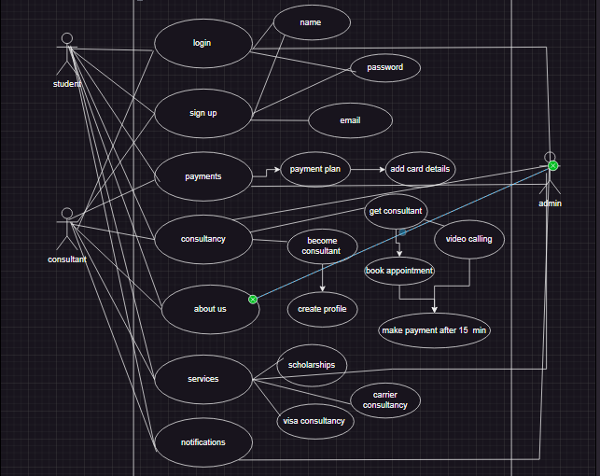

Figure: 2.1 System use case diagram

The diagram represents the different actors involved in the system and the tasks they can perform. The three main actors in the system are the Students, consultants and Admin.
There are various use cases such as sign up, log in, about us, services, payments, latest updates and consultancy. Each of them is responsible for representing specific category of the web application.

    - Sign up Use case
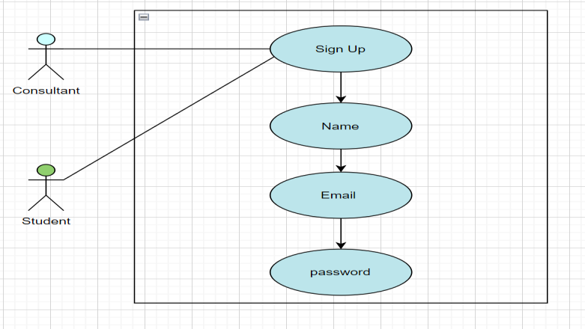

Figure 2.2: Sign up Use Case Diagram

In the represented diagram figure 2.2 sign up page flow is showcased where new user will have to sign up where there will mention there name, email and password to create an account on the smart career services web application so next time they could easily login with their credentials.

    - Sign up Use case
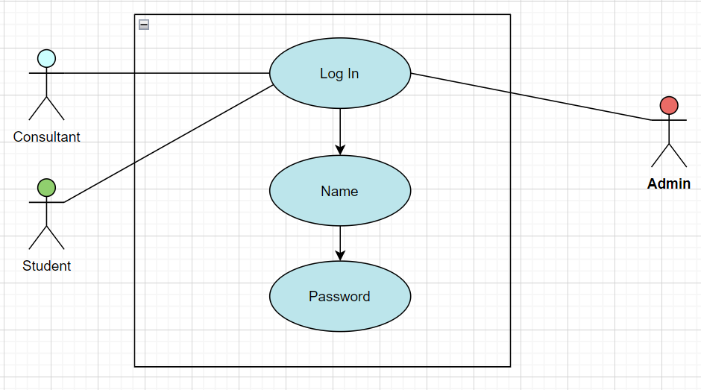

Figure 2.3: Log in use case diagram

Figure 2.3 showcases the login page flow where already existing consultants, users and admin will be able to login with their name and password.

    - Payments use case diagram

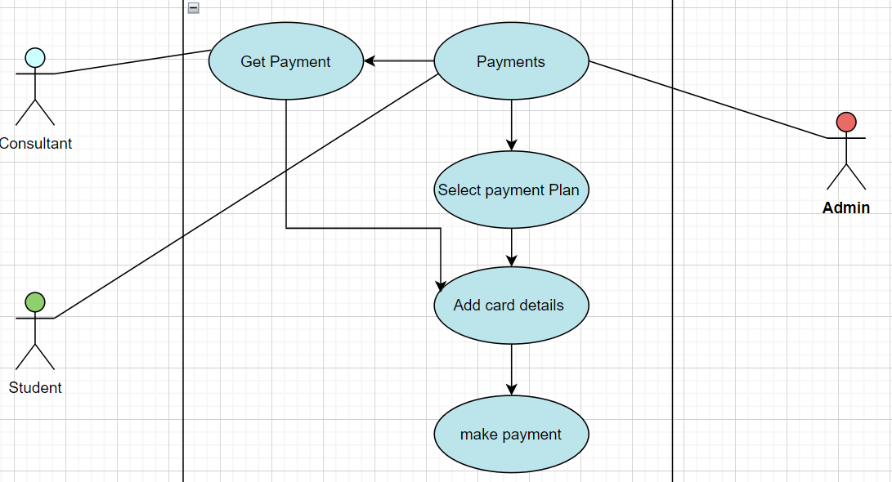

Figure 2.4: Payment system use case diagram

Figure 2.4 payment system use case diagram showcases the payment structure which is related with the admin, consultant and students. Student will make payments where they will have to select payment plan as per their requirement, add their card details. Consultants will receive their payments by using the get details option and then he will also have to add hi card details and then make the payment so he could receive the payments as much he is assigned from the portal.

    - Services Use case diagram

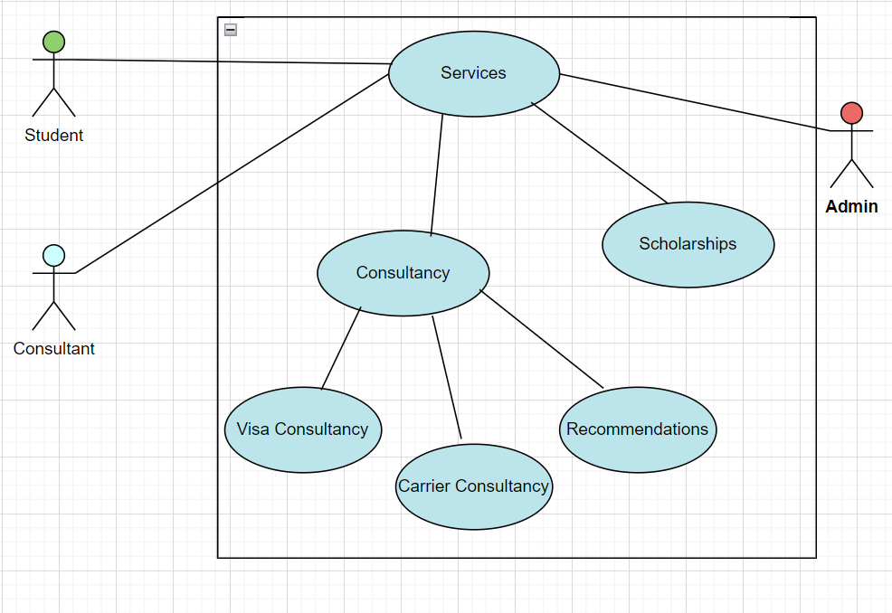

Figure 2.5: Services Use Case diagram

In figure 2.5 Services use case diagram depicts the services which are being provided. Consultancy Services gathers various domains of services such as visa consultancy, carrier consultancy, recommendations which includes recommendation letters and various other recommendations regarding universities and educational courses also focusing upon the job opportunity that specific idea offers.

    - Consultancy Use case Diagram
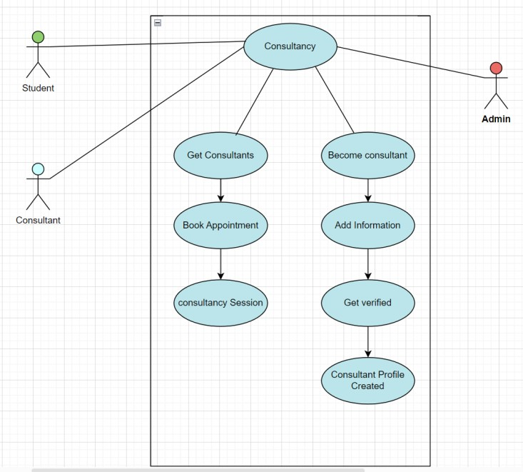

Figure 2.6 Consultancy use case diagram

    - Consultant system use case diagram
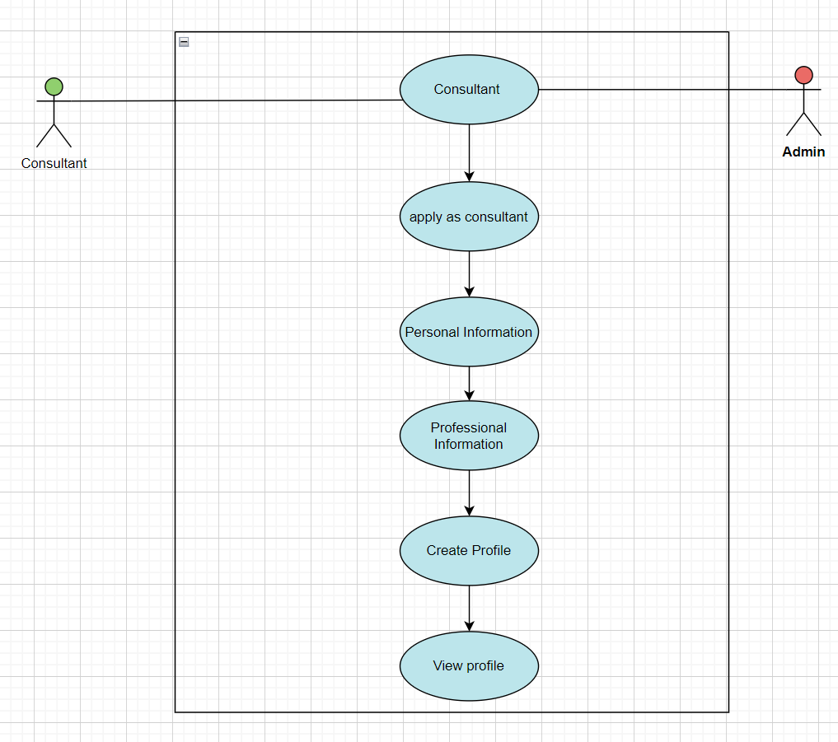

Figure 2.7: consultants use case diagram

Consultants have a proper procedure to follow if they want to register themselves as consultants they will have to add their personal information, professional and educational information. Also Uploading the recommendation letters, testimonials, certificates and experience letter to prove his legitimacy and skill in this field of consultancy.

  - Performance Requirements

The web application shall perform all the required tasks assigned correctly and efficiently. The response time of the application depends on device hardware and internet speed. Without an internet connection user, guide, and room host won’t be able to use the application services.

2.9.1 Software Quality Attributes

- Availability

The application would be available 24/7 to the user and worker having a stable internet connection.
- Flexibility

The application is flexible for all types of web browsers.

- Usability

The web application would be user-friendly for the user and worker and could be easily used and understood by the user. The web-app would have an interactive interface that would attract the user.

- Maintainability

The web application would be easy to maintain and if there is any report of bugs/errors they can be removed, and new functionalities and services can be added in the future with the help of the upgrade of application [6].

  - Results and Review’s Implications

Years | Paper Title | Author | Objectives | Methods | Contribution | Future  Gaps
2020 | Career Counselling in Pakistan: Issues and Challenges | Khan et al. | To identify the challenges faced by career counsellors in Pakistan  and their impact on students | Survey of career counsellors and students, literature review | The paper highlights the need for  trained career counsellors and a  comprehensive career counselling framework in  Pakistan | The study  could be expanded to explore the role of  technology in career counselling in Pakistan
2018 | A Review of Online Career Counselling and Its  Effectiveness | Li &  Feng | To assess the effectiveness of online career counselling as compared to traditional face-to-face counselling | Meta- analysis of existing studies on online career counselling | The paper suggests that online career counselling is as effective as traditional counselling and could be a viable option for students  who cannot  access | The study  could be extended to explore the specific factors that contribute to the effectiveness of online career  counselling

traditional
counselling
2016 | The Role of Career Counsellors in Higher Education | Singh | To explore the role of career counsellors in higher education and their impact on students' career development | Interviews with career counsellors, focus groups with students, literature review | The paper highlights the importance of career counsellors in helping students make informed career decisions and develop essential  career skills | The study  could be expanded to explore the specific strategies and techniques used by career counsellors to help  students
2014 | Career Counselling and the Use of Technology | Lenz & Salyers | To examine the use of technology in career counselling and its  impact on students | Survey of career counsellors, literature review | The paper suggests that technology can enhance the effectiveness of career counselling by providing students with more information and resources, but also  highlights the need for  trained professionals  to guide | The study  could be extended to explore the specific types of technology used in  career counselling and their effectiveness

students in the use of
technology
2012 | The Effectiveness of Career Counselling: A Meta- Analysis | Whiston et al. | To assess the overall effectiveness of career counselling across different populations and settings | Meta- analysis of existing studies on career counselling | The paper suggests that career counselling is effective in improving career  decision- making and reducing career-related problems, but also highlights the need for more research on the specific factors that  contribute to its  effectiveness | The study  could be expanded to explore the long-term impact of career counselling on students' career outcome
Table 2: System Level requirements table

  - Summary

The proposed career services system will be built using the MERN (MongoDB, Express.js, React.js, Node.js) stack, which is a popular and powerful technology platform for developing web applications. The system will have a user-friendly front-end interface built with React.js, and a high-performing back-end built with Node.js and Express.js, using MongoDB as the database management system. The use case diagram shows the main actors and tasks involved in the system, including Student, consultants actions such as registering, logging in, posting job openings, applying for jobs, searching for candidates, and managing job postings. The system is designed to provide a range of benefits, including scalability, flexibility, and ease of use, and will offer a valuable resource for students and employers to connect and find career opportunities.

CHAPTER 3

  - DESIGN AND METHODOLOGY

The methodology used in software development plays a critical role in ensuring the success of the project. Therefore, it is important to select an appropriate methodology that can guide the development process and provide a systematic approach to the entire software development life cycle.

We will describe the various steps involved in the software development process for Smart Career Service. We will begin with the requirements gathering process, followed by the design, implementation, testing, and deployment phases. We will also discuss the tools and technologies that we have used to develop the application.

The third delivery must contain the items on the list below:

    - Domain Model

    - Sequence Diagram

    - Collaboration Diagram

    - Design Class Diagram

    - State Chart Diagram

The methodology used in this project is the agile software development methodology. Agile is an iterative and incremental approach to software development that emphasizes flexibility and collaboration between cross- functional teams. It is a popular methodology in software development due to its ability to adapt to changing requirements, reduce risk, and deliver high-quality software in a timely manner.

The Agile methodology comprises of various frameworks such as Scrum, Kanban, Lean, and Extreme Programming. We have used the Scrum framework, which is one of the most widely used frameworks in agile methodology. The Scrum framework provides a structure for the development process by dividing the work into sprints, each sprint is a time-boxed iteration of one to four weeks. It also provides a set of roles, artefacts, and ceremonies that guide the development process and ensure effective communication and collaboration among the team members.

  - Domain Model

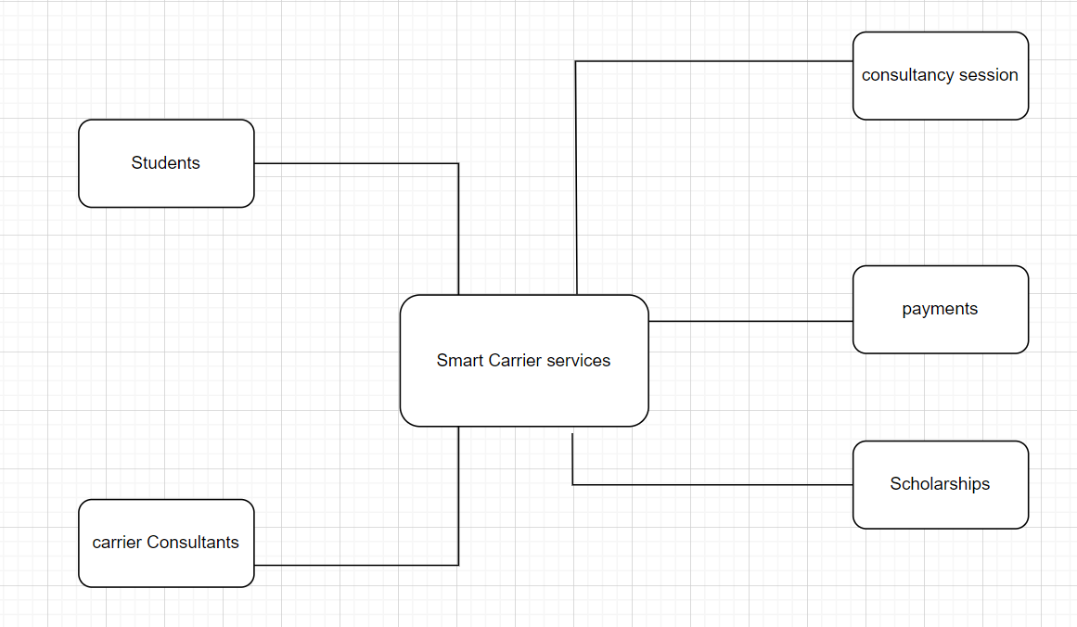

Figure 3.1 Domain Model Diagram

Domain model Diagram showcases the multiple domains in the Smart carrier services web application.

  - Sequence Diagram
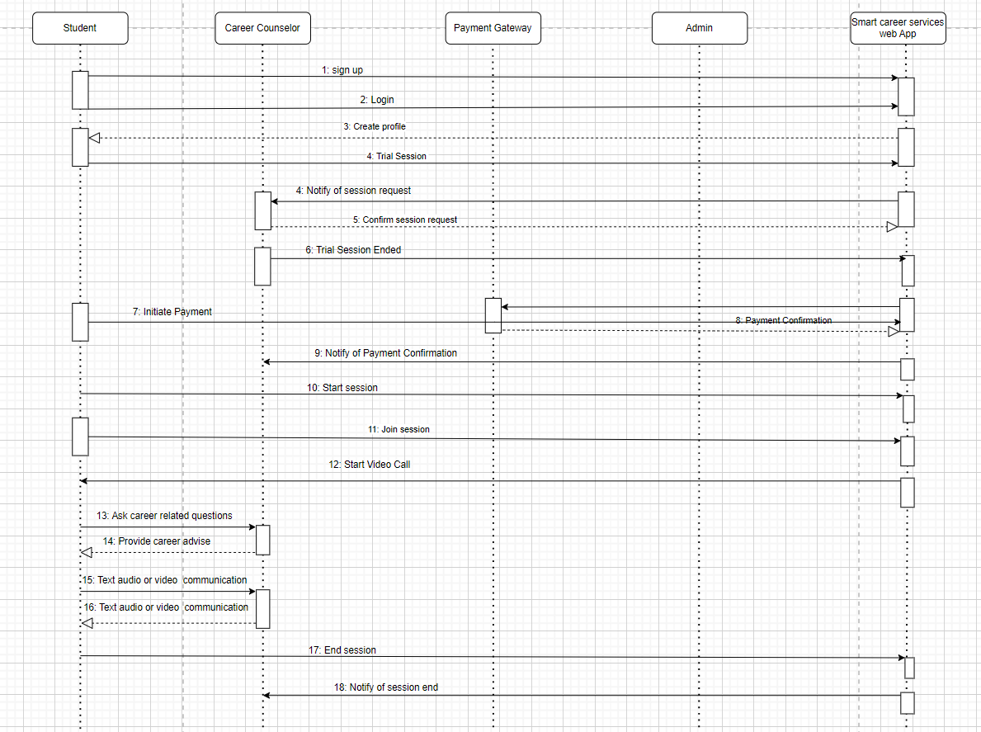

Figure 3.2 Sequence diagram

Figure 3.2 shows the sequence of the smart carrier services application, the flow it follows and also the steps to a successful consultancy session.

  - Design Class Diagram
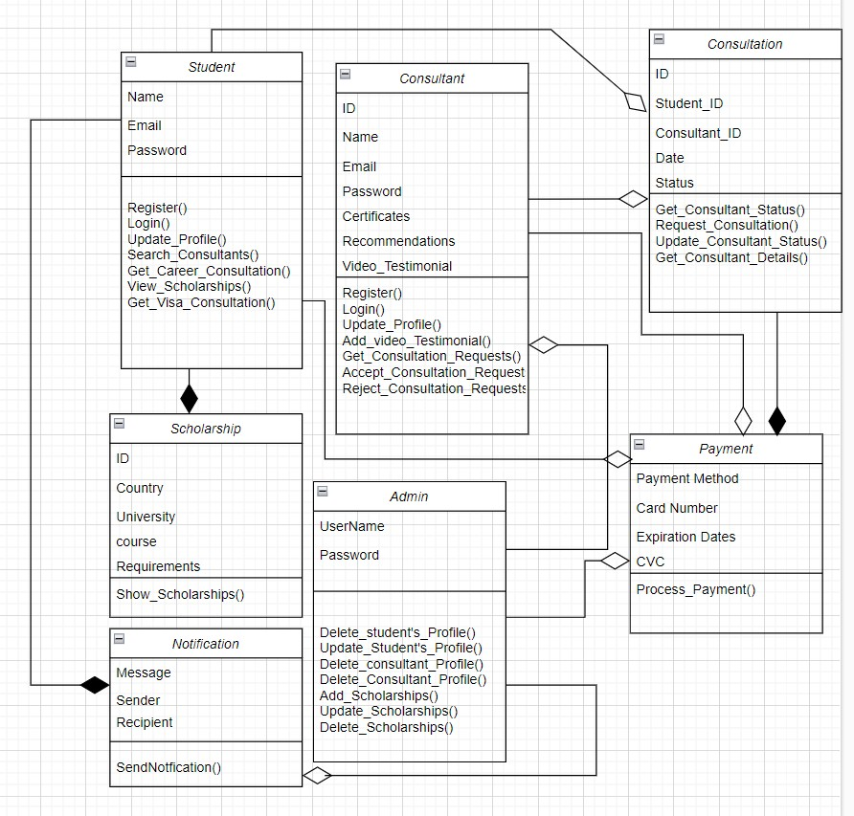

Figure 3.3 Class diagram

Class design diagram figure 3.3 showcases the classes involved in the smart carrier services web application.

  - State Chart Diagram

    - User Sign up

Figure 3.4 user sign up diagram

User sign up diagram figure 3.4 is representing the use sign up procedure where they will submit the form of their credentials and then will be signed up successfully.

    - User Login

Figure 3.5 state chart login diagram

Figure 3.5 of state chart login diagram shows that how will a user Log in the system with their credentials and then land on home page.

    - Admin User Management

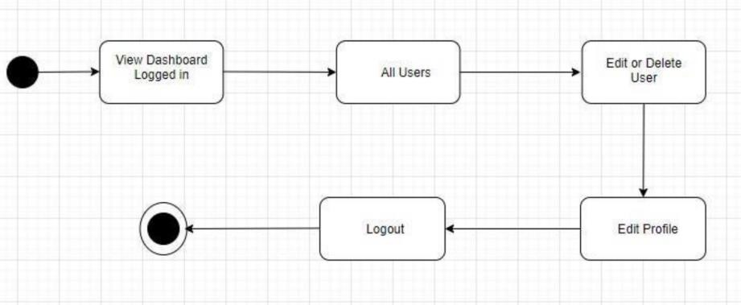

Figure 3.6 User management diagram

User management diagram figure 3.6 shows that how will a user act from login to log out state the procedure it follows.

    - Consultant Search state

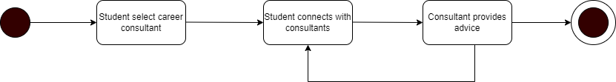

Figure 3.7 consultant search state diagram

Figure 3.7 represents that student will select or search for carrier consultant then connect with him and the carrier advices will be provided.

    - Notifications and alerts

Figure 3.8 notifications diagram

Figure 3.8 showcases that notifications will be created by the smart carrier services web portal and will be sent to respective users.

CHAPTER 4

DATA EXPERIMENTS AND IMPLEMENTATION

  - User Interface Design

The user interface (UI) design is the front-end of the web application that interacts with users. It plays a crucial role in making the web application visually appealing, easy to use, and engaging. In the context of the Smart Career Services web application, the UI design will focus on providing a seamless experience for the users to navigate, understand the features of the web application and connect with consultants.

The UI design will incorporate a colour scheme that is consistent with the brand identity, such as shades of blue and green. The user interface will feature an intuitive layout that is easy to navigate. It will include a homepage with a login button and signup form for new users, and a menu bar to navigate to different sections of the web application such as the scholarship section, workshop section, career counselling section, and profile section.

  - Database Design

Database design is a crucial aspect of the web application, as it will determine the efficiency and effectiveness of the data management system. The database design will be approached by identifying the requirements of the web application and creating a schema that fits the data model of the project.

  - Backend Development

Backend development is the server-side of the web application that is responsible for processing user requests and generating responses. The backend development will be approached by using a robust and scalable framework such as Node.js.

The backend development will involve creating Restful APIs that enable the frontend to interact with the backend. The APIs will be designed to perform CRUD operations on the database and implement features such as scheduling video calls, messaging consultants, and processing payments.

  - Front End Development

Frontend development is the client-side of the web application that interacts with the user interface and sends requests to the backend. The frontend development will be approached by using a modern framework such as React.js or Angular.

The frontend development will involve implementing features such as user authentication, signup form, and payment gateway integration, scheduling video calls, messaging consultants, and displaying data from the database.

  - Testing and Quality Assurance

Testing and quality assurance are crucial aspects of the web application development process. The testing and quality assurance will be approached by implementing a comprehensive test plan that covers different aspects of the web application such as functionality, usability, performance, security, and compatibility..

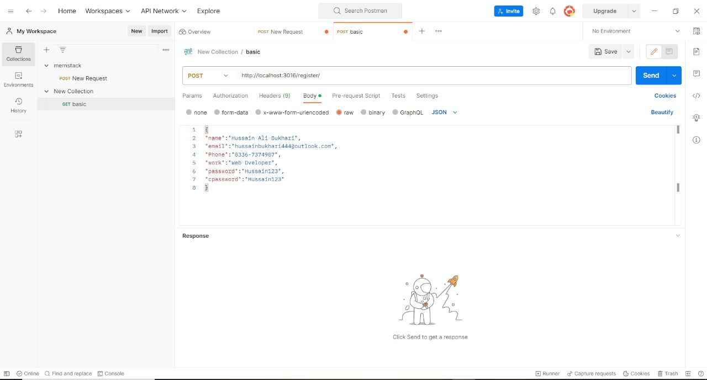

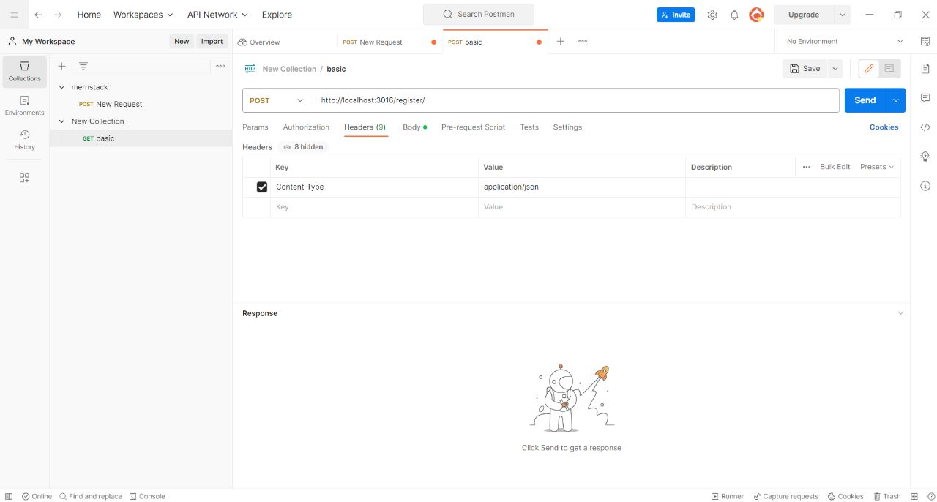
Figure 2 postman testing tool

The API testing and component testing will be conducted using “POSTMAN” tool. The quality assurance will involve monitoring the web application performance, resolving issues, and ensuring the web application meets the requirements and standards of the project.

  - Implementation

First the user, admin, consultant need to open the Smart Career Services website on their devices. Once they have opened, they will be welcomed by the Sign In page on opening the Web application. If the user, consultant, student is new to the application he can roam free and also can create their account and profile by sharing their details required by the application for e.g., your name, password, educational degrees, certificates, recommendations etc. After successfully creating the account, the user can sign into their account and will be redirected to the home screen. From the home screen the user for example:
    - For Students Implementation Procedure: The student can select different consultants from which they want to conduct their consultancy session. They could view different scholarships and payment plan to pay for the consultancy session with the consultants and they will pay for the consultancy session and there will different payment plan upon which they will choose according to their budget and requirements.

    - For the consultants implementation procedure: while registering themselves, they will have to provide evidence of work experience in this domain, recommendation letters, testimonials and educational degrees are required to allow them to be able to become a part of Smart Career Services consultant’s team and get payed by the admin for their services

CHAPTER 5

RESULTS AND DISCUSSIONS

  - Sign Up

When the user opens the Smart Career Services web application, they will be brought to the sign in screen. If the user is new to the web application, they can select sign up which will direct them to the sign-up screen to create his new account by registering their name, email and password as shown in figure 5.1.

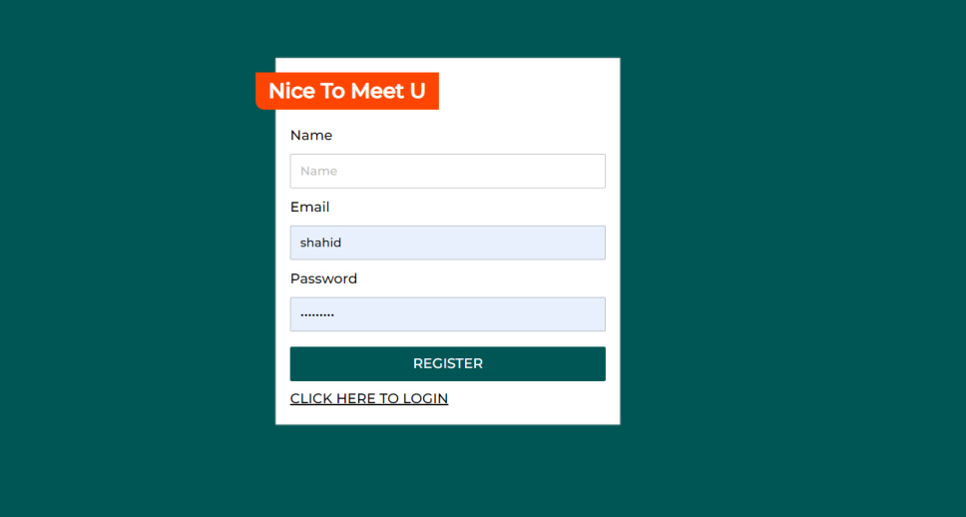

Figure 5.1: Smart Career Service Sign up page

  - Sign In Page

User who have created there account can now directly with their username password to log into the Smart Career Services web application as shown in figure 5.2.


Figure 5.2: smart career service login page

  - Landing page/ home page

As depicted in figure 5.3, interactive home, landing page is designed to entertain its user, the design is kept simple yet elegant and easy to understand so all the students could find what they are looking for on our smart carrier services web application. About us, services, Scholarships Trial session and most importantly the consultants are obvious so students does not have to search for the top consultants on our application. Various important categories are showcased on the home page so this application could prove to be user friendly.

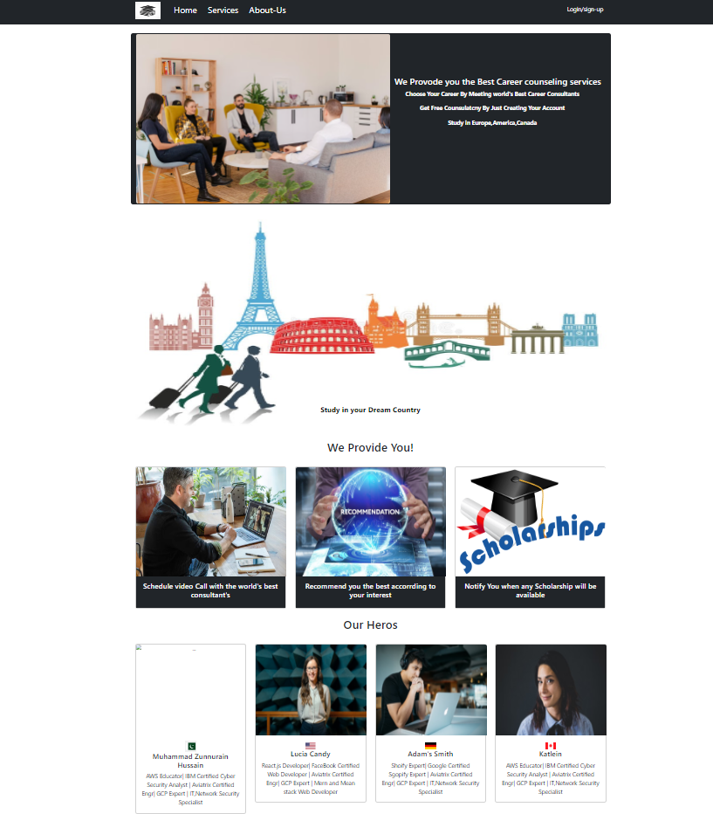

Figure 5.3 Smart Career services home page

  - Smart Carrier Services - Our Services page
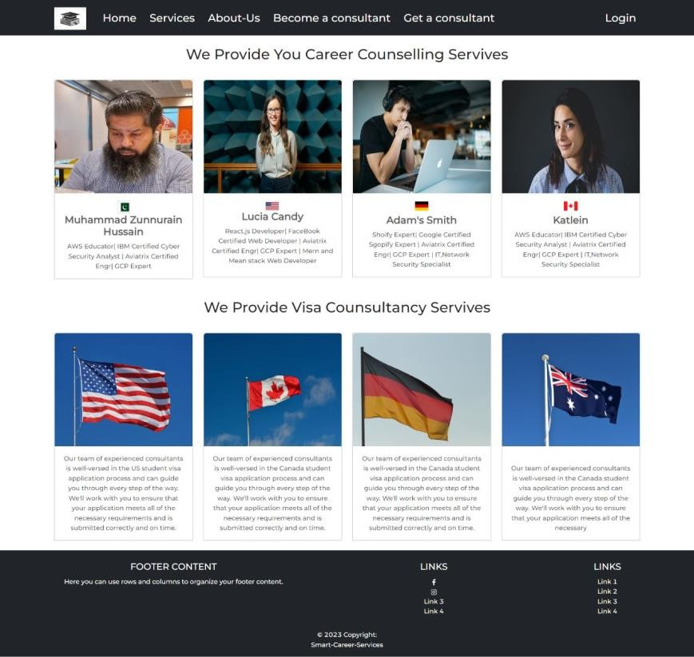

Figure 5.4 Services Landing page

In figure 5.4 our services landing page is represented with all the details regarding the services our system provides such as carrier consultancy, visa consultancy and our recommendations are not only specific to some country we focuses on all the major countries which could pose great economical and wealth benefits to students also various job opportunities.

  - Registering as a consultant

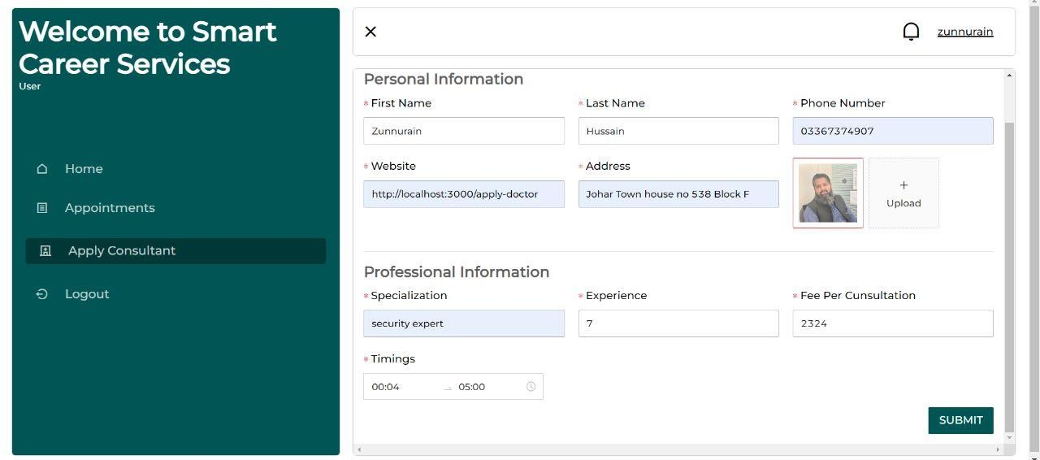

Figure 5.5: Creating Profile as consultant

Figure 5.5 shows the procedure to become a consultant they have to create there profile where they will fill up there personal, professional and educational information. Also Uploading the recommendation letters, testimonials, certificates and experience letter to prove his legitimacy and skill in this field of consultancy. They will also demand the amount they want, per consultation.

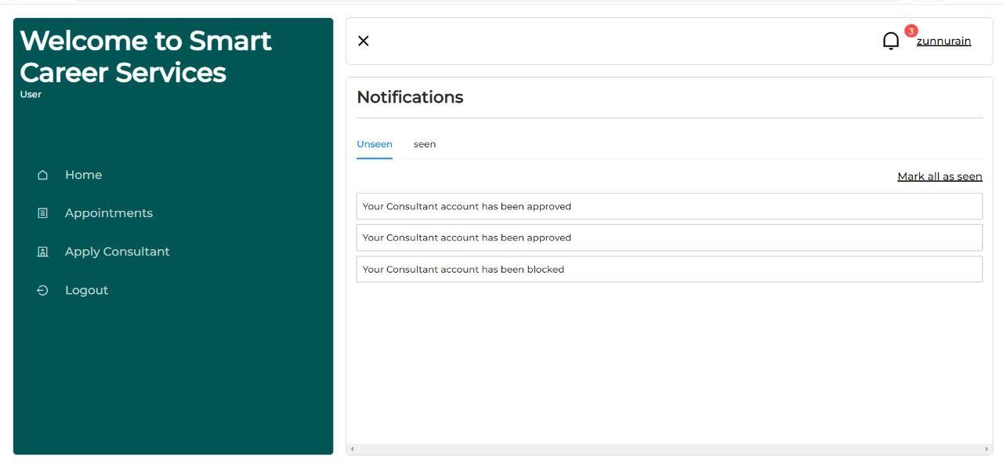
  - Consultant account approval notification

Figure 5.6 account approval notification

Consultant will receive notification of the account approval as shown in figure 5.6

  - Consultant’s profile representation

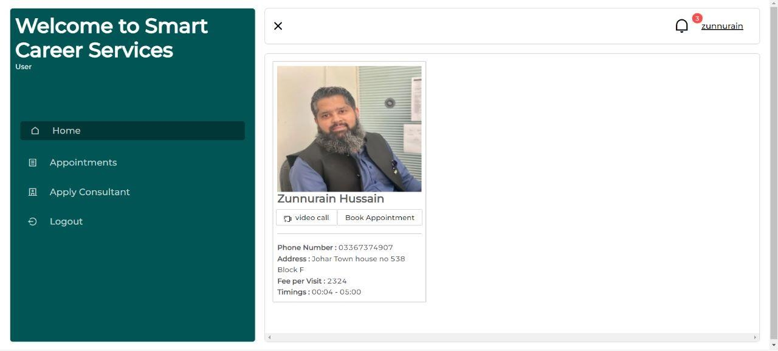

Figure 5.7: Consultant's profile & Appointment booking

In figure 5.7 we could see the consultants profile with his respective details and this profile is also showcased on the student’s portal if they have choose this consultant for their consultancy session . Student can book the appointment for later or can immediately conduct a video call session with the consultant.

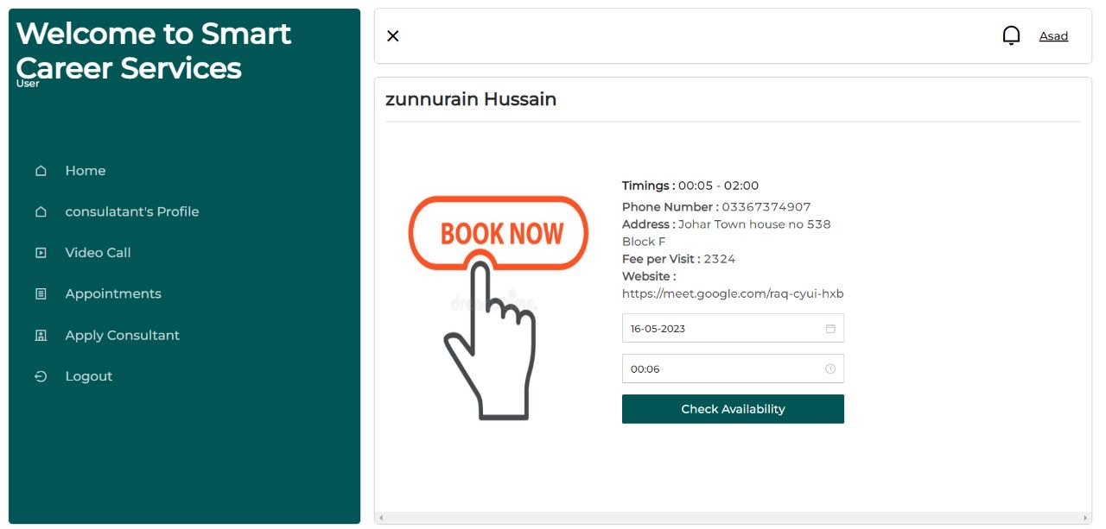

Figure 5.9: selecting date & time for the consultancy session

Student will have to choose specific date and time as shown in figure

  - Session appointment request on consultants profile
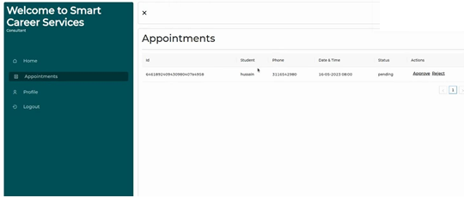

Figure 5.10 Session request to consultant

Consultant will approve or reject the request of the student if he isn’t available at that very moment consultant could reject the appointment as shown in figure 5.10

  - Video Call session request accepted
The video call session request will be accepted by the consultant and the consultancy session will be conducted where student is free to ask as many question he wants to and get a clear carrier path idea from the consultants.

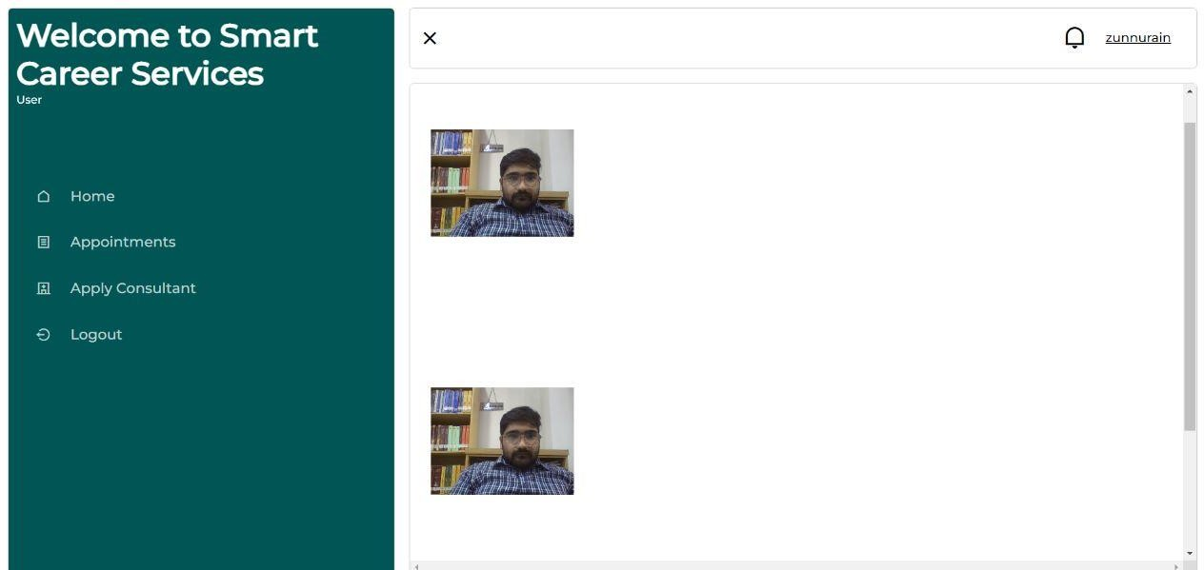

Figure 5.11 Video Session between student & consultant

  - Consultant available for video session

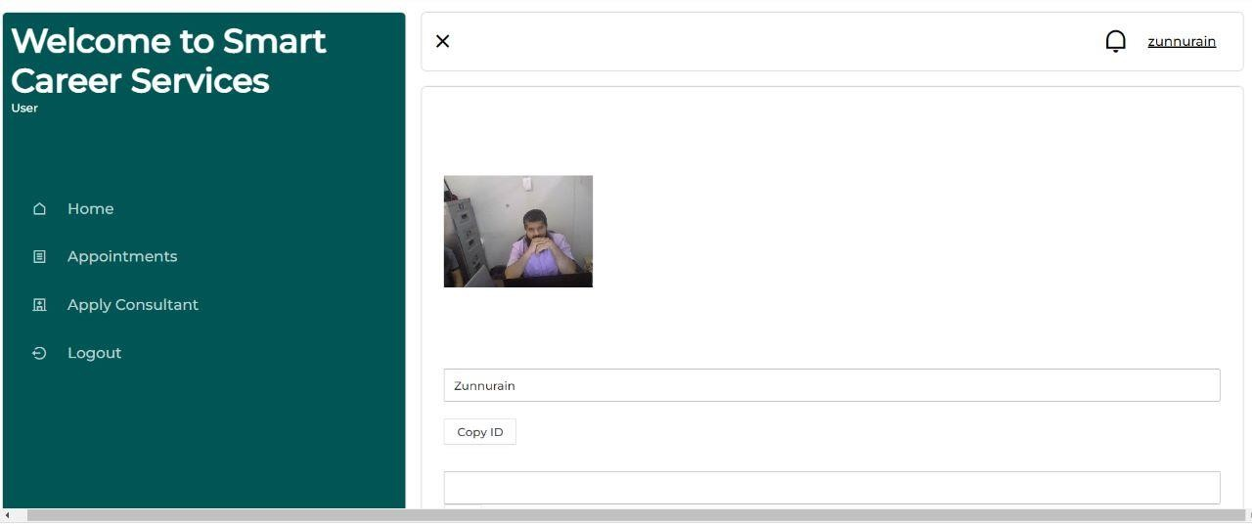

Figure 5.12 video call session with consultant

Consultant has accepted the video call session request and they will be interacting with each other.

CHAPTER 6

CONCLUSION AND RECOMMENDATIONS

  - Conclusion

Smart Career Service is a web-based application that connects students with the best career consultants around the world. The project was aimed at addressing the lack of career counsellors in various colleges and institutions in Pakistan and providing students with the opportunity to plan their career paths based on their knowledge, skills, and abilities. The project was designed, developed, and tested using the Scrum agile development model. The project team focused on accommodating changes on the go and delivering quality results with a lower ratio of risks.

The primary scope of the project, which includes the ability of students to register with the Smart Career Service, discover top consultants globally, pay for their services, and receive consultation via text message, audio call, and video conference with the consultant. The team also identified the final deliverable of the project as a web-based application. The beneficiaries of the project include students, consultants, and parents.

The main objectives of the project were to be a recognized platform for students to find the right career path, to provide help to those students who want to study abroad, to fetch and know about scholarships in different countries on a single platform, to

Serve as an earning platform for consultants, and to maintain a trust relationship with the users by providing them all the latest updates regarding new fields, courses, and consultants. The Smart Career Service project will contribute significantly to addressing the challenges that students face when selecting a career path in Pakistan. It will allow them to explore different career paths and receive professional advice from the best career consultants worldwide.

  - Recommendations

To make the Smart Career Service project more effective and efficient, the following recommendations are made:

- Conduct market research:
Before launching the web application, it is essential to conduct market research to determine the demand for career counselling services in Pakistan, identify competitors and understand the target audience. This information will help and product development.

- Launch Promo codes:
Promo code functionality can be integrated into the app to provide users with access to price reductions. If services could be discounted using coupon codes, more people would use them. Only those who have the discount codes can take advantage of the special offers and save money.

- Expand services to schools:
To increase the reach of the Smart Career Service, it is recommended to collaborate with schools in Pakistan to offer career counselling services to students. This can be achieved by offering free trial sessions to schools and creating partnerships with schools to offer the services to their students.

- Enhance user experience:
To improve user experience, it is recommended to incorporate features that allow students to access the web application easily and quickly, such as a mobile application. The user interface should be easy to navigate, and the site should be optimized for faster loading speeds.

- Partner with universities:
To increase the chances of students receiving scholarships and admission to universities, it is recommended to collaborate with universities to provide accurate and up-to-date information on scholarships and admission requirements.

- Continuously update the platform:
To maintain the trust relationship with users, it is recommended to continuously update the web application with the latest information on new fields, courses, and consultants. This will keep the users engaged and informed, and they will be more likely to recommend the platform to others.

- Offer more payment options:
To increase the convenience of payment for users, it is recommended to incorporate more payment options, such as PayPal and mobile money transfer.

- Offer free trials to new consultants:
To attract more consultants to the platform, offering free trial sessions to new consultants is recommended. This will allow them to test the platform and decide if they want to continue offering their services on the platform.

- Foster a community of career consultants:
Smart Career Services should foster a community of career consultants by offering training and development opportunities to help consultants stay up-to-date with the latest industry trends and best practices. This will help to ensure that the platform continues to attract the best talent and offer the highest quality career advice to students.

- Offer customized career assessments:
Smart Career Services could offer customized career assessments to students to help them gain a better understanding of their interests, skills, and career aspirations. This could be done by incorporating psychometric testing or other assessment tools into the platform.

- Monitor feedback and make necessary improvements:
Smart Career Services should actively monitor feedback from students and career consultants and make necessary improvements to the platform based on their suggestions. This will help to ensure that the platform remains relevant and effective in meeting the needs of its users.

REFERENCES

Journal papers:

[1] | R. Ali, S. Shah, S. M. A. Rizvi, and H. Akhter, “Career Counseling and its Importance in Pakistan,” Journal of Education and Learning, vol. 6, no. 4, pp. 258–263, 2017.
[2] | M. H. Ahmad, “Challenges of Career Counseling in Developing Countries: The Case of Pakistan,” Global Journal of Management and Business Research: E Marketing, vol. 16, no. 3, pp. 1–7, 2016.
[3] | N. M. Khan, S. Asif, A. S. Awan, and A. Khan, “An Overview of E-commerce Payment Systems in Pakistan,” Journal of Information Systems and Technology Management, vol. 15, no. 2, pp. 193–212, 2018.
[4] | L. Li, Z. Li, and W. Li, “Online Education in the Post-COVID-19 Era: A Comprehensive Meta-Analysis of the Impact of Online Learning on Students’ Academic Performance,” Frontiers in Education, vol. 6, no. 551746, pp. 1–12, 2021.
[5] | T. H. Kim and Y. J. Kwon, “The Impact of Social Media Marketing on Consumer Behavior,” Journal of Tourism and Leisure Research, vol. 28, no. 1,  pp. 179–195, 2016.

Electronic Sources from Internet:

[6]
] | Ilo.org. [Online]. Available: https://www.ilo.org/wcmsp5/groups/public/@asia/@ro-bangkok/@ilo-islamabad/d  [7] “Welcome to smart careers,” Smartcareers.co.in. [Online]. Available: http://www.smartcareers.co.in/. [Accessed: 18-May-2023].

ocuments/publication/wcms_185248.pdf. [Accessed: 18-May-2023].

[8] | A. Kamal, B. Naushad, H. Rafiq, and S. Tahzeeb, “Smart Career Guidance System,” in 2021 4th International Conference on Computing & Information  Sciences (ICCIS), 2021, pp. 1–7.

Technical report and Thesis:

[9  ] | D. Ajay, S. Nilesh, D. Anirudh, S. Huzaif, and P. V. Nagare, “An intelligent career guidance system using machine learning,” Irjmets.com. [Online]. Available:  https://www.irjmets.com/uploadedfiles/paper/issue_3_march_2022/20476/final/f in_irjmets1649056741.pdf. [Accessed: 18-May-2023].

APPENDICES

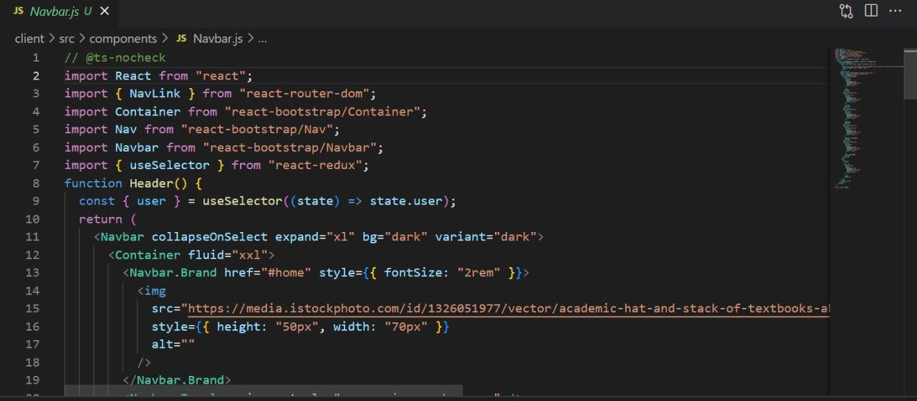
Figure 0.1: Nav Bar
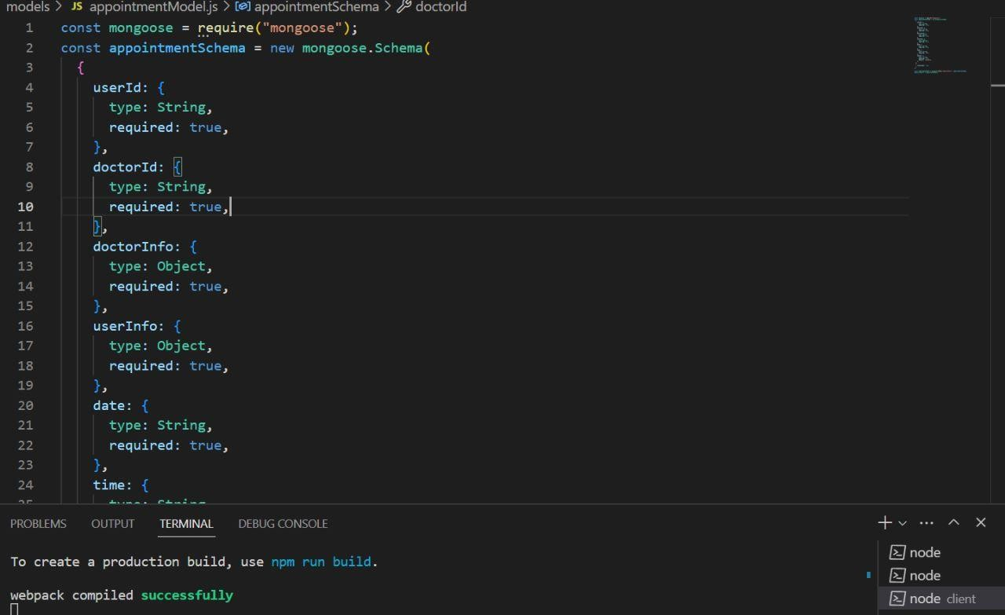
Figure 0.2 Schema of data

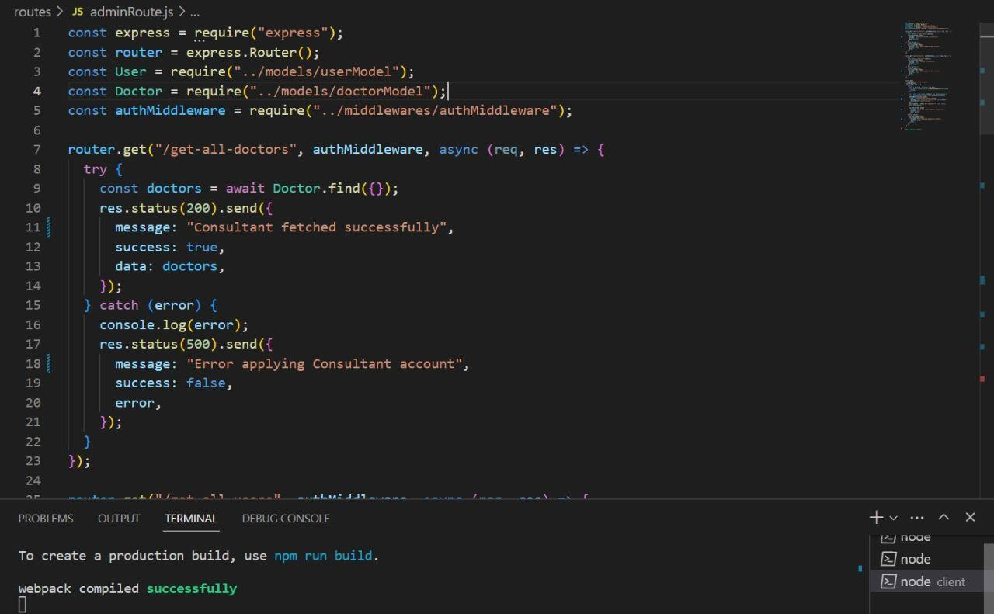
Figure 0.3 Middlewares

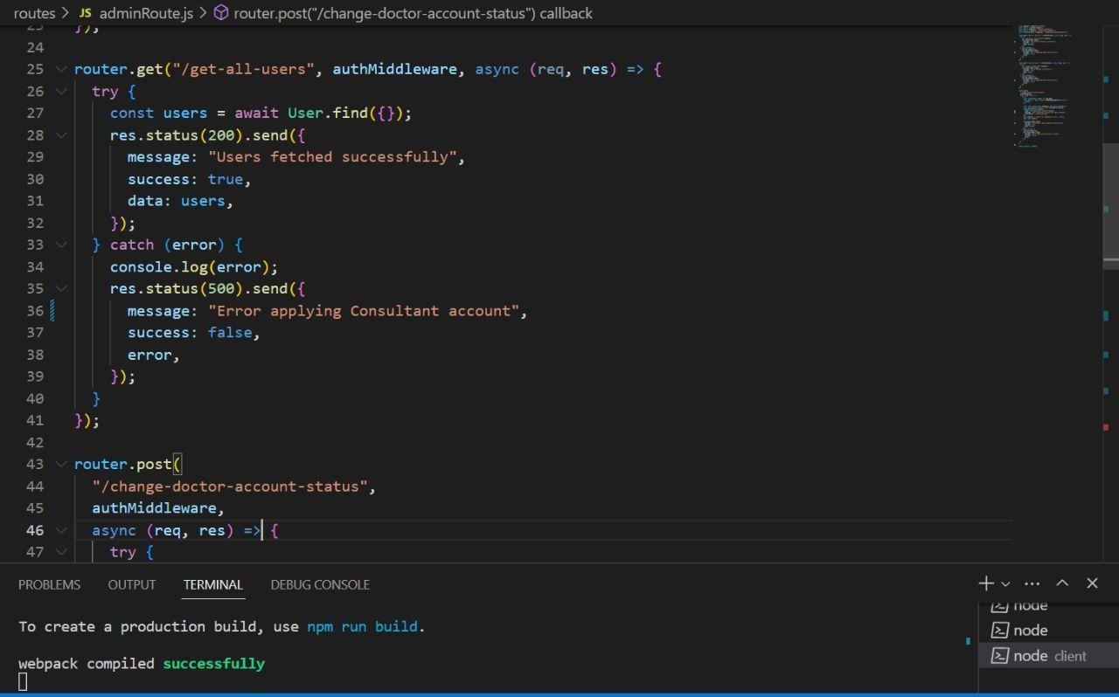
Figure 0.4 Admin Routes

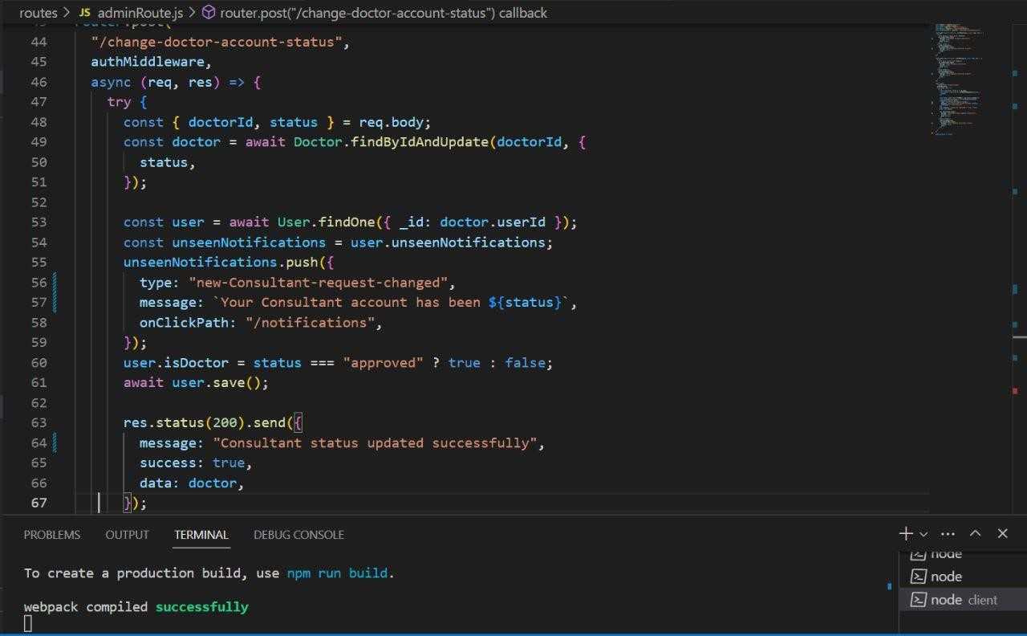
Figure 0.5 Admin routes continued

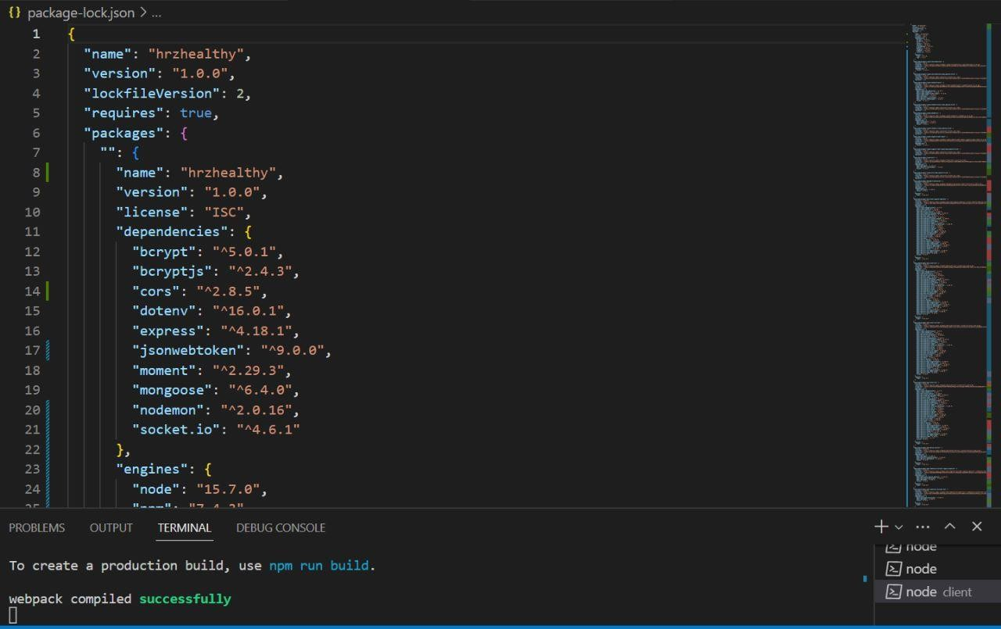
Figure 0.6 Package.JSON

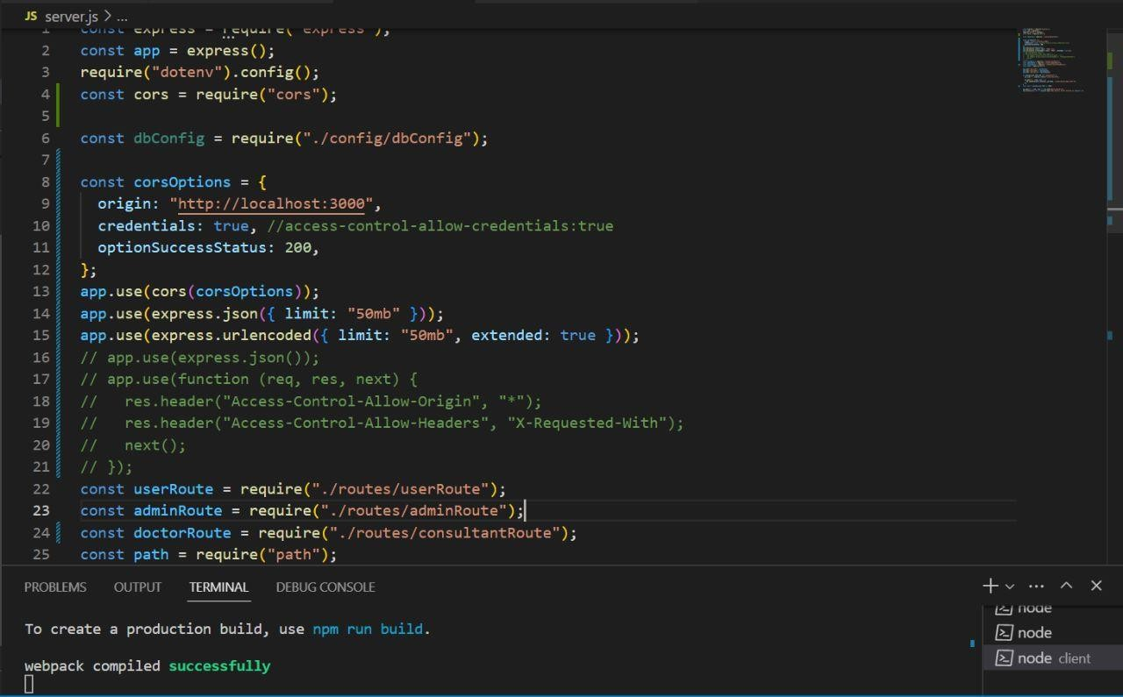
Figure 0.7 Server.JS
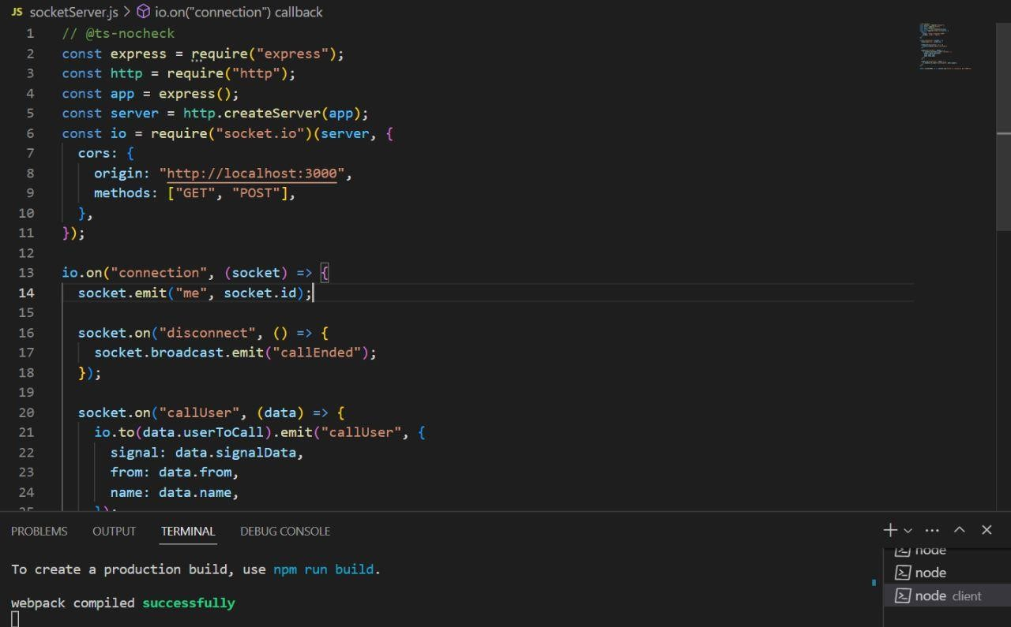
Figure 0.8 Socket.io

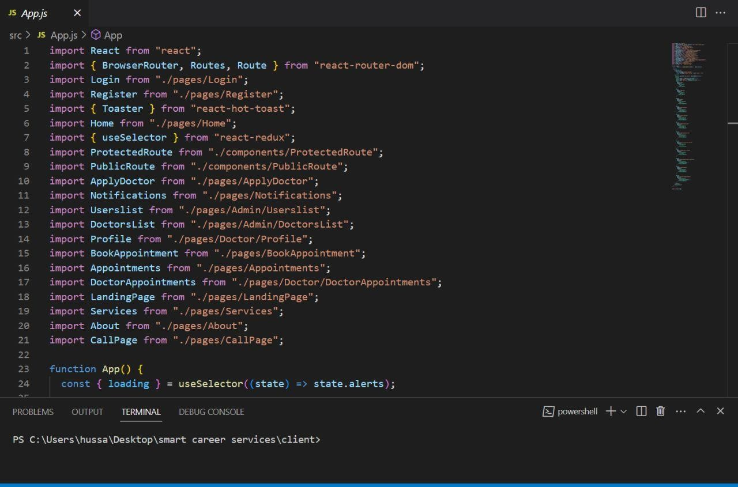
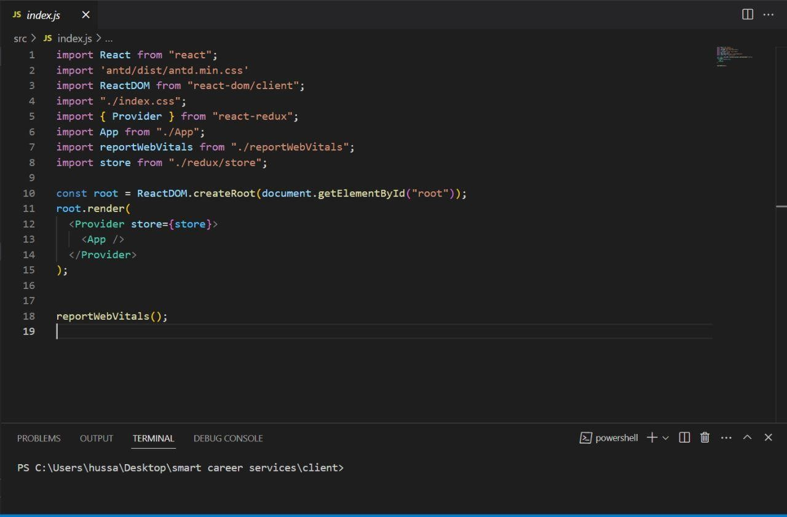
Figure 0.9 App.JS
Figure 0.10 Index.JS

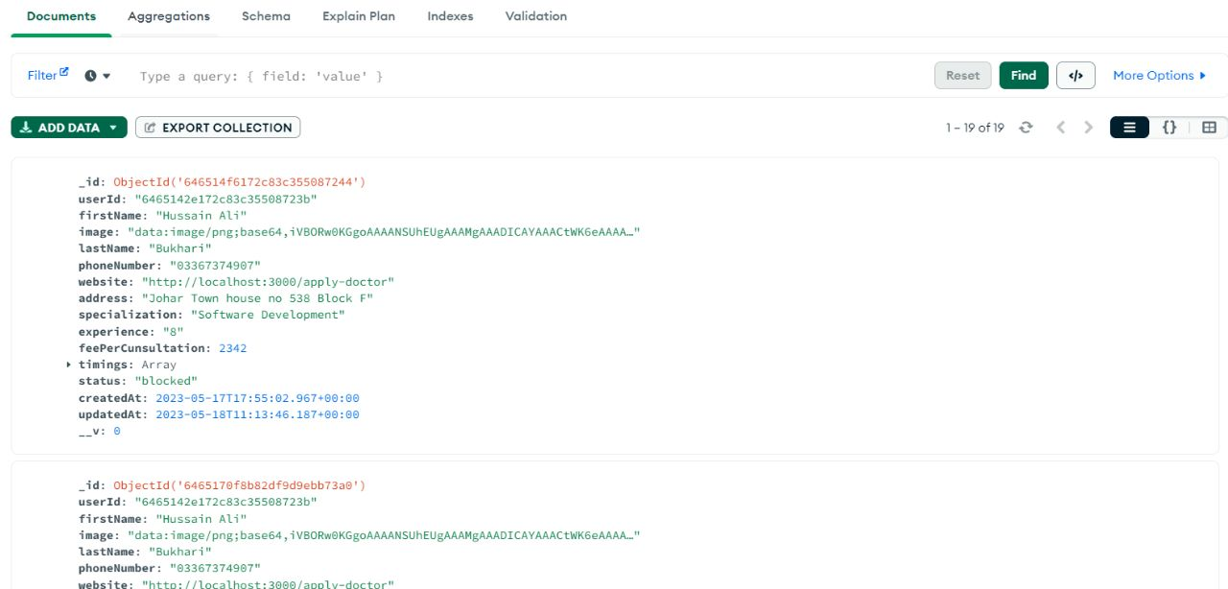
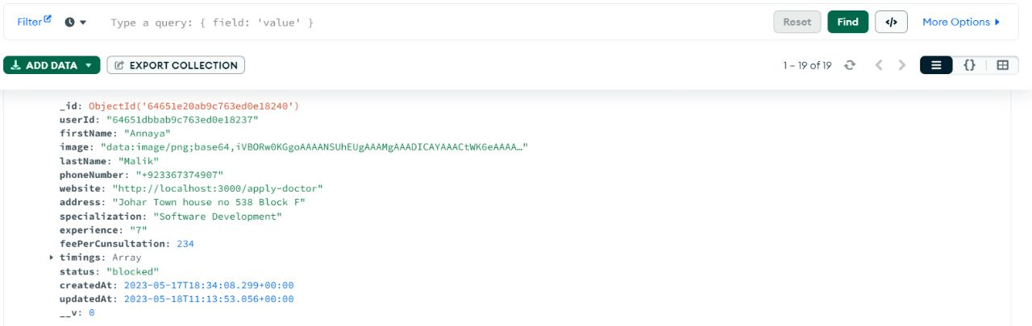

Figure 0.11: Database

Figure 0.12 Database

