
ROLE OF IMPULSIVITTY AND FEAR OF NEGATIVE EVALUATION IN SUICIDAL IDEATION AND THE MEDIATING ROLE OF DEPRESSION AMONG UNIVERSITY STUDENTS
A Research Project
Presented to
The Department of Professional Psychology,
Bahria University, Lahore Campus
In Partial fulfillment
of the requirements for the Degree of
Bachelors of Science
BS Psychology
By
RABAIL BALOCH
&
MUBARA USMAN

JANUARY 2023

Bahria University, 2023
DEPARTMENT OF PROFESSIONAL PSYCHOLOGY
BAHRIA UNIVERSITY, LAHORE CAMPUS
APPROVAL SHEET
SUBMISSION OF RESEARCH DEGREE THESES
Name: Rabail Baloch
Mubara Usman

Discipline: BS Psychology
Department: Department of Professional Psychology
I hereby certify that the above candidate’s work including the thesis has been completed to my satisfaction. The thesis is in a format of an editorial standard recognized by the faculty/ department as appropriate for examination.
Signature:
Principal Supervisor: ___________________
Date: ___________________
These undersigned signify that:
1. The candidate presented at a pre-completion seminar, an overview and synthesis of major findings in the thesis and that the research is of a standard and extent appropriate for submission as a research project.
2. I have checked the candidates' research project and its scope and format. Editorial standards are recognized by the faculty/department as appropriate.
Signature:
Head of Department: ___________________
Date: ___________________
DECLARATION OF AUTHENTICATION

We certify that the research work presented in this research project, to the best of our knowledge, is our own. All the sources used, and any help received in the preparation of this thesis have been acknowledged. We hereby declare that we have not submitted this material, either in whole or in part, for any other degree at this or any institution.
Signatures:
Rabail Baloch ________________
Mubara Usman ________________

DEDICATION

We would like to dedicate this research project to our respective parents who have been so patient and kind with us during the process of writing it. It was due to their unfaltering support and encouragement that we were able to complete this project.

ACKNOWLEDGEMENTS

Firstly, we would like to thank Allah Almighty for enabling us and giving us the strength amidst the given conditions to complete my project.
Secondly, we owe our utmost gratitude to our research supervisor, Ms. Sabiha Dar, who has been so patient and kind with us, granting her supervision, expertise, time, and dedication to this project.
We are thankful to our families for providing us an environment where we were able to work to the best of our abilities.
We are also thankful to the universities and participants who so generously gave us their time and participated in the data collection process.
Without the support of everyone mentioned above, this project wouldn't have been possible.

Table of Contents

APPROVAL SHEET…………………………………………………………………...II
DECLARATION OF AUTHENTICATION………………..………………………....III
DEDICATION………………………………………………………………………....IV
ACKNOWLEDGEMENTS……………………………………………………………V
ABSTRACT…………………………………………………………………………...01
INTRODUCTION…………………………………………………………………….02
METHOD…………………………………………………………………………..….11
Participants………………………………………………………………….…11
Measures………………………………………………………………….……11
Columbia Suicide Severity Rating Scale…………………….…………11
Barratt’s Impulsiveness Scale……………………….…………………11
Brief FNE Scale………………………………………………………...12
Depression, Anxiety and Stress Scale - 21 Items (DASS-21) ….………12
Informed Consent……………………………………………...……….13
Demographics Form………………………………………...…………13
Procedure………………………………………………………..……………...13
RESULTS……………………………………………………………...……………….15
Table 1a………………………………………………………………..……….16
Table 1b…………………………………………………………………..…….17
Table 1c…………………………………………………………………...…….18
Table 2…………………………………………………………………..………19
Table 3……………………………………………………………………….….20
Table 4…………………………………………………………………..………21
Table 5………………………………………………………………………….22
DISCUSSION………………………………………………………………………..…23
REFERENCES………………………………………………………………….….…..27
APPENDICES……………………………………………………………………....….32
Appendix A………………………………………………………………..……33
Appendix B……………………………………………………………..…..…..35
Appendix C…………………………………………………………………..…37
Appendix D……………………………………………………………………..43
Appendix E………………………………………………………………...……48
Appendix F………………………………………………………………..…….53

List of Tables

Table 1a: Sociodemographic Characteristics of University Students…………..………16
Table 1b: Sociodemographic Characteristics of University Students…………….…….17
Table 1c: Sociodemographic Characteristics of University Students…………………...18
Table 2: Reliability analysis of DASS-Depression Subscale, Barratt’s Impulsiveness Scale, Brief Fear of Negative Evaluation and Suicidal Ideation (C-SSRS)…………..…19
Table 3: Mediation analysis of Depression between Impulsivity and Suicidal Ideation..20
Table 4: Mediation analysis of Depression between Fear of Negative Evaluation and Suicidal Ideation………………………...……………………………………………….21
Table 5: Independent Sample t-test for Gender Differences in Impulsivity, FNE, Suicidal Ideation and Depression………………………………………………………………….22

List of Abbreviations and Acronyms

FNE Fear of Negative Evaluation
SI Suicidal Ideation
WHO World Health Organization
ABSTRACT

The objective of this study was to investigate the relationship of impulsivity and fear of negative evaluation with suicidal ideation, and the mediating role of depression, among university students. The research objectives were to find out whether a relation between impulsivity, FNE and suicidal ideation exists and how it will be mediated by depression among university students. Secondly, whether there will be any gender differences in impulsivity, FNE, suicidal ideation and depression. Mediation analyses with depression between impulsivity and suicidal ideation, and separately with depression between FNE and suicidal ideation were performed. It was found that depression acts a mediator between impulsivity and suicidal ideation and impulsivity has no significant direct effect on suicidal ideation. Moreover, depression partially mediates the relation between FNE and suicidal ideation. FNE does not have a significant direct effect on suicidal ideation. An independent samples t-test was conducted to check gender differences but no significant differences of impulsivity, FNE, suicidal ideation and depression were found between male and female students. From the results, it can be inferred that impulsivity and FNE are indirect risk factors for suicidal ideation among university students.
Keywords: suicidal ideation, impulsivity, fear of negative evaluation, depression, university students

Introduction

Suicidal ideation is a widely studied phenomenon because it is a predictor for the lifetime risk for suicide. Majority of the people who attempt suicide have a history of reporting suicidal ideation at some point (Berman, 2018). Most individuals can control suicidal ideation and do not attempt suicide even after endorsing it (Harmer et.al, 2022). But a study in the UK found that about 90 % of the individuals who successfully committed suicide, reported suicidal ideation to their primary care professionals on their last visit (Saini et.al, 2016) so it is still a risk factor. Suicide is the 10th leading cause of death worldwide (Varnik, 2012) and it greatly concerns healthcare and welfare workers. Identifying individuals with a high risk for suicide is important for prevention (Jang et.al, 2014)
Suicidal ideations (SI), is a general term that describes a range of thoughts and preoccupations associated with suicide and death. A unified and globally accepted definition of suicidal ideation does not exist, creating complications for professionals who deal with it and researchers who attempt to study it (Obegi, 2019). Suicidal ideation is a diversified phenomenon (Oquendo & Baca-Garcia, 2014) as it varies greatly in intensity, duration and character. It can range from a desire to fall asleep and not wake up again to very vivid and disturbing visualizations of killing oneself (Harmer et.al, 2022).
Impulsivity is the predisposition to act on impulse, without thinking or any consideration of the consequent outcomes (VandenBos, 2007). It is often studied in relation to decision-making (Cardinal & Robbins, 2004). Various aspects of impulsivity have been identified through factor analyses of tools that measure this trait. Four factors are very common in the self-report tools that measure impulsivity. These are lack of premeditation, sensation-seeking, lack of perseverance and urgency. Lack of premeditation refers to acting without any thoughts or plans. Sensation-seeking is the search for new and exciting experiences. Lack of perseverance is the inability to stay focused on one thing for longer periods of times. And lastly, urgency reflects the tendency to make emotionally driven decisions that are likely to be regretted later on (Whiteside and Lynam, 2001).
FNE is a trait that is often associated with social anxiety, isolation and low self-esteem. In fact, it is one of the main features of social anxiety (Schoeneman, 1983). Social evaluations take place in various social situations on a daily basis. They are a way of organizing social circles (Dickerson et. al, 2004). Gilbert (2014) suggests that carefully examining these evaluations and adjusting behaviors accordingly might have been an evolutionary advantage. However, some people are more sensitive to these evaluations than others and exhibit fearful thoughts regarding them that stem from the possible consequences of these evaluations. The earliest definitions of FNE describe it as a concern for others’ evaluations of themselves, distress over being evaluated negatively, avoiding situations which involve evaluations and always expecting others to evaluate them negatively (Watson & Friend, 1969).
Depression is a serious medical condition that constantly affects people’s passions, studies, and behaviors. Sadness and/ or a loss of interest in former pursuits are symptoms of depression. It can affect your capability to achieve at work and at home and has a number of internal and physical effects. A prolonged sense of sadness and loss of interest are symptoms of depression. Clinical depression affects your feelings, thoughts and lead to a number of physical and psychological symptoms. It makes it difficult to carry out daily tasks and leads to feelings of purposelessness. An estimated 3.8 percent of the world's population suffers from depression, involving 5 percent of grown-ups and 5.7 percent of persons over the age of 60. Around 280 million people worldwide suffer from depression. Depression is not the same as temporary mood changes or feeling low in day-to-day life. People who suffer from depression are at a higher risk of suicide (APA, 2023).
A 2014 study in China regarding the increasing rates of suicide discussed that even though new data regarding this issue is being collected rapidly, data on suicidal ideation in college students remains scarce. Another important observation made in this study was that elevated levels of impulsivity assist in the shift from suicidal ideation to suicidal behavior. The study aimed to find the association between suicide and personality traits related to impulsivity and aggression. It used stratified random cluster sampling method to select a sample of 5,245 students. Structured interviews were conducted to collect information regarding sociodemographic characteristics and suicide morbidity. Patient Health Questionnaire (PHQ-9) was used to measure suicidal ideation and self-harm attempts. 9.1 % students reported suicidal ideation and 1% reported suicidal attempts in the past. There was a significant difference in scores on cognitive impulsivity between those with suicidal ideation and suicidal behavior. Differences were also found between those with ideation only and attempters in harm directed towards oneself (Wang et al., 2014).
A study was done on the association between trait impulsivity and suicidal ideation and how it changes in the context of Interpersonal Theory of Suicide. The purpose of the study was to determine the relationship between trait impulsivity and suicidal ideation as well as suicidal behavior. Secondly, the study aimed to study the association of trait impulsivity with fluctuations in suicidal ideation in a sample of inpatients with a diagnosis of unipolar depression. No associations were found between trait impulsivity and suicidal ideation except for a low but significant association between the thwarted sense of belongingness and the attention subdomain of trait impulsivity. A significant positive correlation was found between trait impulsivity and the capability for suicide. However, no correlation of impulsivity with the two subdomains for capability of suicide was found. Another low but significant correlation was identified between the motor aspect of impulsivity and the fearlessness about death. Suicidal behavior was positively correlated with trait impulsivity but not with its subdomains. A significant correlation between the MSSD (mean of successive squared differences) of passive suicidal ideation and trait impulsivity was indicated. Moreover, the motor domain of trait impulsivity displayed a significant correlation with the MSSD of passive suicidal ideation, but no correlation with active suicidal ideation or the total score of MSSD was detected (Hadzic, 2020).
FNE and suicidal ideation among college students and the moderating role of impulsivity like traits was examined in a 2021 study. FNE is considered to be a prominent feature of social anxiety and is often associated with social isolation and poor self-esteem. Many previous studies showed that impulsivity tends to aggravate potentially dangerous behaviors in people with social anxiety. However, very little research has been done to explore the associations between FNE and suicidality, and between FNE and impulsivity. A sample of 1816 students from 10 different institutes was used to test whether FNE was associated with suicidal ideation. Moreover, statistical analyses were used to determine whether impulsivity-like traits moderated this relationship. It was found that there is a significant association between FNE and suicidal ideation. Additionally, the positive association between FNE and suicidal ideation was reported be the strongest among those who scored high on negative urgency subdomain of impulsivity and low on perseverance. Therefore, FNE can be a potential suicide risk among college students and this association is likely to be affected by levels of impulsivity (Preston et al., 2021).
A study was carried out on comorbid depression and suicidality in patients with combat-related post-traumatic stress disorder, and the role of temperament, character and trait impulsivity was examined. Combat veterans suffering from posttraumatic stress disorder are likely to develop major depressive disorder and suicidal thoughts. The aim of this study was to find out whether personality characteristics such as impulsiveness, temperament and character had a role in making some veterans more prone towards depression and suicidality. The study comprised of 148 male combat veterans who were receiving treatment for PTSD. These participants were mostly in their 40’s. 34% of them had a comorbid diagnosis of present or lifetime major depressive disorder, whereas 66% had a PTSD-only diagnosis. A diagnostic interview was used to evaluate each participant, and they also completed the battery of self-report tests that included the Beck Depression Inventory, Suicidal Behaviors Questionnaire, Temperament and Character Inventory, and the Barratt Impulsive Behavior Scale-11 (BIS-11). Comparisons between the two clinical groups revealed that patients with comorbid posttraumatic stress disorder and depression had higher rates of suicidality and demonstrated differences in the personality traits of self-directedness, reward dependence, and persistence, as well as trait impulsivity and harm avoidance. By using three multivariate regression models, it was found that, after adjusting for the impact of sociodemographic differences, duration of treatment of treatment, and concomitant depression, trait impulsivity and the character dimension of cooperativeness were the only two independent predictors of suicidal thoughts. Hence, it was concluded that patients with depression and combat-related PTSD had higher rates of suicidal thoughts and have different personality types from those with PTSD alone. Trait impulsivity was one of the two predictors of suicidal ideation in patients with comorbid depression and PTSD (Jakšić et al., 2017).
The role of parental and peer attachment, depression and impulsivity was studied in context of two pathways that lead to suicidal intention in Ecuadorian adolescents. By the means of mediational and mode rational analysis, the study examined the associations between impulsivity, depression, and attachment styles, trust, communication, and isolation from peers, parents, and mothers. The study evaluated the data of 395 teenagers who were selected from various schools, aged 14 to 19, with 54.2% male students and 45.8% female students. The participants completed the Beck Depression Inventory, the Plutchik Impulsivity Scale, and the Inventory of Parent and Peer Attachment. The mediational analyses revealed two pathways that predicted suicide intention. One was more directly mediated by depression and the other added impulsivity as a mediator between attachment and depression. No moderation effects were discovered in this study (Moyano et al., 2022).
The current study proposed that impulsiveness indirectly affects suicidal ideation and depression plays the role of mediator. Impulsiveness simultaneously moderates this indirect effect. This study supports the idea that individuals with impulsive features are more likely to experience depression, and consequently have an increased chance of developing suicidal thoughts when they also have impulsive traits. Impulsivity needs to be closely monitored throughout the various stages of depression in clinical and healthcare settings while examining depression to prevent suicidal ideation. Impulsivity can possibly increase the indirect effect of depression by directly causing suicidal ideation. Moreover, it was discovered that depression was important as a mediating and intervening variable because impulsivity did not directly or independently affect suicide thoughts. Despite the association between impulsivity and suicidal ideation, the direct relationship between impulsivity and suicidal ideation was not statistically significant. It can be described as the full mediating impact in a single sentence. This suggests that impulsivity likely predicts depression and that suicidal thoughts predicts depression. It helps to explain how impulsivity affects suicidal ideation partially (Zhang et al., 2022).
The role of FNE as a mediator of the association between academic stress, anxiety and depression in a sample of college students from Ghania was examined in this study. Previous studies have shown comorbidity between anxiety disorders like social anxiety and depression (Kessler et al., 2005). FNE has been linked to depression, according to Wang et al. (2012), since perceiving negative evaluations from others are likely to make one feel like a failure. A correlation between FNE and depressive symptoms was also noted by Adams et al. (2011) in obese patients who underwent bariatric surgery. This highlights the importance of examining the effect of FNE on depression. The purpose of this study was to find whether FNE has a mediating effect between academic stress and psychological symptoms. The findings revealed that FNE partially mediated the relationship between academic stress and psychological symptoms such as anxiety and depression (Nonterah et al., 2015).
The interpersonal theory of suicide (Joiner, 2005) states that there are two components that are present behind a suicide attempt. One is suicidal desire and the other is the ability to act on this desire.
Furthermore, suicidal desire arises when a person experiences two distinct states of mind for a long enough period of time. These are ‘perceived burdensomeness’ and a sense of ‘social alienation’. As far as the ability to commit suicide is concerned, those who have overcome their instinct of ‘self-preservation’ due to exposure to pain, accidental injuries and self-harm and have developed a fearlessness of pain, injury and death are likely to engage in suicidal behavior. Having access to lethal means is also a contributing factor (Joiner, 2009).
Impulsivity is a personality trait with multiple dimensions. For instance, Whiteside and Lynam (2001) identified four factors that were commonly included in self-report measures of impulsivity. The four factors are lack of premeditation, sensation seeking, lack of perseverance, and urgency. Lack of premeditation suggests that people with high impulsivity tend to take action without thinking about the consequences. Sensation-seeking is doing things just to get excitement and thrill out of it. Lack of perseverance means they fail to complete a task and stay focused for longer periods of time. And lastly, urgency describes a tendency to do regrettable things in emotional contexts.
The relationship of impulsivity with suicidal behavior is has been reinforced by a number of studies but its fluctuations and associations with suicidal ideation remain unclear due to varying results. According to one study, trait impulsivity is associated with the fluctuation of passive suicidal ideation. In the context of interpersonal theory of suicide, a weak yet significant association between thwarted sense of belongingness and the attention factor of trait impulsivity is present. Moreover, capability for suicide is positively correlated with trait impulsivity but the latter does not seem to have any effect on the subdomains of suicide capability. A low significant correlation between trait impulsivity’s motor-related factors and the fearless attitude towards death.
FNE is considered to be one of the most prominent features of social anxiety. According to cognitive psychologists, it exists because of a negativity bias in thought processes regarding future events that may involve some form of social evaluations (Clark and McManus, 2002). According to research findings, FNE is one of the factors responsible for the ups and downs in the sense of belongingness.
Joiner (2005) found that feeling alienated and having a thwarted sense of belongingness can lead to increased suicidal ideation and higher suicide risk. FNE is directly associated with thwarted sense of belongingness and this entirely explains how fear of negatively evaluation leads to increased suicidality (Chu et.al, 2015). Maner et al. (2007) conducted a study to determine the moderating role of FNE in how social exclusion affects interpersonal reconnection efforts. They found that those with a high level of FNE have at a greater risk of ending up in social isolation. These individuals lack fulfilling social relationships because they assume that everyone has an unfavorable impression of them. This perception leads to feeling alienated and disconnected from others around them. People with an elevated FNE are more susceptible to suicidal ideation.
A thwarted sense of belongingness may predict depression, among other mental disorders according to social relations theory. A high sense of belonging is associated with promoting better social and psychological functioning (Haggerty & Williams, 1999), but a low sense of belonging is linked to feelings of loneliness, depression, and suicidal ideation (Haggerty et. al, 1996). It is the frustrated sense of belonging that causes those with suicidal ideation and behavior to experience adverse feelings and psychological agony, which eventually leads them to a suicide attempt. This lack of sense of belongingness can lead to feelings of depression which in turn can lead to development of suicidality (Kim & You, 2012).
Suicidal ideation is considered to be the strongest predictor of suicide risk. More than 700 000 people lose their lives to suicide annually. Suicide is the fourth leading cause of death among 15–29-year-olds (WHO, 2022).
Suicidal ideation among university students is a layered and complex phenomenon that negatively effects families, friends and the overall socio-economic development of countries where it prevails. Suicide is the second leading cause of death in young people, especially university students, making this population highly at-risk (Nock et al., 2013). A deeper understanding of this issue is required and the need for extensive research cannot be stressed enough.
Most times, research on suicidal ideation focuses on clinical populations with severe mental health issues. However, suicidal ideation needs to be examined at root level so that it can be prevented from progressing to suicidal behavior. Associations of impulsivity and FNE with suicidal ideation and the mediating role of depression in these relations have been found by previous studies but the literature is not sufficient to form generalized conclusions.
With this study, we aim to identify impulsivity and FNE as potential risk factors of suicidal ideation among university students. The existing literature on the role impulsivity in suicidal ideation shows varying results. Some studies indicate a weak but significant association between these two variables. Research on the role of impulsivity and FNE in suicidal ideation is not sufficient. A limited number of researches discuss the association of FNE with suicide, outside the context of social anxiety disorder. FNE is a contributing factor of anxiety among university students. Both FNE and impulsivity can make individuals prone to depression which significantly increases suicide risk. The existing research on suicidal ideation in Pakistan focuses mainly on mental health issues, environmental and circumstantial factors. Therefore, this study will give us a more in-depth view of these additional factors that have an effect on suicidal ideation among university students. This will create the possibility of timely intervention by identifying at-risk individuals. Moreover, it will help us create more holistic suicide prevention campaigns and awareness programs for students. The findings may also help counselors and clinical psychologists to identify patterns among university students that might lead to suicidal ideation.
The objectives of this study are:
To find out if the relation between impulsivity and suicidal ideation is mediated by depression among university students.
To find out if the relation between FNE and suicidal ideation is mediated by depression among university students.
To find out if there are any gender differences in impulsivity, FNE, depression and suicidal ideation among university students.
The research questions that this study addresses are:
Is the relation between impulsivity and suicidal ideation among university students mediated by depression?
Is the relationship between FNE and suicidal ideation among university students mediated by depression?
Are there any gender differences in impulsivity, FNE, depression and suicidal ideation among university students?
From the literature review and findings of previous studies we have concluded the following hypotheses:
H¹: The relationship between impulsivity and suicidal ideation will be mediated by depression among university students.
H²: The relationship between FNE and suicidal ideation will be mediated by depression among university students.
H³: There will be gender differences in impulsivity, FNE, depression and suicidal ideation among university students.

METHOD

Research Design
The research design of this study is quantitative.
Participants
University students from age 18 to 25 in Pakistan were the sample population. Purposive sampling technique was used. Those diagnosed with any disability, long-term medical condition or psychological disorder (other than depression), were excluded.
Measures
Columbia Suicide Severity Rating Scale (C-SSRS) (Baseline/Screening Version)
This version of the scale was developed by Kelly Posner and her colleagues in 2009 for screening individuals for suicidal ideation and behavior. It has four subscales: suicidal ideation, intensity of ideation, suicidal behavior and actual attempts. The scores are interpreted as follows: moderate (6-10) 11x times the risk of suicide, mod. severe (11-15) 13x times the risk of suicide, severe (16-20) 19x times the risk of suicide, very severe (21-25) 34x times the risk of suicide.
The C-SSRS ideation subscale has a Guttmann split-half reliability of .91 and a Cronbach's alpha of 0.87, 0.89 and 0.93 for the whole sample, the suicide-risk and control groups respectively. Suicide intensity, severity and behavior subscales had Cronbach's alpha of 0.73, 0.89 and 0.91 respectively. C-SSRS inter-items mean correlation was 0.64 (minimum= 0.47, maximum= 0.72). Item-total C-SSRS corrected correlation score had values ranging from 0.47 for item 6 and 0.74 for item 5 (p <0.001).
Barratt’s Impulsiveness Scale
The BIS-11 (Patton, Stanford, & Barratt, 1995; Stanford et al., 2009) is a 30-item self-report measure of impulsive personality traits. This scale scores three subscales: attentional impulsivity, motor impulsivity, and non-planning impulsivity. Items are scored on a 4-point Likert scale that ranges from 1 (rarely/never) to 4 (almost always). The total score ranges from 30 to 120 and higher scores indicate greater impulsivity (Patton, Stanford, & Barratt, 1995).
Responses of all the items can be added to a total score of 30 to 120 points, with higher scores indicating higher impulsivity. Scores on the BIS-11 demonstrate a good test-retest reliability (Spearman's Rho = 0.83) and internal consistency (Cronbach's α =. 83; Stanford et al., 2009).
Brief FNE Scale
FNE Scale (FNE) was first developed by Watson and Friend. The brief version was later developed by Leary (1983). BFNE consists of a total of 12 items with a Likert scale ranging from 1 to 5, with 1 being not at all characteristic of me and 5 being extremely characteristic of me.
Cronbach's alpha coefficient was 0.90 for non-clinical group, and was 0.82 for clinical group (social phobic students). In addition, test-retest reliability of the BFNE showed satisfactory results (Intraclass correlation coefficient = 0.71, p < 0.001).
The validity of the brief FNE has been proven through significant correlations with the symptoms of social anxiety disorder (Watson & Friend, 1969) and the Interaction Anxiousness Scale (Leary, 1983b). It was further validated by conversations with respondents regarding how the scale correlated with their feelings (Leary, 1983).
Depression, Anxiety and Stress Scale - 21 Items (DASS-21)
The Depression, Anxiety and Stress Scale - 21 Items (DASS-21) is a set of three self-report scales designed to measure the emotional states of depression, anxiety and stress. Each of the three DASS-21 scales contains 7 items, divided into subscales with similar content. Scores for depression, anxiety and stress are obtained by adding the scores for the related items ((Lovibond & Lovibond, 1995).
The depression scale assesses dysphoria, hopelessness, devaluation of life, self-deprecation, lack of interest / involvement, anhedonia and inertia. The overall Cronbach's alpha for the DASS-21 scale was 0.74. The depression subscale has a Cronbach’s alpha value of 0.66. Only the scores of the depression subscale were used in this study.
Informed Consent
Participants were made aware of the implications of taking part in this study and they were given the freedom to withdraw at any given moment. They were also made aware that the provided information will be used anonymously to maintain confidentiality and privacy. They were informed that this data will be used for research and educational purposes.
Demographics Form
Demographic information such as age, gender, department, type of university (public/private), number of siblings, family harmony (poor, average or good), relationships with friends (low, middle or high), economic status (low, middle or high) and social support (none, 1-2 persons, 3-5 persons, six or more persons) was obtained from the participants.
Procedure
A permission letter for data collection was obtained from each participating university. University students were approached and were given a brief introduction to the purpose of our research. Surveys were then filled by university students and C-SSRS was administered individually. Purposive sampling was used where university students were approached on the basis of availability and a screening question was used in order to exclude participants with a diagnosis of any psychological disorder, physical or intellectual disability, or long-term medical illness because these factors are shown to have a direct effect on suicidal ideation. Participants signed an informed consent before filling out the questionnaires. Standard instructions were provided.
The collected data was then entered and analyzed with the help of IBM SPSS statistics software to test the hypotheses. For H1 and H2, a mediation analysis was conducted using model 4 of PROCESS by Andrew F. Hayes. And to test H3, an independent samples t-test was conducted.
The nature and purpose of the study was explained to participants and their informed consent was acquired. Participation was on voluntary basis. Participants were informed that they have the right to withdraw at any time and/or withhold any information they don’t feel comfortable sharing. Their confidentiality and privacy were maintained by keeping the data anonymous. Permissions were obtained from the administration of participant’s universities. All the information and tools were ethically sourced. Accuracy was ensured to a maximum degree.

RESULTS

Initially the data was collected from 200 students of four different universities. But 34 questionnaires were excluded from the study because either they had been diagnosed with some psychological disorder, physical or intellectual disability, and long-term medical condition or because they had not filled out the questionnaire completely. Therefore, the remaining sample size was N = 166 (79 males and 87 females).

Table 1a
Socio-Demographic Characteristics of University Students
Variables | n | %
Gender

Male | 79 | 47.6
Female | 87 | 52.4
Age
18 to 20 years | 89 | 53.6
21 to 22 years | 41 | 24.7
23 to 25 years  Department | 36 | 21.7
Fashion Design | 37 | 22.3
Education and Research | 7 | 4.2
Languages | 18 | 10.8
Management Sciences | 9 | 5.4
Psychology | 15 | 9.0
Computer Sciences | 45 | 27.1
Environmental Studies | 26 | 15.7
Pharmacy | 9 | 5.4
Note. N = 166 University Students

Table 1b
Socio-Demographic Characteristics of University Students
Variables | n | %
Semester
Semester 1 | 45 | 27.1
Semester 2 | 17 | 10.2
Semester 3 | 58 | 34.9
Semester 4 | 4 | 2.4
Semester 5 | 7 | 4.2
Semester 6 | 12 | 7.2
Semester 7 | 14 | 8.4
Semester 8 | 9 | 5.4
Residence
Rural | 31 | 18.7
Urban | 135 | 81.3
University
Public | 117 | 70.5
Private | 49 | 29.5
Number of siblings
1 to 2 siblings | 33 | 19.9
3 to 4 siblings | 88 | 53.0
More than 4 siblings | 44 | 26.5
Note. N = 166 University Students
Table 1c
Socio-Demographic Characteristics of University Students
Variables | n | %
Economic Status
low | 3 | 1.8
middle | 151 | 91.0
high | 12 | 7.2
Family Harmony
poor | 2 | 1.2
average | 56 | 33.7
good | 108 | 65.1
Relationships with friends
poor | 6 | 3.6
average | 32 | 19.3
good | 128 | 77.1
Social Support
none | 15 | 9.0
1-2 persons | 79 | 47.6
3 to 5 persons | 41 | 24.7
6 or more people | 31 | 18.7
Note. N = 166 University Students

Table 2
Reliability analysis of DASS-Depression Subscale, Barratt Impulsiveness Scale, Brief FNE Scale and Suicidal Ideation (C-SSRS)
Scale | No. of items | Cronbach’s Alpha
DASS-Depression Subscale | 7 | .662
Barratt’s Impulsiveness Scale | 30 | .611
Brief FNE Scale | 12 | .794
Suicidal Ideation (C-SSRS) | 5 | .806
Note. N = 166. Cronbach’s Alpha Ranges of Excellent (α ≥ 0.9), Good (α ≥ 0.7 -0.9), and Acceptable (α ≥ 0.6 -0.7).

Hypothesis Testing
Hypothesis 1
The relationship between impulsivity and suicidal ideation will be mediated by depression among university students.
Table 3
Mediation analysis of Depression between Impulsivity and Suicidal Ideation
 | coefficient | se | T | p | 95%  confidence interval
 |  |  |  |  | LL | UL
Total Effect | .0021 | .0102 | .2046 | .8381 | -.0181 | .0222
Direct Effect | -.0107 | .0105 | -1.0154 | .3114 | -.0314 | .0101
Indirect effect | .0127 | .0053 |  |  | .0038 | .0244

The results show that there is no significant direct effect of impulsivity on suicidal ideation (r=-.0107) and P>.3114. We can infer a significant indirect effect which means that depression play an important role between relationship of impulsivity and suicidal ideation. The overall mediation regression analysis showed that depression plays an important role in the mediation of impulsivity and suicidal ideation among students.

Hypothesis 2
The relationship between FNE and suicidal ideation will be mediated by depression among university students.
Table 4
Mediation analysis of Depression between FNE and Suicidal Ideation
 | coefficient | se | t | p | 95%  confidence interval
 |  |  |  |  | LL | UL
Total Effect | .0311 | .0144 | 2.1535 | .0327 | .0026 | .0596
Direct Effect | .0172 | .0150 | 1.1502 | .2518 | -.0123 | .0467
Indirect effect | .0139 | .0068 |  |  | .0027 | .0292

The results show that there is no significant direct effect of FNE on suicidal ideation (r= .0172, P>.2518). But table shows the significant indirect effect (r=.0139, p<.000). which suggests that depression play as a mediator role between FNE and suicidal ideation. The overall mediation regression analysis showed that depression plays an important role as a mediator of FNE and suicidal ideation among students.

Hypothesis 3
There will be gender differences in impulsivity, FNE, depression and suicidal ideation among university students.
Table 5
Independent Samples t-test for Gender differences in Impulsivity, FNE, Suicidal Ideation and Depression
Variables | Males |  | Females |  | t | p | Cohen’s d
 | M | SD | M | SD
Impulsivity | 69.1013 | 8.92073 | 68.8276 | 9.13873 | .195 | .846 | 0.03
FNE | 34.4430 | 5.77738 | 33.6322 | 6.71187 | .830 | .408 | 0.13
SI | .6582 | 1.20773 | .4828 | 1.14995 | .959 | .339 | 0.20
Depression | 14.9873 | 8.06304 | 15.0575 | 8.60956 | -.054 | .957 | -0.01

The results showed that there are no significant differences of impulsivity, FNE, depression and suicidal ideation among males and females.

DISCUSSION

According to the results of this study, depression acts as a mediator between impulsivity and suicidal ideation, as well as between FNE and suicidal ideation among university students. This means that impulsivity and FNE predict depression in university students and in turn, depression predicts suicidal ideation in university students. Therefore, hypothesis 1 and hypothesis 2 of the study were verified by the results. However, hypothesis 3 was not accepted since the results showed that no significant differences of impulsivity, FNE, depression, and suicidal ideation exist between male and female students. Both reported similar levels of these variables; hence it can be inferred that impulsivity, FNE, depression and suicidal ideation are equally experienced by both male and female university students.
According to the first hypothesis of the present study, the relationship between impulsivity is mediated by depression among university students. The results supported this hypothesis. Impulsivity as a personality trait often puts individual at risk of making poor decisions and developing psychological issues such as substance use disorders. This study shows that it also makes people more prone to depressive symptoms increasing their vulnerability to suicidal ideation. One previous study showed that impulsivity is indirectly associated with suicidal ideation and depression plays the role of a mediator. This indirect relationship exists because people who have impulsive traits and behavior have been found to be more vulnerable to developing symptoms of depression. According to the same study, impulsivity cannot independently predict suicidal ideation and the presence of depression is necessary as an interacting variable for impulsivity to have any effect on suicidal ideation. So, impulsiveness is an indirect risk factor which can lead to suicidal ideation when it occurs alongside depression. This indirect relationship may also explain why the studies that report an effect of impulsivity on suicidal ideation have such inconsistent results (Zhang et. al, 2022).
The second hypothesis of the current study stated that the relationship between FNE and suicidal ideation is be mediated by depression. The results were in accordance with this statement. University students find themselves in evaluative situations all the time as part of both their degree requirements and their social life at university. FNE has been shown to have a significant positive association with suicidal ideation (Preston et. al, 2021) but the results of the current study show that FNE has no significant direct effect on suicidal ideation rather the relation is partially mediated by depression and possibly by some other factors as well. This partial mediation can be explained by the fact that according to a previous study done with Ghanian students, fear of negative was a mediator between academic stress and psychological symptoms of depression and anxiety (Nonterah et. al, 2015). From this, it can be inferred that FNE is a risk factor for depression and in other words FNE predicts depression among students and depression has already been established as a risk factor for suicidal ideation. Therefore, a relationship between FNE and suicidal ideation, mediated by depression can be inferred, which was also verified by the present study. In conclusion, FNE can be an indirect risk factor for suicidal ideation among university students.
The third hypothesis of the study proposed that there would be gender differences in impulsivity, FNE, suicidal ideation and depression. However, the results showed that there are no significant differences of impulsivity, FNE, suicidal ideation and depression among male and female university students. But some previous studies state that there is a growing prevalence of depression among male university students (Gao et al., 2020) and that girls are more vulnerable to suicidal thoughts (Zhang et al., 2019). Moreover, many past studies have implied that men are more impulsive than women in general and females have been found have greater levels of FNE as compared to males (Duke et al. 2006) because they are often judged more severely for their appearances and social conduct. These inconsistencies of findings of the current study with these previous studies may be attributed to cultural context and the fact that the population of the current study was university students between the age of 18 to 25, so it is not representative of the general population.
Conclusion
It has been established that university students are a vulnerable population in terms of suicide risk and suicidal ideation is the preliminary factor for suicide attempts. Therefore, it is important to identify risk factors of suicidal ideation. From the findings of the current study, we can conclude that impulsivity and FNE are indirect predictors of suicide and depression plays a mediating role. Consequently, it is of great importance to monitor students with impulsive traits for symptoms of depression as this can lead to development of suicidal ideation, putting them at high risk for suicidal attempts. And students with social anxiety or FNE should also be considered at risk of developing depression and suicidal ideation as result of that.
In order to spread awareness regarding these implications of the present study, awareness sessions for students can organized and screening services can be offered to students by their inhouse counselors or clinical psychologists. This might make early intervention possible. Counseling should be offered to those with impulsive traits and/or FNE or social anxiety so that they can overcome their issues before they progress to depression or suicidal ideation.
Limitations and Recommendations of the study
The sample size of the study was rather small due to limitations of resources and time. Moreover, the C-SSRS has to be administered individually on each participant and this made the data collection process slightly more time-taking and complicated. Some students seemed reluctant to share information regarding suicidal ideation and behavior and this might have led to some incorrect or incomplete reports.
There was a language barrier since the questionnaires were in English and it is not the first language for the students of Pakistan. Even though, the medium of instruction at most universities is English, and students know the language, they are not always familiar with the phrases and terms used in questionnaires. Efforts were made to explain such unfamiliar terms to the students but some effect of this on the data was inevitable.
For future studies, it is recommended to use a larger sample of students and translated tools which are consistent with the everyday language used by university students of Pakistan. Moreover, it might be of interest to also study other interaction pathways between these variables since some studies have shown that impulsivity moderates the relation between FNE and suicidal ideation (Preston et. al, 2021) and when it occurs in comorbidity with major depressive disorder, it can significantly increase the risk of suicidal ideation and behavior (Jakšić et. al, 2017).

REFRENCES

Adams, C., Myers, V. H., Barbera, B. L., Phillip, B. (2011). The Role of Fear of Negative Evaluation in Predicting Depression and Quality of Life Four Years after Bariatric Surgery in Women. Psychology. 2. 150-154. 10.4236/psych.2011.23024.
Berman A. L. (2018). Risk Factors Proximate to Suicide and Suicide Risk Assessment in the Context of Denied Suicide Ideation. Suicide & life-threatening behavior, 48(3), 340–352. https://doi.org/10.1111/sltb.12351
Berman, A. L., & Silverman, M. M. (2017). How to ask about suicide? A question in need of an empirical answer [Editorial]. Crisis: The Journal of Crisis Intervention and Suicide Prevention, 38(4), 213–216. https://doi.org/10.1027/0227-5910/a000501
Cardinal, R.N. and Robbins, T.W. (2004) Prefrontal Executive and Cognitive Functions in Rodents: Neural and Neurochemical Substrates. Neuroscience and Biobehavioral Reviews, 28, 771-784. http://dx.doi.org/10.1016/j.neubiorev.2004.09.006
Chu, C., Buchman-Schmitt, J., Ringer, F. & Joiner, T. (2015). Thwarted Belongingness Mediates the Relationship Between Fear of Negative Evaluation and Suicidal Ideation. Cognitive Therapy and Research. 40. 10.1007/s10608-015-9715-3.
Clark, D. M., & McManus, F. (2002). Information processing in social phobia. Biological psychiatry, 51(1), 92–100. https://doi.org/10.1016/s0006-3223(01)01296-3
Dickerson, S. S., Gruenewald, T. L., & Kemeny, M. E. (2004a). When the social self is is threatened: shame, physiology, and health. Journal of personality, 72(6), 1191–1216. https://doi.org/10.1111/j.1467-6494.2004.00295.x
Duke, D., Krishnan, M., Faith, M., & Storch, E. A. (2006). The psychometric properties of the Brief Fear of Negative Evaluation Scale. Journal of Anxiety Disorders, 20, 807–817. https://doi.org/10.1016/j.janxdis.2005.11.002.
Gao, W., Ping, S., & Liu, X. (2020). Gender differences in depression, anxiety, and stress among college students: A longitudinal study from China. Journal of affective disorders, 263, 292–300. https://doi.org/10.1016/j.jad.2019.11.121
Gilbert, Paul. (2014). The origins and nature of compassion focused therapy. The British Journal of Clinical Psychology. 53. 6-41. 10.1111/bjc.12043.
Hadzic, A., Spangenberg, L., Hallensleben, N., Forkmann, T., Rath, D., Strauß, M., Kersting, A., & Glaesmer, H. (2019). The association of trait impulsivity and suicidal ideation and its fluctuation in the context of the Interpersonal Theory of Suicide. Comprehensive psychiatry, 98, 152158. Advance online publication. https://doi.org/10.1016/j.comppsych.2019.152158
Hagerty, B. M., & Williams, R. A. (1999). The effects of sense of belonging, social support, conflict, and loneliness on depression. Nursing research, 48(4), 215–219. https://doi.org/10.1097/00006199-199907000-00004
Harmer, B., Lee, S., Duong, T. V. H., & Saadabadi, A. (2022). Suicidal Ideation. In StatPearls. StatPearls Publishing.
Jakšić, N., Margetić, B. A., & Marčinko, D. (2017). Comorbid Depression and Suicide Ideation in Patients with Combat-Related PTSD: The Role of Temperament, Character, and Trait Impulsivity. Psychiatria Danubina, 29(1), 51–59.
Jang, J. M., Park, J. I., Oh, K. Y., Lee, K. H., Kim, M. S., Yoon, M. S., Ko, S. H., Cho, H. C., & Chung, Y. C. (2014). Predictors of suicidal ideation in a community sample: roles of anger, self-esteem, and depression. Psychiatry research, 216(1), 74–81. https://doi.org/10.1016/j.psychres.2013.12.054
Joiner, T. (2009, June 1). The interpersonal-psychological theory of suicidal behavior: Current empirical status. Psychological Science Agenda.
Joiner, T.E. (2005). Why people die by suicide. Cambridge, MA: Harvard University Press.
Kim B.-M., You S. (2012) Social Connections and Emotion Regulation in Suicidal Ideation among Individuals with Interpersonal Trauma. Korean J. Clin. Psychology.
Maner, J., DeWall, C., Baumeister, R., & Schaller, M. (2007). Does Social Exclusion Motivate Interpersonal Reconnection? Resolving the Porcupine Problem. Journal of personality and social psychology. 92. 42-55. 10.1037/0022-3514.92.1.42.
Moyano, Nieves & Vélez, Katherine & Arias, Andrea & Sánchez-Fuentes, María Del Mar. (2022). Two pathways to suicidal intention in Ecuadorian adolescents: The role of parental and peer attachment, depression and impulsivity. Current Psychology. 41. 10.1007/s12144-020-00757-6.
Nock MK, Green JG, Hwang I, McLaughlin KA, Sampson NA, Zaslavsky AM, Kessler RC: Prevalence, correlates, and treatment of lifetime suicidal behavior among adolescents: Results from the national comorbidity survey replication adolescent supplement. JAMA Psychiatry 70:300–310, 2013
Nonterah, C. W., Hahn, N. C., Utsey, S. O., Hook, J. N., Abrams, J. A., Hubbard, R. R., & Opare-Henako, A. (2015). Fear of Negative Evaluation as a Mediator of the Relation between Academic Stress, Anxiety and Depression in a Sample of Ghanaian College Students. Psychology and Developing Societies, 27(1), 125–142. https://doi.org/10.1177/0971333614564747
Obegi JH. (2019) Rethinking Suicidal Behavior Disorder. Crisis. 40 (3):209-219.
Oquendo M. A., Halberstam B. & Mann J. J. (2003) Risk factors for suicidal behavior: utility and limitations of research instruments. Standardized Evaluation in Clinical Practice, pp. 103 -130.
Oquendo MA, Baca-Garcia E. (2014) Suicidal behavior disorder as a diagnostic entity in the DSM-5 classification system: advantages outweigh limitations. World Psychiatry. 13(2):128-30.
Preston, E. G., Villarosa-Hurlocker, M. C., Raposa, E. B., Pearson, M. R., Bravo, A. J., & Protective Strategies Study Team (2021). Fear of negative evaluation and suicidal ideation among college students: the moderating role of impulsivity-like traits. Journal of American college health: J of ACH, 1–7. Advance online publication. https://doi.org/10.1080/07448481.2021.1891919
Saini P, While D, Chantler K, Windfuhr K, Kapur N. (2014) Assessment and management of suicide risk in primary care. Crisis. 35(6):415-25.
Schoeneman, T. J. (1983). Frequency of social evaluation in self-observed daily interactions. Social Behavior and Personality: An International Journal, 11, 77–80
threatened: Shame, physiology, and health. Journal of Personality, 72(6), 1192–1216
VandenBos, G. R. (2007). APA dictionary of psychology. Washington, DC: APA. p. 470.
Värnik P (2012). Suicide in the world. International Journal of Environmental Research and Public Health. 9 (3):76071.
Wang, W. T., Hsu, W. Y., Chiu, Y. C., & Liang, C. W. (2012). The hierarchical model of social interaction anxiety and depression: the critical roles of fears of evaluation. Journal of anxiety disorders, 26(1), 215–224. https://doi.org/10.1016/j.janxdis.2011.11.004
Wang, Y. Y., Jiang, N. Z., Cheung, E. F., Sun, H. W., & Chan, R. C. (2014). Role of depression severity and impulsivity in the relationship between hopelessness and suicidal ideation in patients with major depressive disorder. Journal of affective disorders, 183, 83–89. https://doi.org/10.1016/j.jad.2015.05.001
Watson, D., & Friend, R. (1969). Measurement of social-evaluative anxiety. Journal of Consulting and Clinical Psychology, 33, 448-457
Whiteside, S. P., & Lynam, D. R. (2001). The Five Factor Model and impulsivity: Using a structural model of personality to understand impulsivity. Personality and Individual Differences, 30(4), 669–689. https://doi.org/10.1016/S0191-8869(00)00064-7
Zhang, J., Zhang, X., Yang, G., & Feng, Z. (2022). Impulsiveness indirectly affects suicidal ideation through depression and simultaneously moderates the indirect effect: A moderated mediation path model. Frontiers in psychiatry, 13, 913680. https://doi.org/10.3389/fpsyt.2022.913680
Zhang, Y. Y., Lei, Y. T., Song, Y., Lu, R. R., Duan, J. L., & Prochaska, J. J. (2019). Gender differences in suicidal ideation and health-risk behaviors among high school students in Beijing, China. Journal of global health, 9(1), 010604. https://doi.org/10.7189/jogh.09.010604

APPENDICES

APPENDIX A
(Consent Form)

Informed Consent
This study is being conducted by students of Department of Professional Psychology, Bahria University Lahore Campus as a part of their research project. You are being invited to participate. You can ask for explanations if you feel that the words in the survey form are difficult to understand. We hope that you will answer all the questions honestly. All of your data will remain private and confidential.
I hereby confirm that my participation in this research is voluntary. I can withdraw any time I want to without any penalties. I understand that the information I provide will be anonymously used for research and educational purposes. I have been made aware of all the conditions of the research.
Date:_________________ Signature of Participant ___________________
For any further queries regarding the study, you can contact us at:

Email: mubaraausman@gmail.com, rabailbaloch50@gmail.com

APPENDIX B
(Demographic Questionnaire)

Gender: ______________ Age: _________________
Department: _____________ Semester: ____________
Residence: (Rural/Urban)
University: (Public/Private)
No. of Siblings: ______________
Economic Status: (low, middle or high) ________
Family Harmony: (poor, average or good) ________
Relationships with friends: (poor, average or good) _________
Social Support: (none, 1-2 persons, 3-5 persons, 6 or more people) ______________
Have you ever been diagnosed with any physical or intellectual disability/long-term medical condition/psychological disorder?
________________________________________________________________________

APPENDIX C
(Research Tools)

Section I
Depression Anxiety and Stress Scale (DASS-21)

Instructions:

Please read each statement and circle a number 0, 1, 2 or 3 which indicates how much the statement applied to you over the past week. There are no right or wrong answers. Do not spend too much time on any statement.

The rating scale is as follows:

- Did not apply to me at all
- Applied to me to some degree, or some of the time
- Applied to me to a considerable degree, or a good part of time
- Applied to me very much, or most of the time

1 | I found it hard to wind down |  | 0 | 1 | 2 | 3
2 | I was aware of dryness of my mouth |  | 0 | 1 | 2 | 3
3 | I couldn’t seem to experience any positive feeling at all |  | 0 | 1 | 2 | 3
4 | I experienced breathing difficulty (e.g., excessively rapid breathing, breathlessness in the absence of physical exertion) |  | 0 | 1 | 2 | 3
5 | I found it difficult to work up the initiative to do things |  | 0 | 1 | 2 | 3
6 | I tended to over-react to situations |  | 0 | 1 | 2 | 3
7 | I experienced trembling (e.g., in the hands) |  | 0 | 1 | 2 | 3
8 | I felt that I was using a lot of nervous energy |  | 0 | 1 | 2 | 3
9 | I was worried about situations in which I might panic and make a fool of myself |  | 0 | 1 | 2 | 3
10 | I felt that I had nothing to look forward to |  | 0 | 1 | 2 | 3
11 | I found myself getting agitated |  | 0 | 1 | 2 | 3
12 | I found it difficult to relax |  | 0 | 1 | 2 | 3
13 | I felt down-hearted and blue |  | 0 | 1 | 2 | 3
14 | I was intolerant of anything that kept me from getting on with what I was doing |  | 0 | 1 | 2 | 3
15 | I felt I was close to panic |  | 0 | 1 | 2 | 3
16 | I was unable to become enthusiastic about anything |  | 0 | 1 | 2 | 3
17 | I felt I wasn’t worth much as a person |  | 0 | 1 | 2 | 3
18 | I felt that I was rather touchy |  | 0 | 1 | 2 | 3
19 | I was aware of the action of my heart in the absence of physical exertion (e.g., sense of heart rate increase, heart missing a beat) |  | 0 | 1 | 2 | 3
20 | I felt scared without any good reason |  | 0 | 1 | 2 | 3
21 | I felt that life was meaningless |  | 0 | 1 | 2 | 3

Section II
Barratt’s Impulsiveness Scale

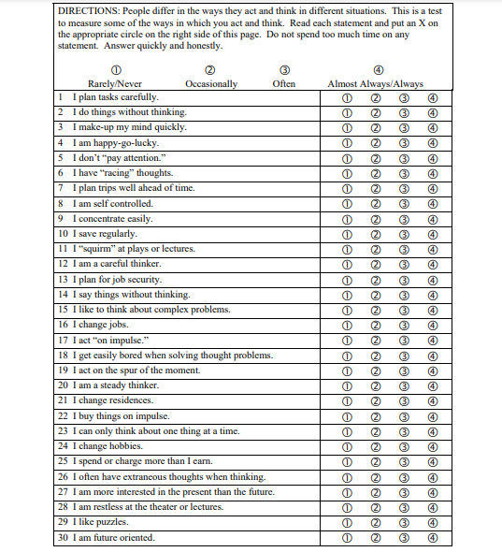

Section III
Brief Fear of Negative Evaluation Scale

Read each of the following statements carefully and indicate how characteristic it is of you according to the following scale:

1 = Not at all characteristic of me
2 = Slightly characteristic of me
3 = Moderately characteristic of me
4 = Very characteristic of me
5 = Extremely characteristic of me

1. I worry about what other people will think of me even when I know it doesn't make any difference. | 1 | 2 | 3 | 4 | 5
2. I am unconcerned even if I know people are forming an unfavorable impression of me. | 1 | 2 | 3 | 4 | 5
3. I am frequently afraid of other people noticing my shortcomings. | 1 | 2 | 3 | 4 | 5
4. I rarely worry about what kind of impression I am making on someone. | 1 | 2 | 3 | 4 | 5
5. I am afraid others will not approve of me. | 1 | 2 | 3 | 4 | 5
6. I am afraid that people will find fault with me. | 1 | 2 | 3 | 4 | 5
7. Other people's opinions of me do not bother me. | 1 | 2 | 3 | 4 | 5
8. When I am talking to someone, I worry about what they may be thinking about me. | 1 | 2 | 3 | 4 | 5
9. I am usually worried about what kind of impression I make. | 1 | 2 | 3 | 4 | 5
10. If I know someone is judging me, it has little effect on me. | 1 | 2 | 3 | 4 | 5
11. Sometimes I think I am too concerned with what other people think of me. | 1 | 2 | 3 | 4 | 5
12. I often worry that I will say or do the wrong things. | 1 | 2 | 3 | 4 | 5

Section IV
Columbia Suicide Severity Rating Scale

APPENDIX D
(Tool Permissions)

Permission for DASS-21

The DASS questionnaire is public domain, and so permission is not needed to use it.
http://www2.psy.unsw.edu.au/

Permission for Barratt’s Impulsiveness Scale (BIS-11)

This tool is open access.
https://scienceofbehaviorchange.org/

Permission for Brief Fear of Negative Evaluation (BFNE)

This tool is open access.
https://www.div12.org/wp-content/uploads/2014/09/Brief-Fear-of-Negative-Evaluation-Scale.pdf

Permission for Columbia Suicide Severity Rating Scale (C-SSRS)

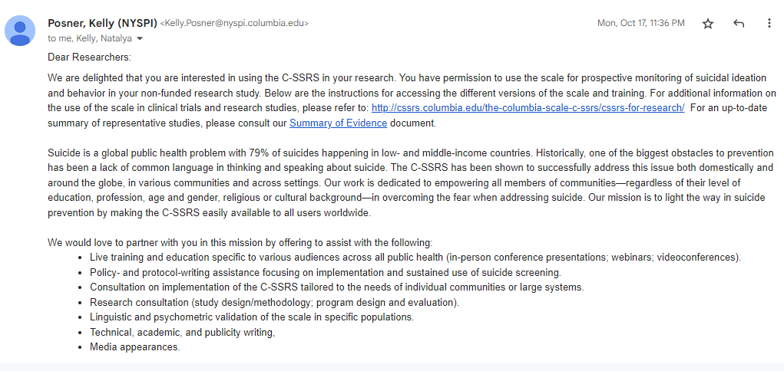

APPENDIX E
(Sampling Permission Letters)

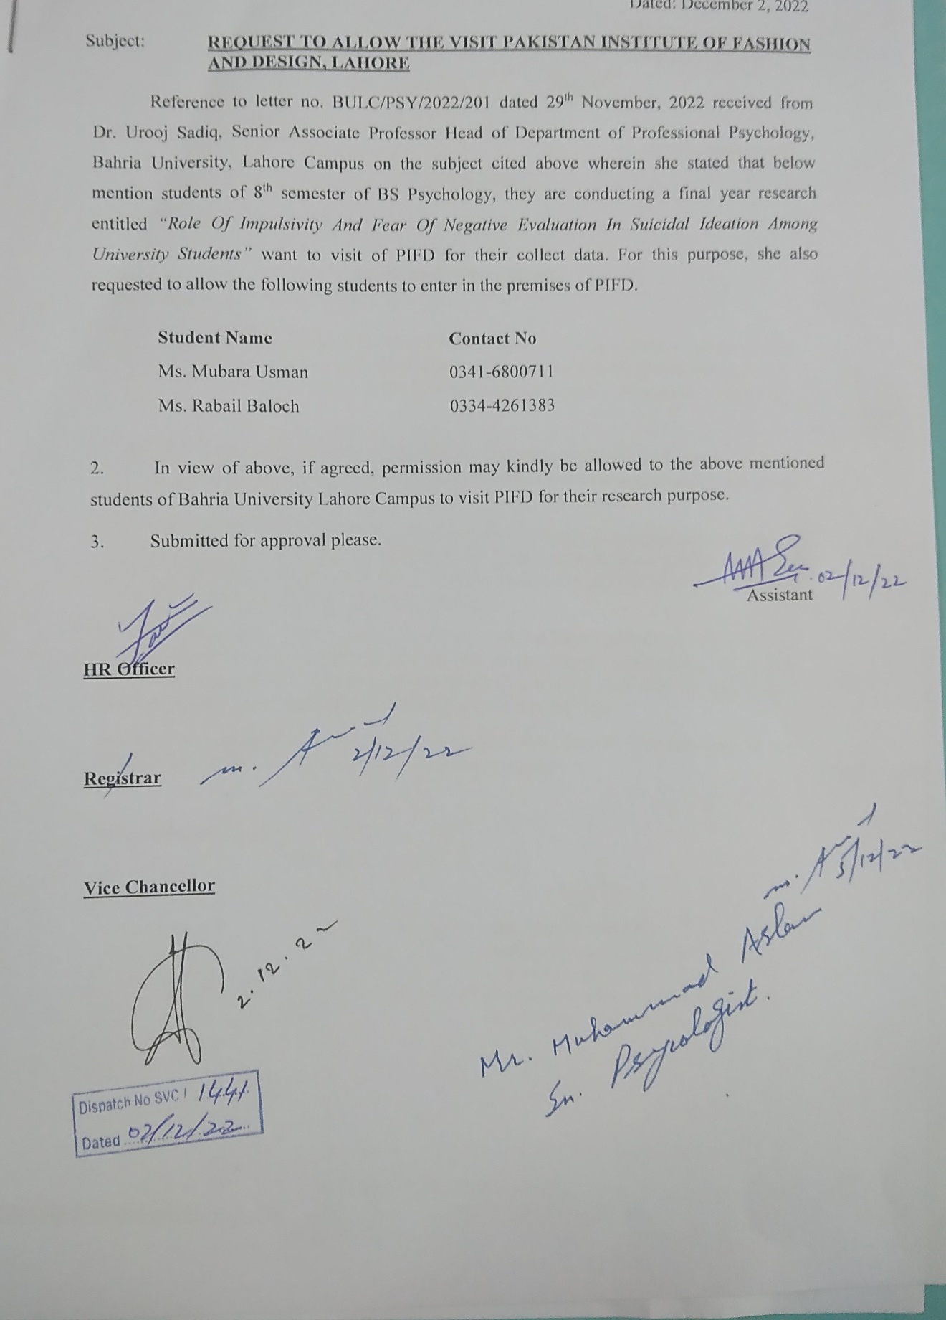

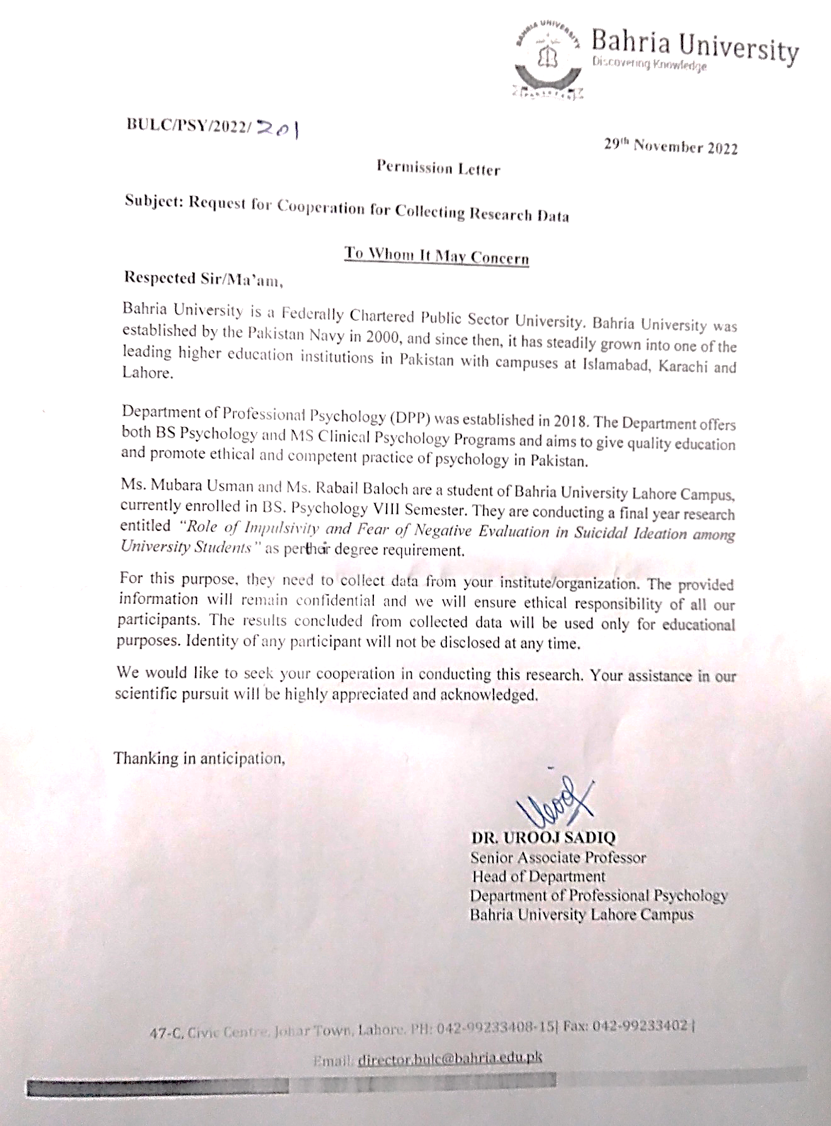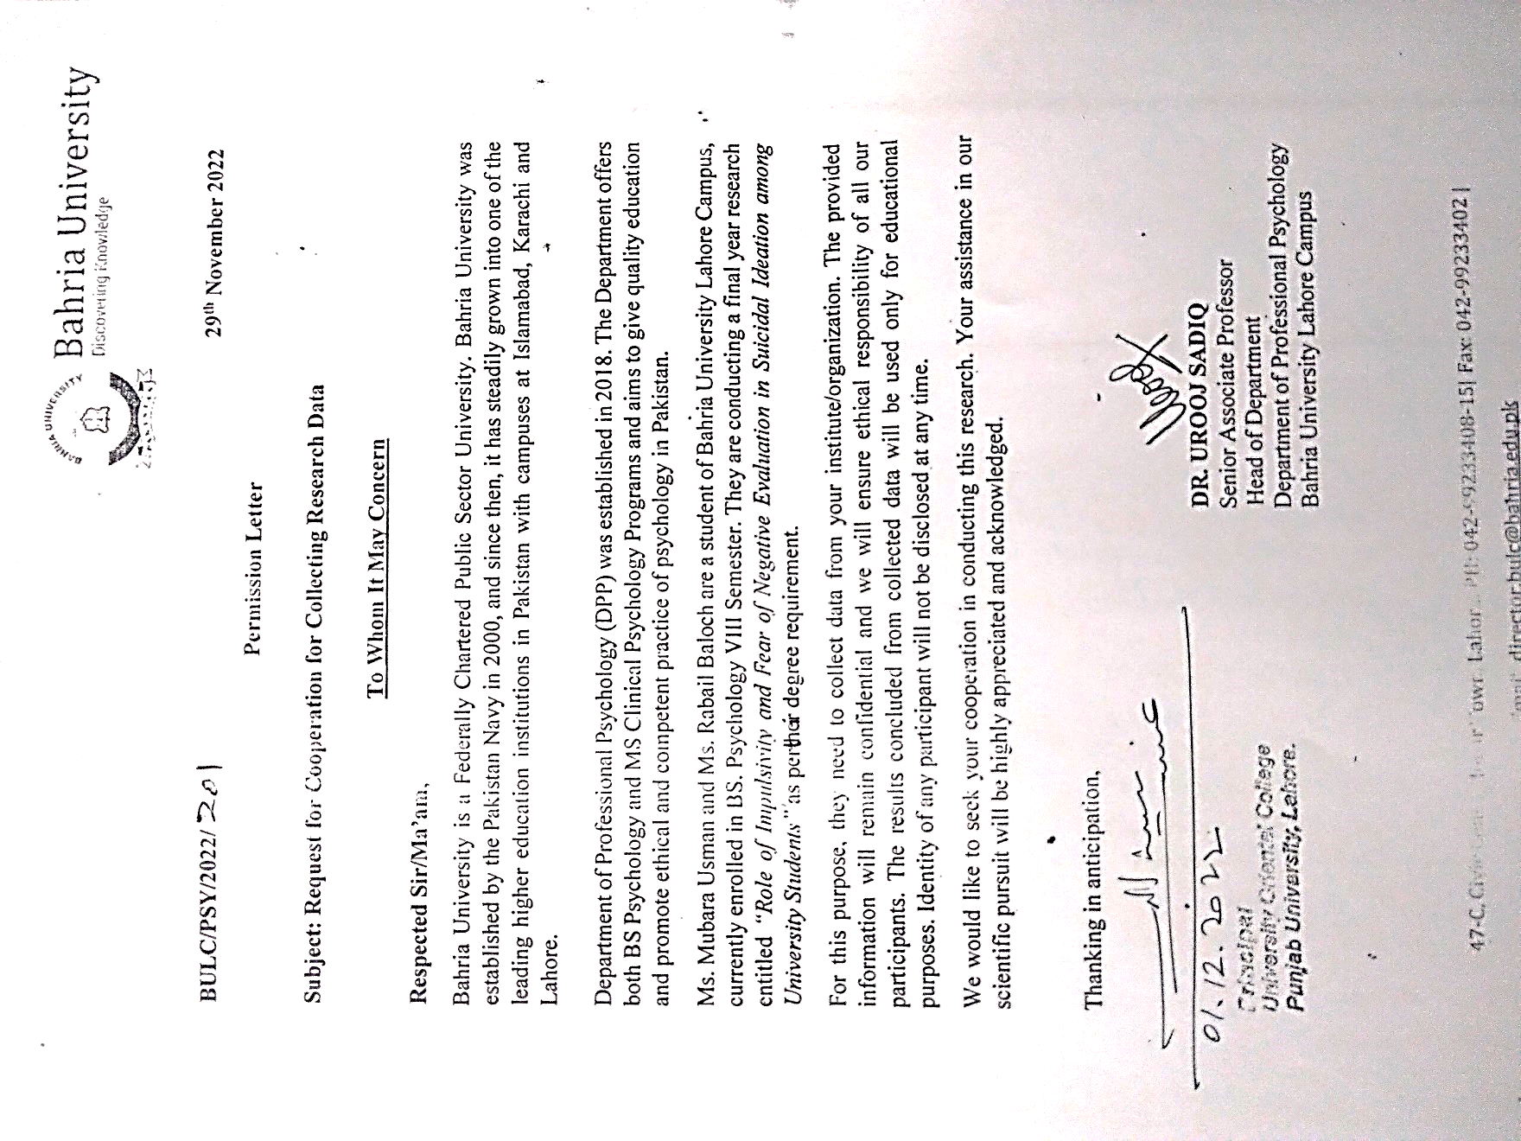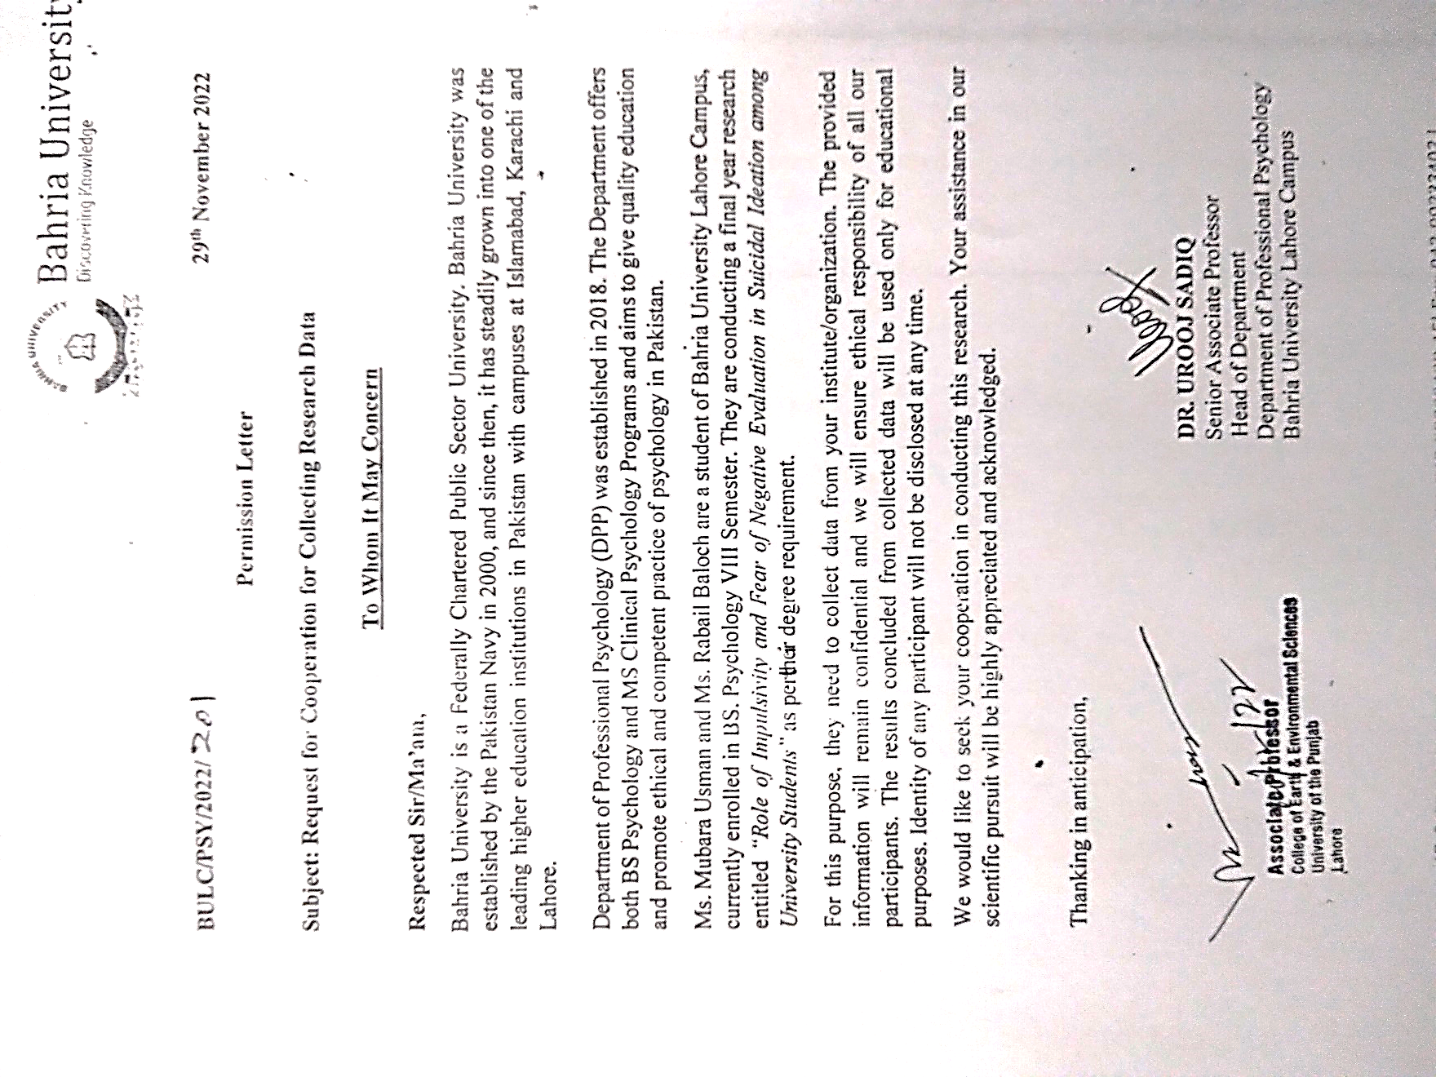

APPENDIX F
(Plagiarism Report)

