(NEW PRODUCTION HALL) – PRE-ENGINEERED BUILDNG

NAME: MR. IRTAZA ALEEM ENROLLMENT: 03-398192-014
NAME: MR.RANA MUHAMMAD AJMAL ENROLLMENT: 03-398192-051
SEMESTER: FALL 2020, MSPM -III PROGRAM: MS (PROJECT MANAGEMENT)

_____________________________________________________________________________________


BAHRIA UNIVERSITY LAHORE CAMPUS

_____________________________________________________________________________________

SUBMITTED TO: Mr. Shehzad Ahmad
SUBMITION DATE: 24 JANUARY, 2020
Table of Contents

PREFACE 7
ACKNOWLEDGEMENT 8
1. ORGANIZATION PROFILE 9
1.1. VISION 10
1.2. MISSION STATEMENT 10
1.3. Core Values 10
1.4. Portfolio 10
1.5. ORGANIZATIONAL CHART 12
2. PROJECT CHARTER 12
2.1. JUSTIFICATION OF NEW PEB BUILDING 12
2.2. PROJECT DIGEST 13
2.3. PROJECT OBJECTIVES 14
2.4. DESCRIPTION OF THE PROJECT 14
2.5. RESULTS OF THE PROJECT 15
3. PROJECTS OF Philip Morris Pakistan Limited ,Sahiwal 16
4. New Pre-Engineered Building INTRODUCTION 16
5. PROJECT MANAGEMENT 18
5.1. KNOWLEDGE AREAS 20
5.2. TRIPLE CONSTRAINT OF PROJECT MANAGEMENT 23
5.3. OBS AND EPS 23
6. NEED FOR THE PROJECT MANAGEMENT 25
7. PRIMAVERA P6 25
7.1. INTRODUCTION 25
7.2. SOME IMPORTANT TERMINOLOGIES 27
7.2.1. ASSUMPTION 27
7.2.2. CLIENT CUSTOMERS 27
7.2.3. CONSTRAINT 27
7.2.4. DELIVERABLE 28
7.2.5. GANTT CHART 28
7.2.6. ISSUE 29
7.2.7. LIFECYCLE 29
7.2.8. MILESTONES 29
7.2.9. PROGRAM 30
7.2.10. PROJECT PHASE 30
7.2.11. SCOPE CHANGE MANAGEMENT 30
7.2.12. SPONSOR 30
7.2.13. STAKEHOLDER 30
7.2.14. BENEFITS OF PRIMAVERA 30
7.2.15. CLEAR VISIBILITY 31
7.2.16. FORECASTING 31
7.2.17. INSTANT ACCESS 31
7.2.18. MONITORING 31
7.2.19. PROJECT MANAGEMENT 31
7.2.20. DIMINISHED RISK 31
7.2.21. CONTROLLING 32
7.2.22. RELATIONSHIP USED IN THIS PROJECT 32
7.2.23. ASSIGNING RESOURCES TO THE ACTIVITIES 32
7.2.24. RESOURCES USED IN CURRENT PROJECT 33
7.2.25. WORK BREAK-DOWN STRUCTURE 33
7.2.26. WBS LEVELS 34
7.2.27. WBS MILESTONE PERCENT COMPLETE 34
7.2.28. S-CURVE 35
7.2.29. HOURS AND MEN S-CURVE 36
7.2.30. TIME S-CURVE VS COST S-CURVE 36
7.2.31. BASELINE S-CURVE 37
7.2.32. ACTUAL S-CURVE 38
7.2.33. TARGET S-CURVE 38
7.2.34. VALUE AND PERCENTAGE S-CURVE 38
7.2.35. WHAT-IF ANALYSIS THROUGH PRIMAVERA P6 39
7.2.36. PROJECT SETTINGS 39
7.2.37. Baseline for Earned Value Calculations 40
7.2.38. EARN VALUE SETTING 40
7.2.39. DURATION TYPE 41
7.2.40. RESOURCE CURVE 41
7.2.41. Resource Histogram 42
7.2.42. BASELINE TYPE 42
7.2.43. CALENDAR SETTING 43
7.2.44. ACTIVITY CODES 43
8. REFERENCES 44
9. LIST OF REPORTS 45
10. LIST OF ANNEXURE 72

List of Figures

Figure 1: Portfolio 11
Figure 2: EPS 23
Figure 3: OBS 24
Figure 4: Gantt Chart 28
Figure 5: Mile stone 33
Figure 6: Resources R-1 33
Figure 7: Resources R-2 34
Figure 8:WBS 35
Figure 9:WBS Milestone Percent Complete 35
Figure 10:S-Curve 36
Figure 11:Cost S-curve 37
Figure 12:Baseline Curve 37
Figure 13:Actual S-curve 38
Figure 14:What If analysis 39
Figure 15: Project Setting 40
Figure 16:Earn Value 41
Figure 17:Resource Histogram 42
Figure 18:Baseline type 42
Figure 19: Calender Setting 43
Figure 20:Activity Code 43

List of Tables

Table 1: Project Dijest 13
Table 2: Project Description 15
Table 3: Cost Summary 18

PREFACE

As per the requirement criteria of MSPM degree program in Bahria University, I have learnt various Project Management tools and techniques and performed various implementations for various tasks. So, to materialize my efforts, I am submitting a comprehensive report which based on two segments, planning and scheduling.
My project is to carry out “Execution of Prefabricated Engineering Building (PEB) at Philip Morris Pakistan Limited” which is located at Qadira-bad, District Sahiwal, Punjab. Primavera P6 is utilized which is a twenty first century tool to implement the best project management practices dictated by PMI. Primavera is an enterprise project portfolio management software. It includes project management, product management, collaboration, control capabilities and integrates with other enterprise software such as Oracle and SAP’s ERP systems. This report includes brief introduction of the organization that undertook the stated project, context in which project was carried and most importantly, it discusses how planning and scheduling of the stated project was carried using Primavera P6 software. It also includes necessary supporting literatures, conclusions and recommendations being rendered after doing the work on Primavera and the understanding with new features that we perceived during working on Primavera. The reports are graphically represented with the help of Primavera.

ACKNOWLEDGEMENT
First of all, all praise is for Allah Almighty who gave me strength and knowledge. I am extremely thankful to all the people and peers who have showed me the path to furnish this report. And specially, I want to give my deepest regards to our in-charge Mr. Shahzad Ahamd, his contributions and guidance has helped me to write this report in best possible way.
Moreover, I am also very thankful of the staff Philip Morris Pakistan Limited, who allowed me to use the equipment and data that was necessary to complete the tasks of the project. A very special regard goes to the Engineering Department Head Engr. Farhad Siddiqui, who helped me to put together this report and gave suggestions about the tasks. Finally, I’m also very thankful to the leader of the project, Engr. Junaid Arshad, who put his utmost efforts in helping us achieve the objectives of the project. I’m also appreciative of the enlightenment by the all the other supervisors on the project team as well as all the other departments and their people who were related to the projects, namely, Engineering Cell and Project Department of Philip Morris Pakistan, Sahiwal, that supported us throughout the project and helped us improve our skills, this is a special thanks to their comments and advices.


ORGANIZATION PROFILE
````
Philip Morris Pakistan is a Pakistani tobacco manufacturing company which is a subsidiary of Philip Morris International. It is headquartered in Karachi, Pakistan. The company is involved in the manufacturing and sale of cigarettes and tobacco products.^{[2]}
It is the second-largest tobacco company in Pakistan after Pakistan Tobacco Company.^{[3]}

The company was founded in 1969 as Lakson Tobacco. In 2007, Philip Morris International acquired the company by increasing its shareholding to 97 percent.]In 2015, the company shut down its plant in Mandra, Rawalpindi District due to rising costs and smuggling of tobacco in Pakistan. 141 employees lost their jobs.In 2019, the company announced that they are shutting down Kotri plant in order to restructure their finances.^{[7]} As a result, 193 employees lost their job.

PMI’s Portfolio of International and local brands is led by Marlboro, the world’s best-selling international cigarette. Our other leading brands are Parliament, Virginia S., L&M, Lark, Merit, Muratti and Philip Morris, Bond Street, Chesterfield, Next and Red & white.
In Pakistan, we are one of the leading tobacco companies, and our product portfolio includes cigarette brands such as Marlboro, Parliament, Morven by Chesterfield, Diplomat, Philip Morris, L&M, and Red & White.

VISION
To build PMI’s future on smoke-free products that are a much better choice than cigarette smoking so, that these products will one day replace traditional cigarette Products.

MISSION STATEMENT
We are committed to being a great employer and a good corporate citizen. We strive to be environmentally and socially responsible. We are dedicated to fighting the illegal cigarette trade. And we proudly support the communities where we source tobacco and where our employees live and work.

Core Values
Trust, collaboration, and integrity are the core values that embody our commitment to society, our shareholders, our business partners, and our colleagues. They guide us as individuals and collectively as a company. They are with us every day and everywhere. We honor this commitment regardless of the challenges and pressures we face in conducting our business. Acting with integrity, honesty, and in full compliance with the law and our own policies is indispensable in securing a prosperous future for PMI.

Portfolio
PMI is selling over 130 brands all over the world. Some of the famous brands are mentioned in the picture given below
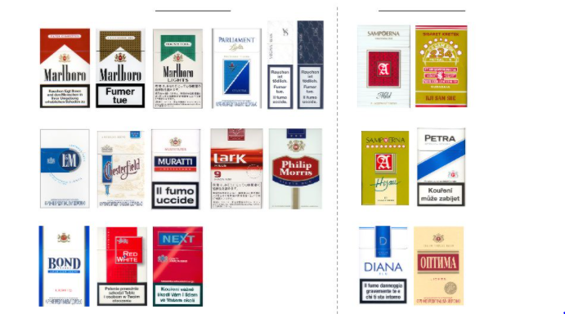
Fig. 01: Portfolio

The major leading brands are
1. MALBORO
2. LARK
3. CHESTERFIELD
4. NEXT
5. BENSON & HEDGES
6. MURATI

ORGANIZATIONAL CHART

PROJECT CHARTER

JUSTIFICATION OF NEW PRE-ENGINEERED BUILDING (PRODUCTION HALL)
The current Infrastructure and construction of building is very old and not in accordance with the global/ local industrial regulation. The Machinery that was implanted during the phase of LAKSON TOBACCO needs to be completely replaced with the new one which comply with the standards of Philip Morris International and manufacturing capacity required in Pakistan
Currently, the building Structure is Frame (Folded Plate Roof) and its adjacent buildings had been made in bit and pieces. Adjacent structures have different type of roofs which are precast roof, Fragile (steel Truss) roof, In-situ concrete roof with over hanging beams and In-situ roof with inverted beams. Due to different structure types of roofs and numerous bolts drilled in roof the building roof drainage becomes insufficient and it faces severe Water Leakages whenever there is rainfall. Further the old buildings are not symmetrical which also creates a hurdle whenever there is need to install any new utility lines / equipment.
The Per Minute Manufacturing Capacity of product is 5000 cigarettes which has been effected by water leakages via un-planned stops. The total duration of un-planned stops that has been occurred last year due to water leakages was 428 minutes which has not only effected the cigarette manufacturing quality but also its shortage in market.
That’s why a new building is required, comply all the global/ local standards and the management has decided to go with the PRE-ENGINEERED Building (Steel Structure) to eliminate the future un-planned stops and to make symmetry of whole production hall (structure type).

PROJECT DIGEST
Name of Project | Construction of Pre-Engineering Building
Location of Project | Philip Morris Pakistan Limited, Sahiwal
Responsible Authorities: | - Sponsor  - Execution Department
Project Proposed Start and End Dates | January 5, 2021 – September 31, 2021
Time Required for Completion of  Project (in months) | 8.5 Months
Capital Cost of Project (Services Only) | 10.1 Million PKR
Table .01: Project Digest

PROJECT OBJECTIVES
- New Building Construction (Pre-engineered Steel Structure)
- Project to be completed in assigned time.
- Project to be completed in assigned budget.
- To eliminate Un-plan stops due to water leakages and building infrastructure.
- To provide enough space for new machinery, equipment and utility lines installation.
- To build a symmetrical building.
- To eliminate the shortage of cigarette occur due to un-plan stops.
- To make new building comply with global and local standards/regulations.
- To execute the project safely with zero TRI (total recordable injury)
- To adopt government sop’s regarding covid-19 for manpower safety.

DESCRIPTION OF THE PROJECT
PMI had takeover LAKSON tobacco in year 2007, which was originally build in 1969. PMI is recognized as one of the giant in tobacco manufacturing companies.
As the Building constructed in Lakson tenure got old and we were facing severe roof drainage and water leakages issue. This reason is the foundation for constructing a new production hall of Pre-engineered Building.
The New building details are as follows
Structure Type | Pre-Engineered Building (Steel Structure)
Covered Area | 75000 square feet
Hygienic floor | Yes (Ucrete flooring)
Building Height | 35 feet
Building width | 250 feet
Building length | 350 feet
Lights | LED
Foundation type | Isolated footings
Table. 02: Project Description

RESULTS OF THE PROJECT
The Results of the project are as follows
- Water leakage issues will be eliminated completely.
- Roof storm water drainage issues will be eliminated completed.
- Internal building infrastructure will be improved.
- Led lights will enhance lux level of floor.
- Better hygiene on the floor due to Ucrete flooring.
- Un-Planned Stops Will be eliminated due to leakages and roof drainage issues.
- No more shortage of cigarettes products due to un-planned stops.
- Safety Champion with zero TRI (total recordable injury)

PROJECTS OF PHILIP MORRIS PAKISTAN LIMITED, SAHIWAL
  - Air Heating Unit Installation
  - Solar Panel Installation
  - New Stem Dryer machine Installation
  - Existing Road Extension
  - New Entrance Gate and Road Rehabilitation
  - New Boiler Installation
  - New Administration Building
  - New Fair Price Shop Building
  - Boundary wall Enhancement

New Production Hall (Pre-Engineered Building) INTRODUCTION
The current production building is very old due to which it’s not only affects product quality but also the worker works under it. It becomes a safety and quality hazard now, which not only effects our customer but also put PMPKL worker life on stake.
The New building will eliminate both these hazards at once.
Following are the areas that will be cover in the new building which are bifurcated as follows
- Filter Rod Making Area
- Dust Collecting System Area
- Primary Tobacco Manufacturing Area
- Secondary Tobacco Manufacturing Area
- Secondary Mechanical & electrical Workshop
- Glue Washing Area
- Add-Pack Area
- Auto-Feeder Area
- Tobacco Infeed Area
All the areas mentioned above are of now greater size than current one. The main structural Elements are steel columns & beams section-I and Section-W of size (Web=1 feet, Flange= 2 feet)
The Concrete elements are the foundation and pedestal columns on which the steel building will rest. There are four types of foundation having different sizes
F-1 = 5 feet ×5 feet
F-2 = 6 feet ×6 feet
F-3 = 9 feet ×9 feet
F-4 = 10 feet ×10 feet
The Building Height, Length and width are already mentioned in Project Description.
The roof sheets are of insulated metal having thickness of 0.9 mm along with PIR (POLYISOCYANURATE) sandwich panels beneath it.
The concrete Floor, Foundation and Pedestal Columns strength comply the standards according to ACI-318 which is compressive strength =3000 psi and the steel structure comply the standards of ASTM (Yield Strength = 60000 psi)
By constructing this pre-engineered building, all the requirement of global and local regulations and issues will be addressed.
Sr.# | ITEMS | Cost (PKR)
1 | Project Start | 0
2 | Designing & Drawings | 1,000,000
3 | Mobilization & Procurement | 389,880
4 | Construction | 7,778,392
5 | Electrical Works | 891,300
6 | Handing Over | 0
Total |  | 10,059,572
SUMMARY OF COST ESTIMATES OF SERVICES FOR WBS ELEMENTS

Table. 03: Cost Summary

PROJECT MANAGEMENT
A temporary endeavor undertaken to create a unique product or service is known as a Project, and to successful application of tool and technologies and implementation of Project Management knowledge to achieve project objectives is known as Project Management. Project management includes processes, process groups, and knowledge areas.
There are 5 process groups required to initiate and complete a project, with a single process group missing, a project cannot be completed. These 5 process groups are as follow:
- Initiation
Initiation includes development of project charter, identification of stakeholders, setting up procurement needs, communication with the stakeholder to evaluate environmental factors and organizational behavior. Initiation sets the momentum of the project and pave the way towards planning.
- Planning
“The Planning Process Group consists of those processes performed to establish the total scope of the effort, define and refine objectives, and develop the course of action required to attain those objectives.” – A Guide to the Project Management Body of Knowledge (PMBOK Guide) Fifth Edition
- Execution
According to PMBOK “The Executing Process Group consists of those processes performed to complete the work defined in the project management plan to satisfy the project specifications.”
Major tasks in Execution process group includes:
Directing and managing project work, performing quality assurance, Acquire, develop and manage project team, manage communication, conduct procurement, manage stakeholder engagement.
- Monitoring and Control
The monitoring and controlling process group includes consist of those processes required to track, review and regulate the progress and performance of the project, identify any areas in which changes to the plan are required, and initiate the corresponding changes. (PMBOK 6) It involves the cycle of Plan, Do, Check and Act. This process group starts working from the initiation of the project and usually ends with the achievement of goals and set objectives of the project.
- Closing
The closing process group includes the process (es) performed to formally complete or close a project, phase or contract. (PMBOK 6)
Major check list of closure includes:
Contract closure, financial closure and administrative closure.

KNOWLEDGE AREAS
According to PMBOK, the knowledge areas occur throughout the process groups, and are vertically integrated into the Project. There are 5 different process groups, 10 knowledge areas and 49 processes in the literature of Project Management.
Following is the list of 10 knowledge areas in the project management:

- Project Integration Management
Integration knowledge area contains the tasks that hold the overall project together, it is the integration of all the knowledge areas, and it starts from the initiation of the project till the completion.
- Project Scope Management
It is the management of the scope of the project, clearly defining the objectives of the project, it includes scope management, requirement collection, defining scope, creating WBS, validating scope, and controlling scope.
- Project Schedule Management
Project schedule management is the most time consuming of all the knowledge areas. This knowledge area includes plan schedule management, defining activities, sequencing activities, estimating activity duration, developing schedule, and controlling schedule.
- Project Cost Management
Project cost management is the most important knowledge area of the project management. We need to make sure that the project is completed under planned budget to avoid complications. Project cost management includes plan cost management, estimate cost, determine budget and control cost.
- Project Quality Management
Project Quality is one of the triple constraints of Schedule, Cost, and Quality, the quality level should be established during planning stage of the project and specified within the project management plan. Project Quality management includes: plan quality management, manage quality, and control quality.
- Project Resource Management
Project resource management is one of the most important factors in the success of a project. A good team will lead to a successful project, we need to make sure that we acquire the right team, ensure that they are satisfied and to make sure that we track their performance. Project resource management in plan resource management, estimate activity resources, acquire resources, develop team, manage team, and control resources.

- Project Communications Management
Project communication management plays a key factor that allows stakeholders to be satisfied even when unexpected changes happen. Communication plan allows all the stakeholders to be in the loop throughout the project and also allows to communicate the changes to all shareholders on timely based. Project communication management includes plan communication management, manage communication, and monitor communication.
- Project Risk Management
Risk management is often not done up to the mark, which then leads to the failure of the projects. Risk management allows the project manager to plan for the mitigation of those risk and to take proactive measures to help reduce the effects of that risk. Project risk management includes plan risk management, identify risks, perform qualitative risk analysis, quantitative risk analysis, plan risk response, implement risk response, and monitor risks.
- Project Procurement Management
Project procurement management includes the plan procurement management, the use of outside procurement, hiring subcontractors (conduct procurement), and controlling procurement.
- Project Stakeholder Management
There is nothing more important than the project’s stakeholders. You could, in theory, declare a project a success if the stakeholders are satisfied but the project was a disaster (although I wouldn’t recommend this line of thinking). The stakeholders should be actively managed and addressed within the project management plan.

TRIPLE CONSTRAINT OF PROJECT MANAGEMENT
Every project has to be carried out in the triple constraint – commonly, they are scope, time and cost. All these are represented as a triangle.
- Projects has to be delivered on said cost
- Projects has to be delivered on said time
- Projects must be delivered on said scope, no more – no less.

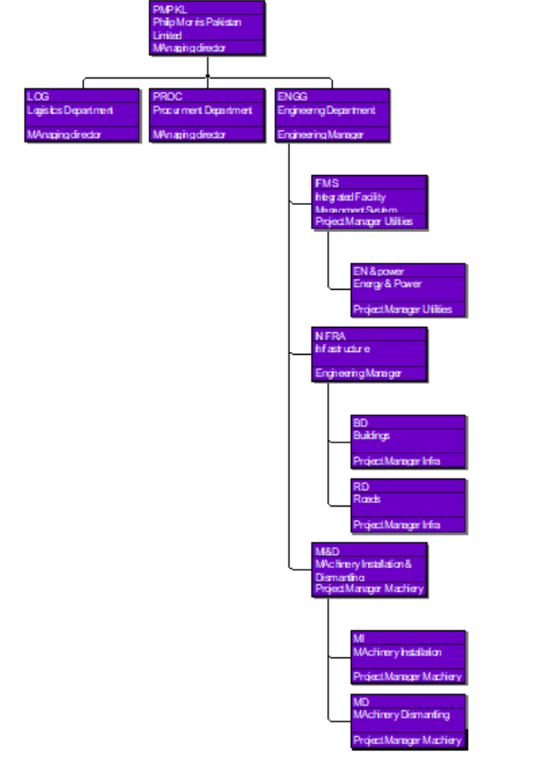
EPS

Fig. 02: EPS
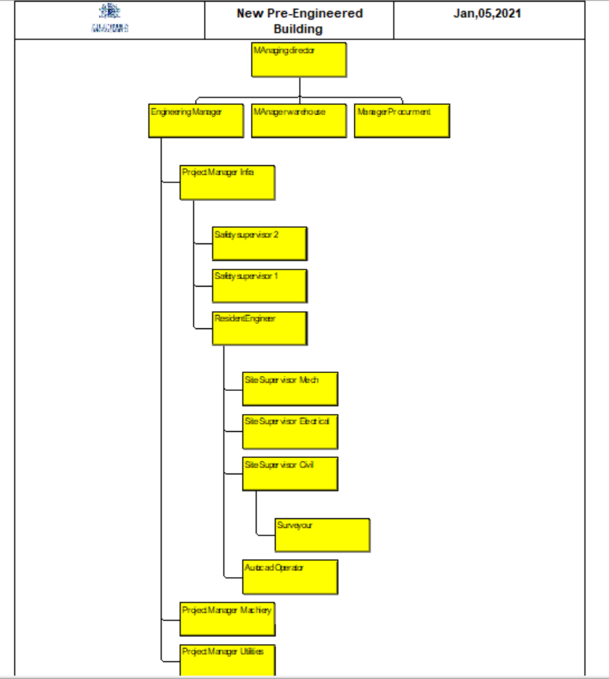
OBS
Fig.03 : WBS

NEED FOR THE PROJECT MANAGEMENT
Project management is direly needed on the large scale project where a lot of resources and costs are invested because it will:
- Help to provide more focus probability of completing the project
- Make sure that the resources and costs are consumed effectively
- Satisfy the needs of the stakeholders and the project itself

PRIMAVERA P6

INTRODUCTION
Primavera Oracle P6 is a planning tool and integrated project portfolio management. Primavera contains a standalone windows interface, server oracle and Microsoft server database. Primavera P6 provide multi features to tackle the needs of project planners and schedulers. Primavera is basically a project management software which helps the users to track and analyze performance of a project. It is a multi-feature and multi user system which provides ease for planning in a best way. This software is perfect for stakeholder’s management who need to deal with different activities and need access over a division or the whole organization’s projects. It supports an enterprise project structure (EPS). Primavera provides unlimited number of tasks, activities, baselines, resources, work breakdown structures (WBS), Organization breakdown structures (OBS), and Critical path method (CPM) budget and resource levelling.
Large scale usage for mega business wide project portfolio management require Oracle or SQL Server as the project database. For little usage standalone SQL Server can be utilized. The PM module likewise gives incorporated resource management. In expansion, the module gives coordinated risk management, issue tracking, and management.
Primavera provide detail reports to client and users some reports are for actual works, some are for budgeted and some are future/remaining works. These reports contain activities, resources and for cost. The Report Wizard makes accurate reports that concentrate information from its database. Moreover, primavera includes the following features.
- Work breakdown structures, user defined fields, codes, resources levelling support by a primavera.
- Same project can be access concurrently by multiple users
- One of the major features is tracking of issues in a project
- Threshold can be used for a management purpose
- Schedule earned value and cross project rollups of cost are enables form tracking feature
- Providing opportunity to assign work products and documents to activities and managed them centrally
- By the help of visualize time-based Gantt and Time scale logic diagram can be created
- Resource management become easy for a planner and project manager
- Different types of reports can be obtained from software for better understanding

SOME IMPORTANT TERMINOLOGIES

ASSUMPTION
There might be outer conditions or occasions that must happen for the venture to be fruitful (or that ought to happen to expand your odds of accomplishment). In the event that you trust that the likelihood of the occasion happening is satisfactory, you could show it as a supposition. A supposition has a likelihood somewhere in the range of 0 and 100%. That is, it isn't inconceivable that the occasion will happen (0%) and it's anything but a reality (100%). It is some place in the middle.

CLIENT CUSTOMERS
The individual or gathering that is the immediate recipient of a venture or administration is the customer/client. These are the general population for whom the task is being embraced (backhanded recipients are partners). In numerous associations, inner recipients are designated "customers" and outer recipients are classified "clients," however this is certainly not a rigid principle.

CONSTRAINT
Constraints have the cause and effect relationship with the dependencies. A constraint is a barrier or a restriction in the four walls of which the task has to be completed and executed. It can be due to the lace of assets or resources, shortage of skills and experiences etc. The constraints may give rise to the dependencies.

DELIVERABLE
A deliverable is any unmistakable result that is created by the task. All ventures make expectations. These can be reports, plans, PC frameworks, structures, air ship, and so on. Interior expectations are created as a result of executing the task and are generally required just by the venture group. Outside expectations are those that are made for customers and partners. Your venture may make one or numerous expectations.

GANTT CHART
A Gantt chart is a bar graph that portrays exercises as squares after some time. The start and end of the square relate to the start and end-date of the movement.
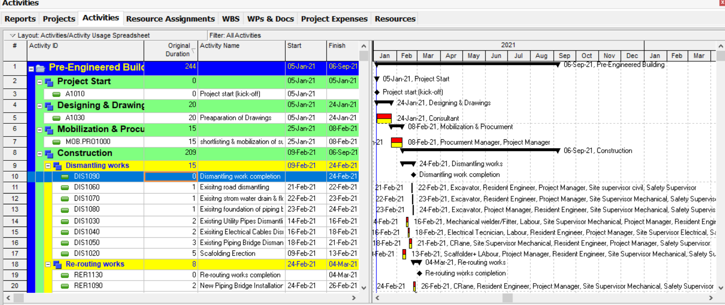
Fig. 04: Gantt chart

ISSUE
An issue is a noteworthy issue that will hinder the advancement of the venture and that can't be settled by the task director and undertaking group without outside help. Task supervisors ought to proactively manage issues through a characterized issues the board procedure.

LIFECYCLE
Lifecycle refers to the procedure used to construct the expectations created by the undertaking. There are numerous models for a venture lifecycle. Incorporate iterative advancement, bundle usage, and innovative work. These lifecycle models speak to a way to deal with making the expectations on the task.

MILESTONES
Milestones are the project schedule instruments that signify a specific set of tasks that are necessary for the onward course of the project execution. By definition, a milestone has zero duration has needs no effort. It is a checkpoint during the project to validate the progress of the project.
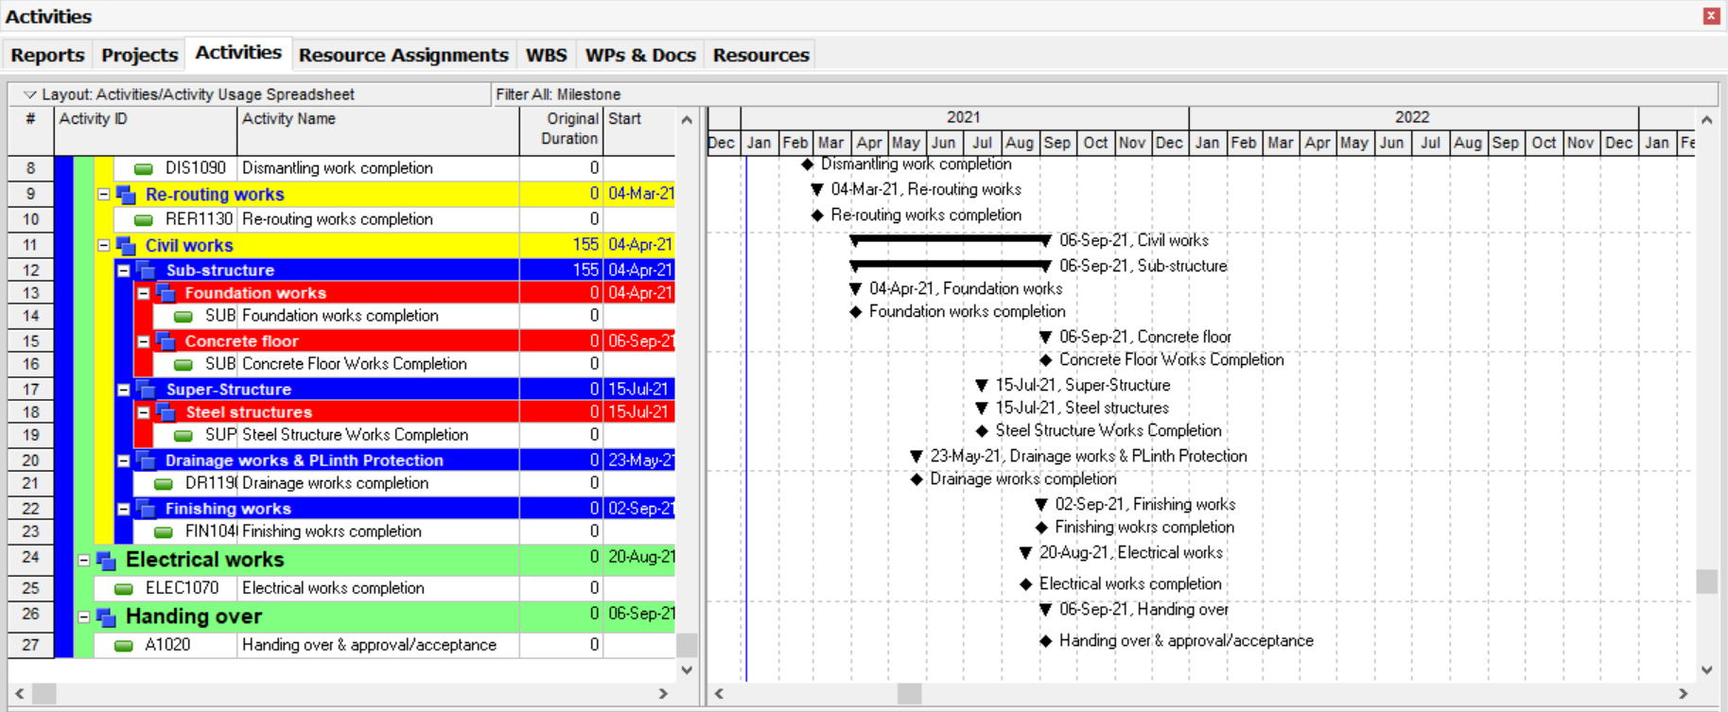
Fig.05: Milestones

PROGRAM
A program is the umbrella structure built up to deal with a progression of related tasks. The program does not create any task expectations. The venture groups create them all. The motivation behind the program is to give by and large heading and direction, to ensure the related ventures are conveying adequately, to give a main issue of contact and center for the customer and the task groups, and to decide how singular activities ought to be characterized to guarantee that all the work gets finished effectively.

PROJECT PHASE
A phase is a major logical grouping of work on a venture. It likewise speaks to the finish of a noteworthy deliverable or set of related expectations. On an IT advancement venture, consistent stages may design, investigation, plan, develop (counting testing), and usage.

SCOPE CHANGE MANAGEMENT
The purpose of scope change management is to manage change that occurs to previously approved scope statements and requirements.

SPONSOR
The sponsor is the person who has ultimate authority over the project. The executive sponsor provides project funding, resolves issues and scope changes, approves major deliverables, and provides high-level direction.

STAKEHOLDER
Specific people or groups who have a stake in the outcome of the project are stakeholders.

BENEFITS OF PRIMAVERA
There are many advantages for working with primavera. It is Oracle based programming which gives many advantages to an organizer and project supervisor. Some the advantages of primavera are as taking after.

CLEAR VISIBILITY
It gives straightforward view that one ready to perceive what is new with a project at various time.

FORECASTING
Anticipating can be enhanced with an entry of time as up-date data gives to see where there is to use asset progressively or not.

INSTANT ACCESS
Advance can be track with a section of time and distinctive angles like asset, cost data can be acquired at whatever point required.

MONITORING
Checking can be better as it give data about the project through following and reports on advance.

PROJECT MANAGEMENT
Less demanding project administration particularly in expansive scale and complex tasks.

DIMINISHED RISK
It not only prominent risk but also cost attached with schedule overhead.

CONTROLLING
One can control project from alternate aspects of project.

RELATIONSHIP USED IN THIS PROJECT
In this project most of the activities are depended on successor activities. Due to this finish to start relationship is used. Some activities were started with successor activities for that start to start relationship used.

ASSIGNING RESOURCES TO THE ACTIVITIES
Assigning of resource is an important task in a primavera because it also estimates about the actual cost incur for completing that activity. Following are the steps to follow for assigning resources to different activities.
- Choose activities of project
- Select the activity that wants to assign a resource
- In activity display click the resource tab
- Then click add resource
- Different resources are given select the resource wants to assign
- Click the assign button and close button for completing assigning

RESOURCES USED IN CURRENT PROJECT
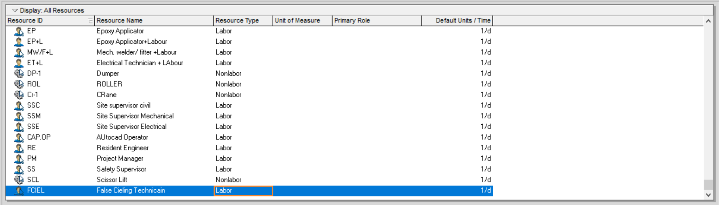
Below are some of resources used for current project but not limited to these.

Fig.06: Resource – 1
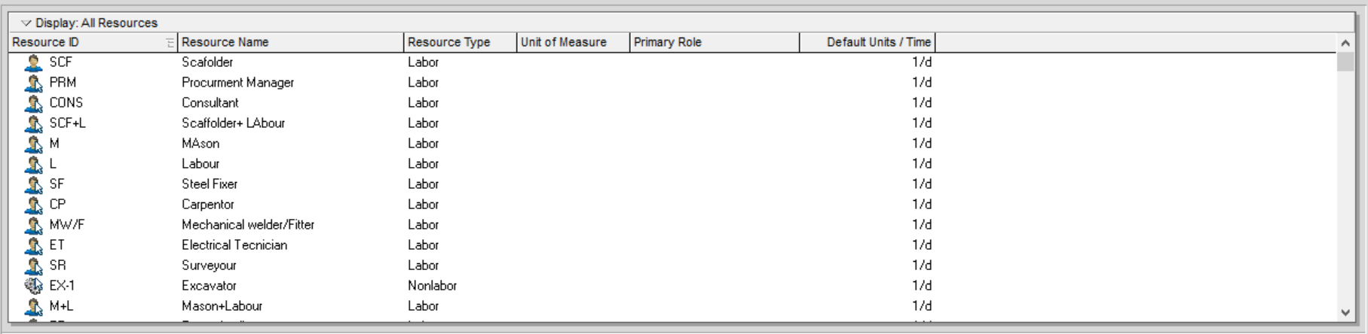
Fig.07: Resource – 2

WORK BREAK-DOWN STRUCTURE
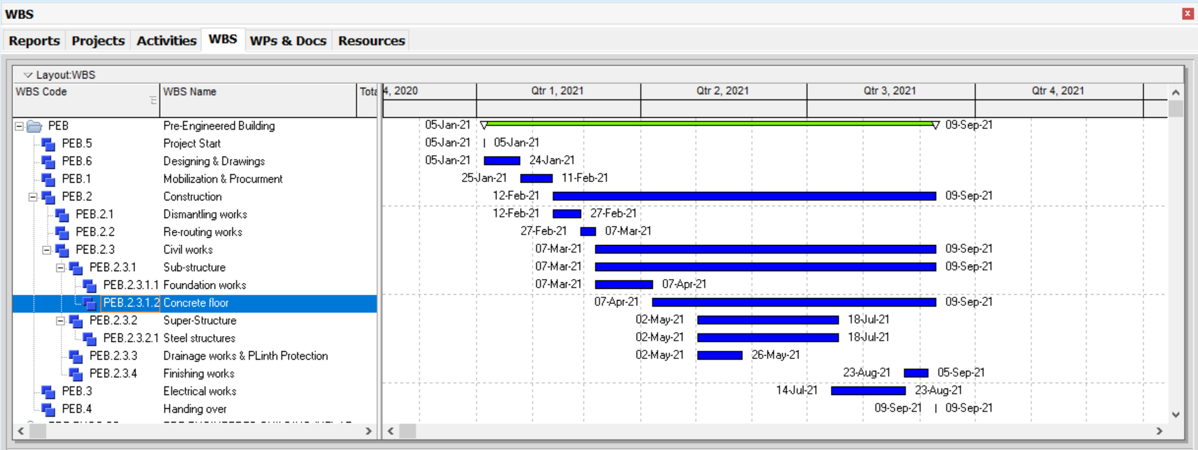
WBS is the lowest level of a Project. This is again a hierarchal structure representing different relative and relevant activities and their relationships. This reflects an organized order that activities related to each other are all under the same level.
Fig. 08: WBS

WBS LEVELS
This structured network gives us a framework for budgeting, scheduling, measuring and reporting a project status and its performance. It is important in a way that Project Manager is aware of all high and low levels of WBS and aware which area needs more attention to control the Project. The WBS provides a roadmap to plan the Project. A WBS also guides us a summary level check list to the activities that must be completed.

WBS MILESTONE PERCENT COMPLETE
This option is selected form the WBS and it is calculated based on completion of the WBS elements weighted milestones.
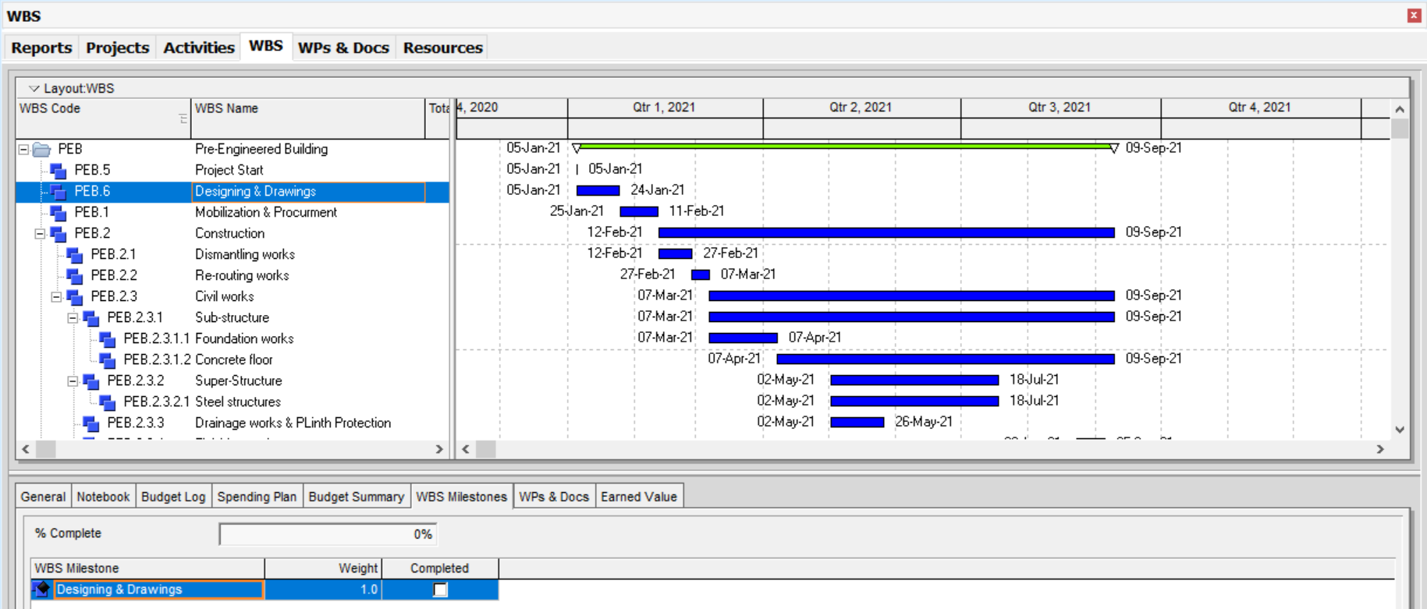
Fig. 09: WBS Milestone Completed Indicator

S-CURVE
S- Curve is a way to show cost, man hour, units against time in the form of a plot. Its shape is like alphabetic “S” as in the start of the project, let’s say cost is very high and then in the middle stage, with the passage of time, you start controlling constraints in favor. At completion time of a project, again it starts increasing due to some unavoidable circumstances. Its significance can be realized with the fact that being the Project manager of a team you need quick review of the activities going around and whether some remedial action is required or not. S- Curve can be created in activities window, by going to resource usage profile options. Types of S-Curve in Primavera are as follow:
- Hours and men
- Time S-Curve vs Cost
- Project baseline S-Curve
- Actual project S-Curve
- Project target S-Curve
- Project percentage and value S-Curves

HOURS AND MEN S-CURVE
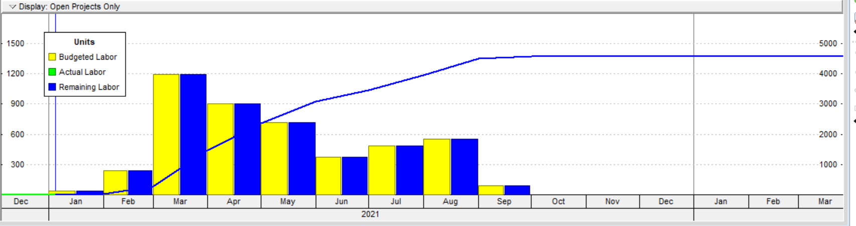
This S-curve is suitable for the projects where high labor rate is involved. Here it gives us the idea that how much man hours are working for project. In other words, it gives us the idea that how much man hours are showing the accomplishments. They are helpful to keep the project on track by allocating more man hours in urgency.
Fig.10: S-curve

TIME S-CURVE VS COST S-CURVE
Cost versus Time S-curve is used when there is a distinction between labor and non-labor activities. Some might be allocated resources while others might need to outsource for on time completion of project. Hence you can calculate the cost incurred over a period of time.
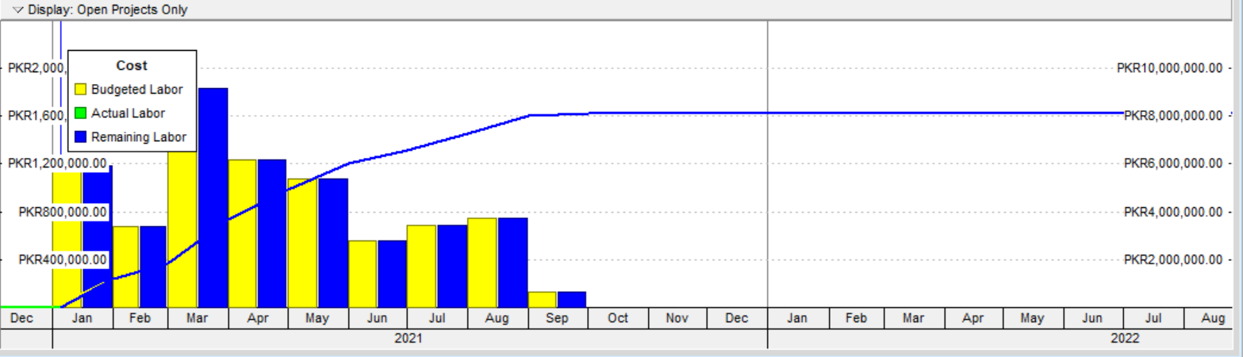
Fig. 11: Cost S-curve (Cost distribution)

BASELINE S-CURVE
Before start of any project, a prototype is made. A plan is originated and then this plan is taken into different phases of the project. This may be called as Baseline of the project. Similarly, baseline S-curve is made against project baseline and hence it assists us to monitor the progress of the project so far. Baseline may need to revise if you are making changes in proposed plan and resources.
Fig.11 Baseline Curve

ACTUAL S-CURVE
When you revise a schedule with time, you get the % completion of each task. This information helps to generate an Actual S-curve. Its use is preferred with baseline S-curve and target S-curve, which make it easier for you to get the exact information and then take action accordingly as per requirement. This actual S-curve, at the completion of the project, meets target S-curve to indicate that you have achieved the target set by you.
Fig 12. : Actual Curve

TARGET S-CURVE
This S-curve is used where you want to compare your actual progress of the project with that of what you have revised over time, different from baseline schedule. It gives a real picture how to achieve your target by keeping in mind the constraints.

VALUE AND PERCENTAGE S-CURVE
This S-curve is helpful when you want to know how much man hours have been used so far and how much cost has been incurred, and how much still need to be invested. This is done by Value S-curve. Percentage S-curve indicated the percentage of actual work been done against baseline S-curve and target S- curve.

WHAT-IF ANALYSIS THROUGH PRIMAVERA P6
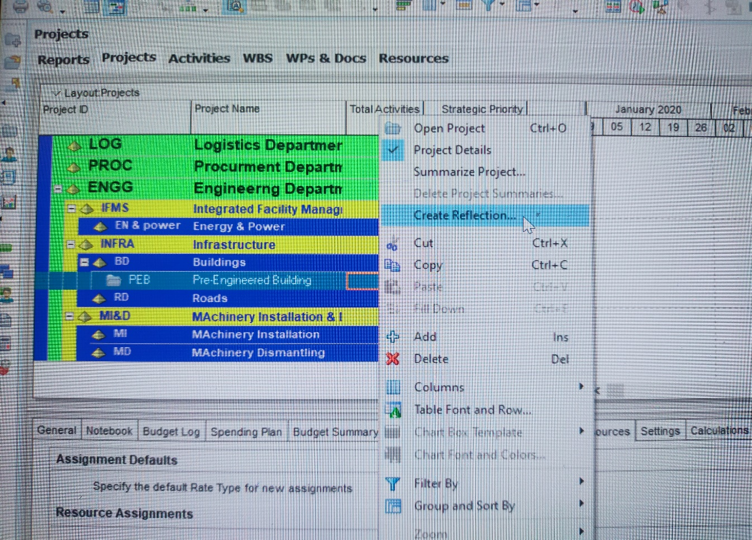
What if is important feature of project planning and controlling. Primavera provides a tool to perform different IF analysis and provides the results of the analysis. Steps to perform what if analysis are as below:
Fig.13: What-If Analysis

PROJECT SETTINGS
Use the Project Details Settings page to choose default settings used for activities when create a new project. Also use this page to check the last summarized date and the WBS level used for summarizing the project. If project is set up to access Primavera Contract Manager, the Contract Manager Link section also appears on this page, so you can link your project to a project in Contract Manager.
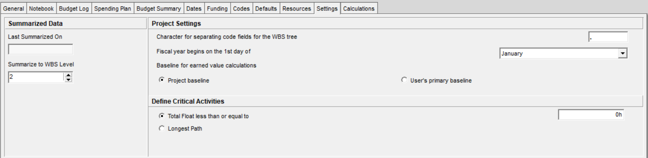
Figure 14: Project Setting

Baseline for Earned Value Calculations
If you have the required privilege, use this option to specify whether you want to use the project baseline or your primary baseline for calculating activity-level earned value data.

EARN VALUE SETTING
Configure earned value settings to specify defaults for calculating earned value.
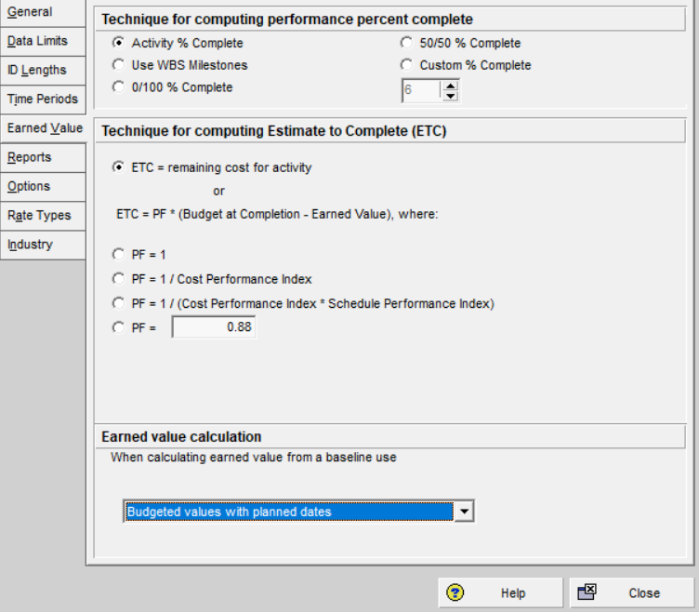
In the Technique for figuring execution percent complete segment, stamp a choice. In the event that you check the Custom % complete choice, utilize the here and there bolts to choose a percent. In the Technique for figuring evaluation to finish (ETC) area, stamp the main choice or check one of the other four alternatives to characterize an equation. On the off chance that you stamp the PF = choice, tap the field and type an incentive to be equivalent to PF.
Fig. 15: Earned Value

DURATION TYPE
Duration type controls the way Primavera manages the variables of the activity duration, effort and budget when adding multiple resources to the activity.

RESOURCE CURVE
Following type of curves are used in this project
- Liner,
- Trapezoidal
- Front Loaded
- Back Loaded
- Customize curves

Resource Histogram
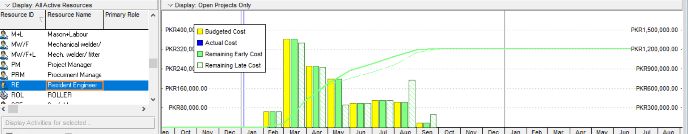
Figure 16: Resource Histogram

BASELINE TYPE
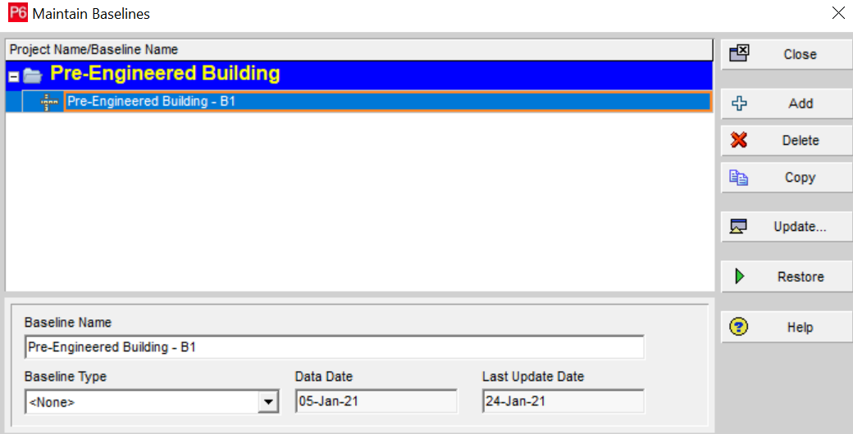
Initial Customer sign off Baseline Type is used.
Figure 17: Baselines

CALENDAR SETTING
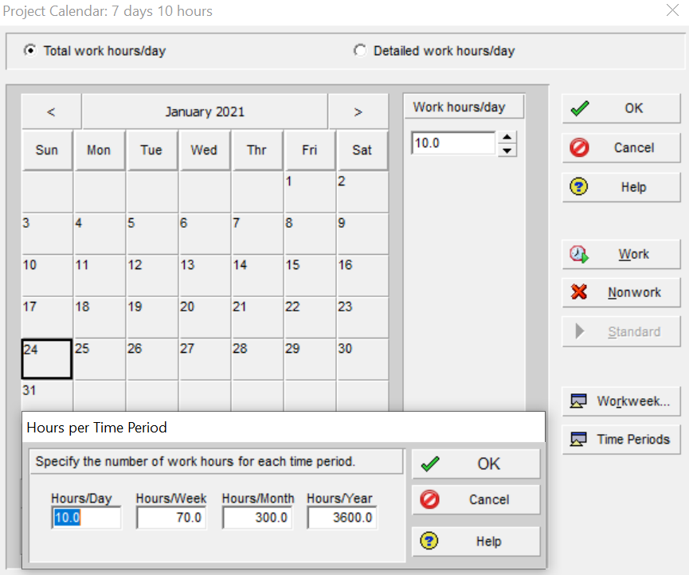
Customize Calendar is used for this project. Calendar is created at global level as well as project level to incorporate all the requirements.
Figure 18: Calendar

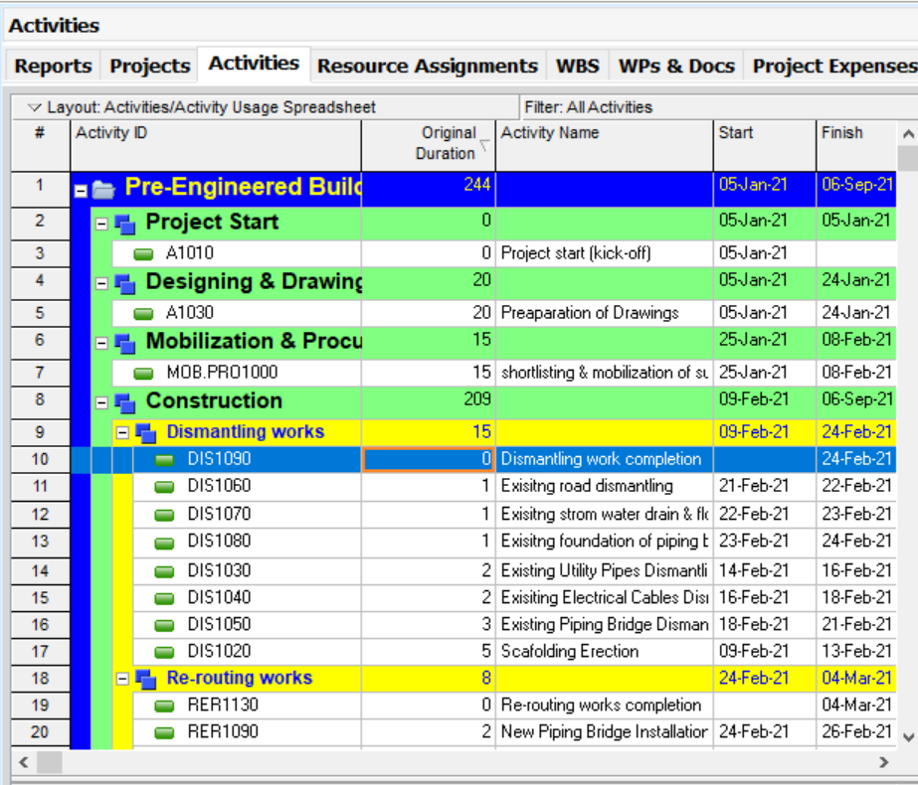
ACTIVITY CODES
Fig 19 : activity code
REFERENCES
- http://www.timelineconsultants.net/
- http://www.businessdictionary.com/definition/project.html
- https://www.pmi.org/about/learn-about-pmi/what-is-project-management
- http://searchcio.techtarget.com/definition/project-management
- https://rapidbi.com/criticalsuccessfactors/
- http://www.3deducators.com/Managementtraining/ProjectManagement/Primaver atraining.asp
- https://www.safaribooksonline.com/library/view/oracle-primavera- p6/9781849684682/ch03s03.html
- http://en.pmimongolia.mn/blog-item/primavera-software-brief-introduction

LIST OF REPORTS
Following Reports are attached.
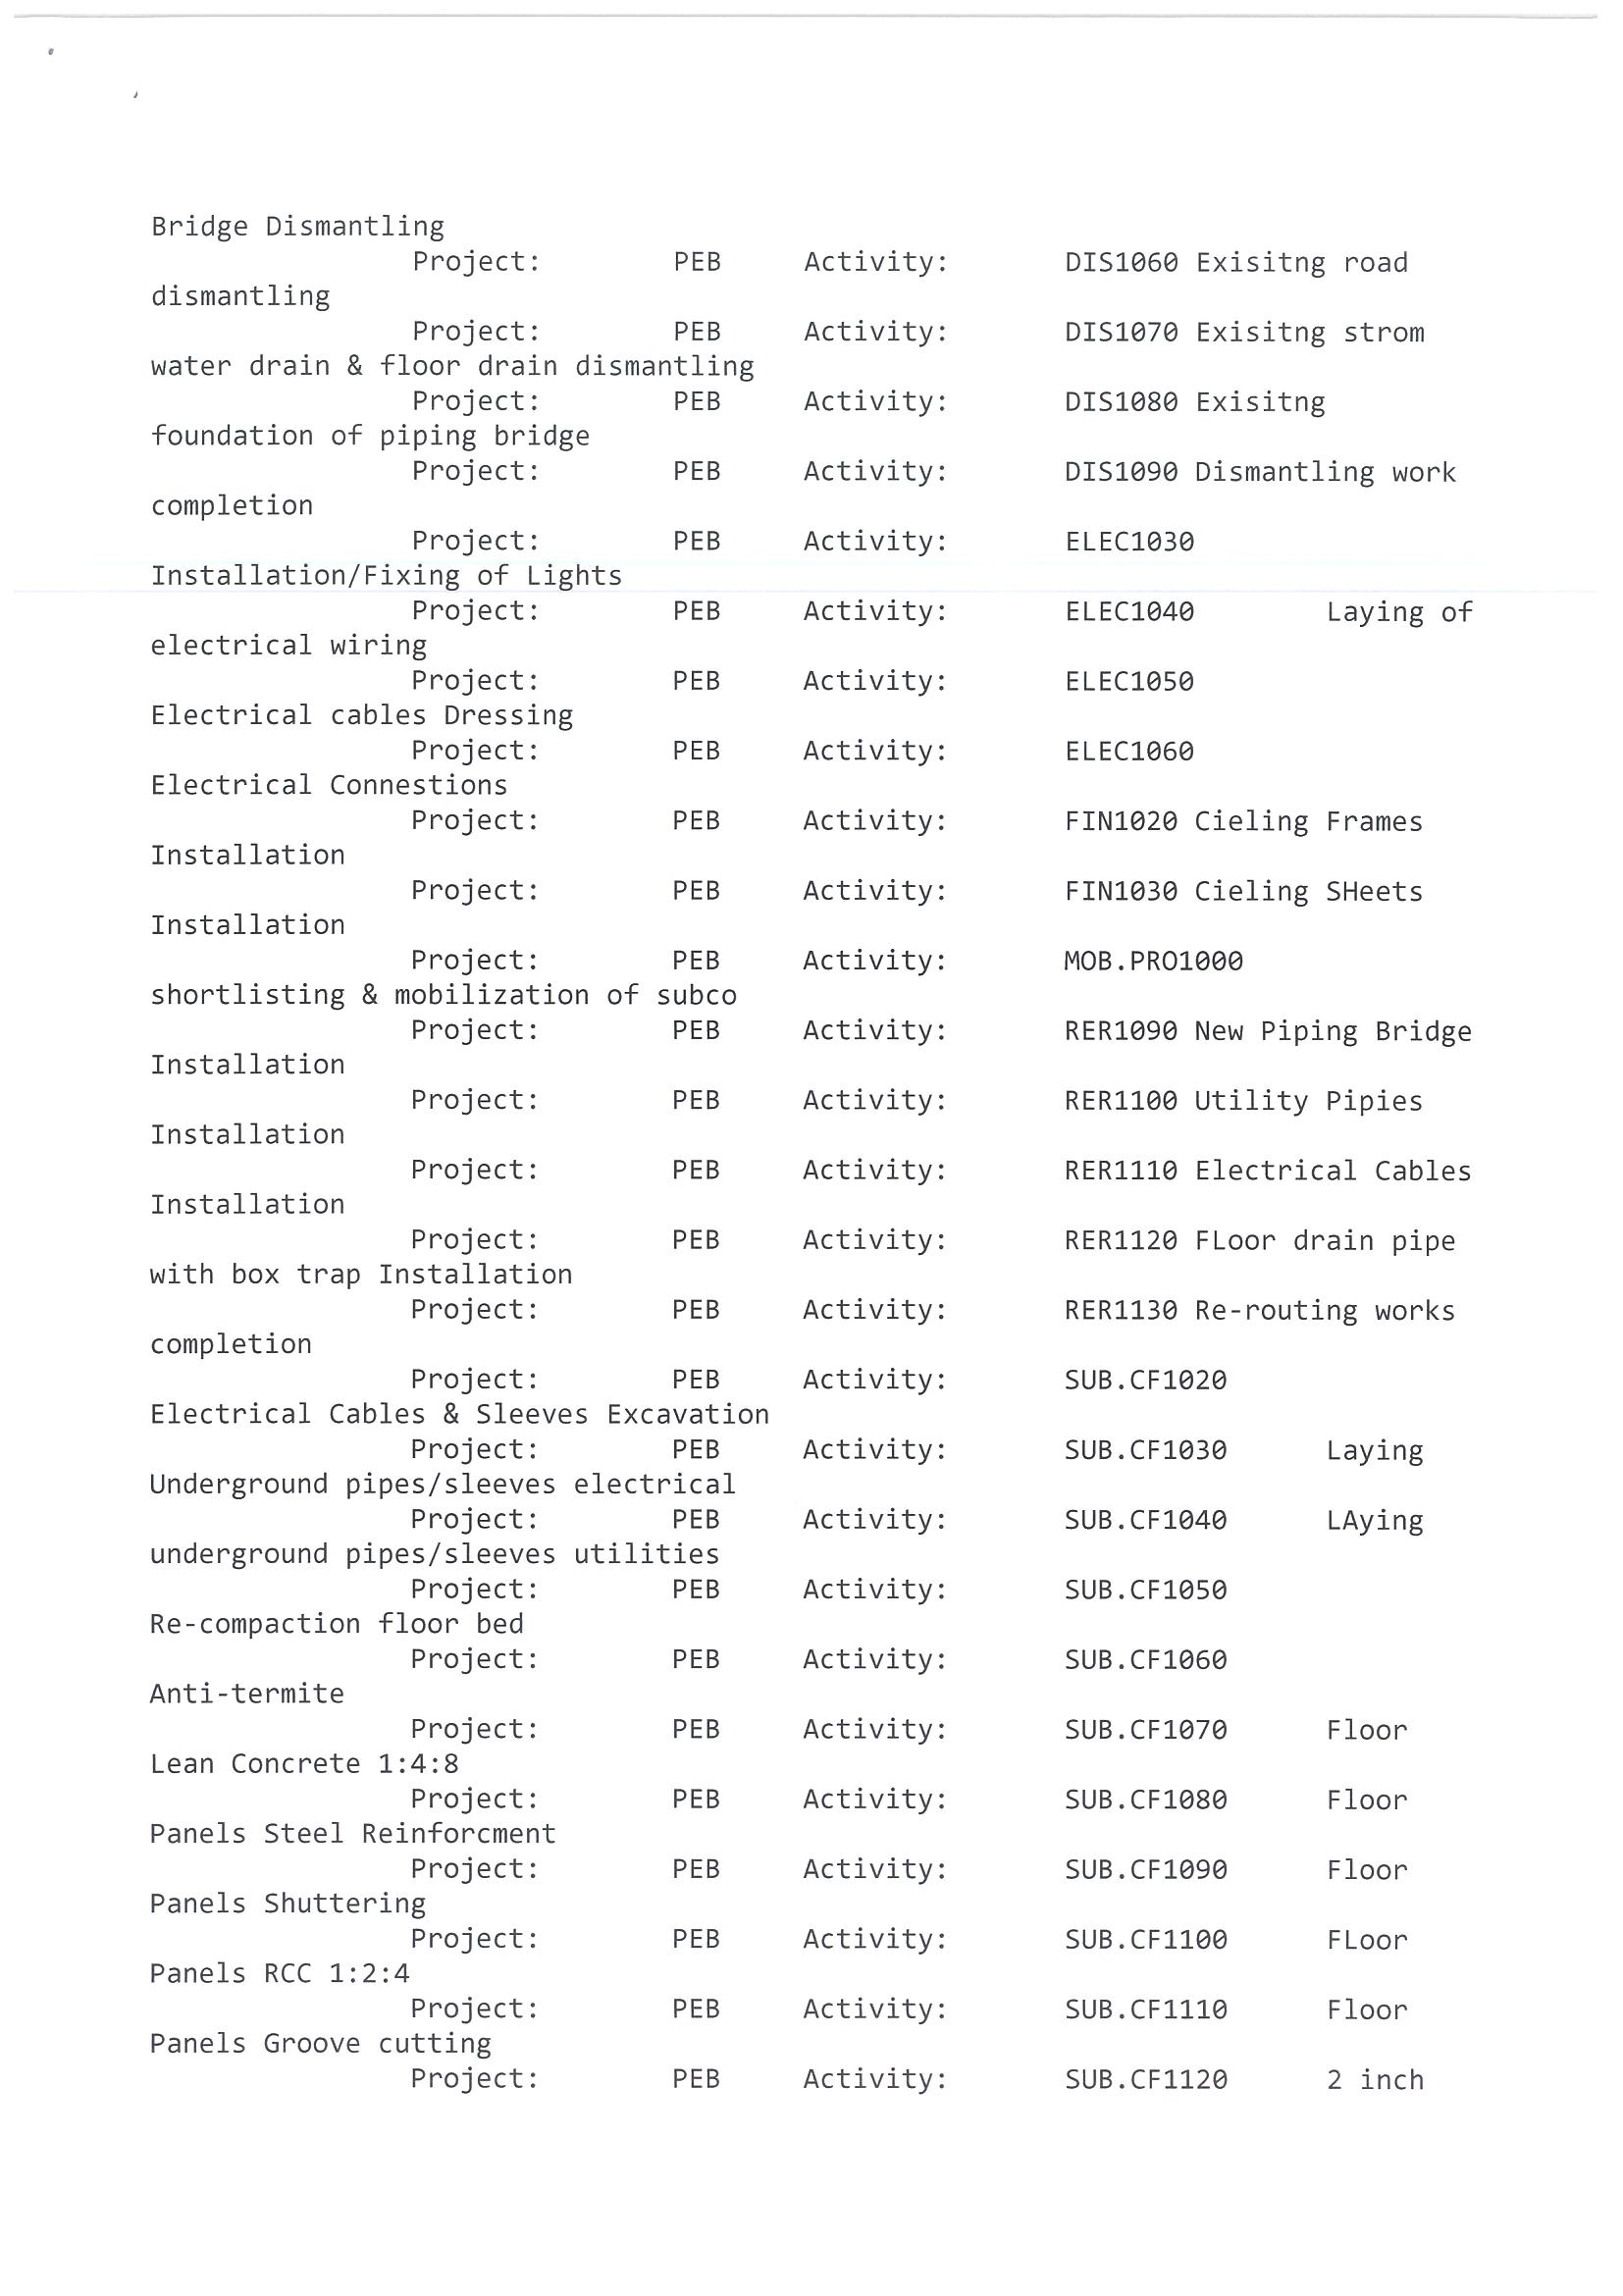
- Project Schedule Log
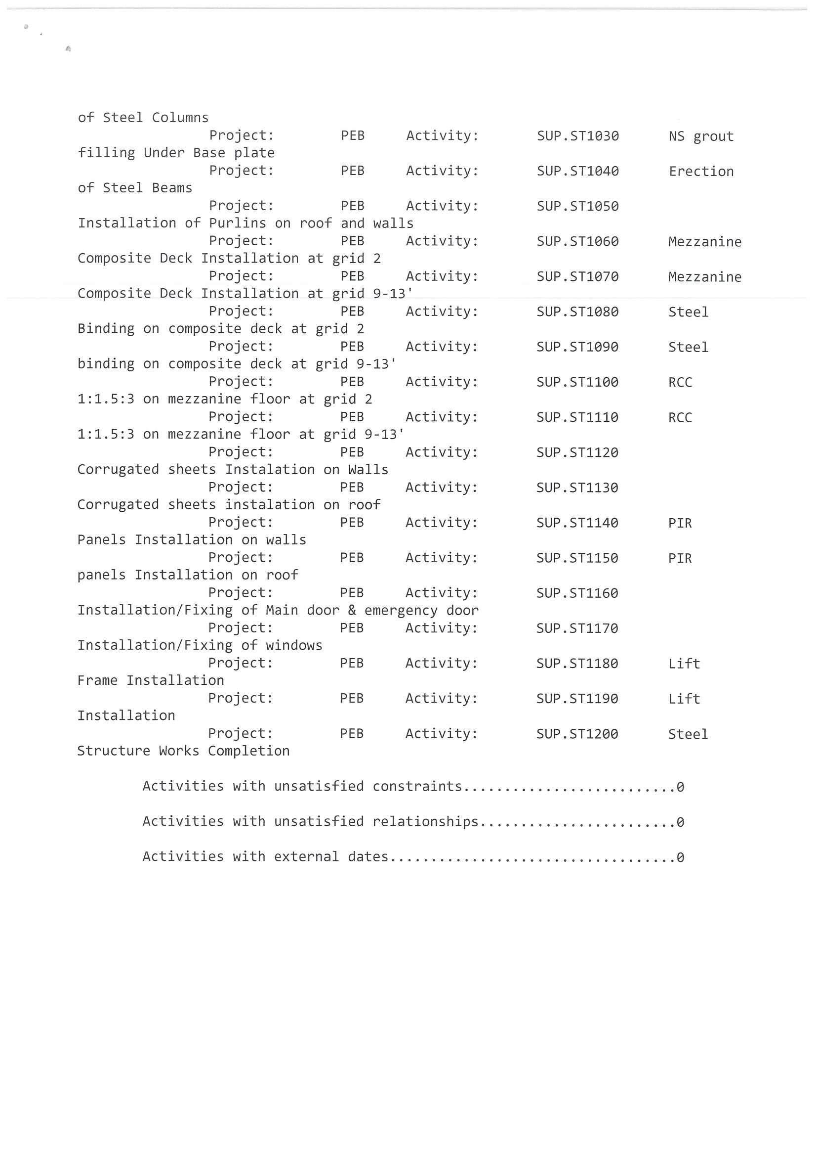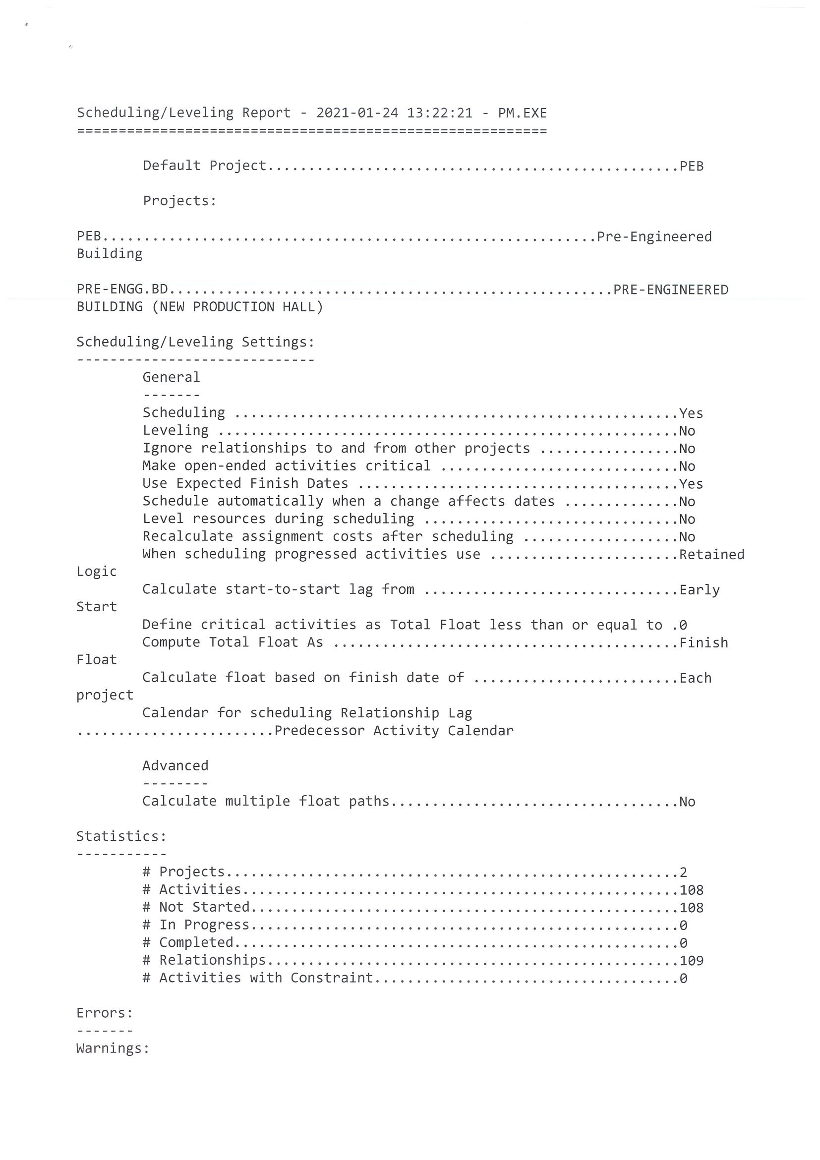
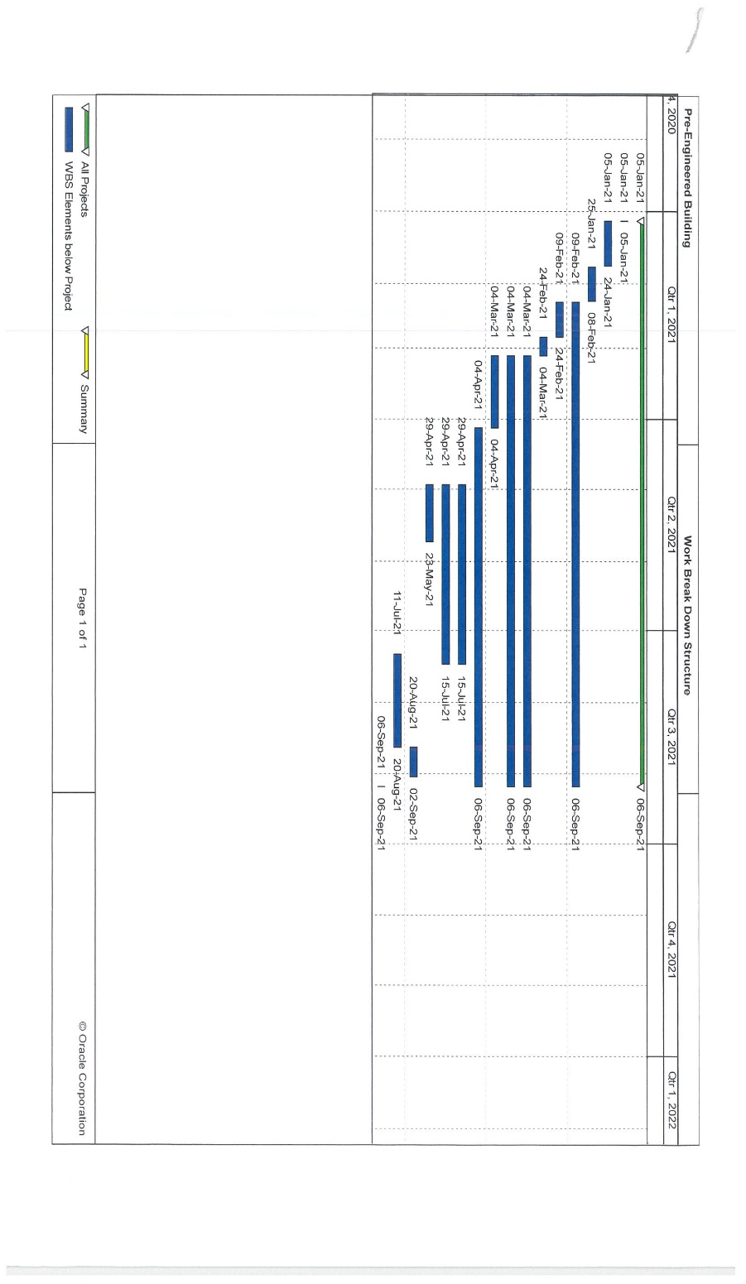
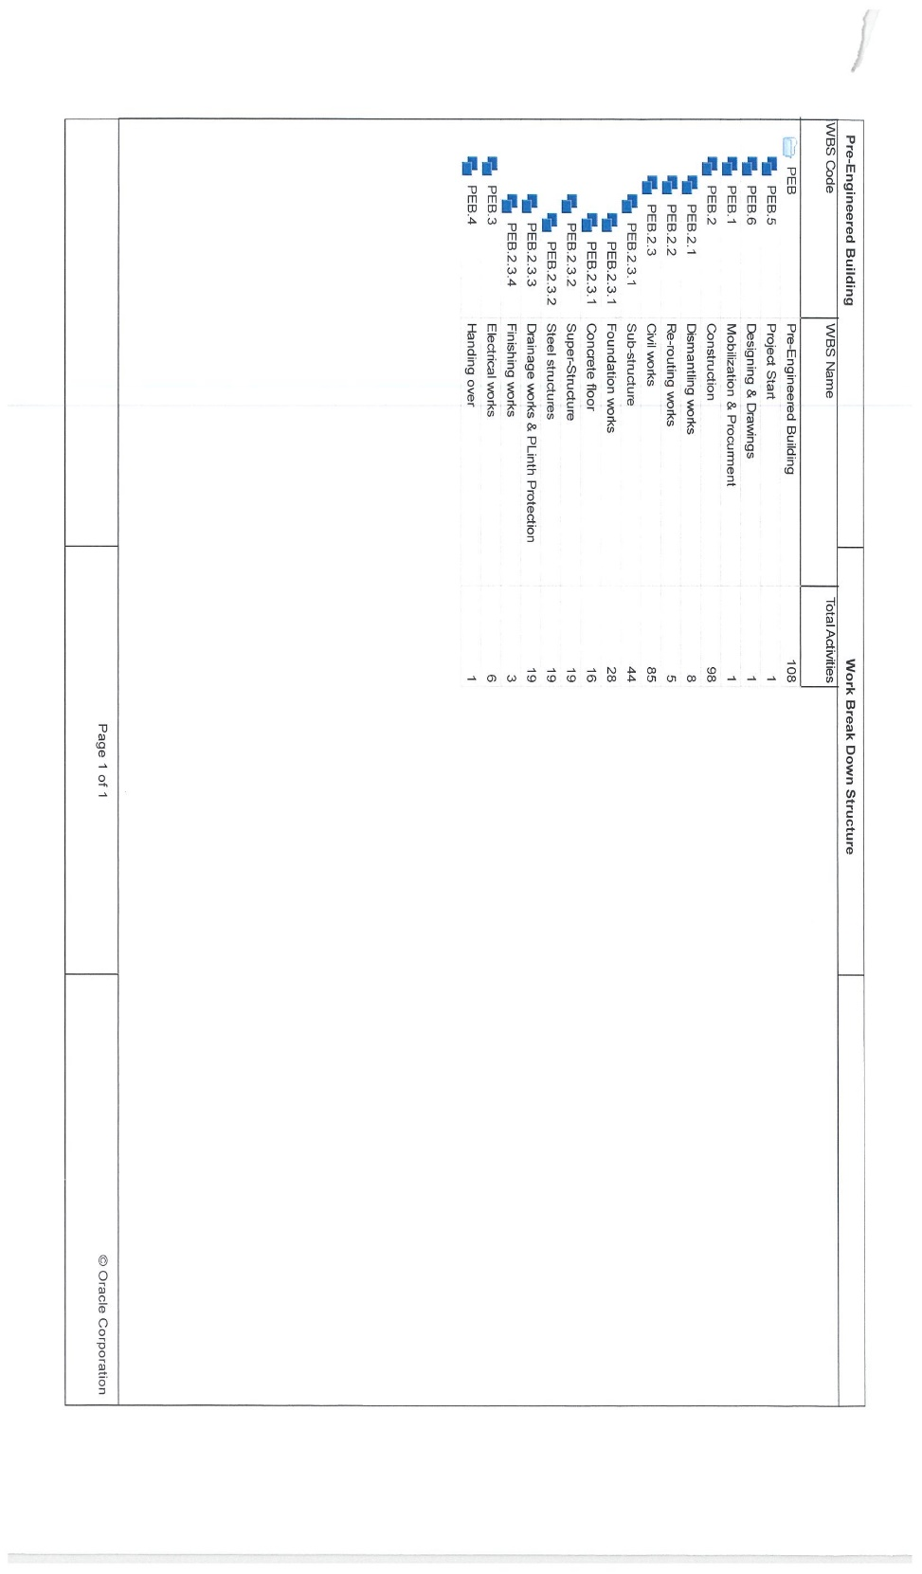
- Project WBS

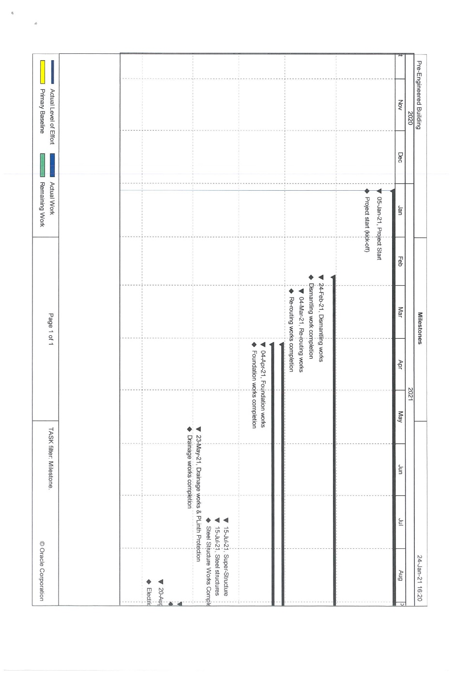
- Project Milestone Report

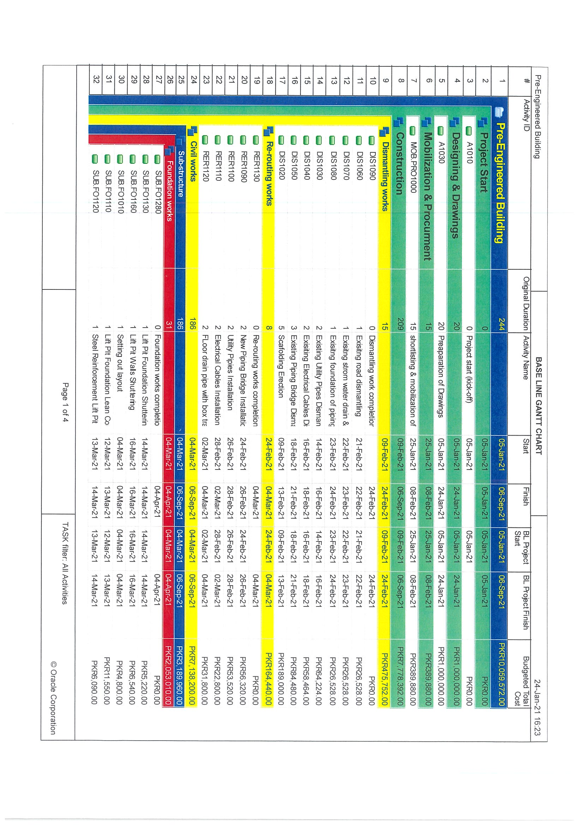
- Project Baseline Table and Gantt Chart 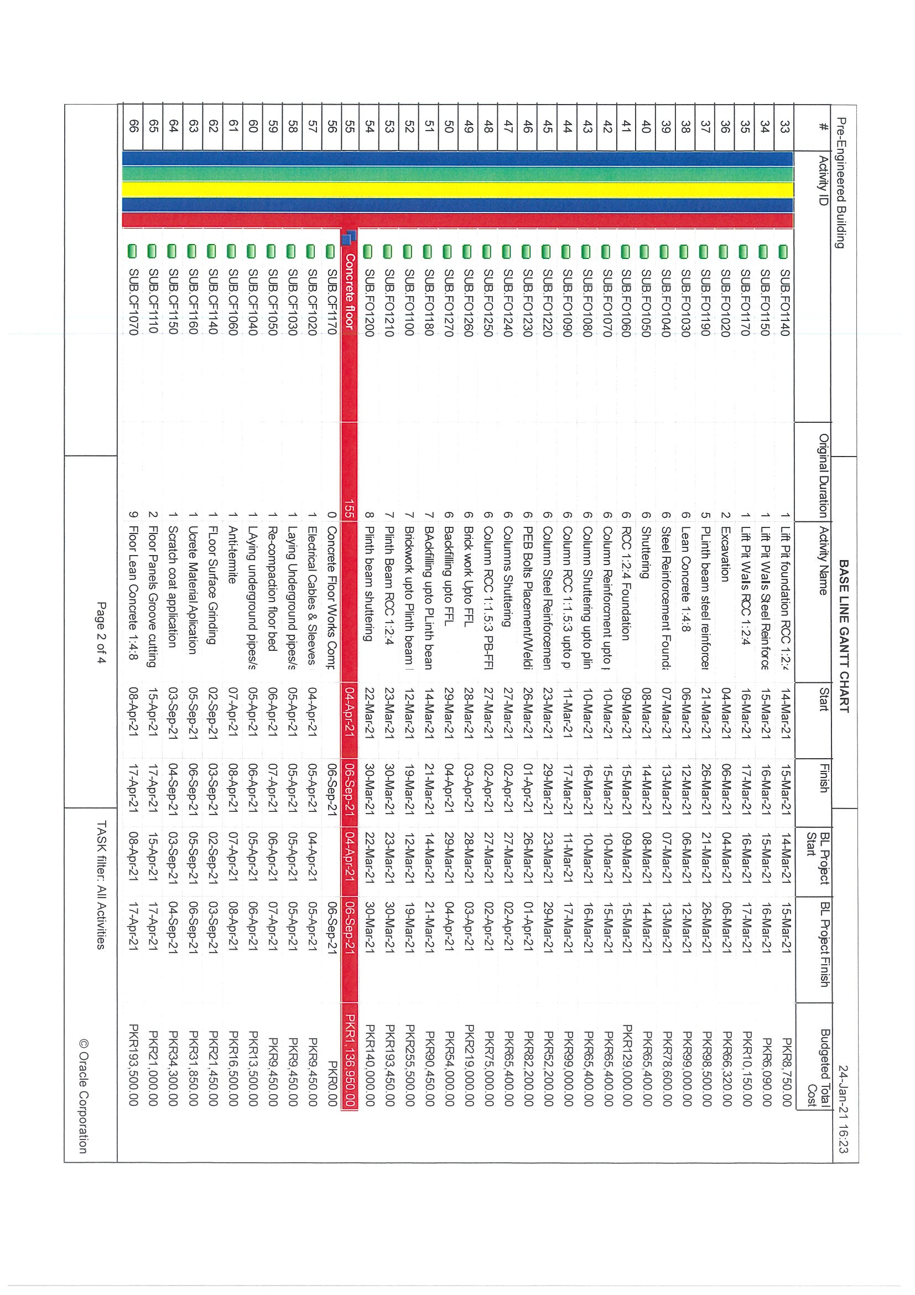
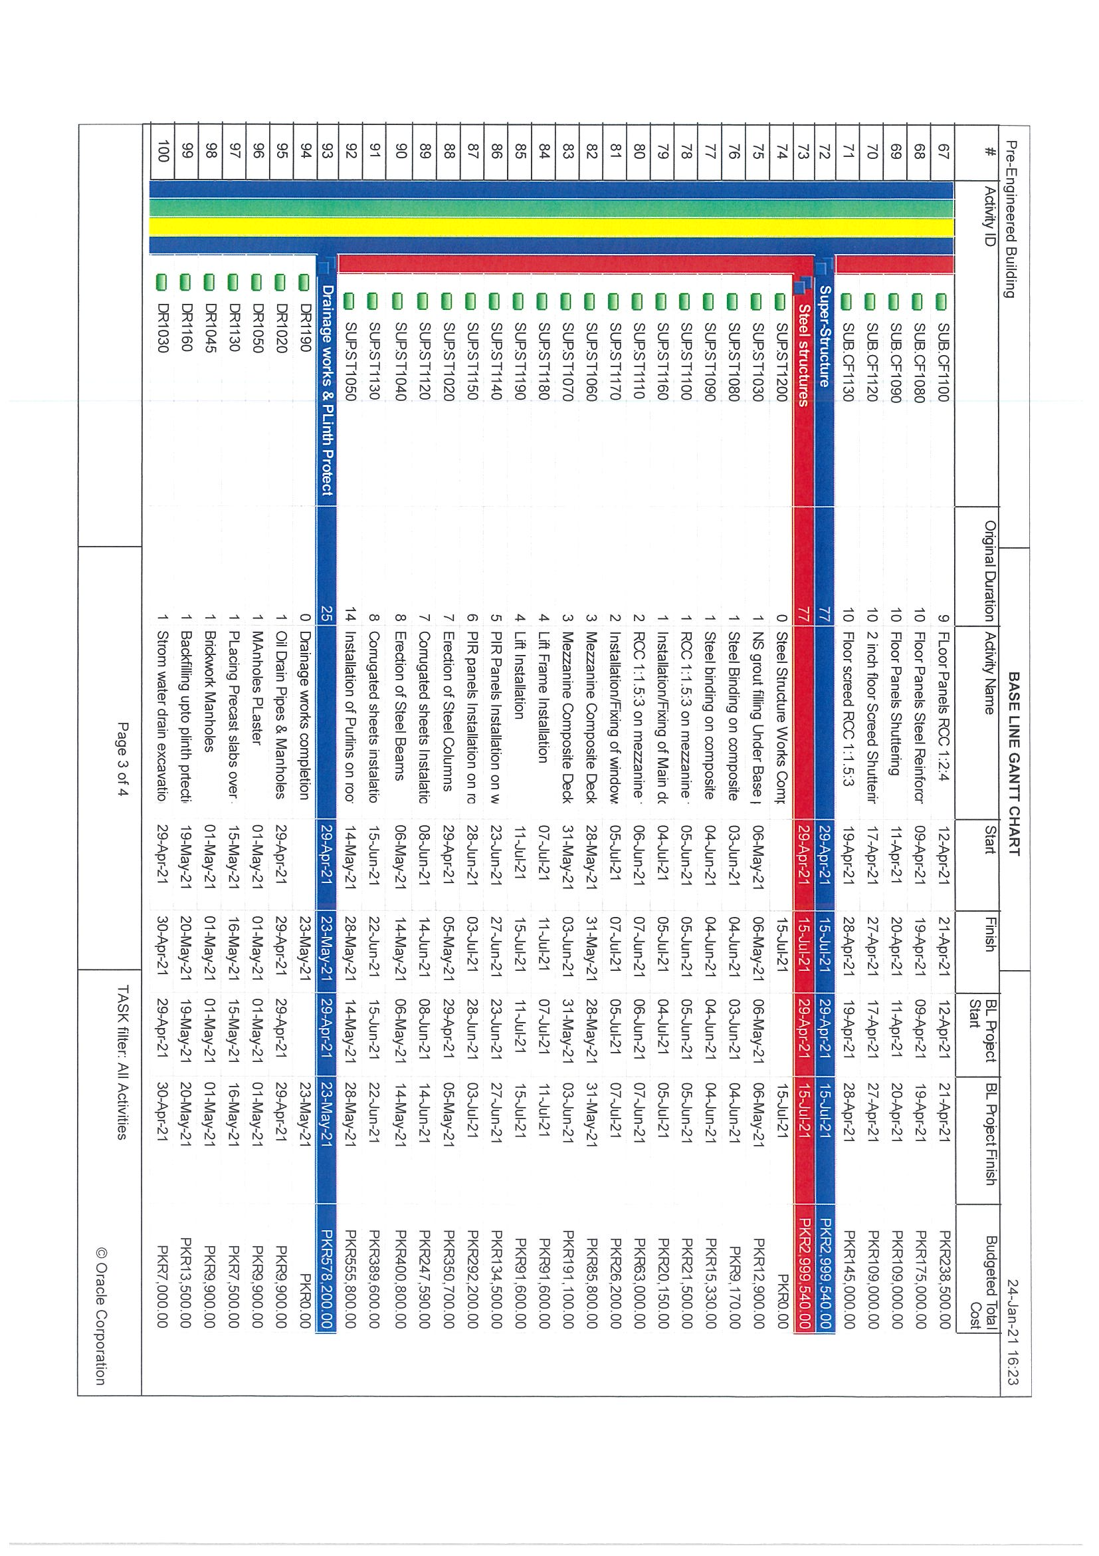
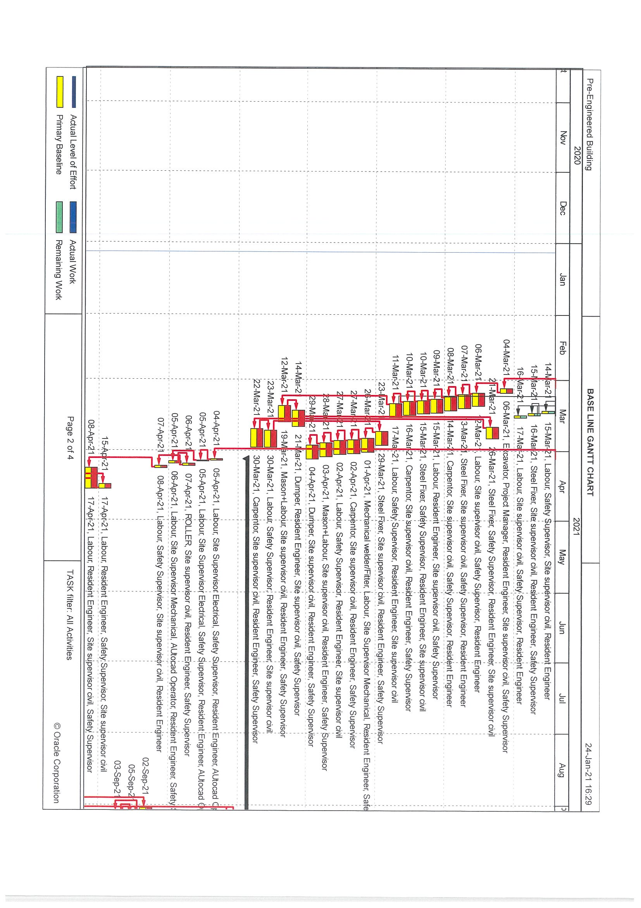
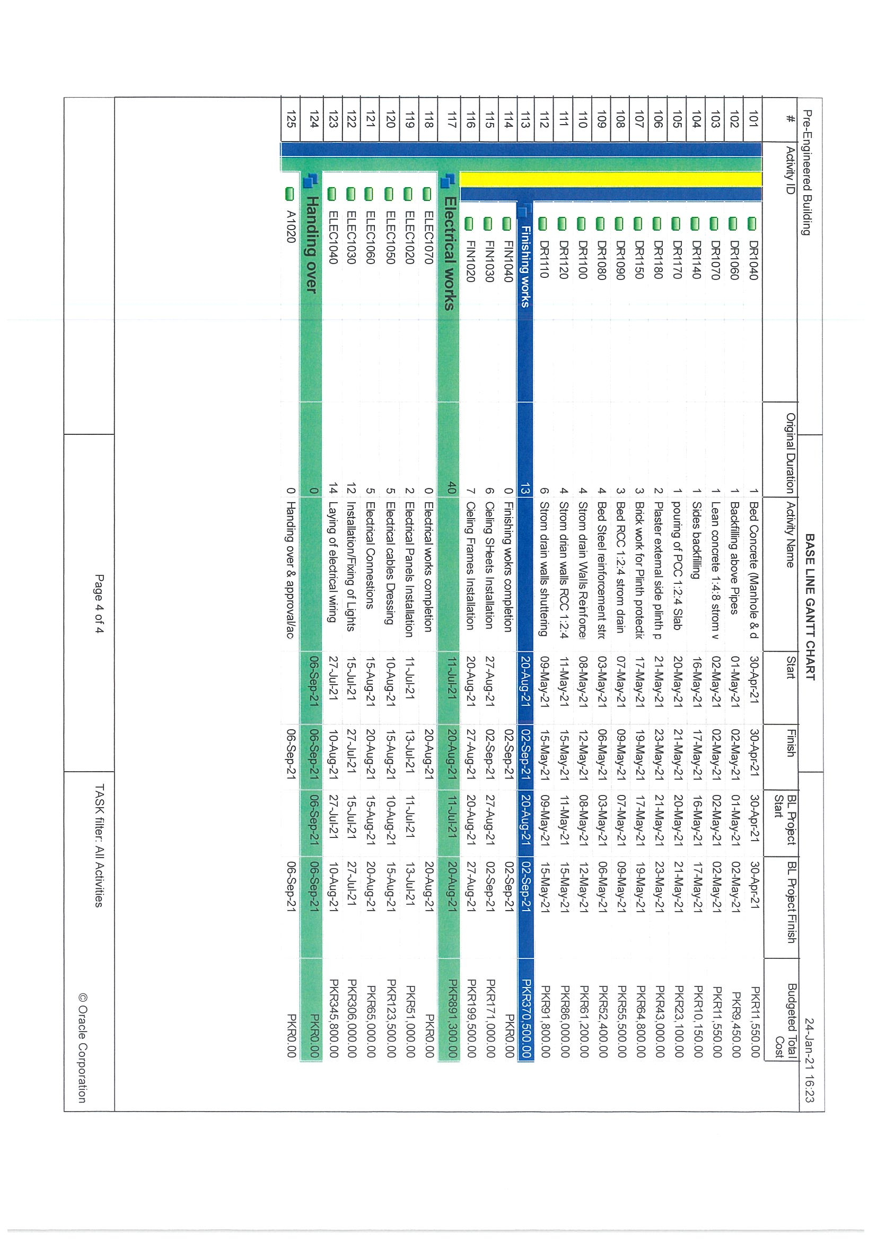
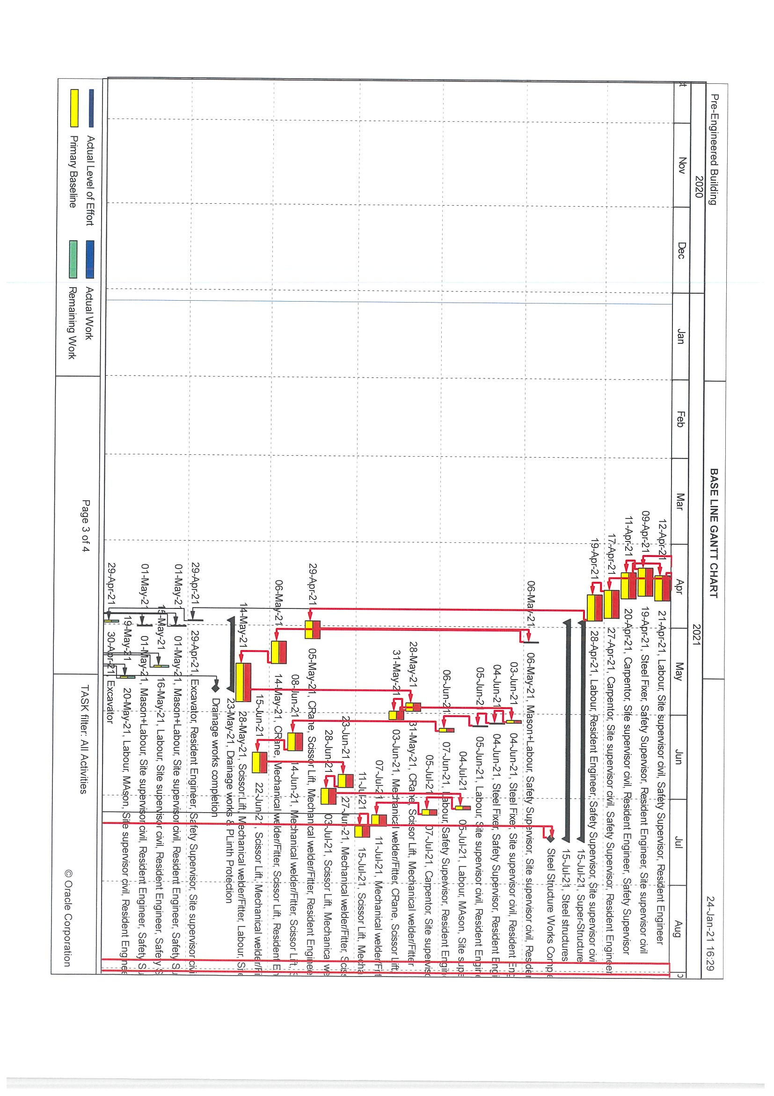
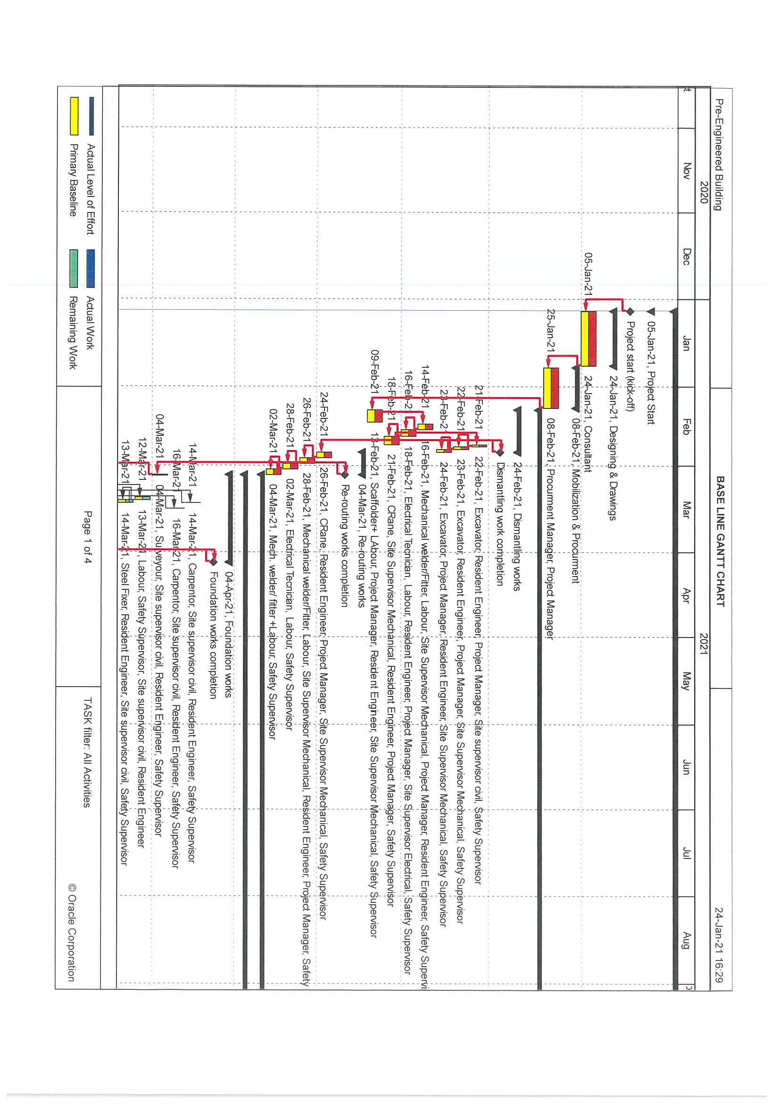
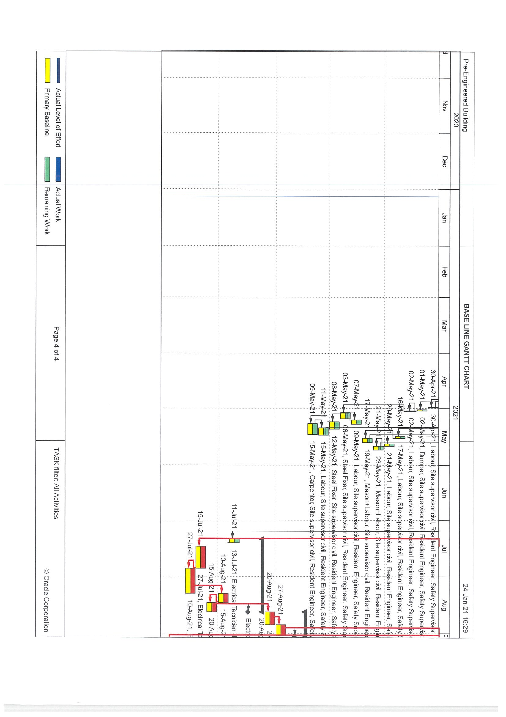
- Critical Activities
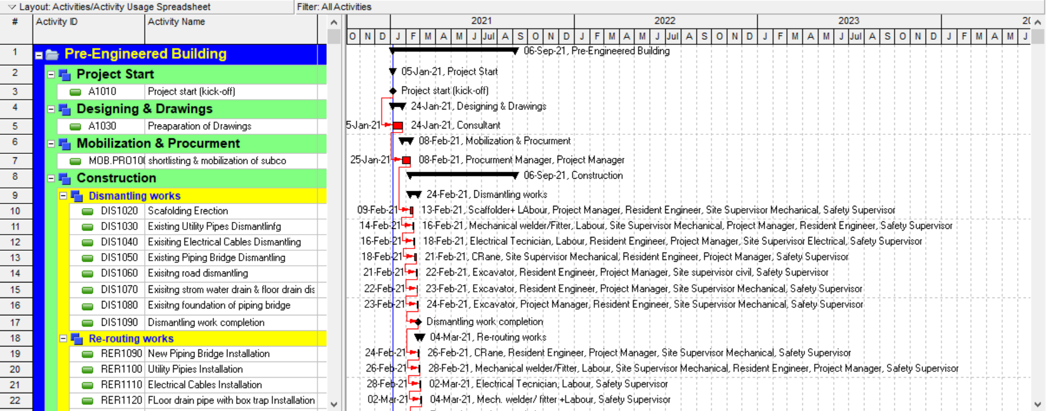

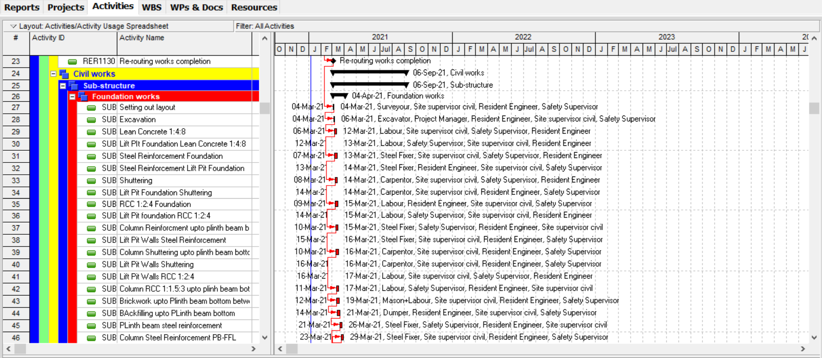

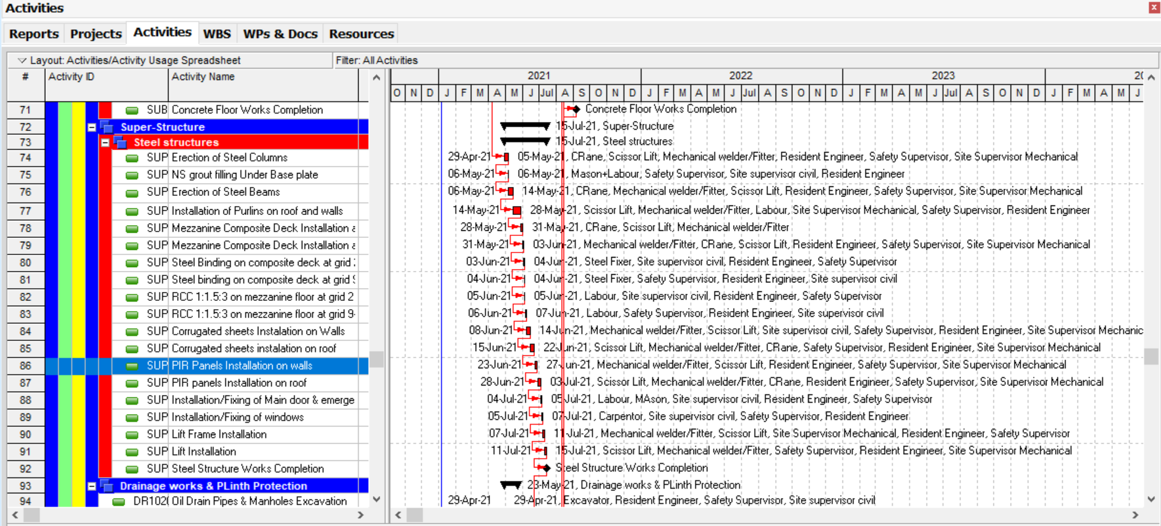
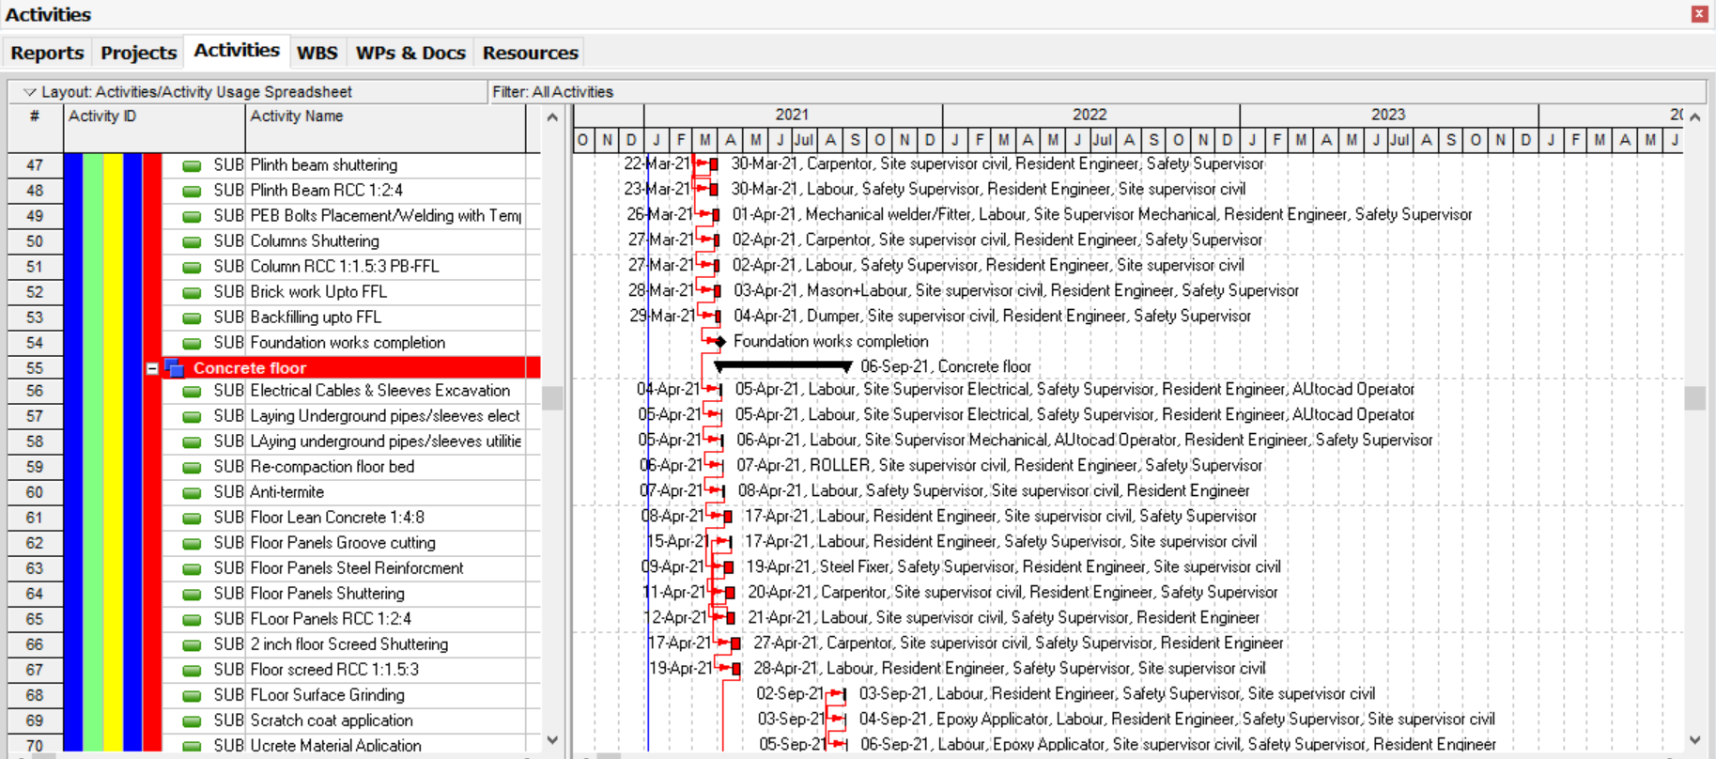
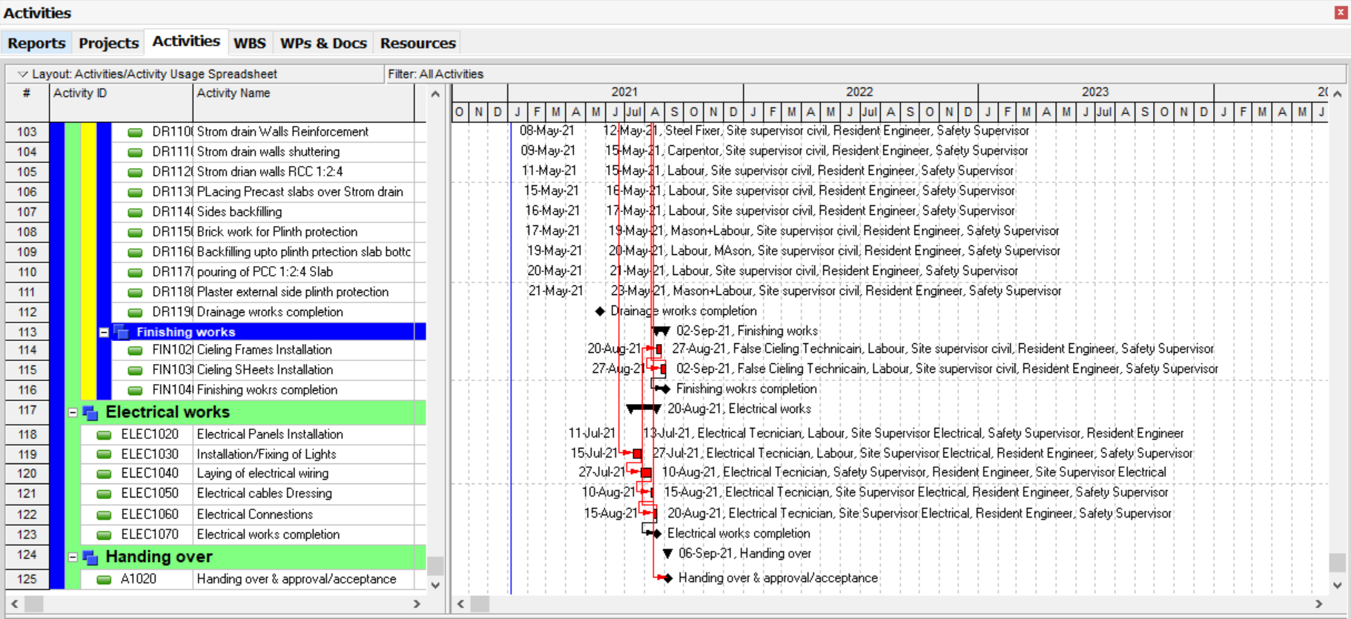
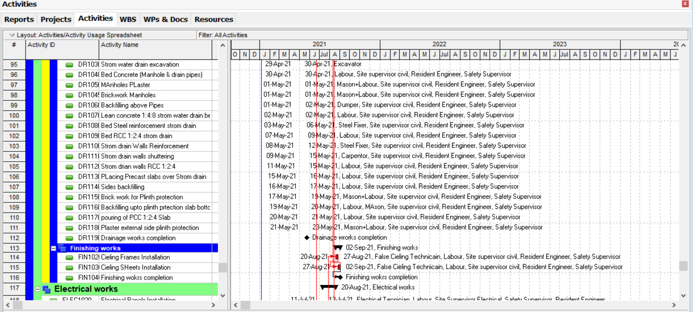
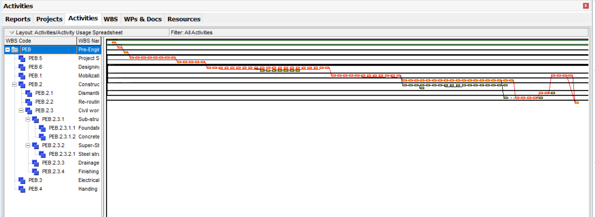
- Critical Path

- Cost Distribution Curve
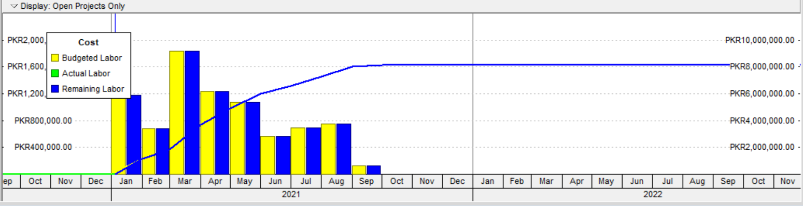

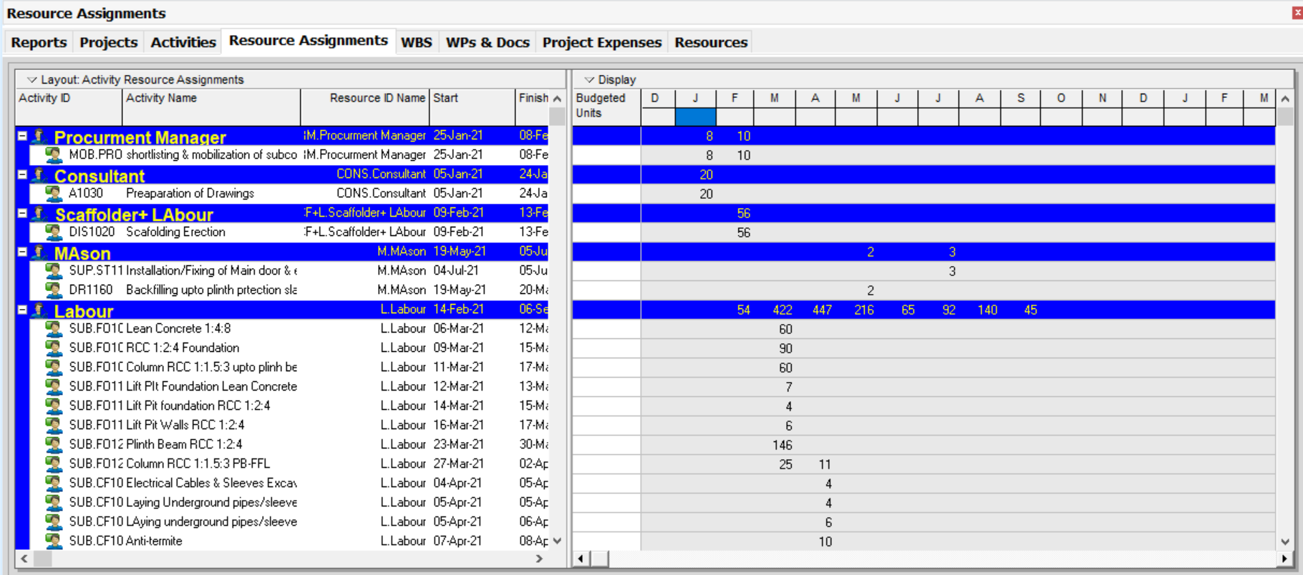
- Resource Assignment Month Wise
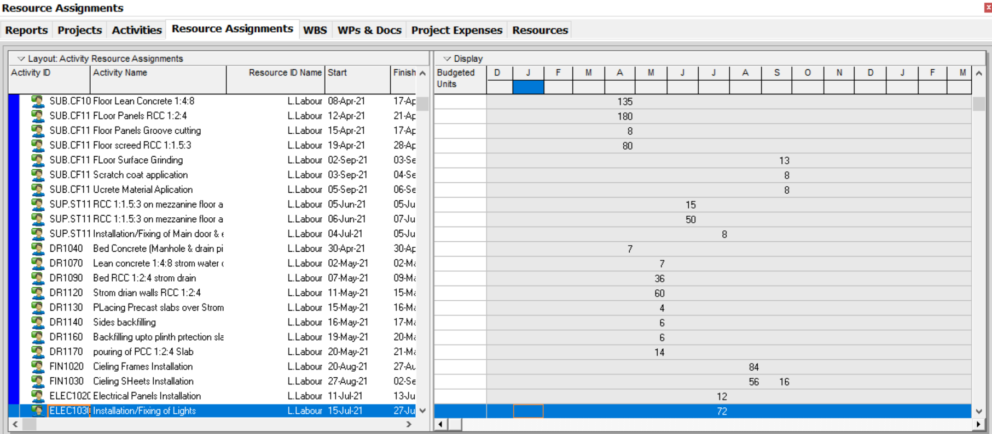
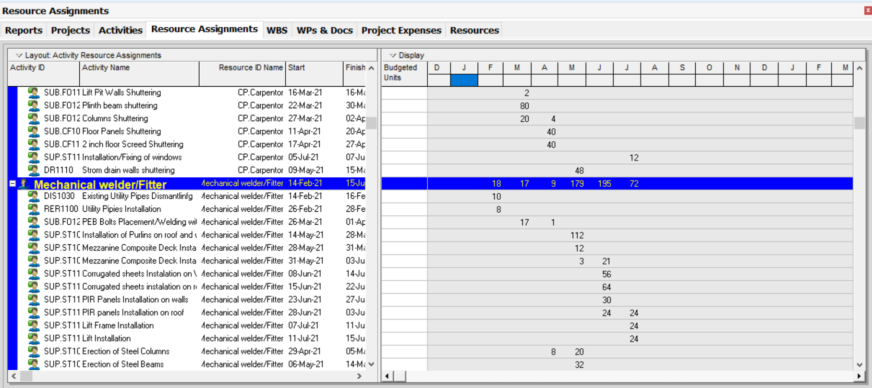
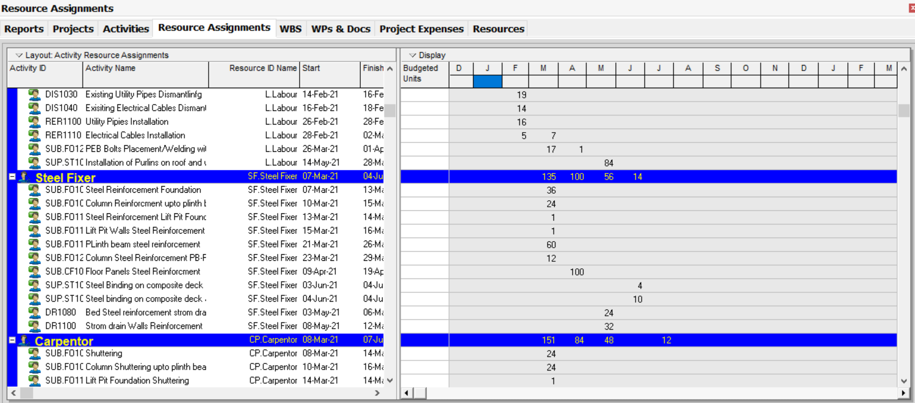
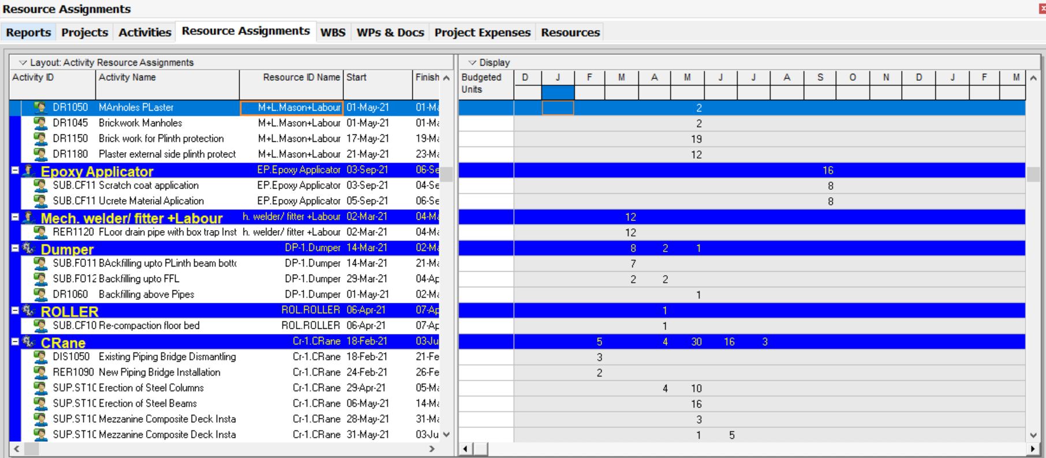
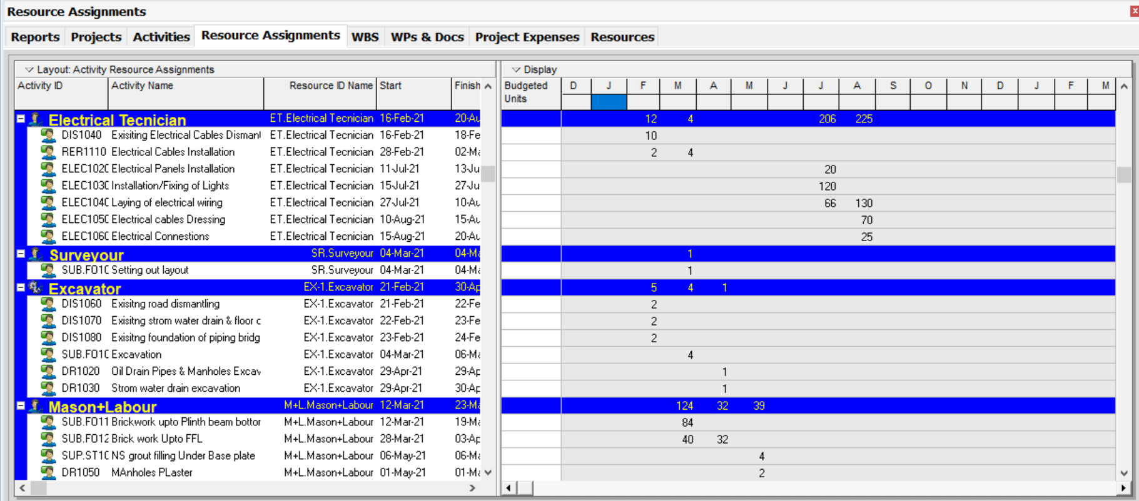
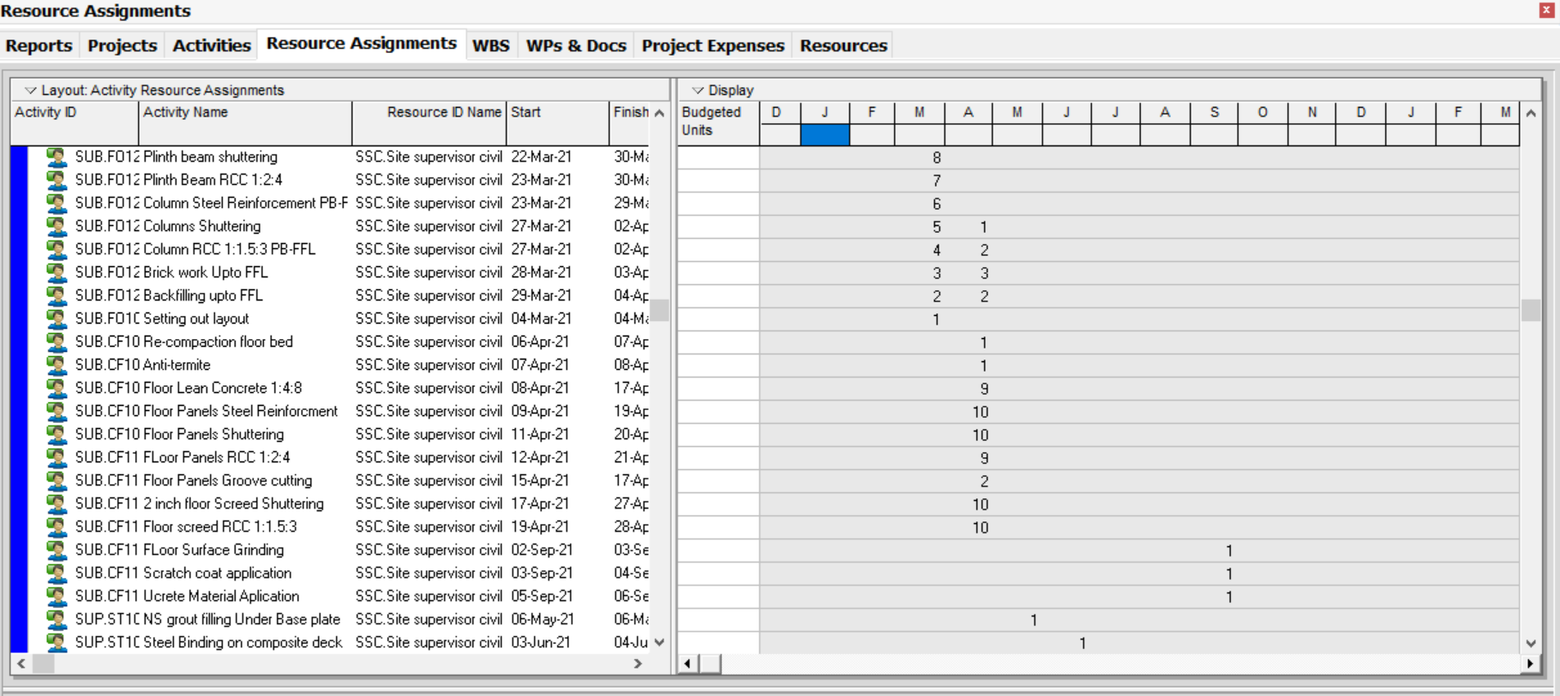
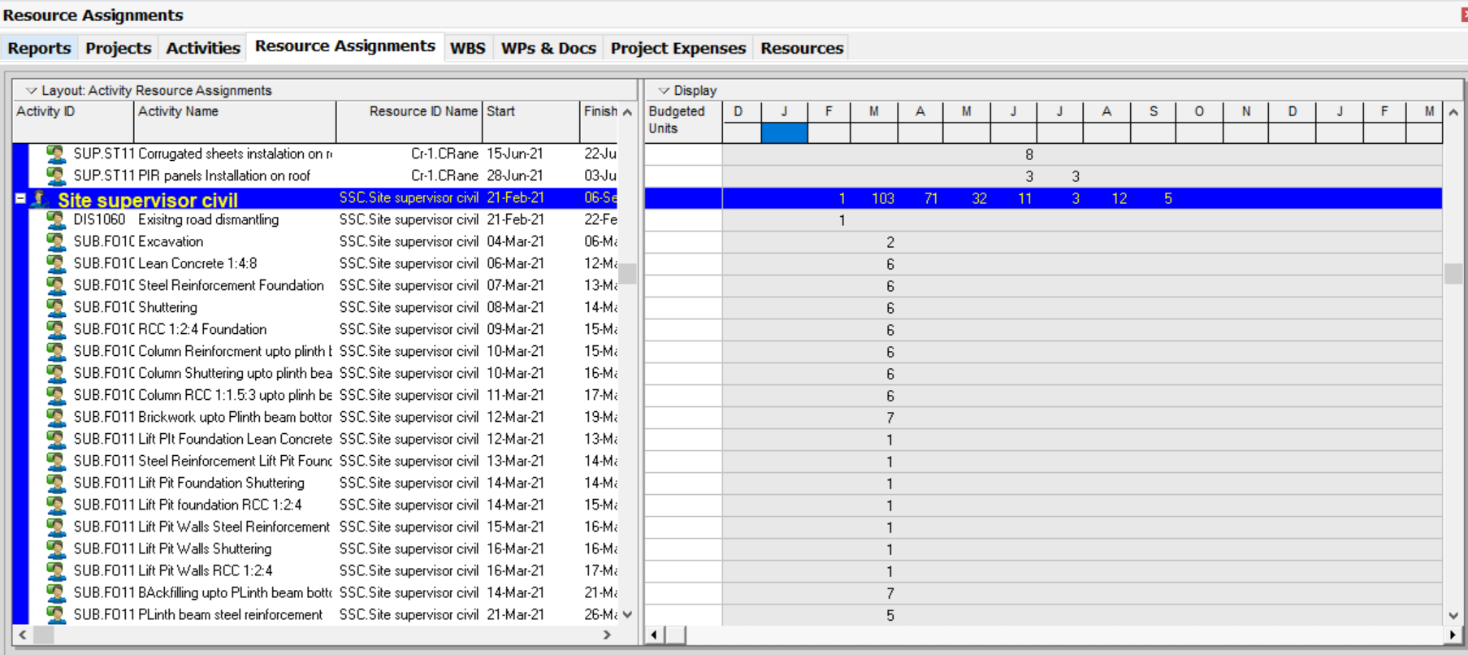
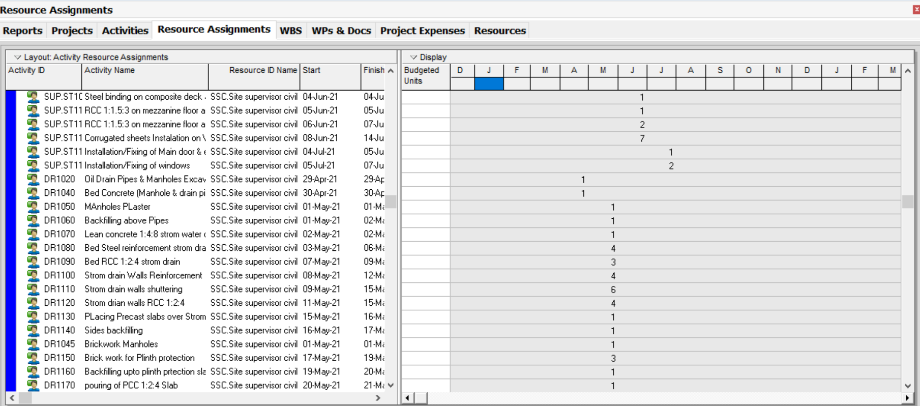
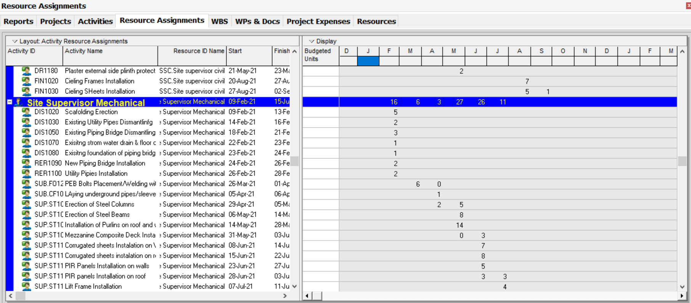
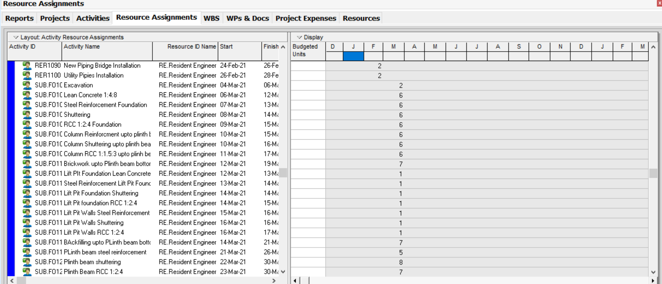
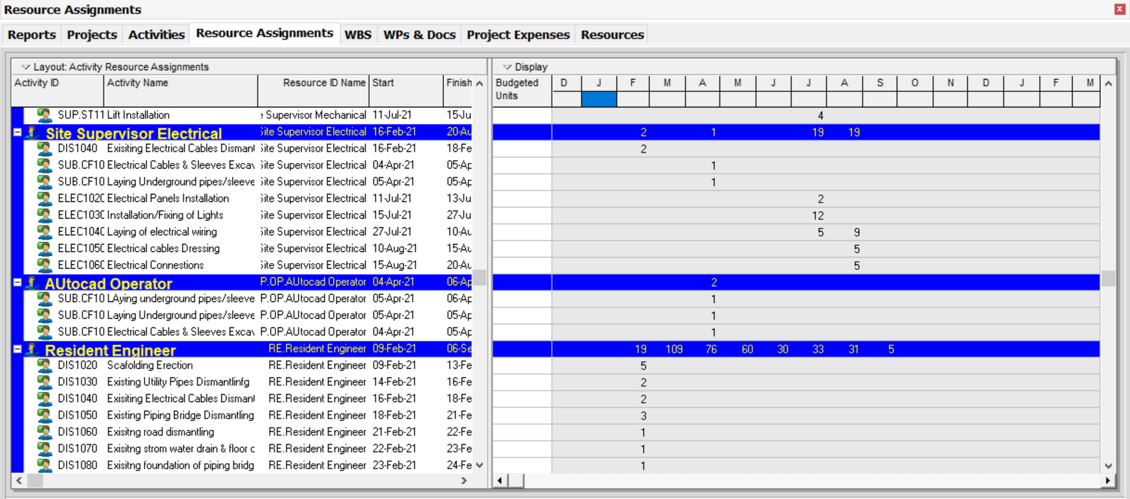
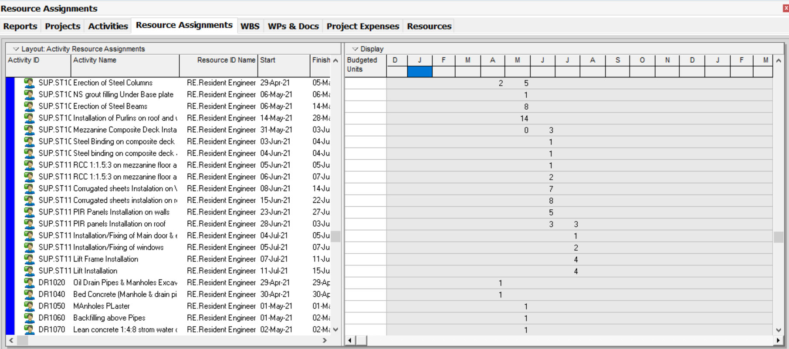
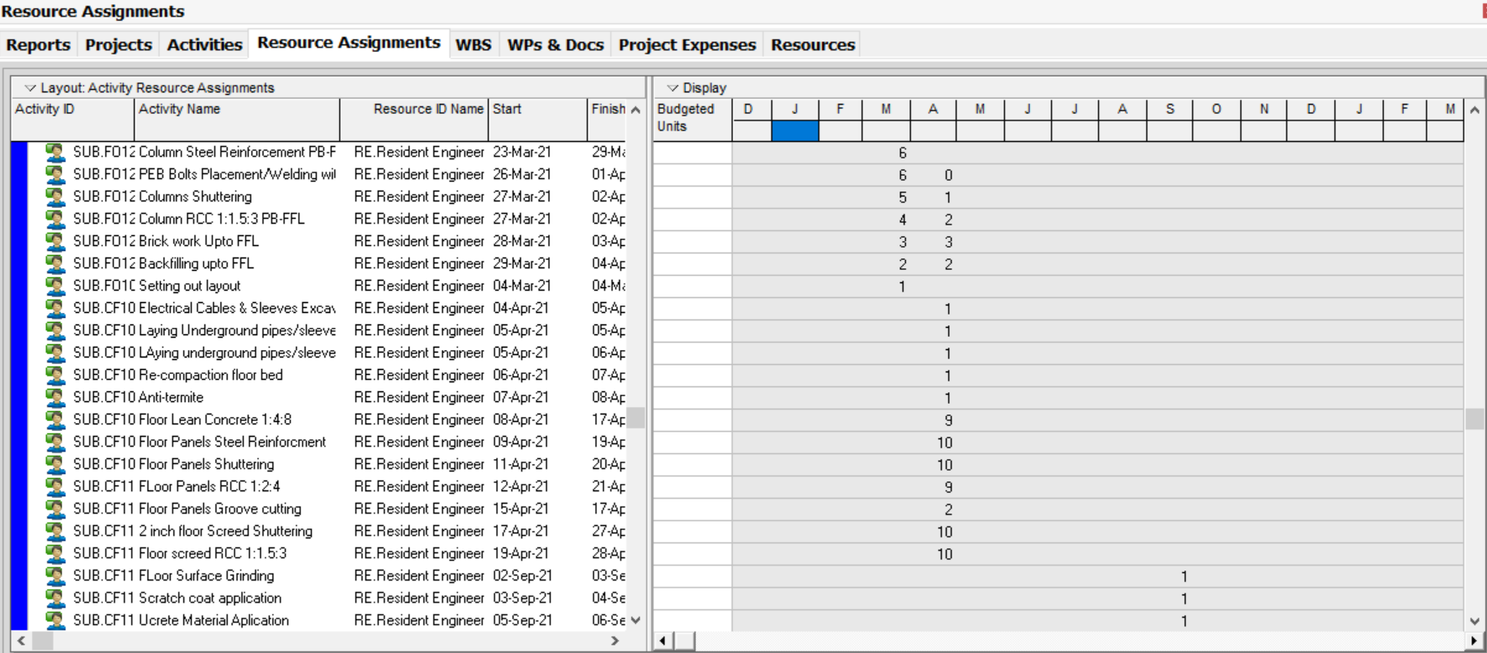
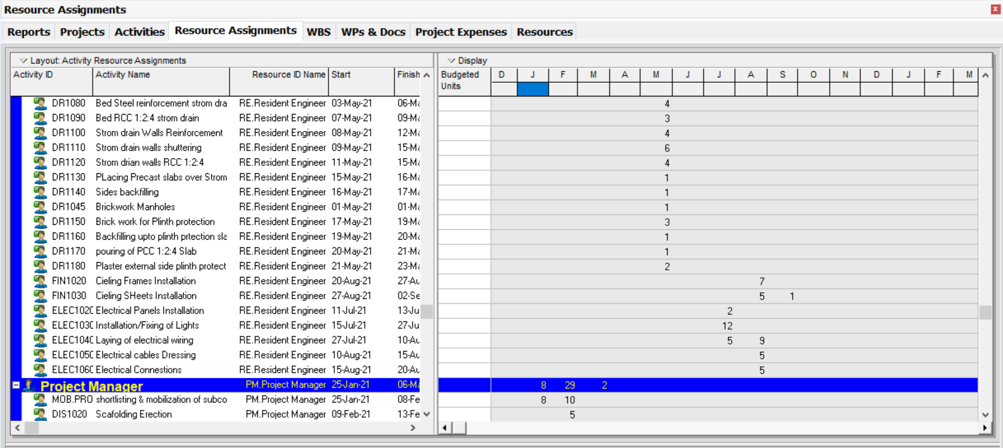
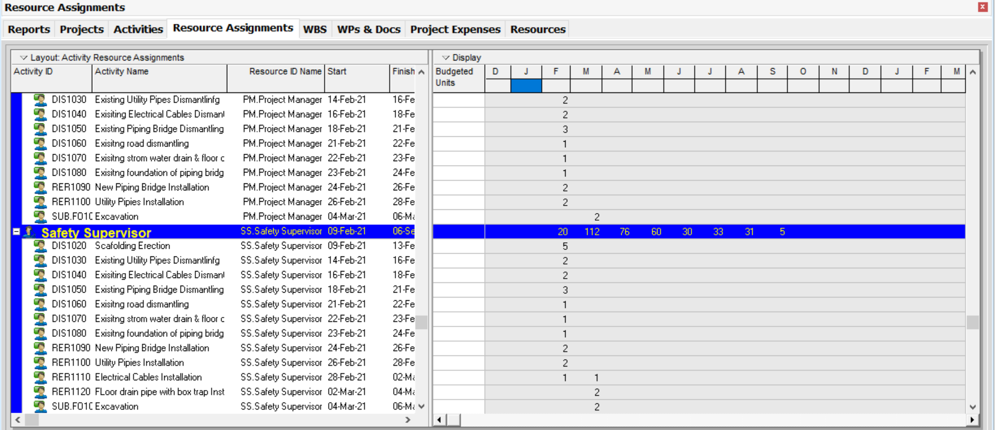
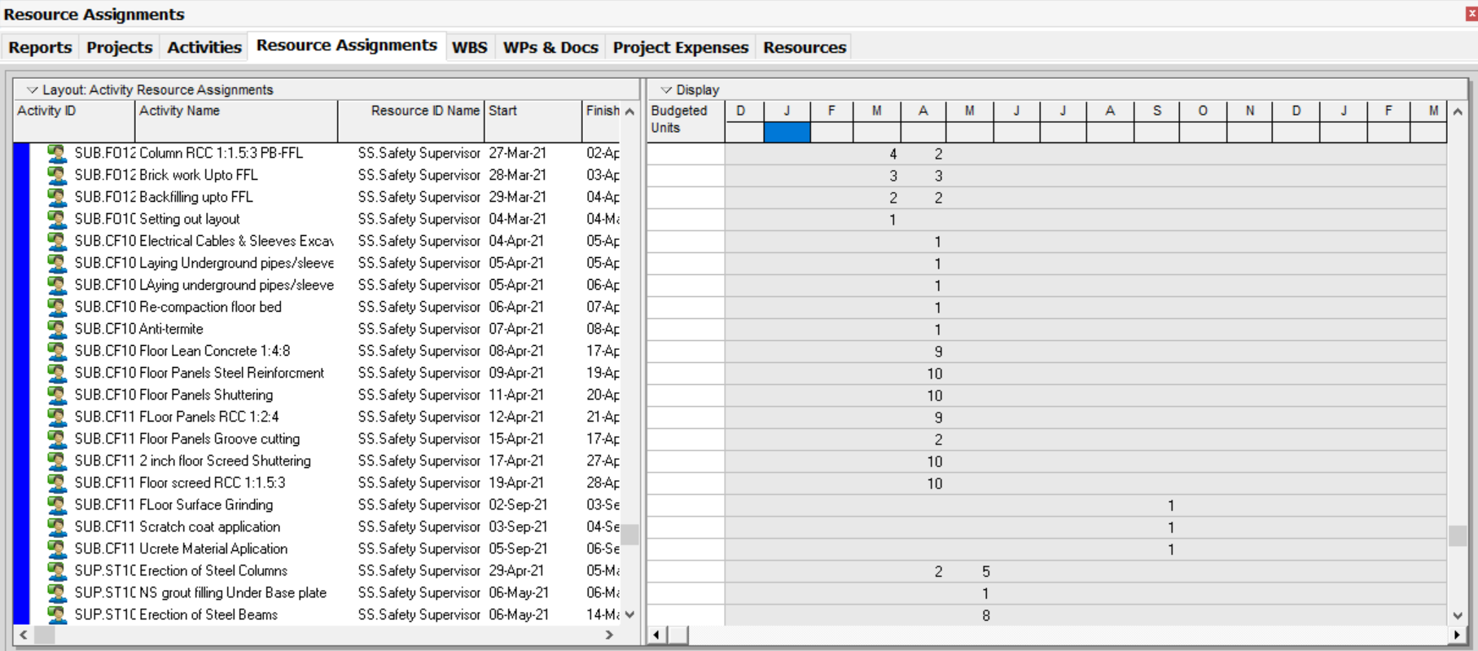
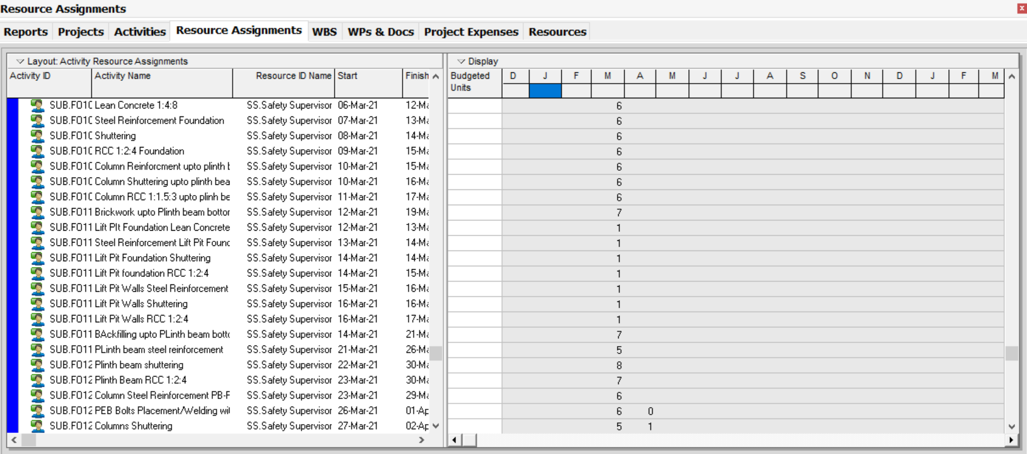
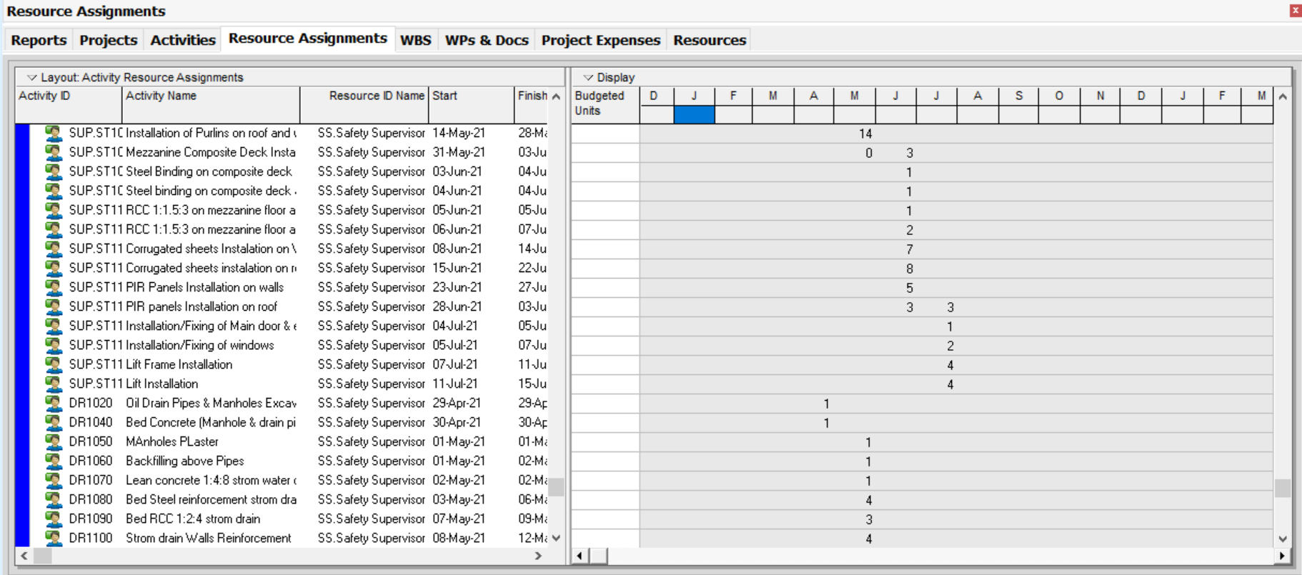
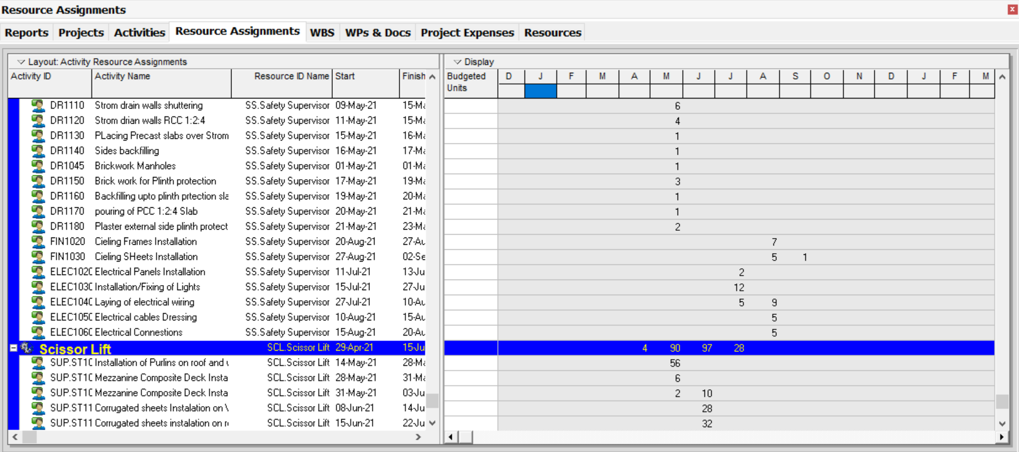
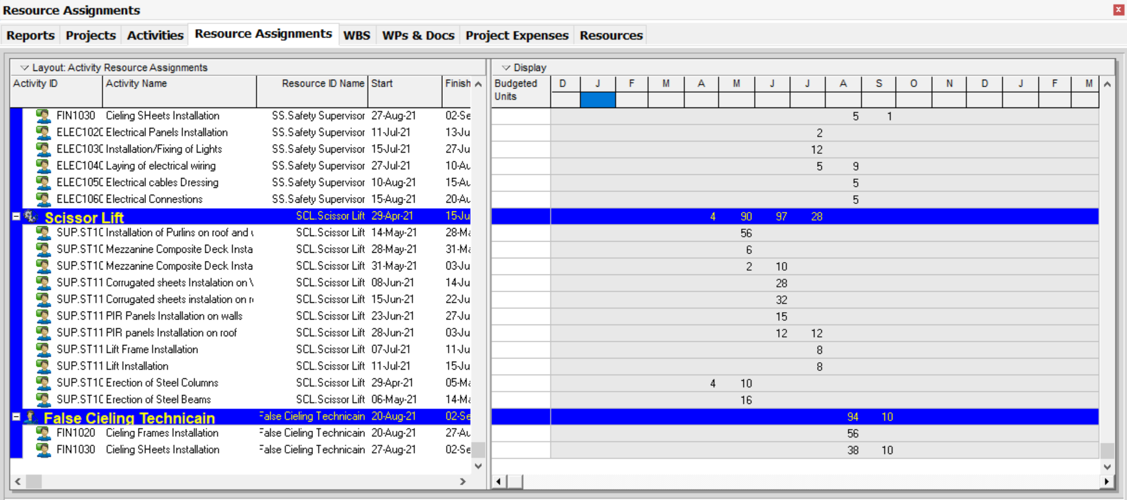

LIST OF ANNEXURE

*NO Annexures Can be attached due to confidentiality claims of PMPKL*

