
BSCS-F19-004
03-134161-002 | ALI RAZA

FYP Interaction System

In partial fulfilment of the requirements for the degree of
Bachelor of Science in Computer Science
Supervisor: Aasim Ali
Department of Computer Sciences
Bahria University, Lahore Campus
July 2020

© Bahria University, 2020

Certificate

We accept the work contained in the report titled
“FYP Interaction System”
written by
ALI RAZA
as a confirmation to the required standard for the partial fulfilment of the degree of
Bachelor of Science in Computer Science.

Approved by:
Supervisor: Aasim Ali
(Signature)

July 20, 2020

DECLARATION

I hereby declare that this project report is based on my original work except for citations and quotations which have been duly acknowledged. I also declare that it has not been previously and concurrently submitted for any other degree or award at Bahria University or other institutions.

Enrolment | Name | Signature
03-134161-002 | ALI RAZA

Date : July 20, 2020

Specially dedicated to
my beloved grandmother, mother and father
(ALI RAZA)

ACKNOWLEDGEMENTS

We would like to acknowledge our gratitude to our supervisor, Aasim Ali for his guidance, constant attention and personal concern towards the completion of this project. Furthermore, our appreciation also goes to our lab engineers from the department of computer science for their time, attention and guidance. We are also thankful to the evaluating team who evaluated our project with full dedication pinpointed our mistakes and guided as in right way during whole project.

In addition, we would also like to say thanks our loving parents and friends who had helped and given encouragement.

ALI RAZA

FYP Interaction System

ABSTRACT
The Abstract of this project is to automate the manual system of undergoing a Final year Project. In this project, client’s requirements will be met. There will be a web based application through which four types of users i.e. The FYP Coordinator, the Supervisor, the Panel and a Student will interact with each other regarding the student’s final year project. In this project various stages will be covered through which, the first phase of our project that is Approval of a project by Panel will be met, after getting approval working on development of project will start. So this application will meet the following demands of the clients that are the features to be included in the application.

TABLE OF CONTENTS

DECLARATION ii
ACKNOWLEDGEMENTS iv
ABSTRACT v
TABLE OF CONTENTS vi
LIST OF FIGURES x

CHAPTERS
1 INTRODUCTION 1
1.1 Background 1
1.2 Problem Statements 1
1.3 Aims and Objectives 2
1.4 Scope of Project 2
2 LITERATURE REVIEW (and/or SRS) 3
2.1 User Class and Characteristics 3
2.2 Operating Environment 3
2.3 Design and Implementation Constraints 4
2.4 Assumptions and Dependencies 4
2.5 Other Non-functional Requirement 4
2.5.1 Performance Requirements 4
2.5.2 Safety Requirements 4
2.5.3 Security Requirements 4
2.5.4 Software Quality Attributes 4
2.6 Other Requirements 4
2.7 System Requirements Chart 5
3 DESIGN AND METHODOLOGY 8
3.1 Use-case Description 8
3.1.1 Login 8
3.1.2 View & Edit Account 8
3.1.3 Add/Edit/Remove/View Faculty 9
3.1.4 Add/Edit/Remove/View Student 9
3.1.5 Add/Edit/Remove/View FYP Group 11
3.1.6 View/Edit Request Form 11
3.1.7 Announcement 12
3.1.8 Panel Allocation 12
3.1.9 View/Edit Panel 13
3.1.10 Add/Edit/View/Remove Form 13
3.1.11 Schedules 14
3.1.12 Add/View/Edit/Remove Notice Board 14
3.1.13 FYP Batch Groups 15
3.1.14 Result Management 15
3.1.15 Logout 16
3.1.16 Sign Up 16
3.1.17 Login 17
3.1.18 Selecting Team member 17
3.1.19 Selecting Supervisor 18
3.1.20 View Announcement 18
3.1.21 View Notice Board 19
3.1.22 Contact Supervisor 19
3.1.23 Add/Edit Request Form & Final Submit 20
3.1.24 Result 20
3.1.25 Logout 21
3.1.26 Sign Up 21
3.1.27 Login 22
3.1.28 Check FYP Groups 22
3.1.29 Panel Related to Group 23
3.1.30 Reject Group 23
3.1.31 Communication Log 24
3.1.32 Result Management 24
3.1.33 Check Progress 26
3.1.34 Logout 26
3.2 Use-case Diagram 27
3.3 Domain Model 30
3.4 Sequence Diagram 30
3.5 Collaboration Diagram 39
3.6 Operation Contracts 40
3.7 Design Class Diagram 43
3.8 Data Model 44
4 DATA AND EXPERIMENTS (and/or IMPLMENTATION) 45
4.1 Methodology 45
4.2 Tools / Technology 46
5 RESULTS AND DISCUSSIONS (or USER MANUAL) 48
5.1 Admin Login 48
5.2 Teacher Login 49
5.3 Student Login 49
5.4 FYP Registration 50
5.5 Student Request Form 50
5.6 Announcements 50
5.7 Project Proposal Submission 51
5.8 Doc1 Submission 51
5.9 Final Report Submission 51
5.10 Student Dashboard 52
5.11 Student Registration 52
5.12 Teacher Registration 53
5.13 Admin Dashboard 53
5.14 Add Student 54
5.15 View, Edit, Delete Student 54
5.16 Add Teacher 55
5.17 View, Edit, Delete Teacher 56
5.18 Make Announcement 56
5.19 Add Panel 57
5.20 View, Edit, Delete Panel 57
5.21 Add Schedules 58
5.22 View, Edit, Delete Schedule 58
5.23 Teacher Dashboard 59
5.24 FYP Group Request 59
5.25 FYP Groups 60
5.26 Supervisor’s Student Submissions 60
5.27 Panel’s Student Submissions 61
5.28 Edit Student 61
5.29 Edit Teacher 62
5.30 Edit Admin 62
5.31 Unapproved Projects 63
5.32 Project 1 64
5.33 Edit Project/Allocate Panel 65
5.34 Database schema 65
6 CONCLUSION AND RECOMMENDATIONS 66
6.1 RECOMMENDATIONS 66
6.2 CONCLUSION 66

LIST OF FIGURES

FIGURE TITLE PAGE
Figure 2.1: Use Case Diagram 27
Figure 3.1: Domain Model Diagram 30
Figure 4.1: Sequence Diagram 30
Figure 5.1: Class Diagram 43
Figure 6.1: Data Model Diagram 44
Figure 7.1: Colaboration Diagram 39

INTRODUCTION

Background
Final Year Project is conducted in all the universities in all most all engineering fields (Major for CS and IT) as it is major requirement for completion of degree from HEC. Final year project is an important part of degree on which expertise and interest of student is shown and it will help the student to make career in that particular field.

Problem Statements
Conduction of FYP in universities is a quite tough job for everyone because student also have burden of their studies they have deadline for their assignment and also have semester projects and they also have classes so they have difficulty to meet the final year project deadline there is no reminder or alert which will tell them, the deadline is near or about to end. Same issue occurs with supervisor because they are teacher and they also have to teach the classes or they have to go to urgent meeting so it is difficult to manage the schedule of meeting with student. Panel is also group of supervisors so they have to face same problems being panel member and supervisor. Coordinator which have all of the burden of Final Year Project (FYP) have to check each and everything. So this system going help each and every person related to final year project through this system all the tracking of final year project can be taken like supervisor panel and coordinator can check which project have done how much work and student don't have to worry about the deadlines system will automatically alert everyone about deadline (including supervisor and coordinator). There are a lot of problem while selecting the supervisor that who is going to be supervisor, this system will help you selecting the supervisor while telling which supervisor have available slots. Give an interaction system to students supervisors among themselves

Aims and Objectives
- To facilitate FYP Office, FYP Students, Supervisors, Examiners.
- To integrate all Forms, Templates and Documentation at one platform.
- To provide smooth and robust interaction among all FYP users.

Scope of Project

This will be a web based application which will work as a complete guide for final year project. Student will be able to select the type of project they want to make in final year project like student want to make the project in domain of artificial intelligence. Student can select the supervisor according to the need of their projects. All supervisors will be able to interact with student in a sense that they are willing to supervise them or not. Student have to meet the supervisor for the specific hours in each week in order to complete the work so they have to schedule or reschedule the meeting according to their availability. Panel have to give instructions to the group of final year project like remodeling or submission of new idea and they also have to evaluate the student and supervisors also have to evaluate the work of the students how much they are responsible are they completing their contacting hours and how they are performing ins final year project.

LITERATURE REVIEW (and/or SRS)

User Class and Characteristics
Four types of users will interact with the application Coordinator, Supervisor, Student and Panel. So, all of them would have different type of requirements. Coordinator will manage entire application. Coordinator will work as an Admin of the application and will provide logins to all other users and will maintain records in database. Student will login from his/her portal and will select the field in which he/she wants to make the project and will select the available supervisor. Supervisor will confirm whether he/she wants to work with that group or not. After that, if that group and supervisor are willing to work on the project, coordinator will register them and will assign a group ID. Coordinator will manage all the record in database. After getting registered, student will be able to access all the online forms and templates and then student can develop proposal of their project for defense against the Panel. Panel will upload marks of student’s defense on his portal and will forward to coordinator, and then coordinator will upload them on result portal. From where every student will be able to view their result from the portal and if proposal is accepted, student can further work on SRS Documentation. Student, supervisor and coordinator will be in communication with each other via their portals.

Operating Environment
It is a Web based app which will be accessed via Web Browser. Whether it is being accessed from a System the only thing required is a Web browser and Internet Connection.

Design and Implementation Constraints
The main constraint for project implementation is integration. When whole application is integrated, it generates some bugs at the end which are difficult to handle. FYP Automated system is based on database and one website, which needs proper internet connection every time, otherwise no one can use it.

Assumptions and Dependencies
As for this application, since it would be a Web Based app and will be accessed via Web Browser, Student will like to work through mobile phone, so they should be familiar with the application and familiar with internet usage. The whole application is internet based so there is a need of internet every time. It will be expected that the Coordinator and Student will have fair strength of internet

Other Non-functional Requirement

Performance Requirements
Load time should be under 5 second

Safety Requirements
Project data should not viewable without Authorization.

Security Requirements
Data should be same no SQL injection no vulnerability.

Software Quality Attributes
Software quality attributes that needs to be addressed are:
- FYP interaction should become flexible.
- Less time consuming and more efficient.
- Accurate conduction of Final Year Project.

Other Requirements
Use my SQL and all open source technologies.

System Requirements Chart
ID | Priority | Type | Used use cases | Description
1 | High | Functional | U1 | Login
2 | High | Functional | U2 | View & Edit Account
3 | High | Functional | U3 | Add/Edit/Remove/View Faculty
4 | High | Functional | U4 | Add/Edit/Remove/View Student
5 | High | Functional | U5 | Add/Edit/Remove/View FYP Group
6 | High | Functional | U6 | View/Edit Request Form
7 | High | Functional | U7 | Announcement
8 | High | Functional | U8 | Panel Allocation
9 | High | Functional | U9 | View/Edit Panel
10 | High | Functional | U10 | Add/Edit/View/Remove Form
11 | High | Functional | U11 | Schedules
12 | High | Functional | U12 | Add/View/Edit/Remove Notice Board
13 | High | Functional | U13 | FYP Batch Groups
14 | High | Functional | U14 | Result Management
15 | High | Functional | U15 | Logout
16 | High | Functional | U16 | Sign Up
17 | High | Functional | U17 | Login
18 | High | Functional | U18 | Selecting Team Member
19 | High | Functional | U19 | Selecting Supervisor
20 | High | Functional | U20 | View Announcement
21 | High | Functional | U21 | View Notice Board
22 | High | Functional | U22 | Contact Supervisor
23 | High | Functional | U23 | Add/Edit Request Form & Final submit
24 | High | Functional | U24 | Result
25 | High | Functional | U25 | Logout
26 | High | Functional | U26 | Sign Up
27 | High | Functional | U27 | Login
28 | High | Functional | U28 | Check FYP groups
29 | High | Functional | U29 | Panel Related to group
30 | High | Functional | U30 | Reject Group
31 | High | Functional | U31 | Communication log
32 | High | Functional | U32 | Result Management
33 | High | Functional | U33 | Check Progress
34 | High | Functional | U34 | Logout

DESIGN AND METHODOLOGY

Use-case Description
A use-case description is a text that captures the detailed functionality of a use-case. Description of all use-cases are written down in this section.
Unique Identifier | U1
Brief description | Admin will login the portal for performing it task by entering their credentials
Priority | High
Actors | Admin
Flow of events
- Basic Flow | Admin will enter email and password for logging in.
- Alternative Flow | If username or password will be incorrect then it will generate error message and ask again for login.
Preconditions | Connected to internet and correct domain will be requested
Post conditions | Login to Admin and redirect to Admin dashboard

Login

View & Edit Account
Unique Identifier | U2
Brief description | Admin Can view its Personal information like Name Email, Phone etc. and also have option to edit it.
Priority | High
Actors | Admin
Flow of events
- Basic Flow | After logging in Admin go to its personal information from dashboard.
- Alternative Flow | Can go to this option by selecting it from the menu bar.
Preconditions | Admin have to be login in first in order to view and edit its information.
Post conditions | Admin Edited personal information can be Viewed after this.

Add/Edit/Remove/View Faculty
Unique Identifier | U3
Brief description | Admin can Add Information of faculty member and can also Edit its information or can Remove that Faculty member from the portal.
Priority | High
Actors | Admin
Flow of events
- Basic Flow | Admin Go to Faculty Portion of its panel and select the operation it want to perform for admin either add/edit/remove.
- Alternative Flow
Preconditions | Admin have all the information related to the faculty member i.e. name, designation etc.
Post conditions | Admin will successfully edit, add, remove the faculty member

Add/Edit/Remove/View Student
Unique Identifier | U4
Brief description | Admin can Add Information of Student and can also Edit its information or can Remove that Student from the portal.
Priority | High
Actors | Admin
Flow of events
- Basic Flow | Admin Go to Student Portion of its panel and select the operation it want to perform for admin either add/edit/remove.
- Alternative Flow
Preconditions | Admin have all the information related to the student i.e. name, enrollment degree program etc.
Post conditions | Admin will successfully edit, add, remove the student

Add/Edit/Remove/View FYP Group
Unique Identifier | U5
Brief description | Admin can Add the students enroll for FYP and make FYP groups can edit that group in which change members etc. included and can remove FYP group and can also View
Priority | High
Actors | Admin
Flow of events
- Basic Flow | Admin go to the portion of panel where FYP groups are listed can view can add groups can delete or can edit the groups
- Alternative Flow
Preconditions | For making FYP group student must be enroll for FYP and list can be viewed when students will be available in list of FYP group
Post conditions | FYP group will be viewed, edited, removed, added successfully

View/Edit Request Form
Unique Identifier | U6
Brief description | Request form submitted by the student for any case can be viewed by admin so admin can take action on it or can be edited for corrections
Priority | High
Actors | Admin
Flow of events
- Basic Flow | Admin go to request form portion where he can see all the request’s submitted by student and admin can go thought it
- Alternative Flow
Preconditions | Must have some request submitted by student so admin can view or edit them
Post conditions | Request will be viewed and some action will be taken on it

Announcement
Unique Identifier | U7
Brief description | Admin can make any announcement related to project i.e. some student have some missing document or coordinator have to meet all of the students of FYP etc.
Priority | High
Actors | Admin
Flow of events
- Basic Flow | Admin will go to Announcements and make announcement which will automatically notify all of the student about it
- Alternative Flow
Preconditions | Admin have some reason to make announcement because these announcements are rare and out of schedule
Post conditions | Admin will successfully notify the students.

Panel Allocation
Unique Identifier | U8
Brief description | After Submission of idea from FYP group admin have to allocate that group a panel for their internal evaluation
Priority | High
Actors | Admin
Flow of events
- Basic Flow | Admin will select the panel team from the list and allocate to that FYP group
- Alternative Flow
Preconditions | FYP group have submitted their idea after finalizing it with supervisor than panel will be allocated
Post conditions | Successful panel allocate till the end of the project for evaluation and can approve, reject or remodeled the idea

View/Edit Panel
Unique Identifier | U9
Brief description | Admin can see all of the list of panels and can edit panel information by changing panel member or can change their information
Priority | High
Actors | Admin
Flow of events
- Basic Flow | Admin go to panel and see all list of panel and members and edit according to need
- Alternative Flow
Preconditions | Panel list must be created or available to view or edit the panel information
Post conditions | Panel will be successfully viewed or updated

Add/Edit/View/Remove Form
Unique Identifier | U10
Brief description | Admin can Add Registration form and can also Edit its information or can Remove that from the portal and can see the form, this can also be done to other type of forms .
Priority
Actors | Admin
Flow of events
- Basic Flow | Admin will to go form where all of the list of form is available admin can select form to view/edit/remove/add
- Alternative Flow
Preconditions | There must be a specific format of form available to be submitted, Edited, Removed, Viewed
Post conditions | Form will be available for students to be work on.

Schedules
Unique Identifier | U11
Brief description | Admin will enter the schedule flow chart of the FYP, system will automatically trigger the action according to schedule entered from flow chart like deadline etc.
Priority | High
Actors | Admin
Flow of events
- Basic Flow | Admin will enter the complete work flow of FYP and submit it system will automatically work on it
- Alternative Flow
Preconditions | All the list of task that are going to triggered must be entered to instruct the system
Post conditions | No notification for FYP can be delayed

Add/View/Edit/Remove Notice Board
Unique Identifier | U12
Brief description | Admin will add/remove/edit/delete the content on notice board will include templates FAQ’s and contact to admin its purpose is to mention a notice that student can read
Priority | High
Actors | Admin
Flow of events
- Basic Flow | Admin will go to notice board and make the modification in notice board according to need
- Alternative Flow
Preconditions | Admin will add all of the templates and FAQ’s for ease of students
Post conditions | It will help student directly instead of asking someone

FYP Batch Groups
Unique Identifier | U13
Brief description | All the files submitted by students like doc1,doc2 proposal etc. must be saved here with the name of Group ID which will a complete file of Final year Project
Priority | High
Actors | Admin
Flow of events
- Basic Flow | Admin create a folder of Group by its id and system will store all files here
- Alternative Flow | .
Preconditions | FYP group must be register so they have group id on behalf of that id folder will created and files will be stored
Post conditions | All file must be saved successfully for future use.

Result Management
Unique Identifier | U14
Brief description | Admin can manage all the results that is submitted by supervisor, panel or complied by FYP office itself
Priority | High
Actors | Admin
Flow of events
- Basic Flow | Submitted evaluation of supervisor or panel is accepted or modified by admin and also evaluation from admin is also managed here
- Alternative Flow
Preconditions | All the students must have gone through initial stage and there evaluation must be starter for managing
Post conditions | All results can be manage and can be saved to show to students after completing of project

Logout
Unique Identifier | U15
Brief description | Admin can logout after doing all the tasks
Priority | High
Actors | Admin
Flow of events
- Basic Flow | In admin panel admin can click button of logout for logging out
- Alternative Flow
Preconditions | Admin has to be logged in first for logging out
Post conditions | After logging out admin is redirected to login page

Sign Up
Unique Identifier | U16
Brief description | Student can Sign Up for the system by providing all of its details on form after submitted details admin will verify student has completed 80 credit hours and verify student account
Priority | High
Actors | Student
Flow of events
- Basic Flow | Student will go to student panel and open sign up and fill all the information and submit it
- Alternative Flow
Preconditions | Internet must be connected and proper domain must be requested  Student must complete 80 credit hour then eligible for FYP
Post conditions | Student can successfully sign up

Login
Unique Identifier | U17
Brief description | After verifying account from admin student can successfully login by providing correct login information and can use login for make FYP groups
Priority | High
Actors | Student
Flow of events
- Basic Flow | Student go to login and provide correct login information and submit form
- Alternative Flow | If incorrect information is provided then error message will generate and ask for login again
Preconditions | Student must be registered first logging in
Post conditions | Student will log in successfully and redirect to its dashboard

Selecting Team member
Unique Identifier | U18
Brief description | Student can select their team member for making FYP group OTP will be send to other student who will be included in group for verification from the particular student
Priority | High
Actors | Student
Flow of events
- Basic Flow | Student go to team member and select team member by adding their phone number then OTP will be sent to student
- Alternative Flow
Preconditions | Team member want to select must be enroll for FYP and willing to work with the student or on that project
Post conditions | Team member will be selected successfully.

Selecting Supervisor
Unique Identifier | U19
Brief description | Student have to select supervisor for their FYP group and OTP will be send to supervisor for verification that faculty member is willing to become supervisor of that group
Priority | High
Actors | Student
Flow of events
- Basic Flow | Student will go to supervisors in panel and select the supervisor from the list and then submit one time password will be send to supervisor
- Alternative Flow | Faculty member can add itself to that group’s supervisor from their panel
Preconditions | Teacher must be willing to be supervisor of that FYP group or that type of project and supervisor must have available slot for the FYP group
Post conditions | Supervisor will be selected successfully.

View Announcement
Unique Identifier | U20
Brief description | Student can view all the announcement made by supervisor and admin it can scheduled announcement or can be random can be for all student can be for pertinent student.
Priority | High
Actors | Student
Flow of events
- Basic Flow | Student go to view announcement from dashboard and view all of the announcement
- Alternative Flow
Preconditions | Student/Students have announcement to be viewed
Post conditions | Student can start working on announcement made by admin or supervisor

View Notice Board
Unique Identifier | U21
Brief description | Student can view notice for general question raise in their mind or can see templates like doc1,doc2, proposal template etc. or can contact the FYP office
Priority | High
Actors | Student
Flow of events
- Basic Flow | Student can go to view notice board to student’s dashboard.
- Alternative Flow
Preconditions | Student have to login first and no other condition for viewing notice board
Post conditions | Student will be easily get informed from notice board

Contact Supervisor
Unique Identifier | U22
Brief description | Student can contact supervisor for meeting and can make scheduled time because supervisor have course to teach and can be busy in other thing so they can easily get in touch
Priority | High
Actors | Student
Flow of events
- Basic Flow | Student can contact supervisor by sending message or making a meeting schedule
- Alternative Flow
Preconditions | Student have to meet supervisor for the assistance of the FYP so they contact their supervisor
Post conditions | Successful meeting schedule for student

Add/Edit Request Form & Final Submit
Unique Identifier | U23
Brief description | Student can add Request form and can edit that request form till the final submission of that form
Priority | High
Actors | Student
Flow of events
- Basic Flow | Student go to request form and open a form and add info then add that form there will be option of edit and final submit
- Alternative Flow
Preconditions | When there is need then i.e. delayed document etc. Request form will be added or edited or can be final submitted
Post conditions | Action on request form will taken.

Result
Unique Identifier | U24
Brief description | After completing all of the stage from student all documents complete project will be submitted than result will be shown and all other thing will not be visible to student
Priority | High
Actors | Student
Flow of events
- Basic Flow | When complete evaluation of project student can see only their result
- Alternative Flow
Preconditions | Student must complete all the stages of FYP for completion of project
Post conditions | Student can see complete evaluation on their panel

Logout
Unique Identifier | U25
Brief description | Student can logout their account after all the task related to FYP and going that phase of project
Priority | High
Actors | Student
Flow of events
- Basic Flow | Student can click logout button from dashboard
- Alternative Flow
Preconditions | Internet must be connected and student must be logged in
Post conditions | Successful logout and redirect to login page

Sign Up
Unique Identifier | U26
Brief description | Faculty member can sign for Final year project by providing there information where members can be selected for supervisor and panel members
Priority | High
Actors | Faculty
Flow of events
- Basic Flow | Faculty member can go on sign up and fill form for registration and then receive verification
- Alternative Flow
Preconditions | Internet connection must be available  Have email and mobile number for verification code
Post conditions | Successful registration of faculty member

Login
Unique Identifier | U27
Brief description | After successful registration of faculty member they can login for checking there groups and there progress etc.
Priority | High
Actors | Faculty
Flow of events
- Basic Flow | Faculty will go to portal and go faculty login and enter credentials.
- Alternative Flow | Error message will be generated if incorrect credentials provided
Preconditions | Internet connection must be required for login  Correct login information
Post conditions | Successful login of faculty member

Check FYP Groups
Unique Identifier | U28
Brief description | Supervisor can see all the FYP group lists which faculty member is supervising.
Priority
Actors | Faculty
Flow of events
- Basic Flow | Faculty member go to the list of FYP group which they are supervising and can check work progress
- Alternative Flow
Preconditions | Faculty member must be a supervisor and supervising projects
Post conditions | Check the groups and their work progress

Panel Related to Group
Unique Identifier | U29
Brief description | Faculty member can only view the panel/panel member of the group which they are supervising from the list
Priority
Actors | Faculty
Flow of events
- Basic Flow | Faculty member can go to list of panel related to group supervising
- Alternative Flow
Preconditions | Faculty member must be supervising FYP groups and panel must be allotted to them
Post conditions | Faculty member will be able to view panel related information about their supervising group

Reject Group
Unique Identifier | U30
Brief description | Faculty member can only entertain 4 groups after selecting those group if supervisor find some other group or other project type suitable for them they can reject that group and can add other group
Priority
Actors | Faculty
Flow of events
- Basic Flow | Supervisor can remove the project from the list of projects
- Alternative Flow
Preconditions | Faculty member have list of groups of projects from where they can reject any of the projects
Post conditions | Successfully reject group project and notification will be received to students

Communication Log
Unique Identifier | U31
Brief description | Whenever faculty member/supervisor contact their student or student contact them there will be log created will be keep track of all the communication take place between student and teacher
Priority | High
Actors | Faculty
Flow of events
- Basic Flow | Faculty member make contact to student by sending them message or giving notification
- Alternative Flow
Preconditions | There must be some communication that is compulsory must take place then log must also be created
Post conditions | Created log will help in future for tracking of all the communication take place between teacher and student

Result Management
Unique Identifier | U32
Brief description | Supervisor, Panel, Exam, FYP all will compile and create a result, Here panel and supervisor can submit there evaluation to FYP office for further processing
Priority | High
Actors | Faculty
Flow of events
- Basic Flow | Faculty member go to result portion and enter the evaluation as supervisor for the group supervising and as a panel for the group allocated as panel
- Alternative Flow
Preconditions | Results will always be compile module after module so results are submitted after evaluation of each phase
Post conditions | Successful result submission from Supervisor and panel

Check Progress
Unique Identifier | U33
Brief description | Supervisor can see all the FYP group lists which faculty member is supervising.
Priority | High
Actors | Faculty
Flow of events
- Basic Flow | Faculty member go to the list of FYP group which they are supervising and can check work progress
- Alternative Flow
Preconditions | Faculty member must be a supervisor and supervising projects
Post conditions | Check the groups and their work progress

Logout
Unique Identifier | U34
Brief description | Faculty Member can logout their account after all the task related to FYP
Priority | High
Actors | Faculty
Flow of events
- Basic Flow | Faculty member can click logout button from dashboard
- Alternative Flow
Preconditions | Internet must be connected and faculty member must be logged in
Post conditions | Successful logout and redirect to login page

Use-case Diagram
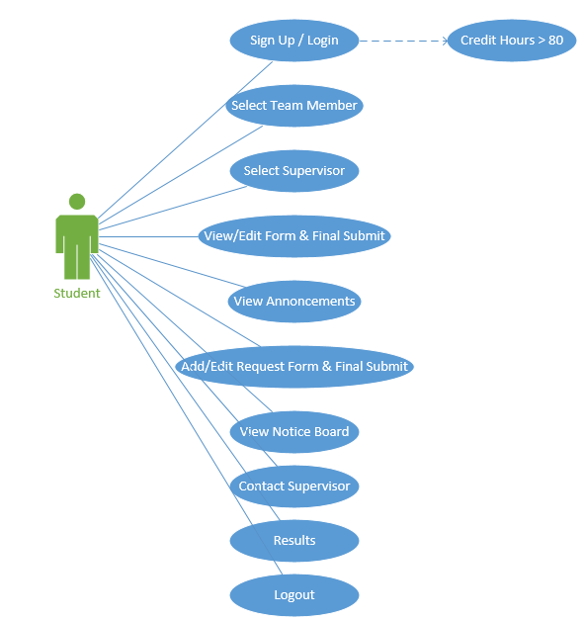
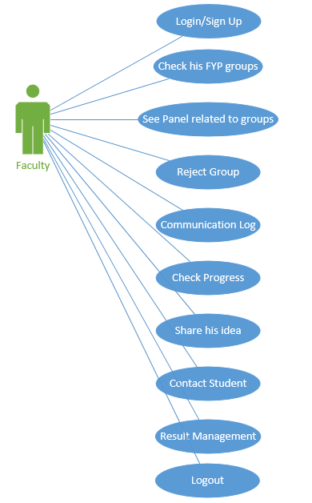
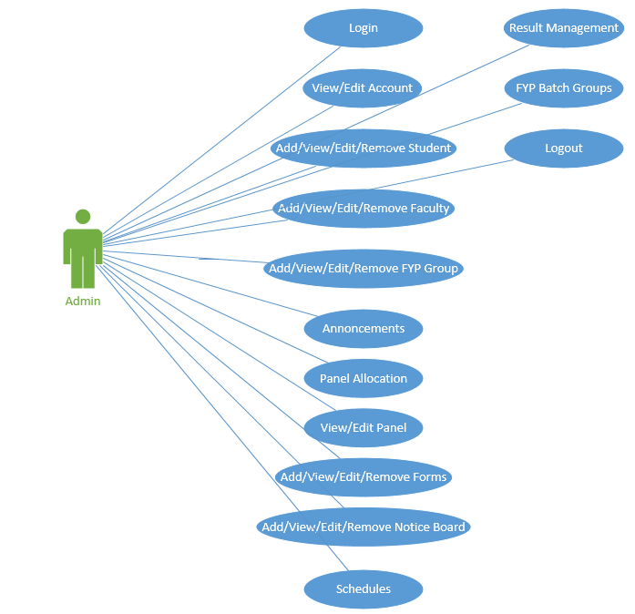

Domain Model
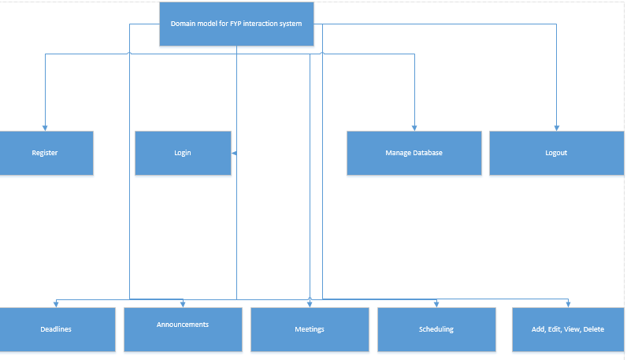

Sequence Diagram

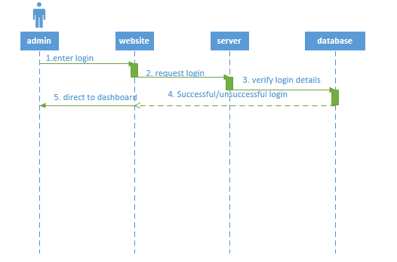
Sequence diagram(Admin login)
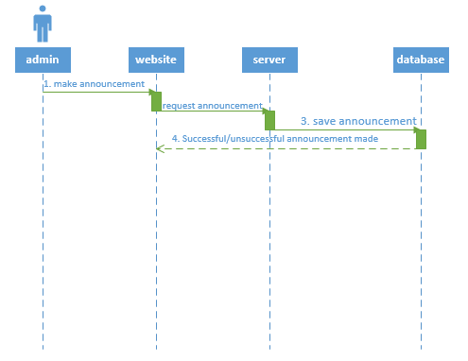
Sequence diagram(Make announcement)
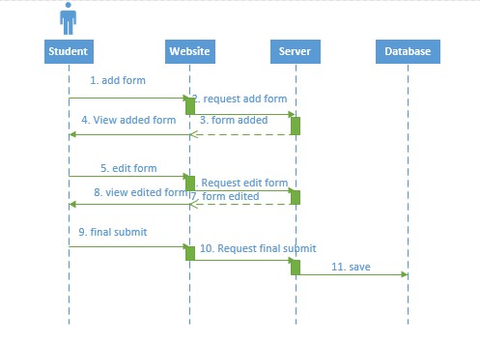Sequence diagram(add, view and final submit form)
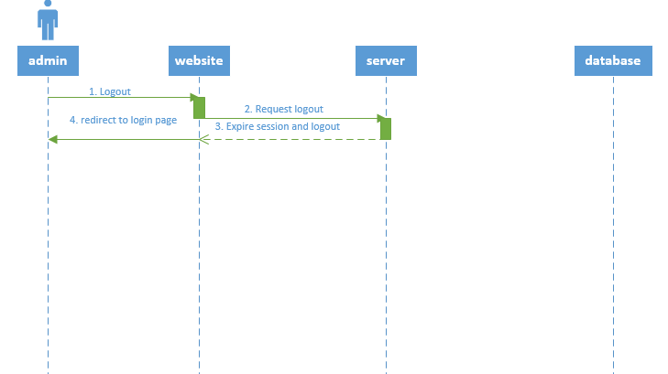Sequence diagram(Admin Logout)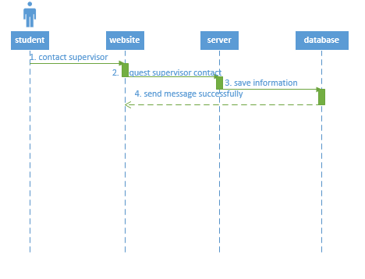
Sequence diagram(Admin login)
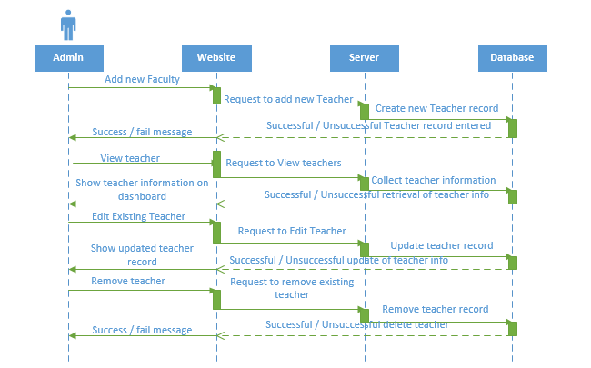
Sequence diagram(add, edit, view, delete faculty)
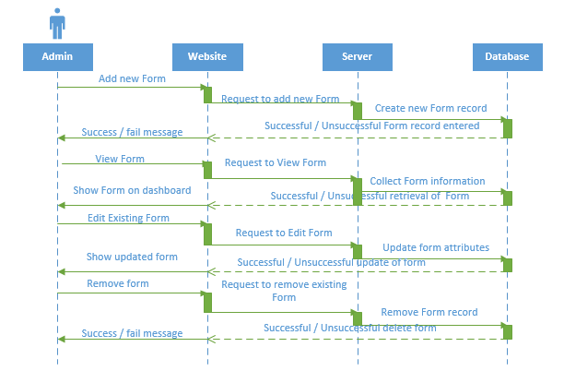
Sequence diagram(add, view, edit, delete form)
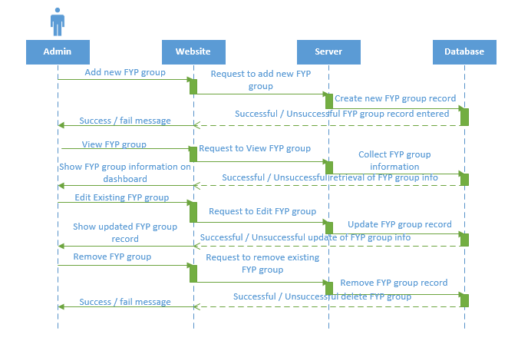
Sequence diagram(add, view, edit , delete FYP group)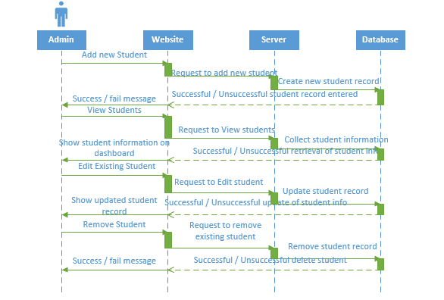 Sequence diagram(add, view, edit , delete student)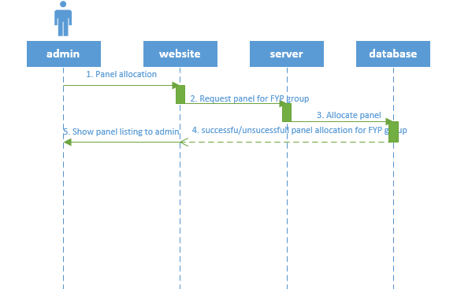
Sequence diagram(Panel allocation)

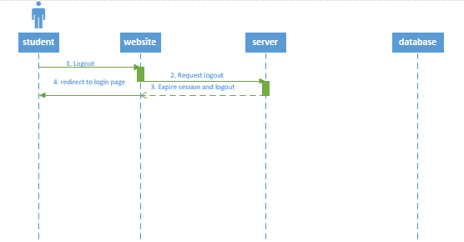
Sequence diagram(Logout student)
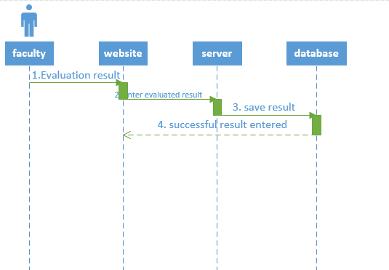

Sequence diagram(Result management)
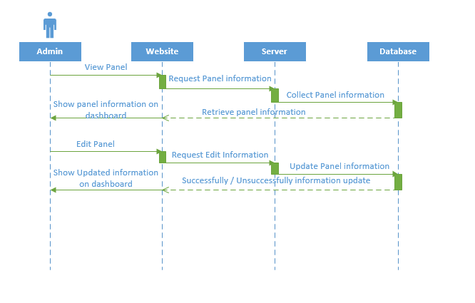
Sequence diagram(view, edit Panel)
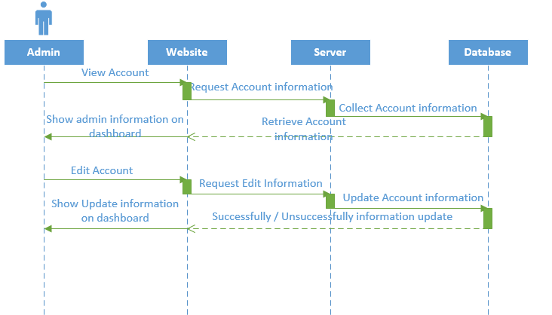

Sequence diagram(view, edit admin)

Collaboration Diagram
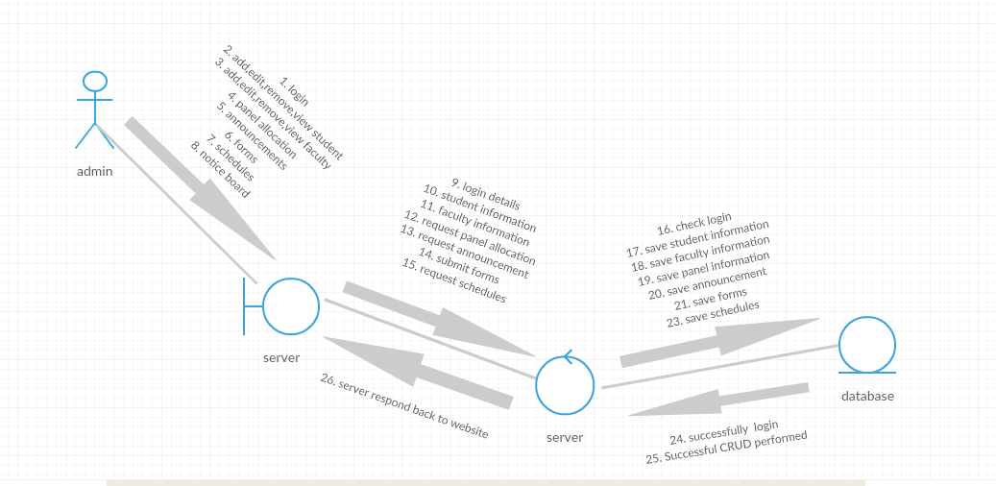
Collaboration diagram(Admin)
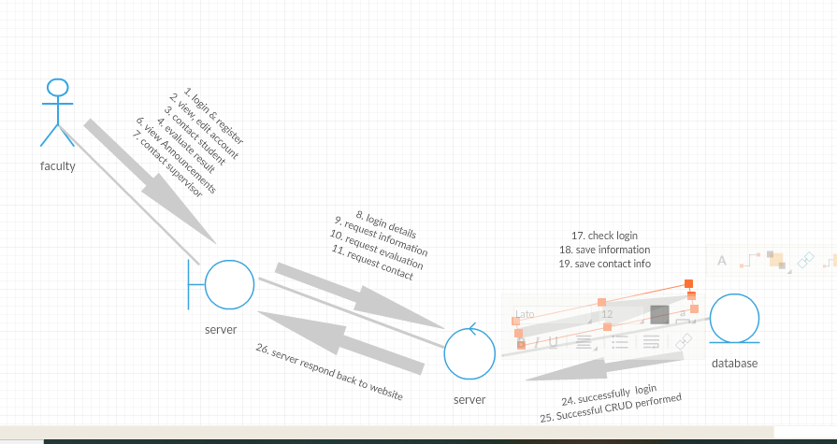
Collaboration diagram(Faculty)
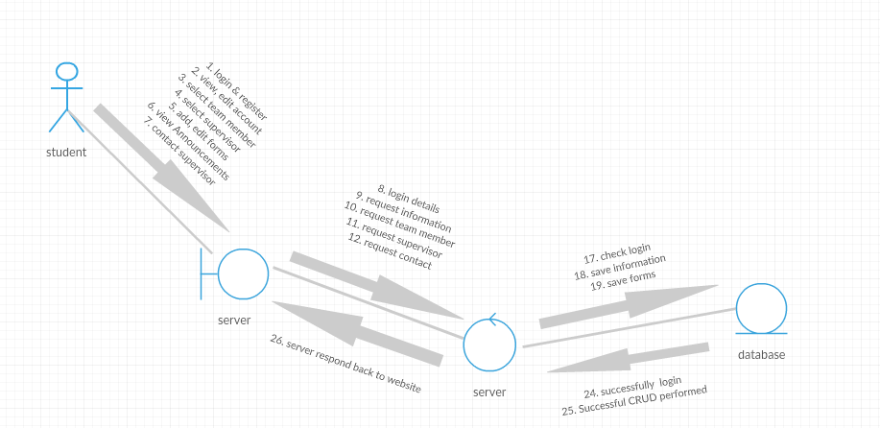
Collaboration diagram(Student)

Operation Contracts
Operation Contract Syntax

Name: Operation Contract Sign up

Responsibilities: To Register Student/Faculty

Cross References: U16,U26

Exceptions: Inappropriate details will be entered

Preconditions: Internet must be connected and proper domain must be requested

Postconditions: Successful sign up

Name: Operation Contract Sign In

Responsibilities: To Sign In Admin/Student/Faculty

Cross References: U1,U17,U27

Exceptions: Incorrect Credentials provided

Preconditions: Internet connection must be required for login

Postconditions: Successful sign in

Name: Operation Contract Announcements

Responsibilities: To Make and View announcements

Cross References: U7,U20

Exceptions: User not logged in

Preconditions: Notifications for students and faculty member

Postconditions: Successfully notifying FYP members

Name: Operation Contract Logout

Responsibilities: To Logout User

Cross References: U15,U25,U34

Exceptions: User not logged in

Preconditions: User must logged in must

Postconditions: Successful logout and redirect to login page

Name: Operation Contract Meeting

Responsibilities: To Provide Interaction between Supervisor and Student

Cross References: U12,U22

Exceptions: none

Preconditions: Both student and teacher have co-ordination in way of FYP

Postconditions: Successful meeting of student and supervisor

Design Class Diagram
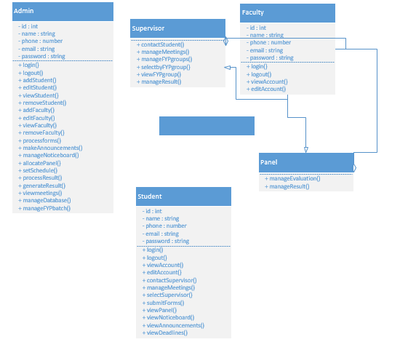

Data Model
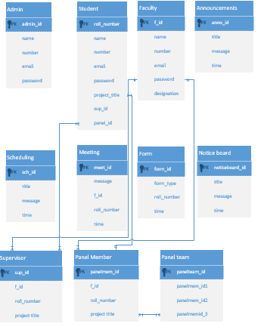

DATA AND EXPERIMENTS (and/or IMPLMENTATION)

Methodology

We will use agile methodology in this project because we are working on review-based teaching method, so we need to actively involve our customer (user) after every iteration. After every development iteration, customer can see the result and understand if he/she is satisfied with that functionality or not. It advocates planning, development, early delivery, and continual improvement, and it encourages rapid and flexible response to change. It is a lightweight process framework and the most widely used one. We will gather requirements from industry survey, document all requirements, implement using ROR, MYSQL, Bootstrap and jQuery/GUI.

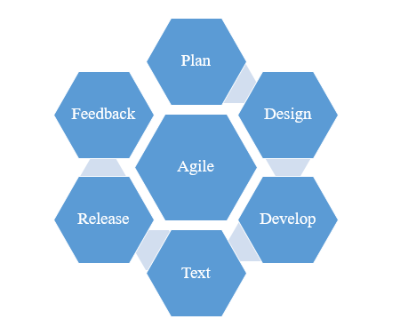
Figure 4-1: Agile

Tools / Technology

Mention all the HW/SW tools/technologies required for the project along with their availability.
These are the tools required for the completion of this project
- MySQL (For Database)
- PHP Laravel (For backend)
- Bootstrap (For frontend)
- Ram 8GB
- Hardisk 500GB
- Processor: Intel(R) Core (TM) i7-7500U CPU @ 2.70GHz 2.90GH

RESULTS AND DISCUSSIONS (or USER MANUAL)

Admin Login
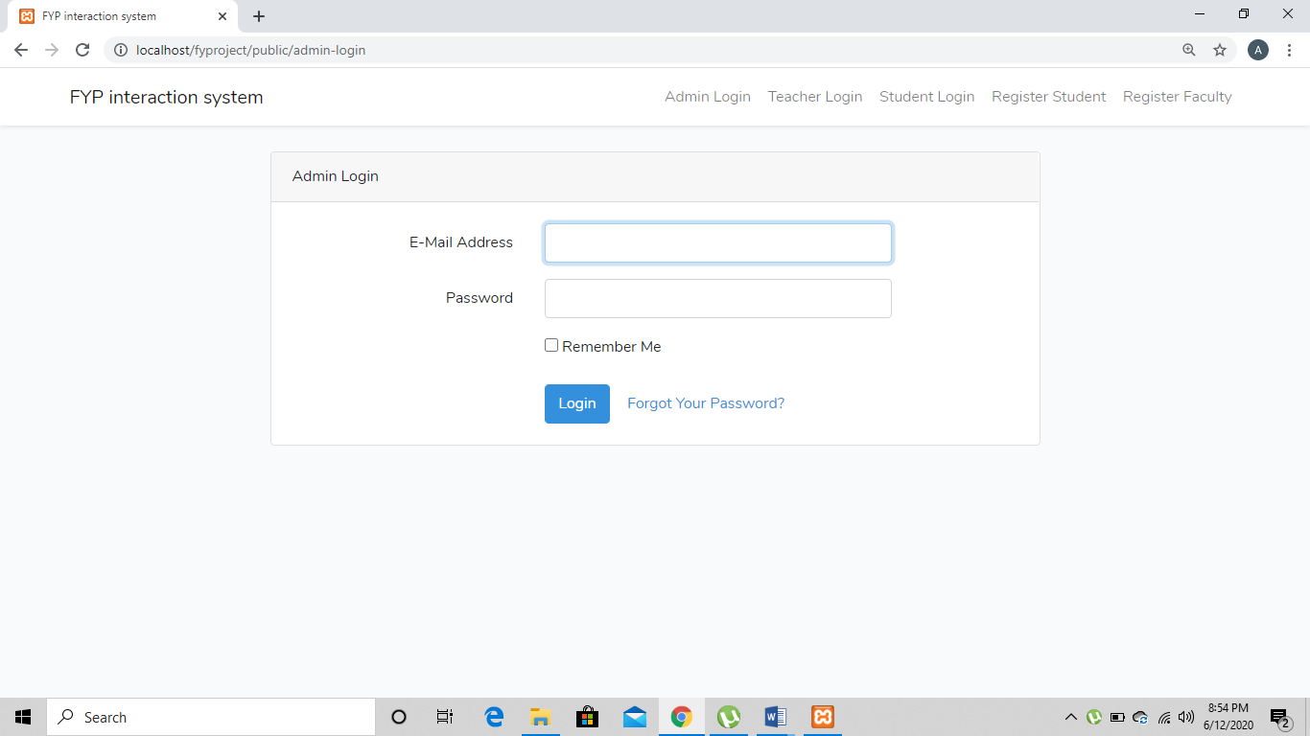

Teacher Login
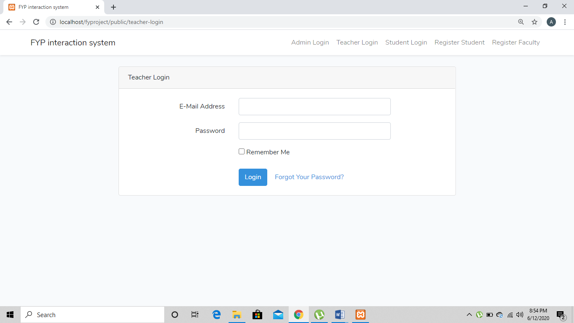

Student Login
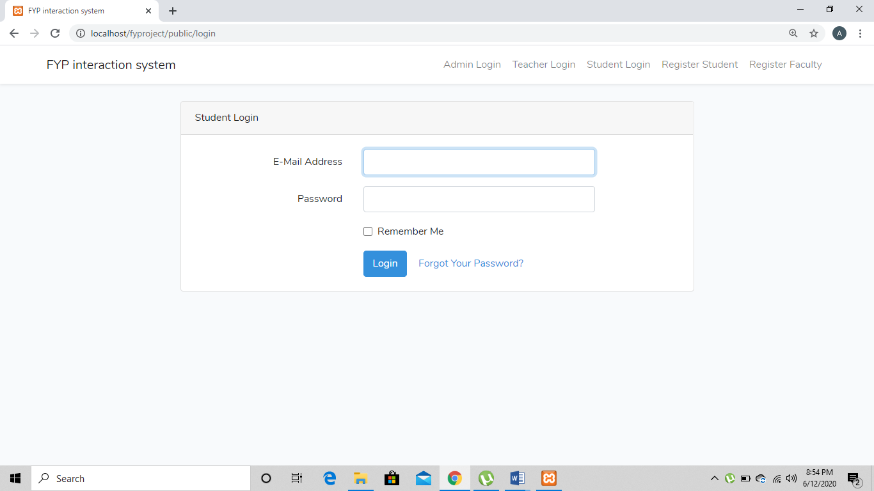

FYP Registration
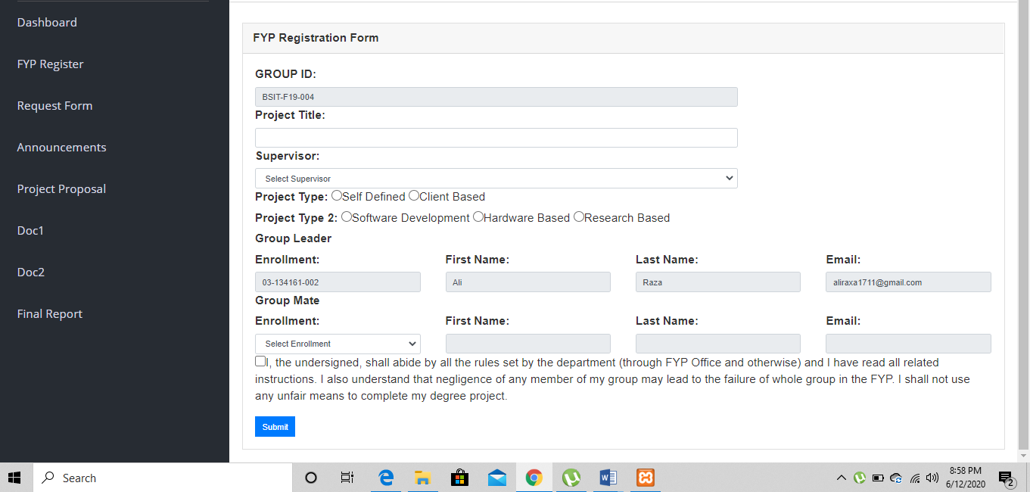

Student Request Form
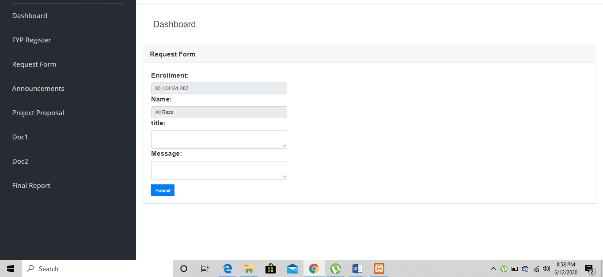

Announcements
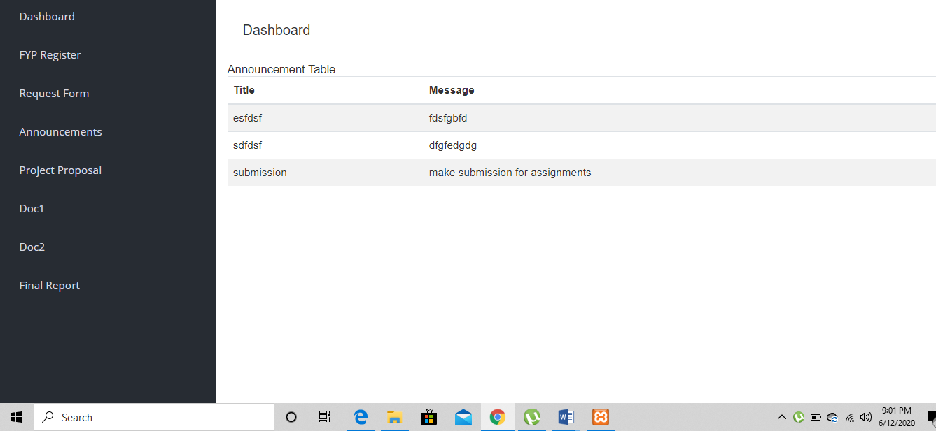

Project Proposal Submission
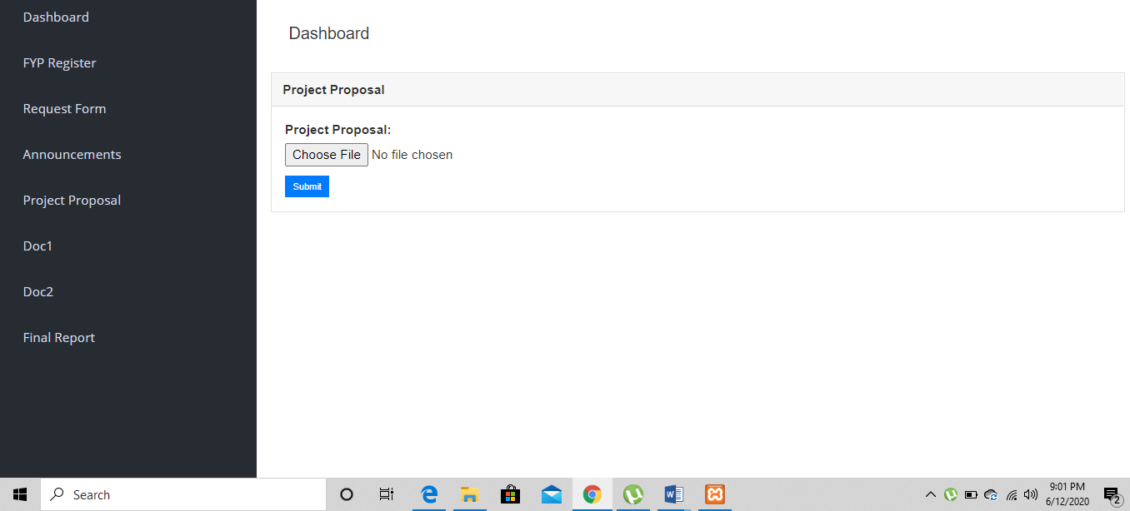

Doc1 Submission
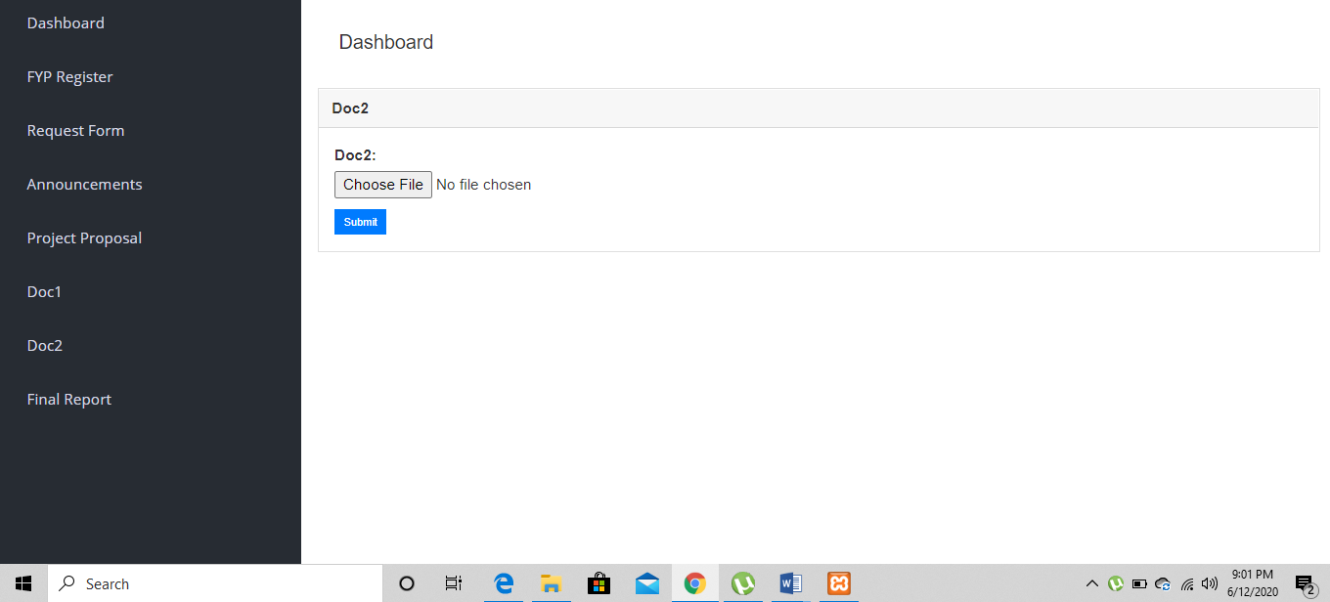

Final Report Submission
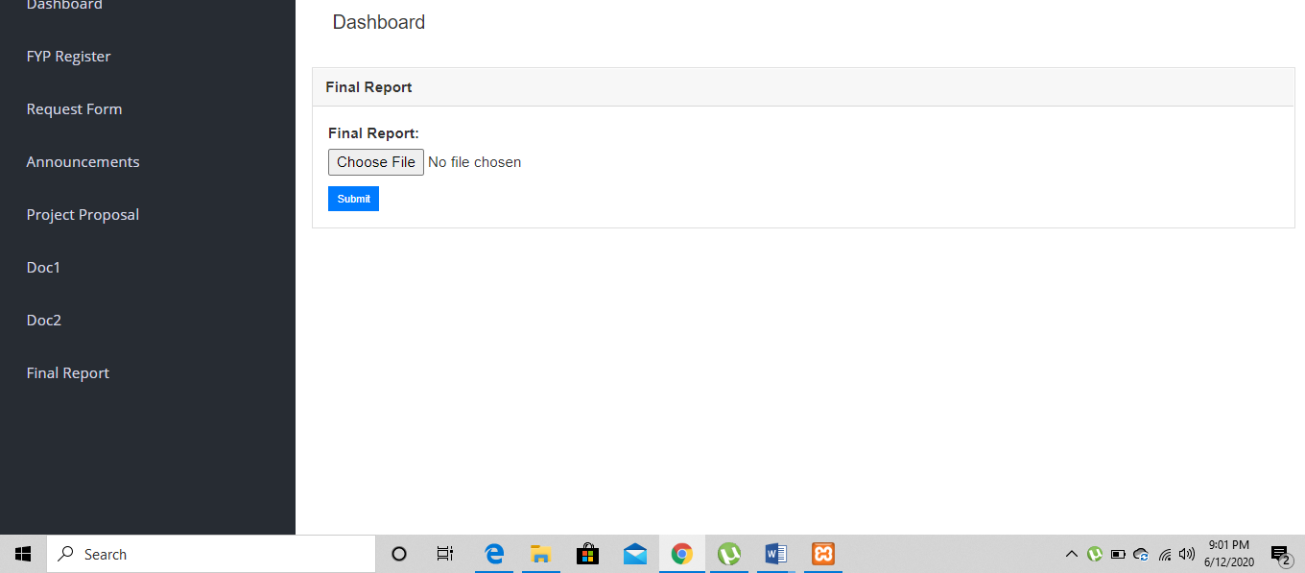

Student Dashboard
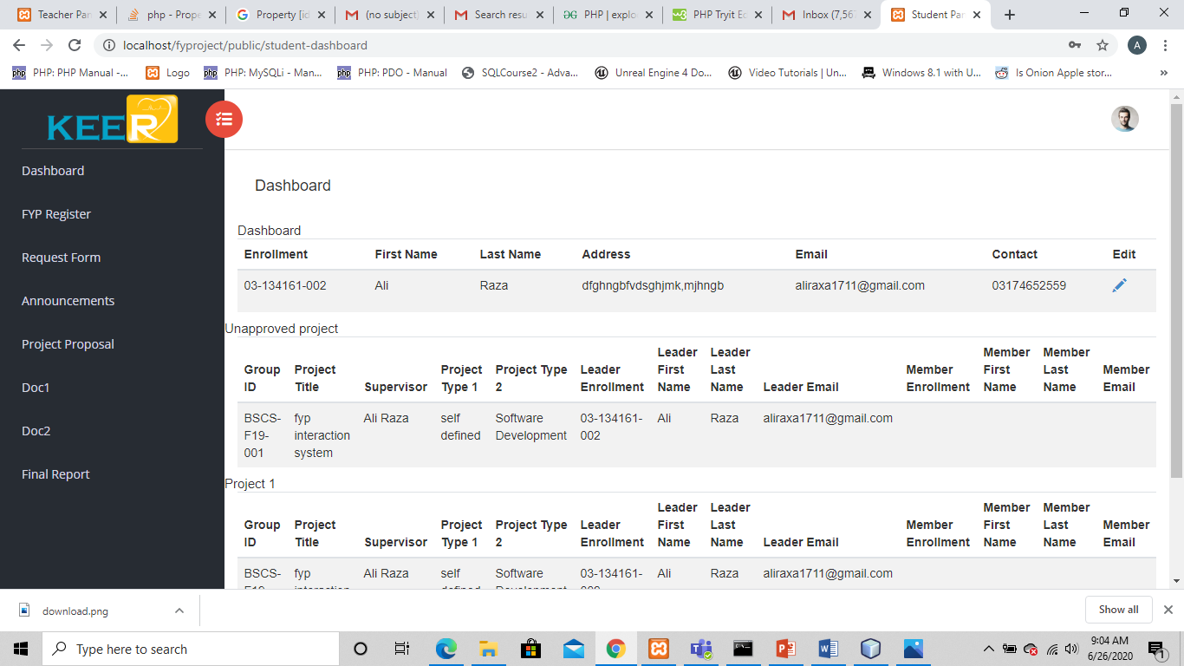

Student Registration
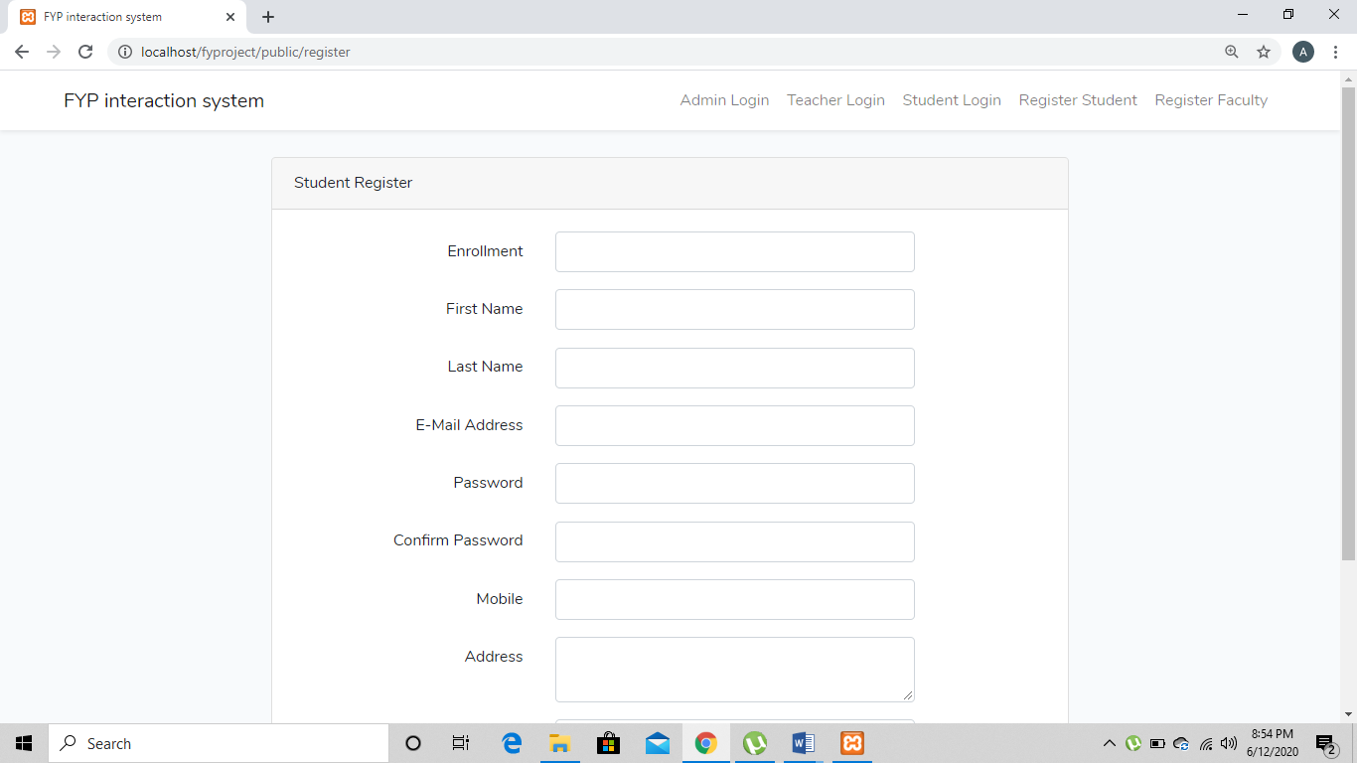

Teacher Registration
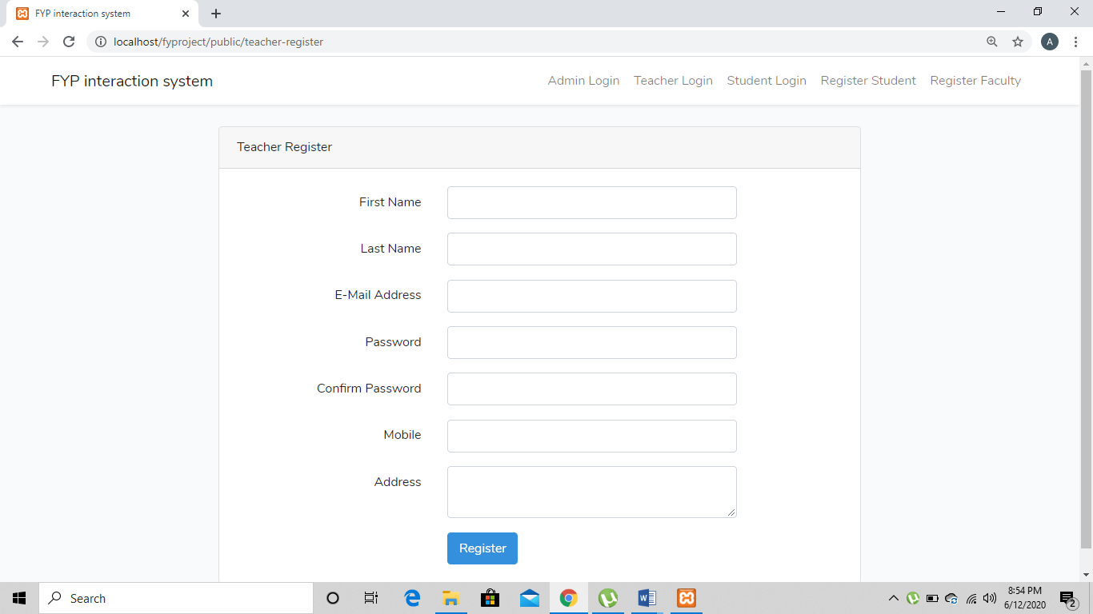

Admin Dashboard
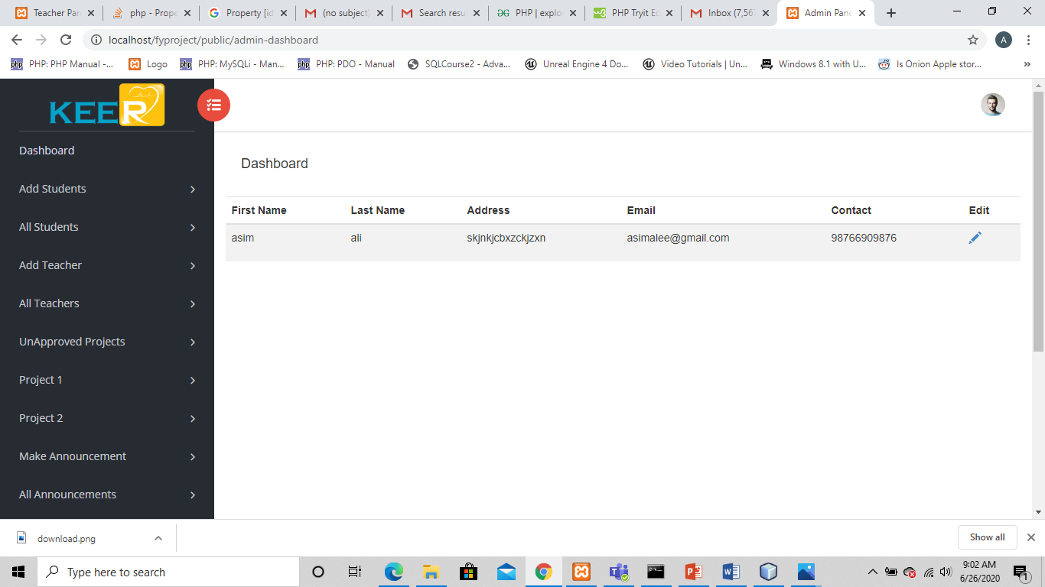

Add Student
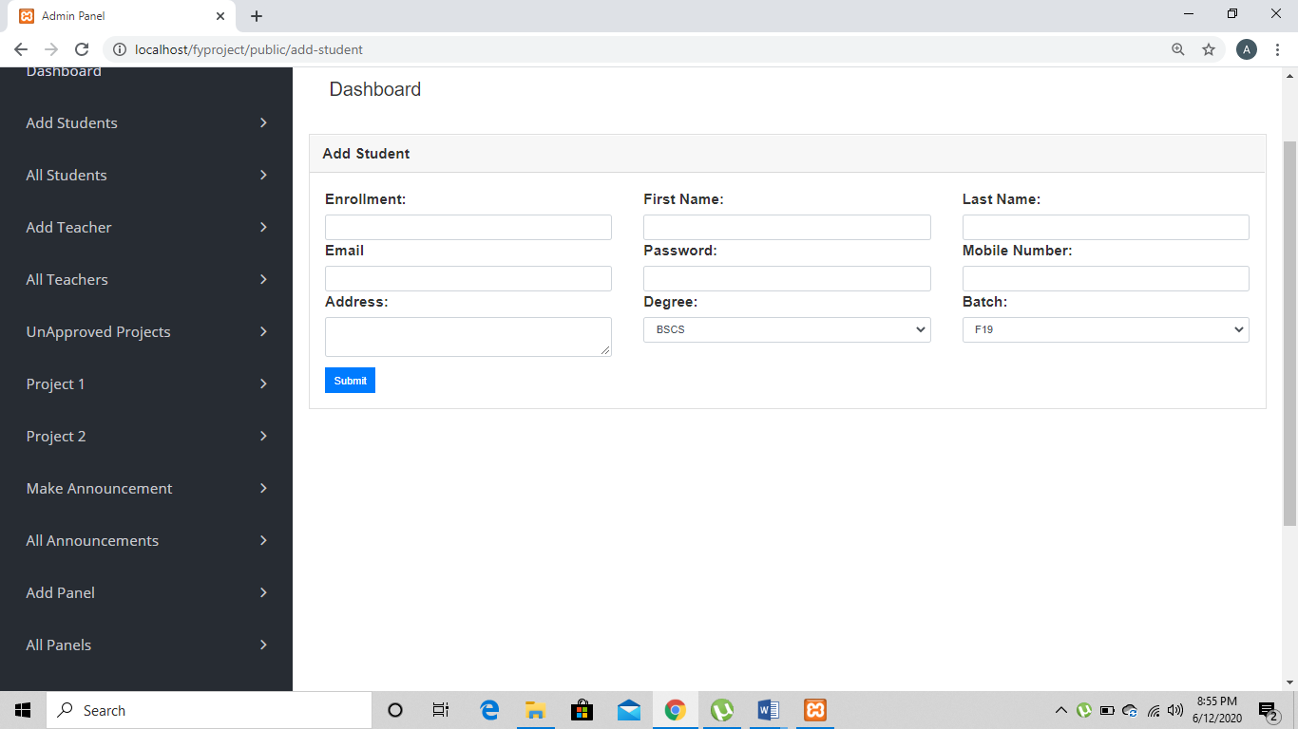

View, Edit, Delete Student
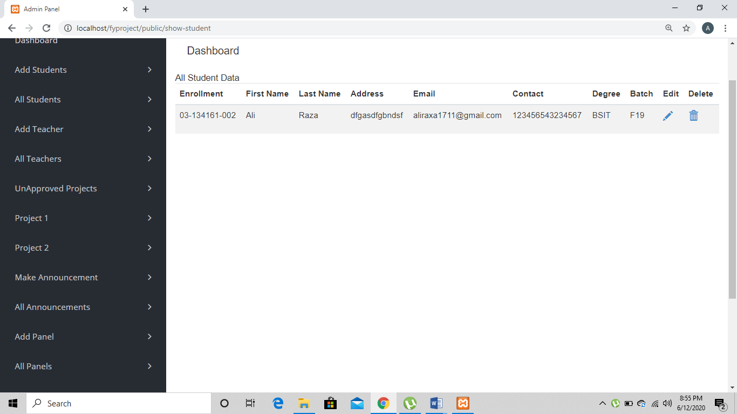

Add Teacher
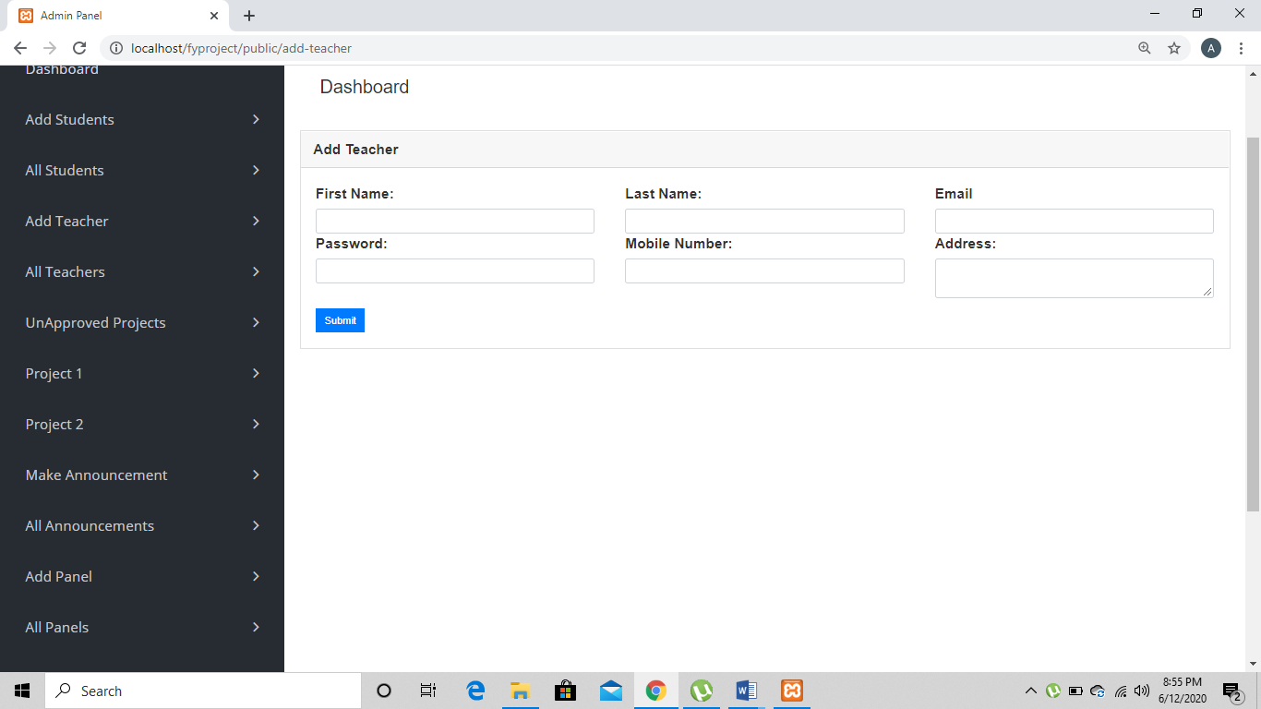

View, Edit, Delete Teacher
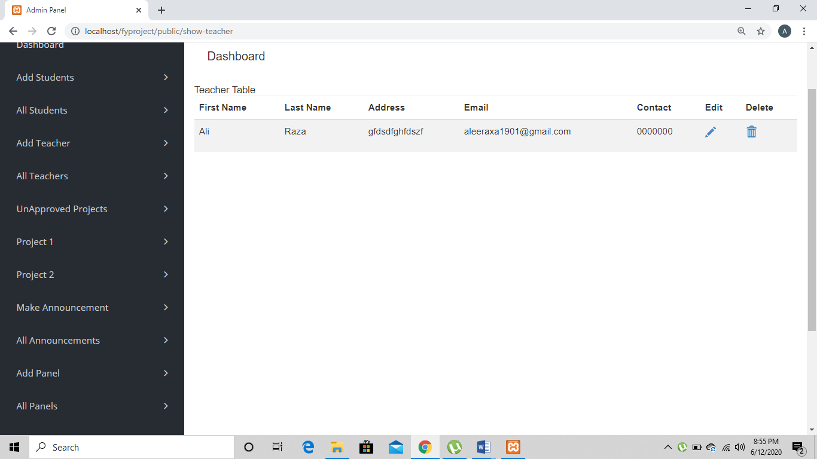

Make Announcement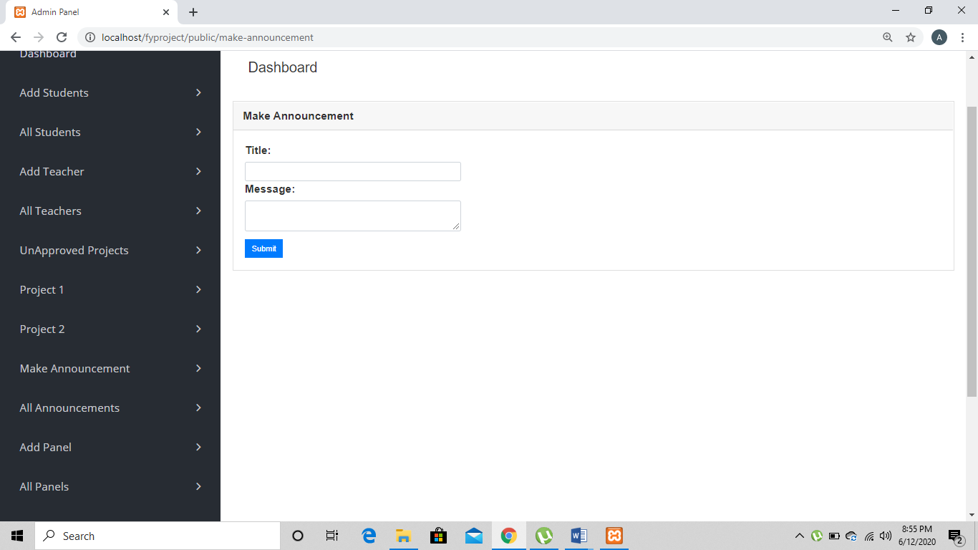

Add Panel

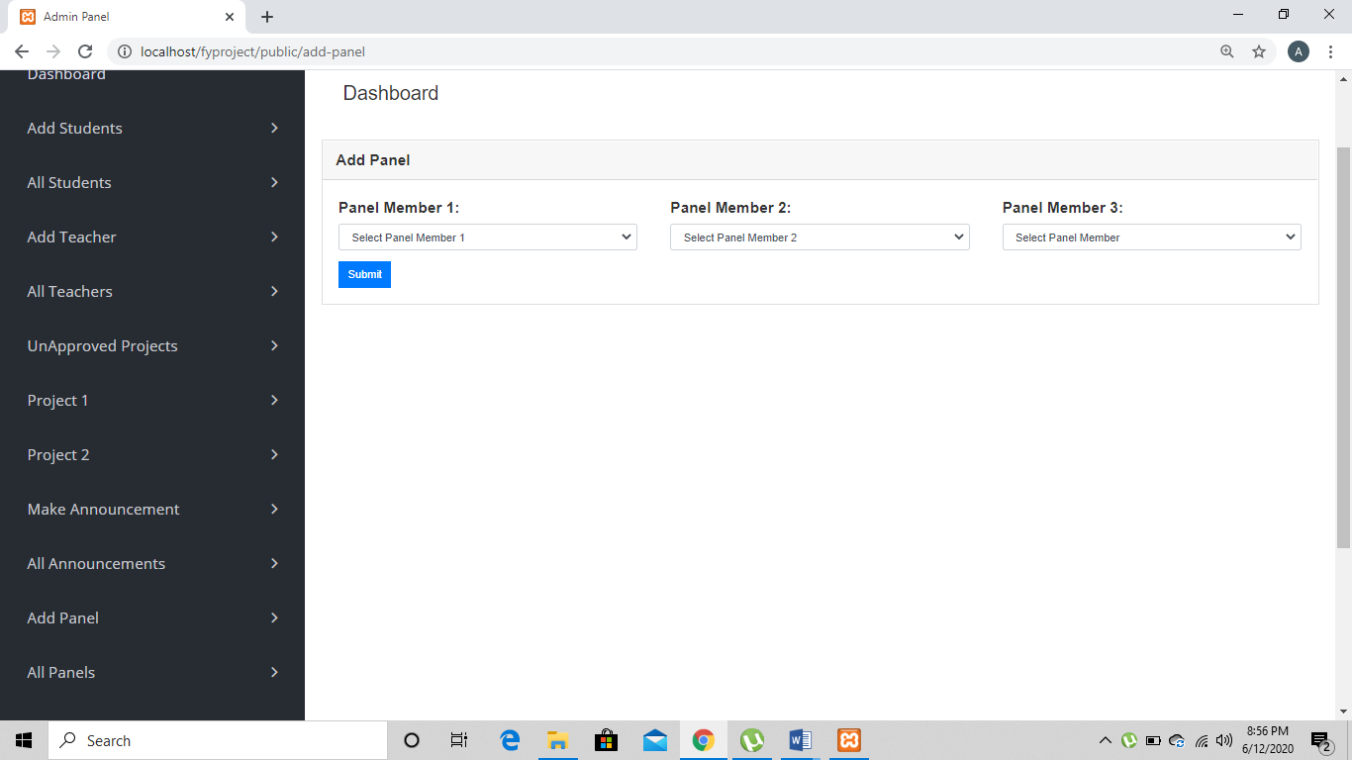

View, Edit, Delete Panel`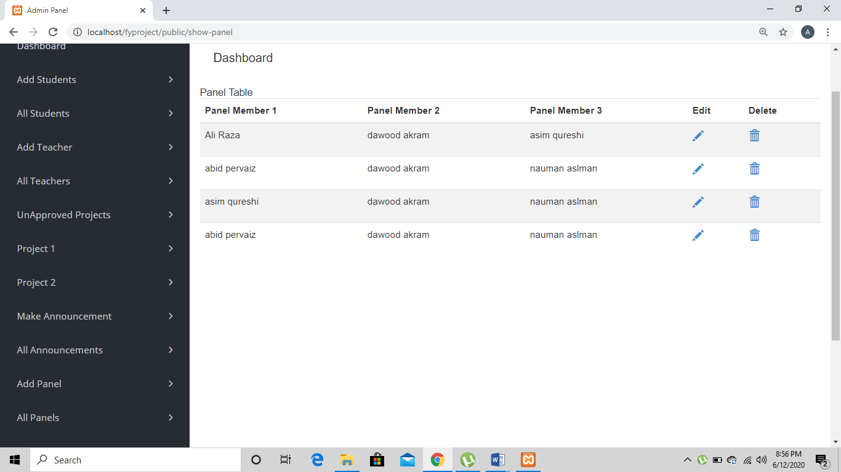

Add Schedules

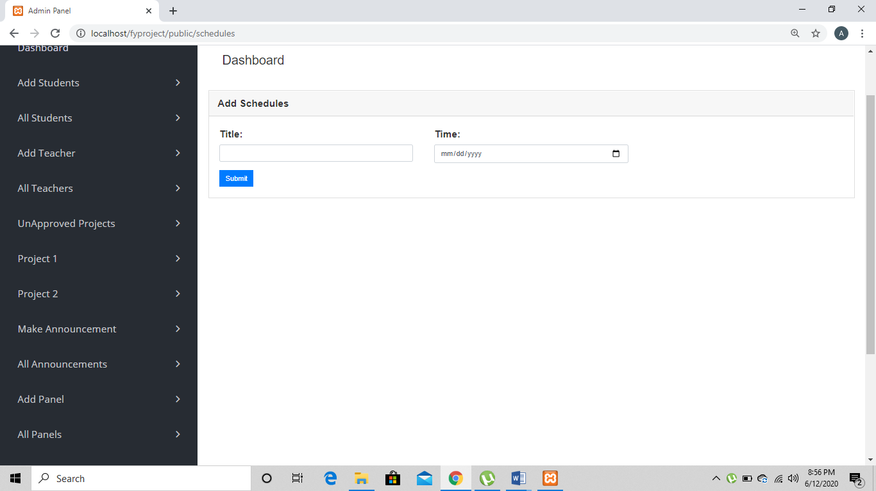

View, Edit, Delete Schedule

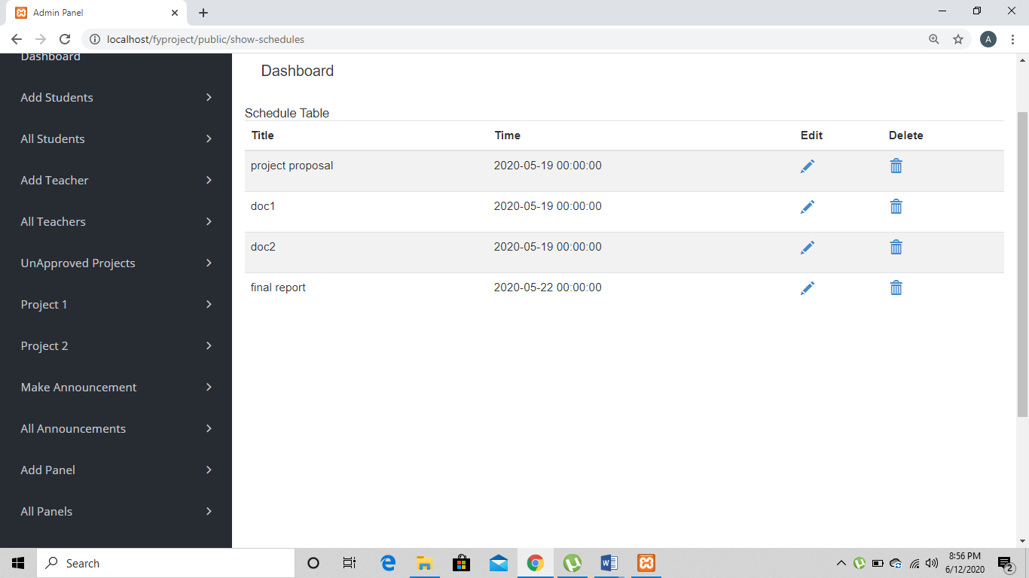

Teacher Dashboard
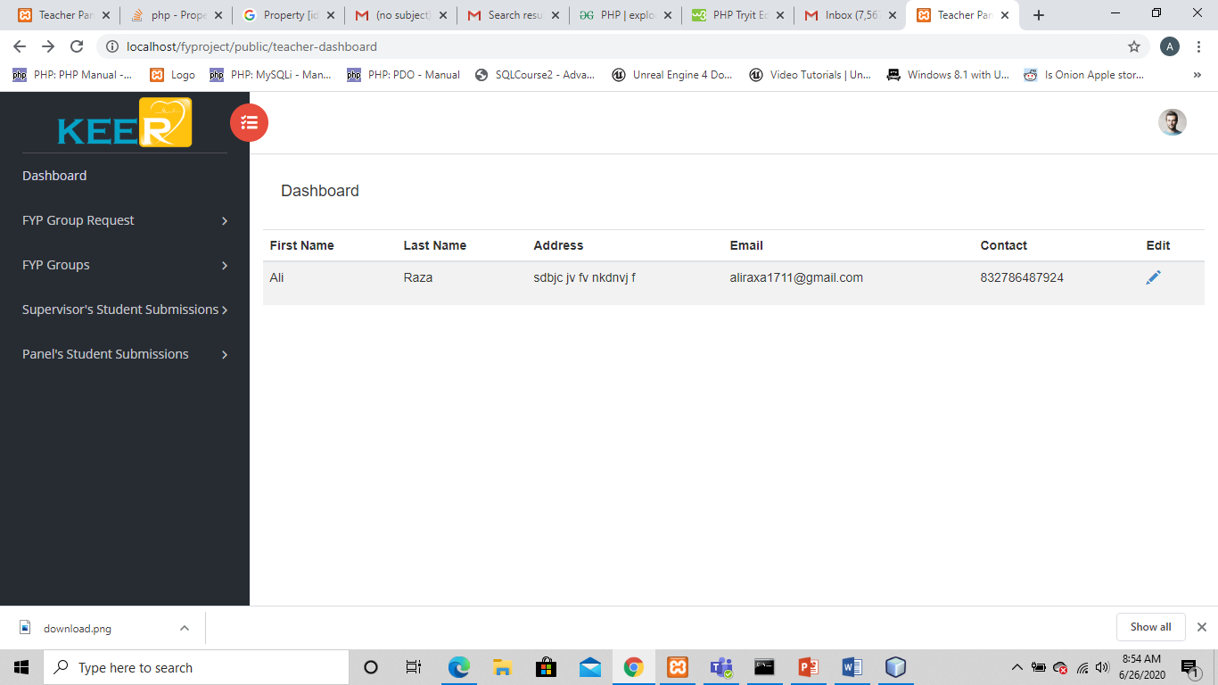

FYP Group Request
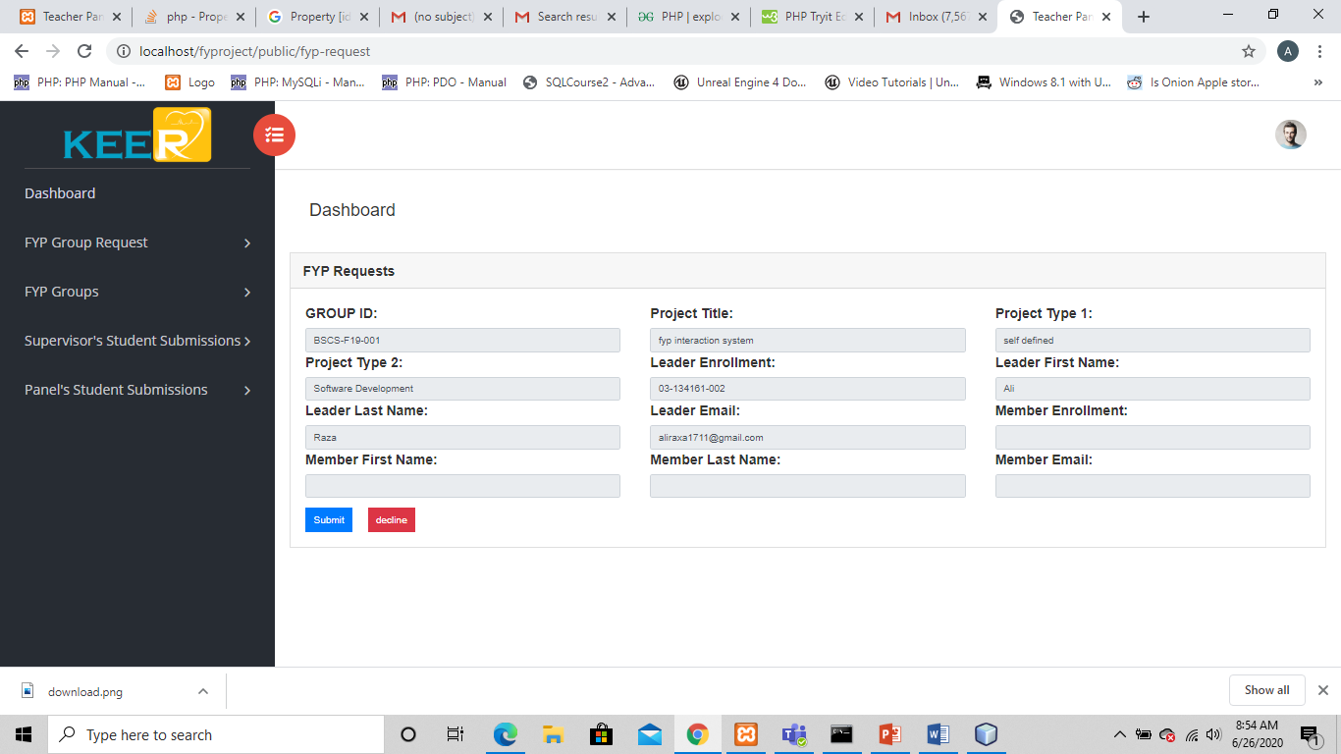

FYP Groups
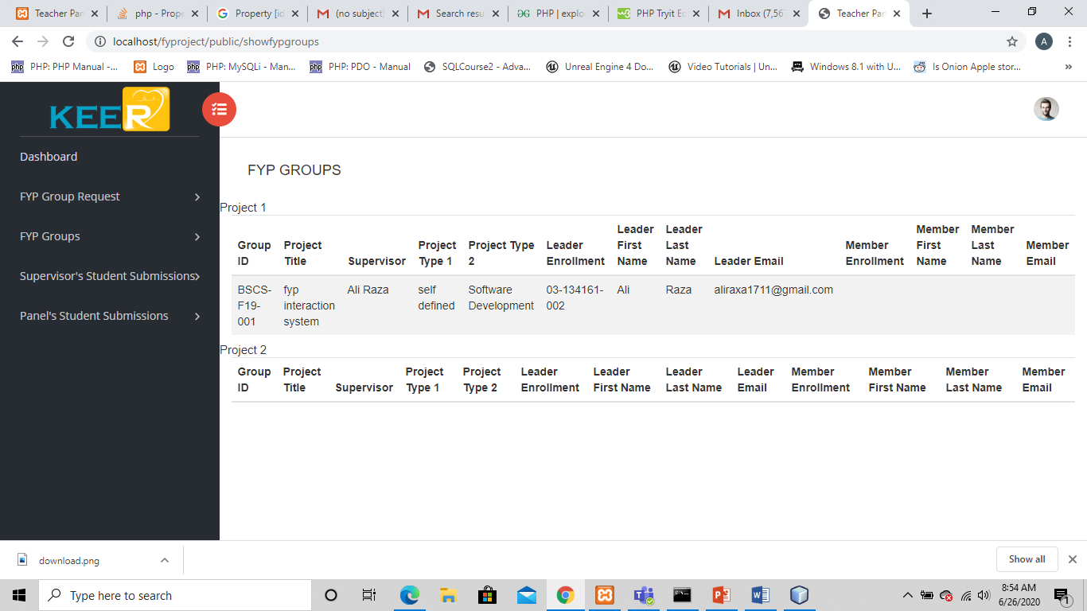

Supervisor’s Student Submissions
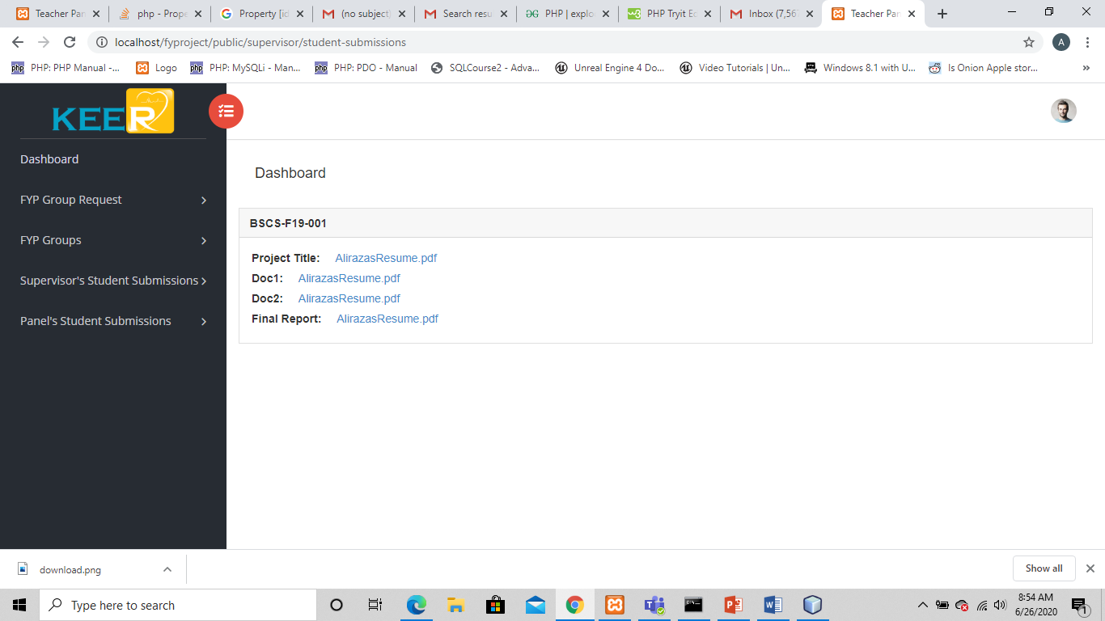

Panel’s Student Submissions
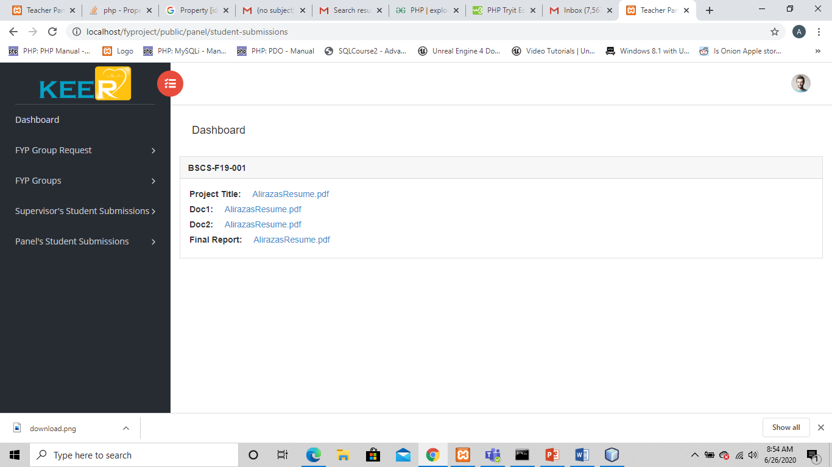

Edit Student
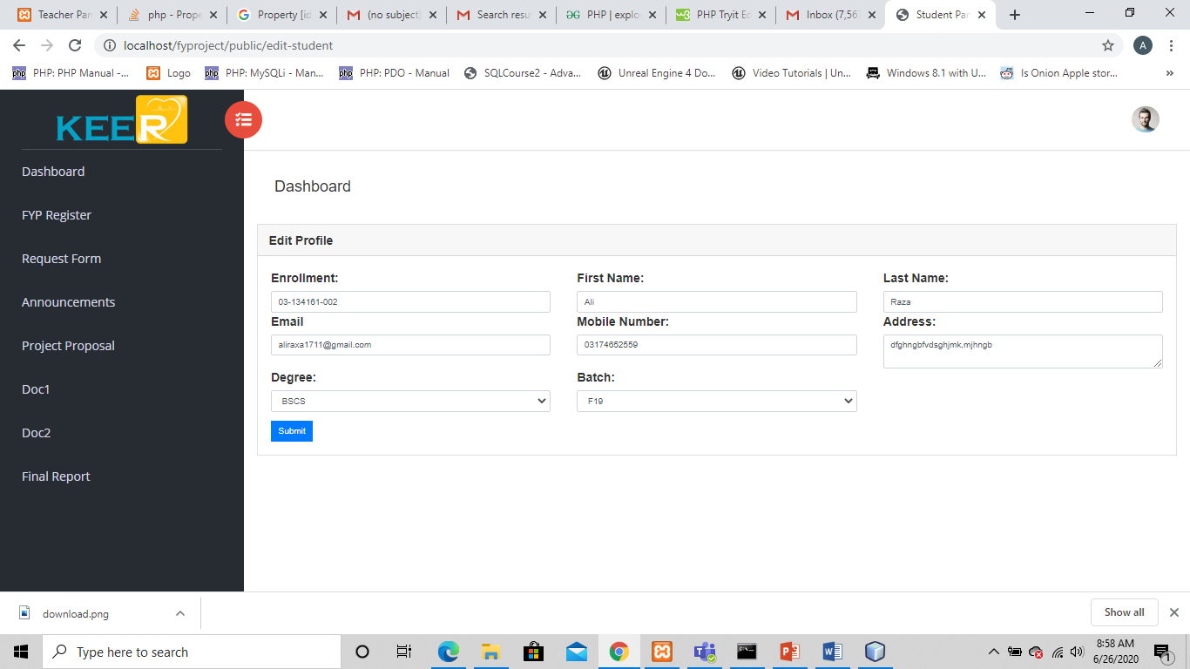

Edit Teacher
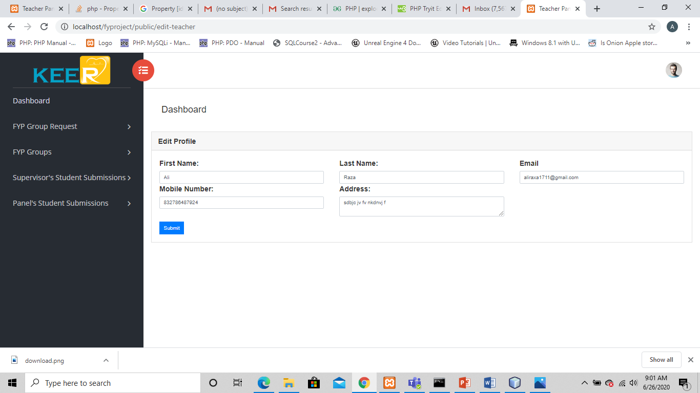

Edit Admin
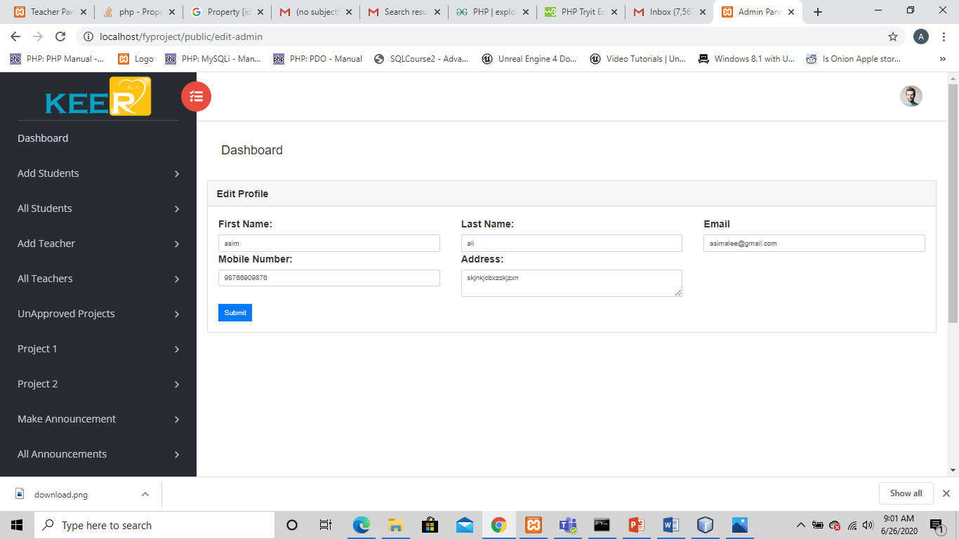

Unapproved Projects
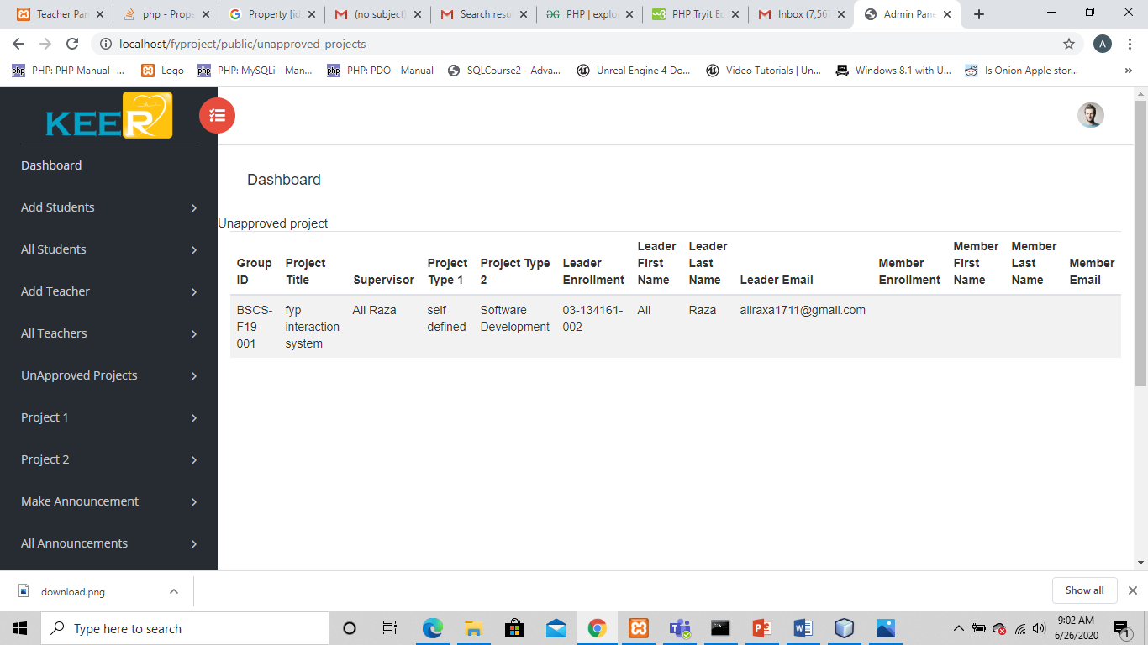

Project 1
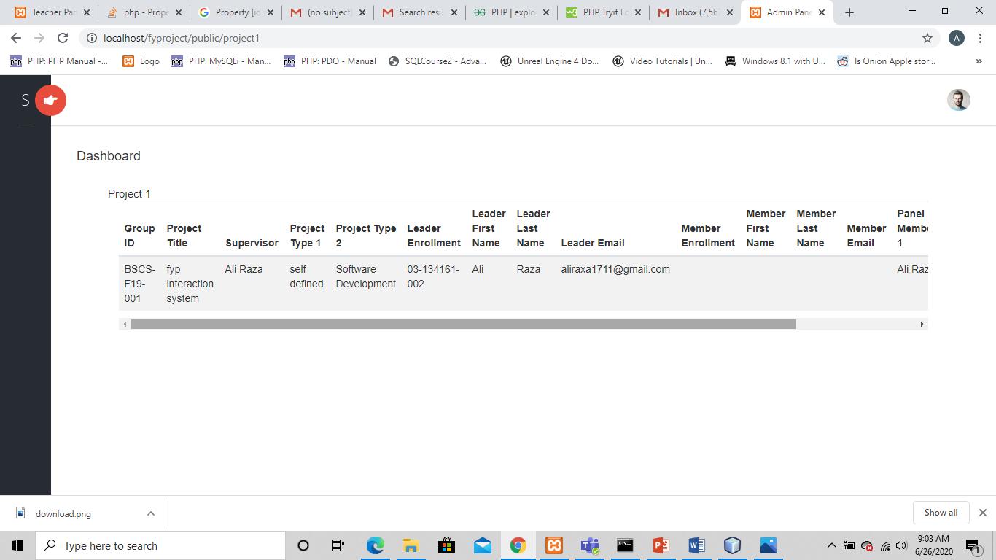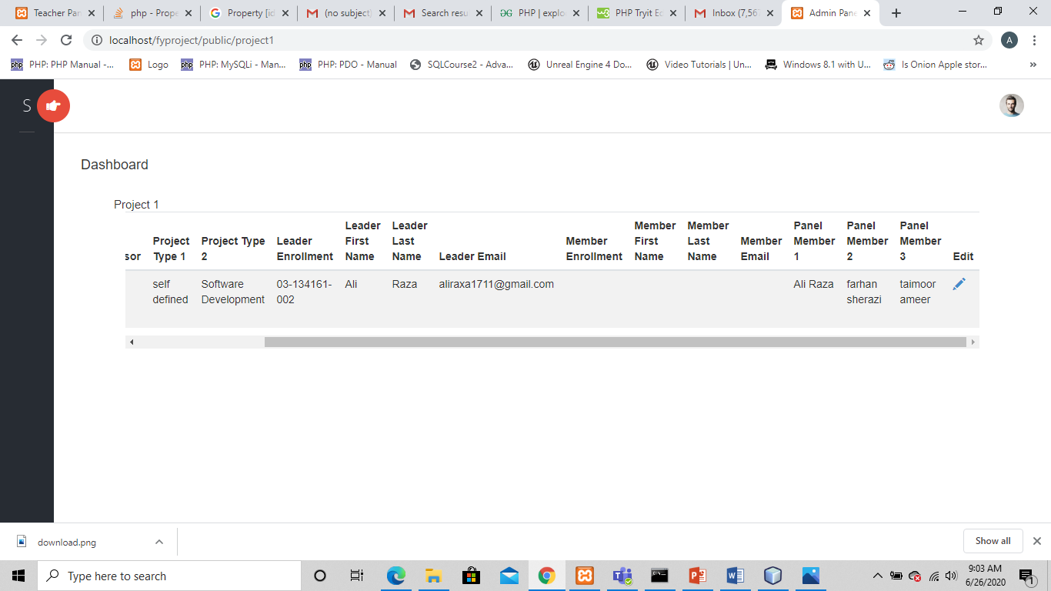

Edit Project/Allocate Panel
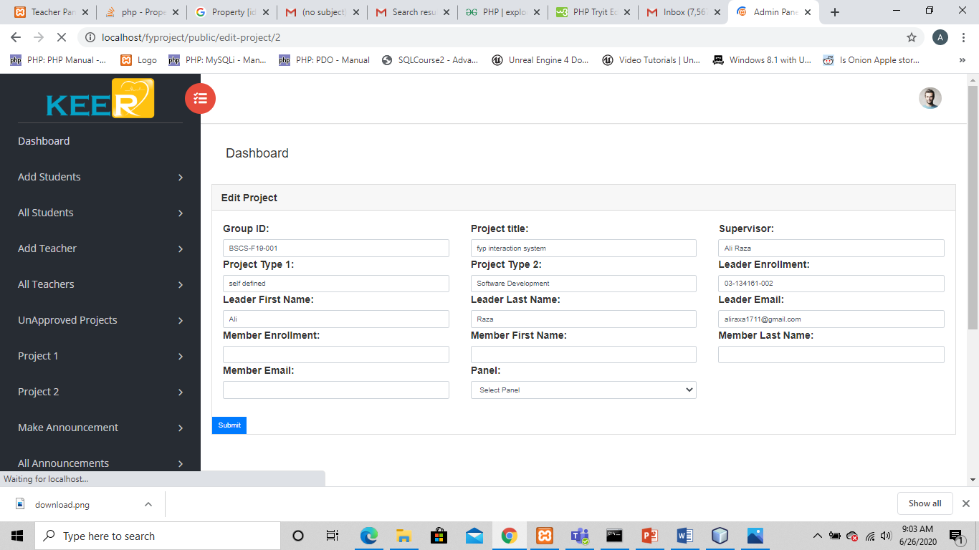

Database schema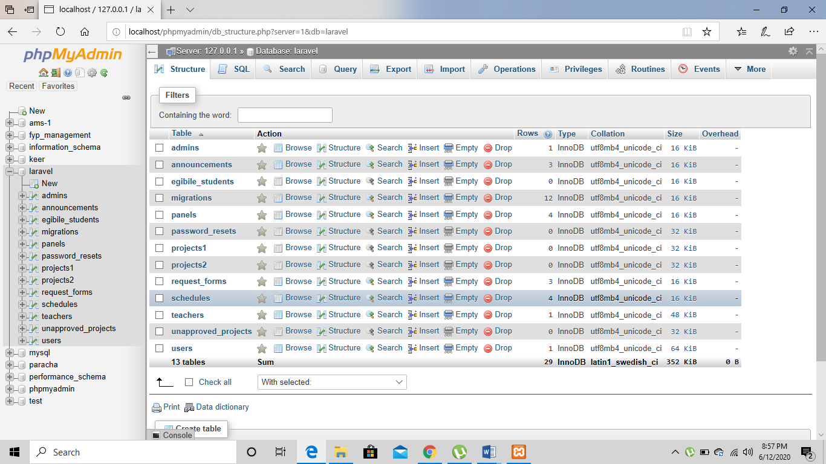

CONCLUSION AND RECOMMENDATIONS

RECOMMENDATIONS
Fyp Interaction system is recommended to handle final year projects of students. Where teacher supervisors, panels don’t have to worry of reminding their students again and again where students can directly contact to FYP team officially and announcements and schedules can be made efficiently.

CONCLUSION
Fyp Interaction system is an interactive and innovative way to handle Final year projects of students. This system will take headache of all the persons related to final year project

