
BSCS-F18-004
03-134151-050 | MUHAMMAD AFNAN AMEER

Thajzia: Heuristic Evaluation of an E-commerce Website

In partial fulfilment of the requirements for the degree of
Bachelor of Science in Computer Science
Supervisor: Dr. Abdul Hafeez
Department of Computer Sciences
Bahria University, Lahore Campus
June 2019

© Bahria University, 2019

Certificate

We accept the work contained in the report titled
“Thajzia: Heuristic Evaluation of E-commerce website”
written by

Muhammad Afnan Ameer

as a confirmation to the required standard for the partial fulfilment of the degree of
Bachelor of Science in Computer Science.

Approved by:
Supervisor: Dr. Abdul Hafeez
(Signature)

_____________, 2019

DECLARATION

I hereby declare that this project report is based on my original work except for citations and quotations which have been duly acknowledged. I also declare that it has not been previously and concurrently submitted for any other degree or award at Bahria University or other institutions.

Enrolment | Name | Signature
03-134151-050 | Muhammad Afnan Ameer

Date : _________________________

I dedicated my work to my beloved parents who always being a source of inspiration, encouragement and stamina to undertake my higher studies and to face eventualities of life with zeal, enthusiasm and fear of Allah
I dedicated this to my Dadi Jan who always pray for me and my success, the one who always seen a shiny day of my life in my eyes and one and only my Khala who always remain as a supportive hand for me.

Muhammad Afnan Ameer

ACKNOWLEDGEMENTS

First, I would like to express my gratitude to Almighty Allah to enable me to complete this research on “Heuristic Evaluation of An Ecommerce Website”.
Successfully completion of any type of project requires help from several people. I’ve also taken help from different people for the completion of this research. Now, there’s a little effort to show my deep gratitude to that helpful person.
I convey my sincere gratitude to my project Supervisor Dr. Abdul Hafeez. Without his kind direction and proper guidance this research would have been a little success. In every phase of this project his supervision and guidance shape this report to be completed perfectly.
I would also like to express my gratitude to my Mom & Dad who had helped me and given me encouragement and being always supportive for me.

Muhammad Afnan Ameer

THAJZIA: HEURISTIC EVALUATION OF AN E-COMMERCE WEBSITE

ABSTRACT

Shopping is a natural piece of everyday life, well beyond the pattern of web-based shopping is increasing the world overstep by step. The innovation arranged and innovation established economies are rethinking the methods for web-based shopping. Purchasing and selling have been broadly changed the same number of individuals extravagant making their shopping from online stores instead of going to ordinary markets. Women are much increasingly hesitant towards web-based shopping. In the present occupied life working ladies have strain to oversee both house and office undertakings, so the criticalness of the internet looking for ladies can never be ignored.
This research-based project consists of a website which enable every type of users to easily know what meant to be. This website uses voiceovers, videos to bring ease and comfort for shopping. Moreover, payment method is improved, and accuracy is also tried to make perfect. Yet makeup and jewellery option are available to be purchased later garments and other product would also be added. Main objectives of this research are to overcome maximum of issues faced by the women of Pakistan and providing them an easy platform for their ease to meet the modern world.

TABLE OF CONTENTS

DECLARATION ii
ACKNOWLEDGEMENTS iv
ABSTRACT v
TABLE OF CONTENTS vi
LIST OF TABLES viii
LIST OF FIGURES ix

CHAPTERS
1 INTRODUCTION 1
1.1 Background 1
1.2 Problem Statements 3
1.3 Aims and Objectives 4
1.4 Scope of Project 4
2 LITERATURE REVIEW 5
2.1 Usability of online shopping 6
2.2 Female user intends toward interaction and design 7
2.3 Online shopping in Pakistan 8
2.3.1 Top e-commerce website of Pakistan 10
2.3.2 Trends of online shopping in Pakistan 11
3 DESIGN AND METHODOLOGY 12
3.1 Overview 12
3.2 Researched based 12
3.3 User central design 13
3.4 Methodology 14
3.5 System Design 17
3.5.1 System Use-case 18
3.5.2 Use-case Narrative 18
3.5.3 Sequence diagram 24
4 DATA AND EXPERIMENTS 28
4.1 Data 28
4.2 Questionnaire 29
4.3 Experiment 30
5 RESULTS AND DISCUSSIONS 33
5.1 Result 33
5.2 Interface 40
6 CONCLUSION AND RECOMMENDATIONS 46
6.1 Conclusion 46
6.2 Recommendation 47
REFERENCES 48

LIST OF TABLES

TABLE TITLE PAGE
Table 1: functionalities of some known websites in Pakistan 11
Table 2: Main use-case 19
Table 3: Login narrative 19
Table 4: Registered Narrative 20
Table 5: Search Narrative 20
Table 6: Shopping Narrative 21
Table 7: Order Tracking Narrative 21
Table 8: Edit details Narrative 22
Table 9: Inquire Narrative 22
Table 10: Maintenance Narrative 23

LIST OF FIGURES

FIGURE TITLE PAGE
Figure 1: User central design process 13
Figure 2: Team process of UCD 14
Figure 3: multidisciplinary design team for UCD 14
Figure 4: Exploratory study 15
Figure 5: Requirement Engineering Process 15
Figure 6: System use-case 18
Figure 7: system sequence Diagram 24
Figure 8: Login Sequence Diagram 25
Figure 9: Registration Sequence Diagram 25
Figure 10: add to cart, search and check-out sequence diagram 26
Figure 11: USer Detail Sequence Diagram 26
Figure 12: Feedback Sequence Diagram 27
Figure 13: Logout Sequence Diagram 27
Figure ‎5-1:Visibility of system status 33
Figure ‎5-2: Match between the system and real world 34
Figure ‎5-3: user control and freedom 34
Figure ‎5-4:consistence & standards 35
Figure ‎5-5: Error Prevention 35
Figure ‎5-6:Recognition rather than recall 36
Figure ‎5-7:Aesthetic and minimalist design 36
Figure ‎5-8:Help users recognize, diagnose and recovers from error 38
Figure ‎5-9: Home page 40
Figure ‎5-10: home page 41
Figure ‎5-11: Jewelry page 41
Figure ‎5-12: Menu bar 42
Figure ‎5-13: signup 42
Figure ‎5-14: Manufacturer 43
Figure ‎5-15: About us 43
Figure ‎5-16: help 44
Figure ‎5-17: customer support 44
Figure ‎5-18: Admin panel 45

INTRODUCTION

Background
People are getting more in-contact with web shopping as they save their time. They used to buy from the fundamental need to stamped pieces of clothing, sharp devices each use of living from the online business webpage.
What is Heuristic evaluation? A heuristic evaluation is a comfort building procedure for finding the usability issues in a UI design, in like manner, making them addressable and resolvable as a noteworthy part of an iterative structure process. It incorporates a little game plan of ace evaluators who check the UI and access its consistency with "heuristics," or saw comfort guidelines. Such techniques help dodge thing frustration post-release.
Ordinary usability evaluations of interfaces can be long, irksome, exorbitant and monotonous strategies that every now and again compromise engineers. They are in this manner as often as possible disregarded—to the detriment of passing on programming that encounters convenience issues and results in disappointment and bumbles during utilization. To vanquish the issue deficiently, Jakob Nielsen (pioneer of web comfort) has pushed for "markdown convenience structuring procedures"— i.e., methods that designers can get which are ratty, brisk and easy to use. A heuristic appraisal is one of these systems.
In a heuristic evaluation, a lot of evaluators study an organized interface for consistency against an agreed arrangement of guidelines. Each evaluator works alone and goes over the UI on different events. At last, the evaluators produce reports which are then discussed, the result is a once-over of usability issues (and their causes) to be tended to. In a heuristic evaluation, evaluators can improve sets of general arrangement models with more heuristics that organize the thing social occasion or its characteristics, as crucial. The number of evaluators for each endeavour may vacillate, anyway using around five of them is generally recommended, as this number has been seemed to have the ability to discover about 75% of all accommodation issues. Since evaluators are surveying the UI and not by any stretch of the imagination using it. Why a heuristic evaluation? heuristic evaluation is fit to early use in the improvement lifecycle, where the UI may include basically paper-just plans. By its tendency, such appraisal empowers getting oversights before they become unsafe.
Future is of advancement. In the innovative world, people get busier in their work and some action going women or even housewives feel deferral to go out for looking for nourishment or for the articles of clothing PDAs. For shopping on the web, they went up against a lot of issues regarding the present destinations. I'll team up the customers get learns about the issues, issue, stood up to while using the present locales. Get-together the reviews from individuals, as a rule, online will develop a webpage which will accord the need and solicitation of the customer.
Kharidloo would be organized by the essential of individuals when all is said in the done/customer. Kharidloo gives their customer to get depiction about the thing, reviews about the thing and opportunity to orchestrate the thing on a singular page. Kharidloo will give a customer the shot of securing their optimal thing by knowing all the nuances of the thing. It would be a site which gives a customer delineation and reviews about the thing.
Our diagrams/interviews while gathering the data from the all-inclusive community/customer would be preliminary and analyst. This investigated will be exploratory based while getting the information from gathering of eyewitnesses about their issues and reviews we will control the customer to use the present interface and consequent to organizing the Kharidloo again lead a test to think about in which an opportunity to the customer will be outfitted to connect with the UI of the Kharidloo encircled and will get the overview about Kharidloo.
For the investigations, I will similarly cover a part of the provincial domain of the country as this site will be a national site as opposed to a regional site.

The example destinations I would use to lead studies will be "Max style", "Jarir.com", "Alibaba". "red tag", "oriflamme.com", "daraz.com".
When we initially direct the surveys about the present interface to turn out to be increasingly familiar with about customer need, issues a lone customer face participating with them we will consider the data from our target customers for instance housewives. We will break down the requirements of our target customers and will focus on the similar necessities obtained.
To buy anything or thing from Kharidloo, there will be an associated card through which a customer can buy the perfect thing in the wake of completing the payment methodology and the thing will be passed on to the customer inside 2 to 5 working days.
Least of 30 women would be considered and will keep interfacing all through the improvement to keep the precise need of the customers. Surveys will be coordinated among low capable and taught women.
To overcome, the issue of procuring an office of cash down or easy paisa modules would in like manner be available so they can without a lot of a stretch purchase the prepared thing by paying through these methods for online business.
To ensure the thing, pass on to the customer is same as appeared nearby, the picture close by the group is stuck in which the customer demand nuances, a picture of the thing and the portrayal will be referenced.

Problem Statements

At present, women, clients can without quite a bit of a stretch methodology many shopping locales to purchase stocks according to their choices with complete mass determinations without limitations. According to Yuan Gao, payment security is the biggest issue in Pakistan. 52% of users rated payment security a biggest issue and 17% of user don’t even trust shopping online.
Now days, designing an e-commerce website is not a big deal, but providing security and keeping privacy and accuracy of both the product and the customer is the big deal which one should keep in mind while designing a website. Usable sites are imperative for e-business salutation, to advance a permitting tactic to available websites, to shapes gumminess and stimulate ladies’ for gradually online consumptions. In any case, modern web-based shopping sites have choosing luxury of use early stage brawls.

Aims and Objectives
The objectives of the thesis are shown as following:
- Provide an online shopping website for women where they can purchase easily using credit/debit card or cash-on-delivery method.
- Identify usability issues and challenges while interacting with e-commerce website faced by housewives.
- To provide a user-friendly interface.
- To provide an online shopping facility in friendly guidance.

Scope of Project
This research-based project is providing a user-friendly interface for all type of our female consumers, so all the ladies of our country can easily enjoy shopping online. This research will point out the issues in existing interfaces popular in Pakistan both in their interface and during the interaction with consumers. A new interface would be designed if required which represents the desire of the consumers. This research is basically for the women to overcome all the major issues and clarifying the availability of Neilson 10 heuristics in the interface. Interface would be designed to build the interest of women towards e-commerce so that they can enter in the modern world easily. The surveys conducted would highlights every single issues either during interaction or in user interface.
Kharidloo would have the accompanying through processes to give their clients:
- An easy understandable interface.
- A chance to buy products.
- Detailed review of the product.
- Clarification of Availability of 10 Neilson heuristics.
- An interface which overcome all the issues in existing interfaces.

LITERATURE REVIEW

The development of aptitude in the eCommerce turf has ruthless professionals and scholastics to attempt endeavours to elect the key mechanisms for achieving a prolific e-store. Website configuration has been eminent as a rudimentary problem. Be that as it may, there is an absenteeism of sympathetic about which rubrics must be chased to accomplish standardized rules in the erection of the sites. This examination examines the key aspects that influence the sites' opulence intent on website configuration. A heuristic inspection empowered us to identify the basic belvederes and to bid clerical implications with the goal for creators to get a feasible site.
Erotic orientation separation in conformation still ropes in this century. Ladies situated structuring accentuation on the planning and assessment of intelligent contexts, keeping in view the proclivities and sexual orientation divergences of females. From the most topical couple of years, the organization of ICT and web exploits a development in Pakistan. In the epoch of business, the term online shopping, virtual stores and eCommerce became famous. Although punters make proceeds with buy by particularly visiting the store and outlets. Through internet shopping, customers can auxiliary stint and vivacity, likewise feel gradually affable and valuable. On the off fortuitous that an online publicist or web publicist needs to be effective, at that point he/she should grasp the patrons essential excessive and give obstinately inspired things.

Usability of online shopping
Website usability is a term depicting the usability of a precise site or chore. Seeing this issue associates various huge qualms for the existing website managements and engineers recognized with how an envisioned curiosity cluster develops an online webpage.
Ease of use inflates user loyalty and efficiency prompts client trust and dependability and results in extensive cost reserve funds and efficiency. The Initiatives are questionable about ease of use valuation, as the regular observation is that the valuation method is boring and expensive. A money saving advantage examination was connected by on shopping site to discover to best approach utilizing two assessment policies ease of use testing and heuristic valuation. The results validate that the heuristic assessment strategy for testing ease of use was more compelling than testing method.
It has been observed majority of Pakistani prefer to visit shops and malls for shopping as they are not much feasible with the usage of online shopping and they are also tired of the fake products being delivered and the payment methods which are not much safe and secure. People get faltered amid exchange through web-based shopping, suggestions Computers in Human Behaviour, for they have security concerns. There was a struggle in shopper hazard and advantage to shopping from online boutique.
To test the usability of a website different method of usability are used some common are user evaluation, Heuristic Evaluation and google analytical method among these user evaluation methods is the most common method used to evaluate the usability. It has been observed through this method that most common issue a user identify during is interaction with a website is design issue. Different eCommerce websites are chosen to get interacted by the user to get to know which they find best and which is worst and what features they like and dislike in them.
To test the ease of use of the UI through a lot of the categorized rule known as "Heuristic". The evaluator tests the ease of use by utilizing these procedures of canons. According to some researches, it’s found the heuristic method of evaluation is the best successful method to identify the usability issues, good and bad feature of a website. It has been found that both the heuristic and user evaluating methods are good and nearly gets the same results but when it comes to identify usability problems user testing method failed to get the accurate results related to security, compatibility and privacy.
Google analytical method is mostly used for usability testing of a software. This study is totally based upon the combination of user testing and heuristic evaluation method to get the accurate result and to identify even a single minor issue of a website from usability of privacy, security, accuracy and product delivery. This research provides more deep light on the issue a single literate and low literate women faced while their interaction with the websites.

Female user intends toward interaction and design
This part is mainly focused on website design, interaction, display, user’s lenience to cram, efficient and pleasant that significantly effect user behaviour. This explored the website related characteristics such as information available on website, visual effects and attractiveness, quality of content, ease of navigation, less time consuming, issues, challenges face during interaction, not long and difficult form to fill to process transaction and overall presence of website with security assurance.
Gender impact matter much more when one wants to shop online in Pakistan. As regard to women, men want to spend much more time on shopping online as they have the habit of getting exhausted very fast. Web-based promoting condition impact the way purchaser's view, backer need to acknowledge to build up the connection to customer. Different types of behaviour have been noted in consumers mood while shopping online and going out for shopping.
Some factor like psychological, societal, emotive and secrecy may affect consumers buying behaviour. Culture also effect consuming online more. Many of the users feel hesitate to purchase online because of privacy, culture and security issues.
To know about the consumer behaviour, one should search about the relation between user behaviour and the quality of website.
According to many researching, price trust and convenience are highly influenced consumer online shopping behaviour. In the starting stage marketing and socio culture factors influenced the behaviour much. After that impacted by purchasing choice and accommodation of online instalment and security. Price factor has a high impact on purchasing online. And at the end trust and convenience have the low impact on the behaviour of user.
It was studied that ladies have gradually seen the danger of identified with purchasing on the web than men nevertheless when web utilization is controlled. Ladies saw more danger of web-based shopping identified with Mastercard abuse, shipping issue, security, and item quality. Results show that apparent hazard and genuine hazard are close indistinguishable. Ladies, for the most part, share their shopping background and react toward shopping on the web with companions. Ladies have high serious to share their positive experience. It would decrease to a great extent the apparent danger of ladies related to the on the web shopping or site if her companion gives the suggestion. Ladies go for broke of purchasing on the off chance that they see that she is not the only one who purchased this item than men.
For this purpose, some surveys have been conducted with different age group of ladies from 21years to 55 years of age from different cities of Pakistan to know about the issues they faced and the result shows that women have mostly issue with interface of the website and low literate women have issue in understanding the method and recognizing the icons. Most responses showed that they even don’t have trust on purchasing online as the product shown and delivered to them are different or even with the payment methods because of some incidents happened with them. Price is also the main factor or concern of people to buy. Surveyed was conducted by interacting the ladies to different websites and their reviews about daraz.pk is that they don’t even trust on this website as multiple vendors are selling their products and the prices on daraz.pk is much higher than the quality, and Maxfashion is a bit difficult to operate.

Online shopping in Pakistan
The quantity of registered web-based business vendors has ascended by 2.6-times and internet business payment have flooded 2.3-times in a range of only a year, according to a State Bank of Pakistan (SBP) report. Yet, this is yet a youthful market with huge space for development. Pakistani organizations have grasped online business. Several retailers, running from attire outlets to electronic gear stores, are presently utilizing sites to pitch products to clients.
According to the SBP's Payment Systems Review (Q2FY18), there were an aggregate of 344 internet business traders in the nation enlisted with banks toward the finish of 2016. Before the finish of 2017, that number had move to 905.
This development was joined by a flood in internet business exchanges from these dealers from Rs3.9 billion over the most recent three months of 2016 to Rs9.1bn over the most recent three months of the earlier year. The national bank's report additionally demonstrates that around 800 million payment exchanges totalling Rs4.5bn were reserved over the most recent three months of 2017. That is additionally significantly more prominent than the Rs2bn online business payments that occurred in a similar time of 2016.
The genuine estimation of internet business deals, in any case, is likely a few times bigger than the previously mentioned numbers. That is on the grounds that the national bank's report just demonstrates those exchanges that happened through charge or Mastercard’s.
Yet, Pakistani shoppers mostly utilize the money down (COD) framework to purchase products on the web. According to one gauge, just about 85 percent of online deals happen through COD. Utilizing this, we can hypothesize that generally Rs25.5bn online business payment may have happened in the Oct-Dec period through the COD framework
It wasn't sometime in the past when the Pakistan Telecommunication Authority noted in its yearly report for the past financial year that the measure of Pakistan's web-based business market could develop from $60m-$100m in 2015 to $1bn by 2020. In any case, industry specialists presently trust that the nation could hit the key achievement when this year.
A report squared by Nielsen "2018 Connected Commerce" has uncovered 82% of shoppers approaching the web in urban territories have influenced an online buy, to up by 6% from 2017.
As designated by Nielsen, the development of web-based business over the most recent couple of years in view of the ascent in web and cell phone entrance, particularly in the nation's urban territories has added to the online closeout of specific classes. Style represented the biggest cut of online exchanges of 40%, trailed by movement 31% and IT 29% individually.
The report diagrams shoppers' internet obtaining propensities and it uncovered classes which posted noteworthy development in web-based business movement included eatery conveyances 24%, 22% in excellence and individual consideration items, books and music 28% separately. The report established that customers are increasingly helpful for making on the web buys when offered two or three acquiring choices and quality affirmations.
Moreover, the report featured roughly 55% of the purchasers expressed that an unconditional promise for items not coordinating what was requested would urge them to purchase on the web.
Additionally, 49% of customers shared that free conveyance for buys over a base spend would contribute emphatically sway their purchasing choice

Top e-commerce website of Pakistan
Now days a lot of eCommerce Websites are in market of Pakistan from where locals can purchase anything available on site, they desired to but from all these top 10 websites as per consumers rating are mentioned below:
I. Daraz
II. Kaymu.
III. Shophive.
IV. Symbios.
V. HomeShopping.
VI. Yayvo.
VII. Jambo.
VIII. Shoprex.
IX. iShopping
X. lootlo.
Internet shopping is new in Pakistan, yet its fast development has made distinctive organizations to think on getting an online entry to oblige clients' needs. The real purposes for its fast achievement are ease, accommodation, comfort, efficient, cost-sharing and speedy conveyance when contrasted with the conventional shopping. It has been seen that internet shopping has a fast development rate in nations like China, Russia, Japan, and Brazil. Though Pakistan is a creating nation has a slower development rate of internet business, still, it has substantially more potential for web-based business development than the created nations.

Trends of online shopping in Pakistan

Pakistan has the quickest web development rate in the district. Also, Pakistan is experiencing issues of web security, extortion, and robbery. Visa cheats and online robbery are particularly by and by which has confined the general population to maintain their organizations online with the assistance of E-trade. Online business would energetic in future if security issues get settled down. The following is given a short record of a couple of web-based shopping sites being utilized in Pakistan:
Website name | Shopping categories | Payment method | Services | Site map
Daraz.pk | Men, women, kids, brands, sports, home and lifestyle. | Master card, visa card, net banking | Appealing, UI, Efficient | No
Kaymu.pk | Clothing, Footwear, Electronics, Computers, Sports | Cash on delivery, Advance payment, Kaymu Save payment | Slow Service, Inefficient, Ineffective | Yes
Shophive.com | Apple Mobile, Tablet, Laptops, Cameras, Server Networking, Printer, Kitchen Products. | Credit Card, Money Transfer, Online Banking. | Not appealing interface, Quite easy, Not too Effective | NO
Pakistangrocery.com | Baby Store, Grocery, Flowers, Gifts | Visa Card, Master Card, Pay pal | UI is not easy, No Option of Quick purchases | Yes
Doorstep.pk | Grocery, Dry Fruits, Frozen Foods, Snacks, Households | Master Card | Descriptive Features | NO
Table 1: functionalities of some known websites in Pakistan

DESIGN AND METHODOLOGY

Overview
In this chapter we will get to know about the design and the methodology used in both the research and the website. After which a reader will come to know what the meaning of research is, what is researched based and what are user centred designed and what are the methodology beneficial for collecting information and how a website would be designed keeping in mind the user understanding level. And then will easily understand why this project is researched based and what methods are used in developing.

Researched based
Research and development (R&D) allude to the exercise’s organizations attempt to advance and acquaint new items and administrations with use or sell, or to improve its current line.
Numerous individuals consider pharmaceutical and innovation organizations when they hear "Research and development," however different firms, including those that produce customer items, put time and assets into R&D too. For instance, a spaghetti sauce brand’s numerous minor departure from the first item – "Thick Garden," "Four Cheese," and "Tomato Basil Garlic"– are the consequences of broad R&D.

It happens in organizations all things considered. Any business that makes and sells an item or administration, regardless of whether it's product or flash attachments, puts resources into some dimension of R&D.
Research and development frequently happen in an inward office in an organization; however, it can likewise be re-appropriated to a master or a college. Substantial global organizations may do each of the three, and a portion of the re-appropriated work may be done in another nation with the goal that the organization uses both the ability and nearby market information there.
Redistributed R&D is particularly engaging the entrepreneur who has another item idea however does not have the structure or building staff expected to make and test alternatives. Solopreneurs who offer to programme as an administration are a model on the littlest scale, as they now and again re-appropriate the R&D and coming about programming improvement.

User central design
User-centred design is an iterative plan process in which architects centre around the clients and their needs in each period of the structure procedure. UCD calls for including clients all through the planned procedure by means of an assortment of research and structure systems to make exceedingly usable and available items for them.
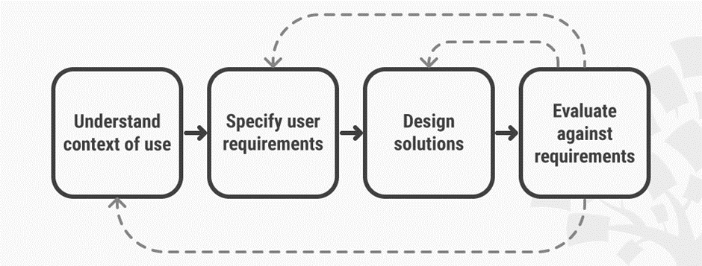
Figure 1: User central design process
Client focused plan requests that planners utilize a blend of analytical (e.g., studies and meets) and generative (e.g., conceptualizing) strategies and apparatuses to build up comprehension of client needs
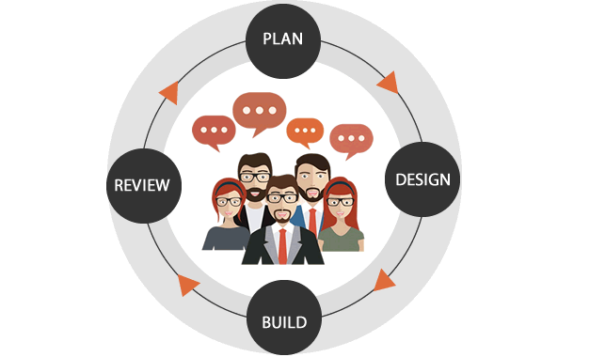
For the most part, every cycle of the UCD approach includes four stages. To begin with, originators endeavor to comprehend the setting in which clients may utilize a framework. In this way, we recognize and indicate the clients' prerequisites. A planned stage pursues, wherein the structure group creates arrangements. The group at that point continue to an assessment stage and survey the results of the assessment against the clients' unique circumstance and necessities in order to check how well the plan is performing—specifically, that it is so near a dimension that coordinates the clients' setting and fulfils most of their significant needs. From here, the group makes further cycles of these four stages, proceeding until the assessment results are attractive.
Figure 2: Team process of UCD
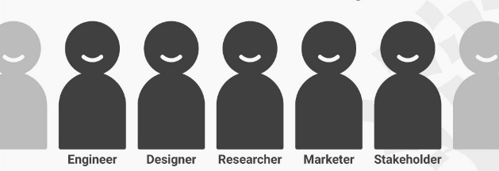
In UCD, fashioners base their ventures upon an unequivocal comprehension of the clients, assignments, and situations. The procedure intends to catch and address the entire client experience; along these lines, the planning group must incorporate experts from over numerous controls (e.g., ethnographers, analysts, programming and equipment engineers), just as area specialists, partners and the clients themselves. Specialists may do assessments of the created plans, utilizing structure rules and criteria. Nonetheless, a pivotal point is this – to traverse the whole client experience, originators must include the clients for assessment, and UCD likewise requests long haul observing of utilization.
Figure 3: multidisciplinary design team for UCD

Methodology
In this project heuristic evaluation, exploratory study and requirement engineering process methodologies are utilised. The exploratory study would help in searching the data more clearly, intended to established priorities and improve the final research design.
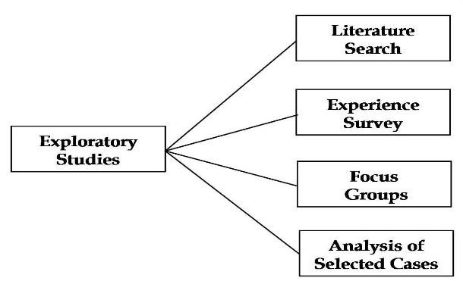
Exploratory research helps determine the best research design, data collection method, and selection of subject. It’s a research used to explore an issue which isn't unmistakably characterized. It is directed to have a superior comprehension of the current issue yet won't give definitive outcomes. For such an examination, a specialist begins with a general thought and uses this exploration as a medium to distinguish issues, that can be the concentration for future research. An essential viewpoint here is that the specialist ought to be happy to change his/her heading subject to the disclosure of new information or knowledge. Such an exploration is generally done when the issue is at a starter arrange. It is frequently alluded to as grounded hypothesis approach or interpretive research as it used to address addresses like what, why and how.
Figure 4: Exploratory study
Requirement engineering process (RE) will help us in defining, documenting and maintaining the requirements. It is a process of gathering and defining services provided by the system. Requirement Engineering is the process of defining, documenting and maintaining the requirements. It is a process of gathering and defining service provided by the system. Requirements Engineering Process consists of the following main activities:
Figure 5: Requirement Engineering Process
- Requirements elicitation
- Requirements specification
- Requirements verification and validation
- Requirements management
The experiment was performed in three steps. First step was about the filling of pre-experiment questionnaire to get participant’s basic information. Then in step two some predefined tasks were given to the subjects and they are open to complete in as much time as they can easily complete. In the last step they have to fill out the post experiment questionnaire and they have to give suggestions, feedback, and design recommendations for the websites. To measure the web usability and user trust experiment was conducted on the two e-commerce websites of Pakistan daraz.pk and MaxFashion. These two websites are most popular and categorized as top ranked for shopping in Pakistan

Participants
As described earlier, the purpose of this study was to evaluate the usability and trust of peoples on e-commerce websites in Pakistan, so the study focuses on those people that haven’t used these websites or used at-least once for online shopping. So that we contacted many housewives and working women for the evaluation of different professions, education and age-group. We selected minimum education of participants 8th passed which is middle and no limit for higher education, and the age group was decided from 20 years to 55 years old women. We excluded some participants on the basis of pre-task questionnaire. The pre-task questionnaire helped us to identify which users can participate in the activity. We shortlisted 55 participants from different cities of Pakistan including Lahore, Karachi, Rawalpindi, Islamabad, Taxila, Peshawar, Char-Sadha, Sialkot and Sheikhupura.
Fifteen (15) participants were found that do not perform online shopping once. Seven (7) users were confused while performing the tasks and left the activity incomplete.
Finally surveys from thirty-three (33) candidates were conducted from the above-mentioned cities of Pakistan.
The experiment was conducted to evaluate the effectiveness, efficiency, satisfaction and user trust on these websites. This study did not require the participants to complete the purchase of a product by submission of credit card information or using checkout method. Different surveys on e-commerce websites shows that the usability and the usefulness of a website can be determined without actually purchasing a product or a service.

Task
The participants were given a small fifteen (15) minutes presentation to explain the purpose of the research and some explanation about pre and post experiment questionnaire. They were also given some time to get acquainted to the system. There were total fifteen (15) tasks which they have to perform on the given two websites, other than filling the pre-experiment questionnaire and post-experiment questionnaire. Daraz.pk and MaxFashion are very famous e-commerce websites of Pakistan to sell different type of goods like jewellery, mobile, computer, musical instruments and garments etc.
In the experiment, task one was to sign up/in the website. They have to make accounts on the websites. Second task was to select the best option to sign-up. Third task was to return to the main menu. Fourth task was sign-in to the website.
Step five was to select the category they want to explore. We performed experiment before the checkout process to avoid the actual order placement and processing. In step six participants were asked to find how to acquire help in these websites. In step seven they have to search for the return policies and in last step they have to sign out from the system.
After these tasks a post experiment questionnaire was given online for each website and they have to fill that form then a short interview was conducted with each participants to get his feedback and suggestions. The suggestions and feedback of the users were noted. The interviews were very helpful for open-ended qualitative feedback about missing features and suggestions to make the process easier, robust, and user friendly.

Experimental Setup and Procedure
The study experiment was carried out in different rooms of the either organization or the houses of housewives. Complete experiments were conducted in three weeks. In 1st week, pre-experiment questionnaire were given to all participants. Questionnaires were in hard form, which each user can fill only one response. In this pre-experiment questionnaire, there were total thirty-two (32) questions to know the user’s basic information, and then different question covering Nielsen 10 heuristics were dividing in different portions of 32 questions.

Evaluate
The end user trust level and web usability were evaluated on the basis of task completion time and our proposed enhanced Standardized User Experience Percentile Rank Questionnaire (SUPR-Q). The SUPR-Q is a rating Scale to measure perceptions of usability, trust, credibility, appearance and loyalty for websites.

System Design
The design of the website would be shown in different mean of diagrams like use-case diagram use-case narratives etc.

System Use-case
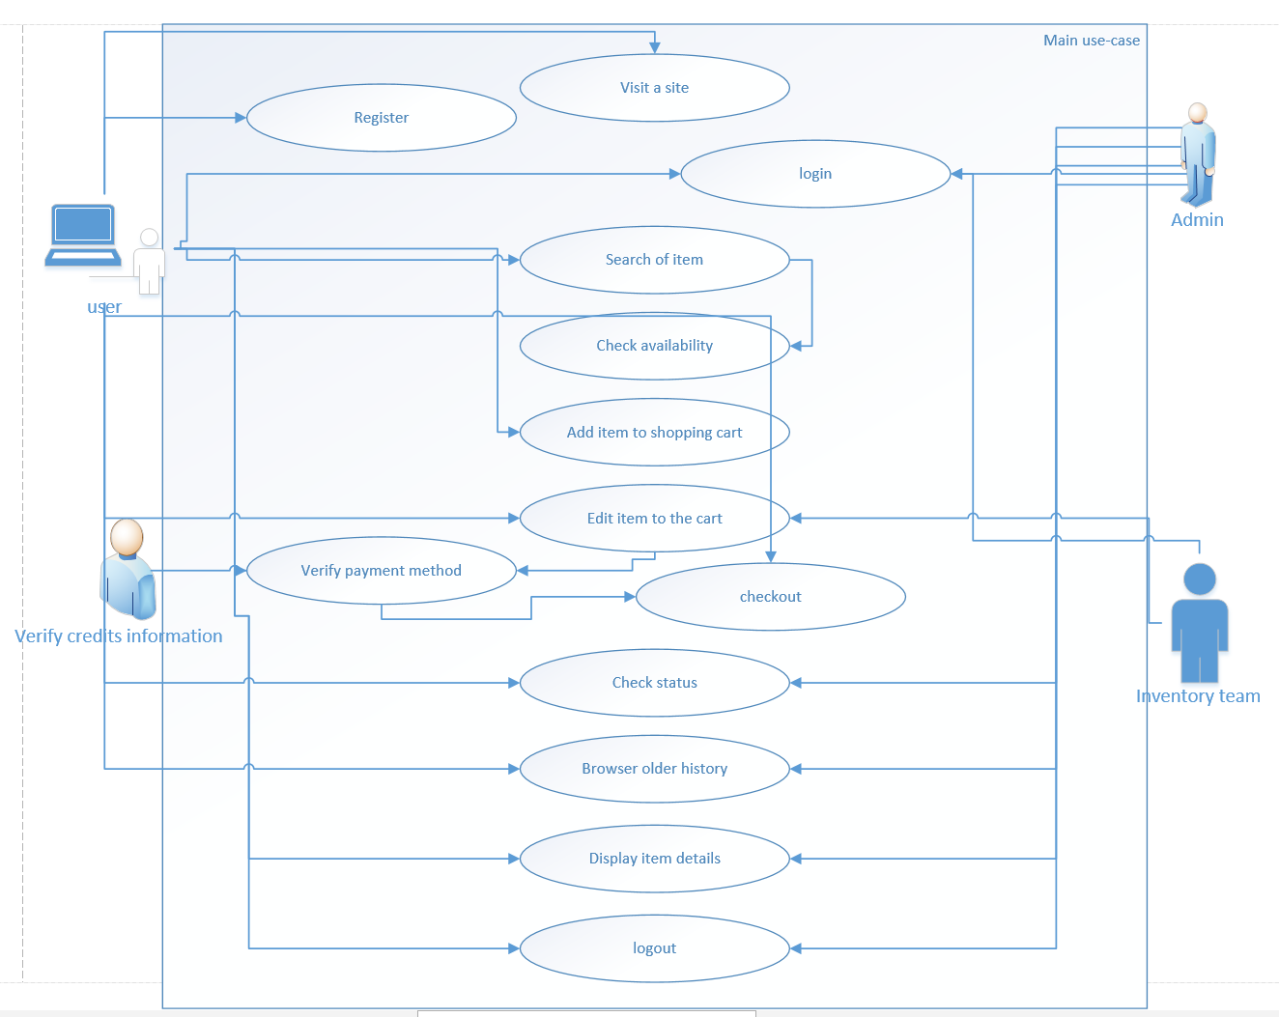
Figure 6: System use-case
In figure6 system use-case is seen clearly which shows the interaction of different users with the system.

Use-case Narrative
In this section complete use-case will be defined clearly. System use-case in figure 6 will be explained in the section in details

Main use-case
ID | TAJ001
Brief description | This use-case described the working of an ecommerce website.
Preconditions | User will to visit the website, should open the website and want to interact and do want to purchase something  Should login to purchase and for this must be a registered member.
Trigger | This event trigger when a user wants to purchase online
Alternate flows | User will to purchase online and the interface seems to be attractive to the user.
Post conditions | User can login after registering to the website and can purchase their desired product
Table 2: Main use-case

Table 2 defines the use case narrative of main use case which have a specific ID provide a brief description conditions and every necessary data.

Login

ID | TAJ002
Brief description | This use-case described the login phase.
Preconditions | User must be a registered member
Trigger | This event trigger when a user wants to try to login by providing the required information
Alternate flows | User will to login to either procced the purchase or want to insert something in cart or track their order
Post conditions | User successfully login
Table 3: Login narrative

Registered

ID | TAJ003
Brief description | This use-case described the registration phase.
Preconditions | User provide the information must not be like existing user
Trigger | When a new user wants to register.
Alternate flows | User provide the information like existing user.  User provide incomplete details
Post conditions | New user registered.
Table 4: Registered Narrative

Search

ID | TAJ004
Brief description | This use-case described the search item procedure
Preconditions | User search about the product.
Trigger | This event trigger when a user search something
Alternate flows | User search something the website doesn’t sale
Post conditions | Found the product like the searched
Table 5: Search Narrative

Shopping
Table 6: Shopping Narrative

Order tracking

ID | TAJ006
Brief description | This use-case describe the tracking of order procedure.
Preconditions | Some confirmed order should be placed
Trigger | This event trigger when a user wants to track their order
Alternate flows | Invalid tracking id  No order placed
Post conditions | Status of the order placed
Table 7: Order Tracking Narrative

Edit details
ID | TAJ007
Brief description | This use-case describe the role of admin in editing user
Preconditions | Must be admin.
Trigger | This event trigger when admin wants to edit the details of user or to remove user
Alternate flows | No alternate flow
Post conditions | User updated in database
Table 8: Edit details Narrative

Inquiry
ID | TAJ008
Brief description | This use-case describe the role of admin in editing user
Preconditions | Must be admin.
Trigger | This event trigger when admin wants to edit the details of user or to remove user
Alternate flows | No alternate flow
Post conditions | User updated in database
Table 9: Inquire Narrative

Maintenance
ID | TAJ009
Brief description | This use-case describe the how inventory team manage the inventory
Preconditions | Must be admin or a member of inventory team
Trigger | This event trigger when new product to be upload or older one to be
Alternate flows | No alternate flow
Post conditions | Database

Table 10: Maintenance Narrative

Sequence diagram
This portion covers the sequence diagram of the project

System
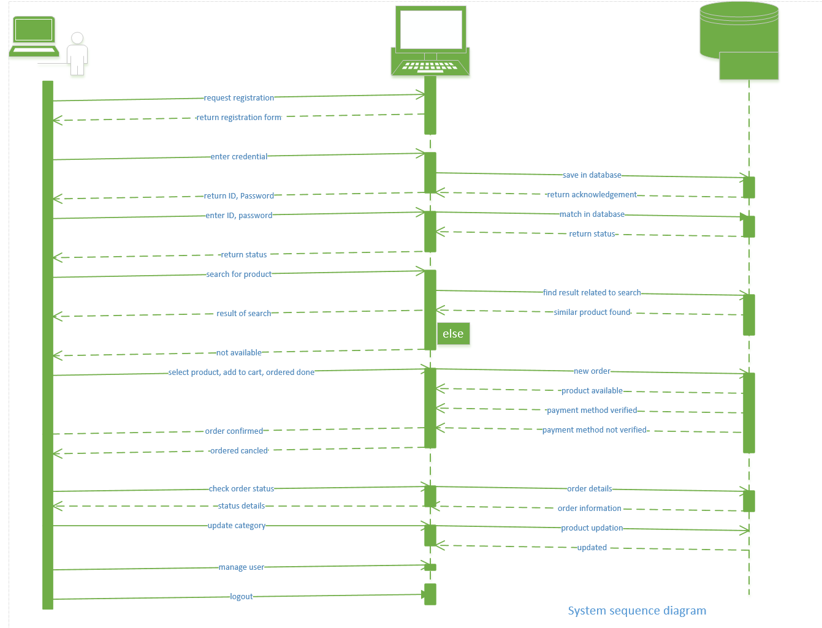
Figure 7: system sequence Diagram

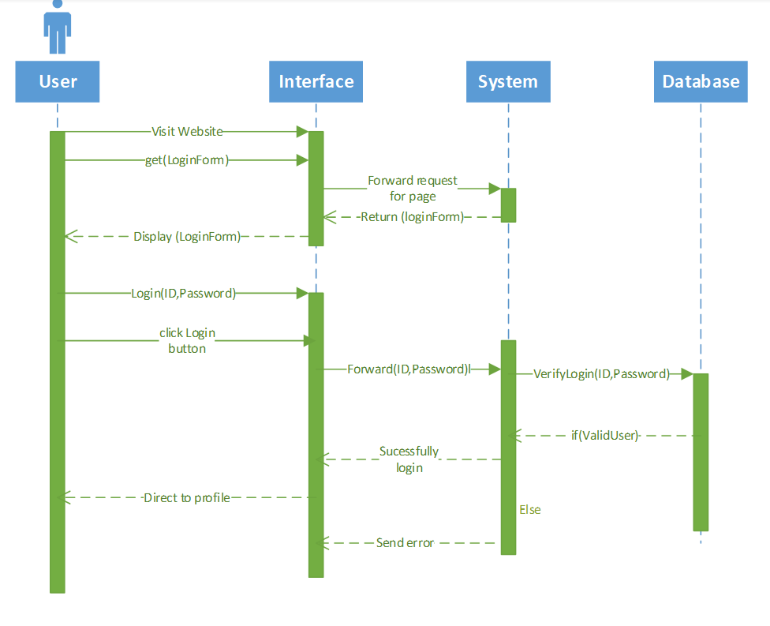
Login
Figure 8: Login Sequence Diagram

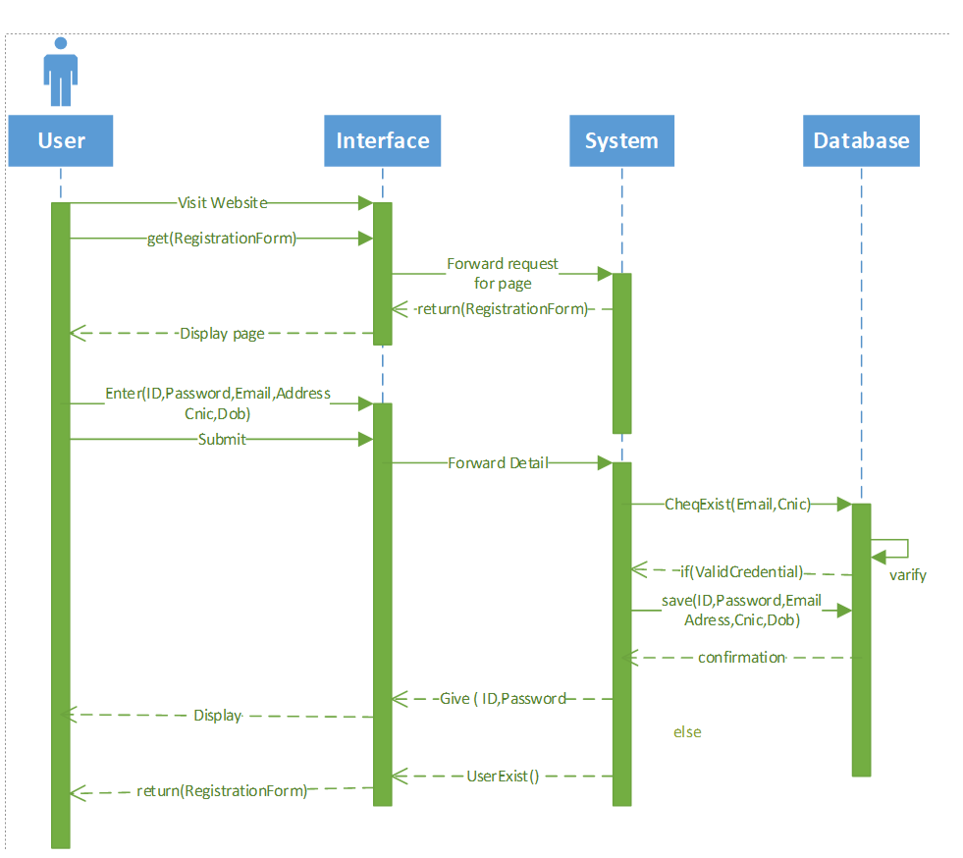
Registration
Figure 9: Registration Sequence Diagram

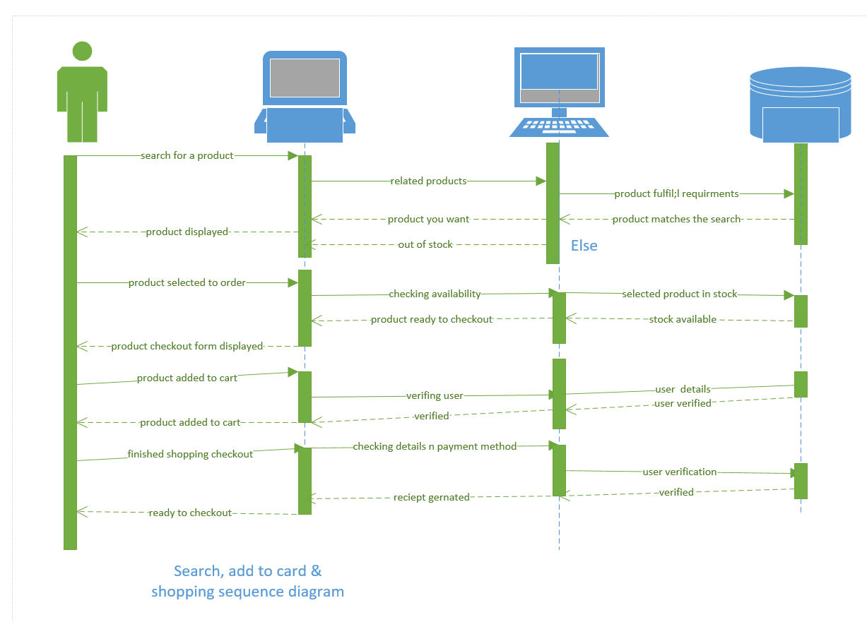
Search, Add to Cart and Check out
Figure 10: add to cart, search and check-out sequence diagram

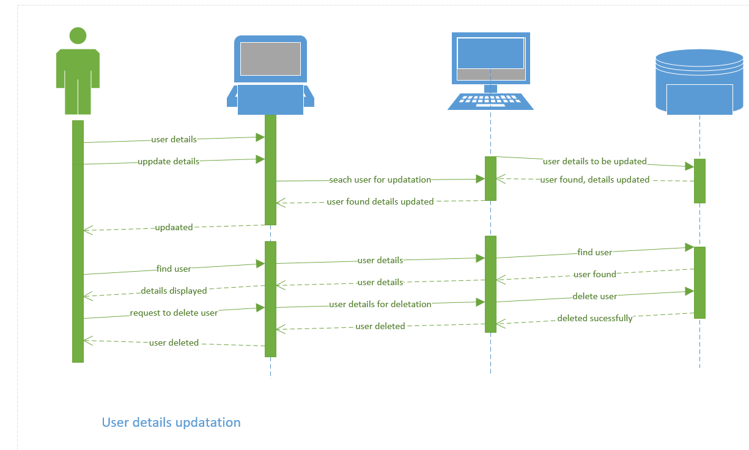
User Details
Figure 11: USer Detail Sequence Diagram

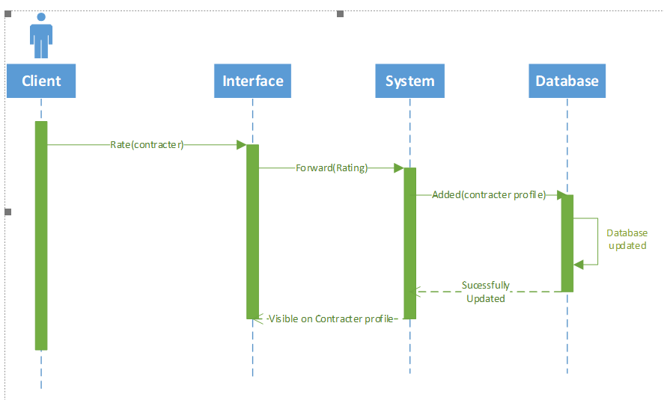
Feedback
Figure 12: Feedback Sequence Diagram

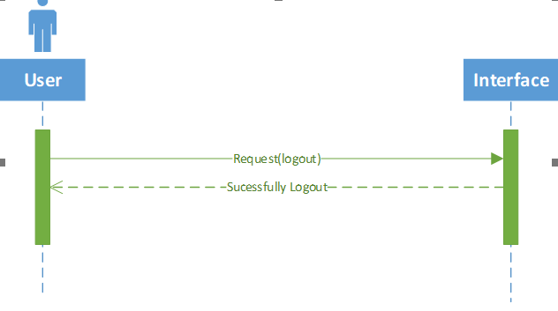
logout
Figure 13: Logout Sequence Diagram

DATA AND EXPERIMENTS

Data

For the research, an experimental survey had been conducted with a different age group from age group of 20 to 55 among women of different occupation both working and housewife. The question has been selected which test the Nielsen’s 10 heuristics which are:
- Visibility of system status.
- Match between system and the real world.
- User control and freedom.
- Consistency and standards.
- Error prevention.
- Recognition rather than recall.
- Flexibility and efficiency of use.
- Aesthetic and minimalist design.
- Help users recognize, diagnose and recovers from error
- Help and documentations.
The above heuristics are being tested from the available e-commerce websites already mentioned in previous chapters.

Questionnaire
The questions selected to prepare the survey questionnaire is being selected from already researched happened and published in “making computer: people literate”
The questionnaire consists of 32 question from which some measured usability, some of which measure visibility and vice versa. Question used for measuring the standard are mentioned below:
- Does every display begin with a title or header that describes screen contents?
- Is there a consistent icon design scheme and stylistic treatment across the system?
- Is a single, selected icon clearly visible when surrounded by unselected icons?
- If users must navigate between multiple screens, does the system use context labels, menu maps, and place markers as navigational aids?
- Are icons concrete and familiar?
- Are menu choices ordered in the most logical way, given the user, the item names, and the task variables?
- Are menu titles parallel grammatically?
- Are function keys labeled clearly and distinctively, even if this means breaking consistency rules?
- If setting up windows is a low-frequency task, is it particularly easy to remember?
- If menu lists are long (more than seven items), can users select an item either by moving the cursor or by typing a mnemonic code?
- Can users set their own system, session, file, and screen defaults?
- Have industry or company formatting standards been followed consistently in all screens within a system?
- Does each window have a title?
- Has a heavy use of all uppercase letters on a screen been avoided?
- Are attention-getting techniques used only for exceptional conditions or for time-dependent information?
- Are there no more than four to seven colors, and are they far apart along the visible spectrum?
- Is sound used to signal an error?
- Are prompts stated constructively, without overt or implied criticism of the user?
- Are error messages grammatically correct?
- Do all error messages in the system use consistent grammatical style, form, terminology, and abbreviations?
- Do error messages indicate what action the user needs to take to correct the error?
- If the database includes groups of data, can users enter more than one group on a single screen?
- Do fields in data entry screens and dialog boxes contain default values when appropriate?
- Does the data display start in the upper-left corner of the screen?
- If the system supports both novice and expert users, are multiple levels of error message detail available?
- Is only (and all) information essential to decision making displayed on the screen?
- Are on-line instructions visually distinct?
- Can users choose between iconic and text display of information?
- Is each individual icon a harmonious member of a family of icons?
- Are protected areas completely inaccessible?
- Can protected or confidential areas be accessed with certain passwords.
- Is this feature effective and successful

These question are answered by 5 different measurements according to the standards which are:
1 | 2 | 3 | 4 | 5
Strongly Disagree | Disagree | Neutral | Agree | Strongly Agree

Experiment
The survey is experimental based different women are interacted with selected websites from different occupations and of different qualification.
Minimum education required for attempting this surveys questionnaire is Secondary school certificate which mean a lady having a secondary school certificate which i.e. matric or O’level are eligible to be examined.
Firstly, they were introduced to the website, a surveyor shows them the tutorial to do the task and then asked them to perform the tasked as shown. This experimental survey is conducted in different big cities of Pakistan like Lahore, Peshawar, Karachi, Islamabad, Sialkot and few surrounding small towns like Taxila, Sheikhupura, Landi.
Total of 33 surveys are conducted, from different areas, organizations.
The experiment was performed in three steps. First step was about the filling of pre-experiment questionnaire to get participant’s basic information. Then in step two some predefined tasks were given to the subjects and they are open to complete in as much time as they can easily complete. In the last step they have to fill out the post experiment questionnaire and they have to give suggestions, feedback, and design recommendations for the websites. To measure the web usability and user trust experiment was conducted on the two e-commerce websites of Pakistan daraz.pk and MaxFashion. These two websites are most popular and categorized as top ranked for shopping in Pakistan
We selected minimum education of participants 8th passed which is middle and no limit for higher education, and the age group was decided from 20 years to 55 years old women. We excluded some participants on the basis of pre-task questionnaire. The pre-task questionnaire helped us to identify which users can participate in the activity. We shortlisted 55 participants from different cities of Pakistan including Lahore, Karachi, Rawalpindi, Islamabad, Taxila, Peshawar, char-sadha, Sialkot and Sheikhupura.
Fifteen (15) participants were found that do not perform online shopping once. Seven (7) users were confused while performing the tasks and left the activity incomplete.
Finally surveys from thirty-three (33) candidates were conducted from the above-mentioned cities of Pakistan.
The experiment was conducted to evaluate the effectiveness, efficiency, satisfaction and user trust on these websites. This study did not require the participants to complete the purchase of a product by submission of credit card information or using checkout method. Different surveys on e-commerce websites shows that the usability and the usefulness of a website can be determined without actually purchasing a product or a service.
The participants were given a small fifteen (15) minutes presentation to explain the purpose of the research and some explanation about pre and post experiment questionnaire. They were also given some time to get acquainted to the system. There were total fifteen (15) tasks which they have to perform on the given two websites, other than filling the pre-experiment questionnaire and post-experiment questionnaire. Daraz.pk and MaxFashion are very famous e-commerce websites of Pakistan to sell different type of goods like jewellery, mobile, computer, musical instruments and garments etc.
In the experiment, task one was to sign up/in the website. They have to make accounts on the websites. Second task was to select the best option to sign-up. Third task was to return to the main menu. Fourth task was sign-in to the website.
Step five was to select the category they want to explore. We performed experiment before the checkout process to avoid the actual order placement and processing. In step six participants were asked to find how to acquire help in these websites. In step seven they have to search for the return policies and in last step they have to sign out from the system.
After these tasks a post experiment questionnaire was given online for each website and they have to fill that form then a short interview was conducted with each participants to get his feedback and suggestions. The suggestions and feedback of the users were noted. The interviews were very helpful for open-ended qualitative feedback about missing features and suggestions to make the process easier, robust, and user friendly.

RESULTS AND DISCUSSIONS

Result

Results of the surveys conducted are in form of graphs which show every heuristics in percentage

visibility of system status

Figure ‎5-1:Visibility of system status

This figure 5-1 represents the percentage of audience answered the question regarding to0 the visibility of the system. Approximately 0% people strongly disagree the with the question related to the visibility and only 6% people only surely agreed with the questions. While majority of 40% people disagree with the visibility and 33% are just okay how the visibility is and 21% are agree and satisfied with the visibility of the system.

Figure ‎5-2: Match between the system and real world
This figure 5-2 represents the efficiently working or in other words match between system and the real world, means how much system relate to the real world. For the question asked related to match between system and the real world only 27% of people disagree and 18% of them agreed with the standard while majority of them i.e. 73% are okay with however the system is and only minorities are totally agreed with the system i.e. only 12% while no one is totally disappointed with the system.
Figure ‎5-3: user control and freedom

The figure 5-3 represents the results of the questions related to user control and freedom. In this section users are asked about how much freely the can use and how much control is provided to them by the system and according to surveys 52% of the audience are just okay means remain neutral with these question while 33% disagree with the standards Nielsen made that doesn’t meet the system and only 9% stayed agree that they have freedom in control. While 0% strongly disagree and 6% strongly agree with the standards availability.

Figure ‎5-4:consistence & standards

The figure 5-4 representing the results related to consistency and standards. According to the audience 49% are okay with however the system is while the percent of agree and disagree are same i.e. 18% that’s mean same percentage of attempters are agree and disagree about the consistency and standards. 6% people only surely agree and 9% are strongly disagree with the standards.

Figure ‎5-5: Error Prevention
Figure 5-5 represents the error prevention of this system. According to survey, most people disagree with the standards i.e. 31% while 27% remain neutral and same percentage of people agree with the standards while the percentage of strongly agree is 3% and strongly disagree rate is 12%.

Figure 5-6 is of Recognition rather than recall standards which shows that 43% people are to agree and satisfied with the standards which need to be meet while 27% are agree 18% people remain neutral and 12% are strongly against the standards.
Figure ‎5-6:Recognition rather than recall
Figure ‎5-7:Aesthetic and minimalist design

Figure 5-7 represents the aesthetics and minimalist design of the system which measure that majority of the survey attempters are disagree with the percentage of 34% and 27% are agree with the design while 21% people remain neutral and 15% disagree with the design while 3% are strongly agree while the standards to be meet.

the figure 5-8 is of help and documentation which shows most people remain neutral when it comes to the standard to help and documentation with the percentage of 31%. While 30% agree with the standards that meet the requirements and 18% people are disagree with the standards and 6% are surly agree and 15% are strongly disagree.
Figure ‎5-9: Flexibility and efficiency of use
Figure ‎5-8: Help and documentation

This figure 5-8 shows the results of flexibility and efficiency of system stands in which majority remain disagree with 34% and 30% remain neutral while the percentage of people who are agree is just 12% and strongly agree rate is just 12%. And the percentage of strongly disagree is just 9%.

Figure ‎5-8:Help users recognize, diagnose and recovers from error
This figure 5-10, shows the result percentage of Help users recognize, diagnose and recovers from error in which majority of people are to satisfy with the standards and percentage of disagree rate is 33% and majority are strongly agreed with percentage of 34% while 3% are strongly agree and 12% are agree and 18% people remain neutral.

Results of all the heuristics and questions are in form of excel mentioned below
Question No. | Responses |  |  |  |  | Total
Question No. | Strongly Disagree | Disagree | Neutral | Agree | Strongly Agree | Total
1 | 0 | 13 | 11 | 7 | 2 | 33
2 | 0 | 9 | 14 | 6 | 4 | 33
3 | 0 | 11 | 17 | 3 | 2 | 33
4 | 3 | 6 | 16 | 6 | 2 | 33
5 | 4 | 10 | 9 | 9 | 1 | 33
6 | 5 | 7 | 11 | 9 | 1 | 33
7 | 5 | 8 | 7 | 12 | 1 | 33
8 | 4 | 12 | 10 | 5 | 2 | 33
9 | 5 | 6 | 10 | 10 | 2 | 33
10 | 3 | 13 | 6 | 7 | 4 | 33
11 | 4 | 13 | 10 | 3 | 3 | 33
12 | 5 | 6 | 10 | 10 | 2 | 33
13 | 10 | 2 | 9 | 11 | 1 | 33
14 | 7 | 8 | 7 | 9 | 2 | 33
15 | 1 | 4 | 17 | 9 | 2 | 33
16 | 1 | 11 | 5 | 12 | 4 | 33
17 | 6 | 6 | 16 | 3 | 2 | 33
18 | 4 | 9 | 12 | 5 | 3 | 33
19 | 1 | 13 | 6 | 13 | 0 | 33
20 | 3 | 4 | 10 | 16 | 0 | 33
21 | 4 | 14 | 6 | 9 | 0 | 33
22 | 0 | 9 | 11 | 11 | 2 | 33
23 | 1 | 9 | 13 | 9 | 1 | 33
25 | 4 | 7 | 8 | 13 | 1 | 33
26 | 3 | 11 | 10 | 4 | 5 | 33
27 | 6 | 16 | 5 | 5 | 1 | 33
28 | 5 | 11 | 7 | 9 | 1 | 33
29 | 5 | 11 | 10 | 7 | 0 | 33
30 | 3 | 10 | 10 | 7 | 3 | 33
31 | 11 | 11 | 6 | 4 | 1 | 33
32 | 8 | 4 | 15 | 6 | 0 | 33

Colour scheme represents the sections of questions sequence wise from 1st heuristic to the 10th Nielsen Heuristics.

Interface

Interface of a recommended website have been designed from the user’s requirements and the recommendations they provided after completing the survey. The design of the interface is as under:
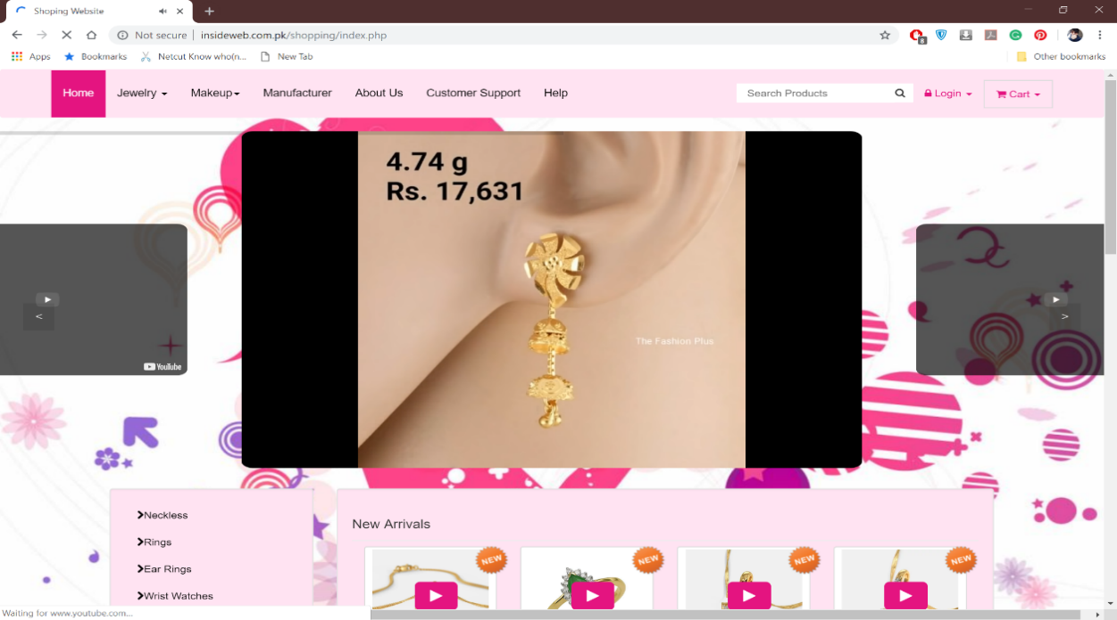
This is the home page of the interface designed. Upper portion of the page is in figure 5-9 in which a video slider menu bad search product can easily be seen. The videos in the slider are basically the frames of YouTube, the frames are used to reduce the loading time and load of the page. In the video slide show feature products, new arrival or the best products will be shown.
Figure ‎5-9: Home page

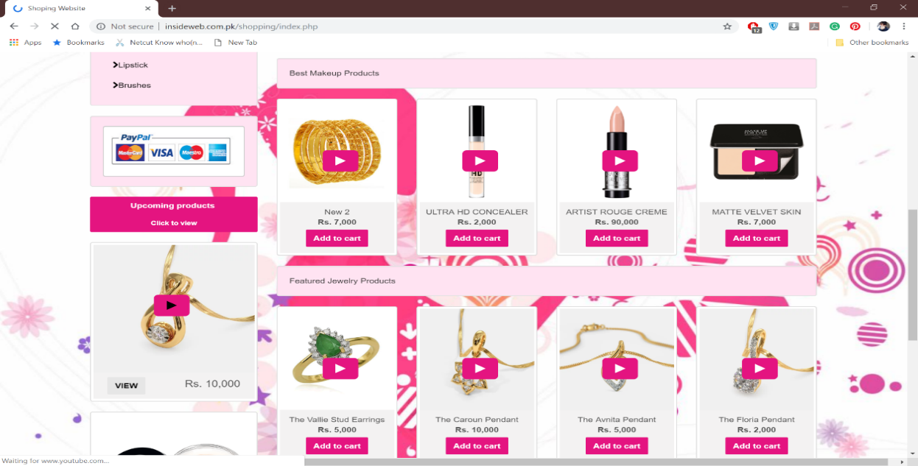
Figure ‎5-10: home page
This is the lower front of the home page in which best product, feature product payment methods are being displayed in different manner.
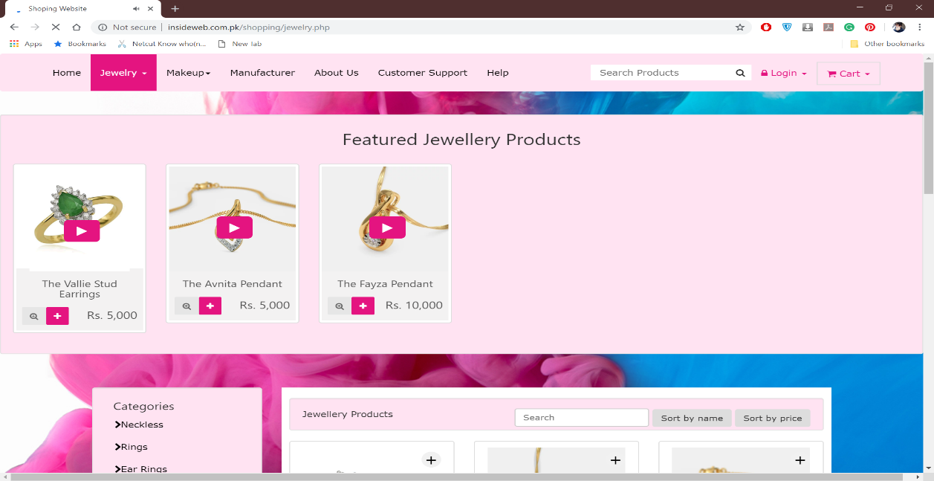
Figure ‎5-11: Jewelry page
Figure 5-11 shows the jewellery tab which contains all the product related to the jewellery. A command of comparing sorting by name and price are also available on tab.
Figure 5-12 is of menu bar which represents all the tabs and the search bar and login page and cart. All these tabs are voiceover commanded.
Figure ‎5-12: Menu bar

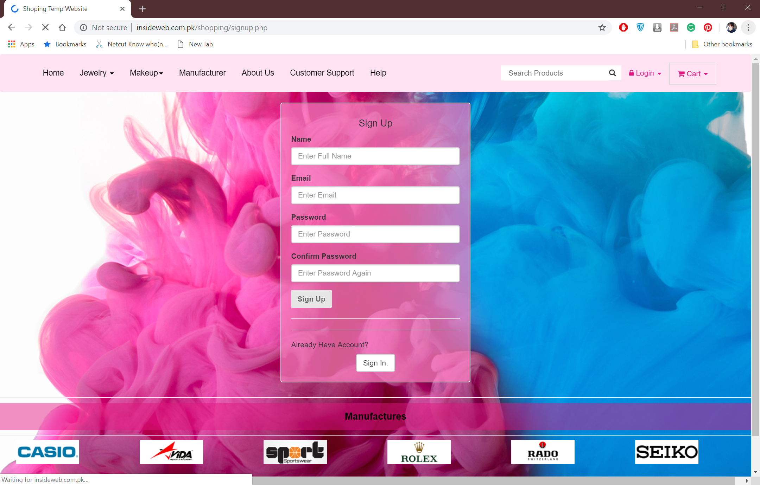
Figure ‎5-13: signup

Signup is required when a person need to purchase anything. Its compulsory to be a member of a website if one wants to purchase any product. A person can signup by filling all the required fields. Figure 5-13 is of signup page .
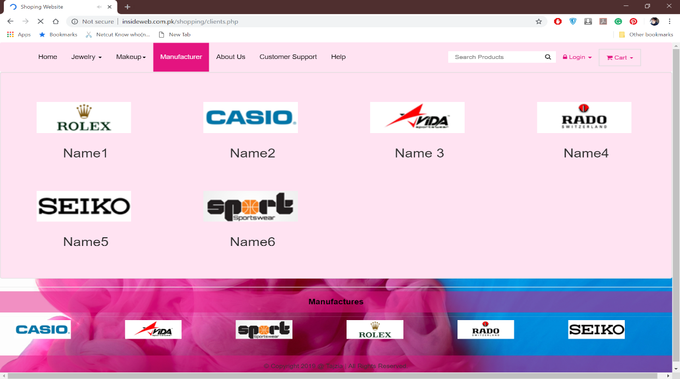
Figure ‎5-14: Manufacturer
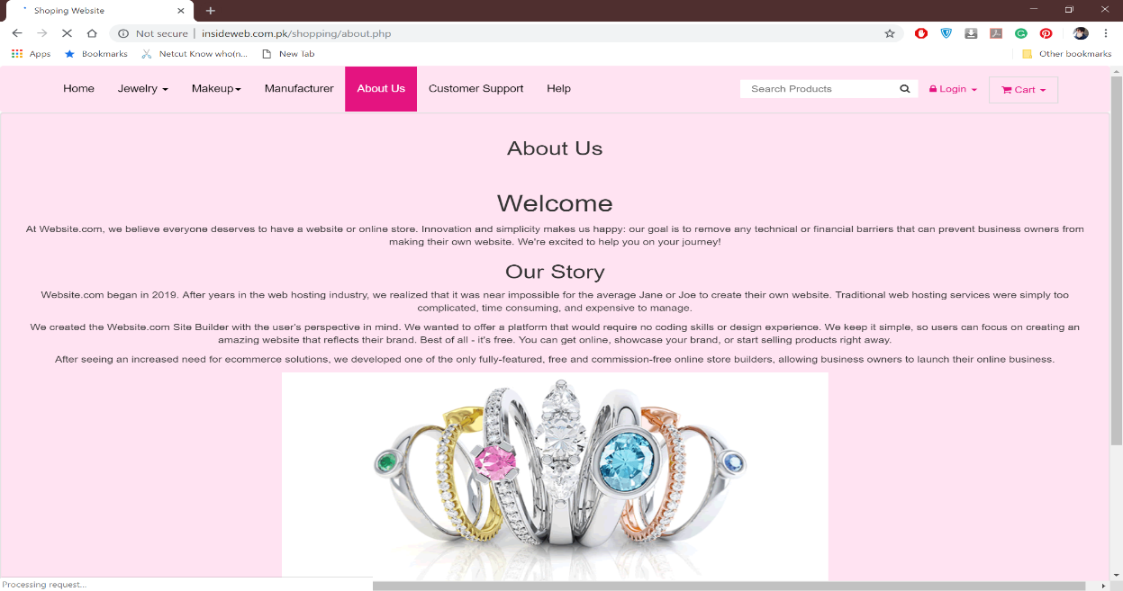
Figure 5-14 is of manufacture tab in which the logs of manufacturers of all the products available of website will be placed in a lovely manner which provide the user information about the manufacturer.
Figure ‎5-15: About us
Figure 5-15 is of about us, in which all the information about the website, background idea and the story of website will be available with a lovely welcoming note.
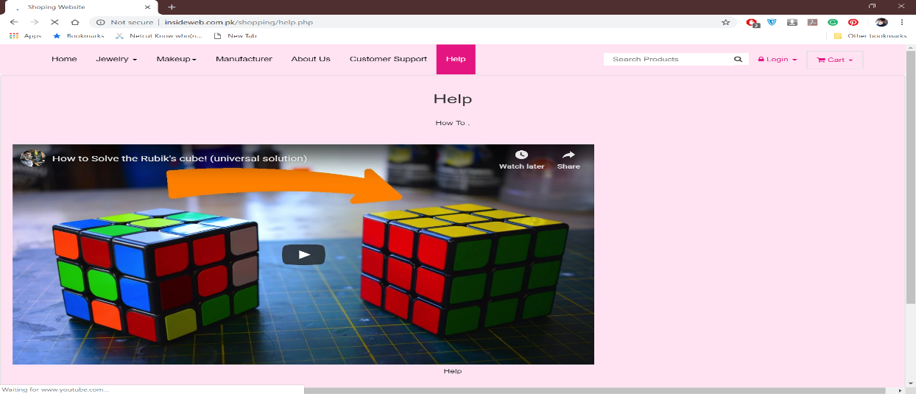
Figure ‎5-16: help
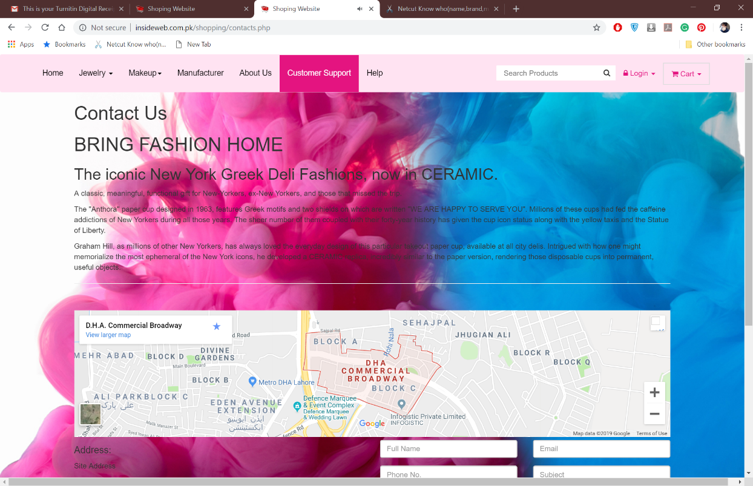
Figure 5-16 is of help tab in which whole video of how to use or interact with proper voice command will be available which enable the user to learn rapidly.Figure 5-17 is of customer support tab which have the details of how to contact directly, outlet location and online support forum will be available.
Figure ‎5-17: customer support
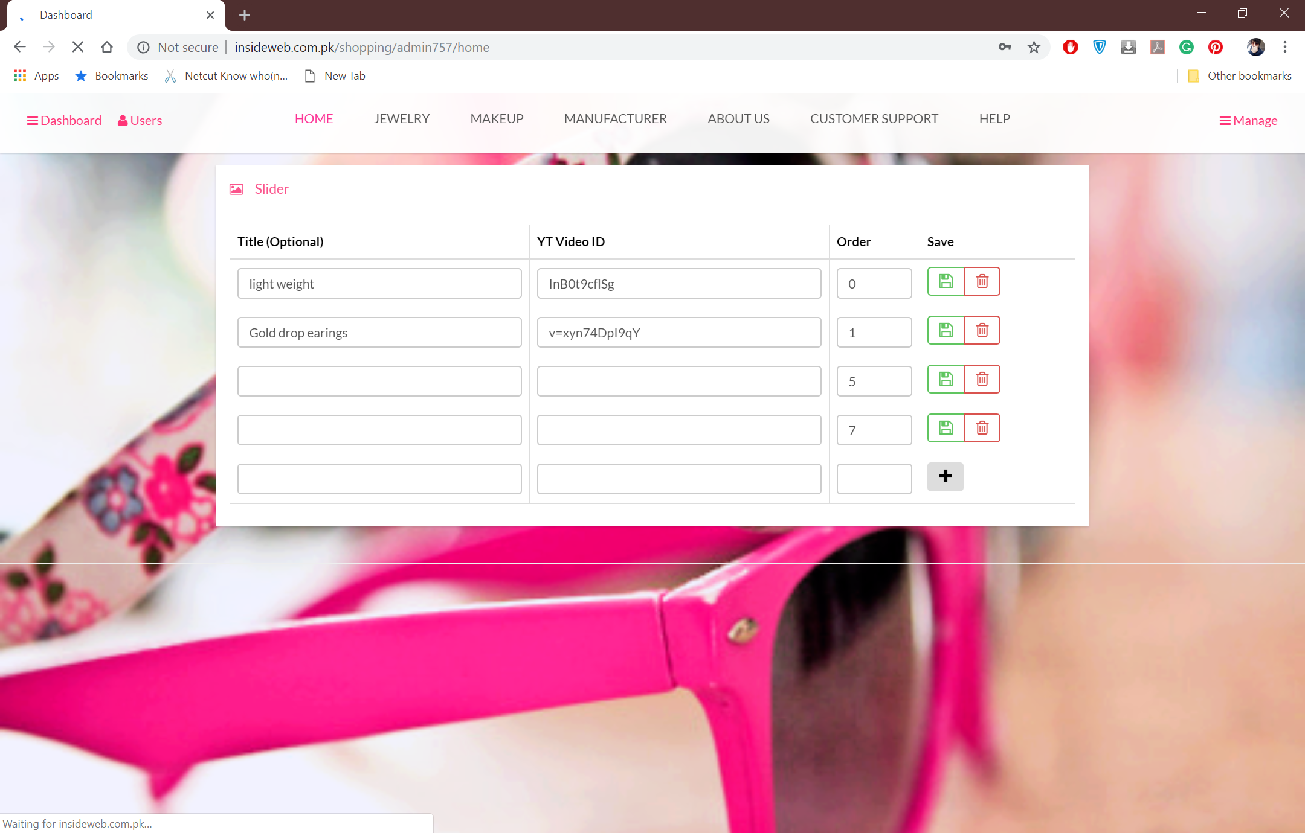
Figure ‎5-18: Admin panel
Figure 5-18 is of admin panel from when admin can manage orders, users, add any page or removing of page setting the videos and update the new video frame and confirm and dispatched the overall orders received

CONCLUSION AND RECOMMENDATIONS

Conclusion

Internet shopping is creating in the development of the most recent years. Be that as it may, web shopping can be beneficial there are some potential issues to be unravelled. Customers show undeniable lead while shopping on the web. There are seen contrasts among male and female customers. Female clients face more difficulties as they don't occasionally use the web and have some security and flourishing concerns. By upkeep, the obvious multifaceted nature specialist should structure the site that will be compelling and attracting for all clients particularly the ladies
The research shows a lot of issues are present in website which women faced, major challenge they face is of security and payment. Majority of them having issue with interaction and minorities have issue with attraction they rarely got attracted with the websites and online shopping. Accuracy of product is also a big downfall in the world of online shopping. The proposed interface is designed after taking the recommendations and knowing the issues. It mostly overcome all the issues and reduced the challenges and design and colour scheme is designed as to get the attraction of the ladies.

Recommendation
As the proposed website is all designed on recommendation. Perhaps the designer should keep in mind both genders while designing the website and try to overcome all the issues. Voice over option is one of the option ladies especially low literate like the most in the website which gives a plus point to Thajzia. People like the voiceover. Video based preview idea also become a source of their attraction as some of ladies find it difficult while video can make their idea clear about the product.
Thajzia moreo0ver overcome the visibility issues and the standard of Nielsen heuristics which again a plus point. Easy paisa option is also an easy command for Pakistani ladies as its much safer than paying online.
If a website is going to be on national level the designer should keep in mind how they can bring ease in their website and what facility they can provide their users by utilizing the means of product available in the country. Keeping the views and assuming the audience should also cause the website a promoting hand.

REFERENCES

Books:

[1] E-commerce website optimization, Dan Croxen-John, Johann van Tonder,2017
[2] Starting an e-commerce business all-in-one for dummies, Shannon Belew, Joel Elad, 2006.
[3] The glossary of human computer interaction, BILL PAPANTONIOU, MADS SOEGAARD, JULIA REINHARD LUPTON, MEHMET GOKTÜRK, DAVID TREPESS, DIRK KNEMEYER, ERIC SVOBODA, 2002

Journal Papers:

[4] Heuristic Evaluation to Enhance the Usability, Anum Arshad, Javed Anjum Sheikh, 2nd International Multi-Disciplinary Conference 19-20 December 2016 Gujrat, Pakistan.
[5] Kostaras, Nektarios, and Mixalis Xenos. "Assessing educational web-site usability using heuristic evaluation rules." Proceedings of 11th Panhellenic Conference in Informatics. 2007
[6] Hearst, Marti A., et al. "Evaluating Information Visualization via the Interplay of Heuristic Evaluation and Question-Based Scoring." Proceedings of the 2016 CHI Conference on Human Factors in Computing Systems. ACM, 2016.
[7] Sheikh, J.A., Fields, B., Duncker, E., “The Cultural Integration of Knowledge Management into Interactive Design”, In: Smith, M.J., Salvendy, G. (eds.) Human Interface, Part I, HCII 2011. LNCS, vol. 6771, pp. 48–57. Springer, Heidelberg 2011.
[8] DITTE MORTENSEN, How to Design Voice User Interfaces, international design foundation, 2019.
[9] Nan Jiang, Mohd Muttaqin, Mamneet kaur, xue ying yang, The Effect of Website Performance and Online Retailer Status on Consumer Purchase Intention: A Mediator Role of Buyer Perception, international Journal of Business and management, September 2015.

Conference Papers:
[10] Leenah Nasir, “Top 10 Most Popular Online Shopping Sites in Pakistan – 2016”, https://pakwired.com/popular-online-shopping-sites-pakistan/.
[11] Boudhayan Ganguly, “The effects of website design on purchase intention in online shopping: The mediating role of trust and the moderating role of culture”, January 2010, https://www.researchgate.net/publication/220300397_The_effects_of_website_design_on_purchase_intention_in_online_shopping_The_mediating_role_of_trust_and_the_moderating_role_of_culture.
[12] DIANNE CYR,The Encyclopedia of Human-Computer Interaction, 2nd Edition, https://www.interaction-design.org/literature/book/theencyclopedia-of-human-computer-interaction-2nd-ed/emotion-and-website-design.
[13] Kaymu, available: http://www.kaymu.pk/payment_methods/, Accessed: April, 27. 2014
[14] Doorstep, available: http://www.doorstep.pk/about, Accessed: April, 27. 2014
[15] Pakistangrocery, Available :Online, www.pakistangrocery.com, http://www.pakistangrocery.com/PakistanGiftsDisplay.php?giftcategoryID=184, Accessed: April,2014
[16] SweetyArora, ”Online Purchases v/s Reality: These Photos will scare you”, Available: Online, http://www.rajnikantvscidjokes.in/online-purchase-vs-reality-photos-will-scare/, Accessed : 29 March 2015.

