
BSCS-F18-027
03-134152-023 | Hamza riaz
03-134152-049 | Muhammad Meesam
03-134152-036 | Moiz Tanveer

BeaconX

In partial fulfilment of the requirements for the degree of
Bachelor of Science in Computer Science
Supervisor: Zunnurain Hussain
Department of Computer Sciences
Bahria University, Lahore Campus
June 2019

© Bahria University, 2019

Certificate

We accept the work contained in the report titled
“BeaconX”
written by
Hamza Riaz
Muhammad Meesam
Moiz Tanveer
as a confirmation to the required standard for the partial fulfilment of the degree of
Bachelor of Science in Computer Science.

Approved by:
Supervisor: Zunnurain Hussain
(Signature)

_____________, 2019

DECLARATION

We hereby declare that this project report is based on our original work except for citations and quotations which have been duly acknowledged. We also declare that it has not been previously and concurrently submitted for any other degree or award at Bahria University or other institutions.

Enrolment | Name | Signature
03-134152-023 | Hamza Riaz
03-134152-049 | Muhammad Meesam
03-134152-036 | Moiz Tanveer

Date : _________________________

Specially dedicated to
My beloved Brother, Supervisor and Father
(Hamza Riaz)
My beloved Mother, Supervisor and Father
(Muhammad Meesam)
My beloved Supervisor, Mother and Father
(Moiz Tanveer)

ACKNOWLEDGEMENTS

We would like to thank everyone who had contributed to the successful completion of this project. We would like to express our gratitude to our research supervisor, Mr Zunnurain Hussain for his invaluable advice, guidance and his enormous patience throughout the development of the research.

In addition, we would also like to express our gratitude to our loving parent and friends who had helped and given us encouragement.

Hamza Riaz
Muhammad Meesam
Moiz Tanveer

BeaconX

ABSTRACT

BeaconX is a project which consists of beacons (A Bluetooth broadcasting device which broadcasts an address every time in its lifespan having no memory) with the integration of an Android-based application named as BeaconX. Both i.e. beacon and the BeaconX will be integrated in a way that the broadcasted address will be recognized by the application and all the stored information against that address (MAC Address) will be shown in the application. A budget calculator will also be introduced, and this calculator will be manipulating the self-billing for the user. This interface is for the customer’s spent amount and products what they have bought in the cart, so that they can shop within their budget. Finally, a QR code will be generated at user’s device which will be further scanned by the cashier during billing process at cash counter end and user can also see all his purchasing in Cart history of BeaconX.

TABLE OF CONTENTS

DECLARATION ii
ACKNOWLEDGEMENTS iv
ABSTRACT v
TABLE OF CONTENTS vi
LIST OF TABLES x
LIST OF FIGURES xi
LIST OF SYMBOLS / ABBREVIATIONS xiii
LIST OF APPENDICES xiv

CHAPTERS
1 INTRODUCTION 1
1.1 Problem Statements 1
1.2 Aims and Objectives 1
1.3 Scope of Project 1
Final Deliverable of the Project and Beneficiaries 2
1.4 Methodology 2
1.5 Feasibility Plan 3
1.5.1 Beacons Specification 4
2.1 Introduction 5
2.1.1 Purpose 5
2.2 Overall Description 5
2.2.1 User Classes and Characteristics 5
2.2.2 Operating Environment 6
2.2.3 Design and Implementation Constraints 6
2.2.4 Assumptions and Dependencies 7
2.3 External Interface Requirements 9
2.3.1 User Interfaces 9
2.3.2 Hardware Interfaces 15
2.3.3 Software Interfaces 15
2.4 System Use Cases 18
2.4.1 Use case name and identifier 18
2.5 Other Non-functional Requirements 19
2.5.1 Performance Requirements 19
2.5.2 Safety Requirements 20
2.5.3 Security Requirements 20
2.5.4 Software Quality Attributes 20
2.6 Other Requirements 20
2.7 System Requirements Chart 21
3 DESIGN AND METHODOLOGY 22
3.1 Use-case Description 22
3.1.1 <BX> 22
3.2 Use-case Diagram (refined and updated) 24
3.3 Domain Model 28
3.4 Sequence Diagram 29
3.4.1 Searching Product 29
3.4.2 Reading QR Code 29
3.4.3 Manage Cart 30
3.4.4 Login 30
3.4.5 Get Beacon ID 31
3.4.6 Generate QR Code 31
3.4.7 Evaluate Budget 32
3.5 Collaboration Diagram 32
3.5.1 Searching Product 32
3.5.2 Reading QR Code 33
3.5.3 Manage Cart 33
3.5.4 Login 34
3.5.5 Getting Beacon Id 34
3.5.6 Generating QR Code 35
3.5.7 Evaluate Budget 35
3.6 Design Class Diagram 36
3.7 Data Model 37
4 IMPLEMENTATION AND TESTING 38
4.1 Implementation 38
4.1.1 Phase 1 38
4.1.2 Phase 2 38
4.1.3 Phase 3 40
4.2 Testing and Evaluation of BeaconX 40
4.2.1 Development Phase 40
4.2.2 Implementation Phase 41
5 RESULTS AND DISCUSSIONS 42
5.1 Analysis of Departmental Store 42
5.2 Result 42
6 CONCLUSION AND RECOMMENDATIONS 43
6.1 Conclusion 43
6.2 Recommendation 43
REFERENCES 45
APPENDICES 46

LIST OF TABLES

TABLE TITLE PAGE
Table 1.1 – Scope 2
Table 1.2 - Final Deliverables 2
Table 1.3 – Beacon Specification 4
Table 2.1 – System Requirement Chart 21
Table 3.1 – Use Case Description 23

LIST OF FIGURES

FIGURE TITLE PAGE
Figure 1.1 – Methodology flow 3
Figure 2.1 – Starting Activity 9
Figure 2.2 – Side bar 9
Figure 2.3 – QR Code 10
Figure 2.4 – Budget Warning 10
Figure 2.5 – Cart History 11
Figure 2.6 – Login Page 11
Figure 2.7 – Login Warning 12
Figure 2.8 - Cart 12
Figure 2.9 – Beacon 1 13
Figure 2.10 - Budget 13
Figure 2.11 – Welcome note 14
Figure 2.12 – Bluetooth Permission 14
Figure 2.13 – Kontakt.io Beacon 15
Figure 2.14 – Local DB 15
Figure 2.15 – Laravel SignUp Page 16
Figure 2.16 – Products DB 16
Figure 2.17 – DB Sign In 17
Figure 2.18 – Laravel Homepage 17
Figure 2.19 – DB Categories 18
Figure 3.1 – Use Case 24
Figure 3.2 – Maintaining DB 24
Figure 3.3 – Manage Cart 25
Figure 3.4 – Search Product 25
Figure 3.5 – Calculate Budget 26
Figure 3.6 – Evaluate Budget 26
Figure 3.7 – Get Beacon ID 27
Figure 3.8 – Invoice Generation 27
Figure 3.9 – Locating Products 28
Figure 3.10 – Domain Model Diagram 28
Figure 3.11 – SD Searching Products 29
Figure 3.12 – SD Reading QR code 29
Figure 3.13 – SD Manage Cart 30
Figure 3.14 – SD Login 30
Figure 3.15 – SD Get Beacon ID 31
Figure 3.16 – SD Generate QR Code 31
Figure 3.17 – SD Evaluate Budget 32
Figure 3.18 – CD Searching Product 32
Figure 3.19 – CD Reading QR Code 33
Figure 3.20 – CD Manage Cart 33
Figure 3.21 – CD Login 34
Figure 3.22 – CD Getting Beacon ID 34
Figure 3.23 – CD generating QR Code 35
Figure 3.24 – CD Evaluate Budget 35
Figure 3.25 – Class Diagram 36
Figure 3.26 – Data Model Diagram 37

LIST OF SYMBOLS / ABBREVIATIONS

UUID Universally Unique Identifiers
CD Collaboration Diagram
SD Sequence Diagram

LIST OF APPENDICES

APPENDIX TITLE PAGE
APPENDIX A: Beacon Deployment 46
APPENDIX B: Market Requirements 46

CHAPTER 1

1 INTRODUCTION

Problem Statements
In departmental store all the sections are well organized along with their categories with specific classification. However, the issue we all face is precise location of a product. Whenever a customer enters the departmental store he can see the sections of the departmental store and can reach them, but he can’t locate the specific product that he wants from any section because of the huge size of departmental store. The team will help customer to search for the product by placing the idea BeaconX. Another problem of customers will be handled by implementing this idea which is to remain within their budget, a budget calculator will be in BeaconX to save time of customer. Invoices will also be automated and will be sent to mobile app at counter when the user will pay for his/her purchased products.

Aims and Objectives
The objective is to automate categories, invoices, shopping trends and to specify the precise location and price of any product in a departmental store. This project will also allow user to shop in budget.

Scope of Project
The departmental stores will be automated with the help of BeaconX in such a way that the user only have to buy products from his phone and user just have to follow the phone to navigate the product that what is the exact location of the product and if a user want to shop in his budget he have to keep counting the purchased items prices but BeaconX is also focusing on this point to handle this problem it have a budget calculator.
Table 1.1 - Scope
Section boards Replacement | Automating the section boards in departmental store | Developing the HW/SW integrated product
Searching for product | Due to huge sizes of sections in departmental store | By displaying all the information of product
Waste of time | Searching for product is a waste of time | Gathering locations of all product at one platform
The above table represents the scope of the project in departmental store that how the beacons will be used to perform above tasks.

Table 1.2 - Final Deliverable of the Project and Beneficiaries
Hardware System | Software System | HW/SW  integrated system | Simulator Design
Beacon | BeaconX (Android Application),  BeaconX Admin Panel | BeaconX | “Quick Beacon”
The above table shows the final deliverables that will be delivered after the development of the project.

Methodology
Different research works referred Agile methodology as best suitable methodology for HW/SW project. As this is, fundamentally, a Component-Based Development project and will be finished in numerous iterations so, Agile is the best approach.
Reasons:
- It Allows for Reuse
- A Component-based UI Approach Accelerates Development
- It Easily Integrates into the Development Process
- Component-based UI Development Optimizes the Requirements & Design Process
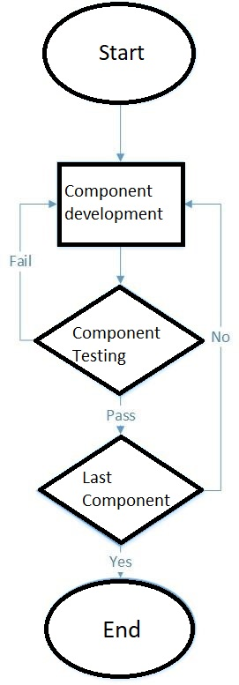
Figure 1.1 – Methodology flow
This figure shows the Methodology flow of BeaconX.

Feasibility Plan
A beacon will be placed at the front of every section, when a customer arrives and enters in the range of that beacon, BeaconX will read the address(MAC Address) and will show all the details against that address suppose if the beacon address used for the Snacks Department then the BeaconX will display all kind of snacks which the departmental store have and then if customer selects Lays then the application will display all the flavours and sizes of Lays they have. BeaconX will show the exact location of that item to the customer by displaying the row number and column number of that rack in which they are placed hence the customer will not have to search for the whole section. When customer sees the location of the item there will be a button for BUY so when the customer will tap on BUY for first item BeaconX will enquire the customer for his budget or he can also skip the budget it will add the amount of that item to the cart and if customer buys more than his budget, then BeaconX will create a warning that you have exceeded your budget so this will also help customer to stay in budget and it will also automate the invoices by generating a QR code which can be read by the cashier module of the app BeaconX and will show all the products against that QR code.
Following are the features of BeaconX:
- Getting MAC Address
- Sorting Data
- Showing Data
- Searching Data
- Asking Budget Range
- Adding to Cart
- Calculating budget
- Transmission of invoice through QR code
When the BeaconX will start it will list all the products of that specific section in which the customer will present, he can just scroll that sorted list or he can search for his desired product from that section because he can only see the products of that section. BeaconX will show the rack numbers of every product and as every rack will be marked with numbers on it so it’s not a problem that where the customer is as whenever the customer will search for a product he can always see the rack number, column number and the row number of that product and he can just move and search that rack number and can go to that specific product.

Beacons Specification
Table 1.3 – Beacon Specification
Beacon | Kontakt.io Beacon
Bluetooth | Bluetooth Low Energy wireless technology 2.4GHz
Battery life | Up to 4 years 24-hours daily usage
Signal Range | 70 m
Compatibility | iBeacon & Eddy stone
The above table represents the specification of Beacon that will be used in BeaconX.

CHAPTER 2

LITERATURE REVIEW

2.1 Introduction

Purpose
A beacon will be placed at the front of every section, when a customer arrives and enters in the range of that beacon, BeaconX will read the address(MAC Address) and will show all the details against that address suppose if the beacon address used for the Snacks Department then the BeaconX will display all kind of snacks which the departmental store have and then if customer selects Lays then the application will display all the flavours and sizes of Lays they have. BeaconX will show the exact location of that item to the customer by displaying the row number and column number of that rack in which they are placed hence the customer will not have to search for the whole section. When customer sees the location of the item there will be a button for BUY so when the customer will tap on BUY for first item BeaconX will enquire the customer for his budget or he can also skip the budget it will add the amount of that item to the cart and if customer buys more than his budget, then BeaconX will just create a warning that you have exceeded your budget so this will also help customer to stay in budget.

Overall Description

User Classes and Characteristics
These are various recognized classes which will be frequently used in BeaconX with their characteristics.
- SplashScreen: A screen will be shown as Welcome to the Departmental store for few seconds.
- HelperMethod: Will help in splash screen and different class.
- WelcomePage: An image that will show the locations of sections.
- ErrorMessage: If not in range of any beacon.
- Search: A searching algorithm implemented Java Class used to search products.
- Categories: Displaying categories available in that section.
- ProductCompany: Displaying the Company and Product name.
- ProductSpecs: Displaying all specification of product e.g. row, column, price, rack no. etc.
- Cart: Showing all the purchased products and total amount of these products.

Operating Environment
The Application BeaconX will work on following operating systems
- Android 5.0.1 and above

Design and Implementation Constraints
Limitations that can occur during interacting with beacons, BeaconX can only work when a user
- is carrying a mobile device.
- has the device switched on?
- has BeaconX installed on the device and authorized to interact with your beacons.
- has Bluetooth switched on.
The Physical Challenges of BLE Beacon Deployment
- The finite life of internal beacon batteries
- The absence of any printed ID on the beacons, making them hard to identify (which does present some difficulties as the unique IDs are critical to app functionality)
- A tendency for some beacons to detach from surfaces (due to a failure in self-adhesive properties)
Delays in getting MAC Address are largely due to the following factors:
- Fluctuations in Bluetooth signal strength
- BLE beacons send out signals intermittently, not continuously
- Phone antennas switch on and off intermittently too, to save battery power
- Older phones seek Bluetooth signals even less frequently than the latest devices

Assumptions and Dependencies
Following are the assumptions for BeaconX that should be completed:
- Key project member’s availability
- Key project member’s performance
- Key project member’s skills
- Budget limitations
- Internal process lead time
- Beacons availability
- Accuracy of the project schedule dates
Following are the tasks dependencies of BeaconX

- Finish to Start (FS):
  - Title Allocation must be completed before starting Defining Scope.
  - Analysis and Designing of Features must be completed before starting Designing Use cases and ERDs.
  - Designing Use Cases/ ERD must be completed before starting Designing SRS.
  - Designing Use Cases/ ERD must be completed before starting GUI Designing of BeaconX.
  - GUI Designing of BeaconX must be completed before starting Development of BeaconX.
  - Database Designing/ GUI Designing of BeaconX, GUI Designing of BeaconX and Development of BeaconX must be completed before starting Integration and testing of BeaconX and beacons.
  - Designing SRS must be completed before starting Final Report.

- Finish to finish (FF):
- Title Allocation must be completed before completing the Defining Scope.
- Analysis and Designing of Features must be completed before completing Designing Use cases and ERDs.
- Designing Use Cases/ ERD must be completed before completing Designing SRS.
- Designing Use Cases/ ERD must be completed before completing GUI Designing of BeaconX.
- GUI Designing of BeaconX must be completed before completing Development of BeaconX.
- Database Designing/ GUI Designing of BeaconX, GUI Designing of BeaconX and Development of BeaconX must be completed before completing Integration and testing of BeaconX and beacons.
- Designing SRS must be completed before completing Final Report.

- Start to start (SS):
- Title Allocation must be started before starting the Defining Scope.
- Analysis and Designing of Features must be started before starting Designing Use cases and ERDs.
- Designing Use Cases/ ERD must be started before starting Designing SRS.
- Designing Use Cases/ ERD must be started before starting GUI Designing of BeaconX.
- GUI Designing of BeaconX must be started before starting Development of BeaconX.
- Database Designing/ GUI Designing of BeaconX, GUI Designing of BeaconX and Development of BeaconX must be started before starting Integration and testing of BeaconX and beacons.
- Designing SRS must be started before starting Final Report.

- Start to Finish
- Defining Scope cannot be completed before starting Title Allocation.
- Designing Use cases and ERDs cannot be completed before starting Analysis and Designing of Features.
- Designing SRS cannot be completed before starting Designing Use Cases/ ERD.
- GUI Designing of BeaconX cannot be completed before starting Designing Use Cases/ ERD.
- Development of BeaconX cannot be completed before starting GUI Designing of BeaconX.
- Integration and testing of BeaconX and beacons cannot be completed before starting Database Designing/ GUI Designing of BeaconX, GUI Designing of BeaconX and Development of BeaconX.
- Final Report cannot be completed before starting Designing SRS.

External Interface Requirements

User Interfaces

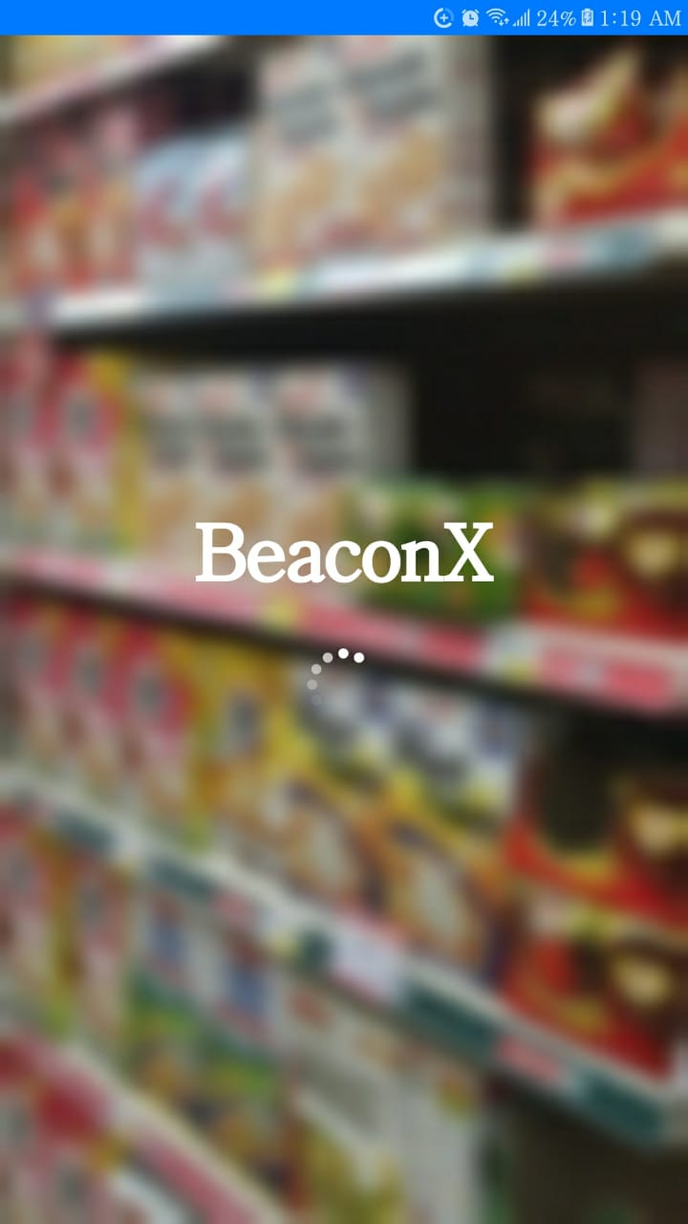
Figure 2.1 – Starting Activity
This figure shows the Starting Activity of BeaconX.
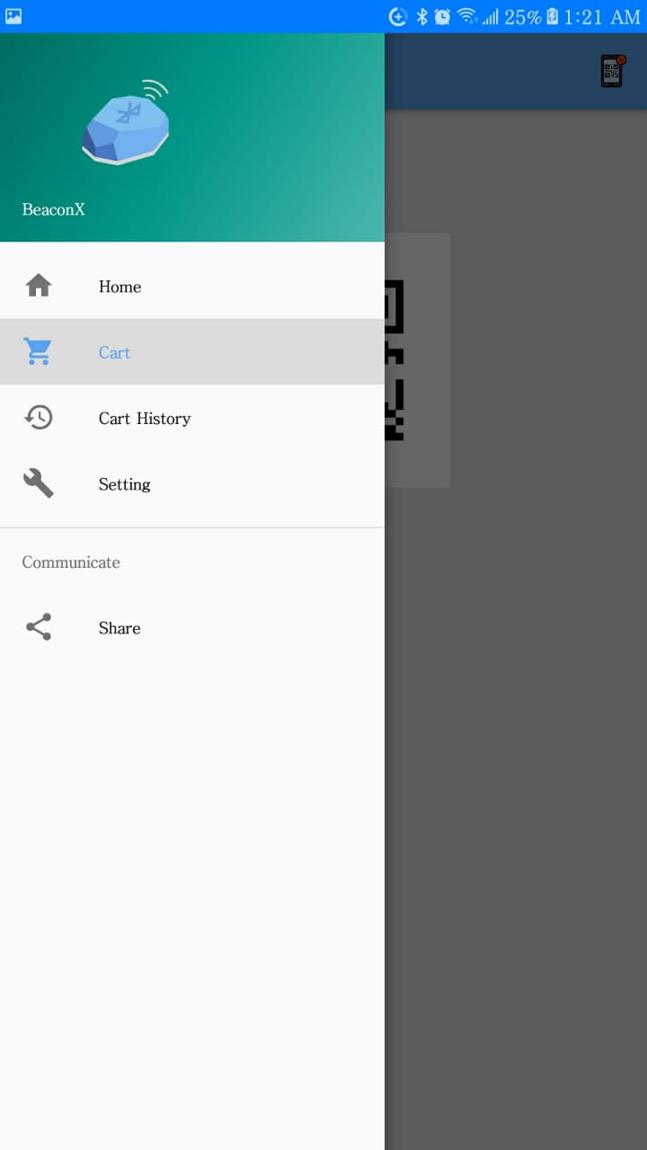
Figure 2.2 – Side bar
This figure shows the Side Bar of BeaconX.


Figure 2.3 – QR Code
This figure shows the QR Code of BeaconX.

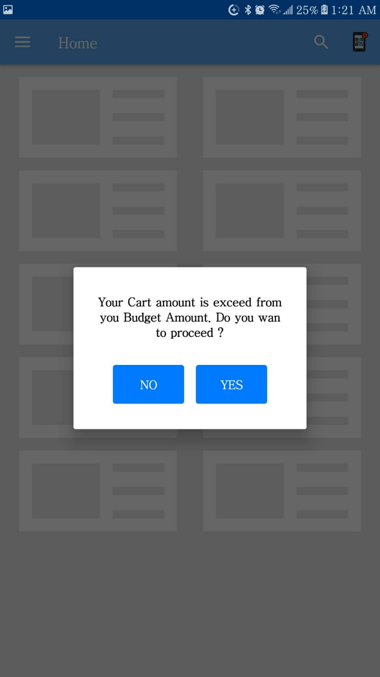
Figure 2.4 – Budget Warning
This figure shows the Budget Exceeding Warning of BeaconX.


Figure 2.5 – Cart History
This figure shows the Cart History of BeaconX.

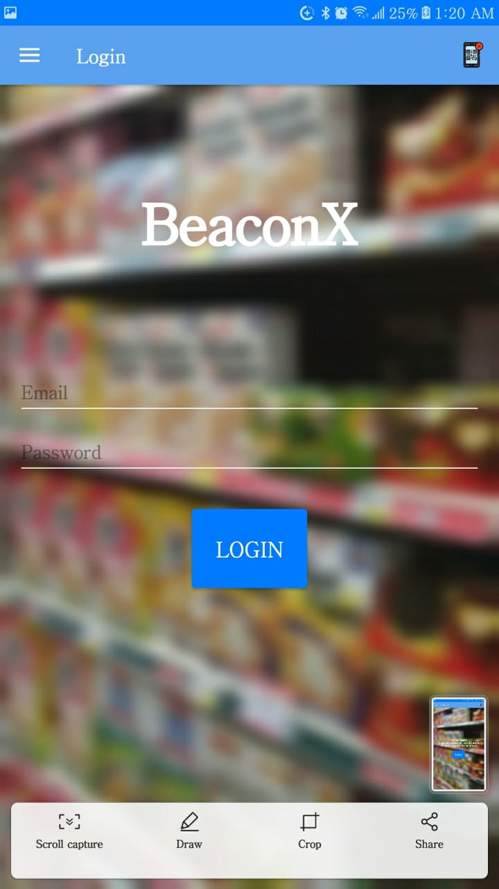
Figure 2.6 – Login Page
This figure shows the Login Page of BeaconX.

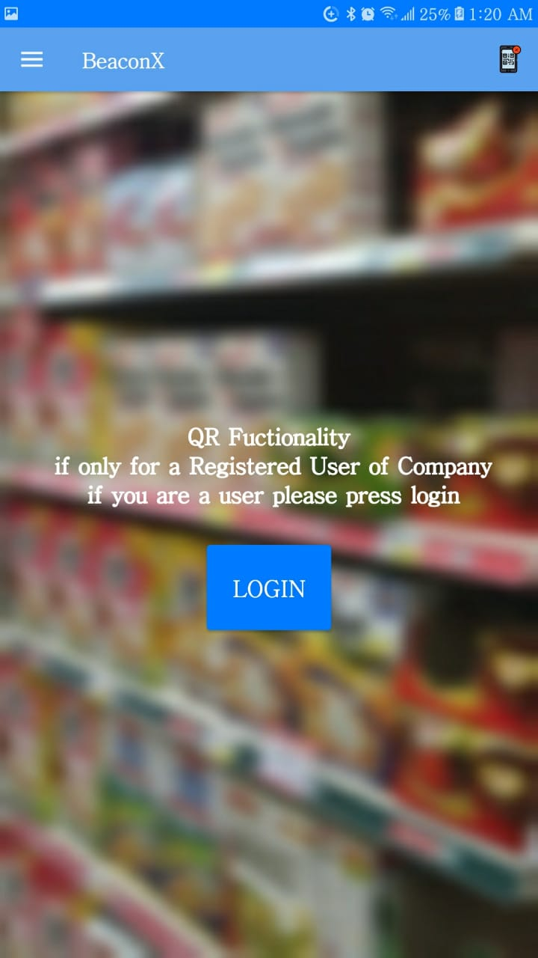
Figure 2.7 – Login Warning
This figure shows the Login Warning of BeaconX.

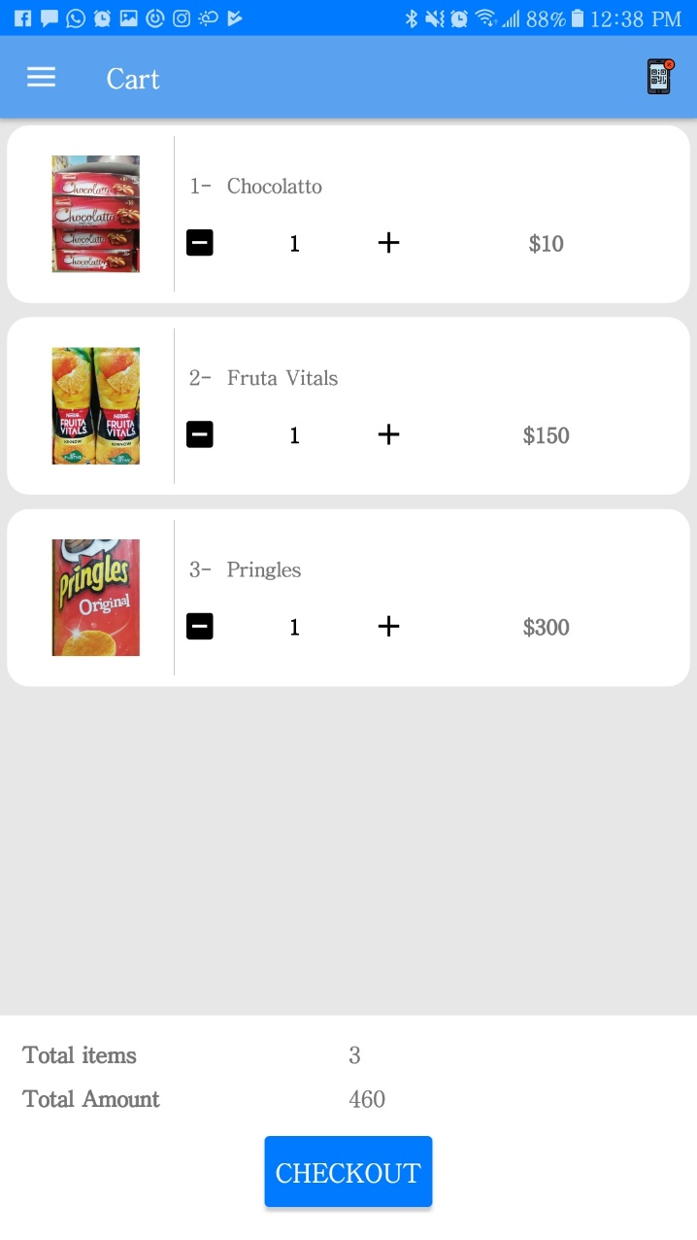
Figure 2.8 – Cart
This figure shows the Cart of BeaconX.

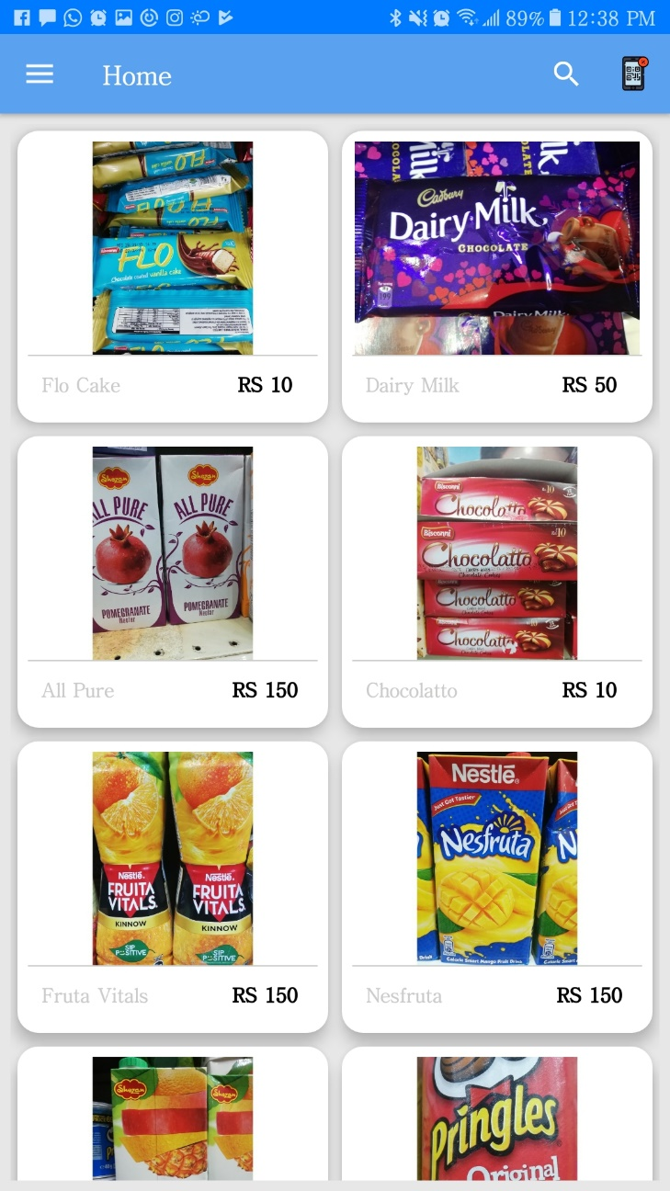
Figure 2.9 – Beacon 1
This figure shows the Products of Beacon 1 of BeaconX.

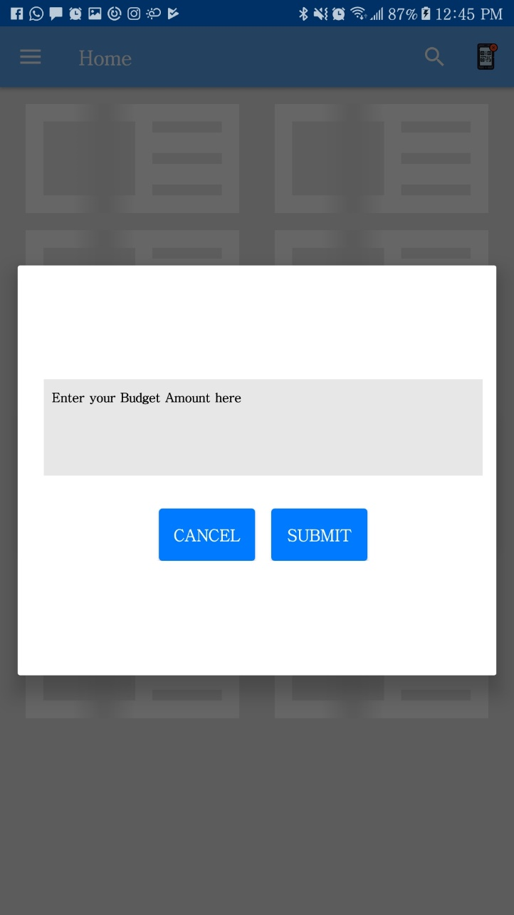
Figure 2.10 – Budget
This figure shows the Budget of BeaconX.

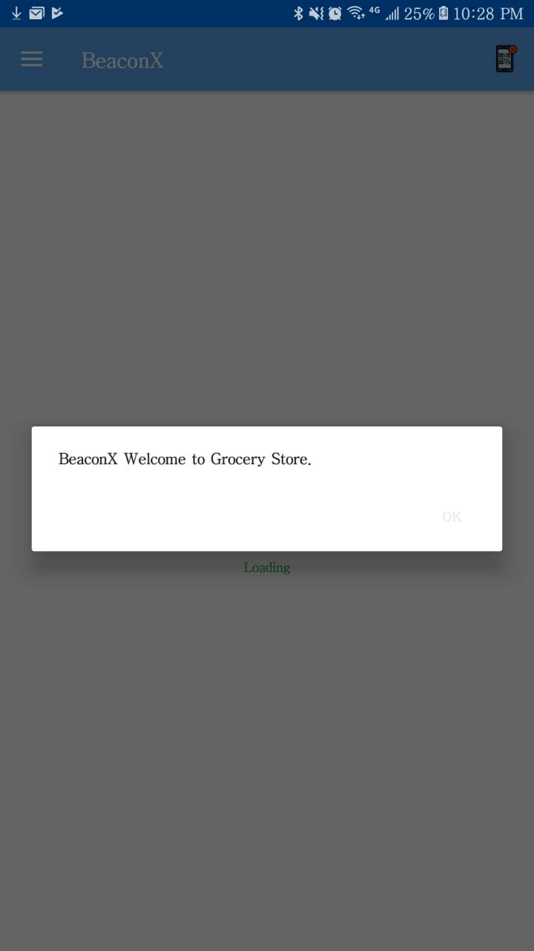
Figure 2.11 – Welcome note
The above figure shows the Welcome note in BeaconX.
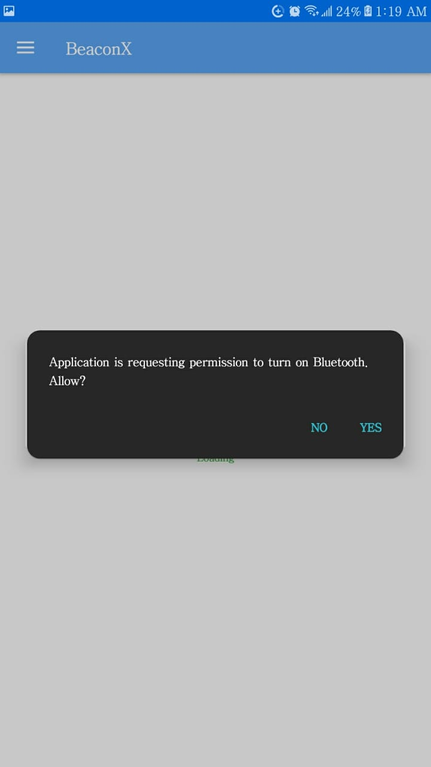
Figure 2.12 – Bluetooth Permission
This figure shows the Bluetooth Permission of BeaconX.

Hardware Interfaces
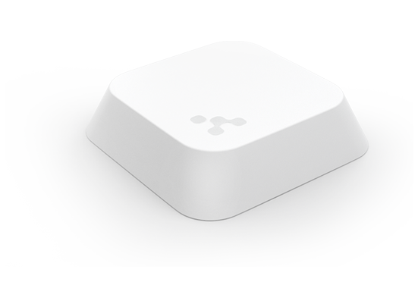
Figure 2.13 – Kontakt.io Beacon
This figure is the picture of a Kontakt.io Beacon that will be used in BeaconX.

Software Interfaces
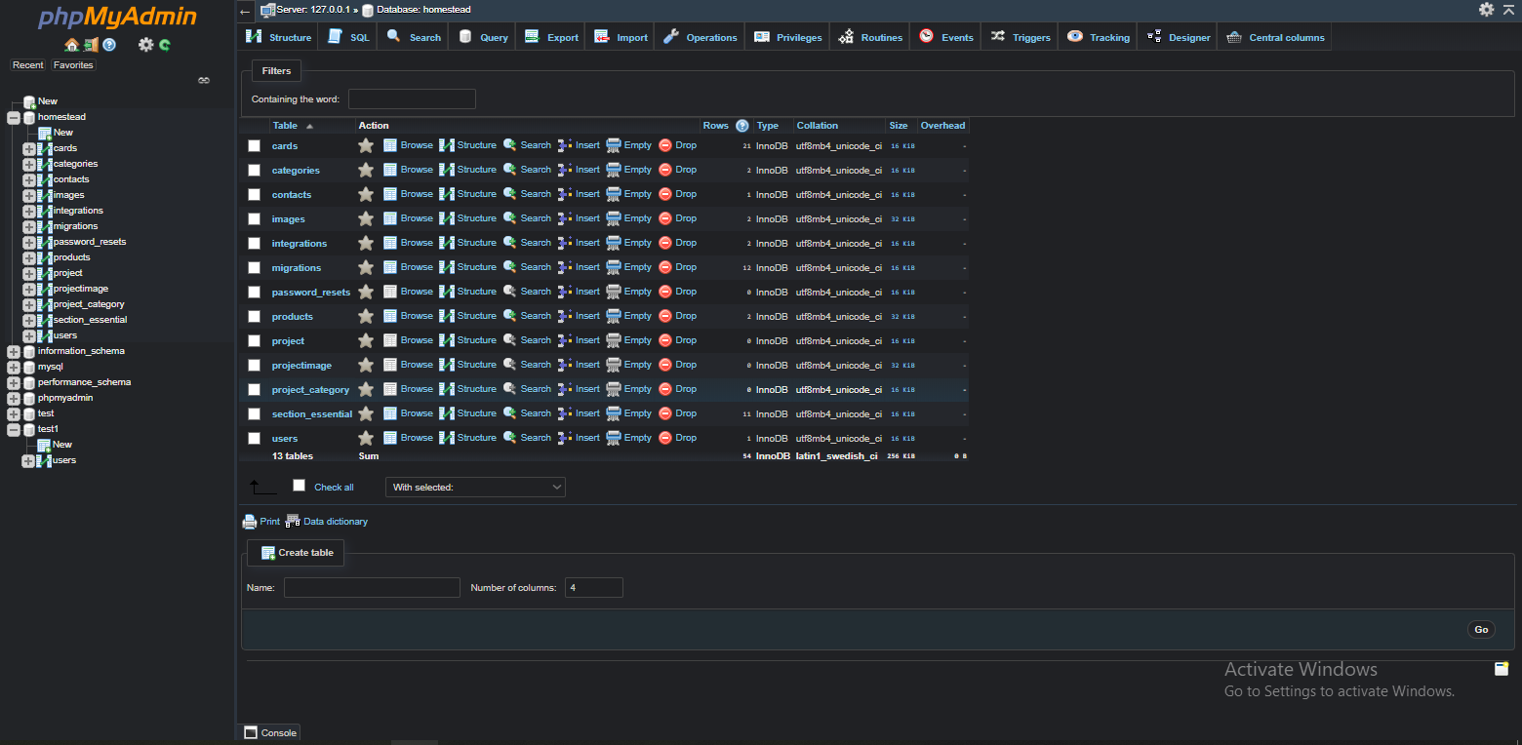
Figure 2.14 – Local DB
The above figure shows all the tables that are required for DB.
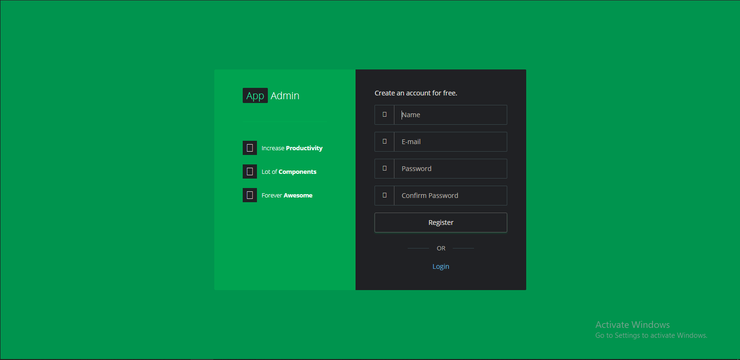
Figure 2.15 – Laravel Sign-up Page
The above figure shows the Web Admin Panel of User showing Sign Up Page.
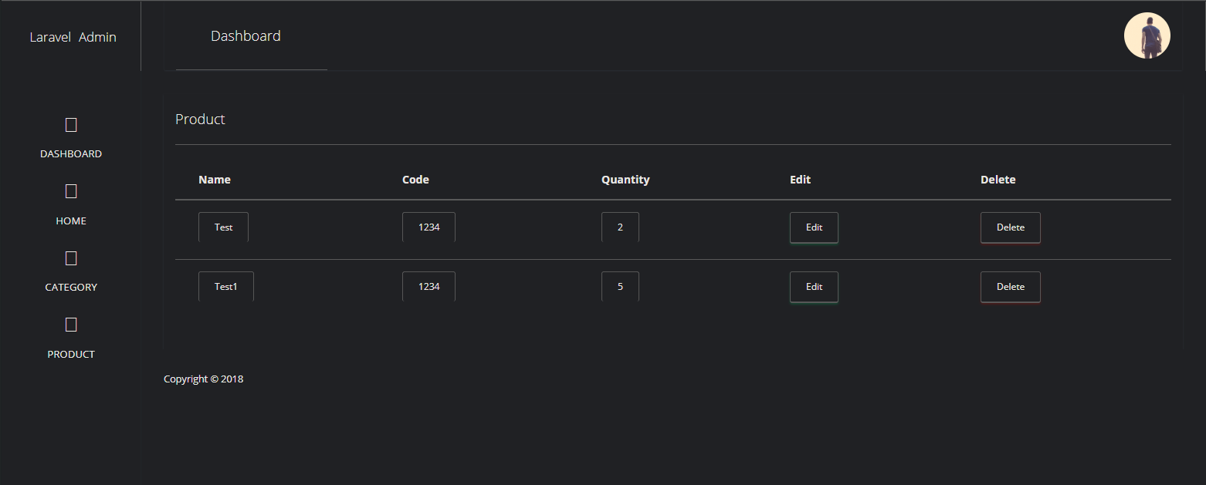
Figure 2.16 – Products DB
The above figure shows the Web Admin Panel of User showing Products present in DB.
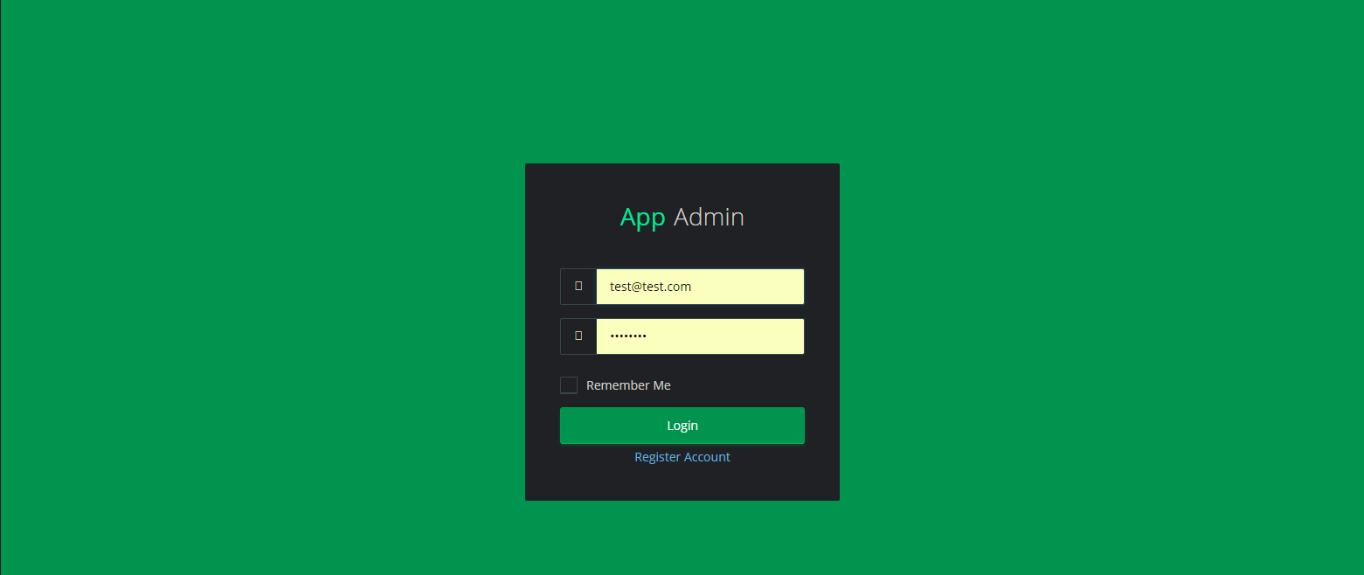
Figure 2.17 – DB Sign In
The above figure shows the Web Admin Panel of User showing Sign in Page.
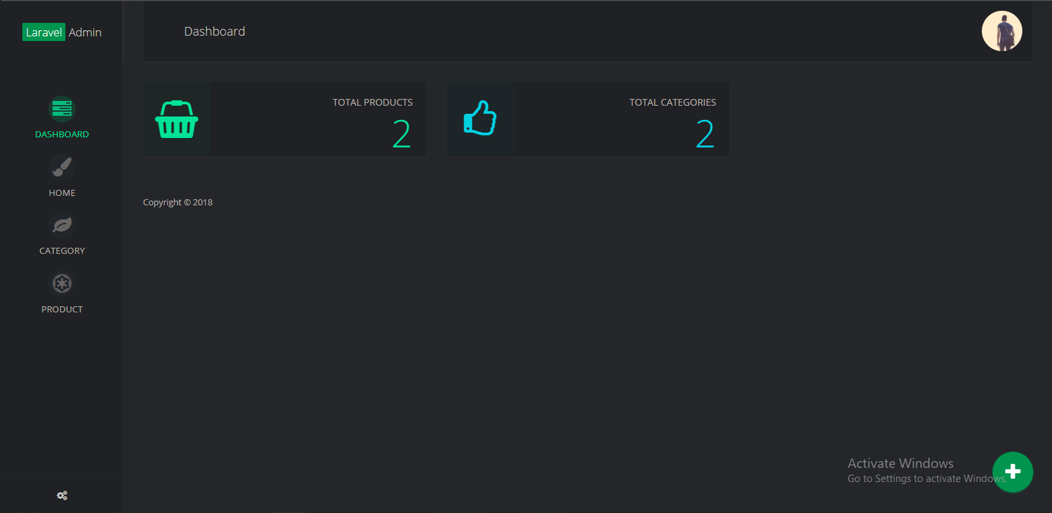
Figure 2.18 – Laravel Homepage
The above figure shows the Web Admin Panel of User showing Homepage.
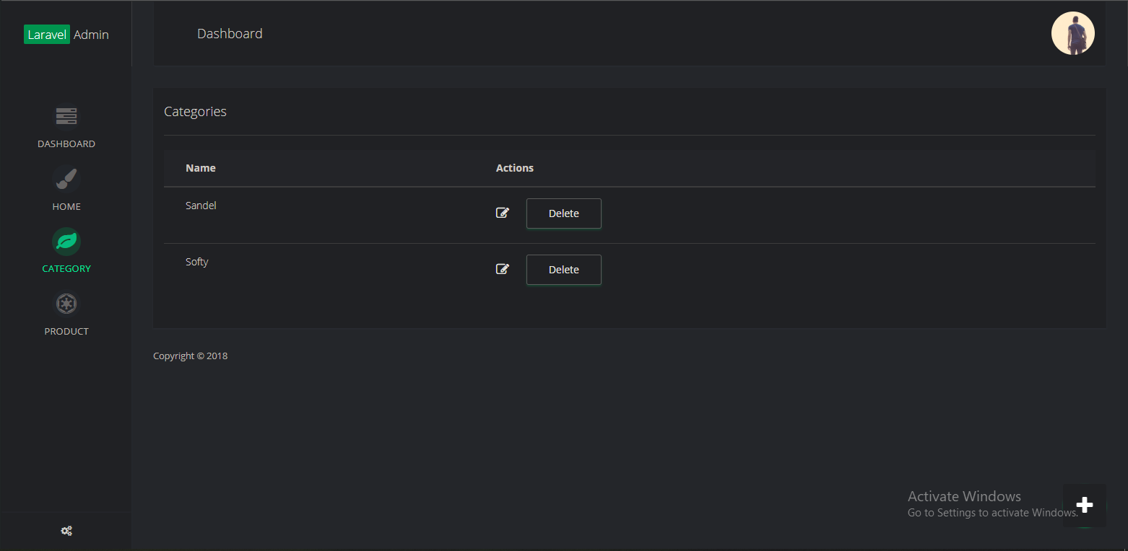
Figure 2.19 – DB Categories
The above figure shows the Web Admin Panel of User showing categories.

System Use Cases

Use case name and identifier
- BX
- Objective – Beacon will help user to locate the products and user will easily buy the products according to his/her budget
- Priority – High
- Source – Locating Product (Navigating)
- Actors – Administrator, System, Beacon, User, Cashier
- Flow of Events
  - Basic Flow –
    - Get Beacon ID
    - Maintaining Database
    - Evaluate Budget
    - Searching Product
    - Locating Product
    - Manage Cart
    - Generating QR Code
    - Invoice Generation
    - Login
    - Reading QR Code
  - Alternative Flow(s) –
    - User only check the price of product
    - An error message is displayed if budget is overflowed
    - If user is not in beacon range
  - Exception Flow(s) –
    - If app is crashed, cart list will be saved
- Includes - Exception occurs
- Preconditions – User should be in range of beacon
- Post conditions – User receiving the payment invoice
- Notes/Issues - None

Other Non-functional Requirements

Performance Requirements

CPU & Memory:
BeaconX (android app) is developed to run on android smart phones with minimum requirements of Android 5.0.1.
The performance of BeaconX also depends on the Ram and CPU of the device. If the device is a low-end android phone with limited Ram and single core CPU, then its performance can be not that effective as compared to a high-end android phone with several Giga-Bytes of RAM and multi core CPU.
Interrupts, notifications and multi-tasking:
When a phone call, SMS or some type of notification (such as a calendar notification) arrives, the mobile device will usually inform application of this event. If the user chooses to respond to the event, the OS will background the application. It does not result in any damage to application’s ability to function normally after the OS ‘foregrounds’ i.e. resumes the application after the user finishes handling the interrupt or after they choose to ignore the interrupt.
Screen resolution and screen form factors:
BeaconX (android application) will automatically adjusts according to the pixel ratio of the device.
Android Studio offers automatic pixel filtering, and this will solve this issue.

Safety Requirements
Our requirement from user is only Bluetooth Enabling so because of this there will be no possible loss, damage or harm that could result from the use of BeaconX.

Security Requirements
There are no security requirements because we are not using or dealing with user’s data and our users are not creating any kind of data. And because of our project is not dealing with any kind of user’s data so we are not using any privacy or user identity authentication requirements.
We just want the access to our application data in user’s phone and this can only be done by user’s permission after installing the application when user open the application for the first time we there ask for the permission to access the data that is integrated in our application.

Software Quality Attributes
- Reliability
- Maintainability
- Usability
- Correctness
- Efficiency
- Testability
- Flexibility
- Reusability
- Interoperability

Other Requirements
Beacons are required that will help to navigate towards location of the product. And Database is also required in this project. In the database, we store category, company name and price of the product.

System Requirements Chart
Table 2.1 – System Requirement Chart
ID | Priority | Type | Source | Contained in Use Case | Description
BX | High | F | Locating Product | - Get Beacon ID  - Maintaining Database  - Evaluate Budget  - Searching Product  - Locating Product  - Manage Cart  - Generating QR Code  - Invoice Generation  - Login  - Reading QR Code | All the working of the system depends on the listed use case requirements.
The above table is the system requirement chart for Use case and all the working of the system depends on the listed use case requirements.

CHAPTER 3

3 DESIGN AND METHODOLOGY

Use-case Description
Following are the description of all use-cases.

<BX>
Use-case description typically contains the following parts:
Table 3.1 – Use Case Description
Name and ID | BX
Brief description | BX has five Actors Administrator, User, Beacon, System and Cashier. The happy path of this use case is simply the administrator will only maintain the Database or he can just handle the database although user has to come in the beacon range so he can enter the budget if he wanted to or he can skip it after that he will just select the product adding it to cart and hence the budget will be calculated after adding all items to cart and he can end shopping to generate a QR code which store ID of these products which can be read by the cashier to generate invoice.
Preconditions | User should be in range of beacon
Basic flow or Happy path | - Get Beacon ID  - Locating Product  - Manage Cart  - Generating QR Code  - Invoice Generation  - Login  - Reading QR Code
Trigger | Getting Beacon ID
Alternate flows | Alternate flow 1  - Get Beacon ID  - Evaluate Budget  - Locating Product  - Manage Cart  - Generating QR Code  - Invoice Generation  - Login  - Reading QR Code  Alternate flow 2  - Get Beacon ID  - Evaluate Budget  - Searching Product  - Locating Product  - Manage Cart  - Generating QR Code  - Invoice Generation  - Login  - Reading QR Code  Alternate flow 3  - Get Beacon ID  - Searching Product  - Locating Product  - Manage Cart  - Generating QR Code  - Invoice Generation  - Login  - Reading QR Code
Post conditions | Reading QR Code
This table is the use case description of whole working of the project BeaconX.

Use-case Diagram (refined and updated)
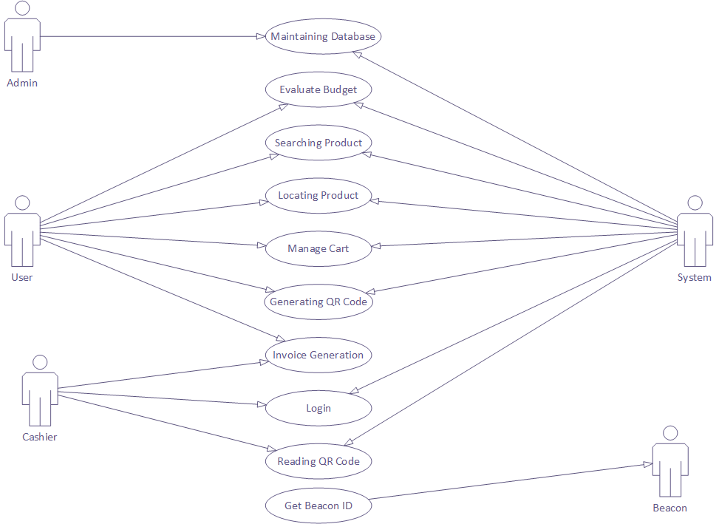
Figure 3.1 – Use Case
This figure is the full diagram of BeaconX Use Case.
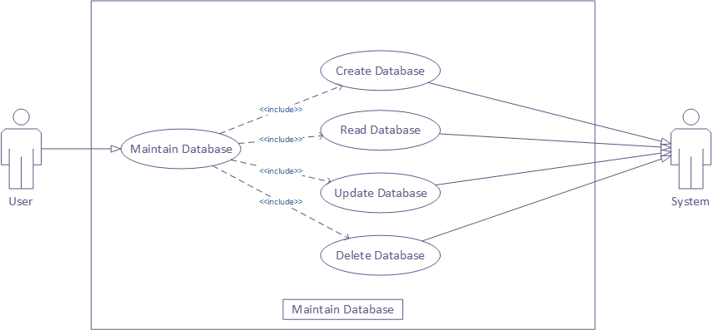
Figure 3.2 – Maintaining DB
This figure is the extended diagram of Maintaining DB in BeaconX Use Case.

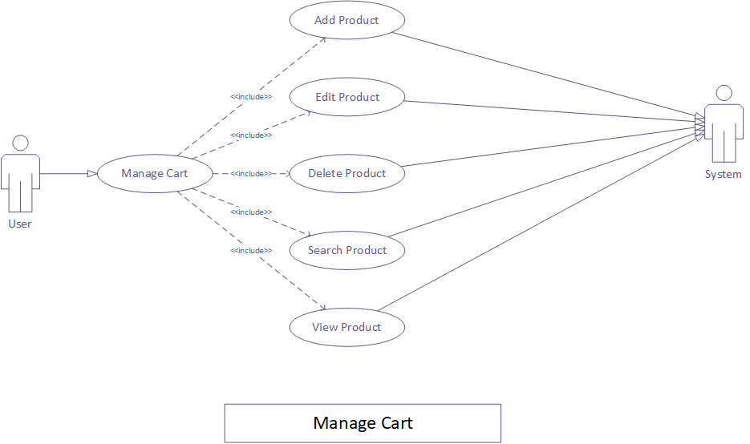
Figure 3.3 – Manage Cart
This figure is the extended diagram of Manage Cart in BeaconX Use Case.

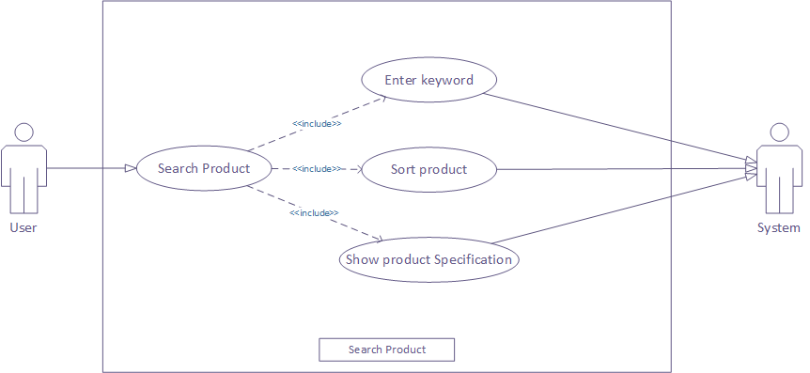
Figure 3.4 – Search Product
This figure is the extended diagram of Search Product in BeaconX Use Case.

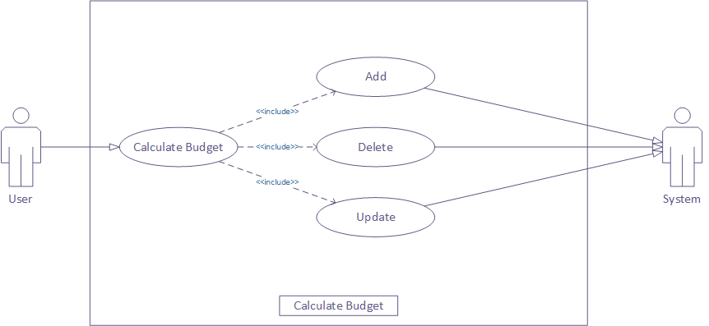
Figure 3.5 – Calculate Budget
This figure is the extended diagram of Calculate Budget in BeaconX Use Case.

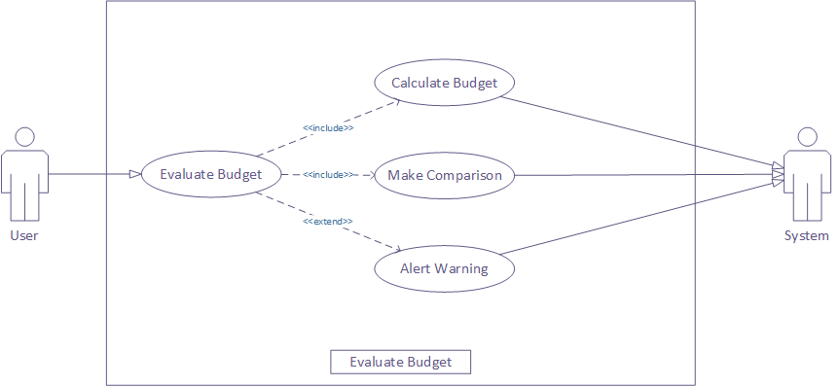
Figure 3.6 – Evaluate Budget
This figure is the extended diagram of Evaluate Budget in BeaconX Use Case.

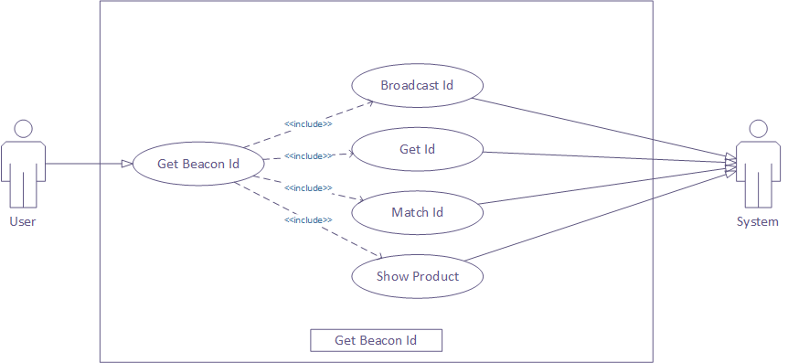
Figure 3.7 – Get Beacon ID
This figure is the extended diagram of Get Beacon ID in BeaconX Use Case.

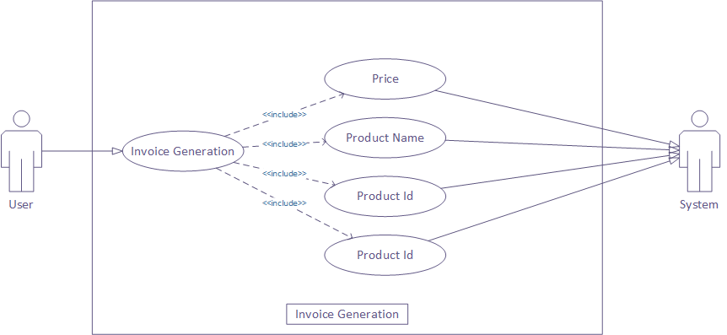
Figure 3.8 – Invoice Generation
This figure is the extended diagram of Invoice Generation in BeaconX Use Case.

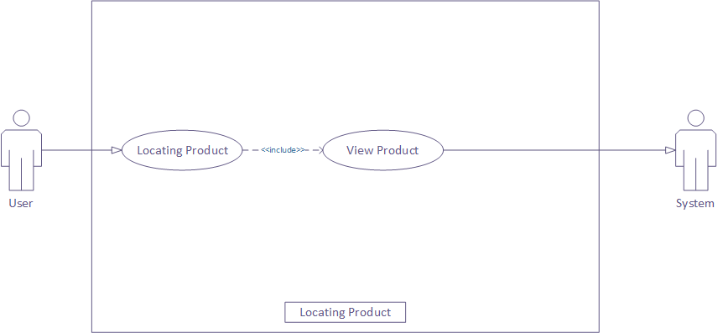
Figure 2 – Locating Products
This figure is the extended diagram of Locating Products in BeaconX Use Case.

Domain Model
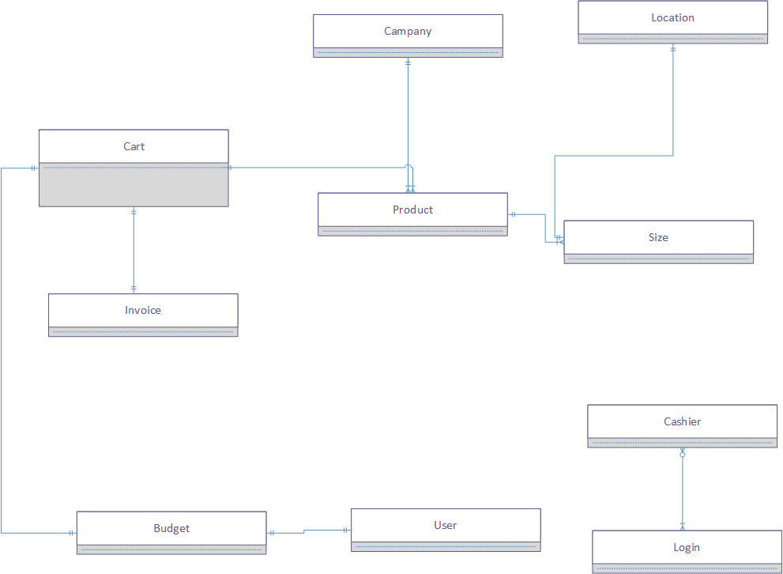
Figure 30 – Domain Model Diagram
This figure shows the Domain Model Diagram of BeaconX.

Sequence Diagram

Searching Product

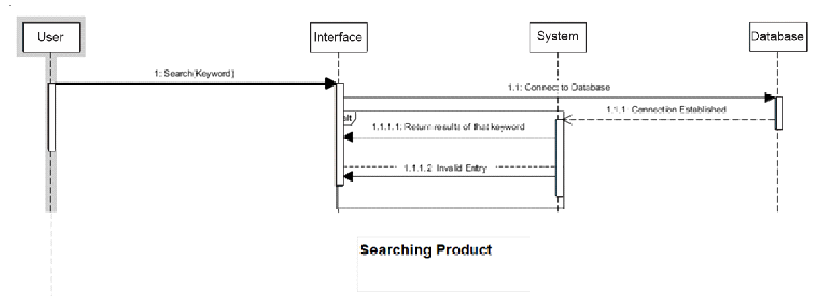
Figure 4 – SD Searching Products
This figure shows the Sequence Diagram of Searching Products in BeaconX.

Reading QR Code
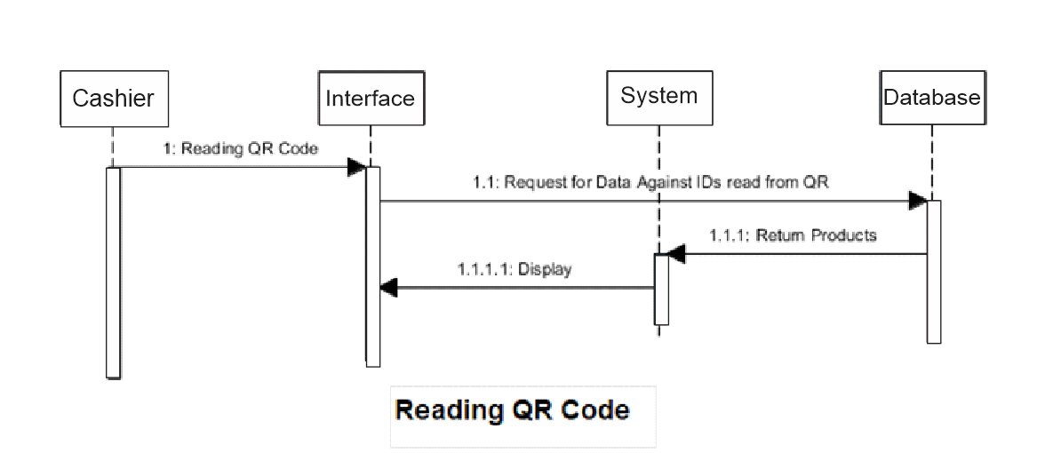
Figure 5 – SD Reading QR code
This figure shows the Sequence Diagram of Reading QR code in BeaconX.

Manage Cart

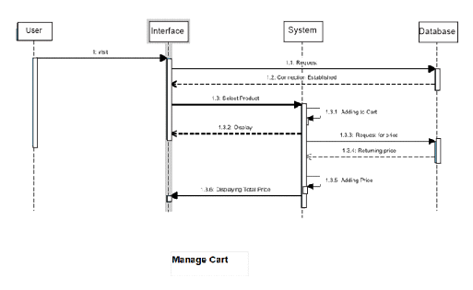
Figure 6.13 – SD Manage Cart
This figure shows the Sequence Diagram of Manage Cart code in BeaconX.

Login
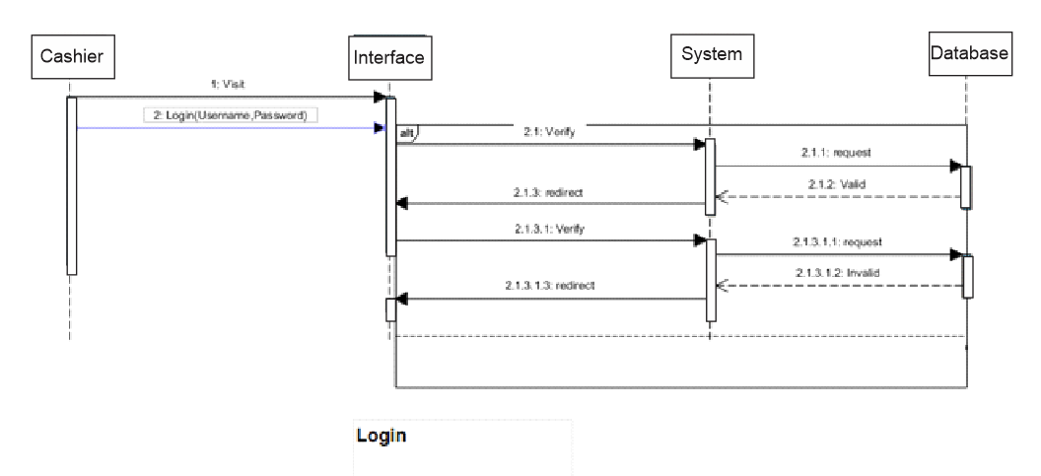

Figure 7.14 – SD Login
This figure shows the Sequence Diagram of Login in BeaconX.

Get Beacon ID
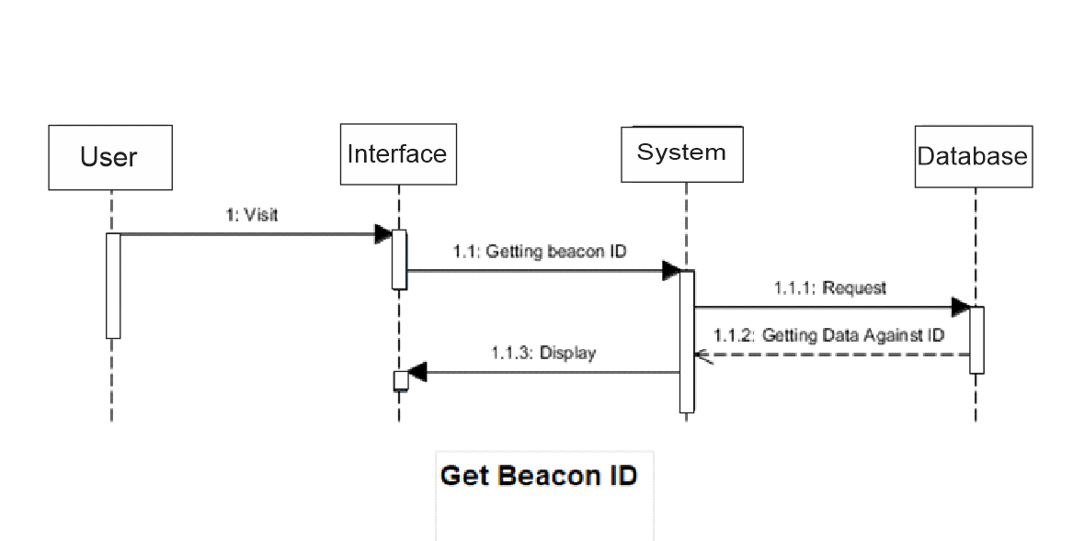
Figure 8 – SD Get Beacon ID
This figure shows the Sequence Diagram of Get Beacon ID in BeaconX.

Generate QR Code

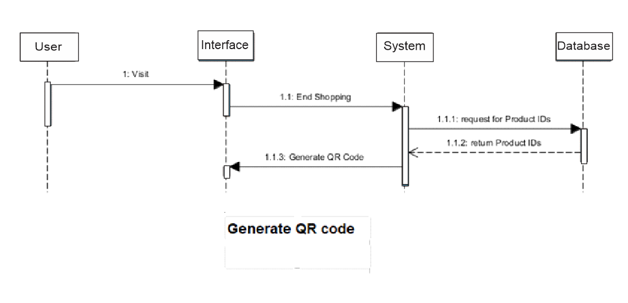
Figure 9.16 – SD Generate QR Code
This figure shows the Sequence Diagram of Generate QR Code in BeaconX.

Evaluate Budget

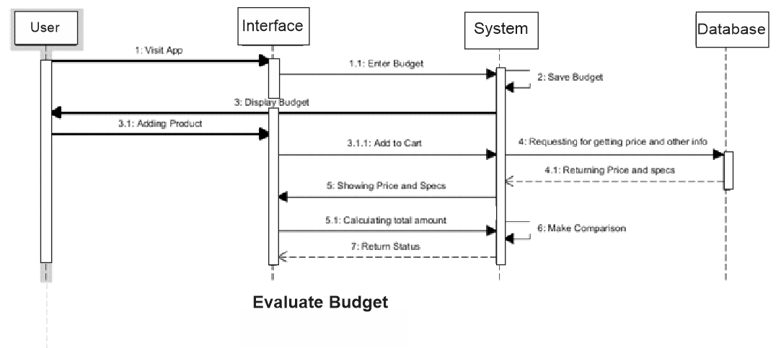
Figure 10.17 – SD Evaluate Budget
This figure shows the Sequence Diagram of Evaluate Budget in BeaconX.

Collaboration Diagram

Searching Product
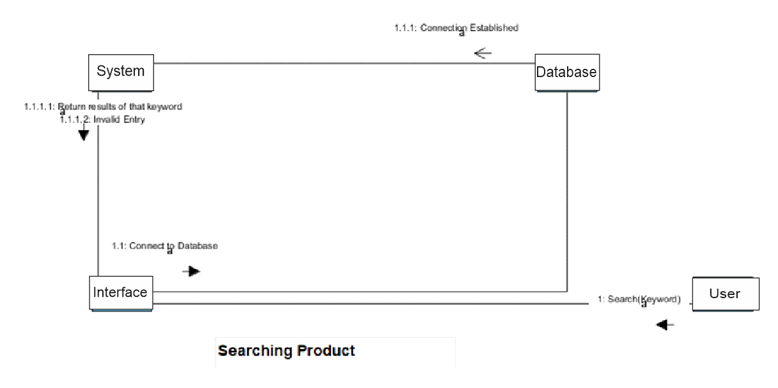
Figure 11.18 – CD Searching Product
This figure shows the Collaboration Diagram of Searching Product in BeaconX.

Reading QR Code
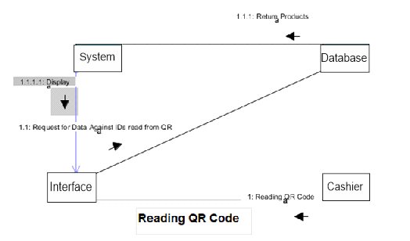
Figure 3.19 – CD Reading QR Code
This figure shows the Collaboration Diagram of Reading QR code in BeaconX.

Manage Cart
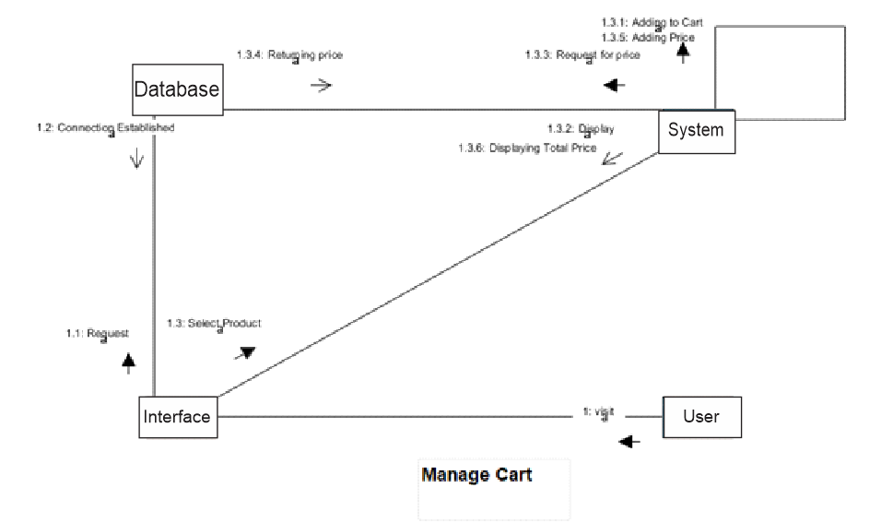
Figure 3.20 – CD Manage Cart
This figure shows the Collaboration Diagram of Manage Cart in BeaconX.

Login
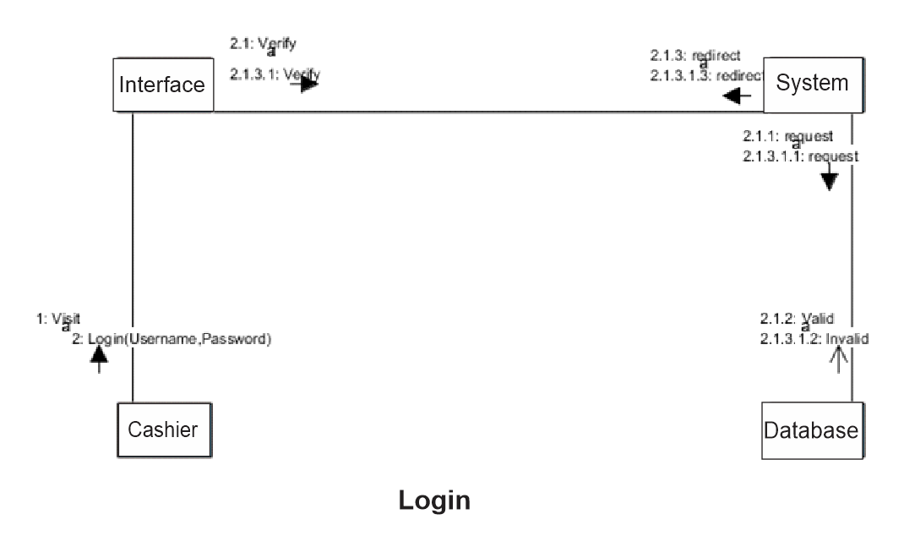
Figure 3.21 – CD Login
This figure shows the Collaboration Diagram of Login in BeaconX.

Getting Beacon Id
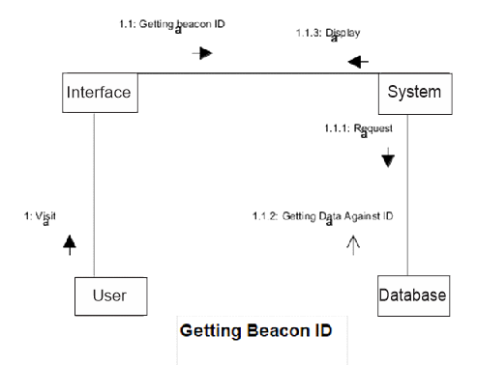
Figure 3.22 – CD Getting Beacon ID
This figure shows the Collaboration Diagram of Getting Beacon ID in BeaconX.

Generating QR Code
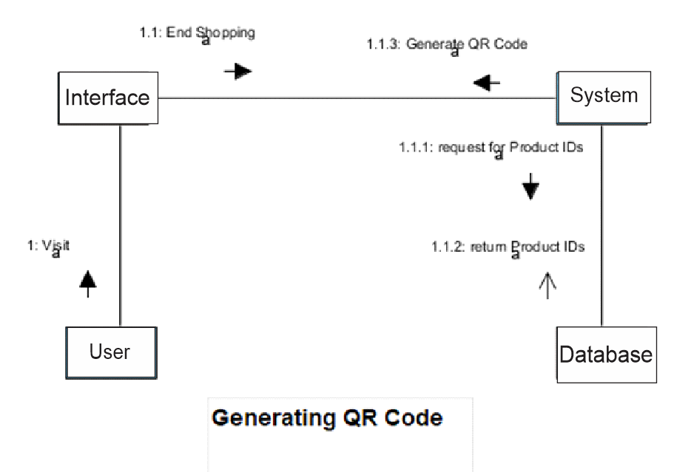
Figure 3.23 – CD Generating QR Code
This figure shows the Collaboration Diagram of Generating QR Code in BeaconX.

Evaluate Budget
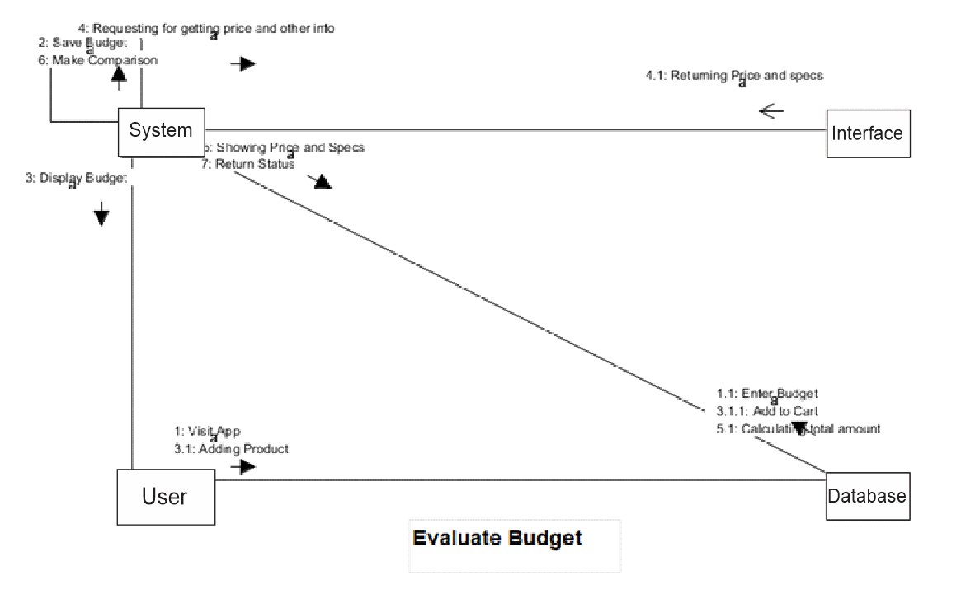
Figure 3.24 – CD Evaluate Budget
This figure shows the Collaboration Diagram of Evaluate Budget in BeaconX.

Design Class Diagram
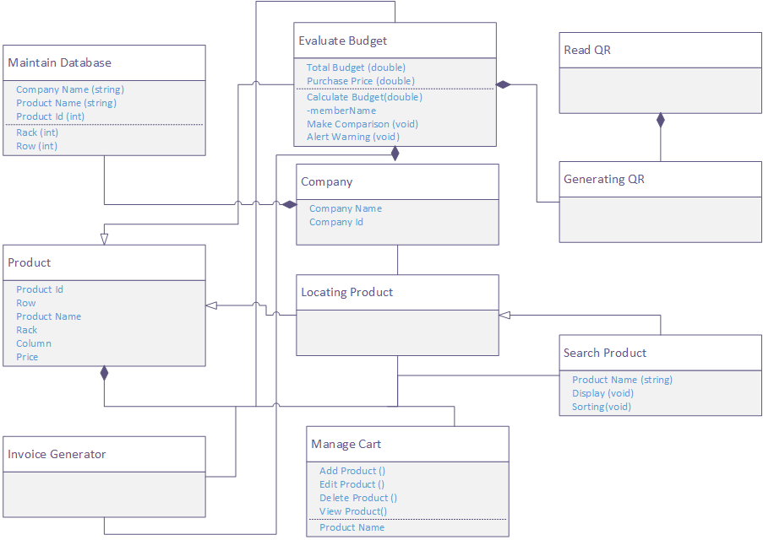
Figure 3.25 – Class Diagram
The above figure is the whole Class Diagram of BeaconX.

Data Model
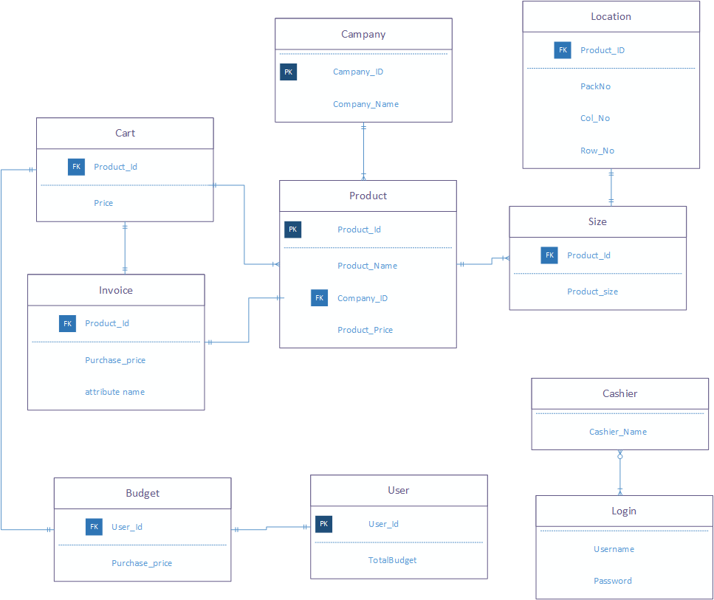
Figure 3.26 – Data Model Diagram
The above figure is the Data Model Diagram of BeaconX.

CHAPTER 4

4 IMPLEMENTATION AND TESTING

Implementation

Phase 1
We went to head office of “The Grocery Store” and discussed our project with the owner of the store and gave him official letter that is attested by our supervisor in which we wrote a short description of our project and mention that we need their store space for implementation and after approval from the owner we went to the store and gathered the data that is related to our implementation.
The data that we gathered from the store is mentioned below:
- Number of racks
- Categories of products
- Length of racks
- Rows and columns
- Map of the store
- Pictures of products
- Videos of racks

Phase 2
After gathering data, we refined it according to our requirement. We uploaded the pictures of products into our database, selected the racks on which we can implement the project and added the products with our specified categories and specifications.
After refinement process the information that we gathered is mentioned below:
- Selected racks: 5
Categories:
- Biscuits
- Tea
- Milk
- Chocolates
- Pampers
- Juice
- Ketchup
- Sauces
- Jam
- Pickles
- Ready to Make
- Snacks
- Detergents & Washroom holds
- House holds
- Toys

Length of racks: 15 feet
Total rows per rack: 5
Total Column per rack: 6
Rack Names: 01, 02, 03, 04, 05, 06
Other specifications are:
- Product Size
- Product Name
- Product Price
- Product Quantity
- Company of Product
- Product Code
- Rack Name in which product is placed
- Row number in which product is placed
- Column number in which product is placed
- Product flavour

Phase 3
After all the necessary work, we went to store and placed the beacons to their specified locations and then we tested our project as a customer. First, we opened our android application (BeaconX) and gave permissions to application that were required.
As we entered the store, where main beacon was located and then our app pop up a message of “Welcome to The Grocery Store” and then displayed a map of whole The Grocery Store and the app asked for the budget and we entered 100 rupees and then we searched for Lays Masala flavour and the app shows us the exact row and column wise location of the product, we picked up two lays medium sized packets and added them to the cart in our application and then we want to add one more but our app shows us a message that budget limit is exceeded so cancelled that pop-up in order to purchase more and then we added it to cart after that we went to cashier and showed our QR code and then cashier scanned it and after payment we closed our app and went out of store.

Testing and Evaluation of BeaconX
The main problems that occurred during this whole project are as follow

Development Phase
- As we were using free live database db4free.net so we are facing issues of slow retrieval of data from live database to the BeaconX which causes an issue of more time consumption.
- At web panel we faced an issue of exceptional handling we applied exceptional handling to every field of the web panel but some of the field were accepting the values that we restricted i.e. we applied a check of integer value in the Name field of the product, but it was still accepting the integer value.
- None of the beacon is compatible with the SDK of kontakt.io beacons. If we are using a kontakt.io beacon in our app we can’t locate or get the MAC Address of any other beacon. So, this was another issue that we faced during the testing process we couldn’t use the Beacon Simulator for testing purposes.
- BeaconX wasn’t working on all the API’s of android when we installed BeaconX on 5.1.1 (Lollipop) it kept stop working but at the same time it was working totally fine on 7.1.1 (Nougat).
- BeaconX got confuse most of the time when we perform bunch of tasks at the same time and stops working. BeaconX have some series of processes i.e. some task should be performed first if any other task is performed before them that process could crash so when we broke that series BeaconX crashed.
- Including all of these we also faced a lot of minor issues that we resolved in versioning of BeaconX.

Implementation Phase
- Before Implementation we faced an issue at Departmental Store search none of them was allowing us to implement this project due to security reasons but at the end “The Grocery Store” allowed us to implement this project after accepting the Request Letter by our Supervisor Mr. Zunnurain.
- The first issue that we faced during implementation that we couldn’t set the ranges of beacons as the departmental store was too small.
- The default range of kontakt.io beacons was set to TX 3 it means the beacons were throwing signals at about 30 feet away in a circle so in this way all the signals of every beacon were overlapping and causes problem and creating confusion for BeaconX to recognizing the MAC Address.
- Another problem that occurred was when we collected all the information and entered all the information to our database the positioning of the products was changed but when we reached to the departmental store for testing and capturing video of implementation of BeaconX as customer all the position of the products were changed so we had to renter all the information of the products.

CHAPTER 5

RESULTS AND DISCUSSIONS

5.1 Analysis of Departmental Store
The purpose of project is to automate the sign boards in the departmental store.
The departmental stores were targeted for this project in which each beacon is covering almost 3 to 8 categories according to their range and categories size.
Our app will help to locate towards the product with the help of beacons.
Beacons are broadcasting the UUID BeaconX will locate the product by MAC Filtering of each beacon. As the app opens it will start scanning for the beacons and as it finds a beacon it will get the MAC address of beacon and will filter the products against that MAC address. A budget calculator is also there which will help the customers they can buy products according to their specific budget and after buying the products a QR code is generated which can be scanned by cashier and cashier can get the list of products.

Result
This project is to automate the different things
- The main feature of BeaconX is to save customers time.
- Working of cashier is reduced he just must scan the QR code and get the payment.
- A budget facility
- Our shopping history is saved in the app
- Sign boards are replaced by beacons

CHAPTER 6

6 CONCLUSION AND RECOMMENDATIONS

Conclusion
BeaconX will help the users to save their time & money. It is a great concern for the customer that they couldn’t find their products in a departmental store and waste their time. Our target was departmental store by automating the signboards through beacons. These beacons broadcasts around its radius. We developed android app with the name "BeaconX” it will fetch the UUID through beacons and a check of MAC Address is present to identify the beacon and navigate customers towards the product, our app consists of features like a budget calculator. Customers must use BeaconX while doing shopping in the departmental store. It is not only a navigating application towards the products, it also helps to save the time and it also facilitates user to buy the products according to their specific budget. We conclude our project with the confirmation that it will save customer time and he will remain within his budget with the use of our project.

Recommendation
This project only targets the department store. We have used proximity beacons which are broadcasting UUIDs and BeaconX is filtering beacons on the bases of MAC Address in a specific radius and by getting their UUID we can easily find the product in that range. An android app will be developed, which helps the user to navigate towards the products in the departmental store.
This project navigates customers easily towards the products and their specific location with the help of beacons. Due to a limited time & budget, we have used this type of beacon in this project.
Our target is to automate the departmental stores, zoo and hospitals by replacing the signboards through beacons in future. We will be using location beacons, as they are more complex than Proximity beacon and more expensive because they have a location-based module present in them through GPS which will help customer to locate towards specific location of that product through GPS using Google Maps API.

REFERENCES

Journal Papers:
- Kang Eun Jeon; James She; Perm Soonsawad; Pai Chet Ng, “BLE Beacons for Internet of Things Applications”, IEEE Internet of Things Journal (Volume: 5, Issue: 2, April 2018), pp. 811 – 828, 2018, IEEE
- A Guide to Bluetooth Beacons September 2014 A white paper by the GSMA
(September 8, 2014)
Books:
- Matthew Gast, “Building Applications with iBeacon”, 1st Edition, O'Reilly Media, 2014
Electronic Sources from Internet:
- “Problems faced in Beacon Technology Implementation”, August 24, 2015, Available at: http://mindbowser.com/problems-faced-in-beacon-technology-implementation/

APPENDICES

APPENDIX A: Beacon Deployment

Radio Environment
Similarly, that Wi-Fi execution endures when there are different passageways utilizing a similar channel in 2.4GHz, so does Bluetooth and beacons. Thus, beacons don't generally execute just as expected, with average indications, for example,
• Applications not seeing guides notwithstanding of being in the range
• Restricted range
• Extremely wrong extending data
• Venality of communicate guide information
A similar kind of procedures and precautionary measures ought to be taken while conveying beacons as are utilized while sending an open Wi-Fi organize [2]. If the guide is work-basic it is great exercise to play out a radio site review earlier establishment to plaid how blocked the wireless condition is. On the off chance that 2.4GHz is especially clogged, more than one reference point might be expected to cover a specific region.

APPENDIX B: Market Requirements

The accompanying business sector necessities have been caught from meetings with associations at present utilizing or trailing beacons and furthermore from associations thinking about utilizing the innovation and right now evaluating the marketplace.

Hardware
There is some disarray in the marketplace today with respect to the abilities of the signal equipment on proposal from makers. Makers ought to consider giving essential direction in their item sheets.

Battery Life
The battery life of a reference point will fluctuate starting with one maker then onto the next and, specifically, contingent upon what particular is being used. Restrictive beacons run from 20 transmissions for each second to once at regular intervals.

For instance, iBeacons transmit 10 times each second, and thus will in general have shorter battery lives than beacons utilizing different details. Contrasted with restrictive reference point conventions the distinction can be as much as a factor of three.

As a rule, the added successive the transmission, the more probable an application is to see the reference point and the more precise the going information (the application's estimation of how a long way from a guide it is) [2].

It is conceivable to design beacons to work to iBeacon rules inside and out aside from promoting recurrence. Decreasing the promoting recurrence can expand the battery life. Be that as it may, this could have suggestions on client experience and raise similarity matters with applications that are expectant regular iBeacon conduct.

As a rule, if a monitor will be placed in a stable situation as an area allusion it is great exercise to guarantee the gadget has a battery-operated life of no less than one year, in a perfect world two years. Anything shorter, especially for huge reference point domains, makes a high weight regarding supplanting beacons.

At the point when a reference point is supplanted, the substitution either needs a similar design or applications/cloud stages should be refreshed of the new guide arrangement. This presents the probable for mix-ups. Accordingly, it is essential to decrease the recurrence of signal vagaries however abundant as could be expected.

Be that as it may, the necessities for battery life differ contingent upon the submission and use case. In certain occasions, the required battery life might be just a couple of days. For shorter term prerequisites, the battery life is unquestionably progressively adaptable, and usually favourable to have a smaller battery life. For instance, for a signal to 'lapse' later a brief timeframe without it being physically evacuated.

One, frequently over-looked, feature is program control. Most beacons can be designed to conduct at various forces. Expanding the control will decrease the battery lifecycle of a signal. It is recommended that producers state program control used to touch base at an expressed battery lifespan to give reference point purchasers some direction. Generally, purchasers may discover beacons coming up short on power far sooner than anticipated.

Normally, a few establishments will consider a decreased transmission control, in this manner broadening the battery life of a reference point. It is important, particularly if you have a huge reference point bequest, that your beacons may well all come up short on power at various occasions making something of an administration migraine.

Range
Over-all input from present clients is that beacons ought to be arranged, and tried afterward establishment, to give a scope of 20 meters, successfully casing a circle with a measurement of amongst 30 meters and 40 meters. Numerous product improvement packs design applications to filter for beacons like clockwork in foundation mode. People will in general stroll at a leap of 1.4 meters every other, which means they spread 28 meters in a 20 time frame. Along these lines, a guide run set to 20 meters with a practical inclusion zone of 30 meters ought to guarantee most applications get an opportunity to see a signal notwithstanding when in foundation mode.

This functions admirably in a passage territory. In any case, beacons put and intended to catch individuals who are waiting can use a far littler range.

iBeacon and iOS make a system for extending, with three states when in scope of a reference point; far, close and quick. Numerous supporters of this paper feel that because of the conflicting idea of radio/conditions these separation estimation states are difficult to utilize dependably. Regularly setting off a commitment when close or moderate is by all accounts the best methodology. The more prominent the range the more shot of being seen by an application, yet the more noteworthy the range the less precise the area information, making for a conceivably less significant commitment. Least four-year battery life for changeless establishments.

Size/Format
The proper size and arrangement of beacons descends to their utilization case. To limit altering and robbery, beacons should stay circumspect except if they are intended for client to physically connect with them. In this way beacons, ought to be as little as physically workable for their ability and circumspect as far as shading and configuration to enable them to go ignored.

Managed Service
Similarly as with some other innovation being sent generally into the field, beacons are an authority foundation item. Numerous associations' IT offices or media/publicizing organizations require an authority organization to send and oversee domains of beacons.

Deployment
Conveying reference points requires the accompanying
• Physical signal establishment to guarantee right, disguised situation
• Testing of the radio condition to guarantee right activity on an area by area premise
• Testing of a pertinent application or use case to guarantee a reference point 'triggers' an application at the opportune time/separate
• Precise recording of guides - which reference point is the place.

On-going support
Because of their effortlessness, beacons are frequently an 'introduce and overlook' innovation, particularly as they require no accessibility and routinely no outside power. Nevertheless, units do miss the mark, get lost/stolen or the batteries run out. There is a necessity for organizations to give an oversaw administration to address these issues, with administration level understandings. In any case, as beacons have no network, upkeep can be troublesome. Numerous associations are hoping to utilize latent observing that includes applications troublesome. At the point when a focal stage sees a guide quits being accounted for, field specialists can be conveyed to fix/supplant the reference point.

