
BSCS-F18-008
03-134152-090 | HASSAN ALI SHAH
03-134152-097 | SAMEED ARSHAD
03-134152-089 | FURQAN AHMED KHAN

HSF BLOOD DONATION

In partial fulfilment of the requirements for the degree of
Bachelor of Science in Computer Science
Supervisor: Dawood Akram
Department of Computer Sciences
Bahria University, Lahore Campus
June 2019

© Bahria University, 2019

Certificate

We accept the work contained in the report titled
“HSF BLOOD FOUNDATION”
written by
HASSAN ALI SHAH
SAMEED ARSHAD
FURQAN AHMED KHAN
as a confirmation to the required standard for the partial fulfilment of the degree of
Bachelor of Science in Computer Science.

Approved by:
Supervisor: Dawood Akram
(Signature)

June 12th, 2019

DECLARATION

We hereby declare that this project report is based on our original work except for citations and quotations which have been duly acknowledged. We also declare that it has not been previously and concurrently submitted for any other degree or award at Bahria University or other institutions.

Enrolment | Name | Signature
03-134152-090 | HASSAN ALI SHAH
03-134152-097 | SAMEED ARSHAD
03-134152-089 | FURQAN AHMED KHAN

Date : 12-06-2019

Specially dedicated to
my beloved grandmother, mother and father
(Hassan Ali Shah)
my beloved grandmother, mother and father
(Sameed Arshad)
my beloved grandmother, mother and father
(Furqan Ahmed Khan)

ACKNOWLEDGEMENTS

We would like to thank everyone who had contributed to the successful completion of this project. We would like to express my/our gratitude to my research supervisor, Mr Dawood Akram for his invaluable advice, guidance and his/her enormous patience throughout the development of the research.

In addition, we would also like to express my gratitude to our loving parent and friends who had helped and given me encouragement.

Hassan Ali Shah
Sameed Arshad
Furqan Ahmed Khan

HSF BLOOD FOUBDATION

ABSTRACT

In Pakistan, we see that to arrange blood people have to go through many channels which is a very difficult & time consuming process. To get rid of this difficulty we will be developing an application by which people can find blood donors near them in a short interval of time. Blood recipient will register on our application, which will be having donors record, search for their required blood and find the suitable person near them in the defined radius. Similarly, donors will be required to register on our app to have their information including their location stored. We will be integrating our application with UBER to assist donors in reaching their destinations. Online chat feature will allow both users to interact with each other. Text to speech feature will be added for handicapped persons to easily interact with our application. When blood group is entered, it will be matched in the database, the application will then show donors having same blood group in the defined radius and will generate the location of the donors that are nearer to the blood recipient and will book a ride afterwards.

TABLE OF CONTENTS

DECLARATION ii
ACKNOWLEDGEMENTS iv
ABSTRACT v
TABLE OF CONTENTS vi
LIST OF TABLES ix
LIST OF FIGURES x

CHAPTERS
1 INTRODUCTION 1
1.1 Background 1
1.2 Problem Statements 1
1.3 Aims and Objectives 1
1.4 Scope of Project 2
2 LITERATURE REVIEW (and/or SRS) 3
2.1 User Classes and Characteristics 3
2.2 Operating Environment 4
2.3 Design and Implementations Constraints 5
2.3.1 Assumptions and Dependencies 5
2.4 System Requirement Chart 5
3 DESIGN AND METHODOLOGY 9
3.1 Design 9
3.2 Use Case Diagram 10
3.3 Use Case Descriptions 11
3.3.1 Register U1 11
3.3.2 Login U2 12
3.3.3 Search for blood U3 13
3.3.4 Request U4 14
3.3.5 Book a ride U5 15
3.3.6 View Ride Status U6 16
3.3.7 Chat Room U7 17
3.3.8 View Profile U8 18
3.3.9 Logout U9 19
3.3.10 Accept/Reject Requests U10 20
3.4 Sequence Diagram 21
3.4.1 Sequence Diagram of Registration 21
3.4.2 Sequence Diagram of Login 21
3.4.3 Sequence Diagram of finding Donor 22
3.4.4 Request Sequence Diagram (Recipient) 22
3.4.5 Request Sequence Diagram (Donor) 23
3.4.6 Ride Sequence Diagram (Recipient) 23
3.4.7 Transaction Sequence Diagram (Admin) 24
3.4.8 Transaction Sequence Diagram (Recipient) 24
3.4.9 Transaction Sequence Diagram (Admin) 25
3.4.10 Transaction Sequence Diagram (Admin) 25
3.5 Domain Model 26
3.6 Entity Relationship Diagram 27
3.7 Design Class Diagram 28
3.8 Operation Contracts 29
4 DATA AND EXPERIMENTS (and/or IMPLMENTATION) 32
4.1 Languages used for Implementation 32
4.1.1 XML 32
4.1.2 Java 32
4.2 Tools used for Implementation 32
4.2.1 Android Studio 32
4.2.2 Google Firebase 33
5 RESULTS AND DISCUSSIONS (or USER MANUAL) 34
5.1 How to approach HSF Blood Foundation? 34
5.2 Splash Screen 35
5.3 Selection for Donor/Recipient 36
5.4 Registration at HSF Blood Foundation (Donor) 37
5.5 Registration at HSF Blood Foundation (Recipient) 38
5.6 Login at Donor/Recipient 39
5.7 Reset Password at Donor/Recipient 40
5.8 Donor Home Page 41
5.9 Recipient Request Page 42
5.9.1 Request Notification 43
5.9.2 Request Notification on Activity 44
5.10 After Selecting Blood Group 45
5.11 Chat Room 46
5.11.1 Chat Notification 47
5.12 Book a Ride 48
5.13 Update Profile 49
5.14 Settings Feature 50
6 CONCLUSION AND RECOMMENDATIONS 51
6.1 Conclusion 51
6.2 Recommendations 51

LIST OF TABLES

TABLE TITLE PAGE
Table 1 System Requirement Chart 8
Table 2 Register U1 11
Table 3 Login U2 12
Table 4 Search for blood U3 13
Table 5 Request U4 14
Table 6 Book a Ride U5 15
Table 7 View Ride Status U6 16
Table 8 Chat Room U7 17
Table 9 View Profile U8 18
Table 10 Logout U9 19
Table 11 Accept/Reject Requests U10 20

LIST OF FIGURES

FIGURE TITLE PAGE
Figure 1 System use-case diagram 10
Figure 2 Registration Sequence Diagram 21
Figure 3 Login Sequence Diagram 21
Figure 4 Find Donor Sequence Diagram 22
Figure 5 Request Sequence Diagram (Recipient) 22
Figure 6 Request Sequence Diagram (Donor) 23
Figure 7 Ride Sequence Diagram (Recipient) 23
Figure 8 Transaction Sequence Diagram (Admin) 24
Figure 9 Transaction Sequence Diagram (Recipient) 24
Figure 10 Transaction Sequence Diagram (Admin) 25
Figure 11 Transaction Sequence Diagram (Admin) 25
Figure 12 Domain Model 26
Figure 13 Entity Relationship Diagram 27
Figure 14 Class Diagram 28
Figure 15 Splash Screen 35
Figure 16 Selection of Donor/Recipient 36
Figure 17 Registration at HSF Blood Foundation (Donor) 37
Figure 18 Registration at HSF Blood Foundation (Recipient) 38
Figure 19 Login at Donor/Recipient 39
Figure 20 Reset Password at Donor/Recipient 40
Figure 21 Donor Home Page 41
Figure 22 Recipient Request Page 42
Figure 23 Request Notification 43
Figure 24 Notification on Activity 44
Figure 25 After Selection of Blood Group 45
Figure 26 Chat Room 46
Figure 27 Chat Notification 47
Figure 28 Book a Ride 48
Figure 29 Update Profile 49
Figure 30 Settings Feature 50

INTRODUCTION

Background

HSF Blood Foundation is a Blood Donation Android Based Application. It provides the facility to the Recipients in different Hospitals to arrange a Blood Donor easily, steadily and quickly to meet their Blood needs.

Problem Statements

The main purpose of our HSF Blood Foundation system is to design an application for arranging blood in a short interval of time. It also provides a facility of ride to donors in assisting them to reach their destination.

Aims and Objectives

The objectives of the thesis are shown as following:
- To design an android-based platform for blood donors and the recipients.
- To provide an easy way to recipients to arrange blood.
- To develop a Blood Donation Application that will provide the facility to arrange nearest blood donor and help him reach the destination.
- To keep record and data regarding the users which can be fetched whenever needed.

Scope of Project

HSF Blood Foundation is a Blood Donation Android Based Application. It provides the facility to the Recipients in different Hospitals to arrange a Blood Donor easily, steadily and quickly to meet their Blood needs.
The main purpose of our HSF Blood Foundation system is to design an application for arranging blood in a short interval of time. It also provides a facility of ride to donors in assisting them to reach their destination. To make it easier and to save time for both donor and receiver, this application will be integrated with UBER. So that a donor can easily come to the location and after donating blood he could easily go back home by the same service.

LITERATURE REVIEW (and/or SRS)

User Classes and Characteristics

There are two types of user classes
Donor
Registration:
- Name
- Location
- Mobile No
- Email
- Password
- Blood Group
Login:
  - Username
- Password
Requests:
- Accept/Reject
- Can see how many requests were processed

Chat Rooms:
  - Chat with receiver

Receiver:
Registration:
- Name
- Mobile No
- Email
- Password
Login:
- Username
- Password
Select Required Blood:
- User selects the required blood group.
Requests:
  - Can request donors.
Map:
- Profiles of donors will pop-up in the defined radius
Chat Room:
  - Chat with donor
Uber:
Can book a ride for donor.

Operating Environment
The required hardware and software required while design of this platform are as shown below.
- Android-Based Requirements:
    - Android version (minimum 5.0)
    - Google Play Services
- Database Management System: Google Firebase.

- Android Development System: Android Studio.

Design and Implementations Constraints
HSF Blood Foundation will be developed using XML and back-end will be developed using Java and Google Firebase. It will be developed in water-fall methodology by making modular designs where features of every module are wrapped separately, and each feature will be divided into possible sub features.

Assumptions and Dependencies
HSF Blood Foundation is an android-based system therefore it requires having compatible android version installed on the android device to run efficiently. There must be a host server always available and running for users of HSF Blood Foundation.

System Requirement Chart
The following Table1 shows the Functional and non-functional requirements.
ID | Priority | Type | Source | Used in Use case | Description
1 | High | Functional | Hospitals | N/A | Open the app of HSF Blood Foundation
2 | High | Functional | Hospitals | U1 | Registration is done by both receiver and donors interact.
3 | Medium | Functional | Hospitals | U1 | Reset Password
4 | Medium | Functional | Hospitals | U2 | User Login
5 | High | Functional | Hospitals | U1 | Register Users
6 | Medium | Functional | Hospitals | U1 | View Search Users
7 | Medium | Functional | Hospitals | U1 | Delete a User
8 | Medium | Functional | Hospitals | U9 | Logout
9 | Medium | Functional | Hospitals | U3 | Registered recipient search for required blood
10 | Medium | Functional | Hospitals | U3 | Drop down list shows up of all possible blood groups
11 | Medium | Functional | Hospitals | U3 | Selects Required blood from drop down list

12 | High | Functional | Hospitals | U4 | Radius is defined around the hospital and then expanded
13 | High | Functional | Hospitals | U4 | Donor pops up in the shortest radius first
14 | High | Functional | Hospitals | U4 | User requests the blood
15 | Medium | Functional | Hospitals | U5 | Request accepted
16 | Medium | Functional | Hospitals | U5 | Receiver books a ride for the donor
17 | Low | Functional | Hospitals | U6 | Opens status interface
18 | Low | Functional | Hospitals | U6 | Both user can see ride status
19 | Low | Functional | Hospitals | U7 | Create a Chat
20 | Low | Functional | Hospitals | U7 | Add both users
21 | Low | Functional | Hospitals | U7 | Open Chat
22 | Low | Functional | Hospitals | U7 | Delete Chat Box
23 | Low | Functional | Hospitals | U8 | Profile Created
24 | Low | Functional | Hospitals | U8 | Opens Profile
25 | High | Functional | Hospitals | U10 | Blood Request Accepted
26 | High | Functional | Hospitals | U10 | Blood Request rejected. Find a new Donor
27 | High | Non Functional | Hospitals | N/A | Display all content after registering the application
28 | High | Non Functional | Hospitals | N/A | Server Response
29 | High | Non Functional | Hospitals | N/A | Make a check if Receiver is in the Hospital
30 | High | Non Functional | Hospitals | N/A | All the passwords should be in encrypted form
31 | High | Non Functional | Hospitals | N/A | Only Related People can access
32 | High | Non Functional | Hospitals | N/A | Components of the project code will be tested alongside the implementation phase to ensure that they are functional.
33 | High | Non Functional | Hospitals | N/A | Final, integrated project code will test to ensure that complete project is integrated well and functioning Properly

Table 1 System Requirement Chart

DESIGN AND METHODOLOGY

Design

This chapter overviews the design of HSF Blood Foundation. The system architecture design gives the total perspective of the system. This will enable developers and clients to see and check the design plan in detail. Following artefacts incorporated in this Chapter
1. Use case diagrams.
2. Use case descriptions.
3. Sequence Diagrams.
4. Domain Model.
5. Entity Relationship Diagram
6. Design Class Diagram.
7. Operation Contract

Use Case Diagram

3.2.1 System Use-Case Diagram
The following Figure1 shows the system Use-Case Diagram.
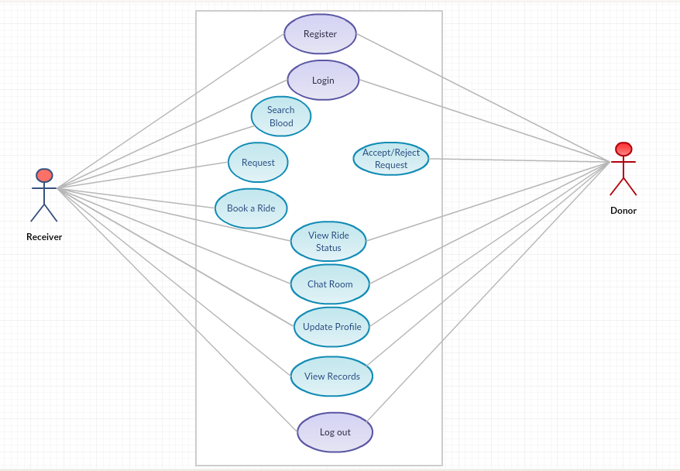
Figure 1 System use-case diagram

Use Case Descriptions
A use-case description is a text that captures the detailed functionality of a use-case. Description of all use-cases are written down in this section.

Register U1

Following table describes all important elements of this use case.
Name | Register
Use case ID | U1
Description | Users need to register to have their record saved and to interact with this
Pre-condition | User is not already registered.
Trigger | This use case is initiated when a donor or receiver is going to register himself.
Basic flow | - User opens the application.  - Clicks on Donor/Receiver Button.  - Clicks on Register Button.  - Enters Required Data.  - Press Register Button.
Alternate flows | 1. At 5 if email already exists in the database  1.1 User will be asked to login if his record already exists  2. At 5 if all required fields are not filled  2.1 Error message is displayed to fill all the fields.  2.2 Return to step 3
Post condition | User is registered.

Table 2 Register U1

Login U2
Following is the table which describes all important elements of this use case.
Name | Login
Use case ID | U2
Description | Registered users can login.
Pre-condition | User should be registered
Trigger | This use case is initiated when donors and receivers are going to login.
Basic flow | - User opens the application.  - Clicks on Donor/Receiver Button.  - Enters username and password.  - Press Login Button.
Alternate flow | - At 4 if user record does not exist  - User will be asked to register on the application first.  - At 4 if user enters wrong username or password  2.1 User will be asked to correct username or password.
Post condition | Successful login.

Table 3 Login U2

Search for blood U3
Following is the table which describes all important elements of this use case.
Name | Login
Use case ID | U2
Description | Registered users can login.
Pre-condition | User should be registered
Trigger | This use case is initiated when donors and receivers are going to login.
Basic flow | - User opens the application.  - Clicks on Donor/Receiver Button.  - Enters username and password.  - Press Login Button.
Alternate flow | - At 4 if user record does not exist  - User will be asked to register on the application first.  - At 4 if user enters wrong username or password  2.1 User will be asked to correct username or password.
Post condition | Successful login.

Table 4 Search for blood U3

Request U4
Following is the table which describes all important elements of this use case.
Name | Request
Use-Case ID | U4
Description | Receiver can request donor
Pre-condition | User should be logged in.  Blood group needs to be entered.
Trigger | This use case is initiated when receiver is going to request for a donor.
Basic flow | - User opens the application.  - Registers/login.  - Selects Blood Group.  - Donors are then matched in the defined radius
Alternate flow | - At 2 if user record does not exist  - User will be asked to register on the application first.  - At 2 if user enters wrong username or password  - User will be asked to correct username or password.  - At 4 if receiver is not in the predefined locations  - Request will not be processed unless he is in some govt. hospital.  - At 4 if no donor gets popped up in the defined radius.  4.1 Radius will be expanded to make sure the availability of donor
Post condition | Donor is arranged.

Table 5 Request U4

Book a ride U5
Following is the table which describes all important elements of this use case.
Name | Book a ride
Use-Case ID | U5
Description | After donor is arranged, receiver will be required to book a ride to get him
Pre-condition | Blood request should be accepted.
Trigger | This use case is initiated when receiver books a ride for donor.
Basic flow | - User opens the application.  - Registers/login.  - Selects Blood Group.  - Donors are then matched in the defined radius.  - Book a ride option will allow receiver to arrange a ride for donor.
Alternate flow | - At 2 if user record does not exist  - User will be asked to register on the application first  - At 2 if user enters wrong username or password  - User will be asked to correct username or password  - At 4 if receiver is not in the predefined location  - Request will not be processed unless he is in some govt. hospital  - At 4 if no donor gets popped up in the defined radius  4.1 Radius will be expanded to make sure the availability of donor.
Post condition | Ride is booked.

Table 6 Book a Ride U5

View Ride Status U6
Following is the table which describes all important elements of this use case.
Name | View Ride Status
Use-Case ID | U6
Description | After ride is booked, receiver/donor can view ride status.
Pre-condition | Blood transaction needs to be started.
Trigger | This use case is initiated when receiver books a ride, after which receiver and donor can view their ride status.
Basic flow | - User opens the application.  - Registers/login.  - Receiver requests for blood.  - After request is accepted, ride will be booked.  - Both users can then view ride status
Alternate flow | - At 2 if user record does not exist  - User will be asked to register on the application first  - At 2 if user enters wrong username or password  - User will be asked to correct username or password.  - At 3 if receiver is not in the predefined location  - Request will not be processed unless he is in some govt. hospital.  - At 3 if no donor gets popped up in the defined radius  4.1 Radius will be expanded to make sure the availability of donor.
Post condition | N/A

Table 7 View Ride Status U6

Chat Room U7
Following is the table which describes all important elements of this use case.
Name | Chat Room
Use-Case ID | U7
Description | Receiver and donors can chat with each other.
Pre-condition | Users should be logged in.  Request needs to be processed.
Trigger | This use case is initiated when a donor and a receiver chat with each other.
Basic flow | - User opens the application.  - Registers/login.  - Receiver requests the blood.  - Donor accepts the request.  - When request is accepted, a connection will be established between donor and receivers.  - Both users can then chat with each other
Alternate flow | - At 2 if user record does not exist  - User will be asked to register on the application first  - At 2 if user enters wrong username or password  - User will be asked to correct username or password.  - At 3 if receiver is not in the predefined location  - Request will not be processed unless he is in some govt. hospital.  - At 4 if donor rejects  - Return to 3.  - At 5 if no donor gets popped up in the defined radius  5.1 Radius will be expanded to make sure the availability of donor.
Post condition | Availability of donors and receivers.

Table 8 Chat Room U7

View Profile U8
Following is the table which describes all important elements of this use case.
Name | View Profile
Use-Case ID | U8
Description | Receiver and donors can view their own profiles.
Pre-condition | Users should be logged in.
Trigger | This use case is initiated when receiver and donors view their profile.
Basic flow | - User opens the application.  - Register/Login.  - Clicks the profile button from the swipe tray
Alternate flow | - At 2 if user record does not exist  - User will be asked to register on the application first.  - At 2 if user enters wrong username or password  2.1 User will be asked to correct username or password.
Post condition | N/A

Table 9 View Profile U8

Logout U9
Following is the table which describes all important elements of this use case.
Name | Logout
Use-Case ID | U9
Description | Receiver and donors can logout.
Pre-condition | User should logged in.
Trigger | This use case is initiated when user is going to logout from the application.
Basic flow | - User opens the application  - Registers/login  - Clicks the logout button from the swipe tray
Alternate flow | - At 2 if user record does not exist  - User will be asked to register on the application first.  - At 2 if user enters wrong username or password  2.1 User will be asked to correct username or password.
Post condition | N/A

Table 10 Logout U9

Accept/Reject Requests U10
Following is the table which describes all important elements of this use case.
Name | Accept/Reject Requests
Use-Case ID | U10
Description | Donors can accept or reject requests
Pre-condition | User should be logged in.
Trigger | This use case is initiated when user is going to accept or reject the request.
Basic flow | - User opens the application  - Registers/login  - Gets blood request.  - Accepts/rejects the request.
Alternate flow | - At 2 if user record does not exist  - User will be asked to register on the application first.  - At 2 if user enters wrong username or password  2.1 User will be asked to correct username or password.
Post condition | Request is accepted or rejected.

Table 11 Accept/Reject Requests U10

Sequence Diagram
Following are the sequence diagrams

Sequence Diagram of Registration
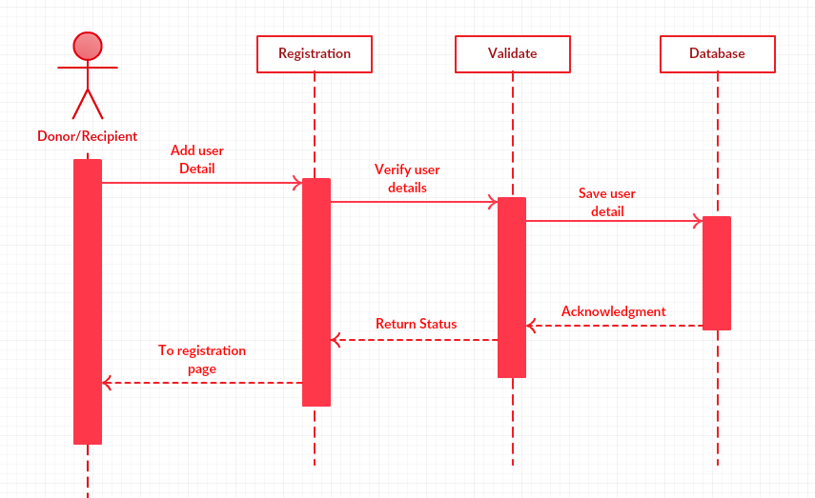
Figure 2 Registration Sequence Diagram

Sequence Diagram of Login
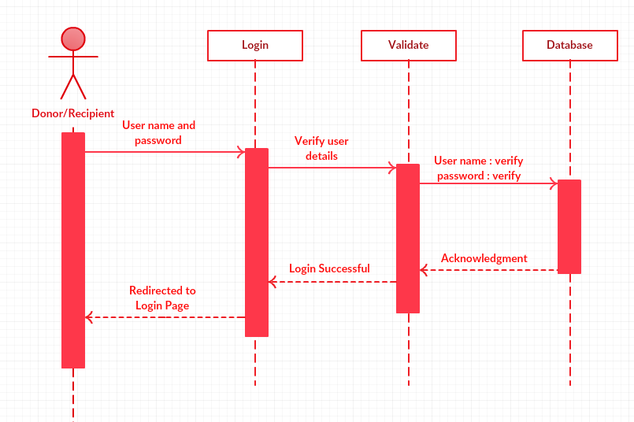
Figure 3 Login Sequence Diagram

Sequence Diagram of finding Donor
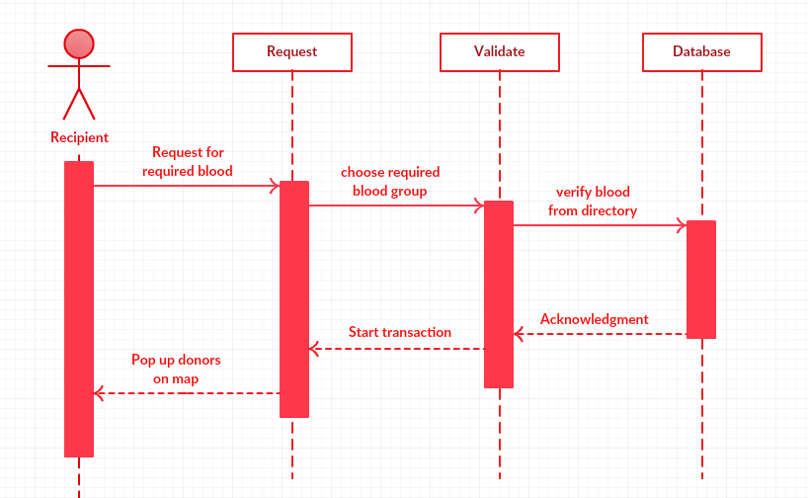
Figure 4 Find Donor Sequence Diagram

Request Sequence Diagram (Recipient)
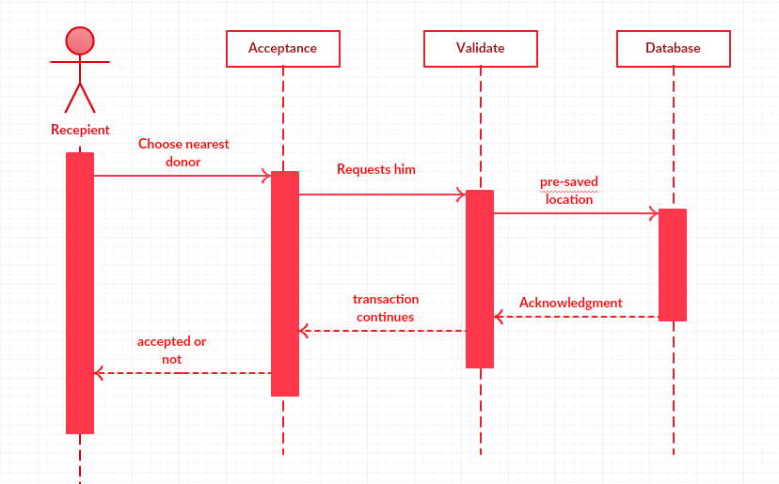
Figure 5 Request Sequence Diagram (Recipient)

Request Sequence Diagram (Donor)
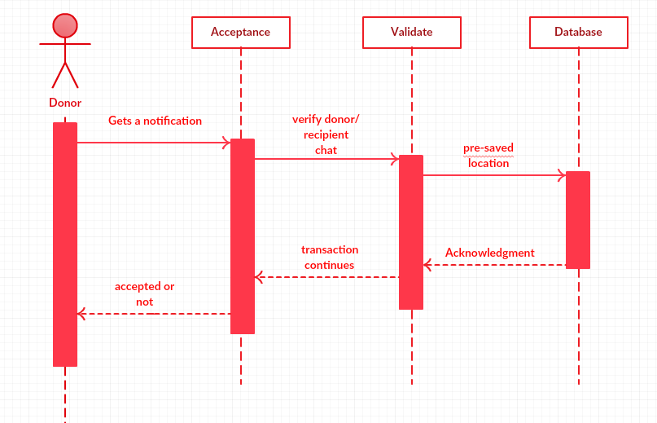
Figure 6 Request Sequence Diagram (Donor)

Ride Sequence Diagram (Recipient)
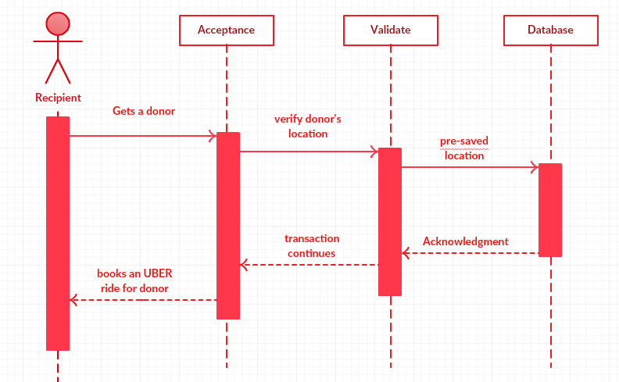
Figure 7 Ride Sequence Diagram (Recipient)

Transaction Sequence Diagram (Admin)
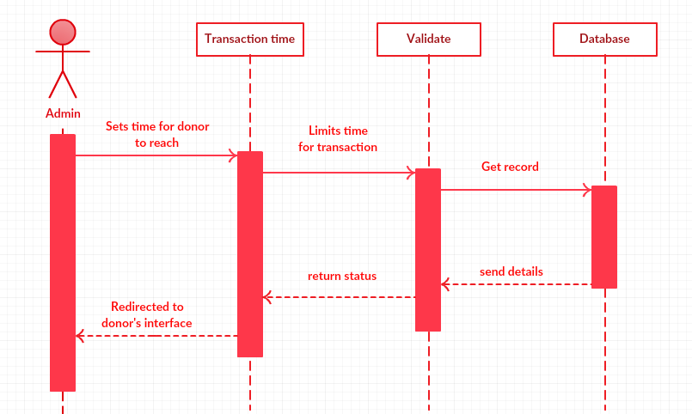
Figure 8 Transaction Sequence Diagram (Admin)

Transaction Sequence Diagram (Recipient)
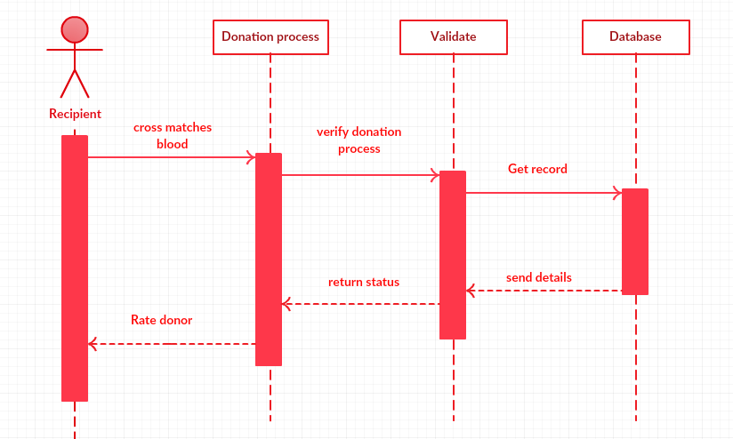
Figure 9 Transaction Sequence Diagram (Recipient)

Transaction Sequence Diagram (Admin)
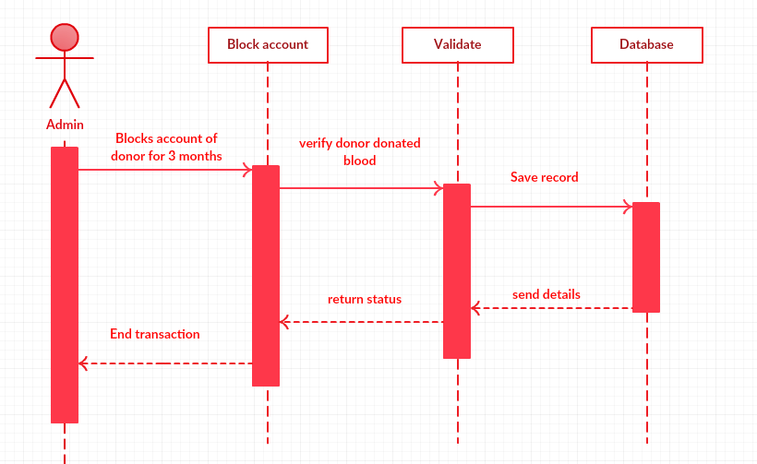
Figure 10 Transaction Sequence Diagram (Admin)

Transaction Sequence Diagram (Admin)
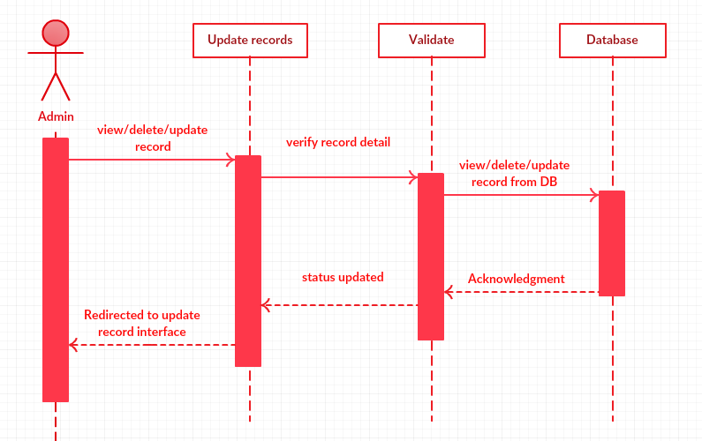
Figure 11 Transaction Sequence Diagram (Admin)

Domain Model

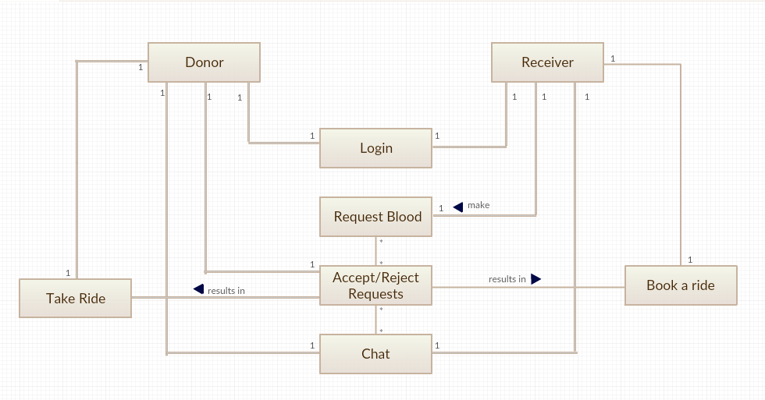
Figure 12 Domain Model

Entity Relationship Diagram
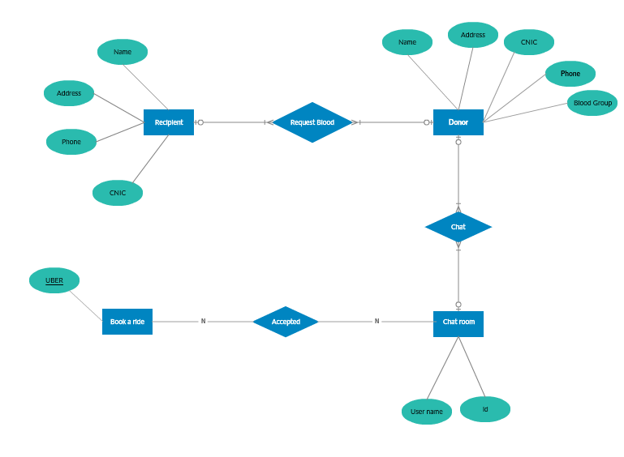
Figure 13 Entity Relationship Diagram

Design Class Diagram

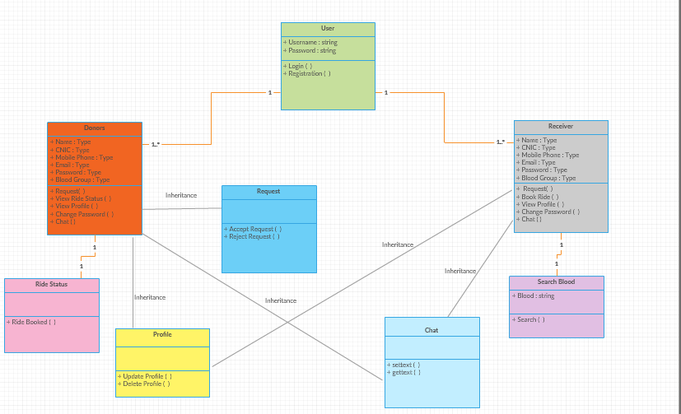
Figure 14 Class Diagram

Operation Contracts

Operation Contract Registration
Name: Registration
Responsibilities: Users need to register to have their record saved and to interact with this app
Cross Reference: U1
Exceptions: none
Preconditions: User in not already registered.
Post conditions: User was registered.

Operation Contract Login
Name: Login
Responsibilities: Registered users can login
Cross Reference: U2
Exceptions: User entered wrong credentials
Preconditions: User should be registered.
Post conditions: User was logged in.

Operation Contract Search for blood
Name: Blood search
Responsibilities: To search required blood.
Cross Reference: U3
Exceptions: none
Preconditions: User should be logged in.
Post conditions: Blood group was selected.

Operation Contract Request
Name: Request
Responsibilities: Receiver can request donor.
Cross Reference: U4
Exceptions: none
Preconditions: User needs to be in one of the pre-selected hospitals.
Post conditions: Donor was arranged.

Operation Contract Book a Ride
Name: Ride
Responsibilities: After donor is arranged, receiver will be required to book a ride to get him.
Cross Reference: U5
Exceptions: none
Preconditions: Donor was arranged.
Post conditions: Ride was booked.

Operation Contract View Ride Status
Name: Ride Status
Responsibilities: After ride is booked, receiver/donor can view ride status.
Cross Reference: U6
Exceptions: none
Preconditions: Ride was booked.

Operation Contract Chat Room
Name: Chat
Responsibilities: Receiver and donors can chat with each other.
Cross Reference: U7
Exceptions: none
Preconditions: Donor was arranged previously.

Operation Contract View Profile
Name: Profile
Responsibilities: Receiver and donors can view their own profiles.
Cross Reference: U8
Exceptions: User entered wrong credentials
Preconditions: User was logged in.

Operation Contract Logout
Name: Logout
Responsibilities: Receiver and donors can logout
Cross Reference: U9
Exceptions: none
Preconditions: User was logged in.

Operation Contract Accept/Reject Request
Name: Request
Responsibilities: Donors can accept or reject requests.
Cross Reference: U10
Exceptions: User entered wrong credentials
Preconditions: User was logged in.
Request was made.

DATA AND EXPERIMENTS (and/or IMPLMENTATION)

Languages used for Implementation

XML
XML stands for extensible Mark-up Language. XML is a mark-up language much like HTML. XML was designed to store and transport data. XML was designed to be self-descriptive. XML is a W3C Recommendation.

Java
Java is a general-purpose computer-programming language that is concurrent, class-based, object-oriented, and specifically designed to have as few implementation dependencies as possible.

Tools used for Implementation

Android Studio
Android Studio is the official integrated development environment for Google's Android operating system, built on Jet Brains' IntelliJ IDEA software and designed specifically for Android development. It is available for download on Windows, mac OS and Linux based operating systems.

Google Firebase
Firebase is a mobile and web application development platform developed by Firebase, Inc. in 2011, then acquired by Google in 2014. As of October 2018, the Firebase platform has 18 products, which are used by 1.5 million apps.

RESULTS AND DISCUSSIONS (or USER MANUAL)

How to approach HSF Blood Foundation?

You can easily download this from Google Play Store.

Splash Screen

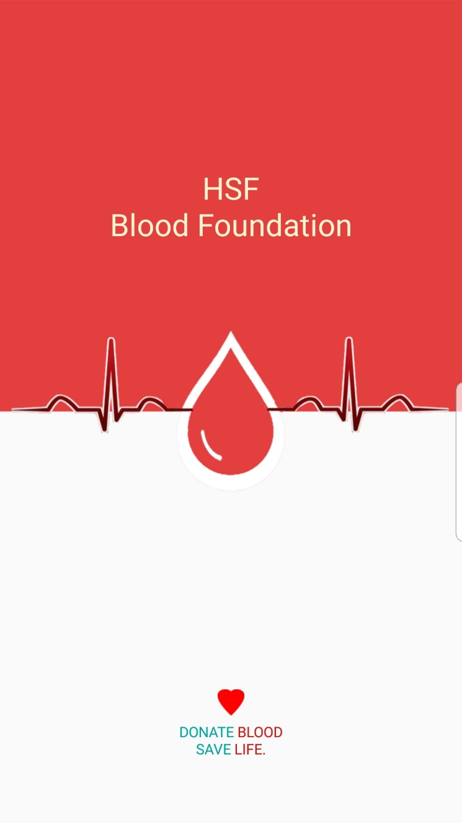
Figure 15 Splash Screen

This is the splash screen. When you download the application and run it on your phone.
First it will appear on your screen.

Selection for Donor/Recipient

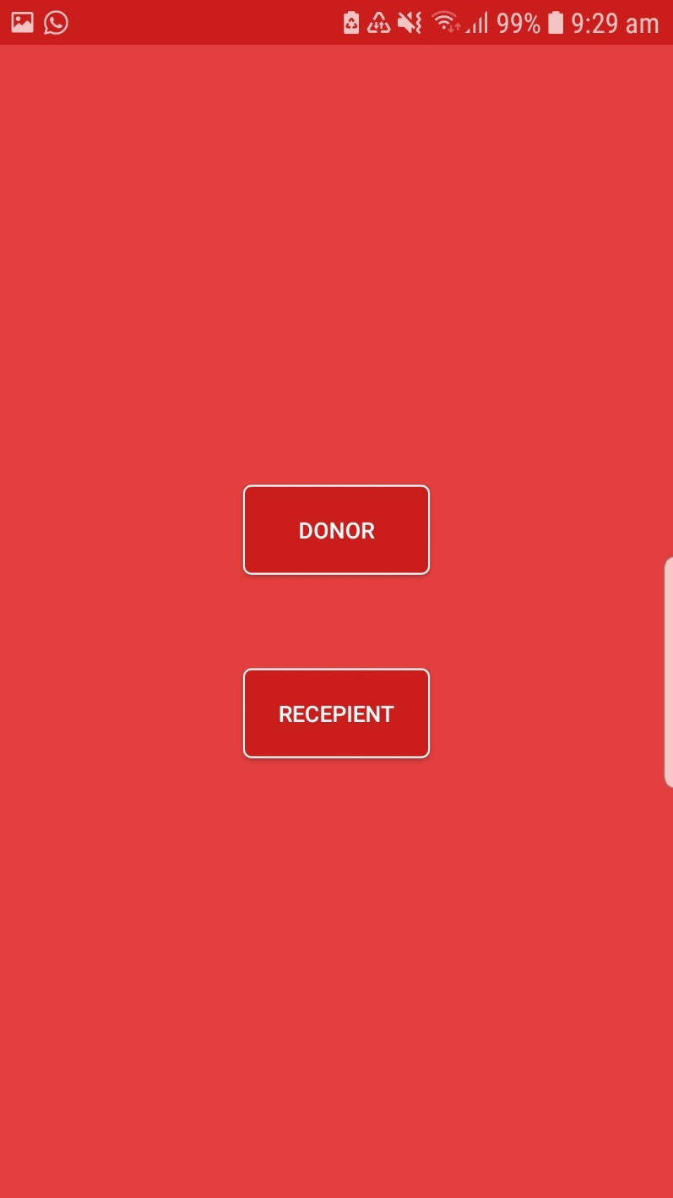
Figure 16 Selection of Donor/Recipient

This is the first interface comes up to your screen when you interact with the application. You can easily select the donor/recipient as you want to proceed further.

Registration at HSF Blood Foundation (Donor)

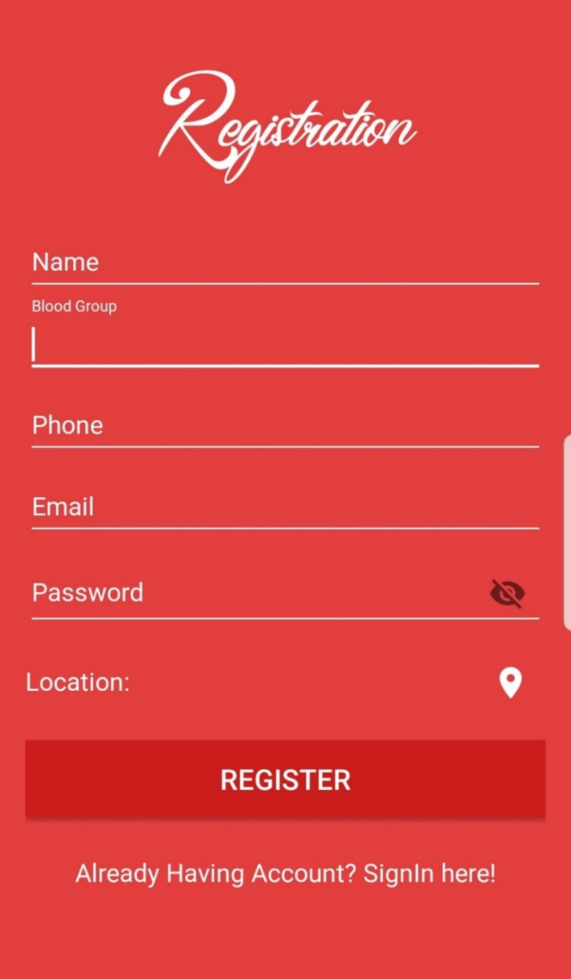
Figure 17 Registration at HSF Blood Foundation (Donor)

You can easily register as Donor by providing specific information on the registration page and click on register. Donor registration contains Username, Blood Group, Phone No., Email, Password and Location by enabling your GPS.

Registration at HSF Blood Foundation (Recipient)

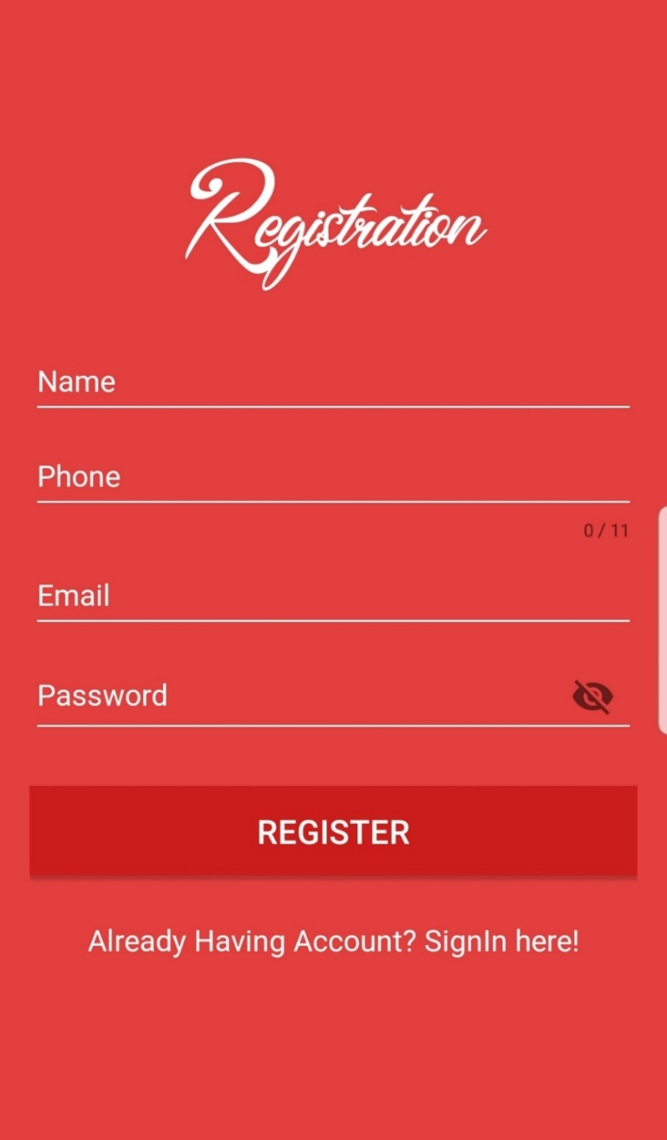
Figure 18 Registration at HSF Blood Foundation (Recipient)

You can easily register as Recipient by providing specific information on the registration page and click on register. Recipient registration contains Username, Phone No., Email and Password.

Login at Donor/Recipient

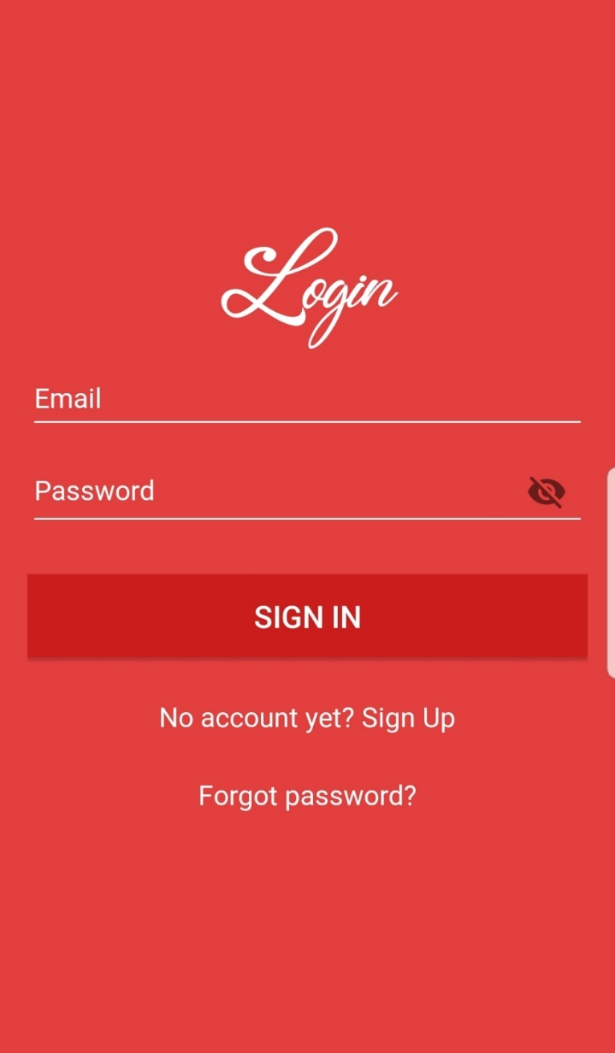
Figure 19 Login at Donor/Recipient

- First you have to select that you want to proceed as a Donor or as a Recipient from the start.
- After selecting Donor or Recipient you can simply login as Donor/Recipient.
- Login page contains the backend data of the Donor and Recipient.

Reset Password at Donor/Recipient

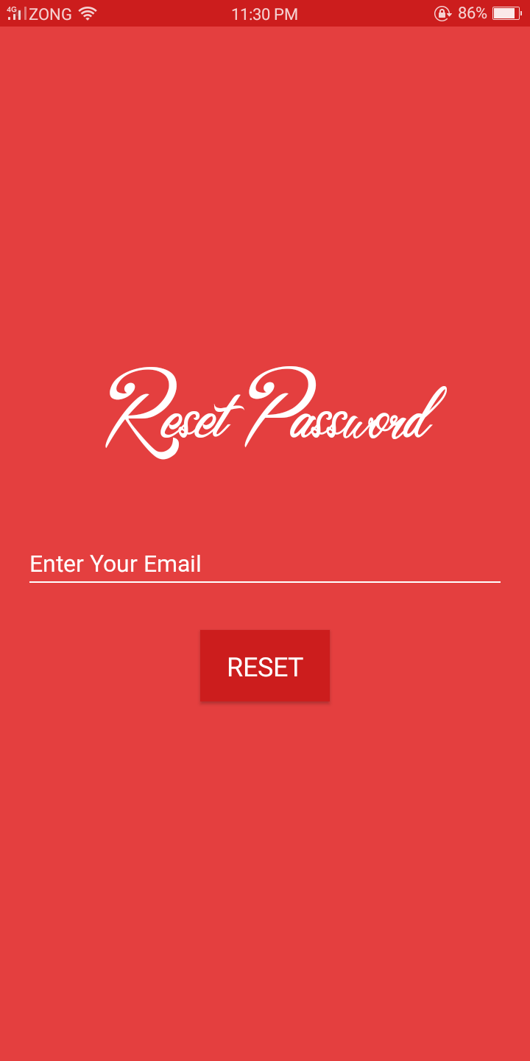
Figure 20 Reset Password at Donor/Recipient

- In case if you forgot your password, then First you have to select that you want to proceed as a Donor or as a Recipient from the start.
- After selecting Donor or Recipient you can simply provide your email to reset the password.
- We shall send you the link on the Email you provide us and there you can easily reset your password.

Donor Home Page

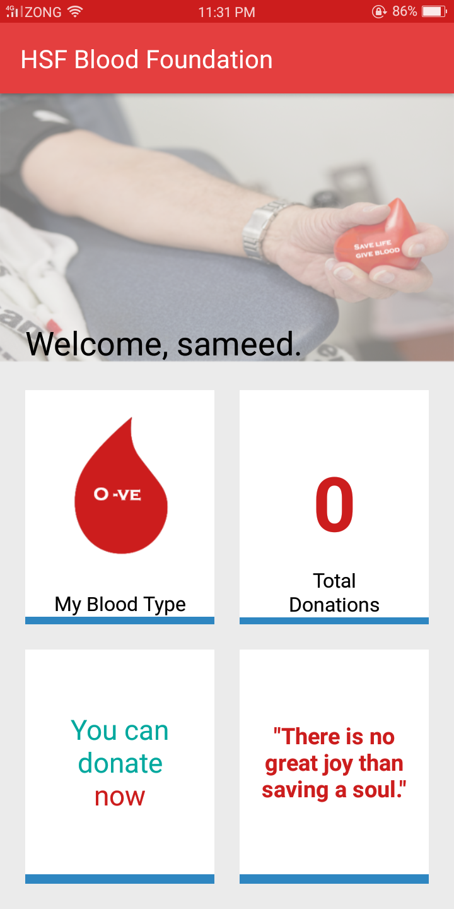
Figure 21 Donor Home Page

This is the Donor Home page. Here you can get the notification of Blood Donation requests by Recipient.
You can also accept/reject the requests.

Recipient Request Page

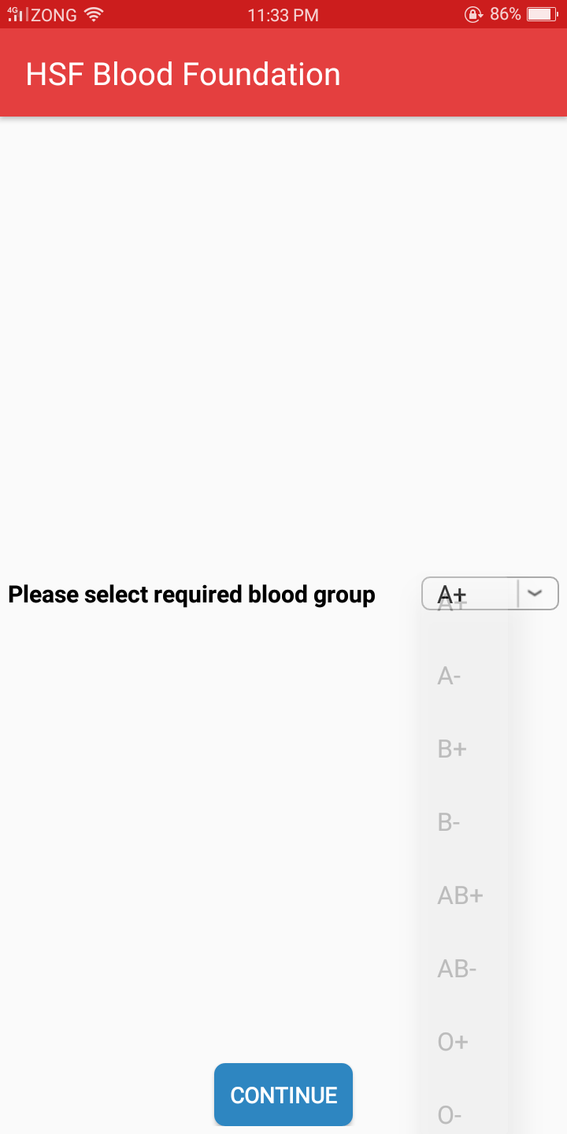
Figure 22 Recipient Request Page

- This is the Recipient Request Page.
- Recipient select the required Blood Group from here.
- After selecting Blood Group and pressing continue it will take you the maps page where you can select the nearest donor and request them.

Request Notification

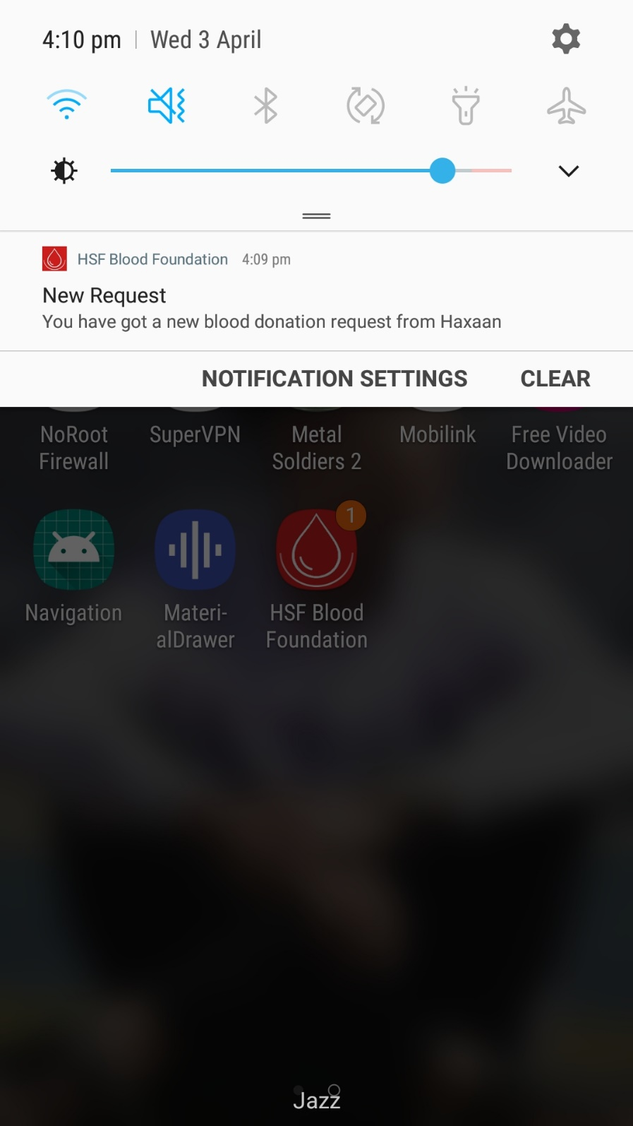
Figure 23 Request Notification

When donor gets a request it gets a notification alike.

Request Notification on Activity

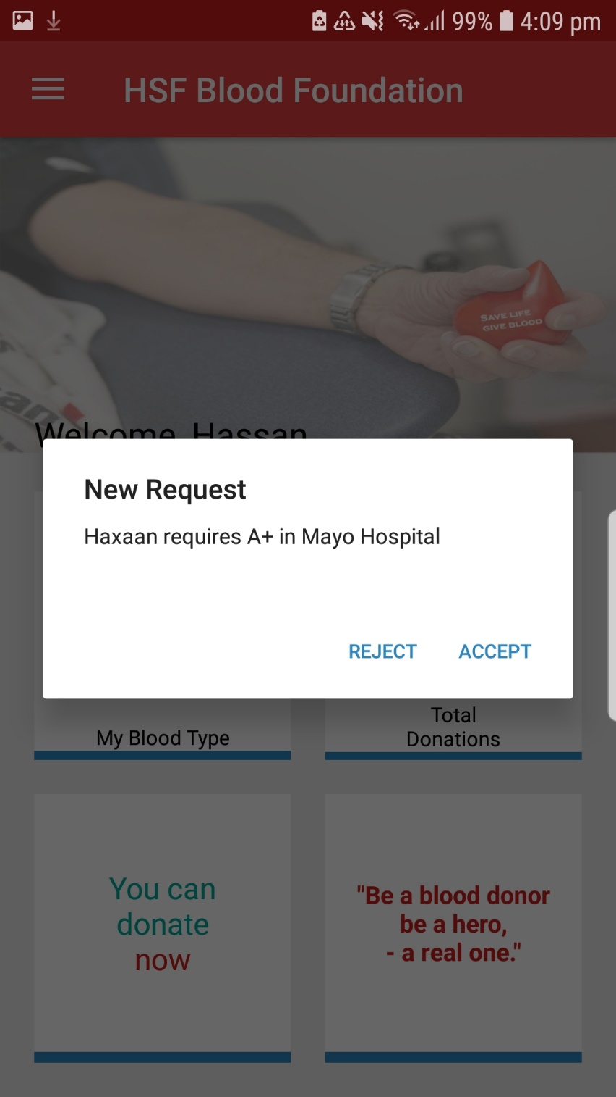
Figure 24 Notification on Activity

This is a notification on activity.

After Selecting Blood Group

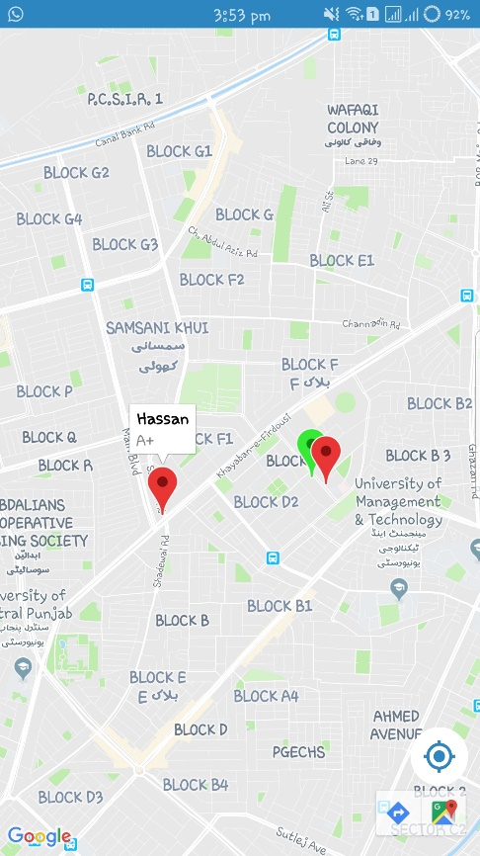
Figure 25 After Selection of Blood Group

This is the map page. Where you can select the nearest donor and request them to donate Blood.

Chat Room

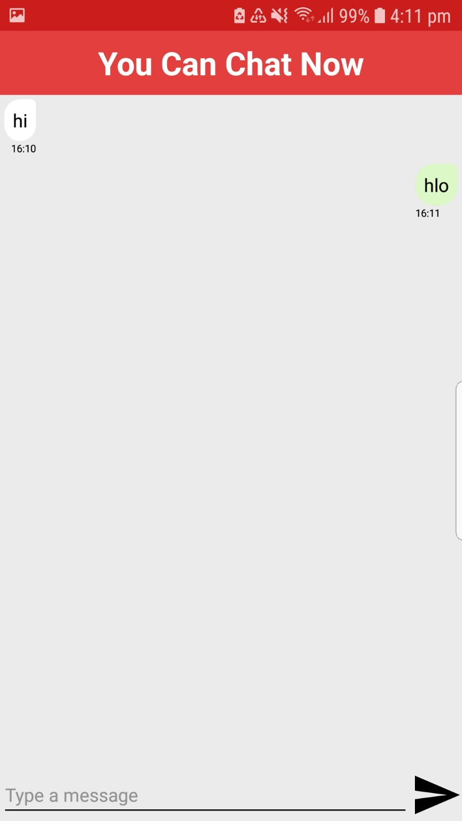
Figure 26 Chat Room

This is the chat room. Where Donor and Recipient can have conservations in order to reach the destination and donate blood.

Chat Notification

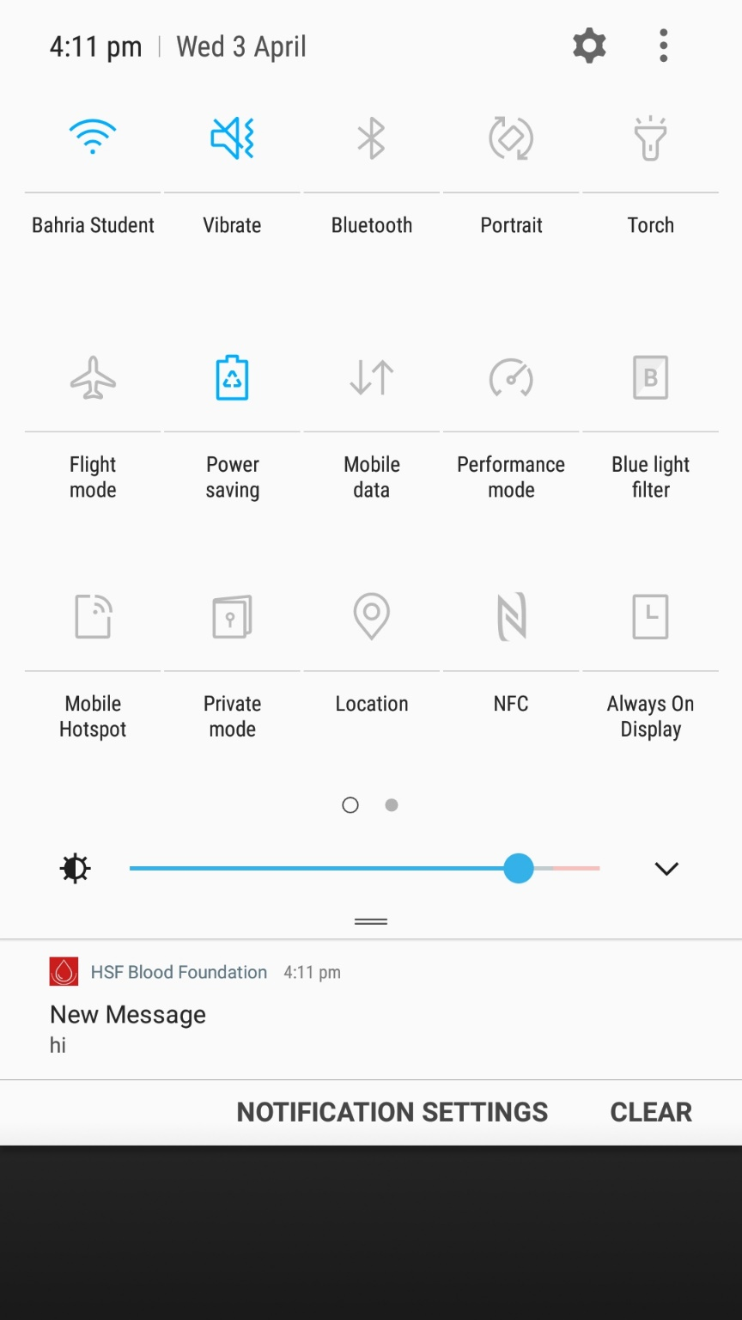
Figure 27 Chat Notification

This is message notification. When you build a connection with donor/recipient. Chat option enable in navigation drawer. When donor/recipient sends you a message, you get a notification alike.

Book a Ride

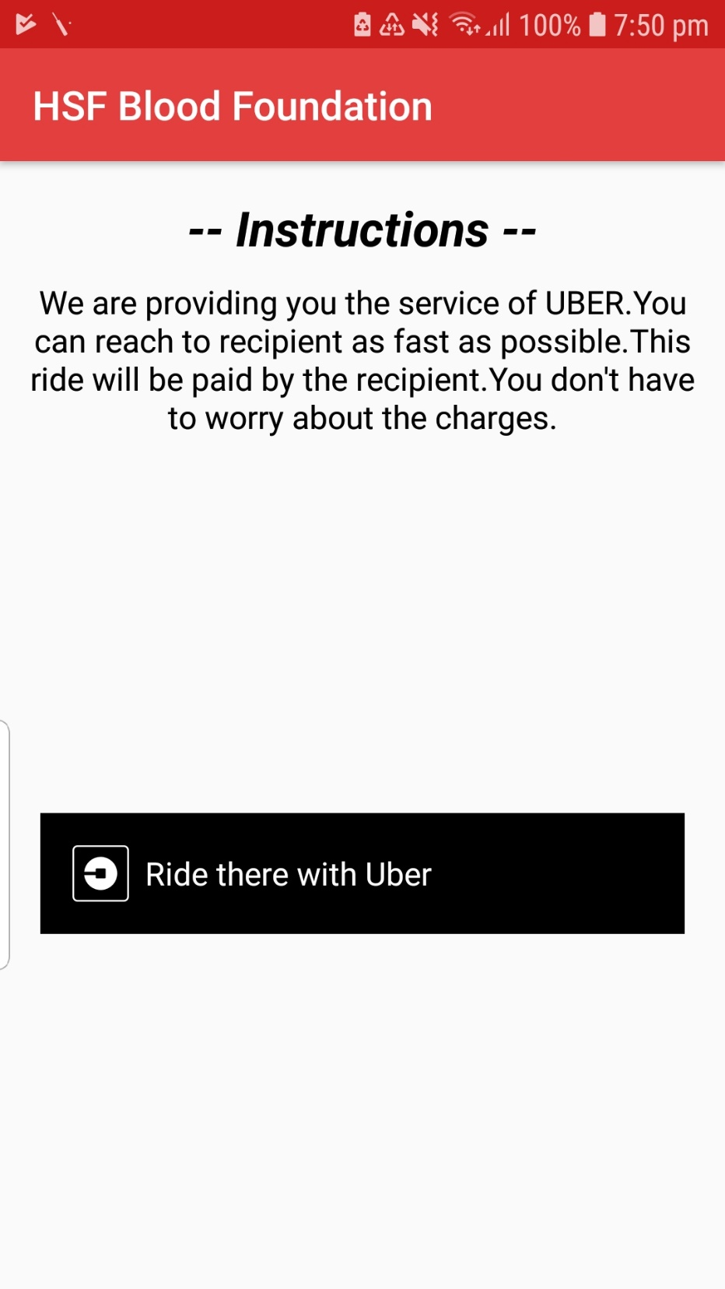
Figure 28 Book a Ride

Request after being accepted by the Donor. Recipient can book an UBER ride for a Donor from here in order to reach them at the hospital.

Update Profile

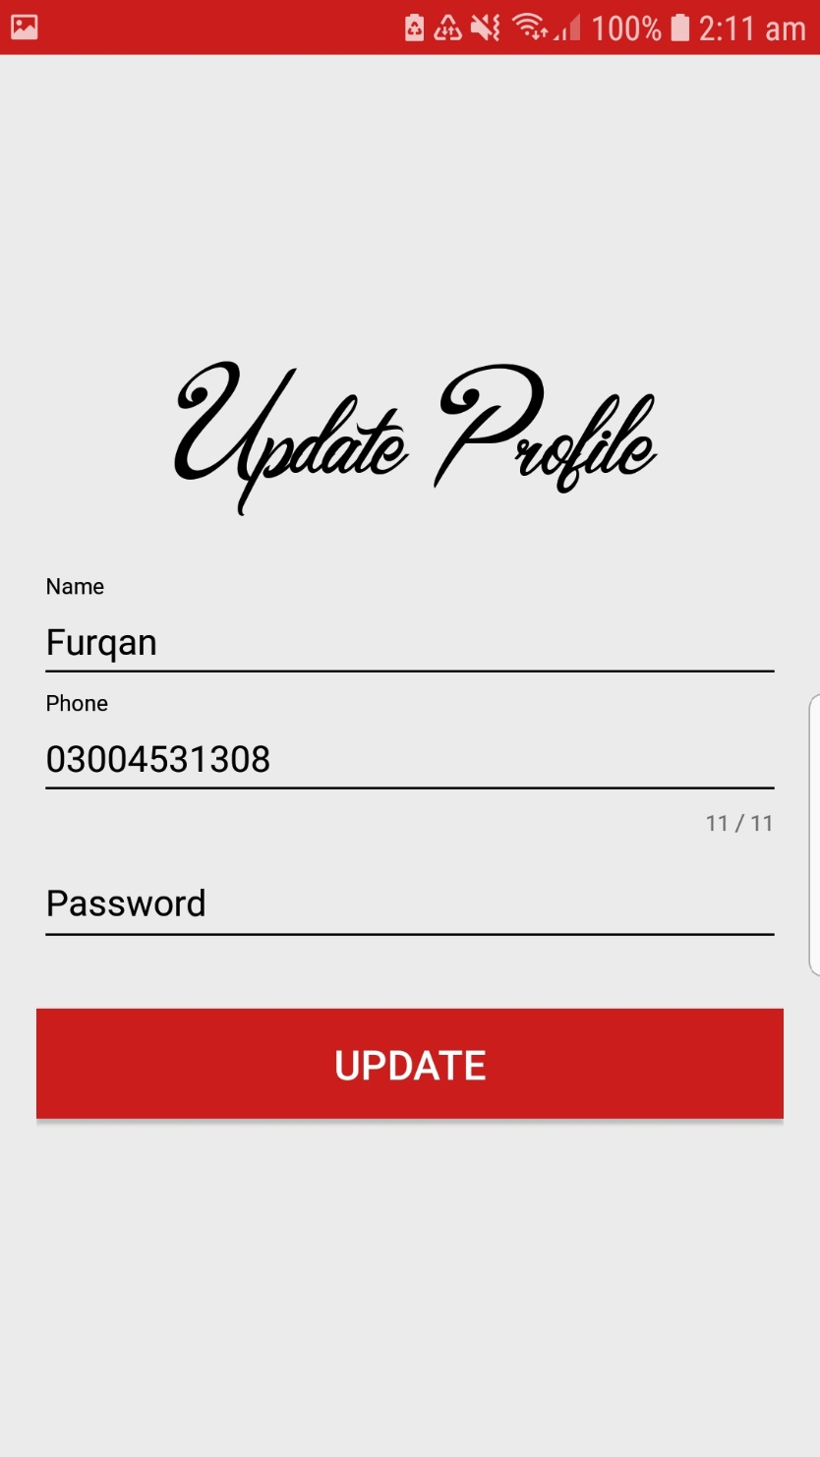
Figure 29 Update Profile

You can easily update your profile.

Settings Feature

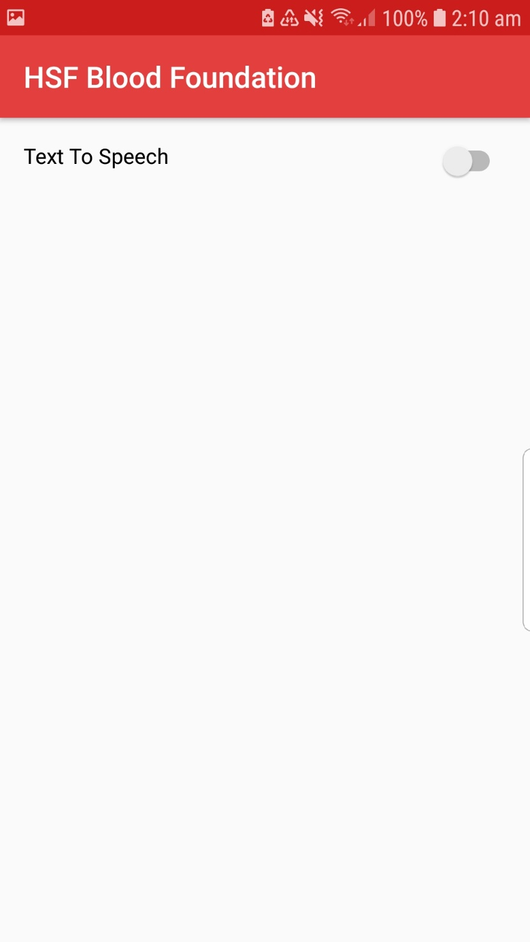
Figure 30 Settings Feature

We are providing the Text to Speech feature in settings option.

CONCLUSION AND RECOMMENDATIONS

Conclusion

HSF Blood Foundation focusing on usability goals, requirements and privacy for user. Recipients can easily get the required Blood on a single platform. Donors can easily reach the destination by using the UBER ride paid by the Recipient.
Donor and Recipient can communicate with each other and Recipients can request Donors to donate blood. We are making this System best for Donors and Recipients.

Recommendations

Due to difficulty in finding Blood we easily meet the Recipient requirements. It will help the Recipient to find Blood ASAP and also helps the Donor to reach the destination quickly by an UBER ride.
In the future, we shall expand this to more major cities. We can add some extra features to use further techniques that can be helpful for the use.

