

Subject: Dynamics of EPM & PMO Semester II

Project Name: Implementation of PMO for the Smart Monitoring of Development Projects across Punjab in Planning & Development Board of the Punjab, Pakistan

Submitted to: Mr. Tauseef Younis

Submitted By: Muhammad Yasir Younus (03-298181-060)
Agha Habib (03-298181-063)

Class: MSPM -2 Spring 2018 Session

Abstract

Over the last few years Project Management Offices have become quite relevant and desirable in the organizations which are facing uncertainties due to project complexities and organizational environmental conditions. Project Management Offices have justified their presence by causing an increase in project successes, standardization of project deliveries and introduction of predictability within the project as well as organizational frameworks.
In this report the implementation of Project Management Office was observed on a flagship project named “Smart Monitoring of Development Projects in Punjab” under the Public Sector Organization, “P&DD Government of Punjab”.
The methodology employed in this report is based upon conducting review of the organization, reviewing the literature related to the project and its associated subsidiaries, analysing the process flows, observance of the implementation of PMO through key metrics, measurement of value addition done by PMO and comparison of the prevalent and predecessor situations and scenarios.

table of contents

abstract ii
table of contents iii
acknowledgements vi
1 Organizational overview 1
Organizational organogram 2
2 Project Management Office 3
2.1 Definition 3
2.2 Characteristics 3
2.3 Need for PMO 3
2.4 Benefits of PMO 4
2.5 Value Addition by PMO 4
2.7 The process of value capturing 5
2.8 The process of delivering value 5
2.9 The process of measuring value 6
2.10 The process of communicating value 7
2.11 Roles of PMO 7
2.11.1 Supportive PMO 8
2.11.2 Controlling PMO 8
2.11.3 Directive PMO 8
2.12 Classification of PMO types 8
2.12.1 Hierarchical Classification 8
2.12.1.1 Business Unit PMO 9
2.12.1.2 Project PMO 9
2.12.1.3 Project Support PMO 9
2.12.1.4 Enterprise PMO 9
2.12.1.5 Center of Excellence 10
2.12.2 Functional Classification 10
2.12.2.1 The Activist PMO 10
2.12.2.2 The Delivery PMO 10
2.12.2.3 Compliance PMO 10
2.12.2.4 Centralized PMO 11
2.13 Proposed PMO for Organization in context 11
2.14 Problems Faced by Organization 11
Template Forms 12
3. Business Drivers 38
3.1 Business Drivers in Project Management 38
3.2 Identification of Business Drivers 38
3.3 Project Selection Criteria 38
3.4 Project Prioritization Criteria 39
4. Project Charter 40
5. Activity List (WBS) 61
6. Resource Sheet 99
REPORTS 101
Project Overview Report 101
Cost overview Report 102
Cost Status Report 103
Burndown Report 104
Resource Overview Report 105
Resource Status Report 106
Cash flow Report 107
Cost Overruns Report 108
Earned Value Report 109
Resource Cost Overview Report 110
Cost Details Report 111
Task Cost Overview 112
Critical Tasks Report 113
Milestone Report 116
S-Curve 117
Gantt chart & network diagram 118

Acknowledgements

We would like to express our sincerest and warmest thanks to our teacher, Mr. Tauseef Younis, for the guidance, support, patience, encouragement, motivation and advice during this course.
We would also like to express our profound gratification to our colleagues, teachers and class fellows for extending their help during this time.
Finally, we would like to convey utmost thankfulness to P&DD Government of Punjab, Bahria University Lahore Campus and all the relevant departments involved during the formulation of this report for their extreme cooperation and willingness to help us in achieving our objectives and providing us with the portals to do so.

- Organizational Overview

The Planning and Development Board, of the Government of Punjab, is the key entity for planning at provincial level. Main purpose of this organization is to systemize and observe the activities related to public sector development of the different government organizations of Punjab. This department also estimates the development budget of every year for the province and get it voted from assembly. This voted and approved budget is known as “The Medium Term Development Framework (MTDF)”. Therefore, the P&D Board is one of the main entity in the evolution of the socio-economic prospective of Punjab province.
The main obligation to this Board is to deliver, in addition of technical care and systemize the various government entities in their planning related accomplishments. It also serves as the agency for collaborating with foreign contributors in the province.
The major goals of P&D board are as follows:
- Valuation of the resources which include material as well as human in the Punjab
- Devising of extended and squat term plans
- Commendations about present economic environments and economic strategies and procedures
- Analysis of economic hitches for advice in the light of prevailing policies
- Systemization of all budget related events in province

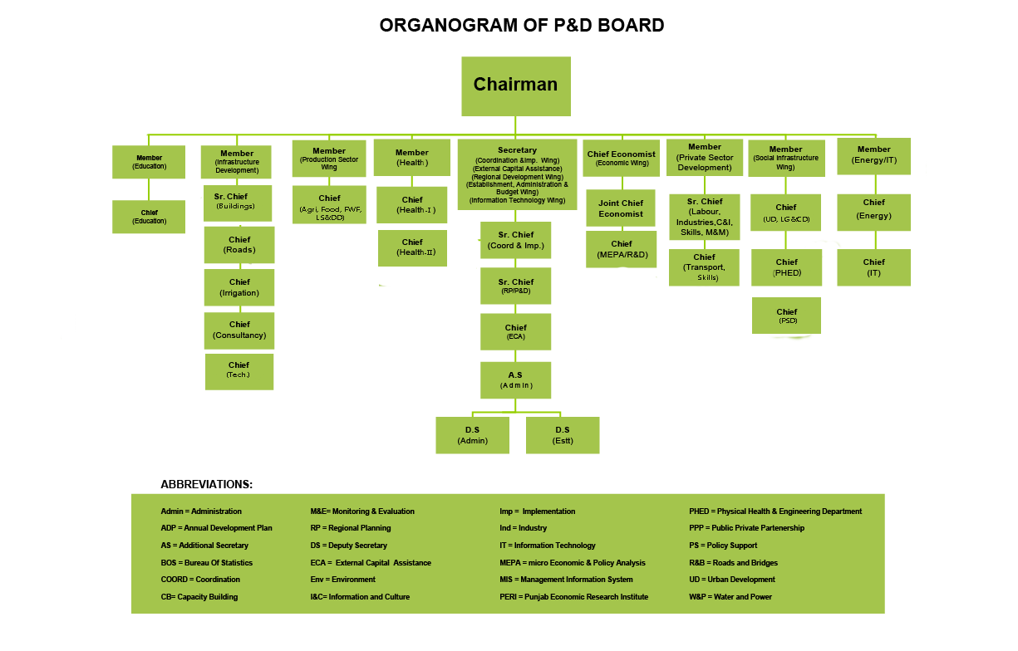

2. Project Management Office
2.1 Definition
A project management office is a setup, an establishment or a structure existing internally or externally within an organization that supervises the setting, maintenance and insurance of centralization and coordination of projects falling within its domain. It also serves as a central repository hub for the documentation, guidance and calibration of success metrics.
2.2 Characteristics
In order for the PMO to have a transformational effect on an organization’s functionality it must have the following characteristics:
- Consistency in practices.
- Transparency in functions.
- Flexibility in modes of operation.
- Communication skills in dealings.
- Agility in problem solving.
- Educational in teaching, training and knowledge dispersal.
2.3 Need for PMO
The need for the establishment of a PMO in any organization depends upon certain factors. Risk and size of the projects of that particular organization are the two key factors. If the prevailing project practices are detrimental or ineffectual to the business, then a PMO establishment can prove to be a valuable asset to the organization. In addition to that, there comes a certain point in the lifetime of an organization, when it gets to a size that despite a large number of talented people, it faces paralysis, its projects become lethargic and difficult to manage. This certain optimal point in an organizational lifetime when a PMO is needed varies according to the organization in question.
The ideal approach to determine when the establishment of PMO is required is to undertake a thorough analysis of operations and projects of a company and to check if different components of it work together in harmony across systems and groups. Furthermore, the implementation of significant projects or strategy changes within an organization also invites the establishment of PMO.

There is a need of PMO establishment when one or more of the following conditions exist:
- Organization is not working on relevant and business driving projects.
- Standard project delivery methodology is lacking in the organization.
- Visibility in project performance is limited.
- Lack of ownership/accountability exists.
- Projects fail to achieve the objectives.
- Need of coordination of resources from multiple departments.
- Projects are interdependent and are distributed over vast geography.
- Fast decisions are required in a dynamic environment.
- Need for creation of a knowledge base.
- Need for increase in transparency.
2.4 Benefits of PMO
Every organization is different, but the practice of project management yields benefits universally for the organizations whatever size they may have. Following are the benefits of establishing a PMO:
- Increase in Consistency of Efforts and Records by procedural maintenance.
- Accountability in terms of project goals, timeline, and deliverables.
- Nimble approach in decision making.
- Improved knowledge sharing.
- Better performance data analysis.
- Refined knowledge tapping.
- Up to date information on best practices.
- Revamped communications with stakeholders and vendors.
- Enhanced resource availability and management.
- Optimized efficiency.
2.5 Value Addition by PMO
In a highly complex and unpredictable environment, organizations yearn more for predictability with regards to project management. In line with the increasing awareness about Project Management worldwide, the formation of Project Management Offices in organizations has had an exponential growth over the last few years. The focus is based on measurement of the actual value added by such kind of structures in organizations.
PMOs can add value to organization’s functions in a lot of ways. This depends on a number of elements e.g. types of PMO, the diversity of offered services and its maturity.
2.6 The process of value creation:
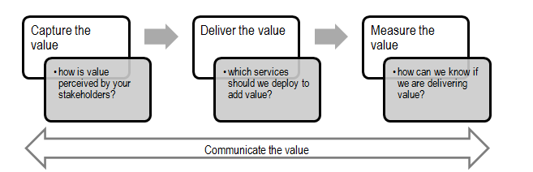
2.7 The process of value capturing
The term value is based on perception. The meaning of value for Senior Management can be very different from its meaning for Project Managers or the team of PMO. Similarly, the difference of perceptions regarding certain project factors can make the value is being delivered in reality but not being perceived. For this specific reason, it is very important that the PMO should inquire and understand the expectations of its key stakeholders and standardize their view of value. The PMO should actively engage the stakeholders, justify the cause of its existence, and should focus on creating a sense of ownership.
2.8 The process of delivering value
When the expectations of the organizations and stakeholders are met or exceeded, the phenomenon is called value deliverance. It should be however, kept in mind that the new PMO would not be able to deliver all kinds of value. The delivered value would be dependent on the maturity level of PMO as well as its type. The process of value addition increases with the maturity level of PMO, as it keeps on improving its services and introduces new services. The visibility and impact of the PMO also becomes higher with broadening of the scope. Value is unique and circumstantial to the context or particular organization. Furthermore, it should be kept in mind that all PMOs have limitations. Therefore, a step by step incremental approach, in line with the project management maturity level of PMO is of utmost importance.
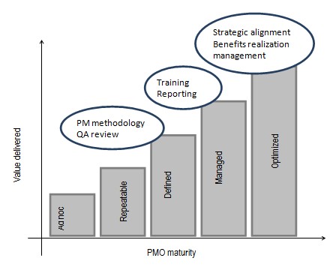
Certain project environmental factors like time spent on core business values vs on added-values, poor understanding of urgency and importance and lack of prioritization of projects resources may sometimes limit or restrict the process of creating value throughout projects. PMOs can play a central role to ensure that the organizations are making the best use of resources available and are focused on the projects that add value.
2.9 The process of measuring value
Improved performance in project delivery can only be shown through demonstration in practice. Defining, tracking, selecting and controlling a group of critical measurements, measuring the variance across the original state, current state, baseline, progress, aspirational state, and target is method to measure performance. These critical measurements are called key performance indicators (KPIs) and, as the name indicates, provide a suggestion of how successfully an individual / team / department / organization operates. After deciding upon the right KPIs for the relevant PMO, continuous monitoring and controlling should be ensured and appropriate actions should be applied where necessary. KPI’s can also be benchmarked against other organizations performance.
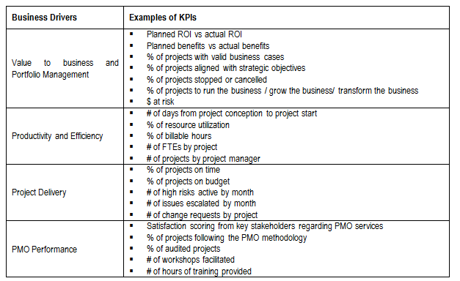
2.10 The process of communicating value
Communicating the value to stakeholders holds as much importance as defining the value itself. The miscommunication is generally the main reason for the challenges faced in justifying the creation of PMO. In order to build reliability, trust, and accountability and to maintain the momentum and continuously depict their value, PMOs have to market themselves. This includes reporting from time to time on the KPIs progress related to project performance, PMO effectiveness, establishing checkpoints within the PMO Sponsor, and advertising the PMO’s achievements. Communicating the value not only justifies why PMO is critical to business, but also helps sustainability as a recognized source and enabler of value.
2.11 Roles of PMO
Project Management Office serves three roles in organizations generally. These roles differ in the way how the influence and control is exerted on projects within a certain organization.
The best type depends upon the culture, environment, strategic goals, alignment and precedents of what’s applicable and prevalent in a particular organization.
Following are the types of PMO:

2.11.1 Supportive PMO
The Supportive PMO delivers on-demand assistance upon prompting in the manifestation of benchmarks, standards, documentation, templates, and knowledge access. Such a PMO is contrived in a setup where projects are executed with a loose control and authority successfully and where extra control is not needed. Supportive PMOs are consultative in nature. They are also implemented in organizations which are in need of data repositories. One of its main characteristics is that it follows unified standards in all projects.
2.11.2 Controlling PMO
In establishments which exert a moderated control to influence the day to day affairs of the projects, project processes, tasks, procedures and documentation, a controlling PMO is implemented. In such a PMO, the organization provides support, but it also makes sure the imposition of that support in the relevant projects. Controlling PMO’s make sure that specific methodologies are adopted, standardized forms are used, templates are adhered to, governance is compiled to, and PMO controlled sets of rules is applied. Controlling PMO also makes sure that the projects being supervised pass periodic reviews.
2.11.3 Directive PMO
This type of PMO goes one step further than controlling and exerts control over the projects by taking over in as well as managing the projects by provision of advice related to best practice models, project management experience and resources. In such an approach experienced project managers belonging to the PMO are usually allocated to the projects which are being done by the organization. This introduces enhanced professionalism to the projects under guidance. The project manager report in turn to the directive PMO about their respective projects and in this way a high level of consistency is guaranteed and practiced in all the projects. This type of PMO is effectual in larger organizations which dole out assistance in multiple areas, and where the culture allows such kind of establishment.
2.12 Classification of PMO types
2.12.1 Hierarchical Classification
Following is the hierarchical classification of PMOs. In any organization there could be either of these types of PMOs or a hybrid of two or more types.

2.12.1.1 Business Unit PMO
Business unit PMO imparts all the services that a regular PMO imparts, but these are generally limited to one unit or division. Given the tremendous variety of deliverables and project types, project managers in a business PMO apply skills at a particular level without knowledge of higher level.
2.12.1.2 Project PMO
Enormous projects require a dedicated PMO of their own. This is usually a non-permanent establishment which is filled with manpower from the main PMO of the organization. Its purpose is to deliver project governance, report coordination, serve as the connection to the high level PMO, and facilitate provision of administrative support and gathering of other relevant data.
2.12.1.3 Project Support PMO
This type of PMO focuses on the functionality and output. They serve as the preservers of procedures and processes. They use the tools and techniques and also offer trainings on practices and processes. They have a repository of a large number of templates and consist of specialists in project management soft wares and coordination tools between the departments.
Such a PMO is driven mainly by governance. Their foremost aim is to support managers in compliance of corporate standards. Project support PMOs appear where project management maturity is low.
2.12.1.4 Enterprise PMO
Enterprise PMO is the uppermost hierarchy level PMO. In organizational hierarchy it is found just below the C-level often reporting to Board of Directors and CEOs. The main purpose of a PMO at enterprise level is strategic alignment. Such PMOs can resolve prioritization issues, depending upon the organization’s strategy and vision.
Enterprise PMO also makes sure governance across whole of the enterprise. It can work at upper hierarchy levels than PMOs existing at lower level in the organization’s hierarchy. It also has an enhanced focus on maximization of benefits and effective management. This kind of Project Management Offices has a very high level of involvement in strategy formulation, prioritization of projects and alignment with strategic direction than any of the other PMO types.

2.12.1.5 Center of Excellence (COE)
This type of PMO follows an approach in which the project work is done by enhancement in the proficiencies and capabilities of the people assigned to the tasks. It consists of a lot of support services, maintaining a repository of project management templates, registers and textbooks and conducting trainings. The COE also serves as the protector and repository of the methodologies. The objectives of a COE include capability enhancement of the organization. It also includes the management of standards, communication skills, soft skills, interpersonal skills and standards. It also does promotion of good practices, facilitate knowledge sharing in the organization and collate and manage lessons learned.
2.12.2 Functional Classification
2.12.2.1 The Activist PMO
Such types of PMOs are favored in establishments with dispersed, pivotal ownership of the projects. These PMOs consider a wholesome view and follow an empowering approach in contradiction to a supervising approach. Such PMOs might provide overview or suggest remedies for critical dashboard developments
2.12.2.2 The Delivery PMO
The project delivery is the most commonly found style among PMO types. In such PMOs project managers are encouraged to manage their projects in an active manner, proactively take decisions and escalate issues, risks and problems. The goal for such a PMO is also to build repeatable processes and techniques that will work to build a culture focused on results.
2.12.2.3 Compliance PMO
Compliance PMO an ideal style of PMO for establishments where project dynamics, documentation and frameworks lack in maturity and are not consistent. In such kind of situations, the compliance PMO has the responsibilities for reinforcement of standard practices for measurement related to project dynamics such as project performance and the development of capabilities for key initiatives.
2.12.2.4 Centralized PMO
Centralized PMO is established to be a center at which fresh human resource can be trained in a short duration to the optimum level to get acquainted with projects of an organization in a speedy manner. In such a PMO, members from respective organizations which support the project gather to discuss their experiences in a council like meeting.
2.13 Proposed PMO for Organization in context
Planning & Development Department itself acts as a directive PMO for projects of Provincial Government of Punjab. However, due to prevailing delayed status and criticality of this flagship project a separate cell has been created as a cascaded PMO for management of this project which is controlling in nature as far as the role of the PMO is concerned.
2.14 Problems Faced by Organization in context in absence of PMO
Following are the hurdles experienced by the organizations when there is an absence of PMO:
- Inconsistency of Efforts and Records.
- Lack of accountability.
- Lethargic decision making.
- Limited knowledge sharing.
- Incomplete data analysis.
- Partial knowledge tapping.
- Outdated information.
- Sluggish communications with stakeholders and vendors.
- Reduced resource availability and management.
- Stunted efficiency.

Templates to be used in Project Lifecycle
PC-I Form
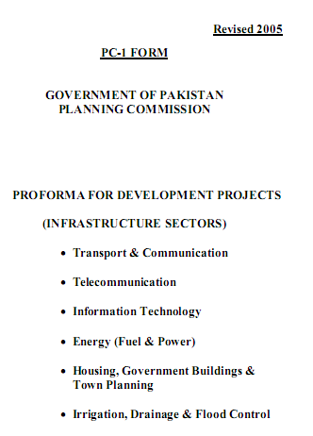
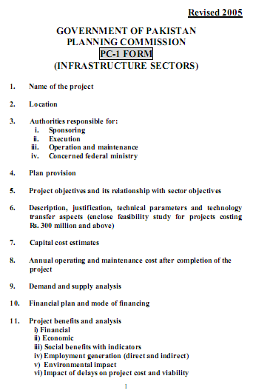
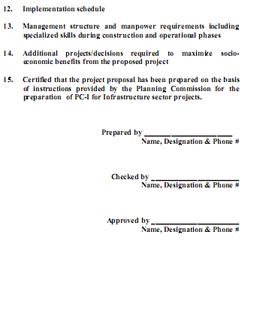

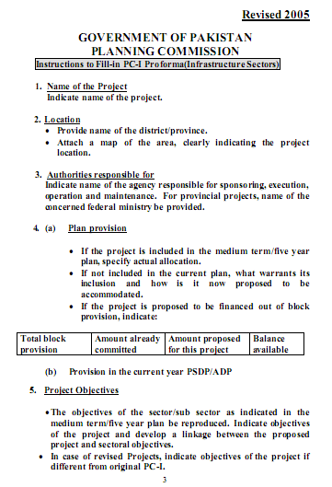

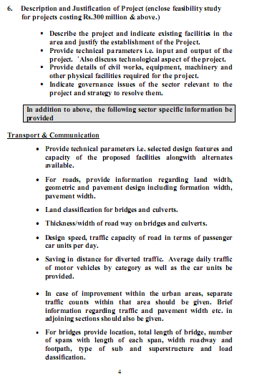
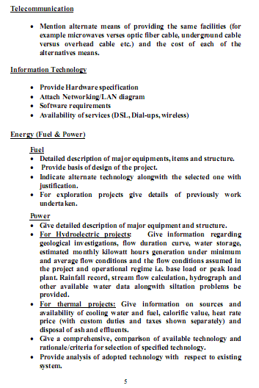
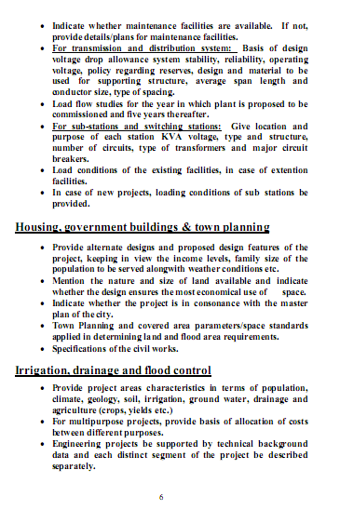
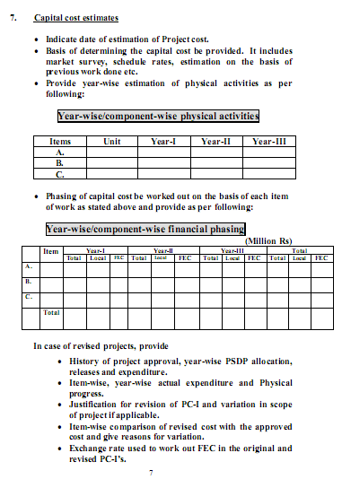
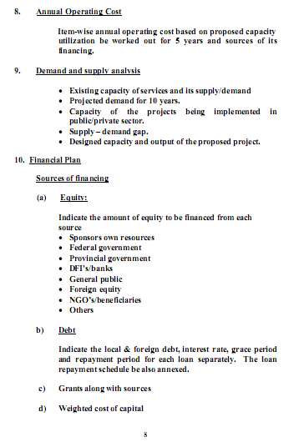
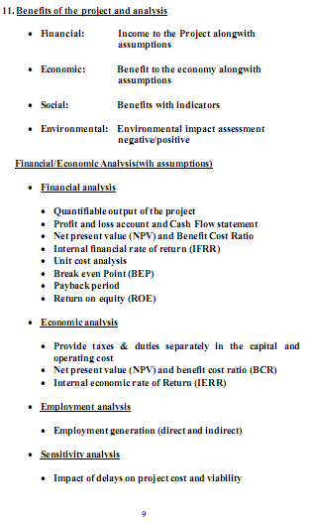
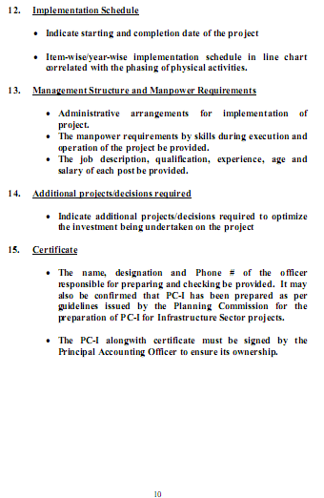
PC-II Form
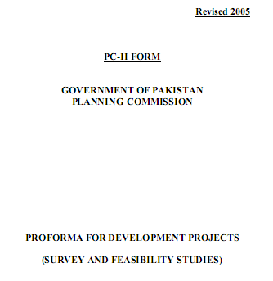

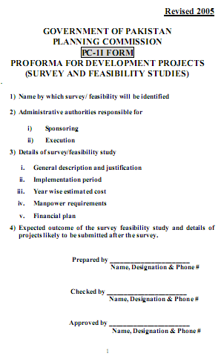
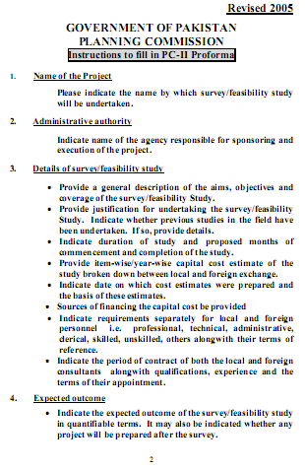
PC-III Form

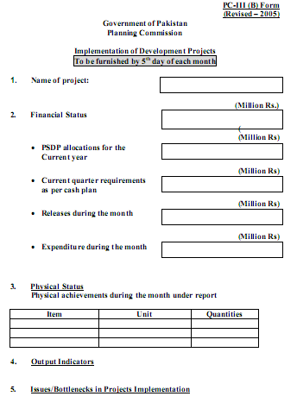
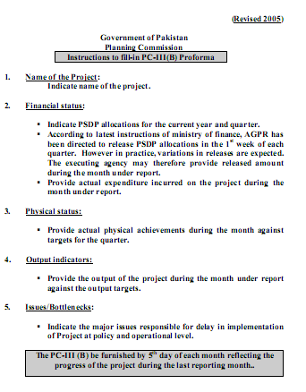

PC-IV Form
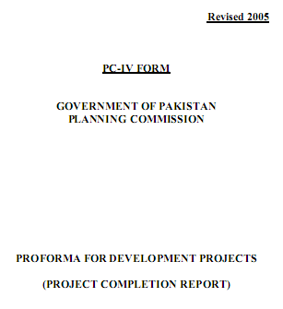

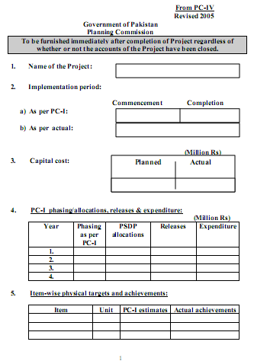
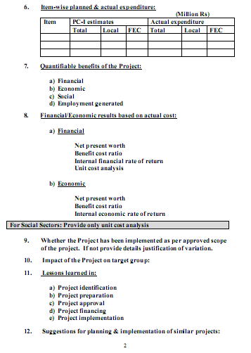
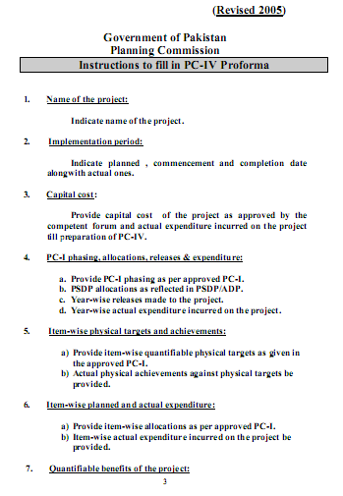
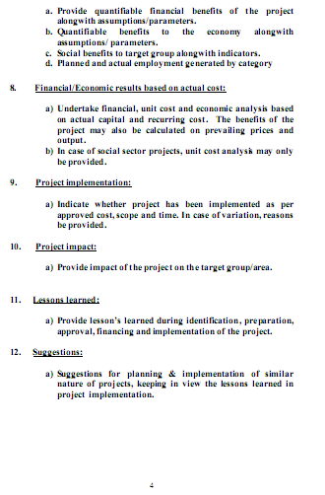
PC-V Form
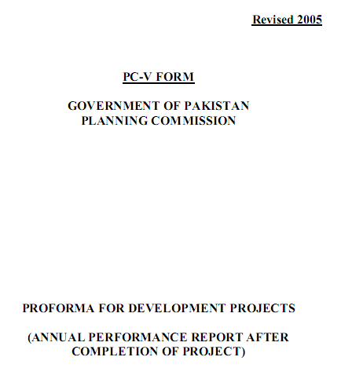


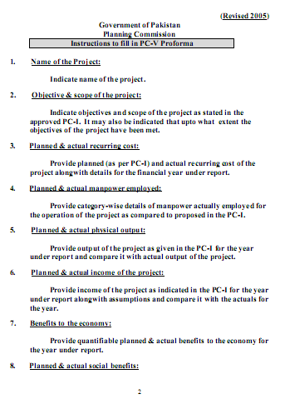
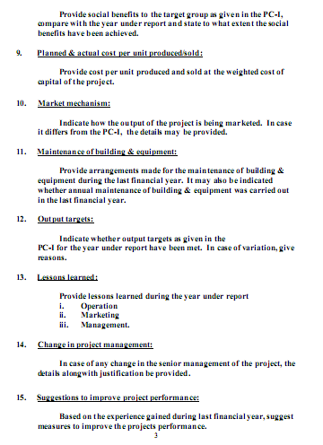

3. Business Drivers
Project management is a practically oriented process which is based on efficient decision making. This impacts the right decision process from the point of view of change in business strategy. Decision makers involved in such practice analyze and investigate prevalent conditions, track the impediments & reorient business directions to align with rational project management conventions.

3.1 Business Drivers in Project Management
Business drivers are the critical factors at the back end of the successful project development. Based on the cumulative utility of these factors, the problems, the needs and the respective possible solutions can be charted out. The business case can then be developed keeping the sustainability in view.
Business driver can be defined as basic rationale for developing a new project from a financial and justification perspective. It explains the need of the project and what tentative solution will be offered by the project upon its successful completion.

3.2 Identification of Business Drivers
Appropriate business drivers are necessary for the success and growth of the projects in continuity. The first step is to identify each business driver and the next step is to capitalize upon the ones any that fall under direct control.
The core characteristics of business drivers are:
- Relevant to the performance of the business
- Related to objectives of the business
- Specific and measurable/quantifiable.
The primary function of business drivers is to help move in the direction of your business objectives.
3.3 Project Selection Criteria
Project selection is done on the basis of the following criteria:
- Strategic Alignment
- Focused Areas
- Target Groups
- Locality Context
- Legal Status
- Internal Policies
- Context Analysis
- Stakeholder Priorities
- Funding
- Organizational Capabilities
- Project Size
- Resources
- Time
- Political relevance
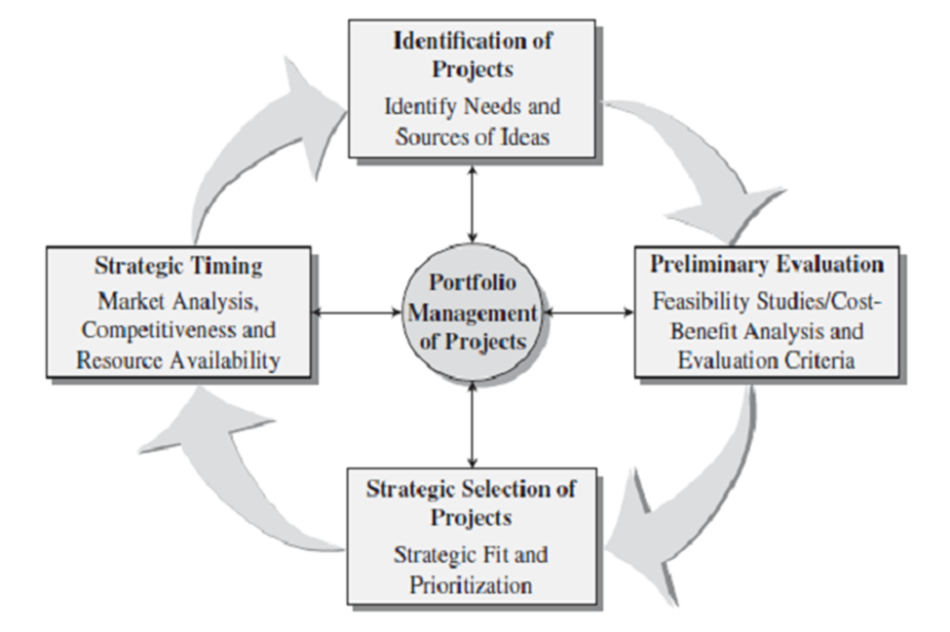
3.4 Project Prioritization Criteria
Project Prioritization is done according to the following criteria:
- Context Analysis
- Stakeholder Priorities
- Funding
- Project Goals
- Resources
- Prestige
- Policy Relevance

4. Project Charter

1. Name of the Project
Smart Monitoring of Development Projects across Punjab
2. Location
All districts of Punjab
3. Authorities Responsible For:
- Sponsoring: Planning and Development Department, Government of Punjab
- Execution: Punjab Information Technology Board (PITB)
Operations and Maintenance:
- Planning and Development Department, Government of Punjab
- Punjab Information Technology Board (PITB)
iv. Concerned Federal Ministry: N/A
4. Plan Provision
- If the project is included in the Medium Term / Five Years Plan, specify actual allocation:
The scheme was included in Provincial ADP 2014-15 against the GSNo 2434 with allocation of Rs. 10 million under IT & Governance Sector. Then the same scheme was reflected as On-Going Scheme in Provincial ADPs 2015-16 (with GSNo 2434), 2016-17 (with GSNo 4647), 2017-18 (with GSNo 9216) and 2018-19 (with GSNo 6834)
- If not included in the current plan, what warrants its inclusion and how is it now proposed to be accommodated:
The scheme is funded through provincial ADPs 2014-15, 2015-16, 2016-17, 2017-18 and 2018-19
If the Project is proposed to be financed out of block provision, indicate:
Total Block  Provision | Amount  Already  Committed | Amount Proposed  for this Project | Balance  Available
N/A | N/A | N/A | N/A

III. Provision in the current PSDP / ADP:
The scheme is funded through provincial ADPs 2014-15, 2015-16, 2016-17, 2017-18 and 2018-19.

Project Overview
Development is an agent of change. It is development that sets the tone for economic growth. Importance of a well-conceived development agenda cannot be over-emphasized. However, development initiatives must be prudently conceived and critically scrutinized to make every penny count. In developing countries like Pakistan, where development funds have to be squeezed out of enormous non-development expenditures, the need for proper conception and efficient implementation/ execution becomes even more vital. Therefore, it is rightly said that channelizing development funds into public sector development projects is a double-edged sword. Public sector development projects, if properly implemented, are laden with huge socio-economic dividends. On the other hand, unsuccessful public initiatives drain scarce public funds. Though each stage of Project Life Cycle is important, execution intrinsically complemented with vigilant supervision/ monitoring is a guarantee for successful implementation of a project.

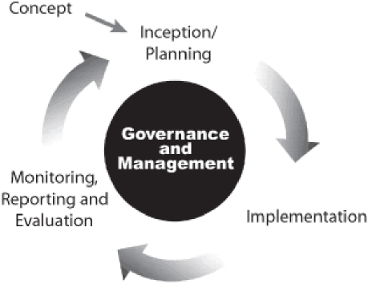
Advancement in Information Technology, especially in domain of project management, has equipped managers and governments to reap the best out of their initiatives. Advanced project management tools are used to keep projects on track and minutely observe their progress. These management tools are critically important for governments, which have to keep track of numerous development projects simultaneously. A central system can be set up which can track real time progress of all projects.

It is in this backdrop that this project titled ‘Smart Monitoring of Development Projects across Punjab’ is conceived. Overall aim of the project is to develop a web based system for tracking progress of projects reflected in Annual Development Program. This project will go a long way in increasing efficiency and efficacy of public sector development projects of the Government of Punjab. It is conceived to bridge the information gaps during:

Planning of the Project
Preparation of PC-I is a tedious task which often requires activities like surveys, feasibility studies, costing, technical methodologies, and deliberation and communication by the decision makers. The details of the PC-I become very important as a result as it is a reference document which is used to execute, monitor and evaluate the project. Any planning as well as communication gaps which are not addressed at this stage may result unfulfilled project goals. Through this Smart Monitoring System a history of projects will be maintained and available to the planners for reference. The successful methodologies and models could be replicated as the information could be disseminated through an easy-to-access web portal. Similarly the scrutiny of new projects would become easier as the completed projects of matching nature could be referenced to make decision and take corrective actions at planning stage.
- Execution of the Project
Execution of the project is a phase in the project lifecycle where corrective actions must be taken very quickly in order to achieve the objectives within given timelines. However, in paper-based environment where snail mail is used as a means of communication, stakeholders are often not on the same page when it comes to understanding the needs of the project. The most critical factor during execution of a project is timely availability and utilization of funds. However, it is observed that departments have often different financial status (release of funds, utilization, surrender etc.) at project level. This not only hampers the smooth execution of project but often results in unutilized/lapsed funds. As a result the project milestones also suffer delays and make it difficult to successfully complete the project within planned/approved resources. The Smart Monitoring System will not only help the stakeholders by bridging these information gaps through a centralized online funds management portal but also pinpoint the delays, thus, making it possible to take timely corrective actions. The system will also generate alerts to remind different stakeholders of pending tasks.
- Monitoring of the Project
Monitoring of the development projects is as important as the execution of the projects as it ensures all the objectives of the projects are met qualitatively as well as quantitatively. Modern information technology tools make efficient monitoring of the projects possible through customized information systems. Smart Monitoring System also aims at providing financial management information system of development projects to its stakeholders. The system will not only record the financial phasing of each and every project but also the milestone fiscal phasing. Alerts will be generated and progress reports on monthly basis will be collected online. This will not only make the progress reviews easier but will help identify the delays and bridge the information gaps between the departments. Timely corrective actions will not only lead to better chances of success for individual projects but also to achieve efficient implementation of Annual Development Program leading to meet Medium-Term Development Framework goals.
- Evaluation of the Project
Objective evaluation of the project is important in creating a history of lessons learnt for future development projects. However, it is possible only when accurate information is easily available for evaluation. The Smart Monitoring System through its comprehensive databases will maintain complete lifecycle of development projects starting from Planning till execution and completion of projects. Therefore, accurate evidential data will be available to objectively evaluate the project and report what went in favor of the project and what went against the project thus leading to meaningful lessons and recommendations for future projects to all stakeholders.
The Smart Monitoring System will, therefore, bring in more transparency and, hence, the efficiency in implementation of Medium-Term Development Framework (3 years’ development program) along with Annual Development Program. The system will enable the management not only to make evidence-based decisions at highest level but to micro-manage the minutest details. These decisions may be at macro level like diverting funds from one sector to another sector or at micro level like removing the bottlenecks to kick-start an individual project in a remote area of Punjab. The system will provide year-wise comparisons for analysis at sector level, department level, division level and district level. It will also provide dashboards to highlight allocations, releases and utilization by different departments so that effective monitoring may lead to meaningful decisions and corrective actions.

A schematic diagram of the envisaged system is shown below:
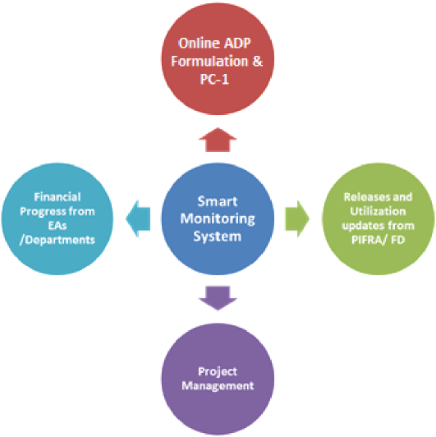
5. Project Objectives and Its Relationship with Other Sector Objectives
The project envisages the following objectives:
- Establishment of web based Smart Monitoring System for:
  - Formulation of Medium Term Development Framework (three years’ program) along with Annual Development Program (ADP):
    - Online preparation in co-ordination with all Administrative Departments of the Government of the Punjab
- Online submission, scrutiny and review of draft ADPs
- Centralized database of information so that all stakeholders are on same page without any information gaps
  - Funds Release Management including Supplementary Demands
  - Computerization of PC-I and PC-II documents as per templates devised by Planning Commission of Pakistan
  - Online submission of PC-III / Monthly Progress Report where the financial progress of each and every development project is entered at the detailed level of spending (PIFRA Chart of Accounts Level 5)
  - Computerization of PC-IV and PC-V
  - Monitoring Dashboards with sector-wise, division-wise, district-wise and year-wise info graphics.
  - Robust IT infrastructure for hosting of web-based system (primary and disaster recovery sites) along with highly secure and robust databases
  - Comprehensive trainings of focal persons nominated by different stakeholders based on Train the Trainer concept
- Capacity building of the P&DD through IT equipment and human resource.

6. Description and Justification of the Project:

Development initiatives can either be a boon or a bane depending upon implementation. If properly conceived projects are implemented as per plan then there are fair chances that the project will bore fruits. However, if projects are not implemented as per plan then projects are bound to fail. It is for this reason that acute vigilance and supervision is necessary during execution of the project. This exercise is simply referred to as Monitoring. At the program level, the purpose of monitoring is to track implementation and outputs systematically, and measure the effectiveness of program. It helps determine exactly when a program is on track and when changes may be needed. Monitoring forms the basis for modification of interventions and assessing the quality of activities being conducted. It is essential in helping managers, planners, implementers, policy makers and donors acquire the information and understanding they need to make informed decisions about program operations. It provides necessary data to guide strategic planning, to design and implement program and projects, to allocate and re-allocate resources efficiently.
Various studies have been carried out across the world to check effectiveness and importance of monitoring public sector development projects. In an international study titled “Evaluation for Greater Development Effectiveness” by Vinod Thomas (Director General, Independent Evaluation Group), the effect of varying degrees of monitoring and evaluation on success of project was checked. Four levels of M&E i.e. High, Substantial, Modest and Negligible tested against six results of projects i.e. Highly Satisfactory, Satisfactory, Moderately Satisfactory, Moderately Unsatisfactory, Unsatisfactory and Highly Unsatisfactory. The study concluded that as the degree of monitoring and evaluation increases, there is increase in success rate of World Bank financed development projects. The results are shown in the figure below:
Figure: Effect of M&E on Results of World Bank Financed Projects (2007-2009)
Various problems hamper successful project implementation and lead to failure of projects. Issues mar projects even in the developed countries, let alone a developing country like Pakistan due to communication gaps between the stakeholders at various stages of project lifecycle. Consequently, success rate of projects is not up to the mark. In many cases projects are not completed in planned gestation period and cost. Thus, projects are revised time and again. This results in drain of public funds.
The need for a web based monitoring system, which can be used to acutely monitor progress as well as plug coordination gaps between stakeholders of projects included in the ADP, is ever more important. Therefore, the Planning & Development department intends to launch the smart monitoring system project in order to use advanced information technological tools for monitoring implementation/ progress of each development initiative in the province and for ironing out communication and coordination gaps among development stakeholders. Moreover, the project will help in streamlining budgeting, allocation, releases, supplementary requests and utilization of development funds.
The line departments share monthly progress report on scheme wise basis with the P&D Department. P&D Department has a web-based system where basic information about each and every scheme is available. Currently the release information by P&D and Finance department is entered into the system. Similarly the utilization of the funds by the executing agency is also entered into the system at the end of every month. Some of the issues of the system are as follows:
- No real time update on progress of project implementation
- Gap of information about release of funds between P&D, Finance Department, Executing Agencies and PIFRA
- Progress reports are shared by the line departments in the form of hard copy and then entered into the system in P&D Department which may leads to error
- Gap in the release of funds information between different stakeholders
- Intermediary interventions at every stage because of paper-based processes which introduces not only delays but human errors
Project will ensure monitoring of Government funds across Punjab. These activities will reflect the current stage of development in a web-based application accessible through Internet from anywhere. Smart monitoring application for submitting field reports will be developed which will further be associated with custom built dashboard for reviewing reports against the subject activity aiding to a precise outlook of the progress work being carried out.

Smart Financial Monitoring System

Background
The Planning and Development Department, Government of Punjab, is the principal planning organization at the provincial level. It coordinates and monitors development programs and activities of various departments of the provincial government.
The department also prepares an overall Annual Development Program (ADP) of developmental activities in the province. The ADP lays down the developmental activities to be carried out in the province in various sectors of the provincial economy. In this manner, the Planning & Development Department is one of the main actors in the growth of the economic potential of the province.

Prerequisites for Monitoring
The presence of a concrete project plan in the PC-I of projects, listing down the milestones is therefore a necessity for the Planning and Development Department, for active monitoring and control. Without inclusion of a well-defined project in the PC-I document, efforts of any pro-active monitoring and control would remain hampered. It is therefore essential that the provincial departments plan their projects carefully and include the timelines of the milestones along with the estimated costs in the PC-I document.
The current paper based environment in the Planning and Development Department is a hurdle in efficient monitoring and control of projects. Manual feeding of project progress information from hard copies is a potential cause of errors. Manual feeding of financial progress from data received from PIFRA is a risk as incorrect input has several serious repercussions.
Therefore digitization of the current paper based system is a mandatory requirement for performing the required level of monitoring and control.

Benefits of Transformation to Smart Financial Monitoring System
Transformation from the current paper based monitoring and control mechanism to the digitized Smart Monitoring System will yield the following benefits:
- ADPs will be formulated online
- Information about progress of project implementation will be available on a centralized dashboard.
- Alerts shall be generated by the system to remind the users of deadlines.
- Information about financial progress shall be collected, measured and distributed among stakeholders.
- Trends shall be assessed for future improvements.
- The database of project information shall be available for decision support.

System Architecture
The Smart Monitoring System will be based on a highly secure web based architecture backed by robust databases and IT infrastructure. The system shall be centralized and shall be resident on highly available clustered servers ensuring online availability for authentic users. The servers shall be placed behind a firewall ensuring security. Primary and DR site will be established and high availability shall be maintained.
Stakeholders shall be given access to the Smart Monitoring System through validated credentials and will have access through client workstations. This user access to the system shall be role based. Some of the stakeholders of the proposed system are as follows:

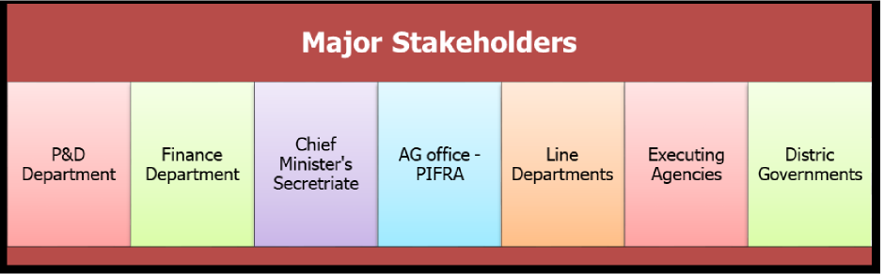

The milestone progress update information shall be submitted through web-based interface by executing agencies. The executing agencies shall use their own indigenous manpower for submitting the progress information. The system architecture will ensure the processes of Planning & Development Department regarding financial monitoring are completely taken care of. It will also ensure the possibility of future expansion and integration of specific information systems serving each of the different stakeholders.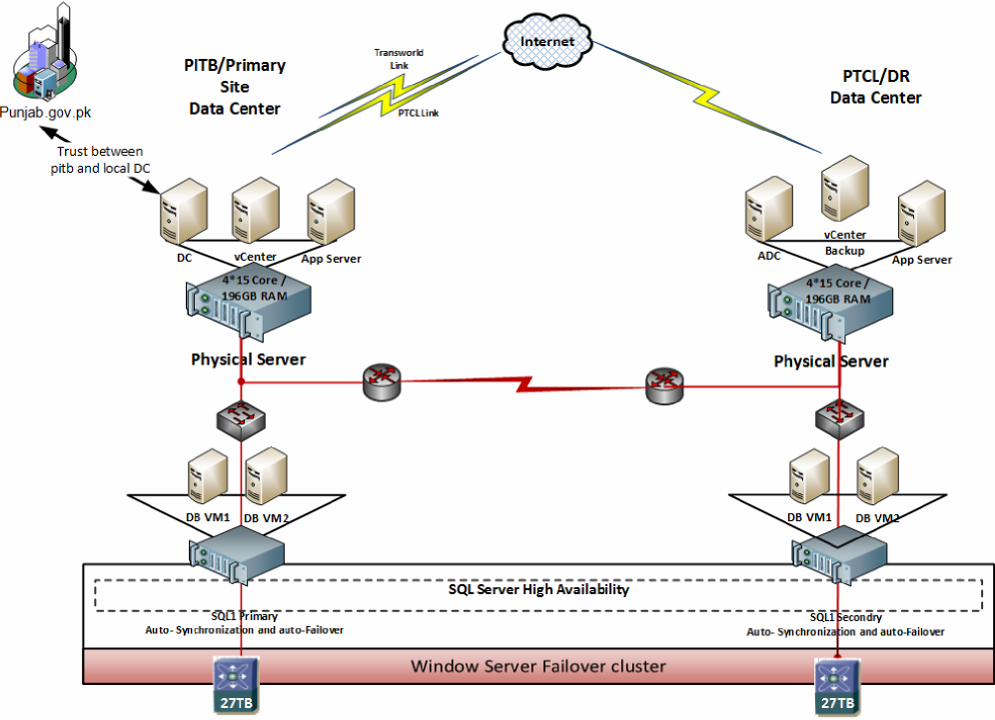
Figure: Architecture of Smart Monitoring System
Software Components of Smart Monitoring System
The Smart Monitoring Software shall have following components:
- Annual Development Program (ADP) Formulation System
The system shall electronically create new development projects with the data requested by P&D from provincial departments. It will maintain ADP formulation schedule and generate messages for P&D & reminders for Departments to ensure adherence to the schedule. The component will generate sector-wise summaries of projects. Fund allocations in the current and previous years ADP shall be compared sector-wise, department-wise and district-wise. The software component shall maintain information on ongoing and un-approved projects in a sector, department and district.
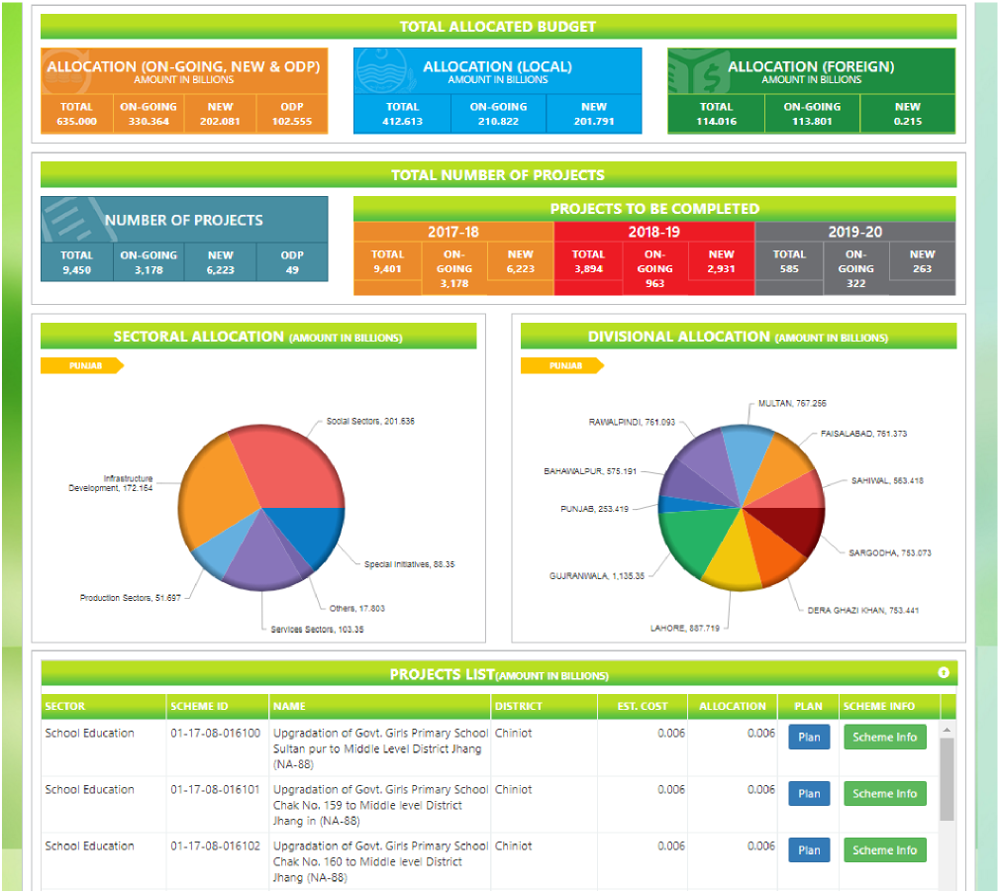
Figure: ADP Formulation System Graphically Exhibiting Sector-wise/District-wise Schemes
The software component shall provide a smart interface of projection of project information on basis of customized queries such as project constituency/district, project year wise allocation, project beneficiary etc.
- Directives Management System
The Directive Management System shall maintain record of all directives received by P&D from the secretariats of President, Prime Minister and the Chief Minister. The system shall maintain status of the directives and shall provide an interface for monitoring of implementation status of the directives. The system shall enable monitoring of utilization of funds of projects being implemented upon directives.
- Tracking System for Funds Released
The system shall maintain information regarding release of funds. The system shall input information directly from the Finance Department and these figures of fund releases shall be used by P&DD and concerned line departments. The system shall generate alerts if an allocation has been made and funds have not been released.
- Project Approval Processing System
The Project Approval Processing System shall maintain and keep track of all the DDSC, PDWP, ECNEC meetings. The system shall store decisions of appropriate forums regarding PC-I of projects and communicate the same to the respective departments. Record of meeting dates, time, forum, participants, and the decisions shall be kept in the system. The system shall issue reminders to departments which fail to get their projects approved by the cutoff date. The system shall generate an email alert for concerned Sector Chief, Coordination Wing, Sectary P&DD and Chairman P&D Board if a project is not approved within its approval cutoff date. The system shall record reasons for delays in approval process if a project is approved after a cutoff date. The system shall keep track of communications to and from P&DD and Project Departments regarding project approval.
- Project Revision Management System
Project Revision Management System shall store revision history of projects. The system shall record reasons for project revisions. The system shall keep track of communications to and from P&DD and Project Departments regarding project revisions.
- Supplementary Funds Management System
The system shall keep record of Funds Release including supplementary requests of projects. The system shall keep record of all funds transferred as re-appropriation. The system shall record the Access and Surrender request received from departments. The system shall generate advice for deduction of funds from slow moving projects so that funds so gathered are re-appropriated to indicate projects.
- Projects Implementation Monitoring System
Project Implementation Monitoring System shall provide a centralized interface for monitoring of projects through computerization of PC-III / Monthly Progress Report. The system shall generate reports regarding utilization of funds. The system shall also keep track of all funds released by P&D Department and the Finance Department pertaining to a specific project so that the status of these releases and the utilization of funds that has occurred so far can be monitored.
- Project Evaluation System
The Project Evaluation System shall maintain sector specific evaluation data. The system shall maintain evaluation observations. The system shall issue meeting notice and would also record minutes of evaluation committee meeting. The system display status of projects vis-à-vis their evaluations.

Development of Smart Monitoring System
The Smart Monitoring System shall be developed in-house. The development work shall be monitored and the software shall be tested before deployment by a comprehensive in-house team. Trainings to the users of the Smart Monitoring System shall be conducted throughout the Punjab.
New hardware (Servers, Storage, and Firewall etc.) shall be procured to host the system developed for Smart Monitoring of Development Projects across Punjab.

Trainings
Comprehensive Training plans will be devised to train the stakeholders on Smart Monitoring System. These stakeholders will include focal persons from administrative departments, nominees of directors and deputy directors at division and district levels, nominees from P&D Department, Finance Department and CM Secretariat. All system users shall be trained to use the centralized web interface of the Smart Monitoring System for viewing and updating progress information. PITB will also focus on “Training the Trainers” strategy wherever possible and intend to create product champion in every functional/concerned office.

Operational Mechanism
A project implementation unit (PIU) will be created in P&DD which will work under the direct administrative control of Secretary P&DD. Senior Chief (Coordination, P&DD) will be the Project Coordinator while Manager (MIS, P&DD) and Computer Programmer (P&DD) will be the Focal Persons from P&DD. Dedicated Human Resources will be recruited to implement the project.
Punjab Information Technology Board will be responsible for execution of the project. The software will be developed in-house by PITB and will be hosted in PITB and PTCL datacenters to ensure high availability. After completion of the project, as it is purely IT based initiative, staff recruited under this project will be retained so that software developed and maintained by the project staff may continue to work smoothly. This requirement arises from the fact that IT and software related needs and requirements evolve along with evolution of actual processes. In addition, given a number of stakeholders, the support required by different departments will also be responsibility of project staff.

Monitoring & Evaluation Mechanism
Like any development project, this project shall go through periodic monitoring and evaluation will be conducted once the project is complete. For this purpose, different milestones (including procurement, hiring, software development and deployment, trainings and implementation) have been made part of this PC-I document. Detailed timelines for each of these activities is also provided in the PC-I along with financial fiscal breakdown. This shall enable not only the project team to follow the agreed upon timelines but also enable timely delivery of all project milestones. PC-III (Monthly Progress Report) of this project shall be submitted to P&DD for periodic review and monitoring of the progress being made on the project. Any corrective actions shall be ensured in timely manner for smooth implementation of the project across all stakeholders.

Project Team Hierarchy
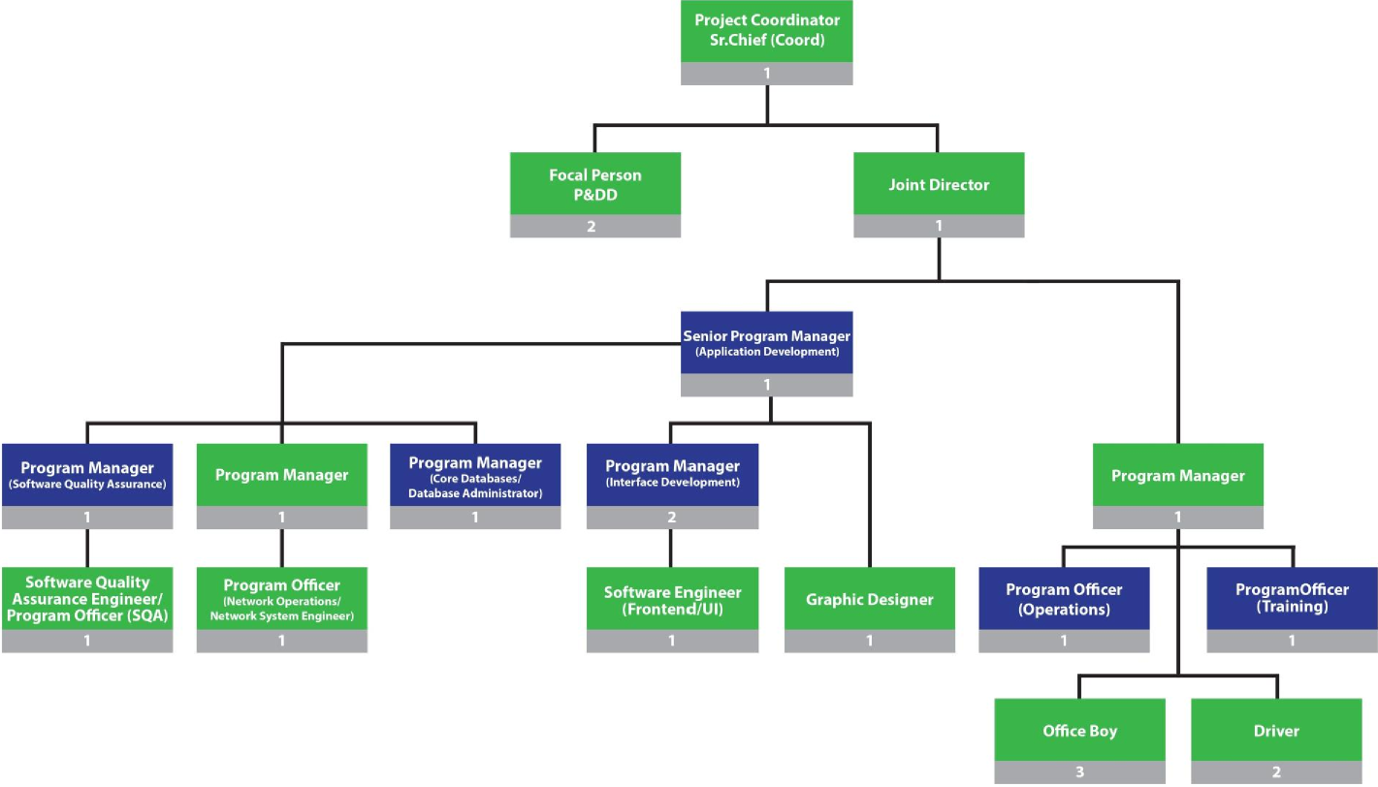
3

Implementation Strategy
Due to the complicated nature of P&DD processes, the SMDP application would be developed with an aim to enable the stakeholders to use computerized processes which will pave the way to achieve desired results. The first module to be implemented would be PC-III module, which would enable the Administrative Department users to submit their Monthly Progress Reports online. ADP Formulation module would be developed afterwards to formulate MTDF/ADP online using the SMDP application.
Funds Release Management including Supplementary Releases would be implemented after ADP Formulation. This would enable users to perform release management operations in SMDP application.
PC-I & PC-II module development would follow once the financial modules (Allocation/Release/Utilization) reach certain level of maturity.
PC-IV & PC-V would be developed along with the maturity of Decision Support System, Reports and Dashboard.
From operations perspective, there will be three tiers. The executing agencies through indigenous manpower will upload financial progress at regular basis. The District Implementation Committees will be responsible for consolidating and monitoring the input on the web. The office will highlight issues to the PIU, P&DD. The PIU will have dedicated project staff for managing the inflow and out flow of information.
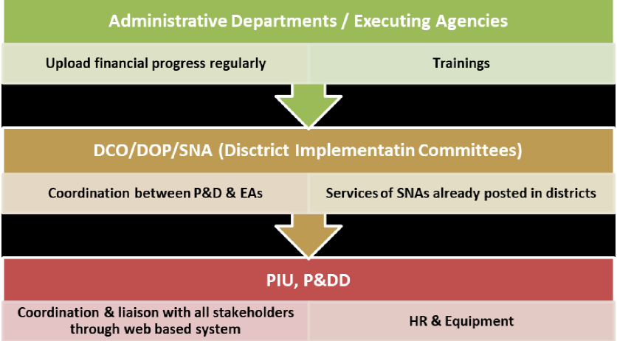

Risk Analysis
As for any software project, SMDP Project also faces following challenges and risks:
Sr# | Risk | Impact
1 | Ownership from all Stakeholders for  successful execution and  Implementation of SMDP Project. | Delays in execution and implementation  of SMDP Project across Punjab.
2 | Timely completion of work by  different stakeholders like Finance  Department/AG Office/PIFRA. | Delay in linking and synchronization of  financial information in real time leading  to information gaps.
3 | Support from associated  Government departments as well as  District Governments | Support from Government Departments  and District Governments is key to  effective, efficient and smooth run of the  SMDP Project across the Punjab.

Responsibility Matrix
Following are the activities identified for the implementation of the project:
R= Responsible I = Input required
 | Stakeholders
Activity | PITB | P & D | Relevant  Department
Preparation of RFPs | R | I
Hiring Manpower | R | R
Training | R | R
Management of the Project | R | R
Continuous Support and Overall  Project ownership | I | R | R
Technical and infrastructural Support | R | R
Software Development | R | I | I

7. Capital Cost Estimates
Fiscal year wise cost breakup is given as under:
(PKR)
Fiscal Year | Cost
FY 2014-15 | 0.288
FY 2015-16 | 43.279
FY 2016-17 | 27.139
FY 2017-18 | 32.034
FY 2018-19 | 28.009
FY 2019-20 | 1.458
Total Cost | 132.208

8. Annual Operating and Maintenance Cost after Completion of Project
(PKR Million)
Fiscal Year | Post Completion Cost
FY 2021-22 | 61.125
FY 2022-23 | 71.880
FY 2023-24 | 84.658
FY 2024-25 | 99.852
FY 2025-26 | 117.930
Total Post Completion Cost (5 Years) | 435.445

- Demand and Supply Analysis N/A
- Financial Plan and Mode of Financing N/A
- Project Benefits and Analysis
- Financial:
Timely reporting of data from the field staff will help in taking informed decisions through customized/meaningful dashboards/reports available 24/7.

Allocation of resource, real time update through inspections on public investment projects will be an added advantage to the Government of Punjab. Since the stakeholders involved in approving the funding of the project should have an insight about the progress of the scheme and with time to time monitoring will ensure timely completion of schemes. Further keeping an eye on utilization of funds allocated will benefit the proper planning and priority scheduling of funds. These policy decisions will be based on evidence provided by the Smart Monitoring system and will set the tone of development in the Punjab province. Benefits of the project thus are as wide as complete development portfolio of the province. In view of above, it can easily be concluded that given the successful implementation of this project, cost that will be incurred is not more than a minimal fraction in comparison to the benefits and economic outcome of the project.
- Economic:
This project will enhance the efficiency of all development projects through efficient financial monitoring and increased transparency. Budgeting, allocation, releases and utilization of funds will be more efficient as the delays will be pin-pointed and corrective actions could be taken. Alerts will be generated to encourage that timelines are followed. This as a whole will yield better implementation of development budgets. Given the scarce availability of funds, the impact shall have a profound economic benefit leading to targeted growth in accordance with directions set in Medium Term Development Framework and Punjab Growth Strategy.
- Social Benefits with Indicators:
Smart Monitoring of all Development Projects will increase transparency and lead to social benefits.
- Employment Generation (Direct and Indirect):
N/A
- Environmental:
N/A
- Impact Of Delays On Project Cost And Viability:
Delays incurred due to any reasons would have a direct impact on cost and timelines of the project (HR Cost, Execution, however, the scope of the project would remain viable and intact as per agreed functionalities.

- Implementation Schedule
- Implementation Schedule
The SMDP project’s gestation proposed gestation is:
Project Start: February 2015
Project End: June 2019
Exit Strategy
As it is purely IT based initiative and staff recruited under this project needs to be retained even after the completion of project so that Software developed and maintained by the Software team may continue to work smoothly. For this purpose after completion of project, staff may be shifted to PITB non development budget and will continue to work at P&D Department.
- Result Based Monitoring (RBM) Indicators
N/A
- Additional Projects/Decision Required N/A

5. Activity LIST (wbs)

WBS | Name | % Complete | Resource Names | Duration
SMDP/ | SMDP Project Plan | 82% |  | 1176 days
SMDP/1 | SMDP Pre development | 100% |  | 271 days
SMDP/1.1 | PC-1 Preparation | 100% |  | 35 days
SMDP/1.1.1 | Documentation of Objectives and other PC-1 contents | 100% | Focal Person (P&DD) | 5 days
SMDP/1.1.2 | High Level Requirements | 100% | Focal Person (P&DD) | 15 days
SMDP/1.1.3 | Define Position Descriptions | 100% | Focal Person (P&DD)[50%] | 15 days
SMDP/1.1.4 | Cost Estimates | 100% | Focal Person (P&DD)[50%] | 10 days
SMDP/1.2 | PC-1 Preparation Completion | 100% |  | 0 days
SMDP/1.3 | PC-1 Approval | 100% |  | 42 days
SMDP/1.3.1 | Submission of PC-1 to P&D for Approval | 100% | Focal Person (P&DD) | 1 day
SMDP/1.3.2 | Assessment/Evaluation of Submitted PC-1 | 100% | Chief IT | 5 days
SMDP/1.3.3 | Redressal to Observations and Comments | 100% | Focal Person (P&DD) | 5 days
SMDP/1.3.4 | Resubmission of PC-1 to P&D | 100% | Focal Person (P&DD) | 1 day
SMDP/1.3.5 | Approval of PDWP meeting and issuance of administrative approval | 100% | Chairman P&D | 30 days
SMDP/1.4 | PC-1 Approval Completion | 100% |  | 0 days
SMDP/1.5 | Project Fund Release/ Project Budget Release | 100% |  | 108 days
SMDP/1.5.1 | Request for Fund Release to P&D by AD's | 100% | Project Coordinator | 95 days
SMDP/1.5.2 | Issuance of Release Order by P&D | 100% | Chief IT | 3 days
SMDP/1.5.3 | Release Order from Finance Department | 100% | Director Budget | 3 days
SMDP/1.5.4 | Audit Copy from Finance Department | 100% | Director Budget | 3 days
SMDP/1.5.5 | Funds allocation at controlling level by Finance Department | 100% | Director Budget | 2 days
SMDP/1.5.6 | Funds transfer at spending level by P&D Department | 100% | Focal Person (P&DD) | 2 days
SMDP/1.6 | Completion of PC-1 and Fund Release | 100% |  | 0 days
SMDP/1.7 | Resource Gathering | 100% |  | 86 days
SMDP/1.7.1 | Hiring of human Resources | 100% |  | 86 days
SMDP/1.7.1.1 | Securing approvals and funding | 100% | Project Coordinator[5%],Focal Person (P&DD)[45%] | 5 days
SMDP/1.7.1.2 | Identify vacancies and evaluate needs | 100% | Project Coordinator[5%],Focal Person (P&DD)[45%] | 5 days
SMDP/1.7.1.3 | Develop Recruitment Plan | 100% | Project Coordinator[5%],Focal Person (P&DD)[45%] | 3 days
SMDP/1.7.1.4 | Select Recruitment Committee | 100% | Project Coordinator[5%],Focal Person (P&DD)[45%] | 3 days
SMDP/1.7.1.5 | Advertisment of Positions | 100% | Project Coordinator[5%],Focal Person (P&DD)[45%] | 15 days
SMDP/1.7.1.6 | Applicant Review and Shortlisting | 100% | Focal Person (P&DD)[50%] | 15 days
SMDP/1.7.1.7 | Interviews | 100% | Chairman P&D | 15 days
SMDP/1.7.1.8 | Offer Letters | 100% | Joint Director[75%] | 15 days
SMDP/1.7.1.9 | Recruitment Finalization | 100% |  | 10 days
SMDP/1.7.2 | Material Resource Procurement | 100% |  | 86 days
SMDP/1.7.2.1 | Securing approvals and funding for material | 100% | Project Coordinator[5%],Focal Person (P&DD)[45%] | 5 days
SMDP/1.7.2.2 | Writing Specifications | 100% | Project Coordinator[5%],Focal Person (P&DD)[45%] | 5 days
SMDP/1.7.2.3 | Estimating Cost | 100% | Project Coordinator[5%],Focal Person (P&DD)[45%] | 2 days
SMDP/1.7.2.4 | Preparing Request for Tender (RFT) | 100% | Project Coordinator[5%],Focal Person (P&DD)[45%] | 2 days
SMDP/1.7.2.5 | Tender Advertisement | 100% | Project Coordinator[5%],Focal Person (P&DD)[45%] | 2 days
SMDP/1.7.2.6 | Submission of Tenders | 100% | Focal Person (P&DD)[45%] | 15 days
SMDP/1.7.2.7 | Tender Evaluation | 100% | Focal Person (P&DD)[50%] | 15 days
SMDP/1.7.2.8 | Contract Award | 100% | Project Coordinator | 5 days
SMDP/1.7.2.9 | Purchase Order Issuance | 100% | Focal Person (P&DD) | 7 days
SMDP/1.7.2.10 | Delievery of goods | 100% | Android Phone[Rs 80,000],Desktop i5[Rs 2,925,000],Laptop i5[Rs 1,520,000],Laptop i7[Rs 825,000],Laptop i7 (Professional)[Rs 495,000],Mid Range Server[Rs 9,200,000],Office Equipment[Rs 1,222,000],Printer[Rs 188,000],UPS[Rs 434,000],SAN[Rs 7,000,000],SAN ... | 13 days
SMDP/1.7.2.11 | Payments | 100% | Joint Director[25%] | 10 days
SMDP/1.7.2.12 | Contacts Closure | 100% | Joint Director | 2 days
SMDP/1.7.2.13 | Inventory Record update | 100% | Joint Director | 3 days
SMDP/1.8 | Completion of Resource Gathering | 100% |  | 0 days
SMDP/2 | Pre Development Completion | 100% |  | 0 days
SMDP/3 | SMDP Software Development | 80% |  | 854 days
SMDP/3.1 | SW Development (PC-III) | 100% |  | 162 days
SMDP/3.1.1 | Specification, Design, Analysis / Preparation SRS | 100% | Focal Person (P&DD),Project Coordinator | 10 days
SMDP/3.1.1.1 | Gather Requirements | 100% | PM Technical,Joint Director,PM Operations,SPM Application Development,SPM Interface Development | 4 days
SMDP/3.1.1.2 | Define Analysis Model of user Requiment | 100% | PM Technical,PO Operations 1,PO Operations 2,Joint Director | 1 day
SMDP/3.1.1.3 | Conclude User Functional Requirements | 100% | Joint Director,PM Core Databases,SPM Application Development,PM Operations,PM Technical,SPM Interface Development,SPM Network Operations & System Configuration | 2 days
SMDP/3.1.1.4 | Incorporate Feedback into Functional Requirements | 100% | Joint Director,PM Operations,PM Technical,PO Operations 1,PO Operations 2,SPM Application Development,SPM Interface Development,SPM Network Operations & System Configuration | 1 day
SMDP/3.1.1.5 | Develop SRS | 100% | PM Technical,Joint Director | 1 day
SMDP/3.1.1.6 | Validate SRS | 100% | Joint Director,PM Technical,PM Operations,SPM Application Development,SPM Interface Development,SPM Network Operations & System Configuration | 1 day
SMDP/3.1.2 | SRS & Design Completion | 100% |  | 0 days
SMDP/3.1.3 | Development and Configuration | 100% | Project Coordinator,Focal Person (P&DD) | 60 days
SMDP/3.1.3.1 | Develop UI | 100% | Graphic Designer,PM Interface Development,PM Operations,PM Technical[50%],PO Operations 1,SPM Interface Development,Software Engineer / PO (Frontend/UI) | 10 days
SMDP/3.1.3.2 | Develop Forms | 100% | PM Interface Development,SPM Application Development[50%],SPM Interface Development | 15 days
SMDP/3.1.3.3 | Develop Workflow | 100% | Joint Director,PM Network Operations,PM Technical,PO Operations 1,Software Engineer / PO (Frontend/UI) | 10 days
SMDP/3.1.3.4 | Davelop Database | 100% | SPM Application Development[50%],PM Core Databases,PO Network System Operations,PM Technical[50%],PM Network Operations | 15 days
SMDP/3.1.3.5 | Develop Middle Tier | 100% | PM Core Databases,PM Interface Development,PM Technical,Software Engineer / PO (Frontend/UI),SPM Application Development,SPM Interface Development,Joint Director | 15 days
SMDP/3.1.3.6 | Develop Connections with Other Systems | 100% | PM Core Databases,PM Network Operations,PO Operations 1,Software Engineer / PO (Frontend/UI),SPM Application Development,SPM Interface Development,SPM Network Operations & System Configuration,Joint Director | 2 days
SMDP/3.1.3.7 | Develop Permissions | 100% | PM Interface Development,SPM Application Development,SPM Interface Development,Joint Director,PM Operations,PM Technical,PO Operations 1,PO Operations 2 | 2 days
SMDP/3.1.3.8 | Create System Documentation | 100% | Joint Director,PM Operations,PM Technical,PO Operations 1,PO Operations 2,SPM Application Development | 3 days
SMDP/3.1.3.9 | Configuration Identification | 100% | PM Network Operations,PO Network System Operations,SPM Network Operations & System Configuration,Joint Director | 2 days
SMDP/3.1.3.10 | Configuration Item Storage | 100% | PM Network Operations,PO Network System Operations,SPM Network Operations & System Configuration,Joint Director | 2 days
SMDP/3.1.3.11 | Configuration Change Control | 100% | PM Network Operations,PO Network System Operations,SPM Network Operations & System Configuration,Joint Director | 2 days
SMDP/3.1.3.12 | Configuration Status Reporting | 100% | PM Network Operations,PO Network System Operations,SPM Network Operations & System Configuration,Joint Director | 2 days
SMDP/3.1.4 | Development & Configuration Completion | 100% |  | 0 days
SMDP/3.1.5 | Application Testing On Simulation/Local Test Enviornment | 100% | Project Coordinator,Focal Person (P&DD) | 10 days
SMDP/3.1.5.1 | Develop Unit Tests | 100% | SQA Engineer / PO (SQA),PM Technical,PM Core Databases,PM Interface Development,PM Network Operations,PO Network System Operations,Software Engineer / PO (Frontend/UI),SPM Application Development,SPM Interface Development,SPM Network Operations & System... | 1 day
SMDP/3.1.5.2 | Develop System Tests | 100% | PM Network Operations,PO Network System Operations,SQA Engineer / PO (SQA),PM Core Databases,SPM Network Operations & System Configuration,Joint Director | 1 day
SMDP/3.1.5.3 | Create Test Documentation | 100% | PO Operations 1,PO Operations 2,SQA Engineer / PO (SQA),Graphic Designer,Joint Director | 1 day
SMDP/3.1.5.4 | Execute Manual Tests | 100% | PM Network Operations,PM Technical,PO Network System Operations,Software Engineer / PO (Frontend/UI),SQA Engineer / PO (SQA),Joint Director,PM Operations,PO Operations 1,SPM Application Development,SPM Interface Development,SPM Network Operations & Syst... | 3 days
SMDP/3.1.5.5 | Execute Automated Tests | 100% | PM Operations,PM Technical,PO Operations 1,PO Operations 2,SPM Application Development,SPM Interface Development,SPM Network Operations & System Configuration,SQA Engineer / PO (SQA) | 2 days
SMDP/3.1.5.6 | Analyze Test Results | 100% | Graphic Designer,Joint Director[50%],SPM Application Development,SPM Interface Development,SPM Network Operations & System Configuration,SQA Engineer / PO (SQA),PM Core Databases,PM Interface Development,PM Network Operations,PM Operations[50%],Software... | 1 day
SMDP/3.1.5.7 | Compile Test Statistics | 100% | PM Operations[50%],PO Operations 1,PO Operations 2,Joint Director[50%] | 1 day
SMDP/3.1.5.8 | Approval by QA | 100% | Software Engineer / PO (Frontend/UI),SPM Application Development,SPM Interface Development,SPM Network Operations & System Configuration,SQA Engineer / PO (SQA),Joint Director | 1 day
SMDP/3.1.6 | Perform regression and stress testing | 100% | Project Coordinator,Focal Person (P&DD) | 10 days
SMDP/3.1.6.1 | Set Testing Requirements for Regression Testing | 100% | SQA Engineer / PO (SQA)[25%],PM Technical[25%],PM Core Databases[25%],PM Interface Development[25%],PM Network Operations[25%],PO Network System Operations[25%],Software Engineer / PO (Frontend/UI)[25%],SPM Application Development[25%],SPM Interface Dev... | 1 day
SMDP/3.1.6.2 | Set Entry Criteria for Regression Testing | 100% | SQA Engineer / PO (SQA)[25%],PM Technical[25%],PM Core Databases[25%],PM Interface Development[25%],PM Network Operations[25%],PO Network System Operations[25%],Software Engineer / PO (Frontend/UI)[25%],SPM Application Development[25%] | 1 day
SMDP/3.1.6.3 | Set Exit Criteria for Regression Testing | 100% | SQA Engineer / PO (SQA)[25%],PM Technical[25%],PM Core Databases[25%],PM Interface Development[25%],PM Network Operations[25%],PO Network System Operations[25%],Software Engineer / PO (Frontend/UI)[25%],SPM Application Development[25%] | 1 day
SMDP/3.1.6.4 | Set Testing Schedule for Regression Testing | 100% | SQA Engineer / PO (SQA)[25%],PM Technical[25%],PM Core Databases[25%],PM Interface Development[25%],PM Network Operations[25%],PO Network System Operations[25%],Software Engineer / PO (Frontend/UI)[25%],SPM Application Development[25%] | 1 day
SMDP/3.1.6.5 | Run Regression Tests | 100% | SQA Engineer / PO (SQA),PM Technical,PM Core Databases,PM Interface Development,PM Network Operations,PO Network System Operations,Software Engineer / PO (Frontend/UI),SPM Application Development,SPM Interface Development | 3 days
SMDP/3.1.6.6 | Define Scenarios for Stress Testing | 100% | SQA Engineer / PO (SQA)[50%],PM Technical[50%],PM Core Databases[50%],PM Interface Development[50%],PM Network Operations[50%],PO Network System Operations[50%],Software Engineer / PO (Frontend/UI)[50%],SPM Application Development[50%],SPM Interface Dev... | 1 day
SMDP/3.1.6.7 | Set Workload and Tools for Stress Testing | 100% | SQA Engineer / PO (SQA)[50%],PM Technical[50%],PM Core Databases[50%],PM Interface Development[50%],PM Network Operations[50%],PO Network System Operations[50%],Software Engineer / PO (Frontend/UI)[50%],SPM Application Development[50%] | 1 day
SMDP/3.1.6.8 | Create Test Cases for Stress Testing | 100% | SQA Engineer / PO (SQA),PM Technical,PM Core Databases,PM Interface Development,PM Network Operations,PO Network System Operations,Software Engineer / PO (Frontend/UI),SPM Application Development,SPM Interface Development | 1 day
SMDP/3.1.6.9 | Test Case Running in Loaded Environment | 100% | SQA Engineer / PO (SQA),PM Technical,PM Core Databases,PM Interface Development,PM Network Operations,PO Network System Operations,Software Engineer / PO (Frontend/UI),SPM Application Development,SPM Interface Development,SPM Network Operations & System... | 3 days
SMDP/3.1.6.10 | Evaluation & Analysis of Results | 100% | SQA Engineer / PO (SQA),PM Technical,PM Core Databases,PM Interface Development,PM Network Operations,PO Network System Operations,Software Engineer / PO (Frontend/UI),SPM Application Development,SPM Interface Development,SPM Network Operations & System... | 1 day
SMDP/3.1.7 | Complete tetsting | 100% |  | 0 days
SMDP/3.1.8 | Deployment/UAT | 100% | Focal Person (P&DD),Project Coordinator | 10 days
SMDP/3.1.8.1 | Create Software Deployement Team | 100% | Joint Director[50%],PM Core Databases[50%],PM Interface Development[50%],PM Operations[50%],PM Technical[50%],PO Network System Operations[50%],SPM Application Development[50%],SPM Interface Development[50%],SPM Network Operations & System Configuration... | 1 day
SMDP/3.1.8.2 | Version Approval for Deployement | 100% | Joint Director[50%],PM Core Databases[50%],PM Interface Development[50%],PM Operations[50%],PM Technical[50%],PO Network System Operations[50%],SPM Application Development[50%],SPM Interface Development[50%] | 1 day
SMDP/3.1.8.3 | Develop High Level Deployment Plan | 100% | Joint Director,PM Core Databases,PM Interface Development,PM Operations,PM Technical,PO Network System Operations,SPM Application Development,SPM Interface Development,SPM Network Operations & System Configuration,PO Operations 1,PO Operations 2 | 1 day
SMDP/3.1.8.4 | Refine deployment plan | 100% | Joint Director,PM Core Databases,PM Interface Development,PM Operations,PM Technical,PO Network System Operations,SPM Application Development,SPM Interface Development,SPM Network Operations & System Configuration,PO Operations 1,PO Operations 2 | 1 day
SMDP/3.1.8.5 | Finalize Deployment Plan | 100% | Joint Director,PM Core Databases,PM Interface Development,PM Operations,PM Technical,PO Network System Operations,SPM Application Development,SPM Interface Development,SPM Network Operations & System Configuration,PO Operations 1,PO Operations 2 | 1 day
SMDP/3.1.8.6 | Conduct deployment Kickoff | 100% | Joint Director,PM Core Databases,PM Interface Development,PM Operations,PM Technical,PO Network System Operations,SPM Application Development,SPM Interface Development,SPM Network Operations & System Configuration,PO Operations 1,PO Operations 2 | 2 days
SMDP/3.1.8.7 | Execute Beta Test | 100% | Joint Director,PM Core Databases,PM Interface Development,PM Operations,PM Technical,PO Network System Operations,SPM Application Development,SPM Interface Development,SPM Network Operations & System Configuration,PO Operations 1,PO Operations 2,Chief I... | 4 days
SMDP/3.1.9 | Application Training | 100% | Focal Person (P&DD),Project Coordinator | 10 days
SMDP/3.1.9.1 | Perform Training Needs Assessment | 100% | Joint Director,APO Operations 1,APO Operations 2,APO Operations 3,APO Operations 4,PM Interface Development,PM Technical,PO Network System Operations,PO Operations 1,PO Operations 2,SPM Application Development,SPM Interface Development | 1 day
SMDP/3.1.9.2 | Develop Learning Objectives | 100% | Joint Director[50%],APO Operations 1[50%],APO Operations 2[50%],APO Operations 3[50%],APO Operations 4[50%],PM Interface Development[50%],PM Technical[50%],PO Network System Operations[50%],PO Operations 1[50%],PO Operations 2[50%],SPM Application Devel... | 1 day
SMDP/3.1.9.3 | Develop Training Materials | 100% | Joint Director[50%],APO Operations 1[50%],APO Operations 2[50%],APO Operations 3[50%],APO Operations 4[50%],PM Interface Development[50%],PM Technical[50%],PO Network System Operations[50%],PO Operations 1[50%],PO Operations 2[50%] | 1 day
SMDP/3.1.9.4 | Implement Training | 100% | Joint Director,APO Operations 1,APO Operations 2,APO Operations 3,APO Operations 4,PM Interface Development,PM Technical,PO Network System Operations,PO Operations 1,PO Operations 2,SPM Application Development,SPM Interface Development | 7 days
SMDP/3.1.9.5 | Evaluate Training | 100% | Joint Director,APO Operations 1,APO Operations 2,APO Operations 3,APO Operations 4,PM Interface Development,PM Technical,PO Network System Operations,PO Operations 1,PO Operations 2,SPM Application Development,SPM Interface Development | 1 day
SMDP/3.1.10 | Go Live | 100% | Joint Director,PM Operations,PM Technical,APO Operations 1,APO Operations 2,APO Operations 3,APO Operations 4,Focal Person (P&DD),PM Core Databases,PM Interface Development,PM Network Operations,PO Operations 1,PO Operations 2,Software Engineer / PO (Fr... | 2 days
SMDP/3.1.11 | Implementation Support | 100% | Focal Person (P&DD),Project Coordinator | 50 days
SMDP/3.1.11.1 | Result Measurement | 100% | Joint Director,PM Operations,PM Technical,APO Operations 1,APO Operations 2,APO Operations 3,APO Operations 4,PM Core Databases,PM Interface Development,PM Network Operations,PO Network System Operations,PO Operations 1,PO Operations 2,SPM Application D... | 1 day
SMDP/3.1.11.2 | Change Management | 100% | Joint Director,PM Operations,PM Technical | 10 days
SMDP/3.1.11.3 | Support Backup | 100% | Joint Director,PM Operations,PM Technical | 39 days
SMDP/3.2 | SW Development (ADP Formulation & Directives Management) | 100% |  | 357 days
SMDP/3.2.1 | Specification, Design, Analysis / Preparation SRS | 100% | Focal Person (P&DD),Project Coordinator | 10 days
SMDP/3.2.1.1 | Gather Requirements | 100% | PM Technical,Joint Director,PM Operations,SPM Application Development | 4 days
SMDP/3.2.1.2 | Define Analysis Model of user Requiment | 100% | PM Technical,PO Operations 1,PO Operations 2,Joint Director | 1 day
SMDP/3.2.1.3 | Conclude User Functional Requirements | 100% | Joint Director,PM Core Databases,SPM Application Development,PM Operations,PM Technical,SPM Interface Development,SPM Network Operations & System Configuration | 2 days
SMDP/3.2.1.4 | Incorporate Feedback into Functional Requirements | 100% | Joint Director,PM Operations,PM Technical,PO Operations 1,PO Operations 2,SPM Application Development,SPM Interface Development,SPM Network Operations & System Configuration | 1 day
SMDP/3.2.1.5 | Develop SRS | 100% | PM Technical,Joint Director | 1 day
SMDP/3.2.1.6 | Validate SRS | 100% | Joint Director,PM Technical,PM Operations,SPM Application Development,SPM Interface Development,SPM Network Operations & System Configuration | 1 day
SMDP/3.2.2 | SRS & Design Completion | 100% |  | 0 days
SMDP/3.2.3 | Development and Configuration | 100% | Project Coordinator,Focal Person (P&DD) | 220 days
SMDP/3.2.3.1 | Develop UI | 100% | Graphic Designer,PM Interface Development[40%],PM Operations,PM Technical[50%],PO Operations 1,SPM Interface Development[25%],Software Engineer / PO (Frontend/UI) | 25 days
SMDP/3.2.3.2 | Develop Forms | 100% | PM Interface Development[60%],SPM Application Development[50%],SPM Interface Development[75%] | 40 days
SMDP/3.2.3.3 | Develop Workflow | 100% | Joint Director,PM Network Operations,PM Technical[50%],PO Operations 1,Software Engineer / PO (Frontend/UI) | 30 days
SMDP/3.2.3.4 | Davelop Database | 100% | SPM Application Development[50%],PM Core Databases,PO Network System Operations,PM Technical[50%],PM Network Operations | 55 days
SMDP/3.2.3.5 | Develop Middle Tier | 100% | PM Core Databases,PM Interface Development,PM Technical,Software Engineer / PO (Frontend/UI),SPM Application Development,SPM Interface Development,Joint Director | 71 days
SMDP/3.2.3.6 | Develop Connections with Other Systems | 100% | PM Core Databases,PM Network Operations,PO Operations 1,Software Engineer / PO (Frontend/UI),SPM Application Development,SPM Interface Development,SPM Network Operations & System Configuration,Joint Director | 31 days
SMDP/3.2.3.7 | Develop Permissions | 100% | PM Interface Development,SPM Application Development,SPM Interface Development,Joint Director,PM Operations,PM Technical,PO Operations 1,PO Operations 2 | 15 days
SMDP/3.2.3.8 | Create System Documentation | 100% | Joint Director,PM Operations,PM Technical,PO Operations 1,PO Operations 2,SPM Application Development | 10 days
SMDP/3.2.3.9 | Configuration Identification | 100% | PM Network Operations,PO Network System Operations,SPM Network Operations & System Configuration,Joint Director | 5 days
SMDP/3.2.3.10 | Configuration Item Storage | 100% | PM Network Operations,PO Network System Operations,SPM Network Operations & System Configuration,Joint Director | 5 days
SMDP/3.2.3.11 | Configuration Change Control | 100% | PM Network Operations,PO Network System Operations,SPM Network Operations & System Configuration,Joint Director | 5 days
SMDP/3.2.3.12 | Configuration Status Reporting | 100% | PM Network Operations,PO Network System Operations,SPM Network Operations & System Configuration,Joint Director | 5 days
SMDP/3.2.4 | Development & Configuration Completion | 100% |  | 0 days
SMDP/3.2.5 | Application Testing On Simulation/Local Test Enviornment | 100% | Project Coordinator,Focal Person (P&DD) | 50 days
SMDP/3.2.5.1 | Develop Unit Tests | 100% | SQA Engineer / PO (SQA),PM Technical,PM Core Databases,PM Interface Development,PM Network Operations,PO Network System Operations,Software Engineer / PO (Frontend/UI),SPM Application Development,SPM Interface Development | 9 days
SMDP/3.2.5.2 | Develop System Tests | 100% | PM Network Operations,PO Network System Operations,SQA Engineer / PO (SQA),PM Core Databases,SPM Network Operations & System Configuration,Joint Director | 3 days
SMDP/3.2.5.3 | Create Test Documentation | 100% | PO Operations 1,PO Operations 2,SQA Engineer / PO (SQA),Graphic Designer,Joint Director | 3 days
SMDP/3.2.5.4 | Execute Manual Tests | 100% | PM Network Operations,PM Technical,PO Network System Operations,Software Engineer / PO (Frontend/UI),SQA Engineer / PO (SQA),Joint Director,PM Operations,PO Operations 1,SPM Application Development,SPM Interface Development | 20 days
SMDP/3.2.5.5 | Execute Automated Tests | 100% | PM Operations,PM Technical,PO Operations 1,PO Operations 2,SPM Application Development,SPM Interface Development,SPM Network Operations & System Configuration,SQA Engineer / PO (SQA) | 15 days
SMDP/3.2.5.6 | Analyze Test Results | 100% | Graphic Designer,Joint Director[50%],SPM Application Development,SPM Interface Development,SPM Network Operations & System Configuration,SQA Engineer / PO (SQA),PM Core Databases,PM Interface Development,PM Network Operations,PM Operations[50%] | 2 days
SMDP/3.2.5.7 | Compile Test Statistics | 100% | PM Operations[50%],PO Operations 1,PO Operations 2,Joint Director[50%] | 2 days
SMDP/3.2.5.8 | Approval by QA | 100% | Software Engineer / PO (Frontend/UI),SPM Application Development,SPM Interface Development,SPM Network Operations & System Configuration,SQA Engineer / PO (SQA),Joint Director | 2 days
SMDP/3.2.6 | Perform regression and stress testing | 100% | Project Coordinator,Focal Person (P&DD) | 20 days
SMDP/3.2.6.1 | Set Testing Requirements for Regression Testing | 100% | SQA Engineer / PO (SQA)[25%],PM Technical[25%],PM Core Databases[25%],PM Interface Development[25%],PM Network Operations[25%],PO Network System Operations[25%],Software Engineer / PO (Frontend/UI)[25%],SPM Application Development[25%] | 2 days
SMDP/3.2.6.2 | Set Entry Criteria for Regression Testing | 100% | SQA Engineer / PO (SQA)[25%],PM Technical[25%],PM Core Databases[25%],PM Interface Development[25%],PM Network Operations[25%],PO Network System Operations[25%],Software Engineer / PO (Frontend/UI)[25%],SPM Application Development[25%] | 2 days
SMDP/3.2.6.3 | Set Exit Criteria for Regression Testing | 100% | SQA Engineer / PO (SQA)[25%],PM Technical[25%],PM Core Databases[25%],PM Interface Development[25%],PM Network Operations[25%],PO Network System Operations[25%],Software Engineer / PO (Frontend/UI)[25%],SPM Application Development[25%] | 2 days
SMDP/3.2.6.4 | Set Testing Schedule for Regression Testing | 100% | SQA Engineer / PO (SQA)[25%],PM Technical[25%],PM Core Databases[25%],PM Interface Development[25%],PM Network Operations[25%],PO Network System Operations[25%],Software Engineer / PO (Frontend/UI)[25%],SPM Application Development[25%] | 2 days
SMDP/3.2.6.5 | Run Regression Tests | 100% | SQA Engineer / PO (SQA),PM Technical,PM Core Databases,PM Interface Development,PM Network Operations,PO Network System Operations,Software Engineer / PO (Frontend/UI),SPM Application Development,SPM Interface Development | 6 days
SMDP/3.2.6.6 | Define Scenarios for Stress Testing | 100% | SQA Engineer / PO (SQA)[50%],PM Technical[50%],PM Core Databases[50%],PM Interface Development[50%],PM Network Operations[50%],PO Network System Operations[50%],Software Engineer / PO (Frontend/UI)[50%],SPM Application Development[50%] | 2 days
SMDP/3.2.6.7 | Set Workload and Tools for Stress Testing | 100% | SQA Engineer / PO (SQA)[50%],PM Technical[50%],PM Core Databases[50%],PM Interface Development[50%],PM Network Operations[50%],PO Network System Operations[50%],Software Engineer / PO (Frontend/UI)[50%],SPM Application Development[50%] | 2 days
SMDP/3.2.6.8 | Create Test Cases for Stress Testing | 100% | SQA Engineer / PO (SQA),PM Technical,PM Core Databases,PM Interface Development,PM Network Operations,PO Network System Operations,Software Engineer / PO (Frontend/UI),SPM Application Development,SPM Interface Development | 3 days
SMDP/3.2.6.9 | Test Case Running in Loaded Environment | 100% | SQA Engineer / PO (SQA),PM Technical,PM Core Databases,PM Interface Development,PM Network Operations,PO Network System Operations,Software Engineer / PO (Frontend/UI),SPM Application Development,SPM Interface Development | 6 days
SMDP/3.2.6.10 | Evaluation & Analysis of Results | 100% | SQA Engineer / PO (SQA),PM Technical,PM Core Databases,PM Interface Development,PM Network Operations,PO Network System Operations,Software Engineer / PO (Frontend/UI),SPM Application Development,SPM Interface Development | 1 day
SMDP/3.2.7 | Complete tetsting | 100% |  | 0 days
SMDP/3.2.8 | Deployment/UAT | 100% | Focal Person (P&DD)[50%],Project Coordinator[50%] | 10 days
SMDP/3.2.8.1 | Create Software Deployement Team | 100% | Joint Director[34%],PM Core Databases[50%],PM Interface Development[50%],PM Operations[34%],PM Technical[34%],PO Network System Operations[50%],SPM Application Development[34%],SPM Interface Development[34%] | 1 day
SMDP/3.2.8.2 | Version Approval for Deployement | 100% | Joint Director[34%],PM Core Databases[50%],PM Interface Development[50%],PM Operations[34%],PM Technical[34%],PO Network System Operations[50%],SPM Application Development[34%],SPM Interface Development[34%] | 1 day
SMDP/3.2.8.3 | Develop High Level Deployment Plan | 100% | Joint Director[68%],PM Core Databases,PM Interface Development,PM Operations[68%],PM Technical[68%],PO Network System Operations,SPM Application Development[68%],SPM Interface Development[68%],SPM Network Operations & System Configuration[68%],PO Operat... | 1 day
SMDP/3.2.8.4 | Refine deployment plan | 100% | Joint Director[68%],PM Core Databases,PM Interface Development,PM Operations[68%],PM Technical[68%],PO Network System Operations,SPM Application Development[68%],SPM Interface Development[68%],SPM Network Operations & System Configuration[68%] | 1 day
SMDP/3.2.8.5 | Finalize Deployment Plan | 100% | Joint Director[68%],PM Core Databases,PM Interface Development,PM Operations[68%],PM Technical[68%],PO Network System Operations,SPM Application Development[68%],SPM Interface Development[68%],SPM Network Operations & System Configuration[68%] | 1 day
SMDP/3.2.8.6 | Conduct deployment Kickoff | 100% | Joint Director[68%],PM Core Databases,PM Interface Development,PM Operations[68%],PM Technical[68%],PO Network System Operations,SPM Application Development[68%],SPM Interface Development[68%],SPM Network Operations & System Configuration[68%] | 2 days
SMDP/3.2.8.7 | Execute Beta Test | 100% | Joint Director[68%],PM Core Databases,PM Interface Development,PM Operations[68%],PM Technical[68%],PO Network System Operations,SPM Application Development[68%],SPM Interface Development[68%],SPM Network Operations & System Configuration[68%] | 4 days
SMDP/3.2.9 | Application Training | 100% | Focal Person (P&DD)[50%],Project Coordinator[50%] | 15 days
SMDP/3.2.9.1 | Perform Training Needs Assessment | 100% | Joint Director[68%],APO Operations 1,APO Operations 2,APO Operations 3,APO Operations 4,PM Interface Development,PM Technical[68%],PO Network System Operations,PO Operations 1[68%],PO Operations 2[68%],SPM Application Development,SPM Interface Development | 1 day
SMDP/3.2.9.2 | Develop Learning Objectives | 100% | Joint Director[34%],APO Operations 1[50%],APO Operations 2[50%],APO Operations 3[50%],APO Operations 4[50%],PM Interface Development[50%],PM Technical[34%],PO Network System Operations[50%],PO Operations 1[34%],PO Operations 2[34%],SPM Application Devel... | 1 day
SMDP/3.2.9.3 | Develop Training Materials | 100% | Joint Director[34%],APO Operations 1[50%],APO Operations 2[50%],APO Operations 3[50%],APO Operations 4[50%],PM Interface Development[50%],PM Technical[34%],PO Network System Operations[50%],PO Operations 1[34%],PO Operations 2[34%] | 1 day
SMDP/3.2.9.4 | Implement Training | 100% | Joint Director[68%],APO Operations 1,APO Operations 2,APO Operations 3,APO Operations 4,PM Interface Development,PM Technical[68%],PO Network System Operations,PO Operations 1[68%],PO Operations 2[68%],SPM Application Development[50%],SPM Interface Deve... | 12 days
SMDP/3.2.9.5 | Evaluate Training | 100% | Joint Director[68%],APO Operations 1,APO Operations 2,APO Operations 3,APO Operations 4,PM Interface Development,PM Technical[50%],PO Network System Operations,PO Operations 1[68%],PO Operations 2[68%],SPM Application Development[50%],SPM Interface Deve... | 1 day
SMDP/3.2.10 | Go Live | 100% | Joint Director[50%],PM Operations,PM Technical[50%],APO Operations 1,APO Operations 2,APO Operations 3,APO Operations 4,PM Core Databases,PM Interface Development,PM Network Operations,PO Network System Operations,PO Operations 1 | 2 days
SMDP/3.2.11 | Implementation Support | 100% | Focal Person (P&DD)[50%],Project Coordinator[50%] | 30 days
SMDP/3.2.11.1 | Result Measurement | 100% | Joint Director[50%],PM Operations,PM Technical[50%],APO Operations 1,APO Operations 2,APO Operations 3,APO Operations 4,PM Core Databases,PM Interface Development,PM Network Operations,PO Network System Operations,PO Operations 1,PO Operations 2 | 1 day
SMDP/3.2.11.2 | Change Management | 100% | Joint Director[32%],PM Operations[32%],PM Technical[32%] | 10 days
SMDP/3.2.11.3 | Support Backup | 100% | Joint Director[34%],PM Operations[34%],PM Technical[34%] | 19 days
SMDP/3.3 | SW Development (Funds Release including Supplementary & Document Management) | 92% |  | 235 days
SMDP/3.3.1 | Specification, Design, Analysis / Preparation SRS | 100% | Focal Person (P&DD)[50%],Project Coordinator[50%] | 30 days
SMDP/3.3.1.1 | Gather Requirements | 100% | PM Technical[32%],Joint Director[32%],PM Operations[32%],SPM Application Development[32%],SPM Interface Development[32%],SPM Network Operations & System Configuration[32%] | 10 days
SMDP/3.3.1.2 | Define Analysis Model of user Requiment | 100% | PM Technical[32%],PO Operations 1[32%],PO Operations 2[32%],Joint Director[32%] | 8 days
SMDP/3.3.1.3 | Conclude User Functional Requirements | 100% | Joint Director[32%],PM Core Databases,SPM Application Development[50%],PM Operations,PM Technical[32%],SPM Interface Development[50%],SPM Network Operations & System Configuration | 2 days
SMDP/3.3.1.4 | Incorporate Feedback into Functional Requirements | 100% | Joint Director[32%],PM Operations[50%],PM Technical[32%],PO Operations 1[32%],PO Operations 2[32%],SPM Application Development[50%],SPM Interface Development[50%],SPM Network Operations & System Configuration | 5 days
SMDP/3.3.1.5 | Develop SRS | 100% | PM Technical[50%],Joint Director[50%] | 3 days
SMDP/3.3.1.6 | Validate SRS | 100% | Joint Director[68%],PM Technical[68%],PM Operations[68%],SPM Application Development,SPM Interface Development,SPM Network Operations & System Configuration | 2 days
SMDP/3.3.2 | SRS & Design Completion | 100% |  | 0 days
SMDP/3.3.3 | Development and Configuration | 100% | Project Coordinator[50%],Focal Person (P&DD)[50%] | 107 days
SMDP/3.3.3.1 | Develop UI | 100% | Graphic Designer,PM Interface Development[50%],PM Operations[34%],PM Technical[34%],PO Operations 1,SPM Interface Development[50%],Software Engineer / PO (Frontend/UI) | 20 days
SMDP/3.3.3.2 | Develop Forms | 100% | PM Interface Development[50%],SPM Application Development[50%],SPM Interface Development[50%] | 30 days
SMDP/3.3.3.3 | Develop Workflow | 100% | Joint Director,PM Network Operations,PM Technical,PO Operations 1,Software Engineer / PO (Frontend/UI) | 16 days
SMDP/3.3.3.4 | Davelop Database | 100% | SPM Application Development[50%],PM Core Databases,PO Network System Operations,PM Network Operations | 32 days
SMDP/3.3.3.5 | Develop Middle Tier | 100% | PM Core Databases,PM Interface Development,PM Technical,Software Engineer / PO (Frontend/UI),SPM Application Development,SPM Interface Development,Joint Director | 30 days
SMDP/3.3.3.6 | Develop Connections with Other Systems | 100% | PM Core Databases,PM Network Operations,PO Operations 1,Software Engineer / PO (Frontend/UI),SPM Application Development,SPM Interface Development,SPM Network Operations & System Configuration,Joint Director | 6 days
SMDP/3.3.3.7 | Develop Permissions | 100% | PM Interface Development,SPM Application Development,SPM Interface Development,Joint Director,PM Operations,PM Technical,PO Operations 1,PO Operations 2 | 7 days
SMDP/3.3.3.8 | Create System Documentation | 100% | Joint Director,PM Operations,PM Technical,PO Operations 1,PO Operations 2,SPM Application Development | 5 days
SMDP/3.3.3.9 | Configuration Identification | 100% | PM Network Operations,PO Network System Operations,SPM Network Operations & System Configuration,Joint Director | 2 days
SMDP/3.3.3.10 | Configuration Item Storage | 100% | PM Network Operations,PO Network System Operations,SPM Network Operations & System Configuration,Joint Director | 2 days
SMDP/3.3.3.11 | Configuration Change Control | 100% | PM Network Operations,PO Network System Operations,SPM Network Operations & System Configuration,Joint Director | 2 days
SMDP/3.3.3.12 | Configuration Status Reporting | 100% | PM Network Operations,PO Network System Operations,SPM Network Operations & System Configuration,Joint Director | 2 days
SMDP/3.3.4 | Development & Configuration Completion | 100% |  | 0 days
SMDP/3.3.5 | Application Testing On Simulation/Local Test Enviornment | 100% | Project Coordinator[50%],Focal Person (P&DD)[50%] | 5 days
SMDP/3.3.5.1 | Develop Unit Tests | 100% | SQA Engineer / PO (SQA)[33%],PM Technical[50%],PM Core Databases[50%],PM Interface Development,PM Network Operations[50%],Software Engineer / PO (Frontend/UI),SPM Application Development[50%],SPM Interface Development[50%] | 1 day
SMDP/3.3.5.2 | Develop System Tests | 100% | PM Network Operations[50%],PO Network System Operations,SQA Engineer / PO (SQA)[34%],PM Core Databases[50%],SPM Network Operations & System Configuration[50%] | 1 day
SMDP/3.3.5.3 | Create Test Documentation | 100% | PO Operations 1,PO Operations 2,SQA Engineer / PO (SQA)[33%],Graphic Designer,Joint Director[33%] | 1 day
SMDP/3.3.5.4 | Execute Manual Tests | 100% | PM Network Operations,PM Technical[50%],PO Network System Operations,Software Engineer / PO (Frontend/UI),SQA Engineer / PO (SQA),Joint Director[66%],PM Operations[50%],PO Operations 1,SPM Application Development[50%],SPM Interface Development[50%] | 2 days
SMDP/3.3.5.5 | Execute Automated Tests | 100% | PM Operations[50%],PM Technical[50%],PO Operations 1,PO Operations 2,SPM Application Development[50%],SPM Interface Development[50%],SPM Network Operations & System Configuration[50%],SQA Engineer / PO (SQA) | 1 day
SMDP/3.3.5.6 | Analyze Test Results | 100% | Graphic Designer,Joint Director[33%],SQA Engineer / PO (SQA)[50%],PM Core Databases,PM Interface Development,PM Network Operations,PM Operations[25%] | 1 day
SMDP/3.3.5.7 | Compile Test Statistics | 100% | PM Operations[25%],PO Operations 1,PO Operations 2 | 1 day
SMDP/3.3.5.8 | Approval by QA | 100% | Software Engineer / PO (Frontend/UI),SPM Application Development[50%],SPM Interface Development[50%],SPM Network Operations & System Configuration[50%],SQA Engineer / PO (SQA)[50%],Joint Director[33%] | 1 day
SMDP/3.3.6 | Perform regression and stress testing | 100% | Project Coordinator[50%],Focal Person (P&DD)[50%] | 5 days
SMDP/3.3.6.1 | Set Testing Requirements for Regression Testing | 100% | SQA Engineer / PO (SQA)[14%],PM Core Databases[14%],PM Interface Development[14%],PM Network Operations[14%],PO Network System Operations[14%],Software Engineer / PO (Frontend/UI)[14%] | 1 day
SMDP/3.3.6.2 | Set Entry Criteria for Regression Testing | 100% | SQA Engineer / PO (SQA)[14%],PM Core Databases[14%],PM Interface Development[14%],PM Network Operations[14%],PO Network System Operations[14%],Software Engineer / PO (Frontend/UI)[14%] | 1 day
SMDP/3.3.6.3 | Set Exit Criteria for Regression Testing | 100% | SQA Engineer / PO (SQA)[14%],PM Core Databases[14%],PM Interface Development[14%],PM Network Operations[14%],PO Network System Operations[14%],Software Engineer / PO (Frontend/UI)[14%] | 1 day
SMDP/3.3.6.4 | Set Testing Schedule for Regression Testing | 100% | SQA Engineer / PO (SQA)[14%],PM Core Databases[14%],PM Interface Development[14%],PM Network Operations[14%],PO Network System Operations[14%],Software Engineer / PO (Frontend/UI)[14%] | 1 day
SMDP/3.3.6.5 | Run Regression Tests | 100% | SQA Engineer / PO (SQA)[50%],PM Technical[25%],PM Core Databases[50%],PM Interface Development[50%],PM Network Operations[50%],PO Network System Operations[50%],Software Engineer / PO (Frontend/UI)[50%],SPM Application Development[25%],SPM Interface Dev... | 2 days
SMDP/3.3.6.6 | Define Scenarios for Stress Testing | 100% | SQA Engineer / PO (SQA)[14%],PM Core Databases[14%],PM Interface Development[14%],PM Network Operations[14%],PO Network System Operations[14%],Software Engineer / PO (Frontend/UI)[14%] | 1 day
SMDP/3.3.6.7 | Set Workload and Tools for Stress Testing | 100% | SQA Engineer / PO (SQA)[14%],PM Core Databases[14%],PM Interface Development[14%],PM Network Operations[14%],PO Network System Operations[14%],Software Engineer / PO (Frontend/UI)[14%] | 1 day
SMDP/3.3.6.8 | Create Test Cases for Stress Testing | 100% | SQA Engineer / PO (SQA)[14%],PM Core Databases[14%],PM Interface Development[14%],PM Network Operations[14%],PO Network System Operations[14%],Software Engineer / PO (Frontend/UI)[14%] | 1 day
SMDP/3.3.6.9 | Test Case Running in Loaded Environment | 100% | SQA Engineer / PO (SQA)[50%],PM Technical[25%],PM Core Databases[50%],PM Interface Development[50%],PM Network Operations[50%],PO Network System Operations[50%],Software Engineer / PO (Frontend/UI)[50%],SPM Application Development[25%],SPM Interface Dev... | 3 days
SMDP/3.3.6.10 | Evaluation & Analysis of Results | 100% | SQA Engineer / PO (SQA),PM Technical,PM Core Databases,PM Interface Development,PM Network Operations,PO Network System Operations,Software Engineer / PO (Frontend/UI),SPM Application Development[50%],SPM Interface Development[50%] | 1 day
SMDP/3.3.7 | Complete tetsting | 100% |  | 0 days
SMDP/3.3.8 | Deployment/UAT | 88% | Focal Person (P&DD)[50%],Project Coordinator[50%] | 5 days
SMDP/3.3.8.1 | Create Software Deployement Team | 100% | Joint Director[22%],PM Core Databases[33%],PM Interface Development[33%],PM Operations[25%],PM Technical[33%],PO Network System Operations[33%],SPM Application Development[17%],SPM Interface Development[17%] | 1 day
SMDP/3.3.8.2 | Version Approval for Deployement | 100% | Joint Director[22%],PM Core Databases[33%],PM Interface Development[33%],PM Operations[25%],PM Technical[33%],PO Network System Operations[33%],SPM Application Development[17%],SPM Interface Development[17%] | 1 day
SMDP/3.3.8.3 | Develop High Level Deployment Plan | 100% | Joint Director[22%],PM Core Databases[33%],PM Interface Development[33%],PM Operations[25%],PM Technical[33%],PO Network System Operations[33%],SPM Application Development[16%],SPM Interface Development[16%] | 1 day
SMDP/3.3.8.4 | Refine deployment plan | 100% | Joint Director[33%],PM Core Databases[50%],PM Interface Development[50%],PM Operations[37%],PM Technical[25%],PO Network System Operations[50%],SPM Application Development[25%],SPM Interface Development[25%],SPM Network Operations & System Configuration... | 1 day
SMDP/3.3.8.5 | Finalize Deployment Plan | 100% | Joint Director[33%],PM Core Databases[50%],PM Interface Development[50%],PM Operations[37%],PM Technical[25%],PO Network System Operations[50%],SPM Application Development[25%],SPM Interface Development[25%] | 1 day
SMDP/3.3.8.6 | Conduct deployment Kickoff | 100% | Joint Director[68%],PM Core Databases,PM Interface Development,PM Operations[68%],PM Technical[68%],PO Network System Operations,SPM Application Development[68%],SPM Interface Development[68%],SPM Network Operations & System Configuration[68%] | 1 day
SMDP/3.3.8.7 | Execute Beta Test | 50% | Joint Director[68%],PM Core Databases[50%],PM Interface Development,PM Operations[68%],PM Technical[68%],PO Network System Operations[50%],SPM Application Development[50%],SPM Interface Development[50%],SPM Network Operations & System Configuration[50%] | 2 days
SMDP/3.3.9 | Application Training | 50% | Focal Person (P&DD)[50%],Project Coordinator[50%] | 5 days
SMDP/3.3.9.1 | Perform Training Needs Assessment | 50% | Joint Director[22%],APO Operations 1[33%],APO Operations 2[33%],APO Operations 3[33%],APO Operations 4[33%],PM Interface Development[33%],PM Technical[22%],PO Network System Operations[33%],PO Operations 1[33%],PO Operations 2[33%] | 1 day
SMDP/3.3.9.2 | Develop Learning Objectives | 50% | Joint Director[22%],APO Operations 1[33%],APO Operations 2[33%],APO Operations 3[33%],APO Operations 4[33%],PM Interface Development[33%],PM Technical[22%],PO Network System Operations[33%],PO Operations 1[33%],PO Operations 2[33%] | 1 day
SMDP/3.3.9.3 | Develop Training Materials | 50% | Joint Director[22%],APO Operations 1[33%],APO Operations 2[33%],APO Operations 3[33%],APO Operations 4[33%],PM Interface Development[33%],PM Technical[22%],PO Network System Operations[33%],PO Operations 1[33%],PO Operations 2[33%] | 1 day
SMDP/3.3.9.4 | Implement Training | 50% | Joint Director[50%],APO Operations 1,APO Operations 2,APO Operations 3,APO Operations 4,PM Interface Development,PM Technical[50%],PO Network System Operations,PO Operations 1[50%],PO Operations 2[50%],SPM Application Development[50%],SPM Interface Deve... | 3 days
SMDP/3.3.9.5 | Evaluate Training | 50% | Joint Director[50%],APO Operations 1,APO Operations 2,APO Operations 3,APO Operations 4,PM Interface Development,PM Technical[50%],PO Network System Operations,PO Operations 1,PO Operations 2,SPM Application Development,SPM Interface Development | 1 day
SMDP/3.3.10 | Go Live | 50% | Joint Director[50%],PM Operations[50%],PM Technical[50%],APO Operations 1,APO Operations 2,APO Operations 3,APO Operations 4,Focal Person (P&DD),PM Core Databases,PM Interface Development,PM Network Operations,PO Network System Operations,PO Operations 1 | 1 day
SMDP/3.3.11 | Implementation Support | 75% | Focal Person (P&DD)[25%],Project Coordinator[25%] | 77 days
SMDP/3.3.11.1 | Result Measurement | 75% | Joint Director,PM Operations[50%],PM Technical[25%],APO Operations 1,APO Operations 2,APO Operations 3,APO Operations 4,PM Core Databases[20%],PM Interface Development[50%],PM Network Operations[50%],PO Network System Operations[50%],PO Operations 1[50%... | 1 day
SMDP/3.3.11.2 | Change Management | 75% | PM Operations[25%],PM Technical[25%] | 10 days
SMDP/3.3.11.3 | Support Backup | 75% | Joint Director[50%],PM Operations[50%],PM Technical[25%] | 66 days
SMDP/3.4 | SW Development (PC-I's & PC-II's) | 80% |  | 164 days
SMDP/3.4.1 | Specification, Design, Analysis / Preparation SRS | 100% | Focal Person (P&DD)[50%],Project Coordinator[50%] | 21 days
SMDP/3.4.1.1 | Gather Requirements | 100% | PM Technical[50%],Joint Director[34%],PM Operations[25%],SPM Application Development[50%],SPM Interface Development[50%],SPM Network Operations & System Configuration[50%] | 12 days
SMDP/3.4.1.2 | Define Analysis Model of user Requiment | 100% | PM Technical[32%],PO Operations 1[32%],PO Operations 2[32%],Joint Director[32%] | 2 days
SMDP/3.4.1.3 | Conclude User Functional Requirements | 100% | Joint Director[32%],PM Core Databases[50%],SPM Application Development[50%],PM Operations[32%],PM Technical[32%],SPM Interface Development[50%],SPM Network Operations & System Configuration[50%] | 2 days
SMDP/3.4.1.4 | Incorporate Feedback into Functional Requirements | 100% | Joint Director[50%],PM Operations[50%],PM Technical[50%],PO Operations 1[50%],PO Operations 2[50%],SPM Application Development[50%],SPM Interface Development[50%],SPM Network Operations & System Configuration[50%] | 3 days
SMDP/3.4.1.5 | Develop SRS | 100% | PM Technical[50%],Joint Director[50%] | 1 day
SMDP/3.4.1.6 | Validate SRS | 100% | Joint Director[50%],PM Technical[50%],PM Operations[50%],SPM Application Development,SPM Interface Development,SPM Network Operations & System Configuration | 1 day
SMDP/3.4.2 | SRS & Design Completion | 100% |  | 0 days
SMDP/3.4.3 | Development and Configuration | 100% | Project Coordinator[50%],Focal Person (P&DD)[50%] | 65 days
SMDP/3.4.3.1 | Develop UI | 100% | Graphic Designer,PM Interface Development[50%],PM Operations[50%],PM Technical[45%],PO Operations 1[50%],SPM Interface Development[50%],Software Engineer / PO (Frontend/UI) | 10 days
SMDP/3.4.3.2 | Develop Forms | 100% | PM Interface Development[50%],SPM Application Development[50%],SPM Interface Development[50%],Joint Director[50%] | 15 days
SMDP/3.4.3.3 | Develop Workflow | 100% | Joint Director[50%],PM Network Operations,PM Technical[75%],PO Operations 1,Software Engineer / PO (Frontend/UI) | 10 days
SMDP/3.4.3.4 | Davelop Database | 100% | SPM Application Development[50%],PM Core Databases[80%],PO Network System Operations[30%],PM Technical[30%],PM Network Operations[30%] | 16 days
SMDP/3.4.3.5 | Develop Middle Tier | 100% | PM Core Databases,PM Interface Development,PM Technical[75%],Software Engineer / PO (Frontend/UI),SPM Application Development,SPM Interface Development,Joint Director[50%] | 21 days
SMDP/3.4.3.6 | Develop Connections with Other Systems | 100% | PM Core Databases,PM Network Operations,PO Operations 1,Software Engineer / PO (Frontend/UI),SPM Application Development,SPM Interface Development,SPM Network Operations & System Configuration,Joint Director[50%] | 2 days
SMDP/3.4.3.7 | Develop Permissions | 100% | PM Interface Development,SPM Application Development,SPM Interface Development,Joint Director[50%],PM Operations[50%],PM Technical[75%],PO Operations 1,PO Operations 2 | 2 days
SMDP/3.4.3.8 | Create System Documentation | 100% | Joint Director[50%],PM Operations[50%],PM Technical[75%],PO Operations 1,PO Operations 2,SPM Application Development | 3 days
SMDP/3.4.3.9 | Configuration Identification | 100% | PM Network Operations,PO Network System Operations,SPM Network Operations & System Configuration,Joint Director[50%] | 4 days
SMDP/3.4.3.10 | Configuration Item Storage | 100% | PM Network Operations,PO Network System Operations,SPM Network Operations & System Configuration,Joint Director[50%] | 2 days
SMDP/3.4.3.11 | Configuration Change Control | 100% | PM Network Operations,PO Network System Operations,SPM Network Operations & System Configuration,Joint Director[50%] | 2 days
SMDP/3.4.3.12 | Configuration Status Reporting | 100% | PM Network Operations,PO Network System Operations,SPM Network Operations & System Configuration,Joint Director[50%] | 2 days
SMDP/3.4.4 | Development & Configuration Completion | 100% |  | 0 days
SMDP/3.4.5 | Application Testing On Simulation/Local Test Enviornment | 100% | Project Coordinator[25%],Focal Person (P&DD)[25%] | 17 days
SMDP/3.4.5.1 | Develop Unit Tests | 100% | SQA Engineer / PO (SQA)[60%],PM Technical[10%],PM Core Databases[10%],PM Interface Development[10%],PM Network Operations[10%],PO Network System Operations[10%],Software Engineer / PO (Frontend/UI)[10%],SPM Application Development[10%],SPM Interface Dev... | 3 days
SMDP/3.4.5.2 | Develop System Tests | 100% | PM Network Operations[50%],PO Network System Operations[50%],SQA Engineer / PO (SQA)[60%],PM Core Databases[50%],SPM Network Operations & System Configuration[50%] | 2 days
SMDP/3.4.5.3 | Create Test Documentation | 100% | PO Operations 1,PO Operations 2,SQA Engineer / PO (SQA)[30%],Graphic Designer | 2 days
SMDP/3.4.5.4 | Execute Manual Tests | 100% | PM Network Operations[25%],PM Technical[40%],PO Network System Operations[50%],Software Engineer / PO (Frontend/UI)[50%],SQA Engineer / PO (SQA)[50%],PO Operations 1,SPM Application Development[25%],SPM Interface Development[25%] | 4 days
SMDP/3.4.5.5 | Execute Automated Tests | 100% | PM Technical[35%],PO Operations 1[50%],PO Operations 2[50%],SQA Engineer / PO (SQA)[50%] | 4 days
SMDP/3.4.5.6 | Analyze Test Results | 100% | SPM Application Development[20%],SPM Interface Development[20%],SPM Network Operations & System Configuration[20%],PM Core Databases[33%],PM Interface Development[33%],PO Network System Operations[33%],PO Operations 2[33%],PO Operations 1[33%] | 1 day
SMDP/3.4.5.7 | Compile Test Statistics | 100% | PO Operations 1[33%],PO Operations 2[33%],PM Core Databases[33%],PM Interface Development[33%],PO Network System Operations[33%],SPM Application Development[20%],SPM Interface Development[20%],SPM Network Operations & System Configuration[20%] | 1 day
SMDP/3.4.5.8 | Approval by QA | 100% | Software Engineer / PO (Frontend/UI),SPM Application Development[25%],SPM Interface Development[25%],SPM Network Operations & System Configuration[25%],SQA Engineer / PO (SQA) | 1 day
SMDP/3.4.6 | Perform regression and stress testing | 100% | Project Coordinator[25%],Focal Person (P&DD)[25%] | 13 days
SMDP/3.4.6.1 | Set Testing Requirements for Regression Testing | 100% | SQA Engineer / PO (SQA)[10%],PM Technical[10%],PM Core Databases[10%],PM Interface Development[10%],PM Network Operations[10%],PO Network System Operations[10%],Software Engineer / PO (Frontend/UI)[10%],SPM Application Development[10%] | 1 day
SMDP/3.4.6.2 | Set Entry Criteria for Regression Testing | 100% | SQA Engineer / PO (SQA)[10%],PM Technical[10%],PM Core Databases[10%],PM Interface Development[10%],PM Network Operations[10%],PO Network System Operations[10%],Software Engineer / PO (Frontend/UI)[10%],SPM Application Development[10%] | 1 day
SMDP/3.4.6.3 | Set Exit Criteria for Regression Testing | 100% | SQA Engineer / PO (SQA)[10%],PM Technical[10%],PM Core Databases[10%],PM Interface Development[10%],PM Network Operations[10%],PO Network System Operations[10%],Software Engineer / PO (Frontend/UI)[10%],SPM Application Development[10%] | 1 day
SMDP/3.4.6.4 | Set Testing Schedule for Regression Testing | 100% | SQA Engineer / PO (SQA)[10%],PM Technical[10%],PM Core Databases[10%],PM Interface Development[10%],PM Network Operations[10%],PO Network System Operations[10%],Software Engineer / PO (Frontend/UI)[10%],SPM Application Development[10%] | 1 day
SMDP/3.4.6.5 | Run Regression Tests | 100% | SQA Engineer / PO (SQA)[40%],PM Technical[40%],PM Core Databases[50%],PM Interface Development[90%],PM Network Operations[90%],PO Network System Operations[40%],Software Engineer / PO (Frontend/UI)[90%],SPM Application Development[45%],SPM Interface Dev... | 5 days
SMDP/3.4.6.6 | Define Scenarios for Stress Testing | 100% | SQA Engineer / PO (SQA)[20%],PM Technical[50%],PM Core Databases[50%],PM Interface Development[50%],PM Network Operations[50%],PO Network System Operations[50%],Software Engineer / PO (Frontend/UI)[50%],SPM Application Development[50%] | 1 day
SMDP/3.4.6.7 | Set Workload and Tools for Stress Testing | 100% | SQA Engineer / PO (SQA)[50%],PM Technical[25%],PM Core Databases[50%],PM Interface Development[50%],PM Network Operations[50%],PO Network System Operations[50%],Software Engineer / PO (Frontend/UI)[50%] | 1 day
SMDP/3.4.6.8 | Create Test Cases for Stress Testing | 100% | SQA Engineer / PO (SQA)[50%],PM Technical[30%],PM Core Databases,PM Interface Development,PM Network Operations[50%],PO Network System Operations[50%],Software Engineer / PO (Frontend/UI)[50%],SPM Application Development[25%],SPM Interface Development[2... | 2 days
SMDP/3.4.6.9 | Test Case Running in Loaded Environment | 100% | SQA Engineer / PO (SQA)[50%],PM Core Databases,PM Interface Development,PM Network Operations[75%],PO Network System Operations[50%],Software Engineer / PO (Frontend/UI)[50%] | 5 days
SMDP/3.4.6.10 | Evaluation & Analysis of Results | 100% | SQA Engineer / PO (SQA)[50%],PM Technical[25%],PM Core Databases,PM Interface Development,PM Network Operations,PO Network System Operations,Software Engineer / PO (Frontend/UI),SPM Application Development[50%],SPM Interface Development[50%] | 1 day
SMDP/3.4.7 | Complete tetsting | 100% |  | 0 days
SMDP/3.4.8 | Deployment/UAT | 100% | Focal Person (P&DD)[25%],Project Coordinator[25%] | 4 days
SMDP/3.4.8.1 | Create Software Deployement Team | 100% | Joint Director[25%],PM Core Databases[33%],PM Interface Development[33%],PM Operations[20%],PM Technical[20%],PO Network System Operations[33%] | 1 day
SMDP/3.4.8.2 | Version Approval for Deployement | 100% | Joint Director[25%],PM Core Databases[33%],PM Interface Development[33%],PM Operations[20%],PM Technical[20%],PO Network System Operations[33%],SPM Application Development[20%],SPM Interface Development[20%] | 1 day
SMDP/3.4.8.3 | Develop High Level Deployment Plan | 100% | PM Core Databases[33%],PM Interface Development[33%],PO Network System Operations[33%],SPM Application Development[20%],SPM Interface Development[20%],SPM Network Operations & System Configuration[20%],PO Operations 2[50%],PO Operations 1[50%] | 1 day
SMDP/3.4.8.4 | Refine deployment plan | 100% | PM Core Databases[33%],PM Interface Development[33%],PO Network System Operations[33%],SPM Application Development[20%],SPM Interface Development[20%],SPM Network Operations & System Configuration[20%],PO Operations 1[25%],PO Operations 2[25%] | 1 day
SMDP/3.4.8.5 | Finalize Deployment Plan | 100% | PM Core Databases[33%],PM Interface Development[33%],PO Network System Operations[33%],SPM Application Development[20%],SPM Interface Development[20%],SPM Network Operations & System Configuration[20%],PO Operations 1[25%],PO Operations 2[25%] | 1 day
SMDP/3.4.8.6 | Conduct deployment Kickoff | 100% | PM Core Databases[33%],PM Interface Development[33%],PO Network System Operations[33%],SPM Application Development[10%],SPM Interface Development[10%],SPM Network Operations & System Configuration[10%],PO Operations 1[33%],PO Operations 2[33%] | 1 day
SMDP/3.4.8.7 | Execute Beta Test | 100% | Joint Director[50%],PM Core Databases,PM Interface Development,PM Operations[50%],PM Technical,PO Network System Operations,SPM Application Development[30%],SPM Interface Development[30%],SPM Network Operations & System Configuration[25%],PO Operations ... | 1 day
SMDP/3.4.9 | Application Training | 43% | Focal Person (P&DD)[50%],Project Coordinator[50%] | 10 days
SMDP/3.4.9.1 | Perform Training Needs Assessment | 100% | Joint Director,APO Operations 1,APO Operations 2,APO Operations 3,APO Operations 4,PM Interface Development,PM Technical,PO Network System Operations,PO Operations 1,PO Operations 2,SPM Application Development[55%],SPM Interface Development[55%] | 1 day
SMDP/3.4.9.2 | Develop Learning Objectives | 100% | Joint Director[50%],APO Operations 1[50%],APO Operations 2[50%],APO Operations 3[50%],APO Operations 4[50%],PM Interface Development[50%],PM Technical[50%],PO Network System Operations[50%],PO Operations 1[50%],PO Operations 2[50%] | 1 day
SMDP/3.4.9.3 | Develop Training Materials | 100% | Joint Director[50%],APO Operations 1[50%],APO Operations 2[50%],APO Operations 3[50%],APO Operations 4[50%],PM Interface Development[50%],PM Technical[50%],PO Network System Operations[50%],PO Operations 1[50%],PO Operations 2[50%] | 1 day
SMDP/3.4.9.4 | Implement Training | 25% | Joint Director,APO Operations 1,APO Operations 2,APO Operations 3,APO Operations 4,PM Interface Development,PM Technical,PO Network System Operations,PO Operations 1,PO Operations 2,SPM Application Development[55%],SPM Interface Development[55%] | 7 days
SMDP/3.4.9.5 | Evaluate Training | 0% | Joint Director,APO Operations 1,APO Operations 2,APO Operations 3,APO Operations 4,PM Interface Development,PM Technical,PO Network System Operations,PO Operations 1,PO Operations 2,SPM Application Development[55%],SPM Interface Development[55%] | 1 day
SMDP/3.4.10 | Go Live | 100% | Joint Director,PM Operations[50%],PM Technical,APO Operations 1,APO Operations 2,APO Operations 3,APO Operations 4,Focal Person (P&DD),PM Core Databases,PM Interface Development,PM Network Operations,PO Network System Operations,PO Operations 1 | 2 days
SMDP/3.4.11 | Implementation Support | 25% | Focal Person (P&DD)[50%],Project Coordinator[50%] | 49 days
SMDP/3.4.11.1 | Result Measurement | 25% | Joint Director,PM Operations[50%],PM Technical,APO Operations 1,APO Operations 2,APO Operations 3,APO Operations 4,PM Core Databases,PM Interface Development,PM Network Operations,PO Network System Operations,PO Operations 1,PO Operations 2 | 1 day
SMDP/3.4.11.2 | Change Management | 25% | Joint Director[50%],PM Operations[50%],PM Technical[50%] | 10 days
SMDP/3.4.11.3 | Support Backup | 25% | Joint Director[50%],PM Operations[50%],PM Technical[50%] | 38 days
SMDP/3.5 | SW Development (PC-IV's & PC-V's) | 0% |  | 169 days
SMDP/3.5.1 | Specification, Design, Analysis / Preparation SRS | 0% | Focal Person (P&DD)[25%],Project Coordinator[25%] | 44 days
SMDP/3.5.1.1 | Gather Requirements | 0% | PM Technical[25%],Joint Director[50%],PM Operations[50%],SPM Application Development[45%],SPM Interface Development[45%],SPM Network Operations & System Configuration[50%] | 30 days
SMDP/3.5.1.2 | Define Analysis Model of user Requiment | 0% | PM Technical[50%],PO Operations 1,PO Operations 2,Joint Director[50%] | 3 days
SMDP/3.5.1.3 | Conclude User Functional Requirements | 0% | Joint Director[50%],PM Core Databases,SPM Application Development,PM Operations[50%],PM Technical[50%],SPM Interface Development,SPM Network Operations & System Configuration | 3 days
SMDP/3.5.1.4 | Incorporate Feedback into Functional Requirements | 0% | Joint Director[50%],PM Operations[50%],PM Technical[50%],PO Operations 1,PO Operations 2,SPM Application Development,SPM Interface Development,SPM Network Operations & System Configuration | 4 days
SMDP/3.5.1.5 | Develop SRS | 0% | PM Technical[50%],Joint Director[50%] | 2 days
SMDP/3.5.1.6 | Validate SRS | 0% | Joint Director[50%],PM Technical[50%],PM Operations[50%],SPM Application Development,SPM Interface Development,SPM Network Operations & System Configuration | 2 days
SMDP/3.5.2 | SRS & Design Completion | 0% |  | 0 days
SMDP/3.5.3 | Development and Configuration | 0% | Focal Person (P&DD)[50%],Project Coordinator[50%] | 34 days
SMDP/3.5.3.1 | Develop UI | 0% | Graphic Designer,PM Interface Development[50%],PM Operations[50%],PM Technical[25%],PO Operations 1,SPM Interface Development[50%],Software Engineer / PO (Frontend/UI) | 10 days
SMDP/3.5.3.2 | Develop Forms | 0% | PM Interface Development[50%],SPM Application Development[50%],SPM Interface Development[50%] | 8 days
SMDP/3.5.3.3 | Develop Workflow | 0% | Joint Director[50%],PM Network Operations,PM Technical[50%],PO Operations 1,Software Engineer / PO (Frontend/UI) | 3 days
SMDP/3.5.3.4 | Davelop Database | 0% | SPM Application Development[50%],PM Core Databases,PO Network System Operations,PM Technical[25%],PM Network Operations | 11 days
SMDP/3.5.3.5 | Develop Middle Tier | 0% | PM Core Databases,PM Interface Development,PM Technical[50%],Software Engineer / PO (Frontend/UI),SPM Application Development,SPM Interface Development,Joint Director[50%] | 10 days
SMDP/3.5.3.6 | Develop Connections with Other Systems | 0% | PM Core Databases,PM Network Operations,PO Operations 1,Software Engineer / PO (Frontend/UI),SPM Application Development,SPM Interface Development,SPM Network Operations & System Configuration,Joint Director[50%] | 2 days
SMDP/3.5.3.7 | Develop Permissions | 0% | PM Interface Development,SPM Application Development,SPM Interface Development,Joint Director[50%],PM Operations[50%],PM Technical[50%],PO Operations 1,PO Operations 2 | 2 days
SMDP/3.5.3.8 | Create System Documentation | 0% | Joint Director[50%],PM Operations[50%],PM Technical[50%],PO Operations 1,PO Operations 2,SPM Application Development | 2 days
SMDP/3.5.3.9 | Configuration Identification | 0% | PM Network Operations,PO Network System Operations,SPM Network Operations & System Configuration,Joint Director[50%] | 2 days
SMDP/3.5.3.10 | Configuration Item Storage | 0% | PM Network Operations,PO Network System Operations,SPM Network Operations & System Configuration,Joint Director[50%] | 1 day
SMDP/3.5.3.11 | Configuration Change Control | 0% | PM Network Operations,PO Network System Operations,SPM Network Operations & System Configuration,Joint Director[50%] | 1 day
SMDP/3.5.3.12 | Configuration Status Reporting | 0% | PM Network Operations,PO Network System Operations,SPM Network Operations & System Configuration,Joint Director[50%] | 2 days
SMDP/3.5.4 | Development & Configuration Completion | 0% |  | 0 days
SMDP/3.5.5 | Application Testing On Simulation/Local Test Enviornment | 0% | Project Coordinator[50%],Focal Person (P&DD)[50%] | 20 days
SMDP/3.5.5.1 | Develop Unit Tests | 0% | SQA Engineer / PO (SQA),PM Technical,PM Core Databases,PM Interface Development,PM Network Operations,PO Network System Operations,Software Engineer / PO (Frontend/UI),SPM Application Development,SPM Interface Development | 3 days
SMDP/3.5.5.2 | Develop System Tests | 0% | PM Network Operations,PO Network System Operations,SQA Engineer / PO (SQA),PM Core Databases,SPM Network Operations & System Configuration,Joint Director | 2 days
SMDP/3.5.5.3 | Create Test Documentation | 0% | PO Operations 1,PO Operations 2,SQA Engineer / PO (SQA),Graphic Designer,Joint Director | 3 days
SMDP/3.5.5.4 | Execute Manual Tests | 0% | PM Network Operations,PM Technical,PO Network System Operations,Software Engineer / PO (Frontend/UI),SQA Engineer / PO (SQA),Joint Director,PM Operations,PO Operations 1,SPM Application Development,SPM Interface Development | 5 days
SMDP/3.5.5.5 | Execute Automated Tests | 0% | PM Operations,PM Technical,PO Operations 1,PO Operations 2,SPM Application Development,SPM Interface Development,SPM Network Operations & System Configuration,SQA Engineer / PO (SQA) | 5 days
SMDP/3.5.5.6 | Analyze Test Results | 0% | Graphic Designer,Joint Director[50%],SPM Application Development,SPM Interface Development,SPM Network Operations & System Configuration,SQA Engineer / PO (SQA),PM Core Databases,PM Interface Development,PM Network Operations,PM Operations[50%] | 1 day
SMDP/3.5.5.7 | Compile Test Statistics | 0% | PM Operations[50%],PO Operations 1,PO Operations 2,Joint Director[50%] | 1 day
SMDP/3.5.5.8 | Approval by QA | 0% | Software Engineer / PO (Frontend/UI),SPM Application Development,SPM Interface Development,SPM Network Operations & System Configuration,SQA Engineer / PO (SQA),Joint Director | 1 day
SMDP/3.5.6 | Perform regression and stress testing | 0% | Project Coordinator[50%],Focal Person (P&DD)[50%] | 15 days
SMDP/3.5.6.1 | Set Testing Requirements for Regression Testing | 0% | SQA Engineer / PO (SQA)[25%],PM Technical[25%],PM Core Databases[25%],PM Interface Development[25%],PM Network Operations[25%],PO Network System Operations[25%],Software Engineer / PO (Frontend/UI)[25%],SPM Application Development[25%] | 1 day
SMDP/3.5.6.2 | Set Entry Criteria for Regression Testing | 0% | SQA Engineer / PO (SQA)[25%],PM Technical[25%],PM Core Databases[25%],PM Interface Development[25%],PM Network Operations[25%],PO Network System Operations[25%],Software Engineer / PO (Frontend/UI)[25%],SPM Application Development[25%] | 1 day
SMDP/3.5.6.3 | Set Exit Criteria for Regression Testing | 0% | SQA Engineer / PO (SQA)[25%],PM Technical[25%],PM Core Databases[25%],PM Interface Development[25%],PM Network Operations[25%],PO Network System Operations[25%],Software Engineer / PO (Frontend/UI)[25%],SPM Application Development[25%] | 1 day
SMDP/3.5.6.4 | Set Testing Schedule for Regression Testing | 0% | SQA Engineer / PO (SQA)[25%],PM Technical[25%],PM Core Databases[25%],PM Interface Development[25%],PM Network Operations[25%],PO Network System Operations[25%],Software Engineer / PO (Frontend/UI)[25%],SPM Application Development[25%] | 1 day
SMDP/3.5.6.5 | Run Regression Tests | 0% | SQA Engineer / PO (SQA),PM Technical,PM Core Databases,PM Interface Development,PM Network Operations,PO Network System Operations,Software Engineer / PO (Frontend/UI),SPM Application Development,SPM Interface Development | 5 days
SMDP/3.5.6.6 | Define Scenarios for Stress Testing | 0% | SQA Engineer / PO (SQA)[50%],PM Technical[50%],PM Core Databases[50%],PM Interface Development[50%],PM Network Operations[50%],PO Network System Operations[50%],Software Engineer / PO (Frontend/UI)[50%],SPM Application Development[50%] | 1 day
SMDP/3.5.6.7 | Set Workload and Tools for Stress Testing | 0% | SQA Engineer / PO (SQA)[50%],PM Technical[50%],PM Core Databases[50%],PM Interface Development[50%],PM Network Operations[50%],PO Network System Operations[50%],Software Engineer / PO (Frontend/UI)[50%],SPM Application Development[50%] | 1 day
SMDP/3.5.6.8 | Create Test Cases for Stress Testing | 0% | SQA Engineer / PO (SQA),PM Technical,PM Core Databases,PM Interface Development,PM Network Operations,PO Network System Operations,Software Engineer / PO (Frontend/UI),SPM Application Development,SPM Interface Development | 3 days
SMDP/3.5.6.9 | Test Case Running in Loaded Environment | 0% | SQA Engineer / PO (SQA),PM Technical,PM Core Databases,PM Interface Development,PM Network Operations,PO Network System Operations,Software Engineer / PO (Frontend/UI),SPM Application Development,SPM Interface Development | 5 days
SMDP/3.5.6.10 | Evaluation & Analysis of Results | 0% | SQA Engineer / PO (SQA),PM Technical,PM Core Databases,PM Interface Development,PM Network Operations,PO Network System Operations,Software Engineer / PO (Frontend/UI),SPM Application Development,SPM Interface Development | 1 day
SMDP/3.5.7 | Complete tetsting | 0% |  | 0 days
SMDP/3.5.8 | Deployment/UAT | 0% | Focal Person (P&DD)[50%],Project Coordinator[50%] | 5 days
SMDP/3.5.8.1 | Create Software Deployement Team | 0% | Joint Director[33%],PM Core Databases[33%],PM Interface Development[33%],PM Operations[33%],PM Technical[33%],PO Network System Operations[33%],SPM Application Development[33%],SPM Interface Development[33%] | 1 day
SMDP/3.5.8.2 | Version Approval for Deployement | 0% | Joint Director[33%],PM Core Databases[33%],PM Interface Development[33%],PM Operations[33%],PM Technical[33%],PO Network System Operations[33%],SPM Application Development[33%],SPM Interface Development[33%] | 1 day
SMDP/3.5.8.3 | Develop High Level Deployment Plan | 0% | Joint Director[34%],PM Core Databases[34%],PM Interface Development[34%],PM Operations[34%],PM Technical[34%],PO Network System Operations[34%],SPM Application Development[34%],SPM Interface Development[34%],SPM Network Operations & System Configuration... | 1 day
SMDP/3.5.8.4 | Refine deployment plan | 0% | Joint Director,PM Core Databases,PM Interface Development,PM Operations,PM Technical,PO Network System Operations,SPM Application Development,SPM Interface Development,SPM Network Operations & System Configuration,PO Operations 1,PO Operations 2 | 1 day
SMDP/3.5.8.5 | Finalize Deployment Plan | 0% | Joint Director,PM Core Databases,PM Interface Development,PM Operations,PM Technical,PO Network System Operations,SPM Application Development,SPM Interface Development,SPM Network Operations & System Configuration,PO Operations 1,PO Operations 2 | 1 day
SMDP/3.5.8.6 | Conduct deployment Kickoff | 0% | Joint Director[50%],PM Core Databases[50%],PM Interface Development[50%],PM Operations[50%],PM Technical[50%],PO Network System Operations[50%],SPM Application Development[50%],SPM Interface Development[50%],SPM Network Operations & System Configuration... | 1 day
SMDP/3.5.8.7 | Execute Beta Test | 0% | Joint Director[50%],PM Core Databases[50%],PM Interface Development[50%],PM Operations[50%],PM Technical[50%],PO Network System Operations[50%],SPM Application Development[50%],SPM Interface Development[50%] | 2 days
SMDP/3.5.9 | Application Training | 0% | Focal Person (P&DD)[50%],Project Coordinator[50%] | 10 days
SMDP/3.5.9.1 | Perform Training Needs Assessment | 0% | Joint Director,APO Operations 1,APO Operations 2,APO Operations 3,APO Operations 4,PM Interface Development,PM Technical,PO Network System Operations,PO Operations 1,PO Operations 2,SPM Application Development,SPM Interface Development | 1 day
SMDP/3.5.9.2 | Develop Learning Objectives | 0% | Joint Director[50%],APO Operations 1[50%],APO Operations 2[50%],APO Operations 3[50%],APO Operations 4[50%],PM Interface Development[50%],PM Technical[50%],PO Network System Operations[50%],PO Operations 1[50%],PO Operations 2[50%] | 1 day
SMDP/3.5.9.3 | Develop Training Materials | 0% | Joint Director[50%],APO Operations 1[50%],APO Operations 2[50%],APO Operations 3[50%],APO Operations 4[50%],PM Interface Development[50%],PM Technical[50%],PO Network System Operations[50%],PO Operations 1[50%],PO Operations 2[50%] | 1 day
SMDP/3.5.9.4 | Implement Training | 0% | Joint Director,APO Operations 1,APO Operations 2,APO Operations 3,APO Operations 4,PM Interface Development,PM Technical,PO Network System Operations,PO Operations 1,PO Operations 2,SPM Application Development,SPM Interface Development | 7 days
SMDP/3.5.9.5 | Evaluate Training | 0% | Joint Director,APO Operations 1,APO Operations 2,APO Operations 3,APO Operations 4,PM Interface Development,PM Technical,PO Network System Operations,PO Operations 1,PO Operations 2,SPM Application Development,SPM Interface Development | 1 day
SMDP/3.5.10 | Go Live | 0% | Joint Director,PM Operations,PM Technical,PM Core Databases,PM Interface Development,PM Network Operations,APO Operations 1,APO Operations 2,APO Operations 3,APO Operations 4,Focal Person (P&DD),PO Network System Operations,PO Operations 1 | 1 day
SMDP/3.5.11 | Implementation Support | 0% | Focal Person (P&DD),Project Coordinator | 40 days
SMDP/3.5.11.1 | Result Measurement | 0% | Joint Director,PM Operations,PM Technical,APO Operations 1,APO Operations 2,APO Operations 3,APO Operations 4,PM Core Databases,PM Interface Development,PM Network Operations,PO Network System Operations,PO Operations 1,PO Operations 2 | 1 day
SMDP/3.5.11.2 | Change Management | 0% | Joint Director,PM Operations,PM Technical | 10 days
SMDP/3.5.11.3 | Support Backup | 0% | Joint Director,PM Operations,PM Technical | 29 days
SMDP/4 | Software Development Completion | 0% |  | 0 days
SMDP/5 | Submition of PC-IV | 0% | Focal Person (P&DD),Joint Director,PM Operations,Project Coordinator,SPM Application Development,SPM Interface Development,SPM Network Operations & System Configuration | 54 days
SMDP/6 | Completion of SMDP Project Plan | 0% |  | 0 days

6. Resources sHEET

Resource Name | Type | Max. Units | Std. Rate | Ovt. Rate | Cost/Use | Accrue At | Actual Cost
APO Operations 1 | Work | 100% | Rs 8,576/day | Rs 0/day | Rs 0 | Prorated | Rs 349,429
APO Operations 2 | Work | 100% | Rs 8,576/day | Rs 0/day | Rs 0 | Prorated | Rs 349,429
APO Operations 3 | Work | 100% | Rs 8,576/day | Rs 0/day | Rs 0 | Prorated | Rs 349,429
APO Operations 4 | Work | 100% | Rs 8,576/day | Rs 0/day | Rs 0 | Prorated | Rs 349,429
Chairman P&D | Work | 100% | Rs 0/hr | Rs 0/hr | Rs 0 | Prorated | Rs 0
Chief IT | Work | 100% | Rs 0/hr | Rs 0/hr | Rs 0 | Prorated | Rs 0
Director Budget | Work | 100% | Rs 0/hr | Rs 0/hr | Rs 0 | Prorated | Rs 0
Focal Person (P&DD) | Work | 100% | Rs 1,300/day | Rs 0/day | Rs 0 | Prorated | Rs 982,324
Graphic Designer | Work | 100% | Rs 16,662/day | Rs 0/day | Rs 0 | Prorated | Rs 1,266,312
Joint Director | Work | 100% | Rs 22,200/day | Rs 0/day | Rs 0 | Prorated | Rs 12,143,400
PM (Android/IOS) Development | Work | 100% | Rs 12,180/day | Rs 0/day | Rs 0 | Prorated | Rs 0
PM Core Databases | Work | 100% | Rs 12,180/day | Rs 0/day | Rs 0 | Prorated | Rs 4,658,972
PM Interface Development | Work | 100% | Rs 12,180/day | Rs 0/day | Rs 0 | Prorated | Rs 4,441,802
PM Network Operations | Work | 100% | Rs 12,180/day | Rs 0/day | Rs 0 | Prorated | Rs 3,987,184
PM Operations | Work | 100% | Rs 12,180/day | Rs 0/day | Rs 0 | Prorated | Rs 3,486,221
PM Technical | Work | 100% | Rs 12,180/day | Rs 0/day | Rs 0 | Prorated | Rs 6,563,772
PO Network System Operations | Work | 100% | Rs 16,662/day | Rs 0/day | Rs 0 | Prorated | Rs 4,848,309
PO Operations 1 | Work | 100% | Rs 16,662/day | Rs 0/day | Rs 0 | Prorated | Rs 5,452,973
PO Operations 2 | Work | 100% | Rs 16,662/day | Rs 0/day | Rs 0 | Prorated | Rs 2,198,968
Project Coordinator | Work | 100% | Rs 2,600/day | Rs 0/day | Rs 0 | Prorated | Rs 1,926,624
Software Engineer / PO (Frontend/UI) | Work | 100% | Rs 16,662/day | Rs 0/day | Rs 0 | Prorated | Rs 6,317,897
SPM Application Development | Work | 100% | Rs 19,618/day | Rs 0/day | Rs 0 | Prorated | Rs 9,560,685
SPM Interface Development | Work | 100% | Rs 19,618/day | Rs 0/day | Rs 0 | Prorated | Rs 8,227,642
SPM Network Operations & System Configuration | Work | 100% | Rs 19,618/day | Rs 0/day | Rs 0 | Prorated | Rs 3,361,544
SQA Engineer / PO (SQA) | Work | 100% | Rs 16,662/day | Rs 0/day | Rs 0 | Prorated | Rs 1,952,453
Android Phone | Cost |  |  |  |  | Prorated | Rs 80,000
Desktop i5 | Cost |  |  |  |  | Prorated | Rs 2,925,000
Internet Dongle | Cost |  |  |  |  | Prorated | Rs 10,500
Laptop i5 | Cost |  |  |  |  | Prorated | Rs 1,520,000
Laptop i7 | Cost |  |  |  |  | Prorated | Rs 825,000
Laptop i7 (Professional) | Cost |  |  |  |  | Prorated | Rs 495,000
Mid Range Server | Cost |  |  |  |  | Prorated | Rs 9,200,000
Office Equipment | Cost |  |  |  |  | Prorated | Rs 1,222,000
Printer | Cost |  |  |  |  | Prorated | Rs 188,000
SAN | Cost |  |  |  |  | Prorated | Rs 7,000,000
SAN Network | Cost |  |  |  |  | Prorated | Rs 2,800,000
UPS | Cost |  |  |  |  | Prorated | Rs 434,000

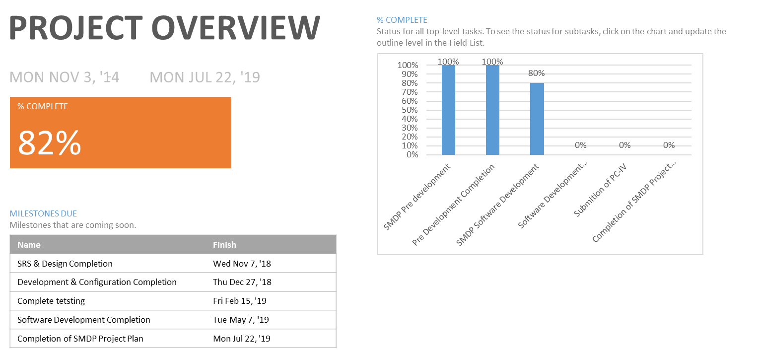

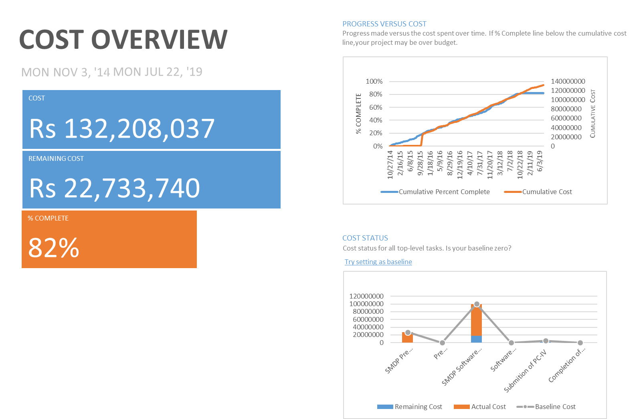
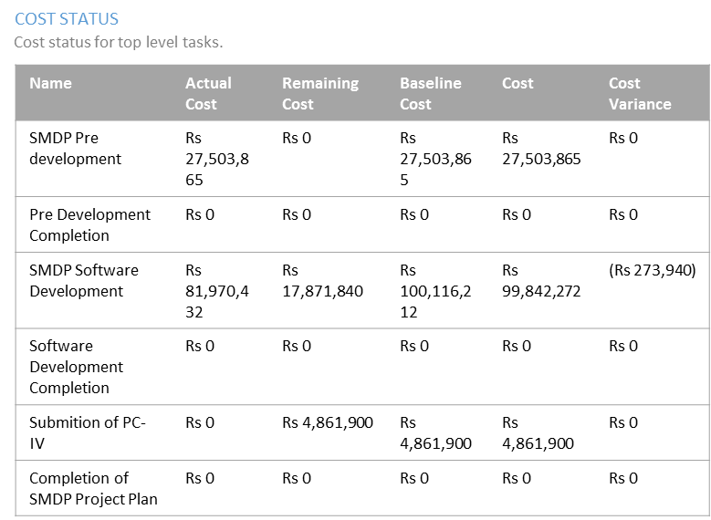

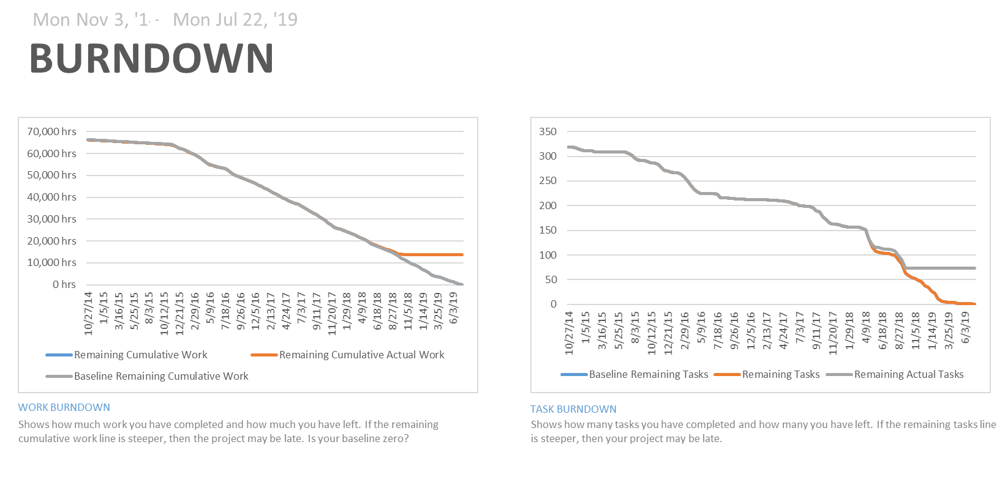

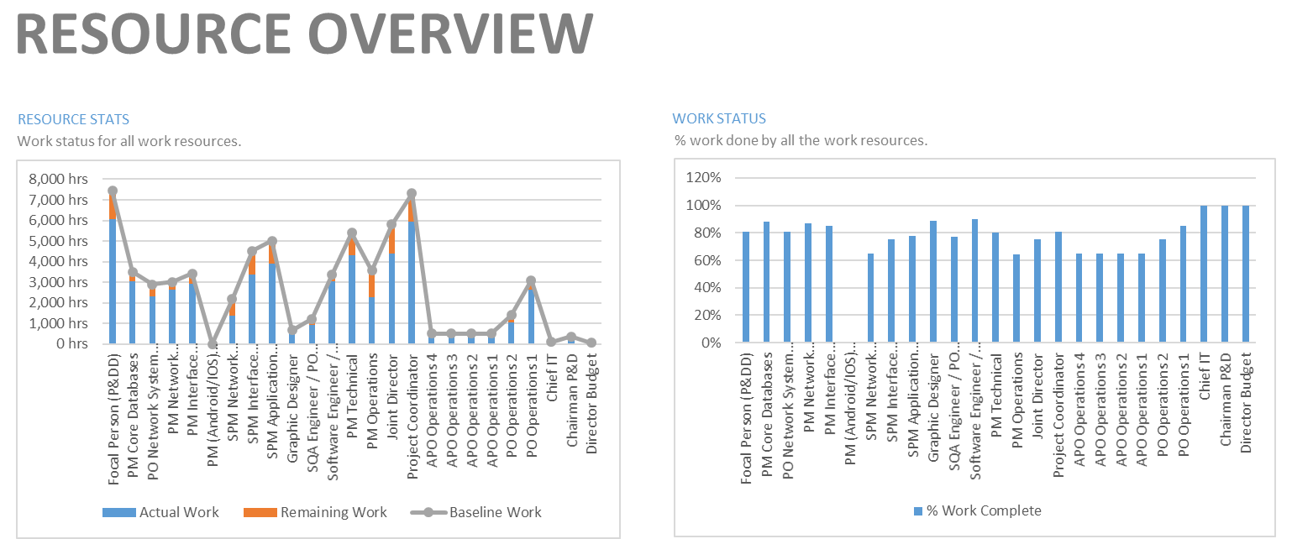

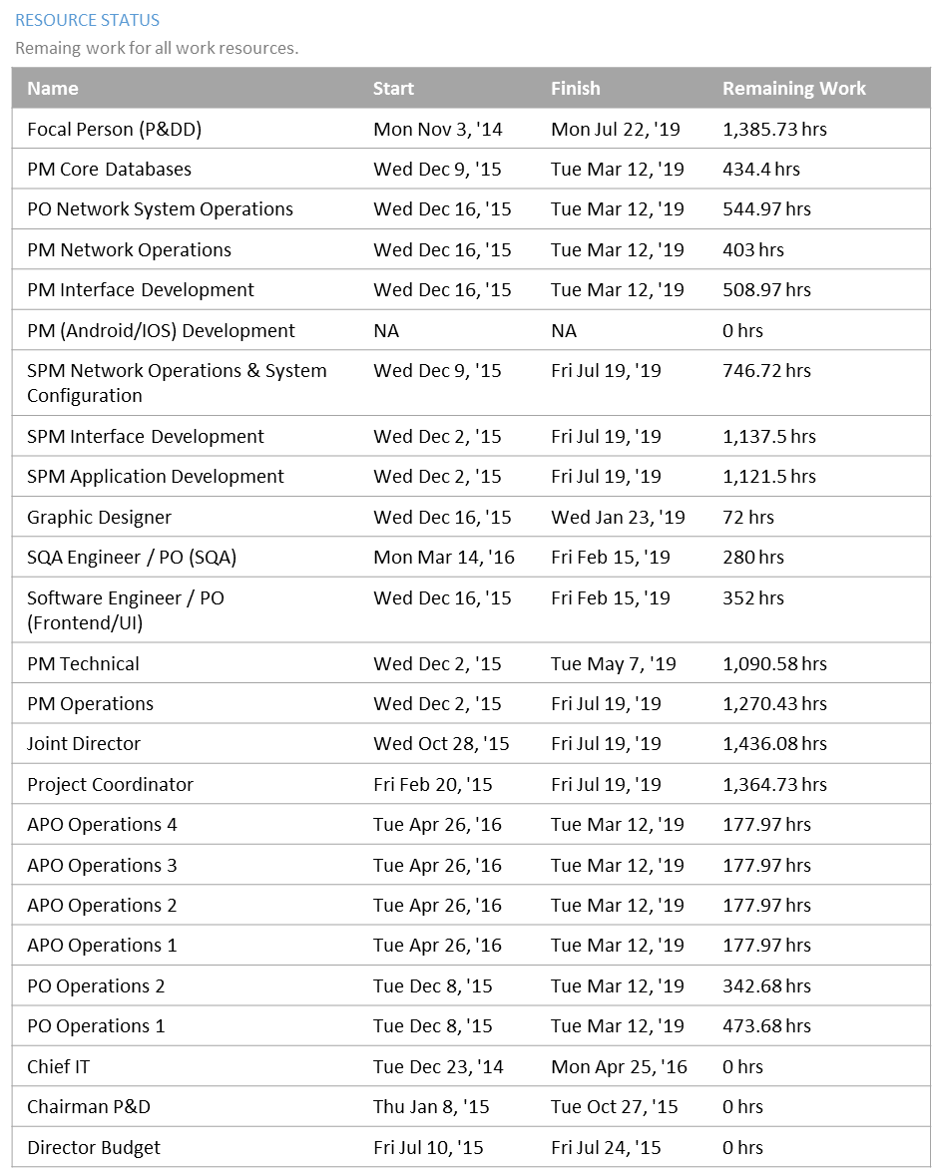
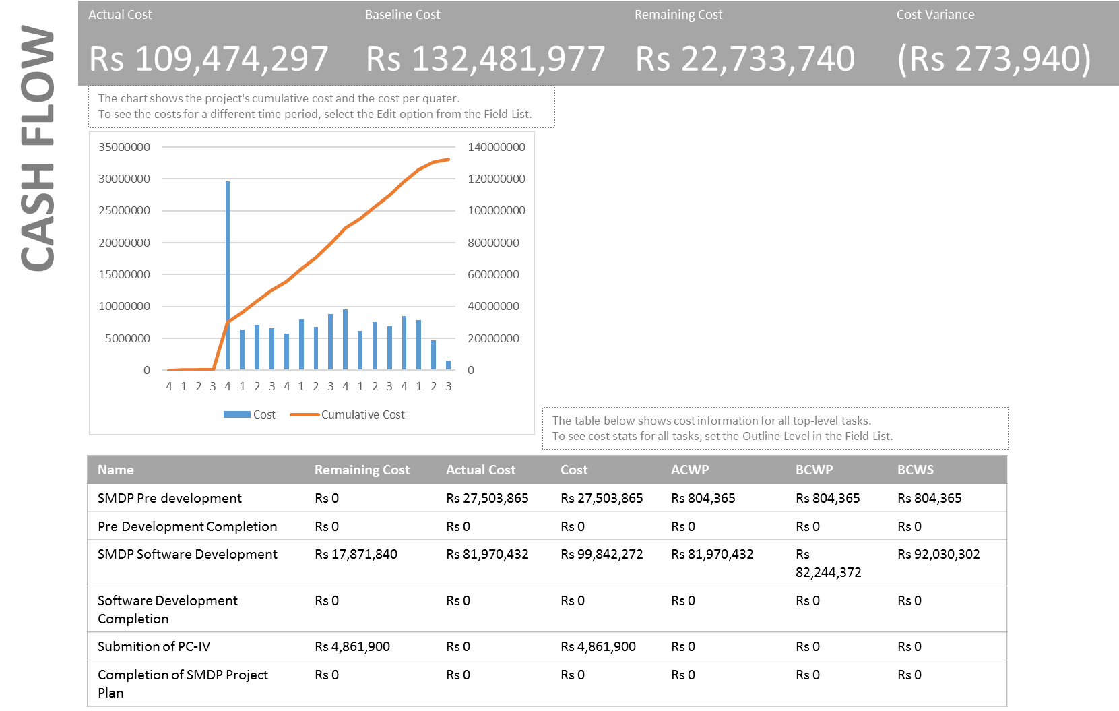
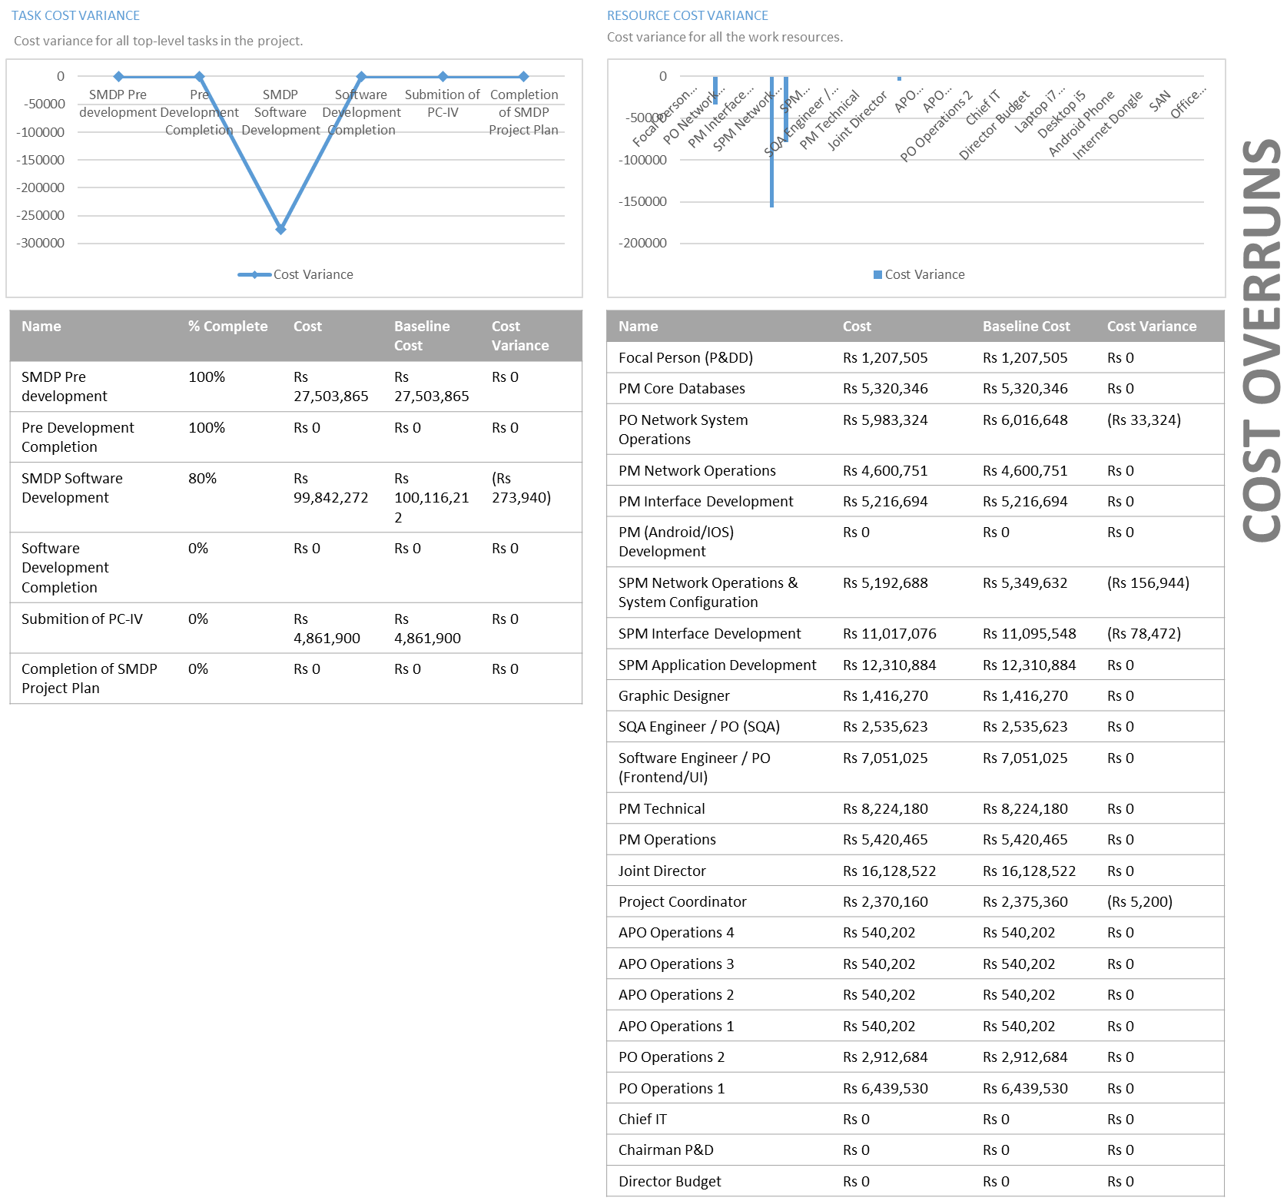
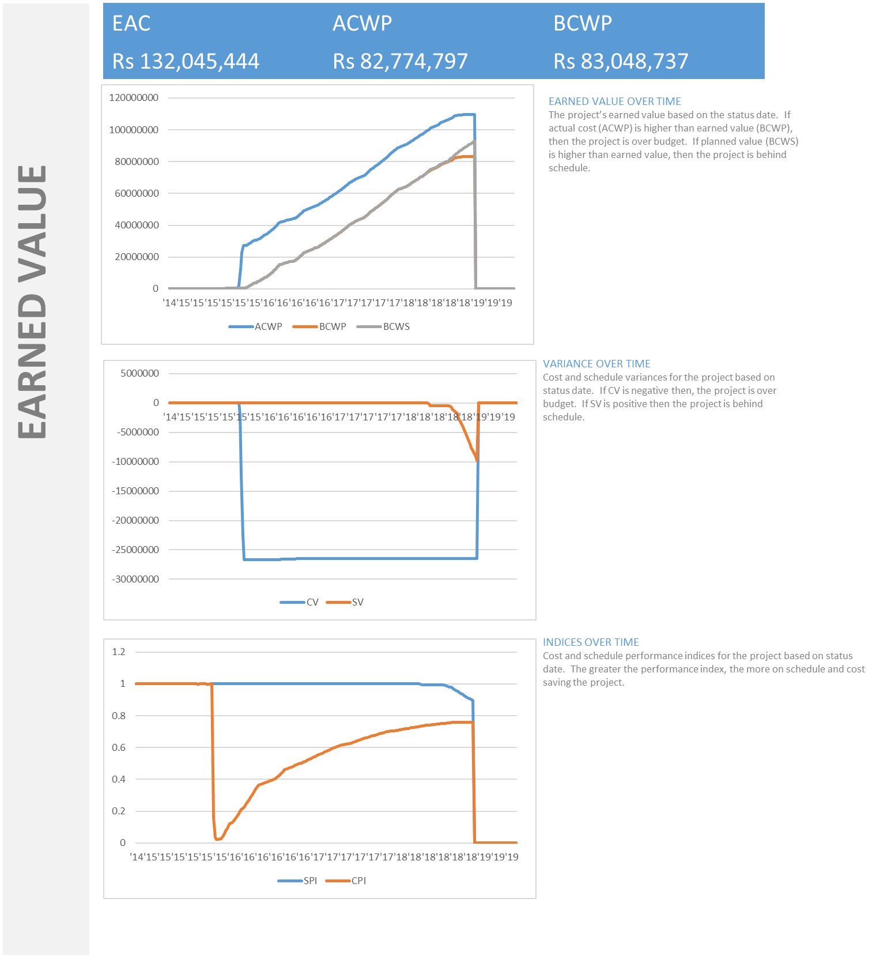
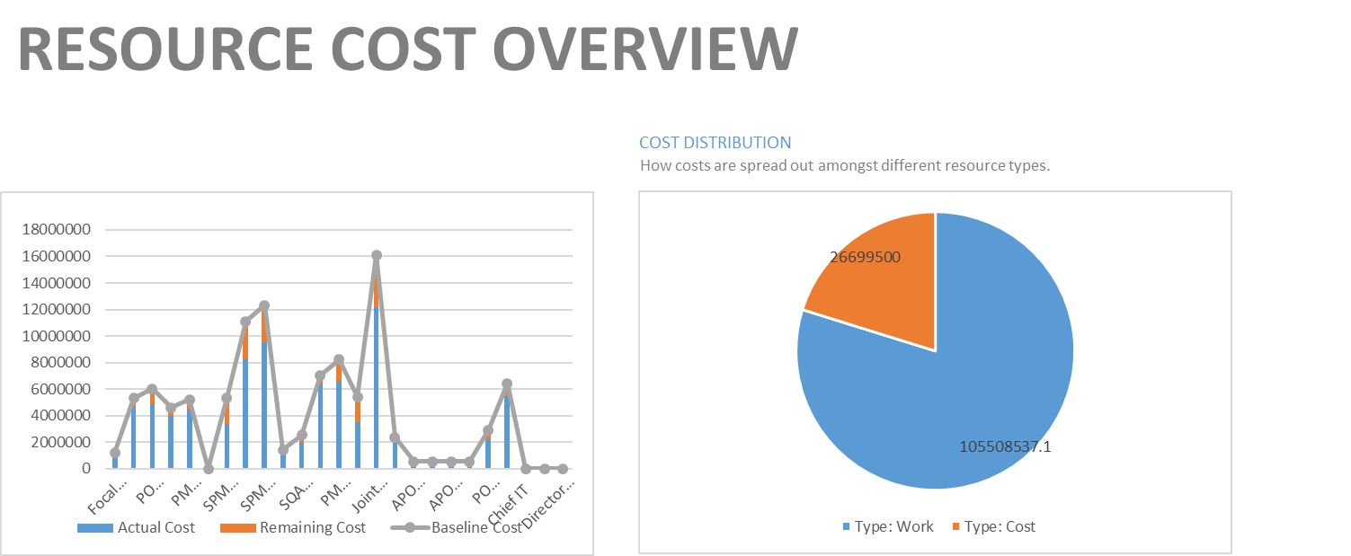

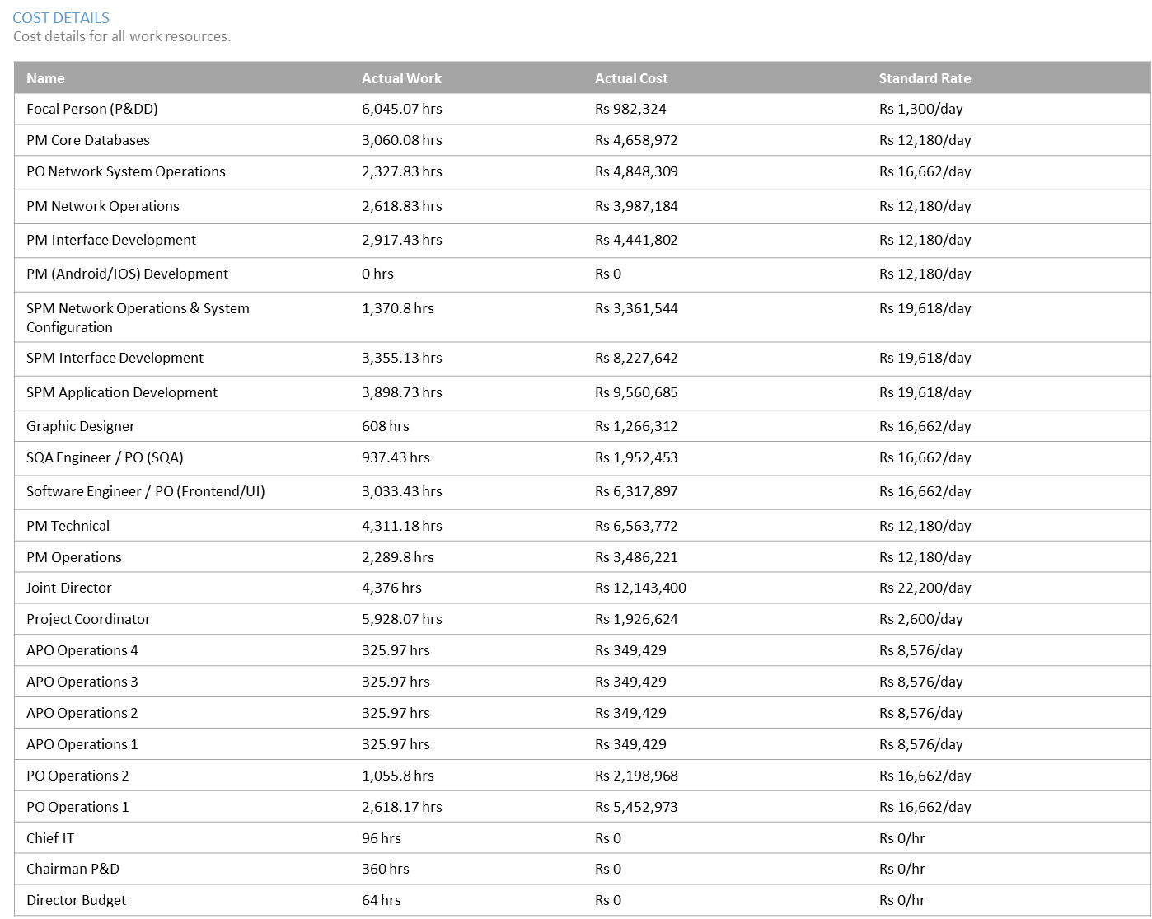
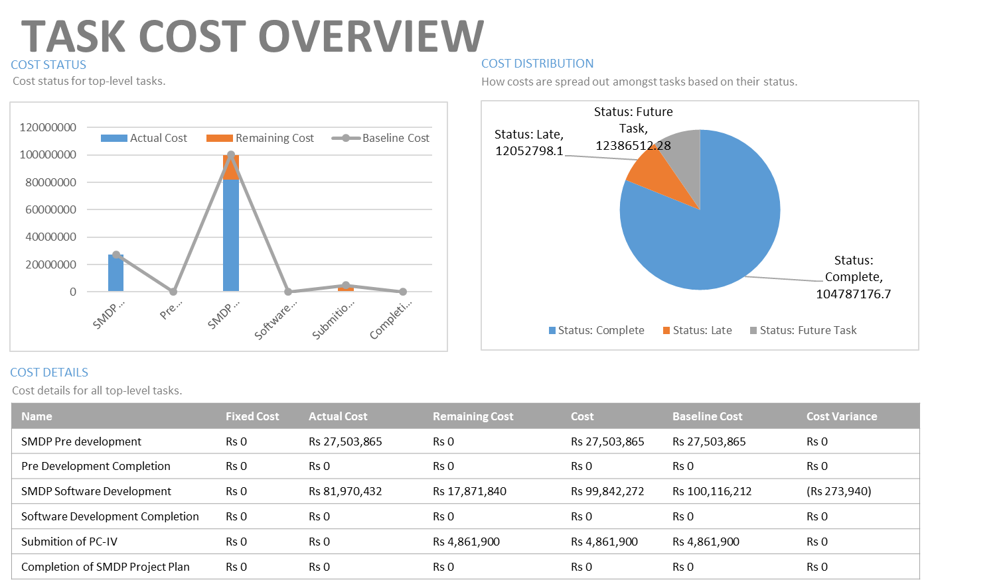

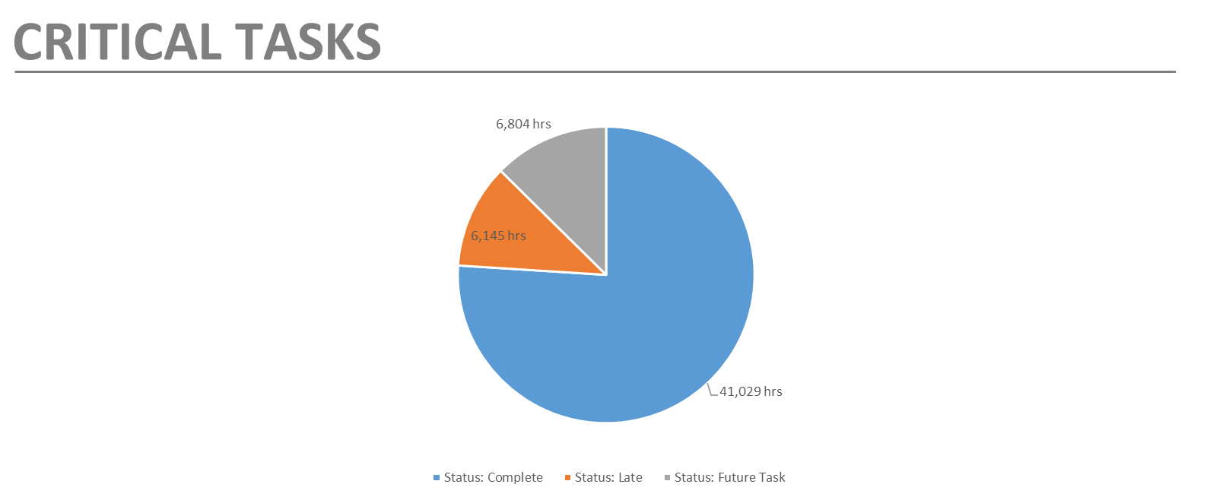

Name | Start | Finish | % Complete | Remaining Work
Gather Requirements | Wed Sep 5, '18 | Thu Oct 18, '18 | 0% | 480 hrs
Define Analysis Model of user Requiment | Fri Oct 19, '18 | Tue Oct 23, '18 | 0% | 72 hrs
Conclude User Functional Requirements | Wed Oct 24, '18 | Fri Oct 26, '18 | 0% | 132 hrs
Incorporate Feedback into Functional Requirements | Mon Oct 29, '18 | Thu Nov 1, '18 | 0% | 208 hrs
Develop SRS | Fri Nov 2, '18 | Mon Nov 5, '18 | 0% | 16 hrs
Validate SRS | Tue Nov 6, '18 | Wed Nov 7, '18 | 0% | 72 hrs
Develop UI | Thu Nov 8, '18 | Thu Nov 22, '18 | 0% | 210 hrs
Develop Forms | Mon Nov 12, '18 | Thu Nov 22, '18 | 0% | 96 hrs
Develop Workflow | Fri Nov 23, '18 | Tue Nov 27, '18 | 0% | 96 hrs
Develop Middle Tier | Wed Nov 28, '18 | Tue Dec 11, '18 | 0% | 480 hrs
Develop Connections with Other Systems | Wed Dec 12, '18 | Thu Dec 13, '18 | 0% | 120 hrs
Develop Permissions | Fri Dec 14, '18 | Mon Dec 17, '18 | 0% | 104 hrs
Create System Documentation | Tue Dec 18, '18 | Wed Dec 19, '18 | 0% | 72 hrs
Configuration Identification | Thu Dec 20, '18 | Fri Dec 21, '18 | 0% | 56 hrs
Configuration Item Storage | Mon Dec 24, '18 | Mon Dec 24, '18 | 0% | 28 hrs
Configuration Change Control | Mon Dec 24, '18 | Tue Dec 25, '18 | 0% | 16 hrs
Configuration Status Reporting | Wed Dec 26, '18 | Thu Dec 27, '18 | 0% | 56 hrs
Develop Unit Tests | Fri Dec 28, '18 | Tue Jan 1, '19 | 0% | 216 hrs
Develop System Tests | Wed Jan 2, '19 | Thu Jan 3, '19 | 0% | 96 hrs
Create Test Documentation | Fri Jan 4, '19 | Tue Jan 8, '19 | 0% | 120 hrs
Execute Manual Tests | Wed Jan 9, '19 | Tue Jan 15, '19 | 0% | 400 hrs
Execute Automated Tests | Wed Jan 16, '19 | Tue Jan 22, '19 | 0% | 320 hrs
Compile Test Statistics | Wed Jan 23, '19 | Wed Jan 23, '19 | 0% | 24 hrs
Approval by QA | Thu Jan 24, '19 | Thu Jan 24, '19 | 0% | 48 hrs
Set Testing Requirements for Regression Testing | Fri Jan 25, '19 | Fri Jan 25, '19 | 0% | 16 hrs
Set Entry Criteria for Regression Testing | Fri Jan 25, '19 | Fri Jan 25, '19 | 0% | 16 hrs
Set Exit Criteria for Regression Testing | Fri Jan 25, '19 | Fri Jan 25, '19 | 0% | 16 hrs
Set Testing Schedule for Regression Testing | Fri Jan 25, '19 | Fri Jan 25, '19 | 0% | 16 hrs
Run Regression Tests | Mon Jan 28, '19 | Fri Feb 1, '19 | 0% | 360 hrs
Define Scenarios for Stress Testing | Mon Feb 4, '19 | Mon Feb 4, '19 | 0% | 32 hrs
Set Workload and Tools for Stress Testing | Mon Feb 4, '19 | Mon Feb 4, '19 | 0% | 32 hrs
Create Test Cases for Stress Testing | Tue Feb 5, '19 | Thu Feb 7, '19 | 0% | 144 hrs
Test Case Running in Loaded Environment | Fri Feb 8, '19 | Thu Feb 14, '19 | 0% | 360 hrs
Evaluation & Analysis of Results | Fri Feb 15, '19 | Fri Feb 15, '19 | 0% | 72 hrs
Develop High Level Deployment Plan | Mon Feb 18, '19 | Mon Feb 18, '19 | 0% | 29.92 hrs
Refine deployment plan | Tue Feb 19, '19 | Tue Feb 19, '19 | 0% | 88 hrs
Finalize Deployment Plan | Wed Feb 20, '19 | Wed Feb 20, '19 | 0% | 88 hrs
Execute Beta Test | Thu Feb 21, '19 | Fri Feb 22, '19 | 0% | 64 hrs
Perform Training Needs Assessment | Mon Feb 25, '19 | Mon Feb 25, '19 | 0% | 96 hrs
Develop Learning Objectives | Tue Feb 26, '19 | Tue Feb 26, '19 | 0% | 40 hrs
Develop Training Materials | Tue Feb 26, '19 | Tue Feb 26, '19 | 0% | 40 hrs
Implement Training | Wed Feb 27, '19 | Thu Mar 7, '19 | 0% | 672 hrs
Evaluate Training | Fri Mar 8, '19 | Fri Mar 8, '19 | 0% | 96 hrs
Go Live | Mon Mar 11, '19 | Mon Mar 11, '19 | 0% | 104 hrs
Result Measurement | Tue Mar 12, '19 | Tue Mar 12, '19 | 0% | 104 hrs
Change Management | Wed Mar 13, '19 | Tue Mar 26, '19 | 0% | 240 hrs
Support Backup | Wed Mar 27, '19 | Tue May 7, '19 | 0% | 696 hrs
Submition of PC-IV | Wed May 8, '19 | Mon Jul 22, '19 | 0% | 2,832 hrs
Completion of SMDP Project Plan | Mon Jul 22, '19 | Mon Jul 22, '19 | 0% | 0 hrs

