SECURITY BRANCH OF BAHRIA UNIVERSITY


PMO AND EPM SERVER IMPLEMENTATION IN BHATTI SECURITY CONSULTANTS & SECURITY SOLUTUON PROVIEDERS
Microsoft Project Professional 2013
Submitted To

Mr. Ahsan Maqbool

Submitted By

Husnain Afzal Bhatti (03-298171-058)
Saddeed ud din (03-298171-053)

(MSPM- 2B)

Bahria University, Lahore Campus
10 January 2018

Acknowledgement

All praise to Allah Almighty, who gave us the courage and opportunity to carry out this investigative research.
We would like to thank our instructor Mr. Ahsan Maqbool for his continuous support, guidance and constant supervision as well as for providing necessary information regarding the project & also for their support in completing the project.
We are also grateful to all employees for their cooperation and providing information that lead to our project being completed.
We owe our special thanks to those closest to us for their endless patience and moral support.
This study would not have been possible without the continual support and guidance of our parents who have willingly helped us out with their abilities.

Dedication

We dedicated this research project to my beloved parents. Who are the source of inspiration and door of heaven for us and they are always praying for us, for our success, and make us strong in difficult moments of life.

 | TABLES OF CONTENTS
1 | SECTION-A  Historical Viewpoint of Organization…………………………………….. | 7
2 | Organizational Organogram……………………………………………….. | 7
3 | PMO Proposal…………………………………………………………… | 8
4 | Culture of the Organization………………………………………… | 8
5 | Problems faced by BSC in Lack of PMO……………………… | 9
6 | PMO Justification ……………………………………….. | 9
7 | SECTION-B  PMO VISION ……………………………………………………… | 12
8 | PMO MISSION …………………………………………………. | 12
9 | Steps for PMO Implementation ………………………………………. | 12
9.1 | STEP 1: Organizational Need and will to accept PMO……………. | 13
9.2 | STEP 2: Approval of top Management and Commitment ………… | 13
9.3 | STEP 3: PMOs Staff and reporting channel……………………….. | 13
9.4 | STEP 4: Progress of Central Data Base of PMO related Measureable | 13
9.5 | STEP 5: Selection of Enterprise Project Management (EPM) to support PMO | 14
9.6 | STEP 6: Plan Execution ………………………. | 14
10 | Challenges in PMO Implementation……………………………………….. | 15
11 | SECTION-C  Why PMO? ……………………………………………………………… | 16
12 | Function Of PMO ………………………………………………………. | 17
13  14 | Types OF PMO …………………………………………………………  Classification of PMO Types …………………………………………… | 18  19
16  16.1 | Why PMO Supportive? ………………………………………....  Why PMO Supportive? ………………………………………… | 20  21
17 | SECTION-D  PROJECT CHARTER…………………………………………………… | 22
17.1 | General Information……………………………………………… | 23
17.2 | Points of Contacts………………………………………………… | 23
17.3 | Document Version……………………………………………….. | 23
17.4 | Executive Summary……………………………………………… | 24
17.5 | Project Purpose…………………………………………………... | 24
17.6 | Assumptions……………………………………………………… | 25
17.7 | Project Authority…………………………………………………. | 25
17.8 | Project Organization Description………………………………… | 26
17.9 | Resources………………………………………………………… | 26
17.10 | Signatures………………………………………………………… | 27
18 | PROJECT SCOPE……………………………………………………….. | 28
18.1 | Document Version………………………………………………. | 29
18.2 | Project Description………………………………………………. | 30
18.3 | Project Success Criteria…………………………………………. | 30
18.4 | Scope…………………………………………………………….. | 30
18.5 | Resources………………………………………………………… | 30
18.6 | Deliverables & Milestones………………………………………. | 30
18.7 | Risks……………………………………………………………… | 31
18.8 | Assumptions and Constraints……………………………………. | 31
18.9 | Approval…………………………………………………………. | 33
19 | Appendix – A - Figure- 1 Organizational Structure…………………….. | 34
20 | MS Project Sheet ………………………….. | 34
21 | Project Calendar  Project Overview & Work Overview) ……………… | 35  36
22 | Work Overview & Resource Cost Overview…………………………………………… | 37
23 | Resource Overview & Over Allocated Resources ……………… | 38
24 | Cash Flow & Cost Overview ………………………….. | 39
25 | Cost Overruns & Burn down ………………. | 40
26 | Critical Task ……………………………… | 41
27 | Earned Value ……………………… | 42
28 | Gant Chart ………………………………… | 44
29 | Milestone Report ………………………………… | 45
30 | Network Diagram …………………………………. | 45
31 | Slipping Tasks……………………………………………. | 46
32 | Task cost…………………………………………….. | 47
33 | Reference & Templates ………………………. | 48
34 | Plagiarism check ………………………. | 48

SECTION-A
Historical Perspective of Organization
Bhatti security consultants and security services provider is a private company which was established in 2005 having its head office in Islamabad and sub offices at Lahore and Karachi. The company provides security services and consultancy services to multinational companies, government and semi government companies for installation of security equipment at their installations and provide them consultancy on how to secure their installations, factories, offices and mills from external threats like theft and terrorism in current security and order scenario of the world. Especially security lapses in Pakistan from terrorism pint of view after 9/11 incident when security forces of Pakistan are involved in fighting with terrorists at its borders and within country. BSC has installed security equipment including surveillance, access control and Intrusion detection equipment at more than 100 sites in Pakistan which includes very important bases of government organizations including defense forces of Pakistan. During its existence of 12 years the company has done business of about 700 Million dollars with local and foreign clients including clients from Middle East and gulf. The company also provides guards for VVIP Security which are trained with the up to date counter terrorism procedures being carried out in escorting

Company is currently holding license and registered with the interior ministry of Pakistan. In order to achieve standardization at par with international security Agencies Company became ISO certified in 2010. The said certification brought Quality Management and customer satisfaction culture in the organization.

Organizational Organogram
The administrative structure of Bhatti Security Consultancy is well-designed. Description of the same is as there:
- The establish is going by Managing Director Bhatti Security Consultancy (MD BSC)
- The three principle sections are going by General Managers (GMs) caring for the accompanying heads:
- General Manager (GM) Survey and Installations ventures (GM) Maintenance
- (G.M) Quality Control/ Quality Assurance
- In support role there are two separate departments controlled by GMs looking after the logistics and financial affairs. These are as follows:
- General Manager (GM) Finance
- General Manager (GM) Logistics
The Quality Unit fills in as a self-sufficient substance and specifically reports to the Managing Director for quality control and confirmation related issues/capacities being executed as institutionalized practice all through the association.

Gap Analysis (Problems)

PMO Proposal
Since the company is presently handling more than 20 project at National level, PMO has been proposed to the existing hierarchal organizational structure as an upcoming department. Upon approval the said setup of PMO will become an enduring part of the organization.

PMO Justification
Establishment of PMO at BSC is considered to be the need of the time in order to institutionalize the organization and cope up with the rapidly changing technology in the field of security keeping in view the latest trends of terrorism. The PMO will ensure proper prioritization of the projects and judicious utilization of resources and per the specialized opinion and requirements of the customers. Furthermore the company will be able in responsibility more projects having bigger scope. The Upper administration at BSC in the wake of looking into execution of the organization in the new years has completely verifiable and devoted towards the foundation of the PMO at BSC. The undertakings patrons' commitment (i.e. the best administration) will be the basic part in the effective development of the PMO.

The PMO won't just enhance the administration of the ventures yet will likewise add on an incentive to winning association structures. The utilization of a shared approach in depending upon the forces of the tasks administration frameworks of entomb connections conveys the direction/support to customers. Following are the couple of likely advantages of PMO operation: Increases the real validity of the systems installed by taking duty for across group placement of each project.
- Provides sustenance, guidance and training in the organization for actual consumption of Project Management tools/ process.
- Ensures that the projects are arranged and united with strategic purposes, vision of the organization and necessities of the end user.
- Execution and arranging of projects in an operative manner.
- Effective communication incapacitating all communication cracks within the organization.
- Amended association between cross-functional project teams.
- Reliability, predictability and enhanced deliverance in terms of customer fulfillment.
- Provision and implementation of project management guidelines. SOPs (Standard Operating Procedures) and Templates.
- Creation of standardized OPAs and project management templates.
- The provision of decision making tools with clear visibility with regard to cost, schedule and tracking of all the project progress.
- Provision of support, guidance and training to employees/ teams on best project management practices.
- Federal provision of data to higher management for decision making.
- Ensuring that no overlapping of projects exists.
- Ensures that the projects are deployed broadly and executive support for the projects exists.
- Ensures proper and timely project closure/ termination.
- It ensures effective management and controlling of projects in all phases of the project life cycle. -

SECTION-B
Project Management office VISION
To establish and create center in Bhatti Security Consultancy (BSC) for improvement of general awareness, mutual partnership, improved efficiency and constant delivery of projects as per scope schedule, inside existing resources and cost.

Project Management office MISSION
Empower BSC Management in smooth execution and usage of vital choices the PMO will:
- Enhance partner fulfillment through executing institutionalized procedures and methodology.
- Help in work of "Good Practices" which will accumulate proficiency and budgetary reserve funds.
- Assist portfolio and Program Management to track, audit and oversight of the ventures.
- PMO will help in guaranteeing that all ventures of the BSC are an example of overcoming adversity by following:
- Collaboration with venture supervisors to give important help required to accomplishing seat imprints, points of reference and destinations.
- Ensure that PMO idea has totally been ingested and incorporated in the association and completely broadening its administrations according to accessible conventions.
- Appreciate the use of repeatable undertaking administration strategies with effectively dealt with guidelines and acknowledgment criteria.
- Provision of current yet innovative propelled venture administration approaches and devices.
- Ensure entomb and intra division coordination viz-a-viz sharing of skill, preparing and training programs.
- Active cooperation in overseeing bury hierarchical exercises.
Steps for PMO Implementation
Undertaking Management Office (PMO) demonstrates a basic part in running and seeking after various tasks, simultaneously. Consequently, its noteworthiness in with respect to gainful specialty unit can't be precluded. Following advances justify thought in foundation of PMO in Bhatti Security Consultancy administrations.
STEP 1: Company Requirement and will to admit PMO
The main step in founding a PMO is to determine and analyze that whether a PMO is required in the organization or not. If it is required do we have consensus

STEP 2: Approval of top Management and Commitment
Every organization contains a person in higher hierarchy who takes responsibility to implement PMO. The said individual is the one who can maintenance, approve funds and allocate resources to turn the concept into reality. In this particular scenario support of MD along with GMs is available.

STEP 3: Allocation of Staff for PMO and their reporting channel
The Project Management Office staff and its network will be as there:

Staffing
The PMO will primarily be equipped with undermentioned Human Resource. However, with the growth of work and volume/ momentum the team may be enhanced in the future:
- Manager
- Deputy Manager
- Two Office Assistants
- Office boy/ Runner
Reporting Network
The Manager PMO will be straightforwardly dependable to the Managing Director (MD) of Bhatti Consultancy Services. In like manner, the Deputy Manager will answer to the Manager PMO. Proposal from GMs and Employees are constantly welcome for advancement of authoritative capacities/ventures.
STEP 4: Expansion of Central Data Base
Extension of focal store comprising of task administration record involving; Project Phases, Risks, Project Appraisals, Reports, HR Skills, Performance investigation, Templates, Acceptance Criteria, Requirement Traceability Matrix, Cost assessments will be a subsequent stage to help development adequacy of PMO. The said focal information base will go about as a focal library for comparative sort of ventures.
STEP 5: Enterprise Project Management (EPM) to support PMO
In order to support PMO purposes essential technological tool i.e. Enterprise Project Management (EPM) application would be mandatory. In this regard Microsoft Project server based on Microsoft Project Professional 2013 is suggested to be employed.

STEP 6: Execution of Plans
Once the PMO operation plan has been decided and relevant stakeholders are onboard, it’s time for regular execution of the plan. One of the pivotal elements to support emergence of PMO is to show progress within short period of time. This will offer necessary support to PMO’s designation as a command advisor so that requisite funds are released to execute the plan. As the plan progresses/ grows compliance of employees to the new set up will also increase various. However, following factors needs emphasis for smooth implementation.

Flexibility
In the beginning times of utilization process, advance is thought to be consistent and decrease might be experiential which will be backed out as the improvement cultivates. Amid this stage a responsible head be named who could comprehend flow of such change in the way of life of association. He ought to have heart to endure introductory downstream pattern in exchange of future profits.
Training/ Monitoring
Preparing as bit from application methodology is additionally vital so best outcomes can be comprehended in most brief conceivable time. Such trainings can include adherence of good practices and enable the change to happen.

Communication Plan
Communication is an imperative need of PMO as it conveys and goes about as middle person between best and low level administration. Hence, directing of criticism and upkeep of ideal linkage in different levels of association can create productive outcomes through work a compelling correspondence methodology.
PMO challenges
Change is constantly opposed at whatever point it is presented in any association, so would be the situation here as each individual would dread to lose his self-government due centralization of procedures. Following difficulties are visualized to be experienced amid usage stage:
Resistance from the functional Departments
- Functional division may oppose in dread of loss of expert/control particularly when all undertakings are deliberately seen and observed by single body/element.
- Opposition from Quality division in discernment that PMO would supplant Quality set up.
- Consent of different offices to formalize their documentation, methodology, process in a standard organization which is a troublesome activity.
- Resentment and dread in representatives due extra work, preparing and arrangement while not having huge photo of the profits related with the PMO.
- Training of HR which may cost extra budgetary sources and time too.
- Creation of focal archive/information base as the information of past activities must be accumulated at one place. So gathering of imperative information may turn into a test.
- Lack of correspondence/hole at different levels of administration is thought to be the fore most test and must be settled through viable correspondence.

SECTION – C
Why PMO?
One of the essential factors in usage of PMO is the determination of appropriate innovation and devices to robotize venture administration forms beginning from its introduction till shutting of the undertaking. The innovation and venture procedures ought to be satisfactorily utilized to help highlights from conceptualization of the undertaking to the endorsement from the best administration in a precise way. Microsoft Project Server 2013 in view of Project Professional offers various highlights basic to reorganization the Project and Portfolio Management (PPM) forms. In this way, Microsoft EPM preparation incorporating MS Project Professional 2013, MS Project Server 2013 and MS Share Point Server 2013 has been chosen for Ship Building Complex (SBC). Following advances are suggested for execution of EPM in SBC:
- Select a group which is persuaded to transform thought of EPM usage into reality.
- Identify in house mastery alongside the ability level to be obtained from outside of the association.
- Arrange workshops, symposiums and addresses to make mindfulness among representatives.
- Set seat imprints and destinations for usage design.
- Select Microsoft EPM server 2013 being having easy to use interface.
- Installation, arrangement and relocation of information as pertinent.
- Training of workers be directed on EPM server.
- Test Runs of the EPM server be ended.
- Run Pilot scheme to break down viability of the framework.
- EPM arrangement in interpretation of careful inquiries and message educated be comprised.
The suggested EPM application will add subsequent benefits:
- Provision of institutionalized venture layouts which will encourage overseeing of new activities.

- Automated determination of undertakings process will guarantee that all proper investigation has been led affirmed earlier endorsement of the subsidizing. This will give money related investigation and a correlation among the conceivable future activities.
- Bottlenecks could be maintained a strategic distance from by determining and proper usage of accessible pool assets that incorporate men and material.
- Provision of normal task administration dashboard to the Program and Portfolio Management for powerful and convenient basic leadership.
- Real time venture execution checking with Key Performance Indicators (KPIs) as far as cost and calendar differences of the undertaking.
- Key venture data and expectations can be imparted to partners and undertaking group through a brought together administration framework by the program administration and the Project Manager.
- Optimized use of money connected assets for profiting most extreme undertakings and all through the venture through a concentrated monetary management and evaluation framework.
- Timely, exact and viable correspondence to extend group through EPM arrangement will upgrade compelling task administration and observing.
- Project Management execution can be assessed through task plan, quality dealings, venture arranging, cost estimation and viable usage of EPM procedures and its administration.
Functions of PMO
In spite of the fact that PMOs fluctuate as far as bulk, structure and duties, here are regular dimensions that go to the accompanying 6 regions:
- Maintenance. This is the essential venture administration workplace capacity to give rules to usage groups and counsel to extend administrators of different specialty units.
- Procedure. This capacity of Project Management Office is focused at creating and executing a reliable and institutionalized procedure of dealing with a few undertakings as per a picked philosophy.
- Training. Directing task administration office preparing permits enhancing abilities and aptitudes of venture administrators and group pioneers. This capacity guarantees that directors and groups with suitable aptitudes and capacities are utilized and doled out.
- Headquarters. Because of effective utilization of this PMO work, chiefs are permitted to chip away at ventures from a solitary, unified office. Subsequently, joint effort between chiefs can be essentially expanded.

- Internal Consulting. Permitting to this PMO work, venture administrators can give their groups recommendations in regards to PMO best practices. Administrators can tutor their subordinates and give coordinate PMO direction without sitting around idly on ineffectual interchanges.

- Software instruments. Plainly virtual wander organization work environments can't be realized whether no PMO writing computer programs is used. Using specific writing computer programs is the foundation for productive PMO execution.
The recorded capacities do exclude cost sparing. Despite the fact that it might appear that sorting out a PMO structure includes executing cost decrease procedures, cutting spending and lessening various ventures, in truth the hypothesis of undertaking administration office advises that PMO exercises absolutely add to diminished costs and less tasks, yet the underlying rationale in building up an office structure alludes to performing vital activities with more consistency and proficiency.
Types of Project Management office
There are many classifications for Project Management offices; in this article we discuss the most 3 recognized and agreed on types by researchers and Project experts are:
1- Supportive Project Management Office
Low control
This make offers assistance as direction available upon inquire. It also gives shapes, information, specific cause and getting ready to the endeavor assemble without compelling control on their undertaking or activities. This sort of working environments fits associations that are known for their successful exercises and are simply in prerequisite for some sort of server cultivate. It's also depicted by its low level of control on exercises and gatherings, despite following united models in all endeavors.

2- Controlling PMO
Direct control
This sort of workplaces gives a bound together structure to the foundation, which requires alterations and adjustments on the utilized procedures, and also structures and applications. Additionally, it forces a direct level of control on ventures and their exercises. This shape is utilized inside organizations that are occupied with having some control on their exercises, procedures and methodology
.3- Directive PMO
High control
This compose is known for its high control on wanders, or even totally administering wanders with giving needed resources and help. The work environment describes chairmen to seek after it clearly going after the PMO wander. This make furthermore gives high cleaned approach in regulating wanders, where every central needs to make periodic reports for the work environment which guarantees an anomalous condition of consistency in tackle wanders level. This compose fits huge foundations that need particular help in various and diverse spots.
Other classifications for POMs type’s
The Project Management Institute orders PMOs to five distinct writes:
1-Departmental: Funding's particular specialty units or divisions.
2-Project-particular: Manages the achievement of a specific task.
3-Strategic: Manages a noteworthy authoritative change.
4-Project-bolster: Handles managerial errands to speed extend finish.
5-Center of Excellence: Handles preparing and creating venture supervisors.

From an organizational point of view, PMOs can be classified to one of the following types:
1- Initiative PMO
2- Structural (departmental) PMO
3- Superior- purpose PMO

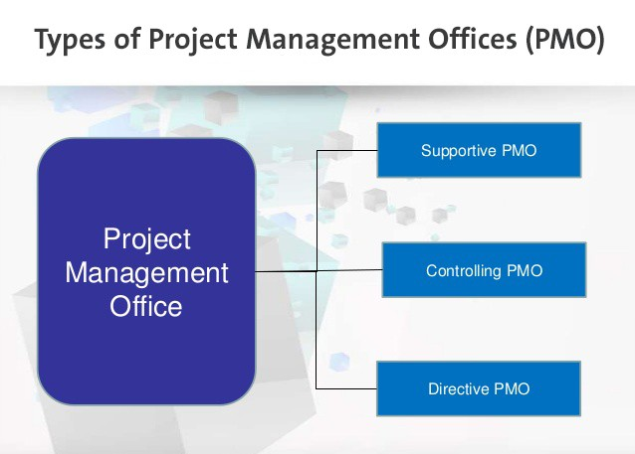

Why Supportive?

A steady PMO concentrates on enabling the PM and task groups to take care of normal issues and succeed. This is the most widely recognized and most prevalent sort of PMO for a few reasons:

From a steady PMO to an order PMO. In the event that the PMO techniques and administrations are broadly valued and acknowledged, the PMO might have the capacity to use this into a redesign of the organization where the venture chiefs are moved with the goal that they answer to the PMO itself. When most or all undertaking directors answer to the PMO, the PMO is of the mandate compose. The PMO would then be able to enhance execution by:

Coordinating that all ventures take after the Project Management techniques

Coordinating preparing, profession way, and advancement in light of venture accomplishment under the PMO's immediate supervision

Lessening cost by concentrating administration administrations for ventures, with the goal that similar upgrades are done at bring down cost

In outline, the strong PMO is the most widely recognized compose, it is well known, and it impacts fast change from the get-go – regularly in the first to three years of operation. It adopts these strategies:

A solid client benefit center to engage venture supervisors and undertaking groups. The adage may be, "We succeed when you succeed."

Enables partners by enhancing their aptitudes and helping them take care of their issues.

Achieves officials by implication, by enabling task chiefs with the goal that administrators see enhanced undertaking results and see issues vanishing.

Advantages the association by enabling task directors to take care of the issues that the PMO characterized in its underlying evaluation of the association's venture administration capacity.

This will work until the steady PMO's prosperity brings about most undertaking chiefs taking care of their own issues. By then, the PMO may experience difficulty legitimizing its reality. Be that as it may, it would be a mix up for the association to close the PMO, in light of the fact that, if preparing isn't kept up, at that point venture administrators will come back to old propensities and the old issues will return. It is best to get ready for this minute by setting up a development arrange for that transforms the steady PMO into a controlling or order PMO.

The strong PMO concentrates on enabling undertaking administrators. Interestingly, the controlling PMO concentrates on guaranteeing that official concerns are tended to.

SECTION - D

PROJECT CHARTER

General Information

BSC has been conferred agreement for installation of a parametric security and Surveillance System at Bahria University Lahore Campus located at Johar Town Lahore. This project will be referred to as Installation of PSS system at Bahria University Lahore Campus ID No. PMO-PSS/BU/LHR-058. The Charter Document has been prepared by the appointed Project Manager PSS systems MR Husnain Afzal Bhatti and Assistant Project Manager MR Sadeed ud din.

Project Title: | Installation Of PSS System | Project ID: | PMO-PSS/BU/LHR-058
Prepared by: | Mr Hhusnain Afzal Bhatti
Points of Contact

Position | Title/Name/Organization | Contact
Project Sponsor | Bahria University Lahore Campus | BU HQ E-8,Islamabad
Program Manager | GM (Projects) | gm_projects@bsc.org
Project Manager | Chief Security consultant Mr Husnain Afzal bhati | csc_projects@bsc.org
Deputy Manager | Security consultant  Mr Sadeed ud din | sc_projects@bsc.org

Document Version

Version | Date | Comments
V 1.0 | 1-10-2018 | NILL

Executive Summary

Parametric Security and surveillance system is widely used for Security of Infrastructures, important installations, building and high profile places in the current deteriorated Security and Law and order scenario of the country. BSC provides a comprehensive security solution to all its customers providing upto date 100% security from Terrorism, Sabotage, Theft, Arson and other crimes like that. The Company being a local running machinery provides after sale support in shape or repair maintenance facility. Through life supportability of the Installed system is supported by BSC. Similarly, midlife up gradation and schedule maintenance can also be undertaken through in country expertise of BSC. Thereby, saves huge amount of national exchequer. Thus, Bahria University Headquarters has awarded contract to BSC for Installation of PSS System to ensure safety of its Campus.

Project Purpose

Business Problem
In prevalent law and order/ threat scenario coupled Terrorism and attack on educational institutes like APS Peshawar requirement of PSS system at educational institutes has increased manifold. In order to meet the demands of Bahria University Lahore a concept of small indigenously developed PSS system was conceived and has successfully turned into reality. The Installation of said System has provided a cheap and economical solution to premises of Bahria University. It is envisaged that such type of projects not only increase security of the Bahria university but also provide a role model to other institutes of Pakistan to Secure their institutes in the same manner.

Project Corporate Objectives
- The venture for Installation of PSS framework has been exhibited to BSC due to in nation unique improvement set up for Installation of PSS frameworks. The said venture offers extremely focused cost when contrasted with remote organizations. Moreover, total repair, protection and through life supportability is accessible locally. Introduction dependability of the privately created and made framework has been satisfying the fulfillment of previous clients. The undertaking is in a state of harmony with the accompanying best position business drivers of the association
- Continual Improvement in Quality of End Products via R&D and quality subsystem procurement
- Cost Saving through Smart Inventory Management System
- Improve Customer Satisfaction & Experience
- Skill Enhancement of Technicians

Assumptions

The task suppositions for the PSS framework ventures are as per the following;
- The framework hearings will be directed for one week at Bahria University Lahore in event of BU Chief Security Officer at Islamabad.
- All divisions will go full help as far as perceived assets and aptitude to Admin wing of BU for fruitful consummation of the task.
- The bolster help required from different areas will be composed by Project Manager.
- URD are well unmistakable
Project Authority

Authorization
The project has been accepted by the sponsor that is Bahria University and funds of PKR 20 M have been assigned to BSC for Installation of PSS system... Managing Director BSC has authorized the Project Manager to commit funding and resources for achieving successful end of the project.
Project Manager
Security consultant Mr. Sadeed ud din has been selected as the Project Manager (PM) for the PSS Installation project. He has been approved to fulfill the contract necessities and expand the assigned budget for conclusion of project objectives. The PM is also responsible for coordinating with other department for support and liaison.
Project Organization Description

The undertaking has been supported by the Bahria University Headquarters. The program under which this venture tumbles is boss security specialist MD BSC. The venture under the Installation is going by the Project Manager PSS Mr Sadeed ud din commotion.

Resources
Resources | Allocation and Source
Funding | Capital is given by Bahria college Headquarters. The aggregate undertaking cost is PKR 20 M and it is to be expert in three (3) months' day and age.
Project Team (Full and Part Time Staff) | The stage chief is Security advisor MR Sadeed ud din noise who will work out his master through the chose venture supervisor. Alternate Departments will reason in a supporting part. The task group will comprise of 25 x Employees from Managerial level to talented level laborer. Points of interest are given in the asset sheet.
Facilities | The Lower level lobby of Bahria University will be utilized for putting away of material, i.e. cameras, Access control frameworks, links, E. wall and so on. The lobby will never again be accessible for use by staff and understudies.
Equipment | Notwithstanding the putting away offices, gear testing office will likewise be made accessible.
Software Tools | MS Professional 2010 Software will be used for project.

Signatures

Position/Title | Signature/Printed Name | Date
Agency Head | M.D BSC | Jan-10-2018
Project Sponsor (required) | MSA Headquarters | Jan-10-2018
Program Manager | G.M Construction/ Projects | Jan-10-2018
Project Manager (required) | Construction Engr. Mr Hammad Ahmed | Jan-10-2018

PROJECT SCOPE

Project Name: | Installation of PSS System
Project ID: | PMO-PSS/BU/LHR-058
Prepared by: | Security consultant Mr. Sadeed ud din
Date: | 10-Jan-2018

Document Version

Version | Date | Remarks
V 1.0 | 10-Jan-2018 | NIL

Project Description:
Installation of Parametric Security and surveillance system at Bahria university Lahore Campus. The total span of the project is 3 months.
Project Achievement Criteria:
Effective judgments of the PSS system by chief Security Officer of Bahria University along with a team of Pakistan Navy security Branch.
Scope
In Scope
- Effective Installation of PSS system.
- Effective Trials of the system along with surveillance, Access control and intrusion detection features.
- Presentation Replacement Warranty of 1 year
Out of Scope
- Accessibility of resources for judgments is not the responsibility of BSC
- Acceptance criteria by Bahria university vetted by BSC
Resources
Team Member | Roles and Responsibility
1. Security consultant Mr. Sadeed ud din  2. As per Resource sheet | Project Manager
Deliverables & Milestones
S. No. | Date
- Provision of equipment and its storage in MPH  - Installation of Cameras  - Cabling of Cameras  - Installation of Access Control system  - Installation of Intrusion detection System  - Test and Trials of system  - Acceptance | By 20 Jan 2018  30 Jan 2018  15 Feb 2018  28 Feb2018  10 March 2018  20 March 2018  07 April 2018
Risks
Risk | Risk Management Approach
Cameras does not cover 100% area  Malfunction of access control system  False Alarm by Intrusion Detection system | Proper Placing of Cameras to eliminate blind arc.  Acceptable Manual entry by Security Guard  System to cater for Birds, mousses etc.
Assumptions and Constraints
Assumptions:
- The top management will provide full support for PSS System Project.
- The trials of the system will be held by expert security professionals on site.
- Bahria University will assist in provision of resources required for testing/trials.
- All departments of BU will encompass full sustenance in terms of identified resources and expertise to BSC.
- The support assist mandatory from other sections will be synchronized by Project Manager.

Constraints:
- Due heavy commitment of the Bahria University Campus MPH may not be available for quite some time, if the storage of equipment delays due non availability of MPH, project may delay for quite some time.
- Delay in shipment of Cameras, Cables and turnstiles from OEM.
- Postponement in publication of capital as per mile stones.

Appreciation
Name | Signature | Accept/Reject
Program Manager |  | Accept  Reject
Bahria University Rep |  | Accept  Reject

Appendix – A
Figure- 1 Organizational Structure
BHATTI SECURITY CONSULTANTS ORGANOGRAM
Managing Director MD
GM (Logistics & Support Group)
Manager Electrical Engineering
Manager Sensor Engineering
Manager Mechanical Engineering
Manager Communication Engineering
GM
(Quality Control/Assurance)
GM
(Funding)
Concern Dte Process Amendment for CNS Approved as CFA through PSO
FA(Navy)
GM (Survey and Installations)
GM (Maintenance)

Manager (Procurement)
Manager (Store)
Manager Quality Control (QC)
Manager
(HR)
PMO
(Proposed)
Manager
(System Design)
Manager
(Work Package & Technical Data Package
Manager
(Integration)
Manager
(Detection)
Manager (ACs)
Manager
(Surveillance)
Manager
(Trials)
Manager (Security)
Manager
(Finance)
Manager Quality Assurance (QA)
Manager (Safety)

MICROSOFT PROJECT SHEETS
MS Project has been used for the scheduling of this project. Reports shown below are generated by using MS Project for this project. Project is in progress. Some tasks have been completed while rest is in progress.
The below mentioned are present in the following section:
- Project Schedule.

- WBS

- Network Diagram

- Project Schedule

- Cost at Milestone Level

- Earned Value

- S Curve

Project Calendar

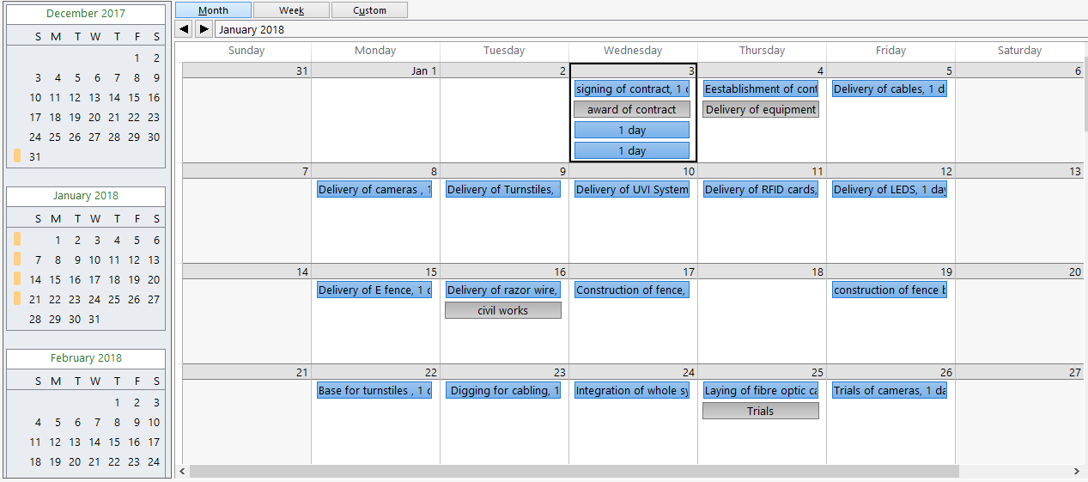

Project Information
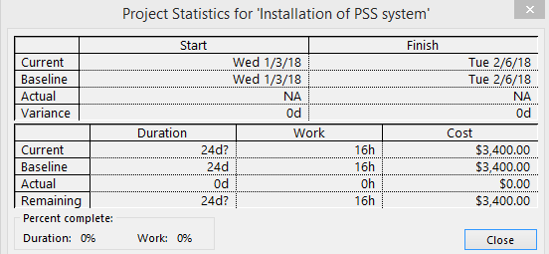

Project Overview:
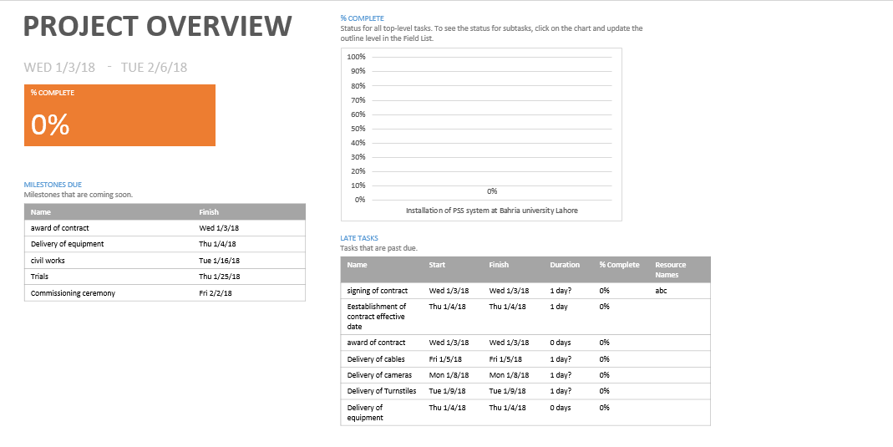

Project overview
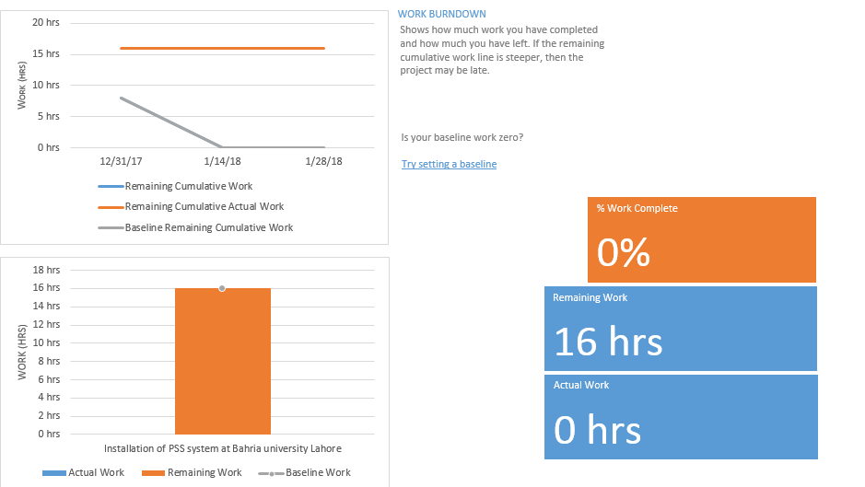

Work Overview
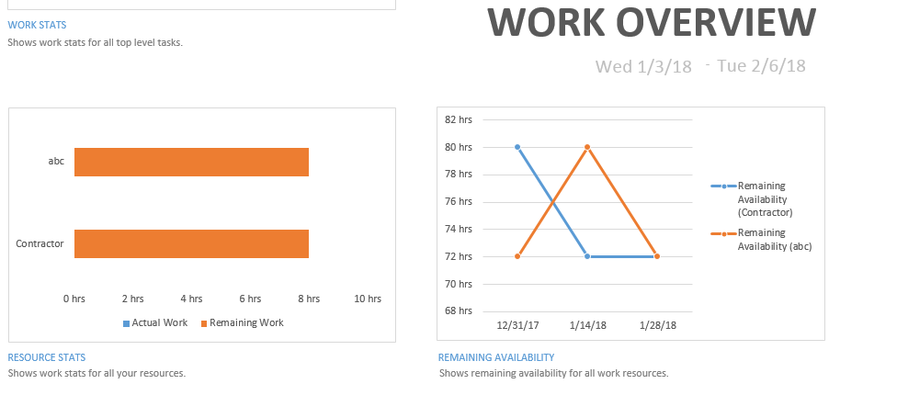
Resource Cost Overview 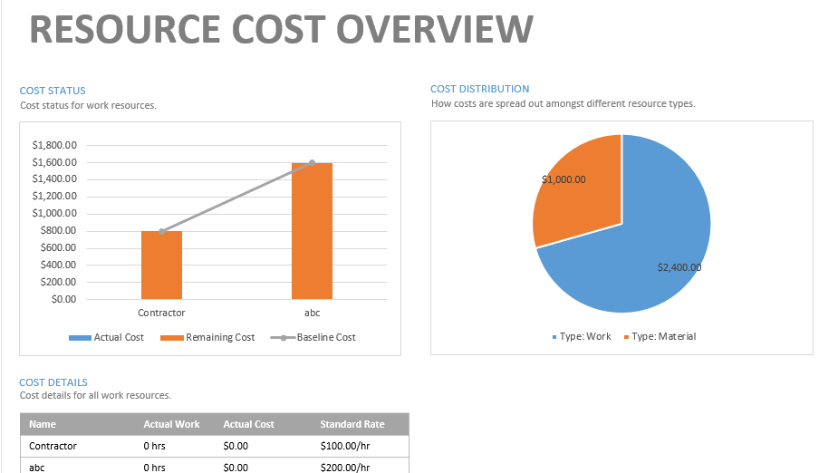

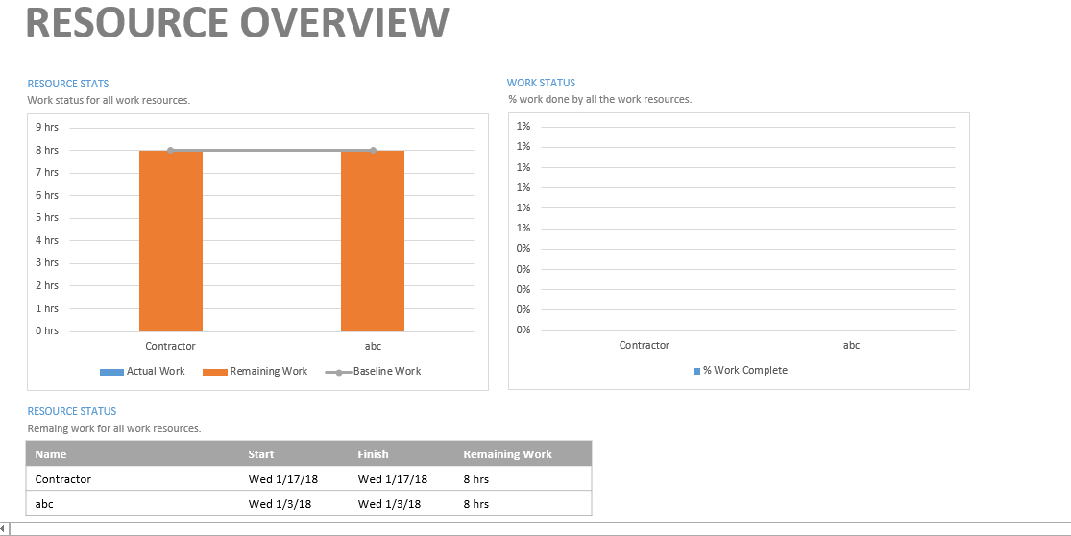
Over allocated Resources
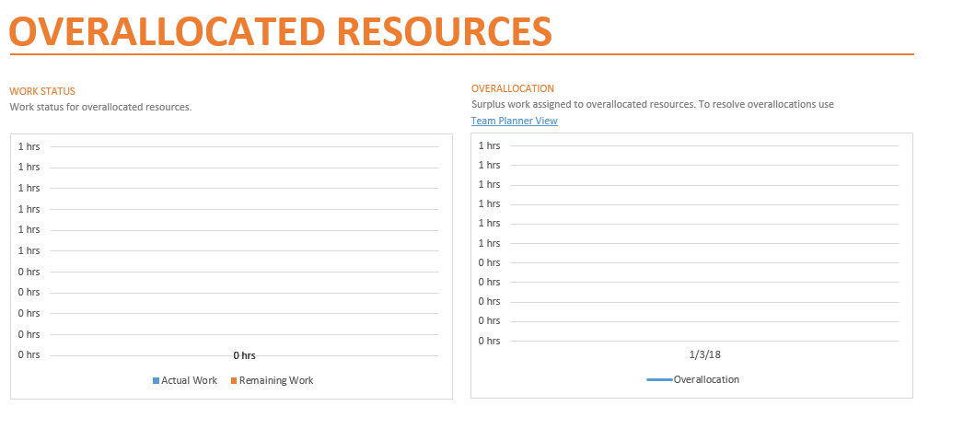

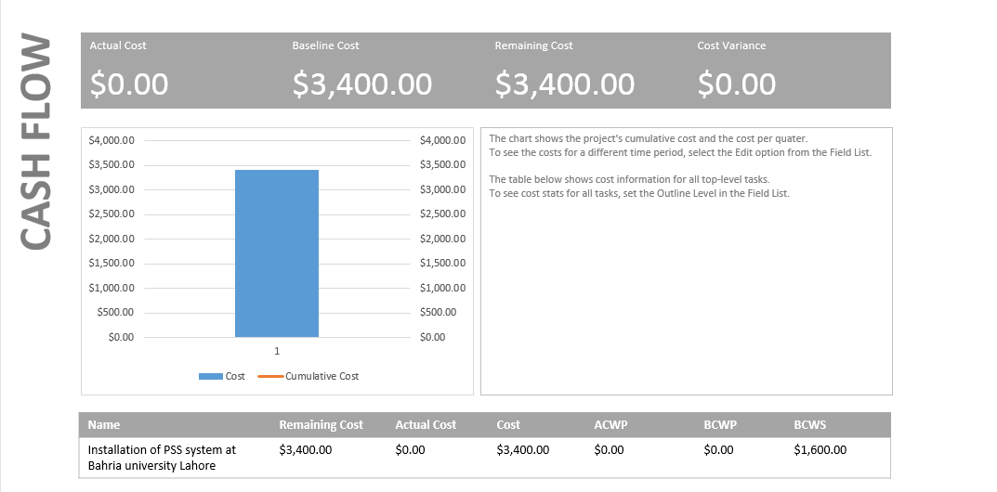
Cost Overview
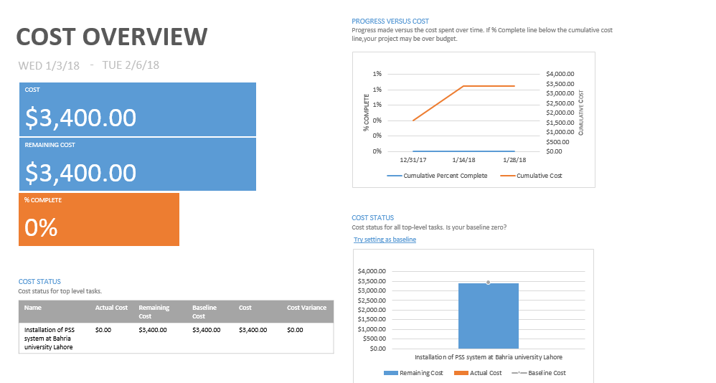

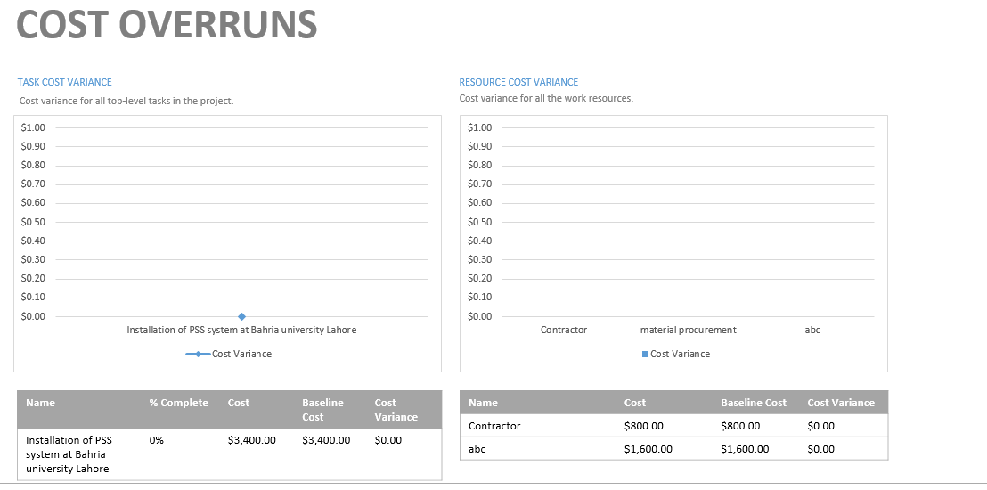
Burn down
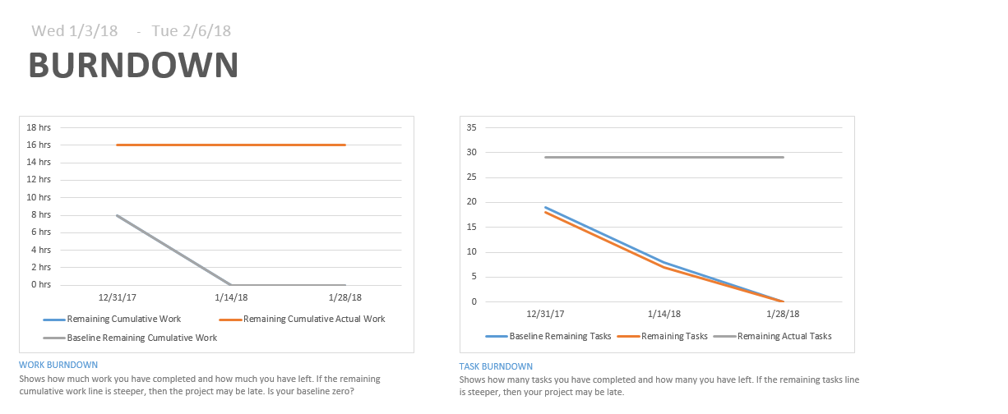

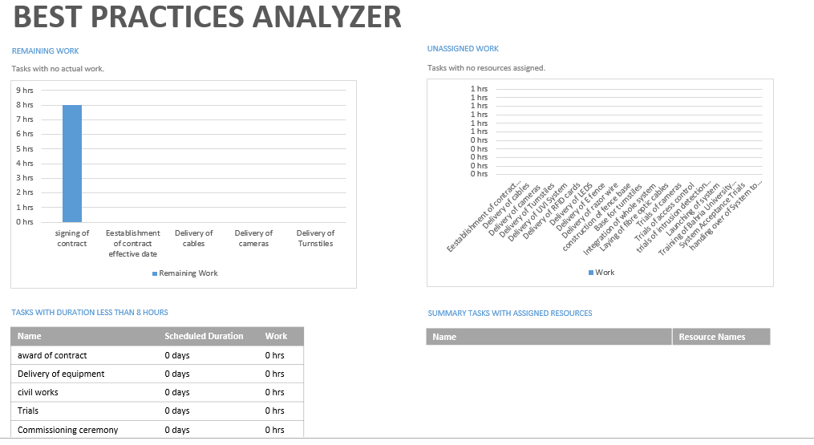
Critical task
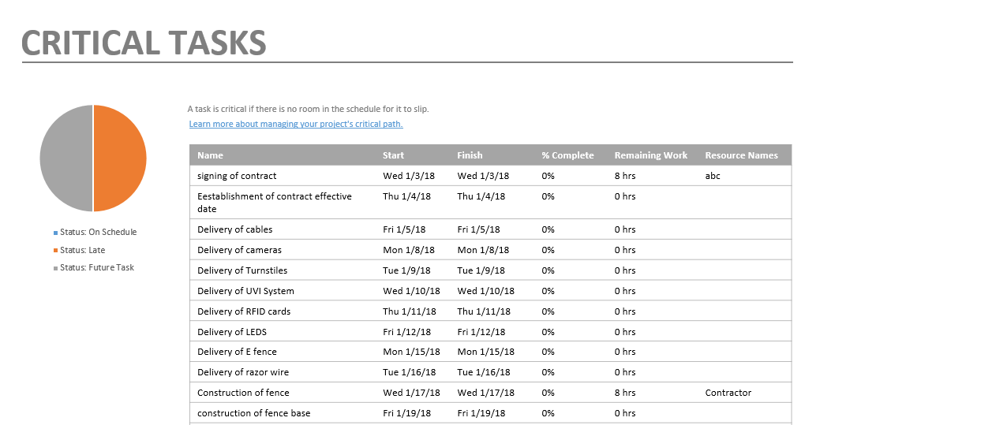

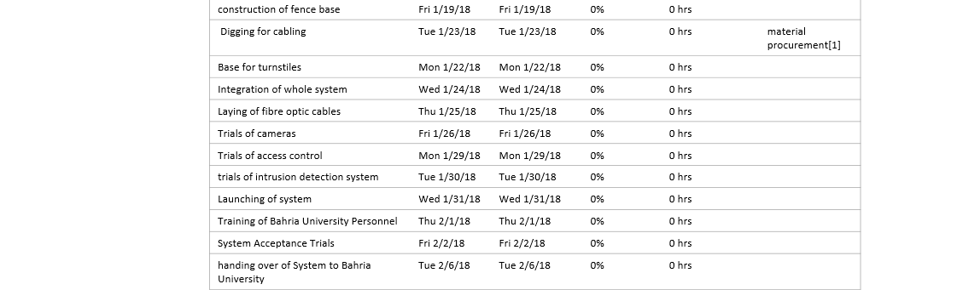
Earned Value
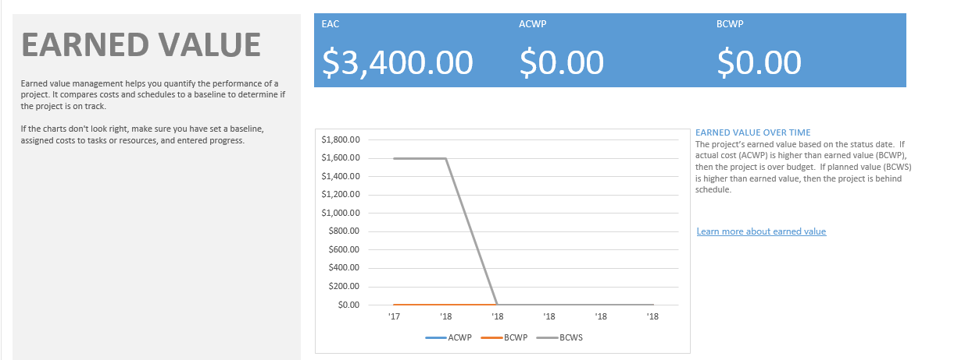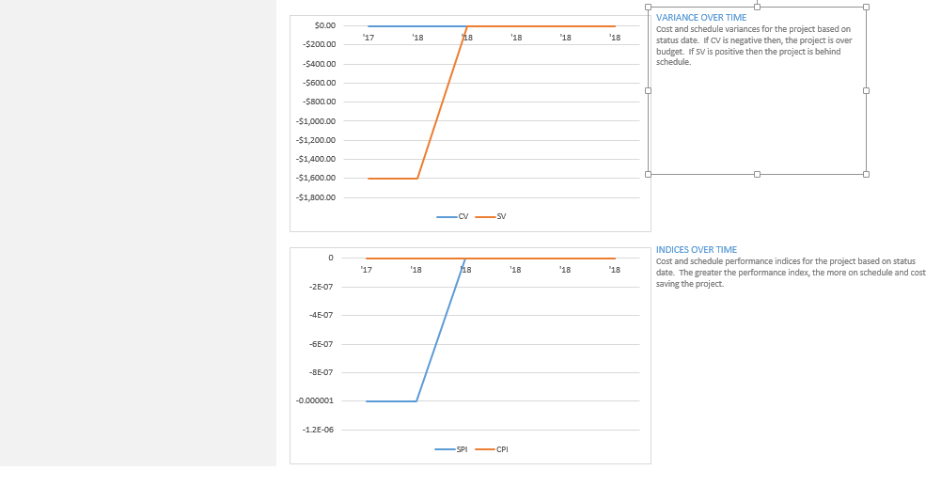

Gant Chart
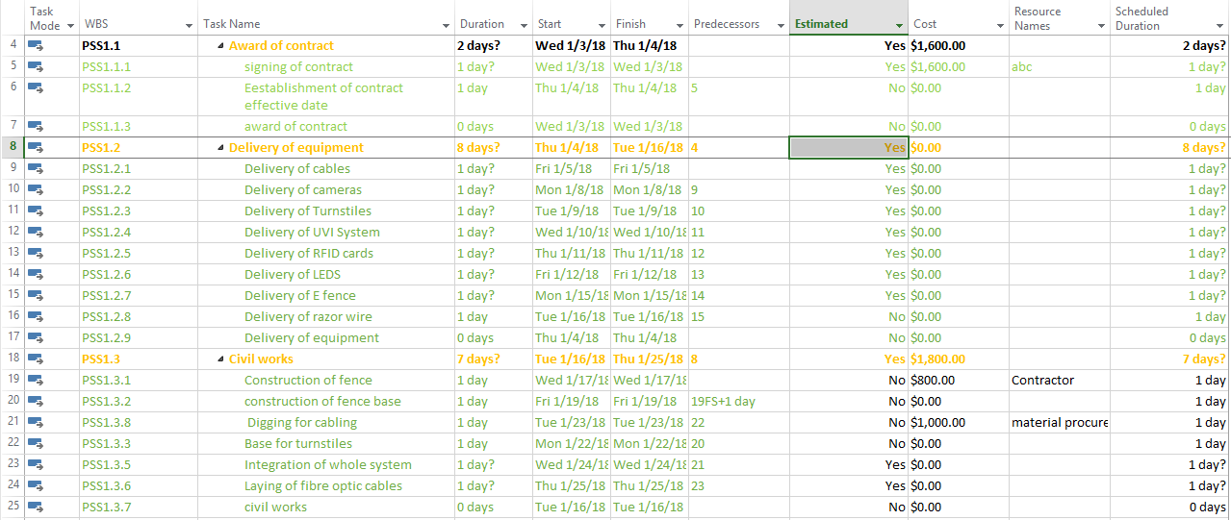
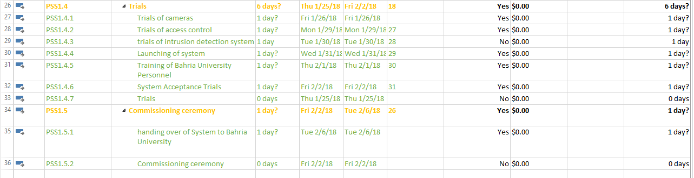
Late Task
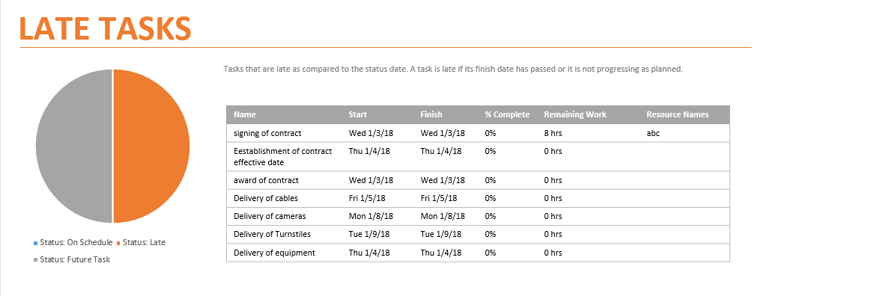

Milestone Report
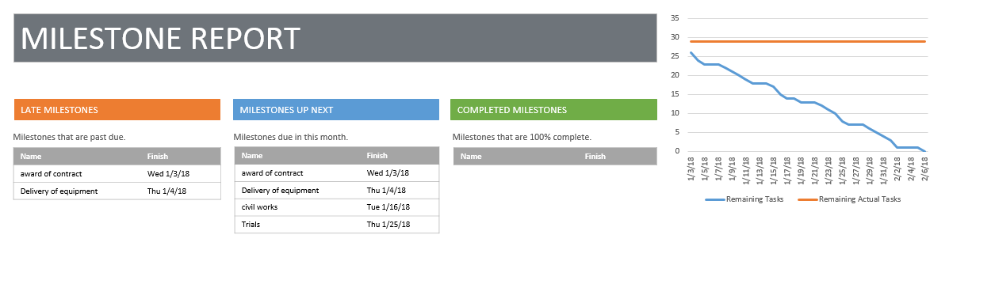
Network Diagram
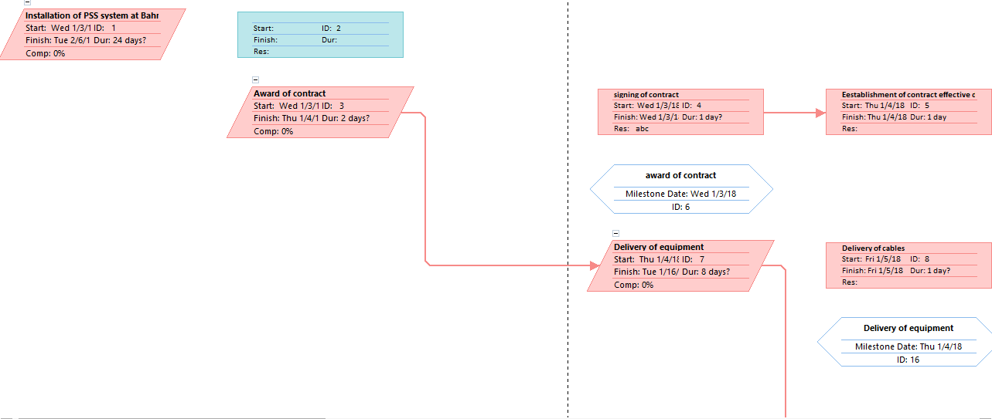
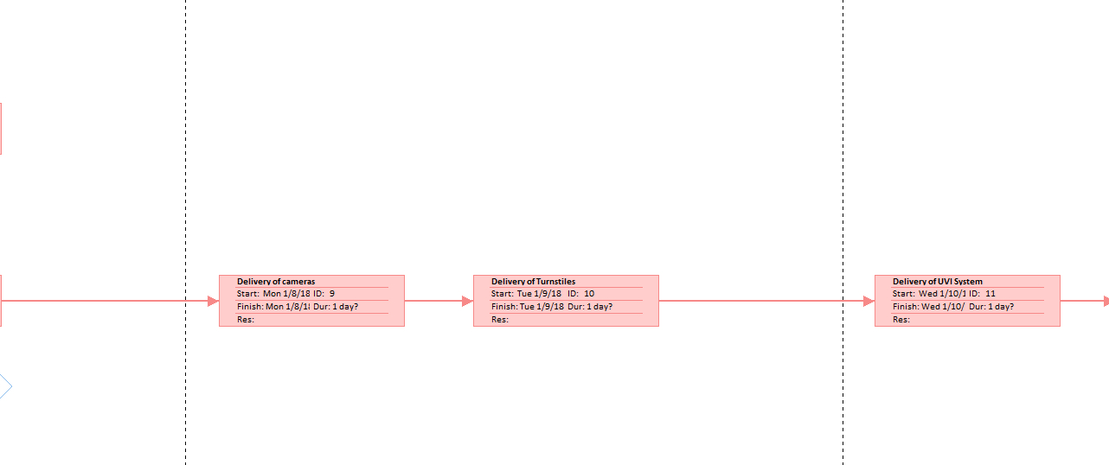

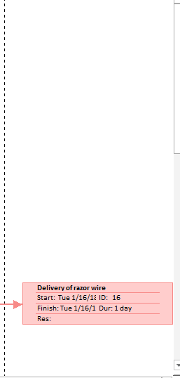
Slipping Task
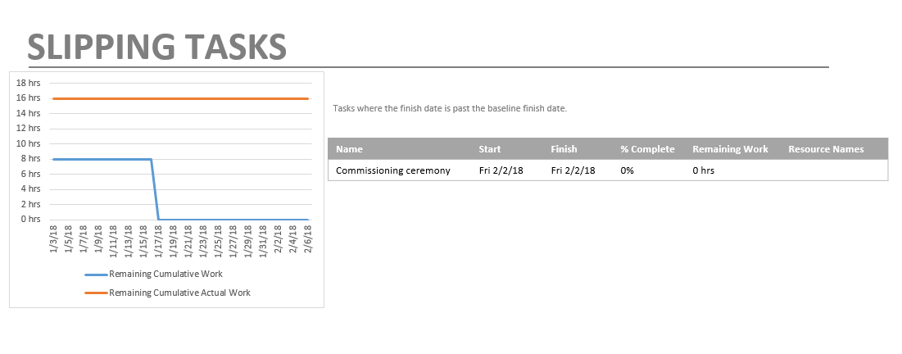
Upcoming task
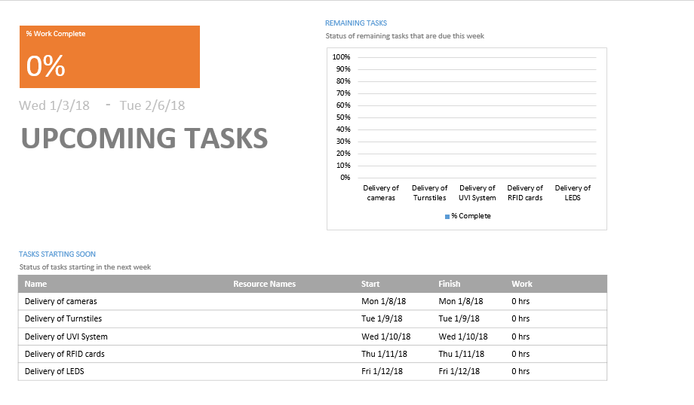
Task Cost Overview
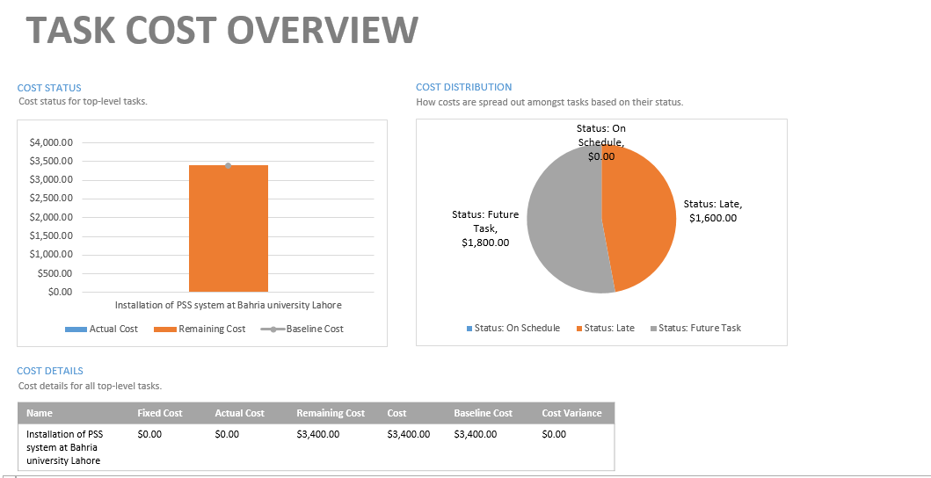

REFERENCES
Project management Body of Knowledge (PMBOK) 5th Edition
http://www.pmi.org/PMBOK-Guide-and-Standards.aspx
http://www.pmi.org/~/media/PDF/Publications/PMI_Pulse_PMO- Frameworks.ashx
TEMPLATES
Templates of following documents are shown in this section:
- A standard template for project charter
- A standard template for change request

ORIGINALITY REPORT  10% |  |  | 1% | 0% | 10%
 | SIMILARITY INDEX |  | INTERNET SOURCES | PUBLICATIONS | STUDENT PAPERS
 | PRIMARY SOURCES
 |  | Submitted to Higher Education Commission |  |  |  | 10%
 | 1 |  |  |  |  | 10%
 | 1 | Pakistan |  |  |  | 10%
 |  | Student Paper
 |  | ethesis.nitrkl.ac.in |  |  |  | <1%
 | 2 |  |  |  |  | <1%
 | 2 | Internet Source |  |  |  | <1%
 |  | www.studymode.com |  |  |  | <1%
 | 3 |  |  |  |  | <1%
 | 3 | Internet Source |  |  |  | <1%

Exclude quotes

Off

Exclude matches

ON

