TRG-ISKY-HONDA CANADA

NAME: Syed Muhammad Umar ENROLLMENT:03-298142-013
NAME: Sara Amjad ENROLLMENT:03-298142-025
SEMESTER: Fall-2015, MSPM - III PROGRAM: MS (PROJECT MANAGEMENT)

_____________________________________________________________________________________


BAHRIA UNIVERSITY LAHORE CAMPUS

_____________________________________________________________________________________

SUBMITTED TO: Mr. Muhammad Faisal Shahzad
SUBMITION DATE: 17-Janaury-2016

Contents
List of Abbreviations: 5
Appreciation Letter 6
ISKY-TRG 7
TRG 7
360 DEGREE INSIGHTS 7
CCM Suite 8
SATMAP 8
College Builder (CB) 8
iSKY 9
iSky Clients: 9
Features of ClearView: 10
Organizational Structure 11
Critical Success Factors (CSF) of Project 11
Business Drivers 12
Challenges 12
Why need Primavera? 13
Advantages of Primavera 13
Project Need Identification 13
Project Feasibility 14
Project KPI 14
Project Title 15
[ISKY-TRG-HC] 15
Project Introduction 15
HONDA CANADA: 15
Business Reason for the Project: 15
Project Objectives: 15
Basic Requirements: 16
Introduction of HC portal 16
Advantages 16
Assumptions: 17
Constraints: 17
Project Risks: 17
Project Deliverables: 17
Project Key Milestone: 18
Roles & Responsibilities: 19
Project Stakeholders: 19
Sponsor: 19
Authorization/Approval: 19
Project Scope Statement 20
Project Scope Statement: 20
Project Name: 20
Project Scope Statement: 20
What’s in-Scope? 20
Project Documents: 20
Change Management Procedure 20
Change in Project Management 21
Decision Matrix: 22
Change request form: 22
Project Anticipated Duration: 23
Approving/Termination Author: 24
Monitoring of Project Performance 24
Project Performance Analysis 24
Re-planning & Controlling Project 25
Control Project Analysis 25
Project Communication: 26
Communication Tools 27
RACI matrix: 27
Project closing: 28
Lesson Learned Report Format: 29
Reports & Project Screen Shots 30
WBS (Work Breakdown Structure) 30
EPS (Enterprise Project Structure) 30
Resources: 31
Activities: 31
S Curve: 34
Activity Usage profile: 35
Resource Usage Profile: 35
Progress Update: 36
Reports of Primavera P6 Projects on ISKY-TRG-Honda Canada 37
References: 38

List of Abbreviations:

Sr. No. | Abbreviation | Word
1 | TRG | The Resource Group
2 | Tech | Technology
3 | CSmile | Customer Satisfaction Smile
4 | QA | Quality Assurance
5 | Dev | Development
6 | HC | Honda Canada
7 | RACI | Responsible accountable communicate Inform
8 | CB | Collage Builder
9 | AMS | Academic Management System
10 | ERP | Enterprise Resource Planning
11 | CSF | Critical Success Factor
12 | UI | User Interface
13 | WBS | Work breakdown structure
14 | PM | Project Manager
15 | ACD | Automatic Call Distributor

Appreciation Letter

To,
Sir Faisal Shahzad
Instructor Primavera P6
Bahria University, Lahore

Subject: Appreciation on Primavera Course

We, Syed Umar and Sara Amjad, are highly thankful and delighted to on attending the lectures of Primavera P6 from Sir Faisal Shahzad. We have learned a lot during the project which will help us in our future endeavors. We appreciate your efforts toward the learning aptitude of class.

We are really thankful to you.

Best Regards,

Syed Umar
Sara Amjad

Company Introduction

ISKY-TRG

TRG
The Resource Group (TRG) world is a group of companies centering on BPO sector and Pakistan’s largest BPO services provider. They have a long track of over a decade in producing revenues in each investment they have made. The company has never experienced loss on an investment since the commencement of their partnership in 2002. They normally invest in one or two companies a year. While a holding company, they have no fixed time bounds to their investments. TRG Pakistan initiated its setup in 1999 by starting a contact center in Lahore with a total strength of 60 employees only. TRG was very first listed IT-enabled Services Company of Pakistan. Now TRG Pakistan is over 1,200 employees strong and counting more. Team of professionals is providing numerous Fortune 1000 companies with matchless support across Contact center, Finance, IT services & other back office functions. TRG is amongst the top 50 public companies in Pakistan. TRG’s current portfolio comprises of 10 global companies with combined revenue of $175 million and over 5,000 employees worldwide.
TRG Tech is a technology innovative organization and a division of TRG world. Its services range from business process consultancy to many customized application developments geared to create and endure competitive advantage both for firms undertaking new technology initiatives and those with established technology situations. TRG provide services that increase or redefine current strategies and shape or integrate tailored solutions. It has a long list of client and products. Some of their prominent products are as following;

360 DEGREE INSIGHTS
The 360 DEGREE INSIGHT's Social Media Support is the dynamic stage for all of your social media monitoring requirements. This insight allows you to customize the exploration criteria and monitor discussions about your brand, product or service. This product can be used to make an impact analysis tools to advance in customer experience and keep a note on them real time via mobile application. With this you can collect customer and organizational data, make customized reports, conduct trend analysis, and turn convert them into consumer insight.

CCM Suite
TRG's exclusive Contact Center Management Suite (CCMS) is an energetic, feature-rich solution which energies valuable customer relations through meaningful businesses. The solution is designed to increase first contact resolution rates thus helping you augment your customer interactions while reducing costs
Contact Center Management Suite comes with an efficient Automatic Call Distributor (ACD) facility and predictive dialer to implement the most complex contact center operations with ease. Developed by experts, it can be modified or enhanced quickly and accurately as per your requirements. Irrespective of the nature and size of your business, CCMS can handle all contact center operations to help you enhance processes and improve service quality.

SATMAP
It is the only contact center technology that optimizes call results by pairing agents with caller finest match.
They uses innovative artificial intelligence and design recognition technology to find patterns of success in large sizes of growing contact center data. SATMAP communicates with current telephony technology to allocate callers to agents to increase the likelihood of successful outcomes. They significantly deliver developed quality communications in the contact center.

College Builder (CB)
This suit offers an Academic Management System (AMS) for learning institutes. College Builder’s task is to improve the quality of education, by improved teaching and management. College Builder’s AMS offers a hosted, protected portal for managing student academics, including registration, admissions, course listing, semester scheduling, time-tabling, course enrolment, attendance management, course management, program planning and management, data archiving & resource management.

iSKY
iSKY is one of the investment of TRG. iSKY was initiated in 1984. Their target was on providing excellent and timely customer insights to the automotive industry. It was the very first company to develop a collaborative customer’s follows up program for the automobile industries; laid the foundation for survey driven customer faithfulness platforms and founded an auditable and interactive way to track dealer performance. There are three main values on which iSky work;
- Clarity
In a noisy world we value clarity above all. There is so much insight around us that gets lost in ineffectual data and fragmented assertions.
- Innovation
This is not only limited to technology, although innovative technology supports all of our customer insight solutions. We value creativity and cleanness of thought when it comes to solve old-fashioned problems.
- Integrity
We value every client and every project – big or small – and attempt to honor every promise we make. Furthermore, we are trusted with personal and sensitive data and sustain this trust every single day.

iSky Clients:
iSky a have long list of client including
- Honda North America
- Acura North America
- Bentley
- Yamaha
- Honda Canada
- Acura Canada
- Toyota Motors Europe
- William Hill
- Ferrari
- Audi
- Volkswagen
The main product of iSky-TRG is ClearView. It’s customer satisfaction software which on the basis of client feedback tells the level of satisfaction and faithfulness of the customer to the specific brand.

Features of ClearView:
Following are some major features of ClearView.
- Customize
The product is customized to each client’s requirement to meet their needs.
- Maximize
It maximizes the response rate of the end customer of its clients.
- Delight
It helps delight the customer by pointing out the areas lacking the client satisfaction.
- Gain
Assist in gaining the valuable insight to business and factors impacting the client satisfaction
- Review and Rate
It helps higher management to review and rate the best practices among the company employees and promote such practices.
- Achieve
The complete application helps in achieving the target client satisfaction and loyalty

Organizational Structure

Critical Success Factors (CSF) of Project
Following is the list of CSFs of the particular project of IKSY HONDA Canada:

- Customer requirement understanding
- Conforming to the customer requirements
- Needs of the organization
- Technical resource for the project
- Support of top management
- Stakeholder management
- Project Management standards
- Measurement & Audit
- Improved project management practices

Business Drivers
It is a process, condition and resource which is very important for continual success of any business. It is very important for any organization to identify its business drivers and try maximum to exploit any which are under their control and then take maximum advantage out of that business driver.
The Business drivers of iSky-TRG are;
- Client Experience
- Customer Satisfaction
- Graphical User Interface (Web)
- ERP (Enterprise Resource Planning Tool)

Challenges
The challenges which iSky is facing right now are;

- Miscommunication
- Buy-in between departments
- Lack of Info/Data Gathering techniques
- Less Technical Coordinators
- Deadlines are not met
- Information flow is not effective
- Prioritization of tasks are not defined
- Poor monitoring of tasks
- Project Prioritization
- Organization work flow
- Resource Management

Why need Primavera?
In iSky-TRG, Primavera was required because of the various reasons mentioned below. The reasons are;
- It was difficult to track down the progress of the project without said software.
- Project completion rate was not up-to the mark
- Lessons learnt documents was not active and mistakes were not studied for future projects.
- Very less qualified project managers are in organization, so using Primavera can help to cover up the gap.
- Urgency of task has more priority than the importance of tasks in a project.

Advantages of Primavera
Few of the advantages of using Primavera are and not limited to:

- On time delivery
- Reporting to higher management
- Delivery in controlled budget
- Developing, implementing and providing standard procedure
- Coordination between different projects teams and managers.
- Identification, selecting and prioritizing new projects in pipeline.
- Providing products or services on time
- Customer satisfaction

Project Need Identification
The project Honda Canada is basically a game changer for TRG in North American region. Once they have the project implemented they can easily take many big giants of automobile industry on the pipeline for the same support and solution. This project involves many big names as stake holders which can easily be impressed by putting all effort on this project. The basic need of the project can only be identified and prioritized once the requirements from customer can be understood by the team ISKY. It will help the team to do the work as per the demand of the customer and what customer is looking for in the support and solution to get maximum output from the said solution from ISKY.
Most of the times the priority to the projects is not there in the organization and resources are being utilized upon the availability where as there is no such importance given to the projects. There are many projects which are still in maturity phase. The useful technical resources are being lost by not assigning them on proper projects as per the criticality of the task. The market, they are in, have a lot of potential which can only be accomplished once they have their processes and resources restructured.

Project Feasibility
Project ISKY-TRG-HF is a project which comes under the domain of ISKY-TRG because they have already done similar projects for other automobile industry and with very experienced and energetic resource. This resource can help them to accomplish this project as well with higher marks and aims. The project involves the customer surveys and the responses from customer along with the coordination among the distributors of Honda Canada which is very similar to the other projects they did for Toyota and BMW for getting the customer feedback. They have the right person as employee and right manager to get the tasks done in time within budget. The project is very much feasible for ISKY-TRG to do and fulfill the requirements of the customer.

Project KPI
They would be so many performance indicators in this project but few of the key performance indicators we will be mentioning here below;
- Survey Builder Counter
- Earn Value Management Technique
- Gantt chart
- TCPI
- Requirement Checklist

Project Title

[ISKY-TRG-HC]

Project Introduction

HONDA CANADA:
iSKY-TRG has an upcoming project from Honda Canada for the development of surveyor portal from where they can take and see the response from their Canadian customers & users, who are having different problems related to the product (cars) and for services as well from the local distributors and resellers. ISKY-TRG has to bring some portal for that arising opportunity in such a way that they can provide Honda a detail response from their customer on which they can make conclusion & decision for future perspective. In this project, iSKY-TRG has to collect all the requirements related to this project to design and develop a proper online portal from where the surveys can be filled and then collected, concise and analyze for further action.

Business Reason for the Project:
This project, iSKY-Honda, will provide an opportunity to the organization to globally demonstrate and prove their worth and potential. It will also help to improvement the brand image of company in very positive way towards the industry, not only in Pakistan but for North American market as well. It is going to help the organization to get more business from international customers and motor vehicle industry to generate the revenue for the firm. The success of this project will also help the company to decrease the turnover rate of the organization and also to increase the morale the employees who will work on this project and for this organization as well. From customer point of view, this project is of great importance as it will help them to know the basic problems and issue related to usage of their products in market and why people in Canada and America shifts from their brand to others without any hindrance. This project will play an important role in the betterment, advancement and success in iSKY-TRG.

Project Objectives:
- An online, readily available Survey Portal for Honda and their customers that will get the response from the existing customers as well as from their suppliers.
- The portal should be user friendly & to be designed in such application which can be operated or used by moderate users easily.
- To provide the customers ease of access towards satisfaction from product.
- To increase the information sharing or relationship between Honda Canada and their customer through this portal.
- To give Honda Canada edge on their competitors by providing them such a useful reporting system/tool which connect them with their customers.

Basic Requirements:
Basic requirement for this project would be; Human Resources (Technical & Non-Technical) which includes software developers, script/content writers, software engineers & analysts, quality assurance personals, etc.), Machines (laptops and servers), Network Servers, software, and Licenses of Software.

Introduction of HC portal
The Honda Canada (CSmile) portal is designed to help Honda Canada to measure, track and improve the customer’s experiences and make them satisfy. CSmile is designed to serve the company to attain their customer recommended goals by providing active data that company can access on any device at any time. And it used latest widget technologies so that company can select and present the information that is vital to their success.
With CSmile, Honda Canada can quickly see what needs to be enhanced and improved in their dealership and what customers appreciate most. By repeatedly reviewing surveys and individual comments, they can analyze root causes, which will allow them to fix issues permanently and improve their customer’s experience.

Advantages
One key advantage of this portal is that data is instantaneously loaded and presented dynamically, so company/dealers are updated on daily basis, in time to intervene if needed. And taking actions can make a difference in customer observation.
Working with this portal every day help to measure, track and boost customer experience and make them happy. All users can open the portal daily to see customer feedback instantaneously.

Assumptions:
- The resources will be accessible on time as per the plans and schedule finalized.
- Office and organization location facility will be available readily.
- Network servers or software and hardware system will not fail during the project.
- Salaries and other accommodating/reimbursement expenses will be released on time from accounts department.
- Project will never be put on halt or stop from client side.
- Project will be performed conferring to the defined standards and procedures.
- There will be no such holidays or vacations (leaves) other than mentioned in exceptions of calendar.

Constraints:
- There is no PMO in organization so Project Manager has to assign the resources in timely and efficiently manner according to the plans.
- The technical resource available is less in numbers and they have to be allocated on maximum tasks.
- Project needs to be completed before mid of 2016 and should start sending surveys in October 2015.
- Project should be completed within budget.

Project Risks:
- Technology enhancement in the field.
- Shortage of funds during the project.
- Less technical resources available for the project.
- Employee’s turnover rates increases.
- Customer dissatisfaction over product.
- A critical resource left the organization.
- Language barrier can affect the duration and schedule of the project

Project Deliverables:
Three basic deliverable for this project is mentioned below. These are just the major deliverables as far as the project is concerned.
- An online web based portal for Honda Canada from where they can produce and distribute different surveys to their customers and end users.
- A System on the same portal, which can generate reports and investigate the response from customer surveys, and make decision on the basis of the same surveys and responses.
- A system that contains information about customers of Honda Canada along with the distributors and services centers there.
- Requirement gathering from client
- Designing of web portal
- Development of prototypes and mockups
- Database maintenance
- Launching project and handing over the web portal

Project Key Milestone:
Milestone | Detail Description
Approve Charter | To get go through on the project and start up the work as per the project feasibility.
Mockup/Prototypes | Create mockup/prototypes on the basis of which the whole designing is to be done against the requirements.
System architecture design | Architecture design of the system will agree the developer to create widgets as per requirements.
Development of summaries of different files | The reports view which will allow the client to examine the data.

Roles & Responsibilities:

Employee Name | Job Title/Role | Key Responsibility
Tashfeen Khalid  Neelum Hayat | Project Manager  Head QA | Responsible for the completion of work packages under approved budget and time. Have authorities to assign resource and tasks.  Ensure the quality of the code, designing and development to make it work properly.
Immad Fawad | Project Coordinator | Ensure flow of information between the client and project team.  To communicate all requirements and processes reports to clients and team.
Abid Haye | Manager Development | To make sure the development of the online portal as per requirement of client.

Project Stakeholders:
The stakeholders for this project, as this is a private company project, are not that much as compared to a public limited project. The major stakeholders involved in this project are and not limited to;
- TRG
- Honda Canada
- iSKY
- Employees of TRG
- Customers of HONDA Canada
- Distributors of HONDA Canada in Canada

Sponsor:
The sponsor of this project is the head office TRG (The Resource Group). The project is monitored, controlled and performed by iSKY.

Authorization/Approval:
Approved by the Project Sponsor: Date:
[CEO iSKY-TRG]

Project Scope Statement
[iSKY-TRG-HC]

Project Scope Statement:

Project Name:
The project is awarded by Honda Canada to iSKY-TRG and the name of the project is “ iSKY-HC” which stands for Honda Canada.

Project Scope Statement:
The project is to prepare an online web portal for Honda Canada to analyze the response from the customers of Honda Canada. For this project the major requirement is for technical resources and few software and licenses. The project team has to gather all the requirements regarding this project and make an online portal from where the surveys filled by customers can the checked and analyzed.
Provide the customers ease of access & an online Survey Portal for Honda Canada., also shortening the time period of response from customer and studying the response. It will increase relationship between Honda Canada and their customers.
The basic purpose of this project is to going globally with Honda Canada and satisfies the customer need to get the brand value higher and also to improve the reputation of organization.

What’s in-Scope?
This online web portal should be able to send surveys and collect the response of customers and produce reports.

Project Documents:

Change Management Procedure
- Decision Matrix
- Change Request Form
- Project Anticipated Duration
- Approving/Termination Author
- Project Performance Monitoring
- Project Performance Analysis
- Project Control/Re-planning
- Project Control Analysis
- Project Communication
- Communication Message and Tools
- RACI Matrix
- Lesson Learned Report
- Project Closing Report

Change in Project Management
It is the sequence of steps or tasks that a change management team or project team leader tracks to apply change management to a change in order to drive individual transitions and guarantee the project meets its proposed outcomes.
Following will be the hierarchy of the change.

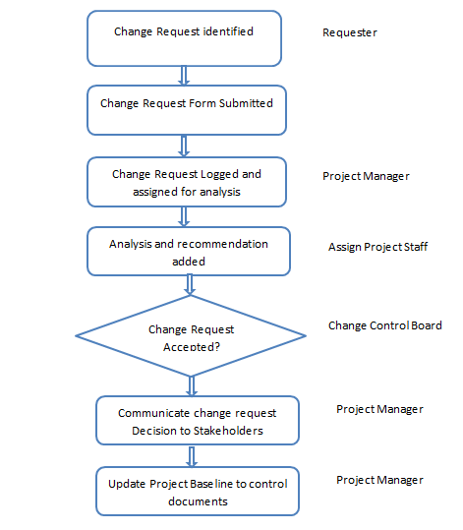

Decision Matrix:
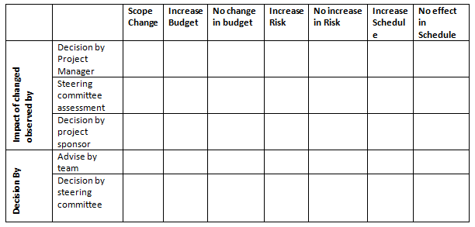

Change request form:
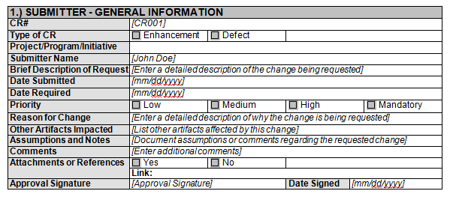

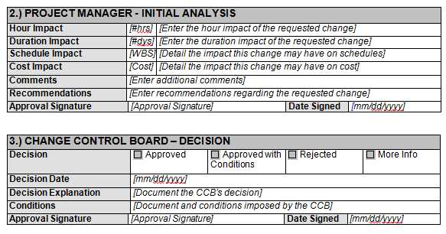

Project Anticipated Duration:
Project anticipated duration will be as following phase wise:
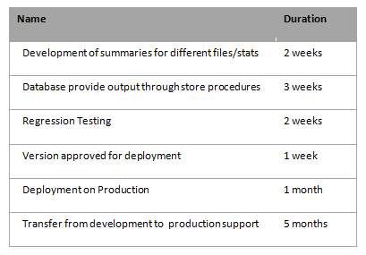

Approving/Termination Author:
The approving and termination author will be Tashfeen (Project manager) who will be mainly responsible for all activities.

Monitoring of Project Performance
It is possible to have activity coordination problems indicated through regularly monitoring your project’s schedule performance. Also it can provide resource conflicts, and possible cost overruns. For monitoring schedule performance, we will gather information and analyze/calculate it and confirm its accuracy.
The Work Breakdown Structure (WBS) is a deliverable-oriented breakdown of the work required to yield your project’s deliverables. Deepest level of detail of each branch of the WBS is a work package, each work package, in turn, is tranquil of activities pieces of work performed throughout this project. So by comparing plan and actual we will monitor the performance of the project and on the basis on the calculations and comments corrective and preventive measures will be taken.

Project Performance Analysis
We will examine the project’s schedule performance by observing the position of individual milestone and on the grounds of following table proper initiative will be taken on time to avoid any delay.
We will evaluate our project’s schedule by relating actual activity start and end dates and actual milestone dates to their scheduled dates:

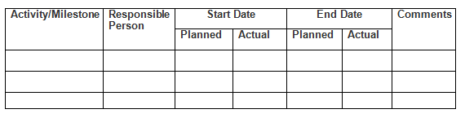

Using above mentioned table we will analyze that where we are and where we should be, which will give us the clear picture of the progress. After this analysis the proper plan to remedy, in case of delay, would be made to keep the project on the right path.

Re-planning & Controlling Project
Our Controlling process will monitor all the tasks and metrics essential to make sure that the accepted and authorized project is within scope, on time, and under budget so that the project proceeds with nominal risk. This process will involve associating actual performance with planned performance and taking remedial action to yield the desired outcome when significant differences are present. Controlling process will be always performed during the life of the project.
Following activities will be performed to control the project or re-planning.
- Control Schedule
- Scope Verification & Change Control
- Control Quality
- Control Risk
- Control Cost
- Reporting Performance
- Complete Monitoring & Controlling Phase Review
- Administration of Contract

Control Project Analysis

To control the project some correct/Preventive actions will be taken, will be analyzed by the PM in order to see the effect of the change. The analysis of the control should be done in proper manner so that due to control other parts of the project should not be affected and if they are impacted then that impact should be identified in timely manner so that we can control that on time.

Following table will be used which will be filled to see the impact of the control on other part of the project.
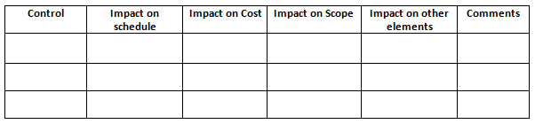

Project Communication:
Following is the list of audiences and the purpose of communication for each audience is defined in detail
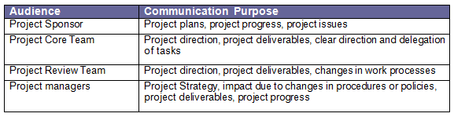

Communication Tools
Following plans the targeted audiences, the method for delivering the information, the key communication messages to be displayed, the communicator, and the frequency of the delivery.
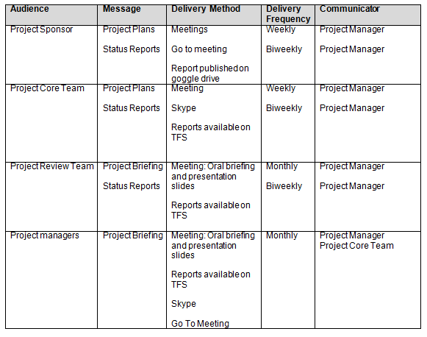

RACI matrix:
We will use RACI chart that will be a lot of supportive in promoting strong communication in a team. RACI basically stands for Responsible, Accountable, Consulted and Informed in a project environment. This chart will make sure that at least one person is responsible of each category, as well as help others to see their role in supporting the responsible person in attainment the job done. It will also support to avoid communication that does not need to take place and only disturbs the flow.

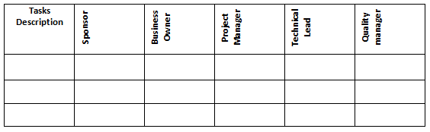

Project closing:
For closing a project following activities need to the performed.
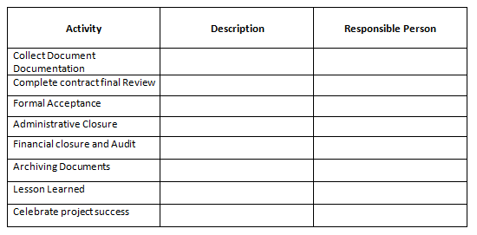

Lesson Learned Report Format:

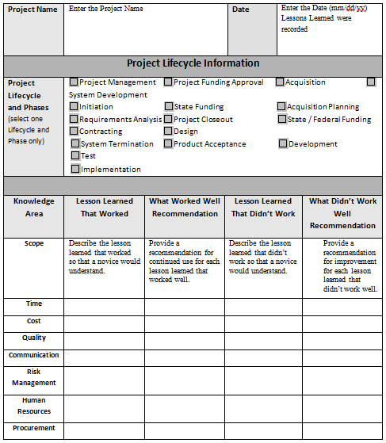

Reports & Project Screen Shots

WBS (Work Breakdown Structure)
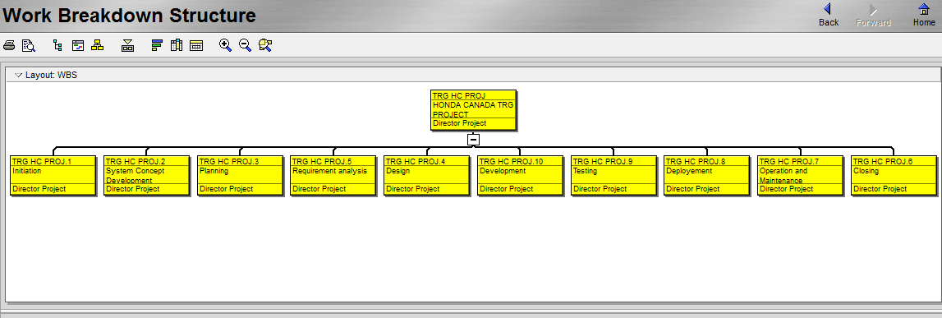

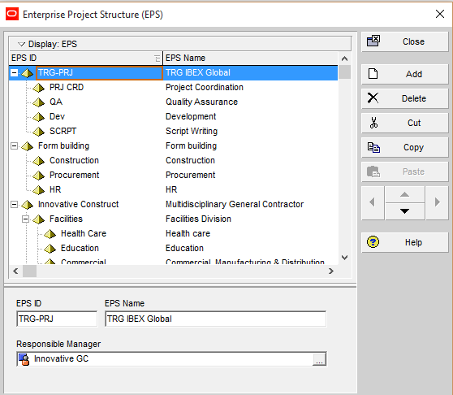
EPS (Enterprise Project Structure)

Resources:
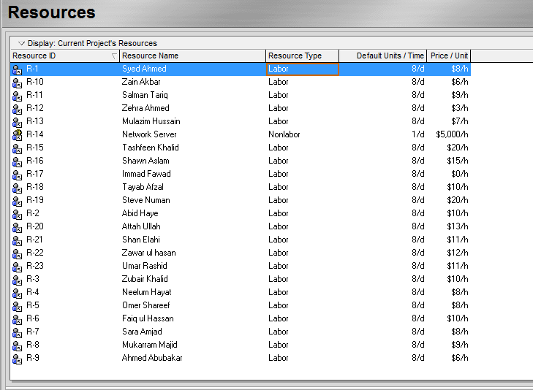

Activities:

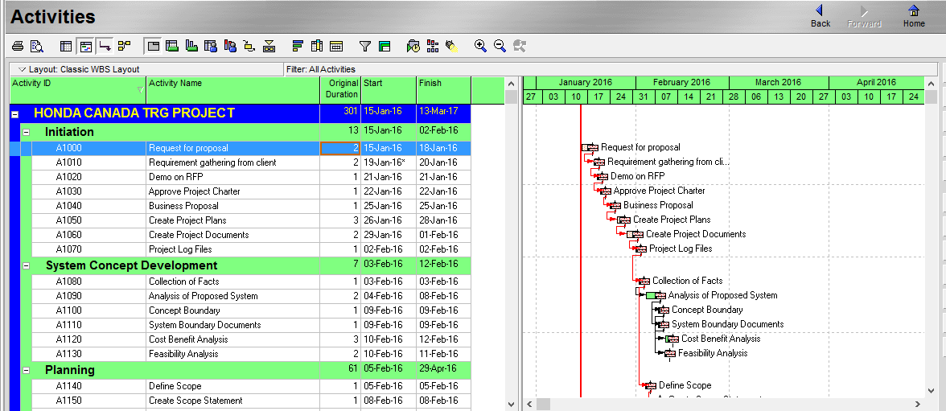
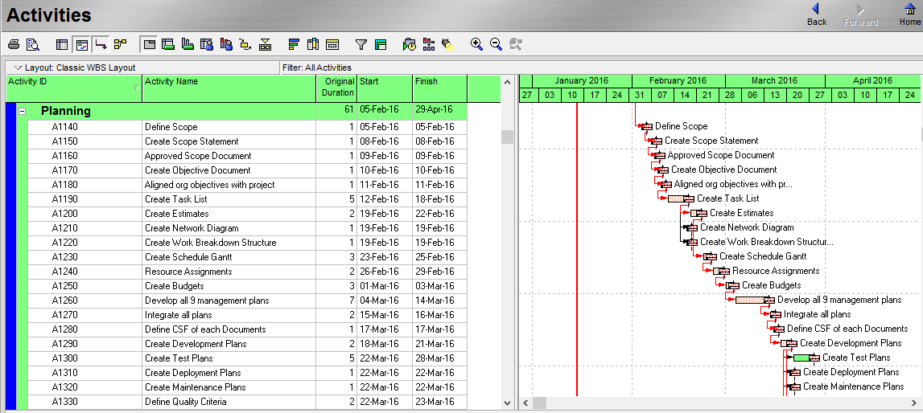
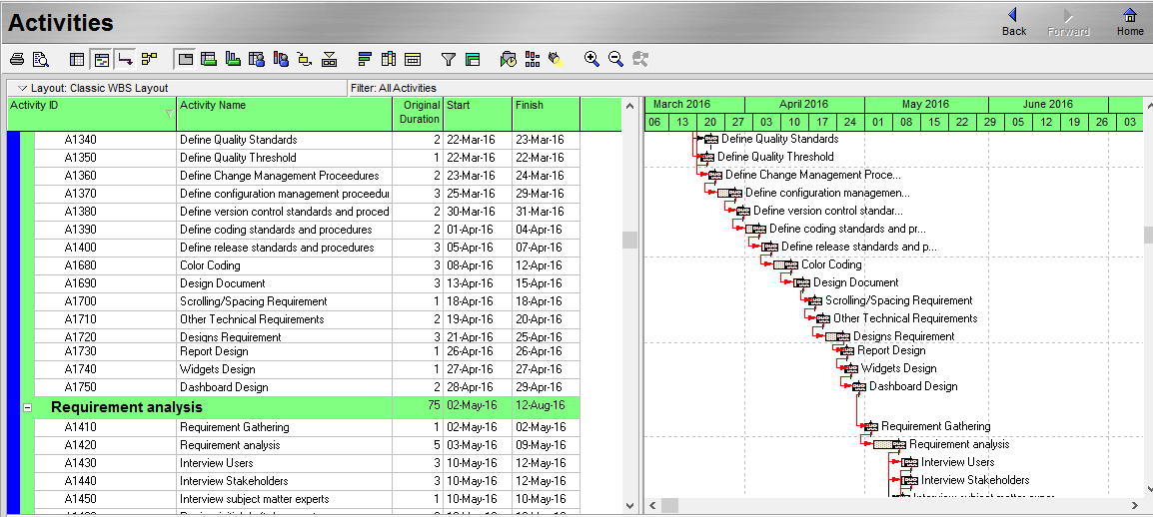
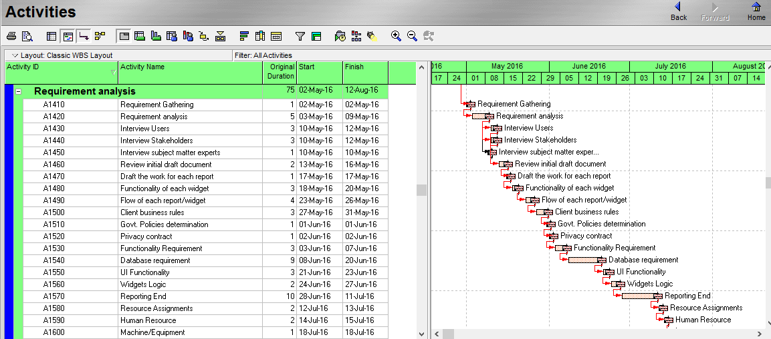
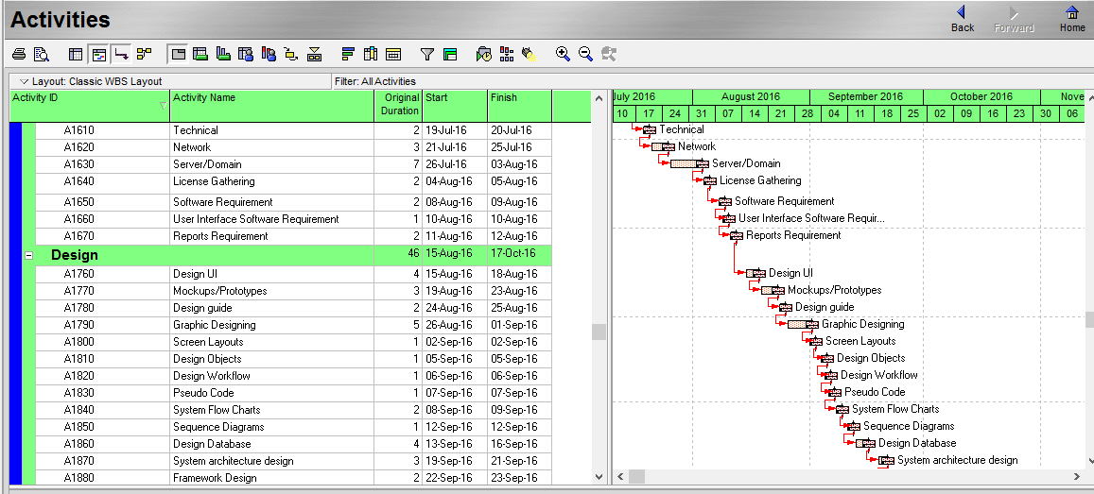
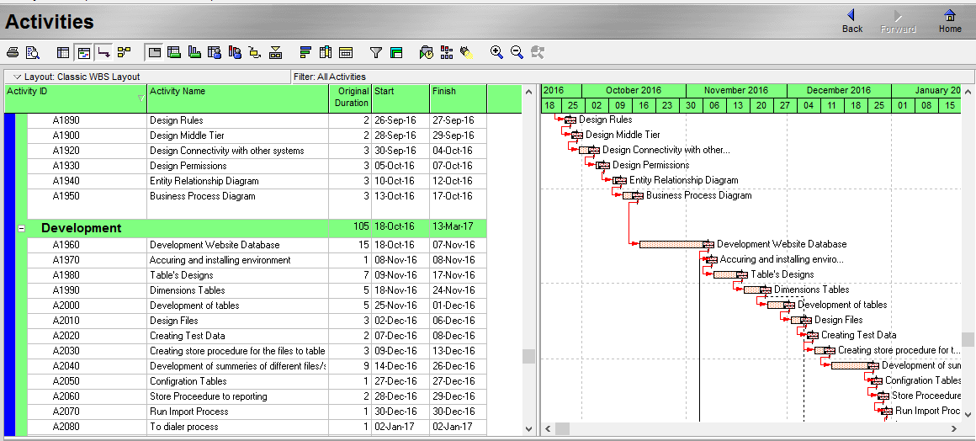

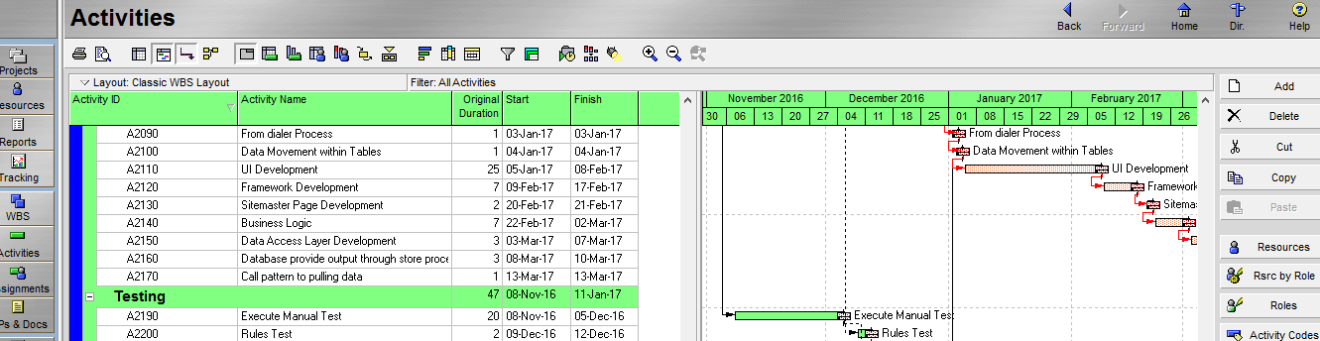

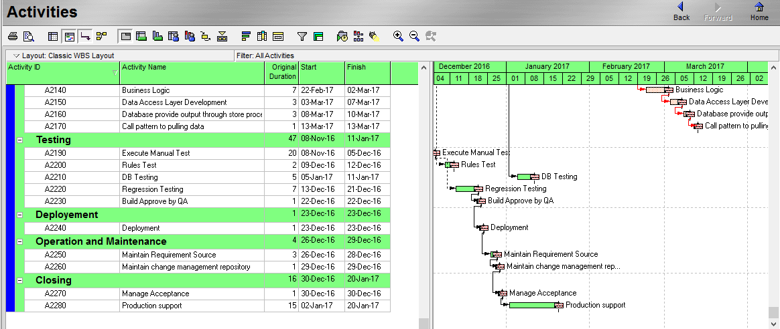

S Curve:
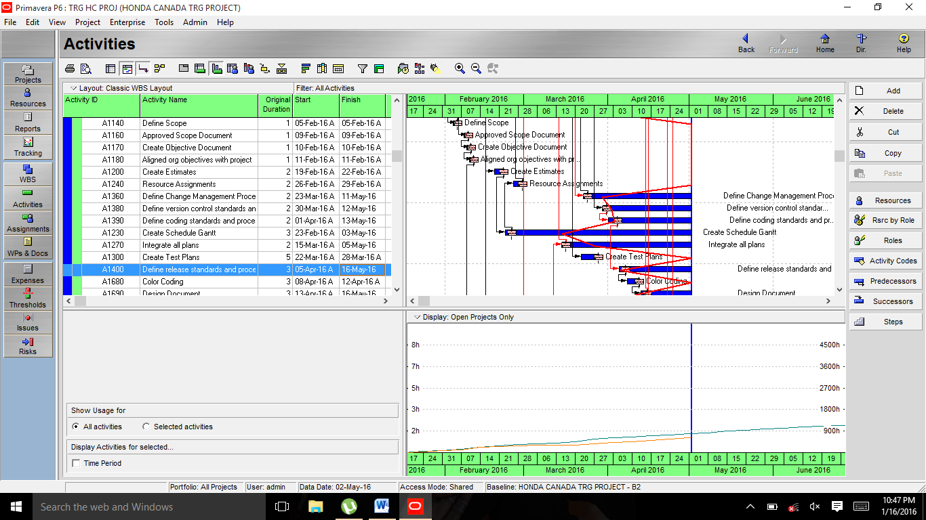

Activity Usage profile:
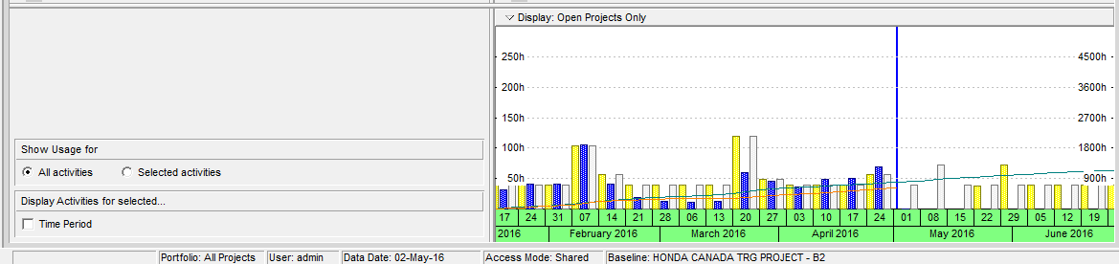

Resource Usage Profile:
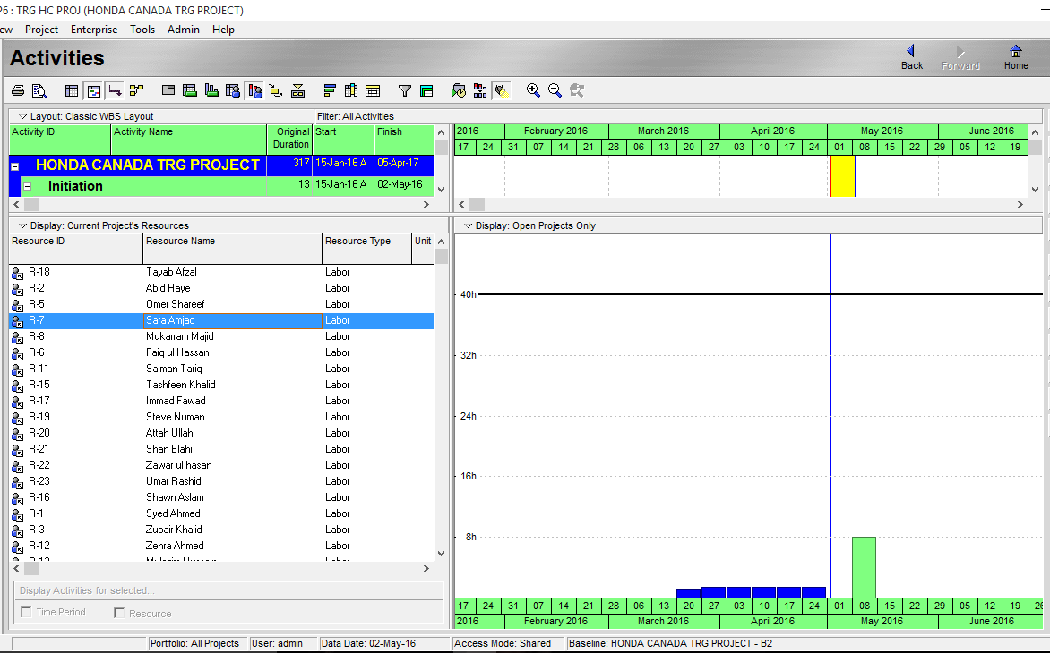

Progress Update:
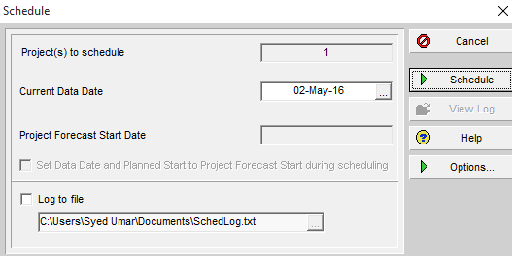

Reports of Primavera P6 Projects on ISKY-TRG-Honda Canada

References:
1 – PMBOK 5th edition
2 – Class Lectures of CBT Primavera
3 – www.TRGworld.com
4 – www.ibexglobal.com
5 – www.slideshare.net

