

BSCS-S25-014
03-134221-018 | Muhammad Ahsan
03-134221-017 | Muhammad Ahmed Saqib
03-134221-021 | Muhammad Asher Danyal

Wuqla AI
In partial fulfilment of the requirements for the degree of
Bachelor of Science in Computer Science
Supervisor: Sumaira Nosheen
Department of Computer Sciences
Bahria University, Lahore Campus
January 2026

© Bahria University, 2026

Certificate

We accept the work contained in the report titled
“Wuqla AI”
written by
Muhammad Ahsan
Muhammad Ahmed Saqib
Muhammad Asher Danyal
as a confirmation to the required standard for the partial fulfilment of the degree of
Bachelor of Science in Computer Science.

Approved by:
Supervisor: Sumaira Nosheen
(Signature)

January 05, 2026

DECLARATION

We hereby declare that this project report is based on our original work except for citations and quotations which have been duly acknowledged. We also declare that it has not been previously and concurrently submitted for any other degree or award at Bahria University or other institutions.

Enrolment | Name | Signature
03-134221-017 | Muhammad Ahsan
03-134221-018 | Muhammad Ahmed Saqib
03-134221-021 | Muhammad Asher Danyal

Date: January 05, 2026

ACKNOWLEDGEMENTS

We would like to thank everyone who had contributed to the successful completion of this project. We would like to express our gratitude to my research supervisor, Miss Sumaira Nosheen for her invaluable advice, guidance and her enormous patience throughout the development of the research.

In addition, we would also like to express my gratitude to our loving parent and friends who had helped and given us encouragement.

Muhammad Ahsan
Muhammad Ahmed Saqib
Muhammad Asher Danyal

Wuqla AI

ABSTRACT

Wuqla AI is a smart online platform created to enhance the process of accessing information regarding the property-related legal matters in Pakistan via incorporation of Chat bot. The system enables to simplify otherwise complicated legal notions like the ownership issues, inheritance question, and the process of the property transfer to make them more comprehensible and accessible to the broad audience. It offers a well-organized space where one can seek automated legal advice, find legal practitioners, launch live interaction and manage his profile effectively using just one platform.

Some of the essential features of the system are AI-based legal query processing, search through lawyers by name, intelligent lawyer recommendation to suit the specific legal issue, chatting consultation, request chat, and feedback and rating system to evaluate the service. All these characteristics contribute to the convenience of users, convenience in decision-making, as they enable communication of the user with the right legal specialist and legal information that can be trusted, in an efficient way.

Contents
CHAPTER 1 1
1 INTRODUCTION 1
1.1 Background 1
1.2 Problem Statements 2
1.3 Aims and Objectives 2
1.4 Scope of Project 2
CHAPTER 2 4
2 LITERATURE REVIEW 4
2.1 Introduction 4
2.2 AI within Legal system 4
2.3 Property Law Challenges: 5
2.3.1 Dataset 5
2.3.2 Similar Applications 6
2.3.3 Law Related Papers: 7
2.4 System Use Cases 14
2.4.1 User Interaction: 14
2.4.2 Lawyer Interaction: 15
2.4.3 Admin Functionalities: 16
2.4.4 System Use Case: 17
2.5 System Use Case Table: 18
2.5.1 User Sign-up: 18
2.5.2 Lawyer Sign-up: 18
2.5.3 User Login: 19
2.5.4 Lawyer Login: 19
2.5.5 Admin Login: 20
2.5.6 User Update profile: 20
2.5.7 Lawyer Update Profile: 21
2.5.8 Admin Update Profile: 21
2.5.9 Admin Functionalities: 22
2.5.10 Live Chat between Lawyer and user 22
2.5.11 Chat Bot 23
2.5.12 Lawyer Feedback 23
2.5.13 Find Lawyer 24
2.5.14 Lawyer referral 24
2.5.15 Chat Request 25
CHAPTER 3 25
3 DESIGN AND METHODOLOGY 25
3.1 System Architecture 25
3.1.1 Front-End: 25
3.1.2 Backend: 26
3.1.3 Database: 26
3.1.4 Lawyer Referral System 26
3.1.5 Live Chat 26
3.2 Login Process: 27
3.3 Signup Process: 27
3.4 Select Language 28
3.5 Chat Request to lawyer 29
3.6 Live Chat With lawyer 30
3.7 Lawyer Recommendation 31
3.8 System Architecture chat bot 32
3.9 ER Diagram: 33
3.10 Methodology: 34
CHAPTER 4 34
4 DATA AND EXPERIMENTS 34
4.1 System Development 34
4.2 Front End Development 34
4.2.1 Limitation: 35
4.3 Backend Development 35
4.4 Database 36
4.4.1 FAISS Database 36
4.4.2 Firebase Database 36
4.5 Chat Bot Model: 37
4.5.1 Limitations: 38
4.6 Lawyer Referral 38
4.6.1 Limitation: 38
4.7 Live Chat between User and lawyer: 39
4.7.1 Limitation in Chat: 39
4.7.2 Other Models Used: 39
CHAPTER 5 42
5.1 Wuqla Ai App Screens 42
CHAPTER 6 50
6 CONCLUSION AND RECOMMENDATIONS 50
6.1 Project Achievement: 50
6.2 Practical Impact: 50
6.3 Recommendations 50
6.3.1 Enhanced Legal Coverage 50
6.3.2 AI Model Optimization 51
6.3.3 Punjabi Language Support 51
6.3.4 Lawyer Verification 51
6.3.5 Draft Template: 51
6.3.6 Province-Wise Law Variations: 51
REFERENCES 52
APPENDICES 54

List of Figures
Figure 2.1 Similar Applications 6
Figure 2.2 User Interaction 14
Figure 2.3 Lawyer Interaction 15
Figure 2.4 Admin Functionalities 16
Figure 2.5 System Use Case 17
Figure 3.1 Login Process 27
Figure 3.2 Signup Process 27
Figure 3.3 Select Language 28
Figure 3.4 Request Chat to lawyer 29
Figure 3.5 Live Chat with Lawyer 30
Figure 3.6 Lawyer Recommendation 31
Figure 3.7 System Architecture 32
Figure 3.8 ER Diagram: 33
Figure 3.9 Methodology 34
Figure 4.1 Fire Base 36
Figure 4.2 Fire Base 37
Figure 5.1 Login Screen 42
Figure 5.2 User Signup Screen 42
Figure 5.3 Lawyer Signup Screen 43
Figure 5.4 Forgot Password 43
Figure 5.5 User Profile 44
Figure 5.6 Update Information 44
Figure 5.7 Lawyer Profile 45
Figure 5.8 Lawyer Update Profile 45
Figure 5.9 Find Lawyer 46
Figure 5.10 Lawyer Referral 46
Figure 5.11 Lawyer Chat request 47
Figure 5.12 Lawyer Dashboard 47
Figure 5.13 Chat bot 48
Figure 5.14 Chat bot 48
Figure 5.15 User Lawyer Chat 49
Figure 5.16 User Lawyer chat 49
Figure 5.17 Admin Profile 49
Figure 5.18 Admin Dashboard 49
List Of Tables
Table 1 Law Related Papers 7
Table 2.2 User Sign-up 18
Table 2.3 Lawyer Sign-up 18
Table 2.4 User Login 19
Table 2.5 Lawyer Login 19
Table 2.6 Admin Login 20
Table 2.7 User Update profile 20
Table 2.8 Lawyer Update Profile 21
Table 2.9 Admin Update Profile 21
Table 2.10 Admin Functionalities 22
Table 2.11 Live Chat b\w Layer & User 22
Table 2.12 Chat Bot 23
Table 2.13 Lawyer Feedback 23
Table 2.14 Find Lawyer 24
Table 2.15 Lawyer Referral 24
Table 2.16 Chat Request 25
Table 17 Model Experimentation 39

INTRODUCTION

Background

As the world has rapidly evolved towards digital technology and increased use of online services, online law services have become of great popularity among any country and in any region. The platforms enable users to find immediate assistance, get access to legal information, and engage AI-driven chatbots that can answer regular questions and share people with legal experts. In Pakistan, however, majority of the available online legal services available are generic, pre-written based content which is usually not sufficient to deal with the particularities of the legal situation of a client. This lack produces misunderstandings and compels individuals to make assumptions, pay either with money to visit the office or spend their time in expensive consultations, which are usually conducted privately.

Wuqla AI is a more sophisticated and customer-centered solution, as it reshapes the process of providing legal advice. The system breaks down the complex laws associated with property and simplifies the query made by the user instead of making generalised or broad statements of the laws. Furthermore, the site allows customers to find attorneys by their names, view the more comprehensive profiles of lawyers, and reach the right legal professionals via the smart recommendation and consultation system. Wuqla AI, by matching users and professionals based on specialization, experience, and situational fit, will make sure that people get reliable, pertinent, and context-specific legal help, as opposed to ambiguous and obsolete data, and enhance access, transparency, and reliability of the legal process.

Problem Statements

People in Pakistan find property laws hard to understand and expensive to get help with. There is no easy, affordable, and reliable way to learn about their rights or solve property-related issues.

Aims and Objectives

Wuqla AI helps people in Pakistan understand property law in an easy way. With the help of Machine Learning, it gives clear guidance on ownership, tenancy, inheritance, and property transfers. The platform saves people from confusion, high lawyer fees, and wasted time by offering simple advice and trusted lawyers. Its goal is to make property law easy, affordable, and accessible for everyone through a mobile-friendly app.

- One on One Chat between lawyer and user.
- Offer lawyer referrals so users can connect with trusted professionals
- Chat-bot for simple property related legal queries.
- Provide Bilingual support.
- Build a simple, mobile-friendly platform that anyone can use
- Protect privacy: no data sharing without consent

Scope of Project

- Legal Topics Covered: Ownership rules, tenancy agreements, inheritance partitions, property transfers, dispute handling.
- One-on-One Chat: Chat between Lawyer and User.
- Lawyer Referral System: Connects users with qualified property lawyers, shows profiles and details
- Legal Chatbot: Provides automated, intelligent responses to user queries related to property law, offering clear legal guidance and simplifying complex legal concepts.
- Smooth Mobile Interface: Easy-to-use design for quick access on phones
- Bilingual Support: Provides accessibility in English and Urdu, with scalable options for more languages in the future
- Knowledge Access: Free and affordable legal knowledge without needing costly consultations.

LITERATURE REVIEW

Introduction

Online legal platforms have grown quickly all over the world due to the development of technology and the increasing need for legal assistance.
Most online legal resources in Pakistan currently offer only generic information or basic templates, which often fail to address individual legal situations accurately. Wuqla AI adopts a more advanced approach by delivering legal guidance that simplifies complex property laws and provides context-aware responses based on user queries. In addition, it enables users to search for lawyers by name, view lawyer profiles, and connect with appropriate legal professionals through an intelligent recommendation and consultation system. This ensures users receive relevant, reliable, and situation-specific legal assistance rather than generalized information.
Wuqla AI's scalability is yet another important benefit. Although the platform's current focus is property law, it is intended to grow into other fields like family, labour, and criminal law in order to provide a long-term, all-inclusive digital solution for people looking for reasonable, reliable legal assistance in a variety of fields.

AI within Legal system

Rising as transformative technologies in the legal sector AI gives new and smarter ways to understand, analyze, and handle legal information easily. More precisely, quickly available, and efficient these technologies could totally change the way legal services are given.

Property Law Challenges:

The property law is a problem that is not easily solved among people in Pakistan. It is hard to understand, information is not clear and there is no easy access to reliable legal guidance. There are also many people who are corrupted and only compelled to use the middlemen because they are not aware of their rights. Wuqla AI can address the issues by providing an easy-to-use chatbot, which will provide an explanation of the property laws in a clear and comprehensible manner. It allows direct access of the verified lawyers to the user, eliminating the use of agents. The platform helps individuals feel more confident and transparent in dealing with their property issues through the introduction of legal guidance that can be easily comprehended.

Dataset

The dataset comprises the full texts of 18 official property-law statutes of Pakistan, gathered from the Pakistan Code gov [1]. These legislations cover a broad spectrum of immovable-property regulation, including ownership transfer, registration, tenancy, inheritance, land revenue, and land dispute resolution. By merging these legal documents, the dataset provides a comprehensive legislative reference for building the knowledge base of Wuqla AI’s legal retrieval and analysis functions.

No | Data Item | Description
1 | Number of laws | 18 property laws
2 | Legal domains covered | Ownership & transfers, registration, tenancy & rent, land revenue, inheritance  dispute resolution,  immovable-property regulation
3 | Use in Wuqla AI | used to answer property-law queries
4 | Scope | National-level federal laws
5 |  | Merged all 18 pdfs to form 1 dataset
  Dataset format

Limitations:

We only have the dataset in English so Urdu queries are translated using a package, same for the answers, so the answers may not be so accurate

Similar Applications

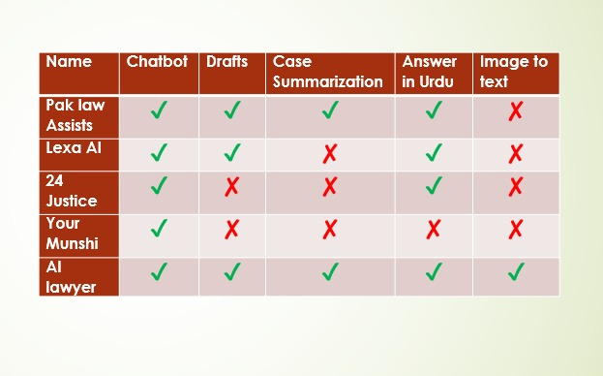
Figure 2.1 Similar Applications

Pak Law Assists:

In Pak Law Assists user can generate legal drafts. Provide case summarization of complex legal cases in seconds and decision making. Provides chat bot for legal queries. [2]

Lexa ai:

It provides chat bot for legal Queries. Judgement on previous cases. Provide multiple legal laws pdf and drafts. Also provide MCQS for students for practise. [3]

24Justice:

Smart legal search for quick answers, easy document management, and AI-powered research support. Automatically reviews and analyzes documents to save time and make legal work simple and efficient.. [4]

Your Munshi:

Your Munshi only provides a chat bot for legal queries. [5]

Ai Lawyer

It provides chat bot for legal queries. Trained on international laws. Provide Templates, Summary of cases, Document review, Consultation with lawyer. [6]

Law Related Papers:

Table 1 Law Related Papers
Paper | Methodology | Dataset | Model | Limitation | Contribution
AI-Powered Interactive Legal Chatbot for the Department of Justice [7] | System design: Flask backend + JS frontend; real-time query | Indian Laws.  Public legal documents (PDF/DOCs, petitions) | LLaMA 3.1 (via Ollama) | • Language limitation: supports only English & Hindi.  • Deployment context/state not fully validated in live environment.  • Model may not handle highly specialized legal domain beyond scope. | Proposed a scalable, user-friendly virtual legal assistant tailored for public legal accessibility bridging legal‐service gap via LLM + multilingual chat interface.
Large language models and their possible uses in law [8] | Literature review + illustrative experiment of LLM in small-law-firm | Legal texts and case-law examples | Large Language Models (LLMs,GPT-style) | • Primarily conceptual rather than large-scale empirical.  • Focus on small law firm may not generalize to large institutions.  • Lacks large dataset/quantitative benchmarks. | It clarifies how LLMs could be used in legal services access to justice, legal information retrieval.
A Legal Approach to the Risks of Commercial Chatbots Powered by Generative Artificial Intelligence [9] | Legal-analytical: risk analysis + regulatory review | Not empirical: works with secondary literature | Transformer-based large language models (LLMs, e.g. ChatGPT) | • No original training data or experimental evaluation.  • The discussion is theoretical and normative.  • Focused on EU context, especially EU AI Act, may not generalize globally.  • Does not propose a concrete technical mitigation tool. | Provides a comprehensive legal risk framework for commercial generative-AI chatbots, mapping immediate risks (e.g., bias, misinformation, environmental) and linking them to law and policy (especially EU AI Act regulatory proposals)
A Smart User Indian Legal Chatbot using Machine Learning Framework [10] | Machine-Learning-based chatbot using the RASA framework for natural language understanding + dialogue management | Indian legal documents / legal knowledge base + user queries | RASA NLU + pattern matching / intent classification | • Limited to intent-reply templates, so may not handle very novel or complex legal queries  • Probably lacks deep domain fine-tuning (no large LLM)  • No detailed evaluation shown (or low-scale evaluation) | Provides a user-friendly, Indian-context legal chatbot that bridges lay users and legal information, using a relatively lightweight ML + RASA setup
Design and Implementation of a Chatbot for Automated Legal Assistance using NLP & ML [11] | Natural Language Processing (NLP) + Machine Learning for building a rule-based + ML hybrid legal-assistance chatbot | Legal documents + user-query data / possibly annotated intents | Likely classical ML / retrieval + NLP (the exact model type isn’t clearly specified in the public summary) | - Dataset size and representativeness not clearly described  - Likely limited to simple / FAQ-style legal queries (not deep legal reasoning or generation)  - Might struggle with ambiguous or very complex legal questions | Provides a straightforward, accessible legal chatbot prototype that automates the retrieval of legal information — an early demonstration that ML + NLP can increase legal-service access for lay users
Legal Solutions – Intelligent Chatbot using Machine Learning [12] | NLP + Machine-Learning based | Legal texts / statutory documents used as knowledge-base. | Traditional ML/NLP methods | • Dataset size/composition unclear  • No advanced generative LLM used  • May not scale or handle highly complex legal reasoning | Shows an applied demonstration of an accessible legal‐chatbot system built with ML/NLP in a real-legal setting useful baseline for legal-tech deployment.
Design and Implementation of a Chatbot for Automated Legal Assistance using Natural Language Processing and Machine Learning [13] | NLP + Machine-Learning based chatbot development | Legal documents + user query data | Traditional ML / NLP techniques | • Dataset size and diversity not clearly defined.  • Likely limited to answer relatively structured/legal-faq style queries.  • May not handle complex legal reasoning or ambiguous questions. | Demonstrates a practical, implementable legal chatbot using ML + NLP provides baseline architecture and shows the feasibility of automating legal assistance for general users.
LawLLM: Law Large Language Model for the US Legal System [14] | Multi-task LLM approach: data preprocessing + unified fine-tuning | Cases from the Harvard Law School Library Innovation Lab’s CaseLaw dataset (state & federal U.S. cases; 6,930,777 in full dataset; they sample subsets for training/testing) | A fine-tuned version of the base model Gemma-7B (instruction-tuned + 4-bit LoRA quantization) | • Focus on U.S. legal domain — may not generalize to other jurisdictions (e.g. South Asia, Pakistan).  • Tasks limited to retrieval & judgment-prediction; may not support full legal reasoning / drafting.  • Training data & verdict extraction pipelines rely on summarization / NLP preprocessing possible information loss or bias | Demonstrates a unified, multi-task legal LLM that outperforms previous baselines (even other strong models) in retrieval, precedent recommendation, and judgment-prediction proving that a single LLM fine-tuned on comprehensive case-law can support multiple core legal tasks
The Cambridge Law Corpus: A Dataset for Legal AI Research [15] | Compilation and curation: collected court-case judgments, cleaned/converted PDFs and Word docs XML, added metadata and case-outcome annotations; provided dataset + baseline extraction experiments | 258,146 UK court cases (raw text + metadata), spanning centuries (some cases as old as 16th century), with ~5 GB of text (≈0.8 billion tokens); plus outcome annotations for a subset (638 cases) by legal experts | models like RoBERTa and tested performance with LLMs (e.g. GPT-4 / GPT-3) to validate structure. | • Only a small subset (638) of cases have detailed outcome annotations rest raw text/metadata.  • Geared toward UK law structure, language, legal conventions specific to UK.  • Some older cases digitized via OCR possible transcription errors. | Provides a large-scale, well-structured legal corpus for AI research: raw judgments + metadata + annotated outcomes. This enables training and evaluation of legal AI models (classification, outcome prediction, retrieval, summarization). Offers a valuable resource to build legal AI systems, especially for common-law jurisdictions, and sets a high-quality standard for dataset curation for legal-AI research.

System Use Cases

User Interaction:
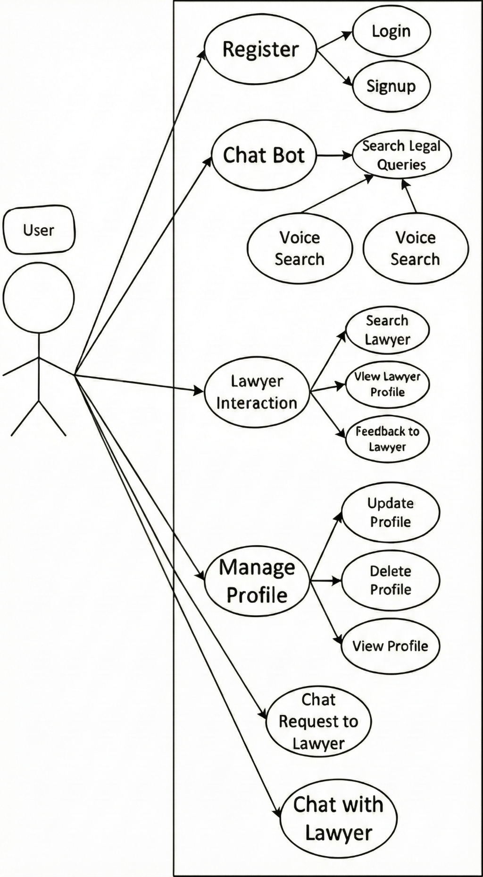
Figure 2.2 User Interaction

Lawyer Interaction:
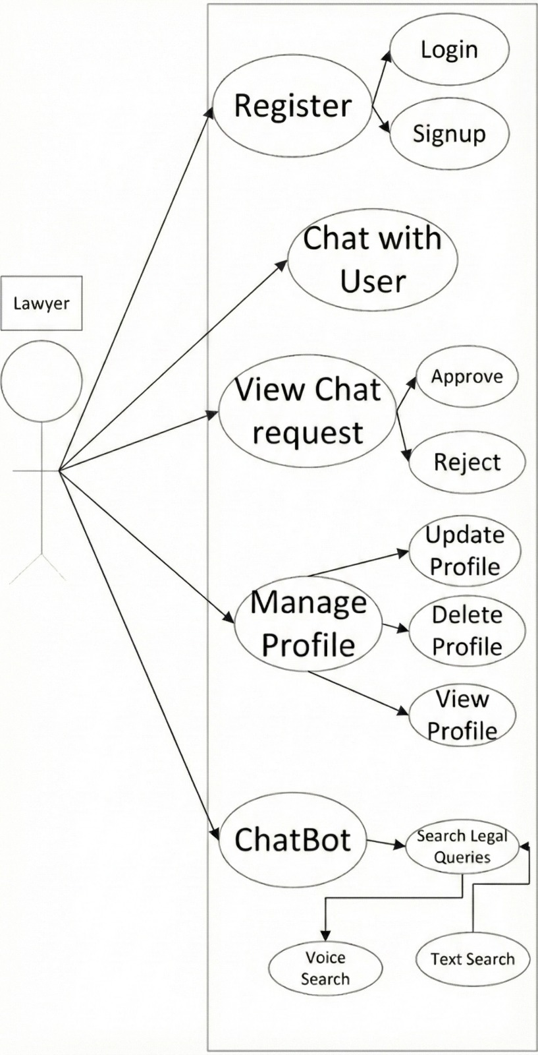
Figure 2.3 Lawyer Interaction

Admin Functionalities:
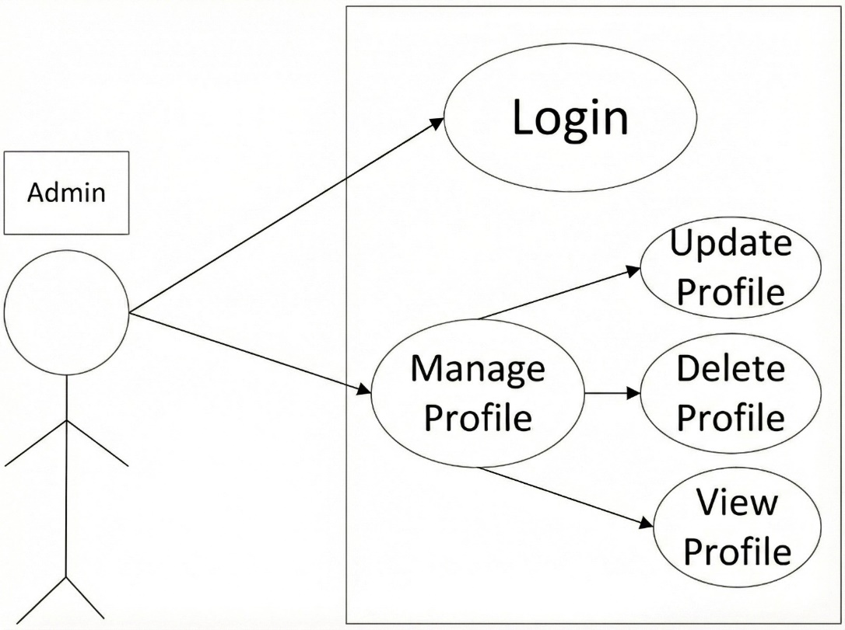

Figure 2.4 Admin Functionalities

System Use Case:
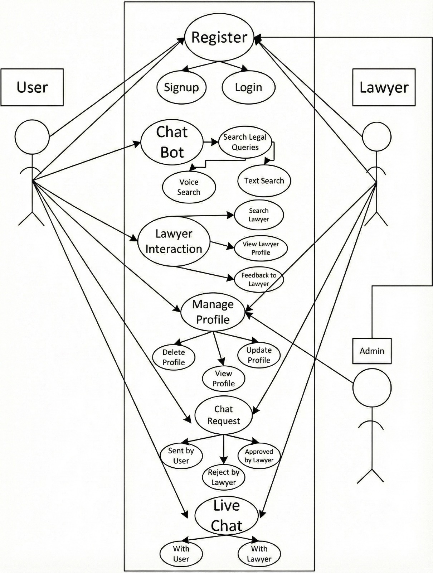

Figure 2.5 System Use Case

System Use Case Table:

User Sign-up:

Table 2.2 User Sign-up
Use Case | Sign Up for User
Use Case ID | UC-001
Actors | User
Description | Allows a user to create an account
Success Scenario | - User accesses the signup page.  - User enters valid personal details (Email, password, etc.).  - System validates the information  provided.
Pre-Condition | User has access to the signup interface.
Post Condition | User account is created and accessible  for login.

Lawyer Sign-up:
Table 2.3 Lawyer Sign-up
Use Case | Signup for Lawyer
Use Case ID | UC-002
Actors | Lawyer
Priority | High
Description | Lawyers registering for an account on  the platform
Success Scenario | - Lawyer accesses the signup page.  - Enters personal and professional details.  - Creates a mail/password.
Pre-Condition | Lawyer accesses signup page.
Post Condition | Lawyer account is successfully created.

User Login:
Table 2.4 User Login
Use Case | User Login
Use Case ID | UC-004
Actors | User
Priority | High
Description | User logs into the system
Success Scenario | User enters valid credentials
Includes | Email, Password
Pre-Condition | User account exists
Post Condition | User is logged into the system.

Lawyer Login:
Table 2.5 Lawyer Login
Use Case | Lawyer Login
Use Case ID | UC-005
Actors | Lawyer
Priority | High
Description | Lawyer logs into the system
Success Scenario | Lawyer enters valid credentials
Includes | Email, Password
Extends | Forget Password
Pre-Condition | Lawyer account exists
Post Condition | Lawyer is logged into the system.

Admin Login:
Table 2.6 Admin Login
Use Case | Admin Login
Use Case ID | UC-006
Actors | Admin
Priority | High
Description | Admin logs into the system
Success Scenario | Admin enters valid credentials
Includes | Email, Password
Pre-Condition | Admin account exists
Post Condition | Admin is logged into the system.

User Update profile:
Table 2.7 User Update profile
Use Case | Update Profile
Use Case ID | UC-007
Actors | User
Priority | High
Description | User updates their profile information.
Success Scenario | - User selects 'Edit Profile.  - User modifies information.  - User saves changes.
Pre-Condition | User is logged in.
Post Condition | User profile information is updated.

Lawyer Update Profile:
Table 2.8 Lawyer Update Profile
Use Case | Update Profile
Use Case ID | UC-008
Actors | Lawyer
Priority | High
Description | Lawyers update their profile info.
Success Scenario | Lawyer navigates to profile update  section.
Pre-Condition | Lawyer is logged in.
Post Condition | Lawyer profile information is updated.

Admin Update Profile:
Table 2.9 Admin Update Profile
Use Case | Update Profile for Admin
Use Case ID | UC-009
Actors | Admin
Priority | High
Description | Admin updates their profile details.
Success Scenario | - Admin navigates to the profile update section.  - Admin modifies the necessary profile information.  - Admin saves the changes successfully.
Pre-Condition | Admin is logged in.
Post Condition | Admin profile is updated successfully.

Admin Functionalities:
Table 2.10 Admin Functionalities
Use Case | System Settings
Use Case ID | UC-010
Actors | Admin
Priority | Low
Description | Admin manages user and lawyer
Success Scenario | Approves lawyer, disable user or lawyer
Pre-Condition | User and lawyer already exists
Post Condition | Successfully approved or deleted

Live Chat between Lawyer and user
Table 2.11 Live Chat b\w Layer & User
Use Case | Live Chat
Use Case ID | UC-011
Actors | User, Lawyer
Priority | High
Description | Real-time messaging session between a User and a Lawyer for quick legal guidance.
Success Scenario | - User requests live chat with a selected Lawyer.  - Lawyer accepts the request.  - System opens a chat session.
Includes | Messages, timestamps, file attachment, chat transcript storage.
Pre-Condition | Lawyer is available and accepts the chat
Post Condition | Chat session is closed, transcript stored.

Chat Bot
Table 2.12 Chat Bot
Use Case | Chat Bot
Use Case ID | UC-013
Actors | User
Priority | High
Description
  The User interacts with the AI chatbot to
  ask legal questions related to property and
  receive instant guidance.
Success Scenario | User enters a question, system processes it through AI and displays an accurate legal response.
Includes | Text input, response, legal guidance
Pre-Condition
  User is logged in and chatbot interface is
  accessible.
Post Condition | The response is displayed on screen

Lawyer Feedback
Table 2.13 Lawyer Feedback
Use Case | Lawyer Feedback
Use Case ID | UC-012
Actors | User, Lawyer
Priority | Medium
Description
  After a consultation or chat, the User
  provides feedback or rating for the
  Lawyer’s service.
Success Scenario | User submits rating after session, system stores it and updates Lawyer’s profile.
Includes | Rating stars, text comments
Pre-Condition
  User and Lawyer have completed a
  consultation or chat session.
Post Condition | Feedback is saved in system, Lawyer’s profile shows updated average rating.

Find Lawyer
Table 2.14 Find Lawyer
Use Case | Find Lawer
Use Case ID | UC-014
Actors | User
Priority | High
Description
  User enters the lawyer’s name, and the
  system displays a list of matching lawyers
  with their details and ratings.
Success Scenario | User submits rating after session, system stores it and updates Lawyer’s profile.
Includes
  lawyer list, profile viewing
Pre-Condition
  User is logged into the system.
Post Condition | List of available lawyers is displayed and user can proceed to request Chat.

Lawyer referral
Table 2.15 Lawyer Referral
Use Case | Lawyer Referral
Use Case ID | UC-015
Actors | User, System
Priority | High
Description | The system recommends the most suitable lawyers to the user by analyzing the legal problem and calculating scores based on specialization relevance, lawyer rating, and experience.
Success Scenario | The system successfully analyzes the user’s legal problem and displays the top 2 recommended lawyers with their relevance percentages.
Includes
  lawyer list, profile viewing
Pre-Condition
  User must be logged in and must submit a legal problem or query
Post Condition | Recommended lawyers are displayed with their relevance percentage and profile details.

Chat Request
Table 2.16 Chat Request
Use Case | Chat Request
Use Case ID | UC-016
Actors | User, Lawyer
Priority | Medium
Description
  The User sends a chat request to a selected
  lawyer for real-time communication.
Success Scenario
  User sends chat request, lawyer receives it
  and accept/reject the session.
Includes
  Message request
Pre-Condition
  User has selected a lawyer from the list.
Post Condition | Chat session started or rejected

DESIGN AND METHODOLOGY

System Architecture

Modular architecture of the Wuqla Ai platform guarantees scalability, security, and effective functionality. The system consists mostly in the following elements:

Front-End:
Flutter is used to create the front end of the system and it follows a design of a widget-based application. It has 3 primary roles, User, Lawyer and Admin, with their own access-specific navigation and dashboard. The interface is bilingual, supporting both the English and Urdu language and controlled by a centralized translation system. The design is receptive and aesthetically unified with indigo as the main color theme. The main characteristics are a secure entry with email/password and Google Sign-In, the possibility of a real-time chat system, voice recognition with speech-to-text, and correct validation of the information submitted by the user. The front end is completely integrated with Firebase application like Authentication, Firestore, and storage to make the data processing and one-way secure interactions within the platform.

Backend:

The backend of the system is designed to intelligently support accurate responses by combining stored legal information with AI processing. FastAPI is responsible for handling the main backend functions and maintaining smooth system performance. Additional technologies assist in analyzing legal documents and interpreting user queries based on their actual meaning, which helps the platform deliver responses that are clear, relevant, and reliable for users.

Database:

User accounts, lawyer details, chat history, and meeting schedules are stored and managed in Firebase. Reliability and security features are intended to be present, including:
- User Data Storage: Stores user accounts, login details, and chat/query history.
- Lawyer Profile Management: Maintains lawyer information, including Specialization, experience.

Lawyer Referral System

The platform incorporates an intelligent lawyer referral system that is able to connect users with the most suitable legal professional based on the relevance of query keywords and lawyer credibility.
Multi-Factor Lawyer Matching System: Weighted Matching Approach: It prioritizes keyword relevance, ratings of the lawyers, and their professional experience to recommend the best-matched lawyers.

Live Chat

Through built-in live chat, the platform allows safe and direct conversations between users and lawyers, supporting smooth and efficient engagement. Important traits comprise:
- Chat Request: Clients schedule Chats with lawyers. Which will be approved by Lawyer and user.

Login Process:

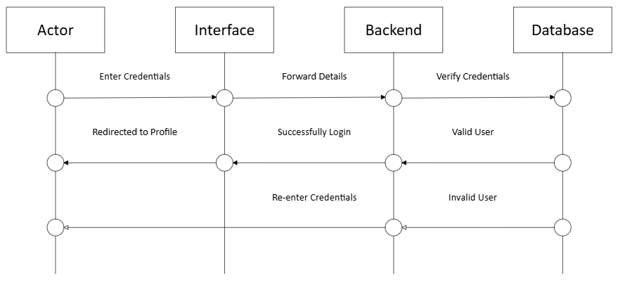
Figure 3.1 Login Process

Signup Process:

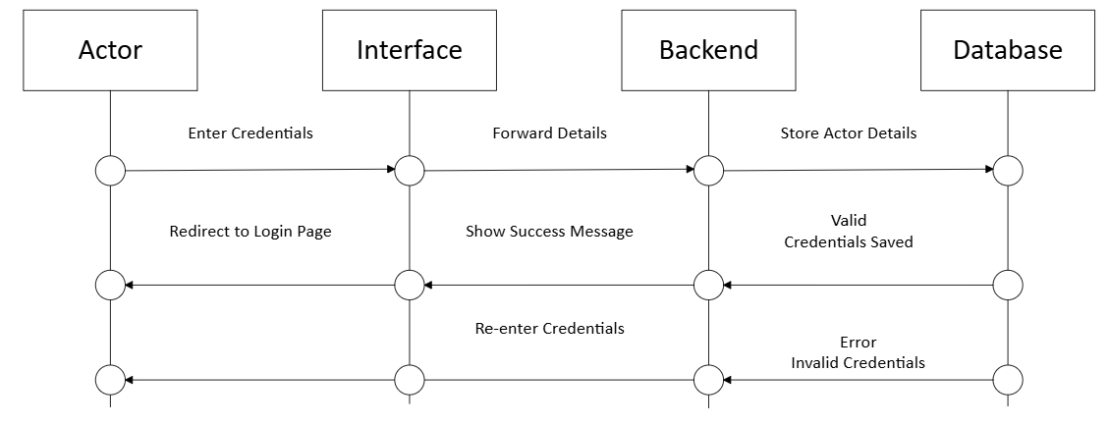
Figure 3.2 Signup Process

Select Language
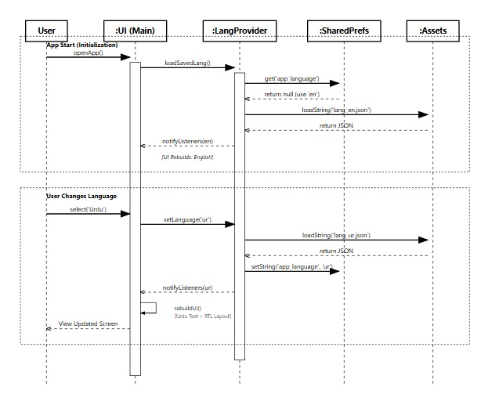
Figure 3.3 Select Language

Chat Request to lawyer
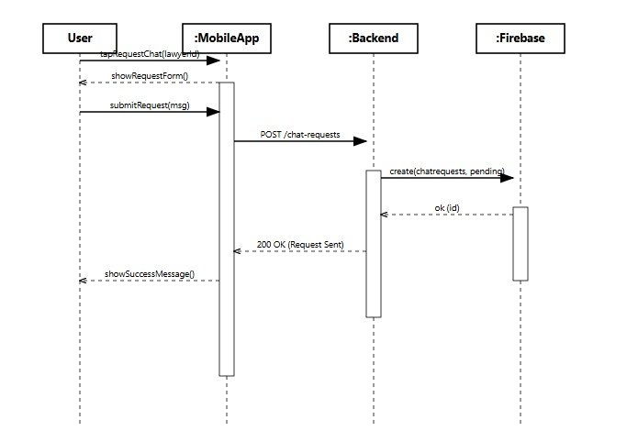
Figure 3.4 Request Chat to lawyer

Live Chat With lawyer
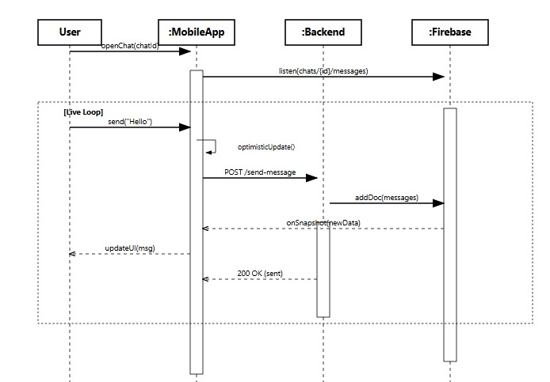
Figure 3.5 Live Chat with Lawyer

Lawyer Recommendation
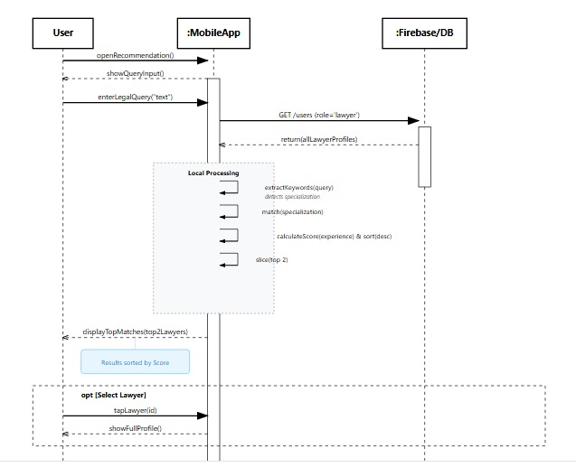
Figure 3.6 Lawyer Recommendation

System Architecture chat bot

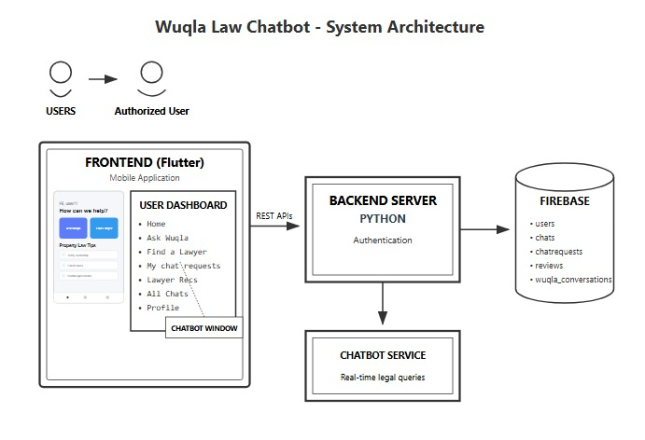
Figure 3.7 System Architecture

ER Diagram:

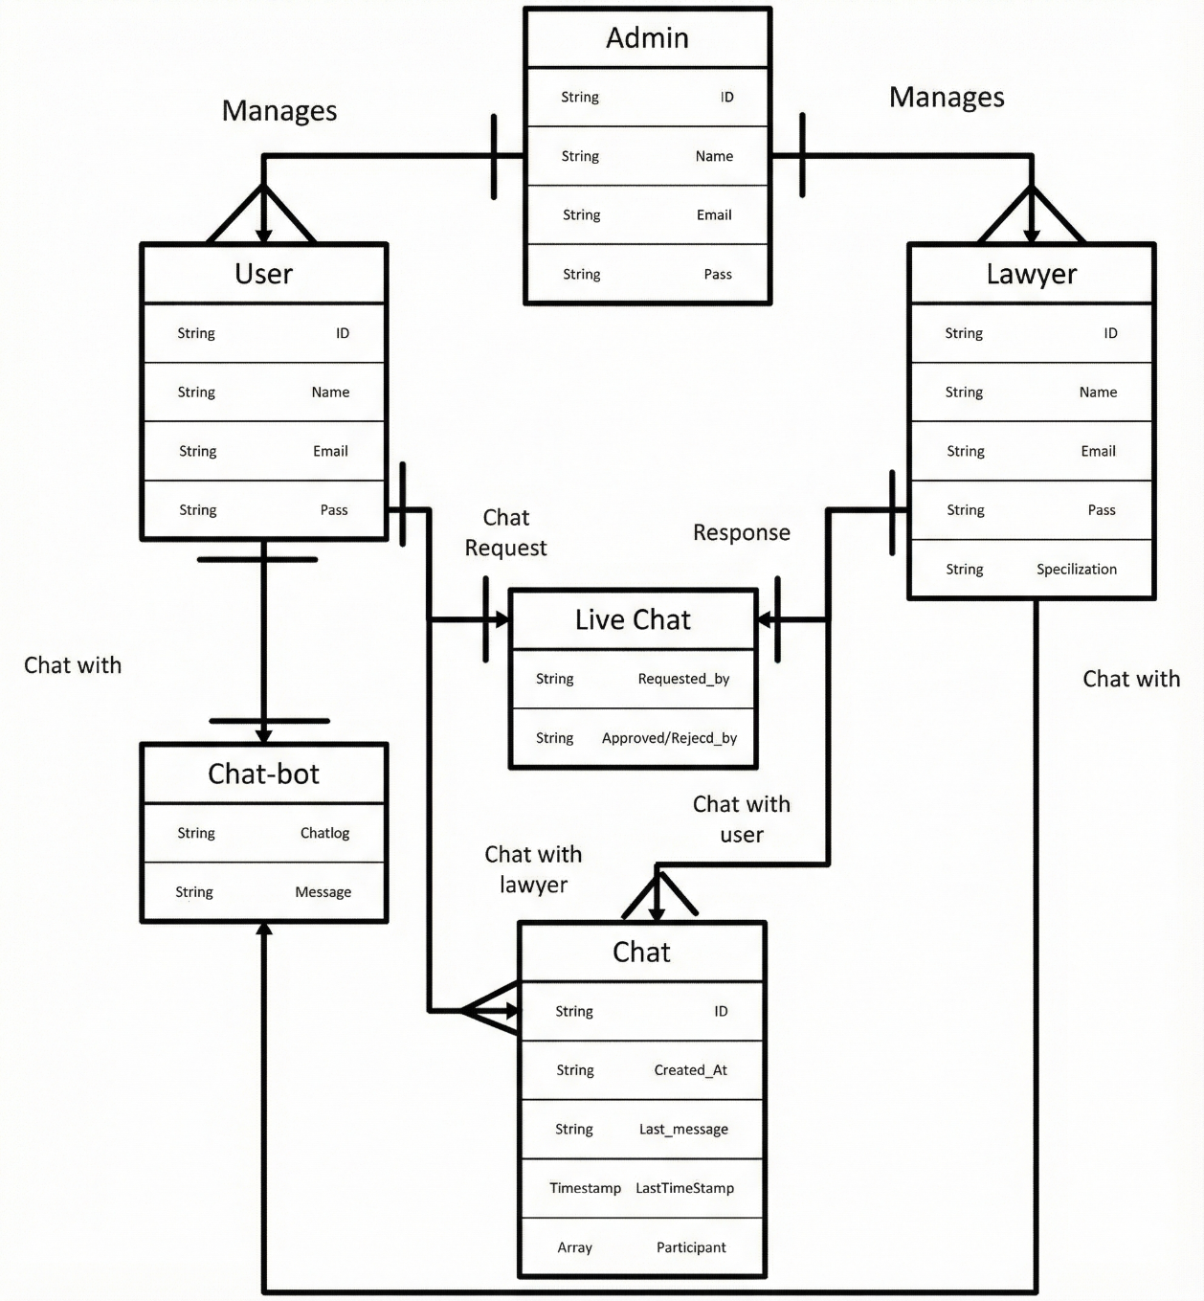
Figure 3.8 ER Diagram:

Methodology:

The Wuqla Ai follows Software Design Methodology like Feature Driven Development FDD because it follows a step-by-step method where the software is built feature by feature, with strong focus on improving quality at every stage.
Features are the building blocks of the project and help the team navigate the processes. Planning by feature: Naturally, it is important to consider the workload of the equipment, the risks and other aspects to avoid complex problems. Designing by feature: Once the team starts working on the project, the domain expert begins to analyze and design a solution for each characteristic. Building by feature: After your team has developed, tested and inspected the code, they are ready to start building the software.
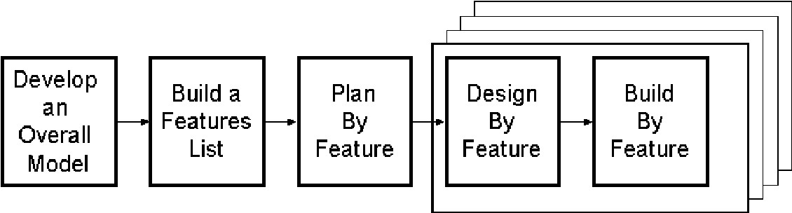
Figure 3.9 Methodology

DATA AND EXPERIMENTS

System Development

Using both front-end and back-end development, Machine Learning integration, and legal data processing.

Front End Development

Flutter is used in frontend of the Wuqla Ai platform to create an interactive and user-friendly interface. The salient qualities consist in:

    - Text Input: Users search the query and obtain the response.
    - Legal Query Submission: Users can enter in English, Urdu or Roman Urdu to easily processed legal enquiries.
    - Search Lawyer profile: User can search or get recommendation about lawyer.
    - Lawyer Profile: Shows availability and expertise of lawyers
    - Chat Request: Shows Chat request approved or rejected by lawyer.
    - Lawyer Home screen: Shows Recent chat request or recent chats.

Limitation:
- Responsive for mobile only. Cannot be open in tablet or desktop.

Backend Development

FastAPI is used for backend development, Improving its high-performance architecture to manage core platform operations, while, Groq, FAISS, and Sentence Transformers power intelligent document processing and semantic legal query resolution:
    - FastAPI Backend Handles API routing, request processing, and system orchestration with high speed and scalability.
    - Groq LLM Interface Uses llama-3.1-8b for fast, reliable, and context-aware legal response generation.
    - FAISS Vector Database Enables high-speed vector similarity search and efficient retrieval of relevant legal content.
    - Sentence Transformers Converts legal text and user queries into dense semantic embeddings for accurate matching.
    - Semantic Search Pipeline Ensures meaning-based retrieval instead of keyword matching, improving legal accuracy and relevance.
    - Scalable Architecture Designed for future expansion including bilingual support and deeper system integrations.

Database

FAISS Database

FAISS is a vector database used to store and retrieve legal knowledge. The merged dataset of 18 property-law documents is processed into smaller text chunks and converted into numerical vector embeddings, which are then indexed and stored in FAISS. When user enters a query in chatbot, the system compares the query with the stored embeddings to find the most relevant legal content based on semantic similarity.

Firebase Database

Firebase is implemented as database for storing user and lawyer profiles, chat messages, chat requests, feedback records and chatbot conversation.
Firebase Auth is used to store the email and password of user and lawyer/Admin.
Firebase Storage is used to store voice note and files during chat and profile pictures. [16]

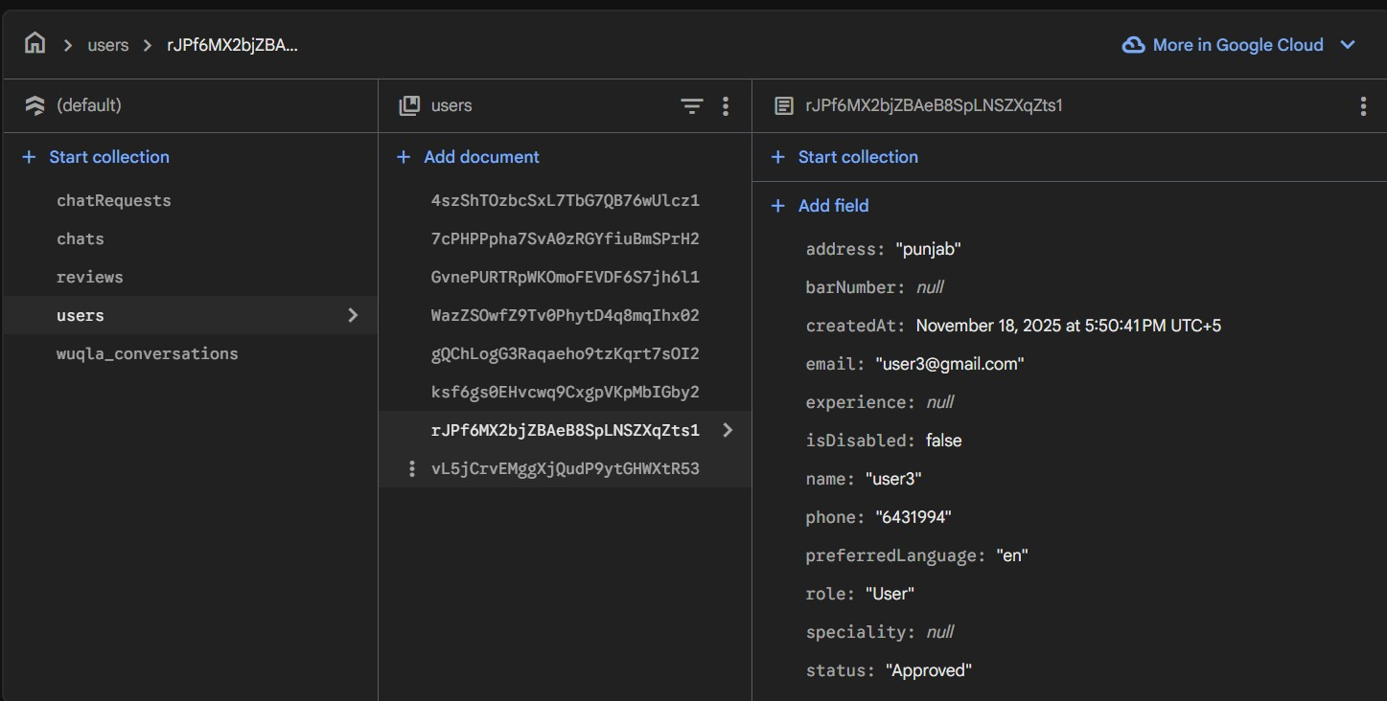
Figure 4.1 Fire Base

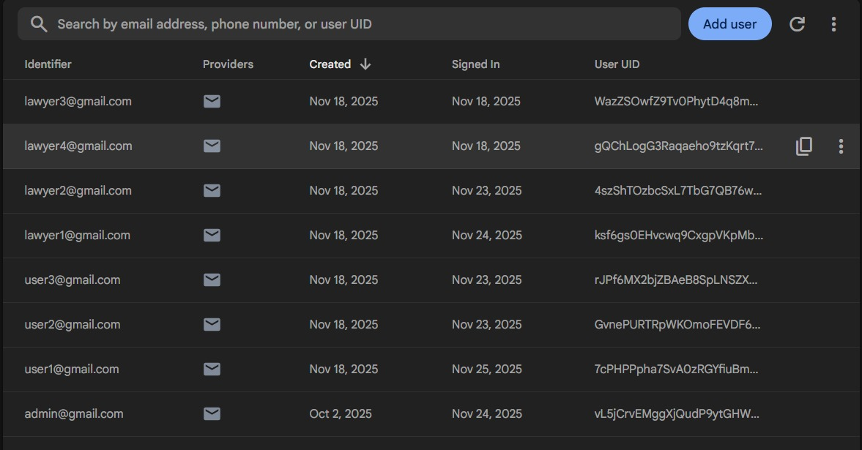
Figure 4.2 Fire Base

Limitations:
Database Security Rules are not applied means anybody can access anything.

Chat Bot Model:

Wuqla AI is an intelligent legal assistant that uses retrieval-augmented generation (RAG) to deliver precise, context-aware answers for Pakistani property law by combining semantic search with advanced language models. It ensures legally grounded responses by retrieving relevant law sections and generating explanations strictly based on verified legal sources.
- Uses RecursiveCharacterTextSplitter to break legal documents into coherent, searchable text chunks.

- Converts text into semantic embeddings using HuggingFace’s all-MiniLM-L6-v2 model.

- Stores embeddings in a FAISS vector database for fast, meaning-based retrieval.

- Matches user queries (text or voice) with relevant legal content via similarity search.

- Sends retrieved excerpts to Groq-hosted llama-3.1-8b-instant for accurate response generation.

- Operates at low temperature for consistency and legal precision.

- Ensures responses are traceable to specific legal provisions.

- Supports future scalability for bilingual features, lawyer matching, and case management integration.

Limitations:
- Model Only answer to the Question asked. It is not context aware
- It takes few seconds to respond about 5-10 seconds.
- There is a time delay of 2-3 seconds in message sending due to the message being stored in firebase first then shown to the user.
- when the chatbot is asked question in roman Urdu it give answers in roman Hindi.

Lawyer Referral

The Smart Lawyer Referral & Scheduling module makes the process feel simple and personal for users. It understands what the user is asking by recognizing key terms and the nature of the legal issue, then suggests the most relevant lawyers based on their expertise. After the user chooses a lawyer, a chat request is instantly sent so both parties can start communicating directly for initial guidance and clarification.
In the lawyer referral system, the user’s problem is first analyzed to identify the most relevant legal specialization by matching keywords and assigning points accordingly. Once the specialization is determined, lawyers are scored using a weighted formula where specialization relevance carries 50%, rating 30%, and experience 20%. Based on the total score, all lawyers are sorted and the top two most suitable lawyers are displayed to the user.

Limitation:
- The Lawyer recommendations system detects the specializations based on keywords of the specialization

Live Chat between User and lawyer:

The software combines real-time live chat for legal advice
    - Instant messaging lets one have real-time discussions with legal professionals.
    - Multimedia Support: Throughout consultations, users can distribute legal documentation.
    - Voice Note: Communication can also be done through voice note

Limitation in Chat:
- It takes 2-3 seconds to send message.
- No notification for receiving messages.

Other Models Used:
Table 17 Model Experimentation
Exp.NO | chunking segmentation | chunking overlap | Temp | Embeddings | Database | searching | Results
1 | Fixed Size (1000 chars) | 0 | 0.4 | all-MiniLM-L6-v2 | ChromaDB | Basic Cosine Similarity | Large chunks (1000) can introduce noise, Low overlap (0) can break sentences across chunks,chromadb speed slow
2 | Recursive Character (1000) | 150 | 0.3 | OpenAI text-embedding-3-small | FAISS | Hybrid (Keyword + Vector) | large overlap for context, Low Temp (0.3) makes the final answer reliable.Faiss speed is fast
3 | Semantic Chunking | 1 | 0.4 | HuggingFace InstructXL | ChromaDB | Similarity (Top-k=4) | Low overlap (1) is a risk, chunking aims to keep related ideas together, which is theoretically best but not for law data
4 | Fixed Size (400 chars) | 20 | 0.2 | OpenAI text-embedding-3-small | FAISS | Similarity (Top-k=4) | Shorter chunks (400) lead to less noise and higher precision in retrieval.
5 | Recursive Character (400) | 50 | 0.2 | all-MiniLM-L6-v2 | FAISS | Similarity (Top-k=4) | Temperature (0.2) means the final LLM output will be highly constrained by the retrieved context, Excellent MiniLm embeddings,  Shorter chunks (400) lead to less noise and higher precision in retrieval.  Combines the more reliable Recursive Character segmentation with smaller chunks (400).

RESULTS AND DISCUSSIONS (or USER MANUAL)

Wuqla Ai App Screens

Figure 5.1 Login Screen
Figure 5.2 User Signup Screen

Figure 5.3 Lawyer Signup Screen
Figure 5.4 Forgot Password

Figure 5.5 User Profile
Figure 5.6 Update Information

Figure 5.7 Lawyer Profile
Figure 5.8 Lawyer Update Profile

Figure 5.9 Lawyer Referral
Figure 5.10 Find Lawyer

Figure 5.11 Lawyer Chat request
Figure 5.12 Lawyer Dashboard

Figure 5.13 Chat bot
Figure 5.14 Chat bot

Figure 5.15 User Lawyer Chat
Figure 5.16 User Lawyer chat

Figure 5.17 Admin Profile
Figure 5.18 Admin Dashboard

CONCLUSION AND RECOMMENDATIONS

Project Achievement:

Wuqla AI offers Pakistani law on property. The system enables people to forward legal enquiries and get correct and case-specific response. There is also an option to find lawyers by name, view complete lawyer profiles, and make appropriate lawyer connections based on the system of percentages which includes specialization, rating, and experience.
Also, the application helps users to communicate with lawyers in real-time by using a live chat system. The mobile interface is easy to use and user-friendly enough to give easy access to the legal services. Comprehensively, the project manages to provide a workable solution that eases the complicated property laws, access to legal advice, and the effectiveness of legal consultation in Pakistan.

Practical Impact:

Wuqla AI is an online platform that is a chatbot, which assists people and property owners in knowing their property-related legal inquiries in a clear and simple manner. People can utilize it when they have fast clarification on the ownership wrangles, property transfer, tenancy and inheritance matters without necessarily having to visit a lawyer right away. Its particular usefulness is in the first-time purchasers of property, students, and people in remote areas who do not have easy access to attorneys.

Recommendations

Wuqla AI will further improve its functionality and user experience in the future with more advanced features and functions as defined below:

Enhanced Legal Coverage

Wuqla Ai will expand from property law to include other domains such as family law, criminal law, labour law etc. It will allow users to get all kind of legal guidance in one application.

AI Model Optimization

Fine-tune the language model on localized legal datasets to further improve response accuracy and contextual understanding.

Punjabi Language Support
Punjabi language will be further added to help people in rural areas and native Punjabi speaking people use the application easily and more effectively.

Lawyer Verification

To protect professional integrity lawyers must be verified through Bar Council ID .
Currently we not verifying because we don’t have this data.

Draft Template:

Ready to use templates will be provided to users such as Sales agreement, lease agreement, Gift deeds, Power of Attorney, Affidavits, Possession Letters.

Province-Wise Law Variations:

Property laws differ region to region. In future we will make categories like Province, Local municipal authority, Cantonment areas vs non-cantonment.

REFERENCES

[1] | “https://pakistancode.gov.pk/english/LGu0xVD-apaUY2Fqa-cQ%3D%3D&action=primary&catid=8,” [Online].
[2] | “https://agent.paklawassist.com/,” [Online].
[3] | “https://www.lexa.lawyer/ChatBot,” [Online].
[4] | “https://www.24justice.com/,” [Online].
[5] | “https://chat.yourmunshi.net/,” [Online].
[6] | “https://app.ailawyer.pro/,” [Online].
[7] | E. M. K. K. S. C. T. P. A. S. F. K L Srujan Surya, “AI-Powered Interactive Legal Chatbot for the Department of Justice,” 2025.
[8] | Z. Z. Péter Homoki, “Large language models and their possible uses in law,” p. 20, 2024.
[9] | S. Migliorini, “A Legal Approach to the Risks of Commercial Chatbots Powered by Generative Artificial Intelligence,” 2024.
[10] | E. Srivastav, A. Patel, A. Singh, R. Sharma and D. P. Rana, “LAWBOT: A Smart User Indian Legal Chatbot using Machine Learning Framework,” 2024.
[11] | M. T. P. Y. S. P. P. P. S. M. C. P. Ashok Reddy Kandula, “Design and Implementation of a Chatbot for Automated Legal Assistance using Natural Language Processing and Machine Learning,” 2023.
[12] | K. R. A, K. S and R. R, “Legal Solutions - Intelligent Chatbot using Machine Learning,” 2023.
[13] | M. T. P. Y. S. P. P. P. S. M. C. P. Ashok Reddy Kandula, “Design and Implementation of a Chatbot for Automated Legal Assistance using Natural Language Processing and Machine Learning,” 2023.
[14] | H. Z. X. L. D. D. Dong Shu, “LawLLM: Law Large Language Model for the US Legal System,” 2024.
[15] | H. S. H. X. L. B. A. T. L. J. M. M. F. S. Andreas Östling, “The Cambridge Law Corpus: A Dataset for Legal AI Research,” 2024.
[16] | R. Johnson, The Firebase Handbook, HiTeX Press, 2025.

APPENDICES

