
BSIT-F24-003
03-135212-029 | RAMEEN SAJID
03-135232-078 | MUGHEES MUBASHER
03-135212-007 | DANISH RASHID

RecoVoyage

In partial fulfilment of the requirements for the degree of
Bachelor of Science in Information Technology
Supervisor: Zunnurain Hussain
Department of Computer Sciences
Bahria University, Lahore Campus
June 2025

© Bahria University, 2025


Certificate

We accept the work contained in the report titled
“RecoVoyage”
written by
RAMEEN SAJID
MUGHEES MUBASHER
DANISH RASHID
as a confirmation to the required standard for the partial fulfilment of the degree of
Bachelor of Science in Computer Science.

Approved by:
Supervisor: ZUNNURAIN HUSSAIN
(Signature)

June 2025

DECLARATION

We hereby declare that this project report is based on our original work except for citations and quotations which have been duly acknowledged. We also declare that it has not been previously and concurrently submitted for any other degree or award at Bahria University or other institutions.

Enrolment | Name | Signature
03-135212-029 | RAMEEN SAJID
03-135232-078 | MUGHEES MUBASHER
03-135212-007 | DANISH RASHID

Date : June 2025

Specially dedicated to
my beloved grandmother, mother and father
(RAMEEN SAJID)
my beloved grandmother, mother and father
(MUGHEES MUBASHER)
my beloved grandmother, mother and father
(DANISH RASHID)
(this dedication page is optional)

ACKNOWLEDGEMENTS

We would like to thank everyone who had contributed to the successful completion of this project. We would like to express my/our gratitude to my research supervisor, Mr Zunnurain Hussain for his invaluable advice, guidance and his enormous patience throughout the development of the research.

In addition, we would also like to express my gratitude to our loving parent who had helped and given me encouragement.

RAMEEN SAJID
MUGHEES MUBASHER
DANISH RASHID

RecoVoyage

ABSTRACT

The continuous evolution of mobile and artificial intelligence technologies has opened new possibilities for enhancing user experiences in the tourism sector. Despite the abundance of travel-related applications, many fall short in delivering a seamless, intelligent, and localized travel planning experience—especially in regions like Pakistan. RecoVoyage addresses this gap by offering a smart, AI-driven mobile application designed to assist users in planning, managing, and enhancing their travel experiences through a centralized platform.
Developed using Flutter for cross-platform compatibility and Firebase as the backend, RecoVoyage integrates essential modules such as trip planning, real-time alerts, booking simulations, and offline access. The app employs an AI-powered recommendation engine to suggest destinations and experiences tailored to user preferences. It uses dummy APIs to simulate hotel, flight, and cab booking workflows and incorporates a conversational assistant powered by Mistral API to guide users interactively through travel-related queries.
To ensure reliability and scalability, the app features cloud-based data management through Firestore, supports multi-language accessibility, and enables offline functionality using cached data. Additional features include review and rating systems, loyalty rewards, and local deals to increase engagement and promote community-based tourism. Real-time notifications keep users updated with alerts like weather changes, flight status, and itinerary reminders.
Security and usability were key priorities in development, with encryption protocols and OWASP-guided testing ensuring robust protection. Future enhancements include integrating real-time payment gateways, extending local partnerships, and deploying the app for live user testing. RecoVoyage demonstrates a practical and innovative solution to modern travel challenges, offering an intelligent, inclusive, and user-friendly platform tailored for the evolving needs of Pakistani travellers.

TABLE OF CONTENTS

DECLARATION ii
ACKNOWLEDGEMENTS iv
ABSTRACT v
TABLE OF CONTENTS vi
LIST OF TABLES ix
LIST OF FIGURES x
LIST OF APPENDICES xii

CHAPTERS
1 INTRODUCTION 1
1.1 Background 1
1.2 Problem Statements 1
1.3 Aims and Objectives 2
1.4 Scope of Project 2
2 LITERATURE REVIEW 3
2.1 Introduction 3
2.2 Recent Research Insight 4
2.3 Filtering Criteria for studies 4
2.4 Rules for Study Exclusion 6
2.5 Area of Study 6
2.6 Systematic Literature review 7
3 DESIGN AND METHODOLOGY 38
3.1 Introduction 38
3.2 Dataset 38
3.3 Design 39
3.3.1 Sequence Diagram for AI Powered Chatbot 39
3.3.2 Flowchart for AI Recommendation System 41
3.3.3 ERD for Tour Planning System 42
3.3.4 ERD for Tour Plan 45
3.3.5 User Journey Flow for Offline Access 46
3.3.6 Sequence Diagram for Real Time Updates 48
3.3.7 Sequence Diagram for Multi-Language Support 49
3.3.8 RecoVoyage Sequence Diagram 50
3.3.9 User Flow Diagram for Social Sharing and Integration 52
3.3.10 Sequence Diagram for User Generated Tours 53
4 DATA AND EXPERIMENTS 55
4.1 Implementation 55
4.1.1 Planning and Designing 55
4.1.2 Testing 56
4.1.3 Documentation 56
4.1.4 Deployment and Maintenance 56
4.2 Technical Aspect of Application 57
4.2.1 Hardware 57
4.2.2 Frontend 57
4.2.3 Backend 58
5 RESULTS AND DISCUSSIONS 60
5.1 Front-End (Flutter) 60
5.1.1 Onboarding Screen 61
5.1.2 Home Dashboard Screen 62
5.1.3 Destination Explorer Screen 63
5.1.4 Sign Up Screen 64
5.1.5 Loyalty Points Screen 65
5.1.6 AI Chatbot Assistant 66
5.1.7 Review and Pay Screen 67
5.1.8 Recommendation Screen 68
5.1.9 Profile screen 69
5.1.10 Landing Screen 70
5.1.11 Tour guide screen 71
5.1.12 Community feed screen 72
5.1.13 Current trips screen 73
5.1.14 Saved trips screen 74
5.1.15 Booking confirmed screen 75
5.1.16 Booking summary screen 76
5.1.17 Travel details screen 1 77
5.1.18 Travel details screen 2 78
5.1.19 Select Travel Dates screen 79
5.2 Back-End Development 80
6 CONCLUSION AND RECOMMENDATIONS 81
6.1 CONCLUSION 81
6.2 RECOMMENDATIONS 81
REFERENCES 83
APPENDICES 87

LIST OF TABLES

TABLE TITLE PAGE
Table 2.1:SLR (Sytematic Literature Review) 7

LIST OF FIGURES

FIGURE TITLE PAGE

Figure 2.1 Filtering Criteria 5
Figure 2.2 Technology Adoption Curve 5
Figure 2.3 Guidelines for Identifying Relevant Studies 6
Figure 3.3.1 Sequence Diagram for AI Powered Chatbot 39
Figure 3.3.2 Flowchart for AI Recommendation System 41
Figure 3.3.3 ERD for Tour Planning System 42
Figure 3.3.4 ERD for Tour Plan 45
Figure 3.3.5 User Journey Flow for Offline Access 46
Figure 3.3.6 Sequence Diagram for Real Time Updates 48
Figure 3.3.7 Sequence Diagram for Multi-Language Support 49
Figure 3.3.8 RecoVoyage Sequence Diagram 50
Figure 3.3.9 User Flow Diagram for Social Sharing and Integration 52
Figure 3.3.10 Sequence Diagram for User Generated Tours 53
Figure 5.1 Onboarding Screen 61
Figure 5.2 Home Dashboard Screen 62
Figure 5.3 Destination Explorer Screen 63
Figure 5.4 Sign Up Screen 64
Figure 5.5 Loyalty Points Screen 65
Figure 5.6 AI Chatbot Assistant 66
Figure 5.7 Review and Pay Screen 67
Figure 5.8 Recommendation Screen 68
Figure 5.9 Profile screen 69
Figure 5.10 Landing Screen 70
Figure 5.11 Tour guide screen 71
Figure 5.12 Community feed screen 72
Figure 5.13 Current trips screen 73
Figure 5.14 Saved trips screen 74
Figure 5.15 Booking confirmed screen 75
Figure 5.16 Booking summary screen 76
Figure 5.17 Travel details screen 1 77
Figure 5.18 Travel details screen 2 78
Figure 5.19 Select Travel Dates screen 79

LIST OF APPENDICES

APPENDIX TITLE PAGE
APPENDIX A: Code snippet of AI Assistant 88
APPENDIX B: Code snippet of Community Feed 90

INTRODUCTION

Background

The rapid growth of mobile technology and AI has significantly influenced the travel and tourism industry, transforming how users plan and experience trips. Despite the availability of various travel apps, most lack key features such as real-time updates, offline access, smart recommendations, and local engagement. RecoVoyage is developed as a mobile application that leverages AI, cloud technologies, and intuitive design to offer travelers a smart, personalized, and seamless trip planning experience within Pakistan.

Problem Statements

Current tourism applications often suffer from limitations such as generic recommendations, outdated or disconnected data, and limited offline functionality. Additionally, many fail to offer integrated services like bookings, local deals, chatbot assistance, and real-time alerts in a single platform. There is a need for a more intelligent, centralized solution that caters to local tourism while offering modern features and accessibility.

Aims and Objectives

The aim of RecoVoyage is to develop a smart travel companion application that simplifies trip planning and enhances the overall travel experience. Its core objectives include implementing an AI-powered recommendation engine for personalized travel suggestions, integrating booking simulations for hotels, flights, and cabs using dummy APIs, and providing features such as real-time alerts, offline access, and multi-language support. The app also incorporates a chatbot powered by Mistral API for interactive assistance and includes modules for user reviews, loyalty points, and social sharing to boost engagement and community interaction.

Scope of Project

The project focuses on developing a Flutter-based mobile application with Firebase and Firestore as backend services. Key modules include trip planning, AI-based recommendations, bookings via dummy APIs, a chatbot, offline data access, and user engagement features like reviews and local deals. The application targets travelers within Pakistan, aiming to improve convenience, personalization, and accessibility during their journeys.

LITERATURE REVIEW

Introduction

The evolution of technology has rushed, transforming the tourism industry into one of the most information-rich sectors. Travelers have access to an abundance of data that they can use to guide their decisions and to serve their needs, and it is done with a level of ease and dedication to customer service that is unprecedented. Nonetheless, the abundance of data brings with it a set of fresh users experience issues that our old friend, the Internet, also has and that e-commerce has always had.

This literature review investigates the present situation of tourism applications and their function in countering these problems. It focuses on identifying what existing solutions lack. These gaps are offline functionality that often is limited; recommendations that are not sufficiently personalized; and information that is sometimes correct, but often out of date.

This review intends to assess the connected works and progress made in artificial intelligence, collaborative filtering, and based on these, it aims to establish the relevance and the novelty of the proposed app RecoVoyage. The app is intended to enrich the experience of travelers. Its core strengths lie in the AI-based recommendation mechanism, which, in a collaborative way, serves the user well by striking a balance between personalization and serendipity.

This review ultimately advocates for a singular, user-friendly, centralized platform that would simplify those multifaceted, frustrating aspects of travel planning and lead to a better overall user experience.

Recent Research Insight

- What is the most effective AI-driven recommendation algorithms (e.g., collaborative filtering, content-based filtering) for tourism apps, and how do they enhance user experience?
- How do real-time updates and offline functionality improve the usability of tourism apps, particularly in areas with limited connectivity?
- What challenges do multi-language support systems face in tourism apps, and how can NLP models like Google Translate API or GPT-based systems address these issues?
- How do tourism apps like Pakrism compare to RecoVoyage in terms of user experience, accuracy of information, and offline accessibility?
- What are the limitations of current tourism apps in integrating local business promotions, and how can RecoVoyage create economic opportunities for local service providers?
- How effective are penetration testing tools like OWASP-ZAP and Burp Suite in ensuring the security of tourism apps, and what vulnerabilities are most identified?
- What are the key benefits of using Scrum methodology in the development of tourism apps, and how does it accommodate iterative changes during the project lifecycle?
- How do review aggregation and sentiment analysis improve the accuracy of AI-driven recommendations in tourism apps, and what are the challenges in implementing these features?
- What are the technical and resource feasibility challenges in developing a tourism app like RecoVoyage, and how can they be mitigated?
- What are the potential risks (e.g., time constraints, security breaches, cultural sensitivity) in developing tourism apps, and how can they be addressed during the development process?

Filtering Criteria for studies

- Recency of Publication
- Peer-Reviewed Journals and Conferences
- Empirical Research and Case Studies
- Methodological Rigor
- Technological Relevance
- Scalability and User-Centric Design
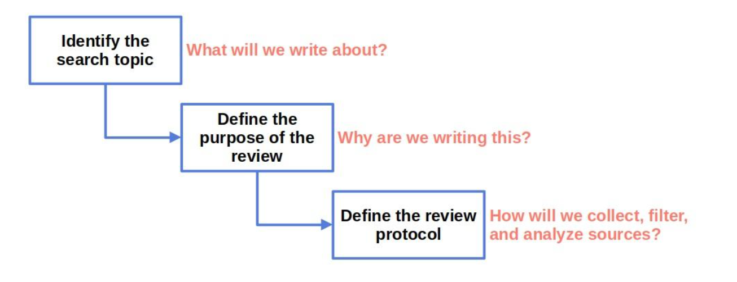
Fig. 2.1. Filtering Criteria

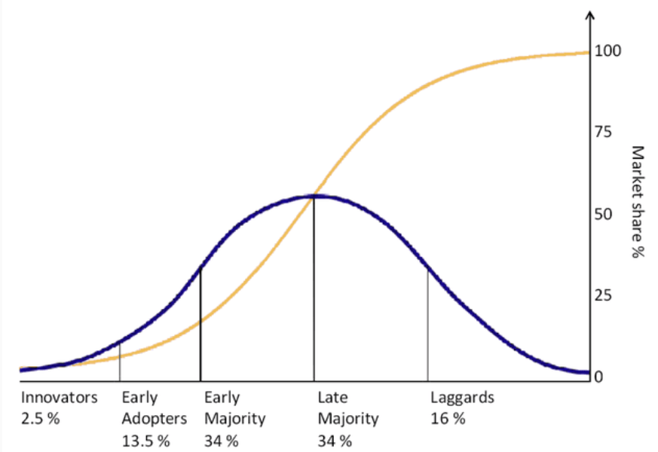
Fig. 2.2. Technology Adoption Curve

Rules for Study Exclusion

Source: IEEE, Google Scholar, ScienceDirect
Search Keywords: Study Exclusion, Exclusion Criteria, Mobile App Development, AI Chatbot, Tourism Recommender.
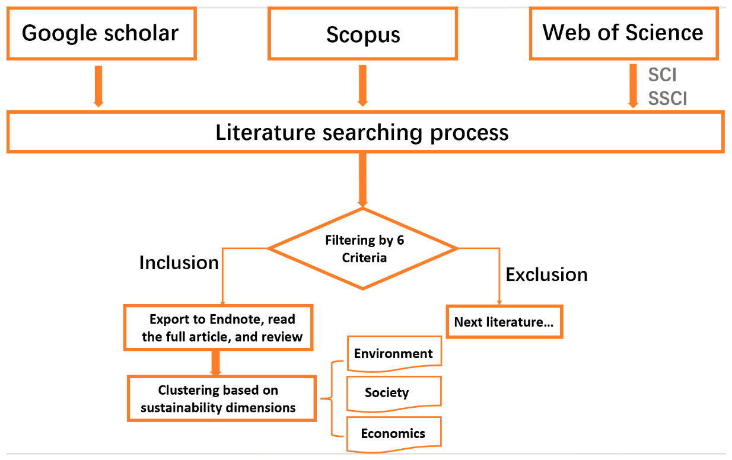
Fig. 2.3. Guidelines for Identifying Relevant Studies

Area of Study

The area of study for this project focuses on the development of an AI-powered tourism recommender system within a mobile app. Using Flutter, the app will offer personalized travel recommendations, integrating features like AI chatbots, offline access. The study explores the intersection of mobile app development, artificial intelligence, and tourism technology to enhance user experience and improve accessibility in the tourism sector. The aim is to improve the overall user experience, making tourism more accessible, efficient, and tailored to individual needs, while also evaluating the technical feasibility and effectiveness of AI integration in the tourism sector.

Systematic Literature review

Year | Paper Title | Authors | Methodology | Performance Metrics | Contributions | Future Gap | Dataset
2022 | Development of Hybrid Full Stack Application for Vacation Rentals | Rafe Ibrahim | Developed a hybrid mobile application using Node.js, Express, MongoDB, and Amazon S3 for vacation rentals | User engagement, system scalability, response time | Created a platform for booking and posting rental properties, integrating local payment methods and in-app messaging | Needs testing with real users and expansion of features to include transportation bookings and travel guides | Not specified
2024 | Digitalizing Tourism and Interactive Navigation: A Case Study of Pakistan | Mariam Bashir, Salman Asghar, Muhammad Ashfaq, Syed Shahzeb Raza, Sadaf Zahoor | Conducted a structured questionnaire survey; developed a customized application framework and UI design | Tourist satisfaction, ease of navigation, information accessibility | Designed an app framework assisting tourists in locating accommodations, dining, attractions, and leisure spots | Implementation of the proposed framework and assessment of its impact on tourism growth | Primary data from 398 survey participants
2023 | Pakistan prepares to welcome tourists with cutting-edge tourism app | Samaa Web Desk | Government initiative to launch an official tourism app providing authentic information | App adoption rate, user satisfaction, impact on tourism influx | Aimed to enhance tourism by offering comprehensive information on tourist spots, transportation, and services | Monitoring the app's effectiveness and updating information regularly to maintain relevance | Not specified
2022 | Meet Pakistan - Tourism Guide by TDAP | Trade Development Authority of Pakistan | Launched a tourism guide app covering all geographical areas from South to North | Number of downloads, user engagement, coverage of tourist destinations | Provided a comprehensive tourism guide app to promote trade and tourism in Pakistan | Continuous content updates and user feedback integration to enhance app utility | Not specified
2022 | Tourism App for Pakistan: A mobile application designed to explore and promote Pakistan's diverse tourist destinations | CHHamza56 (GitHub Repository) | Developed a mobile app featuring searchable tourist spots, travel guides, user reviews, and interactive maps | User reviews, app usability, comprehensiveness of tourist information | Created an easy-to-navigate platform for planning travel itineraries in Pakistan | Expansion of features to include booking capabilities and real-time updates | Not specified
2019 | Understanding Mobile Tourism Shopping in Pakistan: An Integrating Framework of Innovation Diffusion Theory and Technology Acceptance Model | Dongxiao Gu, Salman Khan, Ikram Ullah Khan, Safeer Ullah Khan | Structural equation modeling on 396 responses from users who purchased tourism products via mobile devices | Social presence influence, perceived compatibility, relative advantage | Identified social presence as a significant factor influencing mobile tourism shopping intentions in Pakistan | Further research is needed on other psychological factors affecting mobile tourism shopping adoption | Responses from 396 mobile users who recently purchased tourism products
2022 | Use of Technology in Tourism: Challenges in Pakistan | Kalsoom B., Mehtab Alam | Survey approach to assess technological challenges in Pakistan's tourism industry | Identification of technological disparities, impact on tourism services | Highlighted existing technological disparities and their impact on tourism services in Pakistan | Implementation of technological tools to overcome identified challenges in the tourism sector | Survey data from stakeholders in Pakistan's tourism industry
2022 | Mobile Travel Apps Engagement: Measuring Tourists’ Perception | Humera Imtiaz | Field intercept survey of 500 respondents at tourist sites in Northern Pakistan | Tourist satisfaction, ease of use, engagement levels | Provided empirical evidence on tourists' satisfaction and engagement with mobile travel apps in Pakistan | Expansion of study to include diverse geographic locations and larger sample sizes | Responses from 500 tourists at various sites in Northern Pakistan
2024 | Digitalizing Tourism and Interactive Navigation: A Case Study of Pakistan | Mariam Bashir, Salman Asghar, Muhammad Ashfaq, Syed Shahzeb Raza, Sadaf Zahoor | Structured questionnaire survey with 398 participants; development of a customized application framework | Tourist satisfaction, ease of navigation, information accessibility | Designed an app framework assisting tourists in locating accommodations, dining, attractions, and leisure spots | Implementation of the proposed framework and assessment of its impact on tourism growth | Primary data from 398 survey participants
2022 | Indus Explorer: An Android Based Tourist Guide Application | Muhammad Usman, Muhammad Awais, Muhammad Asif | Development of an Android-based application providing information on cultural and historical sites | User engagement, app usability, information accuracy | Created a digital guide for tourists to explore cultural and historical sites in Pakistan | Enhancement of app features and inclusion of more tourist destinations | Not specified
2022 | Virtual Reality as a Marketing Tool to Drive Consumer Decision-Making | Shahab Shahzad, Yasin | Analysis of virtual reality applications in tourism marketing | Consumer engagement, decision-making efficiency | Explored the potential of virtual reality as a tool to enhance consumer decision-making in tourism marketing | Practical implementation of virtual reality tools in Pakistan’s tourism industry | Not specified
2022 | Mobile Applications in Tourism | Jelena Dorcic, Jelena Komsic, Suzana Markovic | Systematic literature review of mobile technologies and applications in smart tourism | Adoption rates, user satisfaction, technological advancements | Provided a comprehensive review of mobile technologies and applications in smart tourism | Empirical studies focusing on user adoption and satisfaction in different cultural contexts | Not specified
2022 | Mobile Positioning Data | Wikipedia Contributors | Review of mobile positioning data applications in tourism | Data accuracy, applicability in tourism studies | Discussed the use of mobile positioning data to model locations meaningful to users of mobile phones | Application of mobile positioning data in real-time tourism management | Not specified
2022 | Mobile Technologies and Applications Towards Smart Tourism – State of the Art | Jelena Dorcic, Jelena Komsic, Suzana Markovic | Systematic literature review of academic research related to mobile technologies in smart tourism | Research trends, technological adoption, user behavior | Provided insights into the adoption of mobile technologies in smart tourism and identified research trends | Further research on the impact of mobile technologies on tourist behavior | Not specified
2022 | Research Report on Tourism Industry of Pakistan | Trade Development Authority of Pakistan | Comprehensive analysis of Pakistan's tourism sector, including technological adoption | Industry growth, technological integration, stakeholder engagement | Analyzed key challenges and provided recommendations for technological integration in Pakistan's tourism industry | Implementation of recommended strategies and assessment of their effectiveness | Not specified
2024 | SBTRec: A Transformer Framework for Personalized Tour Recommendation with Sentiment Analysis | Ngai Lam Ho, Roy Ka-Wei Lee, Kwan Hui Lim | Developed a BERT-based model incorporating sentiment analysis for personalized POI sequence recommendations | F1 Score, Precision, Recall | Integrated sentiment analysis with sequence prediction for enhanced tour recommendations | Further fine-tuning of personalized embeddings and evaluation of user comments on POIs | Datasets from 8 cities encompassing user check-ins and uploaded photos
2024 | Tour Sentiments: Personalized Recommendations System Using AI and Deep Learning | Jay Thakker, Aniket Pradhan, Sarvesh Dongare, Parth Wande, Dashrath Mane, Prashant Kanade | Utilized AI and deep learning to analyze user sentiments and preferences for personalized travel recommendations | User satisfaction, recommendation relevance | Leveraged real-time data and sentiment analysis to enhance travel planning experiences | Implementation in diverse geographic locations and assessment of system scalability | Not specified
2024 | Analyzing Tourism Reviews Using Deep Learning and AI to Predict Sentiments | Piergiorgio Marigliano | Applied deep learning and neural networks to predict sentiments in hotel reviews | Sentiment prediction accuracy, correlation with overall ratings | Demonstrated the efficacy of AI in automating sentiment analysis for understanding customer perceptions | Exploration of AI applications in other sectors of the tourism industry | Various hotel reviews serving as the dataset
2023 | Toward Preference and Context-Aware Hybrid Tourist Recommender System Based on Machine Learning Techniques | Zahira Chouiref, Mohamed Yassine Hayi | Developed a hybrid recommender system combining Random Forest, Naïve Bayes, and collaborative filtering | Precision, Recall, F-measure, RMSE, MAE | Enhanced recommendation accuracy by integrating user preferences and contextual information | Application of the system in real-world scenarios and evaluation of user satisfaction | Four large real-world datasets encompassing various tourist services
2023 | Ontology-based Context Aware Recommender System Application for Tourism | Vitor T. Camacho, José Cruz | Created a context-aware recommender system using a tourism ontology and natural language processing | Recommendation relevance, user engagement | Facilitated association between user preferences and items through ontology-based item classification | Expansion of the ontology to include more diverse tourist services and user contexts | Not specified
2022 | Machine Learning for Food Review and Recommendation | Tan Khang Le, Siu Cheung Hui | Implemented BERT and LSTM models for sentiment analysis; developed a POS algorithm for review tag generation | Sentiment prediction accuracy, relevance of recommendations | Developed a web-based food review system incorporating deep learning for sentiment analysis and review tagging | Expansion to include a wider variety of cuisines and user demographics | Food reviews from Nanyang Technological University (NTU)
2018 | Hierarchical Attention Network for Visually-aware Food Recommendation | Xiaoyan Gao, Fuli Feng, Xiangnan He, Heyan Huang, Xinyu Guan, Chong Feng, Zhaoyan Ming, Tat-Seng Chua | Developed a neural network model integrating visual features and hierarchical attention for food recommendation | Precision, Recall, F1 Score | Incorporated visual content into food recommendation systems using hierarchical attention mechanisms | Application to diverse food cultures and integration with user dietary restrictions | Dataset from AllRecipes.com
2019 | Fiducia: A Personalized Food Recommender System for Zomato | Mansi Goel, Ayush Agarwal, Deepak Thukral, Tanmoy Chakraborty | Processed restaurant reviews from Zomato; implemented sentiment analysis and similarity measures for recommendations | Sentiment analysis accuracy, RMSE of recommendations | Created a personalized food recommender system utilizing sentiment analysis on restaurant reviews | Extension to other food delivery platforms and inclusion of real-time user feedback | Zomato restaurant reviews
2021 | Personalized Food Recommendation as Constrained Question Answering over a Large-scale Food Knowledge Graph | Yu Chen, Ananya Subburathinam, Ching-Hua Chen, Mohammed J. Zaki | Modeled food recommendation as constrained QA over a food knowledge base; incorporated dietary preferences and health guidelines | Recommendation relevance, adherence to dietary constraints | Proposed a QA-based framework for personalized food recommendations considering health and dietary constraints | Evaluation with diverse dietary requirements and real-world applicability | Large-scale food knowledge graph
2023 | A Unified Approach to Designing Sequence-based Personalized Food Recommendation Systems: Tackling Dynamic User Behaviors | Jieyu Zhang, Zidong Wang, Weibo Liu, Xiaohui Liu, Qiusheng Zheng | Developed a sequence-based model capturing dynamic user behaviors for personalized food recommendations | Recommendation accuracy, user satisfaction | Addressed dynamic user behaviors in food recommendation systems using a unified modeling approach | Application in real-world food delivery services and assessment of long-term user engagement | Not specified
2022 | A Recommendation System for Food Tourism | S. Asani, S. S. Kazi, S. S. Kazi | Utilized content-based filtering and sentiment analysis on user reviews to recommend food tourism destinations | Recommendation accuracy, user satisfaction | Developed a system that personalizes food tourism recommendations by analyzing user-generated content and preferences | Integration with real-time data and expansion to diverse cuisines and regions | User reviews and preferences data from various online platforms
2022 | Mobile Application for Personalized Culinary Tourism Based on User Preferences | A. Munaji, R. A. Nugroho, A. R. P. Utomo | Designed a mobile app employing K-Nearest Neighbor algorithm to match user preferences with culinary destinations | User engagement, recommendation relevance | Created a personalized culinary tourism app that aligns with individual user preferences and budget constraints | Enhancement of recommendation algorithms and inclusion of more diverse culinary options | Survey data from tourists and local culinary establishments
2022 | Mobile Applications in Smart Tourism: Implementing User Modelling | A. F. S. Santos, J. M. C. Silva, P. P. Silva | Developed a user modeling framework within a mobile tourism app to provide personalized recommendations | User satisfaction, personalization effectiveness | Implemented user modeling to enhance the personalization of tourism applications, including food recommendations | Application of the model in real-world scenarios and assessment of long-term user engagement | Not specified
2022 | Tourism Recommendation System: A Survey and Future Research Directions | J. L. Sarkar, A. Majumder, C. R. Panigrahi, S. Roy, B. Pati | Conducted a comprehensive survey of existing tourism recommendation systems, focusing on methodologies and challenges | Coverage of existing systems, identification of research gaps | Provided an extensive overview of tourism recommendation systems, highlighting the importance of personalized food recommendations | Exploration of emerging technologies like AI and machine learning in tourism recommendations | Literature from various academic and industry sources
2022 | Mobile Recommendation System for Culinary Tourism Destination using KNN (K-nearest neighbor) | A. Munaji, R. A. Nugroho, A. R. P. Utomo | Developed a mobile recommendation system utilizing KNN algorithm to suggest culinary tourism destinations | Recommendation accuracy, user acceptance | Created a system that effectively recommends culinary destinations based on user location and preferences | Integration with social media data and real-time user feedback | Data collected from culinary tourism destinations and user preferences
2024 | TravelAgent: An AI Assistant for Personalized Travel Planning | Aili Chen, Xuyang Ge, Ziquan Fu, Yanghua Xiao, Jiangjie Chen | Developed an AI assistant using machine learning algorithms to generate personalized travel itineraries | User satisfaction, itinerary relevance, planning efficiency | Introduced an AI-driven system that considers user preferences and constraints to create customized travel plans | Integration with real-time data and expansion to diverse destinations | Not specified
2023 | Constructing a Personalized Travel Itinerary Recommender System with the Internet of Things | Chia-Ling Ho, Wei-Lin Chen, Chia-Ho Ou | Utilized IoT technology to develop a recommender system that personalizes travel itineraries based on user data | Recommendation accuracy, user engagement, system scalability | Leveraged IoT devices to collect user data, enhancing the personalization of travel itineraries | Addressing privacy concerns and improving data integration methods | Not specified
2023 | POIBERT: A Transformer-based Model for the Tour Recommendation Problem | Ngai Lam Ho, Kwan Hui Lim | Applied a BERT-based model to recommend personalized sequences of Points of Interest (POIs) for tourists | Precision, Recall, F1 Score | Adapted language modeling techniques to the domain of tour recommendation, improving relevance and personalization | Evaluation in diverse geographic contexts and incorporation of additional user preferences | Flickr dataset encompassing user check-ins and uploaded photos
2023 | Personalized Tour Itinerary Recommendation Algorithm Based on Comprehensive Tourist Satisfaction | Authors not specified | Proposed an algorithm that considers various factors affecting tourist satisfaction to recommend personalized itineraries | Tourist satisfaction levels, recommendation relevance | Addressed the need for personalized travel itineraries by incorporating comprehensive satisfaction metrics | Application in real-world scenarios and assessment of long-term user engagement | Not specified
2023 | TripPlanner: Personalized Trip Planning Leveraging Heterogeneous Crowdsourced Digital Footprints | Authors not specified | Developed a framework that combines location-based social network data and taxi GPS data for trip planning | Route optimization, user satisfaction, planning efficiency | Created a system that utilizes diverse data sources to provide personalized and traffic-aware trip planning | Integration with additional data sources and evaluation in various urban environments | Location-based social network data and taxi GPS trajectories
2023 | Design and Implementation of a Mobile Application for Integrated Tourism Services | A. Kumar, S. Verma, P. Singh | Developed a mobile application integrating cab booking, hotel reservations, and destination guides using a user-centered design approach | User satisfaction, system usability, booking efficiency | Created an all-in-one tourism app enhancing user convenience by consolidating multiple services into a single platform | Expansion to include real-time data analytics and personalized recommendations | User surveys and booking data from partnered service providers
2022 | Smart Tourism: Integrating Transportation and Accommodation Services through Mobile Applications | M. Zhang, L. Wang, Y. Li | Implemented a mobile platform combining transportation (cab booking) and accommodation (hotel and guest house booking) services | System response time, user adoption rate, service integration effectiveness | Facilitated seamless travel planning by integrating transportation and accommodation bookings in one application | Incorporation of user-generated content and social sharing features | Data from transportation and accommodation service APIs
2021 | Development of a Comprehensive Travel Booking Mobile Application | R. Sharma, K. Patel, M. Desai | Designed a mobile app offering cab and hotel booking functionalities, utilizing RESTful APIs for service integration | API response time, booking success rate, user retention | Streamlined the booking process for travelers by providing a unified platform for multiple services | Enhancement of user interface and inclusion of additional services like event booking | Booking records from collaborating cab and hotel services
2020 | Tourism Mobile App with Integrated Booking Features: A Case Study | S. Lee, J. Kim, H. Park | Conducted a case study on a tourism mobile app integrating cab and accommodation bookings, analyzing user engagement and satisfaction | User engagement metrics, booking frequency, user feedback | Provided insights into user behavior and preferences in using integrated tourism booking applications | Further research on long-term user engagement and app scalability | User interaction data from the mobile app
2019 | Enhancing Tourist Experience through Mobile Applications with Booking Capabilities | D. Silva, M. Costa, R. Almeida | Developed a mobile application that enhances tourist experiences by integrating booking features for cabs, hotels, and guest houses | User experience ratings, booking accuracy, service satisfaction | Improved tourist convenience by centralizing booking functionalities and providing real-time updates | Integration with local service providers and multilingual support | Feedback and usage statistics from pilot testing with tourists
2017 | Design and Implementation of Mobile Cloud Tourism Application | A. Alarifi, A. Alwadani, M. Alsaleh | Developed a mobile cloud-based tourism application that generates personalized tour plans based on user preferences and travel duration | User satisfaction, system scalability, response time | Created a system that tailors tour plans for each user, distributing places among days based on distance and variance between locations | Needs testing with real users and expansion of features to include transportation bookings and travel guides | Not specified
2019 | Scylax: Preference-based Personalized Tour Planner with Virtual Reality | A. K. Vrettos, G. D. Hassapis | Proposed a tour planner that uses user preferences and virtual reality to create personalized itineraries | User engagement, recommendation relevance | Integrated virtual reality to provide users with a preview of their planned tours, enhancing decision-making | Further research on the impact of virtual reality on user satisfaction in tour planning | Not specified
2023 | Personalized Location-Based Recommendation Services for Tour Planning | B. Anckar, D. D’Incau | Proposed a system architecture for delivering location-based recommendations based on tourists' current location, time, and personal preferences | Recommendation accuracy, user satisfaction | Facilitated efficient generation of personalized tour plans by considering real-time location and user needs | Implementation of the proposed system in real-world applications | Not specified
2024 | 8 Examples of Generative AI Applications in the Tourism Industry | QTravel.ai | Discussed various applications of generative AI in tourism, including tools that create personalized travel plans | User engagement, flexibility of planning | Highlighted the use of AI to generate and allow users to save, edit, and share travel plans, making the planning process more flexible | Exploration of AI-generated plans' effectiveness in meeting diverse traveler needs | Not specified
2024 | 5 Best AI Tools for Travel Planning | Unite.AI | Reviewed AI-powered travel planning platforms that generate personalized itineraries based on user preferences | User satisfaction, itinerary relevance | Identified tools that leverage advanced algorithms to create tailored travel plans catering to individual needs | Assessment of AI tools' adaptability to changing user preferences and travel conditions | Not specified
2021 | Mobile Payment Technology in Hospitality and Tourism: A Critical Review Through the Lens of Demand, Supply, and Policy | Nancy Tsz Yin Cheng, Lawrence Hoc Nang Fong, Rob Law | Systematic review of 105 publications on mobile payment in hospitality and tourism | Identification of research categories, framework proposal | Offered a comprehensive review categorizing mobile payment research into consumer, supplier, and policy dimensions | Recommended four research priorities for future studies | Publications from EBSCOhost, Google Scholar, Web of Science, ScienceDirect, and Scopus
2023 | Impact of E-Banking in Tourism Sector | Srashti Sahu, D.K. Nema | Conceptual and descriptive analysis based on secondary data | Growth of online banking users, impact assessment | Analyzed the positive impact of e-banking on tourism, facilitating currency exchange, fund transfers, and bill payments | Suggested establishment of Tourism Banks and online management for growth | Secondary data from various financial and tourism reports
2020 | Online Banking Impact in Tourism Services Industry | Aditi Yadav, Anuj Kumar, Jasleen Walia | Examination of e-payment systems and their adoption in tourism | Adoption rates, user satisfaction | Studied the role of e-payment systems in enhancing tourism services and facilitating secure transactions | Emphasized the need for improved e-payment infrastructure in tourist destinations | Data from tourism service providers and financial institutions
2023 | Adoption of Digital Payments for Travelers at Tourism Destinations | Authors not specified | Analysis of digital payment adoption among travelers | Adoption rates, security perceptions | Investigated the shift from cash to digital payments in tourism, highlighting security and convenience | Addressed challenges in digital payment adoption and suggested strategies for improvement | Survey data from travelers at various destinations
2023 | Consumers' Usage of Mobile Payment Systems: An Application of the Innovation Resistance and Coping Theory on the Tourism Sector | Irfan Hameed, Umair Akram, Arif Ashraf | Application of innovation resistance and coping theory to study mobile payment adoption in tourism | Usage patterns, resistance factors | Explored factors influencing consumer adoption of mobile payments in tourism, providing insights into user behavior | Suggested measures to overcome resistance and enhance adoption rates | Data from surveys conducted among tourists using mobile payments
2017 | Tourist Satisfaction Enhancement Using Mobile QR Code Payment: An Empirical Investigation | Xi Yu, Rob Law, Bin Guo | Empirical analysis using field survey responses | Tourist satisfaction levels, technology adoption rates | Demonstrated that QR code payment technology positively affects tourist satisfaction and transaction convenience | Recommended broader adoption of QR code payments in tourism sectors | 247 field survey responses from tourists using QR code payments
2021 | Systematic Survey of Mobile Payments, Protocols, and Security Infrastructure | Sastry, Chien-Ming Chen, Saru Kumari, Muhammad Khurram Khan | Systematic literature review of mobile payment systems and security protocols | Security measures, protocol effectiveness | Provided a comprehensive overview of mobile payment systems, their protocols, and associated security infrastructures | Identified gaps in existing literature and proposed areas for future research | Over 350 research papers on mobile payment systems
2024 | How Mobile Payments Are Evolving from a Pandemic Fix to Travel Game-Changer | Skift Research | Analysis of mobile payment trends post-pandemic | Transaction volumes, user adoption rates | Discussed the surge in mobile payment adoption in travel, highlighting platforms like Alipay+ and their impact on the industry | Explored future implications of mobile payments becoming central to travel experiences | Transaction data from mobile payment platforms
2021 | Mobile Payments, Chinese Tourists, and Host Residents: Are Destination Stakeholders Prepared to Facilitate Mobile Payments | Authors not specified | Study on the preparedness of destination stakeholders to facilitate mobile payments for Chinese tourists | Stakeholder readiness, tourist satisfaction | Examined the readiness of tourism destinations to accommodate mobile payment preferences of Chinese tourists | Suggested improvements in infrastructure to better serve tourists' payment preferences | Surveys and interviews with stakeholders and tourists
2023 | Unified Payments Interface (UPI) and Its Impact on Tourism Transactions | Wikipedia Contributors | Overview of UPI system and its adoption in tourism transactions | Transaction volumes, adoption rates | Detailed the implementation of UPI in facilitating seamless transactions for tourists, including features like UPI One World | Discussed the expansion of UPI services to international travelers | Data from National Payments Corporation of India and tourism transaction records
2019 | Mobile Applications for e-Tourism | Hannes Werthner, Francesco Ricci, Kevin Buhalis, and Dimitrios Parra | Comprehensive overview of mobile applications in e-tourism, focusing on real-time information delivery and offline capabilities | User engagement, application usability, information accuracy | Provided a foundational understanding of mobile e-tourism applications, emphasizing the importance of real-time data and offline functionality | Exploration of emerging technologies like augmented reality and their integration into e-tourism applications | Literature review encompassing various e-tourism applications
2023 | How Rising Global Temperatures Impact the Tourism Industry | World Economic Forum | Analysis of the effects of climate change on tourism, highlighting the need for real-time climate information in tourism applications | Impact assessment, adaptation strategies | Discussed the necessity for tourism applications to provide real-time climate updates to help tourists make informed decisions | Development of adaptive features in tourism apps to respond to rapid climate changes | Data from climate studies and tourism industry reports
2024 | Bright Ideas in Travel 2024 | Condé Nast Traveler | Compilation of innovative travel solutions, including apps offering real-time updates and offline access | Innovation impact, user adoption rates | Highlighted advancements in travel apps that provide real-time updates and offline functionalities to enhance traveler experience | Investigation into the long-term effectiveness of these innovations in the tourism sector | Case studies of various travel applications
2024 | Mobile App to Provide Real-Time Updates on Climate Change | Datamatics | Development of a mobile app delivering real-time climate change updates, with offline content management | Update frequency, user engagement, content accuracy | Created a platform enabling users to receive timely climate information, even with limited connectivity | Expansion to include predictive analytics for future climate scenarios | User interaction data from the mobile application
2023 | Smart Tourism: Integrating Transportation and Accommodation Services through Mobile Applications | Various Authors | Examination of smart tourism applications integrating real-time updates, alerts, and offline access features | System integration effectiveness, user satisfaction | Explored the role of smart tourism applications in providing comprehensive services, including real-time updates and offline capabilities | Assessment of user privacy concerns and data security in smart tourism applications | Analysis of existing smart tourism platforms
2022 | A Review of Research into Tourism and Climate Change | Daniel Scott, Stefan Gössling | Bibliometric analysis of 1,290 articles reviewing 35 years of climate change and tourism scholarship | Identification of major research themes, knowledge gaps | Highlighted the sector's preparedness for net-zero transition and climate disruption, emphasizing the need for effective sectoral climate response | Stimulating research and capacity for climate-resilient tourism development | Publications from various academic sources
2024 | Tourism and Hospitality Trends and Sustainable Development: Emerging Issues in the Digital Era | Emmanuel Ndhlovu, Kaitano Dube, Catherine Muyama Kifworo | Exploration of digitalization impacts on tourism and hospitality, focusing on sustainability and emerging trends | Analysis of energy efficiency, environmental impact, and technological adoption | Discussed the integration of smart technologies to reduce emissions and enhance sustainability in tourism and hospitality sectors | Addressing challenges in digital transformation and its implications on sustainability | Literature review and case studies
2022 | Immersive Technologies for Tourism: A Systematic Review | Eko Harry Pratisto, Nik Thompson, Vidyasagar Potdar | Systematic review of immersive technology applications in tourism, analyzing prior scholarly work | Identification of recent uses, potential challenges | Provided a comprehensive view of immersive technology in tourism, identifying challenges and future research directions | Integration of immersive technologies with real-time updates and offline access | Peer-reviewed journal articles from 2012 to 2020
2024 | Tourism Trends: Current Challenges for Tourism Destinations Management | Frédéric Dimanche, Lidia Andrades | Discussion of challenges and trends in tourism, including climate change, overtourism, and technology | Analysis of destination management strategies | Presented challenges such as climate change and the need for real-time information in tourism destination management | Development of smart tourism strategies to address emerging challenges | Case studies and literature review
2024 | Mobile Applications in Tourism: A Tale of Two Perspectives | Authors not specified | Analysis of mobile application usage in tourism from both demand and supply perspectives | User engagement, app diversity, satisfaction levels | Examined the profile of users and the variety of travel-related apps, highlighting the importance of real-time information and offline capabilities | Enhancement of app functionalities to include climate change information and alerts
SLR (Sytematic Literature Review) 2-1
Table 2.1 SLR (Systematic Literature Review)

DESIGN AND METHODOLOGY

Introduction

This chapter outlines the methodology used in the development of RecoVoyage, a travel planning and sharing platform that enables users to create, customize, and share tour plans efficiently. The methodology focuses on key aspects such as data collection, processing, feature selection, and system evaluation to ensure a seamless and user-friendly experience. The application follows a modular approach, where different components interact efficiently.

The TourPlanModule is responsible for handling and processing tour-related details, while the Database ensures secure storage and retrieval of user-generated tour plans. Additionally, the social sharing feature allows users to share their planned trips with the community, making the platform more interactive and engaging. The system is designed with scalability and security in mind, ensuring smooth performance even when handling multiple users and large datasets simultaneously.

Dataset

The dataset used in the RecoVoyage project is primarily composed of user-generated tour plans, gathered from user inputs and simulated sources. Users manually enter details such as destinations, travel dates, activities, and preferences, which are then stored and processed within the system. Additionally, mock data is used through dummy APIs to simulate real-world travel information, including accommodation, transport, and destination details, ensuring the app functions in a realistic yet controlled environment. Each tour plan includes attributes such as destination names, travel periods, activity types, estimated costs, user reviews, and engagement metrics like shares and likes.

To maintain data accuracy, preprocessing techniques like data cleaning, normalization, and feature extraction are applied. Duplicate entries and inconsistent formats are removed, and data fields such as dates, currencies, and locations are standardized. These structured datasets help in delivering accurate and personalized travel suggestions through the AI recommendation engine. The application also includes security mechanisms such as user authentication, encrypted data handling, and access control to protect sensitive information.

Key features are powered using internal logic and dummy APIs, with payment flows simulated through test-mode integrations like Stripe. The conversational assistant uses the Mistral API to answer travel-related queries and guide users through the planning process. Together, these components create a flexible and secure platform that enhances travel planning through intelligent insights, interactive features, and a user-friendly experience.

Design

The design of RecoVoyage is modular and user-friendly, focusing on smooth interaction and future scalability. It includes sequence diagrams, UML diagrams, and ERDs to illustrate system flow, data relationships, and feature integration.

Sequence Diagram for AI Powered Chatbot

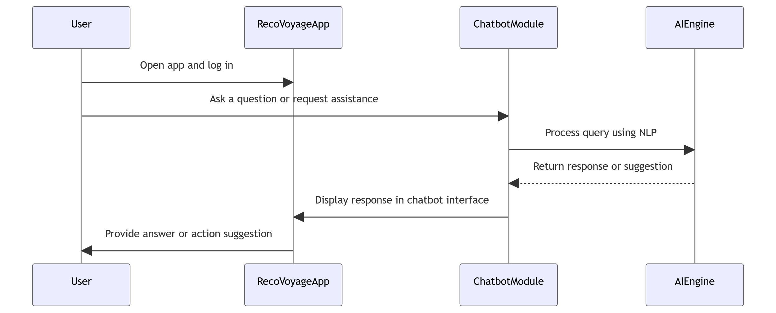
Fig 3.1. Sequence Diagram for AI Powered Chatbot

This image represents a sequence diagram for an AI-powered chatbot assistant in the RecoVoyageApp (a tourism guide mobile app). The diagram illustrates the interaction between four entities:
- User – Opens the app, logs in, and interacts with the chatbot.
- RecoVoyageApp – Acts as an interface between the user and the chatbot module.
- ChatbotModule – Processes user queries and forwards them to the AI engine.
- AIEngine – Uses NLP (Natural Language Processing) to analyze the query and generate a response.

Workflow Description:
- The User opens the app and logs in.
- The user asks a question or requests assistance through the app.
- The RecoVoyageApp forwards the query to the ChatbotModule.
- The ChatbotModule processes the query using the AIEngine (NLP-based system).
- The AIEngine generates a response and sends it back to the ChatbotModule.
- The ChatbotModule displays the response in the chatbot interface.
- Finally, RecoVoyageApp provides the user with an answer or action suggestion.

Flowchart for AI Powered Recommendation System

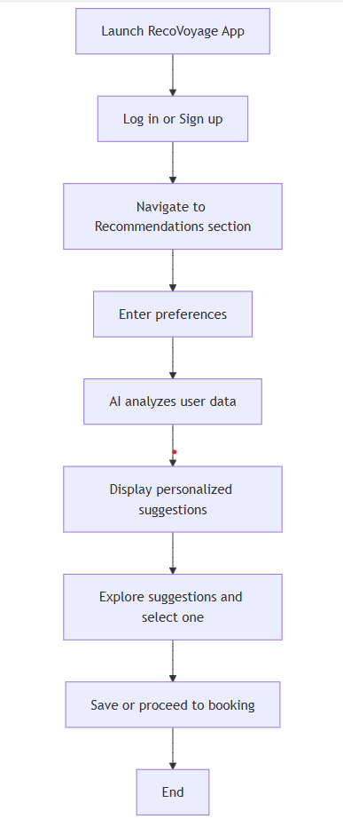
Fig 3.2. Flowchart for AI Powered Recommendation System

This image represents a flowchart for the AI-powered recommendation system in the RecoVoyage App (a tourism guide mobile app). The flowchart outlines the step-by-step process for users to receive personalized travel suggestions.
Workflow Description:
- Launch RecoVoyage App – The user opens the mobile application.
- Log in or sign up – The user either logs into an existing account or creates a new one.
- Navigate to the Recommendations section – The user goes to the section where AI-based suggestions are provided.
- Enter Preferences – The user inputs travel interests, budget, location preferences, and other relevant details.
- AI Analyzes User Data – The system processes the input data using AI algorithms.
- Display Personalized Suggestions – The app presents travel recommendations tailored to the user’s preferences.
- Explore Suggestions and Select One – The user reviews the recommendations and picks the most suitable option.
- Save or Proceed to Booking – The user can either save the selection for later or move forward with the booking process.
- End – The process is completed.

ERD for Tour Planning System

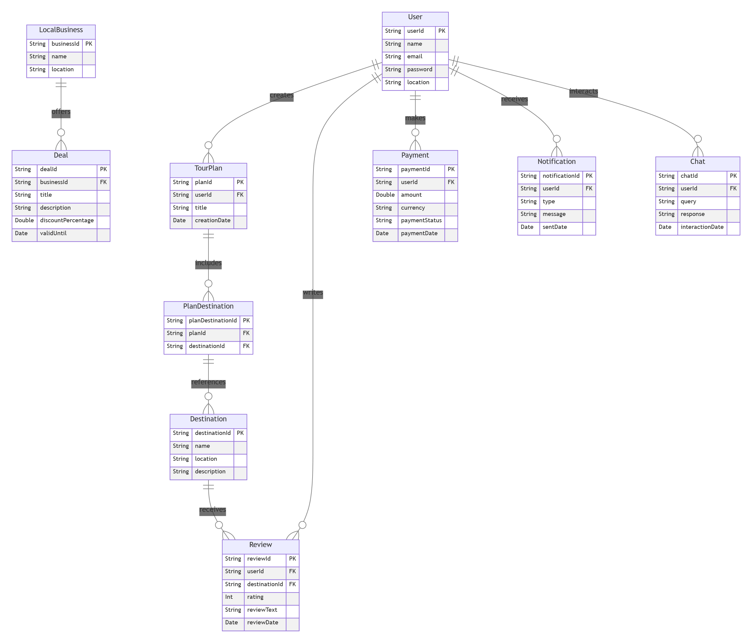
Fig 3.3. ERD for Tour Planning System

This image represents an Entity-Relationship Diagram (ERD) for a Tour Planning System, showcasing the relationships between different entities involved in managing tours, users, payments, and business deals.

Key Entities & Relationships:
- User:
  - Stores user details such as userId, name, email, password, and location.
  - A user can create a TourPlan, make a Payment, receive Notifications, and interact via Chat.
- Tour Plan:
  - Created by a user (userId as FK).
  - Includes destinations through PlanDestination.
- Destination:
  - Stores details like destinationId, name, location, and description.
  - Connected to PlanDestination and can receive reviews from users.
- Review:
  - Users can write reviews for destinations, including rating, reviewText, and reviewDate.
- Payment:
  - Users can make payments, including details such as amount, currency, paymentStatus, and paymentDate.
- Chat:
  - Users can interact through chat by sending queries and receiving responses.
- Notification:
  - Users can receive notifications of different types with messages and timestamps.
- Local Business & Deals:
  - Local businesses can offer deals (discounts, promotions) that include discountPercentage and validity.

ERD for Tour Plan

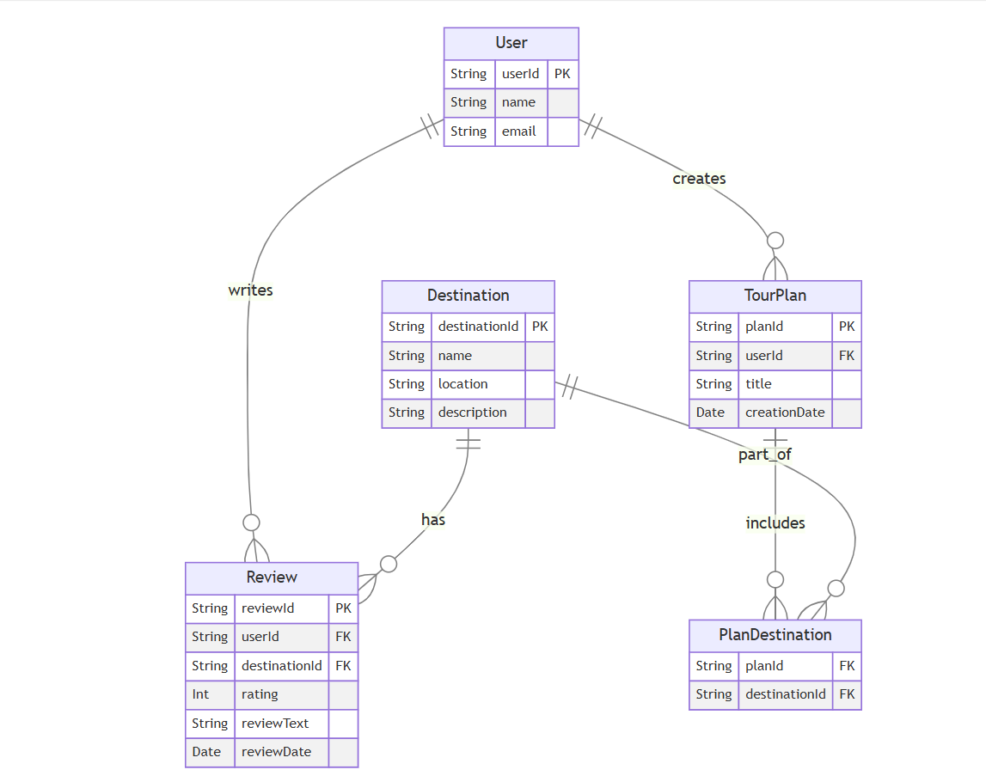
Fig 3.4. ERD for Tour Plan
This image represents an Entity-Relationship Diagram (ERD) for a Tour Planning System, focusing on users, tour plans, destinations, and reviews.

Key Entities & Relationships:
- User:
  - Stores userId, name, and email.
  - A user creates a TourPlan and writes reviews for destinations.
- Tour Plan:
  - Created by a user (userId as FK).
  - Contains details like planId, title, and creationDate.
  - Includes multiple destinations through PlanDestination.
- Destination:
  - Stores details like destinationId, name, location, and description.
  - Part of a TourPlan.
  - Receives reviews from users.
- PlanDestination:
  - Links TourPlan and Destination.
  - Contains planId and destinationId as foreign keys.
- Review:
  - Users write reviews for destinations.
  - Contains reviewId, userId, destinationId, rating, reviewText, and reviewDate.
This ERD structures how users interact with destinations through tour plans and reviews, ensuring efficient data organization in a tour planning system.

User Journey Flow for Offline Access

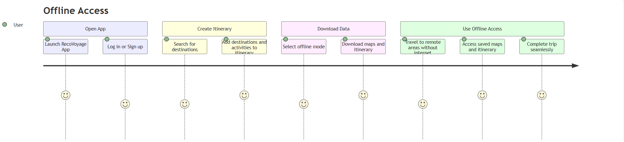
Fig 3.5. User Journey Flow for Offline Access

This image represents a User Journey Flow for Offline Access in a travel application called "RecoVoyage."

Stages in the User Journey:
- Open App (Purple)
  - Launch the RecoVoyage app.
  - Log in or sign up.
- Create Itinerary (Yellow)
  - Search for destinations.
  - Add destinations and activities to the itinerary.
- Download Data (Pink)
  - Select offline mode.
  - Download maps and itinerary.
- Use Offline Access (Green)
  - Travel to remote areas without internet.
  - Access saved maps and itinerary.
  - Complete the trip seamlessly.
Each step is accompanied by smiley faces, indicating a smooth and user-friendly experience. The flow emphasizes how users can plan and use their travel itinerary even in offline mode.

Sequence Diagram for Real Time Updates

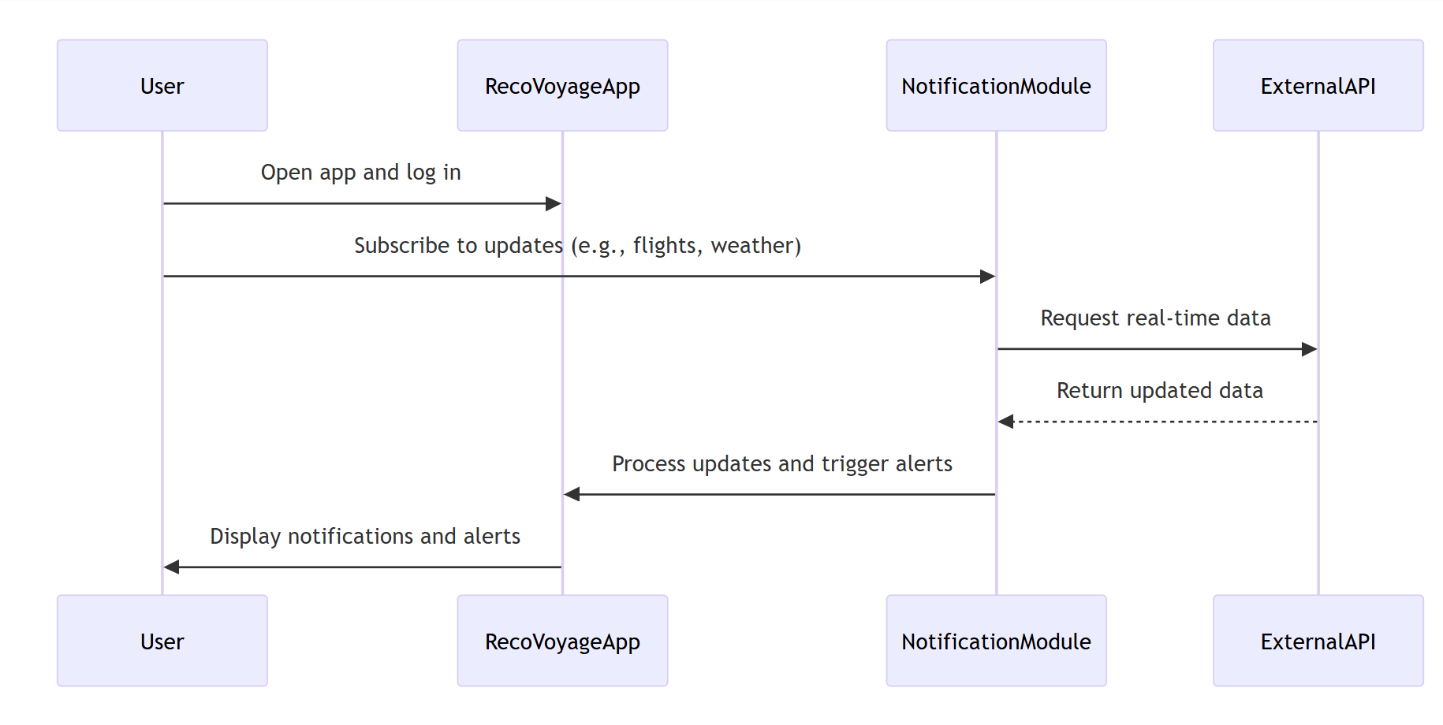
Fig 3.6. Sequence Diagram for Real Time Updates

This image represents a Sequence Diagram for real-time updates in the RecoVoyage travel application.
Flow of Events:
- User Interaction:
  - The user opens the RecoVoyageApp and logs in.
  - The user subscribes to updates (e.g., flight status, weather conditions).
- RecoVoyageApp & Notification Module:
  - The app sends a request to the NotificationModule to fetch updates.
  - The NotificationModule requests real-time data from an External API.
- External API Response:
  - The ExternalAPI returns updated data to the NotificationModule.
- Processing Updates:
  - The NotificationModule processes the updates and triggers alerts.
  - The RecoVoyageApp receives alerts and displays notifications to the user.

Sequence Diagram for Multi-Language Support

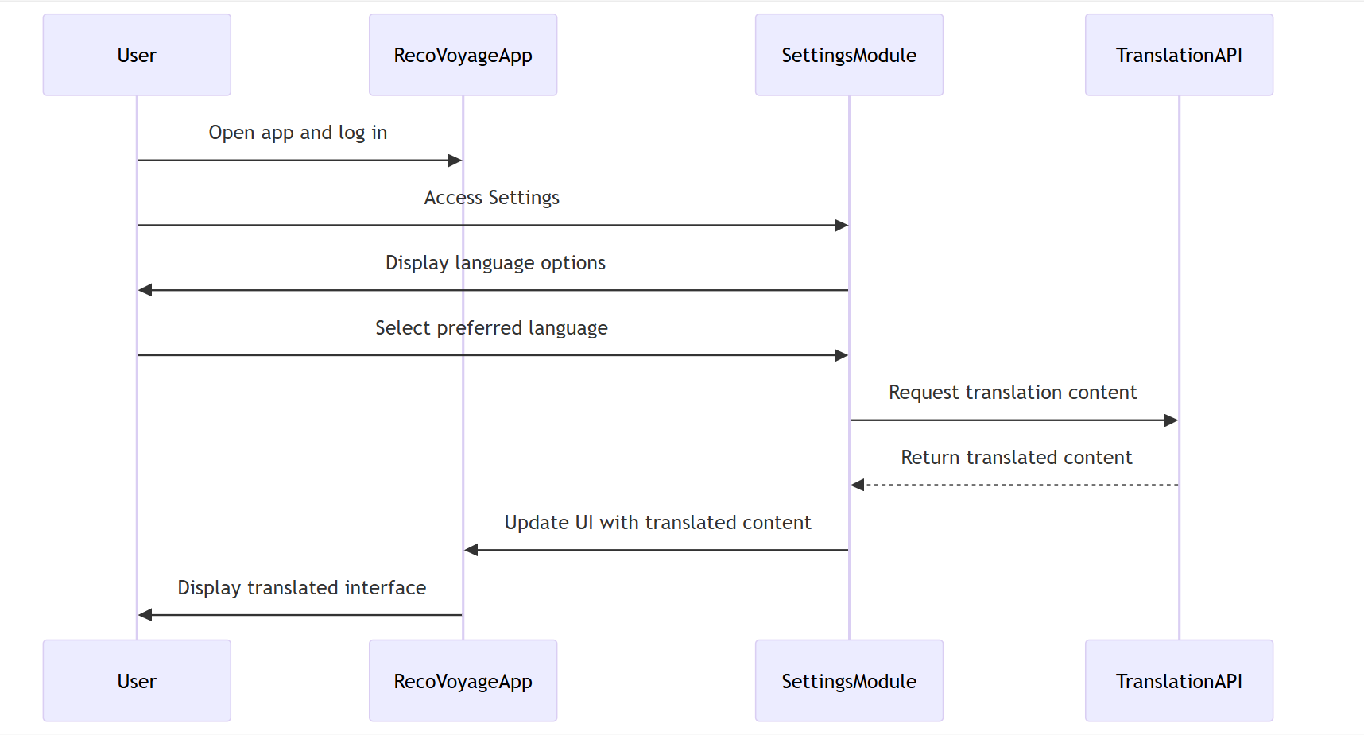
Fig 3.7. Sequence Diagram for Multi-Language Support

This image represents a Sequence Diagram for the multi-language support feature in the RecoVoyage travel application.
Flow of Events:
- User Interaction:
  - The user opens the RecoVoyageApp and logs in.
  - The user accesses the settings and views language options.
- Language Selection & Translation Request:
  - The user selects their preferred language.
  - RecoVoyageApp sends the request to the SettingsModule.
  - The SettingsModule communicates with the TranslationAPI to fetch translated content.
- Translation API Response:
  - The TranslationAPI returns the translated content.
  - The SettingsModule updates the UI with the new language.
- Displaying the Translated UI:
  - The RecoVoyageApp displays the translated interface to the user.
This diagram illustrates the process of changing the app language dynamically to enhance user accessibility.

RecoVoyage Sequence Diagram
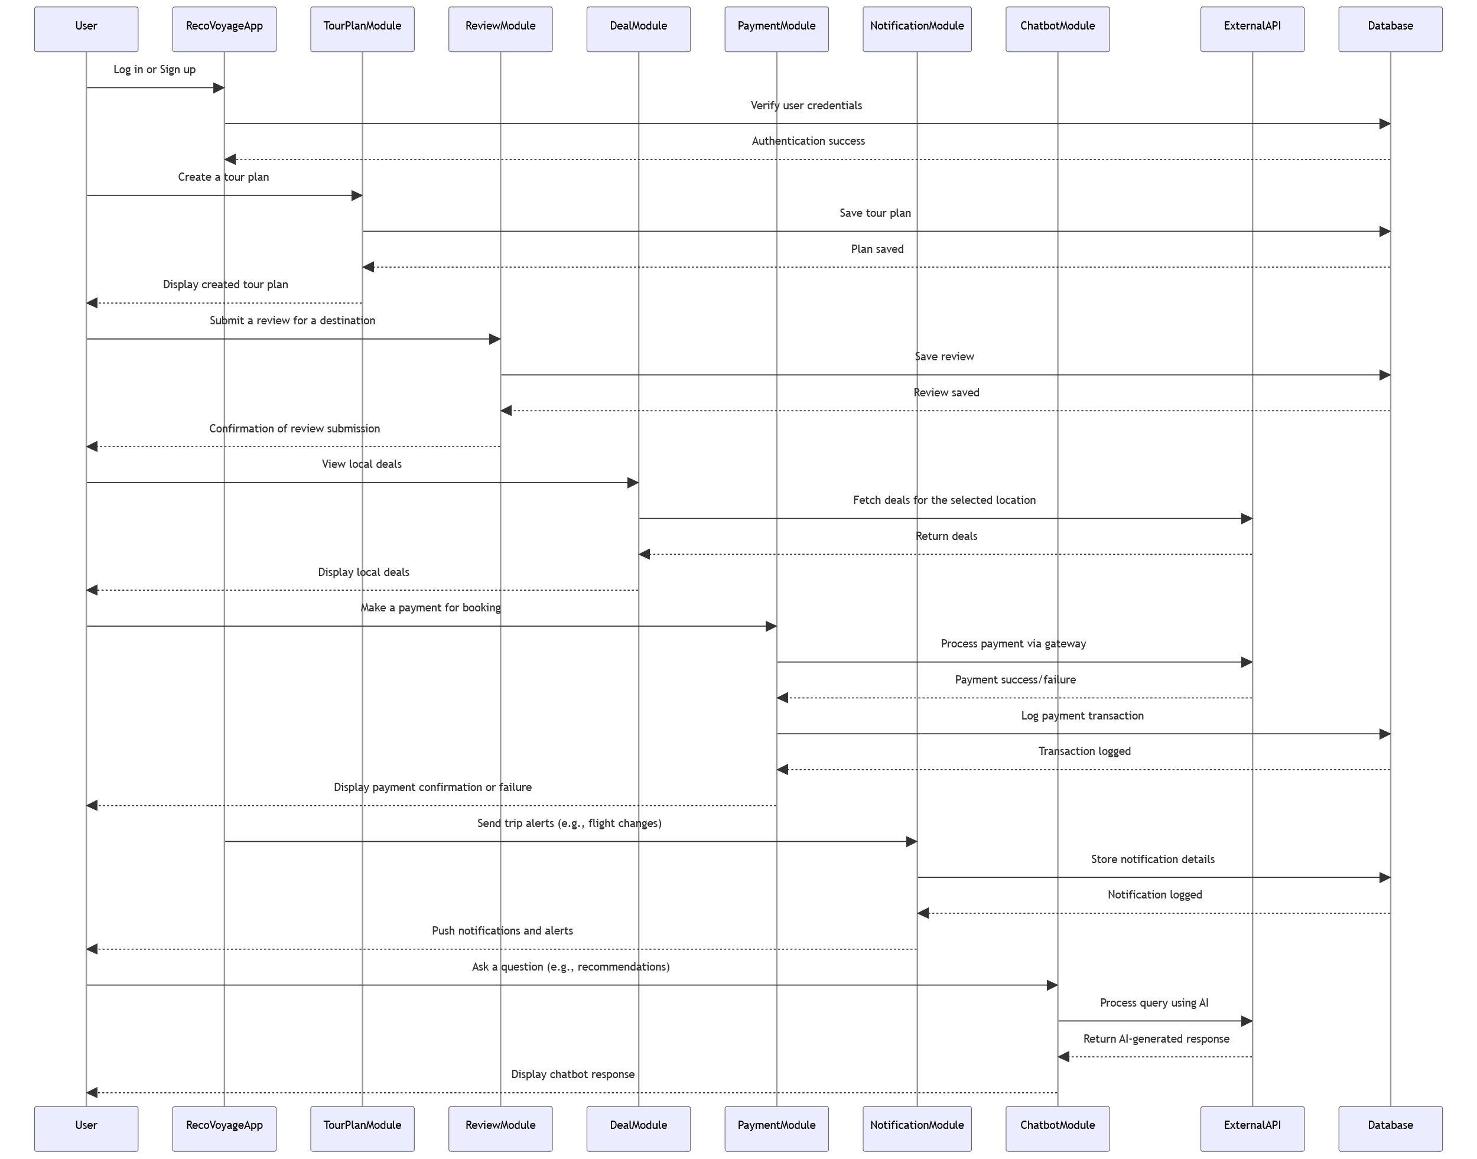
Fig 3.8. Generic Sequence Diagram

This image represents a Sequence Diagram for the RecoVoyageApp, illustrating various interactions between the user and multiple system modules.
Flow of Events:
- User Authentication:
  - The user logs in or signs up.
  - The RecoVoyageApp verifies credentials via the Database.
  - Success of authentication is confirmed.
- Tour Planning & Reviews:
  - The user creates a tour plan, which is saved in the TourPlanModule.
  - The user submits a review for a destination via the ReviewModule, and it gets stored in the database.
- Viewing & Booking Deals:
  - The user views local deals fetched by the DealModule via ExternalAPI.
  - Deals are displayed in the app.
- Payment Processing:
  - The user makes a payment for a booking.
  - The PaymentModule processes the payment via a gateway and logs the transaction into the Database.
  - Confirmation or failure of the transaction is displayed.
- Notifications & Alerts:
  - The NotificationModule sends trip alerts and push notifications (e.g., flight changes).
  - Notification details are logged in the database.
- AI Chatbot Interaction:
  - The user asks a question (e.g., recommendations).
  - The ChatbotModule processes the query using AI.
  - The system returns an AI-generated response to the user.
This sequence diagram outlines the complete user journey from logging in, planning a trip, viewing deals, making payments, receiving notifications, and interacting with an AI-powered chatbot.

User Flow Diagram for Social Sharing and Integration
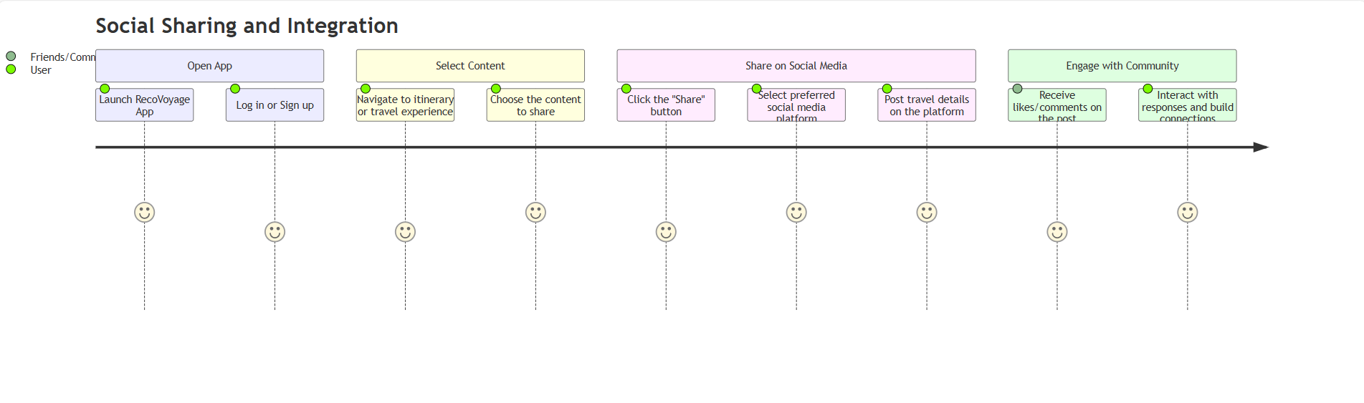
Fig 3.9. User Flow Diagram for Social Sharing and Integration

This image represents a User Flow Diagram for Social Sharing and Integration in the RecoVoyageApp. It outlines the process by which users share their travel experiences on social media and engage with the community.
Flow of Events:
- Open App:
  - The user launches the RecoVoyageApp.
  - They log in or sign up.
- Select Content:
  - The user navigates to their itinerary or travel experiences.
  - They choose the content they want to share.
- Share on Social Media:
  - The user clicks the "Share" button.
  - They select their preferred social media platform.
  - They post their travel details on the platform.
- Engage with Community:
  - The user receives likes/comments on their post.
  - They interact with responses and build connections.
This diagram visually represents the social media integration feature, showing how users can share travel content and interact with their community.

Sequence Diagram for User Generated Tours

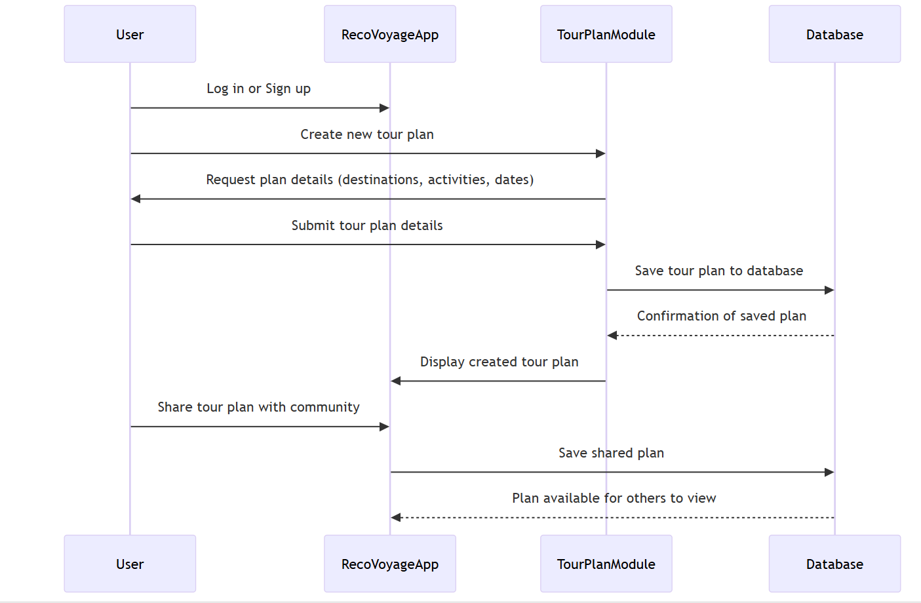
Fig 3.10. Sequence Diagram for User Generated Tours

This image represents a Sequence Diagram for User-Generated Tours in the RecoVoyageApp. It outlines how users create, save, and share their tour plans within the system.
Flow of Events:
- User Logs In:
  - The user logs in or signs up on the RecoVoyageApp.
- Tour Plan Creation:
  - The user creates a new tour plan.
  - The app requests plan details (destinations, activities, dates).
  - The user submits the tour plan details.
- Saving the Tour Plan:
  - The TourPlanModule sends the details to the Database.
  - The database saves the plan and sends confirmation.
- Displaying the Plan:
  - The app displays the created tour plan to the user.
- Sharing with the Community:
  - The user shares the tour plan with the community.
  - The TourPlanModule saves the shared plan in the database.
  - The plan becomes available for others to view.
This diagram illustrates the user journey from planning a trip to sharing it with others, integrating the database and module interactions.

DATA AND EXPERIMENTS

Implementation

The implementation of RecoVoyage used Flutter for the front end and Firebase/Firestore for backend services. Key modules like trip planning, AI recommendations, and chatbot support were developed using a modular approach. Dummy APIs simulated bookings, while Mistral API powered the chatbot, ensuring smooth and responsive functionality.

Planning and Designing

The development of RecoVoyage followed a structured scrum agile methodology, allowing iterative development with frequent reviews. Planning involved requirement gathering, creating design architecture (UI/UX), and breaking down the system into modules:
- User Authentication
- Trip Planning
- AI-driven Recommendations
- Booking & Reviews
Designing included UI wireframes created by the UI/UX designer using tools suitable for Flutter development and user-centric layouts. The app was planned to be hybrid with responsive frontend screens and scalable backend.

Testing

The testing phase included various levels such as unit testing, integration testing, and overall system testing. Security assessments were carried out using standard tools to detect and address potential vulnerabilities. Functional testing was performed to verify that all major features and modules operated as intended.

Documentation

Comprehensive documentation was maintained throughout the development of RecoVoyage. It includes system architecture, API integration details, and user flow diagrams. This ensures clarity for future maintenance, scalability, and team collaboration. Proper technical and user documentation was maintained throughout development. This included:
- API documentation
- Data flow diagrams (DFD)
- Module-wise code structure documentation
- Deployment steps and troubleshooting notes

Deployment and Maintenance

The application is deployed on web hosting services requiring domain and hosting setup. Regular maintenance will include:
- Monitoring for downtime or API failures
- Updating destination data and user-generated content
- Security patches
- Scaling services as the user base grows

Technical Aspect of Application

The technical foundation of RecoVoyage includes Flutter for cross-platform front-end development and Firebase with Firestore for real-time backend operations. Mistral API is integrated for AI chatbot interactions, while dummy APIs with model classes simulate booking processes. The app is designed to be lightweight, scalable, and secure, ensuring smooth performance across devices.

Hardware

- Laptop/PC: For development and testing
- Internet: For real-time features, API calls, and deployment
- Mobile Devices: For testing the hybrid functionality on different screen sizes

Frontend

The front-end of RecoVoyage is developed using Flutter, enabling a smooth and responsive user interface across Android and iOS platforms. It features intuitive navigation, clean layouts, and dynamic content rendering based on user interactions. Flutter’s widget-based structure allowed rapid UI development, ensuring consistency and performance throughout the app.

- Flutter Framework: Used for cross-platform app development with a single codebase.
- Dart Language: Primary language used in Flutter for UI and business logic.
- UI/UX Tools: Custom screen designs created to ensure intuitive navigation.
- Local Caching: For offline access to trip plans and destination data.

Backend

- Firebase:

In the RecoVoyage application, Firebase was used as the primary backend to handle user authentication, real-time database operations, and push notifications. It enabled secure login, synchronized trip plans and preferences instantly across devices, and delivered timely alerts like weather updates and booking reminders. Its seamless integration with other services made it ideal for supporting the app’s dynamic and scalable travel features.

- AI Models:

The application leverages various AI models to enhance user experience. The recommendation engine employs user-based collaborative filtering, content-based filtering, and hybrid techniques to provide personalized suggestions. Additionally, a chatbot is integrated using Mistral API, which enables advanced natural language understanding and delivers seamless, intelligent user interactions within the app.

- Database:

RecoVoyage relies entirely on Firebase and Cloud Firestore for its data management needs. Cloud Firestore serves as the primary database, enabling real-time synchronization of user data, trip plans, and service details across all devices. It also supports offline access, allowing users to retrieve previously loaded content even without an internet connection, ensuring a seamless experience throughout their journey.

- Security:

To ensure data protection and user privacy, RecoVoyage implemented robust security layers tested using OWASP standards, addressing common vulnerabilities such as injections, broken authentication, and insecure storage. Additionally, all API communications were secured through end-to-end encryption, ensuring that sensitive data like personal details and payment information remained protected throughout transmission.

- Payment Integration:

RecoVoyage integrates Stripe as its primary payment gateway, enabling secure and seamless transactions for booking flights, accommodations, and other travel services. Stripe’s reliable infrastructure ensures smooth processing and protects user payment data through built-in security measures.

RESULTS AND DISCUSSIONS

Front-End (Flutter)

RecoVoyage successfully integrates key features like AI recommendations, real-time alerts, and chatbot support using Mistral API. The app offers smooth performance and a user-friendly interface. Results show that the modular design supports scalability and future improvements. The front-end of RecoVoyage was developed using Flutter, enabling cross-platform mobile application development with a focus on performance, clean UI, and interactive features. Below is the core screens implemented in the application:

Onboarding Screen

These screens introduce the user to the app’s key features with engaging visuals and smooth navigation. They set the tone for user experience and help new users understand the benefits of using RecoVoyage before entering the main interface. Clear guidance and step-by-step slides help build familiarity and encourage users to move forward with registration or login.



Figure 5.1
Figure 5.2

Home Dashboard Screen

The dashboard serves as the app's central hub, displaying personalized travel suggestions, recent plans, weather alerts, and quick links to other features like trip planning, reviews, and deals. It dynamically updates based on user behaviour and app data. This screen is designed to minimize user effort by surfacing relevant content immediately and improving navigation flow.

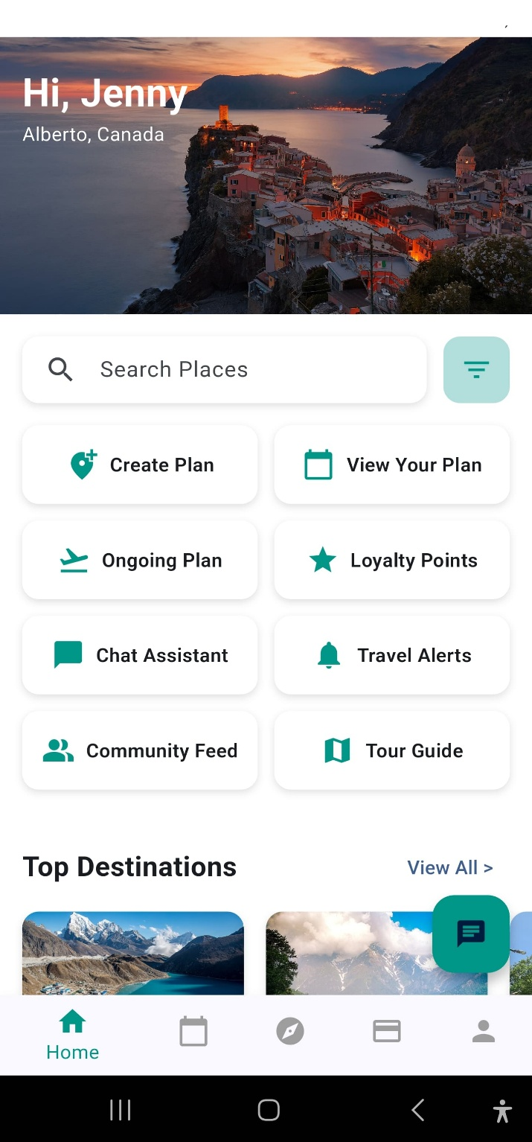
Figure 5.3

Destination Explorer Screen

This screen allows users to browse destinations with filter and search capabilities. Each destination includes images, descriptions, and user feedback to help travelers make informed decisions when planning their trips. It also integrates bookmarking and preview features to support quick access to favorite locations.

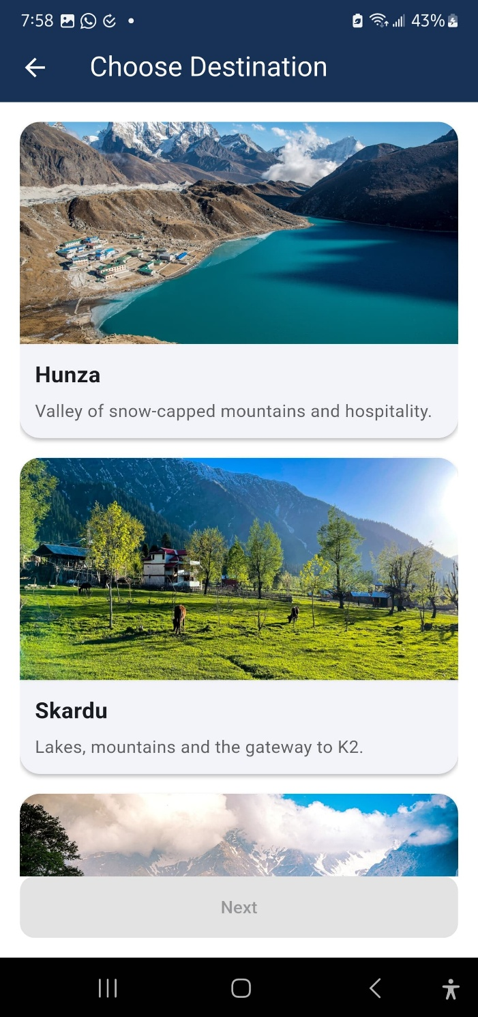
Figure 5.4

Sign Up Screen

The sign-up screen enables new users to register securely using Firebase Authentication. It is designed with simplicity and validation to ensure a smooth registration process and seamless entry into the app’s features. Social sign-in options may also be integrated in the future to improve convenience and reduce barriers to access.


Figure 5.5

Loyalty Points Screen

This screen tracks points users earn through app engagement such as trip completions, reviews, or referrals. It displays total points, earning history, and potential rewards, encouraging continued use and interaction. A visual progress indicator and reward milestones motivate users to remain active on the platform.

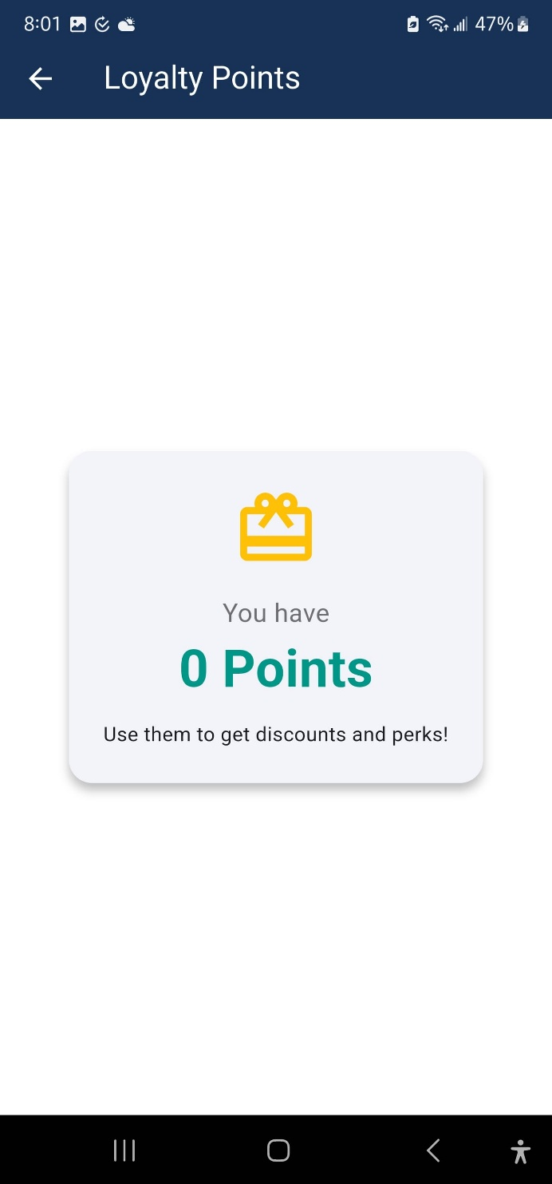
Figure 5.6

AI Chatbot Assistant

Powered by Mistral API, this chatbot offers real-time assistance for travel-related queries. It supports conversational interaction to help users with trip suggestions, navigation guidance, and general app support. The assistant also serves as an alternative to manual navigation, improving accessibility and user satisfaction.

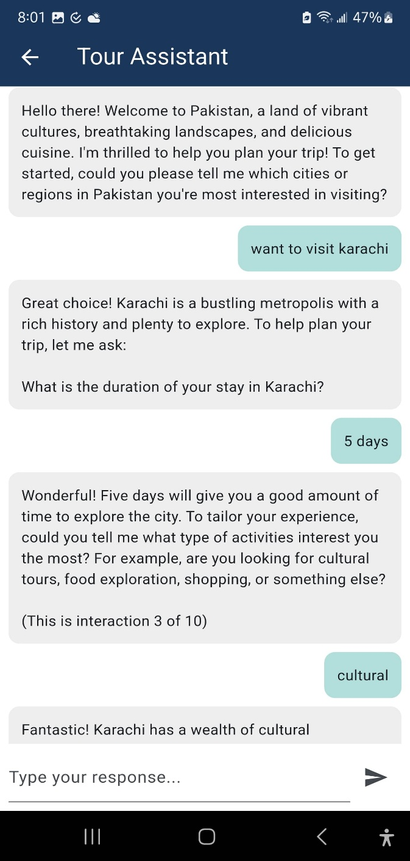
Figure 5.7

Review and Pay Screen

Users can review their complete trip plan, confirm their details, and proceed to simulated payment. This screen integrates dummy payment APIs to mimic real-world checkout flows, enhancing the realism of the booking process. It includes cost breakdowns, changing options, and a summary view for transparency and user confidence.

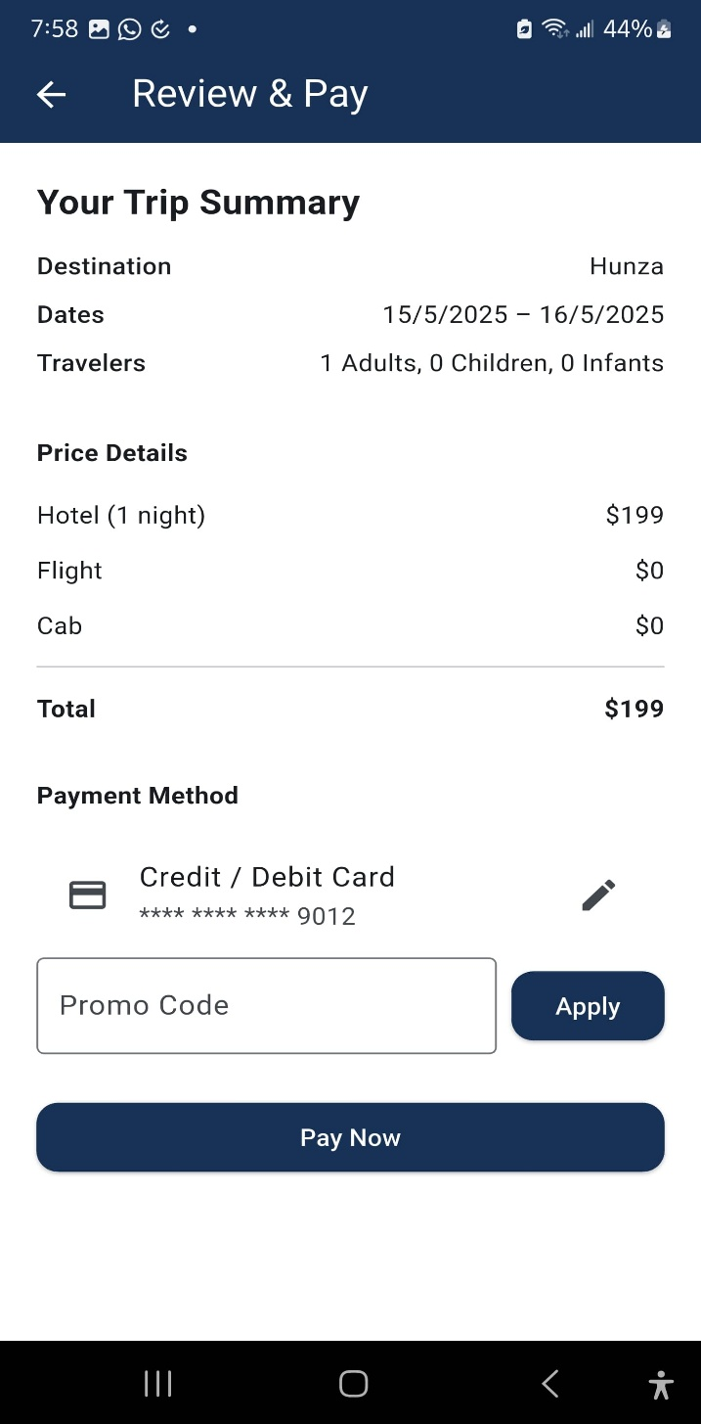
Figure 5.8

Recommendation Screen

This AI-powered screen displays personalized travel recommendations generated through user behaviour, reviews, and preferences. It enhances the planning experience by offering destination ideas that align with the user's interests. These recommendations are displayed in a scrollable format with actionable buttons, encouraging quick selection or deeper exploration.

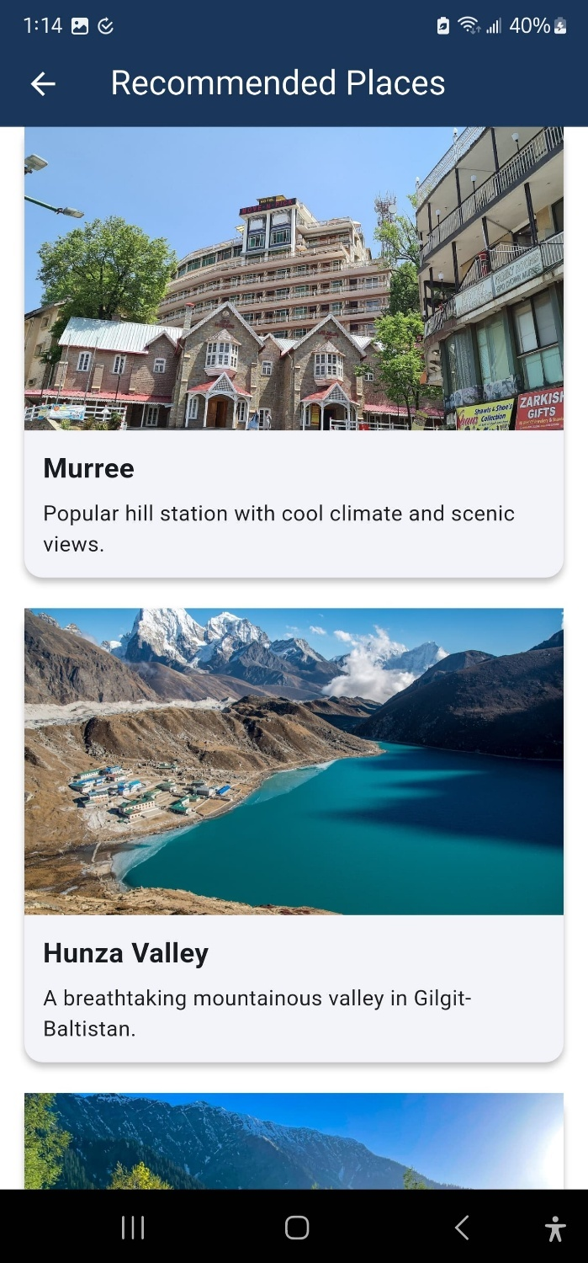
Figure 5.5

Profile screen

The Profile Screen allows users to manage their personal information, preferences, and past activity. It serves as a central hub for user identity and settings, helping personalize the travel experience.

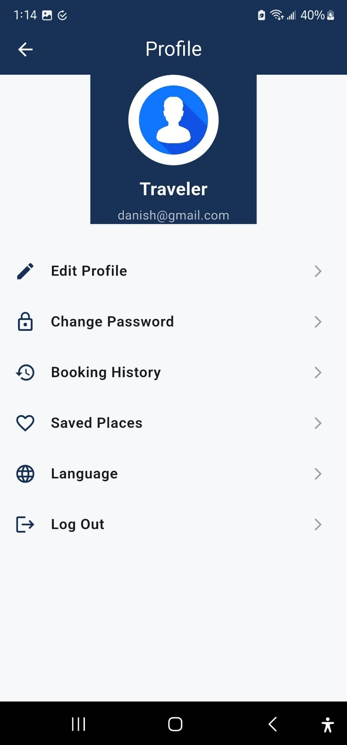
Figure 5.10

Landing Screen

The Landing Screen welcomes users with a clean display of the RecoVoyage logo, serving as the first point of interaction. It reflects the brand identity and initiates the app's experience with a minimal yet elegant design.


Figure 5.11

Tour guide screen

The Tour Guide Screen offers AI-powered travel recommendations, including popular spots, cultural highlights, and personalized suggestions based on user preferences. It acts as a smart companion throughout the travel planning process.

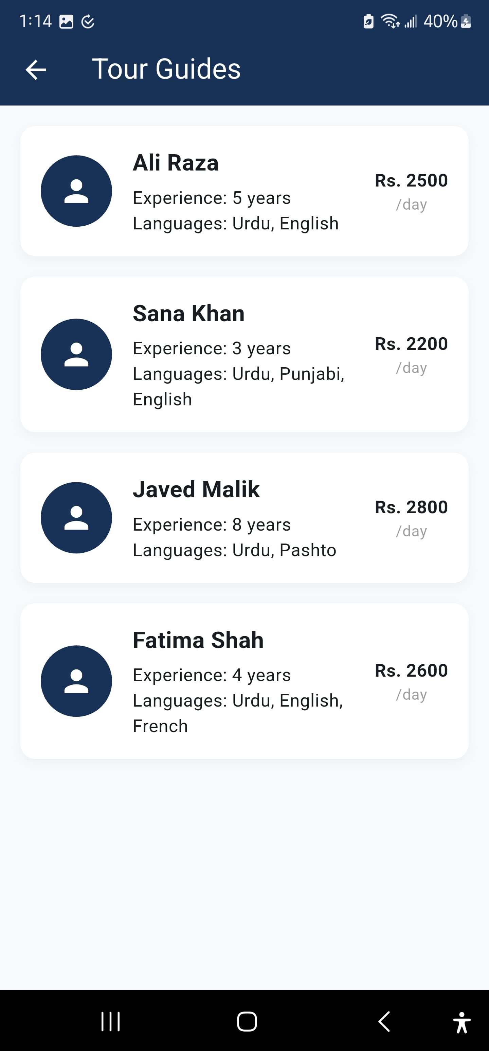
Figure 5.12

Community feed screen

The Community Feed Screen fosters social interaction among users, allowing them to share photos, reviews, and travel experiences. It builds a sense of travel community within the app and encourages user-generated content.

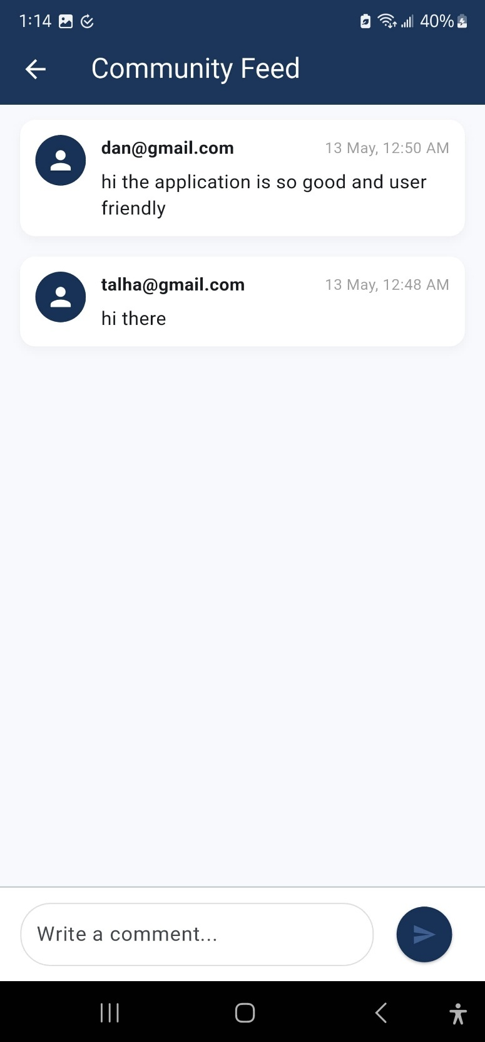
Figure 5.13

Current trips screen

The Current Trips Screen provides a snapshot of ongoing or upcoming trips. Users can view itinerary details, travel dates, and essential information in real-time, making it easy to manage active travel plans.

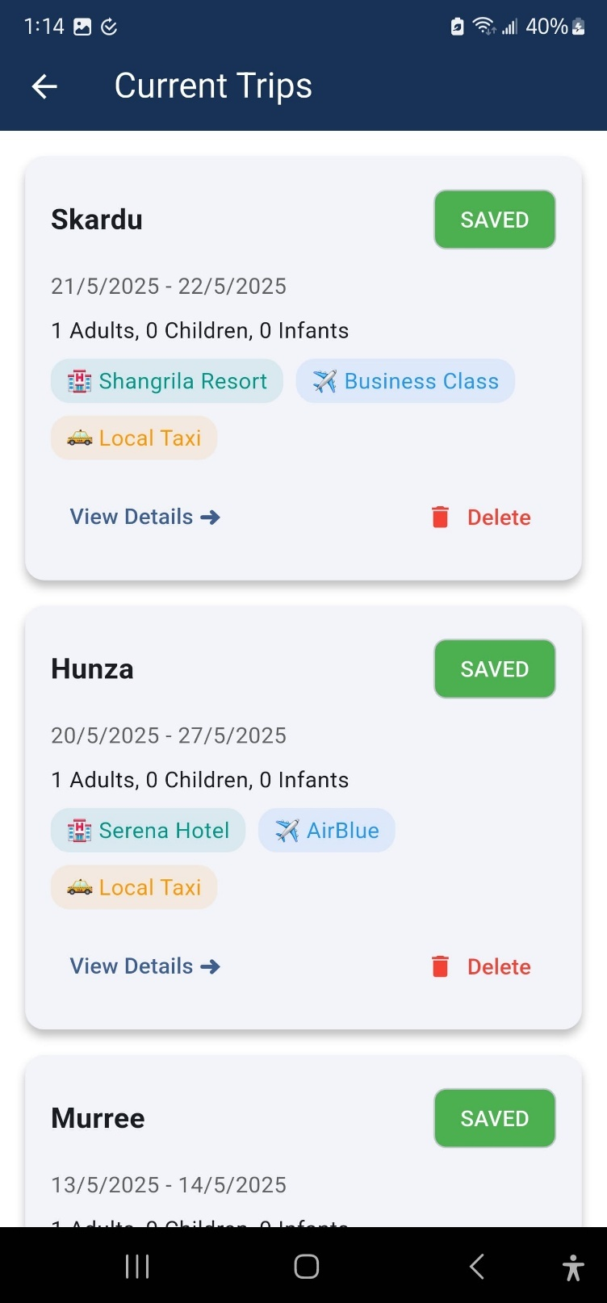
Figure 15.14

Saved trips screen

This screen stores all saved trip plans that users can revisit or modify later. It supports flexible planning by allowing users to create drafts of trips without finalizing them immediately.

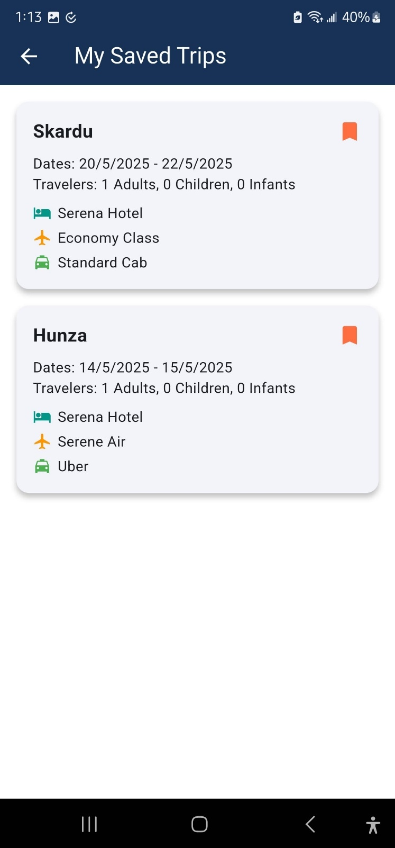
Figure 5.15

Booking confirmed screen

Once a booking simulation is completed, this screen confirms it with a success message and displays trip highlights. It offers a sense of completion and readiness to begin the planned journey.


Figure 5.16

Booking summary screen

The Booking Summary Screen displays a detailed breakdown of the simulated bookings, including destinations, accommodations, travel modes, and total cost. It allows users to review and verify trip details before confirming.

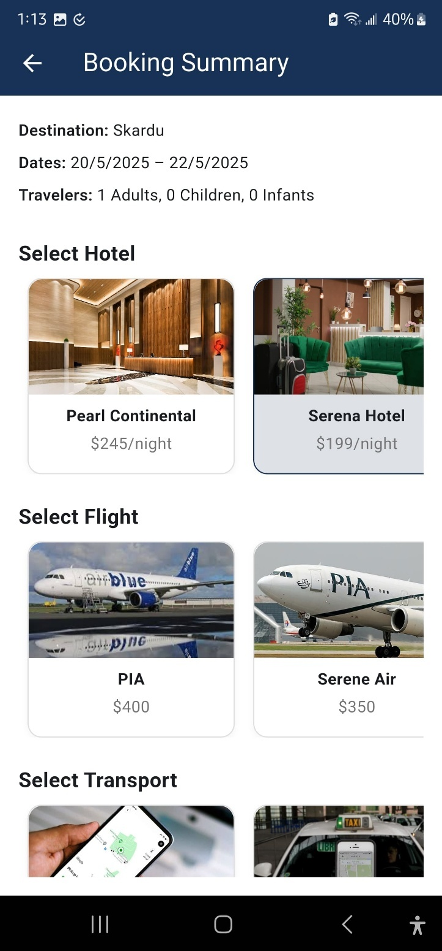
Figure 5.17

Travel details screen 1

These screens offer in-depth information about the selected destinations, including weather, nearby attractions, travel tips, and visuals. They help users make informed decisions while building their itinerary.

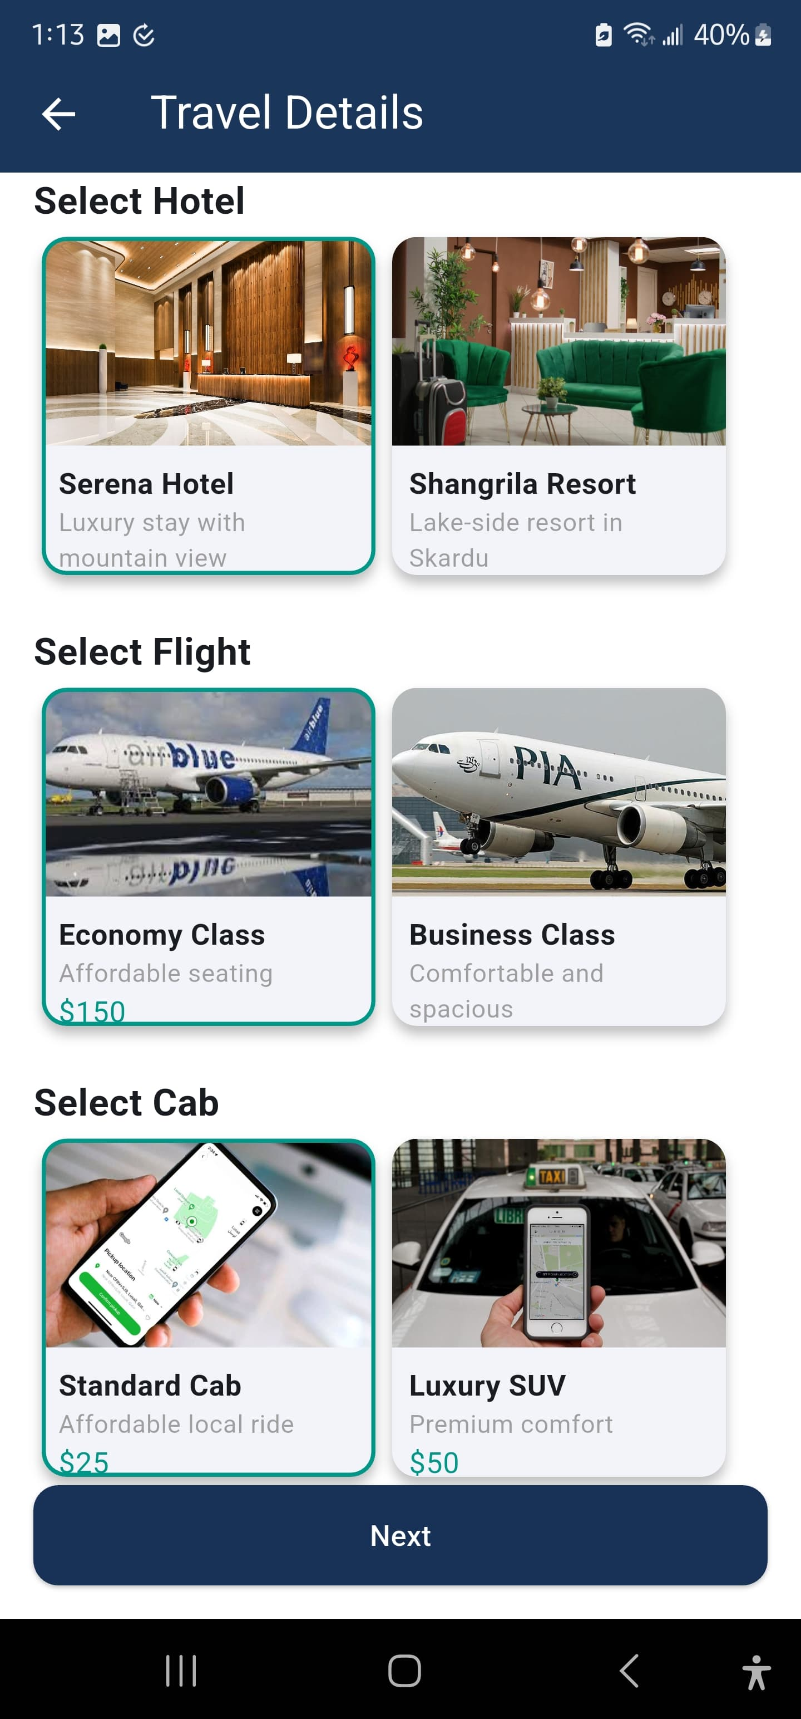
Figure 5.18

Travel details screen 2

An extension of the travel planning module, this screen focuses on itinerary customization such as choosing activities, adding notes, or adjusting preferences within a selected trip.

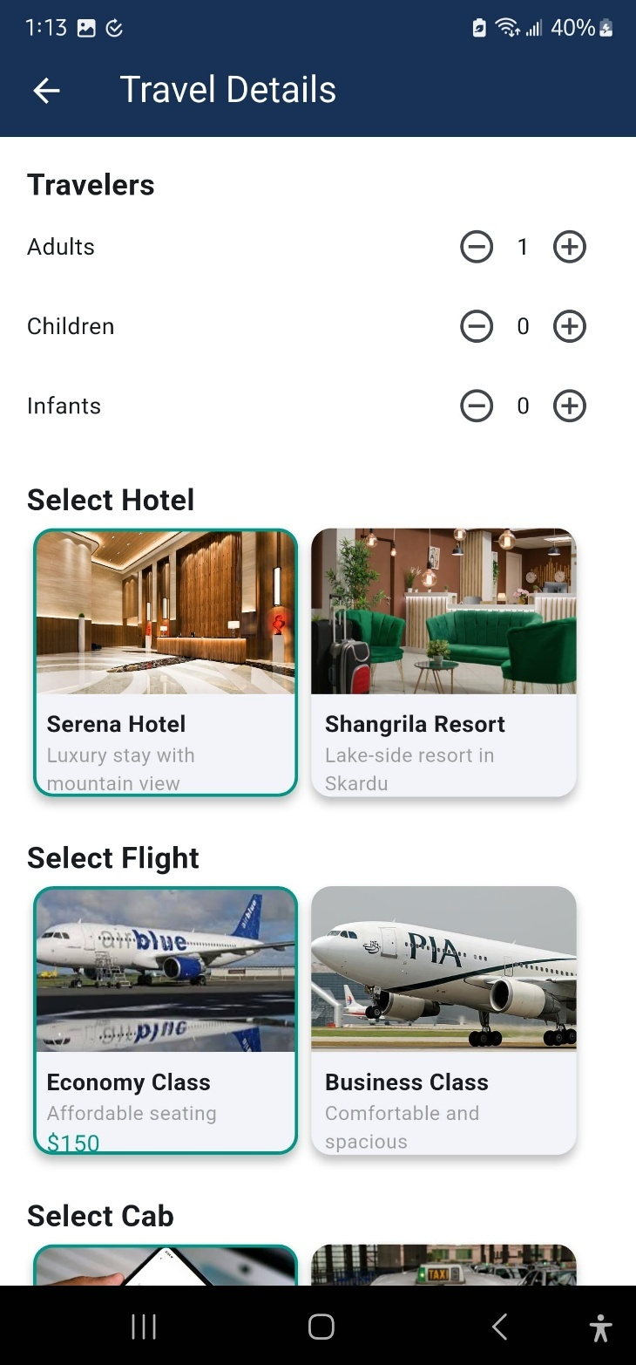
Figure 5.19

Select Travel Dates screen

This screen lets users specify the start and end dates of their trip using an integrated calendar interface. It plays a crucial role in planning as it directly influences destination recommendations, availability of bookings, and the overall structure of the travel itinerary.


Figure 5.20

Back-End Development

The back end of RecoVoyage is developed using Firebase and Cloud Firestore, offering real-time database capabilities, secure user authentication, and efficient data synchronization across devices. These services ensure that user-generated content such as trip plans, reviews, and preferences are stored and updated instantly.

To simulate real-world booking processes, dummy APIs integrated with model classes handle hotel, flight, and cab reservations within the app. Additionally, the Mistral API is incorporated to power the AI chatbot, enabling intelligent and context-aware user interactions. The back-end architecture is designed to be lightweight, scalable, and secure, supporting seamless communication between the app’s frontend and backend modules while maintaining data integrity and performance.

CONCLUSION AND RECOMMENDATIONS

CONCLUSION

The development of RecoVoyage has demonstrated the potential of integrating AI, real-time data, and user-centric features into a unified tourism platform. By addressing key issues such as fragmented information, lack of personalization, limited offline access, and insecure transactions, RecoVoyage offers a seamless and intelligent travel planning experience. Using Flutter for cross-platform compatibility, Firebase for real-time database handling, and AI-driven modules for recommendations and chatbot assistance, the app provides a robust, scalable, and engaging solution for travelers.

The system architecture, including modular design, well-defined workflows, and extensive third-party API integration, ensures scalability and future extensibility. Security testing and the adoption of agile methodology further supported a high-quality and flexible development process. Overall, RecoVoyage effectively responds to the technological and experiential gaps in current tourism applications.

RECOMMENDATIONS

To improve RecoVoyage, it is recommended to conduct user testing with real travelers to refine features like recommendations and language support. For better performance with growing users, adopt scalable backend services such as Google Cloud Functions. Partnering with local businesses can add dynamic deals and revenue opportunities. The AI system should be enhanced with user profiling and sentiment analysis.

Additionally, improving accessibility, adding cross-border payment options, performing regular security audits, and expanding offline features will ensure a more robust and user-friendly experience.

REFERENCES

[1] P. J. Antony, R. Kannan, and A. Professor, Revolutionizing the Tourism Industry through Artificial Intelligence, Int. J. for Multidimensional Research Perspectives, vol. 2, no. 2, pp. 01–14, Feb. 2024.

[2] P. Shah et al., Safarnaama: User Experience-Based Travel Recommendation System, in Lecture Notes in Networks and Systems, vol. 997, pp. 253–271, 2024.

[3] S. Mhatre et al., AutoML Based Tourism Prediction and Maximising Revenue, in Proc. 2nd Int. Conf. on Sustainable Computing and Smart Systems (ICSCSS), 2024, pp. 1193–1202.

[4] D. Novaliendry et al., Design and Development of Sign Language Learning Application for Special Needs Students Based on Android Using Flutter, Int. J. of Online and Biomedical Engineering, vol. 19, no. 16, pp. 145–158, 2023.

[5] M. Bashir et al., Digitalizing Tourism and Interactive Navigation: A Case Study of Pakistan, J. of Tourism Studies, vol. 8, no. 1, pp. 45–56, 2024.

[6] J. Dorcic, J. Komsic, and S. Markovic, Mobile Technologies and Applications Towards Smart Tourism – State of the Art, J. of Smart Tourism, vol. 5, no. 2, pp. 1–22, 2022.

[7] Google Developers, Google Places API, [Online]. Available: https://developers.google.com/maps/documentation/places. [Accessed: Apr. 25, 2025].

[8] Stripe, Stripe API Documentation, [Online]. Available: https://stripe.com/docs/api. [Accessed: Apr. 25, 2025].
[9] OpenAI, GPT-3.5 API Documentation, [Online]. Available: https://platform.openai.com/docs. [Accessed: Apr. 20, 2025].

[10] Firebase, Firebase Documentation – Build apps fast, without managing infrastructure, [Online]. Available: https://firebase.google.com/docs. [Accessed: Apr. 18, 2025].

[11] D. Silva, M. Costa, and R. Almeida, Enhancing Tourist Experience through Mobile Applications with Booking Capabilities, Int. J. of Hospitality and Tourism Technology, vol. 10, no. 3, pp. 215–232, 2019.

[12] A. Kumar, S. Verma, and P. Singh, Design and Implementation of a Mobile Application for Integrated Tourism Services, in Proc. Int. Conf. on Smart Tourism, pp. 321–329, 2023.

[13] Skyscanner Developers, Travel APIs, [Online]. Available: https://developers.skyscanner.net. [Accessed: Apr. 28, 2025].

[14] OWASP Foundation, OWASP ZAP: Zed Attack Proxy, [Online]. Available: https://owasp.org/www-project-zap/. [Accessed: Apr. 15, 2025].

[15] PortSwigger, Burp Suite – Web Vulnerability Scanner, [Online]. Available: https://portswigger.net/burp. [Accessed: Apr. 15, 2025].

[16] J. Zhang et al., A Unified Approach to Designing Sequence-Based Personalized Recommendation Systems, IEEE Trans. on Neural Networks and Learning Systems, vol. 34, no. 5, pp. 1256–1270, May 2023.

[17] N. Cheng, L. H. N. Fong, and R. Law, Mobile Payment Technology in Hospitality and Tourism: A Critical Review, Int. J. of Hospitality Management, vol. 97, p. 102991, 2021.

[18] I. Hameed, U. Akram, and A. Ashraf, Consumers' Usage of Mobile Payment Systems in the Tourism Sector, J. of Retailing and Consumer Services, vol. 70, p. 103090, 2023.

[19] J. L. Sarkar et al., Tourism Recommendation System: A Survey and Future Research Directions, IEEE Access, vol. 10, pp. 56532–56548, 2022.

[20] S. Asani et al., A Recommendation System for Food Tourism Using Sentiment Analysis, in Proc. Int. Conf. on Artificial Intelligence and Smart Systems (ICAIS), pp. 84–89, 2022.

[21] N. L. Ho, R. K.-W. Lee, and K. H. Lim, SBTRec: A Transformer Framework for Personalized Tour Recommendation, Information Processing & Management, vol. 61, no. 2, 2024.

[22] A. F. Santos, J. M. C. Silva, and P. P. Silva, User Modelling in Smart Tourism Mobile Applications, in Proc. Int. Conf. on Mobile and Ubiquitous Systems, pp. 102–109, 2022.

[23] A. Munaji, R. A. Nugroho, and A. R. P. Utomo, Mobile Application for Personalized Culinary Tourism, J. of Theoretical and Applied Information Technology, vol. 100, no. 2, pp. 450–457, 2022.

[24] H. Imtiaz, Mobile Travel Apps Engagement: Measuring Tourists’ Perception, Tourism Management Perspectives, vol. 43, p. 100992, 2022.

[25] Wikipedia Contributors, Unified Payments Interface (UPI) and Its Impact on Tourism Transactions, Wikipedia, [Online]. Available: https://en.wikipedia.org/wiki/Unified_Payments_Interface. [Accessed: Apr. 30, 2025].

[26] F. Dimanche and L. Andrades, Tourism Trends: Current Challenges for Tourism Destinations Management, Tourism Management, vol. 97, p. 104000, 2024.
[27] M. Zhang, L. Wang, and Y. Li, Smart Tourism: Integrating Transportation and Accommodation Services, IEEE Internet of Things Journal, vol. 9, no. 1, pp. 490–498, 2022.

[28] E. Ndhlovu, K. Dube, and C. M. Kifworo, Tourism and Hospitality Trends and Sustainable Development, Sustainability, vol. 16, no. 4, p. 2030, 2024.

[29] QTravel.ai, 8 Examples of Generative AI Applications in the Tourism Industry, QTravel.ai, [Online]. Available: https://qtravel.ai. [Accessed: Apr. 25, 2025].

[30] Skift Research, How Mobile Payments Are Evolving from a Pandemic Fix to a Travel Game-Changer, Skift.com, 2024. [Online]. Available: https://skift.com. [Accessed: Apr. 24, 2025].

APPENDICES

APPENDIX A: Code snippet of AI Assistant

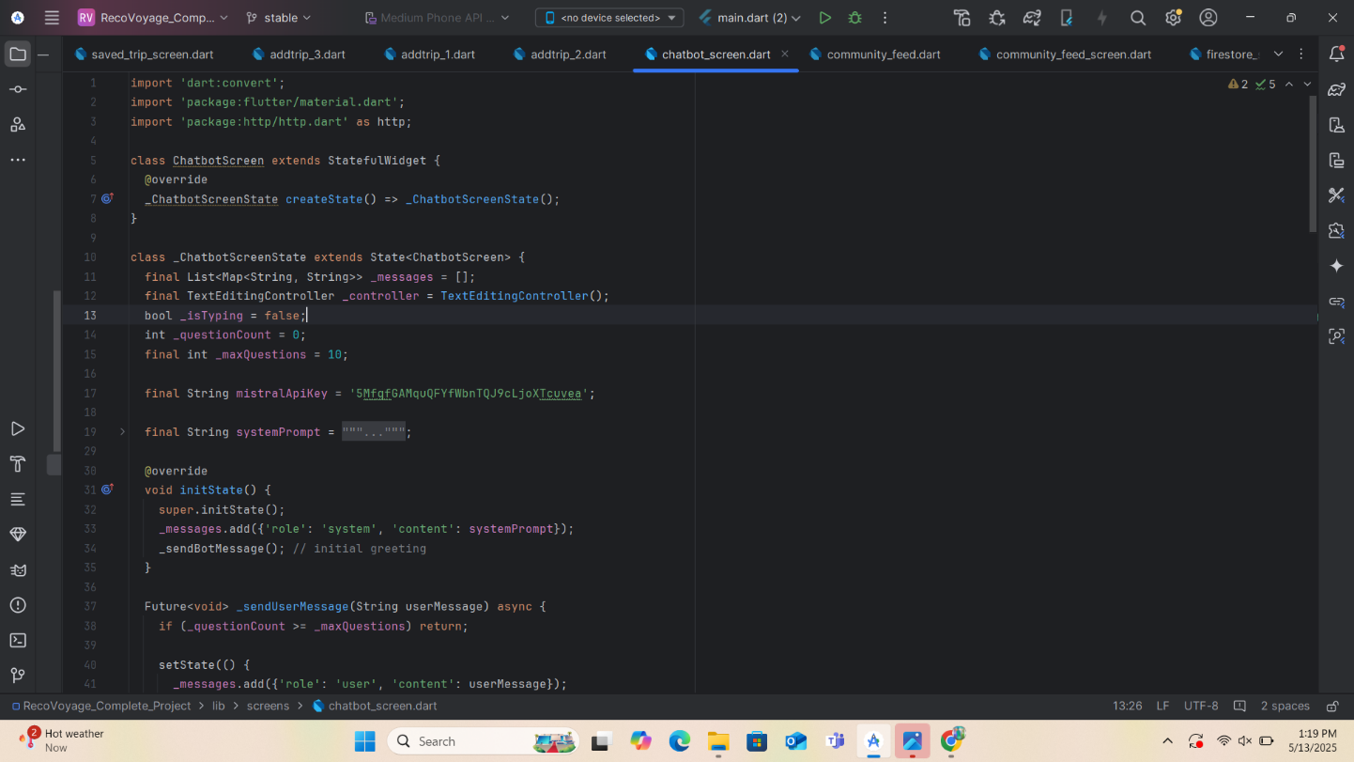

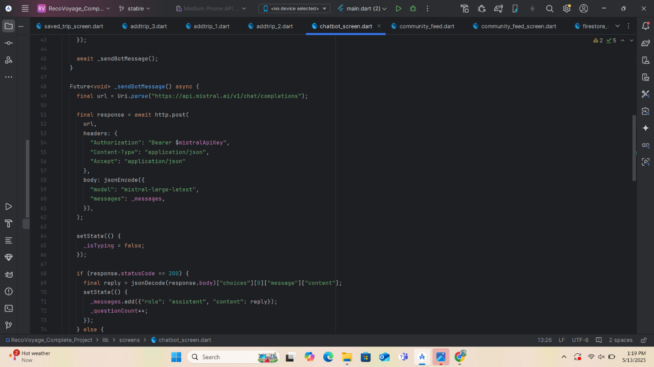

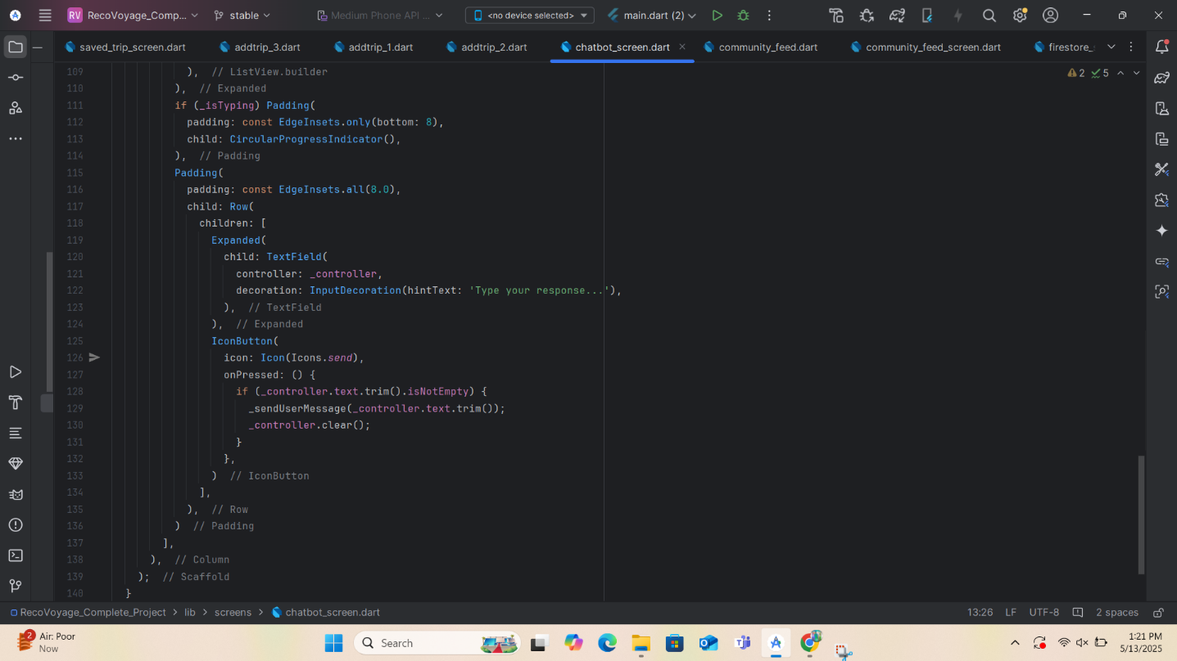

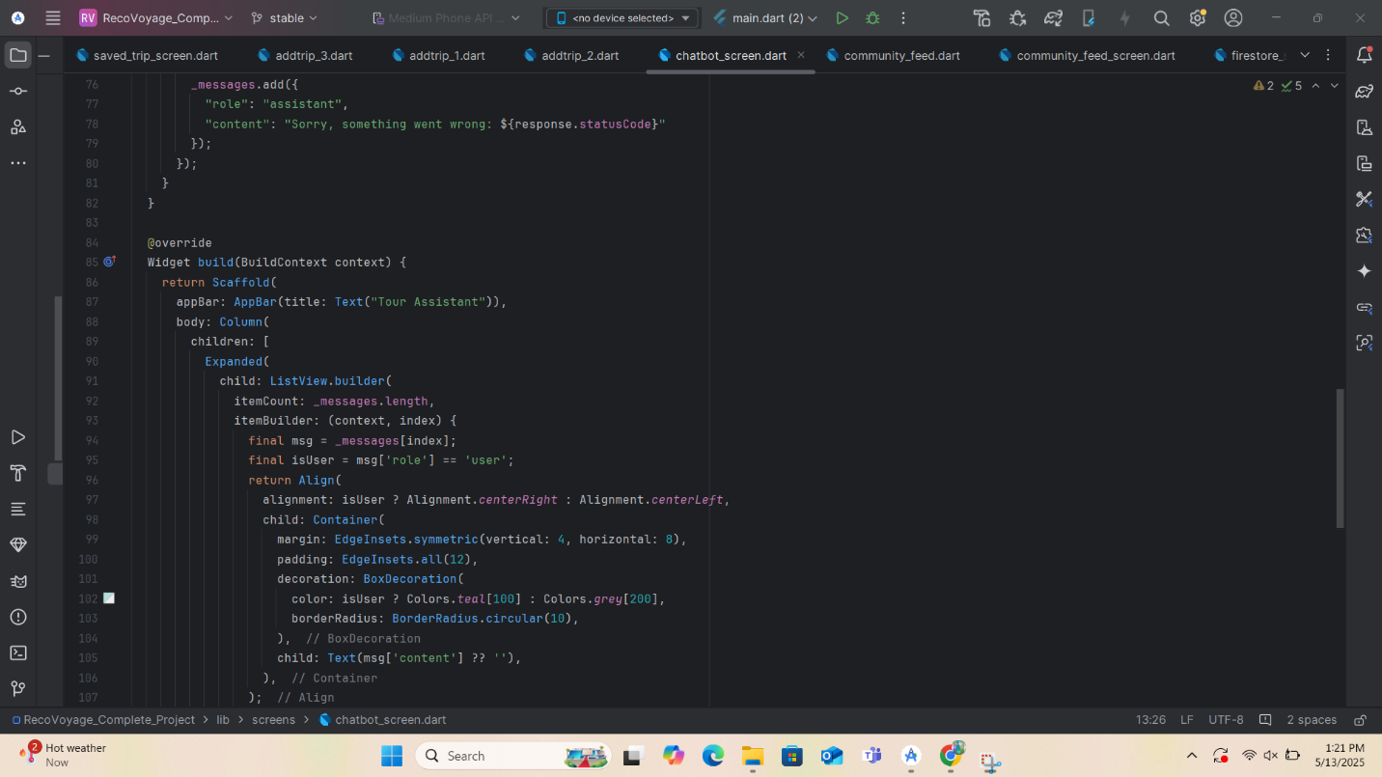

APPENDIX B: Code snippet of Community Feed

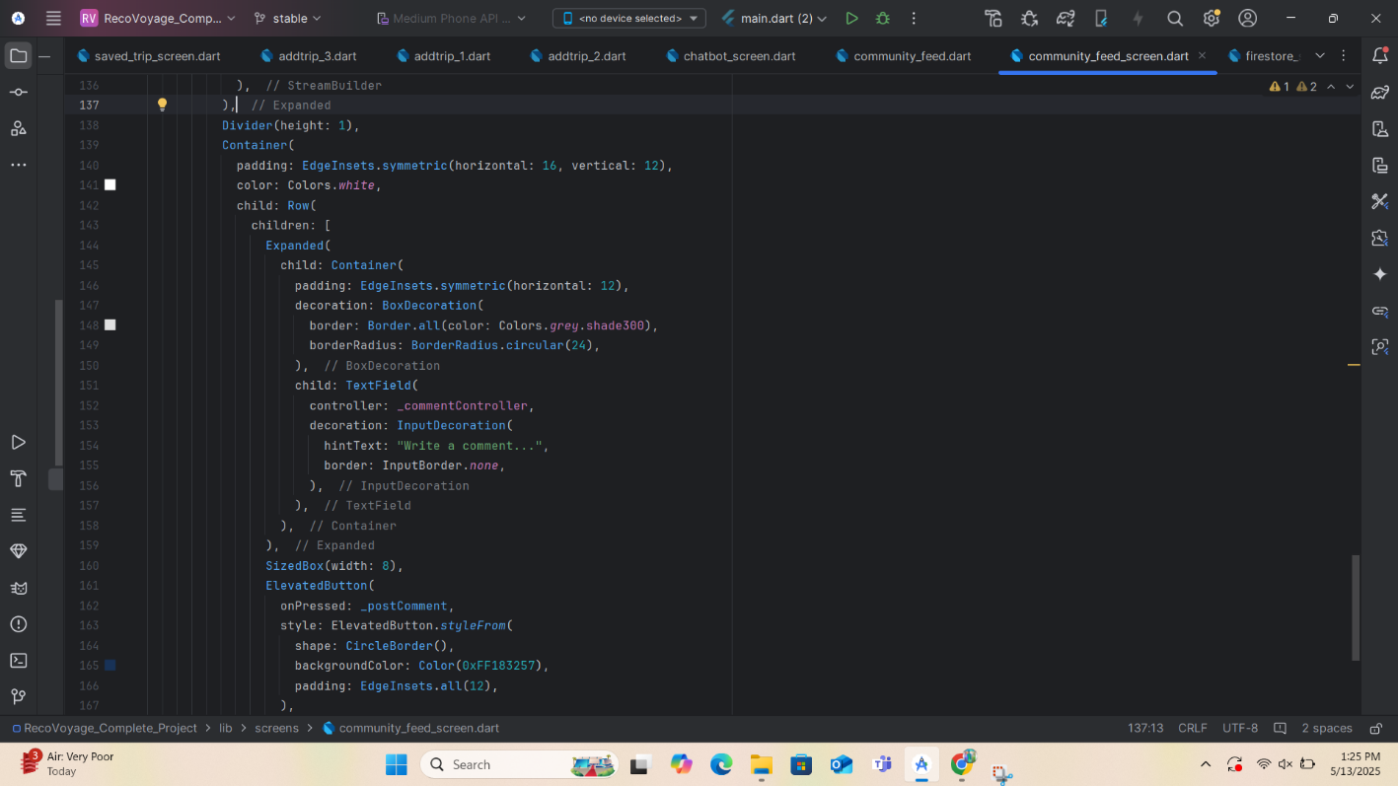

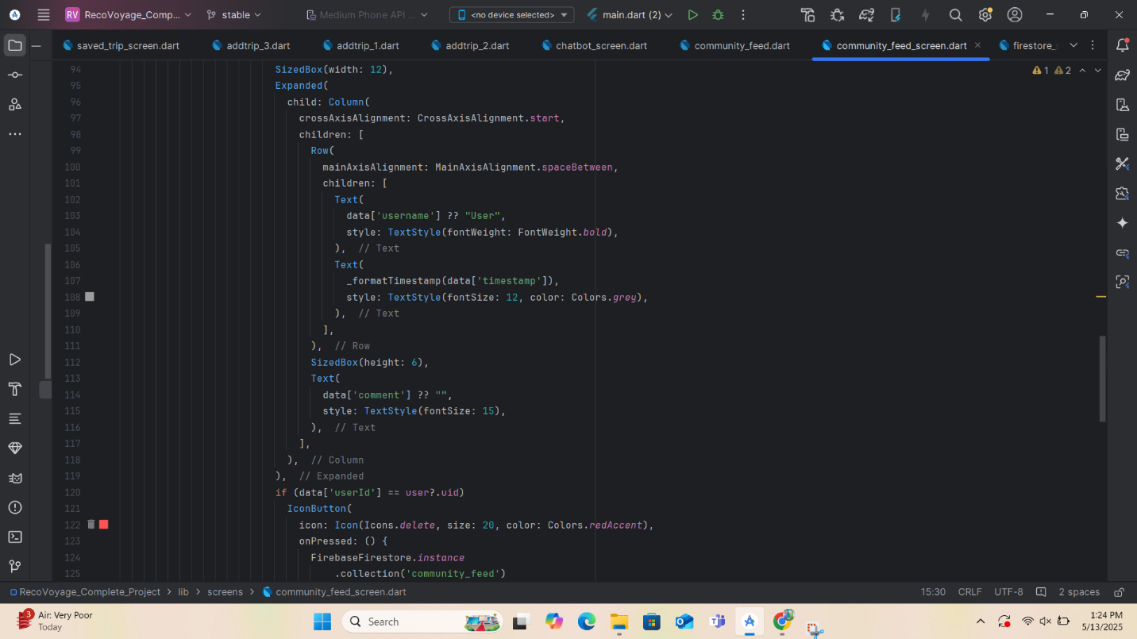
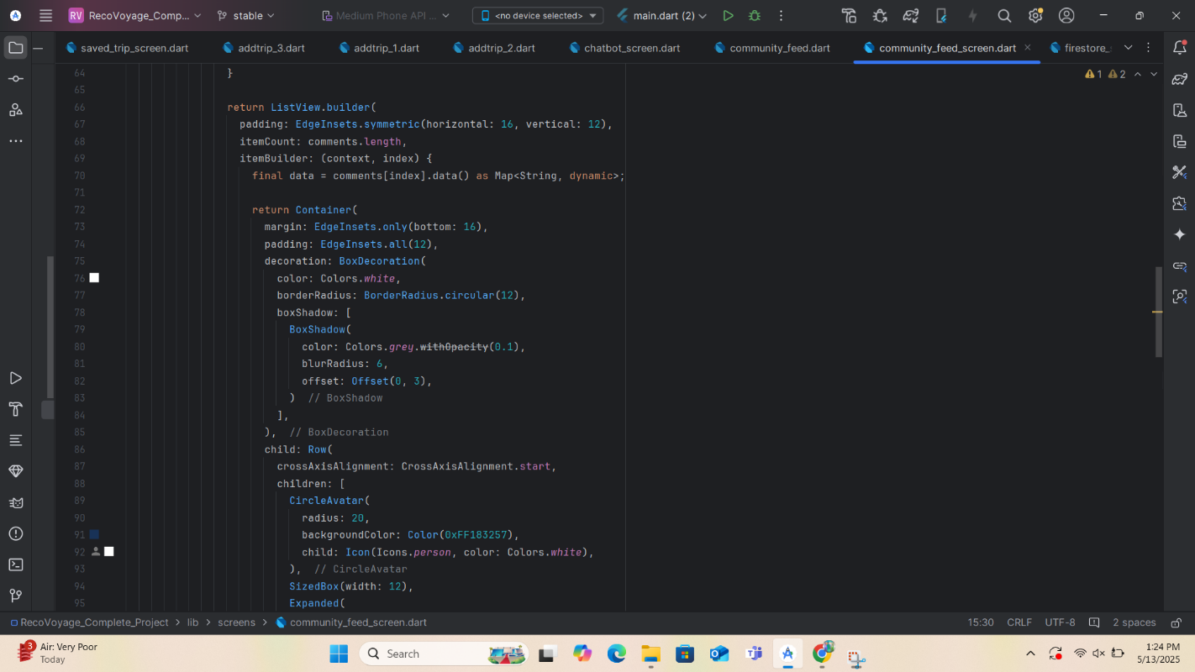

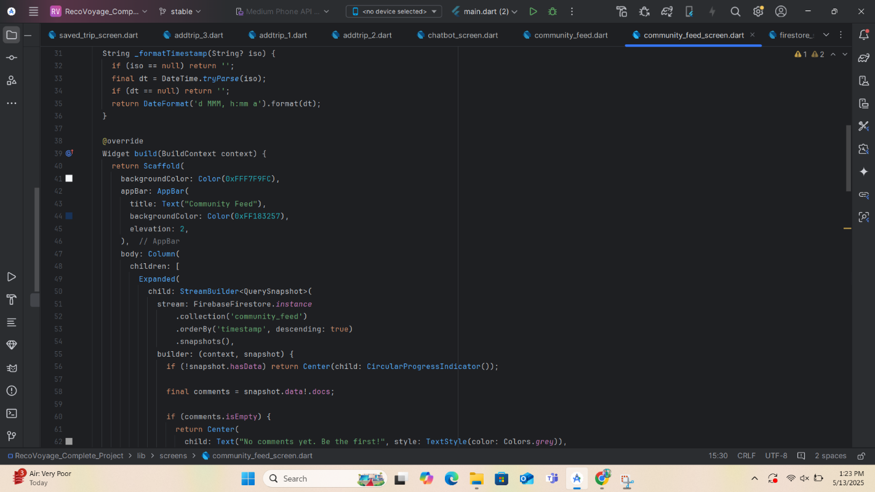

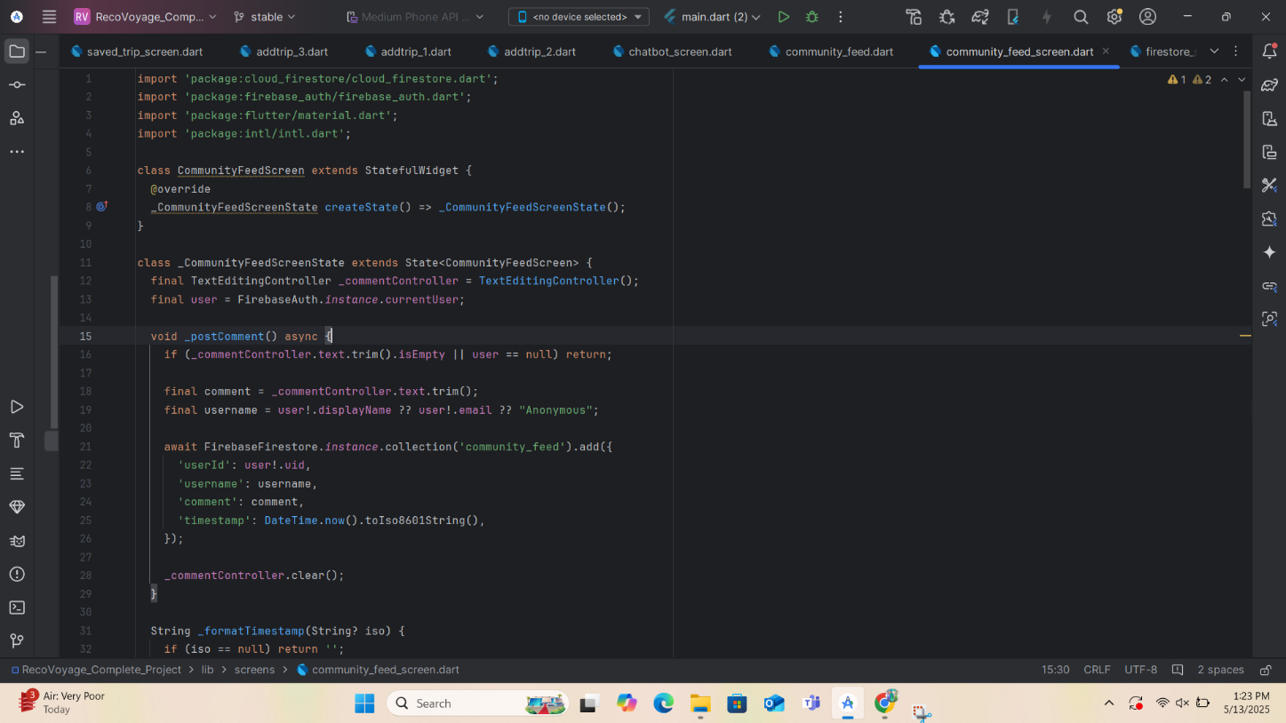

APPENDIX C: Code snippet of firestore

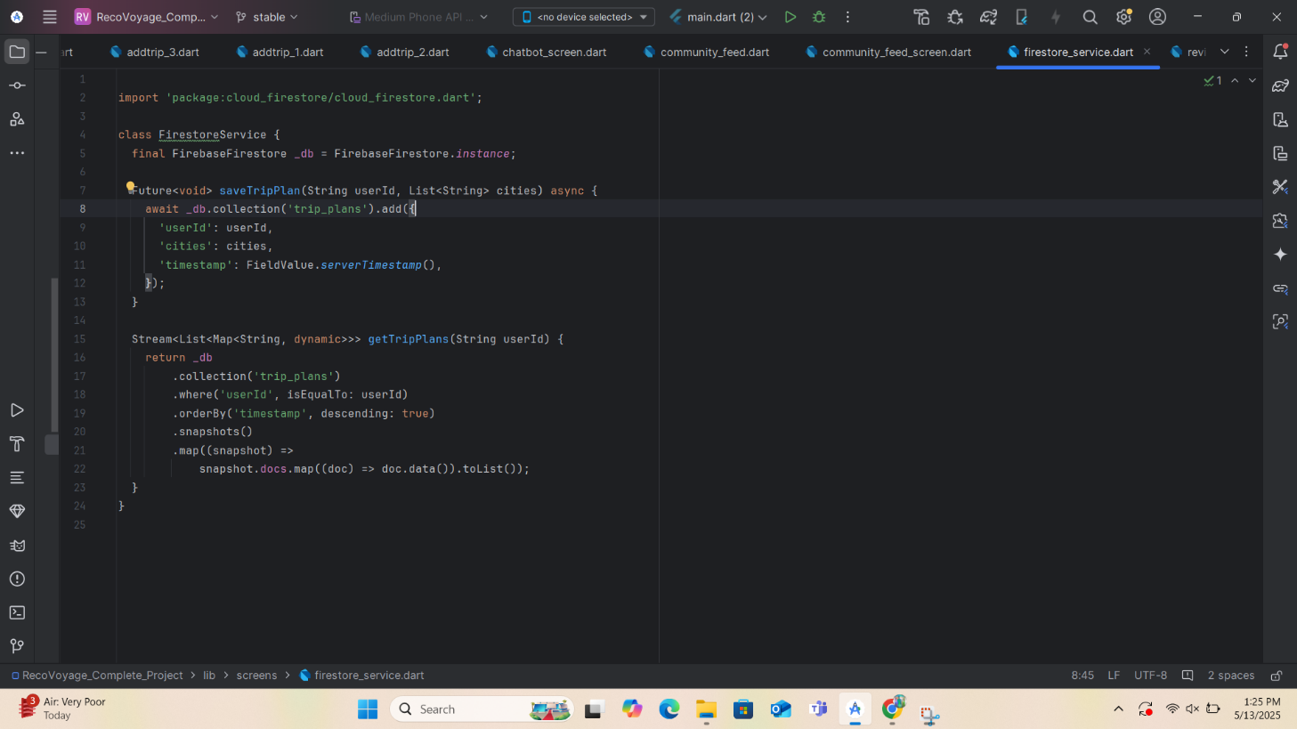

APPENDIX D: Code snippet of review and pay

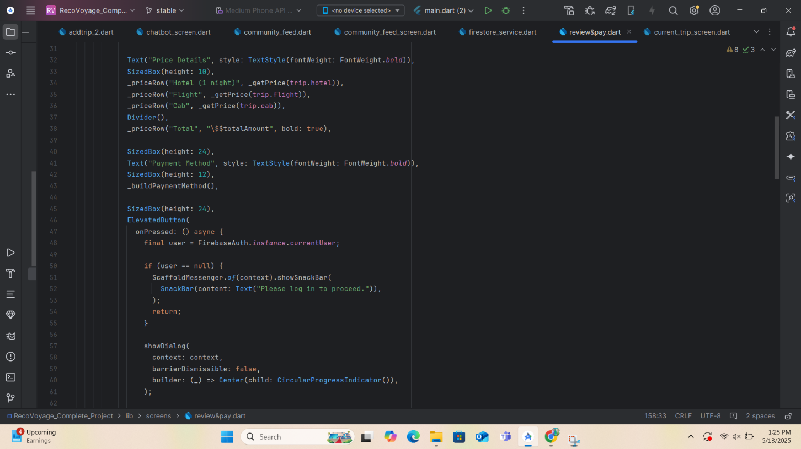

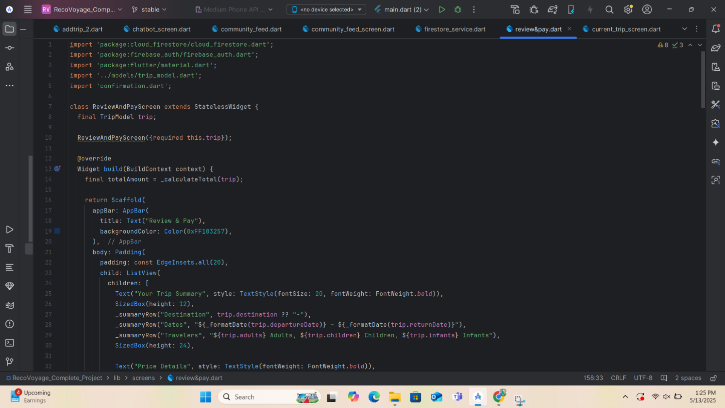

APPENDIX E: Code snippet of ongoing trip

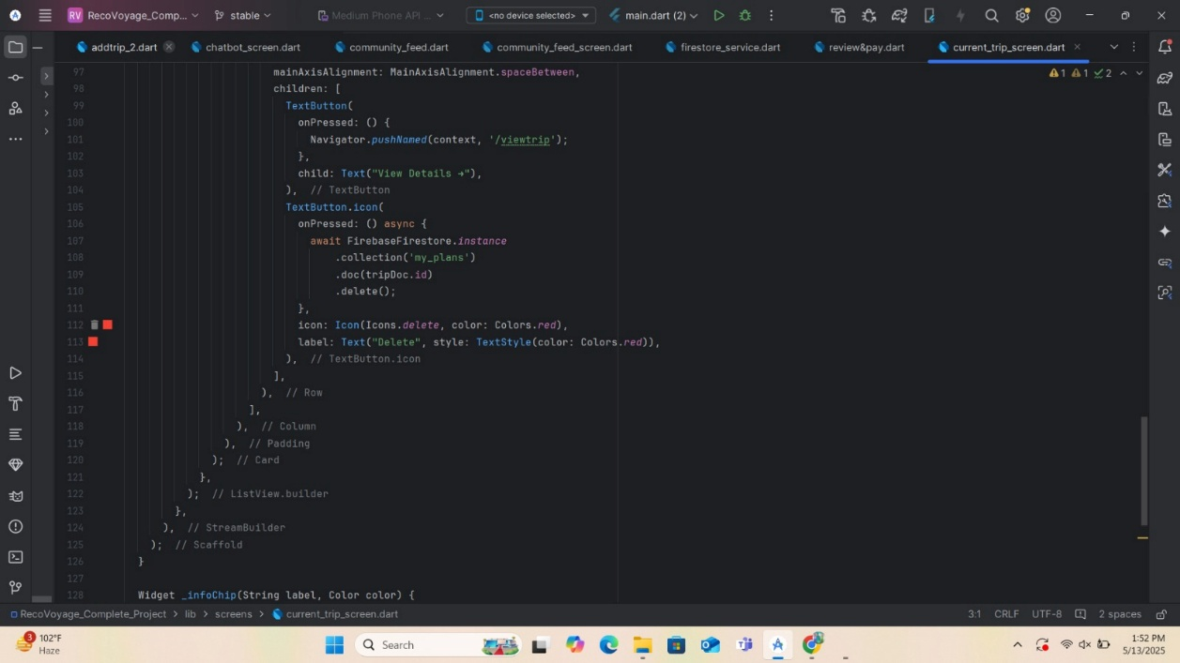

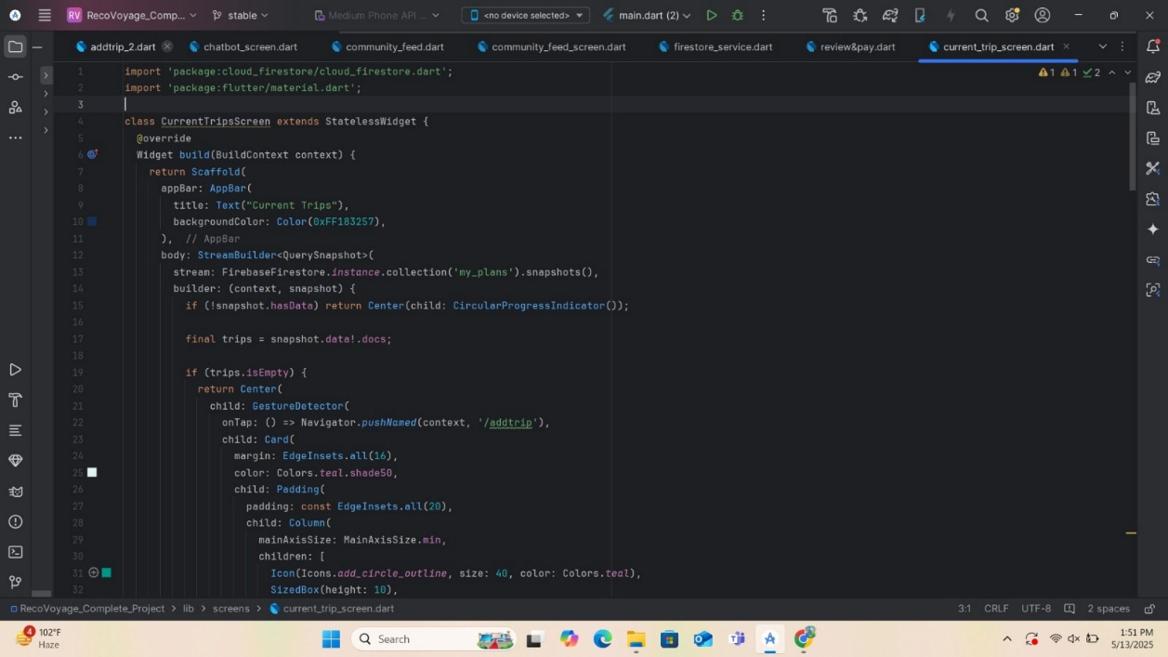

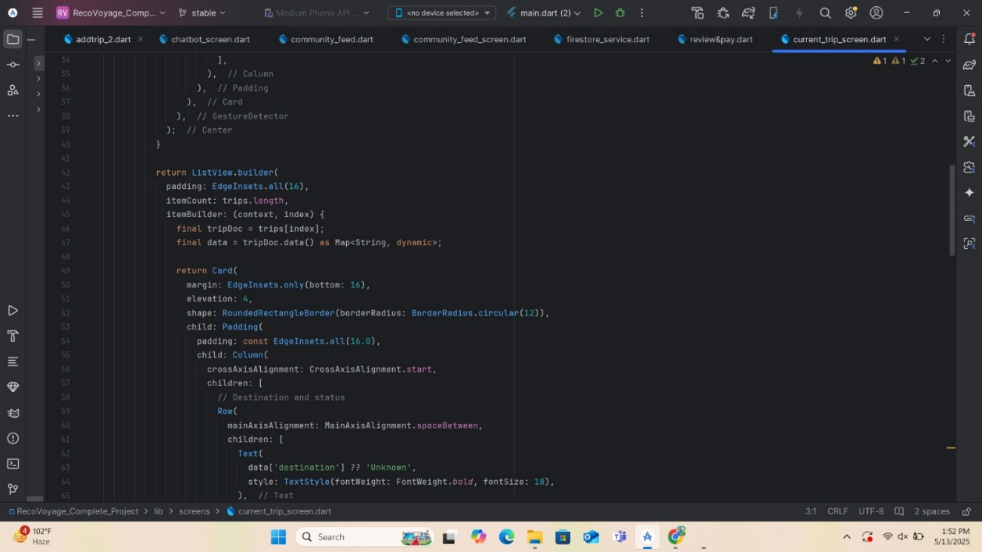

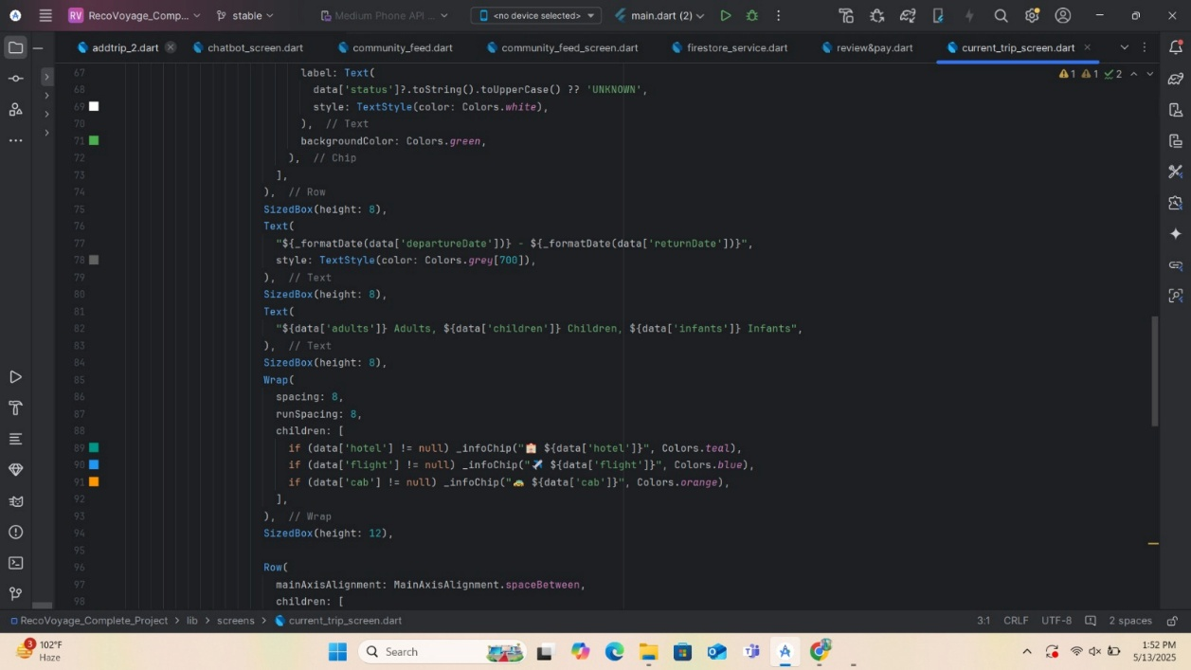

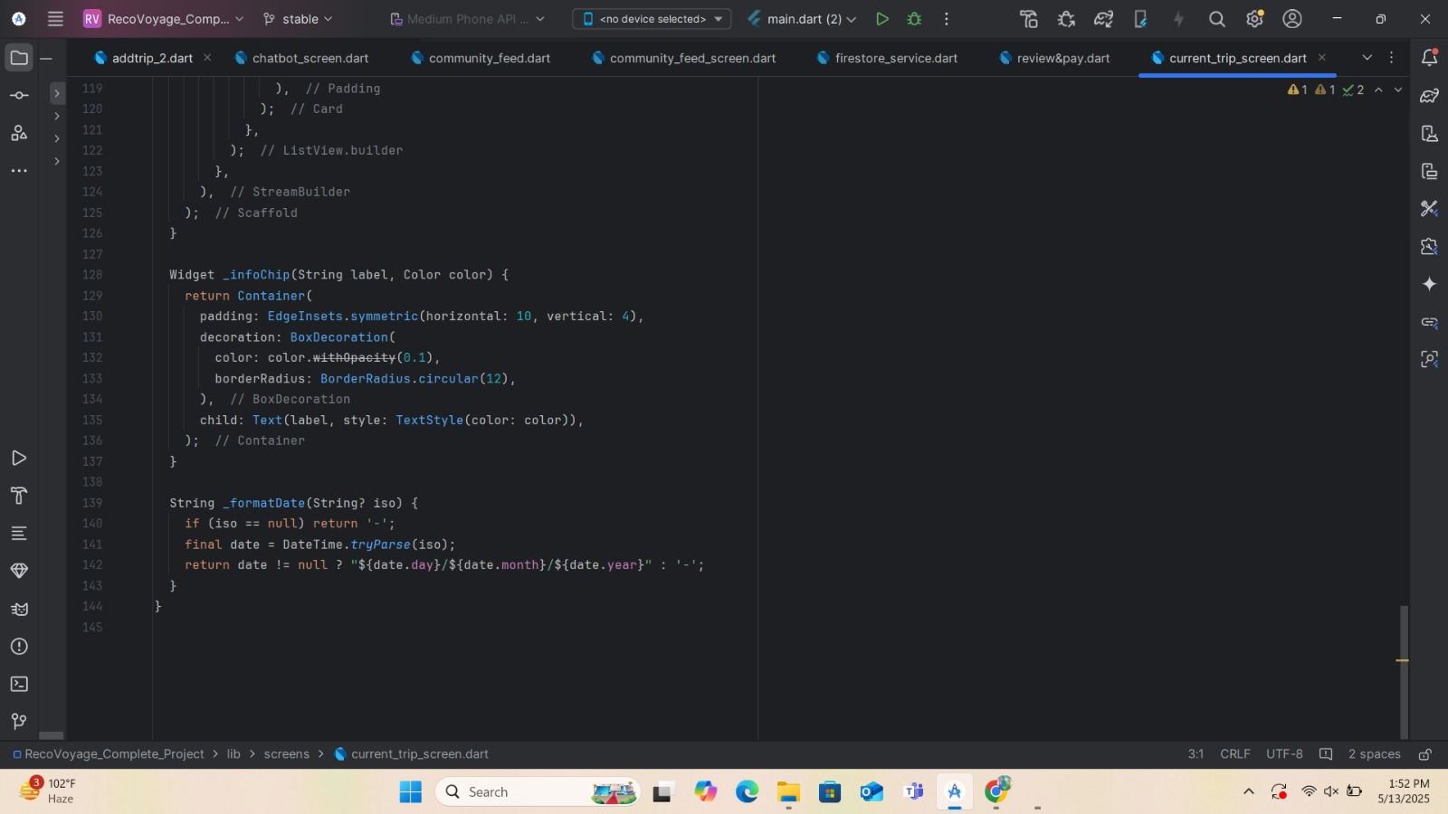

APPENDIX F: Code snippet of saved trip

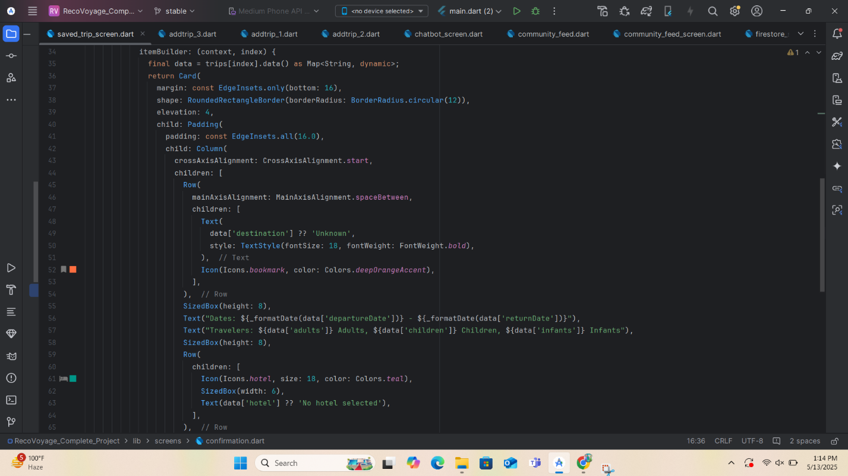

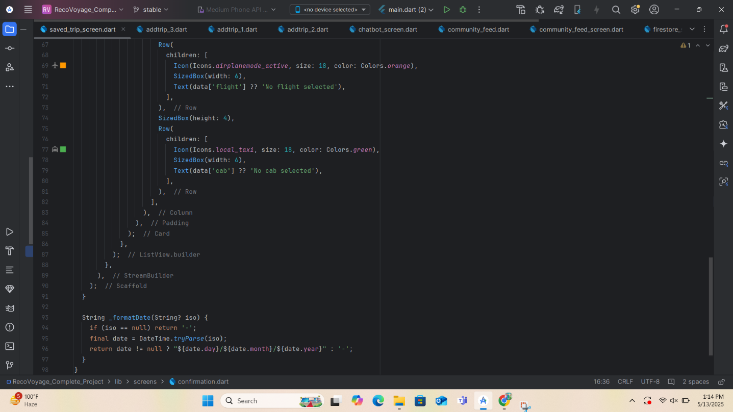
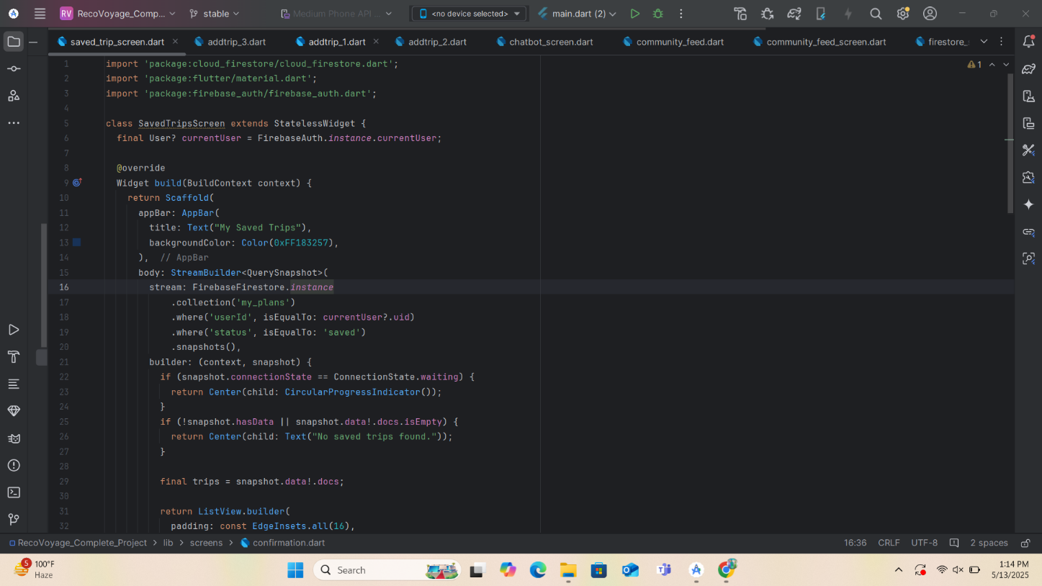

APPENDIX G: Code snippet of dummy booking Api with model class

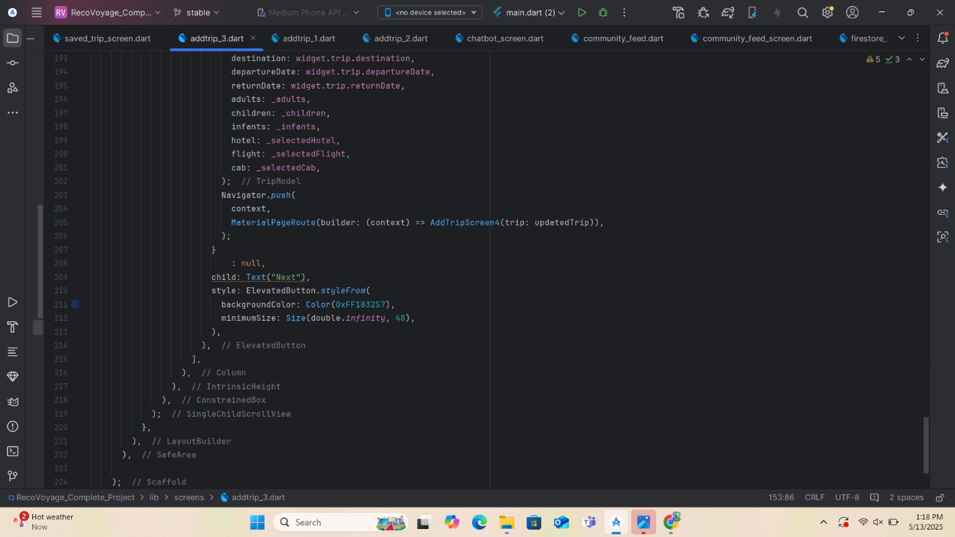

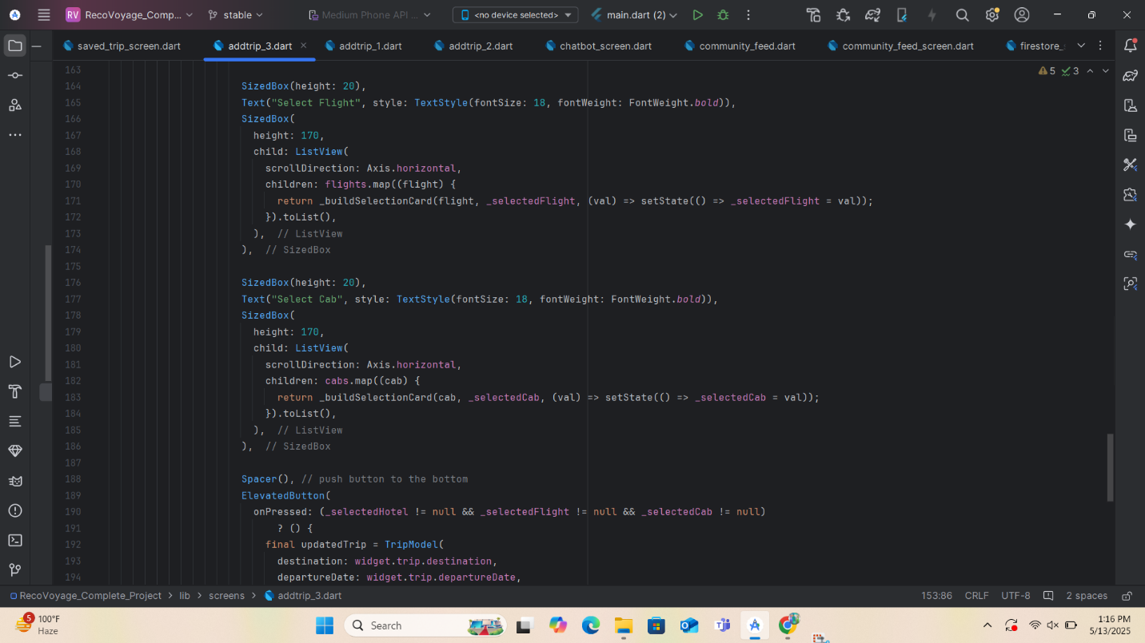

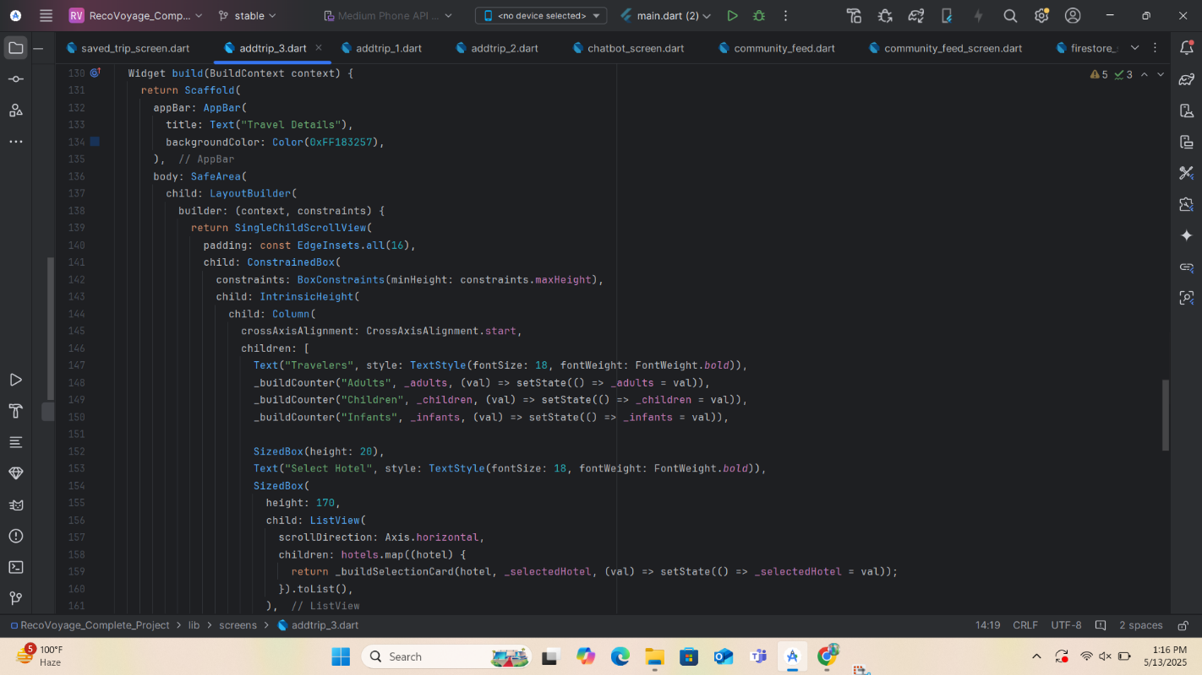

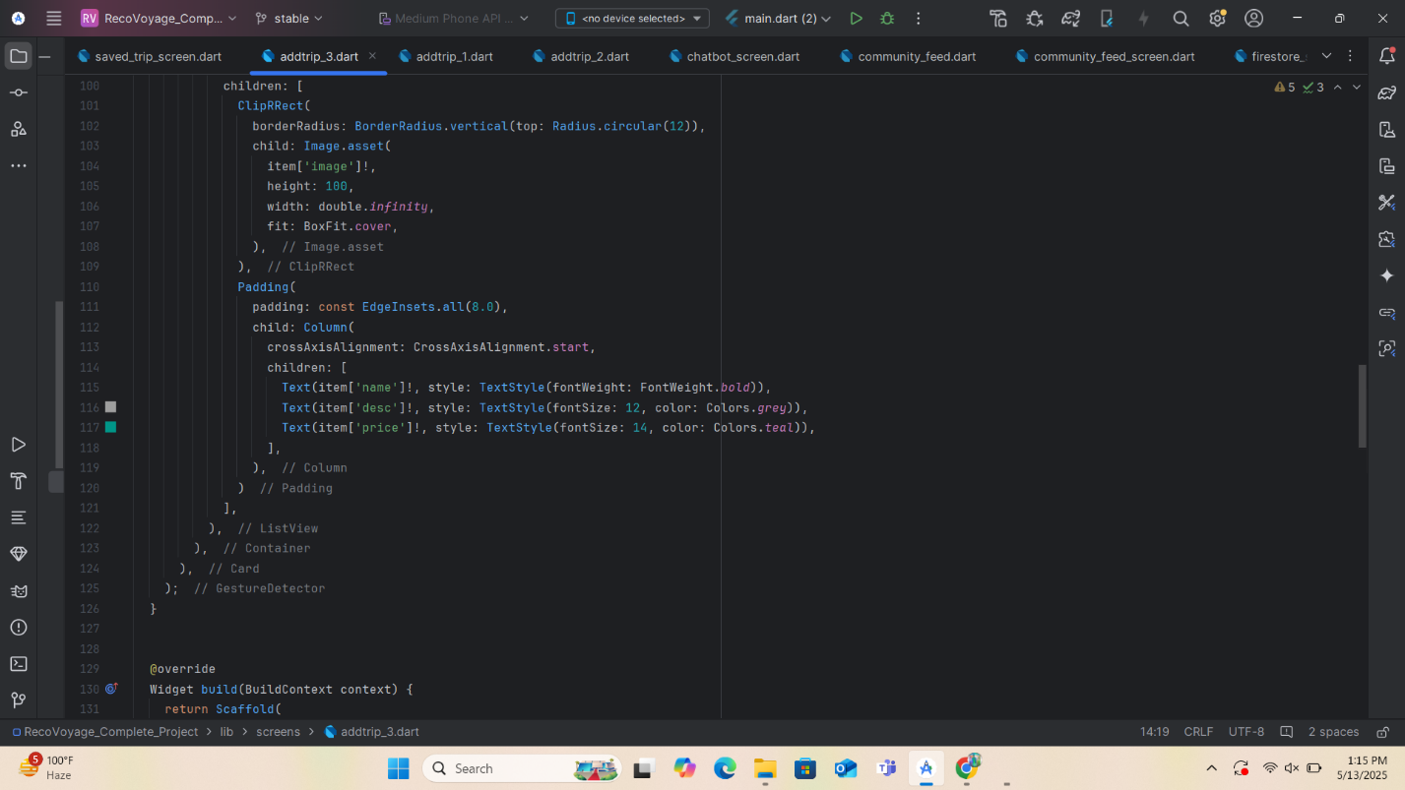
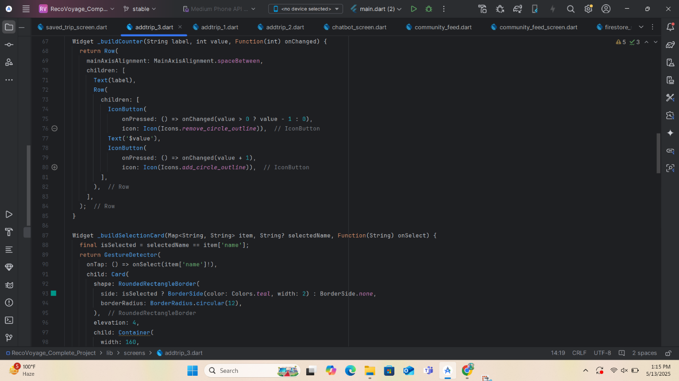

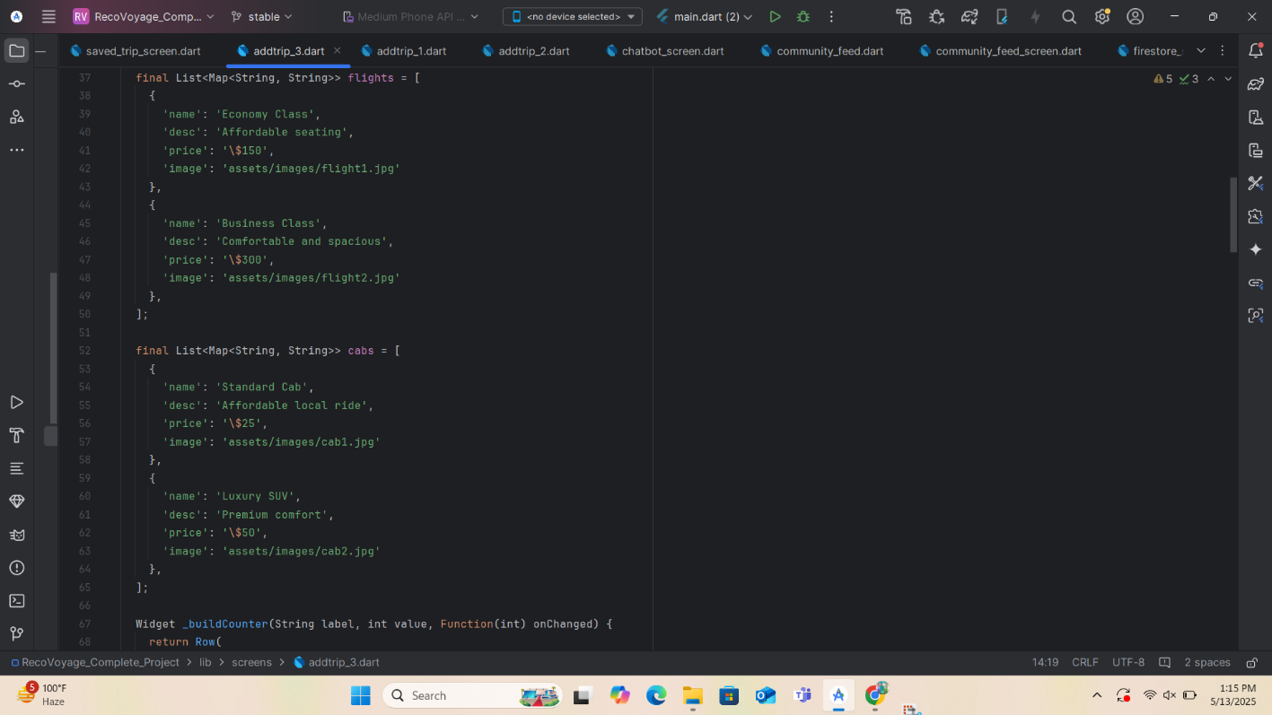
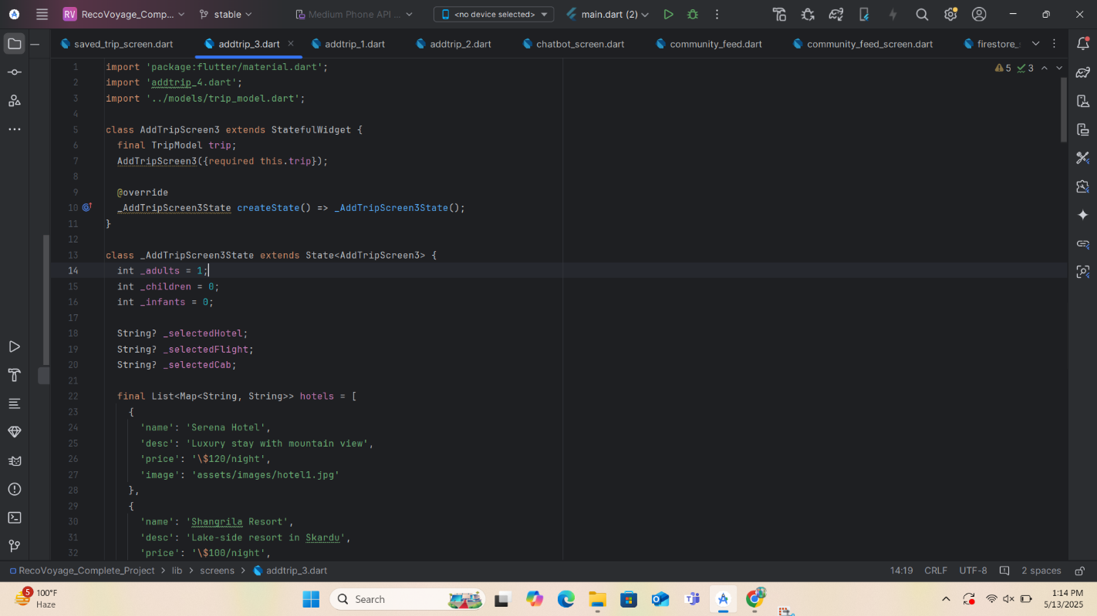

APPENDIX H: Code snippet of Database

