STRENGTHENING OF KING EDWARD MEDICAL UNIVERSITY, LAHORE
FOR Progressive International

NAME: Ahmad Muneeb ENROLLMENT: 03-298162-015

NAME: Muhammad Bilal ENROLLMENT: 03-298162-051

SEMESTER: SPRING-2017, MSPM – II PROGRAM: MS (PROJECT MANAGEMENT)



BAHRIA UNIVERSITY LAHORE CAMPUS

SUBMITTED TO: MR. AHSAN MAQBOOL

SUBMISSION DATE: June 10th 2017

Table of Contents

1.0 Abstract………………..………………………...………...………………………..05
2.0 Acknowledgement ……………………………………………………………………..07
- Introduction of firm …………………….………………………………………………08

3.1 Vision……………….………………………….…………………………………...09
3.2 Mission…………………………………………………………………………….09
3.3 General Information…………………………………………………….…….…10
3.4 Projects…………………………………………………..………………..………11
3.5 Organization chart ……………………………………………………………….12
4.0 Different construction sites…………………………………………….……….....…13
4.1 Building Projects…………………………………………………………………16
4.2 Road Projects…………………………………………………………………….20
  - Infrastructure Development…………………………………...…………..…….24

5.0 Introduction to Project Management Office…………………………………….....26

Frame work of PMO.......................................................................................26
5.2 Process……………………………………………………………………………26
5.3Governance...................................................................................................27
5.4 Resources....................................................................................................27
6.0 PMO roles…………………………………………………………………………….….28
7.0 Types of PMO’s…………………………………………………………………………28
7.1 Types of PMO’s……………………………………………………………….....28
7.1.1 Supportive……………………………………………………..……………...28
    - Controlling…………………………………………………………………….29
    - Directive…………..…………………………………...………………….….29
- Why there is a Need of PMO………………………………………………………...29
  - PMO Vision……………………………………………………...…………..…...29
  - PMO Mission…………………………………………………………………....30
9.0 Purposed type of PMO in Progressive international…………………………….30
9.1 Responsibility of Directive type PMO………………………………………...30
9.2 Directive type of PMO in Progressive international………………………...30
- Directive type PMO role and responsibility……………………………...…..30
10.1 Initiation…………………………………………………………………….....30
  - Planning…………………………………………………………………...…..33
  - Monitoring and controlling…………………………………………………...33
  - Closing…………………………………………………………………….......34
- Importance on PMO in progressive international…………………………..……34
12.0 Selection of project……………………………………………………………..…….35
12.1 Project name………………………………………………………………….36
12.2 Purpose………………………………………………………………………..36
12.3 Objective…………………………………………………………………...….36
12.4 Advantages…………………………………………………………………...36 12.5 Stakeholders………………………………………………………………….36
13.0 Stakeholder analysis……………………………………………………………..…37
14.0 Project charter………………………………………………………………….……38
14.1 Project Identification…………………………………………………………..39
14.2 Reasons for project…………………………………………………….........40
14.3 Project Manager Authority………………………………………………......40
14.4 Project Stakeholders…………………………………………………………41
14.5 Project OBJECTIVES…………………………………………………..…….42
14.6 Project Constrains…………………………………………………………….42
14.7 Project Scope………………………………………………………………...42
14.8 Project Baseline Budget …………………………………………………....42
14.9 Project Baseline Time.............................................................................43
14.10 Project Assumptions……………………………….……………………......43
14.11 Project Risks…………………………………………………………….......43
  - Signoff……………………………………………………………………..…..44
- Project scope statement …………………………………………………………….45

Introduction……………………………………………………..…………...…46

Description………………………………………………………………………..……..46
  - Deliverable………………………………………………………………..….46
  - Acceptance criteria……………………………………………………….....47
  - Constrain………………………………………………………………….….47
  - Assumption…………………………………………………………………..47
  - Exclusion………………………………………………………………….....48
16.0 References …………………………………………………………………………..48
17.0 MS Project………………………………………………………………………...….49

Abstract
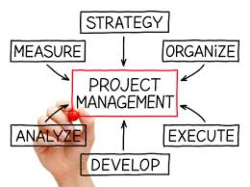

In modern days its very important to know the importance of Project management.Many of project fail due to poor planning and the projects are fail in the shape of over cost over schedule or change in scope.
Many orginizations are willing to apply PMO (Project Management office) because they want develope their strategy growth.PMO need where different type of project running in same time.PMO viewed as a gear to achieve optimization, standars and best management practice for the project management
Many of project are fail due to miss management,poor coordination,early exceptations,no center of authority,incomplete research,poor project management practice,Poor estimation,Inexperienced and unqualified project team.
In this report we discuss how we improve the organization strategy and their methods of management And also purpose of this report is how we impelement the PMO in any organization and how they resolve their problem by implementation of proper PMO.

In this report we suggest to implement the PMO in Progressive International.Progressive internation is strong matrix type organization.This organization work on different types of projects Construction of building,Road repair and maintance and infrastructural development projects.
we have studied “Dynamics of PMO and EPM Server” as an elective course in the degree program MS (Project Management) at Bahria University Lahore Campus.
by respected teacher Mr Ahsan Maqbool who provided us enough information and guide throughout the course.

Acknowledgements
This report has require lot of information and guideline. Thanks to our respected teacher Mr Ahsan Maqbool for the guideline and help throughout this report.
Thanks to my organization i.e. Progressive International for providing us enough exposure to explain the things in detail in this report.
This project report has help to increase my knowledge and professional ability in practical life. It will helpful for me in the future.
I thank you all.

My regards,

Muhammad Ahmad Muneeb
Muhammad Bilal

MSPM-II, Bahria University Lahore Campus

- Introduction of firm

PROGRESSIVE INTERNATIONAL
ENGINEERS & CONTRACTORS

 Firm’s Profile

Head Office: 99–B, Block J–1, Johar Town, Lahore, Pakistan.
Phone No. 042–35311348–9 Fax No. 042 – 35310950
E. Mail: prog_international@yahoo.com, eng_akhtar@hotmail.com

Progressive International was established as a firm in 1997. It is the leading construction firm of the country and specialized in construction of industrial projects, Multi Story Buildings, Roads, Modern Houses and other prestigious projects of National importance.
Progressive International have the privilege to be a registered constructions firm with Pakistan Engineering Council and also enlisted as a “A” Class no limit contractor in the various Government Departments and also pre-qualification for specified projects in Government and Private Sectors.

Progressive International possesses a sound technical expertise to undertake any desired civil or structural Engineering endeavors. Firm is accoutered with a highly professional team of experts in the field of construction. The past experience of the firm demonstrates its credibility and capabilities to strive for the projects demanding highly technical skill over past record bespeaks for our sound financial credibility and attests that we are fully capable managing the financial resources.

  - Vision
The Progressive international is one of the leading project company of Pakistan. First priority of this organization the fulfill the expectation of peoples and give them the right advise for investment

  - Mission
“To provide our clients with innovative, affordable and practical solutions for their investment objectives, through a dedicated team who ensures high quality standard of work is delivered within the given finances and on time”

  - General Information.
1. | Name of Firm | M/s. Progressive International  (Engineers & Contractors)
2. | Head Office Address | 99-B, Block J-1, Johar Town, Lahore.
3. | Telephone  042–35311348 – 9 | Name Engr. Hafiz Muhammad Akhtar  Title Managing Director
4. | Fax  042–35310950 | Email  eng_akhtar@hotmail.com  eng_akhtar@yahoo.com  prog_international@yahoo.com
5. | Place of Registration  Lahore | Year of Registration  1997
6* | PEC Registration #  102 | Validity  31-12-2017
7. | PEC Code Specialization  CE 01,02,04,09,10  BC 01,03 (Up to 10 Storey) | NTN #  2275164-5

  - Projects

3.5 Organization chart

Managing Director

Accounts Manager
Manager Administration
Assistant Account Lahore
Office Staff
Field staff
Field Staff
Material Inspector
Site Engineer
Material Inspector
Site Engineer
PROJECT ENGINEER

PROJECT ENGINEER

RESIDENT DIRECTOR
North

RESIDENT DIRECTOR
SOUTH

- Different Construction Sites

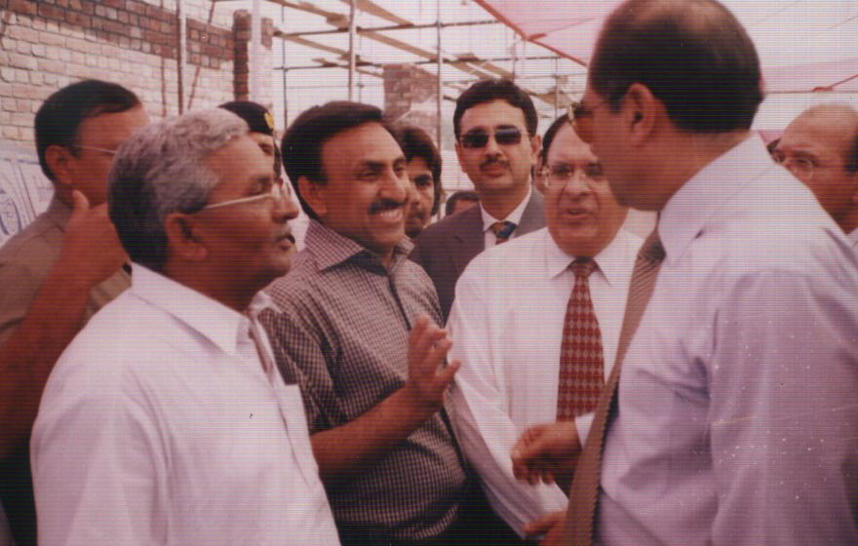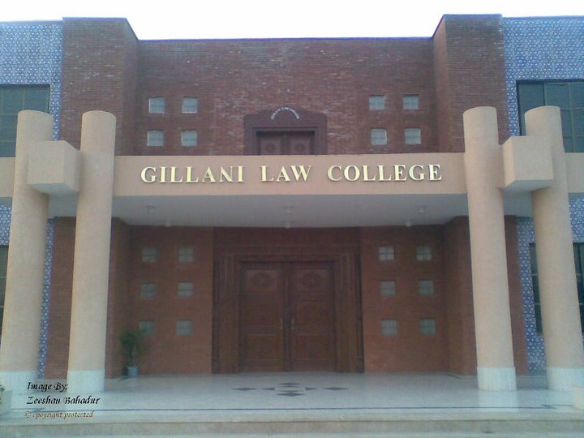
Fixing of Foundation Stone by the Governor of Punjab, at Centre of Under Graduate Studies at Bahauddin Zakaryia University, Multan
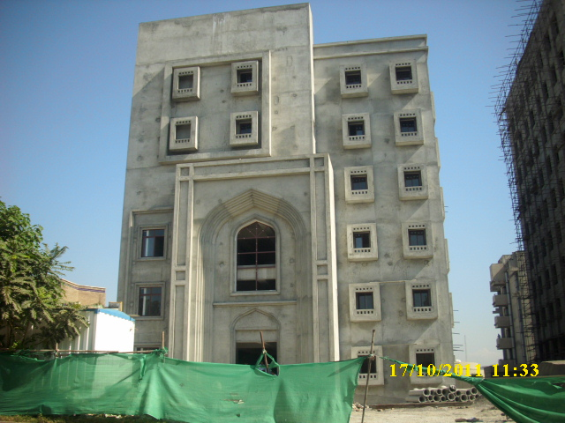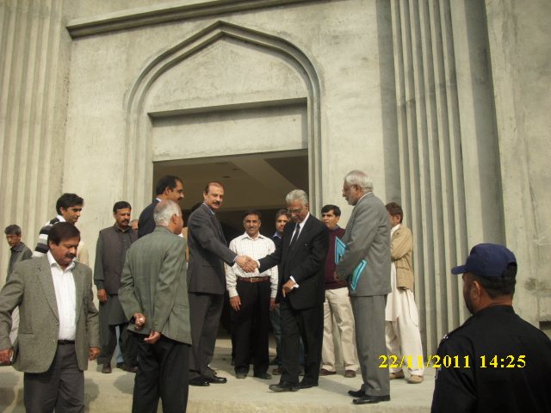
Federal Services Tribunal G-5/2, Islamabad
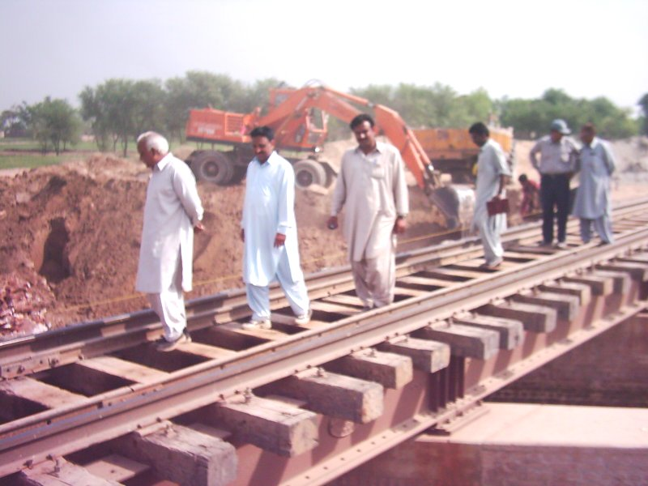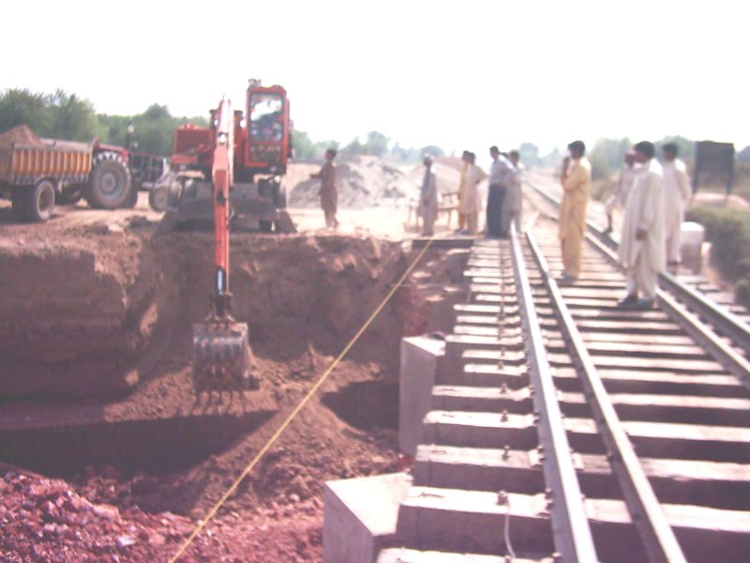
Construction of RCC Bridges on Canals Compressive Cylinder Strength 4,000 PSI in connection with Doubling of Track, Pakistan Railways, Lodhran-Shershah Section, Multan
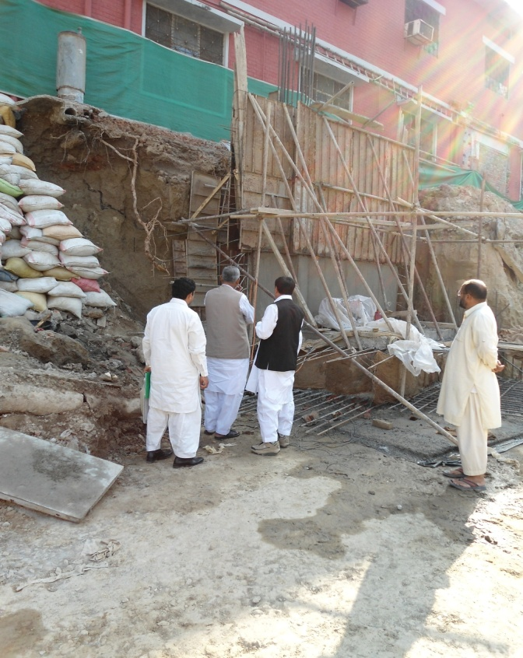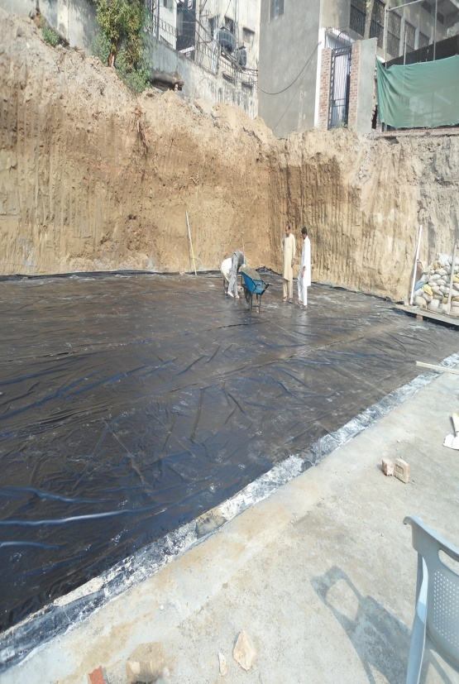

Strengthening of King Edward Medical University (KEMU), Lahore

4.1 BUILDING PROJECTS

Description of Project | Starting Year | Ending Year | Cost of Project | Client*
Construction of Federal Services Tribunal, Islamabad | April  2009 | January 2012 | (221.866 Million) | Executive Engineer,  Central Civil Division-III,  Pak.P.W.D. Islamabad
Construction of Danish Girls School Rahim Yar Khan | January,  2010 | October,  2010 | (231.21 Million) Original  (370.00Million) Revised | The District Coordinator Officer, Chairman Board of Governor, Danish (Boys & Girls) Scholl Rahim Yar Khan
Construction of B.Z. University Gillani Law College at New Campus Bahuddin Zakaryia University, Multan. | July,  2008 | November,  2010 | (73.072Million) | University Engineer, Bahauddin Zakariya University, Multan.
Construction of Centre for Under Graduate Studies B.Z.U. Multan | July,  2005 | October,  2009 | (81.5 Million)  (112.20 Million) (Revised) | Project Director, Bahauddin Zakariya University, Multan.
Department of Mechanical Mechatronics and Manufacturing Engineering, Faisalabad | July,  2007 | March,  2009 | (62.660 Million) | Project Director, Faisalabad Campus of U.E.T., Lahore
Construction of Houses  (Package – C – 1 & C – 2), Mohlanwal, Lahore. | June,  2006 | November,  2008 | (93.903) Original  ( 231.31 Million) (Revised) | Project Director, Punjab Government Servant Housing Scheme, Mohlanwal, Lahore.
Construction of Drains & Culverts at Small Industrial Estate-II, Gujranwala | December,  2005 | February,  2007 | (11.004 Million) | Director (ED&W) Punjab Small Industries Co-operation, Lahore
Construction of 100 Bedded PESSI Hospital, Bara Dari Road, Shahdara, Lahore | August,  2004 | February,  2007 | (85.873 Million) Original  (94.080 Million) Revised | Director Development Punjab Employees Social Security Institution (PESSI), Lahore

4.2 ROAD PROJECTS

Description of Project | Starting Year | Ending Year | Cost of Project | Client*
Widening/Improvement of Shahdara Maqboolpura Narag Road in District Sheikhpura | February  2009 | June 2011 | (539.920 Million) | Executive Engineer Provincial Road Construction Division Lahore
ADB Assisted PRSDP Loan no. 1928-Pak. Construction of Contract Package CR-2  (i), Mianchannu to Tulamba | December,  2007 | June,  2009 | (153.750 Million) | Project Director, Project Engineering Cell, C & E Department, 2-Lake Road, Lahore(153.750 Million)
Widening Improvement of road from Safdarabad to Muhammadpura via Larkan  Length = 18.80 km in District Nankana Sahib | February,  2007 | August,  2009 | (159.590 Million) Original  (186.811 Million) Revised | Executive Engineer Provisional Highway Division, Lahore
Remodeling of Sargodha Road from 4 Lane to 6 Lane from PMC Chowk to M3, Faisalabad | July,  2008 | November,  2009 | (246.621 Million) Original  (347.521 Million) Revised | Faisalabad Development Authority Faisalabad
Improvement & Extension of Level Crossing from LON to SSH Section in connection with Doubling of Track, Lodhran- Khanewal via Multan Cantt.. | September,  2004 | September,  2006 | (12.241 Million) Original  (15.49 Million) Revised | Executive Engineer  Doubling of Track, Pakistan Railways,  Multan

Description of Project | Starting Year |  | Ending Year |  | Cost of Project | Client*
Construction of Bridges on Lodhran Sher Shah Sub-Section on connection with Doubling of Track on Lodhran Khanewal Section via Multan Cantt | December,  2003 |  | June,  2005 |  | (35.674 Million) Original  (38.00 Million) Revised | Executive Engineer  Doubling of Track, Pakistan Railways,  Multan
Improvement of Roads, Replacement of Sewer & Street Lights, Faisalabad | January,  2004 |  | June,  2005 |  | (12.20 Million) | (SIE) Small Industries Estate, Faisalabad
Construction of Shops and Roads at carriage and wagon shops, Mughalpura, Pakistan Railway, Lahore |  | February,  2003 | June,  2004 | (24.00 Million) |  | Pakistan Railway
Construction of Road and related structure, P/F Kerb Stone, RCC Drain, RCC Bridges at Rakh Branch Canal, Footoat, Retaining Wall and other related civil works from Jhal Khanuana to end point at Summandri Road, Faisalabad | January,  2001 |  | July,  2002 |  | (85.00 Million) | Municipal Co-operation, Faisalabad  (NESPAK)

4.3 INFRASTRUTURE DEVELOPMENTS

Description of Project | Starting Year | Ending Year | Cost of Project | Client*
Construction of Water Supply System TMA, Hasilpur | December,  2006 | January,  2011 | (203.109 Million) Original  (253.109 Million) Revised | TMA, Hasilpur
Development of Housing Society including Roads, Sewerage works, Over Head Reservoir, Installation of Tube well & Pumping Station and other related works, Lahore | January,  2004 | January,  2005 | (43.54 Million) | Beacon House Estate, Raiwind Road, Lahore
Development of Housing Scheme including Roads and Roads Structures, Sewerage Work, Water Supply and Installation of Tube well for Abid Group, Lahore | December,  2003 | April,  2005 | (55.00 Million) | Abid Group, Lahore
Construction of Tube well & Pumping Station, Installation of Pumping Machinery, Construction of Over Head Reservoir including Water Supply, Faisalabad  Punjab Community Water Supply and Sanitation Scheme Chak No. 55/RB,  Faisalabad | January,  2004 | October,  2004 | (10.00 Million) | Deputy Project Director,  PCWSS-P P.I.U.  Faisalabad

5.0 Introduction to Project Management Office
A project Management office (PMO) is enterprise department or group which use for
define standards. A project Management office (PMO) is very important in modern days.
PMO mostly use in that organization where they need growth. PMO help in organization
to execute the project. PMO is help where company work on multiple projects in same
time. A project Management office (PMO) Is directly under the CEO of company
because PMO need authority that’s why he come direct under the CEO. If PMO has no
authority then there is no benefits to made a Project Management Office.

Frame work of PMO.
There are following steps for establish the PMO.
1. process
2. governance
3. resources
4. Organization
The main purpose of PMO is to complete the project under the triple constrain (Time, Budget and scope).And the other purpose of PMO to check the project completion time under the schedule for the establish the PMO there are four steps that given above.
5.2 Process
For the developing the project management process best practice should be adopted according to PMBok..

5.3 Governance
For the best PMO status level should be defined for example, Where are we on Schedule , Where we are on Budget. After some time we need to update the status of project.
Are we as per schedule
Are we under the budget
Can we meet the scope
Mile stone updated
Risk management. ( if any type of risk accrue)
Resource management ( Is any type of resources project needed)
Resolving issues
Check standard (is project going as per Standard)
Audits
Conflict management
Reporting standards
Analysis the standards for future.
5.4 Resources
Resources are very important in selecting of any PMO.
1 Experienced
2 Well skilled
3 Ethical
4 Easy availability
- Full time human resources not Part time.

6.0 PMO roles
There is three types of PMO’s in any organization. These types of PMO’s divided by their roles and responsibility, Authority, and control.
1 Supportive.
2 Controlling
3 Directive.
7.0 Types of PMO’s
PMO’s type | Authority | Level of control | Role and responsibility
Supportive | Low | Low | Only give information
Controlling | Low to moderate | Low to moderate | Control the Giving information
Directive | Moderate to High | Moderate to High | Control the Project

7.1 Types of PMO’s
Supportive
Controlling
Directive
7.1.1 Supportive
In this type of PMO level of authority is low. It just use for information and its role and responsibility is low.
For Example in Airline company when the weather is not good for operation then this type of PMO just inform that Weather is not good so Stop the Operation.
7.1.2 Controlling
In this type of PMO level of authority is moderate and its role and responsibility is moderate.
Example of this type of PMO This PMO inform that stop the operation till next update. When the weather is good for operation then restart the Flight operation.
    - Directive
This type of PMO is has more authority and level of control is high he give the all direction for future.
This type of example order stop the operation and park the aircraft till next order.
- Why there is a Need of PMO?
In any organization they have different types of projects. But they have almost same type of responsibility on every projects. But if same nature of work is being executing in different ways, it can create problems for project team.
PMO need because when new staff come at any new project they come with their own standards and their own methodology. Only experience and good skilled is not enough for any new team on new project because all organization has their own standards and methodology for execution
When new staff come on any new project organization face lots of problems.
After studying the PMO in our course we decided to implement the PMO in our organization to track the projects and team performance.
To solve the all the problems coming from any project we recommended the PMO.

  - PMO Vision.
- Adapt best practice of Project management
- They provided base for successful projects
- Improve environment
- For meet the expectation
  - PMO Mission.
- Build the culture project management
- Deliver high quality result
- Continuous improvement

- Purposed type of PMO in Progressive international
In the current situation we suggest the directive type of PMO in Progressive international. Because they need highly improvement in their methodology.
Purpose of implementation of directive type PMO is his authority is high and his responsibility is in any phase of project.

  - Responsibility of Directive type PMO.
- Set standards
- Implementation of standards
- Improvement in methodology.
9.2 Directive type of PMO in Progressive international
We established the directive type of PMO in this organization. This type of PMO is implement in the 3 project phases
- Initiation
- Monitoring and controlling
- Closing
10.0 Directive type PMO role and responsibility
10.1 Initiation
- Client need and expectation
- Establishing the testing lab for material
- Negotiation with contractors and other stakeholders
- Appoint the architectural staff
- Appoint the structural staff
- Approve the design
- Project manager role and responsibility
- Project manager authority

  - Planning
- Schedule
- Set resources
- Dependencies
- Duration
- Documentation
- Coordination with B.O.Qs
- Cost planning
- Contacts with contractors
- Manage schedule
- Resource allocation
- Meet specification
- Meeting with all stakeholders
- Set milestone
- Set constrain
- Set tracking methods
- Cost tracking method
- Recourse tracking
- Resource availability
- Set resource cost
- Set KPIs
Monitoring and controlling
- Site management
- Contractor selection
- Negotiation with contractors
- Check list
- Check the availability of resources
- Deliverable list
- Quality assurance
- Conflict management
  - Closing
- Build as per design
- Lesson learned
- Client satisfaction
- Importance on PMO in progressive international
- Availability of resources
- Establish quality standards
- Cost tracking
- Conflict management
- Enforced to complete the projects under budget
- Enforce to complete the project as per schedule
- Improvement in methodology
- Improvement in organization structure
- Only qualified/certified staff
- Documentation standards
- Reporting standards
- Liability of Project manager and other staff

- Selection Of Project

Strengthening of King Edward Medical University, Lahore

Selected project
This project is STRENGTHENING OF KING EDWARD MEDCAL UNIVERSITY, LAHORE. The purpose of this to build new block for students because KEMU building in old its was build in 1988. Space is less for student and low in strength. After HEC visit they advise to repair the building and build new block for coming students.
Its include examination hall, multipurpose hall, library, Administration offices.
12.1 Project name
STRENGTHENING OF KING EDWARD MEDCAL UNIVERSITY, LAHORE
12.2 Purpose
To provide facility and good environment for students.
HEC requirement
More classrooms for new students
12.3 Objective
The objective of this project is increase the strength of KING EDWARD MEDICAL UNIVERSITY and provide the new environment for students. Provide multipurpose hall for other activities. Build extra class rooms and administration block Build new library for students and examination hall.
12.4 Advantages
The major advantage is that after this project the capacity of classrooms is increase and they can admission more students. The old building is use for medical labs Operation Theater and class rooms/Lecture Theater.
12.5 Stakeholders
Major stakeholders include
- Punjab government
- PM&DC
- HEC
- KEMU director
- Consultant
- Contractor
- Designer
- Students
- Stakeholder analysis

Name | Position | Expectation | Type | Power | Urgency | Legitimacy | interest
KEMU director | sponsor | Patient Satisfied | Internal | High | high | High | High
PM&DC | Medical Council | No Compromise on standards | Internal | High | High | high | high
HEC | Education commission | Standard education environment | Internal | High | High | High | low
Project team | Technical staff | Fund use at right place | internal | high | low | High | High
Students | Students | Facilities for education | internal | Low | Low | Low | high

14.0 Project Charter

Project Charter

Strengthening of King Edward Medical University, Lahore

14.1 Project Identification
Project Name | STRENTHENING OF KING EDWARD MEDICAL UNIVERSITY LAHORE
Description | Construction of an Academic block to increase/strengthening their academic facilities and achieve the all objectives related to Education Department.
Project Sponsor | King Edward Medical University Lahore.
Project Manager | Muhammad Aslam Naeem
Project Team | Construction Manager  Site Engineers (Civil)  Site Engineers (Electrical)  Site Engineers (Mechanical)  Site Supervisors (Civil)  Site Supervisors (Electrical)  Site Supervisors (Mechanical  Quantity surveyor  Quality Control (Inspector)  Health and Safety Officer  Accountant  Ass Accountant  Store keeper

14.2 reasons for project
- To provide quality education within university Environment
- Because Replacement of building is essential due to old structure buildings.
- Due to Increase in student’s capacity medical related departments.
- To provide better standards for students
- Due to New Examination Halls and Libraries for students.
- To provide Offices for University Faculty.

14.3 Project Manager Authority
- Manage and control the project.
- Developing the project Plans.
- Managing the project Stakeholder.
- Managing the Project schedule.
- Project manager has the authority that how to manage and use resources.
- Project Manager has the authority to hire and fire any team member if he can’t do any work
- Project Manager has the authority to use the budget and authority of chances
- Managing the project Conflicts

14.4 Project Stakeholders
- Project Sponsor King Edward Medical University Lahore
- Project Manager Muhammad Aslam Naeem
- Project Team Construction Manager
Site Engineers (Civil)
Site Engineers (Electrical)
Site Engineers (Mechanical)
Site Supervisors (Civil)
Site Supervisors (Electrical)
Site Supervisors (Mechanical
Quantity surveyor
Quality Control (Inspector)
Health and Safety Officer
Accountant
Assistant Accountant
Store keeper
- Sub-Contractor Civil Contractor
Electrical Contractor
Mechanical Contactor
Plumbing Contactor

14.5 Project OBJECTIVES
- The construct a Building which includes ( 01 Basement 6 Floors)
- Floor should be say 1 story of building.
- Project fulfills the client need and requirements.
- Design provided by PEPAC Consultancy.
- No design changing will be made without the approval of client.

14.6 Project Constrains
- Project complete under budget.
- Project complete under schedule
- Project achieve scope
- Sponsor satisfaction

14.7 Project Scope
Construction of an Academic block to increase/strengthening their academic facilities and achieve the all objectives related to Education Department. Project fulfills the client need and requirements

14.8 Project Baseline Budget *
The project is estimated to be completed with the budget of 80 Millions

14.9 Project BaselineTime
The project Time is estimated to be completed within 24 months.

14.10 Project Assumptions
The project time can exceed the base time line of 24 months. The cost of project increase due to amendment/ changing within design. Cost will be increase due to delaying of project (Scope/Time/Cost)

14.11 Project Risks
- Poor direction from High authority
- Delay in schedule
- Weather during concrete
- Late supply of material
- Poor transport may cause delay of material
- Changing in PM&DC standards
- Change in design from sponsor
- Labor dispute/strikes

14.12 Signoff
______________________________________________ Date
King Edward Medical University Lahore .
Project Sponsor

Muhammad Aslam Naeem
______________________________________________ Date:

Project Manager

Project scope statement

Strengthening of King Edward Medical University, Lahore

15 Project scope statement

15 Project scope Statement

15.1 Introduction
Project scope statement is the document which use for description of project deliverable. We also discuss the project constrain ,assumptions and high level detail of deliverable. Is scope statement we discuss the scope provided by sponsor. And we measure the work to complete the project.

15.2 Description.
Our project on strengthening of KEMU, Lahore. The recent building of KEMU is old it was built in 1988 as have less amount of class rooms and less space for students. So due to PM&DC & HEC requirement KEMU decide to make the new building to increase their space
15.3 Deliverable
Project deliverables are following
- Multipurpose hall
- Examination hall
- Admin block
- Library
- Advance surgical labs
- Conference room
- Multimedia room
- Central AC
- Computer labs
- Class Rooms
- Faculty Rooms
- HOD Room
- Masjid
- Bathrooms
- Water Tank
15.4 Acceptance criteria
- All structure according to PEC standards
- All labs according to PM&DC requirements
- All work as per BOQ
- Structure as per approved design
- All bills approved by relevant authority signature
- Material use as per standard of PEC
- Quality assurance
- Follow the Quality standards
15.5 Constrain
Sr.no | Objective | Constrain
1 | Time | Project must be under schedule  Schedule is not change
2 | Cost | Project must be under cost base line  Cause of any changes that must be approved by sponsor or high authority.
3 | Scope | Scope must be achieve  Fulfill the requirement of sponsor and satisfied him
4 | Quality | Quality standards must be follow  No compromise in quality standards.

15.6 Assumption
- Certified staff will be use
- Provided relative training
- And contractor will pay all expensive.
15.7 Exclusion
- Museum not be in this project
- Not playing ground in this project
- Hostel not included
- Cafeteria not in this building
  - References
- Guide from PMbok 5th edition
- Report from library
- https://=progressive+international+engineers+and+contractors
- https://=project+management&source=lnms&tbm=isch&sa=X&sqi=2&ved=0ahUKEwiGr7aZlZzUAhVHVhoKHfcmB2gQ_AUIBigB&biw=1366&bih=662

MS Project

Strengthening of King Edward Medical University, Lahore

