
Smart Phone usage and its effect on Senior Citizens’ Empowerment,
“A Cross Sectional Study in Lahore”

Submitted By:
NUREED NASIR
03-298161-028

Supervisors

Principal Supervisor: Mr. Shehzad Ahmad
Co-Supervisor Mr. Umar Sharif

Department of Management Sciences

A thesis presented to Bahria University, Lahore Campus in partial fulfillment of
the requirements for the degree of Master of Science in Project Management

COPYRIGHT

The copy of this thesis is provided on the understanding that its copyrights rests with the researcher. And that it can only be quoted or its research data can be published after having the author’s prior consent.

© Nureed Nasir, 2016-2017

SUBMISSION FORM OF THESIS FOR HIGHER RESEARCH DEGREE
BAHRIA UNIVERSITTY, LAHORE

Candidate Name: Nureed Nasir (MSPM-III)
I submit 4 Copies of thesis for examination for the degree of MS, Thesis Titled: Smart Phone usage and its effect on Senior Citizens’ Empowerment, “A cross Sectional study in Lahore”
Candidate Signature: _______________________ Date: _______________________

Certificate of Principal Supervisor
I Shehzad Ahmad being the principal Supervisor for the above student certify that thesis is in a form suitable for examination and that the candidate has pursued his course in accordance with the Rules of the University.
Signature: _________________________________ Date: ______________________
Recommendation for Examination
I recommend that the thesis be examined.
Principal Supervisor: ________________________ Date: _____________________
Co-Supervisor: _____________________________ Date: _____________________
Not Recommended for Examination
I recommend that the thesis be examined.
Principal Supervisor: ________________________ Date: ___________________
Co-Supervisor: _____________________________ Date: __________________
Statement by the Head Faculty/Department
I support the submission of the thesis of the above-named student for examination under the University Rules for higher degrees.
Signature: ________________________________ Date: _________________

APPROVAL SHEET
SUBMISSION OF HIGHER RESEARCH DEGREE THESIS

Candidate ‘s Name: Nureed Nasir
Discipline: Project Management
Faculty/Department: Department of Management Sciences

I hereby certify that the above candidate’s work, including the thesis, has been completed to my satisfaction and that the thesis is in a format and of an editorial standard recognized by the faculty/department as appropriate for examination.

Signature(s):
Principal Supervisor: Mr. Shehzad Ahmad
Date: ____________________
The undersigned certify that:
1.The candidate presented at a pre-completion seminar, an overview and synthesis of major findings of the thesis, and that the research is of a standard and extent appropriate for submission as a thesis.
2. I have checked the candidate ‘s thesis and its scope, format; editorial standards are recognized by the faculty/department as appropriate.
Signature(s): Dean/Head of Faculty/Department:
Date: _____________________

DECLARATION OF AUTHENTICATION

I, Nureed Nasir, Student in the Department of Management Sciences, Bahria University. Lahore Campus, certify that the research work presented in this thesis is to the best of my knowledge as my own. All sources used and any help received in the preparation of this dissertation have been acknowledged. I hereby declare that I have not submitted this material, either in whole or in part, for any other degree at this or other institution.
Signature: _____________________
Name: Nureed Nasir

DEDICATION

I dedicate this thesis to my family for nursing me with affections and love and their
dedicated partnership for success in my life

Thank You

ACKNOWLEDGEMENT

This thesis has been one of the most difficult tasks of my life; therefore, without the help of certain people I could not have completed it.
First of all, to my supervisors and mentors, Mr. Shehzad Ahmad and Mr. Umar Sharif. I would like to express my deep gratitude to, for firstly believing in my ability and providing me with an opportunity to begin and get to this completion stage of the MS. Besides my advisors, I would like to thank Head of the Department Dr. Ahmad for teaching us the subject of Research Methodology. I learnt a lot from Dr. Ahmad during my Master Degree. Thank you all of you to help me discover my strength, encouragement, providing comments and standing by me until the end of this research. I am grateful to the entire research team. I will not forget how helpful you have been and are.
I would also like to thank my parents for their continued support, encouragement, and motivation. I would then like to thank my sisters who emotionally encouraged me. Without my lovely family, I would have never journeyed this far in my life. I hope that the success of this MS will make you happy and proud.
In terms of friends, I thank all my friends. I am grateful to all of you for all the guidance, love, support and friendship over the enduring years.
I wish to express my gratitude to the Bahria University for giving me the opportunity to complete this research and also take this opportunity to acknowledge the help and support of all the academic staff members. I thank all those expert panels and participants who spent their valuable time answering my questionnaires on their smartphones empowerment.

ABSTRACT
Smartphones are inventions that currently provide immense benefits to empower the users in society. However, not all the users of society are using smart phones, more specifically, for this research study senior citizens’ (60+) are a demographic group displaying such an attitude. Bearing this in mind, this research study aimed to identify, examine and explain the effect of the usage of smartphones on seniors’ empowerment in Lahore within the 60 years old and above population. For this purpose, a conceptual framework, was formed drawing factors from the literature. Two variables from the literature were brought to consideration, which were use of technology (smartphone) and empowerment. For the research method, a quantitative approach was selected that involved the data collection method by a questionnaire survey that resulted in 159 respondents in the final phase. The collected data was analyzed using SPSS, where the results found that the formed hypotheses was supported, and the factor of smartphone usage influence the senior citizens’ empowerment. From these results, it was understood that senior citizens’ feel empowered by frequently used the basic features of smartphones such as making a phone call, SMS, email, and browsing.
The contributions of this research are viewed to be in the field of industries, that through trainings they can encourage the usage of smart phones within the senior citizens’ population. Secondly, this research can inform the enlighten policy makers when forming decisions that encourage the use of smartphones within the seniors’ population. Regarding limitations, these existed in the form of finance and time. To overcome the limitations, this research recommends further studies that apply qualitative research and/or to provide a comparison between the other areas or cities of Pakistan.

Table of Contents
- Introduction…………………………………………………………….1
  - Background………………………………………………………………………………...1
  - Problem Statement………………………………………………………………………..5
    - Conceptual Discussion………………………………………………………....5
  - Research Gap…………………………………………………………………………..…6
  - Research Question………………………………………………………………….…… 6
  - Research Objective…………………………………………….…………………………7
  - Significance of Study…………………………………………………………………......7
- Literature……………………………..…………………………..…….8
  - Literature Review………………………………………………………….………………8
  - Empowerment of Senior Citizens’ (Dependent Variable) .………….………………...9
  - Smart Phone Usage (Independent Variable) ……………………….………………....9
  - Smart phone usage and empowerment of senior citizens’……….…………..……..10
  - Theoretical Model………………………………………………………………..……….12
  - Research Hypothesis.………………..…….…………………………………………....12
- Research Methodology…………………………………………..….13
  - Approach……………………………………………………………….…………………13
  - Time Horizons…………………………………………………………………………....13
  - Data Collection and Analysis…………………………………………………………...14
  - Sampling……………………………………...…………………………………………..14
    - Population……………….……….…………………………………………….14
    - Sampling Frame…………..…………………………………………………...15
    - Sampling Technique…….………………………………………………….….15
    - Sample Size….…………………………………………………………….…...15
  - Analysis Method….……………………………………………………………………....15
  - Statistical Analysis.……………………………………………………………………....15
    - Descriptive Analysis…………………………………………………………....15
    - Correlation…….…………………..…………………………………………….16
    - Linear Regression Analysis…….…………………………………….............16
    - Reliability………………………………………………………………………….16

- Data Analysis……………………..………………………………………18
  - Demographic Analysis…………….………….………………………………………………18
  - Descriptive Analysis…………………………………………………………………………..22
    - Standard Deviation…………………………………………………………………24
  - Frequency Analysis…………………...…….….……………………………………………..24
  - Reliability and Validity………………………………………………………………………...33
    - Reliability……………………………….………………………………………….…33
    - Variable Reliability………………………….……………………………………….34
      - Independent Variable…………………………………………………….…34
      - Dependent Variable………………………………………………………...35
  - Factor Analysis………………………………………………………………………………..36
    - Sample Adequacy- “Kaiser-Meyer-Olkin and Bartlett’ Test” ………..…………36
    - Anti-Image Correlation…………………………………………………………….37
    - Communalities………………………………………………………………………38
    - Total Variance………………………………………………………………………39
    - Rotated Component Matrix……………………………………………...…….…..40
  - Linear Regression …………………………………………………………………….………41
- Discussion & Conclusion ……….……………………………….……..45
  - Implementation of This Study….….…………..……………………………………………..45
  - Findings …………….….……………………………………..………………………………46
  - Limitations…………….….………………………………………….…………………………46
  - Future Directions………….…………………………………………….……………………..46
  - Recommendations…………………………………………………………………………….46
  - Thesis Conclusion……………………………………………………………………………..47
- References……………….……………………………………….………..48

List of Tables
Table 3.1. Interpretation of Cronbach's Alpha (α) …………….……………………...17
Table 4.2. Descriptive Analysis ………………………………………………………..23
Table 4.3. Frequency Analysis ……………………………………………………….. .24
Table 4.3.1. SPSS Frequency Analysis of Q1 ………………………………………..25
Table 4.3.2. SPSS Frequency Analysis of Q2 ………………………………………..25
Table 4.3.3. SPSS Frequency Analysis of Q3 ………………………………………..26
Table 4.3.4. SPSS Frequency Analysis of Q4 ………………………………………..26
Table 4.3.5. SPSS Frequency Analysis of Q5 ………………………………………..27
Table 4.3.6. SPSS Frequency Analysis of Q6 ……………………………………….27
Table 4.3.7. SPSS Frequency Analysis of Q7 ………………………………………..28
Table 4.3.8. SPSS Frequency Analysis of Q8 ………………………………………..28
Table 4.3.9. SPSS Frequency Analysis of Q9 ………………………………………..29
Table 4.3.10. SPSS Frequency Analysis of Q10 ………………………………….….29
Table 4.3.11. SPSS Frequency Analysis of Q11 ………………………………….… 30
Table 4.3.12. SPSS Frequency Analysis of Q12 ………………………………….… 30
Table 4.3.13. SPSS Frequency Analysis of Q13 ………………………………….….31
Table 4.3.14. SPSS Frequency Analysis of Q14 ………………………………….… 31
Table 4.3.15. SPSS Frequency Analysis of Q15 ……………………………………. 32
Table 4.3.16. SPSS Frequency Analysis of Q 16 …………………………………….32
Table 4.3.17. SPSS Frequency Analysis of Q 17 …………………………………….33
Table 4.4.1. Variables validity …………………………………………………………..34
Table 4.4.2. Reliability Statistics ………………………………………………………..34
Table 4.4.3. List wise deletion based on all IV in the procedure ……………………35
Table 4.4.4. Reliability Statistics of IV ………………………………………………….35
Table 4.4.5. List wise deletion based on all DV in the procedure …………………...35
Table 4.4.6 Reliability Statistics of DV ……………………………………………….…36
Table 4.5.1. KMO and Bartlett’s Test …………………………………………………...37
Table 4.5.2. Anti-Image Correlation …………………………………………………….37
Table 4.5.3. Communalities ……………………………………………………………..38
Table 4.5.4. Total Variance Explained …………………………………………………..39
Table 4.5.5. Rotated Component Matrix ………………………………………………...40
Table 4.6.1. Descriptive Analysis ………………………………………………………...41
Table 4.6.2. Correlation …………………………………………………………………...41
Table 4.6.3. Model Summary …………………………………………………………....42
Table 4.6.4. ANOVA ……………………………………………………………………....42
Table 4.6.5. Coefficients of Variables …………………………………………………...43
Table 4.6.7. Hypothesis……………………………………………………………………44

List of Figures
Figure. 1.1. Growth Rate of Seniors’ in Pakistan………………………………….……….4
Figure 2.2. Theoretical Model ……………………………………………………………… 11
Figure 3.1. Map of Lahore, Pakistan ……………………………………………………… 14
Figure 4.1.1. Gender Analysis Using SPSS ……………………………………………… 18
Figure 4.1.2. Age-Group Analysis Using SPSS …………………………………………...19
Figure 4.1.3. Analysis of Education Using SPSS ………………………………………….19
Figure 4.1.4. Analysis of Employment Status Using SPSS ……………………………. 20
Figure 4.1.5. Analysis of Income using SPSS ……………………………………………. 20
Figure 4.1.6. Analysis of Smartphone Brand Using SPSS ……………………………… 21
Figure 4.1.7. Analysis of Monthly Bill Using SPSS ………………………………………. 21
Figure 4.1.8. Analysis of Health Using SPSS …………………………………………...…22
Figure 4.5.1. Scree Plot ……………………………………………………………………...39

List of Abbreviations
IV Independent Variable
DV Dependent Variable
SPSS Statistical Package for Social Sciences
IT Information Technology

Introduction

  - Background

This study is part of a grand theme of the senior citizens’ empowerment with Smart Phones usage. Empowerment means let the users take control of the variables that are generally pre-determined by marketers (Cova & Pace, 2006). Empowerment is not just an instrument for the educated, associated and dynamic workers (Prahalad & Ramaswamy, 2004). It is additionally for those consumers who are socially frail, reserved and need internal power and the social potential to review their flexibility of decision in the market (McGregor, 2005). This claim depends on the hidden guideline of customer empowerment as the "activity of the individuals who are undermined and acting to end up noticeably empowered" (McLean, 1995). Seniors’ of above 60 years are progressively perceived as disempowered and that deserves marketers attention (Ahmad, 2002).
The purpose of this study is to involve the senior citizens’ to contribute in society through smart phone usage. Senior more than sixty can be recognized as the group of the people having the least support in this advance society(Fuglsang, 2005) . We utilize the technology via smart phone to engage the seniors in the attempt to become "active seniors”. For seniors, the empowerment may originate from being less confused of innovation, or not being nervous to make queries and feeling free while utilizing advanced technology through smart phones. Our curiosity is in the utilization of IT via smartphones by seniors, as they contain one of the quickest developing sector of society, both in the Pakistan and universally.
In the past few years, Information advancement have identified and expanded everywhere throughout the world (Choudrie, Pheeraphuttharangkoon, Zamani, & Giaglis, 2014). United Nations Development Programme (UNDP) (2003) defined ICT as: “ICTs are basically information-handling tools – a varied set of goods, application and services that are used to produce, store, process, distribute and exchange information” (Avgerou, 2003). {Rouse, 2005 #8} predicted the smart phones are the devices that are include under the domain of information and communication devices. The development of innovation has giving advantages to a few zones of society, for example, in specialization, training and individual life {Condie, 2007 #9}. These innovations offer advantages to managers as openness and association of data in a quicker and less demanding way. The primary tool of this study is smartphone. The following part will depict the research background followed by the research problem, its objectives and contribution. Further we will clarify and understand the role of smart phones in senior’s empowerment.
This study will explore the present state of art with respect to ICT use by the seniors. While there is significantly more to be done, some improvement has been made as far as understanding the desires of seniors about innovation when it is said to be done. Hence, the present investigation suggests to review the discoveries of what has been done in such manner, and characterize future regions of research.
Older population, the senior citizens’ of 60+ is the term frequently used in this research. According to United Nations, a person above the age 60 is considered as an old person (Menon & Patil, 2016). Age 60 is commonly used in aging research, moreover, to demarcate the beginning of old age in populations (Roebuck, 1979). The different arguments are present about senior’s citizens age group. For example, pre-seniors are those who are around 50-64 years and those with age 65 above are the young- older {Lee, 2011 #12}. Nevertheless, Senior citizens’ ’ behavior is among those interactive outcomes which have not frequently been tested. By 2050 Pakistan is accepted to have 42.8 million elder people, which make up to 12.4% of the whole society (Ahmed, Chaudhry, & Khan, 2015). As study was about seniors, member's age assemble criteria are begun from the age of 60 years to ahead to get most reasonable data.
Thirty years ago, Kanter in 1977 introduced the concept of empowerment (Islam et al., 2016). According to Bandura (1986), empowerment not only motivate seniors but also provides informational cues to enhance their feeling of self-efficacy. To remain competitive in today’s fierce marketplace, they (seniors) need to adapt the change to survive and thrive. Creating a learning environment / culture may help them (senior citizens’) to remain competitive (Islam et al., 2014a). The empowerment rises as developer accessibility, group viability and worth rise. There has been an expanding enthusiasm for the idea of empowerment among both hierarchical scholars and professionals (Conger & Kanungo, 1988). What's more, (Conger & Kanungo, 1988) saw empowerment as a motivational progress, and observed its strengthening as an empowering as opposed to a designating procedure. The relationships of senior citizens’ with one another tend to be people-oriented and based on sharing (Koberg, Boss, Senjem, & Goodman, 1999). The relationships of senior citizens’ with one another tend to be people-oriented and based on sharing (Koberg, Boss, Senjem, & Goodman, 1999). When they are trusted, and empowered, they feel a sense of pride in their lives and feel confident to communicate with others (McMillan & Rodrik, 2011).When these citizens are empowered, they may have sufficient confidence to perform activities skillfully (Spreitzer, 1995). Though, mobile phones can empowered the senior citizen in several ways by giving them with a facts about safety because they might pursue aid in case of emergency, or else reduced loneliness by involving them through smart phones with their friends & family. (Kurniawan, Mahmud, & Nugroho, 2006).
At the start, it was proposed that primarily, senior citizens’ are lagging in terms of usage of smart phones. Secondly, if they are empowered, they will feel the sense of pride. Having measured senior citizen and technology condition, now we will describe the variable of this exploration, which is smart phone, the device of nervousness. Be that as it may, before researching into any records of the tools, a review to their dimensions and setting is given.
Currently, Pakistan has 11.3 million people above 60 years of age which will be 43.3 million in 2050, making 15.8 per cent of the total population. There are approximately 1 million senior citizens’ in Lahore and their growth rate is increases (Ahmad, 2002). With time as we can see on the chart the increase in growth rate of seniors’ in Pakistan.

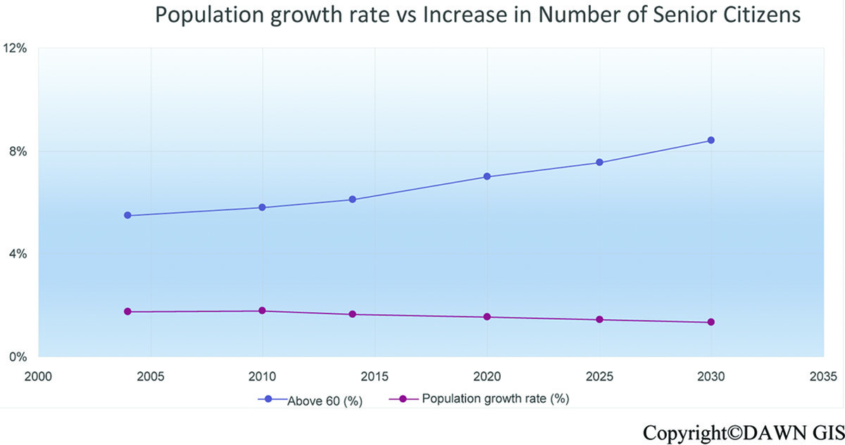
Figure. 1.1. Growth Rate of Seniors’ in Pakistan

Older persons are facing several challenges mainly due to their poor status, insight and exclusion. They depend on others to fulfill their challenges. But by using these smartphones seniors’ can be independent in their lives.
Earlier the smartphone times, communication was done by using mobile phones. The devices that can provide connections to cell phones wirelessly by radio waves in widespread areas is called a smart phone (Chen, Yen, & Chen, 2009). The Short Message Service and voice calls are the basic functions of the mobile phones (Mei Min, Ling Hong, Jian Ai, & Pei Wah, 2012). Mobile phones have uninterruptedly been industrialized by increasing size and capability. Through smart phones they can make calls, send and receive E-mails, download files and share their ideas with outer world. Smart phones have an operating system that accomplished the running downloaded application with touch screen (Aldhaban, 2012; Verkasalo, López-Nicolás, Molina-Castillo, & Bouwman, 2010). Existing examples of the smartphones are the Apple iPhone, Samsung Galaxy phones, that proposed an operating systems in Windows Phone or in Android (Verkasalo, 2010). seniors might face difficulty in adopting advance technologies in smart phones (Kurniawan, 2008). The rate of individuals having a smart phone is progressively growing, even though most of them do not use many of these advanced functions. Pakistan is additionally in accordance with the rest of the world in development of cellular phone industry (Sheikh, Zafar, Pervez, & Bhutta, 2016).
On the rundown of best 10 countries, Pakistan positioned eighth with greatest number of smart phone supporters {Sheikh, 2016 #90}. The restricting component like technology awareness may builds the digital divide between the older and younger generations. This study will advance investigate real recommendations need to decrease this generation gap by measuring the awareness about the usage of smart phones among Senior citizens’ in Lahore. So, they would become the useful part of the society.
1.2. Problem Statement
1.2.1. Conceptual Discussion
Consumers feel empowered when they can appreciate the utilization procedure (Tiu Wright, Newman, & Dennis, 2006). Countless older adults feel nervous and by the thought of using new technologies or their security (Vroman, Arthanat, & Lysack, 2015). Nowadays, smart phone use is one of the study areas that should be explored and invested.
Many investigations have demonstrated that it is a major task for elderly individuals to utilize advanced smart phones, (for web browsing) particularly touch-screens(Leung et al., 2012). In any case, there is extensive variation crosswise over individuals on what they feel is engaging to them in different conditions (Brown, Bayer, & Brown, 1992). The requirements and qualities of the seniors are very not quite the same as those of the more youthful public with regards to smart phone use. In our study, we concentrate on the issues encompassing the ease of use of such tool from the point of view of elderly consumers or citizens. Interestingly, much of the previous research on technology use among Seniors has focused on the reasons why elders do not use technology (Smith, 2004). Few studies explore the loyalty behaviors of dominant market groups such as, senior citizens’ and largely ignoring factors that can improve their empowerment in the society (Meshram & O'Cass, 2013). Senior citizens’ are sure to utilize smart phones, when they are feeling great and educated about the later focal points (Erkert, 1998). Long range informal communication, business, diversion, voyaging, wellbeing wellness are the advantages that the smartphones can give to their consumers in a flash continuously (Xu et al., 2011).
The practice of smartphone usage can be influenced by various aspects like the brands of smartphones or the age of the its user.(Pheeraphuttharangkoon, 2015). Similarly, other features like time, money, information and skill have also an effect a smartphone usage. Nonappearance of learning abilities and poor competence rate moreover de-pushes the senior citizens’.
  - Research Gap
From previous explanations, it can be learnt that phones with advance features (smartphones) play a significant part in supporting the seniors to run their business or to assist their regular livelihoods (Pheeraphuttharangkoon, 2015).
The older people in under developing countries like Pakistan are the only growing age group that preferred the use of smart phones mostly for the most part to perform basic functions like SMS and Phone calls. Having determined that due to a better quality of life and advancement in smart phones, there is the senior citizen’s population that is increasing. However, not all the senior citizens’ are accepting and using the smart phones. Hence, this paper explores a speciﬁc gap within the literature. The gap focuses on the role of smart phone in empowering the senior citizen’s. In the next section, the aim and objectives of this research study are provided.

1.4 Research Question
To further understand this research, the research question was formed:
- Does the smart phone usage empower the senior citizens’ of Lahore?

1.5 Research Objective
To fulfil the aim, the following objective was developed
- To investigate the effect of smart phone usage on the empowerment of senior citizens’ of Lahore.

1.6. Significance of the Study
This study offers an exclusive contribution which are as following:
- This research will display the senior’s points of view and encounters toward smartphone usage, their doubts about its empowerment.
- That aside, the impact of individual elements, for example age, education, working experience might be researched to reveal more insight as how to outline and execute successful and efﬁcient empowering systems.
- For Government, the conclusion can be used as a guide line for the policy maker to support and aid the requirements and desires of the senior citizens’ population.
- For government or strategy originators, the conclusions can be utilized as a procedure to help and assist the necessities and prerequisites of the senior's.

Literature
In this section, the literature review will define the further review on the variables used in this study smart phone and the senior’s empowerment. We can also define a suitable research methodology for this study with the help of literature.
2.1. Literature Review
The recent advances in technology and online social networking in smart phones can have large effects for the comfort of senior citizens’. Technology in smart phones makes it easier for seniors to connect with their loved ones and has made life more useful overall. By using technology and internet their loneliness can reduce and mental health benefits are more often (Cotten, Ford, Ford, & Hale, 2012). There is no doubt that the application of mobile devices can improve and support the lives of the elderly, given the willingness on the part of those concerned to use these devices. This study explored the part of seniors, examined worthy and convenience of innovation, self-adequacy, and state of mind toward utilizing innovation on innovation adoption(Folmer & Bosch, 2010). The way in which senior citizens’ watch development to be important may rely upon the situations they experienced childhood in. Collection of IT items accessible, but the Smartphone is the one most regularly utilized by seniors as a part of regular day to day existence. Smartphones accomplished such a great amount of prevalence since they allow people to keep in contact and have straightforward access to data wherever and at whatever time (Boulos, Wheeler, Tavares, & Jones, 2011). An European study (Mordini et al., 2009) found that "among more younger seniors, say those in the vicinity of 60 and 80 years of age, the primary issues are probably going to be general access to ICT and e-cooperation. Pakistan was hierarchical as most promising state for telecom progress according to Business Monitor International (BMI) (Imtiaz, Khan, & Shakir, 2015).The aging of the population will also result in an increasing number of seniors who have smart phones but no access to the social media (e.g. Face book, Twitter, online communities and chat groups). The social interaction of the seniors helps to reduce their feelings of loneliness and isolation (Cotten, Anderson, & McCullough, 2013).
2.2. Empowerment of Senior Citizens’ (Dependent Variable)
We define empowerment for senior citizens’ as a meaningful shift in the experience of power attained through interaction in the social world. More recognized seniors need to enhance their skills to meet difficult circumstances to be a dynamic member in the society. This is because these difficulties are frequently the aftereffect of debilitation, and social prohibition(Ogg, 2005). The goal to empower the seniors primarily to give them more significant control over their own lives and due noticeable quality in basic leadership in their communities they belong to (Cusack, 1998). Being empowered thus contributing to their social interaction and participation as an active citizen (Fenge, 2006). In particular, presence of empowerment gives them the mental fulfillment to meet the specific conflicts connected to the more established phase of their life cycle, subsequently adding to their social consideration and their support as full-corrected nations (Armadans, Codina, & Pestana, 2015). Among the diverse enabling open doors, struggle preparation in senior citizens’ can speak to a decent open door that lets them to enhance social cooperation, individual to-individual affiliation administration, and associating in the general public (Armadans et al., 2015).
2.3. Smart Phone Usage (Independent Variable)
As the core device of awareness to this research is smartphone, which is an advanced form of a mobile phone. An expanding number of customers get connected to the network by means of smartphones (Ha, Kim, Libaque-Saenz, Chang, & Park, 2015). The most critical component of advanced mobile phones is that dissimilar to cellular phone they enable access to web (Hsiao & Chen, 2015). In this work under the term advanced mobile phone we will consider smart phone that have Internet get to. Internet applications, will be accessible to seniors whenever, which can without much of a stretch transform into over the top utilization of advanced phones. Due to rapid advancement in smart phone usage, the lifecycle of personal communication is changing. The concept of using a function on smart phones, anywhere by any network is rising (Imtiaz et al., 2015).
Since smartphones allow individuals to access the Internet anytime and anywhere, they are emerging as a critical tool to narrow the digital divide. However, if users cannot utilize smartphones easily and freely, they will have difficulties accessing information, to communicate in the on-line community, and to participate actively in the society. This is especially important for senior citizens’ , as smartphones help to enhance not only their quality of life but also the sense of independence and engagement in the society (Kang, Liew, Lim, Jang, & Lee, 2015).There is no doubt that applications of the smart phones are the key features that empower smartphones to be a valuable device and enhancement of mobile phones. Smartphone provides many apps for the readers information too. (Xu et al., 2011) describe these applications into books, corporate, education, entertaining, finance, sports, healthcare, daily routine, medical, melody, navigation, news, photography, social networking (Facebook, tweeter, skype), travelling, services, climates and many more. Users can transfer their instant information with instant networks. Furthermore, the seniors can use their devices to access the information like atlases, navigators, traffic flow information, money exchange (Is4profit, 2010). Through GPS sensor users can find out their desired locations and local news, weather reports on their current location (Xu et al., 2011). From business perspective, Video calls and shearing of photographs are the features offered by camera provide good experience to the seniors in terms of communication. (Is4profit, 2010). The entertainment part of the smart phone is also well recognized. Off line and online videos can also watched through smartphones (Pheeraphuttharangkoon, 2015). Thus, we concluded that smartphone offers vast benefits to the seniors. Now we move towards the relationship between senior’s empowerment and smart phone.
2.4. Smart phone usage and empowerment of senior citizens’
New inventions that recently provide benefits to the seniors are smartphones. Email facility is identified as a most commonly used feature that speedup the working process
in organizations (Beurer-Zuellig & Meckel, 2008). The tracking software installed on smartphones directed towards an interesting finding that the senior’s performance depending on the operating system, with senior’s attention to use SMS and call features massively, followed by web browsing and other advance apps (Verkasalo et al., 2010). Different studies from japan measured how smart phone empowerment impacted seniors. The consequences found that senior citizens’ could improve their skills of using smart phones (Kobayashi et al., 2011) . The major challenge that the senior citizens’ could face in life is familiarizing to variation and to learn innovative skills. We see that one of the best invention comprise of empowering seniors is through smartphones (Ogg, 2005), which usually influence the learning potential with them. (Wagner, Hassanein, & Head, 2010) determined that the barriers stopping seniors from using the advance technology in smartphones were the aspects like lack of information and motivation. Thus, connecting to the internet can empower the seniors and help in reducing them their loneliness and depression. Their familiarity to the internet also increases. The senior’s social isolation and loss of social networks is the decline in their social capital (Putnam, 2001). Social capital is established through individual’s access to social networks (Portes, 1998).
Furthermore, subsequently empowers individuals to remain connected with the group (Ellison, Steinfield, & Lampe, 2007) and the smartphone offers potentially cost-effective and sustainable solutions for people to stay connected with their families, friends and communities. Innovations such as smartphones are viewed to be a means of empowering the seniors (Boontarig, Chutimaskul, Chongsuphajaisiddhi, & Papasratorn, 2012).Our finding will give a hope to the seniors as they are willing and able to learn new technology by using them via smartphones. The use of such technology in smart phones can have a positive effect on their feeling as a part of the society. Prosperity and security have additionally been seen as the most basic purposes for forcing smart phone adoption among more seniors (Bandura, 1989). This study adequately exhibit that seniors can be enabled, that they can take in the ultimate abilities to utilize the advanced mobile phone.

2.6. Theoretical Model

This study draw a theoretical model to find out the effect of technology usage via smartphones on senior’s empowerment. After finding the relation between the variables in literature we draw a following theoretical model for this research by expected that the empowerment is impacted by the utilization of technology via smartphones (independent variable).

Empowerment
(Feeling a part of the society)

Use of Technology
(Smart phones)
Effect

Figure 2.2. Theoretical Model

2.7. Research Hypothesis
“A hypothesis is a statement of the relationship between two variables that can be tested empirically” (Gratton & Jones, 2010). Based on above model, that we draw from literature the following hypothesis can be drawn
H1: Usage of the technology (smart phones) have a positive effect on the empowerment of the senior citizens’.

Research Methodology

After the theoretical model with the identified variables, now we present research methodology of this study.
3.1. Approach
In methodology section, survey strategy was used with questionnaire technique. Moreover, approach such as questionnaire can be discussed as a study tool (Cooper, Schindler, & Sun, 2006). A set of questions that are structured carefully while keeping in mind the research topic and assumed in precisely the similar form to a set of individuals when gathering statistics (Jupp, 2006). A survey generally provides a reasonable and actual method to get facts in an organized and controllable way. For this research that is on smart phone usage and empowerment of senior citizens’ , the data was collected to explain the relationship between these identified variables. Quantitative data was considered suitable for this study because the data was then converted into numbers. Thus, quantitative is a data in numbers (Punch, 2013). Naturally, that type of data does not arise. So, scholars change data into statistics that can be examined (Punch & Oancea, 2014). Numerical data was obtained through questionnaire for this study which means we use quantitative approach. Data was gathered by using a pre-designed and pre-tested semi-structured questionnaire by (Datta et al., 2016).
3.2. Time Horizons
For this study’s purpose and queries, an effort has been done to explore the relationship between smartphone usage and its effect on senior’s empowerment within restricted time duration, where cross sectional study was considered utmost appropriate. Cross section study is “carried out once and represent a snap of one fact in time”(Cooper et al., 2006).

3.3. Data Collection and Analysis
This research obtains the primary data from the survey. Primary data is the statistics composed precisely for an ongoing study (SAUNDERS, LEWIS, & THORNHILL, 2009).
3.4. Sampling
The sampling method in this study include, Population, sampling frame, sample size and sampling technique.
3.4.1. Population
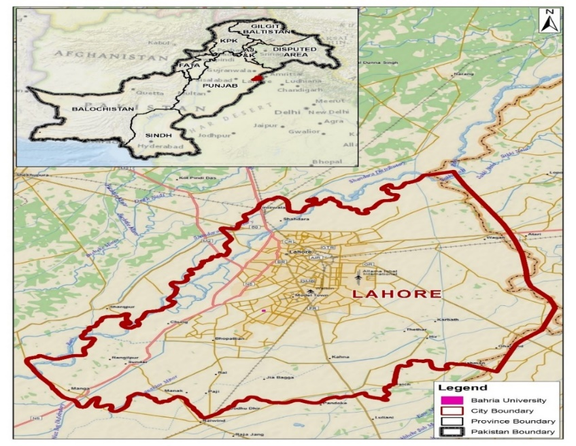
Population is define as the complete group of people (SAUNDERS et al., 2009). There are approximately 1 million senior citizens’ in Lahore. We collected primary data from the senior citizens’ who are still performing their duties in their departments in Lahore after retirement. The network coverage in their areas was well develop.

Figure 3.1. Map of Lahore Region, Pakistan

3.4.2. Sampling Frame
The sampling frame is a list of fundamental components in the population from which the sample is really drawn (Cooper et al., 2006). But for this study, it is unrealistic to contact all the seniors who live in Lahore. So, the participants who are still performing their duties at this age were selected who have smartphones because is it our independent variable.
3.4.3. Sampling Technique
The sampling technique for this study was snowball sampling. This sampling method requires the researcher to follow a chain of personal contacts when choosing a sample. A snow ball is a process that is used when it is very difficult to find appropriate research subjects, as new respondents are located via the previous respondents (Page & Meyer, 1999).
3.4.4. Sample Size
A sample size is subset of the population. For this study, the target was to cross the figure around 130 respondents who have the smart phones. But after data collection, we have the response rate with the figure 159.
3.5. Analysis Method
In questionnaire, Likert-style rating scale was use for capturing the seniors view about technology usage via smartphones and its effect on their empowerment.
3.6. Statistical Analysis
The effect of the research was obtained with the help of diagrams in the form of graphs in MS Excel and calculating values by using SPSS. SPSS offered extensive data-handling capabilities and numerous statistical analysis routines by analyzing the data statistics and dealing with the interaction among variables in the natural data.
3.6.1. Descriptive Statistics
It includes changes of simple information into a form that would give data to depict an arrangement of components in a circumstance. This is done through requesting and by the control of the raw information gathered. Descriptive statistics are given by frequencies, measures of focal inclination and scattering (Sekaran & Bougie, 2016).

3.6.2. Correlation
(Dillon, Madden, & Firtle, 1994) observed that the method or procedure used to measure the degree of association between two factors depends on the measurement scale to which the variables refer. In this study, inter-correlations were done for each of the variables Smartphone usage (independent) and Empowerment (dependent variables). It showed how these variables correlated with and influenced each other.

3.6.3. Linear regression analysis
In regression analysis, we can do either linear or multiple regression to predict the Y and X variables(Cooper et al., 2006). The Y variable is the result of the study, Dependent variable. Y dependents on X (an Independent variable) {Geffen, 2000 #78}. For this study, we have one dependent variable (Empowerment) and independent variable (smartphone) so we do linear regression in our study. Linear regression investigation is the way towards figuring a regression coefficient and regression equation by using identified variables(SAUNDERS et al., 2009). With equation in analysis, the value of dependent variable is predicted. The result of the research will be the regression coefficient that proves the relationship between dependent and independent variables. (SAUNDERS et al., 2009).
3.6.4. Reliability
Reliability mentions the degree to which data assemble methods or investigation process will produce reliable conclusions (SAUNDERS et al., 2009). Reliability concerned with correctness, accuracy, and consistency and is an ultimate, however not adequate condition for validity. Hence, it is not valid if a measure is not reliable (Cooper & Schindler, 2013).
Cronbach's Alpha is a standard means that measures core consistency to demonstrate how well the unusual research variables supplement each other when measuring a similar idea and from a solitary scale (Jupp, 2006). The explanation of Cronbach's Alpha values can be found in Table. As these values, will be considered as homogenous if a record is bigger than 0.7 for positive investigations (Vinzi et al., 2010).

Interpretation of Cronbach's Alpha (α)

Cronbach's Alpha (α) | Internal Consistency
More than 0.9 | Excellent
0.8 to 0.9 | Good
0.7 to 0.8 | Acceptable
< .7 | Unacceptable

Table 3.1. Interpretation of Cronbach's Alpha (α)

Reliability and validity of the questionnaires and analyses of the data are crucial for the acceptance of the results and the credibility of the study. The procedure was intended to boost reliability and validity, the conclusions of the study would thus be able to be acknowledged with a reasonable level of certainty. The calculated Cronbach’s Alpha for our study is:

Reliability Statistics
Cronbach's Alpha | N of Items
0.906 | 17

Data Analysis

The data collected through questionnaire is a raw data that would be worthless unless it could be processed and meaning extracted from it. Data preparation according to (Nel, Rädel, & Loubser, 1988) includes two operations: editing and coding. The procedure of determining whether questionnaires are filled out appropriately and fully is called editing. This includes checking for interviewer and respondent errors. Coding denotes to the method of grouping and assigning numerical codes identifying numerous respondents with a specific question (McDaniel and Gates, 2002).
A variety of statistical analyses were conducted after entering the data in SPSS. The statistical results show that the certain factors have a significant effect on empowerment. The outcomes were showed by pie and bar graphs to make the frequencies easier to read.
4.1. Demographic Analysis
The questionnaire pursued responses from the respondents in terms of the demographic data, which is describe in this part. All the respondents responded. 98 (61.6%) were males and 61(38.4%) were female’s respondents.

Figure 4.1.1. Gender Analysis
Age – group:

Figure 4.1.2. Age-Group Using SPSS

Regarding age, most the respondents 82 (51.6%) were from the 60-64 years’ age group, 70 (44%) were has a place with the age- group of 65-69 years, 6 (3.8%) from the 70-74 years’ age group, 1 (0.6%) from the 75-79 years’ age group and nobody (0%) from the more than 80 years old.
level of education:

Figure 4.1.3. Analysis of Education Using SPSS

For education, the results were diversified with 89 (56%) of the respondents being Master’s degree, 47 (29.6%) respondents had Bachelor’s degree, 3 (1.9%) respondents had high school qualification, 20 (12.6%) respondents had other qualification.
Employment

Figure 4.1.4. Analysis of Employment status

In terms of employment status, 93 (58.5%) respondents were full time employed, 35 (22%) respondents were part time employed, 20 (12.6%) respondents were retired (Unemployed), 11 (6.9%) respondents were self-employed.
Income

Figure 4.1.5. Analysis of Income using SPSS

In terms of monthly income, 26 (16.4%) respondents had <40,000 PKRs. monthly income, 19 (11.9%) respondents had 50,000 PKRs. Income and 114 (71.7%) respondents had >50,000 PKRs income.

Smart phone Brand

I

Figure 4.1.6. Analysis of Smartphone Brand Using SPSS

In terms of Brand, 23 (14.5%) respondents were using IPhone, 108 (67.9%) respondents were using Samsung, 17 (10.7%) respondents were using Nokia and 11 (6.9%) respondents were using other brands smart phones.

Monthly Expenditure

Figure 4.1.7. Analysis of Monthly Expenditure Using SPSS

In terms of monthly expenditure, majority 68 (42.8%) respondents paid around 1000-1900 PKRs, 35 (22%) respondents paid 2000-2900 PKRs, 24 (15.1%) respondents paid 500-900 PKRs, 23 (14.5%) respondents paid > 3000 PKRs and 9 (5.7%) respondents paid <500PKRs.

Health Status

Figure 4.1.8. Analysis of Health Using SPSS

This study looked for respondents to self-analyze their health. The dominant part at 144 (90.6%) of the respondents believed that their health was good. 11 (6.9%) distinguished their health as excellent. However, 4 (2.5%) of the respondents evaluated their health as poor.

4.2. Descriptive Analysis
Statistic is a mathematical representation of data. When we measure, or apply numbers to data to review, establish or better understand the information, we are using statistical approaches. In this section, the measures of central tendencies like mean, median and standard deviation of variables are explained in the following table.

 | Mean | Minimum | Maximum | Std. Deviation
 | Statistic | Statistic | Statistic | Statistic
Independent Variable  1. People important to me think i should use SP | 4.70 | 3 | 5 | 0.487
2. People who influenced my behavior think  that i should use a SP | 4.60 | 2 | 5 | 0.564
3. Whenever possible, I intend to use a  smartphone in my job | 4.29 | 2 | 5 | 0.964
4. I have the resources necessary to use the  smartphone (for example time & money). | 4.74 | 3 | 5 | 0.467
5. I intend to use smartphone for using social  networks like Facebook, twitter, LinkedIn, E-  mail, Browsing. | 4.61 | 2 | 5 | 0.665
6. I believe that using the smartphone is  suitable for me. | 4.43 | 2 | 5 | 0.733
7. I believe that smartphone fits into my work  style. | 4.29 | 2 | 5 | 0.837
8. It help me to finish tasks more quickly. | 4.27 | 2 | 5 | 0.817
9. I intend to use smartphone for making calls  & SMS (Text messages) only. | 1.82 | 1 | 5 | 0.737
10. I feel a smartphone is useful. | 4.36 | 2 | 5 | 0.705
11. I intend to increase my use of smart phone  In the future. | 4.30 | 2 | 5 | 0.663
Dependent Variable  1.Do you think having a smart phone can  empower you? | 4.61 | 2 | 5 | 0.702
2.Do you think having internet facility in mobile  can influence the decisions you make? | 4.58 | 2 | 5 | 0.740
3.Do you think a mobile phone can help in  getting better opportunities? | 4.67 | 2 | 5 | 0.662
4.Do you feel more independent with mobile  phone? | 4.25 | 1 | 5 | 0.954
5.Does internet help you sharing your ideas  with the outer world? | 4.71 | 2 | 5 | 0.555
6.Did you ever get influenced by internet  services to join a political campaign? | 3.01 | 1 | 5 | 1.305
Table 4.2 Descriptive Analysis
It gives us data about Minimum, Maximum, Mean and Standard deviation. Estimations of the greater part of the variable is under 1, so it implies the data for query about is exact.
4.2.1. Standard Deviation
It tells us concerning the scattering or closeness of the information. If value is lesser then its mean that information is more brought together around the mean position and in the event, that it is a huge value, at that point it implies that information is more scattered from the mean value.
In this study, we can see that the clear majority of the values are lesser than one which discloses to us that the information is more exact.
4.3. Frequency Analysis
It gives us data about Mean, Median and Mode of the factors. It can be stated as a sort of Descriptive analysis.

 |  | Q1 | Q2 | Q3 | Q4 | Q5 | Q6 | Q7 | Q8 | Q9 | Q10 | Q11 | Q12 | Q13 | Q14 | Q15 | Q16 | Q17
 | Valid | 159 | 159 | 159 | 159 | 159 | 159 | 159 | 159 | 159 | 159 | 159 | 159 | 159 | 159 | 159 | 159 | 159
 | Missing | 0 | 0 | 0 | 0 | 0 | 0 | 0 | 0 | 0 | 0 | 0 | 0 | 0 | 0 | 0 | 0 | 0
Mean |  | 4.70 | 4.60 | 4.29 | 4.74 | 4.61 | 4.43 | 4.29 | 4.27 | 1.82 | 4.36 | 4.30 | 4.61 | 4.58 | 4.67 | 4.25 | 4.71 | 3.01
Median |  | 5 | 5 | 5 | 5 | 5 | 4 | 4 | 2 | 4 | 4 | 5 | 4 | 4 | 5 | 5 | 5 | 5
Mode |  | 5 | 5 | 5 | 5 | 5 | 5 | 5 | 2 | 5 | 4 | 5 | 5 | 4 | 5 | 5 | 5 | 5
Table 4.3. Frequency Analysis

Mean: The mean is the normal estimation of the variable, processed over all cases
.
Median: The middle indicates to the score which has one portion of the scores on either side of it when the scores have been organized in rising and dropping request.

Mode: The mode can be depicted by the most often and again happening marvel.

The frequency distribution of the variables of this study is given below:

Q No:1 People important to me think I should use SP
71.1% respondents are strongly agreed with this statement where as 1.3% are neutral with this statement.

 |  | Frequency | Percent | Valid Percent | Cumulative Percent
 | Neutral | 2 | 1.3 | 1.3 | 1.3
 | Agree | 44 | 27.7 | 27.7 | 28.9
 | Strongly Agree | 113 | 71.1 | 71.1 | 100.0
 | Total | 159 | 100.0 | 100.0

Table 4.3.1. SPSS Frequency Analysis

Q No:2. People who influence my behavior think that I should use smartphone.

 |  | Frequency | Percent | Valid Percent | Cumulative Percent
Valid | Disagree | 1 | 0.6 | 0.6 | 0.6
Valid | Neutral | 3 | 1.9 | 1.9 | 2.5
Valid | Agree | 55 | 34.6 | 34.6 | 37.1
Valid | Strongly Agree | 100 | 62.9 | 62.9 | 100.0
Valid | Total | 159 | 100.0 | 100.0
62.9% respondents are strongly agreed with this statement whereas only 0.6% are Disagree with this statement.

Table 4.3.2. SPSS Frequency Analysis

Q No:3 Whenever possible, I intend to use a smartphone in my job.

57.9% respondents are strongly agreed whereas 6.9% are disagree with this statement.

 |  | Frequency | Percent | Valid Percent | Cumulative Percent
 | Disagree | 11 | 6.9 | 6.9 | 6.9
 | Neutral | 24 | 15.1 | 15.1 | 22.0
 | Agree | 32 | 20.1 | 20.1 | 42.1
 | Strongly Agree | 92 | 57.9 | 57.9 | 100.0
 | Total | 159 | 100.0 | 100.0

Table 4.3.3. SPSS Frequency Analysis

Q No:4. I have the resources necessary to use the smartphone (for example
time & money)

1.3% respondents are neutral about this statement where as 75.5 % strongly agree to
this statement.
 |  | Frequency | Percent | Valid Percent | Cumulative Percent
 | Neutral | 2 | 1.3 | 1.3 | 1.3
 | Agree | 37 | 23.3 | 23.3 | 24.5
 | Strongly Agree | 120 | 75.5 | 75.5 | 100.0
 | Total | 159 | 100.0 | 100.0

Table 4.3.4. SPSS Frequency Analysis

Q No: 5. I intend to use smartphone for using social networks like Facebook,
twitter, LinkedIn, E-mail, Browsing.

2.5% respondents are disagreed with this statement where as 68.6 % strongly agreed
to this statement.
 |  | Frequency | Percent | Valid Percent | Cumulative Percent
 | Disagree | 4 | 2.5 | 2.5 | 2.5
 | Neutral | 4 | 2.5 | 2.5 | 5.0
 | Agree | 42 | 26.4 | 26.4 | 31.4
 | Strongly Agree | 109 | 68.6 | 68.6 | 100.0
 | Total | 159 | 100.0 | 100.0

Table 4.3.5. SPSS Frequency Analysis

Q No:6 I believe that using the smartphone is suitable for me.

55.3 % respondents are strongly agreed with this statement where as 8.8 %
neutral to this statement.
 |  | Frequency | Percent | Valid Percent | Cumulative Percent
 | Disagree | 3 | 1.9 | 1.9 | 1.9
 | Neutral | 14 | 8.8 | 8.8 | 10.7
 | Agree | 54 | 34.0 | 34.0 | 44.7
 | Strongly Agree | 88 | 55.3 | 55.3 | 100.0
 | Total | 159 | 100.0 | 100.0

Table 4.3.6. SPSS Frequency Analysis

Q No:7 I believe that smartphone fits into my work style.

49.1 % respondents are strongly agreed with this statement where as 4.4 % disagree to this statement.

 |  | Frequency | Percent | Valid Percent | Cumulative Percent
 | Disagree | 7 | 4.4 | 4.4 | 4.4
 | Neutral | 18 | 11.3 | 11.3 | 15.7
 | Agree | 56 | 35.2 | 35.2 | 50.9
 | Strongly Agree | 78 | 49.1 | 49.1 | 100.0
 | Total | 159 | 100.0 | 100.0

Table 4.3.7. SPSS Frequency Analysis

Q No: 8 It help me to finish tasks more quickly.

45.3 % respondents are strongly agreed with this statement where as 5 % disagree to this statement.

 |  | Frequency | Percent | Valid Percent | Cumulative Percent
 | Disagree | 8 | 5.0 | 5.0 | 5.0
 | Neutral | 13 | 8.2 | 8.2 | 13.2
 | Agree | 66 | 41.5 | 41.5 | 54.7
 | Strongly Agree | 72 | 45.3 | 45.3 | 100.0
 | Total | 159 | 100.0 | 100.0

Table 4.3.8. SPSS Frequency Analysis

Q No: 9 I intend to use smartphone for making calls & SMS (Text messages) only.

58.5 % respondents are disagreed with this statement where as 1.3 % strongly agreed to this statement.
 |  | Frequency | Percent | Valid Percent | Cumulative Percent
 | Strongly Disagree | 51 | 32.1 | 32.1 | 32.1
 | Disagree | 93 | 58.5 | 58.5 | 90.6
 | Neutral | 10 | 6.3 | 6.3 | 96.9
 | Agree | 3 | 1.9 | 1.9 | 98.7
 | Strongly Agree | 2 | 1.3 | 1.3 | 100.0
 | Total | 159 | 100.0 | 100.0

Table 4.3.9. SPSS Frequency Analysis

Q No:10. I feel a smartphone is useful

48.4 % respondents are strongly agreed with this statement where as 0.6 % disagreed to this statement.

 |  | Frequency | Percent | Valid Percent | Cumulative Percent
 | Disagree | 1 | 0.6 | 0.6 | 0.6
 | Neutral | 18 | 11.3 | 11.3 | 11.9
 | Agree | 63 | 39.6 | 39.6 | 51.6
 | Strongly Agree | 77 | 48.4 | 48.4 | 100.0
 | Total | 159 | 100.0 | 100.0

Table 4.3.10. SPSS Frequency Analysis

Q No 11: I intend to increase my use of smart phone in the future.

49.1 % respondents are agreed with this statement where as 0.6 % disagreed to this statement.

 |  | Frequency | Percent | Valid Percent | Cumulative Percent
 | Disagree | 1 | 0.6 | 0.6 | 0.6
 | Neutral | 15 | 9.4 | 9.4 | 10.1
 | Agree | 78 | 49.1 | 49.1 | 59.1
 | Strongly Agree | 65 | 40.9 | 40.9 | 100.0
 | Total | 159 | 100.0 | 100.0

Table 4.3.11. SPSS Frequency Analysis

Q No 12: Do you think having a smart phone can empower you?

71.1 % respondents are strongly agreed with this statement where as 2.5 %
disagreed to this statement.
 |  | Frequency | Percent | Valid Percent | Cumulative Percent
 | Disagree | 4 | 2.5 | 2.5 | 2.5
 | Neutral | 8 | 5.0 | 5.0 | 7.5
 | Agree | 34 | 21.4 | 21.4 | 28.9
 | Strongly Agree | 113 | 71.1 | 71.1 | 100.0
 | Total | 159 | 100.0 | 100.0

Table 4.3.12. SPSS Frequency Analysis

Q No 13: Do you think having internet facility in mobile can influence the
decisions you make?

69.8 % respondents are strongly agreed with this statement where as 3.8 % disagreed to this statement.

 |  | Frequency | Percent | Valid Percent | Cumulative Percent
 | Disagree | 6 | 3.8 | 3.8 | 3.8
 | Neutral | 6 | 3.8 | 3.8 | 7.5
 | Agree | 36 | 22.6 | 22.6 | 30.2
 | Strongly Agree | 111 | 69.8 | 69.8 | 100.0
 | Total | 159 | 100.0 | 100.0

Table 4.3.13. SPSS Frequency Analysis

Q No14: Do you think a mobile phone can help in getting better opportunities?

74.8 % respondents are strongly agreed with this statement where as 2.5 % disagreed to this statement.

 |  | Frequency | Percent | Valid Percent | Cumulative Percent
 | Disagree | 4 | 2.5 | 2.5 | 2.5
 | Neutral | 5 | 3.1 | 3.1 | 5.7
 | Agree | 31 | 19.5 | 19.5 | 25.2
 | Strongly Agree | 119 | 74.8 | 74.8 | 100.0
 | Total | 159 | 100.0 | 100.0

Table 4.3.14. SPSS Frequency Analysis

Q No 15: Do you feel more independent with mobile phone?

52.2 % respondents are strongly agreed with this statement where as 1.3 % strongly disagreed to this statement.

 |  | Frequency | Percent | Valid Percent | Cumulative Percent
 | Strongly Disagree | 2 | 1.3 | 1.3 | 1.3
 | Disagree | 8 | 5.0 | 5.0 | 6.3
 | Neutral | 21 | 13.2 | 13.2 | 19.5
 | Agree | 45 | 28.3 | 28.3 | 47.8
 | Strongly Agree | 83 | 52.2 | 52.2 | 100.0
 | Total | 159 | 100.0 | 100.0

Table 4.3.15. SPSS Frequency Analysis

Q No 16: Does internet help you sharing your ideas with the outer world

75.5 % respondents are strongly agreed with this statement where as 0.6 % disagreed to this statement.

 |  | Frequency | Percent | Valid Percent | Cumulative Percent
 | Disagree | 1 | 0.6 | 0.6 | 0.6
 | Neutral | 5 | 3.1 | 3.1 | 3.8
 | Agree | 33 | 20.8 | 20.8 | 24.5
 | Strongly Agree | 120 | 75.5 | 75.5 | 100.0
 | Total | 159 | 100.0 | 100.0

Table 4.3.16. SPSS Frequency Analysis

Q No 17: Did you ever get influenced by internet services to join a political
campaign?

25.8 % respondents are disagreed with this statement where as 15.1 % strongly agreed to this statement.
 |  | Frequency | Percent | Valid Percent | Cumulative Percent
 | Strongly Disagree | 23 | 14.5 | 14.5 | 14.5
 | Disagree | 41 | 25.8 | 25.8 | 40.3
 | Neutral | 31 | 19.5 | 19.5 | 59.7
 | Agree | 40 | 25.2 | 25.2 | 84.9
 | Strongly Agree | 24 | 15.1 | 15.1 | 100.0
 | Total | 159 | 100.0 | 100.0

Table 4.3.17. SPSS Frequency Analysis

4.4. Reliability and Validity
Consistency is associated with the term reliability while correctness is related with the term validity (Hair, 2015). It is along these lines obvious that if any explanation of the results is to be made, the acceptability of the study must be recognized through the assurance of its reliability quality and validity (Sardha, 2000).

    - Reliability
Cronbach’s Co-Efficient Alpha is reliability co-efficient that shows how individually of the variables are absolutely correlated to each other. Cronbach’s Alpha calculate the intercorrelations between the variables measuring the perception of the study. The nearer Cronbach's Alpha is to 1, the higher the internal reliability.

Case Processing Summary
 |  | N | %
Cases | Valid | 159 | 100.0
Cases | Excludedª | 0 | .0
Cases | Total | 159 | 100.0
Table 4.4.1. Variables validity
(IV & DV)

Reliability Statistics
Cronbach's Alpha | N of Items
.906 | 17
Table 4.4.2. Reliability Statistics

The Threshold value for Cronbach’s Alpha is ≥ 0.7. The value achieved from the analysis is 0.906, so it can be considered and taken in as a reliable data. In this study, the Cronbach’s alpha was > 0.7, which indicates a strong reliability for our survey instrument.

    - Variable Reliability
4..4.2.1. Independent variable (IV)
Each study has no less than two factors, Dependent (DV) and Independent (IV). The factor (IV) is often thought of as our input variable. Cronbach’s Co-Efficient Alpha of each variable is measured to indicate how each of the independent variable (IV) in a set are positively correlated to each other.

Case Processing Summary
 |  | N | %
Cases | Valid | 159 | 100.0
Cases | Excludedª | 0 | .0
Cases | Total | 159 | 100.0
Table 4.4.3. List wise deletion based on all
IV in the procedure.

Reliability Statistics
Cronbach's Alpha | N of Items
.868 | 11

Table.4.4.4. Reliability Statistics of IV

Threshold value for Cronbach’s Alpha is ≥ 0.7. The value achieved from the analysis is 0.868, so it can be considered and taken in as a reliable data. Which means that each of the independent variable (IV) in a set are positively correlated to each other.
      - Dependent Variable (DV)
The dependent variable (DV), or outcome variable, is dependent on our independent variable. Cronbach’s Co-Efficient Alpha of each dependent variable is measured to indicate how each of the dependent variable (DV) positively correlated to each other.
Case Processing Summary
 |  | N | %
Cases | Valid | 159 | 100.0
Cases | Excludedª | 0 | .0
Cases | Total | 159 | 100.0
Table 4.4.5. a. List wise deletion based
on all DV in the procedure.

Reliability Statistics
Cronbach's Alpha | N of Items
.822 | 6

Table 4.4.6 Reliability Statistics of DV

Threshold value for Cronbach’s Alpha is ≥ 0.7. The value attained from the analysis is 0.822, so it can be considered and taken in as a reliable data. Which means that each of the dependent variable (DV) in a set are positively correlated to each other.
  - Factor analysis
Having explained the reliability, the next we do is validity. It is significant to show that the gathered information is valid and meets statistical values. In this study, factor analysis was applied to determine the validity of the surveys. Exploratory factor analysis using principle component analysis was applied to assess the develop validity using SPSS. The instrument to validate in this research started with a sampling competency that applied Kaiser-Meyer-Olkin and Bartlett's Test. The estimation display was approved using reflective measurements that include Anti-Image Correlation, communalities, total variance, scree plot and the rotated component matrix. These validation results will be explained in the following section.
    - Sample Adequacy- “Kaiser-Meyer-Olkin and Bartlett’ Test”
The Kaiser-Meyer-Olkin (KMO) is the primary test of the factors to look at the gathered information and to measure the sample capability. A KMO value ranges from 0 to 1, and value > 0.6 is acceptable {Brace, 2003 #87}; {Hinton, #88}. The information from the respondents (n=159) was utilized for this test. The information was analyzed using SPSS that brought about an estimation of 0.925, as appeared in table. This outcome proposes that this dataset is worthy to further analysis for giving an applied model.

KMO and Bartlett's Test
Kaiser-Meyer-Olkin Measure of Sampling Adequacy. |  | .925
Bartlett's Test of Sphericity | Approx. Chi-Square | 1193.559
Bartlett's Test of Sphericity | Df | 45
Bartlett's Test of Sphericity | Sig. | .000

Table 4.5.1. KMO and Bartlett’s Test

Bartlett's sphericity test is the second test that shows and examine whether there is a relationship between the factors. A p-value under 0.05 displays satisfaction {Hinton, #88} and was utilized as the controlling measure. Table validate that for the gathered information the p-value is under 0.05, which proposed that it is suitable to perform further analysis.

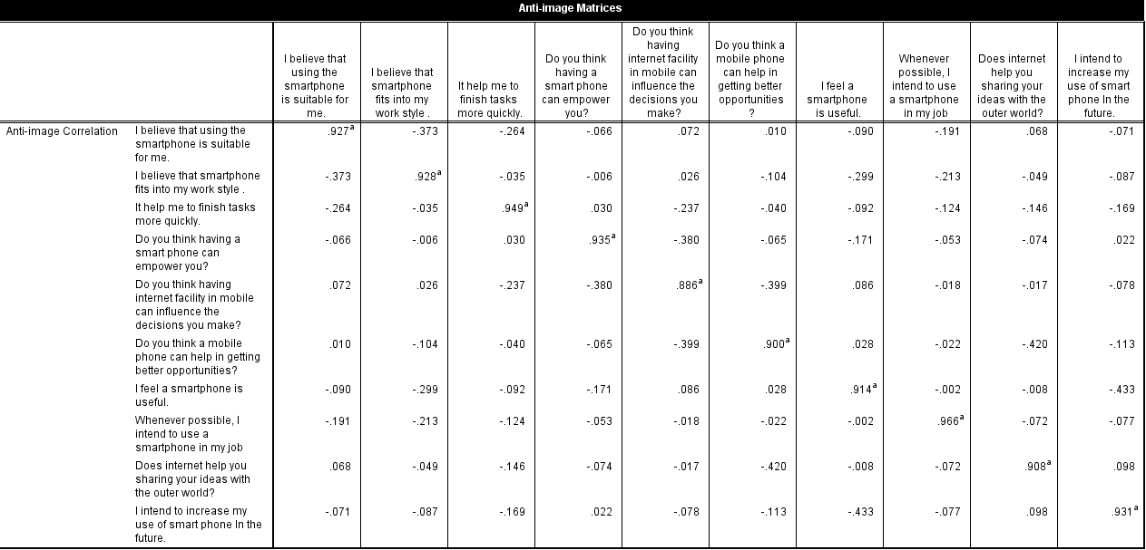
    - Anti-Image Correlation

Table 4.5.2. Anti-Image Correlation

    - Communalities
Varimax rotation was used for further interpretation. Extracted Factors were shown in the table. The factor loadings are all above 0.5, which is its threshold value. The communalities of a variable show the degree of the variation in this factor, which is accounted by the common factor. Which proposed that it is appropriate to go for further analysis.
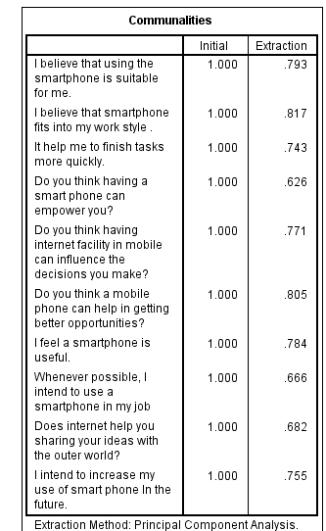

Table 4.5.3. Communalities

Factors were extracted through principle component analysis. Factors whose eigenvalues were > 1.0 were extracted. The factors extracted was likewise shown by the point before the curve in the scree plot ﬂattens out.

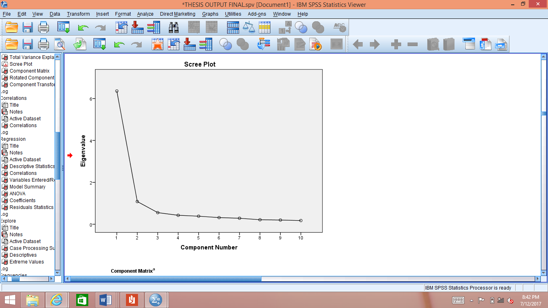

Figure 4.5.1. Scree Plot

    - Total Variance
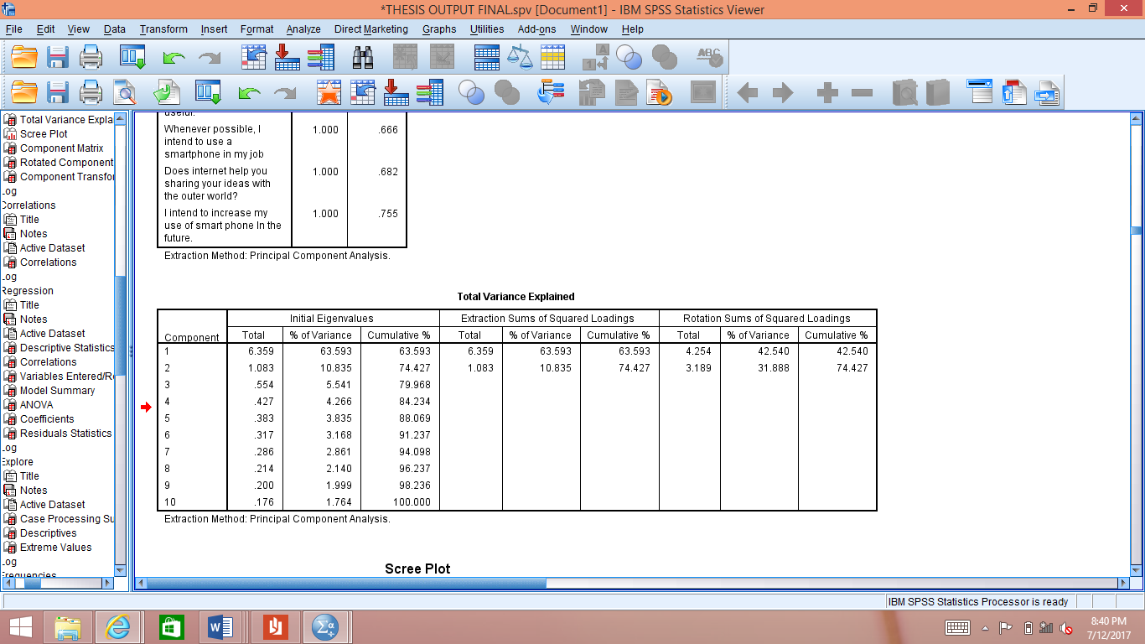
The table shows that 74.42% of the variance is explained by the smart phone usage (Independent Variable) data and empowerment (Dependent Variable) data. The Threshold value for total variance must be greater than 60%. Which proposed to conduct further analysis.
Table 4.5.4. Total Variance Explained

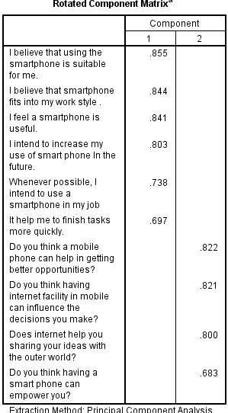
    - Rotated Component Matrix

Table 4.5.5. Rotated Component Matrix
In rotated component matrix, component 1 is smart phone usage. Senior citizens’ used smart phone because they think it is suitable for them. They use the smart phones to perform their daily task and it helps them to complete their task more quickly. They intend to increase the smart phone use in future whenever possible.
Component 2 is termed as empowerment, Consistent with the results of previous factor senior citizens’ feel empowered with the use of smart phone. Senior’s think that smart phone usage helps them in getting better opportunities. They can shear their ideas to the outer world with smart phone. It can influence the decision they make.

Results also prove adequate discriminant validity. Jointly, the hypotheses in this research prove both validity and reliability.
  - Linear Regression
We select linear regression since we have one Independent Variable (IV) and one Dependent Variable (DV). Firstly, all the questions of smart phone usage (technology) were taken as independent variable (IV) and its effect was checked on dependent variable (DV), which in our study is empowerment. Its descriptive statistics (standard deviation and mean) are shown in table.
Descriptive Statistics
 | Mean | Std. Deviation | N
DV | 4.3050 | .62310 | 159
IV | 4.2184 | .46536 | 159

Table 4.6.1. Descriptive Analysis

Mean must be within the range of <5 and >1. Mean of IV and DV both lies within the range. The standard deviation must be <1. In this study, Standard deviation of IV and DV both lies within the threshold limit.
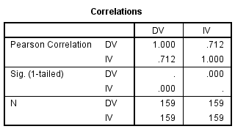

Table 4.6.2. Correlation

Pearson correlation shows the strength or relationship between IV and DV. If the correlation value is 1 its shows the positive correlation. If it is 0 it means that there is no relationship between IV and DV. If correlation value is -1, it shows the negative
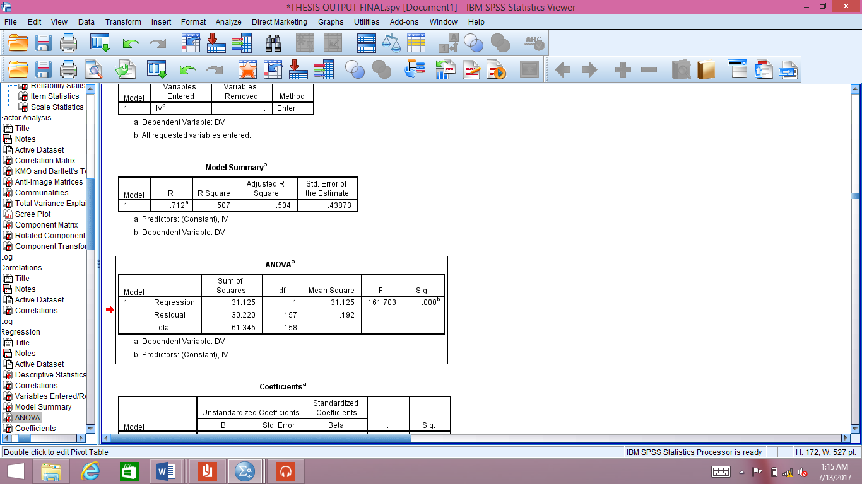
correlation. For this study, Pearson correlation between IV and DV is 0.712, which shows a positive strong relationship between IV and DV.
Table 4.6.3. Model Summary

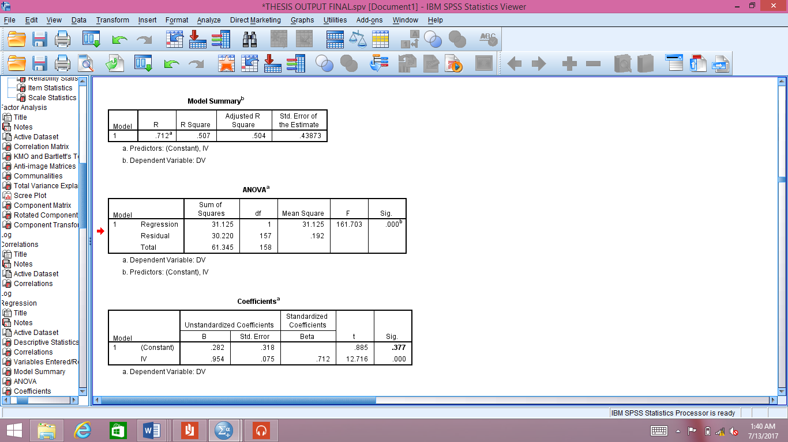
R square value shows us that 50.7 % variance in the Empowerment is accounted and controlled by Smart Phone usage.
Table 4.6.4. ANOVA

This shows us that model is good and fit for the purpose because the significance value “p” value is 0.000 which is within the threshold limit of 0.01. It means by rejecting null hypothesis, we go for alternate hypothesis for this study which shows that there is a relationship between IV and DV. Now we go for regression.

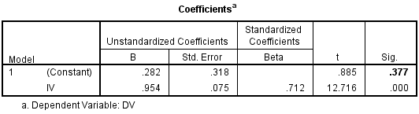

Table 4.6.5. Coefficients of Variables

From this table, we can derive a regression equation to further analyze the effect of independent variable (Smart phone usage) on the dependent variable (Empowerment). The regression equation for this study is:

y = α + β (x) ……… Eq. 1

y = Dependent Variable α = Alpha
x = Independent Variable β = Beta

By putting their values from coefficient table, we have
y = 0.282 + 0.954 (x).…Eq. 2
This equation tells us that if there is a one unit variation in smart phone usage to the upper side then it will have an impact of (0.282+0.954(1)) on the empowerment of the senior citizen which is equal to 1.236. So, it means that if smart phone usage is increased by 1 unit then empowerment will be 1.236 units.
However, it must be highlighted that the hypotheses of the present study have been proven to be true that smart phone usage has a positive effect on the senior citizen’s empowerment. In this study respondents remarked that they feel empowered with the technology used in smart phone, and their behavior changed in society as they start to feel like an active participant of the society.
Furthermore, statistical analysis of the hypothesis testing for this study with the “p” value less than 0.01 which is 0.000 shows that the smart phone usage has a positive effect on senior citizen’s empowerment.

Hypothesis Path Result
H1: Usage of the technology (Smart Phones) Empowerment Statistically signiﬁcant

Table 4.6.7. Hypothesis

Discussion & Conclusion
The results of the hypothesis are obtained by performing different analysis on the data collected from Lahore that accomplished the theoretical framework for this study. Now we discussed and conclude our finding. Using SPSS statistic attained the results of this study. This study exposes that the large number of senior citizen’s in Lahore feel empowered after using smart phone.
5.1. Implementation of This Study
Policy makers, industries and universities are the fields were this study can be implemented.
In Industries
The smart phone producers, network providers and smart phones application designers are the key stakeholders that can use this study in their practical domain. In this study senior’s empowerment, has been measured by using smart phone. These stakeholders can use the social media like T.V or printing media like newspapers and magazines to encourage the smartphone empowerment within senior citizens’.
In terms of facts, smartphone producers might consider to provide trainings for senior citizens’ on how to use it. Through trainings they can help them to use the smart phones in future as this study examined that majority number of seniors are agreed to use smart phones in future.
In Universities
In future, the researchers by adopting this study and by using experimental, approach can empower the senior citizens’. By using the questionnaire from appendix as a guideline to study the relationship of empowerment and smartphone usage.
Policy-Makers
This study also help the policy makers of mobile phone companies that are targeting to encourage and empowered the seniors with technology use through smart phone. As result shows us that majority of seniors use the smart phones to share their ideas with outer world. They can contact to their friends and family members. The policy-makers of

commercial organizations can use these confirmed variables to encourage their senior employees to be empowered.
5.2. Findings
This research find out that the smart phones have a positive effect on senior citizens’ empowerment as they start behaving like an active citizens’. Smart phones empowered them in their jobs as well as in daily lives.
5.3. Limitations
For the validation of any study, the reader needs assistance when referring {Cooper, 2006 #69}. After explaining the research implementation or contribution, now this section will explain the limitations.
- Future researchers could empower the seniors with smart phone usage by using experimental approach.
- The Second limitation is the location of this study. Due to limited time, only the perspective of the senior’s living in Lahore was viewed. Due to only one area used in this study, so the opinion of the other Pakistanis is not possible.
5.4. Future Directions
After the limitations, now we explain the future directions.
- As this study use quantitative approach, in future this study can be reviewed for further understanding by using qualitative approach along with data gathering technique such as interviews, observation or focus groups.
- Other cites or rural areas of Pakistan can be examined in future.
5.5. Recommendations
This study cannot found much research on the smart phone usage and its effects on senior’s empowerment in Pakistan. This study in economic term to create a value can be relate to the source of smartphone brands like LG, Samsung, Apple IPhone that majority of the seniors’ use in Pakistan.
The stakeholders must offer not only trainings to seniors on basic smart phone functions like calls and messages etc, but also give them the knowledge about smart phone usage in their lifestyle that is different from youngers to give them the feeling of an active participant in the society.
5.6. Thesis Conclusions
After the statistical analysis from SPSS, this study find out that majority of the seniors is connected worldwide only because of there smart phones. The tool which is used to empower the seniors is smart phone, successor of mobile phones. It helps them to shear their ideas with outer world. Stakeholders must offer the support to encourage the seniors to use smart phones. Since this group is very important to the economy because of its wealth making and wealth holding abilities. Along these lines, this study demonstrates that this statistic assembly of the seniors needs and warrants dedication. This thesis is currently at end and we hope that it has been informed to the different stakeholders of the smartphone suppliers to give careful attention towards senior citizens’ empowerment.

List of Reference

Ahmad, R. (2002). The older or ageing consumers in the UK: are they really that different? International Journal of Market Research, 44(3), 337.
Ahmed, A., Chaudhry, A. G., & Khan, S. (2015). Declining Age and Social Roles: A Gerontological Perspective of Older Persons of Rawalpindi. Age, 200, 300.
Akour, I. A., & Dwairi, M. A. (2011). Testing technology acceptance model in developing countries: The case of Jordan. International Journal of Business and Social Science, 2(14).
Aldhaban, F. (2012). Exploring the adoption of Smartphone technology: Literature review. Paper presented at the Technology Management for Emerging Technologies (PICMET), 2012 Proceedings of PICMET'12:.
Alharbi, S., & Drew, S. (2014). Using the technology acceptance model in understanding academics’ behavioural intention to use learning management systems. International Journal of Advanced Computer Science and Applications, 5(1), 143-155.
Armadans, I., Codina, N., & Pestana, J. V. (2015). Empowering Senior citizens’ in Leisure Settings Through Mediation: Becoming a Mediator. Educational Gerontology, 41(4), 282-291.
Avgerou, C. (2003). The link between ICT and economic growth in the discourse of development Organizational information systems in the context of globalization (pp. 373-386): Springer.
Bandura, A. (1989). Six theories of child development. Annals of child development, 6, 1-60.
Beurer-Zuellig, B., & Meckel, M. (2008). Smartphones enabling mobile collaboration. Paper presented at the Hawaii International Conference on System Sciences, Proceedings of the 41st Annual.
Boontarig, W., Chutimaskul, W., Chongsuphajaisiddhi, V., & Papasratorn, B. (2012). Factors influencing the Thai elderly intention to use smartphone for e-Health services. Paper presented at the Humanities, Science and Engineering Research (SHUSER), 2012 IEEE Symposium on.
Boulos, M. N. K., Wheeler, S., Tavares, C., & Jones, R. (2011). How smartphones are changing the face of mobile and participatory healthcare: an overview, with example from eCAALYX. Biomedical engineering online, 10(1), 24.
Bracken, C. C., Yang, H., & Pettey, G. (2015). “What I Love about Technology”: Older Adults and Mobile Communication Technologies. Studies in Media and Communication, 3(1), 127-133.
Brophy, C., Blackler, A., & Popovic, V. (2015). Aging and everyday technology. Paper presented at the Proceedings of the 6th IASDR (The International Association of Societies of Design Research Congress).
Brown, R. I., Bayer, M. B., & Brown, P. M. (1992). Empowerment and developmental handicaps: Choices and quality of life: Captus Press.
Chen, J. V., Yen, D. C., & Chen, K. (2009). The acceptance and diffusion of the innovative smart phone use: A case study of a delivery service company in logistics. Information & Management, 46(4), 241-248.
Choudrie, J., Pheeraphuttharangkoon, S., Zamani, E., & Giaglis, G. (2014). Investigating the adoption and use of smartphones in the UK: a silver-surfers perspective.
Condie, R., & Munro, B. (2007). The impact of ICT in schools: Landscape review.
Conger, J. A., & Kanungo, R. N. (1988). The empowerment process: Integrating theory and practice. Academy of management review, 13(3), 471-482.
Cooper, D. R., Schindler, P. S., & Sun, J. (2006). Business research methods (Vol. 9): McGraw-Hill Irwin New York.
Cotten, S. R., Anderson, W. A., & McCullough, B. M. (2013). Impact of internet use on loneliness and contact with others among older adults: cross-sectional analysis. Journal of medical Internet research, 15(2).
Cotten, S. R., Ford, G., Ford, S., & Hale, T. M. (2012). Internet use and depression among older adults. Computers in Human Behavior, 28(2), 496-499.
Cova, B., & Pace, S. (2006). Brand community of convenience products: new forms of customer empowerment–the case “my Nutella The Community”. European Journal of Marketing, 40(9/10), 1087-1105.
Cusack, S. A. (1998). Leadership in Seniors' Centres: power and empowerment in relations between seniors and staff. Education and Ageing, 13, 49-66.
Datta, A., Datta, S. S., Karmakar, N., Nag, K., Tripura, K., & Bhattacharjee, P. (2016). A cross-sectional study regarding usage of mobile phone and internet facilities through mobile handsets and its role in empowering adolescent school going girls in a peri-urban area of Tripura, India. International Journal Of Community Medicine And Public Health, 3(12), 3538-3543.
Dillon, W. R., Madden, T. J., & Firtle, N. H. (1994). Marketing research in a marketing environment: Richard d Irwin.
Ellison, N. B., Steinfield, C., & Lampe, C. (2007). The benefits of Facebook “friends:” Social capital and college students’ use of online social network sites. Journal of Computer‐Mediated Communication, 12(4), 1143-1168.
Folmer, E., & Bosch, J. (2010). Experiences with software architecture analysis of usability. Web engineering advancements and trends: building new dimensions of information technology: building new dimensions of information technology, 177.
Fuglsang, L. (2005). IT and senior citizens’ : Using the Internet for empowering active citizenship. Science, Technology, & Human Values, 30(4), 468-495.
Gefen, D., Straub, D., & Boudreau, M.-C. (2000). Structural equation modeling and regression: Guidelines for research practice. Communications of the association for information systems, 4(1), 7.
Gelderblom, H., Van Dyk, T., & Van Biljon, J. (2010). Mobile phone adoption: Do existing models adequately capture the actual usage of older adults? Paper presented at the Proceedings of the 2010 annual research conference of the south african institute of computer scientists and information technologists.
Gratton, C., & Jones, I. (2010). Research methods for sports studies: Taylor & Francis.
Ha, Y. W., Kim, J., Libaque-Saenz, C. F., Chang, Y., & Park, M.-C. (2015). Use and gratifications of mobile SNSs: Facebook and KakaoTalk in Korea. Telematics and Informatics, 32(3), 425-438.
Imtiaz, S. Y., Khan, M. A., & Shakir, M. (2015). Telecom sector of Pakistan: Potential, challenges and business opportunities. Telematics and Informatics, 32(2), 254-258.
Islam, T., Islam, T., Khan, M. M., Khan, M. M., Bukhari, F. H., & Bukhari, F. H. (2016). The role of organizational learning culture and psychological empowerment in reducing turnover intention and enhancing citizenship behavior. The Learning Organization, 23(2/3), 156-169.
Jeyaraj, A., Rottman, J. W., & Lacity, M. C. (2006). A review of the predictors, linkages, and biases in IT innovation adoption research. Journal of information technology, 21(1), 1-23.
Jupp, V. (2006). The Sage dictionary of social research methods: Sage.
Kang, M., Liew, B. Y. T., Lim, H., Jang, J., & Lee, S. (2015). Investigating the determinants of mobile learning acceptance in Korea using UTAUT2 Emerging issues in smart learning (pp. 209-216): Springer.
Kobayashi, M., Hiyama, A., Miura, T., Asakawa, C., Hirose, M., & Ifukube, T. (2011). Elderly user evaluation of mobile touchscreen interactions. Human-computer interaction–INTERACT 2011, 83-99.
Koberg, C. S., Boss, R. W., Senjem, J. C., & Goodman, E. A. (1999). Antecedents and outcomes of empowerment: Empirical evidence from the health care industry. Group & organization management, 24(1), 71-91.
Kurniawan, S. (2008). Older people and mobile phones: A multi-method investigation. International Journal of Human-Computer Studies, 66(12), 889-901.
Kurniawan, S., Mahmud, M., & Nugroho, Y. (2006). A study of the use of mobile phones by older persons. Paper presented at the CHI'06 extended abstracts on Human factors in computing systems.
Lee, B., Chen, Y., & Hewitt, L. (2011). Age differences in constraints encountered by seniors in their use of computers and the internet. Computers in Human Behavior, 27(3), 1231-1237.
Leung, R., Tang, C., Haddad, S., Mcgrenere, J., Graf, P., & Ingriany, V. (2012). How older adults learn to use mobile devices: Survey and field investigations. ACM Transactions on Accessible Computing (TACCESS), 4(3), 11.
McGregor, S. (2005). Sustainable consumer empowerment through critical consumer education: A typology of consumer education approaches. International Journal of Consumer Studies, 29(5), 437-447.
McLean, A. (1995). Empowerment and the psychiatric consumer/ex-patient movement in the United States: Contradictions, crisis and change. Social Science & Medicine, 40(8), 1053-1071.
McMillan, M. S., & Rodrik, D. (2011). Globalization, structural change and productivity growth: National Bureau of Economic Research.
Mei Min, C., Ling Hong, C., Jian Ai, Y., & Pei Wah, W. (2012). Conceptual Paper: Factors Affecting the Demand of Smartphone among Young Adult. International Journal on Social Science, Economics and Art, 2(2), 44-49.
Menon, N. R., & Patil, A. P. (2016). Health care of senior citizens’ in Indian scenario: A technological perspective. Paper presented at the ICT in Business Industry & Government (ICTBIG), International Conference on.
Meshram, K., & O'Cass, A. (2013). Empowering senior citizens’ via third places: research driven model development of seniors' empowerment and social engagement in social places. Journal of Services Marketing, 27(2), 141-154.
Mordini, E., Wright, D., Wadhwa, K., De Hert, P., Mantovani, E., Thestrup, J., . . . Vater, I. (2009). Senior citizens’ and the ethics of e-inclusion. Ethics and Information Technology, 11(3), 203-220.
Nel, P. A., Rädel, F. E., & Loubser, M. (1988). Researching the South African Market (Vol. 3): University of South Africa.
Ogg, J. (2005). Social exclusion and insecurity among older Europeans: the influence of welfare regimes. Ageing & Society, 25(1), 69-90.
Page, C., & Meyer, D. (1999). Applied research design for business and management: McGraw-Hill Higher Education.
Pheeraphuttharangkoon, S. (2015). The Adoption, Use and Diffusion of Smartphones among Adults over Fifty in the UK.
Portes, A. (1998). Social capital: Its origins and applications in modern sociology. Annual review of sociology, 24(1), 1-24.
Prahalad, C. K., & Ramaswamy, V. (2004). Co-creation experiences: The next practice in value creation. Journal of interactive marketing, 18(3), 5-14.
Punch, K. F. (2013). Introduction to social research: Quantitative and qualitative approaches: Sage.
Punch, K. F., & Oancea, A. (2014). Introduction to research methods in education: Sage.
Putnam, R. D. (2001). Bowling alone: The collapse and revival of American community: Simon and Schuster.
Roebuck, J. (1979). When does" old age begin?: The evolution of the English definition. Journal of Social History, 12(3), 416-428.
Rouse, M. (2005). ICT (information and communications technology-or technologies). Retrieved 22nd July from WhatIs. com.
SAUNDERS, M., LEWIS, P., & THORNHILL, A. (2009). Research methods for business students London: Pitman.
Sekaran, U., & Bougie, R. (2016). Research methods for business: A skill building approach: John Wiley & Sons.
Sheikh, J. A., Zafar, B., Pervez, A., & Bhutta, Z. I. (2016). Smartphone Ergonomics: A Proposal for Older People Advances in Ergonomics in Design (pp. 831-841): Springer.
Spreitzer, G. M. (1995). An empirical test of a comprehensive model of intrapersonal empowerment in the workplace. American journal of community psychology, 23(5), 601-629.
Tiu Wright, L., Newman, A., & Dennis, C. (2006). Enhancing consumer empowerment. European Journal of Marketing, 40(9/10), 925-935.
Verkasalo, H. (2010). Analysis of smartphone user behavior. Paper presented at the Mobile Business and 2010 Ninth Global Mobility Roundtable (ICMB-GMR), 2010 Ninth International Conference on.
Verkasalo, H., López-Nicolás, C., Molina-Castillo, F. J., & Bouwman, H. (2010). Analysis of users and non-users of smartphone applications. Telematics and Informatics, 27(3), 242-255.
Vroman, K. G., Arthanat, S., & Lysack, C. (2015). “Who over 65 is online?” Older adults’ dispositions toward information communication technology. Computers in Human Behavior, 43, 156-166.
Wagner, N., Hassanein, K., & Head, M. (2010). Computer use by older adults: A multi-disciplinary review. Computers in Human Behavior, 26(5), 870-882.
Wallace, L. G., & Sheetz, S. D. (2014). The adoption of software measures: A technology acceptance model (TAM) perspective. Information & Management, 51(2), 249-259.
Wilkinson, D., & Birmingham, P. (2003). Using research instruments: A guide for researchers: Psychology Press.
Xu, Q., Erman, J., Gerber, A., Mao, Z., Pang, J., & Venkataraman, S. (2011). Identifying diverse usage behaviors of smartphone apps. Paper presented at the Proceedings of the 2011 ACM SIGCOMM conference on Internet measurement conference.
Zikmund, W. G., Babin, B. J., Carr, J. C., & Griffin, M. (2013). Business research methods: Cengage Learning.
Is4profit (2010). 'The Benefits of Smartphones' [Online] Available at: http://www.is4profit.com/business-advice/it-telecoms/smartphones/the-benefits-ofsmartphones.html
Yao, J. 2007. To evaluate the level of customer service offered to clients of Pick ’n Pay stores in the greater Durban area. Unpublished Masters Dissertation. Durban University of Technology, South Africa.

