Up Gradation of Laboratories – Riphah Institute of Pharmaceutical Sciences
Riphah International University

NAME: MR. Muhammad Haris ENROLLMENT: 03-298142-046
SEMESTER: Spring-2016, MSPM - III PROGRAM: MS (PROJECT MANAGEMENT)

_____________________________________________________________________________________


BAHRIA UNIVERSITY LAHORE CAMPUS

_____________________________________________________________________________________

SUBMITTED TO: Mr. Muhammad Faisal Shahzad
SUBMITION DATE: 11th – June – 2016

Preface

I am grateful to “Almighty ALLAH” who gave me strength, courage, preservation and patient to finish this report. I am also thankful to our Parents and Teachers who support us to completing this report. As a part of Master of Science - Project Management curriculum and in order to practically implement the knowledge in the field of Project Management, we are making this report on “Up Gradation of Laboratories – Riphah Institute of Pharmaceutical Sciences”. The purpose of making this report is to understand the real-time application of Project Management concepts with Primavera P6 as well as working methodology of Primavera and difference between Primavera and Microsoft Project. In this report I am going to present different views of Primavera P6 its implementation on project regarding Schedule, Activities, Cost, Resources, Earned Value Analysis, and Report generation of selected project.

Acknowledgement

All praises belong to almighty ALLAH who is the supreme authority knows the ultimate relations underlying all sorts of phenomenon going on in this universe and whose blessings and exaltation flourished our thoughts for this project. We also offer our humblest thanks to HOLY PROPHET HAZRAT MUHAMMAD (P.B.U.H) who is the forever torch of guidance and knowledge for humanity as a whole.
We deem it our utmost pleasure to avail this opportunity to express gratitude and deep sense of obligation to our Primavera P6 teacher Muhammad Faisal Shahzad for his valuable and dexterous guidance, scholarly criticism, untiring help, compassionate attitude, kind behavior and moral support. Through the Project he helped us and guided us in every aspect, as that was a very new experience for us.

Dedication

Dedicated to my creator, my parents, family & friends,

- Who bestowed on me the meaning of life

- Who guaranteed me knowledge, love and support

- Who gave me a dedicated and committed team to believe and support my work

- Who coached me inspired me, whenever I was low

Contents

Acknowledgement 3
Dedication 4
List of figures 6
List of Abbreviations 7
Introduction 8
Mission Statement 9
Governance 9
University Ranking and Quality Certification 9
RIPHAH AT A GLANCE 10
Organizational Breakdown Structure (OBS) 10
Project Management Unit (PMU) 11
Project Management Unit Team 12
Riphah Strategy 13
Primavera 13
PROJECT CHARTER 26
PROJECT SCOPE STATEMENT 29
Conclusion 31
Recommendations 31
Issue Log 31
References 32
Annexure 34

List of figures

Fig 1: Enterprise Project Structure ………………………………………………………………13
Fig 2: Man Hours vs. Time S – Curve …......................................................................................20
Fig 3: Cost vs. Time S – Curve ……….…………………………………………………………20
Fig 4: Baseline S – Curve …….…………………………………………………………………21
Fig 5: Actual S – Curve …………………………………………………………………………22
Fig 6: Target S – Curve ……………………….…………………………………………………22

List of Abbreviations

BOG: Board of Governance
RIU: Riphah International University
RIPS: Riphah Institute of Pharmaceutical Sciences
PMU: Project Management Unit
ICME: International conferences on Medical Education
RARE: Riphah Academy of Research & Education
EPS: Enterprise Project Structure
OBS: Organizational Breakdown Structure
HEC: Higher Education Commission
PEC: Pakistan Engineering Council
PMDC: Pakistan Medical & Dental Council
NBEAC: National Business Education Accreditation Council
NCEAC: National Computing Education Accreditation Council
CAA (UAE): Commission for Academic Accreditation
NCUK: Northern Consortium of United Kingdom
TEC (Mauritius): Tertiary Education Commission


Introduction

Riphah International University was established by Islamic International Medical College Trust (IIMCT).
Riphah International University is a private sector university. Maj. Gen. (Retd.) Muhammad Zulfiqar Ali Khan, a renowned cardiologist & educationist, is the Chancellor. Renowned educationist and scholar Prof. Dr. Anis Ahmad is the Vice Chancellor. The university got its charter by the federal government of Pakistan in 2002 and since then the diversity and high quality of its programs is recognized by national and international accrediting bodies like HEC, PMDC, PEC, PPC, NBEAC, NCEAC, CAA (UAE), TEC (Mauritius). The university attained ISO-9001:2008 from Lloyds' Registrar, UK. (Introduction, 2002)
The university has 7 Faculties offering more than 75 undergraduate, graduate and doctoral programs in various disciplines. The university has collaborations with renowned national and international institutions. It has established strategic linkage with the Northern Consortium of United Kingdom (NCUK). It has campuses in Islamabad, Rawalpindi, Lahore & Faisalabad. The university also has its offshore venture, RAK college of Dental Sciences at RAS Al Khaimah, United Arab Emirates offering Bachelors in Dental Surgery (BDS) duly accredited by Minister of Higher Education and scientific Research, Abu Dhabi, UAE. (Introduction, 2002)
The university has successfully completed 10 years of its existence with a number of achievements in academics, research and other curricular and co-curricular activities. Riphah invests heavily in research and has developed an Institute for promotion of Research and Education (RARE). Riphah also hosts International conferences on Medical Education (ICME), Islamic Business and Finance besides organizing a number of seminars, workshops and conferences at national & international level on various subjects. Riphah International University is committed to promoting and imparting quality education in basic, social and applied sciences with focus on the character building of new generation in the light of Islamic Principles and values. (Introduction, 2002)

Mission Statement
“Establishment of state-of-the-art educational institutions with the focus on inculcation of Islamic ethical values." (Introduction, 2002)
Governance
The Honorable President of Islamic Republic of Pakistan is the Patron of the University. Maj. Gen. (Retd.) Muhammad Zulfiqar Ali Khan is the Fonder Chancellor and Mr. Hassan Muhammad Khan is the Pro Chancellor of the University. Prof. Dr. Anis Ahmad, an eminent scholar of international repute and educationist of distinction, is the founding Vice Chancellor of the University. The Board of Governors and the Academic council are the highest policy making bodies of the University. The Vice Chancellor is the Chief Executive and Academic Officer of the University. (Introduction, 2002)

University Ranking and Quality Certification
Riphah International University, Islamabad was included in “W” Category Universities by the Higher Education Commission (HEC) of Pakistan in 2005 and soon was included in the top five universities in the private sector who qualify to receive research grants from the Government of Pakistan through the HEC. Recently, Riphah is ranked at the sixth position among all the private and public sector national universities of medium size with a quality score of 9.70 on the basis of quality assurance and research output criteria set by the HEC. Further, the Quality Enhancement Cell of the University got first position among the private sector “W” Category Universities of the Country according to the score card formulated by the HEC. Riphah is the first University of the Country that has been certified under ISO 9001:2008 Standard announced by the UK based Lloyd’s Register, which is one of the top five global independent risk management and safety assurance organizations. (Introduction, 2002)

RIPHAH AT A GLANCE
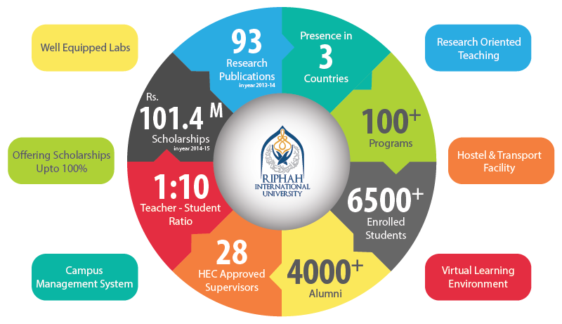

Organizational Breakdown Structure (OBS)

Mr. Hassan M. Khan  Prof. Dr. Anis Ahmad  Mr. Khurram Khan  Engr. Rafat Ullah Khan  Mr. Muhammad Farooq  Brig. (R) Salim Ahmed Khan  Dr. Kousar Firdous  Lt. Col. Muhammad Hasnain, Retd.  Mr. Shahzad Gill  Mr. Muhammad Adeel  Mr. Muhammad Tayyeb Siddiqui  Mr. Haroon Aqeel  Mr. Jalal Uddin Muhammad Akbar  Mr. Obaid ur Rahman  Mr. Aurangzeb Ahmad  Mr. Abid Iqbal  Mr. Jawad Saleem | Pro Chancellor  Vice Chancellor  Director RCIB  Registrar  Director Information Services  Director Quality Enhancement Cell  Director Tarbiyah  Administrator  Deputy Registrar (Academics)  Deputy Controller of Examinations  Deputy Registrar (Affiliations)  Dy. Controller Examination  Manager Finance  Manager Information Technology  Manager Software Development  Manager Student Services  Deputy Manager HR

Project Management Unit (PMU)

PMU is an organizational body/entity part of the Secretariat assigned various responsibilities related to the centralized and coordinated management of projects. The responsibilities of the PMU can range from providing project management support functions to actually being responsible for the direct management of a project.
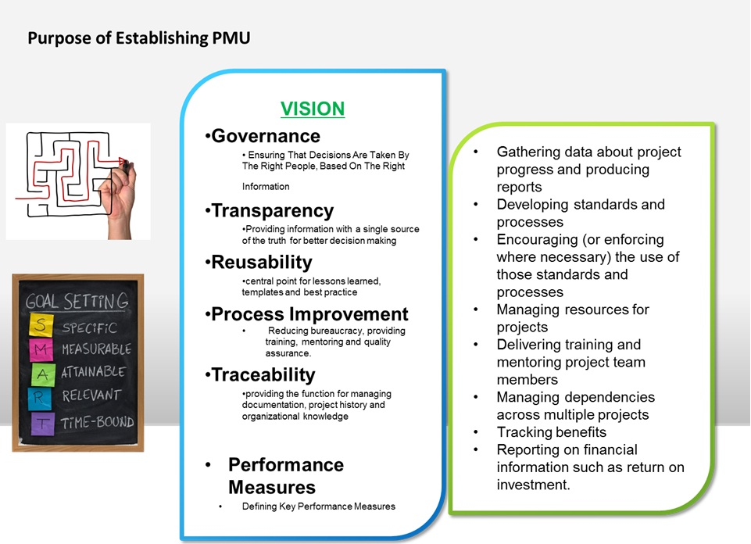
RESPONSIBILITIES
- Set standards for how projects are run
- Ensure project management standards are followed
- Gathering of project data and production of information for management review
- Source of guidance and advice for project managers
- Managing and facilitating the portfolio management process
- Training & Development of Employees

Project Management Unit Team
HEAD OF PMU Mr. Sarfraz Haroon
CONSULTANT Dr. Khalid Ahmed Khan
DEPUTY MANAGER (IS Wing) Mr. Najeeb Ullah
Assistant Manager Projects (Planning Wing) Mr. Asad Munir Butt
Project Executive (Monitoring & Control Wing) Muhammad Khuram Shahzad

Riphah Strategy
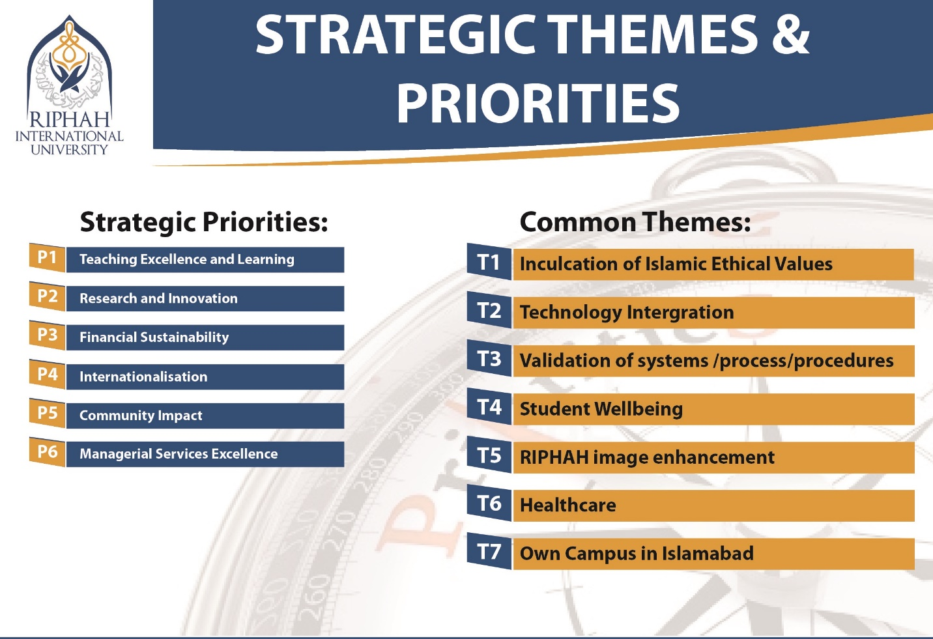

Primavera
- Organizational Breakdown Structure (OBS)
OBS is the hierarchical structure used to depict the organizations structure on the software. The Organizational Breakdown Structure (OBS) defines how people within a company are organized and what rights and access they have within projects. For example, a company that builds ships may have different facilities, with different staff at each facility. Yet certain functions such as the executive team or IT support may span the different facilities. The OBS reflects the chain of command within the company. It can often mirror the EPS, but the two may also diverge. The specific OBS elements may be a mix of specifically named people, business units, departments, and specialties. The OBS and EPS are interconnected such that the OBS can be used to apply security roles and access all projects.
- Enterprise Project Structure (EPS)
The EPS is the outsider's view of your company, showing your lines of business. The EPS is laid out in a tree structure. A construction company may have an EPS tree with only two nodes: Development, for work on existing sites and Construction, for new sites. Or an oil company may split their work first between Natural Gas and Heavy Oil. The structure may be broken down further. For example, Heavy Oil may be broken down into Primary, Cold EOR, and Thermal. The idea is that all projects under an EPS node share common characteristics and may be managed by the same team.
EPS in Primavera
- Choose Enterprise from menu bar, then Enterprise project Structure.
- Click on the EPS name column where we want to add a new element.
- Click on the Add button.
- Type Name and ID of the
- EPS node & in resource Manager Field, select OBS element for new element.
- Hierarchy can be changed by using arrow keys.
- Close the EPS window, go to Enterprise then Projects and specify the project details of budget, resources and dates etc.
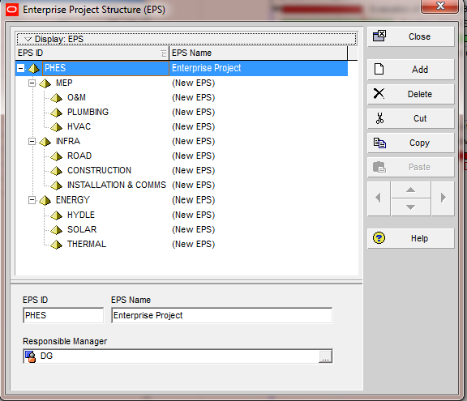
Fig 1: Enterprise Project Structure
- Creating Project in Primavera
- Go to File in the menu bar, and select new.
- Select EPS in Create New Project window.
- Enter Project ID & Project Name.
- Click on Finish Window to create a new Project.

- Work Breakdown Structure (WBS)
Within a project, activities can be grouped, filtered, planned, and organized by Work Breakdown Structure (WBS). The WBS classifies all of the deliverables of a project and is often formed into a hierarchy with an increasing level of detail. How WBS is defined varies by company and by project, but having a well-planned WBS is a key first step to implementing good project controls.
WBS in Primavera
- Click on Project from menu bar, Select WBS.
- Select Add from the command bar, or right click or insert from the keyboard to add a new level on the WBS.
- Use arrow keys for adjustments.
- Close the WBS window.

- Roles in Primavera
- Click on Enterprise from menu bar, and then select Roles.
- Click Add button to add roles.
- Enter Role ID and role Name.
- Hierarchy can be adjusted by using arrow keys.
- In description detail window, type description of Role’s Responsibility.
- Click on Prices Tab to add price of each Role
- Click on Rate type field to enter the Rate.
- Click on Role Limits tab to enter the limit of Each Role.
- Click Add to insert unit/time for the role over time.
- In Effective date/time field, double click and select date from Calendar.
- In Maximum Units/Time field, click and type maximum work units per time for each role.
- Close the window after Assigning Roles.

- Resources
- First enable New Resource Wizard by clicking on Edit button from menu bar, select User Preferences access the “Assistance” tab & then check the box to enable the wizard.
- Go to Project from menu tab, and then select Resource Assignments or Select Resources from Directory bar.
- Click Add button on the command bar.
- Enter Resource ID and Name and Click Next.
- Specify the type of resource (labor, non-labor, or material).
- Enter the unit price, default units per day & maximum units per day for the new resource.
- Enter the office telephone & email.
- Assign “Roles” to the new resource. We can assign multiple roles, identify the proficiency of the resource when performing the role, and designate the “Primary Role” for the resource.
- Select the resource calendar. We can choose from a list of existing calendars or we can create a new calendar.
- Identify whether to “auto-compute actual” for the resource.
- Enter information for the Progress Reporter.
Resource Security
Resource security allows the administrator to restrict your resource access by assigning you to a node in the resource hierarchy. That node is your root node. Once assigned to a resource node, you have access only to your root node and all of its children. In the Resource Assignments window you still have access to current project resources even if they are outside your root node.
- Earned Value
Earned value project/performance management (EVPM) is a project management technique for measuring project performance and progress in an objective manner. It has the ability to combine measurements of the project management triangle:
- Scope
- Schedule
- Cost
In a single integrated system, Earned Value Management is able to provide accurate forecasts of project performance problems, which is an important contribution for project management. Primavera P6 has the functionality to measure project performance according to cost and schedule using Earned Value measurement techniques.
- Steps to Calculate Earned Value in Primavera
- Add Activities, Tie Logic, Set Percent (%) complete to Physical.
- Add Resource Assignments.
- Maintain Baseline and Assign to Project.
- Customize Columns for Analysis.
- Update Physical Percent (%) complete.
- Update Resource Actual units (Or Expenses).
- Schedule Project, Advance Data Date.
- Analyze Earned Value.

- Actual Cost (ACWP)
Actual Cost (ACWP) is the actual total cost incurred on the activity as of the project data date. ACWP is the same as the Actual Total Cost.
- ACWP = Actual Labor Cost + Actual Non-Labor Cost + Actual Material Cost + Actual Expense Cost

- Budget at Completion (BAC)
This is always the Total cost from the Baseline, calculated using the Baseline Budgeted Values or Baseline At Completion values depending upon the ‘Earned Value Calculation’ setting (Admin, Admin Preferences, Earned Value).
If the ‘Earned Value Calculation’ is set to ‘Budgeted Values with Planned dates’ or ‘Budgeted Values with Current Dates’:
- BAC = BL Budgeted Labor Cost + BL Budgeted Non-Labor Cost + BL Budgeted Material Cost + BL Budgeted Expense Cost.
If the ‘Earned Value Calculation’ is set to ‘At Completion Values with Current Dates’:
- BAC = BL at Completion Labor Cost + BL At Completion Non-Labor Cost + BL at Completion Material Cost + BL At Completion Expense Cost.

- Cost Performance Index (CPI)
A CPI greater than 1 means that Earned Value is greater than the actual amount spent. A CPI of less than 1 means that the Earned Value is less than the actual amount spent.
• CPI = EV / Actual Cost
- Cost Variance (CV)
Cost Variance is the difference between the Earned Value and the actual cost of that activity.
- CV = EV – Actual Cost

- Earned Value Cost (BCWP or EV)
Earned Value Cost (EV) is the portion of the budgeted total cost of the activity that is actually completed as of the project data date. Also known as the Budgeted Cost of Work Performed for the activity. The method for computing the performance percent complete depends on the Earned Value technique selected for the activity’s WBS.
- EV = BAC * Performance % Complete

- Estimate at Completion (EAC)
EAC is the estimated cost at completion for the activity.
- EAC = Actual Cost + ETC.

- Estimate to Complete (ETC)
Estimate to Complete is the estimated cost left to complete on the activity. The calculation can be customized at the WBS level (On the ‘Earned Value’ tab in the WBS view).
It can be computed as either:
- ETC = Remaining Total Cost for the activity
- ETC = PF * (BAC – EV)
Where ‘PF’ is a multiplier to weight the ETC calculation. This can be either ‘1’, ‘1/CPI’ or ‘1/ (SPI * CPI)’ or user defined amount.
- Planned Value Cost (BCWS or PV)
Planned Value Cost (PV) is the portion of the budgeted total cost of the activity that is scheduled to be completed as of the project data date according to the baseline dates. Also known as the Budgeted Cost of Work Scheduled for the activity. The Schedule % Complete specifies how much of the activity’s original duration has been completed so far based on the baseline dates.
- PV = BAC * Schedule % Complete

- Schedule Performance Index (SPI)
A SPI greater than 1 means that Earned Value is greater than the Planned Value. A SPI of less than 1 means that the Earned Value is less than the Planned Value.
- SPI = EV / PV

- S-Curve
S-Curve is a display of cumulative costs, labor hours or other quantities plotted against time. A type of curve that shows the growth of a variable in terms of another variable, often expressed as unit of time.
S-Curve represents the utilization of resources over the proposed time of the project. The name derives from the S-like shape of the curve, flatter at the beginning and end and steeper in the middle, which is typical of most projects. The beginning represents a slow, deliberate but accelerating start, while the end represents a deceleration as the work runs out.
  - Types of S-Curve
There are a variety of S-curves that are applicable to project management applications, including:
Resource Consumption
    - Man Hours versus Time S-curve
The Man Hours versus Time S-curve is appropriate for projects that are labor intensive. It shows cumulative man hours expended over time for the duration of the project. As man-hours are a product of manpower and working hours, these may be adjusted together or individually in an attempt to keep the project on schedule. Projects may require additional man-hours to finish on time due to low productivity, delays and disruptions, rework, variations, etc. (Man Hours vs Time S - Curve, 2009)

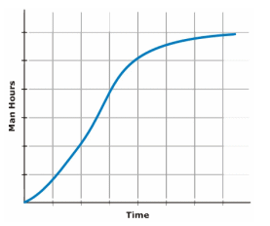
Figure 2: Man Hours versus Time S-curve
    - Costs versus Time S-curve
The Costs versus Time S-curve is appropriate for projects that contain labor and non-labor (e.g. material supply / hire / subcontract) tasks. It shows cumulative costs expended over time for the duration of the project, and may be used to assist in the calculation of the project's cash flow, and cost to complete. (Costs vs Time S - Curve, 2009)
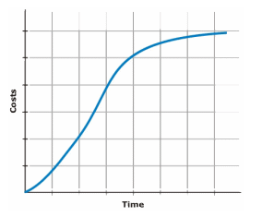
Fig 3: Costs versus Time S-curve
Progress Tracking
    - Baseline S – Curve
This S – curve reflects the planned progress of the project. If the project requirements change prior to commencement (e.g. change of scope, delayed start), the Baseline Schedule may require revision to reflect the changed requirements. (Baseline S - Curve, 2009)
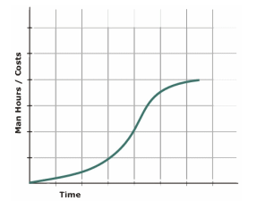
Fig 4: Baseline S-curve
    - Actual S-curve
Following project commencement, modification of the Baseline Schedule is usually required. Changes are continually made to the Production Schedule (which is originally the same as the Baseline Schedule). The production schedule reflects the actual progress of the project to date, and any revisions made to tasks yet to commence or not yet completed. From this schedule, a Target S-curve may be generated. This S-curve reflects the ideal progress of the project if all tasks are completed as currently scheduled. In an ideal world, the Target S-curve will meet the Baseline S-curve at the end of the project (On Time, On Budget) or finish below and to the left of the Baseline S – curve (Early, Under Budget). In reality, it is not uncommon for the Target S – curve to finish above and to the right of the Baseline S-curve (Late, Over Budget). (Actual S - Curve, 2009)

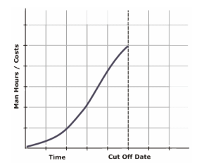
Fig 5: Actual S-curve
    - Target S – Curve
Following project commencement, modification of the Baseline Schedule is usually required. Changes are continually made to the Production Schedule (which is originally the same as the Baseline Schedule). The production schedule reflects the actual progress of the project to date, and any revisions made to tasks yet to commence or not yet completed. From this schedule, a Target S – curve may be generated. (Target S - Curve, 2009)
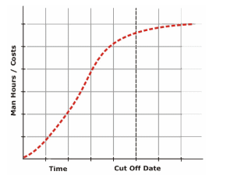
Fig 6: Target S-curve
- Ease of Use & Application Appropriation
Often folks are asking about the differences between Microsoft Project and Oracle Primavera P6. While coming up with a definitive list is more than challenging, below highlights some of the detailed feature differences between Primavera P6 over Microsoft Project.
- It’s all about the Enterprise
It’s clear that Primavera P6 was designed for the enterprise from the start, while Microsoft Project migrated from a desktop application and added enterprise capabilities with Project Server. Now that Oracle owns Primavera P6, this gap is accentuated with the introduction of other heavy weight Oracle applications that support Primavera P6. Examples of these include Primavera P6 Analytics, Business Intelligence Publisher, Workflow and Primavera Gateway. These tools allow for integration with other enterprise applications marrying project information with other corporate data, applications and dashboards. Microsoft has not stood still either, with additional offerings such as SharePoint and Dynamics. (It’s All About The Enterprise, 2015)
- Multiple User Access
Microsoft Project doesn’t allow multiple users to work on a single project at the same time, Primavera P6 does. In Primavera P6 you can specify what features of Primavera a particular user is permitted to use. Microsoft Project Server supports many projects at the same time, but a user locks a project when it’s in use. (Multiple User Access, 2015)
- Baselines
In Microsoft Project, 11 baselines can be created for a project. In Primavera P6, unlimited baselines can be created and as many as four of these baselines can be assigned at any one time to a schedule. (Baseline, 2015)
- Progress and Status
Primavera P6 offers a feature called Progress Spotlight. This Progress Spotlight highlights activity table rows in yellow if they are due any status in the next period (day, week, month, quarter or year). Microsoft Project requires the development of filters to allow for the selection of activities requiring status. (Progress & Status, 2015)
- Issues & Risk
Microsoft Project lacks a feature for tracking project issues or risks. Primavera P6 can record issues and risks against a project, WBS element or activity. (Issues & Risk, 2015)
- Web Support
Primavera P6 plans, documents and other information can be converted to HTML directly from the software. Microsoft Project doesn’t have such options. (Web Support, 2015)
- Steps
The Steps feature in Primavera P6 allows you to create sub-activities (steps) of an activity; effectively a to-do list for discrete progressing. Each step has a weighting that can be used to drive % complete for an activity as the steps are marked off as completed. The additional P6 Step Template allow this feature to be used for common processes that appear often among projects. This capability is not available in Microsoft Project. (Steps, 2015)
- Expenses
In addition to resource costs, Primavera P6 allows planned, remaining and actual project expenses (training, travel, ODC) to be entered at the activity level. Microsoft Project doesn’t have this capability. (Expenses, 2015)
- Custom Fields
Both Microsoft Project and Primavera P6 allow you to create custom fields. Microsoft Project also allows you to define formula for custom fields and add additional values to it. In Primavera P6 you can create a blank custom field, but you cannot set formulas to it, so users have to manually enter values in each field, for each column. You can use Activity Codes in P6 to create a column that has values that can be picked from a list similar to the Lookup feature in Microsoft Project’s custom fields. (Custom Fields, 2015)
- Columns
Primavera P6 is has many columns. It comes installed with over 200 columns, each giving you different information. Column categories include EVM, Budgeting, Costs, etc. In Microsoft Project, there are only around 40 columns.
- Multiple Activity Relationships
In Primavera P6, more than one type of relationship can be established between activities, e.g. we can have FF and SS between the same two activities. In Microsoft Project only one relationship can be made between two activities. (Multiple Activity Relationships, 2015)
- Project Website
Primavera P6 can create a comprehensive website comprising of all the project details including activities, resources, reports, risks, issues, WBS, and anything else that a user can define. This website feature is not present in Microsoft Project without using Project Server. (Project Website, 2015)
- Hint Help
To help new and experienced users alike, P6 Professional offers a Hint Help toggle feature that explains the values and calculations for a column when the cursor is placed on the field. No equivalent feature exists in Microsoft Project. (Hint Help, 2015)

PROJECT CHARTER

Project Title: | Up Gradation of Laboratories – Riphah Institute of Pharmaceutical Sciences
Prepared by: | Muhammad Haris

Version History

Version | Date | Document Title | Comments
1 | 10th – December – 2015 | Project Charter | CREATE CHARTER

Executive Summary

This project is about the purchase of equipment’s for the research laboratory of Riphah Institute of Pharmaceutical Sciences – Riphah International University located at Lahore, Pakistan. Project consist of purchasing of equipment’s which will be used for research & experimental purposes. The contents of charter will be:
Project Problem/Opportunity
Project Approval Authority
Project Cost
Project Time
Project Team
Signatures
Assumptions
High level Risks

Project Problem/Opportunity
- To convert the non-operational facilities to operational status, improving the existing facilities and acquiring new facilities for improving the quality of teaching and research at RIPS.
Project Objectives
- Managing the operational equipment with a more rational integrated approach to yield better academic outcomes.
- Capacity building of each section by procurement of new/advance equipment’s.
- Improvement of research facility at RIPS.
Project Authority

Authorization:

- Board of Governance of Trust is the competent authority for the approval of project.

Project Cost
- RS. 3 Million is allocated for this project.

Project Timeline
- 13th Months are allocated for the completion of this project.

Project Team
- Project Manager
- Project Coordinator
- Project Management Unit (Supporting)
- Procurement Executive
- Finance Executive
- Administration Executive
Project Manager
Mr. Muhammad Haris will be the Project manager. The roles and responsibilities will be:
- Planning and defining of proper scope
- Planning and sequencing of activities
- Planning of resources
- Development of different schedules
- Estimation of time
- Estimation of cost
- Development of budget
- Documentation related to project
- Creating charts & schedules
- Risk analysis
- Monitoring & controlling of reporting progress of project
- Team Leader
Signatures:
Position/Title | Signature/Printed Name | Date
Project Sponsor | Riphah International University
Project Manager | Mr. Muhammad Haris

Assumptions

- Scope will not change
- Equipment will be available easily
- Government taxes / regulations will not change
- No strikes from Project Team
- There will be less political influence on Project
High Level Risks:
- Damage of Equipment
- Political Situations
- Changes in rules & regulations
- Vendor Disputes
- Strikes

PROJECT SCOPE STATEMENT

Project Name: | Up Gradation of Laboratories – Riphah Institute of Pharmaceutical Sciences
Prepared by: | MUHAMMAD HARIS
Date: | 30th – December – 2015

Version History
Version | Date | Comments
1 | 30th – December – 2015 | Scope Statement Preparation
Project Description:
This project is about the purchase of equipment’s for the research laboratory of Riphah Institute of Pharmaceutical Sciences – Riphah International University located at Lahore, Pakistan. Project consist of purchasing of equipment’s which will be used for research & experimental purposes.
Project Success Criteria:
The success criteria of this project is, project should be completed within the defined scope which consists of purchasing the equipment’s, its installation & operationalization within given duration of 13th months & the cost of RS. 3 Million. Also we will see that project deliverables are working properly.
Scope
Project consist of purchasing, installation & operationalization of equipment’s for research laboratory.
Exclusions
- Equipment maintenance
- Civil Work
- Space allocation / building
- Training of people
Resources
Team Member | Roles and Responsibility
- Project Manager  - Project Coordinator  - Procurement Executive | Overall management of the project  Project Coordinator will coordinate with team members.  Timely conduct of purchasing.
Deliverables
Deliverables:
- Flame Photometer
- ELISA Reader
- Overhead Stirrer (Refurbished)
- Tissue Homogenizer
- Microscope With Camera (Refurbished)
- Rota Rod
- Incubator
- Soxhlet Apparatus
- HPLC (Refurbished)
- Shaking Incubator
- Freezer
- Activity Cage
- Hematology Analyzer
- ECG Machine

Assumptions and Constraints:
Assumptions:

- Scope will not change
- Equipment will be available easily
- Government taxes / regulations will not change
- No strikes from Project Team
- There will be less political influence on Project
Constraints:
- Space issues
- Limited vendors
- Lack of skill persons

Conclusion

This report presented the Project of Riphah International University – Pharmacy Department. I presented the information in this report about the project its scope, schedule, cost & resources on a Software named as Primavera P6. This Project was initiated to fulfill the need of Pharmacy department for effectively management of its running programs of undergraduate & post – graduate programs & fulfill the need of regulatory bodies specially Pharmacy Council. This project consist of the procurement of heavy equipment’s / machinery, worth of almost RS. 3 Million for research laboratory.

Recommendations

While working in Riphah International University on this “Up gradation of Laboratories – Riphah Institute of Pharmaceutical Sciences” project I have some observations which I want to highlight here as a recommendation:
- Riphah International University must provide training to their staff on Project Management.
- Importance of a Project its technicalities, cycle & process must be clear to all employees.
- Project Management Pro’s & Con’s must be in the knowledge of employee’s specially those who are engaged in the as a team in any Project.
- Scope must be clear at the start of the project & scope baseline must be freeze.
- Schedule must be realistic & proper implementation of timelines must be in all projects.
- University should provide ample resources for proper & timely execution of Projects.

Issue Log
Issues / Problems | Solutions / Help
New Project in P6 was unable to create. | EPS was deleted, first I have created EPS then project was able to create.
Non – Labor resource type & its impact in P6. | Teacher guide
Update progress / data date | Teacher guide / Video tutorials
Applying Earned Value concepts | Video tutorials / Teacher guide
Reports printing | Video tutorial

References
Actual S - Curve. (2009, February 16). Progress Tracking. Retrieved from Maxwideman: http://www.maxwideman.com/guests/s-curve/resource.htm
Baseline. (2015, April 15). Primavera P6 Vs. Microsoft Project. Retrieved from Ten Six Consulting: https://tensix.com/2013/04/primavera-p6-vs-microsoft-project/
Baseline S - Curve. (2009, February 16). Progress Tracking. Retrieved from Maxwideman: http://www.maxwideman.com/guests/s-curve/resource.htm
Costs vs Time S - Curve. (2009, February 16). Resource Consumption. Retrieved from Maxwideman: http://www.maxwideman.com/guests/s-curve/resource.htm
Custom Fields. (2015, April 15). Primavera P6 Vs. Microsoft Project. Retrieved from Ten Six Consulting: https://tensix.com/2013/04/primavera-p6-vs-microsoft-project/
Expenses. (2015, April 15). Primavera P6 Vs. Microsoft Project. Retrieved from Ten Six Consulting: https://tensix.com/2013/04/primavera-p6-vs-microsoft-project/
Hint Help. (2015, April 15). Primavera P6 Vs. Microsoft Project. Retrieved from Ten Six Consulting: https://tensix.com/2013/04/primavera-p6-vs-microsoft-project/
Introduction. (2002, January 1). Riphah. Retrieved from Riphah International University: https://www.riphah.edu.pk/about-us/introduction
Issues & Risk. (2015, April 15). Primavera P6 Vs. Microsoft Project. Retrieved from Ten Six Consulting: https://tensix.com/2013/04/primavera-p6-vs-microsoft-project/
It’s All About The Enterprise. (2015, April 15). Primavera P6 Vs. Microsoft Project. Retrieved from Ten Six Consulting: https://tensix.com/2013/04/primavera-p6-vs-microsoft-project/
Man Hours vs Time S - Curve. (2009, February 16). Resource Consumption. Retrieved from Maxwideman: http://www.maxwideman.com/guests/s-curve/resource.htm
Multiple Activity Relationships. (2015, April 15). Primavera P6 Vs. Microsoft Project. Retrieved from Ten Six Consulting: https://tensix.com/2013/04/primavera-p6-vs-microsoft-project/
Multiple User Access. (2015, April 15). Primavera P6 Vs. Microsoft Project. Retrieved from Ten Six Consulting: https://tensix.com/2013/04/primavera-p6-vs-microsoft-project/
Progress & Status. (2015, April 15). Primavera P6 Vs. Microsoft Project. Retrieved from Ten Six Consulting: https://tensix.com/2013/04/primavera-p6-vs-microsoft-project/
Project Website. (2015, April 15). Primavera P6 Vs. Microsoft Project. Retrieved from Ten Six Consulting: https://tensix.com/2013/04/primavera-p6-vs-microsoft-project/
Steps. (2015, April 15). Primavera P6 Vs. Microsoft Project. Retrieved from Ten Six Consulting: https://tensix.com/2013/04/primavera-p6-vs-microsoft-project/
Target S - Curve. (2009, February 16). Progress Tracking. Retrieved from Maxwideman: http://www.maxwideman.com/guests/s-curve/resource.htm
Web Support. (2015, April 15). Primavera P6 Vs. Microsoft Project. Retrieved from Ten Six Consulting: https://tensix.com/2013/04/primavera-p6-vs-microsoft-project/

Annexure
Project Description Document
15th – December – 2015

Date
Project ID
Up gradation of Laboratories.
Secretariat – Lahore Campus
Up gradation Project.
1. Project Name
2. SU/FU
3. Project Type
4. Related Target
- Improve the research facility, facilitation of research students.
5. Problem / Opportunity
- To convert the non-operational facilities to operational status, improving the existing facilities and acquiring new facilities for improving the quality of teaching and research at RIPS.
6. Project Objective(s)
- Managing the operational equipment with a more rational integrated approach to yield better academic outcomes.
- Capacity building of each section by procurement of new/advance equipment’s.
- Improvement of research facility at RIPS.
7. Deliverable(s) | Cost (Estimated item Wise)*
- Flame Photometer  - ELISA reader  - Overhead Stirrer (Refurbished)  - Tissue Homogenizer  - Microscope With Camera (Refurbished)  - Rota Rod  - Incubator  - Soxhlet Apparatus  - HPLC (Refurbished)  - Shaking Incubator  - Freezer  - Activity Cage  - Hematology Analyzer  - ECG Machine  - Reserve / Taxes  “These prices are exclusive of Taxes”. | - RS. 190,000  - RS. 450,000  - RS. 30,000  - RS. 55,000  - RS. 70,000  - RS. 125,000  - RS. 32,000  - RS. 40,000  - RS. 600,000  - RS. 350,000  - RS. 40,000  - RS. 30,000  - RS. 450,000  - RS. 70,000  - RS. 468,000  Total = RS. 3,000,000
8. Key Stakeholder(s)
- Riphah International University
- Riphah International University Students
- Riphah International University Employees
9. Risk(s)
- Cost may increase.
- Scope may change.
- Timeline may increase.
10. Success Criteria
- Up gradation of Lab with equipment within specified time & budget.
- Strategic Themes | Student Wellbeing  Riphah Image Enhancement |  | Impact: Effectively & Efficiently running of MS / MPhil. Programs.
- Strategic Priorities | Research and Innovation  Teaching Excellence and learning |  | Impact: University Development & Growth
- Estimated total Cost | 3 Million | - Estimated Duration | 13 Months
- Start Date | 1st – December – 2015 | - Finish Date | 30th – December – 2016
- Estimated Revenues (if any) | None.
Approval and Signatures
Project Manager’s Name & Signature | Muhammad Haris
SU/FU’s Head Name and & Signature | Umer Farooq
PMU’s Endorsement
Executive Director’s Approval/Recommendation
DMT/PC Approval
Approved Cost | RS. 3 Million

