ATTACHMENT STYLES, EMOTIONAL DEPENDENCY, JEALOUSY, AND MARITAL ADJUSTMENT AMONG MARRIED ADULTS



SOHA BATOOL
03-275221-019

A thesis submitted in fulfillment of the
requirements for the award of the degree of
Master of Science (Clinical Psychology)

Department of Professional Psychology

BAHRIA UNIVERSITY LAHORE CAMPUS

APRIL 2024

Approval for Examination
Scholar's Name: SOHA BATOOL
Registration No. 79775
Program of Study: Master of Clinical Psychology
Thesis Title: ATTACHMENT STYLE, EMOTIONAL DEPENDENCY, JEALOUSY, AND MARITAL ADJUSTMENT AMONG MARRIED ADULTS. I hereby confirm that I am satisfied with completing the scholar thesis, and believe it meets the appropriate standards for examination and submission. The plagiarism test, conducted using the HEC-prescribed software, returned a similarity index of 13%, which is within the permissible limit set by the HEC for MS degree theses. Additionally, the thesis adheres to BU's recognized format for MS theses.
Principal Supervisor's Name: Dr.Khawar Bilal Baig
Signature: ___________________________________
Co-Supervisor Name: Miss Nayab Ashraf
Signature: _______________________________________

DECLARATION OF AUTHENTICATION
I, SOHA BATOOL at this moment state that my MS/MPhil thesis titled “ATTACHMENT STYLE, EMOTIONAL DEPENDENCY, JEALOUSY, AND MARITAL ADJUSTMENT AMONG MARRIED ADULTS” is my work and has not been submitted previously by me for taking any degree from this university Bahria University or anywhere else in the country world.
At any time if my statement is found to be incorrect even after my graduation the university has the right to withdraw/cancel my MS/MPhil degree.

Name: SOHA BATOOL
Date: ________________

PLAGIARISM UNDERTAKING
I, solemnly declare that the research work presented in the thesis titled “ATTACHMENT STYLE, EMOTIONAL DEPENDENCY, JEALOUSY, AND MARITAL ADJUSTMENT AMONG MARRIED ADULTS” is solely my research work with no significant contribution from any other person. Small contribution/help wherever taken has been duly acknowledged and that complete thesis has been written by me.
I understand the zero-tolerance policy of the HEC and Bahria University towards plagiarism. Therefore, I as an Author of the above-titled thesis declare that no portion of my thesis has been plagiarized and any material used as reference is properly referred to/ cited.
I undertake that if I am found guilty of any formal plagiarism in the above-titled thesis even after the award of the MS/MPhil degree, the university reserves the right to withdraw/revoke my MS/MPhil degree and that HEC and the University have the right to publish my name on the HEC / University website on which names of students are placed who submitted plagiarized thesis.

Name: SOHA BATOOL

DEDICATION
To my Parents, Uncle, and my best friend: thank you for always supporting me in everything I do. Your constant encouragement, understanding, and humor motivate me daily to do what I love. None of this would be possible without the three of you.

ACKNOWLEDGMENTS
I am grateful to Allah Almighty, Al Rehman, and Al Raheem, for giving me the strength and power to overcome all the obstacles in this research work and enabling me to recognize my goal.
I owe special gratitude to my worthy and honorable Supervisor Dr. Khawar Bilal, and Co-Supervisor Miss Nayab Ashraf whose encouragement in the whole research project was a great source of inspiration for me. I am highly obliged to Dr. Khawar Bilal, and Miss Nayab Ashraf for their valuable suggestions regarding the data analysis.
I want to thank the Head of the Department who supported me and provided us all with a research-friendly environment.
I am also thankful to all those who gave their precious time to fill out my questionnaire. I would like to thank all the librarians who provided me with every book I requested related to my research.
I’m also proud of my friend’s compassion and emotional backing as I struggled through this academic pursuit. Your words of encouragement and assistance have been extremely beneficial in keeping me focused and motivated. I also love to special thanks to Huma Bibi.
SOHA BATOOL

ABSTRACT
The current study aimed to explore the relationship between attachment style, emotional dependency, jealousy, and marital adjustment among married adults. It is hypothesized that a) There would be a relationship between attachment styles (Secure, Preoccupied, Dismissive, Fearful), and emotional dependency, with jealousy among married adults. b) There would be a relationship between attachment styles (Secure, Preoccupied, Dismissive, Fearful), and emotional dependency, with marital adjustment among married adults. c) Adult attachment styles (Secure, Preoccupied, Dismissive, and Fearful) and emotional dependency would predict jealousy among married adults. d) Adult attachment styles (Secure, Preoccupied, Dismissive, and Fearful) and emotional dependency would predict marital adjustment among married adults. e) There would be gender differences in attachment styles (Secure, Preoccupied, Dismissive, and Fearful), emotional dependency, jealousy, and marital adjustment. A non-probability, convenient sampling technique was utilized in this work to conduct quantitative research. Four hundred and Forty-five married individuals were included through convenient sampling in this study. Participants completed the demographic form, Relationship Scale Questionnaire (Griffin & Bartholomew‚ 1994), Partner’s Emotional Dependency scale (Camarillz, Ferre, Echeburua, and Amor, 2020), Multidimensional Jealousy Scale (Pfeiffer and Wong, 1989), and Revised Dyadic Adjustment Scale (Busby, Christensen, 1995). For statistical analysis of the data, the statistics software SPSS (version 22) was used. The findings showed that attachment styles (Preoccupied, Dismissive, Fearful), and emotional dependency are positively correlated with each other (r=.56**, r=.69**, r=.59**, r=.41**), and secure attachment styles negatively correlated with jealousy are positively correlated with each other (r=-.45**), **p<.01 and attachment styles (Preoccupied, Dismissive, Fearful), emotional dependency, and marital adjustment are negatively correlated with each other (r=-.30**, r=-.45**, r=-.46**, r=-.55**), **p<.01 and secure attachment style positively associated with marital adjustment(r=.32**), **p<.01. Finding of regression analysis show that attachment styles (Secure, Preoccupied, Dismissive, Fearful) and emotional dependency were significant predictors of jealousy (F=6.48 =1,439 p<.01) and attachment styles (Secure, Preoccupied, Dismissive, Fearful) and emotional dependency were significant predictors of marital adjustment (F=111.32= 1,439, p<.001). Findings of the independent sample t-test revealed that there were highly significant gender differences in attachment styles (Secure, Preoccupied, Dismissive, Fearful), emotional dependency, jealousy, and marital adjustment (***p˂.001).
Key Words: Attachment Styles, Emotional Dependency, Jealousy, Marital Adjustment, Married Adults.

LIST OF CONTENT
Chapter | Title | Pages
 | Approval for examination | i
 | Authors declaration | ii
 | Plagiarism undertaking | iii
 | Dedication | iv
 | Acknowledgment | v
 | Abstract | vi
 | Table of Contents | viii
 | List of Tables | x
 | List of Figures | xi
 | List of Abbreviation | xii
 | List of Appendices | xiii
1 | Introduction | 1-23
 | 1.1 Attachment Style | 2
 | 1.2 Emotional Dependency | 6
 | 1.3 Jealousy | 9
 | 1.4 Marital Adjustment | 15
 | 1.5Rationale of the Study | 18
 | 1.6 Problem Statement | 19
 | 1.7 Research Question | 20
 | 1.8 Research Objectives | 21
 | 1.9 Significance of the Study | 22
2 | Literature Review | 24-39
 | 2.1 Hypotheses | 33
 | 2.2 Theoretical Framework | 34
 | 2.3 Research Model | 39
3 | Method | 40-46
 | 3.1 Research Design | 40
 | 3.2 Participants | 40
 | 3.3 Inclusion Criteria | 40
 | 3.4 Exclusion Criteria | 40
 | 3.5 Measures | 41
 | 3.6 Procedure | 44
 | 3.7 Ethical Consideration | 45
 | 3.8 Statistical Analysis | 45
4 | Results | 47-62
 | 4.1 Descriptive & Demographics analysis | 48
 | 4.2 Reliability Analysis | 51
 | 4.3 Hypotheses/Model fitness test | 53
5 | Discussion and Conclusion | 63-75
 | 5.1 Conclusion | 71
 | 5.2 Implications | 73
 | 5.3 Limitations | 74
 | 5.4 Recommendations | 75
 | References | 76-79

LIST OF TABLES
Sr. No. | Title | Page No.
1 | Socio-Demographic Characteristics of Participants on Variables | 48
2 | Psychometric properties of Attachment Styles sub-scales (Secure, Fearful, Dismissing, Preoccupied), Partner Emotional Dependency, Jealousy sub-scales (Cognitive, Emotional, Behavioral), Marital Adjustment | 51
3 | Relationship between Attachment Styles (Secure, Fearful, Dismissing, Preoccupied), Emotional Dependency and Jealousy | 53
4 | Relationship between Attachment Styles (Secure, Fearful, Dismissing, Preoccupied), Emotional Dependency, and Marital Adjustment | 55
5 | Regression Coefficients of Attachment Styles (Secure, Fearful, Dismissing, Preoccupied), Emotional Dependency, and Jealousy (n=445) | 57
6 | Regression Coefficients of Attachment Styles (Secure, Fearful, Dismissing, Preoccupied), Emotional Dependency, and Marital Adjustment (n=445) | 59
7 | Independent Sample t-test for Mean Difference in gender, on Secure, Fearful, Dismissing, Preoccupied Attachment Styles, Emotional Dependency, Jealousy, and Marital Adjustment | 61

LIST OF FIGURES
Sr. No. | Title | Page No.
1 | Research Model | 39
2 | Bartholomew’s Model of Attachment | 35
3 | Pfeiffer & Wong Model of Jealousy | 36

LIST OF ABBREVIATIONS
Symbols | Meanings
Α | Alpha
Β | Standardize Beta
< | Less than
> | Greater Than
* | Asterisk
= | Equal to
Abbreviations | Stands for
N | Sample size
M | Mean
SD | Standard Deviation
K | Number of Items
Min. | Minimum
Max. | Maximum
B | Slope/Standard Regression Coefficient
P | Significance value
SEB | Standard Error Coefficient
CI | Confidence Interval
LL | Lower Limit
UL | Upper Limit
No. | Number
R² | Coefficient of Determination
R | Correlation

LIST OF APPENDICES
Appendix-A | Permission letter from the Department of Professional Psychology, BULC
Appendix-B | Permission by Authors of Scales
Appendix-C | Consent Form
Appendix-D | Demographics Information Sheet
Appendix-E | Relationship Scale Questionnaire
Appendix-F | Partner Emotional Dependency Scale
Appendix-G | Multidimensional Jealousy Scale
Appendix-H | Revised Dyadic Adjustment Scale
Appendix-I | Plagiarism Report

CHAPTER I
INTRODUCTION
In relationships, there exists an interaction between attachment style, emotional dependency, jealousy, and marital adjustment. Early-life attachment styles have an impact on how people relate to other people. While insecurely connected people may find it difficult to be intimate or trusting, which can affect how well they adjust to marriage, securely attached people typically have healthier relationships. Marriage satisfaction and attachment styles can be impacted by emotional dependence. Excessive dependency could put strain on the partnership and affect autonomy and trust. Insecurities are a common source of jealousy, which undermines trust. It may have a detrimental impact on marital satisfaction and be connected to attachment styles and emotional dependence. These factors are intertwined, impacting the quality and dynamics of a partnership and the satisfaction and adjustment of a married life.
Marriages are an important aspect of practically all communities and cultures because they allow two people to share their lives most passionately and respectfully as possible while also bearing each other's obligations with love and mutual understanding. However, it is also a very fragile connection, the most demanding and generating a lot of sacrifices at the same time, making the people involved crave marriage joy or marital fulfillment (Nadam & Sylaja, 2015). Marriage is a fundamental social component in most countries. It is an officially recognized collaboration of two individuals in an intimate connection, meant to be one of the most essential, enduring connections in a lifetime, commonly formed to live together, share life experiences, and raise children. Married individuals are supposed to recognize, comprehend, or address the requirements of their partners (Gulec, 2012). While the primary objective of marriage is to care for each other's physical, emotional, and social well-being, achieving optimal integration with marital happiness and adjustment is difficult (Safak, 2014). Marriage is a unique partnership created by society's rules and laws that has a significant impact on individuals' development and self-realization, despite their opposing interests, wants, and requirements (Ersanlı & Kalkan, 2008). Marriage is universal and important for societies because it meets both individuals' natural, mental, social, and inspirational needs, bringing fresh generations into the world, acquiring a place in society, feelings of security and defense, collaboration, being confident about the future, feeling proud of each other, and healthy sexual functioning of life (Canel, 2012).
The union of two people is a blessed, legal, and binding union of two people who agree to spend their adult lives together as partners in a personal connection of companionship, fulfillment, and love, as well as to have children. Marriage is the pillar of the family, and the family is the fundamental unit of society (Gruffi, 2023). Marriage is the most important relationship between two people. A marriage is a relationship in an adult's life that includes both legal and emotional commitment. As a result, marital instability in a couple's lives will damage both the couple and their children (Dildar et al. 2012).
  - Attachment Styles
Creating and maintaining positive relationships alongside other people is an innate individual's desire (Dewall et al. 2012). Attachments are relationships or bonds developed between an individual and a particular person (Prior & Glaser, 2006). Cohan (2005) defines attachment as an intimate bond established between primary and secondary caregivers during childhood (Cohan, 2005). Attachment is regarded as a basic need throughout the life cycle (Zapiain & Lope, 2012), impacting the couple's choice and how they act within it (Barroso, 2014 & Lopez, 2003).
Bowlby initially tried to explain attachment by investigating the intense anxiety felt by infants who were separated from their parents or guardians (Bowlby, 1969). Ainsworth was acknowledged as the first investigator to define affiliation orientations, which she gave as three different models: anxious-ambivalent, secure, and avoiding attachment (Ainsworth, 1978). Subsequently, Hazan and Shaver (1987) were the initial ones to explore partnerships via the lens of attachment. They used Ainsworth's three categories frameworks to organize individual differences in how people reason, perceive, and interact with others. Bartholomew (1990) created four styles of attachment systems of classification based on four categories obtained by dividing a person's intrinsic image of an individual become negativity (high reliance) or positive (low dependency) on a single dimension and the person's non-concrete view of a different subject becomes unpleasant (high evasion) or pleasant. Griffin and Bartholomew (1994) created a model based on adult attachment types, incorporating concepts from Hazen and Shaver (1987) and Bartholomew (1991). Secure people feel comfortable with closeness, are confident that significant others value them, and can rely on significant others for support (Collins & Feeney, 2000). Those individuals possess an intense feeling of confidence and are not afraid of closeness. People having a preoccupied attachment style received inattentive and irregular care in their early years. Preoccupied people are overly reliant, crave attention, and become agitated when their spouse is unavailable in close relationships (Turner, 2008). Individuals who have a really fear style of attachment are more likely to retreat from situations of emotion because their caregivers have been unavailable and inattentive (Besser & Priel, 2009). Dismissive people typically avoid connection as they seek a great deal of autonomy (Turner, 2008). Insecure attachment styles, also known as fearful, dismissive, and preoccupied attachment styles.
Adults with various types of attachment explain and interpret romantic relationships in ways that correspond to their ideas and perceptions regarding themselves and people. Collins (1996) revealed that confident persons gave more positive descriptions, suggesting trust in their romantic connection and their spouse's commitment. Insecure people, in contrast, had more adverse explanations, perceived the spouse's actions negatively, and experienced greater demonstrative pain. In the union of spouses persons who are deeply connected demonstrate higher levels of marital contentment than those who are evasive or uncertainly attached (Fuller & Fincham, 1995). All of these studies appear to indicate that an individual's style of attachment is important in marriage relationships.
The styles of attachment of spouses are one of the psychosocial factors that influence dyadic adjustment because they influence whether partners view marital events, how they judge their partners, and the sorts of approaches to problem-solving they use (Wayment & Campell, 2000). A marital person's evaluation of himself/herself and evaluation of his/her partner, as well as their own mind's connection schemes, vary based on attachment styles developed in early life and carried over into young adulthood and adolescence (Gallo & Smith, 2001). Insecure attachment styles have been associated with increased unhappiness and anxiety, as well as difficulties in connecting with others (Bowlby, 1980; Keskin & Cam, 2008). There are numerous styles of attachments. The initial one is a secure attachment approach. It is characterized as having higher levels of security in intimate connections, more confidence in oneself and others, greater relaxation in connection, and the ability to sustain connection in relationships while retaining one's autonomy. Fearful attachment style is linked to a negative self-image and negative perception of others, while preoccupied attachment style is associated with a negative self-image and positive perception of others. A dismissive type of attachment is characterized by an optimistic perspective of oneself and an adverse view of another (Bartholomew & Horowitz, 1991). The method of attachment in people who are married has a significant influence on communication, conflict resolution, trust, and intimacy. Couples with different attachment styles may struggle to understand each other's needs and settle conflicts. Couples who are aware of these patterns can seek to improve their relationships by using effective communication and empathy-building techniques. Attachment style and emotional reliance are linked in interpersonal relationships. Early interactions with caregivers develop attachment types, which then influence adult relationships.
The four categories of attachment theory have a profound impact on how we handle emotional dependency in adult relationships. People with anxious-preoccupied attachment styles are not necessarily emotionally dependent; rather, they are more likely to be so due to their fear of abandonment and need for continual reassurance and validation. It is critical to emphasize that attachment styles are not fixed and can evolve as a result of introspection, self-awareness, personal growth, and therapeutic interventions. Recognizing and understanding one's attachment style can aid in the formation of healthy relationships by addressing and modifying patterns of emotional dependency that may lead to dissatisfaction or imbalance in partnerships. Self-reflection is frequently effective in healing attachment issues and fostering more secure and meaningful partnerships.

1.2 Emotional Dependency
Our attachment style, which develops in early interactions, has a substantial impact on how we address emotional dependency in adult relationships. Dependency is defined as a state in which one person, group, or society relies on another person, group, or society for resources, support, or guidance. Emotional dependency is a pattern of relying on another person for emotional validation, validation, or security. Dependency is often defined as a relationship in which one is overly reliant on other people (or substances) to meet emotional, physical, or psychological requirements. This can happen in tight interactions like love relationships or friendships (Schultz, unknown year). In a relationship that is romantic, emotional reliance on the partner can be considered as a way to sustain intimacy and security (Telli, 2021). Emotional reliance on a spouse denotes an excessive permanent affection bond with the other person, which is maladaptive, related to low self-worth, and masks an absence of emotion. Emotional dependence includes various undesirable emotional consequences, including mental health symptoms, compulsive thinking, difficulty sleeping, and discontinuation of recreational and social pursuits (Amor, 2020).
Avoidance of being alone, the demand for exclusivity, people-pleasing conduct, and an unequal relationship are all signs of emotional dependence in a relationship (Urbiola et al., 2014). Emotional dependence is a psychological state that arises in personal relationships, such as those with family members, romantic partners, or friends. It affects many people, most of whom are ignorant of it. Emotionally dependent people have a serious lack of self-control and endure significant distress when removed from the person on whom they rely. They have an unending need to be with that person and cannot break the links that bind them. Interpersonal dependency on a spouse is defined as an inappropriate and negative psychological connection to other people (May, 2000).
Early affective impairments may have a role in the development of emotional reliance (Castello, 2012). Emotional reliance is defined as a person's excessive emotive need for their partner in the course of their various relationships (Castello, 2005). Emotional reliance can result in a variety of undesirable emotional effects, such as anxious-depressive signs, compulsive thinking, difficulty sleeping, and disengagement from social and recreational endeavors (Bornstein, 2006; Pico-Alfonso, 2008). Whatever the nature of the relationship, it takes precedence over all other activities in the person's life (Castello, 2005). Emotional dependency is described as a chronic pattern of unfulfilled emotional needs that people desperately want to achieve through tight relationships with other people (Castello, 2002). Emotional reliance is strongest when individuals make considerable investments in their relationships, such as time, effort, and devotion, while prospective alternative connections are unappealing (Rusbult, Drigotas, & Verette, 1994). Emotional dependence is also defined as a rational sickness that involves the display of behaviors that are addictive in an intimate relationship that stems from role imbalance and a reliant mindset toward the individual being relied on (Sirvent, 2000)
Emotional reliance is described as a strong emotional attachment to one's relationship and a belief that it is preferable to alternatives (Buunk 1985). Dependent is defined as a person who perceives the present and previous balance of their stable partner connection as unfavorable and they consider terminating the relationship but are unable to do so due to the lack of financial dependency or pressures of staying in the relationship (Bornstein & Hopwood, 2017). Emotional dependency can lead to violent behavior toward a spouse, which is typically demonstrated by men (Pradas, 2012).
1.2.1 Areas of Emotional Dependency
Emotionally reliance can be described as aversion to love connections although it entails more. There were six categories of emotional dependency recognized (Castello, 2005; Villa & Sirvent, 2008).
1. Anxiety related to separation. A strong dread of abandonment, separateness, or loneliness is expressed. The feeling of separation anxiety could be triggered by temporary confinement that disrupts daily tasks. Any distance impacts doubt about your loving spouse's return, resulting in feelings of loss and isolation (Castello, 2005; Schaeffer, 1998).
2. Expressing feelings. The psychologically reliant individual is continuously uneasy and suspicious of another person's dedication, which can only be soothed by another individual continuously showing affection to reassure them that their feelings are beloved (Lynch, Robins, & Morse, 2001).
3. Alteration of plans These people frequently adjust their strategies or the pursuits they plan to pursue to devote a greater amount of time to their loving partner. Refers to both the emotionally dependent individual's desire for exclusivity and the romantic partner's desire to experience emotions similarly (Castello, 2005).
4. Afraid of loneliness. It is the anxiety of being without a romantic relationship; one requires a mate to feel equal and satisfied on the opposite side, one believes that being alone is exceedingly frightening.
5. The expression is borderline. The idea of an attachment ending is so upsetting to the emotionally dependent person that it frequently motivates that person to participate in actions and indicate a desire to harm them, which is in keeping with the traits of a disorder known as borderline personality disorder.
6. Trying to get attention The reliant individual has an emotional demand for attention from their spouse to enhance their bond and become the focal point of their existence (Castello, 2005).
Emotional dependency on the other can help you stay close and comfortable in a love connection. Emotional reliance on a spouse may lead to envy (Pascuzzo & Bendixen, 2015). In a triadic situation, envy is an interpersonal feeling caused by the imminent or real destruction of a desired connection. The presence of a competitor for a partner's attention frequently results in jealousy (Hart, 2013). This competitor, whether or not they are human, might be real or imaginary (Parker, 2003). Envy is a destructive feeling associated with poor romantic consequences such as disputes, assault at home, and separation (Easton, 2009). Individuals' psychological dependence and envy may be the outcome of a relationship threat that appears more costly to them (Bendixen, 2015). Regardless of the cause of dependency in the relationship, it has been demonstrated that jealousy becomes more intense as dependence develops (Hart, 2013).
1.3 Jealousy
Lazarus noted various replies, including wrathful assault, fleeing from harm with dread, retreating from the individual with despair, and mending or confessing with regret; nevertheless, several reactions may occur simultaneously. Monitoring is linked to Jealousy causing distress, however, it may also be interpreted as a threat (Barrett & Frederick, 2006). Attachment theory was used to investigate adult romantic relationships (Hazan & Shaver, 1987). In close relationships, various kinds of attachment provide both closeness and strength, as well as worry, insecurity, and aversion (Corcoran and Mallinckrodt, 2000). An adult's attachment figure is typically a peer, and the fear of abandoning the other person and their involvement can rise to lustful enviousness (Sharpsteen & Kirkpatrick, 1997).
Enviousness is a complex reaction to a perceived danger that has the potential to end or ruin a significant relationship. Jealousy is described as an unpleasant emotional reaction generated by a current or previous partner's engagement with another person (Buunk & Bringle, 1987). Jealousy is a deviant state of mind characterized by feelings of wrath, sadness, and dread when an essential relationship is disrupted or threatened (Desteno & Salovey, 1996). Jealousy is a set of emotions and reactions, rather than a single one. As a result, it is more reasonable to regard envy as a complicated and multivariate emotion (Mathes & Pines, 1992).
Envy is defined as an individual's sophisticated response to an existing or possible connection with an actual or imaginary competitor that they regard as being harmful to their connection with their significant other (Pines, 1998). Romantic jealousy is a prevalent and recurrent emotion in a couple's relationship that can exhibit itself in a range of emotions, cognition, and acting ways (Pfeiffer and Wong, 1989). Females are more prone than males to perceive jealousy in romantic relationships (Tani & Ponti, 2016). If rivalry occurs at an elevated level, becomes too frequent, displays powerfully, and/or originates in response to unsubstantiated or fictitious conditions, it can have a variety of impacts, greatly altering people's happiness (Kingham & Gordon, 2004), It can also harm relationships with others and general life pleasure (Barelds & Dijkstra, 2007). Jealousy has been defined as a negative reaction to the partner's actual, imagined, or anticipated emotional or sexual connection with someone else (Buunk & Bringle, 1987). According to Pfeiffer (1989), Romantic jealousy is a combination of personal, psychological, and cognition reactions that develop once another individual challenges the presence of a connection (Pfeiffer, 1989).
Jealousy elicits cognitive and emotional responses, but it manifests through conduct (Rodriguez, 2015). Rage, nervousness, and sorrow were three of the six primary jealousy-related feelings. Hatred is comprised of resentment, contempt, and impatience. The anxious set contains stress, nervousness, concern, and pain, whereas the sadness set includes dread and futility (White and Mullen, 1989). Other feeling clusters include envy (avarice), desire, and guilt. Guerrero and Andersen introduced the seventh cluster, positive affect, which includes emotions like love, desire, and appreciation (Guerrero & Andersen, 1998). The basic cognitive responses to jealousy are to criticize oneself or the rival, as well as to make comparisons (Curun & Capkn, 2014). Behavioral responses may be interpreted as negative affect expressions. The most frequently reported jealousy actions are disruptive interactions, such as screaming or leveling allegations, acts of surveillance, active separation, participating in avoidance actions, violating a spouse's solitude, and interacting contact with the opponent (Guerrero and Afifi, 1999).
Interpersonal resentment and affection can be viewed as a desire to maintain the connection (Salovey, 1991). Romantic jealousy creates a sense of being safe when another person is near but produces an opposite response that occurs when he or she is far from home. Those having are characterized by a fear of closeness, fluctuating feelings through their relationships with others, and a lot of enviousness. Anxious/ambivalent styles of attachment are very interdependent and exceedingly vulnerable to potentially harmful events; they need continuous exchange and confirmation, as well as feelings of joy despair, and resentment (Sheets & Fredendall, 1997).
Jealousy can be characterized as a person's sophisticated response to an existing or possible relationship with an actual or imaginary concurrence that they regard as a danger to their bond with the person they love (White, 1981; Duck, 1986; Pines, 1998). Jealousy is a prevalent emotion felt by people in pair interactions around the world (De Silva 2004; Pines and Aronson 1983). This is a defensive response to the danger of abandoning a cherished relationship (Clanton & Smith 1998). While jealousy comes in many forms, emotional jealousy, in particular, can be detrimental to intimate partnerships. Romantic lust can be described as a collection of opinions, emotions, and behaviors that arise in reaction to dangers against one's self-worth and/or the presence or merits of a romantic partnership as these dangers are triggered by the belief of actual or prospective desire between one's spouse and a (probably fictitious) competitor (White, 1981). Jealousy is frequently recognized as a significant source of inadequate self-worth, disagreements between spouses, interpersonal disappointment, violence, aggression, as well as homicide (Gage and Hutchinson 2006), with the ability to damage partnerships and limit contentment (Bevan 2008). Every human community suffers jealousy in marriage and has established cultural conventions to deal with it (Reiss 1986). The degree of social power that men and women wield in society determines their jealousy manifestations. Women, in particular, were portrayed as being less likely to exhibit envy in cultures where women had less social power than men (Reiss 1986).
Envy is referred to as an indication of passion for a relationship (Pines and Aronson 1983), which is marked by a variety of feelings such as harm, dread, and wrath (Parrott and Smith 1993). Guerrero and Andersen (1998) and Pfeiffer and Wong (1989) suggest that jealousy can manifest intellectually, emotionally, and behaviorally.
Cognitive jealousy is defined as anxiety regarding a partner's possible attachment to another person in addition to mistrust of a competitor's relationship (Pfeiffer and Wong 1989). Jealousy of emotions is characterized as the combination of multiple emotions (e.g., sorrow, terror, and wrath) with enviousness, which renders it difficult to identify the fundamental feeling (Guerrero, 2005). In contrast, behavioral envy is the explicit or covert manifestation of animosity (Guerrero and Andersen, 1998). Jealousy needs a societal triad that involves the individual, the individual's relationship, and an opponent, who can be real or imagined (Harmon-Jones et al., 2009). Jealousy is an emotion related to a sense of worthlessness, unhappiness, uncertainty, brooding, abuse, doubt about yourself, and guilt (Costa et al., 2015). In personal relationships, jealousy is defined as the conviction that your partner is or can't be another person representing an imminent danger to the marriage. It emerges as ideas, acts, and sensations (Harmon-Jones et al., 2009).
1.3.1Types of Jealousy
1-Sexual Jealousy
2-Emotional Jealousy
Sexual jealousy and emotional jealousy are the two sorts of jealousy. Sexual jealousy occurs when there is suspicion or knowledge of a spouse's actual or future infidelity, whereas emotional jealousy involves a danger associated with a spouse's emotional interaction with a different individual (Harvey, 2004). Sexual jealousy refers to each of the behaviors that a person participates in if they fear their spouse is with someone else (Guerrero et al. 2004). Emotional jealousy encompasses each of the feelings that an individual has after being duped (Knobloch et al., 2001). Although envy is an emotion on its own, it is frequently associated with desperation, fury, and terror (Harris & Darby, 2010; Hupka, 1984).
Cultural values, ideas, and standards have a significant impact on the nature of enviousness, and also its manifestations and anticipations. It is observed that the reasons and manifestations of jealousy vary among civilizations (Hupka et al., 1985). Envy is a universal emotion, although how it is expressed and evolved varies greatly. The types of events that provoke envy, as well as the interpretations of the perceptions of danger to individuals, vary by culture. Another major distinction is how people from other cultures respond to threats and symptoms of Jealousy in romantic relationships (Pines, 1992). It is strongly based on resource availability and interdependence among couples. When there is a continual fight for survival and essentials, resentment is felt greater than in civilizations in which individuals fail to chase necessities and live relatively simple lives (Pines, 1998). There is a difference between how to handle your emotions and how to deal with an unfaithful partner. Certain societies regard the experience as a typical reaction whilst others individuals see shame as a bad emotion associated with punishment and condemnation of an unfaithful partner (Buss, 2013).
Jealousy is known to be one of the most frequent reasons for marital conflict (Stieglitz, 2012). The capacity to control a person's feelings and actions in response to jealousy may be required for a marital relationship. Jealous people are considered among the most intense, prevalent, and draining emotions in personal relationships (Aune & Comstock, 1991). Jealousy is a topic addressed in marriage research and treatment (Buunk, 1981; Guerrero and Eloy, 1992). Jealousy can significantly impact a marriage, causing insecurities and anxieties about a partner's activities or relationships. This can damage trust, which is crucial for a happy marriage. Unresolved jealousy can lead to communication problems, emotional distress, and frequent disagreements. The jealous spouse may feel apprehensive or insecure, while the other partner may feel scrutinized or under pressure to demonstrate loyalty. This emotional pressure can harm the relationship over time. Unresolved jealousy can cause a loop of rage and frustration, resulting in low satisfaction and a dysfunctional relationship. Jealousy can also affect marital intimacy, as it can cause emotional or physical withdrawal, affecting emotional and physical closeness, and further complicating marital adjustment. Therefore, it is essential to address jealousy and ensure a healthy and happy marriage.
1.4 Marital Adjustment
There is an extensive and growing corpus of studies on the adjustment of marriage, which is a critical part of familial life as an individual. Marriage adaptation is also linked to reduced mental anguish (Whisman, 2003), improved self-worth (Morry, 2009), and a decrease in mental reliance (Rusbult and Verette, 1991). Relationships are complicated, especially marriage relationships, which are intricate processes with numerous implicit and explicit hurdles for individuals to overcome. A stable state of compatibility from both spouses is required for an acceptable and successful marriage relationship (Roodsari & Khalatbari, 2014).
According to Spanier and Cole (1976), the term marriage adaptation encompasses traits such as relationship pleasure and contentment, as well as the competence and functionality of married couples. Marital adjustment is a life-long process that is necessary for aesthetic adherence, personality characteristics recognition, behavior norm formulation, and relationship model construction. Understanding each other's personality traits is essential for marital joy and adjustment. Personality is defined as a person's unique behavior, thought motivation, and emotion. It is what distinguishes an individual and has a great influence on personal expectations, perceptions, values, attitudes, and even marital adjustment (Tabindi, 2005). Understanding the partner's distinctive personality is a continuing process in marriage because people change throughout their lives, even if two people met before or during courtship. Marriage adaptation requires compassion that embraces and acknowledges advancement and growth in the relationship because marital adjustment begins with the husband and directly affects the woman (Westman, Hamilton, & Roziner, 2005). For women in marital adjustment, relationship happiness predicts the chance of relationship breakup, but not for males. Sexual satisfaction, on the other hand, predicts the chance of relationship breakup in males but not in women. Perhaps decreasing sexual satisfaction leads to decreased relationship satisfaction in men, whilst the opposite is true for women.
Married adaptation is the act of adjusting, implementing, or changing a person's or couple's routine of actions and interactions to maximize marital happiness (Bali, Rajni, & Baru, 2010). According to the study, unanimity of reaction among childless partners who were encouraged to idealize their relationship may have an impact on marital adjustment (Ahmed, 2011). Relationships are complicated, especially marriage relationships, which are intricate processes with numerous implicit and explicit hurdles for individuals to overcome. A stable state of compatibility from both spouses is required for an acceptable and successful marriage relationship (Roodsari & Khalatbari, 2014). The concept of marriage adjustment refers to the quality of interaction between spouses, which includes coherence, flexibility, encouragement, expressing sentiments and ideas, interaction, and spending time together. A satisfied relationship is one in which both spouses agree on the most significant aspects of the relationship, such as settling monetary issues or assigning household responsibilities. In addition, satisfied spouses often share comparable passions, ideals, and displays of attachment (Burgess et al., 1963).
Interpersonal adaptation is characterized by four categories: agreement between both partners on major issues in the relationship, contentment with the union, dyadic coherence, and expressiveness of emotions (Spanier, 1976). Individuals' assessments of the degree of adaptability between them and their spouses in terms of interests and values are referred to as marital adjustment (Burgess et al., 1963). Matrimonial adjustment is the state in which two people, husband and wife, experience joy and contentment with one another (Hashmi, Khurshid, & Hassan, 2007). Close relationships improve social skills and promote overall mental and physical well-being. The extent of these interactions is an important indicator of overall life satisfaction and good health (Noller, 2006).
Marital adjustment is the state in which both parties feel generally happy and fulfilled in their marriage and with each other (Barlow, 2001). Mukerjee and Sinah (1990) define marital adjustment as feelings of joy and coherence between couples. Marriage adjustment is linked to marriage quality, marital satisfaction, and marital happiness. This construct is one of the most extensively researched domains in family research literature. One of the reasons for this concept's continued study could be that marital adjustment is linked to more than just high individual and relational competence; it is also linked to general happiness in life. The emotional well-being of spouses is influenced by the quality of their interpersonal relationships and their lived experiences (Jabamelian, 2011). Symptoms of anxiety and depression can be exacerbated by marriage troubles, disputes, adjustment difficulties, and a communication breakdown (Kim 2012; Whitton & Whisman 2010).
Relationship adjustment has a significant impact on marriage quality and mental health issues (Stack & Eslhman, 1998). Partnership adaptation can be defined as having the same attitudes about relationship and marital challenges, dealing with issues as an individual, experiencing relationship fulfillment, being pleased in a relationship together, and constructively assessing relationships (Akar, 2005). Every single person who goes through marriage troubles and adjustment issues has mental health problems (Scot and Cordova, 2002). Several mental organizations have a direct impact on dyadic adjustment and an indirect impact on couples' psychological health. Marital adjustment is defined as a couple's ability to build a mutually beneficial paradigm that involves pleasant sensations and ideas about their partner and also to communicate effectively to achieve consensus on problems (Safak and Arkar, 2014). Individual personality structures, attachment characteristics, sexual relationship quality, and physical and mental health can all impair marital adjustment (Erdogan and Cepik, 2014).
1.5 Rationale of the Study
Understanding complex psychological and emotional aspects that have a substantial impact on the quality, stability, and satisfaction of marriages is the foundation for the rationale behind research on attachment style, emotional dependency, jealousy, and marital adjustment among married individuals. While individual studies have explored these elements separately, there is a lack of comprehensive research analyzing the intricate connections and cumulative effects of attachment styles, emotional dependency, jealousy, and marital adjustment within the context of marriage. Early-life attachment styles significantly influence interpersonal interactions, influencing emotional responsiveness, communication, and behavior patterns in marriages. Higher levels of emotional dependency can strain relationships if they result in frequent neediness, insecurities, or control concerns. It can have an impact on a partner's emotional well-being as well as the dynamics of the relationship. Unaddressed jealousy caused by attachment-related anxieties can undermine trust, communication, and intimacy in a marriage, impairing marital adjustment. Balancing emotional dependency fosters intimacy and emotional support, influencing the success of a couple's relationship. Married individuals can improve their marital adjustment and overall relationship satisfaction by working on attachment security, regulating emotional dependence, resolving jealousy, and strengthening communication. Understanding these styles helps in navigating difficulties, communicating effectively, and maintaining satisfaction. Studying attachment styles, emotional dependency, jealousy, and marital adjustment among married adults provides a comprehensive view of the psychological, emotional, and relational aspects crucial for fostering healthier, more fulfilling marriages.
1.6 Problem Statement
Relationships are essential for human beings, thus adjustment to marriage is crucial. A good married life brings happiness to every individual. Everyone would like to make their marital life successful. Marriage is a complicated interpersonal bond that is shaped by some psychological factors. Attachment styles, which have their roots in early life events, have a big influence on how people establish and sustain relationships. Whether secure, anxious, avoidant, or a combination of these, these attachment styles have a direct impact on emotional dependence, jealousy, and, eventually, the adjustment of a marriage. This research aims to discover the sorts of styles of attachment, in people who are emotionally dependent on a partner and develop jealousy, and marital issues in Pakistani society. People with different kinds of attachment provide clarification and interpretation of partnership experiences in manners that match their opinions and perceptions concerning themselves and another. Individual styles of attachment have a significant influence on marital partnerships. The approaches to attachment of spouses are among the mental organizations that influence marital adaptation in the context of how partners see matrimonial events, how they assess their spouses, and which strategies individuals utilize if challenges emerge (Wayment & Campell, 2000). Relationships are complicated by the interplay of attachment styles, emotional dependence, jealousy, and marital adjustment in married people. Understanding the factors influencing the stability and quality of marriages requires investigation into the intricate interactions among these variables. People's expectations, attitudes, and emotional reactions in a marriage are greatly influenced by the various attachment styles they bring to the marriage. The dynamics of attachment styles are influenced by an individual's emotional dependence on a spouse, which in turn impacts the degree of intimacy, communication, and personal autonomy in a marriage. Anxieties linked to attachment are frequently the source of insecurity and jealousy, which negatively impacts communication, trust, and relationship satisfaction in general. Couples' abilities to resolve conflicts, maintain satisfaction, and develop understanding and support for one another in their marriages are indicators of the effects of attachment styles, emotional dependence, and jealousy.
1.7 Research Questions
The following were the research questions:
- How do different attachment styles (Secure, Preoccupied, Dismissive, Fearful) lead to problems in marital life?
- What is the effect of emotional dependency on marital adjustment among married individuals?
- How do attachment styles (Secure, Preoccupied, Dismissive, Fearful), and emotional dependency lead to jealousy among individuals?
- How do attachment styles (Secure, Preoccupied, Dismissive, Fearful), and emotional dependency lead to marital adjustment for married individuals?
1.8 Research Objectives
The following were the aims of the current research:
- Identify emotional dependency among married adults.
- To analyze the impact of attachment styles (Secure, Preoccupied, Dismissive, Fearful) on jealousy and marital adjustment among married adults.
- To analyze which type of attachment styles (Secure, Preoccupied, Dismissive, Fearful) leads to jealousy among married adults.
- To analyze the effect of emotional dependency on jealousy and marital adjustment among married adults.
- To explore whether individuals with different attachment styles (Secure, Preoccupied, Dismissive, Fearful) experience jealousy when it’s about their intimate partner and whether the presence or absence of jealousy has any effect on the marital adjustment of the adults.
- To investigate how emotional dependency, influences the marital adjustment of married adults.
- The analysis that jealousy causes marital problems in married adults.
- To investigate whether there are any differences in attachment styles (Secure, Preoccupied, Dismissive, Fearful), emotional dependency, jealousy, and marital adjustment based on gender.
- To compare the extent of jealousy and emotional dependency among married males and females.

1.9 Significance of the study
Married individuals' attachment styles, emotional dependency, jealousy, and marital adjustment are important because they have a significant effect on the stability, quality, and general well-being of relationships. Early-life attachment styles significantly impact relationships, influencing how people connect and communicate. Understanding these styles helps couples understand each other's needs and improves communication. Emotional dependency, when balanced, strengthens bonds and fosters closeness. However, excessive reliance can harm relationships. Recognizing and managing emotional dependency can strengthen emotional links. Jealousy, rooted in insecurities, can damage trust in relationships. Addressing jealousy requires understanding its causes and establishing security and trust. Understanding attachment patterns, emotional dependency, and jealousy management can significantly impact marital satisfaction and happiness. Understanding these factors can help couples navigate challenges and maintain a stable and fulfilling relationship. Couples build secure, long-lasting relationships by managing emotional dependency, jealousy, and attachment-related problems. Early recognition and management of these dynamics can prevent future disputes and dissolution. Families are built on marital relationships, and their quality directly impacts children and the social network. Addressing attachment-related problems positively impacts social relationships and the family environment. Understanding attachment styles, emotional dependency, jealousy, and marital adjustment is crucial for fostering healthier, more resilient, and fulfilling marriages and promoting long-term relationship satisfaction and stability. Few studies have been undertaken in Pakistani contexts to investigate the combined association of attachment style, emotional dependency, jealousy, and marital adjustment among married adults. Previously, the pairing of these variables had not been explored collectively in our culture, thus the researcher is interested in investigating the effects of these variables on married individuals living in Pakistani society. This study will provide new opportunities for new scholars.

CHAPTER II
LITERATURE REVIEW
The present study aim to explore the relationship between attachment style, emotional dependency, jealousy, and marital adjustment among married adults.
Guerrero (1998) examined attachment style disparities in the experience and expression of romantic jealousy. The study aimed to find out the association between jealousy and attachment. This study sample consisted of 144 individuals with an age range of 18-55 years from various ethnic groups. This study used the adult attachment scale and jealousy experience and related scale. After applying the correlation and descriptive, MANOVA analysis results revealed that participants having a bad self-image showed a high level of cognitive jealousy. Jealous people with negative models of others showed less extreme dread, less relationship-maintaining action, and more avoidance/denial. Preoccupied individuals showed higher levels of adverse emotion. Individuals with a dismissive expressed lower levels of dread and grief compared to those being secure and preoccupied during jealous situations. The characteristics of the style of attachment such as diminished trust and focus on interaction, were linked to jealousy experience and manifestation.
Richter and Schlegel (2022) conducted a study on romantic partnerships, attachment, and personality that might predict jealousy. The study's first goal was to examine personality traits and attachment as predictors of jealousy, and the second was to investigate the relationship between jealousy, personality characteristics, and attachment dimensions. The sample consisted of 755 community individuals from Germany and Switzerland. This study used a Big Five personality trait adult attachment scale and a German self-report questionnaire. All analyses were carried out with R Studio version 1.3.1093. The findings show that jealousy was found to have a moderate positive link with anxiety and a weak negative correlation with closeness and dependence (*p < 0.05; **p < 0.01; ***p < 0.001). The findings show that attachment elements were studied as predictors, accounting for 22.4% of the variance in jealousy. Close connection was not a significant predictor, but dependent anxiety explained a considerable percentage of the variance in romantic jealousy. The study found substantial differences in the detrimental effects of jealousy between men and women (*p<.05).
Apollinaria and Chursina (2023) studied the effects of romantic attachment patterns on jealousy in young adults. The study's goal is to uncover differences in romantic jealousy expressions depending on romantic attachment types, as well as to investigate how attachment style affects jealousy. The sample consisted of 171 individuals. The tools were used to collect data from the participants on their experience in close relationships revised questionnaire and a multidimensional jealousy scale. The findings reveal that the cognitive jealousy scale was found to correlate with both dimensions of romantic attachment insecurity, anxiety (r = 0.50, p < 0.00), and avoidance (r = 0.29, p < 0.00), as well as the kind of romantic attachment (r = 0.21, p < 0.01). There was a strong association between romantic attachment anxiety and behavioral jealousy (r = 0.41, p < 0.00). The findings reveal that cognitive jealousy (R2 = 0.25, F = 28.17, p < 0.00), explained through attachment insecurity, revealed romantic attachment anxiety as a significant predictor (β = 0.49, t = 6.61, p < 0.00), emotional jealousy explained through indicators of romantic attachment insecurity was statistically insignificant (R2 = 0.01, F = 0.89, p < 0.41) and behavioral jealousy (R2 = 0.27, F = 31.13, p < 0.00), explained through indicators of insecurity of romantic attachment, showed that both anxiety (β = 0.57, t = 7.78, p < 0.00) and avoidance (β = –0.15, t = –2.11, p < 0.04) are significant prerequisites for the development of behavioral jealousy.
Bacalhau and Pedras (2020) studied attachment style and body image as determinants of marital reconciliation and sexual pleasure in cervical cancer patients. The study sought to determine if marital adjustment and body image moderate the association between attachment type, sexual functioning, and sexual satisfaction. This study's design was cross-sectional. The sample included 113 women. This study used the index of sexual satisfaction, the experience in close relationship scale, and the revised dyadic adjustment scale. The findings revealed that there was an association between them (r=0.5**) *p<.05). The findings revealed that avoidance and the effect of anxious attachment were indirectly mediated by marital adjustment (B=0.092, B=0.123, p<0.01).
Ozmen and Aatik (2010) studied attachment styles and marital adjustment of Turkish married people. The study's purpose was to investigate how adult attachment style and gender influence marital adjustment in married people. This study used a convenient sampling technique. There were 204 married persons in the sample from Ankara. This study used a demographics sheet, dyadic adjustment scale, and the experience in close relationship scale. This study used correlation and multiple linear regression analysis. The findings reveal that attachment style dimensions are a significant predictor of marital adjustment (F(3, 200) = 15.00, p < .001). The findings of mean differences indicate men had higher marital adjustment than women. and significant mean differences were found (**p< .01).
Telli and Guler (2021) studied the differentiation of self, forgiveness, jealousy, and conflict resolution responses among married individuals and the mediating role
of relationship satisfaction, relationship adjustment, and emotional dependency. The purpose of the study was to examine the mediating role of relationship satisfaction, relationship adjustment, and emotional dependency, among differentiation of self, forgiveness, jealousy, and conflict resolution responses among married individuals. The sample consisted of 240 married individuals. This study was used to collect data on demographic variables, differentiation of self-inventory, multidimensional jealousy scale, emotional dependency scale, marital adjustment test, the marital offense-specific forgiveness scale, the responses to dissatisfaction in close Relationships-accommodation instrument, and the relationship assessment scale. The correlation and regression analyses were used to evaluate the data. The results revealed that there was a significant correlation between them (r=0.04),*p<.05). The findings show that there was a significant correlation between them (r=0.4), **p<0.01). The results show that jealousy is positively and strongly predicted by emotional reliance (B = 0.281, p < 0.01).
Cirhinlioglu and Tepe (2017) studied psychological distress, self-esteem, and emotional reliance of married individuals were investigated as predictors of marital adjustment.. The purpose of the study was the relationship between psychological distress, self-esteem, emotional dependency, and marital adjustment. The study included 466 married people. This study used a dyadic adjustment scale, brief symptoms inventory, Rosenberg self-esteem scale, emotional dependency scale, and demographic information form. This study used to analyze results through MANOVA and regression analysis. The findings reveal that emotional dependency was a significant predictor of marital adjustment (*p<.01). The results of mean differences suggest that marital adjustment was higher for males than for women (F(1, 446) = 9.31, p< .001).
Perles and Martin (2016) studied gender and conflict resolution strategies in Spanish teen couples and their relationship with jealousy and emotional dependency. The study's goal was to evaluate the relationship between jealousy and emotional dependency and specific conflict resolution tactics employed by Spanish teen couples, as well as gender differences in these strategies. The sample includes 296 teen couples. To test the results, we used hierarchical regression and correlation analysis. The finding reveals a significant correlation between jealousy and emotional dependency (**p < 0.01). The findings of mean differences reveal that significant mean differences in jealousy (*p<.05) and non-significant differences in emotional dependency (*p>.05), men and women have the same scores on dependency.
Cirhinlioglu and Tepe (2017) investigated psychological distress, self-esteem, and emotional reliance among married individuals as predictors of marital adjustment. This study aims to enhance the field of study by focusing on the Turkish instance, which appears to be significantly different from both the United States and other Western nations. In this study, the sample comprises of 466 married adults living in 40 different localities across Turkey who used the snowball technique. Participants complete the following measures: the Demographic Information Form, Dyadic Adjustment Scale (DAS), Brief Symptom Inventory (BSI), Rosenberg Self-Esteem Scale, and Emotional Dependency Scale (EDS). After applying descriptive statistics, regression, and MNCOVA, the findings suggest that males have a higher marital adjustment than females. Psychological distress negatively predicts marital adjustment between men and women, although Self-esteem and emotional dependency predict it favorably, and females are more likely to experience psychological anguish than males.
Arbinaga and Mendoza-Sierra (2021) investigated jealousy, violence, and sexual ambivalence, emotional dependency in the couple's relationship. This study used a cross-sectional approach, with 234 Spanish teenagers participating. Participants took an interview and assessments. According to the data, 40.6% of respondents showed strong emotional dependence and 14.5% expressed excessive emotional dependence. Adolescent boys performed better than adolescent girls (t = 3.92, p < 0.001). Participants who were extremely emotionally dependent had higher ratings for ambivalent sexism (hostile, benign) and envy, as well as assault. In a predictive model of emotional dependence with jealousy and ambivalent sexism as predictor variables, it was discovered that jealousy had the highest predictive and significant explanatory power (R2 = 0.297); with an R2 = 0.334.
Arzun and Cigdem's (2021) study investigates the impact of relationship satisfaction, adjustment, and emotional dependence on self-esteem, forgiveness, jealousy, and conflict resolution reactions among married people. This study investigates marital happiness, adjustment, and emotional dependency in terms of jealousy among married people. The study sample included 240 married Turkish people. The different assessments were used to collect data. Self-differentiation was considerably positively connected with pleasure, marriage adaptation, forgiving and voice response while being strongly adversely correlated with jealousy exit and neglect reactions.
Guclu (2017) investigated gender variations in romantic jealousy and attachment style. The study's goal was to look into gender differences and attachment types as they relate to the phenomenology of jealousy in marriage. The study included 86 married couples. The different assessments and socio-demographic data were utilized to evaluate the subjects. The statistical analysis was used to test the hypothesis through independent samples t-test or Mann-Whitney U test, Pearson's χ2 test. According to the findings, 79% of men and 66% of women feel jealous. Females performed better in both psychological and intellectual tests than males. Females received greater scores for the negative effects of jealousy. Females received higher commitment scores than males. The ambivalent relationship was associated with positive physical, emotional, and behavioral reactions to jealousy, as well as inadequacy as a source of jealousy. According to the study, a comprehensive strategy can assist find or guiding techniques for dealing with jealousy in partnerships.
Ishaq (2015) examined attachment style, self-esteem, and susceptibility to rejection among university students. The study aimed to look into the association between attachment styles (secure, fearful, preoccupied, and dismissing), self-esteem, and rejection sensitivity among university students, as well as the role of self-esteem as a mediator between preoccupied attachment style and rejection sensitivity. A purposive sampling was used to collect the data. The university students (N = 409) were recruited from Pakistani cities Rawalpindi, Islamabad, and Lahore. The data was gathered from both private and public universities. The research population consisted of 409 students (181 males and 228 females) ages 18 to 26. Different questionnaires were used to collect data from the participants. The descriptive statistics were calculated using statistical analysis, and the sample's Alpha values were determined using scales. The Rejection Sensitivity Scale was subjected to confirmatory factor analysis in the Pakistani sample. The relationship was investigated using correlation analysis. To evaluate the mediational hypothesis, a mediation analysis was used. The study demonstrated a negative relationship between secure attachment style and rejection sensitivity levels among students while other insecure attachment styles were significantly positive. Furthermore, only the preoccupied attachment type is revealed to be particularly unfavorable to self-esteem.
Kemer, Yıldız, and Bulgan (2016) found that emotional dependency and dysfunctional relationship ideas are indicators of satisfaction with relationships among married Turkish people. In this study, they looked at married people's contentment with their emotional reliance or problematic interconnection ideas. This study included 203 females and 181 males, 384 married individuals from Turkey's metropolitan cities. They used a hierarchical regression analysis to control for gender and marriage length. The study found that variables have significantly influenced married Turkish persons' relationship satisfaction. However, interpersonal misunderstanding had no significant effect on satisfaction in relationships. When compared to these variables emotional reliance was the most important factor in determining participants' marital happiness.
Negar, Nahaleh, and Abbas (2012) investigated the relationship between Attachment Styles, Marital Satisfaction, and Sex Guilt with Sexual Desire in Iranian Women. The data were collected from 192 married Iranian women. Socio-demographic data and different measures were used to collect data from participants. The Pearson correlation coefficient was used to examine the data, as well as regression. According to the findings, there is a substantial association between the variables. There was a strong correlation between sexuality, chronological age, and duration of marriage. Age, satisfaction with marriage, ambivalent attachment style, and guilt about sexuality may collectively contribute to 52.5% of sexual desire variation.
Gulsah, Yildiz, and Gokce (2016) investigated Emotional Dependency and Dysfunctional Relationship Beliefs as Predictors of Married Turkish People's Relationship Satisfaction. This study included 203 females and 181 males, n= 384 individuals who were married from Turkey's urban areas. In this study researcher used regression analysis. The study found that these variables significantly influenced married Turkish persons' relationship satisfaction. In contrast, interpersonal misunderstanding had no significant effect on participant relationship satisfaction (p >.05). When compared to thoughts of interpersonal rejection and unrealistic relationship expectations, emotional reliance had the greatest influence on participants' satisfaction with their marriage. We evaluate the findings in light of modern literature and cultural importance. We also talk about the implications for future research and mental health therapy.
Arshad, Naeem, and Khalid (2014) examined marital adjustment and life satisfaction in early and late marriages. This study looked at the relationship between marital adjustment and life satisfaction in marriages. The study's primary purpose was to explore how age affects marital adjustment and life satisfaction in both early and late marriages. The sample was selected via convenience sampling. The study used n=160 married individuals from Punjab, Pakistan. The participants' marriage lasted for five years. The different measures were used in this study. The study's data were analyzed using correlation and t-tests. The findings indicate a significant positive relationship (r =.33, p <.01) between marital adjustment and life satisfaction. However, marital adjustment differs significantly (p <.001) between late and early marriages. The study also found a significant difference in life satisfaction between late and early marriages (p <.001). The study discovered a positive correlation (r=.33, significant at p.01) between marital adjustment and life satisfaction. The researchers also discovered a significant (p.001) difference in marital adjustment between late and early marriages. The study revealed a substantial difference (p <.001) in Life Satisfaction between late and early marriages. The study's findings may be valuable to lawmakers as they implement new strategies for societal progress.
Hypotheses
After analyzing the gaps among the above-mentioned studies following hypotheses were constructed.
H1: There would be a relationship between attachment styles (secure, preoccupied, dismissive, fearful), and emotional dependency, with jealousy among married adults.
H2: There would be a relationship between attachment styles (secure, preoccupied, dismissive, fearful), and emotional dependency, with marital adjustment among married adults.
H3: Adult attachment styles (secure, preoccupied, dismissive, fearful) and emotional dependency would predict jealousy among married adults.
H4: Adult attachment styles (secure, preoccupied, dismissive, fearful) and emotional dependency would predict marital adjustment among married adults.
H5: There would be gender differences in attachment styles (secure, preoccupied, dismissive, fearful), emotional dependency, jealousy, and marital adjustment.

THEORETICAL FRAMEWORK
Bowlby's Attachment Theory. Adult Attachment Theory, developed by Hazan and Shaver (1987), is based on Bowlby and Ainsworth's theory of attachment and explains how initial connection relations among youngsters and their main caregivers contribute to individual variations in cognitive and interpersonal components of adolescent love relationships as well as expectations about them. Attachment theory is one of the most used techniques for examining relationships between people. This concept explains why parents have quite a significant impact on the personalities of their kids. Bowlby's attachment theory suggests that children are born with a psychobiological system called the behavioral system of attachment that drives them to look for or sustain an intimate connection with a figure who symbolizes attachment (Bowlby, 1988).
The four attachment styles include secure (positive self/positive other models), preoccupied (negative self/positive other models), dismissive (positive self/negative other models), and fearful-avoidant (negative self/negative other models) (Mikulincer & Shaver, 2007). Adult attachment is characterized by two dimensions: models of self (attachment anxiety) and models of others (attachment avoidance) (Brennan et al., 1998). Anxiety is defined as the degree to which people are concerned that others will be unavailable or leave them. According to Simpson, Rholes, Oriña, and Grich (2002), avoidance refers to a preference for minimum intimacy and emotional independence. Attachment instability in both avoided and anxious people is related to fewer successful, sympathetic styles of interaction with others as well as less efficient dispute resolution. Attachment insecurity also reduces prosaically behavior and is helpful in communication.

Bartholomew’s two-dimensional model of attachment
Positive model of others (Seek out others)
Preoccupied
Overly invested and involved in close relationships, relying on others for self-worth, demanding and needy
Secure
Comfortable with closeness and autonomy in close relationships, self-confident, and capable of resolving problems constructively.

Positive model of self (Self-confident) Negative model of self (Anxious)
Fearful
Dependent on others, yet avoids personal relationships because to fear of rejection, low self-esteem, and severe attachment anxiety.
Dismissing
Compulsively self-sufficient, disconnected in relationships, and downplays the importance of interpersonal relationships.

Negative model of others (Avoid intimacy)
Social Cognitive Theory of Jealousy Harris developed this theory in 2003. This idea best reflects the concept of jealousy whether triggered or caused. Cognitive manifestations are the most significant part of starting emotional outbursts according to all affective theories. They play an important role in anticipating and detecting hazards and threats. The most common cause of romantic jealousy is the impression of a mythological opponent and evil who has the power to endanger a relationship. It threatens the relationship's quality or fundamental reality.
The social cognitive theory of jealousy states that any potential harm to a relationship is assessed in advance of persons engaging in romantic relationships (Harris, 2003). The most prevalent types of betrayal are cognitive and emotional, which lead to sexual or emotional jealousy. Individual differences in romantic jealousy have also been found in terms of attribution and anticipation, according to social cognition theory. Furthermore, the two elements that may precipitate or cause danger are a decline in the worth of the connection and any activity that threatens self-representation, regard, or concept (Salovey & Rodin, 1991).
According to a study, persons who are always afraid that they are not respected or loved equally by others are more prone to experience envy (Levy & Kelly, 2010). Furthermore, other components were found to have been less useful to the partnership than the one related to emotions, since they were adversely connected with affection, but the aspect of emotion was beneficially associated. Because a person gets more feeling of jealous if they have stronger feelings of affection for their spouse, accusations & investigative activities frequently upset individuals and generate disagreements and conflicts in partnerships (Mathes and Severa, 1981; Pfeiffer & Wong, 1989; White, 1984).
Pfeiffer & Wong 1989, Model of Jealousy
Jealousy experience
Outcome
Jealousy emotions:
a) Reaction to appraisal
b) conditioned emotional response
Antecedent
Appraisal of threat
and/or
Presence of certain stimuli
Positive outcome
Negative outcome
Jealousy behavior:
a) Protective
b) Detective
Jealousy cognition:
a) Appraisal of threat
b) Paranoid suspicious

Social Exchange Theory of Marital Adjustment The concept of theory, marital adjustment is likely to be stronger if both parties regard the marriage's attractions to be strong and alternatives to the partnership to be unappealing (Huston and Burgess1979). On the contrary, behavioral explanations of relationships assume that partners favorably rate their marriage if they witness good or gratifying actions in solving issues sessions, whereas unfavorable or forcing acts cause hurt (Markman, 1981). Marital adjustment is the sharing of the spouses' interests, goals, values, and viewpoints, as well as their appraisals of their level of marital satisfaction (Yeşilyaprak, 2003).
Communication theory, structural theory, and the role theory model of marital adjustment were all discussed.
Marital Communication Theory According to marital communication theory, such difficulties can occur at three levels in human communication: syntactic, semantic, and pragmatic. This theory states that pathological communication is typically caused by a lack of clarity or misunderstanding in the syntactical, semantic, and pragmatic elements of communication (Nwoye, 1995).
Structural Theory According to Onwuasonaya (1995), Minuchin established the structural theory approach for marriage counseling in 1974. According to the concept, marital pathology occurs when a single member of the couple is swallowed through the other's personality (the enmeshment problem), or one person's interests clash with the marriage's general values.
Role Theory Model The role theory model posits that the main cause of any marital crisis or dissatisfaction is the phenomenon of role conflict, which comes from irreconcilable role expectations between the two participants in the marriage (Nwoye, Onwuasoanya, 1995). According to Mangus (1957), The concept argues that every couple in the relationship usually comes into the partnership a few beliefs or assumptions about how both of them should conduct themselves, as well as some expectations about how the other should act.

Conceptual Framework
Fearful
Dismissing
Preoccupied
Secure

Jealousy

Attachment Style

Marital Adjustment

Jealousy
Emotional Dependency

Marital Adjustment

CHAPTER III
METHOD
This chapter includes information about the study design, target population, sample size, questionnaires, data collection, procedure, and ethical considerations.
Research Design
The current study was to explore the relationship between attachment style, emotional dependency, jealousy, and marital adjustment among married adults. This study used a quantitative research approach based on a non-probability, convenient sampling technique. The research was a correlational, mean difference, and regression study.
Participants
This research was carried out among married individuals with the least education bachelors. The sample size was determined by taking an average of previously determined sample sizes from earlier research. A total of 445 married individuals were recruited. The participants' ages ranged from 25 to 40.
The inclusion and exclusion criteria for recruiting individuals are outlined below:
Inclusion Criteria
- Participants from 25-40 years were included in the study.
- Married adults with a minimum education of bachelor's were selected.
- Married adults living together.
- Married adults with at least one child were selected.
- Working and Non-working both were included.
Exclusion Criteria
- Adults who had any physical disability were excluded.
- Single parents were excluded.
- Those married individuals who had lived abroad were excluded.
- Those married individuals who were living in a joint family with their parents were excluded.
- Those individuals who had seeking psychiatric treatment were excluded.
Measures
Standardized and well-established instruments were assessed for the sample of this study. These instruments are below:
Demographic Form Self-designed demographic sheet was used for obtaining information. The sheet documented the information from the participants about age, gender, education, duration of marriage, type of marriage, family system, number of children, and occupation. The Sheet was used to assess the characteristics of the participants.
Relationship Scale Questionnaire (RSQ) Griffin and Bartholomew established the scale in 1994. The RSQ has 30 items. The relationship scale questionnaire examines individuals' attachment styles. It is a self-report attachment scale in which individuals must read four paragraphs, each indicating a different attachment style: secure, dismissive, preoccupied, and fearful. On a 5-point scale, participants rate how well each statement describes their characteristic style in intimate relationships. It assesses secure attachment style (trusts others and feels worthy of their attention), preoccupied attachment style (idealizes others, is emotionally needy, seeks reassurance), fearful attachment style (approach, avoidance, fears, intimacy), and dismissing attachment style (high self-worth, compulsively self-reliant). Five-point scale: 1 (not at all), 2 (rarely), 3 (somewhat), 4 (often), and 5 (very much). The attachment style for secure (5-25), preoccupied (4-20), fearful (4-20), and dismissive (5-25) score ranges were adjusted. High scores for each attachment style indicate higher levels of that attachment style. Five statements contribute to secure (items 3, 9, 10, 15, 28) and dismissive attachment patterns (items 2, 6, 19, 22, 26), while four statements contribute to fearful (items 1, 5, 12, 24) and preoccupied attachment patterns (items 6, 8, 16, 25). Scores for each attachment pattern are calculated by taking the average of the four or five items that reflect each attachment prototype. It has a reliability range of.41–.71. The best-fitting attachment type for each subject was chosen by using the attachment category with the greatest score. Some items are scored in reverse, such as items 6, 9, and 28.
Partner's Emotional Dependency Scale Amor developed this scale in 2020. It is a 22-item questionnaire designed to assess emotional dependence on the partner and the score was range 0-88 points. This instrument aims to assess the emotional dependence of the couple through various questions considering the heterogeneity of this construct. The higher the score, the stronger the emotional reliance (all the items score in this direction, except for number 1, which is inverted). The scale consists of 22 items with a 4-point Likert-type 0=totally false to 4=totally true. There are 4 cut-off thresholds dependent on the degree of dependence (<9). "Low Dependence" (10-21 points) "Moderate Dependence" (22-36 points) "High Dependence"> 37 points. "Extreme Dependence" The reliability of the scale was α= 0.90. One item is a reversed score to item 1.
Multidimensional Jealousy Scale (MDJS) Pfeiffer and Wong developed the multidimensional jealousy scale in 1989. This scale assesses jealousy using three subscales: cognitive, emotional, and behavioral jealousy. Cognitive examines the frequency of jealous thoughts, whereas emotional and behavioral assess the frequency of behavior. Each sub-scale has a good reliability, with values ranging from.80 -.90. It has a 24-item, seven-point rating scale ranging from "never" to "all the time" on the cognitive and behavioral scales and "very pleased" to "very upset" on the emotional subscale. There are eight items for each subscale. Cognitive jealousy scoring ranges from 8-35, emotional jealousy score ranges from 13-56, behavioral jealousy score ranges from 8-45, and the overall score range from 44-120. Cognitive jealousy in scoring reverses the score such that 1 becomes 7, 2 becomes 6, etc. A lower score on any of the subscales indicates normal jealousy. Higher values indicate pathological jealousy. The reliability of each subscale is cognitive jealousy alpha .94, emotional jealousy alpha .85, and behavioral jealousy alpha .90. The overall scale reliability range is .80 -.90.
Revised Dyadic Adjustment Scale (RDAS) Busby, Christensen, Russell Crane, and Larson developed a revised dyadic adjustment scale in 1995. The scale consists of a 14-item self-report measure of marital functioning and relationship quality that evaluates seven aspects of couple relationships across three broad categories: decision-making consensus, value, and attachment. Satisfaction with the relationship between stability and conflict regulation. Cohesion is demonstrated through activities and discussions. The instrument includes three subscales (consensus, satisfaction, and cohesion), and a total score of dyadic adjustment. The RDAS scores range from 0 to 69, with higher scores on any of these subscales suggesting greater stability and relationship satisfaction, and lower values indicating greater marital/relationship distress. The RDAS cut-off score is 48, with scores of 48 and above indicating non-distress and 47 and below indicating marital/relationship distress. The RDAS scoring is as simple as computing the sum of the 14-item scores. This produces an overall score which can be interpreted using the cut-off score. The subscale score, which can be interpreted using the subscale consensus overall score, ranges from 0 to 30, with decision-making, value, and affection scores ranging from 0 to 10. The subscale satisfaction overall score goes from 0 to 20. Conflict has a score range of 0–10 on this subscale of stability. The overall score for subscale coherence ranges from 0 to 19, with a score of 0-9 for activities and a score of 0-10 for discussions. Participants responded on a six-point Likert scale, except for one item structured on a five-point scale. Six measures were used to assess consensus on important marital relationship issues (decision-making, values, and affection). Four items (e.g., How frequently do you ponder ending your relationship?) assessed marital satisfaction. This component refers to a couple's stability as well as marital difficulties. The other four elements (for example, "How often do you have a stimulating exchange of ideas?") operationalized marital coherence by involving both marital partners in discussions and activities. The reliability of the scale was .81 for consensus, .85 for satisfaction, .80 for cohesiveness, and.90 for total RDAS.
Procedure
After seeking approval from the Departmental Research Committee, of professional psychology, Research tools (Relationship scale questionnaire, Partner emotional Dependency, Multidimensional Jealousy Scale, and Revised Dyadic Adjustment Scale) were used in this research. These tools were used to gather data from participants. After the selection of each participant, the researcher introduced herself to each participant and was briefed about the topic and objective of the study. Following this, the participant who consented to take part in the study was handed a consent form to obtain their formal approvals. The consent form included information regarding the topic on which the study was conducted. Information about anonymity, confidentiality, the right of voluntary participation, and the right to withdraw was also mentioned on the consent form. After signing the consent form, each participant was given a demographic sheet that demographic sheet was distributed to the study participants to generate the demographic profile of the participants. Following that, participants were requested to complete questionnaires such as a relationship scale questionnaire, partner emotional dependency, multidimensional jealousy scale, and revised dyadic adjustment scales. The questionnaire was administered in about 15-20 minutes on average.
Ethical Consideration
Different ethical concerns were followed while conducting this research. Formal approvals were obtained from the authors of the tools before using them to collect data for the study. Formal permissions were obtained from study participants. Participants signed the informed consent form, which informed them of their conscious decision to participate in the research. Their participation was entirely voluntary, and they had the option to withdraw from the study at any moment with no consequence. In case of withdrawal, they were assured that their data would be destroyed. Following data collection, the researcher debriefed the participants about the study. Participants were advised that the information they provided would be kept confidential and used strictly for academic purposes.
Statistical Analysis
Various statistical analyses were used to examine the data gathered from participants. The demographics were analyzed using descriptive statistics. Also included is a reliability study of attachment style, emotional dependency, jealousy, and marital adjustment. Pearson Product Moment Correlation was used to determine the association between attachment styles, emotional dependency, jealousy, and marital adjustment. Simple Linear regression was used to evaluate the hypothesis. An independent sample t-test was used to determine the mean differences in participants' scores based on their demographics.

CHAPTER IV
RESULTS
This chapter presents and analyzes the study's findings using the Statistical Package for Social Sciences (SPSS) software V22. Descriptive statistics were used to create a demographic profile of the participants. Reliability analysis was used to check the internal consistency of the tools. Inferential statistics were used to test the study hypotheses. Pearson Correlation and Simple linear regression were applied to test hypotheses. Independent sample t-test was also applied to test the hypotheses.

Table 1
Participants’ socio-demographic characteristics
Variables | n | f (%)
Gender
Male | 202 | 45.4
Female | 243 | 54.6
Age
25-30 | 199 | (44.7)
 |  | M= 83(18.6)
 |  | F= 116(26.0)
31-35 | 158 | (35.5)
 |  | M= 66(14.8)
 |  | F= 92(20.6)
36-40 | 88 | (19.7)
 |  | M= 53(11.9)
 |  | F= 35(7.8)
Education
Bachelor | 241 | (54.1)
 |  | M= 116(26.0)
 |  | F=125(28.0)
Master | 177 | (39.7)
 |  | M= 71(15.9)
 |  | F=106(23.8)
PhD | 27 | (6.0)
 |  | M=15(3.3)
 |  | F=12(2.6)
Type of Marriage
Love Marriage | 120 | (26.9)
 |  | M=70(15.7)
 |  | F=50(11.2)
Arrange Marriage | 325 | (73.0)
 |  | M=132(29.6)
 |  | F=193(43.3)
Duration of Marriage
Early Years (1-3 years) | 184 | (41.3)
 |  | M= 75(16.8)
 |  | F=109(24.4)
Middle Years (4-9 years) | 203 | (45.6)
 |  | M=94(21.1)
 |  | F=109(24.4)
Older Years (10+ years) | 69 | (15.5)
 |  | M=33(7.4)
 |  | F=36(8.0)
Family System
Joint | 67 | (15.0)
 |  | M=32(7.1)
 |  | F=35(7.8)
Nuclear | 378 | (84.9)
 |  | M=170(38.2)
 |  | F=208(46.7)
No. of Children’s
1-2 Children | 291 | (65.3)
 |  | M=130(29.2)
 |  | F=161(36.1)
3-4 Children | 150 | (33.7)
 |  | M=69(15.5)
 |  | F=81(18.2)
More than 5 children | 4 | (0.8)
 |  | M=3(0.6)
 |  | F=1(0.2)
Occupational Status
Full-time working | 240 | (53.9)
 |  | M=192(43.1)
 |  | F=48(10.7)
Part-time working | 48 | (10.7)
 |  | M=9(2.0)
 |  | F=39(8.7)
Non-working | 157 | (35.2)
 |  | M=1(0.2)
 |  | F=156(35.0)
Note. n =445

Table 2
Psychometric properties of Attachment Styles sub-scales (Secure, Fearful, Dismissing, Preoccupied), Partner Emotional Dependency, Jealousy sub-scales (Cognitive, Emotional, Behavioral), Marital Adjustment
Variables | M | SD | Ranges | Cronbach’s (α)
Secure Attachment Style | 14.1 | 4.43 | 5-25 | .68
Fearful Attachment Style | 13.1 | 3.6 | 4-20 | .62
Dismissing Attachment Style | 15.7 | 3.9 | 5-25 | .57
Preoccupied Attachment Style | 12.4 | 3.6 | 4-20 | .65
Emotional Dependency | 47.8 | 15.9 | 0-88 | .90
Jealousy Scale Total | 112.1 | 21.05 | 44-120 | .89
Jealousy Sub-scales (Cognitive domain) | 25.3 | 12.4 | 8-35 | .93
Jealousy Sub-scales (Emotional domain) | 43.9 | 6.9 | 13-56 | .85
Jealousy Sub-scales (Behavioral domain) | 29.6 | 10.7 | 8-45 | .90
Marital Adjustment | 39.7 | 12.7 | 0-30 | .90
Note. n =445
Cronbach’s Alpha (α) was calculated to measure the reliability of attachment styles, emotional dependency, jealousy, and marital adjustment among married adults. The reliability of the attachment styles subscale was average on secure, fearful, and preoccupied attachment styles. Dismissing attachment style was poor reliability. The reliability of the total jealousy scale was good. Jealousy Sub-scales (Cognitive Domain) reliability was excellent. Jealousy Sub-scales (Emotional Domain) reliability was average. Jealousy Sub-scales (Behavioral Domain) reliability was good. The reliability of the partner's emotional dependency was good.

Hypotheses Testing
Table 3
Analysis of the Correlation between Attachment Styles, Emotional Dependency and Jealousy
Variables | SASª | DAS^{b} | FAS^{c} | PAS^{d} | EDe | J^{f} | M | SD
Secure Attachment Styleª | - | .49** | .38** | .68** | .61** | -.45** | 14.1 | 4.4
Dismissing Attachment Style^{b} |  | - | .49** | .63** | .40** | .56** | 15.7 | 3.9
Fearful Attachment Style^{c} |  |  | - | .55** | .33** | .69** | 13.2 | 3.6
Preoccupied Attachment Style^{d} |  |  |  | - | .57** | .59** | 12.4 | 3.6
Emotional Dependency^{e} |  |  |  |  | - | .41** | 48.0 | 16.0
Jealousy^{f} |  |  |  |  |  | - | 112.4 | 20.9
Note. n = 445, ** p˂.01
The Results showed a moderately significant relationship (r=.45, p<.01), of secure attachment style (M=14.1, SD=4.4) with jealousy (M=112.4, SD=20.9). The moderately significant relationship (r= .56, p<.01) of dismissing attachment style (M=15.7, SD=3.9) with jealousy (M=112.4, SD=20.9). The moderately significant relationship (r=.69, p<.01) of fearful attachment style (M=13.2, SD= 3.6) with jealousy (M=112.4, SD=20.9). Moreover, the moderately significant relationship (r=.59, p <.01) of preoccupied attachment style (M=12.4, SD=3.6) with jealousy (M=112.4, SD=20.9). The results show a moderately significant relationship (r=.41, ** p˂.01) of emotional dependency (M=48.0, SD=16.0) with jealousy (M=12.4, SD=3.6). Results suggest that individuals with fearful, dismissing, and preoccupied attachment styles towards their partners affect the married life of individuals and also suggest that individuals who are dependent on their partners suffer from jealousy which affects the married life of individuals. The results suggest that individuals who are behaviorally, cognitively, and emotionally attached to their partners face jealousy and adjustment issues in their married life.

Table 4
Analysis of the Correlation between Attachment Styles, Emotional Dependency, and Marital Adjustment
Variables | SASª | DAS^{b} | FAS^{c} | PAS^{d} | EDe | MA^{f} | M | SD
Secure Attachment Styleª | - | .49** | .37** | .68** | .61** | .32** | 14.1 | 4.4
Dismissing Attachment Style^{b} |  | - | .48** | .62** | .40** | -.30** | 15.7 | 3.9
Fearful Attachment Style^{c} |  |  | - | .55** | .33** | -.45** | 13.2 | 3.6
Preoccupied Attachment Style^{d} |  |  |  | - | .57** | -.46** | 12.4 | 3.6
Emotional Dependency^{e} |  |  |  |  | - | -.55** | 48.0 | 16.0
Marital Adjustment^{f} |  |  |  |  |  | - | 39.6 | 12.7
Note. n = 445, ** p˂.01
The results showed a moderately significant negative relationship (r= .32, p <.01) of secure attachment style (M=14.1, SD=4.4) with marital adjustment (M=39.6, 12.7). The result also showed a moderately significant negative relationship (r= -.30, p <.01) of dismissing attachment style (M=15.7, SD= 3.9) with marital adjustment (M=39.6, 12.7). The results show a moderately significant negative relationship (r=-.45, p˂.01) of fearful attachment style (M=13.2, SD=3.6) with marital adjustment (M=39.6, 12.7). The results show a moderately significant negative relationship (r=-.46, p˂.01) of preoccupied attachment style (M=12.4, SD=3.6) with marital adjustment (M=39.6, 12.7). The results show a moderately significant negative relationship (r=-.55, p˂.01) of emotional dependency (M=48.0, SD=16.0) with marital adjustment (M=39.6, 12.7). The results suggest that individuals who have fear, anxiety, and avoidance toward their partner, do not feel secure toward their partners which negatively affects the married life of individuals. The results suggest that individuals who are emotionally dependent on their partners negatively affect married life which also causes adjustment problems for individuals. Results also suggest that individuals who have adjustment issues in their married life negatively affect the married life of individuals.

Table 5
Analysis of the Regression Coefficients of Attachment Styles, Emotional Dependency, and Jealousy
Variable | Model 1 Model 2
Variable | B | β | SE | B | β | SE
Constant | 44.04*** |  | .03 | 42.98 |  | .04
Fearful Attachment Style | 2.78*** | .48 | .22 | 2.74*** | .47 | .21
Dismissing Attachment Style | 1.03*** | .19 | .21 | 1.02*** | .19 | .21
Secure Attachment Style | .27 | .05 | .20 | .08 | -.01 | .21
Preoccupied Attachment Style | .92*** | .16 | .29 | .75** | .13 | .29
Emotional Dependency |  |  |  | .13** | .10 | .05
R² | .57 |  |  | .57
∆R² | .56 |  |  | .57
Note. n=445, ** p˂.01, ***p˂.001
The results suggested that in model 1 attachment style was a significant predictor of jealousy (F=146.06=4,440, p<.001). Fearful attachment style was significantly associated with jealousy (F=146.06, p<.001). The study found that dismissive attachment style was a significant predictor of jealousy (F=146.06, p<.001). Secure attachment style did not significantly predict jealousy (F=146.06, p˃.01). The findings revealed that preoccupied attachment style was a strong predictor of jealousy (F=146.06, p<.001). The results suggested that in model 2 attachment style, emotional dependency was a significant predictor of jealousy (F=6.48 =1,439 p<.01). The results determined that the fearful attachment style was a significant predictor of jealousy (F=6.48, p<.001). The results revealed that dismissing attachment style was a significant predictor of jealousy (F = 6.48, p <.001). The study found that secure attachment style did not significantly predict jealousy (F=6.48, p˃.01). Preoccupied attachment style was a significant predictor of jealousy (F=6.48, p<.01). The study revealed that emotional dependency was a significant predictor of jealousy (F=6.48, p<.01). Furthermore, 57% of variance in outcome variable (Jealousy) was produced by attachment style and emotional dependency (R² =.57).

Table 6
Analysis of the Regression Coefficients of Attachment Styles, Emotional Dependency, and Marital Adjustment
Variable | Model 1 Model 2
Variable | B | β | SE | B | β | SE
Constant | 65.23*** |  | .41 | 68.37 |  | .17
Fearful Attachment Style | 1.03*** | -.29 | .17 | .90*** | -.26 | .15
Dismissing Attachment Style | .13 | .04 | .17 | .15 | -.04 | .15
Secure Attachment Style | .08 | .02 | .16 | .48*** | .16 | .15
Preoccupied Attachment Style | -1.03*** | -.29 | .23 | .52** | -.15 | .21
Emotional Dependency |  |  |  | -.40*** | .51 | .03
R² | .26 |  |  | .41
∆R² | .26 |  |  | .40
Note. n=445, ** p˂.01, ***p˂.001
The results suggested that in model 1 attachment style was a significant predictor of marital adjustment (F=40.25= 4,440, p<.001). The study determined that the fearful attachment style was a significant predictor of marital adjustment (F=40.25, p<.001). The results show that dismissing attachment style was an insignificant predictor of marital adjustment (F=40.25, p˃.01). The result shows that secure attachment style was an insignificant predictor of marital adjustment (F=40.25, p˃.01). The result shows that preoccupied attachment style was a significant predictor of marital adjustment (F=40.25 p<.001). The results suggested that in model 2 attachment style, and emotional dependency were significant predictors of marital adjustment (F=111.32= 1,439, p<.001). The results show that fearful attachment style was a significant predictor of marital adjustment (F=111.32, p<.001). The results show that dismissing attachment style was an insignificant predictor of marital adjustment (F=111.32, p˃.01). The results show that secure attachment style was a significant predictor of marital adjustment (F=111.32, p<.001). The results show that preoccupied attachment style was a significant predictor of marital adjustment (F=111.32, ** p˂.01). The results show that emotional dependency was a significant predictor of marital adjustment (F=111.32, p<.001). Furthermore, 40% of the variance in the outcome variable (Marital Adjustment) was produced by attachment style and emotional dependency (R² =.40).

Table 7
Independent Sample t-test for Mean Difference in gender, on Secure, Fearful, Dismissing, Preoccupied Attachment Styles, Emotional Dependency, Jealousy, and Marital Adjustment
 | Male Female
 | (N=202) (N=243)
Variables | M | SD | M | SD | T | p | Cohen’s d
Fearful Attachment Style | 10.4 | 3.2 | 15.4 | 2.0 | -19.8 | .00*** | 1.8
Dismissing Attachment Style | 14.2 | 4.3 | 16.8 | 3.2 | -7.2 | .00*** | 0.6
Secure Attachment Style | 12.2 | 3.7 | 15.6 | 4.3 | -8.7 | .00*** | 0.8
Preoccupied Attachment Style | 10.2 | 2.9 | 14.2 | 3.1 | -13.6 | .00*** | 1.3
Emotional Dependency | 37.8 | 7.3 | 56.2 | 16.3 | -14.8 | .00*** | 1.4
Jealousy | 98.4 | 21.7 | 124.0 | 10.6 | -16.1 | .00*** | 1.4
Marital Adjustment | 50.0 | 8.0 | 31.1 | 8.8 | 23.3 | .00*** | 2.2
Note. n= 445, ***p˂.001
The findings indicate that there were substantial gender variations in fearful attachment style (F (51.7) = .00, p< .00) in females (M=15.4, SD=2.0), dismissing attachment style (F (19.9) = .00, p< .00) in females (M=16.8, SD=3.2), secure attachment style (F (11.0) = .00, p< .00) in females (M=15.6, SD= 4.3), preoccupied attachment style (F (2.6) = .10, p< .00) in females (M=14.2, SD= 3.1), emotional dependency (F (239.1) = .00, p< .00) in females (M=56.2, SD=16.3), jealousy (F (187.8) = .00, p< .00) in females (M=124.0, SD= 10.6), marital adjustment (F (2.2) = .13, p> .00) in males (M=50.0, SD=8.0).

CHAPTER V
DISCUSSION
This research investigated attachment style, emotional dependency, jealousy, and marital adjustment among married adults. Attachment patterns, shaped by early childhood interactions with caregivers, significantly influence our approach to intimacy and vulnerability in adult relationships, particularly in marriage. People with different attachment patterns are more likely to experience jealousy due to different reasons and respond differently to these feelings. Jealous individuals in intimate relationships have a complex emotional, cognitive, and behavioral response to perceived threats. Attachment styles also influence marital adjustment, the degree of satisfaction and fulfillment experienced within a relationship. Emotional dependency, which relies excessively on one's partner for validation and support, can significantly impact jealousy and marital adjustment.
Descriptive statistics for demographic characteristics of married individuals (n=445) of the present study were 45.4% male and 54.6% female. The married individuals were most prominent from age 25 to 30 age males 18.6% and females were from 25 to 30 age 26%. The married individuals were from different degree levels most prominent among male bachelors 26% and female bachelors 28%. The respondent type of marriage included most prominent among male arranged marriages 29.6% and female arranged marriages 43.3%. The respondent's duration of marriage included the most prominent middle years of marriage (4-9 years) among males 21.1% and females middle years of marriage 24.4%. The respondent family system included the most prominent male nuclear family system 38.2% and the female nuclear family system 46.7%. The respondent number of children was most prominent among male 1-2 children 29.2% and female 1-2 children 36.1%. The respondent’s occupational status was most prominent among male full-time working 43.1% and female non-working 35.0%.
Inferential statistics were used to test the study hypotheses. In the current study, the first hypothesis was to find out the relationship between attachment styles, emotional dependency, and jealousy among married adults, and findings reveal that domains of attachment style, and emotional dependency are positively associated with each other (r=.56**, r=.69**, r=.59**, r=.41**) and secure attachment style negatively associated with jealousy are positively correlated with each other (r=-.45**), **p<.01. Richter, Schlegel, and Thomas (2022) studied the relationship between adult attachment and jealousy in a romantic relationship and the findings show that jealousy also showed a moderate positive correlation with anxiety and weak negative correlations with close and depend (*p < 0.05; **p < 0.01; ***p < 0.001.). Perles and Martin (2016) studied the relationship of jealousy and emotional dependency in couples and their finding reveals that significant correlation between them (**p < 0.01). Guerrero (1998) studied the attachment style and expression of romantic jealousy and bivariate correlations results revealed significant associations between attachment-style dimensions and cognitive jealousy (*p<.05. **p<.0l. ***p<.00). Telli and Guler (2021) studied the relationship of emotional dependency and jealousy in married individuals and their findings shows that there was a significant correlation between them (r=0.04),*p<.05). Apollinaria and Chursina (2023) research romantic attachment styles and jealousy in young adults and their findings reveals that the cognitive jealousy scale was found to correlate with both dimensions of romantic attachment insecurity, anxiety (r = 0.50, p < 0.00) and avoidance (r = 0.29, p < 0.00), as well as the kind of romantic attachment (r = 0.21, p < 0.01). Romantic attachment anxiety has a substantial connection with behavioral jealousy (r = 0.41, p < 0.00). Cabal and Jimenez (2022) studied emotional dependence and romantic jealousy in young couples and their findings reveal that significant association between the emotional dependency and dimensions of jealousy (*p<.05).
Findings suggest that attachment style domains, emotional dependency, and jealousy have a relationship, and in married individuals, attachment style can influence how they handle conflict, emotional dependency, and jealousy in their relationships. Individuals with secure attachments tend to communicate openly during conflicts and have less jealousy but with insecure attachments face struggle with emotional dependency and experience more jealousy due to trust and belief issues. That’s why married individuals need to understand each other’s attachment styles to live happily in their married life.
In the present study, the second hypothesis was to find out the relationship between attachment styles, emotional dependency, and marital adjustment among married adults, and findings reveal that domains of attachment style, emotional dependency, and marital adjustment are negatively correlated with each other (r=-.30**, r=-.45**, r=-.46**, r=-.55**), **p<.01 and secure attachment style positively related with marital adjustment(r=.32**), **p<.01. Bacalhau and Pedras (2020) studied the attachment style and marital adjustment and their findings revealed that there was an association between them (r=0.5**) *p<.05). Telli and Guler (2021) studied the relationship of emotional dependency and relationship adjustment in married individuals and their findings shows that there was a significant correlation between them (r=0.4), **p<0.01). Teimourpour and Bidokhti (2013) studied the association between attachment style and marital satisfaction and their findings reveal that a substantial link exists between secure attachment style (r=0.283, P<0.01), insecure-avoidant attachment style (r=-0.321, P<0.01), insecure-ambivalent attachment style (r=0.144, P<0.05), and marital satisfaction (r=0.512, P<0.01). Kemer, Yıldız, and Bulgan (2016) studied the relationship of emotional Dependency and relationship satisfaction in married Turkish persons. The findings demonstrated that married Turkish people's relationship satisfaction was largely explained by their emotional dependency (sr2 = .300, p < .001) and unrealistic relationship expectations (sr2 = .028, p < .001).
The finding suggests that attachment styles, emotional dependency, and marital adjustment are interconnected in married individuals. Attachment styles like secure, anxious, or avoidant influence how individuals interact in relationships. Secure attachment is linked to better marital adjustment while anxious or avoidant attachment styles can lead to challenges in marriage. Emotional dependency which involves relying heavily on the partner for emotional needs, can also impact marital adjustment. When individuals are emotionally dependent it can strain the relationship if one partner feels overwhelmed or pressured to meet all the emotional needs. Couples need to communicate openly, understand each other’s attachment styles, and work together to build a healthy balance of emotional support and independence for better adjustment.
In the present study, the third hypothesis was to find out that attachment styles and emotional dependency would be a predictor of jealousy among married adults, and findings reveal that attachment style and emotional dependency were significant predictors of jealousy (F=6.48 =1,439 p<.01). The results also showed that domains of attachment style, fearful, dismissing and preoccupied were a significant predictor of jealousy (F=6.48, F=6.48, F=6.48, p<.001, p<.01), and secure was an insignificant predictor of jealousy (F=6.48, p˃.01). The findings revealed that emotional reliance was a strong predictor of jealousy (F=6.48, p<.01). Richter, Schlegel and Thomas (2022) studied the adult attachment as a predictor of jealousy in romantic relationship and findings reveals that Adult attachment variables were investigated as predictors, accounting for 22.4% of the variance in jealousy. The attachment component proximity was no significant predictor, while dependent anxiety was unique and important amounts of the variance in romantic jealousy. Apollinaria and Chursina (2023) research on romantic attachment styles and jealousy in young adults and their findings reveal that cognitive jealousy (R2 = 0.25, F = 28.17, p < 0.00), explained through measures of attachment insecurity, revealed romantic attachment anxiety as a significant predictor (β = 0.49, t = 6.61, p < 0.00), emotional jealousy explained through indicators of romantic attachment insecurity was statistically insignificant (R2 = 0.01, F = 0.89, p < 0.41) and behavioral jealousy (R2 = 0.27, F = 31.13, p < 0.00), explained through indicators of insecurity of romantic attachment, showed that both anxiety (β = 0.57, t = 7.78, p < 0.00) and avoidance (β = –0.15, t = –2.11, p < 0.04) are significant prerequisites for the development of behavioral jealousy. Telli and Guler (2021) studied the relationship of emotional dependency as a predictor of jealousy among married individuals and their findings reveal that jealousy is positively significantly predicted by emotional dependency (B = 0.281, p < 0.01).
Findings suggest that attachment style is a predictor of jealousy in married individuals. Different attachment styles like secure, anxious, and avoidant can influence how a person perceives and reacts to situations that trigger jealousy. Such as individual with an anxious style may be more prone to feelings of jealousy due to their fear of abandonment or rejection. On the other hand person with an avoidant attachment style may exhibit jealousy by withdrawing emotionally and avoiding intimacy. So, understanding every attachment style helps couples navigate and address their jealousy issues in a healthy manner within the marriage. Emotional dependency can also indeed act as a predictor of jealousy in the relationship. When someone is emotionally dependent on their partner they may feel more insecure or fearful of losing the relationship. These heightened senses of dependency can lead to increased feelings of jealousy as the individual may worry more about potential threats to the relationship. Individuals need to work on building their own emotional independence and trust relationships to reduce feelings of jealousy and strengthen the bond with their partner. Communication and mutual support, understanding major keys in the management of dependency, jealousy, and maintaining a healthy relationship.
In the present study, the fourth hypothesis was to find out that attachment styles and emotional dependency would be a predictor of marital adjustment among married adults, and findings reveal that attachment style and emotional dependency were significant predictors of marital adjustment (F=111.32= 1,439, p<.001). The results also showed that domains of attachment style, fearful, secure, and preoccupied were significant predictors of jealousy (F=111.32, F=111.32, F=111.32, p<.001, p<.01), and dismissing was an insignificant predictor of jealousy (F=111.32, p˃.01). The results showed that emotional dependency was a significant predictor of marital adjustment (F=111.32, p<.001). Cirhinlioglu and Tepe (2017) studied emotional dependency as a predictor of marital adjustment in married individuals and their findings reveal that emotional dependency was a significant predictor of marital adjustment (*p<.01). Ozmen and Aatik (2010) studied attachment styles and marital adjustment in married individuals and their findings reveal that attachment styles dimensions are significant predictor of marital adjustment (F(3, 200) = 15.00, p < .001). Bacalhau and Pedras (2020) studied the attachment style as a mediator of marital adjustment in women and findings revealed that avoidance and anxious attachment had an indirect effect mediated by marital adjustment (B=0.092, B=0.123, p<0.01). Kemer and Yildiz (2016) studied emotional dependency as a predictor of relationship satisfaction in married individuals and their results reveal that relationship satisfaction was significantly explained by their emotional dependency (sr2 = .300, p < .001).
Findings reveal that attachment style significant predictor of marital adjustment among married individuals and individuals with secure attachment styles have better communication, trust, and overall satisfaction in their marriages rather than those who have insecure attachment styles. Understanding each other’s and trust attachment styles can help individuals improve marital relationships by fostering empathy and better communication. Emotional dependency is indeed a significant predictor of marital adjustment, when one partner becomes overly reliant on the other for emotional support and validation it can lead to issues in the marriage. A healthy relationship is more important in a relationship but when one partner is excessively emotionally dependent it can strain the marriage and affect the overall adjustment and satisfaction levels. Balancing emotional support and independence is crucial for a successful and fulfilling marriage.
In the present study, the fifth hypothesis was to find out mean differences on attachment style, emotional dependency, jealousy and marital adjustment among married adults, and findings reveals that there were significant gender differences in fearful attachment style (F (51.7) = .00, p< .00) in females, dismissing attachment style (F (19.9) = .00, p< .00) in females, secure attachment style (F (11.0) = .00, p< .00) in females, preoccupied attachment style (F (2.6) = .10, p< .00) in females, emotional dependency (F (239.1) = .00, p< .00) in females, jealousy (F (187.8) = .00, p< .00) in females, marital adjustment (F (2.2) = .13, p> .00) in males. Cirhinlioglu and Tepe (2017) studied emotional dependency as a predictor of marital adjustment in married individuals and their findings of mean differences reveal that marital adjustment was higher for the men than for the women (F(1, 446) = 9.31, p< .001). Richter, Schlegel and Thomas (2022) studied the relationship between adult attachment and jealousy in romantic relationship and the findings of mean differences reveals that the negative effect of dependency on jealousy was significant differences in women and men (*p<.05). Ozmen and Aatik (2010) studied the attachment styles and marital adjustment in married individuals and their findings of mean differences reveals that marital adjustment is higher for men than for women and significant mean differences were found (**p< .01). Arbinaga and Fernández-Ozcorta et.al (2021) studied the jealousy and emotional dependency in couple relationship and their findings of mean differences reveals that significant differences in male and female on dependency and jealousy (**p<0.001, *p<.05). Perles and Martin (2016) studied the relationship of jealousy and emotional dependency in teen couples and their findings of mean differences reveals that significant mean differences on jealousy (*p<.05) and non-significant differences on emotional dependency (*p>.05), men and women have same scores on dependency. Guclu, Senormancı, and Senormanc (2017) studied the gender differences in jealousy and attachment styles and their findings reveal significant mean differences in jealousy (p<.04) and no differences in attachment styles.
Findings suggest that there are significant mean differences of gender in attachment style, emotional dependency, jealousy, and marital adjustment among married individuals. Gender differences in these variables can be influenced by different factors. Societal norms, upbringing, communication styles, and individual experiences all contribute to these differences. Furthermore, societal expectations, cultural influences, and personal beliefs also have an impact on how attachment styles, emotional dependency, jealousy, and marital adjustment manifest differently between genders. Other factors, like psychological factors such as self-esteem, past experiences, and coping mechanisms can contribute to these differences. In the Pakistani context, traditional gender roles, family dynamics, and cultural norms can strongly influence attachment style, emotional dependency, and marital adjustment in married couples. Expectations regarding gender roles, communication patterns, and societal pressure can all contribute to differences observed in these aspects between men and women in Pakistan. Moreover, the influence of religion, community values, and generational beliefs can also shape how these factors play out within marriages in the Pakistani context.
5.1 Conclusion
In conclusion, the purpose of the present study was to explore the relationship between attachment style, emotional dependency, jealousy, and, marital adjustment among married individuals and also determine that attachment style and emotional dependency were a predictor of jealousy and marital adjustment and find out the mean differences of gender on attachment styles, emotional dependency, jealousy, and marital adjustment among married individuals. For this study sample was drawn from different institutes, societies, and residential areas. After Spearman’s correlation analysis, simple linear regression, and independent sample t-test analysis, findings of correlation analysis show that domains of attachment style, and emotional dependency are positively associated with each other (r=.56**, r=.69**, r=.59**, r=.41**) and secure attachment style negatively associated with jealousy are positively correlated with each other (r=-.45**), **p<.01 and domains of attachment style, emotional dependency, and marital adjustment are negatively correlated with each other (r=-.30**, r=-.45**, r=-.46**, r=-.55**), **p<.01 and secure attachment style positively associated with marital adjustment(r=.32**), **p<.01. Finding of regression analysis shows that attachment style and emotional dependency were significant predictors of jealousy (F=6.48 =1,439 p<.01) and attachment style and emotional dependency were significant predictors of marital adjustment (F=111.32= 1,439, p<.001). Findings of the independent sample t-test revealed that there were highly significant gender differences in domains of attachment styles, emotional dependency, jealousy, and marital adjustment (***p˂.001). The hypotheses of the present study were supported by previous research. In addition, it was found that gender plays important roles in attachment style, emotional dependency, jealousy, and marital adjustment among marital adjustment.
Our research adds to the literature on these variables by supporting the notion that attachment styles and dependency might affect individual behavior regarding jealousy and marital dynamics in early adulthood. Thought related to partner relationship adjustment, dependency, and jealousy-related attitudes may have the negative effect of keeping women’s power in the family sphere, limiting their social advancement while perpetuating men’s societal domination. Attachment style, emotional dependency, jealousy, and marital adjustment are closely linked to mental adjustment in relationships. Understanding and addressing these factors can have a significant impact on how individuals adjust to and navigate their relationships. By recognizing these connections, an individual can work towards improving their emotional well-being and overall relationship satisfaction.

  - Implications
- The research findings indicate that attachment styles and emotional dependency are important in determining married couples’ behavior and attachment style and emotional dependency also help to enhance married couples’ jealousy-related attitude and marital satisfaction towards positivity.
- The findings of this study can be valuable for therapists working with married individuals who are experiencing marital adjustment issues as a result of different attachment styles and higher emotional dependency in marriages.
- Mental health professionals can utilize the insights from this research to enhance their understanding of the underlying problems and provide more guidance and support to their clients.
- Gaining insight into the implications of biased or influenced gender perceptions and cultural influences on marital attitudes can assist young adults and those around them including romantic partners comprehending the issues. Early awareness of this problem can aid in addressing it at its early stages and maintaining control over its impact.
- The therapist could implement programs (awareness sessions, workshops) to improve attachment styles and dependency levels which may lead to boosting marital satisfaction, and quality of relationship, and decrease the level of jealousy.
- The findings of this research can help counselors and mental health professionals build up strategies that apply to solve problems or marital issues and work on the divorce rate.
- The findings of this research can help the counselor to promote pre-marital counseling and educate married couples on how they can improve their behavior towards attachment styles, dependency and jealousy, and marital satisfaction.
- Overall such a study can provide valuable insights into the complex interplay between attachment styles, emotional dependency, jealousy, and marital adjustment in young adults, ultimately leading to more effective support and intervention strategies for married individuals facing these challenges.
- Financial stress degrades the quality of marriage, which can lead to emotional suffering and marital divorce.
- Programs and marital counseling services focused on enhancing couples' financial literacy and competence may be beneficial in tackling the numerous financial pressures that couples face.
- Our research shows that to improve the mental health of married couples, it is important to address these risk and protective factors. These findings may provide some insight into the characteristics of married individuals for helpful professions. Counselors or therapists, for example, may assist married people who are dependent or jealous of their spouses, or who are struggling in their marital connection, by analyzing their attachment styles and developing a treatment plan that considers these variables.
5.3 Limitations
- There were certain limitations in the study that should be noted after reading the findings. The sample of the present study was limited and too minimal for evaluating the research results. Therefore, the findings cannot be generalized in context of the Pakistan.
- The limited research conducted combines these variables in the Pakistani cultural context.
- As the study was quantitative, hence qualitative elements were not studied.
- The sample of the present study was only those individuals who live together, do not reside in another country, or are engaged in a relationship.
  - Recommendations
- Future researchers can compare people from different age groups for instance comparison between adolescents and adults.
- The questionnaire was used in English Language. Future researchers should translate the questionnaire into Urdu to better understand the problems of less educated married individuals.
- Future research can incorporate methodologies including a mixed method approach and conduct in-depth interviews to find valuable insights about the phenomenon.
- Therapy to analyze and modify attachment patterns is recommended, as is developing stable relationships via direct interaction and compassion.
- Future researchers developing awareness of oneself and individuality while fostering interconnectedness can help mitigate these challenges. Couples can deal with jealousy by communicating openly, setting limits, and addressing underlying concerns through treatment. Therapy provides a positive atmosphere for addressing concerns while improving awareness, compassion, and ability to solve problems.

References
Ainsworth, M., Blehar, M., & Waters, E. (1978). Patterns of attachment: a psychological study of the strange situation. Hillsdale (NJ)7
Erlbau.
Apollinaria., & Chursina. (2023). Romantic attachment styles and jealousy in young adults. Russian Psychological Society, Family Psychology. 16(3).
Berardo, F. (1968). Widowhood status in the United States: per- spectives on a neglected aspect of the family life-cycle. The Family Coordinator 17:191- 203.
Canel, A. N. (2012). Evlilik ve aile hayatı Marriage and family life. İstanbul, Turkey: Aile ve Sosyal Politikalar Bakanlığı.
Castelló, J. (2005). Dependencia emocional: características y tratamiento. Madrid: España: Alianza.
Castelló, J. (2012). Superación de la dependencia emocional: como impedir que el amor se convierta en un suplicio [Overcoming emotional dependence: how to prevent love from becoming a torture]. Málaga: Ediciones Corona Borealis.
Cirhinlioglu., & Tepe. (2017). Psychological distress, self-esteem and emotional dependency of married individuals as predictors of marital adjustment. Procedia Computer Science. Retrieved Form: https://doi.org/10.1016/j.procs.2017.11.224.
Eyüp, Ç., & Murat, I. ( 2015). Ambivalent Sexism, Submissive Behaviors, and Positive and Negative Affect as Predictor of Marital Adjustment, Educational Research Association, The International Journal of Educational Researchers, 6(3), 1-14, 1308-9501. https://www.researchgate.net/publication/284168175.
Griffin, W, & Bartholomew, K. (1994). The metaphysics of measurement:
the case of adult attachment. In: Bartholomew K, Perlman D, editors.
Advances in personal relationships, vol. 5. London7 Kingsley, 17–52.
Guclu., Şenormanc., & Şenormanc. (2017). Gender differences on jealousy and attachment styles. Psychiatry and clinical psychopharmacology. 27(4). Retrieved Form: https://doi.org/10.1080/24750573.2017.1367554.
Guerrero. (1998). Attachment-style differences in the experience and expression of romantic jealousy. Personal Relationships. Retrieved Form: https://doi.org/10.1111/j.1475-6811.1998.tb00172.x.
Gulsah, k., Yildiz, C. E., & Gokce, B. (2016). The Emotional Dependency and Dysfunctional Relationship Beliefs as Predictors of Married Turkish Individuals’ Relationship Satisfaction. The Spanish Journal of Psychology, 19, E72, DOI: https://doi.org/10.1017/sjp.2016.78.
Gulsah, k., Yildiz, C. E., & Gokce, B. (2016). The Emotional Dependency and Dysfunctional Relationship Beliefs as Predictors of Married Turkish Individuals’ Relationship Satisfaction. The Spanish Journal of Psychology, 19, E72, DOI: https://doi.org/10.1017/sjp.2016.78.
Hazan C, Shaver P. (1987). Conceptualizing romantic love as an attachment
process. J Pers Soc Psychol 1987;52:511–24.
Kalkan, M. (2012). Eş seçimi kuramları Mate selection theories. Evlilik öncesi psikolojik danışma Premarital counseling. Ankara, Turkey: Anı Yayıncılık.
Kemer., Yıldız., and Bulgan. (2016). Emotional Dependency and Dysfunctional Relationship Beliefs as Predictors of Married Turkish Individuals’ Relationship Satisfaction. The Spanish Journal of Psychology. Retrieved Form: DOI: https://doi.org/10.1017/sjp.2016.78.
Mirowsky, J., & Ross, C, E. (2002). Selecting outcomes for the sociology of mental health: Issues of measurement and dimensionality. Journal of Health and Social Behavior. 43:152-170.
Negar, T., Nahaleh, M. B., & Abbas, P. (2012). The Relationship of Attachment Styles, Marital Satisfaction, and Sex Guilt with Sexual Desire in Iranian Women. Practice in clinical psychology. Retrieved From: file:///D:/MS%202021/Third%20Semester/Thesis/Sex%20guilt%20and%20marital%20satisfaction.pdf.
Perles., & Martin. (2019). Gender and Conflict Resolution Strategies in Spanish Teen Couples: Their Relationship with Jealousy and Emotional Dependency. Retrieved Form: https://doi.org/10.1177/0886260516651316.
Richter., Schlegel., & Thomas. (2022). Adult attachment as a predictor of jealousy in romantic relationships. Frontiers in psychology. Retrieved Form: doi: 10.3389/fpsyg.2022.861481.
Shawa., & Saad. (2018). Marital adjustment, convergent communication patterns, and psychological distress in women with early and late marriage. Current Psychology, 39:2326–2333. https://doi.org/10.1007/s12144-018-9936-1.
Telli., & Guler. (2021). Differentiation of Self, Forgiveness, Jealousy, and Conflict Resolution Responses among Married Individuals: The Mediating Role of Relationship Satisfaction, Relationship Adjustment, and Emotional Dependency. Contemporary Family Therapy. Retrieved Form: https://doi.org/10.1007/s10591-021-09603-8.
Unknown Author. (Unknown Year). Emotional dependence. Retrieved From: https://www.topdoctors.co.uk/medical-dictionary/emotional-dependence.
Waters, E., Merrick, S., Treboux, D., Crowell, J., & Albersheim, L. (2000). Attachment security in infancy and early adulthood: a twenty-year
longitudinal study. Child Dev 3:684–9.
Wearden, A. (2005). Adult attachment, alexithymia, and symptom reporting: An extension to the four category model of attachment. Journal of Psychosomatic Research, DOI:10.1016/j.jpsychores.2004.09.010.

Appendices

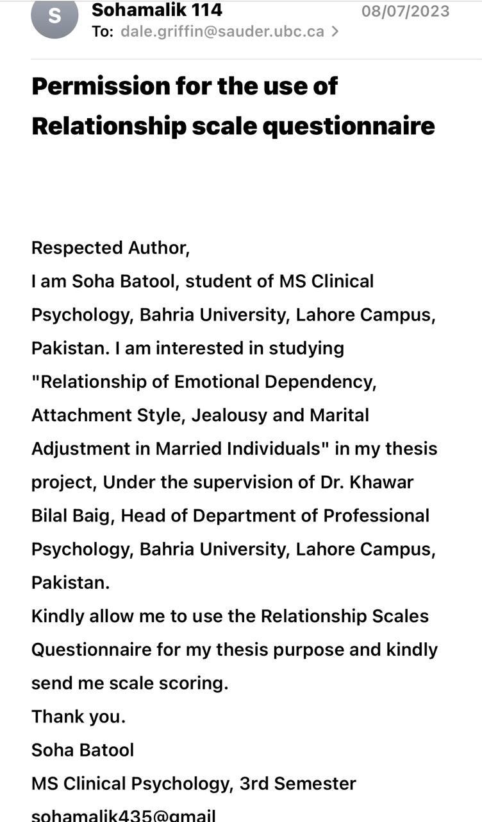
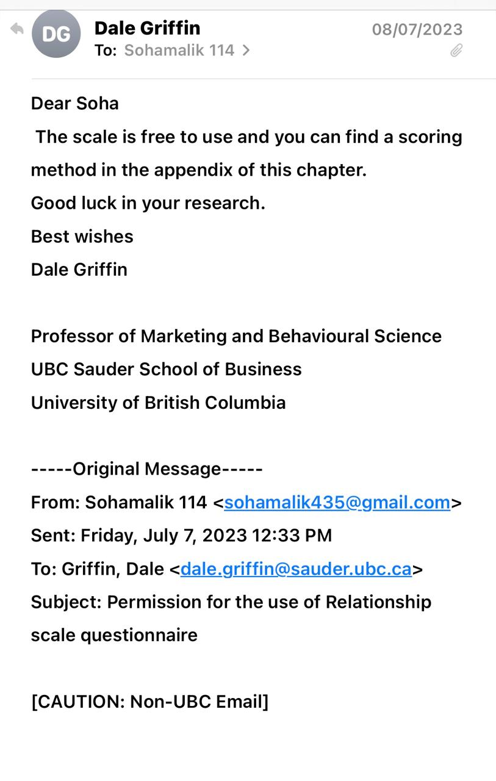

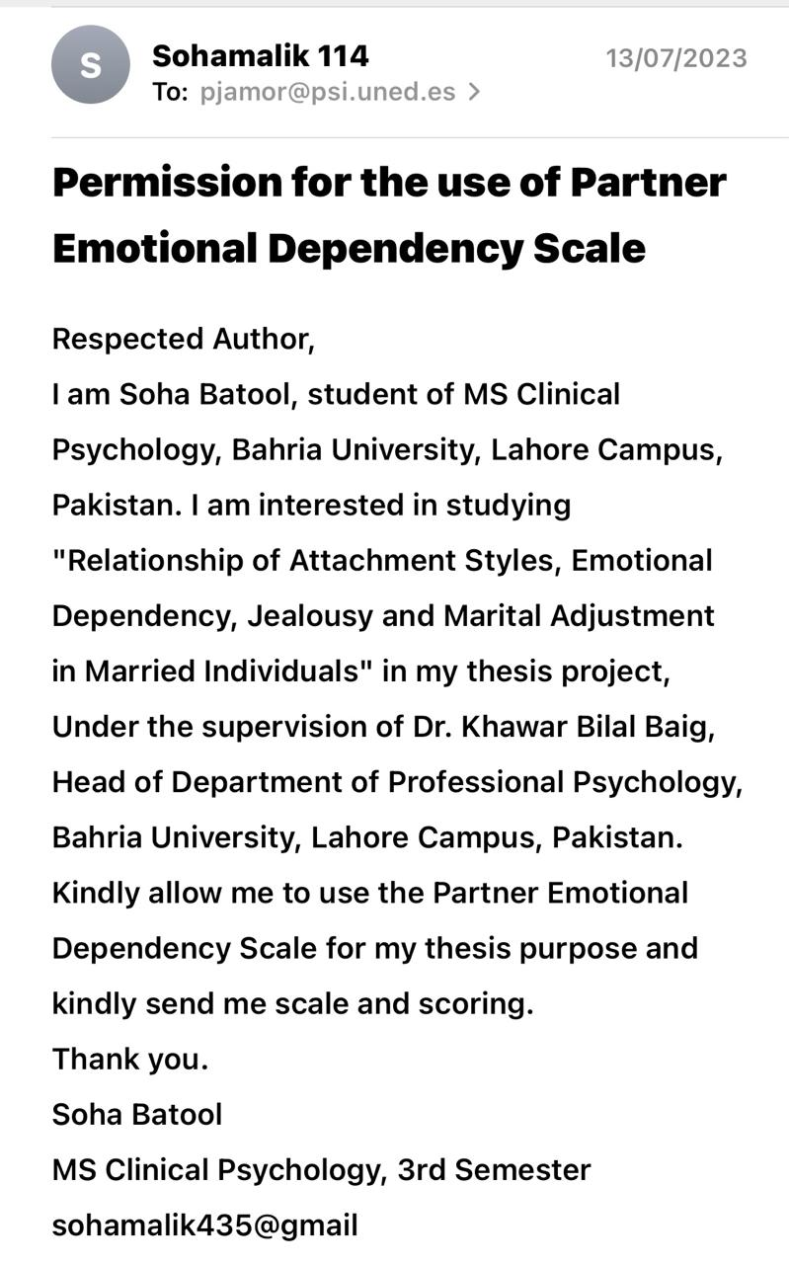
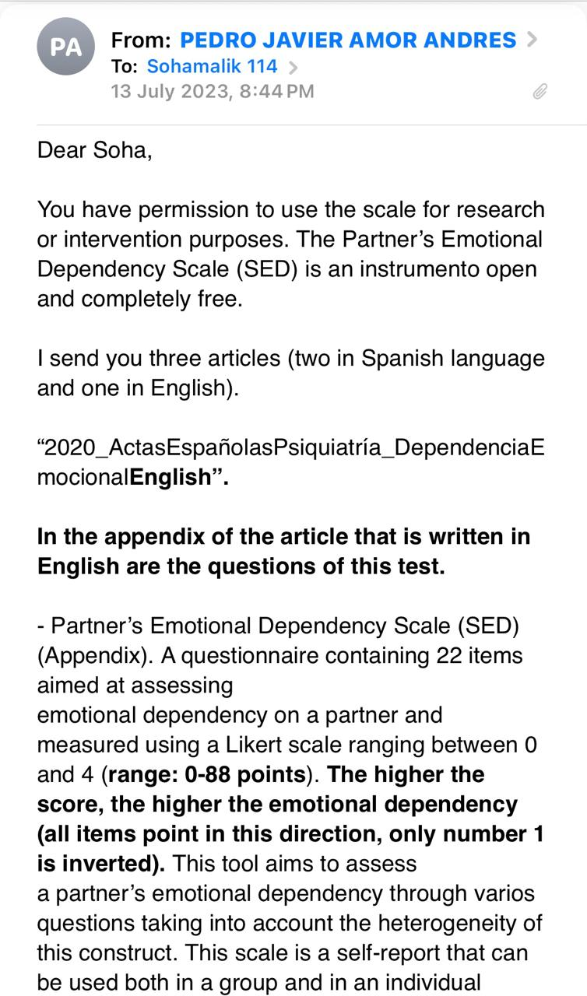
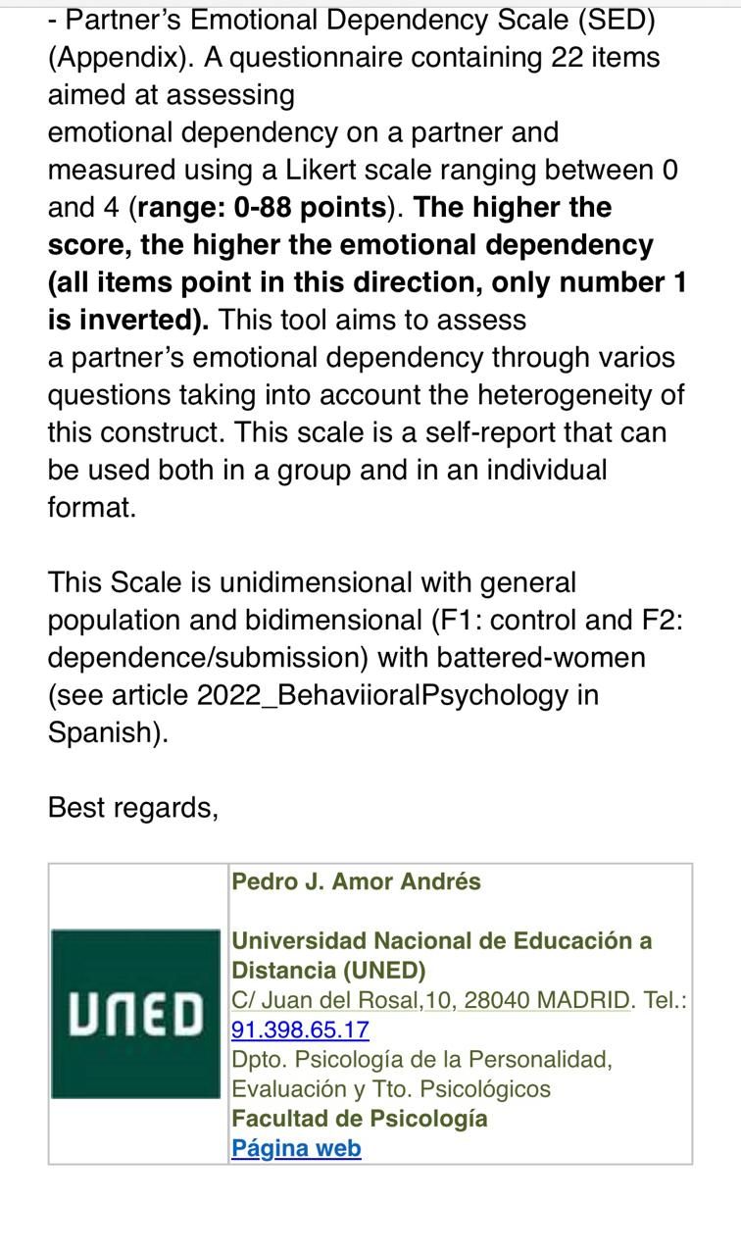
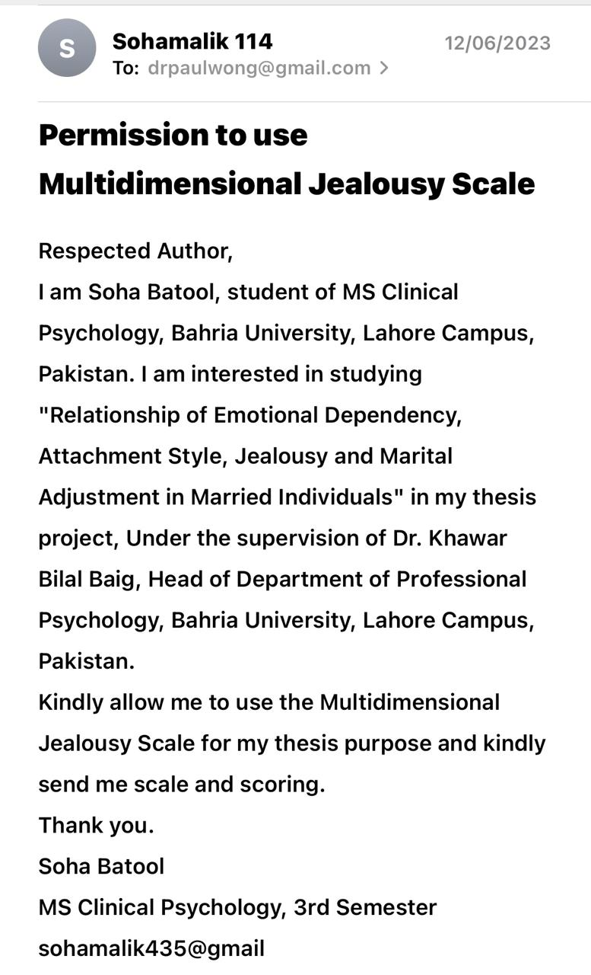
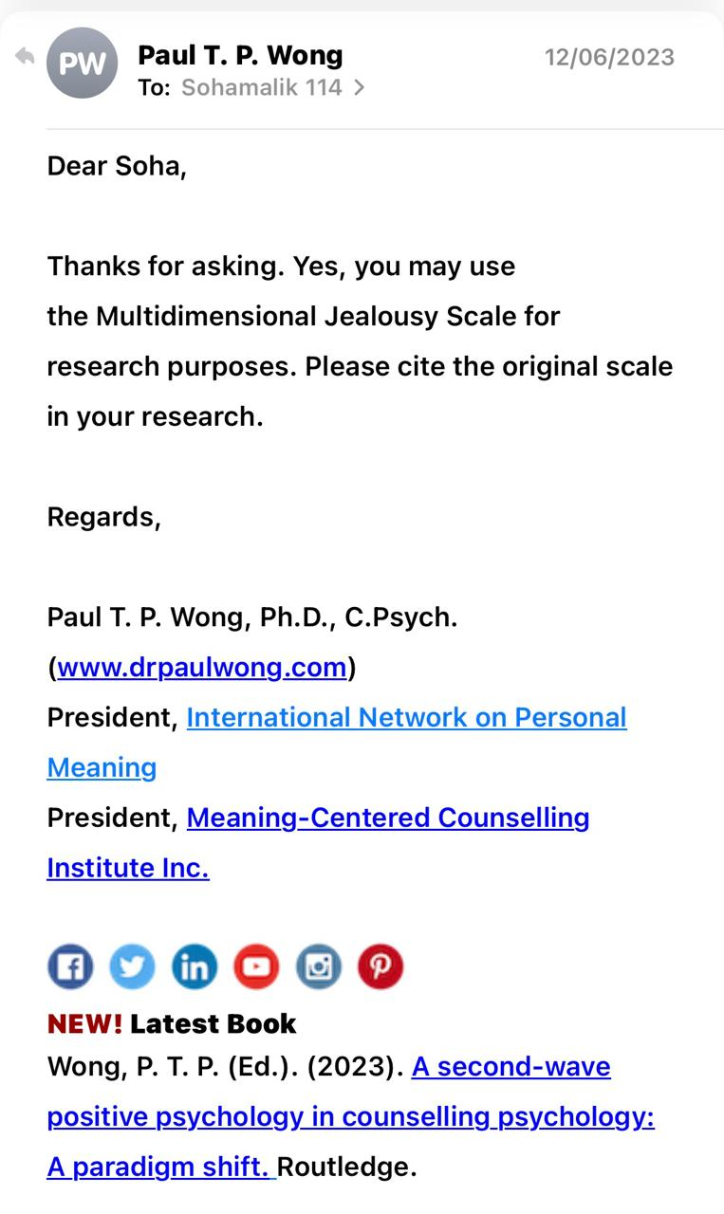
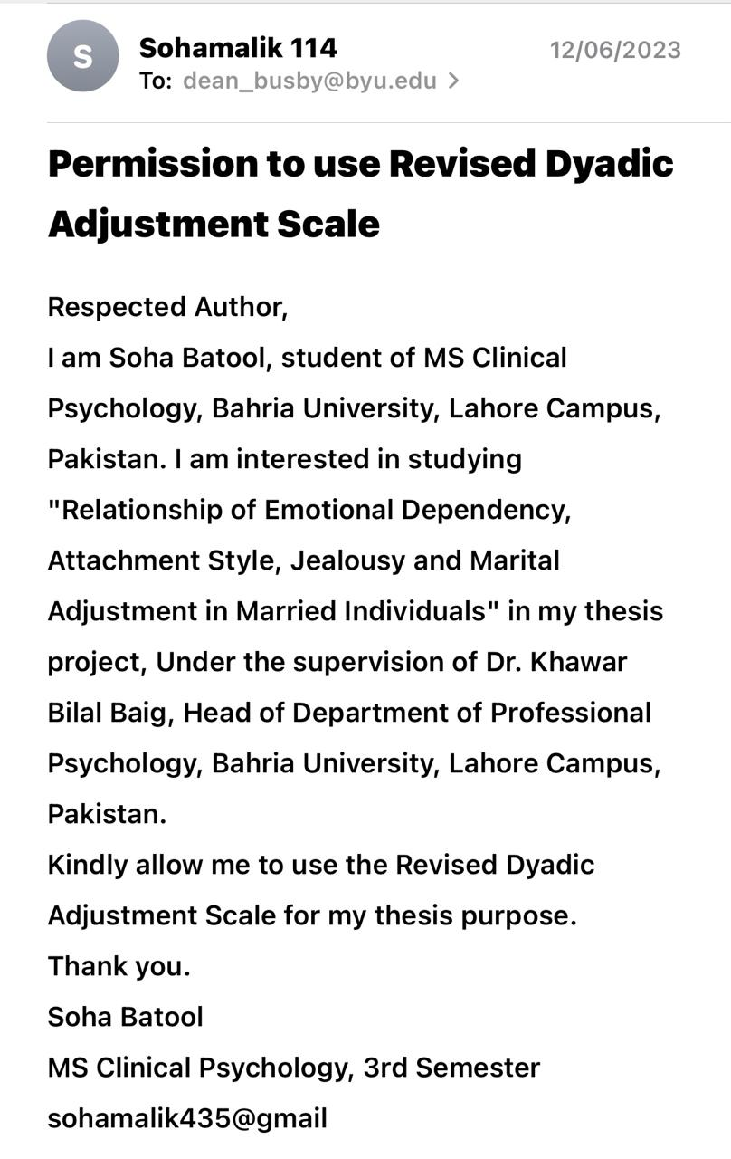

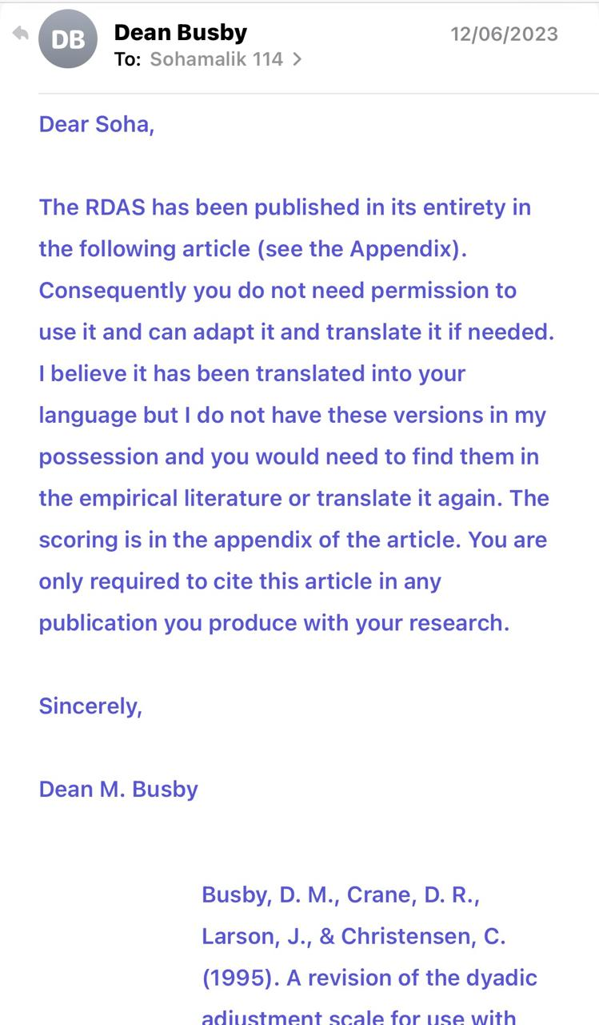
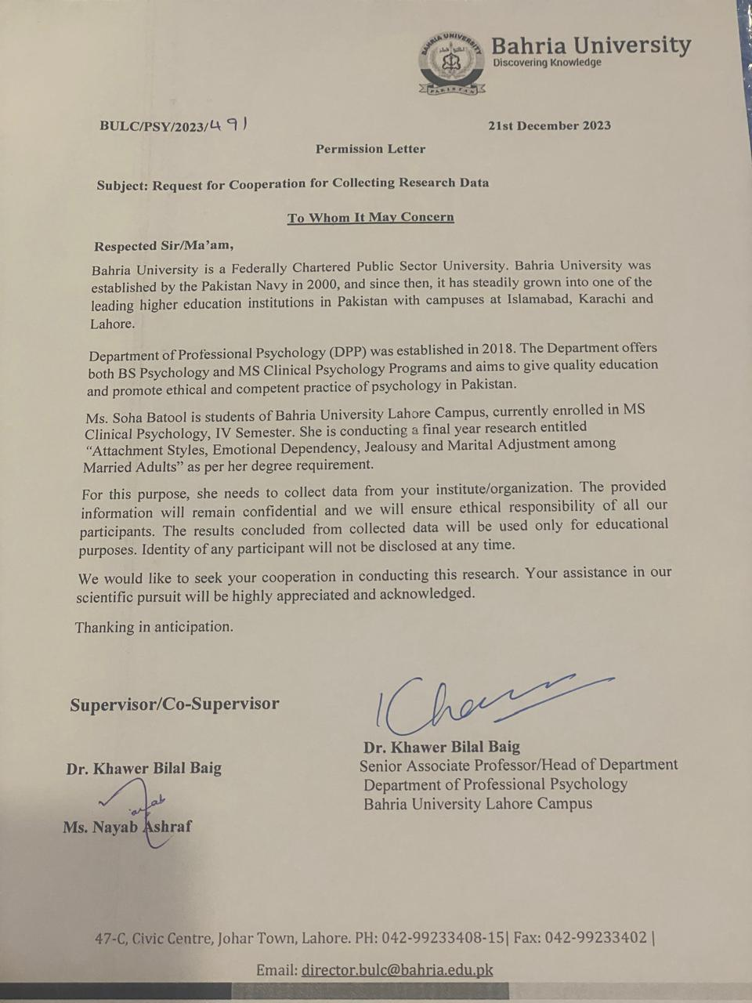

Consent Form for Participation in Research
I am Soha Batool student of MS Clinical Psychology at Bahria University Lahore campus. I am conducting research for degree completion and you are being asked to take part in the research. The title of my study is Attachment Style, Emotional Dependency, Jealousy, and Marital Adjustment among Married Adults. Please read this form carefully and ask any questions you may have before agreeing to take part in the study. If you agree to participate firstly you will be given a demographic sheet to fill in based on questions regarding your gender, age, birth order, education, type of marriage, duration of marriage, family system, number of children, and occupational status. After this, you will be given a questionnaire which will be based on questions regarding your experience. This will take almost 15 to 20 minutes to complete.
Participation in this research is completely voluntary. Taking part in this research has no foreseeable psychological and emotional harm. The identity and the confidentiality of your given responses will be kept secret. So try to answer all the questions. You can withdraw from the research at any point in time. In such a case, the gathered information will be destroyed and you will not be penalized for withdrawing from the research. If you wish to participate, the collected data will be used for academic and publishing purposes, maintaining your confidentiality. It will only be disclosed to the research supervisor and the department. If you need additional information, the researcher can be contacted at sohamalik435@gmail.com.
Statement of consent: I have read all the above information carefully and have received answers to any questions I asked. I agree to take part in the study.
Signature of participant: ________________________
Email (optional): __________________________________
Date: _______________________
Demographic Sheet
Gender
Male Female
Age
25-30 31-35 36-40

Education
Bachelor Master PhD
Type of Marriage
Love Marriage Arrange Marriage

Duration of Marriage
Early years (1-3 years) Middle years (4-9 years) Older years (10+ years)
Family System
Nuclear Joint
Number of Children
  - 3-4 More than 5
Occupational Status
Full-time working Part-time working Non-working

Section I

Instructions: Please read each of the following statements and rate the extent to which you believe each statement best describes your feelings about close relationships.

Sr. no | Statements | Not at all  like me (1) | Rarely (2) | Somewhat  like me (3) | Often (4) | Very much  like me  (5)
1 | I find it difficult to depend on other people.
2 | It is very important to me to feel independent.
3 | I find it easy to get emotionally close to others.
4 | I want to merge completely with another person.
5 | I worry that I will be hurt if I allow myself to become too close to others.
6 | I am comfortable without close emotional relationships.
7 | I am not sure that I can always depend on others to be there when I need them.
8 | I want to be completely emotionally intimate with others.
9 | I worry about being alone.
10 | I am comfortable depending on other people.
11 | I often worry that romantic partners don’t love me.
12 | I find it difficult to trust others completely.
13 | I worry about others getting too close to me.
14 | I want emotionally close relationships.
15 | I am comfortable having other people depend on me.
16 | I worry that others don’t value me as much as I value them.
17 | People are never there when you need them.
18 | My desire to merge completely sometimes scares people away.
19 | It is very important to me to feel self-sufficient.
20 | I am nervous when anyone gets too close to me.
21 | I often worry that romantic partners won’t want to stay with me.
22 | I prefer not to have other people depend on me.
23 | I worry about being abandoned.
24 | I am somewhat uncomfortable being close to others.
25 | I find that others are reluctant to get as close as I would like.
26 | I prefer not to depend on others.
27 | I know that others will be there when I need them.
28 | I worry about having others not accept me.
29 | Romantic partners often want me to be closer than I feel comfortable being.
30 | I find it relatively easy to get close to others.

Section II
Instructions: Read the questions below and answer by marking the answer that best suits how you feel and behave. Please note that the answer options are as follows:

Sr.no | Statements | Totally false  (0) | Partially false (1) | Partially (2) | Partially True (3) | Totally True (4)
1 | Are you generally satisfied with yourself?
2 | Do you often act as if your partner's well-being is above your own?
3 | Does the possibility of breaking up with your partner often cause you anguish or infinite sadness?
4 | Do you usually ask your partner for forgiveness when she is angry, even though you know that you are not the one responsible for the anger?
5 | Do you need your partner to continually show you affection?
6 | Do you habitually carry out behaviors or activities that you do not like just to please your partner or to avoid a relationship breakup?
7 | Do you usually justify your partner's conflicts, criticisms, or infidelities as a lesser evil within the relationship?
8 | Do you usually feel guilty about couple arguments?
9 | Do you feel unable to leave your partner despite the discomfort and suffering that this relationship causes you?
10 | Have you pushed yourself to the limit and done things that you may even recognize as inappropriate for yourself (behaviors sexual behavior, reckless behavior, drug use, allowing financial abuse) just to avoid abandonment?
11 | Do you think that you are not up to your current partner and that, therefore, you could lose them?
12 | Do you need to control your partner (mobile phone, WhatsApp, etc.) to constantly know where or who they are with?
13 | Do you see yourself as different in your way of being and acting since you are with this partner?
14 | Do you organize all the joint plans always according to the tastes and desires of your partner?
15 | Do you suffer from exaggerated jealousy constantly?
16 | Have you set aside your obligations or have you stopped caring for your family or friends to be with your partner?
17 | Do you often think that previous relationships were more satisfying for your partner than being with you?
18 | Has your partner expressed to you the burden they feel because of the need you have to be constantly with them or to continually know about your movements?
19 | Do you feel helpless and alone when you don't have a partner?
20 | Are you convinced or do you constantly suspect that your partner is thinking of ending the relationship?
21 | Do you have a need to continually please your partner?
22 | Do you think you would be able to do anything to get your partner back if he left you?
Section III
Instructions: Please think of a person with whom you are having or had a strong romantic/love relationship. This person is referred to as partner/spouse in this questionnaire. Please rate your response to the following questions by circling the appropriate number beside each item.

Sr.no | Statements | All the time(1) | Most of the time (2) | More often than not (2) | Sometimes (4) | Occasionally (5) | Rarely (6) | Never (7)
 | How often do you have the following thoughts about your partner?
1 | I suspect that the partner is secretly seeing someone of the opposite sex.
2 | I am worried that some members of the opposite sex may be chasing after their partner.
3 | I suspect that partner may be attracted to someone else.
4 | I suspect that my partner may be physically intimate with another member of the opposite sex behind my back.
5 | I think that some members of the opposite sex may be romantically interested in a partner.
6 | I am worried that someone of the opposite sex is trying to seduce my partner.
7 | I think that partner is secretly developing an intimate relationship with someone of the opposite sex.
8 | I suspect that partner is crazy about members of the opposite sex.

 | How would you emotionally react to the following situations?
 |  | Very pleased(1) | Pleased (2) | Some  what Pleased (3) | Neutral (4) | Somewhat upset (5) | Upset (6) | Very upset (7)
9 | Partner comments to you on how great-looking a particular member of the opposite sex is.
10 | Partner shows a great deal of interest or excitement in talking to someone of the opposite sex.
11 | Partner smiles in a very friendly manner to someone of the opposite sex.
12 | A member of the opposite sex is trying to get close to partner all the time.
13 | Partner is flirting with someone of the opposite sex.
14 | Someone of the opposite sex is dating a partner.
15 | Partner hugs and kisses someone of the opposite sex.
16 | Partner works very closely with a member of the opposite sex (in school or office).

 | How often do you engage in the following behaviors?
 |  | Never (1) | Rarely (2) | Occasionally (3) | Sometimes(4) | More often than not(5) | Most of the time  (6) | All the time  (7)
17 | I look through partner drawers, handbags, or pockets.
18 | I call my partner unexpectedly, just to see if s/he is there.
19 | I question my partner about previous or present romantic relationships.
20 | I say something nasty about someone of the opposite sex if a partner shows an interest in that person.
21 | I question my partner about his/her telephone calls.
22 | I question my partner about his/her whereabouts.
23 | I join in whenever I see a partner talking to a member of the opposite sex.
24 | I pay my partner a surprise visit just to see who is with him/her.

Section IV
Instructions: Most persons have disagreements in their relationships. Please indicate below the approximate extent of agreement or disagreement between you and your partner for each item on the following list.

Sr.no | Statements | Always  Agree (5) | Almost  Always  Agree  (4) | Occasionally  Agree  (3) | Frequently  Disagree (2) | Almost  Always  Disagree (1) | Always  Disagree  (0)
1 | Religious matters
2 | Demonstrations of affection
3 | Making major decisions
4 | Sex relations
5 | Conventionality (correct or Proper behavior)
6 | Career decisions

 |  | All the  Time (0) | Most  of the  time (1) | More often  than not (2) | Occasionally (3) | Rarely (4) | Never (5)
7 | How often do you discuss or have you considered divorce separation, or terminating your relationship?
8 | How often do you and your partner quarrel?
9 | Do you ever regret that you married (or lived together)?
10 | How often do you and your mate get on each other’s nerves?

 |  | Every day (4) | Almost every day (3) | Occasionally (2) | Rarely (1) | Never (0)
11 | Do you and your mate engage in outside interests together?

 | How often would you say the following events occur between you and your mate?
 |  | Never (0) | Less than  once a  month (1) | Once or  twice a  month (2) | Once or  twice a  week (3) | Once a day (4) | More  often (5)
12 | Have a stimulating exchange of ideas
13 | Work together on a project
14 | Calmly discuss something

