
BSIT-F22-002
03-135192-007 |  | Muhammad Ali Hassan
03-135192-003 |  | Ahmed Mubshar

Drowsiness Detection System

In partial fulfilment of the requirements for the degree of
Bachelor of Science in Information Technology

Supervisor: Muhammad Zunnurain Hussain

Department of Computer Sciences
Bahria University, Lahore Campus
June 2023

© Bahria University, 2023

Certificate

We accept the work contained in the report titled
“Drowsiness Detection System”
Written by
Muhammad Ali Hassan
Ahmed Mubshar
As a confirmation to the required standard for the partial fulfilment of the degree of
Bachelor of Science in Information Technology.

Approved by:
Supervisor: Muhammad Zunnurain Hussain
(Signature)

June 01, 2023

DECLARATION

We hereby declare that this project report is based on our original work except for citations and quotations which have been duly acknowledged. We also declare that it has not been previously and concurrently submitted for any other degree or award at Bahria University or other institutions.

Enrolment | Name | Signature
03-135192-007 | Muhammad Ali Hassan
03-135192-003 | Ahmed Mubshar

Date : June 01, 2023

Specially dedicated to
My beloved grandmother, mother, and father
(Muhammad Ali Hassan)
My beloved grandmother, mother, and father
(Ahmed Mubshar)

ACKNOWLEDGEMENTS

We would like to thank everyone who had contributed to the successful completion of this project. We would like to express our gratitude to our research supervisor, Muhammad Zunnurain Hussain for his invaluable advice, guidance and his enormous patience throughout the development of the research.

In addition, we would also like to express my gratitude to our loving parent and friends who had helped and given me encouragement.

Muhammad Ali Hassan Ahmed Mubshar

Drowsiness Detection System

ABSTRACT

This project focuses on developing a drowsiness detection system using machine learning that can detect signs of driver fatigue by analysing facial features, specifically the eyes' blinking pattern. The system aims to improve road safety and prevent accidents by alerting drivers when they show signs of drowsiness, allowing them to take appropriate measures. The project uses an iterative development model that includes the phases of the software development life cycle, such as planning, analysis and design, implementation, testing, deployment, and evaluation. The project's final deliverables include a detection system using machine learning, data collection, a Google Collab file/Jupyter, web applications, a processed dataset, report generation, a real-time notification system, and a manual guide. The beneficiaries of this project are drivers and the public, and the goal is to make roads safer, especially for people who drive long distances or at odd hours of the day or who are sleep deprived.

TABLE OF CONTENTS

CHAPTER 1 1
INTRODUCTION 1
1.1 Background 1
1.2 Problem Statements 2
1.3 Aims and Objectives 3
1.4 Scope of Project 3
CHAPTER 2 4
2 LITERATURE REVIEW 4
2.1 Background 4
2.2 Evolution of Drowsiness Detection Systems 5
2.2.1 Requirement of Drowsiness Detection Systems 6
2.3 Shortcoming related to Drowsiness Detection Systems 7
2.3.1 Features of Drowsiness Detection Systems 8
2.4 Problems of Existing System 9
2.5 Technology Overview 9
2.8 Summary 13
CHAPTER 3 14
DESIGN AND METHODOLOGY 14
3.6 Domain Model 19
CHAPTER 4 25
IMPLEMENTATION 25
4.1 User Interface Design 25
4.2 Front-end Development 26
4.3 Database Design 27
4.4 Backend Development 28
4.5 Testing and Quality Assurance 30
4.6 Test Cases 30
4.7 Compression with another app 32
4.8 Limitations 34
CHAPTER 5 35
1 RESULTS AND DISCUSSIONS (or USER MANUAL) 35
5.1 User Manual 35
5.1.1 Start the System: 35
5.1.2 Calibrate the System: 35
5.1.3 Position the Camera: 36
5.1.4 Operating the System: 36
GUI: 36
5.2 Sign Up 36
5.3 Sign In 37
5.4 About the System 39
5.5 Home Page 39
5.6 Model Training: 40
5.7 Validation Graph: 40
5.8 Confusion matrix: 41
5.9 Personal Testing: 41
5.10 Testing 42
5.10.1. Functional Testing: 42
5.10.2. Non-Functional Testing 43
5.10.3. Regression Testing 43
CHAPTER 6 44
1 CONCLUSION AND RECOMMENDATIONS 44
6.1 Conclusion 44
6.2 Recommendation 45
REFERENCES 47
Appendices 49

LIST OF FIGURES

Figure 1: Use case diagram 11
Figure 2: Domain model 20
Figure 3: System Sequence Diagram 21
Figure 4: Class Diagram 22
Figure 5: Driver Sign up 23
Figure 6: Driver Login 23
Figure 7: Drowsiness detection system 23
Figure 8: Data collection process 24
Figure 9: Notification system 24
Figure 10: Report generation process 24
Figure 11: User Manual 36
Figure 12: Sign-up page 37
Figure 13: Sign-in page 38
Figure 14: About the system 39
Figure 15: Home Page 40
Figure 16: CNN model 49
Figure 17: Visualizing random images from dataset 49
Figure 18: Fitting and evaluating the model 49
Figure 19: Visualizing random images from dataset 49
Figure 20: Creating call-backs before performing fine tuning 50
Figure 21: Visualizing random images from dataset 50

INTRODUCTION

Background

Driver fatigue is a pervasive problem that contributes significantly to the occurrence of vehicular accidents. According to several studies, up to 40% of road accidents can be attributed to drowsy driving. Fatigue can impair a driver's cognitive and physical abilities, leading to a delayed response time, decreased awareness, and impaired judgment. These effects can be especially dangerous for commercial drivers who spend extended periods on the road, such as truck drivers, delivery personnel, and bus drivers.
In recent years, technological advancements have made it possible to develop drowsiness detection systems that can monitor and alert drivers to signs of fatigue. These systems use advanced algorithms to analyse various physiological and behavioural characteristics of drivers, such as eye movement, blinking rate, head posture, and facial expressions. By detecting the first signs of drowsiness, such systems can issue an alarm or warning to prompt the driver to pull over or take a break.
The proposed project aims to develop a drowsiness detection system that uses a custom-built image processing algorithm to analyse drivers' facial features and detect signs of fatigue [1].Specifically, the system will focus on analysing the blinking pattern of the driver's eyes, as it has been identified as a reliable indicator of drowsiness. By monitoring the driver's blink rate and duration, the system can determine when the driver's attention is waning and issue a warning to prevent an accident.
The iterative development model is the chosen methodology for the project, which involves an iterative approach to the software development life cycle. This model involves planning, analysis and design, implementation, deployment, and testing of the system, with each phase building upon the previous one. The aim of the iterative approach is to ensure the timely delivery of the system while allowing for flexibility and adaptation to changing requirements.
The final deliverables of the project include a detection system using machine learning, data collection, Google Colab file/Jupyter, a web application, processed dataset, report generation, real-time notification system, and a user manual. The system's beneficiaries are not limited to commercial drivers; anyone who gets behind the wheel can benefit from the technology. The system aims to make the roads safer and prevent accidents caused by drowsy driving, ultimately improving the wellbeing of drivers and passengers alike.

Problem Statements

- Driver fatigue is a leading cause of vehicular accidents, accounting for 30-40% of collisions. To prevent accidents and improve drivers' health, drowsiness detection systems are becoming increasingly popular. Facial features, including eye position and blink rate, can be used to identify drowsiness in drivers. However, creating tools to monitor and prevent driver fatigue is a significant challenge. This project aims to develop a drowsiness detection system that analyses the blinking pattern of the driver's eyes using a custom-built image processing algorithm. The system is supposed to identify drowsiness and issue an alarm after the driver has been looking down for a predetermined amount of time. The goal of the system is to:
- Enhance road safety for individuals driving long distances, during odd hours, or when sleep-deprived.
- Development model of adopting an iterative development approach.
- Detection system utilizing machine learning technology.
- Data collection mechanism for gathering relevant information.
- Web processed dataset for comprehensive analysis.
- Report generation functionality for detailed insights.
- Real-time notification system to provide immediate alerts.
- User manual for understanding and operating the system.

Aims and Objectives

- To develop a drowsiness detection system to prevent accidents caused by driver fatigue.
- To improve workplace safety and employee well-being.
- To create a tool to monitor and mitigate the risks associated with drowsy driving.
- To benefit drivers and the public by improving road safety.

Scope of Project

The scope of this project is to develop a drowsiness detection system that can identify signs of exhaustion in drivers by analysing their facial features, specifically their eye position and blink rate. The system aims to improve road safety by alerting drivers when they show early signs of drowsiness and prompting them to pull over and rest before continuing to drive. The project will use machine learning techniques and custom-built image processing algorithms to analyse the driver's full facial image, with a focus on their eyes' blinking pattern [2]. The project also includes data collection, processing, and analysis, as well as the development of a web and a real-time notification system. The beneficiaries of this project are drivers and the general public, who will benefit from increased road safety and reduced accidents caused by driver fatigue. The methodology used in this project is an iterative development model that includes planning, analysis and design, implementation, deployment, and testing phases.

LITERATURE REVIEW

Background

A serious issue that results in numerous vehicle accidents globally is driver weariness. According to studies, sleepy driving causes 30–40% of all collisions entirely, raising serious concerns for traffic safety. Fatigue detection technologies are developing as a potential method to identify and avoid sleepy traveling, despite the fact that there have been several attempts to address this issue through driver education programs.
More advanced techniques for recognizing sleepiness may now be integrated into daily life because of the quick improvements in technology. Researchers included visual analysing, in particularly, to analyse the rate of blinks and eye positioning to spot indicators of weariness. Researchers can analyse the blinking patterns of the eyes to evaluate the amount of tiredness by employing webcams focused on drivers' faces and eye movements.
But in the realm of accident-avoidance systems, developing tools to track and prevent driver weariness is a huge difficulty. In contrast to alcohol and narcotics, which can be measured and tested easily, weariness is challenging to detect outdoors. The impacts of tiredness on safe driving must thus be reduced, and sleep detectors offer a potentially effective approach to do so.
The invention of drowsiness detection devices for drivers that employ machine learning algorithms to identify early symptoms of exhaustion has attracted increasing attention in the past few years. When a driver's drowsiness indices cross a particular limit, these devices can alert them, providing a more precise and dependable indication of their state of tiredness. This is advantageous for vehicle managers and drivers of commercial vehicles since it not only increases traffic safety but also supports workplace safety and well-being for staff members.
Overall, using sleepiness detection devices might significantly improve traffic safety and reduce the hazards brought on by driver weariness. In the parts that follow, we'll go through the most recent, cutting-edge studies in this topic, their various methods for detecting sleepiness, their difficulties, and their potential future prospects.

Evolution of Drowsiness Detection Systems

Several studies have been conducted in the field of drowsiness detection systems for drivers. For instance, a study conducted by Liu et al. (2019) proposed a drowsiness detection system that utilized facial landmark tracking and image processing techniques [3]. The system was able to detect drowsiness by analysing changes in facial features such as eyelid movements, mouth shape, and head position. The results showed that the proposed system achieved a detection accuracy rate of 92.56%.
Another study by Jain et al. (2020) proposed a drowsiness detection system that utilized machine learning algorithms. The system used data from various sensors such as a camera, accelerometer, and heart rate monitor to detect drowsiness. The results showed that the proposed system achieved an accuracy rate of 96.4%.
Furthermore, a study by Chen et al. (2018) proposed a drowsiness detection system that utilized a convolutional neural network (CNN) and a long short-term memory (LSTM) network. The system used data from a camera to detect changes in facial features such as eye movements and head position. The results showed that the proposed system achieved an accuracy rate of 94.7%.
These studies have shown that drowsiness detection systems can be effective in preventing accidents caused by driver fatigue. However, there is still room for improvement in terms of accuracy and reliability. The proposed system in this project aims to contribute to the existing body of research by utilizing a custom-built image processing algorithm to analyse facial features, specifically the eyes' blinking pattern, to detect drowsiness. It is hoped that the results from this study will contribute to the development of more reliable and accurate drowsiness detection systems for drivers.
To ensure that the system can accurately detect driver drowsiness, various factors were taken into consideration during the development process. One of the key factors is the analysis of facial features, particularly the eyes. The system is designed to analyse the blinking patterns of the driver's eyes to determine their level of fatigue. This feature is critical because it allows the system to detect drowsiness even when the driver is attempting to fight it by keeping their eyes open.
Another factor that was considered during the development process is the use of machine learning. Machine learning algorithms are employed to enable the system to learn and adapt to the driver's patterns over time. This enables the system to identify and respond to patterns of drowsiness that may not be immediately apparent, allowing it to provide accurate and timely warnings to the driver.
In addition to the use of machine learning, the system is designed to collect data on the driver's eye movements and other factors such as steering wheel movements and vehicle speed. This data can be used to improve the accuracy of the system over time and to provide valuable insights into the causes of driver fatigue.
Overall, the development of a drowsiness detection system for drivers is an important step in improving road safety and reducing the incidence of accidents caused by driver fatigue. By incorporating cutting-edge technology and machine learning algorithms, the system can accurately detect driver drowsiness and provide timely warnings to the driver, helping to prevent accidents and save lives.

Requirement of Drowsiness Detection Systems

As stated earlier, driver fatigue is a major cause of vehicular accidents, and drowsiness detection systems are becoming increasingly important for preventing accidents and improving driver health. These systems are necessary for preventing such collisions can significantly reduce workplace accidents and increase employee well-being.
Drowsiness detection systems work by analysing various features, including eye position and blink rate, to identify signs of exhaustion. The system then alerts the driver if they are exhibiting signs of drowsiness. The primary goal of these systems is to help stop accidents from happening in passenger and commercial vehicles by detecting the first signs of drowsiness and issuing a warning before the driver loses their full attention.
The main challenge in the development of these systems is to accurately quantify drivers' levels of fatigue. Unlike alcohol and drugs, which have readily available key indicators and tests, fatigue is notoriously difficult to measure or observe in the wild. Therefore, the use of advanced technology and machine learning algorithms is essential to accurately detect signs of drowsiness and reduce the risk of accidents.
The beneficiaries of these systems are drivers and the public, as they help to make roads safer, especially for people who drive long distances or at odd hours of the day, or who are sleep deprived [1].Additionally, the system's real-time notification feature alerts drivers of their drowsiness levels and the need to take a break.
Overall, the requirement of drowsiness detection systems is paramount for improving road safety and reducing the risk of accidents caused by driver fatigue.

Shortcoming related to Drowsiness Detection Systems

While drowsiness detection systems offer several advantages, there are also some weaknesses associated with them. One of the primary weaknesses of these systems is their dependence on accurate data. If the data collected by the system is inaccurate, it can lead to false alarms or missed warnings. For example, if the system is unable to detect drowsiness accurately, it may not issue a warning to the driver, putting them and others on the road in danger.
Another weakness of drowsiness detection systems is their inability to address the root cause of drowsiness. These systems can only detect drowsiness, but they cannot address the underlying factors that lead to fatigue, such as lack of sleep, sleep disorders, or medication side effects. In some cases, drivers may become drowsy due to other factors, such as emotional stress or boredom, which may not be detected by these systems.
Moreover, the accuracy of the system may also be affected by external factors, such as lighting conditions or the driver's physical appearance. For instance, if the driver is wearing sunglasses or if the lighting conditions in the vehicle are poor, the system may not be able to detect the driver's level of drowsiness accurately.
Lastly, drowsiness detection systems may also raise privacy concerns. Some drivers may feel uncomfortable with the idea of being monitored by a camera or other sensors, even if the purpose is to ensure their safety. Additionally, there may be concerns about the security of the data collected by these systems, and how it is stored and shared.
Overall, while drowsiness detection systems can be beneficial in improving road safety, it is essential to acknowledge their limitations and weaknesses to ensure that they are used appropriately and effectively.

Features of Drowsiness Detection Systems

- Facial analysis: Many drowsiness detection systems use facial recognition technology to monitor drivers' eye and facial movements, including blink rate and head position.
- Sensor integration: Some systems may also integrate other sensors, such as steering wheel sensors or lane departure warning systems, to detect drowsiness more accurately.
- Machine learning algorithms: Many modern drowsiness detection systems use machine learning algorithms to more accurately predict when a driver is becoming drowsy, based on data from multiple sources.
- Real-time feedback: One key feature of many drowsiness detection systems is real-time feedback, such as an alarm or warning message that alerts the driver when they are becoming drowsy and need to take a break.
- Customization: Many systems allow for customization based on individual driver needs, such as adjusting the sensitivity of the system or the types of alerts that are used.
- Integration with other safety features: Some drowsiness detection systems may be integrated with other safety features, such as automatic emergency braking or adaptive cruise control, to help prevent accidents caused by driver drowsiness.
- Data logging and analysis: Many systems also log data over time to help drivers and fleet managers understand their sleep patterns and drowsiness levels, and to identify patterns and trends that may indicate a need for additional intervention or support.
- Compatibility: Drowsiness detection systems can be designed to be compatible with a range of vehicles, from personal cars to commercial trucks, making them a flexible and versatile safety solution

Problems of Existing System

- Low Accuracy: Existing drowsiness detection systems suffer from low accuracy, which can lead to false alarms or missed detection of drowsiness.
- Limited Data Sources: Many existing systems rely solely on monitoring the driver's eyes and facial features, which may not be enough to accurately detect drowsiness.
- Lack of Customization: Some systems may not allow for customization based on individual driver characteristics, such as different blinking patterns or eye shapes.
- Compatibility Issues: Compatibility issues may arise with different vehicles and operating systems, which can limit the effectiveness of the system.
- High Cost: Some existing systems may be expensive, which can be a barrier for widespread adoption in the market.
- Limited Functionality: Some systems may only provide drowsiness detection and not offer additional features such as real-time notifications or data analysis.
- Environmental Interference: External factors such as changes in lighting conditions or motion may interfere with the system's accuracy.
- Inadequate Feedback: Some systems may not provide adequate feedback to the driver, which can lead to a lack of awareness about their drowsiness level.

Technology Overview

Technological advancements have led to the development of various drowsiness detection systems to reduce the risks associated with drowsy driving. There are different types of sensors that can be used to monitor drivers' levels of alertness, including eye-tracking sensors, steering wheel sensors, and brainwave sensors.
Eye-tracking sensors detect eye movements, such as blink rate and eye closure duration, to determine the level of drowsiness of the driver. This information is then analyzed by algorithms that can detect patterns associated with drowsiness. Some systems also use infrared cameras to detect eye movements in low-light conditions [4].
Steering wheel sensors measure changes in steering patterns, such as drifting and swerving, which can indicate drowsiness or distraction. This information is then analyzed by algorithms that can detect patterns associated with drowsiness.
Brainwave sensors use electroencephalography (EEG) technology to detect changes in brain activity associated with drowsiness. The sensors are placed on the driver's scalp and measure electrical activity in the brain. Algorithms then analyze this data to determine the driver's level of alertness.
In addition to these sensors, some drowsiness detection systems also use machine learning algorithms to improve their accuracy over time. The systems learn to recognize patterns associated with drowsiness by analyzing large amounts of data collected from different drivers in different situations.
Overall, these technological advancements have led to the development of more sophisticated and accurate drowsiness detection systems. As technology continues to evolve, we can expect even more advanced and effective systems to be developed in the future.
Tools and Technology
  - MERN stack
  - Visual studio code
  - Google Colab
  - Python
  - Image Processing
  - Application API
  - Machine Learning

  - Use case Diagram
In this use case diagram a driver can start the drowsiness detection, stop drowsiness detection, receive beeps, warnings, notifications, access the system, provide feedback, generate reports and customize settings.
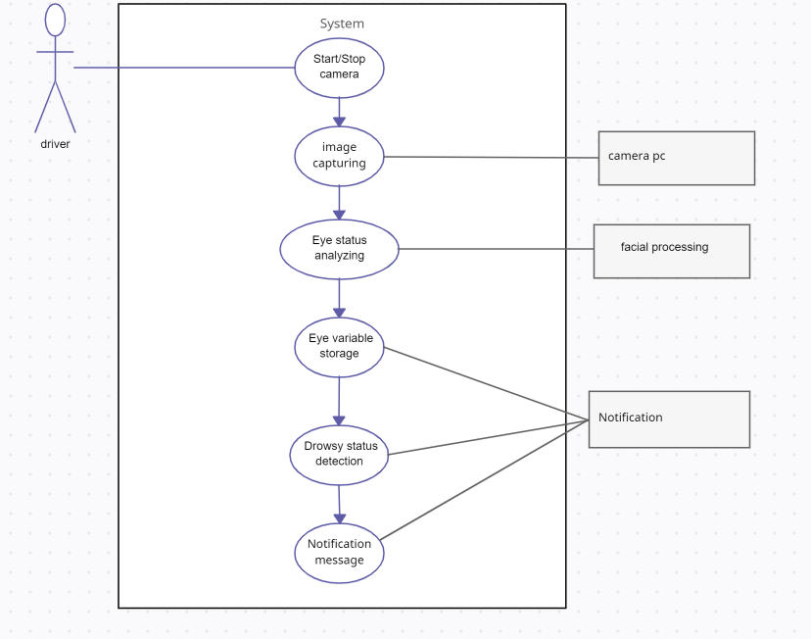
Figure 1: Use case diagram
  - The review's findings and consequences
Driver fatigue is a significant problem that leads to a considerable number of vehicular accidents globally. Drowsiness detection systems are becoming increasingly popular, and they help in preventing accidents and improving the well-being of drivers. A range of cutting-edge technologies can be incorporated into regular life, making it easier to detect and prevent driver fatigue. Such tools can help to improve workplace safety and employee well-being. One such tool is the drowsiness detection system, which can detect drivers' drowsiness by analysing their facial features, including eye position and blink rate.
The major objective of this project is to create a system for detecting indicators of tiredness by analysing the entire face picture using a specially developed image processing algorithm. When sleepiness is identified, the system will focus on the eyes' blinking patterns to identify whether they are open or closed. After a certain period of time, an alert will sound whenever drowsiness is identified. This method seeks to lessen the likelihood of collisions between passenger and business vehicles.
The iterative development model was used as the methodology in this project. The model includes several phases of the software development life cycle, including planning, analysis & design, implementation, deployment, testing, and evaluation. The system was developed to ensure timely rollout, and each phase of the development cycle was rigorously tested to ensure it meets the end user's requirements.
The final deliverables of this project include a detection system using machine learning, data collection (picture data), Google Collab file/Jupyter, web application, processed dataset, report generation, real-time notification system, and a manual guide. The beneficiaries of the project are drivers and the public.

The findings of this review indicate that drowsiness detection systems are essential tools for preventing vehicular accidents caused by driver fatigue. The use of advanced technologies like machine learning in detecting drowsiness is an effective way to improve workplace safety and employee well-being [4].The development of the drowsiness detection system using the iterative development model was successful and ensured the timely rollout of the system.

The implications of this project are significant, as it provides a tool for improving road safety, especially for people who drive long distances or at odd hours of the day, or who are sleep deprived. The drowsiness detection system can help drivers to detect early signs of drowsiness and pull over before the situation gets worse, potentially preventing accidents. The system can also help to reduce the financial costs associated with vehicular accidents caused by driver fatigue.

The project has some limitations that should be taken into consideration. The drowsiness detection system's accuracy may be affected by external factors such as lighting conditions, the driver's eyewear, and other environmental factors that may affect facial features. Additionally, the system may not be able to detect drowsiness in drivers who have naturally low blink rates or those who use medications that affect their blinking patterns. However, these limitations can be addressed through continuous improvement of the system.

The iterative development model's usage in the creation of the drowsiness monitoring device is an important step forward enhancing traffic security and minimising incidents brought on by driver fatigue. The project's success serves as a reminder of the value of adopting modern technologies like artificial intelligence to identify drowsiness, which can enhance safety at work and employee wellbeing. It is impossible to overestimate the system's ability to decrease financial costs connected with driver weariness and prevent accidents for both drivers and the general public. The system's flaws will be fixed through ongoing development, which will also guarantee that it is successful in spotting driver intoxication.

Summary
Drowsiness detection systems have become increasingly important in the realm of road safety, serving as a valuable tool in preventing vehicular accidents and improving driver well-being. Driver fatigue poses a significant risk on the roads, and the ability of these systems to identify and address drowsiness can make a remarkable difference. By utilizing advanced machine learning algorithms to analyze facial features and eye movements, these systems provide a means to accurately assess the level of fatigue in drivers. The primary objective of drowsiness detection systems is to promptly detect signs of drowsiness and alert drivers before accidents occur. Through the real-time monitoring of drivers' fatigue levels, these systems are capable of issuing timely warnings, allowing drivers to take appropriate actions to prevent potential disasters. This is particularly crucial for individuals undertaking long journeys, driving during unconventional hours, or suffering from sleep deprivation, as they are at a higher risk of experiencing fatigue-related accidents. However, it is important to recognize that drowsiness detection systems are not without their limitations. False alarms can occur, potentially leading to driver frustration or desensitization to the warnings. Additionally, some individuals with certain medical conditions or those wearing glasses may present challenges in accurately detecting drowsiness through facial features and eye movements alone. Moreover, there is a concern that drivers may become overly reliant on the system, disregarding their own signs of fatigue and failing to take necessary breaks or rest when needed.

CHAPTER 3

DESIGN AND METHODOLOGY

  - Introduction
The methodology used in this project is an iterative development model. This model allows for a flexible and responsive approach to software development by breaking down the development process into smaller, more manageable phases. The iterative phase’s growth model consists of planning, analysis & design, implementation, deployment, and testing. The planning phase involves identifying the requirements and goals of the project, including defining the scope, selecting the appropriate technologies, and creating a project plan with timelines and milestones.
The analysis and design phase involve identifying and analysing the various factors that will influence the project's success, such as user requirements, potential risks, and technical limitations. This phase also includes designing the system architecture and creating detailed specifications for the project. The implementation phase involves the actual construction of the system using the design specifications and technologies selected in the previous phases. This includes the development of the drowsiness detection algorithm, integrating it with the image processing software, and creating a user interface for the application. The deployment phase entails setting up the system and supplying the user with documentation, instruction, and ongoing support. This includes creating a user manual, developing a web application, and ensuring that the system is easy to use and accessible to a broad audience. The testing phase involves rigorous testing of the system to ensure that it meets the user's requirements and is of high quality. Testing will include unit testing, system testing, and user acceptance testing. Overall, this methodology provides a structured and organized approach to software development, allowing for flexibility and responsiveness to changing requirements and feedback [5].The iterative approach also ensures that the project is developed in a controlled and manageable manner, with regular opportunities to review progress and adjust course as necessary.
The project requires the inclusion of the following artefacts:
  - A Domain Model diagram depicting the conceptual classes and their relationships.
  - A Sequence Diagram illustrating the interactions between objects within the system for a specific use case.
  - A Design Class Diagram showing the classes and their relationships, including attributes and methods.
  - A State Chart Diagram representing the different states of an object and the transitions between them.

  - Data set
A machine learning dataset for a drowsiness detection system typically consists of a collection of labelled examples that represent different instances of drowsiness and wakefulness. The dataset is used to train a machine learning model to accurately classify and detect drowsiness based on input features.

Here's a breakdown of the components typically found in a drowsiness detection dataset:

Input Features: These are the variables or measurements used as input to the machine learning model for predicting drowsiness. Commonly used features include:

Eye-related features: Eye closure level, blink rate, eye movement patterns, eye aspect ratio, pupil diameter, etc.
Head-related features: Head position, head movements, head pose estimation, etc.
Physiological features: Electroencephalogram (EEG) signals, heart rate, skin conductance, etc.
Driving behaviour features: Steering wheel movements, vehicle speed, lane departure, etc.
Audio features: Speech patterns, yawning sounds, snoring sounds, etc.
Labels: Each example in the dataset is labelled with the corresponding state of drowsiness, typically as binary classes (e.g., awake/drowsy or alert/drowsy). These labels indicate whether the individual was awake or exhibiting signs of drowsiness during the recorded instance.

Data Collection: Data collection for drowsiness detection can be performed through various means, such as:
In-lab studies: Participants are monitored using specialized equipment and sensors in a controlled environment, allowing for accurate data collection.
Real-world scenarios: Data can be collected from individuals in natural settings, such as while driving or working, using wearable sensors or specialized equipment integrated into the environment.
Data Balance: The dataset should be well-balanced in terms of the distribution of drowsy and non-drowsy instances to ensure the model is not biased towards one class. An imbalanced dataset may result in poor performance, as the model could favour the majority class. Techniques like oversampling or under sampling can be employed to address class imbalances if necessary.
Data Pre-processing: The dataset may require pre-processing steps to enhance the quality and usefulness of the data. This may involve removing noise, normalizing or scaling features, handling missing values, and addressing outliers.
Training and Testing Split: The dataset is typically divided into training and testing sets. The training set is used to train the machine learning model, while the testing set is used to evaluate the model's performance on unseen data. Common split ratios include 70-30 or 80-20 for training and testing, respectively.

  - Data Preprocessing
In a drowsiness detection system, data pre-processing is an important step to ensure the quality and effectiveness of the data before training a machine learning model. Here's an example of how you can perform data pre-processing for a drowsiness detection system using Python:
Import Required Libraries: Start by importing the necessary libraries for data manipulation and pre-processing, such as NumPy, Pandas, and scikit-learn.
Load the Dataset: Load the dataset into a Pandas Data Frame. Assuming you have your dataset in a CSV file named 'drowsiness_data.csv', you can use the read_csv() function to load it.
Split the Data into Features and Labels: Separate the dataset into input features (X) and the corresponding labels (y). The features represent the input variables, and the labels indicate the drowsiness state.
Handle Missing Values: If your dataset contains missing values, you can handle them in different ways. One common approach is to replace missing values with the mean or median of the respective feature. You can use the fillna() method in Pandas for this purpose.
Normalize or Standardize Features: It is often beneficial to scale the features to a similar range to prevent certain features from dominating the learning process. Two commonly used techniques are normalization and standardization. Here, we'll use standardization as an example.
Split the Data into Training and Testing Sets: Divide the pre-processed data into training and testing sets to evaluate the performance of the model. The train_test_split() function from scikit-learn can be used for this purpose.
  - Model Training
Training a Convolutional Neural Network (CNN) involves the process of optimizing the model's parameters to learn and extract meaningful features from input data. Here's an overview of the steps involved in training a CNN:

Data Preparation: Prepare your dataset by organizing it into training and validation sets. The training set should contain labelled examples of input data and their corresponding output labels.

Model Architecture: Define the architecture of your CNN. This includes specifying the number and type of layers, such as convolutional layers, pooling layers, and fully connected layers. You can use deep learning frameworks like TensorFlow or PyTorch to define the CNN model.

Loss Function: Choose an appropriate loss function that measures the difference between the predicted outputs of the model and the true labels. For classification tasks, common loss functions include categorical cross-entropy or binary cross-entropy, depending on the number of output classes.

Optimization Algorithm: Select an optimization algorithm, such as Stochastic Gradient Descent (SGD), Adam, or RMSprop, to update the model's parameters during training. The optimization algorithm aims to minimize the loss function and improve the model's performance.

Training Loop: Iterate over the training dataset in batches. For each batch, perform the following steps:

Forward Pass: Pass the input batch through the CNN model to obtain the predicted outputs.
Compute Loss: Calculate the loss by comparing the predicted outputs with the true labels using the chosen loss function.
Backward Pass: Propagate the loss backward through the network to compute the gradients of the model's parameters.
Update Parameters: Use the optimization algorithm to update the model's parameters based on the computed gradients.
Repeat these steps until all batches in the training set have been processed.

Validation: After each training epoch (a complete pass through the entire training set), evaluate the model's performance on a separate validation set. Calculate metrics such as accuracy, precision, recall, or F1 score to assess the model's performance and make any necessary adjustments.

Hyper parameter Tuning: Experiment with different hyper parameter values, such as learning rate, batch size, number of layers, or number of filters, to optimize the model's performance. This can be done by iteratively training the model with different hyper parameter configurations and evaluating the results.

Testing: Once the model is trained and tuned, evaluate its performance on an unseen testing dataset to assess its generalization ability. This will give you an idea of how well the model performs on real-world data.

  - Integration with app
To integrate FastAPI into your Python system, follow these steps:

Install FastAPI: Start by installing FastAPI and its dependencies using pip, the Python package manager.
Create a FastAPI App: Create a new Python file to define your FastAPI application. Import the necessary modules and create an instance of the FastAPI class.
Define API Endpoints: Use FastAPI's decorator-based syntax to define API endpoints and their corresponding functions. Each function will be triggered when a specific API endpoint is accessed.
Handle Request Parameters: FastAPI provides automatic request parameter handling based on Python type annotations. You can define parameters in your endpoint functions, and FastAPI will automatically parse and validate the request data.
Add Business Logic: Inside your endpoint functions, you can call your existing Python system's functions or classes to handle the requested data and perform any necessary business logic.

Domain Model

The domain model diagram for the drowsiness detection system includes the main concepts and relationships involved in the system. The system is based on main components is the driver, the alert system, and the detection system. The driver component includes information about the Driver, such as their name, age, gender, and driving experience. The user can log in to the system with their email and password and access their driving history. The detection system component includes the face detection and image processing classes. The face detection class uses a camera and a face detector to capture and detect the driver's face. The image processing class processes the captured image to extract the eye blink rate and status of the driver's eyes. The alert system component includes the alert system and notification system classes. The alert system class is responsible for triggering an alert if the driver shows signs of drowsiness. The notification system class sends a notification to a predefined contact in case of an emergency.

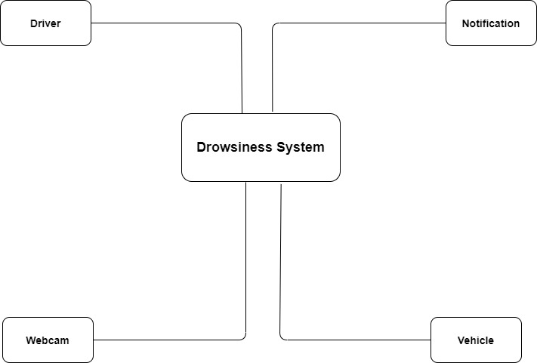
Figure 2: Domain model

  - System Sequence Diagram
The system sequence diagram for the drowsiness detection system describes the interactions between the system and the user, the face detection module, and the image processing module. The user interacts with the system by logging in, starting and stopping the drowsiness detection system, and receiving alerts and notifications.
When the user starts the drowsiness detection system, the face detection module captures images from the camera and sends them to the image processing module for analysis. The image processing module analyses the images to determine if the user is exhibiting signs of drowsiness, such as closed eyes or low blink rate. If drowsiness is detected, the alert system sends an alert to the user, and the notification system sends a notification to a designated emergency contact.

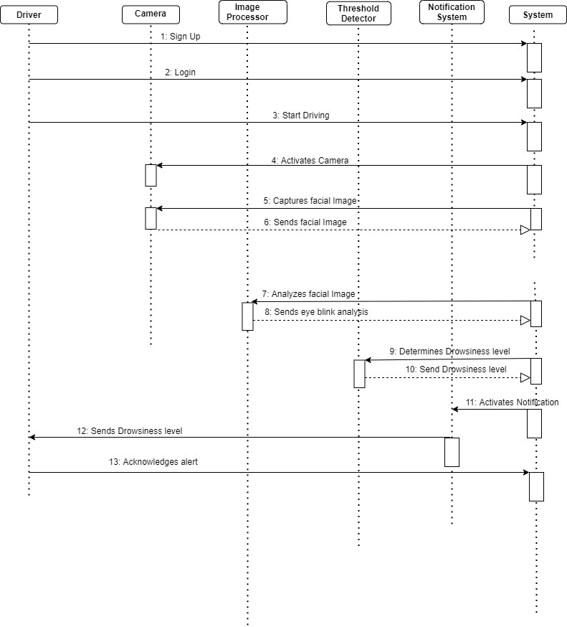
Figure 3: System Sequence Diagram

  - Design Class Diagram
The class diagram represents the structure of the drowsiness detection system in terms of its classes, attributes, and methods. The classes in the diagram include the Driver, Alert System, Face Detection, Image Processing, Notification System, and Processed Data classes.
The Driver class represents the user of the system and has attributes such as name, age, gender, driving experience, email, and password. The Alert System class is responsible for generating alerts to notify the driver of drowsiness and has attributes such as alert type and alert message. The Notification System class is responsible for sending notifications to the driver and has attributes such as notification type and notification message. The Face Detection class is responsible for detecting the face of the user and has attributes such as the camera and the face detector. The Image Processing class is responsible for processing the image data and has attributes such as the image and the image processor. The Processed Data class represents the data that has been processed by the system and has attributes such as the eye blink rate and the eye status.

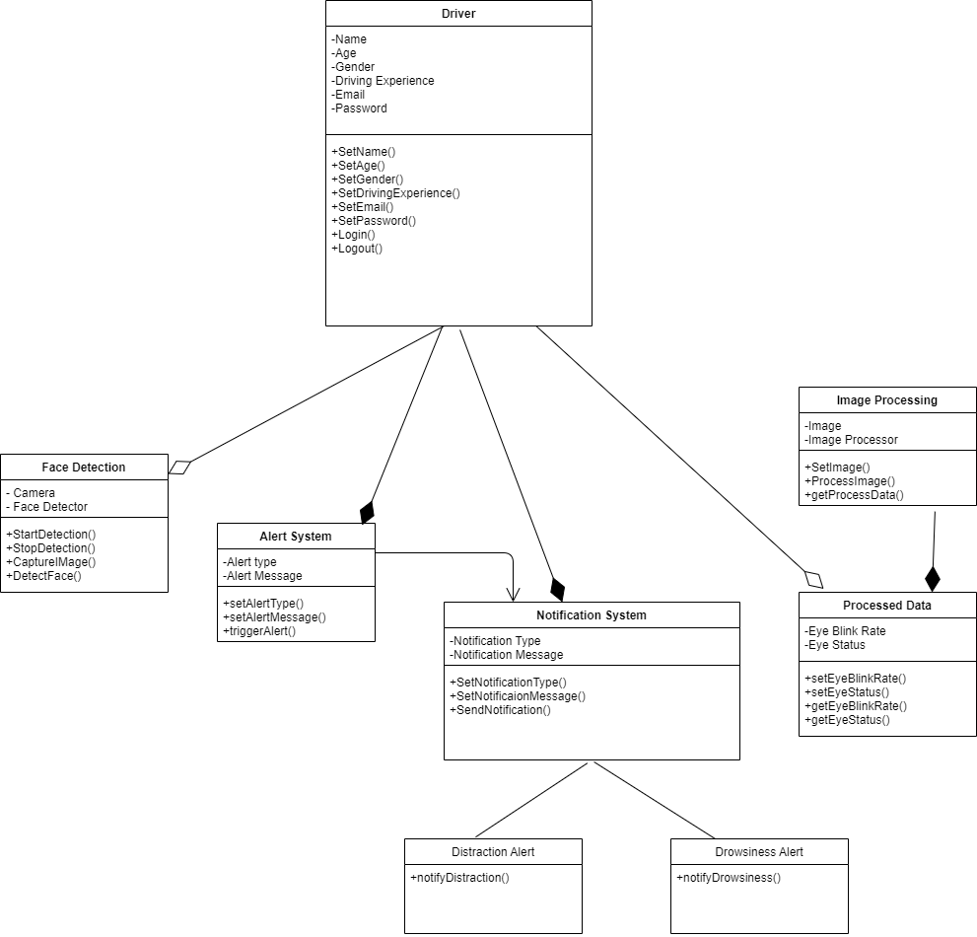
Figure 4: Class Diagram
  - State Chart Diagram
A state chart diagram is a visual representation of the different states an object or system can be in, as well as the transitions between those states. In the context of the drowsiness detection system, the state chart diagram shows the different states that the system can be in and the events or actions that can trigger a transition from one state to another. The state chart diagram for the drowsiness detection system includes several states, such as "Start", "Idle", "Processing", "Drowsy", and "Alarm". The initial state is "Start", which transitions to "Idle" when the system is turned on. In the "Idle" state, the system is waiting for input from the user or for the camera to detect a face. When the camera detects a face, the system transitions to the "Processing" state, where it analyzes the facial features to determine the driver's level of drowsiness. Depending on the results of the analysis, the system can transition to the "Drowsy" state if the driver is showing signs of fatigue, or back to "Idle" if the driver is alert.
If the system detects that the driver is drowsy, it transitions to the "Alarm" state, where it activates an alarm to alert the driver and prompt them to take a break. The driver can then either acknowledge the alarm and transition back to the "Idle" state or turn off the system and return to the "Start" state.

Driver Sign up

Figure 5: Driver Sign up
Driver Login

Figure 6: Driver Login

Drowsiness detection system
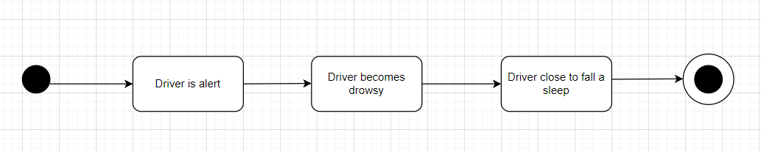
Figure 7: Drowsiness detection system

Data collection process
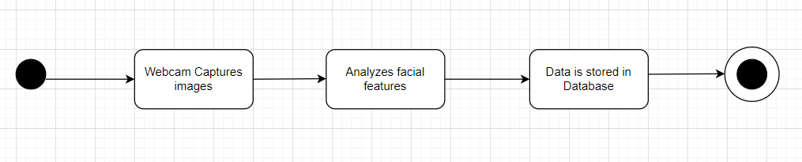
Figure 8: Data collection process

Notification system

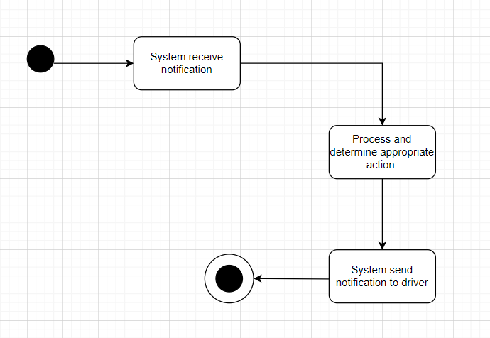
Figure 9: Notification system

Report generation process
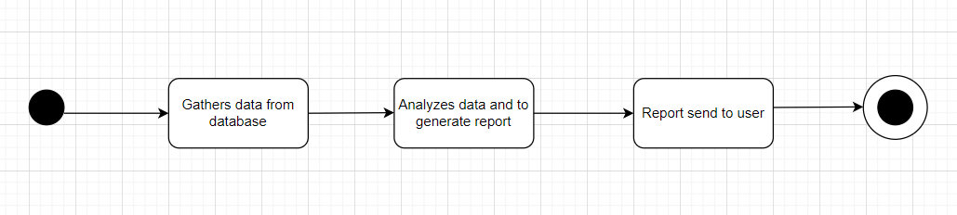
Figure 10: Report generation process

CHAPTER 4

IMPLEMENTATION

The web application is an essential aspect of the project, as it will have a significant impact on user experience and engagement. The following sub-headings explain how it will be approached.

User Interface Design

User interface design is a crucial aspect of the development process of any software application, including drowsiness detection systems. It involves designing and creating interfaces that allow users to interact with the system and receive information about its operation. The user interface design must be clear, easy to navigate, and visually appealing to the user. Here are some important considerations for designing a user-friendly interface for drowsiness detection systems:

Clarity and simplicity: The interface should be easy to understand and use, with clear instructions and labels for each feature [6].It should also be designed with a clean and uncluttered layout, which can help users to focus on the most important information.
Real-time notification: Real-time notification is a critical feature of drowsiness detection systems, and the user interface must be designed to deliver such alerts promptly. Users should be able to receive alerts on the screen or via sound signals.

Customization: Different users have different preferences and needs, and the interface should be designed with customization options to meet these needs. This may include the ability to adjust the alert threshold or customize the visual appearance of the interface.

Compatibility: The interface should be compatible with different devices and operating systems to ensure that the system can be used on a variety of platforms.

User feedback: The user interface should provide feedback to the user about the system's performance, accuracy, and any errors or issues. This can help users to understand the system's operation and identify any problems that need to be addressed.
Overall, designing an effective user interface for drowsiness detection systems requires a careful balance of form and function. The interface should be visually appealing and easy to use, while also delivering critical real-time alerts and providing users with the ability to customize the system to their needs. With careful design and testing, a well-designed user interface can help to improve the accuracy and effectiveness of drowsiness detection systems and reduce the risk of accidents on the road.

Front-end Development

Front-end development is a critical aspect of the project that involves designing and implementing the user interface (UI) and user experience (UX) of the drowsiness detection system. It focuses on the visual elements and interactive features that users will interact with, creating a seamless and intuitive experience for drivers. Here are some potential paragraphs discussing front-end development for the project:
Firstly, front-end development involves designing the user interface (UI) of the drowsiness detection system [7].This includes creating visual elements such as buttons, icons, menus, and screens that drivers will interact with. The UI design should be visually appealing, easy to understand, and accessible to a wide range of users. It should also be responsive, ensuring that it functions well on different devices, such as smartphones or in-car displays.
Secondly, front-end developers are responsible for creating a positive user experience (UX) for the drowsiness detection system. This involves considering the flow of the user interaction, the ease of use, and the overall satisfaction of the user. The UX design should be intuitive, guiding drivers through the system and providing clear feedback on their drowsiness levels. It should also take into consideration the unique requirements and limitations of using the system while driving, such as minimal distraction and quick response times.
Thirdly, front-end developers need to ensure that the drowsiness detection system is accessible to all users, including those with disabilities. This includes implementing features such as adjustable text sizes, high contrast options, and keyboard navigation, to accommodate different needs and provide an inclusive experience for all users. Compliance with accessibility guidelines, such as the Web Content Accessibility Guidelines (WCAG), is crucial to ensure that the system can be used by a diverse range of drivers.
Furthermore, front-end development involves testing and debugging the system to identify and fix any issues or errors. This includes conducting usability testing to gather feedback from real users and making necessary adjustments to improve the system's performance and user satisfaction. Front-end developers also need to ensure that the system is compatible with different web browsers, devices, and screen sizes, to provide a consistent experience for all users.
In conclusion, front-end development plays a crucial role in designing and implementing the user interface and user experience of the drowsiness detection system. It involves creating visually appealing and accessible UI, designing intuitive UX, ensuring compatibility with different devices, and conducting thorough testing and debugging. A well-designed and user-friendly front-end will enhance the effectiveness and usability of the drowsiness detection system, ultimately contributing to increased road safety by helping drivers stay alert and prevent drowsy driving incidents.

Database Design
Database design is an essential aspect of the drowsiness detection system project. The database serves as the foundation of the system, where data is stored, managed, and retrieved. The design of the database is crucial to the overall performance of the system. It is critical to establish a well-organized and optimized database that can handle large amounts of data while maintaining efficiency and reliability.
The database design for the drowsiness detection system is cloud based mongodb. The design of the database includes the use of primary keys, foreign keys, and indexes to manage data efficiently. The primary key is a unique identifier for each record in a table, while the foreign key establishes a relationship between two tables. Indexes are used to speed up data retrieval and search operations.
To ensure that the database design is optimized for the specific needs of the project, it is important to consider factors such as data volume, access patterns, and scalability. The database design should be able to handle large volumes of data while maintaining optimal performance. Additionally, the design should be scalable, allowing for easy expansion as the system grows and more data is added.
Overall, the design of the database is crucial to the success of the drowsiness detection system project. It is essential to establish a well-organized and optimized database that can handle large amounts of data while maintaining efficiency and reliability. A well-designed database will ensure that the system operates smoothly and effectively, providing accurate and timely drowsiness detection results for driver.
Screenshots:
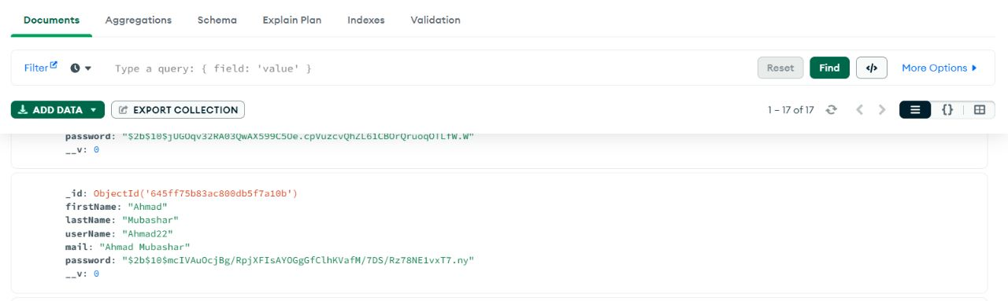

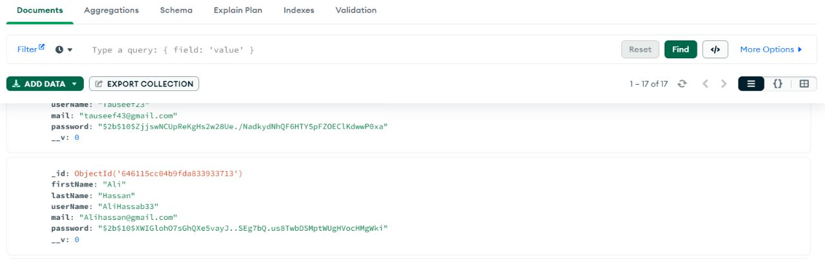

Backend Development

Backend development is an essential aspect of this project, as it involves building the server-side of the drowsiness detection system. The backend is responsible for receiving data from the frontend, processing it, and returning the appropriate response. It is also responsible for communicating with the database to store and retrieve data.
The backend of this project will be built using Python programming language, as it is a popular choice for building web applications. Python has a rich set of libraries and frameworks that make it easier to develop robust web applications quickly. Flask and Django are two popular Python web frameworks that can be used to build the backend of this project. Both frameworks offer a wide range of features and tools to build scalable and reliable web applications.
The backend will be designed using the RESTful API architecture, which provides a standard way to communicate between the server and the client. The API endpoints will be designed to handle requests from the frontend and return appropriate responses. The endpoints will also communicate with the database to retrieve and store data.
The backend will be responsible for the following tasks:
- User Authentication and Authorization: The backend will handle user authentication and authorization to ensure that only authorized users can access the system.
- Data Storage and Retrieval: The backend will communicate with the database to store and retrieve data. The database will store information such as user profiles, drowsiness detection data, and system logs.
- Real-time Notification System: The backend will be responsible for sending real-time notifications to the user when drowsiness is detected. The system will be designed to use push notifications to send alerts to the user's device.
- Machine Learning Model Integration: The backend will integrate the machine learning model to detect drowsiness. The model will be trained using a dataset of images of the driver's face to identify signs of drowsiness.
- Performance Optimization: The backend will be optimized to handle many requests efficiently. Caching mechanisms and load balancing will be used to improve the system's performance.
In conclusion, the backend development of this project is a crucial aspect of the system's overall success. It will be designed to handle all the system's essential functionalities, including user authentication, data storage, and real-time notification system, while also being optimized for high performance and reliability.

Testing and Quality Assurance

Testing and quality assurance play a crucial role in the success of any software development project, and the drowsiness detection system project is no exception. To ensure the system is reliable and performs as expected, a comprehensive testing plan should be developed and executed.
The testing process should begin during the development phase and continue throughout the project's lifecycle. [7]Different types of testing, such as unit testing, integration testing, and system testing, should be performed to identify and fix bugs, errors, and defects in the system's functionality. Testing should be done in various environments, including different operating systems, devices, and network configurations, to ensure the system works correctly in all situations.
Quality assurance is another critical aspect of the development process. It involves verifying that the system meets the specified requirements, standards, and expectations of the end-users. Quality assurance activities should be performed in parallel with testing activities and should include activities such as reviews, inspections, and walkthroughs to ensure that the system design and implementation meet the required quality levels. To ensure the drowsiness detection system's quality, a rigorous testing plan should be developed, including both manual and automated testing methods. Automated testing tools, such as Selenium and JMeter, can be used to automate repetitive and time-consuming testing tasks and help identify defects quickly. Additionally, user acceptance testing should be performed to ensure that the system meets the end-user's requirements and expectations.
In summary, the testing and quality assurance phase is critical to the success of the drowsiness detection system project. The testing plan should be well-defined, and a variety of testing methods should be used to ensure the system's reliability, functionality, and quality. Quality assurance activities should be performed in parallel with testing to ensure that the system meets the end-user's requirements and expectation.

Test Case ID | Test Objective | Test Steps | Expected Result | Actual Result | Pass/Fail
DDS001 | Normal Wakefulness Detection | 1. Sit in front of the sensors | System accurately detects wakefulness | System accurately detects wakefulness | Pass
 |  | 2. Keep eyes open and head upright
 |  | 3. Verify absence of false alarms
DDS002 | Drowsiness Detection | 1. Simulate drowsiness by closing eyes or nodding head | System accurately detects and alerts drowsiness | System accurately detects and alerts drowsiness | Pass
 |  | 2. Monitor system's response
DDS003 | False Positive Detection | 1. Perform activities like rapid blinking or momentary eye closure | System does not generate false positive alarms | System does not generate false positive alarms | Pass
 |  | 2. Observe absence of excessive alarms
DDS004 | False Negative Detection | 1. Engage in activities inducing drowsiness, e.g., reading or staring at a fixed point | System accurately detects and alerts drowsiness | System accurately detects and alerts drowsiness | Pass
DDS005 | Environmental Factors | 1. Introduce dim lighting or background noise | System maintains accuracy and reliability | System maintains accuracy and reliability | Pass
 |  | 2. Observe no significant degradation in performance
DDS006 | System Integration | 1. Verify integration with other devices/platforms, if applicable | System successfully communicates alerts | System successfully communicates alerts | Pass
 |  | 2. Confirm seamless user experience

Test Cases

4.7 Compression with another app
Drowsiness Detection System:
- Functionality: A drowsiness detection system is designed to monitor the user's level of alertness and detect signs of drowsiness or fatigue. It typically uses sensors to track eye movements, head position, and other factors to determine the user's state of wakefulness.
- Purpose: The main purpose of a drowsiness detection system is to ensure safety, particularly in contexts such as driving. It alerts the user when it detects signs of drowsiness, helping them take necessary precautions to avoid accidents.
- Key Features: Drowsiness detection systems often include features like real-time monitoring, alerts or alarms for drowsiness detection, and integration with other devices or platforms (e.g., cars or wearable devices).
- User Base: Drowsiness detection systems are primarily used by drivers, pilots, heavy machinery operators, and individuals in professions where alertness is critical to prevent accidents.
Fitness Tracking App:
- Functionality: A fitness tracking app is designed to monitor and track various aspects of a person's physical activity and health. It can monitor steps, distance, calories burned, heart rate, sleep patterns, and more.
- Purpose: The main purpose of a fitness tracking app is to help users achieve their fitness goals by providing data-driven insights and motivation. It encourages users to lead a healthier lifestyle, set exercise targets, and track their progress over time.
- Key Features: Fitness tracking apps typically include features like activity tracking, heart rate monitoring, sleep tracking, goal setting, personalized workout plans, social sharing, and integration with other fitness devices or platforms.
- User Base: Fitness tracking apps are popular among fitness enthusiasts, athletes, and people looking to improve their health and fitness levels, and individuals who want to monitor their overall well-being.

Comparison:
- Focus: A drowsiness detection system focuses on ensuring safety by monitoring alertness levels, while a fitness tracking app focuses on promoting fitness and well-being through activity monitoring and goal setting.
- Sensors and Data: Drowsiness detection systems primarily rely on sensors that monitor physical cues related to drowsiness, such as eye movements, head position, and facial expressions. Fitness tracking apps often use sensors like accelerometers, heart rate monitors, and GPS to track physical activity and health data.
- Context: Drowsiness detection systems are primarily used in specific contexts like driving or operating heavy machinery, while fitness tracking apps can be used in various settings and activities, including running, cycling, gym workouts, and even sleep tracking.
- User Goals: The primary goal of a drowsiness detection system is to prevent accidents and promote safety, whereas fitness tracking apps aim to improve physical fitness, set and achieve exercise goals, and maintain a healthy lifestyle.
- User Base: Drowsiness detection systems target professionals in safety-critical professions, while fitness tracking apps cater to a broader user base, including fitness enthusiasts, casual users, and individuals interested in monitoring their health and activity levels.

Limitations

Drowsiness detection systems have certain limitations that are important to consider. Here are some common limitations:
- False Positives and False Negatives: Drowsiness detection systems may sometimes generate false positive or false negative alerts. False positives occur when the system incorrectly detects drowsiness or fatigue, leading to unnecessary alerts and disruptions. False negatives happen when the system fails to detect actual drowsiness, potentially missing critical moments of fatigue.
- Individual Variations: People have different patterns of drowsiness, and drowsiness detection systems may not account for all individual variations. Factors such as sleep quality, medication effects, and personal tolerance to fatigue can vary among individuals, affecting the accuracy of the system's predictions.
- Environmental Factors: Drowsiness detection systems can be influenced by external factors, such as lighting conditions, temperature, noise levels, and vibrations. These factors may introduce inaccuracies or affect the system's performance, particularly in real-world scenarios where the environment is not controlled.
- Calibration and Personalization: Drowsiness detection systems often require calibration and personalization to the individual user. This process may involve setting baseline measurements or thresholds based on the user's unique characteristics. Failure to calibrate or personalize the system appropriately can impact its accuracy and reliability.
- Sensor Limitations: Drowsiness detection systems rely on sensors to collect data, such as eye movements, head position, or heart rate variability. The accuracy and reliability of these sensors can vary, affecting the overall performance of the system. Sensor limitations, such as noise interference or technical issues, can impact the system's ability to accurately detect drowsiness.
- Context-Specific Use: Drowsiness detection systems are primarily designed for specific contexts, such as driving or operating heavy machinery. Their performance in different scenarios, such as sedentary activities or non-professional contexts, may be less reliable. It's important to consider the intended use case and limitations of the system before relying on its outputs.
- Ethical Considerations: Drowsiness detection systems raise ethical concerns related to privacy and data security. These systems often collect and process personal data, such as facial images or biometric information. Ensuring proper data protection and user consent is crucial to address potential privacy risks.

CHAPTER 5

RESULTS AND DISCUSSIONS (or USER MANUAL)

5.1 User Manual

5.1.1 Start the System:
Ensure that the system is properly installed and the camera is connected to your computer or microcontroller board. Launch the system by running the appropriate command or executable file.

5.1.2 Calibrate the System:
Before using the system, it is essential to calibrate it to account for different lighting conditions and driver preferences. Follow the on-screen instructions to perform the calibration process. This typically involves capturing a baseline image of the driver's face when fully alert.

5.1.3 Position the Camera:
Make sure the camera is correctly positioned to capture the driver's face. It should provide a clear view without obstructions. Adjust the camera angle, if necessary, to ensure optimal visibility.

5.1.4 Operating the System:
Once the system is running and calibrated, it continuously monitors the driver's facial features and movements. It analyses factors such as eye closure duration, head position, and blinking patterns to detect signs of drowsiness.

GUI:
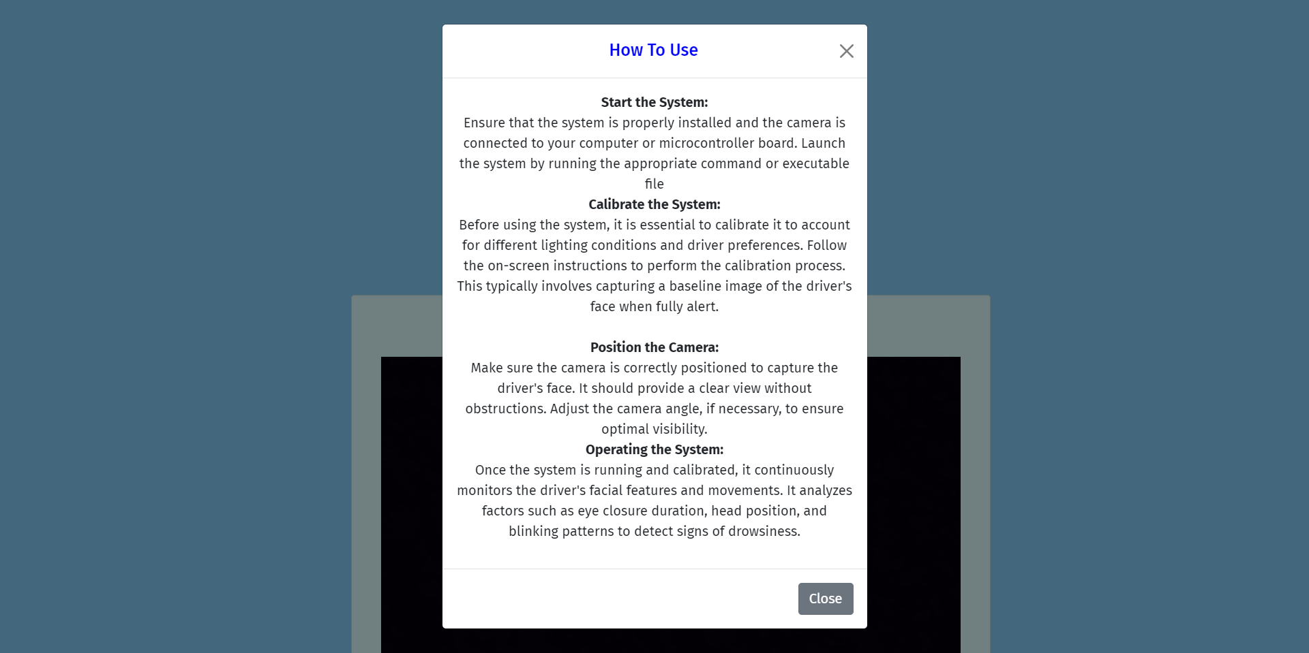
Figure 11: User Manual

5.2 Sign Up
Websites and services that require new users to register for an account have "sign-up pages," also known as "registration pages" or "create an account pages." A form displayed on such a page is used to collect information from users, including names, emails, usernames, passwords, and other data (which varies by service).
A "Sign up," "Create Account," or similar button should encourage users to complete the sign-up process and submit their information.


Figure 12: Sign-up page

5.3 Sign In
A sign-in page, login page, or authentication page is a page that users must visit before they are granted access to a website or service that requires authentication. It allows access to restricted resources, features, and functions.
Users can save time and skip the hassle of creating new accounts by logging in with their existing social media credentials instead. Users can now sign in with their existing social media accounts as opposed to having to remember yet another set of credentials.

Figure 13: Sign-in page

5.4 About the System
A drowsiness detection system is a technology that monitors a person's physiological signals such as heart rate, eye movement, and brain activity to detect when they are becoming drowsy or fatigued. The system alerts the person to take a break or stop their activity to prevent accidents caused by lack of focus or attention. Drowsiness detection systems are especially important for individuals who work long hours, drive long distances, or operate heavy machinery. These systems promote safety and prevent accidents in various settings.

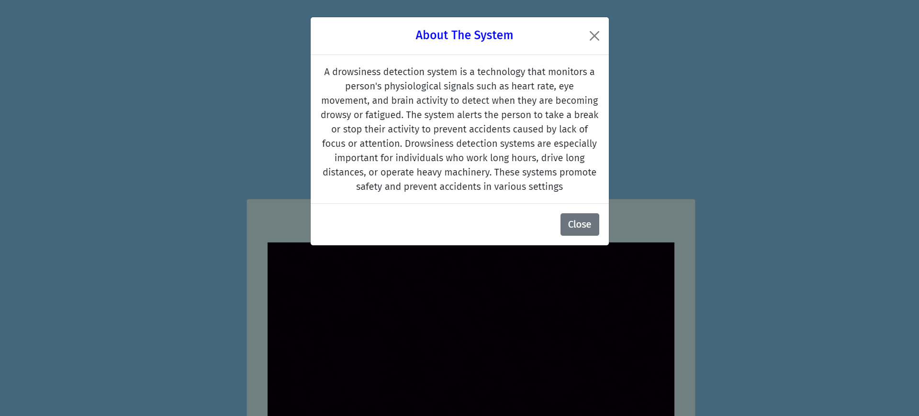
Figure 14: About the system

5.5 Home Page
In home page there is a camera option which detect the drowsiness.

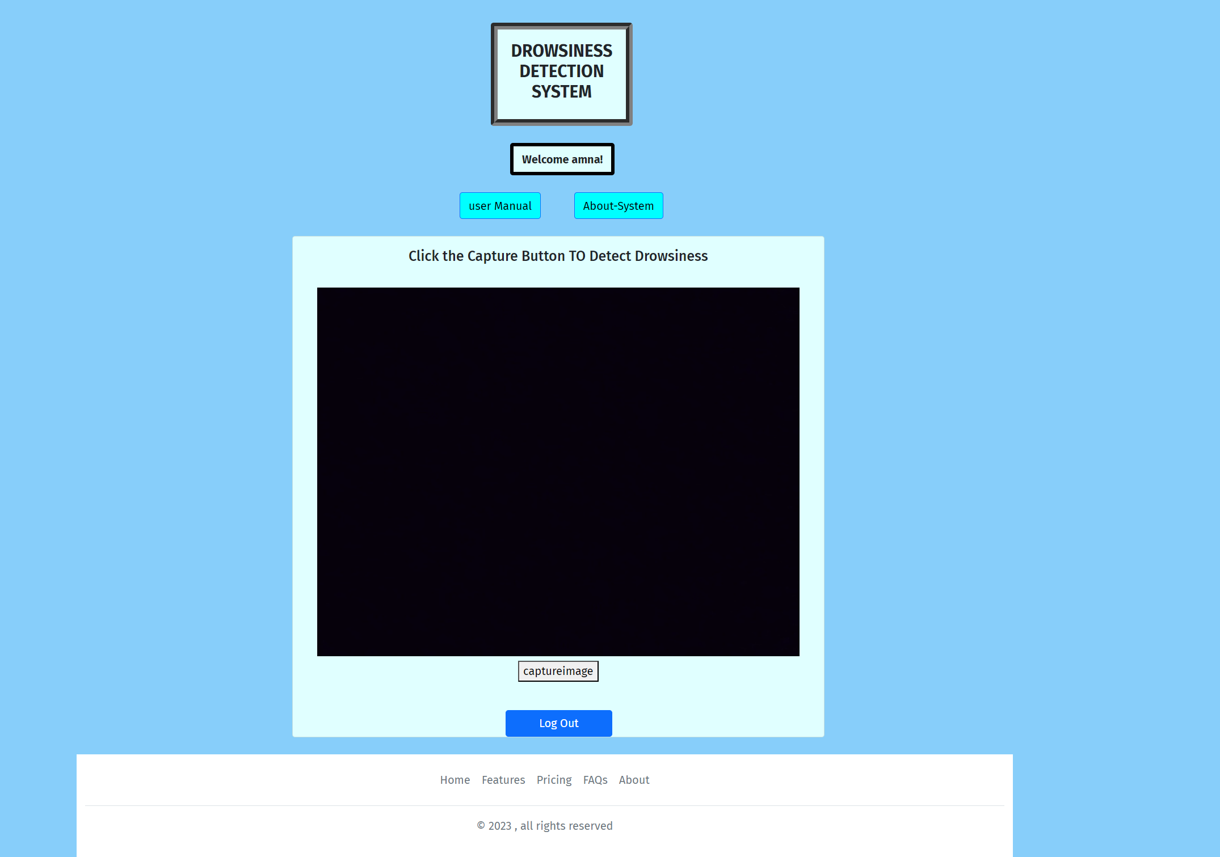

Figure 15: Home Page

5.6 Model Training:
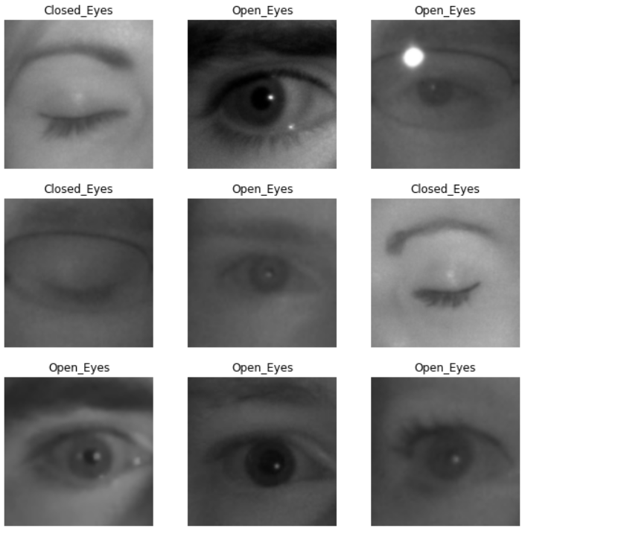

5.7 Validation Graph:
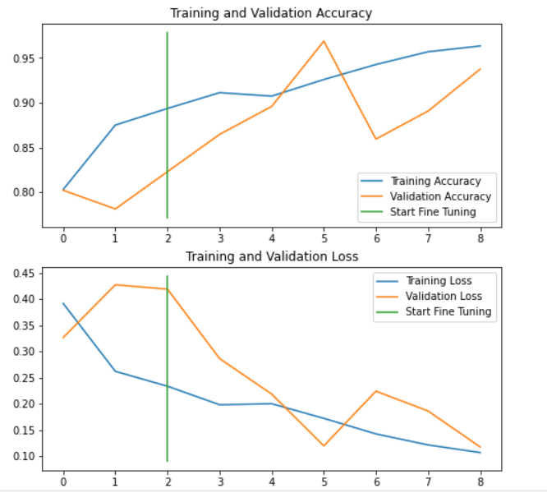

5.8 Confusion matrix:
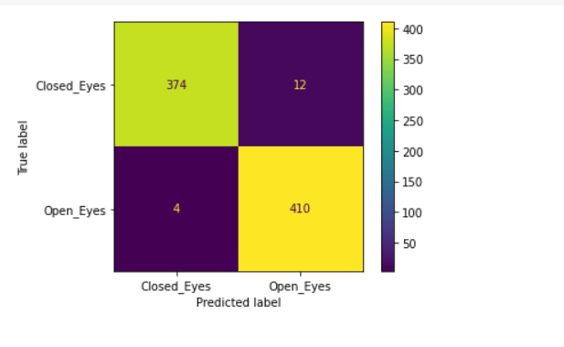

5.9 Personal Testing:
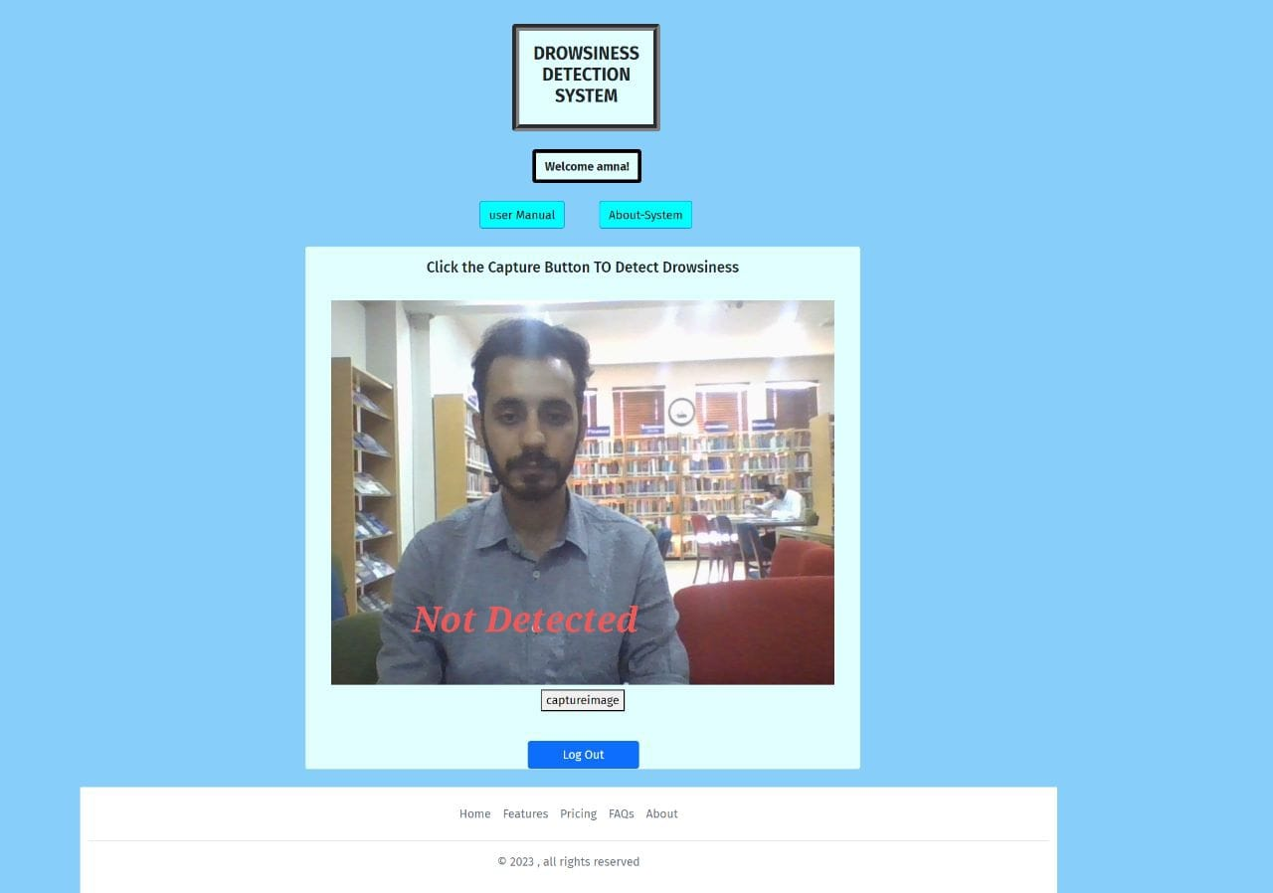
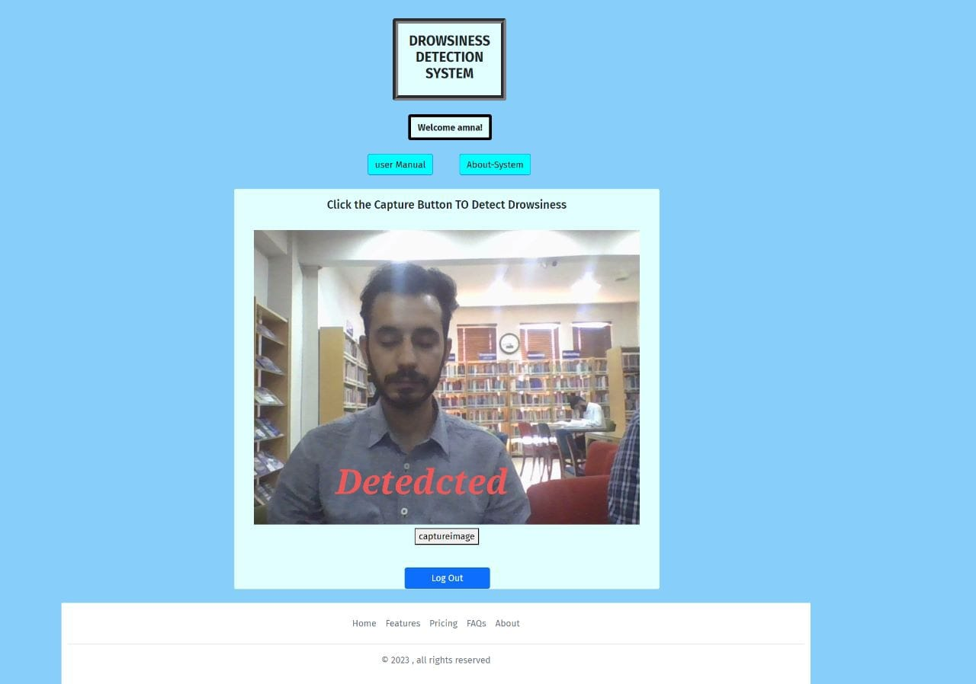

5.10 Testing
By contrasting the achieved results with the anticipated ones, software testing ensures that the system is error-free. By executing some code or checking out some part of the system, one or more desirable qualities can be determined. Software testing also helps find discrepancies between the stated requirements and the final product. Either manual labour or computerised programmes can accomplish this task.

5.10.1. Functional Testing:
The functional requirements and specifications are the focus of Functional Testing, a subset of software testing. The output of a function (or feature) is examined after it is given some input. In order to guarantee that the application fully satisfies the requirements, functional testing must be performed. This kind of test cares more about the outcomes of processing than the processes involved. It makes no assumptions about the structure of the system being simulated but instead models realistic usage. Since the tester isn't privy to the system's inner workings during functional testing, the Black Box Testing method is used. Testing for functionality is typically done during the System Testing and Acceptance testing phases of the testing lifecycle.
The standard procedure for functional testing consists of:
● Identify functions that the software is expected to perform.
● Create input data based on the function’s specifications.
● Determine the output based on the function’s specifications.
● Execute the test case.
● Compare the actual and expected outputs.
When functional test conditions are derived straight from user/business
Requirements, testing is at its most efficient. There is a risk of upsetting end-users
Who use the software for the first time if testing conditions are derived from the
System documentation (system requirements/design documents).

5.10.2. Non-Functional Testing

NON-FUNCTIONAL TESTING is a subset of software testing that focuses on the less directly useful characteristics of an application. Non-functional testing is intended to check whether or not a system is ready in ways that functional testing can't. Testing the maximum number of concurrent users is a great illustration of a non-functional test. Client satisfaction is directly tied to the thoroughness of both functional and non-functional testing. During earlier iterations of testing, we also failed to adequately address the Non Functional requirements. This, however, is no longer the case. The non-functional testing of an application is now paramount because of the importance of addressing performance and security concerns. The performance of an application under heavy load is most affected by this kind of testing. Your app's stability and scalability under pressure will be verified by these tests.

5.10.3. Regression Testing

REGRESSION TESTING is done to ensure that changes (or bug fixes) made to the software have not caused any incompatibilities. As any change to the code has the potential to impact unrelated functionality, regression testing is performed to make sure that fixing one thing has not broken another.
Regression testing involves re-running previously completed test cases rather than creating any new ones. The noun regression, in its most common usage, refers to a process of falling behind or becoming less advanced. While it would be ideal to conduct a thorough regression analysis, limitations in time and money often prevent this from happening. An impact analysis must be conducted to ascertain which components of the software are most vulnerable to the modification and would cause the most trouble for users if something went wrong. Companies and initiatives are increasingly using regression test automation tools due to the breadth and importance of regression testing.

CHAPTER 6

CONCLUSION AND RECOMMENDATIONS

Conclusion

Driver fatigue is a significant problem that contributes to a high percentage of vehicular accidents. To mitigate the risks associated with drowsy driving, the development of drowsiness detection systems has become increasingly important. Using cutting-edge technology such as machine learning algorithms and image processing techniques, these systems can detect early signs of drowsiness and issue warnings to drivers to pull over or take a break.
This project aimed to develop a drowsiness detection system using machine learning algorithms and computer vision techniques. By analysing the facial features of drivers, particularly their eye position and blink rate, the system was able to detect drowsiness and issue real-time notifications to drivers. In addition to the detection system, the project also included the development of a web application, a data collection system, and a comprehensive user manual.
Although the drowsiness detection system has the potential to improve road safety and reduce the number of accidents caused by driver fatigue, there are still some limitations and challenges associated with these systems. Some of the challenges include the high computational power required for real-time processing and the accuracy of detection during adverse weather conditions or when drivers wear glasses or contact lenses.
The development of drowsiness detection systems is a feasible solution to the problem of driver fatigue. However, further research and development are required to overcome the limitations and challenges associated with these systems and to improve their accuracy and reliability in detecting drowsiness. [6]With continued innovation and advancements in technology, drowsiness detection systems have the potential to become an essential component of accident-avoidance systems in vehicles.

Recommendation

- Increase Awareness and Education: It is important to increase awareness among drivers about the dangers of driving while drowsy. One way to achieve this is by running campaigns to educate drivers about the risks of drowsy driving and how to identify signs of fatigue. Additionally, companies that employ drivers should conduct regular training sessions to educate their employees on how to avoid drowsiness while driving.
- Continual Improvement of Drowsiness Detection Systems: While drowsiness detection systems have come a long way, there is still room for improvement. More research is needed to identify additional features that can be incorporated into the systems to improve their accuracy. Additionally, developers should work on creating more user-friendly systems that can be integrated into existing cars and trucks.
- Legal Mandates: Government regulatory agencies should consider mandating the use of drowsiness detection systems in commercial vehicles. This would help to reduce the number of accidents caused by drowsy driving among commercial drivers. Additionally, this would help to create a level playing field for companies, as all would be required to adhere to the same safety standards.
- Standardization of Drowsiness Detection Systems: Currently, there is no standardization of drowsiness detection systems. This means that different systems may use different algorithms or features to detect drowsiness. Standardization of these systems would help to ensure that they all work in a similar manner and produce consistent results.
- Integration with Existing Safety Systems: Drowsiness detection systems should be integrated with existing safety systems, such as collision warning systems and lane departure warning systems. This would provide drivers with a more comprehensive set of safety features that can help to prevent accidents caused by fatigue and distraction.
Drowsiness detection systems have the potential to significantly reduce the number of accidents caused by drowsy driving. However, there is still room for improvement, and additional measures need to be taken to ensure that these systems are effective in preventing accidents. By increasing awareness and education, continually improving the systems, mandating their use in commercial vehicles, standardizing the systems, and integrating them with existing safety features, we can make our roads safer and reduce the number of accidents caused by drowsy driving.

REFERENCES

[1] T. Zhu et al., “Research on a Real-Time Driver Fatigue Detection Algorithm Based on Facial Video Sequences,” Applied Sciences (Switzerland), vol. 12, no. 4, Feb. 2022, doi: 10.3390/app12042224.
[2] I. Jahan et al., “4D: A Real-Time Driver Drowsiness Detector Using Deep Learning,” Electronics (Switzerland), vol. 12, no. 1, Jan. 2023, doi: 10.3390/electronics12010235.
[3] “Title of the Dissertation,” 2023.
[4] R. Sasikala, S. Suresh, J. Chandramohan, and M. Valanrajkumar, “Driver Drowsiness Detection System using Image Processing Technique by the Human Visual System,” International Journal of Emerging Technologies in Engineering Research (IJETER), vol. 6, no. 6, 2018, [Online]. Available: www.ijeter.everscience.org
[5] Y. Albadawi, M. Takruri, and M. Awad, “A Review of Recent Developments in Driver Drowsiness Detection Systems,” Sensors, vol. 22, no. 5. MDPI, Mar. 01, 2022. doi: 10.3390/s22052069.
[6] A. Dipu, S. Sumbul Hossain, Y. Arafat, and F. B. Rafiq, “Real-time Driver Drowsiness Detection using Deep Learning.” [Online]. Available: www.ijacsa.thesai.org
[7] T. Arakawa, “Trends and future prospects of the drowsiness detection and estimation technology,” Sensors, vol. 21, no. 23. MDPI, Dec. 01, 2021. doi: 10.3390/s21237921.
[8] Lal, S. K. L., & Craig, A. (2001). A review of drowsy driving detection technologies and techniques. IEEE Transactions on Intelligent Transportation Systems, 2(4), 155-160. doi:10.1109/6979.983878.
[9] Eren, H., & Tola, E. N. (2019). Driver drowsiness detection: A review of recent systems and technologies. In Proceedings of the IEEE Intelligent Transportation Systems Conference (ITSC) (pp. 2973-2978). doi:10.1109/ITSC.2019.891730.
[10] He, Z., & Wu, B. (2018). Drowsiness detection for drivers using machine learning: A review. In Proceedings of the IEEE International Conference on Intelligent Transportation Systems (ITSC) (pp. 362-367). doi:10.1109/ITSC.2018.8569513
[11] Al-Safadi, E., et al. (2020). Drowsiness detection using machine learning techniques: A review. IEEE Access, 8, 81115-81128. doi:10.1109/ACCESS.2020.2998267
Gonzalez-Pardo, A., et al. (2018). Drowsiness detection for the prevention of road accidents. In Proceedings of the IEEE International Conference on Systems, Man, and Cybernetics (SMC) (pp. 85-90). doi:10.1109/SMC.2018.0010.
[12] Imran, M. A., et al. (2020). Driver drowsiness detection techniques: A comprehensive review. IEEE Access, 8, 91076-91097. doi:10.1109/ACCESS.2020.2995385.
[13] Chai, W. K., & Foufou, S. (2017). Driver drowsiness detection using multimodal data fusion techniques. IEEE Transactions on Intelligent Transportation Systems, 18(6), 1484-1495. doi:10.1109/TITS.2016.2610504
[14] Li, W., et al. (2018). Driver drowsiness detection using convolutional neural network with multiple facial patches. IEEE Access, 6, 14179-14188. doi:10.1109/ACCESS.2018.2816415
[15] Phuoc, L. V., et al. (2020). Driver drowsiness detection based on 3D facial landmark tracking and eye blink features. IEEE Access, 8, 31167-31178. doi:10.1109/ACCESS.2020.2974205

x

Appendices
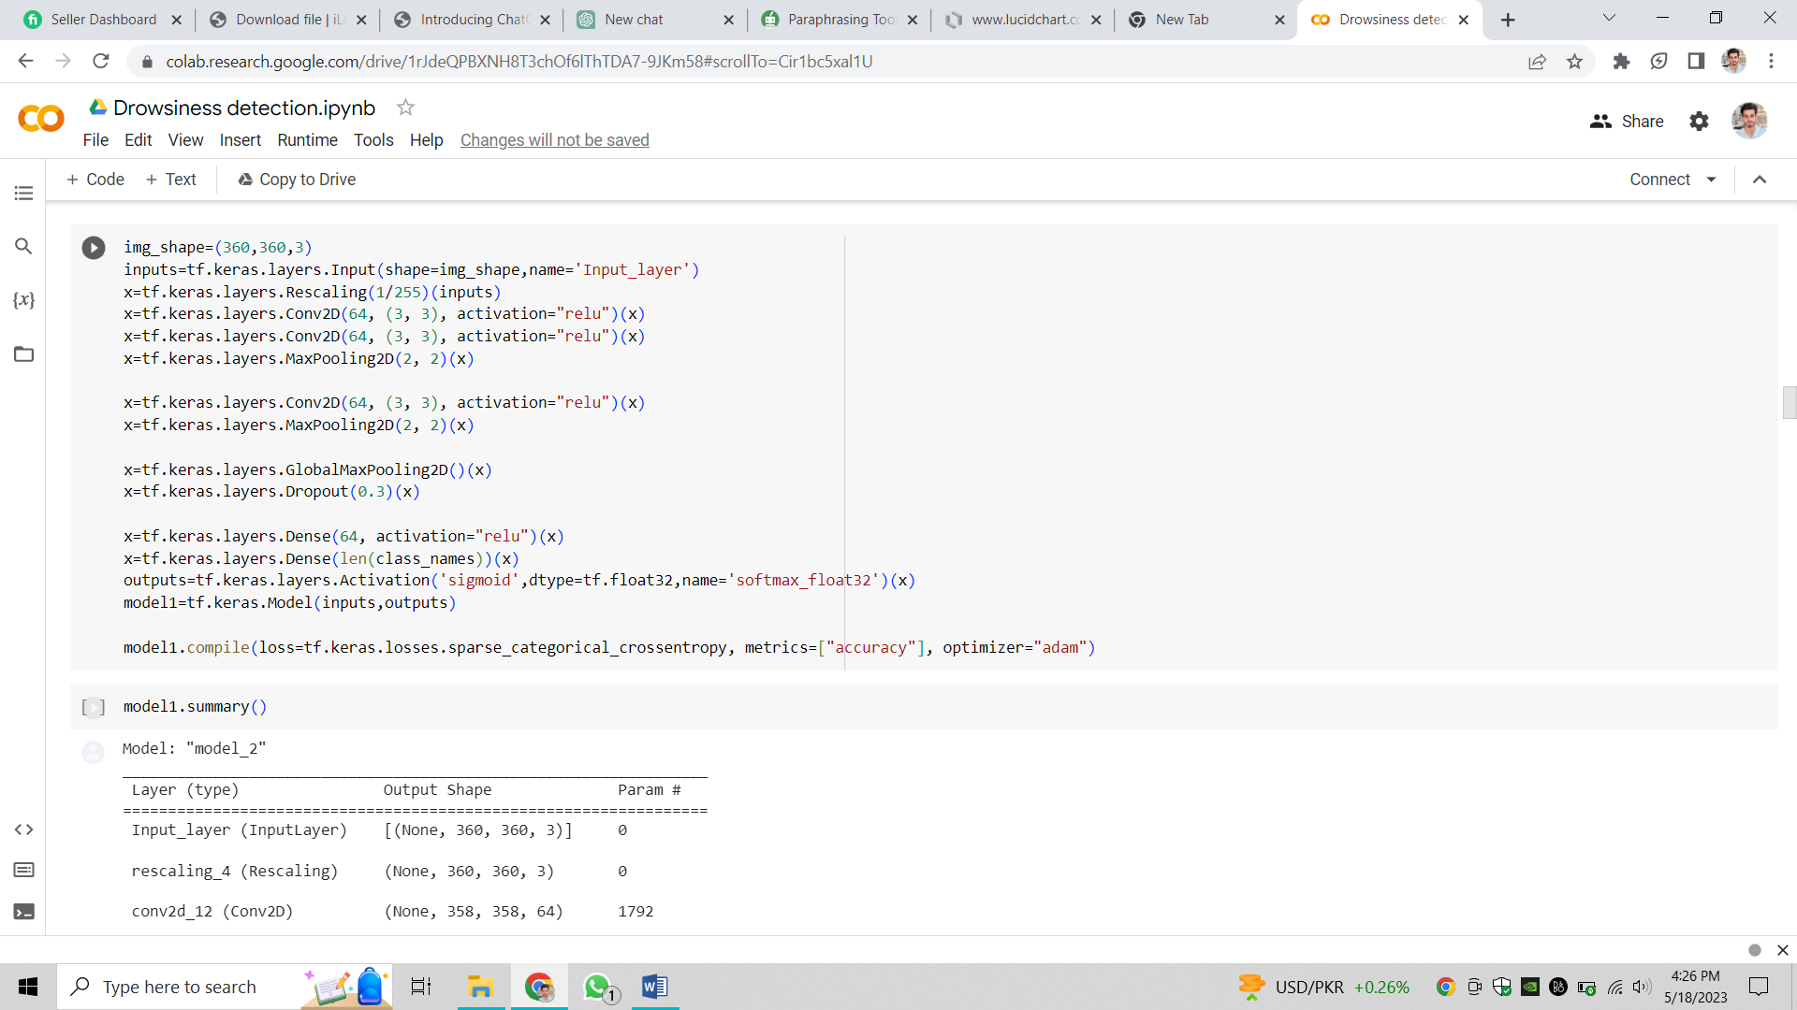
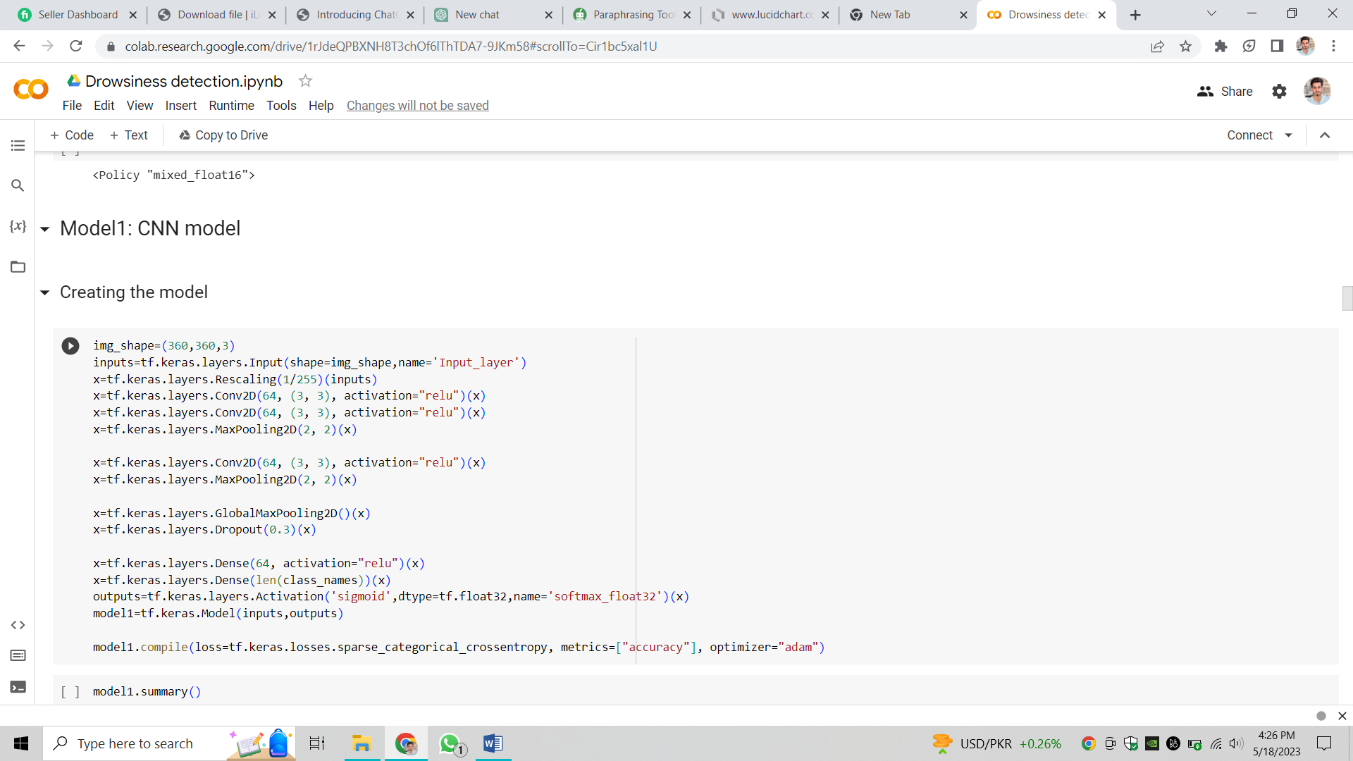
Figure 16: CNN model

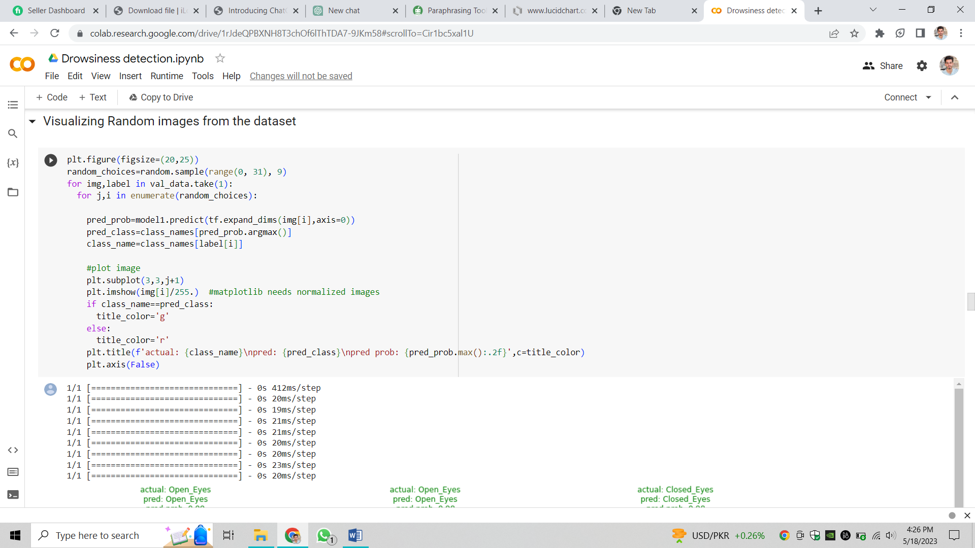
Figure 17: Visualizing random images from dataset

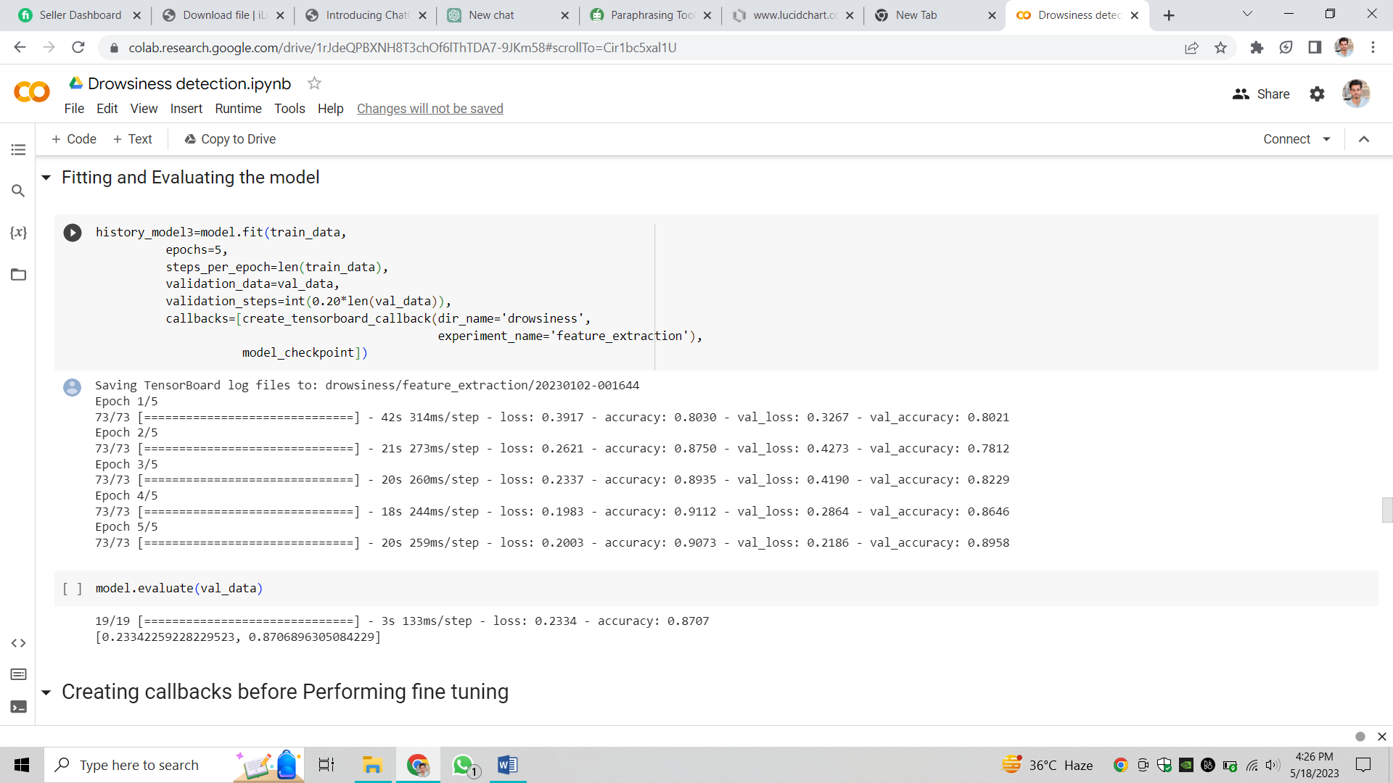
Figure 18: Fitting and evaluating the model
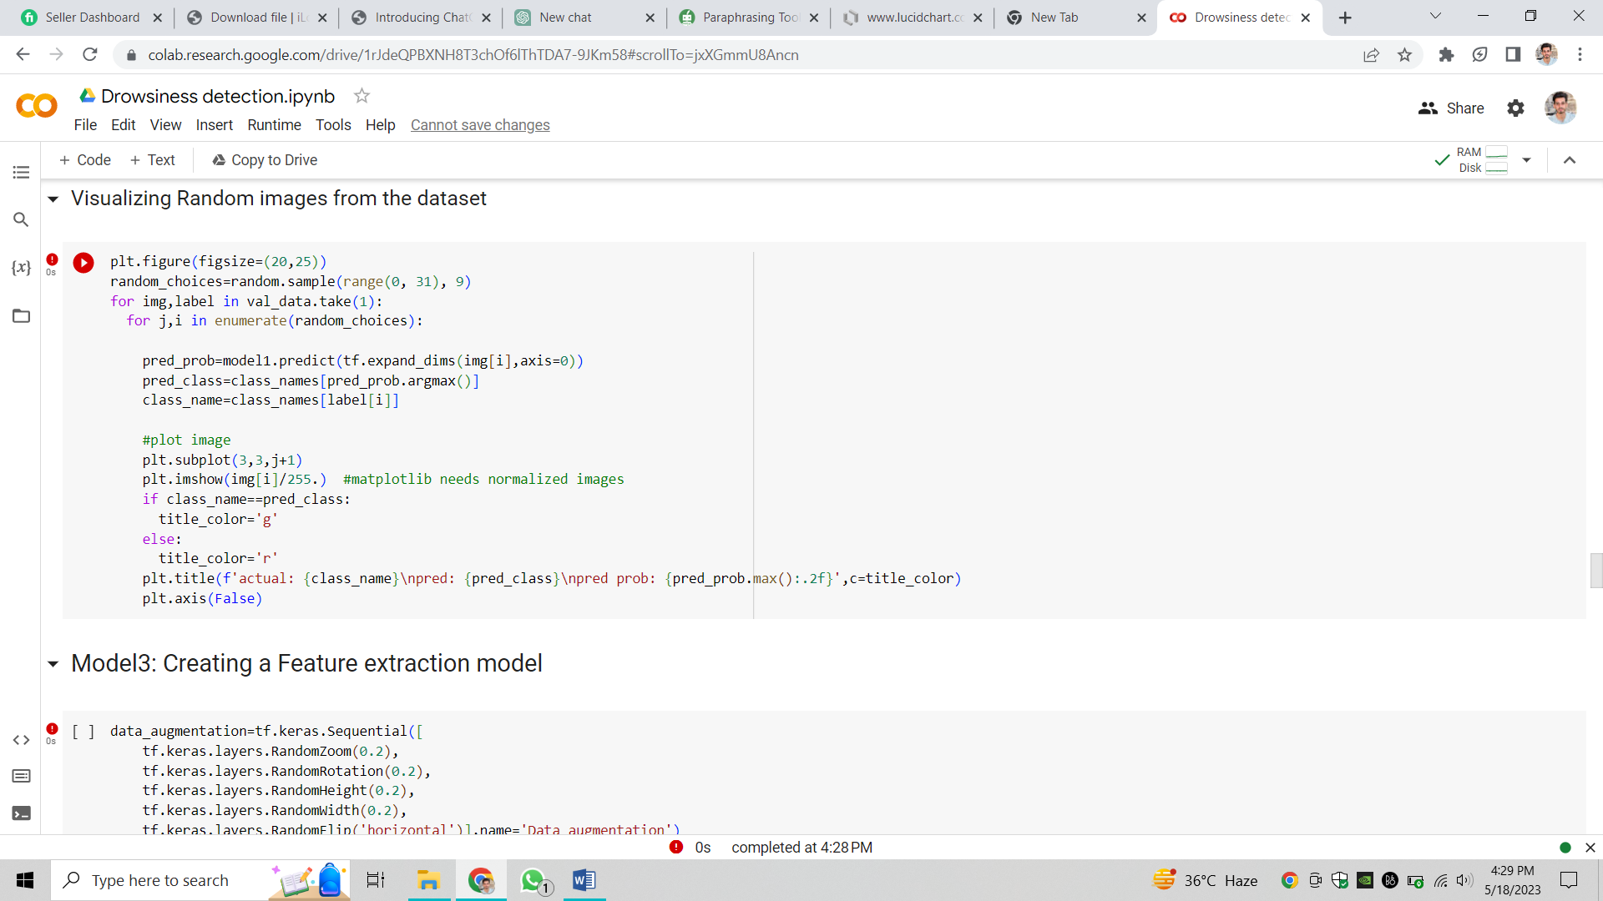
Figure 19: Visualizing random images from dataset
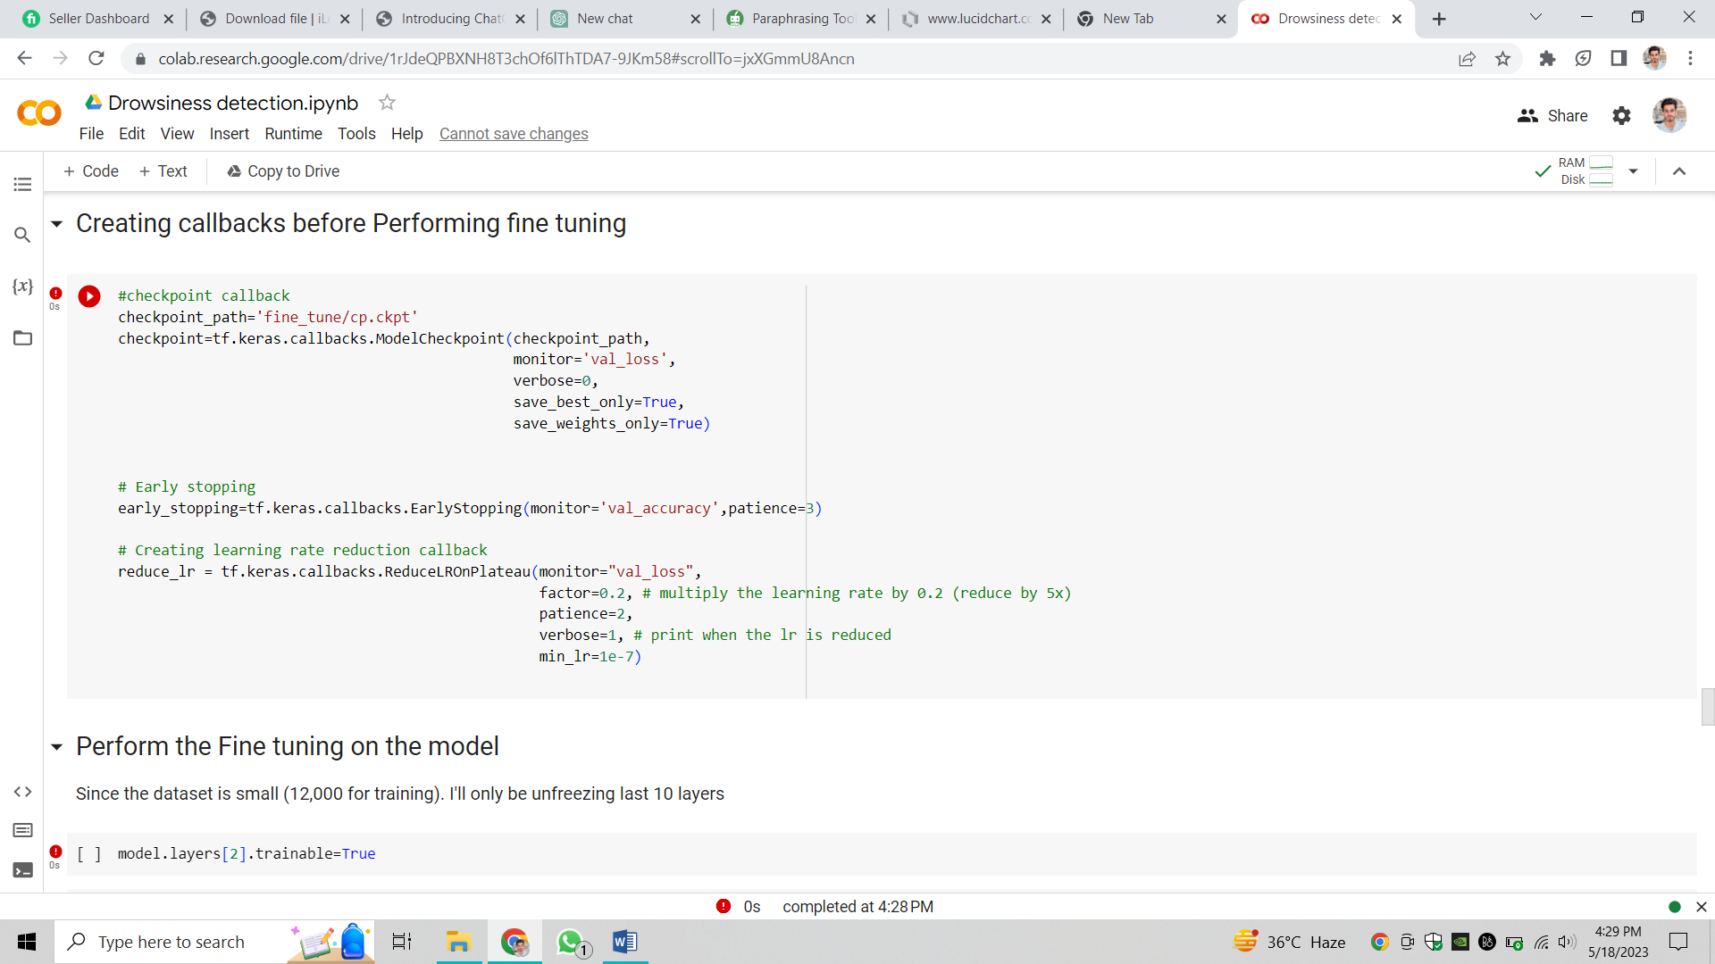
Figure 20: Creating call-backs before performing fine tuning
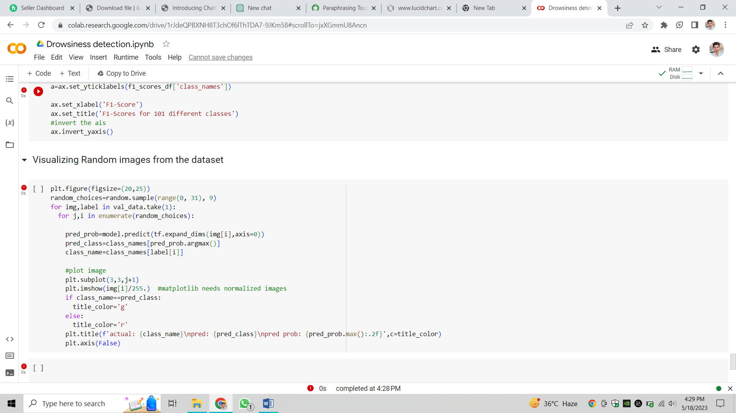
Figure 21: Visualizing random images from dataset

