
BSIT-F22-004
03-135192-001 | MUHAMMAD USAMA
03-135191-013 | HASSAN SHAHID

Quick Quiz

In partial fulfilment of the requirements for the degree of
Bachelor of Science in Information Technology
Supervisor: Summaira Nosheen
Department of Computer Sciences
Bahria University, Lahore Campus
June 2023

© Bahria University, 2023

Certificate

We accept the work contained in the report titled
“Quick Quiz”
Written by
MUHAMMAD USAMA
HASSAN SHAHID
as a confirmation to the required standard for the partial fulfilment of the degree of
Bachelor of Science in Computer Science.

Approved by:
Supervisor: Summaira Nosheen
(Signature)

June 13, 2023

DECLARATION

We hereby declare that this project report is based on our original work except for citations and quotations which have been duly acknowledged. We also declare that it has not been previously and concurrently submitted for any other degree or award at Bahria University or other institutions.

Enrolment | Name | Signature
03-135192-001 | MUHAMMAD USAMA
03-135192-013 | HASSAN SHAHID

Date : June 13, 2023

ACKNOWLEDGEMENTS

We would like to thank everyone who had contributed to the successful completion of this project. We would like to express our gratitude to my research supervisor, Ms. Summaira Nosheen for her invaluable advice, guidance and her enormous patience throughout the development of the research.

In addition, we would also like to express my gratitude to our loving parent and friends who had helped and given me encouragement. We are also very thank full
To BULC that enhance our skill, personality knowledge and for everything that we
Got from BULC

MUHAMMAD USAMA
HASSAN SHAHID

QUICK QUIZ

ABSTRACT
The Quick Quiz is a web-based application to perform quiz in a proper format and easily check quizzes without wasting time. Quick Quiz effectively perform all the functionalities to perform quiz, saves time and offer speedy result. Due to the Quick Quiz application there is no use of anything like paper, pen and many other. This application can be used by the educational institutes and other test Centres. This web application can be used everywhere anytime. There is no need that superintendent will be available in the exam centre while the students performing the quiz.
The agile method is a way to manipulate an undertaking through breaking it up into numerous stages. In agile model, Feature-Driven Development (FDD) method is used to perform this Task. Once work begin teamwork through a process of planning, comparing and executing. Tools, that are used for the development of this web-based application are Reactjs, html, css, JavaScript for frontend and for the backend MongoDB, NodeJs is used. Visual Studio code are used as an IDE.
.

TABLE OF CONTENTS

DECLARATION iii
ACKNOWLEDGEMENTS iv
ABSTRACT v
TABLE OF CONTENTS vi
LIST OF TABLES ix
LIST OF FIGURES x

CHAPTERS
1 INTRODUCTION 10
1.1 Background 10
1.2 Problem Statements 12
1.3 Aims and Objectives 13
1.4 Scope of Project 14
2 LITERATURE REVIEW 16
2.1 Background 16
2.1.1 Application login 17
2.1.2 Quiz creation 18
2.2 Brief Overview 19
2.3 Challenges to The users: 20
3 DESIGN AND METHODOLOGY 21
3.1 Development Plane 21
3.2 Methodology 23
3.3 System Design 25
3.3.1 System Use Case 25
3.3.2 Login 27
3.3.3 Quiz create and code generate 28
3.3.4 Quiz start and Perform quiz 29
3.3.5 Quiz start and Perform quiz 29
3.4 Sequence Diagram 30
3.4.1 Sequence Diagram for system 30
3.4.2 User Login 31
3.5 Start quiz and perfrom Quiz 33
3.6 Entity Relationship Diagram ERD 34
4 IMPLMENTATION 35
4.1 Implementation 35
4.1.1 User Login 36
4.1.2 Creating Quiz and Generate code 36
4.1.3 Join and perform quiz 36
4.1.4 Check quiz and display score 37
5 RESULTS AND DISCUSSIONS 38
5.1 Quick Quiz Web Application 38
5.2 User Login 39
5.3 Create quiz and generate code 40
5.4 Join and Perfrom Quiz 41
6 CONCLUSION AND RECOMMENDATIONS 43
6.1 Conclusion 43
REFERENCES 44

LIST OF TABLES

TABLE TITLE PAGE
Table 3-1: Main Use Case 27
Table ‎3-2: Login 27
Table ‎3-3: Quiz create and code generate 28
Table 3-4: Quiz start and perform quiz 29
Table 3-5: System Use Case 30
Table 3-6: User Login 31
Table 3-7: Quiz Create and Code Generate 32
Table 3-8: Start Quiz and Perfrom Quiz 33

LIST OF FIGURES

FIGURE TITLE PAGE
Figure 3-1:Metodology Diagram 24
Figure 3-2:UC System 26
Figure 3-3: Login 28
Figure 3-4: Quiz create and code generate 29
Figure 3-5: Quiz start and perform quiz 30
Figure 3-6: System sequence diagram 31
Figure 3-7: User Login 32
Figure 3-8: Quiz Create and Code Generate 33
Figure 3-9: Start Quiz and Perform Quiz 34
Figure 3-10: Entity Relationship Diagram ERD 35
Figure 5-1: Home Page 39
Figure 5-2: Sign Up Page 40
Figure 5-3: User Login 41
Figure 5-4: Quiz Creation 41
Figure 5-5: Generating Pin 42
Figure 5-6: Joined Students 42
Figure 5-7: Joining Quiz 43
Figure 5-7: Perfroming Quiz 43

INTRODUCTION

This Quick Quiz provide facility to conduct online examination world-wide. It saves time and this application is also give an opportunity to different number of students to perform quiz at the same time and display the result. The teacher has the opportunity to create and update the quiz papers. Student join by using login option and perform the quiz with their specific ID, and check their result after completing the quiz. Multiple students can give quiz at same time.
The application performs different functionalities to help user to perform quiz. The application was having the time functionality for every question, automatic quiz checker and much more. Teacher just need the create a quiz for the students, Quiz was Created by teacher Manually for the student. Teacher create quiz objective easily which saves time and generate speedy result.

Background

In today's fast-paced world, where information is readily available at our fingertips, online quizzes have become a popular and engaging way to test knowledge, entertain, and educate. Quick Quiz Web Application is a dynamic and user-friendly platform designed to cater to the growing demand for interactive quizzes across a wide range of topics.

The Quick Quiz Web Application aims to provide an immersive and enjoyable quiz experience for users of all ages and backgrounds. Whether you are a student looking to revise your lessons, a professional seeking to expand your knowledge, or simply an individual looking for a fun challenge, this web application has something for everyone.

Key Features:

Live Quizzes: Quick Quiz allows for live quizzes, mirroring the experience of a classroom or event setting. Educators, trainers, and presenters can create and host interactive quizzes in real-time, where participants can join and compete against each other simultaneously. This feature encourages active participation, enhances learning outcomes, and promotes group dynamics.

Multiplayer Mode: Quick Quiz supports multiplayer mode, enabling users to compete against their friends, classmates, or colleagues. Users can join a game room and answer questions in a race against time, fostering a sense of camaraderie and friendly competition. Leader boards display real-time rankings, adding excitement and motivation to the learning process.

Extensive Question Bank: Quick Quiz offers a vast and diverse question bank covering various subjects, including science, history, mathematics, language arts, and more. This comprehensive range of topics caters to different age groups and educational levels, ensuring a wide variety of quizzes suitable for both students and lifelong learners.

User-Generated Content: The Quick Quiz Web Application allows users to create and share their quizzes with others. This feature empowers educators, content creators, and subject matter experts to design quizzes tailored to their specific teaching objectives or niche areas of expertise. It also promotes collaborative learning, as users can exchange quizzes and learn from one another.

Multimedia Integration: To enhance the learning experience, Quick Quiz supports multimedia integration. Educators and quiz creators can incorporate images, videos, and audio files into their questions, making the quizzes more visually appealing, interactive, and engaging. This multimedia-rich approach stimulates different senses, aiding in information retention and comprehension.

Assessment and Analytics: Quick Quiz provides comprehensive assessment and analytics tools to track users' progress and measure learning outcomes. Educators can access detailed reports on individual and group performance, identifying areas of strength and weakness. This data-driven approach enables educators to personalize instruction, target learning gaps, and monitor the effectiveness of their teaching strategies.

Mobile Accessibility: The Quick Quiz Web Application is accessible on various devices, including smartphones and tablets, ensuring flexibility and convenience for users. Students can participate in quizzes anytime, anywhere, allowing for seamless integration of quizzes into their learning routines.

By blending interactive gameplay, friendly competition, and educational content, the Quick Quiz Web Application aims to revolutionize the learning experience and make it more enjoyable, accessible, and impactful. Whether used in classrooms, training sessions, or informal learning environments, Quick Quiz empowers users to actively engage with educational content, enhance their knowledge, and cultivate a lifelong love for learning.
.

Problem Statements
Time-consuming Process: Manual quizzes often required a significant amount of time to prepare, administer, and grade. Educators had to manually create question papers, distribute them to students, collect and check the answer sheets, and calculate scores. This process was time-consuming and took away valuable instructional time.

Limited Question Variation: Manual quizzes had limitations in terms of question variation and complexity. Educators had to manually create each question, resulting in a limited pool of questions for assessment. This made it difficult to ensure a fair and comprehensive assessment of students' knowledge and understanding.

Error-prone Grading: Manual grading of quizzes was prone to human errors, especially when dealing with large class sizes. Grading mistakes could lead to inaccurate assessment results, affecting students' grades and overall performance evaluation. Additionally, manual grading was time-consuming and detracted from other instructional tasks.

Inefficient Feedback: Providing timely and detailed feedback to students was challenging with manual quizzes. Educators often had limited time to individually review and provide feedback on every student's quiz performance. This lack of personalized feedback hindered students' ability to understand their mistakes and make improvements.

Limited Data Analysis: Manual quizzes made it difficult to collect and analyse data regarding student performance, learning trends, and assessment outcomes. Educators had limited insights into class-wide or individual strengths and weaknesses, which hindered their ability to tailor instruction to meet specific learning needs.

Accessibility and Flexibility: Manual quizzes were restricted by physical constraints, such as limited class time or the need for a dedicated space. Conducting quizzes outside of the classroom or providing accommodations for students with special needs was challenging. Additionally, rescheduling quizzes due to unforeseen circumstances or individual circumstances was often cumbersome and time-consuming.

Lack of Engagement: Manual quizzes sometimes lacked the interactive and engaging elements necessary to captivate students' interest. Traditional pen-and-paper quizzes could be perceived as monotonous and less interactive, potentially leading to reduced motivation and engagement among students.

The development of quiz applications addresses these challenges by automating the quiz process, providing a wide range of question formats, enabling efficient grading and feedback, offering data analysis capabilities, facilitating accessibility and flexibility, and enhancing student engagement. These applications have transformed the way quizzes are conducted, making them more efficient, effective, and enjoyable for both educators and learners.

Aims and Objectives

Aim:
The aim of the Quick Quiz Web Application is to provide a dynamic, interactive, and engaging quiz platform. It aims to revolutionize the way quizzes are conducted by offering a user-friendly and customizable experience for educators, trainers, and learners.

Objectives:

Foster Active Learning: The Quick Quiz Web Application aims to promote active learning by engaging participants through interactive quizzes. It encourages learners to actively participate, think critically, and apply their knowledge in a gamified and enjoyable manner.

Enhance Engagement: The primary objective of the Quick Quiz Web Application is to create an engaging and immersive quiz experience. It aims to captivate users' interest by incorporating interactive features, friendly competition, and multimedia elements that stimulate curiosity, motivation, and active participation.

Facilitate Customization: The Quick Quiz Web Application strives to provide educators, trainers, and content creators with extensive customization options. It aims to enable users to create quizzes that align with their specific teaching objectives, subject areas, and individual learner needs. The application aims to offer diverse question formats, difficulty levels, and time constraints for flexible customization.

Enable Collaborative Learning: The Quick Quiz Web Application aims to facilitate collaboration and social interaction among users. It provides features that allow users to form teams, compete against each other, and share their achievements. The application aims to promote a sense of community, peer learning, and collaboration within educational settings.

Scope of Project

The Quick Quiz Web Application aims to provide a comprehensive and feature-rich quiz platform. The scope of the application includes the following aspects:

Quiz Creation and Management:

Users can create quizzes using various question formats, including multiple-choice. The application allows users to customize quiz settings, such as difficulty levels, time limits, and scoring criteria.
Users can manage and organize quizzes into categories or subject areas for easy navigation and access.
Real-time Quiz Experience:

The application supports live quizzes, allowing educators, trainers, and presenters to host quizzes in real-time. Participants can join quizzes using unique access codes or links and compete against each other simultaneously. Real-time leader board displays participants' rankings, creating a sense of competition and excitement.

Multiplayer and Team-Based Quizzes:

The Quick Quiz Web Application facilitates multiplayer quizzes, enabling users to form teams and compete collectively. Users can collaborate within teams, discuss answers, and strategize to achieve the highest score. The application offers team-based scoring and displays team rankings alongside individual rankings.

User-Generated Content:

The application allows users to create and share their quizzes with others. Educators, trainers, and subject matter experts can contribute to the quiz database, expanding the available quiz content.
Users can search and access a wide range of user-generated quizzes to diversify their learning experiences.

LITERATURE REVIEW

Background

The Quick Quiz Application is a web-based quiz platform designed to provide an interactive and engaging learning experience. The Quick Quiz Application aims to address the limitations of traditional quizzes and enhance the educational process through gamification and technology.

In recent years, there has been a growing interest in leveraging game-based learning platforms to promote active learning, increase student engagement, and improve knowledge retention. Quick Quiz, with its unique blend of quizzes, competition, and interactive features, has gained popularity among educators, trainers, and learners worldwide.

By incorporating interactive elements, multimedia integration, real-time feedback, and analytics, the Quick Quiz Application aims to foster active learning, collaboration, and data-driven decision-making. It seeks to provide educators and trainers with a powerful tool to create engaging quizzes, monitor student progress, and tailor instruction to meet individual learning needs.

Research in the field of game-based learning and educational technology has highlighted the benefits of interactive quizzes in promoting student engagement and improving learning outcomes. Studies have demonstrated that gamified quiz platforms can increase motivation, enhance knowledge acquisition, and encourage participation among learners of all ages.

Through a comprehensive literature review, the Quick Quiz Application takes into account the existing research and best practices in the field. It aims to build upon the strengths of Kahoot and other game-based learning platforms while addressing their limitations. By doing so, the Quick Quiz Application aims to contribute to the ongoing efforts in transforming traditional quizzes into interactive and effective learning experiences.

Overall, the Quick Quiz Application aims to create a user-centric and innovative quiz platform that harnesses the power of technology to promote active learning, engagement, and knowledge retention. It seeks to provide educators, trainers, and learners with a versatile tool that enhances the quiz experience and facilitates effective teaching and learning.

Functionalities

Application login
In The user login functionality in the Quick Quiz Web Application ensures that each user has a unique account and can securely access their personalized information and settings. The login process involves the following key elements:
Account Creation:
Users can create their accounts by providing essential details such as username, email address, and password. The application may also offer options for social media login or single sign-on integration to streamline the account creation process. [5]
Authentication:
To maintain the security and integrity of user accounts, the Quick Quiz Web Application implements authentication mechanisms. This typically involves verifying the user's credentials, such as their username and password, to ensure that only authorized users can access their accounts. User Roles and Permissions: The application may have different user roles, such as educators, administrators, and students, each with specific permissions and access levels. During the login process, the system identifies the user's role and grants appropriate privileges accordingly.
By implementing a robust user login functionality, the Quick Quiz Web Application ensures that users can securely access their accounts, personalize their experience, and make full use of the application's features. This functionality is vital for providing a seamless and personalized learning environment, enabling users to track progress, create quizzes, participate in quizzes, and engage in collaborative learning activities within the application. [5]

Quiz creation
The quiz creation functionality in the Quick Quiz Web Application, empowers educators, trainers, and content creators to design engaging and interactive quizzes for learning purposes. This feature allows users to create customized quizzes tailored to specific topics, learning objectives, and target audiences. Here's a brief note on the quiz creation functionality:

Question Types: The Quick Quiz Web Application offers a variety of question types to facilitate comprehensive assessment. Users can create multiple-choice questions. This variety allows for versatile quiz creation, catering to different learning needs and assessment objectives.
Multimedia Integration: To enhance the visual appeal and interactivity of quizzes, the Quick Quiz Web Application supports multimedia integration. Users can include images, in their quiz questions and answer options. This feature enables the use of visual aids, instructional videos, and audio prompts to engage learners and reinforce content understanding.
Customization Options: The quiz creation functionality offers extensive customization options to suit individual preferences and learning requirements. Users can set time limits for answering each question, specify the difficulty level of the quiz, and define scoring criteria. This flexibility allows for the creation of quizzes that align with specific learning objectives and the desired level of challenge.
Preview: Before publishing a quiz, users can preview and review the quiz content. The Quick Quiz Web Application allows users to edit and make adjustments to the questions, answer options, multimedia elements, and overall quiz structure. This iterative process ensures accuracy, clarity, and alignment with the desired learning outcomes.
Sharing and Collaboration: The quiz creation functionality may provide sharing and collaboration features, allowing users to share their quizzes with other educators, trainers, or students. This promotes collaboration and resource sharing within the educational community, facilitating the exchange of knowledge and fostering a sense of community.
The quiz creation functionality in the Quick Quiz Web Application empowers educators and trainers to create engaging quizzes that promote active learning, assess knowledge retention, and reinforce concepts. By offering diverse question types, multimedia integration, customization options, and collaboration features, this functionality enhances the overall learning experience and supports effective assessment practices.

Brief Overview

The Quick Quiz Web Application is a web-based gamified quiz platform designed to provide an engaging and interactive learning experience for educators, trainers, and students. It offers a range of features and functionalities that make it a versatile and effective tool for creating and conducting quizzes. Here are the details of the Quick Quiz Web

The Quick Quiz Web Application boasts a user-friendly interface that ensures ease of use for both creators and participants. The intuitive design and navigation make it easy for users to create quizzes, join sessions, and access their personalized accounts. The Quick Quiz Web Application leverages gamification elements to enhance learner engagement. It incorporates features such as points, leader boards, and rewards to motivate participants and foster healthy competition. The application supports a variety of question types, including multiple-choice, true/false, fill-in-the-blanks, matching, sequencing, and short answer questions. This allows creators to design quizzes that align with their specific learning objectives and accommodate different types of knowledge assessment. Quick Quiz allows creators to incorporate multimedia elements such as images, into their quiz questions and answer options. This feature facilitates a multi-sensory learning experience and enables creators to deliver content in a more engaging and interactive manner. Live game feature, the Quick Quiz Web Application allows creators to host real-time quiz sessions. Participants can join the session using a unique access code, and the quiz progresses in sync, displaying questions and answer options in real-time for all participants. The Quick Quiz Web Application supports team-based collaboration, enabling participants to form teams and compete collectively. This fosters collaboration, communication, and teamwork skills among learners while maintaining an element of fun and engagement. The application provides comprehensive analytics and reporting features that allow creators to monitor participant performance, track progress, and gain insights into learning outcomes. The analytics dashboard provides detailed statistics and visualizations to help creators assess the effectiveness of their quizzes and make data-driven decisions. Quick Quiz offers extensive customization options, allowing creators to tailor quizzes to their specific requirements. Creators can customize quiz settings such as time limits, difficulty levels, scoring criteria, and randomization options to suit their educational goals and learner needs.The Quick Quiz Web Application is designed to be mobile-responsive, ensuring accessibility across devices such as smartphones and tablets. This allows participants to engage in quizzes anytime, anywhere, further enhancing the flexibility and convenience of the learning experience. The Quick Quiz Web Application facilitates collaboration and resource sharing among educators, trainers, and content creators. Users can share their quizzes with others, collaborate on quiz creation, and access a repository of user-generated quizzes, fostering a community-driven approach to learning. The Quick Quiz Web Application aims to provide a dynamic and engaging quiz platform empowering educators, trainers, and students to create and participate in interactive quizzes. By leveraging gamification, multimedia integration, real-time sessions, and customization options, the application aims to enhance learner engagement, promote active learning, and facilitate effective knowledge assessment in various educational contexts.

Challenges to The users:

  - Technical issues related to internet connectivity, device compatibility, and system requirements.
  - Learning curve for users new to gamified quiz platforms, requiring time and practice to understand the application's functionalities and features.
  - Time constraints faced by educators and trainers in creating quizzes within their busy schedules.
  - Difficulty in engaging participants and motivating them to actively participate, respond to questions, and maintain focus throughout the quiz session.
  - Ensuring the accuracy and reliability of quiz assessments by designing valid and reliable questions that measure knowledge and learning outcomes.
  - Student access and participation challenges, such as limited device availability, internet connectivity issues, and varying technological proficiency.
  - Addressing security and privacy concerns regarding the protection of student data and personal information within the application.
  - Providing adequate technical support and training resources to help users overcome challenges and maximize their understanding and utilization of the platform.[4]

DESIGN AND METHODOLOGY

Development Plane

Text Development Plan for Quick Quiz Web Application:

Project Analysis and Planning:

Define the project scope, objectives, and target audience.
Conduct a thorough analysis of user requirements and identify key features.
Create a project plan with clear timelines, milestones, and resource allocation.
User Interface Design:

Design an intuitive and user-friendly interface for the web application.
Create wireframes and prototypes to visualize the layout and navigation.
Ensure the design is responsive and compatible with different devices and screen sizes.
Database Design:

Design the database structure to store user information, quiz data, and results.
Define relationships between different entities and optimize for efficient data retrieval.
Implement data security measures to protect user information. [5]
Backend Development:

Develop the server-side components using appropriate technologies (e.g., Node.js, Reactjs, MongoDB,). [2]
Implement user authentication and authorization functionalities.
Create APIs to handle quiz creation, management, and user interactions.
Integrate the database and ensure data persistence and integrity. [6]
Frontend Development:

Implement the user interface using frameworks (e.g., React,). [3]
Develop interactive features such as quiz creation forms, participant join interface, and real-time updates.
Incorporate gamification elements like points, leader boards, and rewards for an engaging user experience.
Quiz Creation Functionality:

Implement features for users to create quizzes with different question types.
Enable customization options such as time limits, difficulty levels, and multimedia integration. [9]
Provide a question bank feature to store and manage a collection of pre-created questions.
Ensure preview and editing capabilities before publishing quizzes.
Real-time Quiz Sessions:

Develop functionalities for hosting real-time quiz sessions.
Implement session management, including generating unique access codes for participants to join. [5]
Display questions and answer options in real-time for all participants.
Support team-based collaboration and interaction during quiz sessions. [8]
Testing and Quality Assurance:

Conduct comprehensive testing to ensure the functionality, performance, and security of the application.
Perform unit testing, integration testing, and user acceptance testing.
Address and fix any bugs or issues identified during the testing phase.
Deployment and Launch:

Prepare the application for deployment on a suitable hosting platform.
Configure the server environment and ensure scalability and reliability.
Perform a final round of testing on the production environment.
Launch the Quick Quiz web application and monitor its performance.
Ongoing Maintenance and Upgrades:

Continuously monitor user feedback and address any issues or feature requests.
Regularly update and maintain the application to ensure compatibility with new technologies and security updates.
Plan and implement future enhancements based on user needs and market trends.
By following this development plan, the Quick Quiz web application can be successfully built, ensuring a robust, user-friendly, and engaging learning experience web application.

Methodology
We will use “Feature-driven development Methodology” in this project because it provides an iterative and process-oriented method that puts more emphasis on software quality. FDD is a design-oriented agile process. [1]
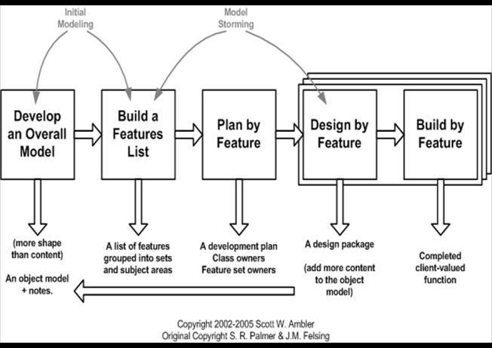
Figure 3-1:Metodology Diagram

Research
A comprehensive understanding of the project scope and status of the project area will be monitored and analysed. The overall model is formulated so that the project reaches its final product form.

- Planning:
We have created the feature list and planned for features of the project. Dependencies of features on others are tracked and prioritized for smooth and efficient development.

- Design:
Each possible UML diagram is formulated to better illustrate the characteristics and phases of the project.

- Feature Build- Development, Testing, Setup
Functions are developed based on the feature list. Each feature is tested and configured for the final product to be delivered. From asset design to hardware assembly, each iteration leads to a new role in the project. [1]

- Maintenance
Any errors or changes required will be made to increase the level of satisfaction and experience of the user.

System Design

System Use Case

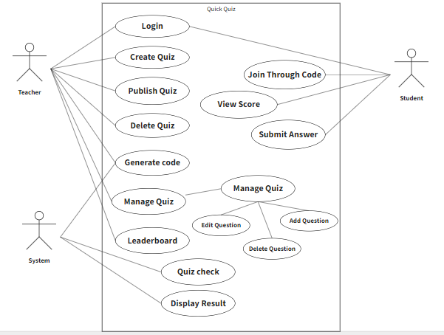
Figure 3-2:UC System

System Use case Description
Name: Quick Quiz | Id: 1
Actor: Student/Teacher | Priority: High
Description: Teacher can create quiz, generate quiz code, and then check the leader board. Students can join quiz by using code, submit answers, check score,
Trigger: User open the web Application
Preconditions
Must have internet connection
Normal flow of user  Teacher open the application  Teacher will login to application  Teacher generate the quiz  Teacher start the quiz and generate quiz code  After student joining quiz teacher start the quiz  After students submit quiz teacher check the score and leader board  Student login to the account  Student join the quiz using quiz code  Student perform quiz by choosing correct answers  Student check their score |  | Normal flow of system  System check the username and password and open the application if the user name and password was authentic  System perform the functionalities and save the answer in the database to check the quiz  System start quiz and generate quiz code by using API and every time API was different  System show the questions to the student account and students mark the answer  System check the quiz by using the save answer and display the score  System check the username and password and open the application if the user name and password was authentic  System check the code and allow student to join that related quiz  System check the answers and display score  System display score at the screen
Alternative flow
- If user cannot perform above functionalities then system display “system error try again”.
Post conditions
User successfully perform the task.
Table 3-1: Main Use Case

Login
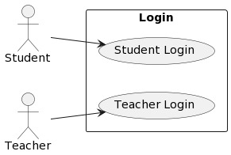
Figure 3-3: Login

Login
Name: Login | Id:2
Actor: Student/Teacher | Priority: High
Description: User can login by using password and username
Trigger: user give authentic username and password
Preconditions
- Must have Internet connection

Normal flow
- User open the application
- User enter authentic username and password
- System check the username and password in database

Alternative flow
- If User do not have login then user create new login

Post conditions
- User successfully perform the task.

Table ‎3-2: Login

Quiz create and code generate

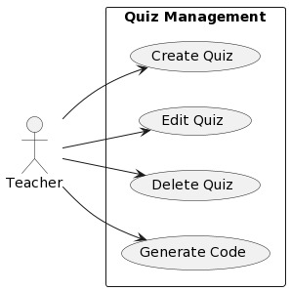
Figure 3-4: Quiz create and code generate

Quiz create and code generate
Name: Quiz create/Code generate | Id: 3
Actor: Teacher | Priority: High
Description: Teacher create quiz and start quiz so the code generate
Trigger: Teacher create quiz and code generate
Preconditions
- Must have Internet connection

Normal flow
- User open the application
- User create quiz by making questions
- User start the quiz so the quiz code generate

Alternative flow
- If user do not create quiz then the quiz do not generate

Post conditions
- User successfully perform the task.

Table ‎3-3: Quiz create and code generate

Quiz start and Perform quiz
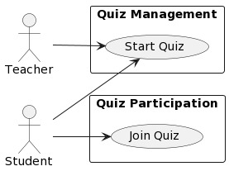
Figure 3-5: Quiz start and perform quiz

Quiz start and Perform quiz
Name: Quiz start and perform Quiz | Id: 4
Actor: User | Priority: High
Description: Teacher Start quiz and user perform the quiz
Trigger: Teacher click on start quiz the quiz code generate and the student join and perform quiz
Preconditions Must have internet connection
Normal flow
User open the application
Teacher click on the start quiz then the quiz code generate
Student join the quiz using that code and perform the quiz
Alternative flow
If user cannot perform above functionalities system will not perform any thing.
Post conditions
1. User successfully perform the task.
Table 3-4: Quiz start and perform qui

Sequence Diagram

Sequence Diagram for system

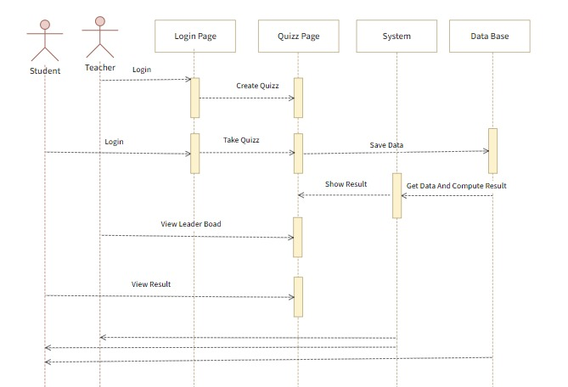
Figure 3-6: System sequence diagram

System Use Case

Name | Quick Quiz
Responsibilities | User create and perform quiz and chekc score
Exception | Perform functionalities to perform quiz and check quiz and get accurate result
Preconditions | Must have internet supply
Post conditions | User successfully perform the task.
Table 3-5: System Use Case

User Login
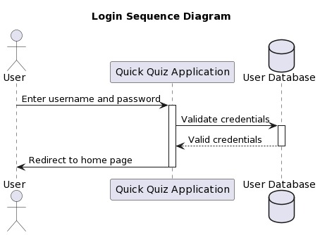
Figure 3-7: User Login

User Login

Name | User Login
Responsibilities | User can login to their account by username and password
Exception | System check the username and password if authentic then login account
Preconditions | Must have internet supply
Post conditions | User successfully perform the task.
Table 3-6: User Login

Quiz create and code generate

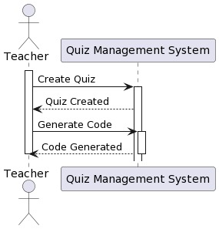
Figure 3-8: Quiz Create and Code Generate

Quiz create and code generate

Name | Quiz create and code generate
Responsibilities | Teacher create quiz and then click on start quiz then quiz code generate
Exception | System save the answers in the database and the code was always different
Preconditions | Must have internet connection
Post conditions | User successfully perform the task.
Table 3-7: Quiz Create and Code Generate

Start quiz and perform Quiz
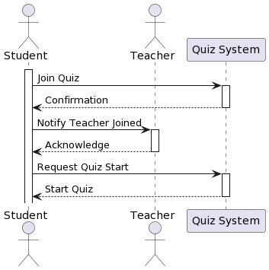
Figure 3-9: Start Quiz and Perform Quiz

Start Quiz and Perform Quiz

Name | Start Quiz and perform
Responsibilities | Students join the quiz using the quiz code and after students joining teacher start the quiz
Exception | Students join the quiz using join so join that quiz related to the code
Preconditions | Must have internet connection
Post conditions | User successfully perform the task.
Table 3-8: Start Quiz and Perform Quiz

Entity Relationship Diagram ERD
The Entity-Relationship Diagram (ERD) for your quiz web application can be described as follows:

The application consists of several collections in the MongoDB database. The "User" collection stores information about users, including their user name, user type, first name, last name, password, and email. This allows you to manage user accounts and authentication. [10]

The "Quizzes" collection is used to store quiz-related data. Each quiz document includes fields such as name, description, background image, creator ID, creator name, points per question, number of questions, and whether the quiz is public or not. This collection helps you manage the quizzes available in the application.

The "Games" collection represents ongoing games within the application. Each game document has fields like a PIN (a unique identifier for the game), whether the game is currently live, a player list, a player result list, the quiz ID associated with the game, and the host ID. This collection enables you to manage the games being played by users.

The "Leader Board" collection is responsible for keeping track of the game leader boards. It stores fields like the current leader board, player results, and the game ID. This collection allows you to track and display the scores and rankings of players in each game.

Overall, this ERD represents the structure of your MongoDB collections, illustrating the relationships between users, quizzes, games, and leader boards in your quiz web application. It provides a foundation for storing and managing the necessary data to support the functionality of your application. [10]

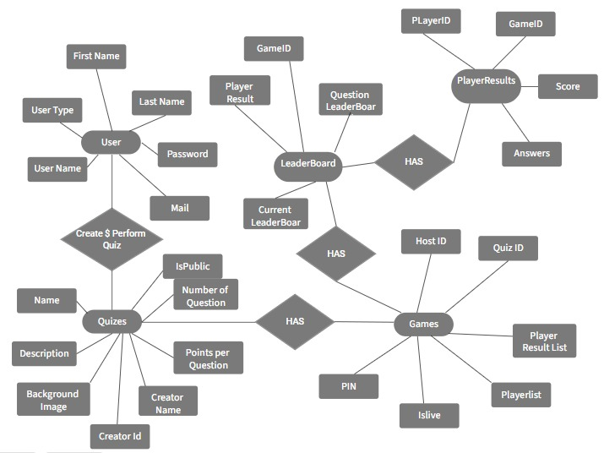
Figure 3-10: Entity Relationship Diagram ERD

IMPLMENTATION

Implementation
The Quick Quiz web application is a platform designed to provide an engaging and interactive learning experience for users. It allows educators, trainers, and students to create, participate in, and manage quizzes in a fun and gamified manner. User Registration and Login: Users can create an account or log in using their credentials to access the application. This allows them to have personalized profiles and track their progress. Educators and trainers can create quizzes using an intuitive interface. They can add various types of questions, such as multiple-choice, true/false, and open-ended questions. The quiz creation tool also supports multimedia elements, such as images and videos, to enhance the learning experience. Once the quizzes are created, the application allows the quizzes to be hosted and shared with participants. Educators can schedule quiz sessions and provide a unique code or link for participants to join. During a quiz session, participants, usually students, join the session using the provided code or link. The application presents questions and answer options in a visually appealing format. Participants can select their answers within a given time limit. Quick Quiz incorporates gamification elements, such as points, leader boards, and timers, to make the quiz experience more engaging and competitive. Participants can earn points based on correct answers and their response time, fostering a sense of achievement and motivation. Participants receive instant feedback on their answers, allowing them to learn from their mistakes and understand the correct answers. At the end of the quiz, the application provides a summary of participants' performance and ranks them on a leader board. The application strives to be accessible and inclusive, providing features such as screen reader compatibility and support for alternative input methods. It also offers customization options, allowing educators to tailor the application's appearance and settings to suit their specific needs. Overall, the Quick Quiz web application aims to revolutionize traditional quiz formats by providing an interactive, gamified, and inclusive learning experience. It promotes active participation, enhances student engagement, and facilitates effective assessment and feedback, ultimately fostering a dynamic and interactive learning environment

User Login
The user registration and login functionality in the Quick Quiz application allows new users to create an account and existing users to access their personalized accounts. Users provide their information during registration, such as name, email address, and password. The login page verifies user credentials through authentication, ensuring only registered users can access their accounts. Error handling displays appropriate messages for incorrect credentials or non-existent accounts. User roles assign different access levels and permissions based on roles like student or teacher. Overall, the user login functionality ensures secure access, authentication, and personalized account management in the Quick Quiz application

Creating Quiz and Generate code
The quiz creation feature in the Quick Quiz application allows teachers or quiz creators to design quizzes with customizable settings, question types, and multimedia elements. Users can set up the quiz by defining settings such as title, duration, and instructions. They can then create individual questions, choose from various question types, and provide answer options and scoring. The application supports the incorporation of multimedia elements to enhance the quiz experience. Once the quiz is created, a unique code is generated for participants to join the quiz session securely. The code is shared with participants, who can enter it to access the quiz. Overall, the Quick Quiz application enables users to create engaging quizzes and facilitates a seamless and interactive experience for both quiz creators and participants

Join and perform quiz
In the Quick Quiz application, participants, usually students, can join a quiz session by entering a unique code provided by the quiz creator. Upon joining, participants receive specific instructions and guidelines for the quiz. The application presents each quiz question individually, displaying the question content, options (if applicable), and any associated multimedia elements. Participants review the question and select their answers from the provided options. After submitting their answers, the application provides immediate feedback, indicating whether the response was correct or incorrect. The participant's score is calculated and displayed based on their answers. Throughout the quiz, participants can track their progress, knowing the number of questions they have answered and the remaining ones. Optionally, a leader board can be displayed, showing the rankings of participants based on their scores. Once all questions are answered, the application shows a quiz summary with the participant's final score and any additional feedback provided by the quiz creator. This process ensures an engaging and interactive experience for participants in the Quick Quiz application.

Check quiz and display score
Check Quiz and Display Score: In the Quick Quiz application, once participants have completed the quiz, the application checks the answers provided by the participants. It evaluates the responses and calculates the final score for each participant based on their correct and incorrect answers. The application then displays the scores to the participants, indicating their performance in the quiz. This feedback allows participants to assess their knowledge and understanding of the quiz content. The display of scores provides a sense of accomplishment and helps participants gauge their performance relative to other participants, if a leader board is available. The check quiz and display score feature enhances the interactive and competitive nature of the Quick Quiz application, providing participants with valuable feedback and motivation to improve their performance in future quizzes.

RESULTS AND DISCUSSIONS

Quick Quiz Web Application
The Quick Quiz web application is a platform offers an engaging and interactive learning experience. Users can register and log in to access personalized profiles and track their progress. Educators and trainers can create quizzes with various question types and multimedia elements. Quizzes can be shared with participants using unique codes or links. Participants join quiz sessions and answer questions within a time limit, earning points and receiving instant feedback. The application incorporates gamification elements and provides a leader board to enhance engagement. It promotes accessibility, customization, and inclusive learning. Quick Quiz aims to revolutionize traditional quizzes by fostering an interactive and dynamic learning environment.

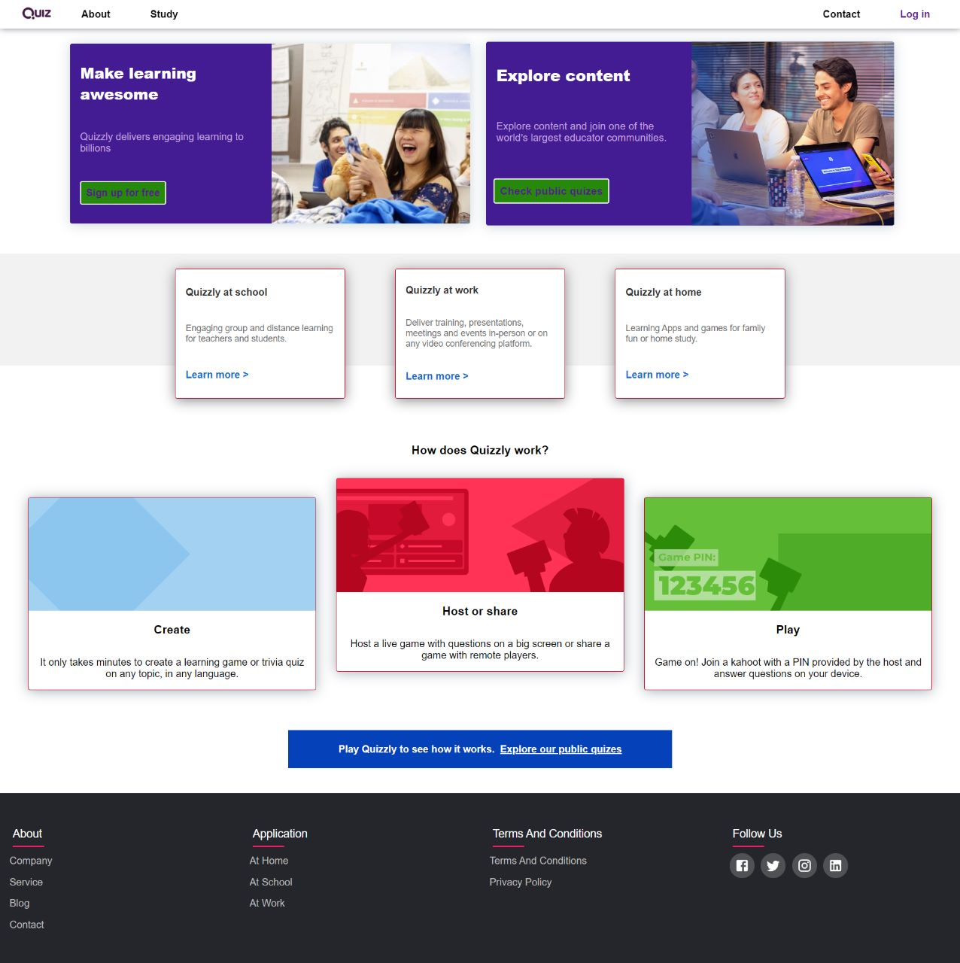Figure 5-1: Home Page

User Login
The user registration and login functionality in the Quick Quiz application enables new users to create accounts and existing users to log in. During registration, users provide their information, and the login page verifies credentials through authentication. Error handling is implemented to handle incorrect credentials or non-existent accounts. User roles are assigned to provide different access levels and permissions. Overall, this functionality ensures secure access, authentication, and personalized account management in the Quick Quiz application
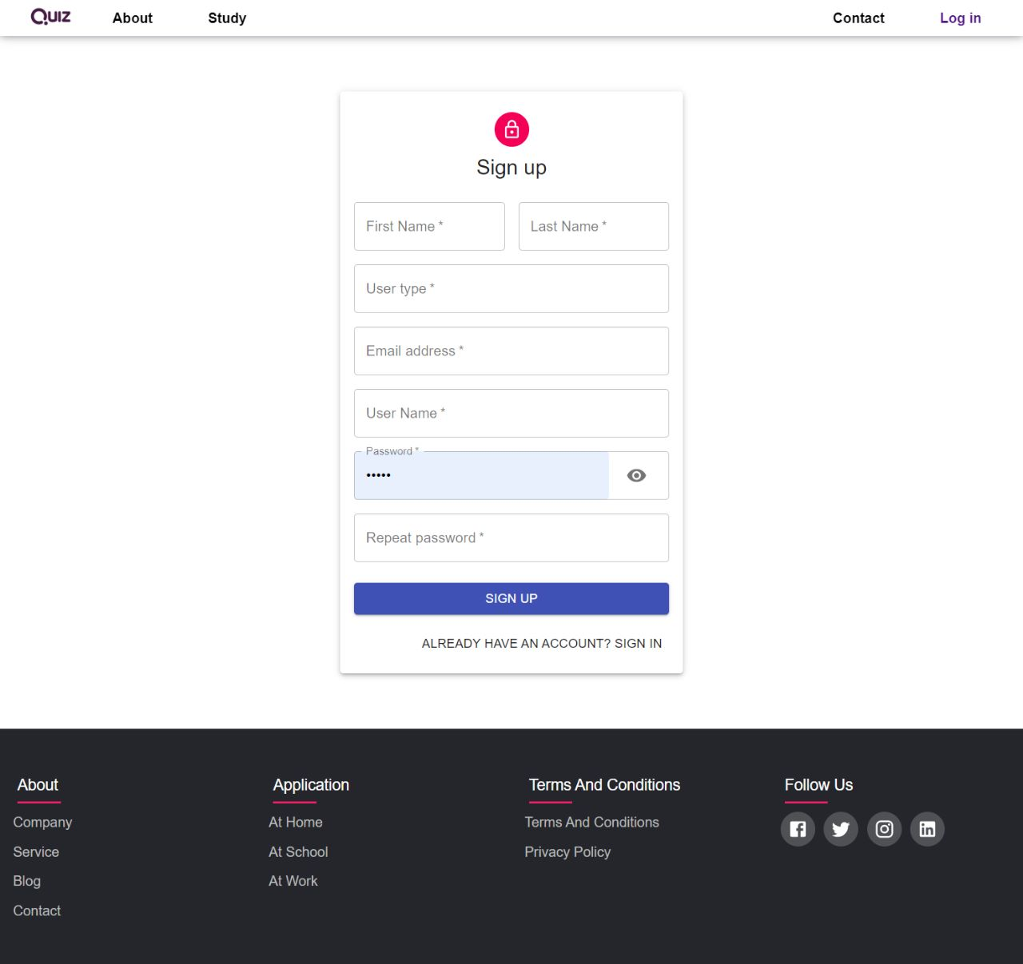
Figure 5-2: Sign Up Page

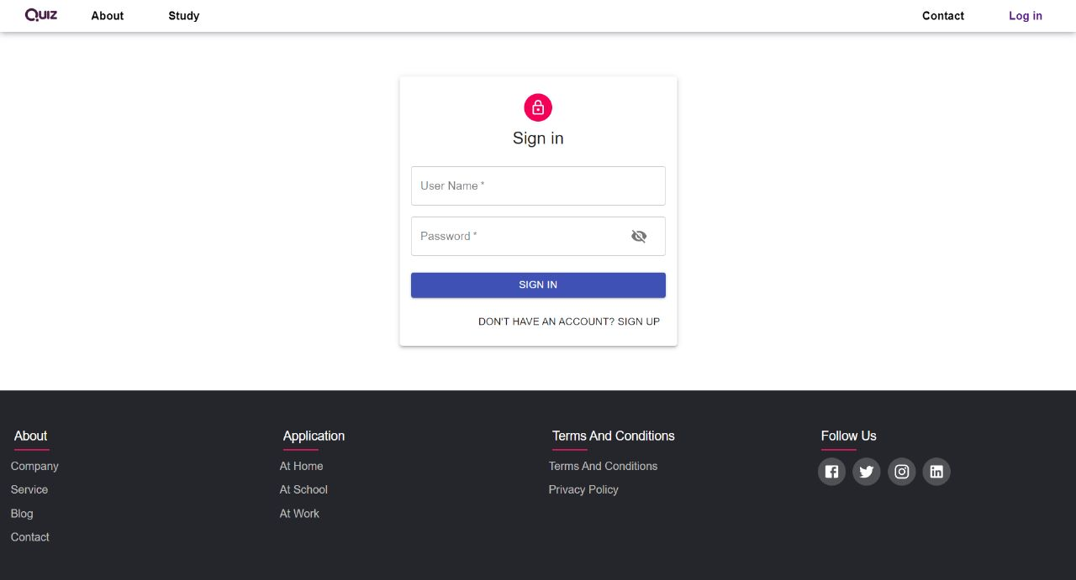

Figure 5-3: User Login

Create quiz and generate code
The Quick Quiz application provides a quiz creation feature for teachers or quiz creators to design customizable quizzes. Users can define settings, create questions, choose question types, and incorporate multimedia elements. A unique code is generated for secure participant access, allowing them to join the quiz session. Quick Quiz enables the creation of engaging quizzes and ensures a seamless and interactive experience for both creators and participants
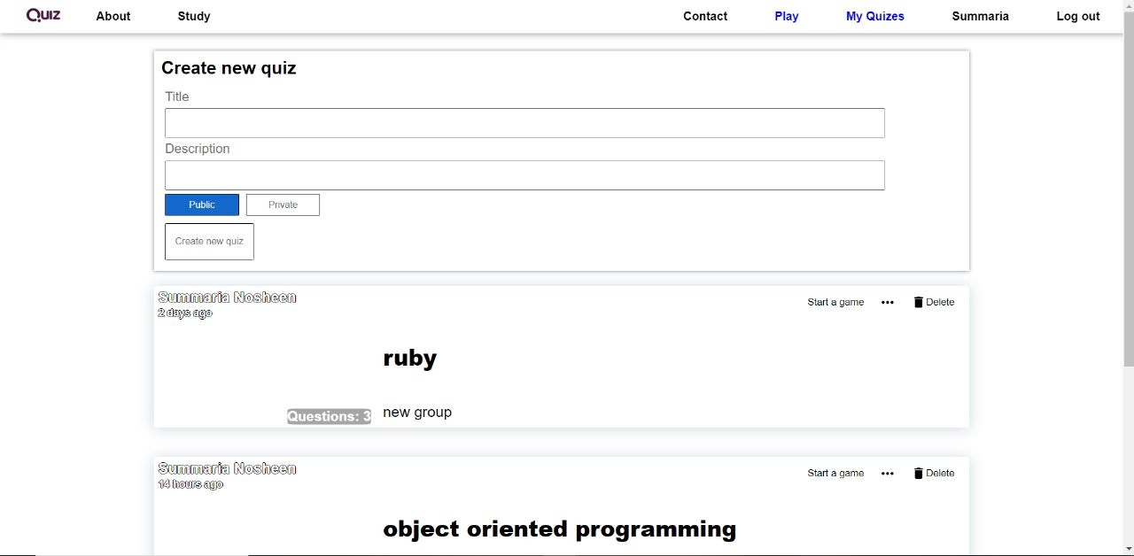
Figure 5-4: Quiz Creation

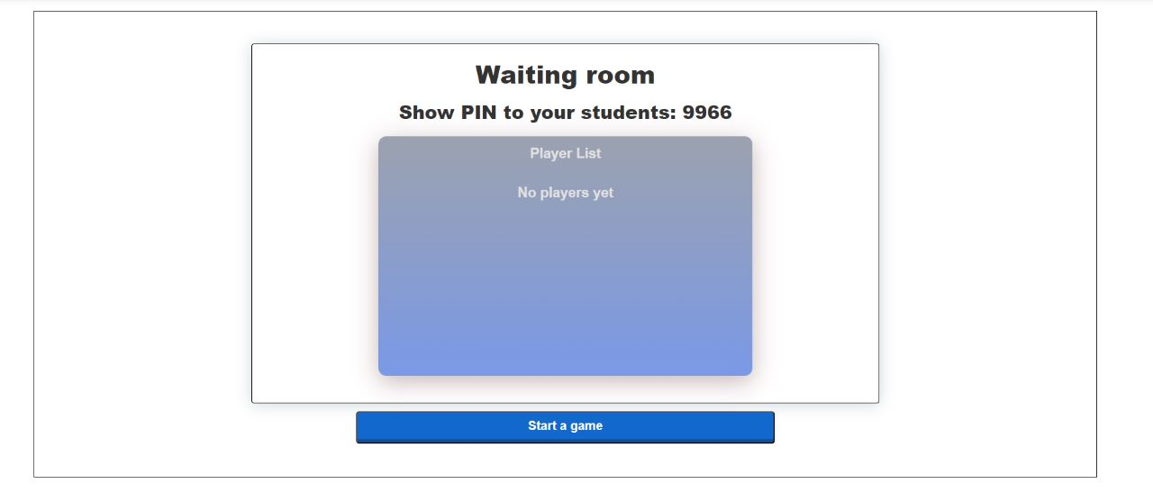
Figure 5-5: Generating Pin

Join and Perform Quiz
In the Quick Quiz application, participants can join a quiz session using a unique code. They receive instructions and guidelines and are presented with individual quiz questions along with multimedia elements. Participants select their answers, receive immediate feedback, and see their scores. They can track their progress and optionally view a leader board. At the end of the quiz, a summary is displayed with the participant's final score and any additional feedback. This ensures an engaging and interactive experience for participants in Quick Quiz.
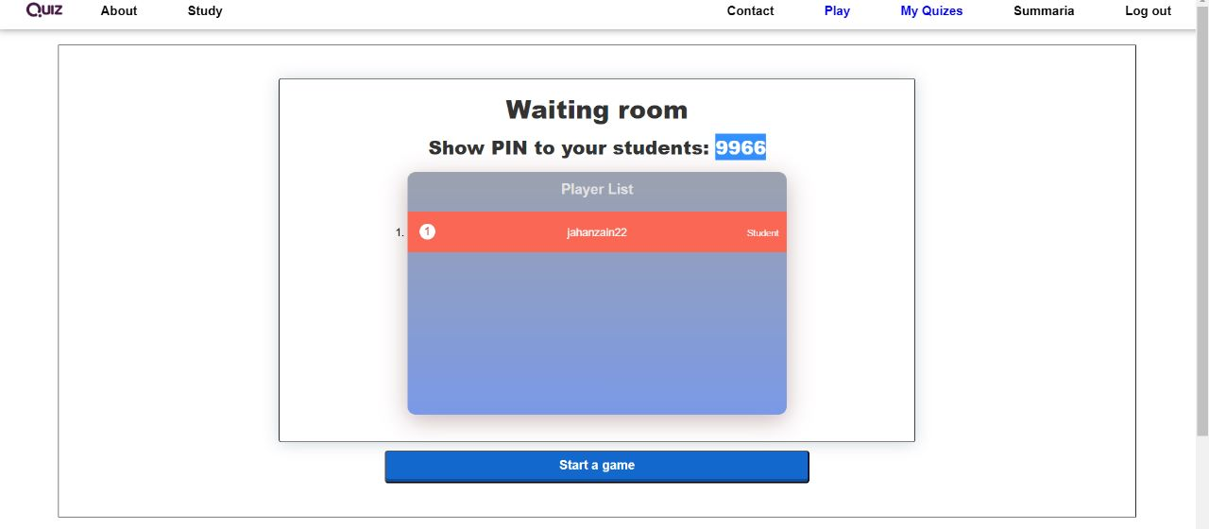
Figure 5-6: Joined Students


Figure 5-7: Joining Quiz

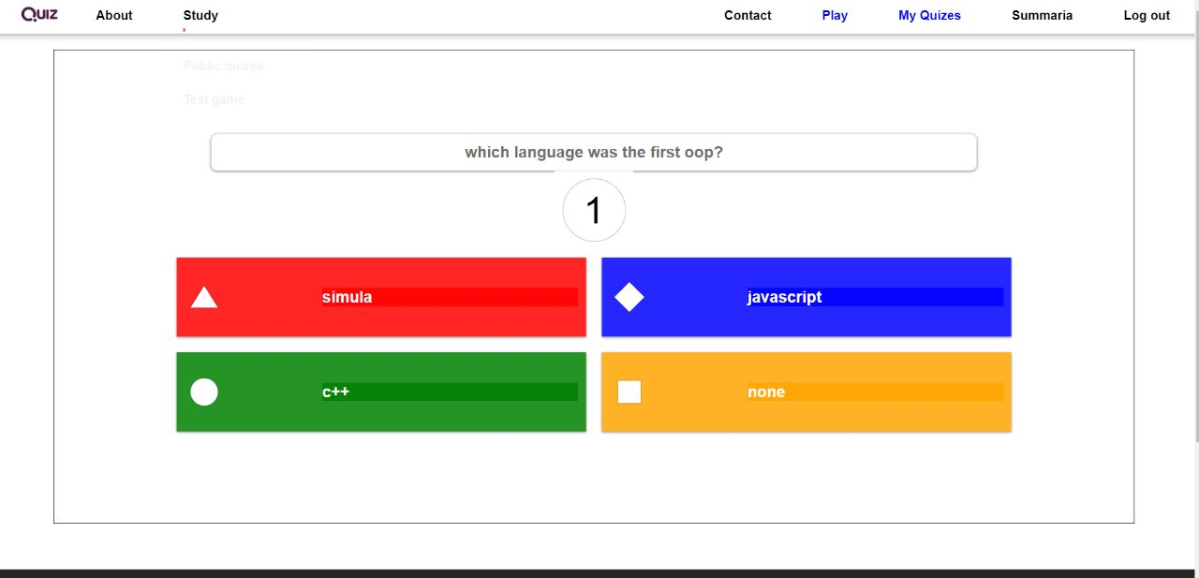
Figure 5-7: Performing Quiz

CONCLUSION AND RECOMMENDATIONS

Conclusion

In conclusion, the Quick Quiz web application provides an experience to the web application, offering an interactive and engaging platform for creating, participating in, and managing quizzes. It allows users, such as educators and students, to register and login, create quizzes with customizable settings and question types, incorporate multimedia elements, and generate unique codes for participants to join quiz sessions securely. Participants can join quizzes using the provided codes, receive instructions, answer questions, receive immediate feedback and scoring, track their progress, and optionally view leader boards. At the end of the quiz, a summary is provided, showcasing the participant's final score and any additional feedback from the quiz creator. Overall, the Quick Quiz web application aims to revolutionize traditional quizzes by offering a gamified and inclusive learning experience that promotes active participation and effective assessment.

REFERENCES

[1] | U. W. shabib aftab, “Agile Software Development Models TDD,,” vol. 8, no. 2, 2017.
[2] | a. bastakoti, “USING NATIVE MOBILE SERVICES IN REACT JS,” no. 2, 2022.
[3] | F. M. &. H. Guerra, “Web Programming Using the MEAN Stack,” no. 18, 2020.
[4] | B. Nguyen, “Improving web development process of MERN stack,” no. 2, 2021.
[5] | V. Subramanian, “Full Stack Web App Development with Mongo, Express, React, and Nod,” no. 6, 2019.
[6] | F. S. &. P. M. Vanessa Wang, “The WebSocket API,” no. 9, 2022.
[7] | gkseedhar, “https://www.geeksforgeeks.org/web-socket-in-node-js/,” [Online]. Available: https://www.geeksforgeeks.org/web-socket-in-node-js/.
[8] | j. rim, “w3school,” w3school, [Online]. Available: https://www.w3schools.com/REACT/react_jsx.asp/.
[9]  [10] | j. kim, “Reactjs,” React js research, vol. https://www.w3schools.com/REACT/react_jsx.asp/, p. 3, 2020.  Neumann, H. et al. (2008) Dyspepsia and IBS symptoms in patients with nerd, Erd and Barrett’s esophagus, Karger Publishers. Available at: https://karger.com/ddi/article-abstract/26/3/243/94922/Dyspepsia-and-IBS-Symptoms-in-Patients-with-NERD?redirectedFrom=fulltext (Accessed: 06 June 2023).

