
BSIT-F22-006
03-135192-018 | Syed Saib Nadeem

Smart Car Parking System

In partial fulfilment of the requirements for the degree of
Bachelor of Science in Information Technology
Supervisor: Dr. Ghulam Mustafa
Department of Computer Sciences
Bahria University, Lahore Campus
June 2023

© Bahria University, 2023

Certificate

We accept the work contained in the report titled
“Smart Car Parking System”
Written by
Syed Saib Nadeem
as a confirmation of the required standard for the partial fulfilment of the degree of
Bachelor of Science in Information Technology.

Approved by:
Supervisor: Dr. Ghulam Mustafa
(Signature)

June 01, 2023

DECLARATION

I hereby declare that this project report is based on my original work except for citations and quotations which have been duly acknowledged. I also declare that it has not been previously and concurrently submitted for any other degree or award at Bahria University or other institutions.

Enrolment | Name | Signature
03-135192-018 | Syed Saib Nadeem

Date : June 01, 2023

Specially dedicated to
My beloved mother and father
(Syed Saib Nadeem)

ACKNOWLEDGEMENTS

I would like to thank everyone who contributed to this project's successful completion. I would like to express my gratitude to my research supervisor, Dr Ghulam Mustafa, for his invaluable advice, guidance and enormous patience throughout the research development.

In addition, I would also like to express my gratitude to my loving parent and friends who had helped and given me encouragement.

Syed Saib Nadeem

Smart Car Parking System

ABSTRACT

In today’s world, people use cars/bikes for traveling purposes more often, and hence, parking spaces area has significantly increased with the rapid population growth and vehicles. Finding empty space is a difficult task. Drivers move their cars back and forth or check different sections to find an empty space. This is time-consuming and also leads to more fuel consumption and air pollution.
The main purpose of the Smart Car Parking System project is to design and implement a system that can automate car registration and generate tickets according to their number plate and navigate toward empty car space. The system includes both hardware and software components. Different type of components is used to interact with the Admin panel page.

TABLE OF CONTENTS

DECLARATION ii
ACKNOWLEDGEMENTS iv
ABSTRACT v
TABLE OF CONTENTS vi
LIST OF TABLES viii
LIST OF FIGURES ix

CHAPTERS
1 INTRODUCTION 1
1.1 Background 1
1.2 Problem Statement 1
1.3 Aims and Objectives 1
1.4 Scope of Project 2
2 LITERATURE REVIEW 3
2.1 Description 3
2.2 User Classes and Characteristics 3
2.3 Operating Environment 4
2.4 Development Environment: 4
2.5 Assumptions and Dependencies: 4
3 DESIGN AND METHODOLOGY 7
3.1 Methodology 7
3.2 Class Diagram 9
3.3 Resources Required: 13
3.3.1 Expertise of Team 13
IMPLEMENTATION 14
4.1 Database Design: 14
4.2 User Registration and Authentication: 14
4.3 Vehicle Management: 14
4.4 Parking Space Management: 14
4.5 Parking Space Availability: 15
4.6 User Interface: 15
4.7 Testing and Quality Assurance: 15
4.8 Deployment: 15
5 USER MANUAL 16
5.1 User Manual 16
5.1.1 Registration: 16
5.1.2 Admin portal: 18
5.1.3 Dashboard: 19
5.1.4 Logout: 19
5.1.5 Navigation to Parking Space: 20
5.1.6 System Management: 20
5.1.7 Troubleshooting: 20
6 CONCLUSION AND RECOMMENDATIONS 21
6.1 Conclusion 21

LIST OF TABLES

TABLE TITLE PAGE
Table 1 Development Enviornment 4

LIST OF FIGURES

FIGURE TITLE PAGE
Figure 1 Feature Driven Development 8
Figure 2 Class Diagram 9
Figure 3 Sequence Diagram 10
Figure 4 Activity Diagram 11
Figure 5 Activity Diagram 12
Figure 6 Converting image in grey scale 16
Figure 7 cropping the number plate 17
Figure 8 Extracting data from number plate 18
Figure 9 Admin Sign In page 18
Figure 10 Admin Dashboard 19
Figure 11 Logout page 19
Figure 12 Displaying Empty Spaces 20

CHAPTER 1

INTRODUCTION

Background

The proposed software goes by the name Smart Car Parking System. This deep learning based software will work on the Windows system that will use the Image Processing technique to read the data number plate of the car that came into a parking lot and convert the information required in the image to generate the ticket against that number plate and the user will pay for the ticket. You will see a piece of digital information on the system where the empty car space is available and the user will be navigated towards the empty car space. If the user tried to enter in the parking lot without generating ticket the gate won’t open. And upon exiting the parking lot the camera will read the number plate and will check if the ticket is generated against the number plate if yes the system will open the gate otherwise it will not.

Problem Statement

According to the general research people waste a lot of time in finding empty space in an organization becomes a crucial task it takes so much time to find an empty parking space. This system will be registering the car through their number plates by using image processing and the cameras will be using the video processing for calculating the coordinates of the parking area and give feedback about the available parking space.

Aims and Objectives
The objectives of this project are shown as following:
- To Automate the car registration
- To navigate towards the empty car space

Scope of Project

Finding empty space in an organization becomes a crucial task it takes so much time to find an empty parking space. This system will be registering the car through their number plates by using image processing and the cameras will be calculating the coordinates of the parking area and give feedback about the available parking space. Previous solutions are wire-based systems and highly maintainable. In this project, the system will be using Image Processing and Video Processing.

LITERATURE REVIEW

Description

The proposed project is a Web based application therefore front end will be developed in VS Code. The final application is system based web application. My development approach was feature-driven development in which first I built an overall model then built a feature list and then I planned, designed, and developed by feature.

User Classes and Characteristics

- Car Owners:
  - Registration
  - Find parking space
- Parking Facility Operators:
  - manage parking space
- System Administrators:
  - Manage system functionality
  - Configuration

Operating Environment

The operating environment for the Smart Car Parking System is as listed below.
- Windows
- Linux
- Stable Internet Connection
- Any Device that has access to internet and browser

Development Environment:

Table 1
Name | Description
Operating system Environment | Windows
Support device | Any Device that has access to internet and browser
Language | Python  ReactJs
Tools and Technology | - RAM 8 GB  - SSD 256 GB  - Google Colab
Database | MongoDB

Table 1 Development Environment

2.5 Assumptions and Dependencies:

Following are the assumptions and dependencies:
- Assume the PC have Windows or Linux OS.
- Assume the PC or Laptop have Internet access.

2.6 Other Non-Functional Requirements:

The Non-Functional requirements of the proposed project are given below

2.6.1 Performance Requirements

The system should provide fast response times for user interactions, ensuring a smooth user experience. It should handle a high volume of concurrent users and process requests efficiently, accommodating peak loads without significant performance degradation. It should scale to handle increasing user demands, registered vehicles, and parking facilities.

2.6.2 Performance:

The system should handle a high volume of users and provide fast response times, ensuring a seamless experience even during peak usage.

2.6.3 Reliability:

The system should be highly reliable and available, with measures in place to handle failures and recover quickly.

2.6.4 Security:

The system should prioritize the security of user data, transactions, and sensitive information, implementing robust security measures.

2.6.5 Scalability:

The system should be designed to accommodate future growth, expanding the number of vehicles and parking facilities without performance degradation.

2.6.6 Usability:

The system should have a user-friendly interface, accommodating users with different levels of technical proficiency.

2.6.7 Maintainability:

The system should be easily maintainable, with well-structured code, documentation, and testing frameworks.

2.6.8 Compatibility:

The system should be compatible with various devices and platforms, ensuring optimal user experience across different devices.

2.6.9 Compliance:

The system should comply with applicable laws, regulations, and industry standards for data protection, privacy, and payment processing.

DESIGN AND METHODOLOGY

Methodology

For the development of this project I am using Feature Driven Development (FDD). Feature Driven Development (FDD) is an agile software development methodology that focuses on delivering features incrementally and collaboratively. It emphasizes a down object modelling approach and iterative development.
The five stages of Feature Driven Development (FDD) are mentioned below:

Develop the overall model:
In this initial step, the development team creates an overall model of the software system. This involves identifying the major functionalities and features of the system and organizing them into a high-level feature list. The overall model provides a clear understanding of the system's scope and sets the direction for subsequent steps.

Build the features list:
The feature list is derived from the overall model and serves as a comprehensive inventory of all the features that need to be implemented in the software. Each feature is typically defined as a small, cohesive unit of functionality that can be developed independently.

Plan by feature:
This step involves breaking down the feature list into development tasks. The team identifies the order in which the features will be implemented and estimates the time and effort required for each feature. This information helps in creating an overall development plan and allocating resources effectively.

Design by feature:
In this, the development team focuses on the design aspects of each feature. The designers work on the detailed design of the features, considering factors such as user interfaces, data structures, and algorithms. The goal is to create a design that ensures the feature will function as intended and integrate smoothly with the rest of the system.

Build by feature:
The development team starts coding the features based on the design specifications. Each feature is developed independently by a small team or an individual developer. This step emphasizes iterative development, with frequent code integration and testing to ensure each feature functions correctly

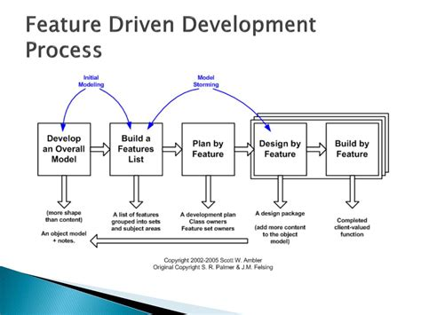
Figure 1 Feature Driven Development

Class Diagram

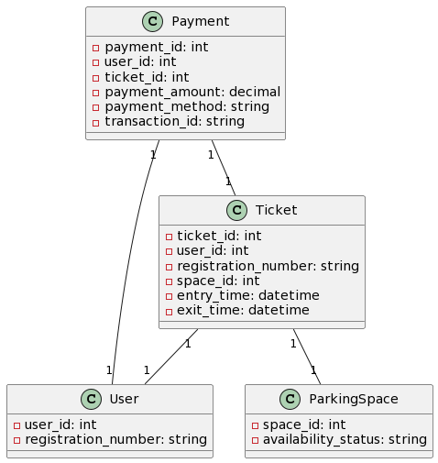
Figure 2 Class Diagram

Fig 2 shows a high-level view of a system's functionality from a user's perspective, identifying the actors, their interactions with the system, and the use cases that meet their needs.

3.3 Sequence Diagram:

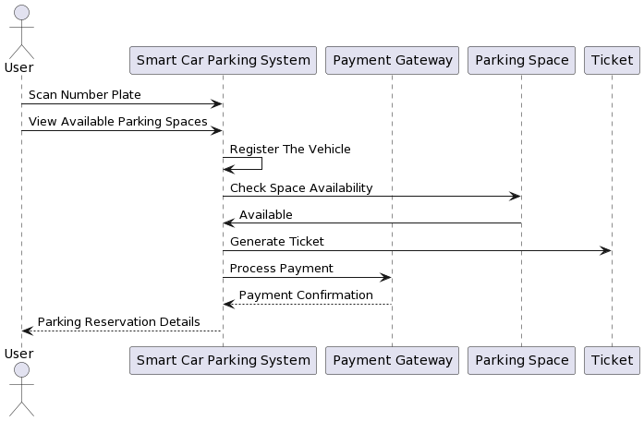
Figure 3 Sequence Diagram

Fig 3 shows an illustration of the interactions between objects or components in a system over time, showing the objects, lifelines, messages, activation, and alternative paths involved in the interaction.

3.4 Activity Diagram:

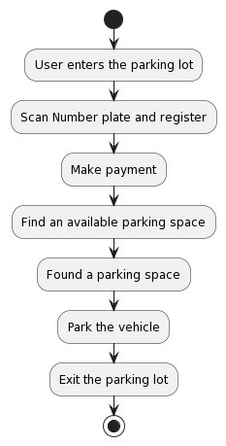
Figure 4 Activity Diagram

Fig 4 shows us the illustration of flow of activities, control flow, decision points, synchronization, and actors involved in a system or organizational workflow or process flow.

3.5 Use Case Diagram:

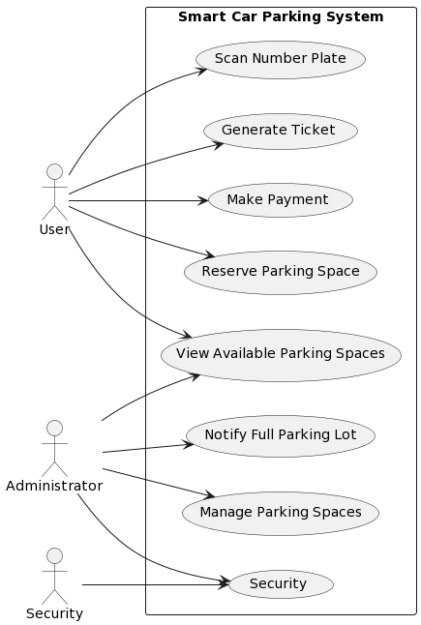
Figure 5 Activity Diagram

Fig 5 shows a high-level view of a system's functionality from a user's perspective, identifying the actors, their interactions with the system, and the use cases that meet their needs

Resources Required:

Following are the resources requirements

Expertise of Team

I am pre-equipped with the knowledge needed for this project's successful completion. I have completed Web and Python courses on my own which are required for this project. Moreover, I have also completed a number of minor projects.

3.3.2 Tools/ Technology:

To develop this project the tools and technology I am using are as follows:
- VS Code or Google Colab
- Laptop
- OpenCV
- ANPR
- MongoDB
- ReactJs

IMPLEMENTATION

Database Design:
The first step in implementing the project was designing the database schema based on the previously defined Entity-Relationship Diagram (ERD). I created tables for User, Vehicle, Parking Space, Ticket, and Payment, along with their relationships and constraints.

User Registration and Authentication:
I developed the functionality to allow users to register with the system by providing their details such as name, email, password, phone number, and address. To ensure secure access, I implemented authentication mechanisms to manage user logins and sessions.

Vehicle Management:
I created features that enable users to add vehicles to their account. Through a user-friendly interface, users can add, view, update, and delete vehicle information, including registration number, vehicle type, and model.

Parking Space Management:
The system includes functionality to manage parking spaces. I implemented features to add new parking spaces, update their availability status, and associate them with specific locations. This allows users to easily find and reserve available parking spaces.

Parking Space Availability:
I implemented algorithms and methods to determine the availability of parking spaces. This involved real-time monitoring of parking spaces or utilizing cameras to detect occupancy. Users are informed about the availability of parking spaces to make informed decisions.

User Interface:
I developed an intuitive and user-friendly interface for users to interact with the system. Through Ill-designed screens and forms, Admin can easily navigate and access functionalities such as user registration, vehicle management, ticket generation, and payment processing.

Testing and Quality Assurance:
To ensure the reliability and correctness of the implemented features, I conducted comprehensive testing. I tested various scenarios and edge cases to identify and address any bugs or issues. Rigorous testing helped ensure a high-quality and robust system.

Deployment:
The final step was deploying the system to a suitable hosting environment. I selected a scalable hosting solution to handle multiple users concurrently. The system is now accessible to users, providing a seamless and efficient car parking experience.

USER MANUAL

User Manual

The Smart Car Parking System is designed to revolutionize the car parking experience by automating various processes such as car registration, ticket generation, payment methods, and navigation toward available parking spaces. This user manual provides step-by-step instructions on how to use the system effectively.

Registration:
To register a vehicle, follow these steps:
- Enter the car in the parking entrance
- The camera will read your number plate and register the vehicle in the system
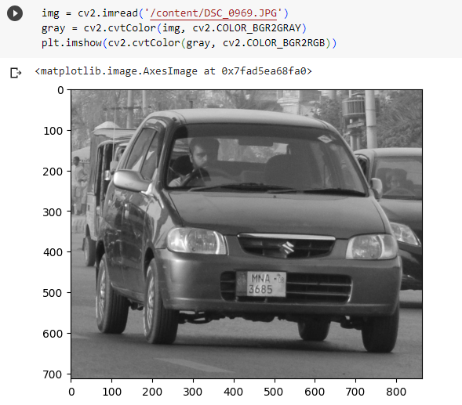
Figure 6 Converting image in grey scale

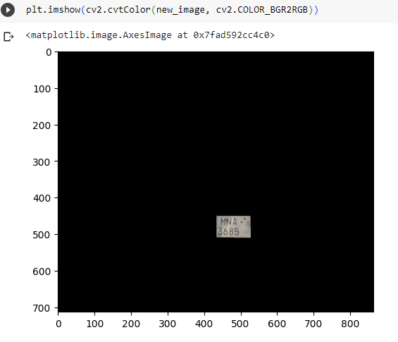
Figure 7 cropping the number plate
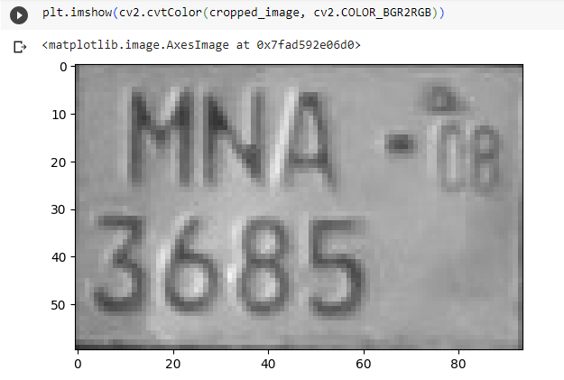
Figure 8 Extracting data from number plate

Admin portal:

- Admin will Sign in through web portal.
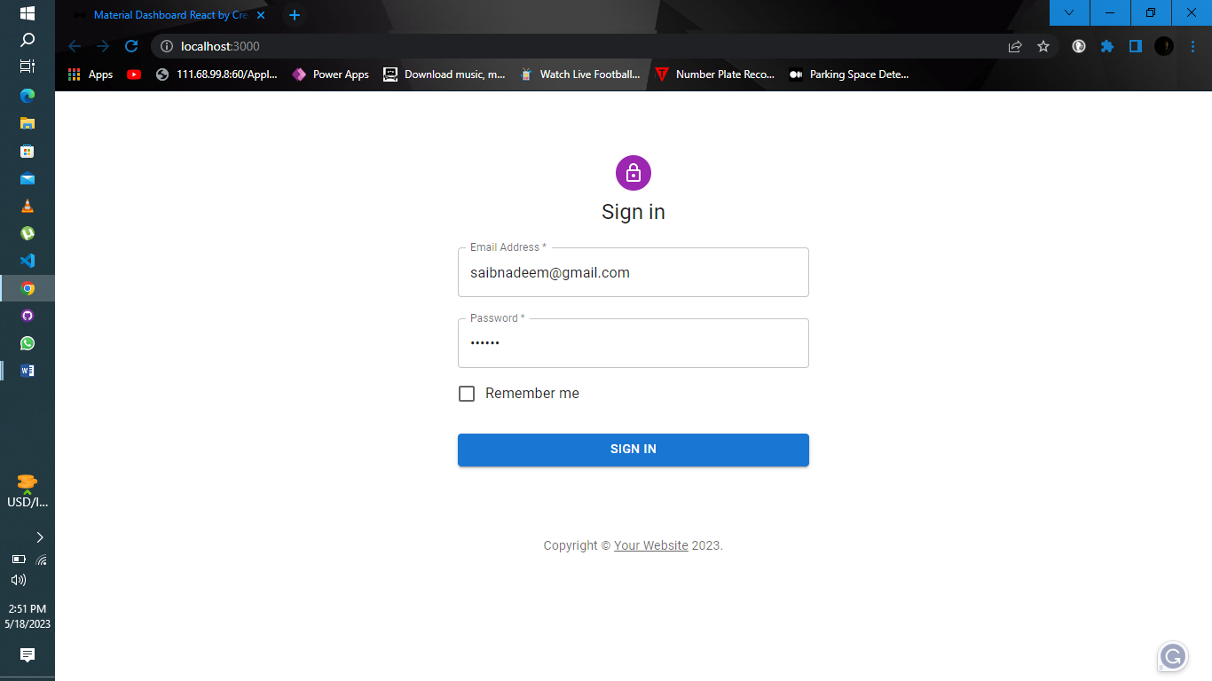
Figure 9 Admin Sign In page

Dashboard:
Admin can see the car entries and the time when the car enters in the parking lot when the car exits and can see available spaces.
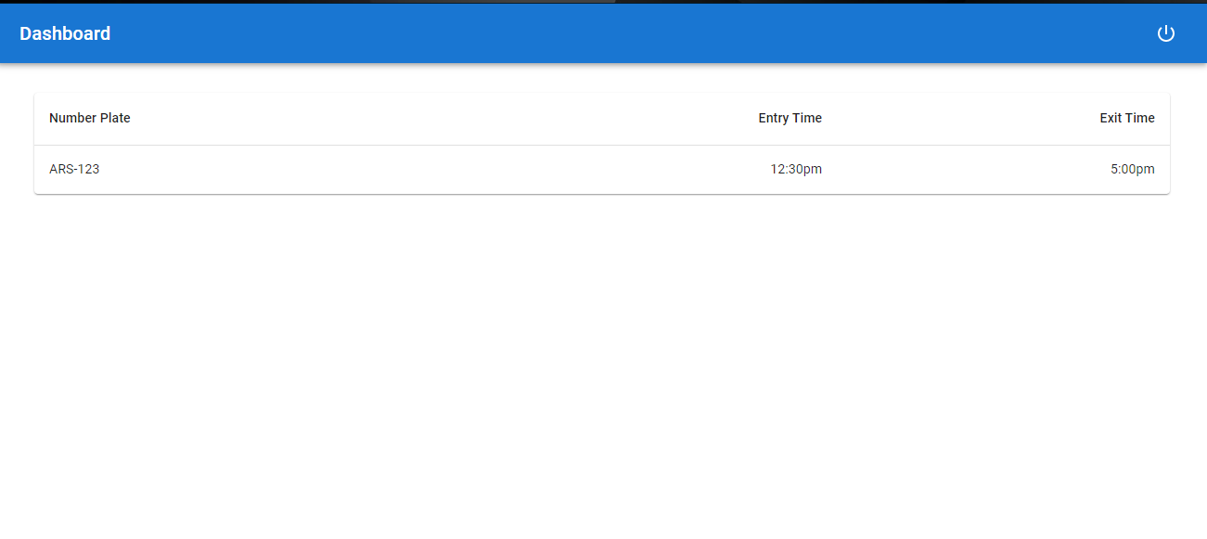
Figure 10 Admin Dashboard

Logout:
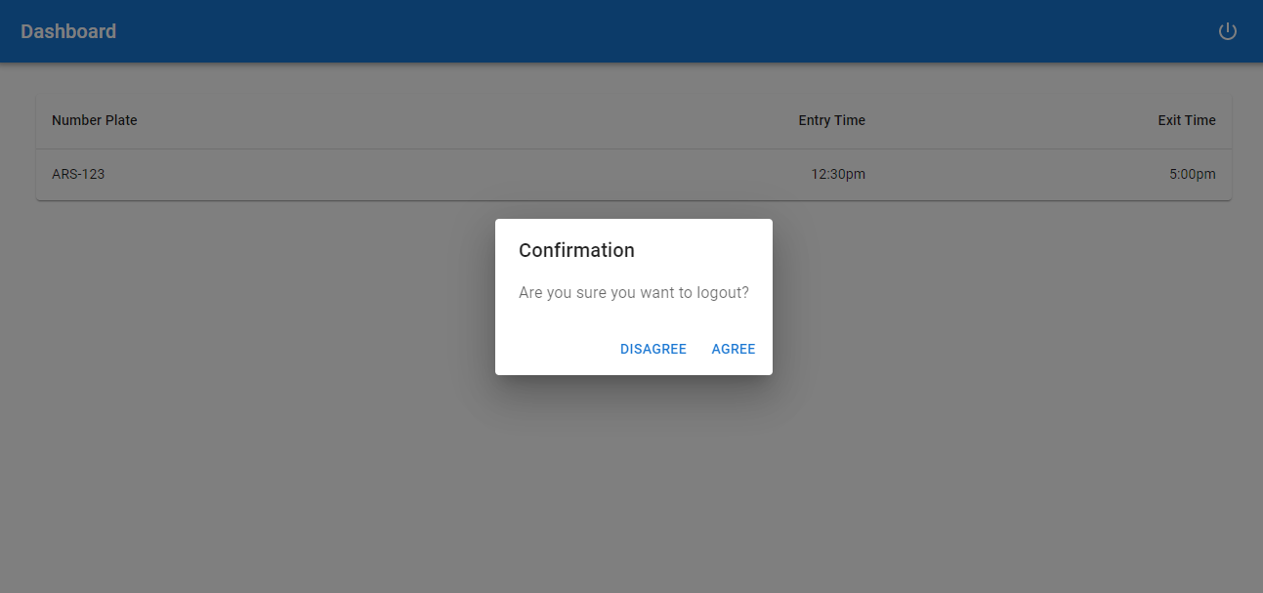
Figure 11 Logout page

Navigation to Parking Space:
To navigate toward an available parking space, follow these steps:
a. The system will display real-time information on available parking spaces.
b. Follow the navigation instructions provided to reach the nearest empty parking space.
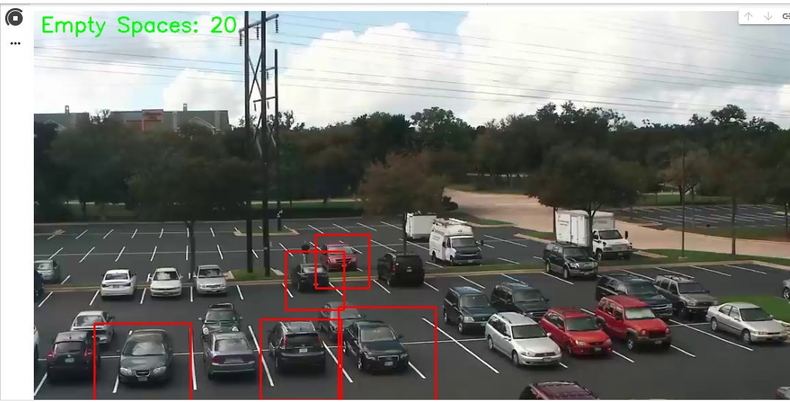
Figure 12 Displaying Empty Spaces

System Management:
System administrators can perform various management tasks:
a. Access the administration interface using administrator credentials.
b. Configure system settings, such as parking rates, ticket types, or user permissions.
c. Monitor system performance and resolve any issues that may arise.

Troubleshooting:
If you encounter any issues or have questions about the system, follow these steps:
a. Refer to the system's help documentation or user manual for troubleshooting tips.
b. Contact the system administrator or support team for assistance.
c. Provide detailed information about the problem or error message received for efficient troubleshooting.

CONCLUSION AND RECOMMENDATIONS

Conclusion

The conclusion of the Automated Car Parking System project is that it successfully automates car registration, ticket generation, digitalizes payment methods, and simplifies navigation to available parking spaces. This implementation significantly enhances the car parking experience by reducing paperwork, queuing time, and manual effort for car owners and parking facility operators. The system's user-centric design principles ensure convenience, efficiency, and accuracy throughout the parking process. However, continuous monitoring, updates, and collaboration with stakeholders are necessary to maintain system performance, scalability, and alignment with evolving industry standards. Overall, the project demonstrates the potential of automation and digitalization to improve the efficiency and user satisfaction of car parking systems.

