

BSCS-F22-032

03-134192-043 | Zaire Shakeel Raja

SportsTracker

In partial fulfilment of the requirements for the degree of
Bachelor of Science in Computer Science

Supervisor: Dawood Akram

Department of Computer Sciences Bahria University, Lahore Campus

June 2023

© Bahria University, 2023

C e r t i f i c a t e

I accept the work contained in the report titled “SportsTracker”
written by Zaire Shakeel Raja
as a confirmation to the required standard for the partial fulfilment of the degree of Bachelor of Science in Computer Science.

Approved by:
Supervisor: Dawood Akram

(Signature)

June 20, 2023

DECLARATION

I hereby declare that this project report is based on my original work except for citations and quotations which have been duly acknowledged. I also declare that it has not been previously and concurrently submitted for any other degree or award at Bahria University or other institutions.

Enrolment | Name | Signature
03-134192-043 | Zaire Shakeel Raja

Date : June 20, 2023

Specially dedicated to
My beloved grandmother, mother and father (Zaire Shakeel Raja)

ACKNOWLEDGEMENTS

I would like to thank everyone who had contributed to the successful completion of this project. I would like to express our gratitude to our research supervisor, Dawood Akram for his invaluable advice, guidance, and his enormous patience throughout the development of the research.

In addition, I would also like to express our gratitude to our loving parent and friends who had helped and given us encouragement.

Zaire Shakeel Raja

SportsTracker

ABSTRACT

The proposed project aims to address the challenges faced by local youth in fulfilling their sports interests and finding opportunities for healthy competition with other individuals or local teams. Currently, many young individuals struggle to find available sports grounds or facilities for booking, which limits their ability to engage in sports activities and showcase their skills. SportsTracker aims to bridge this gap by providing an online platform that allows users to easily discover and book vacant sports grounds or venues. By leveraging the convenience of technology, SportsTracker enables users to make online reservations from any location and at any time, eliminating the hassle of manually searching for available options. While some businesses have adopted online booking systems, the overall familiarity and adoption of such technology among the local community may be limited. Therefore, the SportsTracker app aims to enhance people's ability to learn and use the online booking system by providing a user-friendly interface and a seamless booking experience. The development methodology chosen for this project is Agile methodology. This methodology involves breaking down the project into multiple phases and iterations, allowing for continuous collaboration, feedback, and adaptation. By employing Agile methodology, the development team can efficiently manage the project, address any challenges or changes that may arise, and ensure the successful delivery of the SportsTracker app to meet the needs of the local youth. The Agile methodology provides a flexible and iterative approach to project development, enabling the SportsTracker team to adapt to changing requirements and deliver incremental improvements throughout the development process.

TABLE OF CONTENTS

DECLARATION ii
ACKNOWLEDGEMENTS iv
ABSTRACT v
TABLE OF CONTENTS vi
LIST OF TABLES ix
LIST OF FIGURES x
LIST OF SYMBOLS / ABBREVIATIONS xii
CHAPTERS
- INTRODUCTION 1
  - Background 1
  - Problem Statements 2
  - Aims and Objectives 3
  - Scope of Project 3
- SOFTWARE REQUIRMENTS SPECIFICATIONS 4
  - Overall Description 4
  - User Classes and Characteristics 4
  - Operating Environment 5
  - Development Environment 5
  - Assumptions and Dependencies 6
  - Other Non-Functional Requirements 6
    - Performance Requirements 6
    - Security Requirements 6
  - Software Quality Attributes 6
    - Reliability 7
    - Availability 7
    - Portability 7
    - Maintainability 7
    - Reusability 7
  - Software Requirements Chart 8
- DESIGN AND METHODOLOGY 9
  - Diagrams 9
  - Use case Diagrams 10
  - Entity Relation Diagram 11
  - Sequence Diagram 12

 | 3.4.1 | Login | 12
 | 3.4.2 | Signup | 12
 | 3.4.3 | Home Page | 13
 | 3.4.4 | Venue Information Page: | 13
 | 3.4.5 | Venue Detail Page | 14
 | 3.4.6 | Profile Page | 15
 | 3.4.7 | Recent Page: | 15
 | 3.4.8 | Requests Page: | 16
 | 3.4.9 | Contact us page: | 17
 | 3.4.10 | Settings Page | 18
 | 3.4.11 | Support Page | 19
 | 3.4.12 | About Page | 19
3.5 | Activity | Diagram | 20

- IMPLMENTATION 21
  - Tools and Technologies 21
    - Flutter 21
    - Visual Studio Code 21

RESULTS AND DISCUSSIONS (or USER MANUAL) 22
  - Signup Page 22

  - Login page 23
  - Profile Page 24
  - Home page 25
  - Venue information page 26
  - Venue Detail page 27
  - Contact us page 28
  - Requests Page 29
  - Support Page 30
  - Settings Page 31
  - About Page 32

CONCLUSION AND RECOMMENDATIONS 33
  - Conclusion 33
  - Limitations 33
  - Recommendations & Future Use 34

REFERENCES 35

LIST OF TABLES

TABLE TITLE PAGE

Table 2.1 Development Table 5

Table 2.2 Software Requirement Table 8

LIST OF FIGURES

FIGURE TITLE PAGE

Figure 3.1 Use Case 10

Figure 3.2 ERD 11

Figure 3.3 Login Sequence 12

Figure 3.4 Signup Sequence 12

Figure 3.5 Homepage Sequence 13

Figure 3.6 Venue Sequence 13

Figure 3.7 Venue Detail Sequence 14

Figure 3.8 Profile Sequence 15

Figure 3.9 Recent Page Sequence 15

Figure 3.10 Requests Page Sequence 16

Figure 3.11 Contact Us Page Sequence 17

Figure 3.12 Settings Sequence 18

Figure 3.13 Support Page Sequence 19

Figure 3.14 About Page Sequence 19

Figure 3.15 Activity Sequence 20

Figure 5.1 Signup 22

Figure 5.2 Login 23

Figure 5.3 Profile 24

Figure 5.4 Homepage 25

Figure 5.5 Venue Information page 26

Figure 5.6 Venue Detail Page 27

Figure 5.7 Contact Us Page 28

Figure 5.8 Request Page 29

Figure 5.9 Support Page 30

Figure 5.10 Settings Page 31

Figure 5.11 About Page 32

LIST OF SYMBOLS / ABBREVIATIONS

AFL Flutter
FB Firebase
DT Dart
SRS Software Requirement Specification
ERD Entity Relationship Diagram
APK Android Application Package
iOS iPhone Operating Object
API Application Program Interface
UI User Interface

CHAPTER 1

INTRODUCTION

Background

SportsTracker is a dynamic and user-friendly mobile app designed to cater to the needs of sports enthusiasts. With its sleek and intuitive interface built on the Flutter framework, SportsTracker brings the world of sports booking and tracking right to users' fingertips. The app aims to revolutionize the way people engage with sports activities by offering a convenient online platform for browsing, booking, and managing sports events and facilities. Whether it's reserving a tennis court or joining a friendly basketball game, SportsTracker provides a seamless experience, allowing users to explore a wide range of sports options, make hassle-free bookings, and stay up-to-date with their schedules. With features like secure payment options, personalized profiles, and real-time notifications, SportsTracker empowers users to pursue their sporting passions effortlessly and stay active in a fast-paced, digital world.

Problem Statements

In today's busy and fast-paced world, sports enthusiasts often face challenges when it comes to finding and booking sports activities. Traditional methods of booking, such as phone calls or visiting sports facilities in person, can be time- consuming and inconvenient. There is a need for a dedicated mobile app that focuses solely on sports booking, providing users with a seamless and efficient way to discover, reserve, and manage their desired sports activities.

The current lack of a specialized sports booking app results in inefficiencies and frustrations for both users and sports facility owners. Users may struggle to find accurate information about available sports options, struggle with manual booking processes, or miss out on preferred time slots due to limited visibility. On the other hand, sports facility owners may face difficulties in managing bookings, maintaining communication with customers, and maximizing their facility utilization.

SportsTracker aims to address these challenges by providing a comprehensive and user-friendly platform exclusively dedicated to sports booking. By leveraging the power of mobile technology and the convenience of online transactions, SportsTracker seeks to streamline the sports booking experience, connecting users directly with available sports activities, simplifying the booking process, and enhancing overall customer satisfaction.

.

Aims and Objectives

The objectives of the project are shown as following:
    - The app aims to simplify the process of finding and booking sports activities, providing users with a seamless and user-friendly platform to discover and reserve their preferred sports options.
    - The objective is to offer a delightful user experience by providing a sleek and intuitive interface, personalized profiles, real-time notifications, and secure payment options, ensuring convenience and satisfaction for sports enthusiasts.
    - The app aims to help sports facility owners maximize their facility utilization by connecting them directly with potential customers, streamlining booking management, and providing insights into user preferences and demand.

Scope of Project

The project aims to develop a comprehensive sports booking app that caters to the needs of sports enthusiasts by providing a user-friendly platform to discover, book, and manage sports activities. The app will offer a wide range of sports options, including but not limited to tennis, basketball, and cricket allowing users to explore and choose their preferred activities. Users will have the convenience of accessing real-time information about available time slots, pricing, and location of sports facilities.

The app will incorporate features such as user registration and login, personalized profiles, secure payment options, and notifications to enhance the overall user experience. Users will be able to easily search for sports activities based on their preferences, book and pay for their bookings within the app, and receive timely reminders and updates. Additionally, the app will provide a platform for users to rate and review their sports experiences, enabling others to make informed decisions.

CHAPTER 2

SOFTWARE REQUIRMENTS SPECIFICATIONS

Overall Description

SportsTracker is a cutting-edge mobile app designed to revolutionize the way sports enthusiasts’ book and engage in sports activities. With its sleek and intuitive interface, the app provides users with a seamless platform to explore a wide range of sports options, book their preferred activities, and manage their schedules effortlessly. Offering features like personalized profiles, secure payment options, and real-time notifications, SportsTracker enhances the user experience and simplifies the entire sports booking process. By connecting users with sports facilities and promoting a healthy and active lifestyle, SportsTracker empower both users and facility owners in the dynamic world of sports.

User Classes and Characteristics

The application acts as your personal data manager thus features only a single user i.e., the person who install's the app for their own use.

User
      - The user can perform the following activities.
      - Sign-in
      - Book Sports Facilities
      - Can view detailed information about sports facilities

      - Track their sports activities and their progress
      - Manage their Sports Bookings including booking histories and settings

Operating Environment

The operating environment for the SportsTracker is as listed below.
- Android/IOS Mobile Phone
- Android 10.1/IOS 12
- Stable Internet Connection

Development Environment

Table 2.1 Development Table

Name | Description
Operating system Environment | Windows
Support device | Smart Phone
Language | Dart
Tools and Technology | - RAM 16 GB  - SSD 256 GB  - Adobe or Figma  - Android Studio
Database | Fire Base

Assumptions and Dependencies

Following are the assumptions and dependencies:
- Assume phone is at least Android 10.1/iOS 12 or better to run machine learning models in mobile.
- Assume the user grants permission to the app.
- Assume the user's phone is android or iOS.

Other Non-Functional Requirements

The non-functional requirements of the proposed project are given below:

Performance Requirements

Performance requirement by the user side is android or iOS mobile application should be developed as a less APK mobile application so that it can work on almost any Mobile even with lower APK mobile.

Security Requirements

Strong authentication mechanisms, such as secure login methods and user verification, should be implemented to prevent unauthorized access to user accounts and ensure that only authorized users can make bookings or access sensitive information.

Software Quality Attributes

Software quality attributes are as following:

Reliability

It is a reliable mobile application. The app should be designed to be stable and reliable, minimizing system crashes and unexpected errors. The app should accurately reflect the availability of sports activities and facilities in real-time. Users should have confidence that the information provided by the app is up- to-date and reliable, preventing any issues arising from double bookings or incorrect scheduling.

Availability

The system is available across multiple platforms and can be accessed by users on any of them. The mobile application will be all time available.

Portability

Users can login to the system anywhere at any time.

Maintainability

The developer will maintain the mobile application data and all the services.

Reusability

Provided mobile application has reusability functions. The app should be designed with modular and reusable components to facilitate future enhancements and scalability.

Software Requirements Chart

Table 2.2 Software Requirement Table

ID | Priority | Type | Description
1 | High | Functional | Users should be able to register and create an account using their email and password.
2 | High | Functional | Users should be able to browse and search for available sports activities based on location and category.
3 | Medium | Functional | Users should be able to view detailed information about each sports activity, including pricing and duration.
4 | High | Functional | Users should be able to book a specific  sports activity by selecting a preferred date, time, and facility.
5 | High | Functional | Users should receive a confirmation email or push notification after successfully booking a sports activity.
6 | Medium | Functional | Users should be able to view their booking history and upcoming schedule within the app.
7 | High | Security | User passwords should be securely stored and encrypted to protect user account information.
8 | Medium | Performance | The app should load sports activity listings quickly and provide a responsive user interface.

CHAPTER 3

DESIGN AND METHODOLOGY

Diagrams

This chapter provides an overview of the SportsTracker. The
overall view of the system is provided by the system architectural design. Developers and clients will be able to examine and check the design plan of the project. This Chapter includes the following objects.
    - Use case diagram
    - Entity relationship diagram
    - Sequence Diagrams
    - Activity Diagram

Use case Diagrams

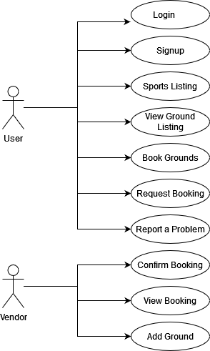
Figure 3.1 Use Case

Entity Relation Diagram

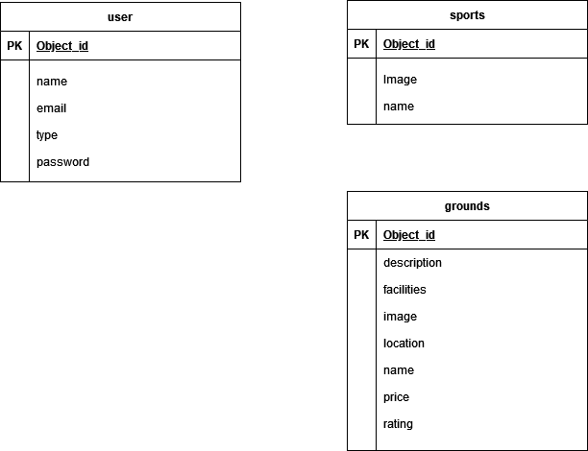
Figure 3.2 ERD

Sequence Diagram

    - Login

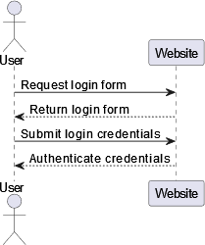

Figure 3.3 Login Sequence

    - Signup
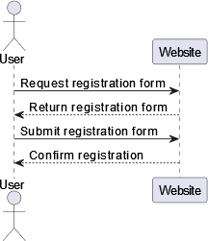

Figure 3.4 Signup Sequence

    - Home Page

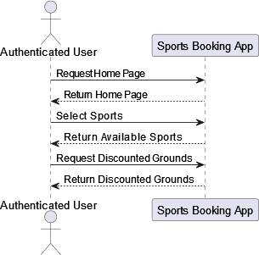

Figure 3.5 Homepage Sequence

    - Venue Information Page:
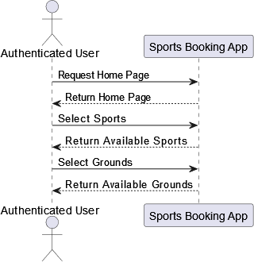

Figure 3.6 Venue Sequence

    - Venue Detail Page

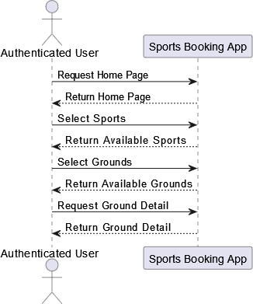

Figure 3.7 Venue Detail Sequence

    - Profile Page

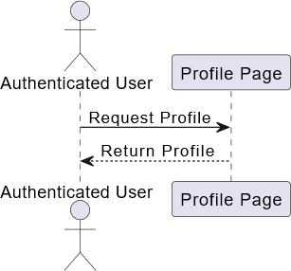

Figure 3.8 Profile Sequence

    - Recent Page:

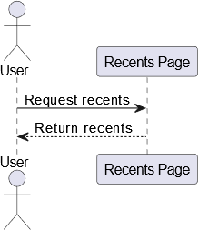

Figure 3.9 Recent Page Sequence

    - Requests Page:

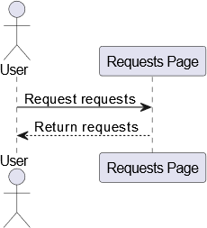

Figure 3.10 Requests Page Sequence

    - Contact us page:

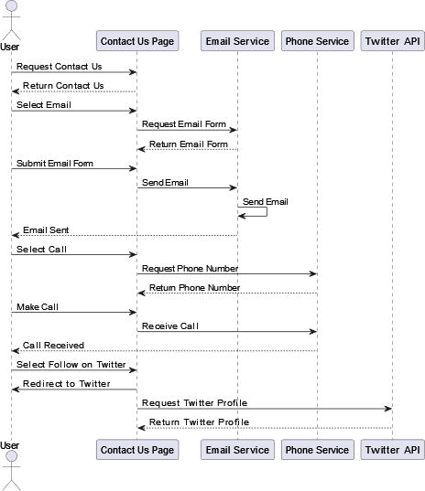

Figure 3.11 Contact Us Page Sequence

    - Settings Page
`

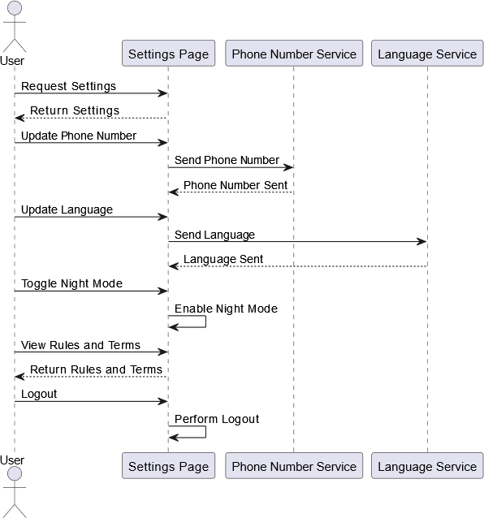

Figure 3.12 Settings Sequence

    - Support Page

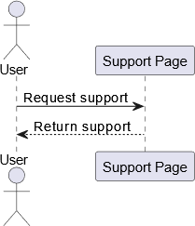

Figure 3.13 Support Page Sequence

    - About Page

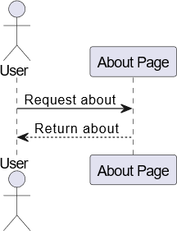

Figure 3.14 About Page Sequence

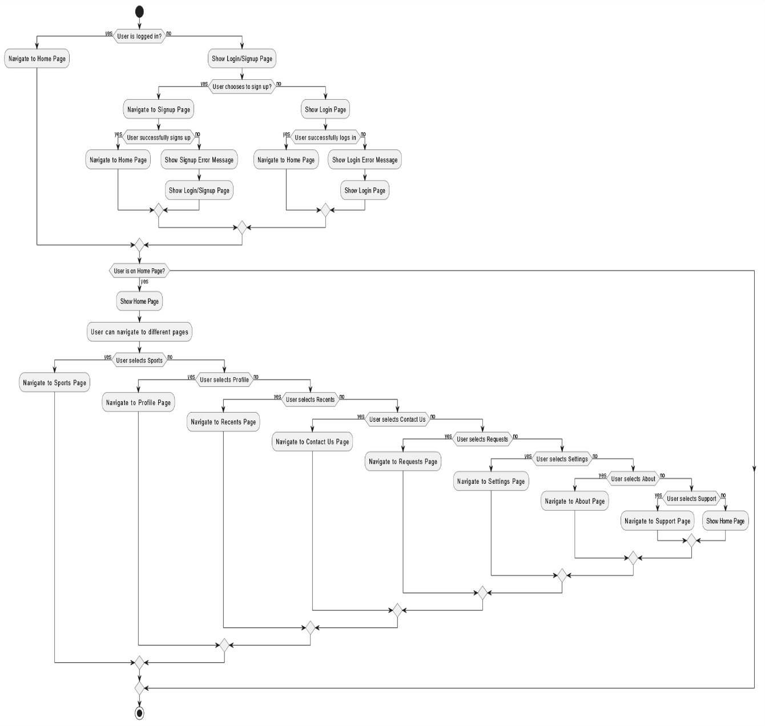
  - Activity Diagram

Figure 3.15 Activity Sequence

CHAPTER 4

IMPLMENTATION

  - Tools and Technologies

The tool and technologies used in this application are under following:

Flutter

Flutter is an open source software created by Google to develop beautiful and fast moving UIs. It is used to create cross platform apps from a single code base for Android, iOS, Linux, macOS, Windows and web. It utilizes Dart as its base language to write code. Flutter allows you to create fast and Dynamic UIs.

Visual Studio Code

Visual Studio Code is a streamlined code editor with support for development operations like debugging, task running, and version control. It aims to provide just the tools a developer needs for a quick code-build-debug cycle and leaves more complex workflows to fuller featured IDEs, such as Visual Studio IDE.

CHAPTER 5

RESULTS AND DISCUSSIONS (or USER MANUAL)

Signup Page

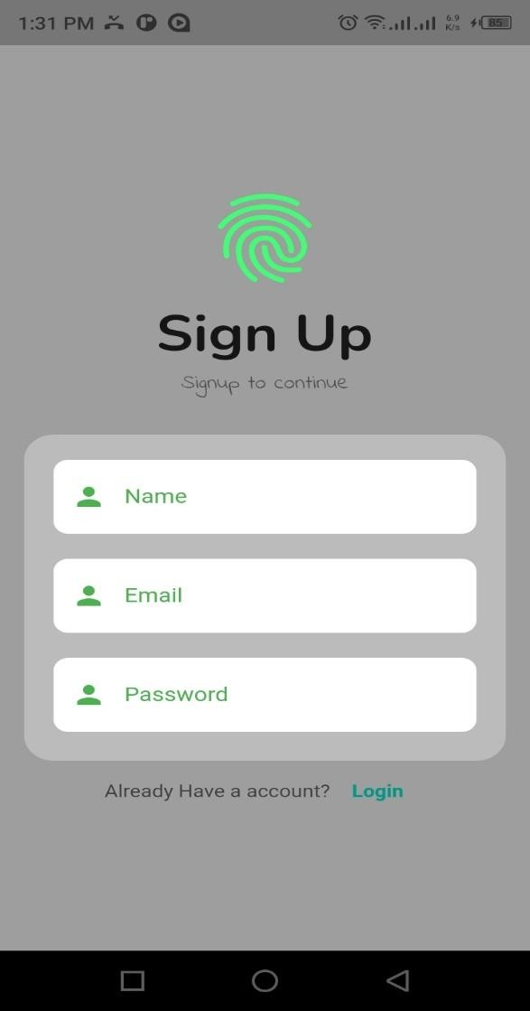
Figure 5.1 Signup

Login page

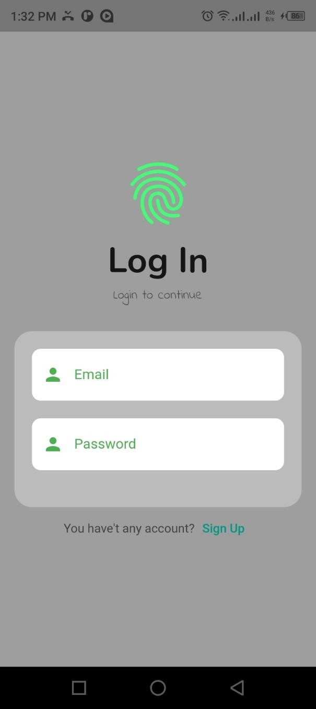
Figure 5.2 Login

Profile Page

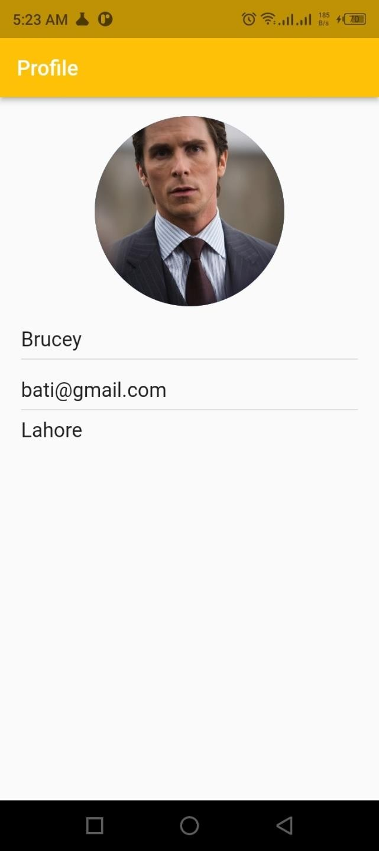

Figure 5.3 Profile

Home page

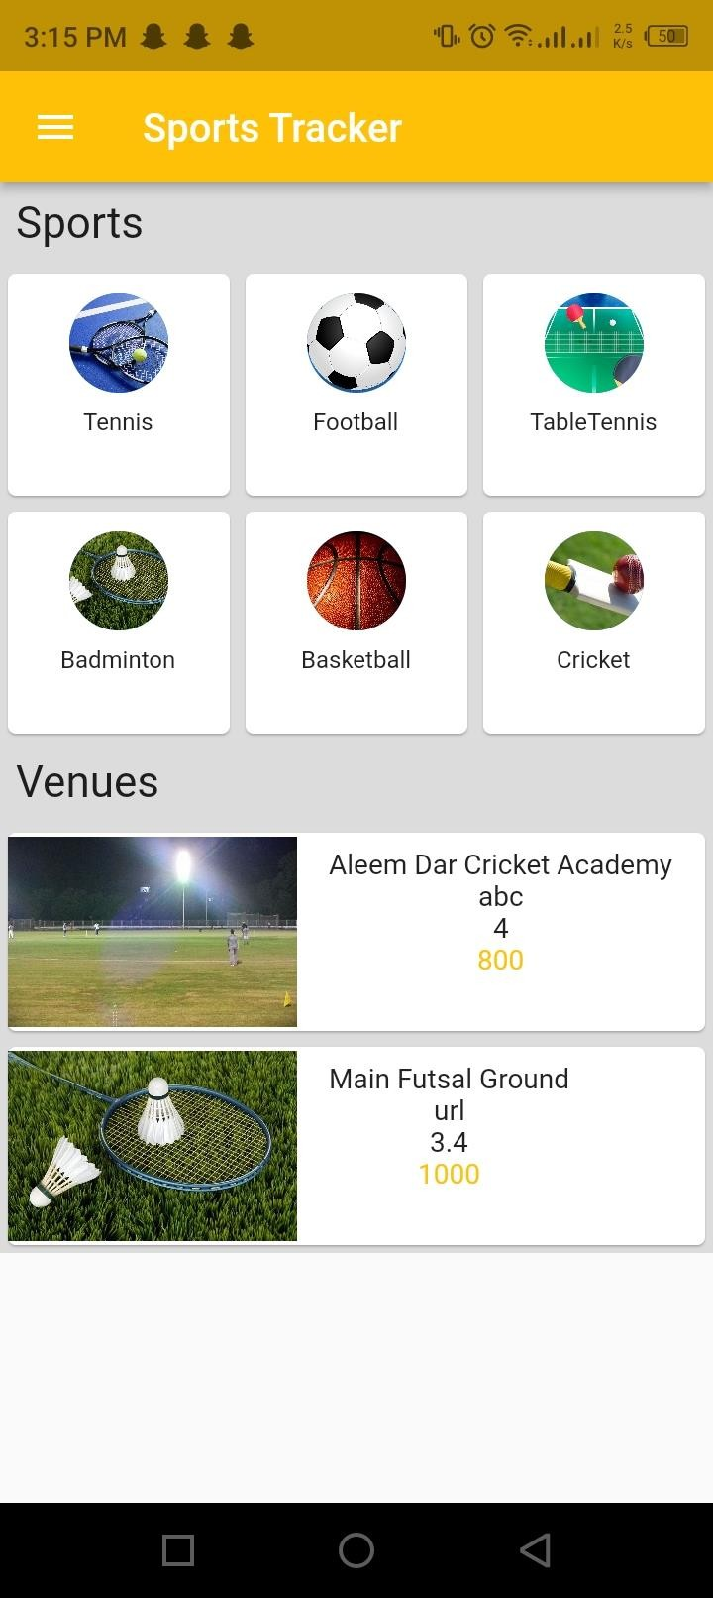

Figure 5.4 Homepage

Venue information page

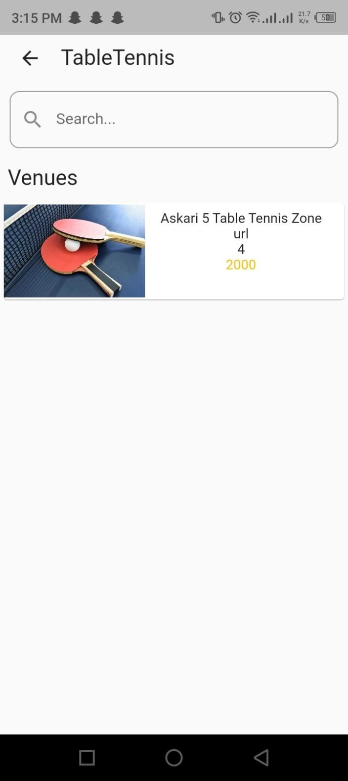

Figure 5.5 Venue Information page
.

Venue Detail page

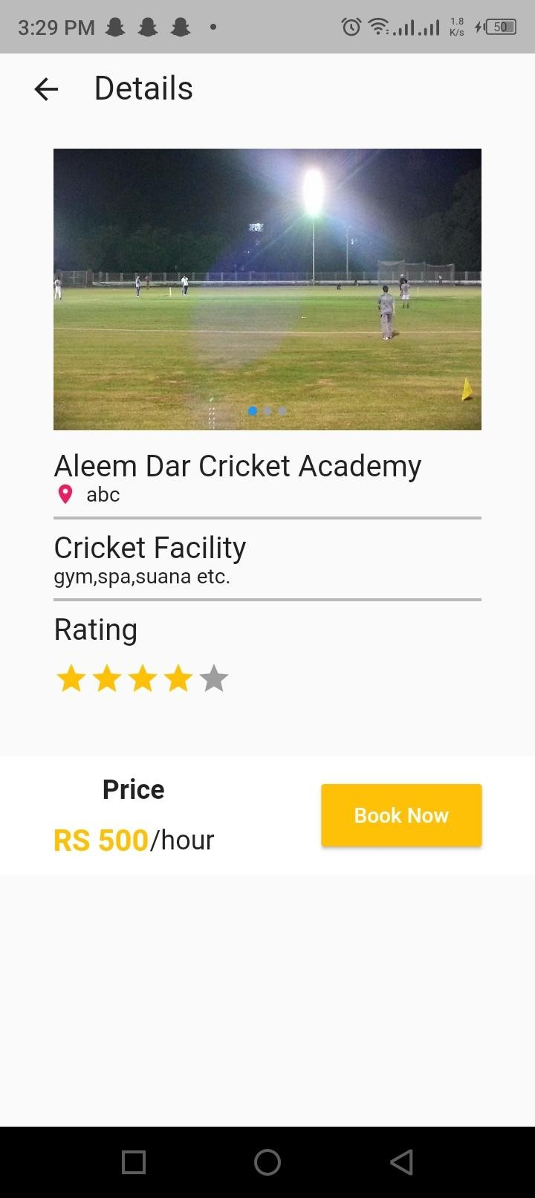
Figure 5.6 Venue Detail Page

Contact us page

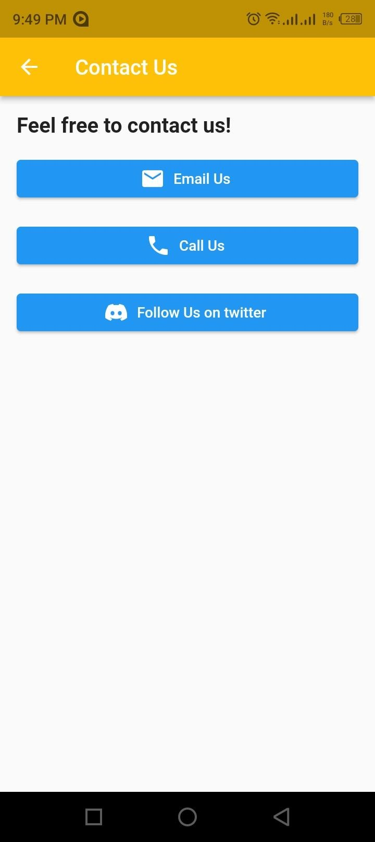
Figure 5.7 Contact Us Page

Requests Page

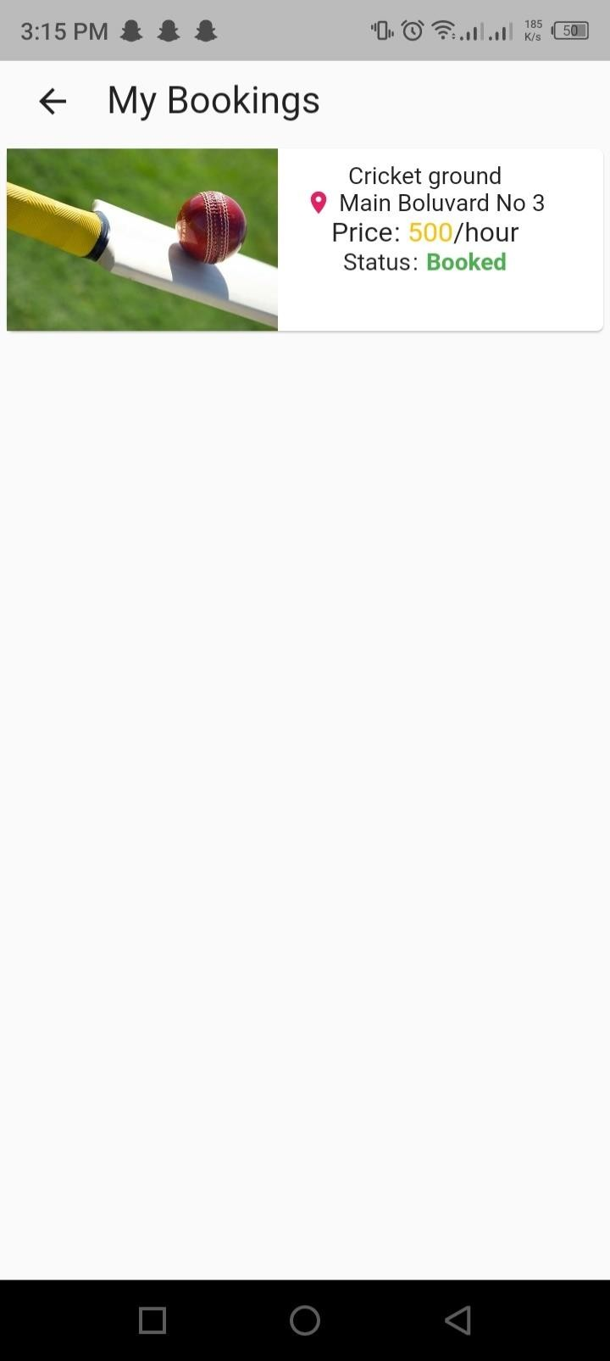
Figure 5.8 Request Page

Support Page

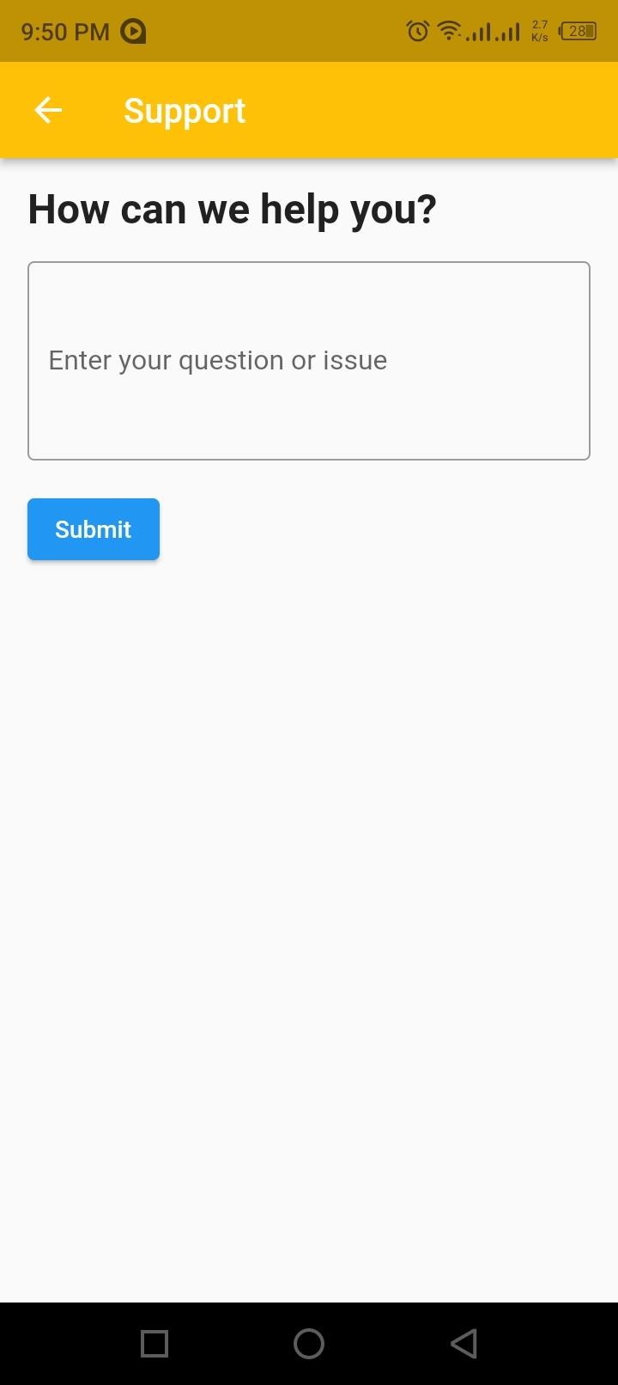
Figure 5.9 Support Page

Settings Page

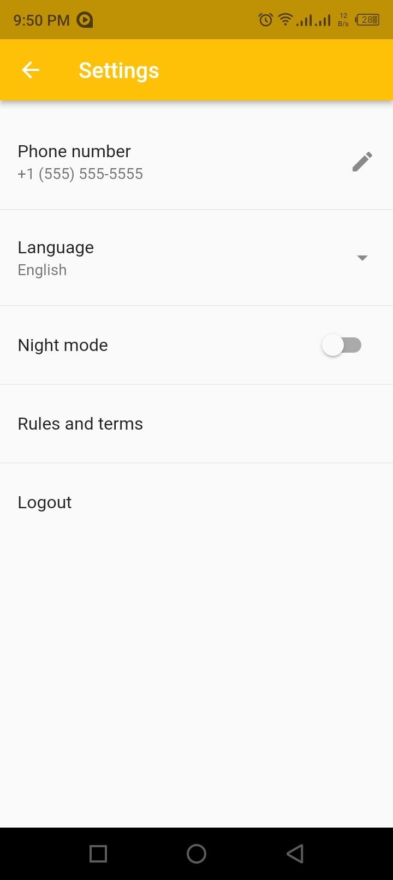
Figure 5.10 Settings Page

About Page

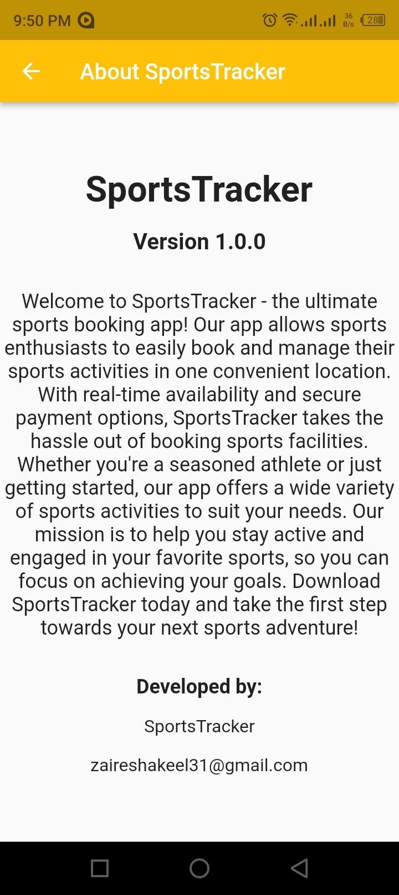

Figure 5.11 About Page

CHAPTER 6

CONCLUSION AND RECOMMENDATIONS

Conclusion

In conclusion, SportsTracker is a sports booking app that aims to provide a comprehensive solution for users to book and manage sports facilities and events. It offers a user-friendly interface, robust features, and secure transactions, making it an ideal platform for sports enthusiasts and facility owners. Overall, SportsTracker has the potential to revolutionize the sports booking industry, providing users with a seamless and hassle-free experience for managing their sports-related activities.

Limitations

SportsTracker has some limitations that could impact its effectiveness and usefulness to users. The app requires a reliable internet connection, which may not always be available, especially in areas with poor network coverage. The app's coverage of sports facilities and sports may also be limited, which could limit its usefulness to users interested in specific sports or facilities. There are also security concerns, such as the risk of hacking or data breaches, which could compromise users' personal information. To address these limitations, it is essential to consider the app's target audience and ensure that it meets their needs while taking appropriate measures to mitigate security risks and improve the app's reliability and coverage.

Recommendations & Future Use

SportsTracker is a promising app with a lot of potential for the sports booking industry. To ensure that it remains relevant and successful, it is important to consider some recommendations for its future development and use. Firstly, the app should aim to expand its geographic coverage to more areas, allowing more sports enthusiasts and facility owners to benefit from its services. Secondly, the app should aim to increase its coverage of sports and facilities to cater to a broader range of interests. Additionally, the app should continue to improve its user interface and user experience to make it more intuitive and user-friendly. Finally, the app should prioritize security and data privacy to maintain users' trust and confidence in the platform. With these recommendations in mind, SportsTracker has the potential to become a valuable and widely-used app in the sports booking industry.

REFERENCES

    - S. E. E. Avomo, A. S. Shibghatullah and J. N. P. Soon, "Online Booking Sports Facilities in the Republic of Equatorial Guinea," 2022 1st International Conference on AI in Cybersecurity (ICAIC), 2022, pp. 1-5, doi: 10.1109/ICAIC53980.2022.9897020.
    - (Sportido 2016)
    - (Rehman 2008)
    - Prunty, Conor “Onlline Booking System” Ireland, 2017.
    - Can Li*, Junjie Li, Hongxiang Cao and Zhan Meng, “Design and Implementation of Online Booking System of University Sports Venues”, Management Engineering School, Zhengzhou University, Zhengzhou, China, 2017.

    - RADITYATAMA, RYAN Android Based Mobile Application for Finding nearby Sports Field and Online Booking System. S1 thesis, Universitas Mercu Buana Jakarta, Jakarta, 2019.

