
BSCS-F22-013
03-134192-041 | Ursal Faisal
03-134192-068 | Umair Rasheed

Dream Walker: A Virtual Reality Game

In partial fulfilment of the requirements for the degree of
Bachelor of Science in Computer Science
Supervisor: Junaid Nasir
Department of Computer Sciences
Bahria University, Lahore Campus
June 2023

© Bahria University, 2023

Certificate

We accept the work contained in the report titled
“Dream Walker: A Virtual Reality Game”
written by
Ursal Faisal
Umair Rasheed
as a confirmation to the required standard for the partial fulfilment of the degree of
Bachelor of Science in Computer Science.

Approved by:
Supervisor: Junaid Nasir
(Signature)

June 20, 2023

DECLARATION

We hereby declare that this project report is based on our original work except for citations and quotations which have been duly acknowledged. We also declare that it has not been previously and concurrently submitted for any other degree or award at Bahria University or other institutions.

Enrolment | Name | Signature
03-134192-041 | Ursal Faisal
03-134192-068 | Umair Rasheed

Date : June 20, 2023

Specially dedicated to
my beloved grandmother, mother, and father
(Ursal Faisal)
my beloved grandmother, mother, and father
(Umair Rasheed)

ACKNOWLEDGEMENTS

We would like to thank everyone who had contributed to the successful completion of this project. We would like to express our gratitude to my research supervisor,
Mr. Junaid Nasir for his invaluable advice, guidance, and his enormous patience throughout the development of the research.

In addition, we would also like to express our gratitude to our loving parents and friends who had helped and given us encouragement.

Ursal Faisal
Umair Rasheed

Dream Walker: A Virtual Reality Game

ABSTRACT

Dream Walker is an immersive VR game centred around the enigmatic world of dream walking. Players assume the role of a protagonist who can control their dreams and venture into the dreams of others. Struggling with amnesia after a tragic accident, the player awakens in a dream where they encounter a restless spirit in their house. To help the spirit move on, the player must fulfil its wish while battling malevolent spirits seeking to impede their progress. Through exploring diverse dreamscapes and completing quests, the player uncovers their lost memories, gradually piecing together the truth behind the accident.

In Dream Walker, players embark on a psychological and adventure-filled journey, utilizing the immersive capabilities of VR to traverse a mesmerizing dream realm. The game's core concept of dream walking allows players to control and navigate their dreams, as well as delve into the dreams of others. As the protagonist with amnesia, players awaken in a dream where they encounter a spirit longing for resolution. To assist the spirit and progress, players must explore various dreamscapes, facing challenges and malevolent spirits aiming to hinder their quest.

Dream Walker offers a captivating narrative, intriguing characters, and profound themes. Through its unique blend of dream walking and lucid dreaming concepts, the game immerses players in a world filled with mystery, adventure, and horror. As players progress, they unveil the secrets of their past, striving to fulfil the spirit's wish and unlock the truth behind their own tragic accident. With its immersive gameplay and thought-provoking storyline, Dream Walker promises an unforgettable VR experience that challenges perception and captivates the imagination.

TABLE OF CONTENTS

DECLARATION ii
ACKNOWLEDGEMENTS iv
ABSTRACT v
TABLE OF CONTENTS vi
LIST OF TABLES ix
LIST OF FIGURES x
LIST OF SYMBOLS / ABBREVIATIONS xii

CHAPTERS
1 INTRODUCTION 1
1.1 Background 1
1.2 Problem Statement 1
1.3 Aims and Objectives 2
1.4 Scope of Project 2
SOFTWARE REQUIREMENT SPECIFICATION 3
2.1 Introduction 3
2.1.1 Overview 3
2.1.2 Functional Requirements 4
2.1.3 Non-Functional Requirements 5
3 DESIGN AND METHODOLOGY 6
3.1 Methodology 6
3.2 Kanban 6
3.3 Methodology Diagram and Implementation 7
3.4 Research 8
3.5 Unreal Engine 9
3.6 Planning 9
3.7 Design 10
3.7.1 System Use Case 10
3.8 Use Cases 11
3.8.1 Use Case 1 (Play Game) 11
3.8.2 Use Case 2 (Options) 12
3.8.3 Use Case 3 (Exit Game) 13
3.8.4 Use Case 4 (Sound Button) 14
3.8.5 Use Case 5 (Video Button) 15
3.8.6 Use Case 6 (Level 1 – Find the ball) 16
3.8.7 Use Case 7 (Level 2 – Navigate through the Maze) 17
3.8.8 Use Case 8 (Level 3 – Game of Checkers) 18
3.9 Sequence Diagram 19
3.10 Class Diagram 20
3.11 Functions, Integration, Testing and Test Cases 20
3.11.1 Test Cases 21
3.11.2 Test Case 1: Successful Game Initiation 21
3.11.3 Test Case 2: Options Opening 22
3.11.4 Test Case 3: Successful Exit 22
3.11.5 Test Case 4: Sound ON 22
3.11.6 Test Case 4.1: Sound OFF 23
3.11.7 Test Case 5: Set Video Quality to High 23
3.11.8 Test Case 5.1: Set Video Quality to Low 23
3.11.9 Test Case 6: Ball Placement 23
3.11.10 Test Case 7: Successful Navigation to Exit 24
3.11.11 Test Case 7.1: Getting Lost in the Maze 24
3.11.12 Test Case 8: Finding the Secret Room 24
3.11.13 Test Case 8.1: Starting a Game of Checkers 25
4 IMPLMENTATION 26
4.1 Introduction 26
4.2 Story Board 27
4.3 Game Design and Development 27
4.4 Unreal Engine 28
4.5 Blueprints 28
4.6 Unreal Motion Graphics 28
4.7 Virtual Reality 28
4.8 First Person View 29
4.9 Camera Shake 29
4.10 MetaHuman 30
4.11 Niagara Visual Effects System 30
4.12 Widget User Interface 31
5 RESULTS AND USER MANUAL 32
5.1 Results and User Manual 32
5.1.1 Title Screen 33
5.1.2 Loading Screen 34
5.1.3 Main Menu Screen 35
5.1.4 Game Controls 36
5.1.5 Gameplay 37
5.1.6 Levels 39
6 CONCLUSION AND RECOMMENDATIONS 41
6.1 Conclusion 41
6.2 Recommendations 41
REFERENCES 43

LIST OF TABLES

TABLE TITLE PAGE
Table 1: Play Game 11
Table 2: Options 12
Table 3: Exit Game 13
Table 4: Sound Button 14
Table 5: Video Button 15
Table 6: Level 1 – Find the ball 16
Table 7: Level 2 – Navigate through the Maze 17
Table 8: Level 3 – Game of Checkers 18

LIST OF FIGURES

FIGURE TITLE PAGE
Figure 1: Kanban Board 7
Figure 2: Kanban Methodology Diagram 7
Figure 3: Kanban Methodology Implementation 8
Figure 4: System Diagram 10
Figure 5: Use Case 1 (Play Game) 11
Figure 6: Use Case 2 (Options) 12
Figure 7: Use Case 3 (Exit Game) 13
Figure 8: Use Case 4 (Sound Button) 14
Figure 9: Use Case 5 (Video Button) 15
Figure 10: Use Case 6 (Level 1 - Find the ball) 16
Figure 11: Use Case 7 (Level 2 – Navigate through the Maze) 17
Figure 12: Use Case 8 (Level 3 – Game of Checkers) 18
Figure 13: Sequence Diagram 19
Figure 14: Class Diagram 20
Figure 15: Title Screen 33
Figure 16: Loading Screen 34
Figure 17: Main Menu Screen 35
Figure 18: Game Controls 36
Figure 19: Game Start Position 37
Figure 20: Game Play Screen 38
Figure 21: Player's Character 39
Figure 22: Level 1 Find the Ball 39
Figure 23: Level 2 Navigate through the Maze 40
Figure 24: Level 3 Game of Checker 40
Figure 25: Plagiarism Report 45

LIST OF SYMBOLS / ABBREVIATIONS

VR Virtual Reality
UE Unreal Engine
UI User Interface
UC Use Case
UMG Unreal Motion Graphics
UML Unified Modelling Language
VFX Visual Effects
FPV First Person View
SRS Software Requirements Specification

INTRODUCTION

Background

Virtual reality (VR) games have gained immense popularity, offering players immersive and captivating experiences. The psychological and adventure-horror genre has become increasingly engaging for gamers seeking thrilling and mysterious narratives.

With the ability to transport players to unique virtual realms, VR games have opened new possibilities for exploring the depths of the human psyche and embarking on thrilling adventures filled with mystery and horror elements.

Problem Statement

While VR games have seen success in various genres, the psychological and adventure-horror genre is still relatively untapped. Translating the intricacies of psychological exploration and suspenseful storytelling into a playable VR format presents a significant challenge for game designers.

Balancing the elements of immersion, fear, and strategic thinking requires careful consideration to ensure players are both engaged and challenged in their virtual experiences.

Aims and Objectives

The objectives of the project are shown as following:
- To provide users with immersive entertainment and a captivating experience during their leisure time through the Dream Walker VR game.
- To foster the development of critical thinking skills in users by engaging them in interactive puzzles, psychological questions, and riddles within the game.
- To offer users an immersive virtual reality experience that allows them to step into the shoes of an amnesic protagonist, unravelling the mysteries of their past and regaining their memories within the game's narrative.

Scope of Project

The project aims to create a virtual reality game, Dream Walker, which explores the concept of dream walking and lucid dreaming. By leveraging the immersive capabilities of VR, players will be transported into a world where they can actively control and navigate their dreams while venturing into the dreams of others. Within this realm, players will encounter restless spirits, malevolent entities, and a captivating storyline that intertwines the protagonist's lost memories and a tragic accident.

Through the game, players will experience the thrill of psychological exploration, adventure, and horror, as they strive to help spirits find closure and regain their own memories. The project aims to deliver a unique and immersive VR experience that challenges players' perception, stimulates curiosity, and provides a compelling journey into the realm of dreams.

SOFTWARE REQUIREMENT SPECIFICATION

Introduction

The Software Requirements Specification (SRS) is intended to provide a comprehensive overview of the Dream Walker [1,2] VR game project. It outlines all the features and functionalities that have been decided upon for the game, highlighting their significance and importance in the overall implementation. The SRS includes both functional and non-functional requirements for the Dream Walker VR game.

By specifying both functional and non-functional requirements, the SRS ensures that all aspects of the Dream Walker VR game, including gameplay mechanics, user interactions, immersive elements, performance, and user experience, are taken into consideration. This comprehensive approach ensures that the game meets the expectations and desires of players, delivering an engaging and captivating VR experience in the world of dreams and exploration.

Overview

Dream Walker [1,2] VR is an immersive virtual reality [3-6] game that takes players on a captivating journey through the realm of dreams.

Player assumes the role of a protagonist who possesses the unique ability to control and navigate their dreams, as well as venture into the dreams of others. The game features three distinct levels, each with its own challenges, providing the player with a diverse and engaging gameplay experience.

Functional Requirements

- Start of Game
  - The game should have a start feature that initializes the game.
- Display on a Computer
  - The game should have a visual display on a computer screen.
- First Person View
  - The game should have a first-person perspective to the player.
- Sound Effects
  - The game should have the option to enable or disable sound effects.
- Scalable Video Effects
  - The game should have adjustable video effects with options for low and high quality.
- Main Menu
  - The game should have a main menu that allows the player to start playing the game or exit the game.
- Movement Control and Tutorial
  - The game should have controls for player movement and include a tutorial in the form of user interface to explain how to play.
- Understandable Challenges and Actions
  - The game should have challenges in a way that is easily understandable to the player, allowing them to trigger appropriate actions.

Non-Functional Requirements

- High-Resolution Display
  - The computer display should support high resolution to provide a visually appealing experience.
- Low Response Time
  - The average response time between a player's click and the game's reaction should always be less than 0.5 seconds.
- Minimum RAM Requirement
  - The game should run smoothly with a minimum of 16 GB of RAM, which is a commonly available specification in gaming computers.
- Maintainable Code and System
  - The code base of the game should be designed in a maintainable manner, allowing for the addition of new features in future versions.
- Security Considerations
  - Since the game does not require user credentials or profiles, security concerns related to user authentication are not applicable in this application.
- Extensibility
  - The game should be designed with the ability to be extended with additional functionalities as required.

DESIGN AND METHODOLOGY

Methodology

We are adopting an agile [7] development framework called Kanban [8] as it is one of the best agile practices in game development.

Kanban

Kanban is a visual implementation of the agile system. In this process, tasks from backlogs are picked and are completed as required. It is also known as the Just-in-time approach.

There are four key principles of Kanban. By following these four principles, we should have enough of an overview to get ourselves started with a Kanban board and some cards to represent the game story.
- Visualize workflow
- Limit work in progress
- Focus on flow
- Continuous improvement

Figure 1 shows an example of a Kanban board where a function to be worked on is added to the “to-do” list then moved to “work-in-progress” list, validated in “validate” list and finally moved to “complete” list when finished.

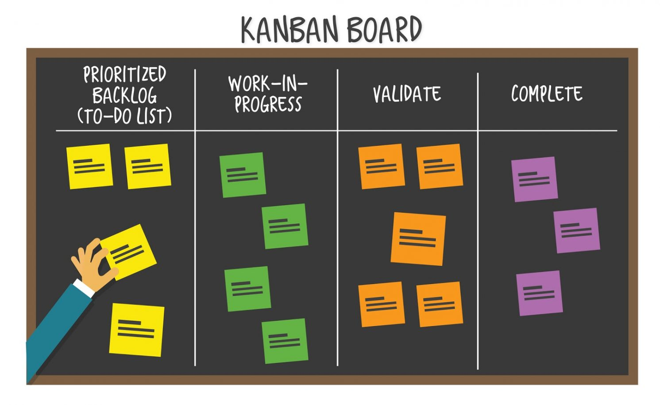

Figure 1: Kanban Board

Methodology Diagram and Implementation

Figure 2 shows the kanban methodology diagram visualizing the kanban board, the list of tasks and each card representing one task.

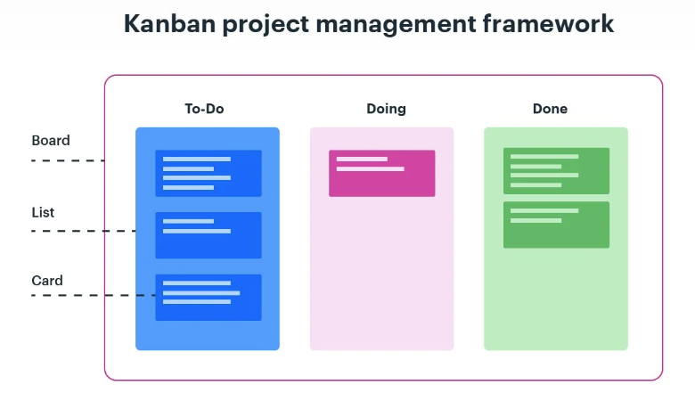

Figure 2: Kanban Methodology Diagram
Figure 3 shows the visual representation of workflow on a kanban board. Functions like “main menu, movement control, head camera shake” are added to the “to-do” list then moved to “work-in-progress” list, validated in “validate” list and finally moved to “complete” list when finished.

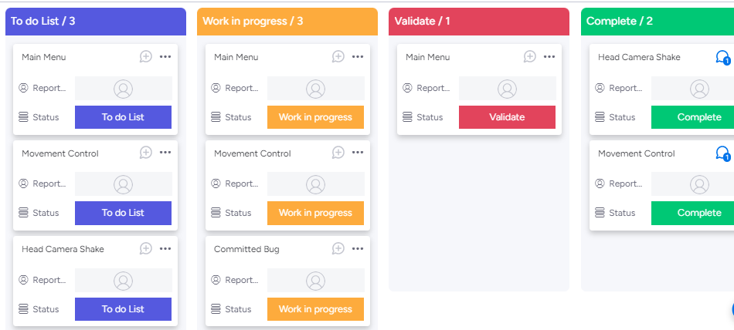

Figure 3: Kanban Methodology Implementation

Research

Psychological and adventure-horror genre. is known for its ability to captivate audiences with mysterious, intriguing and thriller narratives. While literature, TV series, and movies have provided entertaining experiences in this genre, games take it a step further by allowing players to actively participate and experience the thrill by immersing themselves in the joy of exploring different challenges.

To ensure the success of the Dream Walker [1,2] VR game, thorough research is conducted to gain a complete understanding of the project's scope and target domain. Unreal Engine, a powerful and widely used game engine, is chosen as the development platform. Unreal Engine provides a robust and user-friendly environment for creating immersive and visually impressive games.

The research process includes studying existing games in the psychological and adventure-horror genre, analysing their mechanics, storytelling techniques, and gameplay elements. This analysis helps in identifying successful approaches and incorporating them into the development of Dream Walker [1,2] VR. Additionally, research is conducted to understand the expectations and preferences of the target audience, ensuring that the game delivers an engaging and captivating experience.

Unreal Engine

Unreal Engine is a powerful and widely used game engine renowned for its versatility and capabilities in creating immersive and visually stunning experiences. Developed by Epic Games, Unreal Engine provides developers with a user-friendly environment for designing and building high-quality games across various platforms, including PC, consoles, and virtual reality.

With its advanced features, real-time rendering capabilities, and extensive toolset, Unreal Engine empowers developers to bring their creative visions to life, delivering rich and engaging experiences to players around the world.

Planning

The development plan for the Dream Walker VR game involves conceptualization and design, development using Unreal Engine, implementation of dream walking mechanics and diverse dreamscapes with interactive elements, testing and iteration for smooth gameplay.

Finally, polishing and maintenance to release on VR platform to provide players with an immersive and thrilling adventure in the realm of dreams.

Design

All possible UML diagrams are designed here i.e. System Diagram, Use Case Diagram, Sequence Diagram, Activity Flow Diagram and Class Diagram.

System Use Case

A system case diagram in the Unified Modelling Language can describe the specifics of your system's users (also known as actors) and their interactions with the system. To make one, you will need a particular collection of symbols and connections. A good use case diagram can assist your team in discussing and representing:

- Interactions between your system or application and people, organisations, or external systems
- Goals that your system or application assists those entities (referred to as actors) in achieving

Figure 4 shows the system diagram of the game, visualizing the interactions and relationships between the player, system, and different classes.

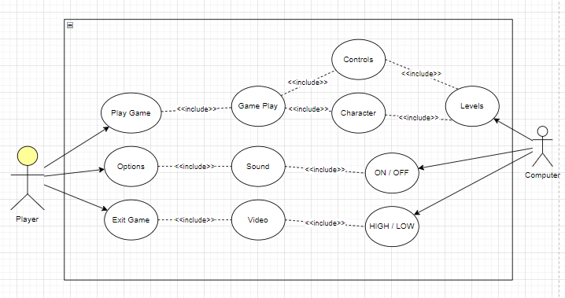
Figure 4: System Diagram

Use Cases

Use Case 1 (Play Game)

Figure 5 shows use case 1 (play game) diagram where player presses “play game” to initiate the “game play” function.

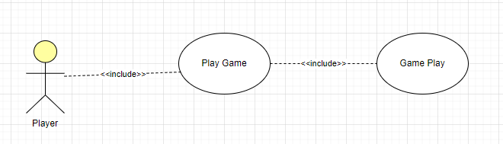

Figure 5: Use Case 1 (Play Game)

Table 1: Play Game

Name: | Play Game
Actor: | Player
Pre-Conditions: | Application is running.
Flow of Events: | Player initiates play game function by clicking the play game button.
Post Conditions: | Game is now in a playable state.

Table 1 shows the name, actor, pre-conditions, flow of events and post conditions of “play game” use case.

Use Case 2 (Options)

Figure 6 shows use case 2 (options) diagram where player presses “options” to initiate the said function.

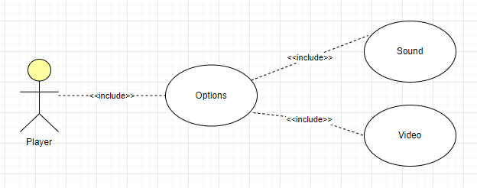

Figure 6: Use Case 2 (Options)

Table 2: Options

Name: | Options
Actor: | Player
Pre-Conditions: | Application is running.
Flow of Events: | Player clicks on options to further open sound and video settings.
Post Conditions: | Proceeds to sound and video options.

Table 2 shows the name, actor, pre-conditions, flow of events and post conditions of “options” use case.

Use Case 3 (Exit Game)

Figure 7 shows use case 3 (exit game) diagram where player presses “exit game” to initiate the quit function.

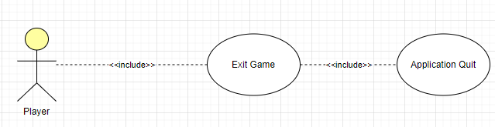

Figure 7: Use Case 3 (Exit Game)

Table 3: Exit Game

Name: | Exit Game
Actor: | Player
Pre-Conditions: | Application is running.
Flow of Events: | - Player selects quit function by clicking the exit button.
Post Conditions: | Game is not in running condition anymore.

Table 3 shows the name, actor, pre-conditions, flow of events and post conditions of “exit game” use case.

Use Case 4 (Sound Button)

Figure 8 shows use case 4 (sound button) diagram where player presses “sound” to initiate the said function.

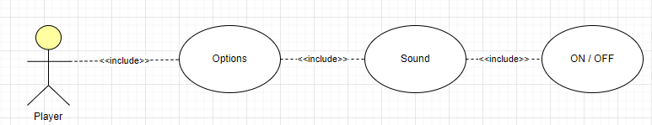

Figure 8: Use Case 4 (Sound Button)

Table 4: Sound Button

Name: | Sound
Actor: | Player
Pre-Conditions: | Application is running.
Flow of Events: | Player can ON/OFF the sound of the game by clicking sound button.
Post Conditions: | Game is in a playable state.

Table 4 shows the name, actor, pre-conditions, flow of events and post conditions of “sound” use case.

Use Case 5 (Video Button)

Figure 9 shows use case 5 (video button) diagram where player presses “video” to initiate the said function.

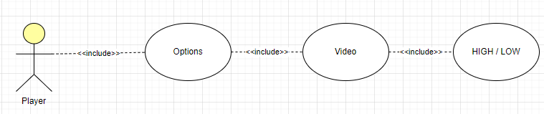

Figure 9: Use Case 5 (Video Button)

Table 5: Video Button

Name: | Video
Actor: | Player
Pre-Conditions: | Application is running.
Flow of Events: | Player can change video quality of the game HIGH/LOW by clicking video button.
Post Conditions: | Game is in a playable state.

Table 5 shows the name, actor, pre-conditions, flow of events and post conditions of “video” use case.

Use Case 6 (Level 1 – Find the ball)

Figure 10 shows use case 6 (Level 1 – Find the ball) diagram where player presses “Play Game” to initiate the said function.

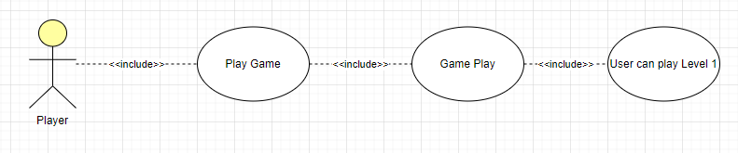

Figure 10: Use Case 6 (Level 1 - Find the ball)

Table 6: Level 1 – Find the ball

Name: | Level 1 – Find the ball
Actor: | Player
Pre-Conditions: | Application is running.
Flow of Events: | Player must find ball, pick it up and place it on the table.
Post Conditions: | Player must complete level.

Table 6 shows the name, actor, pre-conditions, flow of events and post conditions of “Level 1 – Find the ball” use case.

Use Case 7 (Level 2 – Navigate through the Maze)

Figure 11 shows use case 7 (Level 2 – Navigate through the Maze) diagram where player presses “Play Game” to initiate the said function.

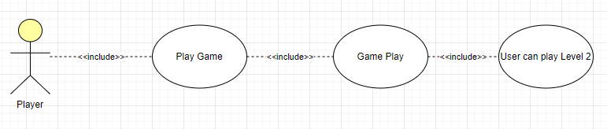

Figure 11: Use Case 7 (Level 2 – Navigate through the Maze)

Table 7: Level 2 – Navigate through the Maze

Name: | Level 2 - Navigate through the Maze
Actor: | Player
Pre-Conditions: | Application is running.
Flow of Events: | Player must navigate through the maze-like mansion.
Post Conditions: | Player must complete level.

Table 7 shows the name, actor, pre-conditions, flow of events and post conditions of “Level 2 - Navigate through the Maze” use case.

Use Case 8 (Level 3 – Game of Checkers)

Figure 12 shows use case 8 (Level 3 – Game of Checkers) diagram where player presses “Play Game” to initiate the said function.

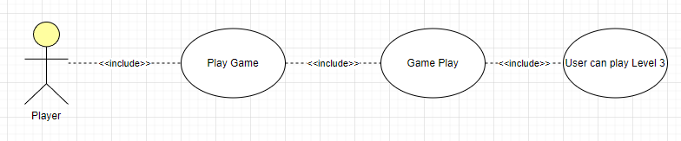

Figure 12: Use Case 8 (Level 3 – Game of Checkers)

Table 8: Level 3 – Game of Checkers

Name: | Level 3 – Game of Checkers
Actor: | Player
Pre-Conditions: | Application is running.
Flow of Events: | Player will find the secret room and play a game of checkers.
Post Conditions: | Player must complete level.

Table 8 shows the name, actor, pre-conditions, flow of events and post conditions of “Level 3 – Game of Checkers” use case.

Sequence Diagram

UML Sequence Diagrams are interaction diagrams that show how processes are performed. They record the interaction of items within the framework of a partnership. Sequence Diagrams are time focused, and they graphically express the sequence of the interaction by using the vertical axis of the diagram to indicate time, what messages are conveyed, and when.
Sequence diagrams are widely used in software development to model and communicate the behaviour of systems, especially in scenarios where the timing and order of interactions are crucial. They provide a visual representation of how processes are performed and how different components collaborate to achieve the desired outcomes.
Figure 13 shows the sequence diagram of the game, how the system overall works and the interactions between different functions.
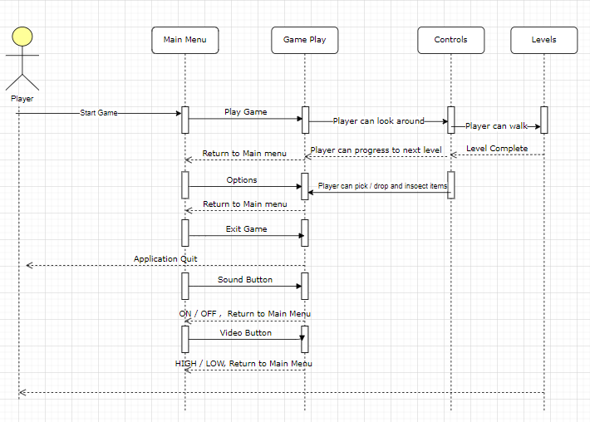
Figure 13: Sequence Diagram

Class Diagram

A class diagram in the Unified Modelling Language is a form of static structural diagram in software engineering that depicts the structure of a system by displaying the system's classes, their attributes, operations (or methods), and the connections between objects.
Figure 14 shows the class diagram of the game, how different classes are dependent on each other and how their relation works.
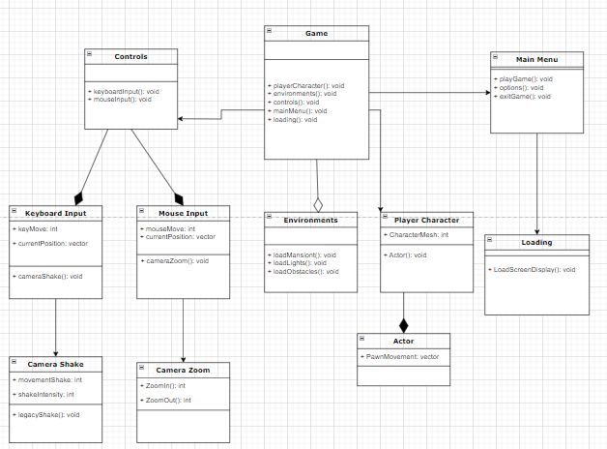

Figure 14: Class Diagram

Functions, Integration, Testing and Test Cases

Functions: Game functions are developed such as game physics and graphics. Each function is implemented following an interactive approach, ensuring that it aligns with the desired features and requirements of the game. This phase focuses on building and implementing the individual functions that contribute to the overall gameplay experience.

Integration: Integration testing is conducted to combine and test the interactions between different game functions and modules. This involves integrating the various functions and modules developed earlier into a complete working system. The goal is to identify any flaws or issues that may arise when these components interact and function together.

Testing: Testing is an essential part of the development process. Each module, including the integrated system, is thoroughly tested to ensure functionality, performance, and stability. Testing helps identify and rectify any bugs, errors, or inconsistencies that may affect the gameplay experience. The testing phase verifies that the implemented functions and integrated system work as intended, providing a smooth and enjoyable user experience.

Test Cases
The test cases provided for the game's functionality cover different aspects of gameplay and user interactions. Each test case focuses on a specific use case, such as playing the game, navigating through levels, adjusting sound and video settings, and engaging in specific level challenges. These test cases ensure that the game functions as expected, allowing players to interact with various features, complete levels successfully, and experience smooth gameplay. By executing these test cases, developers can identify and address any issues or bugs, ensuring a high-quality gaming experience for the players.

Test Case 1: Successful Game Initiation

- Preconditions: The application is running.
- Steps:
  - Launch the application.
  - Verify that the main menu is displayed.
  - Click the "Play Game" button.
- Expected Result: The game starts, and the application transitions to a playable state.

Test Case 2: Options Opening

- Preconditions: The application is running.
- Steps:
  - Launch the application.
  - Verify that the main menu is displayed.
  - Click on the "Options" button.
- Expected Result: The options menu opens, providing access to sound and video settings.

Test Case 3: Successful Exit

- Preconditions: The application is running.
- Steps:
  - Launch the application.
  - Verify that the main menu is displayed.
  - Click the "Exit" button.
- Expected Result: The game closes, and the application is no longer running.

Test Case 4: Sound ON

- Preconditions: The application is running.
- Steps:
  - Launch the application.
  - Verify that the sound is initially set to ON.
  - Click the sound button to toggle it OFF.
  - Click the sound button again to toggle it ON.
- Expected Result: The sound should be enabled, and the player should be able to hear the game audio.

Test Case 4.1: Sound OFF

- Preconditions: The application is running.
- Steps:
  - Launch the application.
  - Verify that the sound is initially set to ON.
  - Click the sound button to toggle it OFF.
- Expected Result: The sound should be disabled, and the player should not hear any game audio.

Test Case 5: Set Video Quality to High

- Preconditions: The application is running.
- Steps:
  - Launch the application.
  - Verify that the video quality is initially set to Low.
  - Click the video button to toggle it to High quality.
- Expected Result: The video quality should be set to High, and the game should display graphics with better visual details.

Test Case 5.1: Set Video Quality to Low

- Preconditions: The application is running.
- Steps:
  - Launch the application.
  - Verify that the video quality is initially set to High.
  - Click the video button to toggle it to Low quality.
- Expected Result: The video quality should be set to Low, and the game should display graphics with reduced visual details for better performance.

Test Case 6: Ball Placement

- Preconditions: The application is running, and Level 1 has started.
- Steps:
  - Verify that the ball is not initially placed on the table.
  - Explore the game environment to find the ball.
  - Interact with the ball to pick it up.
  - Place the ball on the table.
- Expected Result: The ball should be successfully placed on the table, indicating completion of the objective for Level 1.

Test Case 7: Successful Navigation to Exit

- Preconditions: The application is running, and Level 2 has started.
- Steps:
  - Verify the starting location of the player within the maze-like mansion.
  - Navigate through the maze, following the correct path to reach the exit.
  - Interact with the exit to trigger the level completion.
- Expected Result: The player should successfully navigate through the maze and reach the exit, indicating the completion of Level 2.

Test Case 7.1: Getting Lost in the Maze

- Preconditions: The application is running, and Level 2 has started.
- Steps:
  - Verify the starting location of the player within the maze-like mansion.
  - Attempt to navigate through the maze, but take a wrong turn or get lost.
- Expected Result: The player should encounter dead ends or loop around the maze, forcing them to backtrack and find the correct path to progress towards the exit.

Test Case 8: Finding the Secret Room

- Preconditions: The application is running, and Level 3 has started.
- Steps:
  - Explore the game environment to find the entrance to the secret room.
  - Locate and interact with the secret room entrance.
- Expected Result: The player should successfully find and access the secret room where the game of checkers is played.

Test Case 8.1: Starting a Game of Checkers

- Preconditions: The application is running, and Level 3 has started. The player is in the secret room.
- Steps:
  - Verify the initial state of the checkers board.
  - Start a game of checkers by interacting with the checkers board or initiating the game.
- Expected Result: The checkers game should start, and the player should have control over their game pieces to make moves and progress in the game.

IMPLMENTATION

Introduction

Dream Walker [1,2], an immersive and captivating virtual reality (VR) [3-6] game that takes you on a journey into the depths of dreams and mysteries. Prepare to embark on a psychological and adventure-horror experience like no other, where you have the power to control your dreams and venture into the subconscious realm. In this gripping game, you will step into the shoes of an amnesic protagonist, lost in a world of enigmatic spirits and haunted memories.

As you awaken within your dream, you encounter a restless spirit trapped in your house, desperately seeking closure. Your quest begins as you delve into the spirit's request and strive to fulfil its unfulfilled wish.

Dream Walker leverages the power of Unreal Engine, delivering stunning visuals, realistic environments, and seamless gameplay in a virtual reality [3-6] setting. Traverse through beautifully haunting dreamscapes, solve intricate puzzles, and navigate through atmospheric challenges as you slowly unravel the mysteries that lie within your own subconscious mind.

By adopting an agile development framework called Kanban as it is one of the best agile practices in game development, we strive to reach our goals and ensure deadlines are met on time.

Story Board

As the game begins, we have a title screen for the game then a loading screen which then goes to the main menu screen. Player can select between “play game,” “options” and “exit game.” By selecting “options,” player can further select “video” and “audio” settings. Player can choose to quit the game by selecting “exit game.” When the player selects “play game,” the game starts at level one.

In the first level of Dream Walker, the player awakens in a dimly lit bedroom, filled with an eerie atmosphere. A dark figure appears, guiding the player towards the corner of the bed. As the player approaches the corner, they see a ball on the floor.
Player will pick up the ball and place it on the table then the dark figure disappears, and the level is complete.

In the second level, the player must navigate through the dark and creaking corridors of the mansion. Along the way, they encounter vengeful spirit and face spine-chilling encounters, testing their courage to move forward. Once they reach the main dining lounge, the level is completed.

In the third level, the player must find the hidden room in the haunted mansion. By through the secret door and up the stairs, the player will find the room and see a checkers game board which the player needs to play and win to complete the third level.

Game Design and Development

Dream Walker was meticulously designed and developed to create an immersive and captivating virtual reality (VR) [3-6] experience. The game design process involved crafting a unique blend of psychological and adventure-horror elements, where players could explore the realm of dreams, confront their fears, and uncover the mysteries of their past.

Unreal Engine

A powerful and versatile game development platform played a crucial role in bringing Dream Walker to life. Leveraging the capabilities of Unreal Engine, the development team was able to create stunning visuals, realistic environments, and seamless gameplay. The engine's robust rendering capabilities and extensive toolset provided the foundation for building the immersive dreamscapes and atmospheric settings that players would navigate through.

Blueprints

A visual scripting system in Unreal Engine, were utilized to implement the game's mechanics and interactions. This allowed for the creation of gameplay elements such as character movement, camera movement, camera shake, puzzle-solving mechanics, character interactions, and environmental events.

Unreal Motion Graphics

The user interface system in Unreal Engine was utilized to design and develop the game's user interface elements. UMG provided a powerful and flexible framework for creating widget UI for the game controls.

Virtual Reality

In Dream Walk VR game, virtual reality (VR) technology was incorporated to create an immersive experience like no other. By using VR headsets and controllers, players could step into stunning 3D environments, interact naturally with objects, and embark on an unforgettable journey.
The sense of presence and embodiment offered by VR heightened the emotional connection, making exploration more mysterious and challenges more intense. Through the power of VR, the game delivered unparalleled immersion, transforming the player experience into an extraordinary adventure.

First Person View

The first-person view is a fundamental aspect of the player's perspective in Dream Walker. By adopting a first-person viewpoint, players are fully immersed in the game's world, experiencing the events and environments through the eyes of the protagonist.

In Dream Walker, the first-person view serves multiple purposes. It creates a direct connection between the player and the virtual world, making the experience more personal and intimate. Players can see the world unfold directly in front of them, heightening the sense of realism and immersion. Every detail, from the intricate environments to the atmospheric lighting and eerie shadows, is experienced up close, intensifying the emotional impact of the game.

The first-person view also enhances the gameplay mechanics and interactions. Players have a more direct and intuitive control over their character's actions and movements. They can explore the dreamscapes, interact with objects, and solve puzzles with a heightened level of immersion and precision.

Camera Shake

The camera shake was added to the game using the “legacy camera shake” Blueprint. The head camera shake effect in Dream Walker adds an additional layer of realism and immersion to the gameplay experience.

As players navigate through the dreamscapes and encounter various obstacles and challenges, the head camera shake effect simulates the natural movement and vibrations that occur in real-life situations, further enhancing the sense of presence and intensity.

MetaHuman

In Unreal Engine, MetaHumans refer to a revolutionary technology that enables the creation of highly realistic and lifelike virtual humans. MetaHumans provide a streamlined workflow and a vast library of pre-built characters, making it easier for developers and artists to create believable and visually stunning human characters for use in games, virtual reality experiences, films, and more.

The character laying on the bed in the game is a MetaHuman named “Taro.” Taro, the Meta Human Character in Dream Walker, is a pivotal and enigmatic figure within the game's narrative. As a meta human, Taro possesses extraordinary abilities that transcend the boundaries of the dream world, making him a key player in the protagonist's journey.

Niagara Visual Effects System

The Niagara VFX system is a powerful visual effects tool within Unreal Engine. It is a node-based particle and effects system that allows developers and artists to create stunning and complex visual effects for games, simulations, and other interactive experiences.

Niagara offers a flexible and modular approach to creating visual effects. It provides a wide range of customizable nodes and modules that can be connected and combined to generate a variety of effects, such as smoke, fire, explosions, water simulations, and more. Using this vfx system, we added different emitters and lights all over the game to build a realistic and natural environment in the mansion.

Widget User Interface

The Widget UI for game controls in Dream Walker plays a crucial role in providing players with a seamless and intuitive user interface to interact with the game. By using Unreal Engine's Unreal Motion Graphics system, the Widget UI offers a visually appealing and customizable interface that enhances the overall gameplay experience.

The Widget UI consists of various elements such as buttons to show movement and other interactions, mouse to show camera movement and zoom. The UI was designed to facilitate the player with input and control in game

RESULTS AND USER MANUAL

Results and User Manual

In the results section, we present the outputs of key components in the Dream Walker VR game, including loading screen, main menu, and gameplay. This showcases the visual and interactive aspects of the game and provides a glimpse into the overall user interface and design. Additionally, the output of the controls is demonstrated, highlighting the functionality and how it enhances the player's immersion and control within the game.

In the user manual, we provide detailed instructions on how to play the game. This includes guidance on the controls, mechanics, and objectives of the game. The user manual serves as a comprehensive guide for players, ensuring they understand the gameplay concepts, navigation, interactions, and any specific features unique to Dream Walker VR game.

By providing clear instructions and explanations, players can easily grasp the game's mechanics, challenges and quests and enjoy a smooth, immersive and intuitive gaming experience.

Title Screen

Figure 15 shows the title screen for the game where player can press any key to enter loading screen which then goes to main menu.

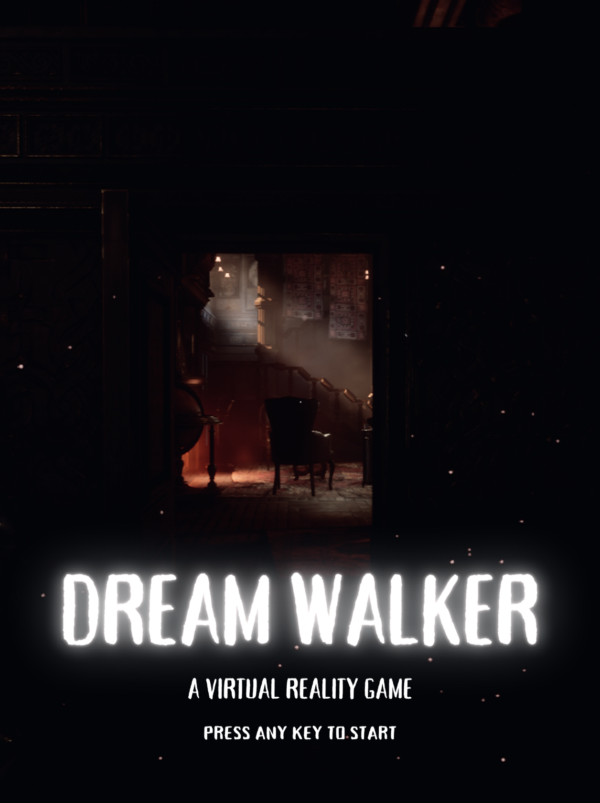

Figure 15: Title Screen

Loading Screen

Figure 16 shows the loading screen where player must wait few seconds before going to main menu screen.

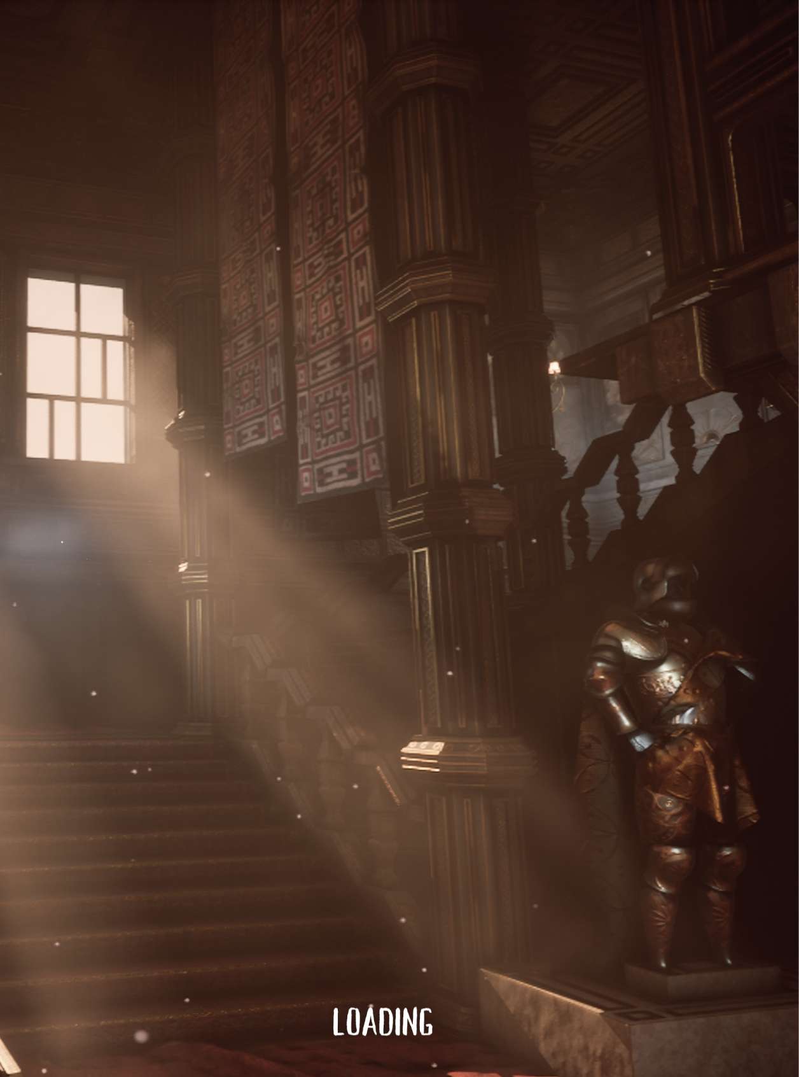

Figure 16: Loading Screen

Main Menu Screen

Figure 17 shows the main menu screen which has three buttons. By clicking, their action is performed, and it goes to next scene. Player can play game, look in options and exit the game.
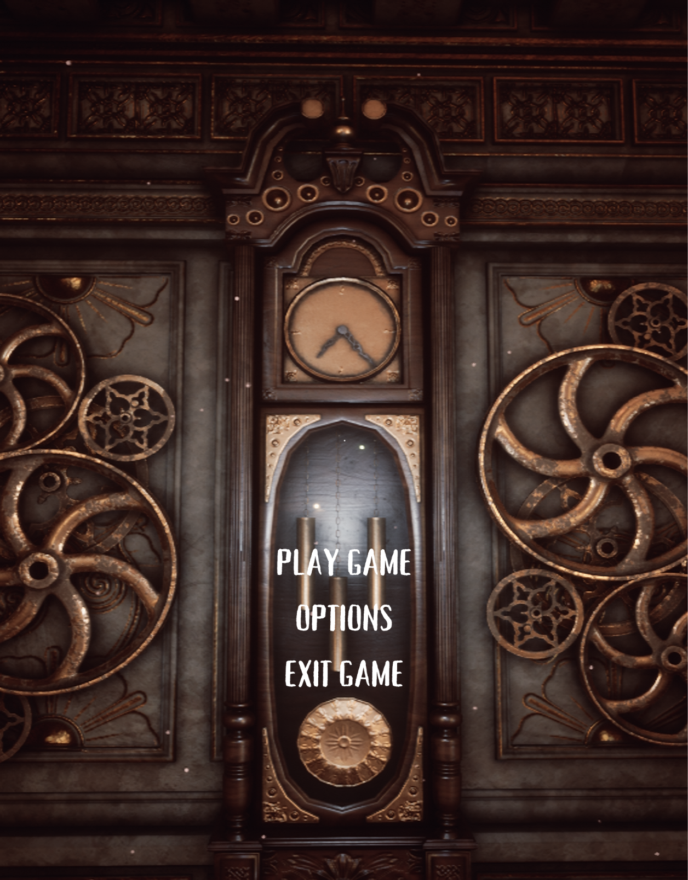

Figure 17: Main Menu Screen

Game Controls

Figure 18 shows the game’s widget user interface that helps the user to control the movement of the player, look around the environment using their mouse to control the camera movement, zoom in objects to inspect them and interact with different interactable objects in game.

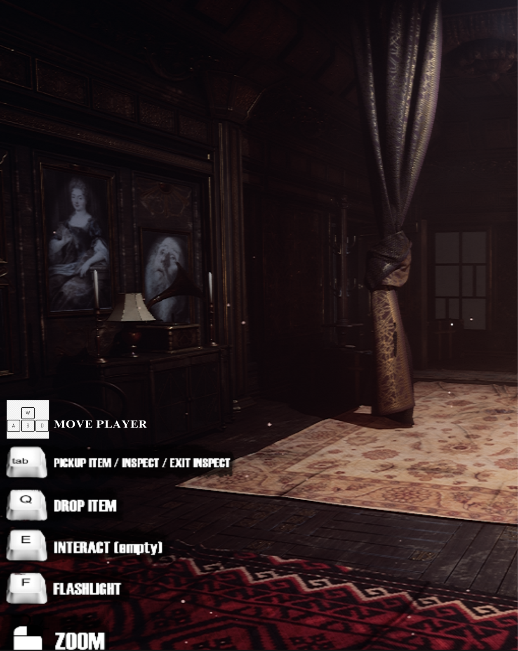

Figure 18: Game Controls

Gameplay

Gameplay refers to the overall experience and interactions between players and a game, specifically in the context of video games. It encompasses the patterns, mechanics, and rules that shape the player's engagement and progression within the game world. Gameplay involves the challenges presented by the game, the strategies and skills required to overcome those challenges, and the player's immersion and connection to the game's narrative or plot.

Figure 19 shows the starting position of the game and where the player will start their exploration.

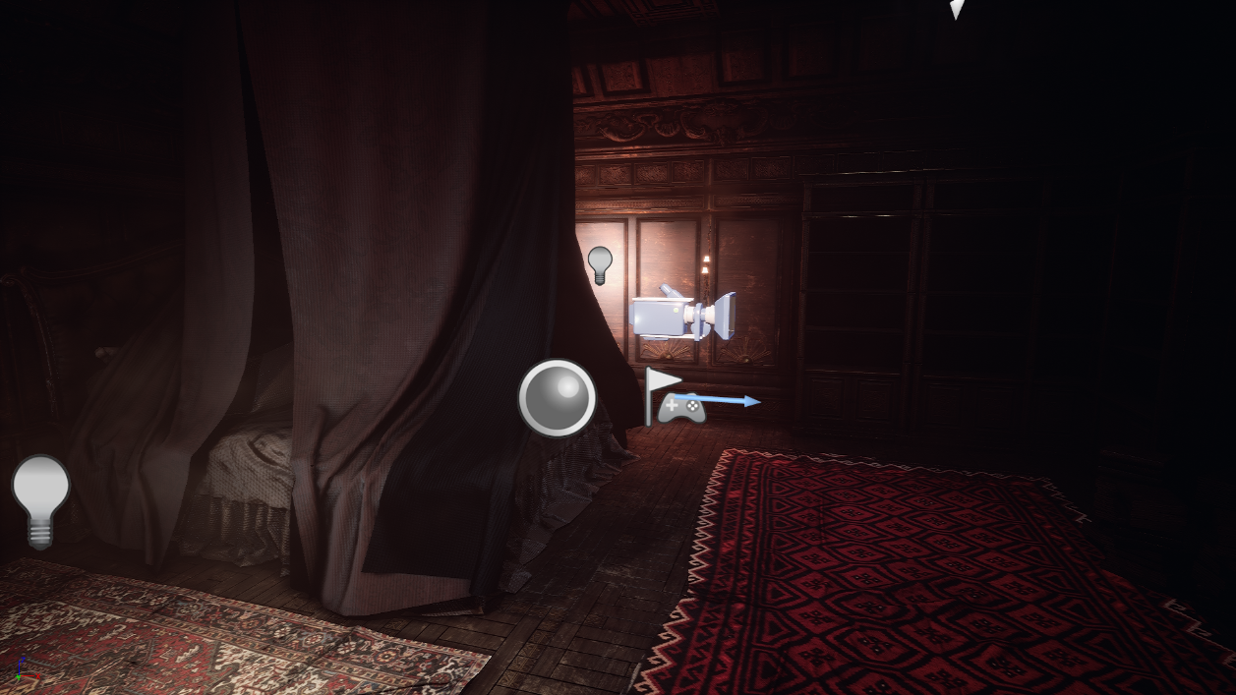

Figure 19: Game Start Position
Figure 20 shows the first person view of the game play screen where player can see the UI for game controls.

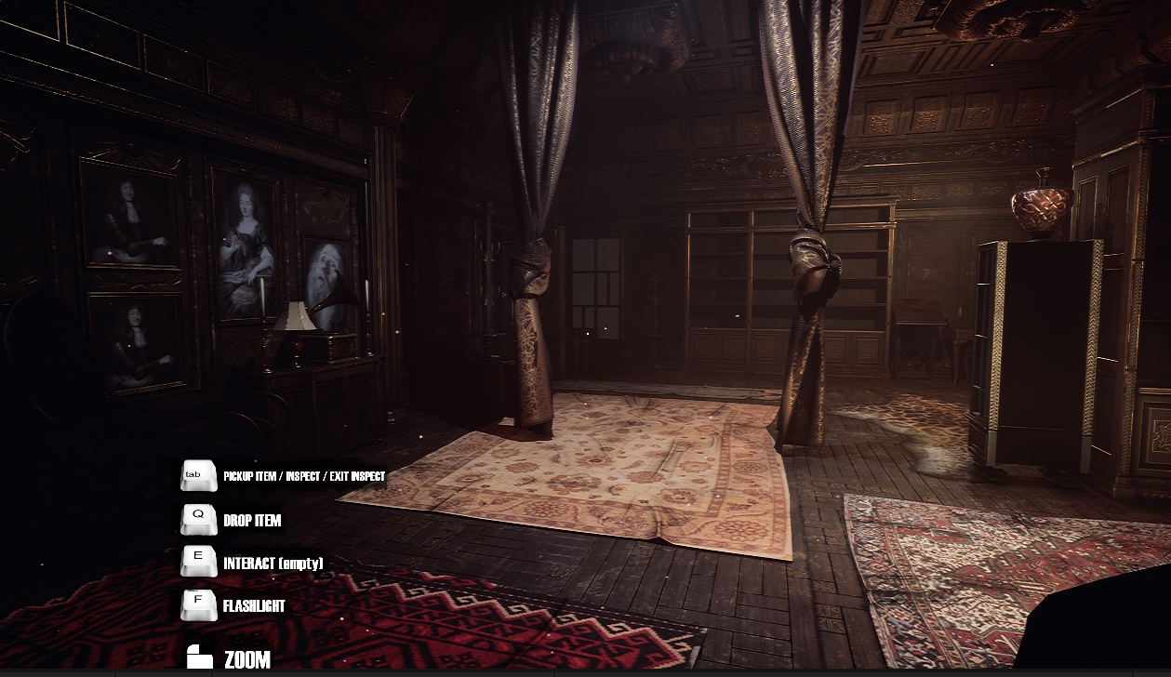

Figure 20: Game Play Screen

Figure 21 shows the player’s character laying on the bed.

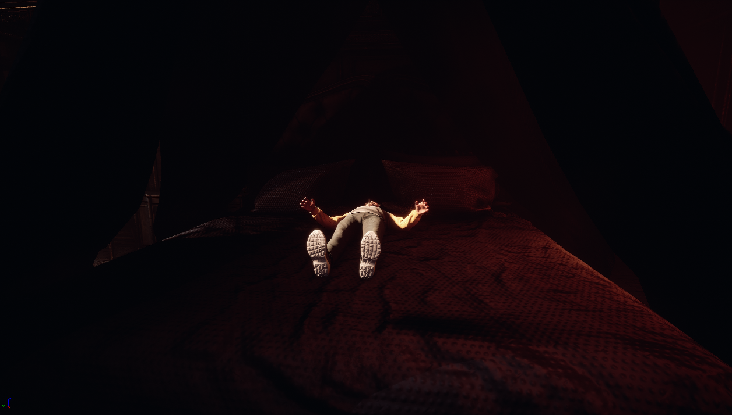

Figure 21: Player's Character

Levels

There are three levels in the game which the player can play. By using movement keys to move around and mouse to look around, player can navigate the environment and the three diverse levels and face the challenges in those levels.

Level 1 – Find the ball

Figure 22 shows the ball that the player must find then pick it up and place it on the table to complete the level.

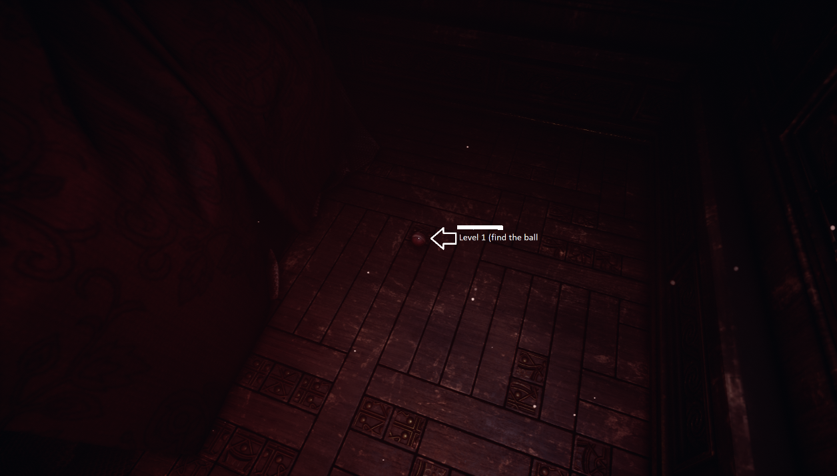

Figure 22: Level 1 Find the Ball

Level 2 – Navigate through the maze

Figure 23 shows the maze-like structure of the mansion that the player must navigate through and find their way to the third level.
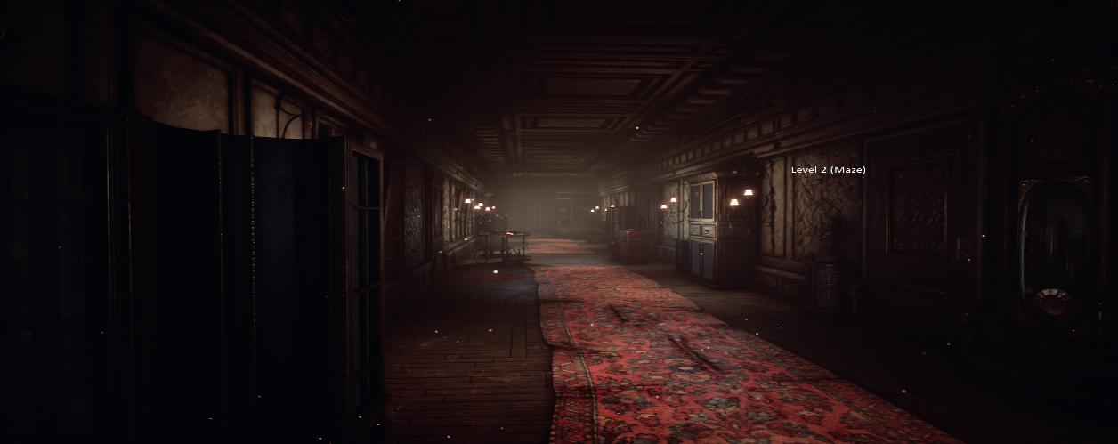

Figure 23: Level 2 Navigate through the Maze

Level 3 – Game of Checkers

Figure 24 shows the table where the game of checkers will appear after the player finds the secret room. Player must play a game of checkers and win to complete the level.

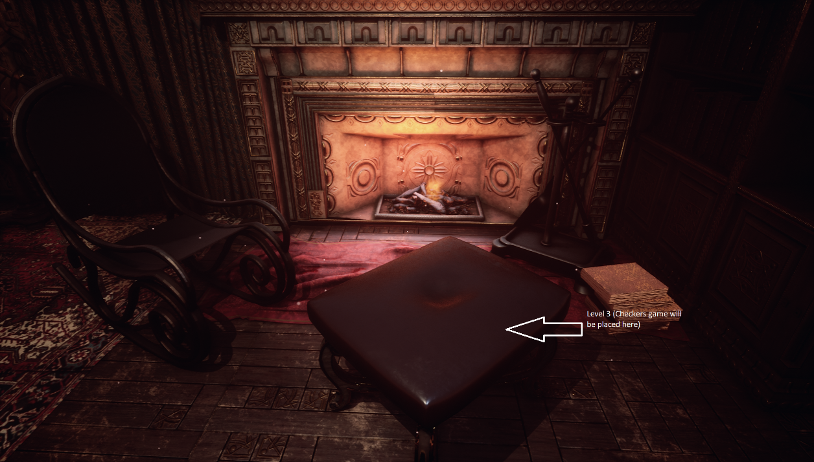

Figure 24: Level 3 Game of Checker

CONCLUSION AND RECOMMENDATIONS

Conclusion

Dream Walker, a virtual reality game, was developed to offer an immersive and thrilling experience for players in the realm of dreams. The game combines the psychological and adventure-horror genres, allowing players to explore and control their dreams while unravelling a mysterious storyline.

The integration of Unreal Engine 5 provides a powerful platform for creating visually stunning and engaging gameplay elements. Through the implementation of dream walking mechanics, interactive puzzles, and a progression system, the game offers a unique and captivating gameplay experience.

Recommendations

Based on the development of the Dream Walker VR game, the following recommendations can be made:

Further Enhance Immersion: To enhance the immersion factor of the game, implementing additional sensory elements, such as spatial audio and haptic feedback, to create a more realistic and immersive experience for the players. This can further enhance the psychological and adventure-horror elements of the game.

Expand Content and Levels: To extend the replayability and longevity of the game, adding more levels and diverse dreamscapes for players to explore. Each level can offer unique challenges, puzzles, and encounters, ensuring that players remain engaged and intrigued throughout their dream-walking journey.

Continuous Testing and Optimization: Game testing should be an ongoing process, even after the initial release. Regular updates and patches can address any bugs, improve performance, and incorporate player feedback to ensure a smooth and enjoyable gameplay experience. It is also recommended to optimize the game for different VR platforms and hardware configurations to reach a wider audience.

Community Engagement: Foster a community around the game by providing avenues for players to connect, share their experiences, and provide feedback. This can be done through online forums, social media, and regular updates that incorporate player suggestions and requests. Building an engaged and enthusiastic community can contribute to the long-term success of the game.

By considering these recommendations, the Dream Walker VR game can continue to evolve and provide players with a captivating and immersive experience, further establishing itself as a standout title in the virtual reality gaming landscape.

REFERENCES

[1] Dreamwalker, Goodreads. Available at: https://www.goodreads.com/en/book/show/47911 (Accessed: 08 June 2023)
[2] The Wheel of Time, a novel series featuring "Dreamers" and "Dream walkers"
Available at: https://www.tor.com/2009/03/06/the-wheel-of-time-re-read-the-dragon-reborn-part-3/ (Accessed: 08 June 2023)
[3] Cipresso, P. et al. (1AD) The past, present, and future of virtual and Augmented Reality Research: A network and cluster analysis of the literature, Frontiers. Frontiers.
Available at: https://www.frontiersin.org/articles/10.3389/fpsyg.2018.02086/full
(Accessed: 08 June 2023)
[4] C. Anthes, R. J. García-Hernández, M. Wiedemann and D. Kranzlmüller, "State of the art of virtual reality technology," 2016 IEEE Aerospace Conference, 2016, pp. 1-19, doi: 10.1109/AERO.2016.7500674. Available at: https://ieeexplore.ieee.org/abstract/document/7500674 (Accessed: 08 June 2023)
[5] X. Chen, M. Wang, and Q. Wu, "Research and development of virtual reality game based on unreal engine 4," 2017 4th International Conference on Systems and Informatics (ICSAI), 2017, pp. 1388-1393, doi: 10.1109/ICSAI.2017.8248503. Available at: https://ieeexplore.ieee.org/abstract/document/8248503 (Accessed: 08 June 2023)
[6] Kong, J.H.K. Best practices on improving the virtual reality (VR) content development process with epic's Unreal Engine, International Journal of Advanced Culture Technology. The International Promotion Agency of Culture Technology. Available at: https://koreascience.kr/article/JAKO202106957212293.page (Accessed: 08 June 2023)
[7] The Best Agile Practices in game development - blog (2021) Juego Studio. Available at: https://www.juegostudio.com/blog/the-best-agile-practices-in-game-development (Accessed: 08 June 2023)
[8] Buehring, S. (2022) Kanban principles, Knowledge Train. Knowledge Train. Available at: https://www.knowledgetrain.co.uk/agile/agile-project-management/agile-project-management-course/kanban-principles (Accessed: 08 June 2023)


Figure 25: Plagiarism Report

