
BSCS F22-017
03-134192-047 Ghulam Umer Farooq
03-134192-053 Daud Suleman

ComparoMeter

In partial fulfilment of the requirements for the degree of
Bachelor of Science in Computer Science
Supervisor: Sadia Aslam
Department of Computer Sciences
Bahria University, Lahore Campus
June 2023

© Bahria University, 2023

Certificate

We accept the work contained in the report titled
“ComparoMeter”
written by
Ghulam Umer Farooq
Daud Suleman

as a confirmation to the required standard for the partial fulfilment of the degree of
Bachelor of Science in Computer Science.

Approved by:
Supervisor: Sadia Aslam
(Signature)

June 20, 2023

DECLARATION

We hereby declare that this project report is based on our original work except for citations and quotations which have been duly acknowledged. We also declare that it has not been previously and concurrently submitted for any other degree or award at Bahria University or other institutions.

Enrolment | Name | Signature
03-134192-047 | Ghulam Umer Farooq
03-134192-053 | Daud Suleman

Date : June 20, 2023

Dedicated especially to
my beloved grandma, mother, and father
(Daud Suleman)
my beloved grandmother, mother and father
(Ghulam Umer Farooq)

ACKNOWLEDGEMENTS

We are immensely grateful to our teacher, Sadia Aslam, for her exceptional guidance and unwavering support during our final year project in the Department of Computer Science. Her expertise and mentorship have been instrumental in shaping our research and academic growth. We are indebted to her for providing valuable insights, constructive feedback, and constant encouragement throughout the project. Her dedication to my success has truly inspired us to push our boundaries and achieve our goals. We would also like to express our appreciation to the faculty and staff of the Department of Computer Science for their assistance and provision of resources, which have significantly contributed to the accomplishment of our research endeavours.
Additionally, I would want to thank my supportive parents and friends for their assistance and words of encouragement.

Daud Suleman
Ghulam Umer Farooq

ComparoMeter

ABSTRACT

This project aims to develop a mobile application that enables users to compare products from multiple online stores, such as Walmart and Lazada, and find the best deals available. The application utilizes APIs provided by various e-commerce platforms to fetch product data, including prices, quality, ratings, reviews, and other relevant information. It employs a sophisticated comparison algorithm that analyses the collected data to rank products based on different criteria, such as price, quality, and customer feedback. The application offers a user-friendly interface that allows users to filter and sort the products based on their preferences. Additionally, it provides features such as bookmarking favourite items and sharing them with others. The project incorporates web scraping techniques to gather data from online stores, data analysis techniques to process and evaluate the collected information, and user interface design principles to create an intuitive and efficient application for online shoppers. By developing this mobile application, the project showcases the integration of multiple e-commerce platforms, the implementation of a powerful comparison algorithm, and the utilization of web scraping, data analysis, and user interface design techniques. The end result is a valuable tool that assists users in making informed purchasing decisions by identifying the best deals across different online stores.

TABLE OF CONTENTS

DECLARATION ii
ACKNOWLEDGEMENTS iv
ABSTRACT v
TABLE OF CONTENTS vi
LIST OF TABLES ix
LIST OF FIGURES x

CHAPTERS
1 INTRODUCTION 1
1.1 Background 1
1.2 Problem Statements 2
1.3 Aims and Objectives 2
1.4 Scope of Project 3
2 LITERATURE REVIEW 4
2.1 User Classes and characteristics: 5
2.2 Limitations: 6
3 DESIGN AND METHODOLOGY 7
3.1 Design 7
3.2 Class diagram 8
3.3 Use case diagram 9
3.3.1 Admin 9
3.3.2 Login 10
3.3.3 Seller: 11
3.3.4 Buyer: 12
3.4 Use Cases 13
3.4.1 Registration 13
3.4.2 Login 14
3.4.3 Search Product 15
3.4.4 Block User 16
3.4.5 View Product 17
3.4.6 Update Password 18
3.4.7 Comparison Product 19
3.4.8 View Profile 20
3.5 Sequence Diagram 21
3.5.1 Create Account 21
3.5.2 Admin Login 22
3.5.3 User Login 23
3.5.4 Search Product 24
3.5.5 Block User 25
3.5.6 View Product 26
3.5.7 Update Password 27
3.5.8 Comparison Product 28
3.5.9 View Profile 29
3.6 Collaboration Diagram 30
3.6.1 Admin 30
3.6.2 Buyer 31
3.6.3 Seller 31
3.7 Domain Model 32
3.7.1 Admin: 32
3.7.2 Seller: 33
3.7.3 Buyer: 34
4 IMPLEMENTATION 35
4.1 Hardware 35
4.2 Development Stack: 35
5 RESULTS AND DISCUSSIONS 37
5.1 Register Buyer 37
5.2 Login 38
5.3 Landing Page: 39
5.4 Logout Page 40
5.5 Product Page 41
5.6 Compare Product Page 42
5.7 Search Page for Comparison 43
5.8 Compare Products Page 44
5.9 Settings Page 45
5.10 Change Password Page 46
6 CONCLUSION AND RECOMMENDATIONS 47
6.1 Conclusion 47
6.2 Future Work 47

LIST OF TABLES

TABLE TITLE PAGE
Table 1-Registration Use Case 13
Table 2-Login Use Case 14
Table 3-Search Use Case 15
Table 4-Block User Use Case 16
Table 5-View Product Use Case 17
Table 6-Update Password Use Case 18
Table 7-Comparison Use Case 19
Table 8-View Profile Use Case 20

LIST OF FIGURES

FIGURE TITLE PAGE
Figure 1 Class Diagram 8
Figure 2 Admin Use Case Diagram 9
Figure 3-Login Use Case Diagram 10
Figure 4-Seller Use Case Diagram 11
Figure 5-Buyer Use Case Diagram 12
Figure 6-Create Account Sequence Diagram 21
Figure 7-Admin Sequence Diagram 22
Figure 8-User Login Sequence Diagram 23
Figure 9-Search Product Sequence Diagram 24
Figure 10-Block User Sequence Diagram 25
Figure 11-View Product Sequence Diagram 26
Figure 12-Update Password Sequence Diagram 27
Figure 13-Comparison Product Sequence Diagram 28
Figure 14-View Profile Sequence Diagram 29
Figure 15-Admin Collaboration Diagram 30
Figure 16-Buyer Collaboration Diagram 31
Figure 17-Seller Collaboration Diagram 31
Figure 18-Admin Domain Model 32
Figure 19-Seller Domain Model 33
Figure 20-Buyer Domain Model 34

INTRODUCTION

Background

Shopping online has become an increasingly popular way for consumers to purchase goods and services, with eCommerce sales expected to reach 8.1 trillion dollars by 2026 [1]. One of the main benefits of shopping online is the ability to easily compare prices and features of products from different retailers. However, manually comparing prices and features from multiple stores can be time-consuming and overwhelming, leading many consumers to simply choose the first option they see.
To address this problem, we have developed ComparoMeter, a tool that allows consumers to compare products quickly and easily from different eCommerce stores [2]. ComparoMeter allows users to input their desired product and see a list of options from various retailers, complete with pricing and key features. In addition, ComparoMeter includes a price tracking feature that alerts users when the price of a product drops below a certain threshold.
The goal of ComparoMeter is to make the process of comparing products from different retailers more efficient and convenient for consumers, ultimately helping them make informed purchasing decisions [2]. In the following sections, we will discuss the current state of eCommerce and consumer behaviour in relation to product comparison, as well as the technical details and features of ComparoMeter.

Problem Statements

How can a price comparison system effectively and accurately compare the prices of products from multiple online retailers, while also providing reliable and unbiased information to consumers to help them make informed purchasing decisions?
Some specific issues that this problem statement might address include:
- Ensuring that the prices displayed on the price comparison system are accurate and up to date.
- Identifying and including all relevant online retailers in the search results.
- Providing additional information, such as product reviews and ratings, that is reliable and unbiased.
- Developing a user-friendly interface that allows consumers to easily search for and compare prices of products.
- Ensuring the security and privacy of users' personal and financial information.
- Managing the complexity of constantly updating and maintaining the price comparison system with a large and constantly changing number of online retailers and products.

Aims and Objectives

Following are the main aims and objectives of this project
- To help consumers save money by providing them with information about the best prices for products they are interested in purchasing.
- To provide a convenient and user-friendly way for consumers to compare prices of products from multiple online retailers.
- To provide additional information, such as product reviews and ratings, to help consumers make informed purchasing decisions.
- To ensure the accuracy and reliability of the prices and other information displayed on the ComparoMeter.
- To include as many relevant online retailers as possible in the search results to provide a comprehensive overview of prices for a particular product.

- To maintain and constantly update the ComparoMeter to ensure that it remains a useful and relevant tool for consumers.

Scope of Project

- Some potential areas that might be within the scope of a ComparoMeter include:
- Comparing prices of products from multiple online retailers: The ComparoMeter would search a variety of online retailers and display the results in a single list or chart to allow users to easily compare prices.
- Providing additional information: The ComparoMeter might also provide additional information about the products, such as product descriptions, reviews, ratings, and images, to help users make informed purchasing decisions.
- Searching for a wide range of products: The ComparoMeter might allow users to search for a wide range of products, including electronics, home goods, clothing, and more.
- Maintaining and updating the ComparoMeter: The ComparoMeter would need to be constantly maintained and updated to ensure that the prices and other information displayed are accurate and up to date.
- Ensuring security and privacy: ComparoMeter would need to take measures to ensure the security and privacy of users' personal and financial information.
- Providing a user-friendly interface: The ComparoMeter should have a user-friendly interface that is easy to use and navigate.

LITERATURE REVIEW

Price comparison websites such as PriceGrabber or ComparoMeter have become increasingly popular in recent years as a convenient way for consumers to find the best prices on products they are interested in purchasing. These websites allow users to enter the name of a product and search for the best price from a variety of online retailers, often providing additional information such as product reviews and ratings to help consumers make informed decisions.
Studies have shown that price comparison websites can be effective in helping consumers save money on their purchases. A review of literature on the use of price comparison websites found that these tools can help consumers save an average of 10-20% on the products they purchase [3]. In addition, the use of price comparison websites has been found to be particularly beneficial for consumers who are unfamiliar with a particular product or who are purchasing a product for the first time.
However, not all price comparison websites are created equal, and it is important for consumers to carefully evaluate the reliability and accuracy of the information provided by these websites. Some research has found that the prices displayed on price comparison websites may not always be the lowest available, and that some websites may not include all relevant retailers in their search results. [4] Additionally, there have been concerns raised about the potential for biased or misleading information to be displayed on these websites, particularly regarding product reviews.
Despite these potential limitations, price comparison websites such as ComparoMeter or Price Grabber remain a popular and useful tool for consumers looking to save money on their purchases. As with any tool, it is important for consumers to carefully evaluate the reliability and accuracy of the information provided by these websites and to consider other factors, such as shipping costs and return policies, in addition to price when making purchasing decisions. [5]

User Classes and characteristics:

ComparoMeter is a mobile application that is divided into three basic users.
- Admin
- Buyer
- Seller

Admin:
- Approved Registration
- Block/Unblock user
- Check the records
- Manage Accounts

Seller:
- Compare Products
- Search available Product
- Check Competitors
- Register Account

Customer:
- Compare Products
- Search available Products.
- Register Account

Limitations:

- Prices may not always be accurate: The prices displayed on a ComparoMeter may not always be the lowest available, as they may not include all relevant retailers or may not be up to date.
- Not all retailers may be included: A ComparoMeter may not include all relevant retailers in its search results, which could lead to incomplete price comparisons.
- Product information may be biased: The additional information provided by a ComparoMeter, such as product reviews and ratings, may be biased or misleading.
- Security and privacy concerns: There may be concerns about the security and privacy of users' personal and financial information when using a ComparoMeter.
- Limited product categories: A ComparoMeter may only include a limited range of product categories, which could limit its usefulness for certain types of products.
- Complexity of constantly updating and maintaining the ComparoMeter: Maintaining and updating a ComparoMeter with a large and constantly changing number of online retailers and products can be complex and time-consuming.

DESIGN AND METHODOLOGY

Design

In the design part, some UML diagrams show a complete flow of ADG and how it can design the functionalities to fulfill the project.
These UML diagrams are as follow:
- Class Diagram
- Use case diagram
- Sequence diagram
- Domain Model

Class diagram

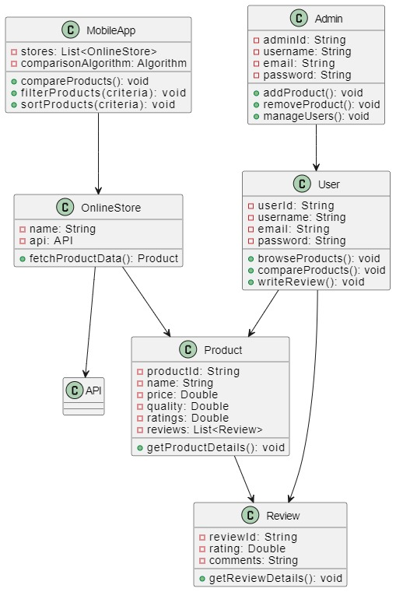
Figure 1 Class Diagram

Use case diagram

A use case diagram is a visual depiction that describes how users (actors) interact with a system in the area of software engineering. It aids in recognizing and comprehending the various ways users might engage with the system by illuminating the functionality offered by a system from the viewpoint of the user.

Admin

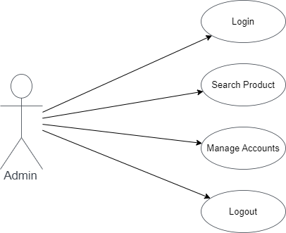
Figure 2 Admin Use Case Diagram

Login

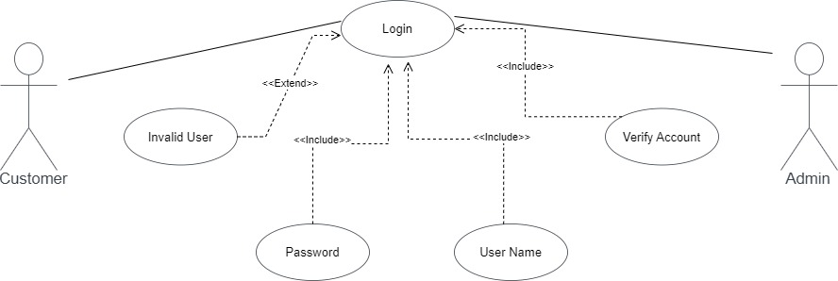
Figure 3-Login Use Case Diagram

Seller:

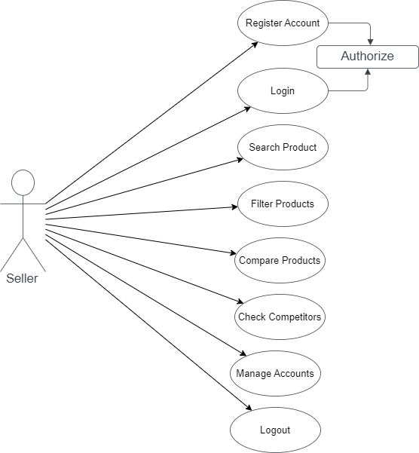
Figure 4-Seller Use Case Diagram

Buyer:

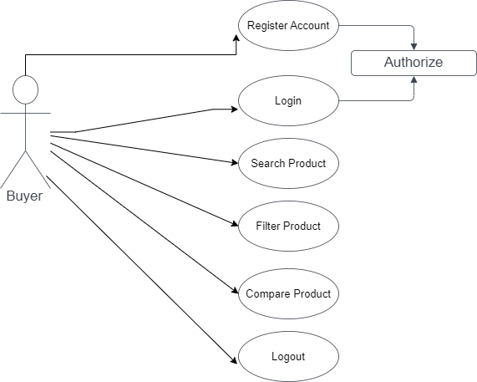
Figure 5-Buyer Use Case Diagram

Use Cases

Registration

Table 1-Registration Use Case
Name and ID | Registration (U1)
Brief description | The purpose of this use case is to allow Admin, Seller, and Buyer to make his/her profile on ComparoMeter and get registered.
Preconditions | The user has a source to register on the Mobile App.
Basic flow or Happy path | The user will provide an email and password and an opt is generated which will verify the user throughout the provided email.
Trigger | Users will come to buy or Compare the Products.
Alternate flows | If any field is not correctly filled up, then the registration page will reload on the Mobile App.
Postconditions | The user will be a member of the Mobile App.

Login

Table 2-Login Use Case
Name and ID | Login (U2)
Brief description | Administrators, Seller, and Buyer can Login-in to gain admittance to their separate boards and can play out their tasks.
Preconditions | The Admin, Seller, and Buyer will become Member of the System
Basic flow or Happy path | This use case begins when Admin, Seller, and Buyer need to sign-in.  The administrator, Seller, and Buyer will give us a Gmail.  The user enters a password.
Alternate flows | If every content field isn't accurately filled, at that point the system reloads the system login page.
Postconditions | User Login to ComparoMeter.

Search Product

Table 3-Search Use Case
Name and ID | Search Product (U3)
Brief description | The Customer can search for Products to buy and visit.
Preconditions | The Customer must be logged in.
Basic flow or Happy path | Customer Select the category.  The Customer searches the niche by entering the Product details.  The Customer will see the description of the Product.
Alternate flows | The Customer will get the message when it will not be available in the system.
Postconditions | Searched Product list available and the Customer will see on the display screen.

Block User

Table 4-Block User Use Case
Name and ID | Block User (U4)
Brief description | Admin can block buyers and sellers if they violate the term and conditions.
Preconditions | Buyer and Seller should be registered.
Basic flow or Happy path | Admin block the buyer and seller.
Alternate flows | Admin can cancel the block action.
Postconditions | Buyer and Seller should be registered.

View Product

Table 5-View Product Use Case
Name and ID | View Product (U5)
Brief description | Admin and Buyer can view all the Products.
Preconditions | The seller should be logged-in
Basic flow or Happy path | Admin and buyer view all Products  The buyer can view the remaining lists of Products.
Postconditions | The buyer can buy Product.

Update Password

Table 6-Update Password Use Case
Name and ID | Update Password (U6)
Brief description | Sellers and Buyer can request for update password.
Preconditions | User must have an account
Basic flow or Happy path | User sent a request for password update and after authorization with mail, a reset password link is sent to the user on the registered mail
Postconditions | User login to the account

Comparison Product

Table 7-Comparison Use Case
Name and ID | Comparison Product (U7)
Brief description | User can compare products from different online stores
Preconditions | The user should be logged-in
Basic flow or Happy path | User enters a product name or category, and list of products from different stores presented to him/her.
Postconditions | User must know the category of the product

View Profile

Table 8-View Profile Use Case
Name and ID | View Profile (U8)
Brief description | Users can view and update their profile
Preconditions | User must be registered, to view profile
Basic flow or Happy path | User can view and update the personal information
Postconditions | User saves the info if he/she update any info.

Sequence Diagram

A use case diagram is a visual depiction that describes how users (actors) interact with a system in software engineering. It aids in recognizing and comprehending the various ways users might engage with the system by illuminating the functionality offered by a system from the viewpoint of the user. The sequence diagram of ComparoMeter is as follow:

Create Account

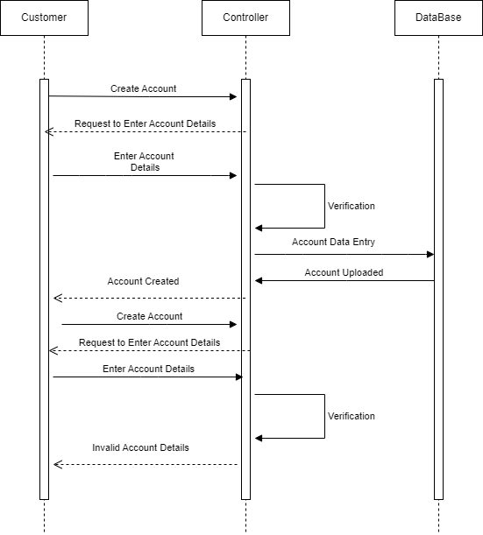
Figure 6-Create Account Sequence Diagram

Admin Login

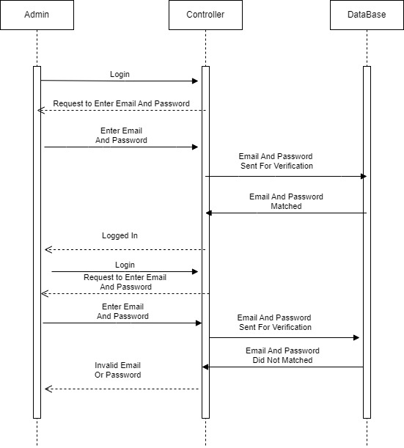
Figure 7-Admin Sequence Diagram

User Login

Figure 8-User Login Sequence Diagram

Search Product

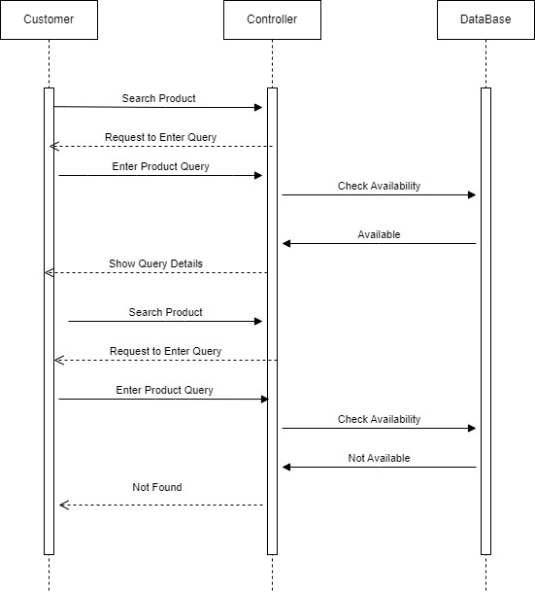
Figure 9-Search Product Sequence Diagram

Block User

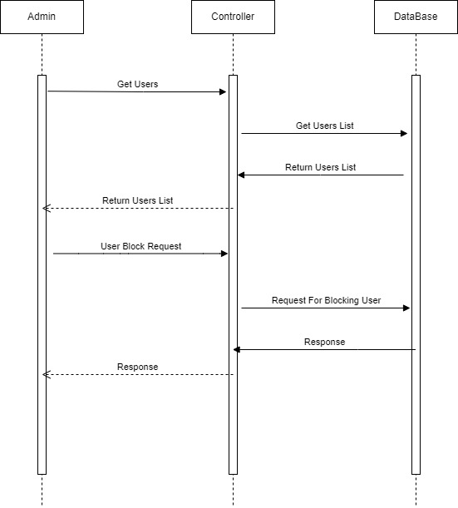
Figure 10-Block User Sequence Diagram

View Product

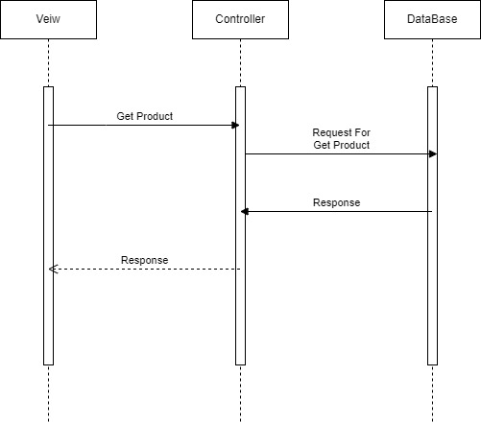
Figure 11-View Product Sequence Diagram

Update Password

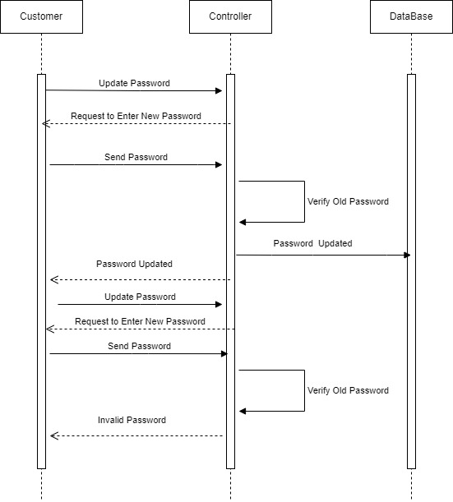
Figure 12-Update Password Sequence Diagram

Comparison Product

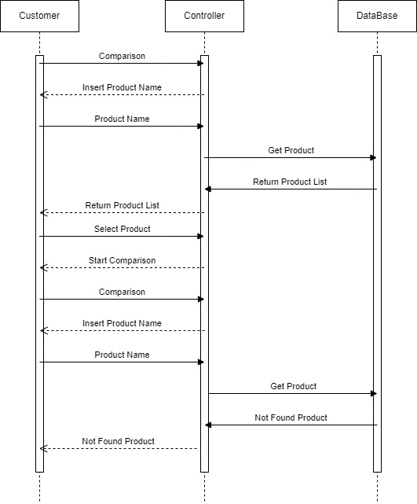
Figure 13-Comparison Product Sequence Diagram

View Profile

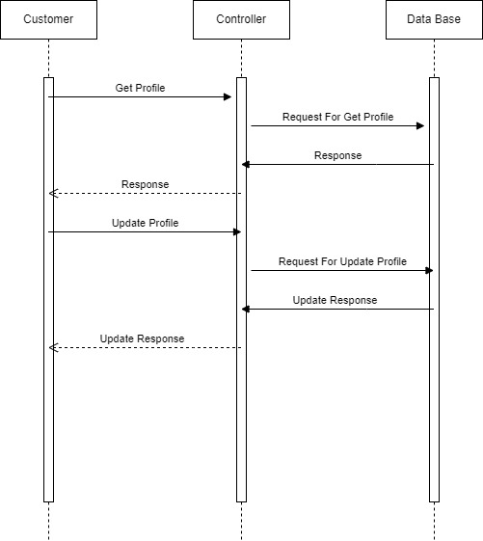
Figure 14-View Profile Sequence Diagram

Collaboration Diagram

A collaboration diagram in UML that shows the relationships among objects or components in an organization is called a collaboration diagram, often referred to as a communication diagram. It focuses on explaining how these things are structurally formed and how they communicate with one another to complete a certain task or event.

Admin

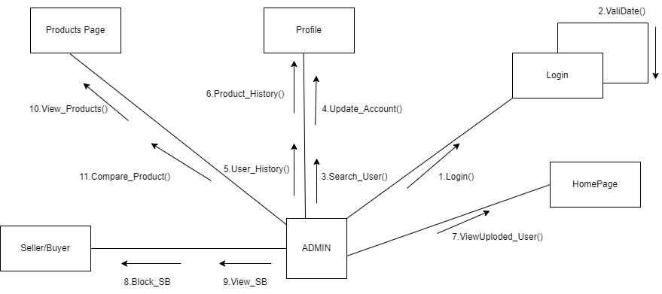
Figure 15-Admin Collaboration Diagram

Buyer

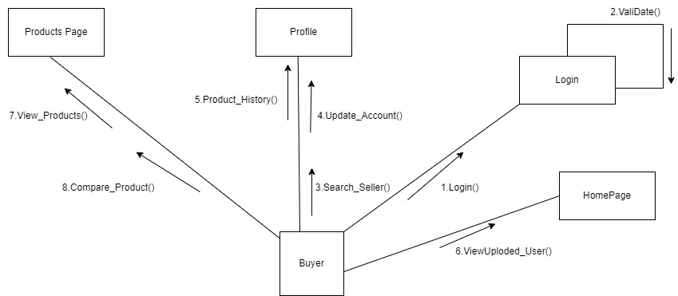
Figure 16-Buyer Collaboration Diagram

Seller

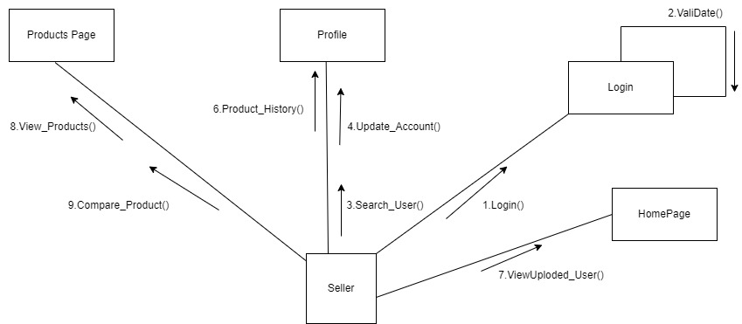
Figure 17-Seller Collaboration Diagram

Domain Model

A domain model is a conceptual rendering of a particular problem area. It is a representation in text or images of the crucial ideas, things, connections, and actions that exist within the issue area.

Admin:

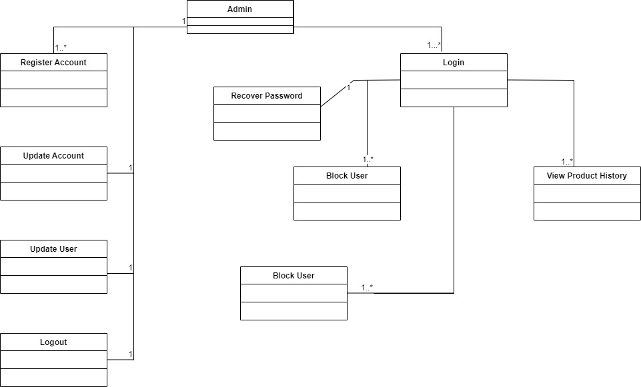
Figure 18-Admin Domain Model

Seller:

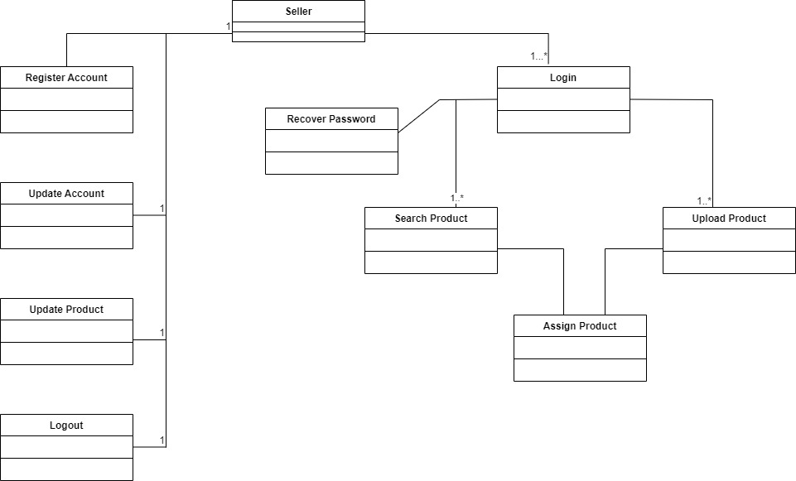
Figure 19-Seller Domain Model

Buyer:
\
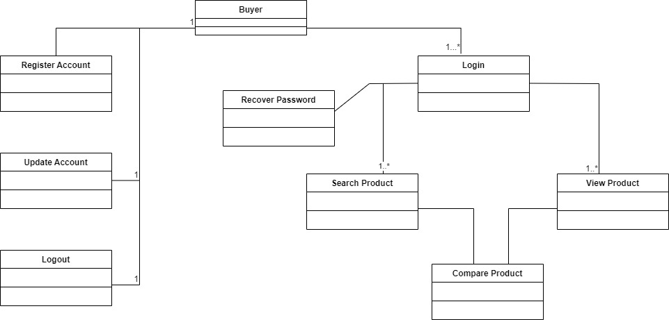
Figure 20-Buyer Domain Model

IMPLEMENTATION

ComparoMeter is a mobile app that helps users find the best deals on various products online. It is built on Flutter, a cross-platform framework that allows fast and beautiful UI development. The backend is supported by Firebase, a cloud-based platform that provides authentication, database, storage, and analytics services. ComparoMeter uses different websites APIs to compare prices, features, ratings, and reviews of products from multiple sources. Users can also get personalized recommendations based on their preferences.

Hardware

We need a development workstation that meets certain hardware requirements: A 64-bit environment is required for Android 2.3.x (Gingerbread) and higher versions. You will need at least 250GB of free disk space to check out the code and an extra 150 GB to build it. At least 16 GB of available RAM is required, but Google recommends 64 GB. Along with that we also need an Android Device to test the application.

Development Stack:

Our app is built on Flutter, a cross-platform framework that allows us to create beautiful and responsive user interfaces. The backend of our app is supported by Firebase, a cloud-based platform that provides us with various services such as authentication, database, storage, and analytics. With our app, you can easily browse and compare products from various online stores, such as Lazada, eBay, Walmart, and more.. Our app is designed to make your online shopping experience easier and more convenient. Download our app today and start comparing products from different websites.

RESULTS AND DISCUSSIONS

Register Buyer

This is the first step if any user wants to become a part of ComparoMeter. Initially users has to register into our system and enter their required details. And then the admin will get their details of the user. Users should not be a member of the system before.

Signup Screen:
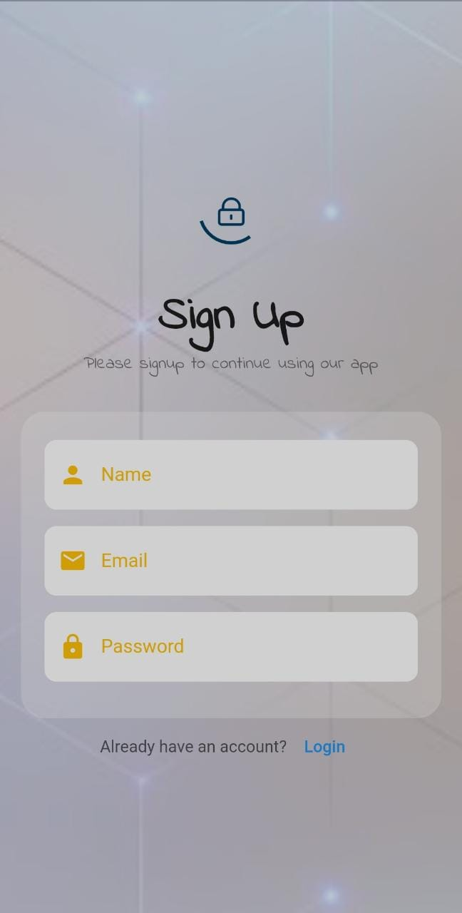

Login

After Registration into our system users will log in to our system by adding their credentials. User has to enter his email id and password.

Login Screen:

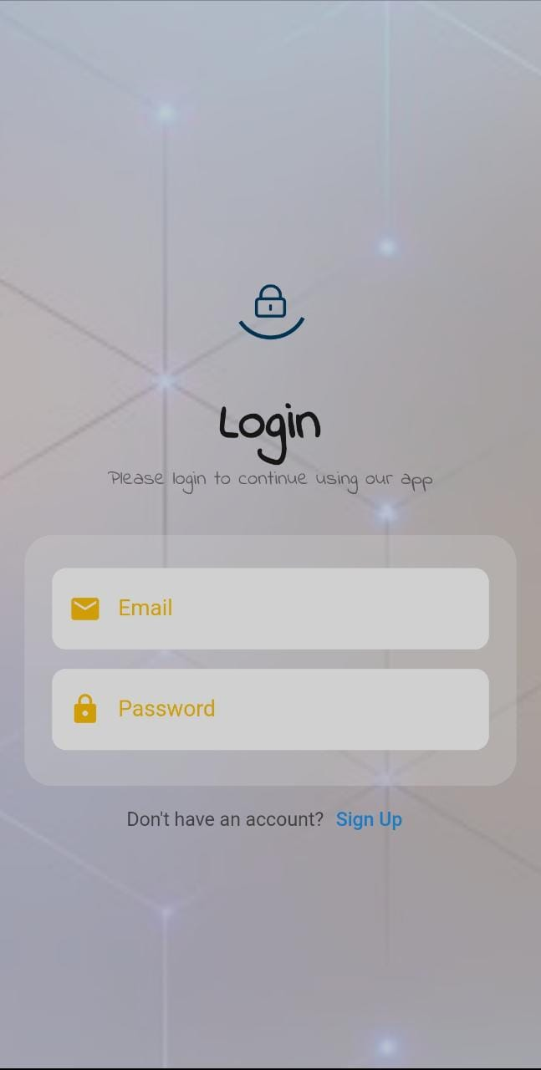

Landing Page:

Landing screen when user logins to the system this page shows according to the search patterns

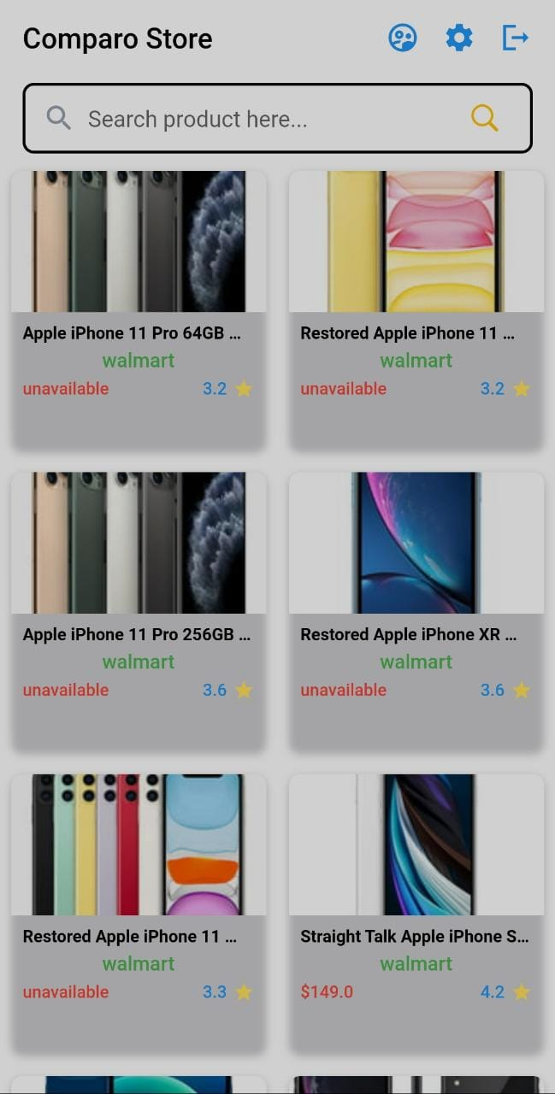

Logout Page

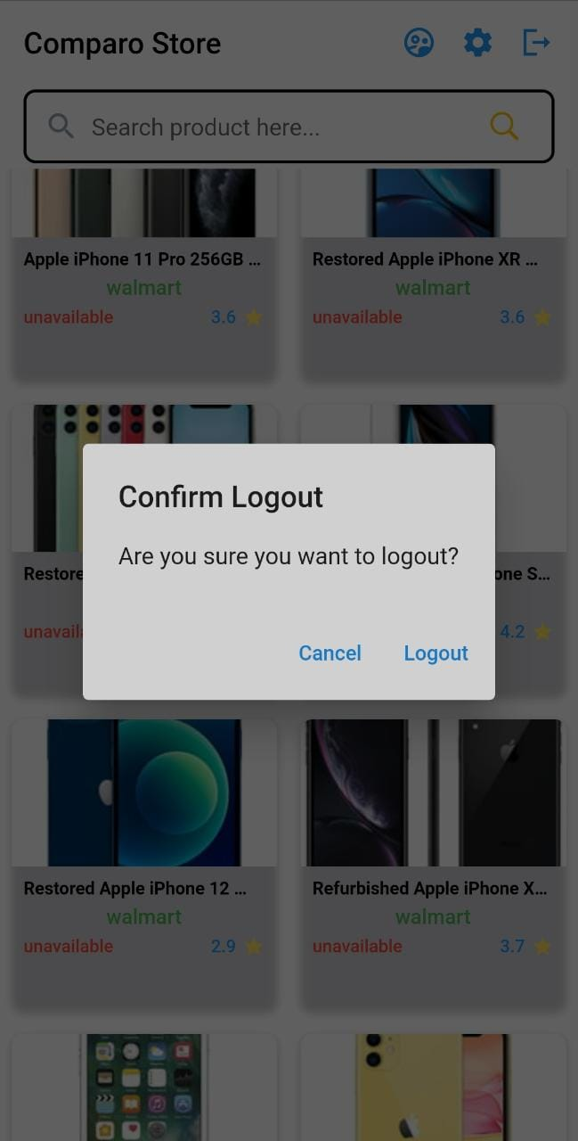

Product Page

This is the product page by clicking the Compare Product Button you can compare products
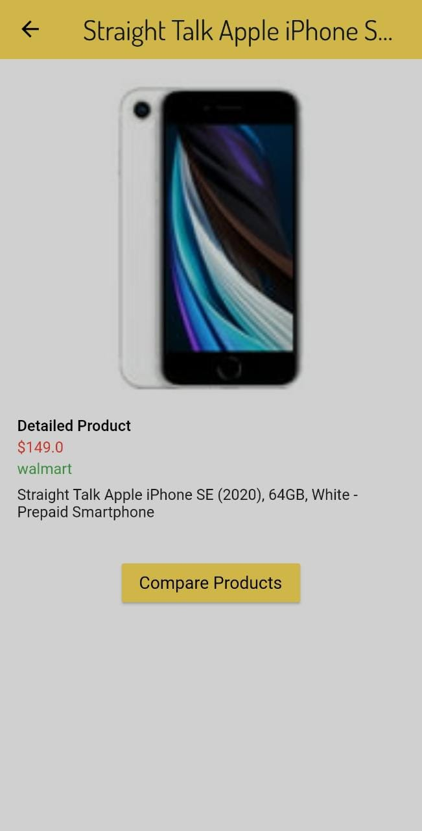

Compare Product Page

On clicking the Compare Product Button User will be directed to this page and

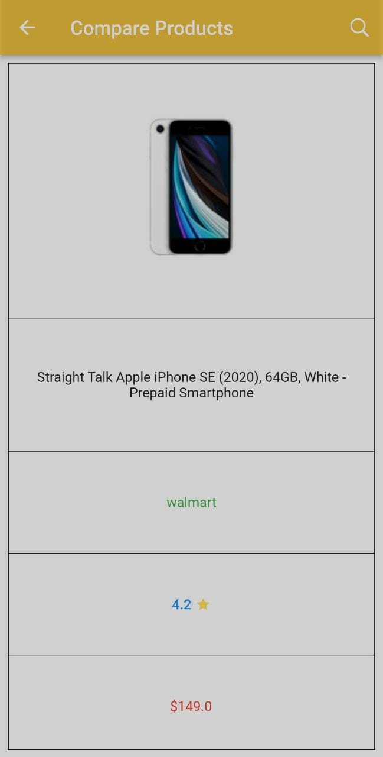

Search Page for Comparison

When User search the desired product a modal is open with the results and user can select from which product he want to compare.
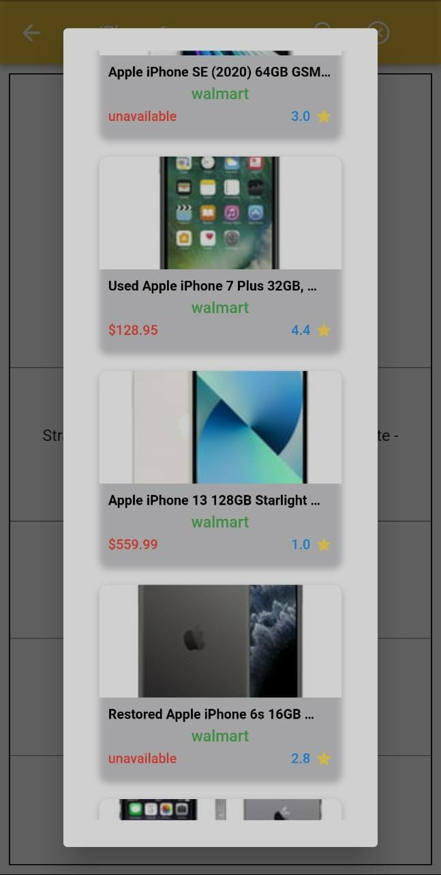

Compare Products Page

This is our main Compare Product page in which 2 products are compare side by side.
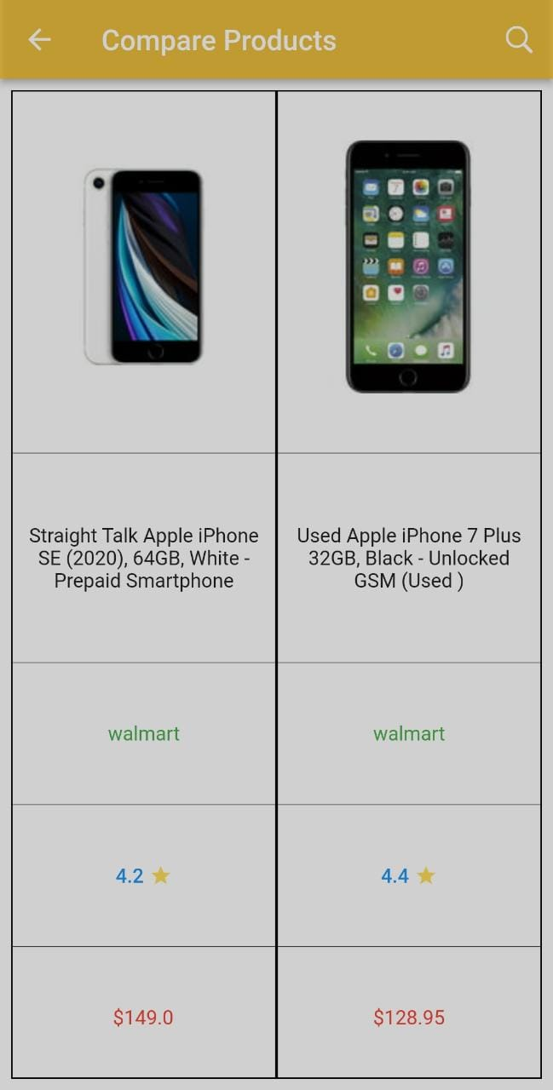

Settings Page

This is the Settings page of ComparoMeter where a user can access different modules of application.
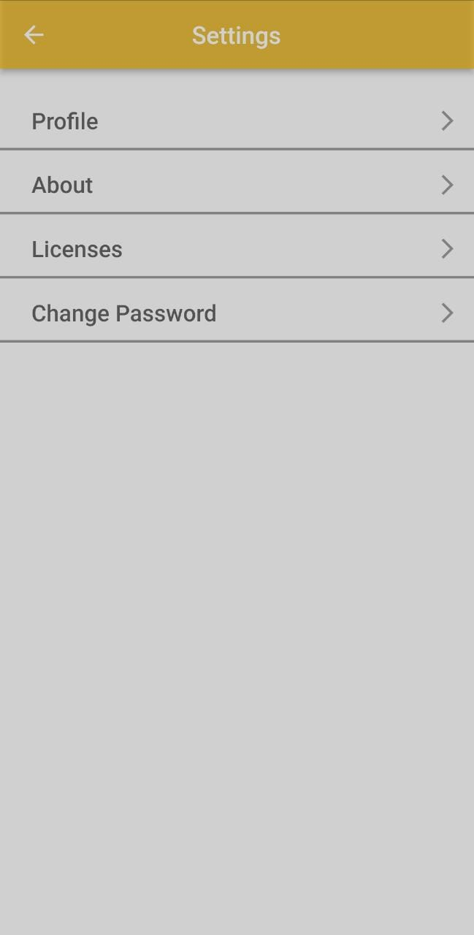

Change Password Page
Here a user can change the password of his application.
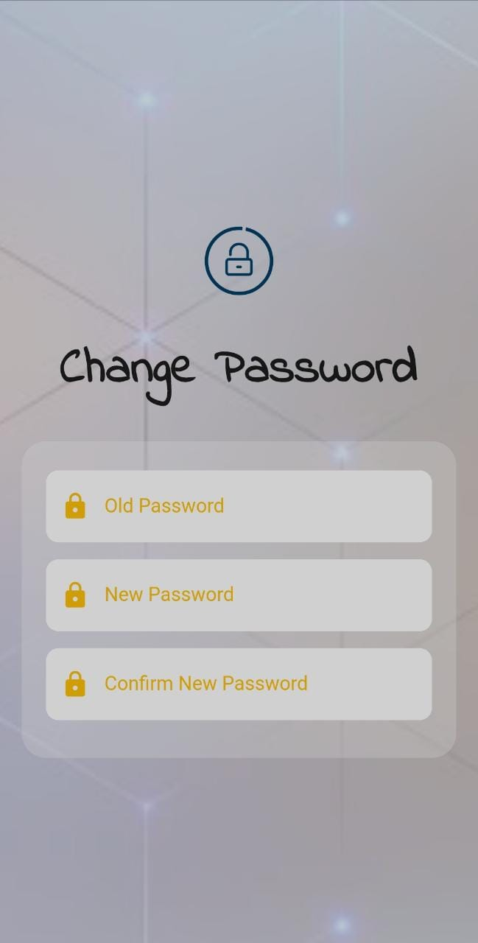

CONCLUSION AND RECOMMENDATIONS

Conclusion

One key area for improvement would be to integrate with more online stores to provide a wider range of products for comparison. Additionally, the app could improve its search functionality, provide customized alerts for specific products, and track the price history of products over time. Expanding the information provided about products to include more detailed specifications, user reviews, and expert opinions would also be beneficial.
Overall, while the app is a good starting point, there are many ways that it could be enhanced and expanded in the future to provide more value and better serve the needs of users.

Future Work

In the future, the mobile app could be expanded and improved in several ways to provide more value and better serve the needs of users. One area for improvement would be to integrate with more online stores to provide a wider range of products for comparison. The app could also improve its search functionality, provide customized alerts for specific products, and track the price history of products over time. Expanding the information provided about products to include more detailed specifications, user reviews, and expert opinions would also be beneficial. Additionally, the app could integrate with social media platforms to allow users to share their favorite products and deals with their friends and followers, and could improve its user interface to make it more intuitive and user-friendly. By implementing these future work items, the app could become a more comprehensive and useful tool for users looking to compare products and find the best deals online.

References

[1] | P. Rawal1, “Comparison Website for Online Shopping”.
[2] | S. Chevalier, “Retail e-commerce sales worldwide from 2014 to 2026”.
[3] | L. Beranek, “E-commerce network with price comparator sites”.
[4] | B. J. C. Ph.D., “Online Shopping,” 2016.
[5] | D. C.-H. Cho, “Online Shopping Hesitation,” 2016.

