

BSCS-F22-15
03-134192-057 | Usama Adnan

Extreme Racing Rush

In partial fulfilment of the requirements for the degree of
Bachelor of Science in Information Technology
Supervisor: Muhammad Sauood
Department of Computer Sciences
Bahria University, Lahore Campus

© Bahria University, 2023

Certificate

We accept the work contained in the report titled.
“Extreme Racing Rush”
Written by
Usama Adnan

as a confirmation to the required standard for the partial fulfilment of the degree of
Bachelor of Science in Information Technology.

Approved by:
Supervisor: Muhammad Sauood
Dec 23, 2022 (Signature)

DECLARATION

I hereby declare that this project report is based on my original work except for citations and quotations which have been duly acknowledged. I also declare that it has not been previously and concurrently submitted for any other degree or award at Bahria University or other institutions.

Enrolment | Name | Signature
03-134192-057 | Usama Adnan

May 22, 2023

ACKNOWLEDGEMENTS

I would like to thank everyone who had contributed to the successful completion of this project. I would like to express my gratitude to my research supervisor, Mr Muhammad Sauood for his invaluable advice, guidance, and his enormous patience throughout the development of the research.

In addition, I would also like to express my gratitude to my loving parent and friends who had helped and given me encouragement.

Usama Adnan

ABSTRACT

The gaming Industry has expanded rapidly in recent years. Not only indie games becoming increasingly popular these days, but particularly clever indie racing games are in demand. Racing games can help kids become flexible in their thinking. These games help users improve their calculating and problem-solving abilities. To succeed at racing games, players must be able to respond effectively to unfamiliar situations, make wise choices, choose the best path of action, and become adept at dodging hurdles.

Going with the trend, I have proposed a Car Racing Game. This Game is being developed in Unity 3D that can help children to stay home by playing games and avoiding getting bored. This game can help you improve your thinking skills and bring out your inner racing abilities. Extreme Racing Rush is a project, which will provide the real experience of a 3D Racing game to the user. The main object of this game is to survive and reach the destination by beating opponent’s cars in the shortest time with efficient speed and avoiding obstacles on the track. The player’s goal is to get to the destination as soon as possible while trying to avoid bumping to other vehicles or road objects. When the total no of laps is completed. This game has different maps in which the player can race with other cars.

I am going to design and build this game in Unity 3D. Tools used to develop the game are Visual Studio, Adobe Photoshop, Blender, Maya, C#, freesounds.org (Sounds), SketchFab (for 3D models).

TABLE OF CONTENTS

TABLE OF CONTENTS v
DECLARATION ii
ACKNOWLEDGEMENTS iii
ABSTRACT iv
LIST OF FIGURES viii
LIST OF TABLES ix
LIST OF SYMBOLS / ABBREVIATIONS x
CHAPTER 1 1
INTRODUCTION 1
1.1 Background 1
1.2 Problem Statement 1
1.3 Aims and Objectives 2
1.4 Scope of Project 2
CHAPTER 2 3
SOFTWARE REQUIREMENT SPECIFICATION 3
2.1 Introduction 3
2.1.1 Overview 3
2.1.2 Functional Requirements 4
2.1.3 Non-Functional Requirements 4
CHAPTER 3 5
DESIGN AND METHODOLOGY 5
3.1 Methodology 5
3.2 Feature Driven Development 5
3.3 Research 5
3.4 Unity 3D 6
3.5 Planning 6
3.6 Design 6
3.6.1 System Case Diagram 6
3.6.2 Sequence Diagram 7
3.6.3 Class Diagram 8
3.7 Use Cases 11
3.7.1 Use Case 1 (Play Game) 11
3.7.2 Use Case 2 (Rate Us & More Games) 12
3.7.3 Use Case 3 (Exit Game) 13
3.7.4 Use Case 4 (Setting Button) 14
3.7.5 Use Case 5 (Survival Mode) 15
3.7.6 Use Case 6 (Time Lapse and Race Mode) 16
3.7.7 Use Case 8 (Pause Button) 17
3.7.8 Use Case 9 (Level Complete & Level Fail) 18
3.8 Feature Build-Development, Testing, Sample 19
CHAPTER 4 20
IMPLEMENTATION 20
4.1 Introduction 20
4.2 Story Board 20
4.3 Game Design and Development 21
4.4 Do Tween 22
4.5 Cinemachine 22
4.6 Particle Pack – Unity Technologies 22
4.7 Cross Platform Input 22
4.8 Car Controller Package 23
4.9 Road Models 23
4.10 Player Model 23
4.11 Car Models 24
4.12 Sky Series Freebie 24
4.13 Race Gamer Soundtrack 24
CHAPTER 5 25
RESULTS AND USER MANUAL 25
5.1 Results and User Manual 25
5.1.1 Splash Screen 25
5.1.2 Main Menu Screen 26
5.1.3 Mode Selection 27
5.1.4 Vehicle Selection 28
5.1.5 Race Selection 29
5.1.6 Gameplay Controls 30
5.1.7 How to Play 31
CHAPTER 6 35
CONCLUSION AND RECOMMENDATIONS 35
6.1 Conclusion 35
6.2 Recommendations 36
REFERENCES 37

LIST OF FIGURES

Figure 1: System Diagram 7
Figure 2: Sequence Diagram 8
Figure 3: Class Diagram 10
Figure 4: Use Case (Play Game) 11
Figure 5: Use Case (More Games & Rate Us ) 12
Figure 6: Use Case (Exit Game) 13
Figure 7: Use Case (Setting Button) 14
Figure 8: Use Case (Survival Mode) 15
Figure 9: Use Case (Race and Time Lapse Mode) 16
Figure 10: Use Case (Pause Button) 17
Figure 11: Use Case (Level Complete & Level Fail) 18
Figure 12: Splash Screen 26
Figure 13: Main Menu Screen 27
Figure 14: Mode Selection Screen 28
Figure 15: Vehicle Selection Screen 29
Figure 16: Race Selection Screen 30
Figure 17: Gameplay Screen 31
Figure 18: Use this Accelerate the car. 32
Figure 19: Use this to apply brake to car. 33
Figure 20: Use this to turn left. 34
Figure 21: Use this to move right 34
Figure 22: Plagiarism Report 38

LIST OF TABLES

Table 1: Play Game 11
Table 2: More Games & Rate Us 12
Table 3: Exit Game 13
Table 4: Setting Button 14
Table 5: Survival Mode 15
Table 6: Race and Time Lapse 16
Table 7: Pause 17
Table 8: Level Complete & Level Failed 18

LIST OF SYMBOLS / ABBREVIATIONS
CPI  DT  UPP  FDD  SRS |  | Cross Platform Input  Do Tween  Unity Particle Pack  Feature Driven Development  Software Requirements Specification

CHAPTER 1

INTRODUCTION

Background

The Extreme car racing rush game is a popular genre of video games that simulates the experience of driving a car at high speeds on a racetrack. It typically involves the player controlling a car and racing against opponents, trying to be the first to cross the finish line. Car racing games have been popular since the earliest days of video games and have evolved over time to incorporate more advanced graphics, physics engines, and gameplay mechanics.

This FYP aims to create an Extreme vehicle racing rush game that is both difficult and interesting for gamers. Realistic car physics, dynamic surroundings, and difficult AI opponents will all be part of the immersive racing experience that the game will produce using contemporary game development tools and technologies. An in-depth examination of current car racing games' gameplay mechanics as well as a complete understanding of game development principles, programming strategies, and graphic design will all be required for this project. The student wants to finish the project with a polished, fully working game that players of all ages and skill levels may enjoy.

Problem Statement
Despite the popularity of car racing games, there aren't many available that give gamers a balanced and difficult racing experience. Existing automobile racing games frequently prioritise graphics and eye-catching images over gameplay mechanics, which leads to a skimpy and disappointing racing experience. Additionally, many car racing games suffer from poor AI opponent behaviour, which can make the game too easy or too difficult for players.

The problem addressed by this FYP is to design and develop an Extreme car racing rush game that addresses these issues and provides a challenging and engaging experience for players. The project aims to create a game that balances graphical fidelity with engaging gameplay mechanics and incorporates AI opponent behaviour that is both challenging and fair. By addressing these issues, the project aims to provide players with a racing game that they can enjoy and play repeatedly, while also demonstrating the student's understanding of game development principles and techniques.

Aims and Objectives

The objectives of this Extreme car racing project are shown below:
- To design and develop a car racing rush game that provides a challenging and engaging experience for players by conducting a thorough analysis of existing car racing games and identifying their strengths and weaknesses.
- To create an entertaining game with challenging yet enjoyable gaming mechanics.

Scope of Project

This project was created by me to turn real-world situations into 3D simulation games. This game's development has taken a variety of ways. The goal of this project is to create a platform for gamers to compete in racing events. This project improves a player's memory, focus, concentration, and ability to make decisions. Additionally, players can reduce stress in their busy lives. In upcoming upgrades, I can include actual police chase racing scenarios.

CHAPTER 2

SOFTWARE REQUIREMENT SPECIFICATION

Introduction

The Software Requirements Specification chapter is intended to give a complete overview of Android game project (Extreme Racing Rush). The SRS chapter details all feature upon which Car Racing Rush have decided with reference to the matter and importance to their implementation. SRS of game have functional and non-functional requirements.

Overview

This FYP intends to create an Extreme racing rush game that offers players a hard and interesting experience. Modern game development techniques and technologies will be incorporated into the project to produce a game with fun gameplay mechanics, accurate car physics, and dynamic AI opponent conduct. There are three game modes: racing, time lapse, and survival. Through user testing and feedback, the study will also assess how well the game's mechanics and design work. The objective is to provide a polished, fully functional game that players of all ages and skill levels can enjoy. I design and develop a police detective simulation game in Unity 3D.

Functional Requirements

- Start of the game, we have a splash screen (Loading Screen)
- Game have projected on an android mobile.
- Game provides sound effects, ON or OFF
- Main Menu allows the player to play the game, exit the game, and play more games by using MORE GAMES button and review us the game.
- Mode selection allows the player to select the mode and play, in every mode there is a different scope for the player.
- In Gameplay player can pause, restart the challenge, and go back to the Main Menu.
- We have left or right movements of player.
- Player can easily understand the tasks in the game and trigger actions.
- Player can pause and resume the game.

Non-Functional Requirements

- The mobile display should have a high resolution.
- The maximum number of clicks for every system function is limited to two.
- The game can operate nicely with 4 GB of RAM, which is now standard in all Android phones.
- The system can be maintained to add new features to the newer editions because the code for the game is maintainable.
- The game can be extended with other functionalities required.

CHAPTER 3

DESIGN AND METHODOLOGY

Methodology

This project follows feature-driven development, which is influenced by an agile framework.

Feature Driven Development
Feature Driven Development, as its name suggests, is an agile methodology that structures the creation of software around advancing features. Features are not typically considered to be traditional product attributes in the FDD. In other words, according to the FDD methodology, "complete the bullet firing process from a gun" might be considered a feature.

Research

This FYP's associated research entails a thorough examination of existing vehicle racing games and their gameplay mechanics. The goal is to discover the strengths and shortcomings of contemporary car racing games, as well as which mechanics are most effective in providing a pleasurable racing experience. In addition, research will be undertaken on the physics principles that govern car movement and control to develop a physics engine in the game that simulates genuine car behaviors. Complete understanding of the project's scope as well as the existing domain targeted and analyzed. Unity 3D is a powerful cross-platform 3D engine with an easy-to-use interface. We created our 3D game in Unity 3D, where we first created the interactive design and then coded it.

Unity 3D

An intuitive development environment and a powerful cross-platform 3D engine are the strengths of Unity3D. With the help of Unity, we can create 2d, 3d, AR, etc. games for different platforms like PC, console, mobile devices. It is easy enough for novices yet powerful enough for experts.

Planning

We develop the feature list and plan the project's features. System needs and tools are gathered. Features Game selection and strategy.

Design

This phase includes the design of all available UML diagrams, such as System Case, Class, and Sequence diagrams. It also includes the design of interfaces and prototypes.

System Case Diagram

The features of your system's users (also known as actors) and their interactions with the system can be depicted using a system case diagram in the Unified Modelling Language. You'll need a specific set of symbols and links to build one. A good use case diagram can aid team's discussion and representation.
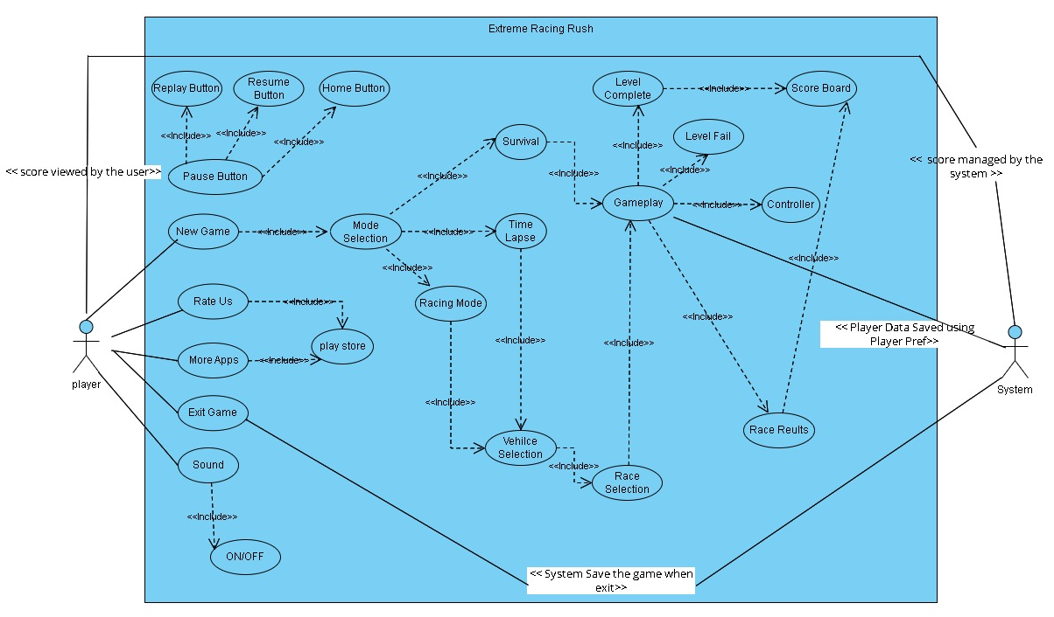

Figure 1: System Diagram

Sequence Diagram

UML Sequence Diagrams are interaction diagrams that explain how procedures are carried out. They document the interplay of things within the context of a relationship. These are graphically illustrating the sequence of the interaction by using the vertical diagrams to imply time, what ideas are conveyed.

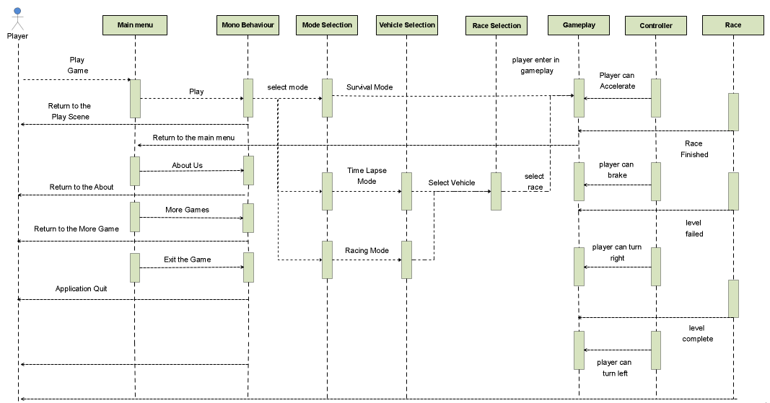

Figure 2: Sequence Diagram

Class Diagram
In software engineering, a class diagram is a type of structural diagram that represents the structure of a system by presenting different elements of the classes in a specified manner, their attributes, actions (procedures), and links. Classes of Extreme Racing Rush are:

- Bullet Trigger
- Mode Selection
- Race Selection
- Garage Manager
- Main Menu
- Complete
- Scene Manager
- Splash
- Load Scene Manager
- Sound Manager
- Car Controller Survival
- Disable Object After Delay
- Navmesh Agent
- Finish Trigger

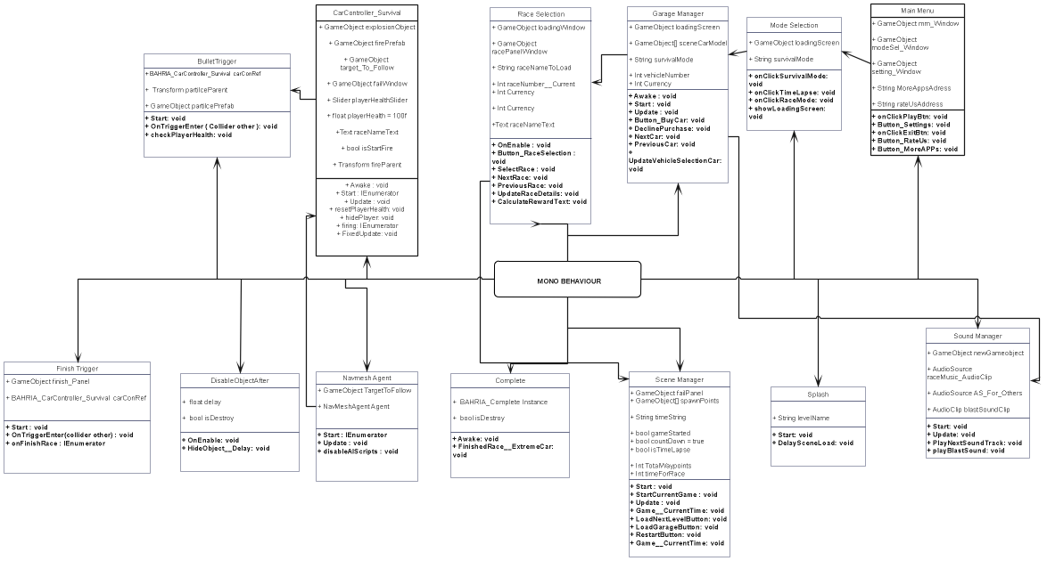

Figure 3: Class Diagram

Use Cases

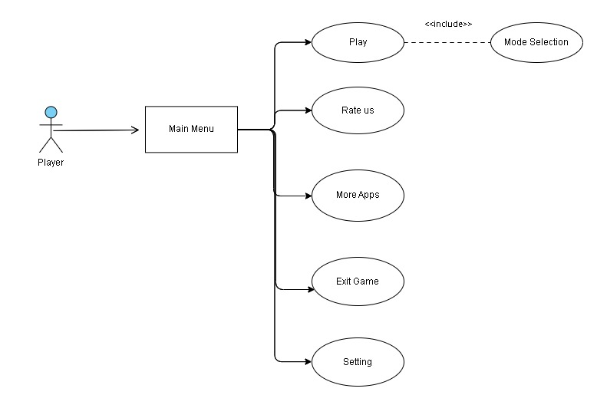
Use Case 1 (Play Game)

Figure 4: Use Case (Play Game)

Name: | Play Game
Actor: | Player
Entry Conditions: | Application is running.
Flow of Events: | By clicking the Play button, player enter in Mode Selection.
Exit Conditions: | Game is now in a playable state.

Table 1: Play Game

Use Case 2 (Rate Us & More Games)

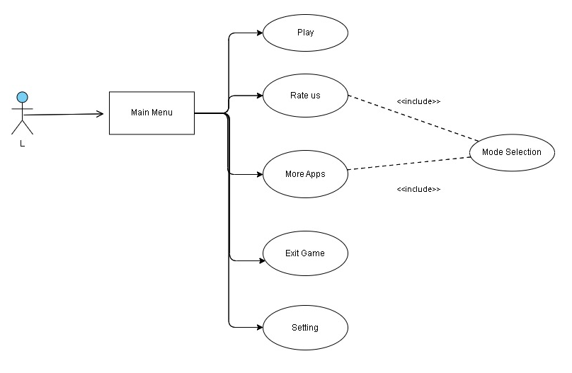

Figure 5: Use Case (More Games & Rate Us )

Name: | More Games & Rate Us
Actor: | Player
Entry Conditions: | Application is running.
Flow of Events: | Player clicks on rate us button to review the game by giving stars or by writing additional comments related to the game on play store and click on more apps button to land on the play store publisher account to check more related games.
Exit Conditions: | Game and developers’ info is displayed.

Table 2: More Games & Rate Us

Use Case 3 (Exit Game)
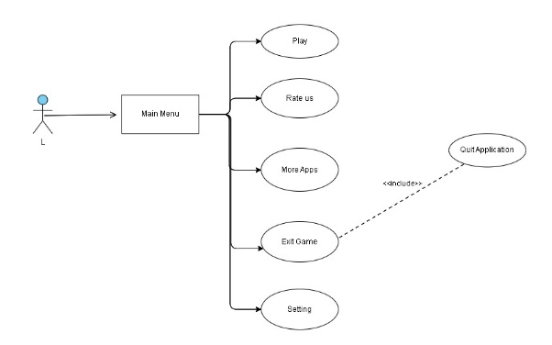

Figure 6: Use Case (Exit Game)

Name: | Exit
Actor: | Player
Entry Conditions: | Application is int running state.
Flow of Events: | - By clicking on exit button which calls Application. Quit function.
Exit Conditions: | Game is not in running state is not anymore.

Table 3: Exit Game

Use Case 4 (Setting Button)

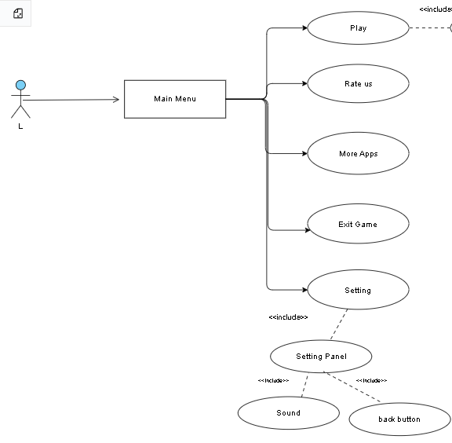

Figure 7: Use Case (Setting Button)

Name: | Setting Button
Actor: | Player
Entry Conditions: | Application is running.
Flow of Events: | Player can ON/OFF the sound of the game by clicking setting button.
Exit Conditions: | Game is in a playable state.

Table 4: Setting Button

Use Case 5 (Survival Mode)
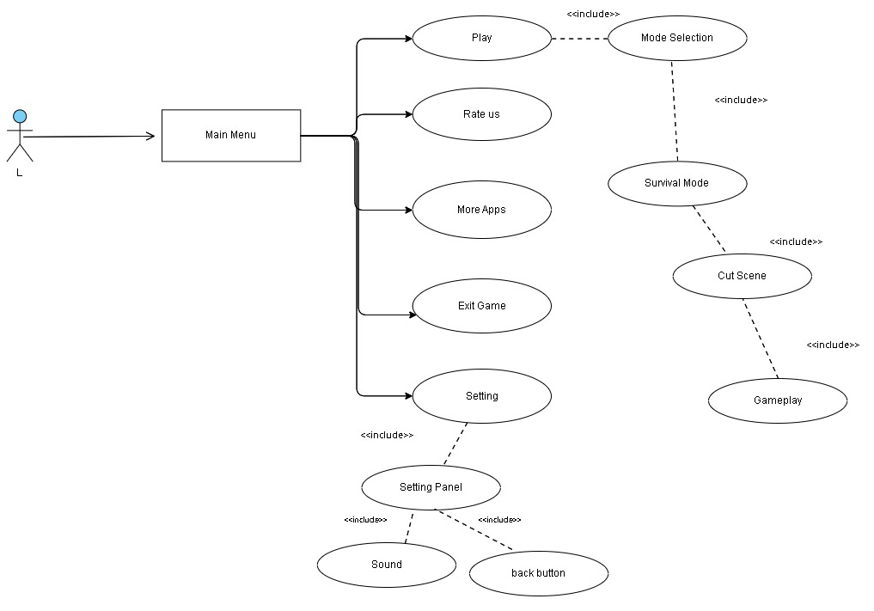

Figure 8: Use Case (Survival Mode)

Name: | Survival Mode
Actor: | Player
Entry Conditions: | Application is running.
Flow of Events: | In Survival mode, player will watch story cutscene and after its completion player will land into gameplay scene and must pick health boost up to survive the level.
Exit Conditions: | Player must complete level, otherwise level failed.

Table 5: Survival Mode

Use Case 6 (Time Lapse and Race Mode)
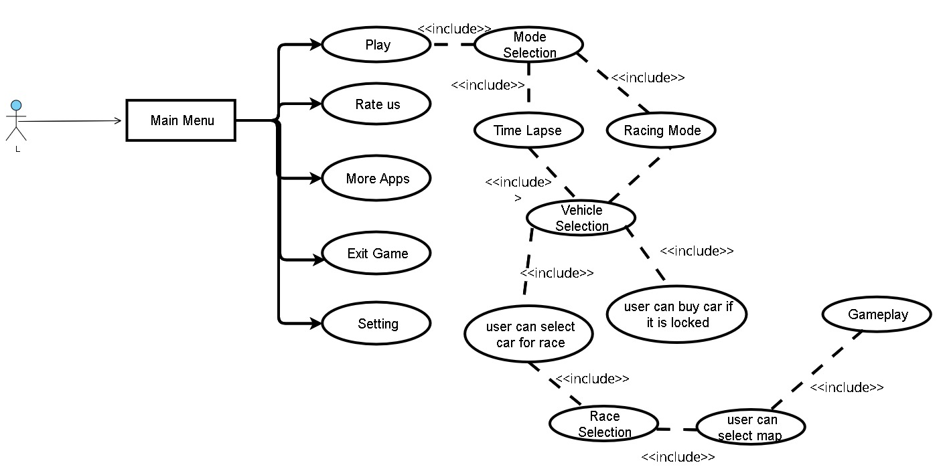

Figure 9: Use Case (Race and Time Lapse Mode)

Name: | Race and Time Lapse
Actor: | Player
Entry Conditions: | Application is running.
Flow of Events: | Player clicks on Race or Time Lapse Mode button to land on Vehicle selection, after selecting vehicle and race map, user would play the desired mode.
Exit Conditions: | Player must complete level, otherwise level failed.

Table 6: Race and Time Lapse

Use Case 8 (Pause Button)
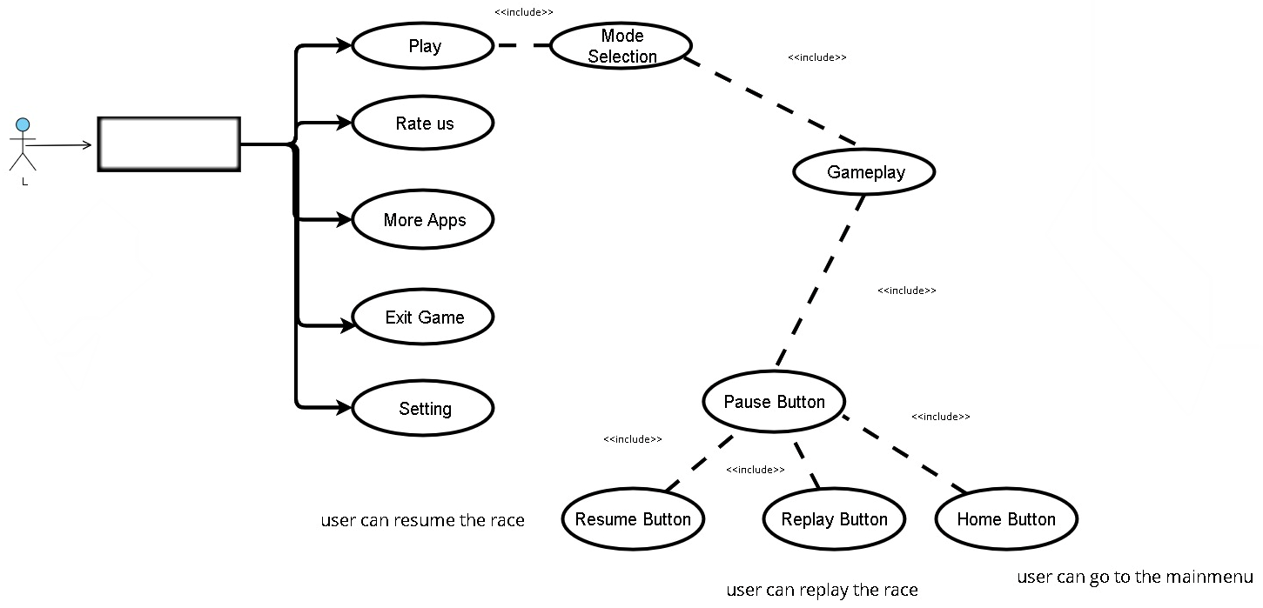

Figure 10: Use Case (Pause Button)

Name: | Pause Game
Actor: | Player
Entry Conditions: | Application is running.  Time. Timescale is approximately zero that’s why game is at pause state.
Flow of Events: | On Clicking pause button, player can pause the game.  Pause panel will appear with button so that user can go to the main menu, replay, and resume the race.
Exit Conditions: | Game is not in a playable state.

Table 7: Pause.

Use Case 9 (Level Complete & Level Fail)
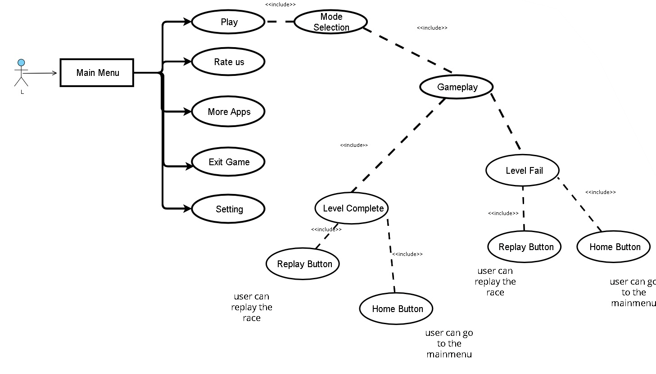

Figure 11: Use Case (Level Complete & Level Fail)

Name: | Level Complete & Level Failed
Actor: | Player
Entry Conditions: | Application is running.
Flow of Events: | Player must complete race level otherwise, race level will fail, and player would have to play again.
Exit Conditions: | Game is in a playable state.

Table 8: Level Complete & Level Failed

Feature Build-Development, Testing, Sample

The feature list is used to design functions. Game Engines like Game Physics and Graphics. The final product is the result of the interactive feature building process.

Testing: Each module is tested after development, and these modules are documented in the implementation chapter, with the results discussed in the results and user manual chapter, where you can examine every development process and task.

Setup: Tested modules are combined here to create a fully functional system. Integration testing involves logically integrating and testing software modules as a group. A typical application consists of multiple modules of software built by various programmers. The purpose of this level of testing is to uncover vulnerabilities in the interaction of multiple software components when they are integrated.

CHAPTER 4

IMPLEMENTATION

Introduction

This FYP game Project is the Racing game where we have a survival mode with story line, Time Lapse and Racing Mode with AI cars. Player can collect health boost ups to survive and when level completes, user get score. With the help of Feature driven development, it is being ensure that goals are met on time. The stages involved in the development of this project are as follows:

Story Board

In the beginning of this game, first splash loading screen will appear that takes 3 seconds to go to main menu scene. The main purpose of the loading screen is to load the essential components of the game in a proper execution order. In main menu we have different buttons i.e., play button, more games button, rate us / review button (these are for marketing purposes of the game) and exit button to quit the game. When the player clicks on Play game button, player moves to a Mode Selection Panel, in which user can play three Modes that are Survival, Time Lapse and Racing Mode. By Clicking on more games button, player switch to play store, where he/she can play more games from the publisher. Player can go to the play store by clicking on Rate us button so that he/she can review the game and the functionality of the exit button is to quit the game.

On the Mode selection screen, user has three modes to play. Each mode has different scenario to perform. First Mode is a survival base mode which includes a story cutscene. After the cutscene finished, player can pick health boost up to survive and go to the finish line by maintaining the heath. Enemy Ai car is attacking on the player vehicle and the health is deducting user must finish the race by maintaining the health to complete the level.

In the second mode, player would unlock the power of time and test your racing skills in the captivating Time Lapse mode. Player must finish the track in the desired time to finish the level Time Lapse mode, if the player failed to reach the finish line in the required time, then the race will be failed.

In the third mode, player can race with multiple AI Cars, there are different laps in this mode and player can race as AI cars become your rivals in the captivating Racing Mode, pushing you to unleash your inner racing champion.

Game Design and Development

Extreme Racing Rush game is developed in unity 3D and the game is a racing game. In the development of game, first I set up the Unity development environment and project structure then I made the splash screen, main menu of the game using unity UI package from the asset store and add functionality in the menu button using scripts/ from unity editor. Second, this game includes a mode selection scene that provide the player the choice of to play different modes of the game, user can play survival, time lapse and racing mode in this game. This game includes vehicle selection and race selection where user can choose different cars and maps to play. I make a controller for handle the movements of Ai car by using the Navmesh components in unity that is shooting on the player car and camera follow in which multiple scripts are written. Game environment is taken from sketchfab. Car Controller, AI Car controller and Waypoint package download by Unity Asset Store.

Do Tween

Do Tween is a C#-optimized, quick, efficient, fully type-safe object-oriented animation engine for Unity. It is free and open-source, and it contains many advanced features. It is also an evolution of my previous Unity tween engine, HO Tween. DO Tween is 400% faster, more efficient, type-safe, eliminates wasteful GC allocations, and adds additional shortcuts and features.

Cinemachine

Providing AAA game grade controls for each camera in your project, Cinemachine is a modular camera tool suite for Unity. It's a simple plugin that lets you add functionality to existing cameras or develop new ones with incredible features.

Cinemachine is designed to be the whole unified camera system in your project, but it can also work in tandem with your existing cameras. If you already have a bunch of camera gear going and just want to utilise Cinemachine for cutscenes or whatever, that's ok. When used throughout your project, however, it allows you to blend any camera to any other camera in a seamless transition from gameplay to cutscene and back.

Particle Pack – Unity Technologies
A collection of sample particle assets to use in your projects. Here we’ll get fire, explosions, ice, dissolves, and other awesome effects FREE to use in projects.

Cross Platform Input

Cross Platform Input is a multi-touch, accelerometer, keyboard, mouse, and gaming controller input system. Without touching a single line of code, you can create a cross-platform game! On-screen controls can include buttons, joysticks, steering wheels, track pads, and super touch zones. Virtual keys, named buttons, and axes can all have different touch control states assigned to them. The pack's most complex control type, Super Touch Zone, allows you to bind any imaginable finger gesture.

A single-finger touch, for example, can simulate a right mouse button click, three fingers swiping horizontally can emulate a mouse scroll wheel, and a two-finger twist motion can be tied to an analogue axis that spins the camera!

Car Controller Package

It offers ready-to-use drag-and-drop vehicle prefabs. Drag-and-drop vehicle prefabs are included in the Stylized Vehicles bundle. Designing a realistic car has never been simpler but by using this package, it simply takes around 5 minutes to build a completely functional vehicle. With a single click, you may change controllers, behaviors, and settings. It is easy to use and highly versatile. It comes with pre-programmed vehicle behaviors. PC, Mac, Android, and iOS have all been tested. You can spawn more cars at a specified point, customize, operate, or change behavior with just one line of code.

Road Models

The asset consists of road meshes and road models including roadside probes, each with one LOD (Level of Detail).
1. Road Models
2. Road Barriers
3. Roadside Separators

Player Model

I utilised the Unity Asset Store's Adventure Character, which is essentially a character in the adventure style.
- The character has a little customization.
- The character has no animations but has a humanoid.

Car Models

Most of the car models used in this game are free models from the Unity Asset store, few of them are listed below:
- Project Car - Defender
- Super mini car model by WITS Games
- Touring Racing Car Pack

Sky Series Freebie

The sky series bundle includes 16 free hdri images.

One free HDR from each current theme, with a sneak peek of future themes in the works.

• Daylight • Sundown • Sunless • Midnight • And more

Race Gamer Soundtrack

Many people must be impressed by the world of loud and roaring speedway race music. This collection includes 16 background music recordings.

Excellent choice for productions with racing scenarios.

CHAPTER 5

RESULTS AND USER MANUAL

Results and User Manual

In results, we show the outputs of the splash screen, main menu, level selection, and game play and show the output of controller. In user manual, we show the user “how to play the game”.

Splash Screen

First, we have a splash scene when initiate game, basically it’s a loading screen consist of a slider and logo, you must wait for some seconds and then main menu scene will appear.

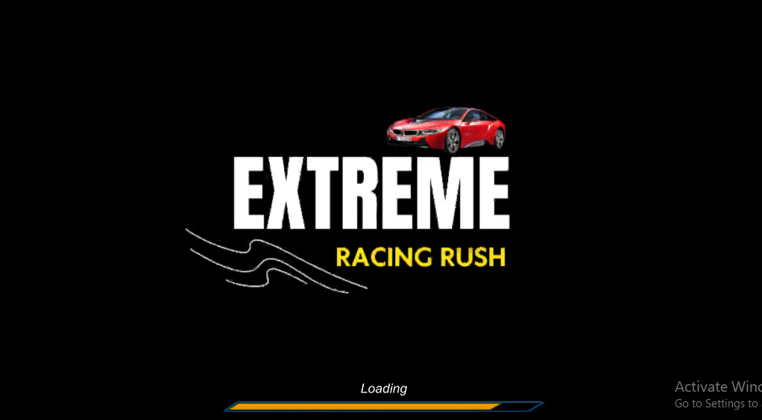

Figure 12: Splash Screen

Main Menu Screen

Main menu screen consists of 4 buttons each having unique functionality. User can play game, rate the game, play more games from the publisher using more games buttons and quit the game. The buttons of main menu given in below figure.

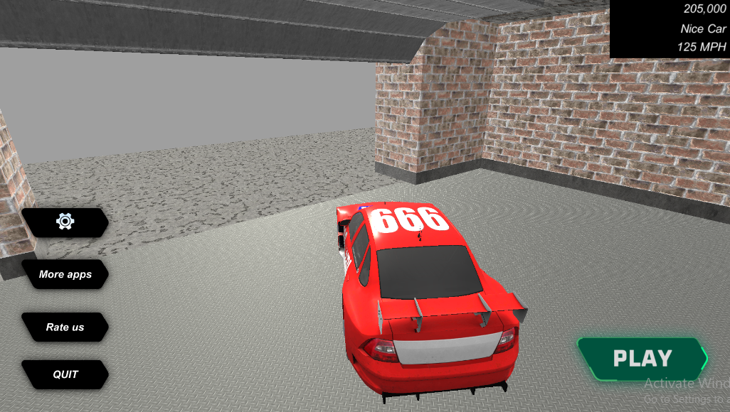

Figure 13: Main Menu Screen

Mode Selection

In Mode selection screen user can select modes from 1 to 3. mode has different tasks to perform.

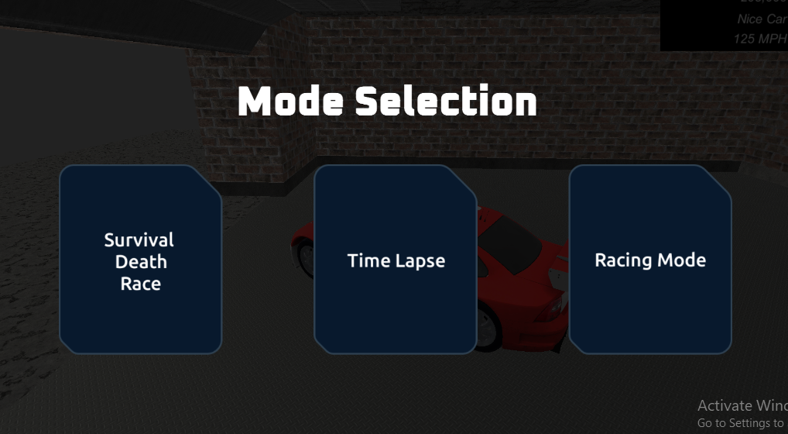

Figure 14: Mode Selection Screen

Vehicle Selection

In Vehicle selection screen user can select vehicle tor race. User can purchase the vehicle if it is locked by earning rewards.
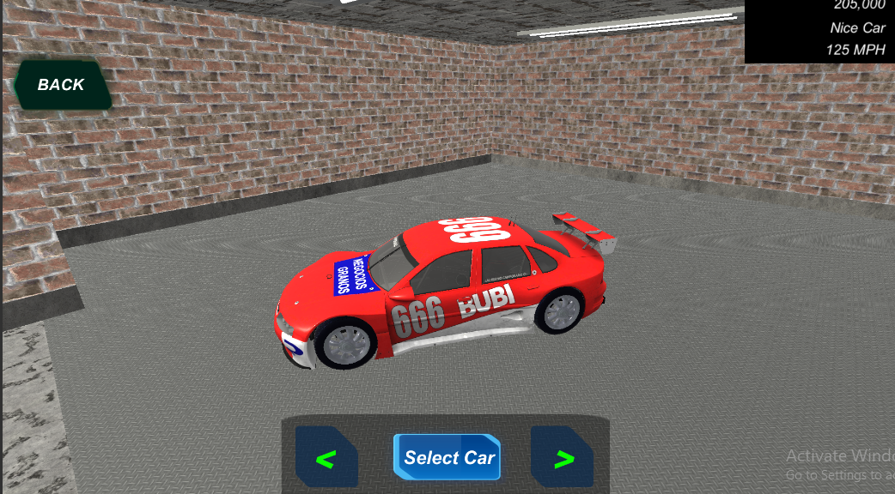

Figure 15: Vehicle Selection Screen

Race Selection

In Race selection screen user can choose race map tor race.
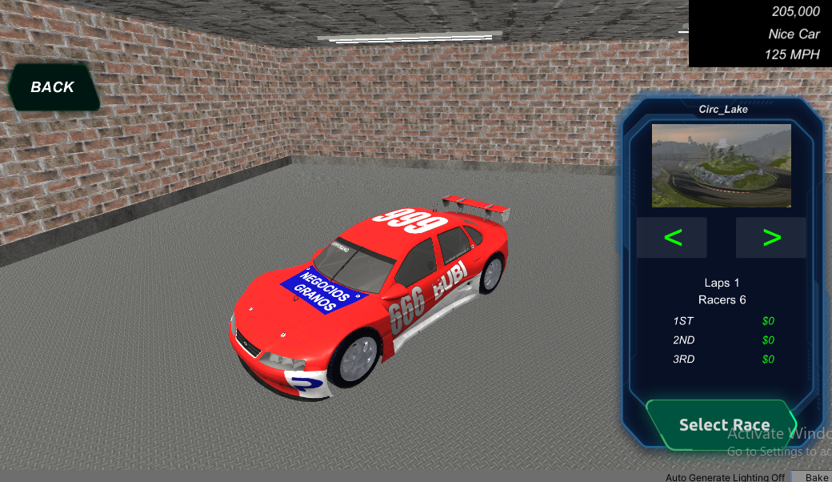

Figure 16: Race Selection Screen

Gameplay Controls

Gameplay is the way in which players engage with a game, particularly video games. Gameplay is the pattern set by the game rules, the connection between the player and the game, the problems and how to overcome them, the plot and the player's relationship to it.

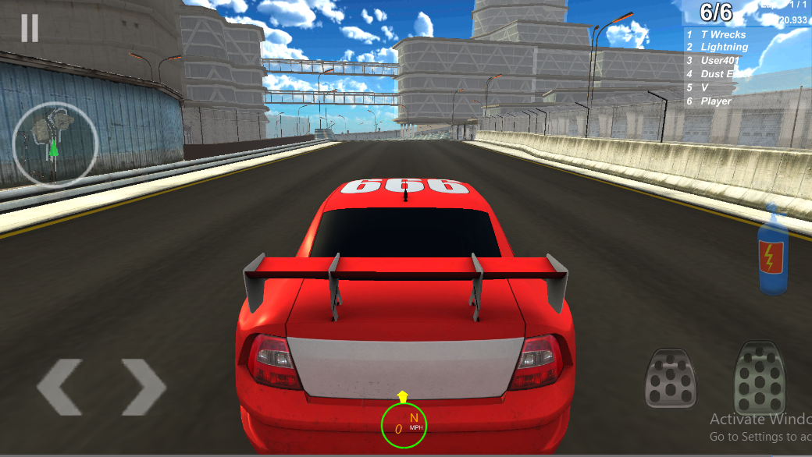

Figure 17: Gameplay Screen

How to Play

In this scene, user follow the instruction given move around anywhere in the environment, these instructions give help to user “How to play” the game.

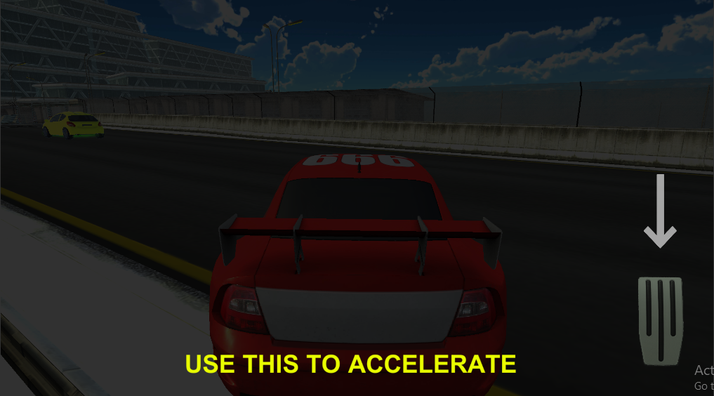

Figure 18: Use this Accelerate the car.
In this mock up, by pressing this button, player can move the car vertically forward, these instructions give help user to play the game.

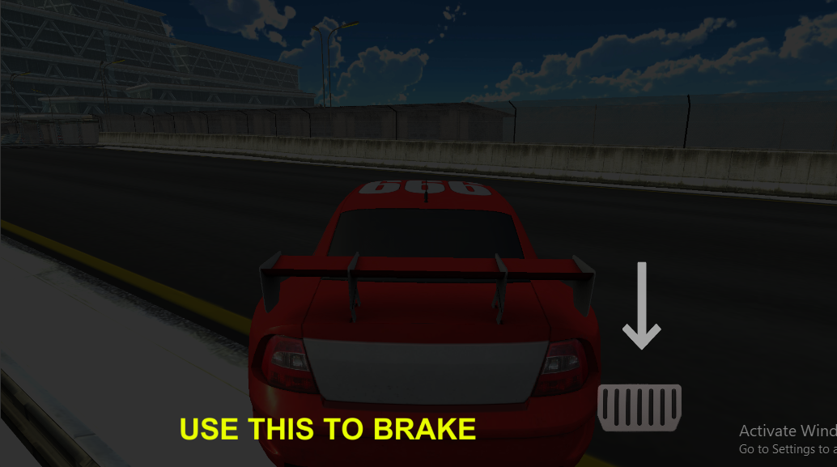

Figure 19: Use this to apply brake to car.
In this mock up, by pressing this button, player can apply brake to the car vertically backward, these instructions give help user to play the game.

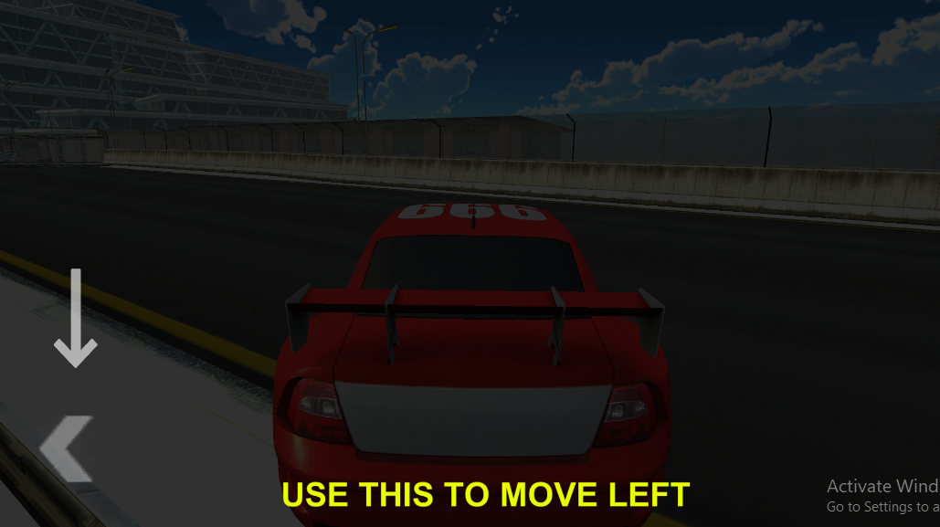
Figure 20: Use this to turn left.

In this scene, player learn how to move the car horizontally, tutorials tell user to move car from left to right by given instructions, which display in the screen.
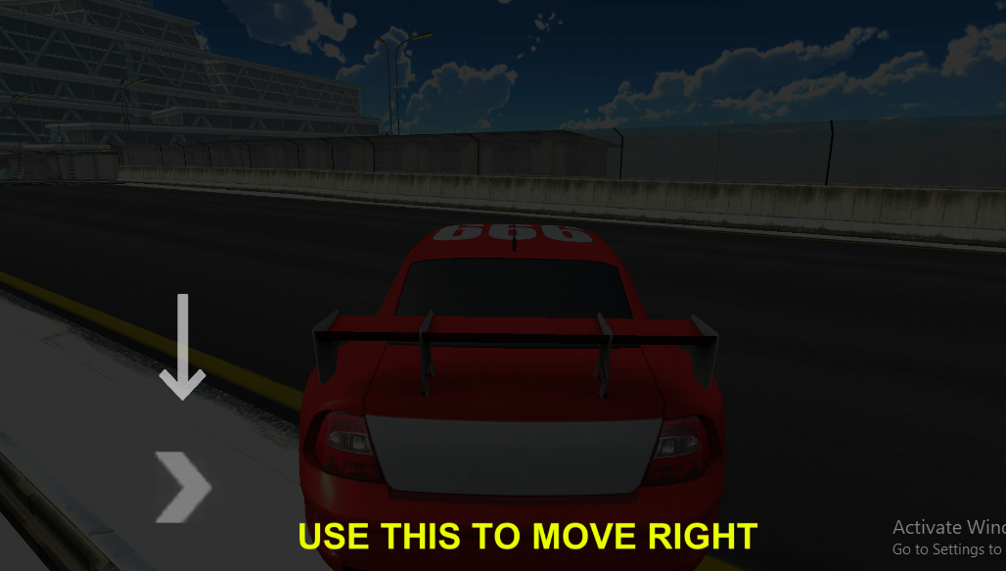

Figure 21: Use this to move right.

In this scene, player learn how to move the car horizontally, tutorials tell user to move car from right to left by given instructions, which display in the screen.

CHAPTER 6

CONCLUSION AND RECOMMENDATIONS

Conclusion

In conclusion, players can have an immersive and exhilarating experience with the Unity 3D car racing game. The game gives intriguing challenges and possibilities for players to demonstrate their racing talents through its numerous game modes, which include Time Lapse and Racing Mode with AI cars.

The game's emphasis on improving thinking skills, problem-solving abilities, and decision-making abilities through racing gameplay provides educational value for players, especially children. Players can enhance their cognitive abilities while having fun by navigating through different maps, avoiding hazards, and competing against opponents.

In future seasons, I can include a limitless number of real-life chase stories. The game includes a splash screen, main menu, mode selection, vehicle selection, race selection, loading screens, and cutscene play.

Recommendations
Based on our recommendations, create a 3D virtual game that collects and interprets the player's hand motions and acts accordingly in the game. The leap motion tracker device is used to precisely capture the gestures of the hand motions. It is extremely excellent in recording the motion of the hands. This type of mechanics is already being used in the new PC games and the mobile device serves as a display for the game in a VR device.

The user receives feedback from the virtual world in addition to providing input to the game. Some other suggestions for this game would be:
- Online Leader boards and Tournaments
- Upgrades and Customization of Car Components
- Optimized AI
- Expanded Track Selection
- Additional Game Modes
- Player Feedback and Iteration

REFERENCES

[1] | I. Zamojc, Introduction to Unity3D, 2012, May 17.
[2] | Taciane Martimiano, “Best Racing Game Tutorials – Cars, Tracks, and More,” 2023. [Online]. Available, https://gamedevacademy.org/best-racing-game-tutorials/.
[3] | JON GILBERT, Best racing games on Android in 2023, 2023, Feb 27.
[4] | Feature driven development (FDD), December 14, 2022.
[5] | Unity Particle System, 2021
[6] | Demigiant.com, DOTween, December 14, 2021.
[7] | Unity3d.com, About Cinemachine, March 10, 2022.
[8] | Cross Platform Input, Unity Technologies, 2020.
[9] | Skethfab.com, Road Models .

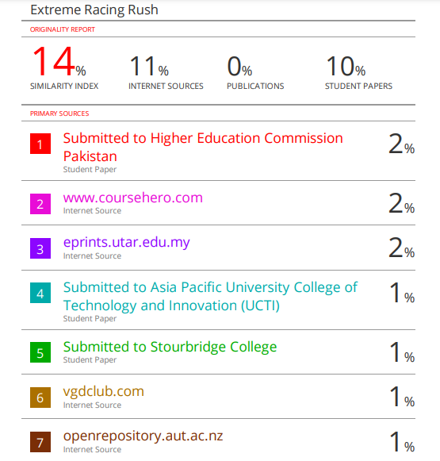
Figure 22: Plagiarism Report

