
BSCS-F22-03

03-134192-003 | ABDUL BASIT

Software Requirements Categorization Using NLP Techniques

In partial fulfilment of the requirements for the degree of
Bachelor of Science in Computer Science
Supervisor: Nadeem Sarwar
Department of Computer Sciences
Bahria University, Lahore Campus
June 2023

© Bahria University, 2023

Certificate

We accept the work contained in the report titled
“Software Requirements Categorization Using NLP Techniques”
written by
Abdul Basit
as a confirmation to the required standard for the partial fulfilment of the degree of
Bachelor of Science in Computer Science.

Approved by:
Supervisor: Nadeem Sarwar
(Signature)

June 20, 2023

DECLARATION

I hereby declare that this project report is based on my original work except for citations and quotations which have been duly acknowledged. I also declare that it has not been previously and concurrently submitted for any other degree or award at Bahria University or other institutions.

Enrolment | Name | Signature
03-134192-003 | Abdul Basit

Date : June 20, 2023

Specially dedicated to
my beloved grandmother, mother and father
(Abdul Basit)

ACKNOWLEDGEMENTS

I would like to thank everyone who had contributed to the successful completion of this project. I would like to express my gratitude to my research supervisor, Mr. Nadeem Sarwar for his invaluable advice, guidance and his enormous patience throughout the development of the research.

In addition, I would also like to express my gratitude to my loving parent and friends who had helped and given me encouragement.

ABDUL BASIT

Software Requirements Categorization Using NLP Techniques

ABSTRACT

Categorizing software requirements is a crucial aspect of software engineering, given the rising need for software worldwide. However, manual categorization is prone to errors and can be time-consuming, leading to a need for more efficient and accurate methods. To address this challenge, a research project was conducted to identify the most effective approaches for acquiring and categorizing software requirements. The study compared several natural language processing techniques and machine learning algorithms and found that the Bag of Words method followed by the Multinomial Naive Bayes algorithm provided the best results with an F-measure of 0.93.

The findings of the study have practical implications for software engineers, enabling them to better understand the requirement categorization process and improve the accuracy of their models. Additionally, the study's proposed future work in enhancing the approach and tweaking algorithms could lead to more efficient categorization of software requirements, with significant impacts on the software industry.

In conclusion, the research project provides valuable insights into improving the process of categorizing software requirements, paving the way for faster and more accurate software development. The study's findings can inform further research in the field of natural language processing and machine learning, and the proposed future work could lead to even more efficient and accurate categorization methods in the future. Overall, the project represents a significant step towards more efficient and accurate software development processes.

TABLE OF CONTENTS

DECLARATION ii
ACKNOWLEDGEMENTS iv
ABSTRACT v
TABLE OF CONTENTS vi
LIST OF TABLES ix
LIST OF FIGURES x
LIST OF SYMBOLS / ABBREVIATIONS xi

CHAPTERS
1 INTRODUCTION 1
1.1 Motivation 2
1.2 Research GAP 3
1.3 Problem Statement 4
1.4 Research Questions 4
1.5 Aims and Objectives 5
1.6 Machine Learning 5
1.6.1 Multinomial Naive Bayes 6
1.6.2 Support Vector Machine 6
1.6.3 Logistic Regression 7
1.6.4 Gradient Boosting Decision Trees 7
1.6.5 K-Nearest Neighbors 7
1.6.6 Neural Networks 8
1.7 Scope of Project 8
2 LITERATURE REVIEW 10
2.1 Literature Review Summary 25
2.2 Conclusion 35
3 METHODOLOGY 36
3.1 Proposed Methodology 36
3.2 Data Collection 37
3.3 Data Pre-processing 40
3.3.1 Text Cleaning 40
3.3.2 Tokenization 41
3.3.3 Stopwords 42
3.3.4 Lemmatization 42
3.3.5 Normalization 43
3.4 Feature Extraction 45
3.4.1 TF-IDF 46
3.4.2 Bag of Words 46
3.5 Feature Selection 47
3.5.1 Chi-Squared 48
3.5.2 Principal Component Analysis 49
3.6 Model Selection and Training 51
3.6.1 Hyperparameter tuning & Cross Validation: 52
3.7 Model Evaluation 54
3.7.1 Performance Metrics 55
3.8 Chapter Summary 58
4 DATA AND EXPERIMENTS 60
5 RESULTS AND DISCUSSIONS 62
5.1 2-class classification 62
5.2 11-class classification 64
5.3 12-class classification 65
5.4 Confusion Metrics 67
5.4.1 2-class 67
5.4.2 11-class 67
5.4.3 12-class 68
5.5 Comparative Analysis 69
5.6 Web Application 70
5.6.1 Home 70
5.6.2 About Page 71
5.6.3 History 72
5.6.4 Contact 72
5.6.5 Login/Sign up 73
6 CONCLUSION AND RECOMMENDATIONS 74
6.1 Future work 75
REFERENCES 76

LIST OF TABLES

TABLE TITLE PAGE
Table 2.1: Literature Review Summary 25
Table 3.1: Dataset count 38
Table 3.2: Chi-squared selected features 49
Table 3.3: 10 most important features (Chi-squared) 49
Table 3.4: PCA selected features 51
Table 5.1: 2-class classification 63
Table 5.2: 11-class classification 64
Table 5.3: 12-class classification 66

LIST OF FIGURES

FIGURE TITLE PAGE
Figure 2.1: Stages for requirements categorization 37
Figure 3.1: PROMISE vs. PROMISE_exp (2-class) 39
Figure 3.2: PROMISE vs. PROMISE_exp (12-class) 39
Figure 3.3: PCA explained variance 50
Figure 5.1: 2-Class classification 63
Figure 5.2: 12-Class classification 66
Figure 5.3: Confusion matrix (2-class) 67

LIST OF SYMBOLS / ABBREVIATIONS

Abbreviations Full form
FR Functional Requirement
NFR Non-Functional Requirement
BoW Bag of Words
TF-IDF Term Frequency-Inverse Document Frequency
ML Machine Learning
NN Neural Network
kNN k-Nearest Neighbors
GBDT Gradient Boosting Decision Trees
SVM Support Vector Machine
MNB Multinomial Naive Bayes
LR Logistic Regression
F-measure F1-Score
NLP Natural Language Processing
POS Part-of-Speech
PCA Principal Component Analysis
CV Cross-Validation
TP True Positive
TN True Negative
FP False Positive
FN False Negative
SDLC Software Development Life Cycle
SE Software Engineering
AI Artificial Intelligence

INTRODUCTION

Text classification is a crucial and common problem in supervised machine learning. There are various uses for classifying documents, including spam detection, email routing, text analytics, etc. Documents can be web pages, library resources, media stories, portfolios, etc. Text identification fundamentally involves classifying newly created documents based on the likelihood given by a certain training corpus of already labeled (recognized) documents. The approach may sound straightforward, and if there are only a few records, it is possible to manually study each one to determine which category it falls into. Using this information, it is feasible to classify or group documents into groups that are similar to one another. It becomes increasingly challenging when there are tens of thousands or millions of records to sort. In this situation, supervised or unsupervised learning methods and vectorization approaches are both beneficial[1].

There are two types of software requirements: functional and non-functional. Instead of outlining the actions that the system must take, non-functional constraints restrict software design[2]. Non-functional requirements also include a few additional subcategories, such as performance, maintainability, security, design, etc. Extraction, specification, verification, and viability analysis are all components of requirement engineering (RE). Due to its importance in reducing uncertainty and subsequent faults, RE is essential in software engineering[9]. To select the appropriate architecture that fulfils non-functional needs, examination of such requirements has become more important in the early stages of software development. Early non-functional requirements identification is crucial in the software development process, particularly during the design phase, to avoid costly revisions in later phases[3].

It remains difficult to classify natural language needs into functional requirements and subclasses of non-functional requirements automatically, even though software requirements are widely recognized and well documented. This is especially true given that consumers and requirements engineers utilize various terminology and grammatical constructions to convey the same sort of demand. Finding the best techniques to implement an accurate automated categorization is a challenge because of the high degree of variance in requirements elicitation[4]. Additionally, such classification is required since it takes a long time to manually classify software needs, especially for big projects with a significant number of requirements.

In this work, we investigate how to improve the categorization of requirement specification by assessing which NLP approach to applying, such as Bag of Words (BoW), Term Frequency, and Inverse Document Frequency (TF-IDF), and which machine learning method has the highest accuracy in the task of categorizing needs. The results of this experiment can be used as a benchmark or a guide for more research in this field, as well as to assist developers who wish to automate the software requirements categorization in selecting the methods and algorithms that will be most beneficial to them[5].

Motivation

In recent years, the area of machine learning has developed as a useful tool in a variety of fields, including natural language processing and pattern identification. Using machine learning techniques for software requirements classification has the potential to transform the software development process by providing an automated and more accurate approach of categorizing needs. By automating this important phase, we may considerably minimize human labour, increase productivity, and improve the overall quality of software systems.

This study was motivated by the need to bridge the gap between manual requirements categorization and the capabilities of machine learning techniques. We hope to provide a systematic and reliable strategy for effectively identifying software needs by investigating and creating effective machine learning models adapted to the particular characteristics of software requirements. Furthermore, our research aims to address the scarcity of thorough studies in this sector, where the available literature is restricted and lacks a unified framework for using machine learning approaches to needs categorization.

The findings of this study have the potential to help a wide range of software development stakeholders, including software engineers, project managers, and quality assurance specialists. We hope that our findings will help to promote software engineering methods, opening the path for more efficient and dependable software development processes. Finally, this study aims to bridge the gap between manual and automated requirements categorization techniques, enabling a paradigm change toward intelligent and data-driven software development methodologies.

Research GAP

Despite the rising relevance of requirements categorization in software engineering, there is no complete and unified framework for applying machine learning techniques explicitly to software requirements in the extant literature. While considerable research has been conducted into the application of machine learning techniques in related domains such as natural language processing and text categorization, there is a dearth of study dedicated to the particular problems and peculiarities of software needs.

Furthermore, the existing literature on requirements categorization depends mostly on manual approaches, which are time-consuming, subjective, and prone to mistakes. Although a few studies have addressed automated methodologies, they frequently lack scalability, fail to take into account the complexities of software requirements, or lack a comparative evaluation of various machine learning algorithms. This research gap emphasizes the necessity for a thorough exploration into the use of machine learning techniques for effectively categorizing software needs.

Additionally, previous research on software requirements categorization focuses on specific domains or types of needs, resulting in a lack of generalizability and restricted application to a larger variety of software projects. This gap in the literature necessitates a thorough evaluation of machine learning approaches capable of handling a wide range of software needs, including functional, non-functional, and domain-specific requirements.

Problem Statement

The categorization of software requirements is an important phase in the software development process, and the application of machine learning techniques has showed promise in automating and optimizing this work. However, extensive research on the usefulness of several NLP methodologies for vectorizing software requirements, such as "Bag of Words (BoW)" and "Term Frequency-Inverse Document Frequency (TF-IDF)," are lacking. Furthermore, in the context of software engineering, the performance of various machine learning methods for demand classification remains largely unexplored.

As a result, the challenge addressed in this research study is determining the best NLP technique and machine learning algorithm for appropriately categorizing software requirements. The project intends to address a gap in the literature by analysing and comparing various approaches for best methodologies for requirements categorization using machine learning. The study's findings will be useful to software engineers, project managers, and quality assurance specialists, resulting in more efficient and dependable software development processes.

Research Questions

The questions that this study seeks to address are as follows:
RQ1: Which NLP approach (“Bag of Words (BoW)” vs. “Term Frequency-Inverse Document Frequency (TF-IDF)” works best to vectorize software requirements?
RQ2: Which machine learning algorithm will perform best for the requirement categorization task?

Aims and Objectives

The objectives of the thesis are shown as following:
- To identify the most effective methods for acquiring and categorizing software requirements using natural language processing and machine learning techniques.
- To compare Bag of Words (BoW) and Term Frequency-Inverse Document Frequency (TF-IDF) approaches and determine the most effective technique for vectorizing software requirements.
- To evaluate the performance of machine learning algorithms, including Multinomial Naive Bayes (MNB), Support Vector Machine (SVM), Neural Network (NN), Logistic Regression (LR), Gradient Boosted Decision Trees (GBDT), and k-Nearest Neighbours (KNN) for the requirement categorization task.
- To provide a guideline for software engineers to better understand the requirement categorization process and improve the accuracy of their models.
- To propose future work in enhancing the approach and tweaking algorithms to increase the accuracy of the categorization process.
- To contribute to improving the speed and accuracy of software development processes, ultimately leading to improved software quality and customer satisfaction.

Machine Learning

Machine learning is an artificial intelligence discipline that focuses on developing algorithms and models capable of automatically extracting patterns and generating forecasts or assessments based on data. Machine learning enables computer systems to learn from and improve with experience without being explicitly programmed by applying statistical approaches and iterative learning procedures[13]. It entails using labelled or unlabelled data to train algorithms to detect and interpret complex patterns, which may subsequently be used for tasks including classification, regression, clustering, and recommendation systems. Machine learning has found applications in a variety of disciplines, transforming companies and boosting scientific research due to its capacity to handle massive volumes of data and unearth new insights.

Multinomial Naive Bayes

Multinomial Naive Bayes is a probabilistic classifier used in machine learning for text categorization. It is based on Bayes' theorem, which posits that given the class label, characteristics are conditionally independent. In text classification, each document is represented as a bag of words, with the frequency of occurrence of each word serving as a feature. Multinomial Naive Bayes computes the likelihood of a document belonging to a certain class by taking into account the prior probabilities of the classes as well as the conditional probabilities of each word given the class[14]. The document is then assigned to the class with the highest likelihood. Despite its basic assumptions, Multinomial Naive Bayes has demonstrated promising results in a variety of applications, notably in text-data problems, because of its efficiency and scalability.

Support Vector Machine

In machine learning, Support Vector Machines (SVM) is a sophisticated and commonly used supervised learning technique. It is mostly utilized for classification jobs, although it may also be used for regression and outlier identification[15]. SVM seeks an ideal hyperplane that separates data points from various classes while maximizing the margin between them. SVM turns the challenge into finding the best linear separator by translating the input data into a high-dimensional feature space. This is accomplished by locating a subset of training samples known as support vectors that are closest to the decision boundary. SVM optimizes a margin-based objective function to maximize the model's generalization capabilities. SVM can handle complicated, nonlinear decision boundaries using kernel functions that implicitly translate the input to a higher-dimensional space. Because of its capacity to handle high-dimensional data and resistance against overfitting, SVM has shown to be beneficial in a variety of applications.

Logistic Regression

Logistic Regression (LR) is a prominent statistical model used in machine learning for binary classification tasks. It is a linear method that calculates the likelihood of an input belonging to a specific class. LR works by fitting a logistic function to the training data, which transfers the linear combination of input characteristics to a value between 0 and 1, signifying the likelihood of the input falling into the positive class. Maximum likelihood estimation is used to learn the model parameters while maximizing the log-loss function[26]. LR may be interpreted and offers information about the significance and direction of each feature's contribution. Because of its simplicity, efficiency, and capacity to handle enormous datasets, it has been widely employed in a variety of industries, including healthcare, finance, and marketing. Furthermore, utilizing approaches such as one-vs-rest or softmax regression, LR may be expanded to handle multi-class classification challenges.

Gradient Boosting Decision Trees

Gradient Boosting Decision Trees (GBDT) is a sophisticated and commonly used machine learning ensemble learning technique. To develop a powerful prediction model, GBDT combines the strengths of decision trees with boosting. It works by generating an ensemble of weak decision trees iteratively, with each succeeding tree trained to rectify the faults caused by the prior ones. GBDT minimizes a loss function during training by determining the negative gradient of the loss with respect to the anticipated values. This gradient information is utilized to update model parameters such as decision tree weights and leaf values[33]. GBDT builds a powerful model that can represent complicated links and interactions in data by iteratively adding trees. GBDT has exhibited remarkable performance in a variety of areas, notably structured data problems, and it has been extensively used because of its high accuracy, interpretability, and resilience against overfitting.

K-Nearest Neighbors

A basic yet powerful machine learning model called K-Nearest Neighbors (KNN) and is a pattern recognition technique. It is a non-parametric and lazy learning method that produces predictions based on the majority vote of the feature space's k nearest neighbors. KNN calculates the distance between a new input and all existing data points in the training set given a new input. The shortest distance is used to identify the k nearest neighbors. In classification tasks, the new input's class label is assigned based on the majority class among the k neighbors. In regression tasks, the prediction is the average of the k neighbors' target values. KNN is adaptable and can handle complicated patterns in data, although it may be computationally expensive for large datasets. However, because of its simplicity, interpretability, and ability to identify local patterns in data, it remains a popular option.

Neural Networks

Neural networks, also known as artificial neural networks or simply neural nets, are a machine learning model that takes inspiration from the structure and functioning of biological brains. They are made up of linked nodes called neurons that are structured in layers. Each neuron takes inputs, performs an activation function to generate an output, and then transmits it to the next layer. Neural networks may learn to approximate complicated functions by altering the weights and biases associated with the connections between neurons, a process known as forward propagation. This is accomplished by minimizing a predetermined loss function using optimization methods such as stochastic gradient descent. Image and audio recognition, natural language processing, and reinforcement learning have all demonstrated exceptional results using neural networks[13]. Their capacity to develop hierarchical representations from raw data and catch complicated patterns makes them a great tool for addressing challenging machine learning and artificial intelligence challenges.

Scope of Project

The objective of this project is to identify optimal methods for acquiring and categorizing software requirements by leveraging natural language processing and machine learning techniques. The project seeks to address the challenges associated with manual categorization of software requirements, which can be time-consuming, costly, and error-prone. Various approaches are compared, including Bag of Words, Term Frequency-Inverse Document Frequency, Logistic Regression, Gradient Boosted Decision Trees, Naive Bayes, Support Vector Machine, and k-Nearest Neighbors, in order to determine the most effective technique for software requirement categorization. The study utilizes the PROMISE exp dataset, comprising software requirements records, and employs normalization and feature selection methods to enhance the dataset's accuracy.

The findings of the project provide a guideline for software engineers to better understand the requirement categorization process and improve the accuracy of their models. Furthermore, the study's future work in enhancing the approach and tweaking algorithms could lead to more efficient categorization of software requirements. The impact of this project could be significant, improving the speed and accuracy of software development processes, ultimately leading to improved software quality and customer satisfaction.

LITERATURE REVIEW

The area of software requirements categorization has received a lot of attention because of its relevance in understanding and organizing software requirements. The necessity for effective and automated ways of identifying requirements has become critical as the complexity of software systems has grown. Machine learning algorithms have emerged as promising techniques for classifying data. The purpose of this literature review is to offer an overview of the research that has been done in the field of software requirements categorization using machine learning techniques. This study investigates the numerous machine learning algorithms deployed, their efficacy, and the lessons learned from their implementation by analysing a variety of articles, including systematic literature reviews and empirical research.

The paper by Xianchang Luo et al. developed a unique technique for software requirement classification called “PRCBERT (Prompt Learning for Requirement Classification Using BERT)”. Existing efforts in this sector have used machine learning techniques such as SVM and decision trees, but they have drawbacks such as old datasets and potentially outmoded NLP methodologies. PRCBERT tackles these challenges by utilising BERT-based pretrained language models and configurable prompt templates to ensure correct demand categorization. The authors perform tests on small datasets (PROMISE and NFR-Review) as well as a big dataset (NFR-SO) that they gathered. The results show that PRCBERT outperforms previous techniques such as NoRBERT and MLM-BERT, with somewhat superior classification performance. Furthermore, when using a self-learning technique on “de-labeled datasets (NFR-Review and NFR-SO)”, the fine-tuned version of “PRCBERT (Trans_PRCBERT)” achieves good zero-shot performance with F1-scores of 53.27% and 72.96%, respectively.[1]

Derya Kici et al. conducted research on the significance of text categorization in Software Requirements Specifications (SRS) papers and its different uses in software development. While machine learning algorithms have been tried for text categorization in SRS documents, many of them perform poorly due to a lack of attention for the meaning of software artefacts and domain knowledge integration. Deep learning approaches have showed potential in Natural Language Processing (NLP) and text categorization, notably those based on pre-trained transformer models such as “BERT, DistilBERT, Roberta, ALBERT, and XLNet”. However, the lack of labelled data and the resource-intensive training procedure make applying deep learning models to software engineering tasks difficult. Transfer learning, which entails fine-tuning pre-trained models using customized input, provides a solution to these problems. The research offers an empirical study of multi-class text categorization utilizing several pre-trained transformer models using DOORS, NFR-PROMISE, and PURE SRS datasets. Except for the Priority of needs, the findings show that transformer models obtain good accuracy in identifying most categories. While the models achieve 80% or greater accuracy in other classification tasks, they only achieve 60% accuracy in categorizing Priority[2].

Anish et al. suggests another study that focuses on the classification of business rules (BRs) during the requirements elicitation phase of the software development life cycle. It uses Ross's BR classification schema and presents a method for automatically labeling and classifying BRs using this schema. Data Programming (DP) is utilized to produce labeled training data, which is subsequently used to train two deep learning-based models for BR classification. According to the data, the technique obtains an average labeling accuracy of 0.73 for all BR classes when utilizing DP. When tested on an industry-specific dataset, the strategy with a “Bi-LSTM with an attention-based model” achieves the greatest weighted F-score (0.69)[3].

The researchers did another study that tackles the critical issue of identifying ambiguous software requirement specifications (SRS) documents, which can lead to requirement misunderstanding and have an influence on testing activities, project deadlines, and costs. The research provides an automated strategy that uses text mining and machine learning approaches to identify unclear requirements from industrial SRS documents in the Malaysian setting. Text mining is used to extract features and prepare the training set, allowing the learning process to identify unclear requirements. The study compares nine machine learning classification methods to discover the best effective approach for detecting ambiguity in software requirement specifications. Based on the experimental results, a functional prototype is created and tested, yielding relatively acceptable classification model results[4].

Some academics tackled the problem of extracting “Non-Functional Requirements (NFR)” from Software Requirement Specifications (SRS) in order to facilitate successful software development. The research emphasises the issue of combining functional and non-functional requirements inside the same document, making differentiation difficult. Previous attempts that used supervised machine learning algorithms encountered issues in word representation and necessitated human feature engineering. The suggested study provides a method for NFR classification by using “Recurrent Neural Network (RNN)” variations, notably LSTM and GRU. The requirements are pre-processed to eliminate extraneous text, and word2vec is utilised to extract features for use as input to the RNN models. Using the PROMISE dataset, the models' performance was tested, and LSTM surpasses CNN and GRU models, with “accuracy, recall, and F1-scores of 0.973, 0.967, and 0.966”, respectively. LSTM is also capable of properly classifying 60% to 80% of unseen needs. The accuracy of “LSTM” is 6.1% higher than that of “GRU”, demonstrating that “RNN” variants are effective for NFR classification from textual requirements [5].

Another study emphasizes the significance of obtaining Non-Functional Requirements (NFRs) from user feedback in order to assist developers in improving their mobile applications. With millions of programs accessible on major distribution platforms, user evaluations include useful information that may help with software maintenance and evolution. The study suggests an automated categorization technique for user evaluations, classifying them into “NFRs (reliability, usability, portability, and performance)”, “Functional Requirements (FRs)”, and Others. To categorize user reviews, four classification approaches (“BoW, TF-IDF, CHI2, and AUR-BoW”) are integrated with three machine learning algorithms (“Naive Bayes, J48, and Bagging”). The experimental findings show that combining “AUR-BoW with Bagging” yields the best results, with an “accuracy of 71.4%”, “recall of 72.3%”, and “F-measure of 71.8%”. This conclusion shows that enhanced user reviews improve classification results, and the Bagging method is more suited for NFR classification from user reviews than “Naive Bayes” and “J48”[6].

Another study deals with the issue of a lack of stakeholder participation in the requirements elicitation process by offering a unique method for extracting software requirements information from web news. Traditional data sources, such as business processes and software documentation, may not represent the whole range of stakeholder demands, according to the report. The suggested method makes use of user stories, which are prevalent in agile software development, and focuses on extracting the "who" (stakeholder), "what" (functional), and "why" (reason) components of online news. To improve comprehension of software functioning, domain specificity is used, and software-specific vocabulary is developed from SRS documents and web news sources. “Part-of-speech (POS)” tags are used to extract information about software needs. The experimental findings show that the suggested method enhances “accuracy and recall”, with average values of 0.56 and 0.579[7].

Another study highlights the necessity for software engineering artifacts, especially tasks, to be classified in order to ease analysis and research. The authors emphasize the importance of proper classification in post-mortem analysis, life cycle modeling, and software metrics. They draw attention to the issue of erroneous or missing categorical properties in software artifacts, such as outdated jobs that are not properly classified. To address this problem, the research proposes an automated task categorization technique based on machine learning. The approach is assessed using two sample project management systems, which categorize activities based on activity and significance. From the project history, the classifier learns project-relevant properties. The technique obtains excellent classification accuracies of 80.51% (six categories) and 83.72% (two categories) using five-fold cross-validation. According to the study, the suggested method may be used for different artifact kinds and categorizations inside a unified software engineering paradigm[8].

Another study by Fahrizal et al. emphasises the importance of requirements engineering in software engineering and the risk for mistakes during the specification stage. The problem of miscommunication between stakeholders and the inclusion of non-atomic requirements in specification papers is specifically addressed. To address this, the study provides a methodology for identifying non-atomic needs in plain language software specification requirements. The study entails developing a corpus of expert annotations comprising atomic and non-atomic needs, which will be utilised as training and test data. The Bayes Net method is used to build the best model after applying feature extraction and keyword generating approaches. Cohen's Kappa is used to compare the categorization model's performance to that of human annotators. The study indicates that the model detects non-atomic needs in software requirements specifications with medium reliability for non-balanced data and moderate reliability for balanced data. This study contributes to the area by providing a model for detecting non-atomic requirements, hence improving the quality and clarity of software specification documents[9].

Another study emphasizes the significance of software requirements in the development process as well as the difficulties involved with manual requirement classification. The study provides an automated solution to classifying software requirements that uses “Deep Learning (DL)” techniques, especially a “Convolutional Neural Network (CNN)”, without the need for labour-intensive feature engineering. The model is tested against the PROMISE corpus, which includes labeled criteria in both “functional and non-functional” areas. The CNN model results show good performance, with high “accuracy, recall, and f-measure” values across the different requirement classes. The suggested model exhibits stability in accuracy, recall, and f-measure, suggesting its robustness and consistency. This study contributes to the field by presenting an efficient and effective way for automating the software requirement categorization process using DL methods, eliminating the need for manual feature engineering and reducing human work. The findings show that DL techniques have the potential to improve the accuracy and efficiency of software requirement categorization activities[10].

Another study by Gaith et al. tackles the problem of automating the classification of software requirements in light of the increasing demand for software development. The manual categorization procedure is time-consuming, expensive, and prone to errors. Previous research attempted to automate the categorization process, but their methods were inadequate. This article proposes a strategy for automatically classifying software requirements into “Functional Requirements and Non-Functional Requirements” using machine learning. For experimentation, the PROMISE_exp dataset with labeled needs is utilized. The dataset is cleaned and prepared for classification using a number of pre-processing procedures. For classification, the Bag-of-Words (BoW) format is used with either the SVM or KNN algorithms. The findings show that combining BoW and SVM outperforms using KNN, with an average “F-measure” of 0.74 across all scenarios. The study offers useful insights and tools for further research in this field. The authors also state their goal to improve the approach by experimenting with alternative algorithms, such as Logistic Regression, to increase the model's accuracy. Overall, this research advances requirements categorization automation and opens the path for future breakthroughs in the sector[11].

Bing et al. work examines the problem of automatically extracting “non-functional requirements (NFRs)” from software requirements documentation, to reduce the effort, time, and cognitive load associated with this activity. For this goal, the authors suggest NFRNet, a revolutionary deep neural network model. They enlarge the widely used PROMISE dataset from 11 to 32 NFR categories, as well as the amount of NFR description statements. On the SOFTWARE NFR dataset, the suggested NFRNet model is tested using 10-fold cross-validation. When compared to other benchmark models, the experimental findings show that the NFRNet model obtains the greatest classification accuracy of 91.00%. The model's efficacy is ascribed to its use of N-gram Masking-based BERT, which captures character and word/sequence properties, and Bi-LSTM, which allows for a thorough grasp of the textual contexts by taking both past and future semantic information into account. This study adds to the automation of NFR extraction and gives insights into the suggested NFRNet model's enhanced accuracy and expressive capability[12].

The review article focuses on the use of “Artificial Neural Networks (ANNs)” to classify software needs. Fourteen publications were reviewed in order to offer an overview of the current state of the art on this topic. The review highlights sixteen alternative strategies for requirement categorization, the most notable of which are “ANN, Naive Bayes, and Support Vector Machine”. “Convolutional Neural Networks” and Shallow Neural Networks were the most often used ANNs. According to the review, seven techniques categorize both “functional and non-functional needs”, whereas six only classify non-functional requirements and one just functional requirement. Metrics such as “accuracy, recall, and F-score” were used to assess categorization performance. The evaluation finishes with a complete description of the results produced by the classifiers reviewed in the papers under consideration. In general, this work gives significant insights into the usage of ANNs for software needs categorization, as well as a complete overview of the current state-of-the-art approaches and metrics employed in this field[13].

Maria et al. investigated several combinations of text vectorization techniques and machine learning algorithms to discover the best effective way for needs categorization. Support Vector Machine (SVM) paired with TF-IDF produces the greatest f1-score (0.95 for functional classification and 0.79 for non-functional classification) according to the results. SVM combined with TF-IDF and the Bigram/Trigram approach outperforms both functional and non-functional classification. Other models with competitive f1-scores include Logistic Regression (LR), Convolutional Neural Networks (CNN), and BETO, whereas Naive Bayes (NB) and Gaussian Naive Bayes (GNB) perform slightly worse. All models, however, fail to detect and differentiate non-functional needs, resulting in lower f1-scores. Overall, this study advances the area of software requirements categorization in Spanish by providing useful insights into the best combinations of text vectorization approaches and ML algorithms for this purpose[14].

In software documentation, quality characteristics, interface requirements, and design restrictions are examples of non-functional requirements (NFRs), which Prateek et al.'s study highlight as being crucial to uncover. The authors emphasize the importance of automated NFR extraction and categorization in facilitating architectural decision-making and improving the production of high-quality software solutions. To identify and categorize requirement phrases into NFR sub-classes, the proposed approach employs a rule-based classification strategy that makes use of thematic roles. Furthermore, the extracted NFR phrases are prioritized by the algorithm based on their presence across several NFR classes within the content. The findings obtained on the PROMISE and Concordia RE corpora illustrate the efficacy of the suggested technique, with F1 measures of 97% and 94%, respectively. This surpasses earlier state-of-the-art techniques, proving that the suggested method produces more specific and higher-quality outcomes. The study adds to the automation of NFR extraction and categorization by offering a beneficial method for decreasing the human work, time, and mental fatigue associated with detecting particular needs from huge texts[15].

Researchers used a “Convolutional Neural Network (CNN)” model to solve the problem of categorizing software requirements into “functional and non-functional categories”. Manual requirement classification takes time, and the proposed CNN-BPSO model attempts to improve CNN performance by optimizing its “architecture, and embedding input word vectors, filter area size, and the number of filters using Binary Particle Swarm Optimisation (BPSO)”. The model is tested using the PROMISE corpus dataset, which includes both functional and non-functional needs. The results of the experiments show that the CNN-BPSO model beats the classic CNN model in terms of prediction accuracy for software needs categorization. The use of BPSO to optimize the CNN enables more accurate and efficient requirement categorization, making an important addition to the field of software requirement analysis. The suggested method has the potential to minimize the amount of human work necessary for requirement classification while also improving the overall software development process[16].

The difficulty of automatically classifying Non-Functional Requirements (NFR) in software requirement specifications is addressed in the study by Ariful Haque et al. Because of the mixed nature of functional and non-functional criteria inside the same document, identifying and categorizing them involves substantial human work. The research presents a mix of machine learning feature extraction and classification approaches to automate this procedure. A detailed empirical investigation comprising seven machine learning algorithms and four feature selection methodologies is carried out. Statistical analysis criteria such as “precision, recall, F1-score, and accuracy” are used to evaluate the studies. The SGD SVM classifier outperforms the others, with a precision of 0.66, recall of 0.61, F1-score of 0.61, and accuracy of 0.76. Furthermore, when compared to other approaches, the “TF-IDF (character level)” feature extraction methodology achieves better average scores. This study advances the area of software development by giving an automated approach to NFR categorization, minimizing the reliance on manual work, and improving the accuracy of recognizing and categorizing non-functional requirements[17].

The importance of requirements engineering in software development is emphasized by this researcher, as are the detrimental repercussions of weak requirement knowledge and classification. They recognize the difficulties in recognizing various types of needs and say that current research on requirements categorization has certain limitations. To solve these challenges, the study presents a hybrid strategy that automates the needs categorization process using artificial intelligence approaches, notably machine learning algorithms. The goal of picking algorithms from various categories is to increase the quality of the classification results. The notion of hybridization is offered as a way to improve individual classifier performance by integrating numerous classifiers. According to the researchers, this strategy can eliminate uncertainties and improve software development efficiency. The study gives useful insights into the possibilities of artificial intelligence approaches for enhancing needs categorization and makes recommendations for future research and development in this area[18].

Researchers have emphasized the significance of accurately defining system requirements in software development, as well as the difficulties involved with manual classification, particularly in large-scale systems. The study is concerned with the use of Machine Learning techniques to automate the requirements categorization process. Thirteen publications are examined, revealing information about the algorithms, training techniques, and assessment measures utilized in these investigations. Naive Bayes, Decision Trees, and Natural Language Processing techniques are the most often used classification algorithms. The training datasets are mostly made up of academic databases and user reviews. The study throws light on the present state of research in the use of Machine Learning for requirement categorization and gives useful information on the techniques and datasets typically used in this arena. These findings add to the current body of knowledge and can help guide future research toward building more efficient and accurate automated categorization systems for software needs[19].

The researchers proposed utilizing a deep learning-based algorithm to identify and classify Architecturally Significant Functional Requirements (ASFRs). ASFRs play an important role in software architecture and have a large influence on system design decisions. However, their clear architectural influence is frequently absent in requirement specification papers, making identification difficult. Traditional machine learning methods have been used in previous research for this job, but this study proposes a unique strategy based on “Bidirectional Long Short-Term Memory Network (Bi-LSTM)” and Attention models. The Attention model gathers important information to accomplish the final classification, while the Bi-LSTM captures contextual information for each word in the required text. The experimental findings show that the suggested strategy is successful, with an “f-score” of 0.86 for ASFR identification and an average “f-score” of 0.83 for ASFR classification. This deep learning-based approach provides a viable option for improving ASFR detection and categorization, thereby reducing the costs and time associated with refactoring in later phases of software development[20].

This work by Pratvina Talele and Rashmi Phalnikar focuses on the role of requirements engineering in the “Software Development Lifecycle (SDLC)” and especially addresses the issues of needs categorization and prioritization. It emphasizes the difficulties of categorizing needs when stakeholders mention both functional and non-functional components, necessitating their separation for efficient prioritizing. The research compares existing prioritising strategies, taking into account characteristics such as usability, speed, scalability, and accuracy. It recognizes the importance of machine learning (ML) in automating software engineering processes and explores several ML algorithms used for requirement categorization and prioritizing. The research emphasizes the conflicting nature of previous study results due to differences in techniques and datasets. To solve these shortcomings, the authors suggest a novel architecture that blends Software Requirement Specifications (SRS) with user text reviews to produce a generalized model. They plan to extract features for training machine learning algorithms and evaluate their performance, scalability, and accuracy. Overall, the study gives insights into the obstacles and potential solutions for needs categorization and prioritization in the context of software engineering using ML approaches[21].

Researchers addressed the issue of accurate time forecast in software projects, which is critical for good project management, in a study. The authors developed a novel methodology that blends traditional methodologies with a soft computing technique known as classification. To categorize needs into temporal groups, they employed a two-layer feed-forward neural network using a backpropagation training technique. The classification results were visualized using confusion matrices, which depicted the classification process's accuracy during the training, validation, and testing phases. The study stated categorization percentages for each time group, with 56.1% for the first class, 12.3% for the second class, 11.0% for the third class, 9.7% for the fourth class, 1.3% for the fifth class, and 0% for the sixth class. The prediction accuracy of the feed-forward neural network was found to be 92.3%. Overall, this research presented a unique technique for estimating time in software development and presented good findings in terms of classification accuracy, giving significant insights for project managers and software firms[22].

Another study by Sanidhya et al. discusses the crucial topic of software requirement categorization and underlines the limits of manual classification. It suggests using machine learning techniques to automate and optimize the categorization process. The research looks into five distinct word embedding approaches that have been used for functional and non-functional software requirements in order to capture their underlying properties. SMOTE is used to correct the class imbalance. Furthermore, dimensionality reduction using PCA and feature selection using the Rank-Sum test (RST) are used to improve classification performance by removing redundant and irrelevant information. Eight classifiers, including ensemble classifiers, are examined to establish their accuracy in identifying the requirements. The experimental findings show that word embedding, feature selection approaches, and multiple classifiers may be used successfully to achieve accurate categorization of functional and quality software requirements. This study advances the area of software engineering by presenting a systematic way for automating the demand categorization process, thereby boosting client and user satisfaction[23].

The paper by Siddarth et al. addresses the issue of software requirement categorization and emphasises the necessity for automated solutions to get beyond the drawbacks of manual classification. The research focuses on extracting significant elements from requirement papers and categorising them as functional or non-functional needs. To extract numerical features, reduce unnecessary information, and balance the dataset, several approaches such as “word-embedding, feature selection, and SMOTE” are used. To train the requirement classification models, the study compares six distinct classifiers. The tests are carried out on the PROMISE software engineering dataset. The findings show that “Word2vec” is the best strategy for extracting numerical features, the “RANK-SUM” test is excellent at selecting key features, and the SVM-R classifier is the best for categorising the requirements. Overall, this study adds to the area by offering insights on feature extraction, feature selection, and classifier selection for automated software requirement classification, eventually improving the classification process's efficiency and accuracy[24].

The research by Laszlo et al. emphasizes the necessity of identifying and categorizing non-functional needs throughout the early stages of software development. It emphasizes that non-functional needs are frequently missed or presented in ambiguous forms, posing issues in software design. Previous research has looked at the use of supervised and semi-supervised learning techniques to assist with the identification and classification of these needs, with encouraging results in terms of precision and recall. The authors emphasize, however, that, in addition to performance measures, the execution time of categorization algorithms is an important issue to consider when building tools to aid business analysts with requirements elicitation activities. The study described in the article evaluates the performance and execution time of several classification procedures, with the goal of providing insights for business analysts to make educated decisions regarding viable approaches for their classification assignments. This study adds to improving the decision-making process for selecting appropriate categorization techniques to assist efficient and successful requirements elicitation by taking both performance benchmarks and execution time into account[25].

Khin Hayman Oo's research focused on detecting linguistic ambiguity in software requirements using three supervised machine learning (ML) algorithms: “support vector machine (SVM), random forest (RF), and k-nearest neighbors (KNN)”. Bag-of-Words characteristics were used by the ML algorithms to detect syntactic ambiguity in requirements statements. Two tests were carried out, one with Rule 2 (requiring conjunction between verbs) and one without. In both situations, the algorithms' accuracy was assessed. According to the data, RF had the best accuracy of 86.66% in recognizing syntactic ambiguity, followed by SVM at 80% and KNN at 70%. In the second trial, which did not include Rule 2, RF had the greatest accuracy of 83.33%, followed by SVM at 70% and KNN at 56.66%. The presence or absence of Rule 2 had no discernible effect on the effectiveness of the ML algorithms in identifying syntactic ambiguity. Overall, the study emphasizes the necessity of resolving ambiguity in requirements statements and shows the efficacy of “SVM, RF, and KNN” in detecting syntactic ambiguity in software requirements[26].

The study by Edna et al. focused on examining various text feature extraction approaches and machine learning algorithms to categorize software requirements into “functional requirements (FR)” and “non-functional requirements (NF)”, as well as sub-classes of NF requirements. They used the PROMISE_exp dataset, an extension of the well-known PROMISE repository, which contains labeled software requirements. The documents were pre-processed and normalized before applying three feature extraction methods:” Bag of Words (BoW), Term Frequency-Inverse Document Frequency (TF-IDF), and Chi-Squared (CHI2)”. Feature selection was performed using CHI2. For classification, they employed four machine learning techniques: “Logistic Regression (LR), Support Vector Machine (SVM), Multinomial Naive Bayes (MNB), and k-Nearest Neighbours (kNN)”. The study provided valuable insights into the experimental method that previous studies had not explored, making it a crucial reference for the software engineering community. The results demonstrated that TF-IDF, followed by LR, was the most effective in binary classification, achieving an F-measure of 0.91, 0.74 in NF classification, and 0.78 in general classification. The authors suggested that future research should explore new methods and strategies to enhance the precision of their models.[27].

A separate research investigation focused on exploring the potential of deep learning (DL) methodologies, particularly ensemble techniques, in automating various software engineering (SE) operations such as maintenance, requirement extraction, and categorization. The study incorporated three ensemble techniques: weighted ensemble based on accuracy, mean ensemble, and weighted ensemble based on accuracy per class. To address the task of software requirement (SR) categorization, four DL models were combined: “LSTM, BiLSTM, GRU, and CNN”. The classification tasks included binary categorization of SRs into functional requirements (FRs) and non-functional needs (NFRs), as well as multi-label classification of both FRs and NFRs into multiple experimental classes. The PROMISE dataset was employed for training and testing purposes. In the study, a one-phase classification technique was devised to immediately classify SRs into 17 multi-classes of FRs and NFRs. Additionally, a two-phase classification approach was developed to initially categorize SRs as FRs or NFRs, followed by multi-class classification. The experimental results demonstrated competitive performance compared to existing approaches. The two-phase classification method exhibited robustness, achieving 95.7% accuracy in the binary classification phase and 93.4% accuracy in the multi-class classification phase for both NFRs and FRs.[28].

Another research sought to solve issues in Requirement Engineering (RE) by utilizing Machine Learning (ML) methods for requirement discovery and prioritization. In these activities, ML algorithms outperformed standard natural language processing methods, according to the study. However, understanding which ML algorithms are most successful in effectively categorizing and prioritizing needs, as well as how to evaluate their performance, was required. Current techniques' scalability and complexity were recognized as constraints. Various text pre-processing approaches for needs retrieved from Software Requirement Specifications (SRS) and user evaluations were proposed in the study. Six ML algorithms and six prioritization algorithms were found as being frequently employed in the sector. Accuracy, precision, and recall were often used as performance criteria. The ML techniques were found to be lacking in regard to requirement dependencies, and the scalability and speed of the outputs were poor. This study adds to the literature by identifying the limits of present ML techniques in RE and emphasizing the need for future scalability and speed breakthroughs[29].

Another research study focuses on the automated categorization of software requirements, which is an important issue in “Requirements Engineering (RE)”. Manual requirement identification and categorization are time-consuming and labor-intensive, driving the investigation of the machine and deep learning approaches for automation. The paper offers BERT-BiCNN, a unique requirements categorization model that combines “Bidirectional Encoder Representations from Transformers (BERT)” with “Bidirectional Long-short Term Memory (BiLSTM)” and “Convolutional Neural Network (CNN)” layers. BERT is used for word embedding in order to capture contextual semantics, whereas BiLSTM removes contextual information and CNN decreases feature dimensionality. On the PROMISE dataset, the efficacy of BERT-BiCNN is tested and compared to six modern deep learning architectures for binary and multi-class classification. The experimental findings show that the suggested method outperforms existing methodologies, with f1-measure scores of 94% for functional needs classification and 96% for non-functional requirements classification. The study also emphasizes the limits of alternative models, such as Artificial Neural Networks (ANN) and CNN, in capturing hidden information within requirement sequences. In general, the results indicate that BERT-BiCNN performs better in needs categorization[30].

Research conducted by Li and Nong addresses the problem of automatically categorising non-functional requirements (NFRs) from software requirement papers. Manual categorization of NFRs is time-consuming and needs skill, hence developing an automated technique is advantageous. NFRNet, a deep neural network model composed of an upgraded BERT word embedding model and a Bi-LSTM classification network, is the proposed solution. The BERT model learns context representations of need descriptions using N-gram masking, whereas the Bi-LSTM network collects context information. For the final classification, a Softmax classifier is used. The model combines multi-sample dropout regularisation techniques to improve training and generalization, lowering the number of iterations necessary and attaining reduced error rates. A new dataset named SOFTWARE NFR is also presented, which outnumbers the original PROMISE dataset in terms of phrase and NFR category counts. Experiment findings show that the NFRNet beats 17 other classification techniques in terms of Precision, Recall, and F1-score on the new dataset, as measured by cross-validation. Furthermore, the use of the multi-sample dropout regularisation technique speeds up training and enhances performance. The results indicate that the proposed NFRNet model provides considerable advances in NFR categorization[31].

Literature Review Summary

Table 2.1: Literature Review Summary
S. No. | Reference | Model | Dataset | Performance Metrics | Contribution
1 | “X. Luo, Y. Xue, Z. Xing, and J. Sun[1]” | “PRCBERT (Prompt Learning for Requirement Classification using BERT-based Pretrained Language Models)” | “PROMISE, NFR-Review, and NFR-SO” | “PRCBERT exhibits moderately better classification performance than NoRBERT and MLM-BERT with 53.27% and 72.96%  F1-score” | “The authors proposed an approach of prompt learning for requirement classification using BERT-based pretrained language models (PRCBERT) and demonstrated its effectiveness on multiple requirement datasets”
2 | “D. Kici, A. Bozanta, M. Cevik, D. Parikh, and A. Başar [2]” | “Pre-trained transformer models for multi-class text categorization” | DOORS, NFR-PROMISE, and PURE SRS datasets | The transformer models achieve good accuracy of 80% or greater accuracy in other classification tasks, but only 60% accuracy in categorizing Priority | Multi-class text categorization using pre-trained transformer models is effective in most categories, but needs improvement in priority categorization.
3 | “P. R. Anish, P. Lawhatre, R. Chatterjee, V. Joshi, and S. Ghaisas[3]” | “Two deep learning-based models for BR classification, including a Bi-LSTM with an attention-based model” | Industry-specific dataset | “Average labelling accuracy of 0.73 for all BR classes using Data Programming (DP); the Bi-LSTM with an attention-based model achieves the highest weighted F-score (0.69)” | Data Programming is used to produce labelled training data for deep learning-based models, achieving promising results in accuracy and classification performance.
4 | “T. Iqbal, P. Elahidoost, and L. Lúcio[5]” | “Recurrent Neural Network (RNN) variations, specifically LSTM and GRU models” | PROMISE dataset | “LSTM model outperforms CNN and GRU models with accuracy, recall, and F1-scores of 0.973, 0.967, and 0.966, respectively.” | RNN variants, particularly LSTM, achieve higher accuracy than GRU and other models for NFR classification.
5 | “Md. A. Rahman, Md. A. Haque, Md. N. A. Tawhid [6]” | “Four classification approaches (BoW, TF-IDF, CHI2, and AUR-BoW) with three ML algorithms (Naive Bayes, J48, and Bagging)” | “User reviews dataset” | “The combination of AUR-BoW with Bagging achieves the best results, with an accuracy of 71.4%, recall of 72.3%, and F-measure of 71.8%” | “The AUR-BoW and Bagging combination provides the best performance for categorizing user reviews, with AUR-BoW and Bagging being the most effective.”
6 | “M. Rahmi Dewi, I. Kharisma Raharjana, D. Siahaan, and C. Fatichah[7]” | “Domain specificity and POS tags are used to extract information about software requirements from SRS documents and web news sources.” | “SRS documents and online news sources” | “The proposed method enhances accuracy and recall, with average values of 0.56 and 0.579” | “Domain specificity and POS tags can be used to extract software requirement-related information from online news sources, improving accuracy and recall for requirements elicitation.”
7 | “B. Bruegge, J. David, J. Helming, and M. Koegel[8]” | “Recurrent Neural Network (RNN) variations” | Project history data from software development projects | “The technique obtains excellent classification accuracies of 80.51% (six categories) and 83.72% (two categories) using five-fold cross-validation” | “Machine learning can be used to automatically classify tasks in software development projects, achieving high accuracy and potential applicability to different artifact types and categorizations.”
8 | “G. Y. Quba, H. Al Qaisi, A. Althunibat, and S. AlZu’bi  [11]” | “SVM or KNN algorithms combined with the Bag-of-Words (BoW)” | PROMISE_exp dataset with labeled requirements | Average F-measure of 0.74 across all scenarios when combining BoW and SVM | BoW and SVM outperform KNN in classifying software requirements, potentially improving requirements engineering and management.
9 | “B. Li, Z. Li, and Y. Yang [12]” | “NFRNet, a deep neural network model using N-gram Masking-based BERT for automatic classification of non-functional requirements” | Enlarged SOFTWARE NFR dataset with 32 NFR categories and an increased number of NFR description statements | Classification accuracy of 91.00% | “The NFRNet model is superior to other benchmark models due to its use of N-gram Masking-based BERT for automatic classification of non-functional requirements.”
10 | “M.-I. Limaylla-Lunarejo, N. Condori-Fernandez, and M. R. Luaces [14]” | “Support Vector Machine (SVM) combined with TF-IDF and the Bigram/Trigram approach, as well as other models like Logistic Regression (LR), Convolutional Neural Networks (CNN), and BETO” | A new Spanish dataset for requirements classification | “F1-score of 0.95 for functional classification and 0.79 for non-functional classification using SVM with TF-IDF” | “SVM combined with TF-IDF and Bigram/Trigram approach outperforms other models in both functional and non-functional classification.”
11 | “ Md. A. Haque, Md. Abdur Rahman, and M. S. Siddik[17]” | “To train the classifier, the MNB, GNB, BNB, KNN, SVM, SGD SVM, and DTree methods were used for each kind of feature vector.” | “The PROMISE software requirement dataset was used  to investigate classification accuracy of considered techniques  with several statistical analyses.” | Precision of 0.66, recall of 0.61, F1-score of 0.61, and accuracy of 0.76 | The SGD SVM classifier outperforms other models and the TF-IDF feature extraction methodology achieves better average scores than other approaches.
12 | “R. Chatterjee, A. Ahmed, and P. R. Anish[20]” | “Bidirectional Long Short-Term Memory Network (Bi-LSTM) and Attention models” | Software  requirements dataset collected from various sources | “F-score of 0.86 for ASFR identification and an average f-score of 0.83 for ASFR classification” | The study proposes a strategy based on Bi-LSTM and Attention models to identify and classify architecturally significant functional requirements, achieving high f-scores for both identification and classification.
13 | “R. Štrba, I. Vondrák, D. Ježek, and S. Štolfa[22]” | “Feed-forward neural network” | A historical database with 1549 items (software needs) represented by quantitative and binary characteristics was used. | “Categorization percentages for each time group (56.1% for the first class, 12.3% for the second class, 11.0% for the third class, 9.7% for the fourth class, 1.3% for the fifth class, and 0% for the sixth class) and prediction accuracy of 92.3%.” | “The study presents a method for estimating software requirements using a neural network-based classification technique, which is visualized using confusion matrices. The prediction accuracy of the feed-forward neural network is found to be 92.3%.”
14 | “K. H. Oo [26]” | “Support Vector Machine (SVM), Random Forest (RF), and K-Nearest Neighbors (KNN) text classifier algorithms” | “Six real text data sets were chosen for their variety in terms of characteristics, data volume, and class numbers.” | Accuracy of the algorithms in recognizing syntactic ambiguity (86.66% for RF, 80% for SVM, and 70% for KNN with Rule 2; 83.33% for RF, 70% for SVM, and 56.66% for KNN without  Rule 2) | “RF has the best accuracy in recognizing syntactic ambiguity in software requirements, followed by SVM and KNN. This study provides valuable insights into the performance of different machine learning” algorithms.
15 | “E. Dias Canedo and B. Cordeiro Mendes” [27] | “Logistic Regression (LR), Support Vector Machine (SVM), Multinomial Naive Bayes (MNB), and k-Nearest Neighbours (kNN)” | PROMISE_ exp dataset | “F-measure (0.91 for binary classification, 0.74 for NF classification, and 0.78 for general classification using TF-IDF and LR)” | “The study compares text feature extraction techniques and machine learning algorithms for software requirements classification, with TF-IDF, followed by LR, performing the best in binary, NF, and general classification.”
16 | “N. Rahimi, F. Eassa, and L. Elrefaei” [28] | “Ensemble Deep Learning” | PROMISE dataset | Accuracy (95.7% for binary classification in the two-phase method, 93.4% for multi-class classification in the two-phase method) | This research developed two-phase classification techniques to improve software requirement classification using ensemble deep learning.
17 | “E. Knauss and D. Ott [32]” | “In order to compare the accuracy of two machine learning tools (Weka and RapidMiner) using a dataset of requirements, a comparison research employing one of machine learning approaches (Naive Bayes) is presented.” | “Large natural language specifications at Mercedes-Benz” | “Only how an automated classification of requirements may be utilized to improve the review process is demonstrated in this study.” | This research provides a method for categorizing requirements in an industrial context, specifically in the automotive domain, to improve the review process.
18 | “Z. Shakeri, H. Abad, and O. Karras [33]” | “Naive Bayes, Decision Tree, Random Forest, and Support Vector Machine” | “The data set for the project is obtained from the OpenScience tera-PROMISE repository.” | “The paper compares the performance of different classification techniques for software requirements using precision, recall, and F1-score as evaluation metrics” | “This research provides a comparative analysis of different classification techniques for software requirements to help practitioners choose the best technique.”
19 | “Manal Binkhonain and Liping Zhao [34]” | “HC4RC, a hierarchical classification model for software requirements” | PROMISE NFR dataset | “The paper evaluates the performance of HC4RC using precision, recall, and F1-score as evaluation metrics” | “HC4RC is a novel machine learning approach for hierarchical classification of software requirements that takes into account the hierarchical relationships between requirements. It contributes to requirements engineering.”
20 | “Kamaljit Kaur, Parminder Kaur” [29] | “Bidirectional Encoder-Decoder Transformer-Convolutional Neural Network (BERT-CNN) model for requirements classification” | “The PROMISE dataset of 625 requirements” | “The paper evaluates the performance of the proposed BERT-CNN model using precision, recall, F1-score, and accuracy as evaluation metrics” | “The paper proposes BERT-CNN for requirements classification that outperforms state-of-the-art baseline approach, contributing to requirements engineering”.

Conclusion

The chapter starts with a clear issue definition that emphasizes the need of having a thorough framework for successful requirements classification. The literature review summarizes the present status of research, highlighting the importance of precise categorization, the limits of human approaches, and the possibilities of machine learning. The project's scope is defined, as are the study's bounds. The chapter finishes by presenting the study objectives, which include investigating and comparing natural language processing (NLP) techniques and machine learning algorithms for requirement vectorization and classification. The project seeks to contribute to the progress of software engineering methods and give practical assistance for automating the requirement categorization process by addressing these gaps.

METHODOLOGY

The goal of this research is to use machine learning approaches to handle the issues in software needs categorization. The PROMISE_exp dataset, a highly established benchmark dataset in the field of software engineering, is used in the study. The methodology entails data collection and pre-processing, feature extraction using the "Bag of Words (BoW)" and "Term Frequency-Inverse Document Frequency (TF-IDF)" methodologies, as well as the selection and training of several machine learning models. To measure the performance of the models, evaluation metrics are used, and hyperparameter tweaking techniques are used to maximize their effectiveness. The findings and discussion provide light on the relative efficacy of various techniques and offer insights into their potential for automated software needs categorization. The study's findings help to develop software engineering techniques by providing practical recommendations for improving the efficiency and accuracy of demand classification.

Proposed Methodology

In this project, the aim is to compare the performance of classifiers in Natural Language Processing (NLP) that utilize popular feature extraction techniques and machine learning algorithms. The PROMISE_exp dataset is used for three classification problems: functional versus non-functional requirements (2 classes), non-functional requirements (11 classes), and all requirement classes (12 classes). For the 12-class problem, two techniques are used: building single classifiers and building hierarchical two-step classifiers.
The first step is to normalize the text corpus, followed by feature extraction using one of three methods: Bag of Words, Term Frequency-Inverse Document Frequency, and word2vec. Three versions of the data are then developed to handle the three categorization challenges by filtering samples and/or relabeling the answer classes. To extract lexical features, Chi-squared feature extraction is applied, followed by dimensionality reduction using Principal Component Analysis (PCA). This data is then used to select a model, which is evaluated to determine the performance of the classifiers. The focus is on comparing different feature extraction techniques and machine learning algorithms to gain insights into their usefulness for the given classification tasks.

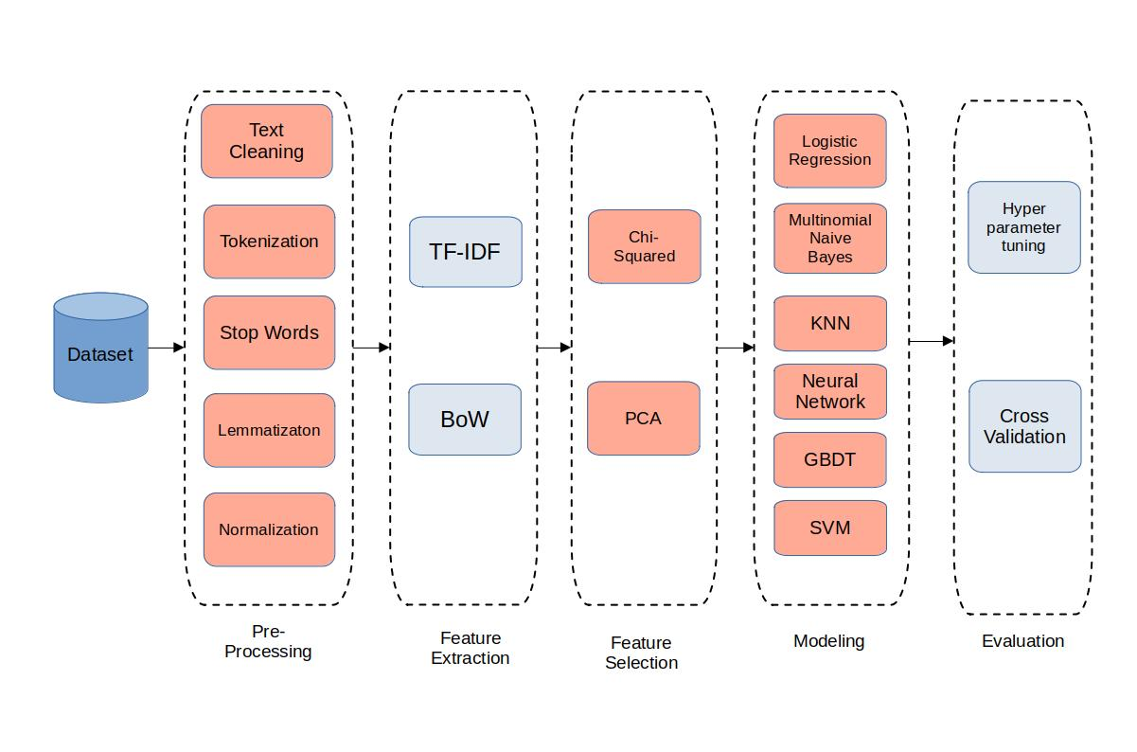
Figure 3.1: Stages for requirements categorization

Data Collection

The study utilized the tera-PROMISE repository as its data source, which comprised 625 natural language requirements that were tagged and categorized. Out of these, 255 were classified as functional requirements, while the remaining 370 were categorized as non-functional. The dataset was collected from fifteen different projects, and the non-functional criteria included aspects such as availability, legality, appearance, maintainability, operability, performance, scalability, security, usability, fault tolerance, and portability. To overcome the limitations of the tera-PROMISE dataset's small size, Lima et al. created an expanded version called the PROMISE_exp[41] dataset, which includes 444 functional and 525 non-functional requirements.

The Software Requirements Specification documents using the Google search engine was gathered. They then performed manual requirements analysis, extraction, and categorization. Expert consensus was used to validate the generated requirement categories. The coding scheme, granularity, language style, and formalism were all preserved to ensure compatibility with the original data. Furthermore, the PROMISE_exp dataset increased variety by incorporating criteria from 34 new projects.

Obtaining the initial tera-PROMISE repository and the enlarged PROMISE_exp dataset was part of the data-gathering procedure, guaranteeing a complete and diversified collection of needs from numerous projects. These datasets will be used to analyze and evaluate feature extraction methodologies and machine learning algorithms for software needs categorization. The table below shows the number of requirements in the extended data set for each kind.

Table 3.1: Dataset count
Requirement Type | Count
Functional Requirement (F) | 444
Availability (A) | 31
Legal (L) | 15
Look-and-feel (LF) | 49
Maintainability (MN) | 24
Operability (O) | 77
Performance (PE) | 67
Scalability (SC) | 22
Security (SE) | 125
Usability (US) | 85
Fault Tolerance (FT) | 18
Portability (PO) | 12
Total | 969

Below are two charts displaying the distribution of classes in the extended dataset compared to the original. The most notable increase in sample count is observed in the Portability (PO) category, which increased from one to twelve samples, consequently enabling effective categorization in this requirement category.
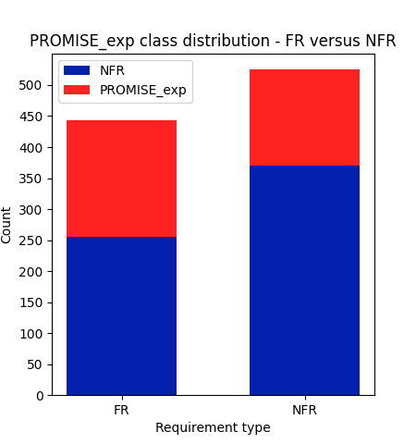
Figure 3.2: PROMISE vs. PROMISE_exp (2-class)

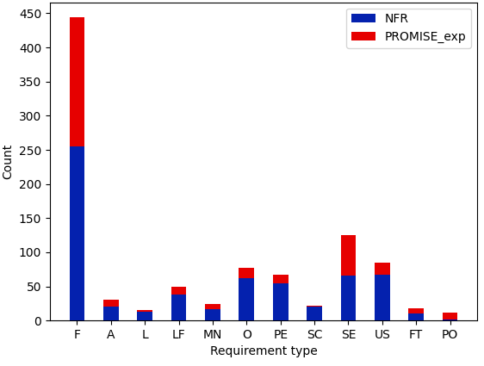
Figure 3.3: PROMISE vs. PROMISE_exp (12-class)
It is critical to recognize the limits of the data set employed in the investigation. Despite the PROMISE_exp data set's extension attempts, the overall quantity of accessible needs data remains relatively small, which may have an influence on the applications of machine learning methods, particularly deep learning approaches. It is critical to keep this restriction in mind while evaluating and generalizing the outcomes of the study.

Furthermore, there is an imbalance in class representation in the data set. Notably, the Portability class contains the fewest samples, with only 12 criteria accounting for 1.24% of the data set. In comparison, the most prevalent non-functional requirement class, Security, has 125 requirements, accounting for 12.9% of the data set. The functional requirements class, on the other hand, contains the most samples (444), accounting for 45.8% of the data set. This information is critical to provide in the study article since it emphasizes potential difficulties and issues associated with the data collection employed. The little amount of data and class imbalance can have an influence on the performance and generalizability of the machine learning models used in the research. As a result, necessary steps should be made to resolve these constraints and assure the study's findings' validity and reliability.

Data Pre-processing

Following the data gathering phase, the obtained software requirements must go through a number of pre-processing activities in order to be ready for further analysis. Text cleaning, tokenization, stop word removal, lemmatization, and normalization were all carried out.

Text Cleaning

Text cleaning is an important step in the preparation of software requirements data. To maintain data quality and consistency, it is required to remove superfluous characters, symbols, and special formatting from the requirements language. Software requirements may contain noise or irregularities throughout the data-gathering process, which might impair future analysis. Punctuation marks, HTML tags, non-alphanumeric characters, and other artifacts introduced during the data-collecting process are examples of these. Text cleaning seeks to remove these characteristics and generate a more aesthetically pleasing version of the required text.

Text cleaning reduces noise and improves analysis accuracy by deleting extraneous letters and symbols. It guarantees that the focus remains on the requirements' relevant content rather than on superfluous aspects. Text cleaning also aids in standardizing the text format throughout the whole dataset, making it easier to handle and analyze. Depending on the needs and nature of the data, the specific procedures utilized for text cleaning may differ. Regular expressions are commonly used to remove punctuation marks, HTML tags are stripped, and special characters are replaced with suitable alternatives. Correcting typical errors or inconsistencies in the wording of the requirements can also be part of the cleaning process.

Tokenization

Tokenization is an important step in the preparation of software requirements data. It entails dividing the text into distinct tokens, usually words or sub-words, in order to build a structured representation that may be utilized for further analysis. Tokenization is useful in the context of software requirements because it converts raw text into a format that can be readily processed and examined at the granular level. Tokenization provides for a more extensive assessment of the requirements by breaking the text into tokens, each representing a different unit, such as a word or sub-word.Various strategies may be used to implement the tokenization process. One popular method is to split the text depending on white space, which separates words and generates tokens. To handle more complicated scenarios, such as hyphenated words or compound phrases, more advanced tokenization approaches, such as employing regular expressions, can be used.

By tokenizing the requirements, further analysis at the word level becomes possible. This involves activities like counting word frequencies, detecting key phrases, and using language-specific processing processes. Tokenization also makes it easier to use machine learning techniques that work with numerical or categorical representations of requirements. Tokenization can provide certain difficulties, such as dealing with specific instances like abbreviations, acronyms, or compound phrases that should be regarded as a single token. Furthermore, considerations must be taken for languages with complicated word structures or agglutinative languages, where tokenization may need the use of specialized procedures.

Stopwords

Stopwords are words that appear often in a language but are typically regarded as irrelevant or uninformative in the context of text analysis. These terms, which include "the," "is," "and," and "in," have no semantic value and may be safely eliminated from the software requirements language during pre-processing. The elimination of stopwords serves two goals. For starters, it reduces the noise and processing cost involved with evaluating words that do not significantly add to the comprehension of the requirements. By removing these frequently recurring words, the emphasis in the criteria is transferred to more relevant and informative keywords. Secondly, eliminating stopwords can assist to increase the speed and accuracy of later analysis and modeling procedures. The analysis results can be more narrowly focused on the distinctive and domain-specific phrases that carry greater weight in the classification or feature extraction procedures by excluding frequently appearing words that have weak discriminating power amongst various criteria.

The stopwords to be eliminated rely on the particular language and industry of the software's needs. Commonly, stopword lists are made using a language's most frequently used words, and they may also include domain-specific phrases important to software needs. It's vital to remember that while eliminating stopwords might improve analysis, the context and precise study goals should still be carefully considered. Some stopwords may have domain-specific meanings in some situations or be crucial to comprehending the requirements. As a result, researchers should assess how the removal of stopwords affected the entire analysis and then base their conclusions on the demands of their particular study.

Lemmatization

Lemmatization is a pre-processing method that breaks down words into their lemma, or basic or root form. By combining many inflected forms that have the same meaning, it seeks to standardize the representation of words. Lemmatization aids in reducing the vocabulary size and capturing the semantic similarity between related terms in the context of software requirements analysis. Word variants, such as plurals, verb tenses, or other grammatical forms, are united by reducing words to their fundamental form. Lemmatization reduces words like "running," "runs," and "ran" to their simplest form, "run". Lemmatization entails identifying each word's basic form by using linguistic tools like dictionaries or morphological analysis. This is often accomplished by considering the words “part of speech (POS)” and using the proper rules or lookup databases to determine the related lemma.

Compared to other word normalization strategies like stemming, lemmatization has a number of advantages. Lemmatization assures that the resultant word is a legitimate term in the language, as opposed to stemming, which only removes word suffixes to produce a root form. This preserves the required text's comprehensibility and grammatical accuracy. Lemmatization, which reduces words to their most basic form, enables more efficient analysis since it unifies a word's various inflected forms into a single representation. It aids in overcoming the difficulty of having many spelling variations of a term, which can affect algorithmic precision and obstruct the extraction of insightful information from the requirements. Lemmatization, however, may not always be appropriate, especially where maintaining the original form or making precise distinctions between word variants is crucial. Other normalization methods, such as stemming or keeping the original word forms, maybe more suited in such circumstances.

Normalization

An important pre-processing step in the study of software requirement data is normalization. It entails formatting the content in a consistent way to maintain uniformity and promote efficient analysis. To regard words with the same letters but various case combinations as the same word, normalization in the context of software requirements often entails changing the text to a consistent case, which is frequently lower-case. By doing this, variances in word capitalization are removed, allowing for more precise phrase comparison and matching. No precise capitalization decisions are made throughout the data-collecting process, normalization's main goal is to provide a consistent representation of the required text. This method makes sure that related words are regarded as identical tokens and helps to prevent repetition and redundancy in the analysis.
Because it harmonizes words with various capitalizations or letter cases, normalization also helps to standardize word comparisons. This is crucial when using machine learning algorithms or conducting tasks like phrase matching or word frequency analysis that depend on numerical or categorical representations of the requirements. By producing a more uniform representation, normalization can also lessen the effects of noisy or inconsistent data. It makes it simpler and clearer to comprehend and analyze the data effectively by reducing complexity and ambiguity in the wording of the requirements. To provide a thorough and consistent preparation pipeline, normalization should be carried out in concert with other preprocessing procedures like text cleaning and tokenization. Depending on the needs of the research project and the natural language processing tools or libraries utilized, several normalization procedures may be applied.
The code used for the text cleaning is as follow:
def processing(text):
# convert to lowercase and tokenize (a token is either a word or interpunction symbols)
tokens = word_tokenize(text.lower())

# filter out non-alphabetic strings, and stopwords ('a', 'the', etc.)
# what remains will either be nouns, verbs, adjectives or adverbs
# finally, perform lemmatization, i.e. replacing each word with its "root" form (e.g.: plural to singular form for nouns, past to present tense for verbs, etc.)
resulting_words = []
lemmatizer = WordNetLemmatizer()

english_stopwords = stopwords.words('english')
tag_map = defaultdict(lambda : wn.NOUN)
tag_map['J'] = wn.ADJ
tag_map['V'] = wn.VERB
tag_map['R'] = wn.ADV

for word, tag in pos_tag(tokens):
if word.isalpha() and word not in english_stopwords:
resulting_words.append(
lemmatizer.lemmatize(word, tag_map[tag[0]]))

return ' '.join(resulting_words)

Feature Extraction

Feature extraction refers to the process of transforming raw data into a set of relevant and useful features that can extract important information from the input data. This process is crucial in machine learning, as it helps to reduce the dimensionality of the data and retain only the most significant features that are relevant to the problem being solved. By selecting the most relevant features, feature extraction can improve the accuracy and efficiency of the machine learning model, making it easier to extract insights and make predictions from the data. Compared to raw data, these characteristics are frequently more compact, useful, and simple to use. The objective of feature extraction is to locate and extract from the data the most pertinent features or patterns required for completing a given job or challenge. The dimensionality of the data may be decreased, unnecessary material can be eliminated, and the computing burden of further analysis can be decreased by identifying significant characteristics. By giving machine learning algorithms more targeted and representative input, feature extraction can also enhance their performance. In computer vision, for example, features can be extracted from images or video frames using methods such as edge detection, scale-invariant feature transform (SIFT), histogram of oriented gradients (HOG), or convolutional neural networks (CNNs).

In natural language processing, features can be extracted from text data using methods such as bag-of-words, term frequency-inverse document frequency, or bag-of-words-inverse document frequency. Several phases are involved in the feature extraction process. First, depending on the problem, input data is collected or created. The data may then be subjected to pre-processing techniques such as cleaning, normalization, and scaling to improve its quality and enable further analysis. Then, depending on domain knowledge and issue needs, suitable features are chosen or created. This stage entails detecting patterns, features, or statistical attributes relevant to the job. Finally, the collected features are fed into various machine-learning algorithms for classification, clustering, regression, and so forth.

TF-IDF

The “TF-IDF (Term Frequency-Inverse Document Frequency)” statistic is a statistical measure commonly used in natural language processing and information retrieval to evaluate the significance of a term within a document. It quantifies the relevance of a phrase by considering its frequency within the document and its rarity across the corpus. The TF-IDF algorithm operates on the principle that a term that appears frequently within a document but infrequently across the corpus is more likely to be relevant to that specific document. The metric consists of two components: “term frequency (TF) and inverse document frequency (IDF)”[37].

Term frequency measures the frequency of a term within a document. It is calculated by dividing the total number of words in the document by the number of times the term appears within it. The underlying concept is that a term that occurs more frequently in a document is deemed more relevant to that particular document. Inverse document frequency assesses the rarity of a term across the corpus. It is determined by dividing the total number of documents in the corpus by the number of documents that contain the term, followed by taking the logarithm of that quotient. The rationale behind this is that a term that appears in fewer documents is considered rare and therefore more significant for the texts in which it occurs.

The term frequency multiplied by the inverse document frequency yields the TF-IDF metric. The resultant value assigns a weight to each phrase in the document, reflecting its significance. Terms with high TF-IDF scores are deemed more relevant to the content than terms with low scores. Text categorization, information retrieval, and sentiment analysis are all prominent uses for TF-IDF in natural language processing applications. It's also used in search engines to rank documents depending on how relevant they are to a query. The metric is straightforward to compute, interpretable, and effective in capturing a document's semantic content.

Bag of Words

The “bag of words (BoW)” model is a natural language processing approach for representing text data. It views a text as an unorganized collection or "bag" of words, ignoring grammar and word order while taking into account the frequency of word occurrences. The text is separated into individual words or tokens in the bag of words model, and a vocabulary is formed by creating a list of unique terms from the full corpus (collection of documents). Each distinct word is incorporated into the BoW model[38].

A feature vector is constructed for each document by counting the occurrences of each word in the lexicon. The feature vector's length is equal to the vocabulary's size, and the value at each location denotes the frequency or existence of the relevant word in the document. This format allows text data to be translated into numerical feature vectors that may be used for text classification, sentiment analysis, and document clustering, among other NLP applications. Because the bag of words model is simple and efficient, it is used as a basic method in many NLP applications.

Feature Selection

Feature selection is an important procedure in data analysis that includes picking a subset of relevant characteristics from the original collection of features. The primary goal of feature selection is to increase model performance, interpretability, and computational efficiency by preserving useful and discriminative features and removing redundant or irrelevant ones. Feature selection addresses difficulties such as overfitting, increased computational complexity, and poor generalization performance of machine learning models by lowering the size of the feature space. Filter methods, wrapper methods, embedding methods, and hybrid methods are all ways to feature selection.

Filter methods evaluate feature relevance based on statistical properties or mutual information, wrapper methods evaluate subsets of features using a specific learning algorithm, embedded methods incorporate feature selection into the model training process, and hybrid methods combine multiple approaches. The task at hand, data availability, computing restrictions, and desired interpretability all influence the choice of an acceptable feature selection strategy. The influence of feature selection on model performance must be assessed using suitable assessment metrics, cross-validation procedures, and statistical tests. Feature selection aids in the identification of important characteristics, resulting in more accurate models, quicker computing, enhanced generalization, and a deeper understanding of underlying data patterns.

Chi-Squared

The Chi-squared feature selection method is commonly used to select relevant features from text data represented in Bag of Words (BoW) and TF-IDF formats. In Natural Language Processing (NLP), the Chi-squared test of statistical independence is widely employed for feature selection when working with categorical data. The significance of the dependence between two variables is determined by the Chi-squared distribution[39]. To address classification challenges, the BoW and TF-IDF representations are relabelled. This leads to three different datasets: the normalized data is used for the 12-class classification, functional requirements are excluded for the 11-class classification, and a single class replaces the non-functional classes for binary classification.

The scoring attribute of the selection model, associated with statistical significance (p-values), is cumulatively accumulated in the implementation. However, there is no clear threshold value, and the decision is based on empirical testing of the performance of the Multinomial Naive Bayes method at different significance levels. The minimum significance level that produces satisfactory results for the chosen method is defined as the cutoff point. The MNB algorithm is used as the feature selection criterion due to its simplicity, which can benefit other more sophisticated algorithms. Moreover, the MNB approach cannot be used for PCA-transformed data, but other techniques may benefit from additional dimensionality reduction. The feature selection obtained is conservative, meaning that adding more features does not improve the predicted test performance through cross-validation, but eliminating more features does.

In all three Bag of Words (BoW) datasets, a cutoff value of 0.075 is applied for feature selection. On the other hand, TF-IDF representations for multi-class problems use a higher cutoff value of 0.8, while the cutoff value for the binary issues in the TF-IDF representation is slightly lower at 0.325. Based on the results and subsequent testing, it can be concluded that the supplied data requires a larger number of TF-IDF features than BoW features for the Multinomial Naive Bayes method and most of the other algorithms evaluated. Out of the original 1524 features, the table below displays the number of selected characteristics at the indicated significance levels.

Table 1.2: Chi-squared selected features
2-class |  | 11-class |  | 12-class
BoW | TF-IDF | BoW | TF-IDF | BoW | TF-IDF
305 | 624 | 382 | 487 | 591 | 695

For each classification task and vector representation type, the table presents the top 10 Chi-squared test characteristics that are deemed most important.

Table 3.3: 10 most important features (Chi-squared)
 | 2-Class |  | 11-Class |  | 12-Class
 | BoW | TF-IDF | BoW | TF-IDF | BoW | TF-IDF
1. | allow | allow | academic | academic | second | comply
2. | meeting | meeting | access | accommodate | regulation | portable
3. | use | server | able | accordingly | fault | regulation
4. | second | display | accommodate | achieve | comply | simultaneous
5. | access | player | abs | abs | available | android
6. | class | second | acceptable | access | response | io
7. | player | use | accordingly | acceptable | time | fault
8. | clinical | select | achieve | accounting | handle | second
9. | server | list | accounting | acknowledgement | failure | mobile
10. | application | application | ability | action | interface | compatible

Principal Component Analysis

Principal Component Analysis (PCA) is a popular approach in data analysis and machine learning. It seeks to minimize a dataset's dimensionality while retaining the most critical information. PCA can give significant insights and enhance computing performance by translating a high-dimensional dataset into a lower-dimensional representation. There are numerous critical phases in the PCA method. To begin, the dataset is normalized such that each feature contributes equally to the PCA computation. Standardization is accomplished by removing the mean of each characteristic and dividing it by its standard deviation. When the characteristics have different scales, this step is critical since it allows for a fair comparison[40].

The covariance matrix is then constructed using the standardized data. The covariance matrix represents the correlations between multiple characteristics and reveals how they fluctuate together. It aids in determining the directions with the largest variance in the data. The covariance matrix is then decomposed into eigenvalues and eigenvectors using eigenvalue decomposition. The eigenvalues describe the amount of variation explained by each main component, but the eigenvectors determine the principal component's direction or loading. The eigenvectors are sorted according to their eigenvalues, with the greatest eigenvalue representing the direction of the largest variance.

The subsequent step is to choose the key components. The eigenvectors with the highest eigenvalues are chosen as the principal components. These components recognize the most important patterns in the data and store the most important information. Finally, the dataset is projected onto the primary components of interest, resulting in a lower-dimensional data representation. This transformation minimizes the feature space while preserving as much information as possible. The orthogonality of the new feature space implies that the primary components are unrelated.

The chart below displays the summed explained variance of each PCA component on the remaining Bag-of-Words (BoW) and Term Frequency-Inverse Document Frequency (TF-IDF) data, which underwent the Chi-squared feature selection process.
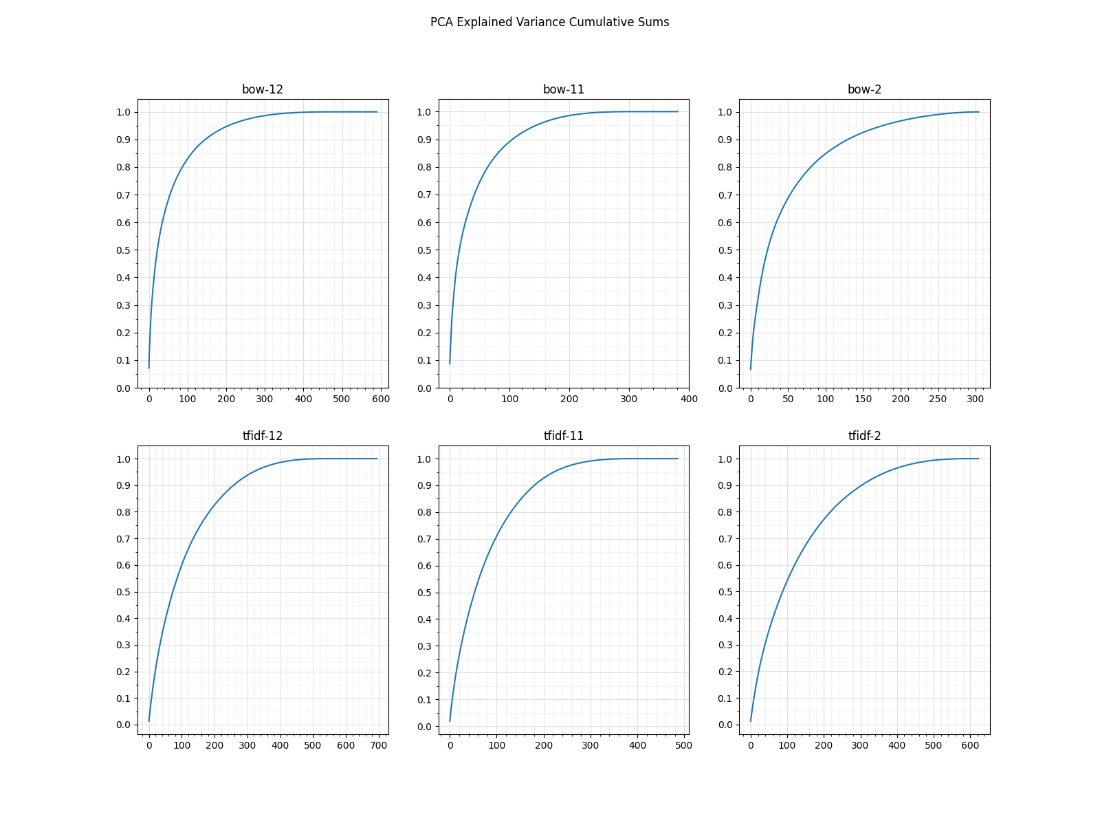
Figure 3.4: PCA explained variance
A conservative criterion was used to determine the number of components maintained in the dimensionality reduction method. The criteria were defined as the cumulative sum of explained variance lying between 98.5% and 99.5%. This range was determined through trial and error, taking into account the point at which the slopes of the explained variance curves became almost flat. Further dimensionality reduction on this particular dataset resulted in a worsening of model performance. The number of components maintained for each categorization task is shown in the table below.
Table 3.4: PCA selected features
2-class |  | 11-class |  | 12-class
BoW | TF-IDF | BoW | TF-IDF | BoW | TF-IDF
250 | 500 | 200 | 300 | 300 | 400

The “LR, SVM, kNN, GBDT, and feed-forward NN” models all need PCA-processed data. In retrospect, only the GBDT model outperformed utilizing the baseline data.

Model Selection and Training

This stage entailed creating and training models for the classification job using various techniques. “Logistic Regression (LR), K-Nearest Neighbors (KNN), Gradient Boosting Decision Trees (GBDT), Multinomial Naive Bayes (MNB), Neural Networks (NN), and Support Vector Machines (SVM)” were used. A rigorous selection method was used for each algorithm to discover the best hyperparameters and setups. Grid search, cross-validation, and performance assessment indicators were used in this selection procedure. The aim was to determine the optimum hyperparameter combination that would optimize the model's performance on the specified challenge. After determining the hyperparameters, the models were trained on the training dataset. This included giving the algorithm preprocessed data, which included the specified characteristics and target labels. Through an iterative optimization process, the algorithms identified the underlying patterns and correlations in the data.
Each algorithm's training step entailed altering the model's parameters depending on a specific goal function. For example, LR intended to minimize logistic loss, whereas SVM sought to determine the ideal hyperplane that best separated the various classes. The training phase was repeated until the model achieved convergence or met a predetermined stopping threshold. Following training, the models were evaluated using the validation dataset to determine their performance. Metrics such as accuracy, precision, recall, F1 score, and area under the receiver operating characteristic curve (AUC-ROC) were included in the evaluation. These measures revealed information about the models' prediction powers, capacity to accurately categorize cases, and performance across classes.

Extensive cross-validation approaches, such as k-fold cross-validation, were used to ensure robustness and minimize overfitting. This included dividing the data into k subgroups, training the model on the first k-1 subsets, and assessing its performance on the remaining subset. This was done k times to ensure that each subset served as both training and validation data. By comparing the performance of the various algorithms and their associated hyperparameter setups, insights into the strengths and shortcomings of each model were gleaned. Based on their performance metrics for the specified classification job, the best-performing algorithm(s) were then chosen.

Hyperparameter tuning & Cross Validation:

To enhance model performance, the objective was to select the most suitable hyperparameter values. The primary evaluation criterion for this task was the test F1-score, obtained through 10-fold cross-validation on the entire dataset. The aim was to identify hyperparameter configurations that deliver the highest F1-score, reflecting the models' classification accuracy. Parsimony was considered to avoid overfitting and promote model simplicity. The goal of model selection was to identify a stable yet straightforward model with excellent performance. This technique struck a balance between model complexity and generalizability.

To avoid the computational expense of grid search in models with many relevant hyperparameters, a broader experimental strategy was employed. This involved exploring numerous combinations of hyperparameter values that showed promise based on theoretical understanding to determine the optimal settings. For multi-class classification, “Logistic Regression (LR), K-Nearest Neighbors (kNN), and Gradient Boosting Decision Trees (GBDT)” models were used, with class membership probability determined using the One-Versus-Rest technique for “Multinomial Naive Bayes (MNB)”. The One-Versus-Rest approach outperformed the One-Versus-One strategy for Support Vector Machines (SVM), resulting in significant performance gains on the dataset. The last layer of both the “feedforward and recurrent Neural Networks (NN)” utilized a sigmoid activation function for binary classification, while a softmax function was used to estimate the one-hot encoded answer variable in the two multi-class scenarios.

The most important hyperparameter for the k-Nearest Neighbor method is the number of neighbors, indicated as k. Small k values increase the variation of the error while decreasing the bias, whereas big k values lower the variance while increasing the bias. For the two-class problem, 11 was chosen as the best value for k. The closest neighbor classification method, on the other hand, was better suited for the 11 and 12-class issues, with k values of 11 and 12 producing the best results. The distance metric of choice was also investigated, with the default Euclidean distance being chosen due to its greater performance. The weights were standardized by the distance between the spots, however, no advantages were seen as compared to uniform weights.

The C hyperparameter in the Support Vector Machines model specifies the regularization strength (lambda) inverse. Although smaller C values were more desirable, the chosen values were relatively high: 5 for the 2-class problem and 1 for the 11 and 12-class models. The RBF kernel performed best with the default value of gamma, which is the reciprocal of the product of the number of features and the variance of the training data.

The Gradient Boosted Decision Trees model has several important hyperparameters, such as n_estimators, learning_rate, max_features, min_samples_split, min_samples_leaf, and max_depth. Out of these, only n_estimators, learning_rate, and max_features were tuned through trial and error, rather than an exhaustive search. By using a lower learning rate, fewer features per tree, and fewer total trees, we were able to create a model that performed well while minimizing overfitting. For all classification problems, we used a learning rate of 0.05 and 200 trees, with each tree using only the square root of the total number of features.

The study utilized feedforward neural networks that had an input layer, a hidden layer with a “Rectified Linear Unit (ReLU)” activation function, and an output layer. For the 2-class issue, the output layer had one node with a sigmoid activation function, while for the 11 and 12-class multiclass issues, it had 11 and 12 nodes, respectively, with a softmax activation function to handle the one-hot encoded answer. To prevent overfitting, dropout regularization was applied before the hidden layer, which randomly eliminated a specific number of nodes throughout each epoch, reducing the network's dependence on specific attributes. The number of nodes in the hidden layer, dropout percentage, and training epochs were optimized for each classification task. The optimal number of hidden layer nodes was selected based on the model's flexibility and complexity, with lower values preferred given the number of characteristics in the preceding layer. The number of epochs was carefully set to minimize overfitting, while the learning rate and other optimizer parameters were kept at their default settings. The values for dropout differed based on the categorization issue, with the 2-class issue having a dropout value of 0.6667, and both the 11 and 12-class TF-IDF issues having a dropout value of 0.3333. For the 11-class Bag of Words (BoW) task, the dropout value was set to 0.1. By fine-tuning these hyperparameters, the neural network models achieved optimal performance for each classification task and data format.

Model Evaluation

The next sub-section reports performance metrics based on a 10-fold cross-validation of the dataset. This method was adopted to solve the shortcomings of using all of the data for model selection and assessment. When the same data is utilized for both purposes, performance can be improved, leading to misleading estimates of genuine performance. Cross-validation reduces the danger of overfitting and bias. Due to the low quantity of data in the high-dimensional space, explicitly splitting the dataset into distinct training and test sets was not possible in this case. Each split might result in radically different models, with conflicting performance estimates. Cross-validation, on the other hand, gives a more robust estimate by averaging the performance over numerous partitionings.
While cross-validation may contribute more variance in the performance estimate, this project considers that the new bias is negligible. This choice is based on past research articles that used a similar methodology. This project seeks to find a compromise between accuracy and stability by selecting a slightly skewed estimate over one with a high variation. The performance of the models on the training data during each cross-validation cycle was also recorded to get insight into the degree of model overfitting. This data gives us a better idea of how effectively the models generalize beyond the training data. A full evaluation of the models' performance may be accomplished by using cross-validation and taking into account performance on both training and test data.

Performance Metrics

Performance metrics are quantitative indicators that are used to assess the efficacy and quality of a machine learning model or system. These metrics give information about the model's accuracy, precision, recall, F1-score, and other assessment criteria. The performance measurements used are determined by the work at hand and the nature of the problem being addressed. The following classification performance metrics were used in this study:

Precision

Precision is a key performance metric used to evaluate the efficacy of machine learning models particularly for binary classification tasks. It is used to measure how well the model can identify true positive instances out of all the predicted positive cases. Essentially, precision focuses on reducing the number of false positives.

The mathematical formula for precision involves dividing the number of true positives (TP) by the sum of true positives and false positives (FP).

Precision = $\frac{True Positive}{True Positive + False Positive}$ 1)

High precision means that the model labels negative examples as positive only seldom. It represents the model's ability to anticipate good outcomes accurately. In a medical diagnosis situation, for example, precision would be the proportion of accurately detected positive instances out of all cases projected to be positive. A high precision score suggests that the model is accurate in recognizing positive situations while minimizing false alarms. Precision is especially valuable when the cost of false positives is significant. In spam email detection, for example, incorrectly categorizing a legal email as spam can be more damaging than missing some spam emails. Maximizing accuracy becomes critical in such instances to guarantee that only the most confident and precise positive forecasts are provided. It is critical to consider the trade-off between precision and memory when assessing precision. Increasing accuracy frequently leads to a reduction in recall, and vice versa. To acquire a thorough picture of the model's overall performance, precision should be assessed with other performance measures like recall, F1-score, and accuracy.

Recall

Recall is a crucial metric used to evaluate the performance of machine learning models in binary classification tasks. It measures the model's ability to correctly identify positive cases among all actual positive examples in the data. This metric is also known as sensitivity or true positive rate. In simpler terms, recall helps in minimizing false negatives.

The mathematical formula to calculate recall is given below, where TP represents true positives, and FN represents false negatives.

Recall = $\frac{True Positive}{True Positive + False Negetive}$ 2)
A high recall means that the model does not frequently identify positive examples as negative. It represents the model's capacity to detect and capture positive cases. In a disease diagnostic situation, for example, the recall would be the proportion of properly detected positive cases out of all actual positive instances. A high recall value indicates that the model captures a considerable fraction of the positive events, lowering the probability of missing key occurrences. It is worth noting that recall is negatively proportional to accuracy. Increasing recall frequently leads to a reduction in precision, and vice versa. Finding the proper mix of accuracy and recall is thus a critical aspect of model evaluation and selection. To acquire a thorough picture of the model's overall performance, recall should be interpreted with other performance indicators like precision, F1-score, and accuracy.

Accuracy

Machine learning practitioners often use accuracy as a key performance metric to evaluate the effectiveness of a classification model. It represents the proportion of correctly predicted instances in comparison to the total number of examples in the dataset. Accuracy is a comprehensive measure of a model's ability to predict both positive and negative events.

To calculate accuracy, you can divide the number of correct predictions (true positives and true negatives) by the total number of predictions, expressed as a percentage.
Accuracy = $\frac{TP + TN}{TP + TN + FP + FN}$ 3)
A high accuracy number shows that the model correctly predicts a high percentage of positive and negative classifications. It indicates the model's overall ability to accurately categorize occurrences. When the dataset is well-balanced, meaning that the number of cases in each class is about equal, accuracy is especially beneficial. Because it examines both true positives and true negatives, accuracy gives an informative assessment of the model's performance in such instances. However, when dealing with unbalanced datasets, where the number of cases in one class considerably outnumbers the other, accuracy may not be the best statistic to use. Other measures, like accuracy, recall, and F1-score, may give a more detailed evaluation of the model's performance in such instances.

When assessing accuracy, it is critical to consider the context as well as the unique requirements of the situation. Accuracy alone may not offer a whole picture of the model's performance, especially when the cost of misclassification varies between classes or there is a class imbalance. As a result, it is frequently advised to evaluate accuracy alongside other performance indicators in order to gain a more thorough evaluation of the model's usefulness.

F1-Score

The F1 score is a popular binary classification performance indicator that combines the accuracy and recall metrics into a single number. It gives a balanced assessment of the model's efficacy by considering both the capacity to detect positive cases properly (recall) and the ability to reduce erroneous positive predictions (precision).

The F1 score is computed by taking the harmonic mean of accuracy and recall and assigning equal weight to both measures. It is mathematically stated as:
F1-Score = $\frac{2×True Positive}{2×True Positive + False Positive + False Negetive}$ 4)
The F1 score is between 0 and 1, with 1 indicating flawless precision and recall and 0 indicating inadequate performance in either or both categories. The F1 score is especially beneficial when the positive and negative classes are imbalanced or when the cost of false positives and false negatives is high. It considers both sorts of mistakes and returns a single number representing the trade-off between accuracy and recall.

The F1 score gives a thorough evaluation of the model's performance by taking accuracy and recall into account, especially in cases where obtaining high precision and high recall at the same time is required. It aids in evaluating and selecting models based on their capacity to balance the precision-to-recall trade-off. When evaluating the F1 score, it is critical to consider the problem's unique needs. A high F1 score implies a model that performs well in terms of both accuracy and recall, however, the best balance of the two measures depends on the application. In medical diagnostics, for example, stronger recall (to decrease false negatives) may be more significant, but higher accuracy (to minimize false positives) may be emphasized in spam detection.

Chapter Summary

In this part of our research study, we discussed the approach we used. We presented the data pre-treatment processes, which included feature extraction using “Bag of Words (BoW) and TF-IDF” representations. We also highlighted the importance of feature selection by using Chi-squared analysis to determine the most significant characteristics for classification tasks. We then discussed the technique of adjusting hyperparameters for various algorithms, such as “Logistic Regression (LR), k-Nearest Neighbor (KNN), Gradient Boosted Decision Trees (GBDT), Multinomial Naive Bayes (MNB), Neural Networks (NN), and Support Vector Machines (SVM)”. Finally, we talked about the performance assessment criteria we used to evaluate the models' efficacy, including accuracy, precision, recall, and F1 score. These processes were crucial in ensuring the validity and robustness of our research findings.

DATA AND EXPERIMENTS

To maintain uniformity across all documents in the database, a normalization procedure was used during the data preparation step. This included employing the NLTK library to execute natural language processing techniques such as converting all words to lowercase and deleting stop words that add nothing to the overall meaning. Conjugated words were also converted back to their original forms.

Following normalization, the vectorization procedure was carried out to represent the texts in a machine-readable way. To generate feature vectors, the “Bag of Words (BoW) and TF-IDF” approaches were used. The findings acquired from the “BoW and TF-IDF” representations were compared to analyze the influence of different feature extraction approaches on the performance of our machine learning models. The frequency of words in vectorized matrices was also investigated in order to discover influential phrases. These pre-processing methods set the groundwork for our studies, allowing us to successfully use the textual knowledge for training and assessing our machine learning models.

Statistical approaches, notably Chi-Squared and PCA, were used in the feature selection step to filter out unnecessary features from the BoW and TF-IDF vectorizations. To determine feature significance, a parameter shared by both algorithms was utilized to remove terms with a document frequency greater than a predefined threshold. Another option was used to filter terms with document frequencies that were less than a particular threshold.

Moving on to the classification phase, six algorithms (NN, kNN, GBDT, SVM, MNB, and LR) were trained and assessed on the normalized and vectorized corpus. The software requirements were classified into three degrees of granularity: FR and NFR; FR and NFR sub-classes; and FR and NFR sub-classes. To solve the class imbalance, the aforementioned algorithms included a hyper-parameter that adjusted weights based on the class frequencies in the input data.

The GridSearchCV function from the sci-kit learn package was used to find the best combination of hyper-parameters for each method. This function ran an exhaustive search over the specified parameter values and chose the combination with the greatest F-measure score. The hyperparameter values that were chosen were then used during the vectorization and classification processes.

Cross-validation was used as part of the assessment procedure to assess the performance of the four algorithms. This method was used to remedy the dataset's imbalance. In a series of rounds, the data was divided into 10 subsets or folds for cross-validation, with each subset acting as both a training set and a validation set. In this study, 10-fold cross-validation was performed, with nine subsets (90% of the dataset) used for training and the remaining subset (10% of the dataset) used for testing. We acquired a full assessment of the algorithms' performance by repeating this approach over all folds. The cross-validation process allows for the calculation of accuracy, recall, and F-measure metrics, which are critical for assessing the performance of algorithms in handling data categorization tasks. This method produced robust and trustworthy performance estimates by accounting for the dataset's unpredictability and potential bias. Using cross-validation, a full evaluation of the algorithms' performance was acquired, allowing us to make accurate conclusions regarding their usefulness in categorizing software demands within our study environment.

RESULTS AND DISCUSSIONS

This section covers the study's findings and their consequences. Several scenarios were tested to identify the best usage of the BoW and TF-IDF techniques with ML algorithms, including 1) classifying FRs and NFRs (2-Class), 2) categorizing NFRs into subcategories (11-Class), and 3) categorizing FRs and NFR subcategories (12-Class). To study these three circumstances, the BoW and TF-IDF approaches, as well as different ML algorithms, were used. The algorithms were evaluated and chosen using “accuracy, precision, recall, and the F1-score”.

2-class classification

The usefulness of ML algorithms in categorizing software requirements into two categories was investigated in this study: “functional requirements (FRs) and non-functional requirements (NFRs)”. The performance of several machine learning methods was evaluated, and the results are shown in the table above. The TF-IDF technique paired with the Multinomial Naive Bayes (MNB) algorithm produced the greatest accuracy score of 0.93 among the several techniques examined. This suggests that this combination produced the best accurate forecasts in separating FRs from NFRs. The MNB algorithm successfully outperformed other algorithms in all assessment measures, routinely attaining scores of 0.91 or above. This demonstrates its dependability and robustness in categorizing software needs.

Furthermore, when the MNB method was paired with the Bag-of-Words (BoW) technique, it performed admirably, showing its utility in this task. When paired with TF-IDF, the Logistic Regression (LR) technique produced a significantly lower accuracy score of 0.91. Despite trailing MNB somewhat, it demonstrated good performance in the binary categorization of software needs. Based on these data, we may infer that the MNB algorithm beats other algorithms when it comes to correctly classifying software requirements as FRs or NFRs. Its constant and high performance across all assessment parameters makes it a trustworthy option for binary software requirement categorization jobs.
Table 5.1: 2-class classification
 | BoW |  |  | TF-1DF
 | Precision | Recall | F1-Score | Precision | Recall | F1-Score
MNB | 0.91 | 0.91 | 0.91 | 0.93 | 0.93 | 0.93
SVM | 0.87 | 0.87 | 0.87 | 0.90 | 0.90 | 0.90
LR | 0.89 | 0.88 | 0.88 | 0.91 | 0.91 | 0.91
GBDT | 0.87 | 0.86 | 0.86 | 0.87 | 0.87 | 0.87
KNN | 0.82 | 0.82 | 0.82 | 0.82 | 0.81 | 0.80
NN | 0.88 | 0.87 | 0.87 | 0.90 | 0.89 | 0.89

The chart for the above scores will be as follow:

Figure 5.1: 2-Class classification

11-class classification

The categorization findings of the subcategories of “Non-Functional Requirements (NFRs)” in the PROMISE_exp dataset are shown in the table below. The purpose of this experiment was to evaluate the efficacy of classifying NFRs into 11 unique subcategories based on the established labels in the PROMISE_exp database. It is crucial to highlight that this is owing to the comparatively low number of occurrences, with just 525 cases supporting the 11 subcategories of NFRs, compared to the dataset's 444 functional needs.

In this classification assignment, the performance of various ML algorithms was examined. The “Multinomial Naive Bayes (MNB)” method in conjunction with the Bag-of-Words (BoW) approach and the Logistic Regression (LR) algorithm in conjunction with TF-IDF produced comparable results. When compared to Support Vector Machines (SVM), both techniques performed better. With a recall measure of 0.77, the LR algorithm had the greatest overall performance. These data indicate that MNB with BoW and LR with TF-IDF are excellent methodologies for subcategorizing NFRs. LR surpassed the other algorithms in terms of recall despite having a slightly lower accuracy value of 0.01. As a result, in this experiment, the LR algorithm is the best choice for accurate categorization of NFR subcategories.
Table 5.2: 11-class classification
 | BoW |  |  | TF-1DF
 | Precision | Recall | F1-Score | Precision | Recall | F1-Score
MNB | 0.77 | 0.74 | 0.74 | 0.74 | 0.74 | 0.72
SVM | 0.70 | 0.68 | 0.67 | 0.74 | 0.72 | 0.70
NN | 0.66 | 0.67 | 0.64 | 0.68 | 0.69 | 0.66
LR | 0.70 | 0.68 | 0.67 | 0.76 | 0.74 | 0.74
GBDT | 0.54 | 0.56 | 0.52 | 0.61 | 0.62 | 0.58
KNN | 0.53 | 0.53 | 0.50 | 0.59 | 0.60 | 0.57

The chart for the above scores will be as follow:

Figure 5.2: 11-Class classification

12-class classification

The table below shows the experiment results produced by integrating the “Bag-of-Words (BoW) and Term Frequency-Inverse Document Frequency (TF-IDF)” feature extraction techniques with six machine learning algorithms (“NN, kNN, GBDT, SVM, MNB, and LR”). The findings are classified into 12 granularity levels, including “Functional Requirements (FRs)” and 11 subtypes of “Non-Functional Requirements (NFRs)”, and “accuracy, recall, and F1-score” metrics are supplied. In general, all feature extraction approaches, and machine learning algorithms produced “accuracy, recall, and F1-score” values of 0.71 or above, suggesting acceptable performance. The BoW technique paired with the Multinomial Naive Bayes (MNB) algorithm produced the greatest accuracy value of 0.79 of these combinations.

These findings show that the BoW method, when combined with the MNB algorithm, outperforms the other algorithms in terms of precision. This implies that using BoW as the feature extraction strategy might increase classification accuracy for the provided dataset, especially when paired with the MNB algorithm.

Table 5.3: 12-class classification
 | BoW |  |  | TF-1DF
 | Precision | Recall | F1-Score | Precision | Recall | F1-Score
MNB | 0.79 | 0.77 | 0.77 | 0.77 | 0.76 | 0.74
SVM | 0.74 | 0.73 | 0.71 | 0.74 | 0.75 | 0.73
NN | 0.71 | 0.72 | 0.70 | 0.67 | 0.70 | 0.66
LR | 0.77 | 0.74 | 0.74 | 0.77 | 0.76 | 0.75
GBDT | 0.63 | 0.66 | 0.61 | 0.61 | 0.67 | 0.61
KNN | 0.60 | 0.61 | 0.57 | 0.65 | 0.65 | 0.60

The chart for the above scores will be as follow:

Figure 5.3: 12-Class classification

To examine classification accuracy, the performance of the algorithms was assessed for each label in the database. Across all assessment measures, the combination of TF-IDF and MNB consistently achieved the greatest F-measure. Notably, although it was not the class with the most observations, the Performance requirements demonstrated good classification, with the second-highest F-measure of 0.82. The Portability condition, on the other hand, had the weakest classification performance due to the restricted amount of examples present in the PROMISE_exp dataset. Another intriguing discovery was the categorization of security needs, which included a sufficient number of samples (125). However, this class's accuracy, recall, and F1 score were all rather poor. This is due to the difficulty in precisely recognizing terms related to security needs. Overall, these findings illustrate the efficacy of the TF-IDF and MNB combination in obtaining excellent classification performance, while also shining a light on the difficulties associated with specific classes due to the nature of their frequency and keywords.

Confusion Metrics

The confusion matrices shown below reflect the performance of SVM models with TF-IDF features. The models shown were chosen based on their comparative performance. These confusion matrices reveal important information about the classification performance of SVM models with TF-IDF data. Please keep in mind that the exact numerical values for “true negatives (TN), false positives (FP), false negatives (FN), and true positives (TP)” are not provided here but may be obtained by running the code.

2-class
 | F | NF
F | 397 | 47
NF | 45 | 480
Figure 5.4: Confusion matrix (2-class)

11-class

 | A | L | LF | MN | O | PE | SC | SE | US | FT | PO
A | 20 | 0 | 3 | 0 | 2 | 1 | 1 | 2 | 1 | 0 | 1
L | 0 | 7 | 4 | 0 | 0 | 0 | 0 | 1 | 2 | 0 | 1
LF | 0 | 0 | 38 | 0 | 3 | 0 | 0 | 2 | 6 | 0 | 0
MN | 0 | 0 | 2 | 7 | 10 | 2 | 0 | 0 | 3 | 0 | 0
O | 1 | 0 | 5 | 2 | 52 | 1 | 1 | 11 | 4 | 0 | 0
PE | 2 | 0 | 2 | 1 | 1 | 56 | 1 | 1 | 3 | 0 | 0
SC | 1 | 0 | 0 | 1 | 5 | 0 | 11 | 1 | 3 | 0 | 0
SE | 1 | 0 | 1 | 0 | 5 | 0 | 0 | 112 | 6 | 0 | 0
US | 0 | 1 | 7 | 0 | 2 | 3 | 1 | 5 | 65 | 1 | 0
FT | 0 | 0 | 1 | 1 | 3 | 1 | 1 | 3 | 2 | 6 | 0
PO | 0 | 0 | 5 | 0 | 6 | 0 | 0 | 0 | 0 | 0 | 1
Figure 5.5: Confusion matrix (11-class)

12-class

 | F | A | L | LF | MN | O | PE | SC | SE | US | FT | PO
F | 415 | 0 | 0 | 2 | 0 | 2 | 1 | 0 | 19 | 5 | 0 | 0
A | 2 | 18 | 0 | 1 | 0 | 6 | 0 | 0 | 1 | 3 | 0 | 0
L | 3 | 0 | 4 | 2 | 0 | 3 | 0 | 0 | 3 | 0 | 0 | 0
LF | 10 | 0 | 0 | 23 | 0 | 7 | 0 | 0 | 2 | 7 | 0 | 0
MN | 5 | 0 | 0 | 0 | 3 | 7 | 0 | 1 | 4 | 4 | 0 | 0
O | 9 | 0 | 0 | 1 | 3 | 47 | 0 | 1 | 10 | 6 | 0 | 0
PE | 5 | 0 | 0 | 0 | 0 | 1 | 54 | 1 | 4 | 2 | 0 | 0
SC | 3 | 0 | 0 | 0 | 0 | 4 | 0 | 12 | 2 | 1 | 0 | 0
SE | 21 | 0 | 0 | 1 | 0 | 5 | 2 | 0 | 95 | 1 | 0 | 0
US | 12 | 0 | 0 | 5 | 0 | 7 | 3 | 0 | 4 | 54 | 0 | 0
FT | 1 | 0 | 0 | 2 | 0 | 6 | 0 | 0 | 4 | 1 | 4 | 0
PO | 0 | 0 | 0 | 0 | 0 | 12 | 0 | 0 | 0 | 0 | 0 | 0
Figure 5.6: Confusion matrix (12-class)
The examination of the confusion matrices demonstrates that the classification performance is poorer for the dataset's less prevalent classes. Notably, the 12-class classifiers completely misclassified the portability criterion, and misclassifications outweighed the right classifications for fault tolerance, maintainability, and legal classes. However, in terms of the algorithm and feature combination under consideration, the hierarchical classification technique demonstrated a modest advantage. This hierarchical approach showed a lower tendency to identify non-functional criteria as functional, which is preferable in practical applications. Misclassifications in the less common classes can be attributable to similarities between the real and projected classes in some attributes. For example, popular terminology used in both portability and operability criteria include "windows," "web," "operating," "system," and "browser." However, because operability is more common, the portability class is sometimes absorbed by it.

Overall, the confusion matrix study illustrates the difficulties in effectively recognizing less common classes and indicates the potential benefits of hierarchical classification in actual circumstances.

Comparative Analysis

The following table contains the comparison of the results of various paper with the results of this study :

Reference | Dataset | Technique | Result
[1] | “PROMISE,  NFR-Review,  and NFR-SO” | PRCBERT, NoBERT | ACC: 72.96%
[5] | User reviews dataset | (BoW, TF- IDF, CHI2, and AUR-BoW) with  (Naive Bayes, J48, and Bagging)” | ACC: 72.3%
[7] | Project history data from software development projects | “Recurrent Neural Network (RNN) variations” | Accuracy: 83.72%
[8] | PROMISE_  exp dataset | “SVM or KNN  algorithms combined  with the Bag- of-Words (BoW)” | Accuracy: 74%
[26] | PROMISE_  exp dataset | “Support Vector Machine (SVM),  Random Forest (RF), and K-Nearest Neighbors (KNN)  text classifier algorithms” | Accuracy:86.66%

On the other hand, the following results were analysed in this study:
Dataset | Technique | Result
“PROMISE_exp dataset” | “Logistic Regression (LR),  Support Vector Machine (SVM),  Multinomial Naive Bayes (MNB), GBDT, Neural Networks and  k-Nearest Neighbours (kNN)” | Accuracy: 93%

Web Application

A web application has been developed with the following pages:

Home

The home page of the web application serves as the main interface for users to predict software requirements. It provides a user-friendly and intuitive environment where users can input relevant information or requirements and obtain predictions or recommendations based on machine learning algorithms. The home page typically includes input fields, buttons, and interactive elements that allow users to interact with the prediction functionality of the application. It serves as the entry point for users to access the core functionality of the web application.

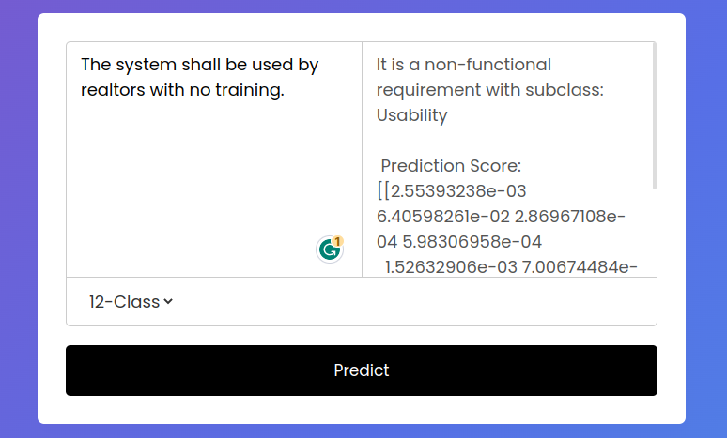

About Page

The about page of the web application provides information about the developer or the team behind the application. It serves as a personal portfolio or a brief introduction to showcase the skills, expertise, and background of the individual or organization responsible for developing the application. The about page include details such as the developer's background, educational qualifications, professional achievements, and past projects. It offers users a better understanding of the application's creators and instills trust and credibility in the software.

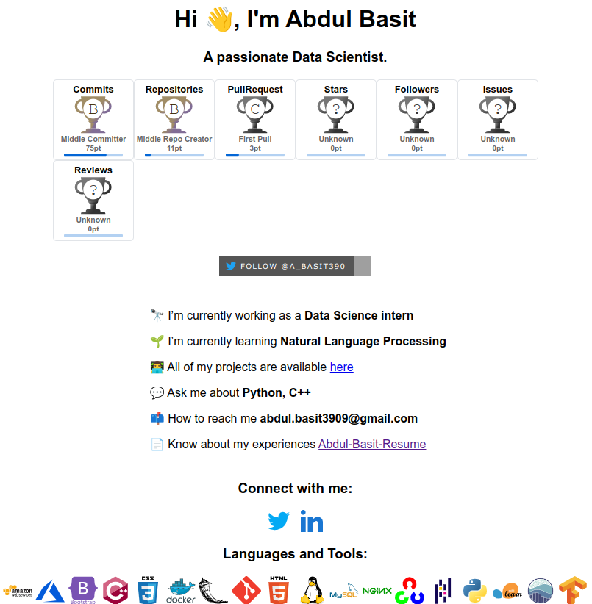

History

The history page within the web application displays the past predictions or interactions of each user. It allows users to view and track their prediction history, providing a chronological record of their previous inputs and corresponding results. The history page typically includes a list or a timeline that shows the date and time of each prediction, along with relevant details or summary of the prediction outcome. This feature enables users to review their past interactions, monitor their progress, and refer back to previous predictions for future reference or analysis. It enhances the user experience by providing a sense of continuity and allowing users to revisit and learn from their previous activities within the application.

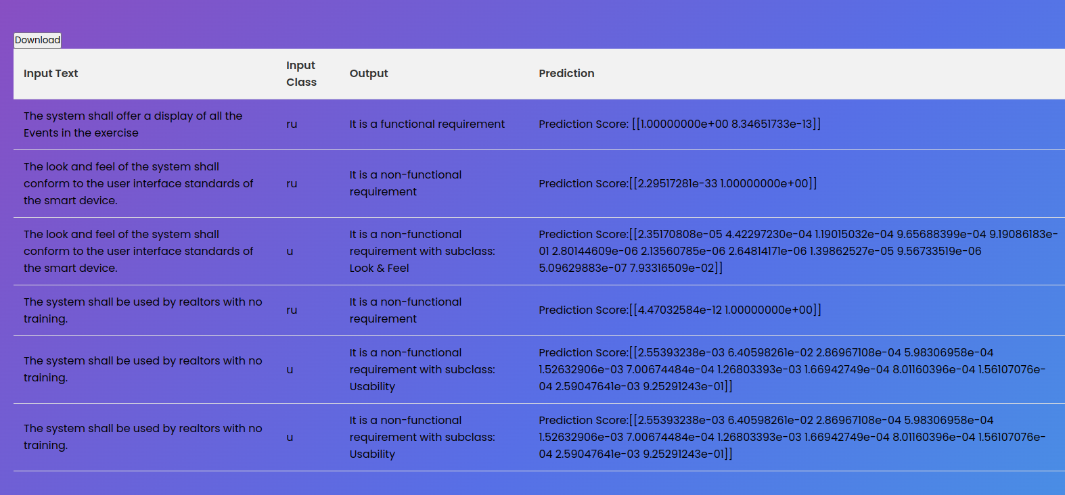

Contact

The contact page of the web application allows users to get in touch with the developer or the support team via email. It includes a contact form through which users can reach out for inquiries, feedback, or support. The contact page provides a convenient means for users to communicate their questions, concerns, or suggestions, facilitating effective communication between users and the application's developers or support personnel.
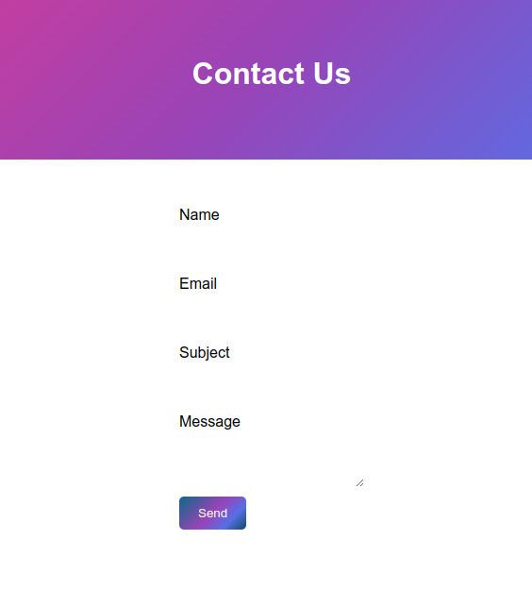

Login/Sign up

The login/sign-up page is an essential component of the web application that enables users to create an account or log into an existing account. It provides a secure authentication mechanism that ensures only authorized users can access personalized features and functionalities within the application. The login/sign-up page typically includes input fields for username and password, as well as options for account registration or password recovery. It serves as a gateway for users to access their personalized data, preferences, or historical information associated with their account.

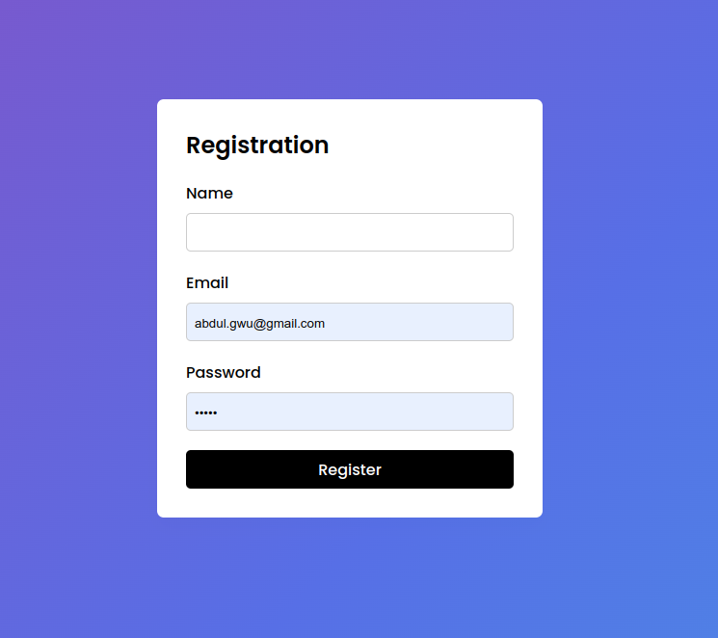

CONCLUSION AND RECOMMENDATIONS

In this study, multiple classification algorithms for software requirements were studied and their efficacy across diverse classification challenges was evaluated. The findings consistently demonstrated that Multinomial “Naive Bayes” and “Logistic Regression” models, when combined with either the “Bag of Words” or “TF-IDF” representations, produced the best accuracy and other assessment metrics. Furthermore, the practical consequences of our findings are highlighted. One possible use is the semi-automation of the software requirement identification and extraction process using publicly available specification papers. Researchers and practitioners may expedite the requirement analysis process and derive significant insights from massive amounts of textual data by using the built models. However, when applied to different datasets or situations, the performance of the models may vary, especially in fully automated computer-aided software engineering scenarios.

Finally, this study adds to the discipline of software engineering by shedding light on the categorization of software requirements. The best-performing models revealed provide useful tools for demand analysis, while the investigation of deep learning methodologies indicates future research areas. We can improve the whole software development process and assist practitioners in producing high-quality software systems by enhancing the automation and efficiency of software requirement analysis.

Future work

Future studies in this area might concentrate on resolving the limitations and expanding on the findings given in this publication. Here are some potential future study directions:

- Expansion of the dataset: Obtaining a broader and more diversified set of software needs would result in a more thorough depiction of real-world circumstances. This would aid in more successfully training and testing classifiers, perhaps leading to higher performance.
- Handling class imbalance: Handling class imbalance in the dataset is an important consideration. Exploring strategies such as oversampling, under sampling, and producing synthetic data can help alleviate the impact of unbalanced classes and improve classifier performance, particularly for less common classes.
- Deep learning methodologies should be investigated further: Additional research into deep learning models such as “recurrent neural networks (RNNs)”, “convolutional neural networks (CNNs”), or transformer-based models might give insights into their usefulness in identifying software needs. Experimenting with various embedding strategies and architectures may reveal their ability to capture subtle patterns in textual material.
- Integrating classifiers into software engineering tools and frameworks: Integrating classifiers into software engineering tools and frameworks can help practitioners automate the requirement analysis process. Creating plugins or APIs that use trained models can increase the efficiency and accuracy of requirement categorization, allowing for faster decision-making and better software development results.
In conclusion, future research should strive to overcome data restrictions, solve class imbalance, investigate deep learning methodologies, test classifiers on real-world datasets, and focus on incorporating classifiers into realistic software engineering workflows. We may enhance the field of software requirement analysis and contribute to the construction of more effective and efficient software systems by following these directions.

REFERENCES

[1] X. Luo, Y. Xue, Z. Xing, and J. Sun, “PRCBERT: Prompt Learning for Requirement Classification using BERT-based Pretrained Language Models,” in Proceedings of the 37th IEEE/ACM International Conference on Automated Software Engineering, New York, NY, USA, Jan. 2023, pp. 1–13. doi: 10.1145/3551349.3560417.
[2] D. Kici, A. Bozanta, M. Cevik, D. Parikh, and A. Başar, “Text classification on software requirements specifications using transformer models,” in Proceedings of the 31st Annual International Conference on Computer Science and Software Engineering, USA, Nov. 2021, pp. 163–172.
[3] P. R. Anish, P. Lawhatre, R. Chatterjee, V. Joshi, and S. Ghaisas, “Automated labeling and classification of business rules from software requirement specifications,” in Proceedings of the 44th International Conference on Software Engineering: Software Engineering in Practice, New York, NY, USA, Oct. 2022, pp. 53–54. doi: 10.1145/3510457.3513071.
[4] M. H. Osman and M. F. Zaharin, “Ambiguous software requirement specification detection: an automated approach,” in Proceedings of the 5th International Workshop on Requirements Engineering and Testing, New York, NY, USA, Jun. 2018, pp. 33–40. doi: 10.1145/3195538.3195545.
[5] T. Iqbal, P. Elahidoost, and L. Lúcio, “A Bird’s Eye View on Requirements Engineering and Machine Learning,” in 2018 25th Asia-Pacific Software Engineering Conference (APSEC), Dec. 2018, pp. 11–20. doi: 10.1109/APSEC.2018.00015.
[6] Md. A. Rahman, Md. A. Haque, Md. N. A. Tawhid, and Md. S. Siddik, “Classifying non-functional requirements using RNN variants for quality software development,” in Proceedings of the 3rd ACM SIGSOFT International Workshop on Machine Learning Techniques for Software Quality Evaluation, New York, NY, USA, Aug. 2019, pp. 25–30. doi: 10.1145/3340482.3342745.
[7] M. Rahmi Dewi, I. Kharisma Raharjana, D. Siahaan, and C. Fatichah, “Software Requirement-Related Information Extraction from Online News using Domain Specificity for Requirements Elicitation: How the system analyst can get software requirements without constrained by time and stakeholder availability,” in 2021 10th International Conference on Software and Computer Applications, New York, NY, USA, Jul. 2021, pp. 81–87. doi: 10.1145/3457784.3457796.
[8] B. Bruegge, J. David, J. Helming, and M. Koegel, “Classification of tasks using machine learning,” in Proceedings of the 5th International Conference on Predictor Models in Software Engineering, New York, NY, USA, May 2009, pp. 1–11. doi: 10.1145/1540438.1540455.
[9] F. Halim and D. Siahaan, “Detecting Non-Atomic Requirements in Software Requirements Specifications Using Classification Methods,” in 2019 1st International Conference on Cybernetics and Intelligent System (ICORIS), Aug. 2019, vol. 1, pp. 269–273. doi: 10.1109/ICORIS.2019.8874888.
[10] R. Navarro-Almanza, R. Juarez-Ramirez, and G. Licea, “Towards Supporting Software Engineering Using Deep Learning: A Case of Software Requirements Classification,” in 2017 5th International Conference in Software Engineering Research and Innovation (CONISOFT), Oct. 2017, pp. 116–120. doi: 10.1109/CONISOFT.2017.00021.
[11] G. Y. Quba, H. Al Qaisi, A. Althunibat, and S. AlZu’bi, “Software Requirements Classification using Machine Learning algorithm’s,” in 2021 International Conference on Information Technology (ICIT), Jul. 2021, pp. 685–690. doi: 10.1109/ICIT52682.2021.9491688.
[12] B. Li, Z. Li, and Y. Yang, “NFRNet: A Deep Neural Network for Automatic Classification of Non-Functional Requirements,” in 2021 IEEE 29th International Requirements Engineering Conference (RE), Sep. 2021, pp. 434–435. doi: 10.1109/RE51729.2021.00057.
[13] D. A. López-Hernández, J. Octavio Ocharán-Hernández, E. Mezura-Montes, and Á. J. Sánchez-García, “Automatic Classification of Software Requirements using Artificial Neural Networks: A Systematic Literature Review,” in 2021 9th International Conference in Software Engineering Research and Innovation (CONISOFT), Oct. 2021, pp. 152–160. doi: 10.1109/CONISOFT52520.2021.00030.
[14] M.-I. Limaylla-Lunarejo, N. Condori-Fernandez, and M. R. Luaces, “Towards an automatic requirements classification in a new Spanish dataset,” in 2022 IEEE 30th International Requirements Engineering Conference (RE), Aug. 2022, pp. 270–271. doi: 10.1109/RE54965.2022.00039.
[15] P. Singh, D. Singh, and A. Sharma, “Rule-based system for automated classification of non-functional requirements from requirement specifications,” in 2016 International Conference on Advances in Computing, Communications and Informatics (ICACCI), Sep. 2016, pp. 620–626. doi: 10.1109/ICACCI.2016.7732115.
[16] M. Bisi and K. Keskar, “CNN-BPSO approach to Select Optimal Values of CNN Parameters for Software Requirements Classification,” in 2020 IEEE 17th India Council International Conference (INDICON), Dec. 2020, pp. 1–6. doi: 10.1109/INDICON49873.2020.9342381.
[17] Md. A. Haque, Md. Abdur Rahman, and M. S. Siddik, “Non-Functional Requirements Classification with Feature Extraction and Machine Learning: An Empirical Study,” in 2019 1st International Conference on Advances in Science, Engineering and Robotics Technology (ICASERT), May 2019, pp. 1–5. doi: 10.1109/ICASERT.2019.8934499.
[18] H. Alrumaih, A. Mirza, and H. Alsalamah, “Toward Automated Software Requirements Classification,” in 2018 21st Saudi Computer Society National Computer Conference (NCC), Apr. 2018, pp. 1–6. doi: 10.1109/NCG.2018.8593012.
[19] J. M. Pérez-Verdejo, A. J. Sánchez-García, and J. O. Ocharán-Hernández, “A Systematic Literature Review on Machine Learning for Automated Requirements Classification,” in 2020 8th International Conference in Software Engineering Research and Innovation (CONISOFT), Nov. 2020, pp. 21–28. doi: 10.1109/CONISOFT50191.2020.00014.

[20] R. Chatterjee, A. Ahmed, and P. R. Anish, “Identification and Classification of Architecturally Significant Functional Requirements,” in 2020 IEEE Seventh International Workshop on Artificial Intelligence for Requirements Engineering (AIRE), Sep. 2020, pp. 9–17. doi: 10.1109/AIRE51212.2020.00008.
[21] P. Talele and R. Phalnikar, “Software Requirements Classification and Prioritisation Using Machine Learning,” in Machine Learning for Predictive Analysis, Singapore, 2021, pp. 257–267. doi: 10.1007/978-981-15-7106-0_26.
[22] R. Štrba, I. Vondrák, D. Ježek, and S. Štolfa, “Method for Estimation of Software Requirements Using Neural Network Based Classification Technique,” in Proceedings of the Third International Afro-European Conference for Industrial Advancement — AECIA 2016, Cham, 2018, pp. 87–96. doi: 10.1007/978-3-319-60834-1_10.
[23] S. Vijayvargiya, L. Kumar, A. Malapati, L. B. Murthy, and S. Misra, “Software Functional Requirements Classification Using Ensemble Learning,” in Computational Science and Its Applications – ICCSA 2022 Workshops, Cham, 2022, pp. 678–691. doi: 10.1007/978-3-031-10548-7_49.
[24] L. Kumar, S. Baldwa, S. M. Jambavalikar, L. B. Murthy, and A. Krishna, “Software Functional and Non-function Requirement Classification Using Word-Embedding,” in Advanced Information Networking and Applications, Cham, 2022, pp. 167–179. doi: 10.1007/978-3-030-99587-4_15.
[25] L. Tóth and L. Vidács, “Study of Various Classifiers for Identification and Classification of Non-functional Requirements,” in Computational Science and Its Applications – ICCSA 2018, Cham, 2018, pp. 492–503. doi: 10.1007/978-3-319-95174-4_39.
[26] K. H. Oo, “Comparing Accuracy Between SVM, Random Forest, K-NN Text Classifier Algorithms for Detecting Syntactic Ambiguity in Software Requirements,” in International Conference on Information Systems and Intelligent Applications, Cham, 2023, pp. 43–58. doi: 10.1007/978-3-031-16865-9_4.
[27] E. Dias Canedo and B. Cordeiro Mendes, “Software Requirements Classification Using Machine Learning Algorithms,” Entropy, vol. 22, no. 9, p. 1057, Sep. 2020, doi: 10.3390/e22091057.
[28] N. Rahimi, F. Eassa, and L. Elrefaei, “One- and Two-Phase Software Requirement Classification Using Ensemble Deep Learning,” Entropy, vol. 23, no. 10, p. 1264, Oct. 2021, doi: 10.3390/e23101264.
[29] P. Talele and R. Phalnikar, “Classification and Prioritisation of Software Requirements using Machine Learning – A Systematic Review,” in 2021 11th International Conference on Cloud Computing, Data Science & Engineering (Confluence), Jan. 2021, pp. 912–918. doi: 10.1109/Confluence51648.2021.9377190.
[30] K. Kaur and P. Kaur, “Improving BERT model for requirements classification by bidirectional LSTM-CNN deep model,” Computers and Electrical Engineering, vol. 108, p. 108699, May 2023, doi: 10.1016/j.compeleceng.2023.108699.
[31] B. Li and X. Nong, “Automatically classifying non-functional requirements using deep neural network,” Pattern Recognition, vol. 132, p. 108948, Dec. 2022, doi: 10.1016/j.patcog.2022.108948
[32] D. Ott, “Automatic Requirement Categorization of Large Natural Language Specifications at Mercedes-Benz for Review Improvements,” in Requirements Engineering: Foundation for Software Quality, J. Doerr and A. L. Opdahl, Eds., in Lecture Notes in Computer Science. Berlin, Heidelberg: Springer, 2013, pp. 50–64. doi: 10.1007/978-3-642-37422-7_4.
[33] Z. S. H. Abad, O. Karras, P. Ghazi, M. Glinz, G. Ruhe, and K. Schneider, “What Works Better? A Study of Classifying Requirements.” arXiv, Jul. 07, 2017. doi: 10.48550/arXiv.1707.02358.
[34] M. Binkhonain and L. Zhao, “A Machine Learning Approach for Hierarchical Classification of Software Requirements,” 2023, doi: 10.48550/ARXIV.2302.12599.
[35] K. Kaur and P. Kaur, “BERT-CNN: Improving BERT for Requirements Classification using CNN,” Procedia Computer Science, vol. 218, pp. 2604–2611, Jan. 2023, doi: 10.1016/j.procs.2023.01.234.
[36] M. Lima, V. Valle, E. Costa, F. Lira, and B. Gadelha, “Software Engineering Repositories: Expanding the PROMISE Database,” in Proceedings of the XXXIII Brazilian Symposium on Software Engineering, in SBES ’19. New York, NY, USA: Association for Computing Machinery, Sep. 2019, pp. 427–436. doi: 10.1145/3350768.3350776.

[37] M. F. Porter, "An algorithm for suffix stripping," Program, vol. 14, no. 3, pp. 130-137, Jul. 1980. [Online]. Available: 10.1108/eb046814
[38] G. Salton and C. Buckley, "Term-weighting approaches in automatic text retrieval," Information Processing & Management, vol. 24, no. 5, pp. 513-523, Sep. 1988. [Online]. Available: 10.1016/0306-4573(88)90021-0
[39] Y. Yang and J. O. Pedersen, "A comparative study on feature selection in text categorization," in Proceedings of the Fourteenth International Conference on Machine Learning, San Francisco, CA, USA, Jul. 1997, pp. 412-420. [Online]. Available: 10.1016/b978-1-55860-486-3.50057-9
[40] H. Abdi and L. J. Williams, "Principal component analysis," Wiley Interdisciplinary Reviews: Computational Statistics, vol. 2, no. 4, pp. 433-459, 2010. [Online]. Available:10.1002/wics.101

Dataset

[41] https://www.kaggle.com/datasets/iamsouvik/software-requirements-dataset

