
BSCS-F22-02
03-134192-059 | ZOHA ABDUL KHALIQ
03-134192-066 | RIMSHA SAJID

Speedo Bus Tracking Application

In partial fulfilment of the requirements for the degree of
Bachelor of Science in Computer Science
Supervisor: IQRA ASHRAF
Department of Computer Sciences
Bahria University, Lahore Campus
June 2023

© Bahria University, 2023

Certificate

We accept the work contained in the report titled
“Speedo Bus Tracking Application”
written by
ZOHA ABDUL KHALIQ
RIMSHA SAJID
as a confirmation to the required standard for the partial fulfilment of the degree of
Bachelor of Science in Computer Science.

Approved by:
Supervisor: IQRA ASHRAF
(Signature)

June 20, 2023

DECLARATION

We hereby declare that this project report is based on our original work except for citations and quotations which have been duly acknowledged. We also declare that it has not been previously and concurrently submitted for any other degree or award at Bahria University or other institutions.

Enrolment | Name | Signature
03-134192-059 | ZOHA ABDUL KHALIQ
03-134192-066 | RIMSHA SAJID

Date : June 20, 2023

Specially dedicated to
my beloved grandmother, mother and father
ZOHA ABDUL KHALIQ
my beloved grandmother, mother and father
RIMSHA SAJID

ACKNOWLEDGEMENTS

We would like to thank everyone who had contributed to the successful completion of this project. We would like to express our gratitude to my research supervisor, Miss IQRA AHSRAF for her invaluable advice, guidance and her enormous patience throughout the development of the research.

In addition, we would also like to express my gratitude to our loving parent and friends who had helped and given me encouragement.

ZOHA ABDUL KHALIQ
RIMSHA SAJID

Speedo Bus Tracking Application

ABSTRACT

In addition to private transportation, the government also runs a public transportation system that is used by the general public, it provides convenience for the public but also it has so many inefficient issues. For these problems, we made this project for those people who use these public transports. And face different type of problems like their timings and delays. Due to traffic block, these buses might be late from their arrival time. This may cause problem for those who have emergency to arrive on exact time. If people know their exact time of arrival, they can reach their stops on that specific time. Students and many other people face this problem from a very long time.
To solve this problem, we make this this application through which people can check their buses timing and also the routes of buses. If they are in a rush, they can use this application to check the time, or if the bus is far away, they can walk there. From the estimated arrival time of the bus from the desired stop for the passenger and also, they can see bus’s real time. In this way, the passengers can control their time in a better way. Basically, it is an application that visualizes the bus on the map. It makes an efficient transport system, where the user can effectively plan the timetable.

TABLE OF CONTENTS

DECLARATION ii
ACKNOWLEDGEMENTS iv
ABSTRACT v
TABLE OF CONTENTS vi
LIST OF TABLES ix
LIST OF FIGURES x
LIST OF ABBREVIATIONS xi

CHAPTERS
1 INTRODUCTION 1
1.1 Background 1
1.2 Problem Statements 2
1.3 Aims and Objectives 2
1.4 Scope of Project 3
1.4.1 Key Features 3
1.4.2 Final Deliverable of the Project and Beneficiaries 3
1.4.3 Significance and limitations 3
2 Software Requirements Specification (SRS) 4
2.1 Introduction 4
2.1.1 Purpose 4
2.1.2 Document Conventions 4
2.1.3 Intended Audience and Reading Suggestions 5
2.1.4 Product Scope 5
2.2 Overall Description 5
2.2.1 Product Perspective 5
2.2.2 Product Functions 6
2.2.3 Operating Environment 6
2.3 External Interface Requirements 6
2.3.1 User Interfaces 6
2.3.2 System Use Cases 7
2.3.3 Use Cases 8
2.3.4 ERD 11
2.3.5 Sequence Diagram 12
2.3.6 Class Diagram 13
2.3.7 Hardware Interfaces 14
2.3.8 Software Interfaces 14
2.4 Functional Requirements 14
2.5 Non-functional Requirements 14
3 DESIGN AND METHODOLOGY 15
3.1 Methodology 15
4 IMPLMENTATION 17
4.1 IDE’S, Tools and Technologies 17
4.1.1 Android Studio 17
4.1.2 Visual Studio Code 17
4.1.3 Android SDK 18
4.1.4 Android SDK Manager 18
4.2 Programming Languages 18
4.2.1 JavaScript 18
4.2.2 CSS 18
4.3 Permissions in Android 19
4.4 Implementation of Modules 19
4.4.1 Dependencies 19
4.4.2 React-native Maps 20
4.4.3 Getting Current Location and Calculate distance 20
4.4.4 Notifications 20
5 RESULTS 21
5.1 Screens of application 21
5.1.1 Welcome Screen 21
5.1.2 Main Screen 22
5.1.3 Location access 23
5.1.4 Bus Live Tracking Screen 24
5.1.5 Bus distance 25
5.1.6 Stops Distance 26
5.1.7 Bus Routes 27
5.1.8 Each Bus Routes 28
5.1.9 Notification: 33
6 CONCLUSION 35
REFERENCES 36

LIST OF TABLES

TABLE TITLE PAGE

Table ‎2.1 Document Conventions 4
Table ‎2.2 Tracking Use Case 8
Table ‎2.3 Bus Routes Use Case 9
Table ‎2.4 Notifications Use Case 10

LIST OF FIGURES

FIGURE TITLE PAGE

Figure ‎2.1 User Use case 7
Figure ‎2.2 ERD 11
Figure ‎2.3 Sequence Diagram 12
Figure ‎2.4 Class Diagram 13
Figure ‎3.1 Work Flow 16
Figure ‎5.1 Welcome Page 21
Figure ‎5.2 Main Page 22
Figure ‎5.3 Live Location Access 23
Figure ‎5.4 Live Location Tracking 24
Figure ‎5.5 Bus distance from user’s live location 25
Figure ‎5.6 Stops distance from bus 26
Figure ‎5.7 Bus Routes 27
Figure ‎5.8 Bus Stops 28
Figure ‎5.9 Bus Stops 29
Figure ‎5.10 Bus Stops 30
Figure ‎5.11 Bus Stops 31
Figure ‎5.12 Bus Stops 32
Figure ‎5.13 Notification access 33
Figure ‎5.14 Notifications 34

LIST OF ABBREVIATIONS

SRS Software requirements specification
RAM Random-access memory
ROM Read-only memory
MB Mega byte
GB Giga byte
IDE Integrated development environment
CSS Cascading style sheet

INTRODUCTION

Background

In these days, buses and other vehicles are rapidly used in different organizations as a transportation system. For example, used in schools, colleges, universities and in other work places. This is leading to a heavy traffic as the population increase day by day. Due to the heavy traffic, it results in more delay to reach towards the destination, the reason is traffic congestion in roads. An effective transport system has better movement of vehicles in the roads. It can also provide better quality of transportation and better for the growth of economic of our country. Bus service the one of the major transports used by the local public. There are various reasons why people take bus instead of their own vehicle. But it has poor information system like their schedules of arrival time and other important notifications as compare to the train and flight transport system. Our current bus service doesn’t show the real time tacking technology to show their arrival timings on specific bus stops. To enhance our current bus transport system, a tracking application has to be implemented.

Problem Statements

Many individuals nowadays rely on public transport. Taking the bus from one stop to another is tough when people are unaware of the arrival timings. Bus routes are not specified as to where they begin and end. People do not know the name of the stop and there is no specific source to see it. When a service is unavailable for any reason, there is nothing to inform people about it.

To solve this issue, our mobile application is here for you to rescue.
We have designed an application that has user friendly interface that address the above problems. Our application helps the user to enter the right bus that takes him to his destination exactly. Our application has also an attractive home screen so that the user easily understands the functionalities of it.

Aims and Objectives

The objective of this project is to design a bus tracking app:
- To provide location of the buses.
- To display the schedule of buses.
- To emphasize on using bus and reducing pollution and fuel consumption.

Scope of Project

Bus utilization has increased as a result of rising fuel prices. Sadly, they confront a lot of difficulties owing to the unavailability of bus arrival times, and most of them prefer to use their own vehicle because they don't have time to wait for the bus. But, since everyone cannot afford their own transportation, people who must use buses still have problems with them. With the help of a real time bus tracking platform, it will be easy for the users to check any delay in bus arrival and any other change in schedule, without wasting their time.

Key Features

- Location tracking so user can track the route and get to know the location of the bus.
- Time schedule of buses with routes.
- Notifications that will notify user in case of no service.

Final Deliverable of the Project and Beneficiaries

Final deliverable of this project is a Mobile application, through which you can check your bus arrival time and stops locations. This project is beneficial for those people who avoid using expensive private transport like students and job holders.

Significance and limitations

Other bus tracking app’s either show the bus stops and bus schedule or bus stops location. But this application shows live location of the bus and also alerts the users regarding any unavailability.

Software Requirements Specification (SRS)

Introduction

Purpose

The purpose of this document/chapter is to specify software requirements (functional and non- functional requirements), system features and external interface requirements of Speedo Bus Tracking Application that can be used by a person, using mobile at any location.

Document Conventions

The following are the conventions and abbreviations used in this document:

Table ‎2.1 Document Conventions
Term | Description
SRS | Software Requirement Specification
RAM | Random-access memory
ROM | Read-only memory

The above table describes the description of terms used in this SRS.

Intended Audience and Reading Suggestions

This SRS document/chapter is intended for students and project managers who are interested in making an application for learning base or use and testing base depending on their requirements. It is advised to start reading the document from the start to the end, go through all points as they are labelled properly. The SRS describes the use, scope and information about our product.

Product Scope

This Speedo Bus Tracking Application provide convenience for the bus riders by providing real time tracking of the bus location on their mobile phones and saves user’s time. This application adds more functionalities like schedule of buses along with time and routes, and notification regarding unavailability of bus service, so, users can check nearest bus stops and location of the bus on their mobile phones.

Overall Description

Product Perspective

Our concept was inspired by the desire to make bus passengers lives easier. We developed our solution. We worked on our concept and looked over the already-available apps and the current ones were not as effective as we wanted them to be, so we made the decision to build the application. Therefore, we consider it from the perspective of the consumer and incorporate our experience into the product while adding any essential functionalities. Our application is user friendly and cost effective.

Product Functions

- Track live location
- Display Schedule
- Show notifications

Operating Environment

This is a mobile application that will run on Android. This application is compatible with the following hardware:
- Android 4.4 and higher.

External Interface Requirements

User Interfaces

- The main pop-up screen will be the Get Started button.
- On clicking Get Started button the main landing page will appear.
- On main landing page there will be Bus Schedule, Bus Tracking button.
- On clicking Bus Schedule button, Schedule of buses with time will appear.
- On clicking Bus Tracking button, live tracking of the bus will appear.

System Use Cases

Below is system use case diagram that illustrates the flow of application.

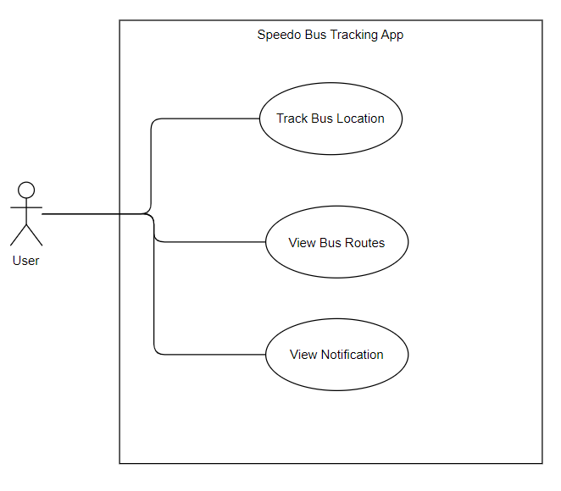
Figure ‎2.1 User Use case

The above figure is the Use case diagram of User that shows the functionalities of user as Track Bus, View Bus Routes, and View Notification.

Use Cases

Below are the use cases of this project:
- Location Tracking Use Case
- Bus Routes Use Case
- Notifications Use Case

Table ‎2.2 Tracking Use Case
 | Name | Location tracking
 | Use-Case ID | U1
 | Objective | Users will track the Bus location
 | Priority | High
 | Actors | Passenger
 | Flow of Events | - Start the Application.  - Click Bus Live Tracking button.
 | Includes | No other use case
 | Pre conditions | App must be installed and user’s device location must be ON with internet connected.
 | Post conditions | App must be running and user’s device location must be ON with internet connected.
 | Notes/Issues | None

Table ‎2.3 Bus Routes Use Case
 | Name | Bus Routes
 | Use-Case ID | U2
 | Objective | Users will able to see bus routes
 | Priority | High
 | Actors | Passenger
 | Flow of Events | - Start the Application.  - Click Bus Routes button.
 | Includes | No other use case
 | Pre conditions | App must be installed and user’s device must be connected to internet.
 | Post conditions | User’s device must be connected to internet.
 | Notes/Issues | None

Table ‎2.4 Notifications Use Case
 | Name | Notifications
 | Use-Case ID | U3
 | Objective | Users will able to see notifications
 | Priority | High
 | Actors | Passenger
 | Flow of Events | - Start the Application.  - Click Alert Notifications button.
 | Includes | No other use case
 | Pre conditions | App must be installed and user’s device must be connected to internet.
 | Post conditions | User’s device must be connected to internet.
 | Notes/Issues | None

ERD

Below is the ERD (entity-relationship diagram) of this project:

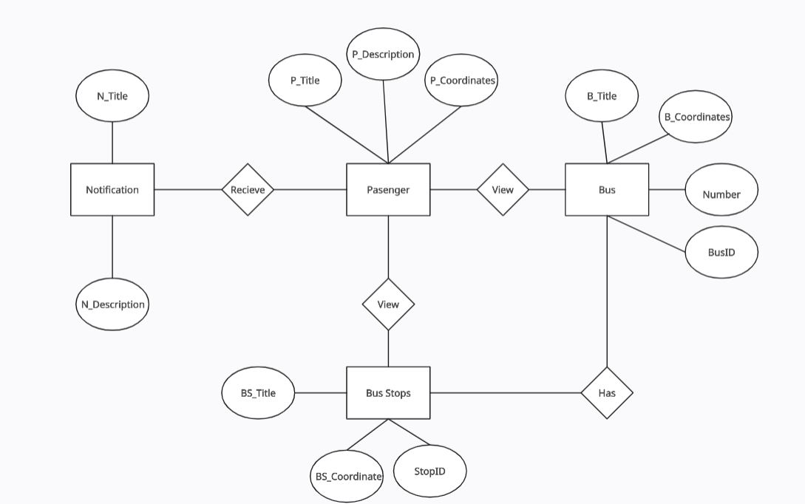
Figure ‎2.2 ERD

The above figure is the ERD of the project, that contains four entities:
- Notification: Notification entity has attributes named as N_Title and N_Description.
- Bus Stops: Bus Stops entity has attributes named as BS_Title, BS_Coordinates and StopID.
- Bus: Bus entity has attributes named as BusID, Number, B_Coordinates and B_Title.
- Passenger: Passenger entity has attributes P_Title, P_Description and P_Coordinates.

Sequence Diagram

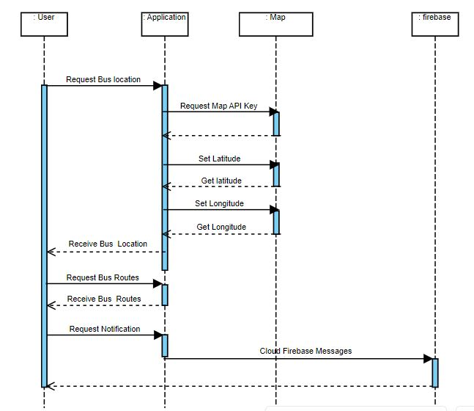
Figure ‎2.3 Sequence Diagram

The above figure is the sequence diagram of this project that describes the interaction between parts of a system:
- User request Bus location from application and application request Map API Key and longitude, latitude from Map and returns it to Application that displays it to User.
- User request Bus Routes from Application and Application display’s it to User.
- From Firebase notifications are displayed to User.

Class Diagram

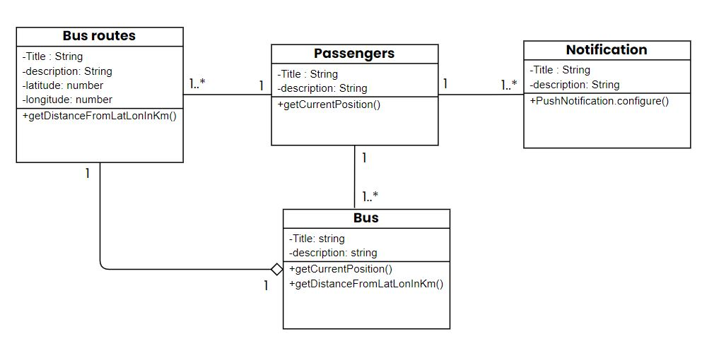
Figure ‎2.4 Class Diagram

The above figure is the Class Diagram of the application that illustrates the aspect of entire application:
- Passengers and Bus have one-to-many relationship because a bus can have many Passengers.
- Passengers and Notifications have one-to-many relationship because a Passenger can receive many Notifications.
- Passengers and Bus Routes have one-to-many relationship because a Passenger can view many routes.
- Bus Routes and Bus have aggregation meaning that if we delete Bus, then Bus Routes will still exist.

Hardware Interfaces

- The device must be an android having minimum of 2 GB RAM.
- Android should be having a nice touch style for conveniency in application.

Software Interfaces

The application will run on android minimum version 4.4 with minimum 512 MB RAM and 4GB ROM. Firebase database will be used in this application.

Functional Requirements

Functional requirements of this application are described below:
- Application must show live location of the bus.
- Application must show Schedule of the buses with their arrival time at stops.
- Application must show alert notifications in case of no service.
- Application must be secure.

Non-functional Requirements

Here are some non-functional requirements of this application are described below:
- Speed show how fast an app can respond to the commands. Like, multiple applications can run at a time by the user.
- Security also affects the application. To secure and protect the personal or sensitive data of the user.
- Portability determines that how well an application can run on different environments like multiple devices can use same application.
- Highly compatibility allows the users to use different operating system.
- Capacity also affects the application it refers to the storage of the device.

DESIGN AND METHODOLOGY

Methodology

In this application, you can open with your location and then view the nearest stop from your location and its route and bus arrival time. This application will be easy to use, so people can use it more without any complexities. In its front look you can easily view the detail of routes. It is more convenient to use rather than waiting for the bus for so long, so in case of hurry you can check its timing and go on your own if the bus is late due to any reason.
In this project, we are using JavaScript, CSS and Firebase for development [1]. This is a mobile application which is made-up on visual studio code tool. For locations and tracking, we will use Google map APIs and React-native maps.
The passenger and the bus distance is calculated using haversine formula which takes the location coordinates of both locations (latitude and longitude) and calculates the distance between them and display the calculated distance to the user along with time.
Implementation of project will be done by implementing spiral model [2] which includes four phases of:
● Planning.
● Risk analysis.
● Engineering.
● Evaluation.

As this model focuses more non risk management. So, in the start the development requirements are gathered and all the development phases are completed and further functionalities were added in the project in the form of spirals until the project is completed.

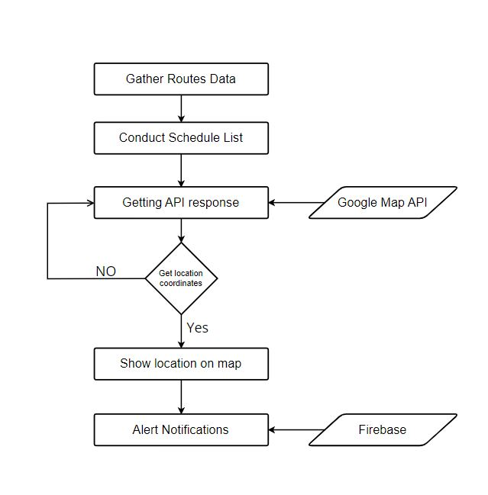
Figure ‎3.1 Work Flow

The above figure shows the work flow that illustrates the flow of the project beginning from gathering Routes Data then conducting Schedule List and then Getting API response from Google Map API for fetching location coordinates and displaying it on map and getting notifications from FCM (firebase).

IMPLMENTATION

Following methods, tools, technologies are used in the implementation of this project

IDE’S, Tools and Technologies

These IDE’s and tools were installed for this project.

Android Studio

It is the standard Integrated Development Environment for Android app development. It is built on JetBrains on IntelliJ IDEA. It provides Gradle-based build support, Android-specific refactoring and quick fixes, support for Google Cloud Platform, integration with FCM (Firebase Cloud Messaging) and other features.

Visual Studio Code

Visual Studio Code or VS Code is the source editor used in the implementation of this project. It supports debugging, snippets, syntax highlighting and a variety of other features. IntelliSense for JavaScript, TypeScript, JSON, CSS, and HTML is also included with Visual Studio Code.

Android SDK

In the development of android applications Android SDK known as Android Software Development Kit is vital. A Complete set of development tools is included in the Android software development kit (SDK) like debugger, libraries and an emulator ensuring that the development process is made to proceed as smoothly as feasible.

Android SDK Manager

Android SDK Manager is one of the command line tools that that enables you view, install, update, and uninstall packages for the Android SDK. It also informs about any compatibility issues that may occur.

Programming Languages

Languages used in this project are JavaScript and Cascading Style Sheet (CSS).

JavaScript
JavaScript is a high-level programming language that follows ECMAScript. It allows the implementation of dynamic features. JavaScript's implementations in online, mobile application, and game development make the scripting language worthwhile to master.

CSS
CSS is a style sheet language used for the styling of HTML elements and when used with different media, it controls how HTML elements should be rendered on screens. CSS saves a significant amount of time.

Permissions in Android

When a simple app is created some permissions are automatically generated but, for higher level API or SDK the permissions must be explicitly mentioned in the AndroidManifest.xml file. The following permissions are explicitly added in this project.

- POST_NOTIFICATIONS
- C2D_MESSAGE
- VIBRATE
- RECEIVE_BOOT_COMPLETED
- SYSTEM_ALERT_WINDOW
- ACCESS_FINE_LOCATION
- ACCESS_COARSE_LOCATION
- ACCESS_BACKGROUND_LOCATION

Implementation of Modules
Implementation of this project is done as:

Dependencies
Following dependencies were added in this project
- react-native-maps
- geo-location
- react-native-firebase/app
- react-native-firebase/messaging
- react-native-push-notification

React-native Maps

To implement Maps for location tracking, a Google Maps API Key is generated and added in the project’s AndroidManifest.xml file. Then React-native-maps were installed.

Getting Current Location and Calculate distance

For calculating the distance between user and bus, the location coordinates (latitude and longitude) of user and driver’s location is fetched using getCurrentPosition () method and distance is calculated by implementing Haversine formula.

Haversine formula:
var R = 6371;
var dLat = deg2rad(lat2 - lat1);
var dLon = deg2rad(lon2 - lon1);
var a =
Math.sin(dLat / 2) * Math.sin(dLat / 2) +
Math.cos(deg2rad(lat1)) * Math.cos(deg2rad(lat2)) *
Math.sin(dLon / 2) * Math.sin(dLon / 2) ;
var c = 2 * Math.atan2(Math.sqrt(a), Math.sqrt(1 - a));
var d = R * c;

Notifications

For sending notifications, Firebase cloud Messaging is used by creating a Firebase project and connecting it with the react-native app and adding the google-services.json file. PushNotification() functionality is added that generates a Token and displays the Notification.

RESULTS

Screens of application

These screens will be displayed to the user:

Welcome Screen

On the opening of application users will see the following pop-up screen.
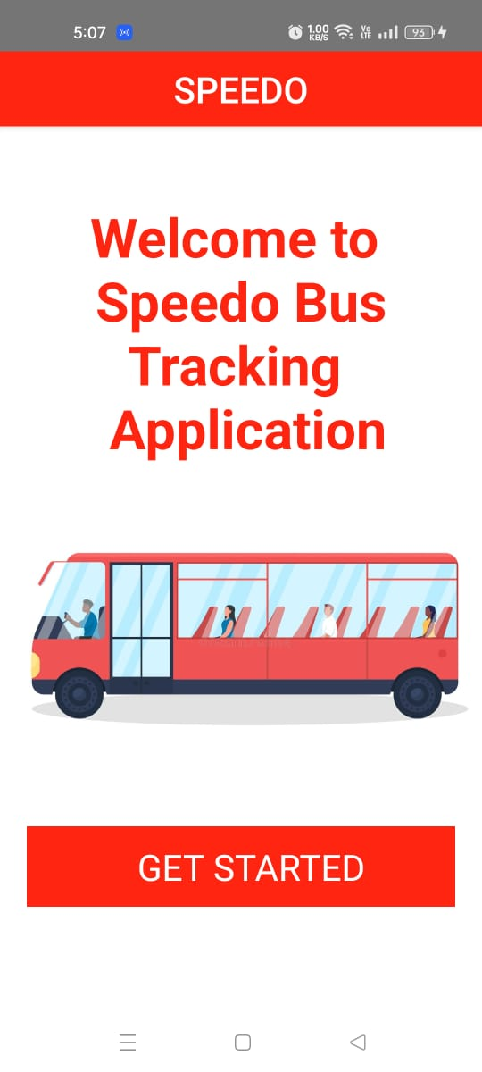
Figure ‎5.1 Welcome Page

Main Screen

Main-landing page shows features of application.

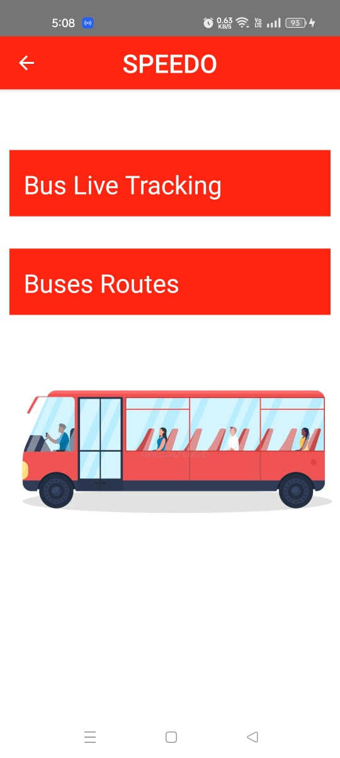
Figure ‎5.2 Main Page

Location access

Allow access to your device’s location.

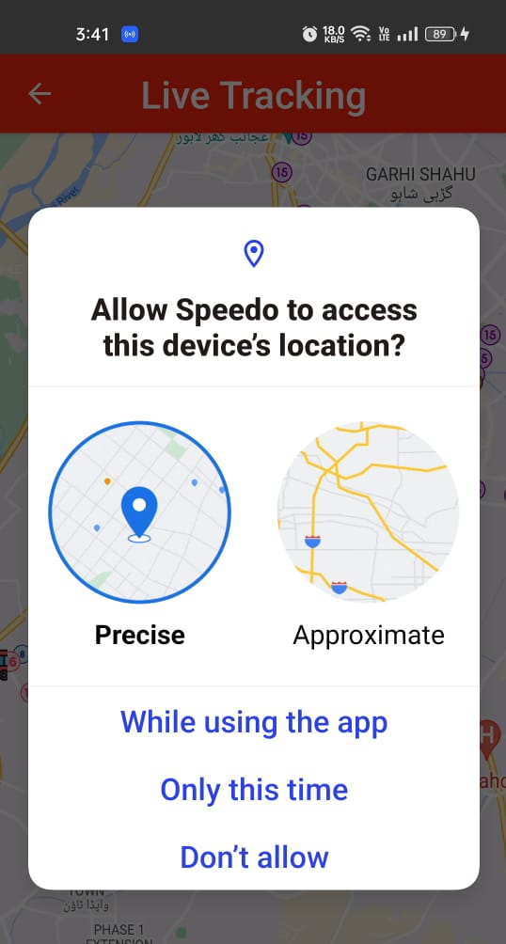
Figure ‎5.3 Live Location Access

Bus Live Tracking Screen

Bus Live Tracking page displays live location of buses and users.

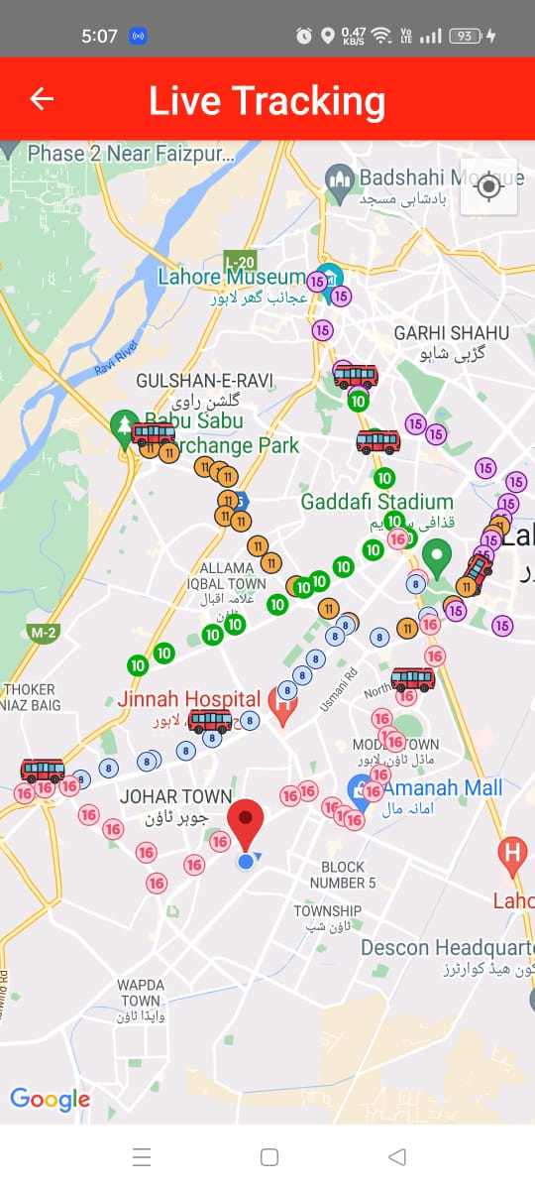
Figure ‎5.4 Live Location Tracking

Bus distance

Bus shows the distance from the user’s live location.

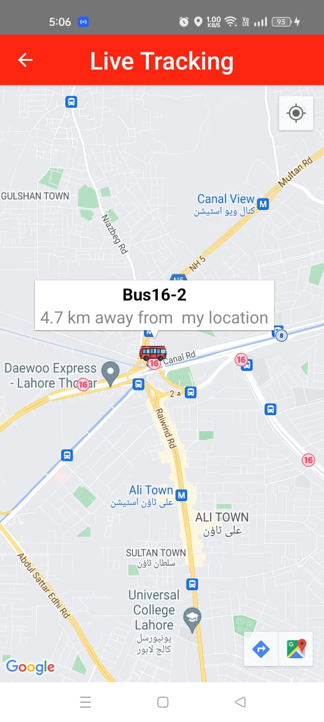
Figure ‎5.5 Bus distance from user’s live location

Stops Distance

Stops shows the distance from its own location to buses.

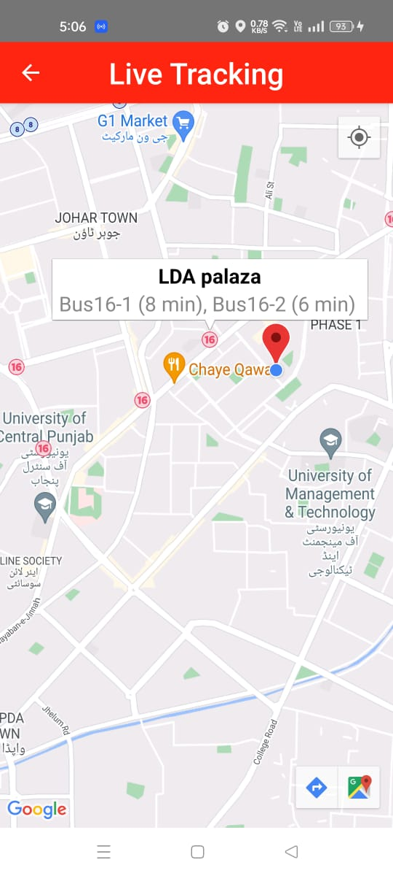
Figure ‎5.6 Stops distance from bus

Bus Routes

Bus Routes page displays all the buses with names.

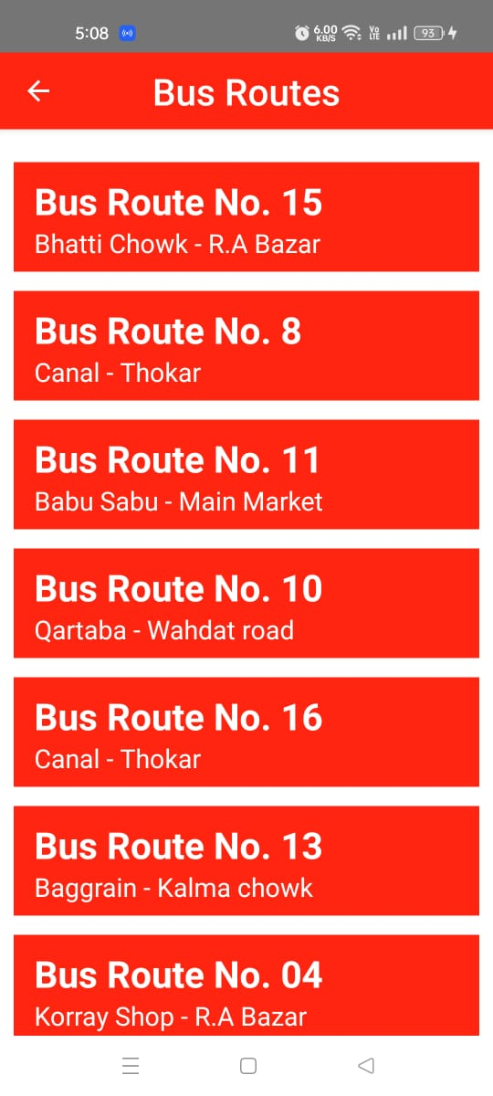
Figure ‎5.7 Bus Routes

Each Bus Routes

All the Bus Routes will display all bus stops from the start of route to the end and buses start time.

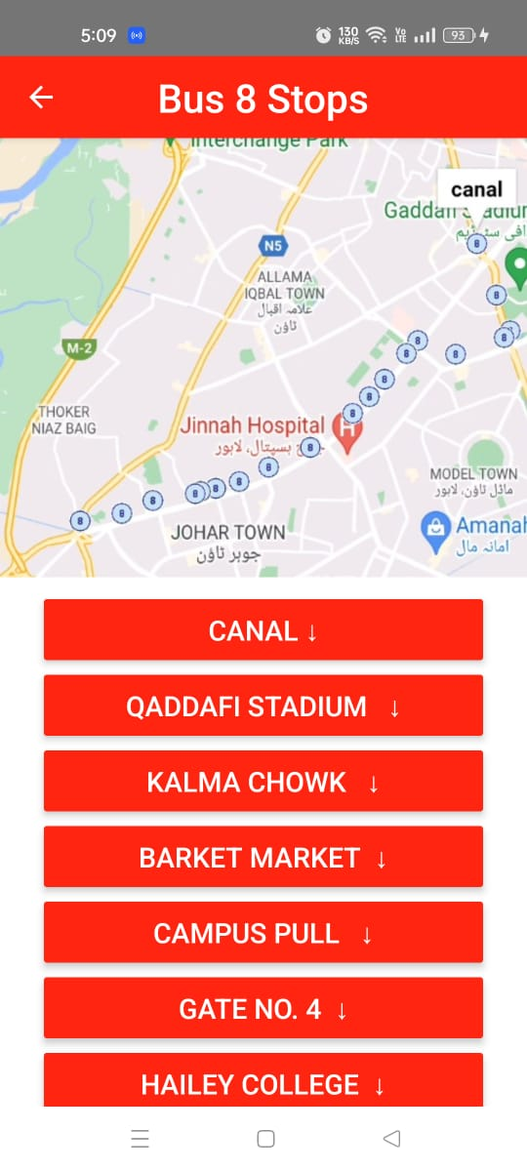
Figure ‎5.8 Bus Stops

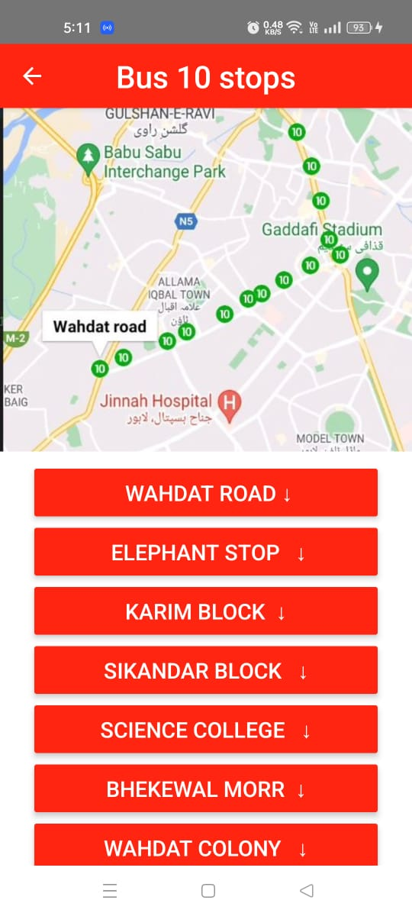
Figure ‎5.9 Bus Stops

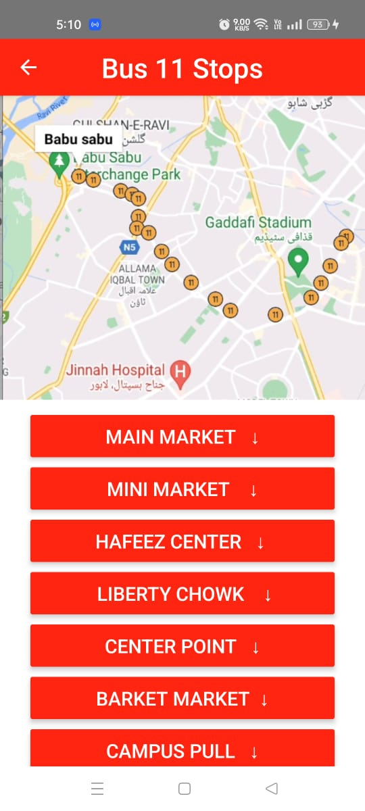
Figure ‎5.10 Bus Stops

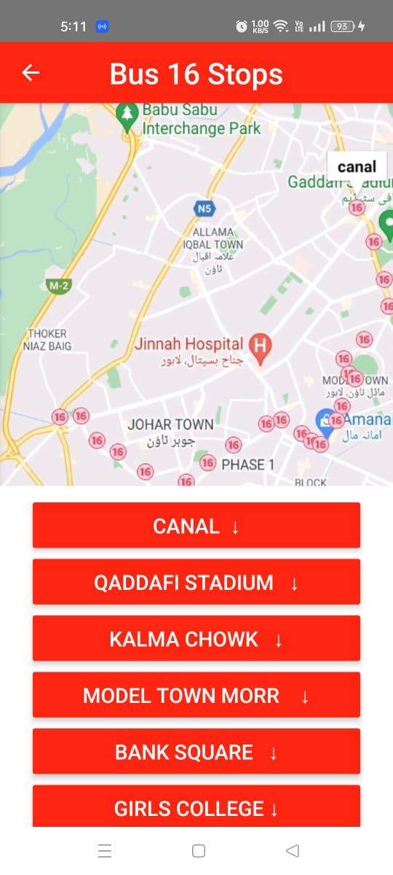
Figure ‎5.11 Bus Stops

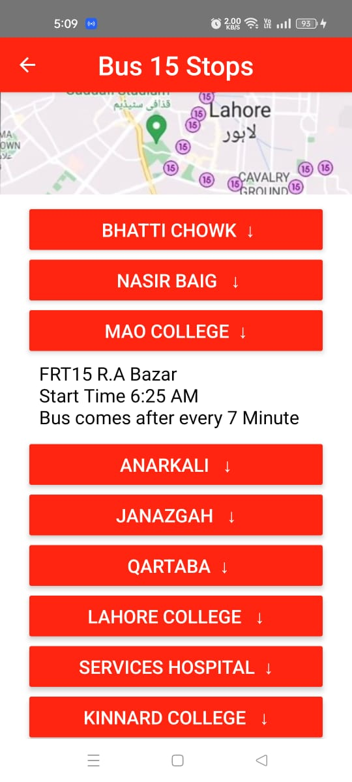
Figure ‎5.12 Bus Stops

Notification:

When there is no service, notification shows in the application.

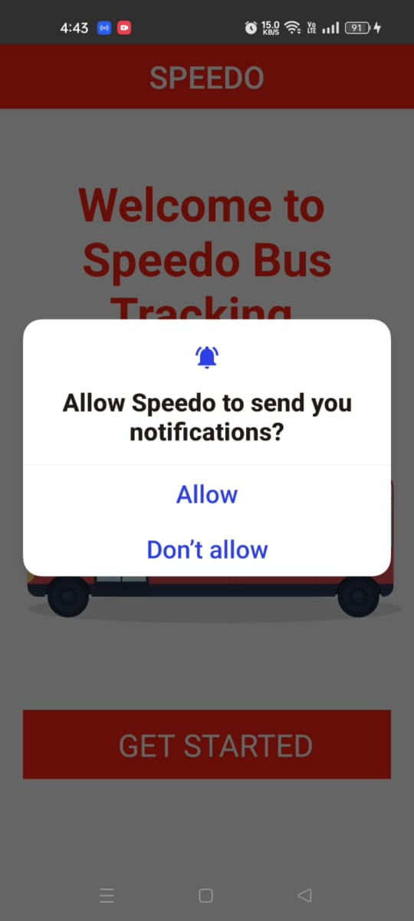
Figure ‎5.13 Notification access

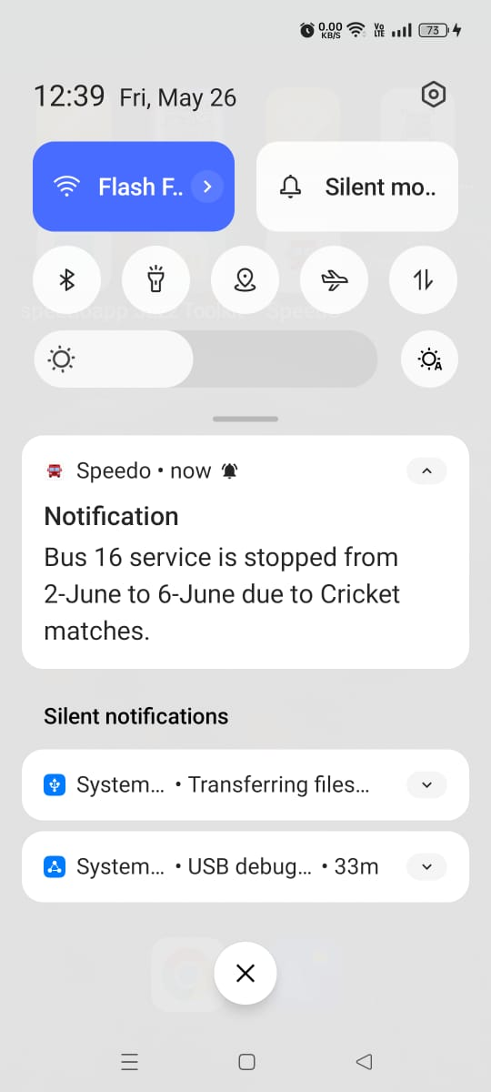
Figure ‎5.14 Notifications

CONCLUSION

As previously said, other existing applications either show bus stops or bus schedules, but this application assists consumers in locating the location of the bus on the route. This mobile application is user friendly and easy to understand. People who use this application in the future will gain various benefits, including tracking the bus location and view the stops with their names and not having to spend a lot of time waiting around for the bus, by using this application. The routes of the bus are displayed in the map clearly with the help of markers. It makes the application more understandable and easier to use. Location tracking helps people to find the bus location. The stops of each bus routes are also mentioned in the ‘Bus Routes’ section. And users will receive notifications in case of any problem.
In future, this application can also be used for local transport buses that runs within the city. And features of this application can be expanded by the addition of microphone recording and video recording.

REFERENCES

Books:

[1] | R. D. M. S. Adam Boduch, React and React Native: Build cross-platform JavaScript applications with native power for the web, desktop, and mobile., 2022.
[3] | M. Doery, Learn By Doing: React Native with Maps, 2020.

Journal Papers:
[2] | A. M. R. M. S. A. M. R. P. M. I. A. Risna Sari, "The Systematic Literature Review of the spiral development model: Topics, trends, and application areas," International Journal of Research and Applied Technology (INJURATECH), vol. 2 No.2, 2022.
[4] | K. G. K. G. Vipul Kaushik, "React Native Application Development," International Journal of Advanced Studies of Scientific Research, vol. 4, p. 7, 2019.

Electronic Sources from Internet:
https://www.npmjs.com/package/react-native-maps
https://reactnative.dev/
https://reactnavigation.org/
https://reactnative.dev/docs/style
https://www.npmjs.com/package/@react-native-community/geolocation

