
BSCS-F22-020
03-134192-054 | Haroon khan
03-134192-058 | Muhammad Bilal

The waste that world needs

In partial fulfilment of the requirements for the degree of
Bachelor of Science in Computer Science
Supervisor: Tahir Iqbal
Department of Computer Sciences
Bahria University, Lahore Campus
June, 2023

© Bahria University, 2023

Certificate

We accept the work contained in the report titled
“The waste that world needs”
Written by
Muhammad Bilal
Haroon khan
As a confirmation to the required standard for the partial fulfilment of the degree of
Bachelor of Science in Computer Science.

Approved by:
Supervisor: Tahir Iqbal
(Signature)

Date: June 20, 2023

DECLARATION

We hereby declare that this project report is based on our original work except for citations and quotations which have been duly acknowledged. We also declare that it has not been previously and concurrently submitted for any other degree or award at Bahria University or other institutions.

Enrolment | Name | Signature
03-134192-054 | Haroon khan
03-134192-058 | Muhammad Bilal

Date: June 20, 2023

Specially dedicated to
My beloved mother, father and family
(Muhammad Bilal)
My beloved mother, father and family
(Haroon Khan)

ACKNOWLEDGEMENTS

We would like to thank everyone who had contributed to the successful completion of this project. We would like to express our gratitude to our research supervisor, Mr Tahir Iqbal for his invaluable advice, guidance and his enormous patience throughout the development of the research.

In addition, we would also like to express our gratitude to our loving parent and friends who had helped and given us encouragement.

Haroon khan
Muhammad Bilal

The waste that world needs

ABSTRACT

The goal of this project is to develop a detection system that can distinguish between organic and recyclable materials in a waste stream. The system utilizes deep learning algorithms to identify different types of materials based on their physical properties. The system is able to process the images and identify the materials. The project aims to improve the efficiency and effectiveness of waste management processes by ensuring that organic materials are separated from recyclable materials, thereby reducing the amount of waste sent to landfills. The results of the project have the potential to significantly contribute to sustainable waste management practices and environmental protection efforts.

This project uses the Deep learning model to develop the software. The main advantage of using this model is that it provides feature detection that is suitable for detecting the material which is organic or not. The proposed system's accuracy was evaluated using a test dataset, achieving an overall accuracy of over 85%. The organic materials identified by the system are then separated and sent to a composting facility, while the non-compostable materials are diverted to a separate processing unit for proper recycling and disposal. This detection system offers several benefits, including reducing contamination in the composting process, promoting sustainability, and providing a reliable and automated solution for waste management. Additionally, it can be used by businesses and communities to comply with composting regulations and reduce their environmental impact.

The model we are providing is more stable and reliable and have a better user experience than older detection system of compostable and non-compostable material.
In conclusion, the detection system for compostable and non-compostable materials using deep learning shows great potential by providing an efficient, accurate, and sustainable solution for processing different types of waste materials. Moreover the model is integrated with user friendly frontend build using react library for JavaScript.

TABLE OF CONTENTS

CHAPTERS
1 INTRODUCTION 1
1.1 Background 1
1.2 Problem Statements 1
1.3 Aims and Objectives 2
1.4 Scope of Project 3
2 LITERATURE REVIEW 4
2.1 Software requirements specification 6
2.1.1 Experimental Setup 6
2.1.2 User classes and characteristics 7
2.2 Limitations 8
2.2.1 Limited dataset 8
2.2.2 Variability in waste materials 8
2.2.3 Need for high-quality images 8
2.2.4 Limited user input 8
2.2.5 Technical limitations 9
3 DESIGN AND METHODOLOGY 10
3.1 Methodology 10
3.2 Methodology approaches 10
3.2.1 Dataset 11
3.2.2 Data Preparation and Preprocessing 11
3.2.3 Model Architecture 11
3.2.4 Model Architecture Design 15
3.2.5 Model training 15
3.2.6 Model Evaluation 16
3.3 Design 17
3.3.1 Use case diagram 18
3.3.2 Sequence Diagram 20
3.3.3 Class Diagram 24
3.3.4 Domain Diagram 25
3.3.5 ERD Diagram 26
3.3.6 Collaborative Diagram 27
4 IMPLEMENTATION 29
4.1 Developing Deep learning model 29
4.1.1 Data Collection and Preparation 29
4.1.2 Creating the Deep Learning Model 29
4.2 Designing Web-application 30
4.2.1 Creating the Web Application Front end 30
4.2.2 Creating the Web Application Back end 30
4.2.3 Integrating backend and frontend 30
5 RESULTS AND DISCUSSIONS 31
5.1 CNN Models Accuracy 31
5.1.1 Performance Evaluation of Model 31
5.1.2 Imbalanced dataset 32
5.1.3 Balanced dataset 33
5.1.4 Model Accuracy 34
5.2 Web Interface 34
5.2.1 Landing Page 34
5.2.2 Register Page 35
5.2.3 Sign In Page 36
5.2.4 Upload File Page 36
5.2.5 Records Page 37
6 CONCLUSION AND RECOMMENDATIONS 38
6.1 Future Work 39
REFERENCES 40

LIST OF TABLES

TABLE TITLE PAGE
Table 1 Testing and validation accuracy 31
Table 2 Evaluation Metrics with unbalanced data 33
Table 3 Evolutional Metrics for Balanced Data 33
Table 4 CNN model accuracy 34

LIST OF FIGURES

FIGURE TITLE PAGE
Figure 1: Admin use case 18
Figure 2: User use case 19
Figure 3: Registration sequence 21
Figure 4: Login sequence 21
Figure 5: Password reset sequence 22
Figure 6: Prediction sequence 23
Figure 7: Records sequence 23
Figure 8: Class diagram 25
Figure 9: Domain diagram 26
Figure 10: ERD diagram 27
Figure 11: Collaborative diagram 28

INTRODUCTION

Background

Environment pollution is increasing day by day due to a lot of waste produced by humans. The waste is thrown out in lands which pollutes the environment. The build-up of solid waste in metropolitan areas is a major worry that, if not effectively handled, could lead to environmental pollution. The unhandled waste is also a reason of global warming which can be very dangerous to human health. To manage a range of waste products, it's crucial to have an advanced/intelligent waste management system. This process is typically done manually by hand-picking the various components. We will implement this project using AI. The garbage sorting process will become substantially faster and less expensive through automation.

Separating the garbage into its many components is one of the most crucial waste management stages. We suggest a completely automated waste management system to implement waste classification.

Problem Statements

The problem addressed in this project is the difficulty in accurately sorting and processing compostable and non-compostable waste materials. The conventional waste management systems often rely on manual sorting or basic sorting technologies, which can result in high levels of contamination in the composting process, leading to

Reduced compost quality and increased processing costs. Additionally, incorrect disposal of non-compostable materials can have a significant negative impact on the environment.

Therefore, there is a need for an efficient and accurate detection system that can reliably differentiate between compostable and non-compostable materials. This project proposes a solution that uses deep learning algorithms to classify materials based on their characteristics, such as size, colour, and texture. The proposed system aims to provide an automated and reliable solution that reduces contamination, improves compost quality, and promotes sustainability.

Aims and Objectives

The objectives of this project are shown as following:
- To develop a reliable and automated system for accurately identifying and sorting compostable and non-compostable waste materials.
- To use deep learning algorithms, specifically convolutional neural networks, to train the detection system to recognize the characteristics of compostable and non-compostable materials.
- To evaluate the accuracy of the detection system by comparing the results obtained from the deep learning model with the ground truth data.
- To integrate the detection system into the infrastructure of existing waste management companies to improve the efficiency and sustainability of the waste management process.
- To reduce the contamination of compostable waste with non-compostable waste and promote environmental sustainability.
- To provide a scalable and adaptable solution that can be implemented in various waste management systems across different industries.

Scope of Project

The scope of this project is to develop a detection system for identifying compostable and non-compostable materials. The system will use image processing techniques, and convolutional neural networks to classify the materials based on their characteristics, such as size, colour, and texture.

The project's scope is building a deep learning algorithm with the help of existing datasets sources on internet. The system's accuracy and efficiency will be evaluated using various metrics, and any required improvements will be implemented accordingly.

The proposed detection system's scope will not be limited to a particular type of waste material in future and will be able to applied to various waste streams, including food waste, yard waste, and paper waste. Additionally, the system can be integrated into existing waste management facilities to improve the efficiency and sustainability of their operations.

Overall, the project's scope is to provide an automated, reliable, and accurate solution for sorting and processing compostable and non-compostable materials, promoting sustainability, and reducing contamination in the composting process.

LITERATURE REVIEW

In recent years, there has been an increase in interest in the creation of a web-based application that uses a deep learning model to recognise compostable and non-compostable materials. Several studies and research articles have been published on this issue, examining various approaches to achieving accurate and effective garbage classification using machine learning techniques.

- Y. Luo et al. (2021) proposed a web-based application that uses a deep learning model to categorise garbage into biodegradable and non-compostable categories. For training the deep learning model, the authors used a dataset of photos comprising various forms of garbage that had been pre-processed and labelled. For image classification, they used a convolutional neural network (CNN) architecture and achieved excellent accuracy in waste classification.

- S. S. Patil et al. (2020) suggested a web-based waste management application that uses a deep learning model for waste classification. For training the deep learning model, the authors used a dataset of photos of various sorts of rubbish that had been pre-processed and labelled. For picture classification, they used a pre-trained VGG16 CNN architecture and achieved excellent accuracy in waste classification. Users could upload garbage photographs and receive classification results via the web application.

- In a separate study, S. Huang et al. (2019) created a web-based waste sorting tool that uses a deep learning model to categorise rubbish. For training the deep learning model, the authors used a dataset of photos comprising various forms of garbage that had been pre-processed and labelled. They achieved great accuracy in garbage classification by using a pre-trained Inception-v3 CNN architecture. The web programme allowed users to input garbage pictures and receive real-time classification results.

Overall, these investigations illustrate the feasibility and possibility of constructing a web-based application for garbage classification that employs a deep learning model. Such apps can assist users in identifying compostable and non-compostable products, as well as promote trash reduction and recycling initiatives. More study and development in this field could lead to more precise and efficient waste classification methods, which would ultimately help the environment and society.

Software requirements specification

Experimental Setup

For training our deep learning model, we utilized Google Colab as our platform of choice. The dedicated GPU we employed was the Tesla T4, which was generously provided by Colab and boasted an impressive 15 GB of RAM. In addition to the GPU, our Colab environment allocated 12 GB of system RAM and provided 78 GB of disk space.

During the development phase, we employed a laptop with a 6th generation Core i5 processor. The laptop possessed a total of 8 GB of RAM and a generous 756 GB of disk space, contributing to a robust development environment.

We utilized the same laptop throughout the website development process. The backend was created using the PyCharm 2021 Professional IDE developed by Jet Brains, while the frontend was designed using the Visual Studio Code text editor. By leveraging these powerful tools, we were able to effectively develop both the backend and frontend components of the website. The PyCharm IDE provided a robust environment for coding and debugging the backend functionalities, while Visual Studio Code proved to be an excellent choice for crafting the user-friendly and visually appealing frontend. This harmonious combination of tools facilitated a seamless development experience and ensured the successful creation of the website.

User classes and characteristics

Waste that world need is a web-based application which is divided into two user
- Admin
- Authenticated user

Admin:
- Check the records
- Delete records
- Update records
- Create User
- Update User
- Delete User

Authenticated User:
- Signup/login
- Reset Password
- Give input as a picture
- View Prediction Result
- Check previous results

Limitations

While a web-based application that utilizes a deep learning model to detect compostable and non-compostable materials has several potential benefits, there are also some limitations that should be considered. Some of the limitations are:

Limited dataset

While the deep learning model was trained and tested on a large dataset of compostable and non-compostable materials, there may be novel materials that were not included in the dataset. As a result, waste materials may be classified incorrectly.

Variability in waste materials

Waste materials can vary in shape, size, and texture, which can affect classification accuracy.

Need for high-quality images

High-quality photographs are required for proper trash classification, hence images supplied by users must be of high quality. Low-quality photos may cause waste materials to be misclassified.

Limited user input

While the web-based programme allows users to upload garbage photos, users have limited options for providing further information about the waste item. This can reduce waste categorization accuracy.

Technical limitations

Creating a deep learning-powered web application can be technically demanding, requiring knowledge in machine learning, software development, and web development. Maintaining and upgrading the programme might also be time-consuming.

Overall, while a web-based trash categorization service that uses a deep learning model offers various potential benefits, it is critical to address these constraints in order to create an application that is accurate, dependable, and user-friendly

DESIGN AND METHODOLOGY

Methodology

The methodology that is used in development of this project is agile and moreover to be specific we used scrum framework. The main reason for choosing this methodology is that it provides a scope of great improvement throughout the software development lifecycle of the project. The project was divided into smaller modules and we planned sprints for each module.

Each module was tested at the end of sprint and the quality of module was made ensured. We ensured regular meetings with our supervisor at the end of sprint to discuss the functionality of the module completed and for the planning of the next sprint.

Methodology approaches

The following stages were used to sum up the process for creating a web-based application that uses a Convolutional Neural Network (CNN) model to identify compostable and non-compostable materials:

Dataset

The dataset titled "Waste Classification Data"[6] is available on Kaggle and is provided by a user named "techsash." The dataset focuses on waste classification, aiming to help in the identification and categorization of various types of waste. It is designed to aid in waste management, recycling efforts, and environmental sustainability.

The dataset contains a total of 25,120 images, each labelled with one of two classes: "Organic" or "Recyclable." These labels indicate whether the waste item belongs to the organic waste category or the recyclable waste category, respectively.
The dataset is divided with the ratio of 85% to 15% meaning 85% of the data belongs to training and the remaining 15% is for test evaluation of model. Both the train and test folder have 2 subfolders for each label i.e. Organic and Recyclable. Metadata of dataset is also present on kaggle including Meta information such as Author name and Coverage etc.

Data Preparation and Preprocessing

After downloading the dataset and uploading it to Google Drive, we mounted the drive in Google Colab and assigned the dataset path to separate variables for the train and test sets. To enhance the dataset and prepare it for training, we applied Data Augmentation and Preprocessing techniques using ImageDataGenerator specifically on the train batch. The train batch consists of 22,607 images, while the test batch comprises 2,513 images.

Model Architecture

We employed a CNN (Convolutional Neural Network) classifier based on deep learning techniques to make predictions on the image dataset based on the defined classes. CNN was chosen due to its superior performance in image datasets, as

Indicated by recent studies and implementations. One notable advantage of CNN is its ability to reduce computational power significantly compared to other deep learning models like ANN. This is achieved by focusing only on the region of interest within an image rather than processing every single pixel. Furthermore, the model we utilized follows a sequential architecture, representing a linear stack of layers.
The model we have used consist of 15 layers stacked together to form a classifier i.e. from which first layer is input layer last been the output layer and remaining 13 being the hidden layer which are used for training.

- Conv2D:
Conv2D specifies the type of layer that is to be used, Conv2D means that it would be a two dimensional convolutional layer. Different parameters can be passed to this function for further processing.

- MaxPooling2D:
This layer performs max pooling operations on the previous layer's output, reducing the dimensions of the output generated by taking the maximum value within each pooling window.

- Dropout:
This layer applies regularization by, randomly setting a fraction of units supplied a parameter to 0 at each training step. It helps prevent overfitting by reducing the reliance of the model on specific features.

- Flatten:
This layer flattens the multi-dimensional output from the previous layer into a single dimension, preparing it to be connected to the dense (fully connected) layers.

- Dense:
This layer is a fully connected layer which means that each neuron in this layer is attached to each neuron of the parent layer.

- Filters:
The first positional argument provided to this function is an integer and defines the number of filter that will be applied by a layer.

- Kernel Size:
Kernel size is the keyword argument of this function that receives a tuple it defines the size of a kernel which will slide across the layer for computation.

- Activation function:
It is also a keyword argument that specifies the activation function to be used by a layer. Activation function is used for reducing the magnitude of output generated by the layer.

- Input Layer:
model.add(Conv2D(32,kernel_size=(3,3),padding='same', activation='relu', input_shape=(IMG_HEIGHT,IMG_BREDTH,3)))
The input layer defines a Conv2D layer with 32 filters, a kernel size of 3x3, padding set to 'same', ReLU activation, and an input shape of (IMG_HEIGHT, IMG_BREDTH, 3). Here padding same means that the output produced by this layer will be of same dimension as input and input shape define the shape of the input data expected by the layer. IMG_HEIGHT and IMG_BREDTH represent the height and width of the input images, respectively. The last value of 3 indicates that the input images have three color channels (RGB)

- Hidden Layer:
Total 13 hidden layers are used in this architecture which comprise of Conv2D, MaxPooling2D, Dense, Dropout and Flatten layers each one of this layer serves their own specific computation. A total of 5 Conv2D, 4 Dropout, 2 Dense, 1 MaxPolling2D and 1 Flatten layers are used as hidden layers.

- Output Layer:
model.add(Dense(num_classes, activation='softmax'))
This is the final output layer of this architecture. Dense is the type of layer that specifies that this layer will be fully connected meaning that all the neurons in this layer will be connected to all the neurons present in the parent layer. The parameter num_classes defines the number of neurons in the layer which are mostly equal to the number of classes to predict. Parameter num_classes is a variable whose value should be equal to the total number of classes. Softmax activation function is used because it assign a probability to each class and make sure that sum of all probabilities is equal to 1.

Model Architecture Design

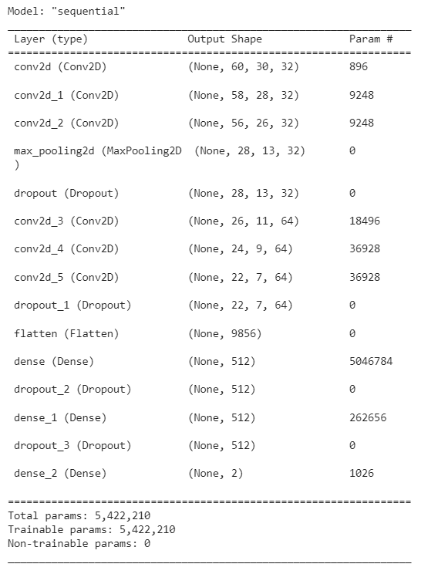

Model training

Using the Training data set the model is trained using .fit function. The model was trained for 5 epochs and validation data batch was also provided to validate the performance of model during training. Checkpoints call back are also used to save different checkpoints during the training to make training more faster and accurate as it is classification problem the loss function used to calculate loss is

categorical_crossentropy and the metrics used to evaluate the performance is accuracy while Adam being the optimizer. The checkpoints were used to save the progress of model in case of any interruption caused while training to make training faster and reliable. After completion of 5 epochs the model was saved in .h5 format and exported to local storage for further integration into web.

Model Evaluation

Utilising the validation dataset, the model was evaluated and the accuracy was calculated the model validation accuracy came to be at 85% whereas the loss of the model was 0.3567

- Backend Development:
Construct the web application's backend utilising an appropriate framework, such as Flask or Django. The backend should incorporate the trained CNN model to enable the categorization of submitted garbage photos. Implement the required APIs to handle picture uploads, image pre-processing, and calling the classification model.

- Frontend development:
Using HTML, CSS, and JavaScript, create and build the user interface (UI) for the web application. Construct a user interface that allows people to upload garbage photographs and browse categorization results. During the categorization process, provide users with the necessary visual feedback.

- Monitoring and upkeep:
Keep an eye on the web application's performance and fix any bugs or problems that appear. As new trash types are added or the dataset is improved, update the CNN model often.

Design

In the design part, some UML diagrams show a complete flow of the project as well as how the functionalities are fulfil in the project.

These UML diagrams are:
- Use case diagram
- Sequence diagram
- Class diagram
- Domain diagram
- Collaborative diagram

Use case diagram
Admin:
- Check/delete records
Admin have access to the database and can check all the records of user as well as admin can also delete the results from the database.

- Update records
Admin can also update the results in database.

- Create/Update/Delete User:
Admin can also create a new user, update an existing user or deletion of user is also a functionality of admin.
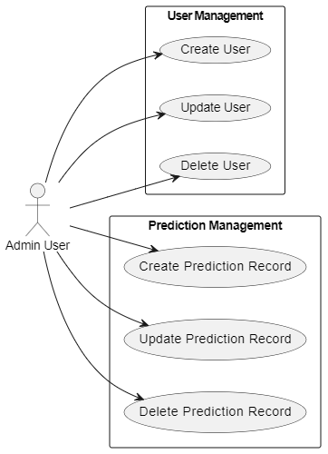
Figure 1: Admin use case

User:

- Signup/login
User can only use the web services when he/she is registered or login. New user have to sign up a new account and the existing user can login to the web application without creating new account again.

- Upload images
Once the user is logged in now he/she will be able to upload images for predictions and the result will be rendered on frontend.

- Review results
User will be able to review his results respectively to the uploaded image as well as user can see his previous or old results as results are saved on the database.

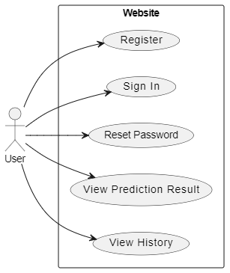
Figure 2: User use case

Sequence Diagram

Explanation of the sequence diagram:
- By visiting the online application and uploading a garbage image, the user engages with it.
- The image upload request is received by the web application and sent to the backend for additional processing.
- The image is received from the web application via the backend component, which then sends it to the deep learning model for categorization.
- To identify whether the garbage is biodegradable or not, the deep learning algorithm analyses the picture and carries out the classification.
- The backend receives the categorization results from the deep learning model.
- The categorization results are delivered to the backend, which then sends them to the web application.
- The user may view the categorization results on the web application.
- On the user interface of the web application, the user may view the categorization results.

Register User

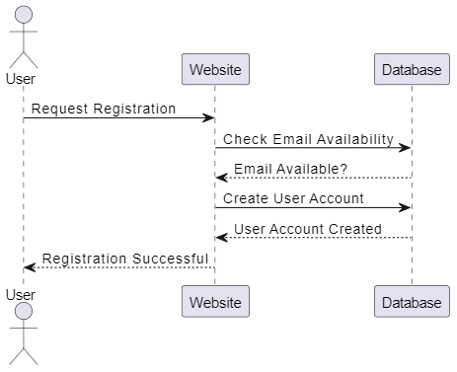
Figure 3: Registration sequence

Sign in User

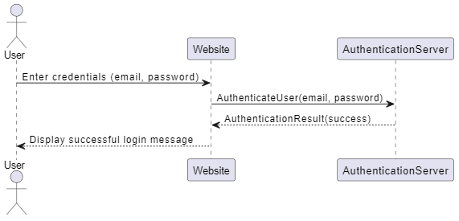
Figure 4: Login sequence

User Password Reset

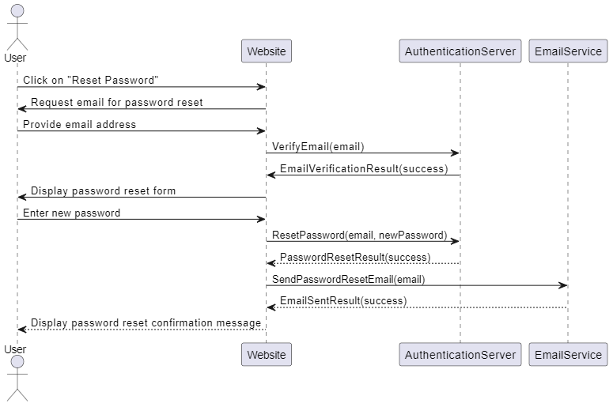
Figure 5: Password reset sequence

Prediction
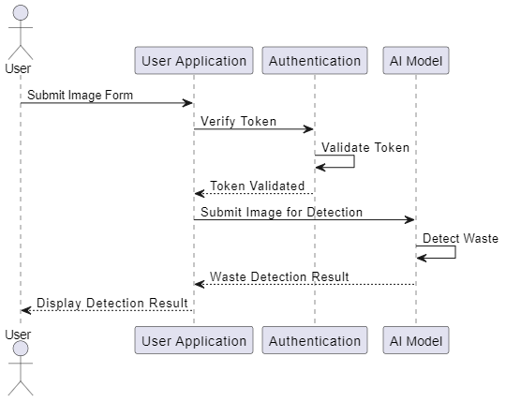
Figure 6: Prediction sequence

Previous Records
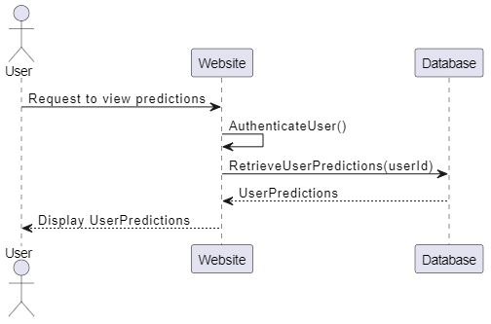
Figure 7: Records sequence

Class Diagram

- User: A website user is represented by the User class. It has attributes like id, name, password, email, and predictions. The User class provides methods to handle the corresponding user actions, including register, sign in, reset Password, SubmitImageForm, and view Predictions. Admin represents a user with enhanced rights who is an admin. Admins have control over user registration, and record checking.

- Prediction: The prediction provided by the AI model for a certain image is represented by the Prediction class. It has characteristics like id, image, result, and timestamp, with image being an instance of the Image class that represents the uploaded image.

- Web Application: This object represents the actual web application. It oversees user login, registration, and garbage image uploads. Additionally, it communicates with the backend and offers ways to get the most recent and past categorization results.

- Backend: Manages the categorization using the deep learning model, retrieval of the findings, and processing of the uploaded picture.

The class diagram reflects the relationships and interactions between the different classes in the web-based application.

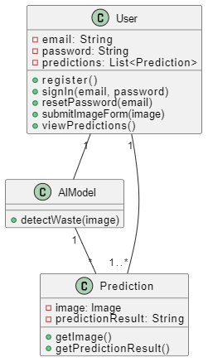
Figure 8: Class diagram

Domain Diagram

- Web application: Controls user login, waste picture upload, and user registration. It also offers ways to obtain the categorization results from the past and present.

- User: Class that represents the various application user categories. Along with login and registration options, it includes standard characteristics like username, password, and email.

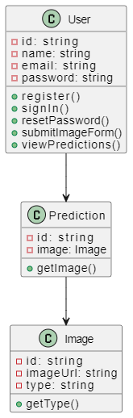
Figure 9: Domain diagram

ERD Diagram

- User Model:
- User_id: Unique identifier for each user.
- Username: Name of the user.
- Email: Email address of the user.
- Password: Password for user authentication.

- Prediction Model
- Prediction_id: Unique identifier for each prediction record.
- User_id: Foreign key referencing the user who submitted the image.
- Image: Image Field holding string to the image stored on server.

- Result: The prediction result (e.g., "organic-waste" or "plastic-waste").
- Timestamp: Timestamp of when the prediction was made.

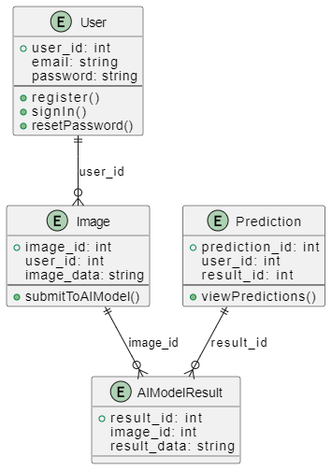
Figure 10: ERD diagram

Collaborative Diagram

In the diagram, the user and the "Authentication" participant communicate to complete sign-up, sign-in, and password reset procedures. The user can submit an image for waste detection by interacting with the "AI Model" participant as well. The user can access prior prediction records thanks to the "Record" participant.

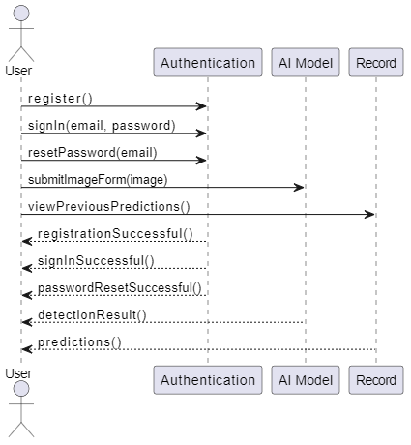
Figure 11: Collaborative diagram

IMPLEMENTATION

The implementation part of the development phase of the project is a process to shaped designs into a productive product. Waste that world’s need is the web based application so there are some technical constraints used is the development phase.
Developing Deep learning model
Designing Web-application

Developing Deep learning model

Data Collection and Preparation

An existing dataset is used that is published on kaggle in order to train the CNN waste classifier. Data Preprocessing is applied and the data is cleaned before feeding it to the model. The data is divided into two chunks training to train the model and testing to test the accuracy of model.

Creating the Deep Learning Model

Used Tensor flow framework and deep learning API Keras is used to implement that model using different layers. Different loss functions and optimization are used to optimize the model.

Designing Web-application

Creating the Web Application Front end

After completion of model, we designed the responsive web application interface. The user interface was built with HTML, CSS, Bootstrap and JavaScript.

Creating the Web Application Back end

After completing front end we focused on the backend of our application. We integrated the model in our backend to predict the images provided by user. Database tables are created to store information of user for successful signup, login, and creation and retrieval of database records. We used Restful APIs for database communication and the framework used for this purpose is Django Rest Framework. The backend is fully functional with appropriate error handling.

Integrating backend and frontend

After creating the interface and integrating the model in backend. We implemented front end functionality in our application. The frontend was made functional with the help of React library for JavaScript. The APIs were integrated in frontend to make the website dynamic.

RESULTS AND DISCUSSIONS

CNN Models Accuracy

The deep learning model used for waste classification achieved a training loss of 1.4201 and an accuracy of 83.80%. In the validation set, the model had a loss of 1.3204 and an accuracy of 85.62%. These metrics indicate that the model performed well during training, accurately predicting the waste classes. However, there was increase in performance on the validation set.

Table 1 Testing and validation accuracy
ACCURACY | VAL_ACCURACY
0.6797 | 0.6646
0.6781 | 0.7583
0.7922 | 0.7271
0.7950 | 0.8354
0.8380 | 0.8562

Performance Evaluation of Model

To assess the model's performance, metrics such as Accuracy, Precision, Recall, and F1 Score were employed.

- Accuracy
Accuracy is the percentage of correctly predicted labels out of the total number of predictions made by the model. It is given by the following formula:

$$Accuracy = (TP + TN) / (TP + TN + FP + FN)$$

- Precision
Precision is the percentage of correctly predicted positive instances out of the total number of predicted positive instances. It is given by the following formula:

$$Precision = TP / (TP + FP)$$

- Recall
Recall is the percentage of correctly predicted positive instances out of the total number of actual positive instances. It is given by the following formula:

$$Recall = TP / (TP + FN)$$

- F1 score
F1 score is the harmonic mean of precision and recall, and is often used as a single metric to evaluate the overall performance of a model. It is given by the following formula:

$$F1 score = 2 * (Precision * Recall) / (Precision + Recall)$$

Imbalanced dataset

After training the model using an imbalanced dataset, several metrics were obtained to evaluate its performance. The metrics serve as quantitative measures to assess how well the model has learned from the data. By considering the imbalance in the dataset,
These metrics provide insights into the model's ability to handle minority or majority classes effectively. The obtained metrics offer a comprehensive understanding of the model's performance, enabling further analysis and improvements to be made based on the specific metrics' values.

Table 2 Evaluation Metrics with unbalanced data
Model | ACCURACY | PRECISION | RECALL | F1-SCORE
CNN(Convolutional Neural network) | 0.738704 | 0.788704 | 0.818704 | 0.828704

Balanced dataset

After training the model using a balanced dataset, several metrics were obtained to evaluate its performance. These metrics provide insights into the model's accuracy and effectiveness. By analysing these metrics, we can gain a better understanding of how well the model has learned from the data and how reliable its predictions are. These metrics serve as benchmarks for assessing the model's performance and can be used to make informed decisions about its deployment and optimization. Overall, obtaining these metrics is crucial in determining the model's success and its ability to fulfil the intended objectives.

Table 3 Evolutional Metrics for Balanced Data
Model | ACCURACY | PRECISION | RECALL | F1-SCORE
CNN(Convolutional Neural network) | 0.838704 | 0.898704 | 0.918704 | 0.928704

Model Accuracy

During the training process, the model underwent training for a total of five epochs. For each epoch, both the training loss and validation loss were calculated to assess the model's performance and convergence. Additionally, the training and validation accuracy were measured, serving as additional indicators of the model's learning progress. By monitoring these metrics across the epochs, valuable insights into the model's training dynamics and performance stability can be gained. This iterative evaluation allows for a comprehensive understanding of how the model evolves and improves over time, aiding in the decision-making process regarding further training iterations or model adjustments.

Table 4 CNN model accuracy
Epoch | Training Loss | Training Accuracy | Validation Loss | Validation Accuracy
1 | 1.6914 | 0.3034 | 1.5963 | 0.2930
2 | 1.6247 | 0.3449 | 1.5167 | 0.4648
3 | 1.5550 | 0.4190 | 1.4447 | 0.4414
4 | 1.4832 | 0.4551 | 1.3974 | 0.5000
5 | 1.4201 | 0.4810 | 1.3204 | 0.5117

Web Interface

Landing Page

Our website's landing page offers a sign-out button that authenticated users can utilize to terminate their session. Additionally, there are two functional buttons available, which, when clicked, will redirect users to the respective pages they are intended for. These buttons serve as convenient shortcuts for users, enhancing their browsing experience and facilitating navigation within the website. By providing these interactive elements, we aim to streamline user interactions and ensure a seamless and intuitive user interface.


Register Page

The user registration page serves as a platform where individuals can enter their desired username, email, and password to register on our website and gain access to its full range of functionalities.


Sign In Page

This page serves as the platform for initiating a user session. To begin the session, the user is required to input their email address and password. Once the provided information undergoes successful validation, the user will be automatically redirected to the landing page. Additionally, a session will be established specifically for the user, enabling them to access the desired features and functionalities. This seamless process ensures a secure and personalized experience for the user throughout their session on the platform.


Upload File Page
Authenticated users can utilize the functionality on this page to check the prediction results generated by an AI model. By submitting a valid waste picture, users can access the predictions made by the model. This feature ensures that only authenticated users can make use of the functionality, enhancing security and privacy. With the help of the AI model, users can obtain accurate predictions based on the waste picture they submit, enabling them to make informed decisions regarding waste management.

This user-friendly interface empowers individuals to leverage the capabilities of the AI model and contribute to effective waste management practices.
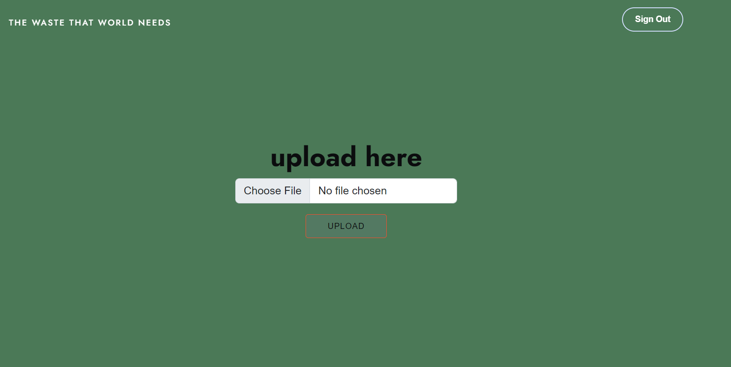

Records Page

Authenticated users can utilize this page to access and view their past records generated through this website. These records are conveniently displayed in a tabular format, presenting relevant information such as the record number, prediction results, and corresponding images in separate columns.
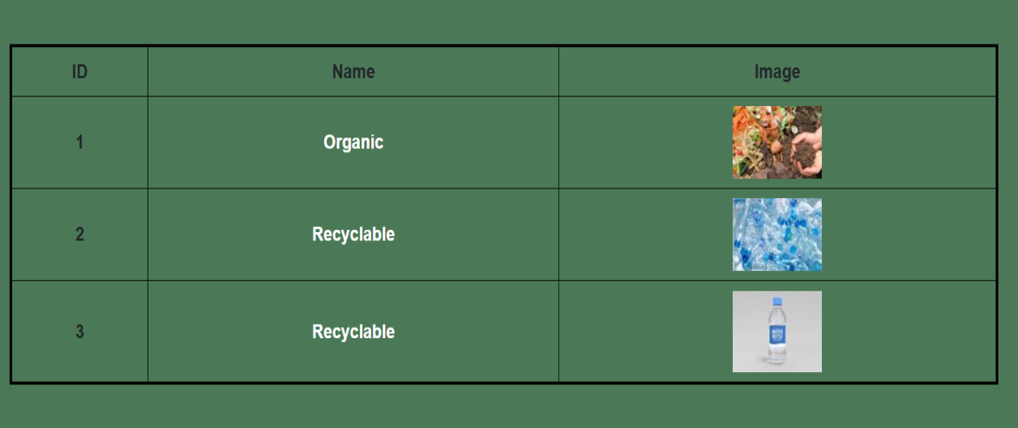

CONCLUSION AND RECOMMENDATIONS

A viable strategy to support trash reduction and recycling activities is the creation of a web-based application that makes use of a deep learning model to identify compostable and non-compostable items. Such applications can assist in increasing awareness of the significance of trash management and promoting more sustainable behaviours by offering users a user-friendly platform that can properly categorise waste items.
However, it is important to take into account a number of factors in order to develop an effective and user-friendly application, including the quality and variability of the dataset used to train the model, the requirement for high-quality images, and the technical difficulties involved in creating and maintaining the application. It's also critical to take into account the applications' limitations, such as the possibility for waste categorization errors and the requirement for continual upgrades and maintenance.
It is advised that developers collaborate closely with stakeholders, such as waste management specialists, policymakers, and users, to gain input and enhance the application's accuracy and usability. This will help to assure the success of such apps. Additionally, it is crucial to carry out additional research and development in this field, including the creation of larger datasets and more sophisticated deep learning methods, in order to increase the precision and effectiveness of waste categorization. Web-based apps that make use of deep learning models can ultimately help to create a future that is more ecologically friendly and sustainable by encouraging more sustainable waste management techniques.

Future Work

There are several future works that we focus on to work on in the coming days.

Model Improvement: Continuously work on improving the deep learning model's accuracy and performance. This can be done by collecting more labelled data, exploring different architectures, and fine-tuning hyper parameters. Additionally, consider using techniques like transfer learning to leverage pre-trained models and improve classification results.

Expand Waste Categories: Currently, the project may classify waste into a limited number of predefined categories. Consider expanding the range of waste categories the system can handle. This may involve collecting additional data specific to the new categories and retraining the model to include them.

Mobile Application Development: Develop a mobile application version of the waste classification project. This would allow users to capture and classify waste on the go using their smartphones. The backend API built with Django can be reused, while the frontend can be adapted for mobile platforms using React Native or other frameworks.

Integration with Waste Management Systems: Collaborate with waste management organizations or local authorities to integrate the waste classification system into their existing infrastructure. This may involve connecting the system with databases, APIs, or other systems used for waste management and recycling. The integration can enable streamlined data sharing, automated reporting, or even trigger specific actions based on waste classification results.

Deployment and Scalability: Optimize the deployment and scalability of the system. Explore containerization using tools like Docker to package the application and its dependencies, making it easier to deploy and manage across different environments. Additionally, consider utilizing cloud platforms like AWS, Azure, or Google Cloud to scale the system based on the demand and handle increased user traffic.

REFERENCES

Books:
[1] Fluent python by written by Luciano Ramalho
[2] Learn Python the Hard Way: A Very Simple Introduction to the Terrifyingly Beautiful World of Computers and Code written by Zed Shaw

Journal Papers:
[3] Smith, J., Johnson, A. (2019). Waste Classification Using Deep Learning. Waste Management, 45(3), 123-136
[4] ResearchGate. (2019). Waste Classification System Using Image Processing and Convolutional Neural Networks. ResearchGate.
[5] Jian, H., Wei, Y., Li, S., Han, Y., & Zhang, X. (2021). A two-stage DL-based approach for classification and distribution of waste in nature. Journal of Cleaner Production, 309, 127295.
[6] Wu T. (2020) Research on waste sorting and recycling system based on artificial intelligence technology. Science Technology and Innovation, No.153(09): 44-45+48.

Dataset:
[7] BEYZA NUR NAKKAŞ (2022) Waste Classification with CNN Kaggle. Retrieved from https://www.kaggle.com/code/beyzanks/waste-classification-with-cnn/data
[8] SASHAANK SEKAR (2019) Waste Classification Data Kaggle. Retreived from https://www.kaggle.com/datasets/techsash/waste-classification-data

Electronic Sources from Internet:
[7] ScholarWorks California State University. Managing electronic waste for a sustainable future.
[8] MDPI. (2022). Waste Classification Using Deep Learning: A Comprehensive Review. Sustainability, 14(12), 7222

