

BSIT-S22-007

03-135191-025 Anus Masood

Door Drop

In partial fulfillment of the requirements for the degree of
Bachelor of Science in Information Technology

Supervisor: Taimoor Aamer

Department of Information Technology
Bahria University, Lahore Campus

January 2023

© Bahria University, 2022

C e r t i f i c a t e

We accept the work contained in the report titled
“Door Drop”
written by Anus Masood
as a confirmation to the required standard for the partial fulfillment of the degree of Bachelor of Science in Information Technology.

Approved by:
Supervisor: Taimoor Aamer

(Signature)

January 10, 2023

DECLARATION

I hereby declare that this project report is based on my original work except for citations and quotations which have been duly acknowledged. I also declare that it has not been previously and concurrently submitted for any other degree or award at Bahria University or other institutions.

Enrolment | Name | Signature
03-135191-025 | Anus Masood

Date: January 10, 2023

Specially dedicated to my beloved grandmother, mother and father
(Anus Masood)

ACKNOWLEDGEMENTS

I would like to thank everyone who had contributed to the successful completion of this project. I would like to express my gratitude to my research supervisor, Sir Taimoor Aamer for his invaluable advice, guidance, and his enormous patience throughout the development of the research.

In addition, I would also like to express my gratitude to my loving parent and friends who had helped and given me encouragement.

Anus Masood

Door Drop

ABSTRACT

As we know life is so busy for everyone nowadays and trends of getting the product by walking in the market is getting quite old and it takes a lot of time and efforts. Nowadays everyone prefers to buy the product they need via online as it saves there lot of quality time and requires less effort. Online shopping is a new trend in which the user purchase the product of their need over the internet. By looking at the recent trends of online shopping as it is increasing day by day so we came up with an online system that provides individuals to buy the product that everyone needed on daily basis which will save their time and effort.
Door drop is very helpful for the customer as well as the shopkeeper. This application will help the customer to buy the product he/she requires by just sitting at home. This will also help the shopkeeper to increase their sales as the recent Covid condition the online buying and selling increases so this will help the business individuals to grow their business. This app is going to create employment opportunities for the person who knows the way to ride a bike. When user will search for a product and if there are multiple product of that category he/she will get the product that has lower price at the top. Tracking will help the user to get to know about their product status.
.

TABLE OF CONTENTS

DECLARATION ii
ACKNOWLEDGEMENTS iii
ABSTRACT iv
TABLE OF CONTENTS v
LIST OF TABLES viii
LIST OF FIGURES ix

CHAPTER 1 1
Introduction 1
1.1 Project Background: 1
1.2 Problem Description: 1
1.3 Problem Objectives: 2
1.4 Project Scope: 2

CHAPTER 2 3
Literature Review (and/or SRS) 3
2.1 Overview: 3
2.2 Online FD Providers and their Delivery System: 3
2.3 GPS (Global Positioning System) 4
2.4 Google Maps: 4
2.5 Use Case Diagram: 5
2.6 Descriptive Use Case Diagram: 6
2.7 Requirement Specifications 11
2.7.1 Functional Requirement 11
2.7.2 Non-Functional Requirement 11

CHAPTER 3 13
Design Methodology 13
3.1 Context Flow Diagram: 13
3.2 Activity Diagram: 14
3.3 Sequence Diagram: 16
3.3.1 Signup: …….16
3.3.2 Login: 17
3.4 Sequence diagram: 18
3.5 Database Design: 19

CHAPTER 4 20
Data Experiment and Implementation 20
4.1 System Architecture: 20
4.2 Development Environment (IDE) Visual Studio: 20
4.3 Development Environment (IDE) Android Studio: 22
4.4 Technologies: 24
CHAPTER 5 25
Result and Discussion 25
5.1 System testing and evaluation: 25
5.2 Graphical user interface testing 25
5.3 Usability Testing 26
5.4 Software Performance Testing: 26
5.5 Compatibility testing: 26
5.6 Exceptional Testing: 26
5.7 Load Testing: 27
5.8 Test Case: 27

CHAPTER 6 35
Conclusion and Recommendations
6.1 Conclusion and Future Work: 35

Appendences
Appendix A………………………………………………………………………….37
User manual…………………………………………………………………………37
Splash Screen: 37
Sign up: 38
Login: 39
Home Screen: 40
Driver Location: 41
Driver location would be visible 41
Add to cart: 42
Search product: 43
Recommendation of Product: 45
References…………………………………………………………………………..46

LIST OF TABLES

Table 2.6UseCase: Register........................................................................,6
Table 2.7UseCase:login................................................................................ 7
Table 2.8UseCase: Customor........................................................................8
Table 2.9UseCase: Shopkeeper.....................................................................9
Table 2.10UseCase: DatabaseUpdate............................................................10
Table 5.1TestCase: signup.............................................................................27
Table 5.2TestCase: Login..............................................................................28
Table 5.3TestCase: Search Product...............................................................29
Table 5.4TestCase: AddtoCart.......................................................................30
Table 5.5TestCase: Order Product ................................................................31
Table 5.6TestCase: Addproduct.....................................................................32`
Table 5.7TestCase: Deleteproduct..................................................................33
Table 5.8TestCase: Activatedeactivateshop...................................................34

List of Figures:

Figure 2.5UseCaseDiagram............................................................................... 5
Figure 3.2ActivityDiagram................................................................................ 13
Figure 3.3.1SequenceDiagram: signup...............................................................16
Figure 3.3.2SequenceDiagram: Login................................................................17
Figure 3.4SequenceDiagram............................................................................. 18
Figure 3.5DatabaseDesign................................................................................. 19

CHAPTER 1

INTRODUCTION

1.1 Background

We live in the world of technology where computers have become part of life for accessing any kind of information. Life in the 21st century is full of technology and in this era, it is difficult for any organization to survive without utilizing the technology. In today’s world the online shopping is gradually increasing as compared to physical shopping almost every one of us is having a phone and aware of online shopping and prefers more to shop online. In today’s age many restaurants, grocery and medical stores offers the services of delivering the items, but the order is taken on phone. This system has many disadvantages which includes the inconvenience of the customers, incorrect orders and many more. There exist many systems that offers online delivery system, but we must install different apps and visits different websites for ordering different items.
So, we decided to do such a thing in our final year project which will help the people to get the items they required in one place. There are some applications in market, but they are not meeting the whole requirements.

1.2 Problem Description:

Now a day’s people have less time and more work to do so they don’t have enough time to prepare their meals and buy their grocery. And as in Covid-19 people are not moving out of their houses so the sales of many restaurants are on the downfall. This project will help the people who don’t have time to prepare food for themselves and the restaurants to increase their sale. As in this global world where everyone is using the internet and find ways to do a work or complete task with minimum effort so in our case instead of visiting different places to get the things, they required they prefer more of doing things online. We have many apps before for the ordering of food, but we don’t have such a collective platform where you can order the food, grocery items and medicines. We are providing a collective platform to user to get the required items he/she needs by using a one application.

1.3 Problem Objectives:

The objective of this project to give an application that can be used by the different shopkeeper to register their shops and sell their goods online using our system and facility to the customers to get the required items they want by just sitting at home.

1.4Project Scope:

Online shopping is defined as buying/selling of the products by just sitting at home this makes shopping quite easy and time saving. In this project the shopkeeper will register and then admin will activate the shopkeepers and then the shopkeeper will be able to add, delete, and edit the products. Shopkeeper will add the description, pictures, price of product. User will register themselves in our app to get access of all the options and functionalities. User will be able to see the product description, pictures, and prices of different product. Cart facilities is also provided which will help the user to select and item they want to purchase and then continue their shopping.

CHAPTER 2

LITERATURE REVIEW (and/or SRS)

2.1 Overview:

The term e-commerce can be traced back to the 1960s, with the ascent of electronic trade – the purchasing and selling of goods through the transmission of information – which was made conceivable by the presentation of the electronic information exchange. Quick forward fifty years and internet business has changed how society sells labor and products. Electronic trade or web-based business that lets firms and individuals to buy and sell things using the internet.

2.2Online FD Providers and their Delivery System:

Food delivery service providers can be divided into restaurant-to-consumer delivery services or Platform-to-consumer delivery operations are performed by restaurants-to-consumer delivery providers Food and its delivery methods represented by providers such as KFC, McDonald’s, and Domino’s. Command. It can be produced directly through the restaurant's online platform or a third-party platform. These ones Third-party platforms vary by country and include examples, such as Uber’s The United States, China’s Eleme, the United Kingdom’s Just Eat, and India’s Swingy. Third-party platforms also provide online. The delivery service from the cooperative restaurant does not necessarily provide its own delivery service. It is defined as the "platform-to consumer delivery" process. (Li, 2020)

2.3 GPS (Global Positioning System)

The word GPS refers to Global Positioning System. It was developed by the US department Defense for defense purposes. Firstly, it was called NAVSTAR (Navigation System with Timing and Ranging). At beginning the GPS was used to provide the weather, location determination for military purpose like ground, sea and for the air forces. The GPS has the broad applications which includes the forestry, wildlife, mineral study, cartography, people’s movement, and the most importantly guide people with the accurate timings.
The GPS:
- Is a satellite-based radio-navigation system owned by the U.S government and operated by U.S
Air force.
- It is a radio navigation system based on satellite signals, owned by US government.
- It is the satellite based global navigation system, provide the geolocation time information to GPS receiver on or near the earth.
- It is hard to use GPS where mountains and building blocks exists. They work as obstacles for GPS system.
- They work independently. No need of telephonic and internet accessibility for GPS.

2.4Google Maps:

Google is a multinational American company that provides its services especially internet related.
It is the world’s most popular and strong search engine. Google maps are the Application or services of the Google. Google maps provides the services based on Web, it gives you all of the information about the geographical region, places and the sites exist from all over the globe. It also provides the areal and satellite views. People can also see the places with the street view. Google maps the comparison for street views which are taken for vehicles but in some areas. Google maps offers following services precisely, Google maps uses route planner which guides the drivers, people who walks and public transporters a direction to move from one place to another. The API for Google map makes it easier for the admins of websites to guide their users by using their services. The horizontal and vertical panoramic street level ensures the street view for users very precisely around the globe. The extra services involve the pictures of planets like mars, moon etc. for astronomers.

2.5 Use Case Diagram:

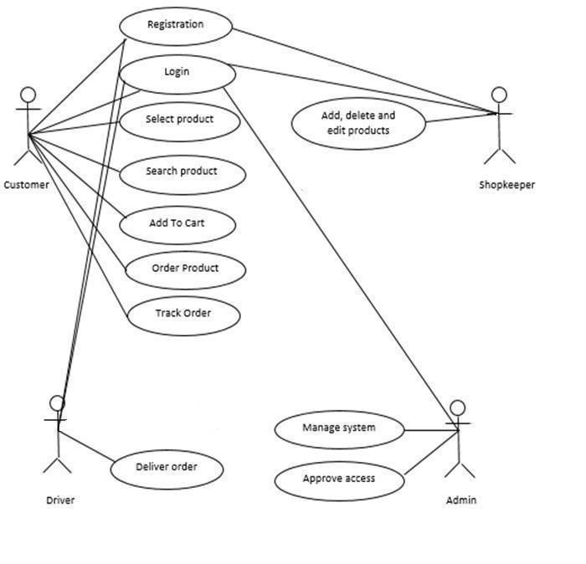
Figure 2.5 Use Case Diagram

2.6 Descriptive Use Cases
Following are the descriptive use cases of Application in tabular form:

Register
ACTORS | Users (customer, shopkeeper, driver) who are not registered.
Description | New user will have to register themselves. .
Flow of events | Register page.  Provide credentials  Just shopkeeper must wait for approval by admin to login.
Precondition | The New User is not registered
Post condition | The New user will be registered.
Data | Username, email, Password, phone, address, city
Stimulus | After putting all the details click Register button.
Response | The User is Successfully registered into application.

Table 2.6Use Case: Register

LOGIN
ACTORS | Admin, user (customer, shopkeeper, driver) registered
Description | Steps to login so that they can use application
Flow of events | login page provide data required to login
Precondition | Cannot login if he has not registered
Post condition | Successful
Data | Username, password
Stimulus | Click the button Login.
Response | Logged in to the system

Table 2.7 Use Case: login

Customer
ACTORS | Registered Customer
Description | Customer will select the product which he/she wants to see or buy
Flow of events | First user will login the system  There will be modules showing in front interface of the application.  The customer will select the module according to their need.  Customer will look for the required product and order that product.
Precondition | User Register User Login Select module
Post condition | Selected the modules
Stimulus | Next command issued by customer

Table 2.8Use Case: Customer

SHOPKEEPER
ACTORS | Registered Shopkeeper
Description | Shopkeeper will add, delete or edit the product in the shop
Flow of events | First shopkeeper will login the system.  The shopkeeper will add the products he wants to sell
Precondition | User Register  User Login
Post condition | Selected the modules
Stimulus | Next command issued by shopkeeper
Response | Shopkeeper selected module successfully.
Table 2.9 Use Case: Shopkeeper

Database Update
ACTORS | System and Admin.
Description | The system will update the database whenever a new user will be registered into the application.
Flow of events | System/Admin will check requests for registration.  Update the database with all details of new user.  A message will be shown of user registered successfully.  An alert message will be generated in case of error.
Precondition | 1)Check new requests 2) Update database 3)Confirm updating
Post condition | The database will be updated.
Data | New data like Username, email, Password, address
Stimulus | Update command is issued by admin/system.
Response | The database is updated successfully.
Table 2.10 Use Case: Database Update

2.7 Requirement Specifications

2.7.1 Functional Requirement:
- Search for product:
The application will allow customer to search for the desired product using the search bar.
- Tracking
The application allows the customer to track the product they order.
- Add to cart
Customer has the facility to add the product to cart and continue shopping if he wants to.
- Order
Customer can order the product.
- Activate & Deactivate
Admin can activate or deactivate the shops.
- Manage Product
Shopkeeper can add, delete, and edit the products.
- Recommended Products
User will get the recommendation of product from the category he/she last order.

3.3.2 Non-Functional Requirements:
Following are the non-functional requirements of our application:
- Usability:
Easy of Learning: Our system is easy to learn for both type of users. E.g., the users having experience of using these kinds of apps or the users having no experience.
Understandability: As the name of the application suggests that it is an online shopping platform, so it is easy to understand for the users that what does Door drop is doing.
Task Efficient: Our system is task efficient as it behaves according to the generated requests from the users.

- Performance:
Performance is measure based on hardware being used.

- Reliability:
We will keep the server maintained and in appropriate atmosphere, so the risk of failure is minimal.

- Security:
Each user will have its own unique id and password. Only the authorized users should be able to handle the software. This will make the system secure

CHAPTER 3

DESIGN AND METHODOLOGY

3.1 Context Flow Diagram:
The diagram describes about the interaction of user with the system. User will search for the product and the system provides the detail of the product.
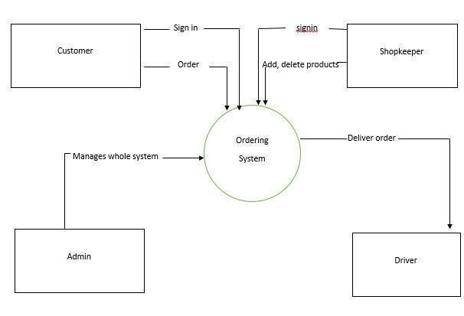

Figure 3.1 Context Flow Diagram

3.2 Activity Diagram:
This activity diagram shows the flow of overall system. Following is the activity diagram of our project.
Website:

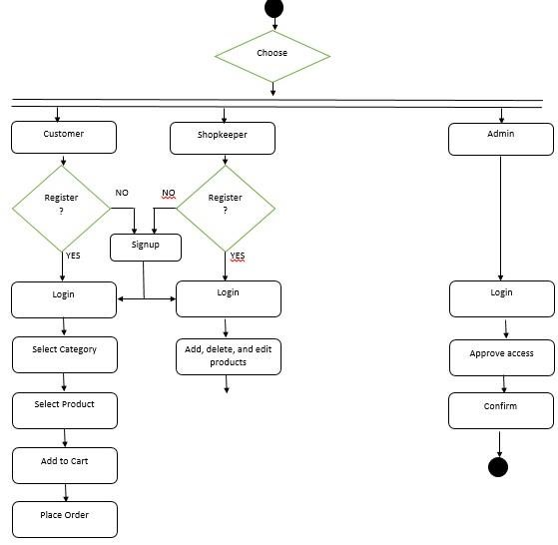

App:

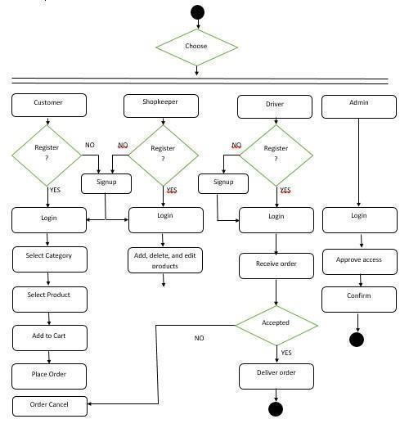

Figure 3.2 Activity Diagram

3.3 Sequence Diagram:

3.3.1 Signup:
To sign up the app the actor needs to enter their credentials and click on the ‘Register’ button placed on the screen. The application will ask the user for necessary credentials e.g., Email, Name, Phone number address, city and Password, and then registration will be successful as illustrated in the figure

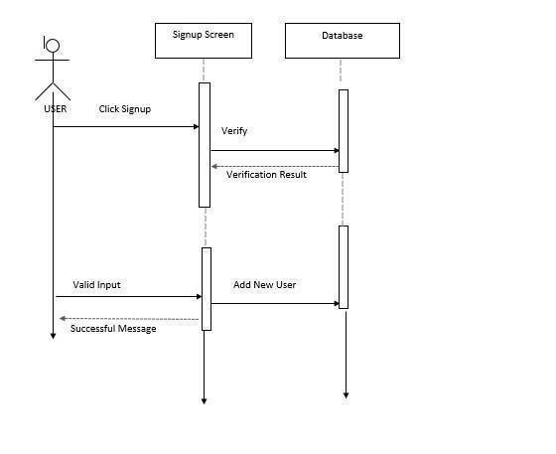
Figure 3.3.1 Sequence Diagram: signup

3.3.2 Login:
To log into the app the actor needs to click on ‘Login’ button and provide his/her necessary credentials e.g., email and password. If the provided credentials matched with the data that is stored in the database, then login will be successful as illustrated in figure below

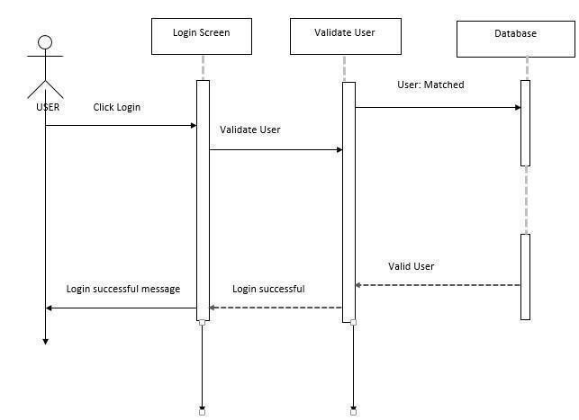

Figure 3.3.2 Sequence Diagram: Login

3.4 Sequence diagram:

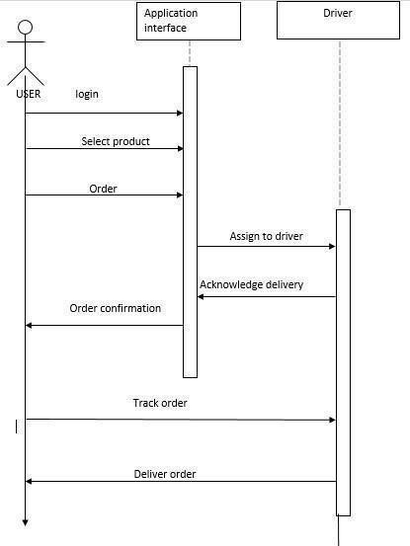

Figure 3.4 Sequence Diagram

3.5 Database Design:

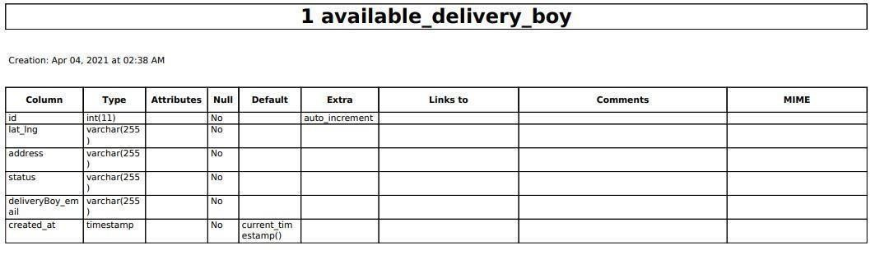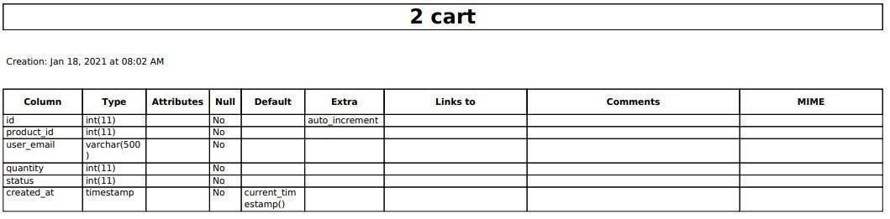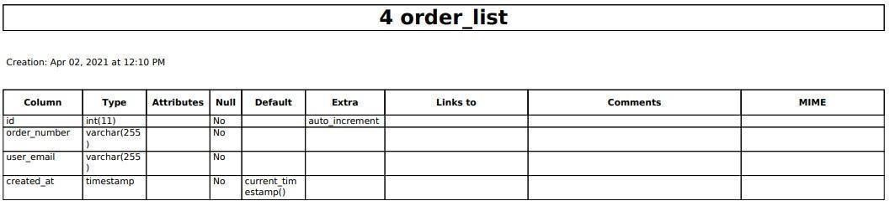

Figure 3.5 Database Design

CHAPTER 4

DATA AND EXPERIMENTS (and/or IMPLMENTATION)

4.1 System Architecture:
The architecture shows our system “Door Drop” that is based on the hierarchy of the overall project. This shows the components, workflow, and different functionalities of the system.

4.2 Development Environment (IDE) Visual Studio:
The system in which our website is being developed and designed is being discussed. We are using Visual Studio Code and local host terminal for developing. The front structure in which our website is made on HTML, CSS, Bootstrap. The Api’s are written in PHP language. The backend of or website is also on PHP. The steps that are used to follow up for setting the development environment are listed below:
- Download and Install Microsoft Visual Studio.
- Download the PHP tools from Online Gallery of Visual Studio.
- After installation of Visual Studio and PHP tools, create a new project.

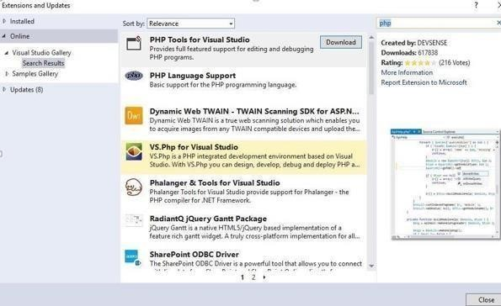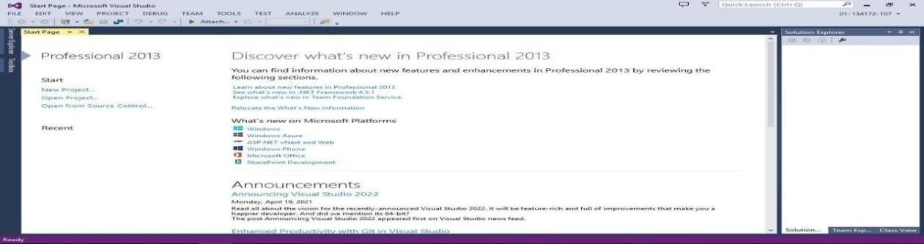

- After creating a new project select the PHP from Visual Studio tools & then select the Empty web site from the dialog.

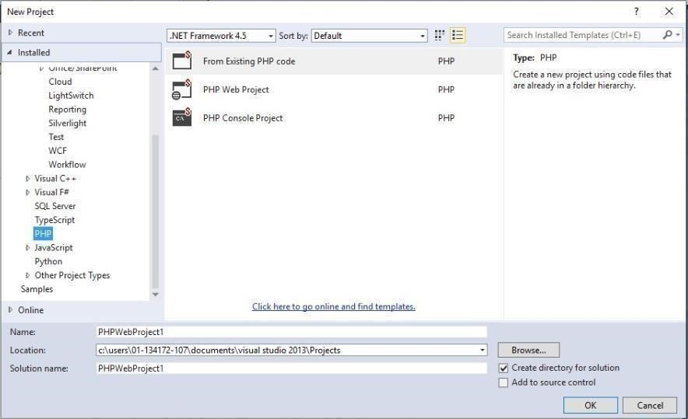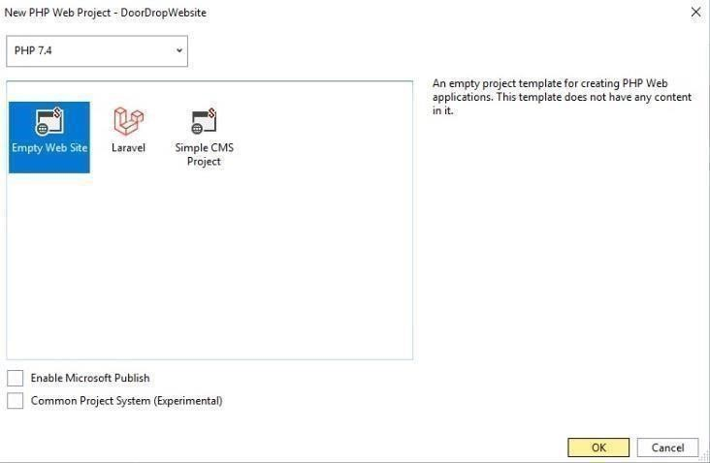

- After selecting the Empty the main page will appear.

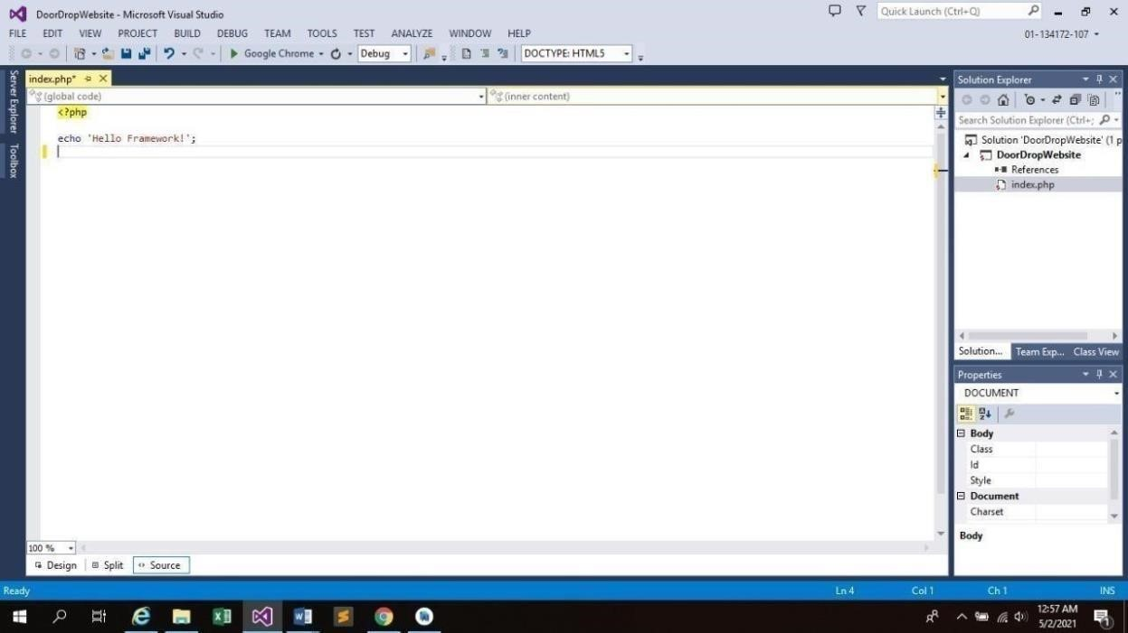

4.3 Development Environment (IDE) Android Studio:
In this section we can discuss our application is being designed and developed. We are using Android Studio and local host terminal for developing. We have developed an android application on Android Studio. The front structure in which the tabs and navigation bars for the android application is made on XML. Furthermore, the chapter also describes the tools and techniques which are used in the implementation. The steps that are used to follow up for setting the development environment are listed below
- Download and Install and Android Studio.
- After installation of Android Studio, create a new project.
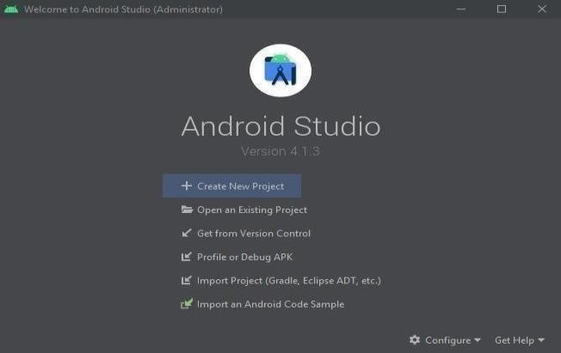

- A dialog box is appeared that is used to enter the name and which language used for the application.
- After entering the name and language then click finish.

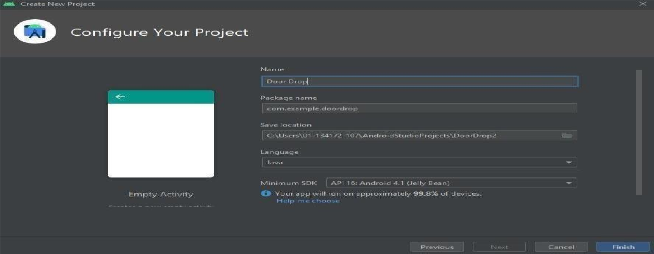

- After finishing Android Studio main page is open with java code.
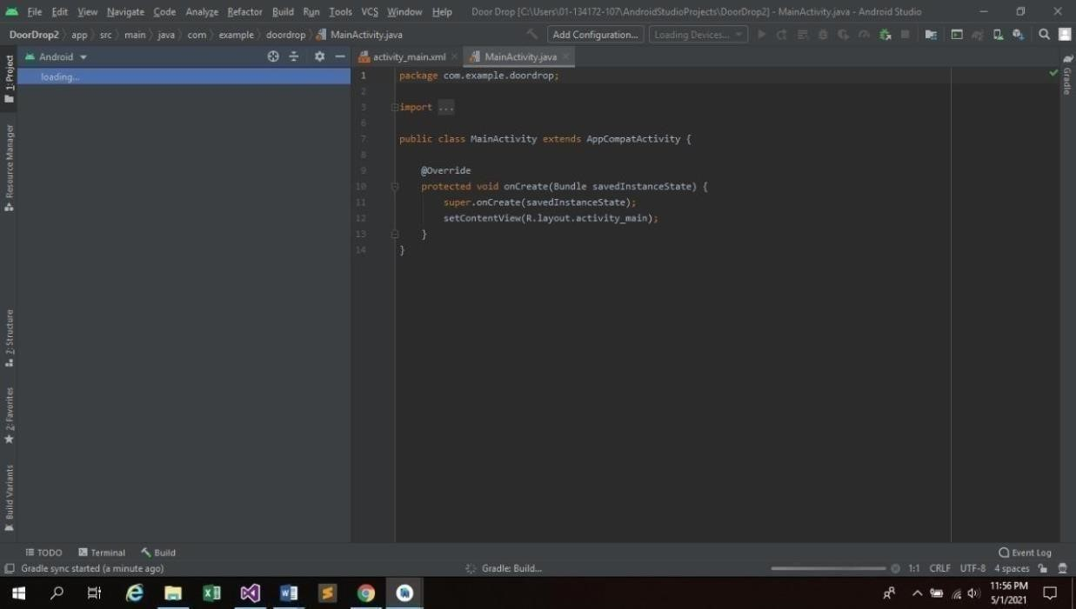

4.4 Technologies:
The technologies used to develop the whole system are as follows

4.4.1 XML:
XML is a markup language used for design and transport of data. It is used to design the android application front end. XML is the lightweight language, so it doesn’t make our layout heavy.
4.4.2 Java:
Java is class and object-oriented based programming language. The mobile application is developed using Java. Java is used to produce software for multiple platforms. Java is fast, secure, and reliable.
Java includes execution engine, compiler, and libraries in it. It is also used a computing platform.
4.4.3 HTML:
HTML is markup language used for creating a web page and web based documents. It can be used for layout of the website that can display on the browser. It is not a programming language.
4.4.4 CSS:
CSS is Cascading Style Sheet used to design the layouts, content, paragraph,
structures, and other designing in the web pages. It describes the HTML elements
that can be displayed on web browser.
CSS control multiple layouts of web pages at once. It is also a rule-based language.
4.4.5 Bootstrap:
Bootstrap is a system to help you plan site quicker and simpler that incorporates HTML and CSS. It is also used for the responsive website that can be Desktop, Mobile and Tablet view. It is full customized. Bootstrap is an open source and free to use with HTML and CSS templates.
4.4.6 PHP:
PHP is general purpose widely used scripting language that is used for web development. It is an open source, fast, secure, flexible and efficient. It is server-side scripting language and manage dynamic content & databases as well.

CHAPTER 5

Result and Discussion

5.1 System testing and evaluation:
Software testing is an important part of software development. Software testing is done to detect any abnormal behavior of the application while it is in the development phase. Testing is essential because if there are any bugs or any fault in the application that bugs won’t make the customer happy to use such application.it is also important to ensure the quality of product. Customer’s confidence is gain by providing them a quality product. For application to work seamless, testing is required. Testing helps to identify the errors which becomes the main reasons for the failure of the product in future.it also ensures whether the product fulfills all the requirement of user or not so testing is most important in software development.

5.2 Graphical user interface testing
GUI testing is the way toward testing the application’s user interface that how the components of the system will be displayed to the users. This testing incorporates checking the screens with the controls like menus, catches and symbols. We have check in our application whether the graphical user interface is correctly functional or not for this we check different things. Launch the application verify the start scene display, graphics color and scheme are correctly displayed, all the pages are displayed accordingly TO GUI is very basic and simple client feels comfortable while interacting with the application.
.

5.3 Usability Testing

Usability testing is to measure of how effectively the system can be utilized by the end-users. Usability testing ensures that how much an application is user friendly. Our system has basic interface that is straightforward and simple to understand. The design is user friendly and more appealing to the user that makes the system more compelling.

5.4 Software Performance Testing:
A software performance test is performed to determine the behavior of the application under extreme workload and how it performed.it is used to validate other attributes such as scalability, reliability, and resource usage. We have performed the SPT by running the application and checking that how much time does it take to perform the functionalities it has, and the time was recorded several time to ensure that the speed is up to standard.

5.5 Compatibility testing:

Compatibility testing is another type of non-practical testing, to guarantee the compatibility with the equipment, working arrangement of the gadget and the product assets needed to run the application. It is utilized to test that the product which we have assembled is completely viable with the gadget to work with.
Open application. The first task is to select the category user wants to enter. Search for the product the application will extract the information about the given product by matching the name in database. After the effective matching of input all the information which is needed about that product will be shown to the screen. Android OS is the operating system which is needed to run our application on a device. Android OS is the most widely used operating system in the world.

5.6 Exceptional Testing:

Exceptional testing is used to evaluate the system response when an unknown or unexpected input will be given to the user.in our system when wrong credentials are provided by the user at the time of login the user will have an alert of wrong input and if user leaves any empty field the user will be moved back to the same field so that the user can understand that field must be filled in order to move forward.

5.7 Load Testing:

Load testing is used to check how the application performs. This was done by checking that whether application runs properly while the user moves across multiple components and when the application runs multiple pages at the same time. The application response was good against these, and it runs properly.

5.8 Test Cases:
This section gives the explanation in tabular form for the test cases we performed. In these explanatory tables we provided brief description of the test cases.
ID | 001
Description | Signup as a new customer, shopkeeper, driver
Revision History | Created by Anus Masood
Function to be tested: | Signup
Test Setup | There should be an internet connection
Test Execution | Expected Result | Actual Result
Select signup as a new customer, shopkeeper, driver | Signup screen should be  presented | Signup screen has been presented  successfully
Enter name, email, phone, address, and password | The app should add these  credentials | The credentials have been added successfully

Table 5.1 Test Case: signup

Login:

ID | 002
Description | login with existing account
Revision History | Created by Anus Masood
Function to be tested: | Login
Test Setup | There should be an internet connection
Test Execution | Excepted result | Actual result
Enter valid email and password | The app  Should accept these credentials | The credentials have been accepted by the app  successfully

Table 5.2 Test Case: Login

Search product:

ID | 003
Description | Search for the product
Revision History | Created by Anus Masood
Function to be tested: | Product searching
Test Setup | There should be an internet connection
Test Execution | Expected  Result | Actual  Result
Search for the product from the search bar | The system  should be able to search the relevant product | The system has opened the product  successfully
View the search product | List of products should be displayed | List of relevant products should be  Displayed  successfully.
Table 5.3 Test Case: Search Product

Add to cart:

ID | 004
Description | Add to cart
Revision History | Created by Anus Masood
Fuction to be tested: | Is add to cart working
Test Setup | There should be an internet connection
Test Execution | Expected Result | Actual Result
Add product to the cart | The system should be able to add  the product that is selected to the cart | The system has added the product successfully
View the product | product should be displayed in cart | List of  Relevant product should be displayed successfully in cart.

Table 5.4 Test Case: Add to Cart

Order product:

ID | 005
Description | Order product
Revision History | Created by Anus Masood
Function to be tested: | Is The product order functionality is working properly?
Test Setup | There should be an internet connection
Test Execution | Expected Result | Actual  Result
Order your desire product | The system should be able to take your order and asked for the credentials required(address) | The  credential should be accepted and order should be placed
Click on confirm button | Order placed successfully | Order was successfully placed.
Table 5.5 Test Case: Order Product

Add product by shopkeeper:

ID | 006
Description | Add or delete product as shopkeeper
Revision History | Created by Anus Masood
Function to be tested: | Add product
Test Setup | There should be an internet connection
Test Execution | Expected  Result | Actual  Result
Click on add or delete button in shopkeeper menu | By clicking the add button add product page will be displayed | The add product page  will be  displayed successfully.
Enter the credentials required to add product(picture, details of product) | The system should add these credentials | The product is  Successfully added.
Table 5.6 Test Case: Add product

Delete product by shopkeeper:

ID | 007
Description | delete product as shopkeeper
Revision History | Created by Anus Masood
Function to be tested: | delete product
Test Setup | There should be an internet connection
Test Execution | Expected Result | Actual Result
Click on delete button in the menu | The product should be deleted once the delete item button is clicked | The product is successfully deleted.
Table 5.7 Test Case: Delete product

Activate and deactivate shops:

ID | 008
Description | activate and deactivate shops
Revision History | Created by Anus Masood
Function to be tested: | Add shop
Test Setup | There should be an internet connection
Test Execution | Expected Result | Actual Result
Click on the activate button to activate the shop. | Shop should activate. | Shop is successfully activated
Table 5.8 Test Case: Activate deactivate shops

CHAPTER 6

CONCLUSION AND RECOMMENDATIONS

6.1 Conclusion and Future Work:

As the world has become a 'Global Village’ so online shopping has also become a necessary thing in everyone's life. Online shopping is all about purchasing and selling products on the internet. Online shopping has made shopping very creative and effortless. Online shopping saves much of the customer time and give an ease to the shopkeeper to deal with the customer. With the increase of mobile phone and internet users the online shopping has got a boom many individuals are preferring online shopping our instore shopping. There are many apps that provide online services related to food, grocery and medicine but there is no collective application that provide these facilities under one roof.
We began dealing with this task keeping some necessities to us. We have unquestionably accomplished our laid-out objectives and came up with the system that has multiple user and would help them individually. The customer will have the benefit of getting the products they required online which will save their quality time and less efforts would be required the customer having some functionalities of selecting a product, order, add to cart and more. The shopkeeper will be able to perform all the basic operations add, delete, and edit. The basic idea of this project was to provide ease to the people to get all the goods related to food grocery medicine at one app.
Technology has made significant progress over the years to provide consumers a better online shopping experience and will continue to do so for years to come. With the rapid growth of products and brands, people have speculated that online shopping will overtake in-store shopping. While this has been the case in some areas, there is still demand for in-store shopping where the consumer feels more comfortable seeing and touching the product being bought. However, the availability of online shopping has produced a more educated consumer that can shop around with relative ease without having to spend a large amount of time. In exchange, online shopping has opened doors to many small retailers that would never be in business if they had to incur the high cost of owning a store in the market. At the end, it has been a win-win situation for both consumer and sellers.

We have some future related plans to accomplish some work in this undertaking in future.

Here are a few highlights which we can include what's to come.
- By adding other categories this application can be converted to a hub of online shopping just like daraz.
- QR scan code for the products.
- 3D images of the product

Appendix A

User manual
After the installation of the application, user first need to register his/her account on the application to use it. A simple signup GUI is shown below:

Splash Screen:

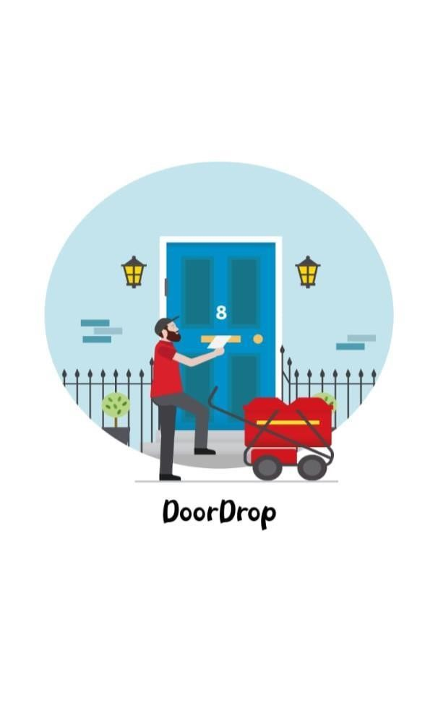

Sign up:
The sign up will allow user to get registered which will look like:

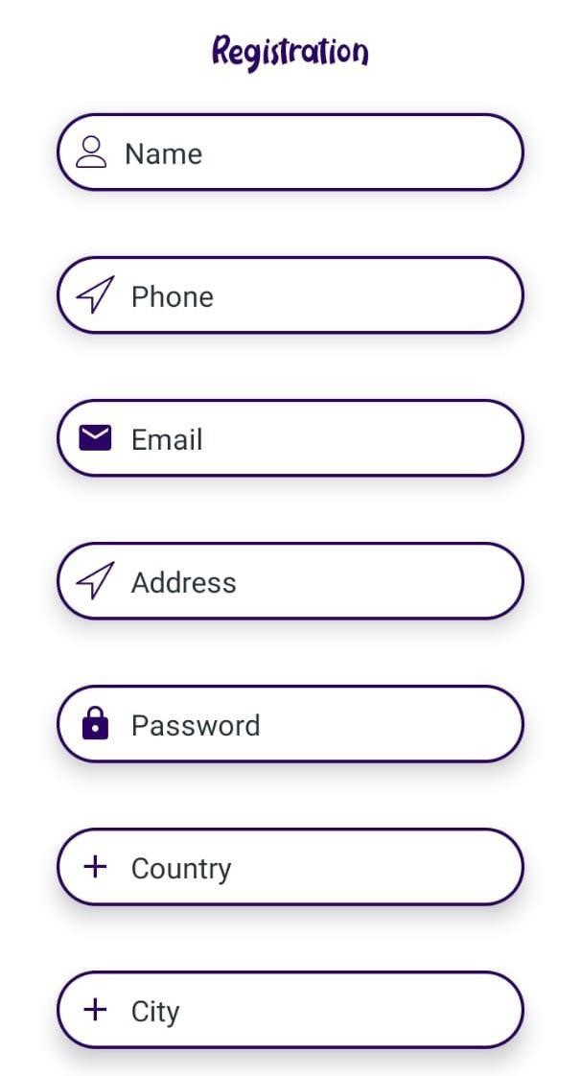

Login:

Login page will allow user to stay signed in:

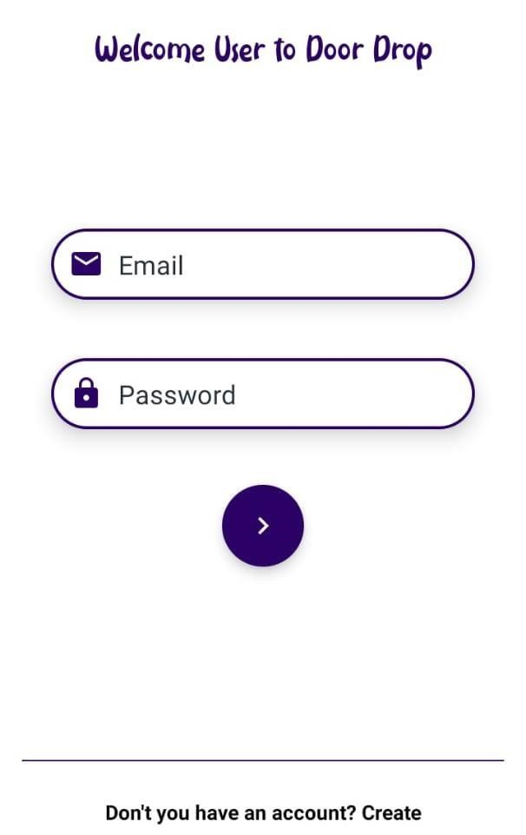

Home Screen:
After logging in, the user will be directed to next main page which will look like

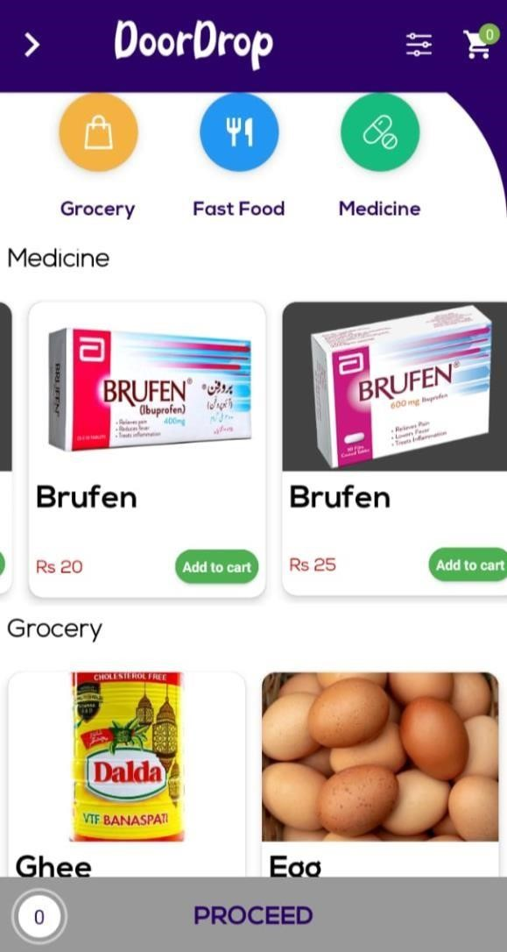

Driver Location:

Driver location would be visible.

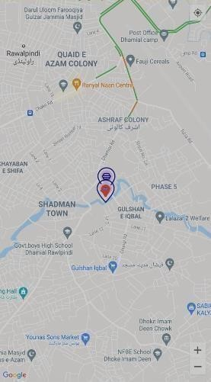

Add to cart:

This will allow user to provide the option of wish listed products which he/she wish to buy later

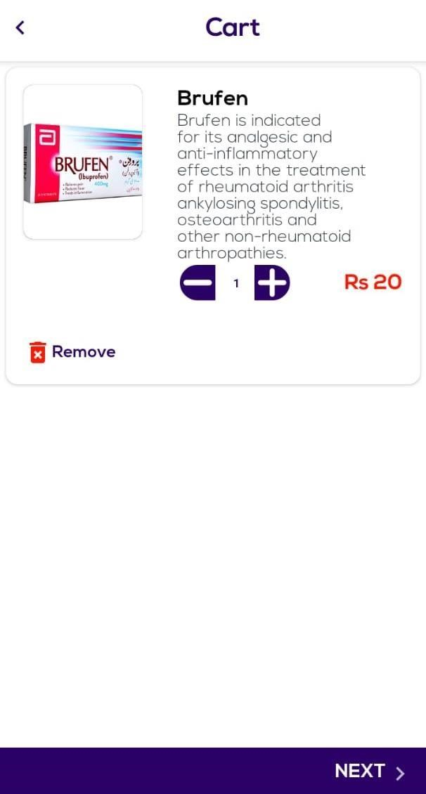

Search product:
Search bar used to search different items which looks like

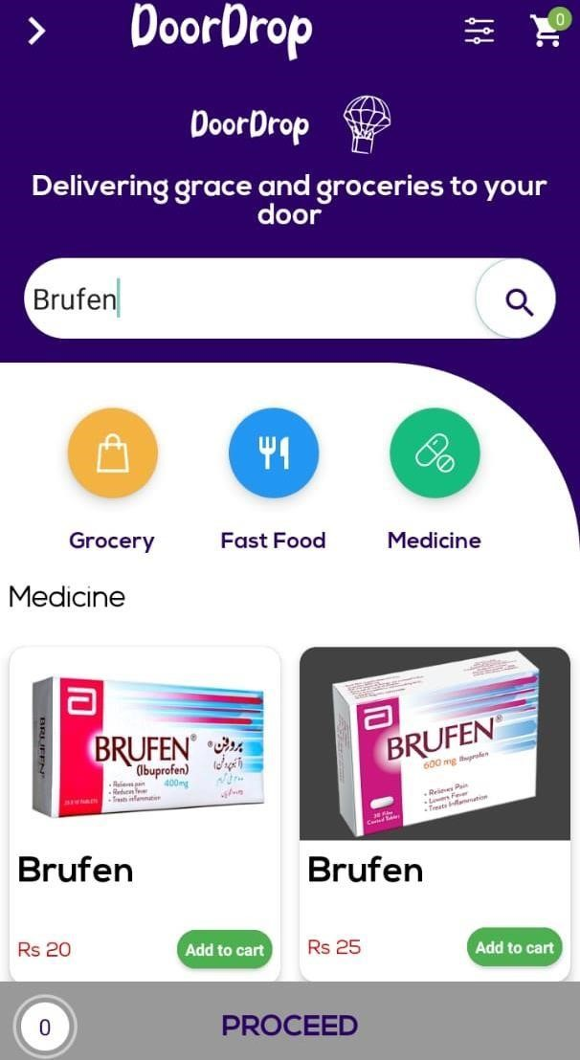

Recommendation of Product:
User will get the product recommendation from the category which they order previously

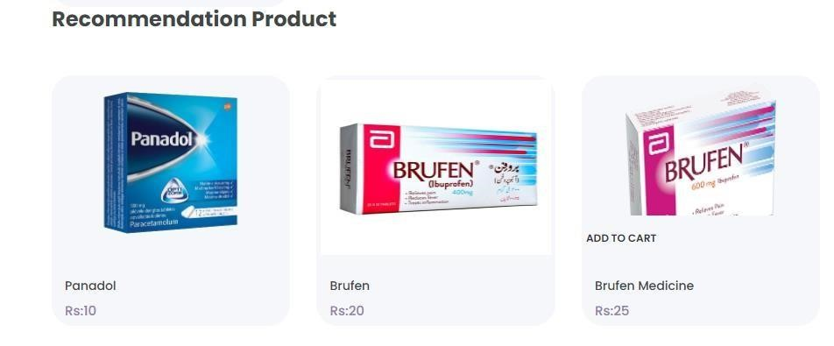

Web:
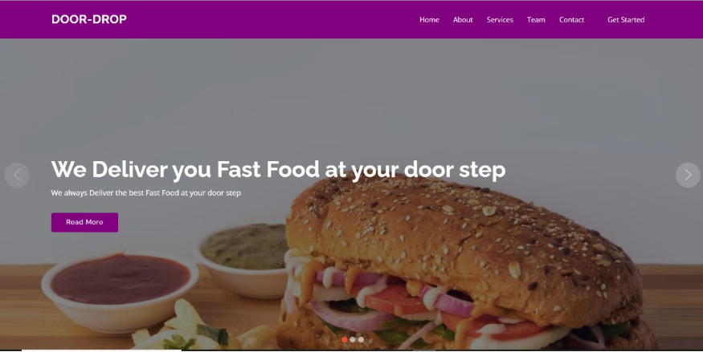

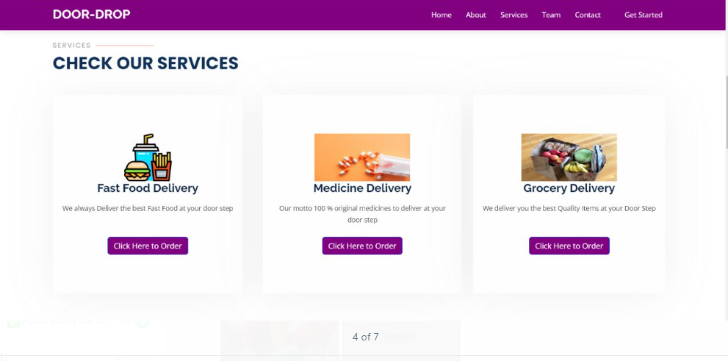

REFERENCES

- Adithya. (2018, June 06). ONLINE FOOD ORDERING SYSTEM. Retrieved from https://www.irjet.net/archives/V5/i6/IRJET-V5I679.pdf.
- Li, C. (2020, July 8). Review of Online Food Delivery Platforms and their Impacts on Sustainability.
Retrieved from
https://www.researchgate.net/publication/342855449_Review_of_Online_Food_Delivery _Platforms and their Impacts on Sustainability.
- Sabeehmemon. (2019, July 8). Food panda competitor analysis. Retrieved from https://www.coursehero.com/file/12595285/Foodpanda-pakistan/.
- Singh, A. (2018, June 06). ONLINE FOOD ORDERING SYSTEM. Retrieved from https://www.irjet.net/archives/V5/i6/IRJET-V5I679.pdf.
- https://www.upmenu.com/blog/ultimate-guide-for-restaurant-online-foodorderingsystem/
- https://creately.com/diagram-type/sequence-diagram
- https://itsourcecode.com/free-projects/fyp/online-medicinedeliverysystemdocumentationchapter1/
- https://www.studentprojectguide.com/php/online-shopping-system/
- https://developer.android.com/studio
- https://visualstudio.microsoft.com/
- https://developers.google.com/maps/support
- http://www.findnsecure.com/vehicle_tracking.html

