

BSCS-S22-020

03-134172-016 Amir Mehmood

Stock inventory system

In partial fulfilment of the requirements for the degree of
Bachelor of Science in Computer Science

Supervisor: Asghar Ali Shah

Department of Computer Sciences
Bahria University, Lahore Campus

January 2023

© Bahria University, 2023

C e r t i f i c a t e

We accept the work contained in the report titled
“Stock inventory system” written by Amir Mehmood
as a confirmation to the required standard for the partial fulfilment of the degree of Bachelor of Science in Computer Science.

Approved by:
Supervisor: Asghar Ali Shah

(Signature)

Date: January 10, 2023

DECLARATION

I hereby declare that this project report is based on my original work except for citations and quotations which have been duly acknowledged. I also declare that it has not been previously and concurrently submitted for any other degree or award at Bahria University or other institutions.

Enrolment | Name | Signature
03-134172-016 | Amir Mehmood

Date: January 10, 2023

Specially dedicated to my beloved grandmother, mother and father
(Amir Mehmood)

ACKNOWLEDGEMENTS

I would like to thank everyone who had contributed to the successful completion of this project. I would like to express my gratitude to my research supervisor, Asghar Ali Shah for his invaluable advice, guidance, and his enormous patience throughout the development of the research.

In addition, I would also like to express my gratitude to my loving parent and friends who had helped and given me encouragement.

Amir Mehmood

STOCK INVENTORY SYSTEM

ABSTRACT

The Inventory Management System is a real-time inventory database capable of connecting multiple stores. This can be used to track the inventory of a single store or to manage the delivery of stock between several branches of a larger franchise. However, the system merely records sales and restocking data and provides a warning of low stock at any location through email at a specified interval.
This project is aimed to develop a web-based application named Inventory Management System for managing the inventory system of any organization. The Inventory Management System (IMS) refers to the system and processes to manage the stock of an organization with the involvement of a Technology system. This system can be used to store the details of the inventory, stock maintenance, update the inventory based on the sales detail and generate sales and inventory reports daily or weekly basis. This project is categorizing individual aspects of the sales and inventory management system. In this system, we are solving different problems affecting direct sales management and purchase management. An inventory management System is important to ensure quality control in businesses that handle transactions revolving around consumer goods. A large retail store may run out of stock on an important item without proper inventory control. A good inventory management system will alert the wholesaler on Mobile Phone when it is time to record. An inventory Management System is also an important means of automatically tracking large shipments. An automated Inventory Management System helps to minimize errors while recording the stock.

TABLE OF CONTENTS

DECLARATION ii
ACKNOWLEDGEMENTS iii
ABSTRACT iv
TABLE OF CONTENTS v
LIST OF TABLES ix
LIST OF FIGURES x

CHAPTER 1..........................................................................................................1
1 Introduction........................................................................................................1

1.2 Problem Statements .............................................................................2

1.3 Aims and Objectives ...........................................................................2

1.4 Scope of Project .................................................................................3

CHAPTER 2...........................................................................................................4

2 Literature Review (and/or SRS) ......................................................................4

2.1 Introduction...................................................................................................4

2.2 User classes and characteristics… ................................................................5

2.2.1 Web............................................................................................................5

2.2.2 App.............................................................................................................5
2.2.2.1 User .......................................................................................................5
2.2.2.2 Admin.....................................................................................................5

2.3 Operating Environment ...................................................................................6

2.5 Assumptions and Dependencies ..................................................................7

2.6 Use-Case Diagrams ....................................................................................7
2.6.1 Registration Use Case ..........................................................................8
2.6.2 Sign in Use Case ..................................................................................9
2.6.3 Sign out Use Case .................................................................................10

2.7 Use-Case Description .......................................................................................11

2.7.1 Registration Use Case ...........................................................................11
2.7.2 Sign in Use Case....................................................................................12
2.7.3 Order Use Case......................................................................................13
2.7.4 Apply Payments....................................................................................14
2.7.5 Conduct sales and inventory Reports....................................................15
2.7.6 Delivery Products..................................................................................16
2.7.7 Sign Out.................................................................................................17
2.8 Non-functional Requirements.............................................................................18
2.8.1 Performance requirements ........................................................................18

CHAPTER 3 ..............................................................................................................19
3 Design and Methodology......................................................................................19

3.1 Introduction ......................................................................................................19

3.2 Sequence Diagram ............................................................................................19
3.2.1 IMS Sequence Diagram .....................................................................20
3.2.2 Sign in Sequence Diagram .................................................................21
3.2.3 DFD level 0.........................................................................................22
3.2.4 DFD level 1.........................................................................................23
3.2.5 IMS component Diagram. ..................................................................24
3.2.6 IMS Activity Diagram…….................................................................25
3.2.7 Class Diagram ....................................................................................26
3.2.8 Entity Relation Diagram ....................................................................27

3.3 SRS for Application ........................................................................................28
3.3.1 IMS Framework design .................................................................28
3.3.2 IMS Context level ..........................................................................28
3.3.3 IMS Use case .................................................................................29
3.3.4 IMS Process flow diagram ............................................................29

CHAPTER 4..............................................................................................................30
4 Implementation .....................................................................................................30
4.1 Languages used for implementation ...................................................................30
4.2 Code Igniter .........................................................................................................30
4.3 PHP.......................................................................................................................30
4.4 AJAX. .................................................................................................................30
4.5 Database ...............................................................................................................31
4.6 MySQL ................................................................................................................31
4.7 XAMPP ...............................................................................................................31
4.8 Implementation ....................................................................................................31

CHAPTER 5.................................................................................................................32
5 Results .....................................................................................................................32
Application ..........................................................................................................32

5.1 Sign Up ...............................................................................................................32

5.1.1 Sign .........................................................................................................33
5.1.2 Dashboard ................................................................................................33
5.1.3 All registered users ..................................................................................34
WEB......................................................................................................................35
5.2 Dashboard screen in web...................................................................................35
5.2.1 Product Listing in stock .......................................................................36
5.2.2 ADD Refund money............................................................................37
5.2.3 Return List............................................................................................37
5.2.4 Purchasing item...................................................................................38
5.2.5 Purchasing list.....................................................................................39
5.2.6 Add selling item..................................................................................39
5.2.7 Listing sales items...............................................................................40
5.2.8 Add category.......................................................................................41
5.2.9 Category List.......................................................................................41

CHAPTER 6 .............................................................................................................42

6 Conclusion..............................................................................................................42

6.1 Conclusion......................................................................................................42
6.2 Recommendation ...........................................................................................42

REFERENCES ........................................................................................................43

LIST OF TABLES

Table 2.1: Software Details for building the application .......................................6
Table 2.2: Registration Use Case Description ........................................................11
Table 2.3: Sign in Use Case Description ...............................................................12
Table 2.4: Order Use Case Description...................................................................13
Table 2.5: Apply payments Use Case Description..................................................14
Table 2.6: Inventory Reports Use Case Description .............................................15
Table 2.7: Delivery Products Case Description ....................................................16
Table 2.8: Sign out Use Case Description .............................................................17

LIST OF FIGURES

Figure2.1: General use case of admin...........................................................................7
Figure 2.2: Registration Use Case ...............................................................................8
Figure 2.3: Sign in Use Case Diagram ........................................................................9
Figure 2.4: Sign in Use Case Diagram ........................................................................10
Figure 3.1: IMS Sequence Diagram............................................................................20
Figure 3.2: Sign in Sequence Diagram........................................................................21
Figure 3.3: DFD level 0...............................................................................................22
Figure 3.4: DFD level 1...............................................................................................23
Figure 3.5: Component Diagram.................................................................................24
Figure 3.6: IMS Activity Diagram..............................................................................25
Figure 3.7: Class Diagram..........................................................................................26
Figure 3.8: Entity Relationship...................................................................................27
Figure 3.9: Framework Design...................................................................................28
Figure 3.10: Context level Diagram............................................................................28
Figure 3.11: Use Case Diagram..................................................................................29
Figure 3.11: Process Flow Diagram............................................................................29
Figure 5.1: Sign-up Screen..........................................................................................32
Figure 5.2: Sign-in Screen............................................................................................33
Figure 5.3: Dashboard Screen.......................................................................................33
Figure 5.4: All User Screen...........................................................................................34
Figure 5.5: Dashboard Screen in web ...........................................................................35
Figure 5.6: Product listing Screen .................................................................................36
Figure 5.7: Refund Money Screen .................................................................................37
Figure 5.8: Return List Screen .......................................................................................37
Figure 5.9: Purchasing Screen .......................................................................................38
Figure 6.0: Purchasing List Screen ...............................................................................39
Figure 6.1: Add Sale Screen ..........................................................................................39
Figure 6.2: All Sales Item Screen ..................................................................................40
Figure 6.3: Add Category Screen ...................................................................................41
Figure 6.4: All Category Screen .....................................................................................41

CHAPTER 1

INTRODUCTION

1.1 Background

Stock administration involves the planning, organisation, and monitoring of a company's procurement, storage, and consumption of the raw materials used in the manufacture of its products. Numerous businesses have harnessed the power of stock administration, and academics and business leaders have lavished considerable attention on the field of stock administration. The primary objective of any stock framework is to comprehend the nuanced characteristics of items (such as their codes, names, conditions, locations, and extended procurement times). It is also intended to facilitate handling. There should be both physical and digital stock rundown methods available. The majority of the written information found in reference books must be physically reviewed. There are numerous flaws [3]. Among these is the fact that administrative personnel are prone to entering data with typos. Many businesses and institutions are transitioning from manual data collection and processing to a more technologically advanced system. There are numerous options for an automated framework. Using a word processor or spreadsheet programme (such as Microsoft Office®) to complete the task incurs expenses. If a client has a substantial amount of data to enter, manually populating the calculation sheet can consume a considerable amount of time[4]. Important information that should not be displayed can be viewed and modified in the same way as other information. This is extremely hostile towards the involved businesses or organisations. The objective of this task is to create a web-based and mobile application to collect and manage inventory data for PC Designing Office[2].

1.2 Problem Statements

The company's lack of a trustworthy system for recording and maintaining inventory records is a significant problem. Since inventory data is only recorded in a logbook, it is difficult for the administration to keep track of it quickly and securely.

1.3 Aims and Objectives

The following are the thesis's goals:

- The goal of an inventory management system is to maintain stock levels that are neither excessive nor insufficient.
- The overstock condition will cause work to cease, and the overload condition will slow down other creation operations.
- To make sure there is a constant supply of stock and materials so that production won't suffer when customers are in demand.
- To maintain the minimal working cash needed for business operations and sales.
- To reduce or eliminate inventory expenditures such as those associated with purchasing, transporting, and storing goods.
- To keep material costs in check as they help to bring down manufacturing costs.

- To eliminate duplication in ordering stocks.

1.4 Scope of Project

Production and retail companies frequently use inventory management systems to keep track of stock. Inventory is one of a company's most valuable assets, and inventory management systems are essential for meeting customer demand. Before making a decision, management must be aware of the limitations of each inventory system.

In addition to determining the stock's value, tracking its movement, and predicting future stock outs, an inventory system may be tasked with a vast array of responsibilities. Each reporting period's balance sheet is based on the stock's value at the end of the period. The cost of goods sold for the period can be calculated by monitoring the inventory turnover.

CHAPTER 2

LITERATURE REVIEW (and/or SRS)

2.1 Introduction

Inventory management entails ordering, storing, and utilising the raw materials used to produce a company's finished goods. Numerous businesses utilise inventory management as a tool for making decisions, and the field of inventory management has been the subject of extensive academic and business research. A key objective of an inventory system is to determine the item's code, name, condition, location, and purchase year. This facilitates the product's handling and serves another purpose. There are two common inventory list creation methods: manually and electronically. When an inventory is manually taken, the information is typically recorded in books. It has numerous disadvantages. One is the possibility of administrative personnel introducing typographical errors during data entry. Several organisations have already shifted from manual data collection and processing to computerised systems. In a computerised system, options are abundant. There are some disadvantages to completing the task using a word processor or spreadsheet programme (such as Microsoft Office®). It can be time-consuming to manually enter a large amount of information into a spreadsheet. Similarly, sensitive information that should not be made public is viewable and editable as required. This is a terrible development for the institutions. This project aims to develop a web-based application and a mobile application for the Computer Engineering Department's inventory tracking and management.

2.2 User classes and characteristics

2.2.1 Web

2.2.1.1 User

- System will allow the user to get login/ Signup
- System will allow the user/ customer to add product to cart for purchase.
- System will allow the customer to view order history and detail
- Payment methods according to customer choice like online and cash on delivery

2.2.1.2 User

- System will allow the admin to perform CRUD operations for Stock Management
- System will allow the admin to define new product
- System will allow to view reports on different category wise Like Products wise Date wise, customer wise
- System will allow the admin to view report and detail of stock
- Admin will also able to view notification/ alerts of stock

2.2.2 App

2.2.2.1 User

- System will allow the user to get login/ Signup
- System will allow the customer to view order history and detail

2.2.2.2 Admin
- System will allow the admin to view report and detail of stock
- Admin will also able to view notification/ alerts of stock
- System will allow the admin to view report and detail of sales stock
- Admin will also able to authorize every new user through application

2.3 Operating Environment

The software details that will be used to develop the application are listed below in the table.
Table 2.1: Software Details for building the application

Operating System | Windows 10
Languages | AJAX, JQUERY, PHP, MySQL
Tools | CodeIgniter,  Google Chrome, Mozilla Firefox

2.4 Design and implementation Constraints

The design of the web application would be kept user-friendly so that it is feasible for all types of users to easily use without creating any difficulty. The application would be responsive so that the interface remains the same for every type of smartphone and screen.

2.5 Assumptions and Dependencies

The app requires an active internet connection and won’t be able to work without an internet connection and it also depends on the internet speed.

2.6 Use-Case Diagrams

The following figures show the use case diagrams of the project.


Manage

inventory

info and status

Manage sales

info and status

Manage product

info and
status

Admin

Save inventory

record

Figure 2.1 General use case of admin

2.6.1 Registration Use Case


Register

First name

Last name

Username

Admin

user

Phone

Email

Password

CNIC

Figure 2.2 depicts how users must enter their personal information to create accounts in order to use the program.

2.6.2 Sign in Use Case


Sign in

Username

Password

user

Admin

Figure 2.3: Sign in Use Case Diagram

After successfully creating their accounts, users must login in to the program using their username and password, as shown in Figure 2.3.

2.6.3 Sign out Use Case


Sign out

user

Admin

Figure 2.4: Sign out Type Use Case Diagram

Users can sign out of the application at any time as shown in
Figure 2.4

2.7 Use-Case Description

Following are the use cases implemented in this project.

2.7.1 Registration Use Case

This use case contains the following parts.

Table 2.2: Registration Use Case Description

ID: | U1
Name: | Register
Actor: | Users
Entry  Conditions | System must be opened after registration
Basic Flow or Happy Path: | - Welcome to Home Page  - Select Registration  - Users will simply enter them information and create a unique username and password to create an account.
Alternative  Flow | No alternative flow.
Exit  Conditions: | Users must complete the registration process to sign in to the app to use its services.

2.7.2 Sign in Use Case

This use case contains the following parts.

Table 2.3: Sign in Use Case Description

ID: | U2
Name: | Sign In
Actor: | Users
Entry  Conditions | U1.
Basic Flow or Happy Path: | 1.  2. | Welcome to Home Page  Click Sign In
 | 3. | Enter Username and Password
 | 4. | Sign In
Alternative Flow: | Users may forget their username or password which can be reset by them through the reset password option.
Exit  Conditions: | Users successfully sign in the app.

2.7.3 Order Use Case

This use case contains the following parts.

Table 2.4: Order Use Case Description

ID: | U3
Name: | Order
Description: | The client bought the item to the worker for his/her own need.
Pre-  Conditions | The item ought to be accessible. The client should demand to buy the request to the deals agent. The client should pay to the clerk before he/she gets the item.
Post-  Conditions | Client will pay the item and get a receipt.
Alternative Flow: | The client drops the item that he/she bought.
Exception Flow: | The Item isn't accessible.

2.7.4 Apply Payments
This use case contains the following parts.

Table 2.5: Apply payments Use Case Description

ID: | U4
Name: | Apply payment
Description: | The buyer pays for the item they ordered.
Pre-  Conditions | The sales person will give the customer the purchased item.
Post-  Conditions | The cashier is required to give the customer an official receipt or sales invoice.
Alternative Flow: | The customer declines to buy the item.
Exception Flow: | The item is damaged.

2.7.5 Conduct sales and inventory Reports

This use case contains the following parts.

Table 2.6: Inventory Reports Use Case Description

ID: | U5
Name: | Report on deals and stock.
Description: | The cashier makes deals and reports on the stock.
Pre-  Conditions | The administration should support the cashier's report.
Post-  Conditions | The management must give his or her approval for the cashier's report.
Alternative Flow:
Exception Flow:

2.7.6 Delivery Products

This use case contains the following parts.

Table 2.7: Delivery Products Case Description

ID: | U6
Name: | Delivery Product
Description: | The provider's conveyance of the item to the business.
Pre-  Conditions | It was delivered by the provider.
Post-  Conditions | The business inspects the item they ordered. They must add the ordered item to their inventory.
Alternative Flow: | The vendor must replace the defective goods.
Exception Flow: | The supplier's delivered item is damaged.

2.7.7 Sign Out
This use case contains the following parts.

Table 2.8: Sign out Use Case Description

ID: | U7
Name: | Sign out
Actor: | Users, guides and room hosts
Entry  Conditions | U2.
Basic Flow or Happy Path: | 1.  2. | Welcome to Home Page.  Click Sign In.
 | 3. | Enter Username and Password.
 | 4. | Sign In.
 | 5. | Welcome to Dashboard.
 | 6. | User or guide, and room host log out whenever they wish to.

Alternative Flow: | Users can explore other services for future use.
Exit  Conditions: | None.

2.8 Non-functional Requirements

The following subsections give details about non-functional requirements of the project app:

2.8.1 Performance requirements

The web application shall perform all the required tasks assigned correctly and efficiently. The response time of the application depends on device hardware and internet speed. Without an internet connection user won’t be able to use the application services.

CHAPTER 3

DESIGN AND METHODOLOGY

3.1 Introduction

In this chapter, we'll look at the many UML diagram models that may be used to depict software solutions, application architecture, system behaviour, and business processes in my project. The list of diagrams is as follows:
- Sequence Diagram
- Class Diagram
- Domain Model Diagram
- Entity Relation Diagram (ERD)

Utilizing these outlines, I will actually want to graphically address a framework, including its principal members, jobs, activities, and classes, to all the more likely comprehend, make due, and record information about the framework.

3.2 Sequence Diagram

The sequential request of thing communications is displayed in a grouping graph. It portrays the situation's articles and the correspondence that happens between them to work the situation. The sequence diagrams for my project are shown in the subsections below.

3.2.1 IMS Sequence Diagram

Figure 3.1 shows the sequence diagram of IMS which shows the interaction between the objects of inventory, receiving stock, payment, customer, supplier.

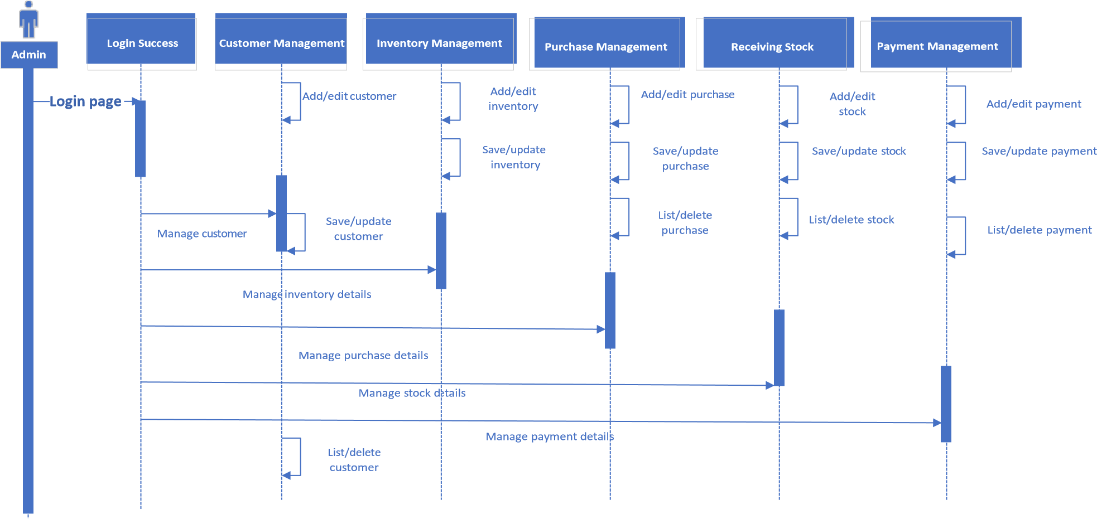

Figure 3.1: IMS Sequence Diagram

3.2.2 Sign in Sequence Diagram

After the user has successfully completed registration and created an account, they will be able to sign in the app. Figure 3.2 shows the sequence diagram for the user to sign in the application.

Admin

Login
Success

Customer
Management

Login page

Forget password

Verification

Database

Login page

Forget password

Check login details

Valid
login details

Provide authorization for
access

Allow users to access the
internal pages

Invalid login details

Create
session and
store in
database

Allow user to
access pages

Login Successfully

Logout from application

Manage payment details

Admin

Authenticate page

Figure 3.2: Sign in Sequence Diagram

3.2.3 DFD level 0

Zero level of DFD of IMS where we have elaborated the high-level process of inventory. It is a basic overview of whole IMS shown in Figure 3.3

Stock Inventory

Management System

Receiving stock
management

Purchasing management

Payment management

Supplier management

Customer management

Inventory

management

Figure 3.3: DFD level 0

3.2.4 DFD level 1

Figure 3.4 shows the first level DFD of IMS, the system is divided into sub-systems each of which deals with one or more of the data flows to or from.

Stock Inventory

Management System

Generate

Supplier

management

Supplier

management

Payment
management

Generate

Payment

management

Receiving stock

management

Generate

Receiving stock
management

Purchasing
management

Generate

Purchasing
management

Generate

Customer

management

Customer
management

Generate

Inventory

management

Inventory
management

Figure 3.4: DFD level 1

3.2.5 IMS component Diagram.

Figure 3.5 shows the Component Diagram which shows components, provided and required interfaces, ports and relationships between the purchase, inventory, stock, customer, payment.



Data access

data access

>>
<<
component

purchase

component
>>
<<

Database

data access

data sccess

<<
component>>
payment

<<
component
>>

stock

data access

<<
>>
component

IMS

<<
component>>
inventory

component
<<
>>

customer

Admin of IMS

Figure 3.5: Component Diagram

3.2.8 IMS Activity Diagram

Figure 3.6 shows the activity flow between suppliers, customer, stock, purchase, payment, inventory.

check

permission

check

permission

Check

permission

check

permission

check

permission

End

Manage customer

Manage inventory

Manage purchase

Manage stock

Manage payment

Logout

Login to IMS

Start

Check user

Figure 3.6: IMS Activity Diagram

3.2.8 Class Diagram

The class chart is a pivotal piece of an item situated technique. It shows the classes in a framework, alongside their connections, qualities, and capabilities. Figure 3.7 presentations the class graph for our venture.
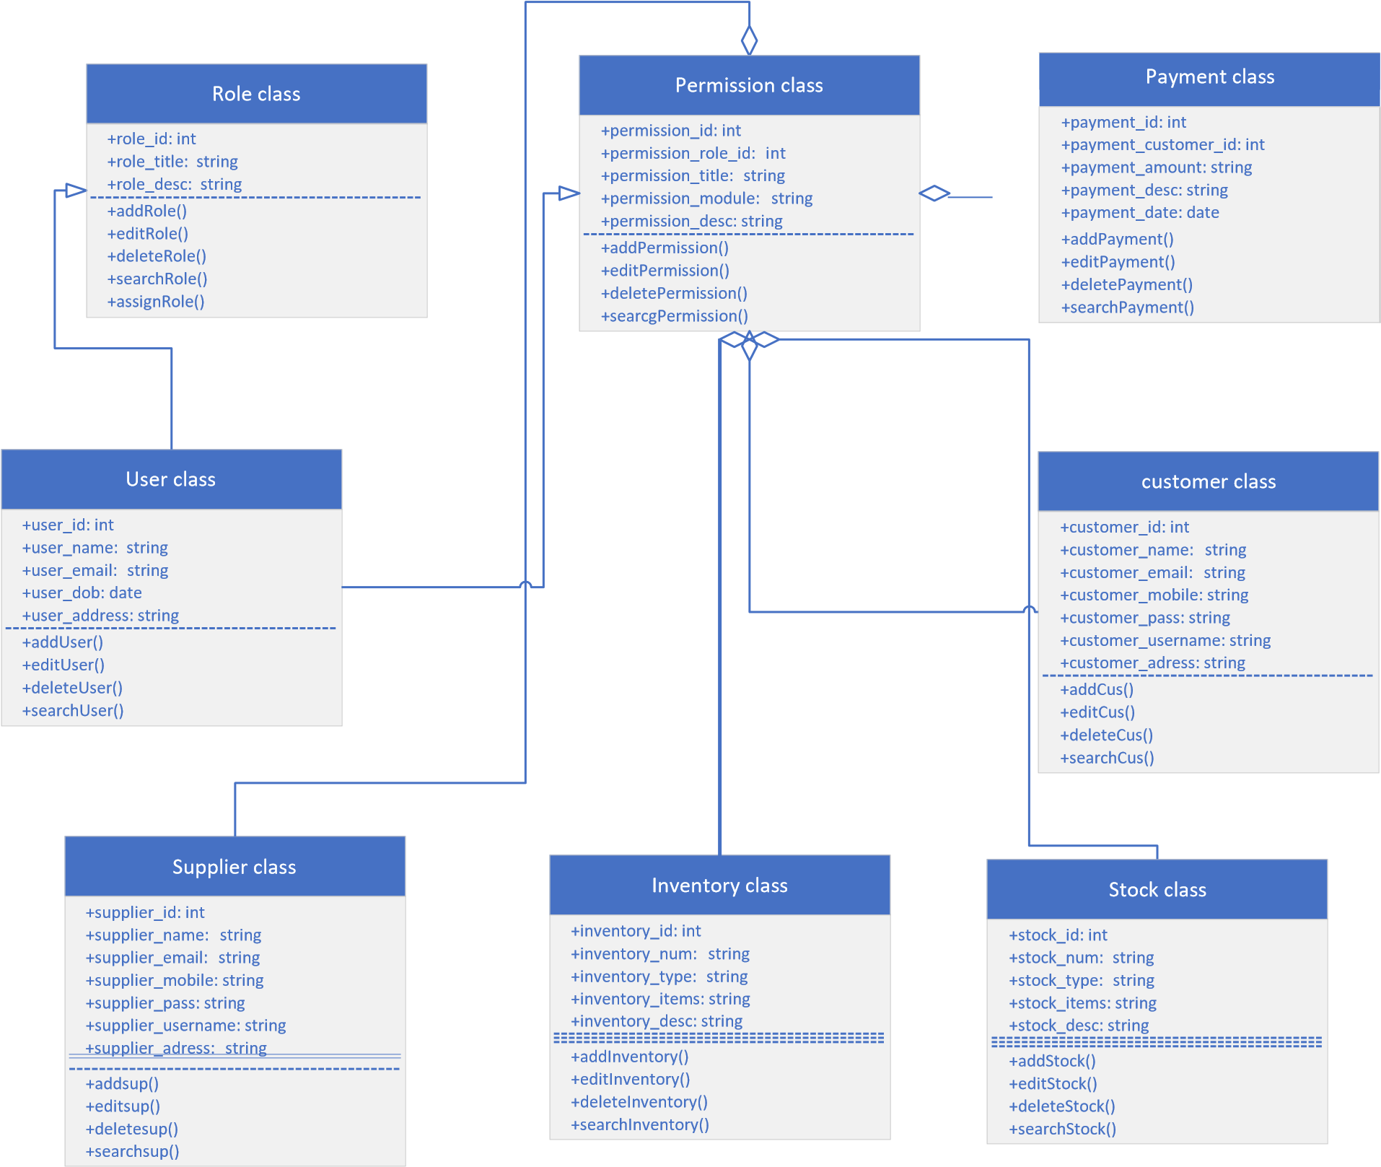

Figure 3.7: Class Diagram

3.2.8 Entity Relation Diagram

The entity relation diagram (ERD) is a diagram that depicts the structure of a database. Figure 3.9 depicts our project's ERD.


Name

Shipment date

Sno.

Shipment no.

Quantiry

Needed by

Product

Replishment

ID

Supplied

Date

Provide details

Request

Order no.

Item desc

Item no.

Products

Orders

Shipments

Inventory

Storage

Figure 3.8: Entity Relation Diagram

3.3 SRS for Application

3.3.1 IMS Framework design

llkfefkqwfkkwef
database
Data base
Data
Data
Add new product
Receive
notifications
Raw data
Processing

data
Processing

data
Procesin
g data

Figure 3.9: Framework design

3.3.2 IMS Context level

Admin/manager
Contractor
Stock management system
Update stock list
View stock report
Add new user
View stock report
Notification for low stock
View user
Update stock count
Scan for stock out
Request new stock
Login

Figure 3.10: Context level diagram

3.3.3 IMS Use case

actor
login
inventory
report
exit
utility
backup
restore
user
current stock
setup
product
opening stock
purchase and sale

Figure 3.11: Use case

3.3.4 IMS Process flow diagram

admin
Start
Login
Company
details
Product
entry
Sales return
Purchase
and sale
store
stock
supplier
Decrease
from stock
Create
invoice
customer
Whole saler
Logout
End
Stock availabe
no
payment

Figure 3.12: Process flow diagram

CHAPTER 4

DATA AND EXPERIMENTS (and/or IMPLMENTATION)

4.1 Languages used for implementation

Following languages were used for the implementation of the application:

4.2 CodeIgniter 4.
CodeIgniter is a quick, adaptable, and secure full-stack PHP web framework. The framework's Model is responsible for data management in CodeIgniter applications. The Controller is where all user input is received. It can help you insert, update, and retrieve data from your application. The model classes are located at /app/Models/.
They are suitable for placement within other folders (called "nesting").

4.3 PHP.
PHP, originally an acronym for "Personal Home Page," is now an acronym for "PHP, a recursive Web development language." Typically, a A PHP translator, which is introduced on a web waiter, is a module, daemon, or Normal Door Connection point (CGI) executable that processes PHP code. The backend of our web applications is written in this language.

4.4 AJAX.
AJAX is simply asynchronous XML and JavaScript. AJAX is a technique for creating dynamic and quick-loading websites. AJAX enables the asynchronous update of web pages by exchanging incremental data with the server. Thus, it is possible to modify specific portions of a webpage without having to reload the entire page.

4.5 Database

Following are the database used in our project:

4.6 MySQL

A free and open-source social data set administration framework is called MySQL, otherwise called "MySQL." The name is a mix of the initials for Organized Question Language and Michael Widenius' little girl's name.
MySQL is frequently liked by PHP designers. Robotized information recovery is made conceivable by the open-source MySQL data set, a SQL-composed RDBMS that offers great help for the production of PHP MySQL web applications.

4.7 XAMPP

XAMPP is a free Apache, MySQL, PHP, and Perl distribution. XAMPP's graphical interface for SQL (phpMyAdmin) makes it easy to manage data in a relational database. The package consists of MariaDB, PHP, and Perl.
XAMPP is a single download that includes the Apache web server, the MySQL database (technically MariaDB), PHP, and Perl (as command-line executables and Apache modules). You can get it for your PC, Mac, or Linux.

4.8 Implementation
First the user need open the website on their devices. Once they have opened, they will be welcomed by the Sign In page on opening the application. If the user is new to the application, he can roam free and also can create their account by sharing their details required by the application for e.g., your name, password etc. After successfully creating the account, the user can sign into their account and will be redirected to the home screen. From the home screen the user can see their buy and selling products, they can also see top selling products there. If there is product decreasing from sellers account as per there mentioned quantity there will be an automatic email notification alert will be received by that seller to refill their particular product.

CHAPTER 5

RESULTS AND DISCUSSIONS (or USER MANUAL)

Application

5.1 Sign Up

When the user opens the application, he will be brought to the registration screen. If the user is new to the application, he can select sign up which will direct him to the sign-up screen to create his new account

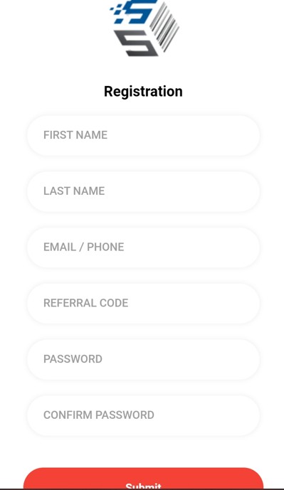

Figure 5.1: Sign Up Screen

5.1.1 Sign in

The user will be sent to the sign in screen when he first starts the app. The user is requested to login into the programme by entering his email/username and password.
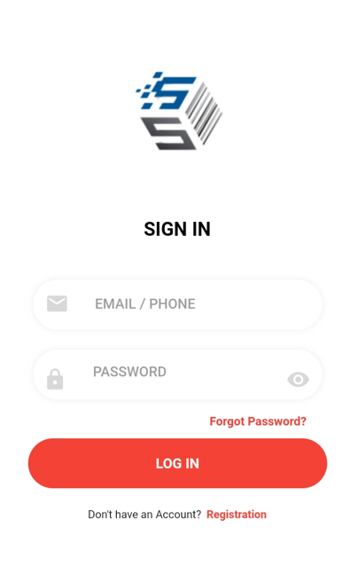

Figure 5.2: Sign in Screen

5.1.2 Dashboard
After signing in to the application a user can have a dashboard where they can track all of their exchanges.
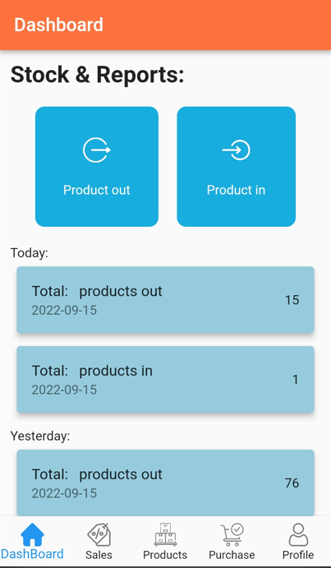

Figure 5.3: Dashboard Screen

5.1.3 All registered users

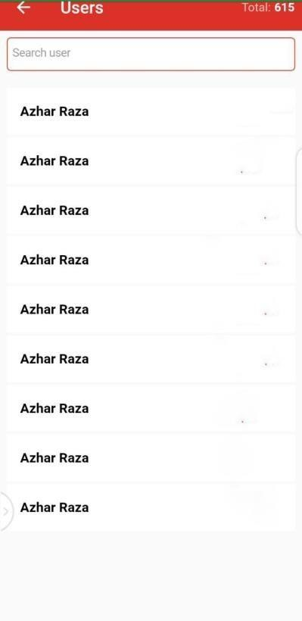
Figure 5.4: All users Screen

WEB

5.2 Dashboard screen in web

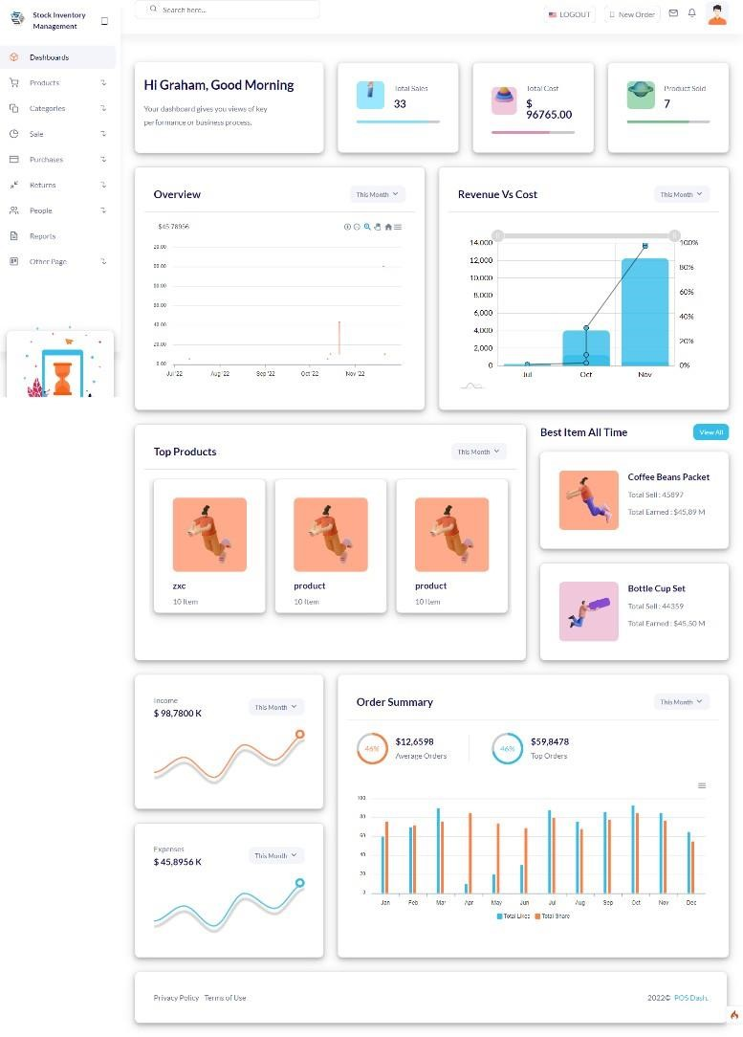

Figure 5.5: Dashboard Screen in web

5.2.1 Product Listing in stock

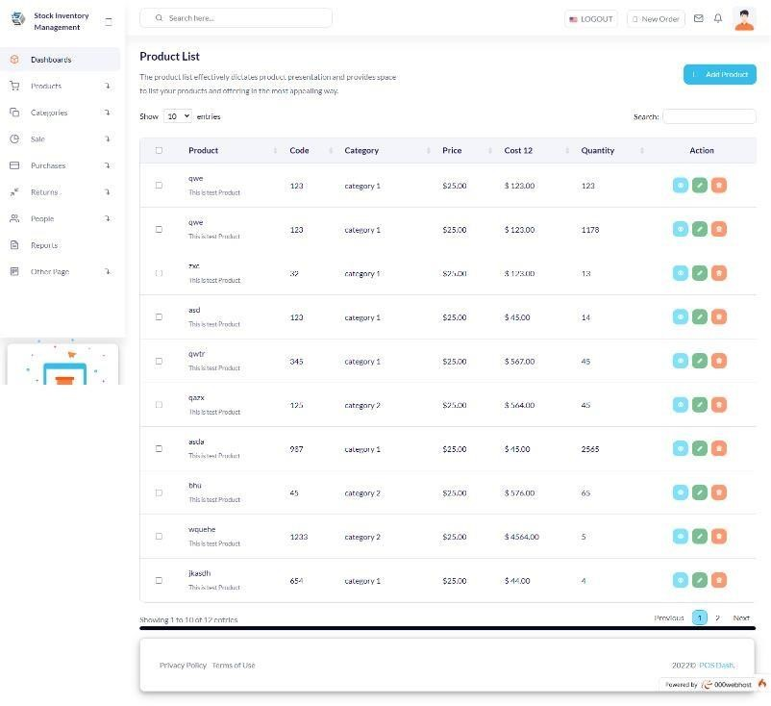

Figure 5.6: Products listing Screen

5.2.2 ADD Refund money

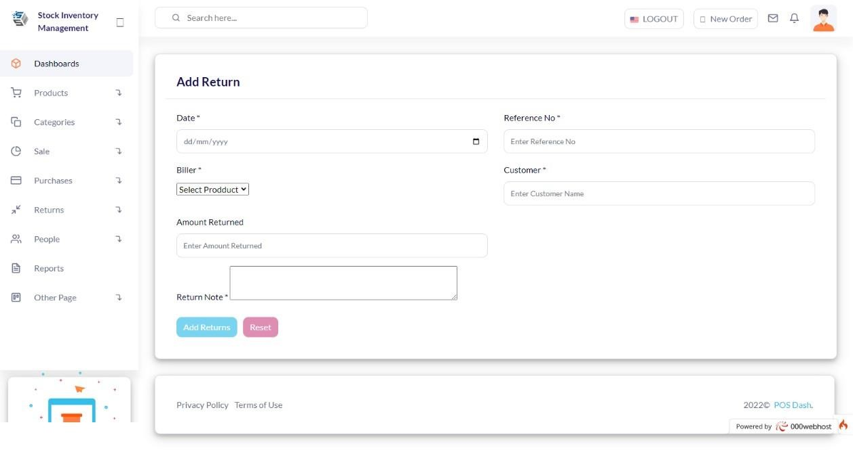
Figure 5.7: Refund money Screen

5.2.3 Return List

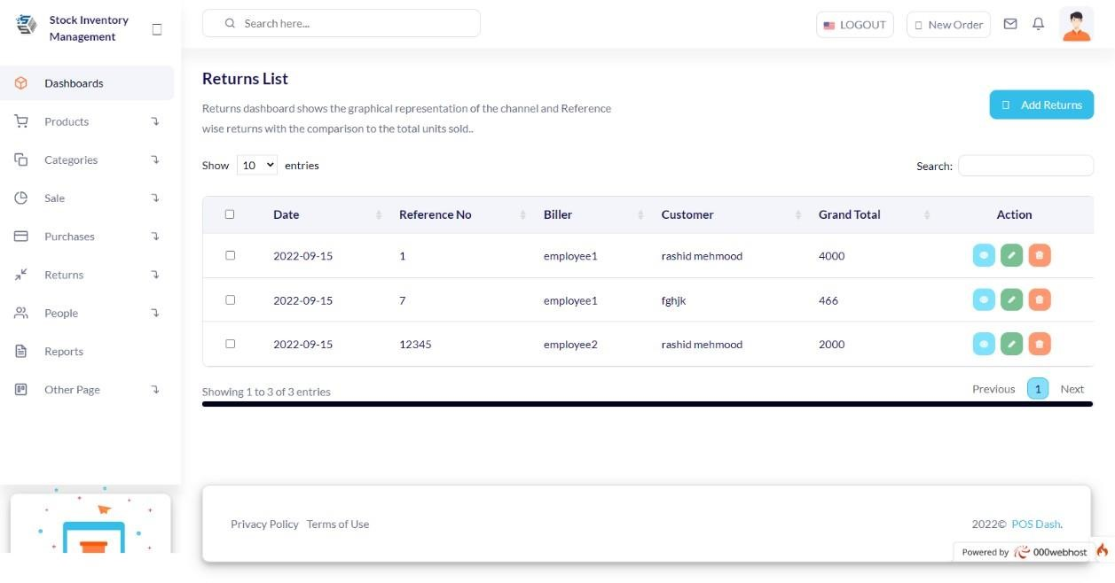
Figure 5.8: Return list Screen

5.2.4 Purchasing item

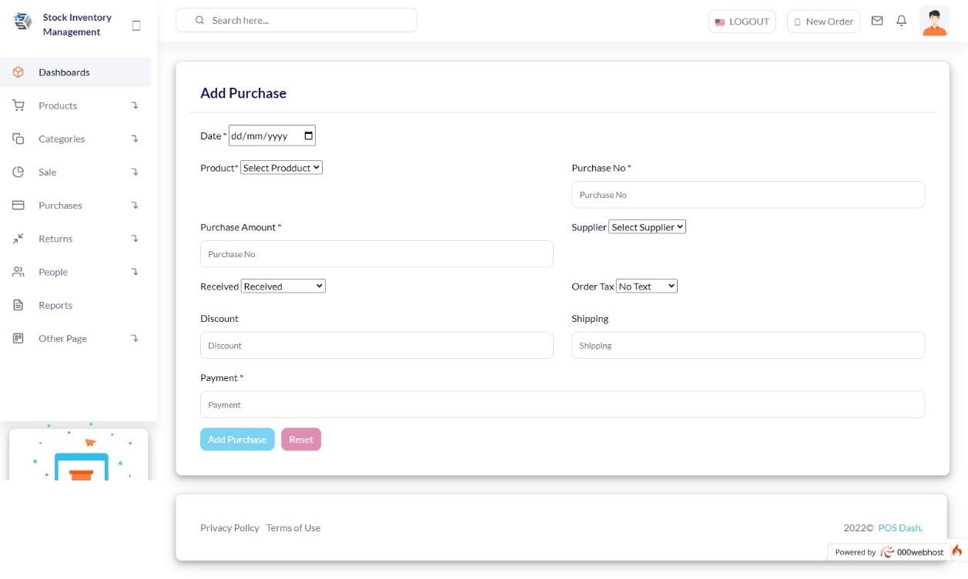

Figure 5.9: Purchasing Screen

5.2.5 Purchasing list

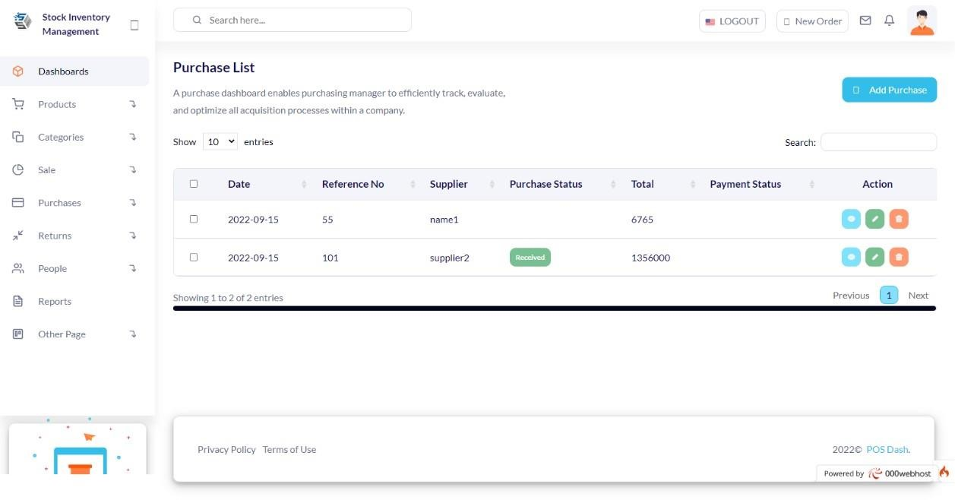
Figure 6.0: Purchasing list Screen

5.2.6 Add selling item

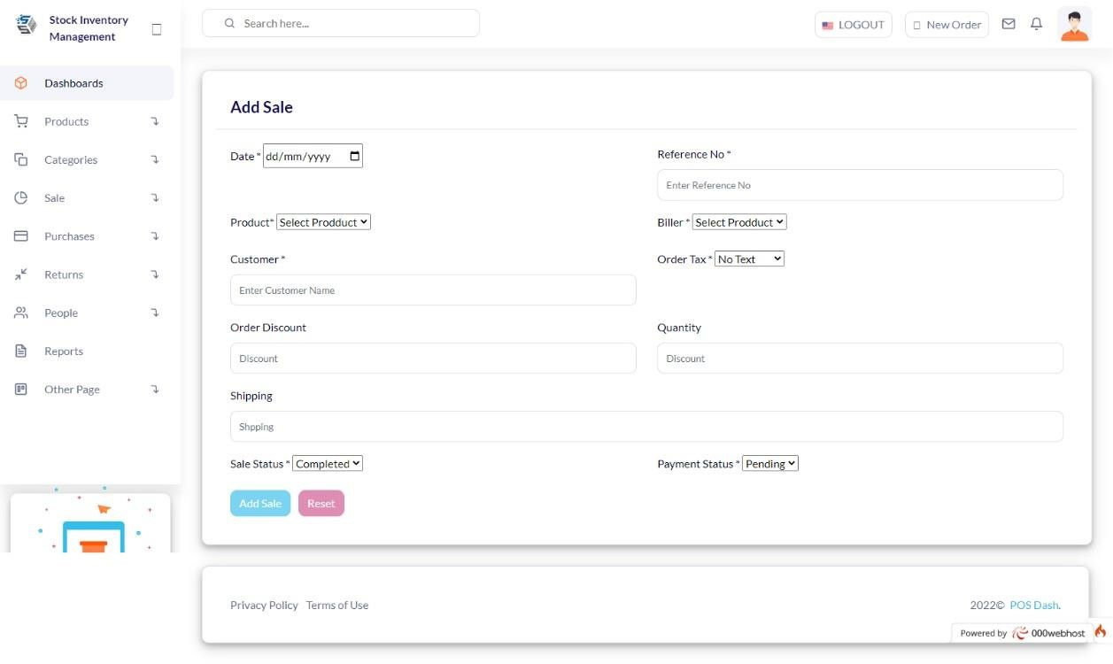

Figure 6.1: Add sales Screen

5.2.7 Listing sales items

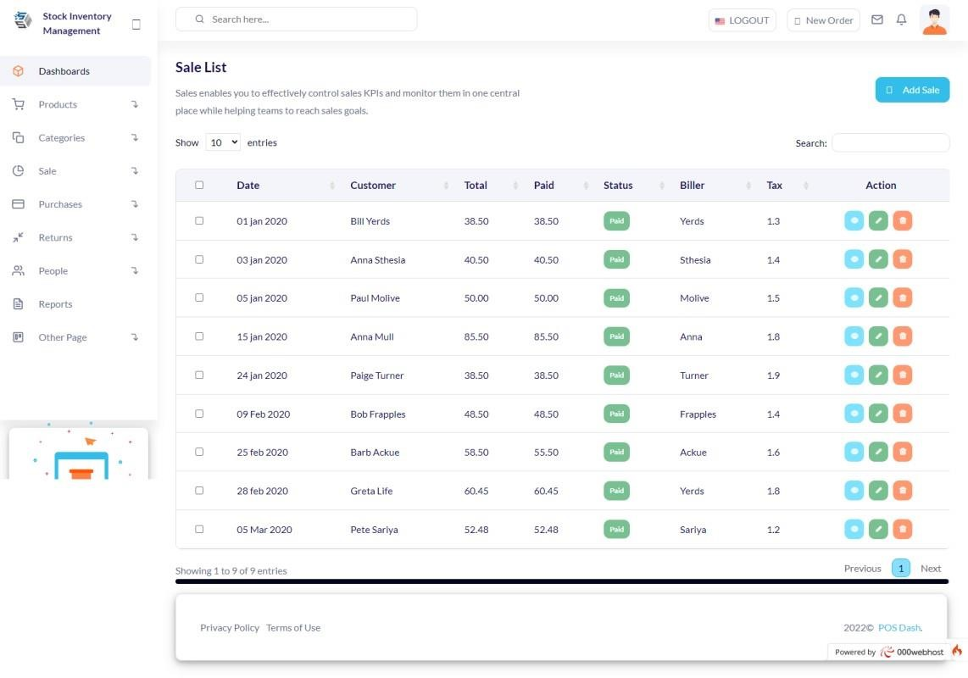
Figure 6.2: All sales items Screen

5.2.8 Add category

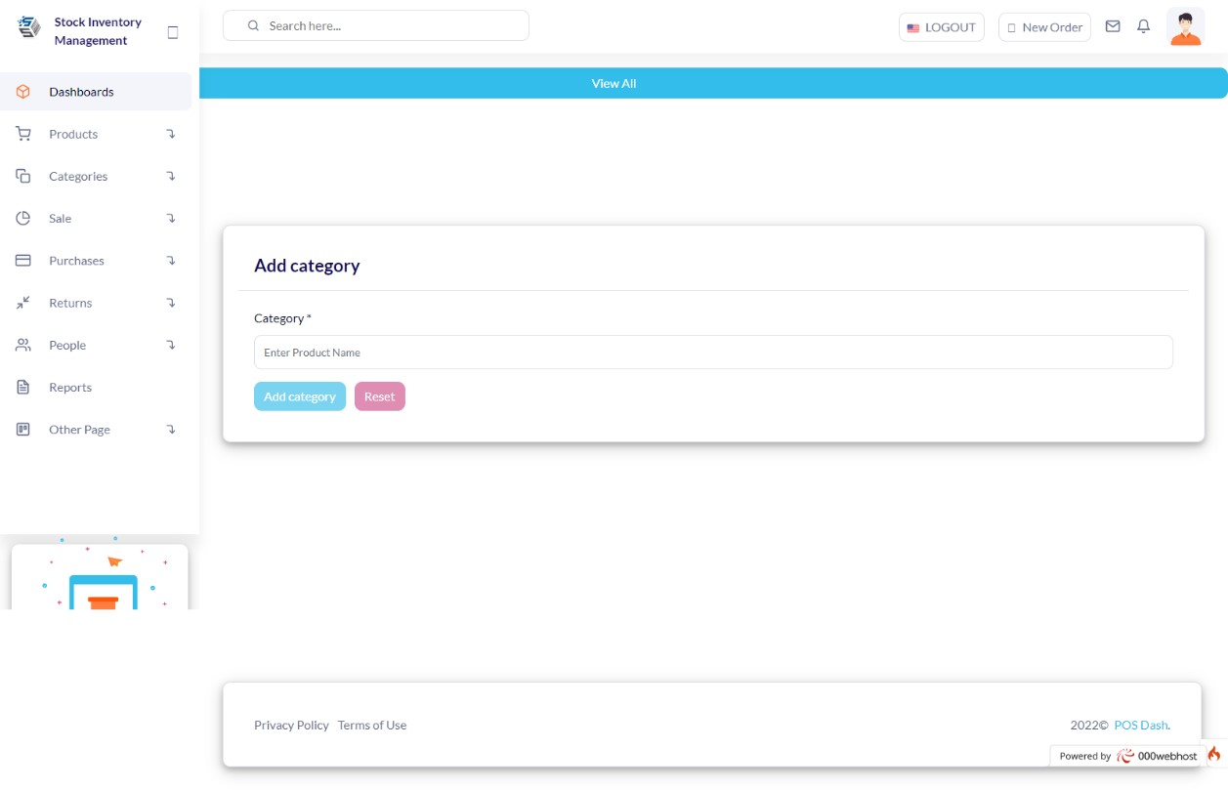
Figure 6.3: Add category Screen

5.2.9 Category List

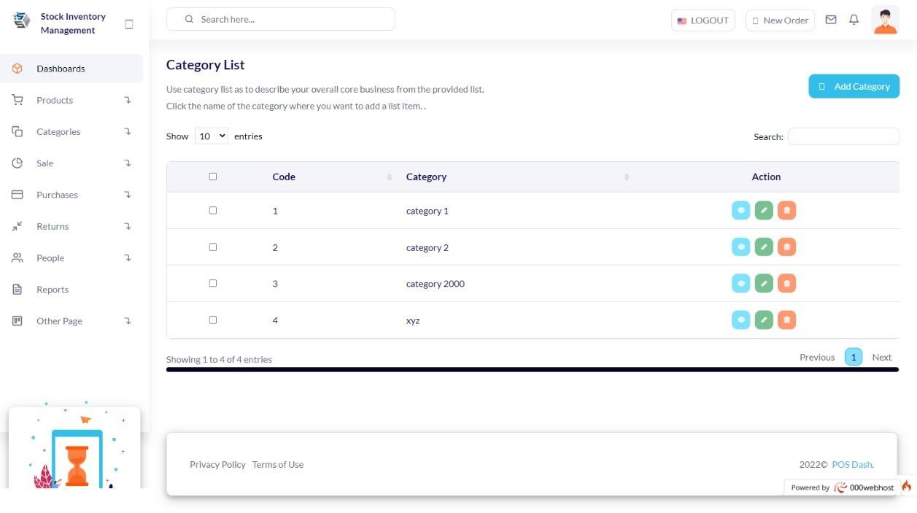

CHAPTER 6

CONCLUSION AND RECOMMENDATIONS

6.1 Conclusion

Proper inventory management will reduce storage costs, boost productivity, and increase customer satisfaction. An ICS is necessary for the efficient operation of any business because it permits both the physical and financial tracking of stock levels. The only purpose of the transactions recorded in such a system is to provide evidence of the past.
Exception lists also rank problems based on their potential business impact, highlighting both existing and emerging issues. Consequently, you can enhance customer service while reducing inventory costs and holding costs.
Consequently, while an Inventory Control System is necessary for the survival of your business, an Inventory Management System is a strategic tool that has the potential to completely transform it.

6.2 Recommendation

The next time you place an order, you'll know exactly how much to order so you don't run out of stock and how much to sell to your customers, thanks to the inventory management system's recommendations.
We intend to incorporate the QR system into the project moving forward. The item's inventory ID and other pertinent information will be encoded into a Quick Response (QR) code, which will be displayed alongside the item to provide quick access to additional information.

The mobile application is both online and offline capable. For inventory management, web-based software will be utilised, with authorised personnel updating inventory lists and scanning QR codes.

REFERENCES

Journal Papers:

[1]. Hassan, U.K., Kasim, S., Hassan, R., Mahdin, H., Ramli, A.A., Fudzee, M.F.M. and Salamat, M.A., 2018. Most Stationery Inventory Management System. Acta Electronica Malaysia, 2(2), pp.10-13.

[2]. Lee, E. and Farahmand, K., 2010, December. Simulation of a base stock inventory management system integrated with transportation strategies of a logistic network.
In Proceedings of the 2010 Winter Simulation Conference (pp. 1934-1945). IEEE.

- Deveshwar, A. and Dhawal, M., 2013. Inventory management delivering profits through stock management. World Trade Centre, Dubai: Ram University of Science and Technology.

Technical Reports and Theses:
- Jayanth, S., Poorvi, M.B. and Sunil, M.P., 2017. Inventory management system using IOT. In Proceedings of the First International Conference on Computational Intelligence and Informatics (pp. 201-210). Springer, Singapore.

- Harrington, T.C., Lambert, D.M. and Vance, M.P., 1990. Implementing an effective inventory management system. International Journal of Physical Distribution & Logistics Management.
Electronic Sources from Internet:
- Imeokparia, L., 2013. Inventory management system and performance of food and beverages companies in Nigeria. IOSR Journal of Mathematics, 6(1), pp.24-30. [7] A Li, S.G. and Kuo, X., 2008. The inventory management system for automobile spare parts in a central warehouse. Expert Systems with Applications, 34(2), pp.1144-1153.
- Stanger, S.H., Yates, N., Wilding, R. and Cotton, S., 2012. Blood inventory management: hospital best practice. Transfusion medicine reviews, 26(2), pp.153-163.

- Pando, V., San-Jose, L.A., Sicilia, J. and Alcaide-Lopez-de-Pablo, D., 2021. Maximization of the return on inventory management expense in a system with price- zand stock-dependent demand rate. Computers & Operations Research, 127, p.10513

- Hassan, U.K., Kasim, S., Hassan, R., Mahdin, H., Ramli, A.A., Fudzee, M.F.M. and Salamat, M.A., 2018. Most Stationery Inventory Management System. Acta Electronica Malaysia, 2(2), pp.10-13

- Plinere, D. and Borisov, A., 2015. Case study on inventory management improvement. Information Technology and Management Science, 18(1), pp.91-96.

- Deveshwar, A. and Dhawal, M., 2013. Inventory management delivering profits through stock management. World Trade Centre, Dubai: Ram University of Science and Technology.
- Buxey, G., 2006. Reconstructing inventory management theory. International Journal of Operations & Production Management.

- Li, S.G. and Kuo, X., 2008. The inventory management system for automobile spare parts in a central warehouse. Expert Systems with Applications, 34(2), pp.1144- 1153.

