
BSCS-S22-018
03-134181-053 | Ahmad Asif

FYP Manager

In partial fulfilment of the requirements for the degree of
Bachelor of Science in Computer Science
Supervisor: Asghar Ali Shah
Department of Computer Sciences
Bahria University, Lahore Campus
10 Janauary 2023

© Bahria University, 2023

Certificate

We accept the work contained in the report titled
“FYP Manager”
written by
Ahmad Asif
as a confirmation to the required standard for the partial fulfilment of the degree of
Bachelor of Science in Computer Science.

Approved by:
Supervisor: Asghar Ali Shah
(Signature)

January 10, 2023

DECLARATION

I hereby declare that this project report is based on my original work except for citations and quotations which have been duly acknowledged. I also declare that it has not been previously and concurrently submitted for any other degree or award at Bahria University or other institutions.

Enrolment | Name | Signature
03-134181-053 | Ahmad Asif

Date : January 10, 2023

Specially dedicated to
my beloved grandmother, mother and father
(Ahmad Asif)

ACKNOWLEDGEMENTS

I would like to thank everyone who had contributed to the successful completion of this project. I would like to express my gratitude to my research supervisor, Mr Asghar Ali Shah for his invaluable advice, guidance and his enormous patience throughout the development of the research.

In addition, I would also like to express my gratitude to my loving parent and friends who had helped and given me encouragement.

Ahmad Asif

FYP Manager

ABSTRACT

Selection of a supervisor for the FYP project is a time taking process in which a lot of discussions are required between the supervisor and students for the confirmation of the FYP project. And as a result, a lot of time is required from both student and supervisor. The main problem is the availability of the students and supervisors at the proper time. And the second main problem is students have no information about the supervisors’ list and their domain. And the other problem is no proper way to track the progress of project. Every student has required supervisors for the FYP project. FYP Manager app will provide information about supervisors like the list of supervisors, their domains, and their status at a time is available or not for selection for FYP project supervisor. And also communicate properly throughout the development of the project.
FYP Manager is an android application that will develop with the Flutter framework and visual studio code will be used as a development tool. SQL, Emulators, and Testing devices will be used as tools and technologies. For the development of the project Feature Driven Development methodology will be used because FDD works on an incremental and iterative approach. It will help my project to achieve its goals easily. Changes could occur at any time during the development of the project and errors could find throughout the development to achieve customer requirements. By making the FYP Manager app all the work of the FYP coordinator, supervisor and student will be digitized to overcome the time and availability issues.

TABLE OF CONTENTS

DECLARATION ii
ACKNOWLEDGEMENTS iv
ABSTRACT v
TABLE OF CONTENTS vi
LIST OF TABLES x
LIST OF FIGURES xii

CHAPTERS
1 INTRODUCTION 1
1.1 Background 1
1.2 Problem Statements 2
1.3 Aims and Objectives 2
1.4 Scope of Project 2
2 LITERATURE REVIEW (and/or SRS) 4
2.1 User Characteristics 4
2.2 Operating Environment 5
2.3 Development System 6
2.3.1 Design and Implementation Constraints 6
2.4 Assumptions and Dependencies 6
2.5 External Interface Requirements 6
2.5.1 User Interfaces 7
2.6 Software Interfaces 7
2.7 Functional Requirements 8
2.8 Non-Functional Requirements 9
2.8.1 Performance Requirements 9
2.8.2 Safety Requirements 9
2.8.3 Security Requirements 9
2.8.4 Software Quality Attributes 10
3 DESIGN AND METHODOLOGY 11
3.1 Features-Driven development 11
3.1.1 Develop Overall Model 11
3.1.2 Build Feature List 12
3.1.3 Plan by Feature 12
3.1.4 Design by Feature 12
3.1.5 Building by Feature 12
3.2 Use-case Description 13
3.2.1 Login 13
3.2.2 CRUD Student Accounts 13
3.2.3 CRUD Supervisor Accounts 14
3.2.4 Submit Project ideas 14
3.2.5 Accept/Reject project idea 15
3.2.6 Track Project Progress 16
3.2.7 Announcements 16
3.2.8 Blogs 17
3.2.9 CRUD Meetings 17
3.2.10 Accept/Reject Meeting 18
3.2.11 Logout 18
3.2.12 Signup 19
3.2.13 Login 19
3.2.14 Accept/Reject project idea 20
3.2.15 Track Project progress 20
3.2.16 CRUD Meetings 21
3.2.17 Accept/Reject Meetings 21
3.2.18 Logout 22
3.2.19 Signup 22
3.2.20 Login 23
3.2.21 List of Supervisor 23
3.2.22 Submit Project ideas 24
3.2.23 Request Meetings 24
3.2.24 Submit Project progress 25
3.2.25 Track Project progress 25
3.2.26 Logout 26
3.3 Use-case Diagrams 27
3.3.1 FYP Coordinator 27
3.3.2 Supervisor 28
3.3.3 Student 29
3.4 Sequence Diagrams 30
3.4.1 Login 30
3.4.2 List of Supervisors 31
3.4.3 Submit Project idea 32
3.4.4 Request Meetings 33
3.4.5 Track Project progress 34
3.4.6 Logout 34
3.4.7 CRUD Student accounts 35
3.4.8 CRUD Supervisor accounts 36
3.4.9 Announcements 37
3.4.10 Accept/Reject project idea 38
3.4.11 Track Project progress 39
3.4.12 CRUD Meetings 40
3.4.13 Accept/Reject Meetings 41
3.5 Class Diagram 42
3.6 Entity Relationship Diagram 43
3.6.1 Entities 43
3.6.2 ERD Diagram 43
4 DATA AND EXPERIMENTS (and/or IMPLMENTATION) 44
4.1 Languages used for implementation 44
4.1.1 Dart 44
4.2 Framework 44
4.2.1 Flutter 44
4.3 Tools 45
4.3.1 Visual Studio code 45
4.3.2 Android Emulator 45
4.4 Database 45
4.4.1 SQL Database 45
5 RESULTS AND DISCUSSIONS (or USER MANUAL) 46
5.1 Splash 46
5.2 Onboarding 48
5.3 Login 51
5.3.1 Coordinator dashboard 56
5.4 List of Supervisors 57
6 CONCLUSION AND RECOMMENDATIONS 58
6.1 Conclusion 58
6.2 Recommendations 58
REFERENCES 59

LIST OF TABLES

TABLE TITLE PAGE
Table 2. 1: Software Interfaces 7
Table 2. 2: Functional Requirement 8

Table 3. 1: Login 13
Table 3. 2: CRUD Student Accounts 13
Table 3. 3: CRUD Supervisor Accounts 14
Table 3. 4: Submit project idea 14
Table 3. 5: Accept/Reject project idea 15
Table 3. 6: Track Project Progress 16
Table 3. 7: Announcements 16
Table 3. 8: Blogs 17
Table 3. 9: CRUD Meetings 17
Table 3. 10: Accept/Reject Meetings 18
Table 3. 11: Logout 18
Table 3. 12: Signup 19
Table 3. 13: Login 19
Table 3. 14: Accept/Reject project idea 20
Table 3. 15: Track Project progress 20
Table 3. 16: CRUD Meetings 21
Table 3. 17: Accept/Reject Meetings 21
Table 3. 18: Logout 22
Table 3. 19: Signup 22
Table 3. 20: Login 23
Table 3. 21: List of Supervisor 23
Table 3. 22: Submit Project ideas 24
Table 3. 23: Request Meetings 24
Table 3. 24: Submit Project progress 25
Table 3. 25: Track Project progress 25
Table 3. 26: Logout 26

LIST OF FIGURES

FIGURE TITLE PAGE
Figure 3. 1: FYP Coordinator 27
Figure 3. 2: Supervisor 28
Figure 3. 3: Student 29
Figure 3. 4: Login 30
Figure 3. 5: List of Supervisors 31
Figure 3. 6: Submit Project idea 32
Figure 3. 7: Request Meetings 33
Figure 3. 8: Track Project progress 34
Figure 3. 9: Logout 34
Figure 3. 10: CRUD Student accounts 35
Figure 3. 11: CRUD Supervisor accounts 36
Figure 3. 12: Announcements 37
Figure 3. 13: Accept/Reject Project idea 38
Figure 3. 14: Track Project progress 39
Figure 3. 15: CRUD Meetings 40
Figure 3. 16: Accept/Reject Meetings 41
Figure 3. 17: Class diagram 42
Figure 3. 18: ERD diagram 43

Figure 5. 1: Splash 47
Figure 5. 2: Onboarding 1 48
Figure 5. 3: Onboarding 2 49
Figure 5. 4: Onboarding 3 50
Figure 5. 5: Login 51
Figure 5. 6: Login Enrollment 52
Figure 5. 7: Login Password 53
Figure 5. 8: Login Select 54
Figure 5. 9: Login type 55
Figure 5. 10: Coordinator dashboard 56
Figure 5. 11: List of Supervisors 57

INTRODUCTION

Background

Manual Selection of supervisors for the FYP project is taking a lot of time and has no information about supervisors. Every student required a supervisor for the FYP project and the student required guidance and the proper way the selection of supervisors. Student and Supervisor required the proper way to track the progress of project. And manually every time supervisor will not available to you to track the progress of project.
FYP Manager App is a mobile application that will be supported by Android. And the main purpose is to digitize the FYP-related process for the FYP project. This app will have 3 types of users Coordinator, Students, and Supervisors.
Coordinator will manage the student’s profile and information related to students and supervisors. And Students will see the list of supervisors with their name and domain and also will see the type of supervisor means teacher or lab advisor. Students will check the status of the supervisor mean the supervisor is selected or not. And for selection students will send a request form with FYP idea and member details. Students will submit project progress. Supervisors can select and reject student requests. Supervisors can track the progress of project.

Problem Statements

Since the presence of personal is necessary for submission of project idea and selection of supervisor, can cause wastage of time due to lengthy process related to FYP. Final year project is processed manually which is a tough task and students have to wait until the required person is available on the campus even for the Selection of supervisor and track the progress of project, which can ultimately cause the student to face the consequences of an extra time and workload. And Coordinator also have all of the burden to manage every process related to FYP. So this project is being developed to reduce the extra workload by making automated system.

Aims and Objectives

The objectives of the thesis are shown as following:
- To develop a cross-platform application that will run on the various operating
system
- To facilitate the teachers and students in a digital integrated environment
- To provide one platform for students, Supervisor and FYP coordinator

Scope of Project

FYP Manager App is an app in which students can select supervisors digitally which will minimize their time consumption and workload. It will help both students and Supervisors in a proper way where all information related to Students and Supervisors for the FYP project will be available. This app has three types of users Admin, Students, and Supervisors.
FYP coordinator will manage the profile of students and supervisors, and then information related to students and supervisors. FYP coordinator will make the announcements to student and supervisor related to FYP activities. FYP coordinator could submit project idea. FYP coordinator will Accept or Reject project idea. FYP coordinator will add blogs and in which documents will be provided to students different forms and FYP project templates. And FYP Coordinator create, update, delete meetings and also accept or reject meetings. And Students will see the list of supervisors with their name and domain and also will see the type of supervisor means teacher or lab advisor. Students will check the status of the supervisor mean the supervisor is selected or not. And for selection students will send a request form with FYP idea and member details. If the supervisor accepts the Students request then the student will request for meeting with the supervisor. Students will submit project progress and the supervisor will check the progress of the project. Supervisors can select and reject student requests for the confirmation of the FYP project which holds the information on FYP ideas and member details. Supervisors can track the progress of project. Supervisor create, update, delete meetings and also accept or reject meetings.
The main aim to develop this app is to facilitate the supervisors and students to perform their tasks digitally related to the FYP project. We are using Flutter for the development of FYP Manager. Flutter is a free and open-source UI software development kit (SDK) created by Google. Flutter uses DART as its official programming language.

LITERATURE REVIEW (and/or SRS)

User Characteristics

This software is created for three main users:
- Students
- Supervisor
- FYP Coordinator

Students – Students will be able to perform the following activities:
- List of Supervisors
- Submit Project idea
- Request Meetings
- Submit Project progress
- Track Project progress

Supervisor – Supervisor will be able to perform the following activities:
- Accept / Reject Project idea
- Track Project progress
- CRUD Meetings
- Accept / Reject Meetings

FYP Coordinator – FYP Coordinator will be able to perform the following activities:
- CRUD Students Accounts
- CRUD Supervisor Accounts
- Submit Project idea
- Accept / Reject Project idea
- Track Project progress
- Announcements
- Blogs
- CRUD Meetings
- Accept / Reject Meeting

Operating Environment

Mobile device with the following (minimum) specifications:
- 2 GB RAM
- Camera
- 1 GB free storage
- Android 6.0

Spacing between the table and first line of text is 3.0 lines. Subsequent paragraphs should be indented 1.27 cm (0.5 inch) from the left margin. General alignment for texts in paragraph should be “justified”.

Development System

- Visual Studio Code
- Android Studio
- Flutter [2]
- SQL Database

Design and Implementation Constraints

FYP Manager app is a mobile application, and the front end of the Application is designed using Flutter. For the database, SQL database is used. This app will be developed by using FDD [3] which divides complex structures into subparts. This model recurrence last two phases i.e., Design by feature and Develop by Feature until all features will complete. The internet connection is also a constraint for the application. Since the application fetches data from SQL Database, there must be an internet connection for the application to function.

Assumptions and Dependencies

We are assuming that the user already has the knowledge required how to use a smartphone. Internet connection is a must dependency for this software. Without these services, FYP Manager won't be able to run.

External Interface Requirements

Following are the external interface requirements of this project:

User Interfaces

- Full-screen application
- Splash screen
- UI/UX includes the following components:
- Buttons
- TextViews
- Google defined UI constraint standards
- Material design theme

Software Interfaces

Following are the required software interfaces:

Table 2. 1: Software Interfaces
Android Version | 6.0+ | This app will run on mobiles that are running Android version 6.0+
Database | SQL Database | SQL Database will be used to save the record of the users.
Tools | Visual Studio Code | Visual Studio Code is the development platform that’ll be used to develop this application using the Flutter framework

Functional Requirements

Table 2. 2: Functional Requirement
ID | Priority | Type | Used Use Cases | Description
1 | High | Functional | U1 | Login
2 | High | Functional | U2 | CRUD Students Accounts
3 | High | Functional | U3 | CRUD supervisor accounts
4 | High | Functional | U4 | Submit Projects Ideas
5 | High | Functional | U5 | Accept/Reject Project Idea
6 | High | Functional | U6 | Track Projects Progress
7 | High | Functional | U7 | Announcements
8 | High | Functional | U8 | Blogs
9 | High | Functional | U9 | CRUD Meetings
10 | High | Functional | U10 | Accept/Reject Meetings
11 | High | Functional | U11 | Logout
12 | High | Functional | U12 | Signup
13 | High | Functional | U13 | Login
14 | High | Functional | U14 | Accept/Reject Projects Idea
15 | High | Functional | U15 | Track Projects Progress
16 | High | Functional | U16 | CRUD Meetings
17 | High | Functional | U17 | Accept/Reject Meetings
18 | High | Functional | U18 | Login
19 | High | Functional | U19 | List Of Supervisors
20 | High | Functional | U20 | Submit Project Idea
21 | High | Functional | U21 | Request  Meetings
22 | High | Functional | U22 | Submit Project Progress
23 | High | Functional | U23 | Track Project Progress
24 | High | Functional | U24 | Logout

Non-Functional Requirements

Non-functional requirements of this project are:

Performance Requirements

A slow internet connection may impact the performance of the application. A good and stable internet connection is required.

Safety Requirements

To provide the users with the best application experience we will update our application from time to time to fix the bugs and errors.

Security Requirements

The database has to be reached securely and its data should not be broken. It also should not change except for integrant updates. Moreover, since our dataset contains some personal information of the user such as user id, project idea he/she submitted, security design is important in the application service.

Software Quality Attributes

Software quality attributes of this project are:
- Availability: The application will be available for the user 24/7.
- Flexibility: The application would be flexible for any type of user.
- Usability: The application should be user-friendly for the user. The users easily understand how to use the application.
- Testability: The application should be easy to test at each level and find the bugs/defect at each level of development and remove the defects easily.
- Reusability: The application is divided into different modules of coding. These modules can be used across the application.
- Maintainability: The design of this application is understandable and can be enhanced according to the business needs

DESIGN AND METHODOLOGY

Features-Driven development

Feature Driven Development Methodology will be used for the development of the project because FDD provides an iterative and incremental approach for the development of software and FDD works on the principle of the agile approach. And throughout the development of the project, we will update and identify errors. It works on small iterations and frequent releases that will suit my project. And responding to change throughout the development. Using the FDD methodology will help to track the progress because FDD promotes the reporting at each level throughout the development of the project.
Feature Driven Development is a Feature focused methodology means this methodology project is developed by making a list of features and a feature should be delivered as early as possible.

There are five basic stages [1] in the FDD approach.

Develop Overall Model

First, we define the overall mission, scope, and objectives of the system being developed and then create the domain models of the system, starting with individual components and then consolidating into a complete model using diagrams such as use case diagrams and sequence diagrams domain member proposed a model and at the end every domain model will be merged to make an overall model.

Build Feature List

We will use the knowledge gathered during the initial modeling to identify a list of features. In this, we make the list of features. And keep in mind these features lists will be made on smaller goals rather than tasks.

Plan by Feature

When we have a list of features in place, we will prioritize them and assign them to a specific two to 10 days timeframe of work called iteration. A team member will analyze the complexity of the feature. The team will evaluate the feature from the perspective at every stage before the development. Every feature delivery will be within two to ten days based on client prioritize. We plan activities to build features according to customers requirements to achieve a high-quality product.

Design by Feature

At this stage, we will design the features using flowcharts and flow diagrams. And we inspected the flow of features. And we design each feature based on design the package. The team will review the feature design before moving forward.

Building by Feature

After a successful design for each activity to produce a feature is planned, we then develop code for each feature. After testing and successful code, the completed feature will be upgraded to the main build. And the feature will be ready for delivery after performing the testing.

Use-case Description

Login

Table 3. 1: Login
Unique Identifier | U1
Brief Description | Admin will login the portal for performing it task by entering their credentials
Priority | High
Actors | Admin
Flow of events
- Basic flow | Admin will enter email and password for logging in.
- Alternative Flow | If username or password will be incorrect then it will generate error message and ask again for login.
Preconditions | Connected to internet and correct domain will be requested
Post conditions | Login to Admin and redirect to Admin dashboard

CRUD Student Accounts

Table 3. 2: CRUD Student Accounts
Unique Identifier | U2
Brief Description | Admin can create Student account and can also Edit its  information and also can Delete that Student Account and also view student account.
Priority | High
Actors | Admin
Flow of events
- Basic flow | Admin Go to dashboard and select the operation it want to perform for admin either create/edit/remove.
- Alternative Flow
Preconditions | Admin have all the information related to the student account i.e. name, etc.
Postconditions | Admin will successfully create, update, delete and read the student account

CRUD Supervisor Accounts

Table 3. 3: CRUD Supervisor Accounts
Unique Identifier | U3
Brief Description | Admin can create Supervisor account and can also Edit its  Information and also can Delete that Student Account and also view student account.
Priority | High
Actors | Admin
Flow of events
- Basic flow | Admin Go to Student Portion of its panel and select the operation it want to perform for admin either add/edit/remove.
- Alternative Flow
Preconditions | Admin have all the information related to the enrolment degree program etc.
Post conditions | Admin will successfully edit, add, remove the student

Submit Project ideas

Table 3. 4: Submit project idea
Unique Identifier | U4
Brief Description | Request form submitted by the student for any case can be viewed  admin so admin can take action
Priority | High
Actors | Admin
Flow of events
- Basic flow | Admin go to request form portion where he can see all the request's  submitted by student and admin can go thought it
- Alternative Flow
Preconditions | Must have some request submitted by student so admin can view or take action
Postconditions | Request will be viewed and some action will be taken on it

Accept/Reject project idea

Table 3. 5: Accept/Reject project idea
Unique Identifier | U5
Brief Description | Coordinator will Accept/Reject the project idea on the basis of submit  Project idea
Priority | High
Actors | Coordinator
Flow of events
- Basic flow | After login coordinator will Accept/Reject the submit project idea
- Alternative Flow
Preconditions | Project idea should be submitted by student
Postconditions | Submitted project idea will be Accepted/Rejected by coordinator

Track Project Progress

Table 3. 6: Track Project Progress
Unique Identifier | U6
Brief Description | Admin will define the modules and percentage and check list come on the basis of modules and percentage and then on the basis of project progress checklist marked
Priority | High
Actors | Admin
Flow of events
- Basic flow | Admin will define the modules and percentage and submit it system  will automatically work on it
- Alternative Flow
Preconditions | All the list of task that are going to triggered must be entered to instruct  the system
Postconditions | Checklist will be marked according to progress of project

Announcements

Table 3. 7: Announcements
Unique Identifier | U7
Brief Description | Admin can make any announcement related to project i.e. some student have some missing document or coordinator have to meet all of the students of FYP etc.
Priority | High
Actors | Admin
Flow of events
- Basic flow | Admin will go to Announcements and make announcement which will  automatically notify all of the student about it
- Alternative Flow
Preconditions | Admin have some reason to make announcement because these announcements are rare and out of schedule
Postconditions | Admin will successfully notify the students.

Blogs

Table 3. 8: Blogs
Unique Identifier | U8
Brief Description | Admin can Add documents related to FYP project like different forms of supervisors to get confirmation of FYP and other
Priority | High
Actors | Admin
Flow of events
- Basic flow | Admin will to go to Blogs and upload different form of documents
- Alternative Flow
Preconditions | Login to Admin and redirect to Admin dashboard
Postconditions | Upload different forms andForm will be available for students to be work on.

CRUD Meetings

Table 3. 9: CRUD Meetings
Unique Identifier | U9
Brief Description | Supervisor can create the meetings for the students and can also Edit its  information and also can Delete the meeting and also view the meeting.
Priority | High
Actors | Supervisor
Flow of events
- Basic flow | Supervisor go to the portion of panel where meetings are listed can view  can add groups can delete or can edit the groups
- Alternative Flow
Preconditions | Students must available for meetings
Postconditions | Meeting will be viewed, edited, removed and created successfully

Accept/Reject Meeting

Table 3. 10: Accept/Reject Meetings
Unique Identifier | U10
Brief Description | Supervisor will Accept/Reject the meetings on the basis of request for meetings by the student
Priority | High
Actors | Supervisor
Flow of events
- Basic flow | After login supervisor will Accept/Reject the meeting
- Alternative Flow
Preconditions | Request should be submitted by student for meeting
Postconditions | Submitted meeting request will be Accepted/Rejected by supervisor

Logout

Table 3. 11: Logout
Unique Identifier | U11
Brief Description | Admin can logout after doing all the tasks
Priority | High
Actors | Admin
Flow of events
- Basic flow | In admin panel admin can click button of logout for logging out
- Alternative Flow
Preconditions | Admin has to be logged in first for logging out
Postconditions | After logging out admin is redirected to login page

Signup

Table 3. 12: Signup
Unique Identifier | U12
Brief Description | Student can Sign Up for the system by providing all of its details on form  after submitted details admin will verify student has completed 80 credit hours and verify student account
Priority | High
Actors | Student
Flow of events
- Basic flow | Student will go to student panel and open sign up and fill all the information and submit it
- Alternative Flow
Preconditions | Internet must be connected and proper domain must be requested  Student must complete 80 credit hour then eligible for FYP
Postconditions | Student can successfully sign up

Login

Table 3. 13: Login
Unique Identifier | U13
Brief Description | After verifying account from admin student can successfully login by  providing correct login information and can use login for make FYP  groups
Priority | High
Actors | Student
Flow of events
- Basic flow | Student go to login and provide correct login information and submit  form
- Alternative Flow | If incorrect information is provided then error message will generate and ask for login again
Preconditions | Student must be registered first logging in
Postconditions | Student will log in successfully and redirect to its dashboard

Accept/Reject project idea

Table 3. 14: Accept/Reject project idea
Unique Identifier | U14
Brief Description | Supervisor will Accept/Reject the project idea on the basis of submit  Project idea
Priority | High
Actors | Supervisor
Flow of events
- Basic flow | After login supervisor will Accept/Reject the submit project idea
- Alternative Flow
Preconditions | Project idea should be submitted by student
Postconditions | Submitted project idea will be Accepted/Rejected by supervisor

Track Project progress

Table 3. 15: Track Project progress
Unique Identifier | U15
Brief Description | Admin will define the modules and percentage and check list come on the basis of modules and percentage and then on the basis of project progress checklist marked
Priority | High
Actors | Supervisor
Flow of events
- Basic flow | Admin will define the modules and percentage and submit it system  will automatically work on it
- Alternative Flow
Preconditions | All the list of task that are going to triggered must be entered to instruct  the system
Postconditions | Checklist will be marked according to progress of project

CRUD Meetings

Table 3. 16: CRUD Meetings
Unique Identifier | U16
Brief Description | Supervisor can create the meetings for the students and can also Edit its  information and also can Delete the meeting and also view the meeting.
Priority | High
Actors | Supervisor
Flow of events
- Basic flow | Supervisor go to the portion of panel where meetings are listed can view  can add groups can delete or can edit the groups
- Alternative Flow
Preconditions | Students must available for meetings
Postconditions | Meeting will be viewed, edited, removed and created successfully

Accept/Reject Meetings

Table 3. 17: Accept/Reject Meetings
Unique Identifier | U17
Brief Description | Supervisor will Accept/Reject the meetings on the basis of request for meetings by the student
Priority | High
Actors | Supervisor
Flow of events
- Basic flow | After login supervisor will Accept/Reject the meeting
- Alternative Flow
Preconditions | Request should be submitted by student for meeting
Postconditions | Submitted meeting request will be Accepted/Rejected by supervisor

Logout

Table 3. 18: Logout
Unique Identifier | U18
Brief Description | Student can logout their account after all the the task related to FYP and going that phase of project
Priority | High
Actors | Student
Flow of events
- Basic flow | Student can click logout button from dashboard
- Alternative Flow
Preconditions | Internet must be connected and student must be logged in
Postconditions | Successful logout and redirect to login page

Signup

Table 3. 19: Signup
Unique Identifier | U19
Brief Description | Student can Sign Up for the system by providing all of its details on form  after submitted details admin will verify student has completed 80 credit hours and verify student account
Priority | High
Actors | Student
Flow of events
- Basic flow | Student will go to student panel and open sign up and fill all the information and submit it
- Alternative Flow
Preconditions | Internet must be connected and proper domain must be requested  Student must complete 80 credit hour then eligible for FYP
Postconditions | Student can successfully sign up

Login

Table 3. 20: Login
Unique Identifier | U20
Brief Description | After verifying account from admin student can successfully login by  providing correct login information and can use login for make FYP  groups
Priority | High
Actors | Student
Flow of events
- Basic flow | Student go to login and provide correct login information and submit  form
- Alternative Flow | If incorrect information is provided then error message will generate and ask for login again
Preconditions | Student must be registered first logging in
Postconditions | Student will log in successfully and redirect to its dashboard

List of Supervisor

Table 3. 21: List of Supervisor
Unique Identifier | U21
Brief Description | Student have to select supervisor for their FYP group and student check the availability of Supervisor
Priority | High
Actors | Student
Flow of events
- Basic flow | Student will see the list of supervisors and the availability of supervisors
- Alternative Flow
Preconditions | Teacher must be willing to be supervisor of that FYP group or that type  of project and supervisor must have available slot for the FYP group
Postconditions | Supervisor will be selected successfully.

Submit Project ideas

Table 3. 22: Submit Project ideas
Unique Identifier | U22
Brief Description | Students will submit project idea and other details like member details and other information related to project idea
Priority | High
Actors | Student
Flow of events
- Basic flow | Student go to request form and add project idea and member details
- Alternative Flow
Preconditions | Supervisor must accept the request of student to select the supervisor
Postconditions | Action on project idea will taken.

Request Meetings

Table 3. 23: Request Meetings
Unique Identifier | U23
Brief Description | Student can contact supervisor for meeting and can make scheduled time because supervisor have course to teach and can be busy in other thing so they can easily get in touch
Priority | High
Actors | Student
Flow of events
- Basic flow | Student can contact supervisor by sending message or making a meeting schedule
- Alternative Flow
Preconditions | Student have to meet supervisor for the assistance of the FYP so they  contact their supervisor
Postconditions | Successful meeting schedule for student

Submit Project progress

Table 3. 24: Submit Project progress
Unique Identifier | U24
Brief Description | Student will submit your project according to modules which are set to track the progress
Priority | High
Actors | Student
Flow of events
- Basic flow | Student can go to submit project and submit project according to modules.
- Alternative Flow
Preconditions | Student have to login first and follow modules to submit project
Postconditions | Student will be submitted project

Track Project progress

Table 3. 25: Track Project progress
Unique Identifier | U25
Brief Description | Admin will define the modules and percentage and check list come on the basis of modules and percentage and then on the basis of project progress checklist marked
Priority | High
Actors | Student
Flow of events
- Basic flow | Admin will define the modules and percentage and submit it system  will automatically work on it
- Alternative Flow
Preconditions | All the list of task that are going to triggered must be entered to instruct  the system
Postconditions | Checklist will be marked according to progress of project

Logout

Table 3. 26: Logout
Unique Identifier | U26
Brief Description | Student can logout their account after all the the task related to FYP and going that phase of project
Priority | High
Actors | Student
Flow of events
- Basic flow | Student can click logout button from dashboard
- Alternative Flow
Preconditions | Internet must be connected and student must be logged in
Postconditions | Successful logout and redirect to login page

Use-case Diagrams

FYP Coordinator

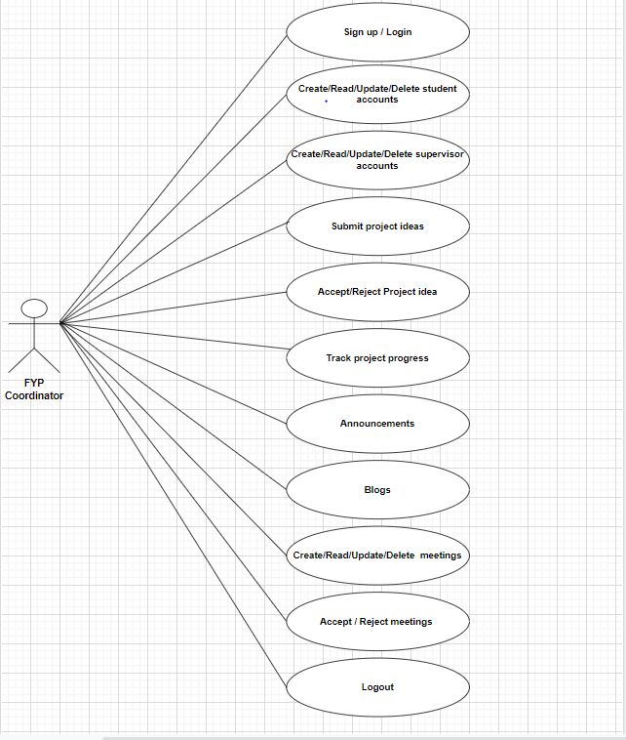
Figure 3. 1: FYP Coordinator

Supervisor

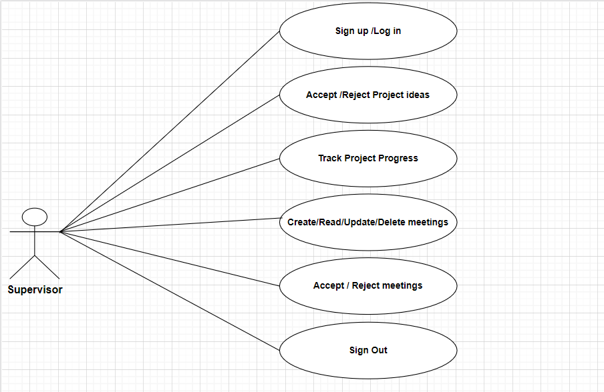
Figure 3. 2: Supervisor

Student

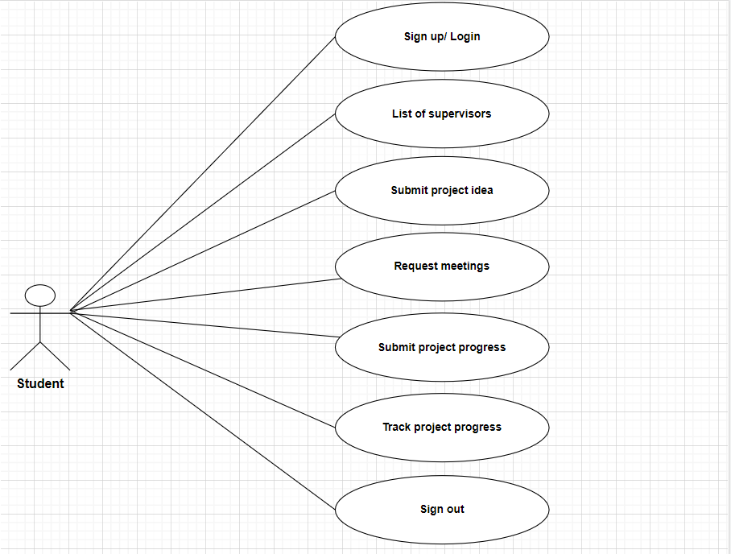
Figure 3. 3: Student

Sequence Diagrams

Login

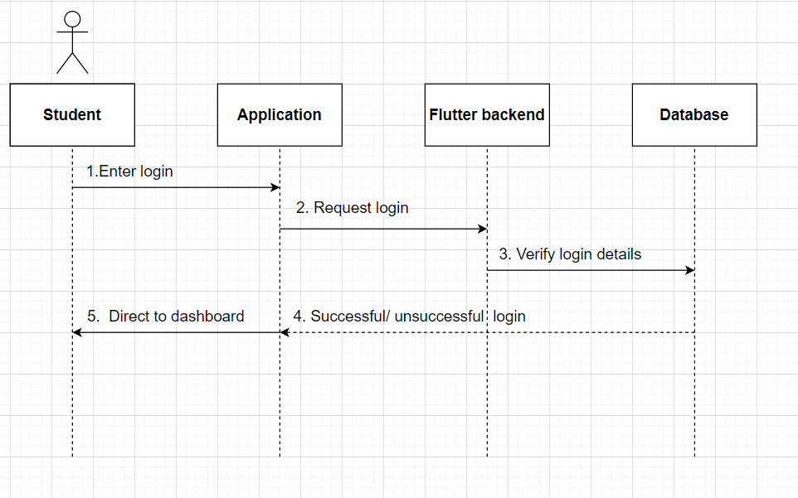
Figure 3. 4: Login

List of Supervisors

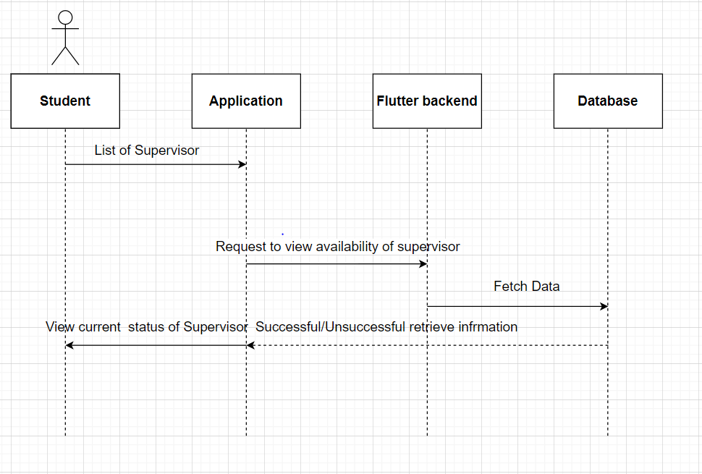
Figure 3. 5: List of Supervisors

Submit Project idea

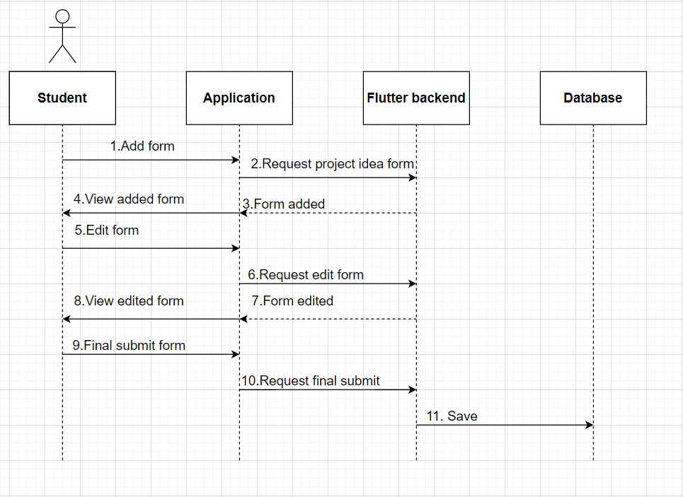
Figure 3. 6: Submit Project idea

Request Meetings

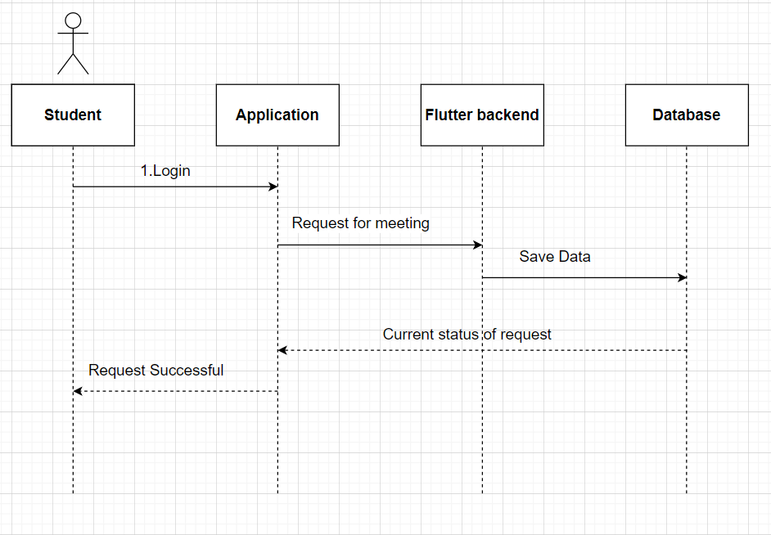
Figure 3. 7: Request Meetings

Track Project progress

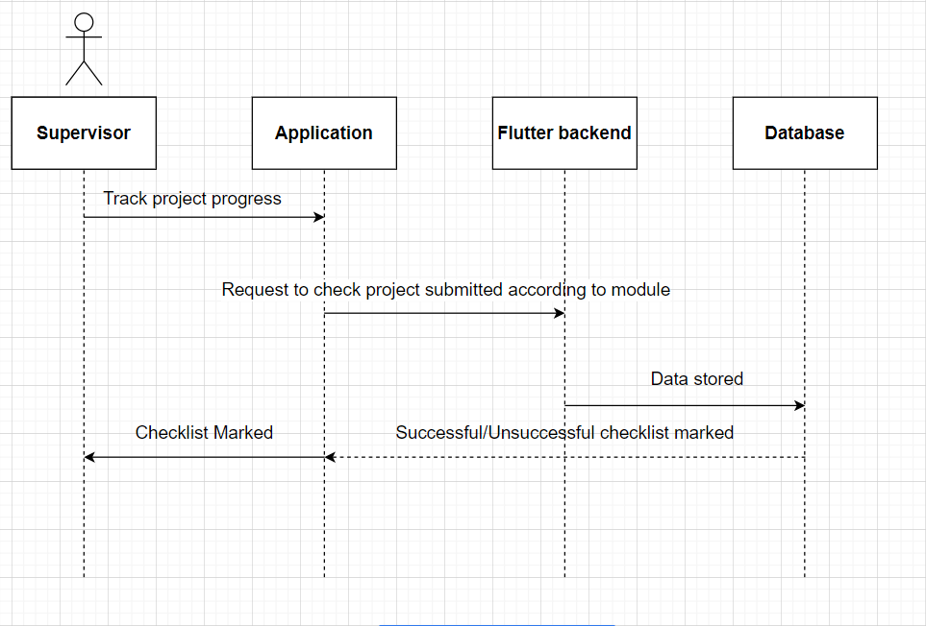
Figure 3. 8: Track Project progress

Logout

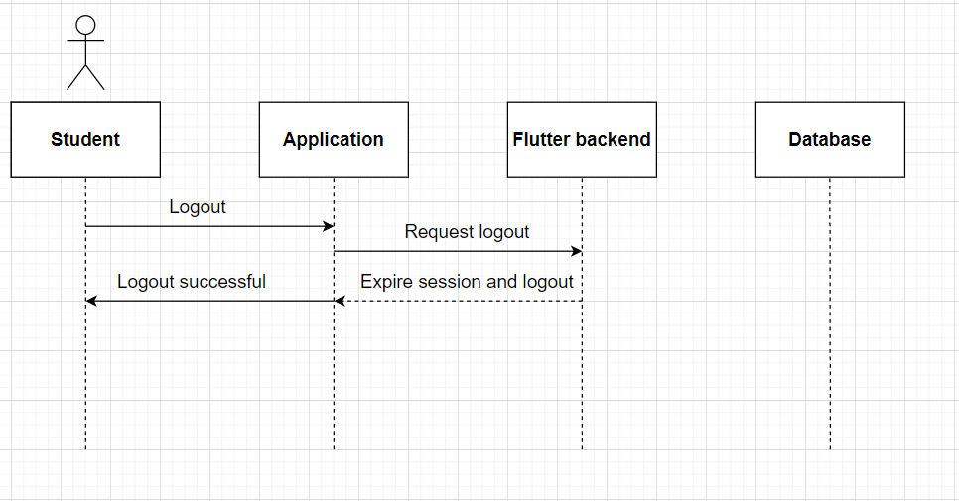
Figure 3. 9: Logout

CRUD Student accounts

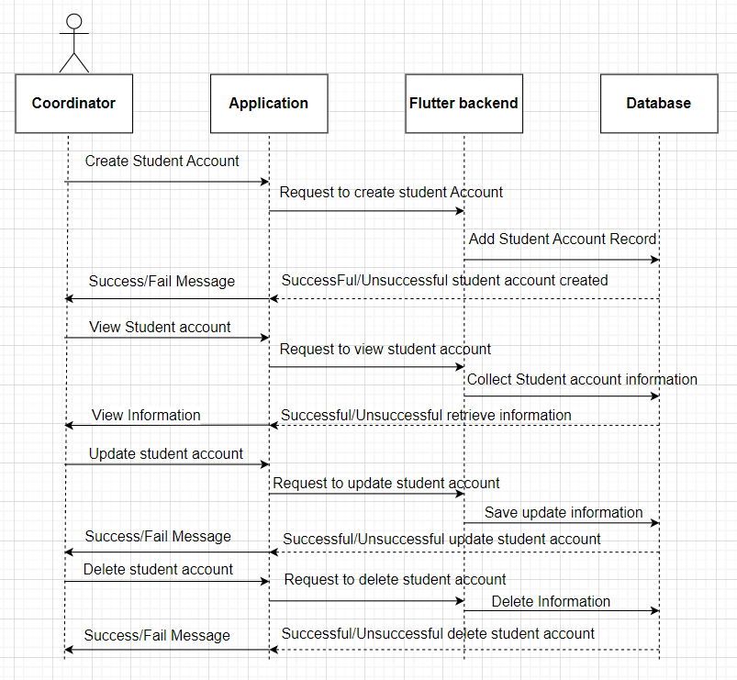
Figure 3. 10: CRUD Student accounts

CRUD Supervisor accounts

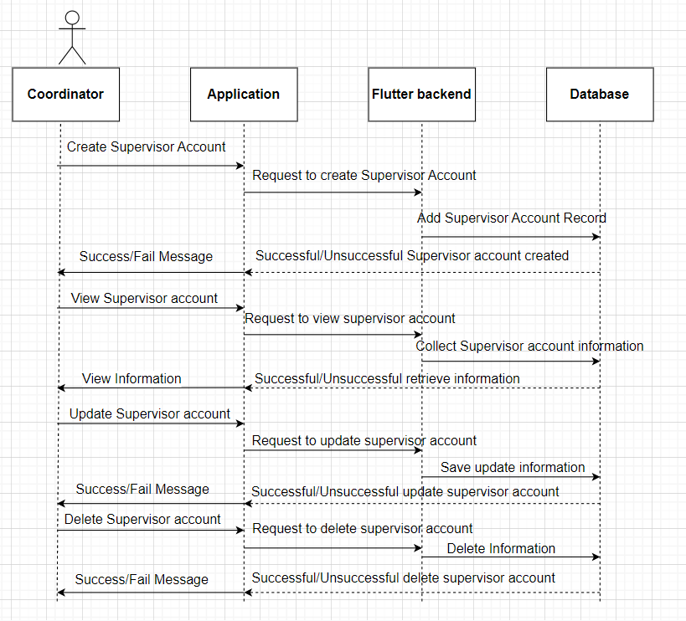
Figure 3. 11: CRUD Supervisor accounts

Announcements

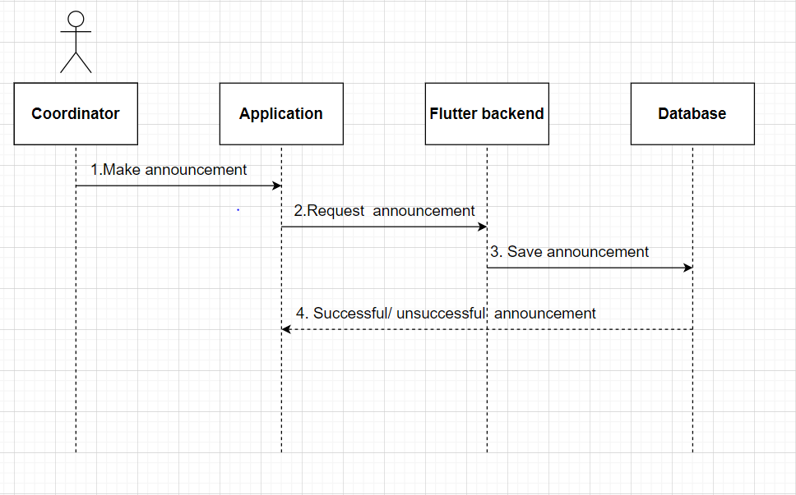
Figure 3. 12: Announcements

Accept/Reject project idea

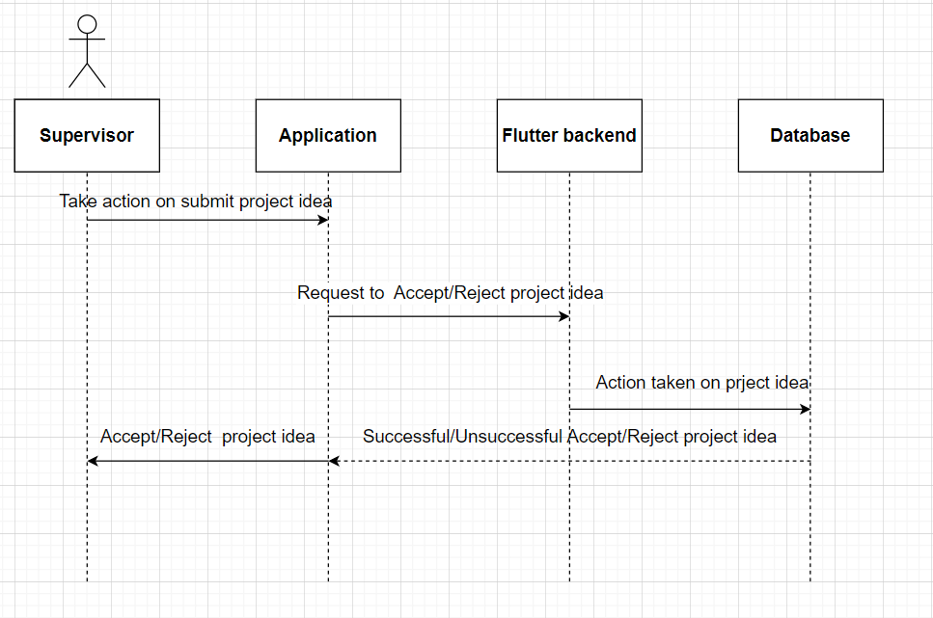
Figure 3. 13: Accept/Reject Project idea

Track Project progress

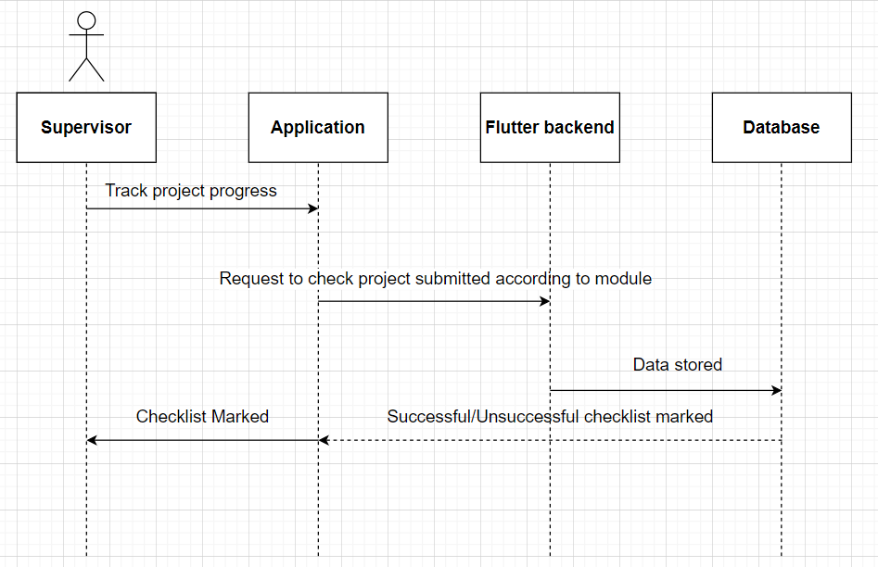
Figure 3. 14: Track Project progress

CRUD Meetings

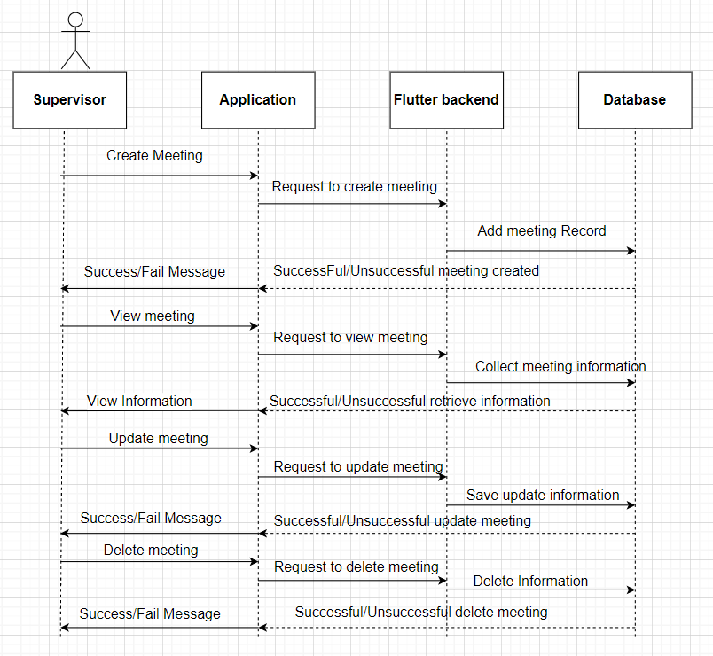
Figure 3. 15: CRUD Meetings

Accept/Reject Meetings

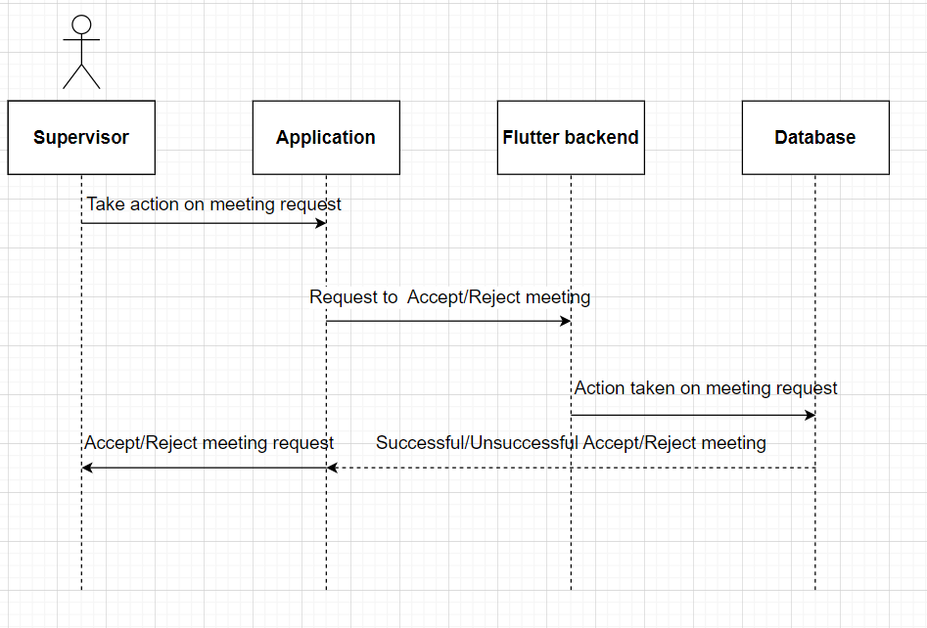
Figure 3. 16: Accept/Reject Meetings

Class Diagram

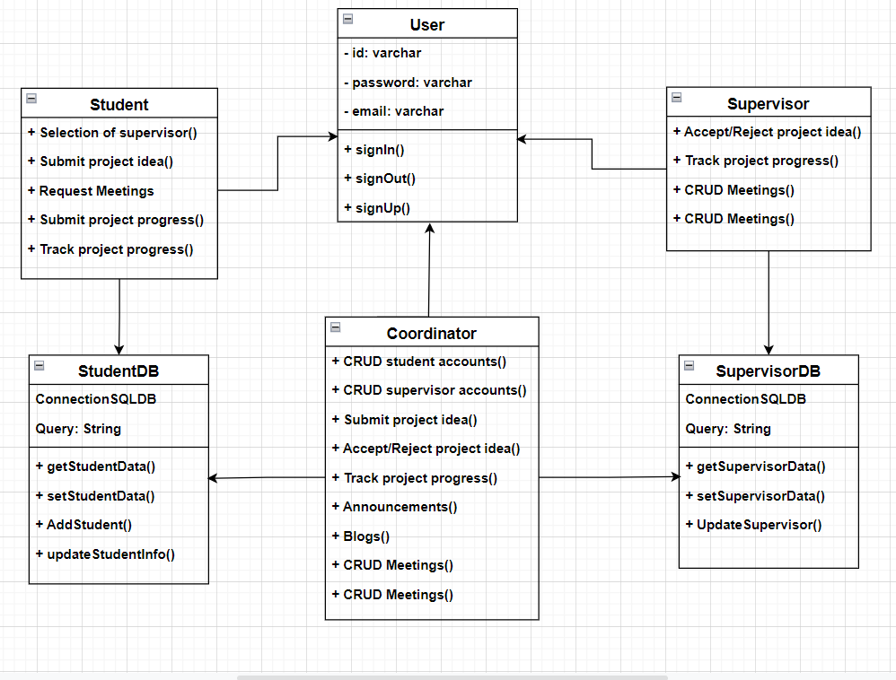
Figure 3. 17: Class diagram

Entity Relationship Diagram

Entities

- Coordinator
- Supervisors
- Students

ERD Diagram

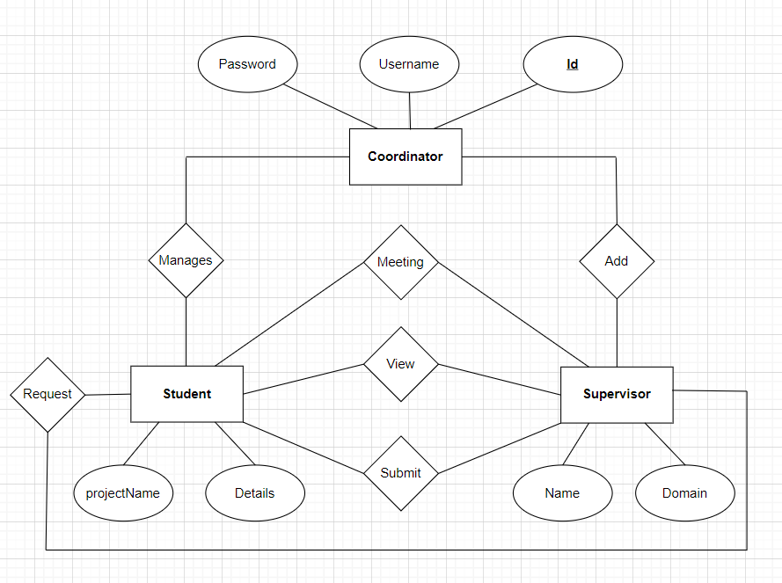
Figure 3. 18: ERD diagram

DATA AND EXPERIMENTS (and/or IMPLMENTATION)

Languages used for implementation

Dart

Dart is an Open-Source, Client-Optimized programming language used for creating high-performance and fast applications. It is used to create a mobile application, write software for the desktop, or design a site. It’s an interpretable language supported by Google alongside numerous features which made it popular among programmers. Dart is also known as an alternative to JavaScript. The use of it is increased when Google introduced Flutter intending to add mobile programming capabilities.

Framework

Flutter

Flutter is an Open-source UI, cross-platform framework for developing a native mobile application. Flutter allows us to build a mobile application for Android and IOS with a single code-based and programming language called Dart. The flutter framework consists of both a software development kit (SDK) and their widget-based UI library.it contains a variety of reusable UI elements.

Tools

Visual Studio code

Microsoft Visual Studio Code is a standalone source code editor that runs on multiple operating systems. It is used to develop computer programs, as well as websites, web apps, web services, and mobile apps. It supports many programming languages and a set of features that differs per language. VS Code provides initial support including syntax highlighting etc.

Android Emulator

The android emulator provides simulations of android devices on your computer which helps us to test our application on a variety of devices without needing to have each physical device. It came along with a predefined configuration for multiple android based Phones, Tablets. Testing in an emulator is way faster than physical devices.

Database

SQL Database

SQL database is a backend as a service. It provides developers a variety of services along with tools to help them to develop a quality application that helps them to grow their user base, and earn.

RESULTS AND DISCUSSIONS (or USER MANUAL)

Splash

When the application launched then first screen appear on the screen it is known as Splash screen. And my app also have Splash screen it will appear when app will be launched.

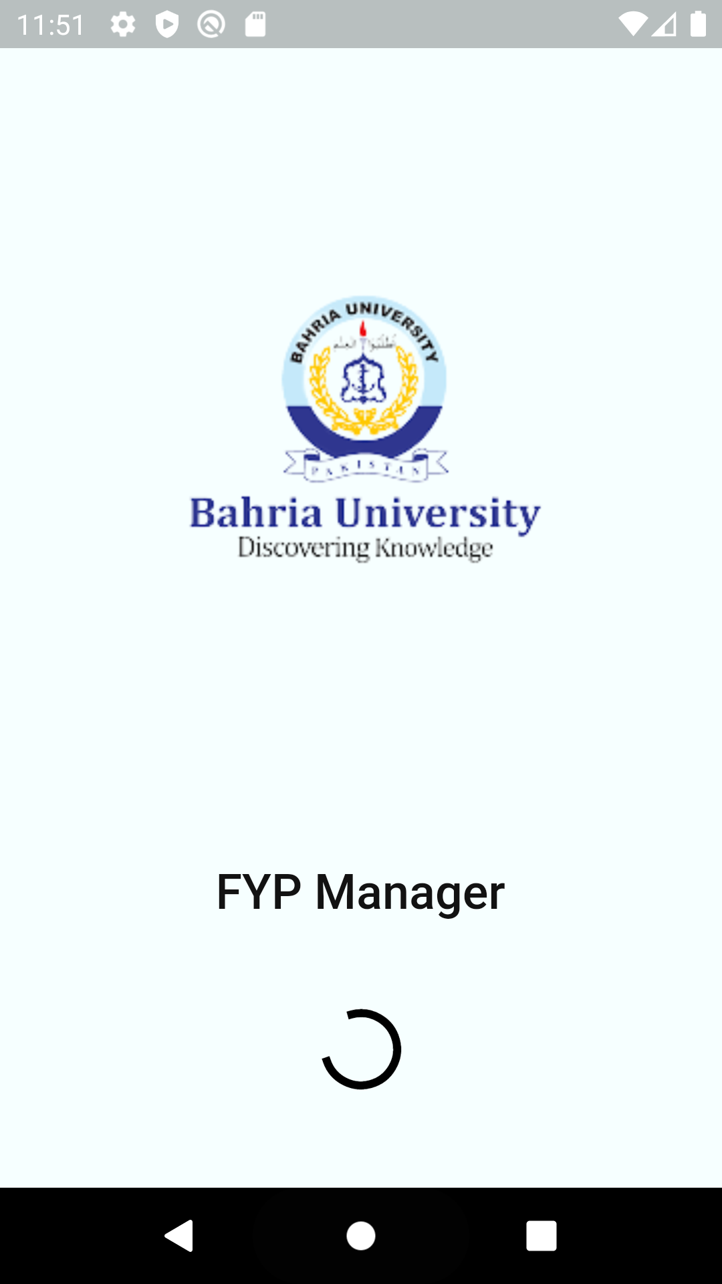
Figure 5. 1: Splash

Onboarding

Onboarding Screens are use to introduce application to users how it work and what type of Features this app have.

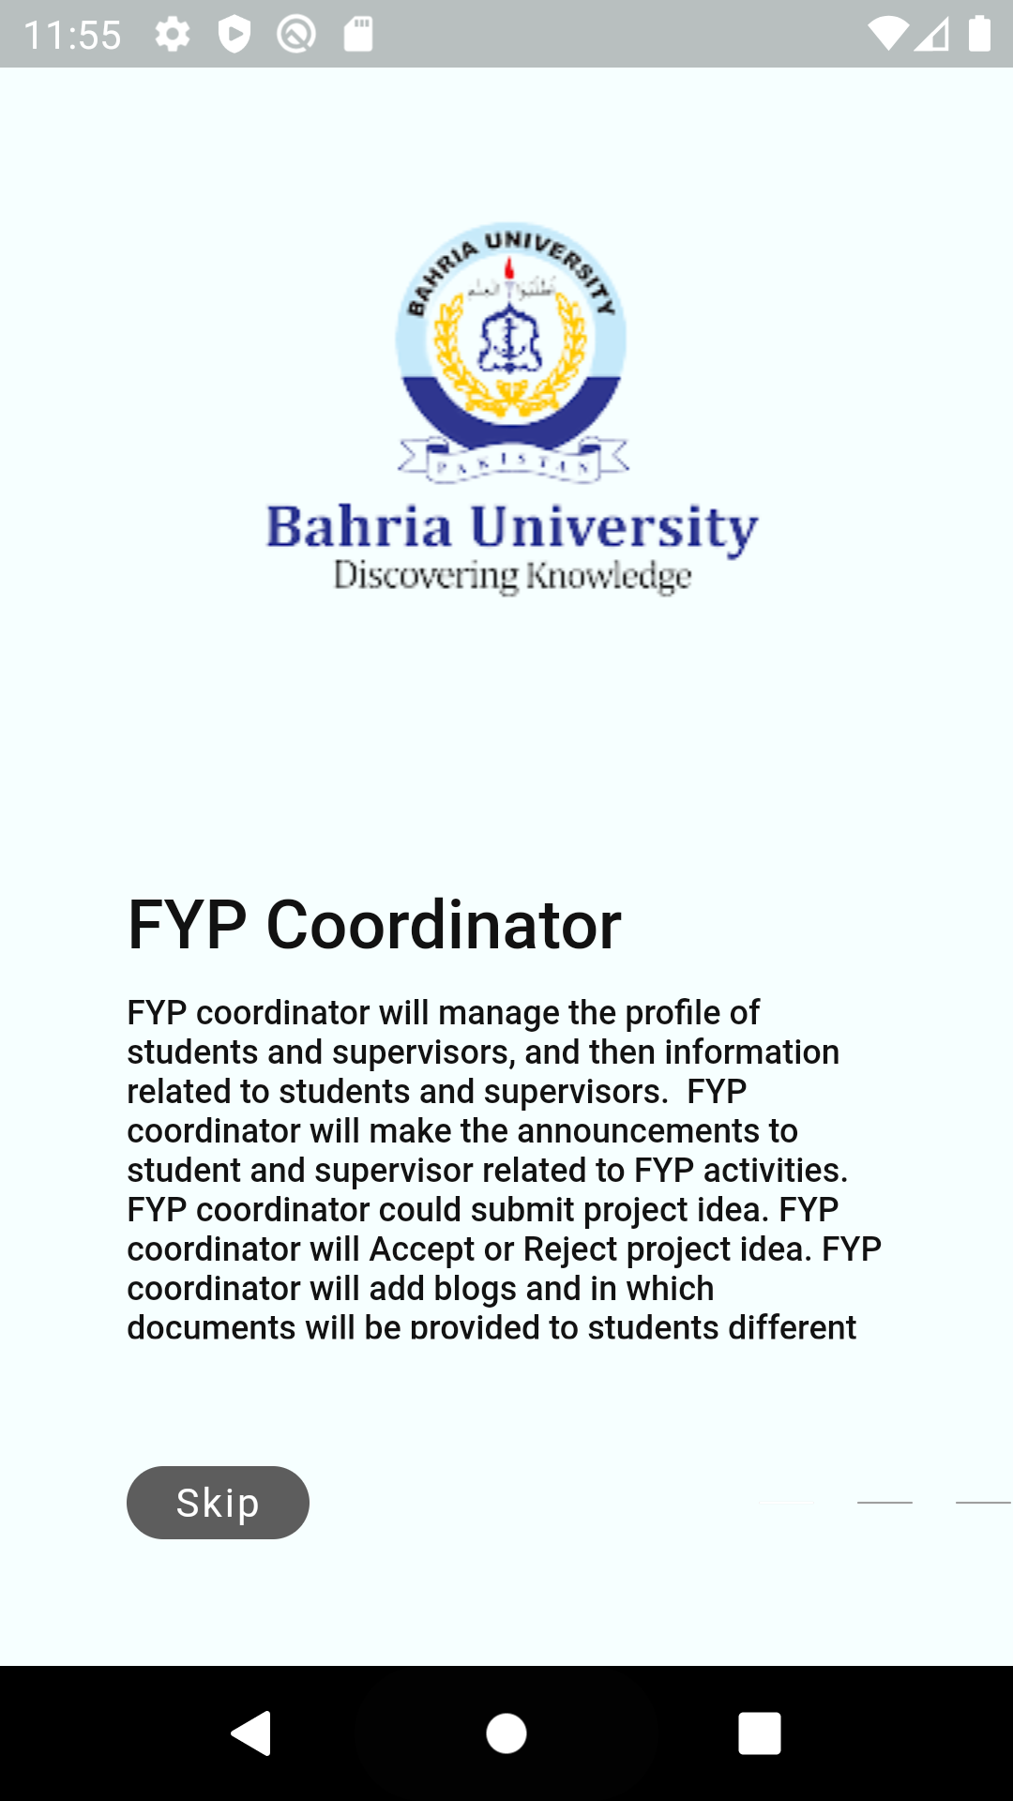
Figure 5. 2: Onboarding 1

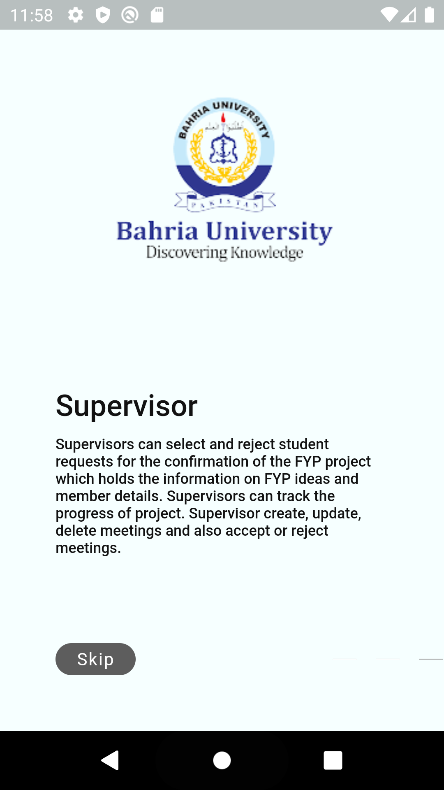
Figure 5. 3: Onboarding 2

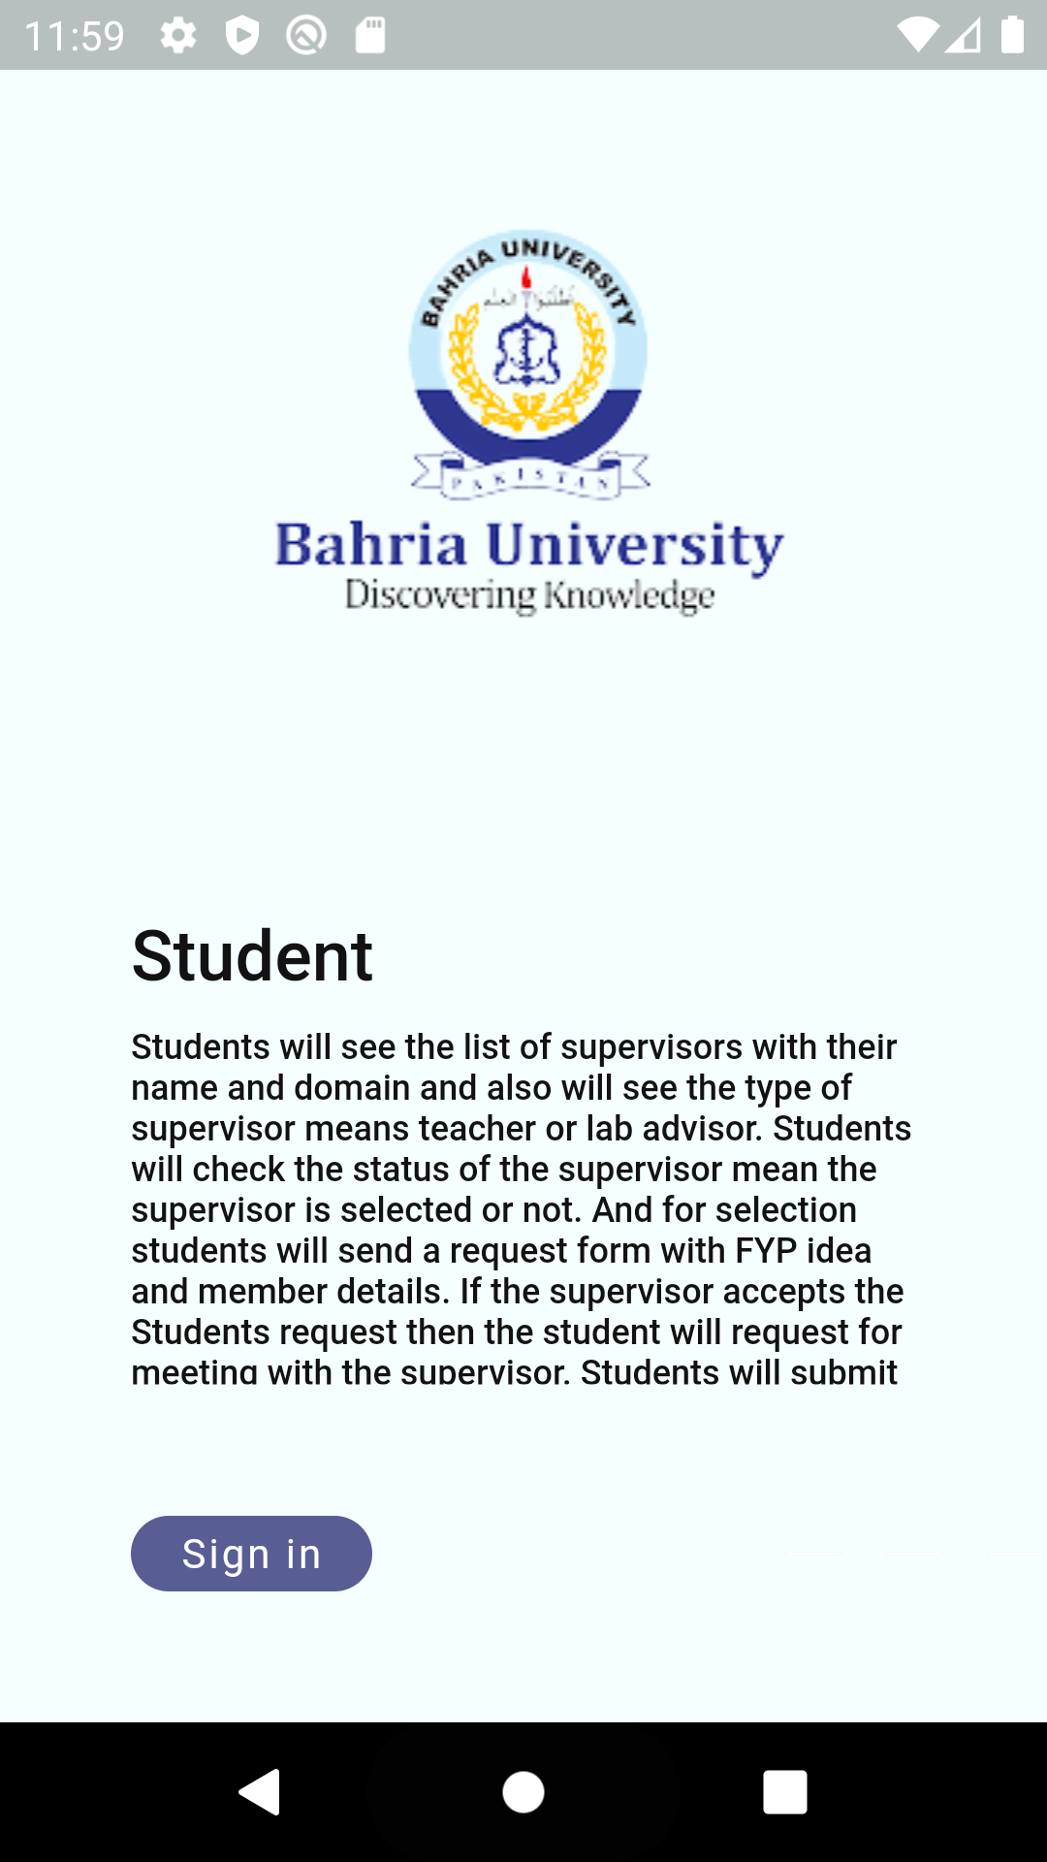
Figure 5. 4: Onboarding 3

Login

Login page verified user which will support confidentiality traid

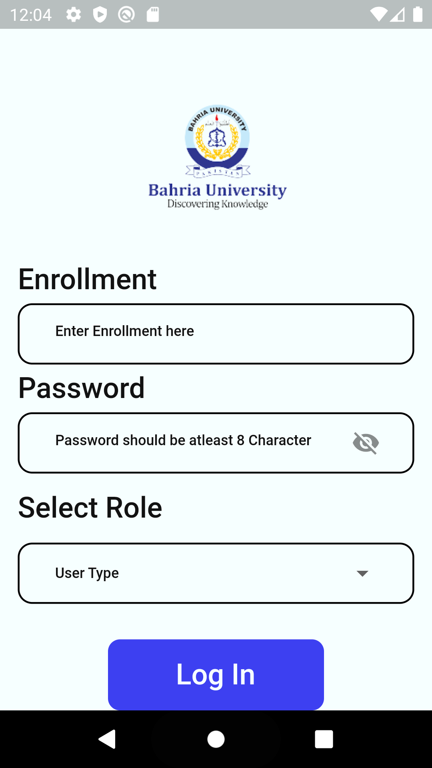
Figure 5. 5: Login

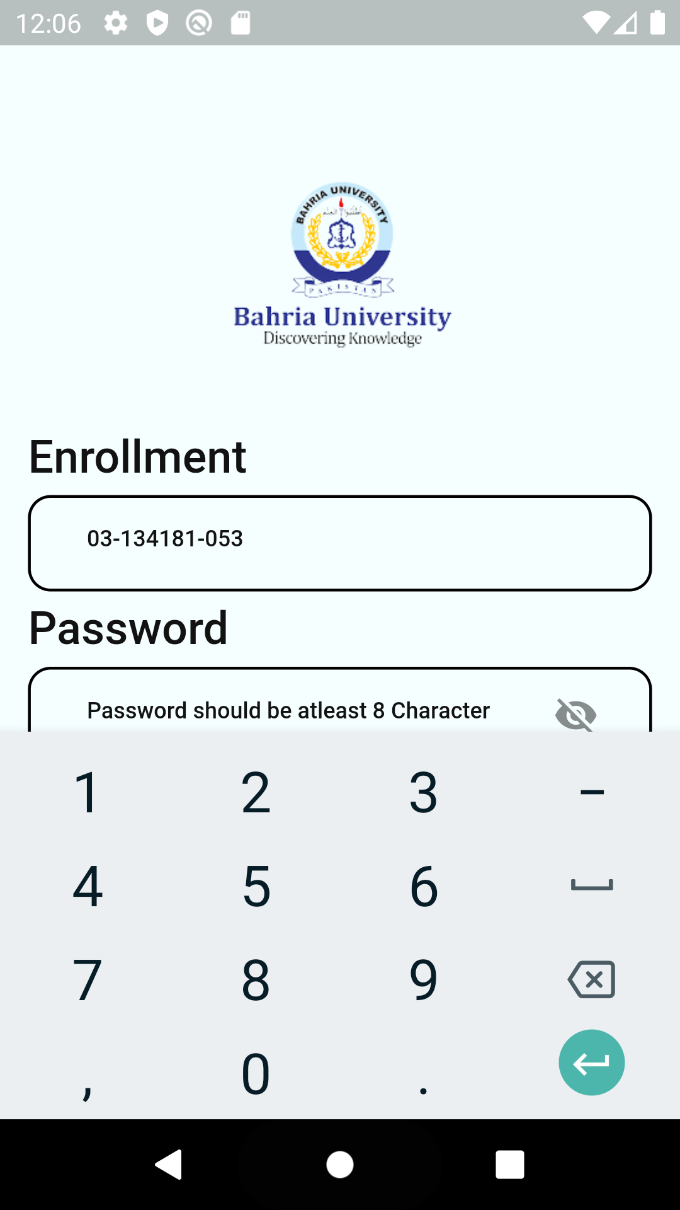
Figure 5. 6: Login Enrollment

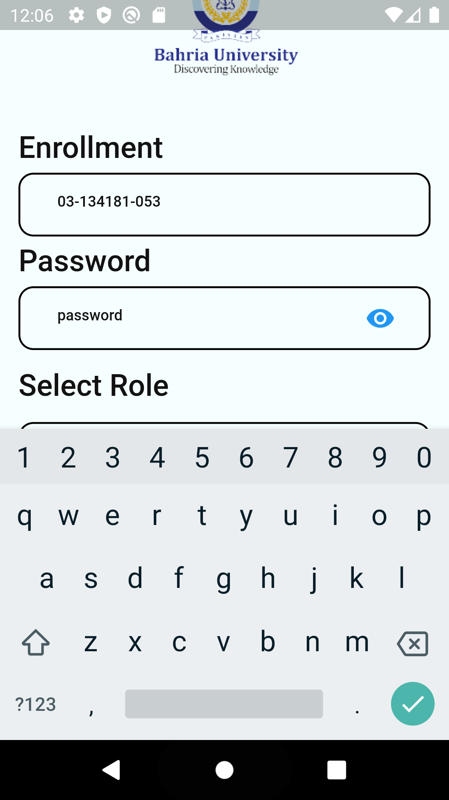
Figure 5. 7: Login Password
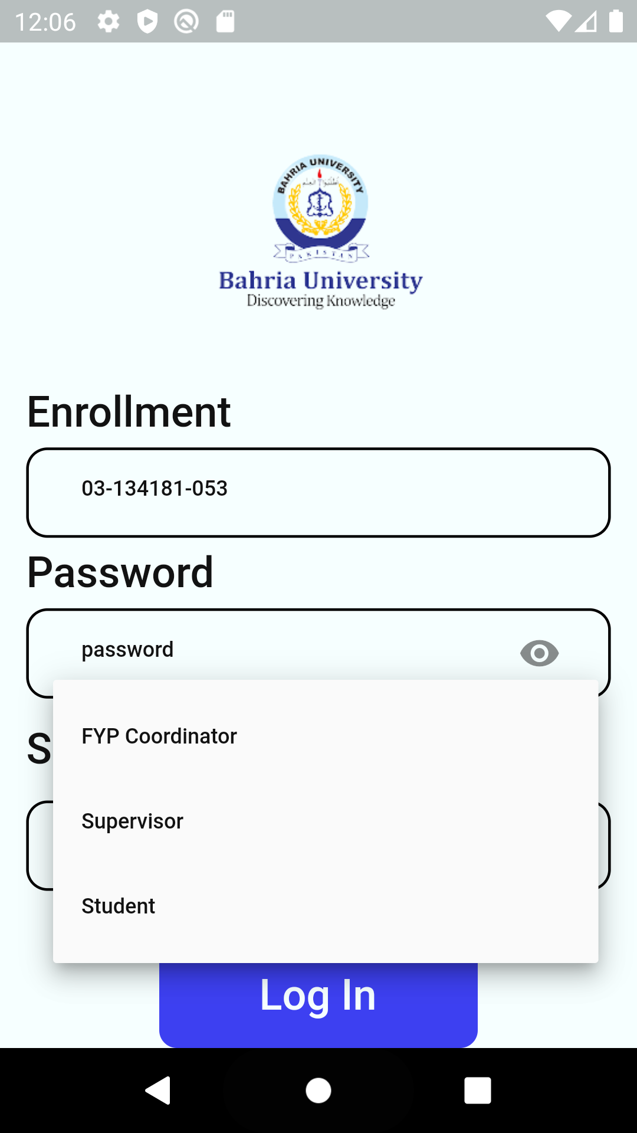
Figure 5. 8: Login Select
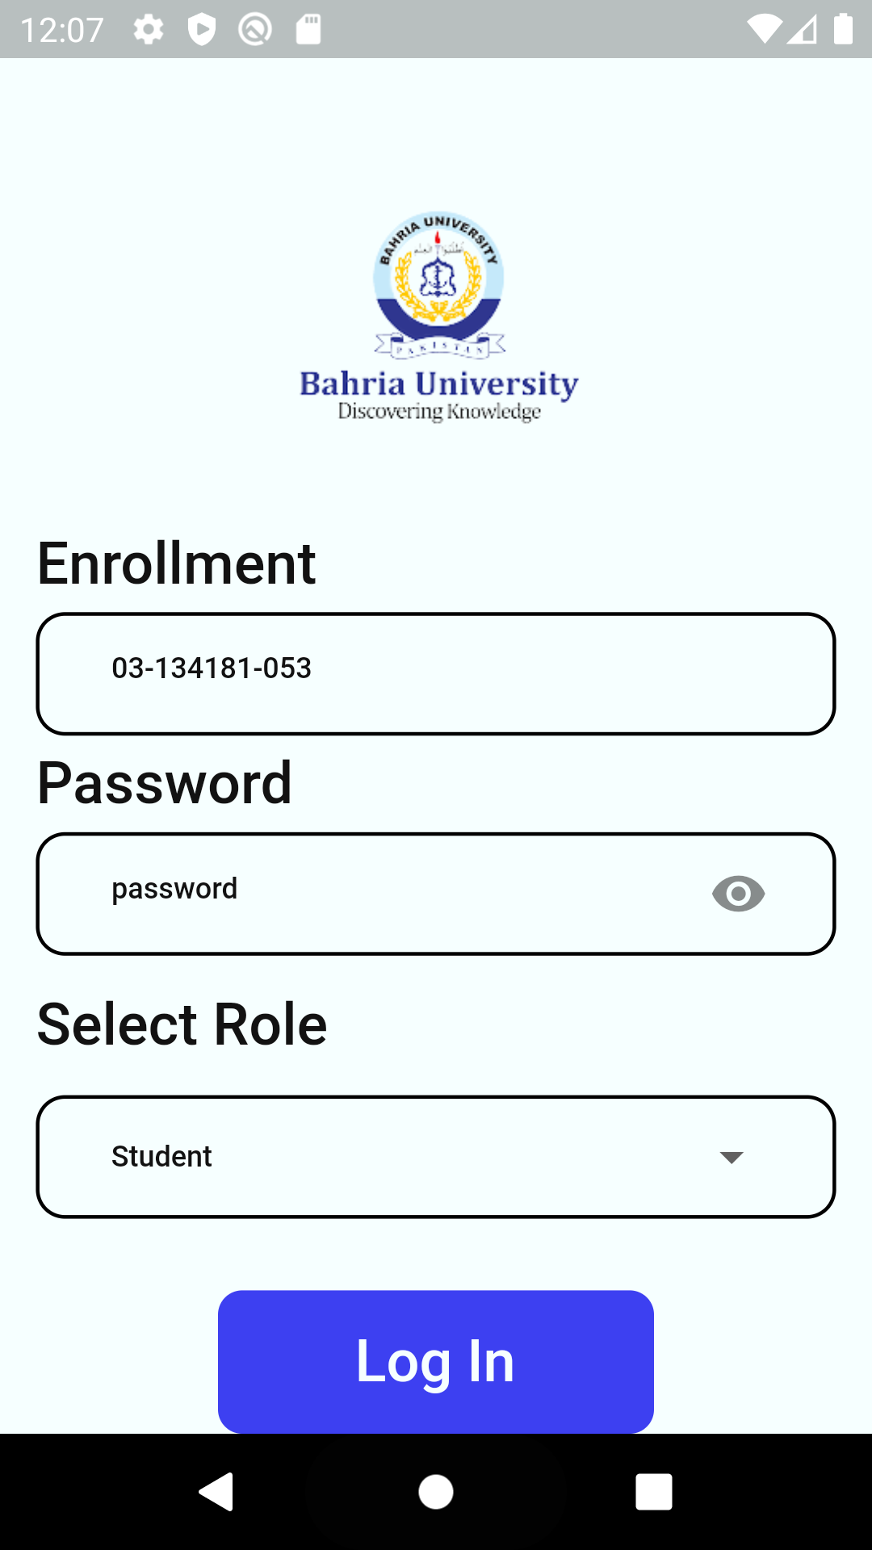
Figure 5. 9: Login type

Coordinator dashboard

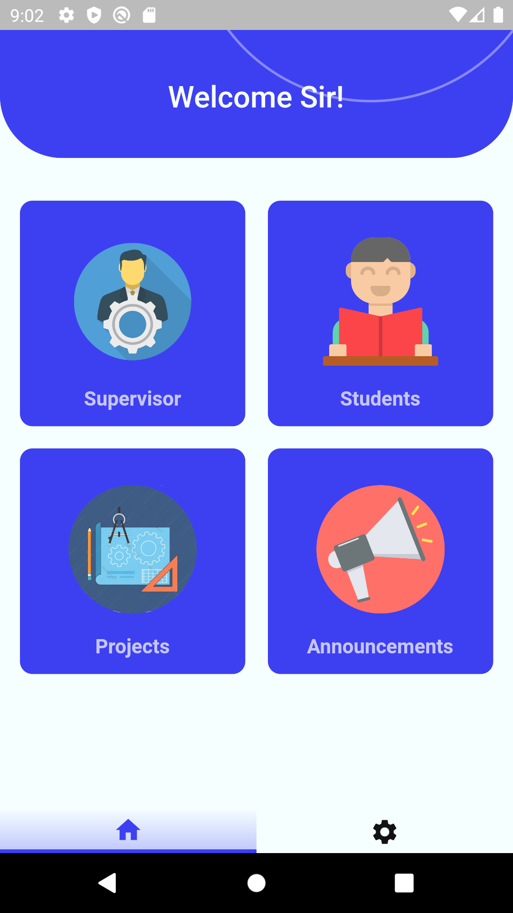
Figure 5. 10: Coordinator dashboard

List of Supervisors

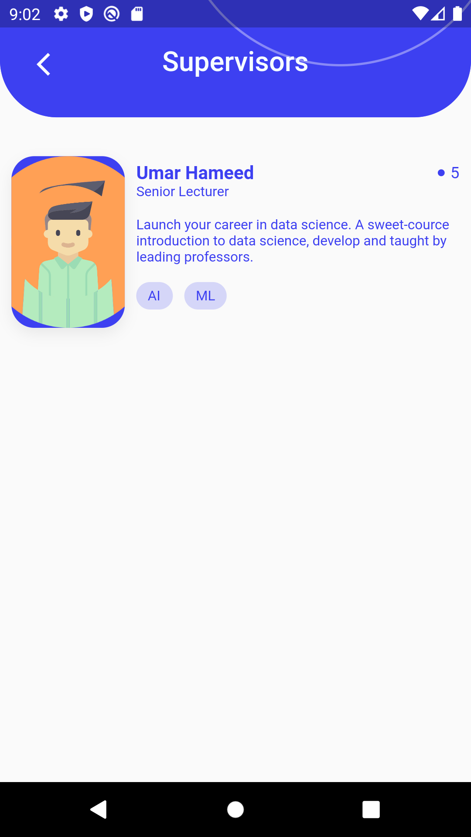
Figure 5. 11: List of Supervisors

CONCLUSION AND RECOMMENDATIONS

Conclusion

In this modern era, manually performed FYP related process is still the same tiring and prolonged as we are still using the same old and outdated process for FYP management. This is not suitable for this era. FYP Manager has numerous features like status availability, etc. So that FYP Manager is an interactive and innovative way to handle final year project of students. Hopefully, through this project, I solve this long-awaited upgrade

Recommendations

FYP Manager is recommended to handle final year project management of students to overcome the headache of students, supervisors and coordinator.
The Users should use strong internet facility on their mobiles otherwise the application might lag while working.

REFERENCES

Journal Papers:

[1] Annie Dunham, feature-driven-development, (2021). Retrieved from Product Plan: https://www.productplan.com/glossary/feature-driven-development

Electronic Sources from Internet:
[2] “Flutter - Beautiful native apps in record time.” https://flutter.dev/ (accessed Jun. 18, 2021).
[3] J. Hunt, “Feature-driven development,” Agil. Softw. Constr., pp. 161–182, 2006.

