
BSCS-S22-014
03-134191-027 | Muhammad Ibrahim
03-134191-041 | Mohamed Ali

Intrusion Detection System

In partial fulfilment of the requirements for the degree of
Bachelor of Science in Computer Science
Supervisor: Zupash Awais
Department of Computer Sciences
Bahria University, Lahore Campus
January 2023
© Bahria University, 2023

© Bahria University, 2023

Certificate

We accept the work contained in the report titled
“Intrusion Detection System”
written by
Muhammad Ibrahim
Mohamed Ali
as a confirmation to the required standard for the partial fulfilment of the degree of
Bachelor of Science in Computer Science.

Approved by:
Supervisor: Zupash Awais
(Signature)

January 05, 2023

DECLARATION

We hereby declare that this project report is based on our original work except for citations and quotations which have been duly acknowledged. We also declare that it has not been previously and concurrently submitted for any other degree or award at Bahria University or other institutions.

Enrolment | Name | Signature
03-134191-027 | Muhammad Ibrahim
03-134191-041 | Mohamed Ali

Date : 05 January, 2023

Specially dedicated to
my beloved grandmother, mother and father
(Mohamed Ali )
my beloved grandmother, mother and father
(Muhammad Ibrahim)

ACKNOWLEDGEMENTS

We would like to thank everyone who had contributed to the successful completion of this project. We would like to express my/our gratitude to my research supervisor, Madam Zupash Awais for her invaluable advice, guidance and his/her enormous patience throughout the development of the research.

We would also like to express my gratitude to my/our loving parent and friends who had helped and given me encouragement.

Muhammad Ibrahim
Mohamed Ali

Intrusion Detection System

ABSTRACT

Due to the processes involved in the electronic transformation of data, the usage of computer systems and the Internet has recently resulted in major security, privacy, and confidentiality challenges. Although much work has been put into improving the security and privacy of computer systems, these issues still exist. In truth, there is no such thing as a completely secure system in the world. Several tools are being developed and employed in various sorts of network attacks as a result of the rise of several types of attacks. For this, we have proposed an intrusion detection system that will help to identify and monitor attacks.
Intrusion detection systems are one of those tools which can monitor a variety of network systems. The IDS can identify and monitor attacks aimed at compromising a system's security aspects (confidentiality, availability, and integrity). It will filter the incoming data packets and identify known, and unknown intrusions, viruses, or threats. We will develop an intrusion detection system (IDS) that will detect the intrusion and prevent those intrusions. Monitoring traffic, scanning the data packet and ports for suspicious data. This system will give all the information related to the server and network like how many ports are open and how many ports are closed and gives all data packets information like which data packet coming from which source and reached from which destination. For this, a machine learning model for intrusion detection will be used.

TABLE OF CONTENTS

CHAPTER 1 1
1 INTRODUCTION 1
1.1 Background 1
1.2 Problem Statements 2
1.3 Aims and Objective 2
1.4 Scope of Project 3
CHAPTER 2 4
2 LITERATURE REVIEW (and/or SRS) 4
2.1 Statement of work 4
2.2 Entity class 4
2.2.1 Administrator 4
2.2.2 User/client 5
2.2.3 Services 5
2.2.4 Operating environment 5
2.3 Design and implementations constraints 6
2.3.1 Assumptions and dependencies 6
2.3.2 EXTERNAL INTERFACE REQUIREENTS 6
2.3.3 Communication interfaces 6
2.4 System Use cases 7
2.5 Analyse network (UC1) 8
2.6 Block IP address (UC2) 9
2.7 Block Ports (UC3) 10
2.8 Filter data packets based on packet protocol (UC4) 10
2.9 Add or remove network (UC5) 11
2.10 Scanning Port (UC6) 11
2.11 Check availability services (UC7) 12
12
2.12 Check packet information (UC8) 12
2.13 Monitor network traffic (UC9) 13
13
2.14 Check ports information (UC10) 13
2.15 Check packet source and destination (UC11) 14
2.16 Check connected clients with servers (UC12) 14
2.17 Non-Functional Requirement 15
2.17.1 Performance Requirement 15
2.17.2 Safety Requirements 15
2.17.3 Security Requirements 15
2.17.4 Software Quality Attributes 15
2.18 Other Requirements 15
2.19 System Requirement Chart 16
2.20 Appendix A: Analysis Models 16
2.20.1 Appendix B: To be determine List 16
2.21 Main services 17
CHAPTER 3 18
3.1 Introduction 18
3.2 Use Case Diagram 18
3.3 User Interaction with Application 19
3.4 Use case description of application 20
3.5 Fix intrusion 20
3.6 Domain Model Diagram 21
3.7 Collaboration 23
3.8 Class Diagram 24
3.9 Methodology 24
3.9.1 Scrum Methodology 25
CHAPTER 4 28
4 DATA AND EXPERIMENTS (and/or IMPLMENTATION) 28
4.1 Tools and Technologies 28
4.1.1 Python 28
▪ IDLE Python 28
▪ Sklearn 28
▪ Panda 28
▪ Numpy 29
▪ Display 29
▪ Socket 29
o System design 29
▪ Client/Server 29
▪ Port Scanner 29
• Data Set 29
CHAPTER 5 32
5 RESULTS AND DISCUSSIONS 32
5.1 General Information 32
5.2 Overview 32
5.3 Port Scanner 32
5.3.1 Scanning for Open Ports 33
5.3.2 Scanning for Close Ports 33
5.3.3 Server and Client Connection 34
5.3.4 Server Start 34
5.3.5 Server Connection Port 34
5.3.6 Server access Client through terminal 34
34
5.3.7 client side output when server check client details 35
5.3.8 server side output when clients check server details 36
5.4 Applied Algorithms 36
5.4.1 Random Forest 37
5.4.1.1 Confusion Matrix for RF 37
5.4.2 Logistic Regression 38
5.4.2.1 Confusion Matrix LR 39
Figure 5. 12 Confusion Matrix for LR 39
5.4.2.2 Model Evaluation for LR 40
5.5 Decision Tree 40
5.5.1 Confusion Matrix for Decision Tree 41
5.5.2 Model Evaluation for Decision Tree 42
5.6 K-Fold (RF,SVM,LR,DT) 42
5.6.1 K-Fold 43
5.6.2 Support Vector Machine 43
5.6.3 Confusion Matrix 44
5.6.4 Model Evaluation for SVM 44
5.7 Comparative Analysis of the Classifiers 45
5.8 Comparison Graph Algorithm 45
CHAPTER 6 46
1 CONCLUSION AND RECOMMENDATIONS 46
6.1 Conclusion 46
6.2 Recommendations 47
6.3 Learning Outcomes 47
REFERENCES 49

LIST OF TABLES

TABLE TITLE PAGE
Table 2. 1: Processing Time (in hours) of Board for Different Machines 5
Table 2. 2: External Interface Requirements 6
Table 2. 3: Analyse Network 8
Table 2.4: Block IP address (UC2) 9
Table 2.5 Block Ports 10
Table 2. 6 Filter data packets based on packet protocol 10
Table 2. 7 Add or remove network 11
Table 2. 8 Scanning Port 11
Table 2. 9 Check availability 12
Table 2. 10 Check packet information 12
Table 2. 11 Monitor network traffic 13
Table 2. 12 Check ports information 13
Table 2. 13 Check packet source and destination 14
Table 2. 14 Check connected Clients with servers 14
Table 2. 15 System Requirement Chart 16

Table 3. 2 Processing Time (in hours) of Board for Different Machines 27

LIST OF FIGURES

FIGURE TITLE PAGE
Figure 2. 1: System Use cases 7

Figure 3. 1: Use Case 19
Figure 3. 2 Fix Intrusion 21
Figure 3. 3:Domain Model 21
Figure 3. 4 Collaboration Diagram 23
Figure 3. 5 Class Diagram 24
Figure 3. 6 OCR Block Diagram 27
Figure 3. 7 Dataset CSV File 30
Figure 3. 8: Dataset CSV File 30
Figure 3. 9: Dataset CSV File 31

Figure 5. 1: Port Scanner 32
Figure 5. 2 Scanning for Open Ports 33
Figure 5. 3 Scanning for Close Port 33
Figure 5. 4 Server Start 34
Figure 5. 5 Server Connection Port 34
Figure 5. 6: Server Connection Port 34
Figure 5. 7: Client side output when server check client details 35
Figure 5. 8: Server side output when clients check server details 36
Figure 5. 9 Confusion Matrix for RF 38
Figure 5. 10 Model Evaluation for RF 38
Figure 5. 11 LR 39
Figure 5. 12 Confusion Matrix for LR 39
Figure 5. 13 Model Evaluation 40
Figure 5. 14 Confusion Matrix for Decision Tree 41
Figure 5. 15 Model Evaluation 42
Figure 5. 16 Kfold 43
Figure 5. 17 Confusion Matrix 44
Figure 5. 18 Module Evaluation 44
Figure 5. 19 Comparative Analysis 45
Figure 5. 20 Comparison Graph 45

LIST OF APPENDICES

APPENDIX TITLE PAGE
APPENDIX A: Graphs 19
APPENDIX B: Computer Programme Listing 20

INTRODUCTION

Background

IDS is a server base system. It is a great server security monitoring program to resolve issues within a practice area that require server digital security capability. An expert system is also called a network security system.
IDS is a quick way to learn about known and unknown attacks that are affecting many server types. It is help to give all the information about the server. The most important thing in this app is that it will tell you how many types pass through your server like FTTP, HTTP, HTTPS, which port the data packet sends and receives and let you know which ports are open and which ports are closed.

Also, when any intrusion is detected in any port scanner and data packet, the packet should be discarded. The most important feature of this application is to identify known and unknown attacks (intrusions) and also provide a user-friendly interface .
The advantage of this application is to interact with CERT (computer emergency response team), increase reliability, compatibility. Also, there are some disadvantages of this application is degrading server performance because it is a demanding task to examine every data packet and scan every port on a server.

Problem Statements

As we have discussed in the “introduction” paragraph no:1 the organizations are facing untrusted networks, usually large networks such as the Internet, as they could face many intrusions on their network and lost their precious data and privacy. Attackers are always coming up with new attack strategies and exploits to get around your defences. To get user credentials that provide them access to your network and data, many assaults utilise social engineering or other malware. Because it allows you to recognise and react to unwanted traffic, a network intrusion detection system (NIDS) is essential for network security.
The issues that now plague our community, An IDS can remove a user from the network and notify security workers of a security policy violation, virus infection, or configuration issue.

Aims and Objective

- To design and develop a server application based on IDS (intrusion detection system) which can detect known and unknown intrusions on the server-side.
- To monitor the traffic, scan the data packet and ports for suspicious data.
- To make “IDS” efficient with the help of various “Machine Learning” algorithms.
- To recognize the viruses or malicious attacks based on their behavior.
- To make our IDS efficient that it will learn from the upcoming viruses and malicious attacks as well as from the experience.
- To detect all the malicious attacks and viruses that can attack the server-side.
- We will use multiple algorithms of the machine learning and test them on our dataset. Then we will finalize that one which will provide us the best accuracy.

Scope of Project

- The “IDS” will detect the virus and malicious attacks efficiently
- This “IDS” will monitor the data packets traffic
- The IDS will detect the known and unknown intrusions, then it will analyze the data packet behavior.
- Packets will be filtered on the network layer. When data flows from source to destination, if detect any intrusions are this data packet will be blocked based on IP address.
- Packets will be filtered on the network layer. When data flows from source to destination, it detect the data packets if there is any kind of intrusions or maclicious acttack then it will generate an alert on the basis of IP address.
- It will result as the “IDS” is a way to enhance the security of a branded network.
- It should be used as an enhancement to the network security, protection mechanism and provided by the intrusion detection system (IDS).
- We will use multiple algorithms of the machine learning for the training of our model but we will finalize that algorithm which will provide us the best results & accuracy according to our dataset.

LITERATURE REVIEW (and/or SRS)

Statement of work
Design and develop ideas which can detect known and unknown intrusion on the server-side monitoring network traffic scanning the data packet and ports for the suspicious data. The app will perform the following.
- Client will use this as a extensions
- Stop the catch on various triggers as the measure of the catch information passed time or the quantity of the parcels
- App will allow to the administrator to make their profile according to their specialization.
- You should focus on the notice generally information misfortune may happen.
- App allow administrator to discard malicious data packet.
- Information about the stage you keep running on the app.
- App will allow to capture the packet
- App will allow to administrator to view the packet.
- App will allow to filter the packet.

Entity class

Administrator
- You may novel advantages through start a live data packet capturing.
- You need to pick the right frame work interface to get pack data form.
- You need to get at the right spot in the network frame work to see the traffic you have to see.
- You need finding out about recognize and reject data bundle.

User/client
- User can select service.
- Being a catch on every single chosen interface quickly utilizing the setting from the last catch or default setting if no alternatives have been set.
- User can read the data packet severity level.

Services
- Available for the UNIX and windows
- Catch live group data from the network framework interface.
- Show group with incredibly point by point to show information.
- Save packet data got.
- Passage a couple or all bundles in different catch archive positions.
- Channel packages on various criteria.
- Search for the groups on various criteria.

Operating environment
- IOS devices
- Window devices

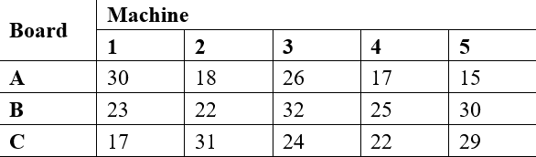
Table 2. 1: Processing Time (in hours) of Board for Different Machines

Design and implementations constraints
IDS is the server-based system for providing server security based services. It is design according the scrum model. Its is behaviour-based system which will detect the malware and attacks through the whole network traffic.[8]

Assumptions and dependencies
The project will mainly use the IDS on the device on which the app is going to be used should have network interface card. The device should have good specs which will make the application runs faster.

EXTERNAL INTERFACE REQUIREENTS
Software interfaces
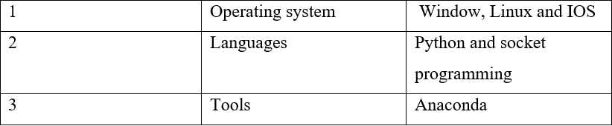
Table 2. 2: External Interface Requirements

Communication interfaces
- Internet
- Ethernet
- LAN
- Intranet

System Use cases

Intrusion Detection System
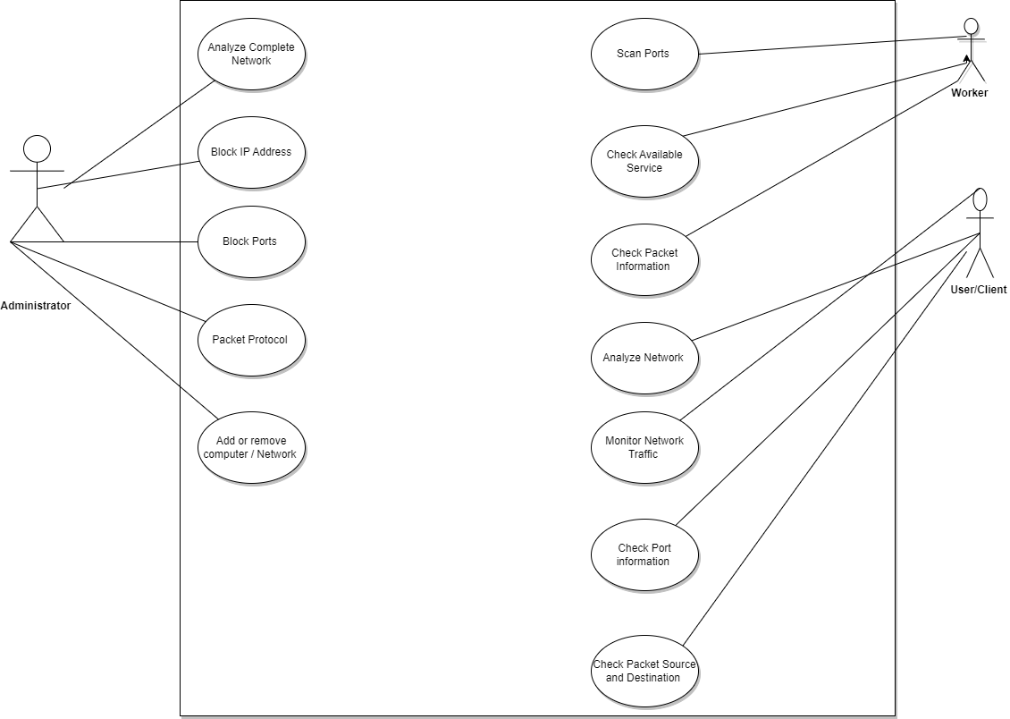
Figure 2. 1: System Use cases

Analyse network (UC1)
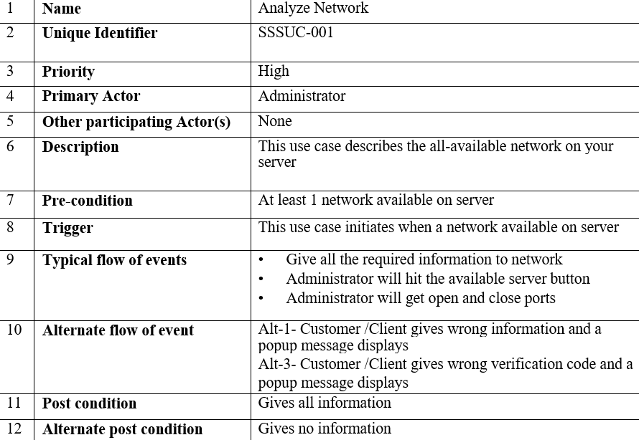
Table 2. 3: Analyse Network

Block IP address (UC2)
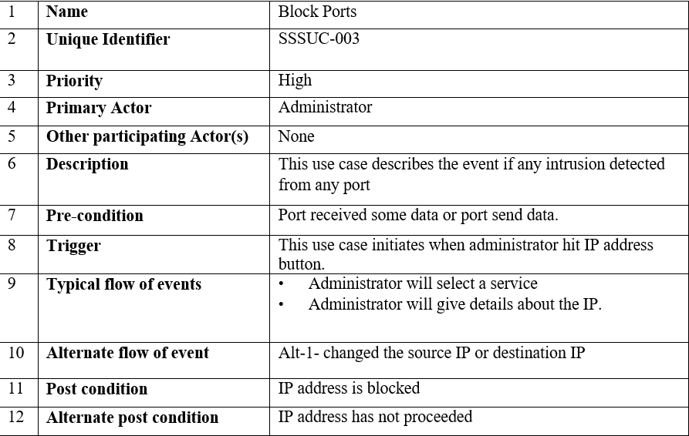
Table 2.4: Block IP address (UC2)

Block Ports (UC3)

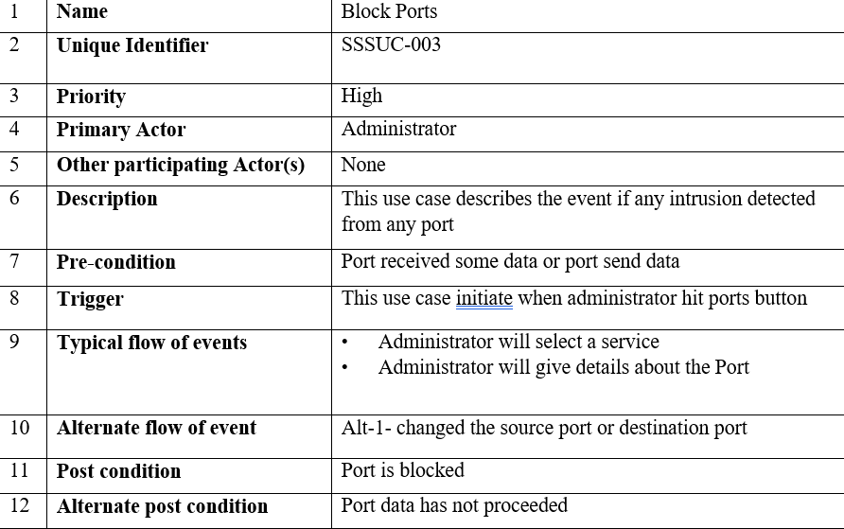
Table 2.5 Block Ports

Filter data packets based on packet protocol (UC4)

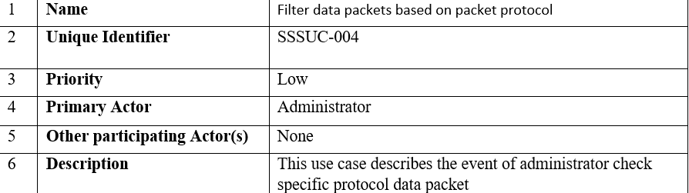
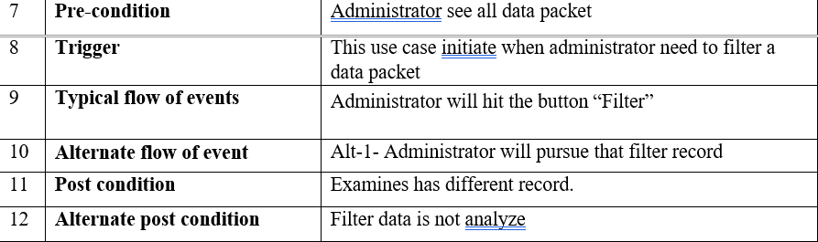
Table 2. 6 Filter data packets based on packet protocol

Add or remove network (UC5)
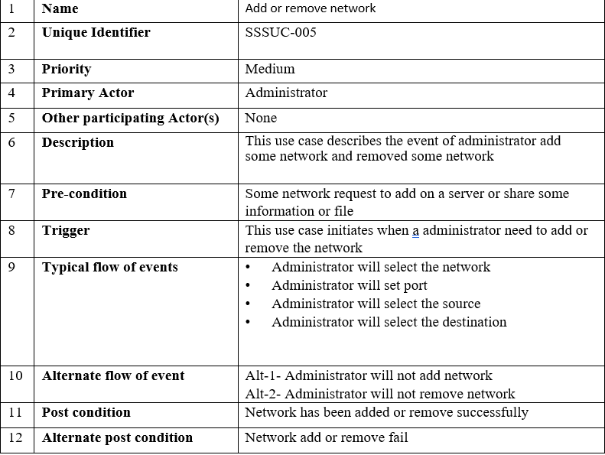
Table 2. 7 Add or remove network

Scanning Port (UC6)

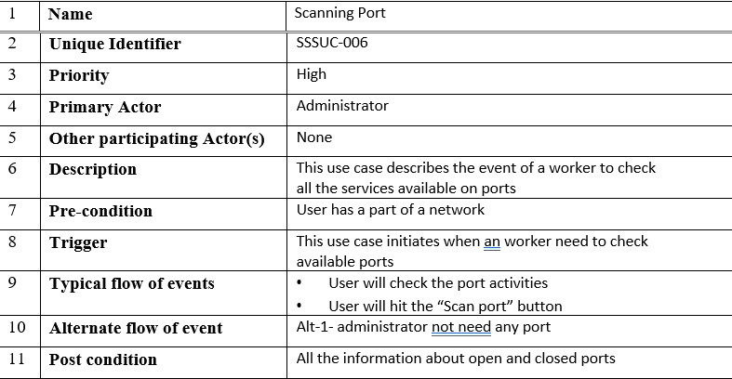
Table 2. 8 Scanning Port

Check availability services (UC7)

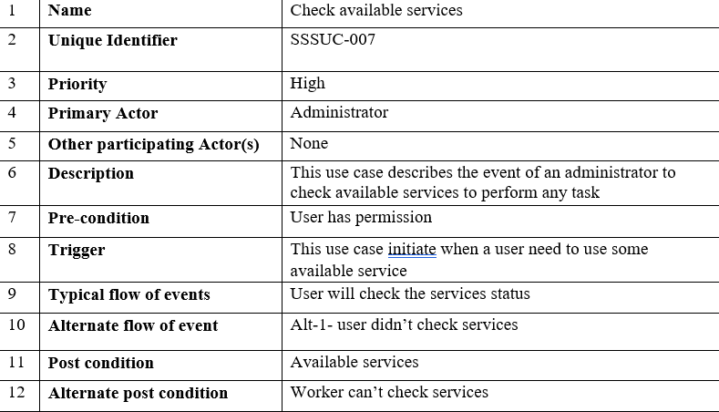
Table 2. 9 Check availability

Check packet information (UC8)
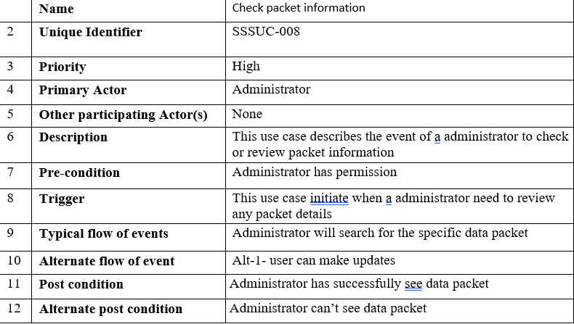
Table 2. 10 Check packet information

Monitor network traffic (UC9)

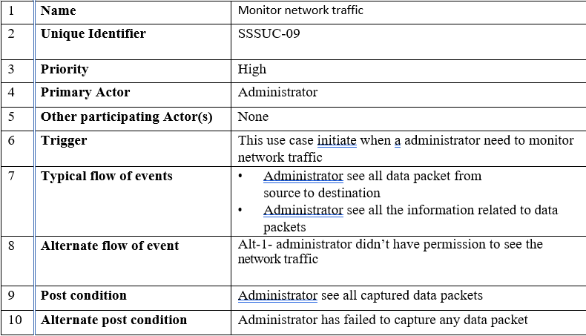
Table 2. 11 Monitor network traffic

Check ports information (UC10)
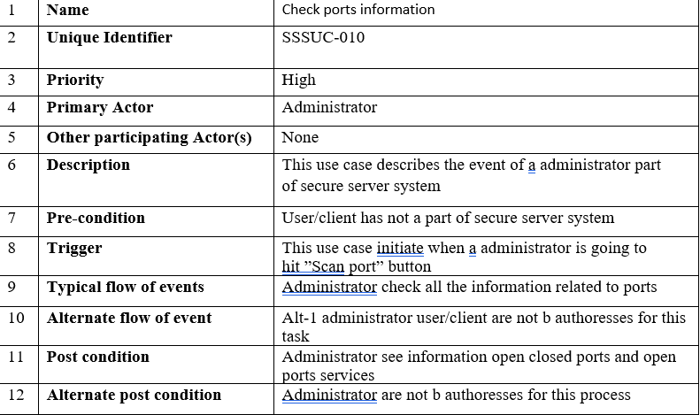
Table 2. 12 Check ports information

Check packet source and destination (UC11)
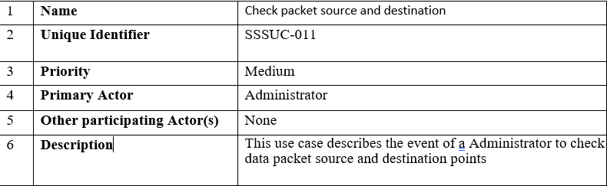
Table 2. 13 Check packet source and destination

Check connected clients with servers (UC12)

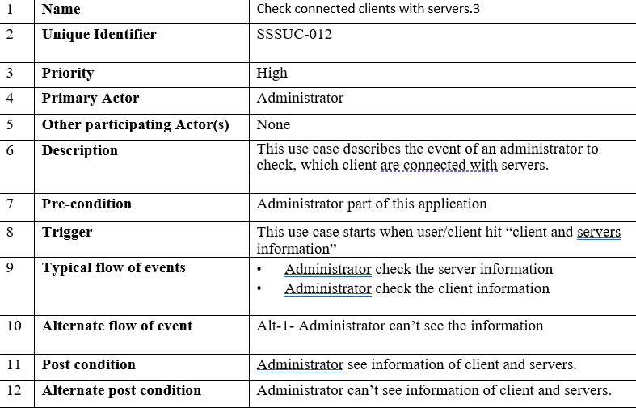
Table 2. 14 Check connected Clients with servers

Non-Functional Requirement

Performance Requirement
The Intrusion Detection System will perform best under these circumstances like speed of
response, execution time and throughput, but may be face limitation when heavily
analyse virus's data packets.

Safety Requirements
Safety for valuable assets is protected, overcome the harm protection, safety
incident protection.

Security Requirements
The Intrusion Detection System will be maintaining the security features of Customer business like, confidentiality, integrity, availability, authentication and auditing.

Software Quality Attributes
The Intrusion Detection System fit for use and fulfil the customer's
requirements and user friendly. This is a reliable, maintainable, usability feature,
correctness, efficiency and flexible

Other Requirements
N/A

System Requirement Chart
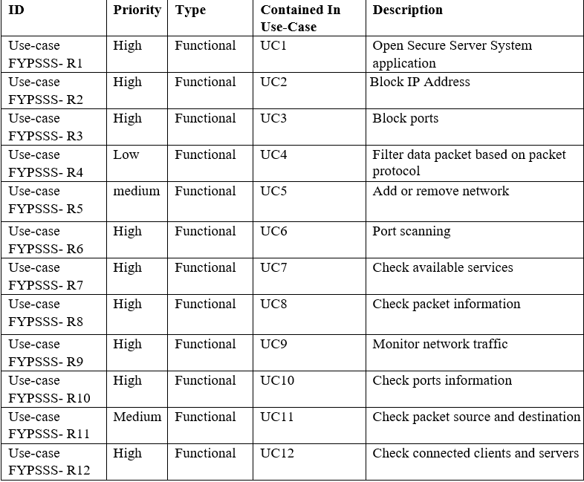
Table 2. 15 System Requirement Chart

Appendix A: Analysis Models

Appendix B: To be determine List
Requirement list
- Modules of the project code will be attempted close-by the execution stage to ensure that they are functional.
- Last, planned project code will test to ensure that all out assignment is integrated fine and functionality correctly.
- Server response should be kept into mind while organizing data revival algorithms

Admin module requirements list
R1: Admin is the power user
R2: Block IP
R3: Block port
R4: monitor network
R5: Add or remove networks

Main services
1. Safety of precious data
Here to secure your precious data on unauthorized persons
2. Secure machine
Our main cause to secure your machine-like server, private computer from
hacker.
3. Prevent from attacks
In this application we prevent you from known and unknown attacks from
attackers.
4 Skilled Professional Services
These are following services:
a) Identify the violence.
b) Easy to check data source and destination.
c) Easy to block unknown services.

DESIGN AND METHADOLOGY

Introduction

Software Design Document is all about Use case modelling and software design
project Intrusion Detection System . In the past deliverable, examination of the system
done. So, we fathom the current situation of the issue zone. By and by we are set up
to try a response for the issue territory by using object-organized system. Following
old rarities are consolidated into this deliverable.
1. Use case description
2. Use case diagram
3. Domain Model
4 Sequence Diagram
5. Collaboration Diagram
6. Design Class Diagram
7. Entity Relationship Diagram

Use Case Diagram
Diagram is designed to understand which actor will interact with which use case in which way. Following is the high priority use case diagram in my project

User Interaction with Application
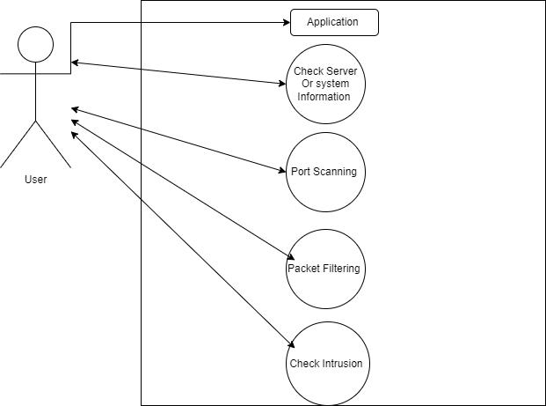
Figure 3. 1: Use Case

The Use Case in figure 3.1: is about the user interaction with the application that how
the user can walk through the app and how he can perform multiple tasks in the application. The user may perform multiple operations like server information, port. Scanning, packet filtering and check intrusions in the system user select the option and utilize those features ever feature on this application interact with user just clicking or selecting any required option all the option run sequentially so user utilize all these application through interact with system. Further discuss in table 3.2.

Use case description of application
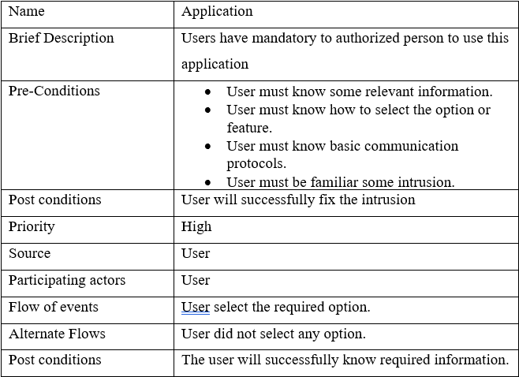
Table 3. 1 User case description of application

Fix intrusion

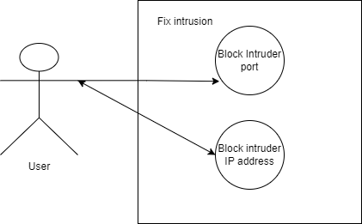
Figure 3. 2 Fix Intrusion
:
The Use Case in figure 3.2: 1s about the user removing intrusions, in this use case the user can perform 2 operations such as Bock port who send intrusion from source and other one id block IP addresses who sent the intrusion when user block those port or IP address who send the intrusions system will not be able to received data packet from those port or IP address.

Domain Model Diagram
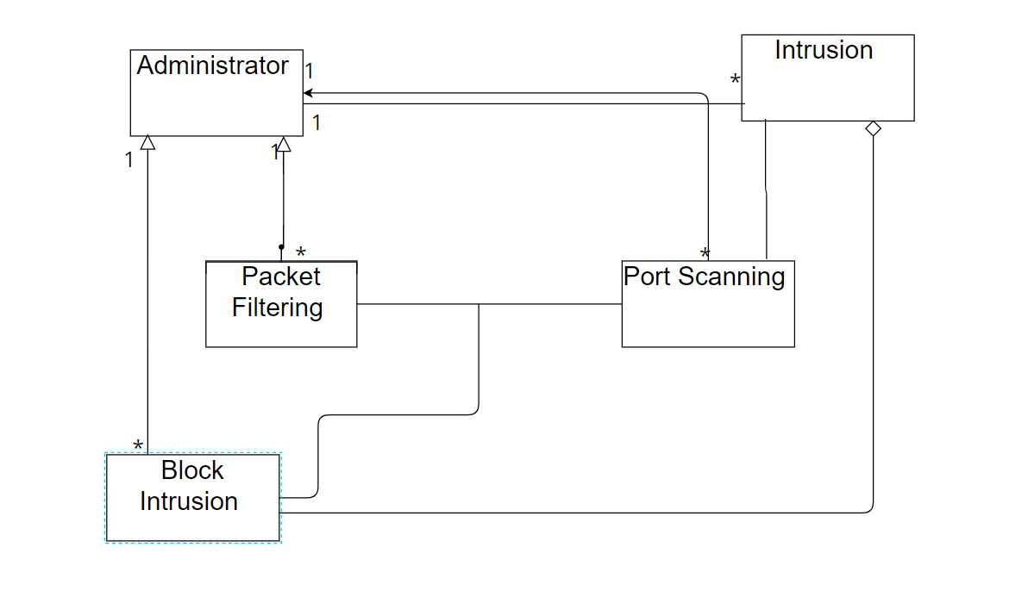
Figure 3. 3:Domain Model
Domain model fig 3.3: of this project describes the domains and the modules which are included in the project and the interactions between all the domains included with this model user is the main domain which is interacting with all other entities regarding whether it is for the assessment of the intrusions of the system. Each entity connected with each other as shown in the model and has corresponding relationship according to the functionality of the module.

Collaboration
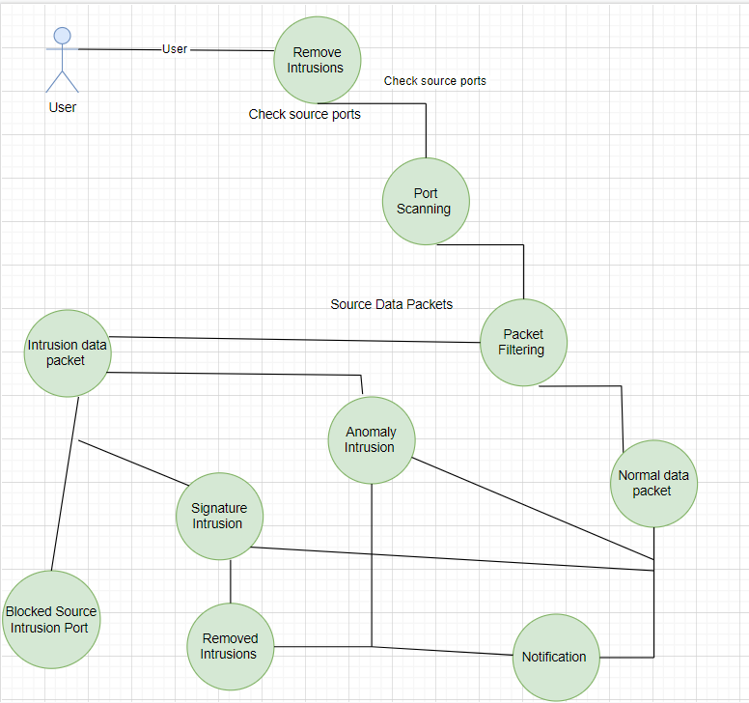
Figure 3. 4 Collaboration Diagram

Collaboration diagram 3.4 : Gives description of collaboration of the entities interacting within the application. It shows that user will first have to login itself to the app then afterwards a server information will interact with the other application feature and easily removed all the intrusion and secure a system.

Class Diagram
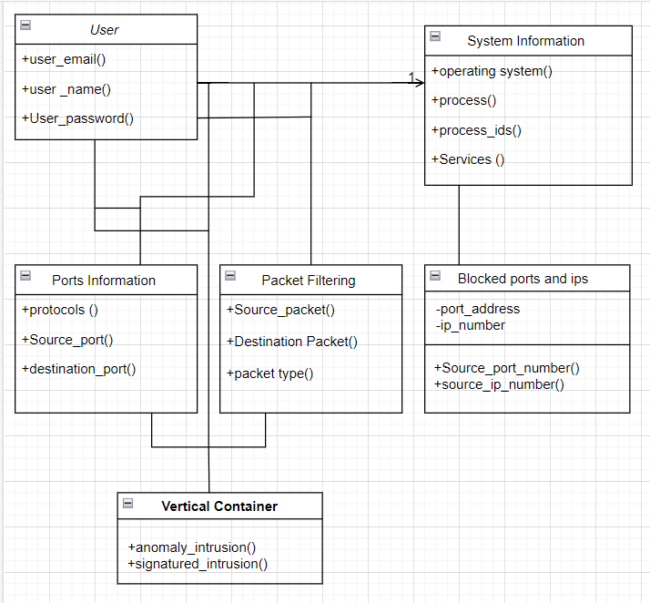
Figure 3. 5 Class Diagram

Class diagram in figure 3.5: gives the dese description of the classes interacting within the application. Classes are also showing the functions used in them including the
variables used in the functions.

Methodology
Methodologies in the project includes:
- Requirement gathering
- Interface designing
- Collection and classification of data
- Making of dataset
- Development of Client
- Development of Server
- Development of Port Scanner
- Connection of Server and Clint
- Making of other modules of the App
- Algorithm applies on the dataset
- Testing
- Implementation of rest of modules
- Execution and Maintenance

Moreover, we will be using some machine learning techniques and algorithms for
- classification of data which are as follows:
- Logistic Regression
- Random Forest
- Decision Tree
- SVM
- K-Fold cross validation technique

Scrum Methodology
We use Scrum Methodology to develop our system for managing work. Scrum is an agile model for development and manage the project. This model design for where development team contain three to nine member and break the work into chunks and at the end, they complete work within time frame and this is called sprints. one sprint contains two weeks or less than 30 days and 15 minutes stand-up meeting for track progress and re-planting. The development of secure server system involved phases and those phases are as under:
- Sprint planning
- Daily scrum
- Sprint review

Sprint planning
Sprint Planning is way to team hold and planning and manually debate for project
plan and scope of work. Select backlog product and finalized in one sprint and
prepare the needed work about related to the product

Daily serum
Daily Scrum is procedure to debate plan with team member and strategy for short
term goal. Anyone welcome to development team who interested and take part in
development team. The main objective of this phase every team member
discusses problem with other team members and suggestion for solutions by
using their past experience.

Sprint review
Sprint reviews close to the completion of the gathering holds this stage help to review the execution of our errand how much work is done or not completed and present the work in your gathering head and accomplices gives the idea how much work will remaining.
Additionally, scrum is a most standard and viable procedures for develop a endeavour with associate in 3-9 people and serum adventure the officials on first day in the midst of the organizing of partners these technologies instruct the partner which partner in that capacity. Improvement of the Server Secure System relies upon four phase which are required information gathering stage, examination and design stage and execution stage and testing stage through these stages we collect ace security system subject to server in this system use differing methodologies and techniques like group filtering ,port sifting and use unmistakable computations and methodology to examination the lead of the framework traffic of known and unknown intrusion Also we use some AI frameworks and estimation of gathering of data which are according to accompanying

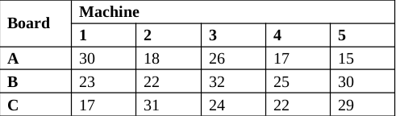
Table 3. 2 Processing Time (in hours) of Board for Different Machines

Figure 3. 6 OCR Block Diagram

DATA AND EXPERIMENTS (and/or IMPLMENTATION)

Tools and Technologies

Python

Python is a newly popular general-purpose and high-level programming language. It can be used for desktop GUI apps, web applications, and particularly for cybersecurity product development. Users of Python benefit from its straightforward syntax and responsive environment. Python Socket Programming is used to establish a connection between two or more network connection nodes. One socket node listens on a specific IP port, while another socket contacts out to that node. After perusing the web, these are the actual strength. Importing and creating basic sockets are the main components of socket programming.

IDLE Python

Python is a programming language used for machine learning algorithms in computer science, and it makes use of statistical techniques to give knowledge gained from prior experience real strength.

Sklearn

Sklearn are the python library that practice for machine learning.

Panda

Panda is a data analysis library that practice for multidimensional structured data set.

Numpy

NumPy is a python library that use for scientific data set analyses.

Display

Display library used for show the complete data set.

Socket

Socket library Display library used for show the complete data set.

Client/Server

These are different modules are developing in using python and using socket programming. Client server communicate with each other.

Port Scanner

Port Scanner analyse the network ports and check to open and close ports.

Data Set

This dataset contains The crude system parcels of the dataset product made by the IXIA Perfect Storm device in the Cyber Range Lab of the Australian Centre for Cyber Security for creating a half and half of genuine present day ordinary exercises and engineered contemporary assault activities. This dataset contains 7 hundred Thousands records.
Tcpdump device is operated to detainment 100 GB of the crude traffic (e.g., Pcap documents). This dataset has nine sorts of assaults, to be specific, Fuzzers, Analysis, Backdoors, DoS, Exploits, Generic, Reconnaissance, Shellcode and Worms.
Final shape of the unsw-nb15 data set files in this section, the description of the final shape of the UNSW-NB15 is provided. The purpose of this section is to guide the researchers on how to use and manipulate final CSV files of the UNSW-NB15 data set. Four CSV files of the data records are provided and each CSV file contains attack and normal records. The names of the CSV files are UNSWNB15_1.csv, UNSW-NB15_2.csv, UNSW-NB15_3.csv and UNSW-NB15_4.csv.
In each CSV file, all the records are ordered according the last time attribute. Further, the first three CSV files each file contains 700000 records and the fourth file contains 440044 records. The ground truth table is named UNSWNB15_GT.csv. The list of event file is labelled UNSWNB15_LIST_EVENTS which contains attack category and subcategory. The interested reader can obtain the raw pcap files by e-mailing the authors.

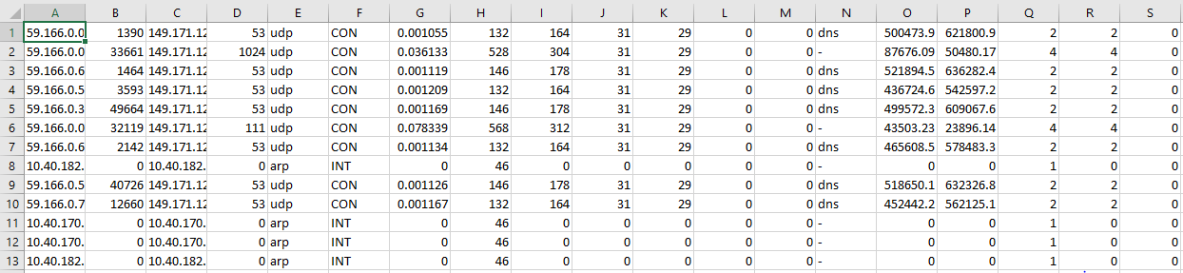
Figure 3. 7 Dataset CSV File
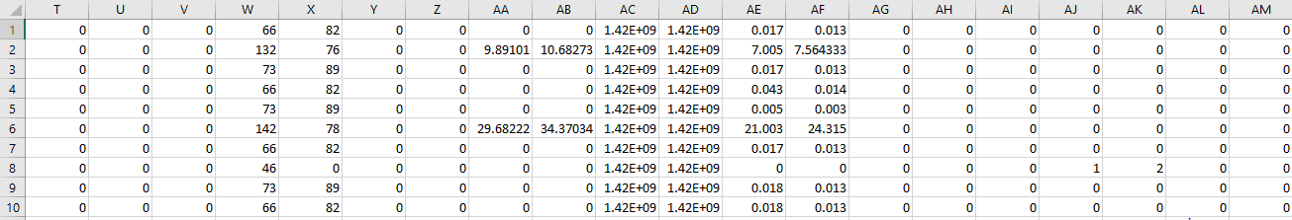
Figure 3. 8: Dataset CSV File

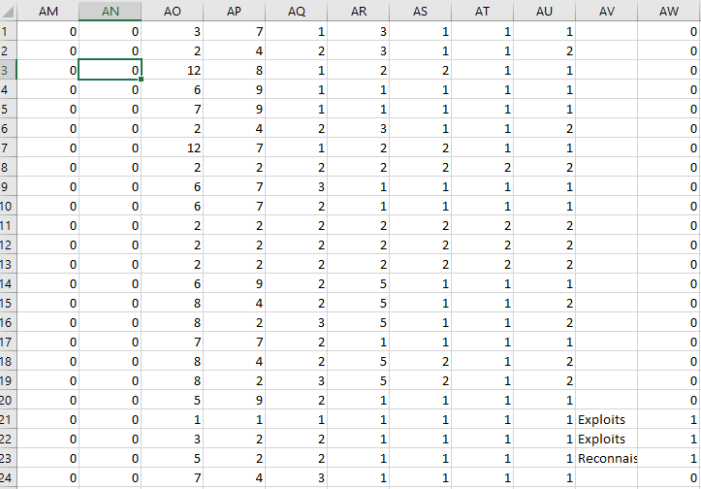
Figure 3. 9: Dataset CSV File

RESULTS AND DISCUSSIONS

General Information

Intrusion Detection System is server based application run on network layer. Scanning the network traffic for detection and prevention of intrusions.

Overview

When Intrusion Detection System (IDS) detect the intrusion then generate the alarm for suspicious data packets.Administrator has especial privileges to start the live capture the data packet and can analyse the which data packet accept and reject. Worker has knowledge of basic idea of network protocols.

Port Scanner

Port Scanner is a module intended to test a server or host for open or close ports. fundamentally identified with check the open and close ports Network Administrator must be used to validate the securities policies and rules of the network. To find out the which type of services running on the host and exploits.

Figure 5. 1: Port Scanner

In this figure 5.1: how to scan the ports. Firstly, enter the Internet Protocol(IP) address for scan the ports. Here total porta is available 0 to 65535.

Scanning for Open Ports

In this module how check the open ports of the network running services.
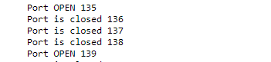
Figure 5. 2 Scanning for Open Ports

In this figure 5.2: how to scan the ports. Firstly, enter the Internet Protocol(IP) address for scan the ports. Here two ports are open according to port number 135 and 139.

Scanning for Close Ports

How check the close ports. The purpose of close ports external person can’t connect to specific ports and in the way increase the security of network services running ports.
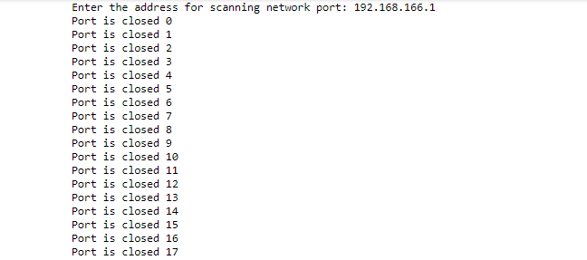
Figure 5. 3 Scanning for Close Port

In this figure 5.3: how to scan the ports. Firstly, enter the Internet Protocol(IP) address for scan the ports. Here all ports are close according to IP address is 192.168.166.1.

Server and Client Connection

Making a Client and Server for communication with each other. The ability of server and client to handle the errors and so other connections are not affected. This is why client or server should not be crashing down if the exception is not caught.

Server Start

Figure 5. 4 Server Start
When Server start firstly, connect with port no 9999.

Server Connection Port

Figure 5. 5 Server Connection Port
When firstly connection start, then it will connect port no 2477.

Server access Client through terminal

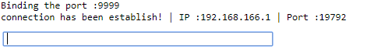
Figure 5. 6: Server Connection Port

In this Figure 5.6: command execution through terminal when Server and Client communicate with each other. Put dir.(directory) command for check the Server or Client.

client side output when server check client details
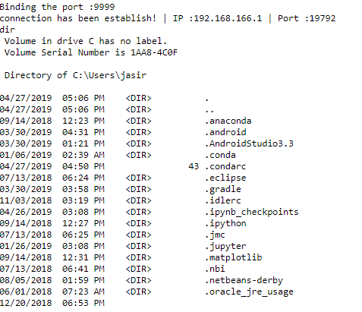
Figure 5. 7: Client side output when server check client details

Server and Client communication start with each other. Server and Client passing messages with each other. The Figure 5.7: show the client side output through server machine.

server side output when clients check server details
Figure 5. 8: Server side output when clients check server details

Server and Client communication start with each other. Server and Client passing messages with each other. The Figure 5.8: show the server side output through client machine.

Applied Algorithms
Our dataset consists of 7 hundred thousands records and contain of nine different types of attacks. The following list of algorithms applies on the datasets.
- Random Forest
- Logistic Regression
- Decision Tree
- SVM
- K-Fold

Random Forest

Random Forest is definitely easy to use and supervised algorithm and more flexible for machine learning and produces most of the time great results. This is used for both purposes like classification and regression tasks. RF develops multiples decision trees and at the end merge for more accurate and constant prediction.
The random forest is an ensemble classifier3. Many current IDS are developed for classifying the attacks. [5] .Therefore, we propose intrusion detection system using Random forest. The major highlights of our approach are:
1) To propose a new model that apply random forest algorithm for network intrusion detection.
2) Classify various type of attacks.
3) To improve accuracy of classifier in detection different types of attacks

Confusion Matrix for RF
For supervised learning with two possible classes, the evaluation of performance is based on the four numbers attained from applying the classifier to the test set. Predictive analytics, a table of confusion, also known as confusion matrix, is a table with 2 x 2 rows and columns that gives the number of true positives, false positives, false negatives, and true negatives. This allows more detailed analysis than meager percentage of correct speculation termed as accuracy. Each row in the confusion matrix represents an observed class, each column represents a predicted class, and each cell counts the number of samples in the intersection of those two classes. The entries in the confusion matrix are integer numbers. The total of the four entries + TN + FP + FN = n, the number of test data.
The Accuracy is the proportion of the total number of predictions that were correct. It is determined using the equation.
ACCURACY = TP + TN / TP + TN + FP +FN
SENSITIVITY (%) = (TP / (TP + FN)) x 100
SPECIFICITY (%) = (TN / (FP + TN)) x 100

Table 5.1
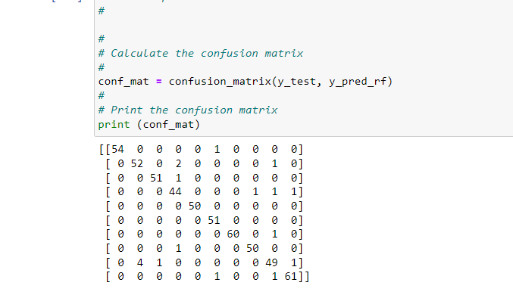
Figure 5. 9 Confusion Matrix for RF
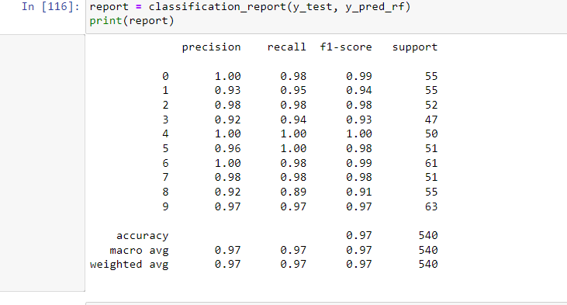
Figure 5. 10 Model Evaluation for RF

Logistic Regression

Despite being called "regression," the ML approach known as logistic regression (LR) is generally used for binary classification tasks. The one-vest approaches utilised by the learning algorithm may also be applied with Te LR for multiclass classification challenges. The sigmoid function or one of its variants is applied to a linear ML model in the LR model. This operation results in a compressed output between [0, 1]. The likelihood of a certain class is identified by an output that is nearer 1. The mathematical formulation is described in Equation 1 and 2 [4]
Linear Model: y = b + w1x1 + w2x2 +···+ wnxn
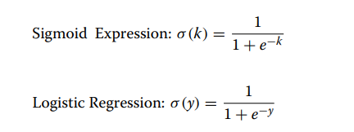
Figure 5. 11 LR

Confusion Matrix LR

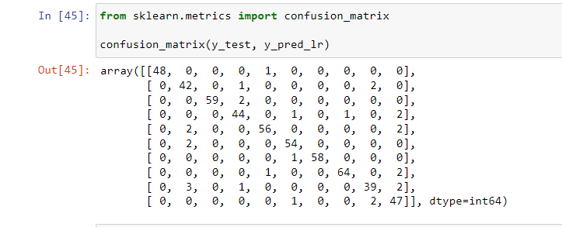

Figure 5. 12 Confusion Matrix for LR

Model Evaluation for LR
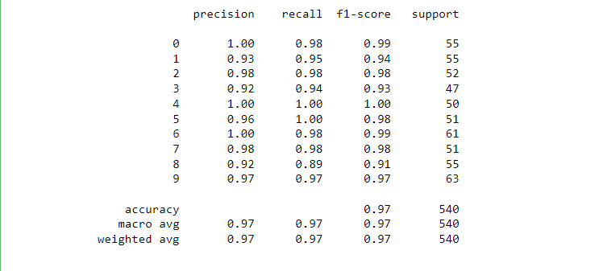
Figure 5. 13 Model Evaluation

Decision Tree
The supervised learning subset of algorithms includes decision tree algorithms. Both classification and regression issues can be resolved with them. The problem is solved using a decision tree, where each leaf node corresponds to a class label and characteristics are expressed on interior nodes of the tree. Using a decision tree, we may describe any boolean function on a set of discrete qualities.
- The entire training set is first regarded as the root.
- It is preferable for feature values to be categorical. If the data are continuous, they are discretized before the model is built.
- Records are distributed recursively based on the values of their attributes.
- We employ statistical techniques to arrange characteristics as the internal node or the root.
The Decision Tree uses the Sum of Product form, also called Disjunctive Normal Form, as you can see from the image up top. In the image above, we project how people will use computers in their daily lives. The identification of the attribute for the root node at each level in the Decision Tree is the main challenge. Attribute selection is the process in question. We have two popular attribute selection measures:
- Information Gain
- Gini Index

Information Acquisition The entropy changes when we employ a decision tree node to divide the training cases into smaller groups. This shift in entropy may be measured via information gain. Definition: Assuming S is a collection of instances, A is an attribute, Sv is a subset of S where A equals v, and Values (A) is a collection of all A's potential values, then

Entropy Entropy, a measure of a random variable's uncertainty, identifies the impurity in any random collection of examples. More information is contained when entropy is higher. Definition: Assuming S is a collection of instances, A is an attribute, Sv is a subset of S where A equals v, and Values (A) is a collection of all A's potential values, then

Confusion Matrix for Decision Tree
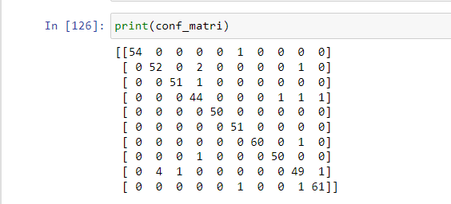
Figure 5. 14 Confusion Matrix for Decision Tree

Model Evaluation for Decision Tree
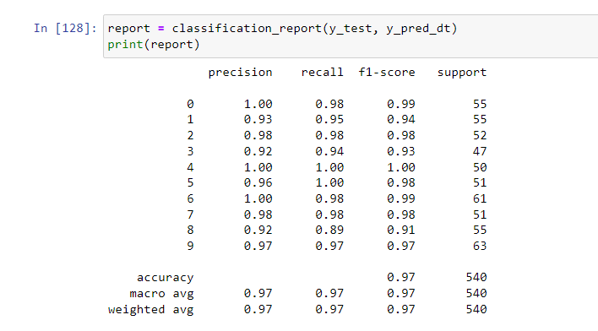
Figure 5. 15 Model Evaluation

K-Fold (RF,SVM,LR,DT)

In machine learning, we use the train test split() class from SKLEARN to divide our complete dataset into training set and test set when we wish to train our ML model. After that, we test our model on test set and train it on training set. We will run across the following issues using this method.
We can't precisely pinpoint the accuracy of our model since every time we alter the random state parameter in train test split(), we obtain a different accuracy for each random state.
By using random sampling, the train test split() function divides the dataset into training test and test set. However, stratified sampling is done.

K-Fold
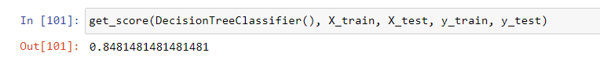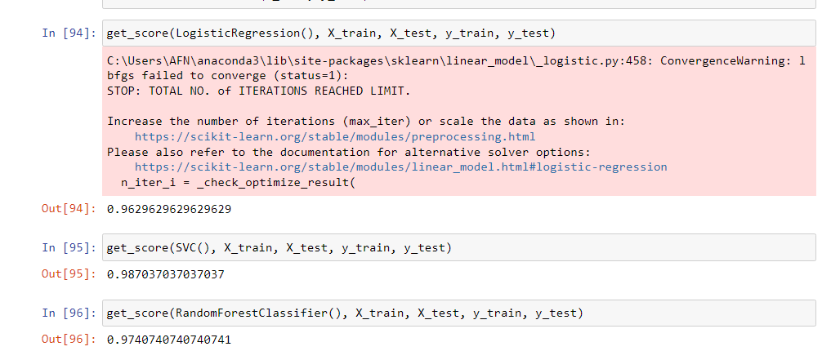
Figure 5. 16 Kfold

Support Vector Machine
Spherical Vector Machine One of the most adaptable ML models that can do both classification and regression tasks is the Support Vector Machine (SVM). SVM is one of the most well-known models in machine learning research. The SVM model seeks to identify the best hyperplanes by classifying a given dataset into distinct groups. The fact that SVM frequently works well for large dimensional input spaces is one of the benefits of employing it. The SVM model also permits the choice of a range of Kernel functions throughout the decision-making process. One of its drawbacks is that it needs meticulous adjustment in general, especially when the input dimension exceeds the number [4]a

Confusion Matrix
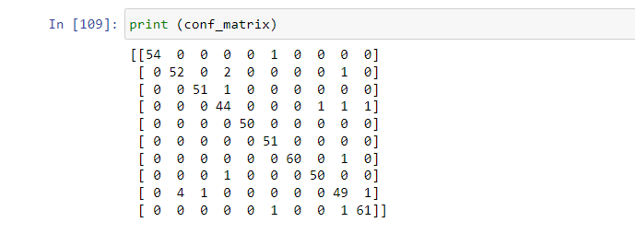
Figure 5. 17 Confusion Matrix

Model Evaluation for SVM

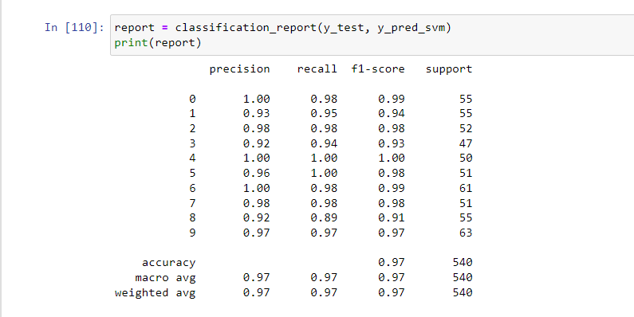
Figure 5. 18 Module Evaluation

Comparative Analysis of the Classifiers
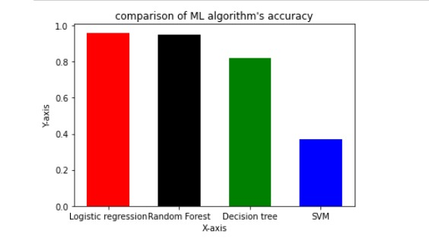
Figure 5. 19 Comparative Analysis

Comparison Graph Algorithm
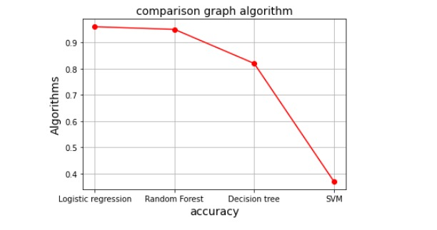
Figure 5. 20 Comparison Graph

CONCLUSION AND RECOMMENDATIONS

Conclusion

Technology advancement and more powerful tool use for connecting to worldwide. Business totally depends on the technology. Cyber Security, Network and Server Security and many other Security related topics hot areas in technology world. We are currently learning about security related topics, and we are inspired the idea of this project. There are many bad intended hackers perform illegal activities on any computer network infrastructure, for financial gaining, stealing secret information and many newer potential threats as hackers and virus’s advance attacks on the server.

Intrusion Detection System (IDS) is server based application which is run on network layer. It will filter all the incoming data packet and identify weather known and unknown intrusions, virus or threats. Develop a server application and filtering the data packets at network layer and implemented on the server. This Application is best for server security parameters management as Confidentiality, Integrity and Availability (CIA). Protect the privacy and integrity of messages going through untrusted networks.

Also IDS(Intrusion Detection System), work as scanning data packet and block ports for suspicious data packets and IDS and IPS and deep packet scanning. This application gives all the information related to the server and network like how much ports are open and how much ports are closed and gives the all data packets information like which data packet coming from which source and reached from which destination.

Recommendations

Concerning this project, we would be corresponding to recommended that a lot a more work can be done with addition new features. Addition of new feature like TCP session analyzation, data packet reassembly mechanism.

Learning Outcomes

Since this project we came to know about how to make an application under the supervision of our supervisor. We done this project with dedication and how to manage time table and follow deadlines for Final Year Project(FYP). How to build a potential team, management skills and group discussion? When you start a project which type of complicities face and why projects fail. We came to know what to do and what not to do FYP champion. This project guides us how software houses develop real software.

Through this project our learning experience very good and we learn very important things during this complete session. Our supervisor trained us for market. In the way, ours FYP complete, and mentioned above all things we have learnt and will useful for all future projects and all give us and edge in the market.

REFERENCES

Books:

[1] M. Barkat, Signal Detection and Estimation, 2nd Edition, Artech House , Boston, MA., 2005
[2] P. Peebles, Probability, Random Variables and Random Signal Processing, 4th Ed., , McGraw Hill, New York, 2001.

Journal Papers:

[3] Liao, H. J., Lin, C. H. R., Lin, Y. C., & Tung, K. Y. (2013). Intrusion detection system: A comprehensive review. Journal of Network and Computer
[4] Mienye, I. D., & Sun, Y. (2021). Improved heart disease prediction using particle swarm optimization based stacked sparse autoencoder. Electronics, 10(19), 2347.

[5] Farnaaz, N., & Jabbar, M. A. (2016). Random forest modeling for network intrusion detection system. Procedia Computer Science, 89, 213-217.
Conference Papers:
[6] Ingre, B., Yadav, A., & Soni, A. K. (2017, March). Decision tree based intrusion detection system for NSL-KDD dataset. In International conference on information and communication technology for intelligent systems (pp. 207-218). Springer, Cham.

[7] M. Almarshad, M. Barkat, and S. Al-shebeili, '' A Monte Carlo Simulation for Two Novel Automatic Censoring Technique of Radar Interfering Targets in Log-Normal Clutter'', Proceedings of the International Symposium on Signal Processing and its Applications, ISSPA 2007, Sharjah, UAE, February 2007
[8] Patgiri, R., Varshney, U., Akutota, T., & Kunde, R. (2018, November). An investigation on intrusion detection system using machine learning. In 2018 IEEE Symposium Series on Computational Intelligence (SSCI) (pp. 1684-1691). IEEE.

