
BSCS-S22-011
03-134191-013 | MUHAMMAD HAMZA REHAN

ByFood-A Place of Discounts

In partial fulfilment of the requirements for the degree of
Bachelor of Science in Computer Science
Supervisor: Sadia Aslam
Department of Computer Sciences
Bahria University, Lahore Campus

January 2023

© Bahria University, 2023

Certificate

We accept the work contained in the report titled
“By Food- A place of discounts”
written by
Muhammad Hamza Rehan
as a confirmation to the required standard for the partial fulfilment of the degree of
Bachelor of Science in Computer Science.

Approved by:
Supervisor: Sadia Aslam
signature

05 January,2023

DECLARATION

I hereby declare that this project report is based on my original work except for citations and quotations which have been duly acknowledged. I also declare that it has not been previously and concurrently submitted for any other degree or award at Bahria University or other institutions.

Enrolment | Name | Signature
03-134191-013 | MUHAMMAD HAMZA REHAN

Date : January 05, 2022

Specially dedicated to
my beloved grandfather, mother, and father
(MUHAMMAD HAMZA REHAN)

ACKNOWLEDGEMENTS

I would like to thank everyone who had contributed to the successful completion of this project. I would like to express my gratitude to my research supervisor, Madam SADIA ASLAM for her invaluable advice, guidance, and her enormous patience throughout the development of the research.

In addition, I would also like to express my gratitude to my loving parent and friends who had helped and given me encouragement.

Muhammad Hamza Rehan

CONTENTS
CHAPTER 1: INTRODUCTION 11
1.1 Objectives 12
1.2 Problem Statement 12
1.3 Assumptions and Constraints 13
1.4 Project Scope 13
2 CHAPTER 2: REQUIREMENTS ANALYSIS 13
2.1 Literature Review: 13
2.2 Stakeholders 14
2.3 Requirements Elicitations 15
2.3.1 Functional Requirements: 15
2.3.2 Non-Functional Requirements 26
2.4 Use Case descriptions 29
2.5 Use Case Design 47
2.5.1 User, Restaurant Owner and Admin Use-case diagram 47
3 CHAPTER 3: WORK BREAKDOWN STRUCTRUE 49
3.1 Work breakdown structure (WBS) 49
3.2 Activity Diagram 50
3.2.1 Login 50
3.2.2 Signup 51
3.2.3 Password Recovery 51
3.2.4 View Restaurants 52
3.2.5 Rating Restaurants 53
3.2.6 View menu 53
3.2.7 QR Code Scan 54
3.2.8 View Posts 55
3.2.9 Create post 55
3.2.10 Delete Post 56
3.2.11 Create Menu 56
3.2.12 Edit Menu 57
3.2.13 Make Comment 57
3.2.14 Access Dashboard 58
3.2.15 Share post 58
3.2.16 Comment on Posts 59
3.2.17 Moderator 59
3.3 Sequence Diagrams 60
3.3.1 Registration and login 60
3.3.2 Recover Password 61
3.3.3 Rating Restaurants 62
3.3.4 QR Code Scan 62
3.3.5 Search Restaurants 63
3.3.6 Delete Post 63
3.3.7 Add Restaurants details 64
3.3.8 Edit/delete restaurant details 64
3.3.9 Add menu items 65
3.3.10 Delete menu items 65
3.3.11 Save post 66
3.3.12 Share Post 66
3.3.13 Moderator (Admin) 67
3.3.14 Blog Page 67
3.4 Software architecture 68
3.5 Class diagram 69
3.7 Collaboration diagram 70
3.7.1 Login 70
3.7.2 Add restaurant Details 70
3.7.3 View Restaurants 71
3.7.4 View Menu 71
3.7.5 Scan QR code 72
3.7.6 Rating Restaurant 72
3.7.7 Create post 73
3.7.8 Delete post 73
3.7.9 Share post 74
3.7.10 Comment on post 74
3.7.11 Add menu 75
3.7.12 Delete menu 75
3.7.13 Moderator 76
4 CHAPTER 4: TESTING 77
4.1 Unit Testing 77
4.2 Integration testing 77
4.3 System Testing 77
4.4 Acceptance testing 77
4.5 Manual Testing 78
4.6 Pass/fail Criteria 78
5 CHAPTER 5: CONCLUSION 78
5.1 Project Summary 78
5.2 Problems faced and lessons learned 79
5.3 Future work 79
6 REFERENCES: 80

List Of Tables
Table 1 FR01......................................................................................................................................... 13
Table 2 FR02......................................................................................................................................... 13
Table 3 FR03......................................................................................................................................... 13
Table 4 FR04......................................................................................................................................... 14
Table 5 FR05......................................................................................................................................... 14
Table 6 FR06......................................................................................................................................... 15
Table 7 FR07......................................................................................................................................... 15
Table 8 FR08......................................................................................................................................... 16
Table 9 FR09......................................................................................................................................... 16
Table 10 FR10 ....................................................................................................................................... 16
Table 11 FR11 ....................................................................................................................................... 17
Table 12 FR12 ...................................................................................................................................... 17
Table 13 FR13 ...................................................................................................................................... 18
Table 14 FR14 ...................................................................................................................................... 18
Table 15 FR15 ....................................................................................................................................... 18
Table 16 FR16 ...................................................................................................................................... 19
Table 17 FR17 ...................................................................................................................................... 19
Table 18 FR18 ...................................................................................................................................... 20
Table 19 FR19 ...................................................................................................................................... 20
Table 20 FR20 ...................................................................................................................................... 20
Table 21 FR21 ...................................................................................................................................... 21
Table 22 FR22 ...................................................................................................................................... 21
Table 23 FR23 ...................................................................................................................................... 22
Table 24 FR24 ...................................................................................................................................... 22
Table 25 NFR01 .................................................................................................................................... 23
Table 26 NFR02 .................................................................................................................................... 23 Table 27 NFR03 .................................................................................................................................... 23
Table 28 NFR04 .................................................................................................................................... 24
Table 29 NFR05 .................................................................................................................................... 24
Table 30 NFR06 .................................................................................................................................... 24
Table 31 Traceability Matrix ................................................................................................................. 25
Table 32 UC-01 ..................................................................................................................................... 29
Table 33 UC-02 ..................................................................................................................................... 30
Table 34 UC-03 ..................................................................................................................................... 30
Table 35 UC-04 ..................................................................................................................................... 31
Table 36 UC-05 ..................................................................................................................................... 32
Table 37 UC-06 ..................................................................................................................................... 33
Table 38 UC-07 ..................................................................................................................................... 34
Table 39 UC-08 ..................................................................................................................................... 34
Table 40 UC-09 ..................................................................................................................................... 35
Table 41 UC-10 ..................................................................................................................................... 36
Table 42 UC-11 ..................................................................................................................................... 36
Table 43 UC-12 ..................................................................................................................................... 37
Table 44 UC-13 ..................................................................................................................................... 38
Table 45 UC-14 ..................................................................................................................................... 39
Table 46 UC-15 ..................................................................................................................................... 40
Table 47 UC-16 ..................................................................................................................................... 40
Table 48 UC-17 ..................................................................................................................................... 41
Table 49 UC-18 ..................................................................................................................................... 42

LIST OF FIGURES
Figure 1 Use-case Diagram .................................................................................................................... 43
Figure 2 SDCL Hybrid model ................................................................................................................ 45
Figure 3 Work Break Down Structure .................................................................................................... 46
Figure 4 Activity Diagram login ........................................................................................................... 47
Figure 5 Activity Diagram Signup ......................................................................................................... 48
Figure 6 Activity Diagram Recover Password ........................................................................................ 48
Figure 7 Activity Diagram View Restaurants ......................................................................................... 49
Figure 8 Activity Diagram Rating Restaurants ....................................................................................... 49
Figure 9 Activity diagram View Menu ................................................................................................... 50
Figure 10 Activity diagram QR Code Scan ............................................................................................ 50
Figure 11 Activity diagram view posts ................................................................................................... 51
Figure 12 Activity Diagram Create Post................................................................................................. 51
Figure 13 Activity diagram Delete post .................................................................................................. 52
Figure 14 Activity diagram Add Menu details........................................................................................ 52
Figure 15 Activity diagram edit-delete menu details .............................................................................. 53
Figure 16 Activity Diagram create comment .......................................................................................... 53
Figure 17 Activity Diagram Access Dashboard ...................................................................................... 54
Figure 18 Activity Diagram share post ................................................................................................... 54
Figure 19 Activity diagram react post .................................................................................................... 55
Figure 20 Activity diagram moderator ................................................................................................... 55
Figure 21 Sequence diagram registration and login ................................................................................ 56
Figure 22 Sequence Diagram Recover Password .................................................................................... 57
Figure 23 Sequence diagram of Rating Restaurants ................................................................................ 58
Figure 24 Sequence diagram QR Code Scan .......................................................................................... 58
Figure 25 Sequence diagram of View Restaurants .................................................................................. 59
Figure 26 Sequence diagram of delete post ............................................................................................ 59
Figure 27 Sequence diagram of add restaurant details ............................................................................ 60
Figure 28 Sequence diagram of edit/delete restaurant details .................................................................. 60
Figure 29 Sequence diagram of add menu items .................................................................................... 61
Figure 30 Sequence diagram of delete menu items ................................................................................. 61
Figure 31 Sequence Diagram Post ......................................................................................................... 62
Figure 32 Sequence Diagram Share Post ................................................................................................ 62
Figure 33 Sequence Diagram Moderator ................................................................................................ 63
Figure 34 Sequence Diagram Blog page ................................................................................................ 63
Figure 35 Software Architecture ............................................................................................................ 64
Figure 36 Class Diagram ....................................................................................................................... 65
Figure 37 Network Diagram (Gantt Chart) ............................................................................................. 66
Figure 38 Collaboration diagram of login .............................................................................................. 67
Figure 39 Collaboration diagram of register restaurant ........................................................................... 67
Figure 40 Collaboration Diagram view restaurant .................................................................................. 68
Figure 41 Collaboration diagram view menu.......................................................................................... 68
Figure 42 Collaboration Diagram Scan QR code .................................................................................... 69
Figure 43 Collaboration Diagram Rating Restaurant .............................................................................. 69
Figure 44 Collaboration Diagram Create post ........................................................................................ 70
Figure 45 Collaboration Diagram Delete Post ........................................................................................ 70
Figure 46 Collaboration Diagram Share post.......................................................................................... 71
Figure 47 Collaboration Diagram React Post ......................................................................................... 71
Figure 48 Collaboration diagram of add menu .................................................................................. 72 Figure 49 Collaboration Diagram Delete menu ...................................................................................... 72
Figure 50 Collaboration Diagram Moderator ......................................................................................... 73

PROJECT ABSTRACT
ByFood-The place of discounts is a web-based application. In which restaurants (in Lahore) will be ranked according to the number of stars it gets in feedback. The user will be able to view the restaurant's menu, discounts, their special deals. The user will also be able to see if the restaurant dines or take away. This app will also be able to give the location of a specified restaurant to the customers if they want it. This application will also use QR based method for availing discounts.
The basic idea behind making this application is that people of now days are very busy in their professional lives. They don’t get time with their families and friends. Some might have the reason of time shortage while others may not afford going out good quality restaurants because of their expensive values. Our application provides the solution to both problems. Now the people neither will need to waste extra time on outings and selecting what to eat and going to which restaurant, nor will they need to pay so much money just to spend a few moments with their loved ones. People can use our application to get to know about the real quality of restaurants with the help of reviews and comments. Also, they will have to spend much lesser time to decide place and menu to eat.

CHAPTER 1: INTRODUCTION

Restaurants in Pakistan are increasing day by day. Many restaurants from five-star to a simple tea shop want to promote and be recognized in Pakistan. Meanwhile, many Pakistanis want to try different restaurants and exotic dishes because why not? Pakistan is known for having the best and delicious food internationally. Many tourists come to Pakistan to try their foods.
Right now, if we go to any nice hotel to eat dinner or have lunch, we notice that most of the time the price of the meal is kind of okay and sense able but with the taxes added to them they skyrocket. We want to create this app and gather a community of nice restaurants to help people get a little discount.
The purpose of making this project is to help people avail different discount offers on different food items. Right now, having a nice peaceful meal in a restaurant in Pakistan is getting expensive and more expensive due to the rise of taxes. We want to help set a trend of discount gathering as many restaurants as we can that will let people have a little discount on their meals just because they have an app on their smartphones. People can give reviews about restaurants where they went to and tell others about their experience
This app is somewhat like other discount apps, but it would differ in the way that it will be having a page where restaurants (in Lahore) are listed down. In these restaurants there will be menus and special deals for users which users will obtain by scanning QR code. It will also be having a blog page where users can post about their experience and other users can like and comment on the posts. Restaurant owners can also make posts like for example about their new special deal. Users can also navigate towards the selected Restaurant as this app would be able to provide restaurants location. The user will also be able to see if the restaurant allows dine in or take away. Motivation and Scope
The worldwide online food ordering industry is proceeding at a rapid pace. In Pakistan, online food ordering systems are trending, but we do not have an application in which people can see the menu of restaurants, discounts, and special deals. This project's motivation and scope comes from the idea of letting people have a little more fun time, even if it's just a small discount, but we all know that everyone likes to save money. We wanted to make it easier and more user-friendly for users to search for food along with feedback provided according to their needs.

1.1 Objectives
- To provide a user-friendly environment to the user.
- To provide restaurant’s menus on your phones to save time.
- To provide platform to people who want to eat good within their budget.
- To provide a platform for restaurants to increase their business
- To provide a platform from where people get to know the realities of quality restaurants.
- To provide a platform where people can share their personal experiences through posts and comments.
- To provide a platform which the help of which people don’t need to take out so much time to share happiness.
- To provide ease and efficiency.
- To provide quality and flexibility.
- To provide a platform where families get connected without hustle.

1.2 Problem Statement

The worldwide online food ordering industry is proceeding at a rapid pace. In Pakistan, online food ordering systems are trending, but we do not have an application in which people can see the menu of restaurants, discounts, and special deals. This project's motivation and scope comes from the idea of letting people have a little more fun time, even if it's just a small discount, but we all know that everyone likes to save money. We wanted to make it easier and more user-friendly for users to search for food along with feedback provided according to their needs.

1.3 Assumptions and Constraints
- If the user has not downloaded the application, He will not be able to access the functionality of the system.
- If the people have week internet connection, they will have to face a delay in loading the menus and restaurants details.
- If the camera of a person is not functional, he won’t be able to scan the QR code to get discounts.
- If the person is living out of Lahore, he will not be able to get benefit from this application until it is published.
- If the restaurant is not registered to the application, the customer won’t be able to search it in this system.
- If the customer is not authorized user, he will need to get his authorization done to get benefits from his system.
- If the person’s camera is not clean, he won’t be able to scan the QR code.
- Only the person who has done a post by mistake, no other person will be able to delete it rather than just the person who uploaded it.

1.4 Project Scope

We see someone post on Facebook group like ESR where a discount is given on certain deal but when you go there and ask for that discounted deal, they say that deal was closed 2 days ago. You become sad all the time got wasted going to that restaurant or you when you need to decide what you want to have to eat, and you don’t find proper menus of restaurants on the internet it’s also frustrates us. Our app will deal with both these problems. It will give discounts on different deals by various restaurants also which will be availed through QR code scan. Also, our app will show menus of different restaurants both saving time and money.

2 CHAPTER 2: REQUIREMENTS ANALYSIS

2.1 Literature Review:

Eat Sleep Repeat (ESR):
- ESR is a digital marketing and PR agency.
- They provide discounts, activities, and events to their esteemed users.
- They help quality food vendors in marketing their products to their amazing Foodie audience.
- It’s a group of passionate individuals who love their food and share their experience with others.
- They offer consultancy Services, Supply Chain Services, Restaurant Sale/Purchase Rental and Franchising Services
- They also manage Events & PR, Digital Marketing Services and Social Media Marketing Services.
The Infatuation:
- The Infatuation is an American New York-based restaurant recommendation website and messaging service, created by former music industry executives Chris Stang and Andrew Steinthal in 2009.
- A small group of highly trained writers and editors write reviews for different restaurants and give travel guides to users.
- They are most known for publishing restaurant reviews and guides.
Lahore Food Posting (LFP):
- Lahore Food Posting (LFP) is a Facebook page/group providing discounts on hundreds of restaurants all over Pakistan mainly in Lahore.
- They offer discounts on different brands and restaurants.
- They also manage Events & PR, Digital Marketing Services and Social Media Marketing Services.

2.2 Stakeholders

- The users (customer, Restaurants owner).
- The development teams
- The admin
- The supervisors
- The market competitors

2.3 Requirements Elicitations

2.3.1 Functional Requirements:

FR 01: Signup

Table 1 FR01
Req | Functional Requirement
FR 01_1 | The application shall ask the user if he/she is a customer or a restaurant owner
FR 01_2 | The user shall select customer or user requirement.
FR 01_3 | The application shall ask email from the customer
FR 01_4 | The application shall ask password from the customer
FR 01_5 | The application shall ask username from the customer

FR 02: Login

Table 2 FR02
Req | Functional Requirement
FR 02_1 | The application shall ask user to enter email and password
FR 02_2 | The application shall allow the user to dashboard if correct credentials are given.
FR 02_3 | If not verified the application shall ring the login page for user to try again

FR 03: Password Recovery

Table 3 FR03
Req | Functional Requirement
FR 03_1 | The application shall ask the user to enter email.
FR 03_2 | The application shall send an email to the customer to change password
FR 03_3 | The user shall click on link to go to application.
FR 03_4 | The user shall enter new password.
FR 03_5 | The user shall click submit button to save password.

FR 04: User’s dashboard

Table 4 FR04
Req | Functional Requirement
FR 04_1 | The application shall show the user dashboard
FR 04_2 | The application shall provide the user with the options to go to restaurant page, blog page or its profile page.

FR 05: Restaurant Page

Table 5 FR05
Req | Functional Requirement
FR 05_1 | The application shall allow the user to go to restaurant page by clicking on restaurant page in dashboard.
FR 05_2 | The application shall show the list of restaurants registered in application to the user.
FR 05_3 | The application shall allow the user to search for specific restaurant.
FR 05_4 | The application shall allow the customers to view menu.
FR 05_5 | The application shall allow the user to view the location of restaurant on google maps.
FR 05_6 | The application shall allow the user to view whether a restaurant gives dine-in or take-away services.
FR 05_7 | The application shall allow the user to view special discounted deals of each restaurant.

FR 06: Scanning the QR code

Table 6 FR06
Req | Functional Requirement
FR 06_1 | The application shall allow the user to scan QR code by pressing QR code option.
FR 06_2 | The application shall open the camera to scan QR code given by restaurant.
FR 06_3 | The application then shows percentage of discount to the customer.

FR 07: Rating Restaurants

Table 7 FR07
Req | Functional Requirement
FR 07_1 | The application shall show 5 stars to the customer for rating.
FR 07_2 | The customer shall select number of stars out 5 to give rating.
FR 07_3 | The application shall calculate total rate of restaurant by taking average of rates.

FR 08: location and navigating to restaurant

Table 8 FR08
Req | Functional Requirement
FR 08_1 | The application shall allow the user to view the location of the restaurant.
FR 08_2 | The application shall allow user to click on location icon.
FR 08_3 | The application shall open google maps.
FR 08_4 | The user shall click on start route to start the route towards the restaurant.

FR09:Userprofile
Table 9 FR09
Req | Functional Requirement
FR 09_1 | The application shall allow the user to go to profile page by clicking on profile page icon in dashboard.
FR 09_2 | The application shall allow the user to update their profile picture.
FR 09_3 | The application shall allow the user to view its own post.

FR 010: Blog page

Table 10 FR10
Req | Functional Requirement
FR 010_1 | The application shall allow the user to go to blog page by clicking on blog page icon in dashboard.
FR 010_2 | The application shall allow the user to view posts from other users registered in the application
FR 010_3 | The application shall allow the user to comment on posts.
FR 010_4 | The application shall allow the user to like posts.

FR 011: Create post on blog page

Table 11 FR11
Req | Functional Requirement
FR 011_1 | The application shall allow the user to go to blog page by clicking on blog page icon in dashboard.
FR 011_2 | The application shall allow the user to create post on the blog page.
FR 011_3 | The user shall click on add post option.
FR 011_4 | The user shall select an image/video or a number of images/videos from the phone’s gallery.
FR 011_5 | The user shall add caption/description with the image.
FR 011_6 | The user shall click on post button to post the post

FR 12: Deleting post from the blog page

Table 12 FR12
Req | Functional Requirement
FR 012_1 | The application shall allow the customer to delete its own post.
FR 012_2 | The user shall click on delete button to delete the post.

FR 13: commenting on a post

Table 13 FR13
Req | Functional Requirement
FR 013_1 | The user shall click on comment icon.
FR 013_2 | The user shall write the comment in the comment section.
FR 013_3 | The user shall select post to post the comment.

FR 14: liking a post from the blog page

Table 14 FR14
Req | Functional Requirement
FR 014_1 | The user shall be able to like a post from the blog page.
FR 014_2 | The user shall click on like icon.

FR 015 sharing a post from the blog page

Table 15 FR15
Req | Functional Requirement
FR 015_1 | The user shall be able to share a post from the blog page.
FR 015_2 | The user shall click on the blog page icon.
FR 015_3 | The user shall select the post they want to share.
FR 015_4 | The user shall click on options icon.
FR 015_5 | The user shall click on share from the options.
FR 015_6 | The user shall be provided with the link of the post.
FR 015_7 | The user shall copy that link and share.

FR 16: Dashboard of Restaurant owner

Table 16 FR16
Req | Functional Requirement
FR 16_1 | The application shall show the restaurant owner to view dashboard
FR 16_2 | The application shall provide the restaurant owner with the options to go to manage restaurant page.

FR 17: Dine in/Take away of Restaurant owner

Table 17 FR17
Req | Functional Requirement
FR 17_1 | The application shall ask the owner to check the Dine In option to tell customer, the restaurant gives dine in services.
FR 17_2 | The application shall ask the owner to check the Takeaway option to tell customer, the restaurant gives Take away services

FR 18: Add Location of Restaurant

Table 18 FR18
Req | Functional Requirement
FR 18_1 | The application shall ask the owner to enter address of their restaurant.
FR 18_2 | The application shall ask the owner to pin the location on google maps.
FR 18_3 | The application shall ask the owner to press submit button to save the location.

FR 19: Edit Location of Restaurant

Table 19 FR19
Req | Functional Requirement
FR 19_1 | The application shall ask the owner to edit address of their restaurant.
FR 19_2 | The application shall ask the owner to pin the location on google maps again to give exact location.
FR 19_3 | The application shall ask the owner to press submit button to save the location.

FR 20: Menu of Restaurant

Table 20 FR20
Req | Functional Requirement
FR 20_1 | The application shall ask the owner to create menu
FR 20_2 | The application shall ask the owner to add items in menu
FR 20_3 | The application shall ask the owner to add prices of items.
FR 20_4 | The application shall ask the owner to attach photos of items.
FR 20_5 | The owner shall add special deals.
FR 20_6 | The application shall ask the owner to submit to save menu.

FR 21: Edit Menu of Restaurant

Table 21 FR21
Req | Functional Requirement
FR 21_1 | The application shall ask the owner to edit item names.
FR 21_2 | The application shall ask the owner to edit prices of items.
FR 21_3 | The application shall ask the owner to change photo of items.

FR 22: profile page for restaurant owner

Table 22 FR22
Req | Functional Requirement
FR 22_1 | The application shall allow the restaurant owner to go to profile page by clicking on profile page icon in dashboard.
FR 22_2 | The application shall allow the restaurant owner to update their profile picture.
FR 22_3 | The application shall allow the restaurant owner to change their login password.

FR23: Admin - Delete Post (from blog page)

Table 23 FR23
Req | Functional Requirement
FR23_1 | The application shall provide the admin with all the reported posts from registered users
FR23_2 | The application shall provide the admin with the option to delete the post of a registered user
FR23_3 | Once the admin opts to delete the post a confirmation dialogue shall appear
FR23_4 | If the admin confirms the deletion, the post shall be deleted from the application database

FR 24: Delete Restaurants

Table 24 FR24
Req | Functional Requirement
FR 24_1 | The application shall allow the admin to delete restaurants.
FR 24_2 | The application shall allow the admin to delete posts.
FR 24_3 | The application shall allow the admin to approve/reject posts
FR 24_4 | The application shall allow the admin to approve/reject restaurants

2.3.2 Non-Functional Requirements

NFR 01: Performance

Table 25 NFR01
NFR no | Non-Functional Requirements
NFR01-01 | Load time of the pages of the system should be less than two seconds.
NFR01-02 | Processing time required to complete a request must be less than five seconds.
NFR01-03 | The system’s mean time of failure must never exceed 60 seconds within 24 hours.
NFR01-04 | Response time of the system must be less than five seconds.

NFR 02: Security

Table 26 NFR02
NFR no | Non-Functional Requirements
NFR02-01 | System should provide access only to the authorized users.
NFR02-02 | The system must never allow any user other than the designated person to update the database.
NFR02-03 | The system should never allow any user to view the encrypted data of other users.

NFR 03: Usability

Table 27 NFR03
NFR no | Non-Functional Requirements
NFR03-01 | The system must provide the voting guide and other help documentations about all the functionalities to the new users.
NFR03-02 | The system will have a very easy to understand interface for the non-technical and first-time users.

NFR 04: Defects Maintenance

Table 28 NFR04
NFR no | Non-Functional Requirements
NFR04-01 | After the release of the system, defects should never be more than 1 in 30 days.
NFR04-02 | After release defects fixing should never take less than 6 hours.

NFR 05: Reliability

Table 29 NFR05
NFR no | Non-Functional Requirements
NFR05-01 | In the case of any server crash or error, all the data should be recoverable within an hour of the event.
NFR05-02 | The system must ensure that there will be no data loss in cases of server/client crashes.

NFR 06: Supportability

Table 30 NFR06
NFR no | Non-Functional Requirements
NFR06-01 | The admin panel should successfully run on all the internet web browsers like chrome, safari, Firefox etc.

2.4 Use Case descriptions

UC-01: Signup

Table 32 UC-01
Usecase.ID:01
Use case Name: Signup
Priority: High
Actors: Customers, restaurant owners
Use Case Summary: Signing up allows the user to get registered into the System.
Pre-Condition: The user firstly needs to open the System to get registered to the system.
Normal Flow of events | Alternative paths
- Use case starts when the user wants to get registered to the system.  - To get registered the user will enter the details like First name, last name, Restaurant Name, Location, security code, contact number, email ID and password.  - System will reconfirm the submission of details by popping up a reconfirmation button.  - Users will confirm the restaurant registration.  - The system in response to successful registration, notify the user for confirmation of Restaurant registration.  - Use case ends here. |  | 1a. In case the user does not confirm registration, he cannot get his account registered.  4a. User does not confirm registration by clicking the “cancel” button.
Exceptions/Alerts
The system will not allow access to users without getting registered first.
The system will not allow account registration in case of any missed information entered.
Post Condition:
The user will be successfully registered into the System.
Use Case Cross reference
Includes: Cancel Action
Extends: None

UC-02: Login
Table 33 UC-02
Usecase.ID:02
Use case Name: Login
Priority: high
Actors: Customers, Restaurant owners, admin
Use Case Summary: Logging in allows the user to access his personal account.
Pre-Condition: If a user wants to login he firstly needs to get signed up into the System.
Normal Flow of events | Alternative paths
- Use case starts when the user wants to login to use the system’s functionality.
- To login the user needs to enter his ID and password.
- The system responds by displaying “Welcome to ByFood-The place of discounts”
- Use case ends here.

Exceptions/Alerts
In case of wrong input, the system will not allow login to access accounts.
Post Condition:
The user has successfully logged in to the System.
Use Case Cross reference
Includes: Cancel Action
Extends: None

UC-03: Forget Password
Table 34 UC-03
Usecase.ID:03
Use case Name: Forget Password
Priority: Normal
Actors: User, Restaurant Owner
Use Case Summary: Forget password allows the user to reset their password in case they forget it.
Pre-Condition: The first needs to open the website/system
Normal Flow of events | Alternative paths
- This use case starts when a User forgets his/her password and want to reset it.
- The application shall ask the user to enter email.
- The application shall send an email to the customer to change password.
- The user shall click on link to go to application.
- The user shall enter new password.
- The user shall click submit button to save password.
- Use case ends here.

Exceptions/Alerts
In case of wrong input, the system will not allow reset password to access accounts.
Post Condition:
The password is successfully reset.
Use Case Cross reference
Includes: Cancel Action
Extends: None

UC-04: Access Dashboard
Table 35 UC-04
Usecase.ID:04
Use case Name: Access Dashboard
Priority: High
Actors: Users, Restaurant Owner, Admin
Use Case Summary: The user accesses dashboard to use the functionality of the system.
Pre-Condition: The user first needs to get logged in to the system.
Normal Flow of events | Alternative paths
1. The application shall show the user dashboard.
- The application shall provide the user with the options to go to restaurant page, blog page or its profile page.
- Use case ends here.

Exceptions/Alerts
None
Post Condition:
The User can use the functionality of the system.
Use Case Cross reference
Includes: Cancel Action
Extends: None

UC-05: Restaurant page
Table 36 UC-05
Usecase.ID:05
Use case Name: Restaurant page.
Priority: High
Actors: users
Use Case Summary: The users open restaurant page to get deals and discounts on different restaurants menus.
Pre-Condition: The user first needs to login to the system.
Normal Flow of events | Alternative paths
- The application shall allow the user to go to restaurant page by clicking on restaurant page in dashboard.  - The application shall show the list of restaurants registered in application to the user.  - The application shall allow the user to search for specific restaurant.  - The application shall allow the customers to view menu.  - The application shall allow the user to view the location of restaurant on google maps.  - The application shall allow the user to view whether a restaurant gives dine-in or take-away services.  - The application shall allow the user to view special discounted deals of each restaurant. |  | 3a. The user searches an invalid restaurant name.
- The application shall allow the user to scan QR code for special discounted deals of each restaurant.
- Use case ends here.

Exceptions/Alerts
None
Post Condition:
The user will successfully be able to get deals and discounts on restaurants menus.
Use Case Cross reference
Includes: Cancel Action
Extends: None

UC-06: Scan QR code
Table 37 UC-06
Usecase.ID:06
Use case Name: Scan QR code
Priority: High
Actors: Users
Use Case Summary: The users will scan the QD code to get discounts on food.
Pre-Condition: They will open the restaurant page.
Normal Flow of events | Alternative paths
- The application shall allow the user to scan QR code by pressing QR code option.  - The application shall open the camera to scan QR code given by restaurant.  - The application then shows percentage of discount to the customer.  - Use case ends here. |  | 1a. The user doesn’t press the button properly.  2a. The user’s camera is blurred so it is unable to scan the QR code.
Exceptions/Alerts
The user’s camera is blurred so it is unable to scan the QR code.
Post Condition:
The user will successfully get discount percentages on menus.
Use Case Cross reference
Includes: Cancel Action
Extends: None

UC-07: Rating Restaurant
Table 38 UC-07
Usecase.ID:07
Use case Name: Rating restaurant
Priority: Normal
Actors: Users
Use Case Summary: The users can give ratings depending upon how much they liked or disliked the restaurants.
Pre-Condition: The Users will click on the give Rating button.
Normal Flow of events | Alternative paths
- The application shall show 5 stars to the customer for rating.
- The customer shall select number of stars out 5 to give rating.
- The application shall calculate total rate of restaurant by taking average of rates.
- Use case ends here.

Exceptions/Alerts
None
Post Condition:
Ratings will be successfully saved and displayed to users.
Use Case Cross reference
Includes: Cancel Action
Extends: None

UC-08: Location and Navigation Table 39 UC-08
Usecase.ID:08
Use case Name: location and Navigation
Priority: High
Actors: users
Use Case Summary: The users can set locations on map.
Pre-Condition: The users will first need to login to the system.
Normal Flow of events | Alternative paths
- The application shall allow the user to view the location of the restaurant.  - The application shall allow user to click on location icon. |  | 4a. the user is unable to set correct route on the map.
- The application shall open google maps.
- The user shall click on start route to start the route towards the restaurant.
- Use case ends here.

Exceptions/Alerts
None
Post Condition:
Restaurants will successfully be shown according to the location.
Use Case Cross reference
Includes: Cancel Action
Extends: None

UC-09: User profile page
Table 40 UC-09
Usecase.ID:09
Use case Name: User profile page
Priority: Normal
Actors: Users, Restaurant Owner
Use Case Summary: The user profile page allows users to manage their profiles.
Pre-Condition: The user first needs to access dashboard of the system.
Normal Flow of events | Alternative paths
- The application shall allow the user to go to profile page by clicking on profile page icon in dashboard.  - The application shall allow the user to update their profile picture  - The application shall allow the user to view its own post.  - The application shall allow the user to view the saved post.  - The application shall allow the user to change their login password.  - Use case ends here. |  | 2a. User enters invalid data.
Exceptions/Alerts
User enter invalid data while editing his profile.
Post Condition:
The user will successfully be able to manage his profile.
Use Case Cross reference
Includes: Cancel Action
Extends: None

UC-10: Blog page
Table 41 UC-10
Usecase.ID:10
Use case Name: blogs page
Priority: Normal
Actors: Users, Restaurant Owner
Use Case Summary: The blog has different posts uploaded by users and post by himself as well.
Pre-Condition: The user first needs to login to the account.
Normal Flow of events | Alternative paths
- The application shall allow the user to go to blog page by clicking on blog page icon in dashboard.
- The application shall allow the user to view posts from other users registered in the application.
- The application shall allow the user to comment on posts.
- The application shall allow the user to like posts.
- The application shall allow the user to report comments.
- The application shall allow the user to report posts.
- Use case ends here.

Exceptions/Alerts
None
Post Condition:
The user will successfully be able to access the functionality of blog page.
Use Case Cross reference
Includes: Cancel Action
Extends: None

UC-11: Post image
Table 42 UC-11
Usecase.ID:11
Use case Name: Post image
Priority: Normal
Actors: Users, Restaurant Owner
Use Case Summary: The user will be able to post images on blogs.
Pre-Condition: The user needs to open the blogs section.
Normal Flow of events | Alternative paths
- The application shall allow the user to go to blog page by clicking on blog page icon in dashboard.  - The application shall allow the user to upload an image on the blog page.  - The user shall click on add post option.  - The user shall select an image or a number of images from the phone’s gallery.  - The user shall add caption/description with the image.  - The user shall click on post button to post the image.  - Post will be saved in admin panel to be reviewed.  - admin allows then post will be shown in blog page  - Use case ends here. |  | 8a. Admin doesn’t allow.
Exceptions/Alerts
None
Post Condition:
The image will be posted successfully.
Use Case Cross reference
Includes: Cancel Action
Extends: None

UC-12: Delete post
Table 43 UC-12
Usecase.ID:12
Use case Name: Delete post
Priority: Normal
Actors: User, Restaurant Owner, Admin
Use Case Summary: The user can delete the uploaded post.
Pre-Condition: The user needs to open the post first
Normal Flow of events | Alternative paths
- The application shall allow the customer to delete its own post.  - The user shall click on delete button to delete the post.  - The user shall be shown a confirmation box if they really want to delete that post.  - The user shall select yes to delete the post.  - Use case ends here. |  | 4a. The user shall select “no”.
Exceptions/Alerts
None
Post Condition:
Post will be deleted.
Use Case Cross reference
Includes: Cancel Action
Extends: None

UC-13; Share post Table 44 U13

Usecase.ID:13
Use case Name: share post
Priority: Normal
Actors: Users
Use Case Summary: The user will be able to share a post.
Pre-Condition: The user first needs to open the post.
Normal Flow of events | Alternative paths
- The user shall be able to share a post from the blog page.
- The user shall click on the blog page icon.
- The user shall select the post they want to share.
- The user shall click on options icon.
- The user shall click on share from the options.
- The user shall be provided with the link of the post.
- The user shall copy that link and share
- Use case ends here.

Exceptions/Alerts
None
Post Condition:
Post will be successfully shared.
Use Case Cross reference
Includes: Cancel Action
Extends: None

UC-14: React post
Table 45 UC-14
Usecase.ID:14
Use case Name: comment on post
Priority: High
Actors: Users
Use Case Summary: The user will be able to react on the post.
Pre-Condition: The user will first need to open the post.
Normal Flow of events
- The user shall be able to comment on a post from the blog page.
- The user shall click on comment. Type the comment and press enter to save comment
- Use case ends here.

Exceptions/Alerts
None
Post Condition:
The post will successfully get a reaction.
Use Case Cross reference
Includes: Cancel Action
Extends: None

UC-15: Add menu
Table 46 UC-15
Usecase.ID:15
Use case Name: Add menu
Priority: High
Actors: Restaurant owners
Use Case Summary: The owner will be able to add menu to his restaurant.
Pre-Condition: The owner will first register his restaurant.
Normal Flow of events | Alternative paths
- The application shall allow the owner to edit item names.
- The application shall allow the owner to edit prices of items.
- The application shall allow the owner to change photo of items.
- Use case ends here.

Exceptions/Alerts
None
Post Condition:
Menu will be added successfully.
Use Case Cross reference
Includes: Cancel Action
Extends: None

UC-16: Edit/Delete menu
Table 47 UC-16
Usecase.ID:16
Use case Name: Delete menu
Priority: High
Actors: Restaurant owners
Use Case Summary: The user will be able to Delete menu to his restaurant.
Pre-Condition: The user will first register his restaurant.
Normal Flow of events | Alternative paths
- The application shall allow the owner to delete items
- Use case ends here.

Exceptions/Alerts
None
Post Condition:
Menu will be deleted successfully.
Use Case Cross reference
Includes: Cancel Action
Extends: None

UC-17: Upload status (Dine-in/Take-Away)
Table 48 UC-17
Usecase.ID:17
Use case Name: Upload status
Priority: high
Actors: Restaurant owner
Use Case Summary: the users will upload the dine in or take away status of their restaurants.
Pre-Condition:
Normal Flow of events | Alternative paths
- The application shall provide the admin with a list of all the Restaurants registered in application.
- The application shall provide the owner with an option to edit a Restaurant.
- Once the owner opts to edit a restaurant, the owner will be redirected to the restaurant form page.
- The admin shall be able to change/edit any information regarding the restaurant.
- The owner shall save the form once
finished editing and the restaurant’s information shall be updated.
- Use case ends here.

Exceptions/Alerts
None
Post Condition:
Menu will be added successfully.
Use Case Cross reference
Includes: Cancel Action
Extends: None

UC-18: Moderate activities
Table 49 UC-18
Usecase.ID:18
Use case Name: Moderate activities.
Priority: High
Actors: Admin
Use Case Summary: The admin will moderate the activities of all users.
Pre-Condition: The user will need to first login to the system.
Normal Flow of events | Alternative paths
The application shall provide the admin with a list of all the posts that users created to be shown on the blog page.
The application shall provide the admin with option to view these posts.
The application shall provide the admin with option to delete these posts.
Use case ends here.

Exceptions/Alerts
None
Post Condition:
Activities will be displayed to the admin.
Use Case Cross reference
Includes: Cancel Action
Extends: None

2.5 Use Case Design

2.5.1 User, Restaurant Owner, and Admin Use-case diagram

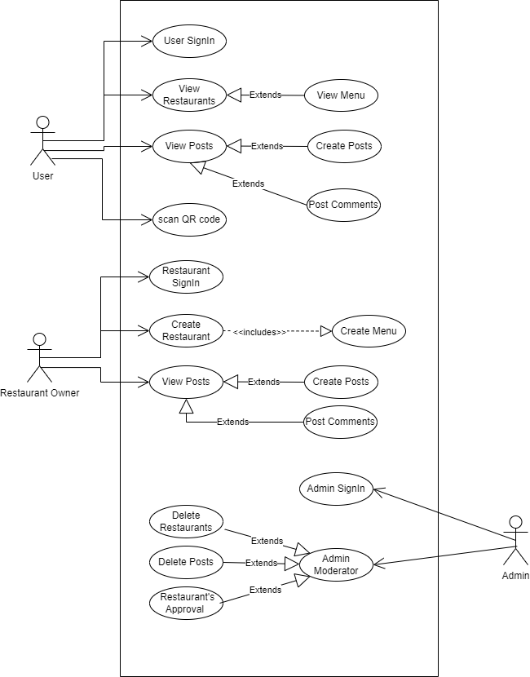
Figure 1 Use-case Diagram
2.6 Software development life cycle

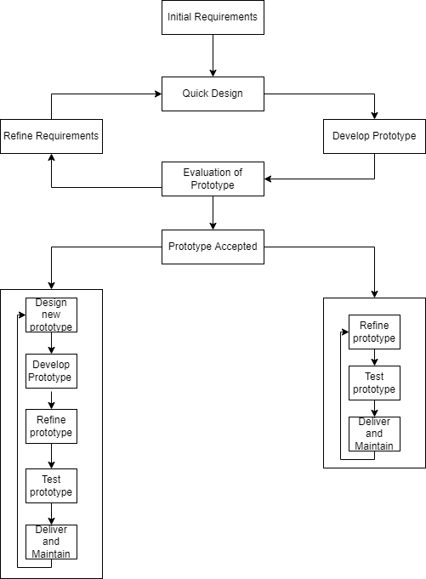
Figure 2 SDCL Hybrid model

3 CHAPTER 3: WORK BREAKDOWN STRUCTRUE

3.1 Work breakdown structure (WBS)

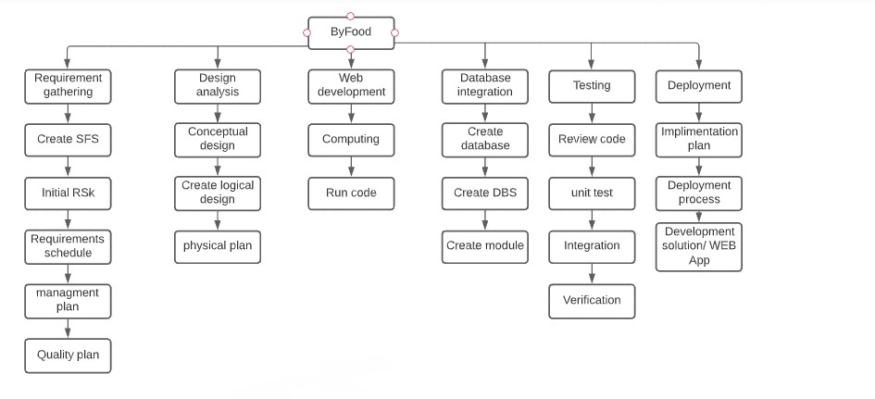
Figure 3 Work Break Down Structure

3.2 Activity Diagram

An activity diagram is a behavioral diagram i.e. it depicts the behavior of a system. An activity diagram portrays the control flow from a start point to a finish point showing the various decision paths that exist while the activity is being executed.

3.2.1 Login
For User, Restaurant owner, and Admin modules
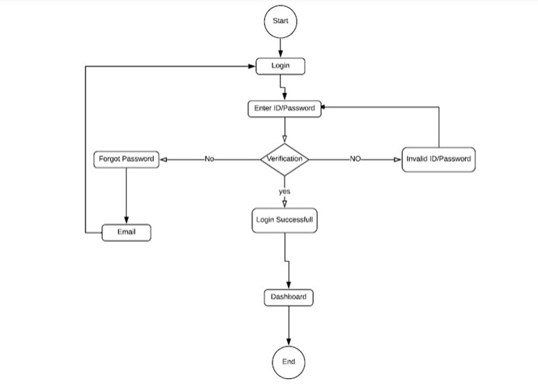

Figure 4 Activity Diagram login

3.2.2 Signup
For User and Restaurant Owner modules
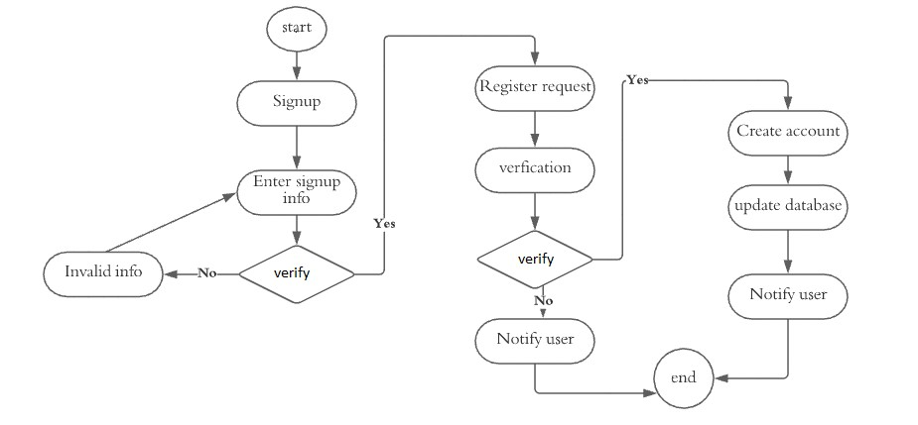

Figure 5 Activity Diagram Signup

3.2.3 Password Recovery
For User, Admin, Restaurant Owner

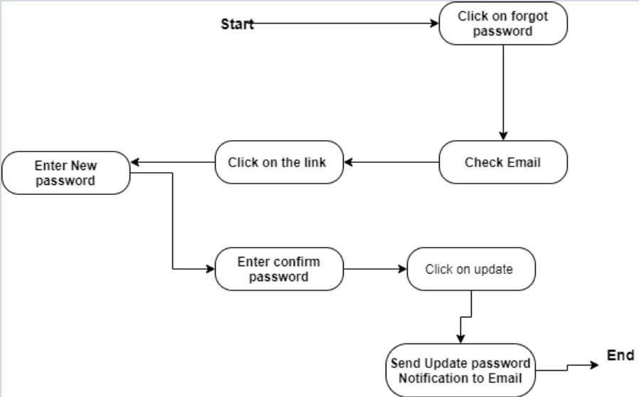
Figure 6 Activity Diagram Recover Password

3.2.4 View Restaurants
For User Module

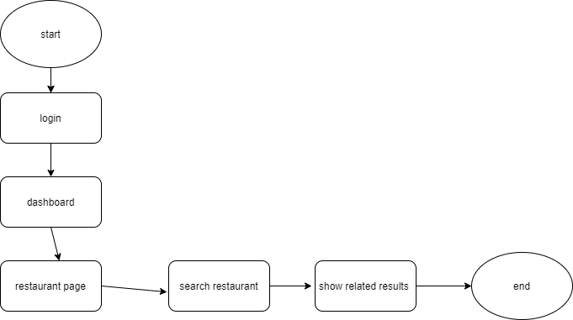
Figure 7 Activity Diagram View Restaurants

3.2.5 Rating Restaurants
For User module

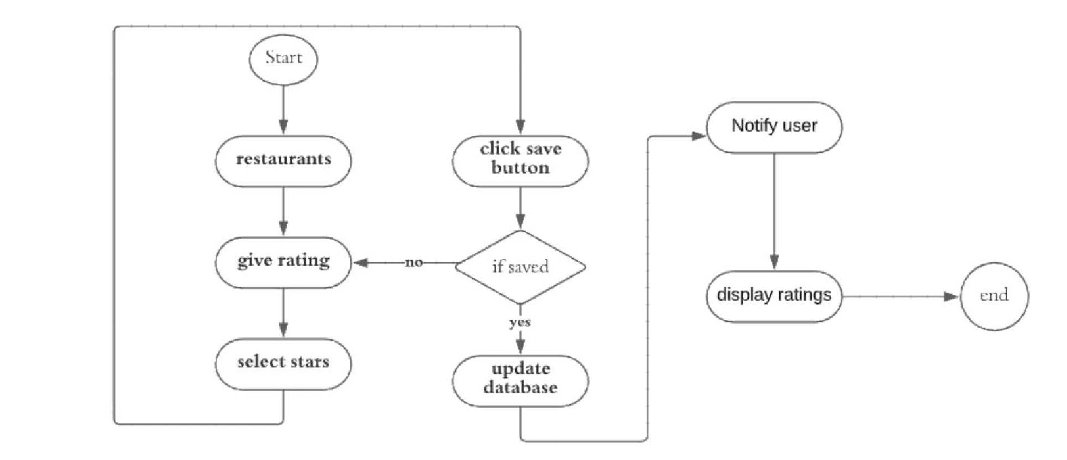
Figure 8 Activity Diagram Rating Restaurants

3.2.6 View menu
For User Module
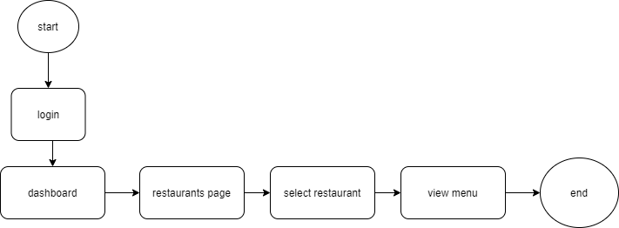
Figure 9 Activity diagram View Menu

3.2.7 QR Code Scan
For User Module

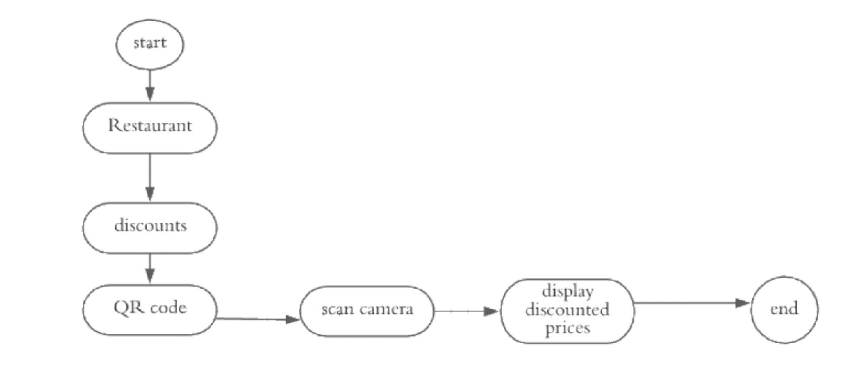

Figure 10 Activity diagram QR Code Scan

3.2.8 View Posts
For User and Restaurant Owner modules
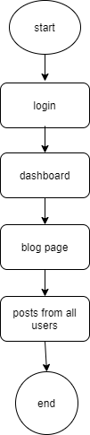
Figure 11 Activity diagram view posts

3.2.9 Create post
For user and restaurant owner modules
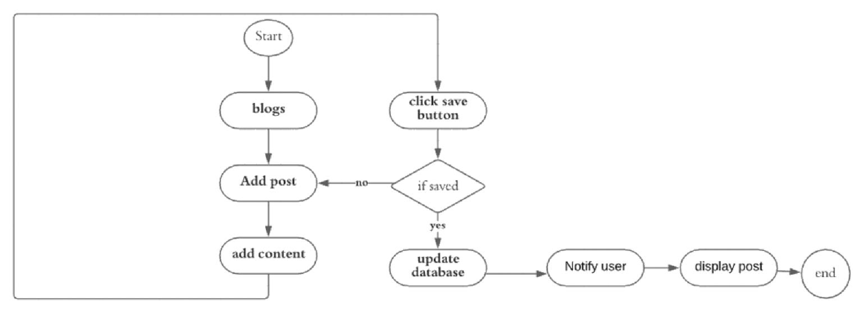
Figure 12 Activity Diagram Create Post

3.2.10 Delete Post
For User, Admin and restaurant owner modules
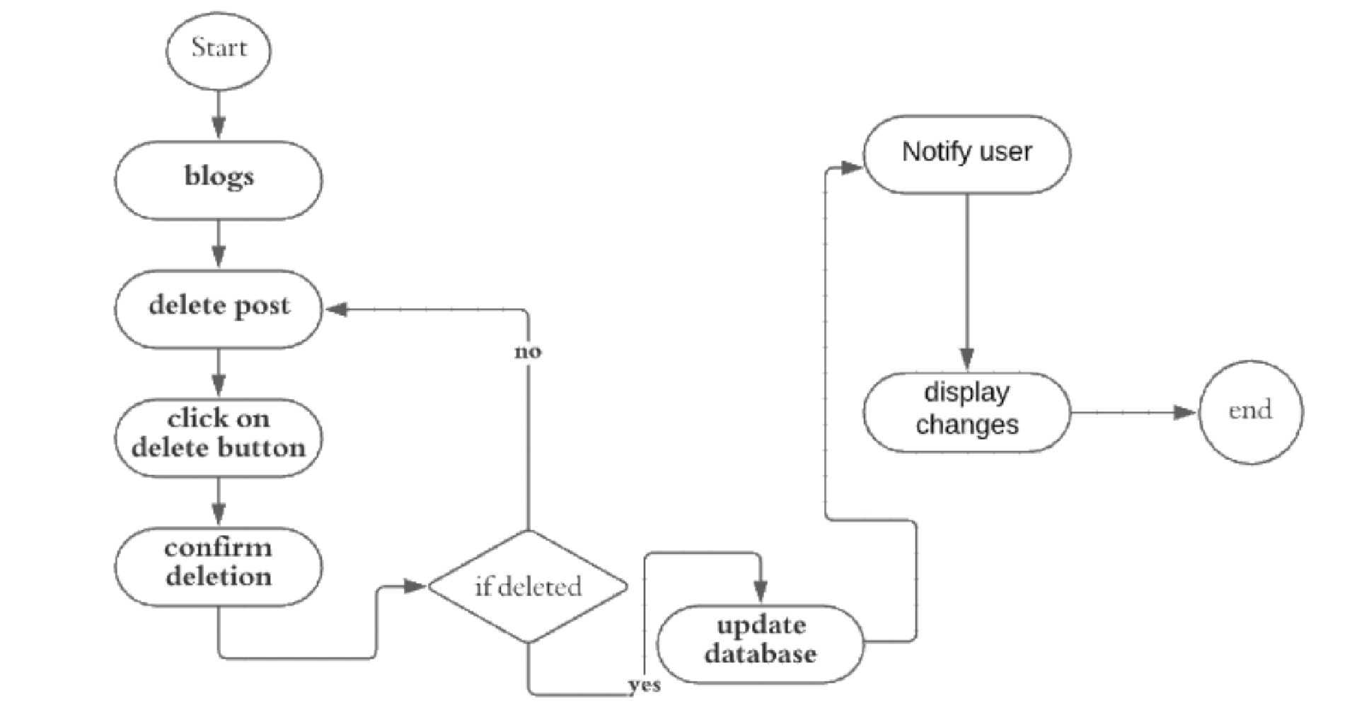

Figure 13 Activity diagram Delete post

3.2.11 Create Menu
For Restaurant owner and Admin modules

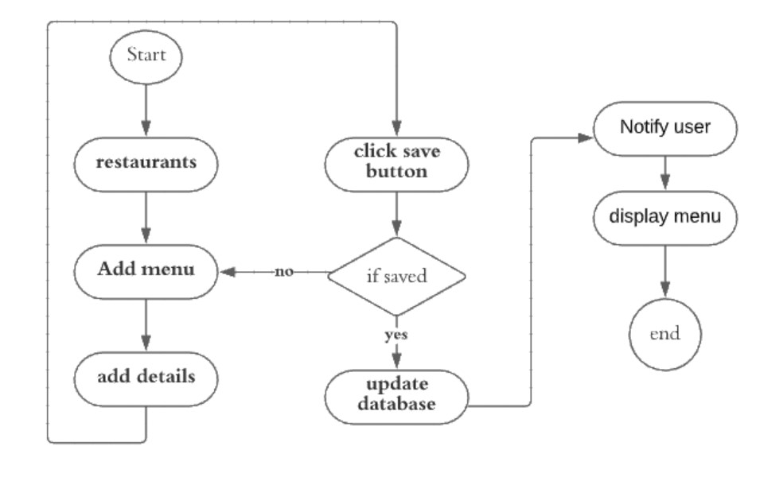
Figure 14 Activity diagram Add Menu details

3.2.12 Edit Menu
For Restaurant owner and Admin Modules
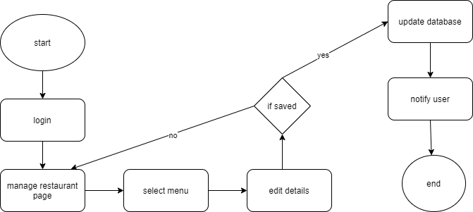
Figure 15 Activity diagram edit-delete menu details

3.2.13 Make Comment
For User and Restaurant owner Modules

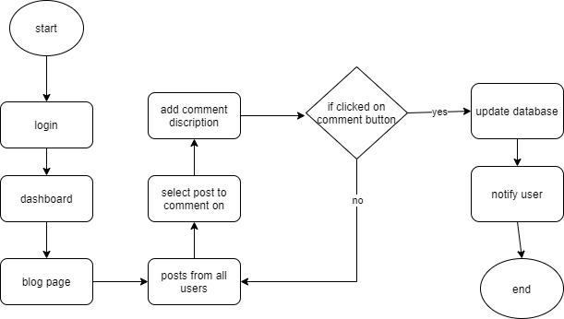

Figure 16 Activity Diagram create comment

3.2.14 Access Dashboard
For User, admin and Restaurant owner modules
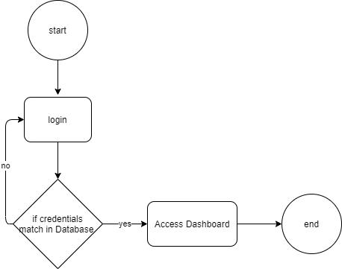
Figure 17 Activity Diagram Access Dashboard

3.2.15 Share post
For user module

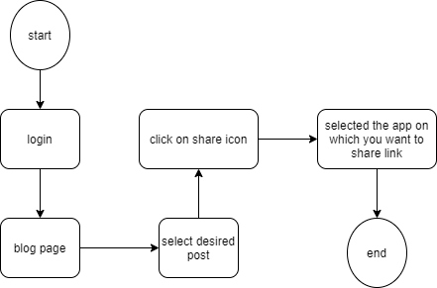

Figure 18 Activity Diagram share post

3.2.16 Comment on Posts
For user and restaurant owner module
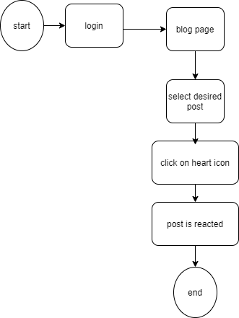
Figure 19 Activity diagram react post

3.2.17 Modetor
For adminModule
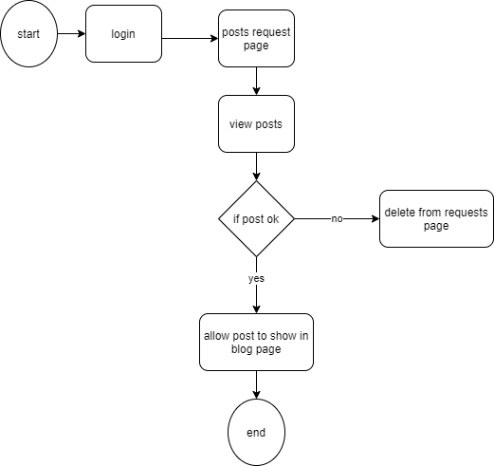
Figure 20 Activity diagram moderator

3.3 Sequence Diagrams
A sequence diagram is a type of interaction diagram because it describes how—and in what order—a group of objects works together. These diagrams are used by software developers and business professionals to understand requirements for a new system or to document an existing process.

3.3.1 Registration and login
For User and Restaurant Owner modules
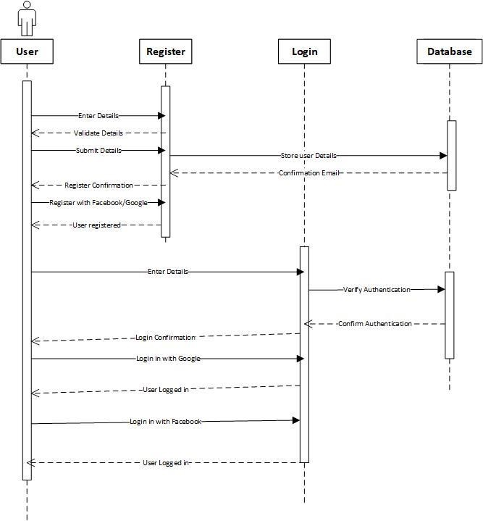

Figure 21 Sequence diagram registration and login

3.3.2 Recover Password
For User, restaurant owner module
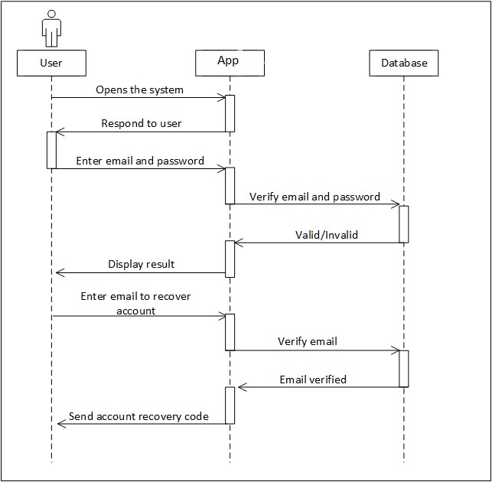
Figure 22 Sequence Diagram Recover Password

3.3.3 Rating Restaurants
For User module
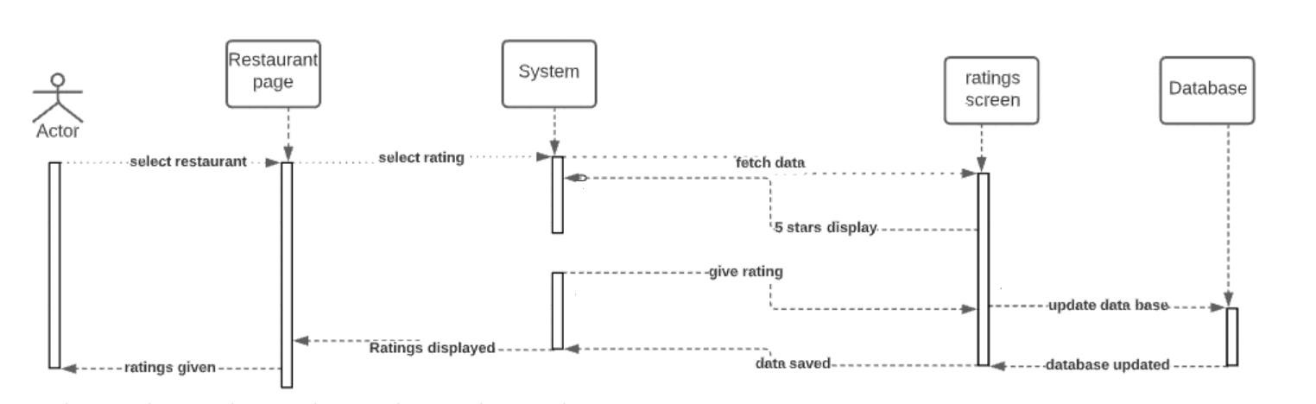
Figure 23 Sequence diagram of Rating Restaurants

3.3.4 QR Code Scan
For User Module
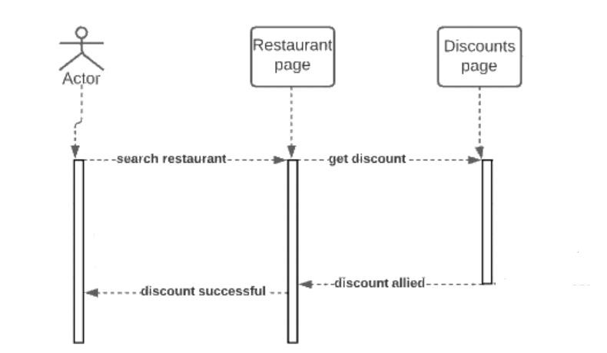

Figure 24 Sequence diagram QR Code Sca

3.3.5 Search Restaurants
For User Module
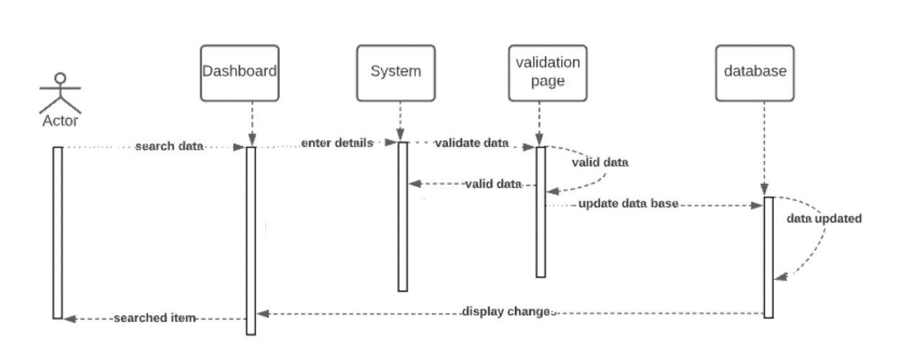
Figure 25 Sequence diagram of View Restaurants

3.3.6 Delete Post
For User, Admin and Restaurant Owner Modules
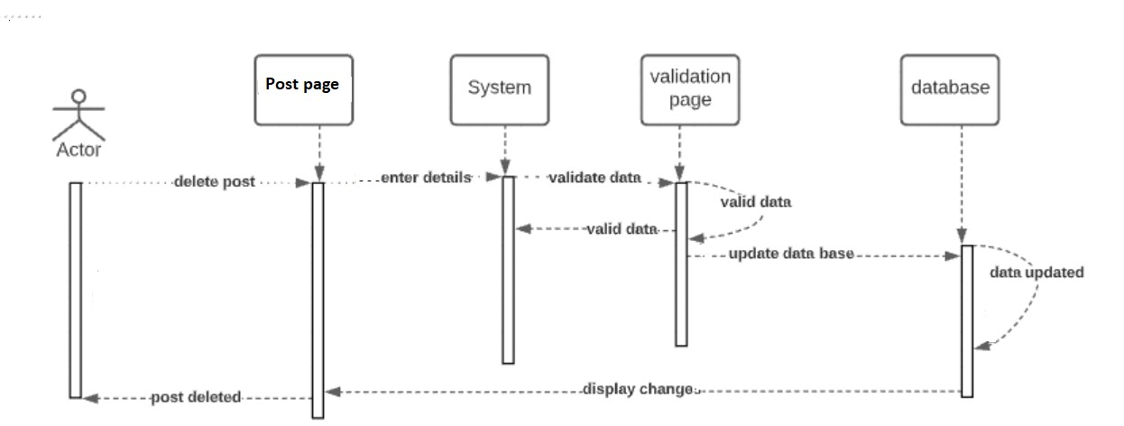

Figure 26 Sequence diagram of delete post

3.3.7 Add Restaurants details
For Restaurant Owner and Admin Modules
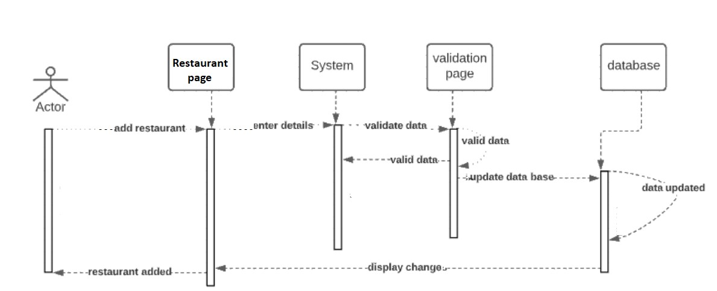

Figure 27 Sequence diagram of add restaurant details

3.3.8 Edit/delete restaurant details
For Restaurant Owner and Admin Modules
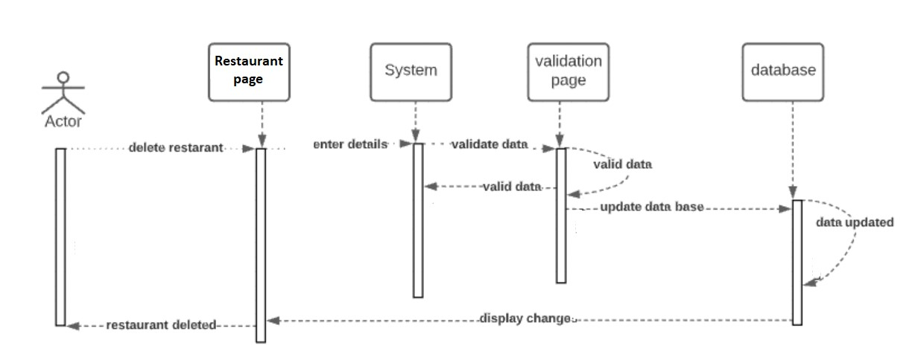

Figure 28 Sequence diagram of edit/delete restaurant details

3.3.9 Add menu items
For Restaurant Owner and Admin Modules
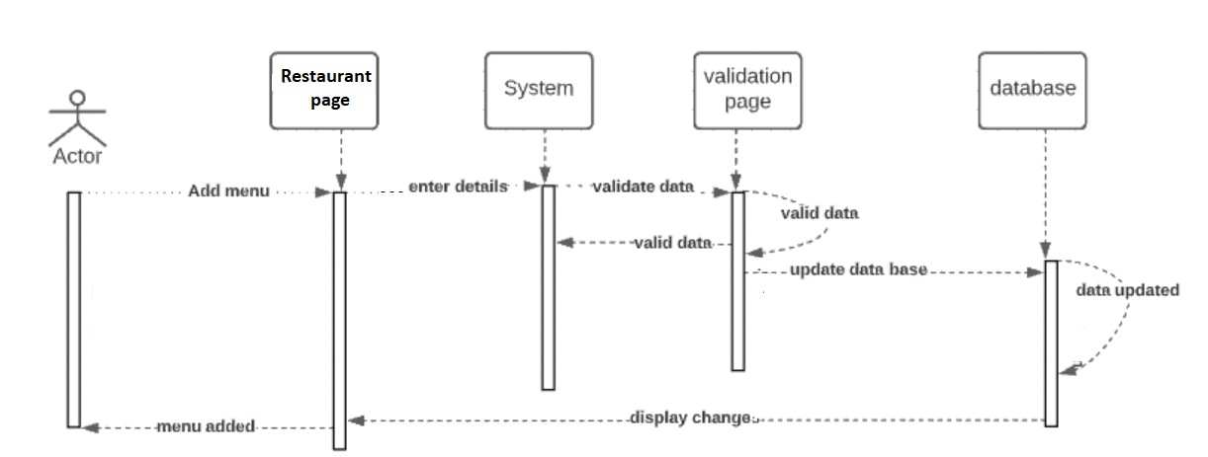

Figure 29 Sequence diagram of add menu items

3.3.10 Delete menu items
For Restaurant Owner and Admin Modules
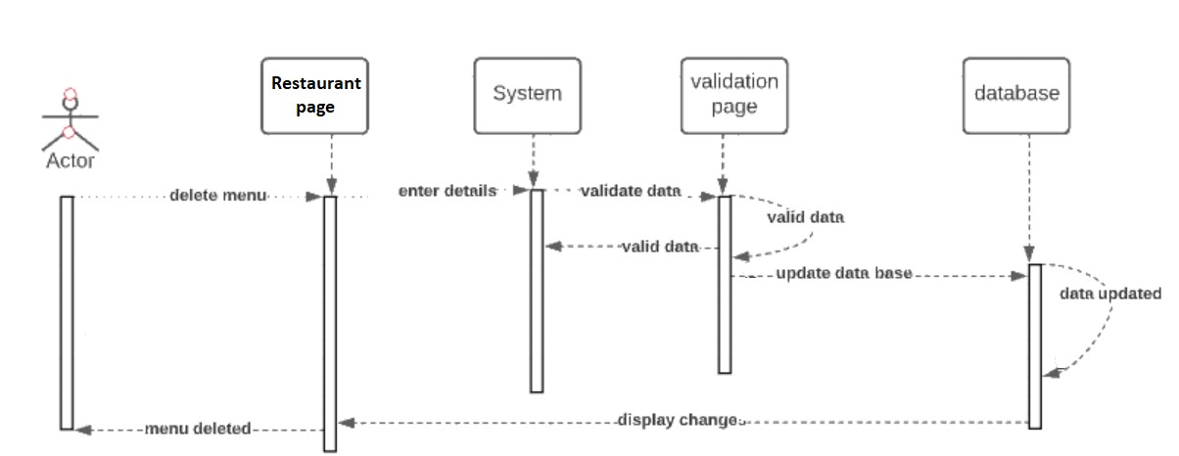

Figure 30 Sequence diagram of delete menu items

3.3.11 Save post
For user and restaurant owner modules
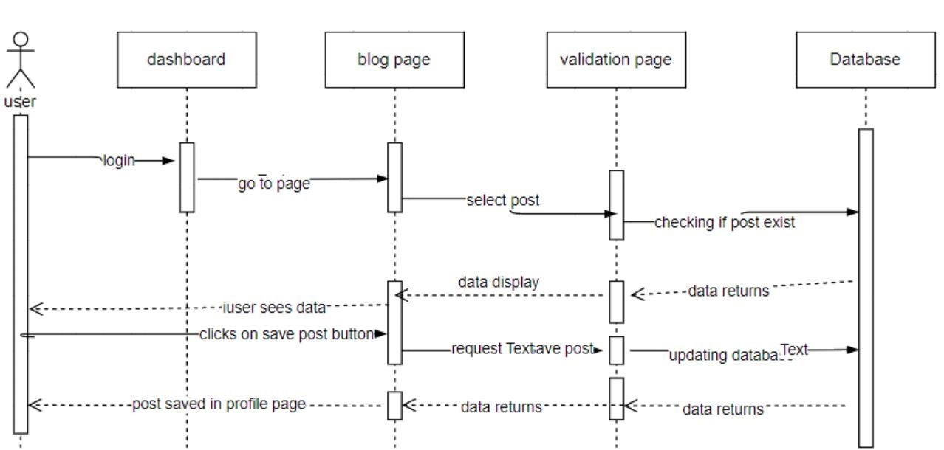
Figure 31 Sequence Diagram Post

3.3.12 Share Post
For user and restaurant owner modules
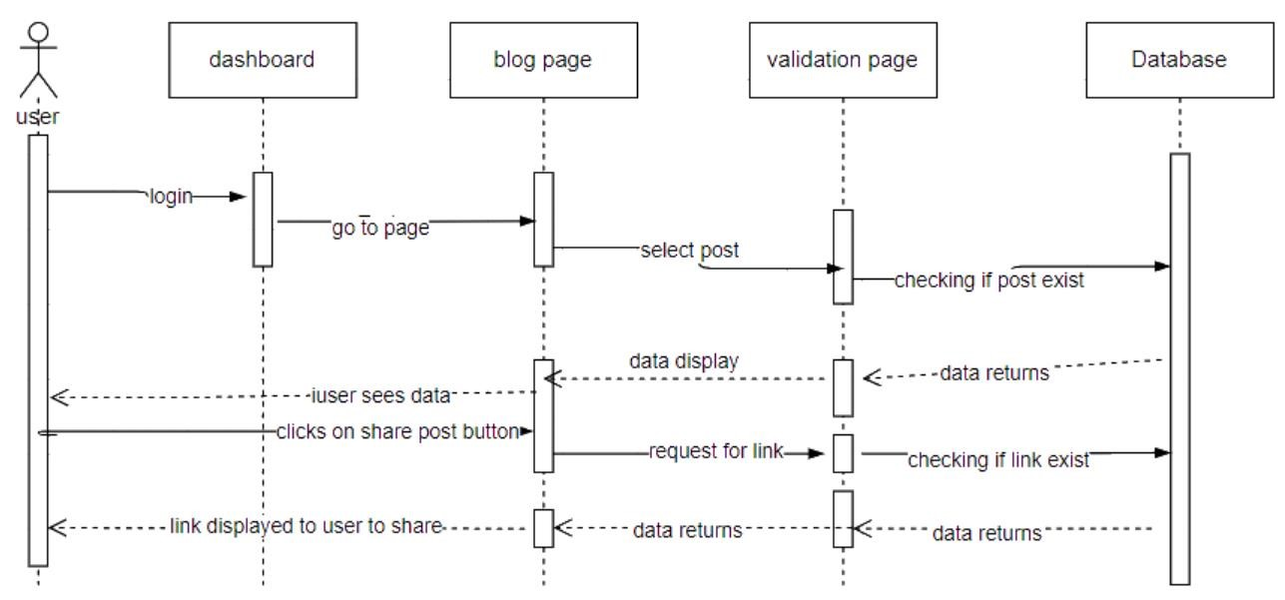
Figure 32 Sequence Diagram Share Post

3.3.13 Moderator (Admin)
For admin Module
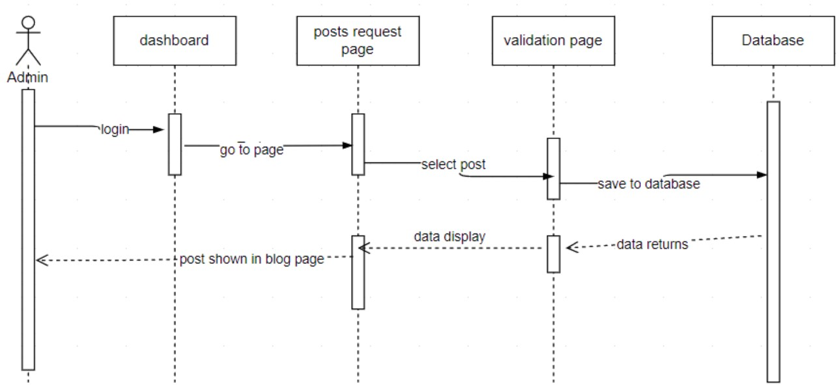
Figure 33 Sequence Diagram Moderator

3.3.14 Blog Page
For user and restaurant owner module
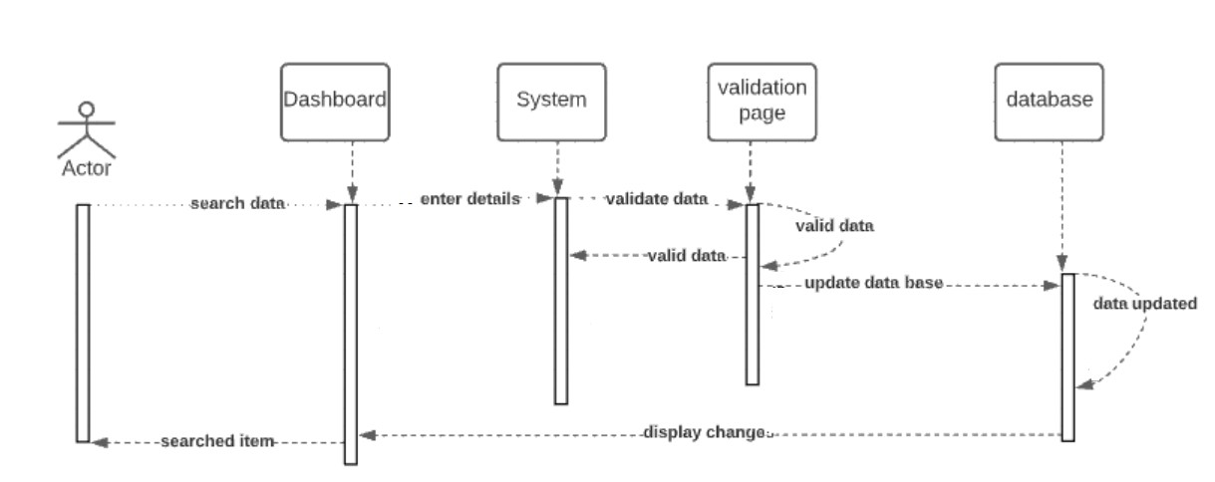
Figure 34 Sequence Diagram Blog page

3.4 Software architecture

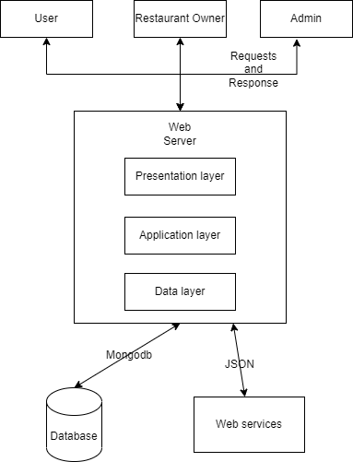
Figure 35 Software Architecture

3.5 Class diagram

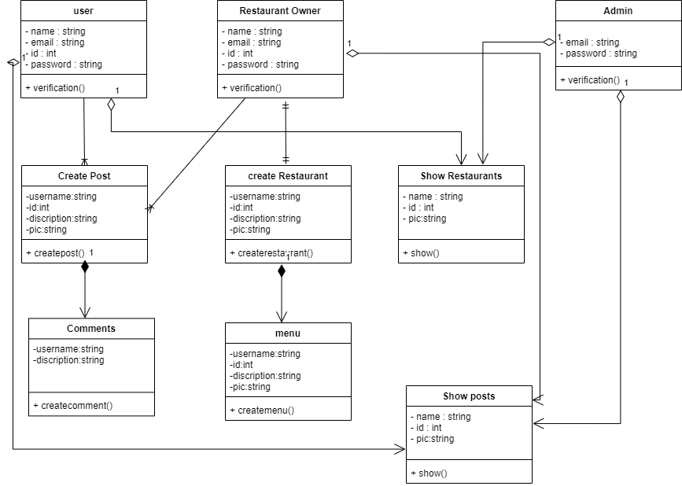
Figure 36 Class Diagram

3.7 Collaboration diagram

A collaboration diagram, also known as a communication diagram, is an illustration of the relationships and interactions among software objects in the Unified Modeling Language (UML). These diagrams can be used to portray the dynamic behavior of a particular use case and define the role of each object.

3.7.1 Login
For user, restaurant owner, admin modules
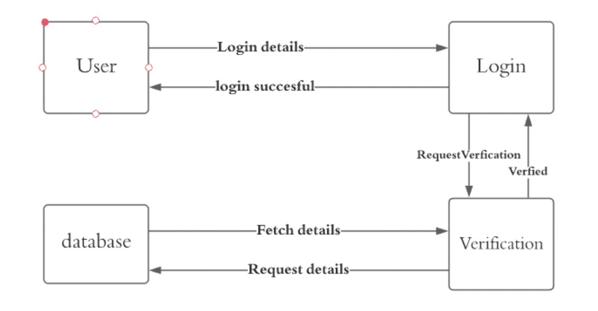

Figure 38 Collaboration diagram of login

3.7.2 Add restaurant Details
For restaurant owner and admin module
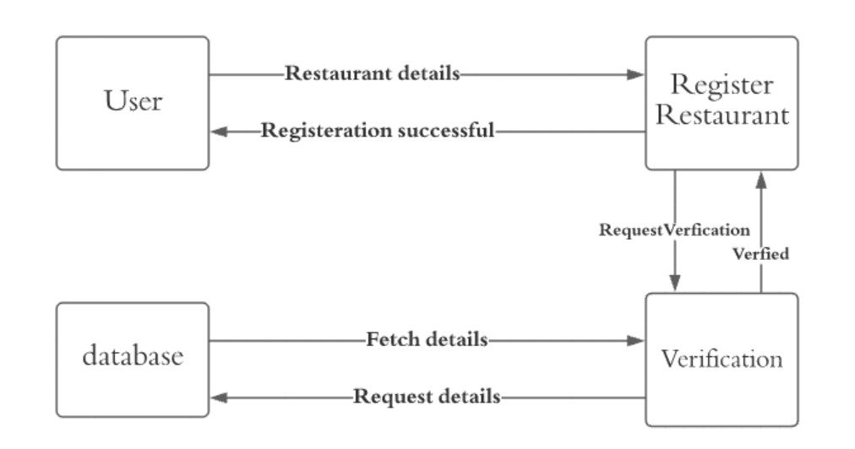Figure 39 Collaboration diagram of register restaurant

3.7.3 View Restaurants
For user module
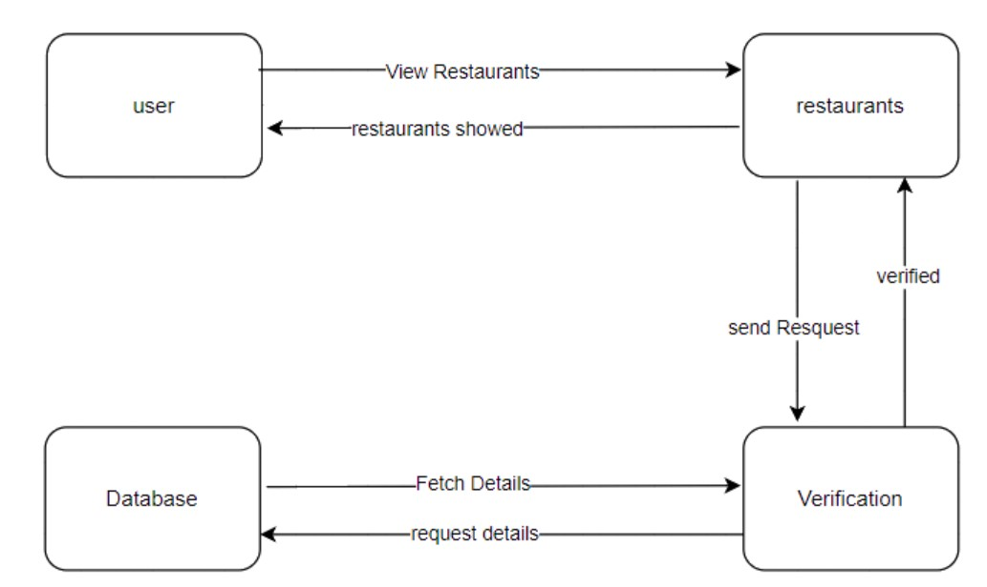
Figure 40 Collaboration Diagram view restaurant

3.7.4 View Menu
For user module
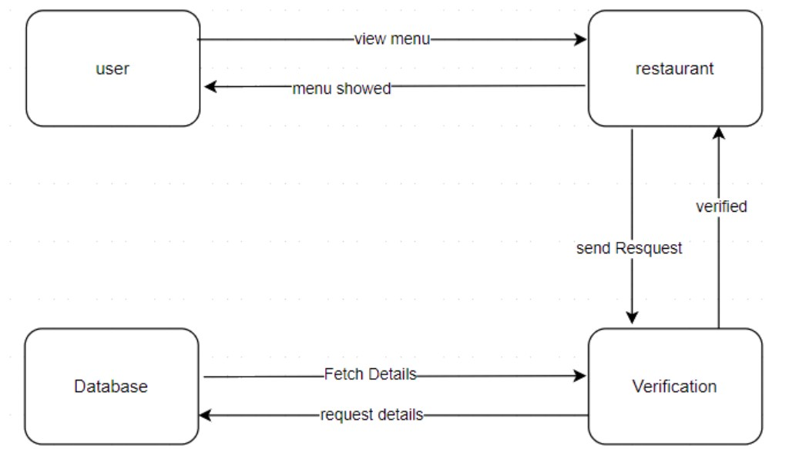
Figure 41 Collaboration diagram view menu

3.7.5 Scan QR code
For user Module
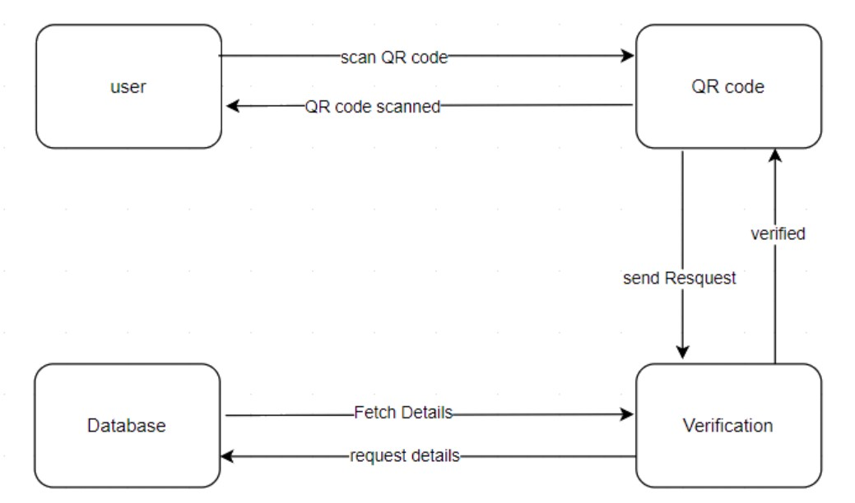
Figure 42 Collaboration Diagram Scan QR code

3.7.6 Rating Restaurant
For user module
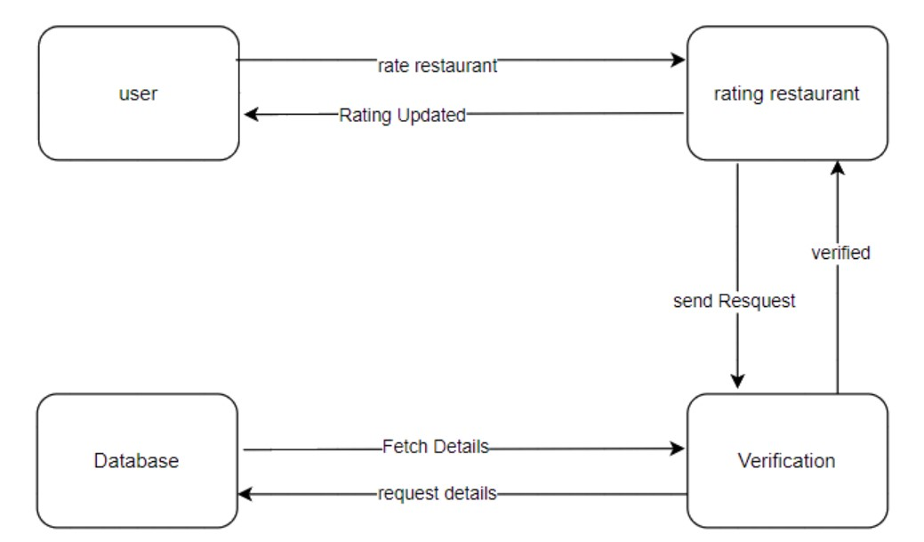
Figure 43 Collaboration Diagram Rating Restaurant

3.7.7 Create post
For user and restaurant owner module
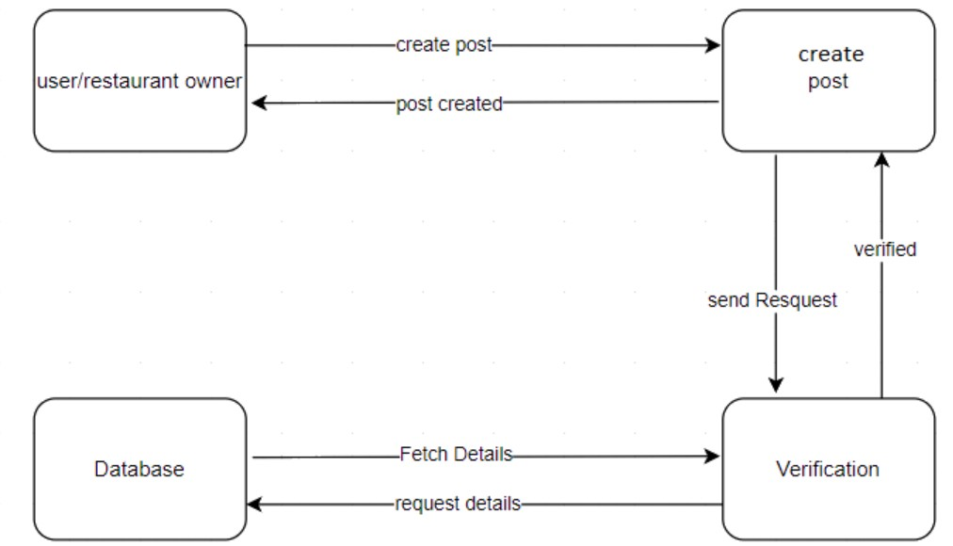
Figure 44 Collaboration Diagram Create post

3.7.8 Delete post
For user, restaurant owner, admin modules
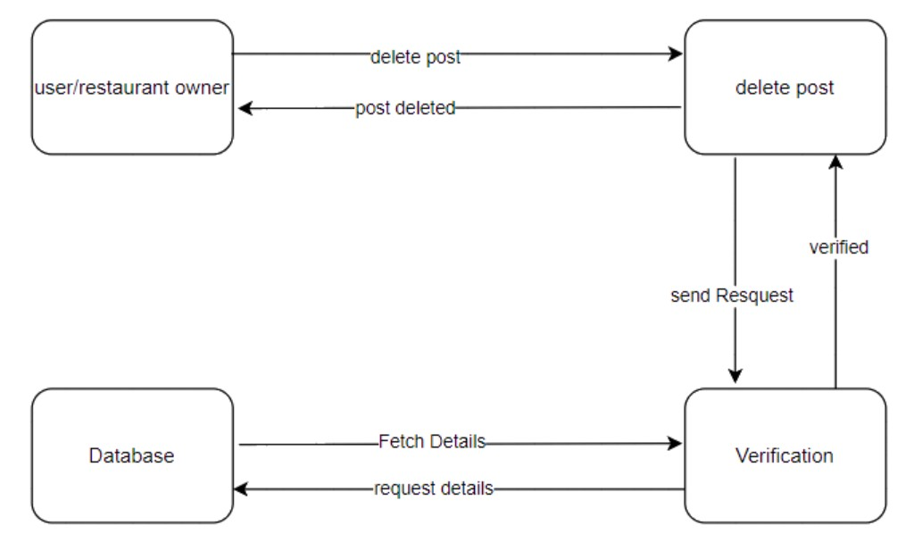
Figure 45 Collaboration Diagram Delete Post

3.7.9 Share post
For user and restaurant owner module
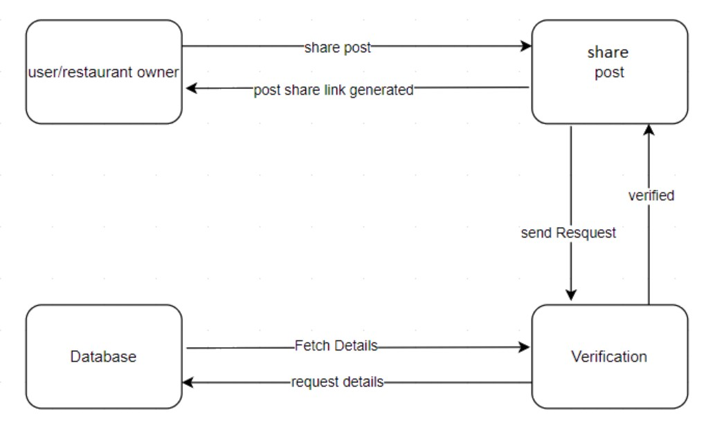
Figure 46 Collaboration Diagram Share post

3.7.10 Comment on post
For user and restaurant owner modules
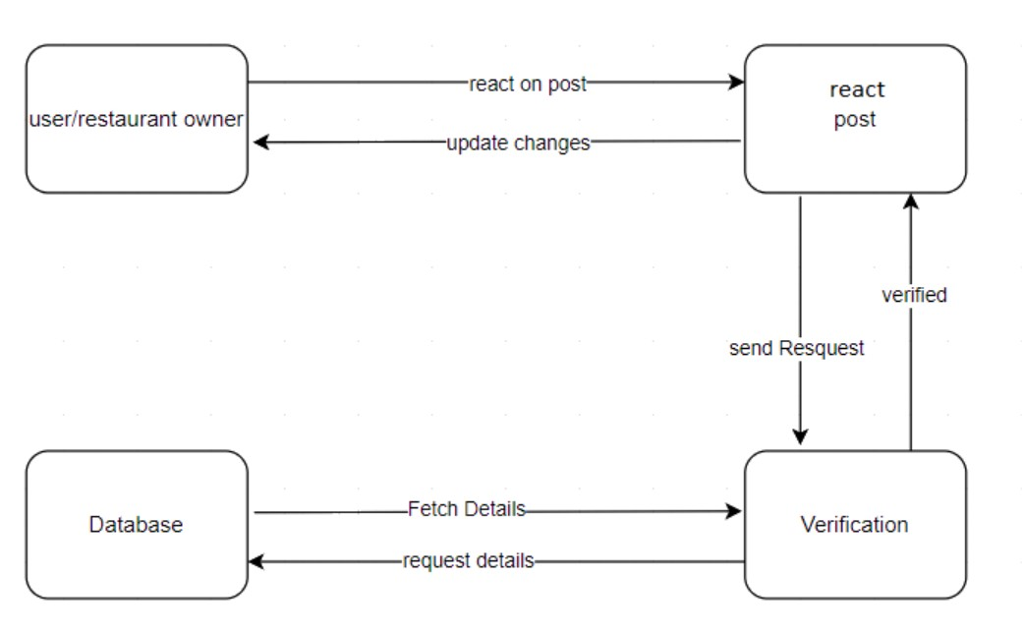
Figure 47 Collaboration Diagram React Post

3.7.11 Add menu
For restaurant owner and admin module
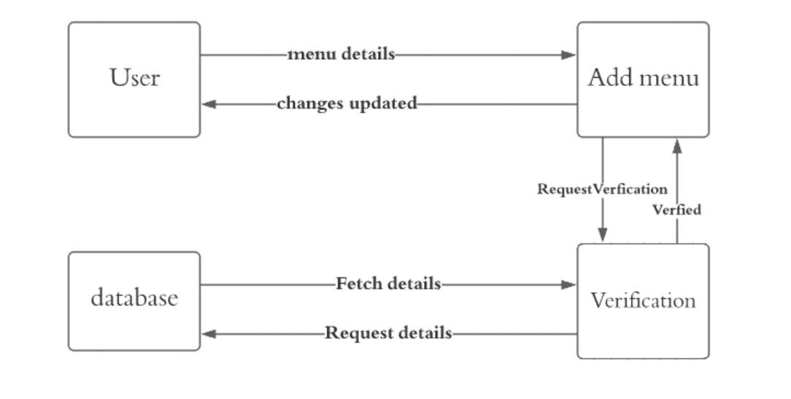
Figure 48 Collaboration diagram of add menu

3.7.12 Delete menu
For restaurant owner and admin module
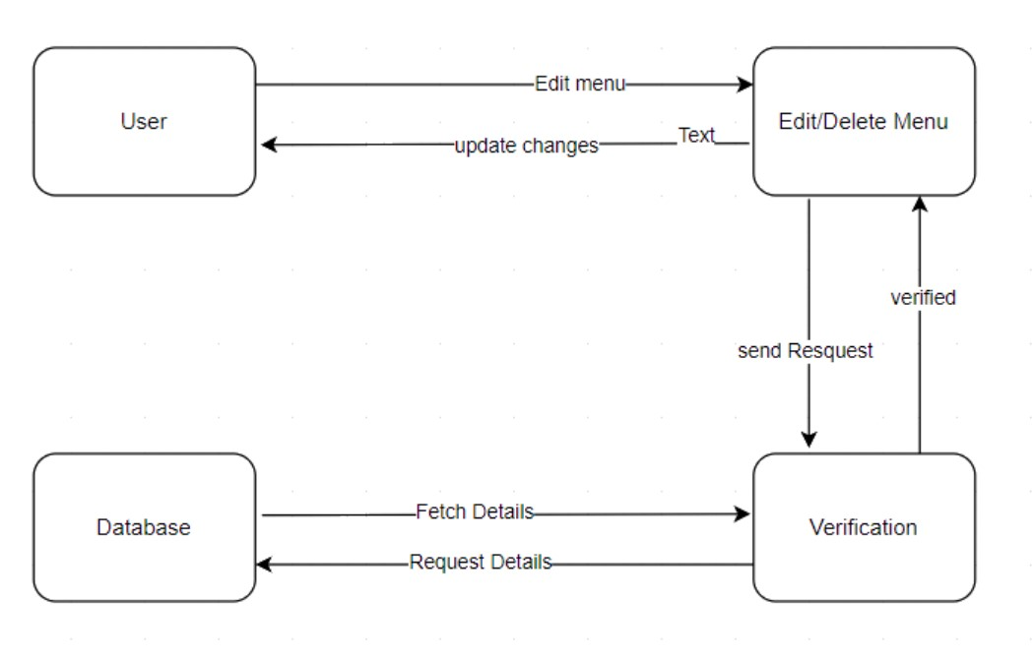
Figure 49 Collaboration Diagram Delete menu

3.7.13 Modetor
For adminmodule
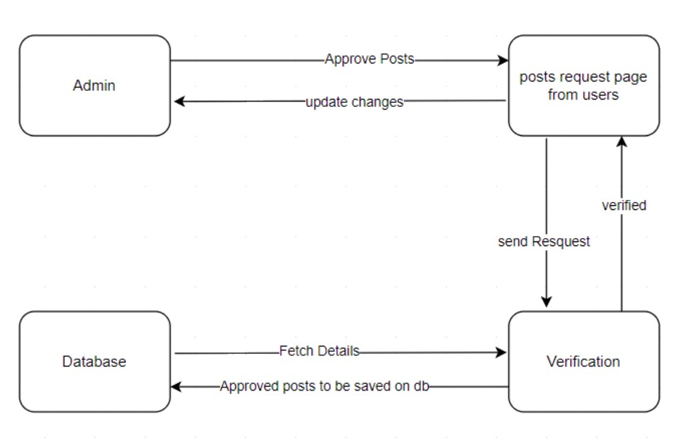
Figure 50 Collaboration Diagram Moderator

4 CHAPTER 4: TESTING

Software testing is the process of evaluating and verifying that a software product or application does what it is supposed to do. The benefits of testing include preventing bugs, reducing development costs, and improving performance.

4.1 Unit Testing
The procedure through which all the individual components of a system are inspected and tested is called unit testing. Unit testing is mainly performed at the module level so that each aspect of the application can be verified.

4.2 Integration testing
Modules are those smaller units which were integrated in the earlier stage. In the Integration testing phase, all the modules are combined and then are tested to check the complete working of that functionality. In this phase we will be testing all the possible actions which the users and admins are going to perform logically.
In our Project, after the creation of restaurants, notifications are sent to the user. In this way one functionality depends on others.

4.3 System Testing
After completion of unit and integration testing, we tested our Application and Amin panel. We Tested all the functional requirements of the Application and Admin panel and fixed all the Bugs We found while testing those requirements of the system.

4.4 Acceptance testing
After completion of system testing our project has been tested according to user’s requirements. We tested our application and web panel with specific users to make sure that our app and admin panel is working properly or not before delivering it to customers.

4.5 Manual Testing
As manual testing ensures correctness and is reliable as well, that is why our Project has been tested manually.

4.6 Pass/fail Criteria
The pass/fail criteria of our project are quite simple. If the test case post conditions are fulfilled, then the test case is passed otherwise it is failed.

5 CHAPTER 5: CONCLUSION

5.1 Project Summary

The proposed system will be web-based system through which a user can use to view different restaurants in Lahore and see their menus and will also be able to avail discounts through QR code scan. It will also show users to view location of restaurant and navigate to the selected restaurant through google map. This system will also facilitate restaurant owners. They just simply need to register on the system and set up their restaurant by creating menu and adding menu items prices, location of restaurant and restaurant name etc. Users will also be able to create post and share their experiences of the different dishes that they have tried from different restaurants. Similarly, Restaurant owners will also be able to create posts to advertise their restaurant and different dishes or discounts on different deals.
The basic idea behind making this application is that people now a days are very busy in their lives. Some might have the reason of time shortage while others may not afford going out good quality restaurants because of their expensive values. Now the people neither will need to waste extra time selecting what to eat and going to which restaurant, nor will they need to pay so much money just to spend a few moments with their loved ones. People can use our application to get to know about the real quality of restaurants with the help of reviews and comments. Also, they will have to spend much lesser time to decide place and menu to eat.

5.2 Problems faced and lessons learned

Completing this document has not been without its challenges. After the submission of the proposal, different problems related to the tools, and technologies for the system were faced. At beginning, we do not even know which tools and technologies we will implement but we had already prepared ourselves for challenge. Various modules of this system were not new to us we had worked on them throughout the course of this degree but applying these to develop a complete software system will be a new challenge for us.
We faced different issues like deciding the scope of this system, working of system etc. But my supervisor helped us a lot in these issues and together I resolved these issues. Developing use case models, activity diagram, sequence diagram, system architecture and software development life cycle to be used was another problem because as mentioned doing these to develop a large system was completely new to us. After doing a lot of research looking at samples and with guidelines from our supervisor, we managed to complete that.

5.3 Future work

Once my system is developed, I aim to launch it on commercial level. I want to help people avail different discount offers on different food items. I want to help set a trend of discount gathering as many restaurants as I can that will let people have a little discount on their meals just because they have an app on their smartphones.
Depending on the success of launch, I will look forward to making IOS app. In addition, the use of application is limited within the people belonging to same City (Lahore). Currently the system will be used in Lahore. In the future, I will extend this system to different cities. In future, I would like to enhance our interface and add the functionality of AI suggestion system.

6 REFERENCES:

- http://www.esr.com.pk/Home/index#AboutUsDiv
- https://www.theinfatuation.com/travel
- https://www.facebook.com/groups/lahorefoodposting

