
BSIT-F21-001
03-135182-005 | BASIT ALI
03-135182-002 | AFAQ FAYYAZ

WEB BASED SOLUTION FOR IDENTIFICATION OF MULTI CLASS CARCINOGENIC MUTATION DETECTION

In partial fulfilment of the requirements for the degree of
Bachelor of Science in Information Technology
Supervisor: ASGHAR ALI SHAH
Department of Computer Sciences
Bahria University, Lahore Campus
June 2022

Certificate

We accept the work contained in the report titled
“Web-Based Solution For Identification Of Multi-Class Carcinogenic Mutation Detection”
written by
BASIT ALI
AFAQ FAYYAZ

as a confirmation to the required standard for the partial fulfilment of the degree of
Bachelor of Science in Information Technology.

Approved by:
Supervisor: ASGHAR ALI SHAH
(Signature)

May 23, 2022

DECLARATION

We hereby declare that this project report is based on our original work except for citations and quotations which have been duly acknowledged. We also declare that it has not been previously and concurrently submitted for any other degree or award at Bahria University or other institutions.

Enrolment | Name | Signature
03-135182-005 | BASIT ALI
03-135182-002 | AFAQ FAYYAZ

Date: May 23, 2022

Specially dedicated to
my beloved grandmother, mother and father
(BASIT ALI)
my beloved grandmother, mother and father
(AFAQ FAYYAZ)

ACKNOWLEDGEMENTS

We would like to thank everyone who had contributed to the successful completion of this project. We would like to express our gratitude to my research supervisor, ASGHAR ALI SHAH for his invaluable advice, guidance, and his enormous patience throughout the development of the research.

In addition, we would also like to express my gratitude to our loving parent and friends who had helped and given me encouragement.

BASIT ALI
AFAQ FAYYAZ

Web-Based Solution for Identification of Multi-Class Carcinogenic Mutation Detection

ABSTRACT

Many people in the world are diagnosed with cancer that can be identified with some signs and symptoms. There is much research developed to identify cancer by symptoms and imaging tests like magnetic resonance imaging (MRI), computerized tomography (CT), positron emission tomography (PET). we are focused to detect cancer in the early stages so that the doctor easily diagnosing and treat cancer without delay.

We purposed to make a web-based solution that focused on the early diagnosis of different types of cancer. We can identify cancer with a blood test, by comparing the genetic sequences we can detect and identify the type of cancer that promotes early cancer detection. The potential of this effort improves cancer outcomes because the doctor can easily identify cancer is in early stage.

TABLE OF CONTENTS

DECLARATION iii
ACKNOWLEDGEMENTS vii
ABSTRACT ix
TABLE OF CONTENTS xi
LIST OF TABLES xiii
LIST OF FIGURES xv
LIST OF SYMBOLS / ABBREVIATIONS xvii
LIST OF APPENDICES xviii

CHAPTERS
1 INTRODUCTION 1
1.1 Background 1
1.2 Problem Statements 2
1.3 Aims and Objectives 3
1.4 Scope of Project 4
2 LITERATURE REVIEW (and/or SRS) 1
2.1.1 Literature Review table 1
3 DESIGN AND METHODOLOGY 3
3.1 Benchmarking 4
3.1.1 Data Set Collection 4
3.1.2 Cancer Types 4
3.2 Data Prepossessing 5
3.3 Feature Extraction 5
3.3.1 Statistical moment: 6
3.3.2 Determination of Position Relative Incidence Matrix (PRIM) 7
3.3.3 Determination of Reverse Position Relative Incidence Matrix (RPRIM) 8
3.3.4 Frequency Matrix Determination 8
3.3.5 Accumulative Absolute Position Incidence Vector (AAPIV) Generation 9
3.3.6 Reverse accumulative absolute position incidence vector (RAAPIV) generation: 9
3.4 Deep Learning Model 9
3.4.1 RNN 9
3.5 Training and Testing 10
3.6 Evaluation 10
3.7 Use-Case Diagrams: 10
3.7.1 Login Use Case Diagram: 10
3.7.2 Sign Up Use Case Diagram: 11
3.7.3 Main Use Case Diagram: 11
3.8 Register use-case description 11
3.8.1 U2 12
3.8.2 Flow of Events 12
3.8.3 Alternative Flow 1 – The user enters wrong username and password. 12
3.8.4 Alternative Flow 2 – The User forget Password. 12
3.8.5 Exception Flow 1 – 12
3.8.6 Preconditions – User must already have the account. 12
3.8.7 Post conditions – User successfully logged in system and access the information. 12
3.8.8 Notes/Issues – None 12
3.9 Sign In use-case description 12
3.9.1 U2 12
3.9.2 Flow of Events 13
3.9.3 Alternative Flow 1 – The user enters wrong username and password. 13
3.9.4 14.3. Alternative Flow 2 – The Step User forget Password. 13
3.9.5 Exception Flow 1 – 13
3.9.6 Includes – U1. 13
3.9.7 Preconditions – User must already have the account. 13
3.9.8 Post conditions – User successfully logged in system and access the information. 13
3.9.9 Notes/Issues – None 13
3.10 Home page 13
3.10.1 U2 13
3.10.2 Flow of Events 13
3.10.3 Alternative Flow 1 – N/A 14
3.10.4 Exception Flow 1 – 14
3.10.5 Includes – U1. 14
3.10.6 Preconditions – User must already have the account. 14
3.10.7 Post conditions – User Successfully got the feature. 14
3.10.8 Notes/Issues – None 14
3.11 About page 14
3.11.1 U2 14
3.11.2 Flow of Events 14
3.11.3 Alternative Flow 1 – N/A 14
3.11.4 Exception Flow 1 – 14
3.11.5 Includes – U1. 15
3.11.6 Preconditions – User must already have the account. 15
3.11.7 Post conditions – User Successfully got the feature. 15
3.11.8 Notes/Issues – None 15
3.12 Workflow diagram 15
4 DATA AND EXPERIMENTS (and/or IMPLMENTATION) 18
4.1 Languages used for implementation 18
4.1.1 Python 18
4.1.2 Flask: 18
4.1.3 Html/ CSS: 18
4.1.4 JavaScript (JS) 18
4.2 Algorithm 19
4.2.1 RNN-Recurrent Neural Network 19
4.2.2 RNN LSTM: 19
4.2.3 RNN GRU: 19
4.2.4 RNN BIDIRECTION: 20
4.3 Tools used for Implementation 21
4.3.1 Jupyter notebook 21
4.3.2 PyCharm 21
4.3.3 Visual studio Code: 21
5 RESULTS AND DISCUSSIONS (or USER MANUAL) 23
5.1 Home Page 23
5.2 About Page 24
5.3 Detect Cancer 24
5.4 RNN LSTM Model 25
5.5 RNN GRU Model 25
5.6 RNN Bi-Directional Model 26
5.7 ROC Curve of LSTM, GRU and Bi-Directional 26
5.8 RNN LSTM Independent Testing Result 27
5.9 Loss And Accuracy Result 27
6 CONCLUSION AND RECOMMENDATIONS 29
6.1 Conclusion and Recommendations 29
REFERENCES 30

LIST OF TABLES

TABLE TITLE PAGE
Table 2.1: Literature Review Table 1
Table 3.1: Register Use Case 13

LIST OF FIGURES

FIGURE TITLE PAGE
Figure 4.1: RNN LSTM Diagram 19
Figure 5.1: Home Page Diagram 22

LIST OF SYMBOLS / ABBREVIATIONS

∑ This symbol is for summation
µ This is for prefix multiplier
$ξ$ This symbol is for Greek numerals has value of 60
Τ This represents the torque
ɳ This is for X-SAMPA
β This means beta

LIST OF APPENDICES

APPENDIX TITLE PAGE
APPENDIX A: Graphs 19
APPENDIX B: Computer Programme Listing 20

INTRODUCTION

Background

A gene is a tiny section of a long DNA double helix particle that contains nucleotide sets in a direct order. A gene is any portion of DNA that contains information that tells a cell to deliver a product, which is usually a protein. Each of these proteins is associated to a biological phenomenon that may or may not occur. The substance that appears in strands is DNA. Each cell in a person's body has a unique function. A similar DNA, yet each individual's DNA is unique Mutations, or changes in genes, are extremely important. In the progression or development of cancer A cell's transformations can cause it to produce proteins that have an impact.
Not all genes are cancer driver genes, and not all mutations provide tumours an edge in terms of growth. Only a small percentage of the mutations are malignant. As a result, just a few genes are cancer drivers. Once mutated2, a gene may provide favourable conditions for cancer growth based on its function. The TP53 gene, for example, is responsible for encoding the tumour suppressor p53 protein. The p53 protein in the cell is in charge of DNA repair.
Most of the types of cancer are diagnosed when after the patient is suffering from cancer. As we know that some types of cancer are diagnosed in the last stage like lung cancer. So, we are used to making a solution that can detect cancer in the early stage. The early diagnosis of cancer makes to increases the chance of survival of an individual. The are many countries like the USA, UK Australia, Canada, etc that can understand the potential of early-stage diagnosis of different types of cancers. There is a need to have such a system that is used to diagnose cancer in early stages so that the patient is treated without any other loss, so we are taking an initiative to make a web-based solution that helps the doctor and the other people for their early detection of carcinogenic mutation.

Problem Statements

As we know that many people across the world are diagnosed with cancer, which can be identified by certain signs and symptoms. There has been a lot of study into detecting cancer using symptoms and imaging tests.
Cancer driver genes must be identified for precision oncology and individualised cancer treatment. Scientists working on personalised cancer treatment want to find the genes that play a role in cancer development and subsequently mute those genes or their cancer-causing functional characteristics. As a result, there is a great demand for technologies that can reliably and efficiently detect cancer driver genes. The capacity to find such driver genes can aid in the unravelling of disease's unique instrument, and so play a vital role in the creation of new cancer medications and treatments. Our system is effective at detecting cancers of various types in their early stages, which is extremely beneficial to the victim's recovery from cancer. A solution based on the web that is used for the identification of carcinogenic (mutation in genes) mutation that is found in many individuals. We compare the genetic sequences through RNN (Recurrent Neural Network) using Deep Learning (Neural Network) in TensorFlow.

Aims and Objectives

This study establishes a meticulous technique for a novel computational cancer driver gene prediction model. The research utilises widely used bioinformatics and computational science methodologies to identify cancer driver genes. The straightforward procedures outlined below can help you design a practical and logical sequence-based approach for an organic framework. (1) the construction of a predictive computational method; (2) the definition of organic arrangement tests with a viable numerical expression that indicates their essential link with the targets in issue; (3) the validation of results that fairly assess the predicted precision (5) Developing a public-use framework based on a proven paradigm. We are going to make a system for the early diagnosis of different types of cancers. we are used to focusing on the top cancer present around us. So that the doctor easily treats the patient in the early stages. Some of the objectives are following
- Easily used by the doctor
- Used to detect different types of cancer (Most common)
- Open for the public usage
- Used in hospital for the early diagnosis

Scope of Project

Web based solution will provide the users to detect the type of cancer in specimen by comparing the gene sequence by the normal sequence of genes. We will help the patients to find the cancer at the early stage as in today’s life there is less research on cancer diagnosis in initial stage. There has been a lot of study into detecting cancer using symptoms and imaging tests. Our system is efficient to detect cancers of different types in the early state that is very helpful for the victim to recover from cancer.
A solution based on the web that is used for the identification of carcinogenic (mutation in genes) mutation that is found in many individuals. We compare the genetic sequences through RNN (Recurrent Neural Network) using Deep Learning (Neural Network) in TensorFlow.
This section delves into the show's computational approaches in depth. The selection/creation of a benchmark dataset, test definitions, and feature vector extraction that emphasize the dataset's attributes are the first three steps, followed by the building and training of a strong prediction model based on the data acquired within the feature vector.

LITERATURE REVIEW

2.1 LITERATURE REVIEW

There is the research developed in prostate cancer, liver cancer and non-small cell lung cancer using deep learning (RNN). There is also have research on mechanisms for breast cancer histology image classification using CNN (Convolutional Neural Network) and RNN (Recurrent Neural Network). But there is no research available in multiclass carcinogenic mutation detection.

Table 2.1: Literature Review Table
Journal/ Article | Institute | Accuracy | Published date
Prostate cancer [2] | The University of British Columbia | 0.93% | 25 June 2018
Non-small cell lung cancer [4] | Health information science and system (China) | steadily higher | 30 July 2019
Deep learning-based liver cancer detection [5] | Cognitive systems research | 99.38% | May 2019
Mechanism of breast cancer by histology image classification [3] | Yunnan University | 96.4 % | 29 November 2019

SOFTWARE REQUIREMENT SPECIFICATIONS (SRS)

2.2 User Classes and Characteristics
- General user, such as walking customer, Common person who wants to examine his test result of cancer diagnosed by our system.
- Administrator, who manage the web-based portal and its related things.
- Developer, who build the application and its features.

2.3 Operating Environment
This project is web based so here are the details of the project in the following table.

Table 2.2: Operating Environment
Operating System Environment | Website
Support Device | Any Window Using Device
Language | JavaScript (front end), Python (back end)
Tools And Technology | - Python  - TensorFlow  - Deep learning (Neural Network)  - Recurrent neural network (RNN)  - Django or Flask  - Html  - CSS

2.4 Design and Implementation Constraints
This project is web-based application so the user of the web application must have a right web application named WEB BASED SOLUTION FOR IDENTIFICATION OF MULTI CLASS CARCINOGENIC MUTATION DETECTION to access this application or use the features of this application.

2.5 Assumptions and Dependencies
This project web-based, and this application needs to be open through website so the user must need to use web device and device requires an internet connection to use this.

2.6 Other Non-Functional Requirements
2.6.1 Performance Requirements
User requires some essentials to access the application is user must have smart phone android based and laptop with windows OS, right application and internet access on it although smart phone and laptop with at least 4GB Ram and Core i5 3rd generation Processor. The More amount of ram and power CPU will affect the access of application.
2.6.2 Safety Requirements
When a user accesses the application from his/her system, he lost the connection with application e.g., smartphone damage, laptop damage or loss of internet connection in that case user session must disconnect.
2.6.3 Security Requirements
We have used best approaches for security of this application. There is more security needed on the application because anyone can sign up to this application and use its features with privileges.
2.6.4 Software Quality Attributes
This application is providing to user many features and its user interface is so simple and well designed. We specially focused on the usability for users so that every type of user can easily use this application without any assistance from others and it will highly recommended

DESIGN AND METHODOLOGY

We will use the agile methodology in our project. Agile methodology is easy to adaptable and proves that they have very efficient in such types of projects. These are the following steps.

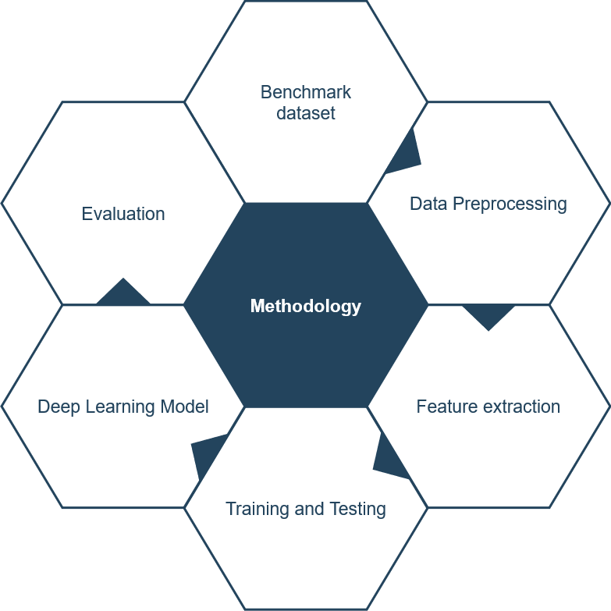
Figure 3.1: METHODOLOGY Diagram

Benchmarking
In benchmarking we can collect the information of genes and create the data set.

Data Set Collection
We can collect the normal gene sequences from ensamble.org and mutated genes from intogen.org.

Cancer Types

- Renal Clear Cell Carcinoma

- Pilocytic Astrocytoma

- Pancreas Adenocarcinoma

- Multiple Myeloma

- Medulloblastoma

Data Prepossessing

The benchmark dataset is often made up of unambiguous known samples that have been empirically established. These samples are used for testing and training purposes as well. The goal is to produce a single high-quality, diversified, accurate, and timely benchmark dataset. Furthermore, a range of experimental validation tests, such as independent set and subsampling, back up the experimental findings (K-fold cross-validation). Because the outcome is a composite of numerous unbiased dataset tests, it is critical to have consistent and meaningful data. A useful dataset of cancer driver gene sequences has been assembled, complete with detailed annotation. The dataset is required as a standard for identifying actual cancer driver gene sequences. The benchmark dataset for this study came from the most recent version of IntOgen on the internet. IntOgen contains 26,725 mutations in a wide range of human genes. The bulk of the cases include non-cancerous passenger mutations, however 2901 of the mutations reported cause cancer. These tumours have 568 cancer driver genes that produce mutations. In addition, 1754 genes were chosen with the least reciprocal homology in passenger mutations. The information gathered in this way is then utilised to generate a benchmark dataset for the topic at hand. The current study's benchmark dataset is designated as G and is characterised as follows:
$$G{=G}^{+}UG^{-}$$
After modest pre-processing and homology reduction, the final benchmark dataset contains 568 positive human gene sequences (G+) and 1743 meticulously selected negative gene sequences (G-) derived from a large collection of passenger genes.

Feature Extraction

In this phase we can make the vector matrices against the all the input because in RNN the input is in the form of 0 and 1.
Statistical moments are used in this study to provide a quantitative description of the data collection. Distinct order moments represent different data properties, and some can be used to determine data size while others can indicate data direction and eccentricity. Many moments have been described by mathematicians and statisticians. For the proposed prediction model, the central, raw, and Hahn moments are determined. Raw moments, which are scale and location variant, are used to calculate the mean, variance, and asymmetry of the probability distribution in the dataset. Central moments compute the mean, variance, and asymmetry in the same way, but they are location invariant because they are calculated with respect to the centroid. The sequence order sensitive information that these statistical moments supply is why they were chosen.

Statistical moment:
This study employs statistical moments to provide a quantitative description of data collecting. Different orders of moments represent different data quality, and some can be used to evaluate data size while others can indicate data direction and eccentricity. Mathematicians and statisticians have used polynomials and distribution functions to characterise a number of well-known moments. The central, raw, and Hahn moments are computed for the proposed prediction model. The mean, variance, and asymmetry of the probability distribution in the dataset are calculated using raw moments, which are scale and location variant. Because the computation is done with regard to the centroid, central moments calculate the mean, variance, and asymmetry, but they are location invariant. These are scale variances, on the other hand. Finally, Hahn moments are determined using Hahn polynomials and vary in scale and location. As previously indicated, the sequence order sensitive information offered by these statistical moments is a significant aspect in their selection. Furthermore, no scale-invariant moments are used. Each technique has its own approach of defining data in the form of quantified values. These moments are employed in a two-dimensional matrix P' of size n*n to accommodate all of the amino acid residues in the proposed approach.
$$P^{'}=\left[\begin{matrix}p_{11} & p_{12} & ⋯ & & p_{1n} \\ p_{21} & p_{22} & ⋯ & & p_{2n} \\ ⋮ & ⋮ & & ⋱ & ⋮ \\ p_{n1} & p_{n2} & ⋯ & & p_{nn}\end{matrix}\right]$$
The matrix transformation into P' is carried done using function. All of the moments are calculated up to degree 3 with the help of P' elements. To begin, compute the raw moments as follows:
$$M_{ij}=\sum_{p=1}^{n}{ }\sum_{q=1}^{n}{ }p^{i}q^{j}β_{pq}$$
The estimated raw moments were in the form of Moo Mo1, M10, M11, M12, M21, M30, and Mo3, and the degree of the moments was I + j. The central moments are determined as follows:
$$η_{ij}=\sum_{p=1}^{n}{ }\sum_{q=1}^{n}{ }(p-\overline{x})^{i}(q-\overline{y})^{j}β_{pq}$$
Transforming P into a two-dimensional square matrix P' gives a significant payoff because t Hahn moments are easily calculated for even dimensional data structure. Discrete Hahn moments, which are two-dimensional orthogonal moments, require a square matrix as input. Because Hahn moments are reversible due to their orthogonality, the data can be reconstructed using the inverse function of discrete Hahn moments while keeping information about sequence composition and relative positions. The following equation is used to calculate the Hahn polynomial of order n.
$$h_{n}^{u,v}(r,N)=(N+V-1)_{n}(N-1)_{n}×\sum_{k=0}^{n}{ }(-1)^{k}\frac{(-n)_{k}(-r)_{k}(2N+u+v-n-1)_{k}}{(N+v-1)_{k}(N-1)_{k}}\frac{1}{k!}$$
The pochhammer symbol and the Gamma operator are defined in the preceding paragraph. The following expression is used to determine the orthogonal normalised Hahn of two-dimensional discrete data.
$$H_{ij}=\sum_{q=0}^{N-1}{ }\sum_{p=0}^{N-1}{ }β_{ij}h_{i}^{\overset{¯}{u,v}}(q,N)h_{j}^{\overset{¯}{u,v}}(p,N),m,n=0,1,⋯N-1$$

Determination of Position Relative Incidence Matrix (PRIM)

The most important paradigm is the relative positioning of the residues, which is the cornerstone of the mathematical model for predicting the features of proteins. It is necessary to quantify the relative position of amino acids. A Position Relative Incidence Matrix (PRIM) in the form of a 20x20 matrix is constructed to extract information on the relative positions of amino acid residues in the protein.
$$S_{\text{PRIM }}=\left[\begin{matrix}s_{1→1} & s_{1→2}⋯ & s_{1→j}⋯ & s_{1→1} \\ s_{2→1} & s_{2→2}⋯ & s_{2→j}⋯ & s_{2→20} \\ s_{i→1} & s_{i→2}⋯ & s_{i→j}⋯ & s_{i→20}^{⋮} \\ s_{N→1} & s_{N→2}⋯ & s_{N→j}⋯ & s_{N→20}\end{matrix}\right]$$
The total of the relative positions of the jth residues in relation to the first occurrence of the ith residue is represented by each q9F element in this matrix. This matrix creates a total of 400 coefficients, and statistical movements for PRIM are used to further reduce the number of coefficients, resulting in a set of 24 elements.

Determination of Reverse Position Relative Incidence Matrix (RPRIM)

Relative Position Reverse RPRIM is used to identify obscure hidden features from the primary sequence of a protein with ambiguity of homologous protein sequences. RPRIM produces the same matrix (20x20 dimension) with 400 coefficients as PRIM, but in the opposite order.
$$S_{RPRIM}=\left[\begin{matrix}s_{1→1} & s_{1→2}⋯ & s_{1→j}⋯ & s_{1→20} \\ s_{2→1} & s_{2→2}⋯ & s_{2→j}⋯ & s_{2→20} \\ s_{i→1} & s_{i→2}⋯ & s_{i→j}⋯ & s_{i→20} \\ s_{N→1} & s_{N→2}⋯ & s_{N→j}⋯ & s_{N→20}\end{matrix}\right]$$
By computing statistical movements, RPRIM's dimensionality is decreased, yielding a set of 24 items.

Frequency Matrix Determination

The frequency matrix is used to construct the frequency distribution, and the frequency denotes the number of occurrences of an amino acid in the sequence.
$$ξ=\left\{τ_{1},τ_{2},⋯,τ_{20}\right\}$$

Where τv denotes the frequency with which the ith residue appears. To recover sequence compositional information, the frequency matrix is constructed.

Accumulative Absolute Position Incidence Vector (AAPIV) Generation
An accumulative absolute position incidence vector (AAPIV) of length 20 elements is produced because the frequency matrix was computed to extract compositional information but did not offer information about the relative positions of residues. AAPIV contains the total of all the ordinal values for each native amino acid found in the main sequence at its corresponding locations.
Let AAPIV be denoted as follows:
$$K=\left\{μ1,μ2,μ3,…,μ20\right\}$$
From this, an arbitrary i th
element of AAPIV is computed as
$$μ_{i}=\sum_{k=1}^{n}{ }p_{k}$$

Reverse accumulative absolute position incidence vector (RAAPIV) generation:
The reverse sequence provides a more detailed glimpse of the gene sequence's hidden patterns. The computation of AAPIV for the reverse sequence of the gene is referred to as RAAPIV. It is written as follows:
$$Λ=\left\{η_{1},η_{2},η_{3},…,η_{20}\right\}$$

Deep Learning Model

In this phase we work on RNN (Recurrent Neural Network) in TensorFlow.

RNN
Recurrent neural networks (RNN) are a type of neural network used for sequential data that is used by Apple's Siri and Google's voice search.
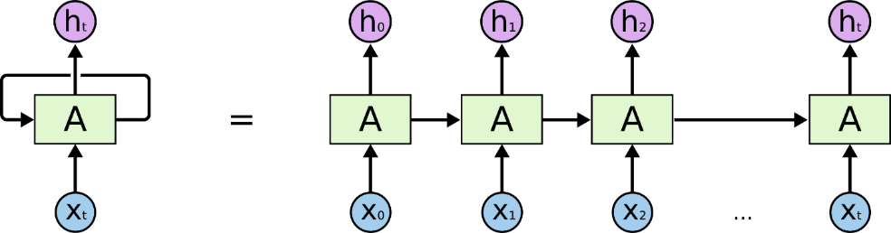
Figure 3.2: RNN Diagram

Training and Testing
In training and testing we can train the algorithm by using the dataset and test the functioning and accuracy of aur dataset. We can train our dataset in RNN all models that are LSTM, GRU and Bi-Directional. The best result shown by independent testing.

Evaluation
Once the testing of the project is done. We must evaluate the final result of the algorithm (RNN) that applied on the dataset.

Use-Case Diagrams:

Login Use Case Diagram:
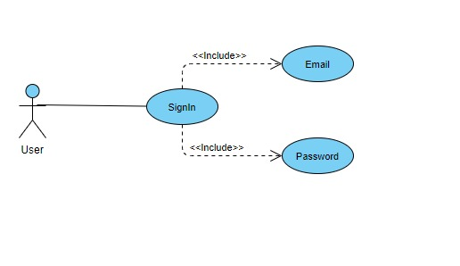

Figure ‎3.2: Login Use Case Diagram :

Sign Up Use Case Diagram:
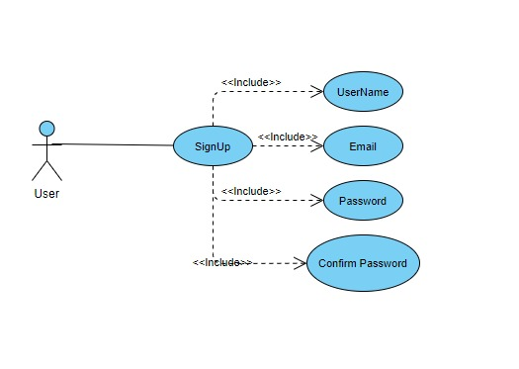
Figure 3.3: Sign Up Use Case Diagram

Main Use Case Diagram:

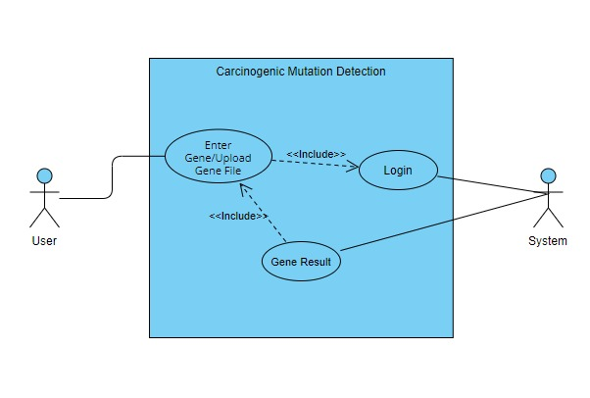
Figure ‎3.4: Main Use Case Diagram

Main Use Case 2 (About Page) Diagram:
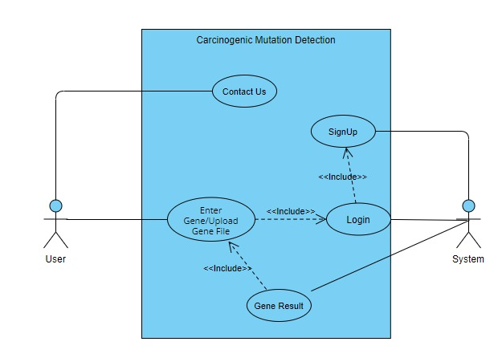
Figure ‎3.5: Main Use Case 2 Diagram

Register use-case description

U2

Objective – Give authorization to user for the access of this application features.

Priority – High

Source – Client

Actors – User

Flow of Events

Basic Flow

Users open the web application for mutation detection.

Please enter email, password.

Click on sign in option/button.

Alternative Flow 1 – NA

Exception Flow 1 –

Server down.

Includes – U1.

Preconditions – User must already have the account.

Post conditions – User successfully register in system and access the web.

Notes/Issues – None

Table 3.1: Register Use Case
ID: | U1
Name: | Register
Actor: | User
Basic Flow | Welcome to Home Page
Alternative Flow | No alternative flow.
Exit Conditions: | User can register his / her identity to use the web app

Sign In use-case description

U2

Objective – Give authorization to user for the access of this application features.

Priority – High

Source – Client

Actors – User

Flow of Events

Basic Flow

Users open the web application.

Please enter username and password.

Click on sign in option/button.

Alternative Flow 1 – The user has entered the incorrect username and password. If you input the wrong username or password, a warning will appear. Please enter your username or password again.

14.3. Alternative Flow 2 – The Step User forget Password. Users click on password reset button. Go to email for reset the account password.

Exception Flow 1 –

Server down.

Includes – U1.

Preconditions – User must already have the account.

Post conditions – User successfully logged in system and access the information.

Notes/Issues – None

Table 3.2: Login Use Case
ID: | U2
Name: | login
Actor: | User
Basic Flow | Welcome to Home Page
Alternative Flow | Enter the wrong email and password.  Re Enter the email password again
Exit Conditions: | User must give the correct credential

Home page

U2

Objective – From here user can enter the data and get the prediction information

Priority – High

Source – Client

Actors – User

Flow of Events

Basic Flow
Users open the web application.
User Login to AB Genomics.
Home pages appear
Users paste the gene sequence file or genes sequence.
Click the prediction button.
Models fetch the similar gene sequences from data and shown it to user.

Alternative Flow 1 – N/A

Exception Flow 1 –

Server down.

Includes – U1.

Preconditions – User must already have the account.

Post conditions – User Successfully got the feature.

Notes/Issues – None

Table 3.3: Home Page Use Case
ID: | U3
Name: | Home page
Actor: | User
Basic Flow | Predict the gene sequence
Alternative Flow | Enter the wrong gene sequence
Exit Conditions: | Close the web app

About page

U2

Objective – from here user can get the contact information

Priority – High

Source – Client

Actors – User

Flow of Events

Basic Flow
Users open the application.
User Login to AB Genomics.

Alternative Flow 1 – N/A

Exception Flow 1 –

Server down.

Includes – U1.

Preconditions – User must already have the account.

Post conditions – User Successfully got the feature.

Notes/Issues – None

Table 3.4: About Page Use Case
ID: | U4
Name: | About page
Actor: | User
Basic Flow | Contact information
Alternative Flow | N/A
Exit Conditions: | Close the web app

Workflow Diagram

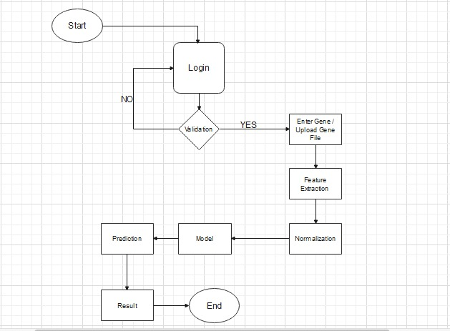
Figure ‎3.5: Workflow Diagram

Dataflow Diagram:

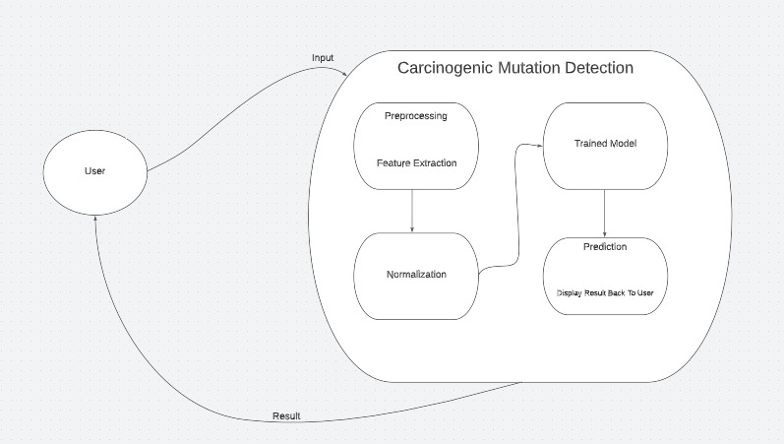
Figure ‎3.6: Dataflow Diagram
Sequential Diagram:
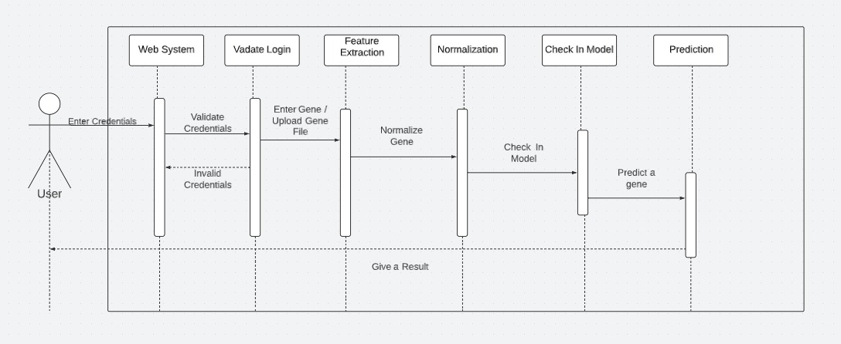
Figure 3.7: Sequential Diagram

System Architecture Diagram:
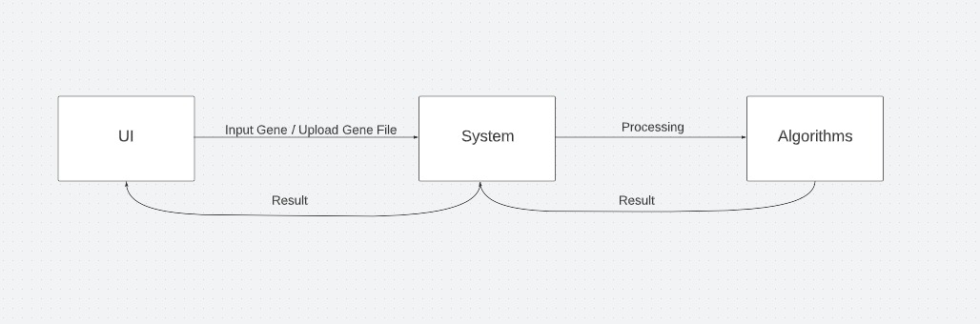

Figure 3.8: System Architecture Diagram

DATA AND EXPERIMENTS

Languages used for implementation

Python
Python is a programming language used for high-level tasks. Python is most popular language for machine learning, artificial intelligence, deep learning and many more algorithms. We have used python language as backend language in our project.

Flask:
Flask is a python framework that is used for the backend we can use the flask to integrate the deep learning model with the web so the user can easily interact with the deep learning model.

Html/ CSS:
We can use html CSS to make the frontend html to make the object arrangement and CSS for the styling we can also use the bootstrap to make the web responsive and JavaScript as well.

JavaScript (JS)
JavaScript has been abbreviated. One of the core technologies is JS, a programming language. JavaScript is used on the client side to control web page behaviour, and it frequently incorporates third-party libraries. For the frontend of our project, we used JavaScript.

Algorithm

RNN-Recurrent Neural Network
In recurrent neural networks, the output from the previous step is used as input for the next step (RNN). RNNs' most common applications are sequence classification, sentiment classification, and video classification. Speech tagging and named entity recognition include sequence labelling. We can also use the sequential data. The data we are using is the gene sequences, so this model is workable for aur data.

RNN LSTM:
For a long time, sequence prediction problems have been considered one of the most difficult problems to solve. They cover a wide range of topics, from anticipating the next word of a sentence to spotting patterns in stock market data, from film plots to recognizing your own voice. Because we already covered the fundamentals of LSTM in my previous post (which you can see on my analytics profile), it's time to dig deeper into the algorithm's intricacies. We know that LSTM is based on the concept of gates.

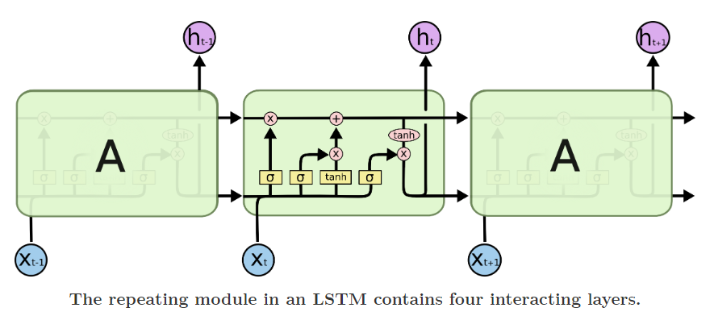
Figure 4.1: RNN LSTM Diagram

RNN GRU:
GRU (Gated Recurrent Unit) is a recurrent neural network that attempts to solve the problem of vanishing gradients. Because they are built similarly and produce similar results in certain situations, GRU could be considered a variant of the LSTM. I recommend reading my brief introduction to Recurrent Neural Networks if you are unfamiliar with them. Many people recommend Christopher Oleh's article to learn more about LSTM. I'd also recommend this work, which distinguishes between GRU and LSTM.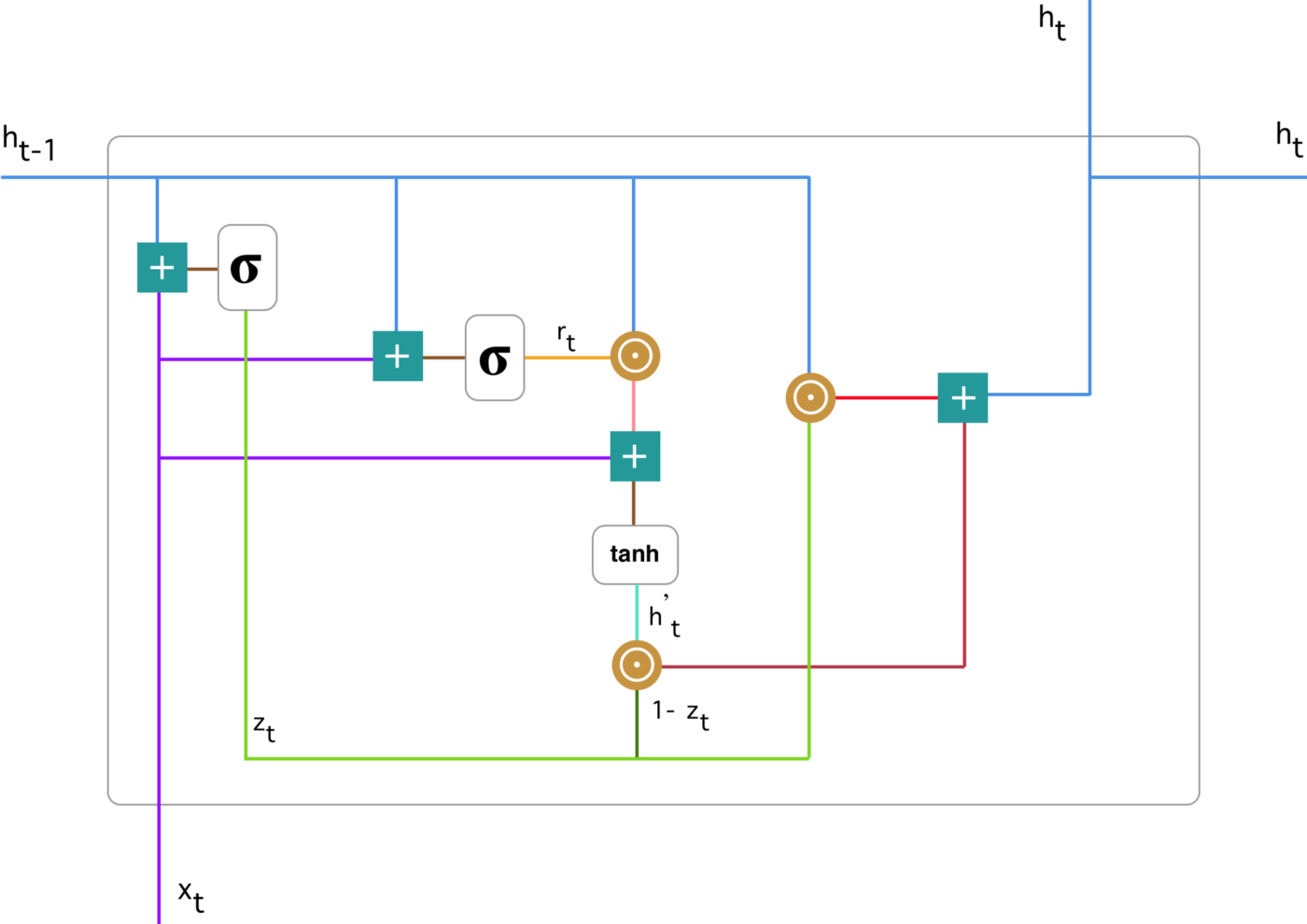
Figure 4.2: RNN GRU Diagram

To overcome the vanishing gradient problem of a regular RNN, GRU employs the so-called update gate and reset gate. In essence, two vectors determine which data should be sent to the output. They are unique in that they can be trained to retain knowledge from the past without having to wash it away over time or delete irrelevant information.

RNN Bidirectional:
Bidirectional RNNs, or BRNNs, are used to provide straight (past) and backward (future) input traversal. A BRNN is composed of two RNNs: one that moves forward, beginning at the beginning of the data sequence, and the other that moves backward, beginning at the end of the data sequence. Simple RNNs, GRUs, or LSTMs can be used as network blocks in a BRNN.

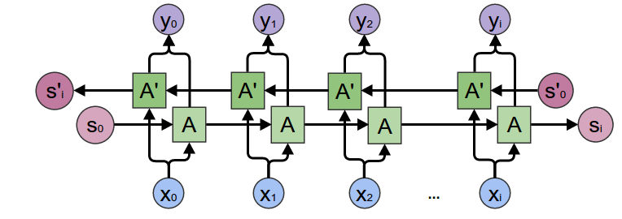
Figure 4.3: RNN Bidirectionnel Diagram

Tools used for Implementation

Jupyter notebook
Jupyter Notebook is a free and open-source web application for creating and sharing documents that include live code, equations, visualisations, and text. We can use Jupyter notebook to make aur deep learning model. We can build the hole model on Jupyter notebook it is easy to use, and the interface is really interactive so that we can use Jupyter notebook for building our model

PyCharm
PyCharm is a Python Integrated Development Environment (IDE) that contains a number of key Python developer tools that are tightly integrated to create a pleasant environment for effective Python, web, and data science development. PyCharm can be used to integrate the aur deep learning model with the front end.

Visual studio Code:
Visual Studio Code is a lightweight code editor with debugging, task execution, and version management capabilities. It aims to provide developers with only the tools they require for a quick code-build-debug cycle, leaving more complex workflows to full-featured IDEs such as Visual Studio IDE. To create the web, we can use Visual Studio Code.

RESULTS AND DISCUSSIONS

Home Page


Figure 5.1: Home Page Diagram

About Page


Figure 5.2: About Page Diagram

Detect Cancer

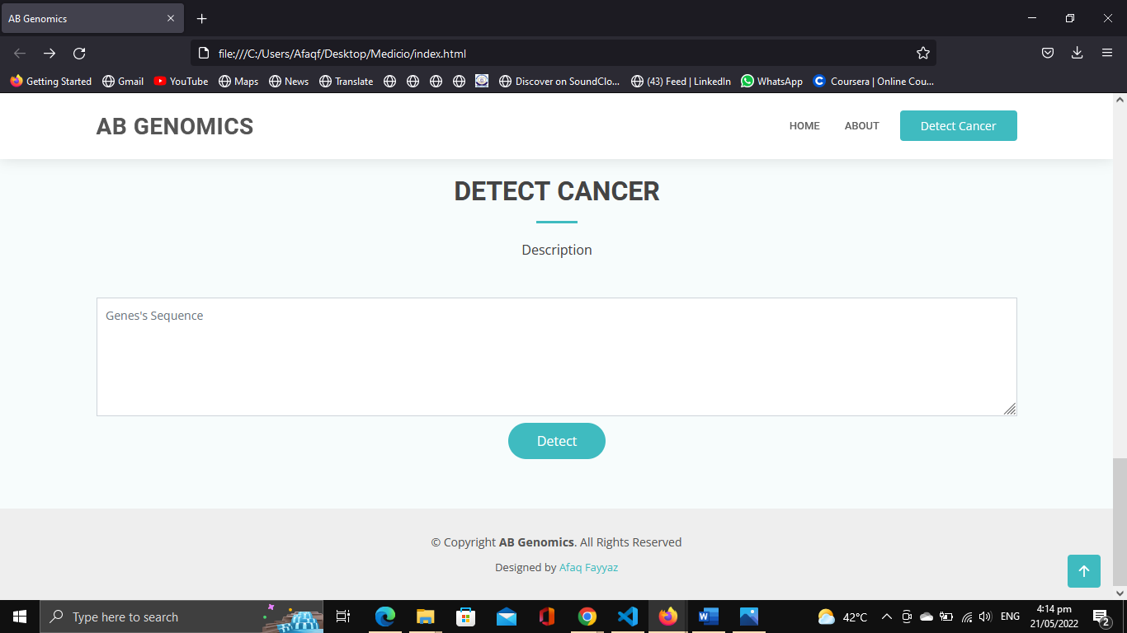
Figure 5.3: Prédiction Page Diagram

RNN LSTM Model

Model: "sequential"
_________________________________________________________________
Layer (type) Output Shape Param #
=================================================================
lstm (LSTM) (None, 100) 40800

dropout (Dropout) (None, 100) 0

dense (Dense) (None, 256) 25856

dense_1 (Dense) (None, 128) 32896

dense_2 (Dense) (None, 64) 8256

dense_3 (Dense) (None, 1) 65

=================================================================
Total params: 107,873
Trainable params: 107,873
Non-trainable params: 0

RNN GRU Model

Model: "sequential_1"
_________________________________________________________________
Layer (type) Output Shape Param #
=================================================================
gru (GRU) (None, 256) 198912

dropout_1 (Dropout) (None, 256) 0

dense_4 (Dense) (None, 256) 65792

dense_5 (Dense) (None, 128) 32896

dense_6 (Dense) (None, 64) 8256

dense_7 (Dense) (None, 1) 65

=================================================================
Total params: 305,921
Trainable params: 305,921
Non-trainable params: 0
_________________________________________________________________

RNN Bi-Directional Model

Model: "sequential_2"
_________________________________________________________________
Layer (type) Output Shape Param #
=================================================================
bidirectional (Bidirectiona (None, 522, 200) 81600
l)

dense_8 (Dense) (None, 522, 256) 51456

dense_9 (Dense) (None, 522, 128) 32896

dense_10 (Dense) (None, 522, 64) 8256

time_distributed (TimeDistr (None, 522, 1) 65
ibuted)

=================================================================
Total params: 174,273
Trainable params: 174,273
Non-trainable params: 0
_________________________________________________________________

ROC Curve of LSTM, GRU and Bi-Directional

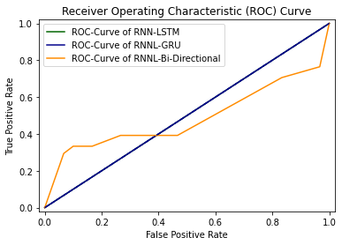
Figure 5.4: ROC Cure RNN Diagram

RNN LSTM Independent Testing Result
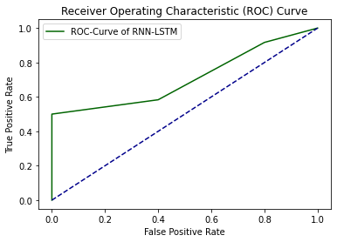
Figure 5.5: ROC Cure RNN LSTM Diagram

Loss And Accuracy Result
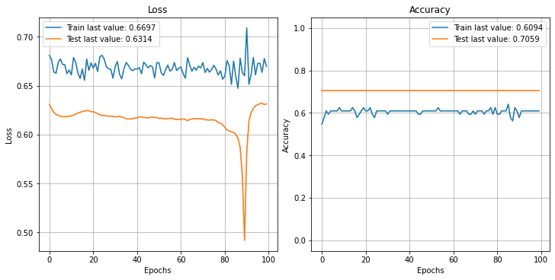
Figure 5.6: Loss and Accuracy Diagram

CONCLUSION AND RECOMMENDATIONS

Conclusion and Recommendations

We propose a web-based solution for identification of multiclass carcinogenic mutation detection who will recommend the probability of cancer that the person have it can detect the cancer on early stages by using the gene sequences of person. This platform will be equally beneficial for all users. This platform provides a user-friendly web so the ordinary person or a doctor can easily use the purpose of this is to facilitate the users. In future we will try to enhance the feature and user interface for better understanding and also add the admin panel so that can be easily used by the organisation helpful to maintain the record.

REFERENCES

[1] Xu, Y., Ding, J., Wu, L.-Y. & Chou, K.-C. iSNO-PseAAC: Predict cysteine S-nitrosylation sites in proteins by incorporating position specifc amino acid propensity into pseudo amino acid composition. PLoS ONE 8, e55844 (2013).
[2] Dietlein, F. et al. Identifcation of cancer driver genes based on nucleotide context. Nat. Genet. 52, 208–218 (2020).
[3] Network, C. G. A. R. Comprehensive genomic characterization defnes human glioblastoma genes and core pathways. Nature 455, 1061 (2008).
[4] Lathrop, M. et al. International Network of Cancer Genome Projects (Te International Cancer Genome Consortium, 2010).
[5] Korthauer, K. D. & Kendziorski, C. MADGiC: A model-based approach for identifying driver genes in cancer. Bioinformatics 31, 1526–1535 (2015).
[6] M. Barkat, Signal Detection and Estimation, 2nd Edition, Artech House , Boston, MA., 2005
[7] P. Peebles, Probability, Random Variables and Random Signal Processing, 4th Ed., , McGraw Hill, New York, 2001.
[8] A. Polydoros, ‘’A unified approach to serial search spread spectrum code acquisition-Part I: General theory’’, IEEE Transactions on Communications, vol. 32, pp. 542-549, May 1984.
[9] P. Ghandi and S. Kassam, Analysis of CFAR Processors in Nonhomogeneous Background”, IEEE Transactions on Aerospace and Electronic Systems, vol. 34, pp.8427-445, 1998
[10] C. E. Shannon, “Two-Way Communication Channels”, Proceedings of the fourth Berkeley Symposium on Probability and Statistics, pp. 611-644, Berkeley, CA, 1961
[11] M. Almarshad, M. Barkat, and S. Al-shebeili, '' A Monte Carlo Simulation for Two Novel Automatic Censoring Technique of Radar Interfering Targets in Log-Normal Clutter'', Proceedings of the International Symposium on Signal Processing and its Applications, ISSPA 2007, Sharjah, UAE, February 2007

[12] M. Barkat and P.K. Varshney, On Adaptive Cell-Averaging CFAR Radar Signal Detection, Technical Report, RADC-TR-87-160, Rome Air Development Center, Air Force Systems Command, Syracuse, NY., April 1987.
[13] L. G. Kraft, a Device for Quantizing, Grouping and Coding Amplitude Pulse, MS Thesis, Department of Electrical Engineering, MIT, Cambridge, MA, 1965
[14] Name of author(s) as above, “Title of content”, page, if any, and year. On Line, Available at: Address of link

