
BSCS-F21-022
03-134182-076 | DANISH ADNAN
03-134182-082 | SYED HAMZA NAVEED

Pak AR Verse

In partial fulfilment of the requirements for the degree of
Bachelor of Science in Computer Science
Supervisor: Tahir Iqbal
Department of Computer Sciences
Bahria University, Lahore Campus
June 2022

© Bahria University, 2022

Certificate

We accept the work contained in the report titled
“Pak AR Verse”
written by
DANISH ADNAN
SYED HAMZA NAVEED
as a confirmation to the required standard for the partial fulfilment of the degree of
Bachelor of Science in Computer Science.

Approved by:
Supervisor: Tahir Iqbal
(Signature)

14 June, 2022

DECLARATION

We hereby declare that this project report is based on our original work except for citations and quotations which have been duly acknowledged. We also declare that it has not been previously and concurrently submitted for any other degree or award at Bahria University or other institutions.

Enrolment | Name | Signature
03-134182-076 | Danish Adnan
03-134182-082 | Syed Hamza Naveed

Date : 14 June, 2022

Specially dedicated to
my beloved grandmother, mother, and father
(Danish Adnan)
my beloved grandmother, mother, and father
(Syed Hamza Naveed)

ACKNOWLEDGEMENTS

We would like to thank everyone who had contributed to the successful completion of this project. We would like to express my/our gratitude to our research supervisor, Mr Tahir Iqbal for his invaluable advice, guidance, and his/her enormous patience throughout the development of the research.

In addition, we would also like to express our gratitude to our loving parents and friends who had helped and given us encouragement.

Danish Adnan
Syed Hamza Naveed

Pak AR Verse

ABSTRACT

Today in our country we can see that the potential for tourism is rising at an extremely impressive pace, more and more local and international tourists are pouring into Pakistan, and we have seen that a lot of these tourists are interested in especially the historical sites, but as the number of tourists increase there has been a shortage of tour guides in this country , we believe or app can help them navigate sites especially historical tourists sites by using their mobile to act as a tourist guide for them using augmented reality . The tourists could use this AR app to learn more about historical sites without needing someone. It would cut their time, cut the costs associated with the personal guide, and due to the new technology used people could learn more and more about augmented reality technology itself.
The AR is the combination of 3D elements generated by the computer with real life elements, you could get a virtuous idea of thing in real life without having to buy it as you could get a computer-generated image imposed on real world to get a respectable impression.

TABLE OF CONTENTS

DECLARATION ii
ACKNOWLEDGEMENTS iv
ABSTRACT v
TABLE OF CONTENTS vi
LIST OF TABLES x
LIST OF FIGURES xi
LIST OF SYMBOLS / ABBREVIATIONS xii

CHAPTERS

INTRODUCTION 1
  - Background 1
  - Problem Statements 2
  - Aims and Objectives 3
  - Scope of Project 3

LITERATURE REVIEW AND SRS 4
  - AR Technology 4
  - User Classes and Characteristics 6
  - Operating Environment 6
  - Design and Implementation Constraints 6
  - Assumptions and Dependencies 7
  - External Interface Requirements 7
    - Hardware Interfaces 7

 | 2.6.2 | Software Interfaces | 8
2.7 | Other | Non-functional Requirements | 8
 | 2.7.1 | Performance Requirements | 8

3 | DESIGN AND METHODOLOGY | 9
 | 3.1 Methodology | 9
 | 3.1.1 Develop an Overall Model | 10
 | 3.1.2 Build A Features List | 10
 | 3.1.3 Plan by Feature | 10
 | 3.1.4 Design by Feature | 10
 | 3.1.5 Build by Feature | 10
 | 3.2 System Design | 11
 | 3.3 Use case diagrams | 11
 | 3.4 Use-case Description | 13
 | 3.4.1 Badshahi Mosque (UC-1) | 13
 | 3.4.2 Hiran Minar (UC-2) | 14
 | 3.4.3 Minar-e-Pakistan (UC-3) | 15
 | 3.4.4 Other (UC-4) | 16
 | 3.4.5 Display and interaction area (UC-5) | 17
 | 3.4.6 Go back to selection menu (UC-6) | 18
 | 3.4.7 Scale (UC-7)  3.4.8 Information (UC-8) | 19  20
 | 3.5 Sequence Diagram | 20
 | 3.5.1 Badshahi Mosue | 21
 | 3.5.2 Hiran Minar | 21
 | 3.5.3 Minar-e-Pakistan | 22
 | 3.5.4 Other | 22
 | 3.5.5 Go Back To Selection Menu | 23
 | 3.5.6 Interaction with model | 23
 | 3.5.7 Scale  3.5.8 Information | 24
 | 3.6 Collaboration Diagram | 25

3.6.1 | Badshahi Mosque | 25
3.6.2 | Hiran Minar | 26
3.6.3 | Minar-e-Pakistan | 26
3.6.4 | Other | 27
Operation Contracts 27
3.7.1 | Badshahi Mosque | 28
3.7.2 | Hiran Minar | 28
3.7.3 | Minar-e-Pakistan | 29
3.7.4 | Other | 29
3.7.5 | Display and interaction area | 30
3.7.6 | Go back to selection menu | 30
3.7.7 | Scale | 31
3.7.8 Information 31

3.7

  - Design Class Diagram 32
  - Flow Diagram 33

DATA AND EXPERIMENTS AND IMPLMENTATION 34

4.1 | Steps | 34
4.2 | Outcome | 36

RESULTS AND DISCUSSIONS 40

CONCLUSION AND RECOMMENDATIONS 41

REFERENCES 42

LIST OF TABLES

TABLE TITLE PAGE
Table 2.1: Software Interfaces 8
Table 3.1: UC_ Badshahi Mosque 13
Table 3.2: UC_Hiran Minar 14
Table3.3: UC_MinareePakistan 15
Table 3.4: UC_other 16
Table 3.5: UC_Display and Interaction Area 17
Table 3.6: UC_Go back to selection menu 18
Table 3.7: UC_Scale 19
Table 3.8: UC_Information 20
Table 3.9: OC_Badshahi Mosque 28
Table 3.10: OC_Hiran Minar 28
Table 3.11: OC_Minar-e-Pakistan 29
Table 3.12: OC_ Other 29
Table 3.13: OC_ Display and Interaction Area 30
Table 3.14: OC_Go Back to selection menu 30
Table 3.15: OC_Scale 31
Table 3.16: OC_Information 31

LIST OF FIGURES

FIGURE TITLE PAGE

Figure 3.1: (FDD) 9
Figure 3.2: Main use case 11
Figure 3.3: Use case 12
Figure 3.4: SD_Badshahi Mosuqe 21
Figure 3.5: SD_ Hiran Minar 21
Figure 3.6: SD_ MinareePakistan 22
Figure 3.7: SD_Other 22
Figure 3.8: SD_Back 23
Figure 3.9: SD_Interaction with model 23
Figure 3.10: SD Scale 24
Figure 3.11: SD_Information 24
Figure 3.12: CD_Badshahi Mosque 25
Figure 3.13: CD_Hiran Minar 26
Figure 3.14: CD_Minar-e-Pakistan 26
Figure 3.15: CD_Other 27
Figure 3.18: Design Class Diagram 32
Figure 3.19: Flow Diagram 33
Figure 4.1: Blender-1 34
Figure 4.2: Blender-2 35
Figure 4.3: Export In Unity 35

LIST OF SYMBOLS / ABBREVIATIONS

AR Augmented Reality
3D Three Dimensional
UC Use case
SD Sequence diagrams
CD Collaboration Diagrams
OC Operation Contract

INTRODUCTION

Background

Augmented reality and its popularity has been advancing at an exponential rate all over the world, its use in different spheres of technology especially digital engineering has been acknowledged by all the major technological powerhouses around the world, as it can be used to significantly reduce the costs associated with the modelling and manufacturing process, because of the mainstreaming of augmented reality technology we can create digital models and do testing on them without having to create physical structures first. We can now run different simulations on these AR generated objects and then simulate conditions which these objects would face in real world, find the defect, and then correct the models and then run the simulation again until we reach a satisfactory point after which we would create real world physical model.

AR has also shown a lot of potential in the tourism sector, especially with the arrival of this pandemic, as more and more people stay home, they cannot visit the sites which they want to in person, but thanks to progress in smartphones capabilities in AR has been seen as a breakthrough over the past couple of years. It has become a very powerful tool for businesses and marketing experts allowing them to change the way the users perceive their environment; this has been especially beneficial in the travel industry as augmented reality can enhance the experience of historical sites. AR changes the user’s perception of their environment around them when it is viewed through some device, AR does not change the physical model but augments it using superimposing digital modules.

Problem Statements

We have seen over the years that more and more tourists are now visiting Pakistan to
Enjoy what the country has to offer, they are especially interested in the historical sites of Pakistan. As we know that Pakistan has deeply rich history spanning multiple empires there are a lot of historical sites related to the past ,Our AR will be particularly helpful for these hundreds of thousands of tourists which visit our country every year to visit the historical sites for example the Badshahi mosque, but it has been observed that a lot of times there are not enough tourist guides to accompany these people who cannot properly learn about the historical site because of this shortage, these people would use our application to give them guidance about the historical place. It has also been observed that even when there are tourist guides available, they are either too expensive or do not know about the site and are just trying to prey on the tourists especially foreigners, using our application tourists would be able to learn about the historical site by looking at the augmented model of the real site through their smartphones.

They would also be able to look at the historical data related to the site using the application. The user would open their smartphones and by using the application, it will show them the virtual model of the site , the user would point their cameras in an open space and select the historical site that they want to augment in the real physical world by using the application, and the application would show that site and information pertaining to that site in the real physical background, it would save their time and their cost, and will give them the ability to get knowledge about the application anytime they wanted. Augmented reality has turn out to be gradually more prevalent within the travel industry. This is mostly because it allows tourism industry to augment the physical environments, they are essentially attempting to persuade customers to visit, especially historical sites, we believe our application could be very beneficial for the travel industry too.

Aims and Objectives

The objectives of the thesis are shown as following:
- Creation of a project that make it easier for tourists to get a complete understanding of the historical site they want to get knowledge about.

- Save their money.

- Letting users interact with 3D models of historical places.

Scope of Project

Our app, at its core is an augmented reality app , our users could experience history in the palms of their hands with our AR app they will be able to do just that, it will be an incredibly useful tool for tourist , especially foreign tourists who come to the country but do not know much about the history of historical sites in Pakistan , in our country there are a lot of historical sites and a population which is proud of these sites but they are not well aware about their information, whenever they go these historical sites they are unable to understand their history and how they came into existence, and in the absence of people who could make them understand about these sites out app would be of great help, even if they cannot visit they could simply open their smartphones anytime they wanted and use that to project that very historical site on their phone screen and learn about the site. While there are guidebooks available to them and maps are also available, these solutions are nowhere near advanced as books only provide a small 2D picture while our AR app would be able to create comprehensive real sized 3D models of the historical site along with information about it. We will be creating models of the most famous historical sites, we will be creating models for some of the sites, for the other two will create links to some website through which user will be able to get information and for the remaining sites we plan on using videos of the historical sites to get tourists information they want.

LITERATURE REVIEW

AR Technology:

Different experts in this field have different definitions on AR, but most of the experts believe that AR is defined as improvement of real surroundings by computer generated objects. Today we can build AR models of historical sites which have not been able to stand the test of time, we can now take a good look as to what they used to look like. There are some historical sites in Pakistan which have been neglected by the government, through use of AR we could re construct them again and use them in our application to that tourist can see the sites which have been either damaged or destroyed.

One of the Most important and very successful implementation of AR can be seen in the field of gaming world, many games which are being made now a days are being implemented in AR and virtual reality too to enhance the playing experience of the players. The field of augmented reality has expanded at a very impressive rate and is now being used in multiple spheres of work. In the field of architecture or tourism, especially of heritage sites we can use AR to complement and, in some places, even replace conventional tourism. Heritage sites are some of the most important sites for tourists who wish to go back to the past. Augmented Reality can act as an enhancement interaction tool for the tourists to relive what the past used to look like while being in the present.

In old AR implementations image target was used as a plane on which the model would be augmented, its implementation and use has largely been discontinued because even though it was easier to work with, provided stable augmentation and just 0-10% shaking and jittering of the models because it cannot be scaled and has a fixed size, and the model which is being augmented on the picture can be rotated or interacted with. One of the most common ways of augmented of objects is now plane targeting which provides a more improved interaction model, the model using this technique can be rotated, its size can be manipulated by many times and the model does not need an image target which means that the model can be augmented in any place in the world. The disadvantage is that model jittering an shaking is relatively higher and requires some work to correct the defect, the mobile phone can also have trouble detection the place for augmentation of models if the surface is shiny or if the surface is uneven and has bumps.

User Classes and characteristics

Tourist user – the user will be the tourist who wants to look at the augmented models and interact with the application.
The user will be able to perform these activities:

- Select the 3d models with which he wants to interact
- Look tat the information bout the historical site
- Select link to other sites from where he will be able to view models of other historical sites
- Go back to the main page to select other models available on the application

Operating Environment:

Operating System:
The operating environment of Pak AR Verse will be android operating system installed on an AR compatible phone.

Design and implementation Constraints:

Our application system is composed of 3D models which are to be augmented in the physical real world , for the purpose of 3D modelling we used Blender 3D modelling software, 3D modelling requires a lot of time so it took us a lot of time to make them, and in the end we managed to create three and gave links for the remaining two models to complete the project in time, for the purpose of implementing models in application we used unity 3D and implemented the coding work on the models using C# language. Sometimes when making AR applications the models made can become distorted and corrupted so stabilizing them in our application took extra time to ensure the models would not stutter and would display in the right way. We also had to ensure the compatibility of code in unity, because any updating in the Unity version may cause issues for the programme in the newer version.

Assumptions and Dependencies:

The assumptions and dependencies are:

- Android mobile phone with AR capability
- Internet connection to open links to other models.

External Interface requirements:

External interface requirements specify hardware, software, elements with which a system or component must interface.

    - Hardware Interfaces:

      - Developer: PC with 500 GB hard-disk and 8GB RAM (Minimum)
      - User: Android phone with AR compatibility (Minimum)
      - Internet connection for opening links

    - Software Interfaces:

Software Interfaces:

Table 2.1: Software Interfaces

Modules | Description
Operating System | Android
Front End | Designed in Unity
Back End | Made In Unity
API | Easy AR, AR Kit

Other Non-Functional Requirements:

The non-functional requirements will specify the criteria that can be used to judge the operations of our project

    - Performance Requirements:

The 3D models which are going to be augmented will require a compatible phone to smoothly augment the models in real physical world, the smartphone should have a good processing unit to ensure that there is no lag, and everything runs smoothly and interaction with the model which is being generated is not delayed. The interface of the application will be very simple to ensure that everyone can use it and will not face complex difficulties in operating the application.

DESIGN AND METHODOLOGY

Methodology

This project is developed using the framework of agile methodology because any agile development project involves continuous planning, continuous testing, continuous integration, and other forms of continuous development of both the project and the application resulting from the agile framework. The framework we used for our project is Feature Driven Development as it is one of the simplest and easy to follow agile methodology. FDD develops project in features and divide complex features into sub parts. FDD was constructed to adhere to a five-step process of development, which is made mostly around the features of the project.

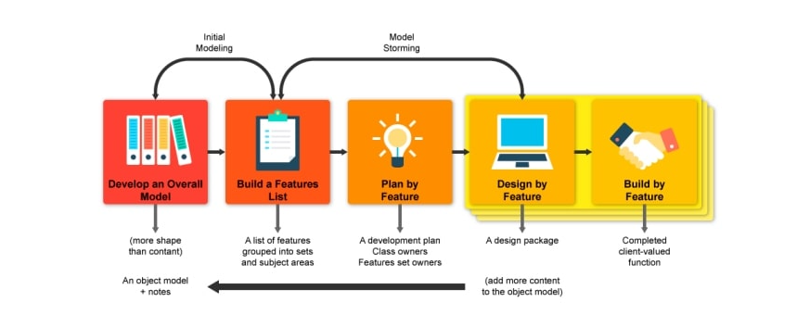
Figure 3.1: FDD

Develop an Overall Model

In this step the extent of the project is specified, and a top-level design is made by analysis of and identifying the phases of the project.

Build A Feature List

After the developing of the general model, a feature list is created by analysis and by splitting the functionality of the project.

Plan by Feature

After creating a list of features, next step is to create a progress plan of the features that were separated in the previous step.

Designing By Feature

Make the following:
      - Create use case and use case diagrams
      - Sequence diagrams
      - Collaboration diagram
      - Design the UI

Build By Feature

• Use of blender software to create the 3D models
• Add as many historical sites as we can
• Import the models in Unity software
• Using Vuforia SDK (software development kit)
• We will use these Vuforia SDK to augment these models
• Animations can also be integrated
• Using blender or unity animation maker software

System Design:

System design is the process of defining the design, modules, interfaces, for a system to satisfy specified requirements. It helps us transform a project from theory to development of system.

Use Case diagrams:

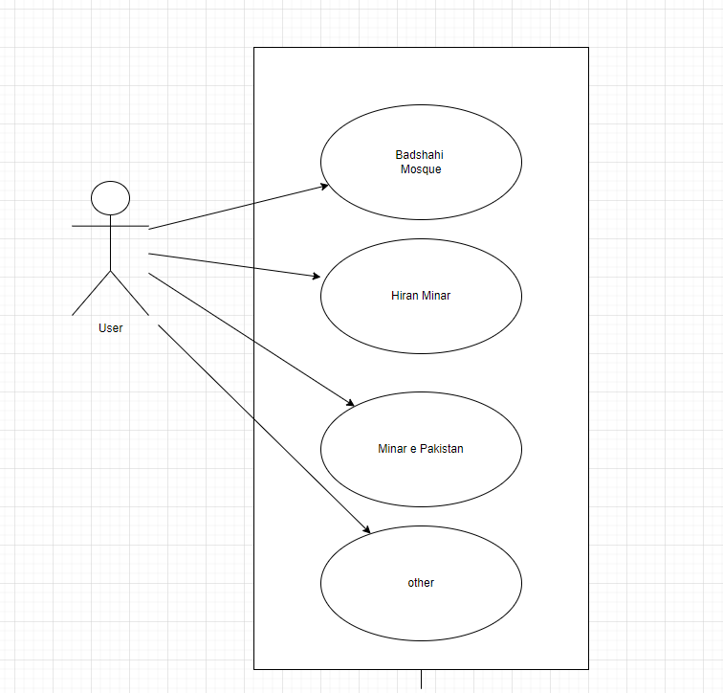

Figure 3.2: Main Use Case

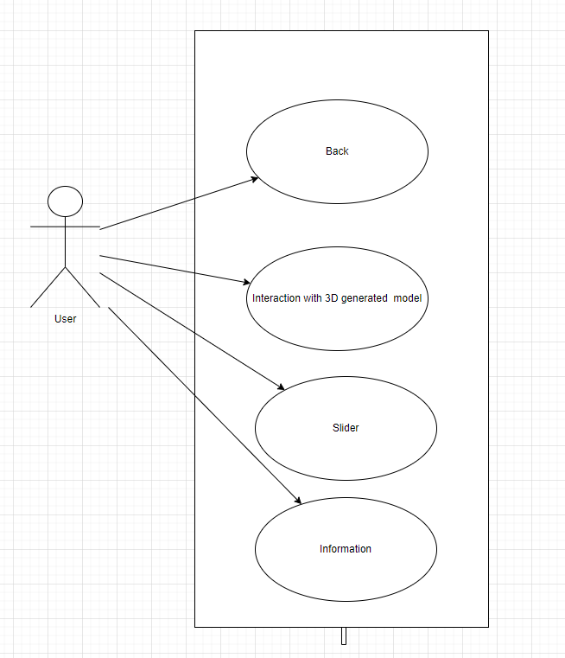

Figure 3.3: Use Case

  - Use-case Description

Description of all use cases of Pak AR Verse are written down in this section.

Badshahi Mosque (UC-1)

Table 3.1: UC_ Badshahi Mosque
 | Name | Badshahi Mosque
1. | Use-Case ID | UC-1
2. | Objective | To select the model
3. | Priority | High
4. | Source | Developer
5. | Actors | User
6. | Flow of Events
6.1. | Basic Flow | After successful selection user will go to the UC
6.2. | Alternative Flow(s) | No alternate flow.
6.3. | Exception Flow(s) | If UC-1 is not successful, user will not be able to display the model
7. | Preconditions | Mobile Phone must be AR compatible
8. | Post conditions | Successful display of 3D model and interaction with it

Hiran Minar (UC-2)

Table 3.2: UC_ Hiran Minar

 | Name | Hiran Minar
1. | Use-Case ID | UC-2
2. | Objective | View the model in AR
3. | Priority | High
4. | Source | Developer
5. | Actors | User
6. | Flow of Events
6.1. | Basic Flow | After successful selection user will go to the UC
6.2. | Alternative Flow(s) | No alternate flow.
6.3. | Exception Flow(s) | If UC-2 is not successful, user will not be able to display the model
7. | Preconditions | Mobile Phone must be AR compatible
8. | Post conditions | Successful display of 3D model and interaction with it

Minar-e-Pakistan (UC-3)

Table 3.3: UC_ Minar-e-Pakistan

 | Name | Minar-e-Pakistan
1. | Use-Case ID | UC-3
2. | Objective | View the model in AR
3. | Priority | High
4. | Source | Developer
5. | Actors | User
6. | Flow of Events
6.1. | Basic Flow | After successful selection user will go to the UC
6.2. | Alternative Flow(s) | No alternate flow.
6.3. | Exception Flow(s) | If UC-3 is not successful, user will not be able to display the model
7. | Preconditions | Mobile Phone must be AR compatible
8. | Post conditions | Successful display of 3D model and interaction with it

Other (UC-4)

Table 3.4: UC_Other

 | Name | Other
1. | Use-Case ID | UC-4
2. | Objective | The select other option which will have links of videos to other historical sites
3. | Priority | Medium
4. | Source | Developer
5. | Actors | User
6. | Flow of Events
6.1. | Basic Flow | After successful selection user will go to the UC
6.2. | Alternative Flow(s) | No alternate flow.
6.3. | Exception Flow(s) | If UC-4 is not successful, user will not be able to display the model
7. | Preconditions | Mobile Phone must be AR compatible
8. | Post conditions | Links to other videos

Display and interaction area (UC-5)

Table 3.5: UC_ Display and interaction area

 | Name | Display and interaction area
1. | Use-Case ID | UC-5
2. | Objective | Display the selected 3D model and interact with it
3. | Priority | High
4. | Source | Developer
5. | Actors | User
6. | Flow of Events
6.1. | Basic Flow | User will be able to augment the model
6.2. | Alternative Flow(s) | No alternate flow.
6.3. | Exception Flow(s) | If UC-5 is not successful, user will not be able to display the model
7. | Preconditions | Mobile Phone must be AR compatible
8. | Post conditions | Successful augment of 3D model and interaction with it

Go Back to selection menu (UC-6)

Table 3.6: UC_ Go Back to selection menu

 | Name | Go Back to selection menu
1. | Use-Case ID | UC-6
2. | Objective | Go back to the selection menu
3. | Priority | High
4. | Source | Developer
5. | Actors | User
6. | Flow of Events
6.1. | Basic Flow | User will be able to go back to the main menu
6.2. | Alternative Flow(s) | No alternate flow.
6.3. | Exception Flow(s) | If UC-6 is not successful, user will remain stuck on the second screen
7. | Preconditions | User must enter either UC1, UC2, UC3
8. | Post conditions | Successful going back to the selection menu

Scale (UC-7)

Table 3.7: UC_ Scale

 | Name | Scale
1. | Use-Case ID | UC-7
2. | Objective | Make the size of model bigger and smaller
3. | Priority | medium
4. | Source | Developer
5. | Actors | User
6. | Flow of Events
6.1. | Basic Flow | User will be able to re size the model
6.2. | Alternative Flow(s) | No alternate flow.
6.3. | Exception Flow(s) | If UC-7 is not successful, user will not manipulate the size
7. | Preconditions | User must enter either UC1, UC2, UC3
8. | Post conditions | Successful manipulation of model

Information (UC-8)

Table 3.8: UC_ Information

 | Name | Information
1. | Use-Case ID | UC-8
2. | Objective | Display the information about the model
3. | Priority | High
4. | Source | Developer
5. | Actors | User
6. | Flow of Events
6.1. | Basic Flow | User will look at the information about the model
6.2. | Alternative Flow(s) | No alternate flow.
6.3. | Exception Flow(s) | If UC-8 is not successful, user will not be able to look at information.
7. | Preconditions | User must enter either UC1, UC2, UC3
8. | Post conditions | Successful access to information of model

Sequence Diagram:

A sequence diagram shows the sequence of activities that happen in a system. The calling of methods in each object, and the order in which it happens is portrayed in a sequence diagram. This makes the sequence diagram a very valuable instrument to effortlessly represent the active performance of a system.

Badshahi Mosque

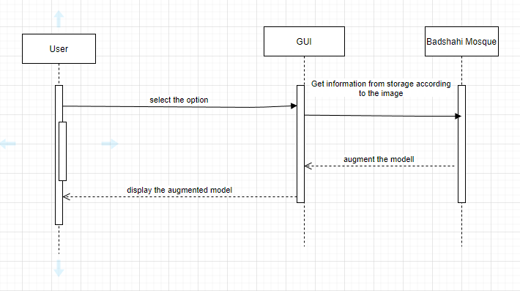
Figure 3.4: SD_ Badshahi Mosque

Hiran Minar

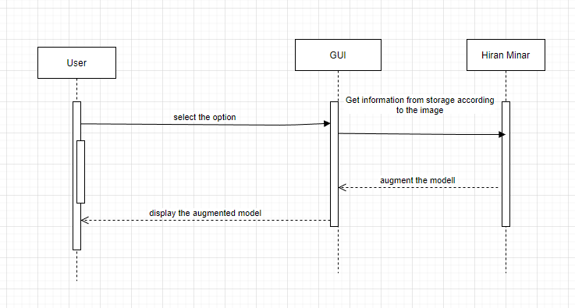

Figure 3.5: SD_ Hiran Minar

Minar-e-Pakistan

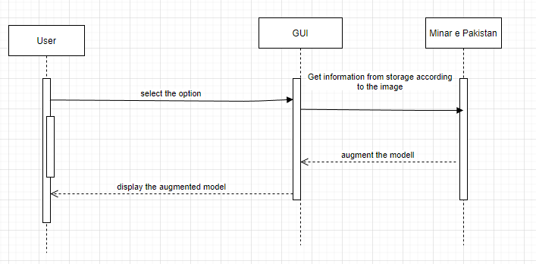

Figure 3.6: SD_ Minar-e-Pakistan

Other

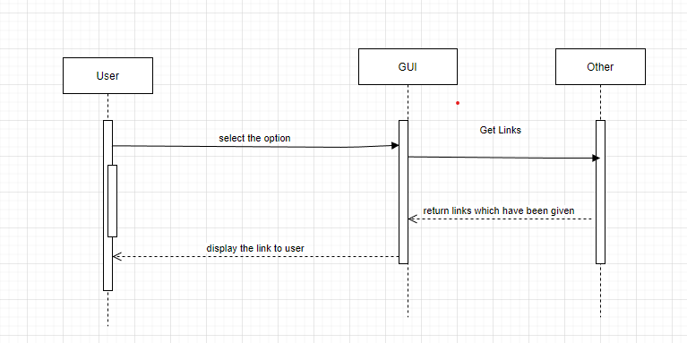

Figure 3.7: SD_ other

Back

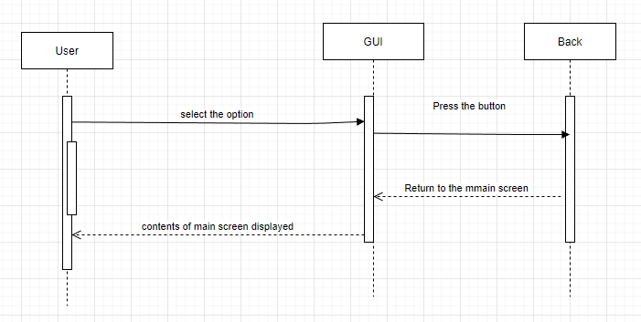

Figure 3.8: SD_ back

Interaction with model

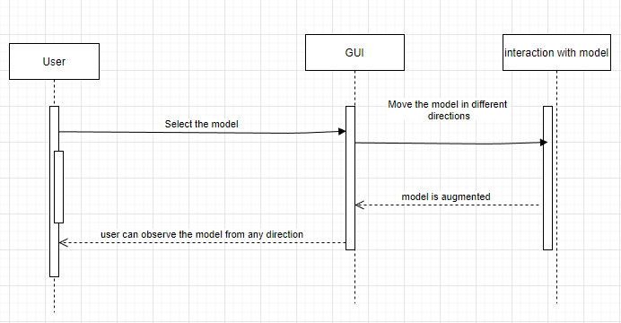

Figure 3.9: SD_ Interaction with Model

Scale

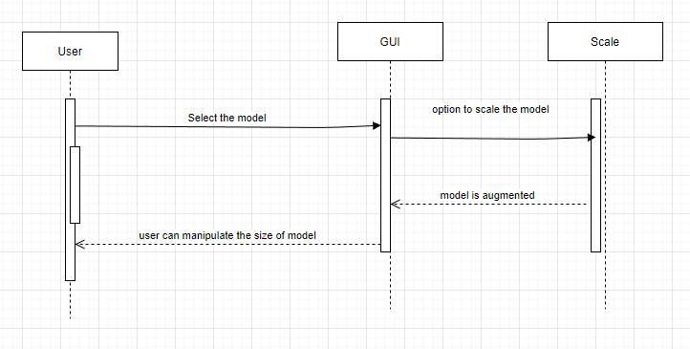

Figure 3.10: SD_ Scale

Information

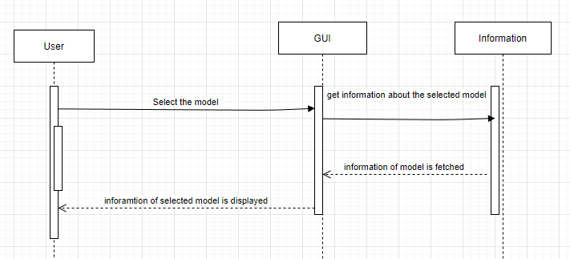

Figure 3.11: SD_ Information

Collaboration Diagram:

A collaboration diagram explains a form of interaction between objects; it reveals the objects contributing to the communication by their connections to each other and the communications that they send to each other. Collaboration diagrams help show how objects work together to execute the conduct of a specific use case, or a part of a use case. Along with sequence diagrams, collaborations are used by designers to describe and make clear the responsibilities of the objects that perform a particular flow of events of a use case.

Collaboration Diagram of our project:

Badshahi mosque

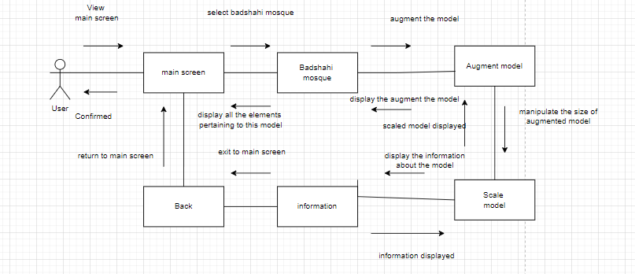

Figure 3.12: CD_ Badshahi Mosque

Hiran Minar

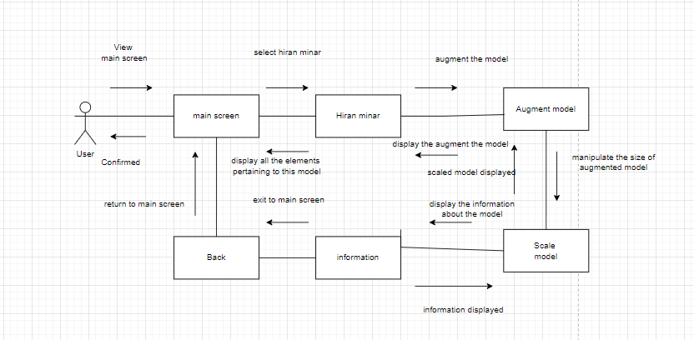

Figure 3.13: CD_ Hiran Minar

Minar-e-Pakistan

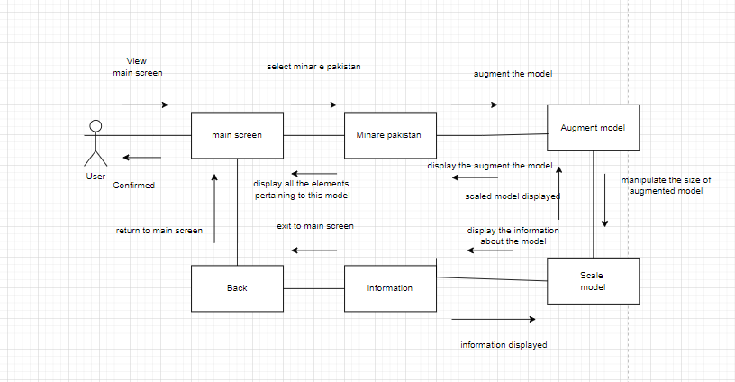

Figure 3.14: CD_ Minar-e-Pakistan

Other

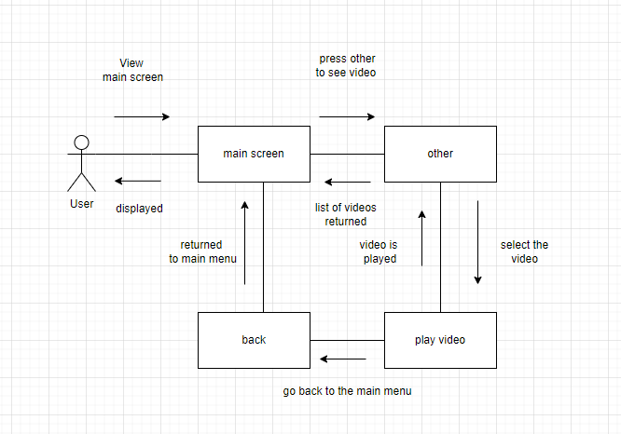
Figure 3.15: CD_ other

Operation Contracts:

A UML OC which stands for operation contracts recognizes system state modifications when an operation occurs. Essentially, it will describe what each system procedure does. A procedure is brought from a system sequence diagram. It is a distinct event from that diagram.

Operation Contracts Pak AR verse:

3.7.1 Select Badshahi Mosque

Table 3.9: OC_ Badshahi Mosque

Name | Badshahi Mosque
Responsibilities | User selects the model
Cross Reference | UC-1
Exceptions | Some other model selected
Pre-Conditions | User must have AR compatible smartphone.
Post-Conditions | User successfully selects the model and can now augment it.

Select Hiran Minar

Table 3.10: OC _ Hiran Minar

Name | Hiran Minar
Responsibilities | User selects the model
Cross Reference | UC-2
Exceptions | Some other model selected
Pre-Conditions | User must have AR compatible smartphone.
Post-Conditions | User successfully selects the model and can now augment it.

Select Minar-e-Pakistan

Table 3.11: OC _ Minar-e-Pakistan

Name | Minar-e-Pakistan
Responsibilities | User selects the model
Cross Reference | UC-3
Exceptions | Some other model selected
Pre-Conditions | User must have AR compatible smartphone.
Post-Conditions | User successfully selects the model and can now augment it.

Select Other

Table 3.12: OC _ Other

Name | other
Responsibilities | User selects other option
Cross Reference | UC-4
Exceptions | No
Pre-Conditions | User must have AR compatible smartphone.
Post-Conditions | User can successfully see the video of other historical sites

Select Display and interaction area

Table 3.13: OC -Display and interaction area

Name | Display and interaction area
Responsibilities | User selects the area in which the model will be augmented
Cross Reference | UC-5
Exceptions | No
Pre-Conditions | User must have AR compatible smartphone.
Post-Conditions | User can successfully augment the models in physical world

Select Back

Table 3.14: OC -Back

Name | Back
Responsibilities | User selects back to return to main menu
Cross Reference | UC-6
Exceptions | User already in main menu
Pre-Conditions | User must have AR compatible smartphone.
Post-Conditions | User can successfully return to the main menu screen

Select Scale

Table 3.14: OC -Scale

Name | Scale
Responsibilities | User selects Scale to manipulate the size of model
Cross Reference | UC-7
Exceptions | No
Pre-Conditions | User must have AR compatible smartphone.
Post-Conditions | User successfully increases or decreases the size of the model being displayed

Select Information

Table 3.15: OC -Information

Name | Information
Responsibilities | User selects information to learn about the model he wants to augment
Cross Reference | UC-8
Exceptions | No
Pre-Conditions | User must have AR compatible smartphone.
Post-Conditions | User successfully gains knowledge and information about the model

Design Class Diagram:

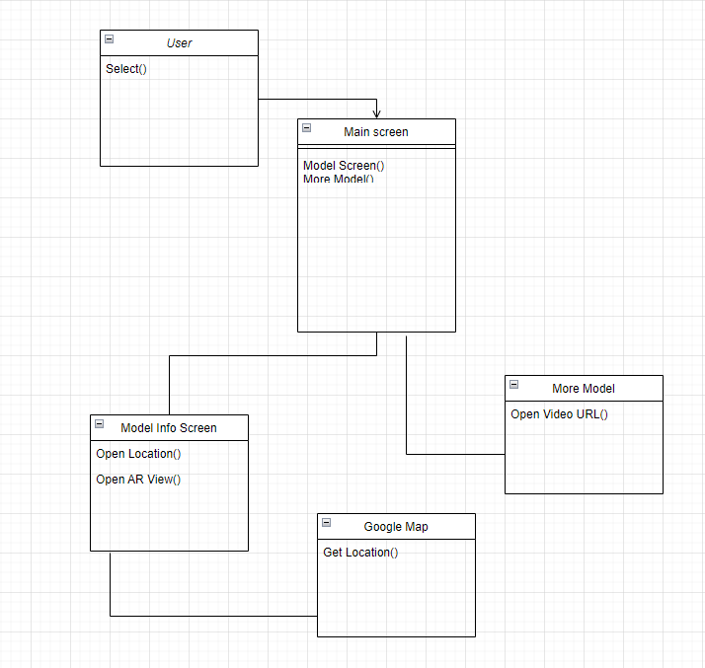

Figure 3.18: Design Class Diagram

Flow Diagram

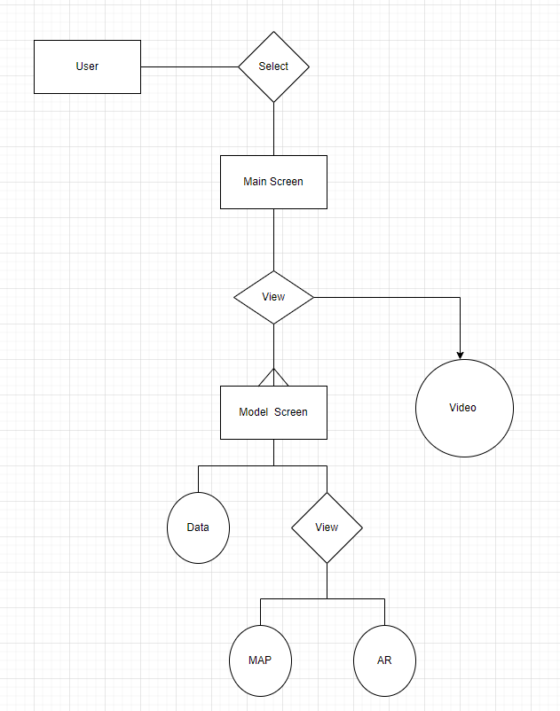

Figure 3.19: Flow diagram

IMPLMENTATION

Steps

First, we will use blender software to create models of the sites which we want to, we will try and add as many historical places as we can to ensure maximum experience, then we will import these models in unity software and then we will use Vuforia SDK to augment these models which we have created, animations can also be integrated in the application through either blender or unity animation maker.
- Using blender to create models
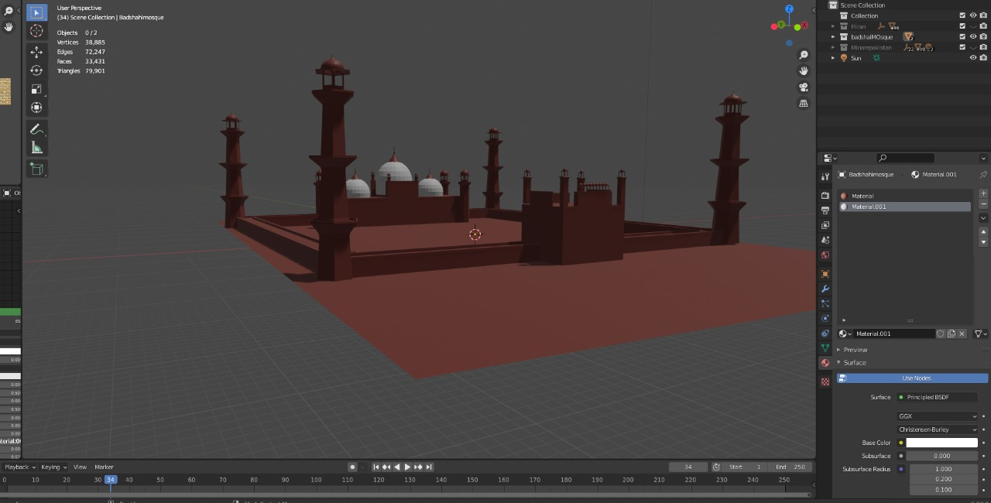

Figure 4.1: Blender Image
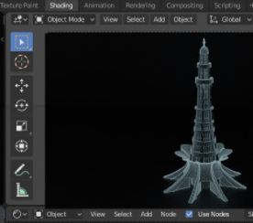
Figure 4.2: Blender image-2

- Importing models into Unity:
After making the model we will import the FBX file in Unity

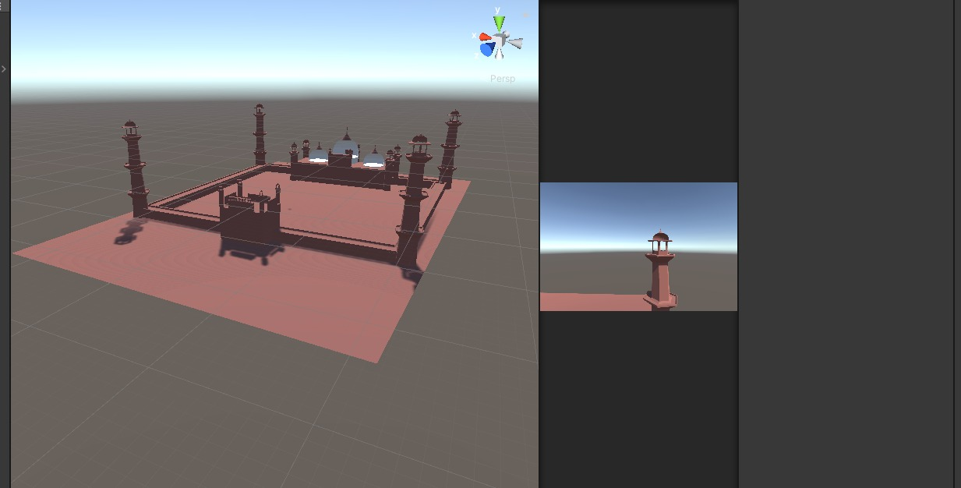
Figure 4.3: Export in unity

- Vuforia engine for android development:
The result will look like this, with historical site augmented in real physical world.

Outcome


Screen -1: Splash Screen

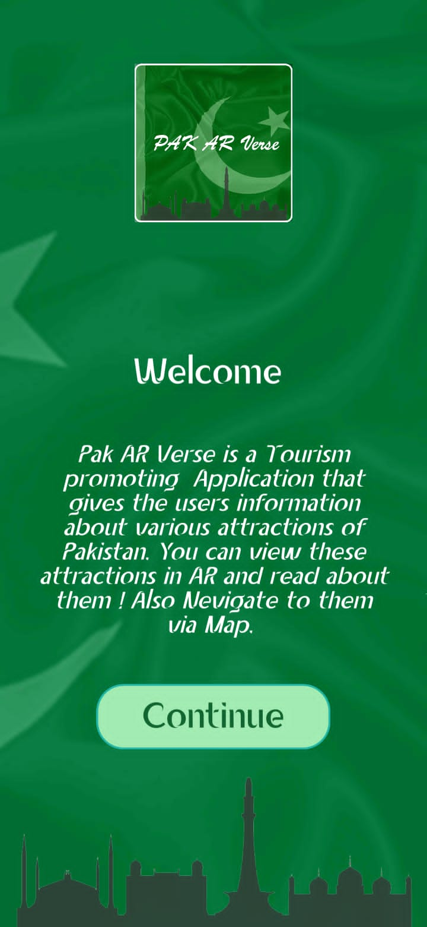
Screen -2: Welcome screen

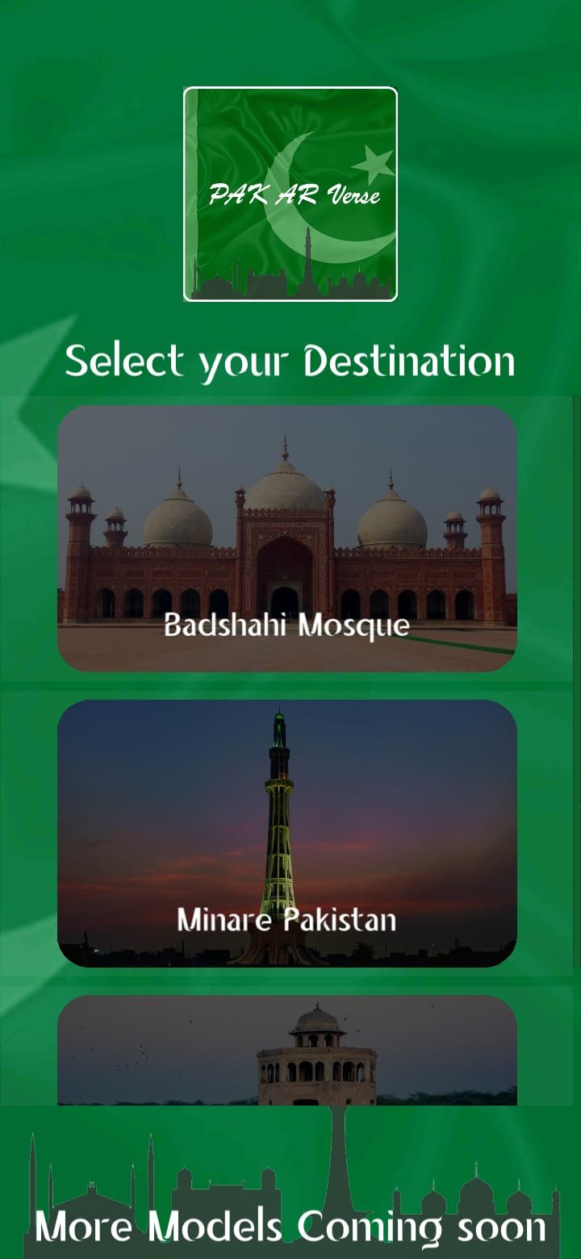
Screen-3: Selection Screen

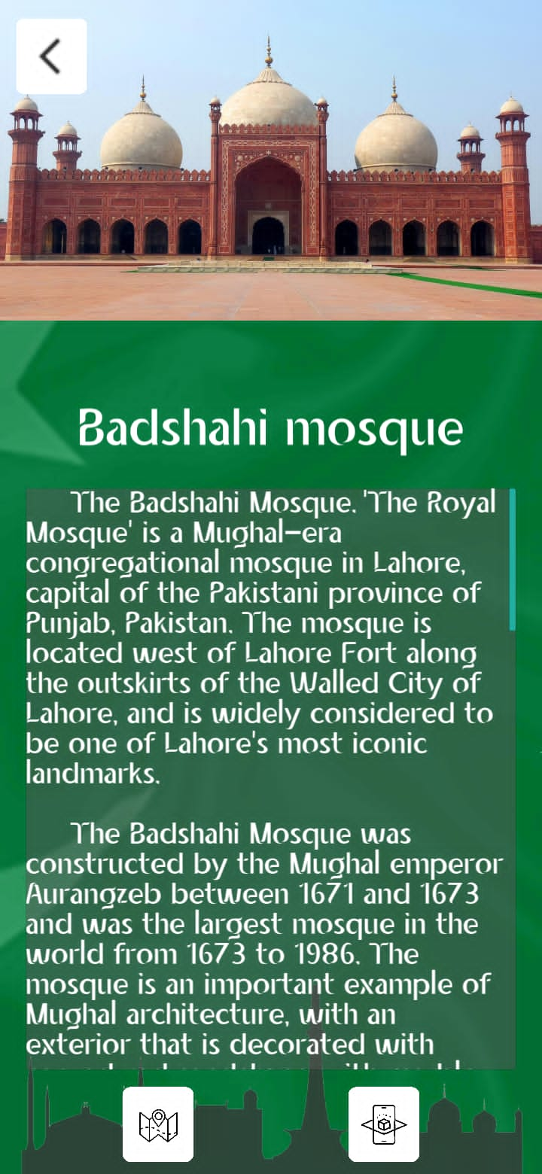
Screen-4: Badshahi Mosque Selected
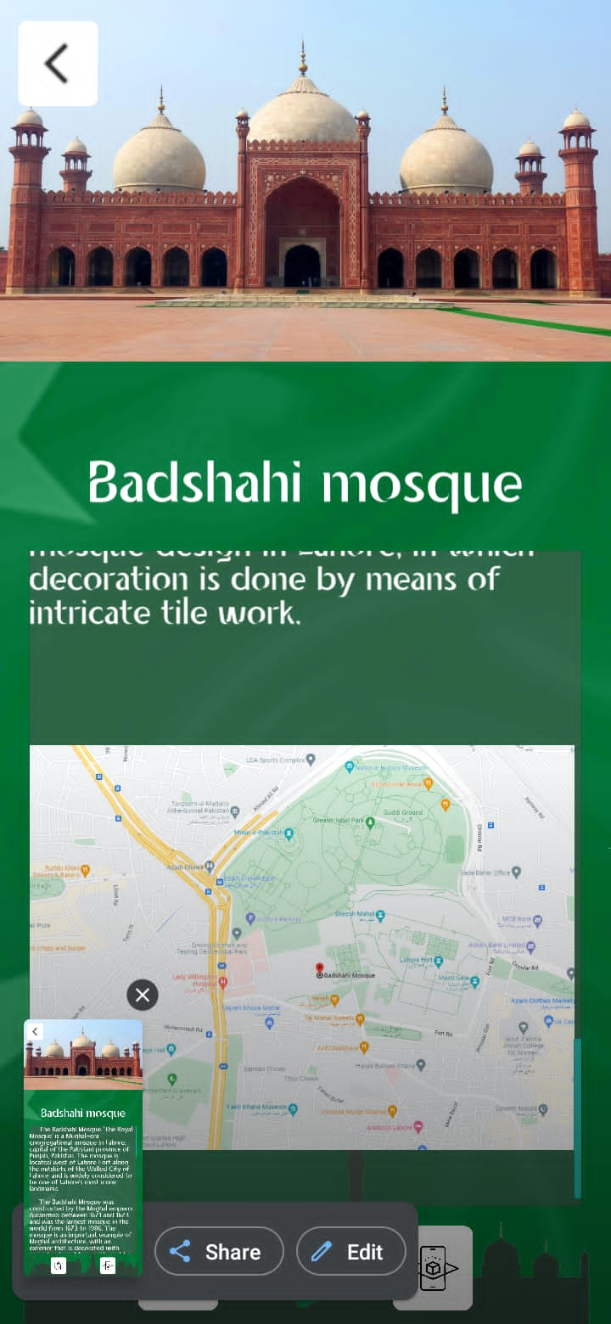
Screen-5: Static Map
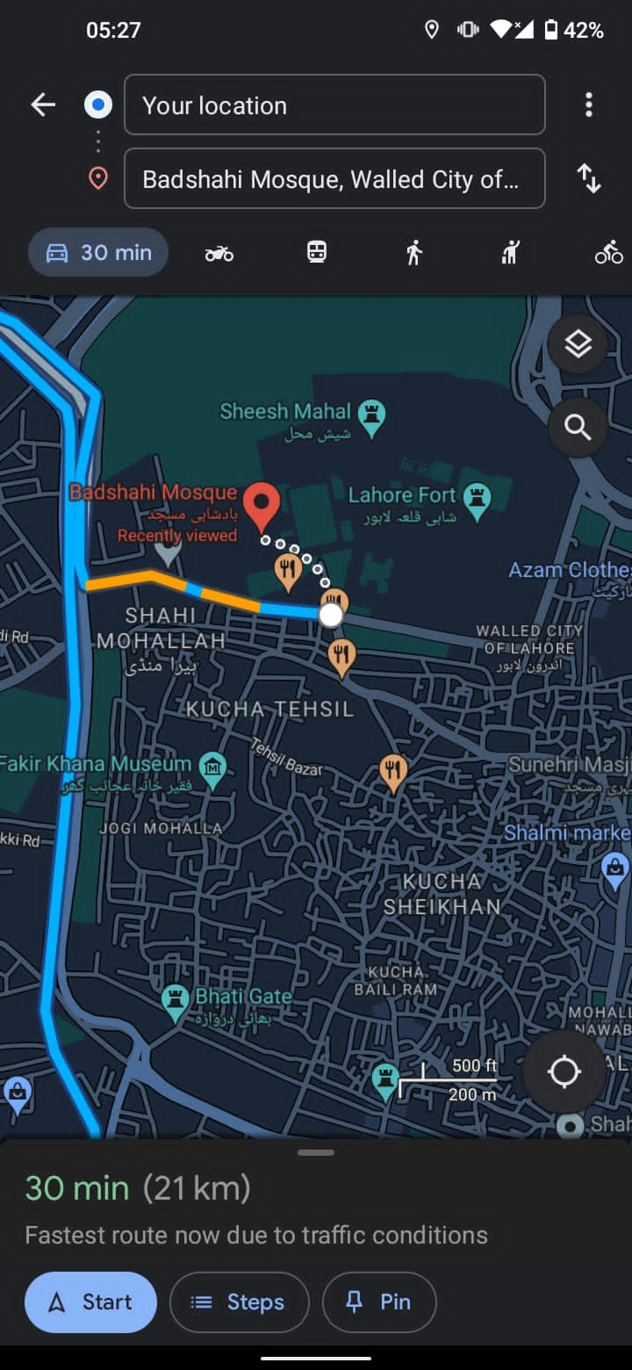
Screen-6: from Google Button live map
t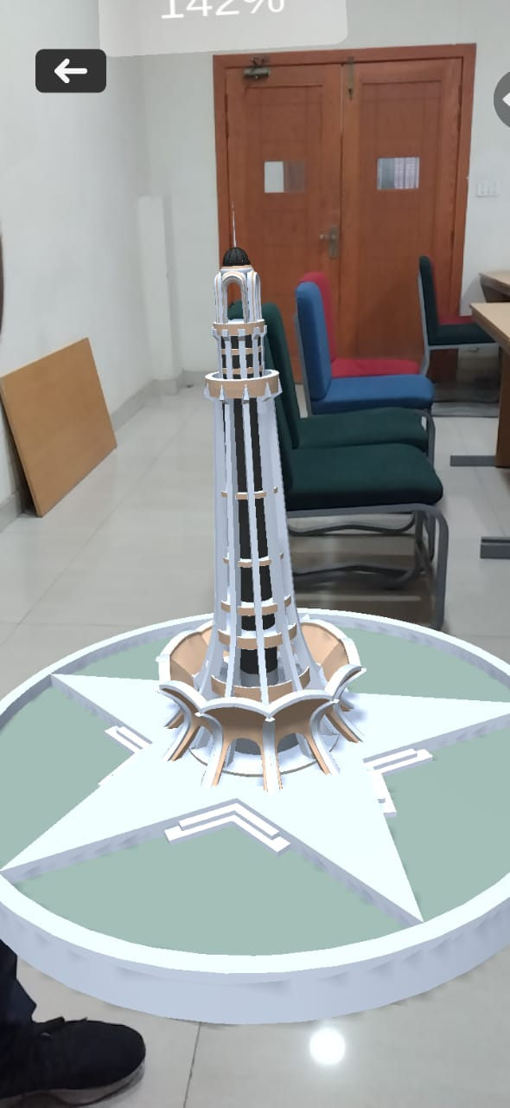
Screen-7: Augmented model from AR-Button

RESULTS AND DISCUSSIONS

Results

Functional Requirements
 | Proposed | Achieved
Augment AR models | YES | YES
Info. About Models | YES | YES
Scalability | YES | YES
The results are explained in the following table.
Non-Functional Requirements
 | Proposed | Achieved
Google Map Integration | NO | YES
YouTube video Integration | NO | YES
Rotation | NO | YES
Static Location | NO | YES

CONCLUSION AND RECOMMENDATIONS

Conclusion

We have achieved expected results from our project, we have concluded to keep the models most optimized and low in polygons as possible we did not design the interior. We have used plane targets for augmentation as it is a better approach than image augmentation technique.

Recommendation

More functionalities can be added like screen record feature, screen shot feature, wire frame view, 2D view, to the product. More models can be added to increase the worth of the project, interior can also be designed and implemented to ten-fold the value of the project. It is better to use lowest polygons as possible in the project to keep the augmentation more optimized. Use FBX format to increase performance.

REFERENCES

Research Papers:

[1] Chang, T.C., Milne, S., Fallon, D., and Pohlmann, C. ,Urban Heritage Tourism – The Gobal-Local Nexus. Annals of Tourism Research, 23(2). (1996)
[2] Fritz, F., Susperregui, A., and Linaza, M.T. , Enhancing Cultural Tourism experiences with Augmented Reality Technologies. The Eurographics Association. (2005).

Technical Reports:
[3] Timothy Jung and Dai-In Han, Augmented Reality (AR) in Urban Heritage Tourism, Department of Food and Tourism Management Manchester Metropolitan University, United Kingdom,2014.

Electronic Sources from Internet:
[4] King, R. “Augmented Reality Goes Mobile”, 2009. On Line, Available at: https://www.bloomberg.com/news/articles/2009-11-03/augmented-reality-goes-mobilebusinessweek-business-news-stock-market-and-financial-advice

[5] https://www.ibigroup.com/ibi-insights/historical-storytelling-through-augmented

[6] https://www.museumnext.com/article/what-can-ar-do-to-bring-heritage-sites-to

Turnitin Report: