
BSCS-F21-015
03-134182-053 | Salman Salim
03-134182-101 | Abdul Moiz

Poly Clinic

In partial fulfilment of the requirements for the degree of
Bachelor of Science in Computer Science
Supervisor: Nadeem Sarwar
Department of Computer Sciences
Bahria University, Lahore Campus
June 2022

© Bahria University, 2022

Certificate

We accept the work contained in the report titled
Poly Clinic
written by
Abdul Moiz
Salman Salim
as a confirmation to the required standard for the partial fulfilment of the degree of
Bachelor of Science in Computer Science.

Approved by:
Supervisor: Nadeem Sarwar
(Signature)

June 14, 2022

DECLARATION

We hereby declare that this project report is based on our original work except for citations and quotations which have been duly acknowledged. We also declare that it has not been previously and concurrently submitted for any other degree or award at Bahria University or other institutions.

Enrolment | Name | Signature
03-134182-053 | Salman Salim
03-134182-101 | Abdul Moiz

Date : June 14, 2022

Specially dedicated to
my beloved father, mother and brother
(Abdul Moiz)
my beloved father and mother
(Salman Salim)

ACKNOWLEDGEMENTS

We would like to thank everyone who had contributed to the successful completion of this project. We would like to express our gratitude to our research supervisor, Mr Nadeem Sarwar for his invaluable advice, guidance and his enormous patience throughout the development of the research.

In addition, we would also like to express my gratitude to our loving parent and friends who had helped and given us encouragement.

Abdul Moiz
Salman Salim

Project Title
Poly Clinic

ABSTRACT

In this pandemic situation of COVID 19 it is difficult for people to go to hospitals & clinics for their treatment. If they have any disease like fever, throat pain, body pain or influenza doctor must ask the patient for COVID test first. Then after the result of COVID doctor will start the treatment after confirming that the patient is COVID positive or not. It may take 2 to 3 days to get the reports of COVID test from the laboratory. Then after 2 to 3 days patient will get the treatment and get the medicine of his/her disease if he/she is COVID negative otherwise patient has to isolate in hospital.
The platform is android studio where this clinic app will be developed. For database firebase will be used to store the data and records of users & doctors. By using this clinic app user can get medicine advice by doctor and doctor will prescribe the medicines to the patient & patient can contact to doctor if he/she has serious symptoms.
People can easily get free advice of medicines by the doctor. They don’t have to go to hospitals & clinics for their treatment of viral disease. They don’t have to pay any fee for using this clinic app it is totally free of cost for medicine advices. If someone has smartphone he/she can easily get benefits. Patient can upload reports to show it to the doctor. And can easily find the nearest hospitals for physical treatment if patient needed and nearest pharmacies to buy or order prescribed medicines by the patient.

TABLE OF CONTENTS

DECLARATION ii
ACKNOWLEDGEMENTS iv
ABSTRACT v
TABLE OF CONTENTS vi
LIST OF TABLES ix
LIST OF FIGURES x

CHAPTERS
1 INTRODUCTION 1
1.1 Background 1
1.2 Problem Statements 1
1.3 Aims and Objectives 2
1.4 Scope of Project 2
2 Software requirement specidication 3
2.1 Overall description 3
2.1.1 User Classes 3
2.1.1.2 Patient Panel 3
2.1.1.3 Clinic Panel 4
2.2.1 Final Deliverables 4
2.2.2 Beneficiaries 4
2.3 Optional Scope 5
2.4 Operating Environment 5
2.5 Design & implementation 5
2.6 Assumptions & dependencies 6
2.7 External Interface Requirement 6
2.7.1 User Interface 6
2.7.2 Hardware Interfaces 6
2.7.3 Software Interfaces 6
2.7.4 Communication Interfaces 7
2.8 System use case diagrams 8-9
2.8.1 Use Case Name & Identifiers 10-19
2.9 Other non-functional 20
2.9.1 Performance Requirements 20
2.9.2 Safety Requirements 20
2.9.3 Security Requirements 20
2.9.4 Software Quality Attributes 20
3 DESIGN AND METHODOLOGY 21
3.1 Methadology 21
3.1.1 Requirements 21
3.1.2 Design 21
3.1.3 Testing 21
3.2 Feasibility Plan 21
3.2.1 Resource Requirement 21
3.2.2 Expertise of Team 22
3.2.3 Tools/ Technology 22
3.2.4 Budget 22
3.2.5 Risks involved 22
3.3 Class Diagram 23
3.4 Sequence Diagram 24-25
3.5 Collaboration Diagram 26-28
3.6 Operation Contracts 28
3.6.1 Operation Contract Register 28
3.6.2 Operation Contract Login 28
3.6.3 Operation Contract Chatting 29
3.6.4 Operation Contract Symptoms 29
3.6.5 Operation Contract View List 29
3.6.6 Operation Contract Appointment 29
3.6.7 Operation Contract Calendar 30
3.6.8 Operation Contract Logout 30
3.7 Data Model 30
4 IMPLMENTATION 31
4.1 Implemetation 31
4.2 Framework 31
4.3 Testing 32
5 RESULTS & USER MANUAL 34
5.1 Sign-up 34
5.2 Dashboard 38
5.3 Edit Profile 40
5.4 App Interfaces 41-44

6 CONCLUSION AND RECOMMENDATIONS 45
6.1 Conclusions 45
6.2 Recommendations 45

REFERENCES 46

APPENDICES 47

LIST OF TABLES

TABLE TITLE PAGE
Table 2.1: PC-01-001 10
Table 2.2: PC-02-002 11
Table 2.3: PC-03-003 12
Table ‎2.4: PC-04-004 13

Table 2.5: PC-05-005 14

Table 2.6: PC-06-006 15

Table 2.7: PC-07-007 16

Table 2.8: PC-08-008 17

Table 2.9: PC-09-009 18

Table 2.10: PC-10-010 19

LIST OF FIGURES

FIGURE TITLE PAGE
Figure 2.8.1.1: Doctor Panel Use Case 8
Figure 2.8.1.2: Patient Panel Use Case 9
Figure 3.3.1 Class Diagram of Poly Clinic 23
Figure 3.4.1: Sequence Diagram Login 24
Figure 3.4.2: Sequence Diagram Doctor 25
Figure 3.4.3: Sequence Diagram Patient 25
Figure 3.5.1: Collaboration Diagram Login 26
Figure 3.5.2: Collaboration Diagram Doctor 26
Figure 3.5.3: Collaboration Diagram Patient 27
Figure 3.5.4: Collaboration Diagram of Registration 28
Figure 3.7: Data Model 30
Figure 5.1.2: Sign-up 34
Figure 5.1.3: Sign-up 35
Figure 5.1.4: Sign-up 36
Figure 5.1.5: Sign-up 37
Figure 5.2.1: Doctor Dashboard 38
Figure 5.2.2: Patient Dashboard 39
Figure 5.2.3: Edit Profile 40
Figure 5.2.4: Doctor List 41
Figure 5.2.5: Profile View 42
Figure 5.2.6: Calendar 43
Figure 5.2.7: Chat 44

INTRODUCTION

Background

In this pandemic situation of COVID-19 it is difficult for patients who are suffering from viral diseases to go to hospitals and clinics for check-up. It is also difficult for the clinic doctor to give physical treatment to his patients. Many people lost their jobs so they can’t afford a good doctor for their treatment. So poor people can’t get a treatment of their viral disease and everyone wants to get treatment at their home and get medicine at their doorstep. [3]

Problem Statements

It is very difficult for poor people to pay the fees of doctor for small diseases and in this pandemic situation people don’t want to go to hospitals, clinics and laboratory for their check-up & test they need to everything they get at their door step.
Solution:
Clinic app that is a medicine app by which anyone can get his/her treatment by just some clicks. It can help the poor people and people can get the medicine advice and treatment by different doctors on their bed. If they want to clear the doubt of their disease they also call the doctor and can send reports, prescription of other doctors or book the physical appointment if they have serious symptoms. If the user have to go to any nearest hospital for check-up he/she can easily find the nearest hospitals by using clinic app. One app can save money of many needy people.

Aims and Objectives

The objectives of the thesis are shown as following:
- To serve to poor people who cannot afford the fee of a good doctor
- To help the people of society by giving free advice about medicines
- To give the medicine advice to user at their home
- To chat with doctors and get treatment
- To see the different doctors, dentist, therapist
- To book doctor appointment at home
- To Consult and physical check-up at same time

Scope of Project

People/patients can get to know about their medicines which they need by just some clicks. They don’t have to go to any clinic/hospital for check-up. They don’t have to spend a lot of fee for doctor. The medicine that is prescribe by the doctor to the patient that medicine advice is free of cost by just knowing his/her symptoms in chat box or sending reports in chat box and thirdly by calling the doctor by using this clinic application. The doctor of clinic can managed his/her patients online and give them medicines and advices. Regular patients can also contact with doctor and chat with doctor. Doctor will easily manage his/her clinic appointments and divide his patients first time check-up is physical second and third check-up is through app so it can save time of doctor. If patient has to find the nearest hospital he/she can find it by using nearest hospital option in clinic application.

Software Requirement Specification

Overall Description

By using this clinic app patient can easily get the medicine advice by the doctor of his/her disease by just entering his/her details in chat box, upload previous reports or prescriptions and by telling the doctor what he/she is feeling. So, doctor will prescribe the patient that this is the medicine of your disease. There is a chat box for patient and for clinic doctor they both can chat and call to each other and patient can upload reports. If doctor feels that patient is having some serious disease and must need a physical check-up so doctor can recommend the patient some other doctors if clinic doctor is not professional in that field otherwise doctor will advise the patient to come to his/her clinic for check-up and here patient have to pay the fee. If patient has some serious symptoms and doctor advised him/her to visit nearest hospital patient can find the nearest hospital by using this clinic app.

2.1.1 User Classes & Characteristics

Poly Clinic Consist of three panels:

2.1.1.2 Patient Panel
Patient user panel for treatment purpose.
- Login (Enter name, city, area, phone number, email address and age)
- Tell symptoms (in Chat)
- Tell early diseases (in Chat)
- Suggest medicines and tests by the doctor
- Display medical assistants who are available
- Appointments
- Upload reports
- Nearest hospitals, pharmacies, labs
- Chat
- Edit profile
- Send request
- See doctor list
- Choice on hospitalization and consultation
- Logout
2.1.1.3 Clinic Panel
Clinic Panel is the service provider
- Recommend medicines, test
- Recommend physical check-up
- Recommend doctors
- Check Appointments
- Accept appointments
- Patient list
- Chat with patients

Final Deliverable of Project & Beneficiaries

People/patients can get to know about their medicines which they need by just some clicks. They don’t have to go to any clinic/hospital for check-up. They don’t have to spend a lot of fee for doctor. The medicine that is prescribe by the doctor to the patient that medicine advice is free of cost by just knowing his/her symptoms in chat box.
2.2.1 Final Deliverable
- Android Application

2.2.2 Beneficiaries
- Patients
- Doctors
- Hospitals
- Pharmacies

Optional Scope

In future or if development team completed the require features before the deadline of FYP there are some features that will be added. Three more panels will be added in this clinic app one is lab panel second is doctor panel and third is buy-medicines panel. Patient user can contact with labs for their tests and clinic app will take commission from labs on monthly bases.by using doctor panel patient can go for physical check-up and clinic app will take commission. And by using buy-medicine panel patient can buy the suggested medicine from this clinic app. These three features are for earning purpose.

Operating Environment

This project is android based application that requires laptops & mobile phones. To build this project android studio is used for front-end and firebase is used for back-end.

2.5 Design & implementation Constraints
It is a android base application so for the development java is used and for live editing and addition live emulator is used by using android studio. For development java language will be used. For database firebase is used. Different unit, widget, acceptance and integration tests can be performed to remove all the bugs, errors and faults from the android application before, during and after the development.

2.6 Assumptions & Dependencies
Time based Assumptions: It can effect technology, availability, quality factors and limitations.
Quality specific Assumptions: It plays an important role because quality for user acceptance is necessary. All the activity of Poly Clinic will be done by this purposed system.
Resource Level Assumptions: It plays a vital role in the success and failure of project because a large portion of project management is based on available and allocate resources.

2.7 External Interface Requirements

2.7.1 User Interfaces
There are two parts of Poly Clinic. First is the home and Sign-up page.
And second is the management board will be designed that is for patient, doctor and assistant panel.
Note: This Graphical user interface is not final it can or can’t be changed during the implementation.

2.7.2 Hardware Interfaces
Mobiles in which android application can run and laptops in which software can run for development were required for Poly Clinic.

2.7.3 Software Interfaces
- Android Studio ( 3.0 version)
- Firebase (29.0.0)

2.7.4 Communication Interfaces
Poly Clinic has user friendly interface that will be displayed to patients so they can easily get the treatment and easily chat with the doctor and can be displayed to doctor so doctor can easily chat with patient and review the reports and give medicines to the patients.

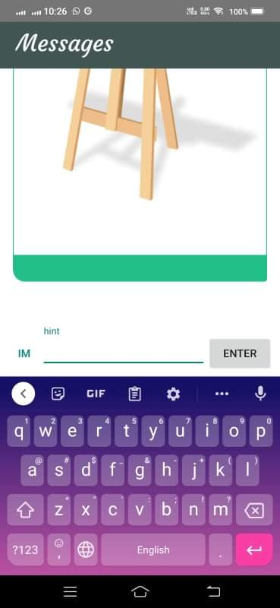

2.8 System Use Case
2.8.1 Use Case Diagrams

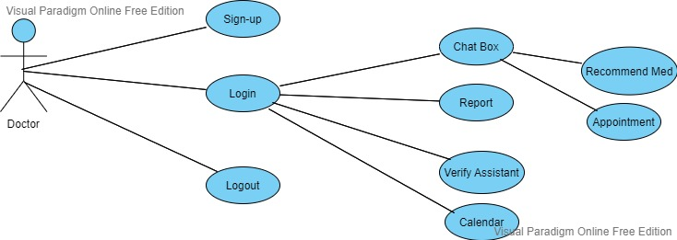

Figure 2.8.1.1 Doctor Panel Use Case Diagram

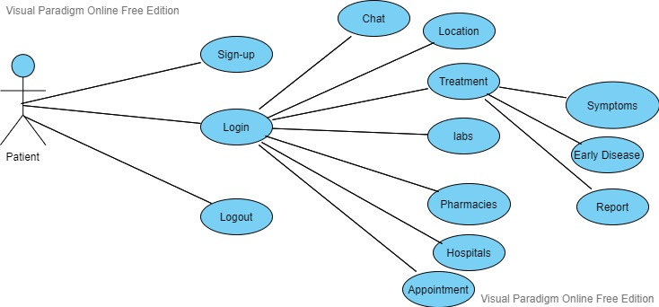

Figure 2.8.1.2 Patient Panel Use Case Diagram

2.8.2 Use Case Name & identifiers
2.8.2.1 Register (PC-01-001)
This use case is for sign-up panel.

Table 2.1 PC-01-001

Name | Sign-up
Unique Identifier | PC-01-001
Objective | Protection of user credentials
Actors | Doctor, Patients & Assistants
Priority | High
Basic Flow | - Download Poly clinic.  - Open Poly Clinic.  - Click on Sign-up.  - Enter all require data.  - Click on Done Button.
Alternative Flow | - Open Poly Clinic.  - Click on sign-up.  - Enter Details.
Preconditions | User must open the app
Post Conditions | User is registered
Notes/issues | This use case describe the registration of users.  If the internet is not working user cannot registered.

2.8.2.2 Register (PC-01-002)
This use case is for login for panels.

Table 2.1 PC-01-002

Name | Login
Unique Identifier | PC-01-002
Objective | Authentication & verification
Actors | User
Priority | High
Basic Flow | - Open Poly Clinic.  - Click on login button.  - Enter name and password.  - Click on login button.
Alternative Flow | - Open Poly Clinic.  - User enter wrong password or name.
Preconditions | User must open the app.
Post Conditions | User is logged in.
Notes/issues | Internet is not stable.

2.8.2.3 Register (PC-01-003)
This use case is for chatting for patient and for doctor.

Table 2.1 PC-01-003

Name | Chat box
Unique Identifier | PC-01-003
Objective | Chat with patients to give advice.
Actors | Doctor
Priority | High
Basic Flow | - Click on view patients.  - Click on chat for that particular patient.
Alternative Flow | - Doctor click on wrong patient.  - Doctor send message to wrong patient.
Preconditions | Doctor must be logged in.
Post Conditions | Doctor advice the patient.
Notes/issues | Internet is not stable.

2.8.2.4 Register (PC-01-004)
This use case is to send report to doctor.

Table 2.1 PC-01-004

Name | Report
Unique Identifier | PC-01-004
Objective | Report helps to advice the patient.
Actors | Doctor.
Priority | High
Basic Flow | - Click on view patient.  - Click on report in chat.
Alternative Flow | - Doctor click on wrong patient.
Preconditions | Doctor must be logged in.
Post Conditions | Doctor advice after seeing the report.
Notes/issues | Internet is not stable.

2.8.2.5 Register (PC-01-005)
This use case is for available doctor dates.

Table 2.1 PC-01-005

Name | Calendar
Unique Identifier | PC-01-005
Objective | To give appointments to patient for physical check-up.
Actors | Doctor.
Priority | High
Basic Flow | - Click on calendar.  - Add Dates of availability.  - Add notes.
Alternative Flow | - Click on wrong button.  - Enter wrong dates.
Preconditions | Doctor must logged in.
Post Conditions | Doctor must available at given date.
Notes/issues | Internet is not stable.

2.8.2.6 Register (PC-01-006)
This use case is that doctor is available.

Table 2.1 PC-01-006

Name | Availability
Unique Identifier | PC-01-006
Objective | Patients can contact.
Actors | Medical Assistant
Priority | High
Basic Flow | - Click on availability.  - Choose yes or no.
Alternative Flow | - Enter on wrong button.
Preconditions | Medical assistant must be logged in.
Post Conditions | Medical assistant available after choosing yes option.
Notes/issues | Internet is not stable.

2.8.2.7 Register (PC-01-007)
This use case is for chatting.

Table 2.1 PC-01-007

Name | Chat
Unique Identifier | PC-01-007
Objective | For medical advice from doctor.
Actors | Patient.
Priority | High
Basic Flow | - Click on chat with doctor.  - Enter Message.  - Click on send button.
Alternative Flow | - Click on wrong button.  - Send wrong message.
Preconditions | Patient must be logged in.
Post Conditions | Patient wait for reply of doctor.
Notes/issues | Internet is not stable.

2.8.2.8 Register (PC-01-008)
This use case is to get the treatment from doctor.

Table 2.1 PC-01-008

Name | Treatment
Unique Identifier | PC-01-009
Objective | For medicine advice by the doctor.
Actors | Patient.
Priority | High
Basic Flow | - Click on treatment.  - Click on treatment option.  - Choose symptoms.  - Choose early diseases.  - Review report.  - Click on Submit.
Alternative Flow | - User select wrong details.
Preconditions | Patient must be logged in.
Post Conditions | Patient wait for medical advice.
Notes/issues | Internet is not stable.

2.8.2.09 Register (PC-01-009)

Table 2.1 PC-01-009

Name | List
Unique Identifier | PC-01-012
Objective | To see the doctor list.
Actors | Patients.
Priority | High
Basic Flow | - Click on view my doctors.  - Select particular doctor..
Alternative Flow | - Patient click on wrong button.
Preconditions | Patient must be logged in.
Post Conditions | Patient can show select the doctor.
Notes/issues | Internet is not stable.

2.8.2.10 Register (PC-01-010)

Table 2.1 PC-01-010

Name | Appointment
Unique Identifier | PC-01-013
Objective | Appointment for physical check-up.
Actors | Patients.
Priority | High
Basic Flow | - Click on appointment option.  - Enter require details.  - Click on submit.
Alternative Flow | - Patient select the wrong date of appointment.  - Patient enter the wrong information.
Preconditions | Patient must be logged in.
Post Conditions | Patient is available on appointment day.
Notes/issues | Internet is not stable.

2.9 Other-Non Functional Requirement
2.9.1 Performance Requirements
To provide better services firebase hosting has to be purchased. Provide the user friendly interface on the updated android version to the users of poly clinic so they can easily use the app anywhere and at any time.

2.9.2 Safety Requirements
App will be scanned on daily bases for any errors and security issues. Reports can be downloaded and have a back-up to prevent from loss.

2.9.3 Security Requirements
For security purpose authentication will be used so only registered users can access their data.

2.9.4 Software Quality Attributes
The system of poly clinic is designed for patients who can be 12 years old to any age. The development team design this project in such a way that user feel free to use Poly Clinic.
Quality attributes are discussed below:
- Adaptability: Poly Clinic is deigned in such a way that user can easily adapt the features of this app and can easily use it when they need any medical advice.
- Availability: This app is available to users at any time and at any place. They just have a android phone and a good internet connection.
- Maintainability: The update of app is on regular bases to prevent from any error and any bug and user can easily use it.
- Flexibility: Development team design such things that is flexible for the users.
- Reusability: This application can use infinite time. And user can contact anytime with the doctor and get the medicine advice.
- Reliability: The app is reliable and can be used any time and user can access all the features at any time.
- Testability: Different tests were performed before and after the development phase to prevent the app from bug and clean it from errors if it has.
- Usability: This app is useable for all the patients who need medicines or any medical advice.

DESIGN AND METHODOLOGY

Methodology
    - Requirements
Developers will take some surveys before the starting the implementation from different age of people about their daily diseases and symptoms and what type of medicine they will take so by this we can add symptoms & diseases in this clinic app.

    - Design
Firstly developers will design the different diagram models ER diagram so we will know the path of our project. Then after that we will towards coding and implementation.

    - Testing
We will perform three test for our app in the development phase.
Low level:
1. Unit testing.
2. Widget testing.
3. Integration testing.
High Level:
- Usability testing
- Function testing
- Acceptance testing

Feasibility Plan
    - Resource Requirement

Following resources are required to complete this project: [5]

- Android Studio (3.0 version)
- Firebase (29.0.0)

    - Expertise of Team
This project requires the complete knowledge of mobile application development course. We have studied database management that help us in backend database of our app and mobile application development that help us in this whole project and also we studied object oriented programming that help us in coding.

    - Tools/ Technology

This clinic app can be developed by using software (SW) tools and technology. By using android studio and it is available on the internet and these software’s can be easily downloaded from the internet and for backend database of login data of users firebase will be used.
- Android Studio. [2]
- Java. [1]
- Firebase.

    - Budget
Developers only have to pay firebase monthly charges that is approximately 2500 RS.

    - Risks Involved
Internet issue:
This issue can be solved by working on different locations where internet is easily available to developers.
Health issue:
In this COVID pandemic and dengue fever health can be easily defected. So one member can still continue working on project more than 9 hours a week if other member is ill.
Hardware failure:
If system fails during the process of this clinic app for this development team will create a backup of code on other system.

Class Diagram

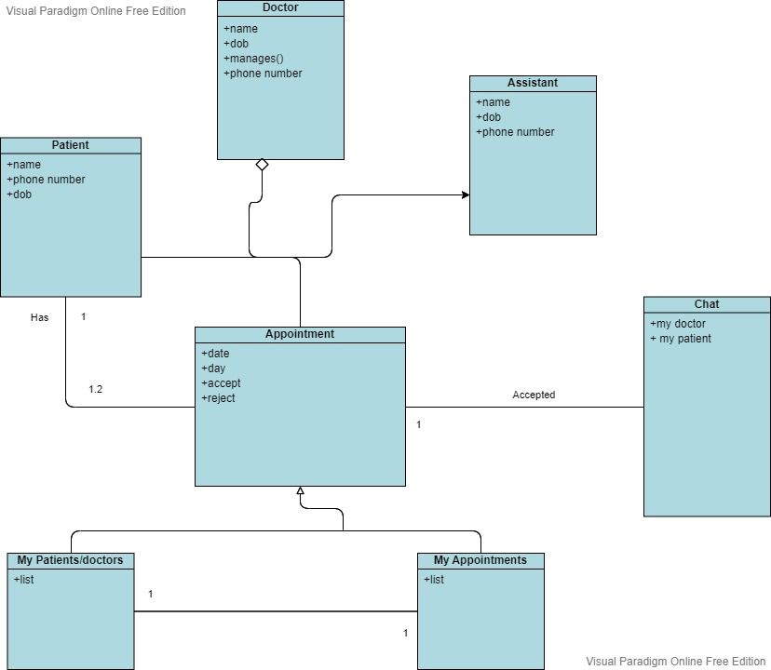

Figure 3.3.1 Class Diagram of Poly Clinic

3.4 Sequence Diagram [4]

3.4.1 Login

This diagram will show the login sequence of Patient, assistant & doctor panel.

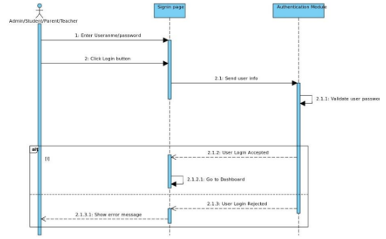

Figure 3.4.1 Sequence diagram of Login

    - Role of Doctor

This diagram will show the sequence of doctor profile.

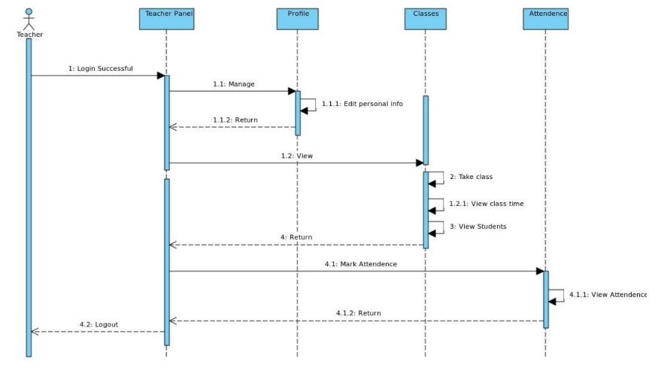
Recommend Medicine
View Appointments
View Calendar
4.1.1 Start Chat1
Chat
Appoint
Profile
Doctor
D

Figure 3.4.2 Sequence diagram of doctor

    - Role of Patient

This diagram will show the sequence of patient profile.

3. View Doctor list
1.2.1 View Calendar1
2. Book Appointment
4.1. Message to Doctor
4.1.1 Message send1
Chat
Appoint
Profile
Patient

Figure 3.4.3 Sequence diagram of patient

  - Collaboration Diagram

Collaboration diagram of poly clinic are given below:

    - Login

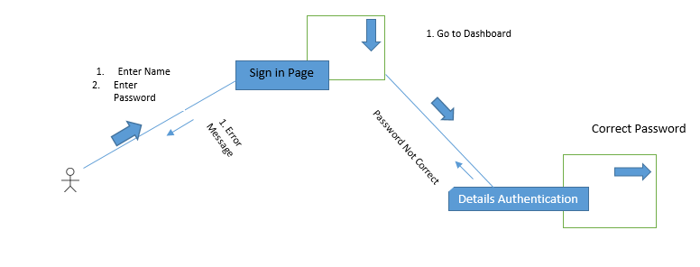

Figure 3.5.1 Collaboration diagram of login

    - Role of Doctor

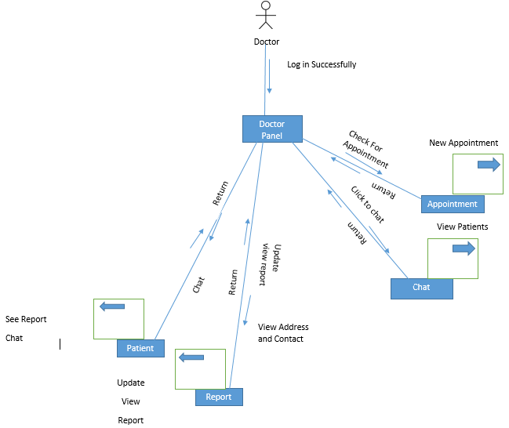
Figure 3.5.2 Collaboration diagram of doctor
    - Role of Patient

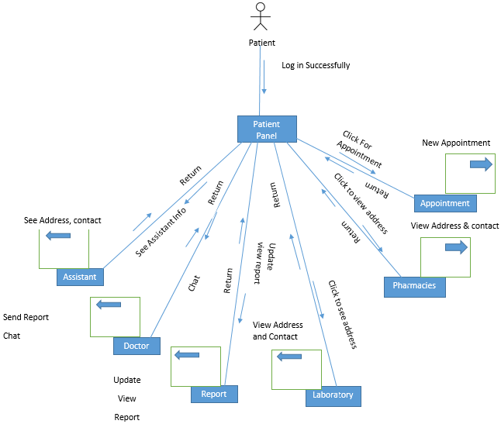

Figure 3.5.3 Collaboration diagram of Patient

    - Registration

By providing the necessary information the patient can login into the app by registering him/herself.
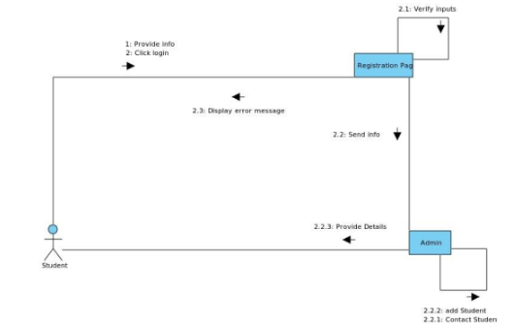
Figure 3.5.4 Collaboration diagram of sign-up

  - Operation Contracts

UML operation contract identifies the change in state when any operation will happen. And it shows that what each operation will do.

    - Operation Contracts Register

Name: Register
Responsibilities: To register patients/assistant/doctor.
Cross reference: Register.
Exceptions: The information about him/her is wrong or incomplete.
Preconditions: Must open the poly clinic app.
Post-conditions: Patients/assistant/doctor registered.

    - Operation Contracts Login

Name: Login.
Responsibilities: To login patients/assistant/doctor.
Cross reference: Login.
Exceptions: Patients/assistant/doctor enter wrong password.
Preconditions: Patients/assistant/doctor must be registered.
Post-conditions: Patients/assistant/doctor login successfully.

    - Operation Contracts Chatting

Name: Chatting.
Responsibilities: Interaction between doctor & patient.
Cross reference: Chatting.
Exceptions: Doctor send message to wrong patient.
Preconditions: Doctor/patient must be logged in.
Post-conditions: Doctor/patient can chat.

    - Operation Contracts Select Symptoms

Name: Select Symptoms.
Responsibilities: For making patient report.
Cross reference: Select Symptoms.
Exceptions: Patient select the wrong symptoms.
Preconditions: Patient must be logged in.
Post-conditions: Patient report will be generated.

    - Operation Contracts View list

Name: View list.
Responsibilities: For medicine recommendation doctor will see the patient list and patient will see doctor list to get medicines.
Cross reference: View list.
Exceptions: Patient/doctor see wrong list.
Preconditions: Patient and doctor must be logged in.
Post-conditions: Patient and doctor will see the list.

    - Operation Contract Appointment

Name: Appointment.
Responsibilities: For physical check-up select appointment.
Cross reference: Appointment.
Exceptions: Patient select the wrong appointment.
Preconditions: Patient must be logged in.
Post-conditions: Patient can get appointment.

    - Operation Contract Calendar

Name: Calendar.
Responsibilities: To select appointment date.
Cross reference: Calendar
Exceptions: Patient select the wrong date.
Preconditions: Patient must be logged in.
Post-conditions: Patient can get a date for appointment.

    - Operation Contract Logout

Name: Logout.
Responsibilities: To protect privacy logout from polyclinic.
Cross reference: Logout.
Exceptions: Patient/assistant/doctor click on other button.
Preconditions: Patient/assistant/doctor must be logged in.
Post-conditions: Patient/assistant/doctor logout from polyclinic.

  - Data Model

Data Model of poly Clinic is given below:

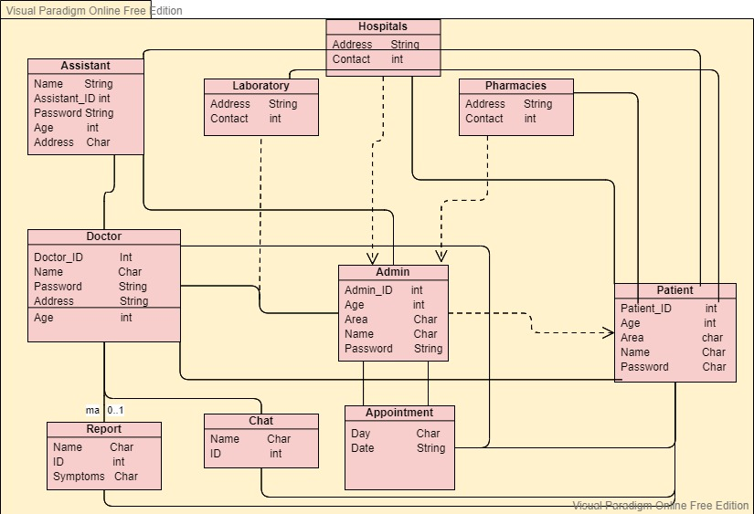
Figure 3.7.1 Data model of Poly Clinic

DATA AND IMPLMENTATION

Implementation

The implementation phase of the project is the development of the designs produced during the design phase. The requirements and analyses are gathered from doctors, patients & assistant. Everything required for the development of the poly Clinic is clarified from the different stakeholders of the Clinic.

Framework

Java is used for the development of poly clinic. Android studio is the platform for developing the android app. And the database is firebase that will be used for the back-end and java is used for the front end development.

Testing

Unit testing is perform for doctor and patient function login.

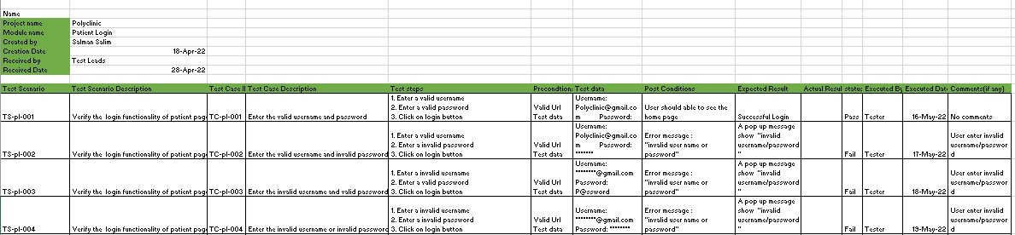

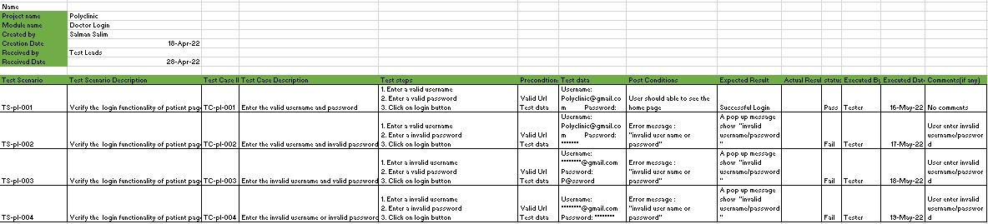

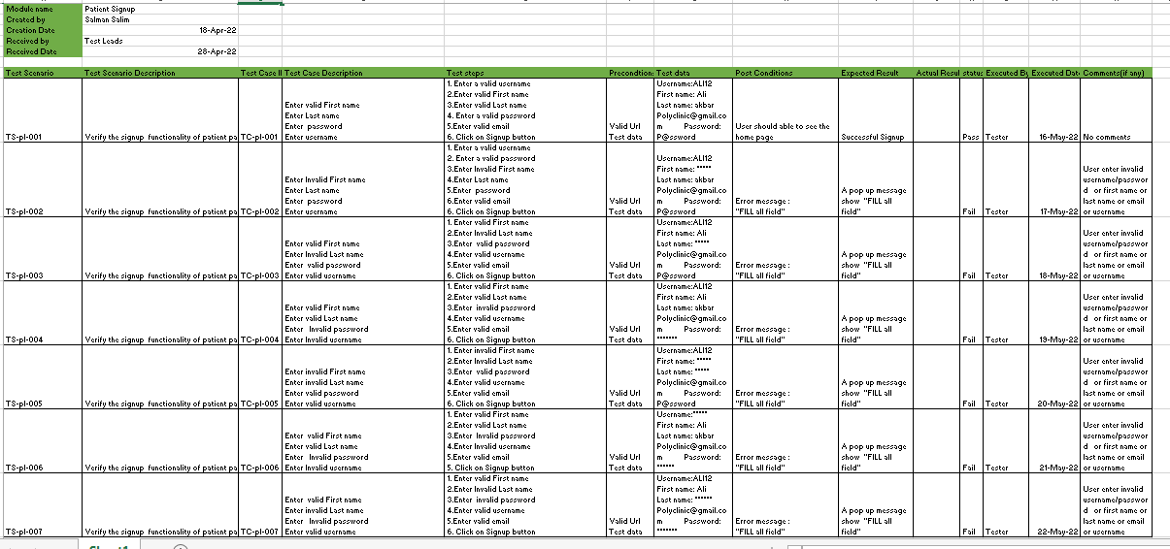

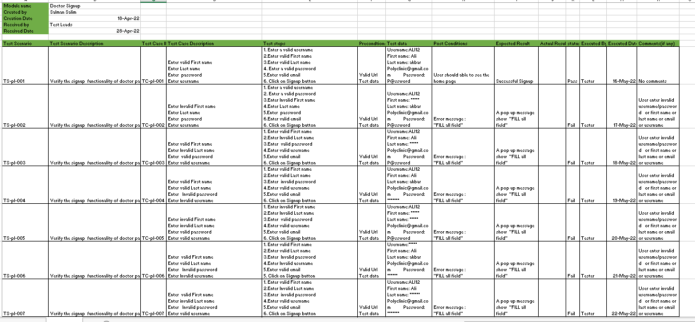

RESULTS AND USER MANUAL

Below all the UI interfaces of Poly Clinic are listed. So, user can easily use Poly Clinic the android app by reading the captions of the given pictures.

Sign-up
Doctor and patient can login by entering some information after sign-up.
- Login if signup already otherwise click on created account.

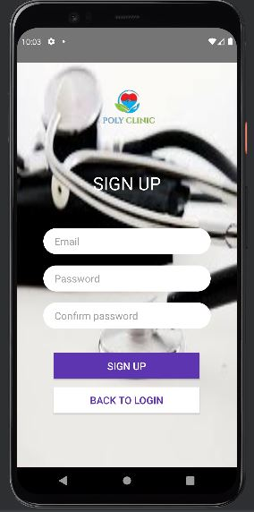

Figure 5.1.1 Sign-up of Poly Clinic

- For signup choose the role.
- Enter your details.
- And click on confirm.

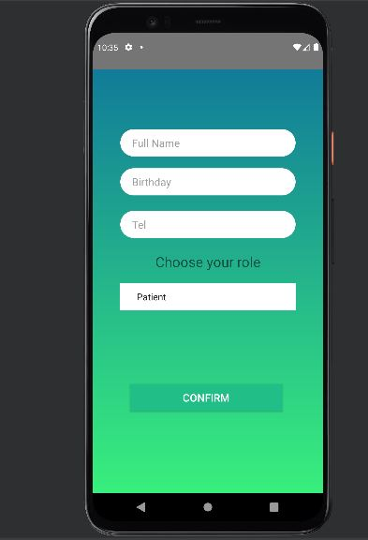

Figure 5.1.2 Sign-up of Poly Clinic

- A sample of entering details.

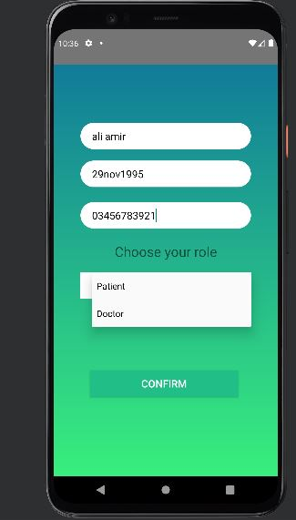

Figure 5.1.3 Sign-up of Poly Clinic

- This is the page you see when you click on signup option.

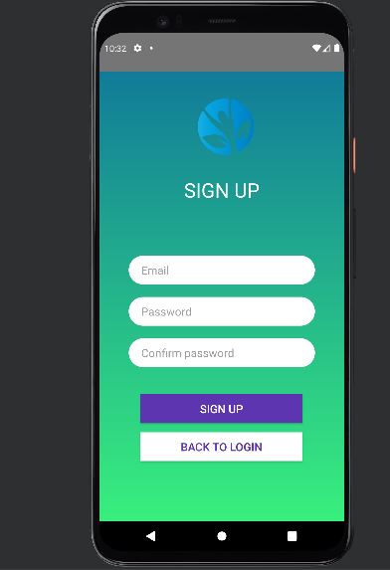

Figure 5.1.4 Sign-up of Poly Clinic

Dashboard
After login/sign-up user can see this dashboard of poly clinic.

Doctor Dashboard
- Doctor can view patients
- Chat with patients
- Check appointments
- Edit Profile
- See profile
- Check calendar
- Sign-out

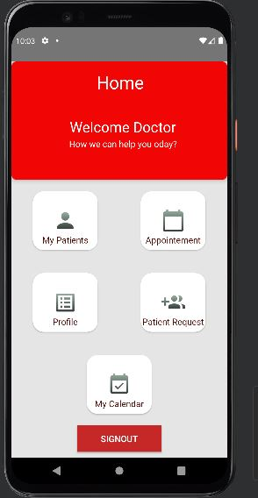

Figure 5.2.1 Doctor Dashboard of Poly Clinic

5.2.2 Patient Dashboard of Poly Clinic

- Patient can search the doctor.
- Medical folder.
- Check previous doctors.
- Check profile.
- Book appointment.

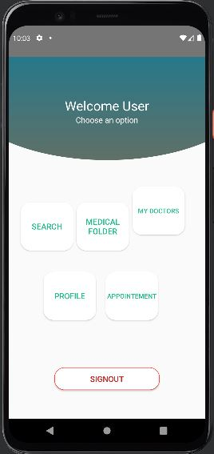

Figure 5.2.2 Patient Dashboard of Poly Clinic

Edit Profile:
- Doctor/Patient can edit profile.
- Can update profile.

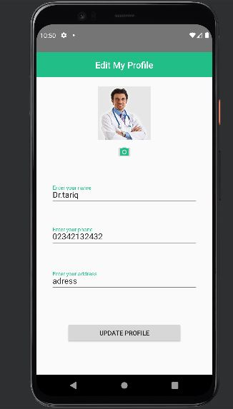

Figure 5.2.3 Edit Profile of Poly Clinic

Doctor list:
- Patient can check the doctors list.

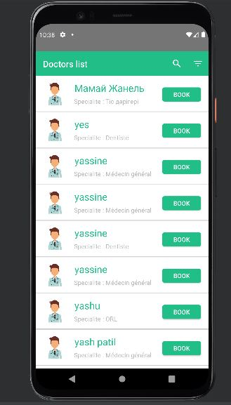

Figure 5.2.4. Patient List of Poly Clinic

Profile View:
- This is the profile view that doctor can see.

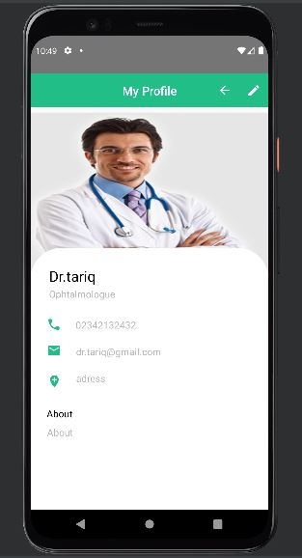

Figure 5.2.5 My Profile of Poly Clinic

Calendar:
- This is the calendar for doctor availability.

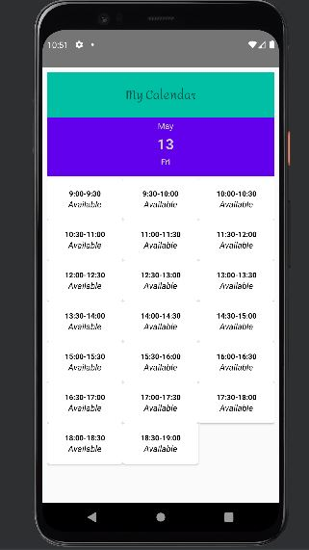

Figure 5.2.6 Appointment interface of Poly Clinic

Chat:
- Doctor and patient can chat with each other.

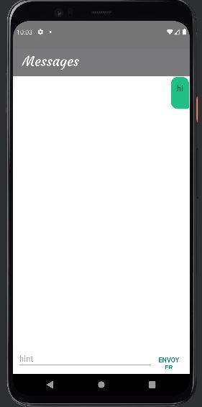

Figure 5.2.7 Chat Box of Poly Clinic

CONCLUSION AND RECOMMENDATIONS

Conclusion

The main purpose of Poly Clinic is that people/patients can get to know about their medicines which they need by just some clicks. They don’t have to go to any clinic/hospital for check-up. They don’t have to spend a lot of fee for doctor. The medicine that is prescribe by the doctor is free of cost by just knowing his/her symptoms by chat with doctor and patient can show the previous medical reports to the doctor for better understanding. Patient can select the appointment time by selecting date & time if need physical check-up. Patient can find the nearest hospitals and can find nearest pharmacies by using Poly Clinic.

Recommendation

This is the android base system, in future there will be an IOS and web application because not everyone use android. Furthermore, features can be added on the suggestions of the patients and doctors. Right now Poly Clinic only provide chat and appointment option but in future many other features like assistant panel in which doctor assistant can manage the appointments and a pharmacy panel by which patient can order the medicines.

REFERENCES

Books:
[1] Cay S. Horstmann, Core java Volume 1-Fundamentals, 11nd Edition, Prentice Hall.
[2] Bill Philips, Android Programming, Old Edition, Chris Stewart, 2017
Electronic Sources from Internet:
[3] https://www.brightwork.com/blog/7-steps-effective-report-writing
[4] https://www.youtube.com/watch?v=pCK6prSq8aw
[5] https://www.youtube.com/watch?v=fis26HvvDII

APPENDICES

Appendix A: Use Case
A use case is a written description of how users will perform tasks on your website. It outlines, from a user's point of view, a system's behaviour as it responds to a request.

Appendix B: Sequence Diagram
A sequence diagram is a UML diagram that illustrates the sequence of messages between objects in an interaction.

Appendix C: Collaboration Diagram
It is an illustration of the relationships and interactions among software objects in UML.

Appendix D: Data Model
A data model is an abstract model that organizes elements of data and standardizes how they relate to one another and to the properties of real-world entities.

Appendix E: Class Diagram
A class diagram in the UML is a type of static structure diagram that describes the structure of a system by showing the system’s classes, their attributes, operations and the relationships among the objects.

Appendix F: Operation Contracts
Operation contracts use a pre- and post-condition form to describe detailed changes to objects in a domain model, as a result of a system operation.

