
BSCS-F21-004
03-134182-088 | Usman Hamid
03-134182-014 | Awais Saleem

Emotion Aware Recommender System
In partial fulfilment of the requirements for the degree of
Bachelor of Science in Computer Science
Supervisor: Dr. Ghulam Mustafa
Department of Computer Sciences
Bahria University, Lahore Campus
June 2022

© Bahria University, 2022
Certificate

We accept the work contained in the report titled
“Emotion Aware Recommender System”
written by
Usman Hamid
Awais Saleem
as a confirmation to the required standard for the partial fulfilment of the degree of
Bachelor of Science in Computer Science.

Approved by:
Supervisor: Dr. Ghulam Mustafa
(Signature)

June 14, 2022

DECLARATION

We hereby declare that this project report is based on our original work except for citations and quotations which have been duly acknowledged. We also declare that it has not been previously and concurrently submitted for any other degree or award at Bahria University or other institutions.

Enrolment | Name | Signature
03-134182-088 | Usman Hamid
03-134182-014 | Awais Saleem

Date : June 14, 2022

Specially dedicated to
My parents, family, and friends
(Usman Hamid)
My parents, family, and friends
(Awais Saleem)

ACKNOWLEDGEMENTS

We would like to thank everyone who had contributed to the successful completion of this project. We would like to express our sincere gratitude to our research supervisor, Dr. Ghulam Mustafa for his invaluable advice, guidance, and his enormous patience throughout the development of the research.

In addition, we would also like to express our gratitude to our loving parents and friends who had helped and given us encouragement.

Usman Hamid
Awais Saleem

Emotion Aware Recommender System

ABSTRACT
In the realm of entertainment, it is having always been the priority to get the right stuff to the right person. This has been made significantly better through the establishment of recommender systems. These systems work on the principles of storing user data such as history, tags, cookies, and cache to try and suggest relevant media that one should find interesting. There has always been a problem with finding relevant information. Information retrieval systems and recommender systems were established to solve that problem but even in recommender systems there exists a 2D element of users and items which does not yield fully exceptional results. If we make it a 3D element by adding a third attribute which is the context of emotions, we can get results with more in-depth information.

Through this emotion awareness system, we will be able to detect a user’s emotions and will be able to propose recommendations based of those emotions. The development of this project will proceed in the fashion of FDD (Feature Driven Development) to accommodate for new features and applications on the run. The website for the system will be to showcase information about the actual recommender system. The mobile app will be the actual product that will be providing the recommender functionalities

TABLE OF CONTENTS

DECLARATION iv
ACKNOWLEDGEMENTS vi
ABSTRACT vii
TABLE OF CONTENTS viii
LIST OF TABLES xi
LIST OF FIGURES xii
LIST OF SYMBOLS / ABBREVIATIONS xiv
LIST OF APPENDICES xv

CHAPTERS
1 INTRODUCTION 1
1.1 Background 1
1.2 Problem Statements 1
1.3 Aims and Objectives 2
1.4 Scope of Project 2
2 Software Requirement Specification 4
2.1 Introduction 4
2.1.1 Purpose 4
2.1.2 Document Conventions 4
2.1.3 Intended Audience and Reading suggestions 4
2.2 Overall Description 5
2.2.1 Product Perspective 5
2.2.2 Product Functions 5
2.2.3 Constraints 6
2.2.4 Assumptions and Dependencies 6
2.3 System Features 7
2.3.1 Website 7
2.3.2 Mobile App 7
2.3.3 Database 7
2.3.4 Server 8
2.4 External Interface Requirements 8
2.4.1 User Interfaces 8
2.4.2 Software Interfaces 8
2.5 Non-functional Requirements 9
2.5.1 Performance Requirements 9
2.5.2 Security 9
2.5.3 Usability 9
3 DESIGN AND METHODOLOGY 10
3.1 Methodology 10
3.1.1 FDD 10
3.2 Analysis Models 12
3.2.1 Use case Diagrams 12
3.2.2 Use Case Descriptions 13
3.2.3 Sequence Diagram 17
3.2.4 ERD Diagram 19
3.2.5 Domain Model Diagram 20
4 DATA AND EXPERIMENTS (and/or IMPLMENTATION) 21
4.1 Scrapper 21
4.2 Mobile Application 23
4.2.1 Main Activity 23
4.2.2 Signup Activity 24
4.2.3 Login Activity 25
4.2.4 Dashboard Activity 26
4.2.5 Settings Activity 28
4.2.6 Change Password Activity 29
4.2.7 Recommend Options Activity 30
4.2.8 Cam Input Activity 31
4.2.9 Facial Recommendations Activity 32
4.2.10 Emotion Input Activity 33
4.2.11 Input Recommendations Activity 34
4.3 Web Page 35
4.3.1 Index Page 35
4.3.2 Download Page 35
4.3.3 About Page 36
4.4 The Recommender System 36
4.4.1 TF-IDF 36
4.4.2 Post-Contextual Filtering 37
5 RESULTS AND DISCUSSIONS (or USER MANUAL) 38
5.1 Dataset 38
5.2 CNN Model 38
5.3 Recommender System Result Discussion 39
6 CONCLUSION AND RECOMMENDATIONS 41
6.1 Conclusion 41
6.2 Future Work 41
REFERENCES 43
APPENDICES 44

LIST OF TABLES

TABLE TITLE PAGE
Table 3-1 User Sign Up 13
Table 3-2 User Login 13
Table 3-3 Change User Information 14
Table 3-4 Movie Recommendations 14
Table 3-5 Movie Recommendations according to emotion input 15
Table 3-6 Movie Recommendations Based on Facial Emotion Detection 15
Table 3-7 Delete user account 16

LIST OF FIGURES

FIGURE TITLE PAGE
Figure 3-1 Feature Driven Development Model 10
Figure 3-2 Main Use Case diagram 12
Figure 3-3 User SignUp 17
Figure 3-4 Login and Recommendations 18
Figure 3-5 Recommendations According to Mood 18
Figure 3-6 Entity Relationship Diagram 19
Figure 3-7 Client Side Domain Model 20
Figure 3-8 Server Side Domain Model 20
Figure 4-1 Crawler Code 1 21
Figure 4-2 Crawler Code 2 22
Figure 4-3 Crawler Code 3 22
Figure 4-4 Main Activity 23
Figure 4-5 SignUp Activity 24
Figure 4-6 Login Activity 25
Figure 4-7 Dashboard Activity-1 26
Figure 4-8 DashBoardActivity-2 27
Figure 4-9 Settings Activity 28
Figure 4-10 Change Password Activity 29
Figure 4-11 Recommend Options Activity 30
Figure 4-12 Cam Input 31
Figure 4-13 Facial Recommendations Activity 32
Figure 4-14 emotionInput Activity 33
Figure 4-15 InputRecommendations Activity 34
Figure 4-16 Website Index Page 35
Figure 4-17 Website Download Page 35
Figure 4-18 Website About Page 36
Figure 5-1 Emotion Labels 38
Figure 5-2 CNN Results 39

LIST OF SYMBOLS / ABBREVIATIONS

FDD Feature Driven Development
CNN Convolutional Neural Networks
VGG16 Visual Geometry Group 16
FER-2013 Facial Expression Recognition – 2013
ELU Exponential Linear Unit
APK Android application Package
API Application Programming Interface
PHP Hypertext Pre-processor
XAMPP Cross-Platform, Apache, MySQL, PHP and Peri
SQL Structured Query Language
TF-IDF Term Frequency-Inverse Document Frequency

LIST OF APPENDICES

APPENDIX TITLE PAGE
APPENDIX A: Roles and Responsibilities 44
APPENDIX B: Computer Programs Listing 45

INTRODUCTION

Background
Human beings are complex creatures. They exhibit behaviour on the basis different environmental factors and every individual reacts differently to their surroundings. Emotions is an integral of the human nature. They are the attributes that one cannot ascertain just on physical characters. What if we can merge emotions with an AI based recommender systems? Since the world is on the track of making AI more like humans, this project will serve as a showcase to the AI’s ability.
A recommender based on one’s emotions is no easy feat. It requires massive amounts of data for processing and to train the specialized algorithms for it is another task on its own. The initial phases of this project will involve gathering data using either web crawler techniques or existing open-source data sets and applying pre-processing on them. After that different machine learning algorithms will be exploited to investigate the best possible result for mood detection and content/collaborative-based recommendations. The system that is being built will have two by products. One being the website which will serve as an informative page about the actual recommender mobile application and a way to download the application and the second being the application itself which will provide all the recommendations based on user data and emotion detection.

Problem Statements
In the domain of entertainment, it has always been one of the top priorities to get the right content to the right person. This has been made significantly better through the establishment of recommender systems. These systems work on the principles of storing user data such as history, tags, cookies, caches and try their best to recommend relevant content that one should find interesting. There has always been the innate problem of finding relevant information. There are massive reserves of data that are easily available, but the problem is that they are not structured.
Information retrieval systems and recommender systems were established to solve this problem but even in recommender systems that use only a 2D element of users x items do not yield fully exceptional results. If we make it a 3D element by adding a third attribute which is the context of emotions, we can garner results more in depth information for more accurate results.

Aims and Objectives

The objectives of the thesis are shown as following:
- To analyze existing data and to perform pre-processing steps on it.
- To define an algorithm which will help with recommendations and emotional detection.
- To investigate the precedence of the data vs emotional state
- To build a Web page and a Mobile App Recommender System that works on user data and emotional state.

Scope of Project

The recommender system that is to be implemented is solely meant for the entertainment industry recommendations. The system will work on the principle of a TFID recommender system for relevant recommendations. Furthermore, the system will also have the capability to recommend content based of a user’s emotions which will be captured using a prompt that will ask the user’s current mood or through facial detection technique and will apply post contextual filtering to the recommendations gained using the TFID approach.
Emotion based awareness is valuable as this will be the next big thing that will revolutionise AI based recommender systems. It will incorporate user profiling alongside human emotions so that we can move steps closer to the “AI as human” approach. In the past recommender systems have succeeded in producing exceptional results and revenue and this new system of emotion-based recommendations is a sure to succeed as it provides more basis for real-time user information. This research and product will help companies like Netflix, Hulu, Amazon Prime Video, HBO and more who already use a recommender system. A new stack of information will help keep their user bases intact.

Software Requirement Specification

Introduction

Purpose

The purpose of this document is to bring forth and enlighten the complete and comprehensive details about the Emotion Aware Recommender System project.
This document will explain in detail, the technical specifications, performance attributes, constraints of the design and other useful information.

Document Conventions

The document font will be Times New Roman with font size 12 for both normal text and headings. Headings are to be in bold format. Paragraphs are justified.

Intended Audience and Reading suggestions

The intended audience for this document are customers, suppliers, users, developers, project managers, testers and documentation writers

Overall Description

Product Perspective

Recommendation systems are a software tool that gives suggestions for items to a user. Our recommender system is an advancement onto the existing recommender technology by providing an additional layer to the typical user x item context by adding a third element which is the user’s emotional state.
Our recommender system will generate user profiles based on when a user creates their account on the system. Account creation will take certain attributes such as location, age and other as user profiling content. Based on those user profiles the user will be provided with recommendations for movies. Furthermore, the system will also incorporate emotional user information where the user will be prompted to input their current mood at that time and according to that input, the recommendations will be channelled. The emotion will also be captured through facial detection if the user opts for that option.
Dataset is the most important part of our system therefore the existence of the main system and wide usage of the recommendation system is important for generating recommendations.

Product Functions

The recommender system is composed of the following list of fundamental features:
- User generated data
- Getting recommendations for users
- Providing datasets
- Updating the datasets
- Integrating the web service and mobile application
- Emotion capture (Input prompt or facial detection)

Constraints

The recommendation system consists of the following problems: sparsity, huge amount of data and cold start.

A cold start is a problem in computer-based information systems which involves the problem of data modelling in the absence of actual data. What that means is that any new user that signs up on the system, has no data that can be used by the system to give results. The system has little to no knowledge about the preferences and no user rating data to draw a user profile.
Massive amounts of data is another big issue, In many cases of environment such as these, there are thousands and even millions of users and content. It is quite the challenge to produce accurate recommendations and to perform them in a few seconds for millions of users. For this case a large and powerful computational power is required.
Collaborative filtering can be rendered useless if sparsity exists. Many active users who do not contribute to ratings as much and only rate a few movies in the database can lead to the issue of not being able to identify the similarity between the users, thus making collaborative filtering a waste of time.
The Accuracy of the mood detection through the camera can be hindered at some point through marginal errors due to camera quality, compression algorithms etc which can lead to faulty detection and inaccurate user profiling which can lead to inaccurate movie recommendations.

Assumptions and Dependencies
The end product of our project will be a website that will serve as a web page for information about the recommender system like a showcase of its functionalities and a place where the actual app can be downloaded.
The App will serve as the main recommender system.

System Features

Website

Description:
The website will be one part of the entire project. It will be an informative showcase of the actual recommender application.
Major Features:
->Provide an informative showcase about the application.
->To provide a download source for the actual application.

Mobile App

Description:
The mobile application will be the actual recommender system that will give users recommendations based on their emotions using post contextual filtering.
Major Features:
->Providing users, the interface to sign up for an account onto the system
->Giving users the option to change/update their profile
->Login page
->Upon login, the user will be shown top rated movies.
->Recommendations will be provided.
->Prompt the user to provide current mood, for recommendations.
-> Facial emotion detection using camera for recommendations
-> API calls with the backend server.
->Java based mobile android application.

Database

Description:
The database of the system will serve as an integral part of the Login and top rated movie showcases.
Main features:
->Store User data
->Store Movie Data
->Get Top rated movies
->User Login validation

Server

Description:
The server will act as the main communication gateway for the app and the logical files. The server in question here is XAMPP (APACHE server)
Major Features:
->Cloud hosting for files
->API call support
->Communication gateway for Webpage and Mobile App.

External Interface Requirements

User Interfaces
The user of the system can interact with the webpage through both a computer and a mobile phone. The website is a responsive design and will accommodate for most devices.
The user of the mobile application can view the sign up and login pages. The user can also see top rated movies and the recommended pages through emotion attribute passing.

Software Interfaces

The user can interact with the Mobile application only through Android or iOS devices. Android version must be 4.1 (API 16) or higher while iOS must be 10.0 or higher.
The webpage can be accessed by all major browsers that are available and are well supported by the developers.

Non-functional Requirements

Performance Requirements

The actual performance of recommendation and the updating of recommendations is a challenge for us, and we are taking great care as to make the system as real-time as possible. In other words, the system should be fast enough so that the users do not actually feel the data processing.
Our web services and the application should be able to handle multiple users at the same time.

Security

The database should be reached securely, and the data involved should not be tampered with or broken at all. It should also not change unless an interagent updates it. Since our database will include sensitive information such as user’s personal information, the design of the security is one of the top priorities.

Usability

The usability of this project is widespread. The only requirement is that the user must have a supported mobile device, an internet connection and an interest in movies.

DESIGN AND METHODOLOGY

Methodology

We will be proceeding with the Feature Driven Development (FDD) methodology for this project. The FDD approach compliment the development procedures of this project well.
The recommender project is versatile in nature for its features. We should have the ability to add and remove features from the system as we see fit and the FDD approach is excellent for this type of practice.
FDD allows us to develop the overall model of the entire system and we can further list down all the features that we think should be made for the system. Once all our features are listed down, we plan according to the features to be made.
Once all that is done, we can start the loop of designing by features and building by features. This is a process which complements our projects development where we can constantly at any time change features, add them, or make improvements to them.

FDD
Here is brief rundown of the FDD approach.
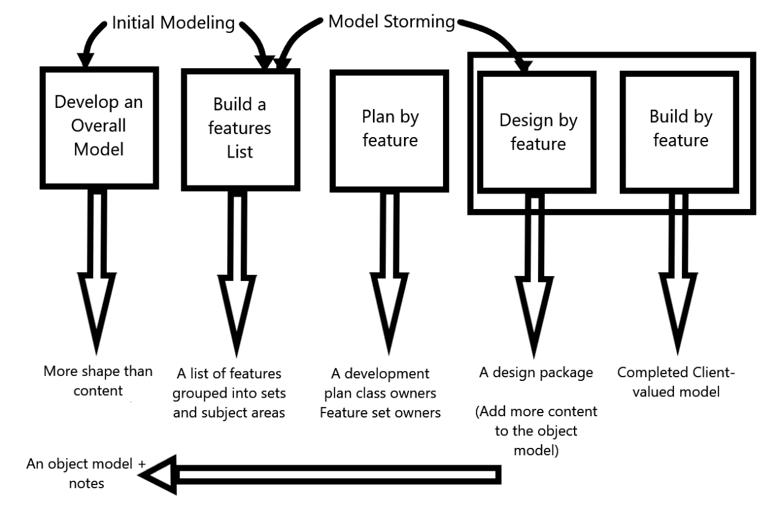
Figure 3-1 Feature Driven Development Model
FDD was designed to follow a five-step development process, built largely around discrete “feature” projects. That project lifecycle looks like this:
- Develop an overall model
- Build a features list
- Plan by feature
- Design by feature
- Build by feature
The simple five step process allows for more rapid development

Developing an Overall Model:
In the first step, the development team members get together and develop an overall model for the domain problem. By finalizing a model, the teams have a much clearer view of the project.

Build a features list:
After the overall model is built, this step ensures that all the features that the user or client wants are identified and noted down. These features are meant to be a guide for the developers to know what direction the project is going to proceed in.

Planning a feature list:
The third stage turns around managing the features and the way the development team tends to implement them.

Designing by Feature:
All the features that should be developed are selected and the domain classes are identified for each. Once the team begins development of the features, the domain experts analyse the requirements and design a solution for each feature.

Building by Feature:
The last step in FDD is to realize each necessary item in action to support the overall model design.

Advantages of FDD:
- Improvement in communication
- Minimal Complexity of the system
- Maximization of quality
- Excellent solution for both big and small projects

Analysis Models

Use case Diagrams

The following use case diagram/s have been identified for the emotion aware recommender system.
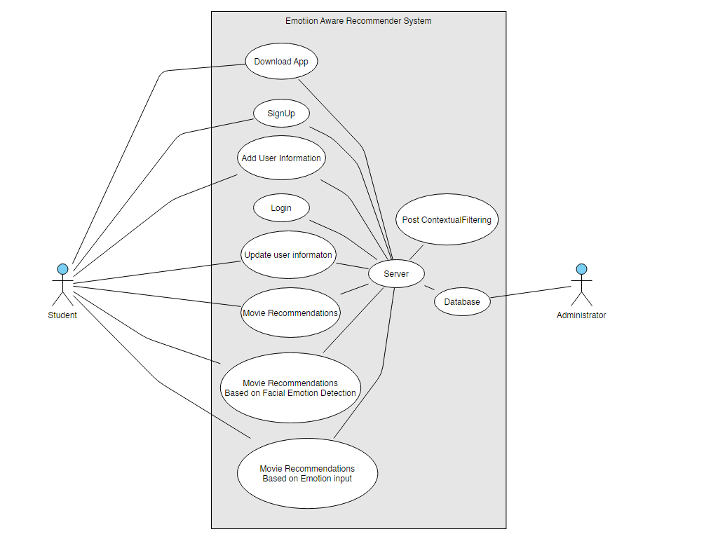
Figure 3-2 Main Use Case diagram

Use Case Descriptions

Table 3-1 User Sign Up
UC ID | UC001
UC Name | User Sign Up
UC Description | User can sign up for an account onto the system using the app
UC Pre-Condition | User has the app downloaded onto their smartphone from the website
UC Post-Condition | User has an account on the system
Normal Flow | The user registers successfully
Alternate Flow | Email is already in the system, the password is not above 8 characters.
Error Control | Error message display for Email and password
Primary Actor | User
Secondary Actor | -
Comments | -

Table 3-2 User Login
UC ID | UC002
UC Name | User Login
UC Description | User Logs into the app.
UC Pre-Condition | The user needs to have an account with the system by signing up for one before logging in.
UC Post-Condition | User is logged in and is redirected to the App’s main screen
Normal Flow | The user logs in successfully
Alternate Flow | Incorrect Email or Password results in no logging in
Error Control | Error message display for incorrect Email or password
Primary Actor | User
Secondary Actor | -
Comments | -

Table 3-3 Change User Information
UC ID | UC003
UC Name | Change User Information
UC Description | User can change their account information such as password
UC Pre-Condition | User has to be logged into their account through the app
UC Post-Condition | User has successfully updated their profile information
Normal Flow | The user updates their information
Alternate Flow | The user password already exists in the system
Error Control | Error message display for same password
Primary Actor | User
Secondary Actor | -
Comments | -

Table 3-4 Movie Recommendations
UC ID | UC004
UC Name | Movie Recommendations
UC Description | When the user logs into the system for the first time, they will be recommended movies on the basis of simple queries
UC Pre-Condition | User has to e logged into the system
UC Post-Condition | User is recommended movies
Normal Flow | The user logs into the system and is greeted with movie recommendations
Alternate Flow | Some DB error occurs and no information is displayed
Error Control | Error message to restart the app will be displayed
Primary Actor | User
Secondary Actor | -
Comments | -

Table 3-5 Movie Recommendations according to emotion input
UC ID | UC005
UC Name | User Movie Recommendations on input of emotion
UC Description | User can get recommendations for movies based on the input they provide for their current emotion
UC Pre-Condition | User has to be logged into the system and input emotional value
UC Post-Condition | User gets recommendations of movies
Normal Flow | The user is successful in giving their emotion and are given recommendations based on that input.
Alternate Flow | Server error occurs and the input is not received
Error Control | Error message to try again
Primary Actor | User
Secondary Actor | -
Comments | -

Table 3-6 Movie Recommendations Based on Facial Emotion Detection
UC ID | UC006
UC Name | User Movie Recommendations on Facial Emotion Detection
UC Description | User can get recommendations for movies based on the Facial emotion detected
UC Pre-Condition | User has the app downloaded onto their smartphone from the website
UC Post-Condition | User gets recommendations of movies
Normal Flow | The user is successful in having their emotion detected through the camera and getting recommendations
Alternate Flow | The emotion could not be detected accurately
Error Control | The user is asked to try again
Primary Actor | User
Secondary Actor | -
Comments | -

Table 3-7 Delete user account
UC ID | UC007
UC Name | User Account Deletion
UC Description | User can sign up for an account onto the system using the app
UC Pre-Condition | User has the app downloaded onto their smartphone from the website
UC Post-Condition | User gets recommendations of movies
Normal Flow | The user is successful in having their emotion detected through the camera and getting recommendations
Alternate Flow | The emotion could not be detected accurately
Error Control | The user is asked to try again
Primary Actor | User
Secondary Actor | -
Comments | -

Sequence Diagram

The following are the sequence diagrams for the emotion aware recommender system project.
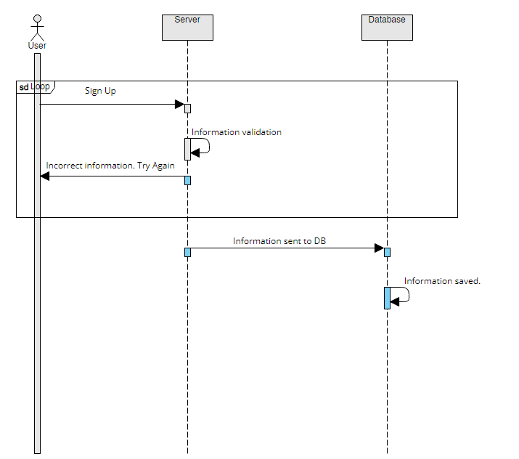
Figure 3-3 User SignUp
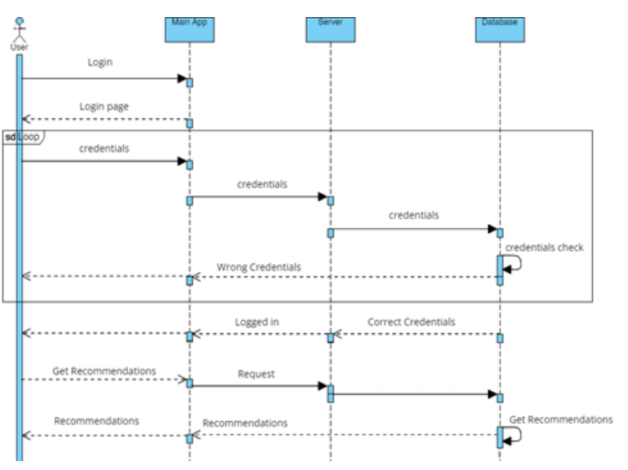
Figure 3-4 Login and Recommendations

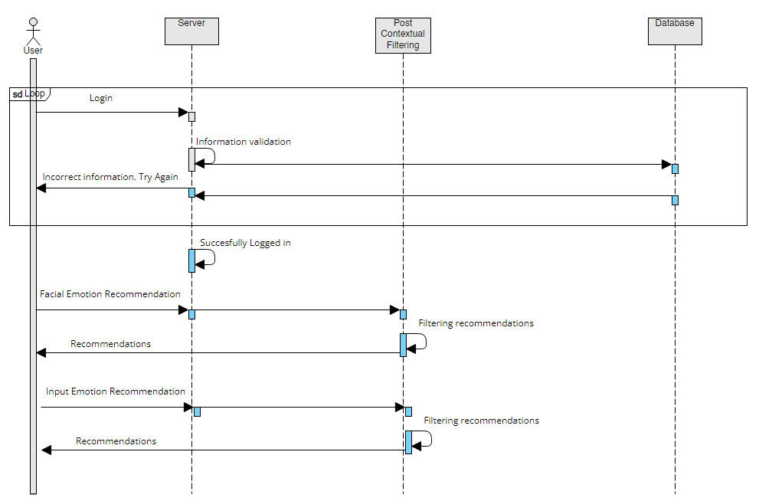
Figure 3-5 Recommendations According to Mood

ERD Diagram
The entity relationship diagram’s purpose is to elaborate the relationship between different entities of our project. The user table stores information about the user and the movie table about movie info. One or more users can get recommended to many movies.
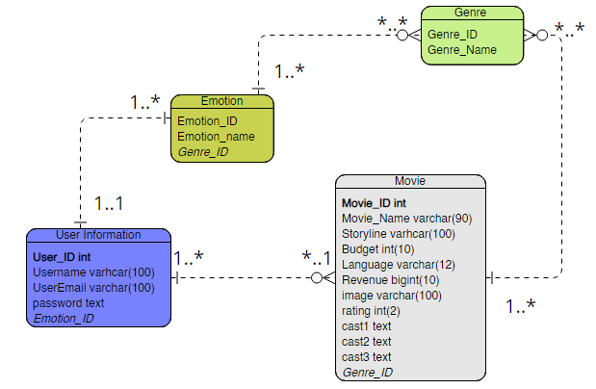
Figure 3-6 Entity Relationship Diagram

Domain Model Diagram
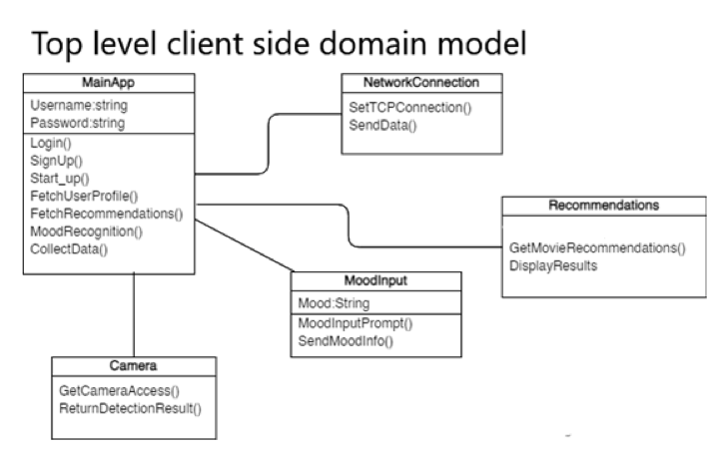
Figure 3-7 Client Side Domain Model

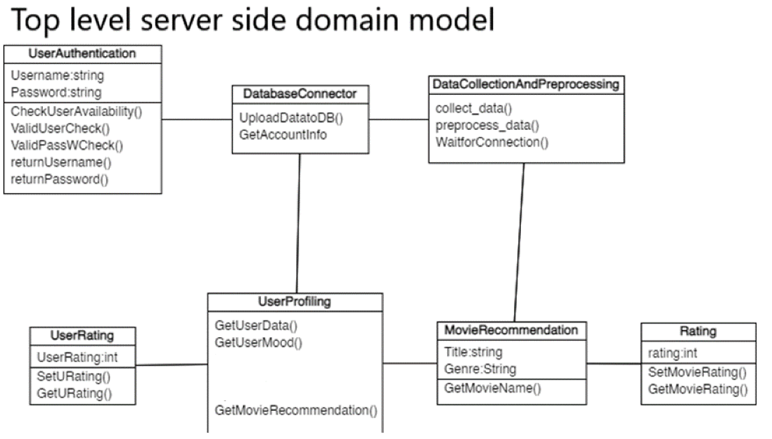
Figure 3-8 Server Side Domain Model

DATA AND EXPERIMENTS (and/or IMPLMENTATION)

4.1 Scrapper
The scrapper we used is a python-based library called scrappy code that allows us to scrap an entire movie website with our custom requirements. The website is called themoviedb.org We can scrape any number of records we want for this project. Here is the code:

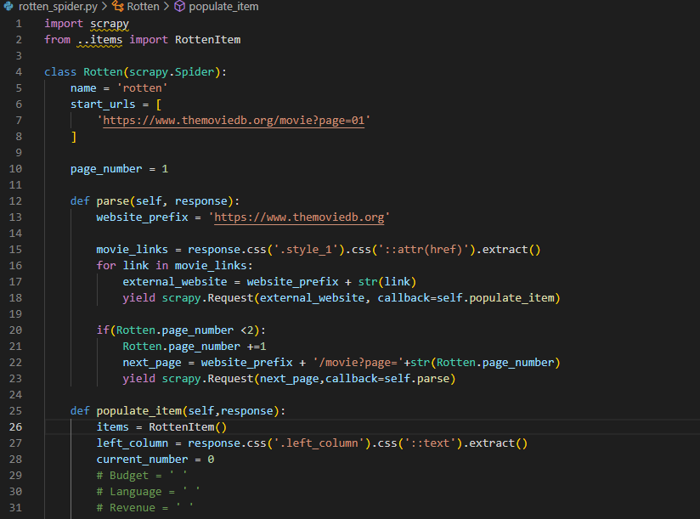
Figure 4-1 Crawler Code 1
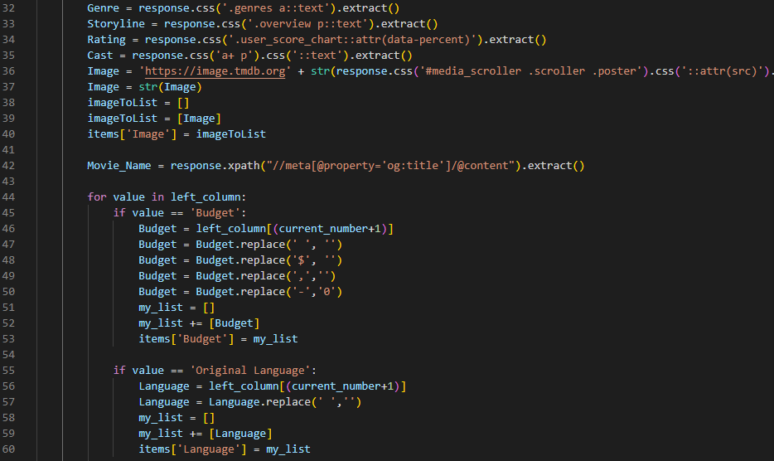
Figure 4-2 Crawler Code 2

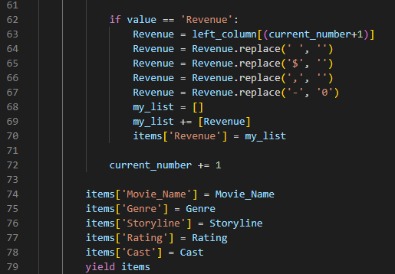
Figure 4-3 Crawler Code 3

Mobile Application

Main Activity
The Main Activity of the mobile application will greet the user with two options of either to sign up or login to the app. The activity also features a logo for the application itself.
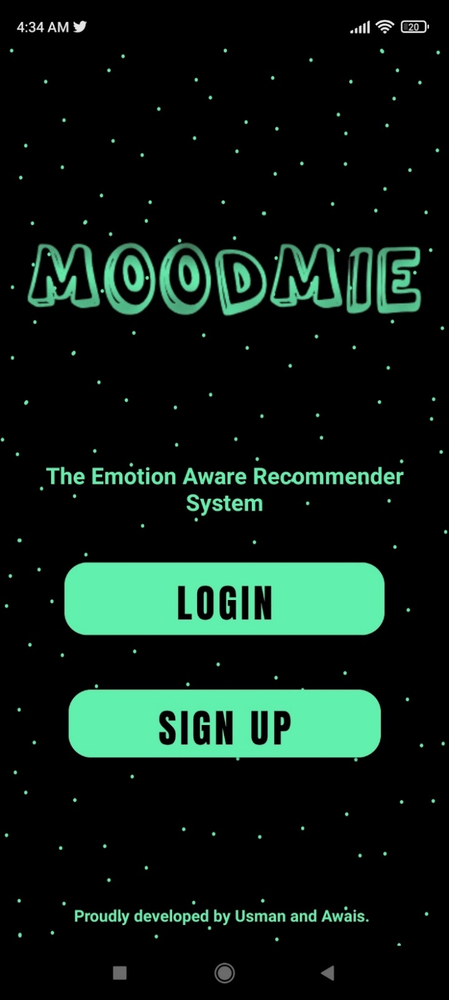
Figure 4-4 Main Activity

Signup Activity
The Signup activity allows the user to give their credentials along with setting up a password. Each field has their own validation checks with non-duplication of email and username, password length not less than 8 characters and re-entering of password.
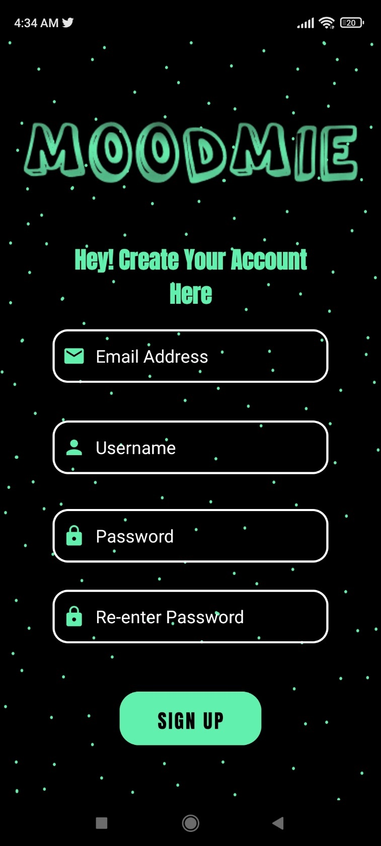
Figure 4-5 SignUp Activity

Login Activity
The login activity allows the user to sign into the app using their credentials with validation checks for each field of email and password.
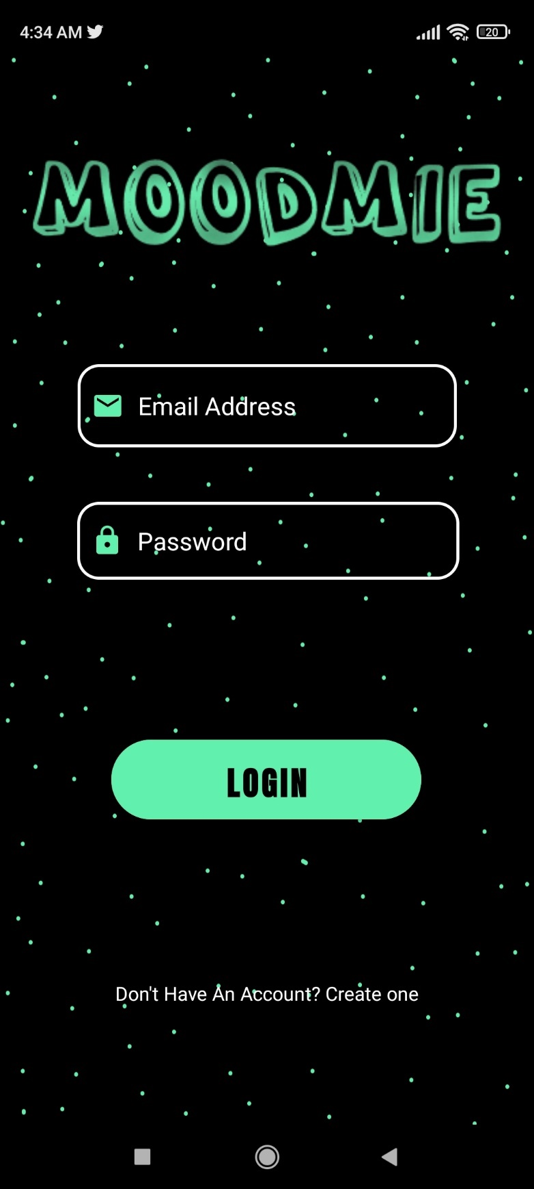
Figure 4-6 Login Activity

Dashboard Activity
The Dashboard activity is where the user will be able to see all the top-rated movies which are defined as “our top picks”. This list changes every time the user logs in. The Dashboard activity also has a gear icon which leads to the Settings activity. Before going into the Dashboard activity the user is also notified about the recommender itself. The user will also select a movie they like for further recommendation options
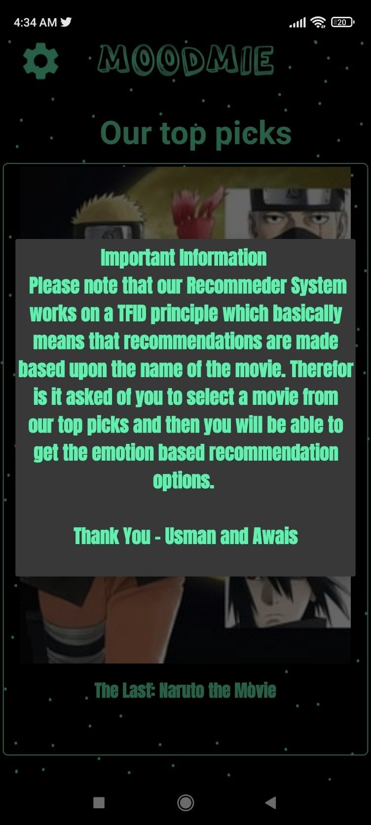
Figure 4-7 Dashboard Activity-1
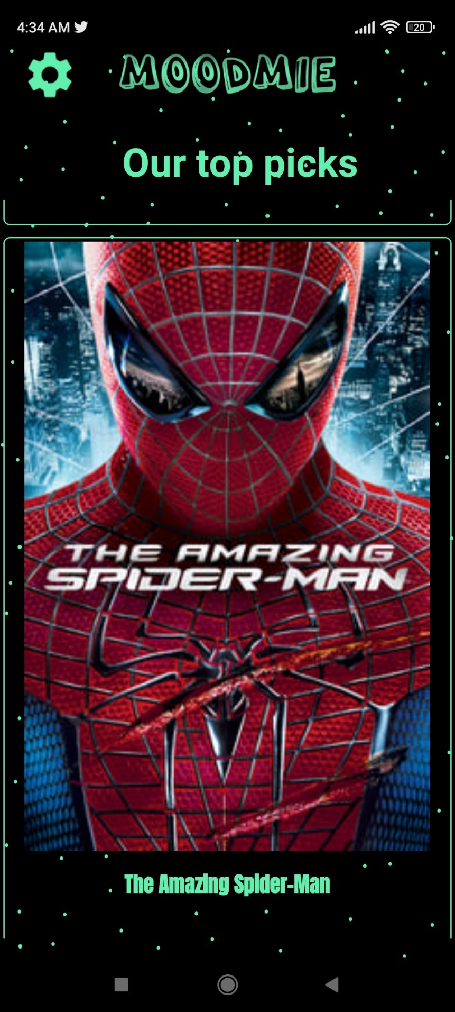
Figure 4-8 DashBoardActivity-2

Settings Activity
The settings activity will allow the user to direct themselves to the change password activity.
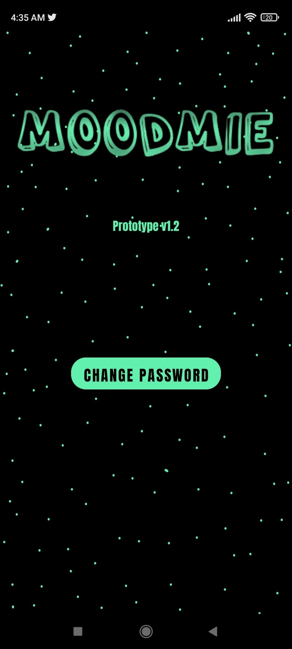
Figure 4-9 Settings Activity

Change Password Activity
The change password activity will allow the user to change their password if they can provide the correct old password and pass the validation checks for password length and duplicate.
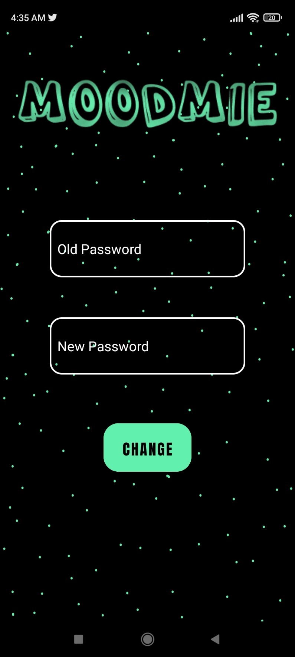
Figure 4-10 Change Password Activity

Recommend Options Activity
The Recommend Options activity will give the users the ability to be able to determine their emotions on the basis of facial detection or input detection and the movie name from the previous Dashboard activity is also carried along as well.
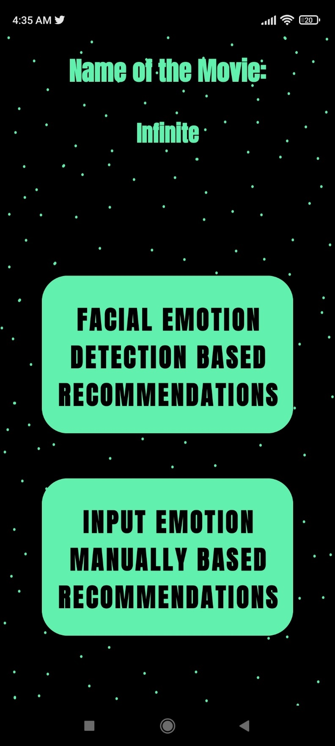
Figure 4-11 Recommend Options Activity

Cam Input Activity
The Cam Input activity will allow the user to access the camera of their smartphone device to take a picture of their face for emotion detection.
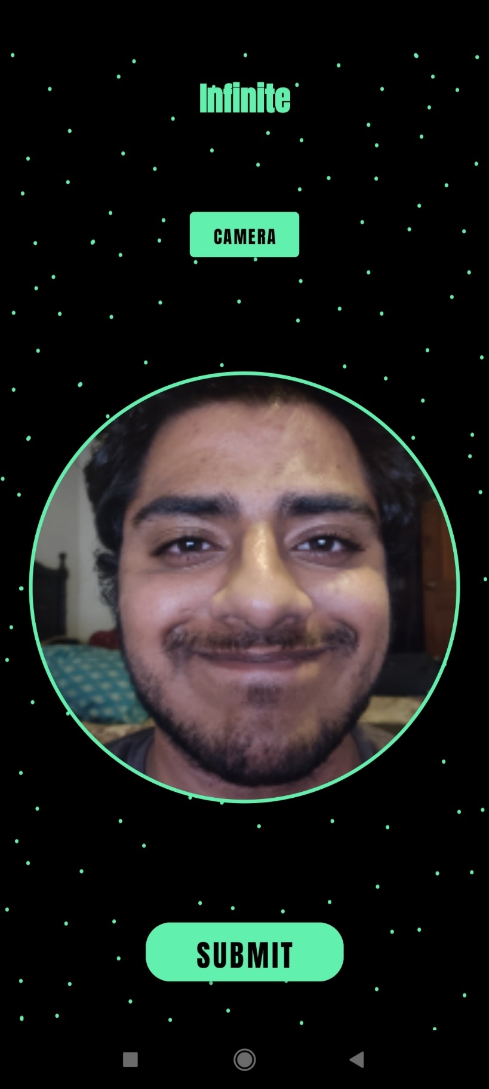
Figure 4-12 Cam Input

Facial Recommendations Activity
The Facial Recommendations Activity will give recommendations on the basis of post contextual filtering using the emotion that was detected using the users face.
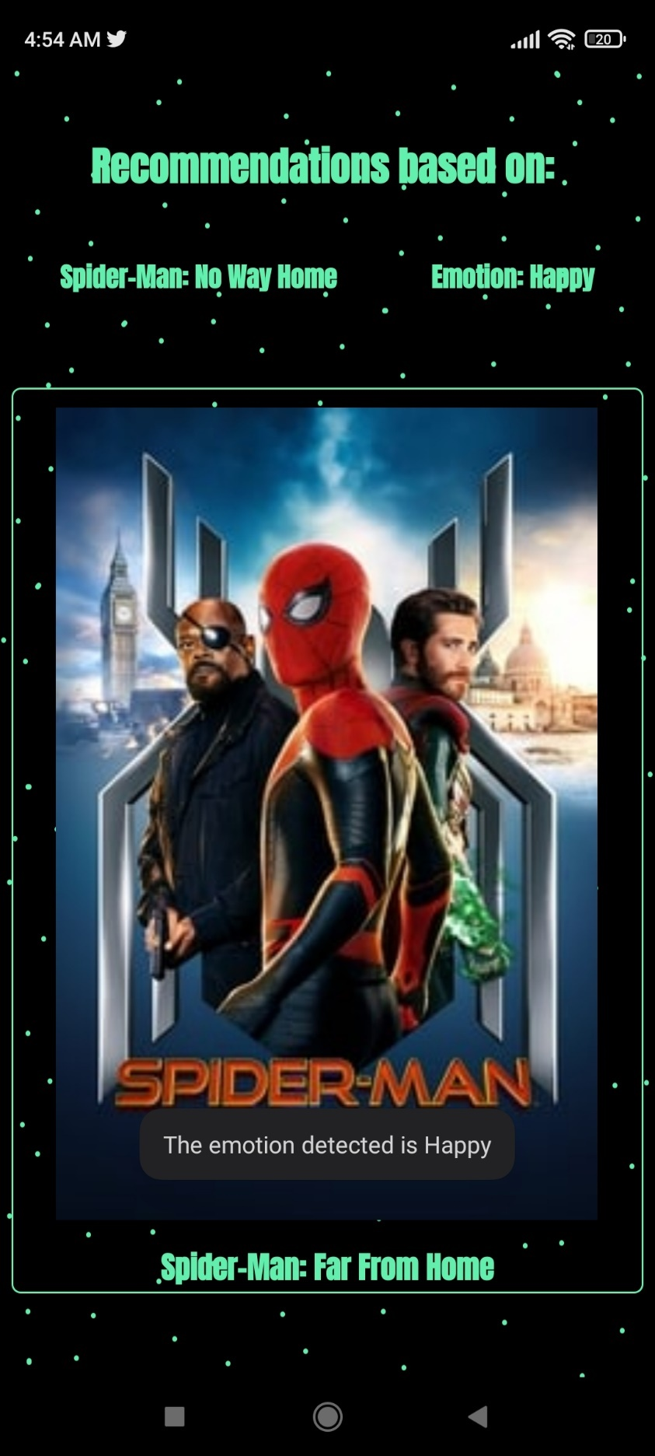
Figure 4-13 Facial Recommendations Activity

Emotion Input Activity
The Emotion Input activity will take in the users emotion manually by text.
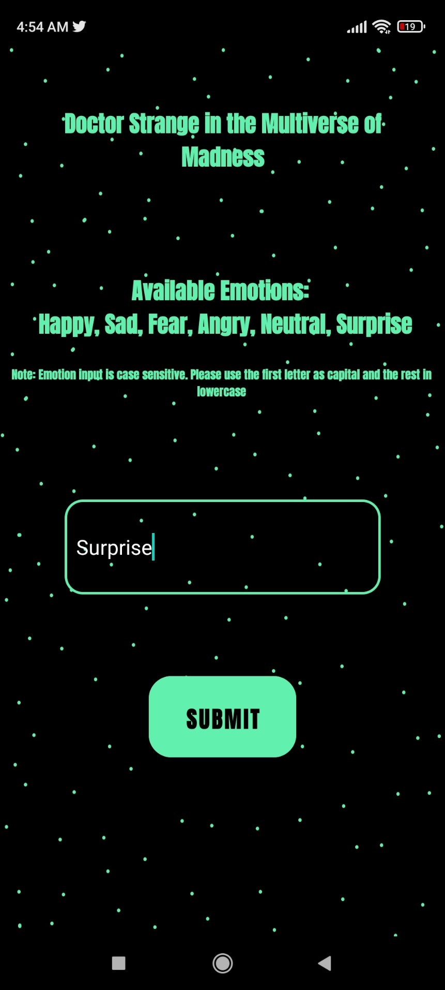
Figure 4-14 emotionInput Activity

Input Recommendations Activity
The Input Recommendations Activity will give recommendations on the basis of post contextual filtering using the emotion that was given by the user.
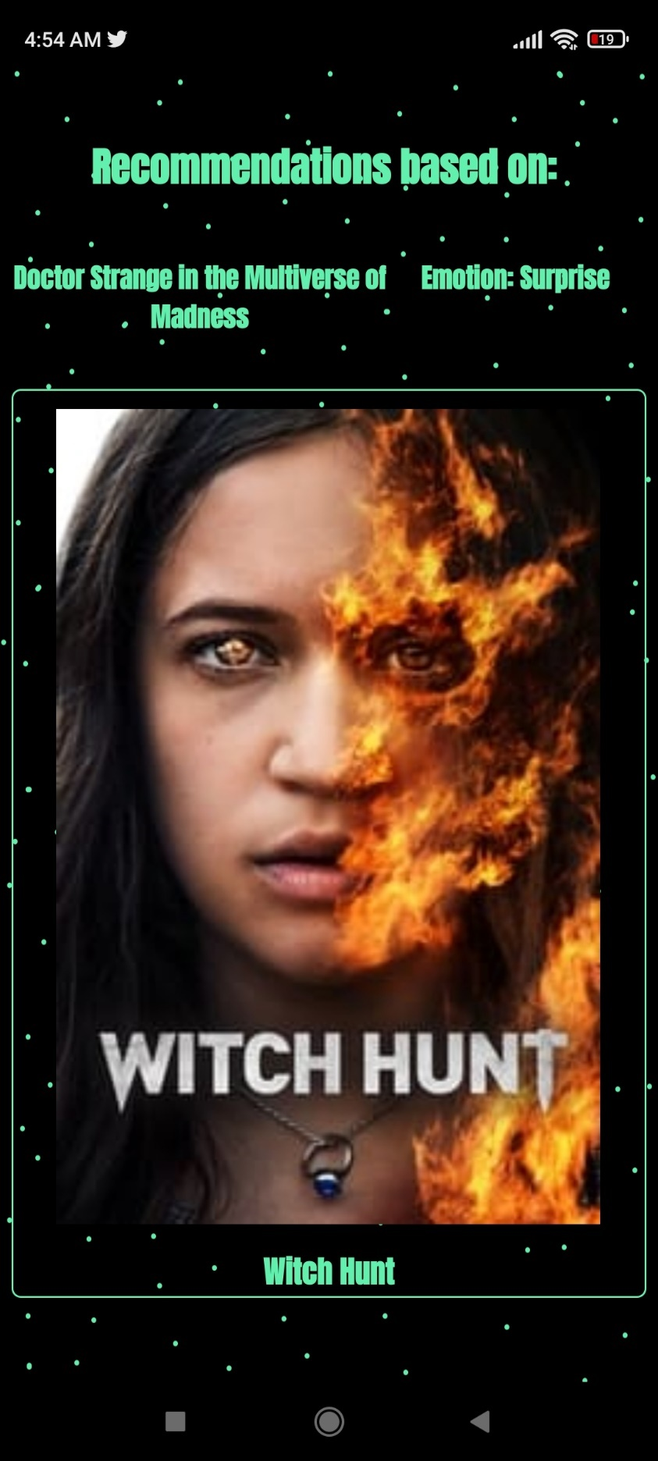
Figure 4-15 InputRecommendations Activity

Web Page

Index Page
The Home page of the website for the recommender system app which will provide information about the app itself.

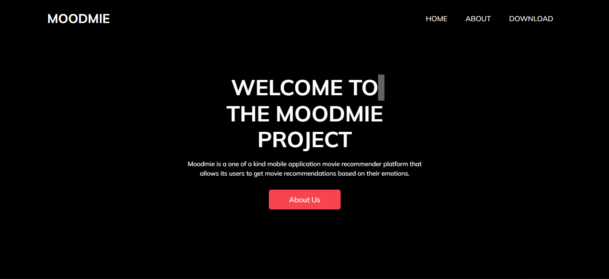
Figure 4-16 Website Index Page

Download Page

The download section of the website will allow the users to download the application (APK) file to be installed on the smartphone.
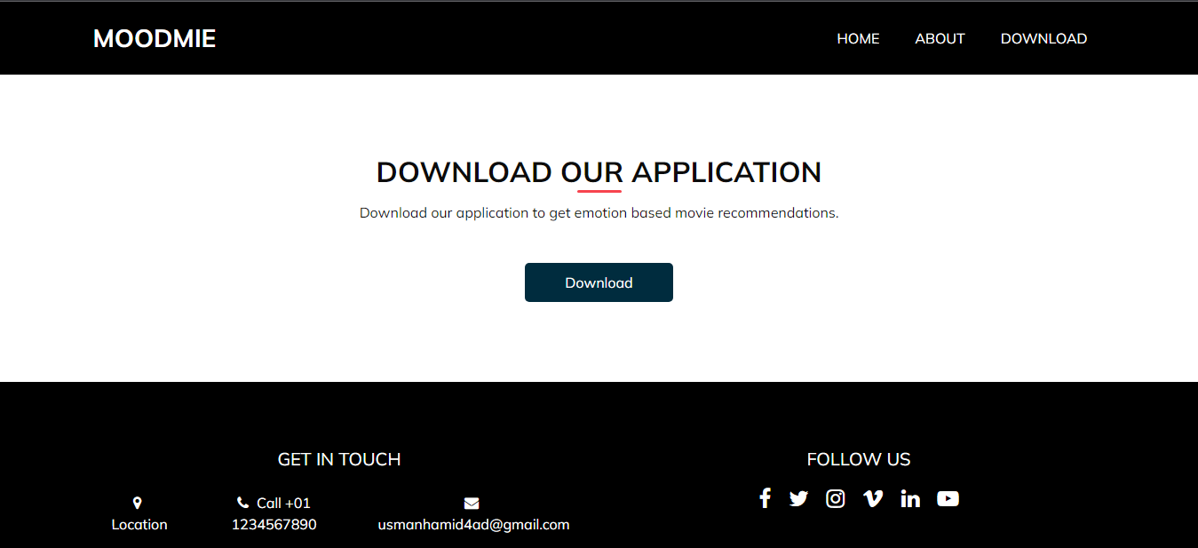
Figure 4-17 Website Download Page

About Page
The about page gives the general information about the recommender system mobile application.
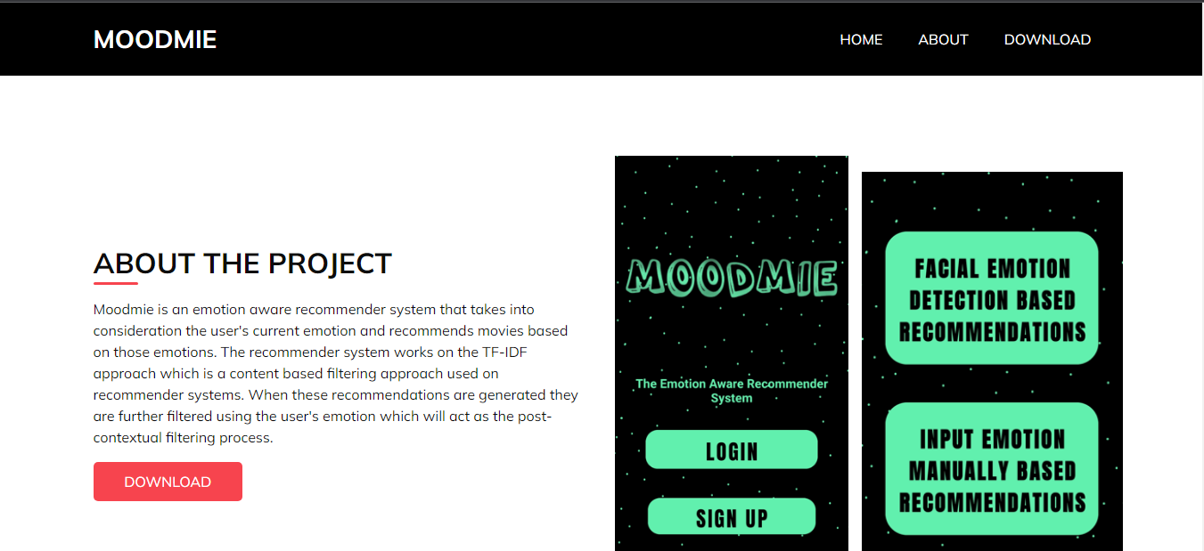
Figure 4-18 Website About Page

The Recommender System
The recommender system that is implemented in this project is based on two approaches. TF-IDF based content recommender system with post filtering applied on those recommendations using emotion of the user as a context. Information about the two is given below

TF-IDF
The term TFIDF stands for Term Frequency Inverse Document Frequency. TF-IDF is a very useful approach in many areas which includes content-based filtering, techniques used in text mining and more. TF-IDF in the case of this project is essential as it is required to build the item profiles.
There are two takeaways from the term one is TF. Term frequency is basically the frequency of the word that occurs in the dataset. IDF is the entire existence of the data among the large group of other data available like for example if there are 1 million documents, and the word “happy” exists in about 0.2 million of them, then their IDF score can be calculated.
When we put TF and IDF we get a TFIDF matrix which can be used to compute the similarities between different items or in this case movies.

Post-Contextual Filtering
In this filtering approach, generally what is happening is that initially in this case the contextual information about the user’s emotion is being ignored for the base recommendations that are being made using the TFIDF content based recommendations. Afterwards, the contextual filtering is applied which adjusts the acquired recommendations using contextual post-filtering information.
It filters out recommendations that are irrelevant and at the same time it adjusts the ranks of the recommendations in the list. A major advantage of contextual filtering is that it allows for the use of many traditional recommendation techniques.

RESULTS AND DISCUSSIONS (or USER MANUAL)

Dataset
The dataset that we are using is the FER-2013 dataset[1] which contains 48x48 grayscale images of faces. There are seven categories (0=Angry, 1=Disgust, 2=Fear, 3=Happy, 4=Sad, 5=Surprise, 6=Neutral) present in the data.
The faces have been automatically registered so that the face is centred and occupies about the same amount of space in each image. The training set consists of 28,709 examples and the public test set consists of 3,589 examples.
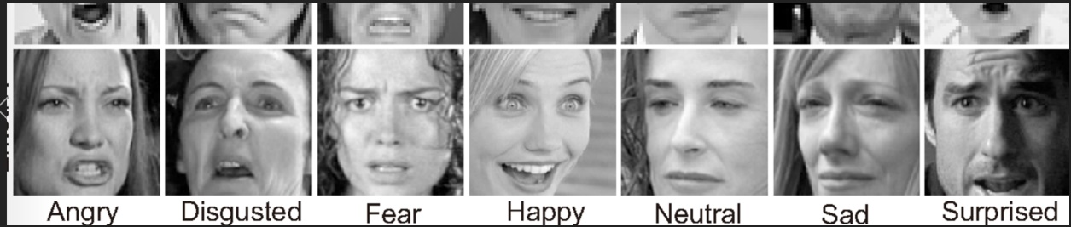
Figure 5-1 Emotion Labels

CNN Model
We are using a Convolution Neural Network for the task of detecting emotions from images. We have decided to use a custom downsized version of the popular VGG16 CNN Model.
Layers of our CNN:
1.Convolution using 32 filters
2.Convolution using 32 filters + Max pooling
3.Convolution using 64 filters
4. Convolution using 64 filters + Max pooling
5. Convolution using 128 filters
6. Convolution using 128 filters + Max pooling
7. Convolution using 256 filters
8. Convolution using 256 filters + Max pooling
9. Flattening Layer
10. Fully connected with 64 nodes
11. Fully connected with 64 nodes
12. Output layer with Softmax activation with total number of classes as nodes.

We are using Batch Normalization after every output produced from each Convolution layer so that our neural network can converge better, and that overfitting is reduced.
The Max Pooling layers are used to reduce the dimensionality of the feature maps and it makes our model more invariant to minor transformations or distortions in our input images.
We have decided to use 2x2 windows on our pooling layers since this model is inspired by the VGG model. The activation function we have decided to use is ‘elu’ (Exponential Linear Unit).
We are also going to use ‘categorical_crossentropy’ loss function and the Adam Optimizer for our model.

Results:

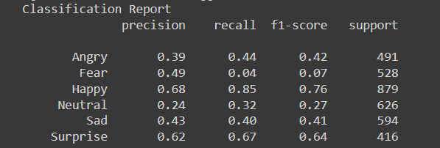
Figure 5-2 CNN Results

Recommender System Result Discussion

If a user requests recommendations based on the query (movie_name = ‘The Dark Knight’, current_emotion = ‘Happy’), than the following is done to suggest the user movies:
First based on the movie_name, by using tf-idf and cosine_similarity, a list of n number of recommended movies is created, with this list being sorted based on the similarity between the movie_name, also it is sorted in a descending fashion. From this list of similar movies, further filtering out is done on this list of movies. Depending on the current_emotion that is provided the list of similar movies is filtered out. For this example’s case the current emotion provided was ‘Happy’, so from the list of movies the genre of the similar movies is checked. Due to the emotion being ‘Happy’, the genres that are checked are: Action, Adventure and Crime. From the list of similar movies those records which contain these genres are filtered and returned as a response /result to the user.

CONCLUSION AND RECOMMENDATIONS

Conclusion
Throughout the various phases of the development and planning of the project we came to the enlightenment to the prospect of many different challenges that come forward when working on a software project. The meticulous time management and other managerial aspects have given us the opportunity to learn more and to instil better practices into our work.
Not only did we learn managerial aspects, but we also had the fortunate opportunity to work and test on different programming languages, tools and technologies that we had not worked on previously or had not dived deep into them.
CNN, which is short Convolutional Neural Networks, is a classification model that is used in deep learning to classify images against a certain character or label. In our case we had to train our mode to detect and stamp images according to a given set of emotions. The model would take the image as an input and in return would produce the nearest possible result for it.
Furthermore, we also worked on our recommender system. The recommender system that we implemented is a context-aware recommender system where the context is the emotion of the user. After many trials and errors, we were able to define a comfort spot for our recommender system and we were able to filter out results that were satisfactory.

Future Work
The project can be further improved in future by using different approaches to the recommendation engine. Currently, the emotional context of the user is being gathered by taking a picture of the user using the camera module.
This can be enhanced by instead of taking one picture, we take continuous streams of frames from the camera in the form of a video. To do this, the neural network model being used in the project should be changed to a RNN (Recurrent Neural Network).
This network will utilize the interdependencies between the multiple frames in the video and provide a more accurate and precise detection of current user emotional state.
It is recommended that in future works, the project’s facial image dataset is increased in diversity and in size so that the features found in the dataset are richer and more meaningful towards better detection of emotional context.
The scrapping of the movies dataset currently does not contain user reviews, which we recommend that in future works is included so that these reviews can be used to detect sentiment analysis which will allow us to make more accurate recommendations to the user depending upon the contextual data provided.
We also have plans to move our project onto a fully functional website so that we have maximum coverage across multiple devices and to also get more user data to further process and use for better improvements in the recommender system.
Further future plans also involve the incorporation of health data which will help us in identifying the emotions with more accuracy. We are already taking in the user’s facial emotion data, if we can couple it with the health data that most smart watches and other health sensors capture, we can use them for more accurate detection of emotion and we wouldn’t have to rely only on input and facial detection.

REFERENCES
[1] B. I Goodfellow, D Erhan, PL Carrier, A Courville, M Mirza, R. L. Hamner, W Cukierski, Y Tang, DH Lee, Y Zhou, C Ramaiah, F Feng, R. I. X Wang, D Athanasakis, J Shawe-Taylor, M Milakov, J Park, A. M Popescu, C Grozea, J Bergstra, J Xie, L Romaszko, B Xu, Z Chuang, and Y. Bengio., “Challenges in Representation Learning: A report on three machine learning contests,” 2013.

APPENDICES

APPENDIX A: Roles and Responsibilities
The following roles and responsibilities should be in consideration for any type of project undertakings. The same person has the ability to fulfil the purpose of more than one role in this scenario and there may be numerous users who will be supporting a single role as well. The roles may be more or different depending upon your own scenario of the project.

Database Administrator (DBA): This responsibility entails the responsibility of security and information classification that is being shared among the system.
Configuration Manager (CM): The individual whose responsibility is to identify configuration items in a system.
Information Technology Analyst: The induvial who is responsible for developing and coming up techniques and process models for the project life cycle.
Information Technology Developer: The individual who is responsible for the development of the software project itself.
Project Manager: The individual who is responsible for making sure that all the activities for the project are being carried out.

APPENDIX B: Computer Programs Listing

The different tools and technologies that were used for the development of this project are:
Python - A backend scripting language and machine learning support.
PHP - A backend scripting language.
Postman API - An application to create and manage APIs.
TensorFlow – For the development of the CNN model.
Visual Studio Code - A Text editor for editing different files and programs.
Android Studio – Main program for android application development.
XAMPP server - A server running on Apache and MySQL for running our PHP files provide a gateway for API communication.
Flask Webserver – A python web framework for hosting a webserver and to generate results using python files and API calls
Java – Main Server Language for Application Development

