
BS (CS)-F21-005
03-134182-011 | Asim Nawaz
03-134182-097 | Sidra Wajid

HOTDEALSPK

In partial fulfilment of the requirements for the degree of
Bachelor of Science in Computer Science
Supervisor: Dr. Ghulam Mustafa

Department of Computer Sciences
Bahria University, Lahore Campus
June 2022

© Bahria University, 2022

Certificate

We accept the work contained in the report titled
“HOTDEALSPK”
Written by
Sidra Wajid
Asim Nawaz
As a confirmation to the required standard for the partial fulfilment of the degree of
Bachelor of Science in Computer Science.

Approved by:
Supervisor: Dr. Ghulam Mustafa
(Signature)

June 14, 2022

DECLARATION

We hereby declare that this project report is based on our original work except for citations and quotations which have been duly acknowledged. We also declare that it has not been previously and concurrently submitted for any other degree or award at Bahria University or other institutions.

Enrolment | Name | Signature
03-134182-097 | Sidra Wajid
03-134182-011 | Asim Nawaz

Date : June 14, 2022

Specially dedicated to
My beloved grandparents, mother and father
(Sidra Wajid)
My beloved grandparents, mother and father
(Asim Nawaz)

ACKNOWLEDGEMENTS

We would like to thank everyone who had contributed to the successful completion of this project. We would like to express our gratitude to my research supervisor, Dr Ghulam Mustafa for his invaluable advice, guidance and his enormous patience throughout the development of the research.

In addition, we would also like to express our gratitude to our loving parent and friends who had helped and given us encouragement.

Sidra Wajid
Asim Nawaz

HOTDEALSPK

ABSTRACT

HOTDEALSPK is a web-based application that aim at providing a single platform where user can find products from multiple vendors at the same place and compare the prices. The system will not only help to find an optimal deal to the users and customers but will also decrease their search time to navigate through multiple systems from a single platform. All the users need will be fulfilled in our web-based application. HOTDEALSPK will be very beneficial for both the customers and the vendors and will ease the life of customer.
The methodology which we will use in our project will be FDD in agile. In big and complicated projects, feature driven development has shown to be quite effective. We will crawl/scrap data of deals from different ecommerce websites and provide it in single platform. All the scrap data will be stored in a data base in proper organized form. The tools that we are using for the backend is python, MYSQL and for frontend we will be using HTML, CSS, or JavaScript.

TABLE OF CONTENTS

DECLARATION ii
ACKNOWLEDGEMENTS iv
ABSTRACT v
TABLE OF CONTENTS vi
LIST OF TABLES x
LIST OF FIGURES xi
LIST OF SYMBOLS / ABBREVIATIONS xiii

CHAPTERS
1 INTRODUCTION 1
1.1 Background 1
1.2 Problem Statements 2
1.3 Aims and Objectives 2
1.4 Scope of Project 3
2 SOFTWARE REQUIREMENTS SPECIFICATION 4
2.1 User Classes and Characteristics 4
2.2 Operating Environment 5
2.3 Design and Implementation Constraints 5
2.4 Assumption and Dependencies 6
2.5 Other Non-functional Requirements 6
2.5.1 Security Requirements 6
2.5.2 Software Quality Attributes 6
2.5.3 Other Requirements 7
2.6 Functional Requirements 8
2.6.1 Use-Case Diagrams 8
2.6.2 System Use-Case diagram 8
2.6.3 Sign up Use-Case diagram 9
2.6.4 Admin Login Use-Case diagram 10
2.6.5 User Login Use-Case diagram 11
2.6.6 Search Deals Use-Case diagram 11
2.6.7 Change Password Use-Case diagram 12
2.6.8 Help Desk Use-Case diagram 13
2.6.9 Admin Panel Use-Case diagram 14
2.6.10 Categories Use-Case diagram 15
2.6.11 Delete Account Use-Case diagram 16
3 DESIGN AND METHODOLOGY 17
3.1 Feature Driven Development 18
3.2 Use Case Descriptions 19
3.2.1 Sign up use-case description 19
3.2.2 Admin Login use-case description 20
3.2.3 User login use-case description 21
3.2.4 Search Deals use-case description 22
3.2.5 Change Password use-case description 23
3.2.6 Help Desk use-case description 24
3.2.7 Admin panel use-case description 25
3.2.8 Categories use-case description 26
3.2.9 User Logout use-case description 27
3.2.10 Admin Logout use-case description 28
3.3 Sequence Diagrams 29
3.3.1 Sequence Diagram of Sign up 29
3.3.2 Sequence Diagram for Admin Login 30
3.3.3 Sequence Diagram for User Login 31
3.3.4 Sequence Diagram for Search Deals 32
3.3.5 Sequence Diagram of Change Password 33
3.3.6 Sequence Diagram of Help desk 34
3.3.7 Sequence Diagram for User Logout 35
3.3.8 Sequence Diagram for Admin Logout 36
3.4 Entity Relationship Diagram 37
3.5 UML Class Diagram 38
4 DATA AND REQUIREMENTS 39
4.1 Languages Used for Implementation 39
4.1.1 Html 39
4.1.2 CSS 39
4.1.3 Java script 39
4.1.4 SQL 40
4.1.5 Python 40
4.2 Tools used for Implementation 40
4.2.1 VS Code 40
4.2.2 MYSQL Workbench 40
4.3 Framework 41
4.3.1 Bootstrap 41
4.3.2 Django 41
4.4 Database Structure 41
4.4.1 Create database 41
4.4.2 Scraped Data 42
4.4.3 Authentic Users 42
5 RESULT AND DISCUSSION 43
5.1 Search Deals at HOTDEALSPK 43
5.2 Categories in HOTDEALSPK 44
5.3 Registration HOTDEALSPK 45
5.4 Login in HOTDEALSPK 46
5.5 Add Address 47
5.6 Forgot Password in HOTDEALSPK 47
5.7 User Change Password 48
5.8 Delete Account 48
5.9 Help Desk 49
5.10 Admin Login in HOTDEALSPK 49
5.10.1 Admin Panel 50
5.10.2 Add User 51
5.10.3 Delete User 52
6 CONCLUSION AND RECOMMENDATION 53
6.1 Conclusion and Recommendations 53
References 54

LIST OF TABLES

TABLE TITLE PAGE
Table 2.1 Operating Environment 5
Table 3.1 Sign up use-case description 19
Table 3.2 Admin Login use-case description 20
Table 3.3 User Login use-case description 21
Table 3.4 Search deals use-case description 22
Table 3.5 Change Password use-case description 23
Table 3.6 Help desk use-case description 24
Table 3.7 Admin panel use-case description 25
Table 3.8 Categories use-case description 26
Table 3.9 User Logout use-case description 27
Table 3.10 Admin Logout use-case description 28

LIST OF FIGURES

FIGURE TITLE PAGE
Figure 2:1 System Use Case Diagram 8
Figure 2:2 Sign up Use-Case diagram 9
Figure 2:3 Admin Login Use-Case diagram 10
Figure 2:4 User Login Use-Case diagram 11
Figure 2:5 Search Deals Use-Case diagram 11
Figure 2:6 Change Password Use-Case diagram 12
Figure 2:7 Help desk Use-Case diagram 13
Figure 2:8 Admin Panel Use-Case diagram 14
Figure 2:9 Categories Use-Case diagram 15
Figure 2:10 Delete Account Use-Case diagram 16
Figure 3:1 FDD 18
Figure 3:2 Sequence Diagram of Sign Up 29
Figure 3:3 Sequence Diagram for Admin Login 30
Figure 3:4 Sequence Diagram for User Login 31
Figure 3:5 Sequence Diagram of Search Deals 32
Figure 3:6 Sequence Diagram of Change Password 33
Figure 3:7 Sequence Diagram of Help desk 34
Figure 3:8 Sequence Diagram User Logout 35
Figure 3:9 Sequence Diagram for Admin Logout 36
Figure 3:10 Entity Relationship Diagram 37
Figure 3:11 UML Class Diagram 38
Figure 4:1 database 41
Figure 4:2 Scraped data 42
Figure 4:3 Authentic Users 42
Figure 5:1 Search Deals 43
Figure 5:2 Categories in HOTDEALSPK 44
Figure 5:3 User Registration 45
Figure 5:4 User Login Page 46
Figure 5:5 Add Address 47
Figure 5:6 User Forgot Password 47
Figure 5:7 User Change Password 48
Figure 5:8 User Delete Account 48
Figure 5:9 User Help Desk 49
Figure 5:10 Admin Login Page 49
Figure 5:11 Admin Panel 50
Figure 5:12 Admin Add User 51
Figure 5:13 Admin Delete User 52

LIST OF SYMBOLS / ABBREVIATIONS

FDD Feature Driven Development
DB Data Base
OS Operating System

INTRODUCTION

Background

HOTDEALSPK is a website platform in which the customer can easily find their product that they want to purchase. The purchasing will be easy for the customer, they just have to search the product of their interest and in best discount deals it will be provided to them. For example, If a customer want to order multiple products like customer want to order an electronics device, want to order few clothes and also want to order some toys, so for that customer will go to different sites of electronics, clothing and toys and if any discount deal on going on these products he might won’t be able to know and customer may pay extra for the products and his a lot of time will also be consumed in searching the product from different sites. HOTDEALSPK will be very beneficial for the purchaser as purchaser just have to search the product of his interest and his product will be shown to him of multiple brands with best discount deal going on it. This web-based application will help user to not go to many sites, what they need will be provided to them on a single platform. This platform will contain deals from multiple vendors, and it will help the user to find the best product at the best price. On this platform the customers can do comparison of the different products provided by the different vendors. It will eventually save time and money of the customer. The website will contain different sections of the product the user can select the section of their choice. The sections can be households, makeup, accessories, electrical appliances etc[1].

Problem Statements

Finding the product of your need with a best discount deal is very time consuming and complex. Purchasers have to go to different sites and search for their product and he might purchase the product expensive without knowing that a discount was going on that product on another site. Purchaser might pay extra for the product without knowing that the cost of that product was so lesser than he paid in market. There is no platform available in the market that can compare the deals from the multiple websites and provide top selling/Low price deals after comparison on a single platform.

Aims and Objectives

Our objectives of the thesis are shown as following:
- To crawl/scrap data of deals from different e-commerce websites
- Reprocess data to store in database in an organized form
- To develop a web-based system that can be used by the both, the customers and vendors
- To develop and integrate web-based GUI with backend
- To test and evaluate the system

Scope of Project

HOTDEALSPK is a web-based platform which will provide the facility to our users to search the product according to their preferences. HOTDEALSPK will show the best discount deals according to purchaser preferences. The users need to register themselves on this platform if they want to save their searches and want to place an order. Through this platform purchaser can view the products of their interest having best discount deals on them. For a purchaser, it is very difficult to find the product which they want having a discount deal on it. They will search the product on different sites, and it will cost their lot of time. Customer can search multiple products and can also order multiple products of his interest on HOTDEALSPK[2].
The main scope of our project is that it will fulfil the users need by fetching the details from different e-commerce systems and compare the deal on a single platform. That will enable the user to buy a product on cheap/economical price from the market.

SOFTWARE REQUIREMENTS SPECIFICATION

User Classes and Characteristics

The user classes are of two types which are:
Users
Users can search deals, products and categories according to their requirements. User don’t need to go to different sites, he just need to search what thing he want to purchase and from multiple vendors, products will be shown to him at a single platform. User need to Sign up if they want to become a verified user. Once they sign up, next time they just have to enter their valid username and the correct password to login. In case the user forgot password, then he can press on forgot password button and request to reset his password through email. If users have any queries related anything, they can contact admin through help desk.
Admin
Admin can login in to the admin panel, they can have full access of the overall system. Admin can do modifications like they can add users, delete users, check their login History, and check their staff and super user status. All queries of the users can be seen by the admin.

Operating Environment

While designing and developing this web-based system, there are following hardware and software requirements.

Table 2.1 Operating Environment
Name | Description
Operating System | Windows
Browser | Google Chrome, Firefox, Safari, Opera, Internet Explorer
Languages | CSS, Java Script, HTML, Python, Django
Database | MySQL Work bench

Design and Implementation Constraints

We developed our front end on HTML, CSS and Java Script[3]. For back end development we used Django, to crawl data from different e-commerce sites we will use python. To store data, instead of purchasing and deploying a hardware server, we store data on local host and MySQL Workbench database because nowadays the trend is moving towards cloud databases which are more secure as compare to the traditional databases.

Assumption and Dependencies

The performance of (HOTDEALSPK) depends upon the user’s internet because fast data helps to retrieve data efficiently and also on other brand sites that will they allow to use their data on other site.

Other Non-functional Requirements

- All actions must be performed by system frequently and correct.
- Within a reasonable time the system should give a response.
- To run the system, internet is very essential because the websites usually rely on the internet. System will have a better performance if the internet is faster.
- A proper comparison among different brand must be displayed to the user and if user want to buy something, a link of that brand must be given.

Security Requirements

- Only an authorized person can use the system.
- Changes can be made by only admins.

Software Quality Attributes

- It is a web-based system and high portability is given to its users so that it can be used with internet access and browser.

Other Requirements

Availability

24/7 the system should be available.

Maintainability

The system should be configured and maintained easily.

Functional Requirements

Use-Case Diagrams
A use case diagram is a way to summarize details of a system and the users within that system. It is generally shown as a graphic depiction of interactions among different elements in a system.[4]

System Use-Case diagram
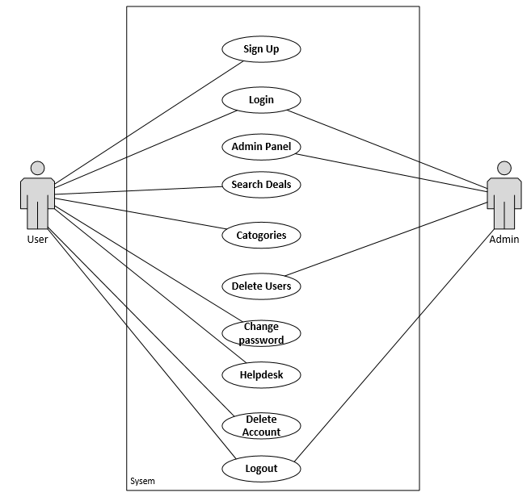
Figure 2:1 System Use Case Diagram

Sign up Use-Case diagram
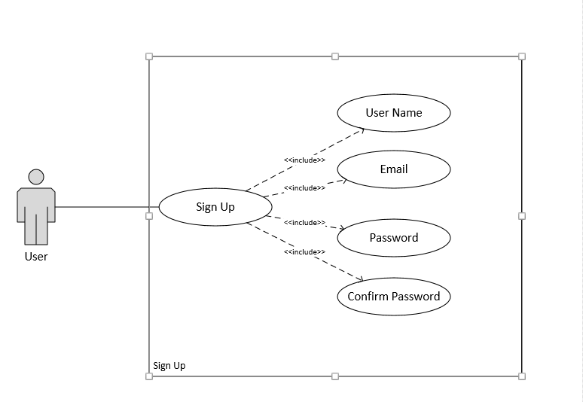
Figure 2:2 Sign up Use-Case diagram

Admin Login Use-Case diagram
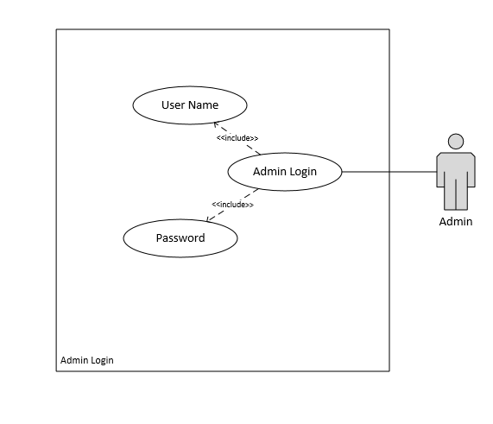
Figure 2:3 Admin Login Use-Case diagram

User Login Use-Case diagram
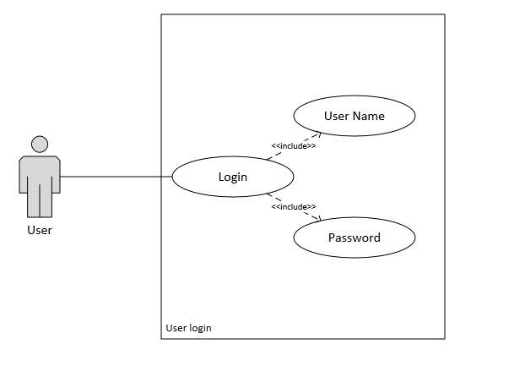
Figure 2:4 User Login Use-Case diagram

Search Deals Use-Case diagram

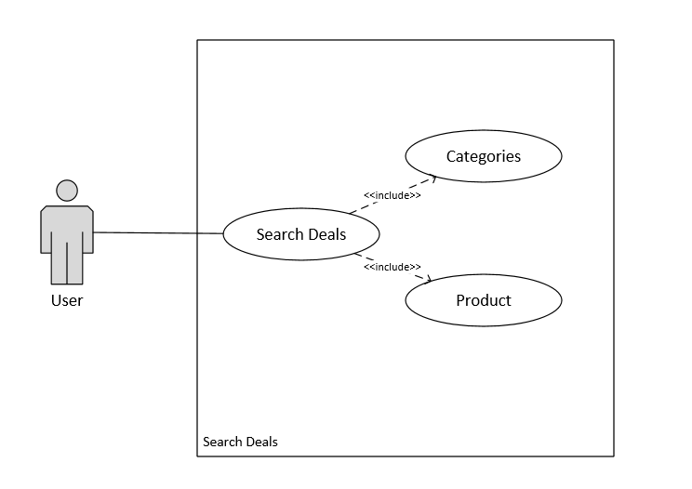
Figure 2:5 Search Deals Use-Case diagram

Change Password Use-Case diagram

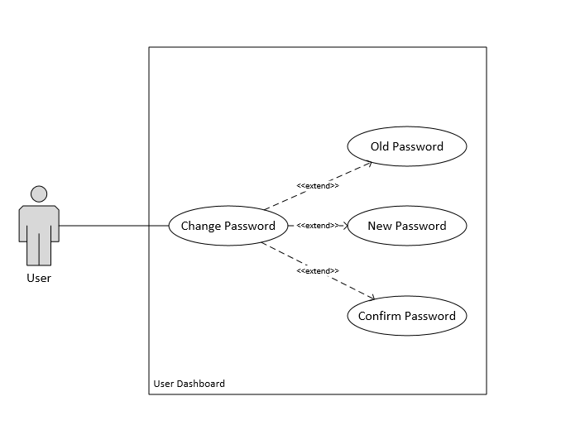
Figure 2:6 Change Password Use-Case diagram

Help Desk Use-Case diagram

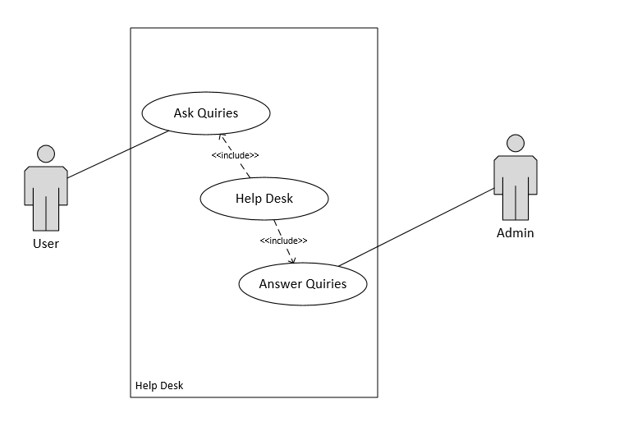
Figure 2:7 Help desk Use-Case diagram

Admin Panel Use-Case diagram

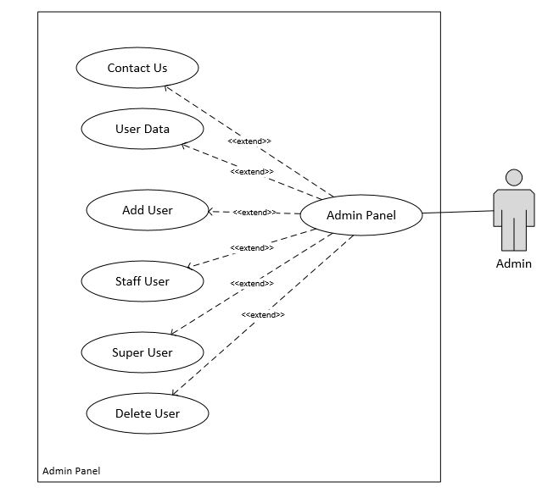
Figure 2:8 Admin Panel Use-Case diagram

Categories Use-Case diagram
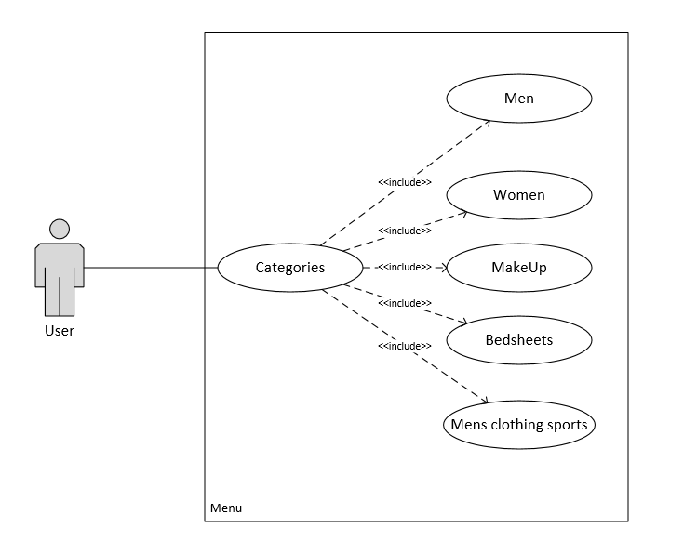
Figure 2:9 Categories Use-Case diagram

Delete Account Use-Case diagram
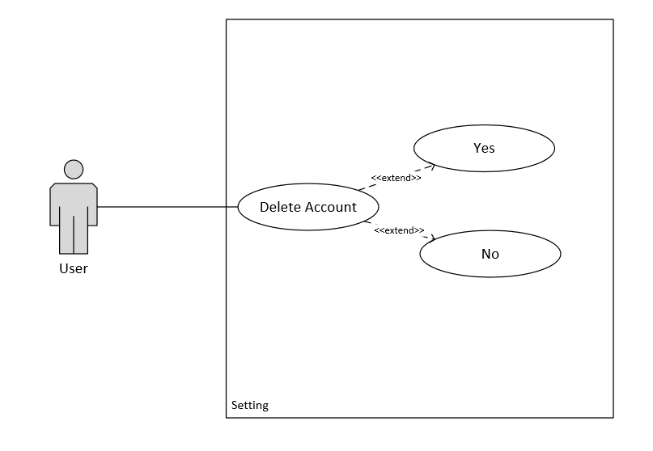
Figure 2:10 Delete Account Use-Case diagram

DESIGN AND METHODOLOGY

The overview of design of HOTDEALSPK is given in this chapter. The complete view of the system is given by the architecture of the system, by this the users and the developers will be allowed to see the design in detail. We will also discuss the methodology which we used.
Following artefacts included in this Chapter
- Feature driven development
- Use Case Description
- Sequence Diagrams
- ERD Diagram
- UML Class Diagram

Feature Driven Development

FDD is an iterative and incremental software development methodology. It is an agile method for developing software. It blends a number of industry recognized best practises in to a cohesive whole. These practises are driven from a client valued functionality perspective[5].

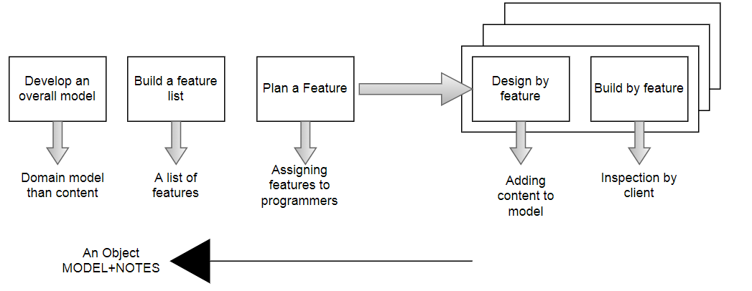
Figure 3:1 FDD

Use Case Descriptions

Sign up use-case description

Table 3.1 Sign up use-case description
Name and ID | Sign up – U1
Brief description | Users will sign up which will make them verified users.
Preconditions | User had a valid email ID
Basic flow or Happy path | - User enters First Name.  - User enters Last Name.  - User enters valid email.  - User enters Password.  - User enters Confirm Password.
Trigger | On clicking sign up button
Alternate flows | Alternative Flow 1 - User email is not valid.  System shows message to re-enter valid email ID.  Alternative Flow 2 – Password and confirm password are not same.  System shows message password and confirm password are not same.
Post conditions | User is registered.

Admin Login use-case description

Table 3.2 Admin Login use-case description
Name and ID | Admin Login – U2
Brief description | Admin can log in to the admin panel.
Preconditions | Login data of Admin already stored in the database.
Basic flow or Happy path | - Admin enters valid email ID and Password.  - Admin Log in to the admin panel.
Trigger | On clicking on the Admin Login button.
Alternate flows | Alternative Flow 1 – Admin enters invalid ID or passwords.  System shows message to enter valid ID and Password.  Alternative Flow 2 – Admin forgets the password.  Update Admins password in data base.
Post conditions | Admin can access admin panel.

User login use-case description

Table 3.3 User Login use-case description
Name and ID | User Login – U3
Brief description | User can login to the site.
Preconditions | User must be login to the site.
Basic flow or Happy path | - User enters the registered email ID.  - Users enters a valid Password.  - User press login button and is logged in.
Trigger | On clicking the Login Button.
Alternate flows | Alternative Flow 1 – User enters invalid email ID or Password.  System shows message to enter valid ID and Password.  Alternative Flow 2 – User forgets the password.  User can reset password.
Post conditions | User Logged in to site.

Search Deals use-case description

Table 3.4 Search deals use-case description
Name and ID | Search Deals – U4
Brief description | User can search brands and products according to their requirements.
Preconditions | User must be on the site.
Basic flow or Happy path | - User enters products of his choice.  - Users enters brands of his choice.  - User click on the search button.
Trigger | On clicking the Search Button.
Alternate flows | Alternative Flow 1 – No item match with the search job.  System shows message NO RESULT FOUND.
Post conditions | System will show Products and Brands to the user with their search requirements.

Change Password use-case description

Table 3.5 Change Password use-case description
Name and ID | Change Password – U5
Brief description | Users can change their password, with the help of change password.
Preconditions | User must be login to the site.
Basic flow or Happy path | - User login to their account.  - User clicks on change password to change the password.
Trigger | On user login.
Alternate flows | Alternative Flow 1 – New password and confirm Password are not same.  System shows alert that the new password and confirm password are not same.
Post conditions | None

Help Desk use-case description

Table 3.6 Help desk use-case description
Name and ID | Help Desk – U6
Brief description | User can ask queries if they have and they will be solved.
Preconditions | User must be login to site.
Basic flow or Happy path | - User selects the help desk option.  - User can ask queries from admin  - Admin will answer user queries.
Trigger | On clicking Helpdesk.
Alternate flows | Alternative Flow 1 – Admin is not available or offline.  User can mail admin.
Post conditions | User queries solved by the admin.

Admin panel use-case description

Table 3.7 Admin panel use-case description
Name and ID | Admin Panel – U7
Brief description | Admin can check user, deals and messages from contact us. Admin can also add users, add deals, delete users or delete deals.
Preconditions | Admin must be logged in.
Basic flow or Happy path | - Admin log in.  - Admin can checks users and can also add or delete users.  - Admin can checks deals and can add or delete deals.  - Admin can read messages from users.
Trigger | On login admin panel.
Alternate flows | Alternative Flow 1 – Admin searches invalid profile.  System shows an error message that profile doesn’t exist.
Post conditions | Admin can check user, add users, delete users and admin can also check messages from contact us.

Categories use-case description

Table 3.8 Categories use-case description
Name and ID | Categories – U8
Brief description | Users can select categories of his interest and product of that categories will be shown to him.
Preconditions | User must be logged in.
Basic flow or Happy path | - User login.  - Users can select categories according to their needs.  - Users can see all products of their required categories.
Trigger | On clicking on Menu.
Alternate flows | None.
Post conditions | User can see all categories on the site.

User Logout use-case description

Table 3.9 User Logout use-case description
Name and ID | User Logout – U9
Brief description | Users can logout from the website so no one can access their account.
Preconditions | User must be logged in.
Basic flow or Happy path | - User press Logout option.  - User logged out from site.
Trigger | On clicking on Log out button.
Alternate flows | None.
Post conditions | User Logged out from site.

Admin Logout use-case description

Table 3.10 Admin Logout use-case description
Name and ID | Admin Logout – U10
Brief description | Admin can Logout from admin panel so no one can access his/her account.
Preconditions | Admin must be logged in.
Basic flow or Happy path | - Admin press logout option.  - Admin logged out from admin panel.
Trigger | On clicking admin logout button.
Alternate flows | None.
Post conditions | Admin logged out from the site.

Sequence Diagrams

Sequence Diagram of Sign up

User can create account by entering valid information. User will be registered when the information successfully saved in the database.
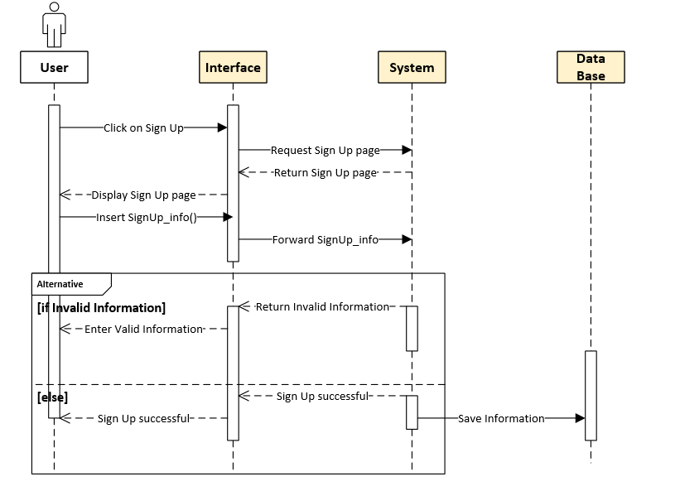
Figure 3:2 Sequence Diagram of Sign Up

Sequence Diagram for Admin Login

Admin can log in to the Admin panel by entering valid email id and password. The Admin Login data verified from the database that condition are valid or invalid.
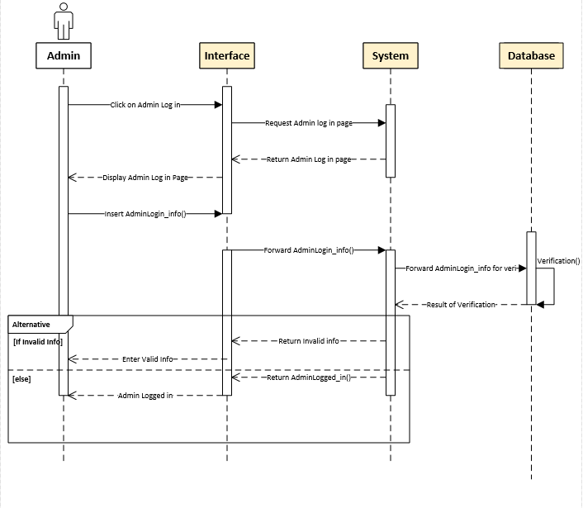
Figure 3:3 Sequence Diagram for Admin Login

Sequence Diagram for User Login

User can log in to the HOTDEALSPK by entering valid email id and password. The Login data is then verified from the database that it is valid or invalid.
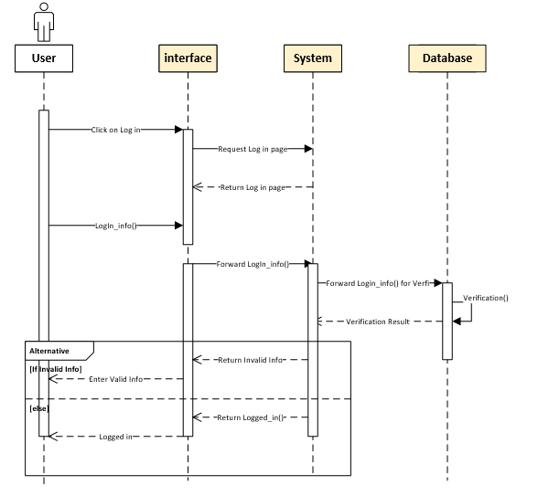
Figure 3:4 Sequence Diagram for User Login

Sequence Diagram for Search Deals

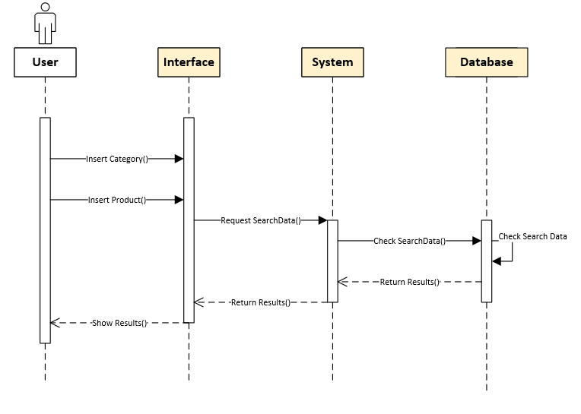
Figure 3:5 Sequence Diagram of Search Deals

Sequence Diagram of Change Password
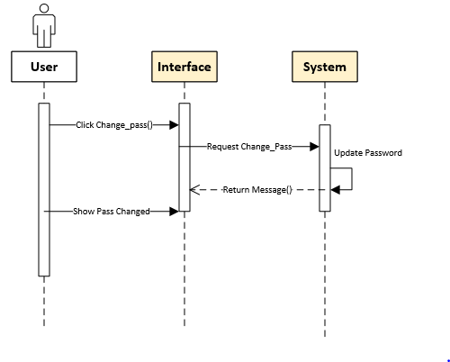
Figure 3:6 Sequence Diagram of Change Password

Sequence Diagram of Help desk
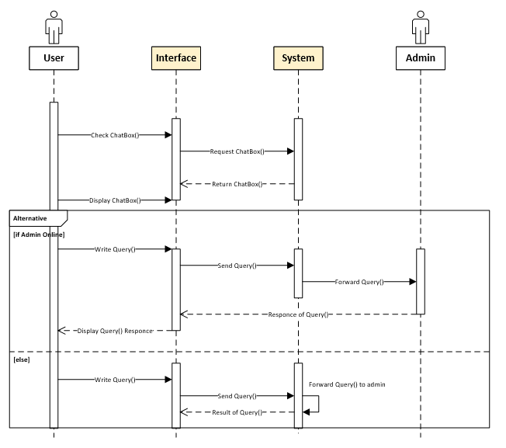
Figure 3:7 Sequence Diagram of Help desk

Sequence Diagram for User Logout
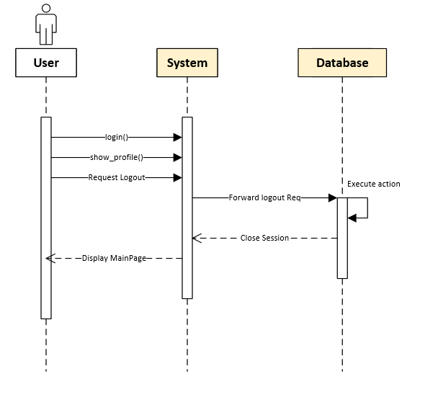
Figure 3:8 Sequence Diagram User Logout

Sequence Diagram for Admin Logout
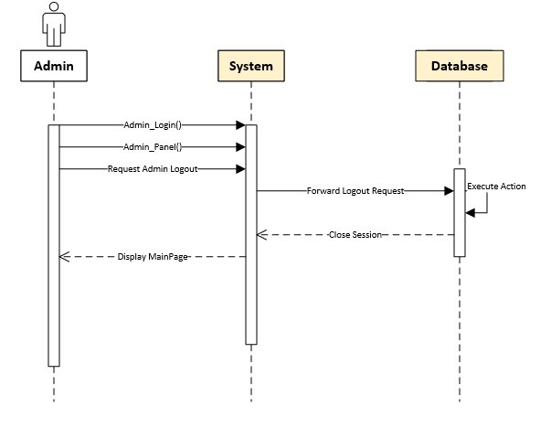
Figure 3:9 Sequence Diagram for Admin Logout

Entity Relationship Diagram

An Entity Relationship (ER) Diagram is a type of flowchart that illustrates how “entities” such as people, objects or concepts relate to each other within a system.
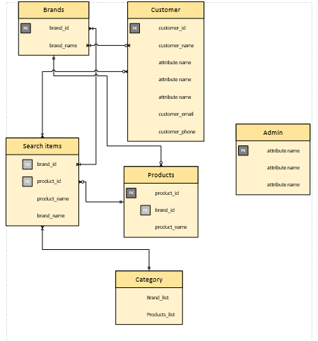
Figure 3:10 Entity Relationship Diagram

UML Class Diagram

The UML Class diagram is a graphical notation used to construct and visualize object oriented systems. A class diagram in the Unified Modelling Language (UML) is a type of static structure diagram that describes the structure of a system by showing the system.
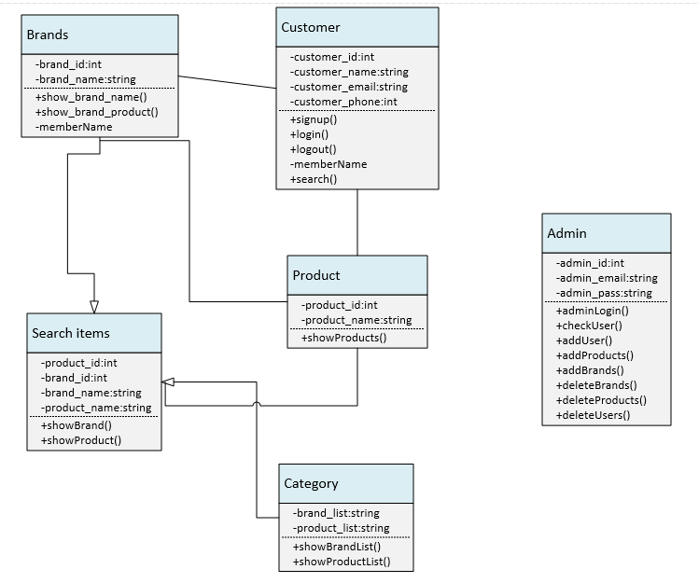
Figure 3:11 UML Class Diagram

DATA AND REQUIREMENTS

Languages Used for Implementation

Html

It stands for hypertext mark-up language and it used mainly to make the web applications and it can be also used to create web pages. It is mainly used to show the content on the web page and it is a front end language.

CSS

It stands for cascading style sheet. In our system CSS is used to define that how the elements of HTML will be shown on the screen and we also used it to do styling of our front-end content.

Java script

It is basically a programming language and we used it in our system to describe the overall behaviour of our web pages. Between starting and ending tag of the script, its code is written. Java script is mainly used in our system for event handling.

SQL

It stands for structure quarry language and it is used in our system for storing the data, manipulating the data and retrieving the data from the database. This is the main reason why we used SQL in our project because there are only few forms which are used to store and manipulate data.

Python

With dynamic semantic, python is an object oriented, interpreted and high level programming language. Python high level built in data structures which is combined with dynamic binding and dynamic typing which makes it very attractive for the development of rapid applications. It is also used for scrapping or glue language so that it can connect existing component together. In our system it is used for backend and for data scraping[6].

Tools used for Implementation

VS Code

Visual Studio Code is a lightweight but powerful source code editor which runs on your desktop and is available for Windows, mac OS and Linux. It comes with built-in support for JavaScript, Type Script and Node.js and has a rich ecosystem of extensions for other languages (such as C++, C#, Java, Python, PHP, Go).

MYSQL Workbench

MySQL Workbench is a unified visual tool for database architects, developers, and DBAs. MySQL Workbench provides data modelling, SQL development, and comprehensive administration tools for server configuration, user administration, backup, and much more[7].

Framework

Bootstrap

It is basically a framework which we used in our system to make our system responsive. In a grid view system, the screen is divided in bootstrap. It mainly contains files like Bootstrap.css, Bootstrap.css.

Django

Django is a free and open source web application framework, written in Python, it is a web framework which contains set of components that helps you to develop websites faster and easier. When you're building a website, you always need a similar set of components: a way to handle user authentication (signing up, signing in, signing out), a management panel for your website, forms, a way to upload files, etc[8].

Database Structure

Create database

A database is created.
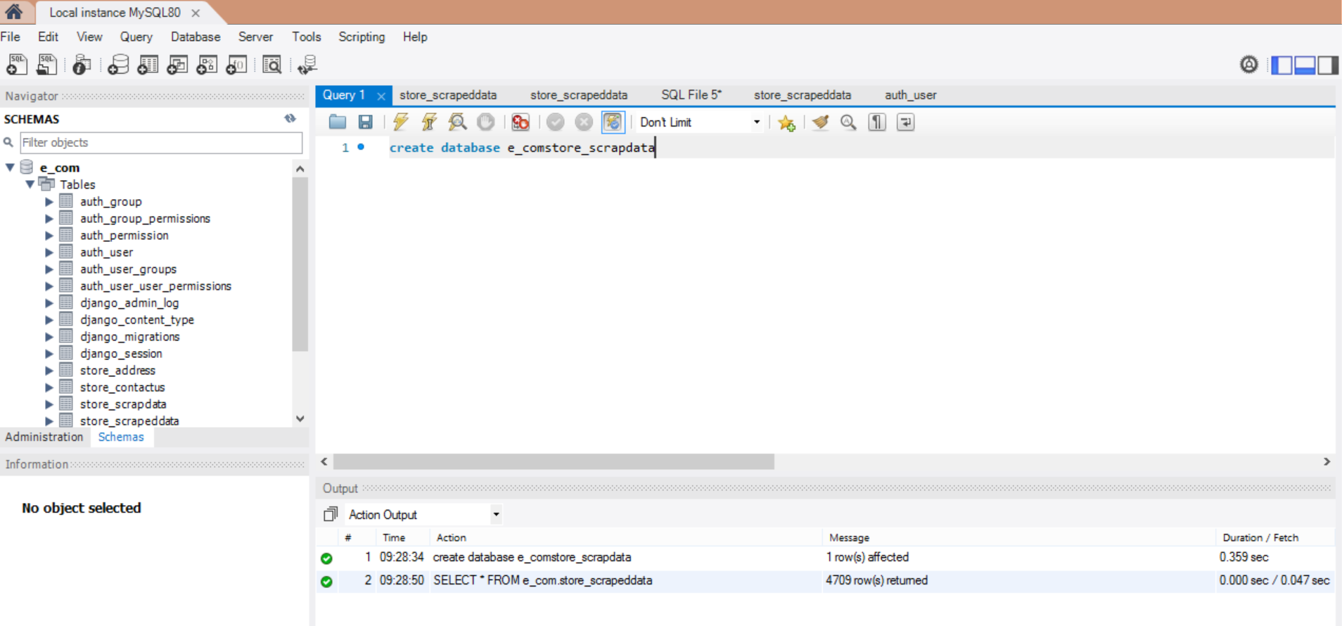
Figure 4:1 database

Scraped Data

All the scraped data from the multiple vendors is stored and represented.

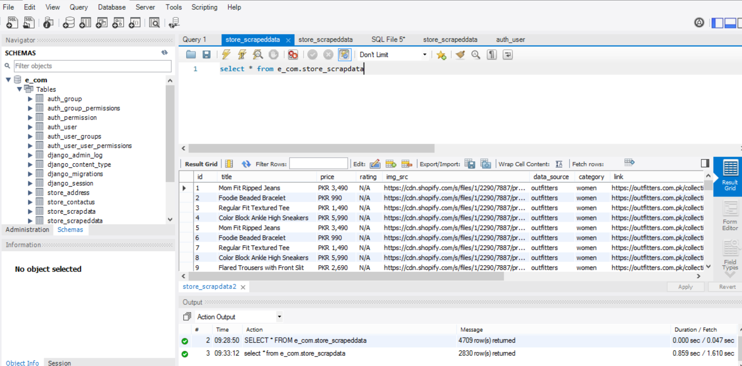
Figure 4:2 Scraped data

Authentic Users

All the users who will sign up in the system, their record will be stored in the database. If any authentic user delete their account or any new user is added, the data base will be updated accordingly.

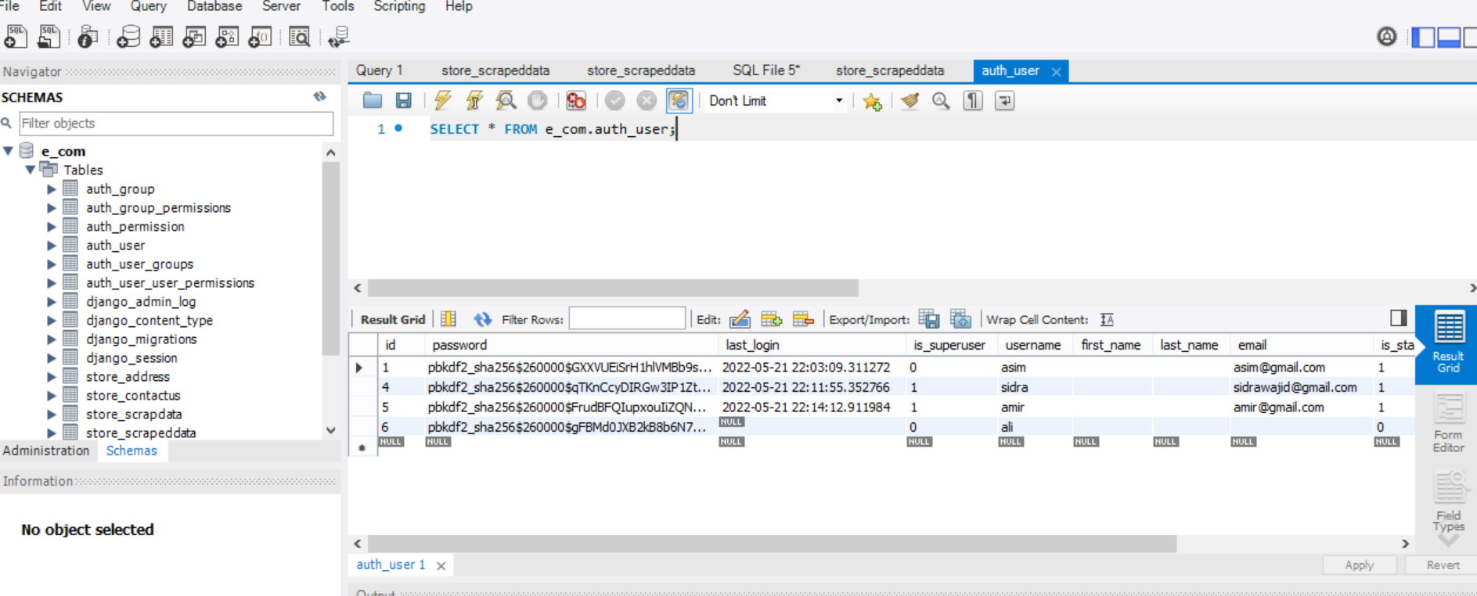
Figure 4:3 Authentic Users

RESULT AND DISCUSSION

Search Deals at HOTDEALSPK

Users can search categories, products according to their interest. List of categories or products will be presented to the user as soon as they search something.

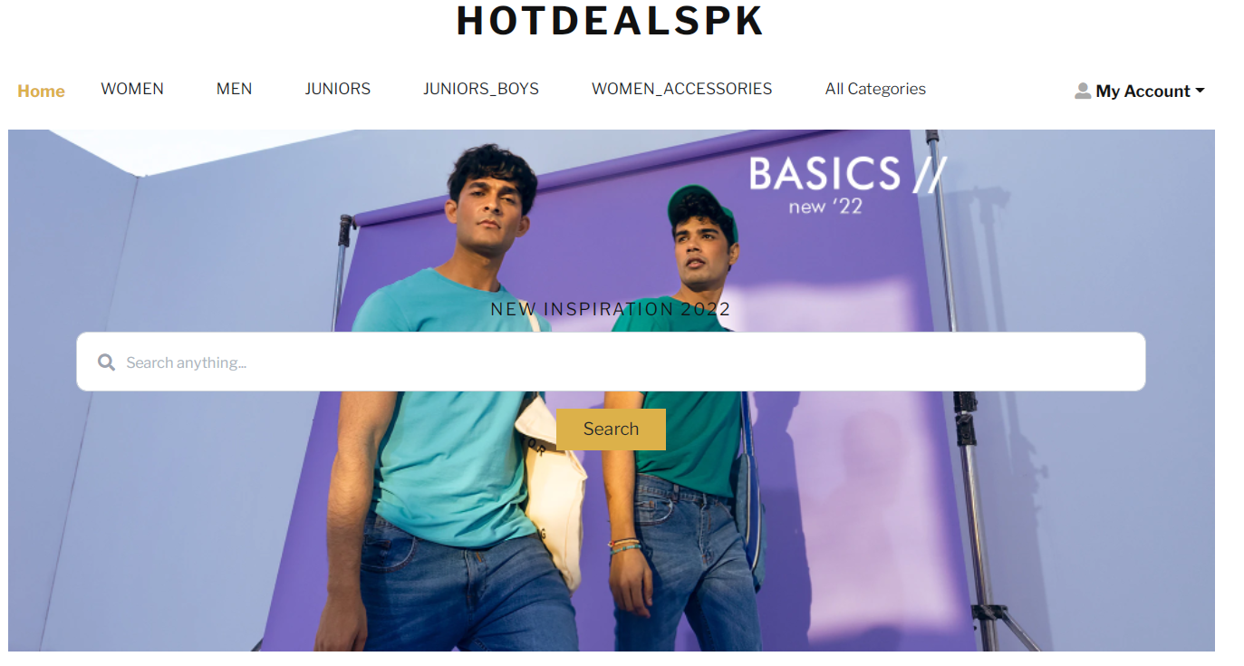
Figure 5:1 Search Deals

Categories in HOTDEALSPK

User will press on all categories button, then all categories in the system will be shown to him on the UI. Users can then click on any category and products will be shown to them which are scraped from multiple vendors.

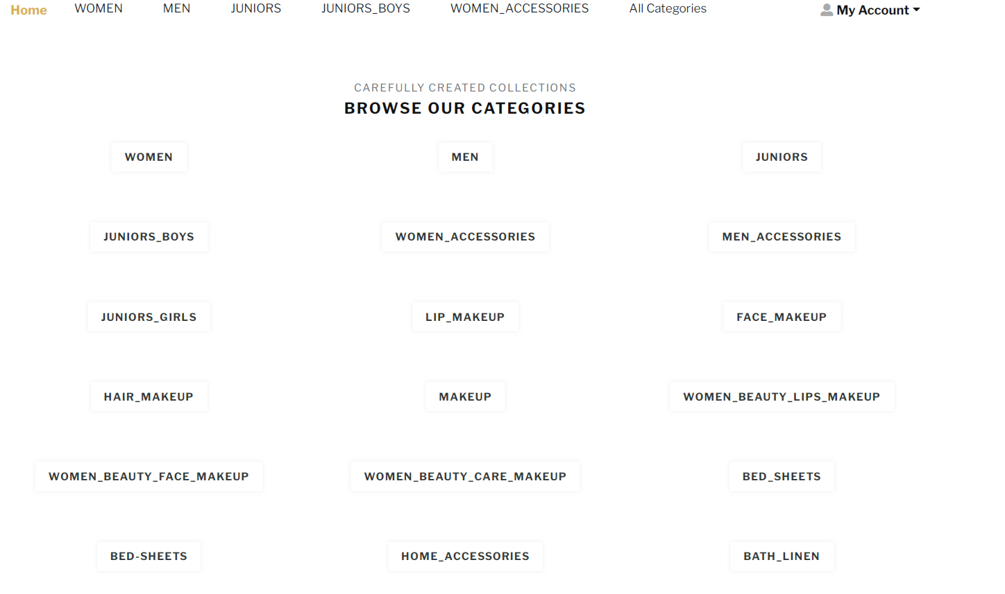
Figure 5:2 Categories in HOTDEALSPK

Registration HOTDEALSPK
User have to enter their username, their valid email and then their password to Login next time in the system and then they have to confirm password.
If user have already account just press on Log in Button.
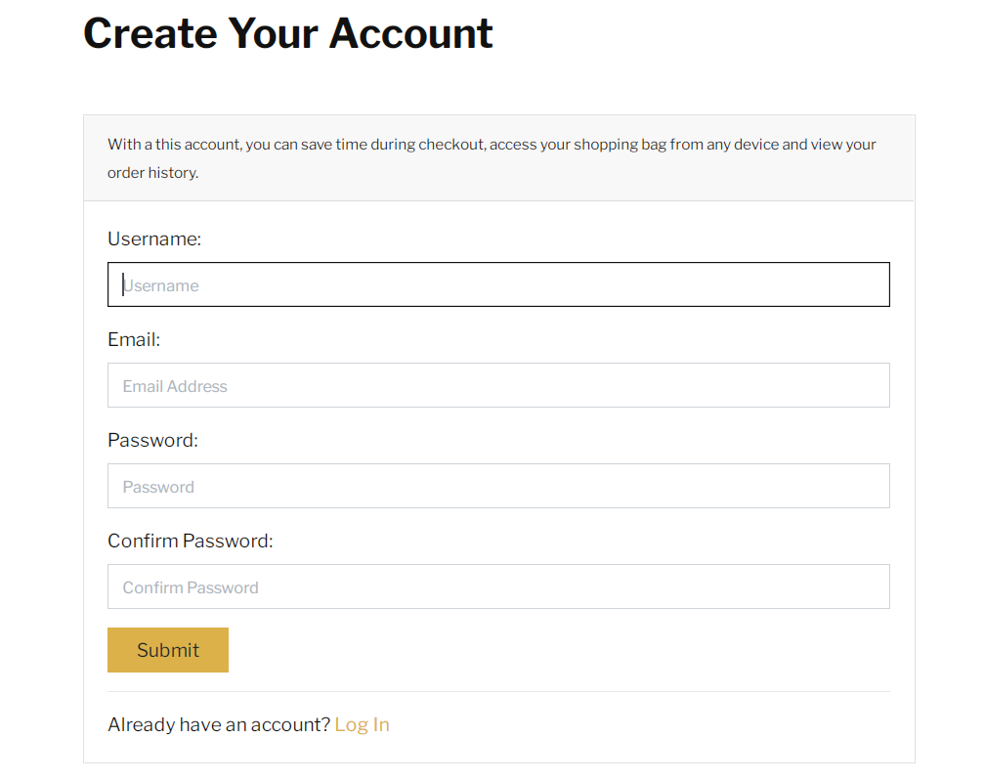
Figure 5:3 User Registration

Login in HOTDEALSPK

User will go in login page and enter his/her valid username and correct password so that he/she can login to the system. In case of forgot password user can reset their passwords and also set new password.

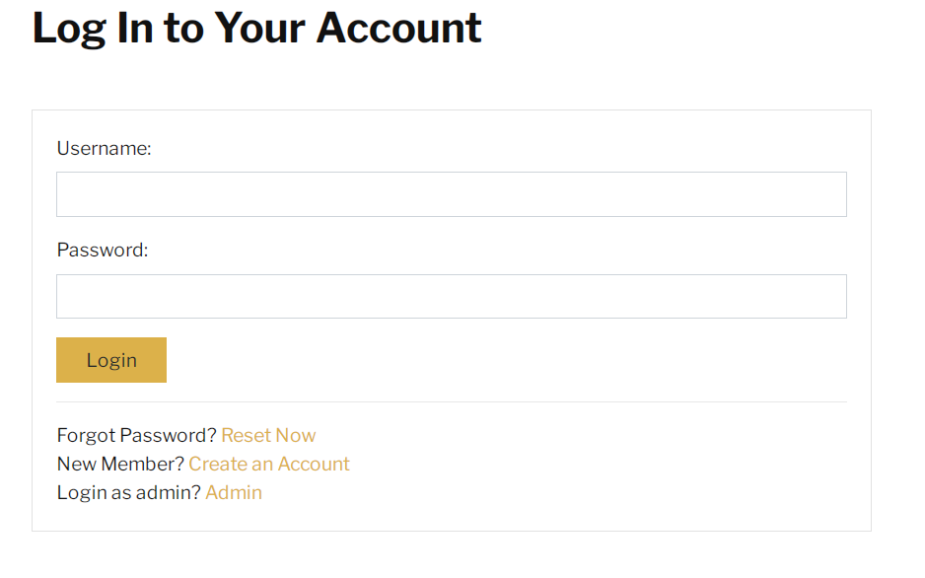
Figure 5:4 User Login Page

Add Address

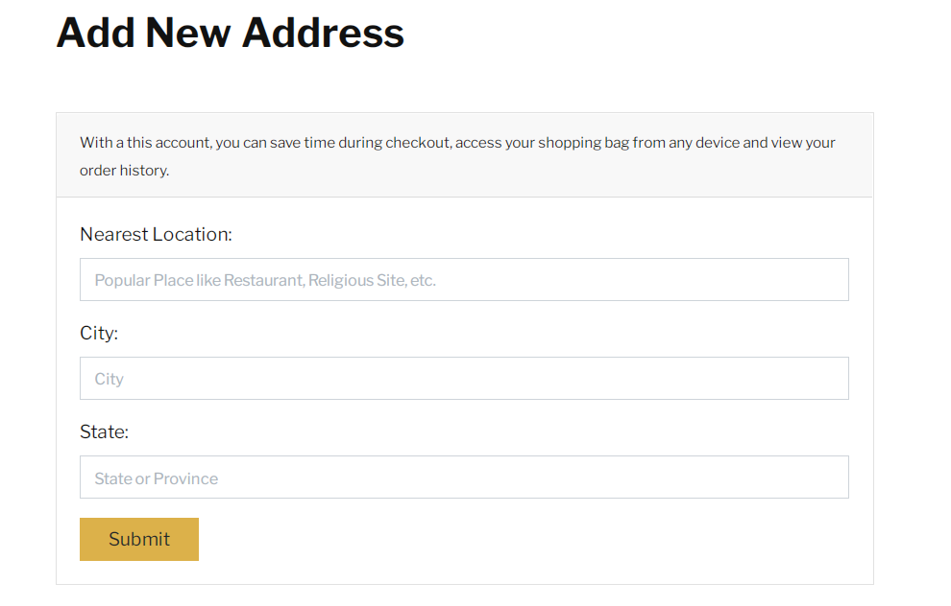
Figure 5:5 Add Address

Forgot Password in HOTDEALSPK

Users will simply press on the reset button in case of forgot password and then they will provide their valid email to get the reset link.

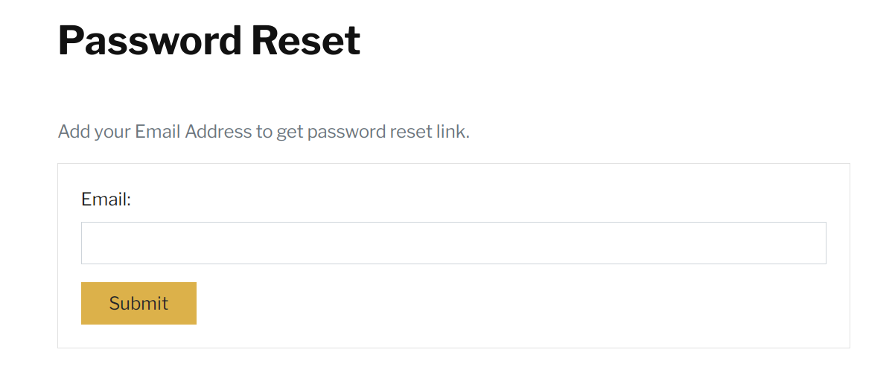
Figure 5:6 User Forgot Password

User Change Password
If users want to change their password, they can do it simply by pressing the change password button and then enter their old password and then their new password and then confirm their new password and save it, their password will be updated.
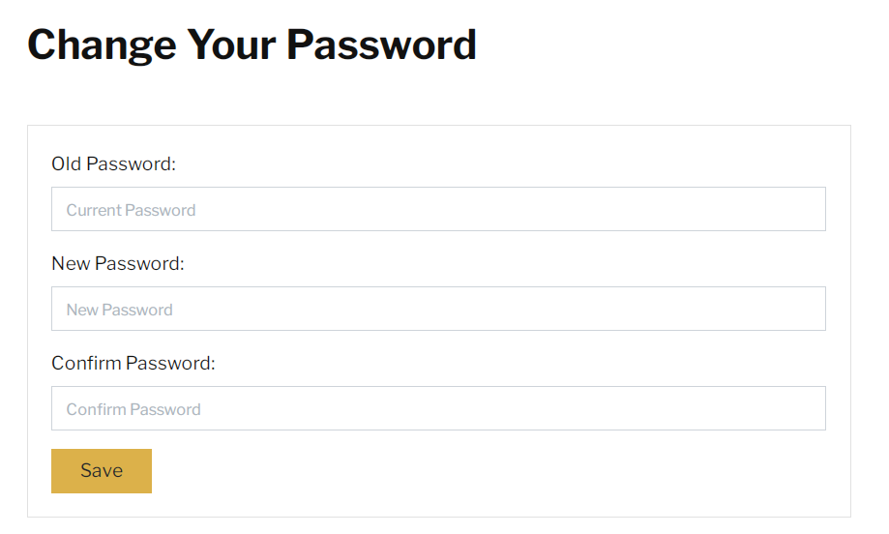
Figure 5:7 User Change Password

Delete Account
Users can delete their account by simply pressing on the delete account button, then a confirmation will be asked from use that are they sure, yes or no, after pressing yes button user account will be deleted.
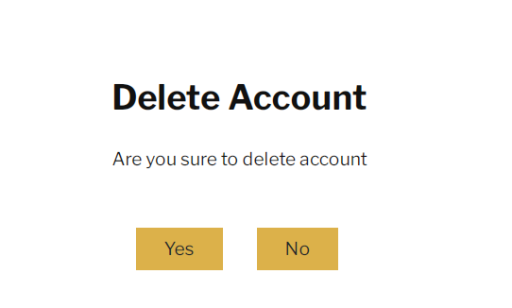
Figure 5:8 User Delete Account

Help Desk
If users is have any query or confusion then can contact us by pressing help desk button.

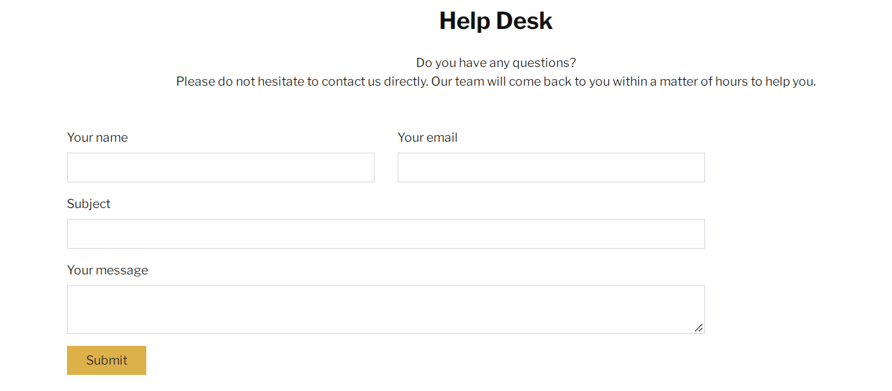
Figure 5:9 User Help Desk

Admin Login in HOTDEALSPK

Admin or super user will be created on the backend and on the UI they just have to enter their user name and password to login on the admin panel.

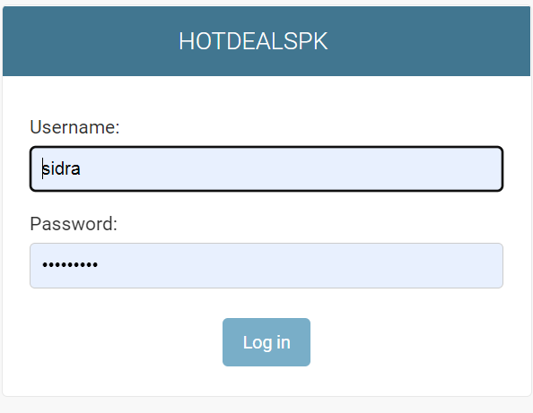
Figure 5:10 Admin Login Page

Admin Panel
On admin panel we can view our all users who have signed up on our platform. We can also see the details of the users and we can also add and delete users through admin panel.
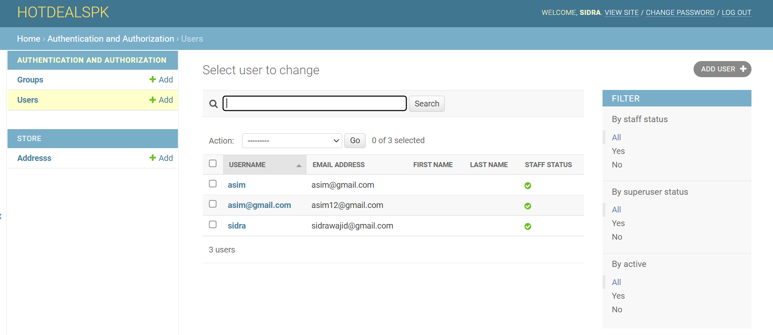
Figure 5:11 Admin Panel

Add User
Admin have access on the overall system so they can users by entering their user name and after that enter password and confirm it, once user is added further information can be added like first name last name etc. new user all information will be stored in the data base.

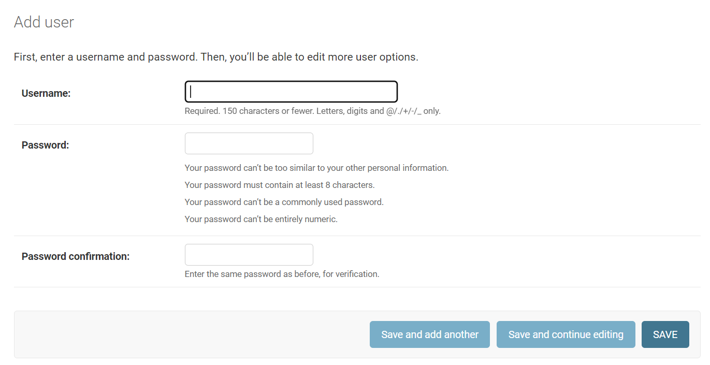
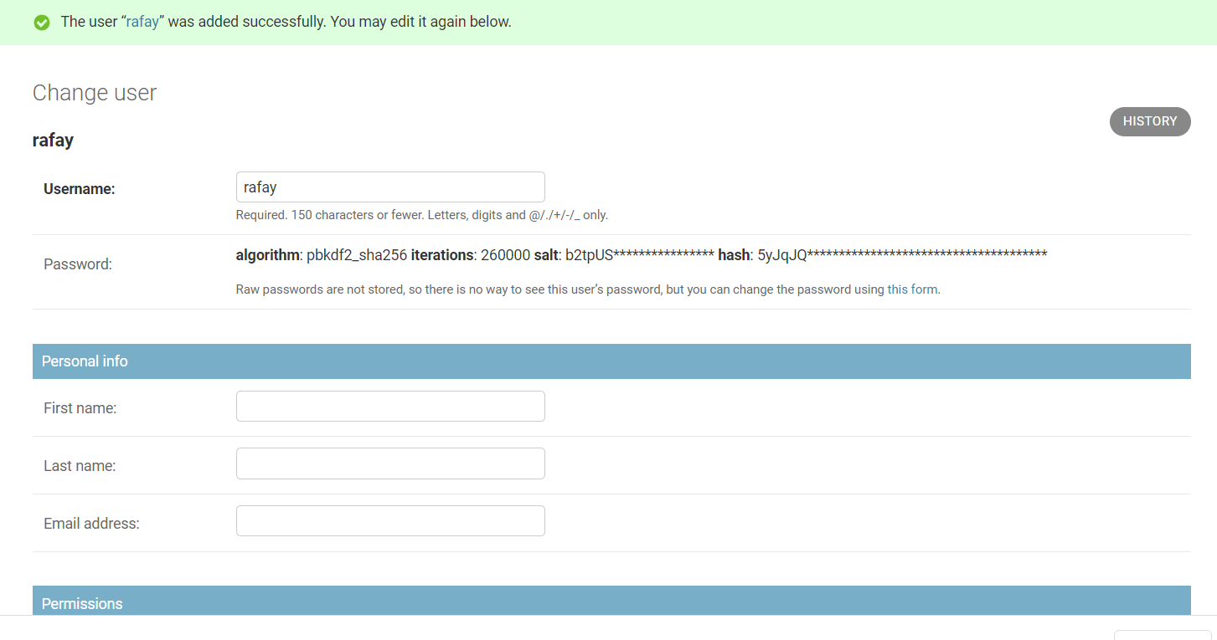
Figure 5:12 Admin Add User

Delete User
Admin have access on the overall system so they can delete users who have sign up on the platform. Admin will simply select the users who they want to delete and press on yes I’m sure button then that user will deleted, and he can’t login on our platform. All their information stored in the data base will also be removed.

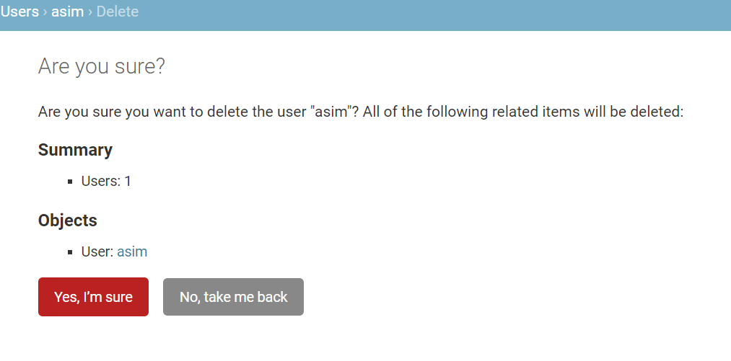
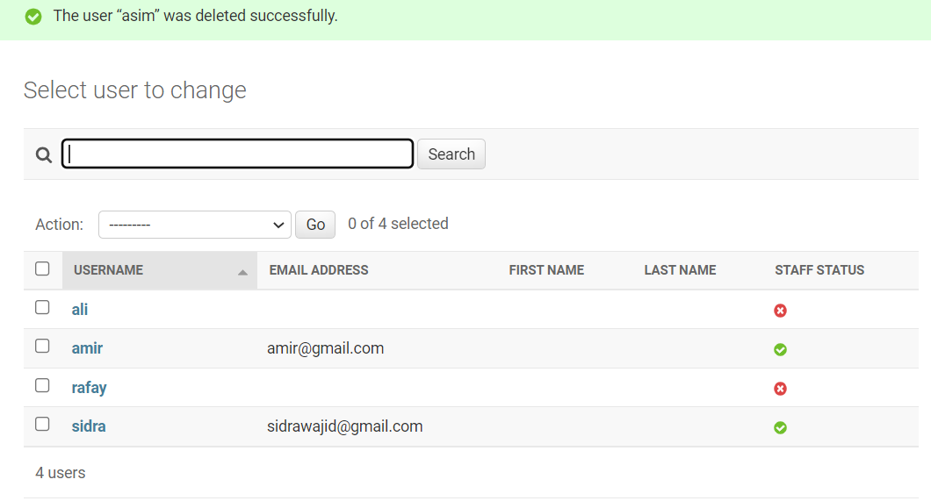
Figure 5:13 Admin Delete User

CONCLUSION AND RECOMMENDATION

Conclusion and Recommendations

HOTDEALSPK will provide best user experience for comparison of different products from different vendors on a single platform. It will save users time because they don’t have to go to different platforms, they can simply have their desired product on our platform. If users wants to be our member then they will register themselves in HOTDEALSPK and when next time they will come they just have to enter username and password to login. It is a belief that there is always a room for improvement and our system is no exception. There are a lot of features which can be added in future. That is the reason why the updates are done in the system so that the system keep working properly and constantly improve overtime as well. In future we will do proper surveys that which kind of products mostly people are interested in and then on the basis of result of surveys we will add products and category in our platform. We will do collaboration with different vendors and different platform and will provide the users multiple deals like if they bought more than specific things, on our platform they will get some discount. In future we also thought that we will allow vendors to upload their products on our platform because most of the people nowadays are selling their products from home and shops so they are not known by much people, so by uploading on our platform their products will be across Pakistan and it might help them grow bigger.

References

[1] “index @ www.hotukdeals.com.” [Online]. Available: https://www.hotukdeals.com/.
[2] “index @ pricemeter.pk.” [Online]. Available: https://pricemeter.pk/.
[3] “web-design-html-css-javascript @ blog.hubspot.com.” [Online]. Available: https://blog.hubspot.com/marketing/web-design-html-css-javascript#:~:text=HTML%2C CSS%2C %26 JavaScript%3A A Tutorial&text=HTML provides the basic structure,the behavior of different elements.
[4] “Uml-Use-Case-Diagram @ Www.Lucidchart.Com.” [Online]. Available: https://www.lucidchart.com/pages/uml-use-case-diagram.
[5] “Feature-driven_development @ en.wikipedia.org.” [Online]. Available: https://en.wikipedia.org/wiki/Feature-driven_development.
[6] “61afa36aca8bbc1aa891c546ea7df0135378da6f @ www.python.org.” [Online]. Available: https://www.python.org/doc/essays/blurb/.
[7] “34da93deb5c17faafcc1da71f347950b199922b2 @ www.mysql.com.” [Online]. Available: https://www.mysql.com/products/workbench/.
[8] “index @ www.djangoproject.com.” [Online]. Available: https://www.djangoproject.com/.

