
BSCS-F21-003
03-134182-106 | ABDUL REHMAN JAVAID
03-134182-061 | USAMA ARSHAD

Face Community App

In partial fulfilment of the requirements for the degree of
Bachelor of Science in Computer Science
Supervisor: Dr Abdul Hafeez
Department of Computer Sciences
Bahria University, Lahore Campus
May 2022

© Bahria University, 2022

Certificate

We accept the work contained in the report titled
“FACE COMMUNITY APP”
written by

ABDUL REHMAN JAVAID
USAMA ARSHAD
as a confirmation to the required standard for the partial fulfilment of the degree of
Bachelor of Science in Computer Science.

Approved by:
Supervisor: Dr Abdul Hafeez
(Signature)

May 20, 2022

DECLARATION

We hereby declare that this project report is based on our original work except for citations and quotations which have been duly acknowledged. We also declare that it has not been previously and concurrently submitted for any other degree or award at Bahria University or other institutions.

Enrolment | Name | Signature
03-134182-106 | ABDUL REHMAN JAVAID
03-134182-061 | USAMA ARSHAD

Date : May 20, 2022

Specially dedicated to
my parents and teachers
(ABDUL REHMAN JAVAID)
my parents and teachers
(USAMA ARSHAD)

ACKNOWLEDGEMENTS

We would like to thank everyone who had contributed to the successful completion of this project. We would like to express our gratitude to my research supervisor, Dr Abdul Hafeez for his invaluable advice, guidance, and his/her enormous patience throughout the development of the research.

In addition, we would also like to express my gratitude to our loving parent and friends who had helped and given me encouragement.

ABDUL REHMAN JAVAID
USAMA ARSHAD

Face Community App

ABSTRACT

Now a days everyone is using social application for different purposes where they have lot of friends and connections. The biggest problem in social apps is to find right friends or connections. Most of the apps use contacts, mutual friends, and location to suggest friends. But this can be a question mark on the privacy and integrity of the consumer. Moreover, these suggested friends are not of our taste or interest and all these suggestions are useless. We are curious about meeting someone with same similarities and having same face resemblance. Now a days we are facing with suggestion of community which are usually fake and having fake names and ids on social media[1]. The significance of this social app is that it allows us to make appropriate relationship with friends and family without interrupting integrity of consumer and privacy. Although it connects with many people within seconds without getting their personal details and info. This app helps us to engage those people who having face resemblance in any area. To develop this application, we use platform of “Jupiter Notebook” where we use framework “flutter” as front app development we use flutter because it is like native app performance and “Firebase” as backend development and database. We use “Tensorflow” as ML and “Keres” as DL. The tool which we used are mobile, laptop and technology which we used are PyCharm and firebase / node.js. This social app is based on face recognition through this we find people having face resemblance. It resolves the issue of privacy and integrity of consumer because it use only face features to find friends and other similarities. This app does not use personal information and contact details for suggesting friends and family. We also get rid from fake friend request and fake suggestion which is totally useless.

TABLE OF CONTENTS

DECLARATION ii
ACKNOWLEDGEMENTS iv
ABSTRACT v
TABLE OF CONTENTS vi
LIST OF TABLES x
LIST OF FIGURES xi
LIST OF SYMBOLS / ABBREVIATIONS xii

CHAPTERS
1 INTRODUCTION 1
1.1 Background 1
1.2 Problem Statement 1
1.3 Aims and Objectives 2
1.4 Scope of Project 2
2 SOFTWARE REQUIREMENT SPECIFICATION 3
2.1 Overall Description 3
2.2 User Classes and Characteristics 3
2.2.1 Admin Panel 4
2.2.2 User Panel 4
2.2.3 Home Panel 4
2.3 Final Deliverable of Project and Beneficiaries 5
2.3.1 Final Deliverable 5
2.3.2 Beneficiaries 5
2.4 Optional Scope 6
2.5 Operation Environment (Tools and Technology) 6
2.5.1 Software and Hardware Required: 7
2.6 Design and Implementation 7
2.7 External requirements 8
2.7.1 Hardware 8
2.7.2 Software 8
2.8 Flow chart 9
2.9 Use Case Diagram 10
2.9.1 Admin panel 10
2.9.2 User panel 11
2.9.3 Use case Final Diagram 12
2.10 Functional Requirements 13
2.11 Non-Functional Requirements 13
2.11.1 Performance Requirement 13
2.11.2 Security Requirements 13
3 DESIGN AND METHODOLOGY 14
3.1 Methodology 14
3.1.1 Testing 15
3.2 Feasibility Plan 15
3.2.1 Requirements 16
3.2.2 Expertise of the Team 16
3.2.3 Budget 16
3.2.4 Risk Involved 16
3.3 Use Case Description 17
3.3.1 Sign up 18
3.3.2 Login 19
3.3.3 Upload Picture 20
3.3.4 Admin 21
3.4 Entity Relation Diagram 22
3.5 Sequence Diagrams 23
3.5.1 Sequence Diagram for Sign Up 23
3.5.2 Sequence Diagram for Sign In 23
3.5.3 Sequence Diagram for User 24
3.5.4 Sequence Diagram for Admin 25
4 IMPLMENTATION 26
4.1 Development Tools 26
4.1.1 Dart 26
4.2 Tools 26
4.2.1 Android Studio 26
4.2.2 Android Emulator 27
4.2.3 VS Code 27
4.3 Framework 27
4.3.1 Flutter 27
4.4 Services 28
4.4.1 Firebase 28
4.4.2 Cloud Fire Store 28
5 USER MANUAL 29
5.1 Introduction 29
5.2 Sign Up 30
5.3 Log In 31
5.4 Home Screen 32
5.5 Profile Screen 33
5.6 Setting Screen 34
5.7 Find Friend Screen 35
5.8 Chat Screen 36
5.9 CNN Model 37
6 CONCLUSION AND RECOMMENDATIONS 38
6.1 Project Achievements 38
6.2 Future Work 38
6.3 Implementation Issues and Challenges 39
6.3.1 Issues 39
6.3.2 Challenges 39
6.4 Conclusion 40
REFERENCES 41
APPENDICES 42

LIST OF TABLES

TABLE TITLE PAGE
Table 2-1: Software Hardware Description 7
Table 3-1: Testing Levels 15
Table 3-2: Use Case Description (Sign up) 18
Table 3-3: Use Case Description (Login) 19
Table 3-4: Use Case Description (Upload picture) 20
Table 3-5: Use Case Description (Admin) 21

LIST OF FIGURES

FIGURE TITLE PAGE
Figure 2-1: Flow chart Diagram 9
Figure 2-2: Admin Panel 10
Figure 2-3: User Panel 11
Figure 2-4: Use case Diagram 12
Figure 3-1: FDD Diagram 14
Figure 3-2: Entity Relation Diagram 22
Figure 3-3: Sequence Diagram for Sign Up 23
Figure 3-4: Sequence Diagram for Sign In 23
Figure 3-5: Sequence Diagram for User 24
Figure 3-6: Sequence Diagram for Admin 25
Figure 5-1: Sign Up 30
Figure 5-2: Log In 31
Figure 5-3: Home Screen 32
Figure 5-4: Profile Screen 33
Figure 5-5: Setting Screen 34
Figure 5-6: Find Friend Screen 35
Figure 5-7: Chat Screen 36
Figure 5-8: CNN Model 37

LIST OF SYMBOLS / ABBREVIATIONS

FDD Feature Driven Development
CNN Conventional Neural Network
AS Android Studio
DL Deep Learning
ML Machine Learning

LIST OF APPENDICES

APPENDIX TITLE PAGE
APPENDIX : Source Code (Face Mode) 42

INTRODUCTION

Background

Now a days everyone is using social application for different purposes where they have lot of friends and connections. The biggest problem in social apps is to find right friends or connections. Most of the apps use contacts, permission, mutual friends, and location to suggest friends. But this can be a question mark on the privacy and integrity of the consumer. Moreover, these suggested friends are not of our taste or interest and all these suggestions are useless. We are curious about meeting someone with same similarities and having same face resemblance. Now a days we are facing with suggestion of community which are usually fake and having fake names and ids on social media. That’s why we are developing such app that helps in finding same similarities of face and ease way to make a communication between them, also helping them to finding new friends in this social era.

Problem Statement

The major problem in social apps is to find right friends or connections. Already existing social apps use personal information such as contacts, mutual friends etc to suggest friends. But this can be a question mark on the privacy and integrity of the consumer. For this we are using modern techniques for better output and result.

In this social app we find friends through face detection, then send request to each other. Having conformation from both side giving option of ACCEPT or DENIED.
After this moves to the chat box where they communicate with each other. They also share their photos, videos, and posts to each other.

Aims and Objectives

The aim of this FYP is to develop user friendly app by connecting number of peoples without getting their personal information. Following are major objectives
are shown as following:
- Design social app (Android) that connects people together using face recognition CNN model.
- Suggest friends having same face similarity.

Scope of Project

We have made this social media app named as "Face Community" which suggest those friends that having Face Similarity. So, they have a platform where they communicate with each other by sharing their photos, videos, and posts.
We have made this this social app because this is unique from other social media platform. Suggest friends without getting their personal information and contacts. Having face recognition feature makes this app unique form other social media platform. In this social app we find friends through face detection, then send request to each other. Having conformation from both side giving option of ACCEPT or DENIED. After this moves to the chat box where they communicate with each other. They also share their photos, videos, and posts to each other.

SOFTWARE REQUIREMENT SPECIFICATION

Overall Description

By using this social app, a large community can communicate with each other. They could find their friends having some same similarities. They can easily enter their First Name, Last Name, email, upload their images. They also find their same face similarities people. There are a suggestion of people requests where user can easily accept or denied the request. In this social app we make a secure connection, and their personal information is not shared with anyone. Only their friends can see their information. This social app covered a large community and helps to make more communication with other users. Easy to download in Android Mobile. Having good User Interface.

User Classes and Characteristics

Face Community App consist of three panels.
- Admin panel
- User panel
- Home panel

Admin Panel

Admin is the main panel which is used for handling all the database. Checking for bugs and updates.
- Adding user Module
- Removing user Module
- Updating App
- Access of all features (Front End, Back End, etc)

User Panel

User panel is for entering the details in Face Community App
- Registration
- Uploading Image from Gallery
- Capturing Image (Selfie)
- Selecting peoples from suggestion
- Sending request
- Accepting OR Deny request
- Profile info
- Log Out

Home Panel

This panel consist of main screen and features
- News feed
- Chat box
- Profile Details
- Suggestion Area

Final Deliverable of Project and Beneficiaries

In the end this project will be in the form of mobile App. This will be a social app so this app direct beneficiaries include common people and those peoples who like social apps or that community which want to make more friends or interact with other people.
Indirect beneficiaries of this app are those who don’t like to interact or communicate with the people such as research scholar’s businessman etc. or it may depend on person own choice.

Final Deliverable

- Final Report (Manual)
- Mobile App (Android)

Beneficiaries

- Extrovert Users
- University Students (BULC)

Optional Scope

In future if this social app goes on live on Play Store, then there is some features that is going to be add in this Face Community App.

We can add a feature in which we allow the user to make friends on the basic of their interest and hobbies if a user wants to make friend of similar interest and hobbies then this feature will help and provide better result. Also, ttransferring this social mobile app to IOS mobile app. Adding subscription OR membership which will be paid. This membership helps user to get less suggestion of peoples. Making User Interface more friendly.

Operation Environment (Tools and Technology)

This project (Face Community App) is based on Android mobile application. For development of this social app, it requires computer or laptop and mobile. To make this project we use following models, hardware, and software.

- Laptop (core i5, windows 10, intel HD Graphics 4000)
- Visual Studio Code V 1.62
- Android Studio Arctic Fox 2021.3.1
- PyCharm V 2021.2.3
- Firebase or node.js October Release
- Flutter V 2.5.3 ---Frontend App Dev
- TensorFlow V 2.6.1 --- ML Model
- Colab --- DL & ML

Software and Hardware Required:

Following are the software and hardware required for development of the app.

Name | Description
Operating System | Windows 10
Language | Dart Language
Framework | Flutter
Tools | Android Studio, Android Emulator, VScode, Jupiter notebook
Hardware | Laptop, Mobile
Service | Internet

Table ‎2-1: Software Hardware Description

Design and Implementation

For making this mobile application Flutter is used for User Interface and this will help for making changes in module on the spot. Flutter is used as a cross platform, using machine learning which is used for collection of data and making this data (Testing, Cleaning, Accuracy). For this model we use tensor flow. Also using Deep Learning on Keras platform. And the total implementation of this mobile app is on Firebase which contains Back End and Database.

External requirements

There are the following external requirements for developing mobile app which includes software and hardware.

Hardware

This social app runs on Android Mobile and for development of this mobile app we use laptop or computer.
- Laptop (core i5, windows 10, intel HD Graphics 4000)

Software

These are the software which is used for developing mobile application.

- Visual Studio Code V 1.62
- Android Studio Arctic Fox 2021.3.1
- PyCharm V 2021.2.3
- Firebase or node.js October Release
- Flutter V 2.5.3 ---Frontend App Dev
- TensorFlow V 2.6.1 --- ML Model
- Colab --- DL & ML

Flow chart

The flow chart of our model is design below which shows how we design our model.

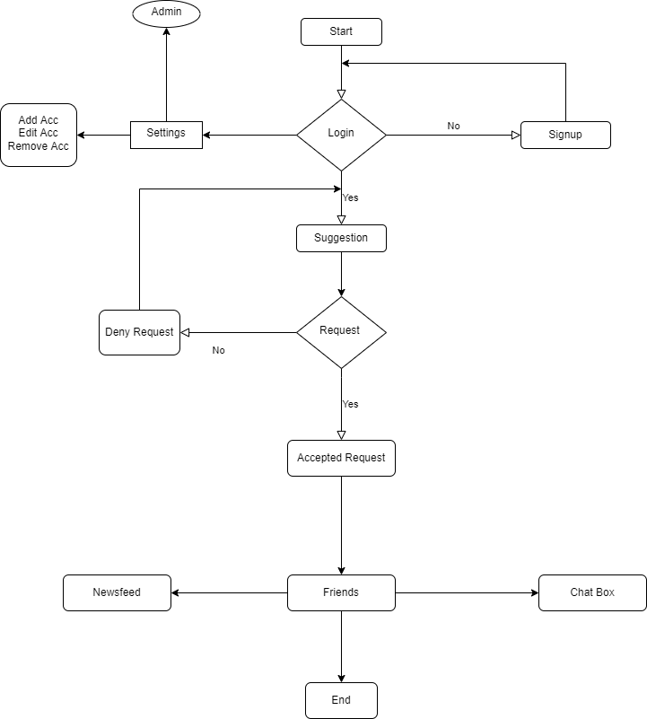

Figure ‎2-1: Flow chart Diagram

Use Case Diagram

The use case diagram of admin and user is designed separately and merge at the end which is the final use case diagram.

Admin panel

The specification of Admin is explained in below diagram.

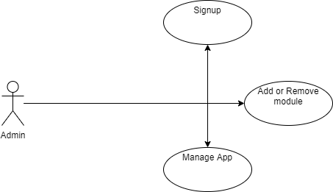

Figure ‎2-2: Admin Panel

User panel

The specification of Admin is explained in below diagram.

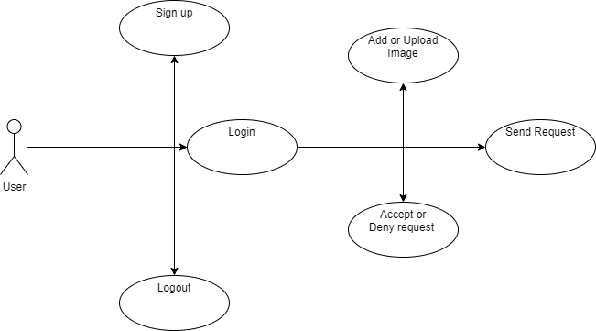

Figure ‎2-3: User Panel

Use case Final Diagram

The flow of use case diagram is designed as bellow

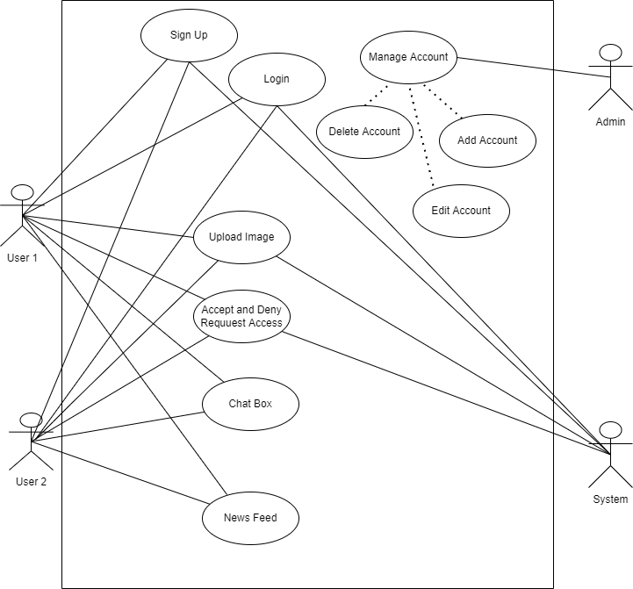

Figure ‎2-4: Use case Diagram

Functional Requirements

Functional requirements of our app are as follow:

- User must sign up if user is new and using the app for first time.
- Login functionality is there for the user.
- User will have to upload his picture for getting the result.
- User will accept and reject the request.

Non-Functional Requirements

Non-functional requirements of this project are following as:

Performance Requirement

- The app must have quick response time
- The app must serve service to multiple users at a same time
- The app must be adoptable to any kind of environment or operating system

Security Requirements

- App must be safe and secure.
- Multiple testing will be performed to check the app security.
- User personal data must be confidential, and no one can access to user personal data easily.

DESIGN AND METHODOLOGY

Methodology

Agile, Feature Driven Development model is used in this project. Feature-driven development (FDD) is an iterative and incremental software development process. It is a lightweight or Agile method for developing software. FDD blends several industry-recognized best practices into a cohesive whole.
In FDD workflow will be shown in below diagram [2].

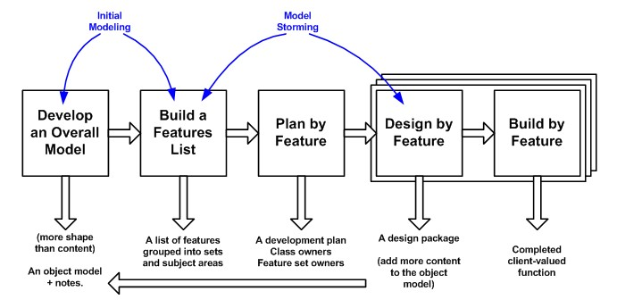

Figure ‎3-1: FDD Diagram

We tackle those problem by using AI (Face recognition) where we solve the problem of privacy and integrity of consumer. Also, we solve the issue of fake requests and useless suggestion by suggesting community by similar face resemblance. And we use these tools for developing this app.

- Flutter ---Frontend App Dev
- TensorFlow --- ML Model
- Keras --- DL Model
- Firebase –Backend & Database Model – [3]

Testing

In this project we are using following testing approaches which is following as:

 | Low Level Testing |  | High level Testing
 | Unit testing  System testing  Integration testing |  | Useability testing  Functional testing  Acceptance testing

Table ‎3-1: Testing Levels

Feasibility Plan

The feasibility plan of our project contains the following requirements, expertise, tools and technology.

Requirements

Following resource requirements are used:
- Flutter ---Frontend App Dev
- TensorFlow --- ML Model
- Kera’s --- DL Model
- Firebase –Backend & Database

Expertise of the Team

All team members are pre-equipped with the level of knowledge needed for the successful completion of this project.

Yes, we study the relevant course by now.
Yes, this project is equal interest to all team members.

Budget

The estimated budget that cost us on this project is about 5k to 10k. having paid libraries, subscription etc.

Risk Involved

These are the following risk that may occur during development of mobile application.
- Software Failure
- Hardware Failure
- Member Illness

Use Case Description

Use case Description of this project is shown in following tables.
- Sign up
- Login
- Upload picture
- Admin

Sign up

Name | Sign up
Use Case ID | FYP US-A1
Priority | High
Primary Actor | User 1
Other Participating Actor | User 2
Description | This use case describes that user will sign up into the app
Preconditions | User should nor registered before
Trigger | This use case initiates when user going to register
Post Conditions | User is successfully registered
Alternate post conditions | User is not registered

Table ‎3-2: Use Case Description (Sign up)

Login

Name | Login
Use Case ID | FYP US-A2
Priority | High
Primary Actor | All the registered users
Other Participating Actor | Admin
Description | User will enter their login ids to entered in the app
Preconditions | 1-Firstly User should register  2-User should not login
Trigger | This use case initiates when user going to login
Post Conditions | User is successfully login
Alternate post conditions | Login failed

Table ‎3-3: Use Case Description (Login)

Upload Picture

Name | Upload Picture
Use Case ID | FYP US-A3
Priority | High
Primary Actor | Users entered the app
Other Participating Actor | Admin
Description | In this use case user upload or take picture
Preconditions | 1-User should not login
Trigger | This use case initiates when user going to upload picture
Post Conditions | User is successfully login
Alternate post conditions | Login failed

Table ‎3-4: Use Case Description (Upload picture)

Admin

Name | Admin
Use Case ID | FYP US-A4
Priority | High
Primary Actor | Users
Other Participating Actor | ---
Description | In this use case admin will control the app, admin will manage account, add account, edit account, and delete account
Preconditions | User should login
Trigger | This use case initiates when user going to made changes regarding to his account.
Post Conditions | User is successfully login
Alternate post conditions | Reset Account

Table ‎3-5: Use Case Description (Admin)

Entity Relation Diagram

The relation between the entities is shown by ERD diagram

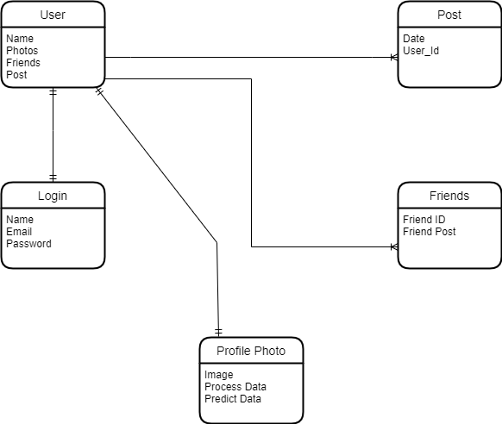

Figure ‎3-2: Entity Relation Diagram

Sequence Diagrams

Sequence Diagram for Sign Up

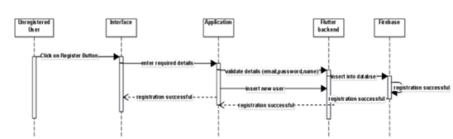

Figure ‎3-3: Sequence Diagram for Sign Up

Sequence Diagram for Sign In

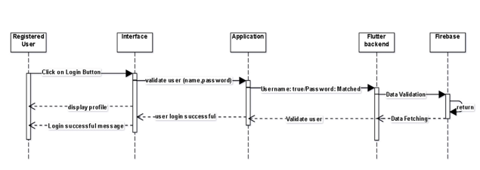

Figure ‎3-4: Sequence Diagram for Sign In

Sequence Diagram for User

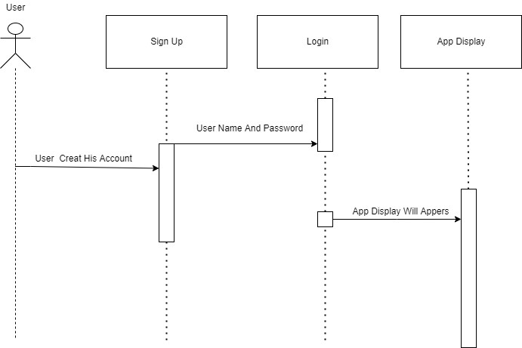

Figure ‎3-5: Sequence Diagram for User

Sequence Diagram for Admin

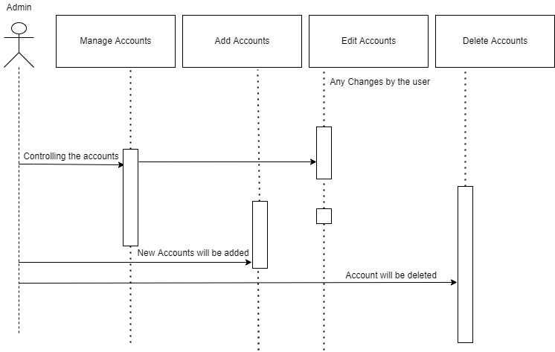

Figure ‎3-6: Sequence Diagram for Admin

IMPLMENTATION

Development Tools

The language tools used for developing this project is following as:

Dart
Dart is an open-source general purpose programming language by google. Dart is used to support applications in both server and client side and give high performance fast application. It may be used to make a mobile app, build desktop software, or design a website. It's a Google-supported interpretable language with various features that have made it popular among programmers. Dart is also known as a JavaScript replacement. Its popularity grew after Google released Flutter, which added mobile programming capabilities [6].

Tools

Android Studio

Android Studio is an official integrated development environment for creating Android applications. Structured code modules allow you to break down your project into functional parts that you can create, test, and debug separately.

Android Emulator

The android emulator simulates Android devices on your computer, allowing us to test our software on several devices without having to own each one physically. It came with a pre-configured setup for numerous Android phones and tablets. Emulators are much quicker than actual devices for testing.

VS Code

Microsoft Visual Studio Code is a stand-alone source code editor that works on a variety of platforms. It's used to make websites, web apps, online services, and mobile apps, among other things. It supports a variety of programming languages, each with its own set of capabilities. Initial support, such as syntax highlighting, is provided by VS Code.

Framework

The framework used for developing this project is flutter which is explained bellow:

Flutter

Flutter is a cross-platform, open-source UI framework for creating native mobile apps. Flutter enables us to create a mobile application for Android and iOS using a single Dart-based programming language. The flutter framework includes a software development kit as well as a widget-based user interface library. It includes several reusable user interface components [4].

Services

There are the following services which are used for developing this project.

Firebase

Backend as a service is what Firebase is. It offers developers several services and tools to assist them in creating a high-quality application that allows them to expand their user base and generate money. It is based on Google's infrastructure, which offers several storage options [5].

Cloud Fire Store

Cloud fire store is a scalable database from Google Cloud and Firebase for mobile, web, and server applications. It uses Realtime listeners to keep data synchronised among client apps and provides offline support for web and mobile apps, allowing us to design apps without worrying about network latency or internet access.

USER MANUAL

Introduction

In this section we are showing how our app lock like and how it is performing the functionality that we mentioned in our project we are showing and discuss the panels that we made for face community app, here we show the main functionality related to our machine learning model and our app user interface.

Sign Up

We add a functionality of signup in which those users that are new to our app first come and get them registered to the app we take their details they set their email and password and confirm the details.

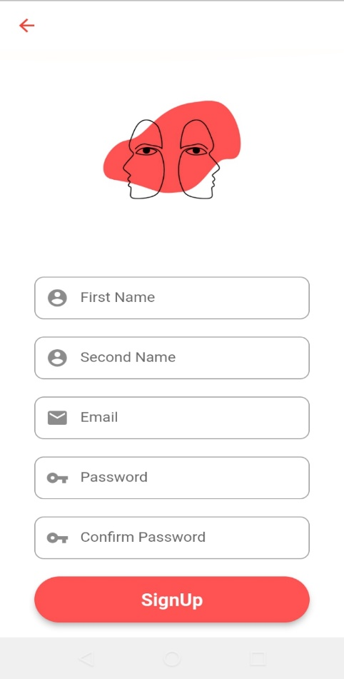

Figure ‎5-1: Sign Up

Log In

If a user is sign up to our app, then he directly come to the screen of sign in in which he entered his login details and get entered the app.

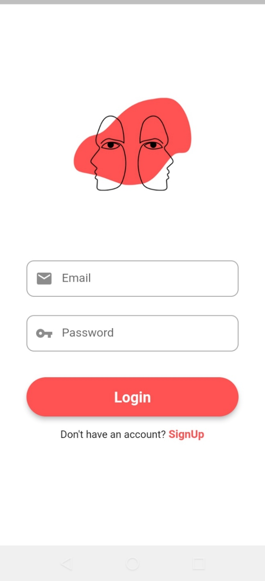

Figure ‎5-2: Log In

Home Screen

After getting sign in user saw the home screen display in which we add the icon of upload image, find friends, setting, Chat box, Profile in home screen you can saw the newsfeed you can see the images that will be uploaded by the user.

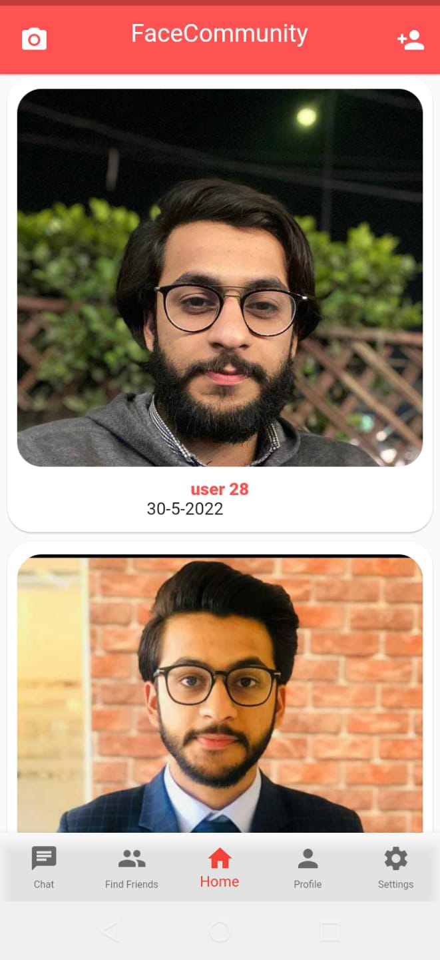

Figure ‎5-3: Home Screen

Profile Screen

In profile screen you can see the profile of the user where you can see posts of the user and user friends, user can enter multiple posts and saw the status of friends.

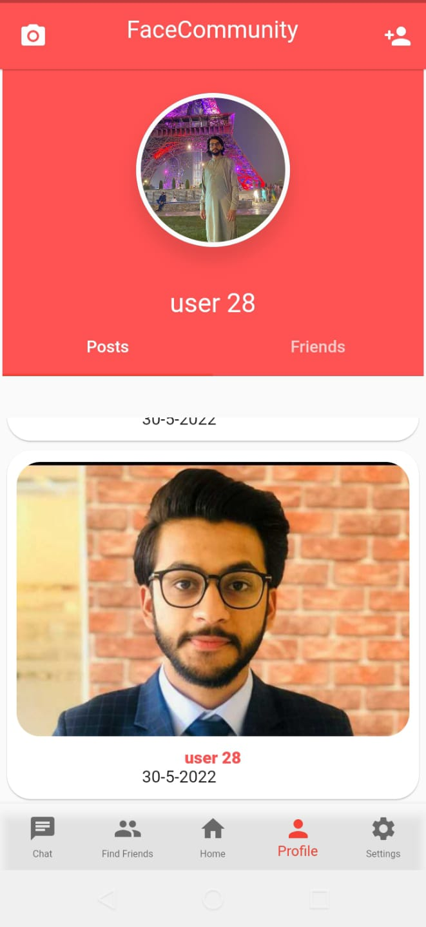

Figure ‎5-4: Profile Screen

Setting Screen

In this screen user can upload his image to find friends user can simply select the image of his own choice and saw the result when you select the image our model can run in back end and provide us result which is like that image.

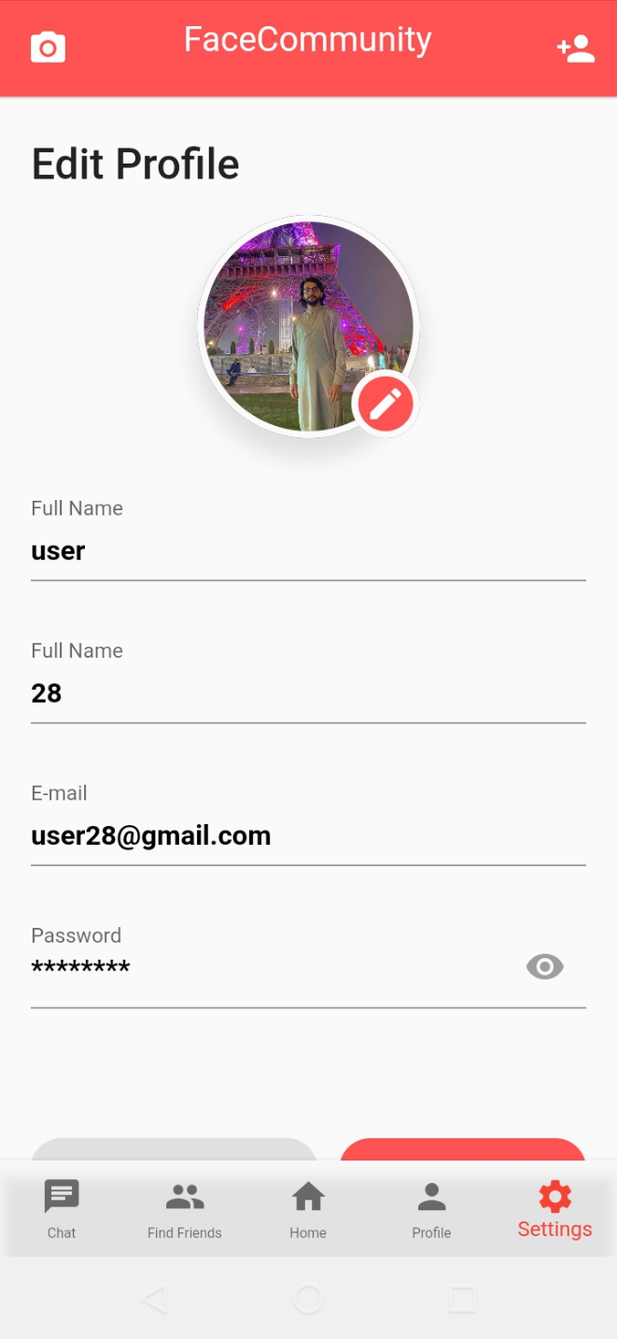

Figure ‎5-5: Setting Screen

Find Friend Screen

In this screen you can saw the suggestion that will be predicted by our model you can see multiple suggestions of images that are like that image you uploaded from setting screen to saw the result.

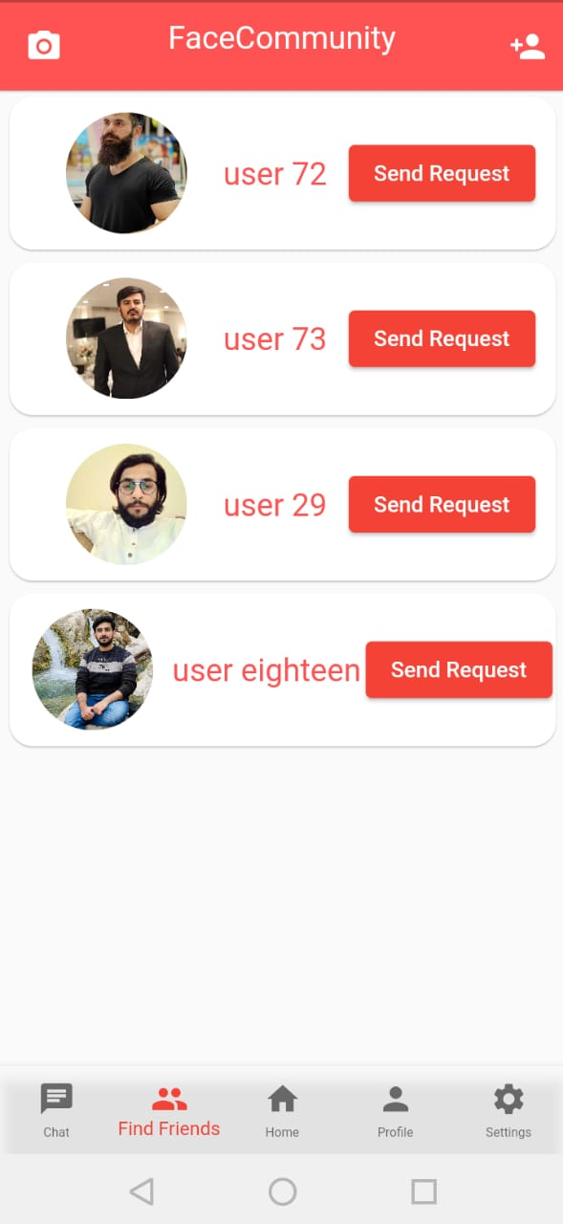

Figure ‎5-6: Find Friend Screen

Chat Screen

In this screen you can saw the chat screen where only those users will be shown who become friends you can chat with any of user of your own choice who become your friend.
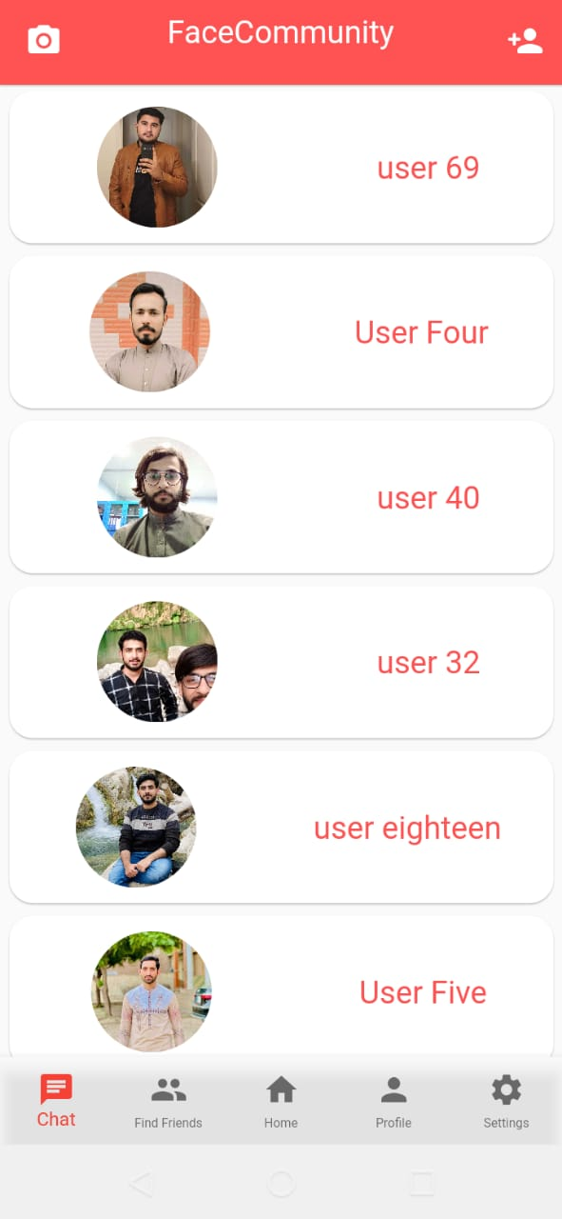

Figure ‎5-7: Chat Screen

CNN Model

Convolution Neural Network is a special kind of feed forward neural network that reduces the number of parameters in a deep neural network with many units without losing too much in the quality of the model [7].

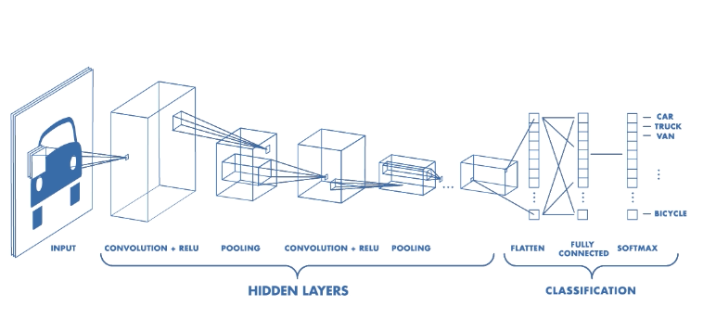

Figure ‎5-8: CNN Model

CONCLUSION AND RECOMMENDATIONS

Project Achievements

From this project we learn new language and its features. Getting information about the model and its working. Performing testing and training datasets. Integration of Model with flutter application.

The approach we used in our project can help us very much for doing things that are not already exist. From this project we learn in detail that how machine learning can help us to develop better and different approach to develop new things we went through the whole process of ML model which included testing of data training of data and prediction of data.

Future Work

Updating application with better user interface. Getting model train to fetch more features. Removing lags and bugs if any. Also we decided to add new features in our app we can predict friends suggestion by knowing user interest we can ask the user about his interest and Hobbies and we predict data on these features the reason behind this is that if our model will not give accurate result or good suggestion then there will be option of Interest and hobbies so our app can predict data on those features this process can make the reliability of our app.

Implementation Issues and Challenges

There are the following issues and challenges that is faced during developing of this project.

Issues

Image Processing
The major issue we can face in this project is image processing the model we are using was not working correctly in the beginning when we add any image in our model to get result then the model cannot detect face feature correctly the reason behind this is that there was a problem in image processing so when we add any image in the model it can interchange the values and we cannot get the desire output.

Run the model
One of main issue we face in our project was to run the model on edge device the reason behind this is that all the things are new for us, and we were not familiar with these things, so it takes time, and we learn things slowly.

Challenges

Integration Of Model
The major challenge we face in our project is integration of Model with app this process was very time consuming and difficult in the beginning the model was not compatible with mobile app, so we face a major challenge in integration of model one of main reason behind this was lack of knowledge that we have in initial stages.

Conclusion

The aim of this project is to provide a platform where users find their friends by getting their face similarities. As we know technology is changing day by day and everyone is looking for interesting and new things. Face Community is providing a platform where you can find friends which having face similarities with your face. Face community with latest features provides you suggestions of friends where user find friends and add friends. Easy to use and operate.

REFERENCES

- S. Chopra, R. Hadsell, and Y. LeCun. Learning a similarity metric discriminatively with application to face verification. CVPR, 2005.
https://www.cvfoundation.org/openaccess/content_iccv_2013/papers/Cao_Similarity_Metric_Learning_2013_I CCV_paper.pdf

- Feature Driven Development Model
http://www.agilemodeling.com/essays/fdd.htm

- Facenet Model Source
https://medium.com/analytics-vidhya/face-recognition-authentication-using-flutter-and-tensorflow-lite-2659d941d56e

- Flutter documentation
https://docs.flutter.dev

- Fire Base
https://console.firebase.google.com/u/0/?pli=1

[6] Dart
https://www.google.com/search?q=dart+language&oq=DART+LANGUAGE&aqs=chrome.0.0i512l10.4029j0j1&sourceid=chrome&ie=UTF-8

[7] CNN
https://towardsdatascience.com/convolutional-neural-networks-explained-9cc5188c4939#:~:text=A%20Convolutional%20Neural%20Network%2C%20also,binary%20representation%20of%20visual%20data.

APPENDICES

