
BSCS-F21-002
03-134182-073 | MOHSIN IMRAN
03-134182-086 | ABDUL RAFAY SHAHWAIZ

Reckon.pk

In partial fulfilment of the requirements for the degree of
Bachelor of Science in Computer Science
Supervisor: Dawood Akram
Department of Computer Sciences
Bahria University, Lahore Campus
May 2021

© Bahria University, 2021

Certificate

We accept the work contained in the report titled
“Reckon.pk”
written by
MOHSIN IMRAN
ABDUL RAFAY SHAHWAIZ
as a confirmation to the required standard for the partial fulfilment of the degree of
Bachelor of Science in Computer Science.

Approved by:
Supervisor: Dawood Akram
(Signature)

May 23, 2021

DECLARATION

We hereby declare that this project report is based on our original work except for citations and quotations which have been duly acknowledged. We also declare that it has not been previously and concurrently submitted for any other degree or award at Bahria University or other institutions.

Enrolment | Name | Signature
03-134182-073 | MOHSIN IMRAN
03-134182-086 | ABDUL RAFAY SHAHWAIZ

Date : May 23, 2021

Specially dedicated to
my parents and teachers
(MOHSIN IMRAN)
my parents and teachers
(ABDUL RAFAY SHAHWAIZ)

ACKNOWLEDGEMENTS

We would like to thank everyone who had contributed to the successful completion of this project. We would like to express our gratitude to my research supervisor, Dawood Akram for his invaluable advice, guidance, and his enormous patience throughout the development of the research.

In addition, we would also like to express my gratitude to our loving parent and friends who had helped and given me encouragement.

MOHSIN IMRAN
ABDUL RAFAY SHAHWAIZ

Reckon.pk

ABSTRACT

Each day multiple people visit public or private organizations to meet some specific person for some reason. They have planned their daily schedule just for that meeting, then they spend their precious time and money to meet that person but when they reach, they come to know that the required person is not available today or at that moment he is not present in the office. This project will be of great significance because we ourselves faces this problem. So, there are many individuals who are facing this problem every day.
Therefore, we are proposing an idea to make a mobile application which helps people to check the availability of that specific individual they are planning to meet. They can see on their mobile phones for the status of that specific person before directly going to the organization. This application will be a cross platform i.e., for both Android and iOS. We are using Flutter for the development of Reckon.pk Flutter is a free and open-source UI software development kit (SDK) created by Google. Flutter uses DART as its official programming language.

TABLE OF CONTENTS

DECLARATION ii
ACKNOWLEDGEMENTS iv
ABSTRACT v
TABLE OF CONTENTS vi
LIST OF TABLES x
LIST OF FIGURES xi
LIST OF SYMBOLS / ABBREVIATIONS xii

CHAPTERS
1 INTRODUCTION 1
1.1 Background 1
1.2 Problem Statements 2
1.3 Aims and Objectives 2
1.4 Scope of Project 3
2 SOFTWARE REQUIREMENT SPECIFICATION 4
2.1 Introduction 4
2.2 User Classes and Characteristics 4
2.3 Operating Environment 6
2.4 Development System 6
2.4.1 Design and Implementation Constraints 6
2.5 Assumptions and Dependencies 7
2.6 External Interface Requirements 7
2.6.1 User Interface 7
2.7 Software Interfaces 8
2.8 System Use Cases 9
2.8.1 Sign-Up as a Student (U1) 11
2.8.2 Sign-Up as a Faculty Member (U2) 12
2.8.3 Sign-In as Student (U3) 13
2.8.4 Sign-In as Faculty Member (U4) 14
2.8.5 Active/Unactive Availability Status (U5) 15
2.8.6 CRUD Schedule (U6) 16
2.8.7 Check Status (U7) 17
2.8.8 Check Schedule (U8) 18
2.8.9 Manage User (U9) 19
2.9 Other Non-functional Requirements 20
2.9.1 Performance Requirements 20
2.9.2 Safety Requirements 20
2.9.3 Security Requirements 20
2.9.4 Software Quality Attributes 20
3 DESIGN AND METHODOLOGY 22
3.1 Feature Driven Development 22
3.2 Use Case Description 23
3.2.1 Sign up 23
3.2.2 Sign In 24
3.2.3 Register Users 25
3.2.4 Create Schedule 26
3.2.5 Check Schedule 27
3.2.6 Availability Status 28
3.2.7 Check Status 29
3.3 Sequence Diagrams 30
3.3.1 Sign In 30
3.3.2 Sign Up 30
3.3.3 Faculty Status 30
3.3.4 Check Status 31
3.3.5 Faculty Schedule 31
3.3.6 Check Schedule 31
3.4 Class Diagram 32
3.5 ERD 33
4 IMPLMENTATION 34
4.1 Languages used for implementation 34
4.1.1 Dart 34
4.2 Framework 34
4.3 Tools 35
4.3.1 Android Studio 35
4.3.2 VS Code 35
4.3.3 Android Emulator 35
4.4 Online Services 35
4.4.1 Firebase 35
4.4.2 Cloud Firestore 36
4.4.3 Firebase Cloud Messaging 36
5 RESULTS AND DISCUSSIONS (or USER MANUAL) 37
5.1 Log In and Sign Up 37
5.2 Edit Profile 38
5.3 Settings 39
5.4 Forgot Password 40
5.5 Faculty Dashboard 41
5.6 Create Schedule 42
5.7 Availability Status 44
5.8 Faculty Reset Password 45
5.9 Student Dashboard 46
5.10 Check Schedule 47
5.11 Check Availability 48
5.12 Student Reset Password 49
6 CONCLUSION AND RECOMMENDATIONS 50
6.1 Project Achievements 50
6.2 Future Work 50
6.3 Implementation Issues and Challenges 51
6.4 Conclusion 51
REFERENCES 52

LIST OF TABLES

TABLE TITLE PAGE
Table 2.1: Software Interface 8
Table 2.2: Sign-Up as a Student 11
Table 2.3: Sign up as a Faculty Member 12
Table 2.4: Sign in as Student 13
Table 2.5: Sign in as Faculty Member 14
Table 2.6: Availability Status 15
Table 2.7: CRUD Schedule 16
Table 2.8: Check Availability Status 17
Table 2.9: Check Schedule 18
Table 2.10: Manage User 19
Table 3.1: Sign up 23
Table 3.2: Sign in 24
Table 3.3: Register Users 25
Table 3.4: Create Schedule 26
Table 3.5: Check Schedule 27
Table 3.6: Availability Status 28
Table 3.7: Check Status 29

LIST OF FIGURES

FIGURE TITLE PAGE
Figure 2.1: Student Use Case Diagram 9
Figure 2.2: Faculty Member Use Case Diagram 10
Figure 2.3: Administrator Use Case Diagram 10
Figure 3.1: FDD 22
Figure 3.2: Sign In 30
Figure 3.3: Sign Up 30
Figure 3.4: Faculty Status 30
Figure 3.5: Check Status 31
Figure 3.6: Faculty Status 31
Figure 3.7: Check Schedule 31
Figure 3.8: Class Diagram of Reckon.pk 32
Figure 5.1: Log In & Sign Up 37
Figure 5.2: Faculty Edit Profile 38
Figure 5.3: Student Edit Profile 39
Figure 5.4: Settings 40
Figure 5.5: Forgot Password 41
Figure 5.6: Faculty Dashboard 42
Figure 5.7: Step 1 to Create Schedule 43
Figure 5.8: Step 2 for creating schedule 44
Figure 5.9: Availability Status 45
Figure 5.10: Reset Password 46
Figure 5.11: Student Dashboard 47
Figure 5.12: Check Schedule 48
Figure 5.13: Check Availability 49
Figure 5.14: Student Reset Password 50

LIST OF SYMBOLS / ABBREVIATIONS

OS Operating System
FDD Feature Driven Development
R.pk Reckon.pk
FCM Firebase Cloud Messaging
AS Android Studio

INTRODUCTION

Background

In many private or public sectors organization there are many employees who do not even bother to come in their office to serve people. In many sectors there is no proper way for attendance of their employees. Even if there is any biometric system for their attendance the employees don’t take it seriously. They are not present in the office to serve. So, a person who spends his time and money going to meet this employee and if he was not in his seat, it would be a very frustrating situation for him. So, the main purpose of our project is to create an application which gives the platform for both organizations and public to check if there all employees are present and for the public, they can see that if that specific employee is there than they can go to meet him otherwise they know that the app is showing the status offline of that specific employee whom he wants to meet is not on his seat.
Reckon.pk is a mobile application, supported by both the most popular OS i.e., iOS & Android. The main purpose of this app is to digitalize the process of checking status for the availability of employees. Another main purpose of this app is to benefit both parties which are organization and public. In this app every user from the organization can active his/her status of availability only within the premises of that specific organization. All the task management is done by the employee by themselves such as by opening his application and by allowing his GPS of the phone to locate whether they are in the organization premises or not than they can active his/her status of availability. On the other hand, the user can check the availability online then they can schedule their visit easily.
We are using Flutter[1] for the development of Reckon.pk. Flutter is a free and open-source UI software development kit (SDK) created by Google. Flutter uses DART as its official programming language.

Problem Statements

The target market of this project is every public and private sector organization, where for some reason a person wants to meet an employee, A person starts his journey from home waking up early and after a lot of hassle he comes to know that the employee is absent and not on his seat. And there is no way to complain to the system. In this way a person has no chance, and he has wasted his precious time, money, and fuel. So, to overcome and handle this situation we are making this application.

Aims and Objectives

The objectives of the thesis are shown as following:
- To develop a cross-platform app that can be for both iOS and Android user.
- To provide a digital integrated environment that will enhance the workflow
- To make an app that will check the status of employee.
- To make a healthy environment for employees regarding their job.
- To save people time and money

Scope of Project

Reckon.pk is the cross-platform application which can be used by both Android and iOS users, which provides great facility to the public in fact it also will be beneficial for the head of any organization. Through this application the employee of any organization which is using this app will update his/her status of availability by themselves. The attendance list of their employees will get live directly. Through this app head of the organization can also check which employee is present or absent, eventually the public can also see with whom they are planning to visit is present or absent. In normal routine there is no check and balance for the employees especially for the government employees they are not present at their seats and the public is getting demeaned. In fact, they are the ones who are getting most affected because they spend their time and money to meet them, but they are not present therefore, it will eventually help them to plan their visit or not. Especially in this COVID-19 pandemic, everyone must follow the SOPs so public cannot go to the organization and check for employees they can easily check on their phone that if the employee is present only than they can go. We are creating a cross-platform app for iOS and Android to overcome this problem.

SOFTWARE REQUIREMENT SPECIFICATION

Introduction

SRS[2] stands for software requirement specification. This document will describe the functional and non-functional requirement for the system. The limitation that the application will have and reasons for the limitation. The system main features and blueprint of the system. The system requirements of Reckon.pk are discussed below.

User Classes and Characteristics

This software is created for two main user classes:
- Students (Knowledgeable users)
- Faculty members (Knowledgeable users)
- Administrator (Expert user)

Faculty members – Faculty members will be able to perform the following activities:
- Sign-up
- Sign-in
- Change Password via Email Authentication
- Show his/her Availability
- Create Schedule
- Update Schedule
- Sign-out

Students – Any student who wants a platform to check the schedule and availability:
- Sign-up
- Sign-in/Login
- Change Password via Email Authentication
- Check the Availability
- Check the Schedule
- Sign-out

Administrator – An admin will be able to perform the following activities:
- Sign in
- Sign-out
- Manage other users

Operating Environment

Mobile device with the following (minimum) specifications:
- 2 GB RAM
- 1 GB free storage
- GPS facility’s
- Android 6.0 marshmallow

Development System

- Android Studio
- Flutter
- Firebase
- Adobe XD
- Adobe Illustrator
- Microsoft Visio

Design and Implementation Constraints

Reckon.pk app is a mobile application, and the front end of the Application is designed using Abode XD and Flutter[3]. For the online database, Firebase[4] is used. It will be developed using FDD which divides complex structures into subparts. This model recurrence last two phases i.e., Design by feature and Develop by Feature until all features will complete. The internet connection is also a constraint for the application. Since the application fetches data from the database over the internet, there must be an internet connection for the application to function

Assumptions and Dependencies

We are assuming that the user already has the knowledge required to operate this application. Internet connection is a must dependency for this software. Without these services’ application won't be able to run.

External Interface Requirements

Following are the external interface requirements of this project:

User Interface

- Full-screen application
- Splash screen
- UI/UX includes the following components:
  - Buttons
  - Text Views
  - Animations
  - Google defined UI constraint standards
  - Material design theme

Software Interfaces

Following are the required software interfaces:

Table 2.1: Software Interface
Android Version | 6.0+ | This app will run on mobiles that are running Android version 6.0+
Database | Firebase | Firebase will be used to save the record of the users.
Tools | Android Studio | Android Studio and Visual Studio Code is the development platform that’ll be used to develop this application using the Flutter framework.

System Use Cases

System use case diagram[5] of this project shows in the following:

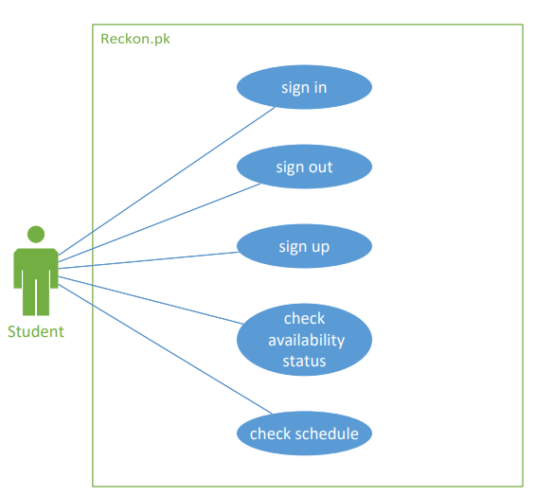
Figure 2.1: Student Use Case Diagram

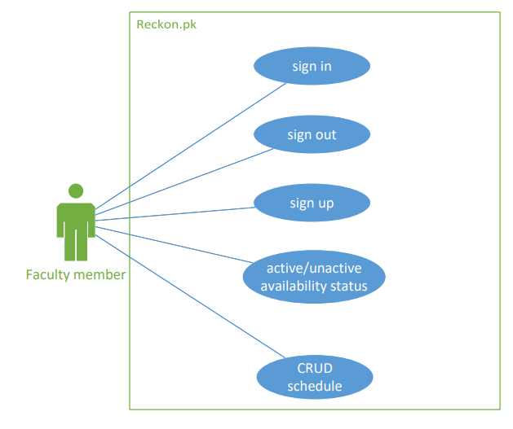
Figure 2.2: Faculty Member Use Case Diagram

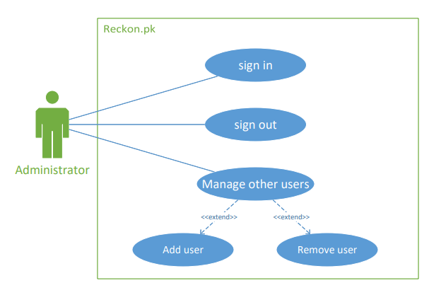
Figure 2.3: Administrator Use Case Diagram

Sign-Up as a Student (U1)

Table 2.2: Sign-Up as a Student
 | Name | Sign-Up as a Student
1. | Use-Case ID | U1
2. | Objective | Students will Sign-Up with valid credentials.
3. | Priority | Normal
4. | Actors | Student
5. | Flow of Events | - Open App  - Click on Sign-Up Button  - Enter Required Credentials  - Press Sign-up button  - Verification of credentials
5.1 | Basic Flow | Same as Flow of Events.
5.2 | Alternate Flow(s) | - If the user already exists in the database. The user will be asked to log in if his record already exists  - If all required fields are not filled. An error message is displayed to fill all the fields.
5.3 | Exception Flow(s) | - Invalid Username  - Invalid Password
6. | Includes | No other use case
7. | Preconditions | The user must be not already registered.
8. | Postconditions | The user gets registered.
9. | Notes/Issues | None.

Sign-Up as a Faculty Member (U2)

Table 2.3: Sign up as a Faculty Member
 | Name | Sign-Up as a Faculty Member.
1. | Use-Case ID | U2
2. | Objective | Faculty Member will Sign-Up with valid credentials.
3. | Priority | High
4. | Source | Faculty
5. | Actors | Faculty Member
6. | Flow of Events | - Open App  - Click on Sign-Up Button  - Enter Required Credentials  - Press Sign-up button  - Verification of credentials
6.1 | Basic Flow | Same as Flow of Events.
6.2 | Alternate Flow(s) | - If the user already exists in the database. The user will be asked to log in if his record already exists  - If all required fields are not filled. An error message is displayed to fill all the fields.
6.3 | Exception Flow(s) | - Invalid Username  - Invalid Password
7. | Includes | No other use case
8. | Preconditions | The user must be not already registered.
9. | Postconditions | The user gets registered.
10. | Notes/Issues | None.

Sign-In as Student (U3)

Table 2.4: Sign in as Student
 | Name | Sign-In as a student
1. | Use-Case ID | U3
2. | Objective | Students will Sign-In with valid credentials.
3. | Priority | Normal
4. | Actors | Student
5. | Flow of Events | - Open App  - Enter Required Credentials  - Press Sign-In button
5.1 | Basic Flow | Same as Flow of Events.
5.2 | Alternate Flow(s) | - If the User’s record does not exist in the database. The user will be asked to Sign-up first.  - If wrong credentials are entered during sign in it will ask to sign in with the right credentials.  - If the user enters the wrong password press forgot password  - Send PIN to the email  - User will reset the password using email
5.3 | Exception Flow(s) | If all required fields are not filled error message is displayed to fill all the fields.
6. | Preconditions | The user must be already registered.
7. | Postconditions | The user gets registered.
8. | Notes/Issues | None.

Sign-In as Faculty Member (U4)

Table 2.5: Sign in as Faculty Member
 | Name | Sign-In as a Faculty Member
1. | Use-Case ID | U4
2. | Objective | Faculty Member will Sign-In with valid credentials.
3. | Priority | High
4. | Source | Faculty
5. | Actors | Faculty Member
6. | Flow of Events | - Open App  - Enter Required Credentials  - Press Sign-In button
6.1 | Basic Flow | Same as Flow of Events.
6.2 | Alternate Flow(s) | - If the User’s record does not exist in the database. The user will be asked to Sign-up first.  - If wrong credentials are entered during sign in it will ask to sign in with the right credentials.  - If the user enters the wrong password press forgot password  - Send PIN to the email  - User will reset the password using email
6.3 | Exception Flow(s) | If all required fields are not filled error message is displayed to fill all the fields.
7. | Preconditions | The user must be already registered.
8. | Postconditions | The user gets registered.
9. | Notes/Issues | None.

Active/Unactive Availability Status (U5)

Table 2.6: Availability Status
 | Name | Availability Status
1. | Use-Case ID | U5
2. | Objective | Faculty Members can active or unactive there availability status
3. | Priority | High
4. | Actors | Faculty Members
5. | Flow of Events | - Open App  - Choose option login as a Faculty Member  - Enter Required Credentials  - Press Sign-In button  - Click to Active status.
5.1 | Basic Flow | Same as Flow of Events.
5.2 | Alternate Flow(s) | - If the User’s record does not exist in the database. The user will be asked to Sign-up first.  - If wrong credentials are entered during sign in it will ask to sign in with the right credentials.
5.3 | Exception Flow(s) | - If all required fields are not filled error message is displayed to fill all the fields.  - If the user enters the wrong password press forgot password  - Send PIN to the email  - User will reset the password using email
6. | Preconditions | The user must be Signed-In.
7. | Postconditions | The user must active or unactive availability status.
8. | Notes/Issues | None.

CRUD Schedule (U6)

Table 2.7: CRUD Schedule
 | Name | Create, retrieve, update, delete Schedule
1. | Use-Case ID | U6
2. | Objective | A faculty member can perform CRUD operation on his/her schedule.
3. | Priority | High
4. | Source | Faculty Members.
5. | Actors | Faculty Members
6. | Flow of Events | - Open App  - Choose option login as a Faculty Member  - Enter Required Credentials  - Press Sign-In button  - Create a schedule  - The schedule will be available automatically on the faculty screen
6.1 | Basic Flow | Same as Flow of Events.
6.2 | Alternate Flow(s) | - If the User’s record does not exist in the database. The user will be asked to Sign-up first.  - If wrong credentials are entered during sign in it will ask to sign in with the right credentials.  - If user already uploaded schedule than he/she can update or delete the schedule.
6.3 | Exception Flow(s) | - If all required fields are not filled error message is displayed to fill all the fields.  - If the user enters the wrong password press forgot password  - Send PIN to the email  - User will reset the password using email
7. | Preconditions | The user must be Signed-In.
8. | Postconditions | CRUD operations are performed.
9. | Notes/Issues | None.

Check Status (U7)

Table 2.8: Check Availability Status
 | Name | Check availability status
1. | Use-Case ID | U7
2. | Objective | A student can check the availability status of respective faculty member
3. | Priority | Normal
4. | Source | Students
5. | Actors | Students
6. | Flow of Events | - Open App  - Login as a student  - Search for respective faculty member  - Check his/her availability status
6.1 | Basic Flow | Same as Flow of Events.
6.2 | Alternate Flow(s) | - If the User’s record does not exist in the database. The user will be asked to Sign-up first.  - If wrong credentials are entered during sign in it will ask to sign in with the right credentials.
6.3 | Exception Flow(s) | - If all required fields are not filled error message is displayed to fill all the fields.  - If the user enters the wrong password press forgot password  - Send PIN to the email  - User will reset the password using email
7. | Preconditions | The user must be Signed-In.
8. | Postconditions | The user knows the availability status of respective faculty member.
9. | Notes/Issues | None.

Check Schedule (U8)

Table 2.9: Check Schedule
 | Name | Check Schedule
1. | Use-Case ID | U8
2. | Objective | Students can view the schedule of faculty members.
3. | Priority | Normal
4. | Actors | Student
5. | Flow of Events | - Open App  - Login  - Search for faculty member  - Check schedule
5.1 | Basic Flow | Same as Flow of Events.
5.2 | Alternate Flow(s) | - If the User’s record does not exist in the database. The user will be asked to Sign-up first.  - If wrong credentials are entered during sign in it will ask to sign in with the right credentials.
5.3 | Exception Flow(s) | - If all required fields are not filled error message is displayed to fill all the fields.  - If the user enters the wrong password press forgot password  - Send PIN to the email  - User will reset the password using email
6. | Preconditions | Faculty member must upload his/her schedule
7. | Postconditions | Users have viewed the schedule.
8. | Notes/Issues | None.

Manage User (U9)

Table 2.10: Manage User
 | Name | Manage User
1. | Use-Case ID | U9
2. | Objective | Administrator can manage user i.e., add user or remove user etc.
3. | Priority | Normal
4. | Actors | Administrator
5. | Flow of Events | - Open App  - Login  - Can check users according to their roles  - Can perform CRUD operations on users
5.1 | Basic Flow | Same as Flow of Events.
5.2 | Alternate Flow(s) | None
5.3 | Exception Flow(s) | None
6. | Preconditions | None
7. | Postconditions | Admin have performed the operations.
8. | Notes/Issues | None.

Other Non-functional Requirements

Non-functional requirements of this project are:

Performance Requirements

A slow internet connection may impact the performance of the application. A good and stable internet connection is required.

Safety Requirements

To provide the users with the best application experience we will bring time to time updates in our application to prevent any bugs and try to fix that bugs and errors.

Security Requirements

The database must be accessed securely, and its data should not be broken. It also should not change except for integrant updates. Moreover, since our dataset contains some personal information of the user such as user id, security design is important in the application service.

Software Quality Attributes

Software quality attributes of this project are:
- Availability: The application will be available for the user 24/7.
- Flexibility: The application would be flexible for any type of user.
- Usability: The application should be user-friendly for the user. The users easily understand how to use the application.
- Testability: The application should be easy to test at each level and find the bugs/defect at each level of development and remove the defects easily.
- Reusability: The application is divided into different modules of coding. These modules can be used across the application.
- Maintainability: The application will be easy to maintain and removing bugs/errors and upgrade the application features, functionalities from time to time.

DESIGN AND METHODOLOGY

Feature Driven Development

FDD[6] is an incremental and iterative software development methodology. It is an Agile method for developing software. FDD combines a variety of well-known industry best practices into a unified totality. These practices are driven from a client-valued functionality perspective
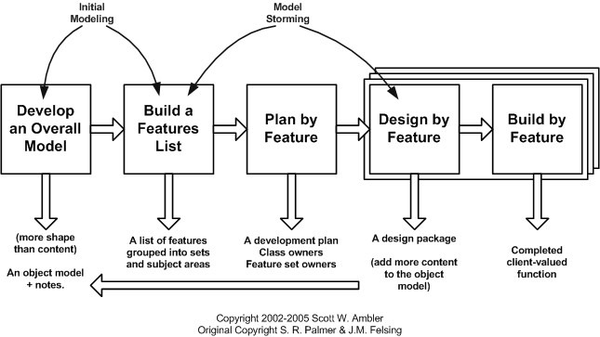
Figure 3.1: FDD

Use Case Description

Sign up

Table 3.1: Sign up
Use Case ID: | RP-I
Use Case  Name: | Sign-up
Used By: | Student, Faculty
Date Created: | 27-02-2022 |  | Date Last  Updated: | 27-02-2022
Actor: |  | Student, Faculty
Priority: |  | High
Preconditions: |  | - The user is required to enter the information that is necessary to become a member of the system.  - The user’s identity has been authenticated.  - The user’s mobile has sufficient free memory available to launch the app.
Postconditions: |  | After the user Signup on the application  The number of users on the application has been updated
Normal Course of Events: |  | Users get verification notification  Enters valid information following regular expression
Alternative Courses:
Exceptions: |  | - Internet shutdown  - An undefined error happened
Includes: |  | To sign up on the application, the user is required to visit the application first, but this use case is not preceded by any further use case
Notes & Issues |  | None

Sign In

Table 3.2: Sign in
Use Case ID: | RP-II
Use Case Name: | Sign In
Used By: | Student, Faculty
Date Created: | 27-02-2022 |  | Date Last Updated: | 27-02-2022
Actor: |  | Student, Faculty
Priority: |  | High
Preconditions: |  | The user is required to have a Password and Email
Postconditions: |  | After the user signup on the application  • The number of users on the application has been updated
Normal Course of Events: |  | User successfully sign-in on the page and become able to access various things related to his profile  In this case  - Faculty member can update his/her status.  - Faculty member can update or upload his/her schedule  - Students can check the availability status of related faculty member.  - Students can check the schedule.  - Admin can manage both above and other various tasks
Alternative Courses: |  | None
Exceptions: |  | - Internet shutdown  - An undefined error happened
Includes: |  | In this use case, the user must sign up on the application first.
Notes & Issues: |  | None

Register Users

Table 3.3: Register Users
Use Case ID: | RP-III
Use Case Name: | Add user
Used By: | Admin
Date Created: | 27-02-2022 |  | Date Last Updated: | 27-02-2022
Actor: |  | Admin
Priority: |  | Average
Preconditions: |  | - The user is required to have valid credentials.  - After the add user on the application number of users on the application has been updated
Postconditions: |  | • User must be categorized i.e., Faculty or Student
Normal Course of Events: |  | - Authorized staff can sign in/out and perform the application management task  - Student can perform their available task
Alternative Courses: |  | • As of step 1 user must get notified
Exceptions: |  | - Internet shutdown  - An undefined error happened
Includes: |  | User should write appropriate ID, name, Email ID
Notes & Issues: |  | None

Create Schedule

Table 3.4: Create Schedule
Use Case ID: | RP-IV
Use Case Name: | Create Schedule
Used By: | Faculty
Date Created: | 27-02-2022 |  | Date Last Updated: | 27-02-2022
Actor: |  | Faculty
Priority: |  | High
Preconditions: |  | - The faculty is required to have valid credentials.  - After the faculty is registered on the application number of users on the application has been updated and account has been created.
Postconditions: |  | • schedule is created or updated and displayed
Normal Course of Events: |  | - Authorized faculty member can sign in/out and can create or update the schedule  - faculty can perform their available task
Alternative Courses: |  | None
Exceptions: |  | - Internet shutdown  - An undefined error happened
Includes: |  | In this use case, the faculty member must sign up on the application first.
Notes & Issues: |  | None

Check Schedule

Table 3.5: Check Schedule
Use Case ID: | RP-V
Use Case Name: | Check Schedule
Used By: | Student
Date Created: | 27-02-2022 |  | Date Last Updated: | 27-02-2022
Actor: |  | Student
Priority: |  | High
Preconditions: |  | - The student is required to have valid credentials.  - After the student is registered on the application number of users on the application has been updated and account has been created.
Postconditions: |  | • schedule has been displayed and checked
Normal Course of Events: |  | - Registered student can sign in/out and can check the schedule  - Student can perform their available task
Alternative Courses: |  | None
Exceptions: |  | - Internet shutdown  - An undefined error happened
Includes: |  | In this use case, the student must sign up on the application first.
Notes & Issues: |  | None

Availability Status

Table 3.6: Availability Status
Use Case ID: | RP-VI
Use Case Name: | Availability Status
Used By: | Faculty
Date Created: | 27-02-2022 |  | Date Last Updated: | 27-02-2022
Actor: |  | Faculty
Priority: |  | High
Preconditions: |  | - The faculty is required to have valid credentials.  - After the faculty is registered on the application number of users on the application has been updated and account has been created.
Postconditions: |  | • faculty member active or inactive status is shown
Normal Course of Events: |  | - Authorized faculty member can sign in/out and can update his/her status of availability.  - Faculty member can perform their available task
Alternative Courses: |  | None
Exceptions: |  | - Internet shutdown  - An undefined error happened
Includes: |  | In this use case, the faculty member must sign up on the application first.
Notes & Issues: |  | None

Check Status

Table 3.7: Check Status
Use Case ID: | RP-V
Use Case Name: | Check Status
Used By: | Student
Date Created: | 27-02-2022 |  | Date Last Updated: | 27-02-2022
Actor: |  | Student
Priority: |  | High
Preconditions: |  | - The student is required to have valid credentials.  - After the student is registered on the application number of users on the application has been updated and account has been created.
Postconditions: |  | • Status has been displayed and checked by the student. Whether the faculty is available or not.
Normal Course of Events: |  | - Registered student can sign in/out and can check the availability status  - Student can perform their available task
Alternative Courses: |  | None
Exceptions: |  | - Internet shutdown  - An undefined error happened
Includes: |  | In this use case, the student must sign up on the application first.
Notes & Issues: |  | None

Sequence Diagrams

Sign In

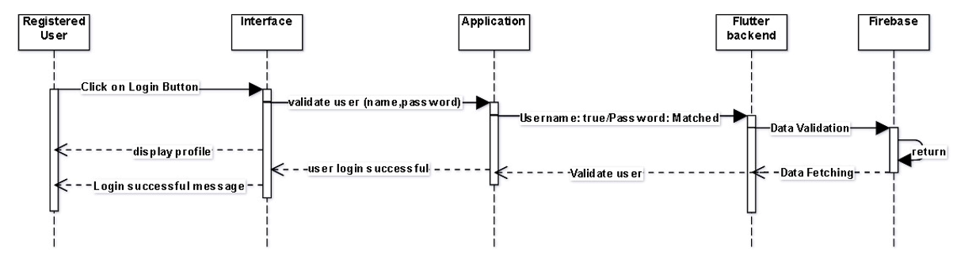
Figure 3.2: Sign In

Sign Up

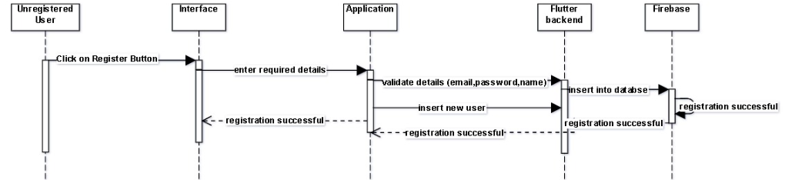
Figure 3.3: Sign Up

Faculty Status

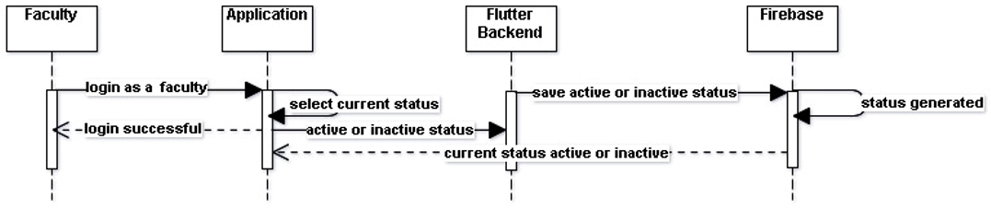
Figure 3.4: Faculty Status

Check Status

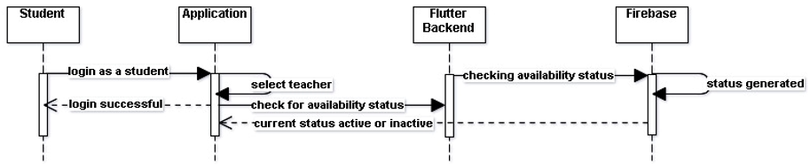
Figure 3.5: Check Status

Faculty Schedule

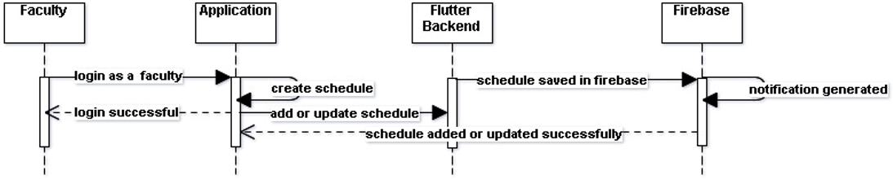
Figure 3.6: Faculty Status

Check Schedule

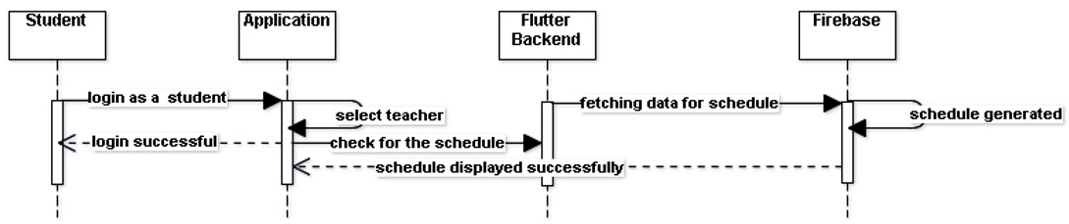
Figure 3.7: Check Schedule

Class Diagram

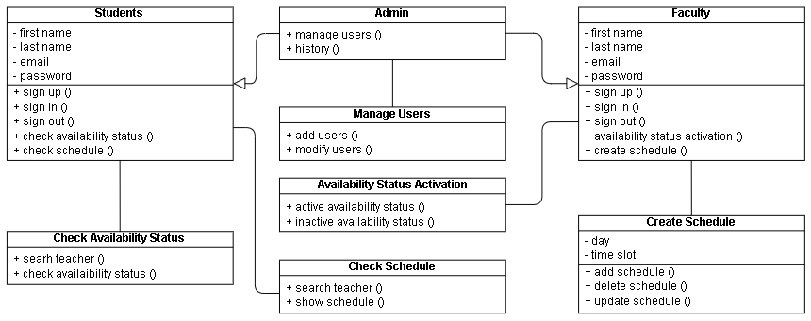
Figure 3.8: Class Diagram of Reckon.pk

ERD

The Firebase databases, either real-time databases or the cloud fire store, are document-oriented NoSQL databases. There are indeed no tables, just collections of documents, where each document is a JSON-like structure, and documents could contain other embedded collections or documents. As said before firebase uses a NoSQL database. It uses JSON objects to be precise.
Consider it like this.
You have three employees then the JSON tree will be formed like this.
• Employees
o Employee 1
- Name
- Address
o Employee 2
- Name
- Address
So, this whole set is considered as one JSON object. Whenever you try to retrieve anything then you must capture the entire object and traverse through it.

IMPLMENTATION

Languages used for implementation

Dart

Dart is an Open-Source, Client-Optimized programming language used for creating high-performance and fast applications. It is used to create a mobile application, write software for the desktop, or design a site. It’s an interpretable language supported by Google alongside numerous features which made it popular among programmers. Dart is also known as an alternative to JavaScript. The use of it is increased when Google introduced Flutter intending to add mobile programming capabilities

Framework

Flutter is an Open-source UI, cross-platform framework for developing a native mobile application. Flutter allows us to build a mobile application for Android and IOS with a single code-based and programming language called Dart. The flutter framework consists of both a software development kit (SDK) and their widget-based UI library.it contains a variety of reusable UI elements.

Tools

Android Studio

Android studio[7] is an official integrated development environment for the development of an android-based application. Structured code modules allow you to divide your project into units of functionality that you can independently build, test, and debug.

VS Code

Microsoft Visual Studio Code is a standalone source code editor that runs on multiple operating systems. It is used to develop computer programs, as well as websites, web apps, web services, and mobile apps. It supports many programming languages and a set of features that differs per language. VS Code provides initial support including syntax highlighting etc.

Android Emulator

The android emulator provides simulations of android devices on your computer which helps us to test our application on a variety of devices without needing to have each physical device. It came along with a predefined configuration for multiple android-based Phones, Tablets. Testing in an emulator is way faster than physical devices.

Online Services

Firebase

Firebase is a backend as a service. It provides developers a variety of services along with tools to help them to develop a quality application that helps them to grow their user base and earn. It is built on googles infrastructure which provides a variety of storage services.

Cloud Firestore

Cloud fire store is a scalable database for mobile, web, server development from firebase and google cloud.it tends to keep your data in sync across client apps through real-time listeners and offers offline support for web and mobile applications so that we can develop an app without worrying about network latency or internet connectivity.

Firebase Cloud Messaging

FCM is a cross-platform solution that lets you safely send a message to multiple or single devices over the internet. In our case, users will get notifications according to their access levels.

RESULTS AND DISCUSSIONS (or USER MANUAL)

Introduction

This is the introduction of the application which tells the main features of the Reckon.pk and this will show only once at the user downloads the application and runs it for the first time.

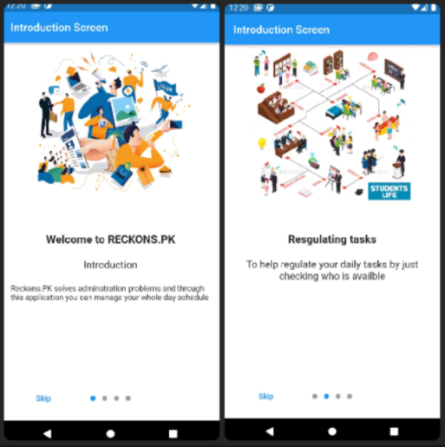
Figure 5.1: Introduction Page 1 & 2

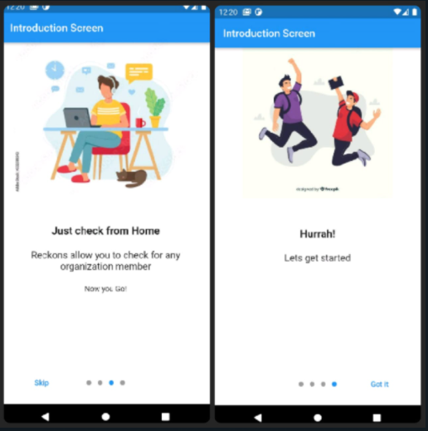
Figure 5.2: Introduction Page 3 & 4

Log In and Sign Up

The Log in and sign up is simple as other mobile applications had with the additional features of email verification which will support the confidentiality triad.

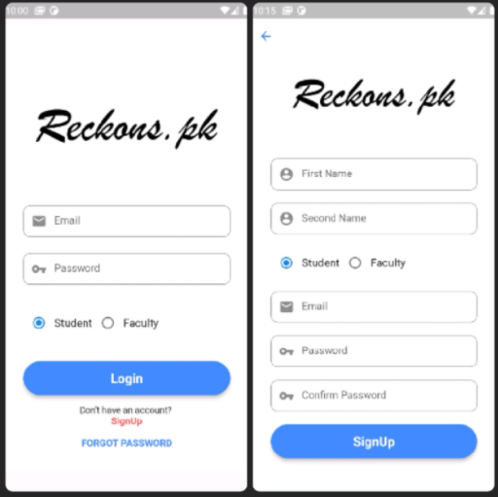
Figure 5.3: Log In & Sign Up

Edit Profile

After logging in user can edit their profile information. To edit information, they have an option in the drawer of profile by clicking on the profile they can easily edit their profile information. Same option is given for both users faculty and students.

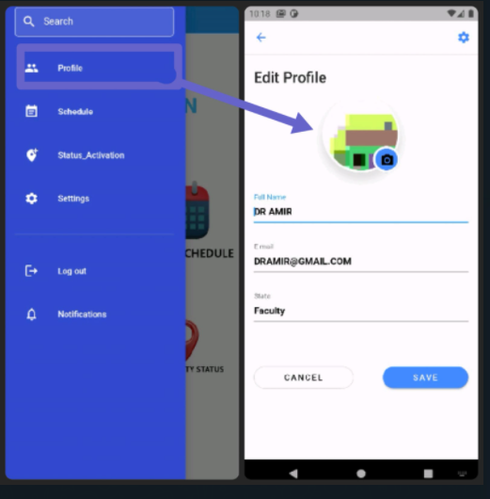
Figure 5.4: Faculty Edit Profile

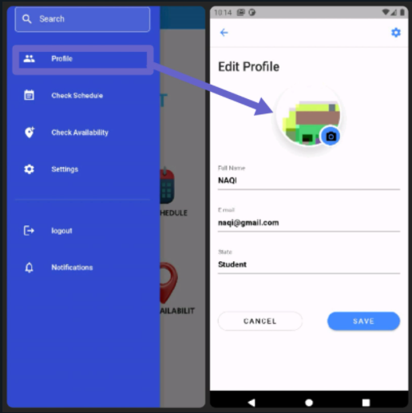
Figure 5.5: Student Edit Profile

Settings

There is an option of settings for both users in the drawer where they have multiple options account settings and notification settings.

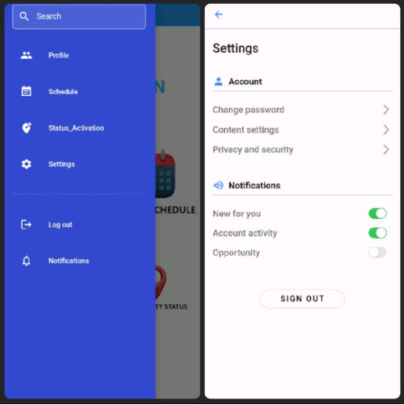
Figure 5.6: Settings

Forgot Password

If a faculty member or student forget his/her password, then he can reset their password through email verification. After clicking on forgot password they are directed towards the screen where they must enter the email than they are receive an email from which they can easily change their password through email verification.

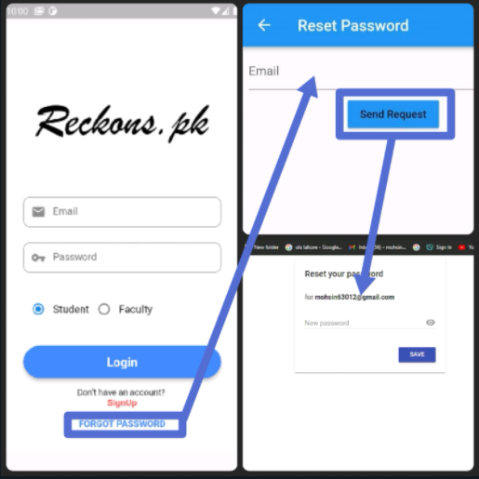
Figure 5.7: Forgot Password

Faculty Dashboard

After Sign in as Faculty member, they will be directed towards this screen which has the following feature:

- Create Scheduled
- Availability Status
- Reset Password
- Logout

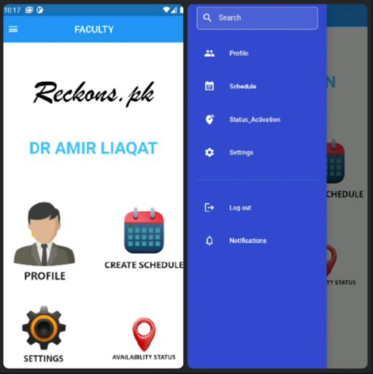
Figure 5.8: Faculty Dashboard

Create Schedule

Faculty member can create their own schedule from the predefined schedule. They can also update and delete their schedule according to their need. The slots in which they have class becomes red which shows they are busy while the time slots which are green shows, they don’t have any class in that specific time slot.

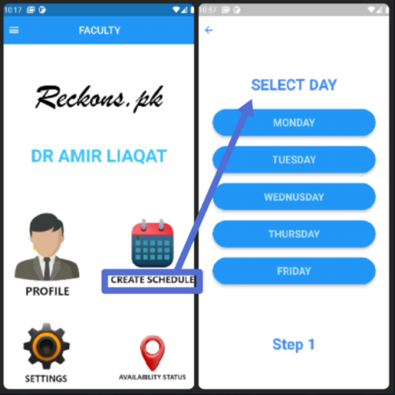
Figure 5.9: Step 1 to Create Schedule

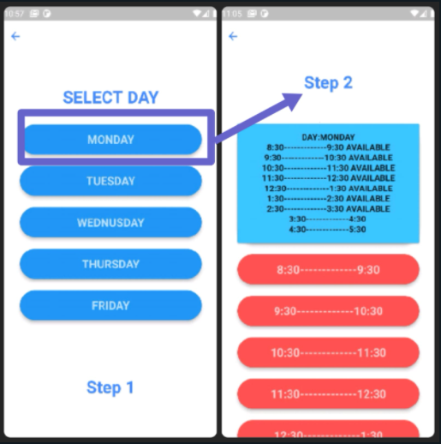
Figure 5.10: Step 2 for creating schedule

Availability Status

Faculty member can active or inactive his/her availability status according to their location. For instance, if they are within the radius of BULC only than they can active their availability status otherwise it will shoe inactive by default.

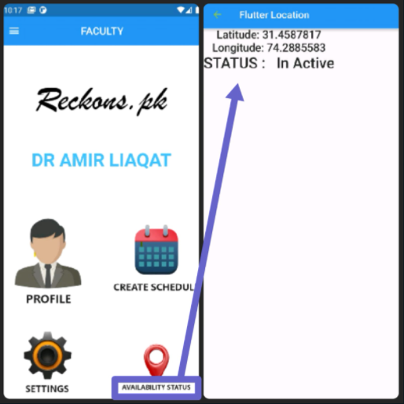
Figure 5.11: Availability Status

Faculty Reset Password

If a faculty member wants to reset his/her password, then they can reset their password through email verification. After clicking on reset password they are directed towards the screen where they can easily change their password through email verification.

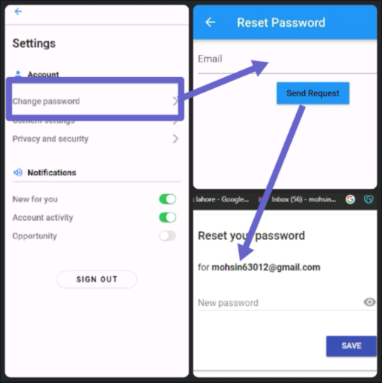
Figure 5.12: Reset Password

Student Dashboard

After signing in as student, they will be directed towards their home screen or dashboard where they can have multiple options such as

- Check Scheduled
- Check Availability Status
- Reset Password
- Logout

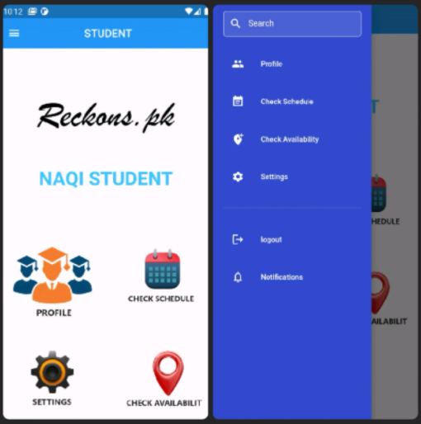
Figure 5.13: Student Dashboard

Check Schedule

Student can check the schedule of the faculty member by clicking on the check schedule button. They are directed towards the screen which shows the schedule of the respective faculty member in the form of list.

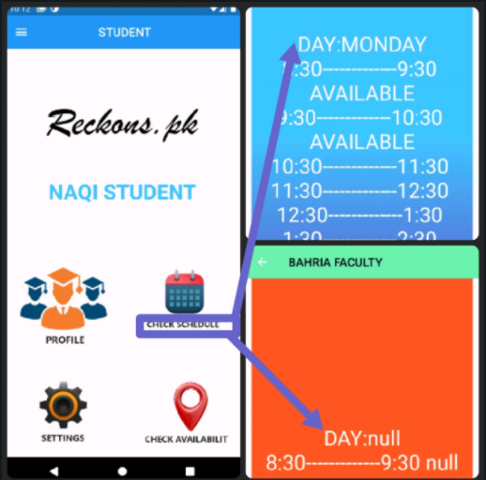
Figure 5.14: Check Schedule

Check Availability

Student can check the availability status of the faculty member by clicking on the availability status. Where they can see the list in which they can see the status of their respective faculty members.

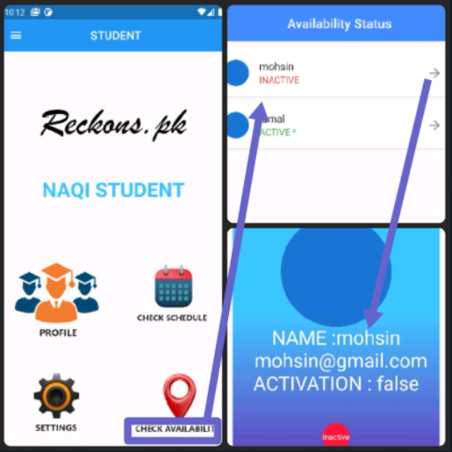
Figure 5.15: Check Availability

Student Reset Password

If a student wants to reset his/her password, then they can reset their password through email verification. After clicking on reset password they are directed towards the screen where they can easily change their password through email verification.

Figure 5.16: Student Reset Password

CONCLUSION AND RECOMMENDATIONS

Project Achievements

Form the verification of plan and after testing the application, the actual output of the Reckon.pk is getting good result as manage to reach all the expected output and fulfilled the project objectives. In the end, Reckon.pk manages to help the organization by providing them a platform that will save the time of the visiting individuals and manages the schedule and availability status of faculty member. Furthermore, Reckon.pk counters the factor which requires individuals to physically show their presence to check whether the person is present in his office or not. By Reckon.pk users can perform their intended task remotely.

Future Work

Some improvements can be made in the future. First and foremost, change is according to the business need as every institute has its mechanism of working to give preferences to client-valued functionality we must change the application UI/UX and mechanism accordingly.
Secondly, we are going to publish a Web App as we had a great advantage of using Flutter for the completion of Reckon.pk we can build a Web App with the code based we used. Flutter provides us the opportunity to develop a cross-platform app i.e., for iOS and Android with a single code base.

Implementation Issues and Challenges

In this project, we encounter serval challenges throughout the project life cycle. First and foremost, development tools and environment need to be determined before the project can proceed. There are many much-integrated development environments such as Android Studio, Visual Studio Code, NetBeans, Eclipse which can be used for the development of Reckon.pk. IDEs like NetBeans, Eclipse is outdated, and they require extra plugins to integrate with the system while developing a mobile application. After the announcement of Goggle in 2016 that they are not going to provide the support for these plugins which makes it harder to develop the applications as it is harder for them to integrate with the systems. From Android studio and Visual Studio Code, we use both as both are the best tools moreover, they have a vast amount of developer community which helps native developers in the hour of need.
On the other hand, as Flutter is new to the market it is still under a lot of development latest version are realizing quickly, we had to change our code frequently as the syntax and new features were added to the build.

Conclusion

In this modern era, most organizations are using the latest technologies and software but hopefully, through this project, we solve this long-awaited upgrade, by successfully meeting our aims and objectives. We have developed a cross-platform app that can be for both iOS and Android user which provide a digital integrated environment that enhanced enhance the workflow. We have created an app that checked the status of employee through GPS also they can set their schedule. This application also makes administrative operation easily automated. Which eventually saves people time and money.

REFERENCES

Electronic Sources from Internet:

[1] “watch @ www.youtube.com.” [Online]. Available: https://www.youtube.com/watch?v=j-LOab_PzzU&ab_channel=Codepur.
[2] “how-write-software-requirements-specification-srs-document @ www.perforce.com.” [Online]. Available: https://www.perforce.com/blog/alm/how-write-software-requirements-specification-srs-document.
[3] “index @ docs.flutter.dev.” [Online]. Available: https://docs.flutter.dev/.
[4] “index @ firebase.google.com.” [Online]. Available: https://firebase.google.com/?gclid=CjwKCAjww-CGBhALEiwAQzWxOlbdg3BQdedrIYhzhQuZ7rUpyOharCcPcBzUfGoo6nS.
[5] “c4968a0a4e5356ed94f87fd7e6ec9eb9b26e95cf @ online.visual-paradigm.com.” [Online]. Available: https://online.visual-paradigm.com/diagrams/solutions/free-use-case-diagram-tool/.
[6] “d22f7ab52ebd4c31cf3c41a3a00970c8583ccd6c @ www.productplan.com.” [Online]. Available: https://www.productplan.com/glossary/feature-driven-development/.
[7] “watch @ www.youtube.com.” [Online]. Available: https://www.youtube.com/watch?v=Ob4vSoWud9k&ab_channel=DJMalone.

