
BSCS-F21-023
03-134182-111 | Arooj Arshad
03-135182-045 | Usman Khalid

Armaan Confectionery

In partial fulfilment of the requirements for the degree of
Bachelor of Science in Computer Science
Supervisor: Dawood Akram
Department of Computer Sciences
Bahria University, Lahore Campus
June 2021

© Bahria University, 2021

Certificate

We accept the work contained in the report titled
“Armaan Confectionary”
written by
Arooj Arshad
Usman Khalid

as a confirmation to the requiredstandard for the partial fulfilment of the degree of
Bachelor of Science in ComputerScience.

Approved by:
Supervisor: DAWOOD AKRAM
(Signature)

June17, 2021

DECLARATION

I/We hereby declare that this project report is based on my/our original work except for citations and quotations which have been duly acknowledged. I/We also declare that it has not been previously and concurrently submitted for any other degree or award at Bahria University or other institutions.

Enrolment | Name | Signature
03-134182-111 | AROOJ ARSHAD
03-134182-045 | USMAN Khalid

Date : June17, 2021

Specially dedicated to
my beloved grandmother, mother and father
(STUDENT 1 NAME)
my beloved grandmother, mother and father
(STUDENT 2 NAME)
my beloved grandmother, mother and father
(STUDENT 3 NAME)
(this dedication page is optional)

ACKNOWLEDGEMENTS

We would like to thank everyone who had contributed to the successful completion of this project. We would like to express our gratitude to my research supervisor, Mr. DAWOOD AKRAM for his invaluable advice, guidance and his enormous patience throughout the development of the research.

In addition, We would also like to express my gratitude to our loving parent and friends who had helped and given me encouragement.

AROOJ ARSHAD
USMAN KHALID

ARMAAN CONFECTIONARY

ABSTRACT

An online bakery shop will make customers' lives simpler by serving them without any bother. Reason of making it online is to manage the things with ease and conjointly spares the time for clients as well. An online bakery that permits clients to check for different pastry shop items accessible at the online store, buy them and put a customized arrangement or anything craved or venture comprising a list of bakery items shown in different categories.
The client may browse through these things as per categories or arrange their crave pastry shop things and put a customized arrangement. On the off chance that the client likes an item he may include it to his shopping cart. We have noticed that there's not any online pastry kitchen shop that can encourage clients.
In this cutting edge world where innovation is included in each field of life. This site is bringing ease and in an exceptionally straightforward and simple way with less sum of time utilization. So that’s the reason that we are planning a modern online pastry kitchen web in such a way that clients will be facilitated.

TABLE OF CONTENTS

DECLARATION iii
ACKNOWLEDGEMENTS vii
ABSTRACT ix
TABLE OF CONTENTS xi
LIST OF TABLES xiii
LIST OF FIGURES xv
LIST OF SYMBOLS / ABBREVIATIONS xvii
LIST OF APPENDICES xviii

CHAPTERS
1 INTRODUCTION 1
1.1 Background 1
1.2 Problem Statements 1
1.3 Aims and Objectives 2
1.4 Scope of Project 3
2 LITERATURE REVIEW (and/or SRS) 4
2.1 Section Title 1 4
2.2 Section Title 2 4
2.3 Section Title 3 5
2.3.1 Subsection Title 1 5
2.3.2 Subsection Title 2 5
2.4 Section Title 4 6
3 DESIGN AND METHODOLOGY 7
3.1 Section Title 1 7
3.2 Section Title 2 7
3.3 Subsection Title 1 8
3.3.1 Sub-subsection Title 1 8
4 DATA AND EXPERIMENTS (and/or IMPLMENTATION) 10
4.1 Section Title 1 10
4.2 Section Title 2 10
4.3 Subsection Title 1 11
4.3.1 Sub-subsection Title 1 11
5 RESULTS AND DISCUSSIONS (or USER MANUAL) 13
5.1 Section Title 1 13
5.2 Section Title 2 13
5.3 Subsection Title 1 14
5.3.1 Sub-subsection Title 1 14
6 CONCLUSION AND RECOMMENDATIONS 15
6.1 Subsection Title 1 15
6.2 Subsection Title 2 15
6.3 Subsection Title 1 16
6.3.1 Sub-subsection Title 1 16
REFERENCES 17
APPENDICES 19

LIST OF TABLES

TABLE TITLE PAGE
Table 2.1: Processing Time (in hours) of Board for Different Machines 5
Table 2.2: Processing Time (in hours) of Board for Different Machines 6
Table 3.1: Processing Time (in hours) of Board for Different Machines 8
Table 3.1: Processing Time (in hours) of Board for Different Machines 10
Table ‎5.1: Processing Time (in hours) of Board for Different Machines 12

LIST OF FIGURES

FIGURE TITLE PAGE
Figure 2.1: Computer User 6
Figure 3.1: OCR Block Diagram 8
Figure 4.1: OCR Block Diagram 11
Figure 5.1: Computer User 14

LIST OF SYMBOLS / ABBREVIATIONS

c_{p} specific heat capacity, J/(kg⋅K)
h height, m
K_{d} discharge coefficient
M mass flow rate, kg/s
P pressure, kPa
P_{b} back pressure, kPa
R mass flow rate ratio
T temperature, K
v specific volume, m³

α homogeneous void fraction
η pressure ratio
ρ density, kg/m³
ω compressible flow parameter

ID inner diameter, m
MAP maximum allowable pressure, kPa
MAWP maximum allowable working pressure, kPa
OD outer diameter, m
PCB printed circuit board

LIST OF APPENDICES

APPENDIX TITLE PAGE
APPENDIX A: Graphs 19
APPENDIX B: Computer Programme Listing 20

INTRODUCTION

Background

Each time of the day there will be a supervisor or at least somebody who will take the arrangement and will converse with the client straightforwardly. Numerous other organizations give these online offices like nourishment panda, cheetah and shops individual domestic conveyance administrations. This online Bakery shop will permit clients to check and buy different pastry kitchen items accessible online. The venture will comprise a list of Bakery items shown in different categories and the client will browse through the things and will do online shopping. Instalment will be cash on conveyance, but we'll offer those rebates. In this way, the online Bakery shopping extension will bring a complete shop online, making it simple for both buyer and vender and clients will have the freedom of requesting specifically by talking to vender.

Problem Statements
As a way to overcome all of these existing websites’ shortcomings, I have proposed this modern thought, which is an internet site for a pastry kitchen system. This documentation is pointed to make a web site which handles requesting and conveying cakes, cakes, treats and cupcakes by means of online. This framework is uncommonly planned for the XYZ Bakery shop which was recently opened.
XYZ Bakery could be a custom made pastry kitchen that opened many months back, and it is found in Lahore. This bakery offers home-made rolls, cakes, cupcakes and additional baked goods, which has an overwhelming taste and scent. Since it was recently opened, many are unaware of this bakery and this made their benefit getting less day by day. Well, this framework is most likely made to advance XYZ Bakery so that it can be recognized by others effortlessly, particularly for those who live around Lahore. The site that has been made for XYZ Bakery has been outlined with a few additional highlights that clients are permitted to customize their claim cake (including flavours, shapes and fixings) and they too give pastry shop administrations for 24 hours.

Aims and Objectives

The objectives of the thesis are shown as following:
- To develop a website for an online bakery system
- To design a user-friendly website interface for the bakery system
- To provide an online bakery system with a delivery services

Scope of Project

The scope for this venture is creating a computer program that works as an online framework that can send and get data to the parties included. Other than that, this extent makes a difference to advance and make a benchmark for XYZ Bakery that is almost to open. This framework works online and will be profoundly secured as there will be diverse clients with distinctive keys to login into their account.

LITERATURE REVIEW(and/orSRS)

Primary Scope

Client fulfilment is the most excellent thing to induce victory for any commerce. In bakery shops the conventional written by hand strategy for composing a charge to keep track of the record is wasteful and leads to misfortune of the organization. Nearly all organization these days comprises the number of assignments like produce charge, overseeing records of the stock and client subtle elements. The issue happens to capture information and keep redress records of the stock points of interest day by day buy and deals.

Final Deliverable of the Project and Beneficiaries
The expansion is based on a location in which the baked good shop administrators will work all the value of the baked good shop. The chief of the cake kitchen or admin can login into the system and change the information; nearly all cake shops or administrators would be well known around the orders of the clients. Boss can update the information.
Executive or admin can modify the mystery word and have the master cancel or celerity any course of action. There will be a system of saving clients personal information like having their contact numbers and their address. In other hands the clients can select the baked good kitchen things which are available.
They can in addition update their profile, watchword, post and see tributes logout. There will be a household page having a course bar consisting of residential, nearly baked good kitchen, contact us buttons. There will be a chat boot elective for clients to ask questions.

Objectives
1. To the proposed system that used to overcome the major limitation of the existing system and enable effective management of the customer details there by improving the performance of bakery shops.
2. To store all the basic data processing needs of the bakery shop.
3. To provide the online ordering facility of bakery items for the customer right from their home rather than physically coming to the bakery.
4. To sign in on the on line Arman Confectionery and get his/her online account access.
5. To provide a facility where customers can login and check numerous bakery products.
6. To place customized order from where you will place it according to your desires.
7. To be organized and considered in distinct classes.
8. To add his/her gadgets to the cart.
9. To provide facility to Customers need to be checked out from the buying cart that allows you to pay a general invoice.
10. To get a popup of available and home based bakery products and the image will be created there accordingly.
11. To provide a facility connected to the shopkeeper and can do further satisfaction.
12. To offer a credit saved system if you don’t pay cash on delivery and go for the lending option then an inquiry receipt will be generated as proof.
13. To a successful payment a thank you message is sent to the user.

Order:
If the order is not on time or not completed on time and uneasy for customer and not available in bakery so Bakery will going to lose their customers and its economic bad effect on bakery and also bad effect on Bakery reputation.

Product
If is not satisfactory so we return the product and sometimes shortage of product in bakery that’s the reason sometime customer order is not available on bakery and fulfill on time.

Raw Material:
Sometimes raw materials are unsatisfactory so we return the material and sometimes raw material prices are unreasonable so its effect on order that’s the reason order is not completed on time.

Members:
If the employee and cashier don’t have skills of working or dealing with customers and are not aware of their work.

Novelty
“There is no comparative FYP as of now affirmed in BULC.” This thought clicked in our minds by looking around our claim houses. We utilized to confront the issue of pastry kitchen things which not as it were incorporates cakes but the other valuable stuff as well. Individuals are active and apathetic within the show time. Food panda and cheetay seem not to solve our issue because it is charging additional for conveyance and it can interface us to the adjacent pastry kitchens as it were.
At that point there comes timing issues and extra charges are there as well. We need to create individuals by their claim choice so they will be able to put customized orders as well. And as this thought came up in our intellect by looking in our environment it is the issue we ourselves were confronting when the arbitrary visitors arrive late at night or at odd timings. For the individuals like women and the families who don’t possess any vehicle it was a bother to go put a customized order before time and after that their accessibility issues. By this online framework we are going to be able to form a cake or anything we need by our own choices.

2.5 Use Case Digram
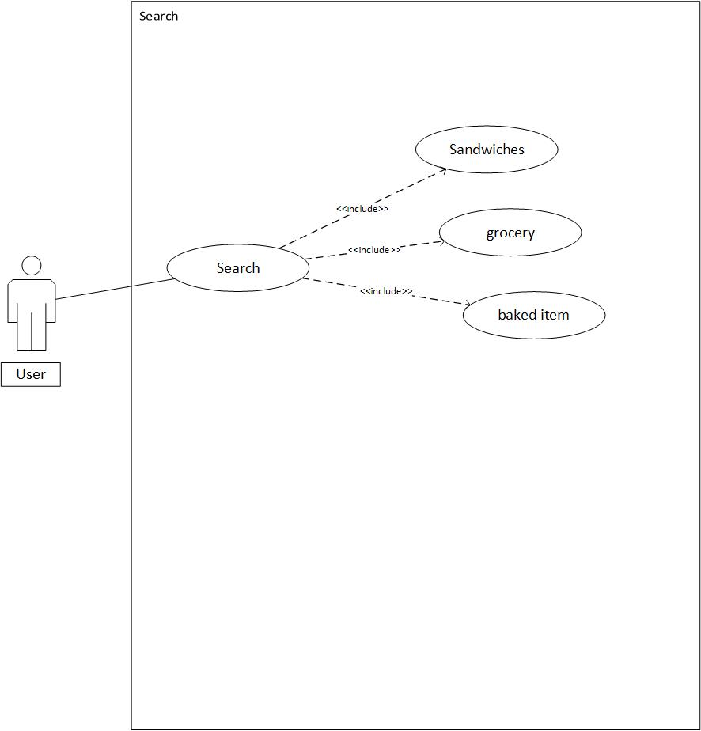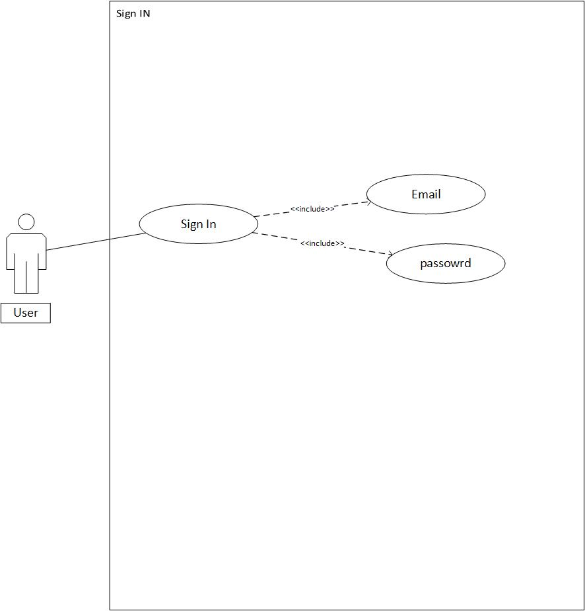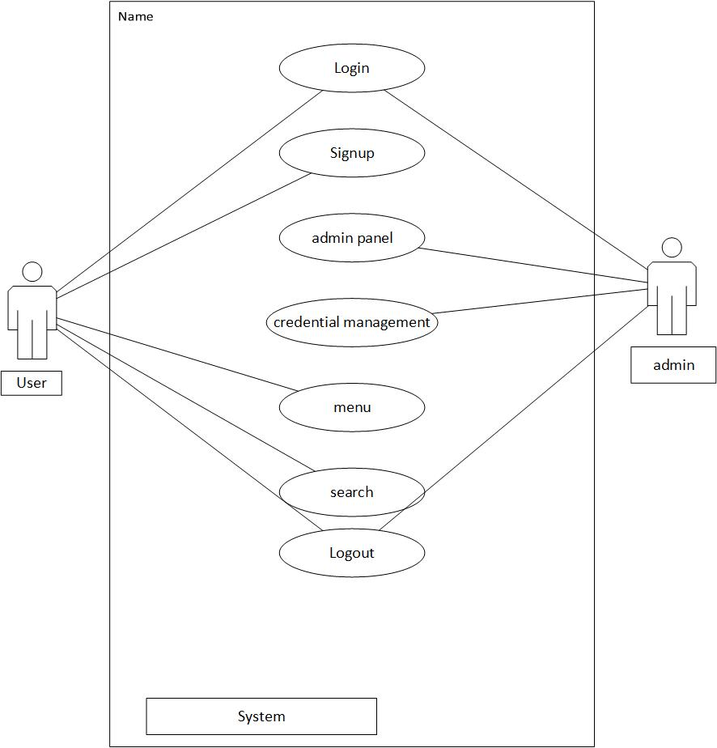

DESIGN AND METHODOLOGY

Project Plans
- Build a web-based system.
- Information handling of the orders placed i.e. new records can be created, data can be cured, update and elimination of the order functionality.
- The scope of the project is to develop a design software package to make less manual problems.
- It should deal with the Bakery Basket management as well as elimination.
- This system never decreases the workers but helps the development of available workers and helps the workers by which the banquet's standards and abilities can be raised to higher dimension.

System Architecture

User Registration: Users can easily register on the system and get his/her account on site.
User Login: Users can login to the system and check different bakery items.
Product Categories: The bakery products are arranged and can be looked at in different types.
Add to cart: Users simply add new items to cart.
Custom Products: User can order a custom product as per his favouriteflavour, size, and shape.
Credit card payment: After the total bill is calculated the user can pay with only cash on delivery.
Email confirmation: After successful payment a thank you message is sent to the user.

3.3 Entity relationship Diagram

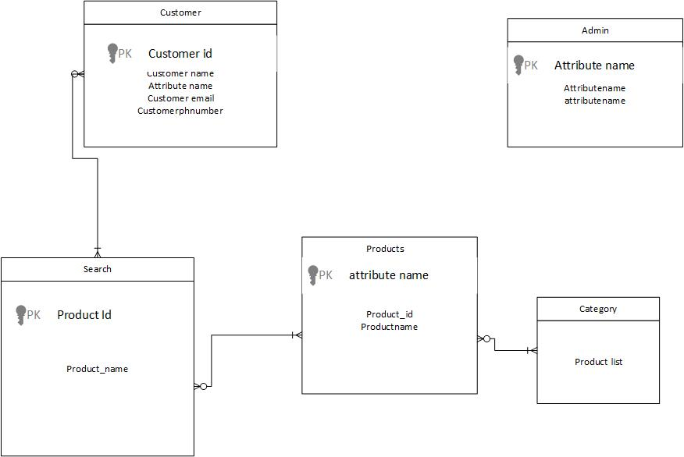

3.4 Sequence Diagram

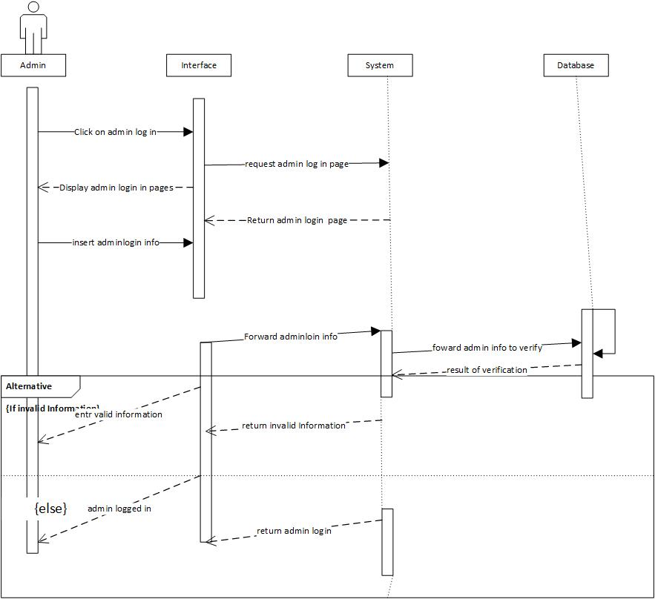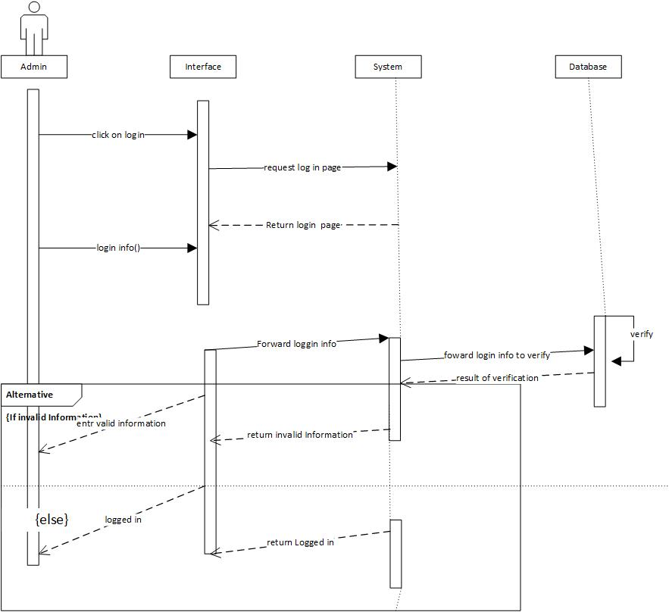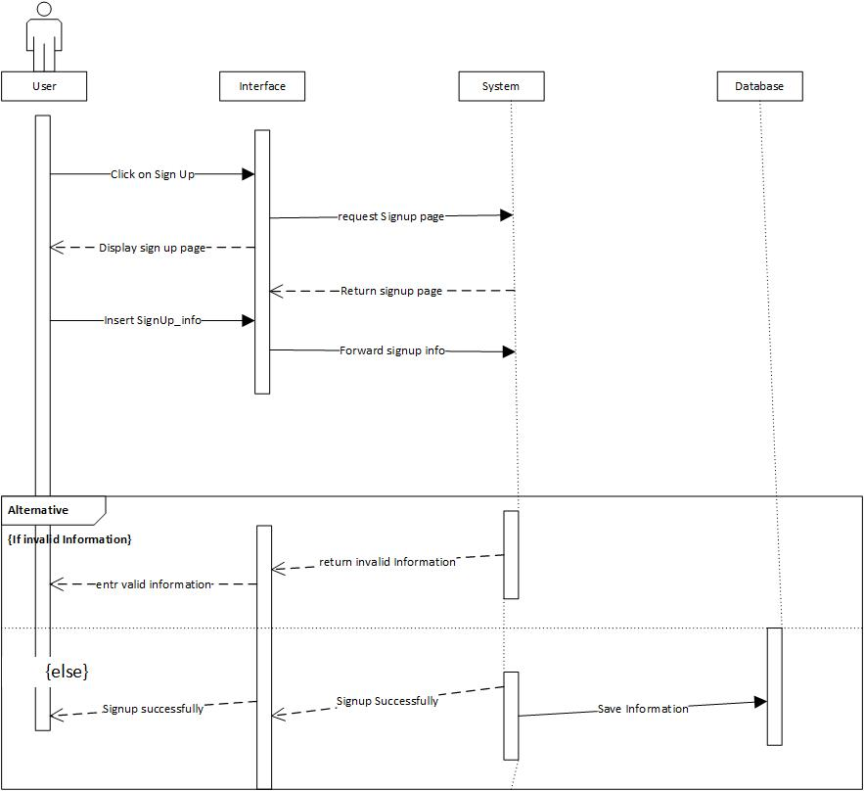

3.5 UML

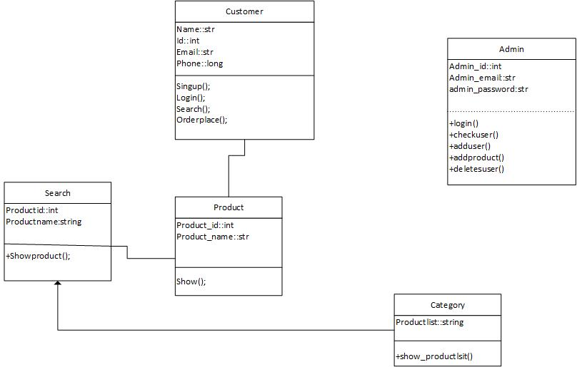

DATA AND EXPERIMENTS(and/or IMPLMENTATION)

The most important phase of any software development life cycle which involves, putting the user requirements, designs and project plans into an action. Implementation is development of project produce by designs.

Technology Used
Following techniques are used to built this project.
- Java Script, CSS (Frontend)
- PHP (Backend)

Java Script
Javascript is used by programmers across the world to create dynamic and interactive web content like applications and browsers. JavaScript is so popular that it's the most used programming language in the world, used as a client-side programming language by 97.0% of all websites.

PHP

PHP(short for Hypertext PreProcessor) is the most widely used open source and general purpose server side scripting language used mainly in web development to create dynamic websites and applications. It was developed in 1994 by Rasmus Lerdorf.

Tool Used

MYSQL
MySQL Workbench is a unified visual tool for database architects, developers, and DBAs. MySQL Workbench provides data modeling, SQL development, and comprehensive administration tools for server configuration, user administration, backup, and much more. MySQL Workbench is available on Windows, Linux and Mac OS X. Used for productive database.

XAMPP
XAMPP is an abbreviation for cross-platform, Apache, My SQL, PHP and Perl, and it allows you to build Word Press site offline, on a local web server on your computer.

.

RESULTS AND DISCUSSIONS(or USER MANUAL)

General Information:

Armaan confectionary is an website that provides a bakery shop system that can be viewed through web application.

Overview

Armaan confectionary is an website based system which provides bakery items based on order selection provided by the customer dashboard and Select cart for that particular item.

System summary

The system designed for providing bakery items is website based operating system which registers users and bakery controllers. A bakery item dashboard interacts with the system and ask customer to select regarding items and gives directions accordingly, and select order to take and cart.

User Access Level
User can access the website after enter the URL of the website. The front page of the main menu will be appear. There you can see the name of bakery. Main menu of the application will have the login option. By enter the right id customer, the customer have to enter the password and will able to move on the next page.

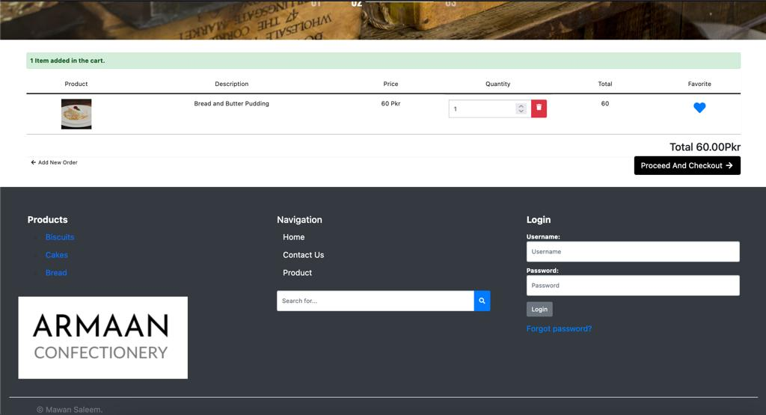

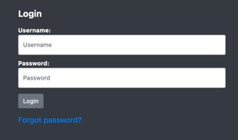

Splash:
When application will load the first splash will be see like this which shows an application Icon and name.

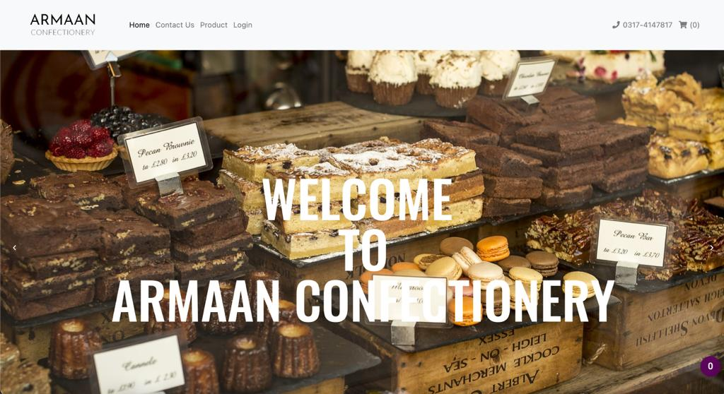

Admin Panel
List of categories
After login the website the next page that appears on the screen is admin panel where you can find multiple options on the left side. You can choose your desire options to fulfil your goal. If you select list of categories. The categories of Bakery item will appear.

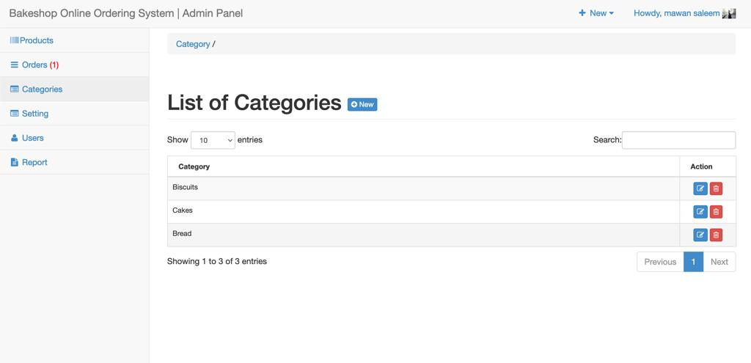

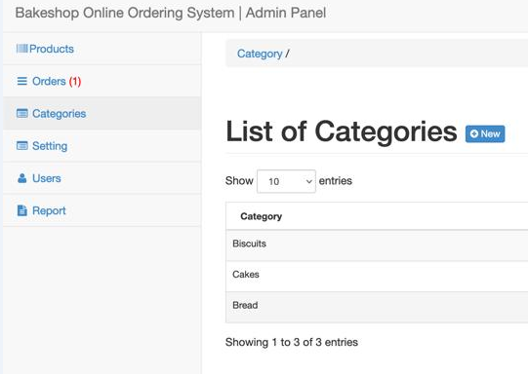

List of products
you can select the list of products from the left side in which you have many bakery products are available to choose which product you should add into cart. you are also able to delete the selected items.

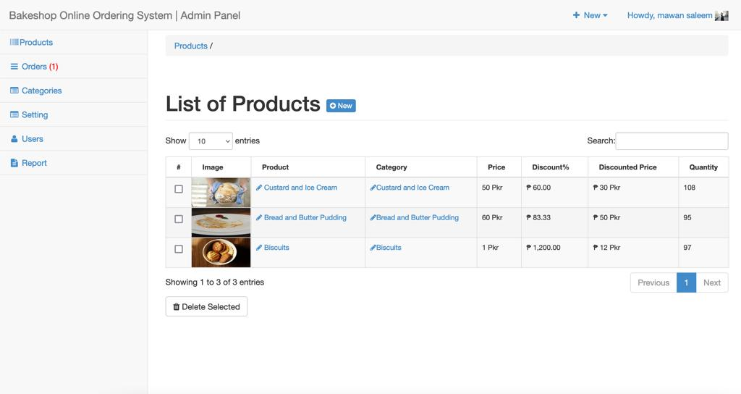

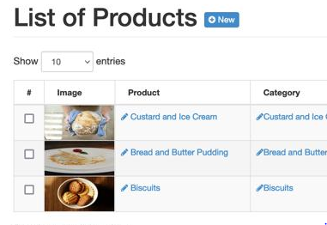

List of Orders
When you choose desire product the items will show in the form of lists. like if you have only one item then it should display only one item and if you should choose multiple products it will make a list of orders with customer name, product, date, quality ,price etc.

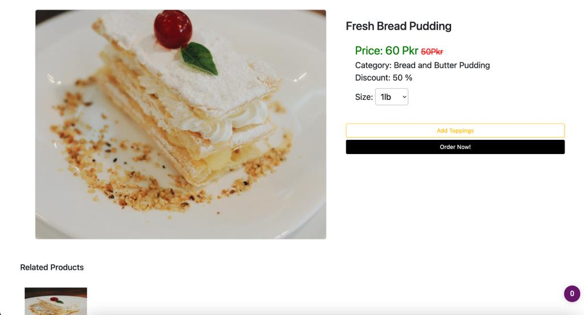

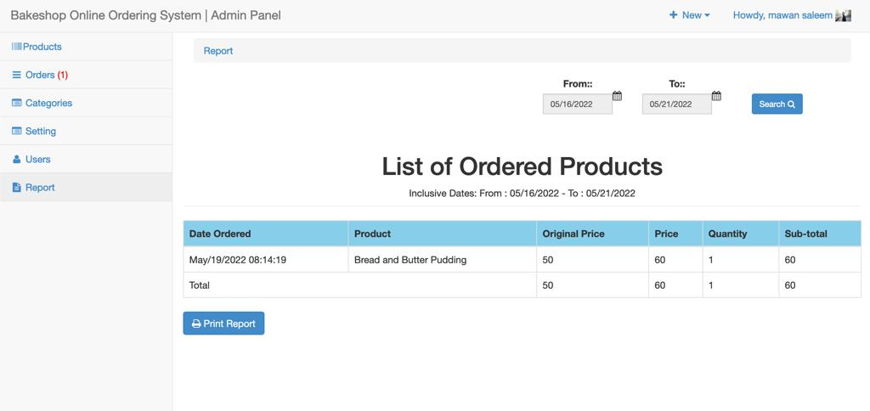

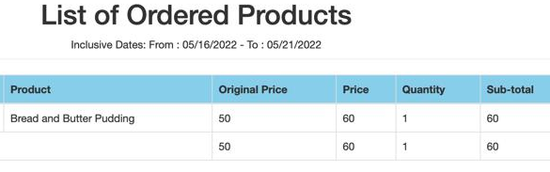
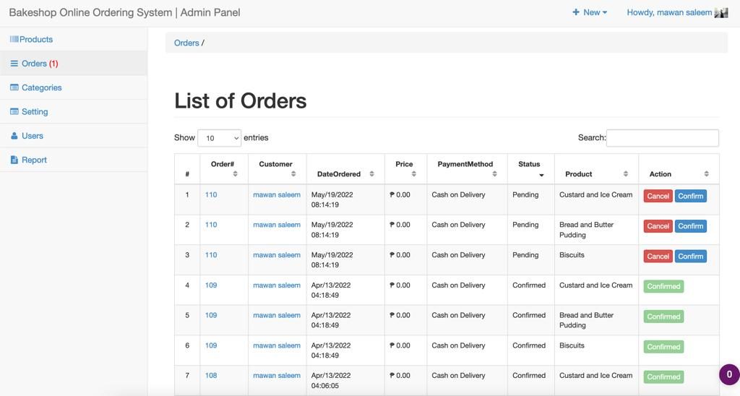

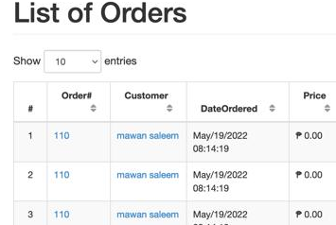

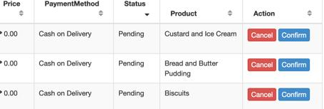

List of Users
By selecting the users options there will be the account name, username, and role position or action of the user display on the screen.

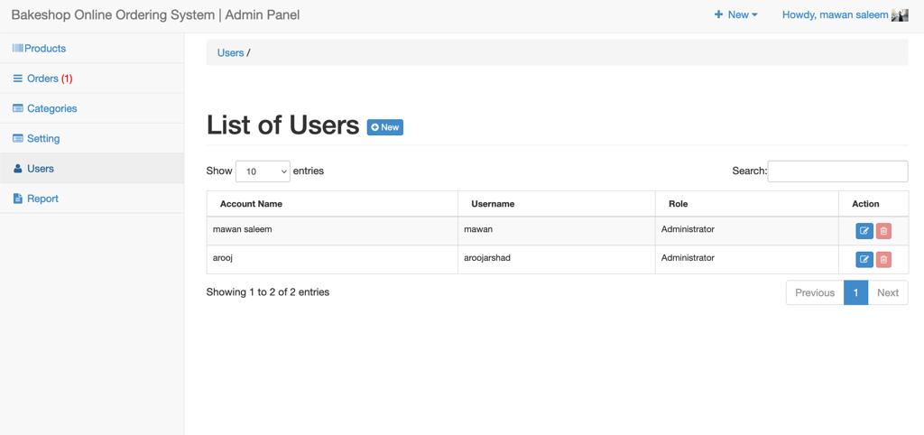

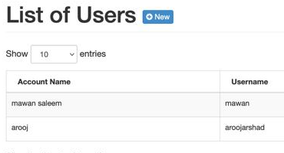

when you select the bakery item you can have also the option for extra toping. If any one wants to pay more for extra toping they will choose the option and select the desire toping.

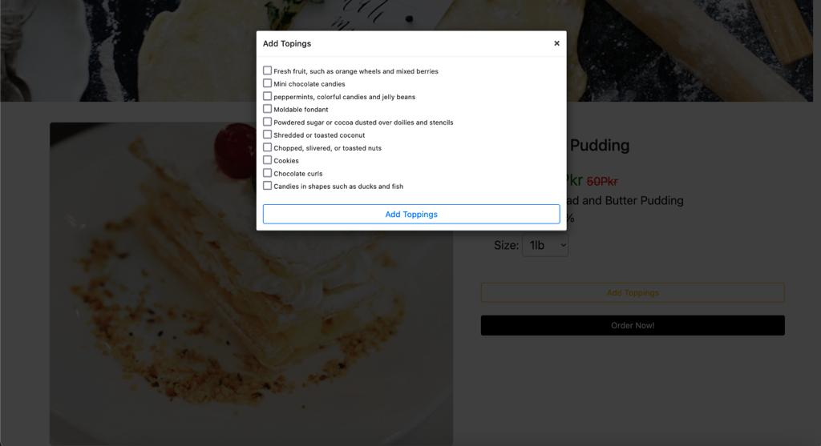

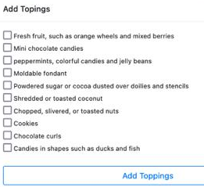

Update Accounts:
user of the admin have the option to select their images and paste on their account also they have are able to make changes in their personal information. users have the option to change their passwords and reset it.

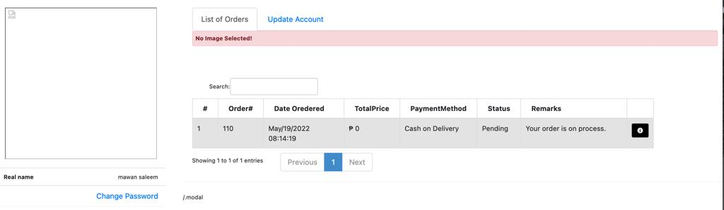

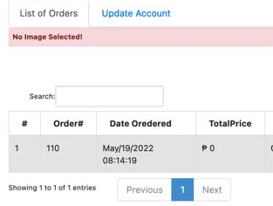

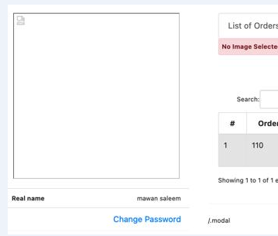

CONCLUSION AND RECOMMENDATIONS

Conclusion:
We got inspired for the idea of this project by looking at the situation of covid 19, where people don’t bother to go for groceries or bakery items due to the precautions of corona virus and people have to wait in long queues to purchase things even the customers or people cannot find appropriate shop for shopping and also feel it difficult to arrange their info at one place.

An online bakery will make customers life easier by serving them without any hassle. Purpose of making it online is to manage the things with ease and also saves the time for customers as well. An online Bakery shop that allows users to check for various bakery products available at the online store, purchase them and place a customized order or whatever desired or project consists of list of bakery products displayed in various categories. The user may browse through these items as per categories or order their desire bakery items and place a customized order. If the user likes a product he may add it to his shopping cart. We have observed that there is not any online bakery shop that can facilitate customers. In this modern world where technology is involve in every field of life. This website is bringing easiness and in very simple and easy way with less amount of time consumption. So that’s the reason that we are preparing a new online bakery web in such a way customer will be eased. Customers can discuss their problems with bakery manager through messaging. Here we utilize easy to use interface to make the whole front end backend SQL fills in as a backend to store bakery shop items records information. In this way, the online Bakery shopping project brings a whole bakery shop web-based, making it simple for both buyer and seller.

Recommendations

Regarding this project I would like to recommend that a lot more work can be done on this project which may include like interaction between the customer and the bakery manager which might be a video call, the transactions will be done through this app, we can also maintain the database of which keeps a record of sales as well as customer and done order with bakery through this application and give notification to both the person about the order replacement.

Learning Outcomes

From this project I came to know how to make website under the supervision of our supervisor for the final year project and following the deadlines side by side and work with team structure. I came to know what to do and what not to do to make project unbeaten. It also gives me benefits to understand how real-world Project carried out in IT Firm. I worked with some of the Team Leaders and experienced persons who were having lots of experience in the same field. On the whole, the project has made me learn so many new as well as important things. The purpose of final semester training is fulfilled with this project. And above all, the things which I have learnt will be useful for all the upcoming projects and will give me an edge in the market.

REFERENCES

Books:

[1] M. Barkat, Signal Detection and Estimation, 2nd Edition, Artech House , Boston, MA., 2005
[2] P. Peebles, Probability, Random Variables and Random Signal Processing, 4th Ed., , McGraw Hill, New York, 2001.

Journal Papers:

[3] A. Polydoros, ‘’A unified approach to serial search spread spectrum code acquisition-Part I: General theory’’, IEEE Transactions on Communications, vol. 32, pp. 542-549, May 1984.
[4] P. Ghandi and S. Kassam, Analysis of CFAR Processors in Nonhomogeneous Background”, IEEE Transactions on Aerospace and Electronic Systems, vol. 34, pp.8427-445, 1998

Conference Papers:
[5] C. E. Shannon, “Two-Way Communication Channels”, Proceedings of the fourth Berkeley Symposium on Probability and Statistics, pp. 611-644, Berkeley, CA, 1961
[6] M. Almarshad, M. Barkat, and S. Al-shebeili, '' A Monte Carlo Simulation for Two Novel Automatic Censoring Technique of Radar Interfering Targets in Log-Normal Clutter'', Proceedings of the International Symposium on Signal Processing and its Applications, ISSPA 2007, Sharjah, UAE, February 2007

Technical Reports and Theses:
[7] M. Barkat and P.K. Varshney, On Adaptive Cell-Averaging CFAR Radar Signal Detection, Technical Report, RADC-TR-87-160, Rome Air Development Center, Air Force Systems Command, Syracuse, NY., April 1987.
[8] L. G. Kraft, a Device for Quantizing, Grouping and Coding Amplitude Pulse, MS Thesis, Department of Electrical Engineering, MIT, Cambridge, MA, 1965

Electronic Sources from Internet:
[9] Name of author(s) as above, “Title of content”, page, if any, and year. On Line, Available at: Address of link.

APPENDICES

APPENDIX A: Graphs

Spacing between chapter title and first line of text is 4.5 lines. The first paragraph in a subsection should align with left margin. General alignment for texts in paragraph should be “justified”.

Spacing between paragraphs is 1.5 lines. Subsequent paragraphs should be indented 1.27 cm (0.5 inch) from the left margin. General alignment for texts in paragraph should be “justified”.

APPENDIX B: Computer Programme Listing

Spacing between chapter title and first line of text is 4.5 lines. The first paragraph in a subsection should align with left margin. General alignment for texts in paragraph should be “justified”.

Spacing between paragraphs is 1.5 lines. Subsequent paragraphs should be indented 1.27 cm (0.5 inch) from the left margin. General alignment for texts in paragraph should be “justified”.

