
BSCS-F21-025
03-134182-093 | NABEELSARWAR
03-134182-107 | SHOAIBLATIF

Event Cart

In partial fulfilment of the requirements for the degree of
Bachelor of Science in Computer Science
Supervisor: Zupash Awais
Department of Computer Sciences
Bahria University, Lahore Campus

Certificate

We accept the work contained in the report titled
“Event Cart”
written by
MUHAMMAD NABEEL SARWAR
SHOAIB LATIF
as a confirmation to the required standard for the partial fulfilment of the degree of
Bachelor of Science in Computer Science.

Approved by:
Supervisor: Zupash Awais
(Signature)

May 23, 2022

DECLARATION

We hereby declare that this project report is based on our original work except for citations and quotations which have been duly acknowledged. We also declare that it has not been previously and concurrently submitted for any other degree or award at Bahria University or other institutions.

Enrolment | Name | Signature
03-134182-093 | MUHAMMAD NABEEL SARWAR
03-134182-107 | SHOAIB LATIF

Date: May 23, 2022

Specially dedicated to
my beloved grandmother, mother, and father
(MUHAMMAD NABEEL SARWAR)
my beloved grandmother, mother, and father
(SHOAIB LATIF)

ACKNOWLEDGEMENTS

We would like to thank everyone who had contributed to the successful completion of this project. We would like to express our gratitude to my research supervisor, Ms ZUPASH AWAIS for her invaluable advice, guidance, and her enormous patience throughout the development of the research.

In addition, we would also like to express my gratitude to our loving parent and friends who had helped and given me encouragement.

MUHAMMAD NABEEL SARWAR
SHOAIB LATIF

EVENT CART

ABSTRACT

Nowadays’ people are busy in their lives if they want to book a venue for their special function, they must spend more in traveling and searching for the place also, money for searching the perfect venue according to the requirements. To overcome such problem, we have purposed an android application where user can easily search for their desired venues nearby and book them in one go. By using our user-friendly application users can save time, money and can book their venue according to their needs just with a single click.
We have developed an android application using android studio using JAVA language. Using the Agile Model for our software we have applied the Feature Driven Development (FDD) method. This application has performed the following: booking of venue, caterers, decorators, photographer etc. The application will be easy to understand and especially useful. The person can contact them via email or phone no. We have using Google API or the implicit application call method. Through this application, a person will be able to check the nearby wedding halls.

TABLE OF CONTENTS

DECLARATION ii
ACKNOWLEDGEMENTS iv
ABSTRACT v
TABLE OF CONTENTS vi
LIST OF TABLES x
LIST OF FIGURES xi
LIST OF APPENDICES xii

CHAPTERS
1 INTRODUCTION 1
1.1 Background 1
1.2 Problem Statements 2
1.3 Aims and Objectives 3
1.4 Scope of Project 3
2 LITERATURE REVIEW (and/or SRS) 5
2.1 User Classes and Characteristics 5
2.1.1 Types of users 5
2.2 Operating Environment 6
2.2.1 Resource Requirement 6
2.2.2 Tools / Technology 6
2.3 Design and Implementation Constraints 7
2.3.1 Hardware Limitations 7
2.3.2 Tools 8
2.3.3 Language Requirements 8
2.4 Assumption and Dependencies 8
2.4.1 Assumptions 8
2.4.2 Dependencies 8
2.5 Non-functional Requirements 8
2.5.1 Security Requirements 9
2.5.2 Software Quality Attributes 9
2.6 Other Requirements 9
2.6.1 Availability 9
2.6.2 Maintainability 9
3 DESIGN AND METHODOLOGY 10
3.1 Architectural Design 10
3.2 Data Flow Diagram 11
3.2.1 Level-1: 11
3.2.2 Level-2: 11
3.2.3 Level-3: 12
3.3 System Use Cases 13
3.3.1 Main Use Case Diagram 13
3.3.2 Sign up Use-Case diagram 14
3.3.3 Vendor Login Use-Case diagram 14
3.3.4 User Login Use-Case diagram 15
3.3.5 Choose Category 15
3.3.6 Book Hall Use-Case diagram 16
3.3.7 Vendor Panel Use-Case diagram 17
3.3.8 Menu Use-Case diagram 18
3.3.9 Recommendation Use-Case diagram 18
3.3.10 Setting Use-Case diagram 19
3.4 Sequence Diagram 25
3.5 METHODOLOGY 26
3.5.1 Feature Driven Development 26
3.5.2 Develop an overall model 26
3.5.3 Build feature list 26
3.5.4 Plan by feature 26
3.5.5 Design by feature 27
3.5.6 Build by feature 27
4 DATA AND EXPERIMENTS (and/or IMPLMENTATION) 28
4.1 Risks Involved 28
4.2 Language used for implementation 28
4.2.1 Front End 28
4.2.2 Back End 28
4.3 Database 28
4.4 Implementation. 28
5 RESULTS AND DISCUSSIONS (or USER MANUAL) 30
5.1 USER MANUAL 30
5.1.1 Splash Screen 30
5.1.2 Login Screen 31
5.1.3 Number Verification Screen 32
5.1.4 One Time OTP Authentication 33
5.1.5 Code Screen 34
5.1.6 User profile Screen 35
5.1.7 Vendor Home Screen 36
5.1.8 Vendor Profile Screen 37
5.1.9 Vendor Menu 38
5.1.10 Access Location Popup Screen 39
5.1.11 Select Location Screen 40
5.1.12 Add Halls 41
5.1.13 My Hotels Screen 42
5.1.14 Search Hotel 43
5.1.15 Customer Menu 44
5.1.16 Customer Home Screen 45
5.1.17 Customer Hotel Details 46
5.1.18 Confirm Booking 47
5.1.19 Customer Profile 48
5.1.20 Real Time Database 49
5.1.21 Users in Database 49
6 CONCLUSION AND RECOMMENDATIONS 50
6.1 Conclusion 50
6.2 Recommendation 50
6.3 Future Work 50
REFERENCES 51

LIST OF TABLES

TABLE TITLE PAGE

Table 2. 1: Tools and Technology 7

Table 3. 1: User Login 20
Table 3. 2: Choose Category 21
Table 3. 3: Book Hall 22
Table 3. 4: Menu 23
Table 3. 5: Recommendation 24

LIST OF FIGURES

FIGURE TITLE PAGE
Figure 3.1-1Architectural Design 10
Figure 3.2-1 Data Flow Diagram (Level-1) 11
Figure 3.2-2 Data Flow Diagram (Level-2) 12
Figure 3.2-3 Data Flow Diagram (Level-3) 12
Figure 3.3-1 System Use Case Diagram 13
Figure 3.3-2 Sign up Use-Case Diagram 14
Figure 3.3-3 Vendor Login Use-Case Diagram 14
Figure 3.3-4 User Login Use-Case Diagram 15
Figure 3.3-5 Choose Category 15
Figure 3.3-6 Book Hall Use-Case Diagram 16
Figure 3.3-7 Vendor Panel Use-Case Diagram 17
Figure 3.3-8 Menu Use-Case Diagram 18
Figure 3.3-9 Recommendation Use-Case Diagram 18
Figure 3.3-10 Setting Use-Case Diagram 19
Figure 3.4-1 Sequence Diagram 25
Figure 3.5-one Feature Driven Development 26

INTRODUCTION

Background

The Event Cart is an android application that helps to organize successful wedding events for users. It will be widely available for the vendor as well as users. This application will be easy to handle and will make things less difficult in prebooking of halls, catering, photography, etc. As everything will be done online, and if necessary, we will be having a short virtual session too, to deal with any problem our customer might be facing. It will be different from others already running applications across the world as it will be having some new features which will make it more beneficial to vendors and users.
The Android application we developed performs all the tasks. To become an event manager, we must have a strong network of service providers. To be a successful event organizer, a wide range of providers will be needed, such as design services, audio services, lighting providers, bottle services, theatre production, and more. However, many suppliers operate at the same time, and these suppliers are exceedingly difficult to manage. It is also important for the event organizer to have the contact details of the customer so that they can contact them at any time and register for the event at the same time. Under normal circumstances, the program performs all organizational tasks manually. Nevertheless, wedding parties are important for every family in the entire world. At a wedding, people mostly face many problems like, how to manage all functions (manyon, mehndi, barrat, wallema). Nonetheless, budget is a very major factor for these functions. We hope that by completing this mission, we will be able to decrease these issues. Customize option will be displayed, through the option, budget-wise marriage halls will be displayed. The users will have free access to the site, and they will be easily able to manage events.

However, the main goal of this project is to resolve all these problems that customers need to know, how to manage these functions in their budget, for this purpose, we can connect customer and event organizers in our android app (Event Cart).
Besides, this app provides an effortless way to plan unique events. Users can add all event details and get service. Users can choose the type of activity, the type of food provided, the type of decoration, and the budget. The administrator will check all the details provided by the user. The administrator will add all the architectural details according to the user's requirements, and the user will submit the event details to the architecture. The planner will review the answers and send these messages along with a confirmation message. The user must complete the payment process to confirm the order.[1]
In the current wedding planning system, consumers must spend a lot of time and energy looking for a venue and not be able to provide clients with the information they need about banquet details such as food, decorations, and budget. All information is stored in logs that are difficult to view or edit.
The proposed event cart planning system will provide users with an intelligent way to book event locations. Users can book locations anytime and anywhere, saving the time and effort. All selected user’s information stored in a database with the highest level of security and authorized members of the application can check and change them frequently at any time. The program management system used to manage all programs. However, many providers work simultaneously, and these providers are difficult to manage. It is also important that the event organizer has all the contact details of the service provider. This allows service providers to communicate and hold events at the same time.[2]

Problem Statements
Nowadays’ people are busy in their lives if they want to book a venue for their special function, they must spend more in traveling and searching for the place also, money for searching the perfect venue according to the requirements. To overcome such problem, we have purposed an android application where user can easily search for their desired venues nearby and book them in one go. By using our user-friendly application users can save time, money and can book their venue according to their needs just with a single click.

Aims and Objectives

The objectives of the thesis are as following:
- To build one platform for all functions (events, parties)
- To find nearby Marriage Hall/event places.
- To use as an event guide for a new customer.
- To use for advertisement purposes for marriage halls.
- To provide information pop-ups.
- To recommend event organizer/according to the result.
- To Every marriage hall has its own a vast parking area.
- To provide best food quality.
- To provide vast/close siting arrangements according to the user requirements.
- To provide beautiful event counter.
- In my application users and vender can trust each other.

Scope of Project

- We will be developing an android application in this app provides an effortless way to plan extraordinary events.
- Users can add all event’s details and get service.
- Users can choose the type of activity, the type of food provided, the type of decoration, and the budget.
- The administrator will check all the details provided by the user.
- The administrator will add all the architectural details according to the user's requirements, and the user will submit the event details to the architecture.
- The planner will review the answers and send these messages along with a confirmation message.
- The user must complete the payment process to confirm the order.
- The application’s processing time will be efficient, the interface will be user-friendly, and usage will be free of cost.
- The Event Cart system provides the places of their user, students for welcome parties, farewell parties.
- Through our application, it will be easy for people to have look at top-rated halls.

LITERATURE REVIEW (and/or SRS)

User Classes and Characteristics

There are two types of user classes that will use this product. One use class is the user, and the other user class is the admin.

Types of users
- Admin.
- User (Adult of eighteen or above 18 years of age).

Admin
- Login.
- Add users.
- Delete users.
- Update users.
- Add guidance related to the categories.
- Delete guidance related to the categories.
- Update guidance related to the categories.
- Add categories.
- Delete categories.
- Update categories.
- Add recommendations.
- Delete recommendations.
- Update recommendations.

User (Adult of eighteen or above 18 years of age)
- Login.
- Choose guidance related to the category.
- Choose category.
- Booking.
- Recommendations.

Operating Environment

While designing and developing this application, there are following hardware and software requirements.

Resource Requirement

The resources required are:
- Laptop(s): Dell Intel Core i3 5th Generation, Hp Intel Core i5 5th Generation.
- Android Phone: lollipop to R version.
- Android Version: Marshmallow (API Level 23)
- Android Studio: 3.3.2.

Tools / Technology
While designing and developing this application, there are following hardware and software requirements.

Sr. No. | Technology/Hardware | Tools/Software | Technique/Description
1. | Laptop |  | Use for Development.
2. | Android Phone |  | Use for Output.
3. |  | Operating System  - Laptop (Windows).  - Phone (Android). | Use for compatibility of hardware and software.
4. |  | Android Studio | IDE for programming.
5. |  | JDK | Development kit for Java.
6. |  | Java | Programming Language (Back end).
7. |  | XML | Android Layout Design (Front end).
8. |  | Firebase | Database.
9. |  | Google API (Google Places SDK for Android). | For finding nearest/nearby locations of halls.

Table 2. 1: Tools and Technology

Design and Implementation Constraints
The Design and Implementation Constraints for our app are as follows:
- Hardware Limitations.
- Tools.
- Language Requirements.

Hardware Limitations
The app needs an active GPS system to find nearby marriage hall. If the GPS is not working properly or may be turned off by the user.

Tools
Android Studio will be used for the development of the application which involves an android virtual device.

Language Requirements
The app will be developed in Java Programming Language using XML as Front-end Language and Java as Back-end Language. XML and Java is a bit new for developer as the developer is not proficient on the languages. The developer requires the time for learning these languages proficiently.

Assumption and Dependencies

The performance of (EVENT CART) depends upon the user’s internet and marriage halls because the marriage hall allows to use their data on application. allow to use their data on another site.

Assumptions
- No copyright breaches.
- An active internet connection must be required.
- The operating environment must be virus free and must be run smoothly.

Dependencies
- The application interface must be user friendly and easy to use.
- Google Places API will be used for finding nearby marriage halls.

Non-functional Requirements

- To run the application, internet is very essential because the online application usually rely on the internet. System will have a better performance if the internet is faster.
- A proper comparison among different marriage halls must be displayed to the user so the users can easily choose best opportunity.

Security Requirements

- Only an authorized person can use the system.
- Changes can be made by only admins.

Software Quality Attributes

- It is a mobile application system and high portability is given to its users.

Other Requirements

Availability

24/7 the system should be available.

Maintainability

The system should be configured and maintained easily.

DESIGN AND METHODOLOGY

Architectural Design

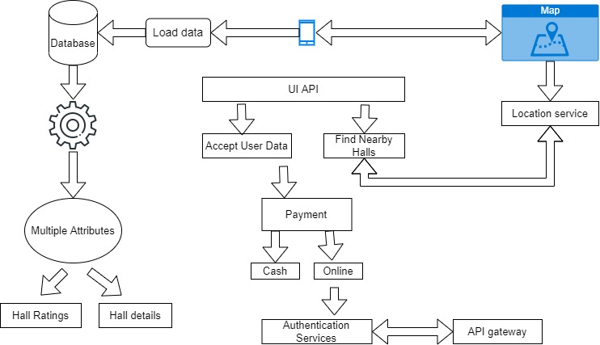
Figure 3.1-1Architectural Design

Data Flow Diagram

Level-1:
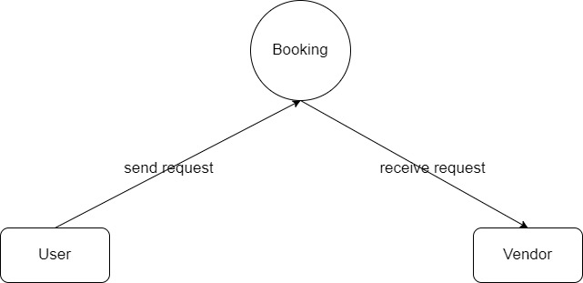
Figure 3.2-1 Data Flow Diagram (Level-1)

Level-2:

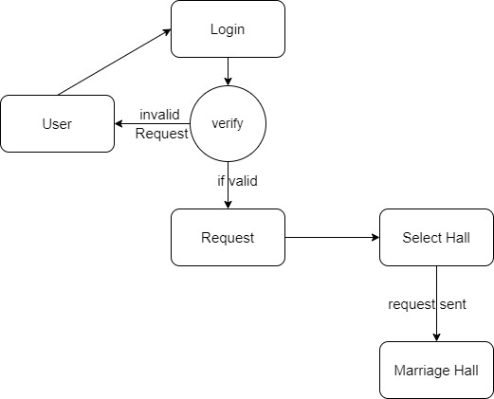
Figure 3.2-2 Data Flow Diagram (Level-2)

Level-3:

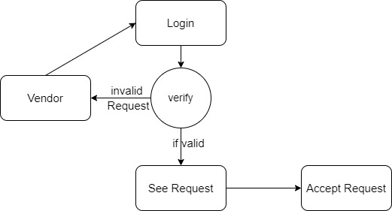
Figure 3.2-3 Data Flow Diagram (Level-3)

System Use Cases

Main Use Case Diagram
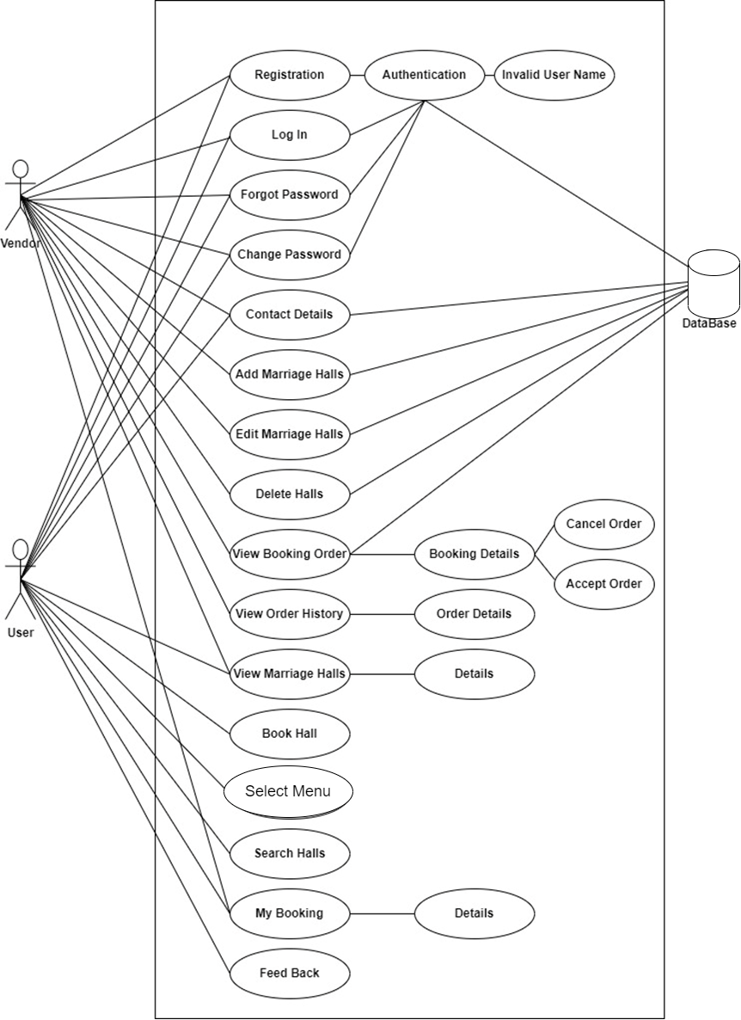
Figure 3.3-1 System Use Case Diagram

Sign up Use-Case diagram

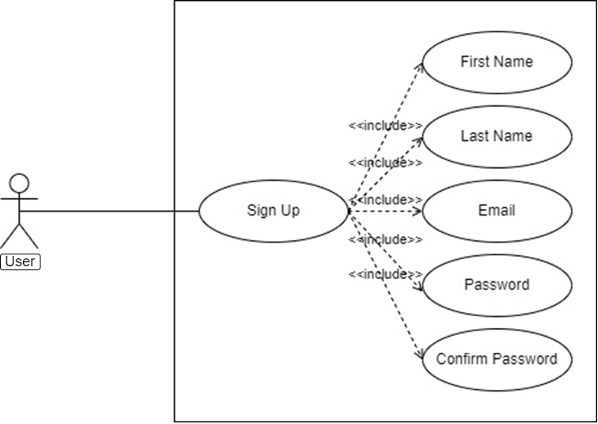
Figure 3.3-2 Sign up Use-Case Diagram

Vendor Login Use-Case diagram

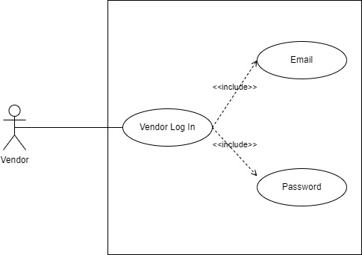
Figure 3.3-3 Vendor Login Use-Case Diagram

User Login Use-Case diagram

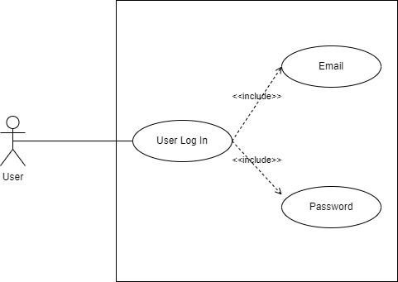
Figure 3.3-4 User Login Use-Case Diagram

Choose Category

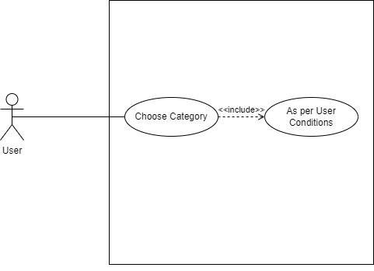
Figure 3.3-5 Choose Category

Book Hall Use-Case diagram

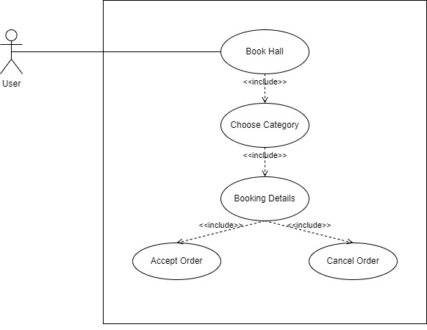
Figure 3.3-6 Book Hall Use-Case Diagram

Vendor Panel Use-Case diagram

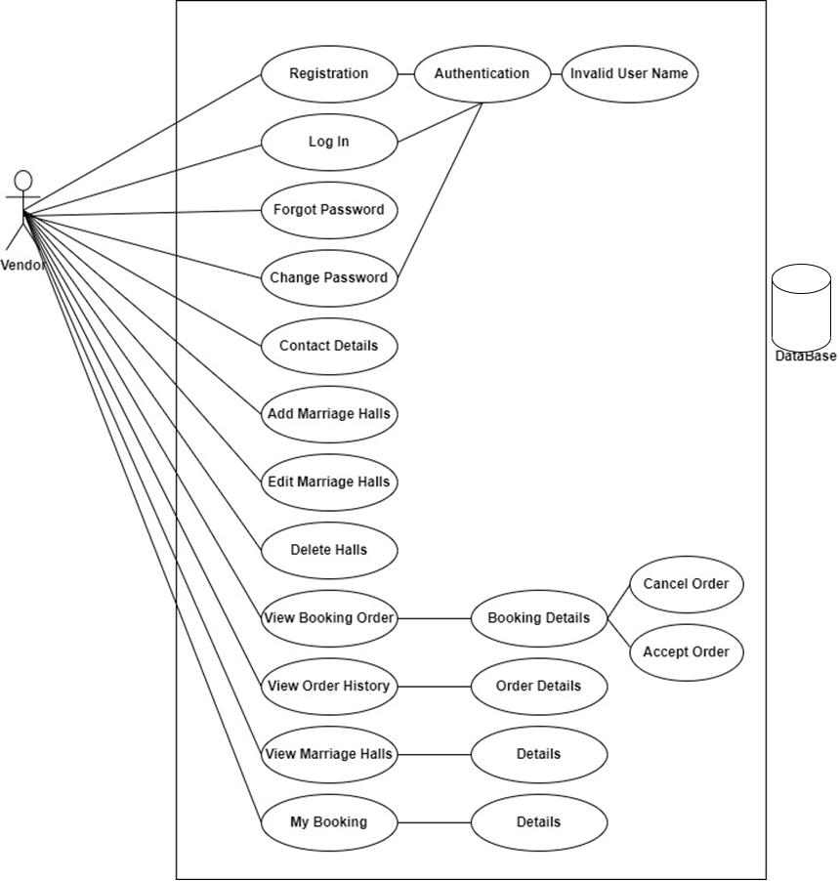
Figure 3.3-7 Vendor Panel Use-Case Diagram

Menu Use-Case diagram

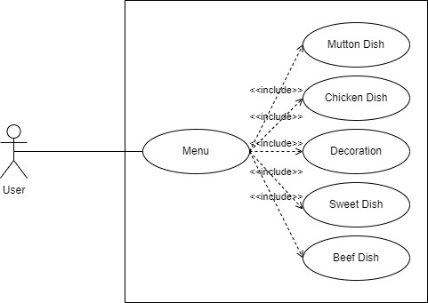
Figure 3.3-8 Menu Use-Case Diagram

Recommendation Use-Case diagram

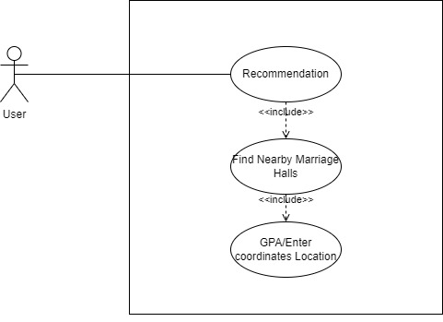
Figure 3.3-9 Recommendation Use-Case Diagram

Setting Use-Case diagram

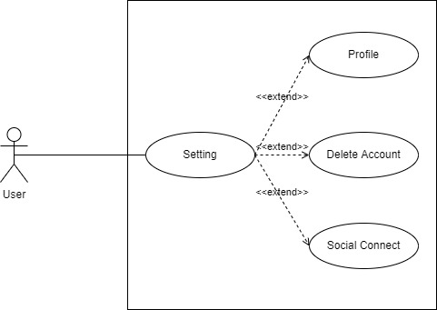
Figure 3.3-10 Setting Use-Case Diagram

 | Name | User Login
1. | Use-Case ID | UC01
2. | Objective | To let the users, use the app by login into the account they have already created.
3. | Priority | The overall priority of this use-case is High.
4. | Source | End-User
5. | Actors | User (Adults of 18 or 18 above years of age).
6. | Flow of Events | Basic Flow  Alternative Flow(s)  Exception Flow(s)
6.1 | Basic Flow | The user must have a strong internet connection.  The user must have an account to login into the app.
6.2. | Alternative Flow(s) | If the user forgets his/her password, then the user can be able to generate a new password by clicking Forgot Password.
6.3. | Exception Flow(s) | If the internet connection has turned off or a poor internet connection, then the user can’t be able to login to the system.
7. | Includes | No Includes.
8. | Preconditions | The user has an account for the app and a stable internet connection.
9. | Postconditions | The user must go to the home page where the categories are listed.
10. | Notes/Issues | No Notes.

Table 3. 1: User Login

 | Name | Choose Category
1. | Use-Case ID | UC02
2. | Objective | To let the users, have some know what they want like marriage booking aur party booking.
3. | Priority | The overall priority of this use-case is High.
4. | Source | End-User
5. | Actors | Vendor, User (Adults of 18 or 18 above years of age).
6. | Flow of Events | Basic Flow  Exception Flow(s)
6.1 | Basic Flow | The user must have a strong internet connection.
6.2 | Exception Flow(s) | If the internet connection has turned off or a poor internet connection, then the user can’t be able to see location.
7. | Includes | No Includes.
8. | Preconditions | The user has an account for the app and a stable internet connection.
9. | Postconditions | The user must go to the home page where the categories are listed.
10. | Notes/Issues | No Notes.

Table 3. 2: Choose Category

 | Name | Book Hall
1. | Use-Case ID | UC03
2. | Objective | To let the users has book the marriage as par requirements.
3. | Priority | The overall priority of this use-case is High.
4. | Source | End-User
5. | Actors | Vendor, User (Adults of 18 or 18 above years of age).
6. | Flow of Events | Basic Flow
6.1 | Basic Flow | The user should have to choose the category wisely for which he/she select hall for marriage aur parties.
7. | Includes | No Includes.
8. | Preconditions | The user has an account for the app and a stable internet connection.
9. | Postconditions | The user must go to the home page where the categories are listed.
10. | Notes/Issues | No Notes.

Table 3. 3: Book Hall

 | Name | Choose Menu
1. | Use-Case ID | UC04
2. | Objective | To let the users, choose the menu item for Dinner or Lunch.
3. | Priority | The overall priority of this use-case is High.
4. | Source | End-User
5. | Actors | User (Adults of 18 or 18 above years of age).
6. | Flow of Events | Basic Flow.
6.1 | Basic Flow | The user must have a strong internet connection.  The user must choose the Menu for their event.
7. | Includes | No Includes.
8. | Preconditions | The user has an account for the app and a stable internet connection.
9. | Postconditions | The user must go to the home page where the categories are listed.
10. | Notes/Issues | No Notes.

Table 3. 4: Menu

 | Name | Recommendation
1. | Use-Case ID | UC05
2. | Objective | To let the users, with a recommended to find nearby marriage places.
3. | Priority | The overall priority of this use-case is High.
4. | Source | End-User
5. | Actors | User (Adults of 18 or 18 above years of age).
6. | Flow of Events | Basic Flow.
6.1 | Basic Flow | The user must have a strong internet connection.  The user must have a GPS system in their device. The user must have an account to login into the app.
7. | Includes | No Includes.
8. | Preconditions | The user has an account for the app and a stable internet connection.
9. | Postconditions | The app should list the nearby places where the user can go easily book their halls.
10. | Notes/Issues | GPS system should be active.

Table 3. 5: Recommendation

Sequence Diagram

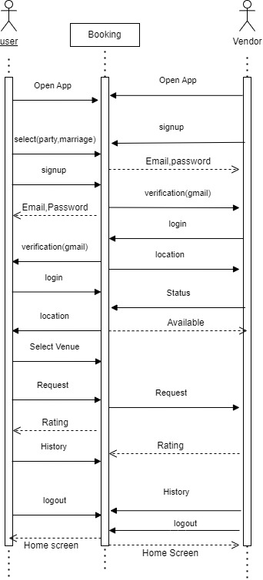
Figure 3.4-1 Sequence Diagram

METHODOLOGY

Feature Driven Development

Feature-driven development is a method of software development that is iterative and incremental. It is a lightweight or agile software development method. FDD combines several industry-accepted best practises into a unified totality. Client-valued functionality is at the heart of these strategies.
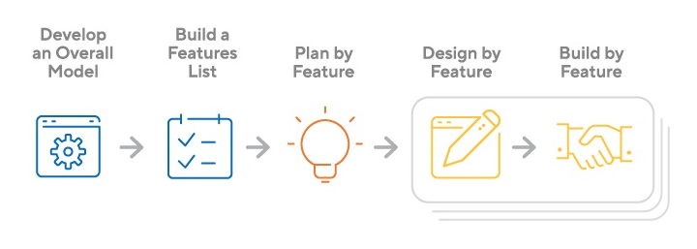
Figure 3.5-one Feature Driven Development

Develop an overall model
Domain object modelling is one of the cornerstones of feature-driven development. Domain object modelling is a method of representing interconnected concepts and their interactions. An outline of the domain model is generated in the first stage. This object model will serve as the project's blueprint.

Build feature list
The characteristics list outlines the aspects that must be conveyed as actions, outcomes, or objects.

Plan by feature
Following the creation of the feature list, you must define the sequence in which they must be developed and implemented, as well as who on the team is responsible for each item, as well as identify potential risks, dependencies, workload limits, and other impediments.

Design by feature
Each feature has its own design package. The design phase ends with a team-wide design review.

Build by feature
It is time to start developing code now that the design has been accepted. All the components required to support the feature design have been implemented. Front-end and back-end elements such as user interfaces and database queries are examples of these elements. Once individual team members have finished their tasks, the item is moved to testing, and the procedure is repeated for the next feature on the list.

DATA AND EXPERIMENTS (and/or IMPLMENTATION)

Risks Involved
Following are the risks which could be involved in EVENT CART.
  - Power Failure
  - Networking Problems

Language used for implementation

Following languages were used for the implementation of the application:

Front End

XML
We are design all front-end using XML activities.

Back End
- JavaScript
- JSON

Database
Database that we are using in this project is firebase. Every time when user want some specific information it will send request to the server, in the response of to request server will send all required information in JSON format.

Implementation.
First the user and vendor need to install the application in their device. Once they have installed the applications, they will be welcomed by the Sign in page on opening the application. If the user is new to the application, they will first create their account by
Sharing their details required by the application for example phone number etc.
When the user login then application access the location of the user and then the nearby marriage hall show in customer home screen.
After successfully creating their account, the user can sign into their account and will be redirected to the home screen. From the home screen the user can select the halls give by the vendors and user can select the hall and book the hall. User can also see the most rating hall in the list. When the customer can book successfully then notification send to vendor and vendor hall are free in that date or time then vendor approved the request. Vendor also reject the request if already booking in that date or time.
The technologies and tools which are discussed in the development of this project are android studio for the development, java and XML are used as programing languages and Firebase for data storage.
To run this application successfully, there must be no networking issue as this is one of the most important factors and so called a backbone of the application. If there is a network disconnection issue arises then user will be unable to do anything and leads to do the application failure and the same in application.

RESULTS AND DISCUSSIONS (or USER MANUAL)

USER MANUAL

Splash Screen

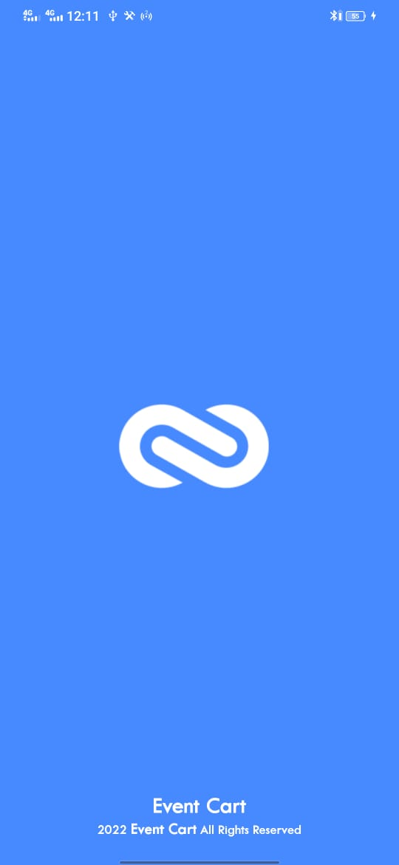
Figure 5.1 1

This form shows the first screen which will be visible to the user who will use this application. This Splash screen will be visible for 5 seconds with official logo.

Login Screen

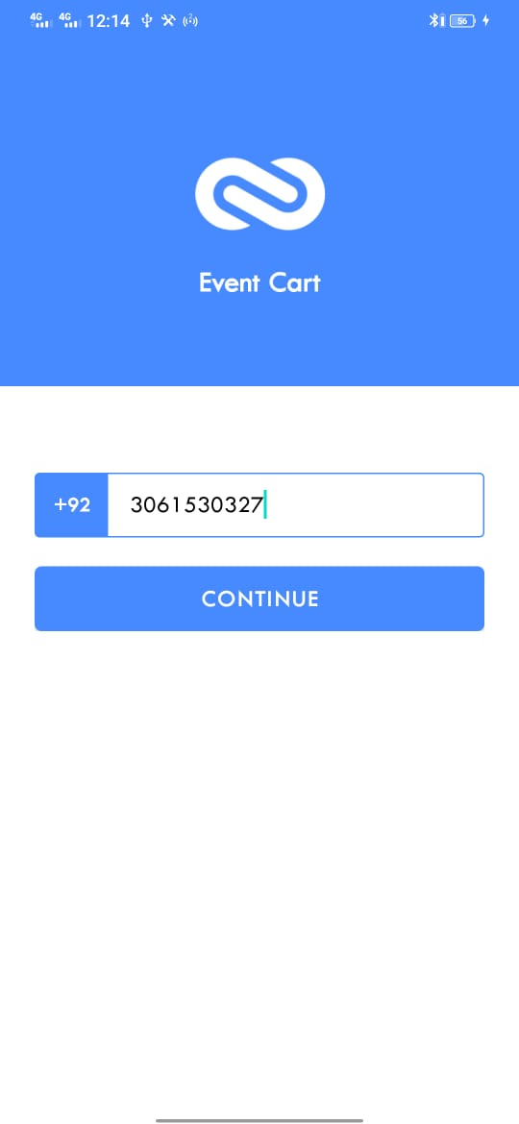
Figure 5.1 2
This form shows the login screen for the users. There is only one way to get registered in this Application.
- Phone Number: user can get registered by providing active phone Number. After providing phone Number, the user will get OTP verification code and then user will get registered in EVENT CART.

Number Verification Screen

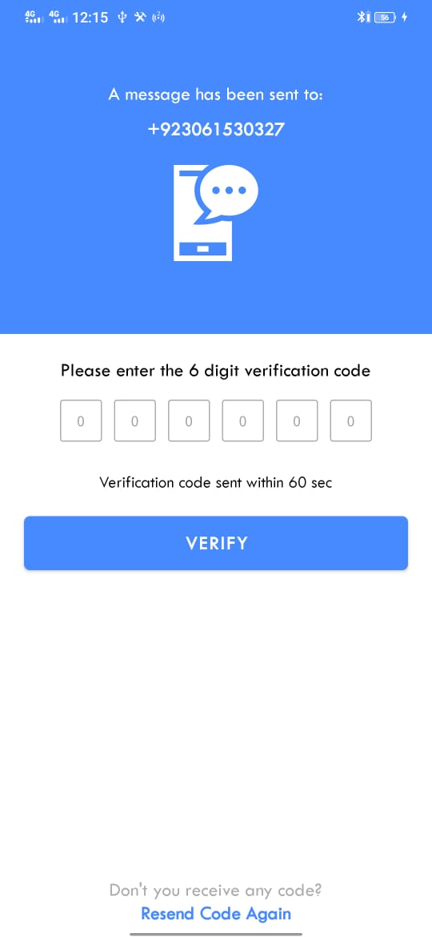
Figure 5.1 3
When the user can enter his mobile number the one-time OTP send to his no, they can put six-digit code on it.

One Time OTP Authentication

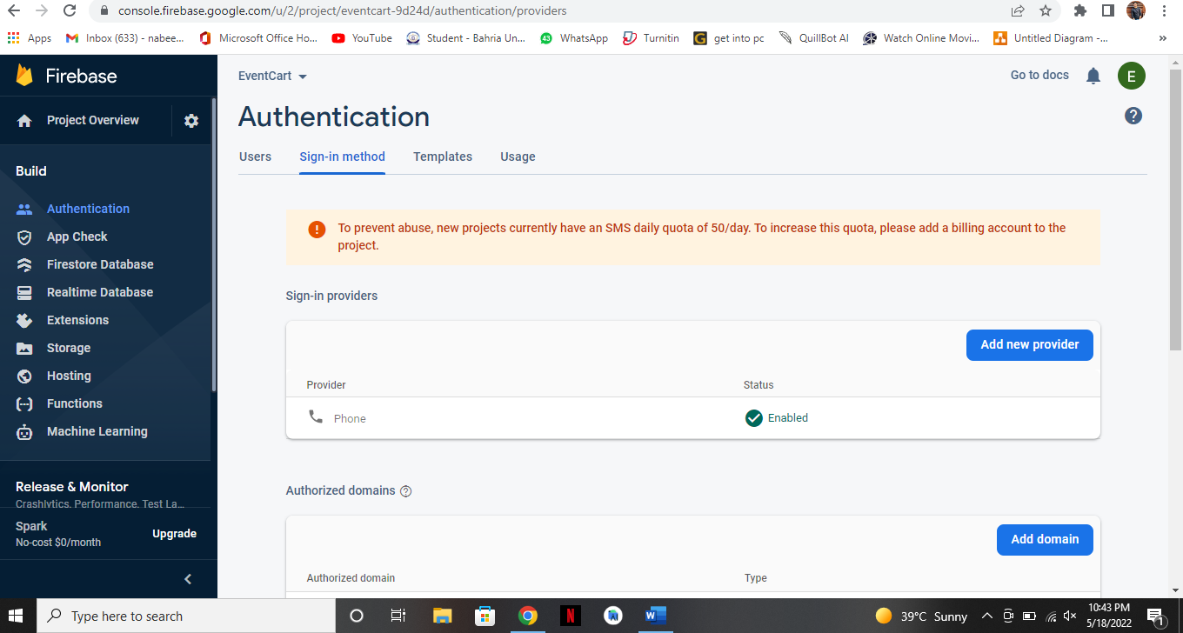
Figure 5.1 4

When the user enters his mobile number for signup the application will send OTP which is generated with the help of firebase authentication to the user number then he will enter in the application to proceed further for signup in the application.

Code Screen

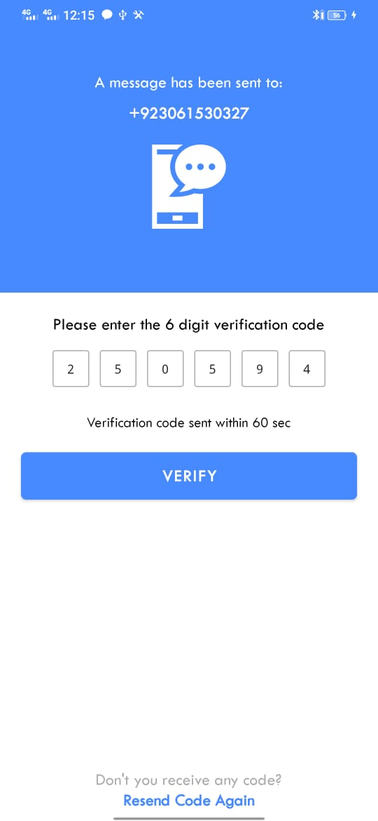
Figure 5.1 5
When the user enters the six-digit code send his number, then verify the number.

User profile Screen

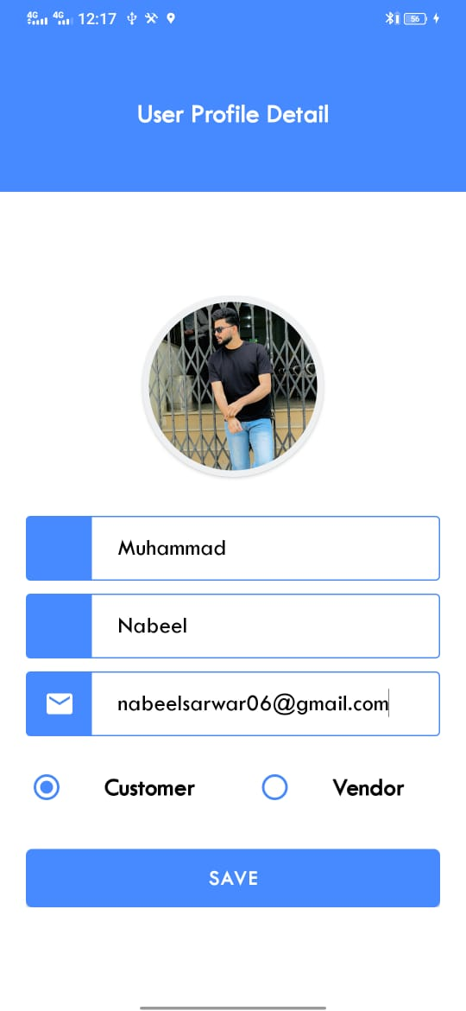
Figure 5.1 6

Vendor Home Screen

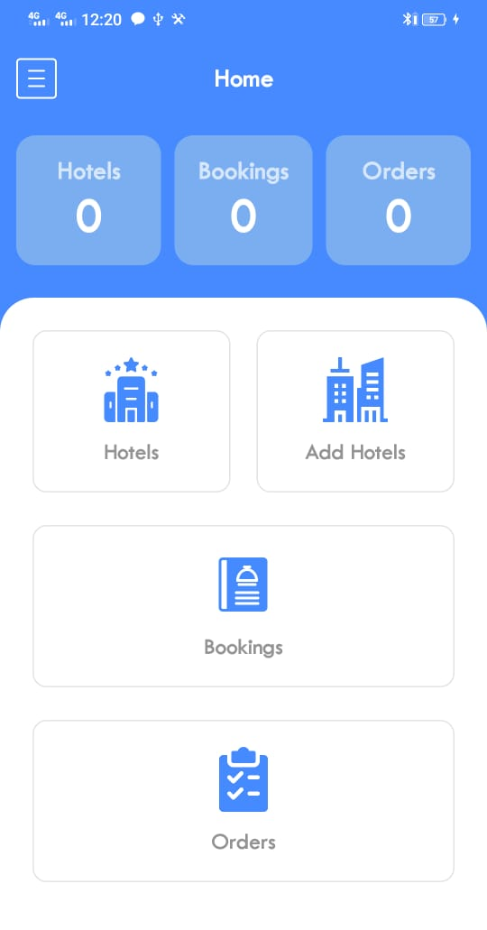
Figure 5.1 7
After Successful Login the vendor will get the First Home Screen where all controls of the application are in Home Screen. And vendor can go anywhere he wants.

Vendor Profile Screen

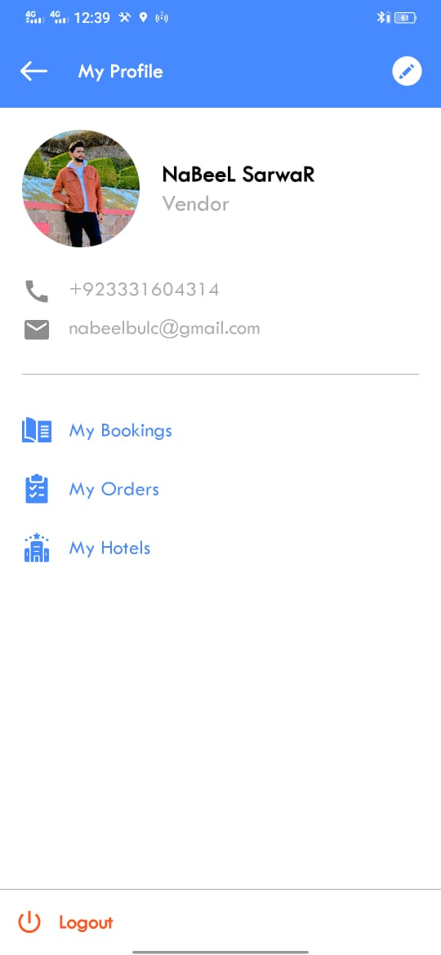
Figure 5.1 8
Vendor profile screen. Vendor can see all Bookings and all pending orders.

Vendor Menu

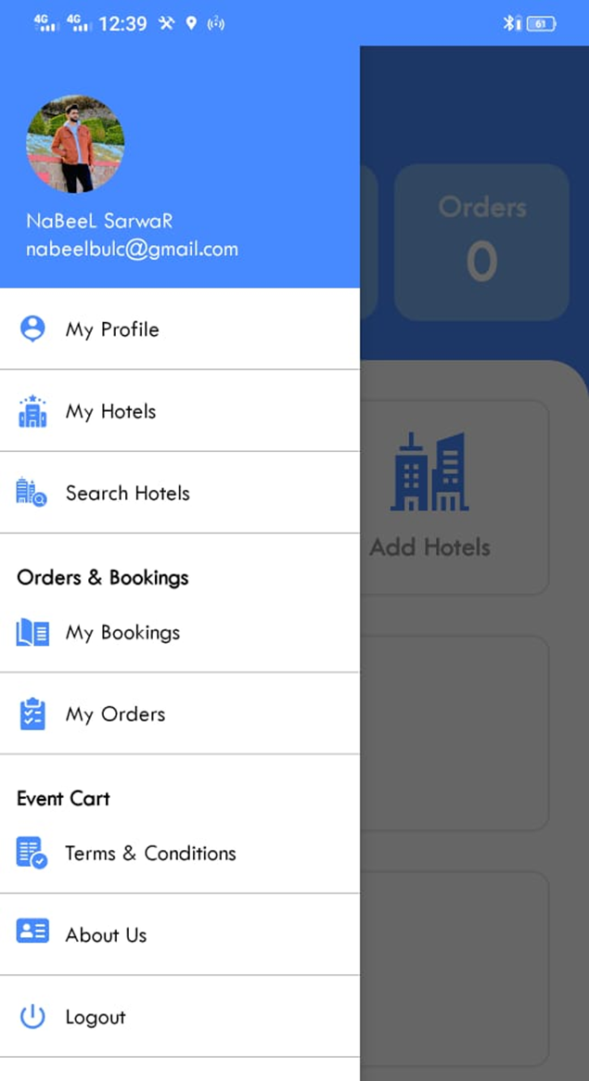
Figure 5.1 9
The vendor Profile screen consists of following tabs:
- My Profile
- My hotels
- Search hotels
- My Booking
- My Orders
- About us
- Logout

Access Location Popup Screen
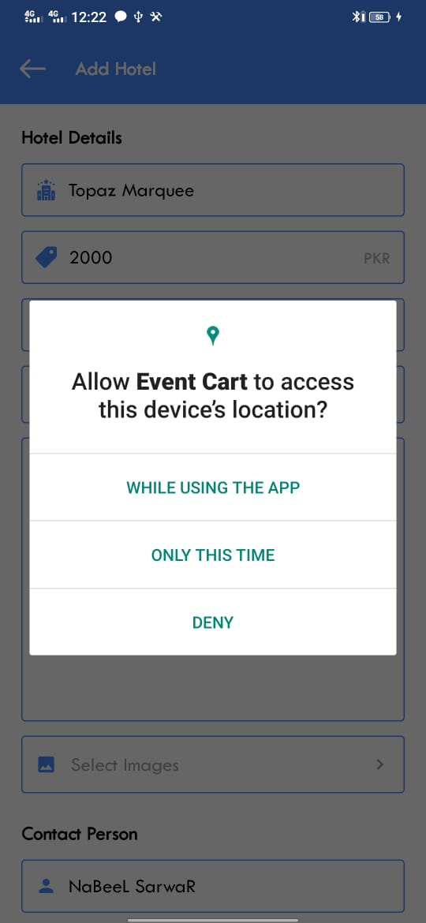
Figure 5.1 10
When the vendor adds the location of the hall a popup message on screen to allow the location in this application.

Select Location Screen

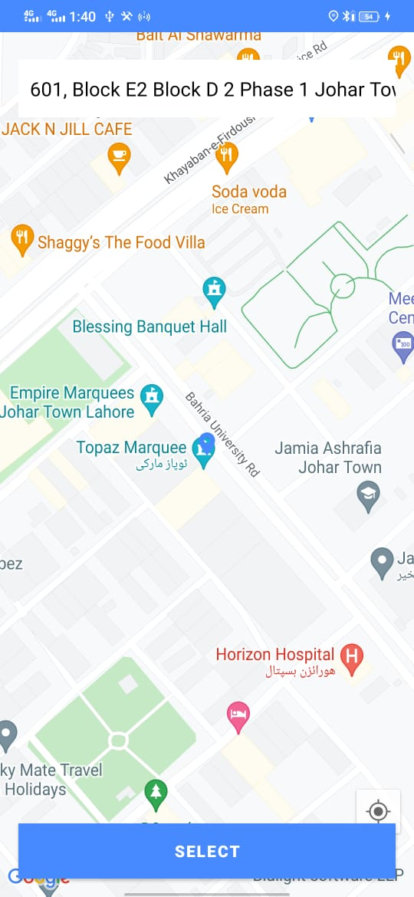
Figure 5.1 11
When the vendor marked his location then application automatically fetch the address.

Add Halls

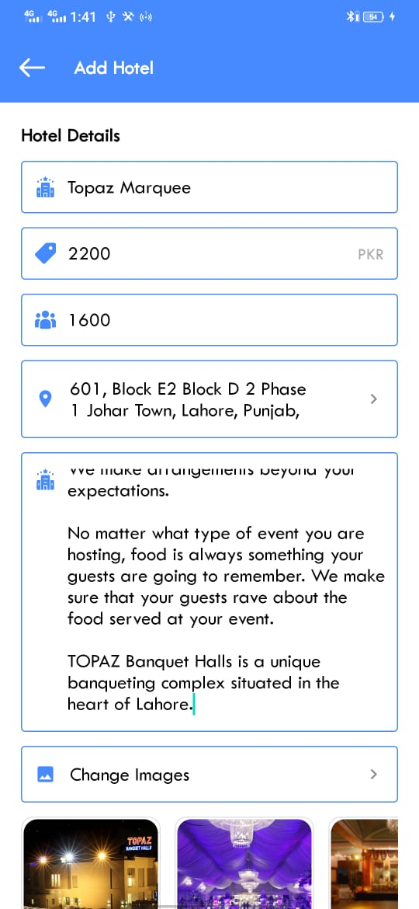
Figure 5.1 12

Vendor can add their halls. Enter all the details name, description and per head price.

My Hotels Screen

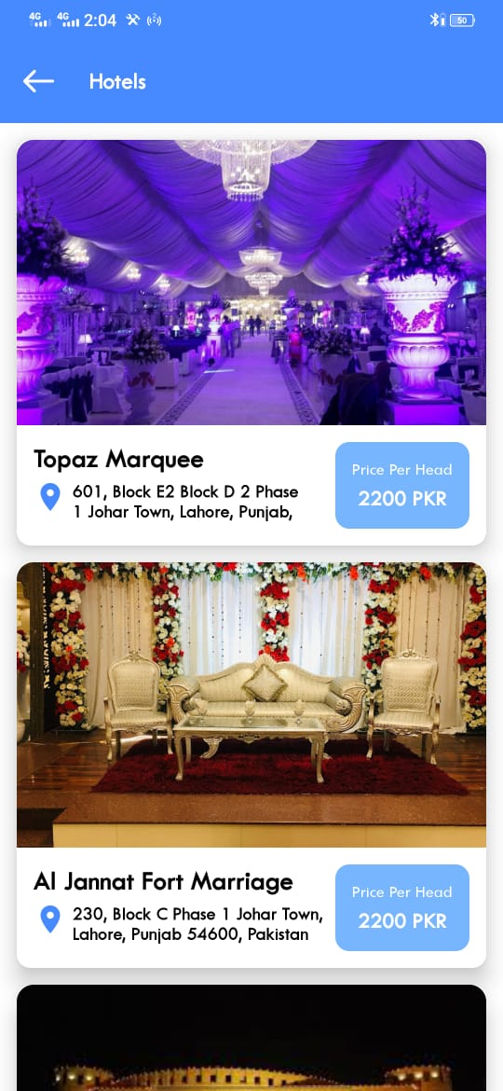
Figure 5.1 13

Vendor can see all his halls he adds in this application.

Search Hotel

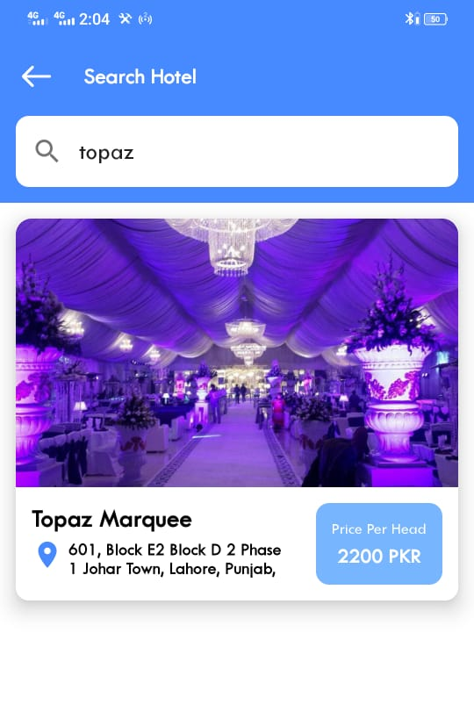
Figure 5.1 14
User can search through hall name and can view the most rating hall in nearest location. User can see all the description/detail of the specific hall.

Customer Menu

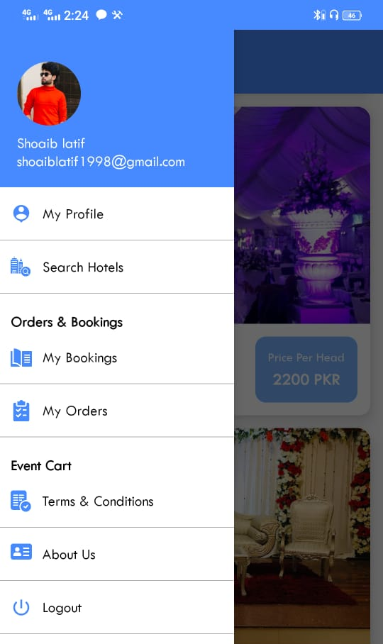
Figure 5.1 15
The vendor Profile screen consists of following tabs:
- My Profile
- My hotels
- Search hotels
- My Booking
- My Orders
- About us
- Logout

Customer Home Screen

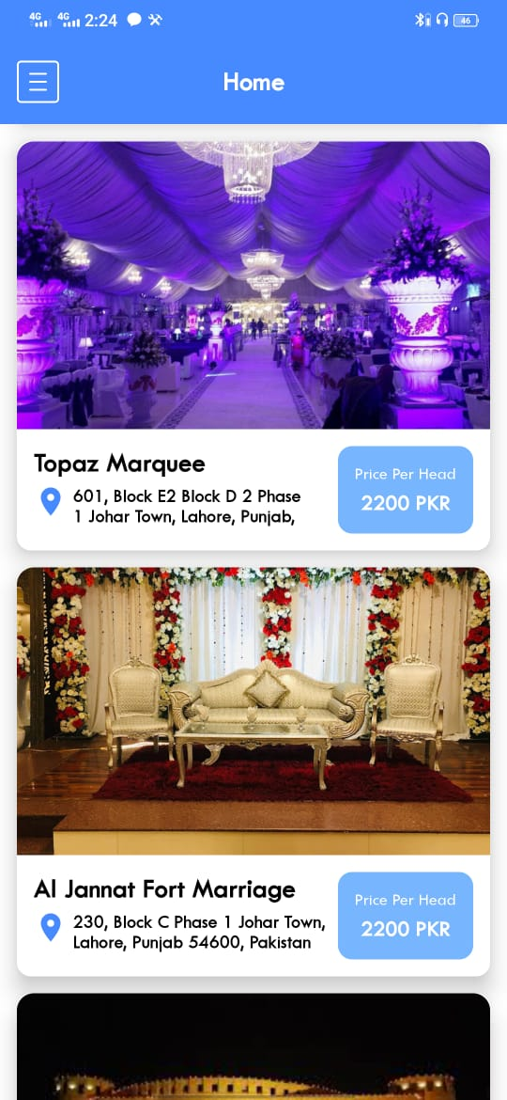
Figure 5.1 16
Customer can see all the nearest halls and select the hotel or book hall.

Customer Hotel Details

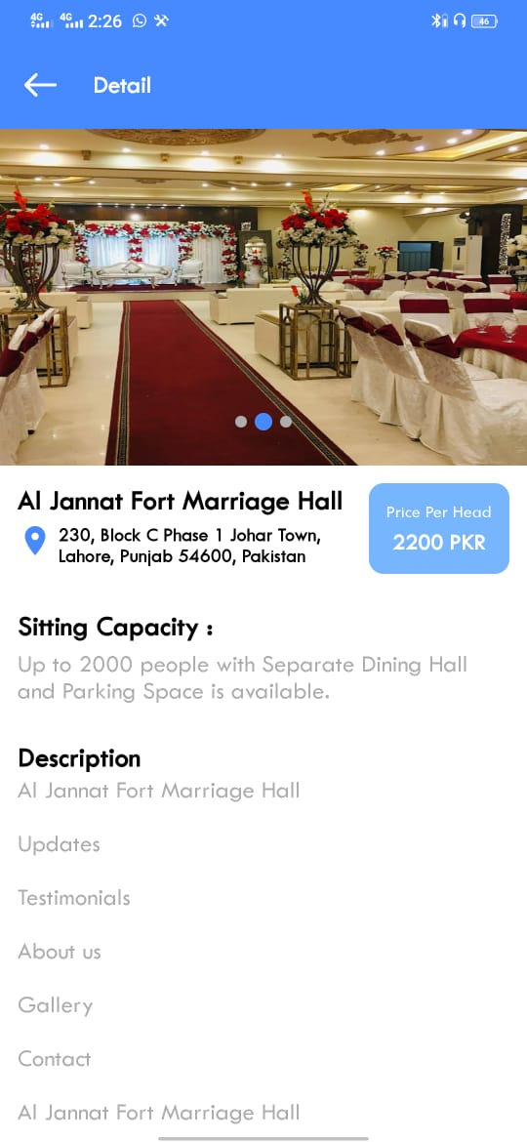
Figure 5.1 17
Customer can see all the details of marriage hall like sitting space and per head price according to menu.

Confirm Booking

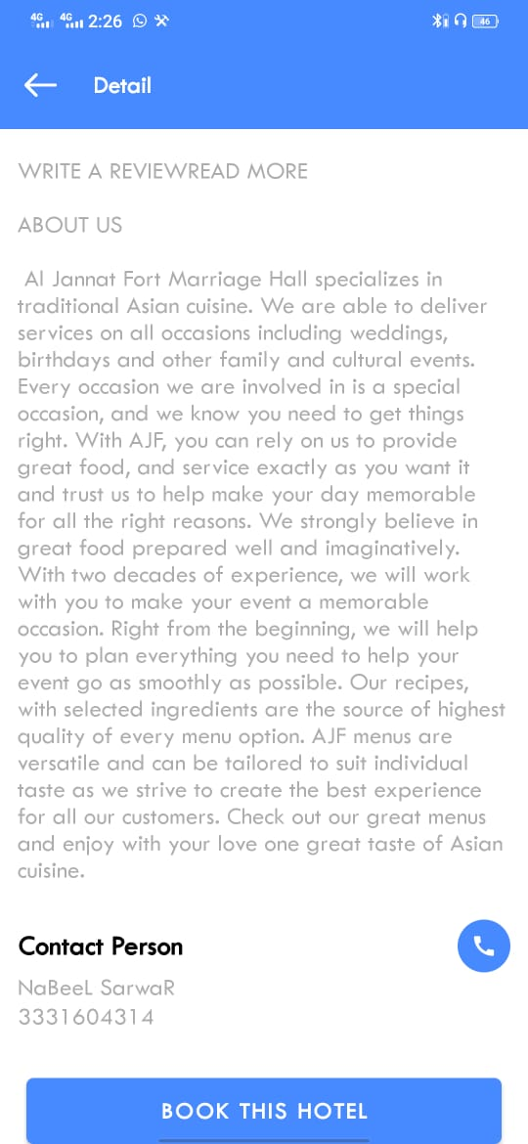
Figure 5.1 18
If the user can show interest in the package. User can also select the number of the guest. All the functionalities can perform after login.

Customer Profile

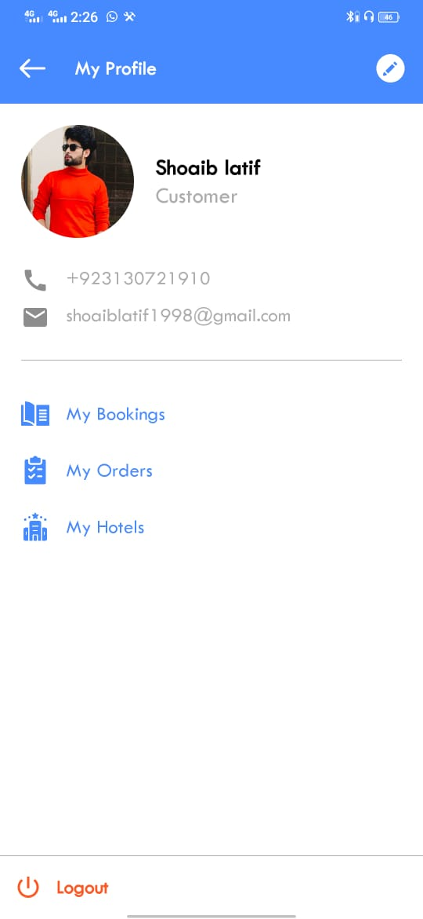
Figure 5.1 19

Real Time Database

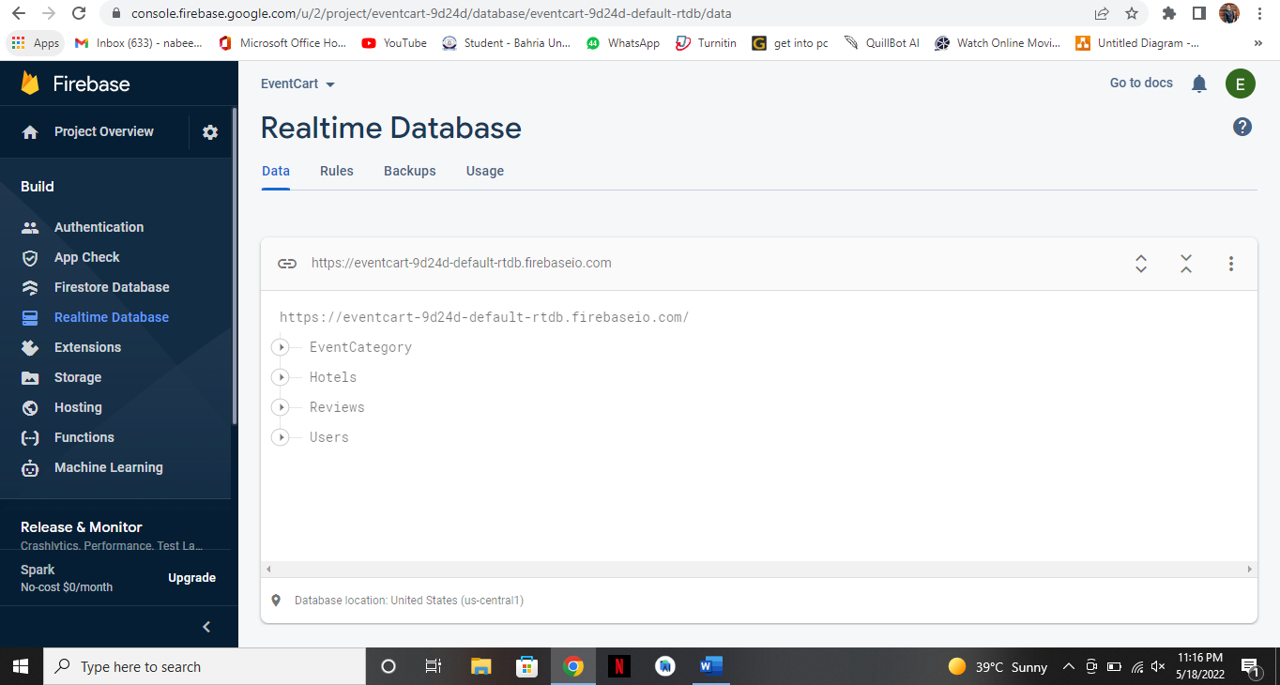
Figure 5.1 20

Users in Database

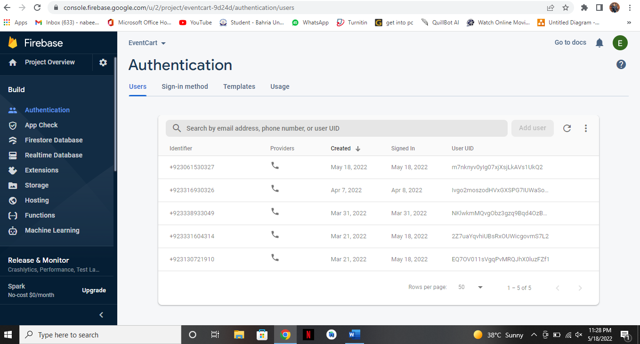
Figure 5.1 21

CONCLUSION AND RECOMMENDATIONS

Conclusion

In conclusion, now a day’s people are busy in their lives, if they want to book a venue for their special event, they bought to spend more money in traveling and searching for the place. Besides, they must spend money for searching the perfect venue according to the requirements. To mitigate such problem, android application has been proposed. By using the android application, user can easily search for their desired venues nearby, and book those on one click. Further, users can save time, money and can book their venue according to their needs just on a single click. Furthermore, proposed application helps the user to booking hall for any event. In addition, the application is beneficial for both the user and the worker.

Recommendation

In future furthermore new categories of services can be added into the application. To avail discounts to the customer the functionality of promo codes can be added in the application. The promo code functionality would provide customers the services on low prices than the normal ones. The people with promo codes will only be able to access those prices at get benefits from it.

Future Work
This System is android based system and. So, our positive intention towards the future work is to extend this android application to IOS at all versions. That, this easy, convenient, and remarkable application will be installed to all users.

REFERENCES
[1] “Index @ Firebase.Google.Com.” [Online]. Available: https://firebase.google.com/
[2] “why-to-choose-feature-driven-development-for-software-development @ evontech.com.” [Online]. Available: https://evontech.com/component/easyblog/why-to-choose-feature-driven-development-for-software-development.html?Itemid=159

