
BSCS-F21-027
03-134182-089 | ABDUL REHMAN KHALID

AutoMart

In partial fulfilment of the requirements for the degree of
Bachelor of Science in Computer Science
Supervisor: SUMMAIRA NOSHEEN
Department of Computer Sciences
Bahria University, Lahore Campus
June 2022

© Bahria University, 2022

Certificate

We accept the work contained in the report titled
“AutoMart”
written by
ABDUL REHMAN KHALID

as a confirmation to the required standard for the partial fulfilment of the degree of
Bachelor of Science in Computer Science.

Approved by:
Supervisor: SUMMAIRA NOSHEEN

June, 2022

DECLARATION

I hereby declare that this project report is based on my original work except for citations and quotations which have been duly acknowledged. I also declare that it has not been previously and concurrently submitted for any other degree or award at Bahria University or other institutions.

Enrolment | Name | Signature
03-134182-089 | ABDUL REHMAN KHALID

Date : June, 2022

Specially dedicated to
my siblings and parents for their unconditional love and support.

ACKNOWLEDGEMENTS

I would like to thank everyone who had contributed to the successful completion of this project. I would like to express my gratitude to my research supervisor, Ms. Summaira Nosheen for her invaluable advice, guidance, and her enormous patience throughout the development of the research.

In addition, I would also like to express my gratitude to my loving parent and friends who had helped and given me encouragement.

Abdul Rehman Khalid

AutoMart

ABSTRACT
eCommerce is an industry that is always changing trends shifting and companies adapting to the way people are purchasing goods and services. It is one of the consistently growing industry. They’re expected to top $5 trillion USD in 2022 and reach more than $6 trillion by 2024. An estimated 2.1 billion shoppers are predicted to buy goods and services online by 2021 [1]. Despite eCommerce being too big industry, there still a big gap in the market. As 60% of Pakistani’s still don’t have access to online shopping. Keeping that in view I felt the need of an accessible and automated shopping platform. My project greatly eases the experience of online shopping.
We have seen multiple instances in which a customer has seen some product on the social media, and really want to get hold of it but does not know what that product is and where to find it. AutoMart provides visualized search where you just need to add a photo of the product and with the power of ML you will have your desired product. Machine learning is being implemented in every field from medicine to farming. AutoMart greatly focuses on the interest of the customer and providing them with best buying experience.

TABLE OF CONTENTS

DECLARATION ii
ACKNOWLEDGEMENTS iv
ABSTRACT v
TABLE OF CONTENTS vi
LIST OF TABLES ix
LIST OF FIGURES x
LIST OF SYMBOLS / ABBREVIATIONS xi
LIST OF APPENDICES xii

CHAPTERS
1 INTRODUCTION 14
1.1 Background 14
1.2 Problem Statements 14
1.3 Aims and Objectives 15
1.4 Scope of Project 15
1.5 List of Features 15
2 LITERATURE REVIEW 16
2.1 Related Work 16
2.1.1 Image search-based eCommerce App 16
2.1.2 Content Based Image classification 16
2.1.3 Content based Product classification 17
2.1.4 A picture is worth more than a thousand words 17
2.1.5 Impact of image recognition on ecommerce 18
2.2 User Classes and Characteristics 18
2.2.1 Seller 18
2.2.2 Customer 19
2.2.3 Admin 19
2.3 Operating Environment 19
2.4 Design and Implementation Constraints 19
3 DESIGN AND METHODOLOGY 20
3.1 Methodology 20
3.1.1 Develop an Overall Model 20
3.1.2 Build A Features List 21
3.1.3 Plan by Feature 21
3.1.4 Design by Feature 21
3.1.5 Build by Feature 21
3.2 Top Level Architecture 21
3.3 System Design 22
3.3.1 Use Case 22
3.4 Use Case Description 22
3.4.1 Login 22
3.4.2 Register 23
3.4.3 Search Product 24
3.4.4 Place Order 24
3.4.5 Make Payment 25
3.4.6 Manage Product 25
3.4.7 Add Product 26
3.5 Sequence Diagram 26
3.5.1 Login 27
3.5.2 Register 27
3.5.3 Search Product 28
3.5.4 Order Product 28
3.5.5 Payment Verification 29
3.5.6 Product Management 29
3.6 Summary of Pre-Development phase 30
3.7 Machine learning and ML kit 30
3.8 User Interface development 30
3.9 Data Model 31
4 DATA AND EXPERIMENTS 32
4.1 Dataset 32
4.2 Experiments 32
4.3 Application Testing 32
5 RESULTS AND DISCUSSIONS 33
5.1 Introduction 33
5.2 Sign In 34
5.3 Sign Up 34
5.4 Product Catalogue 35
5.5 Single Product 36
5.6 Image Search 37
5.7 Image Search Result 38
5.8 Categories & Cart 39
5.9 Payment 40
6 CONCLUSION AND RECOMMENDATIONS 41
6.1 Project Achievements 41
6.2 Implementation Issues and challenges 41
6.3 Future Work 41
6.4 Conclusion 42
REFERENCES 43
APPEDNDICES 45

LIST OF TABLES

TABLE TITLE PAGE
Table 3.1: Use Case Login 21
Table 3.2: Use Case Registration 22
Table ‎3.3: Use Case Search Product 22
Table 3.4: Use Case Place Order 23
Table 3.6: Use Case Manage Product 24
Table 3.7: Use Case Manage Product 24

LIST OF FIGURES

FIGURE TITLE PAGE
Figure 3.1: Future Driven Development 20
Figure 3.2: Top Level Architecture 21
Figure 3.3: Use Case 22
Figure 3.4: Login Sequence Diagram 27
Figure 3.5: Register Sequence Diagram 27
Figure 3.6: Search Product Sequence Diagram 28
Figure 3.7: Order Product Sequence Diagram 28
Figure 3.8: Payment Verification Sequence Diagram 29
Figure 3.9: Product Management Sequence Diagram 29
Figure 3.10: Hierarchical Schema 31
Figure 5.1: Sign In 34
Figure 5.2: Sign Up 34
Figure 5.3: Product Catalogue 35
Figure 5.4: Single Product 36
Figure 5.5: Image Searching 37
Figure 5.6: Image Searching 38
Figure 5.2: Categories & Cart 39
Figure 5.8: Payment 40

LIST OF SYMBOLS / ABBREVIATIONS

ML Machine Learning
FDD Future Driven Development
UML Unified Modelled Language
R&D Research and Development
UI User Interface

LIST OF APPENDICES

APPENDIX TITLE PAGE
APPENDIX A: Requirement List 44
APPENDIX B: Customer User Manual 44
APPENDIX C: Seller User Manual 44

INTRODUCTION

Background
eCommerce being ever growing market keep on growing all over the World. Every business and consumer are moving towards online market especially after the COVID-19 pandemic it got a great boom in the sales. But eCommerce in Pakistan has got people divided. Literate stratum from urban areas got to use online shopping. There are limited number of players in the market which failed in providing accessibility for disable. E-commerce platforms don’t even have websites in local languages, thus making the English-speaking population the primary beneficiary of digitisation [2]. Moreover, online stores in Pakistan are even not in local language. There are many studies about how eCommerce is still stuck in metropolitan cities and cannot expand further. Research says that online shopping is still infancy in Pakistan. According to the research online shopping can be increased if we focus on the customers living abroad and implement the strategies, they work on for online shopping [3].

Problem Statements
eCommerce in Pakistan is facing some barriers and most people do traditional shopping. Surveys have been used to search for deficiency in Pakistan eCommerce market. It was found that there are two main factors which are restricting eCommerce market in Pakistan. One of them is distrust and other is illiteracy. In Pakistan, 60 million people don’t even know to write their name how can they search for product online [4]. Moreover, while browsing on the internet we are exposed to some products which we don’t know the name of, but we want to buy that, visualized search can help them find the product.

Aims and Objectives

The objectives of the thesis are shown as following:
- To give people leverage of not going to stores
- To provide user with better shopping experience
- To let customers, find desired product with ease
- To provide sellers a platform to reach out to potential customer
- To make online shopping accessible to everyone

Scope of Project
The scope of the project is as follows:
- Acquire and test ML model
- Develop eCommerce app run
- Integrate image search in the app

List of Features
- Manage Seller
- Manage Customer
- Manage Cart
- Product Listings
- Image Search
- Payment Module

LITERATURE REVIEW

Related Work
There are many researched available regarding visual searches. Some of these are mentioned below.

Image search-based eCommerce App
A massive image database is fast increasing, with billions of images being transferred every day on platforms such as Instagram, Snapchat, and Facebook, and this trend is projected to continue in the future. The need for a successful quest in the image ages when dealing with a massive amount of data. Furthermore, while amazing apparatuses have been created for text search, image search remains a hazy issue.
Most end-users have traditionally used retrieval systems to write inquiries or queries and receive text results. End customers, on the other hand, continue to demand search engines to be "intelligent," and they desire a retrieval system that can explore cyberspace using a picture, like how a cell phone's built-in camera can communicate pertinent resemblance, videos, and other forms. As a result, retrieving and processing information becomes a huge challenge [5].

Content Based Image classification
Image classification is a method by which computer tries to copy human vision capabilities to process, evaluate and identify information and to divide it into info imitate human brain.Hence, we can see that a lot of work and research is being done in the fields of image recognition and image processing, especially these big e commerce companies like amazon are spending considerable amount of money in R and D to enhance user experience, automated classification for the object image can help in quick transitions on both sides i.e., the retailer and the user [6]. This can also increase the overall efficiency of the e commerce platform, because of this work done in image classification relating to the e commerce is extremely important.
AutoMart also uses image recognition technology to help the customer locate the desired product, using machine learning and google ML kit the application can classify the image being captured by the camera and extract related results which in the case of our e commerce application is either be the same product or sets of related products.

Content based Product classification
A lot of e commerce companies use content based and ML methods and other deep learning methods for the purpose of classification of the e commerce images of the products, an example is the Chinese company Baidu, the method that Baidu mainly uses mapping for the purpose of image classification and getting back or getting a response when searched about faces, locations, and formation of stars [7].
Similarly, TUTU is another company which is used for clothing buying, this site classifies and gets results for clothes. Obviously understanding the significance of image recognition Baidu made the IDL also known as institute of deep learning, based on this they developed image intelligent recognition system, it can find the products by using just a photo and work on facial recognition. Our application is employing the use of google lens, it is implemented in the application, google lens uses machine learning and image classification techniques to return results about a product which is being searched.

A picture is worth more than a thousand words
ML and image recognition of ecommerce, in the field of e commerce it is often is said that a picture is worth more than a thousand words, when start realizing how ML and image recognition are being applied to each single image or picture. Almost all the ecommerce giants know that image recognition for the purpose of buying products in a fast way is reshaping the industry [8]. This technology is fast as systems can now learn and improve as they keep working, now they do not have to be programmed continuously. Because of this shopping has become easier than it used to be.
Images of the objects or products have now become shoppable. Through the use of application we can now go to a website we want , snap a photo from there and search for the products, customers could also just point their cameras at the merchandise they want, or imagine that they are passing by someone and they like what they are wearing through the use of the app the customer could simply search for it by taking a photo instead of going to them and asking where they bought the thing. The application will be no doubt very popular as customers are losing interest in going away from home, especially with the onset of the pandemic work from home has become the norm, with less of them leaving home to buy stuff, they could look at some product, take a picture and then search for it so that it can be bought. Images have become shoppable and this trend will continue.

Impact of image recognition on ecommerce
With each passing day people are shifting their attention towards visuals, now a days they are preferred over others. Big industry players like google have been paying attention this for years and have managed to develop image search in the search engine and, they have created google lens for the very specific purpose of searching using images [9].
Amazon, which is now one of the largest ecommerce giants of the world has created its own image recognition search tool built in their application, they use this feature to detect and find products and buy and sell them.
By using applications like this, for example in our case, AutoMart, customers can shop more practically, they can shop products quickly and faster and it can give a better shopping experience [10].

User Classes and Characteristics
The users can be divided into three class:
- Seller
- Customer
- Admin

Seller
Seller is a user who have access to its store where he can list items.
Seller is performing following activities:
- Login
- Create Operations
- Edit Operations
- Delete Operations
- Logout

Customer
Customer is a user who have access to the product catalogue where he can search and buy a product.
Seller can perform following activities:
- Login
- View Operations
- Add Operations
- Logout

Admin
Admin is developer who can develop and manage the system.
Admin has performed following activities:
- Login
- Create Operations
- Edit Operations
- Delete Operations
- Logout

Operating Environment
Operating environment for AutoMart is:

- On-device resources
- Firebase Firestore
- Google Cloud

Design and Implementation Constraints
AutoMart is a cross-platform application for IOS, and Android developed using Flutter for UI and Firebase Firestore as database. Other back-end services are used provided by Google Firebase like ML kit and firebase storage

DESIGN AND METHODOLOGY

Methodology
This project is developed using the agile framework as this project can be divided into various modules thus any agile methodology involves constant planning and continuous integration.The framework I have used for this project is Future Driven Development because it is one of simplest and easy to stick to. FDD maps project in features and make sub parts of these complex features. FDD has been designed to follow a five-step development process, which is built mainly around discrete “feature” projects.
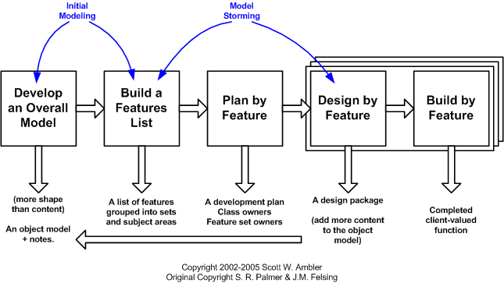

Figure 3.1: Future Driven Development
Each FDD phase mapped according to this project:

Develop an Overall Model
The scope of the project is defined and mapped in this step, and top-level architecture is established by analysing and defining project phases.

Build A Features List
Following the creation of the general model, the functionality of the project is analysed and fragmented to build a feature list.

Plan by Feature
Following the creation of a feature list, the next step is to create a development plan for the features identified in the previous stage.

Design by Feature
Following the planning phase, comes after feature design phase. The steps below are followed in this phase.
• For each feature, create a use case and a use case diagram.
• Each feature's sequence diagrams
• Each feature's collaboration diagram
• Create a user interface

Build by Feature
The steps that are being followed for the development of the project feature by feature are as under:
- Developing the UI
- Integrating the Firebase Firestore and Storage
- Testing the ML Models
- Integrating Image Search

Top Level Architecture
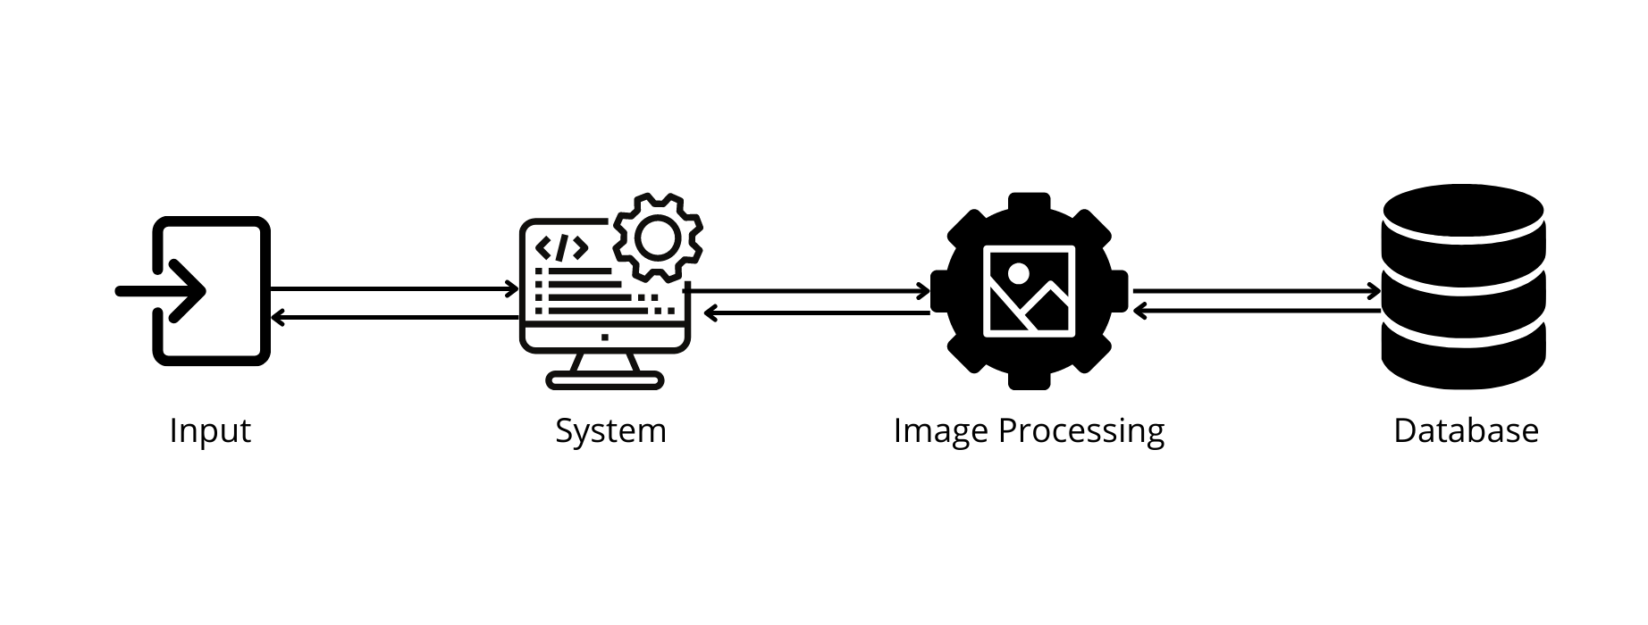
Figure 3.2: Top Level Architecture

System Design
System design is the process of defining the architecture, modules, interfaces, and data for a system to meet specified criteria. It could be thought of as a systems theory application in product development.

Use Case
A use case is a set of activities or event stages that define how a role and a system interact to accomplish a goal.

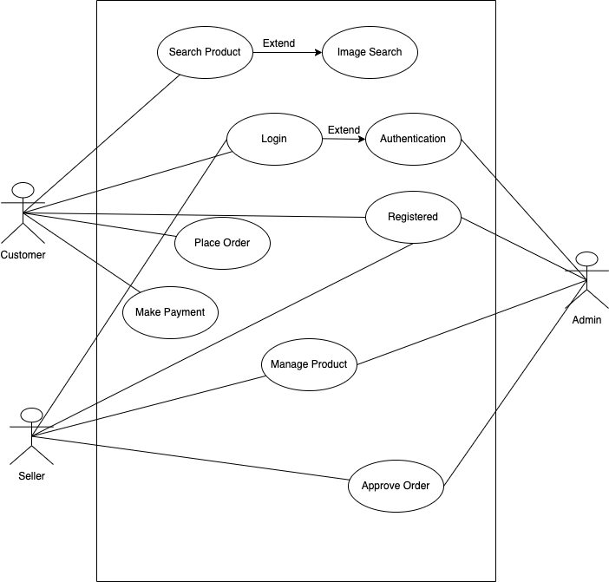
Figure 3.3: Use Case

Use Case Description
Following are the description of all the use cases used in AutoMart.

Login
Following is description of Login use case
Table 3.1: Use Case Login
 | Name | Login
1. | Use-Case ID | UC-1
2. | Objective | Seller and Customer login with credentials
3. | Priority | High
4. | Source | User
5. | Actors | Customer/Seller
6. | Flow of Events
6.1. | Basic Flow | After adding login information user moves to next Use Case
6.2. | Alternative Flow(s) | User doesn’t have account, so he goes to register Use Case
6.3. | Exception Flow(s) | If Login Use Case is not successful, then user will not be logged in
7. | Pre-Conditions | Application should be connected to internet
8. | Post Conditions | User is logged into next Use Case

Register
In the case of registration of the user
Table 3.2: Use Case Registration
 | Name | Login
1. | Use-Case ID | UC-2
2. | Objective | Seller and Customer register with credentials
3. | Priority | High
4. | Source | User
5. | Actors | Customer/Seller
6. | Flow of Events
6.1. | Basic Flow | After adding registration information user moves to next Use Case
6.2. | Alternative Flow(s) | No Alternative Flow
6.3. | Exception Flow(s) | If signup Use Case is not successful, then user will not be logged in
7. | Pre-Conditions | Application should be connected to internet
8. | Post Conditions | User is logged into next Use Case

Search Product
After logged in user is exposed with next use case which is searching for product
Table ‎3.3: Use Case Search Product
 | Name | Login
1. | Use-Case ID | UC-3
2. | Objective | Customer search product with image or keyword
3. | Priority | High
4. | Source | User
5. | Actors | Customer
6. | Flow of Events
6.1. | Basic Flow | After providing image or keyword user moves to Product Catalogue
6.2. | Alternative Flow(s) | No Alternative Flow
6.3. | Exception Flow(s) | System was unable to find related product
7. | Pre-Conditions | Application should be connected to internet
8. | Post Conditions | User has shown results of the search

Place Order
Table 3.4: Use Case Place Order
 | Name | Login
1. | Use-Case ID | UC-4
2. | Objective | Customer places an order
3. | Priority | High
4. | Source | User
5. | Actors | Customer
6. | Flow of Events
6.1. | Basic Flow | After added to cart product is visible in cart
6.2. | Alternative Flow(s) | No Alternative Flow
6.3. | Exception Flow(s) | If inventory is empty, no product is added
7. | Pre-Conditions | Product should have right quantity available
8. | Post Conditions | Product is available to checkout

Make Payment
Table 3: Use Case Make Payment
 | Name | Login
1. | Use-Case ID | UC-5
2. | Objective | Customer makes payment for the product
3. | Priority | High
4. | Source | User
5. | Actors | Customer
6. | Flow of Events
6.1. | Basic Flow | After adding payment information user’s order is placed
6.2. | Alternative Flow(s) | No Alternative Flow
6.3. | Exception Flow(s) | If Payment is not successful, then no order is placed
7. | Pre-Conditions | Payment source should have enough credits
8. | Post Conditions | Order is placed

Manage Product
Table 3.5: Use Case Manage Product
 | Name | Login
1. | Use-Case ID | UC-6
2. | Objective | Seller manages the added products or add products
3. | Priority | High
4. | Source | User
5. | Actors | Seller
6. | Flow of Events
6.1. | Basic Flow | User edits or deletes the available products and thus updated to customers
6.2. | Alternative Flow(s) | No Alternative Flow
6.3. | Exception Flow(s) | Information has not been updated in the server
7. | Pre-Conditions | Application should be connected to internet
8. | Post Conditions | Changes are available for customers

Add Product
Table 3.6: Use Case Manage Product
 | Name | Login
1. | Use-Case ID | UC-7
2. | Objective | Seller manages the orders
3. | Priority | High
4. | Source | User
5. | Actors | Seller
6. | Flow of Events
6.1. | Basic Flow | User approves or deny the orders
6.2. | Alternative Flow(s) | No Alternative Flow
6.3. | Exception Flow(s) | Product not available in inventory
7. | Pre-Conditions | Products are available
8. | Post Conditions | Order is on way to customer

Sequence Diagram
A sequence diagram displays the order in which events in a system occur. A sequence diagram depicts the invocation of methods in each object and the order in which they are invoked. As a result, the sequence diagram is a very effective tool for representing a system's dynamic behavior.

Login
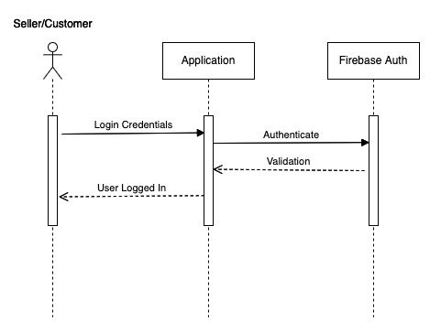

Figure 3.4: Login Sequence Diagram

Register
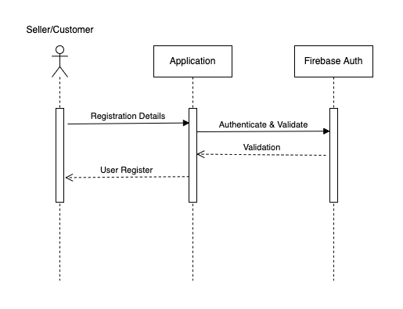

Figure 3.5: Register Sequence Diagram

Search Product
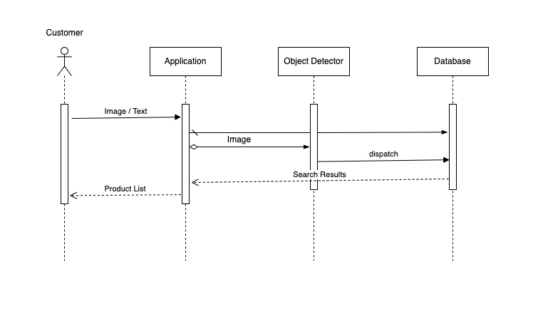

Figure 3.6: Search Product Sequence Diagram

Order Product
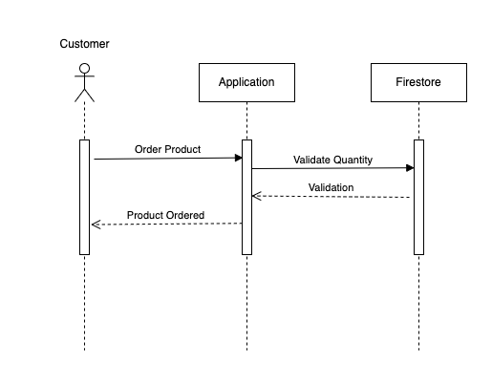

Figure 3.7: Order Product Sequence Diagram

Payment Verification
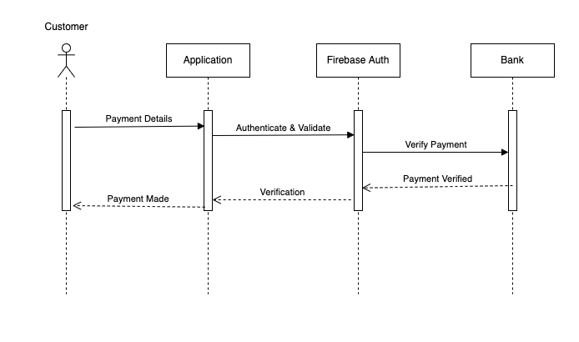

Figure 3.8: Payment Verification Sequence Diagram

Product Management
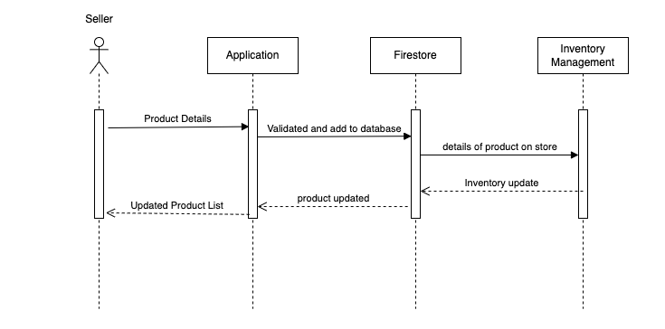

Figure 3.9: Product Management Sequence Diagram

Summary of Pre-Development phase
Prior to development, appropriate ML model was to be selected. So while searching for edge devices ML models, I found some adequate models including SSD, R-CNN, R-FCN, FPN, RetinaNet and YOLO. [11] suggests SSD MobileNet provides the best accuracy tradeoff within fasest detectors. Thus examining [11] work and results of its comparison, I chose SSD MobileNet as viable option.
eCommerce UI is developed using Flutter framework, which is cross-platform UI development SDK. Firebase SDK has been used for backend database and other development modules from SDK. Image Processing and ML is implemented using Google Cloud. Due to the complex nature of the project, Future Driven Development model allowed me to plan the project and then verify requirements, design, implementation and testing and each step and at every iteration, I had a deliverable.
Before the development phase I collected data, this data will be in the form of images. Those data was later used for the testing of SSD MobileNet compressed for edge device.

Machine learning and ML kit
SSD MobileNet with tflite extension requires tensorflow to run model on edge devices but it requires lot of resources like memory and GPU, and still accuracy was not promised. After some research I came to know about Google ML kit and Google Cloud Api’s GoogleVisionKit, which were both used for object detection and product searching respectively. I considered ML kit as viable option because firstly it’s a cloud based API so source device won’t have much load, secondly being the only member I would have not been able to code, train and test ML model all by myself.

User Interface development
Flutter has been used to design and make user interface to make it easier for the seller and the customer. flutter is cross platform UI toolkit which is used to make cross platform applications, language which is used in flutter is known as dart, widgets are made on dart language which are then rendered on the screen, it is an engine which renders and prints on pixels which is why it is faster, it is faster than native because its code does not need to be compiled its code is printed as is on the screen it has a lot of libraries and I’m using flutter because it is open source which has made things easier for me and enable me to control costs. For back end I has used lambda function of firebase known as serverless backend, there is integration of a lot of libraries in it and it also provides cloud services which is the reason it is very well respected in the development community. First of all I have developed UI on flutter and make widgets, then it is integrated with firebase and data is be stored in firebase database known as Fire store and data is also retrieved from here and use lambda functions and then for the purpose of object detection I have used Machine learning kit of firebase and then send the result back to the user, the data base management can be done on the backend on firebase.

Data Model

The Data Model shows correlation and elements of classes used in the project.
ERD of AutoMart is given below:

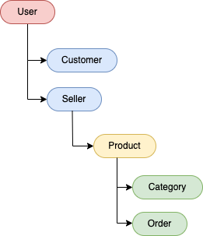

Figure 3.10: Hierarchical Schema

DATA AND EXPERIMENTS

Dataset

The 60000 32x32 colour images in the CIFAR-10 dataset are organised into ten classes, each with 6000 images. A total of 50000 photographs are available for training and 10,000 images are available for testing.
The dataset's 10000 pictures are divided into five training batches and one test batch. Each class has exactly 1000 photos in the test batch, which were picked at random. The remaining photographs are dispersed randomly among the training batches, with certain training batches having more images from one class than others. Between the training batches, there are exactly 5000 photographs from each class.

Experiments
Various CNN trained model tested using this dataset to detect objects from the images including RCNN, YOLO and SSD Mobilenet. Thus, SSD Mobilenet was fastest of them, and accuracy was pretty good. ML kit using SSD enabled application getting best possible results.

Application Testing
Flutter provides build in tools for testing and debugging in devtools. UI is being tested using Widget Inspector and every widget is provided with constraints so there is no overflowing in UI. Similarly, data leaks are monitored using profiler and data overflowing is also prevented.

RESULTS AND DISCUSSIONS

Introduction

AutoMart uses traditional flow of applications from splash screen to login or SignUp screen. Authentication is done using Firebase Authentication. Main screen contains top products where user can instantly choose. Tab bar allows user to navigate to other screens. Image search feature allows user to upload image and then that image is processed using ML kit object detection, and objects are then forwarded to Google vision where products are identified, and related results are shown to the user.

Sign In

Sign In screen requires credential from the user and then authenticate them to enter the app.

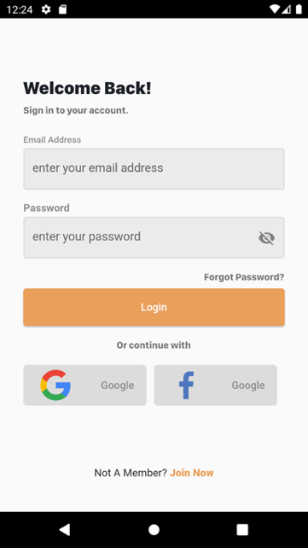

Figure 5.1: Sign In

Sign Up
If user don’t have an account sign up feature allows user to register a new account to get access to the store.
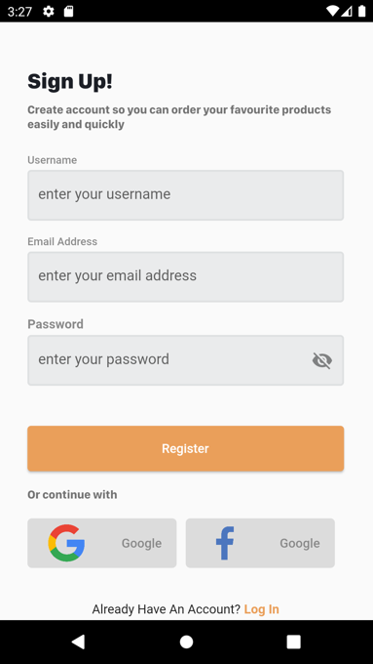
Figure 5.2: Sign Up

Product Catalogue
Product Catalogue is listed with the top products and main menu for the other pages.

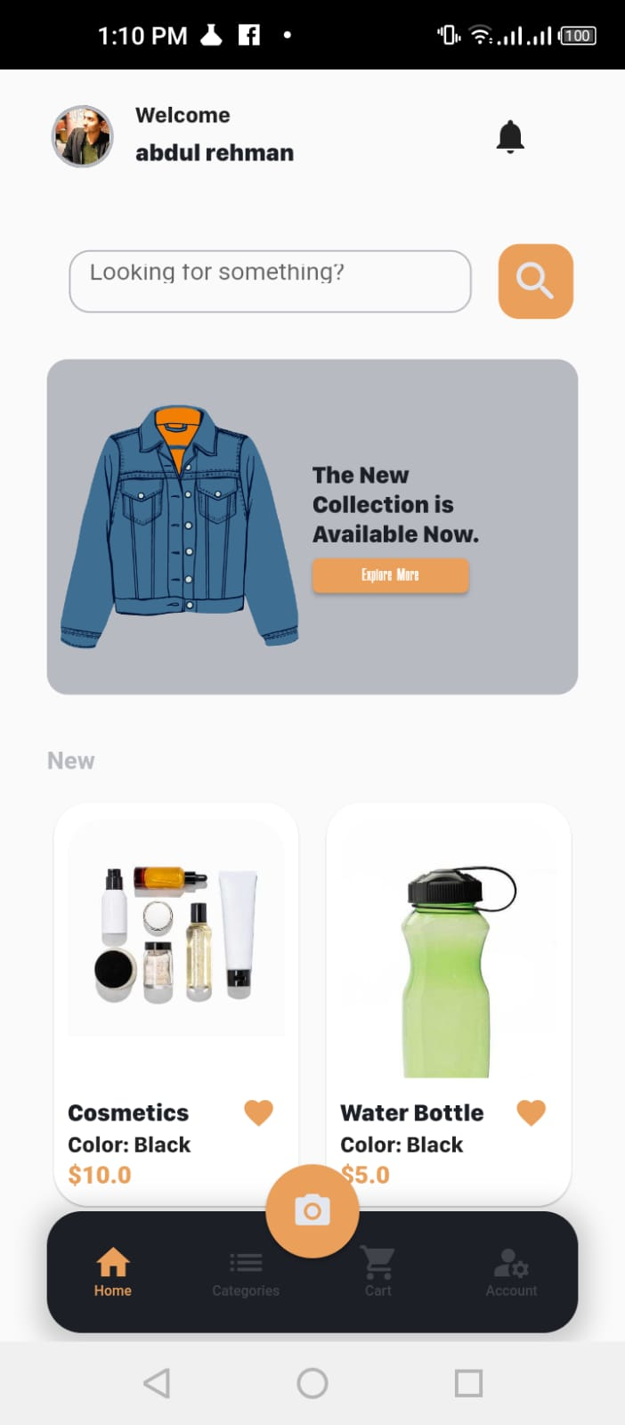
Figure 5.3: Product Catalogue

Single Product
Product Catalogue is listed with the top products and main menu for the other pages.

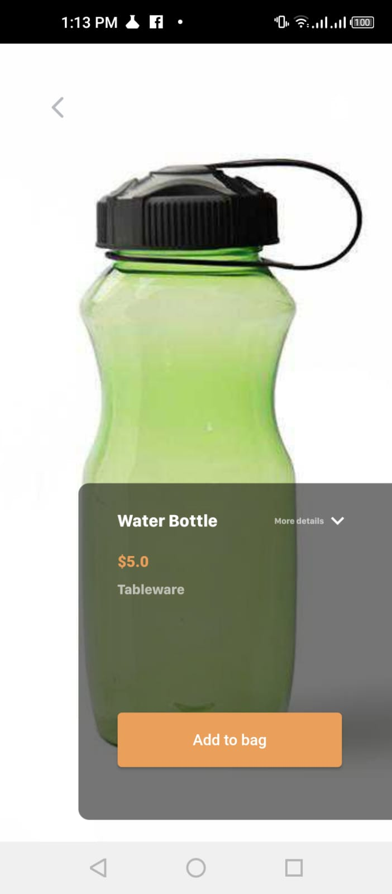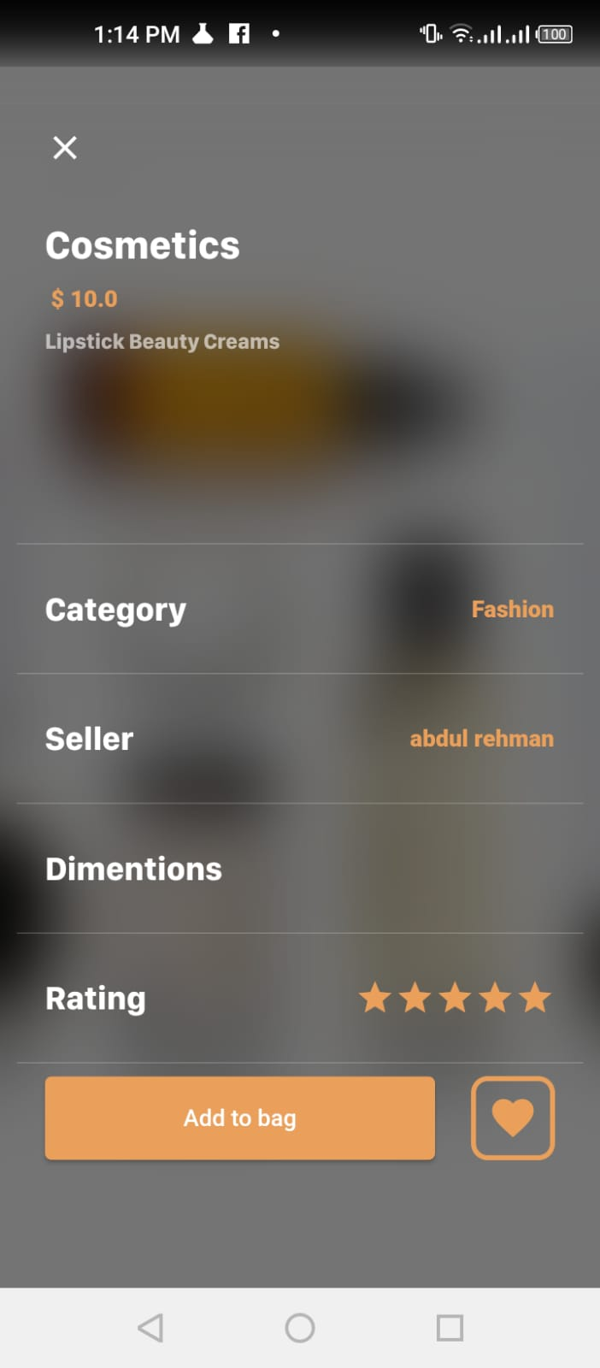

Figure 5.4: Single Product

Image Search

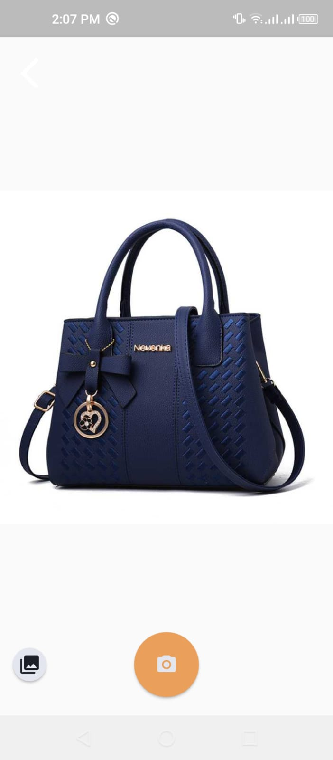
Figure 5.5: Image Searching

Image Search Result

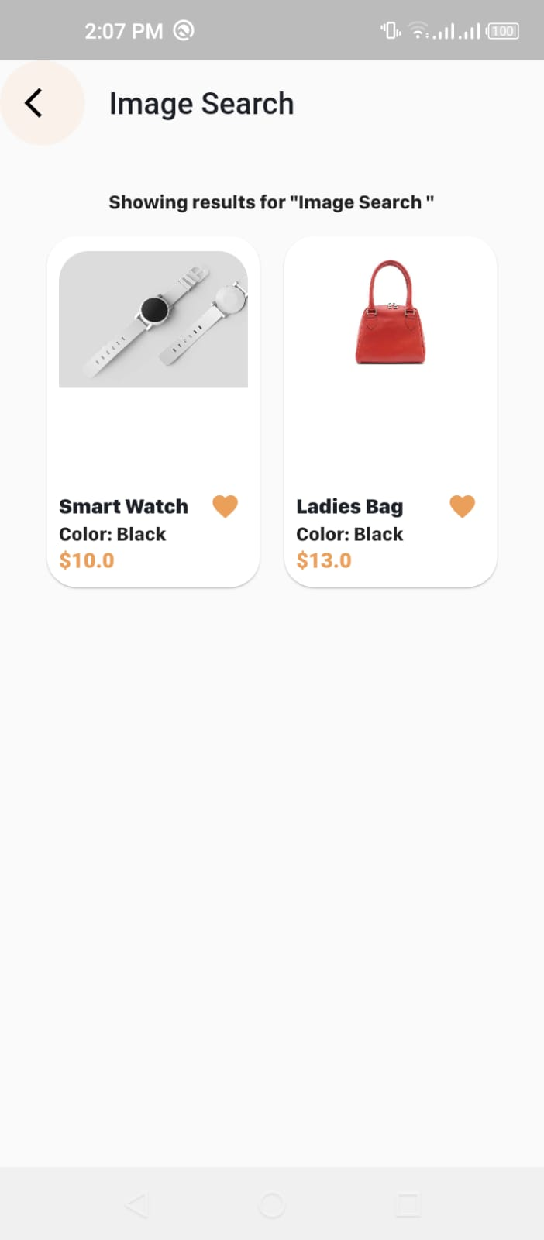
Figure 5.6: Image Searching

Categories & Cart

Categories and cart pages allow users to preview and add to cart and product where he may checkout.
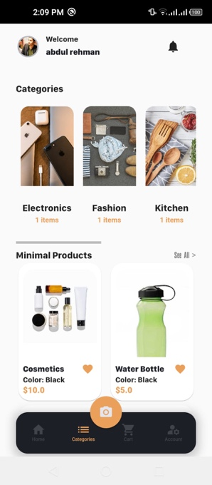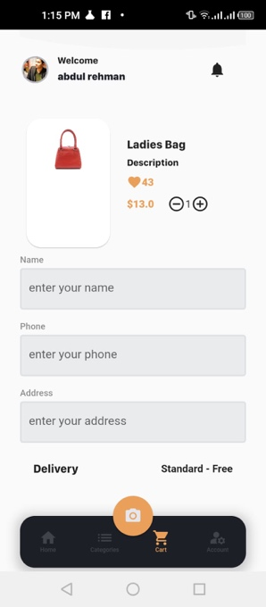
Figure 5.2: Categories & Cart

Payment

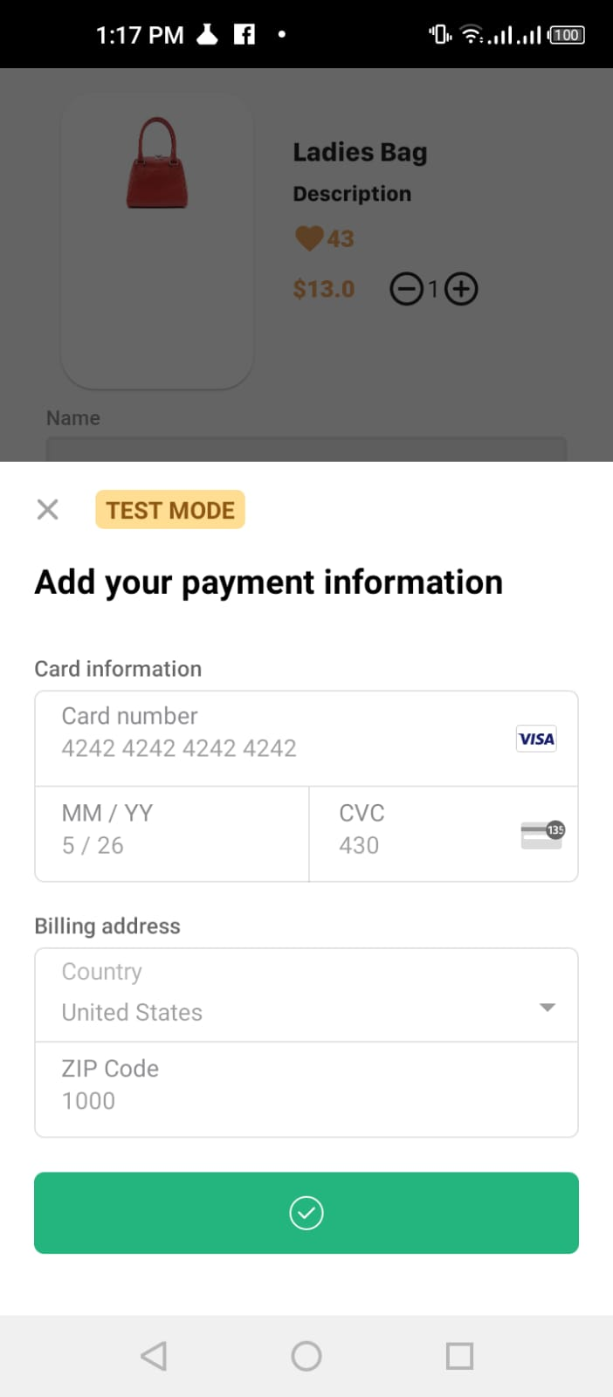
Figure 5.8: Payment

CONCLUSION AND RECOMMENDATIONS

Project Achievements

As this project is fusion of ML and app development, it helps me get the command on these two technologies. I got to learn the machine learning models and their learning which unlocked the spectacular automation of technology. Moreover, flutter enabled me to develop my own app to run on remote mobile devices. I got to learn flutter and implement along with learning which strengthen the process.
The biggest achievement of this project is that I enabled disabled people to link to this huge online market. I was to make online shopping accessible for them.

Implementation Issues and challenges
During development process, there were lot of issues and challenges along with coding. As I was dealing with the three technologies i.e., Machine Learning, Android and IOS application, there integration and compatibility was biggest issue. Sometimes, one was not compatible with current version of the other, otherwise one of the platforms doesn’t support the other’s libraries.

Future Work
I want to further work on this project. This is testing modules of the complete project, which will include AR integration, Inventory Automation, and other accessibility features. My goal is to connect people from remote areas to this online market.

6.4 Conclusion

Machine Learning has evolved over the years and is now part of every project but there are various areas still needs to be explored where Machine Learning can play an important role. Accessibility and automation are two primary leverages a system can have what user can avail. eCommerce market in Pakistan is exponentially growing but the market gap is too much and there are not enough competitors available. Thus, to target consumer from remote areas or especially rural areas of Pakistan where there is lack of trust and knowledge, eCommerce platforms need to make an impact.
This project a step towards accessibility of the eCommerce and automation of eCommerce platforms to lower the cost of process.

REFERENCES

[1] | Shopify, “Future of eCommerce,” [Online]. Available: https://www.shopify.com/research/future-of-commerce/future-of-ecommerce#:~:text=Global%20ecommerce%20sales%20are%20expected,ecommerce%20sites%20across%20the%20globe..
[2] | Dawn, “What’s preventing a boom in e-commerce?,” [Online]. Available: https://www.dawn.com/news/1514770/whats-preventing-a-boom-in-e-commerce.
[3] | A. Akhlaq and E. Ahmed, “Intention Towards Online Shopping: A Pakistan Based Study,” in UK ACADEMY FOR INFORMATION SYSTEMS CONFERENCE PROCEEDINGS 2011, 2011.
[4] | Ministry of Education and Professional Training, “ADULT LITERACY,” [Online]. Available: http://mofept.gov.pk/.
[5] | Yuvraj, I. Bansal, S. Dhar and G. Nikam, “AN IMPLEMENTATION PAPER ON A FRAMEWORK AND TECHNIQUES FOR IMAGE-BASED SEARCH APPLICATION WITH AN E-COMMERCE DOMAIN,” AN IMPLEMENTATION PAPER ON A FRAMEWORK AND TECHNIQUES FOR IMAGE-BASED SEARCH APPLICATION WITH AN E-COMMERCE DOMAIN, 2021.
[6] | L. Zuoren, W. Jiayu and A. Yutong, “Application of extreme learning machine in image segmentation,” Application of extreme learning machine in image segmentation, 2016.
[7] | Y. Xingping, “Searching based on image content,” Searching based on image content , 2011.
[8] | S. Umer, P. P. Mohanta, R. K. Rout and H. M. Pandey, “Machine learning method for cosmetic product recognition: a visual searching approach,” Machine learning method for cosmetic product recognition: a visual searching approach , 2021.
[9] | T. d'Arc, “How image recognition works and impacts for e-commerce,” How image recognition works and impacts for e-commerce, 2020.
[10] | D. Sorokina and E. Cantú-Paz, “Amazon Search: The Joy of Ranking Products,” Amazon Search: The Joy of Ranking Products.
[11] | J. Hui, “Object detection: speed and accuracy comparison (Faster R-CNN, R-FCN, SSD, FPN, RetinaNet and YOLOv3),” Medium, [Online]. Available: https://jonathan-hui.medium.com/object-detection-speed-and-accuracy-comparison-faster-r-cnn-r-fcn-ssd-and-yolo-5425656ae359.
[12] | Amazon, “Amazon App Camera Search,” [Online]. Available: https://amazon.com/b?ie=UTF8&node=17387598011.
[13] | J. Geewax, Google Cloud Platform in Action, Manning Publications, 2018.
[14] | X. Jiang, A. Hadid, Y. Pang, E. Granger and X. Feng, Deep Learning in Object Detection and Recognition, Springer, 2019.
[15] | X. Jiang, A. Hadid, Y. Pang, E. Granger and X. Feng, Deep Learning in Object Detection and Recognition, 2019.

APPEDNDICES

APPENDIX A: Requirement List

R1: Android device should be running on or above 11.0.
R2: IOS device should be running on or above IOS 11.0.
R3: Edge device should support GPU delegate and allow app to use GPU resources.
R4: Edge device should have an active internet.
R5: App should have camera and gallery permissions for image search.

APPENDIX B: Customer User Manual

R1: Customer needs to be login or register before buying products.
R2: Customer browses products from home page.
R3: Customer searches for product by text or by image.
R4: Customer adds a product to the cart.
R5: Customer uses credit card to make payment.
R6: Product is delivered to the customer.

APPENDIX C: Seller User Manual

R1: Seller needs to be login or register before buying products.
R2: Customer signs up for seller by providing additional information.
R3: Seller than granted access to its product inventory.
R4: Seller adds new products and updates the available.
R5: Seller keep track of inventory.

