
BSCS-S21-011
03-134181-044 | ALI SHER SHAHID
03-134181-048 | MALIK ALI HASSAN

RetailDial

In partial fulfilment of the requirements for the degree of
Bachelor of Science in Computer Science
Supervisor: Taimoor Aamer Chughtai

Department of Computer Sciences
Bahria University, Lahore Campus

January,2022

Certificate

We accept the work contained in the report titled
“RetailDial”
written by
ALI SHER SHAHID
MALIK ALI HASSAN
as a confirmation to the required standard for the partial fulfilment of the degree of
Bachelor of Science in Computer Science.

Approved by:
Supervisor: Taimoor Aamer Chughtai

January 26, 2022

DECLARATION

We hereby declare that this project report is based on our original work except for citations and quotations which have been duly acknowledged. We also declare that it has not been previously and concurrently submitted for any other degree or award at Bahria University or other institutions.

Enrolment | Name | Signature
03-134181-044 | ALI SHER SHAHID
03-134181-048 | MALIK ALI HASSAN

Date: January 26, 2022

Specially dedicated to
my beloved grandmother, mother and father
ALI SHER SHAHID
my beloved grandmother, mother and father
MALIK ALI HASSAN

ACKNOWLEDGEMENTS

We would like to thank everyone who had contributed to the successful completion of this project. We would like to express our gratitude to my research supervisor, Mr. Taimoor Aamer Chughtai for his invaluable advice, guidance, and his enormous patience throughout the development of the research.

In addition, we would also like to express my gratitude to our loving parent and friends who had helped and given me encouragement.

ALI SHER SHAHID
MALIK ALI HASSAN

RetailDial

ABSTRACT

In Pakistan alone, we have more than 2 million retail outlets out of which 40% are traditional Kiryana stores. Supply Chain is one of the largest issues that most of them face including competitive pricing and delivery times. We are solving the issue for small retail shops, for which we are coming up with a Flutter mobile application that will help retailers digitize their supply chain demands and will be enabled to place their inventory order through our app and will receive their goods the very next day and most importantly they will get competitive prices on small orders as well. Our application will be built on top of Flutter which is a software development kit developed by Google and we can build various applications through one code base.

TABLE OF CONTENTS

DECLARATION i
ACKNOWLEDGEMENTS i
ABSTRACT i
TABLE OF CONTENTS i

CHAPTERS
1 INTRODUCTION 1
1.1 Background 1
1.2 Problem Statements 1
1.3 Aims and Objectives 1
1.4 Scope of Project 1
1.4.1 Primary Scope 2
1.4.2 Final Deliverable of the Project and Beneficiaries 2
1.4.3 Optional Scope 2
2 LITERATURE REVIEW (and/or SRS) 3
2.1 User Classes and Characteristics 3
2.2 Operating Environment 4
2.3 Design and Implementation Constraints 4
2.4 Assumptions and Dependencies 4
2.5 System Use Cases 5
2.6 UC Diagram 7
2.6.1 Retailer Register (UI) 7
2.6.2 Retailer Login (UI) 8
2.6.3 Checkout (U1) 9
2.6.4 Retailer Add Product to Cart(UI) 10
Table 2.5.1: Retailer Add Product (UI) 10
2.6.5 Retailer Remove Product from Cart(UI) 11
Table 2.5.1:Retailer Remove Product from Cart(UI) 11
2.6.6 Retailer Add Address (UI) 12
Table 2.5.1: Retailer Add Address (UI) 12
2.6.7 Retailer Proceed to check out (UI) 13
Table 2.5.1: Retailer Proceed to check out (UI) 13
2.6.8 Wholesaler Login(UI) 14
Table 2.5.1: Wholesale Login(UI) 14
2.6.9 Wholesaler Add Product to Sell(UI) 15
Table 2.5.1: wholesaler Add Product to Sell(UI) 15
2.6.10 Admin Delete Retailer (UI) 16
Table 2.5.1: Admin Delete retailer (UI) 16
Table 2.5.1: Admin Delete Seller(UI) 17
2.6.11 Admin Suspend retailer(UI) 18
Table 2.5.1: Admin Suspend retailer(UI) 18
2.6.12 Admin Suspend Seller(UI) 19
Table 2.5.1: Admin Suspend Seller(UI) 19
2.6.13 Performance Requirements 20
2.7 Software Quality Attributes 20
2.7.1 Reliability 20
2.7.2 Availability 20
2.7.3 Maintainability 20
3 DESIGN AND METHODOLOGY 21
3.1 Sequence Diagrams 21
3.1.1 User Registration 22
3.1.2 User Login 23
3.1.3 Seller Login 23
3.1.4 User Shopping 24
3.2 Entity Relationship Diagram 25
3.3 Data Gathering 26
3.4 Methodologies 26
4 IMPLEMENTATION 27
4.1 Tools and Technologies 27
5 RESULTS AND DISCUSSIONS 28
5.1 Getting Started 28
5.2 Login 29
5.3 Register 30
5.4 Permissions 31
5.5 My Profile 32
5.6 Cart 33
5.7 Supplier Login 34
5.8 Add Item 35
5.9 Supplier Orders 40
5.10 Address (Customer End) 42
5.11 Order Placed Successfully 45
5.12 Database 46
6 CONCLUSION AND RECOMMENDATIONS 49
6.1 Conclusion 49
6.2 Future Work 50
REFERENCES 50

LIST OF FIGURES

FIGURE TITLE PAGE
Figure 2-1 : SYSTEM USE CASE DIAGRAM 5
Figure 2-2 : Admin 6
Figure 3-1: User Registration 22
Figure 3-2: User Login 23
Figure 3-3: Seller Login 23
Figure 3-4: User Shopping 24
Figure 3-5: Entity Relationship Diagram 25
Figure 5-1: Getting Started 28
Figure 5-2: Login 29
Figure 5-3: Register 30
Figure 5-4: Permissions 31
Figure 5-5: My Profile 32
Figure 5-6: Cart 33
Figure 5-7: Supplier Login 34
Figure 5-8: Add Item 35
Figure 5-9 Supplier Orders 40
Figure 5-10: Address (Customer End) 42
Figure 5-11: Order Placed Successfully 45
Figure 5-12: Database 46
Figure 5-13 Database Authentication 46
Figure 5-14: Database Admin 47
Figure 5-15: Database User 47
Figure 5-16 Database Storage 48
Figure 5-17: Authentication Check 48

INTRODUCTION

Background

Supply chain is the largest issue for retailers. Most of them go to wholesale markets to buy inventory by which they must compromise on their time as well as resources.

Problem Statements

Small general stores face supply chain issues such as high pricing, logistics and waste of time. The objective of this platform is to make supply chain hassle free for the small general stores by leveraging technology to connect retailers with our manufacturers and suppliers on board.

Aims and Objectives

- To ease out supply chain for small retailers.
- To help them in saving time and resources from supply chain.
- To enable Distributors/wholesalers in increasing their reach by using our system.

Scope of Project
This paragraph defines the scope of project.

Primary Scope

To make supply chain hassle free for the small general stores by leveraging technology to connect retailers with our manufacturers and suppliers on board. We will develop an application on top of Flutter which is a SDK developed by Google. That app will have multiple user roles for manufacturer/distributor and retailer. The retailer will sign up and verify its details after which they can place inventory order from our application, after which the manufacturer/distributor will deliver the order to the retailer.

Final Deliverable of the Project and Beneficiaries
- The result of this project is a mobile (android/iOS) application.
- End users of product will be retailer and a whole seller.
- Admin Panel (Firebase)

Optional Scope
- Mobile application to buy goods on wholesale rate.

LITERATURE REVIEW (and/or SRS)

User Classes and Characteristics

The user is divided into two classes:

- Customer/Retailer
- Whole Seller
- Administrator

Administrator – Administrator can perform following actions:
- Add Sellers
- Delete Sellers
- Remove User/Customer
- Disable User/Customer

User/Customer– Can perform the following actions:
- Register
- Login
- Add product to cart
- See orders
- Logout

Whole Seller– Can perform the following actions:
- Login
- Add new product to market
- See orders
- Logout

Operating Environment

Operating Environment for Retail dial app:
- Operating System: Android device with OS version minimum 6.0 and iPhone with iOS version 11.
- Web Browsers: Google Chrome and Firefox Browsers supported because here we need to open our admin panel.
- Database Management System: Firebase

Design and Implementation Constraints

This application is designed using flutter framework using the Bloc pattern of design. This pattern is basic pattern provided by flutter by default and allow to build apps more easily than other available frameworks used for this purpose.

Assumptions and Dependencies

Assumptions and dependencies:
• Android Device (min version 6) / iPhone (min iOS version 11 ).
• Working internet connection.
• No other third-party apps or plugins are needed.

System Use Cases

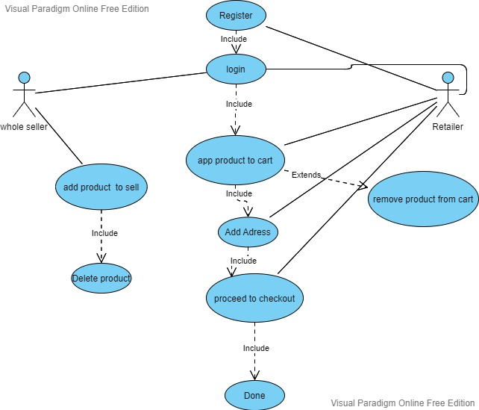

Figure 2-1 : SYSTEM USE CASE DIAGRAM

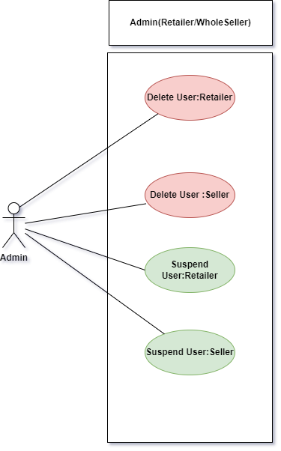

Figure 2-2 : Admin

UC Diagram

Retailer Register (UI)

 | Name | Register Retailer
1. | Use-Case ID | UCRD001
2. | Objective | User/Customer will enter credentials
3. | Priority | High
4. | Source | Developer
5. | Actors | User/Customer
6. | Flow of Events | - Enter Credentials  - Click Register button
7. | Basic Flow | After Registering User/Customer will go to home page/product page
8. | Alternate Flow(s) | Otherwise, error toast will show.
9. | Preconditions | No such preconditions require for now.

Retailer Login (UI)

 | Name | Login Retailer
1. | Use-Case ID | UCRD002
2. | Objective | User/Customer will enter credentials, and get logged in
3. | Priority | High
4. | Source | Developer
5. | Actors | User/Customer
6. | Flow of Events | - Enter Credentials  - Click Login Button
7. | Basic Flow | After Login User/Customer will go to home page/product page
8. | Alternate Flow(s) | Otherwise, error toast will show.  Or you need to register first.
9. | Preconditions | User must be registered before login.

Checkout (U1)

 | Name | Checkout
1. | Use-Case ID | UCRD003
2. | Objective | User/Customer will proceed order
3. | Priority | High
4. | Source | Developer
5. | Actors | User/Customer
6. | Flow of Events | - Add item to cart  - Go to cart  - Add address  - Check out
7. | Basic Flow | After placing order app restarts and go back to product page.
8. | Alternate Flow(s) | No alternating flow
9. | Preconditions | User should have at least one product in his or her cart and must be connected to internet.

Retailer Add Product to Cart(UI)

Table 2.5.1: Retailer Add Product (UI)

 | Name | Add Product to Cart
1. | Use-Case ID | UCRD004
2. | Objective | User/Customer will click on add to cart button on product to cart.
3. | Priority | Moderate
4. | Source | Developer
5. | Actors | User/Customer
6. | Flow of Events | - Open product page  - Click on add to cart button
6.1 | Basic Flow | After adding product to cart user will see cart icon updated with item number and by going to cart page, he can see the product added.
6.2 | Alternate Flow(s) | No alternate flow available.
8. | Preconditions | User must be logged in. And must be connected to internet.

Retailer Remove Product from Cart(UI)

Table 2.5.1:Retailer Remove Product from Cart(UI)

 | Name | Remove Product from cart
1. | Use-Case ID | UCRD005
2. | Objective | User/Customer will go to cart and click on remove from cart button to remove it from cart.
3. | Priority | Moderate
4. | Source | Developer
5. | Actors | User/Customer
6. | Flow of Events | - Open Cart page  - Click on remove from cart button
6.1 | Basic Flow | After removing product from cart, product will no longer be shown on cart page
6.2 | Alternate Flow(s) | No alternate flow available.
8. | Preconditions | Product must be added to cart before removing it.

Retailer Add Address (UI)

Table 2.5.1: Retailer Add Address (UI)

 | Name | Add Address
1. | Use-Case ID | UCRD006
2. | Objective | User/Customer will open side drawer and then click on Add Address to go to add address UI page.
3. | Priority | Moderate
4. | Source | Developer
5. | Actors | User/Customer
6. | Flow of Events | - Open Add Address Page  - Add Address information and then click submit button
6.1 | Basic Flow | After adding address, this will show on address page UI.
6.2 | Alternate Flow(s) | User can go to cart and click on Proceed to pay button then can add address via Add Address button
8. | Preconditions | User must be connected to internet. If user is doing it via cart page he must have at least one product added to cart

Retailer Proceed to check out (UI)

Table 2.5.1: Retailer Proceed to check out (UI)

 | Name | Proceed to check out
1. | Use-Case ID | UCRD007
2. | Objective | User/Customer will click on proceed to check out button to get delivery
3. | Priority | Moderate
4. | Source | Developer
5. | Actors | User/Customer
6. | Flow of Events | Open Cart page  Click on Proceed to check out
6.1 | Basic Flow | User will open cart page, then he, must add at least on address to be product shipped on them he can click on proceed to check out button.
6.2 | Alternate Flow(s) | No alternate flow available.
8. | Preconditions | User must be logged in. And must be connected to internet.

Wholesaler Login(UI)

Table 2.5.1: Wholesale Login(UI)

 | Name | Login wholesaler
1. | Use-Case ID | UCRD008
2. | Objective | User/Seller will enter credentials and get logged in
3. | Priority | High
4. | Source | Developer
5. | Actors | User/Seller
6. | Flow of Events | - Enter Credentials  - Click Login button
6.1 | Basic Flow | After Login User/Seller will go to home page/product page
6.2 | Alternate Flow(s) | Otherwise, error toast will show.  Or you need to register first.
8. | Preconditions | User must be added/registered by admin.

Wholesaler Add Product to Sell(UI)

Table 2.5.1: wholesaler Add Product to Sell(UI)

 | Name | Wholesaler Add Product to Sell
1. | Use-Case ID | UCRD009
2. | Objective | User/Seller will enter product details to sell.
3. | Priority | High
4. | Source | Developer
5. | Actors | User/Seller
6. | Flow of Events | - Enter product details  - Click Add button on top right corner
6.1 | Basic Flow | After Login User/Seller will to back automatically to main page/Add product page
6.2 | Alternate Flow(s) | No alternate flow available.
8. | Preconditions | User must be connected to internet and fill all the required details

Admin Delete Retailer (UI)

Table 2.5.1: Admin Delete retailer (UI)

 | Name | Admin Delete Retailer
1. | Use-Case ID | UCRD0010
2. | Objective | Admin will delete retailer/customer account
3. | Priority | High
4. | Source | Developer
5. | Actors | Admin
6. | Flow of Events | - Click on desired ID.  - Click on delete button
6.1 | Basic Flow | After deleting retailer it’ll be removed from firebase database
6.2 | Alternate Flow(s) | No alternate flow available.
8. | Preconditions | No preconditions, just must be connected to internet

Table 2.5.1: Admin Delete Seller(UI)

 | Name | Admin Delete Seller
1. | Use-Case ID | UCRD0011
2. | Objective | Admin will delete Seller/Wholesaler account
3. | Priority | High
4. | Source | Developer
5. | Actors | Admin
6. | Flow of Events | - Click on desired id  - Click on delete button
6.1 | Basic Flow | After deleting seller, it’ll be removed from firebase database
6.2 | Alternate Flow(s) | No alternate flow available.
8. | Preconditions | No preconditions, just must be connected to internet

Admin Suspend retailer(UI)

Table 2.5.1: Admin Suspend retailer(UI)

 | Name | Admin Suspend Retailer
1. | Use-Case ID | UCRD0012
2. | Objective | Admin will Suspend retailer/customer account
3. | Priority | High
4. | Source | Developer
5. | Actors | Admin
6. | Flow of Events | - Click on desired id  - Click on suspend button
6.1 | Basic Flow | After suspending retailer, he can’t login with these credentials.
6.2 | Alternate Flow(s) | No alternate flow available.
8. | Preconditions | Retailer must be registered first.

Admin Suspend Seller(UI)

Table 2.5.1: Admin Suspend Seller(UI)

 | Name | Admin Suspend Seller
1. | Use-Case ID | UCRD0013
2. | Objective | Admin will Suspend Seller/Wholesaler account
3. | Priority | High
4. | Source | Developer
5. | Actors | Admin
6. | Flow of Events | - Click on desired id  - Click on suspend button
6.1 | Basic Flow | After suspending Seller, he can’t login with these credentials.
6.2 | Alternate Flow(s) | No alternate flow available.
8. | Preconditions | Retailer must be registered first by admin

Performance Requirements

This application needs to use firebase data base so it should have a good connection. As it is created using Flutter so it’s going to take mobile GPU resource. So at least mobile have minimum 2Gb of ram with any supported processor and Mali or its variant GPU

Software Quality Attributes

Reliability

Application will not fail until unless user internet connection is stable and working properly.

Availability

This app will be available to all user having android phones.

Maintainability

Developer will maintain the app timely to ensure that its working properly

DESIGN AND METHODOLOGY

Sequence Diagrams

A sequence diagram simply depicts interaction between objects in a sequential order i.e., the order in which these interactions take place. We can also use the terms event diagrams or event scenarios to refer to a sequence diagram. Sequence diagrams describe how and in what order the objects in a system function.
Following are the sequence diagrams of retail dial:
- User Registration
- User Login
- Seller Login
- User shopping

User Registration

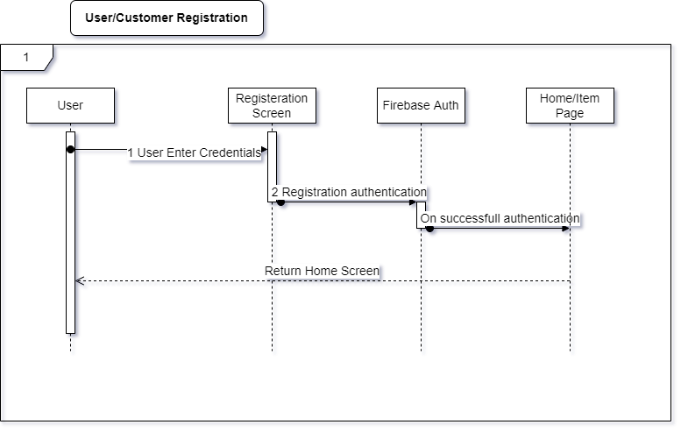
Figure 3-1: User Registration

User Login

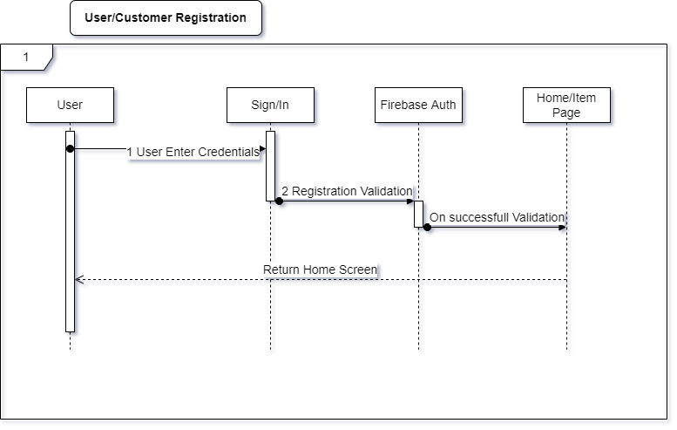
Figure 3-2: User Login

Seller Login
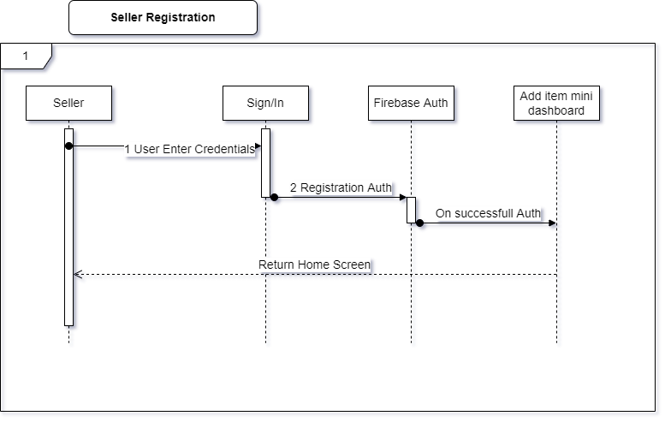
Figure 3-3: Seller Login

User Shopping

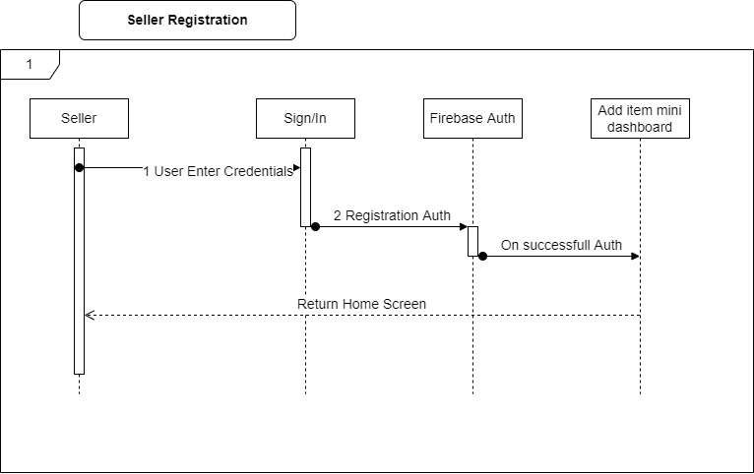
Figure 3-4: User Shopping

Entity Relationship Diagram

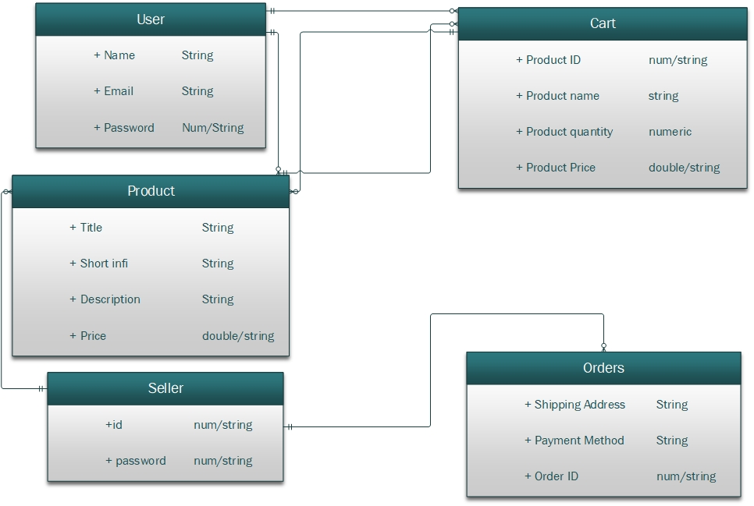

Figure 3-5: Entity Relationship Diagram

Data Gathering

In the real app which is deployed data will be uploaded by seller. While testing the application all the data uploaded is raw data (demo data)

Methodologies

We used Agile Methodology for our project because it fits best for it

As Agile development is particularly effective with large, complex, creative projects. And we are going to develop a market analysing app which will be connected to firebase database, So Agile is the right choice. Agile is lightweight. It allows for changes in vision, or even for improving upon what already exists as new information develops. Agile reduces risk. Since it encourages open communication between the client and project managers, Agile is great for those who value transparency. Agile can adapt to the market.

IMPLEMENTATION

Tools and Technologies

As Flutter is a SDK developed by google for cross platform application development. We used the following:
- Flutter Software Development Kit
- Visual Studio Code
- Android SDK
- Flutter Plugins (pub.dev) in pubsec.yaml file
- Java SDK
- Android Device
- Firebase

RESULTS AND DISCUSSIONS

Getting Started
The getting started page which has animation, and it appears before the sign in/signup page.

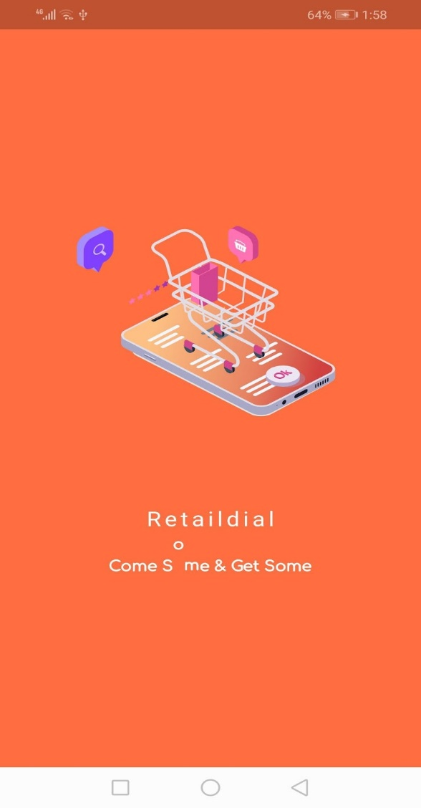
Figure 5-1: Getting Started

Login

The Login page that will appear after the getting started page where the user will have the option of logging in.

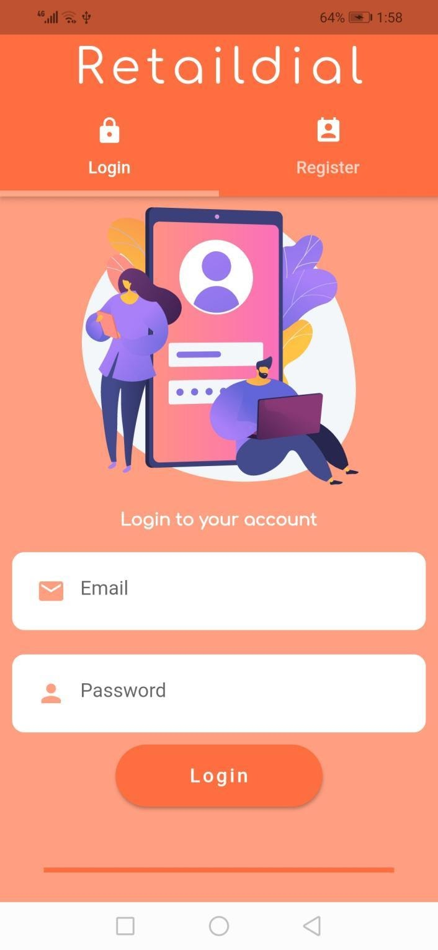
Figure 5-2: Login

Register
The register page where the user can fill in their information to become user of the app

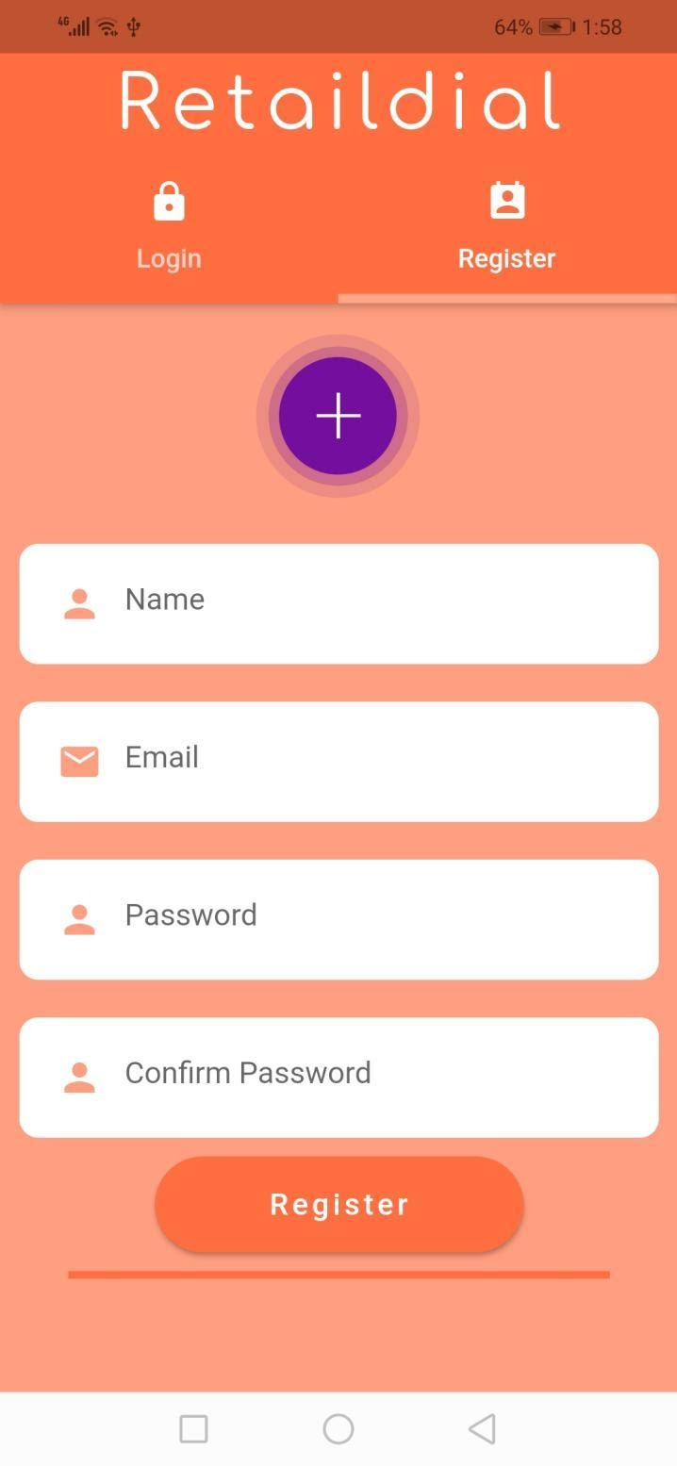
Figure 5-3: Register

Permissions

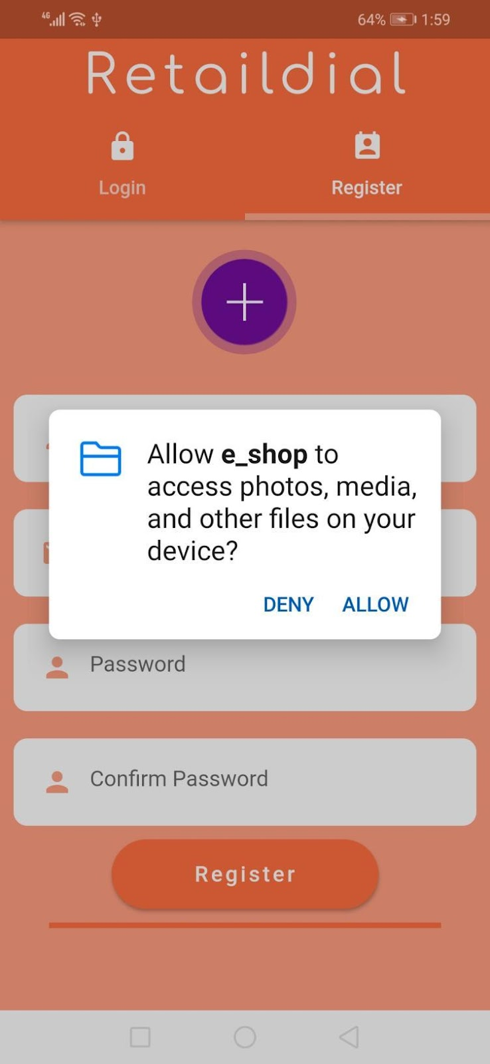
Figure 5-4: Permissions

My Profile

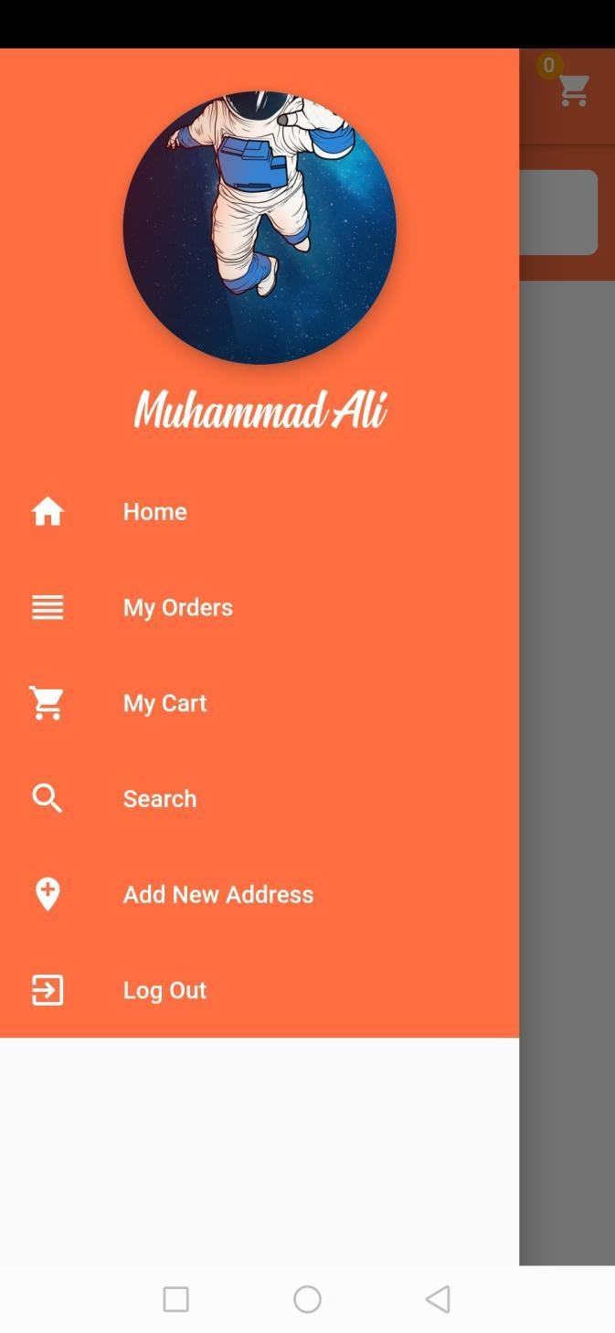
Figure 5-5: My Profile

Cart
The cart when it is empty.

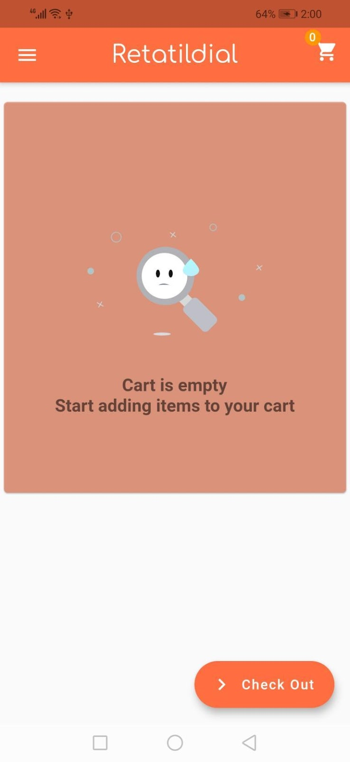
Figure 5-6: Cart

Supplier Login

Login of the supplier end

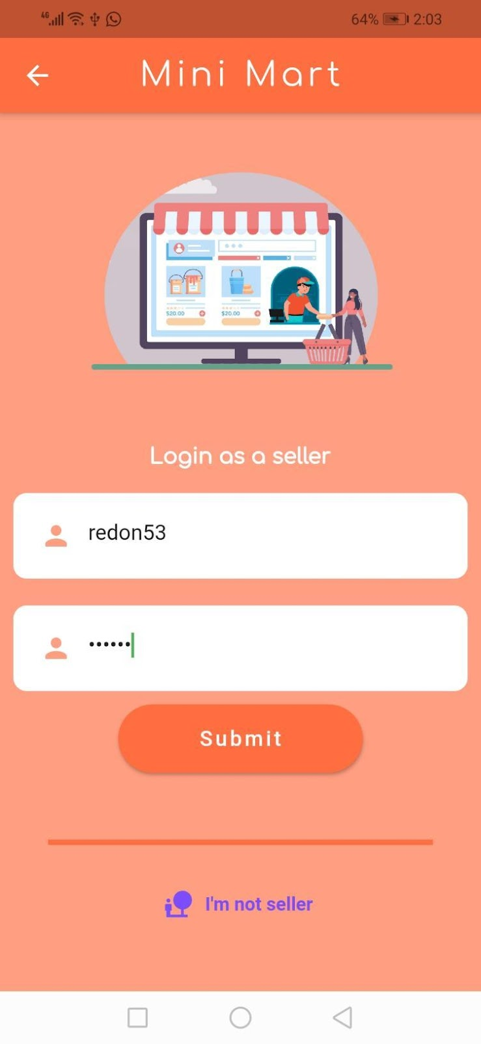
Figure 5-7: Supplier Login

Add Item
Add new item section
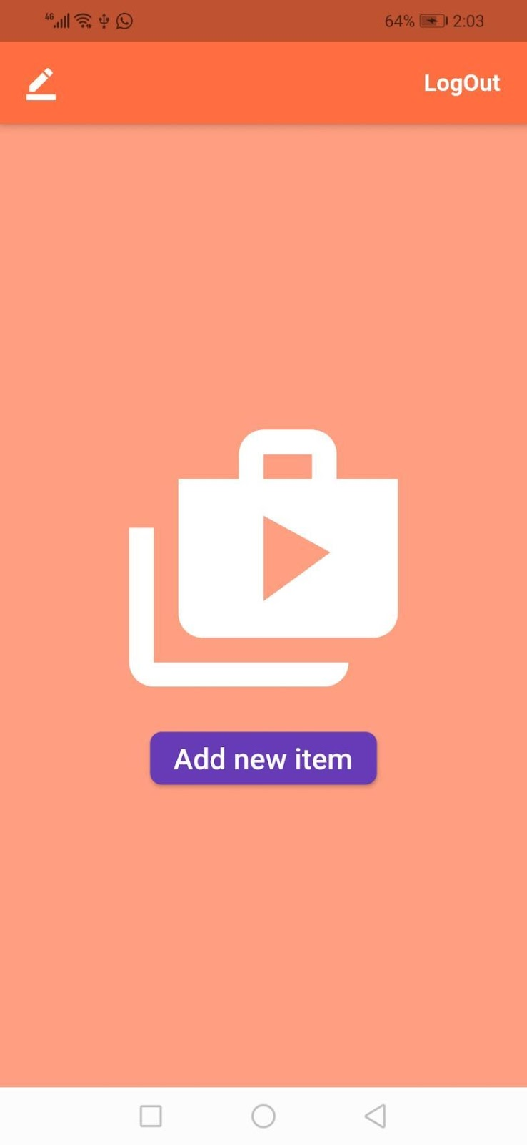
Figure 5-8: Add Item

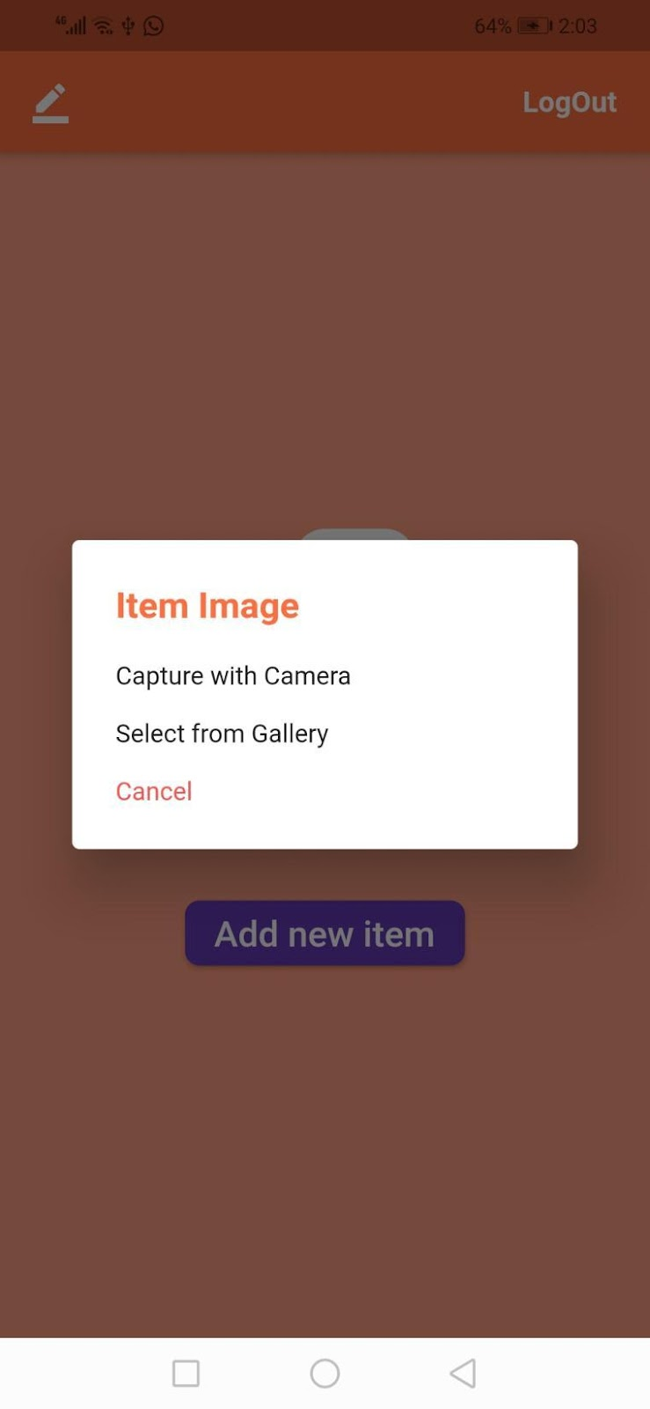

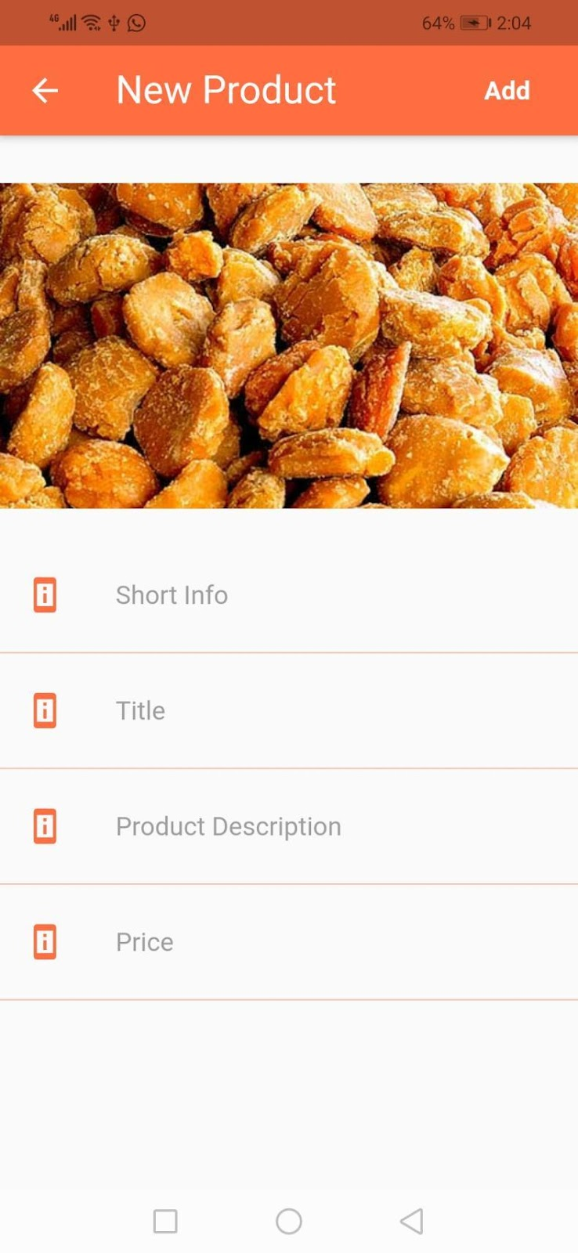

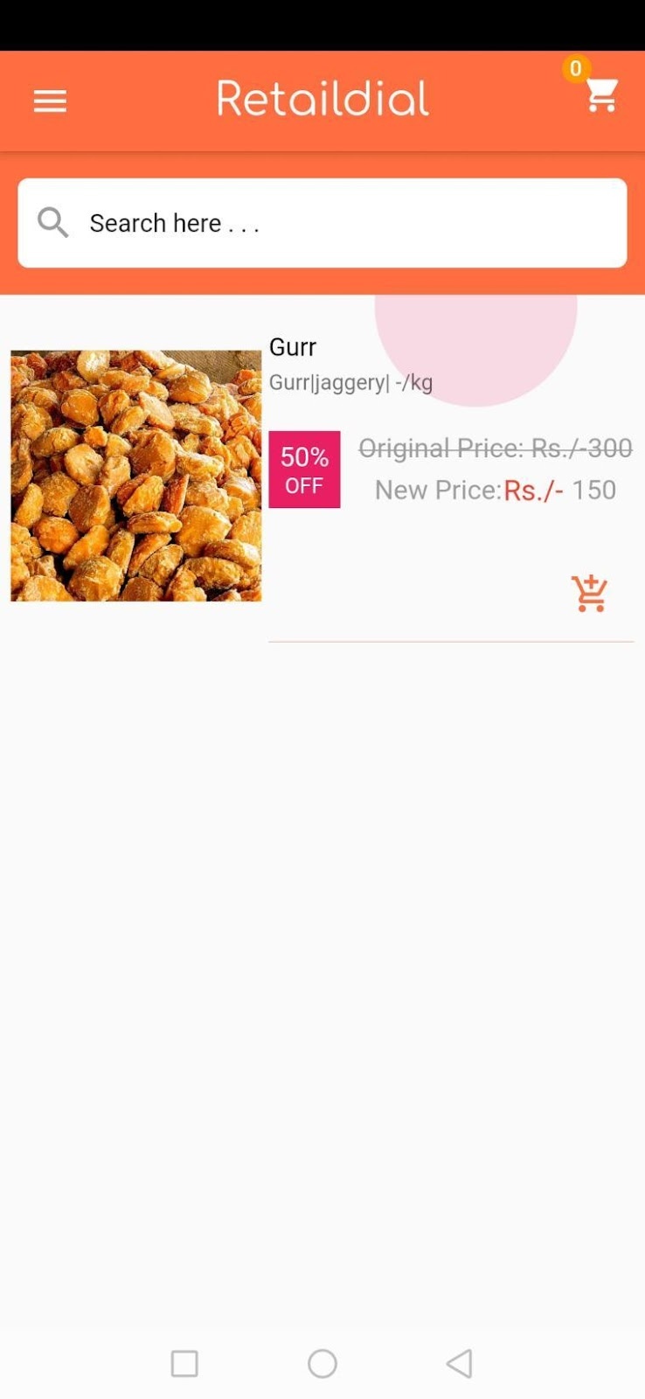

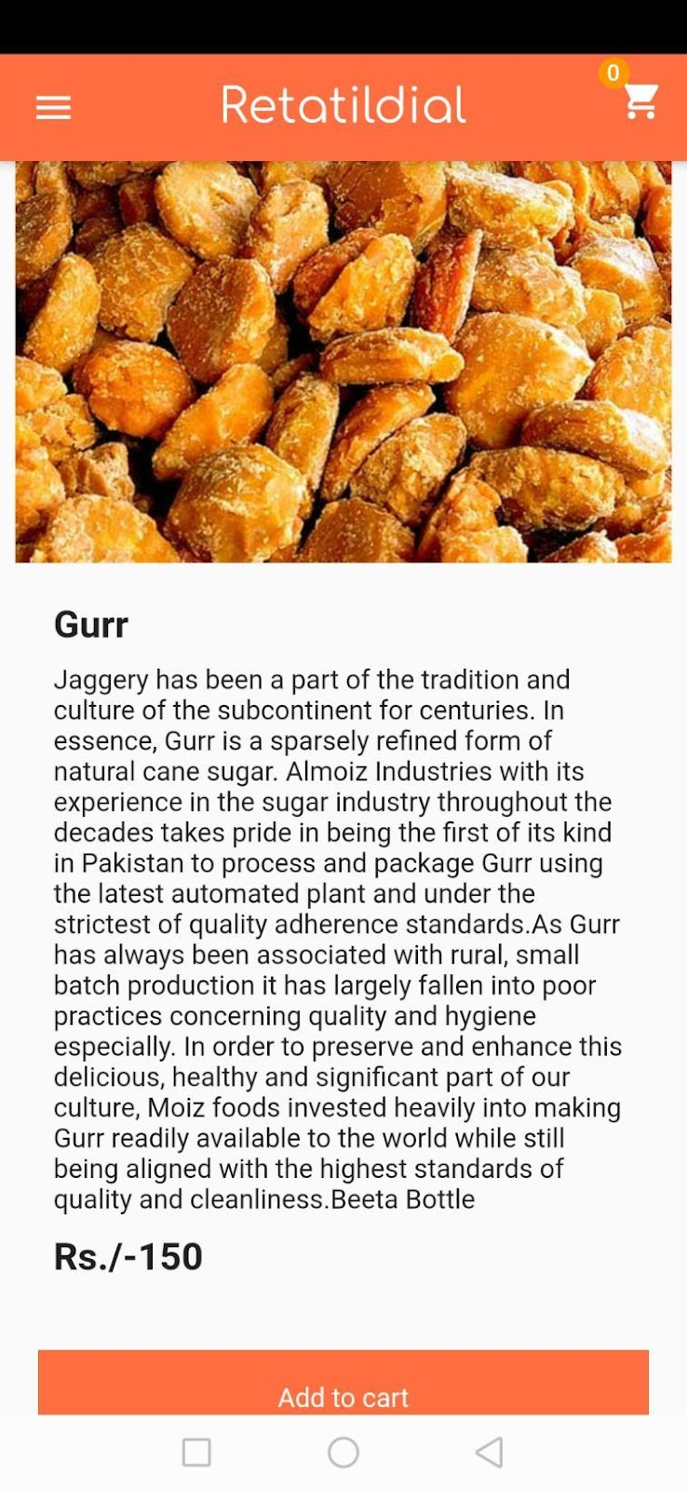

Supplier Orders
The orders will be displayed here.

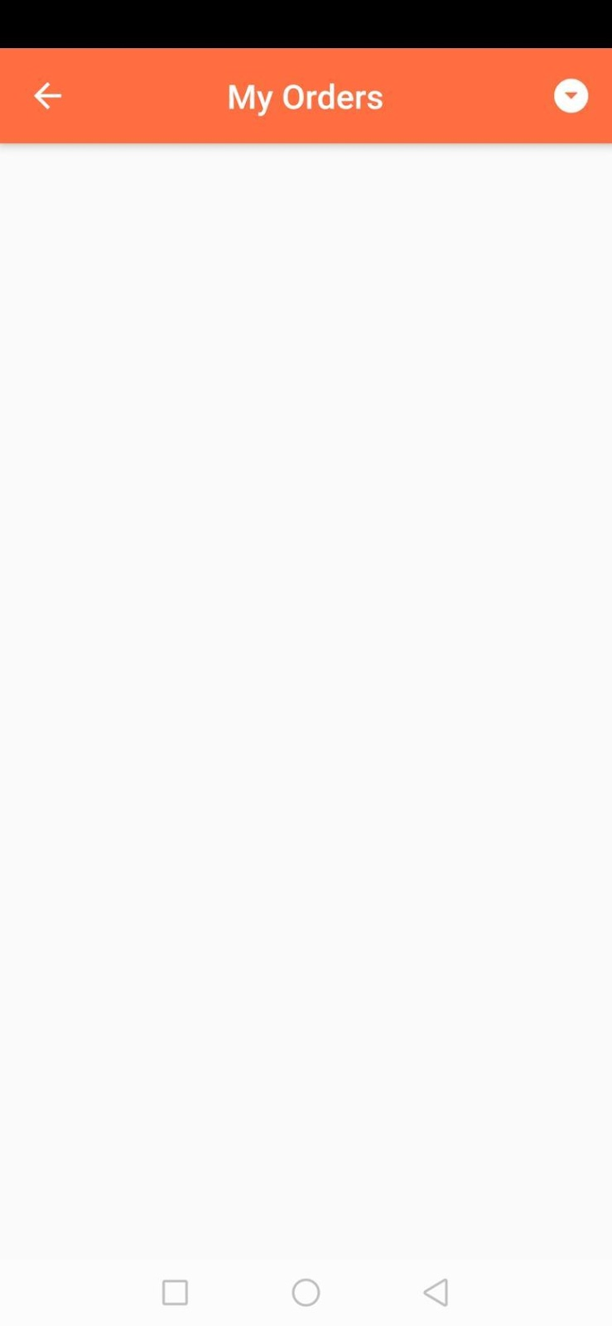
Figure 5-9 Supplier Orders

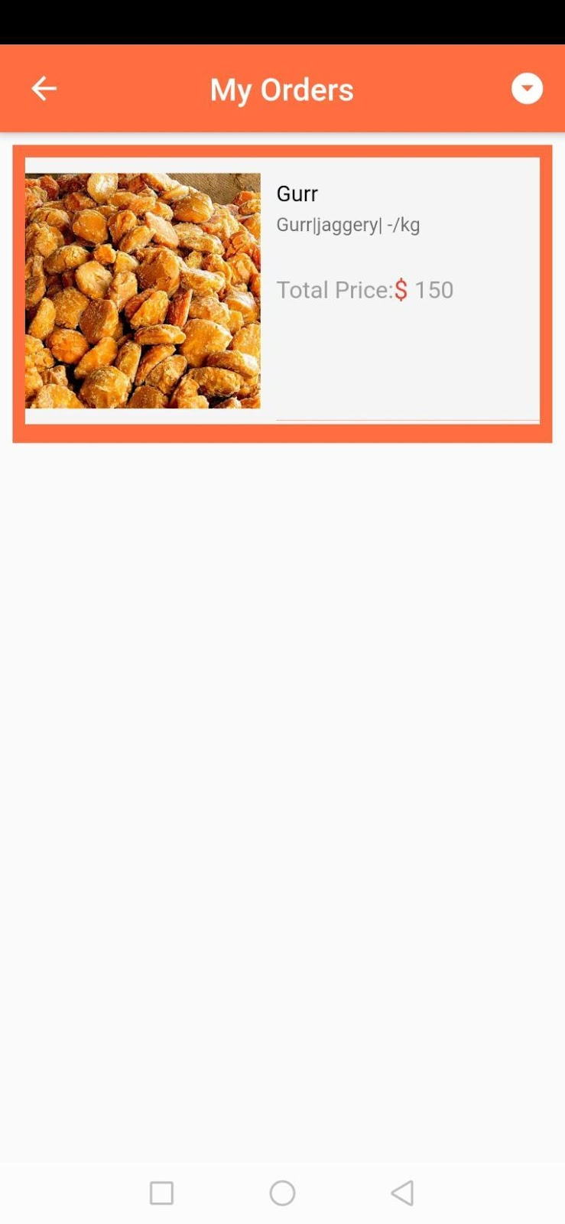

Address (Customer End)
Add delivery address where you want the order to be delivered.

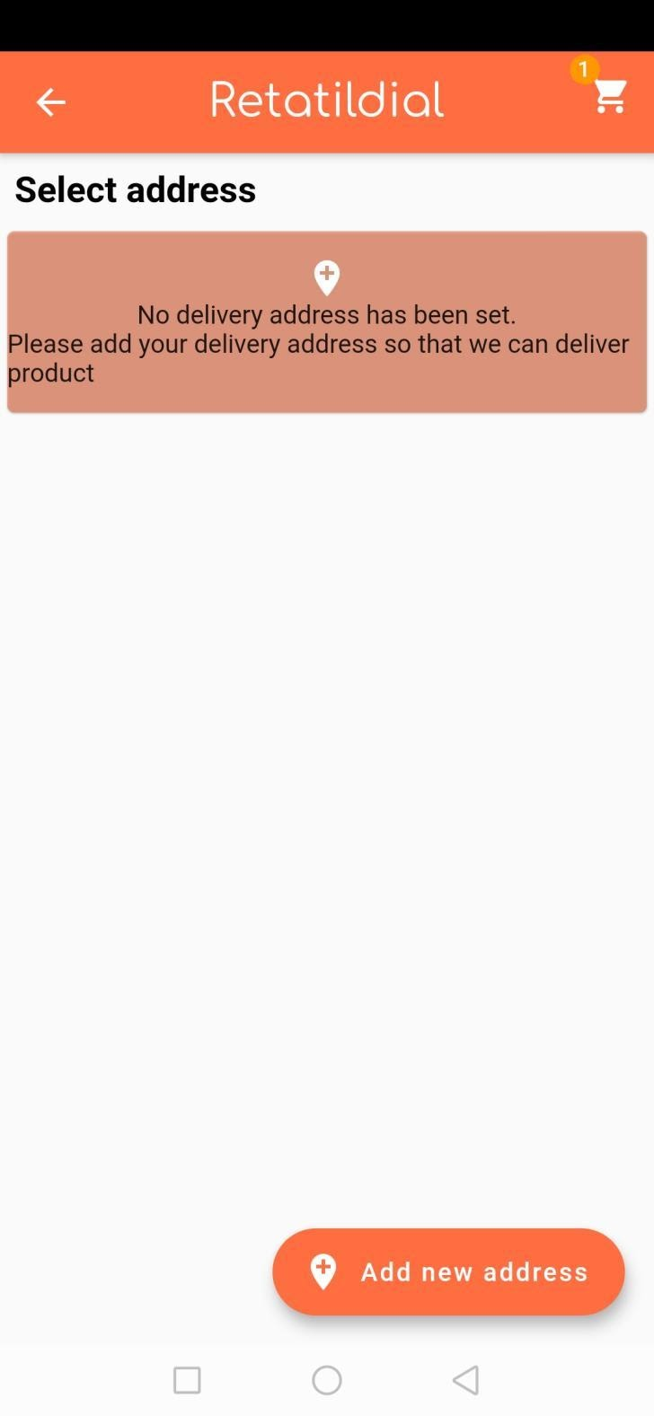
Figure 5-10: Address (Customer End)

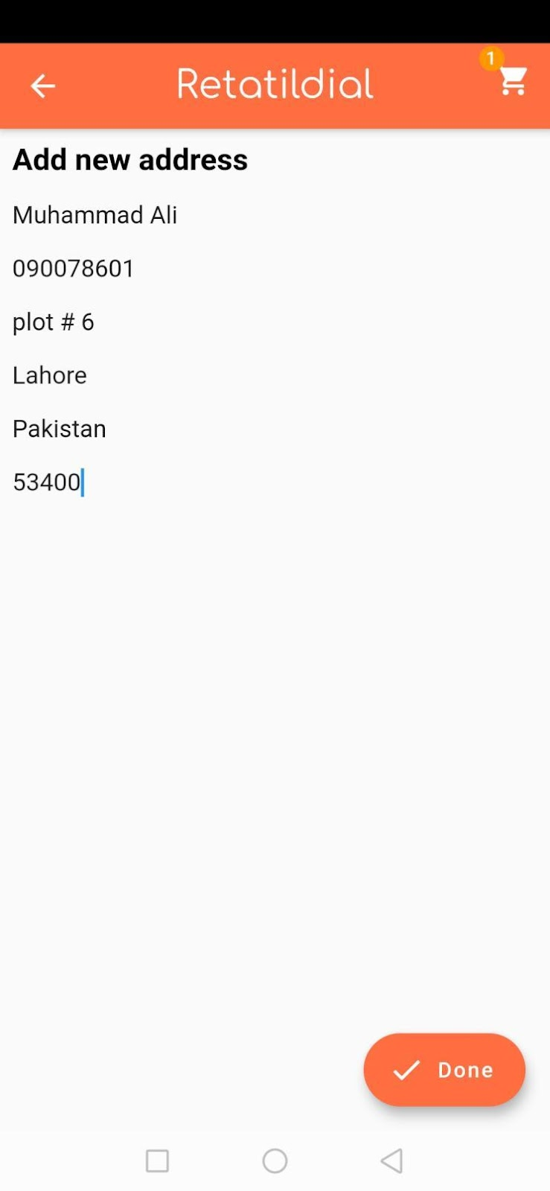

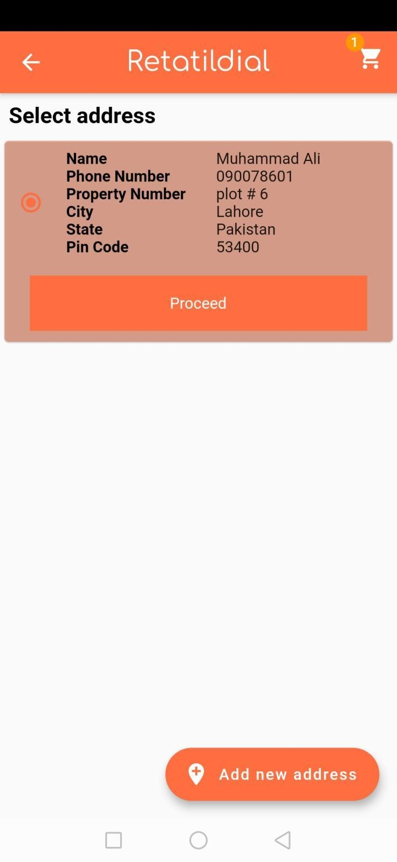

Order Placed Successfully
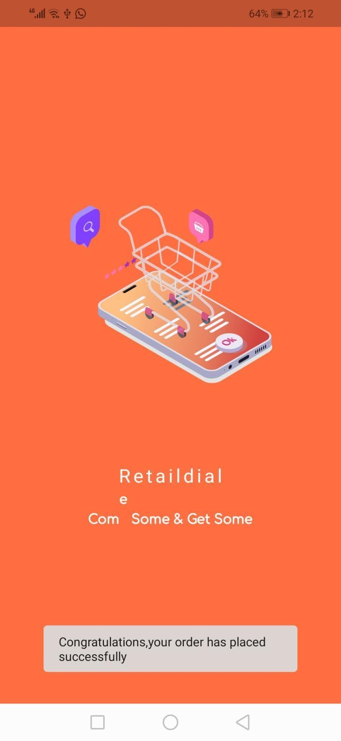
Figure 5-11: Order Placed Successfully

Database

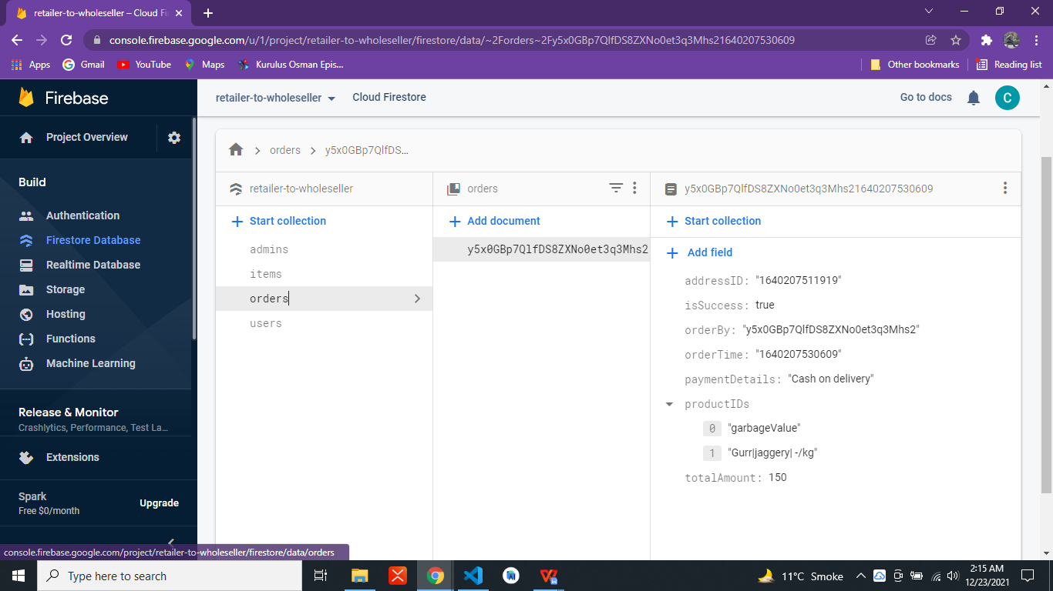

Figure 5-12: Database

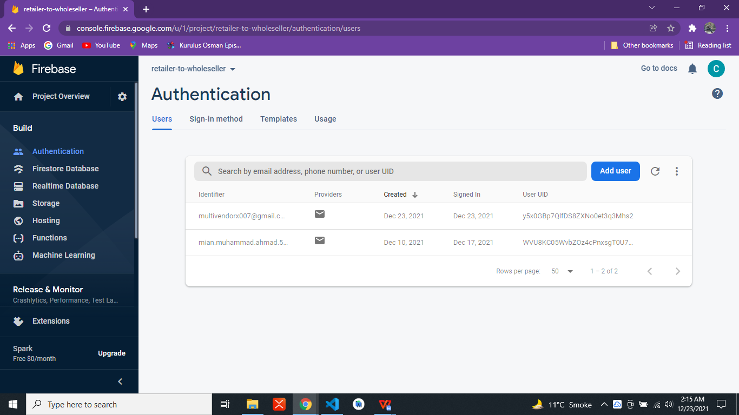
Figure 5-13 Database Authentication

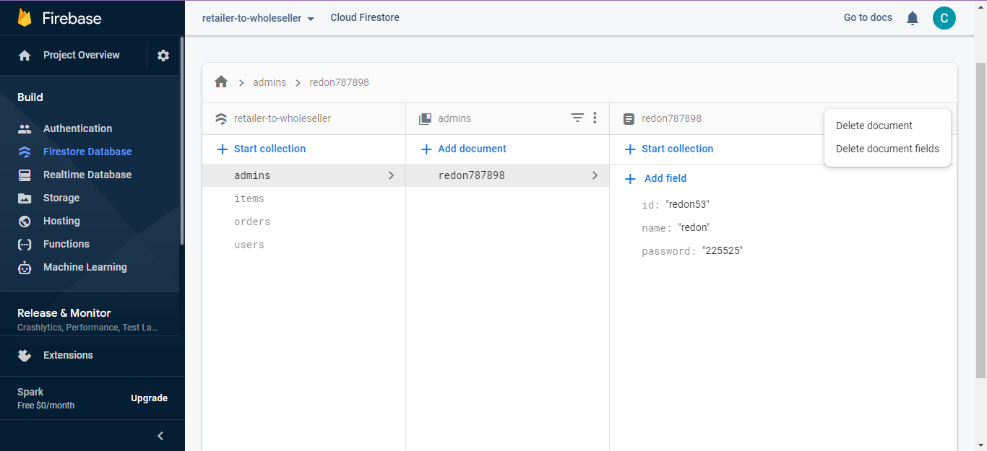
Figure 5-14: Database Admin

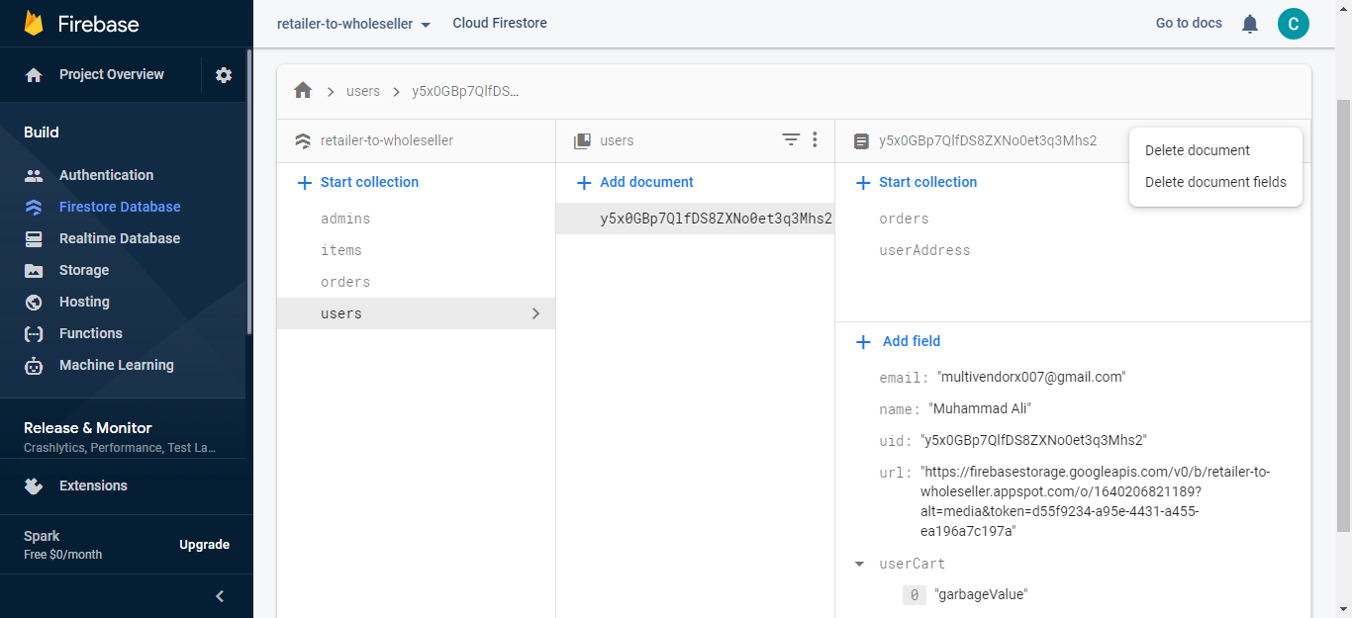
Figure 5-15: Database User

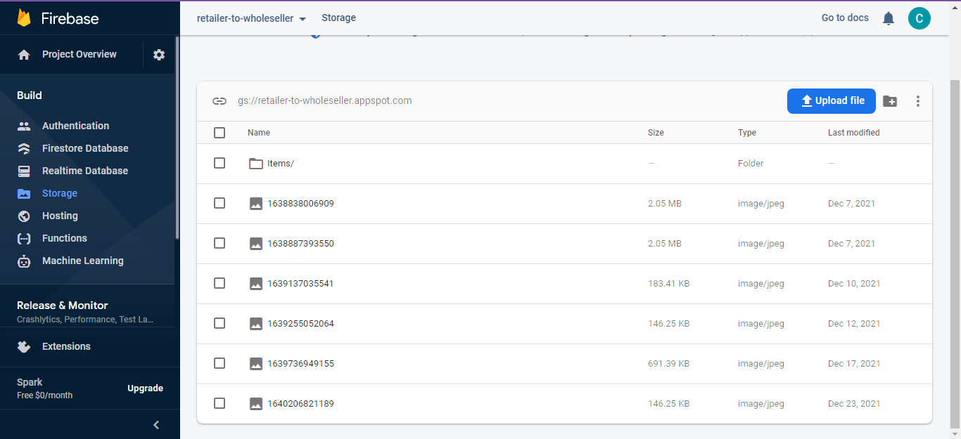
Figure 5-16 Database Storage

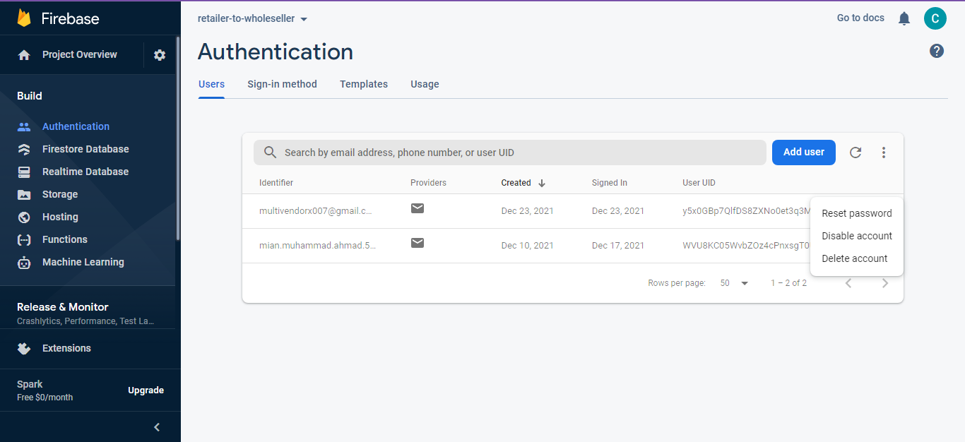
Figure 5-17: Authentication Check

CONCLUSION AND RECOMMENDATIONS

Conclusion
We had certain limitations in our application due to the fact using Flutter Software Development Kit. Flutter currently is not that mature when it comes to its community because finding support for that is a challenge. And as far as the operational limitations of our application are concerned, we are only offering our marketplace to retailers which means we won’t entertain individual customers.
Our motive for this project was to build a marketplace to supercharge the retail supply chain as that is one of largest issues of small retailers. So now, we have achieved the goal that our panel wholesalers can upload their stock/inventory to their app and then the retailers can see that what they must buy and place their order to get their items delivered the very next day at their storefront.

Future Work
In Future, we plan to partner with large brands directly. Moreover, we use our own fleet for logistics so that we can have more control over that part as it is the backbone of the business. We also plan to hire dedicated managers to handle our customers to provide them the best possible experience and collect their valuable feedback to improve our services continuously.
On technical end, we must add some more strict parameters to ensure that customer have the best possible experience with us. We might include some timer thing on the wholesaler end so that no order is delayed. We will add some loyalty points feature as well. Moreover, we might incorporate AI as well to make things more automated.

REFERENCES

Electronic Sources from Internet:
https://dailytimes.com.pk/600117/retail-channels-in-pakistan-changing-trends-and-future-outlook/#:~:text=TRADITIONAL%20KIRYANA%20STORES%20%E2%80%94%20according%20to,retailing%20channel%20in%20the%20country.

