

BSCS-S21-010
03-134181-003 AHMAD RIZWAN
03-134181-005 DANISH ALI

Smart Nurse Finding App

In partial fulfilment of the requirements for the degree of Bachelor of Science in Computer Science

Supervisor: Taimoor Aamer Chughtai

Department of Computer Sciences
Bahria University, Lahore Campus

January 2022

C e r t i f i c a t e

We accept the work contained in the report titled
Smart Nurse Finding App written by
DANISH ALI
AHMAD RIZWAN
as a confirmation to the required standard for the partial fulfilment of the degree of Bachelor of Science in Computer Science.

Approved by:
Supervisor: Taimoor Aamer Chughtai
(Signature)

January 26, 2022

DECLARATION

We hereby declare that this project report is based on our original work except for citations and quotations which have been duly acknowledged. We also declare that it has not been previously and concurrently submitted for any other degree or award at Bahria University or other institutions.

Enrolment | Name | Signature
03-134181-003 | AHMAD RIZWAN
03-134181-005 | DANISH ALI

Date : January 26, 2022

Specially dedicated to my beloved grandmother, mother and father
DANISH ALI
My beloved grandmother, mother and father
AHMAD RIZWAN

ACKNOWLEDGEMENTS

We would like to thank everyone who had contributed to the successful completion of this project. We would like to express our gratitude to my research supervisor, Mr. Taimoor Aamer Chughtai for his invaluable advice, guidance and his enormous patience throughout the development of the research.

In addition, We would also like to express my gratitude to our loving parent and friends who had helped and given me encouragement.

DANISH ALI
AHMAD RIZWAN

Smart Nurse Finding App

ABSTRACT

Human Health is one of the biggest issues in our country, especially in elders. We don’t have any technology that can connect patients with nurses. Although we have dozens of apps that connect patients to doctors for online live consultancy. In this project, we will connect patients with nurses for home care services so that patients can call nurses upon need at their doorstep. We are solving this problem by creating hybrid application that will be used by patients and nurses to connect them to fulfil their needs. Travelling and waste of time are the consequences when patient must physically go to the hospital for the service of nurses. Our technology stack will be Flutter which is a hybrid mobile app development platform developed by Google.

TABLE OF CONTENTS

DECLARATION ii
ACKNOWLEDGEMENTS iii
ABSTRACT v
TABLE OF CONTENTS 1
1 INTRODUCTION 5
1.1 Background 5
1.2 Problem Statements 5
1.3 Aims and Objectives 6
1.4 Scope of Project 6
1.4.1 Primary Scope 6
1.4.2 Final Deliverable of the Project and Beneficiaries 6
1.4.3 Optional Scope 7
2 LITERATURE REVIEW (and/or SRS) 8
2.1 User Classes and Characteristics 8
2.2 Operating Environment 9
2.3 Design and Implementation Constraints 9
2.4 Assumptions and Dependencies 9
2.5 System Use Case 10
2.5.1 Nurse Registration(U1) 12
2.5.2 Nurse Registration(U2) 13
2.5.3 User Registration(U3) 14
2.5.4 Patient Set Request(U4) 15
2.5.5 Nurse will Go Online (U5) 16
2.5.6 Nurse Will Accept Request (U6) 17
2.5.7 Nurse Cancel Request (U7) 18
2.5.8 Admin Delete Account (U8) 19
2.5.9 Admin Suspend Account (U8) 20
2.6 Other Non-functional Requirements 21
2.6.1 Performance Requirements 21
2.7 Software Quality Attributes 21
2.7.1 Reliability 21
2.7.2 Availability 21
2.7.3 Maintainability 22
3 DESIGN AND METHODOLOGY 22
3.1 Sequence Diagrams 22
3.1.1 Login Web Patients 23
3.1.2 Nurse Login 24
3.1.3 Register Patients 25
3.1.4 Register Nurse 26
3.1.5 Search Nurse 27
3.2 Entity Relationship Diagram 28
3.3 Data Gathering 29
3.4 Methodology 29
4 DATA AND EXPERIMENTS (and/or IMPLMENTATION) 30
4.1 Tools and Technologies 30
5 RESULTS AND DISCUSSIONS (or USER MANUAL) 31
5.1 Main Login Page 31
5.2 After Login 32
5.3 Go Offline 34
5.4 New Request 35
5.5 Nurse Arrived 36
5.6 Start Session 37
5.7 End the Session 38
5.8 Sign In (Patient) 39
5.9 Main Page 41
5.10 Set Desired Location 42
5.11 Finding Nurse 43
5.12 Database 44
6 CONCLUSION AND RECOMMENDATIONS 45
6.1 Conclusion 45
6.2 Future Work 45
REFERENCES 46

LIST OF FIGURES

FIGURE TITLE PAGE
Figure 1: System Use Case 10
Figure 2: Admin 11
Figure 3: Login Web Page 23
Figure 4: Nurse Login 24
Figure 5: Register Patient 25
Figure 6: Register Nurse 26
Figure 7: Search Nurse 27
Figure 8: Entity Relationship Diagram 28
Figure 9 : Main Login Page 31
Figure 10: After login 33
Figure 11: Go Offline 34
Figure 12 :New Request 35
Figure 13: Nurse Arrived 36
Figure 14: start Session 37
Figure 15: End-The Session 38
Figure 16: Sign In (Patient) 39
Figure 17: Logging In 40
Figure 18: Main Page 41
Figure 19: Set Desired Location 42
Figure 20: Insert Caption 43
Figure 21: Authentication 44

CHAPTERS
CHAPTER 1

1 INTRODUCTION

1.1 Background

There exist no such application that connects patients with nurses. Late treatment can be risky for the patient’s health. It’s quite difficult for the older patient to especially go to the hospital for the daily routine check-up, there could be many reasons behind this.
There might be no one to accompany the patient in the hospital and the hospital could be far away from the patient’s home. Even if someone is available with the patient, it's time taking to get ready and reach the hospital and come back.

1.2 Problem Statements

Homecare services are the demand of the hour for patients. Currently there are no application available for this type of service. It is obvious for even any layman that this is the need of the hour. Patients must go through many difficulties just to get treatment that even a nurse provides easily and the services that don’t even take much time.
The objective of this application is to provide a platform that connect the patients with the nurses for service like daily check-up. The patient can book a nurse for its services and don’t have to visit the hospital in person, which will save them both time and traveling issues. The technology that we will be working on this application will be flutter. The reason that we are using this software is because it is a hybrid development responsive platform.

1.3 Aims and Objectives
- To provide patients home-service
- To enable people to get home services for their loved ones even if they are away
- To empower nurses by connecting them with patients.

The objectives of the thesis are shown as following:
- Patients must get home services.
- Person can get daily check-up of their loved ones even when they are away from home.
- Nurse can register on the application.
- Application must show only the nearby nurses that are available or according to the location that is provided.

1.4 Scope of Project

Primary Scope is defined below:

1.4.1 Primary Scope
- Connect patient with nurse
- Patient don’t need to visit hospital daily

1.4.2 Final Deliverable of the Project and Beneficiaries
- It is a mobile (android/iOS) app.
- End users of product will be patients or user who need nursing services and off course nurses.

1.4.3 Optional Scope
• Mobile Application to seek doctor.

CHAPTER 2

2 LITERATURE REVIEW (and/or SRS)

2.1 User Classes and Characteristics

The user are of three types:
- Admin
- Patient - End user • Nurse - End user

Administrator – Administrator can perform following actions:
- Delete both end user (patient/nurse).
- Suspend both end users (patient nurse).
- Can monitor their requests.
Patient– Patient can perform following actions:
- Register
- Login
- Request/Find Nurse near him • Set his/her location.
- See nurse approaching her on map

Nurse– Nurse can perform following actions:
- Register
- Login
- Get patient request (via notification)
- See her location corresponding to him/her.

2.2 Operating Environment

Operating Environment for app:
- Operating System: android / iOS
- Firebase database

2.3 Design and Implementation Constraints

This application system is smart enough to connect nearby nurses to the patients or users of this app who need them. This system going to consist on two mobile application one is for patients who can set their location and can the press on find to get the nearby nurses available who have registered on their own app.
Both patient and nurse first needs to register on the app then they are free to connect to their near by ones on their will.

2.4 Assumptions and Dependencies

Assumptions and dependencies:
- PC with any operating system supporting android studio and vscode with flutter sdk installation
- Flutter sdk 2.0.x should be installed
- Working internet connection.
- And an android emulator or an android device for testing application.

2.5 System Use Case

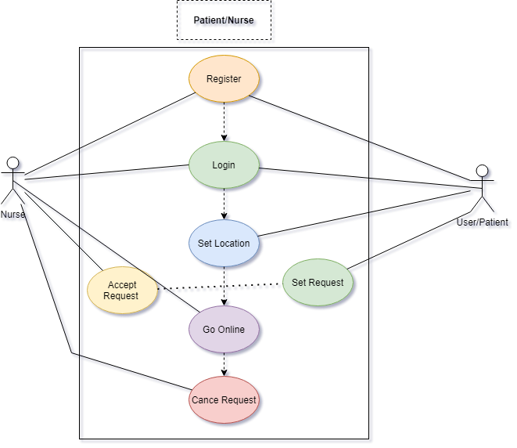
Figure 1: System Use Case

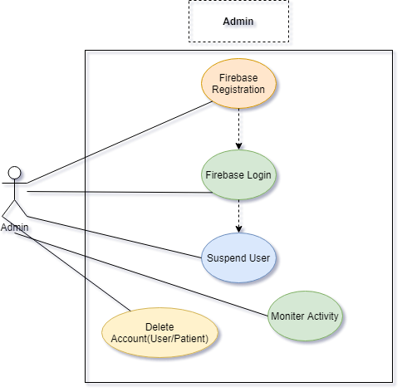
Figure 2: Admin

2.5.1 Nurse Registration (U1)

 | Name | Nurse Registration
1. | Use-Case ID | UCRD001
2. | Objective | Nurse will be registered to application
3. | Priority | High
1. | Source | Developer
2 | Actors | Patient
3 | Flow of Events | User/Nurse will enter credentials to get registered.
4 | Basic Flow | After entering correct information Nurse will get registered and app main page will be opened.
5 | Alternate Flow(s) | Otherwise, error message will be shown
6 | Preconditions | Must be connected to internet

2.5.2 Nurse Registration (U2)

 | Name | Nurse Registration
1. | Use-Case ID | UCRD002
2. | Objective | Nurse will be registered to application
3. | Priority | High
1. | Source | Developer
2 | Actors | Patient
3 | Flow of Events | User/Nurse will enter credentials to get registered.
4 | Basic Flow | After entering correct information Nurse will get registered and app main page will be opened.
5 | Alternate Flow(s) | Otherwise, error message will be shown
6 | Preconditions | Must be connected to internet

2.5.3 User Registration (U3)

 | Name | Patient Registration
1. | Use-Case ID | UCRD003
2. | Objective | Setting patient location to get nurse. To get nearby nurse
3. | Priority | High
1. | Source | Developer
2 | Actors | Patient
3 | Flow of Events | Patient will tap on search button and then will be taken to search location screen.  >Enter Desired Location  >Select Matched from list.
4 | Basic Flow | After successful setting location, patient will be taken back to home screen and
5 | Alternate Flow(s) | Otherwise, error message will be shown
6 | Preconditions | Must be connected to internet

2.5.4 Patient Set Request (U4)

 | Name | Patient Set Request
1. | Use-Case ID | UCRD004
2. | Objective | Setting Request to get nurse
3. | Priority | High
1. | Source | Developer
2 | Actors | Patient
3 | Flow of Events | >Set Location  >On setting location will go back to main screen with a tab showing Request Button  >Press Button  >Request will set settled to firebase Real-time database.
4 | Basic Flow | After successful setting location, patient will be taken back to home screen and
5 | Alternate Flow(s) | There is no alternate way
6 | Preconditions | Must be connected to internet and location should be settled first.

2.5.5 Nurse will Go Online (U5)

 | Name | Patient Go Online
1. | Use-Case ID | UCRD005
2. | Objective | Setting Online Status On Firebase Database
3. | Priority | High
1. | Source | Developer
2 | Actors | Nurse
3 | Flow of Events | >Get Registered Or get logged in.  >Tab Go Online Button on Homepage  >Press Confirm button on dialog box
4 | Basic Flow | After getting online user /nurse will go online and  Button will get green coloured with title to Go  Offline
5 | Alternate Flow(s) | There is no alternate way
6 | Preconditions | Must be connected to internet.

2.5.6 Nurse Will Accept Request (U6)

 | Name | Nurse Accept Request
1. | Use-Case ID | UCRD006
2. | Objective | Accepting the Patient Request.
3. | Priority | High
1. | Source | Developer
2 | Actors | Nurse
3 | Flow of Events | >Go Online  >On Request dialogue.  >Press Accept button to accept request.
4 | Basic Flow | After accepting request nurse will go back to main page with update his/her and patients’ location
5 | Alternate Flow(s) | There is no alternate way
6 | Preconditions | Must be connected to internet. And should be in online status.

2.5.7 Nurse Cancel Request (U7)

 | Name | Nurse Cancel Request
1. | Use-Case ID | UCRD7
2. | Objective | Cancelling the Patient Request.
3. | Priority | High
1. | Source | Developer
2 | Actors | Nurse
3 | Flow of Events | >Go Online  >On Request dialogue.  >Press Cancel button to accept request.
4 | Basic Flow | After cancelling request nurse will go back to main page.
5 | Alternate Flow(s) | There is no alternate way
6 | Preconditions | Must be connected to internet. And should be in online status.

2.5.8 Admin Delete Account (U8)

 | Name | Admin Delete Account
1. | Use-Case ID | UCRD8
2. | Objective | Deleting the patient or Nurse account on need
3. | Priority | High
1. | Source | Developer
2 | Actors | admin
3 | Flow of Events | >Go to firebase console  >Select User  >Press Delete Option
4 | Basic Flow | After deleting user will no longer show in database and will not be able to get logged in
5 | Alternate Flow(s) | There is no alternate way
6 | Preconditions | Must be logged in as a firebase database user having nursing project.

2.5.9 Admin Suspend Account (U8)

 | Name | Admin Suspend Account
1. | Use-Case ID | UCRD8
2. | Objective | Suspend the patient or Nurse account on need
3. | Priority | High
1. | Source | Developer
2 | Actors | admin
3 | Flow of Events | >Go to firebase console  >Select User  >Press Suspend Option
4 | Basic Flow | After suspending user will no longer able to login,
5 | Alternate Flow(s) | There is no alternate way
6 | Preconditions | Must be logged in as a firebase database user having nursing project.

2.6 Other Non-functional Requirements

Following are the non-functional requirements of this nurse finding app:

2.6.1 Performance Requirements

There are not such high-end requirements for this app, you just need a god internet connect with location services on and a device having minimum of 2 GB of ram and provided processor.

2.7 Software Quality Attributes

2.7.1 Reliability

Until unless device is connected to working internet connection and location services are on, application services not going to fail at all.

2.7.2 Availability

This application is available for both android and iOS devices. And user can use it any time on the hour of need.

2.7.3 Maintainability

Developer will maintain the app in future to ensure it is working ideally as it is supposed to.

CHAPTER 3

3 DESIGN AND METHODOLOGY

3.1 Sequence Diagrams

Sequence diagrams describe interactions among classes in terms of an exchange of messages over time. They're also called event diagrams. A sequence diagram is a good way to visualize and validate various runtime scenarios. These can help to predict how a system will behave and to discover responsibilities a class may need to have in the process of modelling a new system.
Following are the sequence diagrams of face recognition based attendance system:
- Login Patient
- Login Nurse
- Register Patient
- Register Nurse
- Search Location/Set Location

3.1.1 Login Web Patients
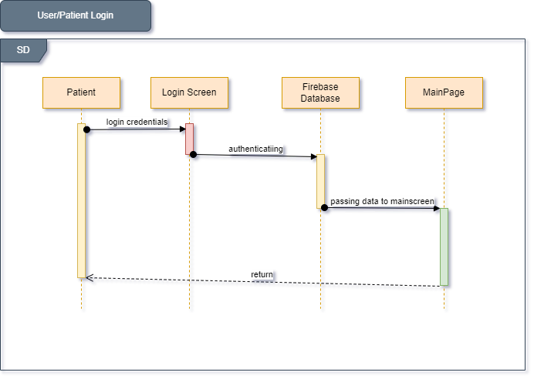
Figure 3: Login Web Page

3.1.2 Nurse Login

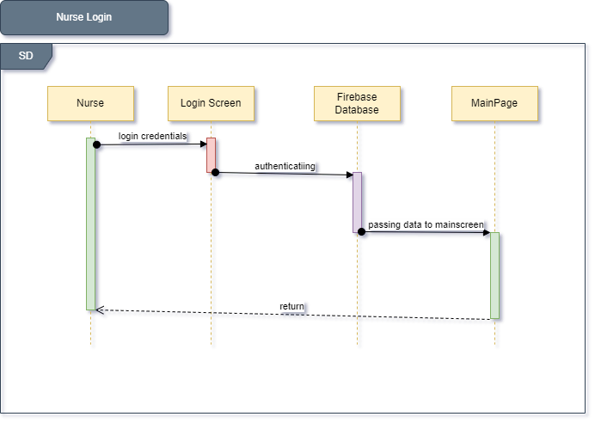
Figure 4: Nurse Login

3.1.3 Register Patients
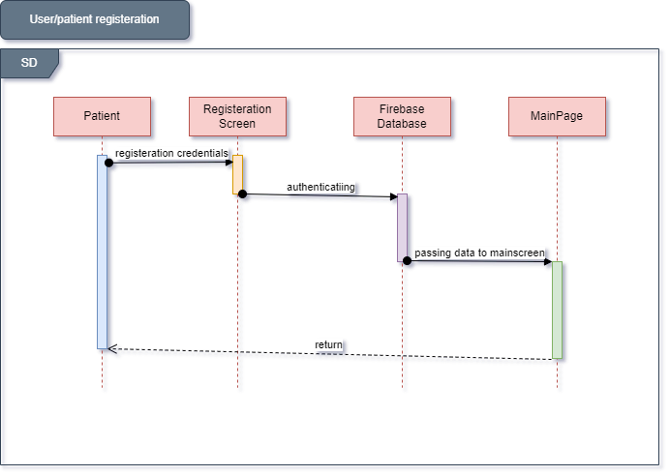
Figure 5: Register Patient

3.1.4 Register Nurse
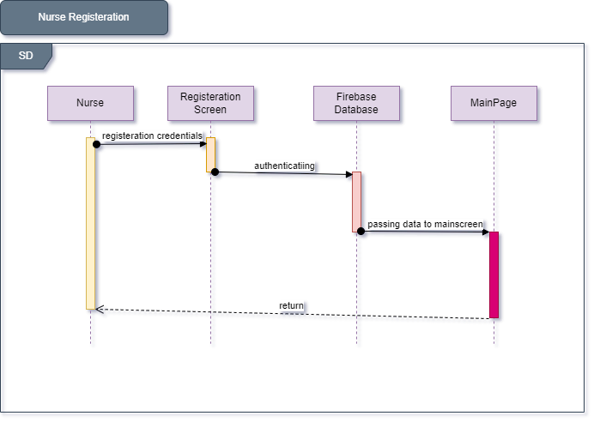
Figure 6: Register Nurse

3.1.5 Search Nurse
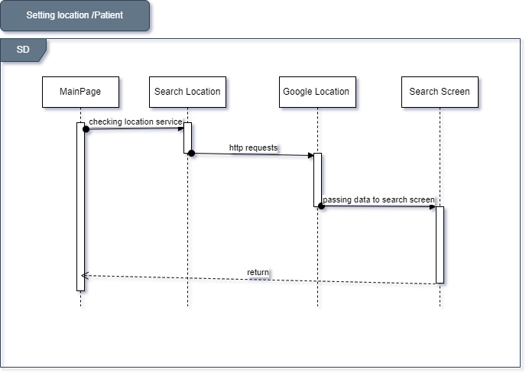
Figure 7: Search Nurse

3.2 Entity Relationship Diagram

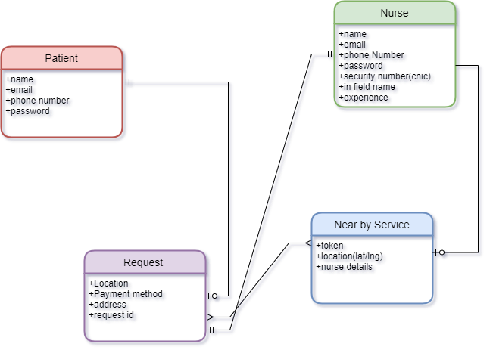
Figure 8: Entity Relationship Diagram

3.3 Data Gathering

There was no need to gather such that, all the demo data is entered by developer.

3.4 Methodology
As Agile development is particularly effective with large, complex, creative projects. And we are going to develop a market analyzing app which will be connected to firebase database, So Agile is the right choice. Agile is lightweight. It allows for changes in vision, or even for improving upon what already exists as new information develops. Agile reduces risk. Since it encourages open communication between the client and project managers, Agile is great for those who value transparency. Agile can adapt to the market. Did something change in your industry halfway through the development process? We can update your site to reflect that!
Agile allows for client involvement. Many clients feel more comfortable knowing they, as stakeholders in the success of the project, can help craft their vision.

CHAPTER 4

4 DATA AND EXPERIMENTS (and/or IMPLMENTATION)

4.1 Tools and Technologies
The tools and technologies used to develop this application were as follows:

- Flutter SDK
- Android SDK
- Visual Studio Code
- Geolocator
- Google Maps
- Geofire

CHAPTER 5

5 RESULTS AND DISCUSSIONS (or USER MANUAL)

5.1 Main Login Page

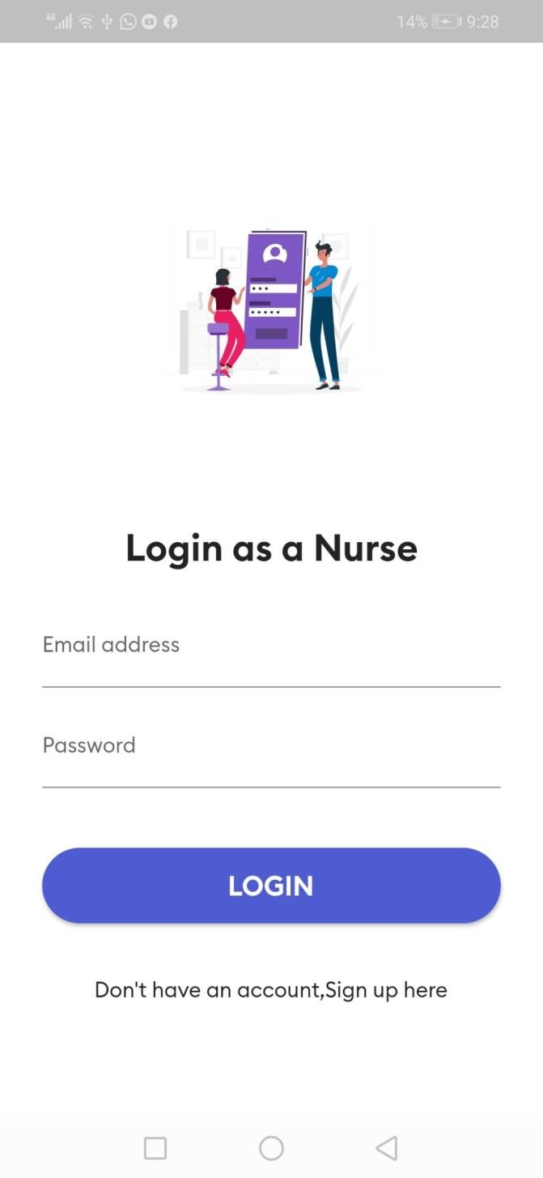
Figure 9 : Main Login Page

5.2 After Login
The nurse has logged in now but is offline. To go online, they have to click the GO ONLINE button.
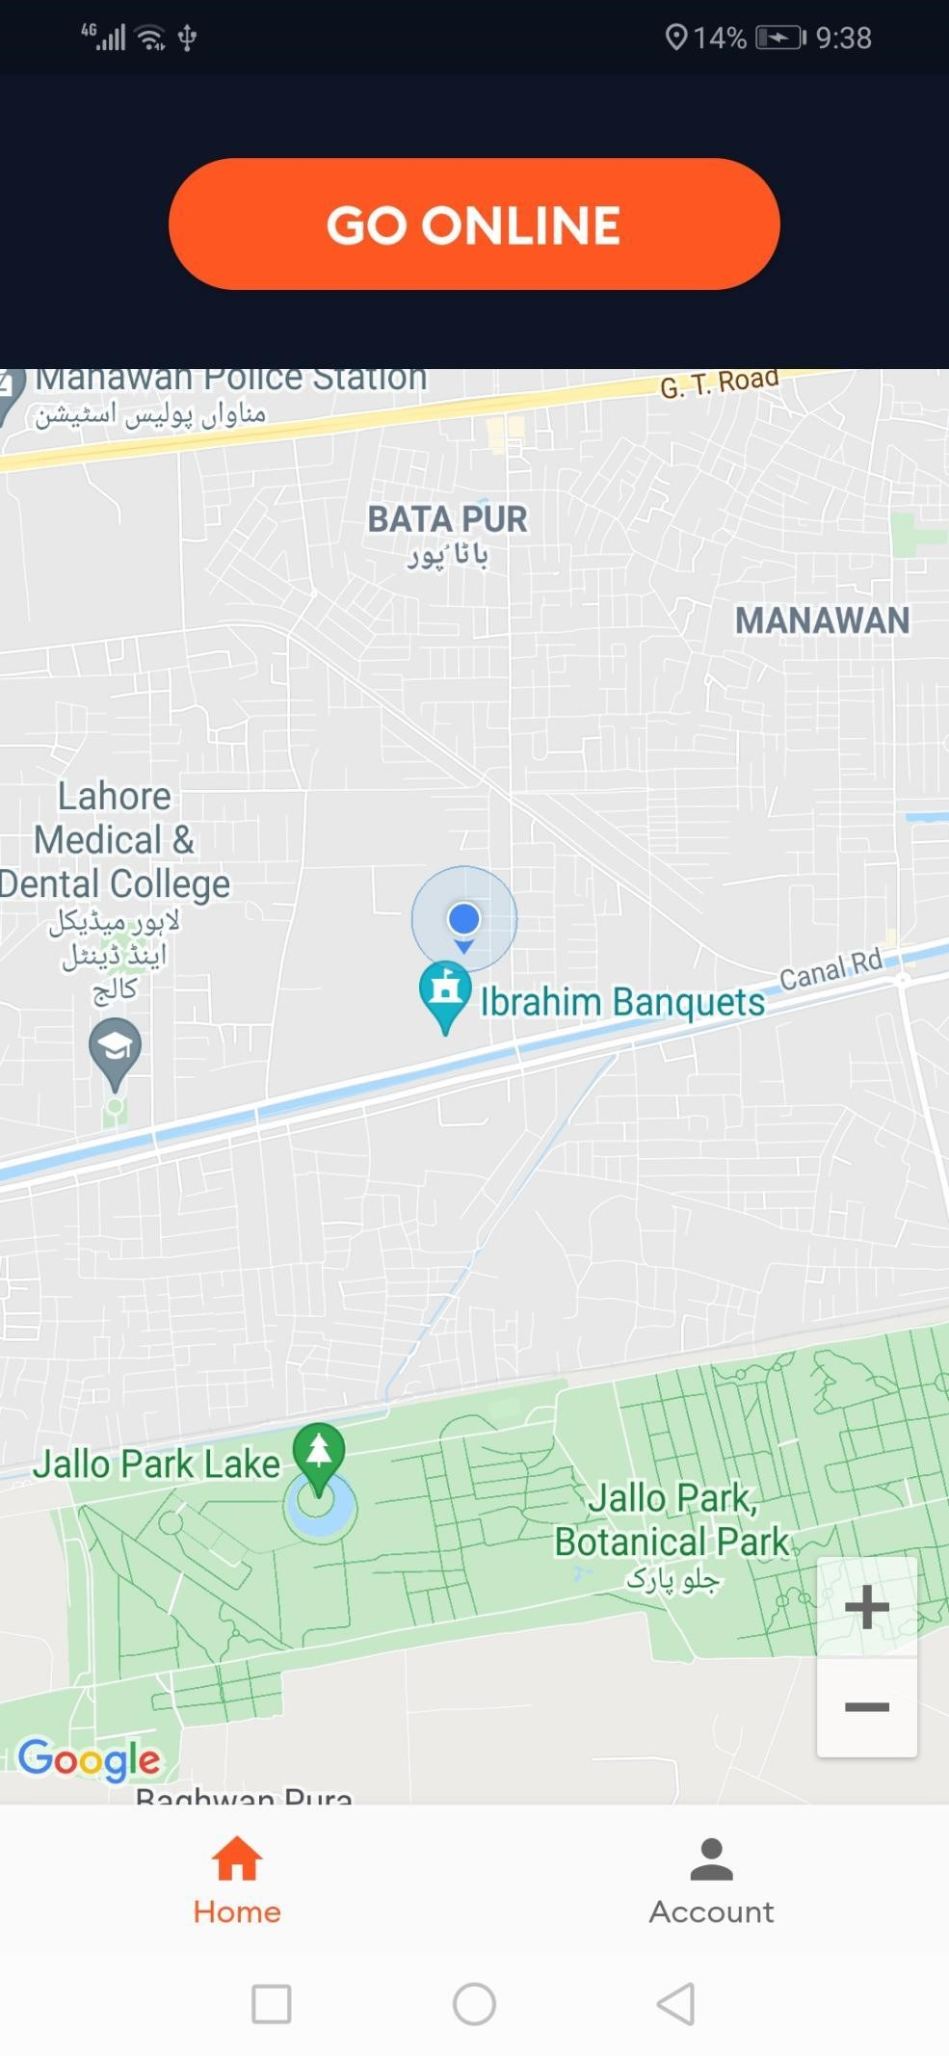
Figure 10: After login

5.3 Go Offline
Nurse is ONLINE. To go offline, they will have to click GO OFFLINE
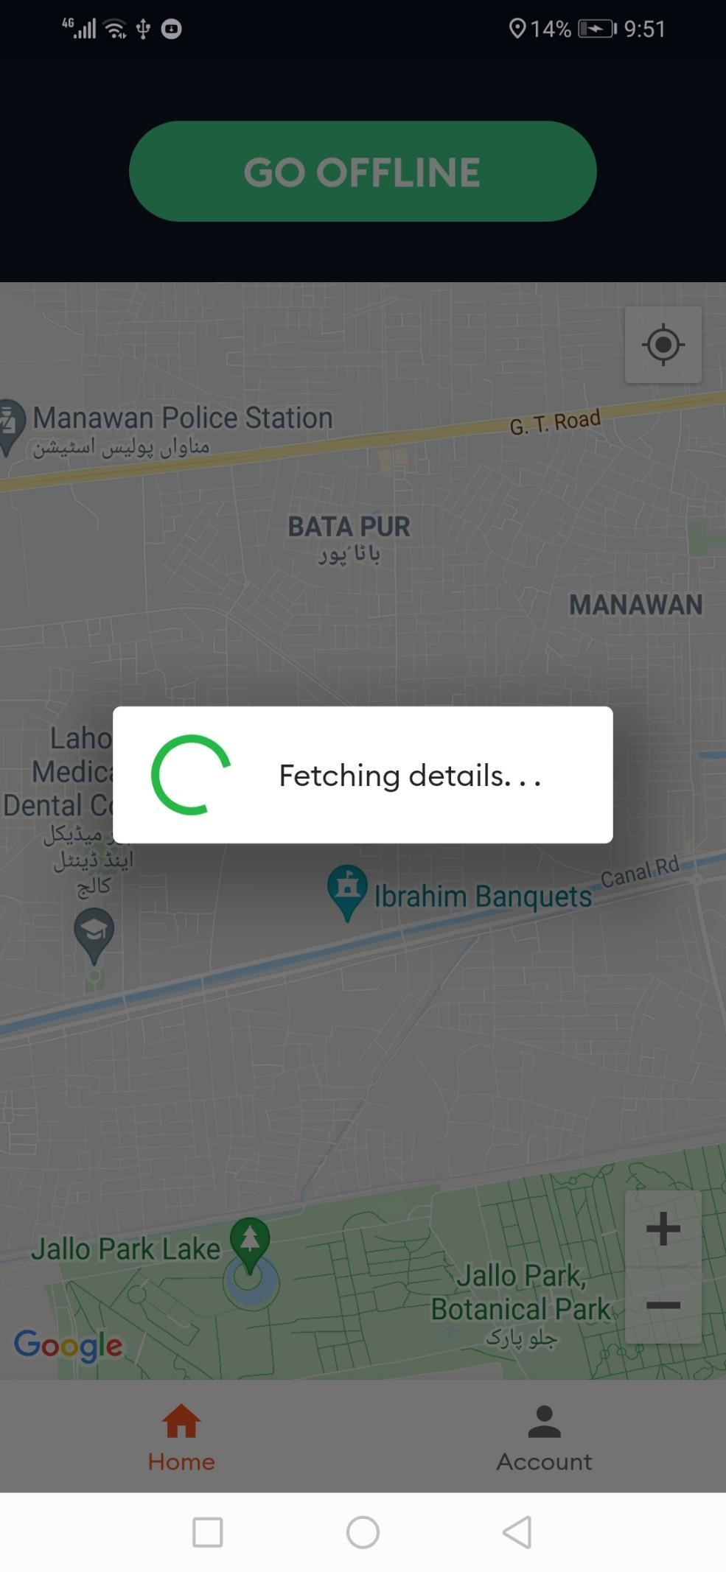
Figure 11: Go Offline

5.4 New Request
When the customer/patient will book the service, nurse will see this interface
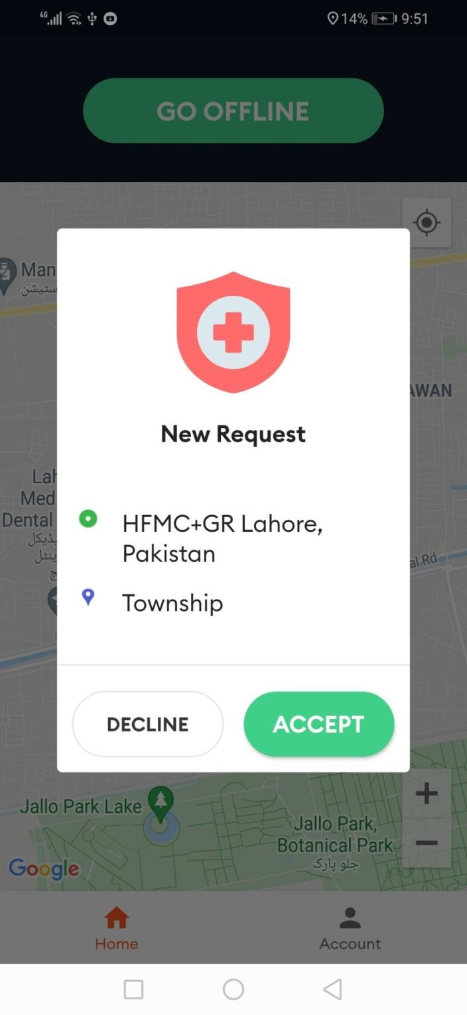
Figure 12 : New Request
5.5 Nurse Arrived
Once the nurse has arrived the designated location. They will see this interface and can click Arrived to let the patient know that the nurse has arrived. 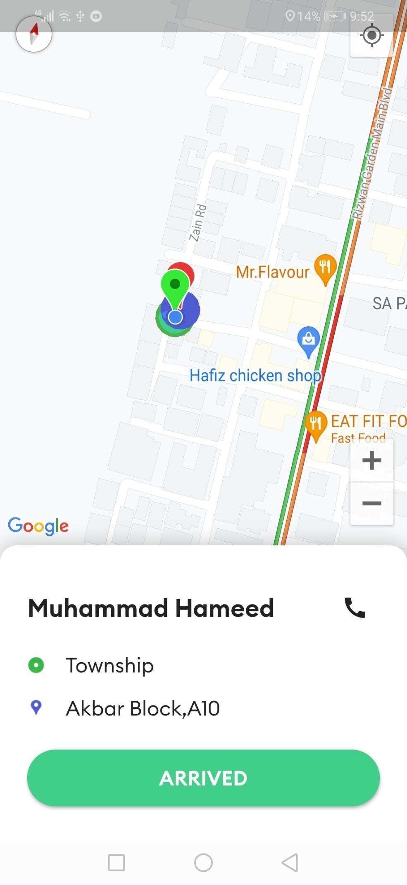
Figure 13: Nurse Arrived

5.6 Start Session
Once the patient is connected to the nurse, then the nurse can click start session to start the service.

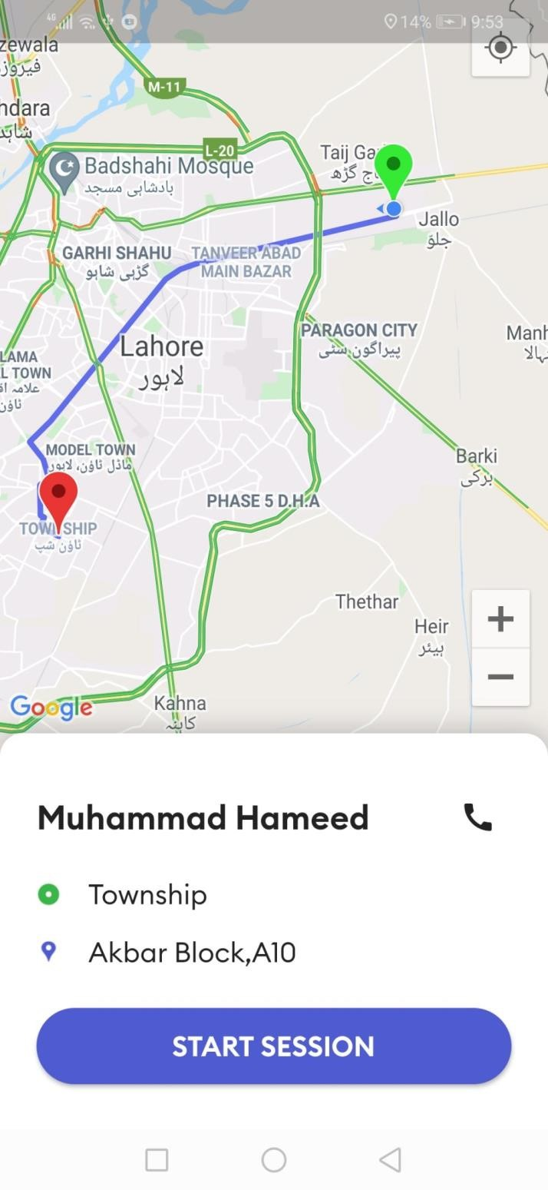
Figure 14: start Session

5.7 End the Session
Once the service has been provided, then the nurse has the option to end the session
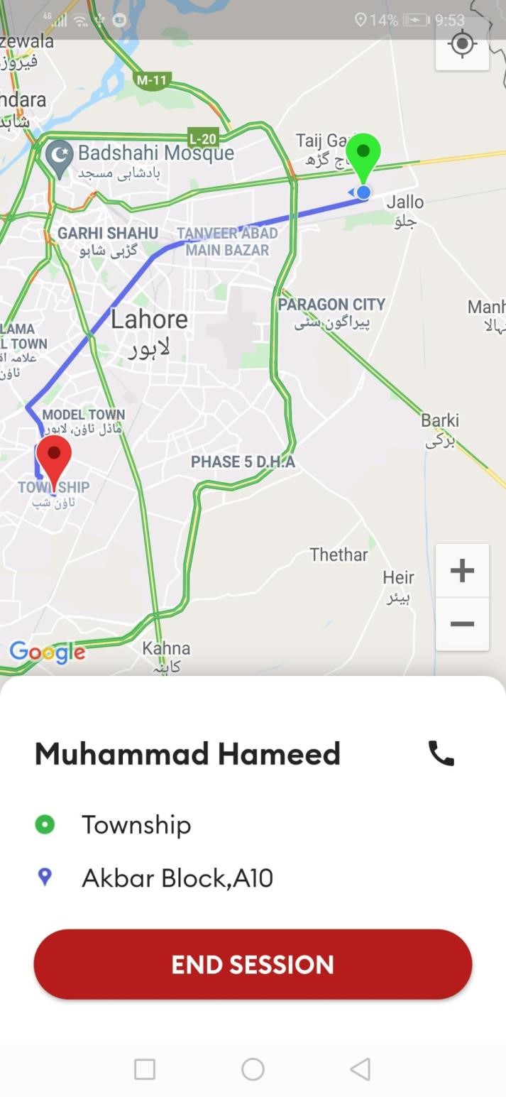
Figure 15: End-The Session

5.8 Sign In (Patient)
Patient interface to sign in

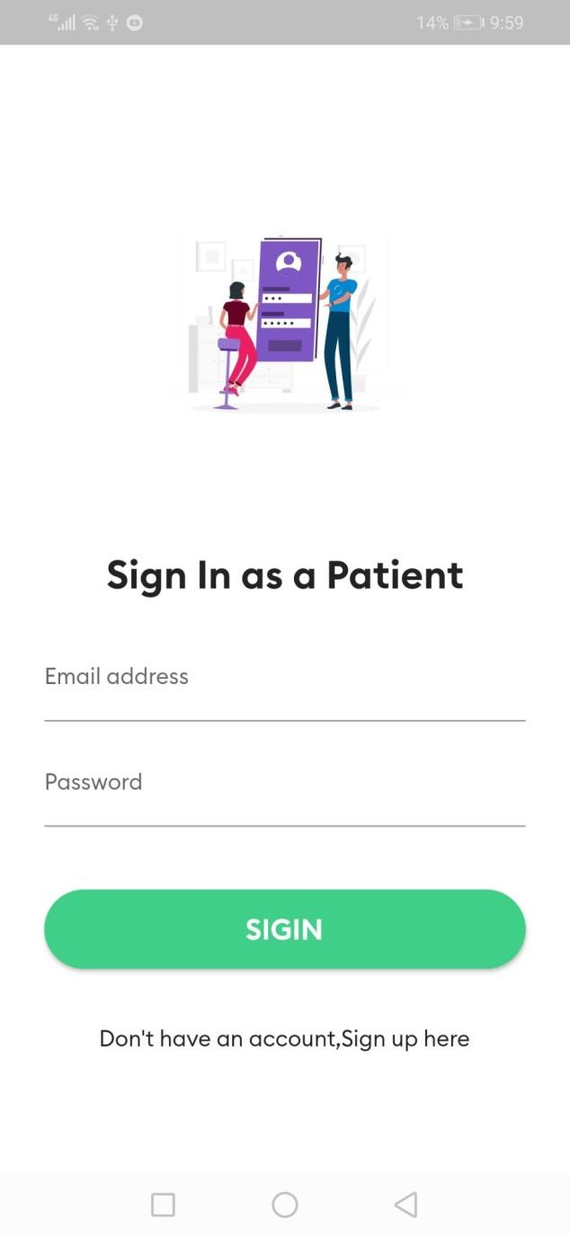
Figure 16: Sign In (Patient)

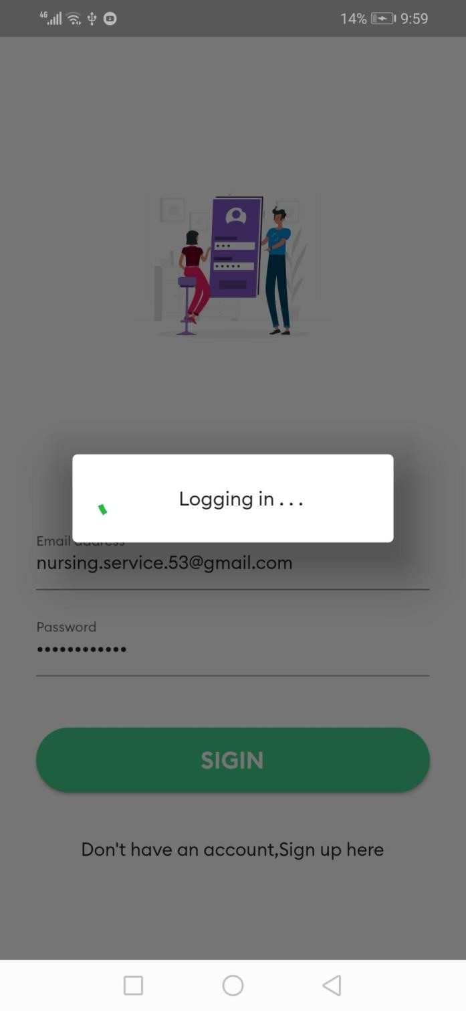
Figure 17: Logging In

5.9 Main Page
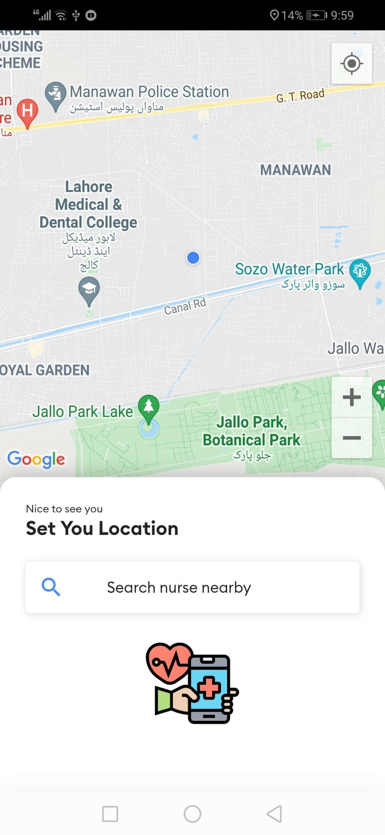
Figure 18: Main Page

5.10 Set Desired Location
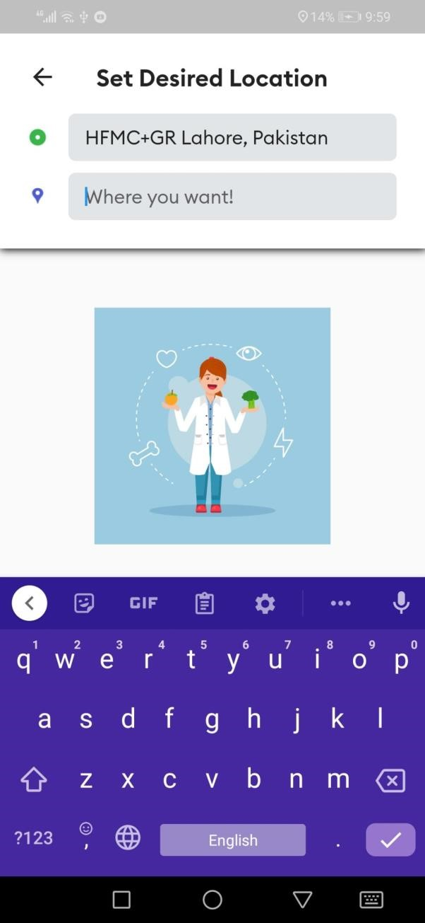
Figure 19: Set Desired Location

5.11 Finding Nurse
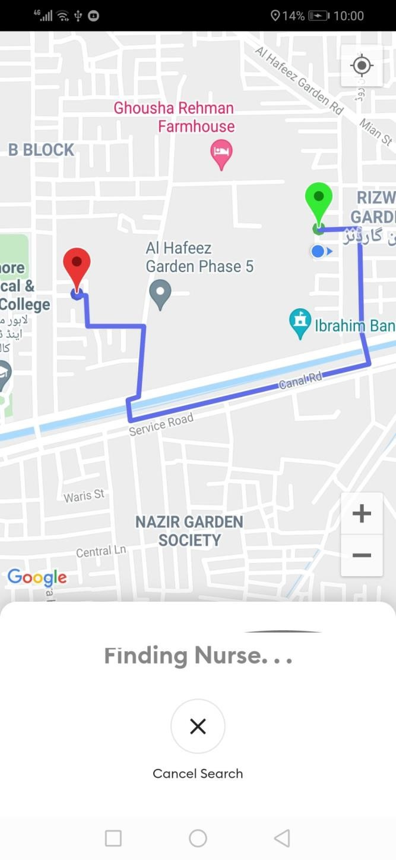
Figure 20: Insert Caption

5.12 Database
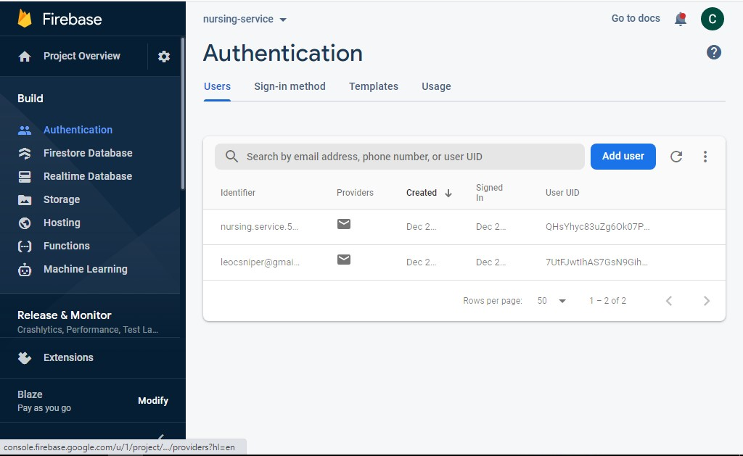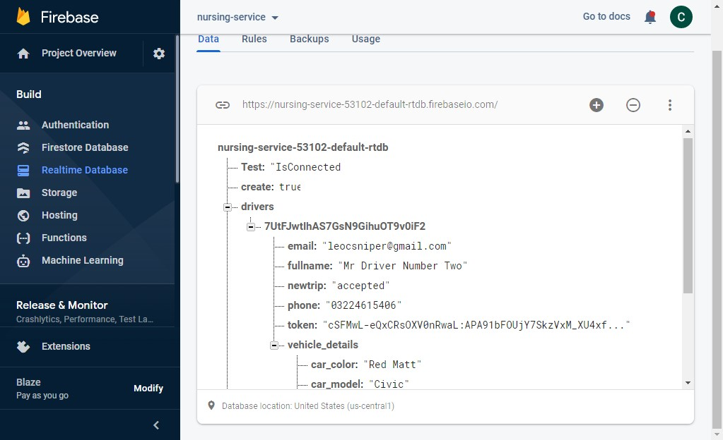
Figure 21: Authentication

CHAPTER 6

6 CONCLUSION AND RECOMMENDATIONS

6.1 Conclusion
Our application has certain limitations such as that we entertain individual people and are currently not open to work for laboratories or private hospitals. Limitation with Flutter SDK is that due to being new development kit, its community is not that large so getting support is difficult. Whenever we faced an error or an issue, we had to spend ample amount of time to get them resolved.
The motive to start this project was to fill the gap in this space where we don’t have a proper service like that. Our app will now empower thousands of nurses by connecting them with the patients who desperately need them.
As of now, we have successfully achieved the goal of developing this application.

6.2 Future Work
As our initial plan was to start from one and only city but moving forward, we have to cater more cities, increase our user base by leveraging marketing channels. Moreover, we will offer good incentives to onboard more nurses to our system. Also we will incorporate AI in our application.

6 REFERENCES
- “Install,” Flutter.dev. [Online]. Available: https://docs.flutter.dev/getstarted/install. [Accessed: 03-Jan-2022].

- “Flutter documentation,” Flutter.dev. [Online]. Available:
https://docs.flutter.dev/. [Accessed: 03-Jan-2022].

The Net Ninja, “Flutter tutorial for beginners.” [Online]. Available:
- https://youtube.com/playlist?list=PL4cUxeGkcC9jLYyp2Aoh6hcWuxFDX6PBJ. [Accessed: 03-Jan-2022].

- Flutter crash course for beginners 2021 - build web iOS & android app with Google’s flutter 2 & dart. 2021.

- “Geolocator,” Dart packages. [Online]. Available:
https://pub.dev/packages/geolocator. [Accessed: 03-Jan-2022].

- “Flutter_geofire,” Dart packages. [Online]. Available:
https://pub.dev/packages/flutter_geofire. [Accessed: 03-Jan-2022].

- “Google_maps_flutter,” Dart packages. [Online]. Available:
https://pub.dev/packages/google_maps_flutter. [Accessed: 03-Jan-2022].

