
BSIT-F20-007
03-135172-043 | ZEESHAN AHMAD
03-135172-042 | UMAIR SHABBIR

Health Assist

In partial fulfilment of the requirements for the degree of
Bachelor of Science in Information Technology
Supervisor: Asghar Ali Shah

Department of Computer Sciences
Bahria University, Lahore Campus
July 2021

© Bahria University, 2021

Certificate

We accept the work contained in the report titled
“Health Assist”
written by
ZEESHAN AHMAD
UMAIR SHABBIR

as a confirmation to the required standard for the partial fulfilment of the degree of
Bachelor of Science in Information Technology.

Approved by:
Supervisor: Asghar Ali Shah
(Signature)

July, 2021

DECLARATION

We hereby declare that this project report is based on our original work except for citations and quotations which have been duly acknowledged. We also declare that it has not been previously and concurrently submitted for any other degree or award at Bahria University or other institutions.

Enrolment | Name | Signature
03-135172-043 | ZEESHAN AHMAD
03-135172-042 | UMAIR SHABBIR

Date: July 27, 2021

Specially dedicated to
my beloved grandmother, mother and father
(ZEESHAN AHMAD)
my beloved grandmother, mother and father
(UMAIR SHABBIR)

ACKNOWLEDGEMENTS

We would like to thank everyone who had contributed to the successful completion of this project. We would like to express my/our gratitude to my research supervisor, Mr Asghar Ali Shah for his invaluable advice, guidance and his enormous patience throughout the development of the research.

In addition, we would also like to express my gratitude to our loving parent and friends who had helped and given me encouragement.

ZEESHAN AHMAD
UMAIR SHABBIR

Health Assist

ABSTRACT

Health Assist is an application that allow user to maintain good health by using the information provided by user it recommends diet plans. It also provides an interface for the user to calculate the body Mass Index (BMI) when the user enters the details in the BMI module it will tell the user its BMI and it will also tell the user if he/she is overweight, average weight or underweight furthermore the app also provides the pedometer that will sync with the hardware of the phone and will tell the exact step count of the user it will also tell the user how much calories he has burned and total distance that he has covered.

Health Assist Also provide user a generic calories calculator grid that have all the major food item when the user selects the food item the interface will show the total calories of the items selected. These features will motivate and engage the users to have a better weight control and planning.

TABLE OF CONTENTS

DECLARATION ii
ACKNOWLEDGEMENTS iv
ABSTRACT v
TABLE OF CONTENTS vi

CHAPTERS
1 INTRODUCTION 1
1.1 Background 1
1.2 Problem Statements 1
1.3 Aims and Objectives. 2
1.4 Scope of Project 2
2 SOFTWARE REQUIREMENT SPECIFICATION (SRS) 3
2.1 User Classes and Characteristics 3
2.2 Operating Environment 3
2.3 Design and Implementation Constraints 4
2.4 Assumptions and Dependencies 4
2.5 System Requirements 4
2.5.1 Functional Requirements 4
2.5.2 Non-functional requirements 5
3 DESIGN AND METHODOLOGY 6
3.1 Methodology: 6
3.1.1 Sequence Diagram 6
3.2 Use case Diagram 8
3.3 Activity Diagram 9
3.4 Class diagram: 10
4 RESULTS AND DISCUSSIONS (or USER MANUAL) 11
4.1 Splash Screen: 11
4.2 Welcome Page: 12
4.3 Sign-in Page: 13
4.4 Signup Page 14
4.5 Dashboard: 15
4.6 BMI 16
4.7 Pedometer 18
4.8 Diet Plan 19
4.9 Calories Calculator 21
4.10 Firebase Authentication 22
5 CONCLUSION AND RECOMMENDATIONS 23
5.1 CONCLUSION 23
5.2 RECOMENDATION 24
REFERENCES 25

List of figures

Figures Title Page
Figure 3-1: Sequence Diagram 7
Figure 3-2: Use Case 8
Figure 3-3: Activity Diagram 9
Figure 3-4: Class Diagram 10
Figure 4-1: Splash Screen 11
Figure 4-2: Welcome Screen 12
Figure 4-3: Login Screen 13
Figure 4-4: Signup Screen 14
Figure 4-5: Dashboard 15
Figure 4-6: BMI (Over Weight) 16
Figure 4-7: BMI (Normal Weight) 17
Figure 4-8: Step Counter 18
Figure 4-9: Diet Plan (Gallery) 20
Figure 4-10: Diet Plan 21
Figure 4-11: Food Item Calories Calculator 22
Figure 4-12: Firebase Authentication 23

CHAPTER 1

INTRODUCTION

Background

Nutrition and today diet apps represent a popular area of mobile health (Health Assist), offering the possibility of delivering behaviour change interventions for healthy eating and weight management in a scalable and cost-effective way. However, if commercial apps for paediatric weight management fail to retain users because of a lack of theoretical background and evidence-based content, Health Assist app that is more evidence-based.
Approaching the apps development process from a multidisciplinary and user-centred design (UCD) perspective is likely to help users and overcome limitations.

Problem Statements

People these days are eating mostly junk food from outside which result in excess weight and heath diseases. There is no such online platform which provide helpful information of diet to the user related according to their health.

Aims and Objectives.

There are following main objective to develop this system:
- The main Objective is to develop a mobile application which will assist user related to its health and diet plan.
- It will help the user by providing calories calculator and basic diet plan.

Scope of Project

The Primary Scope of our project is that it calculates calories of user and provide calories chart of major food items. Health Assist includes daily step counter and BMI calculator. It recommends proper diet plan and calculate burn calories

SOFTWARE REQUIREMENT SPECIFICATION (SRS)

User Classes and Characteristics

The initial users of our application front end will be health and/or fitness conscious individuals who are familiar with operating and navigating a mobile application on Android and/or computer devices. Health and/or fitness conscious individuals that may use this application include (but are not limited to), personal trainers, athletes, dieters, and people looking to live a healthy life.
This software application will not be focused on meeting the needs of people not interested in personal health. Initial users may take a few brief moments to familiarize themselves with the application UI and operations, however the application should be easy to navigate, learn and understand.

Operating Environment

Operating System: Android Application
Database Management System: Firebase, Firebase Server
Android Development System: Android Studio
Language: Kotlin

Design and Implementation Constraints

Numerous limitations apply to our software engineering group. Specifically, one out of the two developers have never made an application, and as a result, we have chosen to develop for Android mobile platforms since it is written in Java, a language that the entire group is comfortable with. Producing a clean and intuitive layout is something to be desired, and everyone in the group is familiar with UI design. This might be helpful in the functionality and experience of the application.

Assumptions and Dependencies

Assumptions
- We assume that the user has access to an Android mobile device.
- We assume that the user is aware of common functionalities of Android mobile devices.
- We assume that the user has a valid internet connection.
- We assume that the user has enough memory to install and operate the base application.

Dependencies
- We depend on API’s running in our application.
- We depend on the correct operation between the application and Firebase databases.

System Requirements

System requirements are statement that identifies the functionality that is needed by a system in order to satisfy the customer’s requirements

Functional Requirements

Following are the Functional Requirements of our application.
- This application will allow the creation of a user account.
- The user should be able to specify his/her name, gender, height, weight and age in a user profile.
- The application should have a homepage/dashboard which displays user daily health information (total calorie intake, current weight, BMI, etc.)
- Update the general information using User Profile.
- Recommend proper diet plan
- Calculate burn calories according to step counter.

Non-functional requirements

- Security:
  - Login requirement – access level
  - Password requirement – length, special character etc.
  - Inactivity – duration, actions.
  - Confidentiality – developers maintain confidentiality of user data.

- Performance:
  - Response time – application loading, screen open
  - Processing time – functions, calculation, imports etc.
  - Query and reporting time – initial load, subsequent load.

- Reliability:
  - Mean time between failure – what is acceptable threshold for down time? e.g one day or 24 hours.
  - Mean time between recovery – if broken, how much system take time to back again.

- Capacity:
  - Throughput – how transaction does system handle per hour.
  - Storage – how much data store

DESIGN AND METHODOLOGY

Methodology:

In our project Agile Method is utilized. The Agile Method is a particular approach to project management that is utilized in software development. This method assists teams in responding to the unpredictability of constructing software. It uses incremental, iterative work sequences that are commonly known as sprints.
Design
- Sequence Diagram
- Use case Diagram
- Activity Diagram
- Class Diagram
Now we discuss these Diagrams one by one as follows:

Sequence Diagram

The sequence diagram shows interactions in the system between objects put together respecting the sequence. It shows the message exchanged between the objects and what kind of interactions are done. In the Health Asist diet application, we look at the exchange between the actor and the system as well as the database.
Sequence Diagram for the user is given below:
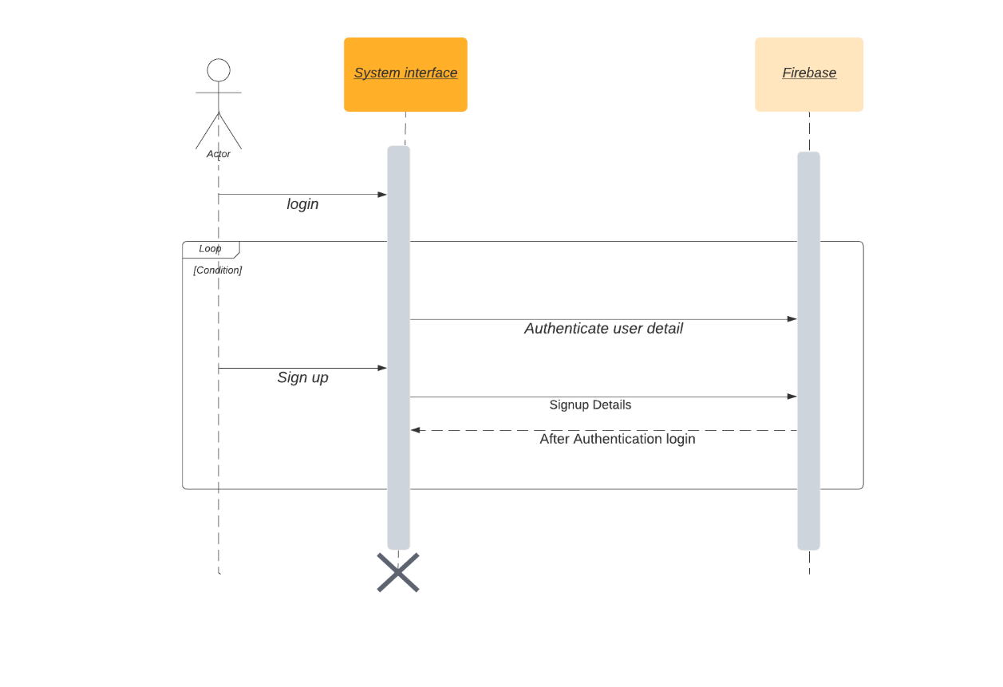
Figure 3-1: Sequence Diagram

Defining a Sequence diagram

A sequence diagram is made up of objects and messages. Objects are represented exactly how they have been represented in all UML diagrams—as rectangles with the underlined class name within the rectangle.
Sequence diagrams describe interactions among classes in terms of an exchange of messages over time.
Actors
Normally an actor instance is represented by the first (left-most) lifeline in the sequence diagram, as the invoker of the interaction. If you have several actor instances in the same diagram, try keeping them either at the left-most, or the right-most lifelines.

Messages
A message is a communication between objects that conveys information with the expectation that activity will ensue; in sequence diagrams, a message is shown as a horizontal solid arrow from the lifeline of one object to the lifeline of another object. In the case of a message from an object to itself, the arrow may start and finish on the same lifeline. The arrow is labelled with the name of the message, and its parameters. The arrow may also be labelled with a sequence number to show the sequence of the message in the overall interaction. Sequence numbers are often omitted in sequence diagrams, in which the physical location of the arrow shows the relative sequence.
Scripts

Scripts describe the flow of events textually in a sequence diagram.

Use case Diagram

The process by which the desires are transformed into demonstration of software is called system design. This approach provides the demonstration of software with the purpose to access for superiority. The use case diagram for this mobile application is shown below:

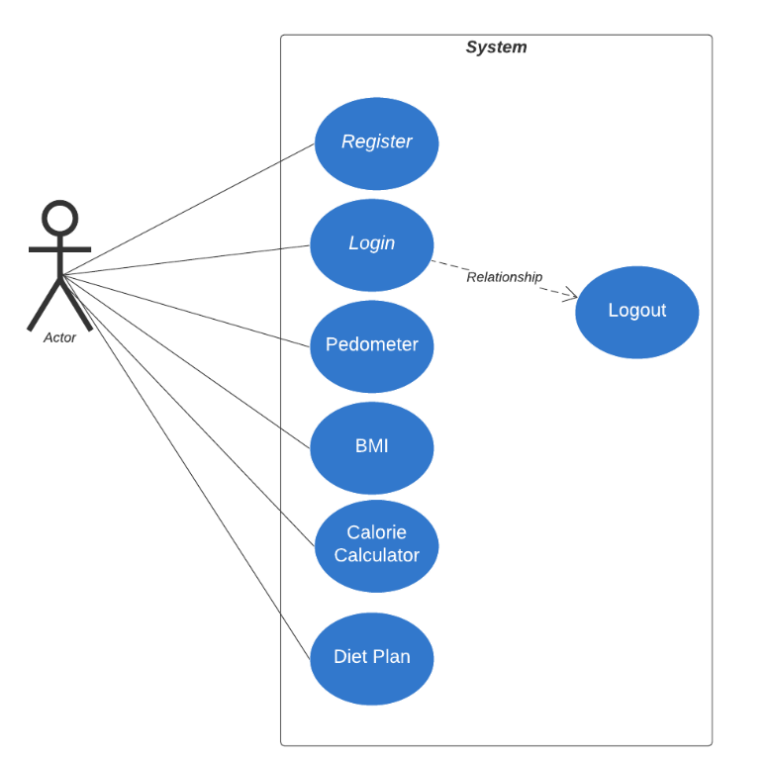

Figure 3-2: Use Case

Activity Diagram

Activity diagram is same as a UML diagram which focuses on top of the implementation and run of the performance of a system as an alternative of implementation.

The activity diagram of this fitness application is shown in. The various activities that are being followed in this android application is user registration, user login, calculate BMI, burn calories, diet plan, step counter and calculating calorie requirement.

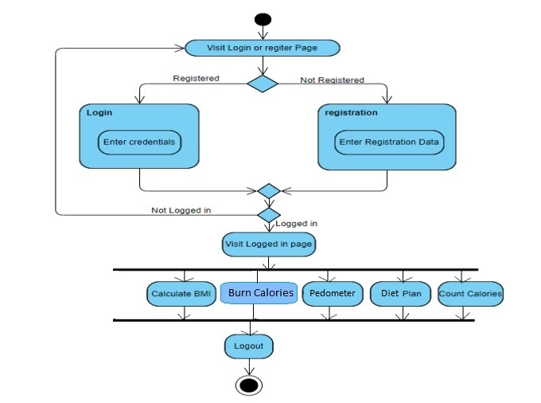

Figure 3-3: Activity Diagram

Class diagram:

The class diagram shows the static approach of this application. Class diagram can be used to construct executable component of this application. The function of this class diagrams shows static organization of classifiers in this system. The class diagram for this mobile application is shown below:

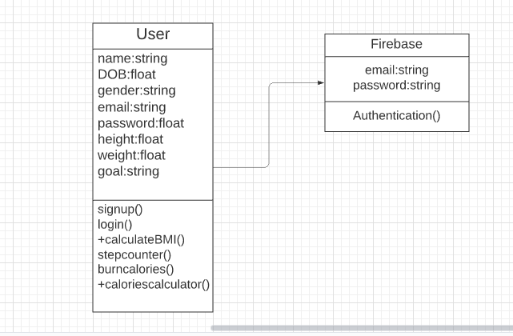

Figure 3-4: Class Diagram

RESULTS AND DISCUSSIONS (or USER MANUAL)

Splash Screen:

The App starts with a beautiful Splash Screen that contain application name and logo.

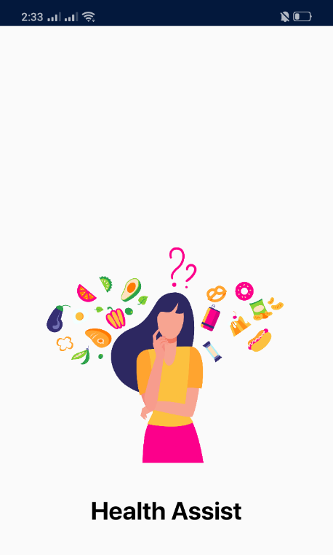

Figure 4-1: Splash Screen

Welcome Page:

The second screen that appear is the Welcome page which ask user if they want to sign in or signup.

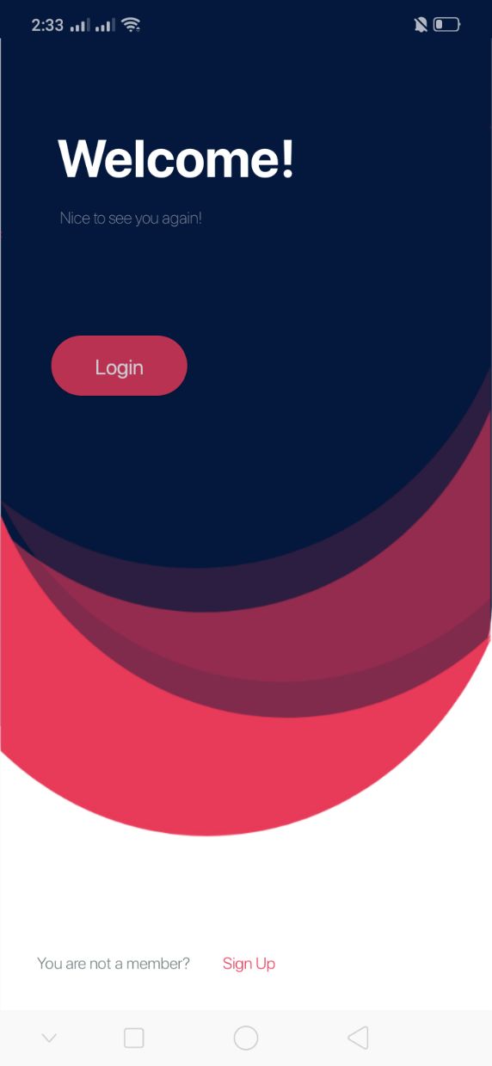

Figure 4-2: Welcome Screen

Sign-in Page:

If the user already has sign-up, then he will enter details in the sign-in page that will ask then user for the username and password.

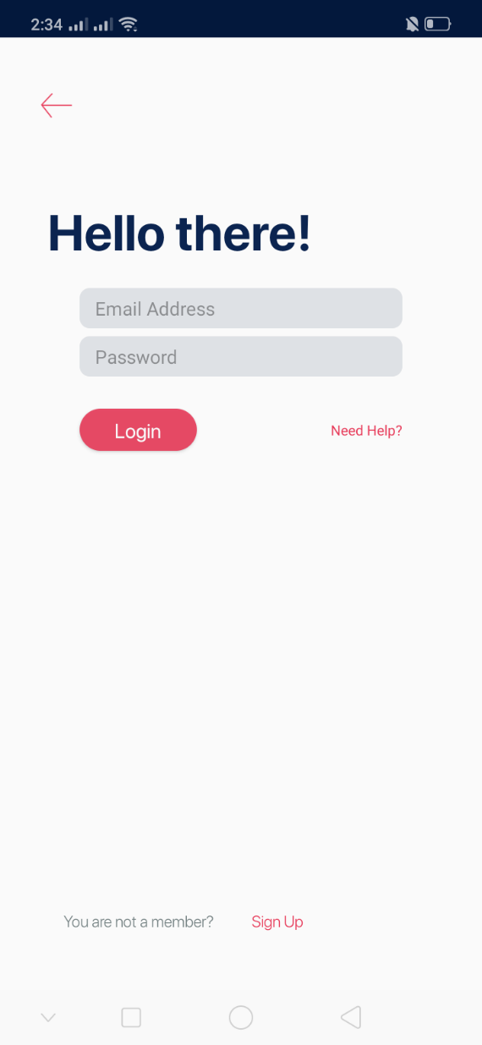

Figure 4-3: Login Screen

Signup Page

The signup page ask user for the information to create account. After adding details, the signup button will save the information provided by the user.

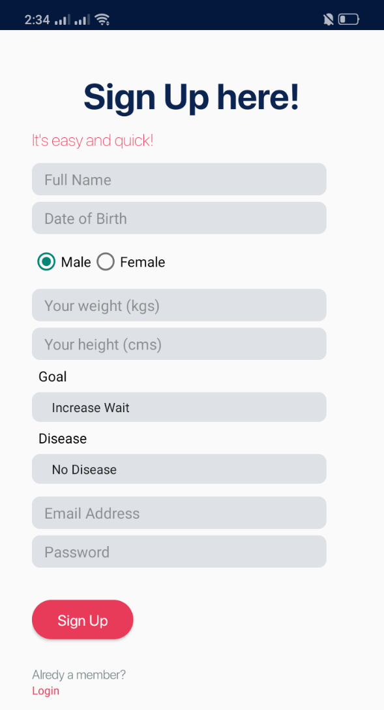

Figure 4-4: Signup Screen

Dashboard:

The dashboard is the main screen that come after the sign-in page and sign-up page contain widgets such as
- BMI calories
- Pedometer
- Diet Plan
- Calories Calculator

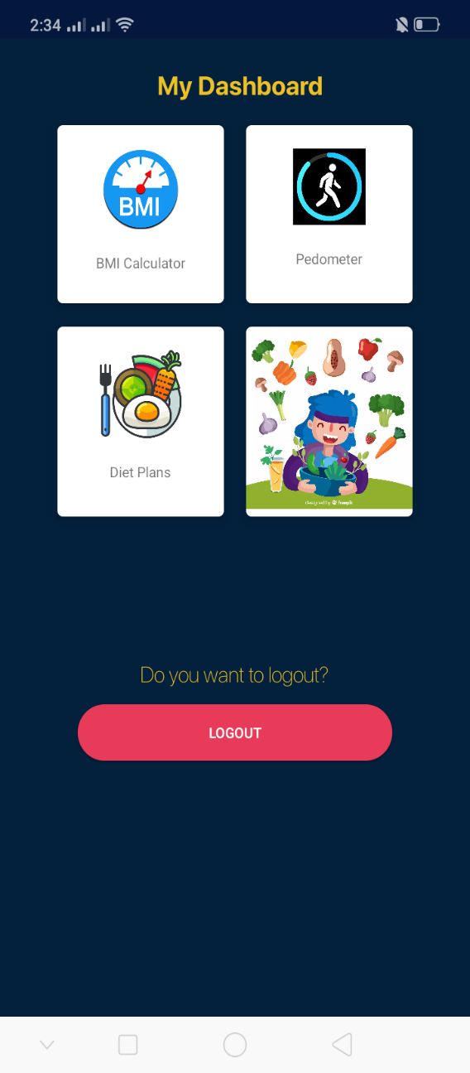

Figure 4-5: Dashboard

BMI

The Body Mass Index (BMI) is a reliable indicator of body fatness for most people. It is used to screen for weight categories that may lead to health problems. Including this widget on your application will allow people to calculate their BMI and see the corresponding weight category. The BMI value and corresponding weight status while taking age into consideration. Use the "Metric Units" tab for the International System of Units or the "Other Units" tab to convert units into either US or metric units.

Formula:
Ans =(weight) / ((height / 100) * (height / 100))
Ans*10.0/10.0

if the result is less than 18.5 than the user is underweight else if the result is greater than equal to twenty-five than the user is overweight if both conditions do not satisfy then user is normal weight.

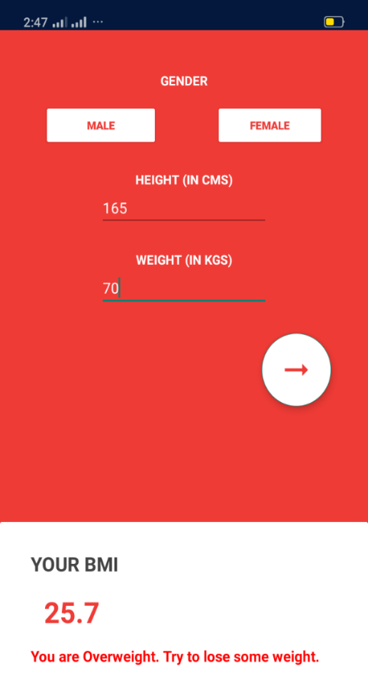

Figure 4-6: BMI (Over Weight)

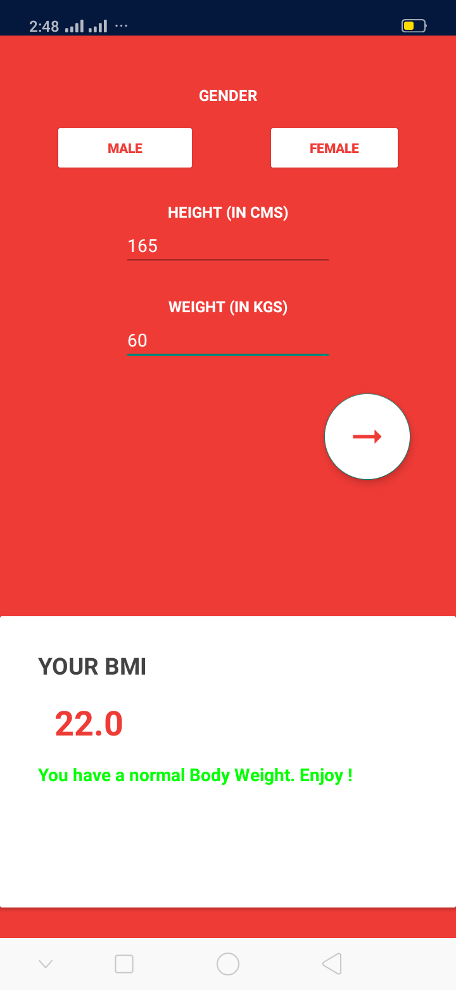

Figure 4-7: BMI (Normal Weight)

Pedometer

This pedometer uses the built-in sensor to count your steps. No GPS tracking, so it can greatly save battery. It also tracks your burned calories, walking distance

Just tap the start button, and it starts counting your steps. Whether your phone is in your hand, bag, pocket or armband, it can auto-record your steps even your screen is locked.

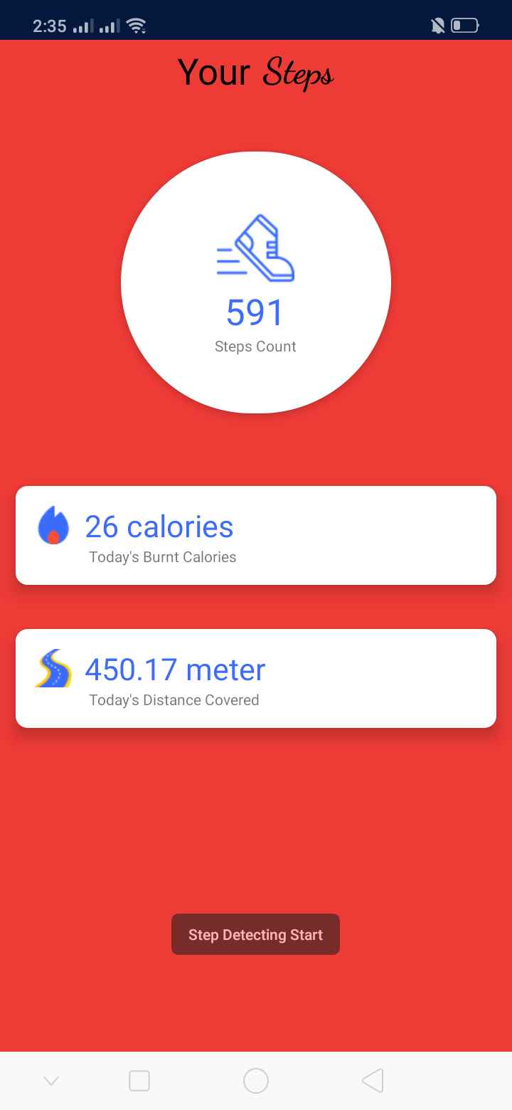

Figure 4-8: Step Counter

Diet Plan

The Diet Plan is customized page that will show the diet plan to the user according to the information that he provides in the signup page the customized diet plan will show user the complete detail of individual diet
The details will include the complete 30 days plan on how to proceed with the diet plan to help you shed weight and improve your overall health. It should be kept in mind by the user that not all diets have this effect. Low carb diets and whole food, lower calorie diets are effective for weight loss and may be easier to stick to than other diets.
Each one of your meals should include:

- a protein source
- fat source
- vegetables
- a small portion of complex carbohydrates, such as whole grains

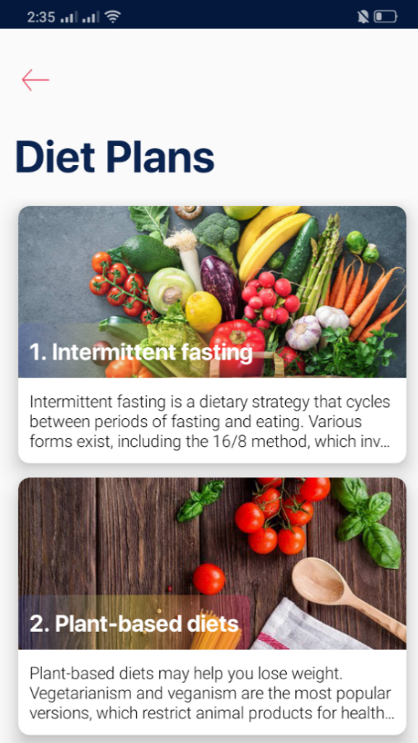

Figure 4-9: Diet Plan (Gallery)

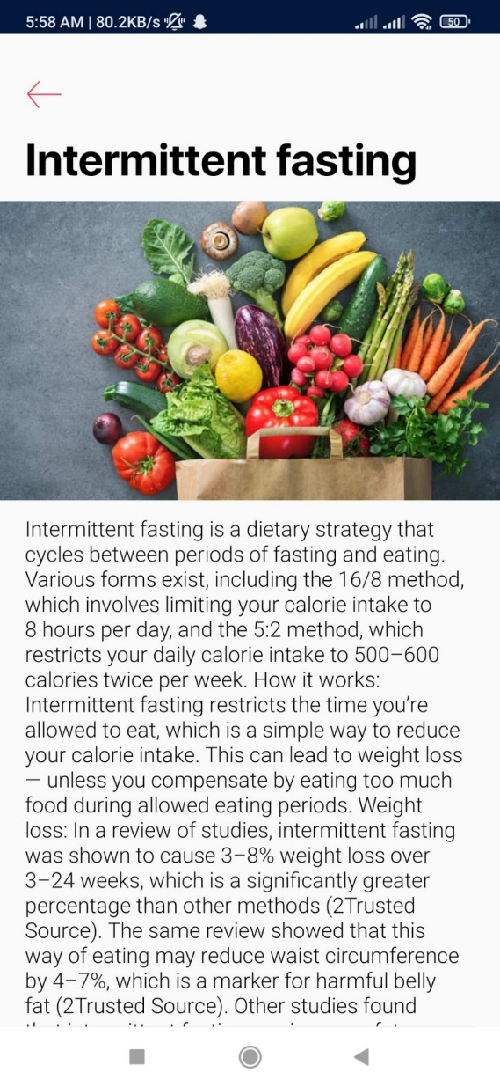

Figure 4-10: Diet Plan

Calories Calculator

The calorie calculator will show all the major food items when the user will select the food item their calories will be calculated in the result section and if the user will select multiple food items then the app will keep on adding the calories of the food item.
And in the end the user will be able to get the total calories that he intake on that specific day.

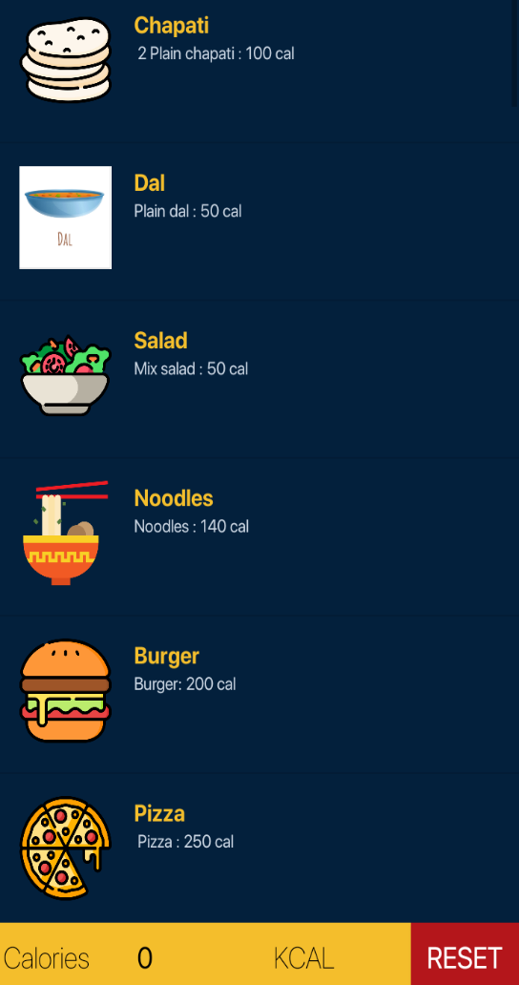

Figure 4-11: Food Item Calories Calculator

Firebase Authentication
All the user entered email and password are being saved in firebase through which the admin can delete or update individual data.

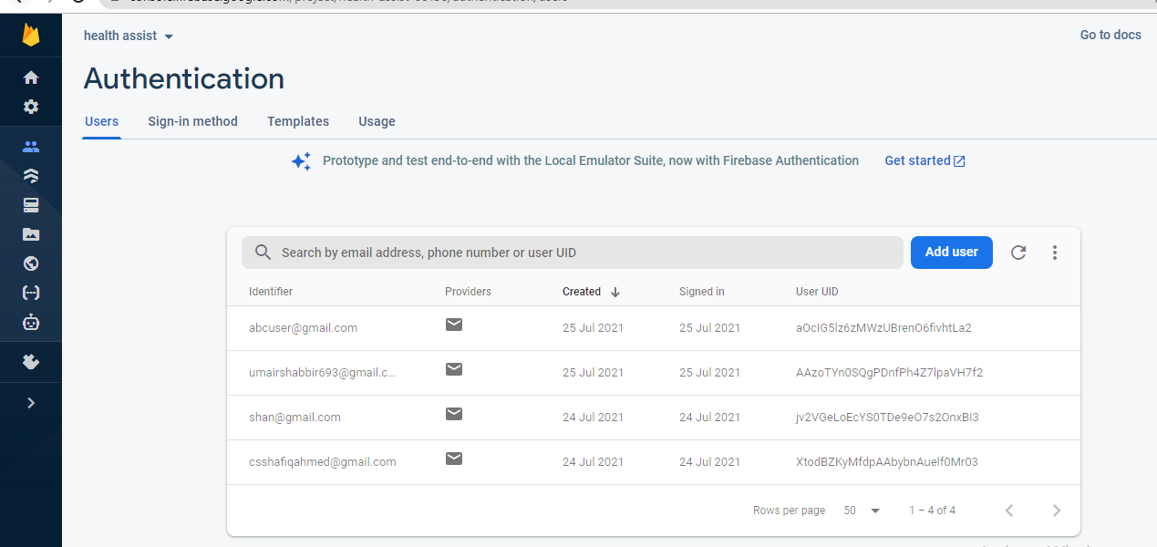

Figure 4-12: Firebase Authentication

CONCLUSION AND RECOMMENDATIONS

CONCLUSION

Health Assist is an application that allow user to maintain good health by using the information provided by user it recommends diet plans. It also provides an interface for the user to calculate the body Mass Index (BMI) when the user enters the details in the BMI module it will tell the user its BMI and it will also tell the user if he/she is overweight, average weight or underweight furthermore the app also provides the pedometer that will sync with the hardware of the phone and will tell the exact step count of the user it will also tell the user how much calories he has burned and total distance that he has covered.

Health Assist Also provide user a generic calories calculator grid that have all the major food item when the user selects the food item the interface will show the total calories of the items selected. These features will motivate and engage the users to have a better weight control and planning.

RECOMENDATION

There are many features that we want to add in the near future. We want to add a user review section on the diet plans that they selected and their feedback on how the app affected them in positive or negative way. Additionally, we want to provide the information of the restaurant on the bases of its hygienic food the data related to the hygienic food will be collected from google and different trusted sources. This system will also collect user reviews related to the restaurants. Information of the restaurants will be in the form of star rating.

We also want to provide Expert diet plan that will only be created by the professional nutritionist after close analysis of the user health history and future goals.

The last feature that we want to include is to provide alert to the family member about the current health progress of the user. Those contacts will be added by the user himself.

REFERENCES

Ching, S. O. (2017). Retrieved from nature.com: https://www.nature.com/articles/srep34563
Ferrara, G. (2019). A. Datum Corporation. Retrieved from ncbi: https://www.ncbi.nlm.nih.gov/pmc/articles/PMC6543803/
Roehrer, E. (2017). Retrieved from researchgate.net: https://www.researchgate.net/publication/305217112_Popular_Mobile_Phone_Apps_for_Diet_and_Weight_Loss_A_Content_Analysis
Today, M. N. (2020). Retrieved from medicalnewstoday.com: https://www.medicalnewstoday.com/articles/best-nutrition-apps

Appendix
(MainActivity.kt)

package com.bulc.healthassis
import android.content.Intent
import android.os.Bundle
import androidx.appcompat.app.AppCompatActivity
import com.google.firebase.auth.FirebaseAuth
import com.google.firebase.auth.FirebaseUser
import kotlinx.android.synthetic.main.activity_main.*
class MainActivity : AppCompatActivity() {
private lateinit var auth: FirebaseAuth
override fun onCreate(savedInstanceState: Bundle?) {
super.onCreate(savedInstanceState)
setContentView(R.layout.activity_main)
auth = FirebaseAuth.getInstance()
loginButton.setOnClickListener {
val intent = Intent(this, loginPage::class.java)
startActivity(intent)
}
home_to_signup.setOnClickListener {
val intent = Intent(this, register_actt::class.java)
startActivity(intent)
}
}
public override fun onStart() {
super.onStart()
// Check if user is signed in (non-null) and update UI accordingly.
val currentUser = auth.currentUser
updateUI(currentUser)
}
fun updateUI(currentUser: FirebaseUser?) {
if (currentUser != null) {
val intent = Intent(this, dashboard::class.java)
startActivity(intent)
}
}
}

(Splash.kt)

package com.bulc.healthassis
import android.content.Intent
import android.os.Bundle
import android.os.Handler
import android.os.Looper
import androidx.appcompat.app.AppCompatActivity
import com.google.firebase.auth.FirebaseAuth
class SplashActivity : AppCompatActivity() {
override fun onCreate(savedInstanceState: Bundle?) {
super.onCreate(savedInstanceState)
setContentView(R.layout.activity_splash)
val mAuth = FirebaseAuth.getInstance()
Handler(Looper.getMainLooper()).postDelayed({
if (mAuth.currentUser != null) {
startActivity(Intent(this@SplashActivity, dashboard::class.java))
finish()
} else {
startActivity(Intent(this@SplashActivity, MainActivity::class.java))
finish()
}
}, 2700)
}
}

(Loginpage.kt)

package com.bulc.healthassis
import android.content.Intent
import android.os.Bundle
import android.util.Log
import android.util.Patterns
import android.widget.Toast
import androidx.appcompat.app.AppCompatActivity
import com.google.firebase.auth.FirebaseAuth
import com.google.firebase.auth.FirebaseUser
import kotlinx.android.synthetic.main.activity_login_page.*
class loginPage : AppCompatActivity() {
private lateinit var auth: FirebaseAuth
override fun onCreate(savedInstanceState: Bundle?) {
super.onCreate(savedInstanceState)
setContentView(R.layout.activity_login_page)
auth = FirebaseAuth.getInstance()
login_back_btn.setOnClickListener {
val intent = Intent(this, MainActivity::class.java);
startActivity(intent);
}
buttonLoginfinal.setOnClickListener {
// Toast.makeText(this,"login btn clicked",Toast.LENGTH_SHORT).show()
doLogin()
}
signup_intent_go.setOnClickListener {
val intent = Intent(this, register_actt::class.java)
startActivity(intent);
}
}
private fun doLogin() {
if (login_email.text.toString().isEmpty()) {
login_email.error = "Please Enter Email"
login_email.requestFocus()
return
}
if (!Patterns.EMAIL_ADDRESS.matcher(login_email.text.toString()).matches()) {
login_email.error = "Please Enter Valid Email"
login_email.requestFocus()
return
}
if (login_passw.text.toString().isEmpty()) {
login_passw.error = "Please Enter Password"
login_passw.requestFocus()
return
}
auth.signInWithEmailAndPassword(login_email.text.toString(), login_passw.text.toString())
.addOnCompleteListener(this) { task ->
if (task.isSuccessful) {
// Sign in success, update UI with the signed-in user's information
Log.d("tag3", "signInWithEmail:success")
Toast.makeText(
baseContext, "Login Success.",
Toast.LENGTH_SHORT
).show()
val user = auth.currentUser
updateUI(user)
} else {
// If sign in fails, display a message to the user.
Log.w("TAG4", "signInWithEmail:failure", task.exception)
Toast.makeText(
baseContext, "Login failed.",
Toast.LENGTH_SHORT
).show()
updateUI(null)
}
}
}
public override fun onStart() {
super.onStart()
// val currentUser: FirebaseUser? = auth.currentUser
// updateUI(currentUser)
}
private fun updateUI(currentUser: FirebaseUser?) {
if (currentUser != null) {
if (currentUser.isEmailVerified) {
startActivity(Intent(this, dashboard::class.java))
finish()
} else {
Toast.makeText(this, "Verify Your Email", Toast.LENGTH_LONG).show()
startActivity(Intent(this, dashboard::class.java))
finish()
}
} else {
Toast.makeText(baseContext, "Login Failed", Toast.LENGTH_SHORT).show()
}
}
}

(SignupPage.kt)

package com.bulc.healthassis
import com.bulc.healthassis.databinding.ActivityRegisterActtBinding
import com.bulc.healthassis.dialogs.DatePickerFragment
import com.bulc.healthassis.helper.AppPrefs
import android.app.DatePickerDialog
import android.content.Intent
import android.os.Bundle
import android.util.Log
import android.view.View
import android.widget.AdapterView
import android.widget.DatePicker
import android.widget.RadioGroup
import android.widget.Toast
import androidx.appcompat.app.AppCompatActivity
import com.bulc.healthassis.model.User
import com.google.firebase.auth.FirebaseAuth
import com.google.firebase.auth.FirebaseUser
import kotlinx.android.synthetic.main.activity_register_act.*
import java.text.DateFormat
import java.util.*
class register_actt : AppCompatActivity(), DatePickerDialog.OnDateSetListener {
private lateinit var auth: FirebaseAuth
var binding: ActivityRegisterActtBinding? = null
lateinit var goalList: Array<String>
lateinit var diseaseList: Array<String>
var goal = ""
var disease = ""
override fun onCreate(savedInstanceState: Bundle?) {
super.onCreate(savedInstanceState)
binding = ActivityRegisterActtBinding.inflate(getLayoutInflater())
setContentView(binding!!.root)
auth = FirebaseAuth.getInstance()
goalList = getResources().getStringArray(R.array.goal)
diseaseList = getResources().getStringArray(R.array.disease)
binding!!.spinnerGoal.setOnItemSelectedListener(object :
AdapterView.OnItemSelectedListener {
override fun onItemSelected(adapterView: AdapterView<*>?, view: View, i: Int, l: Long) {
goal = goalList[i]
}
override fun onNothingSelected(adapterView: AdapterView<*>?) {}
})
binding!!.spinnerDisease.setOnItemSelectedListener(object :
AdapterView.OnItemSelectedListener {
override fun onItemSelected(adapterView: AdapterView<*>?, view: View, i: Int, l: Long) {
disease = diseaseList[i]
}
override fun onNothingSelected(adapterView: AdapterView<*>?) {}
})
binding!!.etDob.setOnClickListener { view ->
val datePickerFragment = DatePickerFragment()
datePickerFragment.show(getSupportFragmentManager(), "Date Picker")
}
binding!!.radioGroupGender.setOnCheckedChangeListener(object :
RadioGroup.OnCheckedChangeListener {
override fun onCheckedChanged(radioGroup: RadioGroup, i: Int) {
if (radioGroup.getCheckedRadioButtonId() == R.id.radio_male) {
binding!!.linearPregnant.visibility = View.GONE
} else {
binding!!.linearPregnant.visibility = View.VISIBLE
}
}
})
signup_to_home.setOnClickListener {
val intent = Intent(this, MainActivity::class.java)
startActivity(intent)
}
binding!!.registerBtn.setOnClickListener { view -> signUpUser() }
}
fun signUpUser() {
val name = binding!!.etName.text.toString().trim()
val dob = binding!!.etDob.text.toString().trim()
var gender = ""
var isPregnant: Boolean
isPregnant = binding!!.radioGroupPreg.checkedRadioButtonId === R.id.radio_preg_yes
if (binding!!.radioGroupGender.checkedRadioButtonId === R.id.radio_male) {
gender = "male"
isPregnant = false
} else {
gender = "female"
}
val weight = binding!!.etWeight.text.toString().trim()
val height = binding!!.etHeight.text.toString().trim()
val email = binding!!.registerEmail.text.toString().trim()
val password = binding!!.registerPassw.text.toString().trim()
var isError = false
if (name == "" || name.length <= 2) {
isError = true
binding!!.etName.error = "Enter full name"
} else if (dob == "") {
isError = true
binding!!.etDob.error = "Enter date of birth"
} else if (weight == "") {
isError = true
binding!!.etWeight.error = "Enter weight"
} else if (height == "") {
isError = true
binding!!.etHeight.error = "Enter height"
} else if (email == "") {
isError = true
binding!!.registerEmail.error = "Enter email address"
} else if (password == "") {
isError = true
binding!!.registerPassw.error = "Enter password"
}
if (!isError) {
val appUser =
User(name, dob, gender, weight, height, goal, disease, isPregnant, email, password)
Log.d("Register", "User: $appUser")
auth.createUserWithEmailAndPassword(registerEmail.text.toString().trim(),register_passw.text.toString().trim())
.addOnCompleteListener(this) { task ->
if (task.isSuccessful) {
// Sign in success, update UI with the signed-in user's information
Log.d("Tag1", "createUserWithEmail:success")
Toast.makeText(this, "Authentication Done.",
Toast.LENGTH_SHORT).show()
val user : FirebaseUser? = auth.currentUser
user!!.sendEmailVerification()
.addOnCompleteListener { task ->
if (task.isSuccessful) {
AppPrefs.setUserData(appUser)
Log.d("Email Tag", "Email sent.")
startActivity(Intent(this, loginPage::class.java))
finish()
}
}
} else {
// If sign in fails, display a message to the user.
Log.w("Tag2", "createUserWithEmail:failure", task.exception)
Toast.makeText(baseContext, "Authentication failed.",
Toast.LENGTH_SHORT).show()
}
// ...
}
}
}
override fun onDateSet(datePicker: DatePicker, year: Int, month: Int, dayOfMonth: Int) {
val c = Calendar.getInstance()
c[Calendar.YEAR] = year
c[Calendar.MONTH] = month
c[Calendar.DAY_OF_MONTH] = dayOfMonth
val currentDateString = DateFormat.getDateInstance(DateFormat.FULL).format(c.time)
binding!!.etDob.setText(currentDateString)
}
public override fun onStart() {
super.onStart()
// Check if user is signed in (non-null) and update UI accordingly.
val currentUser = auth.currentUser
updateUI(currentUser)
}
fun updateUI(currentUser: FirebaseUser?) {
if(currentUser != null) {
startActivity(Intent(this, dashboard::class.java))
finish()
}
}
}

(Dashboard.kt)

package com.bulc.healthassis
import android.content.Intent
import android.os.Bundle
import android.widget.Toast
import androidx.appcompat.app.AppCompatActivity
import com.google.firebase.auth.FirebaseAuth
import kotlinx.android.synthetic.main.activity_dashboard.*
class dashboard : AppCompatActivity() {
override fun onCreate(savedInstanceState: Bundle?) {
super.onCreate(savedInstanceState)
setContentView(R.layout.activity_dashboard)
bmi.setOnClickListener {
Toast.makeText(applicationContext, "BMI", Toast.LENGTH_SHORT).show()
val intent = Intent(this, com.bulc.healthassis.bmi::class.java)
startActivity(intent);
}
pedometer.setOnClickListener {
Toast.makeText(applicationContext, "Pedometer", Toast.LENGTH_SHORT).show()
val intent = Intent(this, peodmeter::class.java)
startActivity(intent);
}
diets.setOnClickListener {
Toast.makeText(applicationContext, "Diets", Toast.LENGTH_SHORT).show()
val intent = Intent(this, DietPlan::class.java)
startActivity(intent)
}
image_selector.setOnClickListener {
val intent = Intent(this, FoodSelectActivity::class.java)
startActivity(intent)
}
btn_logout.setOnClickListener{
var auth: FirebaseAuth
auth = FirebaseAuth.getInstance()
auth.signOut()
val intent = Intent(this, loginPage::class.java)
startActivity(intent)
finish()
}
}
}

(Bmi.kt)

package com.bulc.healthassis
import android.graphics.Color
import androidx.appcompat.app.AppCompatActivity
import android.os.Bundle
import android.view.View
import android.widget.Button
import android.widget.EditText
import android.widget.TextView
import androidx.cardview.widget.CardView
import com.google.android.material.floatingactionbutton.FloatingActionButton
class bmi : AppCompatActivity() {
lateinit var slider: EditText
lateinit var slider1: EditText
lateinit var fab: FloatingActionButton
lateinit var card: CardView
lateinit var bmiText: TextView
lateinit var disclaimer: TextView
lateinit var label: TextView
lateinit var res: TextView
lateinit var feedback: TextView
lateinit var maleButton: Button
lateinit var femaleButton: Button
override fun onCreate(savedInstanceState: Bundle?) {
super.onCreate(savedInstanceState)
setContentView(R.layout.activity_bmi)
if (supportActionBar != null) supportActionBar?.hide()
slider = findViewById(R.id.slider1)
slider1 = findViewById(R.id.slider2)
fab = findViewById(R.id.floatingActionButton)
card = findViewById(R.id.cardView)
bmiText = findViewById(R.id.bmitext)
disclaimer = findViewById(R.id.disclamer)
res = findViewById(R.id.Result)
label = findViewById(R.id.yourBmi)
feedback = findViewById(R.id.Feedback)
maleButton = findViewById(R.id.male)
femaleButton = findViewById(R.id.female)
maleButton.setOnClickListener {
maleButton.setBackgroundColor(Color.parseColor("#FEA595"))
femaleButton.setBackgroundColor(Color.WHITE)
}
femaleButton.setOnClickListener {
femaleButton.setBackgroundColor(Color.parseColor("#FEA595"))
maleButton.setBackgroundColor(Color.WHITE)
}
fab.setOnClickListener {
cardChanger();
}
}
private fun cardChanger() {
bmiText.visibility = View.GONE
disclaimer.visibility = View.GONE
res.visibility = View.VISIBLE
feedback.visibility = View.VISIBLE
label.visibility = View.VISIBLE
val height: Float = slider.text.toString().toFloat()
val weight: Float = slider1.text.toString().toFloat()
val ans: Float = (weight) / ((height / 100) * (height / 100))
val BMI: Double = Math.round(ans * 10.0) / 10.0
res.text = BMI.toString()
if (BMI < 18.5) {
feedback.text = getString(R.string.under)
feedback.setTextColor(Color.RED)
} else if (BMI >= 25) {
feedback.text = getString(R.string.over)
feedback.setTextColor(Color.RED)
} else {
feedback.text = getString(R.string.you_have_a_normal_body_weight_enjoy)
feedback.setTextColor(Color.GREEN)
}
}
}

(Pedometer.kt)

package com.bulc.healthassis
import com.bulc.healthassis.callback.stepsCallback
import com.bulc.healthassis.helper.GeneralHelper
import com.bulc.healthassis.service.StepDetectorService
import android.Manifest
import android.content.Intent
import android.content.pm.PackageManager
import android.os.Build
import android.os.Bundle
import android.widget.Toast
import androidx.appcompat.app.AppCompatActivity
import androidx.core.content.ContextCompat
import kotlinx.android.synthetic.main.pedometer.*
class peodmeter : AppCompatActivity(), stepsCallback {
override fun onCreate(savedInstanceState: Bundle?) {
super.onCreate(savedInstanceState)
setContentView(R.layout.pedometer)
checkPedometerPermission()
}
override fun subscribeSteps(steps: Int) {
TV_STEPS.setText(steps.toString())
TV_CALORIES.setText(GeneralHelper.getCalories(steps))
TV_DISTANCE.setText(GeneralHelper.getDistanceCovered(steps))
}
private fun startPedometerService() {
val intent = Intent(this, StepDetectorService::class.java)
startService(intent)
StepDetectorService.subscribe.register(this)
}
private fun checkPedometerPermission() {
if (Build.VERSION.SDK_INT >= Build.VERSION_CODES.Q) {
if (ContextCompat.checkSelfPermission(
this,
Manifest.permission.ACTIVITY_RECOGNITION
) == PackageManager.PERMISSION_DENIED
) {
requestPermissions(arrayOf(Manifest.permission.ACTIVITY_RECOGNITION), 0)
} else {
startPedometerService()
}
} else {
startPedometerService()
}
}
override fun onRequestPermissionsResult(
requestCode: Int,
permissions: Array<String>,
grantResults: IntArray
) {
super.onRequestPermissionsResult(requestCode, permissions, grantResults)
if (requestCode == 0 && grantResults.isNotEmpty() && grantResults[0] == PackageManager.PERMISSION_GRANTED) {
startPedometerService()
} else {
Toast.makeText(
applicationContext,
"Permission needed for pedometer to work",
Toast.LENGTH_SHORT
).show()
}
}
}

(Dietplan.kt)

package com.bulc.healthassis
import com.bulc.healthassis.adapter.DietPlanAdapter
import com.bulc.healthassis.databinding.ActivityDietPlansBinding
import com.bulc.healthassis.model.Diet
import android.os.Bundle
import android.view.View
import androidx.appcompat.app.AppCompatActivity
import androidx.recyclerview.widget.DefaultItemAnimator
import androidx.recyclerview.widget.LinearLayoutManager
import java.util.*
class DietPlan : AppCompatActivity() {
var binding: ActivityDietPlansBinding? = null
var dietList: ArrayList<Diet>? = null
var adapter: DietPlanAdapter? = null
override fun onCreate(savedInstanceState: Bundle?) {
super.onCreate(savedInstanceState)
binding = ActivityDietPlansBinding.inflate(layoutInflater)
setContentView(binding!!.root)
dietList = ArrayList<Diet>()
createDietList()
adapter = DietPlanAdapter(this, dietList!!)
binding!!.recyclerViewDiets.itemAnimator = DefaultItemAnimator()
binding!!.recyclerViewDiets.layoutManager =
LinearLayoutManager(this, LinearLayoutManager.VERTICAL, false)
binding!!.recyclerViewDiets.adapter = adapter
binding!!.backBtn.setOnClickListener { view: View? -> finish() }
}
private fun createDietList() {
dietList!!.add(
Diet(
"Low-fat diets",
resources.getString(R.string.low_fat_diet),
R.drawable.low_fat_diet,
"No Disease"
)
)
dietList!!.add(
Diet(
"Low-carb diets",
resources.getString(R.string.low_carb_diets),
R.drawable.low_carb_diets,
"No Disease"
)
)
dietList!!.add(
Diet(
"Intermittent fasting",
resources.getString(R.string.intermittent_fast),
R.drawable.intermittent_fast,
"Diabetes"
)
)
dietList!!.add(
Diet(
"The DASH diet",
resources.getString(R.string.the_dash_diet),
R.drawable.the_dash_diet,
"No Disease"
)
)
dietList!!.add(
Diet(
"Intermittent fasting",
resources.getString(R.string.intermittent_fast),
R.drawable.intermittent_fast,
"No Disease"
)
)
dietList!!.add(
Diet(
"Plant-based diets",
resources.getString(R.string.plant_based_diets),
R.drawable.plant_based_diets,
"No Disease"
)
)
dietList!!.add(
Diet(
"The Paleo diet",
resources.getString(R.string.the_paleo_diet),
R.drawable.the_paleo_diet,
"No Disease"
)
)
dietList!!.add(
Diet(
"WW (Weight Watchers)",
resources.getString(R.string.the_weight_watcher),
R.drawable.the_weight_watcher,
"No Disease"
)
)
dietList!!.add(
Diet(
"Plant-based diets",
resources.getString(R.string.plant_based_diets),
R.drawable.plant_based_diets,
"Diabetes"
)
)
dietList!!.add(
Diet(
"Low-carb diets",
resources.getString(R.string.low_carb_diets),
R.drawable.low_carb_diets,
"Diabetes"
)
)
dietList!!.add(
Diet(
"The Paleo diet",
resources.getString(R.string.the_paleo_diet),
R.drawable.the_paleo_diet,
"Blood Pressure"
)
)
dietList!!.add(
Diet(
"Low-fat diets",
resources.getString(R.string.low_fat_diet),
R.drawable.low_fat_diet,
"Blood Pressure"
)
)
dietList!!.add(
Diet(
"The Mediterranean diet",
resources.getString(R.string.the_mediterranean_diet),
R.drawable.the_mediterranean_diet,
"Blood Pressure"
)
)
dietList!!.add(
Diet(
"The DASH diet",
resources.getString(R.string.the_dash_diet),
R.drawable.the_dash_diet,
"Blood Pressure"
)
)
dietList!!.add(
Diet(
"Low-fat diets",
resources.getString(R.string.low_fat_diet),
R.drawable.low_fat_diet,
"Diabetes"
)
)
dietList!!.add(
Diet(
"Plant-based diets",
resources.getString(R.string.plant_based_diets),
R.drawable.plant_based_diets,
"hepatitis"
)
)
dietList!!.add(
Diet(
"Low-fat diets",
resources.getString(R.string.low_fat_diet),
R.drawable.low_fat_diet,
"hepatitis"
)
)
dietList!!.add(
Diet(
"The Mediterranean diet",
resources.getString(R.string.the_mediterranean_diet),
R.drawable.the_mediterranean_diet,
"hepatitis"
)
)
}
}

(FoodSelectActivity.kt)

package com.bulc.healthassis
import android.annotation.SuppressLint
import androidx.appcompat.app.AppCompatActivity
import android.os.Bundle
import android.view.View
import android.widget.*
import food_adapter
import kotlinx.android.synthetic.main.food_select.*
class FoodSelectActivity : AppCompatActivity() {
@SuppressLint("SetTextI18n")
override fun onCreate(savedInstanceState: Bundle?) {
super.onCreate(savedInstanceState)
setContentView(R.layout.food_select)
var listview = findViewById<ListView>(R.id.listView)
var list = mutableListOf<Model>()
var calorieText = findViewById<TextView>(R.id.calorieText)
val reset = findViewById<Button>(R.id.reset)
val value = findViewById<TextView>(R.id.valueCal)
list.add(Model("Rice", "Plain Rice : 200 cal", R.drawable.rice_bowl))
list.add(Model("Chapati", " 2 Plain chapati : 100 cal", R.drawable.roti_canai))
list.add(Model("Dal", "Plain dal : 50 cal", R.drawable.dal2))
list.add(Model("Salad", "Mix salad : 50 cal", R.drawable.salad))
list.add(Model("Noodles", "Noodles : 140 cal", R.drawable.noodles))
list.add(Model("Burger", "Burger: 200 cal", R.drawable.hamburger))
list.add(Model("Pizza", " Pizza : 250 cal", R.drawable.pizza))
list.add(Model("cold drink", "Carbonated cold drink :140 cal", R.drawable.soft_drink))
list.add(Model("Apple", "Apple : 114 cal", R.drawable.apple))
list.add(Model("Bread", "4-bread Slice :65 cal", R.drawable.baguette))
list.add(Model("Cake", "1- Cake Slice : 132 cal", R.drawable.cake))
list.add(Model("Muffin", "muffin : 47 cal", R.drawable.cupcake))
list.add(Model("Carrot", " carrot: 30 cal", R.drawable.carrot))
list.add(Model("Chicken", " chicken : 220 cal", R.drawable.chicken_leg))
list.add(Model("Chocolate", "Chocolate bar : 200 cal", R.drawable.chocolate))
list.add(Model("Donut", "donut : 110 cal", R.drawable.donut))
list.add(Model("Laddu", "Laddu : 170 cal", R.drawable.fazuelos))
list.add(Model("French fries", "French Fries medium : 110 cal", R.drawable.french_fries))
list.add(Model("Orange", " Orange : 52 cal", R.drawable.fruit))
list.add(Model("Hot dog", "Hot Dog: 95 cal", R.drawable.hot_dog))
list.add(Model("Rolls", " Roll : 68 cal", R.drawable.kebab))
list.add(Model("Potato Chips", "Potato chips : 155 cal", R.drawable.potato_chips))
list.add(Model("Sundae", "Sundae : 110 cal", R.drawable.sundae))
list.add(Model("Ice Cream", " Ice Cream : 100 cal", R.drawable.parfait))
list.add(Model("Strawberry", "Strawberry : 110 cal", R.drawable.strawberry))
list.add(Model("meat", "250 g red meat : 300 cal", R.drawable.meat))
list.add(Model("Khichidi", "Khichidi : 70 cal", R.drawable.vegan_food))
listview.adapter = food_adapter(this, R.layout.row, list)
listView.setOnItemClickListener { parent: AdapterView<*>, view: View, position: Int, id: Long ->
if (position == 0) {
value.setText((value.text.toString().toInt() + 200).toString())
}
if (position == 1) {
value.setText((value.text.toString().toInt() + 100).toString())
}
if (position == 2) {
value.setText((value.text.toString().toInt() + 50).toString())
}
if (position == 3) {
value.setText((value.text.toString().toInt() + 50).toString())
}
if (position == 4) {
value.setText((value.text.toString().toInt() + 140).toString())
}
if (position == 5) {
value.setText((value.text.toString().toInt() + 200).toString())
}
if (position == 6) {
value.setText((value.text.toString().toInt() + 250).toString())
}
if (position == 7) {
value.setText((value.text.toString().toInt() + 140).toString())
}
if (position == 8) {
value.setText((value.text.toString().toInt() + 110).toString())
}
if (position == 9) {
value.setText((value.text.toString().toInt() + 200).toString())
}
if (position == 10) {
value.setText((value.text.toString().toInt() + 114).toString())
}
if (position == 11) {
value.setText((value.text.toString().toInt() + 65).toString())
}
if (position == 12) {
value.setText((value.text.toString().toInt() + 132).toString())
}
if (position == 13) {
value.setText((value.text.toString().toInt() + 47).toString())
}
if (position == 14) {
value.setText((value.text.toString().toInt() + 30).toString())
}
if (position == 15) {
value.setText((value.text.toString().toInt() + 220).toString())
}
if (position == 16) {
value.setText((value.text.toString().toInt() + 200).toString())
}
if (position == 17) {
value.setText((value.text.toString().toInt() + 110).toString())
}
if (position == 18) {
value.setText((value.text.toString().toInt() + 170).toString())
}
if (position == 19) {
value.setText((value.text.toString().toInt() + 110).toString())
}
if (position == 20) {
value.setText((value.text.toString().toInt() + 52).toString())
}
if (position == 21) {
value.setText((value.text.toString().toInt() + 95).toString())
}
if (position == 22) {
value.setText((value.text.toString().toInt() + 68).toString())
}
if (position == 23) {
value.setText((value.text.toString().toInt() + 115).toString())
}
if (position == 24) {
value.setText((value.text.toString().toInt() + 110).toString())
}
if (position == 25) {
value.setText((value.text.toString().toInt() + 100).toString())
}
if (position == 26) {
value.setText((value.text.toString().toInt() + 110).toString())
}
if (position == 27) {
value.setText((value.text.toString().toInt() + 300).toString())
}
if (position == 28) {
value.setText((value.text.toString().toInt() + 70).toString())
}
}
reset.setOnClickListener {
value.setText("0")
}
}
}

