
BSIT-F20-002
03-135172-056 KOMAL AQEEL
03-135172-004 LAIBA QAYYUM
Interactive LMS: User Centered Perspective

In partial fulfilment of the requirements for the degree of
Bachelor of Science in Information Technology
Supervisor: Dr Abdul Hafeez.
Department of Computer Sciences
Bahria University, Lahore Campus
July 2021

© Bahria University, 2021

Certificate

We accept the work contained in the report titled
“Interactive LMS: User Centred Perspective”
Written by
KOMAL AQEEL
LAIBA QAYYUM
As a confirmation to the required standard for the partial fulfilment of the degree of
Bachelor of Science in Information Technology.

Approved by:
Supervisor: Dr Abdul Hafeez.
(Signature)

July 9, 2021

DECLARATION

We hereby declare that this project report is based on our original work except for citations and quotations which have been duly acknowledged. We also declare that it has not been previously and concurrently submitted for any other degree or award at Bahria University or other institutions.

Enrolment | Name | Signature
03-135172-004 | LAIBA QAYYUM
03-135172-056 | KOMAL AQEEL

Date : July 9, 2021

Interactive LMS: User Centred Perspective

ABSTRACT

As, we know that technology is creating a great influence in every aspect of life. Traditional way of learning is becoming backward. Students are facing problems regarding lectures, attendance, learning system etc. Keeping in mind these issues, there is now a need to change the learning environment from traditional to smart. Human Computer Interaction (HCI) principles plays an important role while designing any LMS. This will help the students to interact with LMS smartly and by saving their time. Interactive LMS is the solution in which we have to identify the factors critically that should be taken into consideration to make any LMS Interactive. For this purpose, we will take Surveys from students and Expert Advice, after getting the results; we will apply different prioritizing techniques on the obtained guidelines based on HCI Principles. At last, we will develop Enhanced Interactive Prototype of generic LMS (A case of BU) based on HCI Principles.

TABLE OF CONTENTS

DECLARATION ii
ABSTRACT iii
TABLE OF CONTENTS iv
LIST OF TABLES vii
LIST OF FIGURES viii
LIST OF SYMBOLS / ABBREVIATIONS x
LIST OF APPENDICES xi

CHAPTERS
1 INTRODUCTION 1
1.1 Background 1
1.2 Problem Statements 1
1.3 Aims and Objectives 2
1.4 Scope of Project 3
2 LITERATURE REVIEW 4
2.1 Role of Learning Management System 4
2.2 Role of Learning Management System in COVID19 5
2.3 Role of Learning Management System in Higher Education 6
2.3.1 E-Learning 7
2.4 Issues of Learning Management System 13
3 DESIGN AND METHODOLOGY 14
3.1 Methodology 14
3.2 Objectives 15
3.2.1 Steps 15
3.3 Usability 17
3.3.1 Usability Evaluation Method (UEM) 18
3.4 Usability Evaluation 19
3.4.1 Participants 19
3.4.2 Usability Survey 19
3.4.3 Likert Scale 20
3.4.4 User Profiling 20
3.4.5 SUS Details 21
3.4.6 SUS Scoring Criteria 21
3.5 Heuristic Evaluation 22
3.5.1 Principles 22
3.5.2 Ranking System 24
3.6 Prototype 24
3.6.1 Types of Prototype 25
3.7 Tools and Techniques 25
4 DATA AND EXPERIMENTS 27
4.1 User Specified Issues of Learning Management System 27
4.2 Issues of Bahria University Learning Management System 28
4.3 Phase 1 (SUS) 28
4.3.1 Participants 29
4.4 Study Approach 29
4.5 Resource Requirement 29
4.6 SUS Questionnaire 30
Above table consists of the 10 questions of SUS Questionnaire. 30
4.7 SUS Scoring 30
4.8 Data Gathering 31
4.9 Phase 2 (Heuristic Evaluation) 31
4.10 Phase 3 (Prototype) 32
5 RESULTS AND DISCUSSIONS 33
5.1 SUS Results 33
5.1.1 SUS Summary 35
5.2 Heuristic Evaluation Results 38
5.2.1 H1 Result 38
5.2.2 H2 Result 39
5.2.3 H3 Result 39
5.2.4 H4 Result 40
5.2.5 H5 Result 40
5.2.6 H6 Result 41
5.2.7 H7 Result 41
5.2.8 H8 Result 42
5.2.9 H9 Result 42
5.2.10 H10 Result 43
5.3 Heuristics Mean Values 43
5.4 Prioritized Issues 44
5.5 Prototype Design 45
6 CONCLUSION AND RECOMMENDATIONS 51
6.1 Conclusion 51
6.2 Recommendations 52
REFERENCES 55
APPENDICES 56

LIST OF TABLES

TABLE TITLE PAGE
Table 2-1 Methods of Learning before COVID19 10
Table 2-2 Methods of Learning during COVID19 11
Table 3-1 User Profiling 20
Table 3-2 Principles of Heuristics 22
Table 3-3 Ranking Issues Table 24
Table 4-1 SUS Survey Questions 30
Table 4-2 SUS Adjective Rating 30
Table 5-1 Mean Values of Heuristics 43
Table 5-2 Issues after prioritizing 44
Table 6-1 Issues and Recommendations 52

LIST OF FIGURES

FIGURE TITLE PAGE
Figure 2.1 E-Learning Model 6
Figure 3.1 UCD Implementation Process 14
Figure 3.2 Workflow describes the stepwise implementation of Interactive LMS: User-Centred Perspective 15
Figure 3.3 SUS Scoring Scale 22
Figure 4.1Strategem of SUS 29
Figure 4.2 Data Gathered 31
Figure 5.1 SUS Average Score 34
Figure 5.2 SUS Average Score of Bahria University LMS 34
Figure 5.3 Q1 of SUS 35
Figure 5.4 Q2 of SUS 35
Figure 5.5 Q3 of SUS 35
Figure 5.6 Q4 of SUS 36
Figure 5.7 Q5 of SUS 36
Figure 5.8 Q6 of SUS 36
Figure 5.9 Q7 of SUS 37
Figure 5.10 Q8 of SUS 37
Figure 5.11 Q9 of SUS 37
Figure 5.12 Q10 of SUS 38
Figure 5.13 H1 Statistics 38
Figure 5.14 H2 Statistics 39
Figure 5.15 H3 Statistics 39
Figure 5.16 H6 Statistics 40
Figure 5.17 H5 Statistics 40
Figure 5.18 H6 Statistics 41
Figure 5.19 H7 Statistics 41
Figure 5.20 H8 Statistics 42
Figure 5.21 H9 Statistics 42
Figure 5.22 H10 Statistics 43
Figure 5.23 Mean Values of Heuristics 44
Figure 5.24 Enhanced Prototype Screen 1 46
Figure 5.25 Enhanced Prototype Screen 2 46
Figure 5.26 Enhanced Prototype Screen 3 47
Figure 5.27 Enhanced Prototype Screen 4 47
Figure 5.28 Enhanced Prototype Screen 5 48
Figure 5.29 Enhanced Prototype Screen 6 48
Figure 5.30 Enhanced Prototype Screen 7 49
Figure 5.31 Enhanced Prototype Screen 8 49
Figure 5.32 Enhanced Prototype Screen 9 50
Figure 5.33 Enhanced Prototype Screen 10 50

LIST OF SYMBOLS / ABBREVIATIONS

LMS Learning Management System
BULMS Bahria University Learning Management System
TAM Technology Adoption Model
SUS System Usability Scale
UX User Experience
UI User Interface
UCD User-Centred Design
AHP Analytical Hierarchy Process
MCDA Multi Criteria Decision Analysis
UEM Usability Evaluation Method
CTA Cognitive Task Analysis
CW Cognitive Walkthrough
SPSS Statistical Package for the Social Sciences

LIST OF APPENDICES

APPENDIX TITLE PAGE
APPENDIX A: SUS Survey Form 56
APPENDIX B: Heuristic Evaluation Form 61

INTRODUCTION

Background

The introduction of E-learning system into the educational system has reshaped the mechanism of acquisition and distribution of information in society by offering a forum for learning and gaining knowledge at any time, irrespective of geographical location of users. As for the situation of nowadays i.e. COVID19 LMS are an important of the education system, due to which LMS is widely grown and used systems. There are several LMS’s which help users to find out their content and provide guided knowledge related to their curriculum.

As, we realize that innovation is making an incredible impact in each part of life. Traditional classrooms are turning out to be old and reverse in these days especially after COVID-19 Pandemic. Students are confronting many issues including; attendance, learning framework and so on. Remembering these issues, there is currently a need to change the learning environment in form of Interactive LMS. To achieve the student’s satisfaction the LMS should be more useable, interactive and user-friendly.

Problem Statements

In today’s world, Technology has a great influence in every aspect of life especially in
Educational sector. The importance of E-learning has increased after COVID-19 Pandemic. Almost all of the educational institutes have to move on E-learning solutions. For this purpose, Learning Management System has to be attractive and easy to use. The interface plan of LMS assumes a significant function to convey the learning cycle to the both teachers and students. In this regard, design plays a vital role. As we observed that BU LMS is not according to the design principles including Visibility, Usability, Consistency, Affordance etc. [1]

This project aimed to evaluate the User Interface of LMS by breaking down different LMSs of different universities. We will compare different LMS with BU LMS, do research on different LMS, and then we will propose an Improved version of LMS through Prototyping. While designing LMS, it will be difficult together people on a same platform keeping in mind their issues regarding LMS design. In addition, LMS should be fault tolerant because it will be centralized system to E-learning and students as well as faculty members will totally depend on LMS.

Aims and Objectives

Following are the objectives of our Project:
- To study current LMS used by different universities of Pakistan with respect to user experience perspective by different approaches.
- To identify UX /User Experience Issue in BULMS from students.
- To find UX/User interface issues from skilled persons/knowledgeable persons through Heuristic Evaluation.
- To prioritize UX/UI issues in order to get most important issues.
- To integrate UX/UI Issues in BULMS by developing interactive LMS.
- To evaluate proposed interactive LMS from students.

Scope of Project

This project aimed to evaluate the User Interface of LMS by breaking down different LMSs of different universities. We will compare different LMS with BU LMS, do research on different LMS, and then we will propose an Improved version of LMS through Prototyping. While designing LMS, it will be difficult together people on a same platform keeping in mind their issues regarding LMS design. In addition, LMS should be fault tolerant because it will be centralized system to E-learning and students as well as faculty members will totally depend on LMS.

LITERATURE REVIEW

Role of Learning Management System

Educational Institutes have made an extensive interest in the utilization of Learning Management Systems (LMSs) to encourage their showing learning measures; anyway these frameworks are not utilized by the students to their fullest abilities. To address this issue, this study explored factors that influence students’ interactivity with LMSs use conduct and their critical part in deciding student’s perspectives toward LMSs Interactivity. Web based Learning Management Systems (LMSs) are famous Internet advancements that have been supporting distance, up close and personal and mixture/mixed instructing learning measures. A LMS can be defined as “an independent web page containing different tools that helps faculty members in managing contents and let students to engage interactively with the learning. [2]

The quickly developing advancements have changed the methods of educating and learning in instructive establishments since late the 1990s. This reconciliation among advancements and instructive climate has encouraged the correspondence among understudies and educators, however at the equivalent time raised new difficulties too. Today, LMSs have become a basic part of the instructive frameworks in many educational institutes and interest is expanding in crossover moves toward that mix in class and online exercises. A LMS isn't proposed to supplant the conventional classrooms, however its principle job is to enhance the customary talk with course content that can be gotten to from grounds or then again the Internet. While the possible advantages of increasing the customary class with LMS have been perceived and talked about, what has remained to a great extent obscure are understudy and instructor responses to utilizing a LMS as an expansion to the conventional talk.

The fundamental goal of Learning Management Systems is to improve the learning cycle. A Learning Management System conveys content, yet additionally handles enrolling courses, course organization, expertise uploading assignment, lecture contents, uploading quizzes, uploading exams, evaluation students’ performance, uploaded of , following, and detailing. Most LMSs are online and are utilized in different instructive organizations and organizations to improve study hall educating, learning technique, and educational records.

Role of Learning Management System in COVID19

Nobody had ever expected the situation that is currently going on due to COVID-19 pandemic. People are restricted to their homes only, they don’t go outside, they cannot hangout with their friends, and they cannot enjoy their life as they were doing before COVID-19. Even the studies that have higher priority in all aspects are conducting online. Everyone has to work from their homes. The importance of E-learning has increased after COVID-19 Pandemic.

Almost all of the educational institutes have to move on E-learning solutions. For this purpose, Learning Management System has to be attractive and easy to use. The interface plan of LMS assumes a significant function to convey the learning cycle to the both teachers and students. In this regard, design plays a vital role. [1]

This study aimed to evaluate the User Interface of LMS by breaking down different LMSs of different universities. It will include comparison of different LMSs and do research on different LMS. In addition, LMS should be fault tolerant because it will be centralized system to E-learning and students as well as faculty members will totally depend on LMS.

Role of Learning Management System in Higher Education

In advanced education, the issue of using current data and correspondence advances for instructing and learning is significant. Below is the model of E-Learning. The distance learning is the combination of three types of learning i.e. Separate, Mixed and entirely online. Then entirely online learning is divided into two type’s i.e. self-learning and combined learning. At last, combined learning is subdivided into two types i.e. Synchronous (to attend the live lectures on Zoom, MS Teams etc.) and Asynchronous (to access the uploaded content e.g. assignments, quizzes, lectures notes etc.). Eventually, LMSs assuming greater function in advanced education and can be viewed as follows:
- LMSs give more constructivist hypothesis based guidance, zeroing in on adaptability, student characterized objectives. [3]
- It upholds collective learning inside and outside of the higher education students to stretch out the learning environment to the home and further include guardians. [4]
- It provides better communication among students and faculty members, evaluating progress, recording results, and responsiveness to student needs. [3]
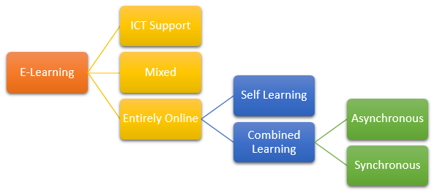
Figure 2.1 E-Learning Model

E-Learning

E-learning is defined as the use of electronic technologies for the process of teaching and learning. The term “E-learning” comprises of many terms like “Virtual Learning”, “Distributed Learning”, “Networked Learning” etc. As the “e” word in E-learning means “Electronic” so, all the learning that occurs Synchronous or Asynchronous, in groups or individually, offline or online etc. It covers all aspects in this word. Moreover, E-learning is not one-way communication. It is a two-way communication in which students listen to the teachers and teachers teach to the students. [2]

History of E-Learning

The expression "e-learning" has possibly been in presence since 1999 when the word was first used at a CBT frameworks course. Different words likewise started to jump up looking for a precise portrayal, for example, "web based learning" and "virtual learning". Notwithstanding, the standards behind e-learning have been all around archived since the beginning, and there is even proof which recommends that early types of e-learning existed as far back as the nineteenth century.

Importance of E-Learning

The most important development in training has taken place since the web was launched. Nowadays students are familiar with cell phone use, text messaging and web use so being interested and doing online courses has become a basic illegal relationship. Message sheets, web-based media and various forms of online correspondence allow students to stay in touch and talk about academic-related issues, while experiencing local feeling.

In the fast-paced e-learning environment, the achievable progress of creating a new and empowering course continues to change, and the potential can be quickly updated to provide students with the most up-to-date data. This is especially important when e-fixing is given to representatives in an area where integration with the latest industrial development is paramount. This is one of the reasons why many organizations currently offer e-learning preparation - a variety of reasons include low cost and the ability of representatives to volunteer and focus. In general, regular reading is expensive, time-consuming, and the results may vary. The importance of e-learning is currently guaranteed and can provide faster, less expensive and better options.

Concerns that arise with E-Learning

Indeed, even given all the advantages of e-learning, one can't deny there are a few downsides. A genuine illustration of a burden of web based acquiring is that useful abilities are to some degree harder to get from online assets. For instance, despite the fact that building a wooden table is something you can undoubtedly share data about, record recordings of and clarify, the pragmatic experience is fundamental. Ceramics and vehicle designing are instances of abilities that require involved insight. In spite of the fact that e-learning offers simplicity, adaptability and the capacity to distantly get to a homeroom in the understudy's own time, students may feel a feeling of disengagement. This is on the grounds that learning on the web is a performance represent the most part, which may give the student the inclination that they are acting totally alone. As innovation advances and e-taking in advantages from the progressions being made, students would now be able to connect all the more effectively with educators or different understudies utilizing apparatuses, for example, video conferencing, web-based media, and conversation discussions among others.

Types of E-Learning

There are below three types of E-learning:
- Entirely Online.
- ICT Support.
- Mixed.

Entirely Online

In this type of E-learning, all the assignments, tasks, quizzes, exams, teaching method, evaluation method etc. is online.
- Self-Learning
In self-learning, all the tasks given by the instructor has to perform by the student individually on his/her own, making groups with others and combined learning in not allowed.
- Combined Learning
In combined Learning, there are groups either made by the teacher or by students themselves, they have to work in groups, all the tasks performed by the students are in groups and they have to study combinable.
- Synchronous
Synchronous Learning is defined as the Online Learning in which all the tasks happen in live environment through online platforms such as Zoom, MS Teams etc.
- Asynchronous
Asynchronous Learning is defined as the Online Learning in which all the tasks happen in offline environment such as via through any Learning Management System.

ICT Support

In self-learning, all the tasks given by the instructor has to perform by the student individually on his/her own, making groups with others and combined learning in not allowed.

Mixed

In combined Learning, there are groups either made by the teacher or by students themselves, they have to work in groups, all the tasks performed by the students are in groups and they have to study combinable. [5]

Modes of E-learning

Below are the different modes of Synchronous E-learning:
- Zoom.
- MS Teams.
- Google Meet.
- Slate.
- Moodle.

Universities and their Learning Methods before COVID19

Table 2-1 Methods of Learning before COVID19
Universities | Learning Methods
- Bahria University Lahore Campus. | Traditional Classrooms as well as BU Portal.
- COMSATS Lahore. | Traditional Classrooms as well as CU Portal.
- University of Central Punjab. | Traditional Classrooms as well as UCP portal.
- Lahore Garrison University. | Traditional Classrooms.
- Government College & University. | Traditional Classrooms.
- Punjab University. | Traditional Classrooms.
- Forman Christian College & University. | Traditional Classrooms and Moodle LMS.
- University of Management & Technology. | Traditional Classrooms as well as Moodle LMS.
- National College of Business Administration and Economics. | Traditional Classrooms and NCBA&E LMS
- University of Lahore. | Traditional Classrooms.

Above table consist of the names of Private, Government and semi-Government Universities in Lahore along with their Teaching Methods before COVID-19 Pandemic.

Universities and their Methods of Learning during COVID19

Table 2-2 Methods of Learning during COVID19
Universities | Learning Methods
- Bahria University Lahore Campus. | Entirely Online using:  - Bahria University LMS  - MS Teams.  - ZOOM.
- COMSATS Lahore. | Entirely Online using:  - Google Meet.  - ZOOM.  - MS Team.
- University of Central Punjab. | Entirely Online using:  - UCP LMS.  - MS Teams.
- Lahore Garrison University. | Entirely online using:  - Google Classroom.  - ZOOM.
- Government College & University. | Entirely Online Using:  - LMS.  - WhatsApp.
- Punjab University. | Entirely Online using:  - ZOOM.  - Email.  - LMS
- Forman Christian College & University. | Entirely Online using:  - Moodle LMS.  - ZOOM.
- University of Management & Technology. | Entirely Online using:  - Moodle LMS.  - ZOOM.  - MS Team.
- National College of Business Administration and Economics. | Entirely Online using:  - NCBA&E LMS  - Google Meet for Exams.  - ZOOM.
- University of Lahore. | Entirely Online using:  - UOL Portal.  - ZOOM.

Above table consist of the names of Private, Government and semi-Government Universities in Lahore along with their Teaching Methods during COVID-19 Pandemic.

Issues of Learning Management System

In literature, many issues regarding Learning Management System were addressed but, the main issues that have been seen according to usability and design issues in most of the research papers are as following: [6]
- User interface of LMS is very complex to use.
- Users are unable to access the resources of LMSs wholly.
- LMSs are unable to support combined learning.
- Lack of Information Sharing.
LMSs can be improved in many ways.

DESIGN AND METHODOLOGY

Methodology

The study uses a mixed method research and User-Centred Design (UCD) in order to achieve the objectives of study to investigate the design issues of Interactive LMS. UCD approach involves 4 phases that includes Analysis, Design, Evaluation and Implementation. [3] Investigation will be started by reviewing the recent literature based on HCI principles of Design issues. It will Include Pre-Surveys, Questionnaire, Skilled Person Advice, and Heuristic Evaluation by assigning tasks to relevant users and Post-Surveys. Different Prioritizing techniques will be used technique to identify the most prioritizing factor among all. It can be Ranking, Analytical Hierarchy Process (AHP) and Moscow Technique etc. [6]
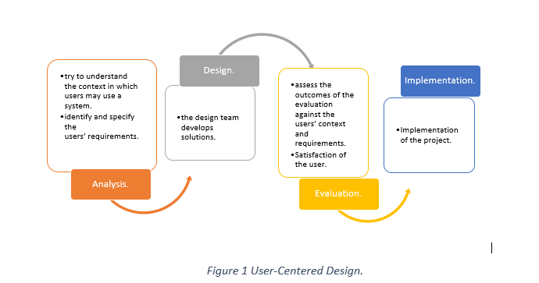
Figure 3.1 UCD Implementation Process

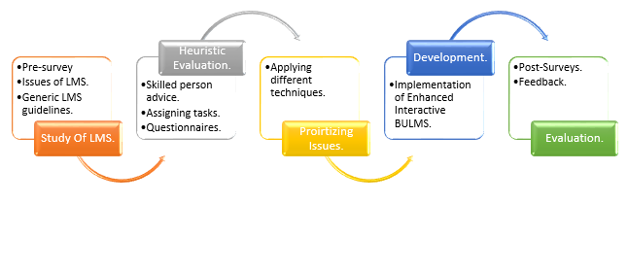
Figure 3.2 Workflow describes the stepwise implementation of Interactive LMS: User-Centred Perspective

Objectives

Below are the Objectives that should be achieved through this project:
- To study current LMS used by different universities of Lahore with respect to user experience perspective by different approaches.
- To identify UX/User Interface Issue in BULMS from students.
- To evaluate UX/User interface issues from skilled persons/knowledgeable persons through Heuristic Evaluation.
- To prioritize UX/UI issues in order to get most important issues.
- To integrate UX/UI Issues in BULMS by developing Prototype of interactive LMS.
- To evaluate proposed interactive LMS from students.

Steps

Below are the sub-objectives and steps in order to achieve the main objectives:

Objective 1

Below are the steps that should be followed in order to achieve objective 1:
- To make list of all universities of Lahore.
- To short list the renowned universities.
- To study their LMS in detail.
- To study their LMS with user perspective.

Objective 2

Below are the steps that should be followed in order to achieve objective 2:
- To make SUS for BU-LMS.
- To disseminate the SUS Form among the targeted audience.
- To get responses from 30+ users.
- To make record of that gathered information.

Objective 3

Below are the steps that should be followed in order to achieve objective 3:
- To make list of issues from SUS.
- To find team of Experts for Heuristic Evaluation.
- To disseminate the list of issues to the Experts.
- To obtain the result of Heuristic Evaluation.

Objective 4

Below are the steps that should be followed in order to achieve objective 4:
- To study different MCDAs Methods.
- To choose the appropriate one for the project.
- To implement the selected prioritizing technique successfully.
- To get the list of the prioritized issues.

Objective 5

Below are the steps that should be followed in order to achieve objective 5:
- To make the list of prioritized issues.
- To integrate them with the enhanced interactive Prototype of BULMS.

Objective 6

Below are the steps that should be followed in order to achieve objective 6:
- To gather some expert students of BULMS.
- To evaluate the enhanced prototype from the students.
- To solve the post survey of the Interactive LMS Prototype.
- To get the Results.

Usability

The term Usability was instituted about 10 years prior to supplant the expression "easy to use"
Which by the mid-1980s had obtained a large group of unfortunately unclear and abstract meanings.
Nonetheless, in the mediating years, the word Usability itself has become nearly as cheapened as the term it was planned to override. There are as yet various ways to deal with making an item
Usable, and no acknowledged meaning of the term ease of use. The definitions which have been utilized get from various perspectives on what Usability is. Three of the perspectives identify with how Usability ought to be estimated:

- the item situated view, that ease of use can be estimated regarding the
- ergonomic credits of the item;
- the client situated view, that Usability can be estimated regarding the psychological
- exertion and mentality of the client;
- the client execution see, that ease of use can be estimated by analysing how
- the client communicates with the item, with specific accentuation on all things considered
  - usability: how simple the item is to utilize, or
  - Adequacy: regardless of whether the item will be utilized in reality.
[6]

Usability Evaluation Method (UEM)

Usability Evaluation Method is a field of Human Computer Interaction that includes different methods to evaluate usability of any System or Interface or Product. Below are some usability Evaluation Methods:
- Interviews: To directly interact with the users to obtain answers of the structured Questions.
- Questionnaires: A document that contains a number of questions to get answers from the users.
- Focus Groups: Interview of specific/similar group of people.
- Cognitive Task Analysis: In CTA, different tasks are given to the users and evaluate their answers from cognitive perspective.
- Cognitive Walkthroughs: CW are utilized to inspect the ease of use of product. They are intended to see whether another user can undoubtedly complete errands inside a given framework.
- System Usability Survey (SUS): It is a pre-defined scale consisting of 10 questions, on the basis of which usability of any system can be evaluated.
- Heuristic Evaluation: Evaluation of any system regarding Interface, through Experts.
Among all the mentioned UEMs, this project only focuses on Interview Conduction, Focus Groups, Surveys, System Usability Scale, and Heuristic Evaluation. [9]

Usability Evaluation

Below is the details of conducting Usability Evaluation of Bahria University Learning Management System.

Participants

Thirty members filled this survey and they were chosen on expert user’s premises (students of Bahria University). These 30 people are those who often interact with Learning Management System. In this 30 members of community, 66.67% are Males and whereas 33.33% are females.

Usability Survey

For this survey, A System Usability Scale (SUS) survey comprising of 10 things (5 Likert scale) was utilized to gauge the ease of use. Members gave their input by rounded out System Usability Scale (SUS) structures and on the SUS structure, ten explanations about the connected site were given to the members. Members could demonstrate their degree of arrangement dependent on the scores gave on the structure (from 1 to 5; with 5 implies emphatically concur). [6]

Likert Scale

It is a psychometric scale which is used for the research work, in which users specify their level of agreement to the statement mentioned according to the scale which is as following:
- 1 Strongly Degree.
- 2 Disagree.
- 3 Neither Agree nor Disagree.
- 4 Agree.
- 5 Strongly Disagree.

User Profiling

Below is the table for the User profiling of the Participants who take part in this study.
Table 3-1 User Profiling
Specification | Category | Percentage
- Gender | Male | 66.67%
- Gender | Female | 33.33%
- Program | MS | 0%
- Program | CS | 96.67%
- Program | Psychology | 3.33%
- Type of Learning Management System | BU LMS | 100%
- Frequency of using LMS | Daily | 83.33%
- Frequency of using LMS | Weekly | 16.67%
- Frequency of using LMS | Monthly | 0%

This study includes 66.67% of male, 33.33% of females. The more percentage are from CS program and some are from Psychology program. Users are using the Learning Management System of Bahria University. The frequency of using Learning Management System daily is 83.33% and weekly is 16.67%

SUS Details

Below is the System Usability Scale (SUS) standardized 10 questions according to John Brooke [6]
- I think that I would like to use Learning Management System frequently.
- I found the Learning Management System unnecessarily complex.
- I thought the Learning Management System was easy to use.
- I think that I would need the support of a technical person to be able to use the Learning Management System.
- I found the various functions in Learning Management System were well integrated.
- I thought there was too much inconsistency in the Learning Management System.
- I would imagine that most people would learn to use the Learning Management System very quickly.
- I found the Learning Management System complicated to use.
- I felt very confident using the Learning Management System.
- I needed to learn a lot of things before I could get going with Learning Management System.

SUS Scoring Criteria

After getting responses of 30 users on the usability of Learning Management Systems of Bahria University, we have calculated the SUS Score for each individual and then calculated Mean of SUS Score. According to John Brooke, below is the scoring criteria that is used to measure the SUS.

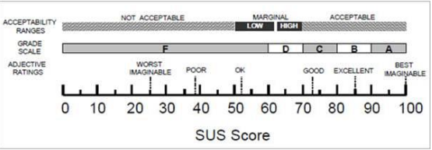
Figure 3.3 SUS Scoring Scale

Heuristic Evaluation

Heuristic evaluation was directed remembering Jacob Nielsen's 10 convenience heuristics to discover all sure and negative discoveries in Learning Management System that went about as a ruin in its utilization.

Principles

The principles of Heuristics are as follows:

Table 3-2 Principles of Heuristics
HEURISTICS | VARIABLES | EXPLANATION
- Visibility of system status. | H1 | The system should always inform users about what is going on, within a reasonable time, using proper feedback.
- Match between system and the real world. | H2 | The system should use the user’s language with words that are familiar with end users.
- User control and freedom. | H3 | The system should facilitate the user for undo and redo activities rather than doing it by yourself.
- Consistency and standards. | H4 | The system should follow platform convention.
- Error prevention. | H5 | The system should tell users about the mistakes through pop-ups or prevent error alerts.
- Recognition rather than recall. | H6 | The system should provide options, objectives and actions visible to users.
- Flexibility and efficiency of use. | H7 | The system should be for both novice and expert users.
- Aesthetic and minimalist design. | H8 | The system should always provide relevant information according to the needs of users.
- Help users recognize, diagnose, and recover from errors. | H9 | The system should provide the mechanism that help them to diagnose from errors.
- Help and documentation. | H10 | The system should provide the guide of using the system efficiently.

Above table demonstrates all heuristic principles along with their variables and proper explanation.

Ranking System

We have ranked each of the problems according:
• Minor issue: interrupts user’s ability to navigate.
• Major issue: discourage or confuses users.
• Catastrophic issue: disable users from performing their given tasks.
According to the table:

Table 3-3 Ranking Issues Table
Minor Issues | Major Issues | Catastrophic Issues
Mean ≤ 1 | Mean >1 , less than 3 | Mean ≥ 3

Above table indicated the ranking of issues according to the obtained mean score.

Prototype

The word Prototype is derived from the Greek word “Prototypon” which means primitive form. This term is used in different context which includes software programming, design and semantics. It is used for realistic product design.

Types of Prototype

There are main two types of prototype as follows:
- High Fidelity.
- Low Fidelity.

High Fidelity

High Fidelity prototype is used to give user an experience similar as he is using the actual product.

Low Fidelity

Low Fidelity prototype is a paper based prototype that does not allow users to interact with product like high fidelity prototype. Through this prototype, user can easily see the first look of his product.

Tools and Techniques

There are many tools available for the development of Prototype. Below are some tools:
- IN Vision.
- Adobe Experience Design.
- Figma.
- Mock Flow.
- MS Visio.
- WordPress.
- Statistical Package for the Social Sciences (SPSS).
In this project, we will be using FIGMA for the development of High Fidelity Prototype.
Different Prioritizing techniques can be used to identify the most prioritizing factor among all. Different prioritizing techniques are:
- Ranking.
- Analytical Hierarchy Process (AHP)
- Moscow Technique.
- Hundred Dollar Method.
- Bubble Sort Technique.

DATA AND EXPERIMENTS

User Specified Issues of Learning Management System

Below are some issues that are specified by the users of LMSs of different renowned
Universities of Pakistan including University of Central Punjab, COMSATS, Lahore
Garrison University, and University of Punjab etc.
- No Guidelines are provided for use of LMS.
- Messy Student Profile Section.
- Unnecessary Information i.e. No need of file type and file size in learning
- Recourses section.
- Redundancy of Information i.e. material type is same as Title.
- Courses that include Labs, should be displayed individually.
- Attendance Summary of all courses should be displayed individually.
- Complex Sign in Credentials, difficult to memorize.
- No proper mapping i.e. compliant menu redirected towards main page.
- Excessive Navigation on main page.
- Massive information on home page.
- No proper menus for relevant information.
- Irrelevant dropdown submenus i.e. program timetable next term, unconfirmed
- timetable.
- Inappropriate information displayed on Home page i.e. Timetable, attendance
- report, general progress report.
- No interactivity i.e. no proper use of icons, colour scheme, fonts.

Issues of Bahria University Learning Management System

Before defining the issues of Bahria University Learning Management System, many
LMSs including UCP LMS, COMSATS LMS etc. have been identified and critically
analysed in order to get issues. After identifying the issues from user regarding
Bahria University Learning Management system, we have come to a result that users
are not satisfied with this LMS according to SUS Survey. And below is the list of
identified issues from users (BU Students):
- BU Logo is not visible.
- Colour Scheme is not appropriate.
- No proper Announcement Alerts.
- Exam seating plan should be displayed in Papers Section.
- Excessive Dropdown Menus.
- Excessive Linked Webpages.
- The Alerts of Paper should be generated only when Papers Occurred.
- Icons are not interactive.
- Redundancy of Information i.e. Guidelines are as same as FAQS,
- Course Plan and Course Outline are same.
- Irrelevant Information is provided i.e. Time provided in LMS.

Phase 1 (SUS)

A System Usability Scale (SUS) survey comprising of 10 things (5 Likert scale) was utilized to gauge the ease of use. Members gave their input by rounded out System Usability Scale (SUS) structures and on the SUS structure, ten explanations about the connected site were given to the members.

Participants

There are 30 participants who participated in this SUS Study of Bahria University Learning Management System.

Study Approach

The study uses System Usability Scale (SUS) in order to achieve the objectives of study to investigate the usability issues of Learning Management System. This will include a questionnaire containing 10 questions that will be send to the individuals who are using Learning Management System via a link. Individuals will get link through their Email Account. After clicking on that link, they will be redirected towards the google form. Then, individuals will fill up the form according to their own experience while interacting with their respective Learning Management Systems. After filling the form, individuals will submit their form. They will receive a thank you message.
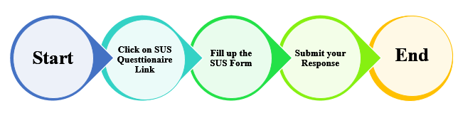
Figure 4.1Strategem of SUS

Resource Requirement

We will need software and hardware resources i.e. interactive tools, different Research Papers for Literature Review and personal computers/laptops.

SUS Questionnaire

Table 4-1 SUS Survey Questions
- I think that I would like to use Learning Management System frequently.
- I found the Learning Management System unnecessarily complex.
- I thought the Learning Management System was easy to use.
- I think that I would need the support of a technical person to be able to use the Learning Management System.
- I found the various functions in Learning Management System were well integrated.
- I thought there was too much inconsistency in the Learning Management System.
- I would imagine that most people would learn to use the Learning Management System very quickly.
- I found the Learning Management System complicated to use.
- I felt very confident using the Learning Management System.
- I needed to learn a lot of things before I could get going with Learning Management System.

Above table consists of the 10 questions of SUS Questionnaire.

SUS Scoring

Table 4-2 SUS Adjective Rating
SUS Score | Grade | Adjective Rating
>80.3 | A | Excellent
69-80.3 | B | Good
68 | C | Okay
51-67 | D | Poor
<51 | F | Awful

Above table consists of the adjective rating of SUS.

Data Gathering

Below is the data collection figure.

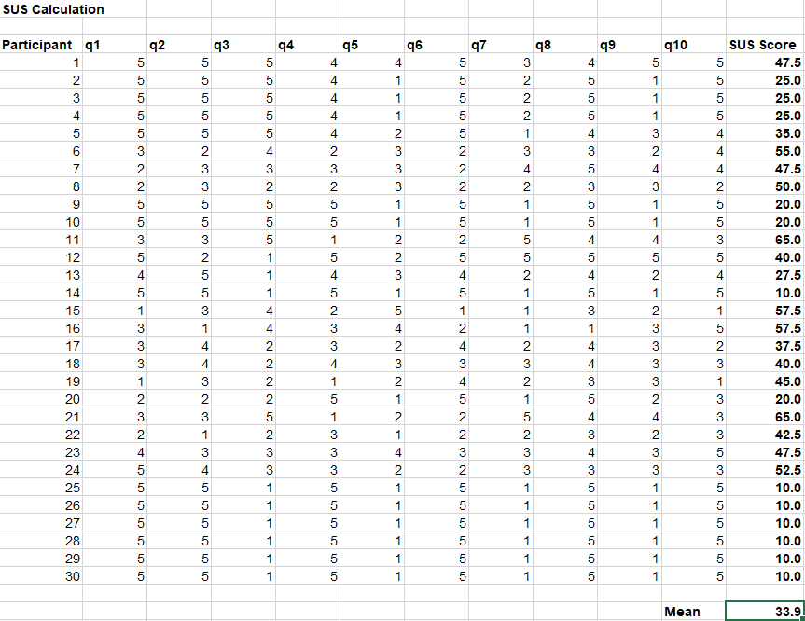
Figure 4.2 Data Gathered

Phase 2 (Heuristic Evaluation)

Heuristic evaluation was directed remembering Jacob Nielsen's 10 convenience heuristics to discover all sure and negative discoveries in Learning Management System that went about as a ruin in its utilization.

Phase 3 (Prototype)

In this project, Figma is used to develop the high fidelity prototype of Bahria University Learning Management System as it provides the real time experience with the product and gives you the feel how the product will act as real.

RESULTS AND DISCUSSIONS

SUS Results

After getting the filled surveys of SUS, then we calculated the SUS average score by following the below steps:
- Calculate score for odd number question by subtracting 1 from their score by user.
- Calculate score for even number question by subtracting their score by the user from 5.
- Then add all scores and multiply it by 2.5.

Below is the screenshot of the excel sheet in which the SUS Average score is calculated:

Figure 5.1 SUS Average Score

Below is the average SUS score in chart form:
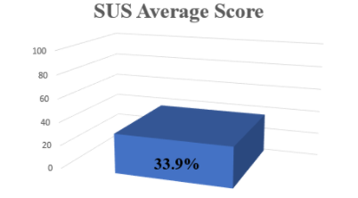
Figure 5.2 SUS Average Score of Bahria University LMS

SUS Summary

Below is the summary of each question of SUS in the form of chart:

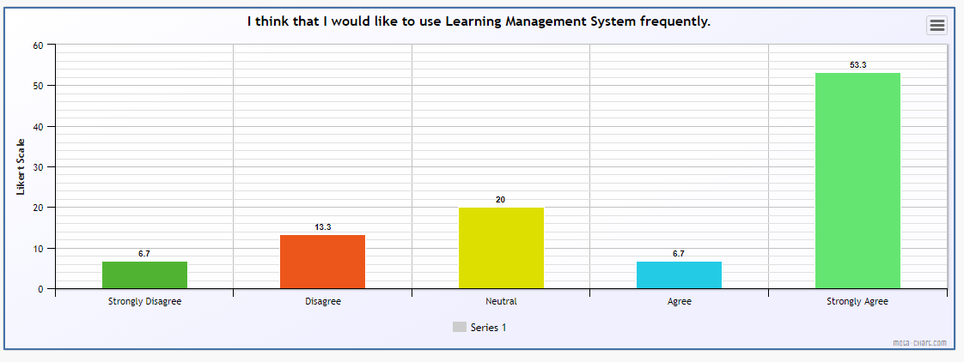
Figure 5.3 Q1 of SUS

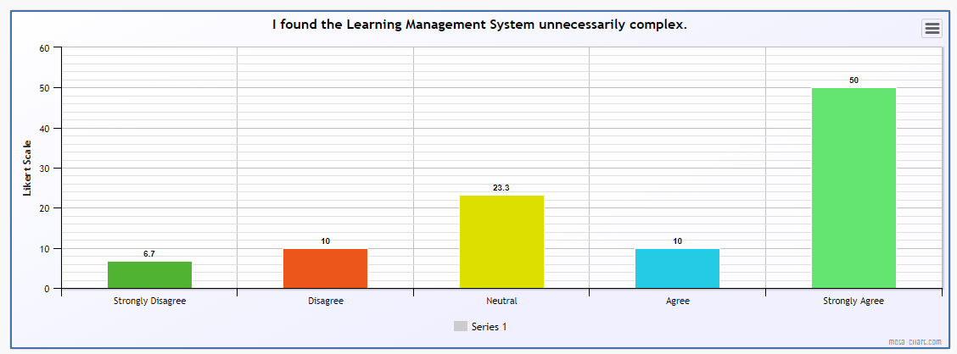
Figure 5.4 Q2 of SUS

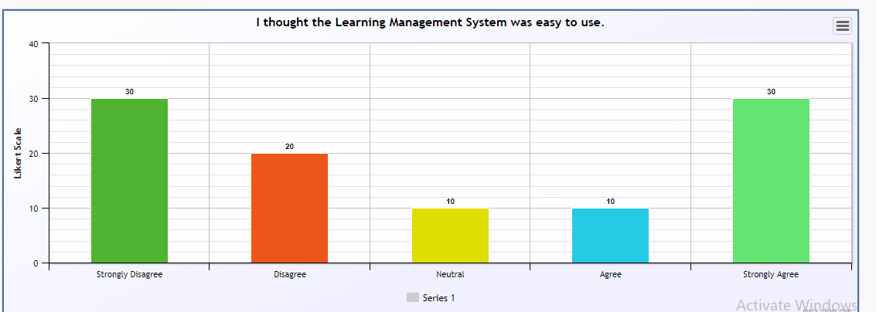
Figure 5.5 Q3 of SUS

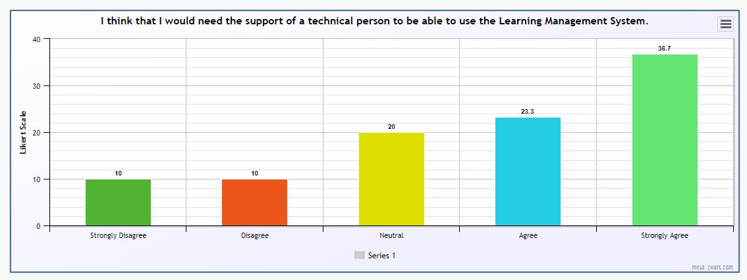
Figure 5.6 Q4 of SUS

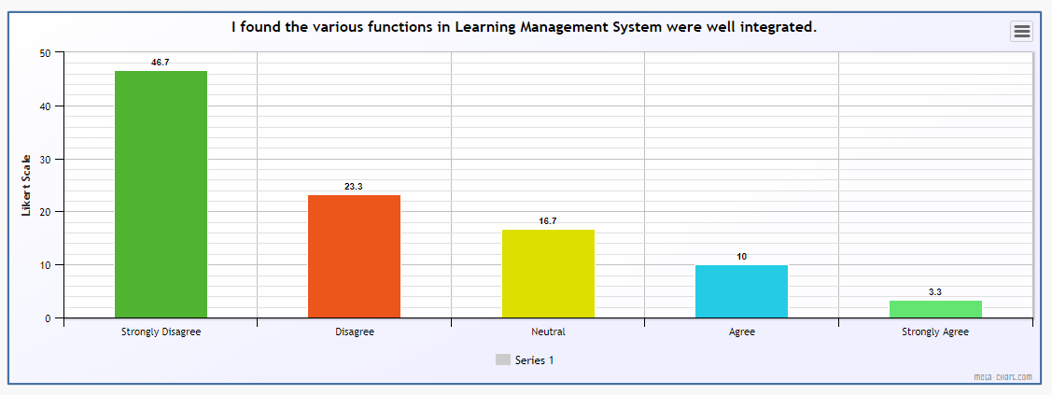
Figure 5.7 Q5 of SUS

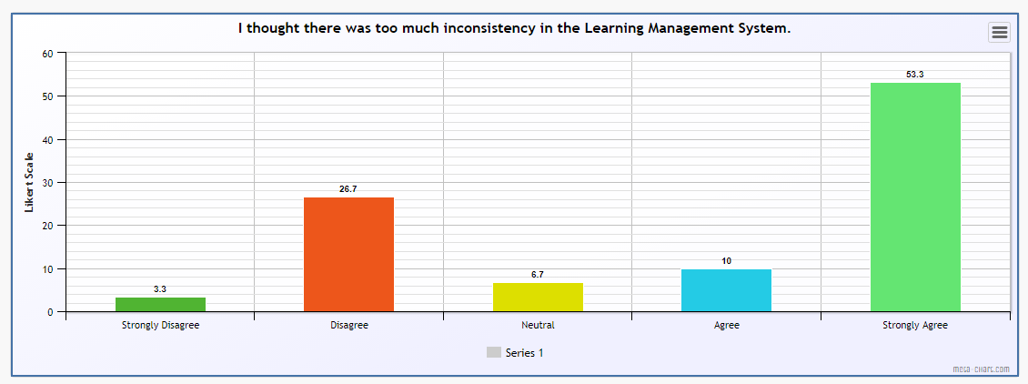
Figure 5.8 Q6 of SUS

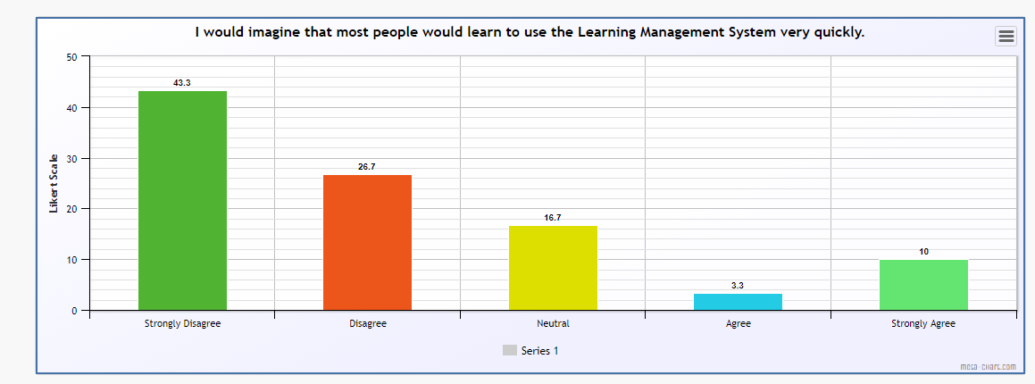
Figure 5.9 Q7 of SUS

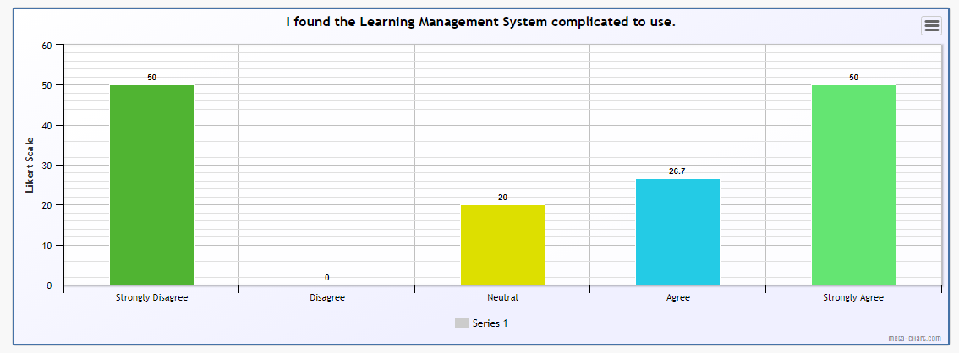
Figure 5.10 Q8 of SUS

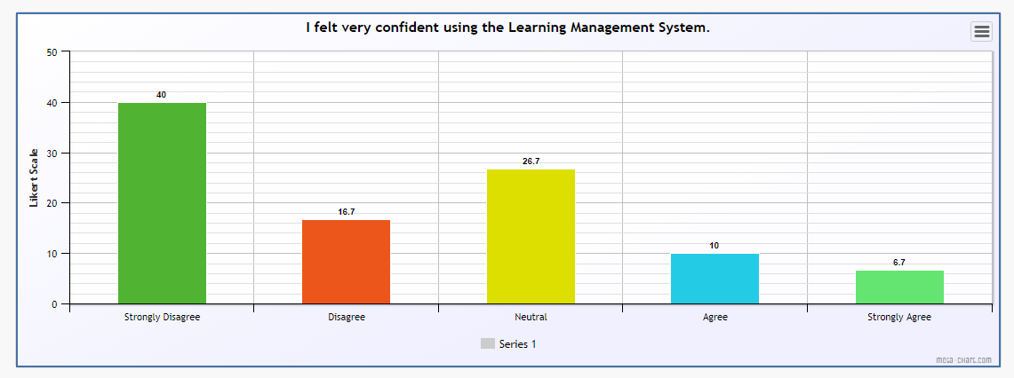
Figure 5.11 Q9 of SUS

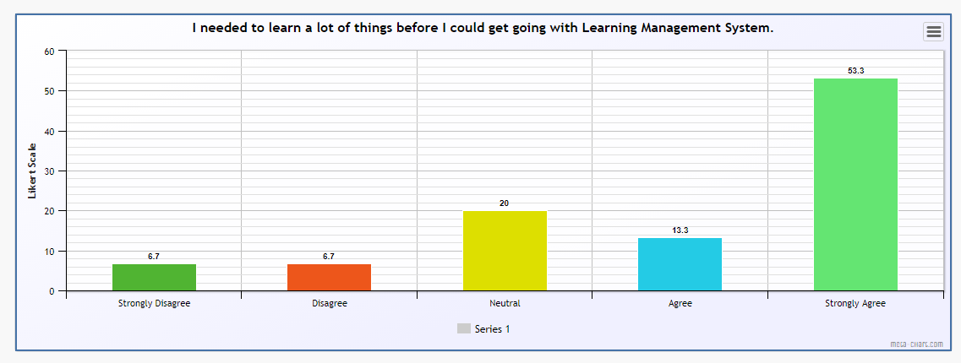
Figure 5.12 Q10 of SUS

Heuristic Evaluation Results

Below are the results Heuristic Evaluation i.e. group wise:

H1 Result

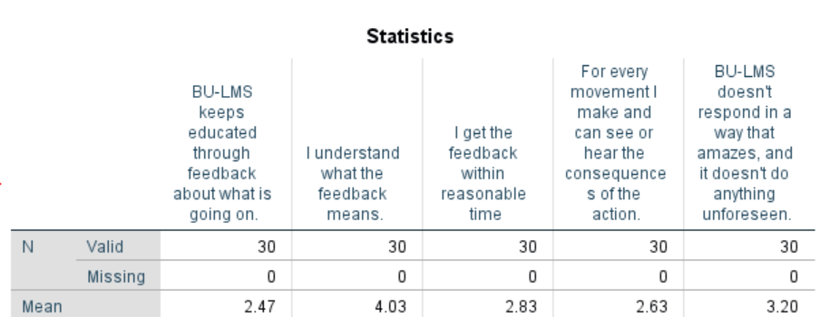
Figure 5.13 H1 Statistics

H2 Result

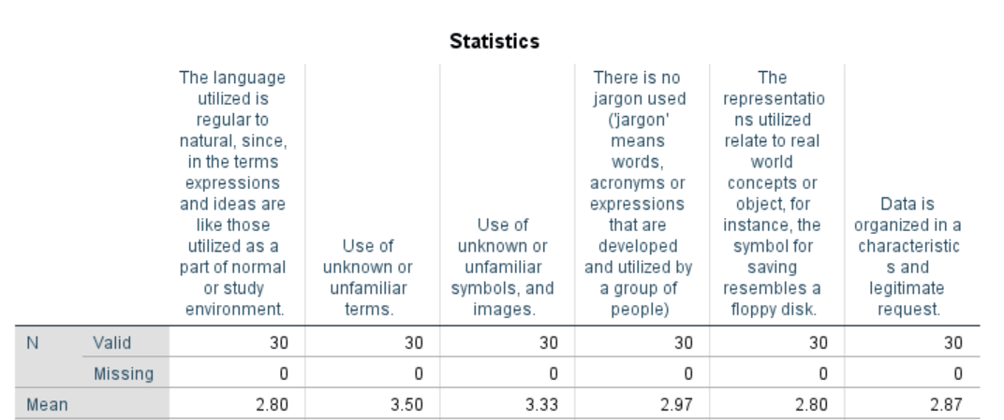
Figure 5.14 H2 Statistics

H3 Result

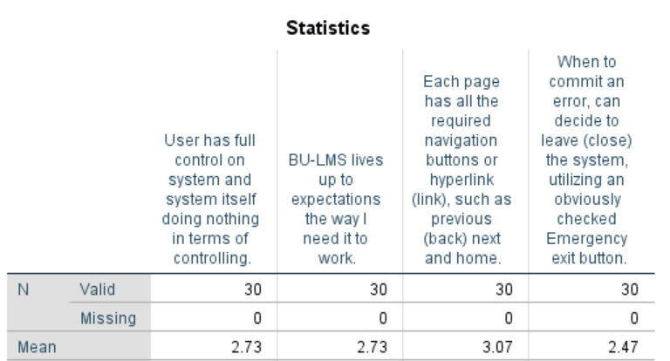
Figure 5.15 H3 Statistics

H4 Result

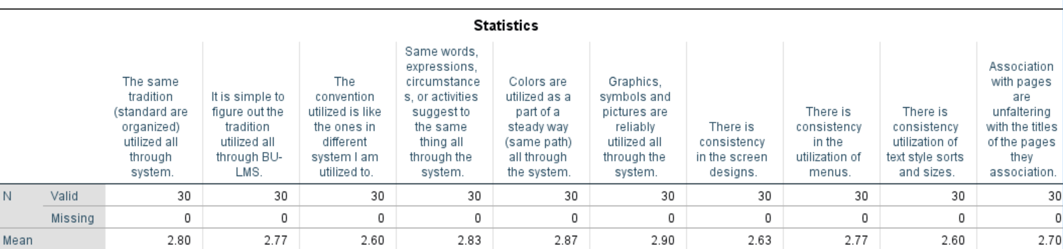
Figure 5.16 H6 Statistics

H5 Result

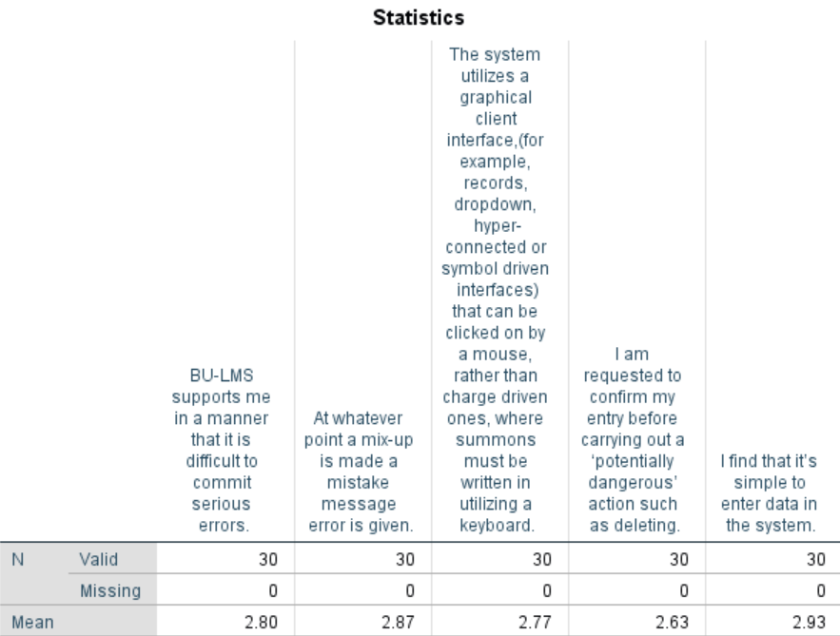
Figure 5.17 H5 Statistics

H6 Result

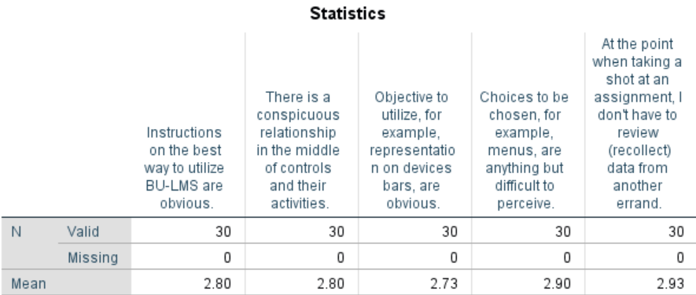
Figure 5.18 H6 Statistics

H7 Result

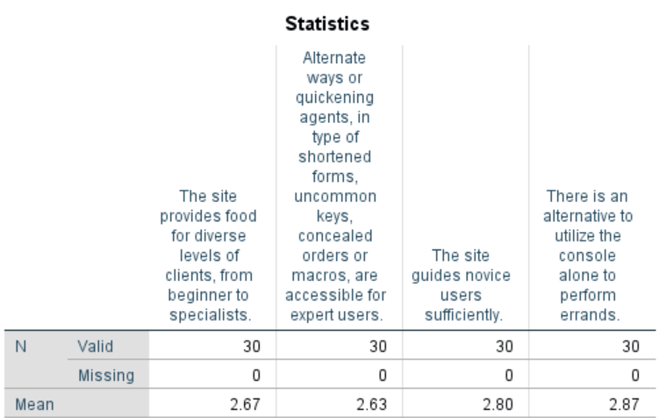
Figure 5.19 H7 Statistics

H8 Result

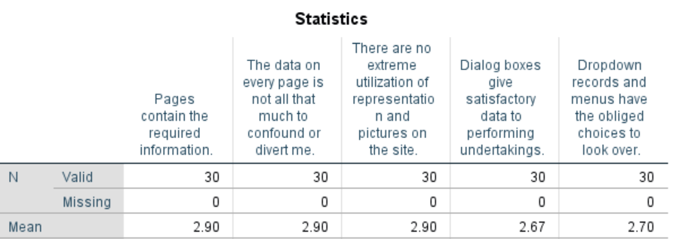
Figure 5.20 H8 Statistics

H9 Result

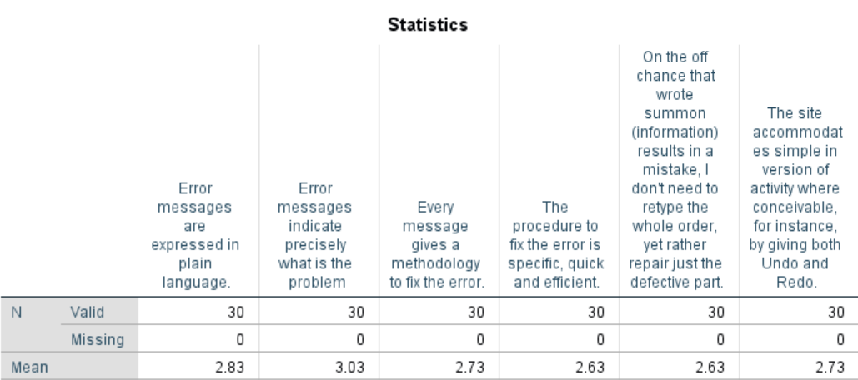
Figure 5.21 H9 Statistics

H10 Result

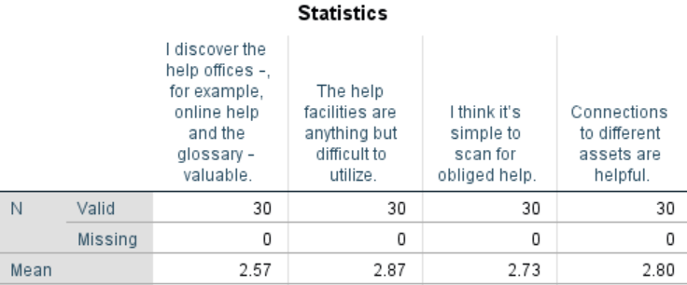
Figure 5.22 H10 Statistics

Heuristics Mean Values

Table 5-1 Mean Values of Heuristics
Heuristic Variables | Mean Value
H1 | 3.032
H2 | 3.045
H3 | 2.75
H4 | 2.747
H5 | 2.8
H6 | 2.832
H7 | 2.7425
H8 | 2.814
H9 | 2.763
H10 | 2.7425

Above table consists of the mean of each heuristic group through SPSS.

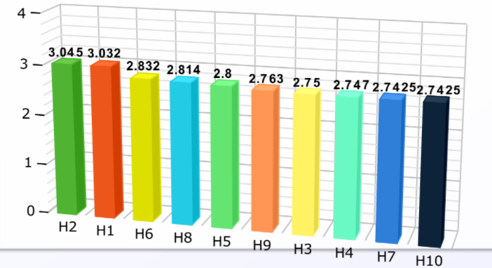
Figure 5.23 Mean Values of Heuristics

Prioritized Issues

After getting the mean of each heuristic group, we prioritized the issues depending upon their mean values.

Table 5-2 Issues after prioritizing
Heuristics | Variable for Heuristic | Minor | Major | Catastrophic
- Visibility of system status. | H1 |  |  | ✔
- Match between system and the real world. | H2 |  |  | ✔
- User control and freedom. | H3 |  | ✔
- Consistency and standards. | H4 |  | ✔
- Error prevention. | H5 |  | ✔
- Recognition rather than recall. | H6 |  | ✔
- Flexibility and efficiency of use. | H7 |  | ✔
- Aesthetic and minimalist design. | H8 |  | ✔
- Help users recognize, diagnose, and recover from errors. | H9 |  | ✔
- Help and documentation. | H10 |  | ✔

Above table contains the Heuristics, its variables and issues after prioritizing on the basis of their obtained mean values. In this table, H1 and H2 are catastrophic issues and else all are major issues.

Prototype Design

Below are the screens of High Fidelity Prototype:

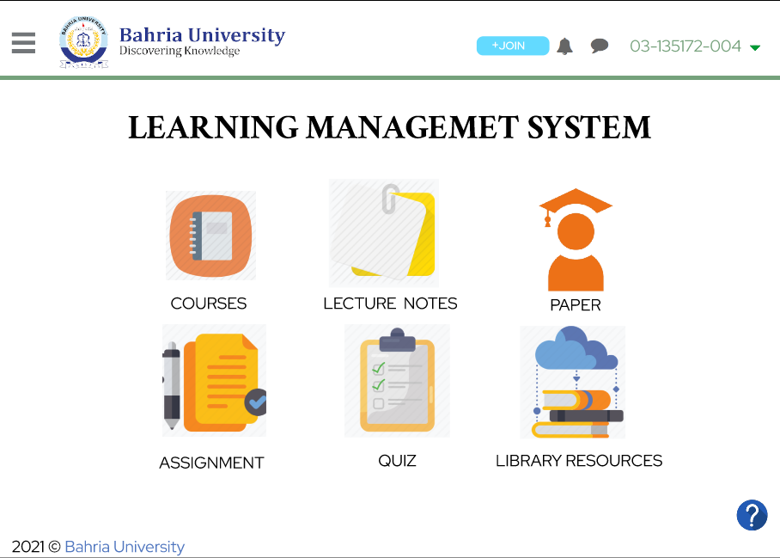
Figure 5.24 Enhanced Prototype Screen 1
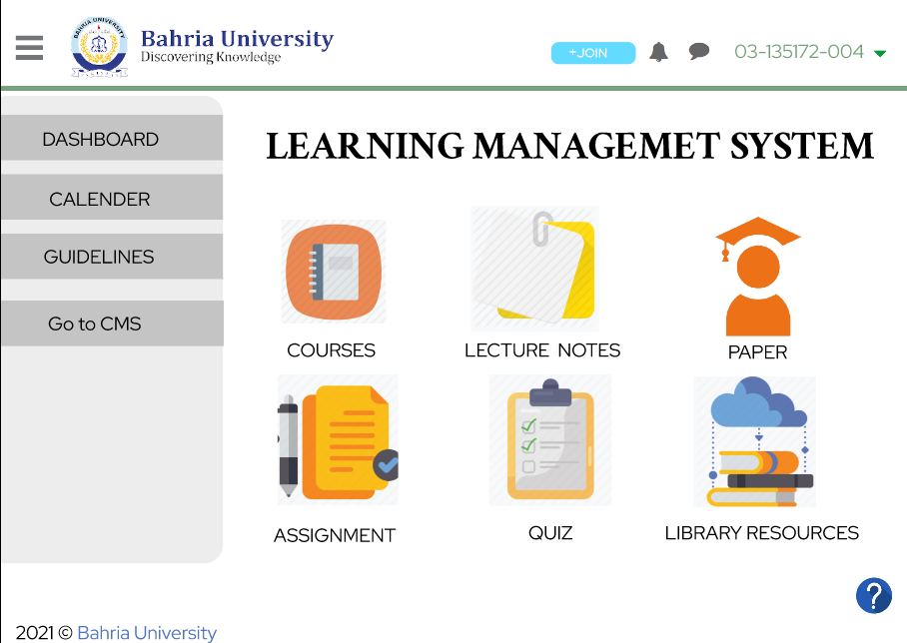
Figure 5.25 Enhanced Prototype Screen 2

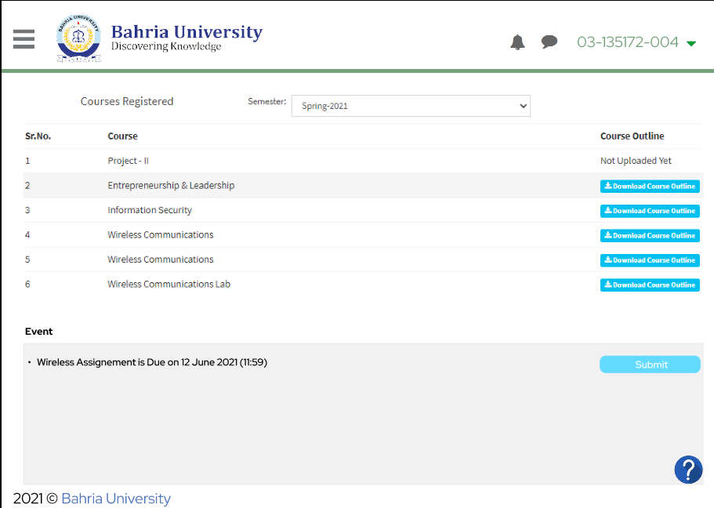
Figure 5.26 Enhanced Prototype Screen 3
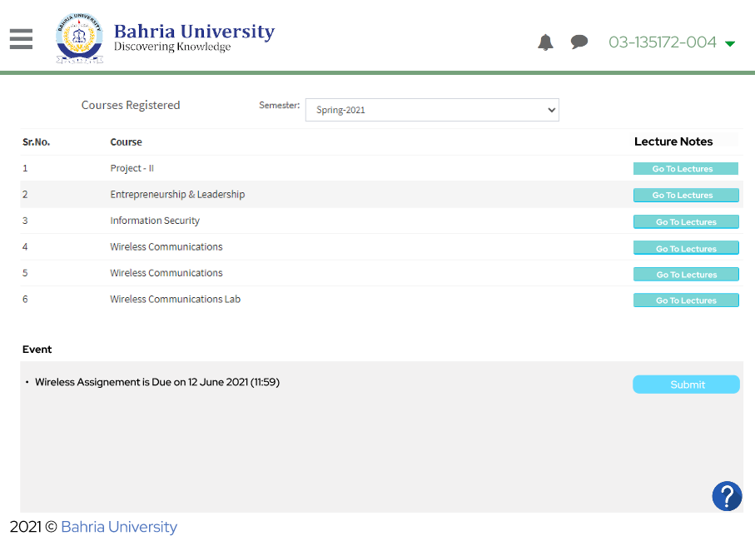
Figure 5.27 Enhanced Prototype Screen 4
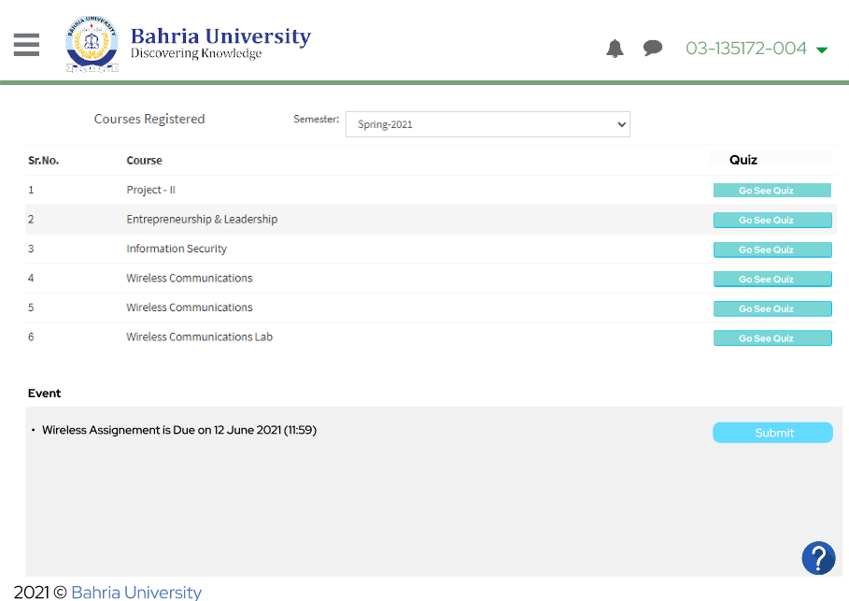
Figure 5.28 Enhanced Prototype Screen 5
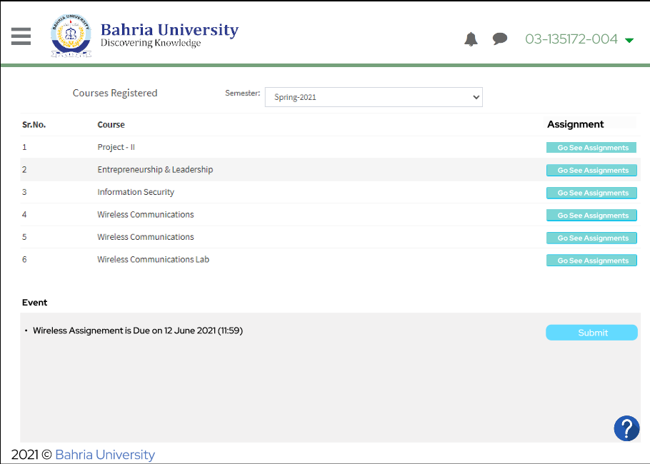
Figure 5.29 Enhanced Prototype Screen 6
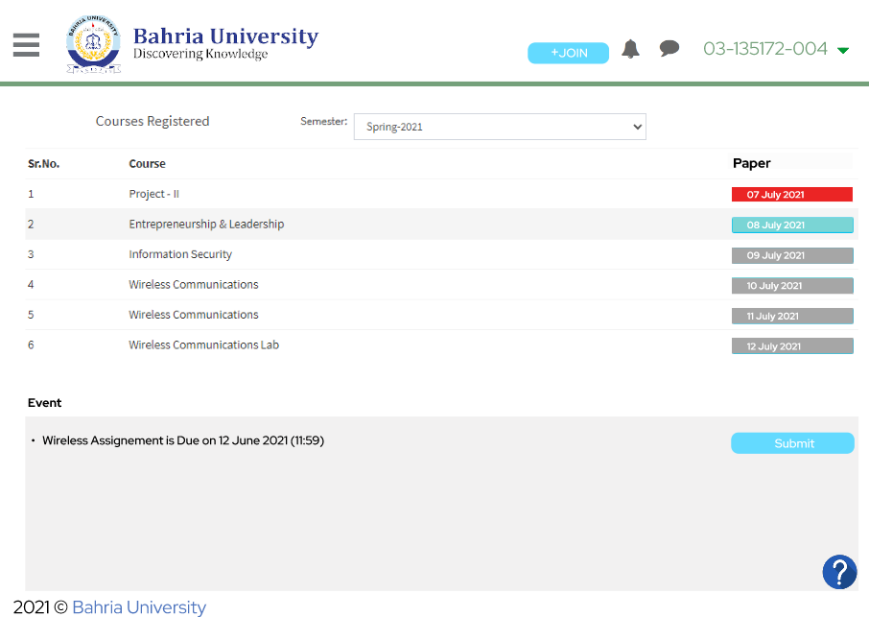
Figure 5.30 Enhanced Prototype Screen 7
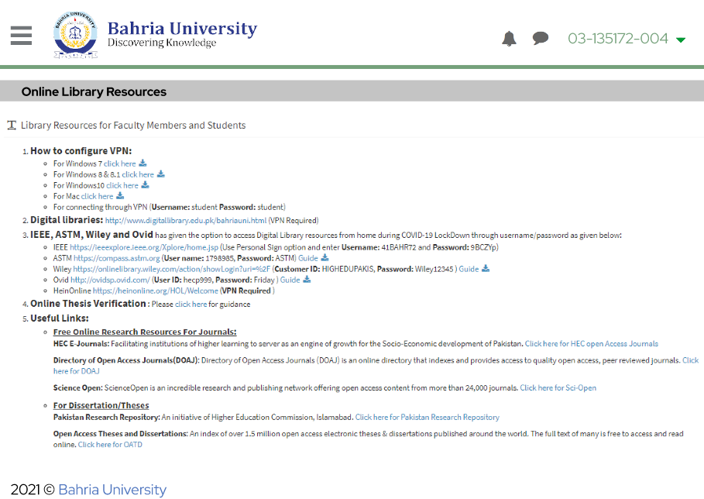
Figure 5.31 Enhanced Prototype Screen 8
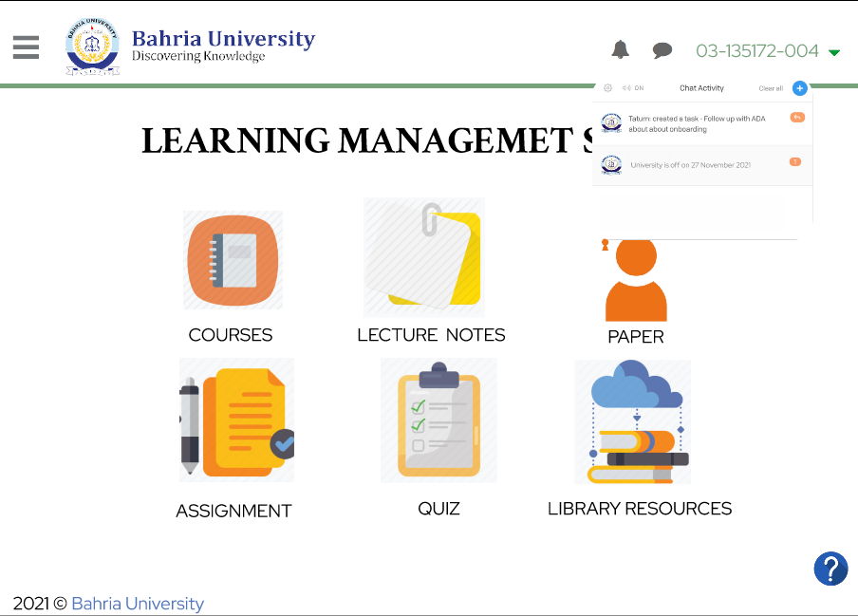
Figure 5.32 Enhanced Prototype Screen 9
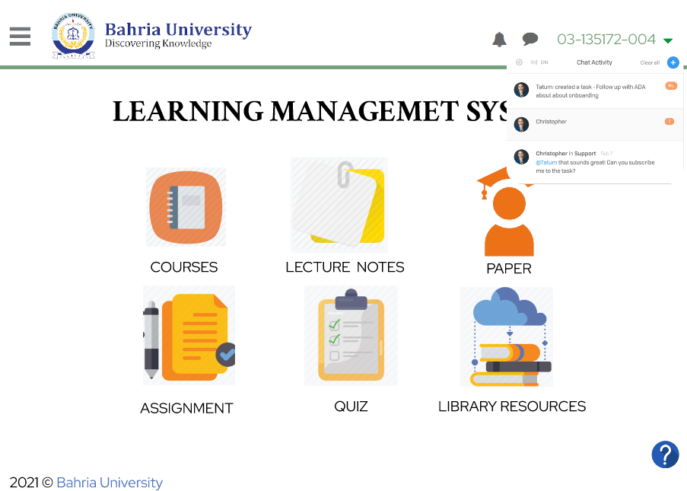
Figure 5.33 Enhanced Prototype Screen 10

CONCLUSION AND RECOMMENDATIONS

Conclusion

Many research papers have been identified for this research and it is found that much work have been done on issues of Learning Management System regarding design, usability etc. but still there is a need to do more research and improvements in LMS after critical analysis. SUS evaluation of E-learning through Learning Management System in Pakistan is represented by this study. The obtained result indicates that all participants are familiar with the Use of LMS and faced no difficulty while participating. As a whole, none of the university’s LMS satisfies the users and requires more work to be done on Usability of Learning Management Systems. As Heuristic Evaluation done afterwards, and it produced the result that clearly portrays, users are not satisfied with the Design of LMSs too. Universities of Pakistan needs to review their LMSs regarding design and usability in order to make the users satisfied as well as they need to enhance the interactivity of the LMSs. The future work may include improvements regarding usability and User Interface Specially. It must focus on user’s centred design (UCD Approach), Technology Adoption Model (TAM) etc. in order to achieve user’s satisfaction on top priority. As this study is limited to SUS and Heuristic Evaluation so more detailed evaluation can be performed by using other Usability Scales, Surveys and different Interactive Design Approaches.
It is concluded that the LMS of Bahria University Lahore Campus really needs to be revise according to the HCI principles as the SUS score is 33.9 which Awful for the audience. So, a high fidelity prototype is developed based on the principles of HCI which is ready to implement UCD approach kept in mind while designing the prototype. Now, BU can develop their LMS by following the prototype developed and make their audience satisfied.

Recommendations

The specific issues are obtained by the google form and recommendations are based on the expert advices.

Table 6-1 Issues and Recommendations
ISSUES | RECOMMENDATIONS
- BU Logo is not visible.   | The size of the logo should be maximized.  Proper feedback should be provided in LMSs.
- Irrelevant Information is provided.   | Irrelevant information should be removed.
- Colour Scheme is not appropriate.   | Colour Scheme should be according to the CMS as the BU LMS is within the CMS.
- No proper Announcement Alerts.   | There should be an alert icon or bar that indicates the alert messages.
- Exam seating plan is always displayed.  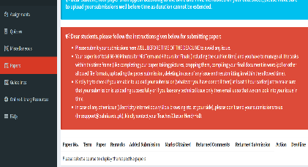 | Exam seating plan should only visible during exams.
- Excessive Dropdown Menus.  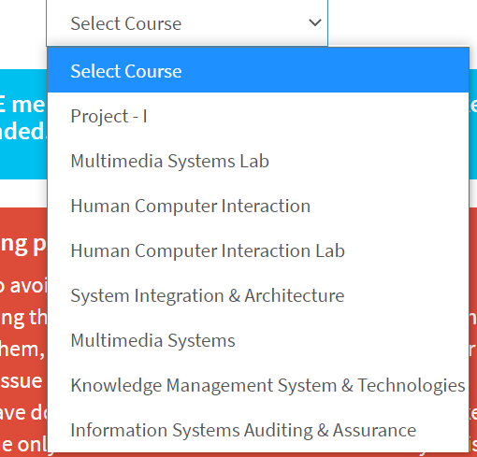 | Menus should be minimized.
- Redundancy of Information i.e. Guidelines are as same as FAQS, Course Plan and Course Outline are same.   | Remove the redundant data.
- The Alerts of Paper showed always in LMS.  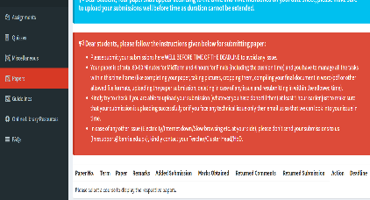 | Alerts should only be occurred when event or exams take place.
- Icons are not interactive. | Icons should be interactive and easy to understand.

Above table indicates the issues gathered and recommendations based on the expert advices.

References

[1] | D. A. Norman, Design principles for human-computer interface., 1983.
[2] | C. Gautreau, “ Motivational factors affecting the integration of a Learning Management System by faculty,” Motivational factors affecting the integration of a Learning Management System by faculty, 2011.
[3] | C. M. a. R. J. G. Reigeluth, “Envisioning a new system of education." Systemic change in education,” Envisioning a new system of education." Systemic change in education , 1994.
[4] | F. P. Taylor, “Education technology helps unite school communities, improve academic achievement,” Education technology helps unite school communities, improve academic achievement, 2004.
[5] | P. Kaewsaiha, “Usability of Learning Management System and choices of alternative,” Usability of Learning Management System and choices of alternative, no. 2019.
[6] | E. H. a. a. A. A. B. A. b, “Facilitating Teaching and Learning Capabilities in Social Learning Management Systems: Challenges, Issues, and Implications for Design,” Facilitating Teaching and Learning Capabilities in Social Learning Management Systems: Challenges, Issues, and Implications for Design.
[7] | L. Wood, “User Interface Design”.
[8] | N. Bevana, “What is Usability?,” What is Usability?, p. 5, September, 1991.
[9] | K. Iqbal, “Heuristic Usability Evaluation of the Uppsala University Student Portal,” Heuristic Usability Evaluation of the Uppsala University Student Portal, 2020.
[10] | J. Brooke, “SUS-A quick and dirty usability scale (in "Usability Evaluation in Industry", PW Jordan, B Thomas, I McLelland, BA Weerdmeester (eds)),” SUS, pp. 189-194, 1996.

APPENDICES

APPENDIX A: SUS Survey Form

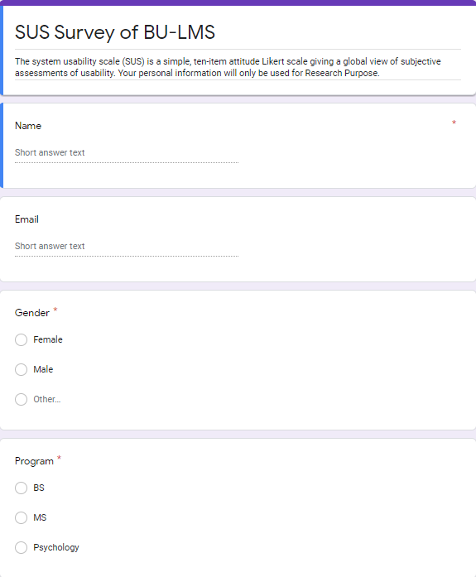
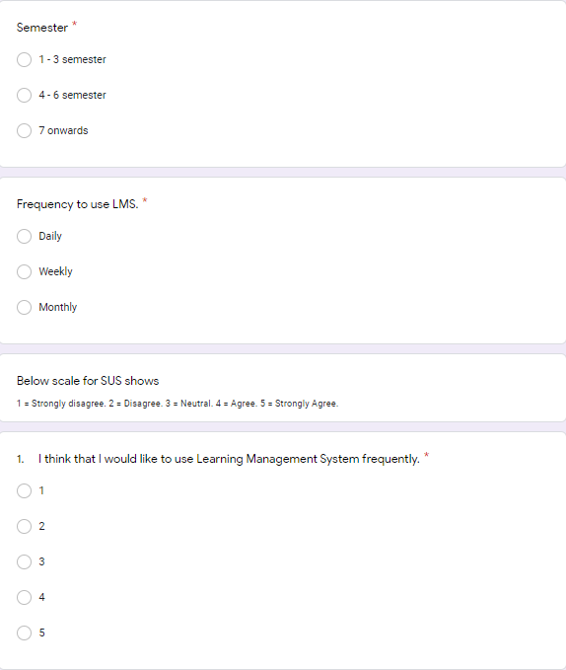
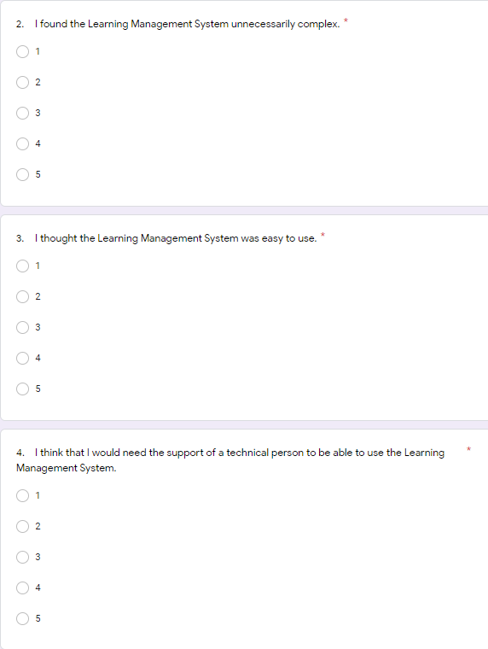
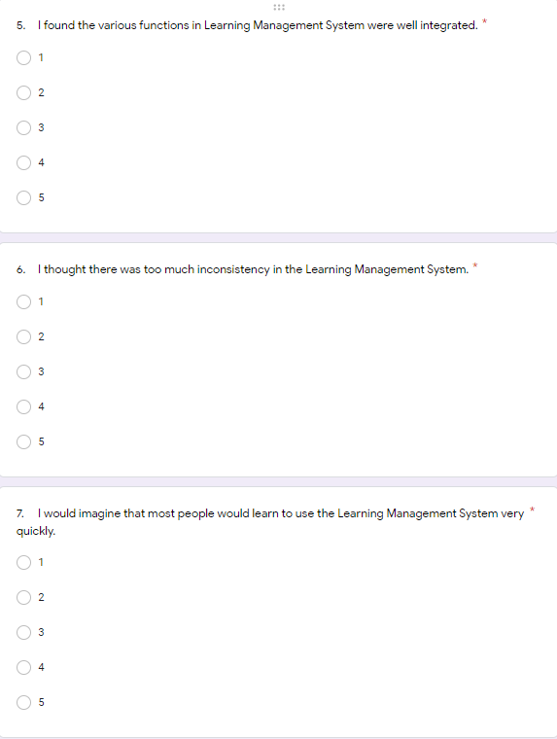
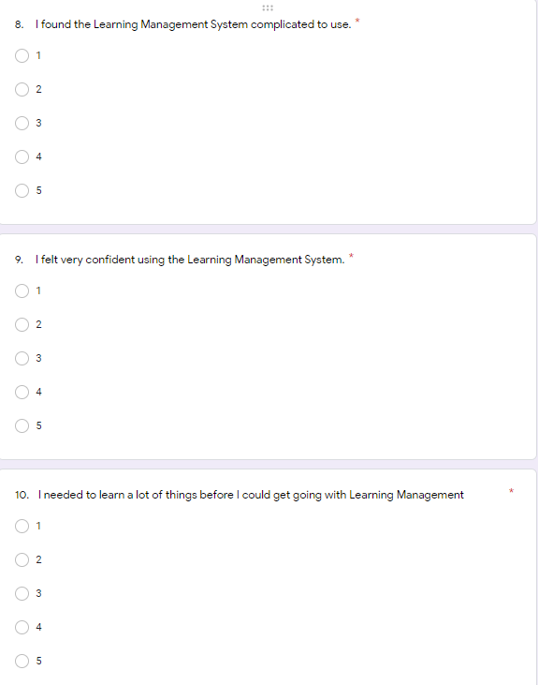

APPENDIX B: Heuristic Evaluation Form

