BSIT | Food Tech | July 2021



BSIT-F20-001
03-135172-034 | Nida Yasin

Food Tech
In partial fulfilment of the requirements for the degree of
Bachelor of Science in Information Technology
Supervisor: Dr. Qasim Khawaja
Department of Computer Sciences
Bahria University, Lahore Campus
July 2021

© Bahria University, 2021

Certificate

We accept the work contained in the report titled
“Food Tech”
written by
Nida Yasin

as a confirmation to the required standard for the partial fulfilment of the degree of
Bachelor of Science in Information Technology.
Approved by:
Supervisor: Dr. Qasim Khawaja
(Signature)
July 12, 2021

DECLARATION

We hereby declare that this project report is based on our original work except for citations and quotations which have been duly acknowledged. We also declare that it has not been previously and concurrently submitted for any other degree or award at Bahria University or other institutions.

Enrolment | Name | Signature
03-135172-034 | Nida Yasin

Date: July 12, 2021

Specially dedicated to
my beloved grandparents, mother and father & siblings
(Nida Yasin)

ACKNOWLEDGEMENTS

Starting with the name of Allah (S.W.T), first we would like to thank Allah (S.W.T) very much for giving us strength to complete this project. We would like to thank everyone who had contributed to the successful completion of this project. We would like to express my gratitude from the depth of our heart to my research supervisor,
Dr. Qasim Khawaja for his invaluable advice, guidance and his enormous patience throughout the development of the research.

In addition, we would also like to express my gratitude to our loving parents who stood beside us in every hour of need, our friends who had helped us in completing this project and given me encouragement.

Our teachers who taught us all from the start and helping us with all our queries and ambiguities so that we could bring this idea into real shape and last but not the least all the doctors who helped us in understanding to complex part of our project.

Nida Yasin

Food Tech

ABSTRACT

Project “No Tiring, Easy Dine-In” is an android-based application. In this emerging technological era, this Project will be the leading online food dine in service that will enable customers to single handily order their food while performing multiple errands. For this situation you can undoubtedly open your application, put in your request while doing shopping, it will straight forwardly reach to your cook and you will get your desired food order with in no time. This project will helps in eliminating Manual handy work, queues, searching through multiple restaurant’s menu cards and hustle hours resulting in saving end user time and budgeting issue, as price will be mentioned in e menu card.
It will empower the end client to install the application with in short time span. End user will now can simply open the application containing all restaurants with their respective E- menu cards. Each restaurant’s E-menu card has their unique food items with mentioned prices. Customer will simple scroll through app and order their favorite food resulting in hustle free environment Application is having multiple automated billing system hence end user will enjoy Hustle Free dine-in.

TABLE OF CONTENTS

CHAPTERS
1 INTRODUCTION 1
1.1 Purpose of the system 2
1.2 Aims and Objectives 2
1.3 Scope of Project 3
1.3.1 Optional Scope 4
2 Software Requirement Specification 5
2.1 Purpose 6
2.2 User classes and characteristics 6
2.2.1 User 6
2.2.2 Admin 7
2.3 Functional Requirement 7
2.3.1 Admin 7
2.3.2 User 7
2.4 Operating Environment 8
2.5 Design and Implementation Constraints 8
2.6 Assumptions and Dependencies 8
2.7 System Use Case 9
2.8 Customer Use case table 10
2.8.1 Registration (NT-01) 10
2.8.2 Log-In (NT-02) 11
2.8.3 Choose Restaurant (NT-03) 12
2.8.4 Select food (NT-04) 13
2.8.5 Payment (NT-05) 14
2.8.6 Place Order (NT-06) 15
2.8.7 Self-check-out/Dine-In (NT-07) 16
2.9 Admin Use Case Table 17
2.9.1 Receive Order 17
2.9.2 Confirm/Deny Order 18
2.9.3 Notify chef about order 19
2.9.4 Notify customer about order 20
2.10 Non-Functional Requirements 20
2.10.1 Performance Requirements 20
2.10.2 Security Requirements 21
2.12 Software quality attributes 21
2.13 System Requirements Chart 22
3 DESIGN AND METHODOLOGY 24
3.1 INTRODUCTION 24
3.2 Use-case Diagrams 25
3.2.1 Main system Use Case Diagram 25
3.4 Domain model Diagram 26
3.5 Sequence Diagram 27
3.6 Collaboration Diagram 28
3.8 Design Class Diagram 29
3.9 Data Model 30
3.9.1 The Relational Data Model 30
3.9.2 ERD 30
4 IMPLEMENTATION 31
4.1 Splash Screen 31
4.2 Main Screen 32
4.3 User Registration 33
4.4 User Login 34
4.5 Home Page 35
4.6 Menu Card 36
4.7 Order Review 37
4.8 Payment Page 38
4.9 Order Summary 39
5 RESULT AND DISCUSSION 40
5.1 Splash Screen 40
5.2 Main Screen 41
5.3 User Registration 42
5.4 User Login Screen 43
5.5 Home Screen 44
5.6 Menu Card Screen 45
5.7 Order Review Screen 46
5.8 Payment Screen 47
5.9 Order Summary 48
6 Conclusion and Recommendation 49

LIST OF TABLES

TABLE TITLE PAGE
Table 2.1: - Registration 10
Table 2.2: - Log-In 11
Table 2.3: - Choose Restaurant 12
Table 2.4: - Select Food 13
Table 2.5: - Payment 14
Table 2.6 Place Order 15
Table 2.7: - Self Check Out 16
Table 2.8: - Receive Order 17
Table 2.9: - Confirm Order/Deny Order 18
Table 2.10: - Notify chef about order 19
Table 2.11: - Notify customer about order 20
Table 2.12: - System Requirement Chart 22

LIST OF FIGURES

FIGURE TITLE PAGE
Figure 2.1:- System Use Case 9
Figure 3.1 Main System Use Case Diagram 25
Figure 3.2: - Main System Domain Model 26
Figure 3.3: - Main System Sequence Diagram 27
Figure 3.4: - System Collaboration Diagram 28
Figure 3.5: - Main System Class Diagram 29
Figure 3.6: - Main System ERD Diagram 30
Figure 4.1 Splash Screen Implementation 32
Figure 4.2 Main Screen Implementation 33
Figure 4.3 Registration Implementation 34
Figure 4.4 Login Implementation 35
Figure 4.5 Home Page Implementation 36
Figure 4.6 Menu Card Implementation 37
Figure 4.7 Order Review Implementation 38
Figure 4.8 Payment Page Implementation 39
Figure 4.9 Order Summary Implementation 40
Figure 5.1 Splash Screen 41
Figure 5.2 Main Screen 42
Figure 5.3 Registration Screen 43
Figure 5.4 Login Screen 44
Figure 5.5 Home Screen 45
Figure 5.6 Menu Card 46
Figure 5.7 Order Review Screen 47
Figure 5.8 Payment Screen 48
Figure 5.9 Order Summary 49

INTRODUCTION

Project “Food Tech” is an android-based application project. In today’s era, technology has grown so much that is makes everything so much easier and convenient for people. This application will be very beneficial as it will reduce the messed up situations in mall’s food court during busy hour and will resolve many other problems. It will enable end user to directly install the application when entering the mall, and easily select the desired food items and place the order.

The result after selecting the food from e menu card will directly appears on the management screen. When chef will prepare the food, a notification will be send to customer that your order is ready and customer will receive it through self-service after being freed from shopping. Application will contain multiple payment methods that are payment with cash or via credit/debit card. This application will be having security limitation that will eliminate the false order system. Management can immediately cancel the order that will exceed the given time ranging from one to five minutes. If customer did payment procedure with timely manner, then management will be able to start the food preparing procedure accordingly.

This application will benefit all the customers or group of people to order their food with ease and nullification of rush in the food court and confusion in ordering food. Customer can easily dine in and order food or he/she can shop and order.

It will reduce time. The manual system involves lots of paper work, it is quite messed up, and it involves so much risk by maintaining this information manually so this application will vanish all these kind of issues and will make ordering much easier and time saving. The purpose of developing this application is that the system where customers order their food and receive food in mall’s court without any delay as they can directly go and collect what they ordered without for a turn or waiting. It is economically feasible as the system require very fewer time factor as compared to manual system. The system will provide fast and efficient automated environment instead of slow manual system, thus reducing time and manpower spent in running he system.

1.1 Purpose of the system

Food Tech is an android application where customers order their food from any restaurant present within mall’s food court through single application without getting tired by visiting whole mall’s food court, searching for desired restaurant to order their favourite food.

1.2 Aims and Objectives

- The system require very fewer time factors as compared to manual system.
- The system will provide fast and efficient automated environment instead of slow and error prone manual system.
- Very less user training is required to learn it.
- To design a digital menu card
- To automate the billing procedure
- To design a user friendly app for both the customer and management for food court
- To create a self-checkout system

1.3 Scope of Project

This application will be very beneficial as it will reduce tiring situation while searching for specific restaurant to order food in mall’s food court. The benefit of this application is if there is rush in food court so there will be difficulty in placing order. In this case you can easily open your application, place your order, it will directly reach to chef and you will get your order easily

This application is being designed to reduce time and messed up situation in mall’s food court because mostly during busy hours, there is unavailability of waiters in some restaurants of food court as well as there will be rush in other restaurants due to which it takes too much time for a person to get its order. There will be no need of searching whole food court to place order. It will reduce time. Moreover manual system is too risky to keep sensitive information. It involves lots of paper work and it is quite messed up and it involves so much risk by maintaining this information manually so this application will vanish all these kind of issues and will make ordering much easier and time saving. So that’s why we will move to automated system to keep information safe so it won’t be in any kind of danger.

It will enable end user to install the application when a person will visit mall and when he will be done with his shopping, he will open application, search for the restaurants from which he wants to place his order, read and select the food from e menu card and place its order using this application. The result after selecting the food from e menu card will directly appears on the management screen. When chef will start preparing the food, customer will be notified about his order details as well as time will be mentioned that in how much time order will be prepared and customer will receive it through self-service. There will be security limitation that customer will pay for his order online while placing the order so there will be no chances of fake orders because when he will pay for his order, then he cannot back off. Customer can cancel his order if he wants to within one to five min as well as management can so there will be no chances of fake ordering. Payment method will online as well as through cash.

1.3.1 Optional Scope

Following are the optional scope

Payment method
- Via Card
- Via Cash

Software Requirement Specification

Project “Food Tech is an android-based application. In this emerging technological era, this Project will be the leading online food dine in service that will enable customers to single handily order their food while performing multiple errands. For this situation you can undoubtedly open your application, put in your request while doing shopping, it will straight forwardly reach to your cook and you will get your desired food order with in no time. This project will helps in eliminating Manual handy work, queues, searching through multiple restaurant’s menu cards and hustle hours resulting in saving end user time and budgeting issue, as price will be mentioned in e menu card.

It will empower the end client to install the application with in short time span. End user will now can simply open the application containing all restaurants with their respective E- menu cards. Each restaurant’s E-menu card has their unique food items with mentioned prices. Customer will simple scroll through app and order their favorite food resulting in hustle free environment Application is having multiple automated billing system hence end user will enjoy Hustle Free dine-in.

2.1 Purpose

No Tiring, Easy Dine-In is an android application where customers order their food from any restaurant present within mall’s food court through single application without getting tired by visiting whole mall’s food court, searching for desired restaurant to order their favourite food.
The purpose of this project is to create a simple mall food court automation system and implement it, which later be used for an android-based application.
- The system require very fewer time factors as compared to manual system.
- The system will provide fast and efficient automated environment instead of slow and error prone manual system.
- Very less user training is required to learn it.

2.2 User classes and characteristics

There will be two-user class give below:

2.2.1 User

General people are the users that will use this application to order their food from desired restaurant without visiting whole mall.

2.2.2 Admin

Admin are the users who manage different issues related to login/registration etc.

Functional Requirement

2.3.1 Admin

- Admin can add users profile
- Admin can delete users profile
- Admin can manage payment method
- Admin can manage issue related to registration/log in

User

- User will register for using mall food court automation app.
- User will fill the Signup form to register.
- User will Sign in providing Credentials.
- User can reset Password by clicking on Forgot Password.
- User can Log In if he has already registered itself.
- Users can choose desired restaurant available on home or main page of application from which they want to order their food.
- User can select menu and will order its food User can pay for food through debit/credit card.

2.4 Operating Environment

While designing and developing this platform, the following hardware and software requirements were crucial.

Name | Description
Operating System | Windows 10
Language | Java
Tool | Android Studio

2.5 Design and Implementation Constraints

Design of application will be user friendly for all type of users such as highly literate, literate and non-literate. Application will be developed in java script language using react native for main coding and android studio for installing its emulator.

2.6 Assumptions and Dependencies

As app will be developed in java scripts language for android devices so a proper android environment is required to run the application, which means a proper android phone is needed to install and run the application.
The performance of application depends on the internet of the user due to which fast internet helps the system to respond rapidly.

2.7 System Use Case

Following is the Use case diagram of the main system. It has 2 panels. One is customer and the other is admin.

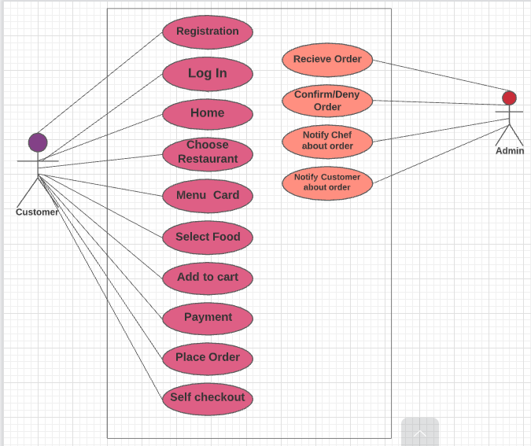
Figure 2.1:- System Use Case

Customer Use case table

Registration (NT-01)

Table 2.1: - Registration
Name | Registration
Use case ID | NT-01
Objective | Customer will register itself and will be able to use application
Priority | High
Actor | User/ Admin
Source | The use case describe the event of general people who will register their selves and will use this application.
Pre-condition | People must open the application
Post condition | Registration
Issues | Type correct credentials

Customer will register itself and will be able to use application

Log-In (NT-02)

Table 2.2: - Log-In
Name | Log-In
Use case ID | NT-02
Objective | User will login in to application.
Priority | High
Actor | User/Admin
Source | The use case describes event of user logging into application.
Pre-condition | Add email, password to log in
Post condition | Log In
Issues | Type correct credentials

User will login in to application

Choose Restaurant (NT-03)

Table 2.3: - Choose Restaurant
Name | Choose restaurant
Use case ID | NT-03
Objective | User will choose its desired restaurant from which he wants to order his food
Priority | High
Actor | User
Source | The use case describe event of user choosing its desired restaurant and then to order food from it.
Pre-condition | User must login to application
Post condition | Choose restaurant
Issues | No issue

User will choose its desired restaurant from which he wants to order his food

Select food (NT-04)

Table 2.4: - Select Food
Name | Select food
Use case ID | NT-04
Objective | The menu box will appear and user will select menu from their desired restaurant
Priority | High
Actor | User
Source | The use case describe event of selecting menu by users.
Pre-condition | 1) User will login  2) User will select restaurant from home page.
Post condition | Select menu
Issues | None

The menu box will appear and user will select menu from their desired restaurant

Payment (NT-05)

Table 2.5: - Payment
Name | Payment
Use case ID | NT-05
Objective | User will do payment for its desired order
Priority | High
Actor | User
Source | The use case describe event of user doing payment for its order
Pre-condition | 1) User will login  2) User will select restaurant from home page  3) User will select food
Post condition | Payment
Issues | None

User will do payment via online payment account or through cash

Place Order (NT-06)

Table 2.6 Place Order
Name | Place order
Use case ID | NT-06
Objective | User will place its desired order
Priority | High
Actor | User
Source | The use case describe event of user placing its order
Pre-condition | 1) User will login  2) User will select restaurant from home page  3) User will select food  4) Payment
Post condition | Placing order
Issues | None

User will place its desired order by choosing item from the menu.

Self-check-out/Dine-In (NT-07)

Table 2.7: - Self Check Out
Name | Self-check-out/ Dine-In
Use case ID | NT-07
Objective | User will collect its order by self-service for dine in purpose
Priority | High
Actor | User
Source | This use case describe event of self-check-out by user collecting its food through self-service for dine in purpose.
Pre-condition | 1) User will login  2) User will select restaurant from home page  3) User will select food  4) Payment  5) Place Order
Post condition | Self-check-out/Dine-In
Issues | None

User will collect its order by self-service for dine in purpose or for take away.

Admin Use Case Table

2.9.1 Receive Order

Table 2.8: - Receive Order
Name | Receive Order
Use case ID | NT-08
Objective | Admin will receive order through customer
Priority | High
Actor | Admin
Source | The use case describe event of Admin receiving order from customer
Pre-condition | Customer must order
Post condition | Receiving order
Issues | Cancellation of order

Admin will receive order through customer

2.9.2 Confirm/Deny Order

Table 2.9: - Confirm Order/Deny Order
Name | Confirm Order/Deny Order
Use case ID | NT-09
Objective | Admin will confirm or deny order if customer has or has been not done payment within given time
Priority | High
Actor | Admin
Source | The use case describe event of Admin confirming or denying order of customer
Pre-condition | Order must be received
Post condition | Confirming order/Deny
Issues | No issue

Admin will confirm or deny order if customer has or has been not done payment within given time

2.9.3 Notify chef about order

Table 2.10: - Notify chef about order
Name | Notify chef about order
Use case ID | NT-10
Objective | Admin will notify chef about order
Priority | High
Actor | Admin
Source | The use case describe event of admin notifying chef about order so he may start preparing the meal
Pre-condition | Confirm order
Post condition | Notify chef
Issues | Fake order confirmation

Admin will notify chef about order

2.9.4 Notify customer about order

Table 2.11: - Notify customer about order
Name | Notify customer about order preparation
Use case ID | NT-11
Objective | Admin will notify customer about its order preparation
Priority | High
Actor | Admin
Source | The use case describe event of Admin that will generate notification message to customer containing details of its order that it has been started preparing  and how much time will it take to get prepared
Pre-condition | Order confirmation
Post condition | Notifying customer about its order
Issues | None

Admin will notify customer about its order preparation

2.10 Non-Functional Requirements

The Non-Functional Requirement makes the application effective and efficient for use.

2.10.1 Performance Requirements

- The application should perform all action completely and accurately.
- Fast Internet is required to install and run application smoothly.
- It should not be time consuming.
- It should be user friendly

2.10.2 Security Requirements

The application contain function of login, password and log out due to which data of the user will remain secure.
- There should be no fake ordering.
- Payment method should contain proper constraints to make this method secured.

2.12 Software quality attributes

This FYP versatile application gives their clients both basic and progressed highlights. Due to its well-designed and easy to use interface, both specialists and typical users can use it. However, users must already have a basic knowledge of using a mobile application before using it.

2.13 System Requirements Chart

Table 2.12: - System Requirement Chart
ID | Type | Priority | Source | Contained in Use Case | Description
NT-01 | Functional | High | User/Admin | Registration | Customer will register itself and will be able to use application
NT-02 | Functional | High | User/Admin | Login | The use case describes event of user logging into application.
NT-03 | Functional | High | User | Choose Restaurant | The use case describe event of user choosing its desired restaurant and then to order food from it.
NT-04 | Functional | High | User | Select Food | The use case describe event of selecting food from e-menu card by users.
NT-05 | Functional | High | User | Payment | The use case describe event of user doing payment for its order
NT-06 | Functional | High | User | Place Order | The use case describe event of user placing its order
NT-07 | Functional | High | User | Self-check-out | This use case describe event of self-check-out by user collecting its food through self-service for dine in purpose.
NT-08 | Functional | High | Admin | Receive Order | The use case describe event of Admin confirming or denying order of customer
NT-09 | Functional | High | Admin | Confirm/Deny Order | The use case describe event of Admin confirming or denying order of customer
NT-10 | Functional | High | Admin | Notify Chef about order | The use case describe event of admin notifying chef about order so he may start preparing the meal
NT-11 | Functional | High | Admin | Notify Chef about order | The use case describe event of Admin that will generate notification message to customer containing details of its order that it has been started preparing  and how much time will it take to get prepared

DESIGN AND METHODOLOGY

3.1 INTRODUCTION

Third deliverable is all about the use-case modelling and software design. In the previous deliverable, analysis of the system is completed. So, we understand the current situation of the problem domain. Now we are ready to strive for a solution for the problem domain by using object-oriented approach.
Following artefacts must be included in this deliverable.
- Use-case diagram refined
- Domain Model
- Sequence Diagram
- Collaboration Diagram
- Design Class Diagram
- Data Model

Now I discuss these artefacts one by one as follows:

3.2 Use-case Diagrams
.
A use case is a written description of how users will perform tasks on your website. It
Outlines, from a user's point of view, a system's behaviour as it responds to a request.

3.2.1 Main system Use Case Diagram

Figure 3.1 Main System Use Case Diagram

3.4 Domain model Diagram

Domain Modeling is a way to describe and model real world entities and the relationships between them, which collectively describe the problem domain space. Below Fig. shows the domain model of No Tiring, Easy Dine-In:

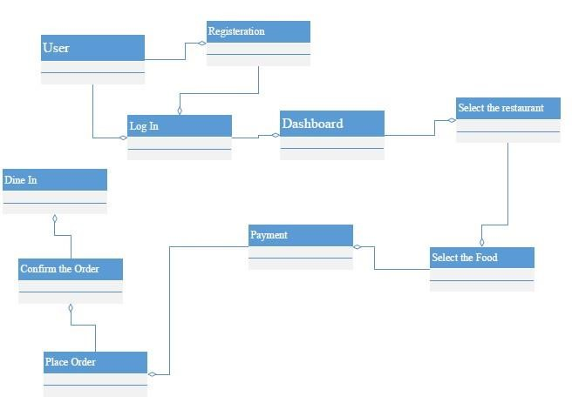
Figure 3.2: - Main System Domain Model

3.5 Sequence Diagram

A Sequence diagram depicts the sequence of actions that occur in a system. The invocation of methods in each object, and the order in which the invocation occurs is captured in a Sequence diagram. This makes the Sequence diagram a very useful tool to easily represent the dynamic behaviour of a system.

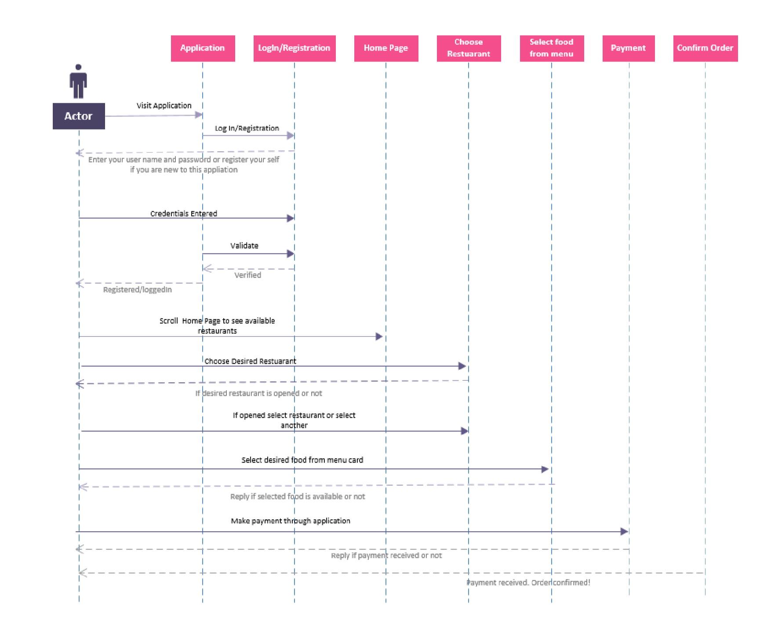
Figure 3.3: - Main System Sequence Diagram

3.6 Collaboration Diagram

A collaboration diagram describes a pattern of interaction among objects; it shows the objects participating in the interaction by their links to each other and the messages that they send to each other.
Collaboration diagrams are used to show how objects interact to perform the behavior of a particular use-case, or a part of a use-case. Along with sequence diagrams, collaborations are used by designers to define and clarify the roles of the objects that perform a particular flow of events of a use-case. They are the primary source of information used to determining class responsibilities and interfaces.
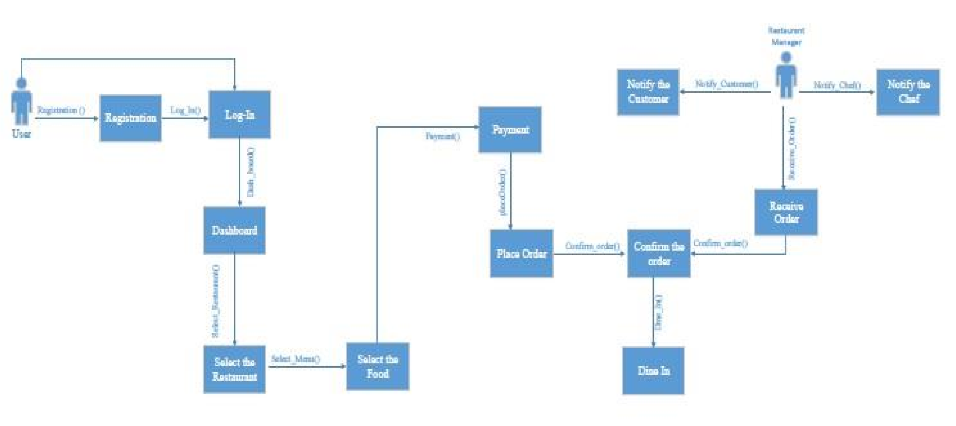
Figure 3.4: - System Collaboration Diagram

3.8 Design Class Diagram

Classes are the workhorses of the design effort—they perform the real work of the system. The other design elements—subsystems, packages and collaborations simply describe how classes are grouped or how they interoperate.

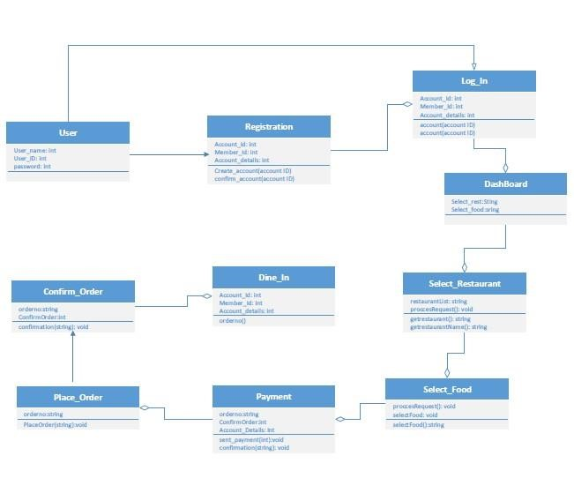
Figure 3.5: - Main System Class Diagram

3.9 Data Model

The data model is a subset of the implementation model, which describes the logical and physical representation of persistent data in the system.

3.9.1 The Relational Data Model

The relational model is composed of entities and relations. An entity may be a physical table or a logical projection of several tables also known as a view.

3.9.2 ERD

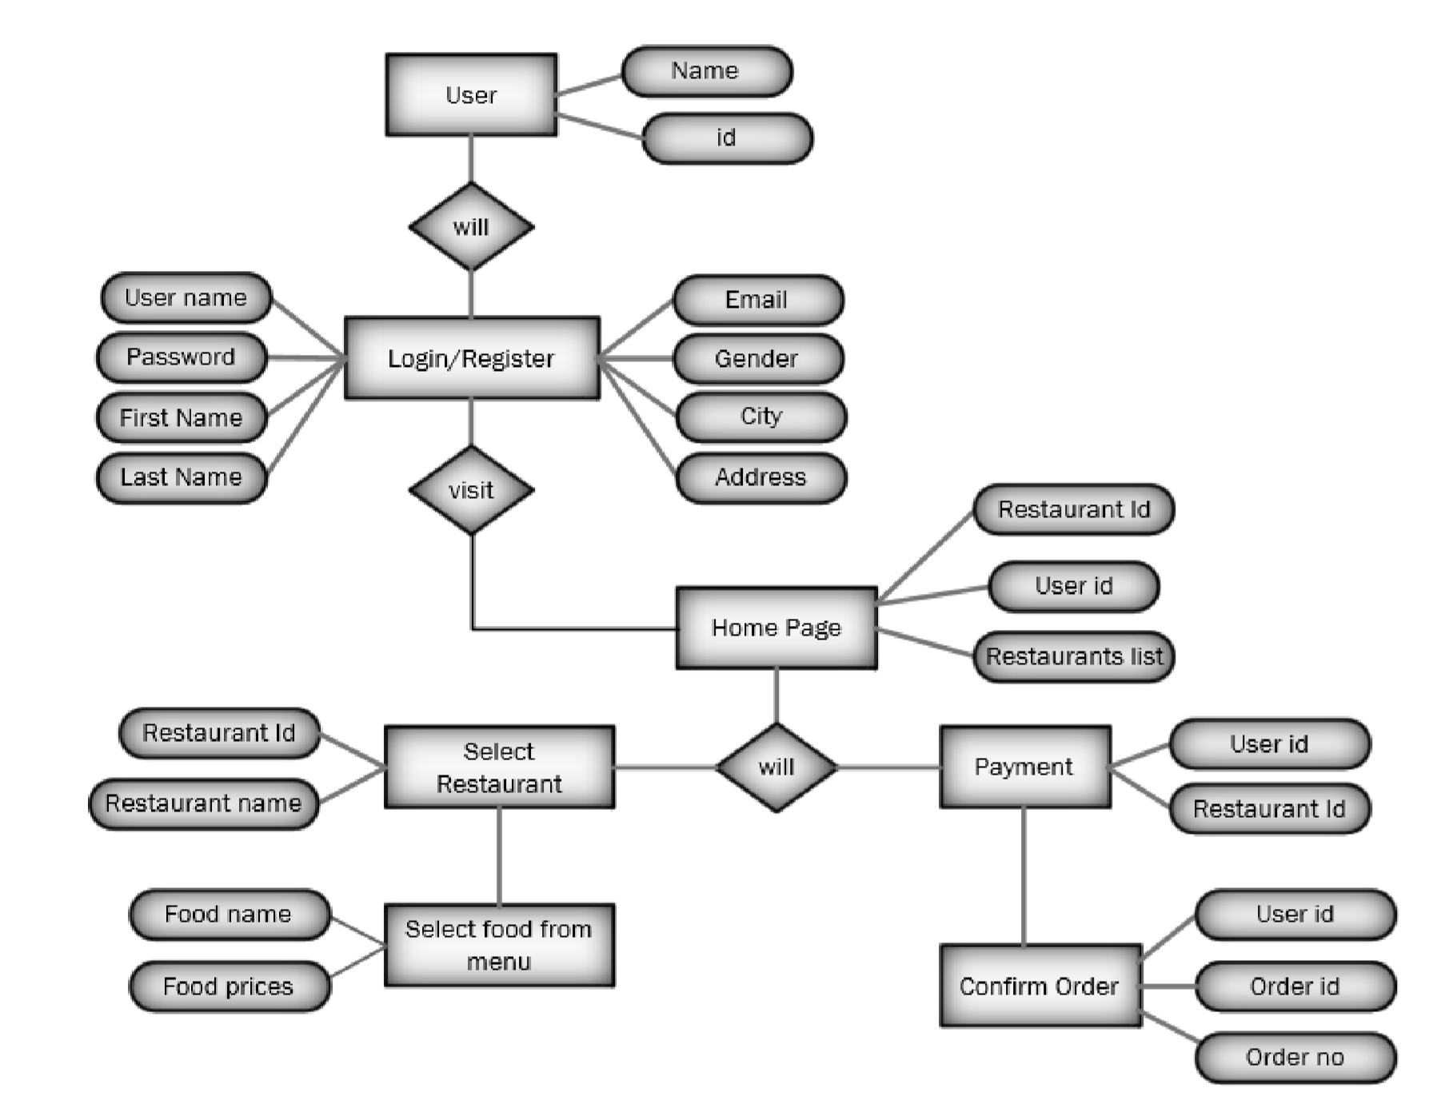
Figure 3.6: - Main System ERD Diagram

IMPLEMENTATION

Tool:
Android Studio

Language:
Java

4.1 Splash Screen

A splash screen is a graphical control element consisting of a window containing an image, and logo. A splash screen can appear while a game or program is launching. A splash page is an introduction page on a website.

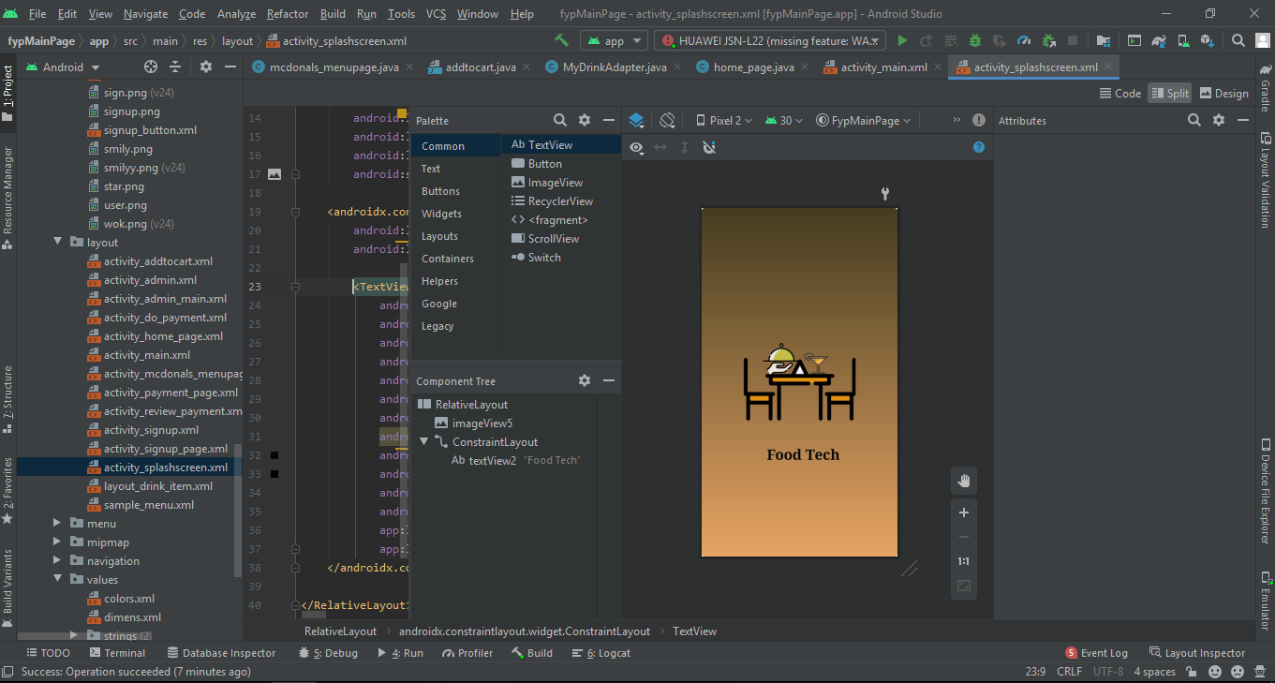
Figure 4.1 Splash Screen Implementation

4.2 Main Screen

Main Screen contain Login and registration button. User will log in or register itself in application
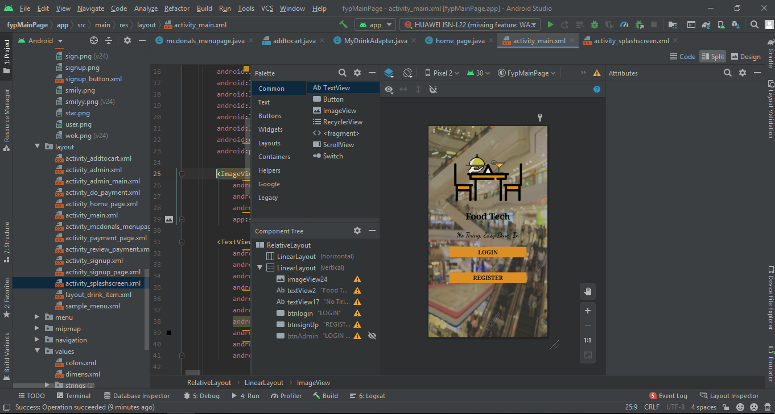
Figure 4.2 Main Screen Implementation

4.3 User Registration

User will do registration so that his account will be created and he can use application.
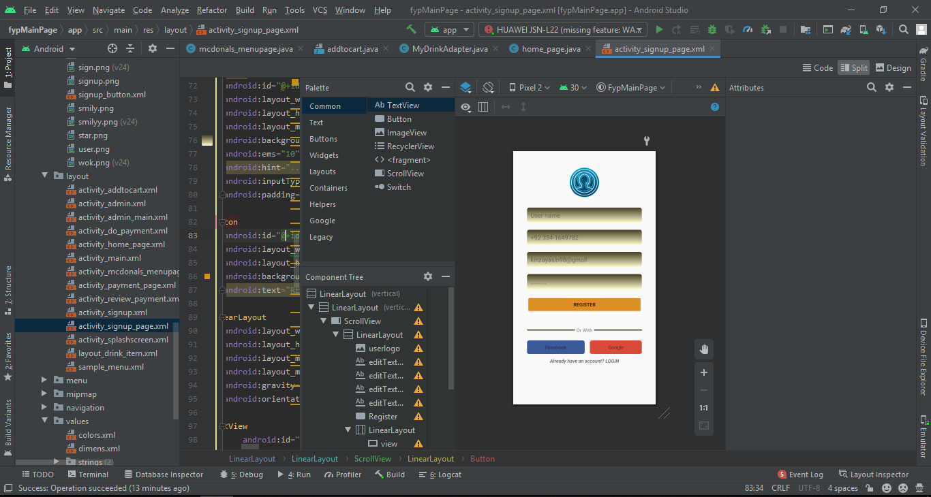
Figure 4.3 Registration Implementation

4.4 User Login

After registration, user will login to application
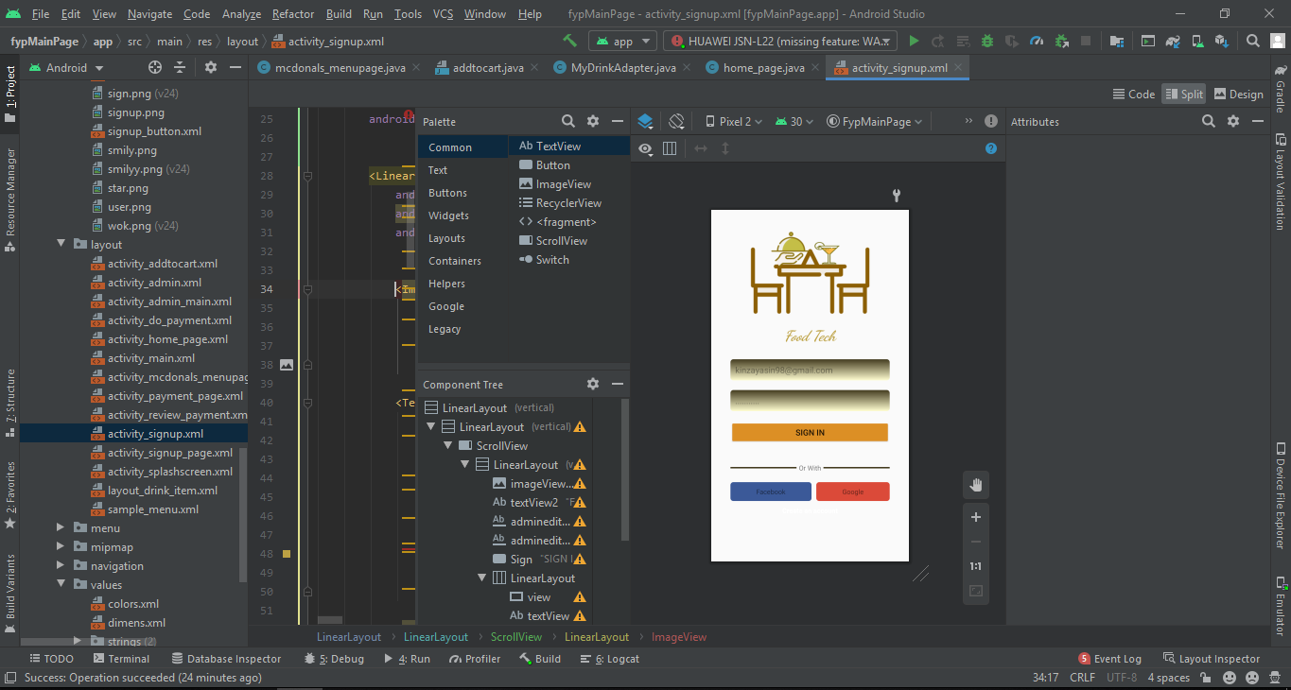
Figure 4.4 Login Implementation

4.5 Home Page

User will select desired restaurant from home page
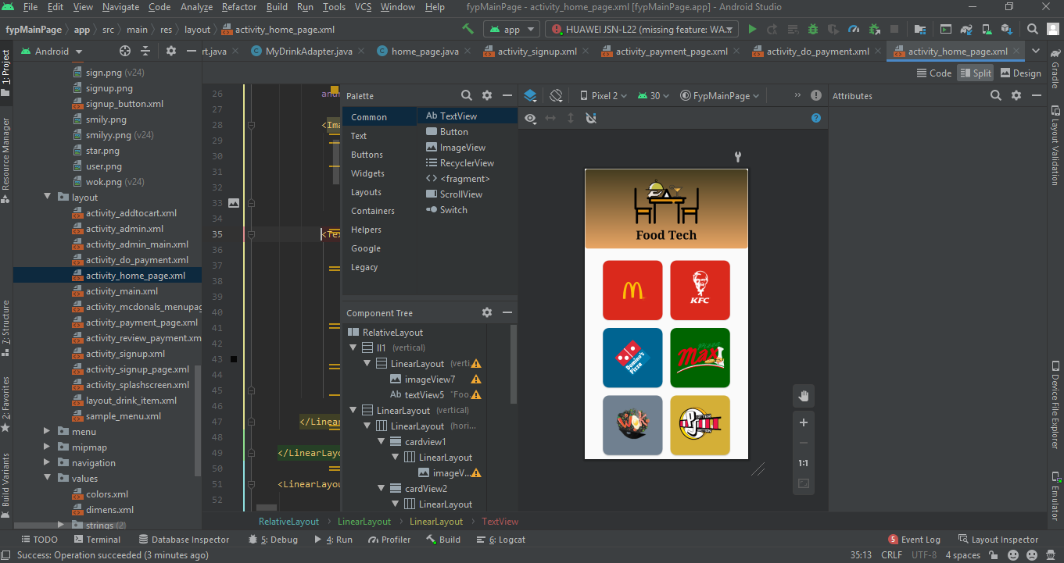
Figure 4.5 Home Page Implementation

4.6 Menu Card

After selecting desired restaurant, user will select food from e menu card
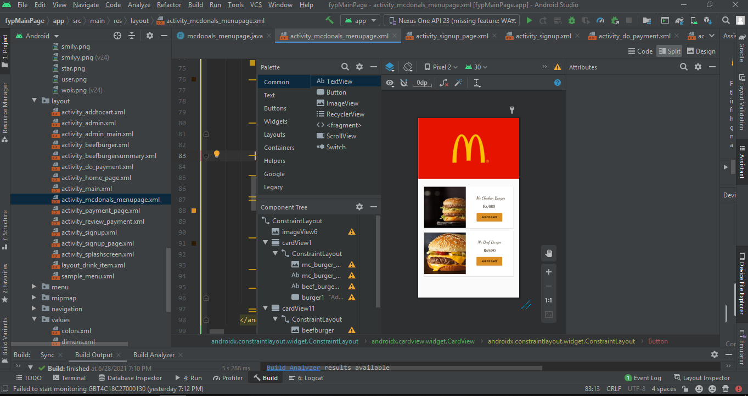
Figure 4.6 Menu Card Implementation

4.7 Order Review

After selecting food from e menu card, user will be provided with order review page generated by admin
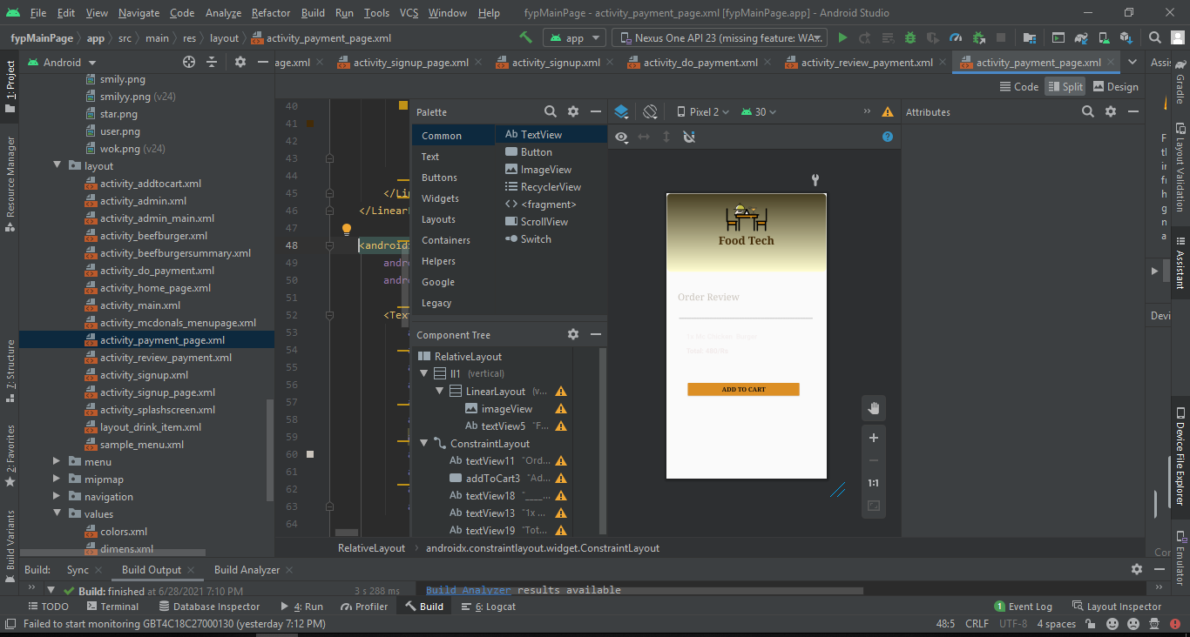
Figure 4.7 Order Review Implementation

4.8 Payment Page

User will do payment for its order within 5 minutes
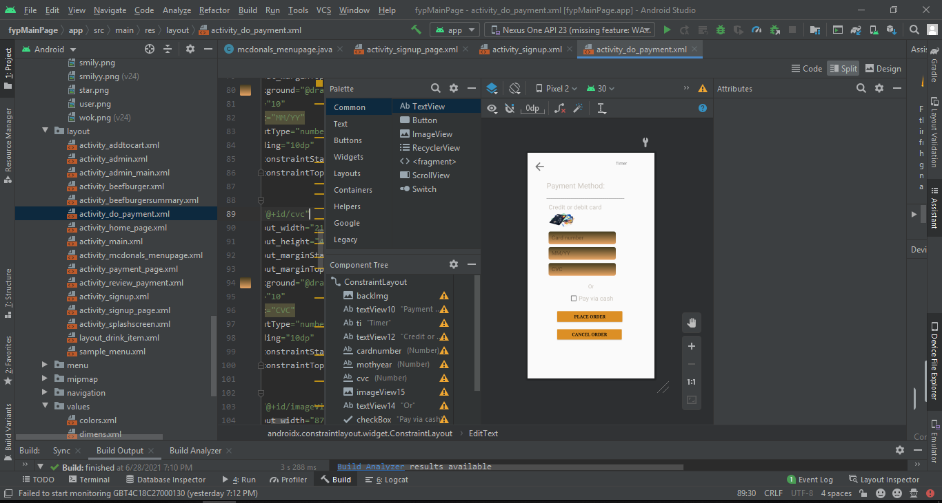
Figure 4.8 Payment Page Implementation

4.9 Order Summary

After doing payment, order summary receipt will be generated by admin.
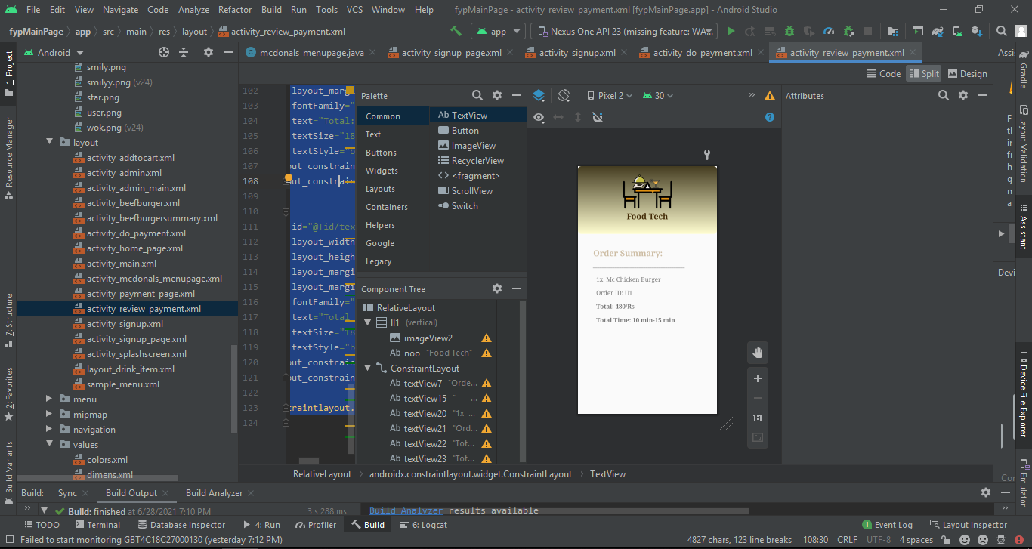
Figure 4.9 Order Summary Implementation

RESULT AND DISCUSSION
We provide a platform which will reduce messed up situation and hustle in mall’s food court. Moreover it will reduce the tiring situation and will create an easy way to order food from application.

5.1 Splash Screen

Splash Screen represents logo and title of application

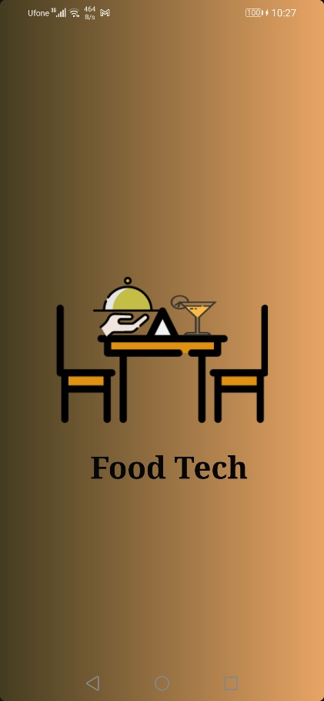
Figure 5.1 Splash Screen

5.2 Main Screen

Main screen contains Login and registration button

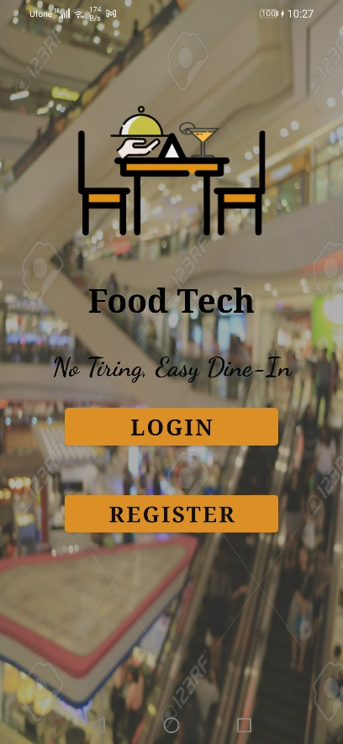
Figure 5.2 Main Screen

5.3 User Registration

This is registration screen from where user will register it self

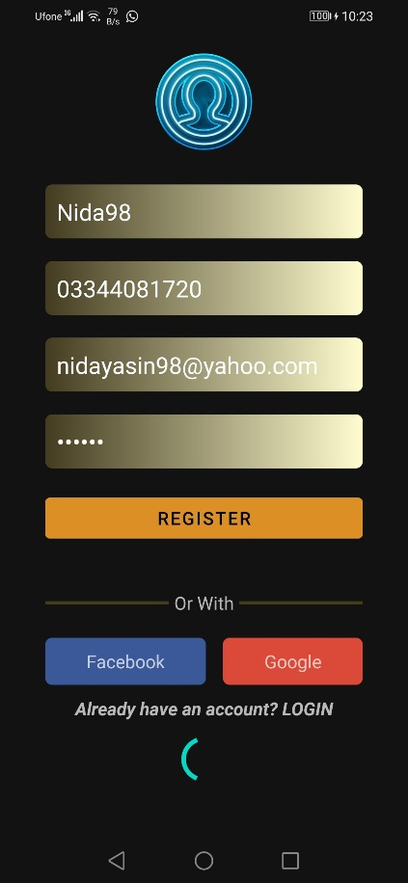
Figure 5.3 Registration Screen

5.4 User Login Screen

This is login screen where user will login after registration

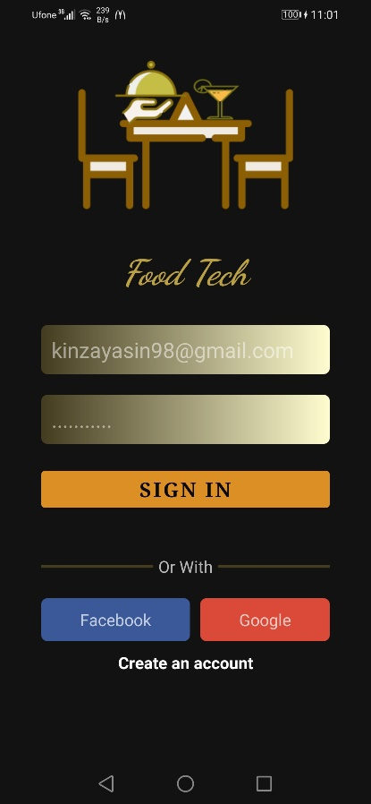
Figure 5.4 Login Screen

5.5 Home Screen

This is home screen where list of restaurants of food court are displayed

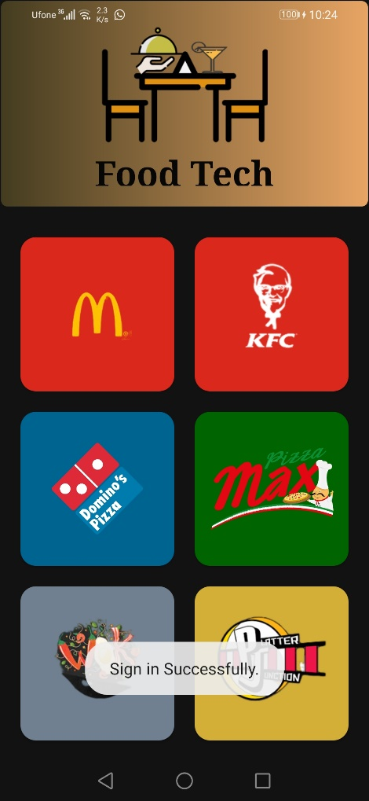
Figure 5.5 Home Screen

5.6 Menu Card Screen
This is menu card screen. When user will select desired restaurant, this screen with menu will open from where user will choose its food.

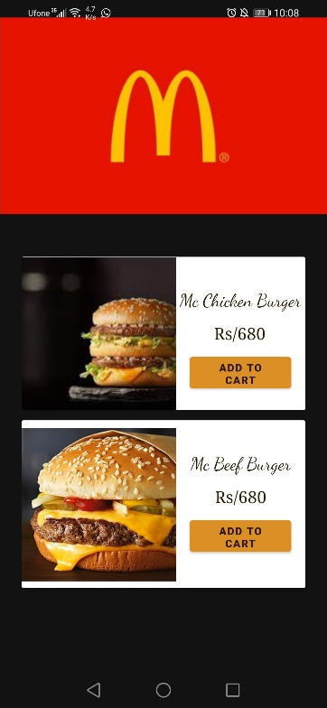
Figure 5.6 Menu Card

5.7 Order Review Screen
This is order review screen which will be generated when user will select food from e-menu card

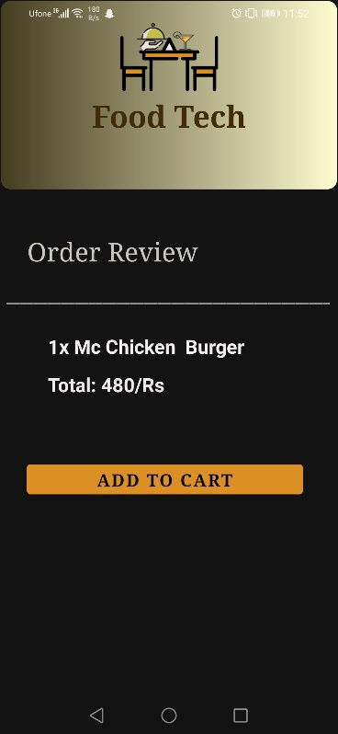
Figure 5.7 Order Review Screen

5.8 Payment Screen
User will do payments via cash pr online payment within 5 minutes after selecting food

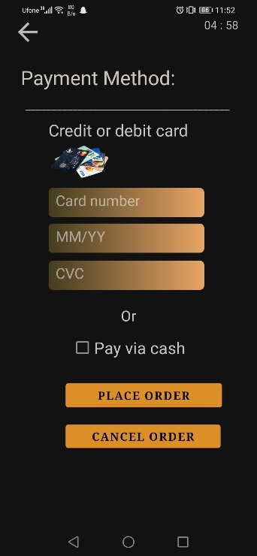
Figure 5.8 Payment Screen

5.9 Order Summary

Order summary receipt will be generated after payment by admin

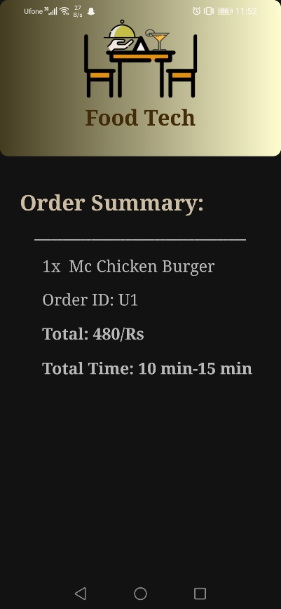
Figure 5.9 Order Summary

Chapter 6

Conclusion and Recommendation

Conclusion:

Food Tech is an android application that is been built for mall’s food court system. It is simple yet user friendly app. It has no complexity. Everything is simple and clearly visible. User can easily register itself into application and then login. Food chains are available on home page. When user will be done with log in, home page will open with the list of mall’s food court restaurants. User can easily choose desired restaurant, select food from e-menu card, do payment within 5 minutes and can place order. After placing order, order summary receipt will be generated and he can collect his order after preparation.

Recommendation:

This app could be implemented in different malls as it is very unique and simple idea to
make food courts of malls automated.

