
BSCS-F20-005
03-134172-084 | SUNDAS MUJAHID
03-134172-092 | HAFSA KARIM

Investigation of RRT*-AB Approach for Bi-Directional Structures

In partial fulfilment of the requirements for the degree of
Bachelor of Science in Computer Science
Supervisor: Dr. Iram Noreen
Department of Computer Sciences
Bahria University, Lahore Campus
July 2021

© Bahria University, 2021

Certificate

We accept the work contained in the report titled.
“Investigation of RRT*-AB Approach for Bi-Directional Structures”
Written by
SUNDAS MUJAHID
HAFSA KARIM
as a confirmation to the required standard for the partial fulfilment of the degree of
Bachelor of Science in Computer Science.

Approved by:
Supervisor: Dr. Iram Noreen
(Signature)

July 14, 2021

DECLARATION

We hereby declare that this project report is based on our original work except for citations and quotations which have been duly acknowledged. We also declare that it has not been previously and concurrently submitted for any other degree or award at Bahria University or other institutions.

Enrolment | Name | Signature
03-134172-084 | SUNDAS MUJAHID
03-134172-092 | HAFSA KARIM

Date : July 14, 2021

Specially dedicated to
my beloved grandfather, grandmother, mother, father, and siblings
(SUNDAS MUJAHID)
my beloved father, mother, and siblings
(HAFSA KARIM)

ACKNOWLEDGEMENTS

We would like to thank everyone who had contributed to the successful completion of this project. We would like to express our gratitude to my research supervisor, Dr. Iram Noreen for her invaluable advice, guidance, and her enormous patience throughout the development of the research.

In addition, we would also like to express my gratitude to our loving parent and friends who had helped and given me encouragement.

SUNDAS MUJAHID
HAFSA KARIM

Investigation of RRT*-AB Approach for Bi-Directional Structures

ABSTRACT

Path planning for mobile robots is an important aspect of robotics. Path planning algorithms play a crucial role in robot's movement and response to the environment. RRT*-AB (Rapidly Exploring Random Trees-Adjustable Bounds) [11] is a sampling-based path planning approach published. This project aims to investigate different features of this algorithm and to extend it with bi-directional structures.
This Research and Development (R&D) project will propose a new algorithm based on some initial findings of BULC research group "Artificial Intelligence, Robotics and computer Vision" (AIRV) and further investigations during this project execution. The project will also develop free to use open-source library framework using python/C++ for the newly proposed approach. The proposed library framework will be beneficial for the research community, for further R&D in different applications related to autonomous robots in exploration and rescue etc.

TABLE OF CONTENTS

DECLARATION ii
ACKNOWLEDGEMENTS iv
ABSTRACT v
TABLE OF CONTENTS vi
LIST OF TABLES ix
LIST OF FIGURES x
LIST OF SYMBOLS/ABBREVIATIONS xiii

CHAPTERS
1 INTRODUCTION 1
1.1 Background 1
1.2 Mobile Robotics 1
1.3 Planners 2
1.3.1 Grid Base Planners 2
1.3.2 Evolutionary Planners 2
1.3.3 Sampling Based Planners 3
1.4 Need for Mobile Robots and Planners 3
1.5 Working Environment 4
1.6 Extension in Family of RRT 4
1.7 Problems in RRT and RRT* 5
1.8 Problem Statement 5
1.9 Motivation 5
1.10 Scope 6
1.11 Goal 6
1.12 Objectives 7
2 LITERATURE REVIEW 8
2.1 Related Work 8
2.2 Working of Planner 10
2.2.1 Bidirectional RRT* 10
2.2.2 Working of RRT*-AB 11
3 DESIGN AND METHODOLOGY 13
3.1 Introduction 13
3.2 Bidirectional RRT*-AB Framework 13
3.3 Parent Classes of Bidirectional RRT*-AB 14
3.3.1 RRT-Connect 14
3.3.2 RRT* 14
3.4 Class Diagram 15
3.5 Class Model 16
3.6 Boundary Class 17
3.7 Class Visibility 18
3.7.1 Operations Detail 18
3.8 Pseudo Code of Bidirectional RRT*-AB 21
3.8.1 Populate(Tree T, Region C_{Region}) 21
4 EXPERIMENTS and IMPLMENTATION 23
4.1 Implementation 23
4.1.1 Tool and Technology 23
4.1.2 Development Environment 23
4.1.3 Language 24
4.1.4 Packages 24
4.1.5 Library Framework 24
4.1.6 Setup 25
4.2 Experimentation 26
4.2.1 Case 1 27
4.2.2 Case 2 29
4.2.3 Case 3 31
4.2.4 Case 4 33
4.2.5 Case 5 35
5 RESULTS AND DISCUSSIONS 37
5.1 Experimentation Results 37
5.1.1 Case 1 38
5.1.2 Case 2 39
5.1.3 Case 3 40
5.1.4 Case 4 42
5.1.5 Case 5 43
5.2 Comparison Results of RRT*-AB and Bi-Directional RRT*-AB 44
5.2.1 Result 1 45
5.2.2 Result 2 46
5.2.3 Result 3 47
5.2.4 Result 4 48
5.2.5 Result 5 49
5.2.6 Result 6 50
5.3 Time Comparison Result 51
5.4 Number of Nodes Comparison Result 51
5.5 Path Length Comparison Result 52
5.6 Height Comparison Result 52
6 CONCLUSION AND RECOMMENDATIONS 53
6.1 Conclusion 53
6.2 Future Recommendations 53
REFERENCES 55

LIST OF TABLES

TABLE TITLE PAGE
Table ‎4.1 Tools and Technology Details 23
Table ‎4.2 Packages Details 24
Table ‎4.3 Software Setup Details 25
Table ‎4.4 Hardware Setup Details 26
Table ‎5.1 Case 1 Experimentation Results 38
Table ‎5.2 Case 2 Experimentation Results 39
Table ‎5.3 Case 3 Experimentation Results 41
Table ‎5.4 Case 4 Experimentation Results 42
Table ‎5.5 Case 5 Experimentation Results 43
Table ‎5.6 Comparison Result 1 of RRT*-AB and BD-RRT*-AB 45
Table ‎5.7 Comparison Result 2 of RRT*-AB and BD-RRT*-AB 46
Table ‎5.8 Comparison Result 3 of RRT*-AB and BD-RRT*-AB 47
Table ‎5.9 Comparison Result 4 of RRT*-AB and BD-RRT*-AB 48
Table ‎5.10 Comparison Result 5 of RRT*-AB and BD-RRT*-AB 49
Table ‎5.11 Comparison Result 6 of RRT*-AB and BD-RRT*-AB 50

LIST OF FIGURES

FIGURE TITLE PAGE
Figure ‎2.1 : Simulation Based Execution of RRT* [6] and RRT*-AB [11] 12
Figure ‎3.1 : Inheritance Diagram of RRT-Connect 14
Figure ‎3.2 : Inherited Classes of RRT* 14
Figure ‎3.3 : Hierarchy Diagram 15
Figure ‎3.4 : Class Model of Bidirectional RRT*-AB 16
Figure ‎4.1 Case 1 Result-a 27
Figure ‎4.2 Case 1 Result-b 27
Figure ‎4.3 Case 1 Result-c 28
Figure ‎4.4 Case 1 Result-d 28
Figure ‎4.5 Case2 Result-a 29
Figure ‎4.6 Case2 Result-b 29
Figure ‎4.7 Case2 Result-c 30
Figure ‎4.8 Case2 Result-d 30
Figure ‎4.9 Case3 Result-a 31
Figure ‎4.10 Case3 Result-b 31
Figure ‎4.11 Case3 Result-c 32
Figure ‎4.12 Case3 Result-d 32
Figure ‎4.13 Case4 Result-a 33
Figure ‎4.14 Case4 Result-b 33
Figure ‎4.15 Case4 Result-c 34
Figure ‎4.16 Case4 Result-d 34
Figure ‎4.17 Case5 Result-a 35
Figure ‎4.18 Case5 Result-b 35
Figure ‎4.19 Case5 Result-c 36
Figure ‎4.20 Case5 Result-d 36
Figure ‎5.1 Case 1 Output Result 38
Figure ‎5.2 Case 2 Output Results 39
Figure ‎5.3 Case 3 Output Result 40
Figure ‎5.4 Case 4 Output Results 42
Figure ‎5.5 Case 5 Output Result 43
Figure ‎5.6 RRT*-AB Result 1 45
Figure ‎5.7 RRT*-AB-BD Result 1 45
Figure ‎5.8 RRT*-AB Result 2 46
Figure ‎5.9 RRT*-AB-BD Result 2 46
Figure ‎5.10 RRT*-AB Result 3 47
Figure ‎5.11 RRT*-AB-BD Result 3 47
Figure ‎5.12 RRT*-AB Result 4 48
Figure ‎5.13 RRT*-AB-BD Result 4 48
Figure ‎5.14 RRT*-AB Result 5 49
Figure ‎5.15 RRT*-AB-BD Result 5 49
Figure ‎5.16 RRT*-AB Result 6 50
Figure ‎5.17 RRT*-AB-BD Result 6 50
Figure ‎5.18 Plots for Case 1 to Case 6; average execution time 51
Figure ‎5.19 Plots for Case 1 to Case 6; average nodes 51
Figure ‎5.20 Plots for Case 1 to Case 6; average path length 52
Figure ‎5.21 Plots for Case 1 to Case 6; average height 52

LIST OF SYMBOLS/ABBREVIATIONS

SMP Sampling Based Planning
PRM Probabilistic Road Map
RRT Rapidly Exploring Random Tree
RRT* Rapidly Exploring Random Tree Star
RRT*-AB Rapidly Exploring Random Tree Start Adjustable Bound
RRT*-AB-BD Rapidly Exploring Random Tree Start Adjustable Bound Bidirectional
PSO Particle Swarm Optimization
ACO Ant Colony Optimization
GA Genetic Algorithms
ABC Artificial Bee Colony
BFO Bacterial Foraging Optimization
UAV Unnamed Aerial Vehicle

INTRODUCTION

Background

For decades human wanted to make robots that act like human and think like human. This wish of human is not too much far, but it still required working. One of the major tasks of making human like robot is its autonomous motion. Robotics [1] is the sub-branch of artificial intelligence whereas robots are the artificial agents operating in real world. Autonomous robot path panning has always been a critical activity for computer scientists and engineers alike. Path planning algorithms help in making this task easier. Through these algorithms still need to be enhanced. Sampling based planners are also part of these algorithms.

Mobile Robotics

A mobile robot is a software-controlled system that uses sensors and other technologies to identify its surroundings and navigate through its world. Mobile robotics operate using a mix of artificial intelligence (AI) [1] and physical robotic components, such as pedals, tracks, and legs. Mobile robots are becoming more and more common across various market sectors. They are used to support job procedures and to carry out jobs that are difficult or hazardous for human employees [3].

Planners

Planners are the algorithms that mainly work on finding designated collision free path. Motion planning refers to collision-free path generation from an initial state to a speciﬁed goal state. Path planning algorithms plays important role in mobile robot application like Unmanned Aerial Vehicles (UAVs), forklifts , surveillance operations, medical , planetary and space missions [2].

Grid Base Planners

Following are the grid-based planners:
- Dijkstra [3]
- A* [4]
- Wavefront [16]
- D* [17]
- Phi* [18]

Above mentioned planners are resolution-complete but are computationally expensive for high dimensional complex problems [2].

Evolutionary Planners

Evolutionary planners are listed as:
- Particle Swarm Optimization (PSO) [19]
- Ant Colony Optimization (ACO) [20]
- Genetic Algorithm (GA) [21]

These planners are good at multi-objective problems. Other evolutionary algorithms such as:
- Artificial Bee Colony (ABC) [22]
- Bacterial Foraging Optimization (BFO) [23]
- Bio Inspired Neural Networks [24]
- Fire-fly algorithm [25]

Above mentioned algorithms have problem while working in high dimension. They often trapped in local optimum and have high computational cost. Moreover, they are highly sensitive to search space size and data representation scheme of problem [2].

Sampling Based Planners

Sampling Based Planning (SBP) [5] approaches mainly focus on path planning of robot. They are the most influential advancement in path planning. Their popularity and high usage are because of their major advantages that are low computational cost, applicability to high dimensional problems and better success rate for complex problems. Sampling Based Planning approaches are probabilistic complete. They can find a solution, if one exists, given that the run time is infinite. Most popular SBP algorithms are,
- Probabilistic Roadmap (PRM) [2]
- Rapidly exploring Random Tree (RRT) [5]
- Rapidly exploring Random Tree Star (RRT*) [6]

PRM based methods are mostly used in highly structured static environment such as factory floors. PRM are most likely suitable for holonomic robot, but they can also use for non-holonomic robots.

On the other hand, RRT [5] and RRT* [6] based approaches naturally extend non-holonomic constraints and support dynamic environment as well.

Need for Mobile Robots and Planners

Increased interest of researchers in improving human computer interaction emphasized the research in the field of mobile robots and in path planning of mobile robots. Mobile robotics technology has been an emerging field over the past three decades. Latest research on mobile robotics addresses questions related primarily to route planning algorithms and optimization in both static and dynamic settings. Many methods have been developed for mobile robot route planning worldwide.

Working Environment

Working environment for this project is an open-source python-based library. Library already contain implemented Rapidly Exploring Random Tree (RRT) [5] and Rapidly Exploring Random Tree Star (RRT*) [6].

Extension in Family of RRT

RRT sampling-based planner is presented by Steven M. LaValle and James J. Kuffner Jr. There are many algorithms that are extension of RRT [5] trying to reduce computational resources as well as time constrains. Some of them are listed below [2]:
- RRT* [6]
- Anytime RRT* [7]
- B-RRT* [2]
- RRT-Connect [8]
- Informed RRT* [9]
- RRT*-Smart [10]
- Optimal B-RRT* [2]
- RRT# (RRT “sharp”) [2]
RRT*-AB [11] is a new member added to family of RRT.

Problems in RRT and RRT*

RRT [5] supports dynamic environment and non-holonomic constraints for car like robots [9] very well. It applied successfully to problems comprising of up to twelve degrees of freedom with both holonomic and non-holonomic constraints. However, path generated by RRT was not optimal [5].

Karaman and Frazzoli proposed a new extension of RRT [5] called RRT* [6] with proven asymptotically optimal property. RRT* [6] improved path quality by introducing major features of tree rewiring and best neighbor search. However, it obtained asymptotic optimality at the cost of execution time. But path convergence rate get slower at cost execution time [5].

Problem Statement

We are living in digital world. With advancement in technology everything is getting digitalized. Autonomous robots work in specific configuration space and find collision free path by using path planners. These path planners play an important in finding path for robot with moderate convergence rate and time constrains. Many planners including RABIT* [2], T-RRT* [2], RRT*-AB [11] and many more [1] tried to resolve convergence rate time constrain hazards. Extension of RRT*-AB [11] algorithm with bi-directional approach tried to solve this issue.

Motivation

Human beings have always been curious about robots and their human like behaviour. With the advancement in technology, technical industry requires more skill set than earlier. Robotics field covers new technologies like:
- Machine Learning
- Digital Image Processing
- Computer Vision
- Deep Learning
- Convolutional neural network

These skill sets are not completely explored yet. Robots that act and think like human simultaneously will make our lives easier. To demonstrate effectiveness in a multi-robot planning domain our motivation is to use RRT*-AB [11] and extend it with bi-directional structures to achieve probabilistic analogue to the widely used family of deterministic algorithms. These robots can be used in medical care, space, education, agriculture and in military.

Scope

RRT*-AB [11] is a well-known sampling based path planner which finds path for a mobile robot in a cluttered environment. Bi-directional planning strategy can expand the search strategy from starting location and goal location both simultaneously. The target is to expand two-sided path joining with each other. This project aims to investigate the rapid convergence features of RRT*-AB [11] for bi-directional search strategy.

Primary Scope of this project is to investigate different features of RRT*-AB [11] algorithm, to extend it by using bi-directional approach and an open-source library of extended algorithm. Collision free designated path of mobile robots within moderate convergence rate, time constrain, and other manageable resources is still an under developing task. This project will be a knowledge contribution towards research community as well as for developer use. Python /C++ based library framework will be beneficial in mobile robot path planning.

Goal

This project deals with investigation and proposing. Investigation of some features of RRT*-AB [11] will be done. Then extending RRT*-AB [11] approach with bi-directional structures to make performance of algorithm better. This project also aims to build an open-source library for new proposed algorithm in C++/python.

Objectives

Objectives of this project include investigation of Rapidly Exploring Random Tree Star Adjustable Bound (RRT*-AB) [11] algorithm. Extending RRT*-AB [11] algorithm with bi-directional approach. Proposing a new algorithm for Path Planning of Mobile Robots. Developing an open-source Python/C++ library framework for new proposed algorithm.

LITERATURE REVIEW

Related Work

Many algorithm have been proposed after RRT* [6] for resolving and obtaining better convergence rate. Another method named as RRT* Anytime [7], proposed with key features of trajectories and branch-and-bound adaptation.

Another approach called B-RRT* [2] is based on feature of improved convergence speed and path refinement using sample rejection with an admissible heuristic. But it has jagged and suboptimal paths also it acquires large memory requirements. A new method RRT*-FN [1], proposed with memory efficient memory usage by focusing fixed number of nodes in tree. But it is only applicable in static environment.

Method called RRT*-Smart [10], proposed with features of intelligent sampling and path optimization. It provides moderate convergence rate with improved efficiency with respect to both time and cost. Another technique named as Optimal B-RRT* [8], proposed functionalities of with multiple heuristics based of different conditions to obtain better convergence rate. But usage of multiple heuristic increases the complexity.

Procedure named RRT# [2], proposed with feature of global planning scheme to maintain promising nodes of tree to obtain better convergence rate with low cost. But real time experimentation was not done.
Method Adapted RRT* [6], proposed with functionalities of kinodynamic extension of RRT* [6] with ensured asymptotic optimality. But controller stabilization for trajectory is not obtained. Another procedure named as SRRT* [1], proposed with functionalities of spline based cubic Bezier curve. It also provides functionality of geometric collision and dynamic feasibility for checking constraints during tree expansion.

Procedure named as Informed RRT* [9], proposed with characteristics of direct sampling technique. It also possesses better convergence rate than RRT* [6]. But shrink planning problem is highly dependent upon initial solution cost making it effective only under certain conditions. Another technique named as IB-RRT* [12], proposed with intelligent sample insertion heuristic with minimal memory requirements. This feature of IB-RRT* [12] improved the path quality as compared to RRT* [6] and B-RRT* [2].

Technique named as DT-RRT [1], proposed with kinodynamic planning for high-speed mobile robot and produced practically feasible trajectories. But this approach require innovation for dynamic and unknown scenarios as it reconnect-tree scheme is only beneficial in known environments. Another method named as RRT*i [1], proposed with predictable and practical trajectory generation for UAVs. It also has Smoother trajectories as compared to RRT [6] and RRT* [6] with improved path quality. But it can produce unexpected collision in multi-UAV applications with increased uncertainty.

Planner named as CARRT* [1], proposed with large number of samples by using two trees and cross entropy in RRT* [6]. It also produced energy efficient path in high dimensional space. But its working is limited address the planning problems for humanoid robot only. Another method called PRRT* [1], proposed with incorporating artificial potential field characteristic in RRT* [6] which resolve problem of high memory consumption and slow convergence.

An algorithm named as HARRT* [1], proposed with featuring of human-robot interactive planner using RRT* [6] and homotropy algorithm. But there occurs trade-off between computational efficiency and path quality.
Another planner called T-RRT* [7], proposed with integrated transition tests with RRT* for efficient extension of tree in a cost space. Technique named as RABIT* [2], proposed with informed global technique BIT* and RRT* [6] to find optimal path for narrow passages in high dimensions.

In [11], they proposed RRT*-AB [11] which rapidly targets the goal region with improved computational efﬁciency. But this algorithm is only applicable in offline condition.

Working of Planner

Planners [13] simply start working by finding random nodes or states in free configuration space. Starting from root node of tree which will be start node, and then simply adding step length in each new node added in parent tree. Final step is to extract a collision free path from start to node.

Bidirectional RRT*

Bidirectional RRT* [12] is a newly proposed algorithm depend on curve-smoothing. They restrict the number of nodes generated without compromising on the accuracy and incorporates kinodynamic constraints for generating smooth trajectories, together resulting in efficient navigation of autonomous mobile robots.

The working implementation of Bidirectional-RRT*(B-RRT*) [2] is explained below:

- Extend

x_{1,} x₂ ∈ R^{n} are the two nodes in the Extend (x_{1,} x₂) that returns a new node x_{new} ∈ R^{n} where x_{new} is closer to x₂ than x₁ in the direction from x₁ to x₂.
- Connect

The heuristic connects employed by B-RRT* [2] is slight variation of greedy RRT-Connect [6] heuristic.

Similarities of Bidirectional RRT* with RRT*

The rest working of bidirectional RRT* [12] are the same as they were for RRT* [6]. The B-RRT* [2] works in the same manner as the original RRT* [6] algorithm in its initial phases. Below are the working steps that are similar to RRT* [6] as,
- It starts with sampling of the configuration space X_{free.}
- Then various operations are performed on this random sample x_{rand.}
- After successful insertion of random sample into the tree, there the algorithm computes nearest vertex x_{conn} from x_{new} in the tree T_{b},
- The connect procedure then executes for the connection of two trees. If the attempt to make connection is successful, the collision-free path σ_{new} new connecting x_{init} and X_{goal} is returned by the connect function.
- The cost of this σ_{new} is then compared with the previously computed path σ_{best}. If the cost of σ_{new} is less than the cost of σ_{best}, then σ_{best} is overwritten by σ_{new.}
- Finally, the iteration ends by swapping the trees and in the next iteration the same procedure is executed on the other tree.

Problems in Bidirectional RRT*

There are the following problems in B-RRT* [2] that are given below,
- B-RRT* [2] takes large number of iterations to find optimal path solution.
- The convergence rate of RRT* [6] as well as B-RRT* [2] is slow.
- It consumed more memory.

Working of RRT*-AB

The RRT*-AB [11] perform the functions of connectivity region, bounded sampling, and path optimization. The working operations of the RRT*-AB [11] approach are as below:
- Initializes tree T with z_{init} as root.
- C_{Region} is then used to limit the search space for sampling of new random nodes.
- C_{Region} is the search space between z_{init} and z_{goal} by using expansion distance scale called D_{scale} which is defined as,

 | D_{scale} = E/m | ( 2.1 )

Where E is the size of environment map and m is the expansion factor.
- By default, m is 4, which gives the scale to generate C_{Region} half the size of the environment map, m could be increased to get a narrow C_{Region}.
- When bounded sampling completes a single scan of C_{Region} and path is not found in the first scan, then D_{scale} is increased gradually to increase C_{Region} until a path is founds.
- D_{scale} can then grow C_{Region} up to the whole environment map in extreme complex scenario such as a maze.
- Exploring the obstacle-free space in C_{Region} makes sampling highly biased towards goal.
- Once an initial path is searched within C_{Region}, a cost function returns the cost of path in terms of Euclidean distance defined as

 | Δd = (x₂ – x₁)² + (y₂ – y₁)² | ( 2.2 )

Relationship of RRT*-AB and RRT*

The steps of near neighbour search, best parent selection, rewiring and node insertion in RRT*-AB [11] are performed same as in RRT* [6].

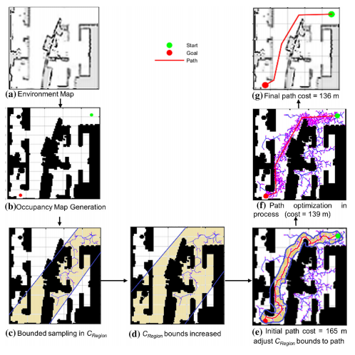
Figure 2.1 : Simulation Based Execution of RRT* [6] and RRT*-AB [11]

DESIGN AND METHODOLOGY

Introduction

Sampling Based Path planning (SBP) [5] algorithms gain immense popularity because they are addressing problem of autonomous robot path planning. Path planning is simply an optimized procedure with an objective to reduce travel-time, shorten path length with safety and with smooth trajectory.

Bidirectional RRT*-AB Framework

RRT*-AB [11] framework is a recent addition in RRT family [6]. It has better convergence rate and manages time constrains. It consumes less memory as it has property of pruning path which has no role in directing robot from source to destination. Bidirectional RRT*-AB [11] will be an extension of RRT*-AB [11] and RRT-Connect [1] algorithms. It will develop two trees, one from source and one from destination to locate best optimal path between them.

Three main features of this proposed approach are as follows:
- Connectivity Region
- Bounded Sample
- Pruning

Parent Classes of Bidirectional RRT*-AB

Bidirectional RRT*-AB [11] is inherited from two classes that are RRT*-AB [11] and RRT-Connect [8]. RRT*-AB [11] is inherited from class RRT*. Class structure of RRT-Connect and RRT* [7] are shown below:

RRT-Connect

The class diagram of RRT-Connect [8] is as,

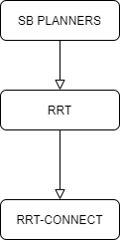
Figure 3.1 : Inheritance Diagram of RRT-Connect

RRT*

The class diagram of RRT* [6] is as,

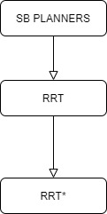
Figure 3.2 : Inherited Classes of RRT*

Class Diagram

The python-based repository implements some common path planning algorithms used in robotics, including Search-based algorithms and Sampling-based algorithms. Animations for algorithm used to display the running process, which makes comparison easier. This repository contains RRT [6] and RRT* [6] implementations.

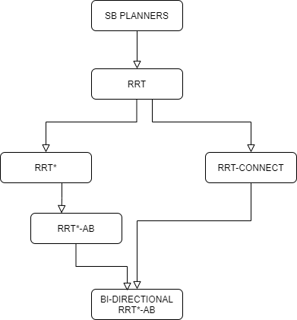
Figure 3.3 : Hierarchy Diagram

Class Model

Bidirectional RRT*-AB is consist of protected as well as public member function and attributes.
Bidirectional RRT*-AB

#allocSampler () : void
#freeMemory () : void
+ setGoalBias (double goalBias) : void
+ getGoalBias () const : double
+setRange (double distance) : void
+getRange () const : double
+setTreePruning (bool) : void
+getTreePuruning()const : bool
+populate(T) : Tree
+merge(T1,T2) : Tree
+Connect(T , q)
+Connectivity Region
+Bounded Sample
+Nearest(T, zrand)
+Steer(znearest, zrand)
+Collison Check
+Near(T, znew,|V|)
+Insert Node
+Rewire(T,znear, zmin, znew)
+Complete Scan
#sampler_ : base: StateSamplerPtr
#infSampler_base: InformedSamplerPtr
#goalBias_ : double
#maxDistance_ : double
#useKNearest_ : bool
#bestGoalMotion_ {nullptr} : Motion
#goalMotions_ : std::vector< Motion * >

Figure 3.4 : Class Model of Bidirectional RRT*-AB

Boundary Class

User interface of open-source python-based library [14] is describe below:

- Home

When we click on home button, it reset to the original view. Let suppose if i have zoom in 200%, when i will click on home button its gonna reset to orginal state

- Left Arrow

This button navigate to previous view. Let suppose if i have drag the view upward and i wanna go to previous state, clicking on this button will take ne to previous view.

- Right Arrow

This button navigate to forward view. Let suppose if i have drag the view downward and i come back to pevious state, now i wanna go again to forward view so i will use this button

- Drag

With this button i can drag positon of map axix to upward or downward

- Zoom

By clicking on this button i can zoom in the map to see the path and nodes.

- Configure Subplots

By this button i can move the positoin of map anywhere (left,right,up or down).

Class Visibility

Public and protected members of Bidirectional RRT*-AB are mentioned in predecessor subsection, i.e., Class Diagram. More detail about functionalities is given in this section.

Operations Detail

The naming conventions of the implementation language for operations, return types, parameters and their types are as follow,

Protected Member Function

Protected member functions of Bidirectional RRT*-AB are listed below:

- void allocSampler ()

Create the samplers.

- void freeMemory ()

Free the memory allocated by this planner.

Public Member Functions

Public member functions of Bidirectional RRT*-AB are listed below:

- void setRange (double distance)

Set the range the planner is supposed to use.

- double getRange () const

Get the range the planner is using.

- void setTreePruning (bool prune)

Tree is pruned during search. If a vertex and all its descending nodes passes the condition than they will be pruned.

- getTreePruning ()

Get the state of the pruning option.

- setGoalBias (double goalBias)

Set the goal bias.

- getGoalBias ()

Get the planner's goal bias.

- populate (Tree T)

Populate function will create tree from given node.

- merge (Tree T1, Tree T2)

Merge function will combine tress together to form a single tree. The finalized tree will be useful to locate an optimal final path from source to destination as required by the user.

- Connect (T, q)

The Connect heuristic is a greedy function. Instead of attempting to extend an RRT by a single e step, the Connect heuristic iterates the EXTEND step until q or an obstacle is reached.

- Connectivity Region

Connectivity Region function is denoted by C_{Region}. Search space is limited for sampling of new random nodes. It defines search space between z_{init} and z_{goal} using extension distance scale (D_{scale}).

 | D_{scale} = E/m | ( 3.1 )

Where E is environment and m is an expansion factor.

- Bounded Sample

Bounded Sample function randomly samples a state.

z_{rand} ∈ C_{Region} ⊂ Z_{free}.

- Nearest

Nearest (T, z_{rand}) function returns the node which is nearest according to cost function from following:

 | T= (V, E) to z_{rand} | ( 3.2 )

- Steer

Steer (z_{nearest}, z_{rand}) gives a new input control which is U_{new} to drive system from z(0) = z_{rand} to z(1) = z_{nearest} along the path z : [0, 1] → Z giving z_{new} at a distance ∆q from z_{nearest} towards z_{rand.}

- Collision Check

Collison check function check weather path z(t) ∈ Z_{free} such that z : [0, 1] for all t = 0 to t = 1.

- Near

Near (T, z_{new},|V|) function return neighboring node from following equation.

 | k = γ (log(n)/n) (1/d) | ( 3.3 )

Where, d is dimension for configuration space, n is number of tree nodes, γ is planning constant based on environment.

- Insert Node

Insert Node function add a node z_{new} to V in the tree T = (V, E) and connects node z_{min} as its parent.

- Rewrite

Rewire (T,z_{near}, z_{min}, z_{new}) check the if cost of node in z_{near} is less than z_{new} as compare to older cost, its parent is changed to z_{new.}

- Complete Scan

Complete scan check if C_{Region} is found in scan. If not, then C_{Region} is increased in algorithm.

Pseudo Code of Bidirectional RRT*-AB

Algorithm

T1 ← InitializeTree_fromSource()
T2 ← InitializeTree_fromDestination()
T1 ← InsertNode(Φ, z_{init}, T1)
T2 ← InsertNode(Φ, z_{goal}, T2)
C_{Source_Region} ← ConnectivityRegion(z_{init} , T1)
C_{Destination_Region} ← ConnectivityRegion(z_{goal} , T2)
T1 ← populate(T1, C_{Source_Region})
T2 ← populate(T2, C_{Destination_Region})
T_{exit} = merge(T1,T2)
if(T_{exit}):
exit
T ← PrunePath(T);
return T

Populate(Tree T, Region C_{Region})

Algorithm

for i ← 0 to N do
z_{rand} ← BoundedSample(i, C_{Region} );
z_{nearest} ← Nearest(T, z_{rand} );
(z_{new}, U_{new}) ← Steer(z_{nearest}, z_{rand})
If CollisionCheck(z_{new}) then
z_{near} ← Near(T, z_{new}, |V|);
z_{min} ← ChooseParent(z_{near}, z_{nearest}, z_{new});
T ← InsertNode(z_{min}, z_{new}, T1);
T ← Rewire(T, z_{near}, z_{min}, z_{new});
If PathFound(T) then
C_{Region} ← ConnectivityRegion(z_{init}, z_{goal},T1);
else if CompleteScan(C_{Region}) then
C_{Region} ← ConnectivityRegion(z_{init}, z_{goal},T1);
return T

EXPERIMENTS and IMPLMENTATION

Implementation

This chapter has discussed the implementation aspects of our project as,

Tool and Technology

Information of tools and technology used in this project are mentioned below:

Table 4.1 Tools and Technology Details
Tool Name | Version
Spyder | 3
PyCharm | 2021.1.2
VS Code | 1.57

Development Environment

Development environment used in this project is python-based library framework.

Language

Language used in this project is Python 3.8.5 [15].

Packages

Packages used in this project are as follows:

Table 4.2 Packages Details
Package Name | Version
NumPy | 1.21.0
Matplot.lib | 3.4.2
Math | 3.8
Time | 3.8
Scipy.spatial.transform | 3

Library Framework

Library [14] we are using in this project implementation is named as “zhm-real” [14]. This library is permissioned for development and research work and for,
- Community Use
- Modification
- Distribution
- Private Use

Moreover, this library [14] has limitation with
- Liability
- Warranty

Setup

Set up used in this project is as follows:

Environment

A simulation of proposed approach is developed under python language [15].

- Free Space

This region is also known as configuration space. Path will be found in this region.

- Obstacles and Boundaries

Path formed must be collision free, for this purpose this region is restricted.

Software Setup

Following is the software setup for our project:

Table 4.3 Software Setup Details
Name | Specification
Edition | Windows 10 Pro
Version | 20H2
OS build | 19042.1052

Hardware Setup

Following is the hardware setup for our project:

Table 4.4 Hardware Setup Details
Name | Specification
Processor | Intel(R) Core (TM) i7-4600U CPU @ 2.10GHz 2.70 GHz
Installed RAM | 8.00 GB
System Type | 64-bit operating system, x64-based processor

Implementation of this project is done on python-based library, forming a simulator. Number of inputs are provided in form of x and y co-ordinates.

Experimentation

This section demonstrates experiments of proposed approach in different cases, each with different combination of inputs. The experimental environment [14] is made up of and rectangle shapes. Every input case is run 100 times, with four figures from each case shared in the section below. The average Experimentation results are discussed in the next chapter.

Case 1

Input for Case 1 is as follows:
(Source Coordinates, Goal Coordinates) = (18, 20) (12, 4)

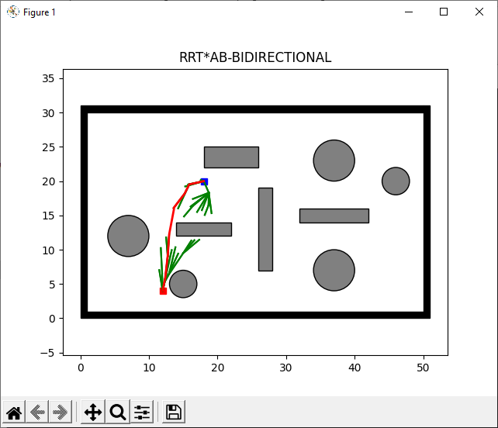
Figure 4.1 Case 1 Result-a

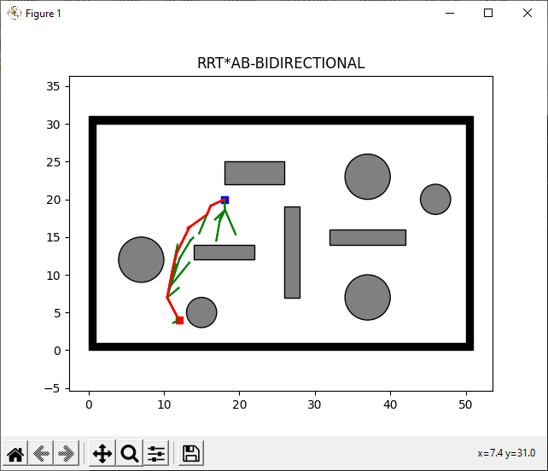
Figure 4.2 Case 1 Result-b
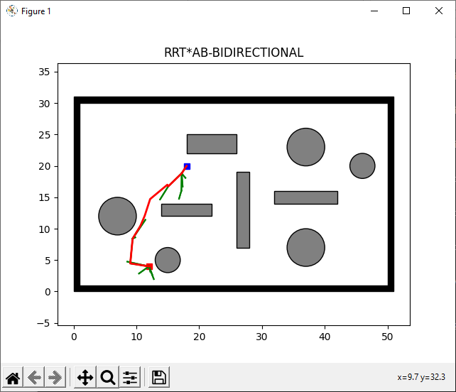
Figure 4.3 Case 1 Result-c

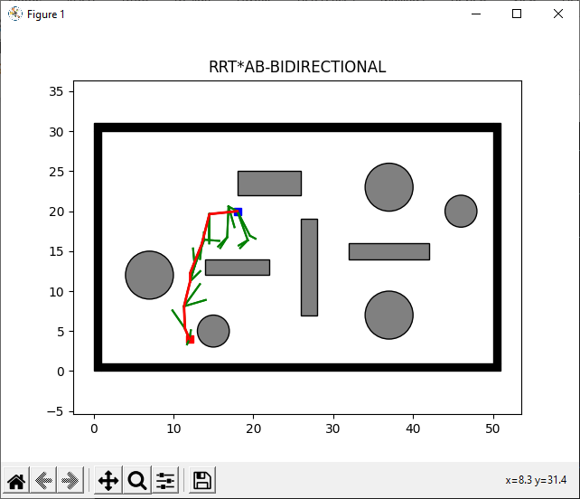
Figure 4.4 Case 1 Result-d

Case 2

Input for Case 2 is as follows:
(Source Coordinates, Goal Coordinates) = (7, 5) (47, 2)

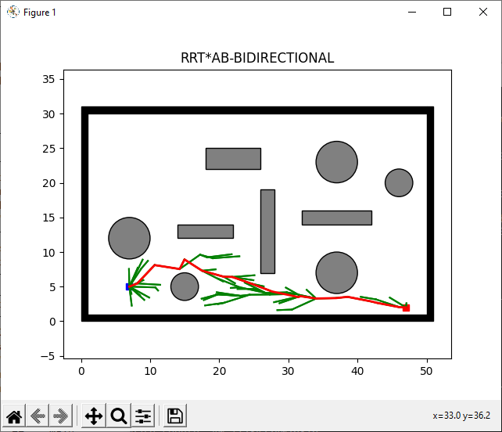
Figure 4.5 Case2 Result-a

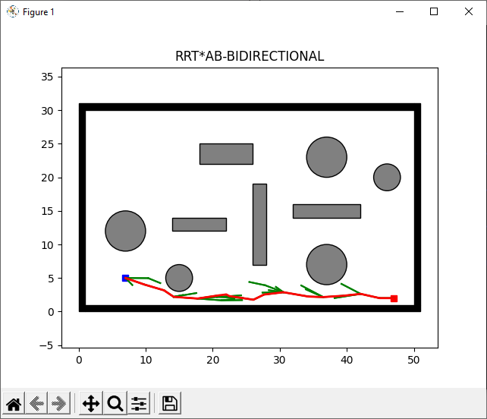
Figure 4.6 Case2 Result-b
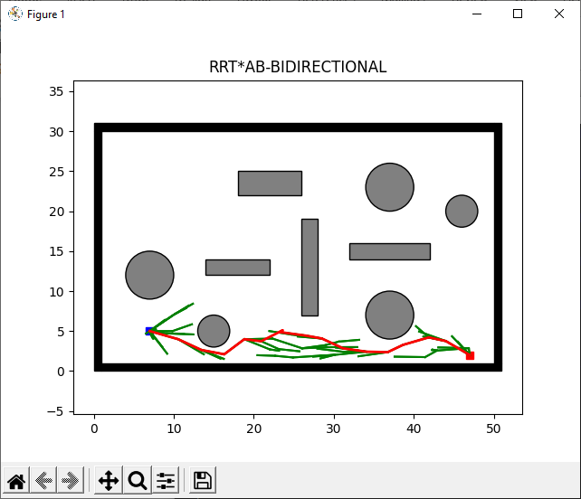
Figure 4.7 Case2 Result-c

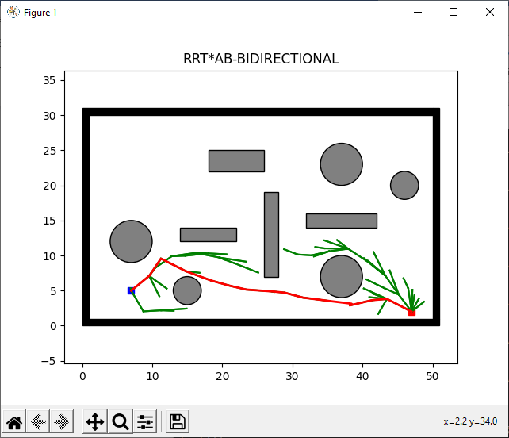
Figure 4.8 Case2 Result-d

Case 3

Input for Case 3 is as follows:
(Source Coordinates, Goal Coordinates) = (25, 26) (12, 8)

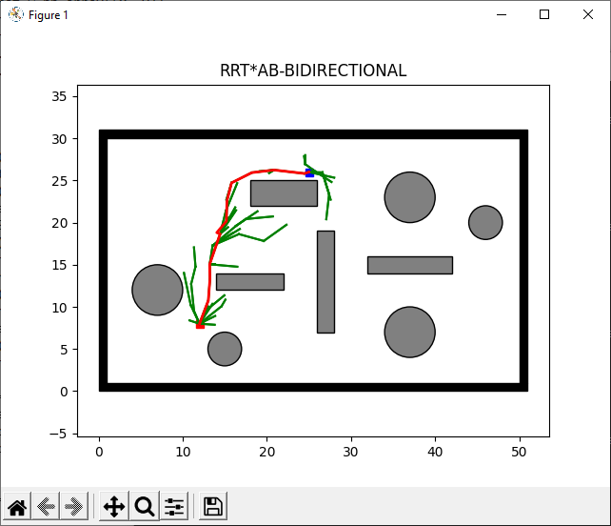
Figure 4.9 Case3 Result-a

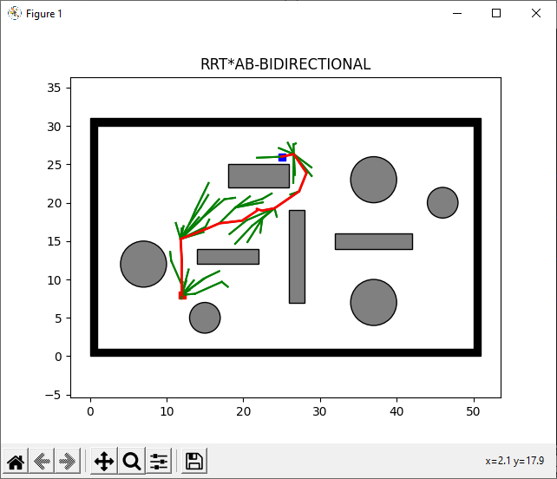
Figure 4.10 Case3 Result-b
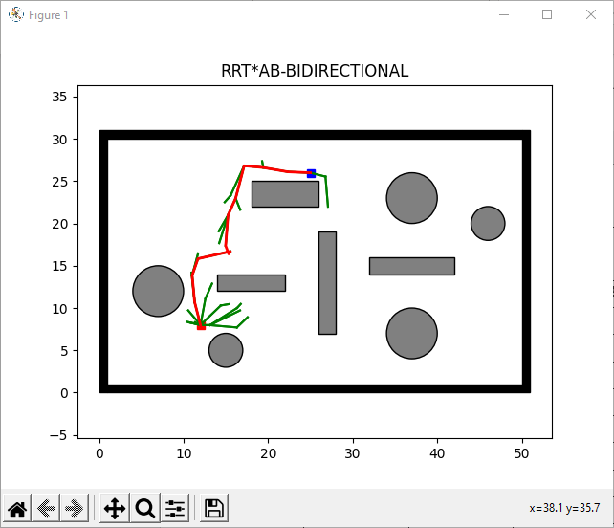
Figure 4.11 Case3 Result-c

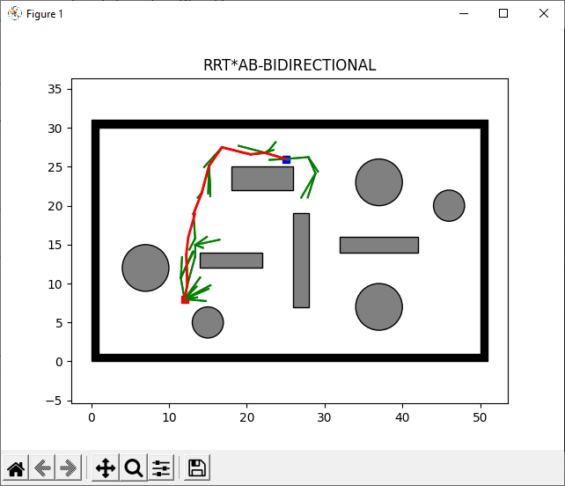
Figure 4.12 Case3 Result-d

Case 4

Input for Case 4 is as follows:
(Source Coordinates, Goal Coordinates) = (2, 28) (38, 18)

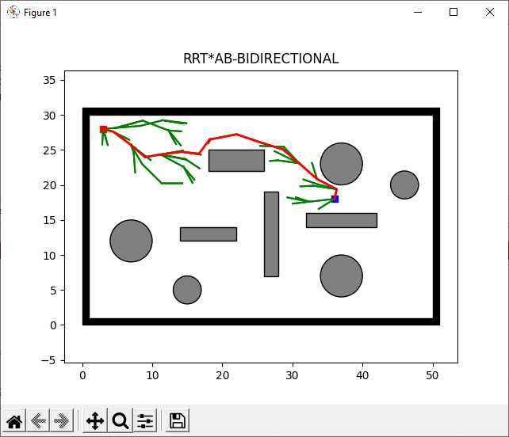
Figure 4.13 Case4 Result-a

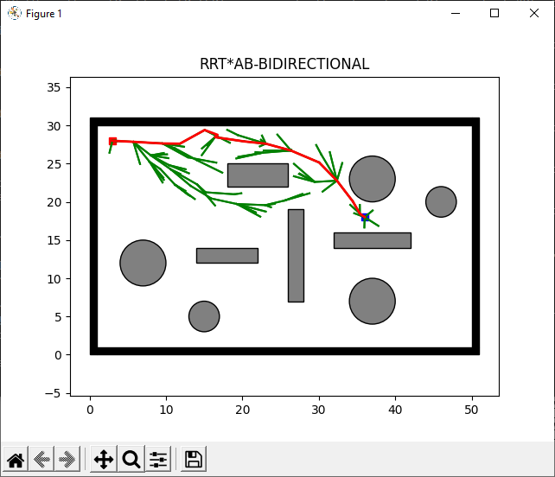
Figure 4.14 Case4 Result-b
\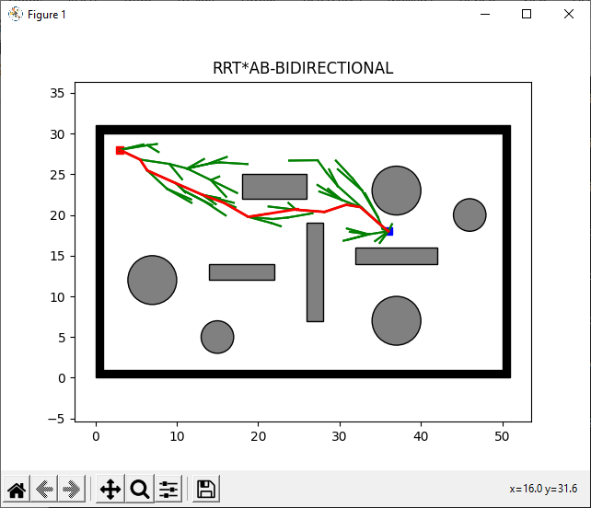
Figure 4.15 Case4 Result-c

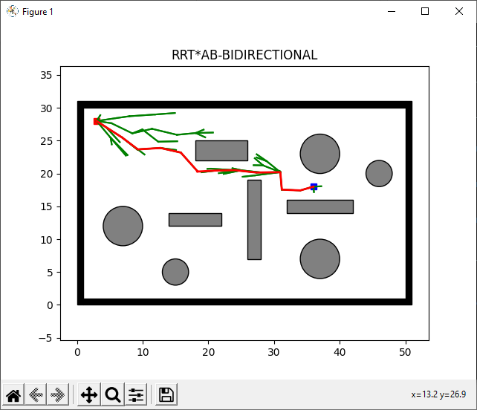
Figure 4.16 Case4 Result-d

Case 5

Input for Case 5 is as follows:
(Source Coordinates, Goal Coordinates) = (49, 4) (40, 29)

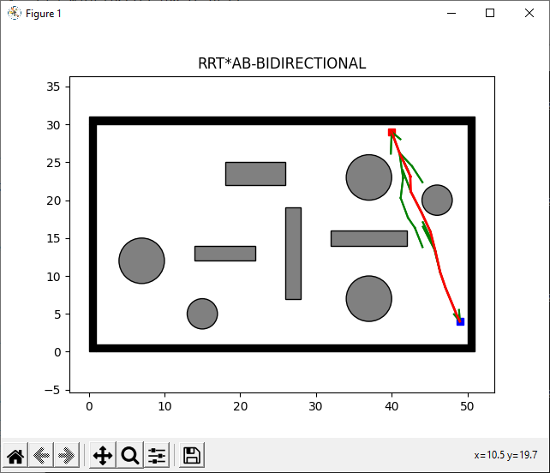
Figure 4.17 Case5 Result-a

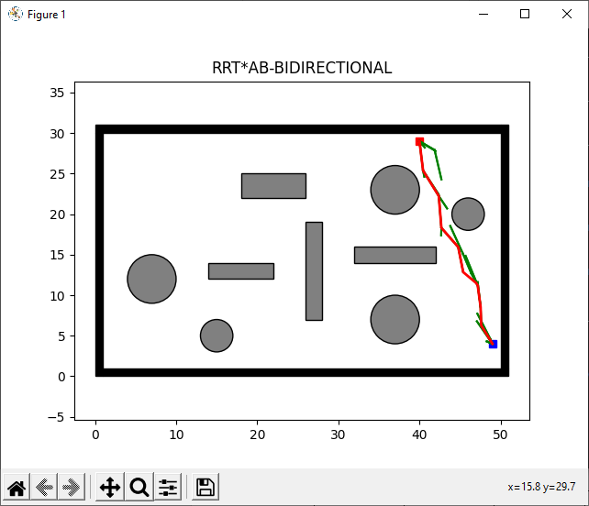
Figure 4.18 Case5 Result-b
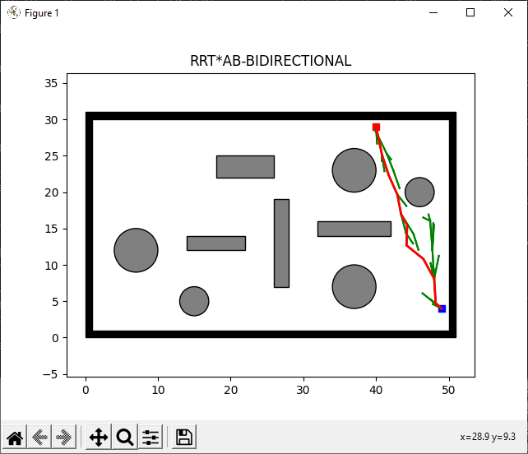
Figure 4.19 Case5 Result-c

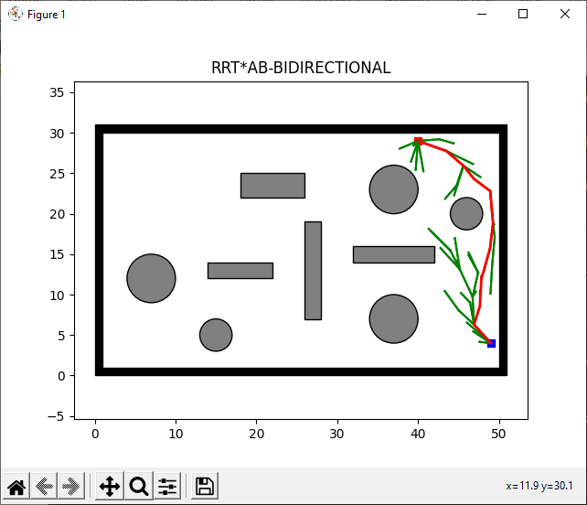
Figure 4.20 Case5 Result-d

RESULTS AND DISCUSSIONS

Experimentation Results

Experiments are performed with different input scenario referred as Case 1, Case 2, Case 3, Case 4, and Case 5. Each experiment set was conducted hundred times, every average output is recorded, and each case is using 200 iterations for execution. Following are the experimentation results:

Case 1

Figure 5.1 displays collision free path for case 1.

Figure 5.1 Case 1 Output Result

Table 5.1 displays experimentation results of RRT*-AB-BD.

Table 5.1 Case 1 Experimentation Results
No. of Trials | Elapsed Time (sec) | Number of Nodes | Path Length (m) | Height  (m)
Input: (Source Coordinates, Goal Coordinates) = (18,20) (12,4)
1 | 11.7136 | 43 | 17.08 | 16
2 | 6.8457 | 24 | 17.08 | 16
3 | 19.1062 | 84 | 17.08 | 16
4 | 6.7619 | 32 | 17.08 | 16
5 | 9.4449 | 35 | 17.08 | 16
6 | 7.6813 | 39 | 17.08 | 16
7 | 5.9734 | 28 | 17.08 | 16
8 | 6.8271 | 26 | 17.08 | 16
9 | 7.7322 | 34 | 17.08 | 16
10 | 4.3361 | 24 | 17.08 | 16
Average | 8.64224 | 36.9 | 17.08 | 16

Case 2

Figure 5.2 displays collision free path for case 2.

Figure 5.2 Case 2 Output Results

Table 5.2 displays experimentation results of RRT*-AB-BD.

Table 5.2 Case 2 Experimentation Results
No. of Trials | Elapsed Time (sec) | Number of Nodes | Path Length (m) | Height  (m)
Input: (Source Coordinates, Goal Coordinates) = (7,5) (47,2)
1 | 14.5070 | 77 | 40.11 | 3
2 | 7.0922 | 38 | 40.11 | 3
3 | 13.6512 | 78 | 40.11 | 3
4 | 39.0598 | 174 | 40.11 | 3
5 | 12.3202 | 69 | 40.11 | 3
6 | 28.1690 | 135 | 40.11 | 3
7 | 20.5151 | 99 | 40.11 | 3
8 | 18.5678 | 85 | 40.11 | 3
9 | 12.4753 | 72 | 40.11 | 3
10 | 20.2178 | 104 | 40.11 | 3
Average | 18.65754 | 93.1 | 40.11 | 3

Case 3

Figure 5.3 displays collision free path for case 3.

Figure 5.3 Case 3 Output Result

Table 5.3 displays experimentation results of RRT*-AB-BD.

Table 5.3 Case 3 Experimentation Results
No. of Trials | Elapsed Time (sec) | Number of Nodes | Path Length (m) | Height  (m)
Input: (Source Coordinates, Goal Coordinates) = (25,26) (12,8)
1 | 18.3384 | 63 | 22.20 | 18
2 | 17.7054 | 73 | 22.20 | 18
3 | 12.1521 | 49 | 22.20 | 18
4 | 14.3647 | 66 | 22.20 | 18
5 | 28.2497 | 98 | 22.20 | 18
6 | 13.2816 | 45 | 22.20 | 18
7 | 8.0389 | 39 | 22.20 | 18
8 | 22.9667 | 70 | 22.20 | 18
9 | 17.5920 | 68 | 22.20 | 18
10 | 26.8294 | 90 | 22.20 | 18
Average | 17.95189 | 66.1 | 22.20 | 18

Case 4

Figure 5.4 displays collision free path for case 4.

Figure 5.4 Case 4 Output Results

Table 5.4 displays experimentation results of RRT*-AB-BD.

Table 5.4 Case 4 Experimentation Results
No. of Trials | Elapsed Time (sec) | Number of Nodes | Path Length (m) | Height  (m)
Input: (Source Coordinates, Goal Coordinates) = (2,28) (38,18)
1 | 15.5512 | 64 | 34.48 | 10
2 | 19.6042 | 96 | 34.48 | 10
3 | 15.7042 | 83 | 34.48 | 10
4 | 11.6439 | 62 | 34.48 | 10
5 | 15.9067 | 83 | 34.48 | 10
6 | 14.9951 | 80 | 34.48 | 10
7 | 24.0226 | 112 | 34.48 | 10
8 | 13.3776 | 71 | 34.48 | 10
9 | 12.2748 | 59 | 34.48 | 10
10 | 18.4303 | 91 | 34.48 | 10
Average | 16.15106 | 80.1 | 34.48 | 10

Case 5

Figure 5.5 displays collision free path for case 5.

Figure 5.5 Case 5 Output Result

Table 5.5 displays experimentation results of RRT*-AB-BD.

Table 5.5 Case 5 Experimentation Results
No. of Trials | Elapsed Time (sec) | Number of Nodes | Path Length (m) | Height  (m)
Input: (Source Coordinates, Goal Coordinates) = (49,4) (40,29)
1 | 4.9976 | 29 | 26.57 | 25
2 | 5.1638 | 33 | 26.57 | 25
3 | 7.3473 | 39 | 26.57 | 25
4 | 9.7144 | 55 | 26.57 | 25
5 | 6.8904 | 36 | 26.57 | 25
6 | 12.4249 | 67 | 26.57 | 25
7 | 4.2282 | 26 | 26.57 | 25
8 | 6.9307 | 39 | 26.57 | 25
9 | 10.3287 | 54 | 26.57 | 25
10 | 4.2631 | 25 | 26.57 | 25
Average | 7.22891 | 40.3 | 26.57 | 25

Comparison Results of RRT*-AB and Bi-Directional RRT*-AB

Statistics of experiments along with simulation results are recorded to provide graphical and numerical comparative analysis with previous approach. Following are the comparison results of RRT*-AB [11] and Bi-Directional RRT*-AB as,

Result 1

For the same input, Figures 5.6 and 5.7 illustrate collision-free paths for RRT*-AB [11] and RRT*-AB-BD.
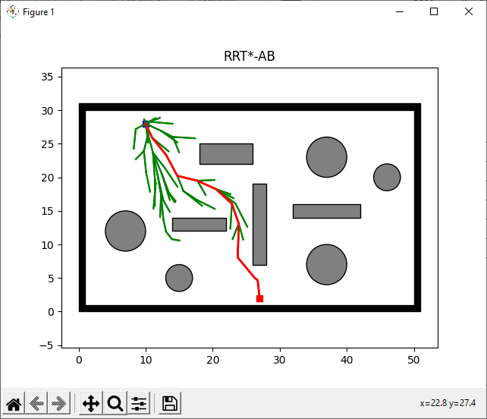
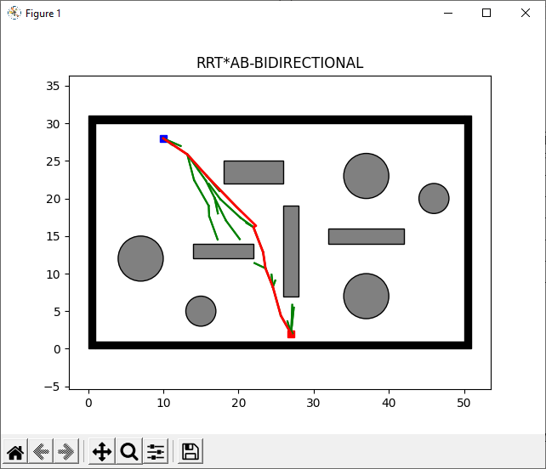
Figure 5.6 RRT*-AB Result 1
Figure 5.7 RRT*-AB-BD Result 1

Table 5.6 shows comparison results of RRT*-AB and RRT*-AB-BD.

Table 5.6 Comparison Result 1 of RRT*-AB and RRT*-AB-BD
Algorithm | RRT*AB | RRT*AB-BIDIRECTIONAL
Input: (Source Coordinates, Goal Coordinates) = (10,28) (27,2)
Elapsed Time (s) | 18.044535 | 4.72507
Number of Nodes | 67 | 39
Path Length (m) | 31.0622 | 31.0622
Height (m) | 26 | 26
Iteration | 200 | 200

Result 2

Results For the same input, Figures 5.8 and 5.9 illustrate collision-free paths for RRT*-AB [11] and RRT*-AB-BD.

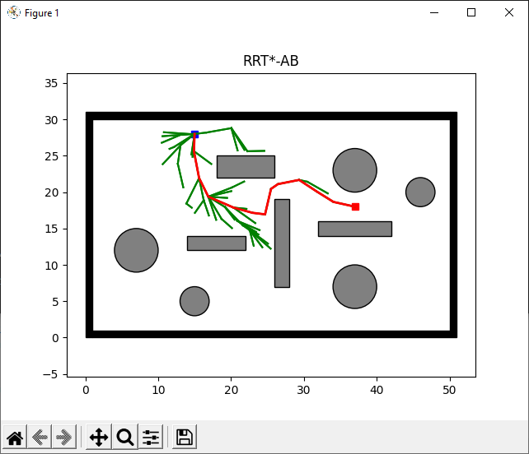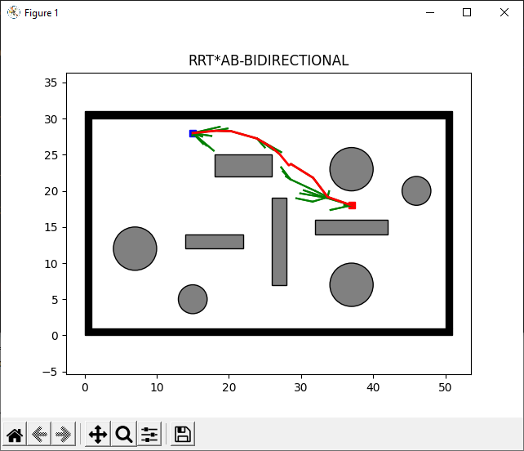
Figure 5.8 RRT*-AB Result 2
Figure 5.9 RRT*-AB-BD Result 2

Table 5.7 shows comparison results of RRT*-AB and RRT*-AB-BD.

Table 5.7 Comparison Result 2 of RRT*-AB and RRT*-AB-BD
Algorithm | RRT*AB | RRT*AB-BIDIRECTIONAL
Input: (Source Coordinates, Goal Coordinates) = (15,28) (37,18)
Elapsed Time (s) | 12.6315 | 4.1920
Number of Nodes | 61 | 35
Path Length (m) | 24.16 | 24.16
Height (m) | 10 | 10
Iteration | 200 | 200

Result 3

Results For the same input, Figures 5.10 and 5.11 illustrate collision-free paths for RRT*-AB [11] and RRT*-AB-BD.

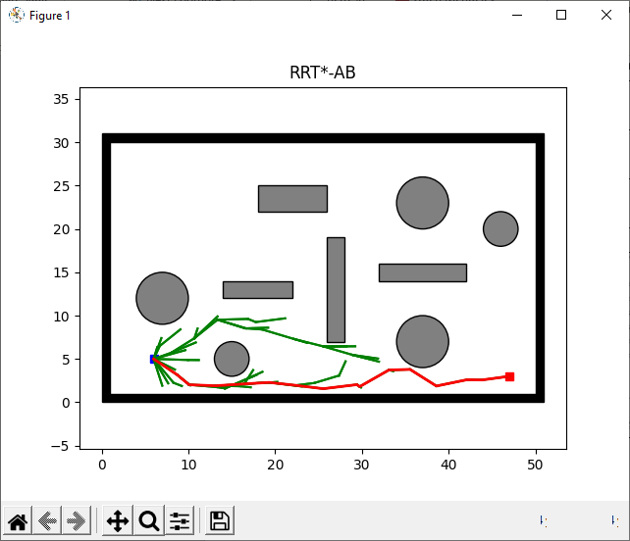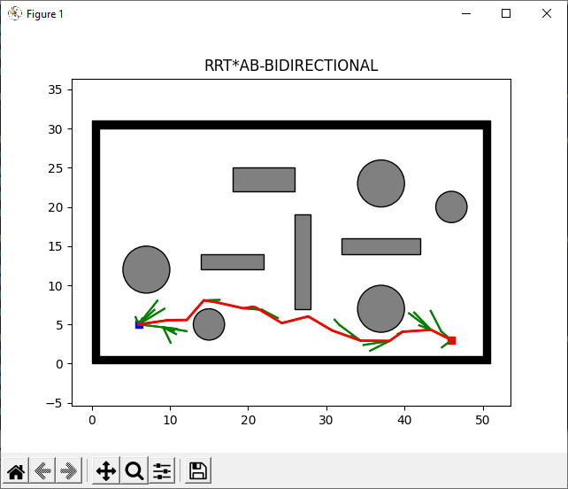
Figure 5.10 RRT*-AB Result 3
Figure 5.11 RRT*-AB-BD Result 3

Table 5.8 shows comparison results of RRT*-AB and RRT*-AB-BD.

Table 5.8 Comparison Result 3 of RRT*-AB and RRT*-AB-BD
Algorithm | RRT*AB | RRT*AB-BIDIRECTIONAL
Input: (Source Coordinates, Goal Coordinates) = (15,28) (37,18)
Elapsed Time (s) | 12.2577 | 5.2057
Number of Nodes | 67 | 45
Path Length (m) | 40.04 | 40.04
Height (m) | 2 | 2
Iteration | 200 | 200

Result 4

Results For the same input, Figures 5.12 and 5.13 illustrate collision-free paths for RRT*-AB [11] and RRT*-AB-BD.

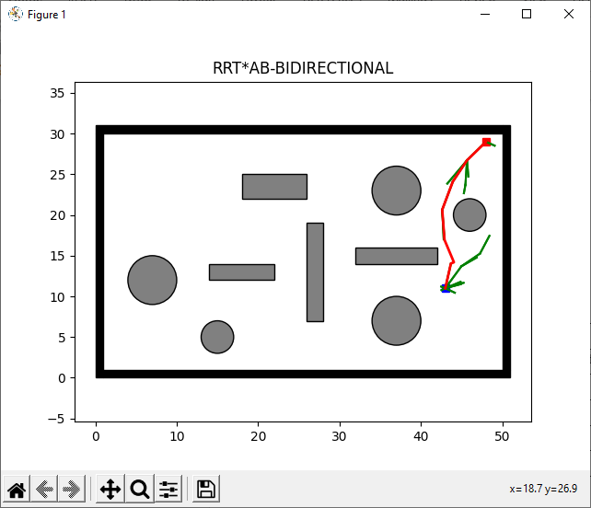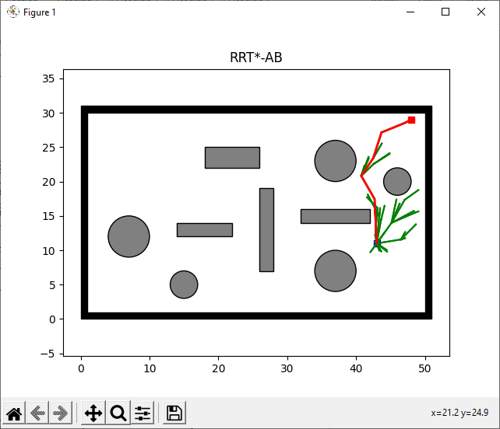
Figure 5.12 RRT*-AB Result 4
Figure 5.13 RRT*-AB-BD Result 4

Table 5.9 shows comparison results of RRT*-AB and RRT*-AB-BD.

Table 5.9 Comparison Result 4 of RRT*-AB and RRT*-AB-BD
Algorithm | RRT*AB | RRT*AB-BIDIRECTIONAL
Input: (Source Coordinates, Goal Coordinates) = (43,11) (48,29)
Elapsed Time (s) | 9.2844 | 3.2575
Number of Nodes | 44 | 19
Path Length (m) | 18.68 | 18.68
Height (m) | 18 | 18
Iteration | 200 | 200

Result 5

For the same input, Figures 5.14 and 5.15 illustrate collision-free paths for RRT*-AB [11] and RRT*-AB-BD.

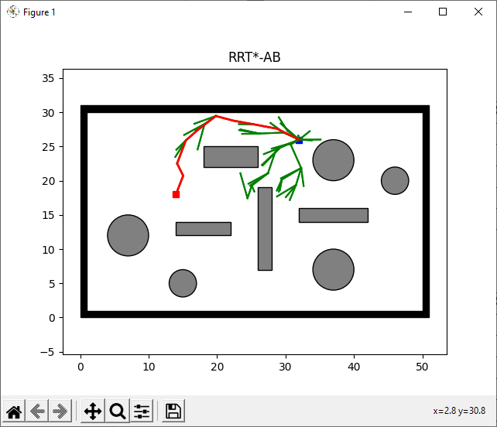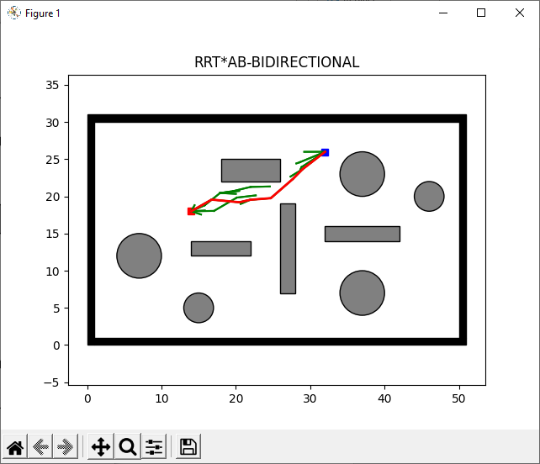
Figure 5.14 RRT*-AB Result 5
Figure 5.15 RRT*-AB-BD Result 5

Table 5.10 shows comparison results of RRT*-AB and RRT*-AB-BD.

Table 5.10 Comparison Result 5 of RRT*-AB and RRT*-AB-BD
Algorithm | RRT*AB | RRT*AB-BIDIRECTIONAL
Input: (Source Coordinates, Goal Coordinates) = (43,11) (48,29)
Elapsed Time (s) | 13.9422 | 6.0465
Number of Nodes | 58 | 23
Path Length (m) | 19.69 | 19.69
Height (m) | 18 | 8
Iteration | 200 | 200

Result 6

For the same input, Figures 5.16 and 5.17 illustrate collision-free paths for RRT*-AB [11] and RRT*-AB-BD.

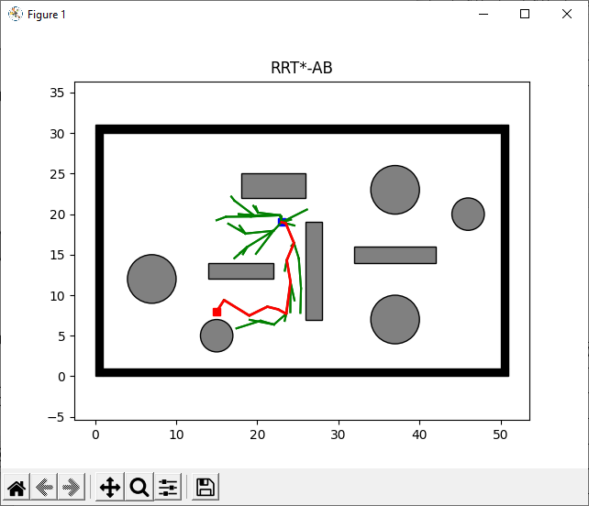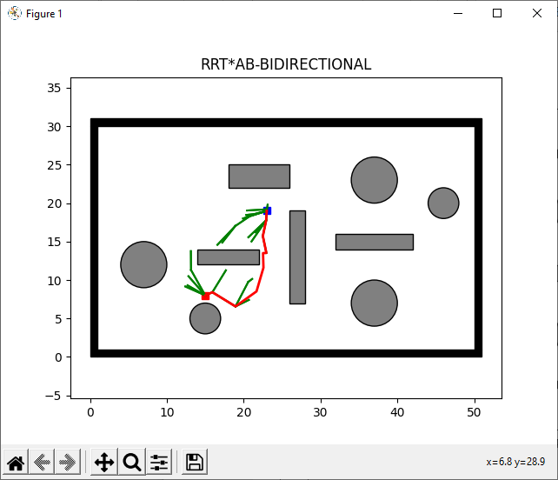
Figure 5.16 RRT*-AB Result 6
Figure 5.17 RRT*-AB-BD Result 6
Table 5.11 shows comparison results of RRT*-AB and RRT*-AB-BD.

Table 5.11 Comparison Result 6 of RRT*-AB and RRT*-AB-BD
Algorithm | RRT*AB | RRT*AB-BIDIRECTIONAL
Input: (Source Coordinates, Goal Coordinates) = (32,26) (14,18)
Elapsed Time (s) | 19.0497 | 7.5996
Number of Nodes | 50 | 32
Path Length (m) | 13.60 | 13.60
Height (m) | 11 | 11
Iteration | 200 | 200

Time Comparison Result

Fig. 5.18 demonstrate that proposed approach RRT*-AB-BD generated shorter path in less time than RRT*-AB [11].

Figure 5.18 Plots for Case 1 to Case 6; average execution time

Number of Nodes Comparison Result

Fig. 5.19 demonstrate that proposed approach RRT*-AB-BD takes less no of nodes than RRT*-AB [11].

Figure 5.19 Plots for Case 1 to Case 6; average nodes

Path Length Comparison Result

Fig. 5.20 demonstrate path length plot of proposed approach RRT*-AB-BD and RRT*-AB [11].

Figure 5.20 Plots for Case 1 to Case 6; average path length

Height Comparison Result

Fig. 5.20 demonstrate height plot of proposed approach RRT*-AB-BD and RRT*-AB [11].

Figure 5.21 Plots for Case 1 to Case 6; average height

CONCLUSION AND RECOMMENDATIONS

Conclusion

This project aimed to investigate features of RRT*-AB [11] and to extent it using Bi-directional approach resulting in featuring of new algorithm named as Rapidly Exploring Random Tree Star Adjustable Bound Bidirectional (RRT*-AB-BD). Experimental results show that proposed algorithm,
- Generates promising tree by intelligently exploring the search space using novel schemes, i.e., connectivity region, goal-biased bounded sampling.
- Converges to optimal solution quickly.
- Generates shorter paths.
- Consumes less memory.
- Deals with narrow and complex environment formations along with cluttered environment.

Future Recommendations

Bi-Directional RRT*-AB is an improved SBP [2] with maximum convergence rate, but still, it requires some modifications in some areas like as follows:
- The advancement of this approach to generate non-holonomic feasible path in un-known 3D environment for car-like mobile robots.
- Path length optimization for improved path quality and reduced tree density.
- Path optimization will also lead to improved path following route.
- Library publishing on GitHub after optimization.

REFERENCES

[1] O. Iliashenko, Z. Bikkulova, and A. Dubgorn, “Opportunities and challenges of artificial intelligence in healthcare,” E3S Web Conf., vol. 110, 2019, doi: 10.1051/e3sconf/201911002028.
[2] I. Noreen, A. Khan, and Z. Habib, “Optimal Path Planning using RRT* based Approaches: A Survey and Future Directions,” Int. J. Adv. Comput. Sci. Appl., vol. 7, no. 11, pp. 97–107, 2016, doi: 10.14569/ijacsa.2016.071114.
[3] E. W. Dijkstra, “Dijkstra1959.pdf,” Numerische mathematik, vol. 1, no. 1. pp. 269–271, 1959, [Online]. Available: http://www.bioinfo.org.cn/~dbu/AlgorithmCourses/Lectures/Dijkstra1959.pdf.
[4] W. Zhan, W. Wang, N. Chen, and C. Wang, “Efficient UAV path planning with multiconstraints in a 3D large battlefield environment,” Math. Probl. Eng., vol. 2014, 2014, doi: 10.1155/2014/597092.
[5] I. Noreen, A. Khan, and Z. Habib, “A Comparison of RRT, RRT* and RRT*-Smart Path Planning Algorithms,” Ijcsns ’16, vol. 16, no. 10, pp. 20–27, 2016, [Online]. Available: http://paper.ijcsns.org/07_book/201610/20161004.pdf.
[6] S. Karaman and E. Frazzoli, “Sampling-based algorithms for optimal motion planning,” Int. J. Rob. Res., vol. 30, no. 7, pp. 846–894, 2011, doi: 10.1177/0278364911406761.
[7] S. Karaman, M. R. Walter, A. Perez, E. Frazzoli, and S. Teller, “Anytime motion planning using the RRT,” Proc. - IEEE Int. Conf. Robot. Autom., pp. 1478–1483, 2011, doi: 10.1109/ICRA.2011.5980479.
[8] J. J. Kuffner and S. M. La Valle, “RRT-connect: an efficient approach to single-query path planning,” in Proceedings - IEEE International Conference on Robotics and Automation, 2000, vol. 2, pp. 995–1001, doi: 10.1109/robot.2000.844730.
[9] J. D. Gammell, S. S. Srinivasa, and T. D. Barfoot, “Informed RRT∗: Optimal sampling-based path planning focused via direct sampling of an admissible ellipsoidal heuristic,” in IEEE International Conference on Intelligent Robots and Systems, Oct. 2014, pp. 2997–3004, doi: 10.1109/IROS.2014.6942976.
[10] F. Islam, J. Nasir, U. Malik, Y. Ayaz, and O. Hasan, “RRT*-Smart: Rapid convergence implementation of RRT* towards optimal solution,” in 2012 IEEE International Conference on Mechatronics and Automation, ICMA 2012, 2012, pp. 1651–1656, doi: 10.1109/ICMA.2012.6284384.
[11] I. Noreen, A. Khan, H. Ryu, N. L. Doh, and Z. Habib, “Optimal path planning in cluttered environment using RRT*-AB,” Intell. Serv. Robot., vol. 11, no. 1, pp. 41–52, 2018, doi: 10.1007/s11370-017-0236-7.
[12] A. H. Qureshi and Y. Ayaz, “Intelligent bidirectional rapidly-exploring random trees for optimal motion planning in complex cluttered environments,” Rob. Auton. Syst., vol. 68, pp. 1–11, 2015, doi: 10.1016/j.robot.2015.02.007.
[13] O. Khatib, “REAL-TIME OBSTACLE AVOIDANCE FOR MANIPULATORS AND MOBILE ROBOTS.,” Int. J. Rob. Res., vol. 5, no. 1, pp. 90–98, 1986, doi: 10.1177/027836498600500106.
[14] “GitHub - zhm-real/PathPlanning: Common used path planning algorithms with animations.” https://github.com/zhm-real/PathPlanning (accessed Jun. 29, 2021).
[15] “Welcome to Python.org.” https://www.python.org/ (accessed Jun. 29, 2021).
[16] Zelinsky, R. A. Jarvis, J. C. Byrne, and S. Yuta, "Planning paths of complete coverage of an unstructured environment by a mobile robot", in Proceedings of International Conference on Advanced Robotics (ICAR), 1993.
[17] Stentz, "Optimal and efficient path planning for partially-known environments", presented at the Proceedings of the International Conference on Robotics and Automation, 1994.
[18] Nash, S. Koenig, and M. Likhachev, "Incremental phi*: Incremental any-angle path planning on grids", in International Joint Conference on Aritificial Intelligence, 2009, pp. 1824–1830.
[19] P. Garcia, O. Montiel, O. Castillo, R. Sepúlveda, and P. Melin, "Path planning for autonomous mobile robot navigation with ant colony optimization and fuzzy cost function evaluation", APPL SOFT COMPUT, vol. 9, pp. 1102-1110, 2009.
[20] M. Dorigo, Ant colony optimization: Cambridge University, Massachusetts: MIT Press, 1992.
[21] T. Arora, Y. Gigras, and V. Arora, "Robotic path planning using genetic algorithm in dyn.

[22] J. H. Liang, and C. H. Lee, "Efficient collision-free path-planning of multiple
mobile robots system using efficient artificial bee colony algorithm", ADV ENG SOFTW, vol. 79, pp. 47-56, 2015.
[23] M. A. Hossain, and I. Ferdous, "Autonomous robot path planning in dynamic environment using a new optimization technique inspired by bacterial foraging technique", ROBOT AUTON SYST, vol. 64, pp. 137- 141, 2015.
[24] D. Q. Zhu, W. C. Li, M. Z. Yan, and S. X. Yang, "The path planning of auv based on d-s information fusion map building and bio-inspired neural network in unknown dynamic environment", International Journal of Advanced Robotic Systems, vol. 11, March 6 2014.
[25] Fister, I. Fister, X.-S. Yang, and J. Brest, "A comprehensive review of firefly algorithms", Swarm and Evolutionary Computation, vol. 13, pp. 34-46, 2013.

