
BSCS-F20-004
03-134172-069 | HUSSNAIN KHAN

RRT*-AB Framework for Path Planning of Mobile Robots

In partial fulfilment of the requirements for the degree of
Bachelor of Science in Computer Science
Supervisor: Dr. Iram Noreen
Department of Computer Sciences
Bahria University, Lahore Campus
July 2021

© Bahria University, 2021

Certificate

We accept the work contained in the report titled.
“RRT*-AB Framework for Path Planning of Mobile Robots”
written by
HUSSNAIN KHAN
as a confirmation to the required standard for the partial fulfilment of the degree of
Bachelor of Science in Computer Science.

Approved by:
Supervisor: Dr. Iram Noreen
(Signature)

July 14, 2021

DECLARATION

I hereby declare that this project report is based on my original work except for citations and quotations which have been duly acknowledged. I also declare that it has not been previously and concurrently submitted for any other degree or award at Bahria University or other institutions.

Enrolment | Name | Signature
03-134172-069 | HUSSNAIN KHAN

Date : July 14, 2021

Specially dedicated to
my beloved grandmother, mother, father, and brother
(HUSSNAIN KHAN)

ACKNOWLEDGEMENTS

I would like to thank everyone who had contributed to the successful completion of this project. I would like to express our gratitude to my research supervisor, Dr. Iram Noreen for her invaluable advice, guidance, and her enormous patience throughout the development of the research.

In addition, I would also like to express my gratitude to my loving parent and friends who had helped and given me encouragement.

HUSSNAIN KHAN

RRT*-AB Framework for Path Planning of Mobile Robots

ABSTRACT

Path planning for mobile robot is an important aspect of robotics. Path planning algorithms play a crucial role in robot's movement and response to the environment. RRT (Rapidly Exploring Random Trees) is a sampling-based path planning algorithm. RRT*-AB [1] is a recent addition to the family of sampling-based algorithms.
This project aims to investigate different features of this algorithm and to develop it's free to use open-source library framework using python/C++ with the support of Artificial Intelligence, Robotics and computer Vision (AIRV) research group. The proposed library framework will be beneficial for the research community order to implement different applications related to exploration and rescue.

TABLE OF CONTENTS

DECLARATION ii
ACKNOWLEDGEMENTS iv
ABSTRACT v
TABLE OF CONTENTS vi
LIST OF TABLES ix
LIST OF FIGURES x
LIST OF SYMBOLS/ABBREVIATIONS xii

CHAPTERS
1 INTRODUCTION 1
1.1 Background 1
1.2 Holonomic and Non-Holonomic Robot 1
1.3 Need of Autonomous Mobile Robot 2
1.4 Application of Autonomous Mobile Robot 2
1.5 Path Planning 3
1.6 Sampling Based Planning 3
1.6.1 Probabilistic Road Map (PRM) 3
1.6.2 Rapidly Exploring Random Tree (RRT) 4
1.7 RRT*-AB 4
1.8 Scope 4
1.9 Goal 5
1.10 Objectives 5
2 LITERATURE REVIEW 6
2.1 Related Work 6
2.2 Working of Planner 8
2.2.1 RRT* 8
2.2.2 RRT*-AB 9
3 DESIGN AND METHODOLOGY 10
3.1 Introduction 10
3.2 RRT*-AB Framework 10
3.3 Parent Classes of RRT*-AB Framework 10
3.3.1 RRT* 11
3.4 Class Diagram 11
3.5 Class Model 12
3.6 Boundary Class 13
3.7 Class Visibility 14
3.7.1 Operations Detail 14
3.8 Pseudo Code of RRT*-AB 17
4 EXPERIMENTS IMPLMENTATION 18
4.1 Implementation 18
4.1.1 Tool and Technology 18
4.1.2 Development Environment 18
4.1.3 Language 19
4.1.4 Packages 19
4.1.5 Library Framework 19
4.1.6 Setup 20
4.2 Experimentation 21
4.2.1 Case 1 22
4.2.2 Case 2 24
4.2.3 Case 3 26
4.2.4 Case 4 28
4.2.5 Case 5 30
5 RESULTS AND DISCUSSIONS 32
5.1 Case 1 Experimentation Results 32
5.1.1 Case 1 Experimentation Result 32
5.1.2 Case 2 Experimentation Result 34
5.1.3 Case 3 Experimentation Result 35
5.1.4 Case 4 Experimentation Result 36
5.1.5 Case 5 Experimentation Result 38
5.2 Fixed Iteration Trend Analysis 39
5.3 Comparison Result of RRT* and RRT*-AB 39
5.3.1 Result 1 40
5.3.2 Result 2 41
5.3.3 Result 3 42
5.3.4 Result 4 43
5.3.5 Result 5 44
5.4 Time Comparison Chart 45
5.5 Number of Nodes Comparison Chart 45
5.6 Path Length Comparison Chart 46
5.7 Height Comparison Chart 46
5.8 Iteration Analysis Comparison Chart 47
6 CONCLUSION AND RECOMMENDATIONS 48
6.1 Conclusion 48
6.2 Future Recommendations 48
REFERENCES 49

LIST OF TABLES

TABLE TITLE PAGE
Table 4.1 Tools and Technology Details 18
Table 4.2 Packages Details 19
Table 4.3 Software Setup Details 20
Table 4.4 Hardware Setup Details 21
Table 5.1 Case 1 Experimentation Results 33
Table 5.2 Case 2 Experimentation Results 34
Table 5.3 Case 3 Experimentation Results 35
Table 5.4 Case 4 Experimentation Results 37
Table 5.5 Case 5 Experimentation Results 38
Table 5.6 Iteration Trend Analysis 39
Table 5.7 Comparison Result 1 of RRT* and RRT*-AB 40
Table 5.8 Comparison Result 2 of RRT* and RRT*-AB 41
Table 5.9 Comparison Result 3 of RRT* and RRT*-AB 42
Table 5.10 Comparison Result 4 of RRT* and RRT*-AB 43
Table 5.11 Comparison Result 5 of RRT* and RRT*-AB 44

LIST OF FIGURES

FIGURE TITLE PAGE
Figure ‎3.1 : Inherited Classes of RRT* 11
Figure ‎3.2 : Hierarchy Diagram 11
Figure ‎3.3 : Class Model of RRT*-AB 12
Figure ‎4.1 Case 1 Output Result-a 22
Figure ‎4.2 Case 1 Output Result-b 22
Figure ‎4.3 Case 1 Output Result-c 23
Figure ‎4.4 Case 1 Output Result-d 23
Figure ‎4.5 Case 2 Output Result-a 24
Figure ‎4.6 Case 2 Output Result-b 24
Figure ‎4.7 Case 2 Output Result-c 25
Figure ‎4.8 Case 2 Output Result-d 25
Figure ‎4.9 Case 3 Output Result-a 26
Figure ‎4.10 Case 3 Output Result-b 26
Figure ‎4.11 Case 3 Output Result-c 27
Figure ‎4.12 Case 3 Output Result-d 27
Figure ‎4.13 Case 4 Output Result-a 28
Figure ‎4.14 Case 4 Output Result-b 28
Figure ‎4.15 Case 4 Output Result-c 29
Figure ‎4.16 Case 4 Output Result-d 29
Figure ‎4.17 Case 5 Output Result-a 30
Figure ‎4.18 Case 5 Output Result-b 30
Figure ‎4.19 Case 5 Output Result-c 31
Figure ‎4.20 Case 5 Output Result-d 31
Figure ‎5.1 Output Results for Case 1 32
Figure ‎5.2 Output Results for Case2 34
Figure ‎5.3 Output Result for Case 3 35
Figure ‎5.4 Output Result for Case 4 36
Figure ‎5.5 Output Result for Case5 38
Figure ‎5.6 RRT* Result 1 40
Figure ‎5.7 RRT*-AB Result 1 40
Figure ‎5.8 RRT* Result 2 41
Figure ‎5.9 RRT*-AB Result 2 41
Figure ‎5.10 RRT* Result 3 42
Figure ‎5.11 RRT*-AB Result 3 42
Figure ‎5.12 RRT* Result 4 43
Figure ‎5.13 RRT*-AB Result 4 43
Figure ‎5.14 RRT* Result 5 44
Figure ‎5.15 RRT*-AB Result 5 44
Figure ‎5.16 Plots for Case 1 to Case 6; average execution time 45
Figure ‎5.17 Plots for Case 1 to Case 6; average nodes 45
Figure ‎5.18 Plots for Case 1 to Case 6; average path length 46
Figure ‎5.19 Plots for Case 1 to Case 6; average height 46
Figure ‎5.20 Iteration Analysis Chart 47

LIST OF SYMBOLS/ABBREVIATIONS

SMP Sampling Based Planning
PRM Probabilistic Road Map
RRT Rapidly Exploring Random Tree
RRT* Rapidly Exploring Random Tree Star
RRT*-AB Rapidly Exploring Random Tree Start Adjustable Bound
PSO Particle Swarm Optimization
ACO Ant Colony Optimization
GA Genetic Algorithms
UAV Unnamed Aerial Vehicle

INTRODUCTION

Background

In this modern era, mobile robot is one of the most rapidly emerging field of scientific research. We human always want ease in the life. Nowadays robots are replacing with human in all aspect of domain. Mobile robots [2] are designed to complete the task effectively and they perform the task by moving from source to destination. Mobile robots operate independently of human intervention. They have a great capacity to understand their environment and then behave accordingly. There are many types of mobile robots including legged robot, flying robot, robot vision etc. Mobile robots are based on locomotion (Robot’s mechanism kinematics and dynamics), perception, (sensors and computer vision technology), navigation (path planning and artificial intelligence) and cognition (observing input and taking action) [3].

Holonomic and Non-Holonomic Robot

Based on robot movement, it falls in holonomic and non-holonomic robots [4]. If total degree of freedom (all movement capabilities of robot) is equal to the controllable degree of freedom (movement capability which are controllable), then it is termed as holonomic robot. Castor wheel is an example of holonomic as they can move in any direction that is mean they have same controllable and total degree of freedom. If controllable degree of freedom is less than total degree of freedom, then we can say it non-holonomic robot. Car is an example of non-holonomic, it has three degrees of freedom, but only two are controllable which are acceleration and turning angle.

Need of Autonomous Mobile Robot

Everything is getting digitalized in this modern era. Still there are few systems which are based on static manual work. Main purpose of autonomous mobile robots is to get rid of manual static working system and make them more efficient. Autonomous mobile robots [5] do work by finding optimal solution by their own and that is why we need them to be implemented in every domain. These mobile robots make the work error free. Autonomous mobile robots do not need the involvement of human. We just have to tell the task and they do them in best way.

Application of Autonomous Mobile Robot

If we see around us, we can observe that everything is moving toward the automation. Autonomous mobile robots are flexible due to which they can be used in every aspect of domain. There are many fields in which autonomous mobile robots are used, some of them are following.

- Medical
- Agriculture
- Aerospace
- Military
- Security
- Space Research

Path Planning

Many planner (Road Map, Potential field, Cell decomposition etc.) are unable to deal with dynamic and high complex problem in autonomous mobile robot [1]. Path planning play important role for autonomous mobile robots. Path planning find the optimal path between two points (source & destination) by avoiding the hurdles in the environment. Optimal path criteria can be based on one or more conditions such as smoothness, shortest distance, convergence rate etc. Path planning take care of mobile robot constraint and always try to achieve feasible path according to criteria.

Sampling Based Planning

Sampling based planning (SBP) [4] are very famous enhancement in path planning. SBP has capability to deal with large complex problems. The main thing that makes SBP superior to other algorithms are that they develop feasible trajectory of road map regardless having information of obstacles in sample space. SBP algorithm are better in working in comparison to evolutionary algorithms and grid-based algorithms. Some of them are mentioned below:
- Particle Swarm Optimization (PSO) [13]
- Ant Colony Optimization (ACO) [14]
- Genetic Algorithm (GA) [15]
- Wavefront [16]
- Dijkstra [17]

Probabilistic Road Map (PRM)

Probabilistic Road Map (PRM) [7] is popular SBP algorithms [4]. PRM [7] is only good in static environment that is why it has many constraints.

Rapidly Exploring Random Tree (RRT)

RRT [8] is also very popular SBP algorithm [4]. RRT [7] is feasible in dynamic environment and it also support non-holonomic constraint. Nowadays, RRT [7] has its own family of algorithms. Rapidly exploring Random Tree Star (RRT*) [1] is also an addition to RRT family [8]. RRT* [1] exploration is fast, and it find initial path faster than RRT [8]. RRT* [1] produce optimal path by refining successive iterations.

RRT*-AB

RRT* [8] adjustable bound is recent addition in RRT family. RRT*-AB [1] resolved all the issues which are in RRT* [6]. It develops highly converged tree by having only useful nodes in it. As it contains only nodes which are useful, due to this it has less memory requirement. RRT* [6] goal-biased bounded sampling and connectivity region make fast convergence to get optimal path. Path is optimized in RRT*-AB [1] by following techniques.

- Concentrated sampling (it selects node only limited vicinity of found path)
- Node rejection (un-necessary nodes are rejected so they are not populated in tree)
- Path pruning (path is optimized by global pruning)

RRT*AB [1] is efficient in memory, time execution and path length.

Scope

Primary scope of this project is to develop an RRT*-AB [1] framework for path planning of mobile robots. This library will be developed in python/C++. No such library exists for this purpose. This project will be beneficial for research community and developers so that they can easily use this library framework for their research work by reducing human effort and time constraints.

Goal

This project aims to build an open source library tool for RRT*-AB [1] to be used for research scholars and projects. It can be used in a number of application domain as robot planner such as agriculture, autonomous vehicle, rescue and searching, UAVs operations [4].

Objectives

Main objective of the project is to develop an open-source Python/C++ based framework for RRT*-AB [1].

LITERATURE REVIEW

Related Work

Many algorithm have been proposed after RRT* [4] for resolving and obtaining better convergence rate. In [4], they proposed RRT* Anytime [9] with key features of trajectories and branch-and-bound adaptation.

Another approach called B-RRT* [5] is based on feature of improved convergence speed and path refinement using sample rejection with an admissible heuristic. But it has jagged and suboptimal paths also it acquires large memory requirements. A new method RRT*-FN [3], proposed with memory efficient memory usage by focusing fixed number of nodes in tree. But it is only applicable in static environment.

Method called RRT*-Smart [5], proposed with features of intelligent sampling and path optimization. It provides moderate convergence rate with improved efficiency with respect to both time and cost. Another technique named as Optimal B-RRT* [6], proposed functionalities of with multiple heuristics based of different conditions to obtain better convergence rate. But usage of multiple heuristic increases the complexity.

Procedure named RRT# [8], proposed with feature of global planning scheme to maintain promising nodes of tree to obtain better convergence rate with low cost. But real time experimentation was not done.
Method Adapted RRT* [8], proposed with functionalities of kinodynamic extension of RRT* [6] with ensured asymptotic optimality. But controller stabilization for trajectory is not obtained. Another procedure named as SRRT* [5], proposed with functionalities of spline based cubic Bezier curve. It also provides functionality of geometric collision and dynamic feasibility for checking constraints during tree expansion.

Procedure named as Informed RRT* [3], proposed with characteristics of direct sampling technique. It also possesses better convergence rate than RRT* [2]. But shrink planning problem is highly dependent upon initial solution cost making it effective only under certain conditions. Another technique named as IB-RRT* [4], proposed with intelligent sample insertion heuristic with minimal memory requirements. This feature of IB-RRT* [4] improved the path quality as compared to RRT* [6] and B-RRT* [8].

Technique named as DT-RRT [1], proposed with kinodynamic planning for high-speed mobile robot and produced practically feasible trajectories. But this approach require innovation for dynamic and unknown scenarios as it reconnect-tree scheme is only beneficial in known environments. Another method named as RRT* [6], proposed with predictable and practical trajectory generation for UAVs. It also has Smoother trajectories as compared to RRT [2] and RRT* [8] with improved path quality. But it can produce unexpected collision in multi-UAV applications with increased uncertainty.

Planner named as CARRT* [1], proposed with large number of samples by using two trees and cross entropy in RRT*. It also produced energy efficient path in high dimensional space. But its working is limited address the planning problems for humanoid robot only. Another method called PRRT* [6], proposed with incorporating artificial potential field characteristic in RRT* [8] which resolve problem of high memory consumption and slow convergence.

An algorithm named as HARRT* [1], proposed with featuring of human-robot interactive planner using RRT* [8] and homotropy algorithm. But there occurs trade-off between computational efficiency and path quality.
Another planner called T-RRT* [6], proposed with integrated transition tests with RRT* [8] for efficient extension of tree in a cost space. Technique named as RABIT* [1], proposed with informed global technique BIT* [6] and RRT* [8] to find optimal path for narrow passages in high dimensions.

Working of Planner

Planners [2] are working on the data set and configuration space offered by the developer. Starting with the root node of the tree, which will be the start node, add step length to each new node added to the parent tree. The final stage is to find a path from start to node that is free of collisions.

RRT*

Working of RRT* is shown below.

Working

RRT*[10] planning in the specific space known as configuration space.

Configuration Space

RRT* [8] methods work in the configuration space. All possible set of transformations are related to the robot is known as configuration space.

Distribution of Configuration Space
- It is denoted by a set Z⊂ R^{n}, n ∈ N where n represents the dimension of the given space and N is a set of positive integers.
- The space is filled by obstacles which is denoted by Z_{obs} ⊂ Z and the free region of obstacle is denoted by Z_{free} =Z/ Z_{obs.}
- The goal of space is denoted by z_{goal} ⊂ Z_{free.}
- The starting point of space is z_{init} ⊂ Z_{free.}
- z_{init and} z_{goal} are the inputs provided to the planner.

Problems in RRT*

Although RRT* [8] gives the optimal path but it contains some issues which need to be refine. Constraints to improve in RRT* [8] are following.

- RRT* [8] explore in all configuration space and it also add the nodes which do not lead toward the optimal path[10].
- RRT* [8] add node which are not important that makes it memory hungry. High memories are utilized due to un-necessary nodes.
- Optimal path convergence rate is slow in RRT* [8].
- In early iterations, RRT* [8] eliminates beneficial sample in vicinity of goal region.

RRT*-AB

RRT*-AB [1] develop promising tree to find the optimal path in less memory requirement and less time by exploring only favorable regions. The main three unique feature of algorithm are following.
- Connectivity Region
- Bounded Sample
- Pruning

DESIGN AND METHODOLOGY

Introduction

Autonomous robot path planning problem is dense complex in nature. Sampling Based Path planning (SBP) algorithms [8] are able to solve these problems with holonomic as well as with non-holonomic robots. Path planning is simply an optimized collision free path from source to destination as required by the user.

RRT*-AB Framework

RRT* [8] approach is extended with some extra functionalities to form a new SBP algorithm [2] named as RTT*-AB [1]. It has better convergence rate and manages time constrains. It consumes less memory as it has property of pruning path which has no role in directing robot from source to destination.

Parent Classes of RRT*-AB Framework

RRT*-AB [1] is inherited from one class named as RRT* [8]. Class structure of RRT* is shown subsection.

RRT*

The class diagram of RRT* [8] is as,

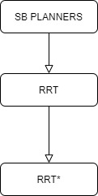
Figure ‎3.1 : Inherited Classes of RRT*

Class Diagram

The python-based repository implements some common path planning algorithms used in robotics, including Search-based algorithms and Sampling-based algorithms. Animations for algorithm used to display the running process, which makes comparison easier. This repository contains RRT [7] and RRT* [8] implementations.

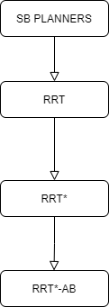
Figure ‎3.2 : Hierarchy Diagram

Class Model

Class model of algorithm RRT*-AB [1] is shown below:
#sampler_ : base: StateSamplerPtr
#infSampler_base: InformedSamplerPtr
#goalBias_ : double
#maxDistance_ : double
#useKNearest_ : bool
#bestGoalMotion_ {nullptr} : Motion
#goalMotions_ : std::vector< Motion * >
#useTreePruning_ {false} : bool
#numSampleAttempts_ {100u} : unsigned int
#useOrderedSampling_ {false} : bool
#batchSize_ {1u} : unsigned int
#startMotions_ : std::vector< Motion * >

#allocSampler () : void
#freeMemory () : void
#removeFromParent (Motion *m) : void
+Connectivity Region
+Bounded Sample
+Nearest(T, zrand)
+Steer(znearest, zrand)
+Collison Check
+Near(T, znew,|V|)
+Insert Node
+Rewire(T,znear, zmin, znew)
+Complete Scan
Figure ‎3.3 : Class Model of RRT*-AB
RRT*-AB

Boundary Class

User interface of open-source python based library [11] is describe below:

- Home

When we click on home button, it reset to the original view. Let suppose if i have zoom in 200%, when i will click on home button its gonna reset to orginal state

- Left Arrow

This button navigate to previous view. Let suppose if i have drag the view upward and i wanna go to previous state, clicking on this button will take ne to previous view.

- Right Arrow

This button navigate to forward view. Let suppose if i have drag the view downward and i come back to pevious state, now i wanna go again to forward view so i will use this button

- Drag

With this button i can drag positon of map axix to upward or downward

- Zoom

By clicking on this button i can zoom in the map to see the path and nodes.

- Configure Subplots

By this button i can move the positoin of map anywhere (left,right,up or down).

Class Visibility

Public and protected members of RRT*-AB [1] are mentioned in predecessor subsection, i.e., Class Diagram. More detail about functionalities is given in this section.

Operations Detail

The naming conventions of the implementation language that includes operations, return types, and parameters and their types are as,

Protected Member Function

Protected member functions RRT*-AB [1] are given below:

- void allocSampler ()

Create the samplers.

- void freeMemory ()

Free the memory allocated by this planner.

- void removeFromParent (Motion *m)

Removes the given motion from the parent's child list.

Public Member Functions

Public member functions of RRT*-AB [1] are listed below:

- Connectivity Region

Connectivity Region function is denoted by C_{Region}. Search space is limited for sampling of new random nodes. It defines search space between z_{init} and z_{goal} using extension distance scale (D_{scale}).

 | D_{scale} = E/m | ( 3.1 )

Where E is environment and m is expansion factor.

- Bounded Sample

Bounded Sample function randomly samples a state.

z_{rand} ∈ C_{Region} ⊂ Z_{free}.

- Nearest

Nearest (T, z_{rand}) function returns the node, which is nearest according to cost function from following,

 | T= (V, E) to z_{rand} | ( 3.2 )

- Steer

Steer (z_{nearest}, z_{rand}) gives a new input control which is U_{new} to drive system from z(0) = z_{rand} to z(1) = z_{nearest} along the path z : [0, 1] → Z giving z_{new} at a distance ∆q from z_{nearest} towards z_{rand.}

- Collision Check

Collison check function check weather path z(t) ∈ Z_{free} such that z: [0, 1] for all t = 0 to t = 1.

- Near

Near (T, z_{new},|V|) function return neighboring node from following equation.

 | k = γ (log(n)/n) (1/d) | ( 3.3 )

Where, d is dimension for configuration space, n is number of tree nodes, γ is planning constant based on environment.

- Insert Node

Insert Node function add a node z_{new} to V in the tree T = (V, E) and connects node z_{min} as its parent.

- Rewrite

Rewire (T,z_{near}, z_{min}, z_{new}) check the if cost of node in z_{near} is less than z_{new} as compare to older cost, its parent is changed to z_{new.}

- Complete Scan

Complete scan check if C_{Region} is found in scan. If not, then C_{Region} is increased in algorithm.

Pseudo Code of RRT*-AB

Algorithm [1]

T ← InitializeTree();
T ← InsertNode(Φ, z_{init}, T);
C_{Region} ← ConnectivityRegion(z_{init,} z_{goal,} T);
for i ← 0 to N do
z_{rand} ← BoundedSample(i, C_{Region} );
z_{nearest} ← Nearest(T, z_{rand} );
(z_{new}, U_{new}) ← Steer(z_{nearest}, z_{rand})
If CollisionCheck(z_{new}) then
z_{near} ← Near(T, z_{new}, |V|);
z_{min} ← ChooseParent(z_{near}, z_{nearest}, z_{new});
T ← InsertNode(z_{min}, z_{new}, T);
T ← Rewire (T, z_{near}, z_{min}, z_{new});
If PathFound(T) then
C_{Region} ← ConnectivityRegion(z_{init}, z_{goal},T);
else if CompleteScan(C_{Region}) then
C_{Region} ← ConnectivityRegion(z_{init},z_{goal},T);
T ← PrunePath(T);
return T

EXPERIMENTS IMPLMENTATION

Implementation

Implementation details are given in below in the following section.

Tool and Technology

Information of tools and technology used in this project are mentioned below:

Table 4.1 Tools and Technology Details
Tool Name | Version
Spyder | 3
PyCharm | 2021.1.2
VS Code | 1.57

Development Environment

Development environment used in this project is python-based library framework [12].

Language

Language used in this project is Python 3.8.5 [12].

Packages

Packages used in this project are as follows:

Table 4.2 Packages Details
Package Name | Version
NumPy | 1.21.0
Matplot.lib | 3.4.2
Math | 3.8
Time | 3.8
Scipy.spatial.transform | 3

Library Framework

The Library [11] that I used in this project implementation is named as “zhm-real” [11]. This library [11] is permissioned for development and research work and for,
- Community Use
- Modification
- Distribution
- Private Use

Moreover, this library has limitation with
- Liability
- Warranty

Setup
The following setups were used in this project:

Environment

A simulation of RRT*-AB [1] is developed under python language.

- Free Space
This region is also known as configuration space. Path will be found in this region.
- Obstacles and Boundaries
Path formed must be collision free, for this purpose this region is restricted.

Software Setup

Following is the software setup for our project:

Table 4.3 Software Setup Details
Name | Specification
Edition | Windows 10 Pro
Version | 20H2
OS build | 19042.1052

Hardware Setup

Following is the hardware setup for our project:

Table 4.4 Hardware Setup Details
Name | Specification
Processor | Intel(R) Core (TM) i7-4600U CPU @ 2.10GHz 2.70 GHz
Installed RAM | 8.00 GB
System Type | 64-bit operating system, x64-based processor

Implementation of this project is done on python-based library, forming a simulator. Number of inputs are provided in form of x and y co-ordinates.

Experimentation

This part shows examinations of RRT*-AB [1] in various cases, each with various combination of sources of information. Environment utilized for experimentation comprise of circle and square shape. Every information case is executed 100 times. Moreover, a trend analysis case for 3000 fixed iteration is also conducted to evaluate performance under same number of cycles. Average experimentation results are referenced in next section.

Case 1

Input for Case 1 is as follows:
(Source Coordinates, Goal Coordinates) = (2, 2) (13, 25)

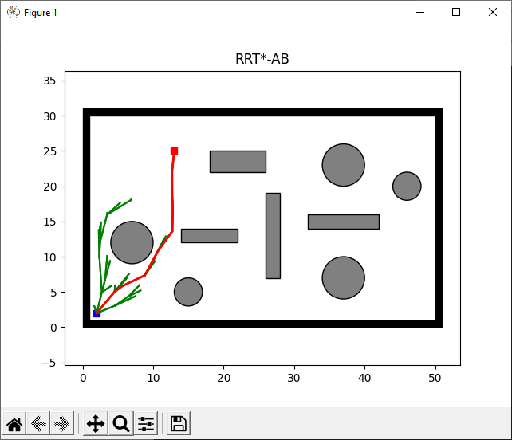
Figure ‎4.1 Case 1 Output Result-a

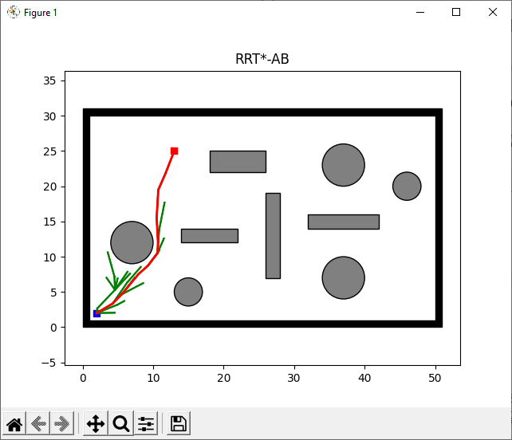
Figure ‎4.2 Case 1 Output Result-b

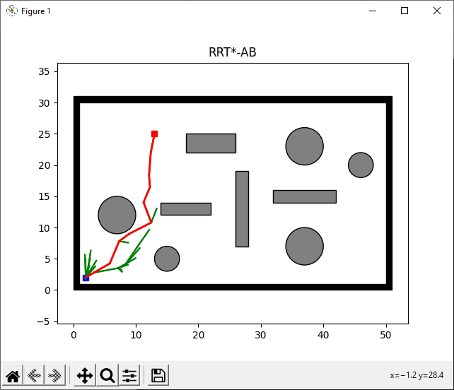
Figure ‎4.3 Case 1 Output Result-c

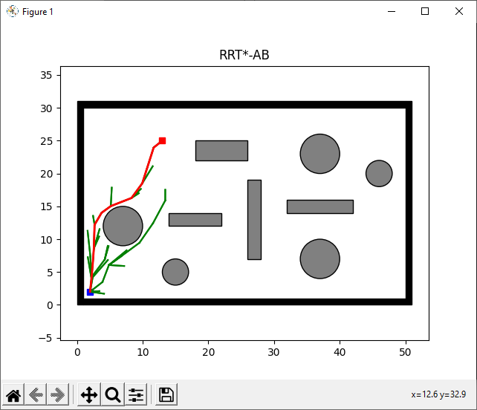
Figure ‎4.4 Case 1 Output Result-d

Case 2

Input for Case 2 is as follows:
(Source Coordinates, Goal Coordinates) = (18, 8) (37, 18)

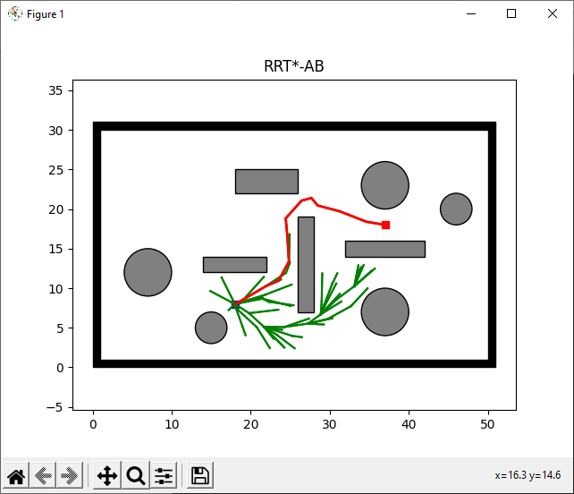
Figure ‎4.5 Case 2 Output Result-a

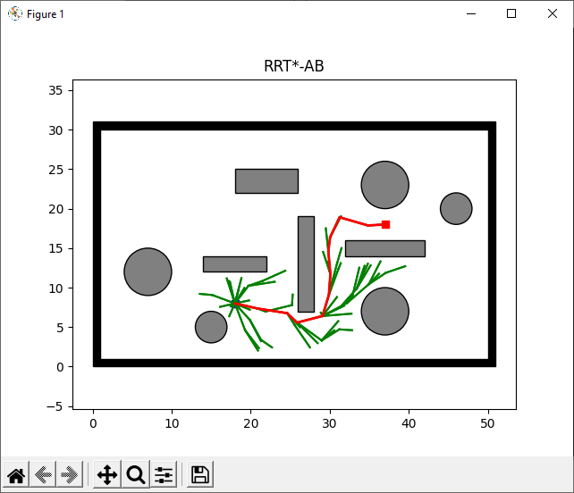
Figure ‎4.6 Case 2 Output Result-b
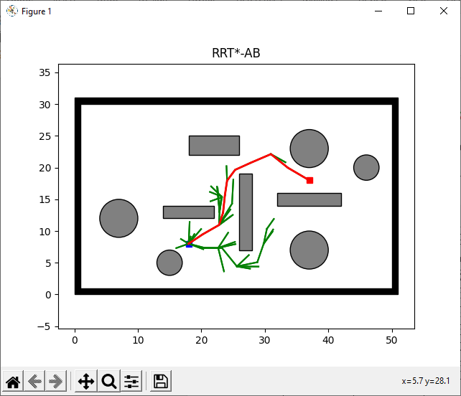
Figure ‎4.7 Case 2 Output Result-c

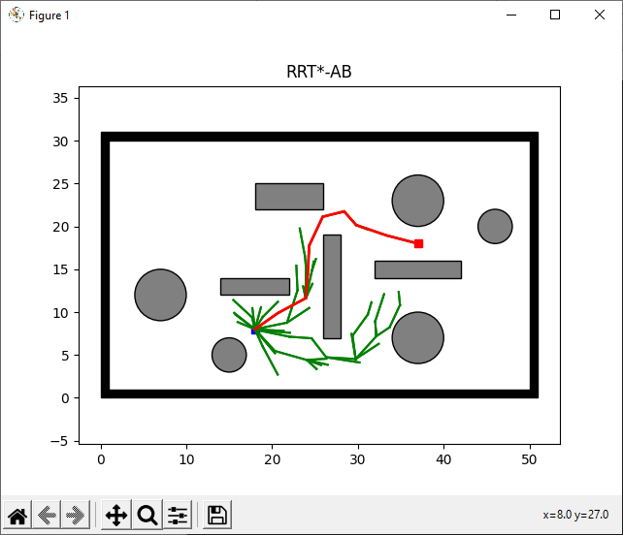
Figure ‎4.8 Case 2 Output Result-d

Case 3

Input for Case 3 is as follows:
(Source Coordinates, Goal Coordinates) = (45, 5) (40, 27)

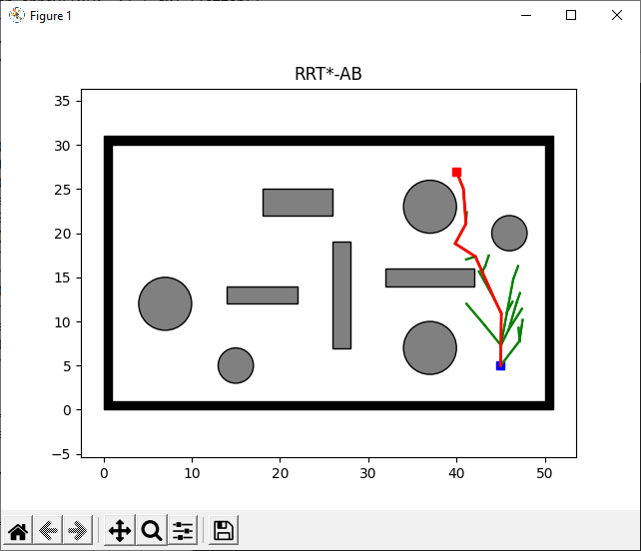
Figure ‎4.9 Case 3 Output Result-a

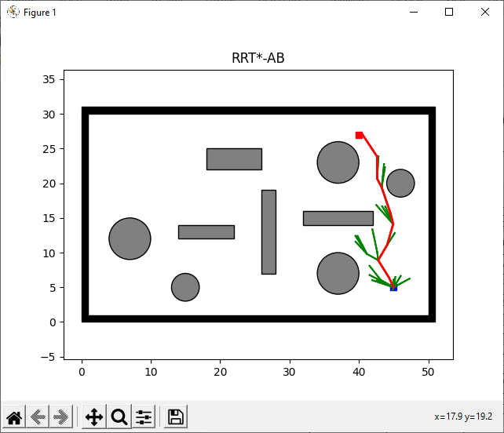
Figure ‎4.10 Case 3 Output Result-b
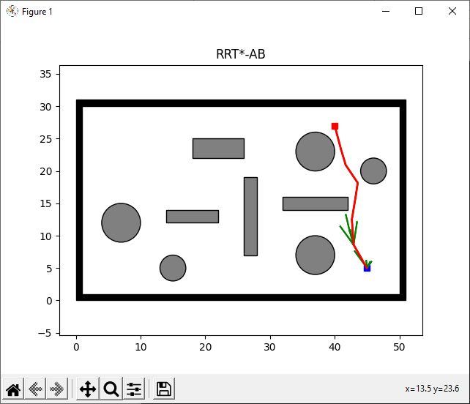
Figure ‎4.11 Case 3 Output Result-c

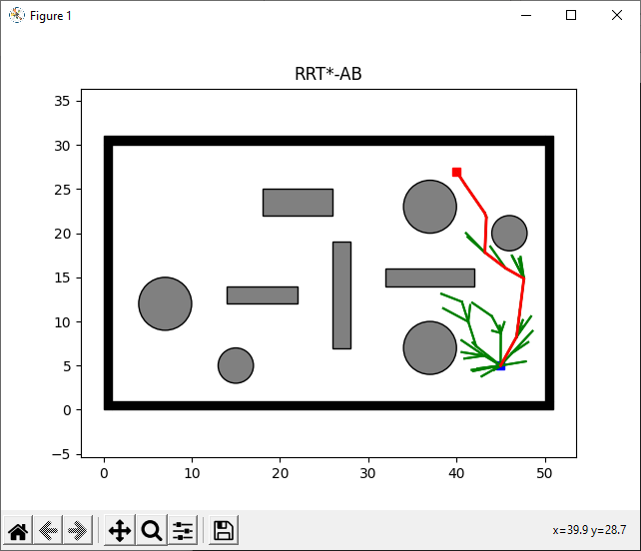
Figure ‎4.12 Case 3 Output Result-d

Case 4

Following are the inputs for Case 4,
(Source Coordinates, Goal Coordinates) = (22, 3) (14, 23)

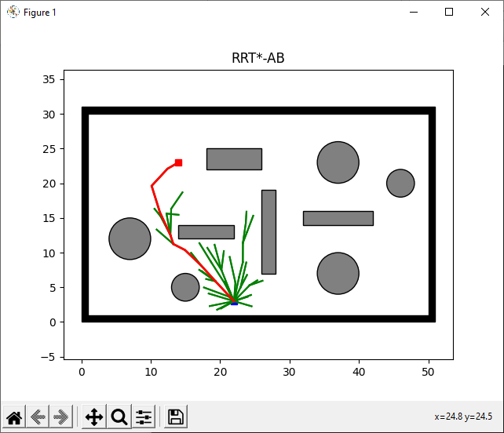
Figure ‎4.13 Case 4 Output Result-a

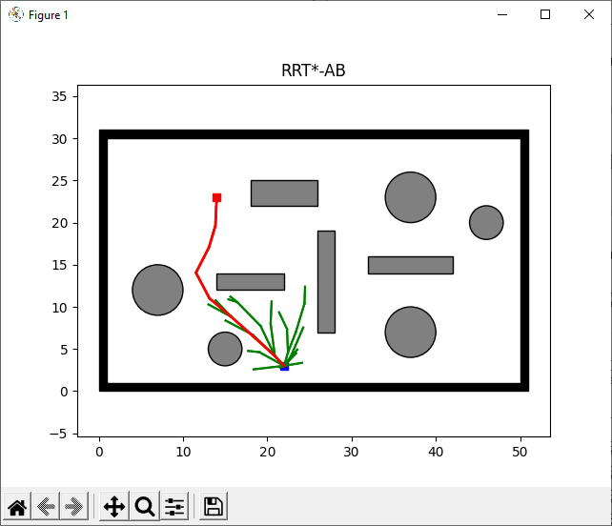
Figure ‎4.14 Case 4 Output Result-b
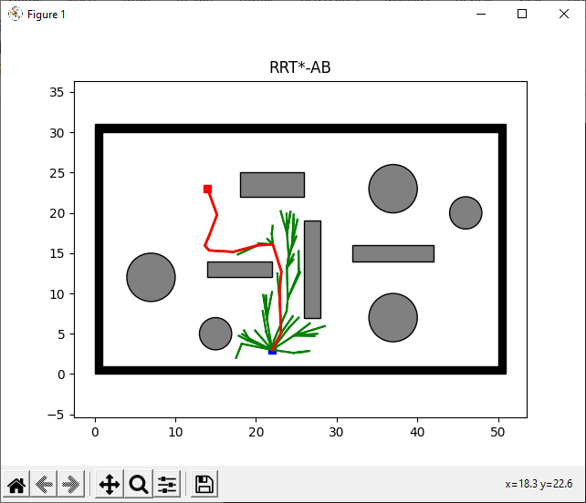
Figure ‎4.15 Case 4 Output Result-c

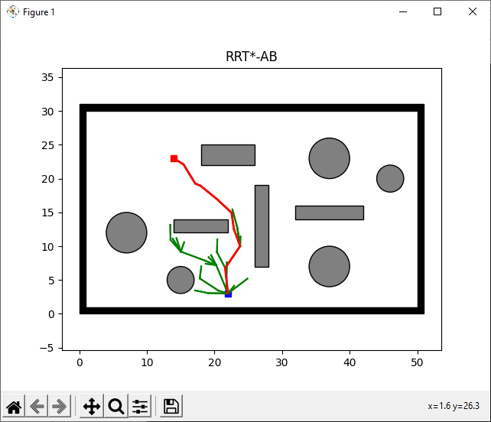
Figure ‎4.16 Case 4 Output Result-d

Case 5

Following are the inputs for Case 5,
(Source Coordinates, Goal Coordinates) = (30, 17) (49, 29)

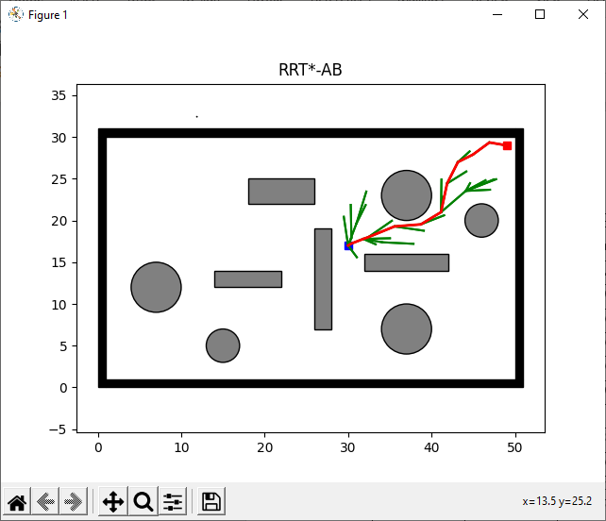
Figure ‎4.17 Case 5 Output Result-a

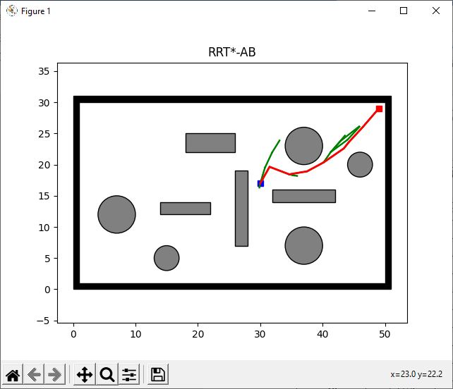
Figure ‎4.18 Case 5 Output Result-b
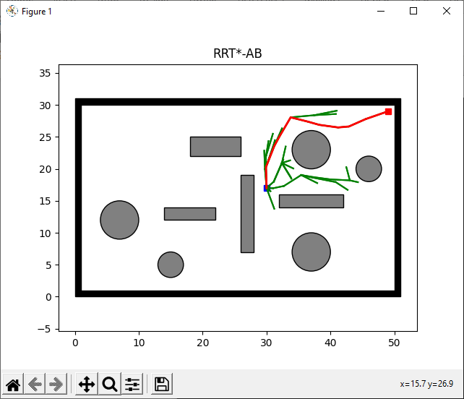
Figure ‎4.19 Case 5 Output Result-c

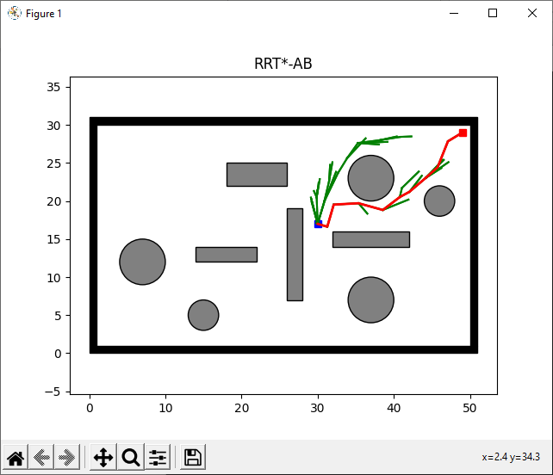
Figure ‎4.20 Case 5 Output Result-d

RESULTS AND DISCUSSIONS

Case 1 Experimentation Results

Following are the experimentation results:

Case 1 Experimentation Result

Figure shows visual representation of collision free path for case 1.

Figure ‎5.1 Output Results for Case 1
Table 5.1 shows experimentation results of RRT*-AB [1].

Table 5.1 Case 1 Experimentation Results
No. of Trials | Elapsed Time (sec) | Number of Nodes | Path Length (m) | Height  (m)
Input: (Source Coordinates, Goal Coordinates) = (2,2) (13,25)
1 | 5.1308 | 38 | 25.49 | 23
2 | 4.6621 | 40 | 25.49 | 23
3 | 3.1918 | 25 | 25.49 | 23
4 | 5.2916 | 44 | 25.49 | 23
5 | 4.2043 | 33 | 25.49 | 23
6 | 4.1503 | 31 | 25.49 | 23
7 | 5.9592 | 47 | 25.49 | 23
8 | 4.9060 | 31 | 25.49 | 23
9 | 5.1767 | 39 | 25.49 | 23
10 | 4.7201 | 36 | 25.49 | 23
Average | 4.73929 | 36.4 | 25.49 | 23

Case 2 Experimentation Result

Figure shows visual representation of collision free path for case 2.

Figure ‎5.2 Output Results for Case2

Table 5.2 shows experimentation results of RRT*-AB [1].

Table 5.2 Case 2 Experimentation Results
No. of Trials | Elapsed Time (sec) | Number of Nodes | Path Length (m) | Height  (m)
Input: (Source Coordinates, Goal Coordinates) = (18,8) (37,18)
1 | 12.1883 | 73 | 21.47 | 10
2 | 10.0558 | 75 | 21.47 | 10
3 | 8.8181 | 52 | 21.47 | 10
4 | 8.3799 | 65 | 21.47 | 10
5 | 12.3378 | 85 | 21.47 | 10
6 | 12.9905 | 90 | 21.47 | 10
7 | 7.8071 | 53 | 21.47 | 10
8 | 10.0318 | 71 | 21.47 | 10
9 | 11.9448 | 80 | 21.47 | 10
10 | 10.9641 | 77 | 21.47 | 10
Average | 10.55182 | 72.1 | 21.47 | 10

Case 3 Experimentation Result

Figure shows visual representation of collision free path for case 3.

Figure ‎5.3 Output Result for Case 3

Table 5.3 shows experimentation results of RRT*-AB [1].

Table 5.3 Case 3 Experimentation Results
No. of Trials | Elapsed Time (sec) | Number of Nodes | Path Length (m) | Height  (m)
Input: (Source Coordinates, Goal Coordinates) = (45,5) (40,27)
1 | 4.6890 | 28 | 22.56 | 22
2 | 2.6915 | 19 | 22.56 | 22
3 | 4.7643 | 35 | 22.56 | 22
4 | 3.1648 | 19 | 22.56 | 22
5 | 3.0023 | 19 | 22.56 | 22
6 | 9.9688 | 84 | 22.56 | 22
7 | 6.8214 | 52 | 22.56 | 22
8 | 2.1589 | 14 | 22.56 | 22
9 | 3.6590 | 30 | 22.56 | 22
10 | 4.0767 | 29 | 22.56 | 22
Average | 4.49967 | 32.9 | 22.56 | 22

Case 4 Experimentation Result

Figure shows visual representation of collision free path for case 4.

Figure ‎5.4 Output Result for Case 4

Table 5.4 shows experimentation results of RRT*-AB [1].

Table 5.4 Case 4 Experimentation Results
No. of Trials | Elapsed Time (sec) | Number of Nodes | Path Length (m) | Height  (m)
Input: (Source Coordinates, Goal Coordinates) = (22,3) (14,23)
1 | 7.8195 | 55 | 21.54 | 20
2 | 4.6805 | 36 | 21.54 | 20
3 | 8.8588 | 66 | 21.54 | 20
4 | 5.3402 | 36 | 21.54 | 20
5 | 10.1690 | 70 | 21.54 | 20
6 | 10.6351 | 81 | 21.54 | 20
7 | 4.7352 | 38 | 21.54 | 20
8 | 4.8274 | 36 | 21.54 | 20
9 | 5.7396 | 43 | 21.54 | 20
10 | 7.3528 | 57 | 21.54 | 20
Average | 7.01581 | 51.8 | 21.54 | 20

Case 5 Experimentation Result

Figure 5.5 shows visual representation of collision free path for case 5.

Figure ‎5.5 Output Result for Case5

Table 5.5 shows experimentation results of RRT*-AB [1].

Table 5.5 Case 5 Experimentation Results
No. of Trials | Elapsed Time (sec) | Number of Nodes | Path Length (m) | Height  (m)
Input: (Source Coordinates, Goal Coordinates) = (30,17) (49,29)
1 | 7.7337 | 40 | 22.47 | 12
2 | 5.2506 | 36 | 22.47 | 12
3 | 4.7343 | 34 | 22.47 | 12
4 | 3.6364 | 16 | 22.47 | 12
5 | 4.7395 | 31 | 22.47 | 12
6 | 5.7844 | 42 | 22.47 | 12
7 | 6.5303 | 21 | 22.47 | 12
8 | 3.6903 | 23 | 22.47 | 12
9 | 7.2385 | 46 | 22.47 | 12
10 | 5.7762 | 45 | 22.47 | 12
Average | 5.51142 | 33.4 | 22.47 | 12

Fixed Iteration Trend Analysis

Table 5.6 shows the fixed iteration comparison result of RRT* [8] and RRT*-AB [1].

Table 5.6 Iteration Trend Analysis
Algorithm | RRT* [8] | RRT*AB [1]
Input: (Source Coordinates, Goal Coordinates) = (30,17) (49,29)
Elapsed Time (sec) | X | 17.3563
Number of Nodes | X | 108
Path Length (m) | X (Path found on obstacle) | 35.35
Height (m) | X | 17
Iteration | 3000 | 200

Comparison Result of RRT* and RRT*-AB

Following are the comparison results of RRT* [8] and RRT*-AB [1].

Result 1

For the same input, Figures 5.6 and 5.7 illustrate collision-free paths for RRT* [8] and RRT*-AB [1].

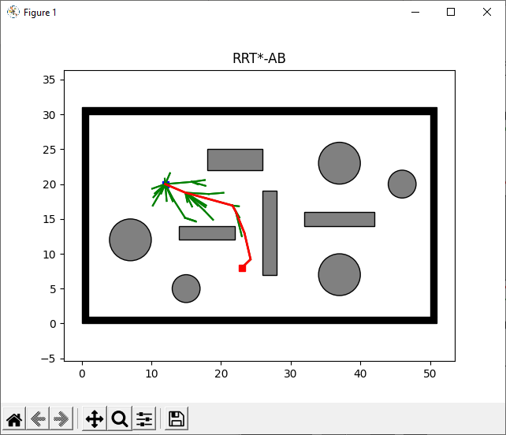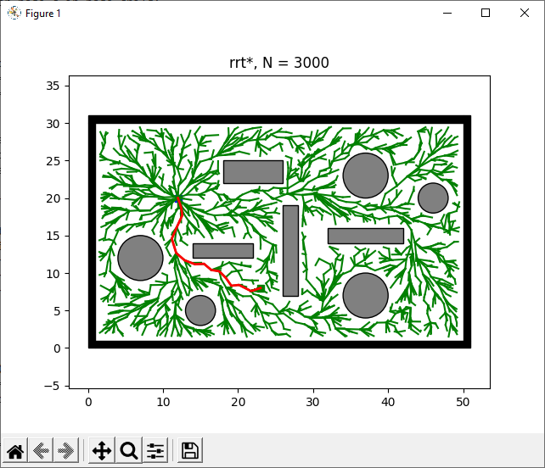
Figure ‎5.6 RRT* Result 1
Figure ‎5.7 RRT*-AB Result 1

Table 5.7 shows comparison results for RRT* [8] and RRT*-AB [1].

Table 5.7 Comparison Result 1 of RRT* and RRT*-AB
Algorithm | RRT* | RRT*AB
Input: (Source Coordinates, Goal Coordinates) = (12,20) (23,8)
Elapsed Time (sec) | 26.6522 | 5.3527
Number of Nodes | 2235 | 37
Path Length (m) | 16.27 | 16.27
Height (m) | 12 | 12
Iteration | 3000 | 200

Result 2

Results For the same input, Figures 5.8 and 5.9 illustrate collision-free paths for RRT* [8] and RRT*-AB [1] .

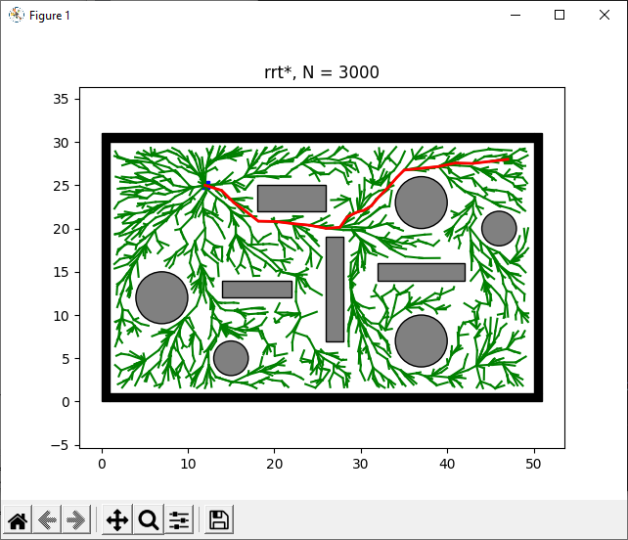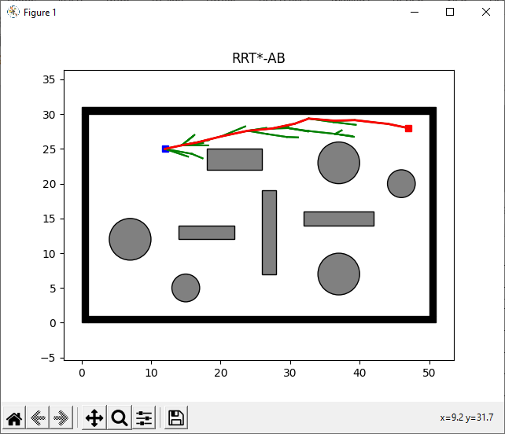
Figure ‎5.8 RRT* Result 2
Figure ‎5.9 RRT*-AB Result 2

Table 5.8 shows comparison results for RRT* [8] and RRT*-AB [1].

Table 5.8 Comparison Result 2 of RRT* and RRT*-AB
Algorithm | RRT* | RRT*AB
Input: (Source Coordinates, Goal Coordinates) = (12,25) (47,28)
Elapsed Time (sec) | 23.2044 | 4.7373
Number of Nodes | 2147 | 39
Path Length (m) | 35.1283 | 35.1283
Height (m) | 3 | 3
Iteration | 3000 | 200

Result 3

Results For the same input, Figures 5.10 and 5.11 illustrate collision-free paths for RRT* [8] and RRT*-AB [1].

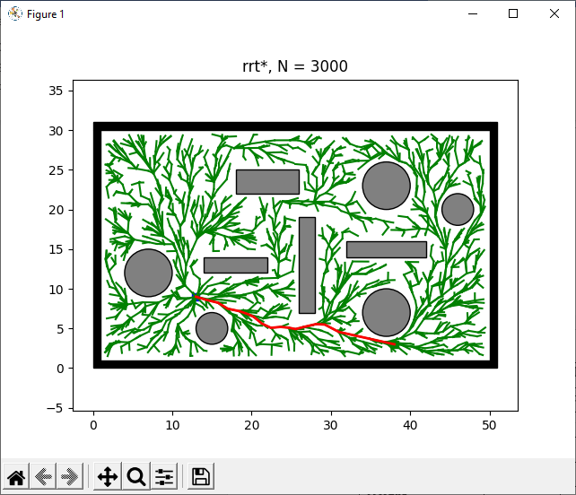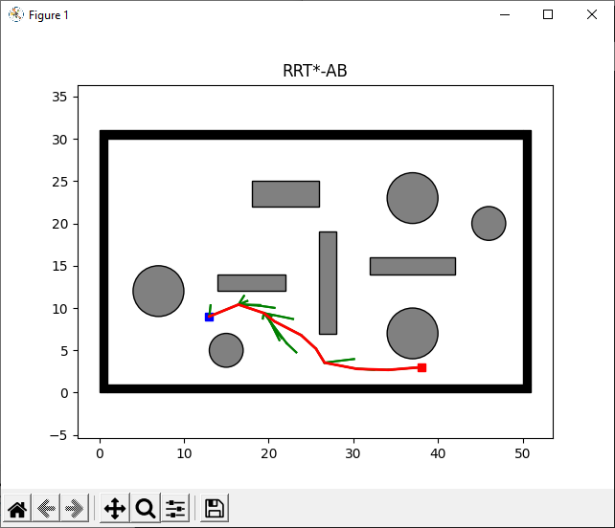
Figure ‎5.10 RRT* Result 3
Figure ‎5.11 RRT*-AB Result 3

Table 5.9 shows comparison results for RRT* [8] and RRT*-AB [1].

Table 5.9 Comparison Result 3 of RRT* and RRT*-AB
Algorithm | RRT* (3000) | RRT*AB (200)
On same number of iterations: Input (13,9) (38,3)
Elapsed Time | 22.8165 | 3.8533
Number of Nodes | 2210 | 26
Path Length | 25.7099 | 25.7099
Height | 6 | 6
Iteration | 3000 | 200

Result 4

Results For the same input, Figures 5.14 and 5.15 illustrate collision-free paths for RRT* [8] and RRT*-AB [1].

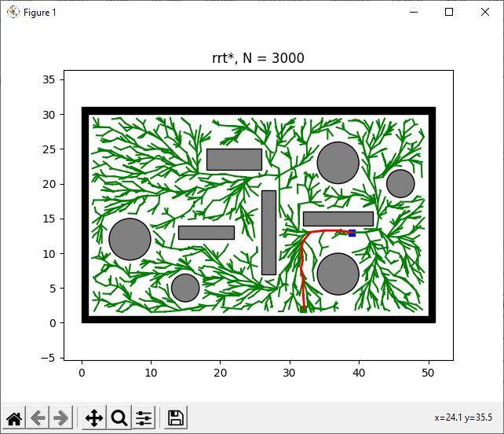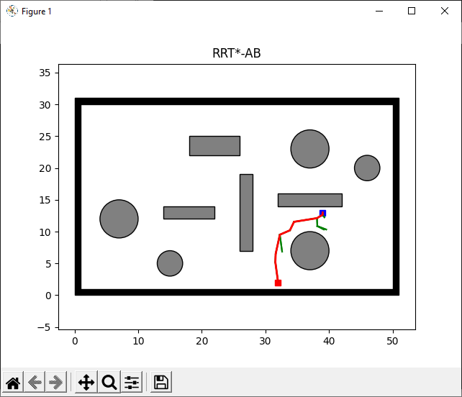
Figure ‎5.12 RRT* Result 4
Figure ‎5.13 RRT*-AB Result 4

Table 5.10 shows comparison results for RRT* [8] and RRT*-AB [1].

Table 5.10 Comparison Result 4 of RRT* and RRT*-AB
Algorithm | RRT* | RRT*AB
Input: (Source Coordinates, Goal Coordinates) = (39,13) (32,2)
Elapsed Time (sec) | 19.1735 | 3.6657
Number of Nodes | 2055 | 14
Path Length (m) | 13.0384 | 13.0384
Height (m) | 11 | 6
Iteration | 3000 | 200

Result 5

Results For the same input, Figures 5.16 and 5.17 illustrate collision-free paths for RRT* [8] and RRT*-AB [1].

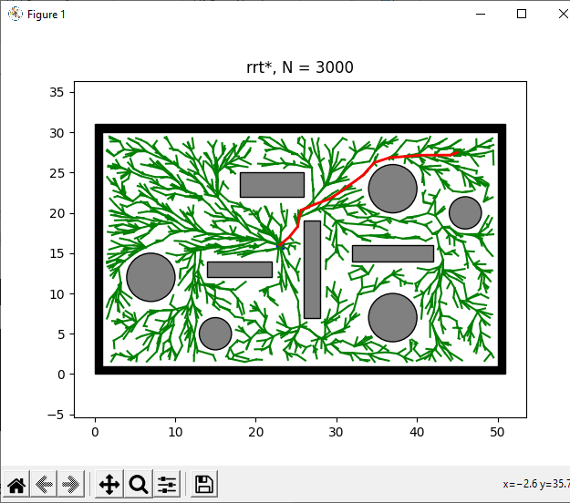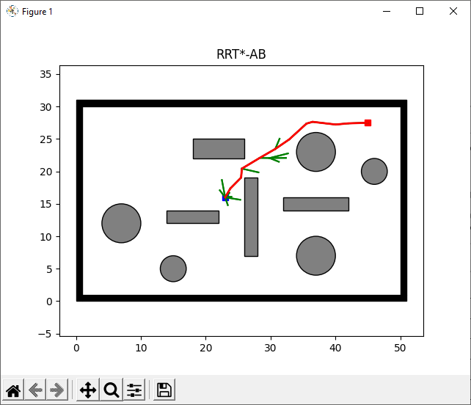
Figure ‎5.14 RRT* Result 5
Figure ‎5.15 RRT*-AB Result 5

Table 5.11 shows comparison results for RRT* [8] and RRT*-AB [1].

Table 5.11 Comparison Result 5 of RRT* and RRT*-AB
Algorithm | RRT* | RRT*AB
On same number of iterations: Input (23,16) (45,27)
Elapsed Time (sec) | 20.5709 | 5.3699
Number of Nodes | 2027 | 14
Path Length (m) | 24.8243 | 24.8243
Height (m) | 11 | 11
Iteration | 3000 | 200

Time Comparison Chart

Figure 5.16 shows that RRT*-AB [1] has less execution time than RRT* [8].

Figure ‎5.16 Plots for Case 1 to Case 6; average execution time

Number of Nodes Comparison Chart

Figure 5.17 shows that the RRT*-AB [1] method uses fewer nodes than RRT* [8].

Figure ‎5.17 Plots for Case 1 to Case 6; average nodes

Path Length Comparison Chart

Fig. 5.18 shows path length plot of proposed approach RRT* [8] and RRT*-AB [1].

Figure ‎5.18 Plots for Case 1 to Case 6; average path length

Height Comparison Chart

Fig. 5.19 shows height plot of proposed approach RRT* [8] and RRT*-AB [1].

Figure ‎5.19 Plots for Case 1 to Case 6; average height

Iteration Analysis Comparison Chart

Fig. 5.20 shows the iteration trend in RRT* [8] and RRT*-AB [1].

Figure ‎5.20 Iteration Analysis Chart

CONCLUSION AND RECOMMENDATIONS

Conclusion

This project aimed to make a python based library of RRT*-AB [1] for multiple usage. Some of them are:
- Community Purpose
- Research Work
Experimental results show that RRT*-AB [1] algorithm is able to,
- Produces path based on exploring the search space using bounded region.
- Converges to solution quickly.
- Short path generation
- Less memory consumption
- Deals with narrow and complex environment.

Future Recommendations

RRT*-AB [1] is an improved SBP with maximum convergence rate in negligible amount of time in comparison to RRT* [6]. Some future recommendation in some areas of RRT*-AB [1] are follows:
- Library publishing on GitHub after optimization.

REFERENCES

[1] I. Noreen, A. Khan, H. Ryu, N. L. Doh, and Z. Habib, “Optimal path planning in cluttered environment using RRT*-AB,” Intell. Serv. Robot., vol. 11, no. 1, pp. 41–52, 2018, doi: 10.1007/s11370-017-0236-7.
[2] O. Khatib, “REAL-TIME OBSTACLE AVOIDANCE FOR MANIPULATORS AND MOBILE ROBOTS.,” Int. J. Rob. Res., vol. 5, no. 1, pp. 90–98, 1986, doi: 10.1177/027836498600500106.
[3] I. Hassani, I. Maalej, and C. Rekik, “Robot Path Planning with Avoiding Obstacles in Known Environment Using Free Segments and Turning Points Algorithm,” Math. Probl. Eng., vol. 2018, 2018, doi: 10.1155/2018/2163278.
[4] I. Noreen, A. Khan, and Z. Habib, “Optimal Path Planning using RRT* based Approaches: A Survey and Future Directions,” Int. J. Adv. Comput. Sci. Appl., vol. 7, no. 11, pp. 97–107, 2016, doi: 10.14569/ijacsa.2016.071114.
[5] “Introduction to Autonomous Mobile Robots - Roland Siegwart, Illah Reza Nourbakhsh, Davide Scaramuzza - Google Books.” https://books.google.com.pk/books?hl=en&lr=&id=4of6AQAAQBAJ&oi=fnd&pg=PP1&dq=autonomous+mobile+robots&ots=2x-bV0vLI4&sig=ZjR8JNLJXAmjQTb9f2OQm625vIU&redir_esc=y#v=onepage&q=autonomous mobile robots&f=false (accessed Jun. 29, 2021).
[6] E. W. Dijkstra, “Dijkstra1959.pdf,” Numerische mathematik, vol. 1, no. 1. pp. 269–271, 1959, [Online]. Available: http://www.bioinfo.org.cn/~dbu/AlgorithmCourses/Lectures/Dijkstra1959.pdf.
[7] R. Bohlin and L. E. Kavraki, “Path planning using Lazy PRM,” Proceedings-IEEE Int. Conf. Robot. Autom., vol. 1, pp. 521–528, 2000, doi: 10.1109/ROBOT.2000.844107.
[8] S. Karaman and E. Frazzoli, “Sampling-based algorithms for optimal motion planning,” Int. J. Rob. Res., vol. 30, no. 7, pp. 846–894, 2011, doi: 10.1177/0278364911406761.
[9] S. Karaman, M. R. Walter, A. Perez, E. Frazzoli, and S. Teller, “Anytime motion planning using the RRT,” Proc. - IEEE Int. Conf. Robot. Autom., pp. 1478–1483, 2011, doi: 10.1109/ICRA.2011.5980479.
[10] I. Noreen, A. Khan, and Z. Habib, “A Comparison of RRT, RRT* and RRT*-Smart Path Planning Algorithms,” Ijcsns ’16, vol. 16, no. 10, pp. 20–27, 2016, [Online]. Available: http://paper.ijcsns.org/07_book/201610/20161004.pdf.
[11] “GitHub - zhm-real/PathPlanning: Common used path planning algorithms with animations.” https://github.com/zhm-real/PathPlanning (accessed Jun. 29, 2021).
[12] “Welcome to Python.org.” https://www.python.org/ (accessed Jun. 29, 2021).
[13] P. Garcia, O. Montiel, O. Castillo, R. Sepúlveda, and P. Melin, "Path planning for autonomous mobile robot navigation with ant colony optimization and fuzzy cost function evaluation", APPL SOFT COMPUT, vol. 9, pp. 1102-1110, 2009.
[14] M. Dorigo, Ant colony optimization: Cambridge University, Massachusetts: MIT Press, 1992.
[15] T. Arora, Y. Gigras, and V. Arora, "Robotic path planning using genetic algorithm in dynamic environment", INT J COMPUT APPL, vol. 89, pp. 8-12, 2014..
[16] E. W. Dijkstra, “Dijkstra1959.pdf,” Numerische mathematik, vol. 1, no. 1. pp. 269–271, 1959, [Online]. Available: http://www.bioinfo.org.cn/~dbu/AlgorithmCourses/Lectures/Dijkstra1959.pdf.
[17] Zelinsky, R. A. Jarvis, J. C. Byrne, and S. Yuta, "Planning paths of complete coverage of an unstructured environment by a mobile robot", in Proceedings of International Conference on Advanced Robotics (ICAR), 1993.

