
BSCS-F20-003
03-134172-057 | Abdullah Amir
03-134172-073 | Muhammad Ali

Hazardous Environment Exploration Using Autonomous Robot

In partial fulfilment of the requirements for the degree of
Bachelor of Science in Computer Science
Supervisor: Dr. Iram Noreen
Department of Computer Sciences
Bahria University, Lahore Campus
July 2021

© Bahria University, 2021

Certificate

We accept the work contained in the report titled
“Hazardous Environment Exploration Using Autonomous Robots”
written by
Abdullah Amir
Muhammad Ali
as a confirmation to the required standard for the partial fulfilment of the degree of
Bachelor of Science in Computer Science.

Approved by:
Supervisor: Dr. Iram Noreen
(Signature)

July, 2021

DECLARATION

We hereby declare that this project report is based on our original work except for citations and quotations which have been duly acknowledged. We also declare that it has not been previously and concurrently submitted for any other degree or award at Bahria University or other institutions.

Enrolment | Name | Signature
03-134172-057 | Abdullah Amir
03-134172-073 | Muhammad Ali

Date : July, 2021

Specially dedicated to
my beloved grandmother, mother and father
(Abdullah Amir)
my beloved grandmother, mother and father
(Muhammad Ali)

ACKNOWLEDGEMENTS

I/We would like to thank everyone who had contributed to the successful completion of this project. I/We would like to express my/our gratitude to my research supervisor, Dr. Iram Noreen for her invaluable advice, guidance, and his/her enormous patience throughout the development of the research.

In addition, I/We would also like to express my gratitude to my/our loving parent and friends who had helped and given me encouragement.

Abdullah Amir
Muhammad Ali

Hazardous Environment Exploration Using Autonomous Robot

ABSTRACT

Robots are a crucial part of number of domains of human’s life nowadays. Safety is the most obvious advantage of utilizing robots in hazardous environment. A robot could be assigned time critical, accessibility critical or safety critical task which otherwise could end up to repair bill, a serious medical bill or a lawsuit. Employees working dangerous jobs are thankful that robots can remove some of the risks. Importantly for those workers who work in dark caves and mines where the workers should have prior knowledge of the inside structure and atmospheric conditions. A robot will make things smooth in such cases and it will surely reduce the risk of human fatality. Moreover, an autonomous robot will be icing on the cake as it will do necessary calculations for us and will surely reduce the chances of miss calculations. A well designed and well programmed autonomous robot is a blessing in disguise for such workers. This project aims to explore a hazardous environment data using an autonomous mobile robot. This robot will also have ability to be controlled manually.

TABLE OF CONTENTS

DECLARATION ii
ACKNOWLEDGEMENTS v
ABSTRACT vi
TABLE OF CONTENTS vii
LIST OF FIGURES x
LIST OF TABLES xi

CHAPTERS
1 INTRODUCTION 1
1.1 Background 1
1.2 Problem Statements 1
1.3 Aims and Objectives 2
1.4 Scope of Project 2
1.4.1 Primary Scope 2
1.4.2 Final Deliverable of the Project and Beneficiaries 3
1.4.3 Optional Scope 3
2 LITERATURE REVIEW 4
2.1 Background 4
2.2 Classification of Robots 5
2.2.1 Stationary Robot 5
2.2.2 Wheeled Robot 5
2.2.3 Legged Robot 6
2.2.4 Autonomous Underwater Vehicle (AUV) Robot 6
2.2.5 Unmanned Aerial Vehicle (UAV) Robot: 7
2.2.6 Swarm Robot 7
2.2.7 Nano Robot 7
2.2.8 Soft Robot 8
2.3 Environment 8
2.3.1 Static Environment 9
2.3.2 Dynamic Environment 9
2.4 Types of Robot 9
2.4.1 Autonomous Robot 9
2.4.2 Non-Autonomous Robots 10
2.5 System of Mobile Autonomous Robot 10
2.5.1 Working of Mobile Autonomous Robot 10
2.5.2 Mapping (Fig. 2.1 Mapping Explained) 11
2.5.3 Simultaneous Localization and Mapping (SLAM) 11
2.5.4 Methods for SLAM 12
2.5.5 Visual SLAM 12
2.5.6 LIDAR SLAM 13
2.5.7 Challenges in SLAM 14
2.5.8 Path Finding 16
2.5.9 Graphs 16
2.5.10 Process of Path Finding 17
2.5.11 Algorithm for Path Planning 17
2.5.12 Actuators 19
2.5.13 Conclusion 19
3 DESIGN AND METHODLOGIES 20
3.1 Introduction 20
3.2 System Architecture 20
3.2.1 Autonomous Stack 21
3.2.2 Environmental Data 21
3.2.3 Manual Control 22
3.3 Domain Model 22
3.4 Class Diagram 24
4 DATA AND EXPERIMENTS (and/or IMPLEMENATION) 25
4.1 Overview 25
4.1.1 Implementation 25
4.1.2 Tools and Technology 25
4.1.3 Development Environment 26
4.1.4 Development Environment Setup 26
4.1.5 Operational Environment 27
4.1.6 Simulation 27
4.1.7 Navigation 30
4.1.8 Exploring Envoirnment 31
4.1.9 Manual Control 32
4.1.10 Virtual World 33
4.2 Hardware 34
4.2.1 ROS Core 35
4.2.2 SLAM, Navigation, Environment Exploration and Manual Control 36
4.2.3 Connecting with TURTLEBOT 36
4.2.4 Environmental Data 37
4.2.5 Firebase 39
4.2.6 Android Application 40
4.2.7 TurtleBot3 41
4.2.8 TurtleBot3 Block Diagram 42
5 RESULTS AND DISCUSSIONS 43
5.1 Simulation 43
5.1.1 Simulation World 44
5.2 Hardware 45
5.3 Environmental Data 46
6 CONCLUSION AND RECOMMENDATIONS 48

LIST OF FIGURES

FIGURE TITLE PAGE
Figure: 2. 1 Autonomous Stack 11
Figure: 3. 1 System Architecture 20
Figure: 3. 2 Domain Model 22
Figure: 3. 3 Class Diagram 24
Figure: 4. 1 SLAM Launch Command 28
Figure: 4.2 SLAM map Visual Representation 29
Figure: 4.3 Move Base Launch Command 30
Figure: 4.4 Explorer Node Command 31
Figure: 4.5 Command to Launch Teleop 32
Figure: 4.6 Launching World in Gazebo 33
Figure: 4.7 Simulation in Gazebo 34
Figure: 4.8 ROS Core Launch Command 35
Figure: 4.9 Establish Connection with Turtlebot 36
Figure: 4.10 Circuit Diagram 37
Figure: 4.11 Hardware (1) 38
Figure: 4.12 Hardware (2) 38
Figure: 4.13 Structure of Firebase 39
Figure: 4.14 Android Application 40
Figure: 4. 15 TurtleBot3 41
Figure: 4.16 Block Diagram of TurtleBot3 42

Figure: 5. 1 Map Generated in Simulated Gazebo Environment (World 1). 43
Figure: 5. 2 Map Generated in Simulated Gazebo Environment (Default World). 44
Figure: 5. 3 World 1 44
Figure: 5. 4 Map Generated of DLD Lab 46
Figure: 5. 5 Android Application 47

LIST OF TABLES

TABLE TITLE PAGE

Table 4. 1 Tool and Technology Details 25
Table 4. 2 Development Environment Information 26
Table 4. 3 Software Setup Information 26
Table 4. 4 Hardware Setup Information 27

INTRODUCTION

Background

Human life has always been valued more than time and money to express this gratitude advancements are made to ensure safety and improve quality of human life. Technology has always played a vital role in making our daily lives better almost anywhere we see today there are computational devices helping with our daily needs and there are creative minds there who have provided these devices a body also what we call “Robots”.
Robots have been used worldwide to not only improve human life but also increase the quality of final product. Robots are not only used to make tasks easy for humans but also to ensure safety of their lives. There are certain tasks or jobs that put human life in danger, but those tasks are necessary, so we have left with no choice but to put human life in danger but with the help of creativity and technology a lot of this jobs are assigned to robots.

Problem Statements

From drilling mountains to extracting coals from mines, the mining industry impacts our daily life. But it is also a difficult and dangerous jobs to do in the world, it also means losing one’s life. A decade ago, only one percent of the world’s labour force works in this industry but according to the report on deaths and accidents eight percent of people from this particular industry dies. According to RAND [1] there are 1500 fatal injuries caused to rescue workers during their job. Our project is to make an autonomous robot that could provide us with such environmental data that would be very helpful for rescue workers and it not only will help them to avoid fatal injuries but also get help them to choose a proper course of action based on the data it collected.

Aims and Objectives

The objectives of this project are shown as following:
- Prioritize human safety
- Environment Monitoring
- Data Collection
- Research Purpose

Scope of Project

Primary scope of our project is defined below.

Primary Scope

The purpose of our project is to provide environmental data of a hazardous environment using an autonomous robot which is also capable of being controlled manually by a person. The data of such environments is unknown and unpredictable, by monitoring environmental factors valuable information can be derived that can provide us detailed knowledge of the territory we are about to explore. Benefit of using an automated robot eliminates the element of surprise or reduces it to minimum. When exploring a hazardous environment, a lot of possibilities are to be considered and yet some can be left out or they were not supposed to exist, using information retrieved from robot a calculated outcome is much higher to be expected. There are certain advantages of using this robot but the most highlighted one are security of human lives and optimized usage of resources.

Final Deliverable of the Project and Beneficiaries

It is a hardware and software integrated system to monitor environment. However, primary scope includes only software simulation as per following criteria:
- Autonomous and Controllable.
- Environment Monitoring.

Optional Scope

- Deployment of solution on real time robot and hardware deployment testing.
- Environment specific optimized hardware and software.

LITERATURE REVIEW

Background

Robots are just basically devices that are capable performing complex series of actions it is now human creativity in which aspects of life and how to utilize them. Robots have now become an important part in our revolutionizing world, they find their applications in both mankind welfare and defence.
Robots are now becoming a daily part of our life from places small as restaurants to large industries they are present everywhere. They impact our life in both positive and negative way [1] [2], there are some myths like at the same time where they provide perfection in product and process, they also cease job opportunity but that is not true, where they cease one job opportunity the create more e.g., more recruitment of robot maintenance and management.
But there are such scenarios where robots are really blessing, e.g., there are robots which serves in war they serve in carrying out such tasks that puts human life in harm another example is of rescue robots [3]. It does not matter how big the reward everyone prioritizes their life first. In such scenarios robots serve good, but each system in which robots works has its own factors. Some systems can be static, and some can be dynamic and seeing this specific property certain tweaks and nature of robot is selected e.g., robots in industries are autonomous they do not an operator 24/7 but on the other hand there are robots such as wight lifting robot they require a controller to pick up and place down objects. Each robot has its own customized parameters with respect of the environment in which it will operate.

Classification of Robots

On basis of factors of environment in which robot have to work they have been categorized into further types explained below

Stationary Robot

These are robot that are fixed in position. They tend to have robot arms that can move about.
Example:
- Welding Bot
- Painting Bot
- Strong Bot
- Dancing Bot

Wheeled Robot

Wheeled robots are robots that navigate around the ground using motorized wheels to propel themselves. This design is simpler than using treads or legs and by using wheels they are easier to design, build, and program for movement in flat, not-so-rugged terrain.
Example:
- Pioneer, PeopleBot, PowerBot & PatrolBot- the ActiveMedia Robotics mobile robots.
- Armadillo, Robotican
- Khepera and e-puck
- Sbot
- Alice
- Roomba
- RoboMow
- Shonkbot, a minimal-cost, Arduino-based teaching robot^{[1]}
- Thymio
- Edison
- Giraff
- Big Trak
- SCUTTLE An open-source payload-capable robot for hobby and university research.

Legged Robot

Legged robots are a type of mobile robot, which use articulated limbs, such as leg mechanisms, to provide locomotion. They are more versatile than wheeled robots and can traverse many different terrains, though these advantages require increased complexity and power consumption. Legged robots often imitate legged animals, such as humans or insects, in an example of biomimicry.
Example:
- One-legged
- Two-legged
- Four-legged
- Six-legged
- Eight-legged
- Hybrids

Autonomous Underwater Vehicle (AUV) Robot

An autonomous underwater vehicle is a robot that travels underwater without requiring input from an operator.
Example:
- The Black ghost AUV is designed to undertake an underwater assault course autonomously with no outside control.
- Pluto Plus AUV for underwater mine identification and destruction. From Norwegian minehunter KNM Hinnøy

Unmanned Aerial Vehicle (UAV) Robot:

Unmanned Aerial Vehicle (UAV), popularly known as Drone, is an airborne system or an aircraft operated remotely by a human operator or autonomously by an onboard computer. Drones are more formally known as unmanned aerial vehicles (UAVs) or unmanned aircraft systems (UASes). Essentially, a drone is a flying robot that can be remotely controlled or fly autonomously through software-controlled flight plans in their embedded systems, working in conjunction with onboard sensors and GPS.

Swarm Robot

Swarm robotics is an approach to the coordination of multiple robots as a system which consist of large numbers of mostly simple physical robots. It is supposed that a desired collective behaviour emerges from the interactions between the robots and interactions of robots with the environment.
Examples are the robot dog Aibo, the Roomba vacuum, AI-powered robot assistants, and a growing variety of robotic toys and kits.

Nano Robot

Nanorobotics is an emerging technology field creating machines or robots whose components are at or near the scale of a nanometer.
Examples:
Nanobots in 2018: Three recent advances shaping the future of research. The field of nanotechnologies, which studies phenomena at the nanometer scale, 1 to 100 nanometers, is today in full expansion and finds applications in medicine, electronics and the development of new materials.

Soft Robot

Soft Robotics is the specific subfield of robotics dealing with constructing robots from highly compliant materials, like those found in living organisms. Soft robotics draws heavily from the way in which living organisms move and adapt to their surroundings.
Prosthetic Robots: Soft robots can be used to create superior prosthetics for those missing limbs or extremities. Often, soft robotics technology is used for grippers at the end of a prosthetic arm for more delicate and accurate grasping of objects.

Environment

There are two types of environment in which a robot has to perform tasks
- Static Environment
- Dynamic Environment
both are explained below in detail

Static Environment

Static Environment all constraints are known and never changes, it is much easy for a robot to work in known static environment. Environment is clearly defined to robot and remains its rigidity, a robot knows and what to expect in a static environment and have pre-defined action against each scenario. E.g., A robot designed to place books on library shelfs the library in which robot is working is never going to change and so are shelf placements such type of environments are static environments.

Dynamic Environment

Dynamic Environments are ever changing the factors are constraints are to be tackled at run time, these environmental constraints are usually measured by different sensor robots face more difficulty in operation in such environments as compared to static ones. E.g., A simple racetrack with cars on it now this environment is dynamic cars will be changing their position and speed an autonomous car is also on the track it would have to continuously take data from environment and make decision.

Types of Robot

Depending on the task robots are divided into two types autonomous and non-autonomous.

Autonomous Robot

Autonomous robots perceive the data from its environment and then take some actions against it. These robots can be arms in industry that separate goods on basis of image recognition, a soccer playing robot or an autonomous mobile robot from any environment [4]. Autonomous Robots usually find their application in dynamic environment.

Non-Autonomous Robots

Non-Autonomous robots are the one that are controller or pre-programmed to do perform some task without perceiving anything form their environment. They take no input data and just perform the task that is taught to them. These robots are used in static environment where there is no need to perceive change in robots’ surroundings.

System of Mobile Autonomous Robot

Mobile autonomous robots require to move in its environment form one place to another, but it requires specific procedure and set of input from environment to accomplish this task. These mobile robots can be a pesticide spraying robot on a field, a robot to serve customers in restaurant or for transportation in fact one of the biggest examples is Tesla autonomous car it is a functional existing autonomous mobile robot that is consumer ready.

Working of Mobile Autonomous Robot

The main of an autonomous mobile robot is its navigation avoiding obstacles in its path, but this is not as simple as it sounds, when listing first time first thing to come in someone mind is just using simple obstacle detection sensors. It is not so straight forward as it seems we have to navigate from point A to B while consuming our resources carefully. When we talk about resources, they include time, computation, and energy. So, to achieve proper functionating the process of navigation is broken down into following parts [5]. (Also Explained in Figure 2.1).
- Mapping
- Path Finding
- Actuation
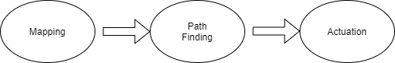
Figure: 2.1 Autonomous Stack

Mapping (Fig. 2.1 Mapping Explained)

In order to move in a terrain, we need to know it first, even if we take humans in consideration if a person does not have information about the terrain he is in, he will probably get lost or stand there in confusion where to go. A robot is nowhere near human beings they do as they are told; it would not be able to navigate until and unless it has information about the terrain.
In mapping we gather information about terrain and make map or floor plan by using which robot will be able to move from one point to another. This process of mapping is called SLAM

Simultaneous Localization and Mapping (SLAM)

What?

SLAM is defined as simultaneous localization and mapping; it is a method or algorithm used for drawing maps with the help of an autonomous vehicle and also to locate that vehicle in that map at the same time. It allows the vehicle to draw maps of unknown environments. We can then use those maps for tasks like path planning and obstacle avoidance.

Why?
SLAM has been used for technical research for many years but as the technology grows and the computer processing speed and the availability of equipment is now in hand, this algorithm has now been used in practical applications in number of fields. SLAM Examples
Consider autonomous robot vacuum, it works on SLAM algorithm it knows where in the room it exists without SLAM, it will just move randomly within the room and may not be able to clean the entire floor. Also, it will use more power and the battery will run out more quickly. But if the robot has SLAM algorithm integration it will use attached equipment to sense out the floor and how much movement he needs to clean entire floor it is called localization. It will also sense out obstacles in the way and also it will avoid cleaning the same area twice it is called mapping.
There are other uses of SLAM too like in swarm robotics to arrange the bots in a position where they do not collide with each other. In modern days it is used in autonomous cars which runs on main roads with the help of satellite mapping the car moves on roads it is still in testing phase in most of the countries and a few of these countries have done their research and they are ready to launch those cars.

How?
To achieve SLAM there are two types of technological components being used. The first type is sensor signal processing, which includes front-end processing which depends on sensors. The Second type is pose-graph optimization, it includes back-end processing, which is sensor agnostic.

Methods for SLAM

To learn more about the front-end processing component, let us take a look at visual SLAM and lidar SLAM – two different methods of SLAM.

Visual SLAM
In Visual SLAM it uses images acquired from cameras and other image sensors. It can use simple cameras, compound eye cameras and RGB-D cameras to get those images. It can be implemented at low cost with inexpensive cameras. In addition, since cameras provide a large volume of information, they can be used to detect a landmark. Landmark detection can also be combined with graph-based optimization, achieving flexibility in SLAM implementation.
Monocular SLAM is when vSLAM utilizes a solitary camera as the lone sensor, which makes it trying to define depth. This can be settled by either distinguishing AR markers, checkerboards, or other known articles in the picture for localization or by fusing the camera information with another sensor such as inertial measurement units (IMUs), which can measure physical quantities such as velocity and orientation. Technology related to vSLAM includes structure from motion (SfM), visual odometry, and bundle adjustment.
Visual SLAM algorithms can be extensively arranged into two classifications inadequate techniques coordinate component purposes of pictures and use algorithms, for example, PTAM and ORB-SLAM. Thick strategies utilize the general splendour of pictures and use algorithms, for example, DTAM, LSD-SLAM, DSO, and SVO.

LIDAR SLAM

Light detection and ranging (lidar) is a method that primarily uses a laser sensor (or distance sensor).
Contrasted with cameras, ToF, and different sensors, lasers are altogether more exact, and are utilized for applications with rapid moving vehicles, for example, self-driving vehicles and robots. The yield esteems from laser sensors are for the most part 2D (x, y) or 3D (x, y, z) point cloud information. The laser sensor point cloud gives high-exactness distance estimations and works successfully for map development with SLAM. For the most part, development is assessed successively by coordinating the point mists. The determined development (voyaged distance) is utilized for confining the vehicle. For lidar point cloud coordinating, iterative nearest point (ICP) and ordinary conveyances change (NDT) algorithms are utilized. 2D or 3D point cloud guides can be spoken to as a matrix map or voxel map.
Then again, point clouds are not as finely definite as pictures as far as thickness and do not generally give adequate highlights to coordinating. For instance, in spots where there are not many impediments, it is hard to adjust the point clouds and this may bring about forgetting about the vehicle area. Moreover, point cloud coordinating for the most part requires high preparing power, so it is important to advance the cycles to improve speed. Because of these difficulties, restriction for self-governing vehicles may include combining other estimation results, for example, wheel odometry, worldwide route satellite framework (GNSS), and IMU information. For applications, for example, stockroom robots, 2D lidar SLAM is generally utilized, while SLAM utilizing 3-D lidar point clouds can be utilized for UAVs and robotized stopping.

Challenges in SLAM

Challenges in SLAM are explained below

Localization errors accumulate, causing substantial deviation from actual values

SLAM estimates sequential movement, which incorporate some wiggle room. The mistake aggregates over the long run, causing significant deviation from real qualities. It can likewise cause map information to fall or misshape, making ensuing pursuits troublesome. How about we take an illustration of cruising all over a square-moulded section. As the blunder collects, robot's beginning and finishing point presently do not coordinate. This is known as a circle conclusion issue. Posture assessment blunders like these are unavoidable. It is critical to distinguish circle conclusion and decide how to address or offset the accumulated error.
One countermeasure is to recollect a few attributes from a formerly visited place as a milestone and limit the confinement blunder. Posture diagrams are developed to help right the mistakes. By addressing blunder minimization as an enhancement issue, more precise guide information can be created. This sort of enhancement is called pack change in visual SLAM.

Localization fails and the position on the map is lost
Image and point-cloud mapping does not think about the attributes of a robot's development. Now and again, this methodology can create spasmodic position gauges. For instance, a figuring result demonstrating that a robot moving at 1 m/s unexpectedly hopped forward by 10 meters. This sort of confinement disappointment can be forestalled either by utilizing a recuperation calculation or by combining the movement model with various sensors to make counts dependent on the sensor information.
There are a few strategies for utilizing a movement model with sensor combination. A typical strategy is utilizing Kalman filters for limitation. Since most differential drive robots and four-wheeled vehicles by and large utilize nonlinear movement models, expanded Kalman filters and molecule channels (Monte Carlo restriction) are frequently utilized. More adaptable Bayes channels, for example, unscented Kalman filters can likewise be utilized now and again. Some regularly utilized sensors are inertial estimation gadgets, for example, IMU, Attitude and Heading Reference System or AHRS, Information Network Systems or INS, accelerometer sensors, gyro sensors, and attractive sensors). Wheel encoders appended to the vehicle are regularly utilized for odometry.
At the point when confinement fizzles, a countermeasure to recuperate is by recollecting a milestone as a key-outline from a formerly visited place. While looking for a milestone, an element extraction measure is applied such that it can examine at high speeds. A few techniques dependent on picture highlights incorporate pack of highlights (BoF) and sack of visual words (BoVW). All the more as of late, profound learning is utilized for examination of good ways from highlights.

High computational cost for image processing, point cloud processing, and optimization

Processing cost is a difficult when executing SLAM on a vehicle equipment. Calculation is normally performed on minimized and low-energy implanted microchips that have restricted preparing power. To accomplish exact confinement, it is fundamental to execute picture preparing and point cloud coordinating at high recurrence. Likewise, advancement figuring, for example, circle conclusion are high calculation measures. The test is the way to execute such computationally costly preparing on implanted microcomputers.
One countermeasure is to run various cycles in equal. Cycles, for example, include extraction, which is pre-processing of the coordinating cycle, is generally appropriate for parallelization. Utilizing multicore CPUs for preparing, single guidance various information (SIMD) estimation, and inserted GPUs can additionally improve speeds at times. Likewise, since present diagram streamlining can be performed over a generally long cycle, bringing down its need and doing this cycle at customary spans can likewise improve execution.

Path Finding

Once we have map of our environment, we need to move from one point to another for that we need to decide a path for robot to following, as shown in Fig 2.1. The process of path finding is a procedure in which we determine the most optimal path, using which robot will move from one source to destination [6].

Graphs

In path finding we have different path finding and planning algorithm that takes map in form of graphs as input and starting from one vertex it explores its adjacent nodes until it does not reach its goal. Techniques used to search destination in graphs are following
- DFS (Depth First Search)
- BFS (Breath First Search)

Process of Path Finding

There are two aspects of path finding
- Search graph to find destination
- Find Optimal Path between source and destination

Search for destination

This process is concerned with finding a destination in a network of graph, all nodes are visited until destination is not reached.

Find Optimal Path

This process is rather of great importance as compared to search for destination. Once we know destination, we need to plan such path which saves computational resources at the same time energy resource and also reduce wear and tear of hardware.

Algorithm for Path Planning

Path planning algorithm are divided into three categories
- Basic or Traditional
- Grid Based
- Sampling Based Algorithms
Details of which are discussed below in detail

Basic or Traditional

Basic path planning algorithms have no issues in terms of computational resources consumption, but they fail and are unable to hold more than one dimensions. So, they are of no use in modern day implementation.

Grid Based Algorithms

Grid based algorithms handles complex data and dimension with ease they have no issue in processing them they require a lot of computational resources and memory they give a viable output, but the cost of resources cannot be afforded in real life applications.
The most famous grid-based planners are DJ, A* etc.

DJ (Dijkstra's)

DJ is the most commonly known pathfinding algorithm, it begins with the start node and examines next node to which has the least small path, then the current node is marked as the closed node and all nodes connected to it are set as opened nodes. Since path with shortest distance is elected fist so the path to destination found is to be smallest [7].

Problem: DJ seems to be the prefect algorithm but it is not its biggest flaw is that it is local optimal. DJ only selects the path which at the hand seems the shortest but what if the shortest path leads to longest path later on it has no heuristic help to determine which path is better for getting a global optimal.

A Star

A* has similar working to Dj but it has an informed guess which allows is to make most better decision in final output and help to escape problem of local optimal.

Sampling Based Algorithms

Sampling based algorithms are the best approach so far, they handle both complex data beautifully and at much lower computational costs. Its most well-known example is RRT*.

Actuators
Actuators are responsible for moving and controlling a mechanism. Actuators are the cause of motion in a robot. In mobile autonomous robot after mapping and path planning actuators are responsible to move robot on the defined path. Most common actuators in a mobile robot are DC motors, as shown in Fig 2.1.

Conclusion
The aim of this project to create an autonomous mobile robot that is able to propagate in environment and collect environmental data. So, we proposed an autonomous robot that can move in a hazardous environment, collect, and share its data to those people who have to interact with hazardous environment. This robot will benefit rescue workers, researchers or whoever wants to explore and collect data from hazardous environment.

DESIGN AND METHODLOGIES

Introduction

This chapter is about design methodology. In pervious chapters, analysis of system is completed. So, we understand the current situation of the problem domain by using object-oriented approach. Following artefacts must be included in this deliverable.
- System Architecture
- Domain Model
- Class Diagram

System Architecture

Below is the system architecture diagram of our system.
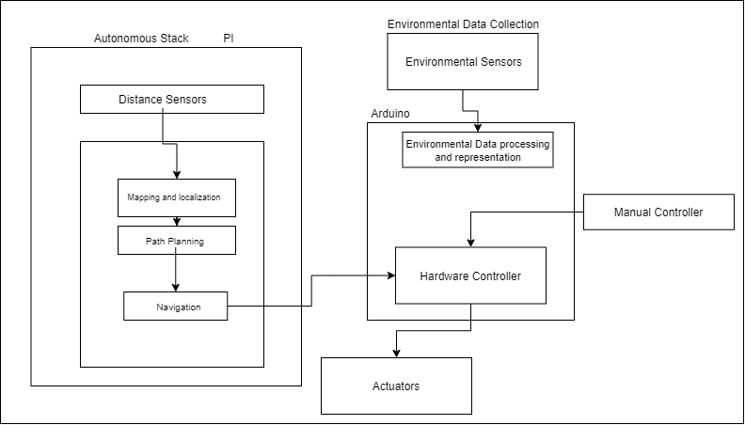
Figure: 3. 1 System Architecture
Figure 3.1 shows architecture of robot system. Robot system is subdivided into following subsystems which are explained in detail below.
- Autonomous Stack
- Environmental Data
- Manual Control

Autonomous Stack

In autonomous stack a scan of environment is taken through a LIDAR sensor. A LIDAR is a laser-based distance measuring sensor it measures the distance of objects why emitting a led light and then receiving it back. Data from Distance measuring sensor is used for generating a map using which our robot would know about environment. And using that map localization is done, by using that map we take current position as start point and select destination form the map. Using those two points a path is planned for robot to move in the environment avoiding obstacles, once the path is generated for robot to move on, we need to navigate on the path any at same time analyse where our robot is on the current planned path, navigator is responsible for keeping this check during moving the robot. Navigator send commands to hardware controller to move actuators so our robot could move in the actual world.

Environmental Data

Environmental data will be gathered using multiple sensors each providing different useful information, this data will be received by a microcontroller (Arduino, Raspberry Pi) and displayed to whomever it concerns.

Manual Control

There will be situations where an autonomous robot would require a manual guidance or there might be need in some scenarios where a more in-depth analysis of the environment might be required so there will be arise of a manual controller. A manual controller will take input directly form user and make robot move according to it.

Domain Model

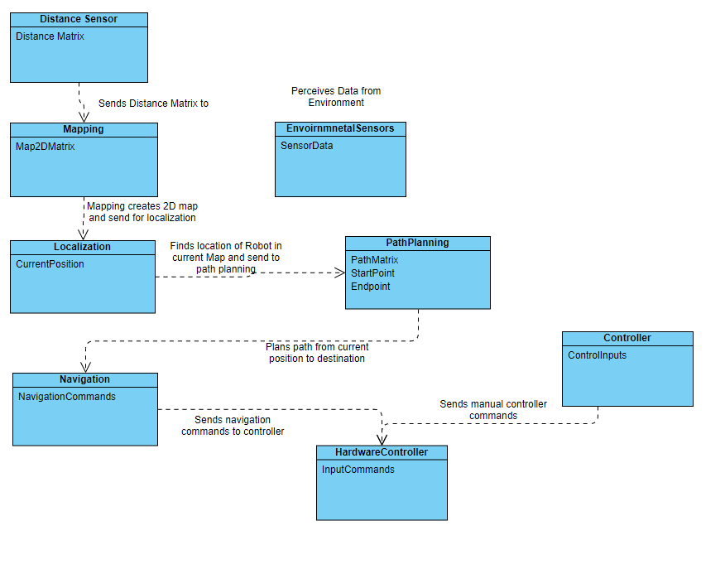
Domain model of your system is given below.

Figure: 3. 2 Domain Model
Figure 3.2 represents the overall domain model of our system and its explanation is given below.

Using a Lidar sensor, a distance matrix is generated that is then passed to mapping to create a map using it once map is generated it is used for localization, determining current position of robot in the map with respect to the environment. Once after localization the map is used for path planning where using giving start point and destination an obstacle free path is generated which is used for navigation form source to destination. Navigator sends information to hardware controller to move robot in actual environment.
Environmental data during this process if simultaneously being collected and provided to concerned people.
Sometimes there might be certain situations where manual control is required of the robot so there is controller that enables someone to manually control robot by sending message to hardware controller.

Class Diagram

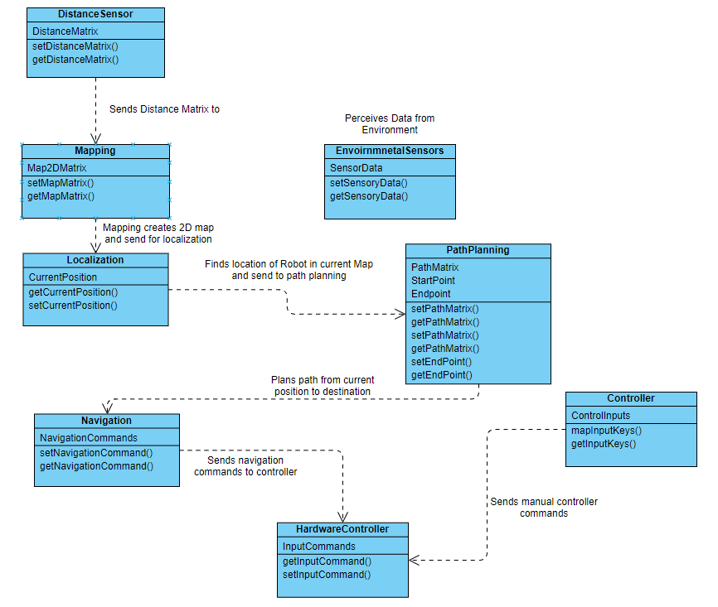
Following class diagram explain the relationship, attributes, and methods each class would hold of our system which is explained further below.

Figure: 3. 3 Class Diagram
Figure 3.3 explains the overall class diagram of our system and its detailed explanation is given below.
Distance information is collected and stored which is later used to create a map whose data is then accessed for localization. After localizing robot current position of the robot and map generated from distance sensor is sent for path planning where initial and final position are set and using them an optimal path is generated. Navigation is responsible for sending proper input data to hardware controller to move robot.
Environmental sensors collect data from environment and that data is stored and retrieved later.
There are some scenarios where there will rise occasion to manually control robot. Controller holds commands which can be send to hardware controller to control the robot.

DATA AND EXPERIMENTS (and/or IMPLEMENATION)

Overview

Implementation is done using ROS environment and packages for autonomous robot using TurtleBot3 and Arduino is used for gathering environmental data.

Implementation

Implementation details are given below.

Tools and Technology

Information of tools and technology used in this project are mentioned below.
Table 4. 1 Tool and Technology Details
Tool Name | Version
Gazebo | 7.0
Rviz | 1.14.8
Notepad | 1.0
Arduino IDE | 1.8.15
VSCode | 1.57
Android Studio | 4.2.1

Development Environment

Development environment used in this project is mentioned below.
Table 4. 2 Development Environment Information
Packages | Version
ROS TURLEBOT 3 SLAM[8] | 2.1.2
ROS TURLEBOT 3 NAVIGATION[8] | 2.1.2
ROS EXPLORATION[9] | 2.1.4
ROS GAZEBO | 7
React Native | 0.64
C | 1.0

Development Environment Setup

Development environment is listed below.

Software Setup

Following is the software setup.
Table 4. 3 Software Setup Information
Name | OS Version
Windows 10 | 20H1
Linux | Ubuntu 16.0

Hardware Setup

Following is the hardware setup of our system.
Table 4. 4 Hardware Setup Information
Name | Specification
Processor | Xeon-E5 1650 V3 @ 3.5 GHz x 6
RAM | 16 Gb
System Type | 64-Bit
Processor | Core M3 @1.0 GHz x 2
RAM | 8gb
System Type | 64-Bit

Operational Environment

Our project was test in static environment because nature of our robot is to explore hazardous environment where there will be no living thing, thus environment will remain static.

Simulation

Below is the data representing implementation of autonomous robot in simulation.

SLAM

The command for executing SLAM package.
roslaunch turtlebot3_slam turtlebot3_slam.launch
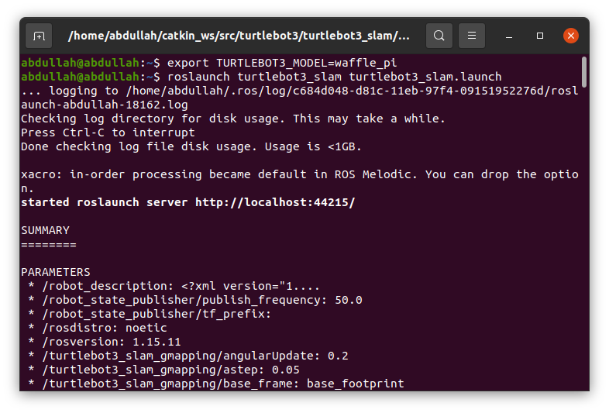

Figure: 4. 1 SLAM Launch Command

Figure 4.1 shows the command to execute to launch SLAM node. A ROS (robot operating system) SLAM node is launched in a separate terminal that communicates with the LIDAR A1M8 sensor via UART USB connection. LIDAR is a distance measuring sensor that emits an IR blasts and then receive it back. Distance is measured by measuring how much time it took for IR blast to return to sensor. ROS SLAM node receives a matrix of distance and angle upon which IR blast was sent, then ROS SLAM node make map matrix and localize robot in it. To see live generation of map RVIZ is used. RVIZ is added in launch file of SLAM node for ease.
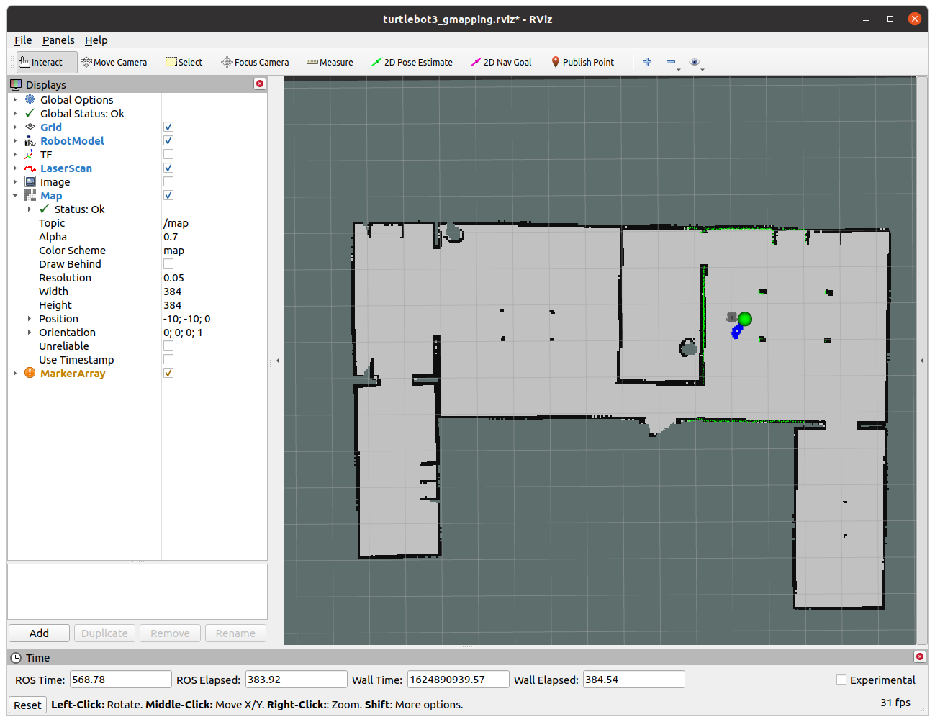
Figure: 4.2 SLAM map Visual Representation

Figure 4.2 shows visual representation of SLAM using RVIZ in Linux based operating system. Rviz is free tool used for data visualization it communicates with the ROS SLAM node launched, SLAM node sends the data matrix that it receives from LIDAR sensor and the rviz uses that to create a visual map.

Navigation

To move robot separate ROS package is used, it is launched in a separate terminal for concurrent execution of process. Command for executing base control.
roslaunch turtlebot3_navigation move_base.launch
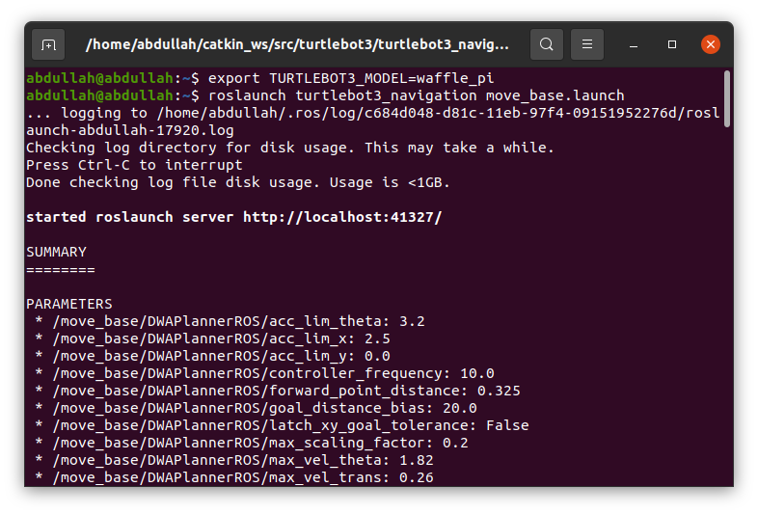

Figure: 4.3 Move Base Launch Command

Figure 4.3 shows node running move base pacakge. Move base ROS pacakge allows to control the wheels of robot by sending movement values matrix. This is a [1x2] matrix where each index shows individual values for each wheel. Turtlebot3 recevies these values and moves in envoirnment according to it.

Exploring Envoirnment

Environment exploration is the ROS node that identifies the available and unexplored parts in SLAM map and commands robot base to move towards those unexplored areas.
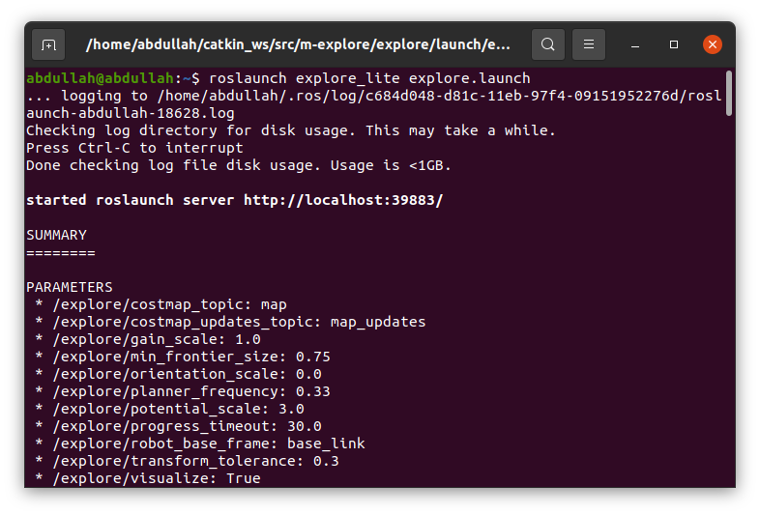
The command for executing explorer node.
roslaunch explore_lite explore.launch
Figure: 4.4 Explorer Node Command

Figure 4.4 shows node running explorer node. Explorer node take the generated slam map form SLAM ROS node and then identifies the unexplored area in slam and place markers on it that shows that there is more place to be explored beyond that point. Once it places markers explorer node plans a path from current position to the closest node.

Manual Control

Teleop is used to control the turtlebot3 manually. It is used to control base of turtlebot3 manually. Command to execute Teleop.
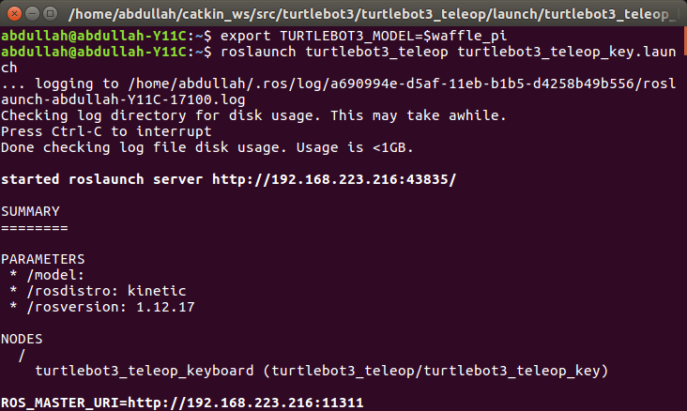
roslaunch turtlebot3_teleop turtlebot3_teleop_key.launch
Figure: 4.5 Command to Launch Teleop

Figure 4.5 shows terminal running Teleop node. Teleop node takes input from keyboard and generates a [2x1] matrix where at each index is value of speed for individual wheels of robot. This data is send to OCR( Open Source Controller Module) which then moves the turtlebot3 in environment.

Virtual World

Gazebo was used to run simulations for exploring envoirnment.

The command to execute simulation in Gazebo.
roslaunch turtlebot3_gazebo turtlebot3_house.launch
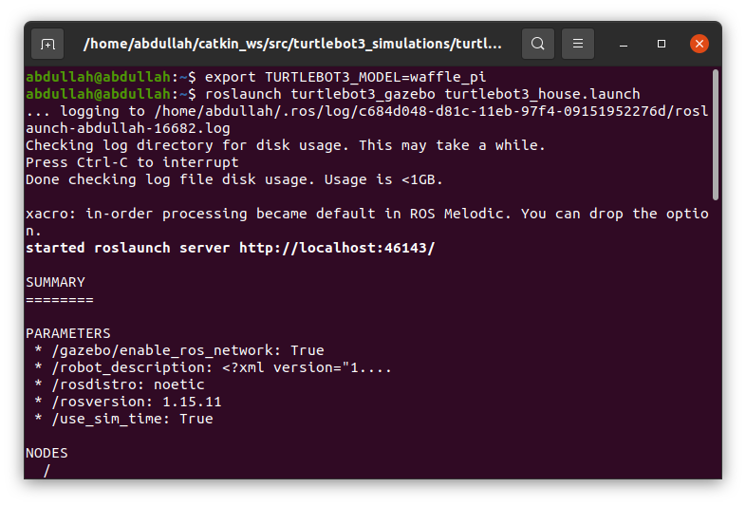
Figure: 4.6 Launching World in Gazebo

Figure 4.6 shows the terminal running a virtual world in gazebo. Gazebo is a tool used for virtualization, gazebo turtlebot3 simulation is used to simulation ROS SLAM, explorer and move_base node.
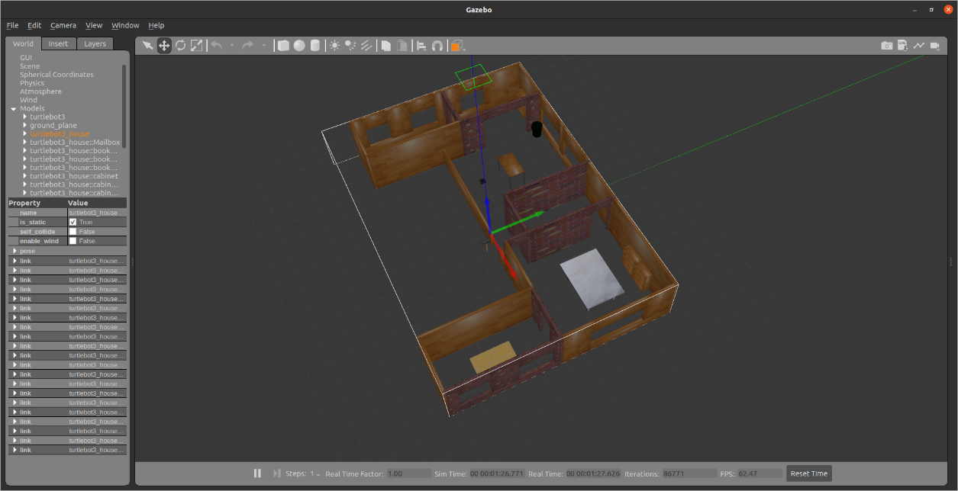
Figure: 4.7 Simulation in Gazebo

Figure 4.7 shows the turtlebot3 simulation in gazebo. A house with multiple rooms was used to test the exploration functionality of turtlebot3, this house consisted of five rooms that were connected. This environment was used to test if turtlebot3 was able to explore complete house and generate SLAM map.

Hardware

Implementation on hardware is done using turtlebot3 and Arduino using MQ-7, MQ-135, KY-011 and MQ-2 sensor for gathering environmental data.

ROS Core

ROS core is required when implementing complete solution on hardware. ROS core is the master that allows communication between multiple ROS nodes. Simulation in gazebo launches a false master node within it thus eliminating need for ROS Core. Command to execute ROS Core.
roscore

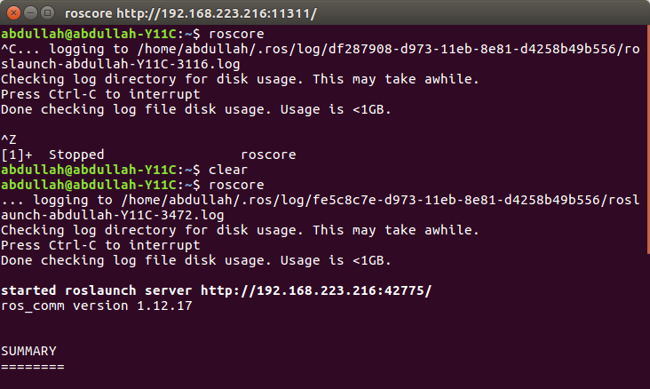
Figure: 4.8 ROS Core Launch Command

Figure 4.8 shows command to terminal running ROS Core it allows multiple ROS node to communicate and exchange data with each other. Each ROS node generates a data and pass it to master node then which ever nodes requires that data communicate with master node and obtain it.

SLAM, Navigation, Environment Exploration and Manual Control

See section 4.2.1, 4.2.2, 4.2.3 and 4.2.4 to see SLAM, Navigation, Environment Exploration and Manual Control.

Connecting with TURTLEBOT

Below is the command to establish connection with turtlebot3.
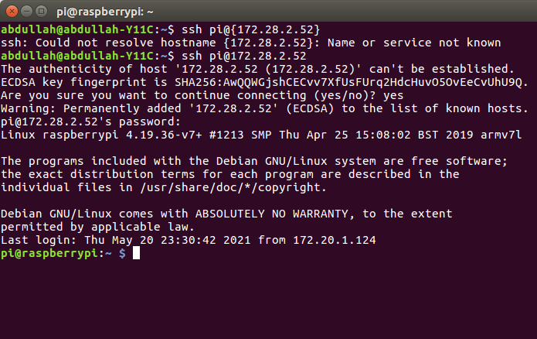
Figure: 4.9 Establish Connection with Turtlebot

Figure 4.9 shows remote terminal connection to turtlebot3, a lot of data is generated at turtlebot3 in order to obtain data from turtlebot3 a remote connection is used to exchange data.

Environmental Data

Environmental data is collected using Arduino and ESP8266 D1 R1 board. Arduino is responsible for reading data from sensors and send it to esp8266 board so it could upload it to firebase from there it is fetched from an android application.

Circuit Diagram of sensors is shown below.

Figure: 4.10 Circuit Diagram

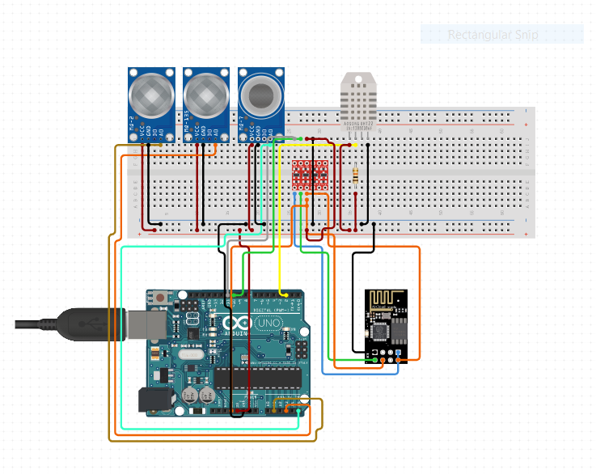
Figure 4.10 shows circuit diagram of Arduino with MQ-7, MQ-135, MQ-2 and KY-011. MQ-7, MQ-135 and MQ-2 all generate analog data but there is only one pulse width modulation pin on esp8266. So Arduino R3 Uno was used as slave that receives data from these sensors then transmits data in serial through SDA and SCL pins to esp8266 then it is uploaded to database.

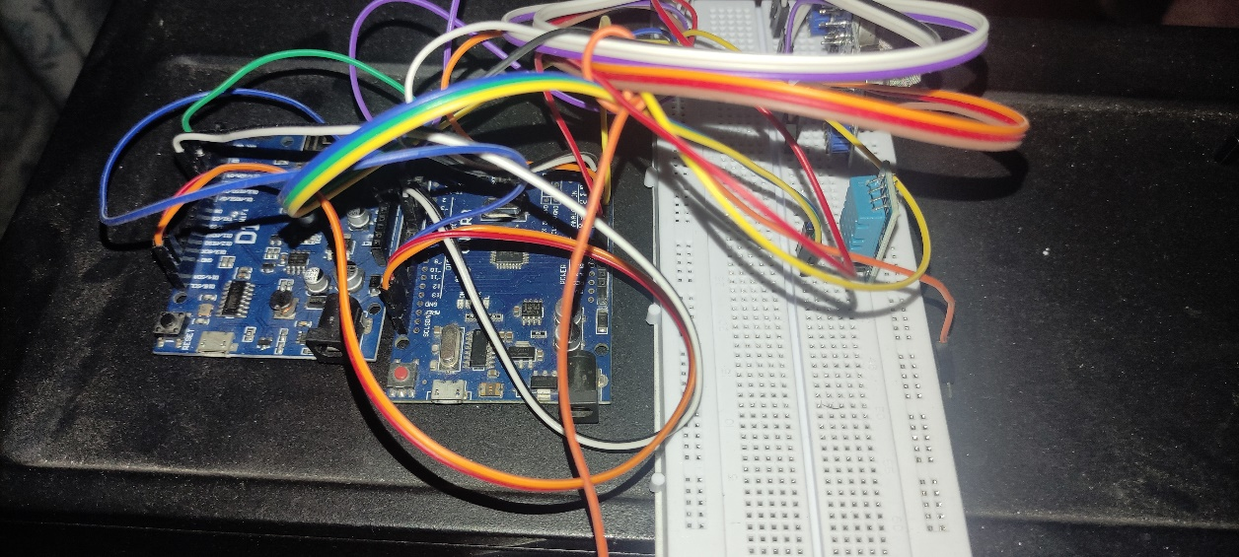
Below is picture of actual circuit.

Figure: 4.11 Hardware (1)

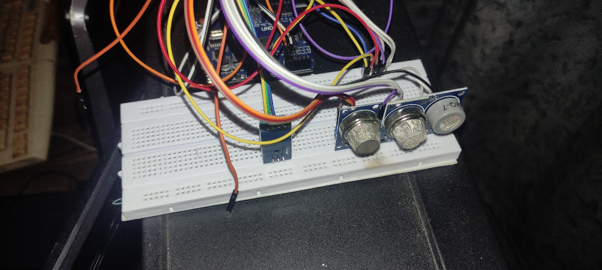
Figure 4.11 shows hardware implementation of sensors.
Figure: 4.12 Hardware (2)

Figure 4.12 shows hardware implementation of sensors but from a different prespective.

Firebase

Data generated from sensors is sent to firebase through esp8266.

Below is the structure of firebase
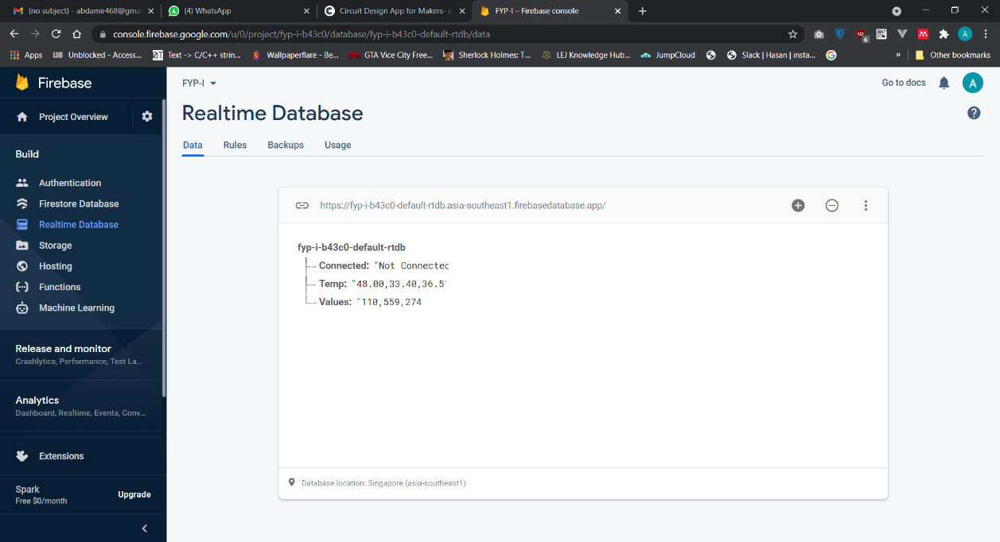
Figure: 4.13 Structure of Firebase

Figure 4.13 represents the structure of firebase. Values from KY-011 sensor are converted into string and inserted into temperature collection and values from MQ-7, MQ-135 and MQ-2 are converted into strings and uploaded in Values collection in firebase.

Android Application

Android application is used to read from firebase and show it live.

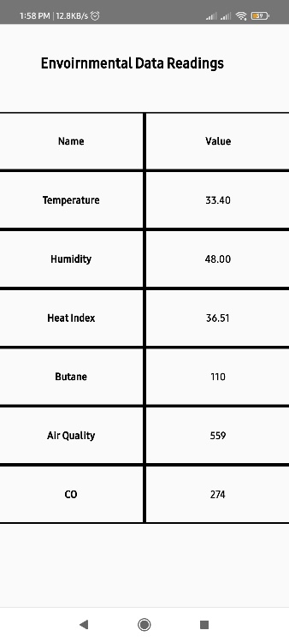

Figure: 4.14 Android Application

Figure 4.14 shows android application user interface. Android application is build using react native, it establishes connection with firebase and listen to changes in data

each time data is changed it reads the values and extract values from string and display on screen.

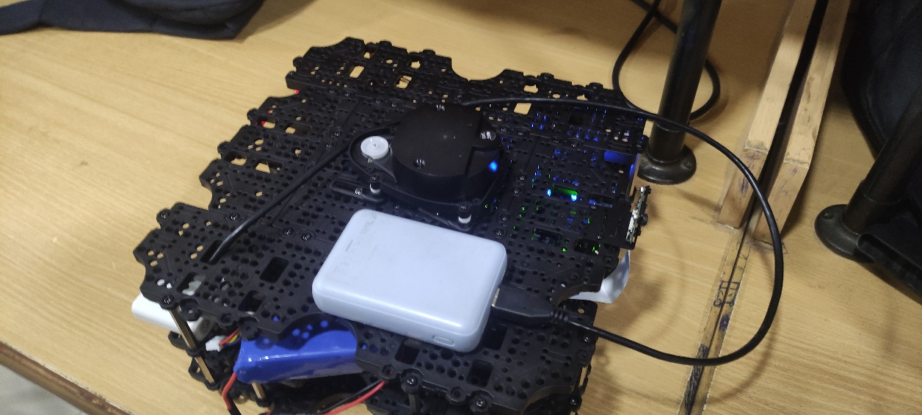
TurtleBot3

Following is the picture of turtlebot3.
Figure: 4. 15 TurtleBot3

Picture 4.15 shows the image of actual TurtleBot3 hardware. The model shown in picture is waffle pi. There are three models in total burger, waffle and waffle_pi , we have used waffle_pi in current implementation. Burger is much more compact and more tower like used for small places while waffle and waffle pi have much larger base with higher central balance which benefits in mounting further add-on modules on it.

TurtleBot3 Block Diagram

Following is the Block Diagram of Turtlebot3.
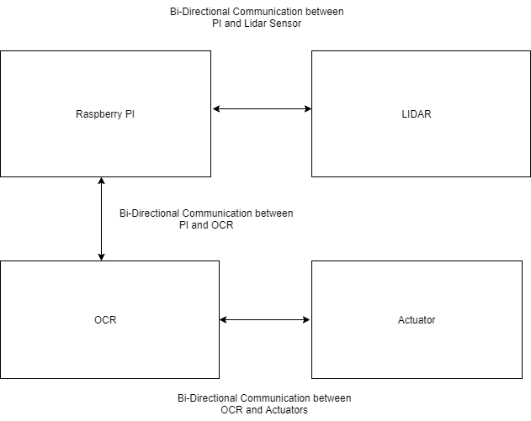

Figure: 4.16 Block Diagram of TurtleBot3

Figure 4.16 shows the block diagram of how turtlebot3 works. The main powerhouse of turtlebot3 is raspberry pi, it acts as main processing brain. OCR (Open-Source Control Module) shares a slave relationship with raspberry pi, OCR (Open-Source Control Module) is responsible for operating such add-on devices that does not require heavy computational power to function, this saves raspberry pi resources. LIDAR sensor communicated directly with raspberry pi because the computational power required to process the data sent by LIDAR sensor is way beyond what OCR (Open-Source Control Module) has to offer.

RESULTS AND DISCUSSIONS

Simulation

The map generated in simulation is shown below.
Figure: 5. 1 Map Generated in Simulated Gazebo Environment (World 1).

Figure 5.1 shows the map generated in simulated environment. The green marker is the maker array which represents the area to be explored yet.

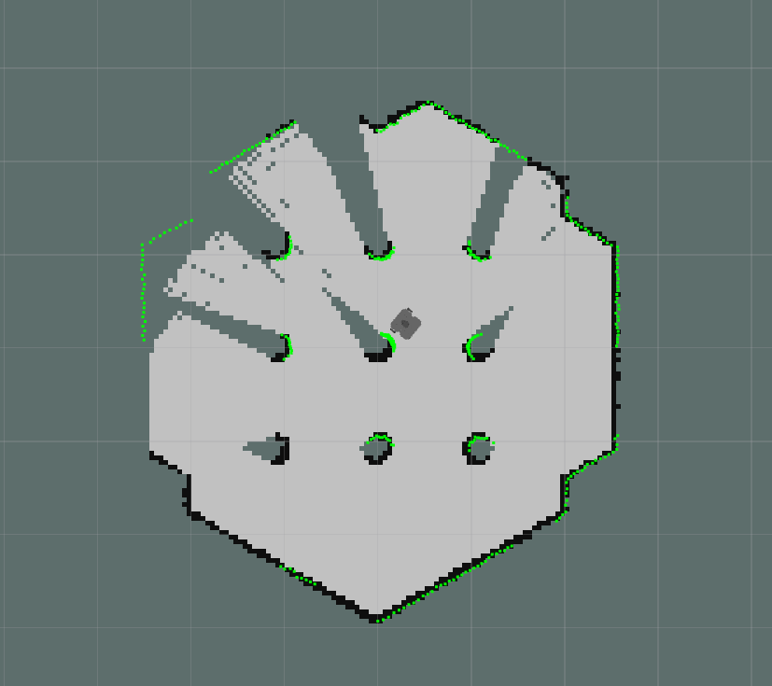

Figure: 5. 2 Map Generated in Simulated Gazebo Environment (Default World).

Figure 5.2 shows the map generated in simulated environment. The green marker is the maker array which represents the area to be explored yet.

Simulation World

Below is the simulated world of maps shown above.
Figure: 5. 3 World 1
Figure 5.3 shows world 1 in gazebo simulation which was used to test robot.

Hardware

Actual hardware testing was done in Basic Electronics Lab of Bahria University Lahore Campus.

Below is the image of environment.
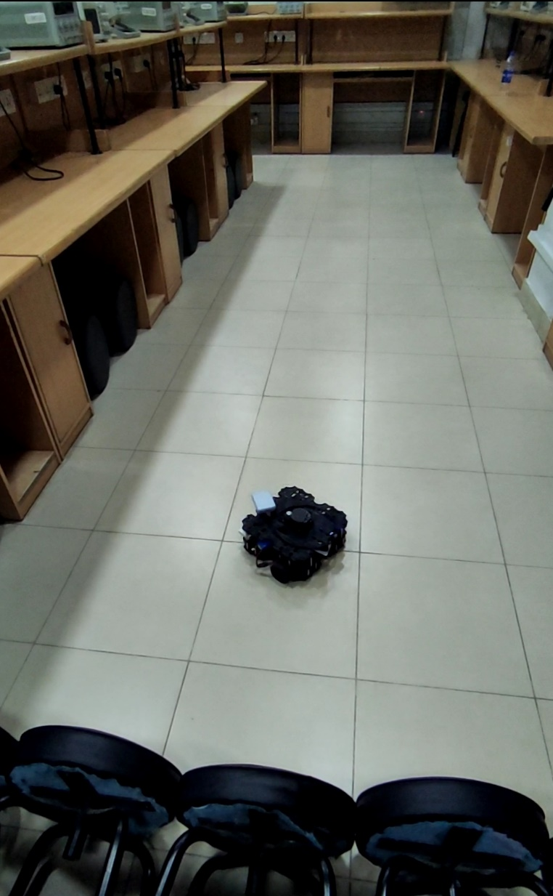

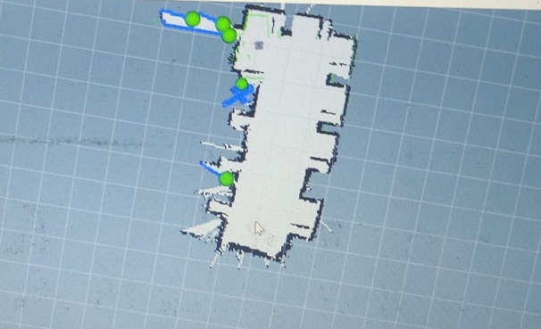
Figure: 5. 4 Map Generated of DLD Lab

Figure 5.4 shows map generated of DLD Lab using turtlebot3.

Environmental Data

Environmental data is shown through android application. Environmental data includes following:
- Temperature
- Humidity
- Heat Index
- Butane Gas PPM
- Air Quality
- Carbon Monoxide PPM

Below is the picture of mobile application

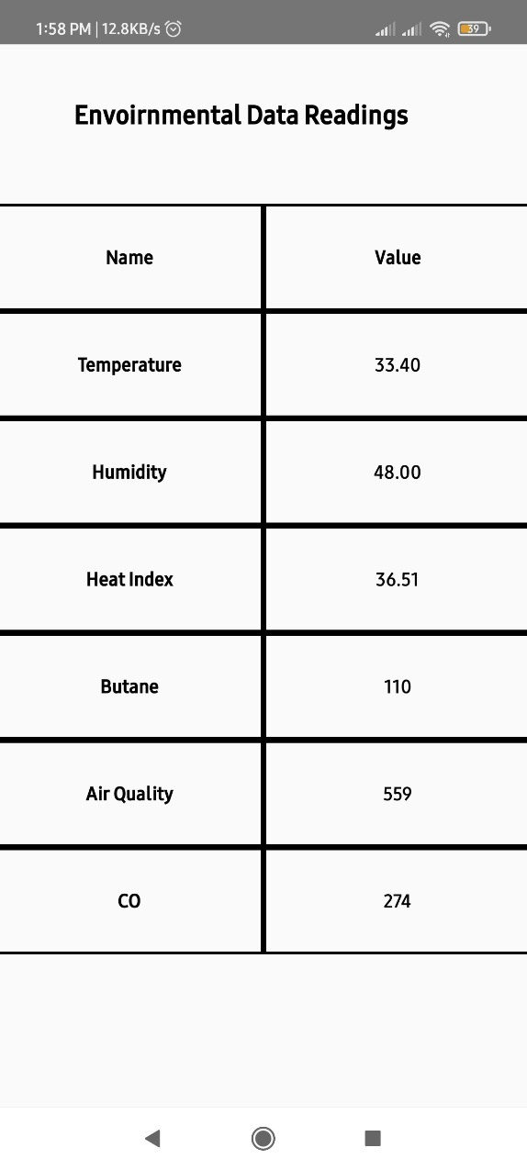

Figure: 5. 5 Android Application

CONCLUSION AND RECOMMENDATIONS

Hazardous environment exploration is difficult and dangerous task for a person, using ROS packages and other tools mentioned in this documentation it is possible to develop a robot that can explore those environments and simultaneously gather and report environmental details to end user. But some constraints remains such has hardware optimization according to environment in which it is working some terrains can be rough and some can be plain for these terrains each should have special hardware, for rough terrains body of robot should be impact resistant and more tough while on plain terrain a simple robot body would be enough. Currently the main computational controller used is PI it is quite strong but if environment size is very large it would be quite costly in terms of computation but as advancements are being made more powerful microprocessors will be available.

REFERENCES

[1] S. Šabanović, “Robots in society, society in robots: Mutual shaping of society and technology as a framework for social robot design,” Int. J. Soc. Robot., vol. 2, no. 4, pp. 439–450, 2010, doi: 10.1007/s12369-010-0066-7.
[2] P. L. P. Rau, Y. Li, and J. Liu, “Effects of a social robot’s autonomy and group orientation on human decision-making,” Adv. Human-Computer Interact., vol. 2013, pp. 6–8, 2013, doi: 10.1155/2013/263721.
[3] S. Hirose and E. F. Fukushima, “Development of mobile robots for rescue operations,” Adv. Robot., vol. 16, no. 6, pp. 509–512, 2002, doi: 10.1163/156855302320535845.
[4] G. Schöner, M. Dose, and C. Engels, “Dynamics of behavior: Theory and applications for autonomous robot architectures,” Rob. Auton. Syst., vol. 16, no. 2–4, pp. 213–245, 1995, doi: 10.1016/0921-8890(95)00049-6.
[5] A. Dhawan, P. Oak, R. Mishra, and G. Puthanpurackal, “Path Based Mapping Technique for Robots,” Int. J. Adv. Res. Artif. Intell., vol. 2, no. 5, pp. 56–62, 2013, doi: 10.14569/ijarai.2013.020509.
[6] R. M. Inigo and D. Alley, “Path planning algorithms for mobile robots,” pp. 1032–1036, 1990, doi: 10.1109/isic.1990.128581.
[7] H. Wang, Y. Yu, and Q. Yuan, “Application of Dijkstra algorithm in robot path-planning,” 2011 2nd Int. Conf. Mech. Autom. Control Eng. MACE 2011 - Proc., no. 2010011004, pp. 1067–1069, 2011, doi: 10.1109/MACE.2011.5987118.
[8] ROBOTIS-GIT, “Turtlebot3-OCR,” 2021. https://github.com/ROBOTIS-GIT/OpenCR/tree/master/arduino/opencr_arduino/opencr/libraries/turtlebot3.
[9] HRNR, “Explorer-Lite,” March, 2021. https://github.com/hrnr/m-explore.

