
BSCS-S20-001
03-134172-082 | SAYAM ZAFAR

Smart Attendance using Real Time Face Recognition

In partial fulfilment of the requirements for the degree of
Bachelor of Science in Computer Science
Supervisor: Dr Muhammad Aasim Qureshi
Department of Computer Sciences
Bahria University, Lahore Campus
July 2021

© Bahria University, 2021

Certificate

We accept the work contained in the report titled
“Smart Attendance using Real Time Face Recognition”
written by
SAYAM ZAFAR
as a confirmation to the required standard for the partial fulfilment of the degree of
Bachelor of Science in Computer Science.

Approved by:
Supervisor: Dr Muhammad Aasim Qureshi
(Signature)

July 09, 2021

DECLARATION

I hereby declare that this project report is based on my original work except for citations and quotations which have been duly acknowledged. I also declare that it has not been previously and concurrently submitted for any other degree or award at Bahria University or other institutions.

Enrolment | Name | Signature
03-134172-082 | SAYAM ZAFAR

Date : July 09, 2021

Specially dedicated to
my beloved grandmother, grandfather, mother and father
(SAYAM ZAFAR)

ACKNOWLEDGEMENTS

I would like to thank everyone who had contributed to the successful completion of this project. I would like to express my gratitude to my research supervisor, Dr MUHAMMAD AASIM QURESHI for his valuable advice, guidance and his enormous patience throughout the development of the research.

In addition, I would also like to express my gratitude to my loving parent and friends who had helped and given me encouragement.

SAYAM ZAFAR

Smart Attendance using Real Time Face Recognition

ABSTRACT

Attendance of students has always been a challenging factor for teachers in terms of time, and accuracy. Already built manual attendance system has a chance of human error. Automated attendance system has also introduced the technology of biometric identifications of students using fingerprints and eye iris which is again a time consuming process.

Proposed system will mark attendance automatically in classroom using real time face recognition technique without student/teacher’s intervention. The attendance of each student is marked on the basis of duration of his/her presence in class. System will also generate daily/monthly report of student presence along with his in/out behaviour in class. As an additional feature, system will also generate alert for any unknown person detected in cameras.

TABLE OF CONTENTS

DECLARATION ii
ACKNOWLEDGEMENTS iv
ABSTRACT v
TABLE OF CONTENTS vi
LIST OF TABLES ix
LIST OF FIGURES x

CHAPTERS
1 INTRODUCTION 1
1.1 Background 1
1.2 Problem Statements 1
1.3 Aims and Objectives 2
1.4 Scope of Project 2
1.4.1 Primary Scope 2
1.4.2 Final Deliverable of the Project and Beneficiaries 2
1.4.3 Optional Scope 2
2 SYSTEM REQUIREMENT SPECIFICATION (SRS) 3
2.1 User Classes and Characteristics 3
2.2 Operating Environment 3
2.3 Design and implementation Constraints 4
2.4 Assumptions and Dependencies 4
2.5 System Use Cases 4
2.5.1 Login (U1) 5
2.5.2 Enrol Student (U2) 6
2.5.3 Update Information (U3) 7
2.5.4 Delete Student (U4) 8
2.5.5 View Summary (U5) 9
2.6 Other Non-functional Requirements 10
2.6.1 Performance Requirements 10
2.6.2 Security Requirements 10
2.7 Software Quality Attributes 11
2.7.1 Reliability 11
2.7.2 Availability 11
2.7.3 Maintainability 11
2.7.4 Reusability 11
3 DESIGN AND METHODOLOGY 12
3.1 Sequence Diagrams 12
3.1.1 Login 12
3.1.2 Enrol 13
3.1.3 Update Information 13
3.1.4 Delete Student 14
3.1.5 View Summary 14
3.2 Entity Relationship Diagram 15
3.3 Data Gathering 16
3.4 Methodology 16
3.4.1 Face Detection 16
3.4.2 Model Design 17
3.4.3 Face Recognition 18
3.4.4 Verification and Validation 19
4 DATA AND EXPERIMENTS 20
4.1 Data Gathering 20
4.1.1 Training Data: 20
4.1.2 Testing data 22
4.2 Face Detection 22
4.3 Model Training 23
4.3.1 Haar Cascade 23
4.3.2 MTCNN 24
4.3.3 Dlib Frontal Face Detector 25
4.4 Why Dlib? 26
4.5 Model Experiments 27
4.5.1 Experiment no 1 27
4.5.2 Experiment no 2 28
4.5.3 Experiment no 3 30
4.5.4 Experiment no 4 31
4.5.5 Experiment no 5 33
4.6 Software 34
4.6.1 Login Screen 35
4.6.2 Add Student 35
4.6.3 Data Collection 36
4.6.4 Model Training 37
4.6.5 View Attendance 38
4.6.6 View Enrolled Users 39
5 RESULTS AND DISCUSSIONS 41
5.1 Results 41
6 CONCLUSION AND RECOMMENDATIONS 42
6.1 Findings 42
6.2 Recommendations 43
REFERENCES 44

LIST OF TABLES

TABLE TITLE PAGE
Table 2.5.1: Login Use Case (U1) 5
Table 2.5.2: Enroll Students Use Case (U2) 6
Table 2.5.3: Update Information Use Case (U3) 7
Table 2.5.4: Delete Student Use Case (U4) 8
Table 2.5.5: View Summary Use Case (U5) 9
Table 4.1.1 Metadata 20
Table 4.5.1 Experiment 1 28
Table 4.5.2 Experiment 2 29
Table 4.5.3 Experiment 3 31
Table 4.5.4 Experiment 4 32
Table 4.5.5 Experiment 5 33
Table 5.1.1 Result 41

LIST OF FIGURES

FIGURE TITLE PAGE
Figure 2.5-1 UC Diagram 5
Figure 3.1-1: SD Login 13
Figure 3.1-2 SD Enroll Student 13
Figure 3.1-3 SD Update 14
Figure 3.1-4 SD Delete 14
Figure 3.1-5 SD Summary 15
Figure 3.2-1 ERD 15
Figure 3.4-1 Face Detection 17
Figure 3.4-2 HOG 18
Figure 3.4-3 Face Recognition 19
Figure 4.1-1 Correct Data 21
Figure 4.1-2 Wrong Datset 21
Figure 4.1-3 Classroom 22
Figure 4.3-1 Haar Cascade 24
Figure 4.3-2 MTCNN 25
Figure 4.3-3 DLIB Experiment 26
Figure 4.5-1 Classroom Experiment 27
Figure 4.5-2 Low Resolution Classroom 29
Figure 4.5-3 Shadowed Image 30
Figure 4.5-4 Detection of distant faces 32
Figure 4.5-5 Detection in different poses 33
Figure 4.6-1 Login 35
Figure 4.6-2 Enrol Student 36
Figure 4.6-3 Data Collection 37
Figure 4.6-4 Model Training 38
Figure 4.6-5 View Attendance 39
Figure 4.6-6 Enrolled Students 40

INTRODUCTION

Background

The presence of students in classroom is a compulsory component in academics. And many attendance systems are used to make sure the presence of student in classroom.

In traditional attendance systems, every student is assigned a unique ID by his academic institution which is used for identification of student within the premises of institution. Teacher call these IDs to mark attendance of students.

Problem Statements

Traditional Attendance system is time consuming process for teachers and have a chance of human error. Student can also leave the class after making him/her present in classroom. Though exist many identification methods like fingerprints and iris scans but face recognition has always been the primary method of authentication for humans[1].

Proposed system will use face recognition technique for automatic attendance without involvement of students in a classroom environment. Our system initially creates a database in which it will detect and save face of students. System will also allow to look upon the history of attendance of particular student.

Aims and Objectives

The objectives of the thesis are shown as following:
- To fully automate attendance without any human involvement.
- Periodic Attendance Reports

Scope of Project

Primary Scope is defined below:

Primary Scope
- Auto Attendance
- Catering in/out time of each student.
- Reports

Final Deliverable of the Project and Beneficiaries
- It is a hardware and software integrated system.
- End users of product will be educational institutions.

Optional Scope
- Mobile Application to view reports.

SYSTEM REQUIREMENT SPECIFICATION (SRS)

User Classes and Characteristics

The user is divided into two classes:
- Administrator
- Teacher

Administrator – Administrator can perform following actions:
- Enroll Student
- Delete Student
- Update Information
- View Attendance Summary

Teacher – Teacher can perform following actions:
- View Attendance Summary

Operating Environment

Operating Environment for Smart Attendance:
- Operating System: Windows 7,8,8.1 and 10
- Web Browsers: Google Chrome and Firefox Browsers supported because these are common
- Database Management System: MySQL/Firebase/MongoDB

Design and implementation Constraints

Smart Attendance using Real time Face Recognition is desktop based application. As it is a deep learning project, python will be preferred to use in project. Therefore, frontend will be developed in Python and backend will be developed using Open-cv and frameworks available for server sides languages[2].

It will be developed using a feature driven development in which I will first develop the overall model and then I will plan, design and develop feature accordingly. Project is based on the database so it may time while synchronizing the database. The internet connection is also the constraint for the application.

Assumptions and Dependencies

Assumptions and dependencies:
- PC (Personal Computer) or workstation with GUI.
- Python 3.7 should be installed.
- Working internet connection.

System Use Cases

Figure 2.1 shows the use case diagram of application which shows how administrator and teacher may interact with system.
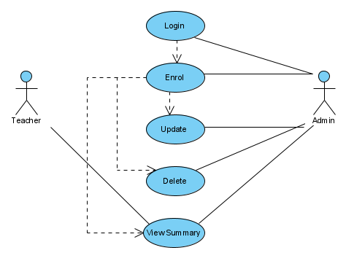
Figure 2.5-1 UC Diagram

Login (U1)

The table 2.5.1 shows the interaction of administrator with login screen to enter credentials and sign into the application.

Table 2.5.1: Login Use Case (U1)
 | Name | Enrol Students
1. | Use-Case ID | U1
2. | Objective | Admin will enter credentials to login the system.
3. | Priority | High
4. | Source | Sayam Zafar (Developer)
5. | Actors | Administrator
6. | Flow of Events | - Enter Credentials  - Click login button
6.1 | Basic Flow | After login, administrator can go to U2, U3,U4 and U5.
6.2 | Alternate Flow(s) | No alternate flow, Admin must login system first
6.3 | Exception Flow(s) | - Alert admin to re-enter the credentials
7. | Includes | No other use case
8. | Preconditions | Administrator must be connected to web service via an internet connection (e.g. LAN, WAN)
9. | Post conditions | Administrator will use all other use cases.
10. | Notes/Issues | If credentials are correct then no issue is caused by system.

Enrol Student (U2)

The table 2.5.2 demonstrates the enrolment process of a student from capturing of face to extraction of features and saving them in database.

Table 2.5.2: Enroll Students Use Case (U2)
 | Name | Enrol Students
1. | Use-Case ID | U2
2. | Objective | Admin will enrol each student by taking a video clip of 30 seconds.
3. | Priority | High
4. | Source | Sayam Zafar (Developer)
5. | Actors | Administrator
6. | Flow of Events | - Run Detector  - Take clip of students
6.1 | Basic Flow | After enrolling, administrator can go to U2, U3 and U4.
6.2 | Alternate Flow(s) | No alternate flow, Student must enrol in system first
6.3 | Exception Flow(s) | - Alert to ask student to take off his wearable item to shoe face clearly
7. | Includes | No other use case
8. | Preconditions | Administrator must be connected to web service via an internet connection and login first (e.g. LAN, WAN)
9. | Post conditions | Administrator will use all other use cases.
10. | Notes/Issues | If position of student is correct then no issue is caused by system.

Update Information (U3)

Table 2.5.3 shows the update information process of enrolled students in database.

Table 2.5.3: Update Information Use Case (U3)
 | Name | Update Information
1. | Use-Case ID | U3
2. | Objective | Admin will update information of any student.
3. | Priority | High
4. | Source | Administrator is the main source of this use case
5. | Actors | Administrator
6. | Flow of Events | - Enter Student ID  - Select any textbox to update student information.
6.1 | Basic Flow | After updating, administrator can go to U2, U4 and U5.
6.2 | Alternate Flow(s) | No alternate flow
6.3 | Exception Flow(s) | - Invalid Student ID entered
7. | Includes | No other use case
8. | Preconditions | - Administrator must be connected to web service via an internet connection (e.g. LAN, WAN)  - Student must be login (U1) and enrolled (U2).
9. | Post conditions | Administrator will use all other use cases.
10. | Notes/Issues | If ID of student is correct then no issue is caused by system.

Delete Student (U4)

Table 2.5.4 shows the sequence diagram of deleting an enrolled student by just typing student ID.

Table 2.5.4: Delete Student Use Case (U4)
 | Name | Delete Information
1. | Use-Case ID | U4
2. | Objective | Admin will delete any student by entering ID of student.
3. | Priority | High
4. | Source | Administrator is the main source of this use case
5. | Actors | Administrator
6. | Flow of Events | - Enter Student ID  - Select delete button to delete student data
6.1 | Basic Flow | After deleting, administrator can go to U1, U2, U3 and U5.
6.2 | Alternate Flow(s) | No alternate flow
6.3 | Exception Flow(s) | - Invalid Student ID entered
7. | Includes | No other use case
8. | Preconditions | - Administrator must be connected to web service via an internet connection (e.g. LAN, WAN)  - Student must be enrolled first(U1).
9. | Post conditions | Administrator will use all other use cases.
10. | Notes/Issues | If ID of student is correct then no issue is caused by system.

View Summary (U5)

Administrator or university management may view the in/out behaviour of student by monthly or weekly as shown in Table 2.5.5:

Table 2.5.5: View Summary Use Case (U5)
 | Name | View Summary
1. | Use-Case ID | U5
2. | Objective | Admin and teacher can view summary of any student by entering ID of student. Or may view by class.
3. | Priority | High
4. | Source | Administrator is the main source of this use case
5. | Actors | Administrator, Teacher
6. | Flow of Events | - Enter Summary Tabs  - Select student or class to view reports
6.1 | Basic Flow | After viewing summary, administrator can go to U1, U2, U3 and U5.
6.2 | Alternate Flow(s) | No alternate flow
6.3 | Exception Flow(s) | - Invalid Student ID entered
7. | Includes | No other use case
8. | Preconditions | - Administrator must be connected to web service via an internet connection (e.g. LAN, WAN)  - Student must be enrolled first(U1).
9. | Post conditions | Administrator will use all other use cases.
10. | Notes/Issues | If ID of student is correct then no issue is caused by system.

Other Non-functional Requirements

Following are the non-functional requirements of smart attendance:

Performance Requirements

Software is going to connect with database of academic institution so it needs high band internet speed so it may enroll the students in system easily. As system is based on image recognition and deep learning it requires high speed processor to train the model on a large dataset of thousands of students as well as ample space on cloud or local storage.

Security Requirements

Admin will use credentials provided by university to access their enrolled student. There is a captcha provided on deletion of student records which may protect the record from any bot attack.

Software Quality Attributes

Reliability

System will not fail on any basis until it is forcefully stopped by administrator or an internet connection is not available. Any information regarding student faces will be kept safe because of database of university. In trainer, data will not be available in readable format.

Availability

System will get enable automatically when its starts detecting faces of students. It will become unavailable due to loss of internet connection only.

Maintainability

Developer will maintain the system in future by optimizing the model so it takes less resources and more computational power.

Reusability

Teacher can use it anytime to view reports of attendance and same for administrator to enrol students iteratively.

DESIGN AND METHODOLOGY

Sequence Diagrams

A sequence diagram depicts the sequence of actions that occur in a system. The invocation of methods in each objects. The invocation of methods in each object, and the order in which the invocation occurs is captured in a Sequence diagram. This makes the Sequence diagram a very useful tool to easily represent the dynamic behaviour of a system.

Following are the sequence diagrams of face recognition based attendance system:
- Login
- Enroll Student
- Update Information
- Delete Student
- View Summary

Login

The figure 3.1.1 shows the interaction of administrator with login screen to enter credentials and sign into the application.
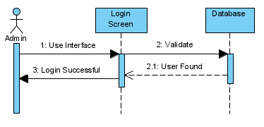
Figure 3.1-1: SD Login

Enrol

The Figure 3.1.2 demonstrates the enrolment process of a student from capturing of face to extraction of features and saving them in database.

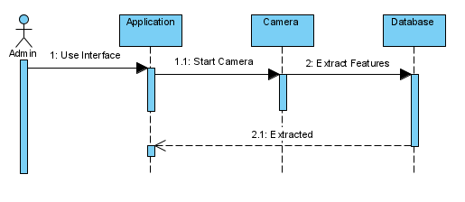
Figure 3.1-2 SD Enroll Student

Update Information

Figure 3.1.3 shows the update information process of enrolled students in database.

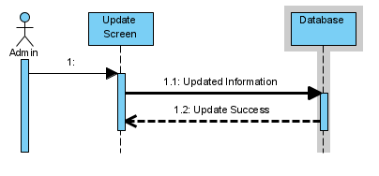
Figure 3.1-3 SD Update

Delete Student

Figure 3.1.4 shows the sequence diagram of deleting an enrolled student by just typing student ID.

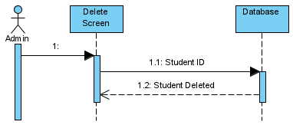
Figure 3.1-4 SD Delete

View Summary

Administrator or university management may view the in/out behaviour of student by monthly or weekly as shown in Figure 3.1.5:

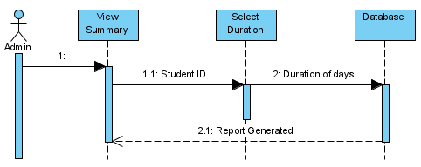
Figure 3.1-5 SD Summary

Entity Relationship Diagram

Figure 3.2-1 defines the overall relational entitites for users, students and their attendance.
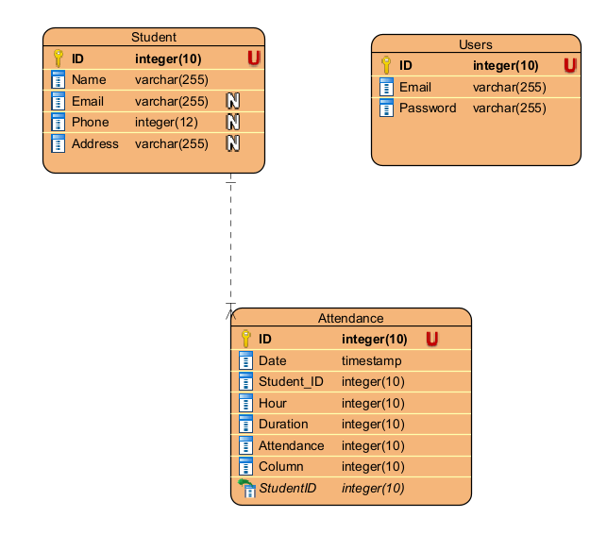
Figure 3.2-1 ERD

As above ERD shows the two entities e.g. student and users. In users there could be an admin and a teacher.

Data Gathering

The accuracy of system always depend upon the training of model. Quality of input data in model is primary concern for training. Team used Computer Vision (cv2) library to open camera and capture the images of students. Team also written a script to capture 100 images of each student in approximately 20 seconds in which student will stay straight in front of camera for first 4 seconds then left, right, up and down accordingly, to make model learn all the sides of particular student.

Admin often discard the images manually if the image is not suitable for model training or it becomes an outlier for training data. The used dlib library automatically discard image for dataset while training the model. Admin will no longer need to delete blur or wrong angle of faces manually.

Methodology

A face detection module will work at the time of enrolment of students through which 200 pictures of a single student will be captured at different angles and then model train itself and recognize the persons by testing them.

Face Detection

Before enrolling a student, system will show it unknown and take its sample to store in database as shown below:

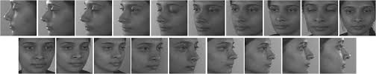
Figure 3.4-1 Face Detection

Model Design

DLIB’s integrated hog technique is used on frontal face detector extracted location of faces for training the data. HOG technique contains three major steps as following:

- Pre-processing of data, which includes resizing and color normalization of each image.
- Computation of gradient vector of every pixel, as well as its magnitude and direction.
- Divide the image into many 8x8 pixel cells. In each cell, the magnitude values of these 64 cells are binned and cumulatively added into 9 buckets of unsigned direction (no sign, so 0-180 degree rather than 0-360 degree; this is a practical choice based on empirical experiments).

For better robustness, if the direction of the gradient vector of a pixel lays between two buckets, its magnitude does not all go into the closer one but proportionally split between two. For example, if a pixel’s gradient vector has magnitude 8 and degree 15, it is between two buckets for degree 0 and 20 and we would assign 2 to bucket 0 and 6 to bucket 20.
This interesting configuration makes the histogram much more stable when small distortion is applied to the image.

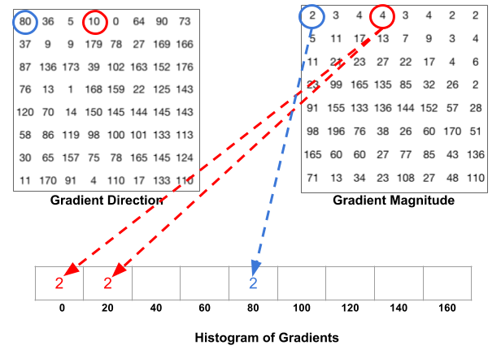
Figure 3.4-2 HOG

- Then it slides a 2x2 cells (thus 16x16 pixels) block across the image. In each block region, 4 histograms of 4 cells are concatenated into one-dimensional vector of 36 values and then normalized to have unit weight. The final HOG feature vector is the concatenation of all the block vectors.[3]

Then these block vectors will pass to SVM classifier along with student name array. SVM classifier will predict the number of faces found in an image. Attendance with timestamp and current duration of class will store in database on the base of recognized students.

Face Recognition

Camera will recognize face of each student sitting in classroom which is enrolled in system earlier. A prototype of recognized face is as follows:

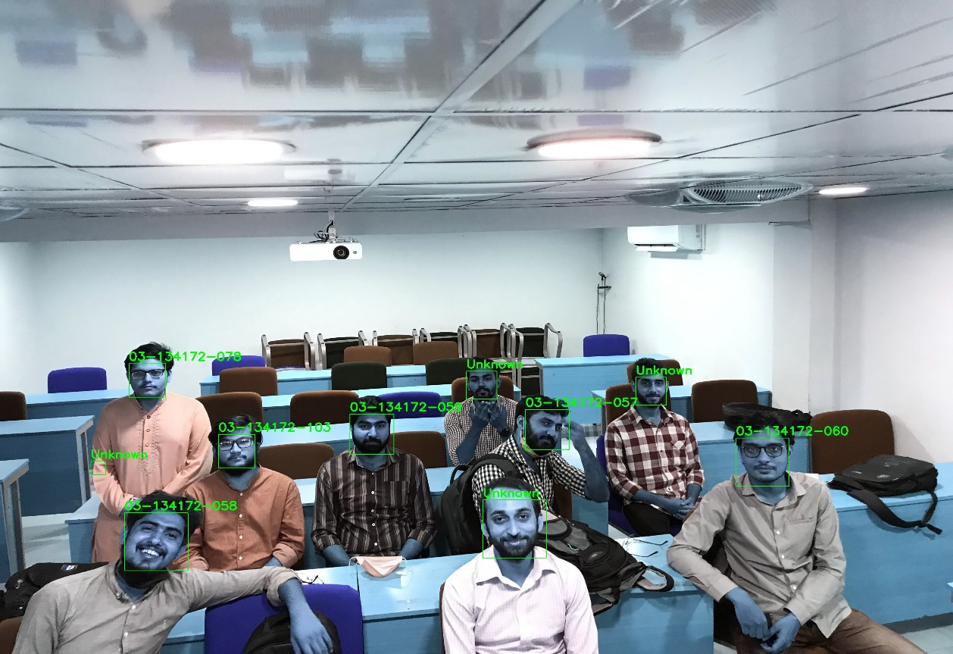
Figure 3.4-3 Face Recognition

Verification and Validation

System will mark attendance as the model predicts the name of students. There would be two types of tests:
- Manually check the number of faces detected by model and present students in classroom
- Check how accurate model recognize the faces of students.

DATA AND EXPERIMENTS

Data Gathering

Team generated dataset of approximately 20 students of university. Hundred full profile face pictures of each student were captured. Table 4.1-1 shows the metadata of

Table 4.1.1 Metadata
Students | Images per Student | Image Description
20 | 100 | Full Profile Face

Following are the characteristics of training data with some samples along with testing data which covers overall classroom in single frame.

Training Data:

Training data contains the image of students with full profile faces. Figure 4.1-1 shows the sample face sides as well as correct posture to capture in camera which will then passed for feature extraction. During collection of data, admin should ensure the clear face of student in front of camera. Wrong postures of students will be discard from model while training.






Figure 4.1-1 Correct Data

Below Figure 4.1-2 shows the wrong postures which should not be captured during the process of data colleciton.



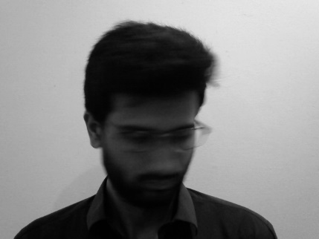


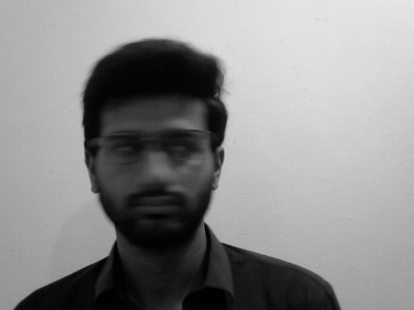
Figure 4.1-2 Wrong Datset

Testing data

Testing data contains the pictures of classroom because system will mark attendance in classroom environment. Following figure 4.1-3 shows the students sitting in classroom with one having a different postures. Figure is also used for comparisons of pre-trained models used for detection of faces.

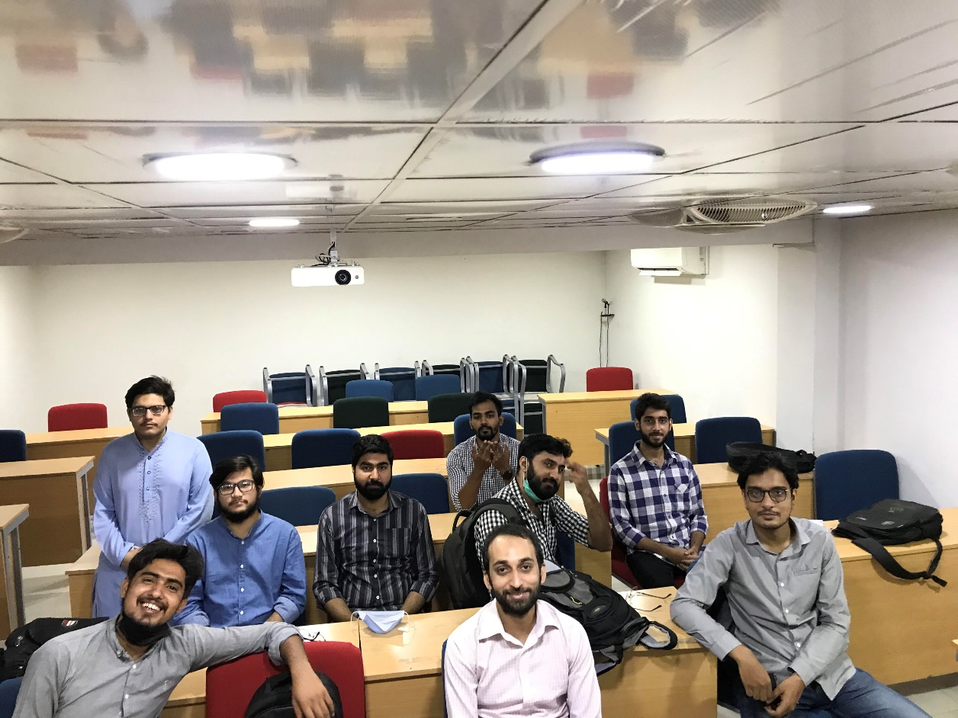
Figure 4.1-3 Classroom

Face Detection

Viola & Jones algorithm is mainly used in detection of faces in images or real time videos but it is not effective in slightly different environments. Moreover, it is also inaccurate for small faces in images or distant faces in a video. Sometimes, it does not detect full face of person, discards the chin or forehead part of face. That is why team used dlib’s built in frontal face detector.

Frontal Face Detector returns the face location ([top:left], [bottom:right]) using histogram-oriented gradients from a picture which means we don’t need to crop face form a picture it will automatically crop and extract features or embedding from it.

Model Training

SVM (Support Vector Machine) is used for training the model. SVM is the supervised learning technique that learns by example to assign labels to objects. Pre trained models are used for detection of faces in real time classroom frames. Detection algorithm returns the bounding box. Bounding box is a face location in a frame from which we can extract features using Dlib’s image encoding function.

Extracted image encodings are then passed to SVM to fit the model. It hardly takes 5 seconds to recognize or predict the student. SVM will compare the vectors of test image with trained data which contains twenty labels and each label contains approximately hundred vectors. After prediction, an array is return to the function which will then mark attendance of recognized or predicted labels.

Following are the experimented models used in project:
- Haar Cascade
- MTCNN
- Dlib

Haar Cascade

Haar Cascade is the fastest algorithm[4] which extracts lot of features from image like CNN. Approximately 16000 features+ are extracted by Haar Cascade which is then reduced to 6000 approximately. But it takes a lot of time using sliding window so they grouped them together to make a cascade of classifier.
If sliding window fails at a feature then whole process stopped and remaining features are not processed in that cascade. This process is repeated until window passes all features then it is classified as face[4].

Figure 4.3-1 below Shows the recognition rate of pre-trained Haar cascade model:

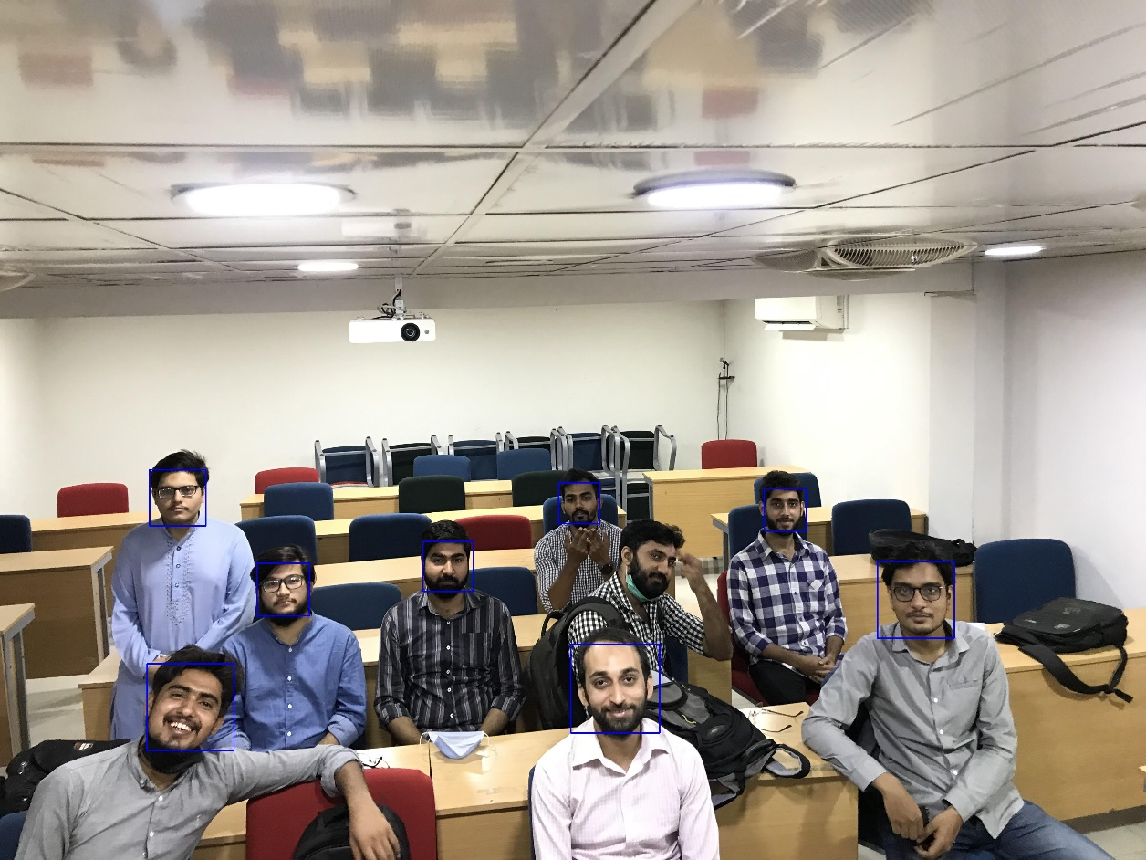
Figure 4.3-1 Haar Cascade

MTCNN

MTCNN (Multi task Convolutional Neural Network) was introduced in 2016 by Keipang Zhang which not only detect a face but also detect five key points. MTCNN uses three stage of Convolutional Neural Networks. At first, it obtain the windows and bounding box vectors. Overlapped candidates passed to another in CNN, which rejects a lot of false positive and perform calibration on bounding boxes[5].

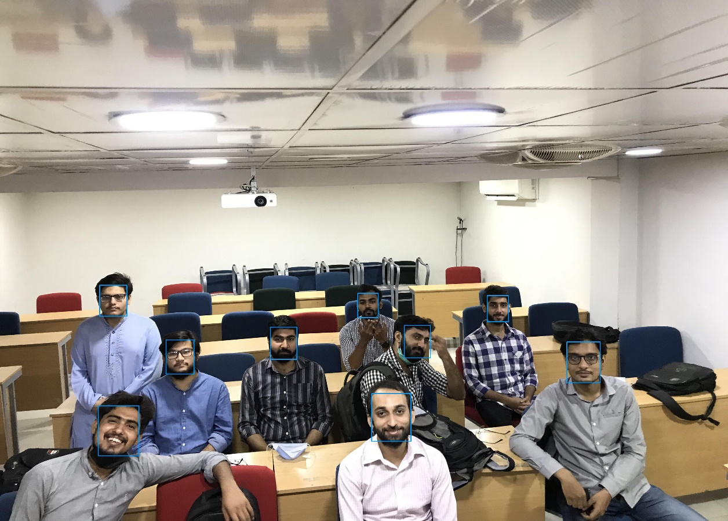
Figure 4.3-2 MTCNN

Dlib Frontal Face Detector

Frontal face detector works using feature extracted by histogram of gradients which is then passed through an SVM classifier. It uses the direction of gradients as the features.
Then these gradient vectors are normalized and concatenated to make block vectors which is then passed to SVM classifier.[6]

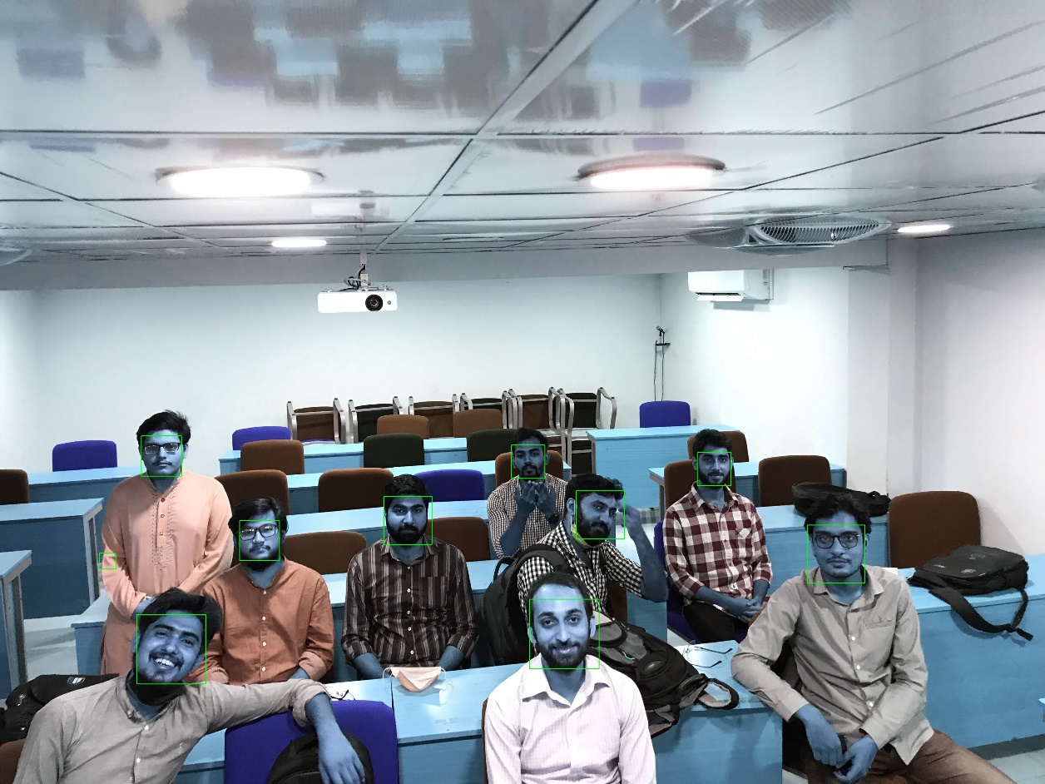
Figure 4.3-3 DLIB Experiment

Why Dlib?

Attendance of students will mark on images of classroom so the comparison of models are based on the image. Cascade classifier perform worst in majority of images. It does not detect full face and for recognition it gets affected by lightning conditions.

Dlib and MTCNN performed better in different environmental conditions but MTCNN take too much time and resources (GPU) to get it trained. For more than 70 picture of each student, it takes more than 10 minutes for single student to train on CPU and it is basically developed for real time images while Dlib takes less time for extraction than MTCNN and also take seconds to fit the model of approximately 2000 pictures of students. But for extracting the feature using Dlib it takes 30 minutes for 2000 pictures. Moreover, Dlib’s HOG gives the best result on pictures in good lightning and controlled environment.

Model Experiments

For testing the trained, multiple classroom pictures will pass to trained model to predict number of faces and compare the known and unknown faces.

Experiment no 1

The Figure 4.5-1 shows the first experiment of face recognition and attendance marking in classroom of Bahria University. Frame was captured in normal lightning conditions as well as at ideal distance.

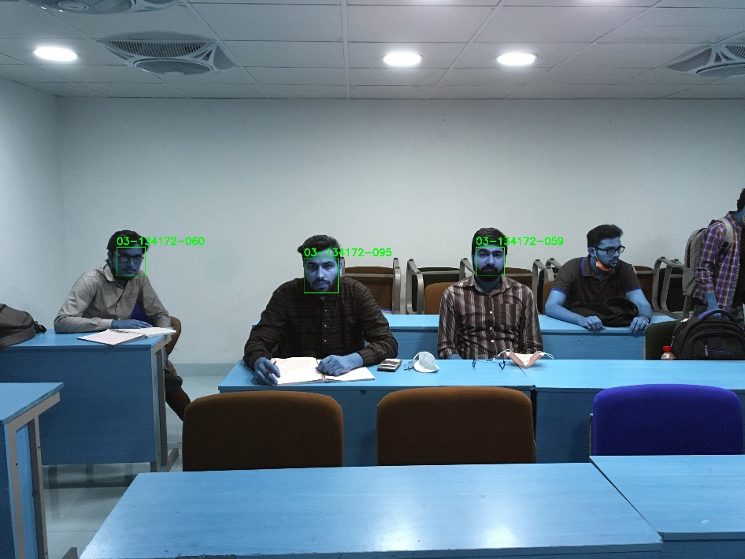
Figure 4.5-1 Classroom Experiment

Below Table 4.5.1 defines the context of the experiment which contains the data of timestamp, Location and detected and non-detected students in figure 4.5-1

Table 4.5.1 Experiment 1
Room | B1
Date | 09 June, 2021
Time | 10:51
Number of Students | 4
Rows | 3
Columns | 4
Detected | 3
Not Detected | 1

As per the table 4.5.1 metadata and figure 4.5-1 also shows the recognized students as well as the one non-detected student at last bench.

Experiment no 2

Another experiment of marking attendance can be shown in Figure 4.5-2 with detection of faces from moderate height along with increased number of students. One student has also made his pose slightly left but system not only detected the face but also recognized him accurately. Moreover, the students are not properly arranged in a form of matrix but system detected them efficiently.

The last two persons are also recognized unknown which defines that if student is not enrolled in course, system can show them unknown and it will not made an impact on the attendance of enrolled students.

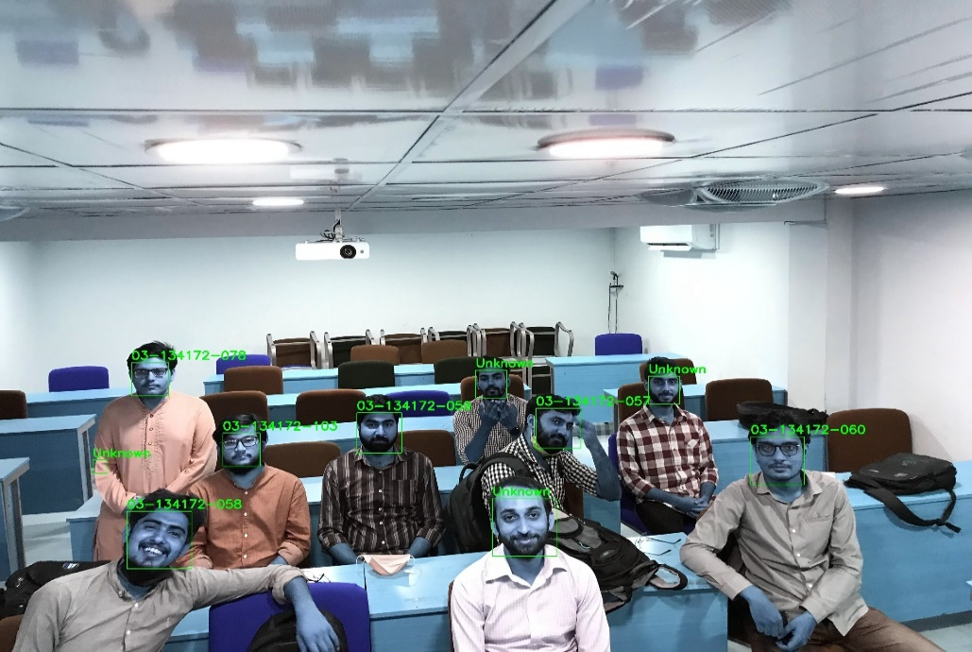
Figure 4.5-2 Low Resolution Classroom

Below Table 4.5.2 defines the context of the experiment which contains the data of timestamp, Location and detected and non-detected students in figure 4.5-2

Table 4.5.2 Experiment 2
Room | B2
Date | 10 June, 2021
Time | 2:05
Number of Students | 9
Rows | 3
Columns | 3
Detected | 9
Not Detected | 0

As per the table 4.5.2 metadata and figure 4.5-2 also shows the recognized students and reflects that there is no any undetected student in increase number of students.

Experiment no 3

Figure 4.5-3 shows another example of face recognition with slightly different environment then previous ones. It shows the shadow on face as well as low light but model detected the persons accurately except the left one. Due to mask and low light the face of the student was not detected and it is also reflected in constraints section which states that the face of student should be clearly visible.

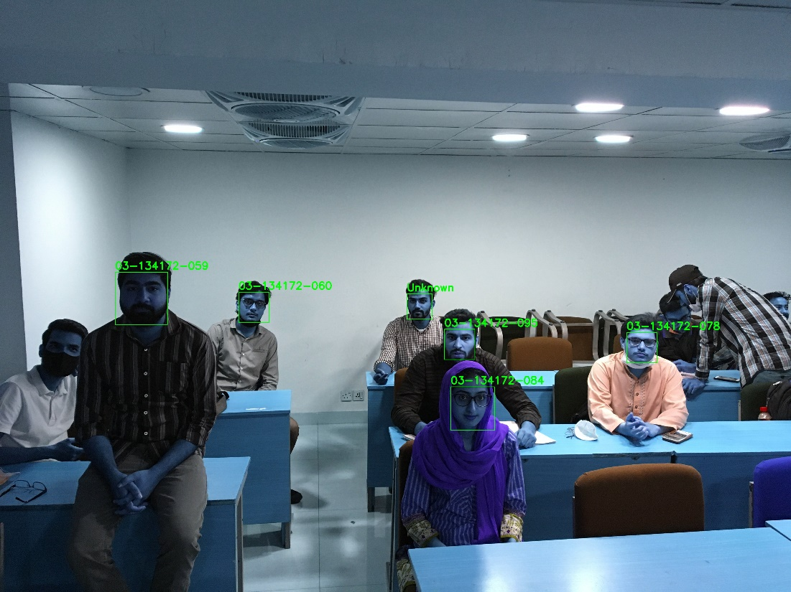
Figure 4.5-3 Shadowed Image

Below Table 4.5.3 defines the context of the experiment which contains the data of timestamp, Location and detected and non-detected students in figure 4.5-3

Table 4.5.3 Experiment 3
Room | B2
Date | 09 June, 2021
Time | 12:30
Number of Students | 7
Rows | 3
Columns | 3
Detected | 6
Not Detected | 1

As per the table 4.5.3 metadata and figure 4.5-3 also shows the recognized students as well as the one non-detected student at left bench. Two students at the last of the class, there faces were also not detected by the system due to low resolution and also the direction of face was down and not enough visible in camera.

Experiment no 4

Figure 4.5-4 shows the pictures of students near to each other as well as camera is also far to them. System marked the attendance of all students accurately.

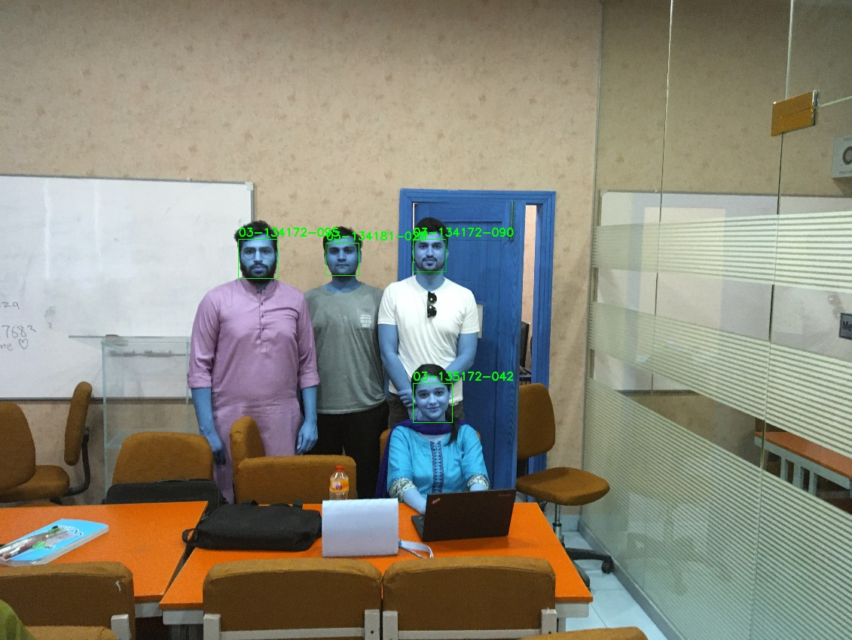
Figure 4.5-4 Detection of distant faces

Below Table 4.5.4 defines the context of the experiment which contains the data of timestamp, Location and detected and non-detected students in figure 4.5-4

Table 4.5.4 Experiment 4
Room | FYP Lab
Date | 28 June, 2021
Time | 4:30
Number of Students | 4
Rows | 2
Columns | 3
Detected | 4
Not Detected | 0

As per the table 4.5.4 metadata and figure 4.5-4 also shows the recognized students and reflects that there is no any undetected student in increase number of students.

Experiment no 5

Figure 4.5-5 shows the detection of faces of students which are sitting and standing in different postures. System detected and recognized all the students accurately.

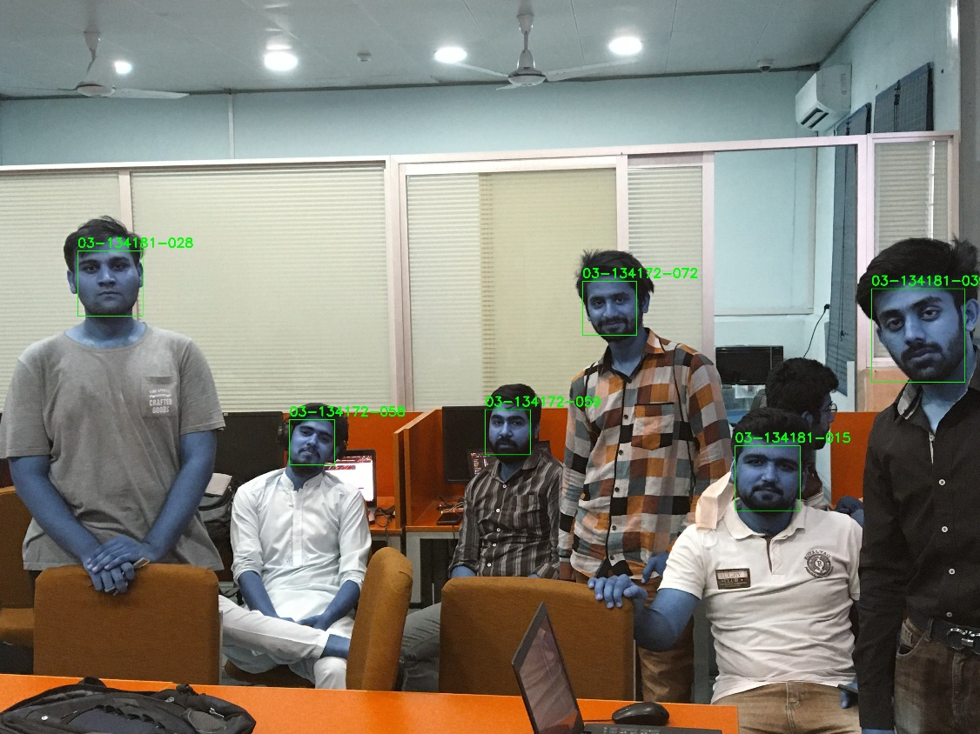
Figure 4.5-5 Detection in different poses

Below Table 4.5.5 defines the context of the experiment which contains the data of timestamp, Location and detected and non-detected students in figure 4.5-5

Table 4.5.5 Experiment 5
Room | FYP Lab
Date | 28 June, 2021
Time | 4:50
Number of Students | 6
Rows | 1
Columns | 5
Detected | 6
Not Detected | 0

As per the table 4.5.4 metadata and figure 4.5-4 also shows the recognized students and reflects that there is no any undetected student in increase number of students. All experiments show the accuracy in form of table because training data and testing data is different and we cannot compute accuracy according to splitting data in any ratio. Accuracy can be determined through these metadata of every experiments.

Software

Software is the main part of research which contains the flexibility to change according to usability characteristics. The design of software is based on the standard usability goals which engage the user as well as perform the user actions effectively and efficiently. It integrates the deep learning model with user interface which makes user to collect data and train the model with the use of buttons only.

System can have multiple user entities like admin and teacher. Admin can perform following operations:
- Enroll Student
- Collect Data
- Train the model

Whereas, teacher can:
- Mark attendance
- View Report

Following are the snaps of Interface along with functionality:

Login Screen

Figure 4.6-1 shows the login screen of System where admin will login in to the system with provided standard credentials.

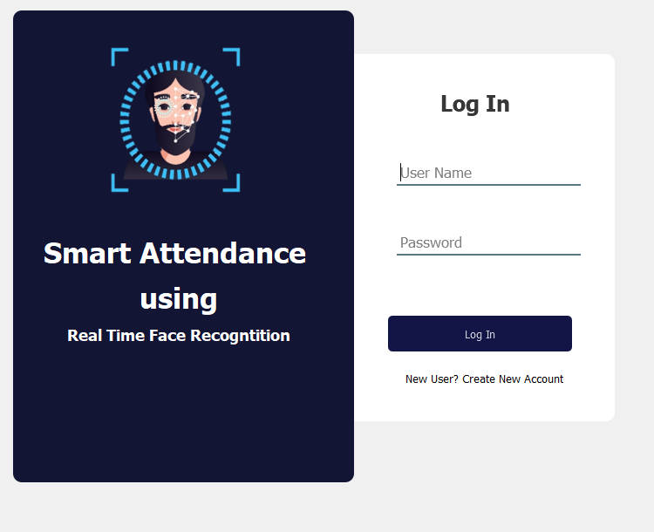
Figure 4.6-1 Login

Add Student

After login, the first and most usable screen appears as a homepage for user. The screen shows the input fields of ID, Name, Email, Phone Number, Address as shown in Figure 4.6-2. User will input data into the fields to register the student same as a university stores the information in their own database.

ID, Email, Phone Number and address will pass to the system. Add Student button will insert the student information in database.

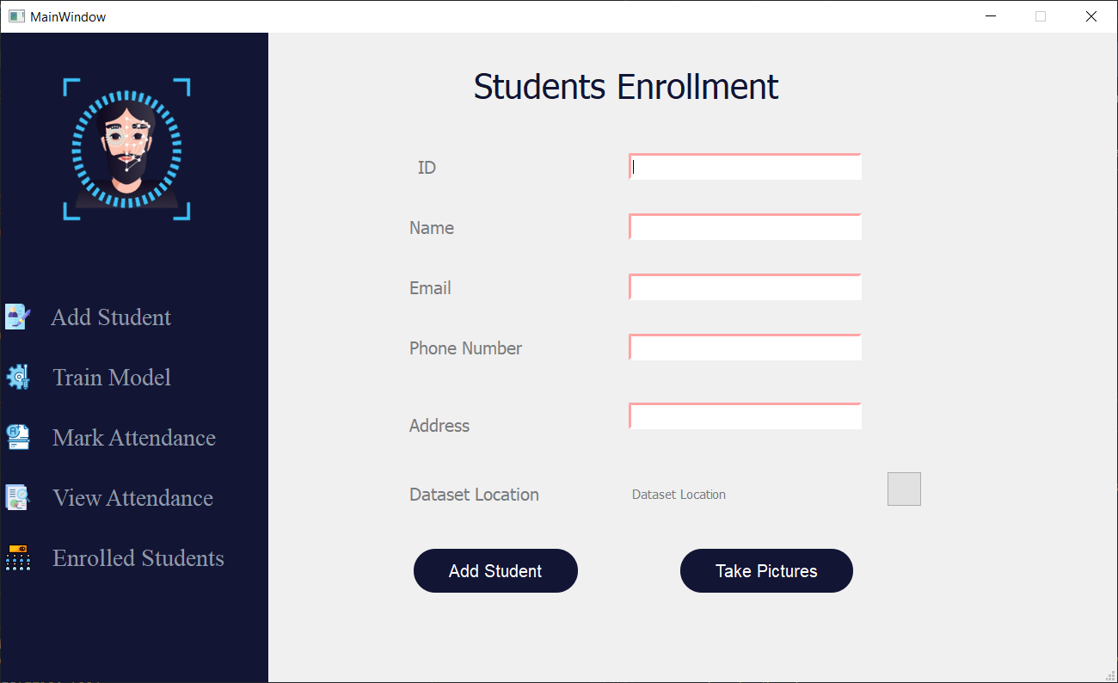
Figure 4.6-2 Enrol Student

Figure 4.6-2 shows the field of data set location along with a button in right side of screen. Pressing this button will open a dialog box to select a location of folder on screen. After selecting the folder, the location and full path to that folder will be displayed to screen. It ensures the user to cross check the location because it is the main location for data collection and also used for model training.

Data Collection

After successful enrolment process, User will press Take pictures button which will take 100 pictures of student with full face profile as shown in Figure 4.6-3.

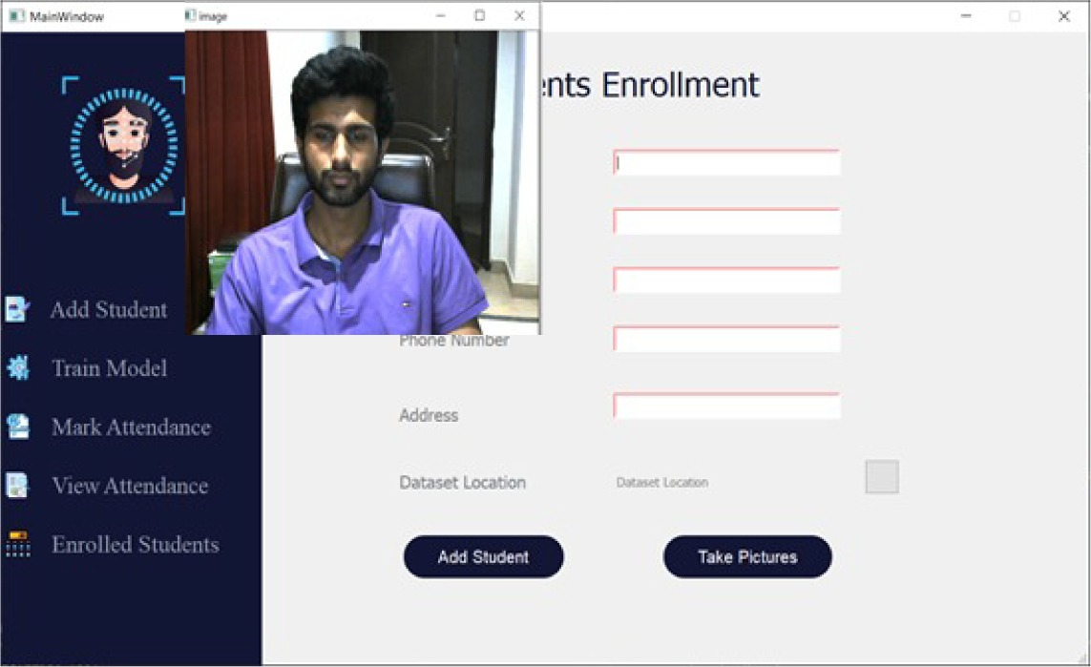
Figure 4.6-3 Data Collection

Admin will make sure that system will capture each side of face accurately. When camera start capturing the pictures student should see straight to the camera for first five seconds. Then he can move his face with slightly less speed of normal rotation to right or left depending on user. On each angle of turning his face on either side and coming back to front side should not take more than 6 to 7 seconds.

Model Training

Figure 4.6-4 shows the progress of training the model in which features of all students are extracted from their faces and passed to classifier for training.

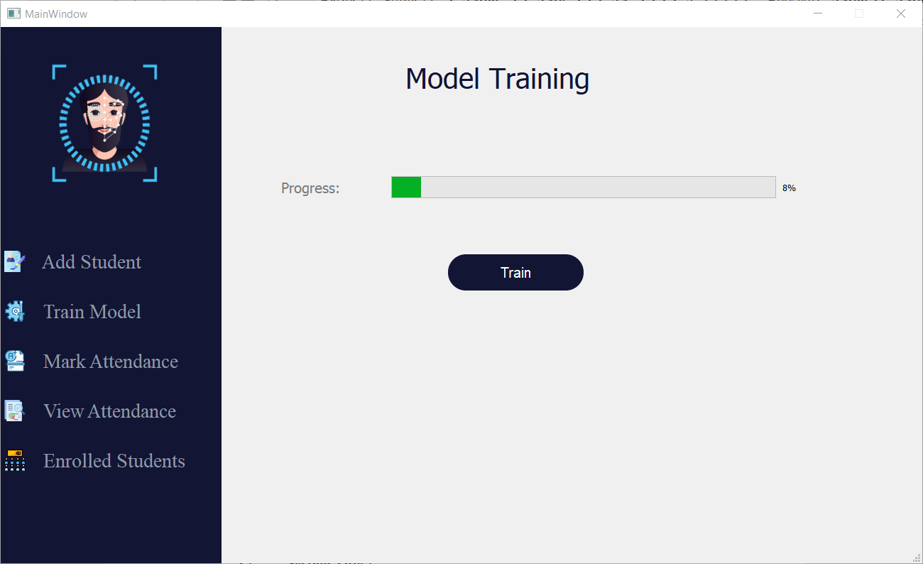
Figure 4.6-4 Model Training

When user press on train button the system shows the progress of trained model in percentage. The working of progress bar is based on the total number of students along with the number of images per student used in training the model. Progress bar moves as the number of images passed or discard for feature extraction and model training. Some blur and wrong angle face pictures are discarded from the process of feature extraction and model training.

View Attendance

Figure 4.6-5 shows the report of student present in classroom along with their in/out behaviour of student.
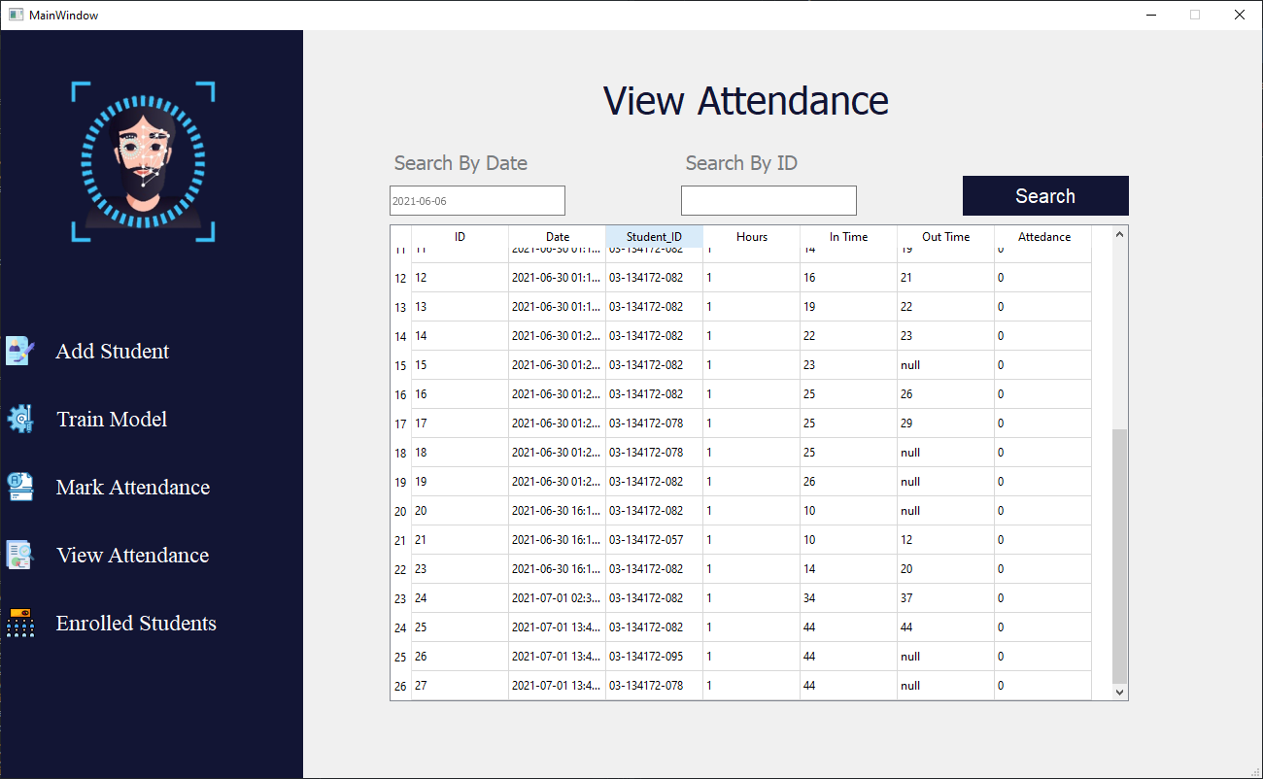
Figure 4.6-5 View Attendance

After the process of marking the attendance, Teacher can view the report of student which shows the attendance of each student along with in/out behaviour of each student. As shown in picture, if the duration of in time and out time does not full fill the condition of duration of presence the attendance of student would be marked zero.

User can also view the report of particular student by entering the enrolment of student which is the primary key for getting the student information. If teacher wants to view the report according to specific date, then he can enter date in specified format which can be parsed at the backend to search in database of particular day entries in attendance table.

View Enrolled Users

Figure 4.6-6 shows the enrolled student IDs with their relevant information stored on the system at the time of enrolment.

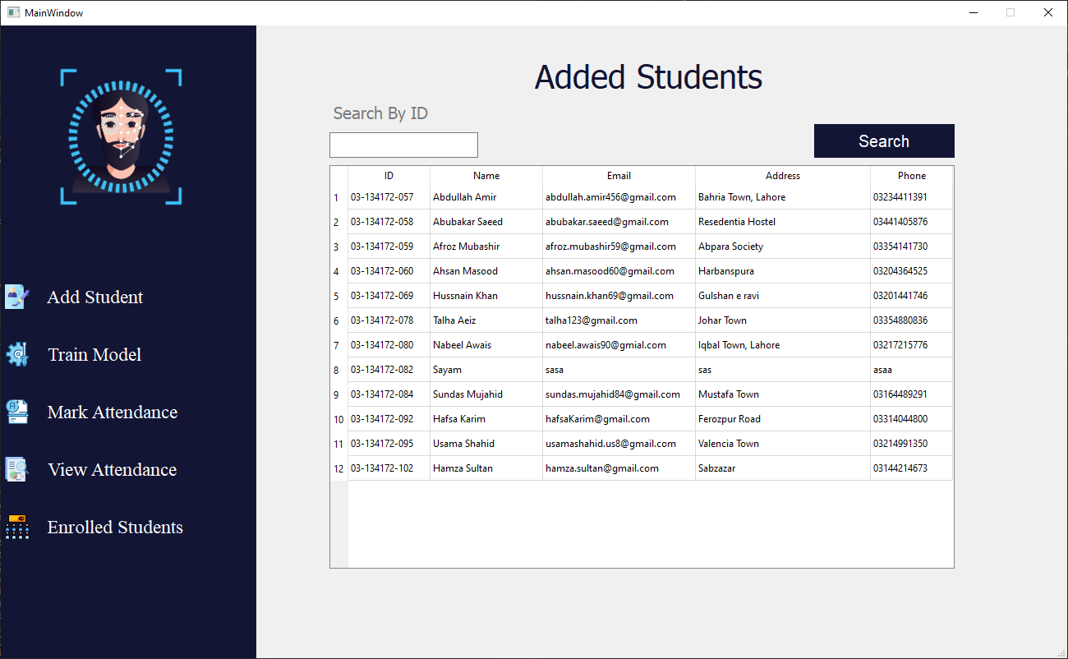
Figure 4.6-6 Enrolled Students

When admin adds a student as shown in Figure 4.6-2, which is already enrolled. System will generate a warning that student is already enrolled. Moreover, Figure 4.6.6 shows that there is a tab to view the enrolled students along with their all information. Admin can also search the student by typing the enrolment.

RESULTS AND DISCUSSIONS

Results

Training data contains the images of single person while testing data has multiple faces in a single frame. Accuracy cannot be computed on the base of splitting the data set of training and testing.

However, we can compute accumulated accuracy on the base of total number of students in all experiments with the number of detected ones. Following Table 5.1-1 shows the results of all experiments.

Table 5.1.1 Result
Total Number of Students | 30
Detected | 28
Not Detected | 2
Accuracy | 93.33%

As per Table 5.1-1, the count of non-detected person is due to low resolution and light constraints in classroom. If the resolution of camera could be better, it would definitely improve the results.

CONCLUSION AND RECOMMENDATIONS

Findings

Teacher should ensure presence of students in classroom during lectures. Most of the time, student made proxies or leave the class after attendance. Proposed system saves the time of teacher to mark attendance of students and also aims at eliminating the human errors and proxy in recording attendance. This can be achieved using face recognition to monitor the attendance of students in class.

The system will use DLIB library for detecting faces and to extract features of them. Originally, Viola & Jones was planned to detect faces in an image and to extract features on the basis of its pre-trained model but it was found less effective in university classroom environments. For some pictures it detects accurate faces but most of the time its accuracy was less than DLIB.

DLIB’s histogram of gradient technique was used to extract face locations and image encodings. The encodings are 128 measurements of face arranged in 2d array. Instead of comparing images, measurements were generated to reduce the time to recognize significantly.

Similar faces are mapped near to each other and different faces are mapped far apart. So it is important to note that while data gathering, environment conditions should not made an impact on every picture which results in making them similar. Such as light constraints and shadow on every phase.

Recommendations

Although current system is properly efficient but there is still room for optimization and to further speed up the process. For future works following are the proposed solution to make system more efficient:

- Feature file or Image encodings file of trained students is currently maintained in local storage. We can append new features in current file along with labels. By achieving this, we can delete pictures of previous students because we are maintaining the feature vectors instead of pictures. This can save a lot of memory.

- This system can be further enhanced by making it fully automatic not for classrooms only but also for a whole organization’s safety and security purpose.

- For a single classroom, we can create multiple feature extraction files for different classroom students, so it may restrict any unauthorized person to attend the particular class.

REFERENCES

Conference Papers:

[1] R. Nandhini, N. Duraimurugan, and S. P. Chokkalingam, “Face Recognition Based Attendance System,” no. 3, pp. 574–577, 2019.
[2] Y. Kawaguchi, W. Lin, and M. Minoh, “Face Recognition-based Lecture Attendance System.”
[3] R. Rai, S. Shukla, and B. Singh, “Reactive Power Based MRAS for Speed Estimation of Solar Fed Induction Motor with Improved Feedback Linearization for Water Pumping,” IEEE Trans. Ind. Informatics, vol. 16, no. 7, pp. 4714–4725, 2020, doi: 10.1109/TII.2019.2950094.
[4] P. Viola and M. Jones, “Robust Real-Time Face Detection Intro to Face Detection,” Int. J. Comput. Vis., vol. 57, no. 2, pp. 137–154, 2004.
[5] K. Zhang, Z. Zhang, Z. Li, and Y. Qiao, “Joint Face Detection and Alignment Using Multitask Cascaded Convolutional Networks,” IEEE Signal Process. Lett., vol. 23, no. 10, pp. 1499–1503, 2016, doi: 10.1109/LSP.2016.2603342.
[6] S. Praveen Kumar, V. Kesava Jayendra Varma, V. Subramanya, and A. Venkata Sai Harish, “A multiple face recognition system with DLIB’s RESNET network using deep metric learning,” J. Crit. Rev., vol. 7, no. 6, pp. 856–859, 2020, doi: 10.31838/jcr.07.06.147.

